PANDEMIC PREPAREDNESS PLAN
OF PATTAMBI MUNCIPALITY

MESSAGE FROM PRESIDENT/CHAIR LSGI
Ensuring the health and safety of our citizens is one of the foremost responsibilities of Pattambi Municipality. The preparation of this Pandemic Preparedness and Response Plan reflects our commitment to building a resilient urban local body capable of effectively preventing, detecting, and responding to public health emergencies.
Urban settings present unique challenges during pandemics due to higher population density, mobility, and interconnected public services. Therefore, this plan has been developed with a comprehensive and coordinated approach, aligned with the guidance of the District Administration and the Health Department. It emphasizes strengthened surveillance systems, rapid response mechanisms, infection prevention and control measures, risk communication strategies, and continuity of essential civic and health services.
The plan clearly defines the roles and responsibilities of municipal departments, health institutions, frontline workers, educational institutions, Kudumbashree units, sanitation teams, and other stakeholders. Special priority has been given to protecting vulnerable populations, maintaining essential supplies and logistics, ensuring environmental sanitation, and sustaining uninterrupted delivery of healthcare, water supply, waste management, and other essential municipal services.
Pattambi Municipality remains committed to periodic review, capacity building, mock drills, and interdepartmental coordination to ensure operational readiness at all times. Preparedness is a shared responsibility, and active participation from the community is crucial for minimizing the impact of future health emergencies.
I extend my sincere appreciation to all departments and stakeholders who have contributed to the development of this comprehensive plan. Together, with vigilance, cooperation, and collective action, we can safeguard the health and well-being of the people of Pattambi.
Chairperson
Pattambi Municipality

MESSAGE FROM HEALTH STANDING COMMITTEE CHAIR
Pattambi Municipality, situated along the banks of the Bharathapuzha River, faces unique public health vulnerabilities, particularly during monsoon seasons when flooding, water contamination, and vector breeding increase the risk of communicable diseases. In addition, the presence of busy market areas, educational institutions, transport hubs, and densely populated wards adds complexity to pandemic response and disease containment efforts.

This Pandemic Preparedness and Response Plan has therefore been developed with a strong focus on local risk assessment, urban surveillance strengthening, and rapid response mechanisms. The Health Standing Committee will ensure close monitoring of seasonal disease trends, flood-related health risks, water quality, sanitation systems, and vector control activities. Special emphasis will be placed on preventing outbreaks of waterborne and vector-borne diseases alongside preparedness for respiratory pandemics and emerging infections.
Periodic mock drills, capacity-building sessions, and awareness campaigns will be conducted to maintain readiness among municipal staff and frontline workers. Transparent communication and timely public advisories will be prioritized to strengthen community trust and cooperation.
Preparedness is a continuous and dynamic process. The Health Standing Committee remains committed to sustained oversight, evidence-based planning, and coordinated interdepartmental action to ensure that Pattambi Municipality remains resilient and well-prepared to address any future public health emergency.

Chairperson
Health Standing Committee
Pattambi Municipality

MESSAGE BY MEDICAL OFFICER
Strengthening preparedness at the local level is fundamental to ensuring an effective response to pandemics and other public health emergencies. The development of this Pandemic Preparedness and Response Plan for Pattambi Municipality reflects our commitment to reinforcing urban health systems and establishing a coordinated, evidence-based approach to emergency management.
Experiences from recent global and national health crises have demonstrated the critical importance of robust disease surveillance, timely case identification, laboratory networking, strict infection prevention and control practices, and transparent risk communication. A structured preparedness framework enables early recognition of potential threats, efficient deployment of resources, and systematic implementation of containment strategies to reduce morbidity and mortality.
This plan provides detailed operational guidance on surveillance systems, outbreak investigation procedures, clinical case management, referral linkages, logistics coordination, and community-level interventions. Given the urban setting of Pattambi, particular emphasis has been placed on high-risk environments, seasonal disease trends, continuity of essential healthcare services, and protection of vulnerable and high-risk populations.
As the Medical Officer, I reaffirm the dedication of our municipal health team—including medical officers, nursing personnel, health inspectors, junior public health nurses, ASHA workers, and other frontline staff—to implement this plan with professional competence and accountability. Effective pandemic response, however, extends beyond the health sector and requires coordinated support from all municipal departments and active cooperation from the community.
Through preparedness, scientific planning, and collective action, we can ensure that Pattambi Municipality remains resilient and capable of effectively managing future public health challenges.
Medical Officer
Taluk Head quarters hospital Pattambi
EXECUTIVE SUMMARY
Pattambi Municipality serves as an important urban local body responsible for ensuring the health, sanitation, and overall well-being of its residents. In coordination with the Urban Health Centre, other public and private healthcare institutions, and district health authorities, the Municipality plays a central role in delivering accessible, equitable, and quality healthcare services with a strong emphasis on preventive, promotive, curative, and rehabilitative care in alignment with national and state health programmes.
As an urban area characterized by dense population clusters, active commercial establishments, educational institutions, and significant daily mobility, Pattambi faces unique public health challenges. Key priorities include maternal and child health, communicable and non-communicable disease control, immunization coverage, tuberculosis elimination, vector-borne and waterborne disease prevention, adolescent and geriatric health services, and environmental sanitation management.
The Municipality actively supports the implementation of major national health initiatives such as the National Health Mission (NHM), National Tuberculosis Elimination Programme (NTEP), National Programme for Prevention and Control of Cancer, Diabetes, Cardiovascular Diseases and Stroke (NPCDCS), Integrated Disease Surveillance Programme (IDSP), and other public health interventions. Surveillance systems, outbreak response mechanisms, and field-level monitoring are strengthened through coordination between municipal authorities, health staff, ASHA workers, Anganwadi centres, educational institutions, Kudumbashree units, and community-based organizations.
Given Pattambi’s geographical setting along the Bharathapuzha River, seasonal risks such as monsoon-related flooding, water contamination, and vector proliferation require focused preparedness measures. Emphasis is placed on early disease detection, timely referral services, sanitation oversight, safe water monitoring, waste management, health education, and lifestyle modification to reduce disease burden and improve health outcomes.
Despite increasing service demand, resource constraints, and evolving public health threats, Pattambi Municipality continues to strengthen its systems through evidence-based planning, digital reporting mechanisms, interdepartmental coordination, and community participation. Upgrading urban health infrastructure, enhancing emergency preparedness, improving surveillance systems, and expanding preventive health services remain key priorities for sustainable development.
Overall, Pattambi Municipality stands committed to safeguarding public health and improving the quality of life of its residents through coordinated governance, strengthened health systems, and active community engagement.

LIST OF ABBREVIATIONS

LSGD/LSGI | Local Self Government Department / Local Self Government Institution
BMO | Block Medical Officer
IDSP | Integrated Disease Surveillance Programme
NDMA | National Disaster Management Authority
PPE | Personal Protective Equipment
ICMR | Indian Council of Medical Research
CD | Communicable Diseases
NCD | NON-COMMUNICABLE Diseases

TABLE OF CONTENTS

3
INTRODUCTION 9
● Background of the PPP 9
LSGD AT A GLANCE 9
INTEGRATED HEALTH INFRASTRUCTURE MAP OF PATTAMBI MUNCIPALITY 10
GENERAL PROFILE OF THE LSGI’S 13
Background of the LSGI 13
Demographic and Vulnerable Population 14
Clinical Vulnerability 16
INFRASTRUCTURE & RESOURCE INVENTORY 18
Health Facility Directory & Basic Capacity in the LSGD 18
Private Clinics 19
Healthcare Education & Training Institutions 20
Specialized Services & Emergency Inventory 20
Oxygen & Diagnostic Capacity 21
Diagnostics facility mapping at the LSGI level 22
Laboratory Identification & Basic Details 22
Social and Community Infrastructure for surge plan 22
Human resources 24
Community & Support Cadre 25
Community Organizations 26
Administrative & Emergency Services 27
Information regarding resources 27
ONE HEALTH & ENVIRONMENTAL SURVEILLANCE 28
Animal & Bird Population 28
Veterinary Infrastructure 29
Veterinary Doctors & Workforce 30
High-Risk Interface Points (Surveillance Sites) 30
Environmental Risk Mapping 31
Disease Seasonality Mapping 32
Vulnerability Mapping 33
EPIDEMIOLOGICAL TRENDS (2021–2025) 34
Disease Burden among human beings(Last 5 Years) 34
*(use the above table data to create the graph/diagram) 36
Seasonal Trend Analysis 37
Outcome-Based Trend Analysis- 2025 39
Transmission Trend- 2025 40
Integrated Disease Hotspot Map (2021–2025) 42
Preparedness and Response Protocol at LSG Level 44
Constitution of One Health Committee 44
Pandemic Response Workforce 45
Activities and Measures before and during Pandemic 47
PHASE 1 - Alert / Preparation 47
PHASE 2 - Active Response 50
Standard Screening Protocol 51
PHASE 3 - Surge Capacity 60
Conversion of Community Facilities 60
CONCLUSION 61
RECOMMENDATIONS 62
ANNEXURE 63
1. IMPORTANT PHONE NUMBERS 63

INTRODUCTION

Background of the PPP
- LSGD at a glance

GEOGRAPHICAL BOUNDARIES OF PATTAMBI MUNICIPALITY
(Source: https://wardmap.ksmart.live/)

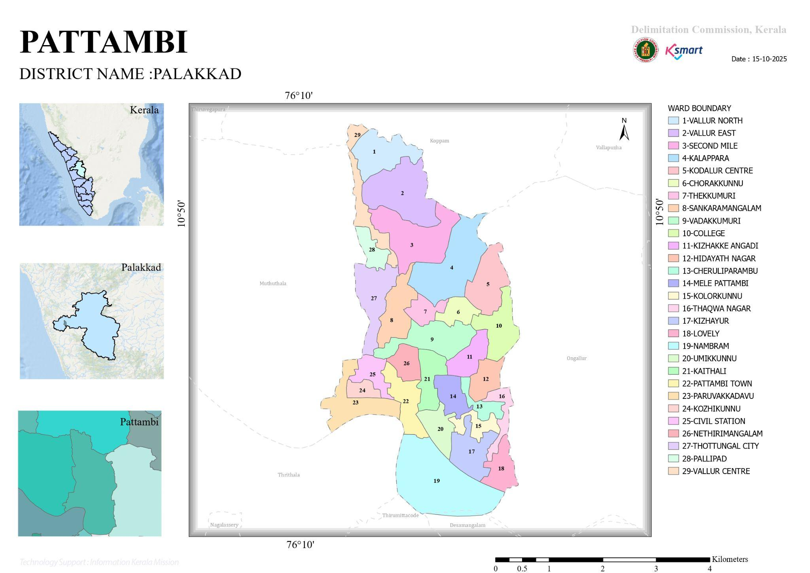

LSGD AT A GLANCE
- Geographical boundaries with political map ( based on latest delimitation)
- Baseline data
- Ward division -
Ward | Houses | Population | Migrants | Wells | Hot  spots | Ed. Institutions | Hosp pvt/govt.
1 | 300 | 1252 | 27 | 122 | 15 | 0
2 | 343 | 1326 | 22 | 177 | 9 | 2
3 | 345 | 1352 | 16 | 135 |  | 0
4 | 240 | 1018 | 9 | 162 |  | 0 | 1
5 | 326 | 1214 | 4 | 127 |  | 3 | 2
6 | 368 | 1381 | 25 | 102 |  | 0
7 | 379 | 1298 | 0 | 118 | 14 | 2
8 | 336 | 1384 | 12 | 214 |  | 1
9 | 325 | 1254 | 16 | 235 |  | 0
10 | 384 | 1139 | 14 | 242 |  | 1
11 | 378 | 1675 | 0 | 228 |  | 1
12 | 356 | 1425 | 21 | 264 |  | 0
13 | 348 | 1326 | 25 | 195 |  | 0 | 1
14 | 387 | 1333 | 0 | 201 |  | 1
15 | 346 | 1265 | 22 | 219 |  | 2 | 1
16 | 337 | 1245 | 0 | 227 |  | 2
17 | 365 | 1254 | 0 | 222 |  | 1
18 | 321 | 1322 | 16 | 264 |  | 2 | 1
19 | 349 | 1325 | 85 | 209 |  | 3 | 2
20 | 387 | 1356 | 24 | 135 |  | 1
21 | 359 | 1420 | 12 | 138 | 6 | 3 | 1
22 | 314 | 1104 | 21 | 247 | 0 | 1
23 | 264 | 1234 | 0 | 187 |  | 2
24 | 264 | 1177 | 12 | 186 |  | 3
25 | 198 | 952 | 0 | 265 |  | 1
26 | 419 | 2104 | 0 | 282 |  | 1
27 | 316 | 1281 | 14 | 126 | 9 | 1
28 | 190 | 744 | 30 | 170 | 7 | 0
Total=28 | 7672 | 35907 | 914 | 6218 |  | 21 | 1

- Risk stratification among wards in the context of Communicable diseases and hazards
- Major Roads/rivers
- Major establishments with geospatial mapping
- occupational groups, socio cultural groups, migration & mobility patterns
- Vulnerability mapping
- Disaster prone areas (geographic vulnerability)

SATELLITE MAP OF PATTAMBI MUNICIPALITY
(Source: https://dmp.kila.ac.in/)

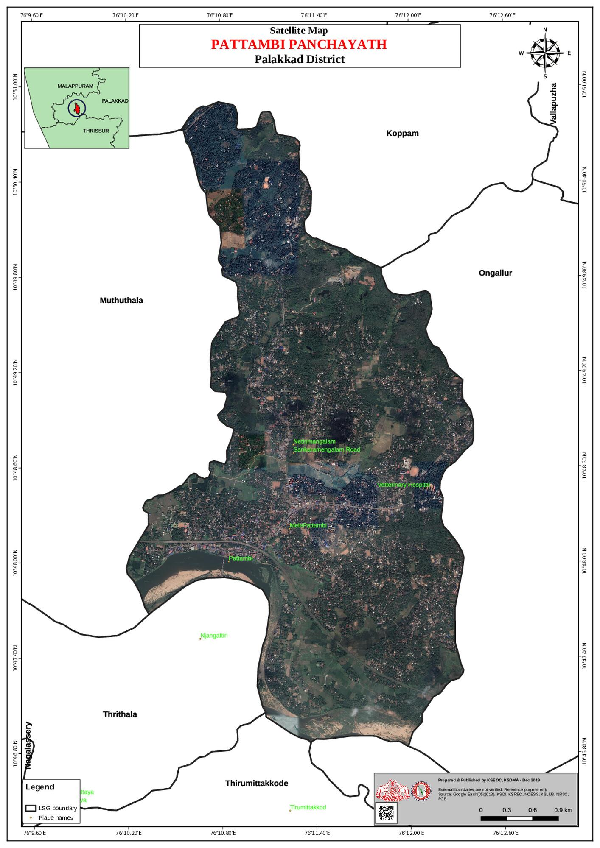

COMMUNICATION MAP OF PATTAMBI MUNICIPALITY
(Source: https://dmp.kila.ac.in/)

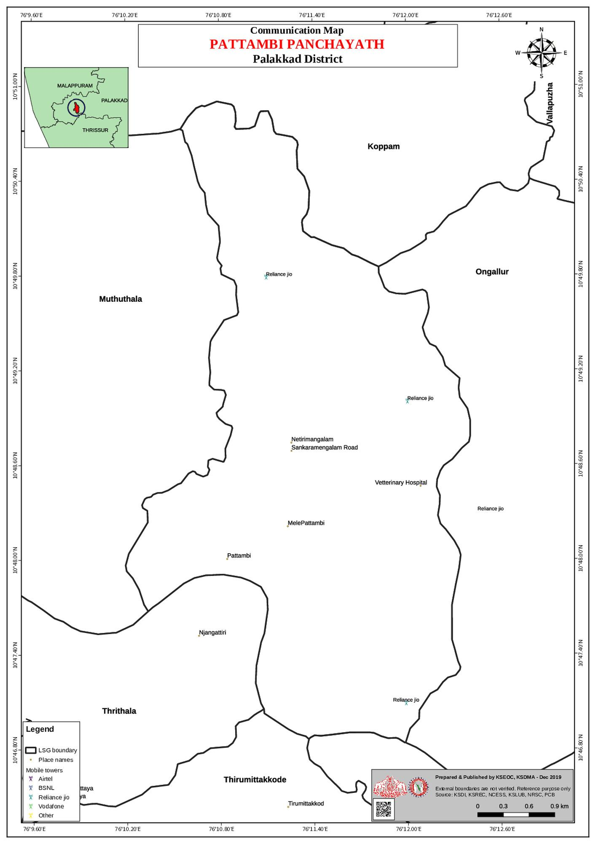

FLOOD PRONENESS V/S INFRASTRUCTURE FACILITIES MAP OF PATTAMBI MUNICIPALITY

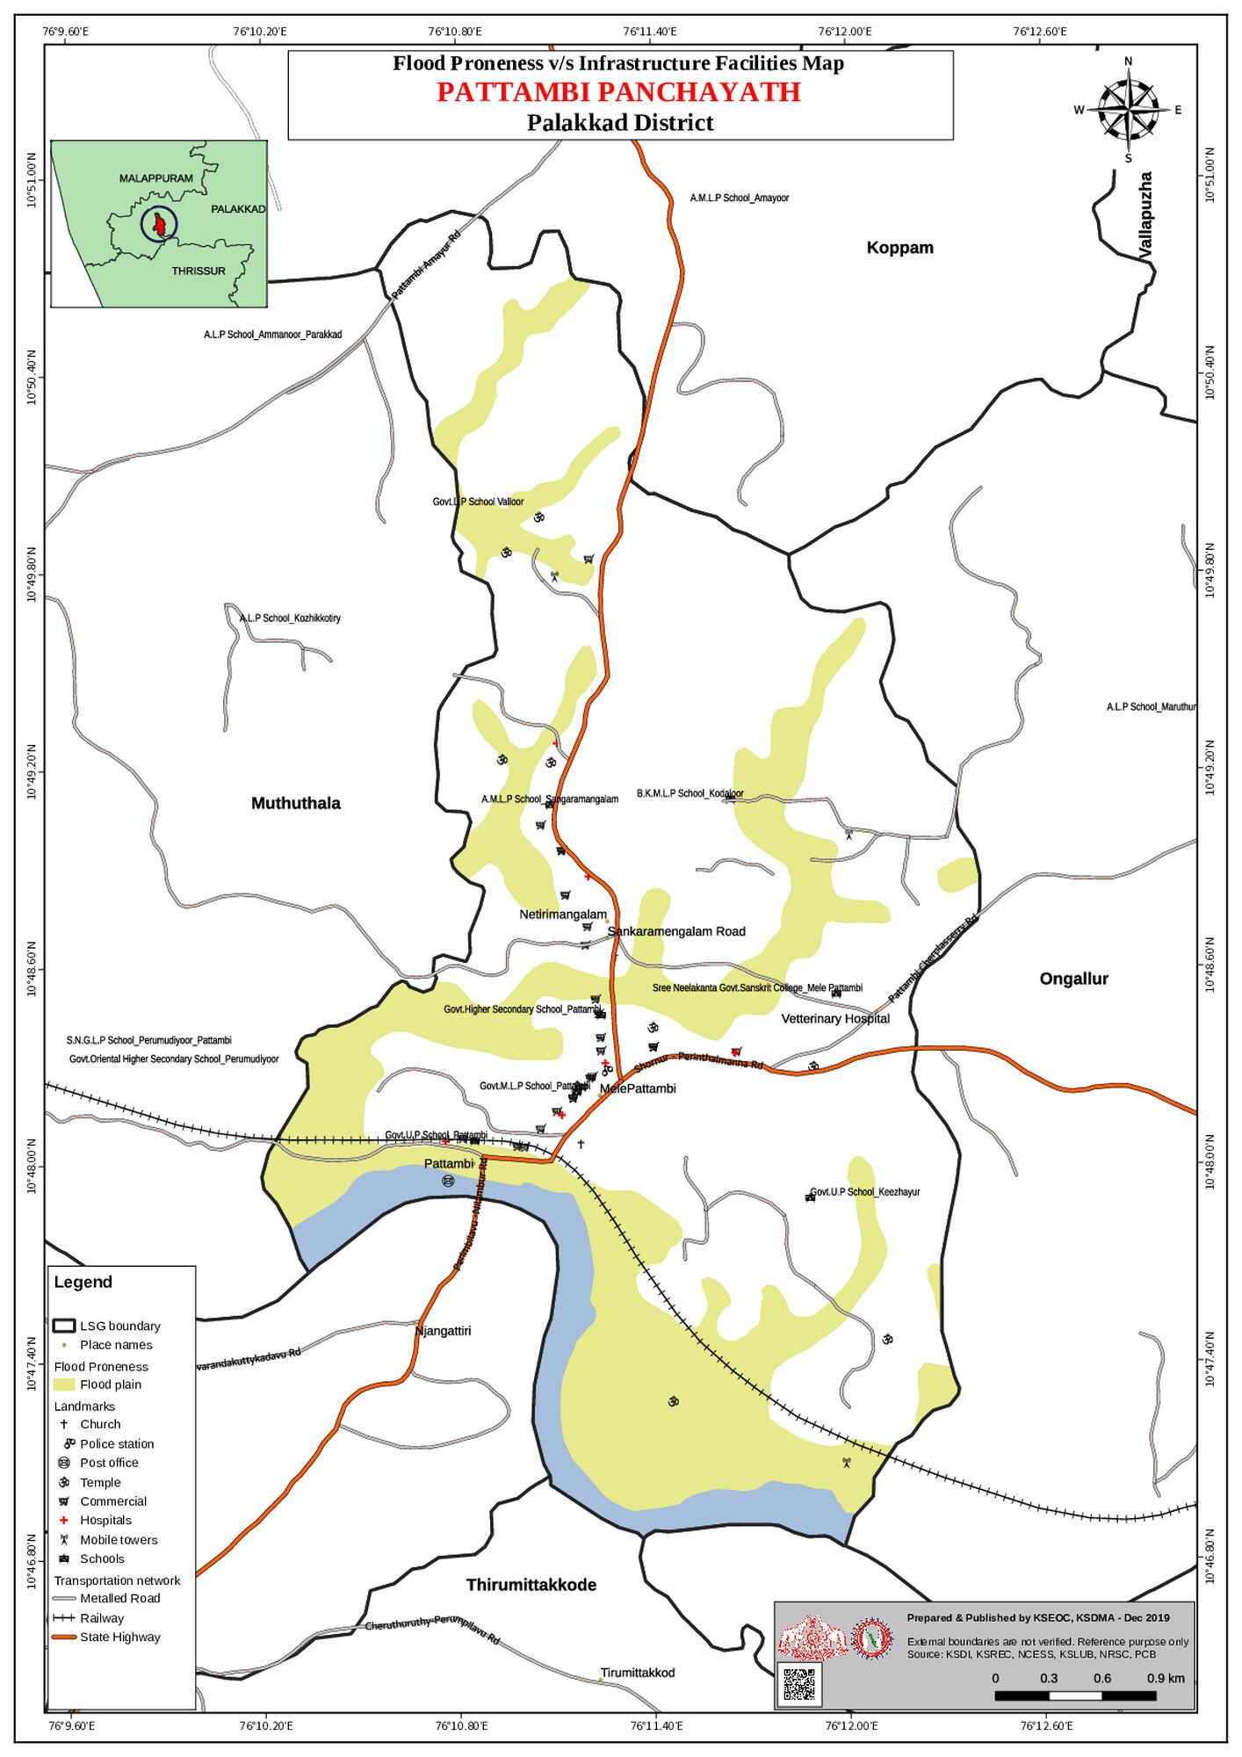

TRANSPORTATION MAP OF PATTAMBI MUNICIPALITY
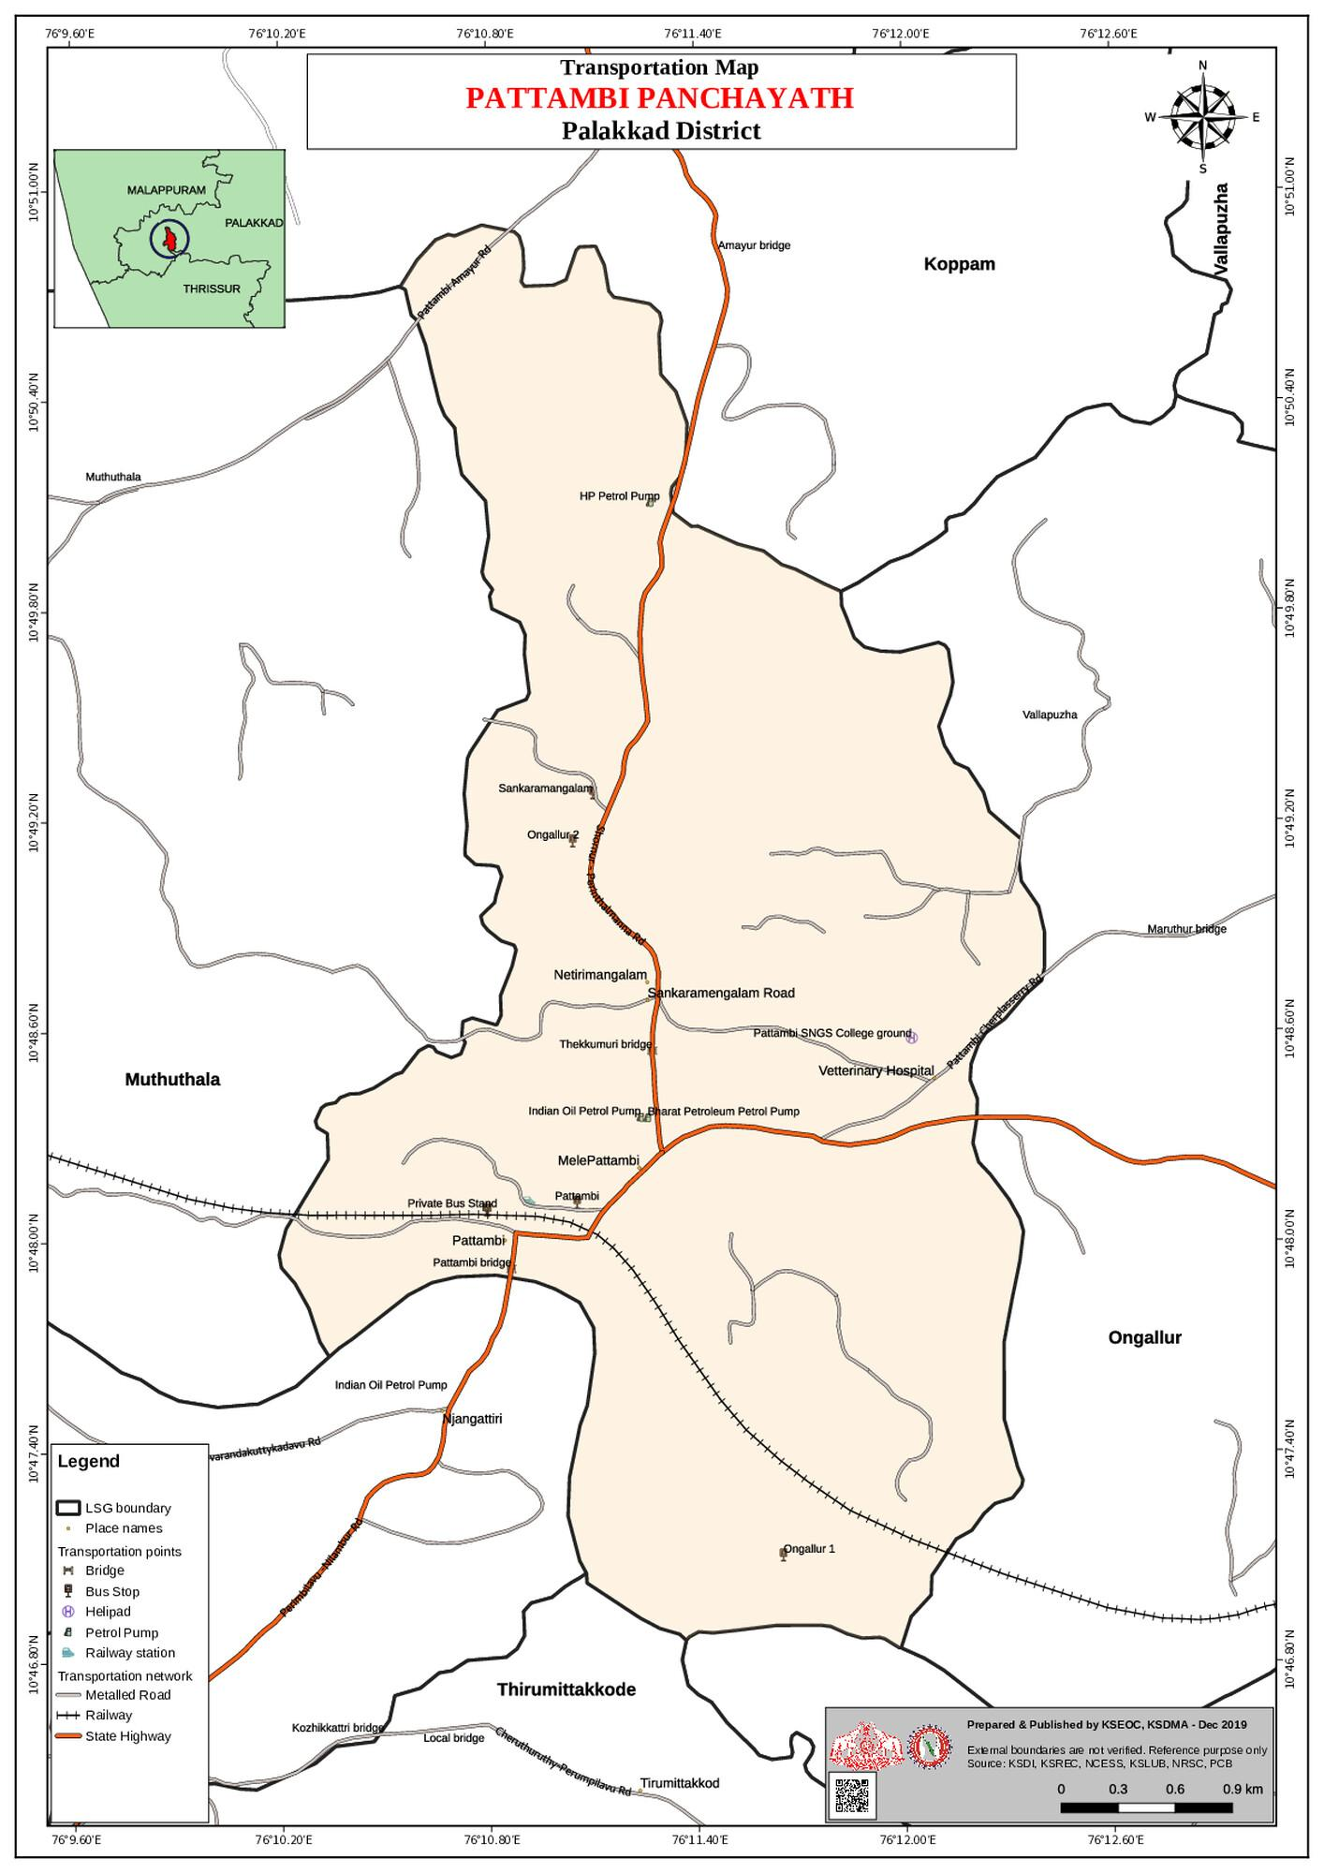

LAND USE MAP(As of 2000) OF PATTAMBI MUNICIPALITY

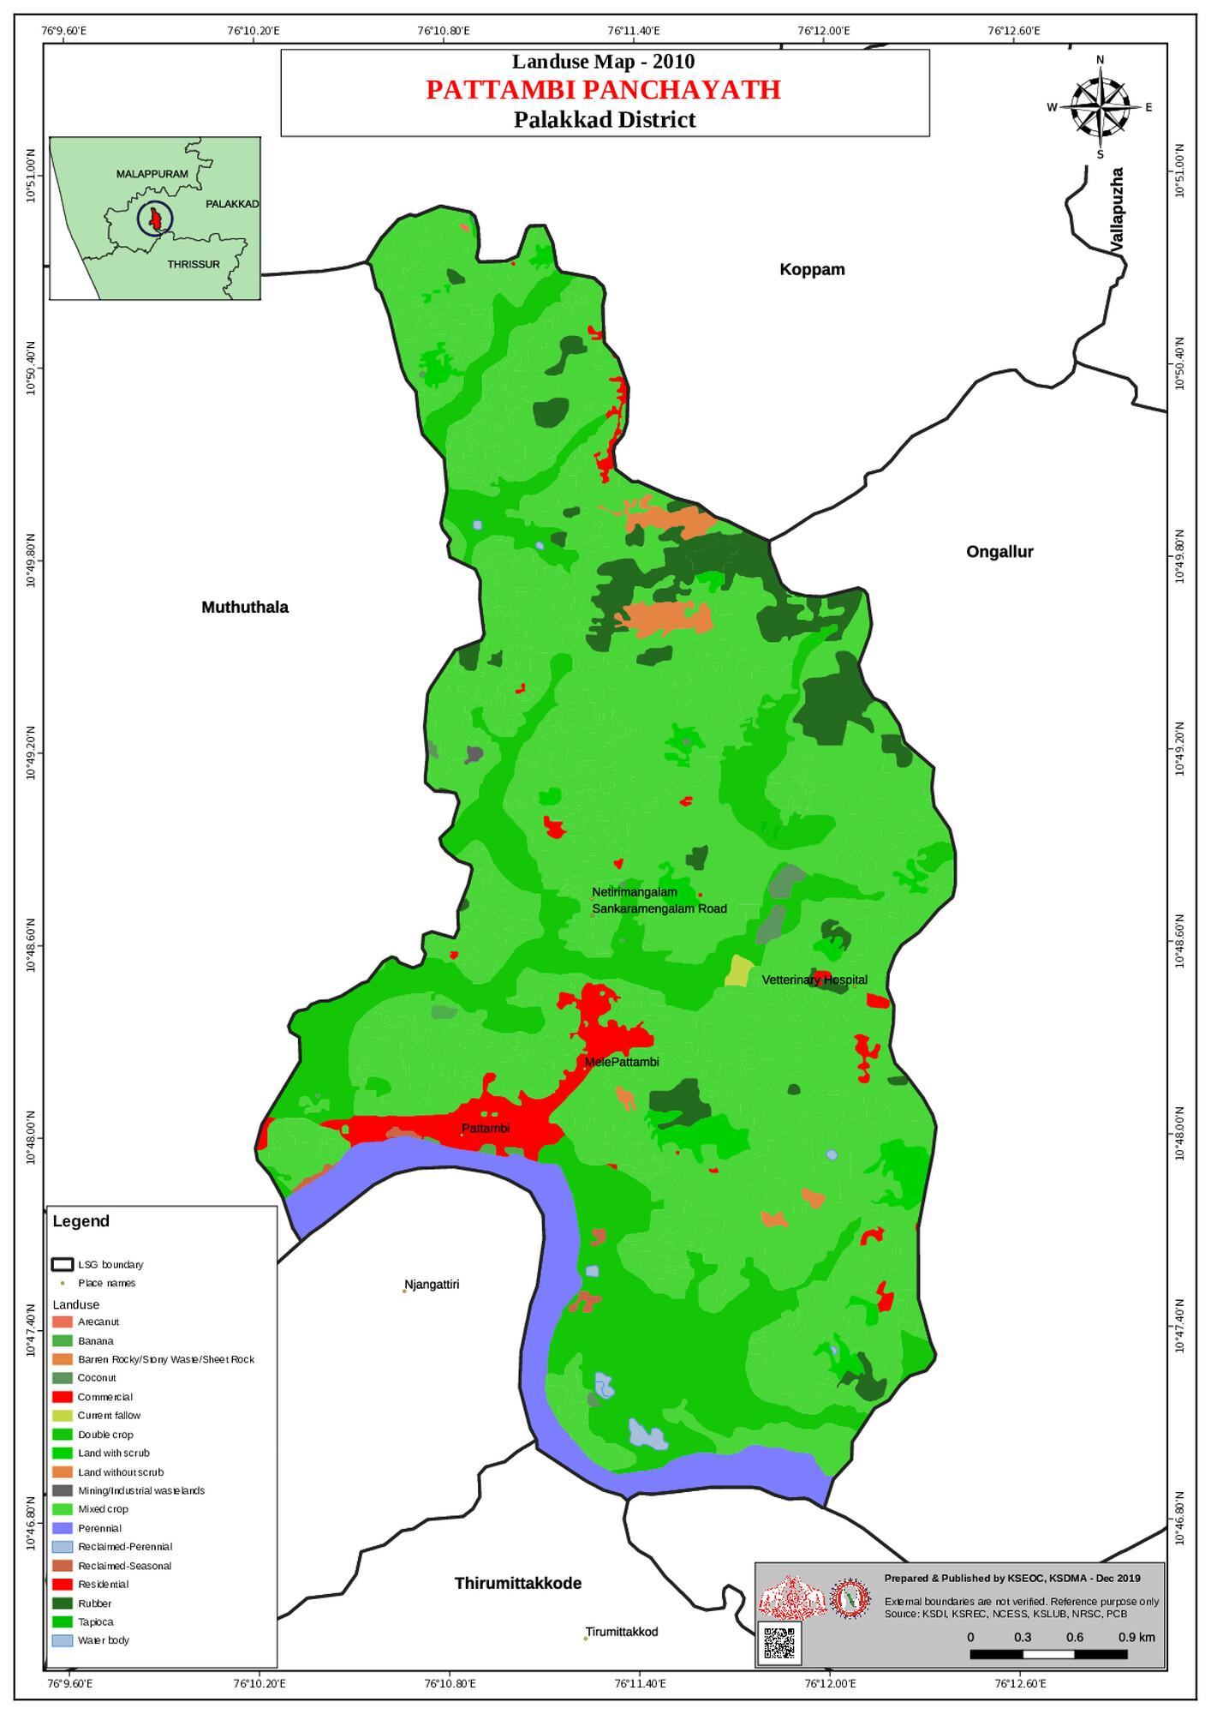

SOIL TYPE MAP(As of 2000) OF PATTAMBI MUNICIPALITY
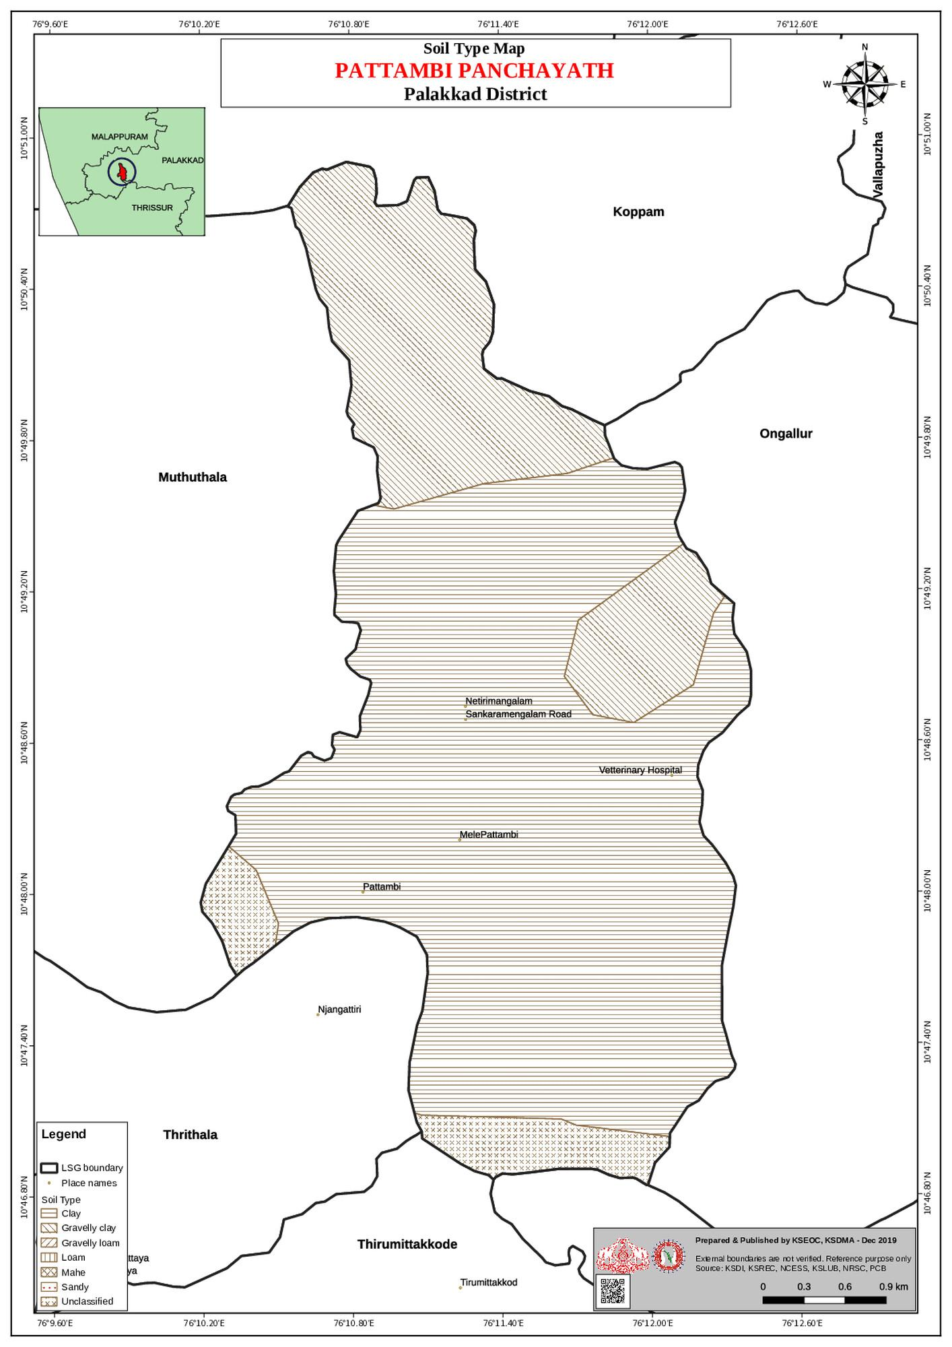

Maps - ward-based (Source: https://dmp.kila.ac.in/)

- Geographical boundaries - ward boundaries map
- Health infrastructure map
- roads and rivers map
- major establishments map
- disaster-prone areas map
- hotspot map - CD & disasters

INTEGRATED HEALTH INFRASTRUCTURE MAP OF PATTAMBI MUNICIPALITY
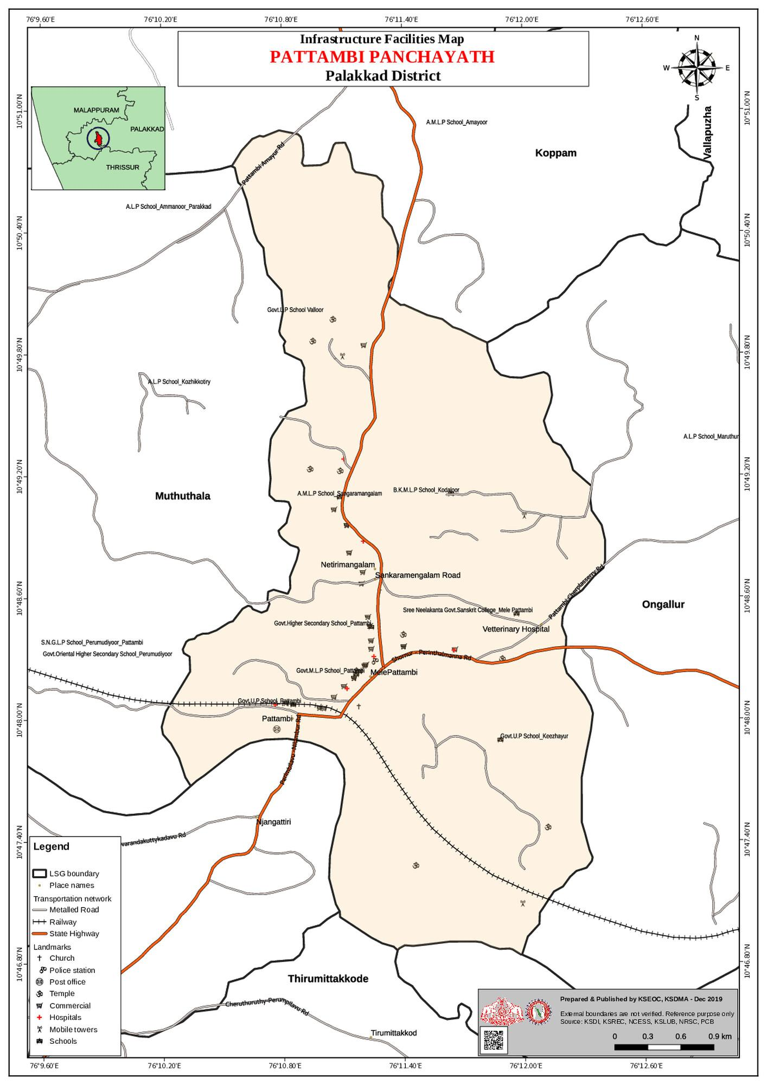

LANDSLIDE PRONENESS V/S COMMUNICATION MAP OF PATTAMBI MUNICIPALITY
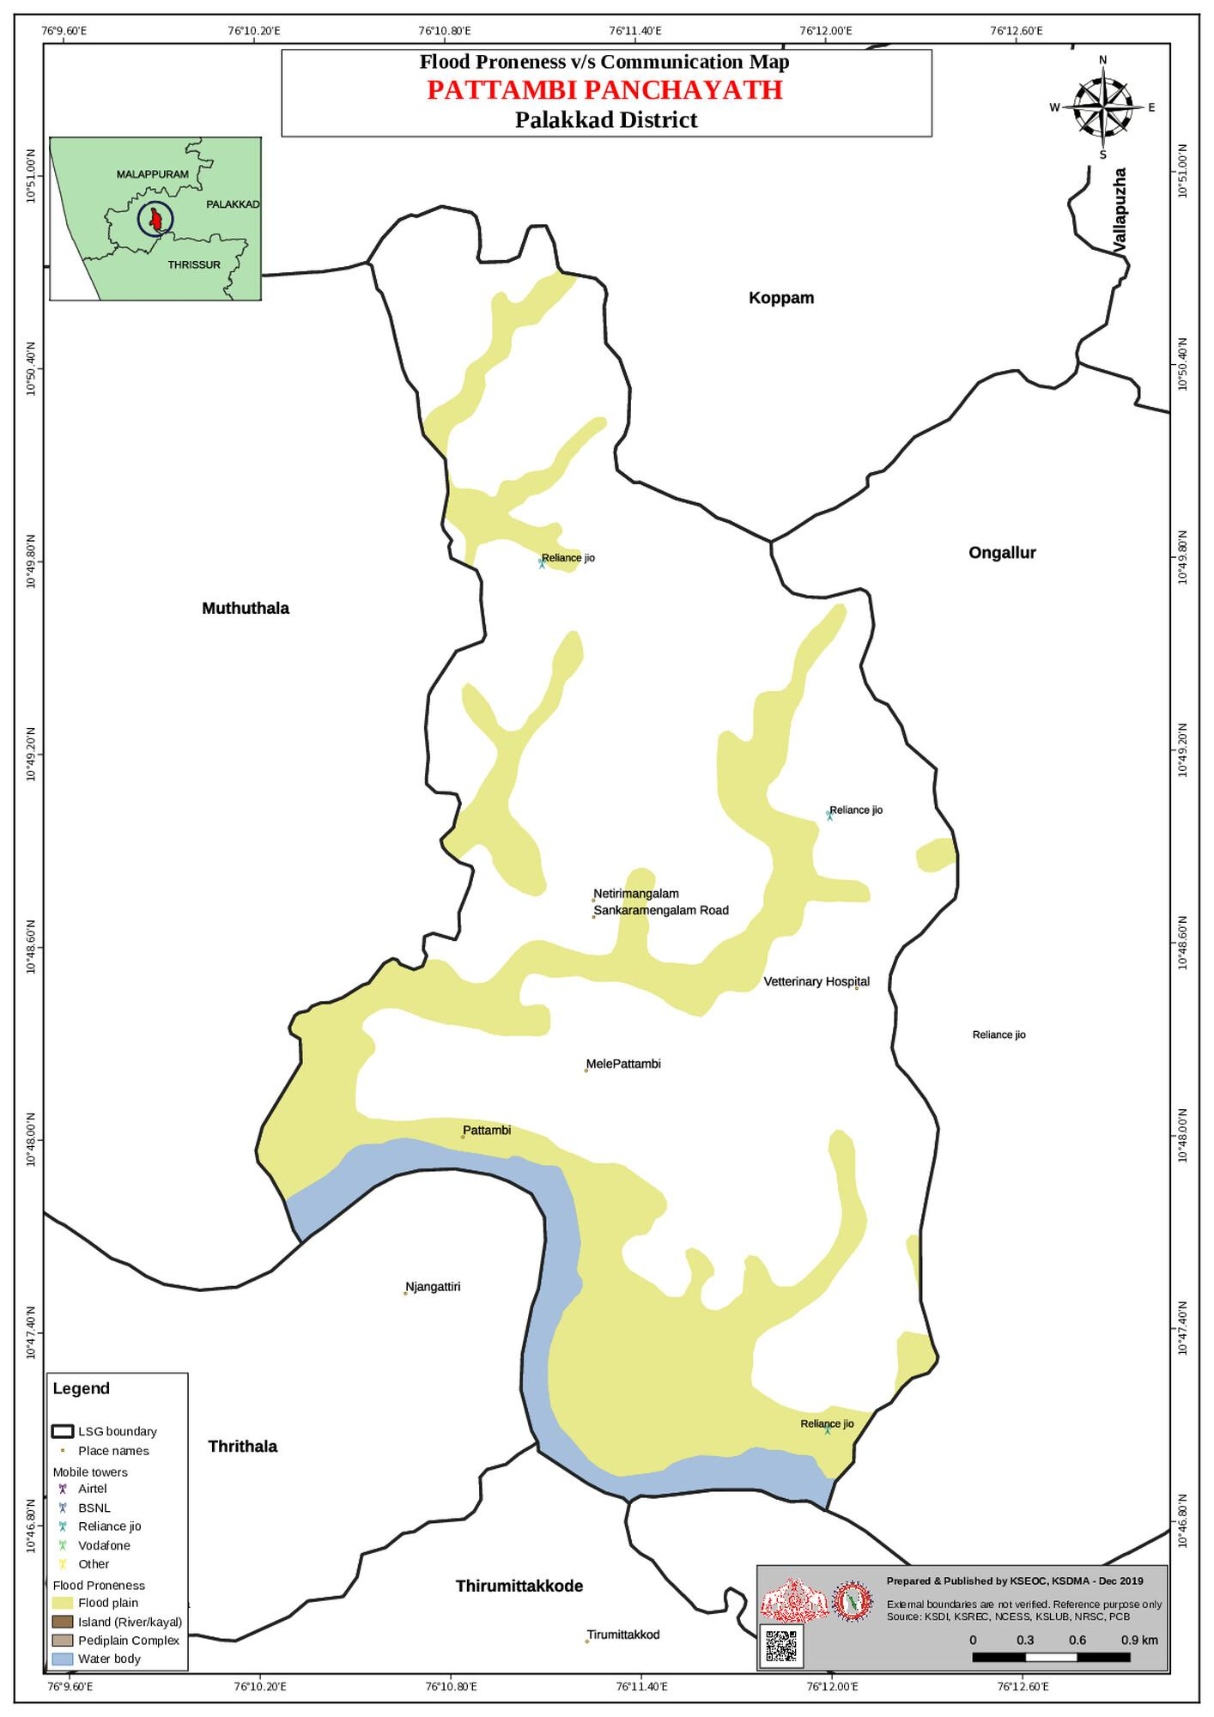

GENERAL PROFILE OF THE LSGI’S

Background of the LSGI
Pattambi Municipality is situated in the Palakkad district, Kerala. The geographical landscape of the Panchayat is predominantly low-lying, characterized by extensive paddy fields (Kole lands) and a dense network of rivers, canals, and backwaters. This unique terrain plays a significant role in shaping the local microclimate and poses distinct challenges to transportation, emergency response, and service delivery, particularly during monsoon seasons and flood events.
The Panchayat is administratively divided into multiple wards, with a population largely dependent on traditional livelihoods. Agriculture—especially paddy cultivation—fishing, coir and coconut husk processing, and allied activities form the backbone of the local economy. In recent years, tourism-related activities and service-sector employment have also shown gradual growth. The area hosts a diverse workforce, including a notable presence of migrant labourers, particularly in construction, agriculture, and allied sectors.
From a public health and disaster management perspective, Pattambi Muncipality has historically been vulnerable to seasonal flooding, waterborne diseases, and vector-borne illnesses such as Dengue and Leptospirosis. The severe floods experienced during recent years, including the 2018 flood disaster, significantly impacted life, livelihoods, and infrastructure within the Panchayat. These recurring emergencies have underscored the importance of strengthening local preparedness, response mechanisms, and inter-departmental coordination.
In this context, the development of a localized, data-driven Auxiliary Infrastructure and Logistical Resource Map is essential to support effective planning, timely emergency response, and sustainable development initiatives. Such mapping enables the Panchayat to identify critical resources, improve accessibility during disasters, and enhance overall resilience of the community.

Table 1: Background of LSGD
Description | Details
Name of LSGI | Pattambi
Type (GP/Municipality / Corporation etc.) | Municipality
Block | Pattambi
District | Palakkad
Number of wards | 29
Total area (sq. km) | 15.84
Population(Projected) | 35019
Population density | 980 Persons/sq km
Terrain (coastal/low-lying/backwaters/foothills, etc.) | Midland termix of rolling hills and plains- influenced by the Bharathappuzha River (Nila), with low-lying areas located along the riverbank
Number of rivers passing through LSGI | 1
Number of water bodies in the LSGI | NA
Number of educational institutions | 21
Factories / small-scale industries | 15
Flood-prone wards | 13,19,24,20,25,26
Landslide-prone wards | Nil
Death Management and Disposal Facilities (mortuaries/crematorium, including electric/ Burial grounds) | NA
Auditoriums/Marriage halls/convention centres/community halls | 5

Demographic and Vulnerable Population
Understanding the demographic composition and vulnerable population groups is essential for pandemic preparedness. Children, elderly, economically deprived families, migrant workers, and socially vulnerable groups are at increased risk during public health emergencies due to higher exposure, limited access to services, and dependency on public systems..

Description |  | Details (in numbers)
DEMOGRAPHIC PROFILE
Total population |  | 35907
Male |  | 17859
Female |  | 18048
Transgender |  | NA
Children under 5 |  | 2492
Adolescent |  | 2553
Elderly (>60) |  | 3625
SOCIAL/LIVELIHOOD VULNERABILITY
Previous EPEP family |  | 64
BPL family |  | 3159
Tribal communities |  | 0
Migration | Immigrant | 914
Migration | Emigrant | 228
Socio-economically deprived |  | NA
Fisherfolk |  | 0
SC Community |  | 3099
ST Community |  | 0

Graphs: Population pyramid (if possible) for seeing if your LSGI has a high "dependency ratio" (lots of children and elderly compared to working adults).

Clinical Vulnerability
Certain population groups needs priority healthcare & are at higher risk of severe illness, complications, and mortality during pandemics. Patients with chronic diseases, those requiring regular medical care, and individuals with mobility or functional limitations face challenges in accessing timely care during emergencies. Mapping these groups helps in prioritizing continuity of treatment, medicine stock planning, oxygen support, referral transport, and targeted home-based care.
Description | Details in numbers
Pregnant women | 317
Lactating mothers | 951
Bedbound patients | 48
Patients under palliative care other than bedbound | 85
Patients on Haemodialysis | 18
Patients on CAPD | 23
Cancer patients (currently on treatment) | 32
Haemophilic patients | 2
Mentally challenged | 11
Differently abled | 169
Diabetic patients | 2228
Hypertensive patients | 2456
TB patients | 9

Major Festivals & Events specific to the LSGI
(with the possibility of a public gathering)

Sl. No. | Name of festival | Month detailing the periodicity
1 | Pattambi Nercha | March
2 | Panthakkal Pooram | March

INFRASTRUCTURE & RESOURCE INVENTORY

Health Facility Directory & Basic Capacity in the LSGD
This section provides an overview of the healthcare infrastructure available within the LSGD area. It outlines the distribution and basic capacity of health facilities that form the backbone of service delivery during routine times and public health emergencies.

Family Health Centres (FHCs) and Community Health Centres (CHCs) generally function as the first point of contact for the community, providing essential outpatient and inpatient services. General Hospitals (GH) and Medical College Hospitals (MCH), where accessible, serve as the main referral centres for advanced diagnostics, specialist care, and critical services during public health emergencies. This inventory helps identify existing strengths, gaps, and potential surge capacity that can be mobilised during a pandemic or disaster.

Table 5. Health Facility Resource Summary
Sl.no. | Health Facility | Type of Facility (MCH/GH/CHC/FHC/SC etc.) | Contact Number | Total beds | ICU Beds | Oxygen-Supported Beds | No. of Ventilator Support Beds | No. of ambulances
Government Healthcare Facilities
1 | THQH pattambi | THQH | 8943310060  8113913553 | 76 |  | 68 |  | 1
2 | S/C PANTHAKAPARAMBIL | SC | 9495888190 | 1 | 0 | 0 | 0 | 0
3 | KEEZHAYOOR | SC | 9847680104 | 1 | 0 | 0 | 0 | 0
4 | SANKARAMANGALAM | SC | 8921501301 | 1 | 0 | 0 | 0 | 0
5 | KODALOOR | SC | 6238559358 | 1 | 0 | 0 | 0 | 0
6 | NILA HOSPITAL | HOSPITAL | 9645922565 | 97 | 16 | 46 | 4 | 2
AYUSH Healthcare Facilities
1 | AYURVEDA HOSPITAL | GOVT | 9427385645 | 0 | 0 | 0 | 0 | 0
2 | HOMEO HOSPITAL | GOVT | 9651284523 | 0 | 0 | 0 | 0 | 0
3 | Amiya Ayurveda Hospital | Private | Dr Vinod  9446239252 | 0 | 0 | 0 | 0 | 0
4 | SHAFI AYURVEDA NURSING HOME | PRIVATE | SHAFI  8086856065

Private Clinics
Private clinics are an essential part of pandemic preparedness, as they are often the first place people seek care when symptoms begin. In many communities, private clinics manage a significant share of outpatient visits and therefore play a critical role in early case detection, timely referrals, and disease surveillance. Having an up-to-date understanding of where these clinics are located, the services they provide, and how they are linked to the public health system helps ensure that no cases are missed during an outbreak. It also allows health authorities to engage private practitioners more effectively for reporting, risk communication, and coordinated response, strengthening the overall capacity of the health system to manage public health emergencies.

Table 6. Private Clinic Resource Summary
Sl No. | Name of Clinic | Registered (Y/N) | Clinic (General / Speciality) | Speciality (if any) | Address | Contact Number | Diagnostic Facility (Y/N) | Ambulance Linkage (Y/N)
1 | ZAYAN HEALTH CARE | Y | Speciality | Child clinic | MELE, Pattambi -  ward 12 Cherpulassery Rd, Pattambi, Kerala 679306 | 9544663366  8943931310 | y | Y
2 | BABU MEDICAL CLINIC | Y | General |  | Pattambi | 9946946842 | Y | Y
3 | SHAFI AYURVEDA HOSPITAL | Y | General |  | Pattambi | 8086856065 | Y | Y
4 | SM DENTAL CARE | Y | Dental speciality |  | Pattambi | 9846993844 | N | Y
5 | SUNIL DENTAL CLINIC | Y | Dental speciality |  | Pattambi | 9446551719 | N | Y
6 | SM DENTAL CARE | Y | Dental speciality |  | Pattambi | 9846993844 | N | Y
7 | PEOPLE’S HOMEOPATHY CLINIC | Y | Homeo |  | Old Court Road, Kizhayur Rd, Pattambi, Kerala 679303 | Dr Nivedh 9496058005 | N | Y
8 | Pattambi Cosmic Clinic Pvt Ltd | Y |  |  | Said Haji Nagar, 20/386, near railway overbridge, Pattambi, Kerala 679303 | 8111820959 | N | Y
9 | Dr.Nablas Dental Speciality Centre | Y | Dental speciality |  | Pallipuram - Pattambi Rd, Pattambi, Kerala 679303 | Dr Nabla  9961176777 | N | Y
10 | Dr.Manoj's Dental Clinic | Y | Dental speciality |  | Guruvayoor road, Pattambi, Kerala 679303 | Dr Manoj  9496436818 | N | Y
11 | Dev Ayurcare | Y |  |  |  | PRASEENA  9746908347
12 | SUGHAM WELLNESS | Y |  |  |  | SUJA  9037205743
13 | PISHIL HOMEO | Y |  |  | WARD-20 | Dr NIVED  9496058005
14 | SMILE DENTAL CARE | Y |  |  |  | 8590815312

Healthcare Education & Training Institutions
This section tracks the educational infrastructure available, which is vital for human resource planning in the health sector.

Category of Institution | Govt | Private | AYUSH | Total
Medical Colleges | 0
Nursing Colleges | 0
Dental Colleges | 0
Para-medical / Allied Health | 0
Pharmacy Colleges | 0

Specialized Services & Emergency Inventory
This section provides a detailed view of the specialized medical resources available to the community, focusing on emergency response and critical care capabilities. This table tracks the vital assets required for managing severe illnesses and emergencies across Government, Private, and AYUSH sectors.

Item | Govt | Private | AYUSH | Total
Hospital beds | 80 | 97 | 23 | 200
Oxygen-generating systems(Y/N) | Nil | Nil | Nil | Nil
Oxygen-supported beds(Numbers) | 68 | 46 | N | 80
Ventilator-supported beds | 0 | 4 | 0 | 4
ICU beds | 0 | 0 | 0 | 0
Burns units | 0 | 0 | 0 | 0
Blood centres | 0 | 0 | 0 | 0
BLS ambulances | 1 | 1 | 0 | 2
ALS ambulances | 0 | 0 | 0 | 0
Dialysis facilities | 1 | 0 | 0 | 1
Dispensaries | 2 | 2 | 0 | 0
Medical store | 1 | 22 | 2 | 25
Industrial establishments(Medium-scale industries/small-scale industries establishments to whom we can depend in a worst-case scenario) | 0 | 15 | 0 | 15

Oxygen & Diagnostic Capacity
Monitoring oxygen and diagnostic capacity is a critical component of public health preparedness, ensuring that the LSGD can handle both chronic care and sudden surges in respiratory or infectious diseases.
Name of Health Facility | Oxygen-generating System (Y/N) | Backup Oxygen Source (Y/N) | Diagnostic Facilities Available(Y/N)
Name of Health Facility | Oxygen-generating System (Y/N) | Backup Oxygen Source (Y/N) | Lab | USG | X-ray | CT/MRI | RT-PCR
Government Healthcare Facilities

TQHQ Pattambi | N | N | Y | Y | Y | Y | Y

Diagnostics facility mapping at the LSGI level
The diagnostic capacity of Pattambi Municipality represents the "intelligence network" of our healthcare system. The speed and accuracy of disease identification depend entirely on the distribution and technical level of these facilities.

Item | Govt | Private | AYUSH | Total
General labs | 1 | 7 | 0 | 8
Microbiology labs | 1 | 7 | 0 | 8
RT-PCR labs | 1 | 2 | 0 | 3
USG units | 1 | 2 | 0 | 3
CT/MRI units | 1 | 2 | 0 | 3
Research labs | 0 | 0 | 0 | 0
Labs of other departments that can be repurposed | 0 | 0 | 0 | 0

Laboratory Identification & Basic Details
Sl. No. | Name of Laboratory | Ownership (Govt / Private / Academic) | Address | Contact No. | 24×7 Services (Yes/No) | NABL / Govt Approved (Yes/No)
1 | KARUNYA | PRIVATE | PATTAMBI | 9895681470
2 | METRO | PRIVATE | PATTAMBI | 04957143005
3 | SREECHITHRA | PRIVATE | PATTAMBI | 9846532318 |  | YES
4 | SUDHARMA | PRIVATE | PATTAMBI | 7356882287 |  | YES
5 | ASTER | PRIVATE | PATTAMBI | 9895612455
6 | NEETHI | PRIVATE | WARD 23, PATTAMBI | 9895446961 |  | YES
7 | MEDLIFE | PRIVATE | WARD 23, PATTAMBI | 9946832738
8 | SHASTHA LAB | PRIVATE | WARD 23, PATTAMBI | 9809077914 | 10 | SHASTHA LAB
9 | SREELAKSHMI LAB | PRIVATE | WARD 23, PATTAMBI | 9946242323 | 11 | SREELAKSHMI LAB
10 | DOCTOR’S MEDICS LAB | PRIVATE | WARD 23, PATTAMBI | 9539999109 | 12 | DOCTOR’S MEDICS LAB

Social and Community Infrastructure for surge plan
This table serves as our logistics and shelter inventory. By mapping these locations, quickly we can identify where to house displaced citizens, where to set up temporary medical clinics, and how to manage the deceased with dignity during a crisis.

Colleges | 12
Category | Total Count | Ward | Est. Capacity (Persons) | Contact details
Educational Institutions
Anganwadis | 22
Schools | 13 |  | 500
Healthcare Educational Institutions
Medical colleges (Govt/Private) | 0 | 0 | 0 | 0
Nursing colleges (Govt/Private) | 0 | 0 | 0
Dental colleges (Govt/Private) | 0 | 0 | 0 | 0
Paramedical institutes (Govt/Private) | 0 | 0 | 0 | 0
Community Gathering Spaces
Community halls | 4 | 0 | 0 | 4
Auditoriums | 4 | 18,19,21 | 280 | 4
Religious buildings | 96
Vulnerable Group Support Facility
Destitute homes | 0 | 0 | 0 | 0
Elderly homes | 0 | 0 | 0 | 0
LSGD owned other buildings | 16
Mass Fatality Management (MFM) Infrastructure
Mortuary | 1
Crematorium | 1
*refer annexure 1 for contact details

Human resources
This section focuses on the human capital available within the LSGI. In any emergency—be it a pandemic, flood, or industrial accident—infrastructure is only as effective as the people operating it.

Medical & Clinical Personnel
This table tracks the "Frontline" providers responsible for diagnosis, treatment, and clinical management. Narrative sentence: eg., "Total health workforce: 450 personnel, with 60% in government facilities serving as primary surge capacity." A detailed directory with the contact numbers of all workers is maintained (Annexure in 1).

Cadre | Govt (No.) | Private (No.) | Total
Doctors—Modern Medicine | 9 | 35 | 44
Doctors – AYUSH | 2 | 12 | 14
Doctors – Veterinary | 1 | 3 | 4
Doctors – Dental | 0 | 12 | 12
Nursing officers | 19 | 15 | 27
Lab technicians | 2 | 24 | 26
Optometrist | 0 | 5 | 5
Pharmacists | 3 | 22 | 22
Psychologists | 0 | 5 | 5
Counsellors | 0 | 2 | 2

Public Health & Field-Level Workforce
These individuals are the backbone of surveillance, maternal-child health, and decentralized care.

Cadre | Health services | Municipal common services | Total
HS (Health Supervisors) | 0 | 1 | 1
HI (Health Inspectors) | 0 | 1 | 1
LHS (Lady Health Supervisor) | 0 | 0 | 0
LHI (Lady Health Inspectors) | 0 | 0 | 0
JPHN (Jr Public Health Nurses) | 4 | 1 | 5
JHI (Jr Health Inspectors) | 2 | 3 | 5
MLSP (Mid-Level Service Providers) | 3 | 0 | 2
Palliative Nurses | 1 | 0 | 1
RBSK Nurses | 1 | 0 | 1
PRO | 1 | 0 | 1
Epidemiologist | 1 | 0 | 0
Data Manager | 0 | 1 | 1

Community & Support Cadre
This group represents the surge capacity of the LSGI—people who can be called upon for logistics, rescue, and specialized support.

Cadre | Number
ASHA Workers | 28
AWW (Anganwadi Workers) | 22
Emergency Medical Volunteers (Trained) | 207
Kudumbashree | 272
MNREGA | 374
Purusha Swayam Sahaya Sangham | 0
Ex-Servicemen | 84
Retired Police Officers | 22
NCC/NSS Volunteers | 145
Red Cross volunteers | 0
One Health Community Volunteers | 0
One Health Community Mentors | 0

Community Organizations
This section details the presence of community-based organisations (CBOs), non-governmental organisations (NGOs), faith-based organisations (FBOs), Kudumbashree Self-Help Groups (SHGs), and Ayalkootams within the Local Self-Government Institution (LSGI). These groups enhance grassroots mobilization, resource distribution, and support networks crucial for pandemic response and community resilience.

Category | Total Count
NGOs | 10
Religious based organizations | 4
Foreign based organizations | 2
Sports Club/youth clubs | 14
Kudumbashree SHGs | 12
Ayalkootams | 165
Political organizations | 3
Residential organizations | 8

Administrative & Emergency Services
This section outlines the availability of key non-health emergency support services and infrastructure within the LSGI, which are essential for effective pandemic preparedness and response. These facilities support law enforcement, disaster response, water supply, logistics, mobility, and community-level interventions during public health emergencies.

Category | Total Count | Contact details
Police Stations | 1 | 04662212224
Fire & Rescue Stations | 1 | 04662955101
Water Pumping Points | 7 | 04712738300
Public Distribution System (PDS) | 24 | 9188527761

Information regarding resources
The availability of essential transport and support resources plays a quiet but critical role in saving lives. Equipment such as ambulances, mobile mortuaries, amphibian ambulances, and motorized boats ensures that patients, samples, and healthcare teams can move swiftly—even in flooded, remote, or difficult terrains. Heavy vehicles like JCBs, cranes, tractors, and torus lorries support logistics, waste management, emergency infrastructure, and rapid conversion of spaces into care or isolation facilities. Taxis, four-wheel-drive vehicles, and trucks help maintain continuity of essential services, reach vulnerable populations, and support home-based care and supply delivery.

Means of transportation | Total Count
JCB | 22
Crane | 4
Heavy Trucks | 3
Tractor | 47
Ambulances | 8
Mobile mortuaries | 0
Boats | 0
Taxi service | 35
Note: For specific details regarding vehicle owners and contact information, please refer to Annexure [X].

ONE HEALTH & ENVIRONMENTAL SURVEILLANCE
The One Health method integrates environmental, animal, and human health to enable proactive pandemic preparedness. Panchayat-level surveillance needs to be improved in order to detect and treat zoonotic and environmentally generated diseases early. Surveillance is strengthened through systematic assessment of animal populations, veterinary infrastructure, poultry and slaughter facilities, inter-sectoral coordination, and specialised tools like avian influenza seasonality mapping using GIS in previous outbreaks to enable predictive alerts and ward-specific sampling to support effective pandemic preparedness in high-risk areas like NIL.

Animal & Bird Population
Mapping animal and bird populations at the Panchayat level is essential for identifying and prioritising zoonotic disease hazards like rabies, avian influenza (H5N1), leptospirosis, anthrax, and Nipah-like spillover occurrences. Risk classification, targeted surveillance, vaccination planning, and early epidemic detection made feasible by comprehensive population mapping all enhance One Health-based pandemic preparedness.

Category | Item | Estimated Population | Wards
Animal Population | Livestock (Cattle/Goats/Buffalo) | 560 | 1 TO 29
Animal Population | Pet Animals (Dogs/Cats) | 627 | 1 TO 29
Animal Population | Stray Dog Population | 257 | 1 TO 29
Animal Population | Pig Farms (Number of heads) | 0 | 0
 | Small Units (Sheep / Goats – clustered) | 289 | 1 TO 29
Bird Population | Poultry Units (Birds) | 20 | 1 TO 29
Bird Population | Poultry- (FOWL) | 0 | 0
Bird Population | Wild/Migratory Birds (Observed) | 4 | 19,25,28,25
Bird Population | Crow Mortality Events (Reported) | 0 | 0

The main risk of zoonotic diseases is concentrated in Ward NIL, which is explained by the high density of pig farms, cattle congregation areas, and poultry units. The stray dog population in market areas, fish landing sites, bus stations continues to be a substantial problem for rabies surveillance and bite prevention. There is a considerable risk of avian influenza introduction and amplification during November - December due to the seasonal presence of migratory and resident water birds near ponds/ canal / river / backwater / paddy field. Clusters of pig farms and animal shelters vulnerable to flooding further raise the risk of leptospirosis and other zoonoses mediated by the environment, especially during monsoon floods.

Veterinary Infrastructure
Veterinary institutions are a core pillar of One Health surveillance, enabling early zoonotic disease detection through vaccination, investigation of unusual animal illness or deaths, sample collection, and timely outbreak reporting. A well-mapped and responsive veterinary network strengthens coordination with human health and LSGI systems, ensuring rapid response during zoonotic events and pandemics.
Facility Type | Name of Facility | Ownership Govt / Pvt | Location(Ward No) | Contact number
Veterinary Dispensary | 1 | Govt | Sankaramangalam | 9447945327
Veterinary Hospital / Polyclinic | 0 | 0 | 0 | 0
Private Veterinary Clinics | 0 | 0 | 0 | 0
Mobile / Emergency Vet Service (incl. night services) | 0 | 0 | 0 | 0
Pet Homes / Animal Shelters | 0 | 0 | 0 | 0
Slaughterhouse-linked Veterinary Inspection Unit | 0 | 0 | 0 | 0

Veterinary Doctors & Workforce
Early detection, diagnosis, reporting, and reaction to animal illness epidemics depend on the availability and accessibility of qualified veterinary specialists. By identifying unusual animal morbidity or mortality promptly, collecting samples promptly, and coordinating efficiently with human health and LSGI systems—especially during zoonotic outbreaks and pandemic-prone situations—a clearly defined veterinary workforce enhances One Health surveillance.

Category | Number Available | Type (Govt/Pvt) | Contact number
Government Veterinary Doctors | 1 | GOVT | 9447945327
Private Veterinary Doctors | 0 | 0 | 0
Livestock Inspectors | 2 | GOVT | –
Para-veterinary Staff / Attenders | 0 | 0 | 0
Contract / On-call Veterinary Support (if any) | 0 | 0 | 0

High-Risk Interface Points (Surveillance Sites)
High-risk interface points for zoonotic disease surveillance include wetland–livestock–human contact zones, backyard poultry farms, cattle sheds near water bodies, fish markets, and areas of high human–animal interaction such as community slaughter points and migratory bird congregation sites. These are the primary surveillance sites where zoonotic spillover risks are elevated.

Type of Habitat | Type of High risk interface | Geographical vulnerability
Wetlands & Backwaters | 1 | 19
Backyard Poultry Farms | 623 | 1 TO 29
Cattle Sheds near Water Bodies | 0 | 0
Fish & Meat Markets | 1 | 24
Community Slaughter Sites | 0 | 0
Migratory Bird Congregation Areas | 4 | 19,25,24,28
Rodent-Infested Grain Storage | 0 | 0

Category | Total Count | Key Locations (wards)
Poultry Farms | 20 | PATTAMBI 1 TO 29 WARD
Backyard / Clustered Poultry Units | 623 | 1 TO 29
Duck Rearing Units (open water access) | 0 | 0
Slaughterhouses/ Slaughter Points | 0 | 0
Meat/Fish Markets | 1 | 24
Live Bird Sale Points | 12 | 1 TO 29
Cattle Markets / Weekly Animal Fairs | 0 | 0
Pet Shops / Breeders | 6 | 1 TO 29
Animal Shelters / Pet Homes | 0 | 0
Waste Disposal Sites near Animal Units | 0 | 0

Environmental Risk Mapping
Environmental risk mapping identifies monsoon/flood hotspots for vector-borne (dengue, chikungunya), water-borne (leptospirosis, diarrhoea), and zoonotic diseases in Kerala's wetlands. Systematic surveillance supports early warnings, targeted interventions, and Panchayat pandemic preparedness.
Waterborne exposure: Flood-prone areas and stagnant water bodies facilitate leptospira survival, raising leptospirosis risk.

Traditional practices: Informal slaughter and fish markets lack standardized hygiene, creating spillover opportunities.

Risk Factor | High-Risk Wards | Key Locations | Risk Level (High/Med/Low)
Flood-prone areas | 19, 20 | NAMBRAM | HIGH
Water bodies/wetlands | 1 | NAMBRAM | HIGH
Solid waste accumulation | 1 | 3 | LOW
Animal waste disposal issues | 0 | 0 | 0
Rodent infestation zones | 0 | 0 | 0
Industrial effluent discharge | 0 | 0 | 0
Construction sites / abandoned buildings | 16 | PATTAMBI | LOW
Poor drainage/blocked canals | 0 | 0 | 0
Drinking water source contamination risk | 0 | 0 | 0

Disease Seasonality Mapping
1, Flooding & waterlogging → amplifies leptospirosis, malaria, diarrheal diseases.
·
2, Migratory bird influx (Nov–Feb) → avian influenza risk.

3, Mosquito breeding cycles → vector-borne disease peaks in monsoon.

4, Agricultural practices → close human–animal contact in paddy fields.

Disease | Peak Risk Season | Key Drivers | High-Risk Locations | Surveillance Focus
Avian Influenza | 0 | 0 | 0 | 0
Leptospirosis | JUNE TO NOVEMBER | RODENTS | HIGH
Dengue/Chikungunya | FEB TO OCTOBER | WATER SCARCITY AREA, PRE MONSOON INTERMITTENT RAIN | SCRAP UNITS | VECTOR SURVEILLANCE, HOSPITALS, CLINICS, SYMPTOM SURVEILLANCE
Acute Diarrheal Diseases | JANUARY TO DECEMBER | EVENTS LIKE MARRIAGES, FESTIVALS | LOW | SYMPTOM SURVEILLANCE, WATER QUALITY TESTING
Rabies | 0 | 0 | 0 | 0
Anthrax (rare) | 0 | 0 | 0 | 0

Vulnerability Mapping
Vulnerability mapping pinpoints high-risk populations, occupations, and areas exposed via environment, livelihoods, socio-economics, and poor service access. Paired with environmental/seasonality mapping, it enables risk-based surveillance, targeted actions, and optimal resource use in One Health and pandemic planning.
Vulnerability Factor | High-Risk Wards | Key Groups / Locations | Risk Level
Flood-prone households | 19 | NAMBRAM | HIGH
Wetland-adjacent communities | 0
Backyard poultry / duck rearing households | 623 | 1 TO 29 WARDS | —
Livestock-rearing households | 0
Slaughterhouse & meat market workers | 0
Fisherfolk & fish market workers | 0
Sanitation workers | 372 | PATTAMBI | —
Daily wage / migrant workers | 458 | PATTAMBI | —---
Elderly & chronically ill populations | 1 to 29 | PATTAMBI | —
Pregnant Women | 1 to 29
Children (schools, Anganwadi’s) | 2
Limited access to safe water & sanitation | 26,28,23&18

EPIDEMIOLOGICAL TRENDS (2021–2025)

Disease surveillance is the systematic collection, analysis, and interpretation of health data for planning, implementation, and evaluation of public health practice. This section presents the disease surveillance profile of the LSGI based on routine reporting systems and outbreak investigations to identify priority diseases, seasonal patterns, and emerging public health threats.

Disease Burden among human beings(Last 5 Years)
Analysis of disease-wise data for the last five years helps identify persistent public health problems, emerging diseases, and changes in disease burden. This information supports prioritisation of prevention, preparedness, and response activities at the Panchayat level.

Disease | 2021 | 2022 | 2023 | 2024 | 2025 | Trend(Increasing/Stable/Decreasing)
Dengue | 10 | 15 | 36 | 34 | 99 | Increasing
Leptospirosis | 0 | 0 | 1 | 3 | 0 | Stable
Hepatitis A | 1 | 0 | 17 | 52 | 66 | Increasing
Malaria | 0 | 0 | 0 | 2 | 0 | Stable
Scrub Typhus | 0 | 0 | 0 | 0 | 0 | Stable
Typhoid | 1 | 4 | 0 | 1 | 2 | Stable
H1N1 | 0 | 0 | 2 | 0 | 1 | Stable
H3N2 | 0 | 0 | 0 | 0 | 0 | Stable
ADD | 11 | 60 | 105 | 110 | 137 | Increasing
Mumps | 3 | 11 | 14 | 169 | 0 | Increasing
Measles | 4 | 0 | 44 | 14 | 0 | Decreasing
Hepatitis B | 0 | 0 | 0 | 0 | 1 | Increasing
Hepatitis C | 0 | 0 | 0 | 0 | 0 | Stable
Tuberculosis | 2 | 3 | 12 | 15 | 9 | Decreasing
Leprosy | 0 | 0 | 0 | 0 | 2 | Increasing
COVID-19 | 0 | 0 | 0 | 0 | 0 | Stable

*(use the above table data to create the graph/diagram)

Seasonal Trend Analysis
Seasonal analysis helps anticipate surges (e.g. dengue in monsoon, leptospirosis after floods, influenza in cooler months) and plan pre‑emptive vector control, stockpiling of IV fluids, and awareness campaigns at Panchayat level.

DENGUE
Dengue is a major seasonal vector-borne disease strongly associated with rainfall, water stagnation, and increased mosquito breeding during the monsoon period.

Peak: July–November

Dengue – Ward-wise Yearly Distribution (2021–2025)

Ward | Dengue – Ward-wise Yearly Distribution
Ward | 2021 | 2022 | 2023 | 2024 | 2025 | Total
1 | 1 | 1 | 2 | 1 | 2 | 7
2 | 1 | NA | 2 | 2 | 6 | 11
3 | NA | NA | 1 | 0 | 3 | 4
4 | 1 | NA | 2 | 2 | 9 | 14
5 | 1 | NA | 1 | 2 | 3 | 7
6 | NA | 2 | 1 | 0 | 2 | 5
7 | 1 | 1 | 3 | 2 | 1 | 8
8 | NA | 2 | 2 | 2 | 3 | 9
9 | NA | 1 | 2 | 1 |  | 4
10 | NA | 1 | 1 | 1 | 2 | 5
11 | NA | NA | 1 | 1 |  | 2
12 | NA | 1 | 4 | 1 | 2 | 8
13 | NA | NA | 1 | 2 | 2 | 5
14 | NA | NA | 2 | 3 | 26 | 31
15 | 1 | 1 | NA | 2 | 2 | 6
16 | NA | NA | 2 | NA | 6 | 8
17 | NA | NA | 1 | 2 | 2 | 5
18 | 1 | NA | NA | NA | 3 | 4
19 | 1 | 1 | 3 | 3 | 18 | 26
20 | NA | NA | NA | NA | 2 | 2
21 | NA | NA | 1 | NA | 4 | 5
22 | NA | 1 | NA | 1 | 2 | 4
23 | NA | NA | 1 | NA | 2 | 3
24 | 1 | 2 | NA | 1 | 2 | 6
25 | NA | NA | 1 | NA | NA | 1
26 | 1 | NA | NA | 2 | 3 | 6
27 | NA | NA | 1 | 1 | NA | 2
28 | NA | 1 | NA | 2 | 2 | 5
29 | NA | NA | NA | NA | NA | NA

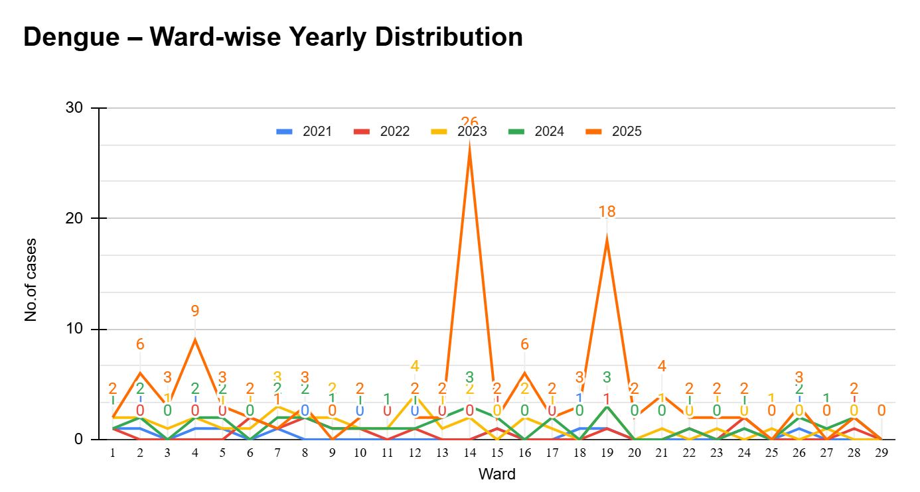

LEPTOSPIROSIS
Leptospirosis cases are closely linked to monsoon rains, flooding, and occupational exposure, particularly in low-lying and waterlogged areas.

Peak: June - August

Leptospirosis – Ward-wise Yearly Distribution (2021–2025)

Ward | Leptospirosis – Ward-wise Yearly Distribution
Ward | 2021 | 2022 | 2023 | 2024 | 2025 | Total
1 | 0 | 0 | 1 | 0 | 0 | 3
2 | 1 | 0 | 0 | 0 | 0 | 2
3 | 0 | 0 | 0 | 0 | 0 | 1
4 | 0 | 0 | 0 | 0 | 0 | 0
5 | 0 | 0 | 0 | 2 | 0 | 2
6 | 0 | 0 | 0 | 1 | 0 | 1
7 | 0 | 00 | 0 | 0 | 0 | 3
8 | 0 | 0 | 0 | 0 | 0 | 0
9 | 0 | 0 | 0 | 0 | 0 | 1
10 | 0 | 0 | 0 | 0 | 0 | 1
11 | 0 | 0 | 0 | 0 | 0 | 4
12 | 0 | 0 | 0 | 0 | 0 | 0
13 | 0 | 0 | 0 | 0 | 0 | 0
14 | 0 | 0 | 0 | 0 | 1 | 1
15 | 0 | 0 | 0 | 0 | 0 | 0
16 | 0 | 0 | 0 | 0 | 00 | 0
17 | 0 | 0 | 0 | 0 | 0 | 0
18 | 0 | 0 | 0 | 0 | 0 | 0
19 | 0 | 0 | 0 | 0 | 1 | 1
20 | 0 | 0 | 0 | 0 | 0 | 0
21 | 0 | 0 | 0 | 0 | 0 | 0
22 | 0 | 0 | 0 | 0 | 0 | 0
23 | 0 | 0 | 0 | 0 | 0 | 0
24 | 0 | 0 | 0 | 0 | 0 | 0
25 | 0 | 0 | 0 | 0 | 0 | 0
26 | 0 | 0 | 0 | 0 | 0 | 0
27 | 0 | 0 | 0 | 0 | 0 | 0
28 | 0 | 0 | 0 | 0 | 0 | 0
29 | 0 | 0 | 0 | 0 | 0 | 0

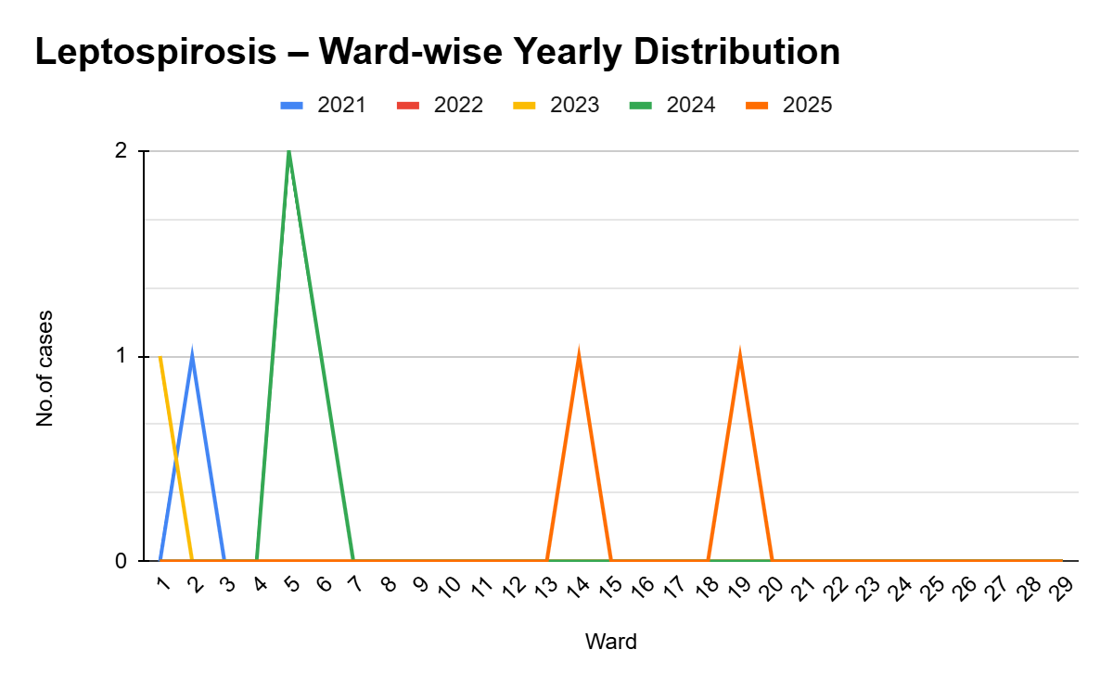

VIRAL HEPATITIS - A
Hepatitis A cases are commonly associated with unsafe drinking water, food contamination, and breakdowns in sanitation, often presenting as clusters or outbreaks.
Peak: October - December

Hepatitis A – Ward-wise Yearly Distribution (2021–2025)

Ward | Hep A – Ward-wise Yearly Distribution
Ward | 2021 | 2022 | 2023 | 2024 | 2025 | Total
1 | 0 | 2 | 2 | 2 | 2 | 6
2 | 0 | 1 | 1 | 5 | 1 | 8
3 | 0 | 3 | 4 | 0 | 2 | 9
4 | 1 | 1 | 0 | 2 | 1 | 5
5 | 0 | 1 | 2 | 2 | 2 | 7
6 | 1 | 1 | 0 | 9 | 0 | 11
7 | 0 | 0 | 0 | 8 | 2 | 10
8 | 0 | 0 | 0 | 4 | 1 | 5
9 | 1 | 0 | 1 | 0 | 0 | 2
10 | 1 | 0 | 0 | 0 | 2 | 3
11 | 1 | 2 | 2 | 0 | 0 | 5
12 | 0 | 3 | 0 | 0 | 1 | 4
13 | 0 | 1 | 1 | 0 | 4 | 6
14 | 0 | 0 | 0 | 2 | 5 | 7
15 | 0 | 0 | 0 | 0 | 10 | 10
16 | 0 | 0 | 1 | 0 | 2 | 3
17 | 0 | 0 | 0 | 0 | 0 | 0
18 | 0 | 0 | 1 | 2 | 4 | 7
19 | 0 | 0 | 0 | 0 | 4 | 4
20 | 0 | 0 | 0 | 2 | 1 | 3
21 | 0 | 0 | 1 | 1 | 8 | 10
22 | 0 | 0 | 0 | 2 | 6 | 8
23 | 0 | 0 | 0 | 3 | 1 | 4
24 | 0 | 0 | 1 | 2 | 4 | 7
25 | 0 | 0 | 0 | 2 | 0 | 2
26 | 0 | 0 | 0 | 0 | 8 | 8
27 | 0 | 0 | 0 | 2 | 1 | 3
28 | 0 | 0 | 0 | 1 | 2 | 3
29 | 0 | 0 | 0 | 0 | 0 | 0

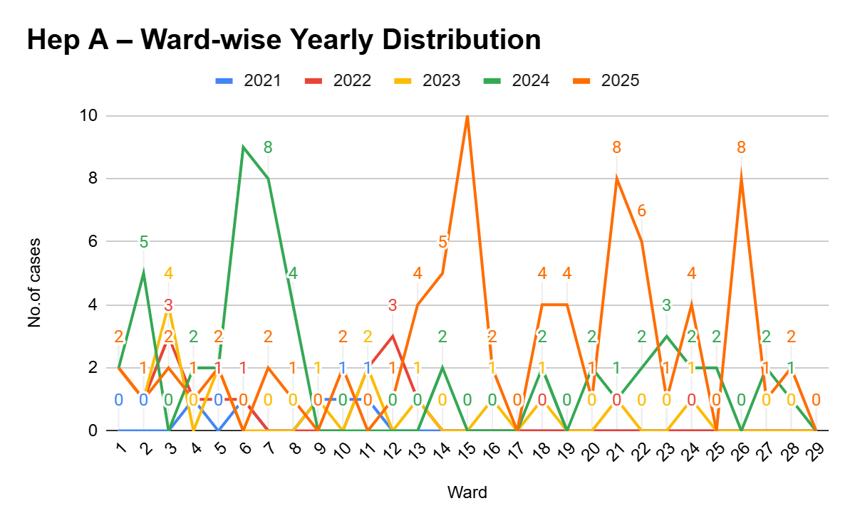

Outcome-Based Trend Analysis- 2025

Transmission Trend- 2025
For effective management of public health issues, it is important to track the trend of disease transmission mode. It helps identify the population or place at high risk that can be used to predict outbreaks and implement targeted interventions as quickly as possible. Understanding these kinds of trends enables authorities to allocate resources efficiently and change the strategies adequately based on the trend that follows.

Mode of Transmission | No. of cases | No. of Deaths
Vector Borne Diseases | 99 | 0
Water Borne Diseases | 205 | 0
Air Borne Diseases | 11 | 0
Blood Borne Diseases | 0 | 0
Food Borne Diseases | 0 | 0

Vector-Borne Disease

Disease | No. of Cases | No. of Deaths
Dengue | 99 | 0
Malaria | 0 | 0
Chikungunya | 2 | 0

Water Borne Disease

Disease | No. of Cases | No. of Deaths
Cholera | 0 | 0
Typhoid | 2 | 0
Hep- A | 99 | 0
Dysentery | 0 | 0
Amoebiasis | 0 | 0
E- Coli infections | 0 | 0
Air Borne Disease

Disease | No. of Cases | No. of Deaths
Influenza | 0 | 0
H1N1 | 0 | 0
TB | 9 | 0
Chickenpox | 0 | 0
Measles | 0 | 0
Covid-19 | 0 | 0
Pertussis | 0 | 0
Mumps | 0 | 0

Blood-Borne Disease

Disease | No. of Cases | No. of Deaths
AIDS | 0
Hep- B | 1
Hep- C | 0

Zoonotic Disease

Disease | No. of Cases | No. of Deaths
Rabies | 0 | 0
Leptospirosis | 0 | 0
Avian influenza | 0 | 0
West nile | 0 | 0
Anthrax | 0 | 0
Nipah | 0 | 0
Scrub Typhus | 0 | 0

Integrated Disease Hotspot Map (2021–2025)

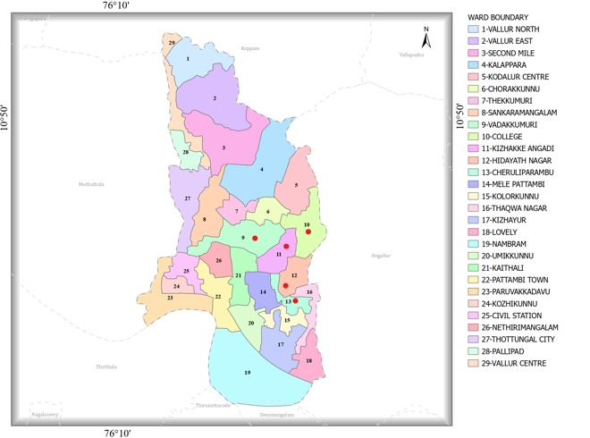

Ward No | Den  gue Total (2021-25) | Leptospirosis Total (2021-25) | Hepatitis A Total (2021-25) | Mumps (2021-25) | ADD (2021-25) | Total Cases
1 | 5 | 5 | 2 | 0 | 55 | 67
2 | 4 | 4 | 11 | 23 | 9 | 51
3 | 1 | 3 | 25 | 12 | 17 | 58
4 | 5 | 3 | 5 | 24 | 10 | 47
5 | 3 | 4 | 23 | 11 | 22 | 63
6 | 4 | 5 | NA | 16 | 18 | 43
7 | 7 | 8 | 12 | 11 | 19 | 57
8 | 7 | 5 | 22 | 33 | 16 | 87
9 | 0 | 5 | 13 | 24 | 57 | 119
10 | 0 | 4 | 11 | 11 | 62 | 150
11 | 12 | 9 | 10 | 31 | 71 | 199
12 | 6 | 6 | 7 | 41 | 81 | 224
13 | 2 | 9 | 24 | 20 | 60 | 208
14 | 2 | 1 | 4 | 5 | 11 | 23
15 | 3 | 2 | 5 | 5 | 10 | 25
16 | 1 | 2 | 5 | 6 | 12 | 26
17 | 3 | 1 | 3 | 4 | 10 | 21
18 | 4 | 2 | 3 | 6 | 14 | 29
19 | 2 | 1 | 5 | 2 | 10 | 20
20 | 2 | 2 | 4 | 4 | 12 | 24
21 | 1 | 1 | 3 | 3 | 12 | 20
22 | 1 | 1 | 2 | 2 | 11 | 17
23 | 3 | 3 | 4 | 1 | 10 | 21
24 | 3 | 2 | 6 | 2 | 12 | 25
25 | 1 | 3 | 4 | 2 | 20 | 30
26 | 1 | 3 | 5 | 5 | 8 | 22
27 | 2 | 1 | 6 | 2 | 12 | 23
28 | 2 | 4 | 5 | 1 | 20 | 32
29

By overlaying five years of data, we have identified 5 'Red Zone' Wards. These are wards where at least two different categories of diseases (e.g., Dengue and Lepto) recurred in consecutive years. Ward 19 is categorized as the Highest Priority Hotspot due to its combination of flood vulnerability and high vector density. Future health infrastructure, such as the proposed R.O plants at municipality level should be prioritized.

Preparedness and Response Protocol at LSG Level
This section describes the operational framework for the LSGI once a pandemic is declared. It explains how the LSGI and health system will move from routine data collection to active response, using a One Health approach.

Constitution of One Health Committee
The LSGD shall constitute a One Health Committee comprising the LSGI President, Medical Officers (Modern Medicine, AYUSH, and Veterinary), the Health Inspector, and the Veterinary Surgeon.

Objective: The One Health Committee coordinates human, animal, and environmental health to prevent and control pandemics.

Sl No | Name | Designation | Department/Institution | Role in Committee | Contact Number
1 | TP SHAJI |  | LSGD | Chairperson | 9447176270  9400000016
2 | HARIDAS | Medical Officer (PHC/CHC) | Health Dept | Member Secretary | 8113913553
3 | Dr Ponmurugan | Veterinary Officer | Animal Husbandry | Member | 9447945327
4 | FLORIYA | Epidemiologist | Health Dept | Member | 7994053272
5 | SUBRAMANIYAN | Health Inspector/PHN | Health Dept | Surveillance | 9037356223
6 | SUNIMOL  ANGEL | ASHA Supervisor | Health Dept | Community link | 9495888190  6238559358
7 | SINDHU | ICDS Supervisor | Social Welfare | Vulnerable groups | 9946120700
8 | JAYAKUMAR | Police Station Officer | Police Dept | Law & order | 8281288040
9 | SHAMSEENA | Ward Councillor Representative | LSGD | Community coordination | 9745067533
10 | GEETHA | Kudumbashree CDO | Kudumbashree | Community mobilisation | 9744828446
11 |  | NGO/Volunteer rep | Civil Society | Support services
12 | Dr Rajana | Ayurveda doctor |  |  | 9497354546
13 | Dr Anupama | Homeo doctor |  |  | 9744817047

Key Responsibilities:
- Review disease surveillance data (human + animal)
- Conduct ward-wise risk assessment and vulnerability mapping
- Approve quarantine/isolation centre locations
- Coordinate with district for resources (PPE, oxygen, ambulances)
- Periodically review health system surge capacity, including beds, oxygen, human resources, and ambulances.
- Approve and monitor risk communication and community engagement strategies, including rumour management.
- Ensure protection and service continuity for vulnerable groups (elderly, persons with disabilities, dialysis patients, coastal populations).
- Conduct quarterly mock drills
- Monitor equity measures for vulnerable groups

Meeting Schedule:
Quarterly (normal times) | Weekly (outbreak alert) | Daily (pandemic phase)

Pandemic Response Workforce
To ensure a coordinated and timely response during a pandemic, a dedicated Pandemic Response Workforce shall be constituted at the LSG level. The workforce will function under the overall supervision of the One Health Committee and in close coordination with the health authorities. Team-based deployment will enable efficient surveillance, case management, quarantine and isolation management, logistics support, and risk communication. Each team shall have a clearly designated team leader, defined roles, and an identified pool of personnel to allow rapid activation, rotation of duties, and continuity of services during prolonged emergencies.

Total Response Workforce Available: 300 persons

Team Name | Composition | Key Responsibilities | Team Leader
Surveillance and Contact Tracing Team | HI, JHI, JPHN, ASHAs and Volunteers | Case detection, contact listing, home visits, reporting | HI
Case Management Team | Doctors, Nurses, MLSP, Palliative Nurses | Patient care & referral | DOCTOR
Quarantine & Isolation Team | LSGD staff, Volunteers | Facility management | JHI
Psychosocial support
Logistics & supply chain Team | LSGD staff, Storekeepers, Drivers 3 | Supplies & transport [PPE, medicines, oxygen, transport, waste management] | Ward Member
Communication Team | Ward members, Kudumbashree, Youth clubs,  AWW workers and other self help groups | IEC, community meetings, countering misinformation | M.O in charge
Transportation | KSRTC, educational institutional buses
Media Surveillance
Intersectoral coordination and convergence
Collaborative surveillance

All teams shall be activated immediately upon outbreak alert or pandemic declaration and shall report daily to the LSG Incident Commander/Medical Officer, with consolidated reporting to the Block PHC. Duty rosters and alternate personnel shall be maintained to ensure uninterrupted services during staff shortages or prolonged response periods. Team composition and numbers may be revised based on the magnitude of the outbreak and availability of human resources.

Activities and Measures before and during Pandemic

PHASE 1 - Alert / Preparation
Surveillance and Reporting-Enhanced syndromic surveillance:
- Data sources for surveillance:
- Event-based triggers (to be monitored and reported):
- Zoonotic and animal health surveillance
- Logistics and Stock Preparedness
  - Identify and empanel local vendors and define emergency procurement mechanisms in accordance with existing LSGD and Health Department norms.
  - Prepare and maintain an essential logistics checklist covering medical supplies, consumables, and support equipment.
  - Pre-identify secure storage locations for emergency stocks and ensure maintenance of stock registers with regular updating.
  - Finalise emergency transport arrangements, including availability of vehicles and identified drivers for rapid deployment during alerts.
  - Designate a Nodal Officer for Logistics to enable prompt decision-making, coordination, and communication during emergencies.
  - Conduct rapid stock verification and ensure availability of minimum buffer stock, including:
- PPE kits – numbers
- Pulse oximeters – ___ numbers
- Hand sanitizers – ___ litres
- Masks, gloves, disinfectants – adequate quantity
Identify critical gaps in logistics and immediately communicate requirements to the Block and District authorities for timely replenishment and support. Monitor expiry dates and stock rotation.

Identification of Quarantine and Isolation Facilities
  - Identify and list suitable buildings for quarantine and isolation (schools, hostels, community halls, etc.).
  - Categorise cases as per the severity and allocate to appropriate facilities (for instance, severe cases to classrooms, mild cases to an assembly hall in case of a school).
  - Facility readiness checklist needed (beds, toilets, ventilation) etc.
  - Find an alternate site if the primary sites are not available or not in use.
  - Identify facility managers and support staff
  - Prepare basic SOPs for:
    - Admission and discharge
    - Food, water, sanitation
    - Infection prevention and waste disposal
  - Ensure availability of basic amenities: water, sanitation, electricity, ventilation, and waste disposal. Prepare a rapid activation plan for these facilities if case numbers increase.

Risk Communication and Community Preparedness
  - Disseminate early warning messages on symptoms, preventive measures, and reporting mechanisms. Display IEC materials both in English and the local language in public places and ensure ward-level awareness.
  - Sensitize elected representatives and community leaders on preparedness measures.
  - Establish a rumour tracking and misinformation response mechanism to identify, verify, and promptly counter false or misleading information.
  - Engage trusted local persons (ward members, ASHA workers, religious leaders, teachers, community volunteers) to communicate official public health messages and reinforce correct practices.
  - Develop and deploy targeted IEC materials for:
    - Schools and educational institutions
    - Markets and commercial areas
    - Work sites and labour settings
  - Conduct community sensitization meetings at the ward level to promote preventive behaviors, address concerns, and strengthen community participation in preparedness and response.

Protection of Vulnerable Groups
Vulnerable populations require priority protection through targeted line-listing, service continuity, and delivery mechanisms.
- Prepare and regularly update line-lists of vulnerable populations, including:
  - Elderly persons living alone
  - Persons with disabilities
  - Pregnant women
  - Migrant workers
  - Dialysis patients
The detailed line-lists shall be maintained as Annexure ___ and updated periodically.

Clinical Dependency Mapping
Develop ward-wise dependency and vulnerability maps to identify households requiring regular support during emergencies. Ensure continuity of essential health services for vulnerable groups, including
- Dialysis services (facility mapping, transport arrangements, and scheduling)
- Continuity of treatment for TB, HIV, and other chronic conditions requiring uninterrupted medication
- Mental health and psychosocial support services
Establish delivery mechanisms for food, essential commodities, and medicines to vulnerable households through coordinated action involving ASHAs, JPHNs, Kudumbashree, volunteers, and local administration.

PHASE 2 - Active Response

Case Identification and Contact Tracing
Case detection and contact tracing activities will be carried out in coordination with the Health authorities, following disease-specific SOPs and IDSP guidelines.
Field Staff Involved
- Health Inspector (HI)
- Junior Health Inspector (JHI)
- Junior Public Health Nurse (JPHN)
- ASHAs and ASHA Supervisors
- Ward-level volunteers and Kudumbashree members (as required)

Screening Checkpoints
Screening checkpoints at high-traffic locations (transport hubs, markets, religious gatherings) for early detection of symptomatic travellers and crowd screening during outbreaks. Potential locations include bus stands, market entry points, and boat jetties, based on local context and risk assessment.
Screening activities will be carried out by trained personnel such as ASHAs, ward members, and volunteers, with support from Health Department staff. Necessary equipment, including non-contact thermometers and appropriate PPE, shall be ensured prior to activation.
Location | Type (Bus stand/Jetty/Market/Railway) | Staff Deployed (ASHAs/Volunteers) | Screening Method | Reporting authority
Bus stand | Transport hub | One JHI  One ASHA  One health Mentors | 1.Swab Collection.  2. Blood smears collection (RDT)  3.Thermal Scanners | Surveillance Nodal Officer in control room
Market entry | Market | One JHI  One ASHA  Male health volunteers | 1.Swab Collection.  2. Blood smears collection (RDT)  3.Thermal Scanners | Surveillance Nodal Officer in control room
Boat jetty | Water transport | One JHI  One ASHA  Male health volunteers | 1.Swab Collection.  2. Blood smears collection (RDT)  3.Thermal Scanners | Surveillance Nodal Officer in control room

Standard Screening Protocol
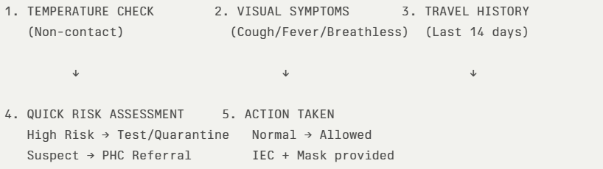
The screening protocol shall include temperature screening, observation for visible symptoms, and inquiry regarding recent travel or exposure history. Individuals identified as suspects during screening shall be immediately referred to the nearest PHC/FHC for further evaluation, testing, and appropriate action as per prevailing guidelines.

Pandemic Control Room
The Pandemic Control Room (PCR) serves as the central nerve center for real-time coordination, data aggregation, decision support, and communication during outbreaks. It consolidates information from all LSGD teams, health facilities and community sources to enable rapid response decisions.

Control Room Infrastructure and Location
Primary Location: _Pattambi Municipal Office.
Backup Location: Chithra Community Hall in _Pattambi Municipality

Health System Control Room Framework
The PCR is organized into seven functional pillars to ensure no aspect of the response is overlooked:

Rapid Response Team (RRT)
  - Provides immediate intervention during emergencies, clusters, and field alerts.​
  - Coordinates urgent actions such as case investigation, contact tracing, isolation, and inter‑facility referrals.

Data Management & Analytics Team
  - Collects, validates, and manages key health system indicators (cases, tests, beds, HR, supplies).​
  - Analyzes data trends, generates projections, and supports evidence‑based decision‑making for local authorities.

Human Resource Deployment Team
  - Allocates healthcare staff efficiently based on workload and need
  - Ensures adequate and equitable workforce distribution across facilities

Laboratory Surveillance Team
  - Oversees diagnostic testing coordination, sample transport, and timely reporting of results.​
  - Monitors lab indicators (testing volume, positivity rate, turnaround time) for early detection of outbreaks

Vaccination Cell (If Required)
  - Plans and executes vaccination campaigns, including micro‑planning and session scheduling.​
  - Tracks coverage, identifies gaps, and coordinates corrective actions with field teams and outreach services.

Infrastructure & Patient Occupancy Team
  - Monitors facility capacity, earmarked beds, oxygen and critical care resources across all linked facilities.​
  - Ensures optimal patient distribution and referral management using updated bed‑status and resource data.
  - BMWM

Communication team
- Logistics and supply chain
- Transportation (interfacility & emergency transport)
- Media surveillance Call centre
- Management of the deceased
- Intersectoral coordination and convergence

Key Control Room Team
The Control Room Team coordinates all pandemic response activities within the LSGD and serves as the single command and communication hub during activation. It integrates information, field actions, logistics, and policy execution across all participating departments and health facilities.

Role | Name | Designation | Contact Number | Responsibility
In-charge/Nodal Officer | Amal Salim | secretary | 9847130431 | Overall coordination, decision-making, and reporting to the District level.
Data Entry Operator | mohanan | jhi | 9946739445 | Managing the line list, updating dashboards, and tracking testing results.
Communication Officer | subramannyan | health supervisor | 9037356223 | Handling the public helpline, coordinating ambulance dispatch, and contact tracing calls.
Logistics Coordinator | laya K sunil | PHI | 9995806922
Technical Support (IT/Data) | rohini | PHI | 9539637179

SOP for alert escalation/trigger point with mapping of responsibilities.
Key Points:
- The Control Room shall be staffed with a designated In-charge, data entry personnel, and communication staff with clearly defined roles and shift arrangements.
- It shall maintain updated records on daily monitoring indicators including new cases, persons under active quarantine, and hospital bed occupancy.
- All reports and situation updates shall be shared daily with the Block and District Surveillance Unit.
- The Control Room shall act as a single point of contact for coordination with response teams, health institutions, and other departments.
- Contact details of the Control Room shall be widely communicated to field staff and stakeholders during activation.

Daily Monitoring Indicators
To ensure timely decision-making and effective response, the following key indicators shall be monitored and updated on a daily basis by the Pandemic Control Room:

Epidemiological Indicators:
New cases reported today, Total active cases, Test Positivity Rate (TPR), Case Fatality Rate (CFR)
- Surveillance Indicators:
Persons under home quarantine, High-risk contacts identified, Fever, ILI, SARI or other symptoms (syndromic surges), Travellers (symptomatic or high-risk arrivals),Animal husbandry surveillance (zoonotic alerts, unusual animal deaths, poultry/bird flu signals), Mortality surveillance (excess deaths, unexplained fatalities, verbal autopsy reports)
- Logistics and Infrastructure Indicators:
Hospital / CFLTC beds occupied, Oxygen cylinders/concentrators available, Ambulances on standby
- Alert Findings
The following table outlines category-specific trigger points (red flags) from surveillance indicators and corresponding immediate actions for the Pandemic Control Room. These enable rapid response to alert findings like testing anomalies, positive cases exceeding thresholds, clusters, and WGS reports.

Category | Trigger Pophint (Red Flag) | Immediate Action
Clusters | Geographical or facility-based: 5+ cases linked to one location (office, school, street). | Declare a micro-containment zone; perimeter control and active case finding.
Testing | Sudden drop in testing volume / delay in reporting / unusual testing trends | Review the sample collection process, address lab bottlenecks, deploy additional testing teams, and notify the District Lab.
Lab | Test Positivity rate increases | Increase testing sites in that ward.
Hospital | >80% Oxygen bed occupancy | Activate backup/CFLTC beds.
Travel | Cluster of cases from a single flight/train or high-risk arrival group. | Trace all passengers in adjacent seats; implement mandatory institutional quarantine.
Animal | Mass poultry/wildlife death or unusual sickness | Notify Animal Husbandry, sample the area, and dispatch RRT for environmental sampling and zoonotic check.
Mortality | Sudden spike in home deaths or brought-in-dead (BID) cases | Audit the deaths and Active Case Search drive
Additional investigations like Whole Genome Sequencing (WGS) | Detection of a Variant of Concern (VOC) or Variant of Interest (VOI) | Implement strict micro-containment; update clinical protocols to match variant severity.

Communication of Public Health Information
A Community Communication Hub shall be established to ensure timely, accurate, and consistent dissemination of information during a pandemic. The Hub will function under the coordination of Nodal officers of the control room and act as the nodal point for public communication, risk messaging, and community engagement. It will support dissemination of official advisories, promote preventive behaviors, address rumors and misinformation, and ensure that messages reach all sections of the population through trusted local channels and leaders.

Key communicators
Channel | Responsible Person | Contact
Ward-level announcements | Ward member | Latha | 9747922690
Social media | mohanan | JHI | 9946739445
Local Cable TV/Radio | subramannyan | Health supervisor | 9037356223

- All messages disseminated through the Hub shall align with advisories issued by the Health Department and District authorities.
- Community leaders shall be sensitized to support behavior change, reduce stigma, and counter misinformation.
- Special efforts shall be made to reach vulnerable and hard-to-reach populations using locally appropriate communication methods.

Rumor Tracking: A designated volunteer will monitor local social media/WhatsApp groups daily to identify misinformation and issue official clarifications via the Communication Hub.

Coordination with District/State Authorities & Other Organisations
Effective coordination with Block, District, and State authorities is essential to ensure timely reporting, technical guidance, and uninterrupted supply of essential resources during a pandemic. The LSG shall establish clear communication channels, designate responsible officers, and adhere to prescribed reporting timelines to support coordinated public health action and efficient resource mobilisation.

Key Details:
- Nodal Officer for Reporting:
- Contact Number:
Reporting Schedule and Protocols:

To Whom | What to Report | Frequency | Nodal Person
Block PHC | Complete Situation Report (Cases, Quarantine, Beds, Screening, Deaths) | Daily | Taluk Superintend
District IDSP Unit | Outbreaks/Clusters/Unusual Events (>5 cases same ward) | Daily | District Surveillance Officer
Veterinary Officer | Animal health events/Zoonotic alerts | Daily | Veterinary Surgeon
State Cell | Zoonotic cross-sector events

Supply Chain Coordination
The LSG shall coordinate closely with Block, District, and State authorities (KMSCL) to ensure uninterrupted availability of essential goods, medical supplies, and logistics during a pandemic. Supply requirements shall be assessed regularly based on case load and communicated promptly to the appropriate authorities for timely replenishment.
Key Points:
- Maintain updated contact details of District and Block nodal officers for health logistics, oxygen supply, ambulances, and essential medicines.
- Submit timely indent requests for PPE, testing kits, medicines, oxygen, and other critical supplies through prescribed channels.
- Monitor stock levels at LSGD facilities, quarantine/isolation centres, and field teams through daily stock registers and dispensing logs to prevent shortages.
- Coordinate with District authorities, Karunya/Neethi medical shops, and local purchase committees for funds allocation and emergency procurement.

- Ensure regular monitoring of dispensing registers at all facilities to track usage, expiry, and pilferage—shortages being a perennial issue requiring proactive weekly audits.

- Activate surge procurement protocols during high caseloads, leveraging local purchase powers under LSGD funds alongside state supplies.

Resource Inventory and Contacts
Resource Category | Source  (District/State/Private) | Contact
PPE Kits/Masks/Gloves | KMSCL | 914912533336
PPE Kits/Masks/Gloves | Local Vendors | Jan Aushadhi-  9746960603
Oxygen  Cylinders/Concentrators | KMSCL | 914912533336
Medicines/Antivirals | KMSCL | 914912533336
Medicines/Antivirals | Neethi Shops | 8891764599.
Test Kits (RTPCR/Rapid) | KMSCL | 914912533336

Collaboration with NGOs, PPP, and CSR
To augment government efforts during a pandemic, the LSG shall collaborate with NGOs, voluntary organisations, and private sector partners through public–private partnerships and Corporate Social Responsibility (CSR) initiatives, in coordination with District authorities.

Key Points:
- Engage NGOs and community-based organisations for community outreach, awareness, and support to vulnerable populations.
- Leverage CSR support for procurement of medical equipment, PPE, oxygen concentrators, food kits, and sanitation materials, as permitted.
- Ensure all collaborations align with government guidelines and are routed through approved administrative and financial procedures.
- Maintain transparency and documentation for all external support received and utilised.
Organization | Type | Support Offered | Contact Person
Youth Clubs/Student Unions | CBO | RAJITHA NSS | 8907622073

Interdepartmental Coordination
Coordination among departments during a pandemic shall be ensured through regular review meetings convened by the LSGD President. These meetings will provide a structured platform for sharing situational updates, assessing resource availability, resolving operational gaps, and taking joint decisions to ensure a coordinated and timely response.

Department | Representative | Key Role | Contact
Health (PHC) | Staff Nurse : Afsal | Case management | 9744570830
Veterinary | Veterinary Surgeon: | Animal surveillance | Dr Murugan  9447945327
ICDS | Supervisor: Sindhu | Nutrition support | 9747769643
Education | Head Teacher:Prashanth | School coordination | Prashanth HSS Pattambi  9539073757
Police | 9497980625 | Containment enforcement | __________
Water Authority | Muralidharan | Water supply | 9447945327
LSGD Engineering | Swami  9446072414 | Quarantine infrastructure | GNHS College  0466 221 2223

PHASE 3 - Surge Capacity
Phase 3 is activated when there is a rapid increase in cases, high test positivity rates, or when existing health facilities and quarantine arrangements approach saturation. The focus of this phase is to expand isolation capacity, augment clinical care services, and mobilise additional resources through district and state support mechanisms.

Conversion of Community Facilities
To manage increased case load, the LSGD shall activate additional isolation facilities by repurposing identified community infrastructure such as community halls, auditoriums, schools, hostels, or other suitable buildings.

Name of facility | Facility Type | No. of Buildings | Ward | Surge Capacity (Beds) | Nodal Person
HSS Pattambi | School | 4 | 17 | 50 | Prashanth  9539073757
MES INTERNATIONAL SCHOOL | School | 3 | 19 | 50 | 4662213975
GHSS PATTAMBI | School | 4 | 22 | 60 | 4662964334
ST.PAULS.H.S PATTAMBI | School | 3 | 21 | 50 | 9048511213
AET SCHOOL | School | 3 | 21 | 50 | 9435256547
ROYAL CONVENTION CENTRE | HALL | 1 | 17 | 50 | 9400560057
RAJAPRASTHAM | HALL | 1 | 12 | 50 | 04662213547
RUGMINI KALYANAMANDAPAM | HALL | 1 | 12 | 50 | 04662313943
MALUTTY AUDITORIUM | AUDITORIUM | 1 | 2 | 50 | 9846269203  MOHANAN
OPH CONVENTION CENTRE | HALL | 1 | 2 | 50 | 9847813116  ABDUL SALAM
BOUGAINVILLEA AUDITORIUM, KOTTAPADI | HALL | 1 | 4 | 50 | 8078996999  USMAN ALIKKAL

- Recovery and rehabilitation phase
- Recovery
  - Damage & impact assessment
  - Restoration of health services
  - Rehabilitation of affected population
  - Psychosocial & mental health support
  - Disease surveillance during recovery phase
  - Environmental cleanup & sanitation
  - Livelihood restoration
  - Community engagement & confidence building
  - Documentation & after-action review
  - Lessons learned & best practices
  - Health system strengthening
  - Policy revision & preparedness enhancement
  - Research

CONCLUSION

Additional points
- tech support
- relief based commodities
- ham reading operators
- hazard vulnerability mapping
- Kseb & other power source
- HR specific responsibility

RECOMMENDATIONS

Strengthening Healthcare Infrastructure
- Establish a primary health response unit within the Panchayat with trained staff.
- Ensure availability of basic medical supplies (masks, sanitizers, PPE kits, oxygen cylinders).
- Create tie-ups with nearby hospitals- SEVANA, NILA HOSPITAL for emergency referral and transport.

2. Community Awareness & Education
- Conduct regular awareness campaigns on hygiene, vaccination, and preventive measures.
- Use local communication channels (community radio, WhatsApp groups, notice boards) to spread verified information.
- Train volunteers to act as health ambassadors in each ward.

3. Emergency Response & Coordination
- Form a Pandemic Preparedness Committee at Panchayat level including health workers, ward members, and NGOs.
- Develop a clear action plan for lockdowns, quarantine, and distribution of essentials.
- Maintain a database of vulnerable groups (elderly, differently-abled, chronically ill) for targeted support.

4. Supply Chain & Food Security
- Identify and support local suppliers and farmers to ensure uninterrupted food supply.
- Create community kitchens during emergencies to serve vulnerable populations.
- Stockpile essential commodities in Panchayat-run outlets for crisis periods.

5. Digital Preparedness
- Promote digital platforms for telemedicine consultations.
- Use Panchayat’s website/social media for real-time updates on health advisories.
- Encourage online grievance redressal to reduce crowding in offices.

6. Training & Capacity Building
- Organize mock drills for pandemic response in schools, offices, and public spaces.
- Train Panchayat staff and volunteers in first aid, infection control, and crowd management.
- Collaborate with NGOs and health departments for capacity-building workshops.

7. Long-Term Resilience
- Integrate pandemic preparedness into the Panchayat Development Plan.
- Allocate a dedicated budget for health emergencies.
- Encourage community participation in planning and monitoring preparedness measures.

MOCKDRILL SCENARIOS

ANNEXURE

IMPORTANT PHONE NUMBERS

Phone numbers and particulars of persons responsible for providing guidance, assistance, and support for pandemic preparedness operations may be provided here in a manner that allows easy reference at a glance. The information recorded here could be exhibited elsewhere at the time of emergencies. LSG institutions shall give special attention to collect and record the above data of persons and institutions who/which are supposed to give technical and co-ordination support to reduce the impact of pandemic.

1.1. Details of grama panchayat/municipality/corporation wards
Sl.No | Name of the ward | Ward number | Name of the ward  member | Contact number
1 | VALLOOR NORTH | 1 | LATHA KUMARI | 9747922490
2 | VALLOOR EAST | 2 | ATHIRA MAHESH | 8943108620
3 | SECOND MILE | 3 | GIRIJA | 9495815175
4 | KALAPPARA | 4 | SADHIQUE | 9846721786
5 | KODALOOR CENTRE | 5 | SHAFEEDHA | 7907668021
6 | CHORAKKUNNU | 6 | SOORYA | 9995197653
7 | THEKKUMURI | 7 | MUNAVIRA RASIQUE | 9037727079
8 | SANGARAMANGALAM | 8 | VIJILA | 9846070348
9 | VADAKKUMURI | 9 | KAVITHA | 9745067533
10 | COLLEGE | 10 | SAFA NISAR | 8075011922
11 | KIZHAKKE ANGADI | 11 | SHAHUL HAMEED | 9947874145
12 | HIDAYATH NAGAR | 12 | USMAN TP | 9447443326
13 | CHEROOLIPPARAMB | 13 | SHAJAHAN TP | 9400000016
14 | MELE PATTAMBI | 14 | ABDHUL SAJAD | 9995472530
15 | KOLORKUNNU | 15 | MADHUSOODHANAN K | 9495485891
16 | THAQWA NAGAR | 16 | SHAMSEENA | 9048307886
17 | KIZHAYOOR | 17 | KRISHNADAS | 9520747958
18 | LOULI | 18 | ASHA SANTHOSH | 9846586205
19 | NAMBAM | 19 | VIJAYAN | 9846606655
20 | UMIKKUNNU | 20 | FAISAL BABU | 9846352044
21 | KAITHALI | 21 | JITHESH MOZHIKKUNNAM | 9447091111
22 | PATTAMBI TOWN | 22 | M P SUBRAHMANYAN | 9562752879
23 | PARUVAKKADAV | 23 | SHSFEEQUE | 9946333525
24 | KOZHIKKUNNU | 24 | SULAIKHA | 8086603104
25 | CIVIL STATION | 25 | SANGEETHA PRAMOD | 9895046350
26 | NETHIRI MANGALAM | 26 | SURESH | 9895205019
27 | THOTTUNGAL CITY | 27 | VIJITHA | 8943245440
28 | PALLIPPAD | 28 | VIJAYAKUMAR | 9495708450
29 | VALLOOR CENTRE | 29 | ASNA | 6282918151

1.2. Other important phone numbers of grama panchayat/municipality/corporation area
Sl. No. | Name | Contact number
1. | EXCISE DEPARTMENT | 0491 2505897
2. | FOREST DEPARTMENT | 0466 2214660
3. | MUNICIPALITY | 04662212233
4.
5.
6.
7.
8.

1.3. Important offices of grama panchayat/municipality/ corporation
Sl.No | Name of the office | Contact person | Contact number
1. | Village Office | Village Officer | 08547615124
2. | Agriculture Office | Agriculture Officer | 04662212275
3. | Animal Husbandry Office | Animal Husbandry Doctor | Dr Murugan  9447945327
4. | Police Station | Police Officer | 0466 2212224
5. | BSNL Office | Officer
6. | Block Office | Officer | 04662212254
7. | KSEB Office | Officer | 04662212255
8. | Fisheries Office | Officer | 0491 2815245
9. | Fire and Rescue | Officer | 0466 2955101

1.4. Health Services

Sl. No | Name of the hospital/institution | Location | Phone number
1. | Government hospitals/PHC | PATTAMBI | 0466 2213769
2. | Private hospitals | PATTAMBI | 0466 2212565
3. | Clinical laboratories | KARUNYA | 9895681470
4. | Chemist/pharmacy | Karunya community pharmacy | 0466 221 2223
5. | Blood donors
6. | Other language experts (Bihari, Hindi, Bengali,  Asamees ………)

1.5. Veterinary Services
Sl.No | Name of the Clinic | Name of the  Surgeon/Doctor | Place/location | Phone  number
1 | Govt.Veterinary Hospital | Dt Murugan | Pattambi | 9447945327

1.6. Helpline numbers
Helpline | Phone number
Police | 0466 2212224
Fire and Rescue | 0466 2955101
KSEB | 04662212255

1.7. Public and Private Schools Contact details

S.No | Name of School | Institution type | Phone number
1 | G H S S PATTAMBI | GOVNT | 4662214008
2 | MES INTERNATIONAL SCHOOL | UN Aided
3 | GHSS PATTAMBI | GOVERNMENT | 4662213975
4 | ST.PAULS.H.S PATTAMBI | UNAIDED RECOGNISED | 4662964334
5 | AET SCHOOL | UNAIDED | 9048511213
6 | MES INTERNATIONAL SCHOOL | Private
7 | AMPS MARUTHUR | Private | 8086510003
8 | GUPS KEEZHAYUR | Govt | 4662206062
9 | GUPS PATTAMBI | Govt | 4662214373
10 | GMLPS PATTAMBI | GOVT | 9495761689
11 | GLPS VALLUR | GOVT | 9497672646
12 | BKMLPS KODALUR | AIDED | 9539347272
13 | AMLPS SANGARAMANGALAM | AIDED | 8547238453
14 | MES INTERNATIONAL SCHOOL | UNAIDED

1.9. Anganwadi Contact Details

Ward No | Name of Anganwadi Teachers | Phone number
 | SUBADHRA | 9048317161
 | LATHIKA | 9048701550
 | REMADEVI | 9744439146
 | KAMALAKSHI | 9846026940
 | BHOOMAVATHI | 8891510756
 | SAJITHAKUMARI | 9072476353
 | KALYANIKUTTY | 9846831965
 | JISHA | 9048216275
 | VRINDHADEVI | 8943655976
 | PREMAKUMARI | 9745273147
 | PARVATHY | 8086454988
 | RADHA | 9544421368
 | ANITHA | 9745028450
 | SHOBHANA | 9539058312
 | VILASINI | 9048755763
 | SANTHAKUMARI | 974567899
 | PATHUMMA | 7560831526
 | RADHA K | 9747947000
 | SREEJA NP | 9846411558
 | PREMA | 8075971656
 | SREELATHA | 9946728053
 | RESHMA PP | 9645428878
 | RADHAMANI VP | 9447531613
 | BHANUMATHI | 9744201308
 | RADHIKA CK | 9645428878
 | PREMALATHA | 9447531613
 | SANGEETHA | 9633245917
 | SANDHYA DEVI | 9744201308

Ward No | Anganwadi No and Name of Teacher | Phone number
7 | - VRINDADEVI | 8943655976
7 | - PREMAKUMARI | 9745273147
8
9 | - PARVATHY | 8086454988
9 | - RADHA | 9544421368
9 | - ANITHA | 9745028450

1.12. Information regarding resources

Means of transportation | Name of Owner | Phone Number
Heavy Trucks | asna transport | 7947107055
Tractor | usman | 9846828371
Ambulances | noushad` | 9895024032
Boats | NIL | NIL
Taxi service | diya toures | 8487092712

Annexure 1: LSG Baseline Data Collection Format
A. Baseline data
Sl. No. | Indicator / Field | Baseline Data | Source / Remarks
1 | Name of LSG | Pattambi | Municipality
2 | District | Palakkad
3 | Block / Taluk | Pattambi
4 | Type of LSG (Gram Panchayat / Municipality / Corporation) | Municipality
5 | Area (sq. km) | 15.84 | Municipality
6 | No. of wards | 29 | Municipality
7 | GIS boundary file available | (Yes/No) YES
8 | Key contact person & phone |  | Municipality

B. Demography
Indicator / Field | Baseline Data | Source / Remarks
Total population | 35907 | Baseline data
Males | 17508 | Baseline data
Females | 18399 | Baseline data
Transgender population | 0 | Baseline data
Age distribution  (<5, 5–14, 15–59, ≥60) | <5- 2492 | Baseline data
No. of households | 7672 | Baseline data
Population density (persons/sq.km) | 1808/sq.km
No. of migrant workers | 468 | Baseline data
Major occupational groups

C. Vulnerable Populations & Social Risks
Sl. No. | Indicator / Field | Baseline Data (Value / Description) | Source / Remarks
1 | No. of elderly (≥60) | 3475 | base line data
2 | No. of persons with disability | 148
3 | No. of bedridden persons | 65
4 | No. of chronic disease cases (DM/HTN/COPD/CKD etc.) | 3256
5 | Pregnant women (current estimate) | 317
6 | Children <5 years | 2492
7 | Tribal population (if any) | 0
8 | Fisherfolk / coastal vulnerable groups (if any) | 0
9 | Urban slums / unnotified settlements (if any) | 0
10 | Homeless population | 0
11 | Orphanages / old age homes (number & capacity) | 0
12 | Hostels / prisons / shelters (number & capacity) | 0
13 | Poverty / BPL estimate | 4521
14 | Food insecurity hotspots | 0
15 | Any history of stigma/discrimination issues (Yes/No) | 0

D. Health System & Service Readiness
Sl. No. | Indicator / Field | Baseline Data (Value / Description) | Source / Remarks
1 | No. of health facilities in LSG (PHC/CHC/TH/DH/Private)
2 | PHC/Family Health Centre details (name, location)
3 | Subcentres / Health & Wellness Centres (number) | 4 in number  Contact: 9495888190
4 | Private clinics / hospitals (number) | Zayan clinic  9544663366
5 | Labs available (public/private) | Karunya  9895681470
6 | Availability of ambulance services (Yes/No, number) | Yes
7 | Availability of isolation/quarantine facilities (Yes/No, details) | Yes
8 | Cold chain facilities (Yes/No, details) | Yes
9 | Stockpile space available (Yes/No) | Yes
10 | PPE / mask / sanitizer availability plan (Yes/No) | Yes
11 | Surveillance staff available (JHI/JPHN/ASHA count) | Yes
12 | Existing emergency referral pathways (Yes/No) | Yes

E. Points of Entry & Mobility
Sl. No. | Indicator / Field | Baseline Data (Value / Description) | Source / Remarks
1 | Bus stands / depots (number) | 1 Bus stand
2 | Railway stations (number) | ` 1
3 | Boat jetties / fishing harbours (number) | 0
4 | Ports / airports nearby (specify distance) | 0
5 | Major highways/roads passing through | 1
6 | Border crossings (state/district) | 2
7 | Major markets / weekly markets | 1
8 | Tourism hubs / major event venues | 0
9 | Schools/colleges with hostels (number) | 0
10 | Factories / large workplaces (number) | 0
F. Water, Sanitation & Hygiene (WASH)
Sl. No. | Indicator / Field | Baseline Data (Value / Description) | Source / Remarks
1 | Major drinking water sources (piped / wells / borewells / springs) | WELLS
2 | No. of public wells | 65
3 | No. of households with piped water connection | 5845
4 | Water quality testing routine (Yes/No) | N
5 | Common contamination risks (flooding, salinity, industrial waste) | flooding
6 | Open defecation free status (Yes/No) | yes
7 | Solid waste management system (Yes/No) | yes
8 | Bio-medical waste disposal mechanism (Yes/No) | no
9 | No. of public toilets | 12
10 | Handwashing stations in public places (Yes/No) | yes
G. Zoonotic Risks & One Health
Sl. No. | Indicator / Field | Baseline Data (Value / Description) | Source / Remarks
1 | Livestock population (cattle/goats/pigs/poultry) – estimates | 560
2 | No. of dairy farms / poultry farms / pig farms | 627
3 | Slaughterhouses / meat shops (number) | 9 meat shops
4 | Animal markets (Yes/No, details) | Fish market-1
5 | Veterinary dispensaries (number) | 1
6 | History of zoonotic outbreaks (rabies, leptospirosis, avian flu etc.) | No
7 | Stray dog population management measures (Yes/No) | Yes
8 | Rodent infestation hotspots (Yes/No) | No
9 | Wetlands / waterlogged areas prone to leptospirosis | Ward 19
10 | Bat roosting areas / caves / fruit orchards (if any) | Pattambi bus stand
11 | Human-animal interface hotspots (farms near residences) | No
H. Climate & Disaster Risks (Pandemic Amplifiers)
Sl. No. | Indicator / Field | Baseline Data (Value / Description) | Source / Remarks
1 | Flood-prone wards (list) | 19,20, 22,
2 | Landslide-prone wards (list) | 0
3 | Cyclone/sea surge risk (Yes/No) | 0
4 | Heatwave risk zones (Yes/No) | 0
5 | Waterlogging areas (list) | 0
6 | Shelter homes / relief camps (number, capacity) | 6
7 | Past disaster displacement history | 0
8 | Disruption to water supply/transport common (Yes/No) | No
I. Critical Infrastructure & Logistics
Sl. No. | Indicator / Field | Baseline Data (Value / Description) | Source / Remarks
1 | Schools (number) | 13
2 | Anganwadis (number) | 22
3 | Colleges (number) | 5
4 | Community halls (number) | 6
5 | Places of worship with large gatherings (number) | 22
6 | Large markets / shopping areas (number) | 2
7 | Warehouses / cold storages (number) | 0
8 | Telecom/mobile network coverage gaps (Yes/No) | no
9 | Power outage frequency (high/medium/low) | Medium
10 | Availability of generators in key facilities | Yes

J. Risk Communication & Community Networks
Sl. No. | Indicator / Field | Baseline Data (Value / Description) | Source / Remarks
1 | Ward-level rapid response teams (Yes/No) | yes
2 | Jagratha samithis / committees active (Yes/No) | yes
3 | Kudumbashree presence and strength (number of units) | 75
4 | Volunteer network (number, coverage) | Yes- 129
5 | Community-based surveillance mechanisms (Yes/No) | Yes
6 | IEC dissemination channels (WhatsApp groups, community radio, PA systems) | Yes
7 | Rumour tracking mechanisms (Yes/No) | Yes
8 | Languages spoken / literacy considerations | Malayalam, English, Hindi, Tamil
9 | Vulnerable groups communication strategy available (Yes/No) | Yes

K. Preparedness Planning & Governance
Sl. No. | Indicator / Field | Baseline Data (Value / Description) | Source / Remarks
1 | LSG emergency plan available (Yes/No) | Yes
2 | Pandemic preparedness plan available (Yes/No) | Yes
3 | Incident Command System identified (Yes/No) | Yes
4 | Rapid procurement mechanism available (Yes/No) | Yes
5 | Emergency fund available (Yes/No, amount) | No
6 | Past outbreak response experience (Yes/No, details) | Yes
7 | Intersectoral coordination mechanism (Health, Police, LSG, Veterinary, Education) | Yes
8 | Mock drills conducted in last 12 months (Yes/No) | No
9 | Training coverage for staff/volunteers (Yes/No) | Yes

L. Surveillance & Data Systems
Sl. No. | Indicator / Field | Baseline Data (Value / Description) | Source / Remarks
1 | Digital reporting tools used (e.g., DHIS2, portals) | Yes
2 | Availability of line-listing format (Yes/No) | Yes
3 | Contact tracing team identified (Yes/No) | Yes
4 | Mapping of high-risk households available (Yes/No) | Yes
5 | Testing sample transport mechanism (Yes/No) | Yes
6 | Reporting timeline adherence (good/average/poor) | Average
7 | Data sharing between departments (Yes/No) | Yes
8 | Availability of dashboard for monitoring (Yes/No) | No

M. Additional Notes & Observations
Sl. No. | Indicator / Field | Baseline Data (Value / Description) | Source / Remarks
1 | Key challenges perceived by LSG | Limited Human Resources for Health
2 | Top 5 high-risk wards (reason) | 19, 20, 21, 18, 22  Flood prone areas
3 | Any unique local risks (industrial pollution, refugee camps, etc.) | No
4 | Recommendations for preparedness strengthening | Nil

