PANDEMIC PREPAREDNESS PLAN
MODEL OF LSG
KOZHINJAMAPARA GRAMA PANCHAYATH

MESSAGE FROM PRESIDENT

It gives me immense pleasure to present this report highlighting the developmental and public health initiatives undertaken by the Local Self Government Institution (LSGI), Kozhinjampara.
Kozhinjampara Grama Panchayat has consistently prioritized the well-being of our community through strengthened primary healthcare services, improved sanitation, disease prevention activities, and community-based interventions. Our Local Self Government Institution remains committed to delivering accessible, affordable, and quality services to every household.
Over the past years, we have focused on strengthening public health infrastructure, supporting the Primary Health Centre, implementing national and state health programmes, improving waste management systems, and promoting preventive healthcare awareness. Special attention has been given to communicable disease surveillance, vector control activities, immunization coverage, maternal and child health services, and non-communicable disease screening.
The collaborative efforts of elected representatives, health officials, ASHA workers, Anganwadi staff, Kudumbashree members, and community volunteers have significantly contributed to improving health indicators in our Panchayat.
We reaffirm our commitment to sustainable development, transparency, and people-centered governance. With continued public participation and coordinated efforts, Kozhinjampara will move forward towards becoming a healthier, cleaner, and more resilient Panchayat.
I extend my sincere appreciation to all departments, stakeholders, and citizens for their wholehearted cooperation and support.
Together, let us continue to build a healthier Kozhinjampara .

President
LSGI Kozhinjampara

MESSAGE FROM HEALTH STANDING COMMITTEE CHAIR
It is with great responsibility and commitment that I present this message as the Chairperson of the Health Standing Committee, LSGI Kozhinjampara .
Health remains one of the highest priorities of our Panchayat. Through coordinated planning and effective implementation, the Health Standing Committee has been actively supporting the Primary Health Centre and allied health institutions to ensure accessible, equitable, and quality healthcare services to all sections of our community.
Our focus areas include disease prevention and control, strengthening immunization programmes, maternal and child health services, non-communicable disease screening, sanitation and waste management, vector control activities, and health awareness campaigns. Continuous monitoring of communicable diseases and timely interventions have helped us maintain better public health outcomes.
We have also emphasized community participation through the involvement of ASHA workers, Anganwadi staff, Kudumbashree units, and volunteers. Their dedication has been instrumental in implementing national and state health programmes effectively at the grassroots level.
The Health Standing Committee remains committed to promoting preventive healthcare, improving infrastructure, ensuring environmental sanitation, and supporting initiatives that enhance the overall well-being of our people.
I express my sincere appreciation to the President, Members of the Panchayat Committee, Medical Officers, Health Inspectors, field staff, and the public for their cooperation and collective efforts.
Together, we will continue to work towards building a healthier and stronger Kozhinjampara .
Chairperson
Health Standing Committee
LSGI Kozhinjampara

MESSAGE BY MEDICAL OFFICE

The Primary Health Centre remains committed to delivering comprehensive, accessible, and quality healthcare services to the people of Kozhinjampara . Our services encompass preventive, promotive, curative, and rehabilitative care in alignment with National Health Mission guidelines and State Health Department programmes.
During the reporting period, focused efforts were undertaken in communicable disease surveillance and control, immunization services, maternal and child healthcare, adolescent health services, non-communicable disease screening, geriatric care, and school health programmes. Continuous monitoring, early detection, and timely intervention have strengthened disease prevention and management within the community.
Special emphasis has been placed on health education, sanitation, vector control measures, and community outreach activities. The dedicated efforts of our healthcare team—including Staff Nurses, Health Inspectors, Junior Public Health Nurses, ASHA workers, and supporting staff—have been instrumental in achieving improved service delivery and better health outcomes.
We are grateful for the constant support of the Panchayat Administration, Health Standing Committee, ICDS department, and community stakeholders. Their collaboration has significantly enhanced the effectiveness of healthcare initiatives in our area.
We reaffirm our commitment to strengthening primary healthcare services and ensuring the well-being of every citizen of Kozhinjampara .
Medical Officer
Primary Health Centre, Kozhinjampara

EXECUTIVE SUMMARY

Primary Health Centre (PHC) functions as the primary public healthcare institution serving the population of Kozhinjampara Grama Panchayath. The PHC plays a pivotal role in delivering comprehensive, accessible, and affordable healthcare services, with a strong focus on preventive, promotive, curative, and rehabilitative care in accordance with national and state health programmes.
The PHC caters to a predominantly rural population, addressing key public health priorities such as maternal and child health, communicable and non-communicable disease control, immunization, family welfare, adolescent health, and geriatric care. Regular outpatient services, home-based care through field health staff, and outreach activities ensure healthcare coverage even in geographically challenging areas. The institution actively implements national health missions, including the National Health Mission (NHM), National Tuberculosis Elimination Programme, National Programme for Prevention and Control of Cancer, Diabetes, Cardiovascular Diseases and Stroke (NPCDCS), and other disease surveillance initiatives.
CHC Kozhinjampara works in close coordination with the Grama Panchayath, ASHA workers, Anganwadi centres, schools, and community-based organizations to strengthen community participation and improve health awareness. Emphasis is placed on early detection, timely referral, health education, and lifestyle modification to reduce disease burden and improve overall health outcomes.
Despite constraints related to infrastructure, manpower, and increasing service demand, the PHC continues to enhance service delivery through effective planning, data-driven decision-making, and community engagement. Strengthening facilities, upgrading digital health systems, and expanding preventive services remain key focus areas for future development.
Overall, FHC Vannamada Primary Health Centre stands as a vital institution in safeguarding public health and improving the quality of life of the residents of Kozhinjamapara Grama Panchayath

LIST OF ABBREVIATIONS

LSGD/LSGI | Local Self Government Department / Local Self Government Institution
BMO | Block Medical Officer
IDSP | Integrated Disease Surveillance Programme
NDMA | National Disaster Management Authority
PPE | Personal Protective Equipment
ICMR | Indian Council of Medical Research
CD | Communicable Diseases
NCD | NON-COMMUNICABLE Diseases

TABLE OF CONTENTS

3
INTRODUCTION 9
● Background of the PPP 9
LSGD AT A GLANCE 9
INTEGRATED HEALTH INFRASTRUCTURE MAP OF KOZHINJAMPARA PANCHAYAT 11
GENERAL PROFILE OF THE LSGI’S 17
Background of the LSGI 17
Demographic and Vulnerable Population 18
Clinical Vulnerability 20
INFRASTRUCTURE & RESOURCE INVENTORY 22
Health Facility Directory & Basic Capacity in the LSGD 22
Private Clinics 23
Healthcare Education & Training Institutions 24
Specialized Services & Emergency Inventory 24
Oxygen & Diagnostic Capacity 25
Diagnostics facility mapping at the LSGI level 26
Laboratory Identification & Basic Details 26
Social and Community Infrastructure for surge plan 27
Human resources 32
Community & Support Cadre 33
Community Organizations 34
Administrative & Emergency Services 35
Information regarding resources 35
ONE HEALTH & ENVIRONMENTAL SURVEILLANCE 36
Animal & Bird Population 36
Veterinary Infrastructure 37
Veterinary Doctors & Workforce 38
High-Risk Interface Points (Surveillance Sites) 39
Environmental Risk Mapping 40
Disease Seasonality Mapping 41
Vulnerability Mapping 41
EPIDEMIOLOGICAL TRENDS (2021–2025) 42
Disease Burden among human beings(Last 5 Years) 42
*(use the above table data to create the graph/diagram) 43
Seasonal Trend Analysis 44
Outcome-Based Trend Analysis- 2025 46
Transmission Trend- 2025 47
Integrated Disease Hotspot Map (2021–2025) 49
Preparedness and Response Protocol at LSG Level 51
Constitution of One Health Committee 51
Pandemic Response Workforce 52
Activities and Measures before and during Pandemic 54
PHASE 1 - Alert / Preparation 54
PHASE 2 - Active Response 57
Standard Screening Protocol 58
PHASE 3 - Surge Capacity 67
Conversion of Community Facilities 67
CONCLUSION 68
RECOMMENDATIONS 69
ANNEXURE 70
1. IMPORTANT PHONE NUMBERS 70

INTRODUCTION

Background of the PPP
- LSGD at a glance

LSGD AT A GLANCE
- Geographical boundaries with political map ( based on latest delimitation)
- Baseline data

Institution information

Name of the Institution : FHC Vannamada
Panchayath : Kozhinjampara
Block Panchayath : Chittur
District Panchayath : Palakkad
Village : Kozhinjampar
Taluk : Chittur
District : Palakkad

Geographic Information

Area : 43.8Sq Kilometres
Boundaries : S - Perumatti
N - Nallepilly
W - NallepilLU
E - Eruthenpathy

DemographicInformation
Total Households : 8277
Total Population : 28791
Male : 14096
Female : 14695
Transgender : 0
Below 5 Years : 1688
5-15 Years : 3215
15-59 Years : 18866
Above 60 Years : 5056

- Ward division -
Ward | Houses | Population | Migrants | Wells | Hot  spots | Ed. Institutions | Hosp pvt/govt.
18 | 8277 | 28291 | 216 | 1503 | 6 | 14 | 3

- Risk stratification among wards in the context of Communicable diseases and hazards

- Major Roads/rivers
- Major establishments with geospatial mapping
- occupational groups, socio cultural groups, migration & mobility patterns
- Vulnerability mapping
- Disaster prone areas (geographic vulnerability)

Maps - ward-based (Mention source also)

- Geographical boundaries - ward boundaries map
- Health infrastructure map
- roads and rivers map
- major establishments map
- disaster-prone areas map
- hotspot map - CD & disasters

INTEGRATED HEALTH INFRASTRUCTURE MAP OF KOZHINJAMPARA PANCHAYAT

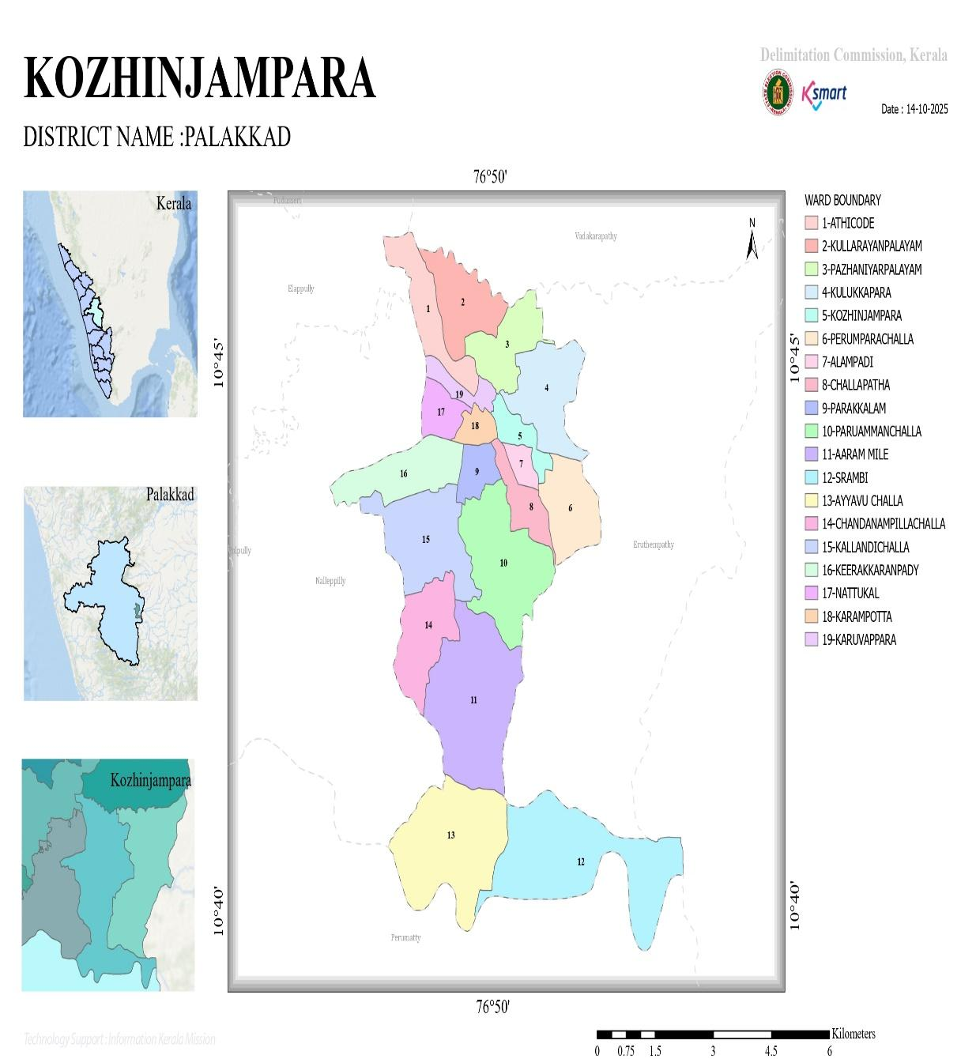

Health Infrastructure Map
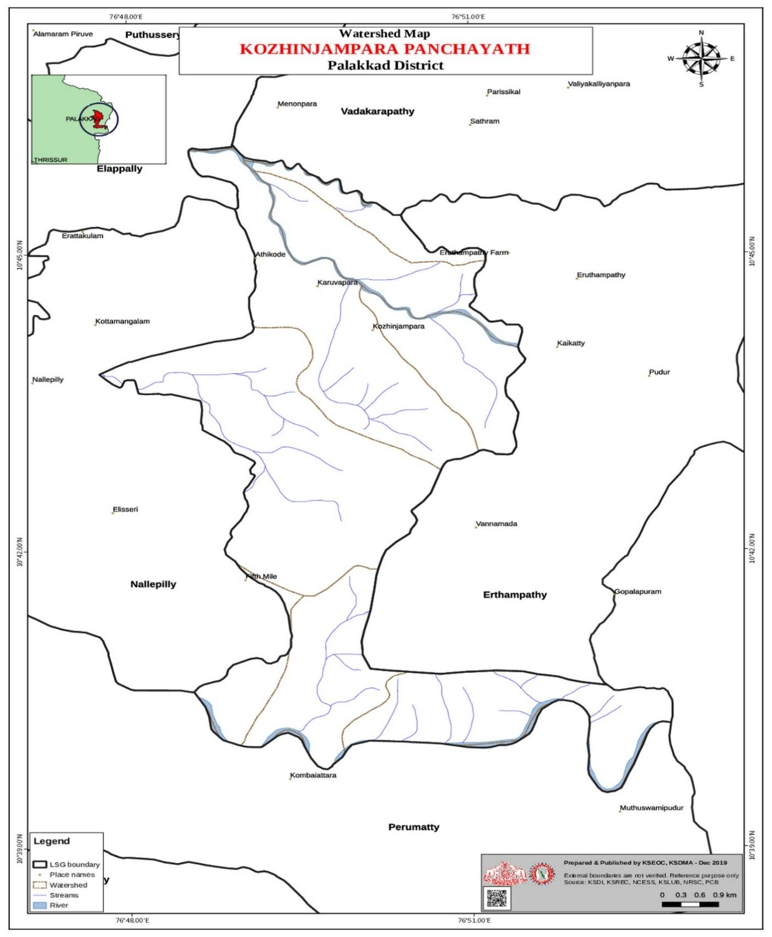

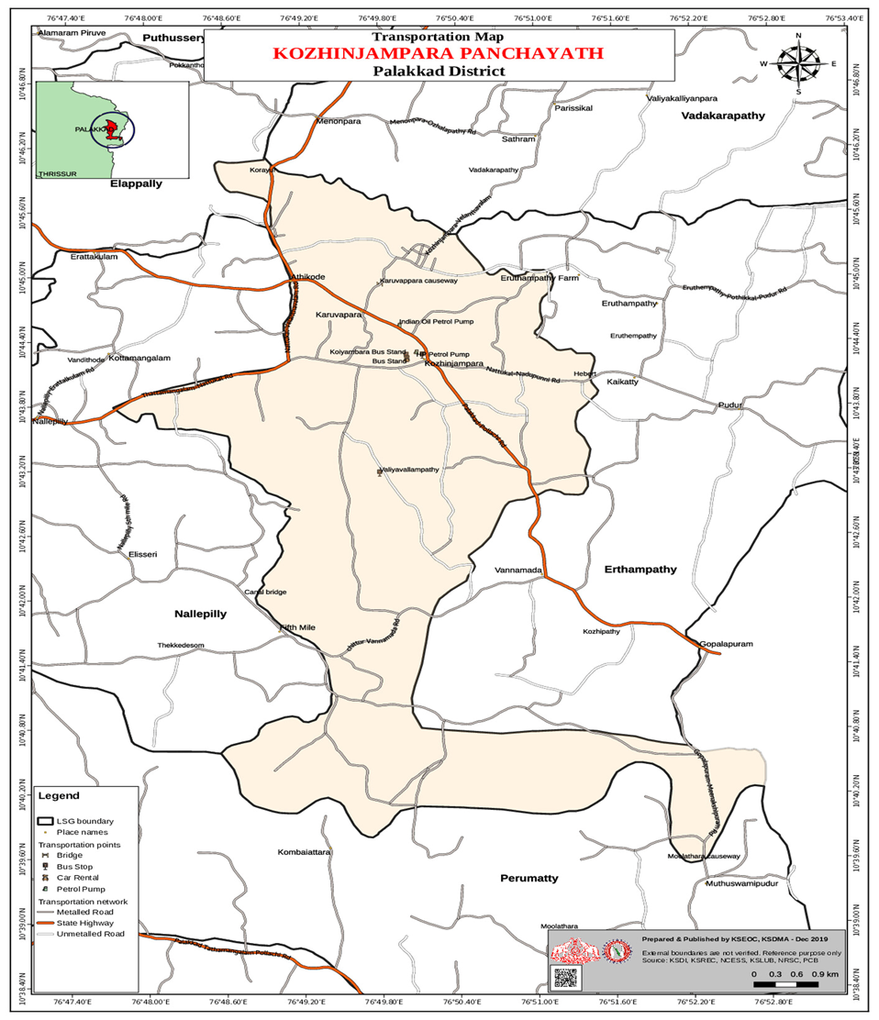

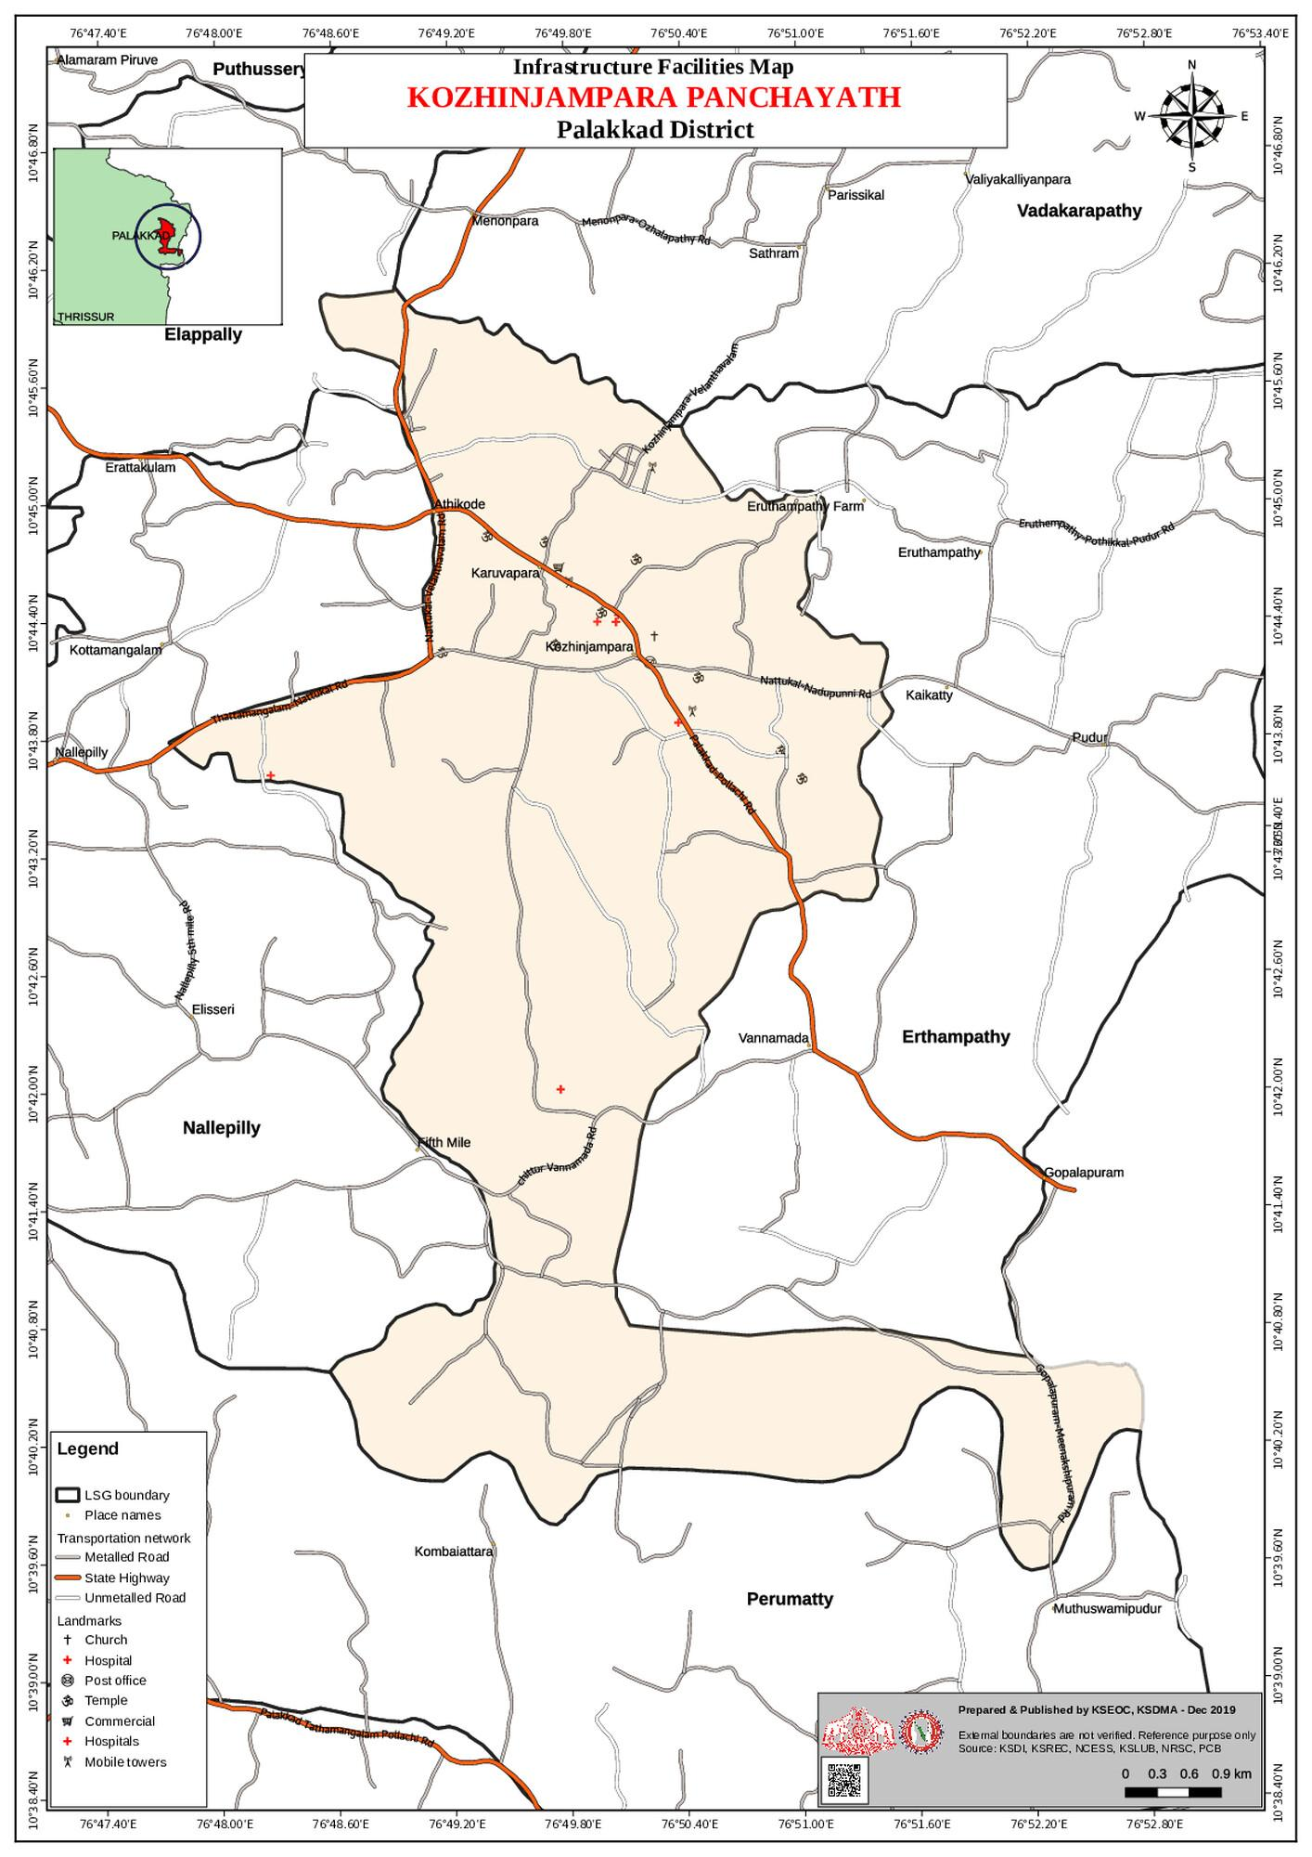

GENERAL PROFILE OF THE LSGI’S

Background of the LSGI
Kozhinjampara Grama Panchayat is situated in the Chittur Taluk of Palakkad district, Kerala. The geographical landscape of the Panchayat is unique within the district; while much of Palakkad is known as the "Granary of Kerala," Kozhinjampara sits in the rain-shadow region near the Tamil Nadu border.
The terrain is characterized by a mix of semi-arid plains and agricultural stretches, though it faces distinct challenges compared to the coastal "Kole lands" mentioned in your draft. In this region, the network of canals—fed by the Chitturpuzha and the Parambikulam-Aliyar project—is the lifeblood of the local microclimate. This geography poses specific challenges to water management and service delivery, particularly during the transition between drought-like summers and heavy monsoon bursts.
The Panchayat is administratively divided into multiple wards. The population is largely dependent on • Agriculture: Predominantly coconut groves, groundnuts, and vegetables, alongside traditional paddy.
• Livestock: Dairy farming is a massive pillar of the local economy here.
• Migrant Workforce: There is a significant presence of migrant laborers integrated into the agricultural and brick-manufacturing sectors.
From a public health and disaster management perspective, Kozhinjampara LSGI must manage a dual-threat profile:
- Water Scarcity: Being in a rain-shadow area, groundwater depletion is a recurring concern.
- Flooding/Vector Diseases: During extreme monsoon events (like those in 2018 and 2019), the canal systems can overflow, leading to localized flooding and outbreaks of waterborne or vector-borne illnesses like Dengue and Leptospirosis.

Table 1: Background of LSGD
Description | Details
Name of LSGI | Kozhinjampara
Type (GP/Municipality / Corporation etc.) | Grama Panchayath
Block | Chittur
District | Palakkad
Number of wards | 19
Total area (sq. km) | 43 Sq. Kilometers
Population(Projected) | 28791
Population density | 656
Terrain (coastal/low-lying/backwaters/foothills, etc.) | NA
Number of rivers passing through LSGI | 2
Number of water bodies in the LSGI | 1503
Number of educational institutions | 14
Factories / small-scale industries | 17
Flood-prone wards | Ward -11,12
Landslide-prone wards | 0
Death Management and Disposal Facilities (mortuaries/crematorium, including electric) | 2
Auditoriums/Marriage halls/convention centres/community halls | 10

Demographic and Vulnerable Population
Understanding the demographic composition and vulnerable population groups is essential for pandemic preparedness. Children, elderly, economically deprived families, migrant workers, and socially vulnerable groups are at increased risk during public health emergencies due to higher exposure, limited access to services, and dependency on public systems..

Description |  | Details (in numbers)
DEMOGRAPHIC PROFILE
Total population |  | 28791
Male |  | 14096
Female |  | 14695
Transgender |  | 0
Children under 5 |  | 1596
Adolescent
Elderly (>60) |  | 4944
SOCIAL/LIVELIHOOD VULNERABILITY
Previous EPEP family |  | 35
BPL family |  | 6355
Tribal communities |  | 908
Migration | Immigrant | 216
Migration | Emigrant | 575
Socio-economically deprived |  | 47
Fisherfolk |  | 0
SC Community |  | 2076
ST Community |  | 908

Graphs: Population pyramid (if possible) for seeing if your LSGI has a high "dependency ratio" (lots of children and elderly compared to working adults).

Clinical Vulnerability
Certain population groups needs priority healthcare & are at higher risk of severe illness, complications, and mortality during pandemics. Patients with chronic diseases, those requiring regular medical care, and individuals with mobility or functional limitations face challenges in accessing timely care during emergencies. Mapping these groups helps in prioritizing continuity of treatment, medicine stock planning, oxygen support, referral transport, and targeted home-based care.
Description | Details in numbers
Pregnant women | 97
Lactating mothers
Bedbound patients | 91
Patients under palliative care other than bedbound
Patients on Haemodialysis | 15
Patients on CAPD
Cancer patients (currently on treatment)
Haemophilic patients | 3
Mentally challenged | 6
Differently abled
Diabetic patients
Hypertensive patients
TB patients | 13

Major Festivals & Events specific to the LSGI
(with the possibility of a public gathering)

Sl. No. | Name of festival | Month detailing the periodicity
1 | Mariyamman Pooja, Kularayanpalayam | March
2 | Mariyamman Pooja, Pazhaniyarpalayam | March
3 | Mariyamman Pooja, Keerakaranpadi | April
4 | Mariyamman Pooja, Alampadi, | April
5 | Mariyamman Pooja,Muttimampallam | May
6 | St.Francis Xavier Feast ,Kozhinjampara | December
7 | Chandhanakudam, Hanafi Mosque ,Kozhinjampara | May,June

INFRASTRUCTURE & RESOURCE INVENTORY

Health Facility Directory & Basic Capacity in the LSGD
This section provides an overview of the healthcare infrastructure available within the LSGD area. It outlines the distribution and basic capacity of health facilities that form the backbone of service delivery during routine times and public health emergencies.

Family Health Centres (FHCs) and Community Health Centres (CHCs) generally function as the first point of contact for the community, providing essential outpatient and inpatient services. General Hospitals (GH) and Medical College Hospitals (MCH), where accessible, serve as the main referral centres for advanced diagnostics, specialist care, and critical services during public health emergencies. This inventory helps identify existing strengths, gaps, and potential surge capacity that can be mobilised during a pandemic or disaster.

Table 5. Health Facility Resource Summary
Sl.no. | Health Facility | Type of Facility (MCH/GH/CHC/FHC/SC etc.) | Contact Number | Total beds | ICU Beds | Oxygen-Supported Beds | No. of Ventilator Support Beds | No. of ambulances
Government Healthcare Facilities
1 | Ayurvedic Dispensary ,Kozhinjamapara | GH | 6282434797-  Dr.Haripriya | 1 | 0
2 | Block CHC Kozhinjampara | CHC | 04923-272229-
3 | Homeo |  | 8281735581-  P V Indhu
4 | HWC Kozhinjampara | HWC | 9744476251-  Ashna
5 | HWC Malakattuchalla | HWC | 8590325823-  Ahana Rigved
6 | HWC Pazhaniyarpalayam | HWC | 8281936447-  Renimol
7 | HWC Valiyavallampathy | HWC | 9074382134-  Niaha Rani
Private Healthcare Facilities
1 | ANU Ayurvedic Wellness Centre |  | 9447248430-  Radhakrishnan
2 | AV Clinic | Clinic | 04923272348-  DR.Muthukutty
3 | Das Prakash Clinic | Homeo | 9447839573-  Das prakash
4 | Dental Clinic | Clinic | 9497128267
5 | DR.Koshi Clinic | Homeo | 9446725811-  Koshi
6 | Malabar Clinic | Clinic | 9447839680-  Dr.Mary
7 | Mary Clinic | Clinic | 9567114923-  Dr.Mary
AYUSH Healthcare Facilities
1 | ANU Ayurvedic Wellness Centre |  | 9447248430-  Radhakrishnan | 1 | 0 | 0 | 0 | 0 | 0
2 | Ayurvedic Dispensary ,Kozhinjamapara | GH | 6282434797-  Dr.Haripriya | 1 | 0 | 0 | 0 | 0
3 | Homeo |  | 8281735581-  P V Indhu | 1 | 0 | 0 | 0 | 0

Private Clinics
Private clinics are an essential part of pandemic preparedness, as they are often the first place people seek care when symptoms begin. In many communities, private clinics manage a significant share of outpatient visits and therefore play a critical role in early case detection, timely referrals, and disease surveillance. Having an up-to-date understanding of where these clinics are located, the services they provide, and how they are linked to the public health system helps ensure that no cases are missed during an outbreak. It also allows health authorities to engage private practitioners more effectively for reporting, risk communication, and coordinated response, strengthening the overall capacity of the health system to manage public health emergencies.

Table 6. Private Clinic Resource Summary
Sl No. | Name of Clinic | Registered (Y/N) | Clinic (General / Speciality) | Speciality (if any) | Address | Contact Number | Diagnostic Facility (Y/N) | Ambulance Linkage (Y/N)
1 | AV Clinic |  | Clinic |  |  | 04923272348-  DR.Muthukutty | Y | N
2 | Dental Clini |  | Clinic | DENTISTRY |  | 9497128267 | Y | N
3 | Mary Clinic |  | Clinic |  |  |  | Y | N
4 | Riya Clinic |  | Clinic |  |  | 9496697220 | Y | N

Healthcare Education & Training Institutions
This section tracks the educational infrastructure available, which is vital for human resource planning in the health sector.

Category of Institution | Govt | Private | AYUSH | Total
Medical Colleges | 0 | 0 | 0 | 0
Nursing Colleges | 0 | 0 | 0 | 0
Dental Colleges | 0 | 0 | 0 | 0
Para-medical / Allied Health | 0 | 0 | 0 | 0
Pharmacy Colleges | 0 | 0 | 0 | 0

Specialized Services & Emergency Inventory
This section provides a detailed view of the specialized medical resources available to the community, focusing on emergency response and critical care capabilities. This table tracks the vital assets required for managing severe illnesses and emergencies across Government, Private, and AYUSH sectors.

Item | Govt | Private | AYUSH | Total
Hospital beds | 10 | 45 | 0 | 55
Oxygen-generating systems(Y/N) | 0 | 0 | 0 | 0
Oxygen-supported beds(Numbers) | 0 | 0 | 0 | 0
Ventilator-supported beds | 0 | 0 | 0 | 0
ICU beds | 0 | 0 | 0 | 0
Burns units | 0 | 0 | 0 | 0
Blood centres | 0 | 0 | 0 | 0
BLS ambulances | 0 | 0 | 0 | 0
ALS ambulances | 0 | 0 | 0 | 0
Dialysis facilities | 0 | 0 | 0 | 0
Dispensaries | 0 | 0 | 0 | 0
Medical store | 0 | 0 | 0 | 0
Industrial establishments(Medium-scale industries/small-scale industries establishments to whom we can depend in a worst-case scenario) | 0 | 0 | 0 | 0

Oxygen & Diagnostic Capacity
Monitoring oxygen and diagnostic capacity is a critical component of public health preparedness, ensuring that the LSGD can handle both chronic care and sudden surges in respiratory or infectious diseases.
Name of Health Facility | Oxygen-generating System (Y/N) | Backup Oxygen Source (Y/N) | Diagnostic Facilities Available(Y/N)
Name of Health Facility | Oxygen-generating System (Y/N) | Backup Oxygen Source (Y/N) | Lab | USG | X-ray | CT/MRI | RT-PCR
Government Healthcare Facilities

Diagnostics facility mapping at the LSGI level
The diagnostic capacity of Kozhinjamapara G.P represents the "intelligence network" of our healthcare system. The speed and accuracy of disease identification depend entirely on the distribution and technical level of these facilities.

Item | Govt | Private | AYUSH | Total
General labs | 1 | 5 | 0 | 6
Microbiology labs | 0 | 0 | 0 | 0
RT-PCR labs | 0 | 0 | 0 | 0
USG units | 0 | 1 | 0 | 1
CT/MRI units | 0 | 0 | 0 | 0
Research labs | 0 | 0 | 0 | 0
Labs of other departments that can be repurposed | 0 | 0 | 0 | 0

Laboratory Identification & Basic Details
Sl. No. | Name of Laboratory | Ownership (Govt / Private / Academic) | Address | Contact No. | 24×7 Services (Yes/No) | NABL / Govt Approved (Yes/No)
1 | CHC Kozhinjampara | GOVT | CHC Kozhinjampara |  | NO | NO
2 | DX | PVT | Kozhinjampara | Senthil-8129555155 | NO | NO
3 | IFA | PVT | Kozhinjampara | Basheer-9952328045 | NO | NO
4 | NEETHI | PVT | Kozhinjampara |  | NO | NO
5 | VIJAYA | PVT | Kozhinjampara | Vijayan-9495982440 | NO | NO
6 | VINAYAKA | PVT | Kozhinjampara | Inbaraj-9946711393 | NO | NO

Social and Community Infrastructure for surge plan
This table serves as our logistics and shelter inventory. By mapping these locations, quickly we can identify where to house displaced citizens, where to set up temporary medical clinics, and how to manage the deceased with dignity during a crisis.

Category | Total Count | Ward | Est. Capacity (Persons) | Contact details
Educational Institutions
Anganwadis | 1  1  2  1  1  2  3  1  2  1  2  1  2  2  2  2  1  2 | 1  2  3  4  5  6  7  8  9  10  11  12  13  14  15  16  17  18 | 10  10  10  10  10  10  10  10  10  10  10  10  10  10  10  10  10  10 | Haseena-9747678403  Abhitha-8428451347  Katharbeevi-9846680931  Faridha-9656073730  Suja-9446446974  Pyarijan-9072570211  Suchithra-6235131635  Lekha-9539000305  Sani-8078426696  Foujinisa-9809014803  Pushpalath-9946087571  Vijaya-9809757697  Manjula-7403400352  Prema-9605095964  Nil  Prabhavathy-9846453568  Vijaya-9995155259  Sheela-9605144285  Reetha-9496676226  Latha-9645697345  Latha-9539960304  Thushara-9778347796  Leela-6282499751  Divya-8156903913  Pushpalatha-9645070790  Sabira-9349583166  Valsala-8281161347  Raihana-9544148125  Syamala -9846728761
Schools | 3  1  1  1  1  1  1  3 | 1  3  5  10  12  14  16  18 |  | St.Martins EMHS Athicode-  8547005126  Yes English Medium School-  9567382730  St.Francis Central School-8281126961  GLPS Souriyarpalayam-  9995473827  GoodNews Eng.. Medium School-  9495877882  Saraswathy Vidhayalayam –  9446449231  GLPS Kunnamkattupathy-9567488458  GLPS Kallandichalla-  8547574562  GLPS Nattukal-  9443477359  GUPS Kozhinjampara –  0492-3272205  St.Pauls HSS-  9446387053  St.Pauls English Medium -9539691145
Colleges | 1 | 16 |  | Bharathamatha college-  0492-3272318
Healthcare Educational Institutions
Medical colleges (Govt/Private) | 0 | 0 | 0 | 0
Nursing colleges (Govt/Private) | 0 | 0 | 0 | 0
Dental colleges (Govt/Private) | 0 | 0 | 0 | 0
Paramedical institutes (Govt/Private) | 0 | 0 | 0 | 0
Community Gathering Spaces
Community halls | 1 | 8
Auditoriums | 3  1  1  1  1  2 | 1  3  4  7  8  18 | 95  180  180  120  25  180  250  50  50 | JJHall-9846752077  Galaxy Auditorium –  9447723426  Fathima Sulthan-  9388889222  Pazhaniyarpalayam Mandapam  KRS Kullukapara-9447323034  Ruby Hall-7356056007  AR Hall-9447723410  Ashmi Auditorium-9656273577  Annapoorna-9446422580
Vulnerable Group Support Facility
Destitute homes | 0 | 0 | 0 | 0
Elderly homes | 1 | 09 | 50 | Goodnews old age home: 04923273204
LSGD owned other buildings | 0 | 0 | 0 | 0
Mass Fatality Management (MFM) Infrastructure
Mortuary | 0 | 0 | 0 | 0
Crematorium | 3 | 01,02, 03
*refer annexure 1 for contact details

Human resources
This section focuses on the human capital available within the LSGI. In any emergency—be it a pandemic, flood, or industrial accident—infrastructure is only as effective as the people operating it.

Medical & Clinical Personnel
This table tracks the "Frontline" providers responsible for diagnosis, treatment, and clinical management. Narrative sentence: eg., "Total health workforce: 450 personnel, with 60% in government facilities serving as primary surge capacity." A detailed directory with the contact numbers of all workers is maintained (Annexure in 1).

Cadre | Govt (No.) | Private (No.) | Total
Doctors—Modern Medicine | 1 | 7 | 8
Doctors – AYUSH | 1 | 1 | 1
Doctors – Veterinary | 1 | 0 | 1
Doctors – Dental | 0 | 1 | 1
Nursing officers | 12 | 10 | 22
Lab technicians | 1 | 5 | 6
Optometrist | 1 | 0 | 1
Pharmacists | 2 | 4 | 6
Psychologists | 0 | 0 | 0
Counsellors | 1 | 0 | 1

Public Health & Field-Level Workforce
These individuals are the backbone of surveillance, maternal-child health, and decentralized care.

Cadre | Health services | Municipal common services | Total
HS (Health Supervisors) | 0 | 0 | 0
HI (Health Inspectors) | 0 | 1-LSGD | 0
LHS (Lady Health Supervisor) | 0 | 0 | 0
LHI (Lady Health Inspectors) | 0 | 0 | 0
JPHN (Jr Public Health Nurses) | 4 | 0 | 4
JHI (Jr Health Inspectors) | 3 | 0 | 3
MLSP (Mid-Level Service Providers) | 3 | 0 | 3
Palliative Nurses | 0 | 1 | 1
RBSK Nurses | 1 | 0 | 0
PRO | 0 | 0 | 0
Epidemiologist | 0 | 0 | 0
Data Manager | 0 | 1 | 1

Community & Support Cadre
This group represents the surge capacity of the LSGI—people who can be called upon for logistics, rescue, and specialized support.

Cadre | Number
ASHA Workers | 18
AWW (Anganwadi Workers) | 29
Emergency Medical Volunteers (Trained) | NIL
Kudumbashree | 850
MNREGS | 955
Purusha Swayam Sahaya Sangham | 20
Ex-Servicemen
Retired Police Officers
NCC/NSS Volunteers
Red Cross volunteers
One Health Community Volunteers
One Health Community Mentors

Community Organizations
This section details the presence of community-based organisations (CBOs), non-governmental organisations (NGOs), faith-based organisations (FBOs), Kudumbashree Self-Help Groups (SHGs), and Ayalkootams within the Local Self-Government Institution (LSGI). These groups enhance grassroots mobilization, resource distribution, and support networks crucial for pandemic response and community resilience.

Category | Total Count
NGOs | 0
Religious based organizations | 2
Foreign based organizations | 0
Sports Club/youth clubs | 6
Kudumbashree SHGs | 85
Ayalkootams | 85
Political organizations | 4
Residential organizations | 0

Administrative & Emergency Services
This section outlines the availability of key non-health emergency support services and infrastructure within the LSGI, which are essential for effective pandemic preparedness and response. These facilities support law enforcement, disaster response, water supply, logistics, mobility, and community-level interventions during public health emergencies.

Category | Total Count | Contact details
Police Stations | 1
Fire & Rescue Stations | 0
Water Pumping Points | 1
Public Distribution System (PDS)

Information regarding resources
The availability of essential transport and support resources plays a quiet but critical role in saving lives. Equipment such as ambulances, mobile mortuaries, amphibian ambulances, and motorized boats ensures that patients, samples, and healthcare teams can move swiftly—even in flooded, remote, or difficult terrains. Heavy vehicles like JCBs, cranes, tractors, and torus lorries support logistics, waste management, emergency infrastructure, and rapid conversion of spaces into care or isolation facilities. Taxis, four-wheel-drive vehicles, and trucks help maintain continuity of essential services, reach vulnerable populations, and support home-based care and supply delivery.

Means of transportation | Total Count
JCB
Crane
Heavy Trucks
Tractor
Ambulances | 4
Mobile mortuaries | 2
Boats | 0
Taxi service
Note: For specific details regarding vehicle owners and contact information, please refer to Annexure [X].

ONE HEALTH & ENVIRONMENTAL SURVEILLANCE
The One Health method integrates environmental, animal, and human health to enable proactive pandemic preparedness. Panchayat-level surveillance needs to be improved in order to detect and treat zoonotic and environmentally generated diseases early. Surveillance is strengthened through systematic assessment of animal populations, veterinary infrastructure, poultry and slaughter facilities, inter-sectoral coordination, and specialised tools like avian influenza seasonality mapping using GIS in previous outbreaks to enable predictive alerts and ward-specific sampling to support effective pandemic preparedness in high-risk areas like _____NIL_______.

Animal & Bird Population
Mapping animal and bird populations at the Panchayat level is essential for identifying and prioritising zoonotic disease hazards like rabies, avian influenza (H5N1), leptospirosis, anthrax, and Nipah-like spillover occurrences. Risk classification, targeted surveillance, vaccination planning, and early epidemic detection made feasible by comprehensive population mapping all enhance One Health-based pandemic preparedness.

Category | Item | Estimated Population | Wards
Animal Population | Livestock (Cattle/Goats/Buffalo)
Animal Population | Pet Animals (Dogs/Cats)
Animal Population | Stray Dog Population
Animal Population | Pig Farms (Number of heads) | 3 | 13-Rajaligam-9048526432  1-Jayakumar  1-Arul Prakash-  8086808715
 | Small Units (Sheep / Goats – clustered)
Bird Population | Poultry Units (Birds) | 1 | 3- Debdas
Bird Population | Poultry- (FOWL)
Bird Population | Wild/Migratory Birds (Observed)
Bird Population | Crow Mortality Events (Reported)

The main risk of zoonotic diseases in ______NIL______ is concentrated in Wards………………., which is explained by the high density of pig farms, cattle congregation areas, and poultry units. The stray dog population in market areas, fish landing sites, bus stations continues to be a substantial problem for rabies surveillance and bite prevention. There is a considerable risk of avian influenza introduction and amplification during November - December due to the seasonal presence of migratory and resident water birds near ponds/ canal / river / backwater / paddy field. Clusters of pig farms and animal shelters vulnerable to flooding further raise the risk of leptospirosis and other zoonoses mediated by the environment, especially during monsoon floods.

Veterinary Infrastructure
Veterinary institutions are a core pillar of One Health surveillance, enabling early zoonotic disease detection through vaccination, investigation of unusual animal illness or deaths, sample collection, and timely outbreak reporting. A well-mapped and responsive veterinary network strengthens coordination with human health and LSGI systems, ensuring rapid response during zoonotic events and pandemics.
Facility Type | Name of Facility | Ownership Govt / Pvt | Location(Ward No) | Contact number
Veterinary Dispensary | Veterinary sub centre, pazhaniyarpalayam | GOVT | Pazhaniyarpalayam (ward-3) | Dr.Jayan: 9847240000
Veterinary Hospital / Polyclinic | Veterinary hospital, kozhinjampara |  | Kannamedu(ward-9) | 2.veterinary surgen: 9847240000
Private Veterinary Clinics | 0 | 0 | 0 | 0
Mobile / Emergency Vet Service (incl. night services) | 0 | 0 | 0 | 0
Pet Homes / Animal Shelters | 0 | 0 | 0 | 0
Slaughterhouse-linked Veterinary Inspection Unit | 0 | 0 | 0 | 0

Veterinary Doctors & Workforce
Early detection, diagnosis, reporting, and reaction to animal illness epidemics depend on the availability and accessibility of qualified veterinary specialists. By identifying unusual animal morbidity or mortality promptly, collecting samples promptly, and coordinating efficiently with human health and LSGI systems—especially during zoonotic outbreaks and pandemic-prone situations—a clearly defined veterinary workforce enhances One Health surveillance.

Category | Number Available | Type (Govt/Pvt) | C)ontact number
Government Veterinary Doctors | 1 | Govt | 9847240000
Private Veterinary Doctors | 0 | 0 | 0
Livestock Inspectors | 1 | Govt
Para-veterinary Staff / Attenders | 2 | Govt
Contract / On-call Veterinary Support (if any) | 0 | 0 | 0

High-Risk Interface Points (Surveillance Sites)
High-risk interface points for zoonotic disease surveillance in ____________ Grama Panchayath include wetland–livestock–human contact zones, backyard poultry farms, cattle sheds near water bodies, fish markets, and areas of high human–animal interaction such as community slaughter points and migratory bird congregation sites. These are the primary surveillance sites where zoonotic spillover risks are elevated.

Type of Habitat | Type of High risk interface | Geographical vulnerability
Wetlands & Backwaters | 0 | 0
Backyard Poultry Farms | 0 | 0
Cattle Sheds near Water Bodies | 0 | 0
Fish & Meat Markets | 0 | 0
Community Slaughter Sites | 0 | 0
Migratory Bird Congregation Areas | 0 | 0
Rodent-Infested Grain Storage | 0 | 0

Category | Total Count | Key Locations (wards)
Poultry Farms | 1 | Pallikoodathanoor(Ward-3)
Backyard / Clustered Poultry Units | 0 | 0
Duck Rearing Units (open water access) | 0 | 0
Slaughterhouses/ Slaughter Points | 0 | 0
Meat/Fish Markets | 0 | 0
Live Bird Sale Points | 0 | NA
Cattle Markets / Weekly Animal Fairs | 0 | NA
Pet Shops / Breeders | 0 | 0
Animal Shelters / Pet Homes | 0 | 0
Waste Disposal Sites near Animal Units | 0 | NA

Environmental Risk Mapping
Environmental risk mapping identifies monsoon/flood hotspots for vector-borne (dengue, chikungunya), water-borne (leptospirosis, diarrhoea), and zoonotic diseases in Kerala's wetlands. Systematic surveillance supports early warnings, targeted interventions, and Panchayat pandemic preparedness.
Waterborne exposure: Flood-prone areas and stagnant water bodies facilitate leptospira survival, raising leptospirosis risk.

Traditional practices: Informal slaughter and fish markets lack standardized hygiene, creating spillover opportunities.

Risk Factor | High-Risk Wards | Key Locations | Risk Level (High/Med/Low)
Flood-prone areas
Water bodies/wetlands | 0 | 0 | 0
Solid waste accumulation | 0 | 0 | 0
Animal waste disposal issues | 0 | NA | NA
Rodent infestation zones | 0 | 0 | 0
Industrial effluent discharge | 0 | NA | NA
Construction sites / abandoned buildings | 0 | 0 | 0
Poor drainage/blocked canals | 0 | 0 | 0
Drinking water source contamination risk

Disease Seasonality Mapping
1, Flooding & waterlogging → amplifies leptospirosis, malaria, diarrheal diseases.
·
2, Migratory bird influx (Nov–Feb) → avian influenza risk.

3, Mosquito breeding cycles → vector-borne disease peaks in monsoon.

4, Agricultural practices → close human–animal contact in paddy fields.

Disease | Peak Risk Season | Key Drivers | High-Risk Locations | Surveillance Focus
Avian Influenza | 0 | 0 | 0 | 0
Leptospirosis | June,July, Nov, Dec | Contaminated water | Karampotta, Keerakkarampadi, kulukkappara,
Dengue/Chikungunya | June,July, August, Nov, Dec | Indoor water collection | Alampadi, Pallistreet, Manimuthunagar, Pazhaniyarpalayam, vaniyar street
Acute Diarrheal Diseases | June,July, August | Flies, | Pallistreet, Alampadi, , kozhinjampara
Rabies | Through out the year | Dog, Cat | Panchayath area
Anthrax (rare) | 0 | 0 | 0

Vulnerability Mapping
Vulnerability mapping pinpoints high-risk populations, occupations, and areas exposed via environment, livelihoods, socio-economics, and poor service access. Paired with environmental/seasonality mapping, it enables risk-based surveillance, targeted actions, and optimal resource use in One Health and pandemic planning.
Vulnerability Factor | High-Risk Wards | Key Groups / Locations | Risk Level
Flood-prone households
Wetland-adjacent communities | 0 | 0 | 0
Backyard poultry / duck rearing households | 0 | 0 | 0
Livestock-rearing households
Slaughterhouse & meat market workers | 0 | 0 | 0
Fisherfolk & fish market workers | 0 | 0 | 0
Sanitation workers
Daily wage / migrant workers
Elderly & chronically ill populations
Pregnant Women
Children (schools, Anganwadi’s)
Limited access to safe water & sanitation

EPIDEMIOLOGICAL TRENDS (2021–2025)

Disease surveillance is the systematic collection, analysis, and interpretation of health data for planning, implementation, and evaluation of public health practice. This section presents the disease surveillance profile of the LSGI based on routine reporting systems and outbreak investigations to identify priority diseases, seasonal patterns, and emerging public health threats.

Disease Burden among human beings(Last 5 Years)
Analysis of disease-wise data for the last five years helps identify persistent public health problems, emerging diseases, and changes in disease burden. This information supports prioritisation of prevention, preparedness, and response activities at the Panchayat level.

Disease | 2021 | 2022 | 2023 | 2024 | 2025 | Trend(Increasing/Stable/Decreasing)
Dengue | 4 | 17 | 51 | 98 | 63 | 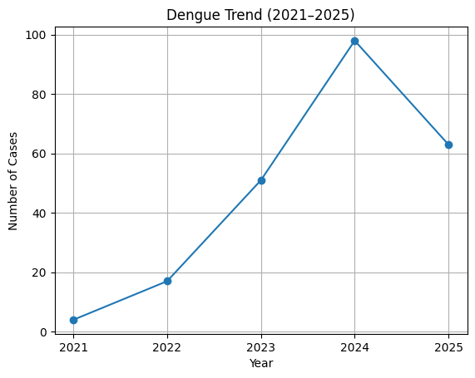
Leptospirosis | 0 | 0 | 0 | 1 | 2 | 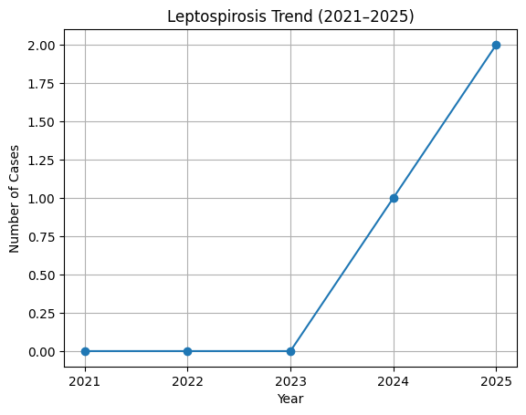
Hepatitis A | 0 | 0 | 0 | 1 | 2 | 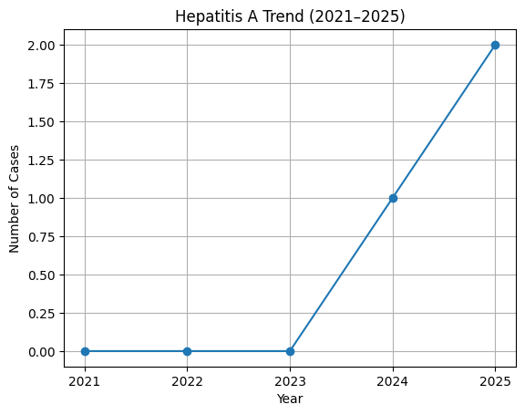
Malaria | 0 | 1 | 0 | 0 | 1 | 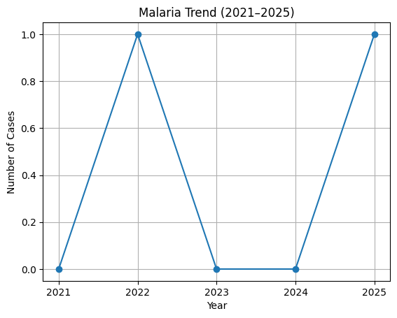
Scrub Typhus | 0 | 0 | 2 | 3 | 7 | 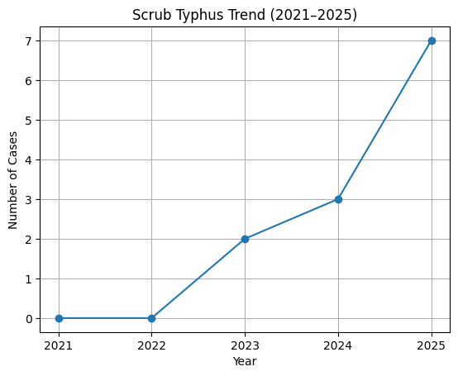
Typhoid | 0 | 0 | 0 | 1 | 2 | 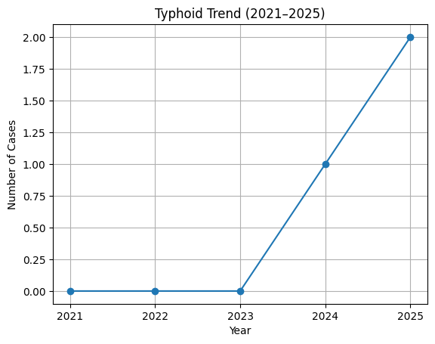
ADD | 43 | 67 | 83 | 76 | 72 | 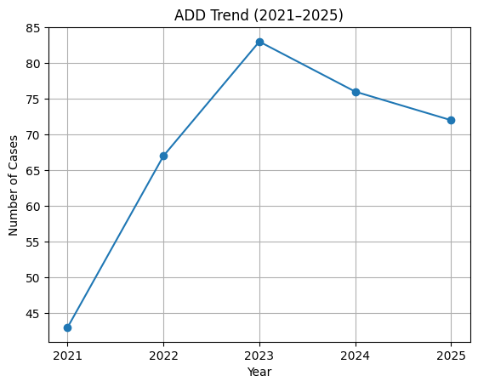
Mumps | 17 | 42 | 36 | 51 | 68 | 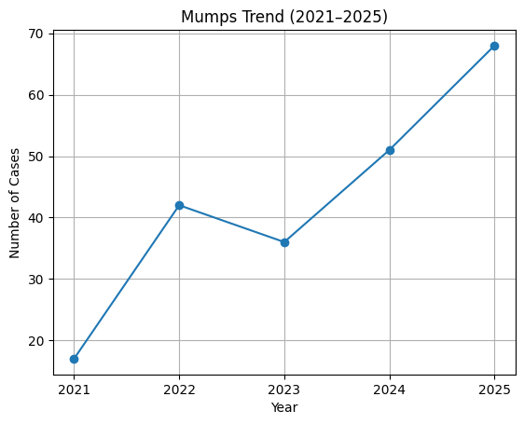
Hepatitis B | 0 | 1 | 0 | 2 | 4 | 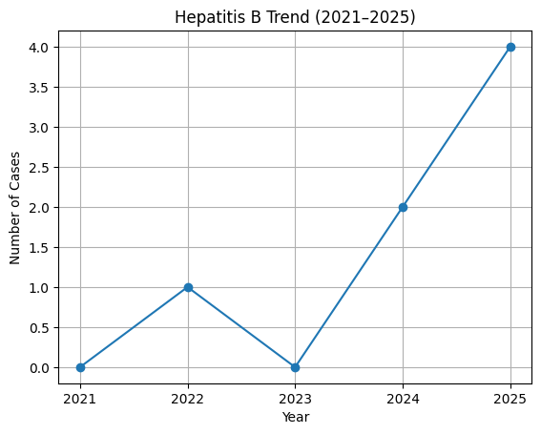
Hepatitis C | 0 | 0 | 1 | 0 | 1 | 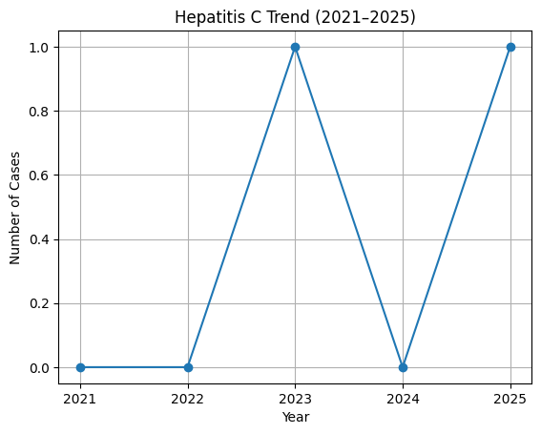
Tuberculosis | 1 | 4 | 9 | 18 | 21 | 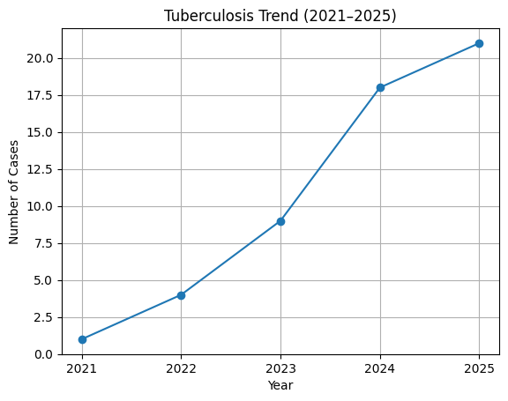
Leprosy | 0 | 0 | 0 | 14 | 0 | 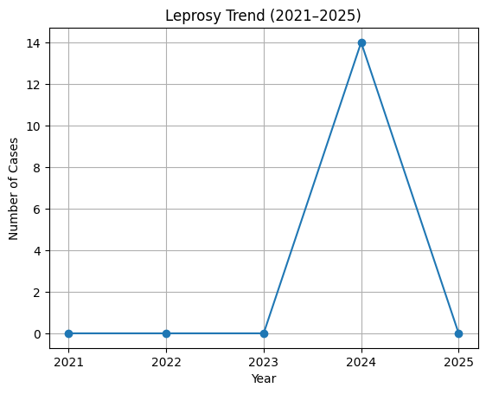
COVID-19

*(use the above table data to create the graph/diagram)

Seasonal Trend Analysis
Seasonal analysis helps anticipate surges (e.g. dengue in monsoon, leptospirosis after floods, influenza in cooler months) and plan pre‑emptive vector control, stockpiling of IV fluids, and awareness campaigns at Panchayat level.

DENGUE
Dengue is a major seasonal vector-borne disease strongly associated with rainfall, water stagnation, and increased mosquito breeding during the monsoon period.

Peak: July–November

Dengue – Ward-wise Yearly Distribution (2021–2025)

Ward | Dengue – Ward-wise Yearly Distribution
Ward | 2021 | 2022 | 2023 | 2024 | 2025 | Total
1 | 0 | 1 | 3 | 7 | 1 | 12
2 | 0 | 0 | 2 | 5 | 2 | 9
3 | 1 | 2 | 4 | 7 | 4 | 18
4 | 0 | 0 | 2 | 6 | 1 | 9
5 | 1 | 2 | 7 | 9 | 6 | 25
6 | 0 | 0 | 4 | 5 | 2 | 11
7 | 1 | 2 | 5 | 8 | 7 | 23
8 | 1 | 1 | 3 | 8 | 6 | 19
9 | 0 | 1 | 2 | 4 | 3 | 10
10 | 0 | 0 | 1 | 1 | 1 | 3
11 | 0 | 2 | 2 | 6 | 4 | 14
12 | 0 | 1 | 1 | 2 | 2 | 6
13. | 0 | 1 | 2 | 3 | 4 | 10
14 | 0 | 0 | 2 | 4 | 3 | 9
15 | 0 | 2 | 1 | 5 | 4 | 12
16 | 0 | 0 | 3 | 5 | 2 | 10
17 | 0 | 1 | 3 | 7 | 5 | 16
18 | 0 | 1 | 4 | 6 | 6 | 17

LEPTOSPIROSIS
Leptospirosis cases are closely linked to monsoon rains, flooding, and occupational exposure, particularly in low-lying and waterlogged areas.

Peak: June - August

Leptospirosis – Ward-wise Yearly Distribution (2021–2025)

Ward | Leptospirosis – Ward-wise Yearly Distribution
Ward | 2021 | 2022 | 2023 | 2024 | 2025 | Total
1 | 0 | 0 | 0 | 0 | 0 | 0
2 | 0 | 0 | 0 | 0 | 0 | 0
3 | 0 | 0 | 0 | 1 | 1 | 2
4 | 0 | 0 | 0 | 0 | 0 | 0
5 | 0 | 1 | 0 | 0 | 0 | 1
6 | 0 | 0 | 0 | 0 | 0 | 0
7 | 0 | 0 | 1 | 0 | 0 | 1
8 | 0 | 0 | 0 | 0 | 0 | 0
9 | 0 | 0 | 0 | 0 | 0 | 0
10 | 0 | 0 | 0 | 0 | 0 | 0
11 | 0 | 0 | 0 | 0 | 0 | 0
12 | 0 | 0 | 0 | 0 | 1 | 1
13 | 0 | 0 | 0 | 0 | 0 | 0
14 | 0 | 0 | 0 | 0 | 0 | 0
15 | 0 | 0 | 0 | 1 | 0 | 1
16 | 0 | 0 | 0 | 0 | 0 | 0
17 | 0 | 0 | 0 | 0 | 0 | 0
18 | 0 | 0 | 0 | 0 | 0 | 0
Total | 0 | 1 | 1 | 2 | 2 | 6

VIRAL HEPATITIS - A
Hepatitis A cases are commonly associated with unsafe drinking water, food contamination, and breakdowns in sanitation, often presenting as clusters or outbreaks.

Peak: October - December

Hepatitis A – Ward-wise Yearly Distribution (2021–2025)

Ward | Hep A – Ward-wise Yearly Distribution
Ward | 2021 | 2022 | 2023 | 2024 | 2025 | Total
1 | 0 | 0 | 0 | 0 | 0 | 0
2 | 0 | 0 | 0 | 0 | 0 | 0
3 | 0 | 0 | 0 | 0 | 0 | 0
4 | 0 | 0 | 0 | 0 | 0 | 0
5 | 0 | 0 | 0 | 1 | 0 | 1
6 | 0 | 0 | 0 | 0 | 0 | 0
7 | 0 | 0 | 0 | 0 | 0 | 0
8 | 0 | 0 | 0 | 0 | 0 | 0
9 | 0 | 0 | 0 | 0 | 0 | 0
10 | 0 | 0 | 0 | 0 | 0 | 0
11 | 0 | 0 | 0 | 0 | 0 | 0
12 | 0 | 0 | 0 | 0 | 0 | 0
13 | 0 | 0 | 0 | 0 | 1 | 1
14 | 0 | 0 | 0 | 0 | 0 | 0
15 | 0 | 0 | 0 | 0 | 1 | 1
16 | 0 | 0 | 0 | 0 | 0 | 0
17 | 0 | 0 | 0 | 0 | 0 | 0
18 | 0 | 0 | 0 | 0 | 0 | 0
Total | 0 | 0 | 0 | 1 | 2 | 3

Transmission Trend- 2025
For effective management of public health issues, it is important to track the trend of disease transmission mode. It helps identify the population or place at high risk that can be used to predict outbreaks and implement targeted interventions as quickly as possible. Understanding these kinds of trends enables authorities to allocate resources efficiently and change the strategies adequately based on the trend that follows.

Mode of Transmission | No. of cases | No. of Deaths
Vector Borne Diseases | 98 | 0
Water Borne Diseases | 74 | 0
Air Borne Diseases | 0 | 0
Blood Borne Diseases | 5 | 0
Food Borne Diseases | 0 | 0

Vector-Borne Disease

Disease | No. of Cases | No. of Deaths
Dengue |  | 0
Malaria |  | 0
Chikungunya |  | 0

Water Borne Disease

Disease | No. of Cases | No. of Deaths
Cholera |  | 0
Typhoid |  | 0
Hep- A |  | 0
Dysentery |  | 0
Amoebiasis |  | 0
E- Coli infections |  | 0
Air Borne Disease

Disease | No. of Cases | No. of Deaths
Influenza |  | 0
H1N1 |  | 0
TB |  | 0
Chickenpox |  | 0
Measles |  | 0
Covid-19 |  | 0
Pertussis |  | 0
Mumps |  | 0

Blood-Borne Disease

Disease | No. of Cases | No. of Deaths
AIDS |  | 0
Hep- B |  | 0
Hep- C |  | 0

Zoonotic Disease

Disease | No. of Cases | No. of Deaths
Rabies |  | 0
Leptospirosis |  | 1
Avian influenza |  | 0
West nile |  | 0
Anthrax |  | 0
Nipah |  | 0
Scrub Typhus |  | 0

Integrated Disease Hotspot Map (2021–2025)
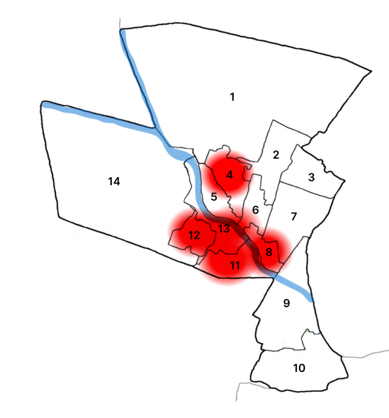

Ward No | Dengue Total (2021-25) | Leptospirosis Total (2021-25) | Hepatitis A Total (2021-25) | Mumps (2021-25) | ADD (2021-25) | Total Cases
1
2
3
4
5
6
7
8
9
10
11
12
13

Preparedness and Response Protocol at LSG Level
This section describes the operational framework for the LSGI once a pandemic is declared. It explains how the LSGI and health system will move from routine data collection to active response, using a One Health approach.

Constitution of One Health Committee
The LSGD shall constitute a One Health Committee comprising the LSGI President, Medical Officers (Modern Medicine, AYUSH, and Veterinary), the Health Inspector, and the Veterinary Surgeon.

Objective: The One Health Committee coordinates human, animal, and environmental health to prevent and control pandemics.

Sl No | Name | Designation | Department/Institution | Role in Committee | Contact Number
1 | Sri.Ramakrishnan | Panchayat President | LSGD | Chairperson | 9745681463
2 | Dr.Bibin Chacko | Medical Officer (PHC/CHC) | Health Dept | Member Secretary | 9895052375
3 |  | Veterinary Officer | Animal Husbandry | Member | 9847240000
4 |  | Epidemiologist | Health Dept | Member | NA
5 | Sri.K Suresh | Health Inspector/PHN | Health Dept | Surveillance | 8086000001
6 | Smt. Akhila | ASHA Supervisor | Health Dept | Community link | 9496352718
7 |  | ICDS Supervisor | Social Welfare | Vulnerable groups
8 |  | Police Station Officer | Police Dept | Law & order | 04923272224
9 | 1.S Roshna Beegam  2.KS Thanikachalam  3.Angelin Mary  4.Jayapalan N  5.Sadhdham Hussain M  6.Sivaraman K  7.Rajitha S  8. Ancila A  9.Jerosha Sajeev  10.N Vijayanandh  11.KM Deepa Sumesh  12.GK Vijayalakshmi  13.Ramakrishnan T  14.Satheesh M  15.M Indhira  16.Vijayakumaran V  17.Vanaja Kannan  18.Vichithran  19.Musfira Shefeeq | Ward Councillor Representative | LSGD | Community coordination | 1.9446240254  2.9447703370  3.9074736887  4.7592005444  5.9809860085  6.9846622819  7.8139027700  8.9633300908  9.8547083752  10.9446267000  11.9447107221  12.9865988868  13.9745681463  14.9846702150  15.8281582712  16.8129674938  17.9539022908  18.9048151484  19.8589012313
10 |  | Kudumbashree CDO | Kudumbashree | Community mobilisation
11 |  | NGO/Volunteer rep | Civil Society | Support services
12 |  | Line Department representations

Key Responsibilities:
- Review disease surveillance data (human + animal)
- Conduct ward-wise risk assessment and vulnerability mapping
- Approve quarantine/isolation centre locations
- Coordinate with district for resources (PPE, oxygen, ambulances)
- Periodically review health system surge capacity, including beds, oxygen, human resources, and ambulances.
- Approve and monitor risk communication and community engagement strategies, including rumour management.
- Ensure protection and service continuity for vulnerable groups (elderly, persons with disabilities, dialysis patients, coastal populations).
- Conduct quarterly mock drills
- Monitor equity measures for vulnerable groups

Meeting Schedule:
Quarterly (normal times) | Weekly (outbreak alert) | Daily (pandemic phase)

Pandemic Response Workforce
To ensure a coordinated and timely response during a pandemic, a dedicated Pandemic Response Workforce shall be constituted at the LSG level. The workforce will function under the overall supervision of the One Health Committee and in close coordination with the health authorities. Team-based deployment will enable efficient surveillance, case management, quarantine and isolation management, logistics support, and risk communication. Each team shall have a clearly designated team leader, defined roles, and an identified pool of personnel to allow rapid activation, rotation of duties, and continuity of services during prolonged emergencies.

Total Response Workforce Available: 300 persons

Team Name | Composition | Key Responsibilities | Team Leader
Surveillance and Contact Tracing Team | HI, JHI, JPHN, ASHAs and Volunteers | Case detection, contact listing, home visits, reporting | HI
Case Management Team | Doctors, Nurses, MLSP, Palliative Nurses | Patient care & referral | DOCTOR
Quarantine & Isolation Team | LSGD staff, Volunteers | Facility management | JHI
Psychosocial support
Logistics & supply chain Team | LSGD staff, Storekeepers, Drivers 3 | Supplies & transport [PPE, medicines, oxygen, transport, waste management] | Ward Member
Communication Team | Ward members, Kudumbashree, Youth clubs,  AWW workers and other self help groups | IEC, community meetings, countering misinformation | M.O in charge
Transportation | KSRTC, educational institutional buses
Media Surveillance
Intersectoral coordination and convergence
Collaborative surveillance

All teams shall be activated immediately upon outbreak alert or pandemic declaration and shall report daily to the LSG Incident Commander/Medical Officer, with consolidated reporting to the Block PHC. Duty rosters and alternate personnel shall be maintained to ensure uninterrupted services during staff shortages or prolonged response periods. Team composition and numbers may be revised based on the magnitude of the outbreak and availability of human resources.

Activities and Measures before and during Pandemic

PHASE 1 - Alert / Preparation
Surveillance and Reporting-Enhanced syndromic surveillance:
- Data sources for surveillance:
- Event-based triggers (to be monitored and reported):
- Zoonotic and animal health surveillance
- Logistics and Stock Preparedness
  - Identify and empanel local vendors and define emergency procurement mechanisms in accordance with existing LSGD and Health Department norms.
  - Prepare and maintain an essential logistics checklist covering medical supplies, consumables, and support equipment.
  - Pre-identify secure storage locations for emergency stocks and ensure maintenance of stock registers with regular updating.
  - Finalise emergency transport arrangements, including availability of vehicles and identified drivers for rapid deployment during alerts.
  - Designate a Nodal Officer for Logistics to enable prompt decision-making, coordination, and communication during emergencies.
  - Conduct rapid stock verification and ensure availability of minimum buffer stock, including:
- PPE kits – numbers
- Pulse oximeters – ___ numbers
- Hand sanitizers – ___ litres
- Masks, gloves, disinfectants – adequate quantity
Identify critical gaps in logistics and immediately communicate requirements to the Block and District authorities for timely replenishment and support. Monitor expiry dates and stock rotation.

Identification of Quarantine and Isolation Facilities
  - Identify and list suitable buildings for quarantine and isolation (schools, hostels, community halls, etc.).
  - Categorise cases as per the severity and allocate to appropriate facilities (for instance, severe cases to classrooms, mild cases to an assembly hall in case of a school).
  - Facility readiness checklist needed (beds, toilets, ventilation) etc.
  - Find an alternate site if the primary sites are not available or not in use.
  - Identify facility managers and support staff
  - Prepare basic SOPs for:
    - Admission and discharge
    - Food, water, sanitation
    - Infection prevention and waste disposal
  - Ensure availability of basic amenities: water, sanitation, electricity, ventilation, and waste disposal. Prepare a rapid activation plan for these facilities if case numbers increase.

Risk Communication and Community Preparedness
  - Disseminate early warning messages on symptoms, preventive measures, and reporting mechanisms. Display IEC materials both in English and the local language in public places and ensure ward-level awareness.
  - Sensitize elected representatives and community leaders on preparedness measures.
  - Establish a rumour tracking and misinformation response mechanism to identify, verify, and promptly counter false or misleading information.
  - Engage trusted local persons (ward members, ASHA workers, religious leaders, teachers, community volunteers) to communicate official public health messages and reinforce correct practices.
  - Develop and deploy targeted IEC materials for:
    - Schools and educational institutions
    - Markets and commercial areas
    - Work sites and labour settings
  - Conduct community sensitization meetings at the ward level to promote preventive behaviors, address concerns, and strengthen community participation in preparedness and response.

Protection of Vulnerable Groups
Vulnerable populations require priority protection through targeted line-listing, service continuity, and delivery mechanisms.
- Prepare and regularly update line-lists of vulnerable populations, including:
  - Elderly persons living alone
  - Persons with disabilities
  - Pregnant women
  - Migrant workers
  - Dialysis patients
The detailed line-lists shall be maintained as Annexure ___ and updated periodically.

Clinical Dependency Mapping
Develop ward-wise dependency and vulnerability maps to identify households requiring regular support during emergencies. Ensure continuity of essential health services for vulnerable groups, including
- Dialysis services (facility mapping, transport arrangements, and scheduling)
- Continuity of treatment for TB, HIV, and other chronic conditions requiring uninterrupted medication
- Mental health and psychosocial support services
Establish delivery mechanisms for food, essential commodities, and medicines to vulnerable households through coordinated action involving ASHAs, JPHNs, Kudumbashree, volunteers, and local administration.

PHASE 2 - Active Response

Case Identification and Contact Tracing
Case detection and contact tracing activities will be carried out in coordination with the Health authorities, following disease-specific SOPs and IDSP guidelines.
Field Staff Involved
- Health Inspector (HI)
- Junior Health Inspector (JHI)
- Junior Public Health Nurse (JPHN)
- ASHAs and ASHA Supervisors
- Ward-level volunteers and Kudumbashree members (as required)

Screening Checkpoints
Screening checkpoints at high-traffic locations (transport hubs, markets, religious gatherings) for early detection of symptomatic travellers and crowd screening during outbreaks. Potential locations include bus stands, market entry points, and boat jetties, based on local context and risk assessment.
Screening activities will be carried out by trained personnel such as ASHAs, ward members, and volunteers, with support from Health Department staff. Necessary equipment, including non-contact thermometers and appropriate PPE, shall be ensured prior to activation.
Location | Type (Bus stand/Jetty/Market/Railway) | Staff Deployed (ASHAs/Volunteers) | Screening Method | Reporting authority
Bus stand | Transport hub | One JHI  One ASHA  One health Mentors | 1.Swab Collection.  2. Blood smears collection (RDT)  3.Thermal Scanners | Surveillance Nodal Officer in control room
Market entry | Market | One JHI  One ASHA  Male health volunteers | 1.Swab Collection.  2. Blood smears collection (RDT)  3.Thermal Scanners | Surveillance Nodal Officer in control room
Boat jetty | Water transport | One JHI  One ASHA  Male health volunteers | 1.Swab Collection.  2. Blood smears collection (RDT)  3.Thermal Scanners | Surveillance Nodal Officer in control room

Standard Screening Protocol

The screening protocol shall include temperature screening, observation for visible symptoms, and inquiry regarding recent travel or exposure history. Individuals identified as suspects during screening shall be immediately referred to the nearest PHC/FHC for further evaluation, testing, and appropriate action as per prevailing guidelines.

Pandemic Control Room
The Pandemic Control Room (PCR) serves as the central nerve center for real-time coordination, data aggregation, decision support, and communication during outbreaks. It consolidates information from all LSGD teams, health facilities and community sources to enable rapid response decisions.

Control Room Infrastructure and Location
Primary Location: ____________ Panchayath Office.
Backup Location: Community Hall in ____________ G.P.

Health System Control Room Framework
The PCR is organized into seven functional pillars to ensure no aspect of the response is overlooked:

Rapid Response Team (RRT)
  - Provides immediate intervention during emergencies, clusters, and field alerts.​
  - Coordinates urgent actions such as case investigation, contact tracing, isolation, and inter‑facility referrals.

Data Management & Analytics Team
  - Collects, validates, and manages key health system indicators (cases, tests, beds, HR, supplies).​
  - Analyzes data trends, generates projections, and supports evidence‑based decision‑making for local authorities.

Human Resource Deployment Team
  - Allocates healthcare staff efficiently based on workload and need
  - Ensures adequate and equitable workforce distribution across facilities

Laboratory Surveillance Team
  - Oversees diagnostic testing coordination, sample transport, and timely reporting of results.​
  - Monitors lab indicators (testing volume, positivity rate, turnaround time) for early detection of outbreaks

Vaccination Cell (If Required)
  - Plans and executes vaccination campaigns, including micro‑planning and session scheduling.​
  - Tracks coverage, identifies gaps, and coordinates corrective actions with field teams and outreach services.

Infrastructure & Patient Occupancy Team
  - Monitors facility capacity, earmarked beds, oxygen and critical care resources across all linked facilities.​
  - Ensures optimal patient distribution and referral management using updated bed‑status and resource data.
  - BMWM

Communication team
- Logistics and supply chain
- Transportation (interfacility & emergency transport)
- Media surveillance Call centre
- Management of the deceased
- Intersectoral coordination and convergence

Key Control Room Team
The Control Room Team coordinates all pandemic response activities within the LSGD and serves as the single command and communication hub during activation. It integrates information, field actions, logistics, and policy execution across all participating departments and health facilities.

Role | Name | Designation | Contact Number | Responsibility
In-charge/Nodal Officer | Dr.Bibin Chacko | MO |  | Overall coordination, decision-making, and reporting to the District level.
Data Entry Operator |  |  |  | Managing the line list, updating dashboards, and tracking testing results.
Communication Officer |  |  |  | Handling the public helpline, coordinating ambulance dispatch, and contact tracing calls.
Logistics Coordinator
Technical Support (IT/Data)

SOP for alert escalation/trigger point with mapping of responsibilities.
Key Points:
- The Control Room shall be staffed with a designated In-charge, data entry personnel, and communication staff with clearly defined roles and shift arrangements.
- It shall maintain updated records on daily monitoring indicators including new cases, persons under active quarantine, and hospital bed occupancy.
- All reports and situation updates shall be shared daily with the Block and District Surveillance Unit.
- The Control Room shall act as a single point of contact for coordination with response teams, health institutions, and other departments.
- Contact details of the Control Room shall be widely communicated to field staff and stakeholders during activation.

Daily Monitoring Indicators
To ensure timely decision-making and effective response, the following key indicators shall be monitored and updated on a daily basis by the Pandemic Control Room:

Epidemiological Indicators:
New cases reported today, Total active cases, Test Positivity Rate (TPR), Case Fatality Rate (CFR)
- Surveillance Indicators:
Persons under home quarantine, High-risk contacts identified, Fever, ILI, SARI or other symptoms (syndromic surges), Travellers (symptomatic or high-risk arrivals),Animal husbandry surveillance (zoonotic alerts, unusual animal deaths, poultry/bird flu signals), Mortality surveillance (excess deaths, unexplained fatalities, verbal autopsy reports)
- Logistics and Infrastructure Indicators:
Hospital / CFLTC beds occupied, Oxygen cylinders/concentrators available, Ambulances on standby
- Alert Findings
The following table outlines category-specific trigger points (red flags) from surveillance indicators and corresponding immediate actions for the Pandemic Control Room. These enable rapid response to alert findings like testing anomalies, positive cases exceeding thresholds, clusters, and WGS reports.

Category | Trigger Pophint (Red Flag) | Immediate Action
Clusters | Geographical or facility-based: 5+ cases linked to one location (office, school, street). | Declare a micro-containment zone; perimeter control and active case finding.
Testing | Sudden drop in testing volume / delay in reporting / unusual testing trends | Review the sample collection process, address lab bottlenecks, deploy additional testing teams, and notify the District Lab.
Lab | Test Positivity rate increases | Increase testing sites in that ward.
Hospital | >80% Oxygen bed occupancy | Activate backup/CFLTC beds.
Travel | Cluster of cases from a single flight/train or high-risk arrival group. | Trace all passengers in adjacent seats; implement mandatory institutional quarantine.
Animal | Mass poultry/wildlife death or unusual sickness | Notify Animal Husbandry, sample the area, and dispatch RRT for environmental sampling and zoonotic check.
Mortality | Sudden spike in home deaths or brought-in-dead (BID) cases | Audit the deaths and Active Case Search drive
Additional investigations like Whole Genome Sequencing (WGS) | Detection of a Variant of Concern (VOC) or Variant of Interest (VOI) | Implement strict micro-containment; update clinical protocols to match variant severity.

Communication of Public Health Information
A Community Communication Hub shall be established to ensure timely, accurate, and consistent dissemination of information during a pandemic. The Hub will function under the coordination of Nodal officers of the control room and act as the nodal point for public communication, risk messaging, and community engagement. It will support dissemination of official advisories, promote preventive behaviors, address rumors and misinformation, and ensure that messages reach all sections of the population through trusted local channels and leaders.

Key communicators
Channel | Responsible Person | Contact
Ward-level announcements
Social media
Local Cable TV/Radio

- All messages disseminated through the Hub shall align with advisories issued by the Health Department and District authorities.
- Community leaders shall be sensitized to support behavior change, reduce stigma, and counter misinformation.
- Special efforts shall be made to reach vulnerable and hard-to-reach populations using locally appropriate communication methods.

Rumor Tracking: A designated volunteer will monitor local social media/WhatsApp groups daily to identify misinformation and issue official clarifications via the Communication Hub.

Coordination with District/State Authorities & Other Organisations
Effective coordination with Block, District, and State authorities is essential to ensure timely reporting, technical guidance, and uninterrupted supply of essential resources during a pandemic. The LSG shall establish clear communication channels, designate responsible officers, and adhere to prescribed reporting timelines to support coordinated public health action and efficient resource mobilisation.

Key Details:
- Nodal Officer for Reporting:
- Contact Number:
Reporting Schedule and Protocols:

To Whom | What to Report | Frequency | Nodal Person
Block PHC | Complete Situation Report (Cases, Quarantine, Beds, Screening, Deaths) | within 24 hrs | Health Supervisor
District IDSP Unit | Outbreaks/Clusters/Unusual Events (>5 cases same ward) | as early as possible | Health Supervisor
State Cell | Zoonotic cross-sector events | as early as possible | Health Supervisor

Supply Chain Coordination
The LSG shall coordinate closely with Block, District, and State authorities (KMSCL) to ensure uninterrupted availability of essential goods, medical supplies, and logistics during a pandemic. Supply requirements shall be assessed regularly based on case load and communicated promptly to the appropriate authorities for timely replenishment.
Key Points:
- Maintain updated contact details of District and Block nodal officers for health logistics, oxygen supply, ambulances, and essential medicines.
- Submit timely indent requests for PPE, testing kits, medicines, oxygen, and other critical supplies through prescribed channels.
- Monitor stock levels at LSGD facilities, quarantine/isolation centres, and field teams through daily stock registers and dispensing logs to prevent shortages.
- Coordinate with District authorities, Karunya/Neethi medical shops, and local purchase committees for funds allocation and emergency procurement.

- Ensure regular monitoring of dispensing registers at all facilities to track usage, expiry, and pilferage—shortages being a perennial issue requiring proactive weekly audits.

- Activate surge procurement protocols during high caseloads, leveraging local purchase powers under LSGD funds alongside state supplies.

Resource Inventory and Contacts
Resource Category | Source  (District/State/Private) | Contact
PPE Kits/Masks/Gloves | KMSCL
PPE Kits/Masks/Gloves | Local Vendors
Oxygen  Cylinders/Concentrators | KMSCL
Medicines/Antivirals | KMSCL
Medicines/Antivirals | Neethi Shops
Test Kits (RTPCR/Rapid) | KMSCL

Collaboration with NGOs, PPP, and CSR
To augment government efforts during a pandemic, the LSG shall collaborate with NGOs, voluntary organisations, and private sector partners through public–private partnerships and Corporate Social Responsibility (CSR) initiatives, in coordination with District authorities.

Key Points:
- Engage NGOs and community-based organisations for community outreach, awareness, and support to vulnerable populations.
- Leverage CSR support for procurement of medical equipment, PPE, oxygen concentrators, food kits, and sanitation materials, as permitted.
- Ensure all collaborations align with government guidelines and are routed through approved administrative and financial procedures.
- Maintain transparency and documentation for all external support received and utilised.
Organization | Type | Support Offered | Contact Person
Youth Clubs/Student Unions | CBO

Interdepartmental Coordination
Coordination among departments during a pandemic shall be ensured through regular review meetings convened by the LSGD President. These meetings will provide a structured platform for sharing situational updates, assessing resource availability, resolving operational gaps, and taking joint decisions to ensure a coordinated and timely response.

Department | Representative | Key Role | Contact
Health (PHC) | Medical Officer | Case management | 04923-272229
Veterinary | Veterinary Surgeon: | Animal surveillance | 04923-222338 (Chittur Poly)
ICDS | Supervisor: Sindhu | Nutrition support | Internal Ext.
Education | Head Teacher: | School coordination | 04923-272275 (Panchayat Ref)
Police | SI Shiju K / SI Jayakumar | Containment enforcement | 9497980613
Water Authority | A.E | Water supply | 8547638309
LSGD Engineering | Sreevidya S. (A.E.) | Quarantine infrastructure | 04923-272275
Panchayat Admin | Secretary | Resource Allocation & Funding | 9496047219

PHASE 3 - Surge Capacity
Phase 3 is activated when there is a rapid increase in cases, high test positivity rates, or when existing health facilities and quarantine arrangements approach saturation. The focus of this phase is to expand isolation capacity, augment clinical care services, and mobilise additional resources through district and state support mechanisms.

Conversion of Community Facilities
To manage increased case load, the LSGD shall activate additional isolation facilities by repurposing identified community infrastructure such as community halls, auditoriums, schools, hostels, or other suitable buildings.

Name of facility | Facility Type | No. of Buildings | Ward | Surge Capacity (Beds) | Nodal Person
Govt. Arts & Science College | Hostel/Edu | 1 (Girls Hostel) | Ward 5 | 60–80 | Principal/Warden
St. Paul’s Higher Secondary | School | 2 | Ward 5 | 120 | Headmaster
Panchayat Community Hall | Comm. Hall | 1 | Ward 5 | 40 | LSGD Secretary
Govt. UP School, Athicode | School | 1 | Ward 1 | 50 | Headmaster
VHSC Sathram | School | 1 | Ward 12 | 40 | Headmaster
St. Martin’s High School | School | 1 | Ward 17 | 60 | Headmaster
PWD Rest House | Guest House | 1 | Ward 5 | 15 | PWD Overseer
Govt. UP School, Nattukal | School | 1 | Ward 17 | 45 | Headmaster

- Recovery and rehabilitation phase
- Recovery
  - Damage & impact assessment
  - Restoration of health services
  - Rehabilitation of affected population
  - Psychosocial & mental health support
  - Disease surveillance during recovery phase
  - Environmental cleanup & sanitation
  - Livelihood restoration
  - Community engagement & confidence building
  - Documentation & after-action review
  - Lessons learned & best practices
  - Health system strengthening
  - Policy revision & preparedness enhancement
  - Research

CONCLUSION

Additional points
- tech support
- relief based commodities
- ham reading operators
- hazard vulnerability mapping
- Kseb & other power source
- HR specific responsibility

RECOMMENDATIONS

Strengthening Healthcare Infrastructure
- Establish a primary health response unit within the Panchayat with trained staff.
- Ensure availability of basic medical supplies (masks, sanitizers, PPE kits, oxygen cylinders).
- Create tie-ups with nearby hospitals in CHC Kozhinjampara & AV Hospital for emergency referral and transport.

2. Community Awareness & Education
- Conduct regular awareness campaigns on hygiene, vaccination, and preventive measures.
- Use local communication channels (community radio, WhatsApp groups, notice boards) to spread verified information.
- Train volunteers to act as health ambassadors in each ward.

3. Emergency Response & Coordination
- Form a Pandemic Preparedness Committee at Panchayat level including health workers, ward members, and NGOs.
- Develop a clear action plan for lockdowns, quarantine, and distribution of essentials.
- Maintain a database of vulnerable groups (elderly, differently-abled, chronically ill) for targeted support.

4. Supply Chain & Food Security
- Identify and support local suppliers and farmers to ensure uninterrupted food supply.
- Create community kitchens during emergencies to serve vulnerable populations.
- Stockpile essential commodities in Panchayat-run outlets for crisis periods.

5. Digital Preparedness
- Promote digital platforms for telemedicine consultations.
- Use Panchayat’s website/social media for real-time updates on health advisories.
- Encourage online grievance redressal to reduce crowding in offices.

6. Training & Capacity Building
- Organize mock drills for pandemic response in schools, offices, and public spaces.
- Train Panchayat staff and volunteers in first aid, infection control, and crowd management.
- Collaborate with NGOs and health departments for capacity-building workshops.

7. Long-Term Resilience
- Integrate pandemic preparedness into the Panchayat Development Plan.
- Allocate a dedicated budget for health emergencies.
- Encourage community participation in planning and monitoring preparedness measures.

MOCKDRILL SCENARIOS

ANNEXURE

IMPORTANT PHONE NUMBERS

Phone numbers and particulars of persons responsible for providing guidance, assistance, and support for pandemic preparedness operations may be provided here in a manner that allows easy reference at a glance. The information recorded here could be exhibited elsewhere at the time of emergencies. LSG institutions shall give special attention to collect and record the above data of persons and institutions who/which are supposed to give technical and co-ordination support to reduce the impact of pandemic.

1.1. Details of grama panchayat/municipality/corporation wards
Sl.No | Name of the ward | Ward number | Name of the ward  member | Contact number
1
2
3
4
5
6
7
8
9
10
11
12

1.2. Other important phone numbers of grama panchayat/municipality/corporation area
Sl. No. | Name | Contact number
1.
2.
3.
4.
5.
6.
7. | Excise department
8. | Forest department

1.3. Important offices of grama panchayat/municipality/ corporation
Sl.No | Name of the office | Contact person | Contact number
1. | Village Office | Village Officer | 1.ValiyaValampathy  8547614706  2.Kozhipathy  8547614705
2. | Agriculture Office | Agriculture Officer | 04923273082
3. | Animal Husbandry Office | Animal Husbandry Doctor
4. | Police Station | Police Officer | 04923-272224
5. | BSNL Office | Officer
6. | Block Office | Officer | 04923272241
7. | KSEB Office | Officer | 04923272273
8. | Fisheries Office | Officer | 04912815245
9. | Fire and Rescue | Officer | 04923-222499

1.4. Health Services

Sl. No | Name of the hospital/institution | Location | Phone number
1. | Government hospitals/PHC
2. | Private hospitals
3. | Clinical laboratories
4. | Chemist/pharmacy
5. | Blood donors
6. | Other language experts (Bihari, Hindi, Bengali,  Asamees ………)

1.5. Veterinary Services
Sl.No | Name of the Clinic | Name of the  Surgeon/Doctor | Place/location | Phone  number
1 | Govt.Veterinary Hospital

1.6. Helpline numbers
Helpline | Phone number
Police
Fire and Rescue
KSEB

1.7. Public and Private Schools Contact details

S.No | Name of School | Institution type | Phone number
1 |  | Aided
2 |  | Aided
3 |  | Private
4 |  | Govt
5 |  | Private
6 |  | Private
7 |  | Private
8 |  | Govt
9 |  | Govt
10

1.9. Anganwadi Contact Details

Ward No | Name of Anganwadi Teachers | Phone number
6
1
5
4
2
3

Ward No | Anganwadi No and Name of Teacher | Phone number
7

8
9

1.12. Information regarding resources

Means of transportation | Name of Owner | Phone Number
Heavy Trucks
Tractor
Ambulances
Boats
Taxi service

Annexure 1: LSG Baseline Data Collection Format
A. Baseline data
Sl. No. | Indicator / Field | Baseline Data | Source / Remarks
1 | Name of LSG
2 | District
3 | Block / Taluk
4 | Type of LSG (Gram Panchayat / Municipality / Corporation)
5 | Area (sq. km)
6 | No. of wards
7 | GIS boundary file available | (Yes/No)
8 | Key contact person & phone

B. Demography
Indicator / Field | Baseline Data | Source / Remarks
Total population
Males
Females
Transgender population
Age distribution  (<5, 5–14, 15–59, ≥60) | <5 = 1688  5-14 = 3215  15-59 = 18866  ≥60 = 5056
No. of households
Population density (persons/sq.km)
No. of migrant workers
Major occupational groups

C. Vulnerable Populations & Social Risks
Sl. No. | Indicator / Field | Baseline Data (Value / Description) | Source / Remarks
1 | No. of elderly (≥60)
2 | No. of persons with disability
3 | No. of bedridden persons
4 | No. of chronic disease cases (DM/HTN/COPD/CKD etc.)
5 | Pregnant women (current estimate)
6 | Children <5 years
7 | Tribal population (if any)
8 | Fisherfolk / coastal vulnerable groups (if any)
9 | Urban slums / unnotified settlements (if any)
10 | Homeless population
11 | Orphanages / old age homes (number & capacity)
12 | Hostels / prisons / shelters (number & capacity)
13 | Poverty / BPL estimate
14 | Food insecurity hotspots
15 | Any history of stigma/discrimination issues (Yes/No)

D. Health System & Service Readiness
Sl. No. | Indicator / Field | Baseline Data (Value / Description) | Source / Remarks
1 | No. of health facilities in LSG (PHC/CHC/TH/DH/Private)
2 | PHC/Family Health Centre details (name, location)
3 | Subcentres / Health & Wellness Centres (number)
4 | Private clinics / hospitals (number)
5 | Labs available (public/private)
6 | Availability of ambulance services (Yes/No, number)
7 | Availability of isolation/quarantine facilities (Yes/No, details)
8 | Cold chain facilities (Yes/No, details)
9 | Stockpile space available (Yes/No)
10 | PPE / mask / sanitizer availability plan (Yes/No)
11 | Surveillance staff available (JHI/JPHN/ASHA count)
12 | Existing emergency referral pathways (Yes/No)

E. Points of Entry & Mobility
Sl. No. | Indicator / Field | Baseline Data (Value / Description) | Source / Remarks
1 | Bus stands / depots (number)
2 | Railway stations (number)
3 | Boat jetties / fishing harbours (number)
4 | Ports / airports nearby (specify distance)
5 | Major highways/roads passing through
6 | Border crossings (state/district)
7 | Major markets / weekly markets
8 | Tourism hubs / major event venues
9 | Schools/colleges with hostels (number)
10 | Factories / large workplaces (number)
F. Water, Sanitation & Hygiene (WASH)
Sl. No. | Indicator / Field | Baseline Data (Value / Description) | Source / Remarks
1 | Major drinking water sources (piped / wells / borewells / springs)
2 | No. of public wells
3 | No. of households with piped water connection
4 | Water quality testing routine (Yes/No)
5 | Common contamination risks (flooding, salinity, industrial waste)
6 | Open defecation free status (Yes/No)
7 | Solid waste management system (Yes/No)
8 | Bio-medical waste disposal mechanism (Yes/No)
9 | No. of public toilets
10 | Handwashing stations in public places (Yes/No)
G. Zoonotic Risks & One Health
Sl. No. | Indicator / Field | Baseline Data (Value / Description) | Source / Remarks
1 | Livestock population (cattle/goats/pigs/poultry) – estimates
2 | No. of dairy farms / poultry farms / pig farms
3 | Slaughterhouses / meat shops (number)
4 | Animal markets (Yes/No, details)
5 | Veterinary dispensaries (number)
6 | History of zoonotic outbreaks (rabies, leptospirosis, avian flu etc.)
7 | Stray dog population management measures (Yes/No)
8 | Rodent infestation hotspots (Yes/No)
9 | Wetlands / waterlogged areas prone to leptospirosis
10 | Bat roosting areas / caves / fruit orchards (if any)
11 | Human-animal interface hotspots (farms near residences)
H. Climate & Disaster Risks (Pandemic Amplifiers)
Sl. No. | Indicator / Field | Baseline Data (Value / Description) | Source / Remarks
1 | Flood-prone wards (list)
2 | Landslide-prone wards (list)
3 | Cyclone/sea surge risk (Yes/No)
4 | Heatwave risk zones (Yes/No)
5 | Waterlogging areas (list)
6 | Shelter homes / relief camps (number, capacity)
7 | Past disaster displacement history
8 | Disruption to water supply/transport common (Yes/No)
I. Critical Infrastructure & Logistics
Sl. No. | Indicator / Field | Baseline Data (Value / Description) | Source / Remarks
1 | Schools (number)
2 | Anganwadis (number)
3 | Colleges (number)
4 | Community halls (number)
5 | Places of worship with large gatherings (number)
6 | Large markets / shopping areas (number)
7 | Warehouses / cold storages (number)
8 | Telecom/mobile network coverage gaps (Yes/No)
9 | Power outage frequency (high/medium/low)
10 | Availability of generators in key facilities

J. Risk Communication & Community Networks
Sl. No. | Indicator / Field | Baseline Data (Value / Description) | Source / Remarks
1 | Ward-level rapid response teams (Yes/No) | YES
2 | Jagratha samithis / committees active (Yes/No) | YES
3 | Kudumbashree presence and strength (number of units)
4 | Volunteer network (number, coverage)
5 | Community-based surveillance mechanisms (Yes/No)
6 | IEC dissemination channels (WhatsApp groups, community radio, PA systems)
7 | Rumour tracking mechanisms (Yes/No)
8 | Languages spoken / literacy considerations
9 | Vulnerable groups communication strategy available (Yes/No)

K. Preparedness Planning & Governance
Sl. No. | Indicator / Field | Baseline Data (Value / Description) | Source / Remarks
1 | LSG emergency plan available (Yes/No) | YES
2 | Pandemic preparedness plan available (Yes/No) | YES
3 | Incident Command System identified (Yes/No) | YES
4 | Rapid procurement mechanism available (Yes/No) | YES
5 | Emergency fund available (Yes/No, amount)
6 | Past outbreak response experience (Yes/No, details) | YES
7 | Intersectoral coordination mechanism (Health, Police, LSG, Veterinary, Education) | YES
8 | Mock drills conducted in last 12 months (Yes/No) | YES
9 | Training coverage for staff/volunteers (Yes/No)

L. Surveillance & Data Systems
Sl. No. | Indicator / Field | Baseline Data (Value / Description) | Source / Remarks
1 | Digital reporting tools used (e.g., DHIS2, portals)
2 | Availability of line-listing format (Yes/No)
3 | Contact tracing team identified (Yes/No)
4 | Mapping of high-risk households available (Yes/No)
5 | Testing sample transport mechanism (Yes/No)
6 | Reporting timeline adherence (good/average/poor)
7 | Data sharing between departments (Yes/No)
8 | Availability of dashboard for monitoring (Yes/No)

M. Additional Notes & Observations
Sl. No. | Indicator / Field | Baseline Data (Value / Description) | Source / Remarks
1 | Key challenges perceived by LSG
2 | Top 5 high-risk wards (reason)
3 | Any unique local risks (industrial pollution, refugee camps, etc.)
4 | Recommendations for preparedness strengthening

