[Author name]
[Email address]

PANDEMIC PREPAREDNESS PLAN
MODEL OF LSG
VADAKARAPATHY PANCHAYAT

MESSAGE FROM PRESIDENT/CHAIRPERSON LSGI
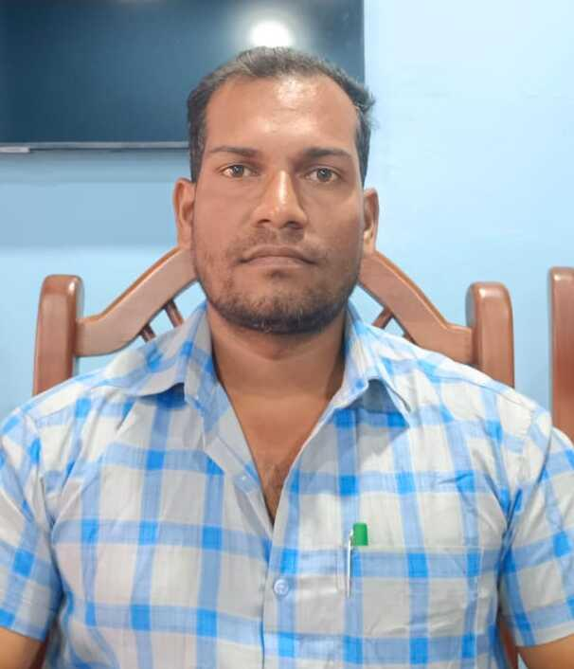
Vadakarapathy Panchayat
It is with great pleasure that I present this report outlining the initiatives and achievements of LSGI Vadakarapathy Panchayat. Our Panchayat is committed to ensuring sustainable development, improved public health, enhanced sanitation, and overall community welfare.
During the year, we have focused on strengthening primary healthcare services, improving waste management systems, promoting environmental protection, and enhancing infrastructure facilities for the benefit of our residents. Community participation and transparent governance remain the foundation of our progress.
I sincerely appreciate the dedicated efforts of our elected representatives, officials, health workers, and the wholehearted support of our citizens. Together, we will continue to work towards building a healthier, cleaner, and more resilient Vadakarapathy Panchayat.

DINESH
President
LSGI Vadakarapathy Panchayat

MESSAGE FROM HEALTH STANDING COMMITTEE CHAIRPERSON
Vadakarapathy Panchayat
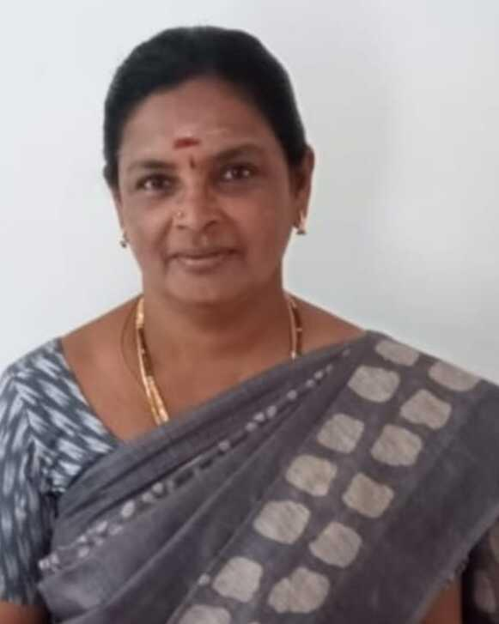
The Health Standing Committee of Vadakarapathy Panchayat remains dedicated to safeguarding the health and well-being of our community. Through strengthened primary healthcare services, effective disease surveillance, sanitation drives, vaccination programs, and health awareness initiatives, we continue to improve public health standards across the Panchayat.
Our efforts focus on preventive healthcare, early detection of communicable diseases, vector control, and environmental health protection. These achievements are made possible through the committed work of our health staff, field workers, and the active cooperation of our residents.
I sincerely thank all stakeholders for their continued support as we strive to build a healthier and safer Vadakarapathy Panchayat.
Chairperson
Health Standing Committee
Vadakarapathy Panchayat

MESSAGE BY MEDICAL OFFICER
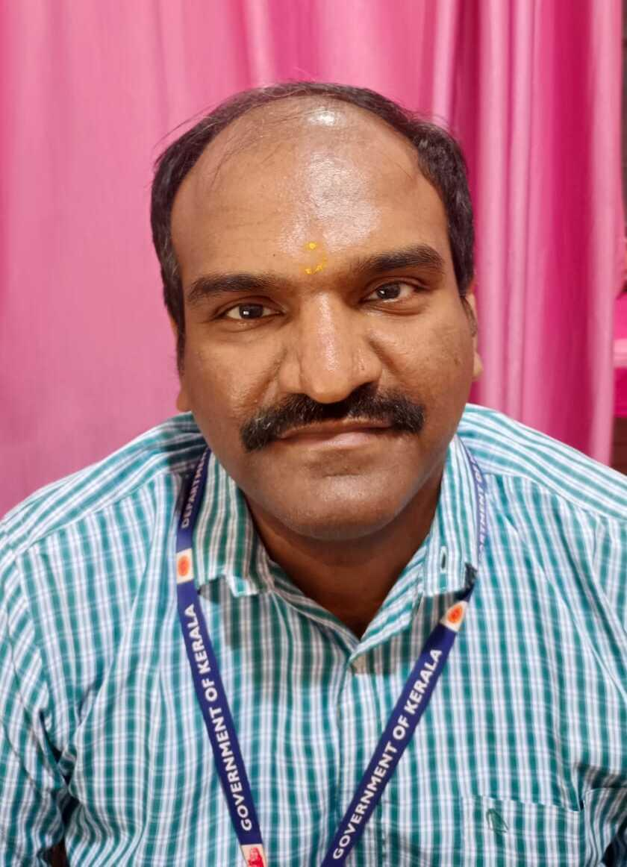
It is a matter of pride to present this report highlighting the healthcare services and public health activities carried out in Ozhapathy during the year. Our team remains committed to providing accessible, affordable, and quality healthcare to all sections of the community.
Priority has been given to disease surveillance, immunization, maternal and child health services, control of communicable and non-communicable diseases, and health awareness initiatives. Through timely monitoring and coordinated efforts, we strive to ensure early detection and effective response to public health challenges.
I sincerely thank our dedicated healthcare staff, field workers, and the community for their continued cooperation and support. Together, we will continue working towards a healthier and safer Ozhapathy.

Medical Officer
DR. NIPUN R
FHC Ozhapathy

EXECUTIVE SUMMARY

Primary Health Centre (PHC) functions as the primary public healthcare institution serving the population of VADAKARAPATHY.. Grama Panchayath. The PHC plays a pivotal role in delivering comprehensive, accessible, and affordable healthcare services, with a strong focus on preventive, promotive, curative, and rehabilitative care in accordance with national and state health programmes.
The PHC caters to a predominantly rural population, addressing key public health priorities such as maternal and child health, communicable and non-communicable disease control, immunization, family welfare, adolescent health, and geriatric care. Regular outpatient services, home-based care through field health staff, and outreach activities ensure healthcare coverage even in geographically challenging areas. The institution actively implements national health missions, including the National Health Mission (NHM), National Tuberculosis Elimination Programme, National Programme for Prevention and Control of Cancer, Diabetes, Cardiovascular Diseases and Stroke (NPCDCS), and other disease surveillance initiatives.
OZHALAPATHY PHC works in close coordination with the Grama Panchayath, ASHA workers, Anganwadi centres, schools, and community-based organizations to strengthen community participation and improve health awareness. Emphasis is placed on early detection, timely referral, health education, and lifestyle modification to reduce disease burden and improve overall health outcomes.
Despite constraints related to infrastructure, manpower, and increasing service demand, the PHC
continues to enhance service delivery through effective planning, data-driven decision-making, and community engagement. Strengthening facilities, upgrading digital health systems, and expanding preventive services remain key focus areas for future development.
Overall, OZHALAPATHY Primary Health Centre stands as a vital institution in safeguarding public health and improving the quality of life of the residents of VADAKARAPATHY Grama Panchayath

LIST OF ABBREVIATIONS

LSGD/LSGI | Local Self Government Department / Local Self Government Institution
BMO | Block Medical Officer
IDSP | Integrated Disease Surveillance Programme
NDMA | NationalDisaster Management Authority
PPE | Personal Protective Equipment
ICMR | IndianCouncil of Medical Research
CD | Communicable Diseases
NCD | NON-COMMUNICABLE Diseases

TABLE OF CONTENTS

3
INTRODUCTION 9
● Background of the PPP 9
LSGD AT A GLANCE 9
INTEGRATED HEALTH INFRASTRUCTURE MAP OF VADAKARAPATHY PANCHAYAT 10
GENERAL PROFILE OF THE LSGI’S 13
Background of the LSGI 13
Demographic and Vulnerable Population 14
Clinical Vulnerability 16
INFRASTRUCTURE & RESOURCE INVENTORY 18
Health Facility Directory & Basic Capacity in the LSGD 18
Private Clinics 19
Healthcare Education & Training Institutions 20
Specialized Services & Emergency Inventory 20
Oxygen & Diagnostic Capacity 21
Diagnostics facility mapping at the LSGI level 22
Laboratory Identification & Basic Details 22
Social and Community Infrastructure for surge plan 22
Human resources 24
Community & Support Cadre 25
Community Organizations 26
Administrative & Emergency Services 27
Information regarding resources 27
ONE HEALTH & ENVIRONMENTAL SURVEILLANCE 28
Animal & Bird Population 28
Veterinary Infrastructure 29
Veterinary Doctors & Workforce 30
High-Risk Interface Points (Surveillance Sites) 30
Environmental Risk Mapping 31
Disease Seasonality Mapping 32
Vulnerability Mapping 33
EPIDEMIOLOGICAL TRENDS (2021–2025) 34
Disease Burden among human beings(Last 5 Years) 34
*(use the above table data to create the graph/diagram) 36
Seasonal Trend Analysis 37
Outcome-Based Trend Analysis- 2025 39
Transmission Trend- 2025 40
Integrated Disease Hotspot Map (2021–2025) 42
Preparedness and Response Protocol at LSG Level 44
Constitution of One Health Committee 44
Pandemic Response Workforce 45
Activities and Measures before and during Pandemic 47
PHASE 1 - Alert / Preparation 47
PHASE 2 - Active Response 50
Standard Screening Protocol 51
PHASE 3 - Surge Capacity 60
Conversion of Community Facilities 60
CONCLUSION 61
RECOMMENDATIONS 62
ANNEXURE 63
1. IMPORTANT PHONE NUMBERS 63

INTRODUCTION

Background of the PPP
- LSGD at a glance

LSGD AT A GLANCE
- Geographical boundaries with political map ( based on latest delimitation)
- Baseline data
- Ward division -
Ward | Houses | Population | Migrants | Wells | Hot  spots | Ed. Institutions | Hosp pvt/govt.
18 | 7277 | 26884 | 154 | 408 | 0 | 17 | 2/3

- Risk stratification among wards in the context of Communicable diseases and hazards
- Major Roads/rivers
- Major establishments with geospatial mapping
- occupational groups, socio cultural groups, migration & mobility patterns
- Vulnerability mapping
- Disaster prone areas (geographic vulnerability)

Maps - ward-based (Mention source also)

- Geographical boundaries - ward boundaries map
- Health infrastructure map
- roads and rivers map
- major establishments map
- disaster-prone areas map
- hotspot map - CD & disasters

INTEGRATED HEALTH INFRASTRUCTURE MAP OF VADAKARATHY GRAMA PANCHAYAT

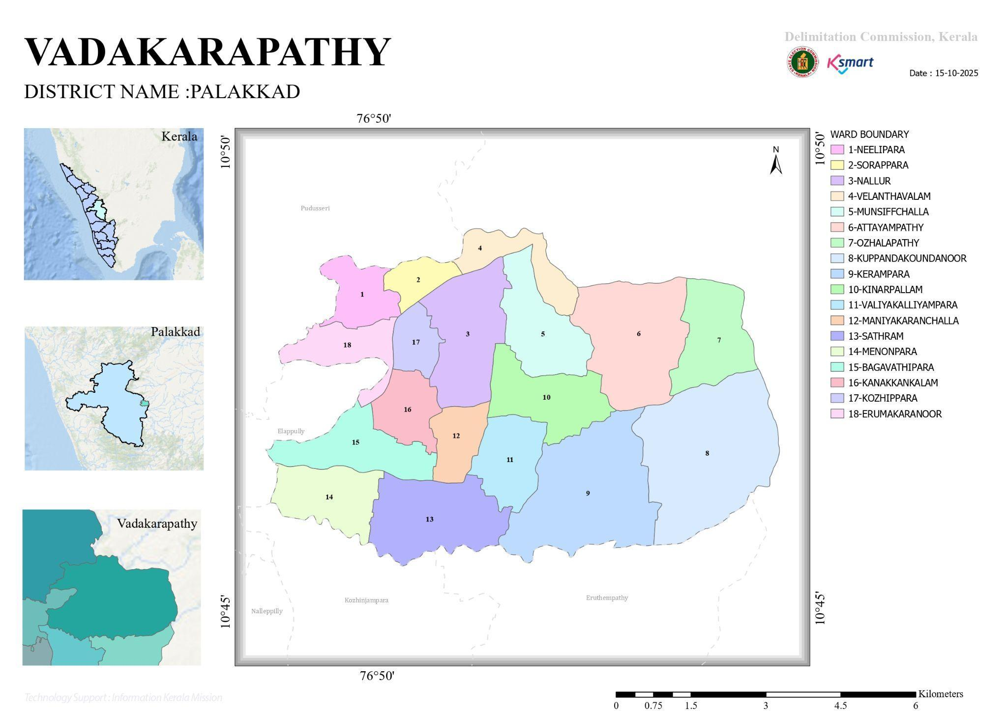

Infrastructure facilities Map

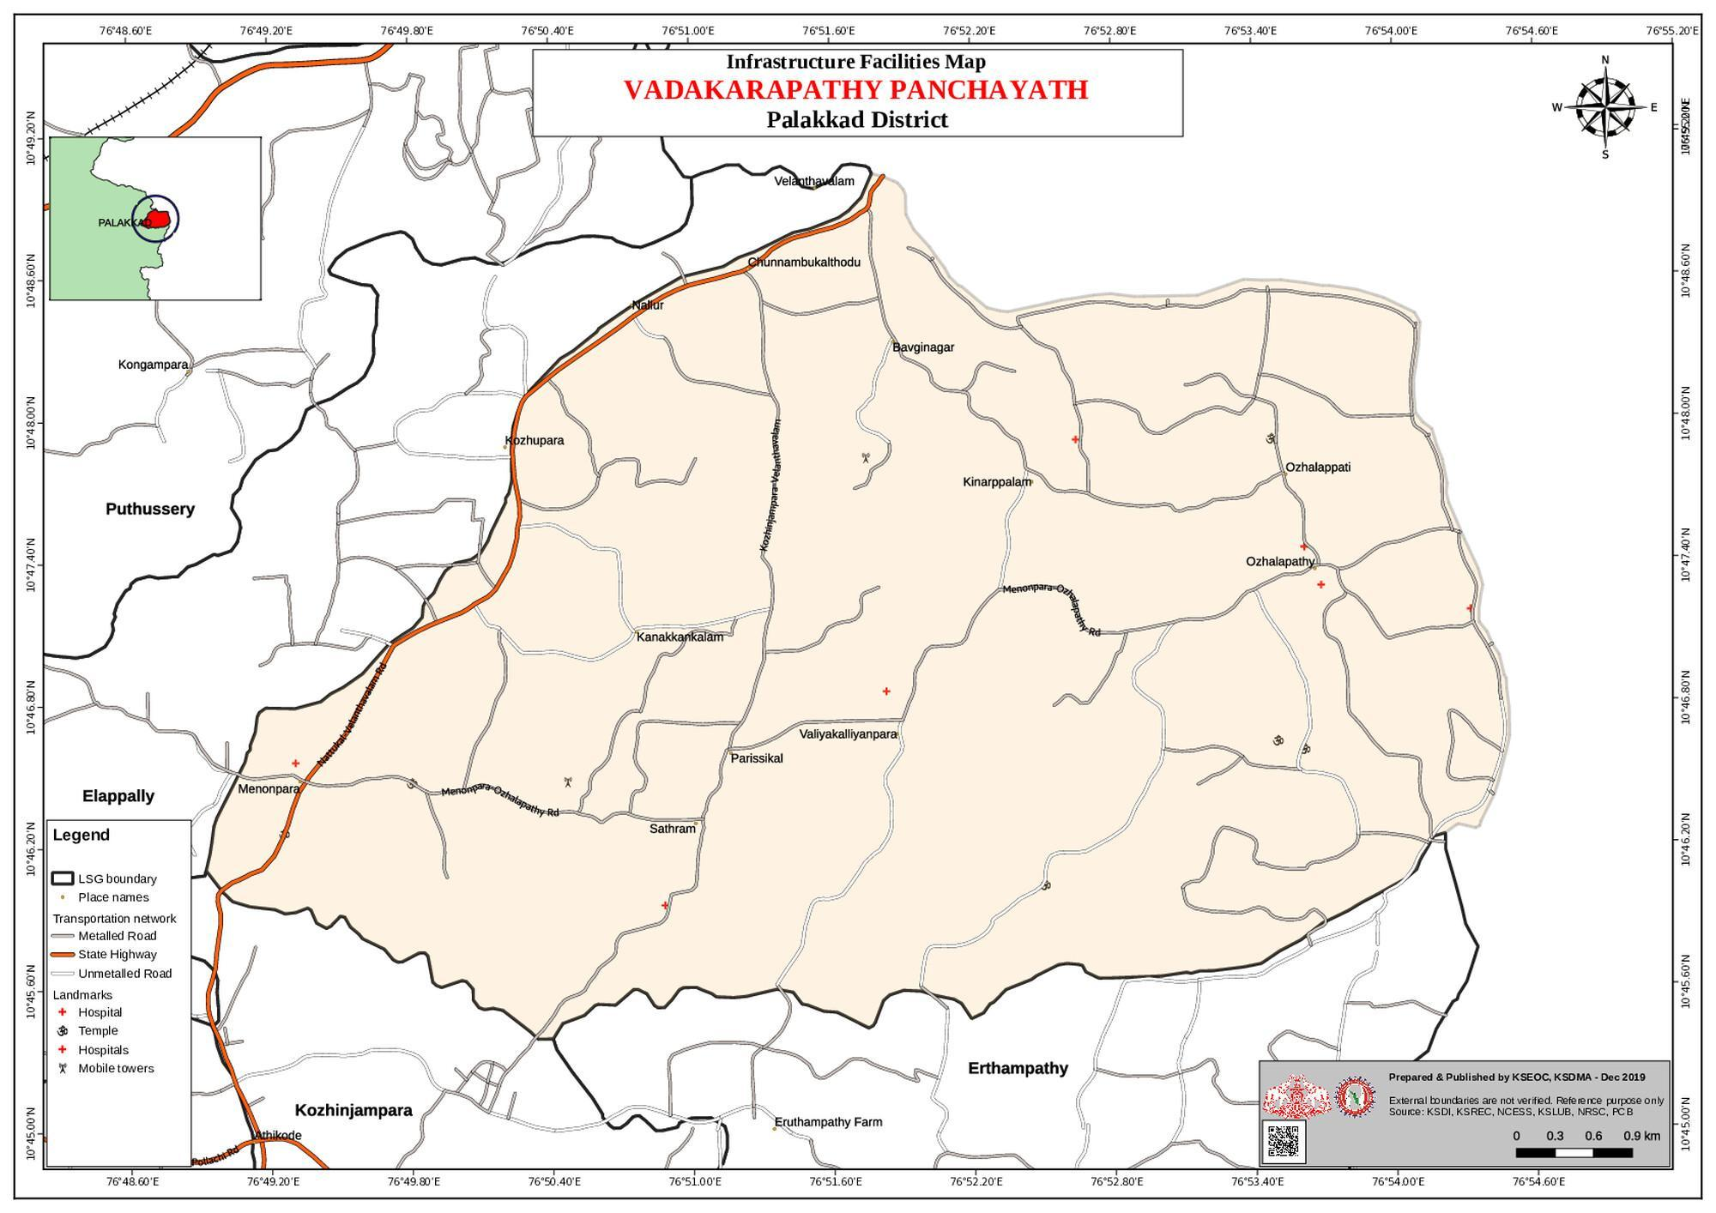

Roads and Rivers map

Transportation Map

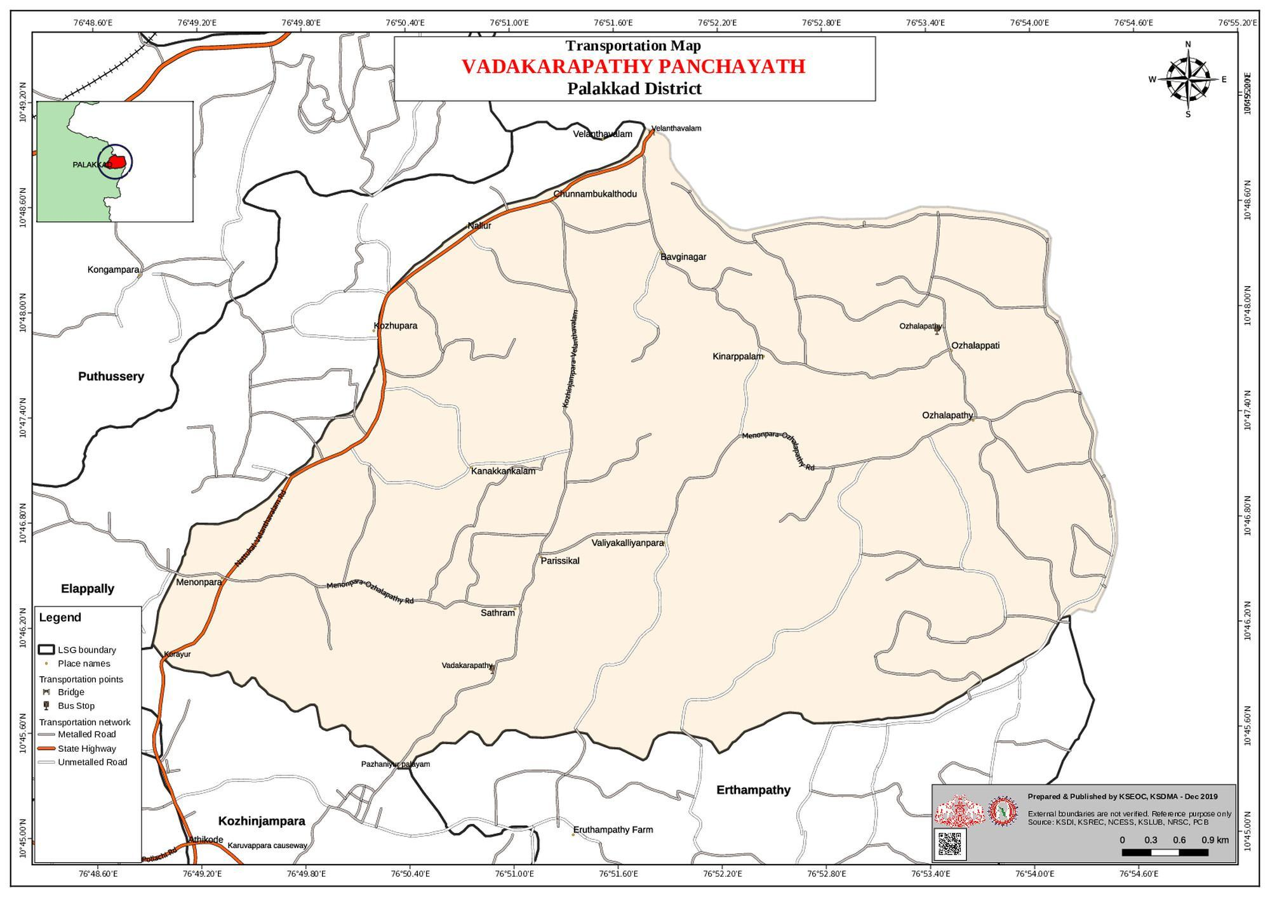

WATER MAP
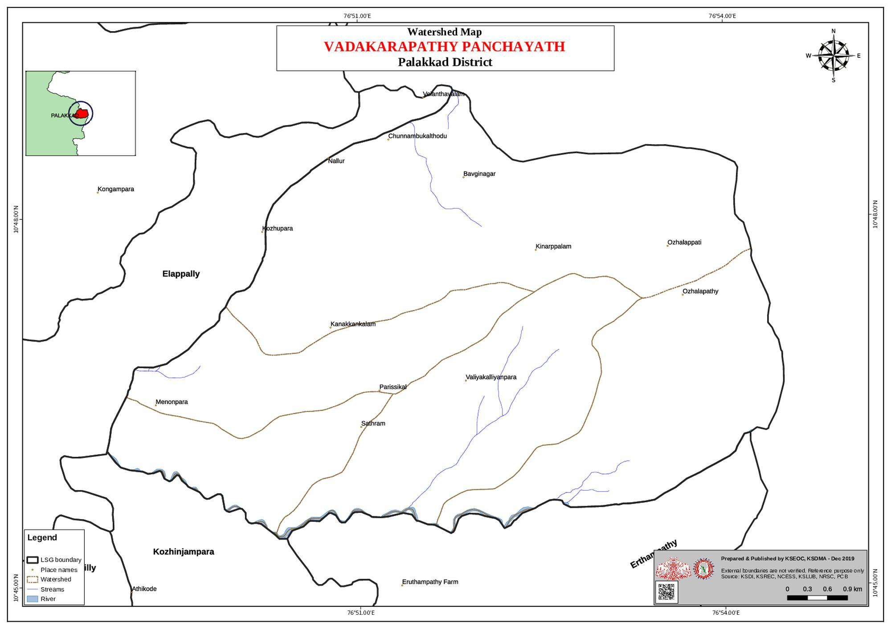

GENERAL PROFILE OF THE LSGI’S

Background of the LSGI
VADAKARAPATHY Grama Panchayat is situated in the CHITTUR TALUK of PALAKKAD district, Kerala. The geographical landscape of the Panchayat is predominantly low-lying, characterized by extensive paddy fields (Kole lands) and a dense network of rivers, canals, and backwaters. This unique terrain plays a significant role in shaping the local microclimate and poses distinct challenges to transportation, emergency response, and service delivery, particularly during monsoon seasons and flood events.
The Panchayat is administratively divided into 18 wards, with a population largely dependent on dry-land agriculture. Groundnut (peanut) cultivation, coconut groves, and maize form the backbone of the local economy. . In recent years, tourism-related activities and service-sector employment have also shown gradual growth. The area hosts a diverse workforce, including a notable presence of migrant labourers, particularly in construction, agriculture, and allied sectors.
From a public health and disaster management perspective, VADAKARAPATHY LSGI has historically been vulnerable to acute water scarcity and drought , rather than seasonal flooding.. However, during extreme climate events like the 2018 floods, the region faced secondary impacts such as infrastructure damage and disruption of irrigation channels. The recurring challenge in this LSGI is the management of the Right Bank Canal (RBC) and ensuring sustainable drinking water through schemes like the Jal Jeevan Mission.
In this context, the development of a localized, data-driven Auxiliary Infrastructure and Logistical Resource Map is essential to support effective planning, timely emergency response, and sustainable development initiatives. Such mapping enables the Panchayat to identify critical resources, improve accessibility during disasters, and enhance overall resilience of the community.

Table 1: Background of LSGD
Description | Details
Name of LSGI | Vadakarapathy
Type (GP/Municipality / Corporation etc.) | Grama Panchayath
Block | Chittur
District | Palakkad
Number of wards | 18
Total area (sq. km) | 26.26 km²
Population(Projected) | 26884
Population density | 1023  persons/sq km
Terrain (coastal/low-lying/backwaters/foothills, etc.) | etc
Number of rivers passing through LSGI | 1
Number of water bodies in the LSGI | 0
Number of educational institutions | 17
Factories / small-scale industries | 3
Flood-prone wards | 0
Landslide-prone wards | 0
Death Management and Disposal Facilities (mortuaries/crematorium, including electric) | 14
Auditoriums/Marriage halls/convention centres/community halls | 4

Demographic and Vulnerable Population
Understanding the demographic composition and vulnerable population groups is essential for pandemic preparedness. Children, elderly, economically deprived families, migrant workers, and socially vulnerable groups are at increased risk during public health emergencies due to higher exposure, limited access to services, and dependency on public systems..

Description |  | Details (in numbers)
DEMOGRAPHIC PROFILE
Total population |  | 26884
Male |  | 13190
Female |  | 13694
Children under 5 |  | 1342
Adolescent |  | 3212
Elderly (>60) |  | 4302
SOCIAL/LIVELIHOOD VULNERABILITY
Previous EPEP family |  | 109
BPL family |  | 3783
Tribal communities |  | 2
Migration | Immigrant | 868
Migration | Emigrant | 154
Socio-economically deprived |  | 0
Fisherfolk |  | 0
SC Community |  | 12
ST Community |  | 6

Graphs: Population pyramid (if possible) for seeing if your LSGI has a high "dependency ratio" (lots of children and elderly compared to working adults).

Clinical Vulnerability
Certain population groups needs priority healthcare & are at higher risk of severe illness, complications, and mortality during pandemics. Patients with chronic diseases, those requiring regular medical care, and individuals with mobility or functional limitations face challenges in accessing timely care during emergencies. Mapping these groups helps in prioritizing continuity of treatment, medicine stock planning, oxygen support, referral transport, and targeted home-based care.
Description | Details in numbers
Pregnant women | 246
Lactating mothers | 502
Bedbound patients | 94
Patients under palliative care other than bedbound | 534
Patients on Haemodialysis | 12
Patients on CAPD | 0
Cancer patients (currently on treatment) | 24
Haemophilic patients | 1
Mentally challenged | 124
Differently abled | 40
Diabetic patients | 1277
Hypertensive patients | 1480
TB patients | 12

Major Festivals & Events specific to the LSGI
(with the possibility of a public gathering)

Sl. No. | Name of festival | Month detailing the periodicity
1 | Palliperunal | january

INFRASTRUCTURE & RESOURCE INVENTORY

Health Facility Directory & Basic Capacity in the LSGD
This section provides an overview of the healthcare infrastructure available within the LSGD area. It outlines the distribution and basic capacity of health facilities that form the backbone of service delivery during routine times and public health emergencies.

Family Health Centres (FHCs) and Community Health Centres (CHCs) generally function as the first point of contact for the community, providing essential outpatient and inpatient services. General Hospitals (GH) and Medical College Hospitals (MCH), where accessible, serve as the main referral centres for advanced diagnostics, specialist care, and critical services during public health emergencies. This inventory helps identify existing strengths, gaps, and potential surge capacity that can be mobilised during a pandemic or disaster.

Table 5. Health Facility Resource Summary
Sl.no. | Health Facility | Type of Facility (MCH/GH/CHC/FHC/SC etc.) | Contact Number | Total beds | ICU Beds | Oxygen-Supported Beds | No. of Ventilator Support Beds | No. of ambulances
Government Healthcare Facilities
1 | Family Health Centre | FHC | 9400623743 | 0 | 0 | 0 | 0 | 0
2 | Govt.AyurvedaHospital,Velanthavalam | SC | 8289933564 | 0 | 0 | 0 | 0 | 0
3 | Govt. Homeo hospital Maniyananchalla | SC | 82281735581 | 0 | 0 | 0 | 0 | 0
Private Healthcare Facilities
1 | Santhi Hospital Kozhippara | Pvt | 7561002751 | 0 | 0 | 0 | 0 | 0

Private Clinics
Private clinics are an essential part of pandemic preparedness, as they are often the first place people seek care when symptoms begin. In many communities, private clinics manage a significant share of outpatient visits and therefore play a critical role in early case detection, timely referrals, and disease surveillance. Having an up-to-date understanding of where these clinics are located, the services they provide, and how they are linked to the public health system helps ensure that no cases are missed during an outbreak. It also allows health authorities to engage private practitioners more effectively for reporting, risk communication, and coordinated response, strengthening the overall capacity of the health system to manage public health emergencies.

Table 6. Private Clinic Resource Summary
Sl No. | Name of Clinic | Registered (Y/N) | Clinic (General / Speciality) | Speciality (if any) | Address | Contact Number | Diagnostic Facility (Y/N) | Ambulance Linkage (Y/N)
1 | Santhi Clinic | Yes | General | Nil | Kozhippara | 7561002751 | Yes | No

Healthcare Education & Training Institutions
This section tracks the educational infrastructure available, which is vital for human resource planning in the health sector.

Category of Institution | Govt | Private | AYUSH | Total
Medical Colleges | 0 | 0 | 0 | 0
Nursing Colleges | 0 | 0 | 0 | 0
Dental Colleges | 0 | 0 | 0 | 0
Para-medical / Allied Health | 0 | 0 | 0 | 0
Pharmacy Colleges | 0 | 0 | 0 | 0

Specialized Services & Emergency Inventory
This section provides a detailed view of the specialized medical resources available to the community, focusing on emergency response and critical care capabilities. This table tracks the vital assets required for managing severe illnesses and emergencies across Government, Private, and AYUSH sectors.

Item | Govt | Private | AYUSH | Total
Hospital beds | 3 | 0 | 0 | 3
Oxygen-generating systems(Y/N) | 0 | 0 | 0 | 0
Oxygen-supported beds(Numbers) | 0 | 0 | 0 | 0
Ventilator-supported beds | 0 | 0 | 0 | 0
ICU beds | 0 | 0 | 0 | 0
Burns units | 0 | 0 | 0 | 0
Blood centres | 0 | 0 | 0 | 0
BLS ambulances | 0 | 0 | 0 | 0
ALS ambulances | 0 | 0 | 0 | 0
Dialysis facilities | 0 | 0 | 0 | 0
Dispensaries | 2 | 0 | 0 | 2
Medical store | 0 | 4 | 0 | 4
Industrial establishments(Medium-scale industries/small-scale industries establishments to whom we can depend in a worst-case scenario) | 0 | 4 | 0 | 4

Oxygen & Diagnostic Capacity
Monitoring oxygen and diagnostic capacity is a critical component of public health preparedness, ensuring that the LSGD can handle both chronic care and sudden surges in respiratory or infectious diseases.
Name of Health Facility | Oxygen-generating System (Y/N) | Backup Oxygen Source (Y/N) | Diagnostic Facilities Available(Y/N)
Name of Health Facility | Oxygen-generating System (Y/N) | Backup Oxygen Source (Y/N) | Lab | USG | X-ray | CT/MRI | RT-PCR
Government Healthcare Facilities
0 | 0 | 0 | 0 | 0 | 0 | 0 | 0
0 | 0 | 0 | 0 | 0 | 0 | 0 | 0

Diagnostics facility mapping at the LSGI level
The diagnostic capacity of _vadakarapathy_ G.P represents the "intelligence network" of our healthcare system. The speed and accuracy of disease identification depend entirely on the distribution and technical level of these facilities.

Item | Govt | Private | AYUSH | Total
General labs | 1 | 1 | 0 | 2
Microbiology labs | 0 | 0 | 0 | 0
RT-PCR labs | 0 | 0 | 0 | 0
USG units | 0 | 0 | 0 | 0
CT/MRI units | 0 | 0 | 0 | 0
Research labs | 0 | 0 | 0 | 0
Labs of other departments that can be repurposed | 0 | 0 | 0 | 0

Laboratory Identification & Basic Details
Sl. No. | Name of Laboratory | Ownership (Govt / Private / Academic) | Address | Contact No. | 24×7 Services (Yes/No) | NABL / Govt Approved (Yes/No)
1 | FHC Ozhalapathy | Govt | Ozhalapathy | 9400623743 | NO | No
2 | PIMS | Pvt | Velanthavalam | 9655639649 | No | No

Social and Community Infrastructure for surge plan
This table serves as our logistics and shelter inventory. By mapping these locations, quickly we can identify where to house displaced citizens, where to set up temporary medical clinics, and how to manage the deceased with dignity during a crisis.

Category | Total Count | Ward | Est. Capacity (Persons) | Contact details
Educational Institutions
Anganwadis | 6 | 1,6,11,14 | 10 | Neethu ICDS Supervisor
Schools | 3 | 10,17,4 | 125/Each | Sisai selvi  H M
Colleges | 0 | 0 | 0 | 0
Healthcare Educational Institutions
Medical colleges (Govt/Private) | 0 | 0 | 0 | 0
Nursing colleges (Govt/Private) | 0 | 0 | 0 | 0
Dental colleges (Govt/Private) | 0 | 0 | 0 | 0
Paramedical institutes (Govt/Private) | 0 | 0 | 0 | 0
Community Gathering Spaces
Community halls | 3 | 4,7,12 | 250/Each | A 1 Velanthavala
Auditoriums | 3 | 5,8,13 | 350/Each | Baby Hall Menonpara
Religious buildings | 2 | 3,6 | 24/Each | Sahaya nathen Manalkkadsa
Vulnerable Group Support Facility
Destitute homes | 0 | 0 | 0 | 0
Elderly homes | 0 | 0 | 0 | 0
LSGD owned other buildings | 0 | 0 | 0 | 0
Mass Fatality Management (MFM) Infrastructure
Mortuary | 0 | 0 | 0 | 0
Crematorium | 16 | 0 | 0 | 0
*refer annexure 1 for contact details

Human resources
This section focuses on the human capital available within the LSGI. In any emergency—be it a pandemic, flood, or industrial accident—infrastructure is only as effective as the people operating it.

Medical & Clinical Personnel
This table tracks the "Frontline" providers responsible for diagnosis, treatment, and clinical management. Narrative sentence: eg., "Total health workforce: 450 personnel, with 60% in government facilities serving as primary surge capacity." A detailed directory with the contact numbers of all workers is maintained (Annexure in 1).

Cadre | Govt (No.) | Private (No.) | Total
Doctors—Modern Medicine | 3 | 2 | 5
Doctors – AYUSH | 2 | 0 | 2
Doctors – Veterinary | 1 | 0 | 1
Doctors – Dental | 0 | 1 | 1
Nursing officers | 0 | 0 | 0
Lab technicians | 1 | 1 | 2
Optometrist | 0 | 0 | 0
Pharmacists | 0 | 3 | 3
Psychologists | 0 | 0 | 0
Counsellors | 0 | 0 | 0

Public Health & Field-Level Workforce
These individuals are the backbone of surveillance, maternal-child health, and decentralized care.

Cadre | Health services | Municipal common services | Total
HS (Health Supervisors) | 0 | 0 | 0
HI (Health Inspectors) | 1 | 1 | 2
LHS (Lady Health Supervisor) | 0 | 0 | 0
LHI (Lady Health Inspectors) | 1 | 0 | 1
JPHN (Jr Public Health Nurses) | 4 | 0 | 4
JHI (Jr Health Inspectors) | 3 | 0 | 3
MLSP (Mid-Level Service Providers) | 6 | 0 | 6
Palliative Nurses | 0 | 1 | 1
RBSK Nurses | 1 | 0 | 1
PRO | 0 | 0 | 0
Epidemiologist | 0 | 0 | 0
Data Manager | 0 | 0 | 0

Community & Support Cadre
This group represents the surge capacity of the LSGI—people who can be called upon for logistics, rescue, and specialized support.

Cadre | Number
ASHA Workers | 27
AWW (Anganwadi Workers) | 27
Emergency Medical Volunteers (Trained) | 24
Kudumbashree | 208
MNREGS | 0
Purusha Swayam SahayaSangham | 0
Ex-Servicemen | 16
Retired Police Officers | 6
NCC/NSS Volunteers | 24
Red Cross volunteers | 0
One Health Community Volunteers | 0
One Health Community Mentors | 0

Community Organizations
This section details the presence of community-based organisations (CBOs), non-governmental organisations (NGOs), faith-based organisations (FBOs), Kudumbashree Self-Help Groups (SHGs), and Ayalkootams within the Local Self-Government Institution (LSGI). These groups enhance grassroots mobilization, resource distribution, and support networks crucial for pandemic response and community resilience.

Category | Total Count
NGOs | 54
Religious based organizations | 6
Foreign based organizations | 0
Sports Club/youth clubs | 4
Kudumbashree SHGs | 208
Ayalkootams | 0
Political organizations | 0
Residential organizations | 0

Administrative & Emergency Services
This section outlines the availability of key non-health emergency support services and infrastructure within the LSGI, which are essential for effective pandemic preparedness and response. These facilities support law enforcement, disaster response, water supply, logistics, mobility, and community-level interventions during public health emergencies.

Category | Total Count | Contact details
Police Stations | 0 | 0
Fire & Rescue Stations | 0 | 0
Water Pumping Points | 0 | 0
Public Distribution System (PDS) | 11 | 1,3,5,7,8,10,12,14,15,16,18(Wards)

Information regarding resources
The availability of essential transport and support resources plays a quiet but critical role in saving lives. Equipment such as ambulances, mobile mortuaries, amphibian ambulances, and motorized boats ensures that patients, samples, and healthcare teams can move swiftly—even in flooded, remote, or difficult terrains. Heavy vehicles like JCBs, cranes, tractors, and torus lorries support logistics, waste management, emergency infrastructure, and rapid conversion of spaces into care or isolation facilities. Taxis, four-wheel-drive vehicles, and trucks help maintain continuity of essential services, reach vulnerable populations, and support home-based care and supply delivery.

Means of transportation | Total Count
JCB | 6
Crane | 0
Heavy Trucks | 0
Tractor | 14
Ambulances | 0
Mobile mortuaries | 0
Boats | 0
Taxi service | 24
Note: For specific details regarding vehicle owners and contact information, please refer to Annexure [X].

ONE HEALTH & ENVIRONMENTAL SURVEILLANCE
The One Health method integrates environmental, animal, and human health to enable proactive pandemic preparedness. Panchayat-level surveillance needs to be improved in order to detect and treat zoonotic and environmentally generated diseases early. Surveillance is strengthened through systematic assessment of animal populations, veterinary infrastructure, poultry and slaughter facilities, inter-sectoral coordination, and specialised tools like avian influenza seasonality mapping using GIS in previous outbreaks to enable predictive alerts and ward-specific sampling to support effective pandemic preparedness in high-risk areas like Kozhipara, and Ozhalapathy.

Animal & Bird Population
Mapping animal and bird populations at the Panchayat level is essential for identifying and prioritising zoonotic disease hazards like rabies, avian influenza (H5N1), leptospirosis, anthrax, and Nipah-like spillover occurrences. Risk classification, targeted surveillance, vaccination planning, and early epidemic detection made feasible by comprehensive population mapping all enhance One Health-based pandemic preparedness.

Category | Item | Estimated Population | Wards
Animal Population | Livestock (Cattle/Goats/Buffalo) | 2874/12/18 | 1-17
Animal Population | Pet Animals (Dogs/Cats) | 1750/125 | 1-17
Animal Population | Stray Dog Population | 100 | 1-17
Animal Population | Pig Farms (Number of heads) | 0 | 0
 | Small Units (Sheep / Goats – clustered) | 0 | 0
Bird Population | Poultry Units (Birds) | 0 | 0
Bird Population | Poultry- (FOWL) | 0 | 0
Bird Population | Wild/Migratory Birds (Observed) | 0 | 0
Bird Population | Crow Mortality Events (Reported) | 0 | 0

The main risk of zoonotic diseases in VADAKARAPATHY is concentrated in Wards 2, 4, 8, and 15., which is explained by the high density of cattle congregation areas and commercial poultry units. The stray dog population in Kozhipara, and the bus station areas continues to be a substantial problem for rabies surveillance and bite prevention. There is a considerable risk of avian influenza introduction and amplification during November - December due to the seasonal presence of migratory and resident water birds near local ponds and the irrigation canal network. . Clusters of pig farms and animal shelters vulnerable to flooding further raise the risk of leptospirosis and other zoonoses mediated by the environment, especially during monsoon floods.

Veterinary Infrastructure
Veterinary institutions are a core pillar of One Health surveillance, enabling early zoonotic disease detection through vaccination, investigation of unusual animal illness or deaths, sample collection, and timely outbreak reporting. A well-mapped and responsive veterinary network strengthens coordination with human health and LSGI systems, ensuring rapid response during zoonotic events and pandemics.
Facility Type | Name of Facility | Ownership Govt / Pvt | Location(Ward No) | Contact number
Veterinary Dispensary | 0 | 0 | 0 | 0
Veterinary Hospital / Polyclinic | Veterinary Clinic | Govt | 3 | 9048959689
Private Veterinary Clinics | 0 | 0 | 0 | 0
Mobile / Emergency Vet Service (incl. night services) | 0 | 0 | 0 | 0
Pet Homes / Animal Shelters | 0 | 0 | 0 | 0
Slaughterhouse-linked Veterinary Inspection Unit | 0 | 0 | 0 | 0

Veterinary Doctors & Workforce
Early detection, diagnosis, reporting, and reaction to animal illness epidemics depend on the availability and accessibility of qualified veterinary specialists. By identifying unusual animal morbidity or mortality promptly, collecting samples promptly, and coordinating efficiently with human health and LSGI systems—especially during zoonotic outbreaks and pandemic-prone situations—a clearly defined veterinary workforce enhances One Health surveillance.

Category | Number Available | Type (Govt/Pvt) | Contact number
Government Veterinary Doctors | 1 | Govt | 9048959689
Private Veterinary Doctors | 0 | 0 | 0
Livestock Inspectors | 1 | Govt | Leave
Para-veterinary Staff / Attenders | 0 | 0 | 0
Contract / On-call Veterinary Support (if any) | 0 | 0 | 0

High-Risk Interface Points (Surveillance Sites)
High-risk interface points for zoonotic disease surveillance in VADAKARAPATHY Grama Panchayath include wetland–livestock–human contact zones, backyard poultry farms, cattle sheds near water bodies, fish markets, and areas of high human–animal interaction such as community slaughter points and migratory bird congregation sites. These are the primary surveillance sites where zoonotic spillover risks are elevated.

Type of Habitat | Type of High risk interface | Geographical vulnerability
Wetlands & Backwaters | 0 | 0
Backyard Poultry Farms | 0 | 0
Cattle Sheds near Water Bodies | 0 | 0
Fish & Meat Markets | 0 | 0
Community Slaughter Sites | 0 | 0
Migratory Bird Congregation Areas | 0 | 0
Rodent-Infested Grain Storage | 0 | 0

Category | Total Count | Key Locations (wards)
Poultry Farms | 0 | 0
Backyard / Clustered Poultry Units | 0 | 0
Duck Rearing Units (open water access) | 0 | 0
Slaughterhouses/ Slaughter Points | 0 | 0
Meat/Fish Markets | 0 | 0
Live Bird Sale Points | 0 | 0
Cattle Markets / Weekly Animal Fairs | 0 | 0
Pet Shops / Breeders
Animal Shelters / Pet Homes | 0 | 0
Waste Disposal Sites near Animal Units | 0 | 0

Environmental Risk Mapping
Environmental risk mapping identifies monsoon/flood hotspots for vector-borne (dengue, chikungunya), water-borne (leptospirosis, diarrhoea), and zoonotic diseases in Kerala's wetlands. Systematic surveillance supports early warnings, targeted interventions, and Panchayat pandemic preparedness.
Waterborne exposure: Flood-prone areas and stagnant water bodies facilitate leptospira survival, raising leptospirosis risk.

Traditional practices: Informal slaughter and fish markets lack standardized hygiene, creating spillover opportunities.

Risk Factor | High-Risk Wards | Key Locations | Risk Level (High/Med/Low)
Flood-prone areas | 0 | 0 | 0
Water bodies/wetlands | 0 | 0 | 0
Solid waste accumulation | 0 | 0 | 0
Animal waste disposal issues | 0 | 0 | 0
Rodent infestation zones | 0 | 0 | 0
Industrial effluent discharge | 0 | 0 | 0
Construction sites / abandoned buildings | 0 | 0 | 0
Poor drainage/blocked canals | 0 | 0 | 0
Drinking water source contamination risk | 0 | 0 | 0
Border Check post | 14,12 | Velanthavalam,Ozhalapathy

Disease Seasonality Mapping
1, Flooding& waterlogging → amplifies leptospirosis, malaria, diarrheal diseases.
·
2, Migratory bird influx (Nov–Feb) → avian influenza risk.

3, Mosquito breeding cycles → vector-borne disease peaks in monsoon.

4, Agricultural practices → close human–animal contact in paddy fields.

Disease | Peak Risk Season | Key Drivers | High-Risk Locations | Surveillance Focus
Avian Influenza | 0 | 0 | 0 | 0
Leptospirosis | 0 | 0 | 0 | 0
Dengue/Chikungunya | Summer | Water vessels | 12,13,14 | V S
Acute Diarrheal Diseases | Monsoon | Polluted water | 1-15 | H E
Rabies | 0 | 0 | 0 | 0
Anthrax (rare) | 0 | 0 | 0 | 0

Vulnerability Mapping
Vulnerability mapping pinpoints high-risk populations, occupations, and areas exposed via environment, livelihoods, socio-economics, and poor service access. Paired with environmental/seasonality mapping, it enables risk-based surveillance, targeted actions, and optimal resource use in One Health and pandemic planning.
Vulnerability Factor | High-Risk Wards | Key Groups / Locations | Risk Level
Flood-prone households | 0 | 0 | 0
Wetland-adjacent communities | 0 | 0 | 0
Backyard poultry / duck rearing households | 0 | 0
Livestock-rearing households | 0 | 0 | 0
Slaughterhouse & meat market workers | 0 | 0 | 0
Fisherfolk & fish market workers | 0 | 0 | 0
Sanitation workers | 0 | 0 | 0
Daily wage / migrant workers | 12,14,16 | Brick work | Medium
Elderly & chronically ill populations | 0 | 0 | 0
Pregnant Women | 0 | 0 | 0
Children (schools, Anganwadi’s) | 0 | 0 | 0
Limited access to safe water & sanitation | 0 | 0 | 0

EPIDEMIOLOGICAL TRENDS (2021–2025)

Disease surveillance is the systematic collection, analysis, and interpretation of health data for planning, implementation, and evaluation of public health practice. This section presents the disease surveillance profile of the LSGI based on routine reporting systems and outbreak investigations to identify priority diseases, seasonal patterns, and emerging public health threats.

Disease Burden among human beings(Last 5 Years)
Analysis of disease-wise data for the last five years helps identify persistent public health problems, emerging diseases, and changes in disease burden. This information supports prioritisation of prevention, preparedness, and response activities at the Panchayat level.

Disease | 2021 | 2022 | 2023 | 2024 | 2025 | Trend(Increasing/Stable/Decreasing)
Dengue | 11 | 14 | 89 | 107 | 14 | 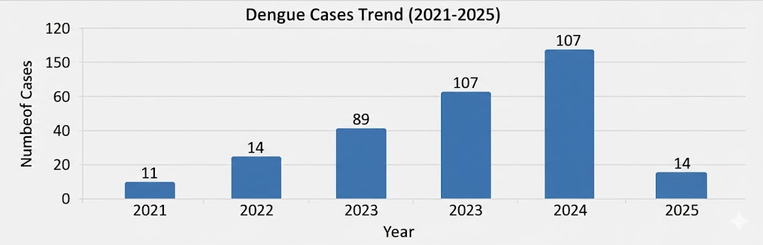
Leptospirosis | 1 | 0 | 0 | 1 | 3 | 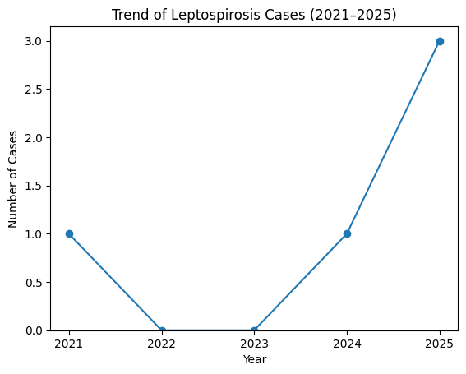
Hepatitis A | 2 | 1 | 2 | 2 | 3 | 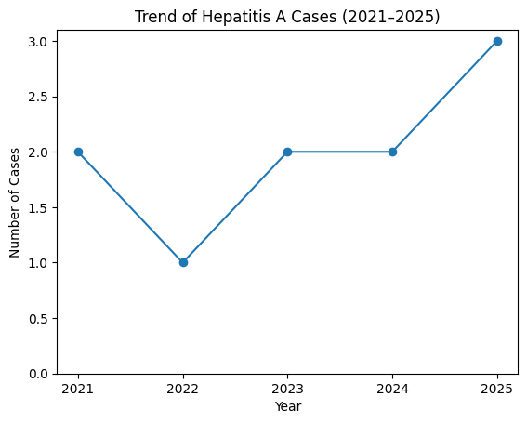
Malaria | 0 | 0 | 0 | 0 | 1 | 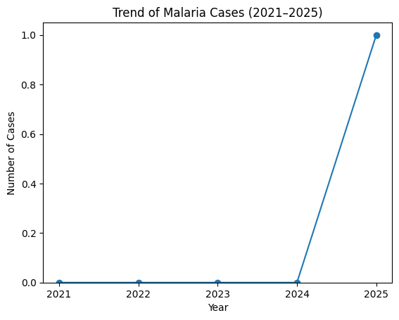
Scrub Typhus | 0 | 0 | 0 | 02 | 2 | 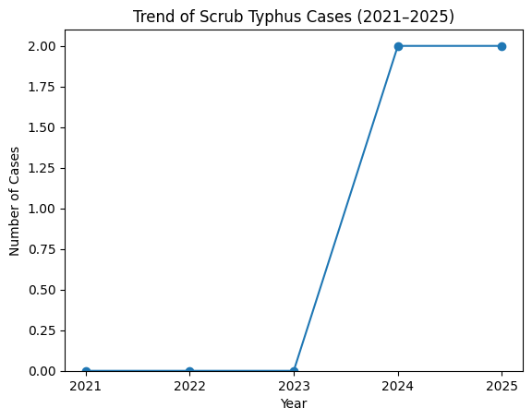
Typhoid  H1N1  H3N2 | 0 | 0 | 0 | 0 | 0
ADD | 98 | 235 | 324 | 356 | 314 | 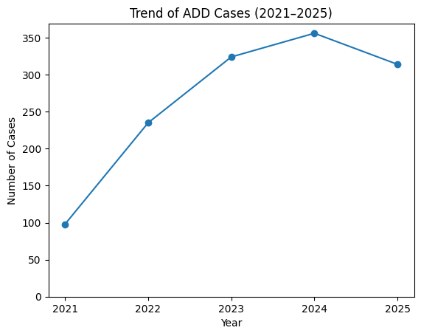
Mumps | 0 | 0 | 0 | 2 | 6 | 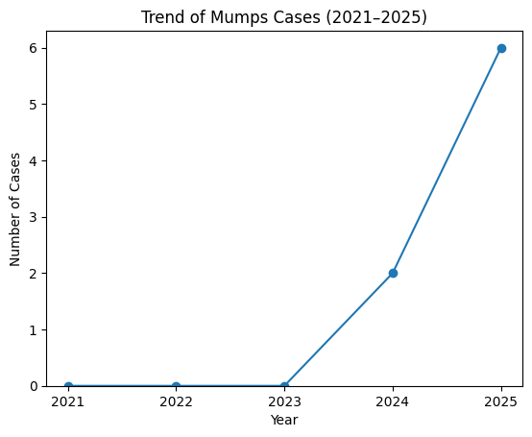
Measles | 0 | 0 | 0 | 1 | 2 | 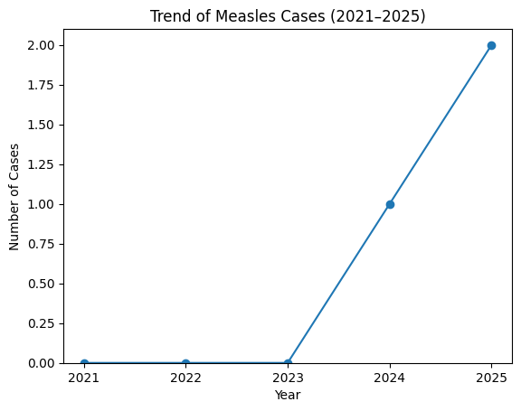
Hepatitis B | 0 | 0 | 1 | 0 | 2 | 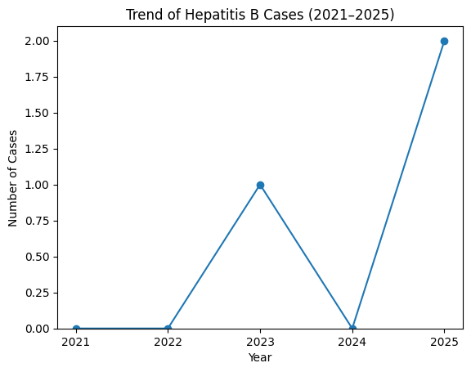
Hepatitis C | 0 | 0 | 0 | 0 | 0
Tuberculosis | 11 | 15 | 18 | 21 | 23 | 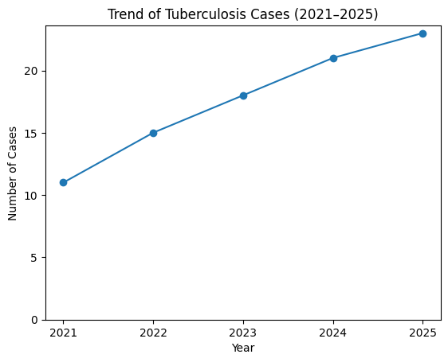
Leprosy | 0 | 0 | 1 | 1 | 0 | 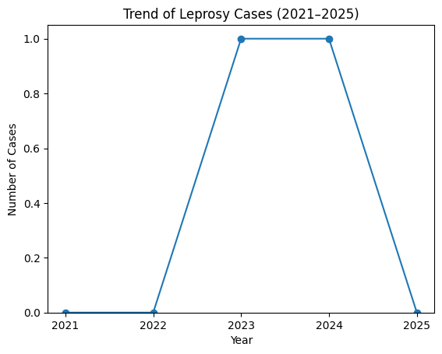

Seasonal Trend Analysis
Seasonal analysis helps anticipate surges (e.g. dengue in monsoon, leptospirosis after floods, influenza in cooler months) and plan pre‑emptive vector control, stockpiling of IV fluids, and awareness campaigns at Panchayat level.

DENGUE
Dengue is a major seasonal vector-borne disease strongly associated with rainfall, water stagnation, and increased mosquito breeding during the monsoon period.

Peak: July–November

Dengue – Ward-wise Yearly Distribution (2021–2025)

Ward | Dengue – Ward-wise Yearly Distribution
Ward | 2021 | 2022 | 2023 | 2024 | 2025 | Total
1 | 1 | 2 | 7 | 4 | 2 | 16
2 |  | 2 | 6 | 5 |  | 13
3 | 3 | 1 | 5 |  | 6 | 15
4 |  | 2 | 11 | 6 |  | 19
5 | 5 |  | 13 |  |  | 18
6 |  | 3 | 9 | 14 | 2 | 28
7 | 2 |  |  |  |  | 2
8 |  |  | 8 | 19 |  | 27
9 |  | 2 | 14 |  | 2 | 18
10 |  | 2 | 16 | 5 | 2 | 25
11 |  |  |  | 15 |  | 15
12 |  |  |  | 17 |  | 17
13 |  |  |  | 14 |  | 14
14
15 |  |  |  | 8 |  | 8
16
17

LEPTOSPIROSIS
Leptospirosis cases are closely linked to monsoon rains, flooding, and occupational exposure, particularly in low-lying and waterlogged areas.

Peak: June - August

Leptospirosis – Ward-wise Yearly Distribution (2021–2025)

Ward | Leptospirosis – Ward-wise Yearly Distribution
Ward | 2021 | 2022 | 2023 | 2024 | 2025 | Total
1 |  | 0 |  |  |  | 00
2 |  |  |  |  |  | 0
3 |  |  |  |  | 1 | 1
4 |  |  |  |  |  | 0
5 |  |  |  | 1 |  | 1
6 |  |  |  |  |  | 0
7 |  |  |  |  |  | 0
8 | 1 |  |  |  |  | 1
9 |  |  |  |  | 1 | 1
10 |  |  |  |  |  | 0
11 |  |  |  |  |  | 0
12 |  |  |  |  | 1 | 1
13
14
15
16
17

VIRAL HEPATITIS - A
Hepatitis A cases are commonly associated with unsafe drinking water, food contamination, and breakdowns in sanitation, often presenting as clusters or outbreaks.

Peak: October - December

Hepatitis A – Ward-wise Yearly Distribution (2021–2025)

Ward | Hep A – Ward-wise Yearly Distribution
Ward | 2021 | 2022 | 2023 | 2024 | 2025 | Total
1 |  |  |  | 1 |  | 1
2 | 1 |  |  |  |  | 1
3 |  |  | 1 |  |  | 1
4 |  |  |  |  | 1 | 1
5 | 1 |  |  |  |  | 1
6 |  |  |  |  |  | 0
7 |  |  | 1 |  |  | 1
8 |  |  |  |  | 1 | 1
9 |  |  |  |  |  | 0
10 |  | 1 |  |  |  | 1
11 |  |  |  |  |  | 0
12 |  |  |  |  | 1 | 1
13 |  |  |  | 1 |  | 1
14
15
16
17

Outcome-Based Trend Analysis- 2025

Transmission Trend- 2025
For effective management of public health issues, it is important to track the trend of disease transmission mode. It helps identify the population or place at high risk that can be used to predict outbreaks and implement targeted interventions as quickly as possible. Understanding these kinds of trends enables authorities to allocate resources efficiently and change the strategies adequately based on the trend that follows.

Mode of Transmission | No. of cases | No. of Deaths
Vector Borne Diseases | 15 | 0
Water Borne Diseases | 5 | 0
Air Borne Diseases | 23 | 2
Blood Borne Diseases | 0 | 0
Food Borne Diseases | 0 | 0

Vector-Borne Disease

Disease | No. of Cases | No. of Deaths
Dengue | 14 | 0
Malaria | 1 | 0
Chikungunya | 0 | 0

Water Borne Disease

Disease | No. of Cases | No. of Deaths
Cholera | 00 | 0
Typhoid | 0 | 0
Hep- A | 3 | 0
Dysentery | 0 | 0
Amoebiasis | 0 | 0
E- Coli infections | 0 | 0
Air Borne Disease

Disease | No. of Cases | No. of Deaths
Influenza | 0 | 0
H1N1 | 0 | 0
TB | 23 | 1
Chickenpox | 7 | 0
Measles | 2 | 0
Covid-19 | 0 | 0
Pertussis | 0 | 0
Mumps | 6 | 0

Blood-Borne Disease

Disease | No. of Cases | No. of Deaths
AIDS | 3 | 0
Hep- B | 2 | 0
Hep- C | 1 | 0

Zoonotic Disease

Disease | No. of Cases | No. of Deaths
Rabies | 0 | 0
Leptospirosis | 3 | 0
Avian influenza | 0 | 0
West nile | 0 | 0
Anthrax | 0 | 0
Nipah | 0 | 0
Scrub Typhus | 0 | 0

Integrated Disease Hotspot Map (2021–2025)

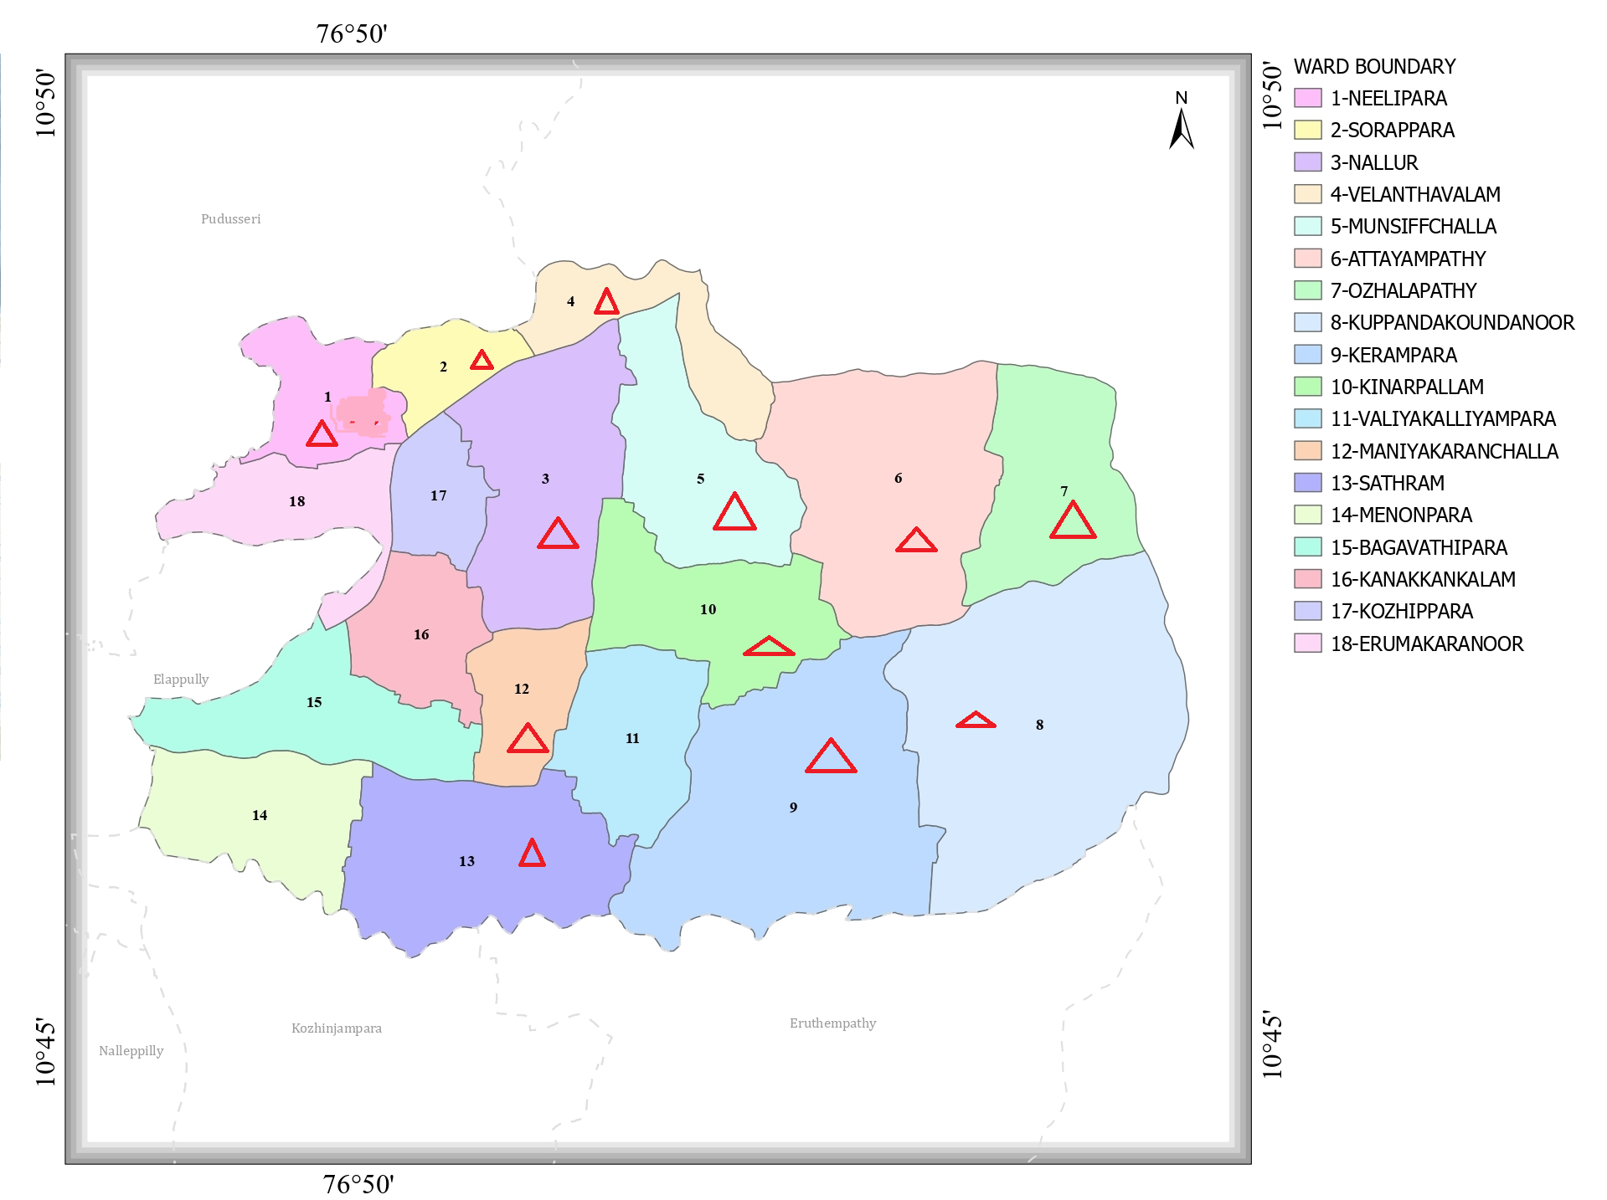
Ward No | Dengue Total (2021-25) | Leptospirosis Total (2021-25) | Hepatitis A Total (2021-25) | Mumps (2021-25) | ADD (2021-25) | Total Cases
1 | 16 | 0 | 1 | 0 | 154 | 171
2 | 13 |  | 1 | 0 | 175 | 189
3 | 15 | 1 | 1 |  | 115 | 132
4 | 19 |  | 1 | 0 | 96 | 116
5 | 18 | 1 | 1 | 2 | 11 | 33
6 | 28 |  |  | 0 | 145 | 173
7 | 2 |  | 1 | 1 | 196 | 200
8 | 27 | 1 |  | 2 | 98 | 128
9 | 18 |  |  | 0 | 78 | 96
10 | 25 |  | 1 | 0 | 87 | 113
11 | 15 |  |  |  | 54 | 71
12 | 17 | 1 | 1 |  | 54 | 73
13 | 14 |  | 1 | 1 | 48 | 64
14 |  |  |  |  | 54 | 54
15 | 8 |  |  | 1 | 67 | 76
16 |  |  |  | 1 |  | 1
17 |  |  |  |  | 49 | 49

By overlaying five years of data, we have identified 1, 2, 3, 4, 5, 6, 7, 8, 9, 10, 12, and 13..'Red Zone' Wards. These are wards where at least two different categories of diseases (e.g., Dengue and Lepto) recurred in consecutive years. Ward 2 is categorized as the Highest Priority Hotspot due to its combination of ADD cases (96), Dengue (19). Future health infrastructure, such as the proposed R.O plants at Ozhalapathy should be prioritized.

Preparedness and Response Protocol at LSG Level
This section describes the operational framework for the LSGI once a pandemic is declared. It explains how the LSGI and health system will move from routine data collection to active response, using a One Health approach.

Constitution of One Health Committee
The LSGD shall constitute a One Health Committee comprising the LSGI President, Medical Officers (Modern Medicine, AYUSH, and Veterinary), the Health Inspector, and the Veterinary Surgeon.

Objective: The One Health Committee coordinates human, animal, and environmental health to prevent and control pandemics.

Sl No | Name | Designation | Department/Institution | Role in Committee | Contact Number
1 | Dineesh | Panchayat President | LSGD | Chairperson | 7012295929
2 | Nibun | Medical Officer (PHC/CHC) | Health Dept | Member Secretary | 9400623746
3 | Francis | Veterinary Officer | Animal Husbandry | Member | 9048959689
4 |  | Epidemiologist | Health Dept | Member
5 | David | Health Inspector/PHN | Health Dept | Surveillance | 9349451610
6 | Seelina | ASHA Supervisor | Health Dept | Community link | 7907612646
7 | Neethu | ICDS Supervisor | Social Welfare | Vulnerable groups | 9188148435
8 |  | Police Station Officer | Police Dept | Law & order
9 |  | Ward Councillor Representative | LSGD | Community coordination
10 |  | Kudumbashree CDO | Kudumbashree | Community mobilisation
11 |  | NGO/Volunteer rep | Civil Society | Support services
12 |  | Line Department representations

Key Responsibilities:
- Review disease surveillance data (human + animal)
- Conduct ward-wise risk assessment and vulnerability mapping
- Approve quarantine/isolation centre locations
- Coordinate with district for resources (PPE, oxygen, ambulances)
- Periodically review health system surge capacity, including beds, oxygen, human resources, and ambulances.
- Approve and monitor risk communication and community engagement strategies, including rumour management.
- Ensure protection and service continuity for vulnerable groups (elderly, persons with disabilities, dialysis patients, coastal populations).
- Conduct quarterly mock drills
- Monitor equity measures for vulnerable groups

Meeting Schedule:
Quarterly (normal times) | Weekly (outbreak alert) | Daily (pandemic phase)

Pandemic Response Workforce
To ensure a coordinated and timely response during a pandemic, a dedicated Pandemic Response Workforce shall be constituted at the LSG level. The workforce will function under the overall supervision of the One Health Committee and in close coordination with the health authorities. Team-based deployment will enable efficient surveillance, case management, quarantine and isolation management, logistics support, and risk communication. Each team shall have a clearly designated team leader, defined roles, and an identified pool of personnel to allow rapid activation, rotation of duties, and continuity of services during prolonged emergencies.

Total Response Workforce Available: 300 persons

Team Name | Composition | Key Responsibilities | Team Leader
Surveillance and Contact Tracing Team | HI, JHI, JPHN, ASHAs and Volunteers | Case detection, contact listing, home visits, reporting | HI
Case Management Team | Doctors, Nurses, MLSP, Palliative Nurses | Patient care & referral | DOCTOR
Quarantine & Isolation Team | LSGD staff, Volunteers | Facility management | JHI
Psychosocial support
Logistics & supply chain Team | LSGD staff, Storekeepers, Drivers 3 | Supplies & transport [PPE, medicines, oxygen, transport, waste management] | Ward Member
Communication Team | Ward members, Kudumbashree, Youth clubs,  AWW workers and other self help groups | IEC, community meetings, countering misinformation | M.O in charge
Transportation | KSRTC, educational institutional buses
Media Surveillance
Intersectoral coordination and convergence
Collaborative surveillance

All teams shall be activated immediately upon outbreak alert or pandemic declaration and shall report daily to the LSG Incident Commander/Medical Officer, with consolidated reporting to the Block PHC. Duty rosters and alternate personnel shall be maintained to ensure uninterrupted services during staff shortages or prolonged response periods. Team composition and numbers may be revised based on the magnitude of the outbreak and availability of human resources.

Activities and Measures before and during Pandemic

PHASE 1 - Alert / Preparation
Surveillance and Reporting-Enhanced syndromic surveillance:
- Data sources for surveillance:
- Event-based triggers (to be monitored and reported):
- Zoonotic and animal health surveillance
- Logistics and Stock Preparedness
  - Identify and empanel local vendors and define emergency procurement mechanisms in accordance with existing LSGD and Health Department norms.
  - Prepare and maintain an essential logistics checklist covering medical supplies, consumables, and support equipment.
  - Pre-identify secure storage locations for emergency stocks and ensure maintenance of stock registers with regular updating.
  - Finalise emergency transport arrangements, including availability of vehicles and identified drivers for rapid deployment during alerts.
  - Designate a Nodal Officer for Logistics to enable prompt decision-making, coordination, and communication during emergencies.
  - Conduct rapid stock verification and ensure availability of minimum buffer stock, including:
- PPE kits – numbers
- Pulse oximeters – ___ numbers
- Hand sanitizers – ___ litres
- Masks, gloves, disinfectants – adequate quantity
Identify critical gaps in logistics and immediately communicate requirements to the Block and District authorities for timely replenishment and support. Monitor expiry dates and stock rotation.

Identification of Quarantine and Isolation Facilities
  - Identify and list suitable buildings for quarantine and isolation (schools, hostels, community halls, etc.).
  - Categorise cases as per the severity and allocate to appropriate facilities (for instance, severe cases to classrooms, mild cases to an assembly hall in case of a school).
  - Facility readiness checklist needed (beds, toilets, ventilation) etc.
  - Find an alternate site if the primary sites are not available or not in use.
  - Identify facility managers and support staff
  - Prepare basic SOPs for:
    - Admission and discharge
    - Food, water, sanitation
    - Infection prevention and waste disposal
  - Ensure availability of basic amenities: water, sanitation, electricity, ventilation, and waste disposal. Prepare a rapid activation plan for these facilities if case numbers increase.

Risk Communication and Community Preparedness
  - Disseminate early warning messages on symptoms, preventive measures, and reporting mechanisms. Display IEC materials both in English and the local language in public places and ensure ward-level awareness.
  - Sensitize elected representatives and community leaders on preparedness measures.
  - Establish a rumour tracking and misinformation response mechanism to identify, verify, and promptly counter false or misleading information.
  - Engage trusted local persons (ward members, ASHA workers, religious leaders, teachers, community volunteers) to communicate official public health messages and reinforce correct practices.
  - Develop and deploy targeted IEC materials for:
    - Schools and educational institutions
    - Markets and commercial areas
    - Work sites and labour settings
  - Conduct community sensitization meetings at the ward level to promote preventive behaviors, address concerns, and strengthen community participation in preparedness and response.

Protection of Vulnerable Groups
Vulnerable populations require priority protection through targeted line-listing, service continuity, and delivery mechanisms.
- Prepare and regularly update line-lists of vulnerable populations, including:
  - Elderly persons living alone
  - Persons with disabilities
  - Pregnant women
  - Migrant workers
  - Dialysis patients
The detailed line-lists shall be maintained as Annexure ___ and updated periodically.

Clinical Dependency Mapping
Develop ward-wise dependency and vulnerability maps to identify households requiring regular support during emergencies. Ensure continuity of essential health services for vulnerable groups, including
- Dialysis services (facility mapping, transport arrangements, and scheduling)
- Continuity of treatment for TB, HIV, and other chronic conditions requiring uninterrupted medication
- Mental health and psychosocial support services
Establish delivery mechanisms for food, essential commodities, and medicines to vulnerable households through coordinated action involving ASHAs, JPHNs, Kudumbashree, volunteers, and local administration.

PHASE 2 - Active Response

Case Identification and Contact Tracing
Case detection and contact tracing activities will be carried out in coordination with the Health authorities, following disease-specific SOPs and IDSP guidelines.
Field Staff Involved
- Health Inspector (HI)
- Junior Health Inspector (JHI)
- Junior Public Health Nurse (JPHN)
- ASHAs and ASHA Supervisors
- Ward-level volunteers and Kudumbashree members (as required)

Screening Checkpoints
Screening checkpoints at high-traffic locations (transport hubs, markets, religious gatherings) for early detection of symptomatic travellers and crowd screening during outbreaks. Potential locations include bus stands, market entry points, and boat jetties, based on local context and risk assessment.
Screening activities will be carried out by trained personnel such as ASHAs, ward members, and volunteers, with support from Health Department staff. Necessary equipment, including non-contact thermometers and appropriate PPE, shall be ensured prior to activation.
Location | Type (Bus stand/Jetty/Market/Railway) | Staff Deployed (ASHAs/Volunteers) | Screening Method | Reporting authority
Bus stand | Transport hub | One JHI  One ASHA  One health Mentors | 1.Swab Collection.  2. Blood smears collection (RDT)  3.Thermal Scanners | Surveillance Nodal Officer in control room
Market entry | Market | One JHI  One ASHA  Male health volunteers | 1.Swab Collection.  2. Blood smears collection (RDT)  3.Thermal Scanners | Surveillance Nodal Officer in control room
Boat jetty | Water transport | One JHI  One ASHA  Male health volunteers | 1.Swab Collection.  2. Blood smears collection (RDT)  3.Thermal Scanners | Surveillance Nodal Officer in control room

Standard Screening Protocol
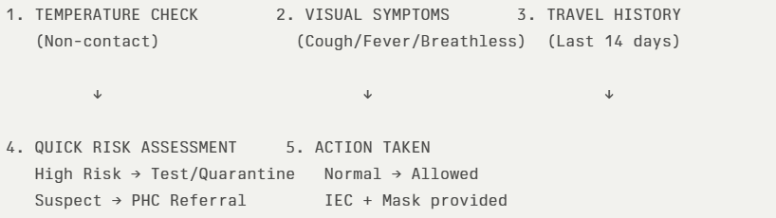
The screening protocol shall include temperature screening, observation for visible symptoms, and inquiry regarding recent travel or exposure history. Individuals identified as suspects during screening shall be immediately referred to the nearest PHC/FHC for further evaluation, testing, and appropriate action as per prevailing guidelines.

Pandemic Control Room
The Pandemic Control Room (PCR) serves as the central nerve center for real-time coordination, data aggregation, decision support, and communication during outbreaks. It consolidates information from all LSGD teams, health facilities and community sources to enable rapid response decisions.

Control Room Infrastructure and Location
Primary Location: VADAKARAPATHY Panchayath Office.
Backup Location: Community Hall in VADAKARAPATHY G.P.

Health System Control Room Framework
The PCR is organized into seven functional pillars to ensure no aspect of the response is overlooked:

Rapid Response Team (RRT)
  - Provides immediate intervention during emergencies, clusters, and field alerts.​
  - Coordinates urgent actions such as case investigation, contact tracing, isolation, and inter‑facility referrals.

Data Management & Analytics Team
  - Collects, validates, and manages key health system indicators (cases, tests, beds, HR, supplies).​
  - Analyzes data trends, generates projections, and supports evidence‑based decision‑making for local authorities.

Human Resource Deployment Team
  - Allocates healthcare staff efficiently based on workload and need
  - Ensures adequate and equitable workforce distribution across facilities

Laboratory Surveillance Team
  - Oversees diagnostic testing coordination, sample transport, and timely reporting of results.​
  - Monitors lab indicators (testing volume, positivity rate, turnaround time) for early detection of outbreaks

Vaccination Cell (If Required)
  - Plans and executes vaccination campaigns, including micro‑planning and session scheduling.​
  - Tracks coverage, identifies gaps, and coordinates corrective actions with field teams and outreach services.

Infrastructure & Patient Occupancy Team
  - Monitors facility capacity, earmarked beds, oxygen and critical care resources across all linked facilities.​
  - Ensures optimal patient distribution and referral management using updated bed‑status and resource data.
  - BMWM

Communication team
- Logistics and supply chain
- Transportation (interfacility & emergency transport)
- Media surveillance Call centre
- Management of the deceased
- Intersectoral coordination and convergence

Key Control Room Team
The Control Room Team coordinates all pandemic response activities within the LSGD and serves as the single command and communication hub during activation. It integrates information, field actions, logistics, and policy execution across all participating departments and health facilities.

Role | Name | Designation | Contact Number | Responsibility
In-charge/Nodal Officer | Secretary | Panchayat Secretary | 9496047227 | Overall coordination, decision-making, and reporting to the District level.
Data Entry Operator | Clerk | LD Clerk / IT Coordinator | 04923-235497 | Managing the line list, updating dashboards, and tracking testing results.
Communication Officer | VEO | Village Extension Officer | 9496042226 | Handling the public helpline, coordinating ambulance dispatch, and contact tracing calls.
Logistics Coordinator | Assistant Engineer | LSGD AE | 04923-235222
Technical Support(IT/Data) |  | Junior Health Inspector | 9349451610 | Technical health data validation, ensuring the accuracy of ward-level reporting.

SOP for alert escalation/trigger point with mapping of responsibilities.
Key Points:
- The Control Room shall be staffed with a designated In-charge, data entry personnel, and communication staff with clearly defined roles and shift arrangements.
- It shall maintain updated records on daily monitoring indicators including new cases, persons under active quarantine, and hospital bed occupancy.
- All reports and situation updates shall be shared daily with the Block and District Surveillance Unit.
- The Control Room shall act as a single point of contact for coordination with response teams, health institutions, and other departments.
- Contact details of the Control Room shall be widely communicated to field staff and stakeholders during activation.

Daily Monitoring Indicators
To ensure timely decision-making and effective response, the following key indicators shall be monitored and updated on a daily basis by the Pandemic Control Room:

Epidemiological Indicators:
New cases reported today, Total active cases, Test Positivity Rate (TPR), Case Fatality Rate (CFR)
- Surveillance Indicators:
Persons under home quarantine, High-risk contacts identified, Fever, ILI, SARI or other symptoms (syndromic surges), Travellers (symptomatic or high-risk arrivals),Animal husbandry surveillance (zoonotic alerts, unusual animal deaths, poultry/bird flu signals), Mortality surveillance (excess deaths, unexplained fatalities, verbal autopsy reports)
- Logistics and Infrastructure Indicators:
Hospital / CFLTC beds occupied, Oxygen cylinders/concentrators available, Ambulances on standby
- Alert Findings
The following table outlines category-specific trigger points (red flags) from surveillance indicators and corresponding immediate actions for the Pandemic Control Room. These enable rapid response to alert findings like testing anomalies, positive cases exceeding thresholds, clusters, and WGS reports.

Category | Trigger Pophint (Red Flag) | Immediate Action
Clusters | Geographical or facility-based: 5+ cases linked to one location (office, school, street). | Declare a micro-containment zone; perimeter control and active case finding.
Testing | Sudden drop in testing volume / delay in reporting / unusual testing trends | Review the sample collection process, address lab bottlenecks, deploy additional testing teams, and notify the District Lab.
Lab | Test Positivity rate increases | Increase testing sites in that ward.
Hospital | >80% Oxygen bed occupancy | Activate backup/CFLTC beds.
Travel | Cluster of cases from a single flight/train or high-risk arrival group. | Trace all passengers in adjacent seats; implement mandatory institutional quarantine.
Animal | Mass poultry/wildlife death or unusual sickness | Notify Animal Husbandry, sample the area, and dispatch RRT for environmental sampling and zoonotic check.
Mortality | Sudden spike in home deaths or brought-in-dead (BID) cases | Audit the deaths and Active Case Search drive
Additional investigations like Whole Genome Sequencing (WGS) | Detection of a Variant of Concern (VOC) or Variant of Interest (VOI) | Implement strict micro-containment; update clinical protocols to match variant severity.

Communication of Public Health Information
A Community Communication Hub shall be established to ensure timely, accurate, and consistent dissemination of information during a pandemic. The Hub will function under the coordination of Nodal officers of the control room and act as the nodal point for public communication, risk messaging, and community engagement. It will support dissemination of official advisories, promote preventive behaviors, address rumors and misinformation, and ensure that messages reach all sections of the population through trusted local channels and leaders.

Key communicators
Channel | Responsible Person | Contact
Ward-level announcements | JHI David | 9349451610
Social media | Panchayat Secretary | 9496046755
Local Cable TV/Radio | Vision Channel / KCCL | Local Operator (Vision Channel and KCCL (Kerala Communicable Cable Ltd) cover the Kozhinjampara/Vadakarapathy area for local scrolls.)

- All messages disseminated through the Hub shall align with advisories issued by the Health Department and District authorities.
- Community leaders shall be sensitized to support behavior change, reduce stigma, and counter misinformation.
- Special efforts shall be made to reach vulnerable and hard-to-reach populations using locally appropriate communication methods.

Rumor Tracking: A designated volunteer will monitor local social media/WhatsApp groups daily to identify misinformation and issue official clarifications via the Communication Hub.

Coordination with District/State Authorities & Other Organisations
Effective coordination with Block, District, and State authorities is essential to ensure timely reporting, technical guidance, and uninterrupted supply of essential resources during a pandemic. The LSG shall establish clear communication channels, designate responsible officers, and adhere to prescribed reporting timelines to support coordinated public health action and efficient resource mobilisation.

Key Details:
- Nodal Officer for Reporting: Panchayat Secretary, Vadakarapathy
- Contact Number: 04923-215354 / 9496046755 (Panchayat Office)
Reporting Schedule and Protocols: Medical Officer, PHC Ozhalapathy

To Whom | What to Report | Frequency | Nodal Person
Block PHC Kozhinjampara | Complete Situation Report (Cases, Quarantine, Beds, Screening, Deaths) | Daily (by 4:00 PM) during outbreaks; Weekly otherwise. | Health Inspector (HI) / Medical Officer
District IDSP Unit (Palakkad) | Outbreaks/Clusters/Unusual Events (>5 cases same ward) | Immediate (within 24 hours of detection). | Junior Health Inspector (JHI)
Veterinary Officer | Animal health events/Zoonotic alerts | Immediate upon sighting/report. | Veterinary Surgeon
State Cell (DHS/IDSP) | Zoonotic cross-sector events | As per State Call (usually daily during Level 3 emergencies). | Panchayat Secretary / MO

Supply Chain Coordination
The LSG shall coordinate closely with Block, District, and State authorities (KMSCL) to ensure uninterrupted availability of essential goods, medical supplies, and logistics during a pandemic. Supply requirements shall be assessed regularly based on case load and communicated promptly to the appropriate authorities for timely replenishment.
Key Points:
- Maintain updated contact details of District and Block nodal officers for health logistics, oxygen supply, ambulances, and essential medicines.
- Submit timely indent requests for PPE, testing kits, medicines, oxygen, and other critical supplies through prescribed channels.
- Monitor stock levels at LSGD facilities, quarantine/isolation centres, and field teams through daily stock registers and dispensing logs to prevent shortages.
- Coordinate with District authorities, Karunya/Neethi medical shops, and local purchase committees for funds allocation and emergency procurement.

- Ensure regular monitoring of dispensing registers at all facilities to track usage, expiry, and pilferage—shortages being a perennial issue requiring proactive weekly audits.

- Activate surge procurement protocols during high caseloads, leveraging local purchase powers under LSGD funds alongside state supplies.

Resource Inventory and Contacts
Resource Category | Source  (District/State/Private) | Contact
PPE Kits/Masks/Gloves | KMSCL | 0491-2533336
PPE Kits/Masks/Gloves | Local Vendors | 7947429533
Oxygen  Cylinders/Concentrators | KMSCL | edrugs.kmscl@kerala.gov.in
Medicines/Antivirals | KMSCL | 0491-2521143
Medicines/Antivirals | Neethi Shops | 0491-2521143
Test Kits (RTPCR/Rapid) | KMSCL | 0491-2533336

Collaboration with NGOs, PPP, and CSR
To augment government efforts during a pandemic, the LSG shall collaborate with NGOs, voluntary organisations, and private sector partners through public–private partnerships and Corporate Social Responsibility (CSR) initiatives, in coordination with District authorities.

Key Points:
- Engage NGOs and community-based organisations for community outreach, awareness, and support to vulnerable populations.
- Leverage CSR support for procurement of medical equipment, PPE, oxygen concentrators, food kits, and sanitation materials, as permitted.
- Ensure all collaborations align with government guidelines and are routed through approved administrative and financial procedures.
- Maintain transparency and documentation for all external support received and utilised.
Organization | Type | Support Offered | Contact Person
Youth Clubs (Nehru Yuva Kendra affiliated) | CBO | Voluntary labor for disaster relief, blood donation, and awareness campaigns. | Secretary (Local Club Network) - 9447612340
Student Unions (GHSS Kozhippara/Kozhinjampara) | CBO/Student Body | Mobilizing young volunteers for data collection and school-based health awareness. | Staff Advisor (NSS/SPC) - 9745032152
Kudumbashree (CDS) | CBO | Door-to-door risk communication, community kitchens, and surveillance of vulnerable households. | CDS Chairperson - 9446320145

Interdepartmental Coordination
Coordination among departments during a pandemic shall be ensured through regular review meetings convened by the LSGD President. These meetings will provide a structured platform for sharing situational updates, assessing resource availability, resolving operational gaps, and taking joint decisions to ensure a coordinated and timely response.

Department | Representative | Key Role | Contact
Health (PHC) | Staff Nurse : | Case management | 9544877578
Veterinary | Veterinary Surgeon: | Animal surveillance | 9048959649
ICDS | Supervisor: Sindhu | Nutrition support | 9188148435
Education | Head Teacher: | School coordination | 9745032152
Police | SHO (Kozhinjampara PS) | Containment enforcement | 04923-272230
Water Authority | Asst. Engineer (KWA) | Water supply | 8547638127 (Chittur Section)
LSGD Engineering | Asst. Engineer (LSGD) | Quarantine infrastructure | 04923-235222 (Panchayat Section)

PHASE 3 - Surge Capacity
Phase 3 is activated when there is a rapid increase in cases, high test positivity rates, or when existing health facilities and quarantine arrangements approach saturation. The focus of this phase is to expand isolation capacity, augment clinical care services, and mobilise additional resources through district and state support mechanisms.

Conversion of Community Facilities
To manage increased case load, the LSGD shall activate additional isolation facilities by repurposing identified community infrastructure such as community halls, auditoriums, schools, hostels, or other suitable buildings.

Name of facility | Facility Type | No. of Buildings | Ward | Surge Capacity (Beds) | Nodal Person
Name of Facility | Facility Type | No. of Buildings | Ward | Surge Capacity (Beds) | Nodal Person (Designation)
Govt. VHSS, Kozhipara | School | 2 Blocks | 4 | 25 | School Principal / VEO
St. Francis Xavier’s Parish Hall | Community Hall | 1 Large Hall | 8 | 25 | Parish Secretary / Ward Member
Ozhalapathy Community Hall | Auditorium | 1 Building | 14 | 40 | Secretary

- Recovery and rehabilitation phase
- Recovery
  - Damage & impact assessment
  - Restoration of health services
  - Rehabilitation of affected population
  - Psychosocial & mental health support
  - Disease surveillance during recovery phase
  - Environmental cleanup & sanitation
  - Livelihood restoration
  - Community engagement & confidence building
  - Documentation & after-action review
  - Lessons learned & best practices
  - Health system strengthening
  - Policy revision & preparedness enhancement
  - Research

CONCLUSION

Additional points
- tech support
- relief based commodities
- ham reading operators
- hazard vulnerability mapping
- Kseb& other power source
- HR specific responsibility

RECOMMENDATIONS

Strengthening Healthcare Infrastructure
- Establish a primary health response unit within the Panchayat with trained staff.
- Ensure availability of basic medical supplies (masks, sanitizers, PPE kits, oxygen cylinders).
- Create tie-ups with nearby hospitals in Kozhinjampara, Chittur, and the Ahalia Campus (Kozhipara)for emergency referral and transport.

2. Community Awareness & Education
- Conduct regular awareness campaigns on hygiene, vaccination, and preventive measures.
- Use local communication channels (community radio, WhatsApp groups, notice boards) to spread verified information.
- Train volunteers to act as health ambassadors in each ward.

3. Emergency Response & Coordination
- Form a Pandemic Preparedness Committee at Panchayat level including health workers, ward members, and NGOs.
- Develop a clear action plan for lockdowns, quarantine, and distribution of essentials.
- Maintain a database of vulnerable groups (elderly, differently-abled, chronically ill) for targeted support.

4. Supply Chain & Food Security
- Identify and support local suppliers and farmers to ensure uninterrupted food supply.
- Create community kitchens during emergencies to serve vulnerable populations.
- Stockpile essential commodities in Panchayat-run outlets for crisis periods.

5. Digital Preparedness
- Promote digital platforms for telemedicine consultations.
- Use Panchayat’s website/social media for real-time updates on health advisories.
- Encourage online grievance redressal to reduce crowding in offices.

6. Training & Capacity Building
- Organize mock drills for pandemic response in schools, offices, and public spaces.
- Train Panchayat staff and volunteers in first aid, infection control, and crowd management.
- Collaborate with NGOs and health departments for capacity-building workshops.

7. Long-Term Resilience
- Integrate pandemic preparedness into the Panchayat Development Plan.
- Allocate a dedicated budget for health emergencies.
- Encourage community participation in planning and monitoring preparedness measures.

MOCKDRILL SCENARIOS

ANNEXURE

IMPORTANT PHONE NUMBERS

Phone numbers and particulars of persons responsible for providing guidance, assistance, and support for pandemic preparedness operations may be provided here in a manner that allows easy reference at a glance.The information recorded here could be exhibited elsewhere at the time of emergencies. LSG institutions shall give special attention to collect and record the above data of persons and institutions who/which are supposed to give technical and co-ordination support to reduce the impact of pandemic.

1.1. Details of grama panchayat/municipality/corporation wards
Sl.No | Name of the ward | Ward number | Name of the ward  member | Contact number
1 | Neelipara | 1 | Princy | 8991810534
2 | Sorapara | 2 | Sagaya arockiaraj | 9074664439
3 | Nalloor | 3 | Aiswarya | 9544689464
4 | Velanthavalam | 4 | Saradha mani | 9995531258
5 | Muncif Challa | 5 | Felix sundharraj | 9745032453
6 | Attayanpathy | 6 | Ambika | 9633882988
7 | Ozhalapathy | 7 | Mohanraj | 9746932831
8 | Kuppandakoudanoor | 8 | Ummamaheswari | 9788611456
9 | Keranpara | 9 | Senthil kumar | 9865210331
10 | Kinerpallama | 10 | Bindhu | 9895682544
11 | Valiyakaliyanpara | 11 | Josy brito | 9946302795
12 | Maniyakaran challa | 12 | Reena mary | 9048557336
13 | Sathram | 13 | Pichamuthu | 9266732089
14 | Menonppara | 14 | Devadas | 9946349945
15 | Bagavathy para | 15 | Dineesh | 7012295929
16 | Kanakankalam | 16 | Lidya princy | 8086732979
17 | Kozhippara | 17 | Makesh | 7736391108
18 | Erumakaranoor | 18 | Fathima mery | 7034326887

1.2. Other important phone numbers of grama panchayat/municipality/corporation area
Sl. No. | Name | Contact number
1. | Secretary (Grama Panchayat) | 9895196115
2. | Krishi officer | 8893311530
3. | President (Grama Panchayat) | 94960 47226 (Official)
4. | Assistant Engineer (LSGD Section Office) | 04923 235222 (Office)
5. | Police (SHO) (Kozhinjampara PS) | 94979 80613 /  04923 272224
6. | Health Supervisor | 94476 20539 (HS)
7. | Excise department(Chittur Range Office) | 94000 69619 (ERO)
8. | Forest department(Walayar Range Office) | 0491 2862215 /  94479 79143

C 1.4. Health Services

Sl. No | Name of the hospital/institution | Location | Phone number
1. | Government hospitals/PHC | Ozhalapathy | 9400623743
2. | Private hospitals | Elippara | 7561002751
3. | Clinical laboratories | Ozhalapathy | 8138871287
4. | Chemist/pharmacy | Neethi Medical Store | 04923 235450
5. | Blood donors | Kozhinjampara RRT / WhatsApp Group | 94463 33115 (Coordinator)

1.5. Veterinary Services
Sl.No | Name of the Clinic | Name of the  Surgeon/Doctor | Place/location | Phone  number
1 | Govt.Veterinary Hospital | Francis | Naloor | 9048959689

1.6. Helpline numbers
Helpline | Phone number
Police (Local Police Station) | 04923 272224
Fire and Rescue (Chittur Fire Station) | 04923 222499  04923 222400
KSEB (Kozhinjampara AE) | 94960 10061

1.7. Public and Private Schools Contact details

S.No | Name of School | Institution type | Phone number
1 | St Francis Xaviour | Aided | 9809929271
2 | GLPS Kaliyamppara | Govt | 9446789843
3 | GLPS Kerampara | Govt | 9746446800
4 | Kozhippara Govt H S S | Govt | 8129673226
5 | GLPS Menonpara | Govt | 9447589316
6 | GLPS Attyanpathy | Govt | 9745398052
7 | Christ the king aided LP school | Private | 9567150995

1.9. Anganwadi Contact Details

1 | Neelippara | Bindhu | 1 | Meelippara | 9847779074
2 | Near Ozhalapathy | Anitha | 1 | Neelippara | 9446335018
3 | Nallur | hhhhhhhh | 2 | Sorappara | 8129022127
4 | Sorappara | Ushakumari | 2 | " | 9746380013
5 | Velamthavalam | Radhamaw | 3 | Velamthavalam | 9745032152
6 | Chunnambukalthode | Remadevi | 3 | Velamthavalam | 9809127664
7 | Munchofchella | Remya | 4 | Munchofchella | 9809368698
8 | Chettiyarkalam | Kavitha | 5 | Attyampathy | 9809410224
9 | Chinnakaundannor | Sumitha | 6 | Valiya Kattu | 9048197788
10 | Anupur | Sasheela | 7 | Kupanda | 9961197351
11 | KupandaKaundanoor | Sara | 7 | " | 6238821245
12 | Kerampara | Sarojini | 8 | Korampara | 9946214456
13 | Kaziyanchettikalam | Shyamala | 8 | Kerampara | 9048782252
14 | Ozhalapathy | Krishnaveni | 9 | Kinarpallam | 9400635348
15 | Kinarpallam | Rathika | 9 | Kinarpallam | 9545261868
16 | Kalliyampara | Ratnambika | 10 | Maniyaramchella | 9495242816
17 | Maniyamkaranamchella | Jainsi | 10 | Ozhalapathy | 9447943260
18 | Ramandichella | Mini | 11 | Sathram | 975776217
19 | Sathram | Renukadevi | 12 | Maniyaramchella | 9961244543
20 | Menonpara | Blessy | 13 | Menonpara | 9846808146
21 | Elippara | Haritha | 14 | Bahawathypura | 7012537981
22 | Devarayankotta | Savithri | 14 | " | 9048734982
23 | Kanakkamkalam | Deepa | 15 | Kanakkamkalam | 9495591848
24 | Koppumanchalla | July | 15 | Kanakkamkalam | 8714344215
25 | Kozhippara 4cent | Priyanka | 16 | Kozhippara | 9656952802
26 | Kozhippara | Meera | 17 | Erumakaranor | 9539021729
27 | Erumakaranor | Anthonyamma | 17 | Erumakaranor | 9946712456

1.12. Information regarding resources

Means of transportation | Name of Owner | Phone Number
Heavy Trucks
Tractor
Ambulances
Boats
Taxi service

Annexure 1: LSG Baseline Data Collection Format
A. Baseline data
Sl. No. | Indicator / Field | Baseline Data | Source / Remarks
1 | Name of LSG | Vadakarapathy | LSGD
2 | District | Palakkad
3 | Block / Taluk | Chittur
4 | Type of LSG (Gram Panchayat / Municipality / Corporation) | Grama Panchayath
5 | Area (sq. km)
6 | No. of wards | 18
7 | GIS boundary file available | (Yes/No)
8 | Key contact person & phone | Dinesh | 7012295929

B. Demography
Indicator / Field | Baseline Data | Source / Remarks
Total population | 26854 | Base line data
Males | 13190
Females | 13694
Transgender population | 0
Age distribution  (<5, 5–14, 15–59, ≥60) | 1342,5372,16649,3491
No. of households | 7277
Population density (persons/sq.km)
No. of migrant workers | 154
Major occupational groups | Agriculture

C. Vulnerable Populations & Social Risks
Sl. No. | Indicator / Field | Baseline Data (Value / Description) | Source / Remarks
1 | No. of elderly (≥60) | 3491
2 | No. of persons with disability | 297
3 | No. of bedridden persons | 94
4 | No. of chronic disease cases (DM/HTN/COPD/CKD etc.) | 1247/1480/21/18
5 | Pregnant women (current estimate) | 246
6 | Children <5 years | 1342
7 | Tribal population (if any) | 897
8 | Fisherfolk / coastal vulnerable groups (if any) | 0
9 | Urban slums / unnotified settlements (if any) | 0
10 | Homeless population | 0
11 | Orphanages / old age homes (number & capacity) | 2/2  17/21
12 | Hostels / prisons / shelters (number & capacity) | 0
13 | Poverty / BPL estimate | 3783
14 | Food insecurity hotspots | 0
15 | Any history of stigma/discrimination issues (Yes/No) | 0

D. Health System & Service Readiness
Sl. No. | Indicator / Field | Baseline Data (Value / Description) | Source / Remarks
1 | No. of health facilities in LSG (PHC/CHC/TH/DH/Private) | 8 | Includes  FHC - 1  Sub-centres- 6  and major Private Ayurvedic Hospital. -1
2 | PHC/Family Health Centre details (name, location) | PHC Ozhalapathy | Ozhalapathy
3 | Subcentres / Health & Wellness Centres (number) | 6
4 | Private clinics / hospitals (number) | 2 Major | Notably Ahalia Ayurvedic Hospital (Kozhipara) and small local clinics.
5 | Labs available (public/private) | Public (FHC) & Private (1-2) | Basic diagnostic tests available at FHC; advanced labs in nearby Chittur or Coimbatore.
6 | Availability of ambulance services (Yes/No, number)
7 | Availability of isolation/quarantine facilities (Yes/No, details) | Yes | Identified schools/community halls (e.g., Govt High Schools) used as domiciliary care centers.
8 | Cold chain facilities (Yes/No, details) | Yes (ILR & DF at FHC) | Ice-Lined Refrigerators (ILR) available at the FHC for vaccine storage.
9 | Stockpile space available (Yes/No) | Yes | Dedicated storage room within the FHC and Panchayat office for relief materials.
10 | PPE / mask / sanitizer availability plan (Yes/No) | Yes | Buffer stock maintained as per the District Medical Office (DMO) guidelines.
11 | Surveillance staff available (JHI/JPHN/ASHA count) |  | JHI - 3  JPHN - 4  ASHA - 22
12 | Existing emergency referral pathways (Yes/No) | Yes | Referral flow: FHC → CHC Kozhinjampara → TH Chittur → DH Palakkad.

E. Points of Entry & Mobility
Sl. No. | Indicator / Field | Baseline Data (Value / Description) | Source / Remarks
1 | Bus stands / depots (number) | 0 (Major depots are in Chittur and Palakkad) | Local bus stops at Kozhipara, Ozhalapathy, and Athicode.
2 | Railway stations (number) | 0 (Nearest: Palakkad Town & Kanjikode) | Palakkad Town (15 km) and Kanjikode (12 km) are the closest.
3 | Boat jetties / fishing harbours (number) | 0 (Landlocked rain-shadow region) | Not applicable to this topography.
4 | Ports / airports nearby (specify distance) | Coimbatore International Airport (35 km) | Cochin (COK) is ~110 km; Coimbatore (CJB) is the primary gateway.
5 | Major highways/roads passing through | Gopalapuram Road / Kozhinjampara-Velanthavalam Road | Connects to NH 544 at Kanjikode/Walayar.
6 | Border crossings (state/district) | Velanthavalam (Interstate) | Major gateway between Kerala and Tamil Nadu.
7 | Major markets / weekly markets | Velanthavalam & Kozhinjampara Markets | Weekly markets for livestock and dry-land produce.
8 | Tourism hubs / major event venues | Ahalia Heritage Village / Sculpture Park | Significant cultural and event destination in the region.
9 | Schools/colleges with hostels (number) | 2-3 (Ahalia Campus / St. Francis) | Ahalia Institutions (Kozhipara) have large-scale hostel facilities.
10 | Factories / large workplaces (number) | 15+ (Small & Medium Enterprises) | Concentrated in the Ozhalapathy industrial belt (Agri-processing/Poultry).
F. Water, Sanitation & Hygiene (WASH)
Sl. No. | Indicator / Field | Baseline Data (Value / Description) | Source / Remarks
1 | Major drinking water sources (piped / wells / borewells / springs) | Piped (JJM/KWA), Borewells, and Public Wells | Primarily reliant on the CWSS to Kozhinjampara, Eruthempathy, and Vadakarapathy.
2 | No. of public wells | 378 | As per LSGD / Panchayat Asset Register.
3 | No. of households with piped water connection | ~1,522 (Completed) / 6,020 (Target) | Based on JJM Phase II data as of late 2024/early 2025.
4 | Water quality testing routine (Yes/No) | YES | Conducted by KWA Quality Control Sub-division, Chittur and through "FTK" (Field Test Kits) at the ward level.
5 | Common contamination risks (flooding, salinity, industrial waste) | High Fluoride/Hardness and Drought-induced depletion | Being a rain-shadow area, salinity/hardness and depletion of the water table are higher risks than flooding.
6 | Open defecation free status (Yes/No) | Yes (ODF Plus) | Kerala was declared ODF in 2016; Vadakarapathy is currently working toward ODF Plus Model status.
7 | Solid waste management system (Yes/No) | YES | Managed by Haritha Karma Sena (HKS) via doorstep non-bio waste collection.
8 | Bio-medical waste disposal mechanism (Yes/No) | YES | Handled through IMAGE (IMA) for the FHC and private clinics like Ahalia.
9 | No. of public toilets | ~8-12 | Located at major hubs: Kozhipara, Ozhalapathy, and Velanthavalam border.
10 | Handwashing stations in public places (Yes/No) | YES | Established during COVID-19 at the Panchayat office, FHC, and schools (maintained under Break the Chain).
G. Zoonotic Risks & One Health
Sl. No. | Indicator / Field | Baseline Data (Value / Description) | Source / Remarks
1 | Livestock population (cattle/goats/pigs/poultry) – estimates | Cattle: ~5,200; Goats: ~3,100; Poultry: ~45,000 | Estimated based on the 20th Livestock Census & local farm registries.
2 | No. of dairy farms / poultry farms / pig farms | Dairy: 85; Poultry: 12 (Commercial); Pig: 2 | Notable commercial poultry cluster in the Ozhalapathy belt.
3 | Slaughterhouses / meat shops (number) | Meat Shops: 14; Authorized Slaughterhouses: 0 | Most meat is sourced from authorized facilities in Chittur or private farm-gate sales.
4 | Animal markets (Yes/No, details) | Yes (Interstate proximity) | Proximity to the Velanthavalam border and Pollachi (TN) markets; weekly cattle trade is common.
5 | Veterinary dispensaries (number) | 1 (Kozhipara) | The Government Veterinary Dispensary, Kozhipara is the primary center.
6 | History of zoonotic outbreaks (rabies, leptospirosis, avian flu etc.) | Rabies (Sporadic), Leptospirosis (Seasonal) | High vigilance for Avian Flu due to proximity to large poultry clusters in Tamil Nadu.
7 | Stray dog population management measures (Yes/No) | Yes (ABC/ARV Program) | Periodic Animal Birth Control (ABC) and Anti-Rabies Vaccination (ARV) drives by the LSGI.
8 | Rodent infestation hotspots (Yes/No) | Yes (Granaries / Feed stores) | Common in wards with large-scale poultry feed storage and groundnut warehouses.
9 | Wetlands / waterlogged areas prone to leptospirosis | Minimal (Rain-shadow region) | Low risk; potential hotspots are limited to the Parambikulam-Aliyar canal banks during peak flow.
10 | Bat roosting areas / caves / fruit orchards (if any) | Coconut groves & Mango orchards | Wide stretches of mango trees in Athicode and Ozhalapathy serve as fruit bat habitats.
11 | Human-animal interface hotspots (farms near residences) | High | Traditional housing often includes integrated cattle sheds; high density of poultry farms near residences.

H. Climate & Disaster Risks (Pandemic Amplifiers)
Sl. No. | Indicator / Field | Baseline Data (Value / Description) | Source / Remarks
1 | Flood-prone wards (list) | Minimal (Parts of Wards 2, 7 & 11 near Canal banks) | Rare; only occurs during emergency release from Parambikulam-Aliyar dams.
2 | Landslide-prone wards (list) | NONE | The terrain is undulating plains, not high-slope hilly terrain.
3 | Cyclone/sea surge risk (Yes/No) | NO | Landlocked. However, experiences high-velocity winds (Palakkad Gap effect).
4 | Heatwave risk zones (Yes/No) | Yes (High Risk) | Wards 1, 4, 10, 14, and 18 are prone to extreme summer temperatures (40°C+).
5 | Waterlogging areas (list) | Velanthavalam Junction, low-lying farm-tracks | Limited to localized monsoon drainage issues in market areas.
6 | Shelter homes / relief camps (number, capacity) | ~5 Centers (Capacity: 1,500+) | Primary: Govt VHSS Kozhipara, Ozhalapathy School, Parish Hall.
7 | Past disaster displacement history | Minimal | No major history of mass evacuation due to floods (unlike 2018 in Central Kerala).
8 | Disruption to water supply/transport common (Yes/No) | Yes (Seasonal Water Scarcity) | Summer water supply is frequently disrupted; wind-felled trees often disrupt KSEB lines.
I. Critical Infrastructure & Logistics
Sl. No. | Indicator / Field | Baseline Data (Value / Description) | Source / Remarks
1 | Schools (number)
2 | Anganwadis (number)
3 | Colleges (number)
4 | Community halls (number)
5 | Places of worship with large gatherings (number)
6 | Large markets / shopping areas (number)
7 | Warehouses / cold storages (number)
8 | Telecom/mobile network coverage gaps (Yes/No)
9 | Power outage frequency (high/medium/low)
10 | Availability of generators in key facilities

J. Risk Communication & Community Networks
Sl. No. | Indicator / Field | Baseline Data (Value / Description) | Source / Remarks
1 | Ward-level rapid response teams (Yes/No) | Yes (Active in all 17 wards)
2 | Jagrathasamithis / committees active (Yes/No) | YES | Specifically active in addressing social issues and health monitoring at the ward level.
3 | Kudumbashree presence and strength (number of units) | Sannadha Sena & Local Volunteers | The Panchayat has a strong CDS (Community Development Society) with units active in every ward.
4 | Volunteer network (number, coverage) | Sannadha Sena & Local Volunteers | Registered volunteers under the "Sannadha Sena" portal plus local youth club networks (approx. 300+ volunteers).
5 | Community-based surveillance mechanisms (Yes/No) | YES | Conducted through ASHA workers and Kudumbashree 'Arogya Jagratha' teams.
6 | IEC dissemination channels (WhatsApp groups, community radio, PA systems) | WhatsApp, PA Systems, Temple/Church announcements | Extensive use of WhatsApp groups (Ward-level) and Public Address (PA) systems during emergencies.
7 | Rumour tracking mechanisms (Yes/No) | Yes (Informal/Police-linked) | Monitored by the Panchayat Secretary and Cyber Cell; Ward members act as first-line verifiers.
8 | Languages spoken / literacy considerations | Malayalam, Tamil (High Bilingualism) | Literacy is ~88–90%. As a Linguistic Minority Area, Tamil is widely used alongside Malayalam.
9 | Vulnerable groups communication strategy available (Yes/No) | YES | Direct outreach through ASHA/Anganwadi workers for elderly and SC/ST colonies.

K. Preparedness Planning & Governance
Sl. No. | Indicator / Field | Baseline Data (Value / Description) | Source / Remarks
1 | LSG emergency plan available (Yes/No) | Yes (Disaster Management Plan) | Updated annually as per KSDMA guidelines. Focuses on drought and monsoon hazards.
2 | Pandemic preparedness plan available (Yes/No) | Yes (Integrated Health Plan) | Developed post-COVID-19; includes isolation protocols and Ward-level monitoring.
3 | Incident Command System identified (Yes/No) | Yes | Led by the Panchayat President (Chairman) and Panchayat Secretary (Convener).
4 | Rapid procurement mechanism available (Yes/No) | Yes | Under the Kerala Panchayat Raj Act (Emergency Powers); allows for immediate purchase of medical/relief supplies.
5 | Emergency fund available (Yes/No, amount) | Yes (General Purpose Fund) | Allocation varies; usually maintained through the Panchayat Development Fund & Disaster Relief Fund.
6 | Past outbreak response experience (Yes/No, details) | Yes (COVID-19, Dengue) | Successful management of "CFLTCs" (Carbon Neutral/First Line Treatment Centers) during 2020-22.
7 | Intersectoral coordination mechanism (Health, Police, LSG, Veterinary, Education) | Yes (RRT & Task Force) | Monthly coordination meetings involving PHC Medical Officer, VEO, Police (Chittur/Walayar), and Veterinary Surgeon.
8 | Mock drills conducted in last 12 months (Yes/No) | Yes (Monsoon Preparedness) | Usually conducted in May/June before the monsoon season in coordination with Fire & Rescue.
9 | Training coverage for staff/volunteers (Yes/No) | Yes | Training provided to RRT members, ASHA workers, and Kudumbashree leaders on first aid and reporting.

L. Surveillance & Data Systems
Sl. No. | Indicator / Field | Baseline Data (Value / Description) | Source / Remarks
1 | Digital reporting tools used (e.g., DHIS2, portals) | ILGMS, e-Health, SHAILI App | ILGMS for LSG admin; e-Health/SHAILI for health screening and reporting by ASHAs.
2 | Availability of line-listing format (Yes/No) | Yes | Standard formats used by the PHC/FHC for communicable disease tracking (e.g., Dengue, ILI).
3 | Contact tracing team identified (Yes/No) | ILGMS, e-Health, SHAILI App | Comprises ASHA workers, Health Inspectors, and ward-level volunteers.
4 | Mapping of high-risk households available (Yes/No) | Yes | Households in water-scarce areas and SC/ST colonies are mapped for targeted surveillance.
5 | Testing sample transport mechanism (Yes/No) | Yes (Triple-Layer Protocol) | Samples are transported from PHC to the District Lab (Palakkad) or Virology Lab via dedicated hubs.
6 | Reporting timeline adherence (good/average/poor) | Good | Daily reporting is mandatory during outbreaks via the Integrated Disease Surveillance Program (IDSP).
7 | Data sharing between departments (Yes/No) | Yes | Structured sharing between Health, Veterinary (for Zoonotic alerts), and the LSG Secretary.
8 | Availability of dashboard for monitoring (Yes/No) | Yes (e-Health Dashboard) | Local health officials access real-time data via the e-Health Kerala and SHAILI portals.

M. Additional Notes & Observations
Sl. No. | Indicator / Field | Baseline Data (Value / Description) | Source / Remarks
1 | Key challenges perceived by LSG | Water Scarcity & Cross-border Surveillance | Frequent drought conditions require intensive water distribution; cross-border transit makes health monitoring difficult.
2 | Top 5 high-risk wards (reason) | Wards 1, 2, 8, 15, 17 (approx.) | Reason: Proximity to the TN border (high transit), water depletion zones, and presence of concentrated SC/ST colonies.
3 | Any unique local risks (industrial pollution, refugee camps, etc.) | Agricultural Drought & Linguistic Gap | High risk of crop failure (groundnut/cotton); communication barriers due to predominant Tamil-speaking population in some clusters.
4 | Recommendations for preparedness strengthening | Bilingual IEC & Water Recharge | 1. Issue all alerts in Malayalam/Tamil. 2. Desilt old ponds for groundwater recharge. 3. Specialized RRT training for border check-posts.

