PANDEMIC PREPAREDNESS PLAN
MODEL OF LSG
ERUTHENPATHY GRAMA PANCHAYATH

acer
[Email address]

MESSAGE FROM PRESIDENT - ERUTHENPATHY
It gives me immense pleasure to present this report highlighting the developmental and public health initiatives undertaken by the Local Self Government Institution (LSGI), Eruthenpathy.
Eruthenpathy Grama Panchayat has consistently prioritized the well-being of our community through strengthened primary healthcare services, improved sanitation, disease prevention activities, and community-based interventions. Our Local Self Government Institution remains committed to delivering accessible, affordable, and quality services to every household.
Over the past years, we have focused on strengthening public health infrastructure, supporting the Primary Health Centre, implementing national and state health programmes, improving waste management systems, and promoting preventive healthcare awareness. Special attention has been given to communicable disease surveillance, vector control activities, immunization coverage, maternal and child health services, and non-communicable disease screening.
The collaborative efforts of elected representatives, health officials, ASHA workers, Anganwadi staff, Kudumbashree members, and community volunteers have significantly contributed to improving health indicators in our Panchayat.
We reaffirm our commitment to sustainable development, transparency, and people-centered governance. With continued public participation and coordinated efforts, Eruthenpathy will move forward towards becoming a healthier, cleaner, and more resilient Panchayat.
I extend my sincere appreciation to all departments, stakeholders, and citizens for their wholehearted cooperation and support.
Together, let us continue to build a healthier Eruthenpathy.

President
LSGI Eruthenpathy

MESSAGE FROM HEALTH STANDING COMMITTEE CHAIRPERSON

It is with great responsibility and commitment that I present this message as the Chairperson of the Health Standing Committee, LSGI Eruthenpathy.
Health remains one of the highest priorities of our Panchayat. Through coordinated planning and effective implementation, the Health Standing Committee has been actively supporting the Primary Health Centre and allied health institutions to ensure accessible, equitable, and quality healthcare services to all sections of our community.
Our focus areas include disease prevention and control, strengthening immunization programmes, maternal and child health services, non-communicable disease screening, sanitation and waste management, vector control activities, and health awareness campaigns. Continuous monitoring of communicable diseases and timely interventions have helped us maintain better public health outcomes.
We have also emphasized community participation through the involvement of ASHA workers, Anganwadi staff, Kudumbashree units, and volunteers. Their dedication has been instrumental in implementing national and state health programmes effectively at the grassroots level.
The Health Standing Committee remains committed to promoting preventive healthcare, improving infrastructure, ensuring environmental sanitation, and supporting initiatives that enhance the overall well-being of our people.
I express my sincere appreciation to the President, Members of the Panchayat Committee, Medical Officers, Health Inspectors, field staff, and the public for their cooperation and collective efforts.
Together, we will continue to work towards building a healthier and stronger Eruthenpathy.
Chairperson
Health Standing Committee
LSGI Eruthenpathy

MESSAGE BY MEDICAL OFFICER

The Primary Health Centre remains committed to delivering comprehensive, accessible, and quality healthcare services to the people of Eruthenpathy. Our services encompass preventive, promotive, curative, and rehabilitative care in alignment with National Health Mission guidelines and State Health Department programmes.
During the reporting period, focused efforts were undertaken in communicable disease surveillance and control, immunization services, maternal and child healthcare, adolescent health services, non-communicable disease screening, geriatric care, and school health programmes. Continuous monitoring, early detection, and timely intervention have strengthened disease prevention and management within the community.
Special emphasis has been placed on health education, sanitation, vector control measures, and community outreach activities. The dedicated efforts of our healthcare team—including Staff Nurses, Health Inspectors, Junior Public Health Nurses, ASHA workers, and supporting staff—have been instrumental in achieving improved service delivery and better health outcomes.
We are grateful for the constant support of the Panchayat Administration, Health Standing Committee, ICDS department, and community stakeholders. Their collaboration has significantly enhanced the effectiveness of healthcare initiatives in our area.
We reaffirm our commitment to strengthening primary healthcare services and ensuring the well-being of every citizen of Eruthenpathy.

Medical Officer
Primary Health Centre, Eruthenpathy
EXECUTIVE SUMMARY

Primary Health Centre (PHC) functions as the primary public healthcare institution serving the population of Eruthenpathy Grama Panchayath. The PHC plays a pivotal role in delivering comprehensive, accessible, and affordable healthcare services, with a strong focus on preventive, promotive, curative, and rehabilitative care in accordance with national and state health programmes.
The PHC caters to a predominantly rural population, addressing key public health priorities such as maternal and child health, communicable and non-communicable disease control, immunization, family welfare, adolescent health, and geriatric care. Regular outpatient services, home-based care through field health staff, and outreach activities ensure healthcare coverage even in geographically challenging areas. The institution actively implements national health missions, including the National Health Mission (NHM), National Tuberculosis Elimination Programme, National Programme for Prevention and Control of Cancer, Diabetes, Cardiovascular Diseases and Stroke (NPCDCS), and other disease surveillance initiatives.
FHC Vannamada works in close coordination with the Grama Panchayath, ASHA workers, Anganwadi centres, schools, and community-based organizations to strengthen community participation and improve health awareness. Emphasis is placed on early detection, timely referral, health education, and lifestyle modification to reduce disease burden and improve overall health outcomes.
Despite constraints related to infrastructure, manpower, and increasing service demand, the PHC continues to enhance service delivery through effective planning, data-driven decision-making, and community engagement. Strengthening facilities, upgrading digital health systems, and expanding preventive services remain key focus areas for future development.
Overall, FHC Vannamada Primary Health Centre stands as a vital institution in safeguarding public health and improving the quality of life of the residents of Eruthenpathy Grama Panchayath

LIST OF ABBREVIATIONS

LSGD/LSGI | Local Self Government Department / Local Self Government Institution
BMO | Block Medical Officer
IDSP | Integrated Disease Surveillance Programme
NDMA | National Disaster Management Authority
PPE | Personal Protective Equipment
ICMR | Indian Council of Medical Research
CD | Communicable Diseases
NCD | NON-COMMUNICABLE Diseases

TABLE OF CONTENTS

3
INTRODUCTION 9
● Background of the PPP 9
LSGD AT A GLANCE 9
INTEGRATED HEALTH INFRASTRUCTURE MAP OF ERUTHENPATHY PANCHAYAT 11
GENERAL PROFILE OF THE LSGI’S 14
Background of the LSGI 14
Demographic and Vulnerable Population 15
Clinical Vulnerability 17
INFRASTRUCTURE & RESOURCE INVENTORY 19
Health Facility Directory & Basic Capacity in the LSGD 19
Private Clinics 20
Healthcare Education & Training Institutions 20
Specialized Services & Emergency Inventory 21
Oxygen & Diagnostic Capacity 22
Diagnostics facility mapping at the LSGI level 22
Laboratory Identification & Basic Details 23
Social and Community Infrastructure for surge plan 24
Human resources 29
Community & Support Cadre 30
Community Organizations 31
Administrative & Emergency Services 32
Information regarding resources 32
ONE HEALTH & ENVIRONMENTAL SURVEILLANCE 33
Animal & Bird Population 33
Veterinary Infrastructure 34
Veterinary Doctors & Workforce 35
High-Risk Interface Points (Surveillance Sites) 35
Environmental Risk Mapping 36
Disease Seasonality Mapping 37
Vulnerability Mapping 38
EPIDEMIOLOGICAL TRENDS (2021–2025) 39
Disease Burden among human beings(Last 5 Years) 39
*(use the above table data to create the graph/diagram) 40
Seasonal Trend Analysis 40
Outcome-Based Trend Analysis- 2025 Error! Bookmark not defined.
Transmission Trend- 2025 44
Integrated Disease Hotspot Map (2021–2025) 46
Preparedness and Response Protocol at LSG Level 48
Constitution of One Health Committee 48
Pandemic Response Workforce 50
Activities and Measures before and during Pandemic 51
PHASE 1 - Alert / Preparation 51
PHASE 2 - Active Response 54
Standard Screening Protocol 55
PHASE 3 - Surge Capacity 65
Conversion of Community Facilities 65
CONCLUSION 66
RECOMMENDATIONS 67
ANNEXURE 68
1. IMPORTANT PHONE NUMBERS 68

INTRODUCTION

Background of the PPP
- LSGD at a glance

LSGD AT A GLANCE
- Geographical boundaries with political map ( based on latest delimitation)
- Baseline data

Institution information

Name of the Institution : FHC Vannamada
Panchayath : Eruthenpathy
Block Panchayath : Chittur
District Panchayath : Palakkad
Village : ERUTHENPATHY
Taluk : Chittur
District : Palakkad

Geographic Information

Area : 36.93 Sq Kilometres
Boundarie: N-Vadakarapathy
S-Kozhinjampara
E-Tamilnadu
W-Kozhinjampara
DemographicInformation
Total Households : 5158
Total Population : 17553
Male : 8557
Female : 8996
Transgender : 0
Below 5 Years : 862
5-15 Years : 1885
15-59 Years : 10379
Above 60 Years : 4427

- Ward division -
Ward | Houses | Population | Migrants | Wells | Hot  spots | Ed. Institutions | Hosp pvt/govt.
9 | 5158 | 17553 | 261 | 275 |  | 5

- Risk stratification among wards in the context of Communicable diseases and hazards

- Major Roads/rivers
- Major establishments with geospatial mapping
- occupational groups, socio cultural groups, migration & mobility patterns
- Vulnerability mapping
- Disaster prone areas (geographic vulnerability)

Maps - ward-based (Mention source also)

- Geographical boundaries - ward boundaries map
- Health infrastructure map
- roads and rivers map
- major establishments map
- disaster-prone areas map
- hotspot map - CD & disasters

INTEGRATED HEALTH INFRASTRUCTURE MAP OF ERUTHENPATHY PANCHAYAT

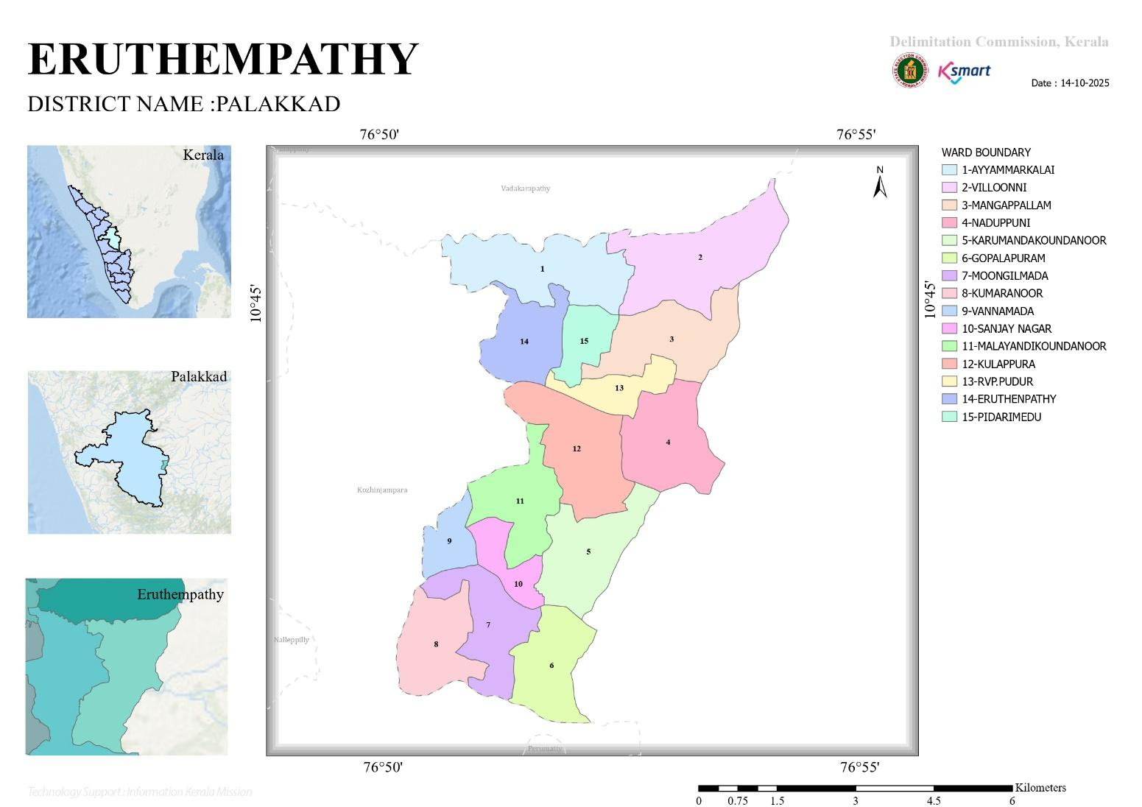

WHATERSHED Map
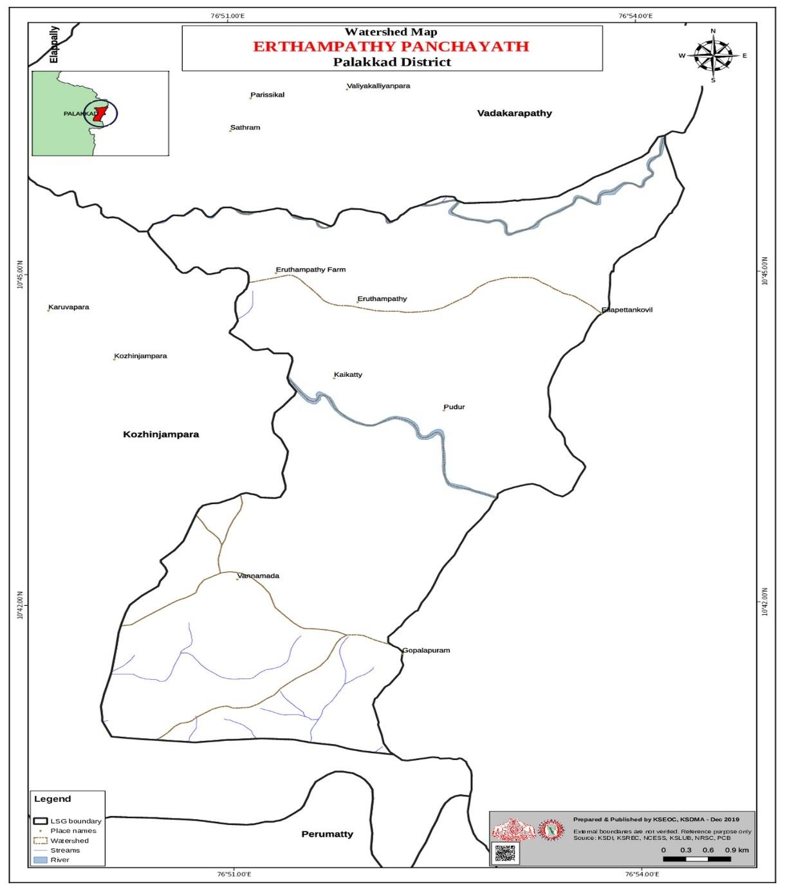

TRANSPORTATION MAP

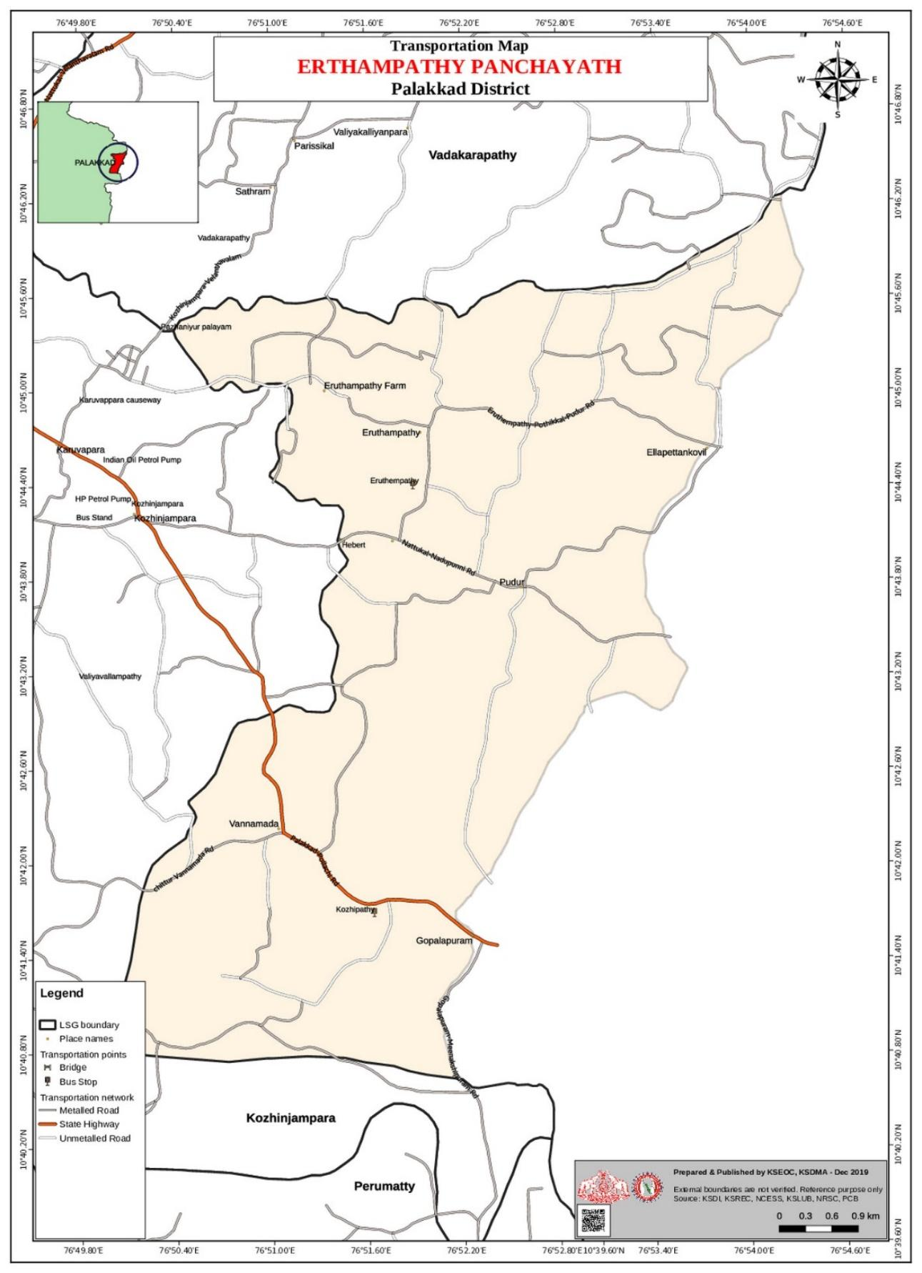

INFRASTURUCTURE FACILITIES MAP

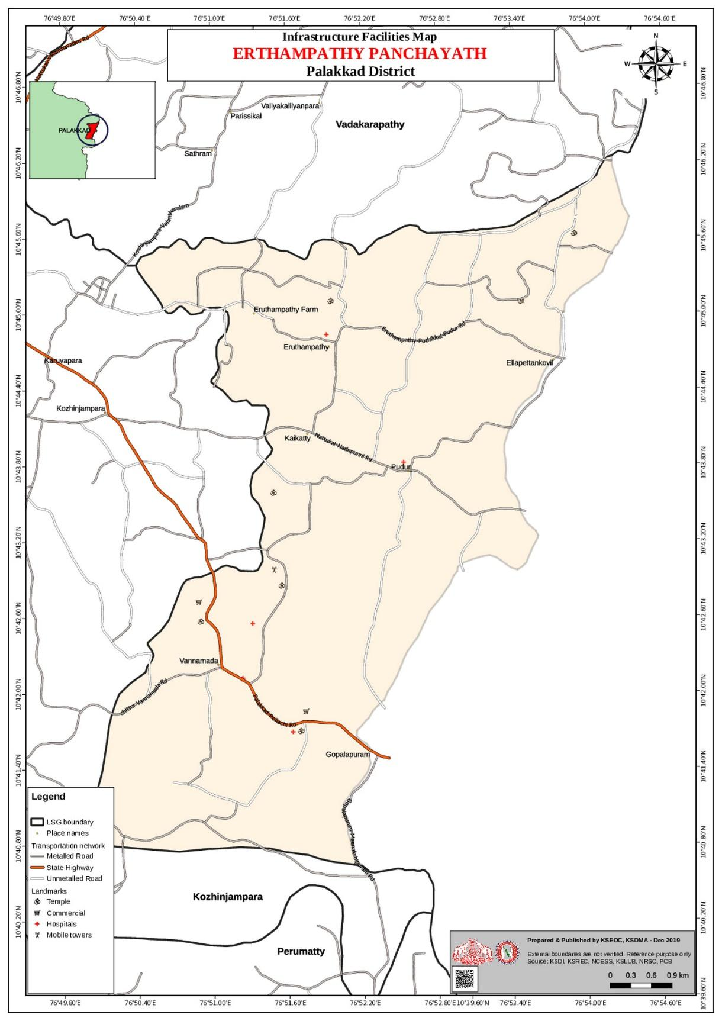

GENERAL PROFILE OF THE LSGI

Background of the LSGI ERUTHENPATHY
Eruthenpathy Grama Panchayat is situated in the Chittur Taluk of Palakkad district, in the state of Kerala. The Panchayat occupies a predominantly rural setting with a landscape characterized by agricultural lands, irrigation canals, and water bodies that support its agrarian economy.
The geographical profile of the Panchayat includes low-lying agricultural areas and seasonal water flow channels, which influence the local climate and environmental conditions. During the monsoon season, certain areas experience water stagnation and localized flooding, creating challenges in transportation, service delivery, and emergency response.
Administratively, the Panchayat is divided into multiple wards governed under the Local Self Government framework. The population primarily depends on agriculture—particularly paddy cultivation—along with coconut farming, livestock rearing, small-scale trade, and daily wage labour. The Panchayat also has a presence of migrant workers engaged in construction and agricultural activities, contributing to the local economy.
From a public health perspective, seasonal variations and environmental conditions occasionally increase the risk of waterborne and vector-borne diseases such as Dengue and Leptospirosis. Strengthening preventive healthcare services, sanitation systems, and disease surveillance mechanisms remains a priority for the Panchayat administration.
The Panchayat administration functions through coordinated efforts of elected representatives, standing committees, government departments, and community-based organizations. Emphasis is placed on sustainable development, infrastructure improvement, disaster preparedness, sanitation management, and community participation to enhance the overall quality of life.
Eruthenpathy Grama Panchayat continues to focus on inclusive growth, improved service delivery, and resilient development planning to ensure the well-being of its residents.

Table 1: Background of LSGD
Description | Details
Name of LSGI | ERUTHENPATHY
Type (GP/Municipality / Corporation etc.) | Grama Panchayath
Block | Chittur
District | Palakkad
Number of wards | 15
Total area (sq. km) | 36.93 Sq. Kilometers
Population(Projected) | 17553
Population density | 470 SQ KM
Terrain (coastal/low-lying/backwaters/foothills, etc.) | LOW LYING
Number of rivers passing through LSGI | 2
Number of water bodies in the LSGI | 837
Number of educational institutions | 6
Factories / small-scale industries | 10
Flood-prone wards | 0
Landslide-prone wards | 0
Death Management and Disposal Facilities (mortuaries/crematorium, including electric) | 0
Auditoriums/Marriage halls/convention centres/community halls | 4

Demographic and Vulnerable Population
Understanding the demographic composition and vulnerable population groups is essential for pandemic preparedness. Children, elderly, economically deprived families, migrant workers, and socially vulnerable groups are at increased risk during public health emergencies due to higher exposure, limited access to services, and dependency on public systems..

Description |  | Details (in numbers)
DEMOGRAPHIC PROFILE
Total population |  | 17553
Male |  | 8557
Female |  | 8996
Transgender |  | 0
Children under 5 |  | 862
Adolescent |  | 1885
Elderly (>60) |  | 4427
SOCIAL/LIVELIHOOD VULNERABILITY
Previous EPEP family |  | 8
BPL family |  | 3212
Tribal communities |  | 366
Migration | Immigrant | 217
Migration | Emigrant | 118
Socio-economically deprived |  | 8
Fisherfolk |  | 0
SC Community |  | 1670
ST Community |  | 366

Graphs: Population pyramid (if possible) for seeing if your LSGI has a high "dependency ratio" (lots of children and elderly compared to working adults).

Clinical Vulnerability
Certain population groups needs priority healthcare & are at higher risk of severe illness, complications, and mortality during pandemics. Patients with chronic diseases, those requiring regular medical care, and individuals with mobility or functional limitations face challenges in accessing timely care during emergencies. Mapping these groups helps in prioritizing continuity of treatment, medicine stock planning, oxygen support, referral transport, and targeted home-based care.
Description | Details in numbers
Pregnant women
Lactating mothers
Bedbound patients | 50
Patients under palliative care other than bedbound | 90
Patients on Haemodialysis | 4
Patients on CAPD
Cancer patients (currently on treatment) | 39
Haemophilic patients | 1
Mentally challenged | 11
Differently abled | 0
Diabetic patients | 0
Hypertensive patients
TB patients

Major Festivals & Events specific to the LSGI
(with the possibility of a public gathering)

Sl. No. | Name of festival | Month detailing the periodicity
1 | MARIYAMMAN POOJA | JANUARY
2 | MARIYAMMAN POOJA | MARCH
3 | MOOKALIYAMMAN POOJA | MARCH
4 | MARIYAMMAN POOJA | MARCH
5 | MARIYAMMAN POOJA | APRIL
6 | MADHURAVELAN POOJA | APRIL
7 | MAKALIYAMMAN POOJA | APRIL

INFRASTRUCTURE & RESOURCE INVENTORY

Health Facility Directory & Basic Capacity in the LSGD
This section provides an overview of the healthcare infrastructure available within the LSGD area. It outlines the distribution and basic capacity of health facilities that form the backbone of service delivery during routine times and public health emergencies.

Family Health Centres (FHCs) and Community Health Centres (CHCs) generally function as the first point of contact for the community, providing essential outpatient and inpatient services. General Hospitals (GH) and Medical College Hospitals (MCH), where accessible, serve as the main referral centres for advanced diagnostics, specialist care, and critical services during public health emergencies. This inventory helps identify existing strengths, gaps, and potential surge capacity that can be mobilised during a pandemic or disaster.

Table 5. Health Facility Resource Summary
Sl.no. | Health Facility | Type of Facility (MCH/GH/CHC/FHC/SC etc.) | Contact Number | Total beds | ICU Beds | Oxygen-Supported Beds | No. of Ventilator Support Beds | No. of ambulance
Government Healthcare Facilities
1 | Ayurvedic Dispensary ,Eruthenpathy | GH | 6282434797-  Dr.Haripriya | 1 | 0 | 0 | 0 | 0
2 | FHC Vannamada | FHC | 04923272585 |  | 0 | 0 | 0 | 0
3 | Homeo |  |  |  | 0 | 0 | 0 | 0
4 | HWC Main centre | HWC | 9526854476  Aiswarya(JPHN) |  | 0 | 0 | 0 | 0
5 | HWC Vannamada | HWC | 9526854476  Aiswarya(JPHN) |  | 0 | 0 | 0 | 0
6 | HWC Malayandi Koundanoor | HWC | 7034135151  Francina (JPHN)
7 | HWC R V Puthur | HWC | 9074382134  Nisha Rani(JPHN)
8 | HWC Eruthenpathy | HWC | 9633090122  Jency (JPHN)
Private Healthcare Facilities

Private Clinics
Private clinics are an essential part of pandemic preparedness, as they are often the first place people seek care when symptoms begin. In many communities, private clinics manage a significant share of outpatient visits and therefore play a critical role in early case detection, timely referrals, and disease surveillance. Having an up-to-date understanding of where these clinics are located, the services they provide, and how they are linked to the public health system helps ensure that no cases are missed during an outbreak. It also allows health authorities to engage private practitioners more effectively for reporting, risk communication, and coordinated response, strengthening the overall capacity of the health system to manage public health emergencies.

Table 6. Private Clinic Resource Summary
Sl No. | Name of Clinic | Registered (Y/N) | Clinic (General / Speciality) | Speciality (if any) | Address | Contact Number | Diagnostic Facility (Y/N) | Ambulance Linkage (Y/N)
1 | NIL
2
3

Healthcare Education & Training Institutions
This section tracks the educational infrastructure available, which is vital for human resource planning in the health sector.

Category of Institution | Govt | Private | AYUSH | Total
Medical Colleges | 0 | 0 | 0 | 0
Nursing Colleges | 0 | 0 | 0 | 0
Dental Colleges | 0 | 0 | 0 | 0
Para-medical / Allied Health | 0 | 0 | 0 | 0
Pharmacy Colleges | 0 | 0 | 0 | 0

Specialized Services & Emergency Inventory
This section provides a detailed view of the specialized medical resources available to the community, focusing on emergency response and critical care capabilities. This table tracks the vital assets required for managing severe illnesses and emergencies across Government, Private, and AYUSH sectors.

Item | Govt | Private | AYUSH | Total
Hospital beds | 10 | 0 | 0 | 10
Oxygen-generating systems(Y/N) | 0 | 0 | 0 | 0
Oxygen-supported beds(Numbers) | 1 | 0 | 0 | 1
Medical store | 1 | 3 | 0 | 4
Industrial establishments(Medium-scale industries/small-scale industries establishments to whom we can depend in a worst-case scenario) | 0 | 0 | 0 | 0

Oxygen & Diagnostic Capacity
Monitoring oxygen and diagnostic capacity is a critical component of public health preparedness, ensuring that the LSGD can handle both chronic care and sudden surges in respiratory or infectious diseases.
Name of Health Facility | Oxygen-generating System (Y/N) | Backup Oxygen Source (Y/N) | Diagnostic Facilities Available(Y/N)
Name of Health Facility | Oxygen-generating System (Y/N) | Backup Oxygen Source (Y/N) | Lab | USG | X-ray | CT/MRI | RT-PCR
Government Healthcare Facilities
FHC Vannamada | N | Y | 1 | 0 | 0 | 0 | 0

Diagnostics facility mapping at the LSGI level
The diagnostic capacity of ERUTHENPATHY G.P represents the "intelligence network" of our healthcare system. The speed and accuracy of disease identification depend entirely on the distribution and technical level of these facilities.

Item | Govt | Private | AYUSH | Total
General labs | 1 | 0 | 0 | 1

Social and Community Infrastructure for surge plan
This table serves as our logistics and shelter inventory. By mapping these locations, quickly we can identify where to house displaced citizens, where to set up temporary medical clinics, and how to manage the deceased with dignity during a crisis.

Category | Total Count | Ward | Est. Capacity (Persons) | Contact details
Educational Institutions
Anganwadis | 12 |  | 120 (10 / ANGANWADIS | SEE ANNEXURE -1
Schools | 5 | 9 AND 13 |  | SEE ANNEXURE -1
Community Gathering Spaces
Community halls | 1 | 11 |  | Rajamanikyam  9946063056
Auditoriums | 1 | 5 | 50 | Madhu  9946224266
Vulnerable Group Support Facility
Destitute homes | 0 | 0 | 0 | 0
Elderly homes | 2 | 10,12 | 35
LSGD owned other buildings | 0 | 0 | 0 | 0
Mass Fatality Management (MFM) Infrastructure
Mortuary | 0 | 0 | 0
Crematorium | 2 | 2,12 | 0
*refer annexure 1 for contact details

Human resources
This section focuses on the human capital available within the LSGI. In any emergency—be it a pandemic, flood, or industrial accident—infrastructure is only as effective as the people operating it.

Medical & Clinical Personnel
This table tracks the "Frontline" providers responsible for diagnosis, treatment, and clinical management. Narrative sentence: eg., "Total health workforce: 450 personnel, with 60% in government facilities serving as primary surge capacity." A detailed directory with the contact numbers of all workers is maintained (Annexure in 1).

Cadre | Govt (No.) | Private (No.) | Total
Doctors—Modern Medicine | 3 | 0 | 3
Doctors – AYUSH | 1 | 0 | 1
Doctors – Veterinary | 1 | 0 | 1
Doctors – Dental | 0 | 0 | 0
Nursing officers | 2 | 0 | 2
Lab technicians | 1 | 0 | 1
Optometrist | 1 | 0 | 1
Pharmacists | 2 | 0 | 2
Psychologists | 0 | 0 | 0
Counsellors | 1 | 0 | 1

Public Health & Field-Level Workforce
These individuals are the backbone of surveillance, maternal-child health, and decentralized care.

Cadre | Health services | Municipal common services | Total
HS (Health Supervisors) | 0 | 0 | 0
HI (Health Inspectors) | 1 | 0 | 1
LHS (Lady Health Supervisor) | 0 | 0 | 0
LHI (Lady Health Inspectors) | 1 | 0 | 0
JPHN (Jr Public Health Nurses) | 4 | 0 | 4
JHI (Jr Health Inspectors) | 2 | 0 | 2
MLSP (Mid-Level Service Providers) | 5 | 0 | 5
Palliative Nurses | 0 | 1 | 1
RBSK Nurses | 1 | 0 | 1
PRO | 0 | 0 | 0
Epidemiologist | 0 | 0 | 0
Data Manager | 0 | 0 | 0

Community & Support Cadre
This group represents the surge capacity of the LSGI—people who can be called upon for logistics, rescue, and specialized support.

Cadre | Number
ASHA Workers | 18
AWW (Anganwadi Workers) | 18
Emergency Medical Volunteers (Trained) | NIL
Kudumbashree | 45
MNREGS | 987
Purusha Swayam Sahaya Sangham | 0
Ex-Servicemen
Retired Police Officers
NCC/NSS Volunteers
Red Cross volunteers
One Health Community Volunteers
One Health Community Mentors

Community Organizations
This section details the presence of community-based organisations (CBOs), non-governmental organisations (NGOs), faith-based organisations (FBOs), Kudumbashree Self-Help Groups (SHGs), and Ayalkootams within the Local Self-Government Institution (LSGI). These groups enhance grassroots mobilization, resource distribution, and support networks crucial for pandemic response and community resilience.

Category | Total Count
NGOs | 0
Religious based organizations | 1
Foreign based organizations | 0
Sports Club/youth clubs | 0
Kudumbashree SHGs | 45
Ayalkootams | 45
Political organizations | 4
Residential organizations | 0

Administrative & Emergency Services
This section outlines the availability of key non-health emergency support services and infrastructure within the LSGI, which are essential for effective pandemic preparedness and response. These facilities support law enforcement, disaster response, water supply, logistics, mobility, and community-level interventions during public health emergencies.

Category | Total Count | Contact details
Police Stations | 0
Fire & Rescue Stations | 0
Water Pumping Points | 1
Public Distribution System (PDS)

Information regarding resources
The availability of essential transport and support resources plays a quiet but critical role in saving lives. Equipment such as ambulances, mobile mortuaries, amphibian ambulances, and motorized boats ensures that patients, samples, and healthcare teams can move swiftly—even in flooded, remote, or difficult terrains. Heavy vehicles like JCBs, cranes, tractors, and torus lorries support logistics, waste management, emergency infrastructure, and rapid conversion of spaces into care or isolation facilities. Taxis, four-wheel-drive vehicles, and trucks help maintain continuity of essential services, reach vulnerable populations, and support home-based care and supply delivery.

Means of transportation | Total Count
JCB
Crane
Heavy Trucks
Tractor
Ambulances | 0
Mobile mortuaries | 0
Boats | 0
Taxi service
Note: For specific details regarding vehicle owners and contact information, please refer to Annexure [X].

ONE HEALTH & ENVIRONMENTAL SURVEILLANCE
The One Health method integrates environmental, animal, and human health to enable proactive pandemic preparedness. Panchayat-level surveillance needs to be improved in order to detect and treat zoonotic and environmentally generated diseases early. Surveillance is strengthened through systematic assessment of animal populations, veterinary infrastructure, poultry and slaughter facilities, inter-sectoral coordination, and specialised tools like avian influenza seasonality mapping using GIS in previous outbreaks to enable predictive alerts and ward-specific sampling to support effective pandemic preparedness in high-risk areas like __NIL_______.

Animal & Bird Population
Mapping animal and bird populations at the Panchayat level is essential for identifying and prioritising zoonotic disease hazards like rabies, avian influenza (H5N1), leptospirosis, anthrax, and Nipah-like spillover occurrences. Risk classification, targeted surveillance, vaccination planning, and early epidemic detection made feasible by comprehensive population mapping all enhance One Health-based pandemic preparedness.

Category | Item | Estimated Population | Wards
Animal Population | Livestock (Cattle/Goats/Buffalo)
Animal Population | Pet Animals (Dogs/Cats)
Animal Population | Stray Dog Population
Animal Population | Pig Farms (Number of heads) | 0 | 0
 | Small Units (Sheep / Goats – clustered)
Bird Population | Poultry Units (Birds) | 0 | 0
Bird Population | Poultry- (FOWL)
Bird Population | Wild/Migratory Birds (Observed)
Bird Population | Crow Mortality Events (Reported)

The main risk of zoonotic diseases in ______NIL______ is concentrated in Wards………………., which is explained by the high density of pig farms, cattle congregation areas, and poultry units. The stray dog population in market areas, fish landing sites, bus stations continues to be a substantial problem for rabies surveillance and bite prevention. There is a considerable risk of avian influenza introduction and amplification during November - December due to the seasonal presence of migratory and resident water birds near ponds/ canal / river / backwater / paddy field. Clusters of pig farms and animal shelters vulnerable to flooding further raise the risk of leptospirosis and other zoonoses mediated by the environment, especially during monsoon floods.

Veterinary Infrastructure
Veterinary institutions are a core pillar of One Health surveillance, enabling early zoonotic disease detection through vaccination, investigation of unusual animal illness or deaths, sample collection, and timely outbreak reporting. A well-mapped and responsive veterinary network strengthens coordination with human health and LSGI systems, ensuring rapid response during zoonotic events and pandemics.
Facility Type | Name of Facility | Ownership Govt / Pvt | Location(Ward No) | Contact number
Veterinary Dispensary | Veterinary sub centre, RV Puthur | GOVT | RV Puthur (ward-12) | 9447310741
Veterinary Hospital / Polyclinic | Veterinary hospital, |  |  | 9447310741
Private Veterinary Clinics | 0 | 0 | 0 | 0

Veterinary Doctors & Workforce
Early detection, diagnosis, reporting, and reaction to animal illness epidemics depend on the availability and accessibility of qualified veterinary specialists. By identifying unusual animal morbidity or mortality promptly, collecting samples promptly, and coordinating efficiently with human health and LSGI systems—especially during zoonotic outbreaks and pandemic-prone situations—a clearly defined veterinary workforce enhances One Health surveillance.

Category | Number Available | Type (Govt/Pvt) | C)ontact number
Government Veterinary Doctors | 1 | Govt | 9447310741
Private Veterinary Doctors | 0 | 0 | 0
Livestock Inspectors | 1 | Govt
Para-veterinary Staff / Attenders | 2 | Govt
Contract / On-call Veterinary Support (if any) | 0 | 0 | 0

High-Risk Interface Points (Surveillance Sites)
High-risk interface points for zoonotic disease surveillance in ERUTHENPATHY Grama Panchayath include wetland–livestock–human contact zones, backyard poultry farms, cattle sheds near water bodies, fish markets, and areas of high human–animal interaction such as community slaughter points and migratory bird congregation sites. These are the primary surveillance sites where zoonotic spillover risks are elevated.

Type of Habitat | Type of High risk interface | Geographical vulnerability
Wetlands & Backwaters | 0 | 0
Backyard Poultry Farms | 0 | 0
Cattle Sheds near Water Bodies | 0 | 0
Fish & Meat Markets | 0 | 0
Community Slaughter Sites | 0 | 0
Migratory Bird Congregation Areas | 0 | 0
Rodent-Infested Grain Storage | 0 | 0

Category | Total Count | Key Locations (wards)
Poultry Farms | 0 | 0
Backyard / Clustered Poultry Units | 0 | 0
Duck Rearing Units (open water access) | 0 | 0
Slaughterhouses/ Slaughter Points | 0 | 0
Meat/Fish Markets | 0 | 0
Live Bird Sale Points | 0 | NA
Cattle Markets / Weekly Animal Fairs | 0 | NA
Pet Shops / Breeders | 0 | 0
Animal Shelters / Pet Homes | 0 | 0
Waste Disposal Sites near Animal Units | 0 | NA

Environmental Risk Mapping
Environmental risk mapping identifies monsoon/flood hotspots for vector-borne (dengue, chikungunya), water-borne (leptospirosis, diarrhoea), and zoonotic diseases in Kerala's wetlands. Systematic surveillance supports early warnings, targeted interventions, and Panchayat pandemic preparedness.
Waterborne exposure: Flood-prone areas and stagnant water bodies facilitate leptospira survival, raising leptospirosis risk.

Traditional practices: Informal slaughter and fish markets lack standardized hygiene, creating spillover opportunities.

Risk Factor | High-Risk Wards | Key Locations | Risk Level (High/Med/Low)
Flood-prone areas | 0 | 0 | 0
Water bodies/wetlands | 0 | 0 | 0
Solid waste accumulation | 0 | 0 | 0
Animal waste disposal issues | 0 | NA | NA
Rodent infestation zones | 0 | 0 | 0
Industrial effluent discharge | 0 | NA | NA
Construction sites / abandoned buildings | 0 | 0 | 0
Poor drainage/blocked canals | 0 | 0 | 0
Drinking water source contamination risk | 0 | 0 | 0

Disease Seasonality Mapping
1, Flooding & waterlogging → amplifies leptospirosis, malaria, diarrheal diseases.
·
2, Migratory bird influx (Nov–Feb) → avian influenza risk.

3, Mosquito breeding cycles → vector-borne disease peaks in monsoon.

4, Agricultural practices → close human–animal contact in paddy fields.

Disease | Peak Risk Season | Key Drivers | High-Risk Locations | Surveillance Focus
Avian Influenza | 0 | 0 | 0 | 0
Leptospirosis | June,July, Nov, Dec | Contaminated water | Malayandi Koundanoor
Dengue/Chikungunya | June,July, August, Nov, Dec | Indoor water collection | Sanjay Nagar
Acute Diarrheal Diseases | June,July, August | Flies, | RV Puthur ,Vannamada
Rabies | Through out the year | Dog, Cat | Panchayath area
Anthrax (rare) | 0 | 0 | 0

Vulnerability Mapping
Vulnerability mapping pinpoints high-risk populations, occupations, and areas exposed via environment, livelihoods, socio-economics, and poor service access. Paired with environmental/seasonality mapping, it enables risk-based surveillance, targeted actions, and optimal resource use in One Health and pandemic planning.
Vulnerability Factor | High-Risk Wards | Key Groups / Locations | Risk Level
Flood-prone households
Wetland-adjacent communities | 0 | 0 | 0
Backyard poultry / duck rearing households | 0 | 0 | 0
Livestock-rearing households
Slaughterhouse & meat market workers | 0 | 0 | 0
Fisherfolk & fish market workers | 0 | 0 | 0
Sanitation workers
Daily wage / migrant workers
Elderly & chronically ill populations
Pregnant Women
Children (schools, Anganwadi’s)
Limited access to safe water & sanitation

EPIDEMIOLOGICAL TRENDS (2021–2025)

Disease surveillance is the systematic collection, analysis, and interpretation of health data for planning, implementation, and evaluation of public health practice. This section presents the disease surveillance profile of the LSGI based on routine reporting systems and outbreak investigations to identify priority diseases, seasonal patterns, and emerging public health threats.

Disease Burden among human beings(Last 5 Years)
Analysis of disease-wise data for the last five years helps identify persistent public health problems, emerging diseases, and changes in disease burden. This information supports prioritisation of prevention, preparedness, and response activities at the Panchayat level.

Disease | 2021 | 2022 | 2023 | 2024 | 2025 | Trend(Increasing/Stable/Decreasing)
Dengue | 1 | 3 | 14 | 21 | 19 | 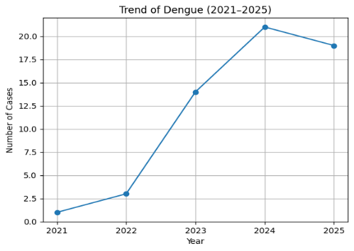
Leptospirosis | 0 | 0 | 0 | 0 | 2 | 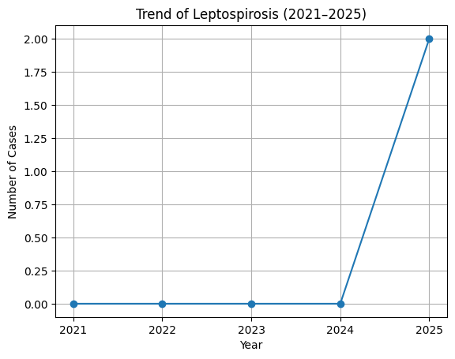
Hepatitis A | 0 | 0 | 0 | 0 | 2 | 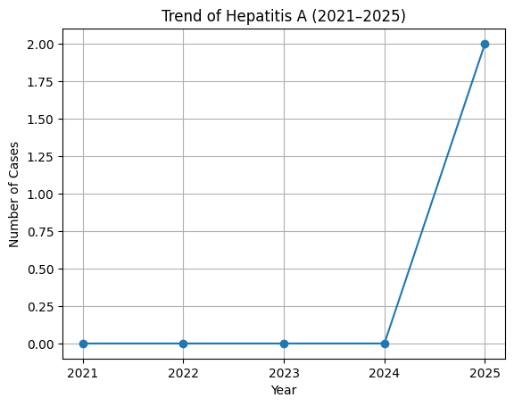
Malaria | 0 | 0 | 0 | 0 | 1 | 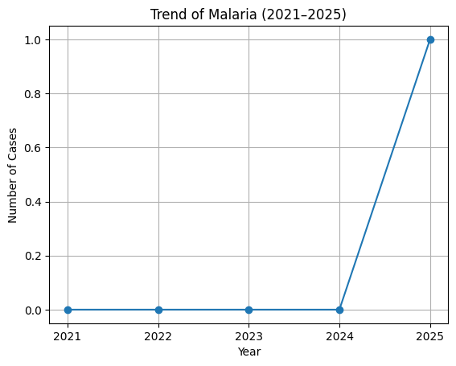
Scrub Typhus | 0 | 0 | 0 | 1 | 4 | 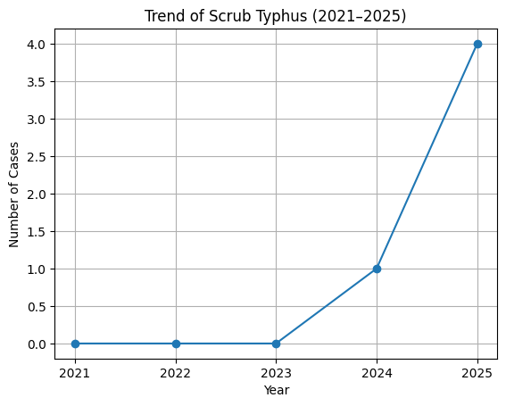
ADD | 44 | 82 | 124 | 133 | 168 | 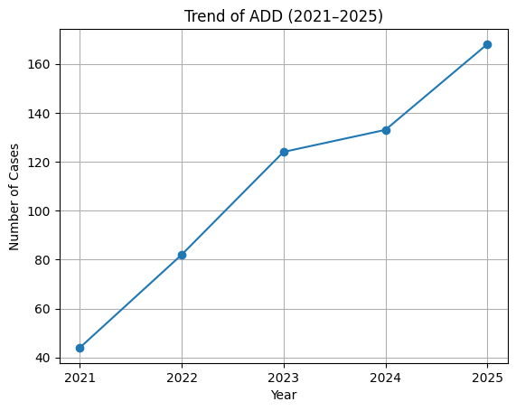
Mumps | 2 | 8 | 17 | 24 | 31 | 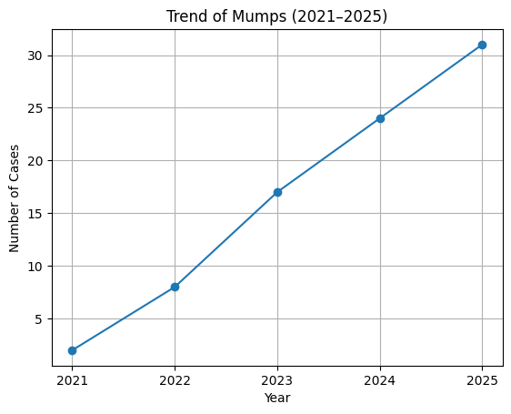
Hepatitis B | 0 | 0 | 1 | 1 | 2 | 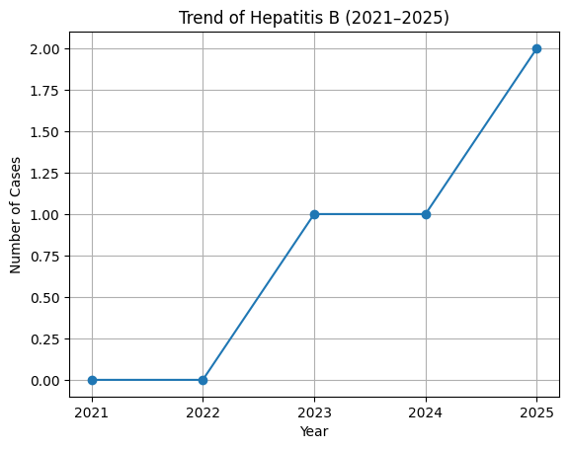
Tuberculosis | 0 | 3 | 7 | 12 | 5 | 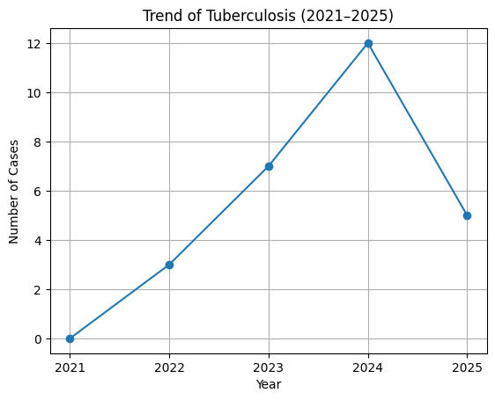
Leprosy | 0 | 0 | 0 | 9 | 0 | 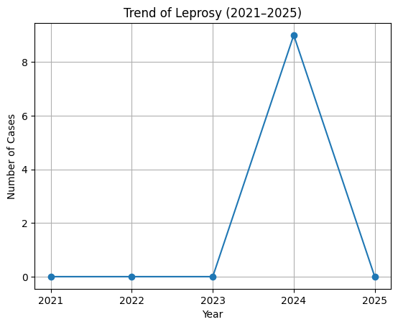
COVID-19

*(use the above table data to create the graph/diagram)

Seasonal Trend Analysis
Seasonal analysis helps anticipate surges (e.g. dengue in monsoon, leptospirosis after floods, influenza in cooler months) and plan pre‑emptive vector control, stockpiling of IV fluids, and awareness campaigns at Panchayat level.

DENGUE
Dengue is a major seasonal vector-borne disease strongly associated with rainfall, water stagnation, and increased mosquito breeding during the monsoon period.

Peak: July–November

Dengue – Ward-wise Yearly Distribution (2021–2025)

Ward | Dengue – Ward-wise Yearly Distribution
Ward | 2021 | 2022 | 2023 | 2024 | 2025 | Total
1 | 0 | 1 | 1 | 2 | 3 | 7
2 | 0 | 0 | 1 | 2 | 1 | 4
3 | 0 | 0 | 2 | 1 | 1 | 4
4 | 0 | 0 | 1 | 3 | 2 | 6
5 | 0 | 0 | 2 | 1 | 1 | 4
6 | 0 | 0 | 1 | 1 | 0 | 2
7 | 0 | 0 | 0 | 1 | 1 | 2
8 | 0 | 0 | 0 | 1 | 2 | 3
9 | 0 | 0 | 1 | 2 | 2 | 5
10 | 0 | 1 | 0 | 1 | 2 | 4
11 | 0 | 0 | 1 | 2 | 1 | 4
12 | 0 | 0 | 1 | 2 | 1 | 4
13. | 0 | 0 | 1 | 1 | 1 | 3
14 | 1 | 1 | 1 | 1 | 2 | 6
15 | 0 | 0 | 0 | 0 | 0 | 0
Total | 1 | 3 | 14 | 21 | 19 | 58

LEPTOSPIROSIS
Leptospirosis cases are closely linked to monsoon rains, flooding, and occupational exposure, particularly in low-lying and waterlogged areas.

Peak: June - August

Leptospirosis – Ward-wise Yearly Distribution (2021–2025)

Ward | Leptospirosis – Ward-wise Yearly Distribution
Ward | 2021 | 2022 | 2023 | 2024 | 2025 | Total
1 | 0 | 0 | 0 | 0 | 0 | 0
2 | 0 | 0 | 0 | 0 | 0 | 0
3 | 0 | 0 | 0 | 0 | 0 | 0
4 | 0 | 0 | 0 | 0 | 0 | 0
5 | 0 | 0 | 0 | 0 | 0 | 0
6 | 0 | 0 | 0 | 0 | 0 | 0
7 | 0 | 0 | 0 | 0 | 0 | 0
8 | 0 | 0 | 0 | 0 | 0 | 0
9 | 0 | 0 | 0 | 0 | 1 | 1
10 | 0 | 0 | 0 | 0 | 0 | 0
11 | 0 | 0 | 0 | 0 | 1 | 1
12 | 0 | 0 | 0 | 0 | 0 | 0
13 | 0 | 0 | 0 | 0 | 0 | 0
14 | 0 | 0 | 0 | 0 | 0 | 0
15 | 0 | 0 | 0 | 0 | 0 | 0
16 | 0 | 0 | 0 | 0 | 0 | 0
17 | 0 | 0 | 0 | 0 | 0 | 0
18 | 0 | 0 | 0 | 0 | 0 | 0
Total | 0 | 0 | 0 | 0 | 2 | 2

VIRAL HEPATITIS - A
Hepatitis A cases are commonly associated with unsafe drinking water, food contamination, and breakdowns in sanitation, often presenting as clusters or outbreaks.

Peak: October - December

Hepatitis A – Ward-wise Yearly Distribution (2021–2025)

Ward | Hep A – Ward-wise Yearly Distribution
Ward | 2021 | 2022 | 2023 | 2024 | 2025 | Total
1 | 0 | 0 | 0 | 0 | 0 | 0
2 | 0 | 0 | 0 | 0 | 0 | 0
3 | 0 | 0 | 0 | 0 | 0 | 0
4 | 0 | 0 | 0 | 0 | 0 | 0
5 | 0 | 0 | 0 | 0 | 0 | 0
6 | 0 | 0 | 0 | 0 | 0 | 0
7 | 0 | 0 | 0 | 0 | 0 | 0
8 | 0 | 0 | 0 | 0 | 0 | 0
9 | 0 | 0 | 0 | 0 | 0 | 0
10 | 0 | 0 | 0 | 0 | 0 | 0
11 | 0 | 0 | 0 | 0 | 1 | 1
12 | 0 | 0 | 0 | 0 | 0 | 0
13 | 0 | 0 | 0 | 0 | 1 | 1
14 | 0 | 0 | 0 | 0 | 0 | 0
15 | 0 | 0 | 0 | 0 | 0 | 0
16 | 0 | 0 | 0 | 0 | 0 | 0
17 | 0 | 0 | 0 | 0 | 0 | 0
18 | 0 | 0 | 0 | 0 | 0 | 0
Total | 0 | 0 | 0 | 0 | 2 | 2

Transmission Trend- 2025
For effective management of public health issues, it is important to track the trend of disease transmission mode. It helps identify the population or place at high risk that can be used to predict outbreaks and implement targeted interventions as quickly as possible. Understanding these kinds of trends enables authorities to allocate resources efficiently and change the strategies adequately based on the trend that follows.

Mode of Transmission | No. of cases | No. of Deaths
Vector Borne Diseases | 58 | 0
Water Borne Diseases | 170 | 0
Air Borne Diseases | 0 | 0
Blood Borne Diseases | 2 | 0
Food Borne Diseases | 0 | 0

Vector-Borne Disease

Disease | No. of Cases | No. of Deaths
Dengue |  | 0
Malaria |  | 0
Chikungunya |  | 0

Water Borne Disease

Disease | No. of Cases | No. of Deaths
Cholera |  | 0
Typhoid |  | 0
Hep- A |  | 0
Dysentery |  | 0
Amoebiasis |  | 0
E- Coli infections |  | 0
Air Borne Disease

Disease | No. of Cases | No. of Deaths
Influenza |  | 0
H1N1 |  | 0
TB |  | 0
Chickenpox |  | 0
Measles |  | 0
Covid-19 |  | 0
Pertussis |  | 0
Mumps |  | 0

Blood-Borne Disease

Disease | No. of Cases | No. of Deaths
AIDS |  | 0
Hep- B |  | 0
Hep- C |  | 0

Zoonotic Disease

Disease | No. of Cases | No. of Deaths
Rabies |  | 0
Leptospirosis |  | 0
Avian influenza |  | 0
West nile |  | 0
Anthrax |  | 0
Nipah |  | 0
Scrub Typhus |  | 0

Integrated Disease Hotspot Map (2021–2025)
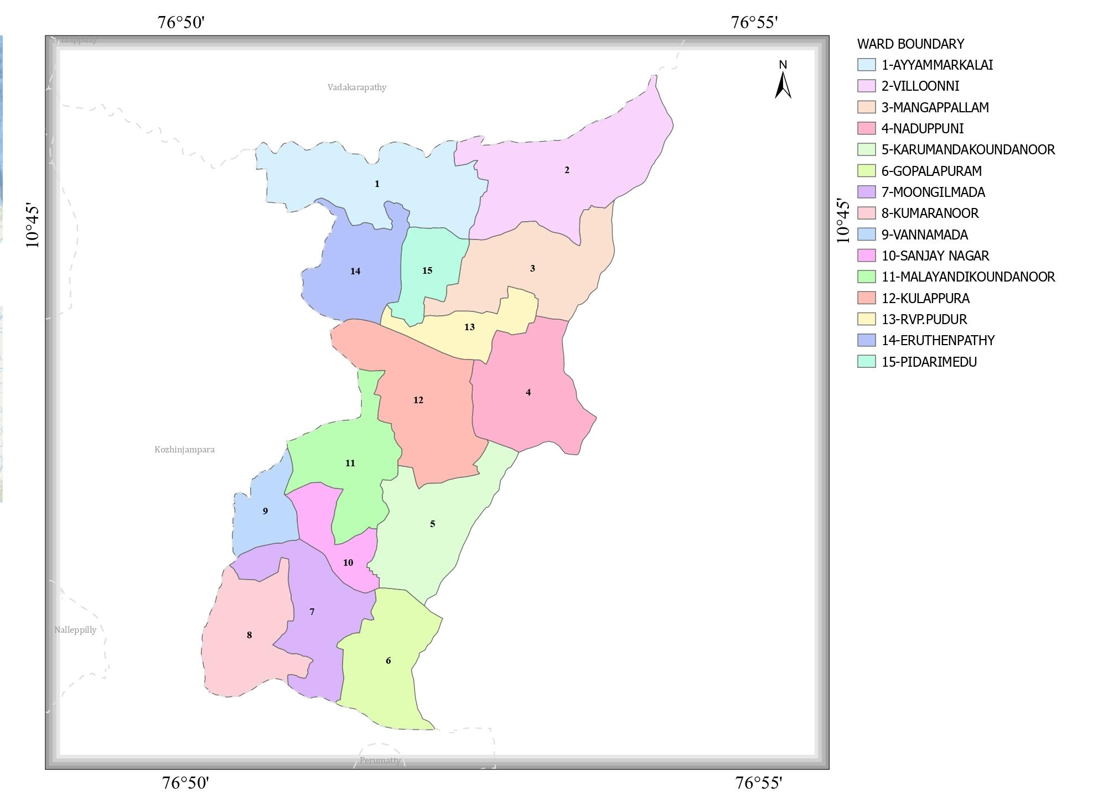

Ward No | Dengue Total (2021-25) | Leptospirosis Total (2021-25) | Hepatitis A Total (2021-25) | Mumps (2021-25) | ADD (2021-25) | Total Cases
1 | 7 | 0 | 0
2 | 4 | 0 | 0
3 | 4 | 0 | 0
4 | 6 | 0 | 0
5 | 4 | 0 | 0
6 | 2 | 0 | 0
7 | 2 | 0 | 0
8 | 3 | 0 | 0
9 | 5 | 1 | 0
10 | 4 | 0 | 0
11 | 4 | 1 | 1
12 | 4 | 0 | 0
13 | 3 | 0 | 1
14 | 6 | 0 | 0
15 | 0 | 0 | 0

.

Preparedness and Response Protocol at LSG Level
This section describes the operational framework for the LSGI once a pandemic is declared. It explains how the LSGI and health system will move from routine data collection to active response, using a One Health approach.

Constitution of One Health Committee
The LSGD shall constitute a One Health Committee comprising the LSGI President, Medical Officers (Modern Medicine, AYUSH, and Veterinary), the Health Inspector, and the Veterinary Surgeon.

Objective: The One Health Committee coordinates human, animal, and environmental health to prevent and control pandemics.

Sl No | Name | Designation | Department/Institution | Role in Committee | Contact Number
1 | Smt.Sheeja | Panchayat President | LSGD | Chairperson | 9946376765
2 | Dr.Bibin Chacko | Medical Officer (PHC/CHC) | Health Dept | Member Secretary | 9895052375
3 |  | Veterinary Officer | Animal Husbandry | Member | 9447310741
4 |  | Epidemiologist | Health Dept | Member | NA
5 | Sri.K Suresh | Health Inspector/PHN | Health Dept | Surveillance | 8086000001
6 | Smt. Akhila | ASHA Supervisor | Health Dept | Community link | 9496352718
7 |  | ICDS Supervisor | Social Welfare | Vulnerable groups
8 |  | Police Station Officer | Police Dept | Law & order | 04923272224
9 | SEE ANNEXURE | Ward Councillor Representative | LSGD | Community coordination
10 |  | Kudumbashree CDO | Kudumbashree | Community mobilisation
11 |  | NGO/Volunteer rep | Civil Society | Support services
12 |  | Line Department representations

Key Responsibilities:
- Review disease surveillance data (human + animal)
- Conduct ward-wise risk assessment and vulnerability mapping
- Approve quarantine/isolation centre locations
- Coordinate with district for resources (PPE, oxygen, ambulances)
- Periodically review health system surge capacity, including beds, oxygen, human resources, and ambulances.
- Approve and monitor risk communication and community engagement strategies, including rumour management.
- Ensure protection and service continuity for vulnerable groups (elderly, persons with disabilities, dialysis patients, coastal populations).
- Conduct quarterly mock drills
- Monitor equity measures for vulnerable groups

Meeting Schedule:
Quarterly (normal times) | Weekly (outbreak alert) | Daily (pandemic phase)

Pandemic Response Workforce
To ensure a coordinated and timely response during a pandemic, a dedicated Pandemic Response Workforce shall be constituted at the LSG level. The workforce will function under the overall supervision of the One Health Committee and in close coordination with the health authorities. Team-based deployment will enable efficient surveillance, case management, quarantine and isolation management, logistics support, and risk communication. Each team shall have a clearly designated team leader, defined roles, and an identified pool of personnel to allow rapid activation, rotation of duties, and continuity of services during prolonged emergencies.

Total Response Workforce Available: 300 persons

Team Name | Composition | Key Responsibilities | Team Leader
Surveillance and Contact Tracing Team | HI, JHI, JPHN, ASHAs and Volunteers | Case detection, contact listing, home visits, reporting | HI
Case Management Team | Doctors, Nurses, MLSP, Palliative Nurses | Patient care & referral | DOCTOR
Quarantine & Isolation Team | LSGD staff, Volunteers | Facility management | JHI
Psychosocial support
Logistics & supply chain Team | LSGD staff, Storekeepers, Drivers 3 | Supplies & transport [PPE, medicines, oxygen, transport, waste management] | Ward Member
Communication Team | Ward members, Kudumbashree, Youth clubs,  AWW workers and other self help groups | IEC, community meetings, countering misinformation | M.O in charge
Transportation | KSRTC, educational institutional buses
Media Surveillance
Intersectoral coordination and convergence
Collaborative surveillance

All teams shall be activated immediately upon outbreak alert or pandemic declaration and shall report daily to the LSG Incident Commander/Medical Officer, with consolidated reporting to the Block PHC. Duty rosters and alternate personnel shall be maintained to ensure uninterrupted services during staff shortages or prolonged response periods. Team composition and numbers may be revised based on the magnitude of the outbreak and availability of human resources.

Activities and Measures before and during Pandemic

PHASE 1 - Alert / Preparation
Surveillance and Reporting-Enhanced syndromic surveillance:
- Data sources for surveillance:
- Event-based triggers (to be monitored and reported):
- Zoonotic and animal health surveillance
- Logistics and Stock Preparedness
  - Identify and empanel local vendors and define emergency procurement mechanisms in accordance with existing LSGD and Health Department norms.
  - Prepare and maintain an essential logistics checklist covering medical supplies, consumables, and support equipment.
  - Pre-identify secure storage locations for emergency stocks and ensure maintenance of stock registers with regular updating.
  - Finalise emergency transport arrangements, including availability of vehicles and identified drivers for rapid deployment during alerts.
  - Designate a Nodal Officer for Logistics to enable prompt decision-making, coordination, and communication during emergencies.
  - Conduct rapid stock verification and ensure availability of minimum buffer stock, including:
- PPE kits – numbers
- Pulse oximeters – ___ numbers
- Hand sanitizers – ___ litres
- Masks, gloves, disinfectants – adequate quantity
Identify critical gaps in logistics and immediately communicate requirements to the Block and District authorities for timely replenishment and support. Monitor expiry dates and stock rotation.

Identification of Quarantine and Isolation Facilities
  - Identify and list suitable buildings for quarantine and isolation (schools, hostels, community halls, etc.).
  - Categorise cases as per the severity and allocate to appropriate facilities (for instance, severe cases to classrooms, mild cases to an assembly hall in case of a school).
  - Facility readiness checklist needed (beds, toilets, ventilation) etc.
  - Find an alternate site if the primary sites are not available or not in use.
  - Identify facility managers and support staff
  - Prepare basic SOPs for:
    - Admission and discharge
    - Food, water, sanitation
    - Infection prevention and waste disposal
  - Ensure availability of basic amenities: water, sanitation, electricity, ventilation, and waste disposal. Prepare a rapid activation plan for these facilities if case numbers increase.

Risk Communication and Community Preparedness
  - Disseminate early warning messages on symptoms, preventive measures, and reporting mechanisms. Display IEC materials both in English and the local language in public places and ensure ward-level awareness.
  - Sensitize elected representatives and community leaders on preparedness measures.
  - Establish a rumour tracking and misinformation response mechanism to identify, verify, and promptly counter false or misleading information.
  - Engage trusted local persons (ward members, ASHA workers, religious leaders, teachers, community volunteers) to communicate official public health messages and reinforce correct practices.
  - Develop and deploy targeted IEC materials for:
    - Schools and educational institutions
    - Markets and commercial areas
    - Work sites and labour settings
  - Conduct community sensitization meetings at the ward level to promote preventive behaviors, address concerns, and strengthen community participation in preparedness and response.

Protection of Vulnerable Groups
Vulnerable populations require priority protection through targeted line-listing, service continuity, and delivery mechanisms.
- Prepare and regularly update line-lists of vulnerable populations, including:
  - Elderly persons living alone
  - Persons with disabilities
  - Pregnant women
  - Migrant workers
  - Dialysis patients
The detailed line-lists shall be maintained as Annexure ___ and updated periodically.

Clinical Dependency Mapping
Develop ward-wise dependency and vulnerability maps to identify households requiring regular support during emergencies. Ensure continuity of essential health services for vulnerable groups, including
- Dialysis services (facility mapping, transport arrangements, and scheduling)
- Continuity of treatment for TB, HIV, and other chronic conditions requiring uninterrupted medication
- Mental health and psychosocial support services
Establish delivery mechanisms for food, essential commodities, and medicines to vulnerable households through coordinated action involving ASHAs, JPHNs, Kudumbashree, volunteers, and local administration.

PHASE 2 - Active Response

Case Identification and Contact Tracing
Case detection and contact tracing activities will be carried out in coordination with the Health authorities, following disease-specific SOPs and IDSP guidelines.
Field Staff Involved
- Health Inspector (HI)
- Junior Health Inspector (JHI)
- Junior Public Health Nurse (JPHN)
- ASHAs and ASHA Supervisors
- Ward-level volunteers and Kudumbashree members (as required)

Screening Checkpoints
Screening checkpoints at high-traffic locations (transport hubs, markets, religious gatherings) for early detection of symptomatic travellers and crowd screening during outbreaks. Potential locations include bus stands, market entry points, and boat jetties, based on local context and risk assessment.
Screening activities will be carried out by trained personnel such as ASHAs, ward members, and volunteers, with support from Health Department staff. Necessary equipment, including non-contact thermometers and appropriate PPE, shall be ensured prior to activation.
Location | Type (Bus stand/Jetty/Market/Railway) | Staff Deployed (ASHAs/Volunteers) | Screening Method | Reporting authority
Bus stand | Transport hub | One JHI  One ASHA  One health Mentors | 1.Swab Collection.  2. Blood smears collection (RDT)  3.Thermal Scanners | Surveillance Nodal Officer in control room
Market entry | Market | One JHI  One ASHA  Male health volunteers | 1.Swab Collection.  2. Blood smears collection (RDT)  3.Thermal Scanners | Surveillance Nodal Officer in control room
Boat jetty | Water transport | One JHI  One ASHA  Male health volunteers | 1.Swab Collection.  2. Blood smears collection (RDT)  3.Thermal Scanners | Surveillance Nodal Officer in control room

Standard Screening Protocol

The screening protocol shall include temperature screening, observation for visible symptoms, and inquiry regarding recent travel or exposure history. Individuals identified as suspects during screening shall be immediately referred to the nearest PHC/FHC for further evaluation, testing, and appropriate action as per prevailing guidelines.

Pandemic Control Room
The Pandemic Control Room (PCR) serves as the central nerve center for real-time coordination, data aggregation, decision support, and communication during outbreaks. It consolidates information from all LSGD teams, health facilities and community sources to enable rapid response decisions.

Control Room Infrastructure and Location
Primary Location: ERUTHENPATHY Panchayath Office.
Backup Location: Community Hall in ERUTHENPATHY G.P.

Health System Control Room Framework
The PCR is organized into seven functional pillars to ensure no aspect of the response is overlooked:

Rapid Response Team (RRT)
  - Provides immediate intervention during emergencies, clusters, and field alerts.​
  - Coordinates urgent actions such as case investigation, contact tracing, isolation, and inter‑facility referrals.

Data Management & Analytics Team
  - Collects, validates, and manages key health system indicators (cases, tests, beds, HR, supplies).​
  - Analyzes data trends, generates projections, and supports evidence‑based decision‑making for local authorities.

Human Resource Deployment Team
  - Allocates healthcare staff efficiently based on workload and need
  - Ensures adequate and equitable workforce distribution across facilities

Laboratory Surveillance Team
  - Oversees diagnostic testing coordination, sample transport, and timely reporting of results.​
  - Monitors lab indicators (testing volume, positivity rate, turnaround time) for early detection of outbreaks

Vaccination Cell (If Required)
  - Plans and executes vaccination campaigns, including micro‑planning and session scheduling.​
  - Tracks coverage, identifies gaps, and coordinates corrective actions with field teams and outreach services.

Infrastructure & Patient Occupancy Team
  - Monitors facility capacity, earmarked beds, oxygen and critical care resources across all linked facilities.​
  - Ensures optimal patient distribution and referral management using updated bed‑status and resource data.
  - BMWM

Communication team
- Logistics and supply chain
- Transportation (interfacility & emergency transport)
- Media surveillance Call centre
- Management of the deceased
- Intersectoral coordination and convergence

Key Control Room Team
The Control Room Team coordinates all pandemic response activities within the LSGD and serves as the single command and communication hub during activation. It integrates information, field actions, logistics, and policy execution across all participating departments and health facilities.

Role | Name | Designation | Contact Number | Responsibility
In-charge/Nodal Officer | Dr.Bibin Chacko | MO |  | Overall coordination, decision-making, and reporting to the District level.
Data Entry Operator | Sharath | Clerk |  | Managing the line list, updating dashboards, and tracking testing results.
Communication Officer |  |  |  | Handling the public helpline, coordinating ambulance dispatch, and contact tracing calls.
Logistics Coordinator
Technical Support(IT/Data) | Deena | Data Manager | 9567748076

SOP for alert escalation/trigger point with mapping of responsibilities.
Key Points:
- The Control Room shall be staffed with a designated In-charge, data entry personnel, and communication staff with clearly defined roles and shift arrangements.
- It shall maintain updated records on daily monitoring indicators including new cases, persons under active quarantine, and hospital bed occupancy.
- All reports and situation updates shall be shared daily with the Block and District Surveillance Unit.
- The Control Room shall act as a single point of contact for coordination with response teams, health institutions, and other departments.
- Contact details of the Control Room shall be widely communicated to field staff and stakeholders during activation.

Daily Monitoring Indicators
To ensure timely decision-making and effective response, the following key indicators shall be monitored and updated on a daily basis by the Pandemic Control Room:

Epidemiological Indicators:
New cases reported today, Total active cases, Test Positivity Rate (TPR), Case Fatality Rate (CFR)
- Surveillance Indicators:
Persons under home quarantine, High-risk contacts identified, Fever, ILI, SARI or other symptoms (syndromic surges), Travellers (symptomatic or high-risk arrivals),Animal husbandry surveillance (zoonotic alerts, unusual animal deaths, poultry/bird flu signals), Mortality surveillance (excess deaths, unexplained fatalities, verbal autopsy reports)
- Logistics and Infrastructure Indicators:
Hospital / CFLTC beds occupied, Oxygen cylinders/concentrators available, Ambulances on standby
- Alert Findings
The following table outlines category-specific trigger points (red flags) from surveillance indicators and corresponding immediate actions for the Pandemic Control Room. These enable rapid response to alert findings like testing anomalies, positive cases exceeding thresholds, clusters, and WGS reports.

Category | Trigger Pophint (Red Flag) | Immediate Action
Clusters | Geographical or facility-based: 5+ cases linked to one location (office, school, street). | Declare a micro-containment zone; perimeter control and active case finding.
Testing | Sudden drop in testing volume / delay in reporting / unusual testing trends | Review the sample collection process, address lab bottlenecks, deploy additional testing teams, and notify the District Lab.
Lab | Test Positivity rate increases | Increase testing sites in that ward.
Hospital | >80% Oxygen bed occupancy | Activate backup/CFLTC beds.
Travel | Cluster of cases from a single flight/train or high-risk arrival group. | Trace all passengers in adjacent seats; implement mandatory institutional quarantine.
Animal | Mass poultry/wildlife death or unusual sickness | Notify Animal Husbandry, sample the area, and dispatch RRT for environmental sampling and zoonotic check.
Mortality | Sudden spike in home deaths or brought-in-dead (BID) cases | Audit the deaths and Active Case Search drive
Additional investigations like Whole Genome Sequencing (WGS) | Detection of a Variant of Concern (VOC) or Variant of Interest (VOI) | Implement strict micro-containment; update clinical protocols to match variant severity.

Communication of Public Health Information
A Community Communication Hub shall be established to ensure timely, accurate, and consistent dissemination of information during a pandemic. The Hub will function under the coordination of Nodal officers of the control room and act as the nodal point for public communication, risk messaging, and community engagement. It will support dissemination of official advisories, promote preventive behaviors, address rumors and misinformation, and ensure that messages reach all sections of the population through trusted local channels and leaders.

Key communicators
Channel | Responsible Person | Contact
Ward-level announcements | Ward Member / JHI
Social media | Panchayat Secretary | 9496047219 (Kozhinjampara)
Local Cable TV/Radio | ICDS Supervisor | Sindhu
Religious/Community Leaders (Announcements at Places of Worship) | Religious Heads / Kudumbashree ADS
Digital Health Alerts (Integrated SMS Alerts) | Nodal Officer (Reporting)x

- All messages disseminated through the Hub shall align with advisories issued by the Health Department and District authorities.
- Community leaders shall be sensitized to support behavior change, reduce stigma, and counter misinformation.
- Special efforts shall be made to reach vulnerable and hard-to-reach populations using locally appropriate communication methods.

Rumor Tracking: A designated volunteer will monitor local social media/WhatsApp groups daily to identify misinformation and issue official clarifications via the Communication Hub.

Coordination with District/State Authorities & Other Organisations
Effective coordination with Block, District, and State authorities is essential to ensure timely reporting, technical guidance, and uninterrupted supply of essential resources during a pandemic. The LSG shall establish clear communication channels, designate responsible officers, and adhere to prescribed reporting timelines to support coordinated public health action and efficient resource mobilisation.

Key Details:
- Nodal Officer for Reporting:
- Contact Number:
Reporting Schedule and Protocols:

To Whom | What to Report | Frequency | Nodal Person
Block PHC | Complete Situation Report (Cases, Quarantine, Beds, Screening, Deaths) | Daily (by 4:00 PM) | Health Inspector (HI) / Staff Nurse
District IDSP Unit | Outbreaks/Clusters/Unusual Events (>5 cases same ward) | Immediate (within 2 hours) | Junior Health Inspector (JHI)
Veterinary Officer | Animal health events/Zoonotic alerts | Immediate | Veterinary Surgeon
State Cell | Zoonotic cross-sector events | As Triggered | Medical Officer / LSG President

Supply Chain Coordination
The LSG shall coordinate closely with Block, District, and State authorities (KMSCL) to ensure uninterrupted availability of essential goods, medical supplies, and logistics during a pandemic. Supply requirements shall be assessed regularly based on case load and communicated promptly to the appropriate authorities for timely replenishment.
Key Points:
- Maintain updated contact details of District and Block nodal officers for health logistics, oxygen supply, ambulances, and essential medicines.
- Submit timely indent requests for PPE, testing kits, medicines, oxygen, and other critical supplies through prescribed channels.
- Monitor stock levels at LSGD facilities, quarantine/isolation centres, and field teams through daily stock registers and dispensing logs to prevent shortages.
- Coordinate with District authorities, Karunya/Neethi medical shops, and local purchase committees for funds allocation and emergency procurement.

- Ensure regular monitoring of dispensing registers at all facilities to track usage, expiry, and pilferage—shortages being a perennial issue requiring proactive weekly audits.

- Activate surge procurement protocols during high caseloads, leveraging local purchase powers under LSGD funds alongside state supplies.

Resource Inventory and Contacts
Resource Category | Source  (District/State/Private) | Contact
PPE Kits/Masks/Gloves | KMSCL (state) | 0491-2533336 / 9496006200
PPE Kits/Masks/Gloves | Local Vendors | Neethi Stores
Oxygen  Cylinders/Concentrators | KMSCL(state) | 0491-2533336 (Warehouse Manager)  mgrpkd.kmscl@kerala.gov.in
Medicines/Antivirals | KMSCL | 0491-2533336
Medicines/Antivirals | Neethi Shops | 0491-2502035 (Selvapalayam/District Hospital)
Test Kits (RTPCR/Rapid) | KMSCL (State) | 0491-2533336 (District Drug Warehouse)

Collaboration with NGOs, PPP, and CSR
To augment government efforts during a pandemic, the LSG shall collaborate with NGOs, voluntary organisations, and private sector partners through public–private partnerships and Corporate Social Responsibility (CSR) initiatives, in coordination with District authorities.

Key Points:
- Engage NGOs and community-based organisations for community outreach, awareness, and support to vulnerable populations.
- Leverage CSR support for procurement of medical equipment, PPE, oxygen concentrators, food kits, and sanitation materials, as permitted.
- Ensure all collaborations align with government guidelines and are routed through approved administrative and financial procedures.
- Maintain transparency and documentation for all external support received and utilised.
Organization | Type | Support Offered | Contact Person
Youth Clubs/Student Unions | CBO

Interdepartmental Coordination
Coordination among departments during a pandemic shall be ensured through regular review meetings convened by the LSGD President. These meetings will provide a structured platform for sharing situational updates, assessing resource availability, resolving operational gaps, and taking joint decisions to ensure a coordinated and timely response.

Department | Representative | Key Role | Contact
Health (PHC) | Staff Nurse : | Case management
Veterinary | Veterinary Surgeon: | Animal surveillance
ICDS | Supervisor: Sindhu | Nutrition support
Education | Head Teacher: | School coordination
Police |  | Containment enforcement | __________
Water Authority | A.E | Water supply | 8547638309
LSGD Engineering | A.E | Quarantine infrastructure | 7306925737

PHASE 3 - Surge Capacity
Phase 3 is activated when there is a rapid increase in cases, high test positivity rates, or when existing health facilities and quarantine arrangements approach saturation. The focus of this phase is to expand isolation capacity, augment clinical care services, and mobilise additional resources through district and state support mechanisms.

Conversion of Community Facilities
To manage increased case load, the LSGD shall activate additional isolation facilities by repurposing identified community infrastructure such as community halls, auditoriums, schools, hostels, or other suitable buildings.

Name of facility | Facility Type | No. of Buildings | Ward | Surge Capacity (Beds) | Nodal Person
Eruthenpathy Community Hall | Community Hall | 1 |  |  | VEO (Village Extension Officer)
Local Government School | Educational Inst. | 1 |  |  | Headmaster / Ward Member
Public Auditorium | Auditorium | 1 |  |  | Secretary, Co-op Bank

- Recovery and rehabilitation phase
- Recovery
  - Damage & impact assessment
  - Restoration of health services
  - Rehabilitation of affected population
  - Psychosocial & mental health support
  - Disease surveillance during recovery phase
  - Environmental cleanup & sanitation
  - Livelihood restoration
  - Community engagement & confidence building
  - Documentation & after-action review
  - Lessons learned & best practices
  - Health system strengthening
  - Policy revision & preparedness enhancement
  - Research

CONCLUSION

Additional points
- tech support
- relief based commodities
- ham reading operators
- hazard vulnerability mapping
- Kseb & other power source
- HR specific responsibility

RECOMMENDATIONS

Strengthening Healthcare Infrastructure
- Establish a primary health response unit within the Panchayat with trained staff.
- Ensure availability of basic medical supplies (masks, sanitizers, PPE kits, oxygen cylinders).
- Create tie-ups with nearby hospitals in FHC Vannamada for emergency referral and transport.

2. Community Awareness & Education
- Conduct regular awareness campaigns on hygiene, vaccination, and preventive measures.
- Use local communication channels (community radio, WhatsApp groups, notice boards) to spread verified information.
- Train volunteers to act as health ambassadors in each ward.

3. Emergency Response & Coordination
- Form a Pandemic Preparedness Committee at Panchayat level including health workers, ward members, and NGOs.
- Develop a clear action plan for lockdowns, quarantine, and distribution of essentials.
- Maintain a database of vulnerable groups (elderly, differently-abled, chronically ill) for targeted support.

4. Supply Chain & Food Security
- Identify and support local suppliers and farmers to ensure uninterrupted food supply.
- Create community kitchens during emergencies to serve vulnerable populations.
- Stockpile essential commodities in Panchayat-run outlets for crisis periods.

5. Digital Preparedness
- Promote digital platforms for telemedicine consultations.
- Use Panchayat’s website/social media for real-time updates on health advisories.
- Encourage online grievance redressal to reduce crowding in offices.

6. Training & Capacity Building
- Organize mock drills for pandemic response in schools, offices, and public spaces.
- Train Panchayat staff and volunteers in first aid, infection control, and crowd management.
- Collaborate with NGOs and health departments for capacity-building workshops.

7. Long-Term Resilience
- Integrate pandemic preparedness into the Panchayat Development Plan.
- Allocate a dedicated budget for health emergencies.
- Encourage community participation in planning and monitoring preparedness measures.

MOCKDRILL SCENARIOS

ANNEXURE

IMPORTANT PHONE NUMBERS

Phone numbers and particulars of persons responsible for providing guidance, assistance, and support for pandemic preparedness operations may be provided here in a manner that allows easy reference at a glance.The information recorded here could be exhibited elsewhere at the time of emergencies. LSG institutions shall give special attention to collect and record the above data of persons and institutions who/which are supposed to give technical and co-ordination support to reduce the impact of pandemic.

1.1. Details of grama panchayat/municipality/corporation wards
Sl.No | Name of the ward | Ward number | Name of the ward  member | Contact number
1 |  |  | Vineesh | 9188762608
2 |  |  | Drishya Mol | 9188509787
3 |  |  | Babu K | 9946971762
4 |  |  | Jayalakshmi | 9497325300
5 |  |  | Nganasundhari | 9497059637
6 |  |  | Renuka Devi | 9544872330
7 |  |  | Anandh R | 9645933920
8 |  |  | Karthiyayani | 9539657002
9 |  |  | Sheeja | 9946376765
10 |  |  | Usha K | 8547976614
11 |  |  | Abdulsamad | 9446975406
12 |  |  | Baburaj | 9496111122
13 |  |  | Murukabhoopathy | 8547687500
14 |  |  | Madhu P | 9446149325
15 |  |  | Annai Punitha | 8156949904

1.2. Other important phone numbers of grama panchayat/municipality/corporation area
Sl. No. | Name | Contact number
1. | Panchayat President (Eruthenpathy) | 9496047216
2. | Panchayat Secretary (Eruthenpathy) | 9496047217
3. | Police Station (Kozhinjampara) | 04923-272224 / 9497980613
4. | Krishi Bhavan (Eruthenpathy) | 04923-236910 / 8281155054
5. | KSEB Section Office (Eruthenpathy) | 1912 / 9496010101 (Emergency)
6. | Taluk Office (Chittur) | 04923-224740
7. | Excise Range Office (Chittur) | 04923-3221849 / 9400069619
8. | Forest Range Office (Palakkad) | 0491-2555521 / 9447979143

1.3. Important offices of grama panchayat/municipality/ corporation
Sl.No | Name of the office | Contact person | Contact number
1. | Village Office | Village Officer | RV P Pudur - 8547614704  Kozhipathy - 8547614705
2. | Agriculture Office | Agriculture Officer | 9383471542
3. | Animal Husbandry Office | Animal Husbandry Doctor
4. | Police Station | Police Officer | 04923-272224
5. | BSNL Office | Officer
6. | Block Office | Officer | 04923272241
7. | KSEB Office | Officer | 04923272273
8. | Fisheries Office | Officer | 04912815245
9. | Fire and Rescue | Officer | 04923-222499

1.4. Health Services
Sl. No | Name of the hospital/institution | Location | Phone number
1. | Government hospitals/PHC | Eruthenpathy
 | Gov. Homoeo Dispensary | Palaniyarpalayam | 04923-234241 (Panchayat)
 | Community Health Centre (CHC) | Kozhinjampara (Nearby) | 04923-272235
 | Gov. Taluk Hospital | Chittur (Referral) | 04923-222385
2. | Private hospitals
 | Maria Hospital | Kozhinjampara | 04923-272939
 | Athani Hospital | Athicode | 04923-232504
 | Ahalia Diabetes Hospital | Kozhippara | 04923-225000
3. | Clinical laboratories
 | PHC Lab Facility | Eruthenpathy PHC | 04923-236399
4. | Chemist/pharmacy
 | Neethi Medical Store | Eruthenpathy | 04923-234241 (via SCB)

1.5. Veterinary Services
Sl.No | Name of the Clinic | Name of the  Surgeon/Doctor | Place/location | Phone  number
1 | Govt.Veterinary Hospital | Dr. Shemy V. S. | Eruthenpathy
 | Veterinary Polyclinic | Senior Surgeon | Chittur

1.6. Helpline numbers
Helpline | Phone number
Police | SHO Mobile: 94979-87149
Fire and Rescue | 04923-222499
KSEB | 04923-236531

1.7. Public and Private Schools Contact details

S.No | Name of School | Institution type | Phone number
1 | BGHSS Vannamada | Govt | 9446293193
2 | GUPS RVP Pudur | Govt | 9495485596
3 | St. Philomina’s School | Private | 9539124913
4 | St. Peters AUP School Eruthenpathy – | Govt | 9946969388
5 | Sri Vidhya VHS School | Private | 9495230469

1.9. Anganwadi Contact Details

Ward No | Name of Anganwadi Teachers | Phone number
11 |  | 9645586653
11 |  | 9995477407
11 |  | 6282510049
5 | Nagalakshmi | 7538883090
5 | Kalavathy | 9995817620
6 | Jayalakshmi | 8921104424
8 | Geetha | 9745397802
7 | Sushashini | 9446486059
12 | Sudha | 9744550350
12 | Sumathy- | 9745397987
9 | Susheela | 8547686725
10 | Bhavana | 9745456754

1.12. Information regarding resources

Means of transportation | Name of Owner | Phone Number
Heavy Trucks | Palakkad Building Material Suppliers  Jai Sree Ram Earthmovers | 97452 42534  94476 11234
Tractor | Tractors - Eruthenpathy | 94465 73519
Ambulances | Ambulance Service God’s Wheel  Sevabharathi Ambulance  Eruthenpathy PHC Ambulance | 94479 64234  94476 22011  04923-236399
Taxi service | Eruthenpathy Taxi Stand  Sanchari Travels | 04923-234241 (GP)  94473 05555

Annexure 1: LSG Baseline Data Collection Format
A. Baseline data
Sl. No. | Indicator / Field | Baseline Data | Source / Remarks
1 | Name of LSG | ERUTHENPATHY
2 | District | PALAKKAD
3 | Block / Taluk | CHITTUR
4 | Type of LSG (Gram Panchayat / Municipality / Corporation) | GRAMA PANCHAYAT
5 | Area (sq. km) | 470 SQ KM | Note: 470 sq km is the total area for the entire Chittur Block. For the GP specifically, it is ~29.74.
6 | No. of wards | 15 | Verified ward count for Eruthenpathy.
7 | GIS boundary file available | YES | Available via the Information Kerala Mission (IKM) portal.
8 | Key contact person & phone | Panchayat Secretary | Office: 04923-234241

B. Demography
Indicator / Field | Baseline Data | Source / Remarks
Total population | 11,515 | Sum of provided age-group data.
Males | ~5,620 | Based on standard sex ratio for the block.
Females | ~5,895 | Kerala’s higher female ratio is consistent here.
Transgender population | ~2–5 | Based on Social Justice Dept. registrations.
Age distribution  (<5, 5–14, 15–59, ≥60) | <5 = 662  5-14 = 1285  15-59 = 7141  ≥60 = 2427 | High adult/elderly workforce (83%).
No. of households | ~2,850 | Based on 4 members per household average.
Population density (persons/sq.km) | 387 persons/sq. km | Calculated using area of 29.74 sq. km.
No. of migrant workers | ~1,200–1,500 | Seasonal influx for harvest and brick kilns.
Major occupational groups | Agriculture, Livestock, & Brick Kiln Labor | Primary: Coconut/Vegetable farming & Dairy.

C. Vulnerable Populations & Social Risks
Sl. No. | Indicator / Field | Baseline Data (Value / Description) | Source / Remarks
1 | No. of elderly (≥60) | 2,427 | High priority for heatwave/pandemic response.
2 | No. of persons with disability | ~280–320 | Based on 'Sannadham' / Panchayat PWD register.
3 | No. of bedridden persons | ~45–60 | Covered under the Palliative Care project at PHC.
4 | No. of chronic disease cases (DM/HTN/COPD/CKD etc.) | DM: ~850 | HTN: ~1,100 | DM (Diabetes) and HTN (Hypertension) are high in this block.
5 | Pregnant women (current estimate) | ~120–140 | Current estimate via RCH (Reproductive & Child Health) portal.
6 | Children <5 years | 662 | Vulnerable to seasonal infections/malnutrition.
7 | Tribal population (if any) | Minimal | Primarily non-tribal agricultural community.
8 | Fisherfolk / coastal vulnerable groups (if any) | 0 / NA | Landlocked geography.
9 | Urban slums / unnotified settlements (if any) | 0 / NA | Rural/Agricultural landscape.
10 | Homeless population | ~10–15 | Identified via the 'LIFE Mission' survey.
11 | Orphanages / old age homes (number & capacity) | 1 (Capacity: ~20) | Small-scale community-run or NGO facility.
12 | Hostels / prisons / shelters (number & capacity) | 2–3 | School hostels and temporary labor shelters.
13 | Poverty / BPL estimate | ~35% of households | High concentration in border farm-labor wards.
14 | Food insecurity hotspots | Wards 4, 7, 12 | Areas with highest water scarcity/low farm yield.
15 | Any history of stigma/discrimination issues (Yes/No) | NO | No major recent reported incidents.

D. Health System & Service Readiness
Sl. No. | Indicator / Field | Baseline Data (Value / Description) | Source / Remarks
1 | No. of health facilities in LSG (PHC/CHC/TH/DH/Private) | 1 Govt / 3–4 Private | Primary care is local; Specialist care is in Chittur/Pollachi.
2 | PHC/Family Health Centre details (name, location) | FHC Eruthenpathy | Located near the Panchayat Office.
3 | Subcentres / Health & Wellness Centres (number) | 4–5 | Health & Wellness Centres located in various wards.
4 | Private clinics / hospitals (number) | 3 | Small-scale clinics and one larger facility in Athicode.
5 | Labs available (public/private) | 1 Public / 2 Private | FHC has a basic lab; private labs available at the junction.
6 | Availability of ambulance services (Yes/No, number) | YES | 1 Govt (FHC) and 2 Private/NGO-operated units.
7 | Availability of isolation/quarantine facilities (Yes/No, details) | YES | Pre-designated rooms in the FHC and local schools.
8 | Cold chain facilities (Yes/No, details) | YES | Ice-Lined Refrigerator (ILR) available at FHC Eruthenpathy.
9 | Stockpile space available (Yes/No) | YES | Designated room within the FHC and Panchayat store.
10 | PPE / mask / sanitizer availability plan (Yes/No) | YES | Buffer stocks maintained via NHM and KMSCL.
11 | Surveillance staff available (JHI/JPHN/ASHA count) | JHI: 2 | JPHN: 3 | ASHA: 15 | Based on 1 ASHA per ~1000 population/ward.
12 | Existing emergency referral pathways (Yes/No) | YES | Referral link to Taluk Hospital Chittur & District Hospital.

E. Points of Entry & Mobility
Sl. No. | Indicator / Field | Baseline Data (Value / Description) | Source / Remarks
1 | Bus stands / depots (number) | 1 (Main Junction) | Primary transit point for local and inter-state private buses.
2 | Railway stations (number) | 0 | Residents use Pollachi (15km) or Palakkad Junction (35km).
3 | Boat jetties / fishing harbours (number) | 0 | Landlocked agricultural region.
4 | Ports / airports nearby (specify distance) | Coimbatore (CJB) - 45km | Nearest international airport and logistics hub.
5 | Major highways/roads passing through | SH 52 (Palakkad-Pollachi) | Critical transit artery passing through the block.
6 | Border crossings (state/district) | Gopalapuram / Vannamadai | Major inter-state check-posts (Kerala-Tamil Nadu).
7 | Major markets / weekly markets | 2 (Weekly Chanda) | High-density gatherings at Vannamadai and Kozhinjampara.
8 | Tourism hubs / major event venues | Temples / Marriage Halls | Seasonal influx during temple festivals (Vela/Pooram).
9 | Schools/colleges with hostels (number) | 1–2 | Residential facilities for staff or specific residential schools.
10 | Factories / large workplaces (number) | 15–20 | Mostly Brick Kilns, Coconut oil mills, and Coir units.
F. Water, Sanitation & Hygiene (WASH)
Sl. No. | Indicator / Field | Baseline Data (Value / Description) | Source / Remarks
1 | Major drinking water sources (piped / wells / borewells / springs) | Piped (JJM/KWA), Borewells, & Open Wells | High reliance on borewells due to low water table.
2 | No. of public wells | ~35–40 | Includes community wells maintained by the Panchayat.
3 | No. of households with piped water connection | ~2,800–3,200 households | Rapidly increasing under the Jal Jeevan Mission (JJM).
4 | Water quality testing routine (Yes/No) | YES | Conducted bi-annually by KWA and Health Dept (JHI).
5 | Common contamination risks (flooding, salinity, industrial waste) | Salinity & Agricultural Runoff | High fluoride/salinity in some pockets; pesticide runoff from farms.
6 | Open defecation free status (Yes/No) | YES (ODF Plus) | All households have individual household latrines (IHHL).
7 | Solid waste management system (Yes/No) | YES | Managed by Haritha Karma Sena (HKS); doorstep collection.
8 | Bio-medical waste disposal mechanism (Yes/No) | YES | Via IMAGE (IMA) for the PHC and private clinics.
9 | No. of public toilets | 4 | Located at Eruthenpathy Junction, Bus stand, and Markets.
10 | Handwashing stations in public places (Yes/No) | YES | Installed at PHC, Schools, and Panchayat Office during COVID-19.
G. Zoonotic Risks & One Health
Sl. No. | Indicator / Field | Baseline Data (Value / Description) | Source / Remarks
1 | Livestock population (cattle/goats/pigs/poultry) – estimates |  | Major dairy and poultry pocket in Palakkad.
2 | No. of dairy farms / poultry farms / pig farms | Dairy: 12 | Poultry: 18 | Pigs: 2 | Includes several large-scale commercial poultry units.
3 | Slaughterhouses / meat shops (number) | ~8–10 registered meat shops | Mostly small-scale local retail outlets.
4 | Animal markets (Yes/No, details) | YES (Nearby) | Rely on the major Vannamadai/Kozhinjampara animal markets.
5 | Veterinary dispensaries (number) | 1 | Govt. Veterinary Dispensary, Eruthenpathy.
6 | History of zoonotic outbreaks (rabies, leptospirosis, avian flu etc.) | Leptospirosis & Rabies | Sporadic cases of Lepto; Rabies cases in stray dogs (2024–25).
7 | Stray dog population management measures (Yes/No) | YES | ABC (Animal Birth Control) programs via Block Panchayat.
8 | Rodent infestation hotspots (Yes/No) | YES | High risk near grain warehouses and poultry feed stores.
9 | Wetlands / waterlogged areas prone to leptospirosis | Wards 5, 8, 14 | Near irrigation canals and check-dams during monsoon.
10 | Bat roosting areas / caves / fruit orchards (if any) | YES | Extensive Mango and Coconut orchards; high bat activity noted.
11 | Human-animal interface hotspots (farms near residences) | HIGH | Many residences are located within 50 meters of cattle sheds/poultry farms.
H. Climate & Disaster Risks (Pandemic Amplifiers)
Sl. No. | Indicator / Field | Baseline Data (Value / Description) | Source / Remarks
1 | Flood-prone wards (list) | NIL / Minimal | No major rivers; flash floods are rare but can occur in low-lying farm drains.
2 | Landslide-prone wards (list) | NIL | The terrain is largely flat agricultural plains.
3 | Cyclone/sea surge risk (Yes/No) | NO | Landlocked; however, high-velocity winds occur during the monsoon.
4 | Heatwave risk zones (Yes/No) | YES (All Wards) | Identified as a "Heat Hotspot" in Palakkad; temperatures often exceed 40°C.
5 | Waterlogging areas (list) | Wards 2, 5, 8 (Partial) | Occurs briefly near check-dams or clogged irrigation canals during heavy rain.
6 | Shelter homes / relief camps (number, capacity) | ~5 (Capacity: 500+) | Primary schools and Community Halls identified in Section I.
7 | Past disaster displacement history | Minimal | No major recent evacuations, though drought has caused "economic migration."
8 | Disruption to water supply/transport common (Yes/No) | YES | Summer water scarcity is common; transport is rarely disrupted.
I. Critical Infrastructure & Logistics
Sl. No. | Indicator / Field | Baseline Data (Value / Description) | Source / Remarks
1 | Schools (number) | 10–12 | Includes Govt/Aided Primary and High Schools (e.g., GHS Eruthenpathy).
2 | Anganwadis (number) | 24 | Distributed across all 15 wards; key for nutrition & surveillance.
3 | Colleges (number) | 0 | Students generally commute to Chittur or Kozhinjampara.
4 | Community halls (number) | 4–5 | Includes the Panchayat Community Hall and Co-operative Bank halls.
5 | Places of worship with large gatherings (number) | ~15 | Includes major Temples and Churches; significant for festival gatherings.
6 | Large markets / shopping areas (number) | 2 | Weekly markets (Chanda) and the primary junction shopping area.
7 | Warehouses / cold storages (number) | 3–4 | Mostly agricultural warehouses for coconut/copra and fertilizers.
8 | Telecom/mobile network coverage gaps (Yes/No) | YES | Some weak zones near the Tamil Nadu border/hilly pockets.
9 | Power outage frequency (high/medium/low) | MEDIUM | Occasional outages during monsoon/high wind; generally stable.
10 | Availability of generators in key facilities | YES | Available in the Panchayat Office, PHC, and major Co-operative Banks.

J. Risk Communication & Community Networks
Sl. No. | Indicator / Field | Baseline Data (Value / Description) | Source / Remarks
1 | Ward-level rapid response teams (Yes/No) | YES | Active in all 15 wards; includes local youth and ASHAs.
2 | Jagratha samithis / committees active (Yes/No) | YES | Monthly meetings chaired by Ward Members.
3 | Kudumbashree presence and strength (number of units) | ~150–180 ADS Units | Strong presence with Neighborhood Groups (NHGs) in every ward.
4 | Volunteer network (number, coverage) | Sannadham Volunteers | ~50+ registered volunteers; 100% ward coverage.
5 | Community-based surveillance mechanisms (Yes/No) | YES | "Aarogyajagratha" portals and ASHA-led reporting.
6 | IEC dissemination channels (WhatsApp groups, community radio, PA systems) | WhatsApp, PA Systems, Notice Boards | Ward-level WhatsApp groups are the primary channel.
7 | Rumour tracking mechanisms (Yes/No) | YES | Monitored by Health Inspector & Police (Chittur Station).
8 | Languages spoken / literacy considerations | Malayalam, Tamil, Hindi | High bilingual (Mal-Tam) proficiency; Hindi needed for migrants.
9 | Vulnerable groups communication strategy available (Yes/No) | YES | Priority communication for elderly and Palliative care patients.

K. Preparedness Planning & Governance
Sl. No. | Indicator / Field | Baseline Data (Value / Description) | Source / Remarks
1 | LSG emergency plan available (Yes/No) | YES | Local Disaster Management Plan (LDMP) updated annually.
2 | Pandemic preparedness plan available (Yes/No) | YES | Revised post-COVID-19; includes isolation protocols.
3 | Incident Command System identified (Yes/No) | YES | Led by Panchayat President & Secretary as per KSDMA guidelines.
4 | Rapid procurement mechanism available (Yes/No) | YES | Handled via the LSG Steering Committee for emergency supplies.
5 | Emergency fund available (Yes/No, amount) | YES / (Variable Amount) | Sourced from the Panchayat General Fund and NHM Untied Funds. (Usually ₹1–5 Lakhs initially).
6 | Past outbreak response experience (Yes/No, details) | YES | Successful containment of Dengue (2023) and Leptospirosis (2024) in border wards.
7 | Intersectoral coordination mechanism (Health, Police, LSG, Veterinary, Education) | YES | Monthly 'Jagratha Samithi' and Health Sanitation Committee meetings.
8 | Mock drills conducted in last 12 months (Yes/No) | YES | Specifically for Drought/Heatwave and Infectious Disease containment.
9 | Training coverage for staff/volunteers (Yes/No) | YES | Completed for ASHA workers and RRT volunteers on surveillance protocols.

L. Surveillance & Data Systems
Sl. No. | Indicator / Field | Baseline Data (Value / Description) | Source / Remarks
1 | Digital reporting tools used (e.g., DHIS2, portals) | IHIP, DHIS2, K-Health, & Sankhya | Integrated Health Information Platform (IHIP) is primary for infectious diseases.
2 | Availability of line-listing format (Yes/No) | YES | Standardized Excel/Word formats used by JHI/JPHN for outbreak tracking.
3 | Contact tracing team identified (Yes/No) | YES | Comprises ASHA workers, Ward RRTs, and Health Volunteers.
4 | Mapping of high-risk households available (Yes/No) | YES | Based on the "Vulnerability Mapping" conducted by Kudumbashree and Health Dept.
5 | Testing sample transport mechanism (Yes/No) | YES | Dedicated courier/vehicle system from PHC Eruthenpathy to District Lab/DPHL.
6 | Reporting timeline adherence (good/average/poor) | GOOD | Daily reporting via IHIP; weekly "S-Form" and "P-Form" submissions.
7 | Data sharing between departments (Yes/No) | YES | Inter-sectoral meetings held at the Panchayat level (Health, LSG, Veterinary).
8 | Availability of dashboard for monitoring (Yes/No) | YES | District-level dashboards managed by the DMO and NHM IT cell.

M. Additional Notes & Observations
Sl. No. | Indicator / Field | Baseline Data (Value / Description) | Source / Remarks
1 | Key challenges perceived by LSG | Water Scarcity & Drought: Acute drinking water shortage during summer months (Feb–May). High dependency on the Parambikulam Aliyar Project (PAP) and inter-state water sharing. | LSG Disaster Management Plan / KSDMA Drought Monitoring.
2 | Top 5 high-risk wards (reason) | Wards 1, 4, 7, 12, 15: These are identified as high-risk for Drought and Heatwaves due to their rain-shadow location and lack of perennial water sources. | Palakkad DDMP / Ward Jagratha Samithis.
3 | Any unique local risks (industrial pollution, refugee camps, etc.) | Zoonotic Risks: High density of livestock (cattle/poultry) near residences increases the risk of Leptospirosis (Rat Fever) and Rabies. Migrant Health: Large influx of seasonal farm laborers requires constant surveillance for communicable diseases. | Health Inspector Records / Veterinary Dept.
4 | Recommendations for preparedness strengthening | 1. Rainwater Harvesting: Mandatory desilting of community ponds and renovation of abandoned wells. 2. One Health Integration: Regular joint surveillance by Health and Veterinary departments for zoonotic disease early warning. 3. Migrant Screening: Establish regular health camps for inter-state workers. | NHM Kerala / District Medical Office (DMO).

