NANNIODE BLOCK
[Email address]
PANDEMIC PREPAREDNESS PLAN
LSGI- PERUMATTY
[Document subtitle]

MESSAGE FROM PRESIDENT PERUMATTY
It gives me immense pleasure to present this report highlighting the developmental and public health initiatives undertaken by the Local Self Government Institution (LSGI), PERUMATTY.
PERUMATTY Grama Panchayat has consistently prioritized the well-being of our community through strengthened primary healthcare services, improved sanitation, disease prevention activities, and community-based interventions. Our Local Self Government Institution remains committed to delivering accessible, affordable, and quality services to every household.
Over the past years, we have focused on strengthening public health infrastructure, supporting the Primary Health Centre, implementing national and state health programmes, improving waste management systems, and promoting preventive healthcare awareness. Special attention has been given to communicable disease surveillance, vector control activities, immunization coverage, maternal and child health services, and non-communicable disease screening.
The collaborative efforts of elected representatives, health officials, ASHA workers, Anganwadi staff, Kudumbashree members, and community volunteers have significantly contributed to improving health indicators in our Panchayat.
We reaffirm our commitment to sustainable development, transparency, and people-centered governance. With continued public participation and coordinated efforts, PERUMATTY will move forward towards becoming a healthier, cleaner, and more resilient Panchayat.
I extend my sincere appreciation to all departments, stakeholders, and citizens for their wholehearted cooperation and support.
Together, let us continue to build a healthier PERUMATTY.

Sri:SURESH.K
PRESIDENT PERUMATTY GRAMAPANCHAYATH

MESSAGE FROM HEALTH STANDING COMMITTEE CHAIR
It is with great responsibility and commitment that I present this message as the Chairperson of the Health Standing Committee, LSGI Perumatty.
Health remains one of the highest priorities of our Panchayat. Through coordinated planning and effective implementation, the Health Standing Committee has been actively supporting the Primary Health Centre and allied health institutions to ensure accessible, equitable, and quality healthcare services to all sections of our community.
Our focus areas include disease prevention and control, strengthening immunization programmes, maternal and child health services, non-communicable disease screening, sanitation and waste management, vector control activities, and health awareness campaigns. Continuous monitoring of communicable diseases and timely interventions have helped us maintain better public health outcomes.
We have also emphasized community participation through the involvement of ASHA workers, Anganwadi staff, Kudumbashree units, and volunteers. Their dedication has been instrumental in implementing national and state health programmes effectively at the grassroots level.
The Health Standing Committee remains committed to promoting preventive healthcare, improving infrastructure, ensuring environmental sanitation, and supporting initiatives that enhance the overall well-being of our people.
I express my sincere appreciation to the President, Members of the Panchayat Committee, Medical Officers, Health Inspectors, field staff, and the public for their cooperation and collective efforts.
Together, we will continue to work towards building a healthier and stronger Perumatty.

Chairperson
Sreemathi: Sharmila Rajan
Health And Education Standing Committee

MESSAGE BY MEDICAL OFFICER
The Primary Health Centre remains committed to delivering comprehensive, accessible, and quality healthcare services to the people of Perumatty. Our services encompass preventive, promotive, curative, and rehabilitative care in alignment with National Health Mission guidelines and State Health Department programmes.
During the reporting period, focused efforts were undertaken in communicable disease surveillance and control, immunization services, maternal and child healthcare, adolescent health services, non-communicable disease screening, geriatric care, and school health programmes. Continuous monitoring, early detection, and timely intervention have strengthened disease prevention and management within the community.
Special emphasis has been placed on health education, sanitation, vector control measures, and community outreach activities. The dedicated efforts of our healthcare team—including Staff Nurses, Health Inspectors, Junior Public Health Nurses, ASHA workers, and supporting staff—have been instrumental in achieving improved service delivery and better health outcomes.
We are grateful for the constant support of the Panchayat Administration, Health Standing Committee, ICDS department, and community stakeholders. Their collaboration has significantly enhanced the effectiveness of healthcare initiatives in our area.
We reaffirm our commitment to strengthening primary healthcare services and ensuring the well-being of every citizen of Perumatty.

DR.REMYA.E
MEDICAL OFFICER
FHC PERUMATTY
EXECUTIVE SUMMARY

Family Health Centre (FHC) Perumatty functions as the primary public healthcare institution serving the population of 30958 Perumatty Grama Panchayath. The FHC plays a pivotal role in delivering comprehensive, accessible, and affordable healthcare services, with a strong focus on preventive, promotive, curative, and rehabilitative care in accordance with national and state health programmes.
The FHC caters to a predominantly rural population, addressing key public health priorities such as maternal and child health, communicable and non-communicable disease control, immunization, family welfare, adolescent health, and geriatric care. Regular outpatient services, home-based care through field health staff, and outreach activities ensure healthcare coverage even in geographically challenging areas. The institution actively implements national health missions, including the National Health Mission (NHM), National Tuberculosis Elimination Programme, National Programme for Prevention and Control of Cancer, Diabetes, Cardiovascular Diseases and Stroke (NPCDCS), and other disease surveillance initiatives.
Perumatti FHC works in close coordination with the Grama Panchayath, ASHA workers, Anganwadi centres, schools, and community-based organizations to strengthen community participation and improve health awareness. Emphasis is placed on early detection, timely referral, health education, and lifestyle modification to reduce disease burden and improve overall health outcomes.
Despite constraints related to infrastructure, manpower, and increasing service demand, the PHC continues to enhance service delivery through effective planning, data-driven decision-making, and community engagement. Strengthening facilities, upgrading digital health systems, and expanding preventive services remain key focus areas for future development.
Overall, Perumatti Family Health Centre stands as a vital institution in safeguarding public health and improving the quality of life of the residents of Perumatty Grama Panchayath

LIST OF ABBREVIATIONS

LSGD/LSGI | Local Self Government Department / Local Self Government Institution
BMO | Block Medical Officer
IDSP | Integrated Disease Surveillance Programme
NDMA | National Disaster Management Authority
PPE | Personal Protective Equipment
ICMR | Indian Council of Medical Research
CD | Communicable Diseases
NCD | NON-COMMUNICABLE Diseases

TABLE OF CONTENTS

3
INTRODUCTION 9
● Background of the PPP 9
LSGD AT A GLANCE 9
INTEGRATED HEALTH INFRASTRUCTURE MAP OF PERUMATTY PANCHAYAT 10
GENERAL PROFILE OF THE LSGI’S 13
Background of the LSGI 13
Demographic and Vulnerable Population 14
Clinical Vulnerability 16
INFRASTRUCTURE & RESOURCE INVENTORY 18
Health Facility Directory & Basic Capacity in the LSGD 18
Private Clinics 19
Healthcare Education & Training Institutions 20
Specialized Services & Emergency Inventory 20
Oxygen & Diagnostic Capacity 21
Diagnostics facility mapping at the LSGI level 22
Laboratory Identification & Basic Details 22
Social and Community Infrastructure for surge plan 22
Human resources 24
Community & Support Cadre 25
Community Organizations 26
Administrative & Emergency Services 27
Information regarding resources 27
ONE HEALTH & ENVIRONMENTAL SURVEILLANCE 28
Animal & Bird Population 28
Veterinary Infrastructure 29
Veterinary Doctors & Workforce 30
High-Risk Interface Points (Surveillance Sites) 30
Environmental Risk Mapping 31
Disease Seasonality Mapping 32
Vulnerability Mapping 33
EPIDEMIOLOGICAL TRENDS (2021–2025) 34
Disease Burden among human beings(Last 5 Years) 34
*(use the above table data to create the graph/diagram) 36
Seasonal Trend Analysis 37
Outcome-Based Trend Analysis- 2025 39
Transmission Trend- 2025 40
Integrated Disease Hotspot Map (2021–2025) 42
Preparedness and Response Protocol at LSG Level 44
Constitution of One Health Committee 44
Pandemic Response Workforce 45
Activities and Measures before and during Pandemic 47
PHASE 1 - Alert / Preparation 47
PHASE 2 - Active Response 50
Standard Screening Protocol 51
PHASE 3 - Surge Capacity 60
Conversion of Community Facilities 60
CONCLUSION 61
RECOMMENDATIONS 62
ANNEXURE 63
1. IMPORTANT PHONE NUMBERS 63

INTRODUCTION

Background of the PPP
- LSGD at a glance

LSGD AT A GLANCE
- Geographical boundaries with political map ( based on latest delimitation)
- Baseline data
- Ward division -
Ward | Houses | Population | Migrants | Wells | Hot  spots | Ed. Institutions | Hosp pvt/govt.
20 | 8365 | 30958 | 155 | 2333 | 0 | 10 | 1/3

- Risk stratification among wards in the context of Communicable diseases and hazards
- Major Roads/rivers
- Major establishments with geospatial mapping
- occupational groups, socio cultural groups, migration & mobility patterns
- Vulnerability mapping
- Disaster prone areas (geographic vulnerability)

Maps - ward-based (Mention source also)

- Geographical boundaries - ward boundaries map
- Health infrastructure map
- roads and rivers map
- major establishments map
- disaster-prone areas map
- hotspot map - CD & disasters

INTEGRATED HEALTH INFRASTRUCTURE MAP OF PERUMATTI GRAMA PANCHAYAT

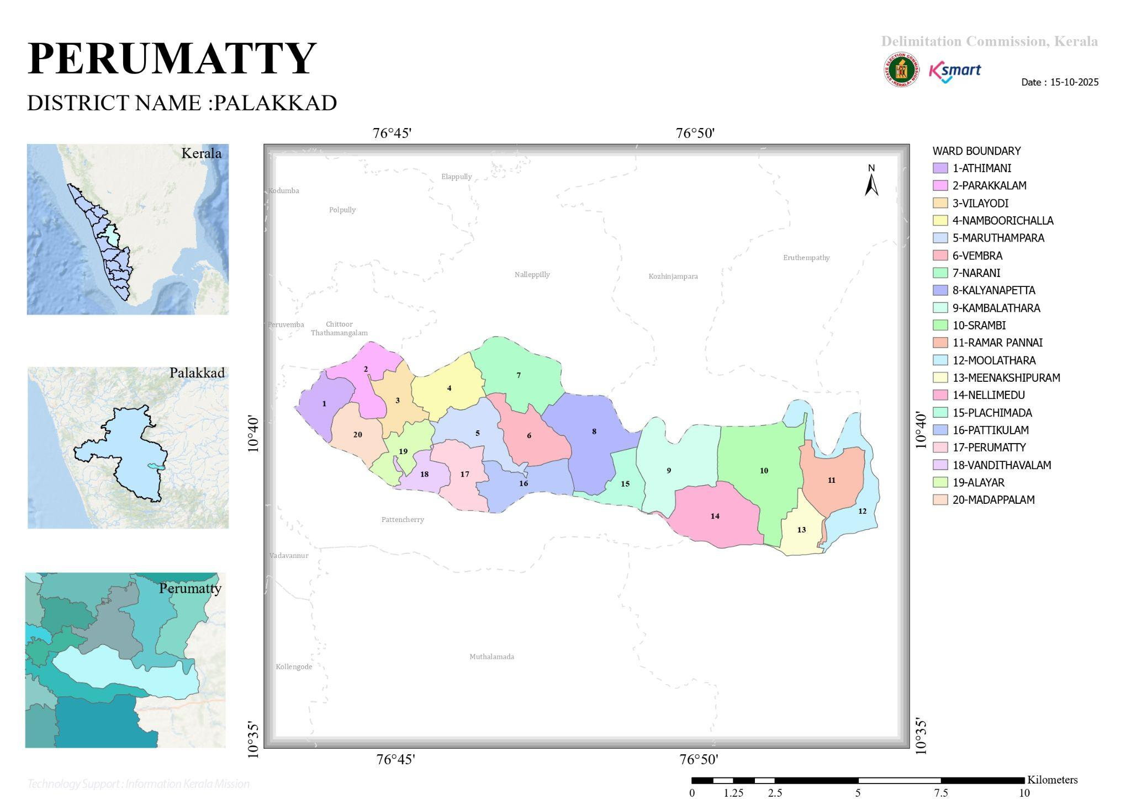

WATERSHED MAP

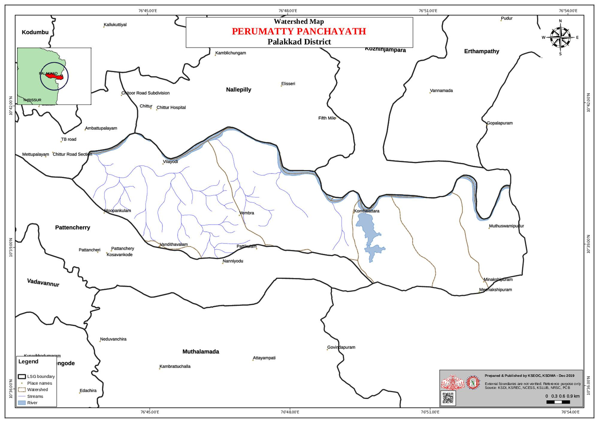

TRANSPORTATION MAP
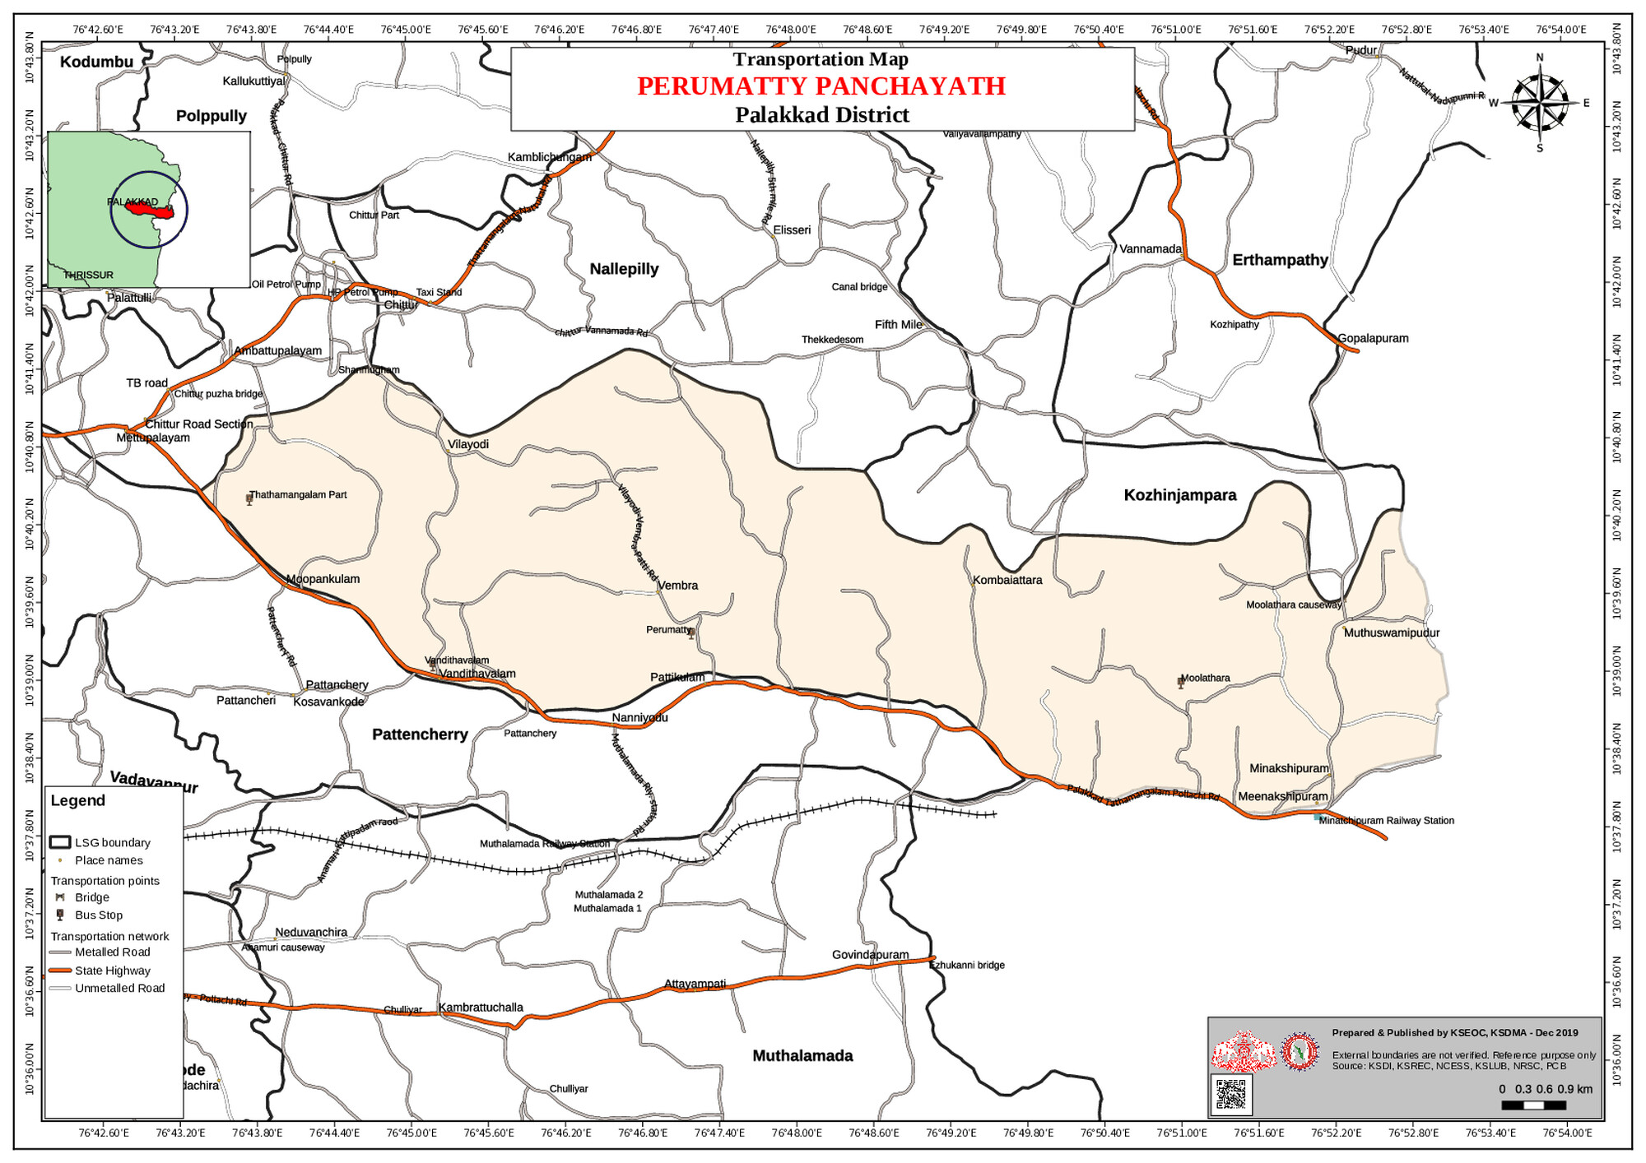

DROUGHT PRONESS MAP
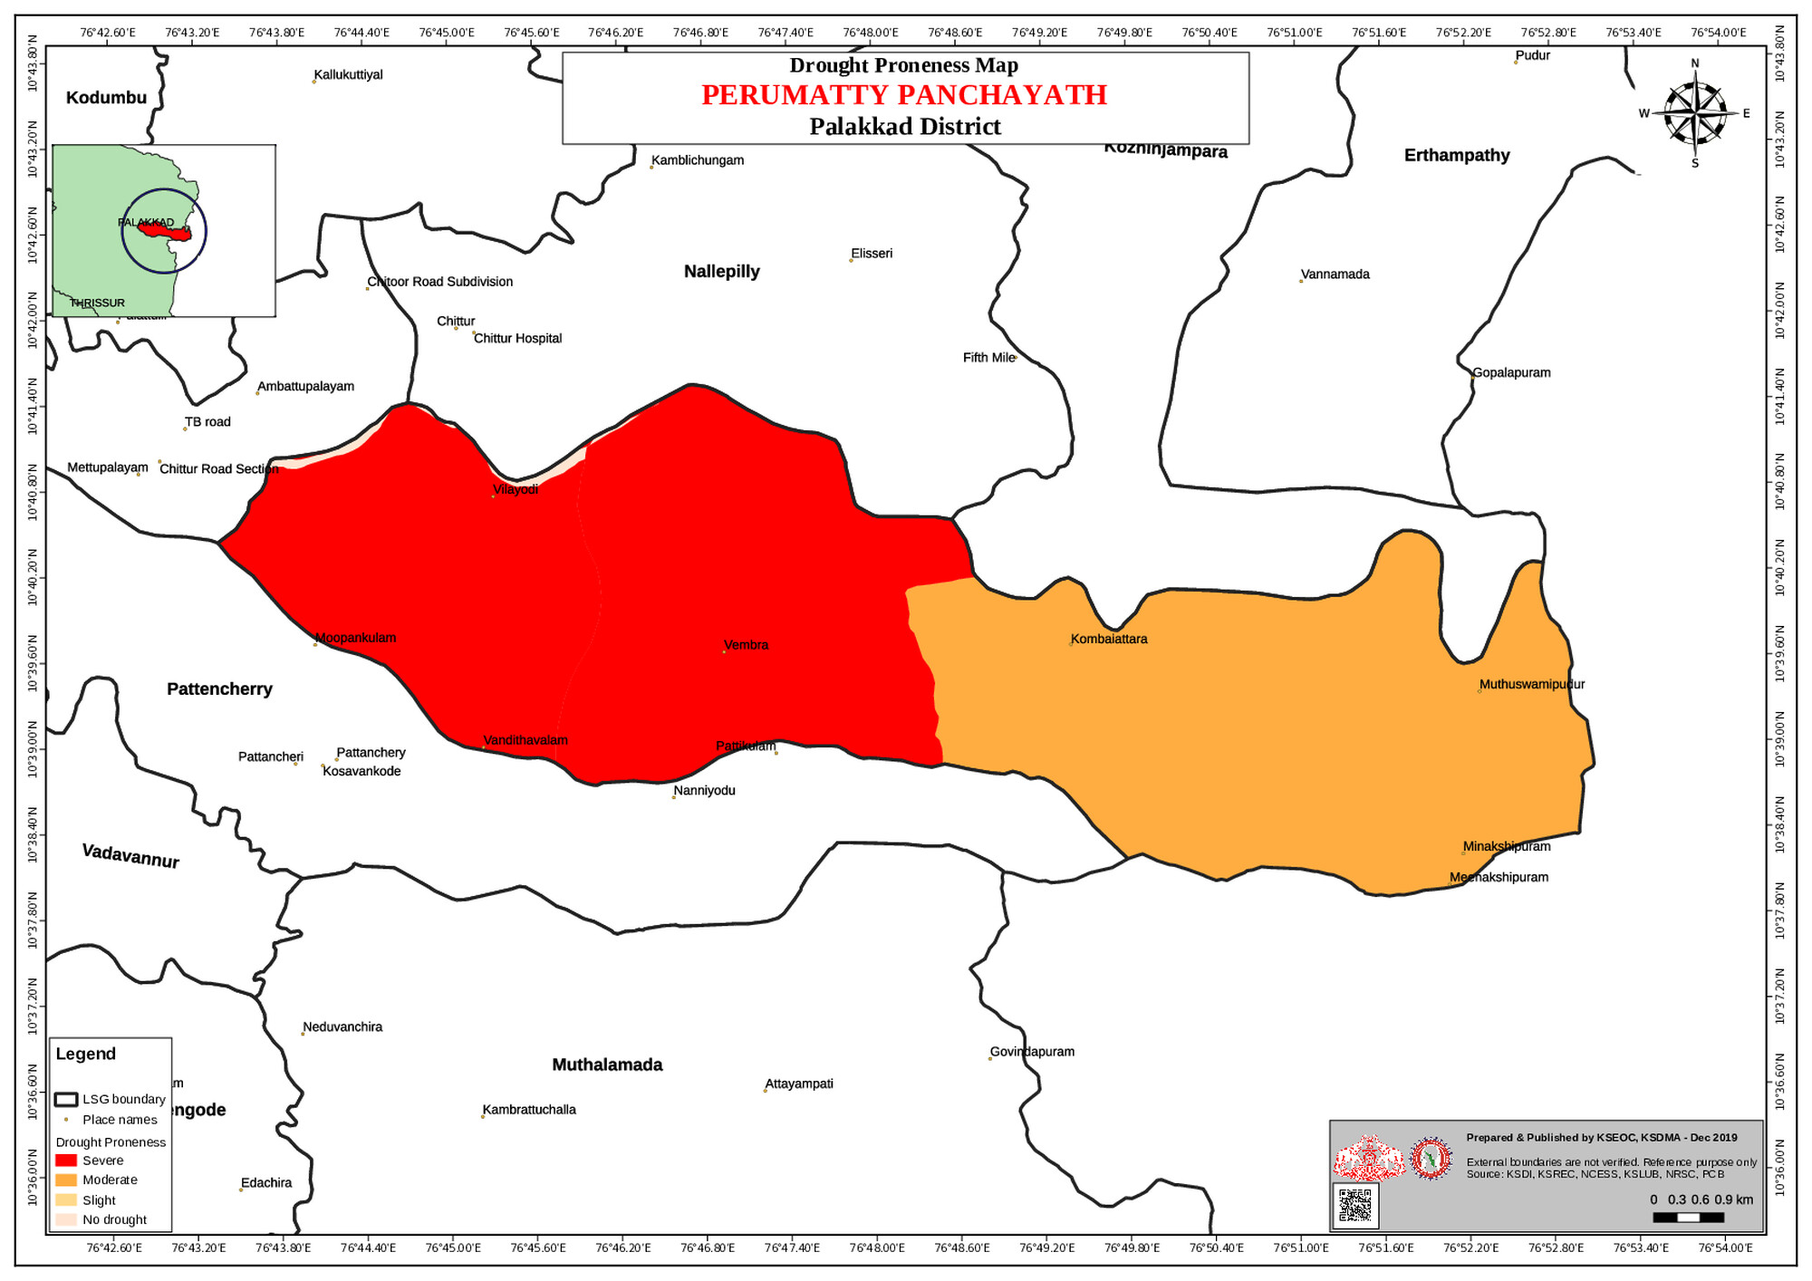

LANDSLIDE PRONESS MAP
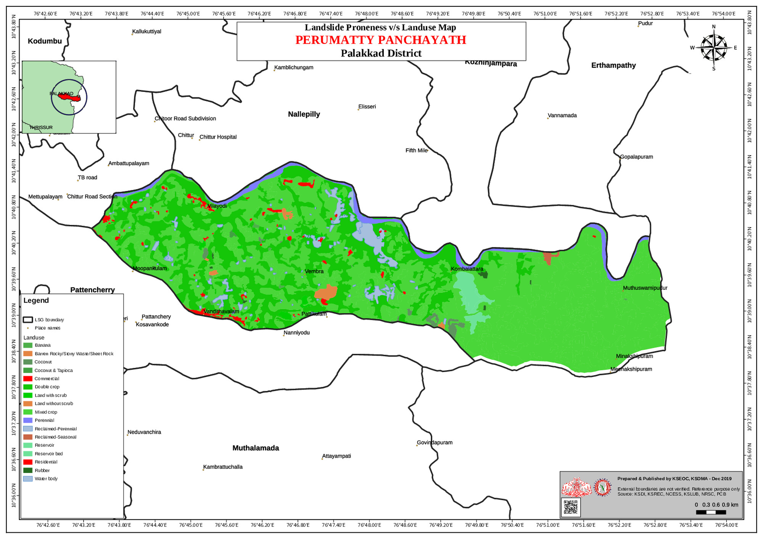

GENERAL PROFILE OF THE LSGI’S

Background of the LSGI
Perumatti Grama Panchayat is situated in the Chittur taluk of Palakkad district, Kerala. The geographical landscape of the Panchayat is predominantly plain laying characterized by extensive paddy fields and a dense network of rivers, canals, and dams. This unique terrain plays a significant role in shaping the local microclimate and poses distinct challenges to transportation, emergency response, and service delivery, particularly during monsoon seasons and flood events.
The Panchayat is administratively divided into multiple wards, with a population largely dependent on traditional livelihoods. Agriculture—especially paddy cultivation and coconut plantation and small scale milk societies allied activities form the backbone of the local economy. The area hosts a diverse workforce, including a notable presence of migrant labourers, particularly in construction, agriculture, and allied sectors.
From a public health and disaster management perspective, _Perumatti__ LSGI has not been vulnerable to seasonal flooding, waterborne diseases, and vector-borne illnesses such as Dengue and Leptospirosis.In 2018 the flood affected partially in several part of Ward 3 named Vilayodi. These recurring emergencies have underscored the importance of strengthening local preparedness, response mechanisms, and inter-departmental coordination.
In this context, the development of a localized, data-driven Auxiliary Infrastructure and Logistical Resource Map is essential to support effective planning, timely emergency response, and sustainable development initiatives. Such mapping enables the Panchayat to identify critical resources, improve accessibility during disasters, and enhance overall resilience of the community.

Table 1: Background of LSGD
Description | Details
Name of LSGI | Perumatti
Type (GP/Municipality / Corporation etc.) | Grama Panchayath
Block | Chittur
District | Palakkad
Number of wards | 20
Total area (sq. km) | 60.79
Population(Projected) | 30958
Population density | 509 /sq km
Terrain (coastal/low-lying/backwaters/foothills, etc.) | Plain
Number of rivers passing through LSGI | 1
Number of water bodies in the LSGI | 256
Number of educational institutions | 10
Factories / small-scale industries | 4
Flood-prone wards | 1(ward -3)
Landslide-prone wards | NIL
Death Management and Disposal Facilities (mortuaries/crematorium, including electric) | 5
Auditoriums/Marriage halls/convention centres/community halls Total | 6
ALAYAR -Haji mahal | 1 (mob-9447944624)
NELLIMMEDU Sabari Auditorium | 1(mob-7904280099)
NANNIYODE TKD Auditorium | 1 mob(9745293451)
NANNIODE-Parvathy Auditorium | 1(9539619377)
Moopankulam -RP Auditorium | 1(9656232343)
Vandithavalam-AS Auditorium | 1(9496351437)

Demographic and Vulnerable Population
Understanding the demographic composition and vulnerable population groups is essential for pandemic preparedness. Children, elderly, economically deprived families, migrant workers, and socially vulnerable groups are at increased risk during public health emergencies due to higher exposure, limited access to services, and dependency on public systems..

Description |  | Details (in numbers)
DEMOGRAPHIC PROFILE
Total population |  | 30958(before delimitation)
Male |  | 15466
Female |  | 15492
Transgender |  | 0
Children under 5 |  | 1273
Adolescent |  | 2686
Elderly (>60) |  | 4040
SOCIAL/LIVELIHOOD VULNERABILITY
Previous EPEP family |  | 45
BPL family |  | 4586
Tribal communities |  | 34
Migration | Immigrant | 155
Migration | Emigrant | 80
Socio-economically deprived |  | 53
Fisherfolk |  | nil
SC Community |  | 20 population 4591
ST Community |  | 34 Populatiuon 2154

Graphs: Population pyramid (if possible) for seeing if your LSGI has a high "dependency ratio" (lots of children and elderly compared to working adults).

Clinical Vulnerability
Certain population groups needs priority healthcare & are at higher risk of severe illness, complications, and mortality during pandemics. Patients with chronic diseases, those requiring regular medical care, and individuals with mobility or functional limitations face challenges in accessing timely care during emergencies. Mapping these groups helps in prioritizing continuity of treatment, medicine stock planning, oxygen support, referral transport, and targeted home-based care.
Description | Details in numbers
Pregnant women | 199
Lactating mothers | 122
Bedbound patients | 6
Patients under palliative care other than bedbound | 72
Patients on Haemodialysis | 11
Patients on CAPD | 1
Cancer patients (currently on treatment) | 82
Haemophilic patients | 1
Mentally challenged | 29
Differently abled | 80
Diabetic patients | 1513
Hypertensive patients | 2145
Both DM&HTN | 255
TB patients | 12

Major Festivals & Events specific to the LSGI
(with the possibility of a public gathering)

Sl. No. | Name of festival | Place | Month detailing the periodicity
1 | Ramarpannai Festival | Meenakshipuram | Mid September & mid October
2 | Ayyapan Festival | Ayyappankavu | December first week

INFRASTRUCTURE & RESOURCE INVENTORY

Health Facility Directory & Basic Capacity in the LSGD
This section provides an overview of the healthcare infrastructure available within the LSGD area. It outlines the distribution and basic capacity of health facilities that form the backbone of service delivery during routine times and public health emergencies.

Family Health Centres (FHCs) and Community Health Centres (CHCs) generally function as the first point of contact for the community, providing essential outpatient and inpatient services. General Hospitals (GH) and Medical College Hospitals (MCH), where accessible, serve as the main referral centres for advanced diagnostics, specialist care, and critical services during public health emergencies. This inventory helps identify existing strengths, gaps, and potential surge capacity that can be mobilised during a pandemic or disaster.

Table 5. Health Facility Resource Summary
Sl.no. | Health Facility | Type of Facility (MCH/GH/CHC/FHC/SC etc.) | Contact Number | Total beds | ICU Beds | Oxygen-Supported Beds | No. of Ventilator Support Beds | No. of ambulances
Government Healthcare Facilities
1 | FHC PERUMATTY | FHC | 04923296433 | 3 | 0 | 0 | 0 | 0
2 | HWC Meenakshipuram | SC | 8547264211 | 0 | 0 | 0 | 0 | 0
3 | HWC KORIYARCHALLA | SC | 9544882505 | 0 | 0 | 0 | 0 | 0
4 | HWC PERUMATTY | SC | 9847181677 | 0 | 0 | 0 | 0 | 0
5 | HWC MOOPANKULAM | SC | 9745162978 | 0 | 0 | 0 | 0 | 0
6 | HWC VILAYODI | SC | 9745360247 | 0 | 0 | 0 | 0 | 0
Private Healthcare Facilities
1 | KMCH VILAYODI | PRIVATE | 0492225300 | 635 | 35 | 50 | 20 | 4
AYUSH Healthcare Facilities
1 | Govt Ayurvedha Dispensery,Parakkalam | FHC | 04923296117 | 3 | 0 | 0 | 0 | 0
2 | Govt Homeo Dispensery | FHC | 04923232316 | 2 | 0 | 0 | 0 | 0

Private Clinics
Private clinics are an essential part of pandemic preparedness, as they are often the first place people seek care when symptoms begin. In many communities, private clinics manage a significant share of outpatient visits and therefore play a critical role in early case detection, timely referrals, and disease surveillance. Having an up-to-date understanding of where these clinics are located, the services they provide, and how they are linked to the public health system helps ensure that no cases are missed during an outbreak. It also allows health authorities to engage private practitioners more effectively for reporting, risk communication, and coordinated response, strengthening the overall capacity of the health system to manage public health emergencies.

Table 6. Private Clinic Resource Summary
Sl No. | Name of Clinic | Registered (Y/N) | Clinic (General / Speciality) | Speciality (if any) | Address | Contact Number | Diagnostic Facility (Y/N) | Ambulance Linkage (Y/N)
1 | Smile Dental Clinic | N | Dental | Dental | Vandithavalam | 999597003 | Y | N
2

Healthcare Education & Training Institutions
This section tracks the educational infrastructure available, which is vital for human resource planning in the health sector.

Category of Institution | Govt | Private | AYUSH | Total
Medical Colleges | 0 | 1 | 0 | 1
Nursing Colleges | 0 | 1 | 0 | 1
Dental Colleges | 0 | 0 | 0 | 0
Para-medical / Allied Health | 0 | 0 | 0 | 0
Pharmacy Colleges | 0 | 0 | 0 | 0

Specialized Services & Emergency Inventory
This section provides a detailed view of the specialized medical resources available to the community, focusing on emergency response and critical care capabilities. This table tracks the vital assets required for managing severe illnesses and emergencies across Government, Private, and AYUSH sectors.

Item | Govt | Private | AYUSH | Total
Hospital beds | 2 | 635 | 4 | 641
Oxygen-generating systems(Y/N) | 0 | 0 | 0 | 0
Oxygen-supported beds(Numbers) | 0 | 50 | 0 | 50
Ventilator-supported beds | 0 | 20 | 0 | 20
ICU beds | 0 | 35 | 0 | 35
Burns units | 0 | 1 | 0 | 1
Blood centres | 0 | 1 | 0 | 1
BLS ambulances | 0 | 3 | 0 | 3
ALS ambulances | 0 | 1 | 0 | 1
Dialysis facilities | NIL | 10 | 0 | 10
Dispensaries | 0 | 0 | 2 | 2
Medical store | 1 | 1 | 0 | 2
Industrial establishments(Medium-scale industries/small-scale industries establishments to whom we can depend in a worst-case scenario) | 0 | 0 | 0 | 0

Oxygen & Diagnostic Capacity
Monitoring oxygen and diagnostic capacity is a critical component of public health preparedness, ensuring that the LSGD can handle both chronic care and sudden surges in respiratory or infectious diseases.
Name of Health Facility | Oxygen-generating System (Y/N) | Backup Oxygen Source (Y/N) | Diagnostic Facilities Available(Y/N)
Name of Health Facility | Oxygen-generating System (Y/N) | Backup Oxygen Source (Y/N) | Lab | USG | X-ray | CT/MRI | RT-PCR
Government Healthcare Facilities
FHC PERUMATTY | NO | NO | 1 | 0 | 0 | 0 | 0
Private Healthcare Facility
KMCH VILAYODI | YES | YES | Y | Y | Y | Y | Y

Diagnostics facility mapping at the LSGI level
The diagnostic capacity of PERUMATTY G.P represents the "intelligence network" of our healthcare system. The speed and accuracy of disease identification depend entirely on the distribution and technical level of these facilities.

Item | Govt | Private | AYUSH | Total
General labs | 1 | 5 | 0 | 6
Microbiology labs | 0 | 1 | 0 | 1
RT-PCR labs | 0 | 1 | 0 | 1
USG units | 0 | 5 | 0 | 5
CT/MRI units | 0 | 2 | 0 | 2
Research labs | 0 | 0 | 0 | 0
Labs of other departments that can be repurposed | 0 | 0 | 0 | 0

Laboratory Identification & Basic Details
Sl. No. | Name of Laboratory | Ownership (Govt / Private / Academic) | Address | Contact No. | 24×7 Services (Yes/No) | NABL / Govt Approved (Yes/No)
1 | SREE VT HITECH | PRIVATE | NELLIMEDU | 9645317976 | NO | NO
2 | NEETHI LAB DIAGNOSTIC CENTRE | PRIVATE | VANDITHAVALAM | 9791173507 | NO | NO
3 | ARK HITECH LAB | PRIVATE | VANDITHAVALAM | 8593802229 | NO | NO
4 | FHC PERUMATTY | GOVT | NELLIMEDU | 8078190337 | NO | NO
5 | CENTRE LAB KMCH VILAYODI | PRIVATE | VILAYODI | 9447448118 | YES | YES(NABL)

Social and Community Infrastructure for surge plan
This table serves as our logistics and shelter inventory. By mapping these locations, quickly we can identify where to house displaced citizens, where to set up temporary medical clinics, and how to manage the deceased with dignity during a crisis.

Category | Total Count | Ward | Est. Capacity (Persons) | Contact details
Educational Institutions
Anganwadis | 33(Attach additional sheet for detailed explanations) | 20 | see Annexure 3, | 9961198304
Schools | 9 | 9 | 450 | nil
Colleges | 1 | 0 | nil | nil
Healthcare Educational Institutions
Medical colleges (Govt/Private) | 1(PRIVATE) | 7 | 0 | 09496962555
Nursing colleges (Govt/Private) | 1(PRIVATE) | 4 | 0 | Karuna N.college  04923-221794
Dental colleges (Govt/Private) | NIL | NIL | 0 | 0
Paramedical institutes (Govt/Private) | NIL | NIL | 0 | 0
Community Gathering Spaces
Community halls | 4 | 9,13,15 | 120 | 0
Auditoriums | 6( Details mentioned in Table no 1) | 1,17,16,14,12, | 3000 | 0
Religious buildings | 9 | 5,15,10,16,17,4,6 | 1000 | 0
Vulnerable Group Support Facility
Destitute homes | NIL | NIL | NIL | NIL
Elderly homes | 2 | (13,13) | 25 | NIL
LSGD owned other buildings | 0 | 0 | 0 | 0
Mass Fatality Management (MFM) Infrastructure
Mortuary | NIL | NIL | NIL | NIL
Crematorium | 1 | 6 | NIL | NIL
*refer annexure 1 for contact details

Human resources
This section focuses on the human capital available within the LSGI. In any emergency—be it a pandemic, flood, or industrial accident—infrastructure is only as effective as the people operating it.

Medical & Clinical Personnel
This table tracks the "Frontline" providers responsible for diagnosis, treatment, and clinical management. Narrative sentence: eg., "Total health workforce: 450 personnel, with 60% in government facilities serving as primary surge capacity." A detailed directory with the contact numbers of all workers is maintained (Annexure in 1).

Cadre | Govt (No.) | Private (No.) | Total
Doctors—Modern Medicine | 3 | 200 | 203
Doctors – AYUSH | 2 | 0 | 2
Doctors – Veterinary | 1 | 0 | 1
Doctors – Dental | 0 | 5 | 5
Nursing officers | 2 | 170 | 172
Lab technicians | 1 | 24 | 25
Optometrist | 0 | 2 | 2
Pharmacists | 1 | 8 | 9
Psychologists | 0 | 1 | 1
Counsellors | 0 | 2 | 2

Public Health & Field-Level Workforce
These individuals are the backbone of surveillance, maternal-child health, and decentralized care.

Cadre | Health services | Municipal common services | Total
HS (Health Supervisors) | 0 | 0 | 0
HI (Health Inspectors) | 1 | 0 | 1
LHS (Lady Health Supervisor) | 0 | 0 | 0
LHI (Lady Health Inspectors) | 1 | 0 | 1
JPHN (Jr Public Health Nurses) | 5 | 0 | 5
JHI (Jr Health Inspectors) | 3 | 0 | 3
MLSP (Mid-Level Service Providers) | 5 | 0 | 5
Palliative Nurses | 1 | 0 | 1
RBSK Nurses | 1 | 0 | 1
PRO | 0 | 0 | 0
Epidemiologist | 0 | 0 | 0
Data Manager | 0 | 0 | 0

Medical & Clinical Personnel

This table tracks the "Frontline" providers responsible for diagnosis, treatment, and clinical management. Narrative sentence: eg., "Total health workforce: 450 personnel, with 60% in government facilities serving as primary surge capacity." A detailed directory with the contact numbers of all workers is maintained

ANNEXURE 1
NAME OF STAFF | Designation | Contact No
DR Remya E | Medical Officer | 8078190337
Dr Shanakara Subramaniyam | NHM | 9095011105
DR Shifa | Ardram | 9600697558
Resana | Staff Nurse | 8921357721
Latha | Staff Nurse | 9447340959
Akshara | Staff Nurse | 8921980804
Aiswarya | Pharmacist | 6282083776
Vismaya | Lab technician | 9746195875
Ajeesh | Clerk | 9447835055
Dhanya | OA | 9809792535
Sheeja | Grade 2 | 9567030407
Basheer | Nursing Assistant | 9048092227
Sathananthan | PTS | 9445193523
Shereena | RBSK Nurse | 9846438255

Public Health & Field-Level Workforce
Name of Staff | Designation | Contact No
Abdhu Razack | Health Inspector | 8089726985
Girija | PHN | 6282250358
Sanoj.P.V | JHI | 7293105801
Jinsy S George | JHI | 7560910412
Roja | JHI | 9497693132
Shahanaz | JPHN | 8075443608
Lekha | JPHN | 9745360247
Simi | JPHN | 9544882505
Daivani | JPHN | 9745162978
Anu Ramesh | JPHN | 9847181677
Parvathy | MLSP | 7293584770
Nimmy | MLSP | 7034201387
Abhijna | MLSP | 9074563241
Aiswarya | MLSP | 8590645589
Aswathy | MLSP | 8139838865
Ambika | CN (Community/ Palliative Nurse) | 9539569258

Community & Support Cadre
This group represents the surge capacity of the LSGI—people who can be called upon for logistics, rescue, and specialized support.

Cadre | Number
ASHA Workers | 25(attached details in annexure 2)
AWW (Anganwadi Workers) | 33(attached details in annexured 3)
Emergency Medical Volunteers (Trained) | Palliative Volunteers only-15
Kudumbashree | 258
MNREGS | 2200
Purusha Swayam Sahaya Sangham | 1
Retired Police Officers | 21(details attached in annexure 5)
NCC/NSS Volunteers | NIL
Red Cross volunteers | NIL
One Health Community Volunteers | 40

ANNEXURE 2
List Asha workers -FHC PERUMATTY
SL NO | ASHA NAME | CONTACT  NO | Allotted Ward(WardNo, Name based 2025)
 | ASHA NAME | CONTACT  NO | No | name
1 | Premakumari | 9544140453 | 1 | Athimani
2 | Rajamma | 9961639141 | 1 | Athimani
3 | Geetha | 9633713223 | 2 | Parakkalam
4 | Ambika | 9745504947 | 3 | Vilayodi
5 | Sujatha | 9809740498 | 4 | Namboorichalla
6 | Saritha | 9400602700 | 5 | Vembra
7 | Leelamani | 9400785600 | 6 | Narani
8 | Priyadarshini | 9349540285 | 6 | Narani
9 | Sumathi | 9048997024 | 7 | Kalyanapetta
10 | Bhagyavathi | 8301961377 | 8 | Kambalathara
11 | Sunitha | 9061474568 | 8 | Kambalathara
12 | Selvi | 9539153889 | 9 | Srambi
13 | Shanthi | 8590576262 | 10 | Moolathara
14 | Girija | 9846016185 | 11 | Meenakshipuram
15 | Reena | 9544526620 | 12 | Nellimedu
16 | Kalyani | 9809185326 | 13 | Kannimari
17 | Bhanu | 9745177513 | 13 | Kannimari
18 | Premalatha | 9605842099 | 14 | Pattikulam
19 | Reena | 9048151651 | 14 | Pattikulam
20 | Prema | 8547689551 | 15 | Ayyappankavu
21 | Sheeba | 9495097154 | 15 | Ayyappankavu
22 | Krishnaveni | 9496146758 | 16 | Vandithavalam
23 | Baby | 9048515656 | 16 | Vandithavalam
24 | Kalyani | 9605384874 | 17 | Alayar
25 | Padmaja | 9605123701 | 18 | Madappallam

ANNEXURE 3
LIST OF ANGANWADIES UNDER FHC PERUMATTY
SL no | Name OF AWW | NAME OF AW | Centre Number | WARD | MOBILE NUMBER
11 | Sheenamol | Karadikunnu | 57 | 13 | 9074800234
22 | Saudamini | Plachimada | 81 | 13 | 9846713269
33 | Bindhu | Anjuvallakadu | 54 | 8 | 9048515642
44 | Rohini | Vijayanagar | 56 | 8 | 9645933639
55 | Dhanalakshmi | Narani | 79 | 6 | 9605700281
66 | Pushpalatha | Koriyarchalla | 75 | 6 | 9496194491
77 | Premalatha | Odukurinji | 64 | 15 | 9288055835
88 | Sheena | Kizhakkekadu | 71 | 14 | 9946013773
99 | Saraswathi | Kaipayamkulambu | 62 | 14 | 9746827728
110 | Ambika U | Valayampara | 78 | 14 | 9747866952
111 | Aysha | Kalimenonchalla | 58 | 7 | 7510367253
12 | Susheela | Mullakalchalla | 82 | 7 | 9645790388
13 | Ambika S | Maniyattukulambu | 67 | 2 | 9447620051
14 | Pushpalatha | Parakkalam | 77 | 1 | 8086521499
15 | Sundari | Vayalukulam | 74 | 18 | 9496293414
16 | Nilavarneesa | Karikulam | 66 | 1 | 9809028818
17 | Sheela | Muthalamthodu | 59 | 5 | 9496437643
18 | Ambika | Pudussery,Vilayodi | 68 | 3 | 9544656630
19 | Chinthamani | Vilayodi | 69 | 3 | 9947907849
20 | Sowmana | Vavakkode | 72 | 4 | 9567733286
21 | Rugmani | Alayar,Purayoram | 73 | 17 | 9961576248
22 | Smrithi | Vembra | 60 | 5 | 7012454278
23 | Bhagyam | Maruthampara | 61 | 5 | 9745160832
24 | Shobana kumari | Vandithavalam | 63 | 16 | 9645314352
25 | Rahmath | Harijan Colony | 51 | 10 | 9074777257
26 | Manimala | Muthuswamipudur | 52 | 9 | 9048214307
27 | Geetha | Sarkarpathy | 53 | 9 | 9747912552
28 | Shylaja | Ezhuthani | 65 | 16 | 9544567571
29 | Sundari P | Nellimedu | 55 | 12 | 9745903031
30 | Soumini | Indiranagar | 70 | 11 | 9526084866
31 | Sumathi C | Meenakshipuram 2 | 76 | 11 | 8086917370
32 | Vasanthakumari | Kunjumenonpathy | 80 | 12 | 9526084866
33 | Baby | EMS COLONY | 83 | 10 | 7402576576

ANNEXURE 4

SANNADHA SENA VOLUNTEERS LIST
SL NO | NAME | PHONE NUMBER
1 | Madhusudhanan | 9895006051
2 | Jyothish | 9747496596
3 | Aneesh | 8848550316
4 | Kiran | 8593941415
5 | Sanoj | 9446272639
6 | Praveen | 9656266907
7 | Aswin | 7356489490
8 | Mithun | 9656346106
9 | Adhithyan | 9947299745
10 | Jasir | 8589862484
11 | Shaji | 9846656743
12 | Gokul | 9447287882
13 | Thrijesh | 8086328842
14 | Jithu | 8281926897
15 | Selvakumar | 8921979559
16 | Liju | 9207815639
17 | Sanjith | 9020492149
18 | Aswanth | 7560851115

ANNEXURE 5
Retired Police Officers
SL NO | NAME & ADDRESS | PHONE NUMBER
1 | Velayudhan,Vilayodi(Rt ASI) | 9645417980
2 | Sreedharan , Vembra(Rt ASI) | 9446495940
3 | Chandrababu, Vembra(Rt HC) | 9446071474
4 | Sahadevan,Alayar(Rt ASI) | 9946757153
5 | Samsaranathan, parakalam(Rt ASI) | 9496519603
6 | Devadas, Nanniode(Rt ASI) | 9447922454
7 | Aruchami, Koomankadu(Rt ASI) | 8547799468
8 | Madhanmohan, Vandikthavalam(Rt ASI) | 9446932315
9 | Chandran, Chulliperukamedu(Rt ASI) | 9846974157
10 | Mohan, Vilayodi(Rt ASI) | 9446493626
11 | Shanmughan, Vandithavalam(Rt ASI) | 82813303
12 | Abdhul Kalam Azad(Rt SI) | 90745917
13 | Arumughan (Rt HC) | 94955030
14 | Vimala, Vembra (Rt CI) | 9446071474
15 | Chamimmala,Mullakalchalla(Rt SI) | 6282222626
16 | Radhadevi,Meleezhuthani (Rt SI) | 8907678418
17 | Rajan, (Rt SI) | 7994520905
18 | Sulaiman,Moolakada (Rt HC) | 9946093456
19 | Sreenivasan,Nanniode (Rt SI) | 9495888861
20 | Sundarraj menon (Rt HC) | 9495172258
21 | Velayudhan , Vilayodi (Rt SI) | 9645417990

Community Organizations
This section details the presence of community-based organisations (CBOs), non-governmental organisations (NGOs), faith-based organisations (FBOs), Kudumbashree Self-Help Groups (SHGs), and Ayalkootams within the Local Self-Government Institution (LSGI). These groups enhance grassroots mobilization, resource distribution, and support networks crucial for pandemic response and community resilience.

Category | Total Count
NGOs | 0
Religious based organizations | 11
Foreign based organizations | NIL
Sports Club/youth clubs | YOUTH CLUB-7(detils attached annexure 6)
Kudumbashree SHGs | 284
Ayalkootams | 284
Political organizations | 3
Residential organizations | 1

ANNEXURE 6
YOUTH CLUBS
YOUTH CLUBS
SL NO | Name | Phone number
1 | Vilayodi | 9656973009
2 | Pranavam | 9999464617
3 | Kannimari | 9207177143
4 | Vidastha | 9020492149
5 | Priyam | 8589862484
6 | Kizhakkekadu | 9539214455
7 | MKPM | 9747695389

Administrative & Emergency Services
This section outlines the availability of key non-health emergency support services and infrastructure within the LSGI, which are essential for effective pandemic preparedness and response. These facilities support law enforcement, disaster response, water supply, logistics, mobility, and community-level interventions during public health emergencies.

Category | Total Count | Contact details
Police Stations | 1 | 04923-234100 (Meenakshipuram)
Fire & Rescue Stations | 1 | 04923222499 (Chittur)
Water Pumping Points | 3 | Meenakshipuram,chamiyarkalam,Nellimedu
Public Distribution System (PDS) | 11 | 9947269991(Hari Ration shop)

Information regarding resources
The availability of essential transport and support resources plays a quiet but critical role in saving lives. Equipment such as ambulances, mobile mortuaries, amphibian ambulances, and motorized boats ensures that patients, samples, and healthcare teams can move swiftly—even in flooded, remote, or difficult terrains. Heavy vehicles like JCBs, cranes, tractors, and torus lorries support logistics, waste management, emergency infrastructure, and rapid conversion of spaces into care or isolation facilities. Taxis, four-wheel-drive vehicles, and trucks help maintain continuity of essential services, reach vulnerable populations, and support home-based care and supply delivery.

Means of transportation | Total Count
JCB | 15
Crane | 2
Heavy Trucks | 1
Tractor | 80
Ambulances | 4
Mobile mortuaries | 0
Boats | 0
Taxi service | 10
Note: For specific details regarding vehicle owners and contact information, please refer to Annexure [X].

ONE HEALTH & ENVIRONMENTAL SURVEILLANCE
The One Health method integrates environmental, animal, and human health to enable proactive pandemic preparedness. Panchayat-level surveillance needs to be improved in order to detect and treat zoonotic and environmentally generated diseases early. Surveillance is strengthened through systematic assessment of animal populations, veterinary infrastructure, poultry and slaughter facilities, inter-sectoral coordination, and specialised tools like avian influenza seasonality mapping using GIS in previous outbreaks to enable predictive alerts and ward-specific sampling to support effective pandemic preparedness in Perumatti Grama Panchayath.

Animal & Bird Population
Mapping animal and bird populations at the Panchayat level is essential for identifying and prioritising zoonotic disease hazards like rabies, avian influenza (H5N1), leptospirosis, anthrax, and Nipah-like spillover occurrences. Risk classification, targeted surveillance, vaccination planning, and early epidemic detection made feasible by comprehensive population mapping all enhance One Health-based pandemic preparedness.

Category | Item | Estimated Population | Wards
Animal Population | Livestock (Cattle/Goats/Buffalo) | 8497 | unavailable
Animal Population | Pet Animals (Dogs/Cats) | 22/0 | unavailable
Animal Population | Stray Dog Population | 818 | unavailable
Animal Population | Pig Farms (Number of heads) | 0 | unavailable
 | Small Units (Sheep / Goats – clustered) | 0 | unavailable
Bird Population | Poultry Units (Birds) | 0 | unavailable
Bird Population | Poultry- (FOWL) | 6021 | unavailable
Bird Population | Wild/Migratory Birds (Observed) | 0 | unavailable
Bird Population | Crow Mortality Events (Reported) | 0 | unavailable

.

Veterinary Infrastructure
Veterinary institutions are a core pillar of One Health surveillance, enabling early zoonotic disease detection through vaccination, investigation of unusual animal illness or deaths, sample collection, and timely outbreak reporting. A well-mapped and responsive veterinary network strengthens coordination with human health and LSGI systems, ensuring rapid response during zoonotic events and pandemics.
Facility Type | Name of Facility | Ownership Govt / Pvt | Location(Ward No) | Contact number
Veterinary Dispensary | 1 | GOVT | MEENAKSHIPURAM WARD-11 | 9747074058
Veterinary Hospital / Polyclinic | NIL | nil | nil | nil
Private Veterinary Clinics | NIL | nil | nil | nil
Mobile / Emergency Vet Service (incl. night services) | NIL | NIL | NIL | NIL
Pet Homes / Animal Shelters | NIL | NIL | NIL | NIL
Slaughterhouse-linked Veterinary Inspection Unit | NIL | NIL | NIL | NIL

Veterinary Doctors & Workforce
Early detection, diagnosis, reporting, and reaction to animal illness epidemics depend on the availability and accessibility of qualified veterinary specialists. By identifying unusual animal morbidity or mortality promptly, collecting samples promptly, and coordinating efficiently with human health and LSGI systems—especially during zoonotic outbreaks and pandemic-prone situations—a clearly defined veterinary workforce enhances One Health surveillance.

Category | Number Available | Type (Govt/Pvt) | Contact number
Government Veterinary Doctors | 1 | GOVT | 9747074058
Private Veterinary Doctors | NIL | Nil | nil
Livestock Inspectors | 2 | GOVT | 9400436271,  9526652634
Para-veterinary Staff / Attenders | NIL | NIL | NIL
Contract / On-call Veterinary Support (if any) | NIL | NIL | NIL

High-Risk Interface Points (Surveillance Sites)
High-risk interface points for zoonotic disease surveillance in PERUMATTY Grama Panchayath include wetland–livestock–human contact zones, backyard poultry farms, cattle sheds near water bodies, fish markets, and areas of high human–animal interaction such as community slaughter points and migratory bird congregation sites. These are the primary surveillance sites where zoonotic spillover risks are elevated.

Type of Habitat | Type of High risk interface | Geographical vulnerability
Wetlands & Backwaters | 0 | 0
Backyard Poultry Farms | 0 | 0
Cattle Sheds near Water Bodies | 0 | 0
Fish & Meat Markets | 0 | 0
Community Slaughter Sites | 0 | 0
Migratory Bird Congregation Areas | 0 | 0
Rodent-Infested Grain Storage | 0 | 0

Category | Total Count | Key Locations (wards)
Poultry Farms | 0 | 0
Backyard / Clustered Poultry Units | 0 | 0
Duck Rearing Units (open water access) | 0 | 0
Slaughterhouses/ Slaughter Points | 0 | 0
Meat/Fish Markets | 0 | 0
Live Bird Sale Points | 0 | 0
Cattle Markets / Weekly Animal Fairs | 0 | 0
Pet Shops / Breeders | 0 | 0
Animal Shelters / Pet Homes | 0 | 0
Waste Disposal Sites near Animal Units | 0 | 0

Environmental Risk Mapping
Environmental risk mapping identifies monsoon/flood hotspots for vector-borne (dengue, chikungunya), water-borne (leptospirosis, diarrhoea), and zoonotic diseases in Kerala's wetlands. Systematic surveillance supports early warnings, targeted interventions, and Panchayat pandemic preparedness.
Waterborne exposure: Flood-prone areas and stagnant water bodies facilitate leptospira survival, raising leptospirosis risk.

Traditional practices: Informal slaughter and fish markets lack standardized hygiene, creating spillover opportunities.

Risk Factor | High-Risk Wards | Key Locations | Risk Level (High/Med/Low)
Flood-prone areas | NIL | NIL | LOW-  WARD 3, VILAYODI
Water bodies/wetlands | NIL | NIL | NIL
Solid waste accumulation | 14 | MCF (Material Collection Facility) | Low
Animal waste disposal issues | NIL | NIL | NIL
Rodent infestation zones | NIL | NIL | NIL
Industrial effluent discharge | NIL | NIL | NIL
Construction sites / abandoned buildings | NIL | NIL | NIL
Poor drainage/blocked canals | NIL | NIL | NIL
Drinking water source contamination risk | NIL | NIL | NIL

Disease Seasonality Mapping
1, Flooding & waterlogging → amplifies leptospirosis, malaria, diarrheal diseases.
·
2, Migratory bird influx (Nov–Feb) → avian influenza risk.

3, Mosquito breeding cycles → vector-borne disease peaks in monsoon.

4, Agricultural practices → close human–animal contact in paddy fields.

Disease | Peak Risk Season | Key Drivers | High-Risk Locations | Surveillance Focus
Leptospirosis | Monsson | water logging,paddy farmers | SCATTERED | DOXY PROPHYLAXIS
Dengue | Monsoon | stagnant water | Alayar | Vector survey & Source reduction
Acute Diarrheal Diseases | Summer/Monsoon | Water contamination | ward 6 Narani,ward 13 kannimari | chlorination activities & chlorine tab treatment
HEP A | winter | Water Contamination | scattered | chlorination activities & chlorine tab treatment,Health Education

Vulnerability Mapping
Vulnerability mapping pinpoints high-risk populations, occupations, and areas exposed via environment, livelihoods, socio-economics, and poor service access. Paired with environmental/seasonality mapping, it enables risk-based surveillance, targeted actions, and optimal resource use in One Health and pandemic planning.
Vulnerability Factor | High-Risk Wards | Key Groups / Locations | Risk Level
Flood-prone households | NIL | nil | LOW-WARD-3
Wetland-adjacent communities | NIL | nil | NIL
Backyard poultry / duck rearing households | NIL | NIL | NIL
Livestock-rearing households | NIL | NIL | NIL
Slaughterhouse & meat market workers | NIL | VANDITHAVALAM-3, MEENAKSHIPURAM-2 | LOW
Fisherfolk & fish market workers | NIL | NIL | NIL
Sanitation workers | NIL | PERUMATTY | LOW RISK
Daily wage / migrant workers | NIL | NIL | NIL
Elderly & chronically ill populations | NIL | PERUMATTY | 4040
Pregnant Women-11 | NIL | MEENAKSHIPURAM | LOW RISK
Children (schools, Anganwadi’s) | NIL | NIL | NIL
Limited access to safe water & sanitation | NIL | NIL | LOW RISKS

EPIDEMIOLOGICAL TRENDS (2021–2025)

Disease surveillance is the systematic collection, analysis, and interpretation of health data for planning, implementation, and evaluation of public health practice. This section presents the disease surveillance profile of the LSGI based on routine reporting systems and outbreak investigations to identify priority diseases, seasonal patterns, and emerging public health threats.

Disease Burden among human beings(Last 5 Years)
Analysis of disease-wise data for the last five years helps identify persistent public health problems, emerging diseases, and changes in disease burden. This information supports prioritisation of prevention, preparedness, and response activities at the Panchayat level.

Disease | 2021 | 2022 | 2023 | 2024 | 2025 | Trend(Increasing/Stable/Decreasing)
Dengue | 1 | 12 | 53 | 35 | 3 | 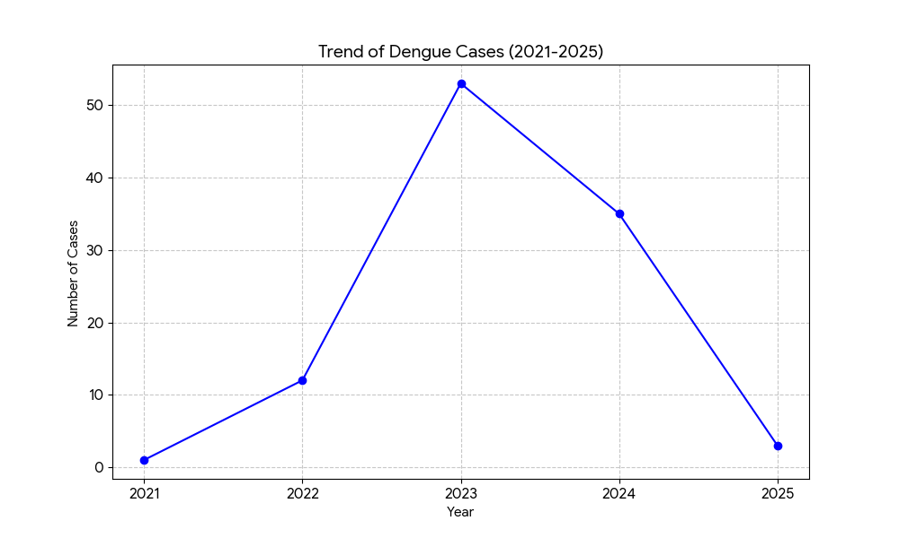
Leptospirosis | 1 | 2 | 1 | 6 | 2 | 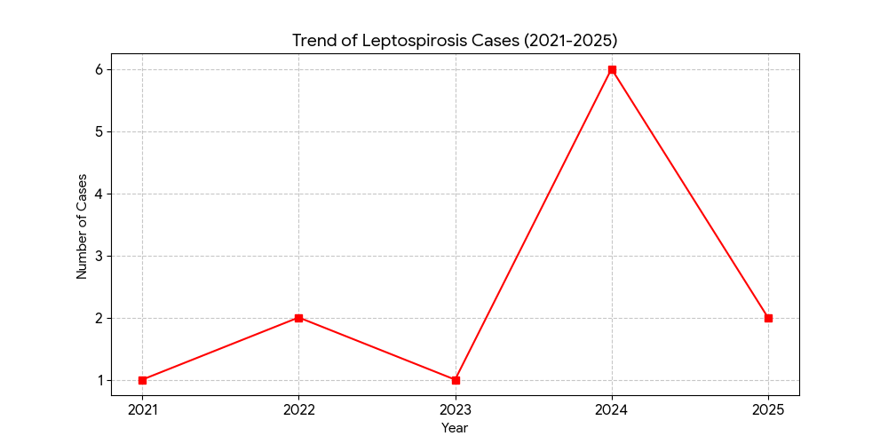
Hepatitis A | 0 | 0 | 0 | 6 | 0 | 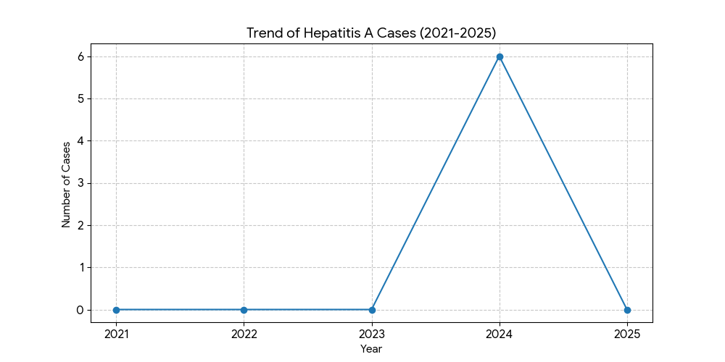
Malaria | 0 | 0 | 0 | 0 | 1 | 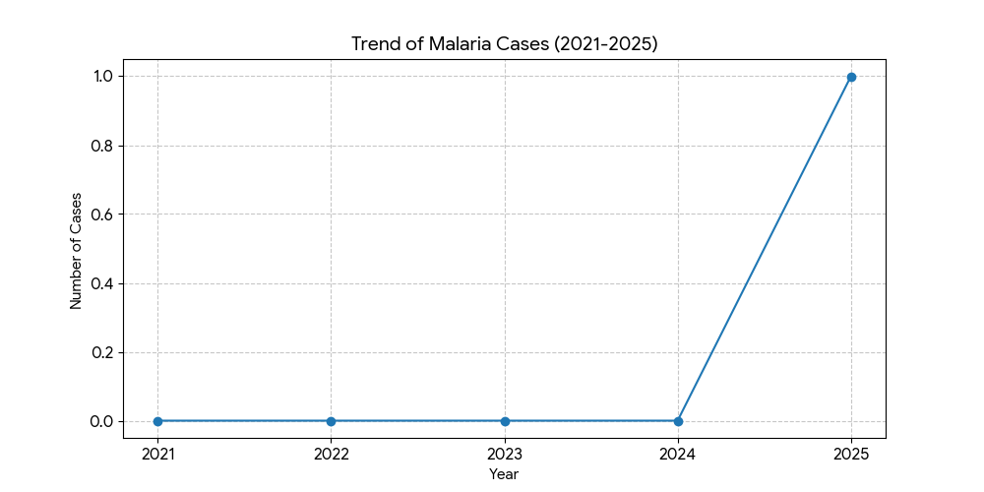
Scrub Typhus | 0 | 0 | 1 | 0 | 0 | 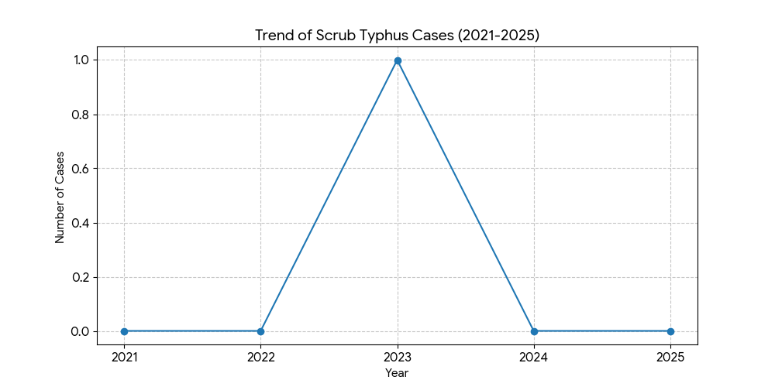
Typhoid | 0 | 7 | 0 | 3 | 0 | 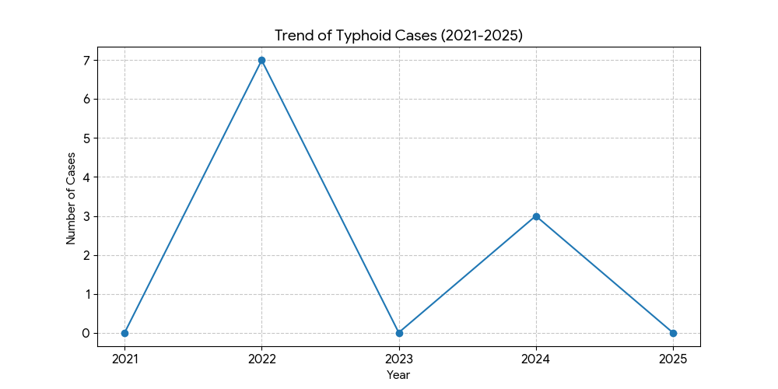
H1N1 | 0 | 0 | 1 | 1 | 0 | 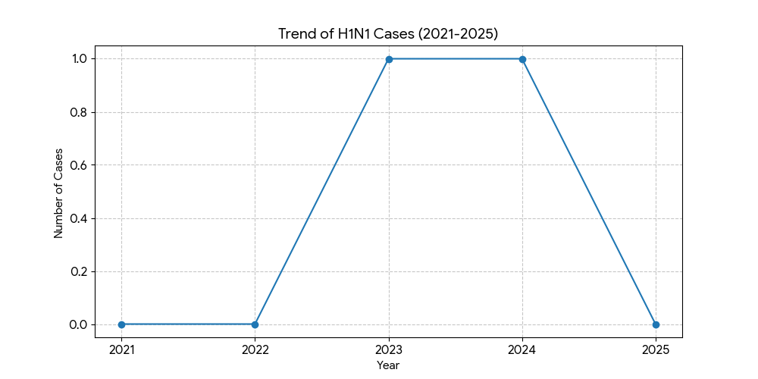
ADD | 0 | 27 | 36 | 94 | 21 | 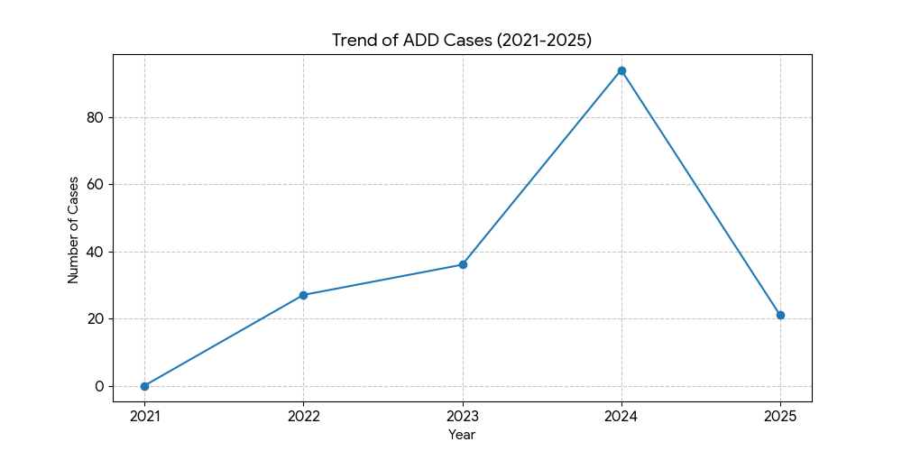
Hepatitis B | 0 | 2 | 2 | 8 | 3 | 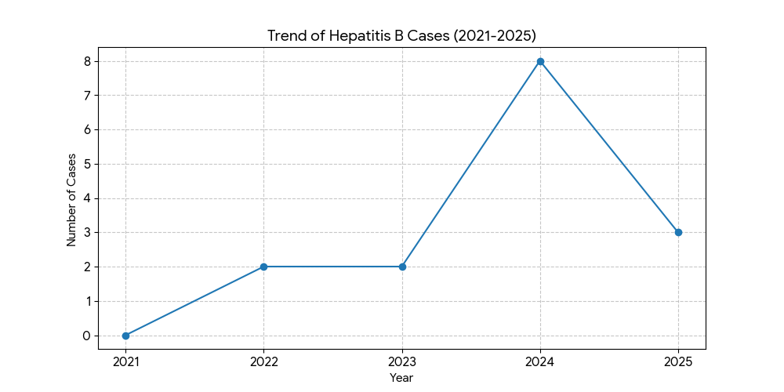
Hepatitis C | 0 | 1 | 1 | 0 | 0 | 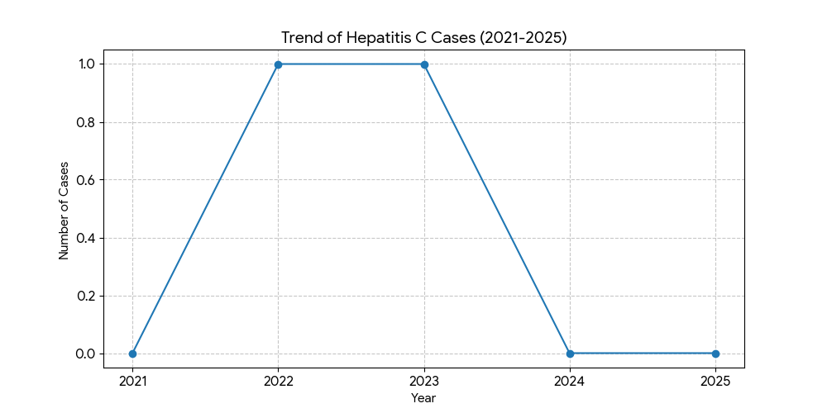
Tuberculosis | 27 | 29 | 22 | 19 | 19 | 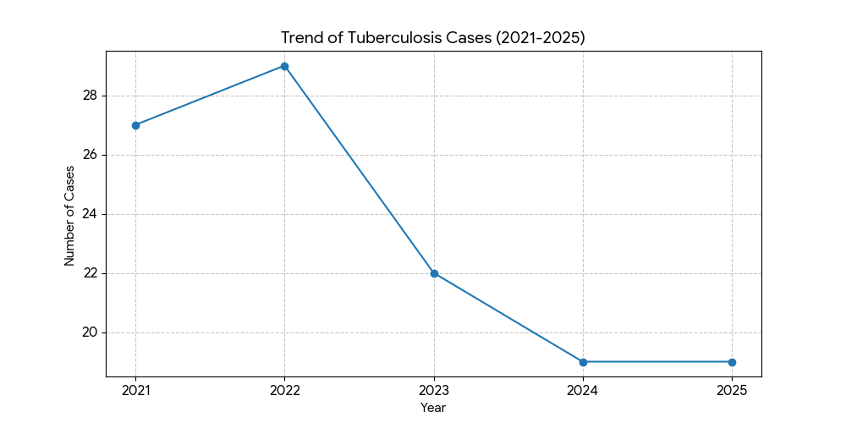
Leprosy | 0 | 8 | 0 | 0 | 15 | 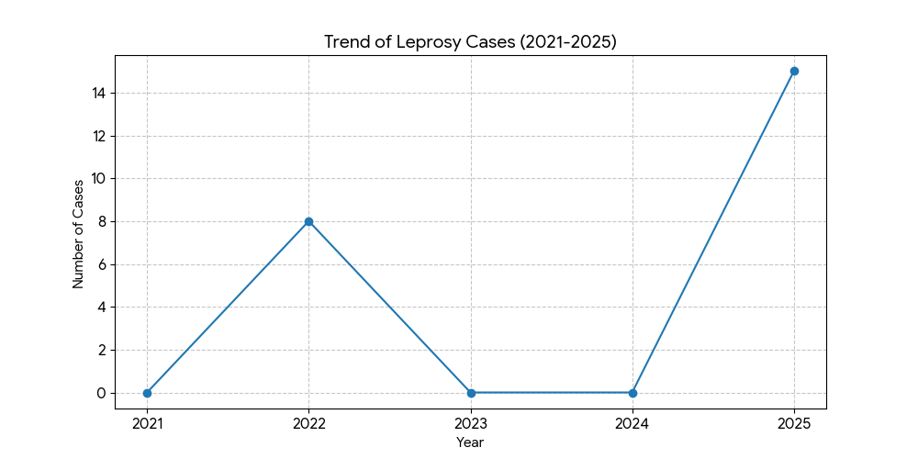

*(use the above table data to create the graph/diagram)

Seasonal Trend Analysis
Seasonal analysis helps anticipate surges (e.g. dengue in monsoon, leptospirosis after floods, influenza in cooler months) and plan pre‑emptive vector control, stockpiling of IV fluids, and awareness campaigns at Panchayat level.

DENGUE
Dengue is a major seasonal vector-borne disease strongly associated with rainfall, water stagnation, and increased mosquito breeding during the monsoon period.

Peak: July–November

Dengue – Ward-wise Yearly Distribution (2021–2025)

Ward | Dengue – Ward-wise Yearly Distribution
Ward | 2021 | 2022 | 2023 | 2024 | 2025 | Total
1 | 0 | 0 | 1 | 0 | 0 | 1
2 | 0 | 0 | 4 | 2 | 0 | 6
3 | 0 | 1 | 2 | 0 | 0 | 3
4 | 0 | 1 | 2 | 0 | 0 | 3
5 | 0 | 1 | 2 | 1 | 0 | 4
6 | 0 | 0 | 1 | 1 | 0 | 2
7 | 0 | 1 | 3 | 2 | 0 | 6
8 | 0 | 0 | 0 | 2 | 1 | 3
9 | 0 | 0 | 0 | 2 | 0 | 2
10 | 0 | 0 | 0 | 1 | 1 | 2
11 | 0 | 3 | 0 | 0 | 0 | 3
12 | 0 | 2 | 0 | 1 | 1 | 4
13 | 0 | 0 | 3 | 5 | 2 | 10
14 | 0 | 1 | 1 | 2 | 1 | 5
15 | 0 | 1 | 1 | 5 | 0 | 7
16 | 1 | 0 | 1 | 2 | 0 | 4
17 | 0 | 1 | 26 | 3 | 2 | 32
18 | 0 | 1 | 7 | 3 | 1 | 12

LEPTOSPIROSIS
Leptospirosis cases are closely linked to monsoon rains, flooding, and occupational exposure, particularly in low-lying and waterlogged areas.

Peak: June - August

Leptospirosis – Ward-wise Yearly Distribution (2021–2025)

Ward | Leptospirosis – Ward-wise Yearly Distribution
Ward | 2021 | 2022 | 2023 | 2024 | 2025 | Total
1 | 0 | 0 | 0 | 0 | 0 | 0
2 | 0 | 0 | 0 | 0 | 0 | 0
3 | 0 | 0 | 0 | 0 | 0 | 0
4 | 0 | 0 | 0 | 1 | 0 | 1
5 | 0 | 1 | 0 | 0 | 0 | 1
6 | 0 | 0 | 0 | 0 | 0 | 0
7 | 0 | 0 | 0 | 0 | 0 | 0
8 | 0 | 1 | 0 | 1 | 0 | 2
9 | 0 | 0 | 0 | 0 | 0 | 0
10 | 0 | 0 | 0 | 2 | 1 | 3
11 | 0 | 0 | 0 | 0 | 0 | 0
12 | 0 | 0 | 0 | 0 | 0 | 0
13 | 0 | 0 | 0 | 2 | 1 | 3
14 | 0 | 0 | 0 | 1 | 0 | 1
15 | 0 | 0 | 1 | 0 | 0 | 1
16 | 0 | 0 | 0 | 0 | 0 | 0
17 | 1 | 0 | 0 | 0 | 0 | 1
18 | 0 | 0 | 0 | 0 | 0 | 0

VIRAL HEPATITIS - A
Hepatitis A cases are commonly associated with unsafe drinking water, food contamination, and breakdowns in sanitation, often presenting as clusters or outbreaks.

Peak: October - December

Hepatitis A – Ward-wise Yearly Distribution (2021–2025)

Ward | Hep A – Ward-wise Yearly Distribution
Ward | 2021 | 2022 | 2023 | 2024 | 2025 | Total
1 | 0 | 0 | 0 | 0 | 0 | 0
2 | 0 | 0 | 0 | 0 | 0 | 0
3 | 0 | 0 | 0 | 0 | 0 | 0
4 | 0 | 0 | 0 | 0 | 0 | 0
5 | 0 | 0 | 0 | 0 | 0 | 0
6 | 0 | 0 | 0 | 0 | 1 | 1
7 | 0 | 0 | 0 | 0 | 1 | 1
8 | 1 | 0 | 0 | 0 | 0 | 1
9 | 0 | 0 | 0 | 0 | 1 | 1
10 | 0 | 0 | 0 | 1 | 0 | 1
11 | 0 | 0 | 0 | 0 | 0 | 0
12 | 0 | 0 | 0 | 1 | 0 | 1
13 | 0 | 0 | 0 | 0 | 0 | 0
14 | 0 | 0 | 0 | 0 | 1 | 1
15 | 1 | 0 | 0 | 0 | 0 | 1
16 | 0 | 0 | 0 | 1 | 0 | 1
17 | 0 | 0 | 0 | 0 | 0 | 0
18 | 0 | 0 | 0 | 0 | 4 | 4

Outcome-Based Trend Analysis- 2025

Transmission Trend- 2025
For effective management of public health issues, it is important to track the trend of disease transmission mode. It helps identify the population or place at high risk that can be used to predict outbreaks and implement targeted interventions as quickly as possible. Understanding these kinds of trends enables authorities to allocate resources efficiently and change the strategies adequately based on the trend that follows.

Mode of Transmission | No. of cases | No. of Deaths
Vector Borne Diseases | 8 | 0
Water Borne Diseases | 8 | 0
Air Borne Diseases | 19 | 2
Blood Borne Diseases | 0 | 0
Food Borne Diseases | 0 | 0

Vector-Borne Disease

Disease | No. of Cases | No. of Deaths
Dengue | 9 | 0
Malaria | 1 | 0
Chikungunya | 0 | 0

Water Borne Disease

Disease | No. of Cases | No. of Deaths
Cholera | 0 | 0
Typhoid | 1 | 0
Hep- A | 8 | 0
Dysentery | 0 | 0
Amoebiasis | 0 | 0
E- Coli infections | 0 | 0
Air Borne Disease

Disease | No. of Cases | No. of Deaths
Influenza | 0 | 0
H1N1 | 0 | 0
TB | 19 | 2
Chickenpox | 7 | 0
Measles | 0 | 0
Covid-19 | 0 | 0
Pertussis | 0 | 0
Mumps | 11 | 0

Blood-Borne Disease

Disease | No. of Cases | No. of Deaths
AIDS | 0 | 0
Hep- B | 4 | 0
Hep- C | 0 | 0

Zoonotic Disease

Disease | No. of Cases | No. of Deaths
Rabies | 0 | 0
Leptospirosis | 2 | 0
Avian influenza | 0 | 0
West nile | 0 | 0
Anthrax | 0 | 0
Nipah | 0 | 0
Scrub Typhus | 0 | 0

Integrated Disease Hotspot Map (2021–2025)

Ward No | Dengue Total (2021-25) | Leptospirosis Total (2021-25) | Hepatitis A Total (2021-25) | H1NI(2021-25) | SCRUB TYPHUS (2021-25) | Total Cases
1 | 1 | 0 | 0 | 0 | 0 | 1
2 | 6 | 0 | 0 | 0 | 0 | 6
3 | 3 | 0 | 0 | 0 | 0 | 3
4 | 3 | 1 | 0 | 0 | 0 | 4
5 | 4 | 1 | 0 | 1 | 0 | 6
6 | 2 | 0 | 1 | 0 | 0 | 3
7 | 6 | 0 | 1 | 0 | 0 | 7
8 | 3 | 2 | 1 | 1 | 0 | 7
9 | 2 | 0 | 1 | 0 | 0 | 3
10 | 2 | 3 | 1 | 0 | 0 | 6
11 | 3 | 0 | 0 | 0 | 0 | 3
12 | 4 | 0 | 1 | 0 | 0 | 5
13 | 10 | 3 | 0 | 0 | 1 | 14
14 | 5 | 1 | 1 | 0 | 0 | 3
15 | 7 | 1 | 1 | 0 | 0 | 9
16 | 4 | 1 | 1 | 0 | 0 | 6
17 | 32 | 1 | 0 | 0 | 0 | 33
18 | 12 | 0 | 4 | 0 | 0 | 16

Preparedness and Response Protocol at LSG Level
This section describes the operational framework for the LSGI once a pandemic is declared. It explains how the LSGI and health system will move from routine data collection to active response, using a One Health approach.

Constitution of One Health Committee
The LSGD shall constitute a One Health Committee comprising the LSGI President, Medical Officers (Modern Medicine, AYUSH, and Veterinary), the Health Inspector, and the Veterinary Surgeon.

Objective: The One Health Committee coordinates human, animal, and environmental health to prevent and control pandemics.

Sl No | Name | Designation | Department/Institution | Role in Committee | Contact Number
1 | SURESH | Panchayat President | LSGD | Chairperson | 9946607366
2 | DR Remya | Medical Officer (PHC/CHC) | Health Dept | Member Secretary | 8078180337
3 | Arjun Shajahan | Veterinary Officer | Animal Husbandry | Member | 9747074058
4 | Renjana | Epidemiologist | Health Dept | Member | 6238556793
5 | Abdhul Razzak | Health Inspector/PHN | Health Dept | Surveillance | 8089726985
6 | Sumesh Kumar | ASHA Supervisor | Health Dept | Community link | 9745177022
7 | Sameena | ICDS Supervisor | Social Welfare | Vulnerable groups | 9961198304
8 | Medenakshipuram police station | Police Station Officer | Police Dept | Law & order | 04923234100
9 | Sharmila | Ward Councillor Representative | LSGD | Community coordination | 9447266877
10 | Sangeetha | Kudumbashree CDO | Kudumbashree | Community mobilisation | 8089396892
11 | Vijayakrishnan | NGO/Volunteer rep | Civil Society | Support services | 8921651895

Key Responsibilities:
- Review disease surveillance data (human + animal)
- Conduct ward-wise risk assessment and vulnerability mapping
- Approve quarantine/isolation centre locations
- Coordinate with district for resources (PPE, oxygen, ambulances)
- Periodically review health system surge capacity, including beds, oxygen, human resources, and ambulances.
- Approve and monitor risk communication and community engagement strategies, including rumour management.
- Ensure protection and service continuity for vulnerable groups (elderly, persons with disabilities, dialysis patients, coastal populations).
- Conduct quarterly mock drills
- Monitor equity measures for vulnerable groups

Meeting Schedule:
Quarterly (normal times) | Weekly (outbreak alert) | Daily (pandemic phase)

Pandemic Response Workforce
To ensure a coordinated and timely response during a pandemic, a dedicated Pandemic Response Workforce shall be constituted at the LSG level. The workforce will function under the overall supervision of the One Health Committee and in close coordination with the health authorities. Team-based deployment will enable efficient surveillance, case management, quarantine and isolation management, logistics support, and risk communication. Each team shall have a clearly designated team leader, defined roles, and an identified pool of personnel to allow rapid activation, rotation of duties, and continuity of services during prolonged emergencies.

Total Response Workforce Available: 300 persons

Team Name | Composition | Key Responsibilities | Team Leader
Surveillance and Contact Tracing Team | HI, JHI, JPHN, ASHAs and Volunteers | Case detection, contact listing, home visits, reporting | HI
Case Management Team | Doctors, Nurses, MLSP, Palliative Nurses | Patient care & referral | DOCTOR
Quarantine & Isolation Team | LSGD staff, Volunteers | Facility management | JHI
Psychosocial support | counseller
Logistics & supply chain Team | LSGD staff, Storekeepers, Drivers 3 | Supplies & transport [PPE, medicines, oxygen, transport, waste management] | Ward Member
Communication Team | Ward members, Kudumbashree, Youth clubs,  AWW workers and other self help groups | IEC, community meetings, countering misinformation | M.O in charge
Transportation | KSRTC, educational institutional buses
Media Surveillance
Intersectoral coordination and convergence | Forest ,Civil supplies etc

All teams shall be activated immediately upon outbreak alert or pandemic declaration and shall report daily to the LSG Incident Commander/Medical Officer, with consolidated reporting to the Block PHC. Duty rosters and alternate personnel shall be maintained to ensure uninterrupted services during staff shortages or prolonged response periods. Team composition and numbers may be revised based on the magnitude of the outbreak and availability of human resources.

Activities and Measures before and during Pandemic

PHASE 1 - Alert / Preparation
Surveillance and Reporting-Enhanced syndromic surveillance:
- Data sources for surveillance:
- Event-based triggers (to be monitored and reported):
- Zoonotic and animal health surveillance
- Logistics and Stock Preparedness
  - Identify and empanel local vendors and define emergency procurement mechanisms in accordance with existing LSGD and Health Department norms.
  - Prepare and maintain an essential logistics checklist covering medical supplies, consumables, and support equipment.
  - Pre-identify secure storage locations for emergency stocks and ensure maintenance of stock registers with regular updating.
  - Finalise emergency transport arrangements, including availability of vehicles and identified drivers for rapid deployment during alerts.
  - Designate a Nodal Officer for Logistics to enable prompt decision-making, coordination, and communication during emergencies.
  - Conduct rapid stock verification and ensure availability of minimum buffer stock, including:
- PPE kits –50 numbers
- Pulse oximeters – __20_ numbers
- Hand sanitizers – ___ 100 litres
- Masks, gloves, disinfectants –1500 adequate quantity
Identify critical gaps in logistics and immediately communicate requirements to the Block and District authorities for timely replenishment and support. Monitor expiry dates and stock rotation.

Identification of Quarantine and Isolation Facilities
  - Identify and list suitable buildings for quarantine and isolation (schools, hostels, community halls, etc.).
  - Categorise cases as per the severity and allocate to appropriate facilities (for instance, severe cases to classrooms, mild cases to an assembly hall in case of a school).
  - Facility readiness checklist needed (beds, toilets, ventilation) etc.
  - Find an alternate site if the primary sites are not available or not in use.
  - Identify facility managers and support staff
  - Prepare basic SOPs for:
    - Admission and discharge
    - Food, water, sanitation
    - Infection prevention and waste disposal
  - Ensure availability of basic amenities: water, sanitation, electricity, ventilation, and waste disposal. Prepare a rapid activation plan for these facilities if case numbers increase.

Risk Communication and Community Preparedness
  - Disseminate early warning messages on symptoms, preventive measures, and reporting mechanisms. Display IEC materials both in English and the local language in public places and ensure ward-level awareness.
  - Sensitize elected representatives and community leaders on preparedness measures.
  - Establish a rumour tracking and misinformation response mechanism to identify, verify, and promptly counter false or misleading information.
  - Engage trusted local persons (ward members, ASHA workers, religious leaders, teachers, community volunteers) to communicate official public health messages and reinforce correct practices.
  - Develop and deploy targeted IEC materials for:
    - Schools and educational institutions
    - Markets and commercial areas
    - Work sites and labour settings
  - Conduct community sensitization meetings at the ward level to promote preventive behaviors, address concerns, and strengthen community participation in preparedness and response.

Protection of Vulnerable Groups
Vulnerable populations require priority protection through targeted line-listing, service continuity, and delivery mechanisms.
- Prepare and regularly update line-lists of vulnerable populations, including:
  - Elderly persons living alone
  - Persons with disabilities
  - Pregnant women
  - Migrant workers
  - Dialysis patients
The detailed line-lists shall be maintained as Annexure ___ and updated periodically.

Clinical Dependency Mapping
Develop ward-wise dependency and vulnerability maps to identify households requiring regular support during emergencies. Ensure continuity of essential health services for vulnerable groups, including
- Dialysis services (facility mapping, transport arrangements, and scheduling)
- Continuity of treatment for TB, HIV, and other chronic conditions requiring uninterrupted medication
- Mental health and psychosocial support services
Establish delivery mechanisms for food, essential commodities, and medicines to vulnerable households through coordinated action involving ASHAs, JPHNs, Kudumbashree, volunteers, and local administration.

PHASE 2 - Active Response

Case Identification and Contact Tracing
Case detection and contact tracing activities will be carried out in coordination with the Health authorities, following disease-specific SOPs and IDSP guidelines.
Field Staff Involved
- Health Inspector (HI)
- Junior Health Inspector (JHI)
- Junior Public Health Nurse (JPHN)
- ASHAs and ASHA Supervisors
- Ward-level volunteers and Kudumbashree members (as required)
Designation | Name | Contact
HI | Abdhu Razcak | 8089726985
JHI | Sanoj | 7293105801
JPHN | Anu Ramesh | 9847181677
ASHA | BHANU | 9809185326
ASHA | SUNITHA | 8301961377
ASHA | GIRIJA | 9846016185
ASHA | SARITHA | 9400602700
ASHA | PADMAJA | 9605123701
Ward level volunteers & Kudumbasree members | Sangeetha(CDS)  Ambika | 8089396892  9947569258

Screening Checkpoints
Screening checkpoints at high-traffic locations (transport hubs, markets, religious gatherings) for early detection of symptomatic travellers and crowd screening during outbreaks. Potential locations include bus stands, market entry points, and boat jetties, based on local context and risk assessment.
Screening activities will be carried out by trained personnel such as ASHAs, ward members, and volunteers, with support from Health Department staff. Necessary equipment, including non-contact thermometers and appropriate PPE, shall be ensured prior to activation.
Location | Type (Bus stand/Jetty/Market/Railway) | Staff Deployed (ASHAs/Volunteers) | Screening Method | Reporting authority
Bus stand  Meenakshipuaram | Busstand | Shahanaz JPHN /Girija Asha | 1.Swab Collection.  2. Blood smears collection (RDT)  3.Thermal Scanners | Surveillance Nodal Officer in control room
Vandithavaalm | Bus stand | ROJA JHI/Prema Asha | 1.Swab Collection.  2. Blood smears collection (RDT)  3.Thermal Scanners | Surveillance Nodal Officer in control room
Vilayodi | Busstand | Jinsy Jhi/Sujatha Asha | 1.Swab Collection.  2. Blood smears collection (RDT)  3.Thermal Scanners | Surveillance Nodal Officer in control room
Kannimari Pallimmokku | All type Vehicle | Abhinjha MLSP/Sumathi Asha | 1.Swab Collection.  2. Blood smears collection (RDT)  3.Thermal Scanners | Surveillance Nodal Officer in control room
Narani | All type Vehicle | Abhinjha MLSP/Leelamani Asha | 1.Swab Collection.  2. Blood smears collection (RDT)  3.Thermal Scanners | Surveillance Nodal Officer in control room
Special Team | All type Vehicle | Simi Jphn/Kalyani Asha/Bhagyavathi Asha/Reena Asha | 1.Swab Collection.  2. Blood smears collection (RDT)  3.Thermal Scanners | Surveillance Nodal Officer in control room

Standard Screening Protocol

The screening protocol shall include temperature screening, observation for visible symptoms, and inquiry regarding recent travel or exposure history. Individuals identified as suspects during screening shall be immediately referred to the nearest PHC/FHC for further evaluation, testing, and appropriate action as per prevailing guidelines.

Pandemic Control Room
The Pandemic Control Room (PCR) serves as the central nerve center for real-time coordination, data aggregation, decision support, and communication during outbreaks. It consolidates information from all LSGD teams, health facilities and community sources to enable rapid response decisions.

Control Room Infrastructure and Location
Primary Location: Perumatty Panchayath Office.
Backup Location: Community Hall in perumatty G.P.

Health System Control Room Framework
The PCR is organized into seven functional pillars to ensure no aspect of the response is overlooked:

Rapid Response Team (RRT)
  - Provides immediate intervention during emergencies, clusters, and field alerts.​
  - Coordinates urgent actions such as case investigation, contact tracing, isolation, and inter‑facility referrals.

Data Management & Ainalytics Team
  - Collects, validates, and manages key health system indicators (cases, tests, beds, HR, supplies).​
  - Analyzes data trends, generates projections, and supports evidence‑based decision‑making for local authorities.

Human Resource Deployment Team
  - Allocates healthcare staff efficiently based on workload and need
  - Ensures adequate and equitable workforce distribution across facilities

Laboratory Surveillance Team
  - Oversees diagnostic testing coordination, sample transport, and timely reporting of results.​
  - Monitors lab indicators (testing volume, positivity rate, turnaround time) for early detection of outbreaks

Vaccination Cell (If Required)
  - Plans and executes vaccination campaigns, including micro‑planning and session scheduling.​
  - Tracks coverage, identifies gaps, and coordinates corrective actions with field teams and outreach services.

Infrastructure & Patient Occupancy Team
  - Monitors facility capacity, earmarked beds, oxygen and critical care resources across all linked facilities.​
  - Ensures optimal patient distribution and referral management using updated bed‑status and resource data.
  - BMWM

Communication team
- Logistics and supply chain
- Transportation (interfacility & emergency transport)
- Media surveillance Call centre
- Management of the deceased
- Intersectoral coordination and convergence

Key Control Room Team
The Control Room Team coordinates all pandemic response activities within the LSGD and serves as the single command and communication hub during activation. It integrates information, field actions, logistics, and policy execution across all participating departments and health facilities.

Role | Name | Designation | Contact Number | Responsibility
In-charge/Nodal Officer | DR REMYA | MO | 8078190337 | Overall coordination, decision-making, and reporting to the District level.
Data Entry Operator | Ajeesh Aswathy | clerk, Mlsp | 9447835055,  8139838865 | Managing the line list, updating dashboards, and tracking testing results.
Communication Officer | Anu Ramesh,Aiswarya | Jphn,MLSP | 9847181677,8590645589 | Handling the public helpline, coordinating ambulance dispatch, and contact tracing calls.
Logistics Coordinator | Daivani,Shereena | Jphn,RBSK | 9745162978,9846438255 | N
Technical Support (IT/Data) | Bindhu TA Panchayath,Sanoj | TA,JHI | 9567141910,7293105801 | N

SOP for alert escalation/trigger point with mapping of responsibilities.
Key Points:
- The Control Room shall be staffed with a designated In-charge, data entry personnel, and communication staff with clearly defined roles and shift arrangements.
- It shall maintain updated records on daily monitoring indicators including new cases, persons under active quarantine, and hospital bed occupancy.
- All reports and situation updates shall be shared daily with the Block and District Surveillance Unit.
- The Control Room shall act as a single point of contact for coordination with response teams, health institutions, and other departments.
- Contact details of the Control Room shall be widely communicated to field staff and stakeholders during activation.

Daily Monitoring Indicators
To ensure timely decision-making and effective response, the following key indicators shall be monitored and updated on a daily basis by the Pandemic Control Room:

Epidemiological Indicators:
New cases reported today, Total active cases, Test Positivity Rate (TPR), Case Fatality Rate (CFR)
- Surveillance Indicators:
Persons under home quarantine, High-risk contacts identified, Fever, ILI, SARI or other symptoms (syndromic surges), Travellers (symptomatic or high-risk arrivals),Animal husbandry surveillance (zoonotic alerts, unusual animal deaths, poultry/bird flu signals), Mortality surveillance (excess deaths, unexplained fatalities, verbal autopsy reports)
- Logistics and Infrastructure Indicators:
Hospital / CFLTC beds occupied, Oxygen cylinders/concentrators available, Ambulances on standby
- Alert Findings
The following table outlines category-specific trigger points (red flags) from surveillance indicators and corresponding immediate actions for the Pandemic Control Room. These enable rapid response to alert findings like testing anomalies, positive cases exceeding thresholds, clusters, and WGS reports.

Category | Trigger Pophint (Red Flag) | Immediate Action
Clusters | Geographical or facility-based: 5+ cases linked to one location (office, school, street). | Declare a micro-containment zone; perimeter control and active case finding.
Testing | Sudden drop in testing volume / delay in reporting / unusual testing trends | Review the sample collection process, address lab bottlenecks, deploy additional testing teams, and notify the District Lab.
Lab | Test Positivity rate increases | Increase testing sites in that ward.
Hospital | >80% Oxygen bed occupancy | Activate backup/CFLTC beds.
Travel | Cluster of cases from a single flight/train or high-risk arrival group. | Trace all passengers in adjacent seats; implement mandatory institutional quarantine.
Animal | Mass poultry/wildlife death or unusual sickness | Notify Animal Husbandry, sample the area, and dispatch RRT for environmental sampling and zoonotic check.
Mortality | Sudden spike in home deaths or brought-in-dead (BID) cases | Audit the deaths and Active Case Search drive
Additional investigations like Whole Genome Sequencing (WGS) | Detection of a Variant of Concern (VOC) or Variant of Interest (VOI) | Implement strict micro-containment; update clinical protocols to match variant severity.

Communication of Public Health Information
A Community Communication Hub shall be established to ensure timely, accurate, and consistent dissemination of information during a pandemic. The Hub will function under the coordination of Nodal officers of the control room and act as the nodal point for public communication, risk messaging, and community engagement. It will support dissemination of official advisories, promote preventive behaviors, address rumors and misinformation, and ensure that messages reach all sections of the population through trusted local channels and leaders.

Key communicators
Channel | Responsible Person | Contact
Ward-level announcements | SURESH (Panchayt president) | 9946607366
Social media | sasi kumar(ward member) | 9446876540
Local Cable TV/Radio | Ajimon(Volunteer) | 9961155326

- All messages disseminated through the Hub shall align with advisories issued by the Health Department and District authorities.
- Community leaders shall be sensitized to support behavior change, reduce stigma, and counter misinformation.
- Special efforts shall be made to reach vulnerable and hard-to-reach populations using locally appropriate communication methods.

Rumor Tracking: A designated volunteer will monitor local social media/WhatsApp groups daily to identify misinformation and issue official clarifications via the Communication Hub.

Coordination with District/State Authorities & Other Organisations
Effective coordination with Block, District, and State authorities is essential to ensure timely reporting, technical guidance, and uninterrupted supply of essential resources during a pandemic. The LSG shall establish clear communication channels, designate responsible officers, and adhere to prescribed reporting timelines to support coordinated public health action and efficient resource mobilisation.

Key Details:
- Nodal Officer for Reporting:
- Contact Number:
Reporting Schedule and Protocols:

To Whom | What to Report | Frequency | Nodal Person
Block PHC | Complete Situation Report (Cases, Quarantine, Beds, Screening, Deaths) | Every hour | Ramadas (Health supervisor)
District IDSP Unit | Outbreaks/Clusters/Unusual Events (>5 cases same ward) | Every hour | Medical officer FHC Perumatty
Veterinary Officer | Animal health events/Zoonotic alerts | Every hour | Health inspector
STATE CELL | Zoonotic cross-sector events | Every hour | Panchayat secretary/Nodel officer

Supply Chain Coordination
The LSG shall coordinate closely with Block, District, and State authorities (KMSCL) to ensure uninterrupted availability of essential goods, medical supplies, and logistics during a pandemic. Supply requirements shall be assessed regularly based on case load and communicated promptly to the appropriate authorities for timely replenishment.
Key Points:
- Maintain updated contact details of District and Block nodal officers for health logistics, oxygen supply, ambulances, and essential medicines.
- Submit timely indent requests for PPE, testing kits, medicines, oxygen, and other critical supplies through prescribed channels.
- Monitor stock levels at LSGD facilities, quarantine/isolation centres, and field teams through daily stock registers and dispensing logs to prevent shortages.
- Coordinate with District authorities, Karunya/Neethi medical shops, and local purchase committees for funds allocation and emergency procurement.

- Ensure regular monitoring of dispensing registers at all facilities to track usage, expiry, and pilferage—shortages being a perennial issue requiring proactive weekly audits.

- Activate surge procurement protocols during high caseloads, leveraging local purchase powers under LSGD funds alongside state supplies.

Resource Inventory and Contacts
Resource Category | Source  (District/State/Private) | Contact
PPE Kits/Masks/Gloves | KMSCL | 04912533336,7012208221
PPE Kits/Masks/Gloves | Local Vendors | 04912533336
Oxygen  Cylinders/Concentrators | KMSCL | 04912533336
Medicines/Antivirals | KMSCL | 04912533336
Medicines/Antivirals | Neethi Shops | 7593851943 thrissur,9495968218 (Kanjikode)
Test Kits (RTPCR/Rapid) | KMSCL | 04912533336

Collaboration with NGOs, PPP, and CSR
To augment government efforts during a pandemic, the LSG shall collaborate with NGOs, voluntary organisations, and private sector partners through public–private partnerships and Corporate Social Responsibility (CSR) initiatives, in coordination with District authorities.

Key Points:
- Engage NGOs and community-based organisations for community outreach, awareness, and support to vulnerable populations.
- Leverage CSR support for procurement of medical equipment, PPE, oxygen concentrators, food kits, and sanitation materials, as permitted.
- Ensure all collaborations align with government guidelines and are routed through approved administrative and financial procedures.
- Maintain transparency and documentation for all external support received and utilised.
Organization | Type | Support Offered | Contact Person
Youth Clubs/Student Unions | CBO | Volunteers (RRT:Delivery of food kits,medicines,blood donation & Awareness campaign) | Secretary local clubs

Interdepartmental Coordination
Coordination among departments during a pandemic shall be ensured through regular review meetings convened by the LSGD President. These meetings will provide a structured platform for sharing situational updates, assessing resource availability, resolving operational gaps, and taking joint decisions to ensure a coordinated and timely response.

Department | Representative | Key Role | Contact
Health (PHC) | Staff Nurse : | Case management | 8921357721
Veterinary | Veterinary Surgeon: | Animal surveillance | 9747074058
ICDS | Supervisor: Sindhu | Nutrition support | 9961198304
Education | Head Teacher: | School coordination
Police | SHO (MEENAKSHIPURAM) | Containment enforcement | 04923234100,  04923236233
Water Authority | AE | Water supply | 04923221056
LSGD Engineering | smitha(Assist Engineer) | Quarantine infrastructure | 9961327764

PHASE 3 - Surge Capacity
Phase 3 is activated when there is a rapid increase in cases, high test positivity rates, or when existing health facilities and quarantine arrangements approach saturation. The focus of this phase is to expand isolation capacity, augment clinical care services, and mobilise additional resources through district and state support mechanisms.

Conversion of Community Facilities
To manage increased case load, the LSGD shall activate additional isolation facilities by repurposing identified community infrastructure such as community halls, auditoriums, schools, hostels, or other suitable buildings.

Name of facility | Facility Type | No. of Buildings | Ward | Surge Capacity (Beds) | Nodal Person
Community Halls | Community Hall | 4 | 9,13,15 | 120 | AE LSGD
Government Higher Secondary School | School | 9 | 1,3,4,7,12,11 | 150 | HEAD MASTER
AuditoriumS | Auditorium | 6 | 1,17,16,14,12 | 3000 | Health Inspector
ST Hostel Complex | Hostel | 1 | 11 | 500 | ST DEpartment
Model Anganwadi Center (Large) | Other | 1 | 15 | 15 | ICDS Supervisor

- Recovery and rehabilitation phase
- Recovery
  - Damage & impact assessment
  - Restoration of health services
  - Rehabilitation of affected population
  - Psychosocial & mental health support
  - Disease surveillance during recovery phase
  - Environmental cleanup & sanitation
  - Livelihood restoration
  - Community engagement & confidence building
  - Documentation & after-action review
  - Lessons learned & best practices
  - Health system strengthening
  - Policy revision & preparedness enhancement
  - Research

CONCLUSION

Additional points
- tech support
- relief based commodities
- ham reading operators
- hazard vulnerability mapping
- Kseb & other power source
- HR specific responsibility

RECOMMENDATIONS

Strengthening Healthcare Infrastructure
- Establish a primary health response unit within the Panchayat with trained staff.
- Ensure availability of basic medical supplies (masks, sanitizers, PPE kits, oxygen cylinders).
- Create tie-ups with nearby hospitals in ____________ for emergency referral and transport.

2. Community Awareness & Education
- Conduct regular awareness campaigns on hygiene, vaccination, and preventive measures.
- Use local communication channels (community radio, WhatsApp groups, notice boards) to spread verified information.
- Train volunteers to act as health ambassadors in each ward.

3. Emergency Response & Coordination
- Form a Pandemic Preparedness Committee at Panchayat level including health workers, ward members, and NGOs.
- Develop a clear action plan for lockdowns, quarantine, and distribution of essentials.
- Maintain a database of vulnerable groups (elderly, differently-abled, chronically ill) for targeted support.

4. Supply Chain & Food Security
- Identify and support local suppliers and farmers to ensure uninterrupted food supply.
- Create community kitchens during emergencies to serve vulnerable populations.
- Stockpile essential commodities in Panchayat-run outlets for crisis periods.

5. Digital Preparedness
- Promote digital platforms for telemedicine consultations.
- Use Panchayat’s website/social media for real-time updates on health advisories.
- Encourage online grievance redressal to reduce crowding in offices.

6. Training & Capacity Building
- Organize mock drills for pandemic response in schools, offices, and public spaces.
- Train Panchayat staff and volunteers in first aid, infection control, and crowd management.
- Collaborate with NGOs and health departments for capacity-building workshops.

7. Long-Term Resilience
- Integrate pandemic preparedness into the Panchayat Development Plan.
- Allocate a dedicated budget for health emergencies.
- Encourage community participation in planning and monitoring preparedness measures.

MOCKDRILL SCENARIOS

ANNEXURE

IMPORTANT PHONE NUMBERS

Phone numbers and particulars of persons responsible for providing guidance, assistance, and support for pandemic preparedness operations may be provided here in a manner that allows easy reference at a glance. The information recorded here could be exhibited elsewhere at the time of emergencies. LSG institutions shall give special attention to collect and record the above data of persons and institutions who/which are supposed to give technical and co-ordination support to reduce the impact of pandemic.

Annexure 7

1.1. Details of grama panchayat/municipality/corporation wards
Sl.No | Name of the ward | Ward number | Name of the ward  member | Contact number
1 | Athimani | 1 | Jayan.M | 9349733534
2 | Parakkalam | 2 | Amsaveni.k | 6238089408
3 | Vilayodi | 3 | Sheeja | 9544656721
4 | Namboorichalla | 4 | Vijesh.V | 9846417796
5 | Maruthampara | 5 | Pratheena.P | 9539685859
6 | Vembra | 6 | Sabitha.H | 8089805046
7 | Narani | 7 | Vijeesh.K | 9633553962
8 | Kalyanapetta | 8 | Narayanankutty.K | 9497122667
9 | Kambalathara | 9 | Sunitha.M | 8301961377
10 | Srambi | 10 | Priyanka.M | 7306570130
11 | Ramarpannai | 11 | Jayanthi | 9597325061
12 | Moolathara | 12 | D.Senthilkumar | 9865986363
13 | Meenakshipuram | 13 | Sivakumar.S | 9446240256
14 | Nellimedu | 14 | Nagaraj.A | 9942844555
15 | Plachimada | 15 | Suesh.K | 9946607366
16 | Pattikulam | 16 | Sarasu.M | 9745324118
17 | Perumatty | 17 | Sreeja | 8139807929
18 | Vandithavalam | 18 | Sharmila | 9447266877
19 | Alayar | 19 | Shyamalakumari | 9447619918
20 | Madappallam | 20 | Sasikumar.R | 9446876540

Annexure 8

1.2. Other important phone numbers of grama panchayat/municipality/corporation area
Sl. No. | Name | Contact number
1. | Perumatty Gramapanchayat | 04923232226
2. | Police station | 04923234100
3. | Family Health Centre Perumatty | 04023296433
4 | Excise department Chittur | 04923222272

1.3. Important offices of grama panchayat/municipality/ corporation
Sl.No | Name of the office | Contact person | Contact number
1. | Village Office | Village Officer | 8547614712-Perumatty,8547614715-Vandithavalam,  8547614710-Moolathara
2. | Agriculture Office | Agriculture Officer | 9383471546
3. | Animal Husbandry Office | Animal Husbandry Doctor | 97470784058
4. | Police Station | Police Officer | 04923234100
5. | BSNL Office(Chitur) | Officer | 04923223000
6. | Block Office Nattukal | Officer | 04923272241
7. | KSEB Office | Officer | 04923232880
8. | Fisheries Office `(Chitur) | Officer | 04923222444
9. | Fire and Rescue(Chitur) | Officer | 9778411720

1.4. Health Services

Sl. No | Name of the hospital/institution | Location | Phone number
1. | Government hospitals/PHC | Nellimedu/  Alayar/  Parakkalam | 04923296433/04923232316/04923296111
2. | Private hospitals | KMCH Vilayodi | 04923225300
3. | Clinical laboratories | Vandithavalam/Vandithavalam/Nellimedu | 9791173507/8593802229/96453179076
4. | Chemist/pharmacy | NIL | NIL
5. | Blood donors | Blood Donors Kerala | 9846460694(Palakkad Unit)
6. | Other language experts (Bihari, Hindi, Bengali,  Asamees ………)

1.5. Veterinary Services
Sl.No | Name of the Clinic | Name of the  Surgeon/Doctor | Place/location | Phone  number
1 | Govt.Veterinary Hospital | Arjun Shajahan` | Meenakshipuram | 9747074058

1.6. Helpline numbers
Helpline | Phone number
Police | 04923234100,  9497987364
Fire and Rescue | 9778411720
KSEB | 04923232880

Annexure 9

1.7. Public and Private Schools Contact details

S.No | Name of School | Institution type | Phone number
1 | SNUPS NALLAMADANCHALLA | Aided | 9400624066
2 | GLPS NELLIMEDU | Govt | 9965251815
3 | GLPS PARAKKALAM | Govt | 9447741664
4 | RKMLPS KALYANAPETTA | Aided | 9447619911
5 | NUEL PUBLIC SCHOOL VILAYODI | UnAided | 8547215075
6 | GHS MEENAKSHIPURAM | GOVT | 9865162114
7 | Royal School Koomankadu | UnAided | 9656461861
8 | PPHS Kannimari | Govt | 9446082492
9 | PPHSS Kannimari | Govt

Annexure 3

1.9. Anganwadi Contact Details

Ward No | Anganwadi no | NAME OF ANGANWADI TEACHER | Phone number
13 | 57 | Sheenamol | 9074800234
13 | 81 | Saudamini | 9846713269
8 | 54 | Bindhu | 9048515642
8 | 56 | Rohini | 9645933639
6 | 79 | Dhanalakshmi | 9605700281
6 | 75 | Pushpalatha | 9496194491
15 | 64 | Premalatha | 9288055835
14 | 71 | Sheena | 9946013773
14 | 62 | Saraswathi | 9746827728
14 | 78 | Ambika U | 9747866952
7 | 58 | Aysha | 7510367253
7 | 82 | Susheela | 9645790388
2 | 67 | Ambika S | 9447620051
1 | 77 | Pushpalatha | 8086521499
18 | 74 | Sundari | 9496293414
1 | 66 | Nilavarneesa | 9809028818
5 | 59 | Sheela | 9496437643
3 | 68 | Ambika | 9544656630
3 | 69 | Chinthamani | 9947907849
4 | 72 | Sowmana | 9567733286
17 | 73 | Rugmani | 9961576248
5 | 60 | Smrithi | 7012454278
5 | 61 | Bhagyam | 9745160832
16 | 63 | Shobana kumari | 9645314352
10 | 51 | Rahmath | 9074777257
9 | 52 | Manimala | 9048214307
9 | 53 | Geetha | 9747912552
16 | 65 | Shylaja | 9544567571
12 | 55 | Sundari P | 9745903031
11 | 70 | Soumini | 9526084866
11 | 76 | Sumathi C | 8086917370
12 | 80 | Vasanthakumari | 9526084866
10 | 83 | Baby | 7402576576

.12. Information regarding resources

Means of transportation | Name of Owner | Phone Number
Heavy Trucks | BASHEER | 9847997264
Tractor | MANIKANDAN | 9745656384
Ambulances | VISHNU GEETHAM | 9809940339
JCB | JISHNU | 8086752259
Taxi service | PRASHOB | 8593807172

Annexure 1: LSG Baseline Data Collection Format
A. Baseline data
Sl. No. | Indicator / Field | Baseline Data | Source / Remarks
1 | Name of LSG | PERUMATTY | Local self Government Records
2 | District | PALAKKAD | State Administrative dIVISION
3 | Block / Taluk | Chittur | Block Development Office
4 | Type of LSG (Gram Panchayat / Municipality / Corporation) | Gram Panchayt | Rural Local Body
5 | Area (sq. km) | 60.79 | Panchayat Statistics
6 | No. of wards | 20 | Ward delimitation Records
7 | GIS boundary file available | (Yes/No) | KSITM/Planning Board
8 | Key contact person & phone | Suresh (Panchayath President) | LSGD

B. Demography
Indicator / Field | Baseline Data | Source / Remarks
Total population | 30958 | Census/Health Survey
Males | 15466 | Gender wise Distribution
Females | 15492 | Gender wise Distribution
Transgender population | 0 | No Registered data
Age distribution  (<5, 5–14, 15–59, ≥60) | <5 667+606=1273  5-14 1270+1213=2483  >60=-4040 | Integrated age wise Registary
No. of households | 8365 | Household survey/Ration card data
Population density (persons/sq.km) | 509 sq km | Density/Area
No. of migrant workers | 105 | Adithi Portal/Labour data
Major occupational groups | Agricultural allied services,construction | Priumarily& agrarian economy

C. Vulnerable Populations & Social Risks
Sl. No. | Indicator / Field | Baseline Data (Value / Description) | Source / Remarks
1 | No. of elderly (≥60) | 4040 | Local health survey /Asha Registary
2 | No. of persons with disability | 80 | ICDS/PHC Records
3 | No. of bedridden persons | 33 | Palliative Registary
4 | No. of chronic disease cases (DM/HTN/COPD/CKD etc.) | DM-1513  HTN 2145 | NCD Register
5 | Pregnant women (current estimate) | 199 | RCH Register
6 | Children <5 years | 1273 | Anganwady/RCH Records
7 | Tribal population (if any) | 2154 | Census/Tribal department
8 | Fisherfolk / coastal vulnerable groups (if any) | NIL | Land locked area
9 | Urban slums / unnotified settlements (if any) | nil | Rural department
10 | Homeless population | 13 | Life mission Data
11 | Orphanages / old age homes (number & capacity) | NIL | NIL
12 | Hostels / prisons / shelters (number & capacity) | 1 | TRIBAL DEPARTMENT
13 | Poverty / BPL estimate |  | Ration card/Civil Supplies
14 | Food insecurity hotspots | Targeted ST Colonies | SPecific to pocket settlement
15 | Any history of stigma/discrimination issues (Yes/No) | NO | NO report available

D. Health System & Service Readiness
Sl. No. | Indicator / Field | Baseline Data (Value / Description) | Source / Remarks
1 | No. of health facilities in LSG (PHC/CHC/TH/DH/Private) | FHC-1 HWC-5, HOMEO-1,AYURVEDA-1 | Comprehensive public network
2 | PHC/Family Health Centre details (name, location) | FHC PERUMATTI | Panchayat level curative& preventive hub
3 | Subcentres / Health & Wellness Centres (number) | 5 | 1) HWC VILAYODI  2)HWC MOOPANKULAM  3)HWC Koriyarchalla  4)HWC Ayyappankavu  5)HWC Meenakshipuram
4 | Private clinics / hospitals (number) | 1/1 | 1.Smile Dental clinic  2.Karuna medical college vilayodi
5 | Labs available (public/private) | 3 | 1)ARK Vandithavalam  2)Sree VT Nellimedu  3)Neethi Lab Vandithavalam
6 | Availability of ambulance services (Yes/No, number) | YES | 108&Karuna medical college vilayodi
7 | Availability of isolation/quarantine facilities (Yes/No, details) | YES | Maintained at FHC Perumatti
8 | Cold chain facilities (Yes/No, details) | YES(ILR & Deep Freezer) | Dedicated room at FHC
9 | Stockpile space available (Yes/No) | YES | Integrated with KMSCL procurement
10 | PPE / mask / sanitizer availability plan (Yes/No) | YES | Field force for ward level level monitering
11 | Surveillance staff available (JHI/JPHN/ASHA count) | 3/5/25 | Perumatty Gramapanchayth
12 | Existing emergency referral pathways (Yes/No) | YES | Linkage to Taluk Hospital Chittur/DH Palakkad

E. Points of Entry & Mobility
Sl. No. | Indicator / Field | Baseline Data (Value / Description) | Source / Remarks
1 | Bus stands / depots (number) | Meenakshipuram | KSRTC & Private stop over point
2 | Railway stations (number) | NIL | Nearest station Meenakshipuram
3 | Boat jetties / fishing harbours (number) | NIL | NIL
4 | Ports / airports nearby (specify distance) | NIL | NIL
5 | Major highways/roads passing through | SH 27 (Palakkad-Pollachi ) | Road Transport
6 | Border crossings (state/district) | Meenakshipuram | State Border(Kerala -Tamilnadu)
7 | Major markets / weekly markets | Vandithavalam | Local trade & vegetable market
8 | Tourism hubs / major event venues | NIL | NIL
9 | Schools/colleges with hostels (number) | 9/2 | Govenment &Aided/Tribal Department
10 | Factories / large workplaces (number) | Small Scale 4 | MILL
F. Water, Sanitation & Hygiene (WASH)
Sl. No. | Indicator / Field | Baseline Data (Value / Description) | Source / Remarks
1 | Major drinking water sources (piped / wells / borewells / springs) | piped / wells-2333 / borewells / springs) | KWA/Rural Water Supply Scheme
2 | No. of public wells | 61 | Panchayth Asset Register
3 | No. of households with piped water connection | 7999 | KWA Records
4 | Water quality testing routine (Yes/No) | Yes | Bacteriological & Chemical test (monthly)
5 | Common contamination risks (flooding, salinity, industrial waste) | Fluoride content | LAB Test Report
6 | Open defecation free status (Yes/No) | Yes (ODF Plus) | Pnchayat
7 | Solid waste management system (Yes/No) | YES (DOOR to Door status) | LSGI
8 | Bio-medical waste disposal mechanism (Yes/No) | Yes | Image
9 | No. of public toilets | 2 | LSGI
10 | Handwashing stations in public places (Yes/No) | YES | Maintainted At all HWC & FHC
G. Zoonotic Risks & One Health
Sl. No. | Indicator / Field | Baseline Data (Value / Description) | Source / Remarks
1 | Livestock population (cattle/goats/pigs/poultry) – estimates | 14518 | Veterinary Department
2 | No. of dairy farms / poultry farms / pig farms | NIL | Veterinary Department
3 | Slaughterhouses / meat shops (number) | NIL | Veterinary Department
4 | Animal markets (Yes/No, details) | NIL | Veterinary Department
5 | Veterinary dispensaries (number) | 1 | Veterinary Department
6 | History of zoonotic outbreaks (rabies, leptospirosis, avian flu etc.) | Seasonaly | Veterinary Department
7 | Stray dog population management measures (Yes/No) | Yes 818 | Veterinary Department
8 | Rodent infestation hotspots (Yes/No) | Market Areas | Identified as lepto vulnerable zones
9 | Wetlands / waterlogged areas prone to leptospirosis | Paddy Field | Survey/Scattered Wards
10 | Bat roosting areas / caves / fruit orchards (if any) | 1 | Field survey/Ward 8
11 | Human-animal interface hotspots (farms near residences) | \Y | Most households maintain small live stock
H. Climate & Disaster Risks (Pandemic Amplifiers)
Sl. No. | Indicator / Field | Baseline Data (Value / Description) | Source / Remarks
1 | Flood-prone wards (list) | 1(Ward 3-Vilayodi)/Low risk | LSGI DATA
2 | Landslide-prone wards (list) | NIL | LSGI DATA
3 | Cyclone/sea surge risk (Yes/No) | NIL | LSGI DATA
4 | Heatwave risk zones (Yes/No) | NIL | LSGI DATA
5 | Waterlogging areas (list) | NIL | LSGI DATA
6 | Shelter homes / relief camps (number, capacity) | NIL | LSGI DATA
7 | Past disaster displacement history | Minimal localized in 2018 (flood) | LSGI DATA
8 | Disruption to water supply/transport common (Yes/No) | Minimal localized in 2018 (flood) | LSGI DATA
I. Critical Infrastructure & Logistics
Sl. No. | Indicator / Field | Baseline Data (Value / Description) | Source / Remarks
1 | Schools (number) | 9 | Reffer Annexure 9
2 | Anganwadis (number) | 33 | Reffer Annexure 3
3 | Colleges (number) | 0 | nil
4 | Community halls (number) | 6 | Entered in previous pages
5 | Places of worship with large gatherings (number) | 3 | entered in previous pages
6 | Large markets / shopping areas (number) | 0 | LSGI
7 | Warehouses / cold storages (number) | 0 | NIL
8 | Telecom/mobile network coverage gaps (Yes/No) | NIL | NIL
9 | Power outage frequency (high/medium/low) | Medium | LSGI.KSEB
10 | Availability of generators in key facilities | YES | Essential for cold chain maintenance

J. Risk Communication & Community Networks
Sl. No. | Indicator / Field | Baseline Data (Value / Description) | Source / Remarks
1 | Ward-level rapid response teams (Yes/No) | YES | Active since 2018 flood time
2 | Jagratha samithis / committees active (Yes/No) | YES | Active for health and social welfare
3 | Kudumbashree presence and strength (number of units) | 258 | strong grass root network
4 | Volunteer network (number, coverage) | 100 | registered via state portal
5 | Community-based surveillance mechanisms (Yes/No) | yes
6 | IEC dissemination channels (WhatsApp groups, community radio, PA systems) | Whatsapp,PA systems | Health Inspector coordinates
7 | Rumour tracking mechanisms (Yes/No) | YES | Field
8 | Languages spoken / literacy considerations | Malayalam ,Tamil | Border area(Tamilnadu)
9 | Vulnerable groups communication strategy available (Yes/No) | Yes | Volunteer

K. Preparedness Planning & Governance
Sl. No. | Indicator / Field | Baseline Data (Value / Description) | Source / Remarks
1 | LSG emergency plan available (Yes/No) | yes | Updated annually
2 | Pandemic preparedness plan available (Yes/No) | YES | SURVEY
3 | Incident Command System identified (Yes/No) | YES | Standerd administrative structure
4 | Rapid procurement mechanism available (Yes/No) | YES | LSGI
5 | Emergency fund available (Yes/No, amount) | YES | PLAN FUND,NHM(Allocated for disaster/outbreak)
6 | Past outbreak response experience (Yes/No, details) | YES | FHC DATA
7 | Intersectoral coordination mechanism (Health, Police, LSG, Veterinary, Education) | YES | LSGI/FHC DATA
8 | Mock drills conducted in last 12 months (Yes/No) | YES | Monsoon preparedness
9 | Training coverage for staff/volunteers (Yes/No) | YES | occassionally

L. Surveillance & Data Systems
Sl. No. | Indicator / Field | Baseline Data (Value / Description) | Source / Remarks
1 | Digital reporting tools used (e.g., DHIS2, portals) | SHaili,IHIP,JAK PORTAL,AAM | CENTRAL/KERALA HEALTH PORTALS
2 | Availability of line-listing format (Yes/No) | YES | STATE/CENTRAL
3 | Contact tracing team identified (Yes/No) | YES | FIELD
4 | Mapping of high-risk households available (Yes/No) | YES | Focus on high risk groups
5 | Testing sample transport mechanism (Yes/No) | no | no
6 | Reporting timeline adherence (good/average/poor) | Good | Real time entry by JHI/JPHN
7 | Data sharing between departments (Yes/No) | YES | LSGI
8 | Availability of dashboard for monitoring (Yes/No) | YES | PORTAL

M. Additional Notes & Observations
Sl. No. | Indicator / Field | Baseline Data (Value / Description) | Source / Remarks
1 | Key challenges perceived by LSG | Border surveillance/Migrant tracking/POOR living condition of vulnerable groups eg.ST | lABOUR DEPARTMENT,FIELD SURVEY,ST DEPARTMENT
2 | Top 5 high-risk wards (reason) | 10,9,17 | Leprosy patients area & dengue out break history (ward 17)
3 | Any unique local risks (industrial pollution, refugee camps, etc.) | diary farms/Agriculturals fields | veterinary and agriculturals zone
4 | Recommendations for preparedness strengthening | strengthen one health joint visits | Weekly veterinary health team meets

