PANDEMIC PREPAREDNESS PLAN
MODEL OF LSG
KANNAMBRA PANCHAYAT

THE MEDICAL OFFICER
FHC KANNAMBRA
phckannambra@gmail.com

MESSAGE FROM PRESIDENT LSGI
It gives me immense pleasure to present this document on behalf of Kannambra Grama Panchayat. As a Local Self Government Institution, our Panchayat remains committed to the holistic development and well-being of the community through participatory governance, transparency, and sustainable planning.
Kannambra Panchayat, with its unique geographical setting and strong social cohesion, has consistently upheld the values of cooperation and collective responsibility. While the Panchayat has achieved steady progress across multiple sectors, it continues to face challenges such as seasonal climatic variations, public health concerns, environmental issues, and the growing demand for basic infrastructure and essential services. Addressing these challenges calls for coordinated efforts, systematic planning, and active participation from the community.
The Panchayat, in close collaboration with health institutions, government departments, community-based organizations, and field-level functionaries, is continuously strengthening public health initiatives, sanitation and waste management systems, and disaster preparedness measures. Emphasis is placed on disease surveillance, environmental conservation, social welfare programmes, and inclusive development to ensure equitable benefits reach all sections of society.
We firmly believe that preparedness, decentralized planning, and proactive governance are fundamental to building community resilience. Through sustained community engagement and coordinated action, Kannambra Grama Panchayat strives to create a safe, healthy, and sustainable environment for present and future generations.
I extend my sincere appreciation to all officials, health workers, volunteers, and citizens who consistently contribute to the development and welfare of the Panchayat. Let us continue to work together with shared responsibility towards the comprehensive development of Kannambra.

President
Kannambra Grama Panchayat

MESSAGE FROM HEALTH STANDING COMMITTEE CHAIRPERSON
The Health Standing Committee of Kannambra Grama Panchayat remains steadfast in its commitment to safeguarding and promoting the health and well-being of the community. Public health is a core pillar of local governance, and the Committee’s efforts are directed towards ensuring accessible, equitable, and quality health services for all residents.
Kannambra Panchayat, with its predominantly rural character and diverse settlement patterns, presents both opportunities and challenges in the delivery of health services. Seasonal climatic variations, water-related health concerns, the risk of vector-borne diseases during monsoon periods, and the increasing burden of non-communicable diseases necessitate continuous vigilance and coordinated action. The Committee works in close coordination with the Health Department, Primary Health Centres, ASHA workers, Anganwadi centres, and other key stakeholders to strengthen preventive and promotive health initiatives.
Special emphasis is placed on immunization, maternal and child health services, care of the elderly, sanitation and waste management, disease surveillance, and health education activities. Community participation and effective interdepartmental coordination remain central to the Committee’s approach, ensuring that health programmes reach all sections of the population in a timely and effective manner.
The Committee recognizes that preparedness and prompt response are critical for managing public health emergencies and seasonal disease outbreaks. Through systematic planning, regular review mechanisms, and data-driven interventions, the Health Standing Committee continues to enhance public health preparedness and resilience within the Panchayat.
I extend my sincere appreciation to all health professionals, field-level staff, volunteers, and community members whose dedicated efforts strengthen the public health system. Together, we strive to build a healthier and safer Kannambra.
Chairperson
Health Standing Committee
Kannambra Grama Panchayat
message from medical officer

Pandemics pose a serious threat to global health, as clearly demonstrated during the recent COVID-19 pandemic. Primary Health Centres play a crucial role because they are the first point of contact for the community.Preparedness at the PHC level begins with strong surveillance and early detection. Any unusual clusters of fever or respiratory illness must be reported promptly through the Integrated Disease Surveillance Programme.PHCs must establish proper screening and triage systems to identify suspected cases early and prevent transmission within healthcare facilities.Strict infection prevention and control measures are essential. This includes proper hand hygiene, use of masks and PPE, and regular disinfection of healthcare settings, following recommendations of the World Health Organization. PHCs must have a clear referral mechanism and temporary isolation facility to manage suspected cases safely before transfer to higher centers.Equally important is community participation. Health education through ASHA workers and field staff can promote awareness about symptoms, preventive measures, and the importance of early medical consultation.Finally, while responding to pandemics, PHCs must ensure continuity of essential services, including maternal health care, immunization, and management of chronic diseases.

In conclusion, strong surveillance, effective infection control, and community engagement will enable PHCs to act as the frontline defense against future pandemics.

Dr. Ullas Thomas
Medical Officer
FHC Kannambra

EXECUTIVE SUMMARY

Primary Health Centre (PHC) functions as the primary public healthcare institution serving the population of Kannambra Grama Panchayath. The PHC plays a pivotal role in delivering comprehensive, accessible, and affordable healthcare services, with a strong focus on preventive, promotive, curative, and rehabilitative care in accordance with national and state health programmes.
The PHC caters to a predominantly rural population, addressing key public health priorities such as maternal and child health, communicable and non-communicable disease control, immunization, family welfare, adolescent health, and geriatric care. Regular outpatient services, home-based care through field health staff, and outreach activities ensure healthcare coverage even in geographically challenging areas. The institution actively implements national health missions, including the National Health Mission (NHM), National Tuberculosis Elimination Programme, National Programme for Prevention and Control of Cancer, Diabetes, Cardiovascular Diseases and Stroke (NPCDCS), and other disease surveillance initiatives.
Kannambra PHC works in close coordination with the Grama Panchayath, ASHA workers, Anganwadi centres, schools, and community-based organizations to strengthen community participation and improve health awareness. Emphasis is placed on early detection, timely referral, health education, and lifestyle modification to reduce disease burden and improve overall health outcomes.
Despite constraints related to infrastructure, manpower, and increasing service demand, the PHC continues to enhance service delivery through effective planning, data-driven decision-making, and community engagement. Strengthening facilities, upgrading digital health systems, and expanding preventive services remain key focus areas for future development.
Overall, Kannambra Primary Health Centre stands as a vital institution in safeguarding public health and improving the quality of life of the residents of Kannambra Grama Panchayat.

LIST OF ABBREVIATIONS

LSGD/LSGI | Local Self Government Department / Local Self Government Institution
BMO | Block Medical Officer
IDSP | Integrated Disease Surveillance Programme
NDMA | National Disaster Management Authority
PPE | Personal Protective Equipment
ICMR | Indian Council of Medical Research
CD | Communicable Diseases
NCD | NON-COMMUNICABLE Diseases

TABLE OF CONTENTS

3
INTRODUCTION 9
● Background of the PPP 9
LSGD AT A GLANCE 9
INTEGRATED HEALTH INFRASTRUCTURE MAP OF KANNAMBRA GRAMA PANCHAYAT 10
GENERAL PROFILE OF THE LSGI’S 13
Background of the LSGI 13
Demographic and Vulnerable Population 14
Clinical Vulnerability 16
INFRASTRUCTURE & RESOURCE INVENTORY 18
Health Facility Directory & Basic Capacity in the LSGD 18
Private Clinics 19
Healthcare Education & Training Institutions 20
Specialized Services & Emergency Inventory 20
Oxygen & Diagnostic Capacity 21
Diagnostics facility mapping at the LSGI level 22
Laboratory Identification & Basic Details 22
Social and Community Infrastructure for surge plan 22
Human resources 24
Community & Support Cadre 25
Community Organizations 26
Administrative & Emergency Services 27
Information regarding resources 27
ONE HEALTH & ENVIRONMENTAL SURVEILLANCE 28
Animal & Bird Population 28
Veterinary Infrastructure 29
Veterinary Doctors & Workforce 30
High-Risk Interface Points (Surveillance Sites) 30
Environmental Risk Mapping 31
Disease Seasonality Mapping 32
Vulnerability Mapping 33
EPIDEMIOLOGICAL TRENDS (2021–2025) 34
Disease Burden among human beings(Last 5 Years) 34
*(use the above table data to create the graph/diagram) 36
Seasonal Trend Analysis 37
Outcome-Based Trend Analysis- 2025 39
Transmission Trend- 2025 40
Integrated Disease Hotspot Map (2021–2025) 42
Preparedness and Response Protocol at LSG Level 44
Constitution of One Health Committee 44
Pandemic Response Workforce 45
Activities and Measures before and during Pandemic 47
PHASE 1 - Alert / Preparation 47
PHASE 2 - Active Response 50
Standard Screening Protocol 51
PHASE 3 - Surge Capacity 60
Conversion of Community Facilities 60
CONCLUSION 61
RECOMMENDATIONS 62
ANNEXURE 63
1. IMPORTANT PHONE NUMBERS 63

INTRODUCTION

Background of the PPP
Pandemics pose significant challenges to public health systems and community well-being, highlighting the need for strong preparedness and coordinated response mechanisms at the local level. The Pandemic Preparedness Plan (PPP) of Kannambra Grama Panchayat has been developed to strengthen early detection, preparedness, and response through the coordinated efforts of health institutions, the Panchayat administration, and frontline health workers. The plan serves as a structured framework to ensure timely and effective action during public health emergencies, maintain continuity of essential health and civic services, and provide focused protection to vulnerable and high-risk populations within the Panchayat.
The Local Self Government Department (LSGD), Government of Kerala, is responsible for policy formulation, guidance, and overall oversight of Local Self Government Institutions, including Grama Panchayats, Municipalities, and Corporations. Through decentralized governance, participatory planning, capacity building, and systematic monitoring, LSGD supports Kannambra Grama Panchayat in the implementation of public health, development, and welfare programmes. This institutional support strengthens the Panchayat’s capacity to respond effectively to pandemics and other public health emergencies in an inclusive, resilient, and sustainable manner.

- LSGD at a glance
Kannambra Grama Panchayat, located in Palakkad district, comprises 18 wards with a total population of 27,199 residing in 7,137 households, indicating a moderately dense rural settlement pattern. Population distribution varies across wards, with Ward 16 (1,960) and Ward 6 (1,954) recording the highest populations, while Wards 13 (1,009) and 15 (1,014) have the lowest. Household distribution follows a similar trend, with Ward 16 having the highest number of houses (505) and Wards 13 and 15 the lowest (270 each). The Panchayat has a total migrant population of 330, with significant concentrations observed in Ward 10 (102), Ward 14 (43), Ward 16 (36), and Ward 15 (30), indicating localized labour influx and associated public health considerations.
Water resource availability, represented by 1,574 wells, shows uneven distribution across wards, with higher concentrations in Wards 14 (172), 13 (156), and 15 (151), suggesting dependence on groundwater sources in these areas. Several wards have missing or low well data, indicating either limited access or data gaps that require further verification.
Infrastructure related to education and healthcare is limited and unevenly distributed. A total of 12 educational institutions are present, mainly concentrated in Wards 1 (3), 5 (2), and 15 (2), while other wards have minimal or no access. Healthcare facilities are extremely limited, with only two hospitals (one government and one private) reported, both located in Ward 17, indicating a major gap in healthcare accessibility for the remaining wards.

LSGD AT A GLANCE
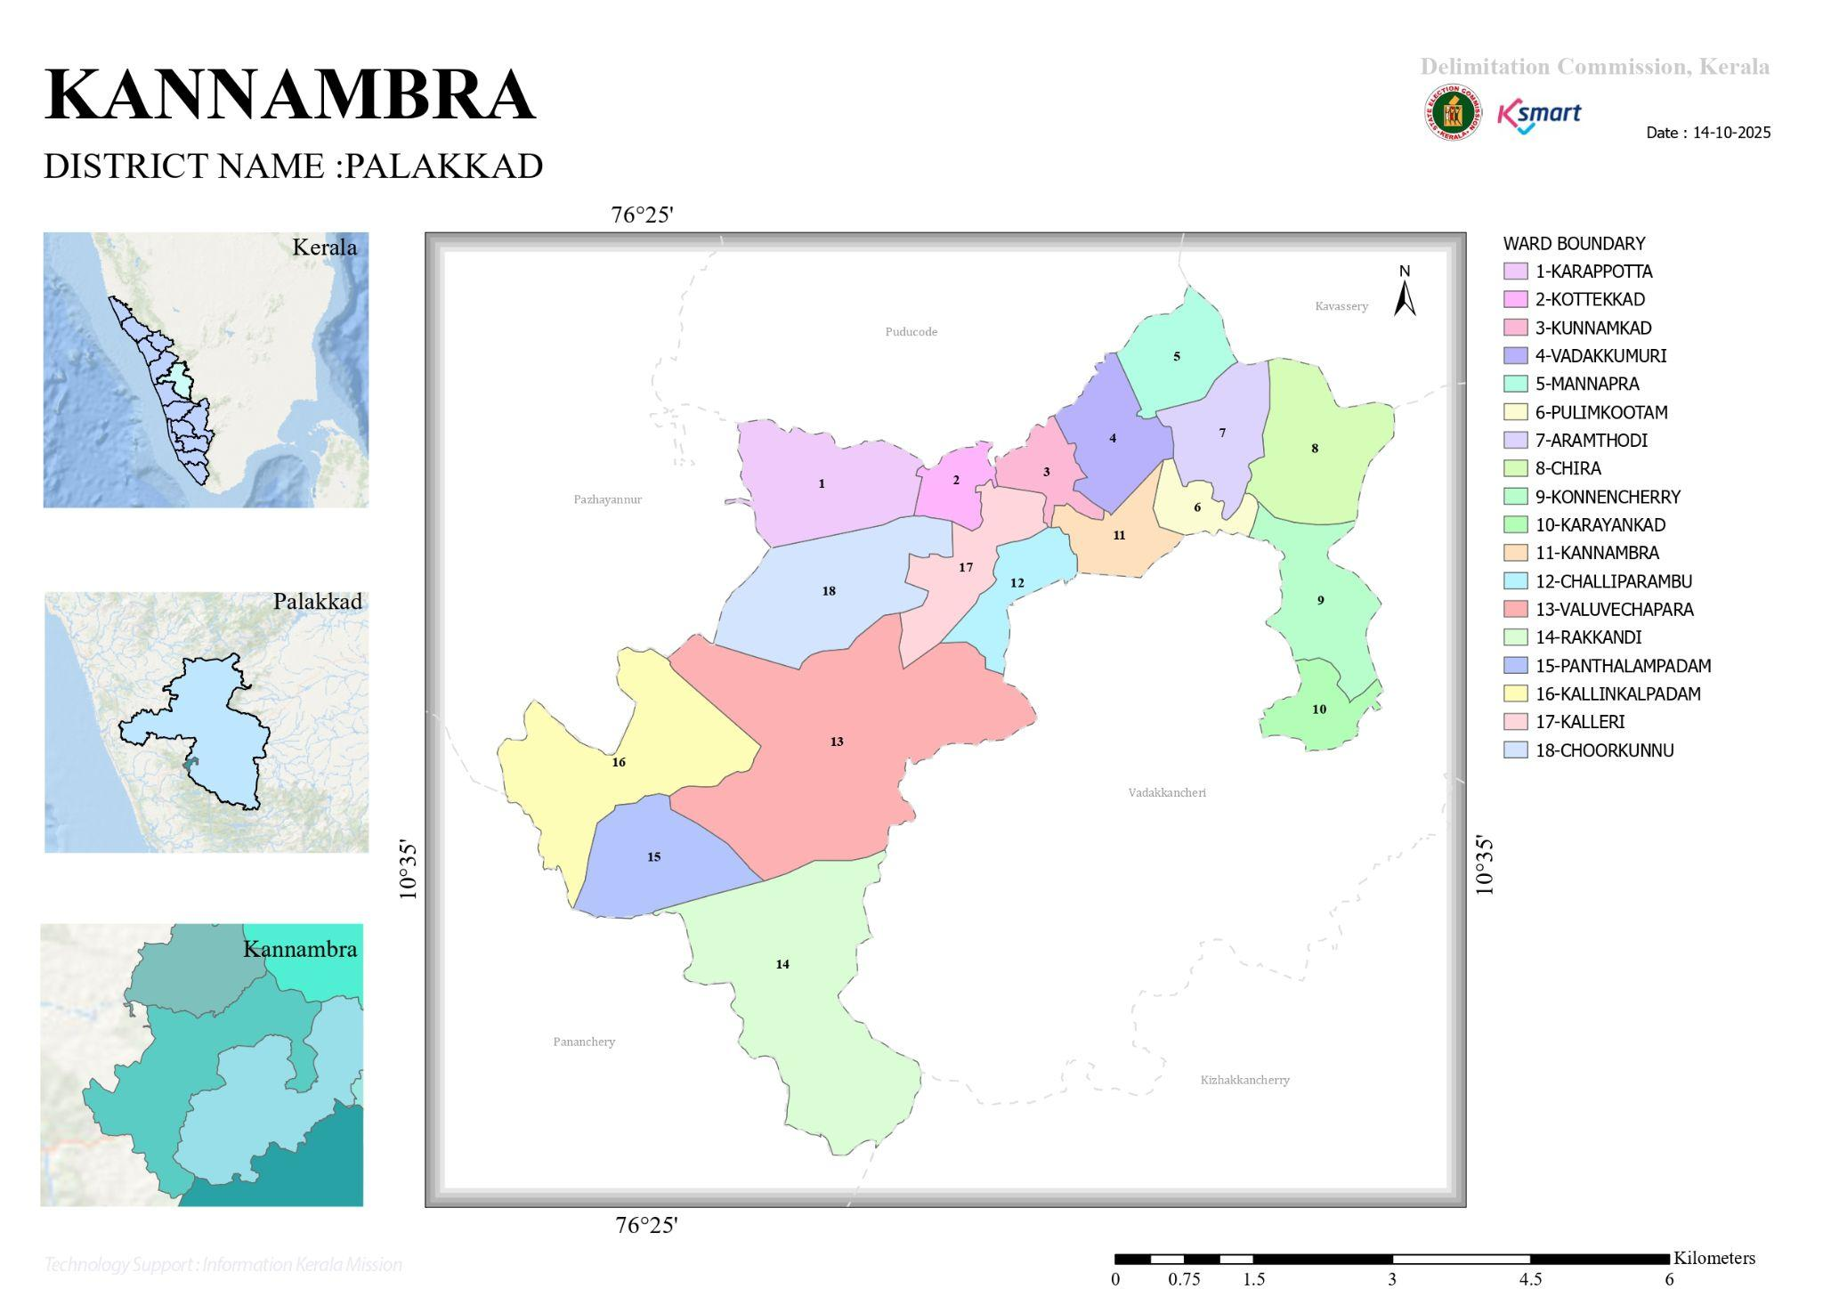
Map 1:Geographical boundaries with political map ( based on latest delimitation)
Source:Ward Mapping
- Baseline data
- Ward division -
Ward | Houses | Population | Migrants | Wells | Hot  spots | Ed. Institutions | Hosp pvt/govt.
1 | 435 | 1815 | 14 | 67 | 0 | 3 | 0
2 | 440 | 1843 | 0 | 74 | 0 | 0 | 0
3 | 453 | 1293 | 0 | 58 | 0 | 0 | 0
4 | 282 | 1117 | 2 | 22 | 0 | 0 | 0
5 | 404 | 1312 | 0 | 32 | 0 | 2 | 0
6 | 438 | 1954 | 0 | 92 | 0 | 1 | 0
7 | 420 | 1638 | 0 | 70 | 0 | 0 | 0
8 | 410 | 1510 | 18 | 64 | 0 | 1 | 0
9 | 477 | 1792 | 0 | 55 | 0 | 1 | 0
10 | 400 | 1493 | 102 | 85 | 0 | 0 | 0
11 | 370 | 1395 | 4 | 101 | 0 | 1 | 0
12 | 455 | 1729 | 7 | 77 | 0 | 0 | 0
13 | 270 | 1009 | 24 | 156 | 0 | 0 | 0
14 | 343 | 1361 | 43 | 172 | 0 | 0 | 0
15 | 270 | 1014 | 30 | 151 | 0 | 2 | 0
16 | 505 | 1960 | 36 | 111 | 0 | 1 | 0
17 | 414 | 1628 | 19 | 94 | 0 | 1 | 3
18 | 421 | 1535 | 7 | 48 | 0 | 0 | 0
TOTAL | 7137 | 27199 | 330 | 1529 | 0 | 12 | 1/1

Risk stratification among wards in the context of Communicable diseases and hazards
Risk stratification of wards in Kannambra Grama Panchayath, based on communicable diseases and environmental hazards, reveals a varied distribution of public health risk across the region. Certain wards, particularly Ward 11, Ward 13, and Ward 15, emerge as high-risk areas due to a consistently higher burden of diseases such as dengue, Hepatitis A, and acute diarrheal diseases (ADD), indicating ongoing transmission influenced by factors like water stagnation, sanitation gaps, and population density. Ward 4 is identified as a priority hotspot owing to its relatively higher overall case load and favorable conditions for vector breeding and possible contamination of water sources. Moderate-risk wards, including Ward 1, Ward 2, Ward 9, Ward 12, and Ward 14, show a mix of vector-borne and water-borne diseases, suggesting the need for integrated interventions focusing on both environmental management and safe water practices. Additionally, flood-prone wards such as Ward 8 and Ward 9 are vulnerable to water-borne diseases like leptospirosis, especially during the monsoon season, while Ward 16 shows increased vulnerability due to migrant population movement, which may influence disease transmission dynamics. Low-risk wards, including Ward 3, Ward 5, Ward 6, Ward 7, Ward 8, Ward 10, and Ward 16, currently report sporadic or low incidence of communicable diseases but require continued surveillance to prevent escalation. Overall, this stratification highlights the importance of targeted, ward-specific interventions, combining strengthened surveillance, vector control, water sanitation measures, and community awareness to effectively manage and mitigate public health risks.

Major Roads/rivers
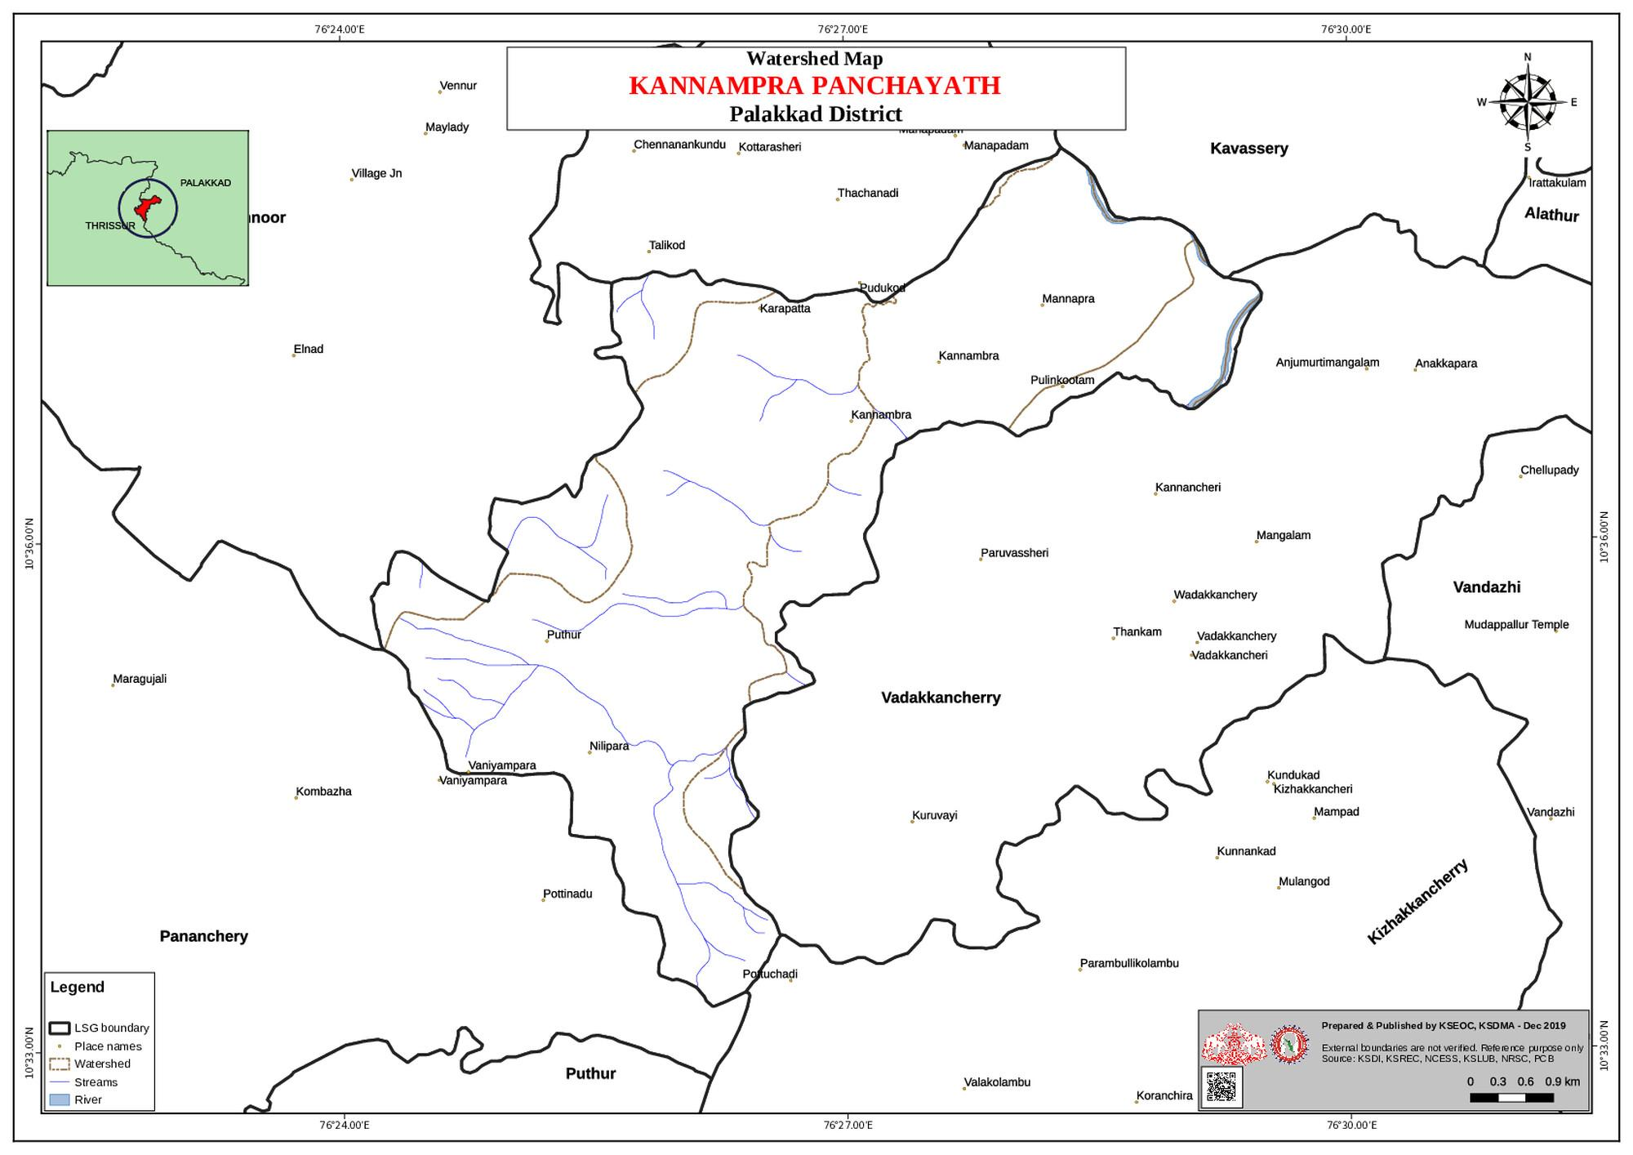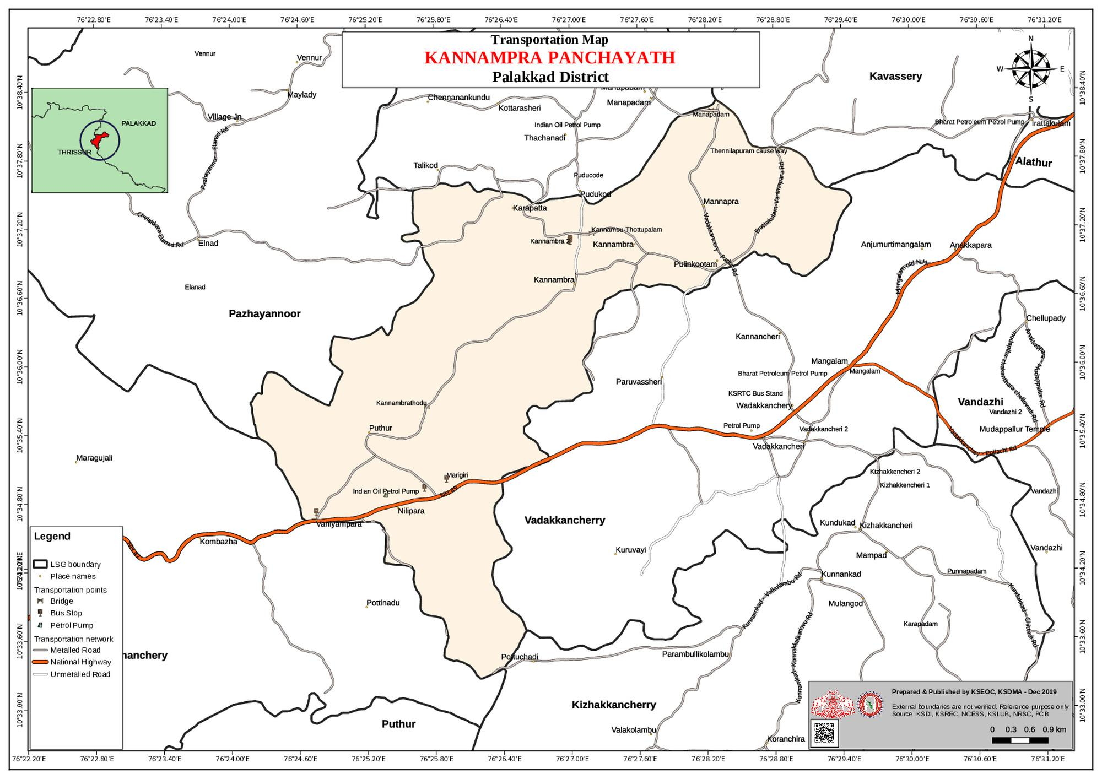
Map 2&3: Road & River Map
source:Kerala Disaster Management Plan
Kannambra Grama Panchayath is well connected by a network of local roads that link all 18 wards to nearby towns and the block headquarters at Alathur, facilitating movement of people, goods, and access to health services. The road network plays a crucial role during public health emergencies by enabling rapid transport of patients, medical supplies, and emergency response teams. However, certain interior and rural roads may become less accessible during heavy rainfall and monsoon seasons, potentially delaying response activities. The Panchayath is also characterized by the presence of one river and multiple water bodies, which contribute to irrigation and local livelihoods. These water sources, while beneficial, pose a risk during monsoon periods due to flooding and water stagnation, especially in low-lying wards. Such conditions increase the likelihood of water-borne and vector-borne diseases like leptospirosis and dengue. Therefore, major roads and river systems are important considerations in both risk assessment and planning for emergency response, surveillance, and resource mobilization within the Panchayat.

Major establishments with geospatial mapping
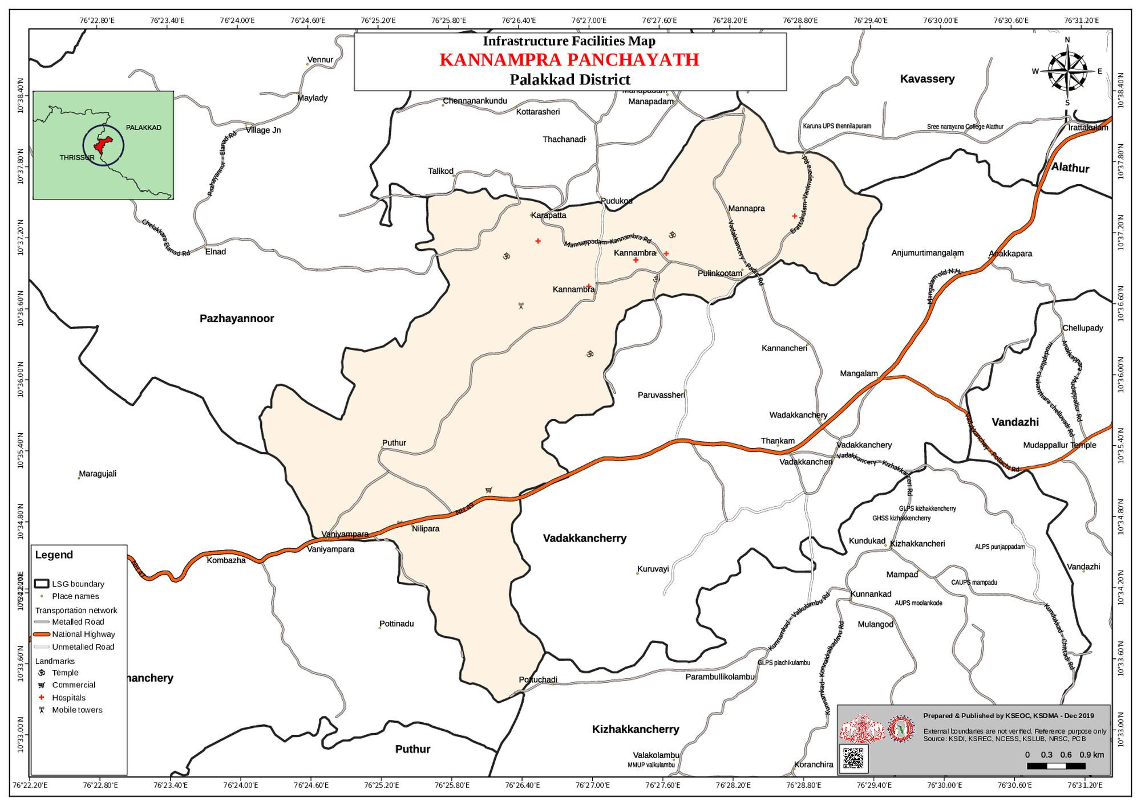
Map 4:Infrastructure Map
source:Kerala Disaster Management Plan
Kannambra Grama Panchayath has a range of key establishments that support healthcare delivery, community services, and emergency response, which can be effectively utilized through geospatial mapping. The health infrastructure includes 1 Family Health Centre (FHC), 2 AYUSH health centres, 7 private clinics, 5 laboratories, and 1 veterinary hospital, forming the core of the healthcare and surveillance system. In terms of educational infrastructure, there are 13 schools and 25 anganwadis, which can be used for awareness programmes and as temporary facilities during emergencies. Community infrastructure includes 4 auditoriums, 1 elderly care home, 1 crematorium, and 2 burial grounds, which are important for surge capacity planning and mass management during crises. Administrative and support services consist of 9 Public Distribution System (PDS) shops and 19 water pumping points, although there are no police or fire stations located within the Panchayath. Transport and logistics resources include 2 ambulances and 1 JCB, with no availability of boats or heavy vehicles. Under One Health infrastructure, the area has 2 veterinary doctors, 3 livestock inspectors, 7 poultry units, and 140 backyard poultry units, indicating potential zoonotic risk interfaces. Additionally, there are 13 small-scale industrial establishments and a total of 18 wards in the Panchayath. Mapping these establishments geographically helps in identifying service gaps, improving accessibility, and strengthening preparedness and response during public health emergencies.

occupational groups, socio cultural groups, migration & mobility patterns
Kannambra Grama Panchayath is predominantly rural, with occupational groups largely engaged in agriculture, daily wage labour, and employment under schemes such as MGNREGS, along with a smaller proportion involved in small-scale industries and service-related activities. These occupational patterns often involve outdoor work and exposure to environmental risks, increasing vulnerability to vector-borne and water-borne diseases, especially during monsoon seasons. The socio-cultural composition of the Panchayath is relatively homogeneous, with strong community networks, active participation of Kudumbashree groups, and support from anganwadi and ASHA workers, which play a vital role in community mobilisation and public health interventions. At the same time, certain vulnerable groups such as elderly individuals, economically weaker families, and marginalized communities require targeted attention during health emergencies. Migration and mobility patterns also influence disease dynamics, with approximately 295 migrant individuals residing in selected wards such as 10, 14, 15, and 16. Movement of people for employment and return migration can increase the risk of introduction and spread of infectious diseases. Additionally, daily commuting to nearby towns for work, education, and trade contributes to continuous population movement. Understanding these occupational, socio-cultural, and mobility patterns is essential for targeted surveillance, risk communication, and effective pandemic preparedness planning.

Vulnerability mapping
Vulnerability mapping in Kannambra Grama Panchayath identifies populations and areas at increased risk during public health emergencies by considering demographic, environmental, socio-economic, and health-related factors. Key vulnerable groups include the elderly population (6174 individuals), children under five (1227), pregnant women (161), lactating mothers (149), and individuals with chronic diseases such as diabetes (2154) and hypertension (2550), who require continuous medical care and are at higher risk of complications. Social vulnerability is also evident among 2293 BPL families, migrant populations (approximately 295 individuals concentrated in wards 10, 14, 15, and 16), and tribal communities, who may face barriers in accessing timely healthcare services. Environmental vulnerabilities are observed in flood-prone wards such as 8 and 9, which are at risk of water-borne diseases like leptospirosis and diarrheal illnesses, particularly during monsoon seasons. Additionally, areas with high population density and poor sanitation are more prone to outbreaks of vector-borne and communicable diseases. Occupational exposure among agricultural workers and daily wage laborers further increases risk due to frequent contact with contaminated water and outdoor environments. This vulnerability mapping helps prioritize high-risk populations and locations, ensuring targeted interventions, continuity of essential services, and efficient allocation of resources during pandemics and other public health emergencies.

Disaster prone areas (geographic vulnerability)
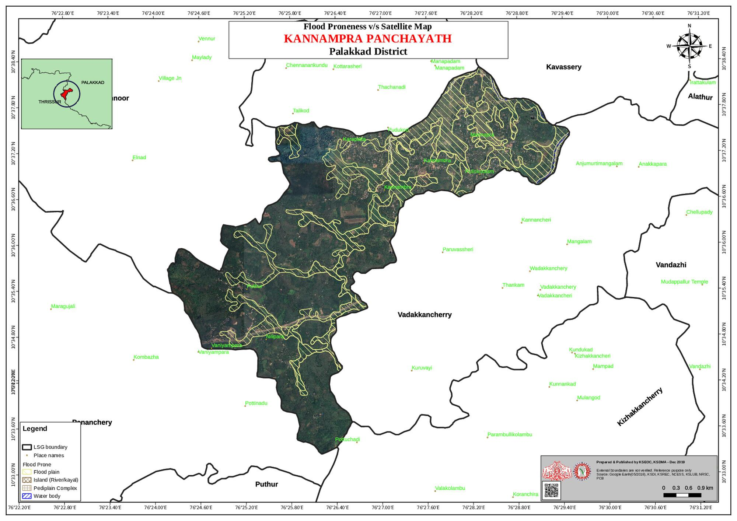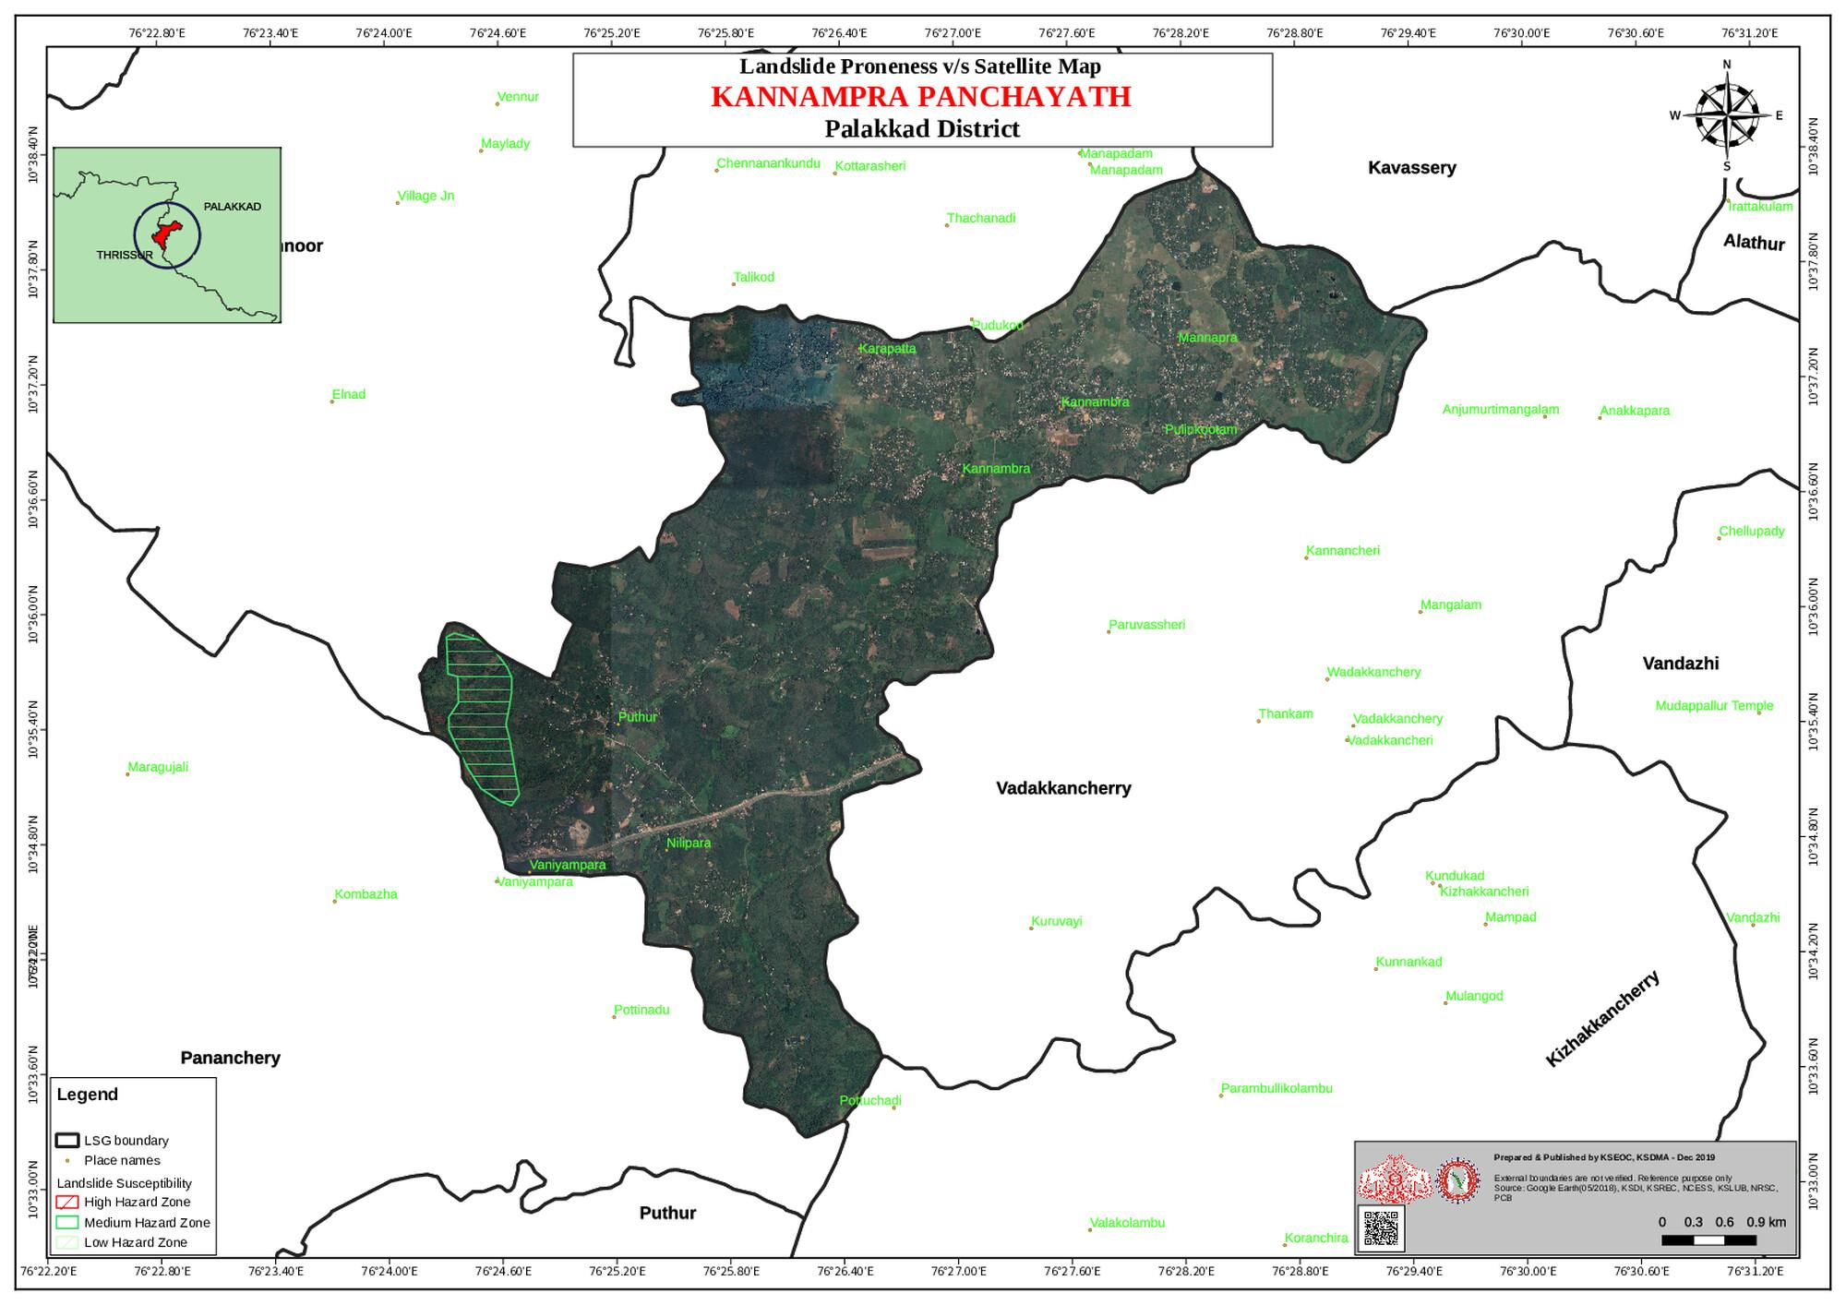
Map 4: Disaster Proneness Map
source:Kerala Disaster Management Plan
Kannambra Grama Panchayath has certain geographic areas that are vulnerable to natural disasters, primarily influenced by monsoon patterns and terrain characteristics. Flood-prone areas have been identified in Wards 8 and 9 (Chira and Konnenchery), where water stagnation and overflow from nearby water bodies during heavy rainfall increase the risk of flooding and associated public health issues such as leptospirosis, dengue, and other water-borne diseases. In addition, Ward 16 (Kallingalpadam) is identified as a landslide-prone area, posing risks of displacement, injury, and disruption of essential services including access to healthcare and transportation. The Panchayath has also experienced significant flooding during the 2018 Kerala floods, highlighting its susceptibility to extreme weather events. Low-lying areas, poor drainage systems, and proximity to water bodies further contribute to geographic vulnerability in certain pockets. These disaster-prone areas require focused preparedness measures, including early warning systems, evacuation planning, strengthening of infrastructure, and targeted health surveillance to minimize the impact of disasters on the population.

Background of the LSGI
Kannambra Grama Panchayat is situated in the Palakkad district of Kerala. The geographical landscape of the Panchayat is predominantly rural, characterized by a mix of low-lying plains, gently undulating terrain, and extensive agricultural lands. Paddy fields, coconut groves, and patches of dry land cultivation define the local ecosystem. The presence of irrigation canals, small streams, and seasonal water bodies supports agriculture but also contributes to waterlogging in certain areas during heavy rainfall. The terrain and climatic conditions influence accessibility, local livelihoods, and service delivery, particularly during monsoon periods.
The Panchayat is administratively organized under the Alathur Block and is divided into multiple wards to ensure decentralized governance and effective service delivery. The population is largely dependent on agriculture, with paddy cultivation, coconut farming, and livestock rearing forming the primary sources of income. In addition, a section of the population is engaged in small-scale trade, daily wage labor, and service-sector employment. The Panchayat also includes vulnerable groups such as elderly individuals, economically weaker households, and marginalized communities, which are important considerations in local planning and development activities.
From a public health and disaster management perspective, Kannambra Grama Panchayat faces challenges typical of semi-rural agrarian areas. The presence of water bodies and agricultural fields creates conducive conditions for vector breeding, increasing the risk of diseases such as Dengue and Leptospirosis. Seasonal monsoon rains may lead to localized flooding and water stagnation, while dry periods can result in water scarcity and heat-related stress. Although impacts were moderate compared to highly flood-prone regions, events like the 2018 Kerala floods highlighted the need for improved preparedness, infrastructure resilience, and coordinated response systems. Public health services are delivered through nearby government health institutions, supported by grassroots-level workers including ASHA and Anganwadi staff.
In this context, the development of a localized, data-driven Auxiliary Infrastructure and Logistical Resource Map is essential to support effective planning, timely emergency response, and sustainable development initiatives. Such mapping enables the Panchayat to identify critical infrastructure, vulnerable areas, and resource gaps, thereby strengthening disaster preparedness, improving public health response, and ensuring better coordination among departments at the local level.

Table 1: Background of LSGD
Description | Details
Name of LSGI | FHC KANNAMBRA
Type (GP/Municipality / Corporation etc.) | GRAMA PANCHAYATH
Block | ALATHUR
District | PALAKKAD
Number of wards | 18
Total area (sq. km) | 29.72 Sq.km
Population(Projected) | 27199
Population density | persons/sq km
Terrain (coastal/low-lying/backwaters/foothills, etc.) | Plane land
Number of rivers passing through LSGI | 1
Number of water bodies in the LSGI | 55
Number of educational institutions | 12
Factories / small-scale industries | 13
Flood-prone wards | 8,9
Landslide-prone wards | 16
Death Management and Disposal Facilities (mortuaries/crematorium, including electric) | crematorium-1,burrial-2
Auditoriums/Marriage halls/convention centres/community halls | 4
Kurumali kalyana mandapam Poothara | 8
Mangalya Auditarium Kannambra | 11
Grace plaza Auditorium | 17
Lashmy Auditorium Konnencheri | 9

Demographic and Vulnerable Population
Understanding the demographic composition and vulnerable population groups is essential for pandemic preparedness. Children, elderly, economically deprived families, migrant workers, and socially vulnerable groups are at increased risk during public health emergencies due to higher exposure, limited access to services, and dependency on public systems..

Description |  | Details (in numbers)
DEMOGRAPHIC PROFILE
Total population |  | 27199
Male |  | 13486
Female |  | 13713
Transgender |  | 0
Children under 5 |  | 1227
Adolescent |  | 2220
Elderly (>60) |  | 6174
SOCIAL/LIVELIHOOD VULNERABILITY
Previous EPEP family |  | 47
BPL family |  | 2293
Tribal communities |  | 128
Migration | Immigrant | 295
Migration | Emigrant | 0
Socio-economically deprived |  | 0
Fisherfolk |  | 0
SC Community |  | 6
ST Community |  | 2

Graphs: Population pyramid (if possible) for seeing if your LSGI has a high "dependency ratio" (lots of children and elderly compared to working adults).

Clinical Vulnerability
Certain population groups need priority healthcare & are at higher risk of severe illness, complications, and mortality during pandemics. Patients with chronic diseases, those requiring regular medical care, and individuals with mobility or functional limitations face challenges in accessing timely care during emergencies. Mapping these groups helps in prioritizing continuity of treatment, medicine stock planning, oxygen support, referral transport, and targeted home-based care.
Description | Details in numbers
Pregnant women | 161
Lactating mothers | 149
Bedbound patients | 80
Patients under palliative care other than bedbound | 0
Patients on Haemodialysis | 20
Patients on CAPD | 0
Cancer patients (currently on treatment) | 50
Haemophilic patients | 0
Mentally challenged | 113
Differently abled | 103
Diabetic patients | 2154
Hypertensive patients | 2550
TB patients | 5

Major Festivals & Events specific to the LSGI
(with the possibility of a public gathering)

Sl. No. | Name of festival | Month detailing the periodicity
1 | kannambra vela | may

INFRASTRUCTURE & RESOURCE INVENTORY

Health Facility Directory & Basic Capacity in the LSGD
This section provides an overview of the healthcare infrastructure available within the LSGD area. It outlines the distribution and basic capacity of health facilities that form the backbone of service delivery during routine times and public health emergencies.

Family Health Centres (FHCs) and Community Health Centres (CHCs) generally function as the first point of contact for the community, providing essential outpatient and inpatient services. General Hospitals (GH) and Medical College Hospitals (MCH), where accessible, serve as the main referral centres for advanced diagnostics, specialist care, and critical services during public health emergencies. This inventory helps identify existing strengths, gaps, and potential surge capacity that can be mobilised during a pandemic or disaster.

Table 5. Health Facility Resource Summary
Sl.no. | Health Facility | Type of Facility (MCH/GH/CHC/FHC/SC etc.) | Contact Number | Total beds | ICU Beds | Oxygen-Supported Beds | No. of Ventilator Support Beds | No. of ambulances
Government Healthcare Facilities
1 | FHC KANNAMBRA | FHC | 9447315695 | 0 | 0 | 0 | 0 | 0
2 | Main centre HWC Kannambra | sc | 9544430759 | 0 | 0 | 0 | 0 | 0
3 | HWC Kannambra Sub centre | sc | 9526258090 | 0 | 0 | 0 | 0 | 0
4 | HWC Kalleri | sc | 9562687813 | 0 | 0 | 0 | 0 | 0
5 | HWC Kallingalpadam | sc | 9645820204 | 0 | 0 | 0 | 0 | 0
6 | HWC Chira | SC | 7902940459 | 0 | 0 | 0 | 0 | 0
7 | HWC Manjapra | SC | 8086867001 | 0 | 0 | 0 | 0 | 0
Private Healthcare Facilities
AYUSH Healthcare Facilities
1 | AYUSH PRIMARY HEALTH CENTRE KANNAMBRA | FHC | Dr.Aiswarya 9645633416 | 0 | 0 | 0 | 0 | 0
2 | AYURVEDHA HOSPITAL KANNAMBRA | FHC | Dr.Vidhya 9656883662 | 0 | 0 | 0 | 0 | 0

Private Clinics
Private clinics are an essential part of pandemic preparedness, as they are often the first place people seek care when symptoms begin. In many communities, private clinics manage a significant share of outpatient visits and therefore play a critical role in early case detection, timely referrals, and disease surveillance. Having an up-to-date understanding of where these clinics are located, the services they provide, and how they are linked to the public health system helps ensure that no cases are missed during an outbreak. It also allows health authorities to engage private practitioners more effectively for reporting, risk communication, and coordinated response, strengthening the overall capacity of the health system to manage public health emergencies.

Table 6. Private Clinic Resource Summary
Sl No. | Name of Clinic | Registered (Y/N) | Clinic (General / Speciality) | Speciality (if any) | Address | Contact Number | Diagnostic Facility (Y/N) | Ambulance Linkage (Y/N)
1 | Dr.Santhosh clinic | Y | G | No | Kannambra | 9447993998 | N | N
2 | Premier Medical Centre | Y | G | No | Karappotta | 8075759740 | yes | NO
3 | Saraswathi clinic | Y | G | Yes | Pulinkoottam | 9048527605 | Yes | No
4 | Kalpaka Medicals | Y | G | No | Karappotta | 9447834586 | No | No
5 | PVT Clinic | Y | G | No | Kottekad | 9847736975 | No | No
6 | Kalpaka Medicals | Y | G | No | Pradeep Karappotta | 9447834586 | No | No
7 | Sreelekshmi clinic | Y | G | No | Dr.Binitha Pulinkoottam | 6369511303 | No | No

Healthcare Education & GTraining Institutions
This section tracks the educational infrastructure available, which is vital for human resource planning in the health sector.

Category of Institution | Govt | Private | AYUSH | Total
Medical Colleges | 0 | 0 | 0 | 0
Nursing Colleges | 0 | 0 | 0 | 0
Dental Colleges | 0 | 0 | 0 | 0
Para-medical / Allied Health | 0 | 0 | 0 | 0
Pharmacy Colleges | 0 | 0 | 0 | 0

Specialized Services & Emergency Inventory
This section provides a detailed view of the specialized medical resources available to the community, focusing on emergency response and critical care capabilities. This table tracks the vital assets required for managing severe illnesses and emergencies across Government, Private, and AYUSH sectors.

Item | Govt | Private | AYUSH | Total
Hospital beds | 0 | 0 | 0 | 0
Oxygen-generating systems(Y/N) | 0 | 0 | 0 | 0
Oxygen-supported beds(Numbers) | 0 | 0 | 0 | 0
Ventilator-supported beds | 0 | 0 | 0 | 0
ICU beds | 0 | 0 | 0 | 0
Burns units | 0 | 0 | 0 | 0
Blood centres | 0 | 0 | 0 | 0
BLS ambulances | 0 | 0 | 0 | 0
ALS ambulances | 0 | 0 | 0 | 0
Dialysis facilities | 0 | 0 | 0 | 0
Dispensaries | 0 | 0 | 0 | 0
Medical store | 0 | 9 | 0 | 0
Industrial establishments(Medium-scale industries/small-scale industries establishments to whom we can depend in a worst-case scenario) | 0 | 0 | 0 | 0

Oxygen & Diagnostic Capacity
Monitoring oxygen and diagnostic capacity is a critical component of public health preparedness, ensuring that the LSGD can handle both chronic care and sudden surges in respiratory or infectious diseases.
Name of Health Facility | Oxygen-generating System (Y/N) | Backup Oxygen Source (Y/N) | Diagnostic Facilities Available(Y/N)
Name of Health Facility | Oxygen-generating System (Y/N) | Backup Oxygen Source (Y/N) | Lab | USG | X-ray | CT/MRI | RT-PCR
Government Healthcare Facilities
FHC Kannambra | No | No | Y | N | N | N | N

Diagnostics facility mapping at the LSGI level
The diagnostic capacity o Kannambra G.P represents the "intelligence network" of our healthcare system. The speed and accuracy of disease identification depend entirely on the distribution and technical level of these facilities.

Item | Govt | Private | AYUSH | Total
General labs | 1 | 4 | 0 | 5
Microbiology labs | 0 | 0 | 0 | 0
RT-PCR labs | 0 | 0 | 0 | 0
USG units | 0 | 0 | 0 | 0
CT/MRI units | 0 | 0 | 0 | 0
Research labs | 0 | 0 | 0 | 0
Labs of other departments that can be repurposed | 0 | 0 | 0 | 0

Laboratory Identification & Basic Details
Sl. No. | Name of Laboratory | Ownership (Govt / Private / Academic) | Address | Contact No. | 24×7 Services (Yes/No) | NABL / Govt Approved (Yes/No)
1 | Nandana Lab | pvt | Karappotta | 8281675077 | No
2 | Smart Health Lab | pvt | Kannambra | 963937487 | No
3 | Anjana Lab | Pvt | Kannambra | 9747854221 | No
4 | Doctor care Lab | Pvt | Pulinkoottam | 9895212313 | No
5

Social and Community Infrastructure for surge plan
This table serves as our logistics and shelter inventory. By mapping these locations, quickly we can identify where to house displaced citizens, where to set up temporary medical clinics, and how to manage the deceased with dignity during a crisis.

Category | Total Count | Ward | Est. Capacity (Persons) | Contact details
Educational Institutions
Anganwadis | 25 | 1,2,3,4,5,6,7,8,9,10,11,12,13,14,15,16,17,18 | 250
Schools | 13 | 1,2,3,4,5,8,9,17,16,13,15
Colleges | 0 | 0 | 0 | 0
Healthcare Educational Institutions
Medical colleges (Govt/Private) | 0 | 0 | 0 | 0
Nursing colleges (Govt/Private) | 0 | 0 | 0 | 0
Dental colleges (Govt/Private) | 0 | 0 | 0 | 0
Paramedical institutes (Govt/Private) | 0 | 0 | 0 | 0
Community Gathering Spaces
Community halls | 0 | 0 | 0 | 0
Auditoriums | 4 | 12,17,9&8 | 0 | 0
Religious buildings | 0 |  | 0 | 0
Vulnerable Group Support Facility
Destitute homes | 0 | 0 | 0 | 0
Elderly homes | 1 | 18 | 60
LSGD owned other buildings | 0 | 0 | 0 | 0
Mass Fatality Management (MFM) Infrastructure
Mortuary | 0 | 0 | 0 | 0
Crematorium | 1 | 5 | 0 | 0
*refer annexure 1 for contact details

Human resources
This section focuses on the human capital available within the LSGI. In any emergency—be it a pandemic, flood, or industrial accident—infrastructure is only as effective as the people operating it.

Medical & Clinical Personnel
This table tracks the "Frontline" providers responsible for diagnosis, treatment, and clinical management. Narrative sentence: eg., "Total health workforce: 450 personnel, with 60% in government facilities serving as primary surge capacity." A detailed directory with the contact numbers of all workers is maintained (Annexure in 1).

Cadre | Govt (No.) | Private (No.) | Total
Doctors—Modern Medicine | 1 | 7 | 8
Doctors – AYUSH | 2 | 0 | 2
Doctors – Veterinary | 1 | 1 | 2
Doctors – Dental | 0 | 1 | 1
Nursing officers | 1 | 0 | 1
Lab technicians | 1 | 4 | 5
Optometrist | 0 | 0 | 0
Pharmacists | 1 | 9 | 10
Psychologists | 0 | 0 | 0
Counsellors | 0 | 0 | 0

Public Health & Field-Level Workforce
These individuals are the backbone of surveillance, maternal-child health, and decentralized care.

Cadre | Health services | Municipal common services | Total
HS (Health Supervisors) | 0 | 0 | 0
HI (Health Inspectors) | 1 | 0 | 0
Hi(LSGD) | 0 | 1 | 1
LHS (Lady Health Supervisor) | 0 | 0 | 0
LHI (Lady Health Inspectors) | 1 | 0 | 1
JPHN (Jr Public Health Nurses) | 5 | 0 | 5
JHI (Jr Health Inspectors) | 3 | 0 | 3
MLSP (Mid-Level Service Providers) | 6 | 0 | 6
Palliative Nurses | 1 | 0 | 1
RBSK Nurses | 1 | 0 | 1
PRO | 0 | 0 | 0
Epidemiologist | 0 | 0 | 0
Data Manager | 0 | 0 | 0

Community & Support Cadre
This group represents the surge capacity of the LSGI—people who can be called upon for logistics, rescue, and specialized support.

Cadre | Number
ASHA Workers | 23
AWW (Anganwadi Workers) | 25
Emergency Medical Volunteers (Trained) | 0
Kudumbashree | 213
MNREGS | 2807
Purusha Swayam Sahaya Sangham | 0
Ex-Servicemen | 0
Retired Police Officers | 11
NCC/NSS Volunteers | 300
Red Cross volunteers | 0
One Health Community Volunteers | 5
One Health Community Mentors | 2

Community Organizations
This section details the presence of community-based organisations (CBOs), non-governmental organisations (NGOs), faith-based organisations (FBOs), Kudumbashree Self-Help Groups (SHGs), and Ayalkootams within the Local Self-Government Institution (LSGI). These groups enhance grassroots mobilization, resource distribution, and support networks crucial for pandemic response and community resilience.

Category | Total Count
NGOs | 1
Religious based organizations | 0
Foreign based organizations | 1
Sports Club/youth clubs | 5
Kudumbashree SHGs | 17
Ayalkootams | 213
Political organizations | 4
Residential organizations | 0

Administrative & Emergency Services
This section outlines the availability of key non-health emergency support services and infrastructure within the LSGI, which are essential for effective pandemic preparedness and response. These facilities support law enforcement, disaster response, water supply, logistics, mobility, and community-level interventions during public health emergencies.

Category | Total Count | Contact details
Police Stations | 0
Fire & Rescue Stations | 0
Water Pumping Points | 19 | NA
Public Distribution System (PDS) | 9 | 9745564879 mani

Information regarding resources
The availability of essential transport and support resources plays a quiet but critical role in saving lives. Equipment such as ambulances, mobile mortuaries, amphibian ambulances, and motorized boats ensures that patients, samples, and healthcare teams can move swiftly—even in flooded, remote, or difficult terrains. Heavy vehicles like JCBs, cranes, tractors, and torus lorries support logistics, waste management, emergency infrastructure, and rapid conversion of spaces into care or isolation facilities. Taxis, four-wheel-drive vehicles, and trucks help maintain continuity of essential services, reach vulnerable populations, and support home-based care and supply delivery.

Means of transportation | Total Count
JCB | 1
Crane | 0
Heavy Trucks | 0
Tractor | 0
Ambulances | 2
Mobile mortuaries | 0
Boats | 0
Taxi service
Note: For specific details regarding vehicle owners and contact information, please refer to Annexure [X].

ONE HEALTH & ENVIRONMENTAL SURVEILLANCE
The One Health method integrates environmental, animal, and human health to enable proactive pandemic preparedness. Panchayat-level surveillance needs to be improved in order to detect and treat zoonotic and environmentally generated diseases early. Surveillance is strengthened through systematic assessment of animal populations, veterinary infrastructure, poultry and slaughter facilities, inter-sectoral coordination, and specialised tools like avian influenza seasonality mapping using GIS in previous outbreaks to enable predictive alerts and ward-specific sampling to support effective pandemic preparedness in high-risk areas .

Animal & Bird Population
Mapping animal and bird populations at the Panchayat level is essential for identifying and prioritising zoonotic disease hazards like rabies, avian influenza (H5N1), leptospirosis, anthrax, and Nipah-like spillover occurrences. Risk classification, targeted surveillance, vaccination planning, and early epidemic detection made feasible by comprehensive population mapping all enhance One Health-based pandemic preparedness.

Category | Item | Estimated Population | Wards
Animal Population | Livestock (Cattle/Goats/Buffalo) | 1229 | All wards
Animal Population | Pet Animals (Dogs/Cats) | 299 | All wards
Animal Population | Stray Dog Population | 198 | All wards
Animal Population | Pig Farms (Number of heads) | 3 | ward 14,ward 16,ward 8
 | Small Units (Sheep / Goats – clustered) | 0 | 0
Bird Population | Poultry Units (Birds) | 7801(140 unit)
Bird Population | Poultry- (FOWL) | 0
Bird Population | Wild/Migratory Birds (Observed) | 0
Bird Population | Crow Mortality Events (Reported) | 0

The main risk of zoonotic diseases is concentrated in WarDS 14,16,8 which is explained by the high density of pig farms. The stray dog population in market areas, fish landing sites, bus stations continues to be a substantial problem for rabies surveillance and bite prevention. There is a considerable risk of avian influenza introduction and amplification during November - December due to the seasonal presence of migratory and resident water birds near ponds/ canal / river / backwater / paddy field. Clusters of pig farms and animal shelters vulnerable to flooding further raise the risk of leptospirosis and other zoonoses mediated by the environment, especially during monsoon floods.

Veterinary Infrastructure
Veterinary institutions are a core pillar of One Health surveillance, enabling early zoonotic disease detection through vaccination, investigation of unusual animal illness or deaths, sample collection, and timely outbreak reporting. A well-mapped and responsive veterinary network strengthens coordination with human health and LSGI systems, ensuring rapid response during zoonotic events and pandemics.
Facility Type | Name of Facility | Ownership Govt / Pvt | Location(Ward No) | Contact number
Veterinary Dispensary | 0 | 0 | 0 | 0
Veterinary Hospital / Polyclinic | 1 | govt | Ward 12 | 9447543234
Private Veterinary Clinics | 0 | 0 | 0 | 0
Mobile / Emergency Vet Service (incl. night services) | 0 | 0 | 0 | 0
Pet Homes / Animal Shelters | 0 | 0 | 0 | 0
Slaughterhouse-linked Veterinary Inspection Unit | 0 | 0 | 0 | 0

Veterinary Doctors & Workforce
Early detection, diagnosis, reporting, and reaction to animal illness epidemics depend on the availability and accessibility of qualified veterinary specialists. By identifying unusual animal morbidity or mortality promptly, collecting samples promptly, and coordinating efficiently with human health and LSGI systems—especially during zoonotic outbreaks and pandemic-prone situations—a clearly defined veterinary workforce enhances One Health surveillance.

Category | Number Available | Type (Govt/Pvt) | Contact number
Government Veterinary Doctors | 1 | Govt | 9447543284
Private Veterinary Doctors | 1 | Pvt | 9048859842
Livestock Inspectors | 3 | Govt | 8547203858 9961785068 8592891838
Para-veterinary Staff / Attenders | 1 | Govt | 7306005762
Contract / On-call Veterinary Support (if any) | 1 | Govt | 9048859842

High-Risk Interface Points (Surveillance Sites)
High-risk interface points for zoonotic disease surveillance in the Kannambra Grama Panchayath include wetland–livestock–human contact zones, backyard poultry farms, cattle sheds near water bodies, fish markets, and areas of high human–animal interaction such as community slaughter points and migratory bird congregation sites. These are the primary surveillance sites where zoonotic spillover risks are elevated.

Type of Habitat | Type of High risk interface | Geographical vulnerability
Wetlands & Backwaters | 0 | 0
Backyard Poultry Farms | minimal | Minimal
Cattle Sheds near Water Bodies | 0 | 0
Fish & Meat Markets | 0 | 0
Community Slaughter Sites | 0 | 0
Migratory Bird Congregation Areas | 0 | 0
Rodent-Infested Grain Storage | 0 | 0

Category | Total Count | Key Locations (wards)
Poultry Farms | 7
Backyard / Clustered Poultry Units | 140 | All 18 wards
Duck Rearing Units (open water access) | 0 | 0
Slaughterhouses/ Slaughter Points | 0 | 0
Meat/Fish Markets | 0 | 0
Live Bird Sale Points | 0 | 0
Cattle Markets / Weekly Animal Fairs | 0 | 0
Pet Shops / Breeders | 0 | 0
Animal Shelters / Pet Homes | 0 | 0
Waste Disposal Sites near Animal Units | 0 | 0

Environmental Risk Mapping
Environmental risk mapping identifies monsoon/flood hotspots for vector-borne (dengue, chikungunya), water-borne (leptospirosis, diarrhoea), and zoonotic diseases in Kerala's wetlands. Systematic surveillance supports early warnings, targeted interventions, and Panchayat pandemic preparedness.
Waterborne exposure: Flood-prone areas and stagnant water bodies facilitate leptospira survival, raising leptospirosis risk.

Traditional practices: Informal slaughter and fish markets lack standardized hygiene, creating spillover opportunities.

Risk Factor | High-Risk Wards | Key Locations | Risk Level (High/Med/Low)
Flood-prone areas | 8,9 | Konnencheri and Chira | low risk
Water bodies/wetlands | 0 | 0
Solid waste accumulation | 0 | 0
Animal waste disposal issues | 0 | 0
Rodent infestation zones | 0 | 0
Industrial effluent discharge | 0 | 0
Construction sites / abandoned buildings | 0 | 0
Poor drainage/blocked canals | 0 | 0
Drinking water source contamination risk | 0 | 0

Disease Seasonality Mapping
1, Flooding & waterlogging → amplifies leptospirosis, malaria, diarrheal diseases.
·
2, Migratory bird influx (Nov–Feb) → avian influenza risk.

3, Mosquito breeding cycles → vector-borne disease peaks in monsoon.

4, Agricultural practices → close human–animal contact in paddy fields.

Disease | Peak Risk Season | Key Drivers | High-Risk Locations | Surveillance Focus
Avian Influenza | 0 | 0 | 0 | 0
Leptospirosis | 0 | 0 | 0 | 0
Dengue/Chikungunya | April,May,june,july,August | water scarcity and intermittent rain | ward 12 kizhakekalam | 0
Acute Diarrheal Diseases | june,july | 0 | 0 | 0
Rabies | 0 | 0 | 0 | 0
Anthrax (rare) | 0 | 0 | 0 | 0

Vulnerability Mapping
Vulnerability mapping pinpoints high-risk populations, occupations, and areas exposed via environment, livelihoods, socio-economics, and poor service access. Paired with environmental/seasonality mapping, it enables risk-based surveillance, targeted actions, and optimal resource use in One Health and pandemic planning.
Vulnerability Factor | High-Risk Wards | Key Groups / Locations | Risk Level
Flood-prone households | 0 | 0
Wetland-adjacent communities | 0 | 0 | 0
Backyard poultry / duck rearing households | Minimal |  | Low risk
Livestock-rearing households | 0
Slaughterhouse & meat market workers | 0 | 0 | 0
Fisherfolk & fish market workers | 0 | 0 | 0
Sanitation workers | 0 | 0 | 0
Daily wage / migrant workers | 16 | Kallingalpadam | Medium Risk
Elderly & chronically ill populations | 0 | 0 | 0
Pregnant Women | 0 | 0 | 0
Children (schools, Anganwadi’s) | 0 | 0 | 0
Limited access to safe water & sanitation

EPIDEMIOLOGICAL TRENDS (2021–2025)

Disease surveillance is the systematic collection, analysis, and interpretation of health data for planning, implementation, and evaluation of public health practice. This section presents the disease surveillance profile of the LSGI based on routine reporting systems and outbreak investigations to identify priority diseases, seasonal patterns, and emerging public health threats.

Disease Burden among human beings(Last 5 Years)
Analysis of disease-wise data for the last five years helps identify persistent public health problems, emerging diseases, and changes in disease burden. This information supports prioritisation of prevention, preparedness, and response activities at the Panchayat level.

Disease | 2021 | 2022 | 2023 | 2024 | 2025 | Trend(Increasing/Stable/Decreasing)
Dengue | 0 | 3 | 7 | 21 | 12 | Increasing
Leptospirosis | 0 | 1 | 0 | 2 | 3 | Increasing
Hepatitis A | 0 | 1 | 1 | 3 | 10 | Increasing
Malaria | 0 | 0 | 0 | 0 | 0 | Stable
Scrub Typhus | 0 | 0 | 1 | 0 | 2 | Increasing
Typhoid | 0 | 1 | 0 | 1 | 0 | Decreasing
H1N1 | 0 | 0 | 1 | 0 | 0 | Decreasing
H3N2 | 0 | 0 | 0 | 0 | 3 | Increasing
ADD | 26 | 44 | 105 | 107 | 221 | Increasing
Mumps | 0 | 0 | 2 | 74 |  | Decreasing
Measles | 0 | 1 | 0 | 0 | 1 | Decreasing
Hepatitis B | 0 | 1 | 0 | 1 | 0 | Decreasing
Hepatitis C | 0 | 0 | 0 | 0 | 0 | Decreasing
Tuberculosis | 8 | 14 | 23 | 12 | 12 | Decreasing
Leprosy | 0 | 1 | 1 | 0 | 0 | Decreasing
COVID-19 |  |  |  | 0 | 0 | Decreasing

*(use the above table data to create the graph/diagram)

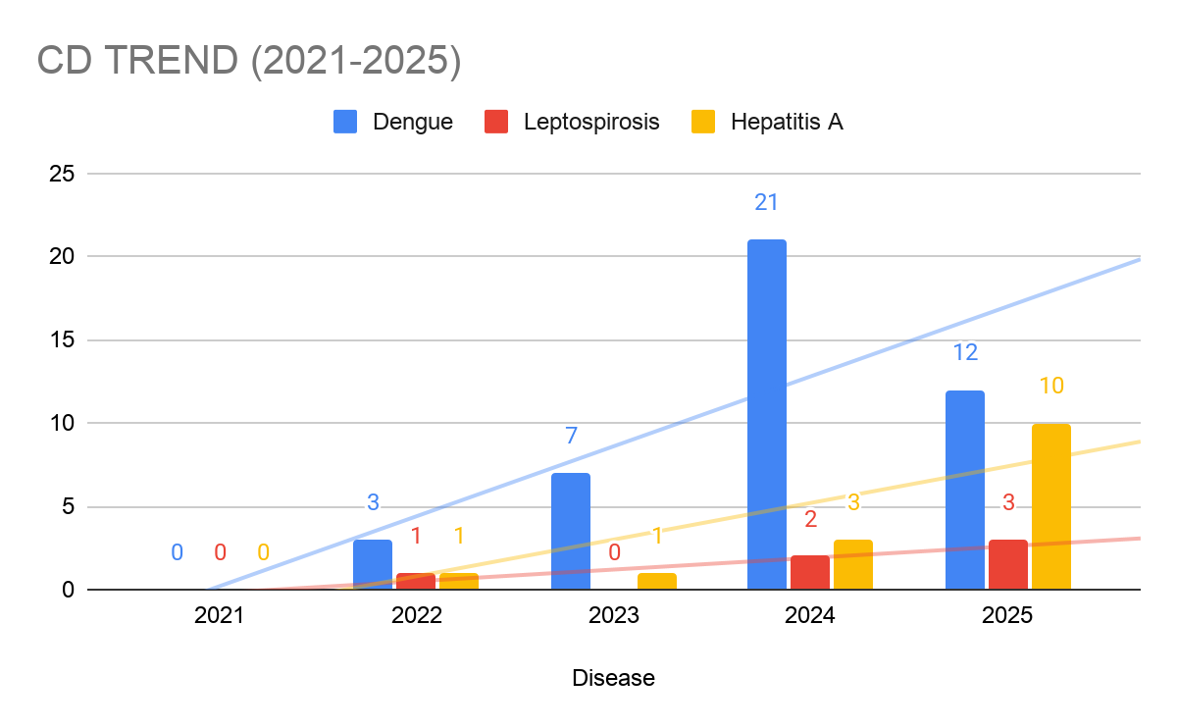

Seasonal Trend Analysis
Seasonal analysis helps anticipate surges (e.g. dengue in monsoon, leptospirosis after floods, influenza in cooler months) and plan pre‑emptive vector control, stockpiling of IV fluids, and awareness campaigns at Panchayat level.

DENGUE
Dengue is a major seasonal vector-borne disease strongly associated with rainfall, water stagnation, and increased mosquito breeding during the monsoon period.

Peak: July–November

Dengue – Ward-wise Yearly Distribution (2021–2025)

Ward | Dengue – Ward-wise Yearly Distribution
Ward | 2021 | 2022 | 2023 | 2024 | 2025 | Total
1 | 0 | 0 | 1 | 0 | 2 | 3
2 | 0 | 0 | 0 | 0 | 2 | 2
3 | 1 | 0 | 0 | 2 | 0 | 3
4 | 0 | 1 | 0 | 0 | 0 | 3
5 | 0 | 1 | 0 | 1 | 1 | 3
6 | 0 | 0 | 0 | 0 | 0 | 0
7 | 0 | 0 | 0 | 2 | 0 | 2
8 | 0 | 0 | 0 | 1 | 0 | 1
9 | 0 | 0 | 0 | 1 | 0 | 1
10 | 0 | 0 | 0 | 0 | 1 | 1
11 | 0 | 0 | 1 | 3 | 0 | 4
12 | 0 | 0 | 0 | 2 | 1 | 3
13 | 0 | 1 | 0 | 0 | 4 | 5
14 | 0 | 0 | 2 | 2 | 0 | 4
15 | 0 | 0 | 0 | 1 | 0 | 1
16 | 0 | 0 | 1 | 2 | 0 | 3

LEPTOSPIROSIS
Leptospirosis cases are closely linked to monsoon rains, flooding, and occupational exposure, particularly in low-lying and waterlogged areas.

Peak: June - August

Leptospirosis – Ward-wise Yearly Distribution (2021–2025)

Ward | Leptospirosis – Ward-wise Yearly Distribution
Ward | 2021 | 2022 | 2023 | 2024 | 2025 | Total
1 | 0 | 0 | 0 | 0 | 0 | 0
2 | 0 | 0 | 0 | 0 | 0 | 0
3 | 0 | 0 | 0 | 3 | 0 | 3
4 | 0 | 0 | 0 | 0 | 3 | 3
5 | 0 | 0 | 0 | 0 | 0 | 0
6 | 0 | 0 | 0 | 0 | 0 | 0
7 | 0 | 0 | 0 | 0 | 0 | 0
8 | 0 | 0 | 0 | 0 | 0 | 0
9 | 0 | 0 | 0 | 0 | 0 | 0
10 | 0 | 0 | 0 | 0 | 0 | 0
11 | 0 | 0 | 1 | 0 | 0 | 1
12 | 0 | 0 | 0 | 0 | 0 | 0
13 | 0 | 1 | 0 | 0 | 0 | 1
14 | 0 | 0 | 0 | 0 | 0 | 0
15 | 0 | 0 | 0 | 1 | 0 | 1
16 | 0 | 0 | 0 | 0 | 1 | 1

VIRAL HEPATITIS - A
Hepatitis A cases are commonly associated with unsafe drinking water, food contamination, and breakdowns in sanitation, often presenting as clusters or outbreaks.

Peak: October - December

Hepatitis A – Ward-wise Yearly Distribution (2021–2025)

Ward | Hep A – Ward-wise Yearly Distribution
Ward | 2021 | 2022 | 2023 | 2024 | 2025 | Total
1 | 0 | 0 | 0 | 0 | 6 | 6
2 | 0 | 0 | 0 | 0 | 0 | 0
3 | 0 | 0 | 0 | 0 | 0 | 0
4 | 0 | 0 | 0 | 0 | 0 | 0
5 | 0 | 0 | 0 | 0 | 0 | 0
6 | 0 | 0 | 0 | 0 | 0 | 0
7 | 0 | 0 | 0 | 0 | 0 | 0
8 | 0 | 0 | 0 | 0 | 0 | 0
9 | 0 | 0 | 0 | 0 | 0 | 0
10 | 0 | 0 | 0 | 0 | 1 | 1
11 | 0 | 0 | 0 | 0 | 0 | 0
12 | 0 | 0 | 0 | 0 | 0 | 0
13 | 0 | 0 | 0 | 0 | 1 | 1
14 | 0 | 0 | 0 | 0 | 0 | 0
15 | 0 | 0 | 0 | 1 | 0 | 1
16 | 0 | 1 | 0 | 0 | 0 | 1

Outcome-Based Trend Analysis- 2025
The overall epidemiological situation during 2021–2025 shows a rising disease burden with low mortality, with only one death reported under air-borne diseases in 2025, indicating generally effective case management despite increasing incidence. Dengue, Leptospirosis, and Hepatitis A show an increasing trend, highlighting growing concerns related to vector breeding, environmental conditions, and water safety. Acute Diarrhoeal Disease (ADD) has shown a sharp and continuous increase, emerging as a major public health concern, while Mumps shows a recent decline after a significant peak, suggesting possible outbreak control measures in effect. Tuberculosis continues to maintain a moderate but persistent burden, though showing a declining trend in recent years.
Most diseases demonstrate low fatality with no major outbreak-related deaths, reflecting strong surveillance and healthcare response systems. However, the increase in water-borne and food-borne diseases (particularly ADD and Hepatitis A) indicates gaps in sanitation, hygiene, and safe drinking water. Air-borne diseases contribute significantly to morbidity, while vector-borne diseases remain moderately controlled but still significant.
Ward-level analysis indicates higher risk in Wards 11, 13, and 15, with moderate risk in Wards 1, 2, 4, 9, 12, and 14, due to the presence of multiple diseases and cumulative case burden.
Overall, there is a critical need for strengthened interventions focusing on sanitation, safe water supply, food hygiene, vector control, and targeted public health measures in identified hotspot wards to reduce disease burden and enhance community health resilience.

Transmission Trend- 2025
For effective management of public health issues, it is important to track the trend of disease transmission mode. It helps identify the population or place at high risk that can be used to predict outbreaks and implement targeted interventions as quickly as possible. Understanding these kinds of trends enables authorities to allocate resources efficiently and change the strategies adequately based on the trend that follows.

Mode of Transmission | No. of cases | No. of Deaths
Vector Borne Diseases | 15 | 0
Water Borne Diseases | 10 | 0
Air Borne Diseases | 42 | 1
Blood Borne Diseases | 2 | 0
Food Borne Diseases | 221(ADD | 0

Vector-Borne Disease

Disease | No. of Cases | No. of Deaths
Dengue | 15 | 0
Malaria | 0 | 0
Chikungunya | 0 | 0

Water Borne Disease

Disease | No. of Cases | No. of Deaths
Cholera | 0 | 0
Typhoid | 0 | 0
Hep- A | 10 | 0
Dysentery | 0 | 0
Amoebiasis | 0 | 0
E- Coli infections | 03 | 0
Air Borne Disease

Disease | No. of Cases | No. of Deaths
Influenza | 3 | 0
H1N1 | 0 | 0
TB | 12 | 0
Chickenpox | 33 | 0
Measles | 0 | 0
Covid-19 | 0 | 0
Pertussis | 0 | 0
Mumps | 5 | 0

Blood-Borne Disease

Disease | No. of Cases | No. of Deaths
AIDS | 1 | 0
Hep- B | 0 | 0
Hep- C | 1 | 0

Zoonotic Disease

Disease | No. of Cases | No. of Deaths
Rabies | 0 | 0
Leptospirosis | 4 | 0
Avian influenza | 0 | 0
West nile | 0 | 0
Anthrax | 0 | 0
Nipah | 0 | 0
Scrub Typhus | 2 | 0

Integrated Disease Hotspot Map (2021–2025)

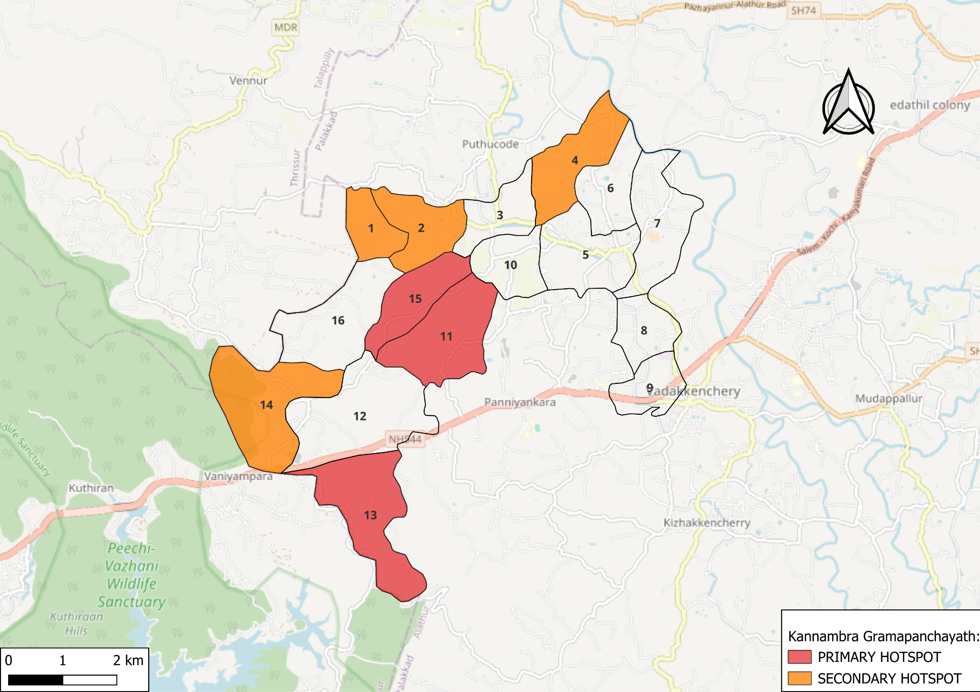
Map 6: Hotspot Map
Source:https://map.opendatakerala.org || created with QGIS

Ward No | Dengue Total (2021-25) | Leptospirosis Total (2021-25) | Hepatitis A Total (2021-25) | Mumps (2021-25) | ADD (2021-25) | Total Cases
1 | 3 | 0 | 6 | 4 | 20 | 33
2 | 2 | 0 | 2 | 6 | 22 | 32
3 | 3 | 0 | 0 | 8 | 19 | 30
4 | 3 | 0 | 0 | 8 | 10 | 21
5 | 3 | 0 | 0 | 5 | 18 | 26
6 | 0 | 1 | 0 | 7 | 16 | 24
7 | 2 | 1 | 0 | 2 | 17 | 22
8 | 1 | 0 | 0 | 4 | 20 | 25
9 | 1 | 1 | 0 | 10 | 25 | 37
10 | 1 | 0 | 0 | 4 | 26 | 31
11 | 4 | 0 | 1 | 8 | 24 | 35
12 | 3 | 0 | 0 | 10 | 24 | 37
13 | 5 | 0 | 1 | 7 | 23 | 36
14 | 1 | 1 | 0 | 7 | 30 | 39
15 | 3 | 0 | 0 | 12 | 20 | 35
16 | 1 | 0 | 0 | 6 | 15 | 22

Primary hotspots:
Ward 11, Ward 13, and Ward 15 show a comparatively higher concentration of cases, with repeated occurrence of Dengue, Hepatitis A, and ADD, indicating sustained transmission risk and the need for strengthened surveillance, vector control, and environmental management measures.
Secondary hotspots (moderate risk):
Ward 1, Ward 2, Ward 4, Ward 9, Ward 12, and Ward 14 report multiple diseases with moderate total caseload, suggesting mixed transmission patterns (vector-borne and water-borne) and the need for integrated preventive actions including water safety and sanitation improvements.
Low-risk but watch-list wards:
Wards 3, 5, 6, 7, 8, 10, and 16 have reported relatively low or sporadic incidence during the period and should continue under routine surveillance to prevent future escalation.

By overlaying five years (2021–2025) of disease surveillance data, we have identified Ward 1, Ward 2, Ward 7, Ward 9, Ward 11, and Ward 13 as “Red Zone” wards. These wards have reported recurrence of at least two different categories of diseases, including vector-borne and water-borne illnesses, over multiple years, indicating persistent transmission risk.
Ward 4 is categorized as the Highest Priority Hotspot due to its higher case burden and favourable conditions for vector breeding and possible water stagnation.
Future health-supportive infrastructure, such as the proposed R.O. drinking water plants, should be prioritized in Ward 4 and other Red Zone wards, particularly Wards 11, 13, and 9, to reduce water-borne disease risk and strengthen community resilience.

Preparedness and Response Protocol at LSG Level
This section describes the operational framework for the LSGI once a pandemic is declared. It explains how the LSGI and health system will move from routine data collection to active response, using a One Health approach.

Constitution of One Health Committee
The LSGD shall constitute a One Health Committee comprising the LSGI President, Medical Officers (Modern Medicine, AYUSH, and Veterinary), the Health Inspector, and the Veterinary Surgeon.

Objective: The One Health Committee coordinates human, animal, and environmental health to prevent and control pandemics.

Sl No | Name | Designation | Department/Institution | Role in Committee | Contact Number
1 | Vijayakumari | Panchayat President | LSGD | Chairperson | 9526818981
2 | Dr. Ullas Thomas | Medical Officer (PHC/CHC) | Health Dept | Member Secretary | 9447315695
3 | Dr.Sreenivasan | Veterinary Officer | Animal Husbandry | Member | 9447543234
4 | Dr.Haritha | Epidemiologist | Health Dept | Member | 8971034366
5 | Muhammed Riyas/Beefathima T U | Health Inspector/PHN | Health Dept | Surveillance | 9447963082
6 | Sindhu PRO | ASHA Supervisor | Health Dept | Community link | 8547758552
7 | Subhashini S | ICDS Supervisor | Social Welfare | Vulnerable groups | 8848395695
8 |  | Police Station Officer | Police Dept | Law & order
9 | Chandrabose | Ward Councillor Representative | LSGD | Community coordination | 9446375512
10 | Sisira Gopidas | Kudumbashree CDPO | Kudumbashree | Community mobilisation | 9496050193
11 |  | NGO/Volunteer rep | Civil Society | Support services
12 |  | Line Department representations

Key Responsibilities:
- Review disease surveillance data (human + animal)
- Conduct ward-wise risk assessment and vulnerability mapping
- Approve quarantine/isolation centre locations
- Coordinate with district for resources (PPE, oxygen, ambulances)
- Periodically review health system surge capacity, including beds, oxygen, human resources, and ambulances.
- Approve and monitor risk communication and community engagement strategies, including rumour management.
- Ensure protection and service continuity for vulnerable groups (elderly, persons with disabilities, dialysis patients, coastal populations).
- Conduct quarterly mock drills
- Monitor equity measures for vulnerable groups

Meeting Schedule:
Quarterly (normal times) | Weekly (outbreak alert) | Daily (pandemic phase)

Pandemic Response Workforce
To ensure a coordinated and timely response during a pandemic, a dedicated Pandemic Response Workforce shall be constituted at the LSG level. The workforce will function under the overall supervision of the One Health Committee and in close coordination with the health authorities. Team-based deployment will enable efficient surveillance, case management, quarantine and isolation management, logistics support, and risk communication. Each team shall have a clearly designated team leader, defined roles, and an identified pool of personnel to allow rapid activation, rotation of duties, and continuity of services during prolonged emergencies.

Total Response Workforce Available: 300 persons

Team Name | Composition | Key Responsibilities | Team Leader
Surveillance and Contact Tracing Team | HI, JHI, JPHN, ASHAs and Volunteers | Case detection, contact listing, home visits, reporting | HI
Case Management Team | Doctors, Nurses, MLSP, Palliative Nurses | Patient care & referral | DOCTOR
Quarantine & Isolation Team | LSGD staff, Volunteers | Facility management | JHI
Psychosocial support | AH counsellor | Psychosocial support | AH counsellor
Logistics & supply chain Team | LSGD staff, Storekeepers, Drivers 3 | Supplies & transport [PPE, medicines, oxygen, transport, waste management] | Ward Member
Communication Team | Ward members, Kudumbashree, Youth clubs,  AWW workers and other self help groups | IEC, community meetings, countering misinformation | M.O in charge
Transportation | KSRTC, educational institutional buses
Media Surveillance | Development Standing Committee members, IT Volunteers | Monitoring media reports, rumor tracking, misinformation control | Development Standing Committee Chairperson
Intersectoral coordination and convergence | Representatives from Health, LSGD, Police, Education, ICDS | Multi-department coordination, review meetings, resource mobilization | Development Standing Committee Chairperson
Collaborative surveillance | Health Officials, Private Practitioners, Labs | Data sharing, case notification, outbreak alert system | Health Standing Committee Chairperson

All teams shall be activated immediately upon outbreak alert or pandemic declaration and shall report daily to the LSG Incident Commander/Medical Officer, with consolidated reporting to the Block PHC. Duty rosters and alternate personnel shall be maintained to ensure uninterrupted services during staff shortages or prolonged response periods. Team composition and numbers may be revised based on the magnitude of the outbreak and availability of human resources.

Activities and Measures before and during Pandemic

PHASE 1 - Alert / Preparation
Surveillance and Reporting-Enhanced syndromic surveillance:
- Data sources for surveillance:
Surveillance data shall be compiled from multiple sources to ensure comprehensive coverage across the Panchayat. These include outpatient and inpatient registers from public and private health facilities, laboratory test results, reports from ASHA workers and other field health staff including JHIs, JPHNs, and MLSPs, school absenteeism records, pharmacy sales trends of antipyretics and antibiotics, and mortality data from the local registrar. All notifiable diseases and priority syndromes shall be reported in real time through the Integrated Health Information Platform (IHIP) to facilitate early warning signal generation, trend analysis, and rapid public health response.

- Event-based triggers (to be monitored and reported):
Event-based surveillance shall focus on the prompt identification and reporting of unusual or unexpected public health events that may indicate the emergence of a pandemic threat. The following triggers shall be actively monitored and immediately reported through appropriate channels, including the Integrated Health Information Platform (IHIP):
- Sudden clustering of fever, respiratory illness (ILI/SARI), diarrhoeal disease, or other similar syndromes within a locality.
- Two or more epidemiologically linked cases occurring in households, institutions, schools, hostels, migrant labour camps, or elderly care facilities.
- Unexplained severe illness, rapid deterioration, or deaths due to unknown causes.
- Increase in hospital admissions for respiratory or febrile illness beyond the expected baseline.
- Illness among healthcare workers or frontline staff.
- Reports of unusual clinical presentations or failure of standard treatment response.
- Rumours or community reports of sudden illness outbreaks.
All such events shall be verified promptly by field staff, documented, and escalated to higher authorities for timely outbreak investigation and control measures.

- Zoonotic and animal health surveillance
Zoonotic and animal health surveillance shall be strengthened during the alert and preparedness phase through close coordination between the Health Department, Animal Husbandry Department, and local Panchayat authorities under a One Health approach. Continuous monitoring shall be undertaken for unusual illness, sudden deaths, or changes in disease patterns among domestic animals, poultry, and wildlife, particularly in areas of close human–animal interaction such as livestock holdings, backyard poultry units, animal markets, slaughter points, and forest fringe areas.
Reports from livestock owners, poultry farmers, veterinary field staff, and community informants shall be promptly collected, verified, and shared with the public health surveillance system. Any suspected zoonotic event, including clusters of animal illness or mortality with potential human exposure, shall be immediately reported and jointly investigated. Integrated human and animal health surveillance findings shall be used to guide early risk assessment, targeted preventive measures, and timely containment actions to reduce the risk of zoonotic spillover and pandemic emergence.

- Logistics and Stock Preparedness
  - Identify and empanel local vendors and define emergency procurement mechanisms in accordance with existing LSGD and Health Department norms.
  - Prepare and maintain an essential logistics checklist covering medical supplies, consumables, and support equipment.
  - Pre-identify secure storage locations for emergency stocks and ensure maintenance of stock registers with regular updating.
  - Finalise emergency transport arrangements, including availability of vehicles and identified drivers for rapid deployment during alerts.
  - Designate a Nodal Officer for Logistics to enable prompt decision-making, coordination, and communication during emergencies.
  - Conduct rapid stock verification and ensure availability of minimum buffer stock, including:
- PPE kits 0 numbers
- Pulse oximeters – 4 numbers
- Hand sanitizers – 3 litres
- Masks, gloves, disinfectants – adequate quantity
Identify critical gaps in logistics and immediately communicate requirements to the Block and District authorities for timely replenishment and support. Monitor expiry dates and stock rotation.

Identification of Quarantine and Isolation Facilities
  - Identify and list suitable buildings for quarantine and isolation (schools, hostels, community halls, etc.).
  - Categorise cases as per the severity and allocate to appropriate facilities (for instance, severe cases to classrooms, mild cases to an assembly hall in case of a school).
  - Facility readiness checklist needed (beds, toilets, ventilation) etc.
  - Find an alternate site if the primary sites are not available or not in use.
  - Identify facility managers and support staff
  - Prepare basic SOPs for:
    - Admission and discharge
    - Food, water, sanitation
    - Infection prevention and waste disposal
  - Ensure availability of basic amenities: water, sanitation, electricity, ventilation, and waste disposal. Prepare a rapid activation plan for these facilities if case numbers increase.

Risk Communication and Community Preparedness
  - Disseminate early warning messages on symptoms, preventive measures, and reporting mechanisms. Display IEC materials both in English and the local language in public places and ensure ward-level awareness.
  - Sensitize elected representatives and community leaders on preparedness measures.
  - Establish a rumour tracking and misinformation response mechanism to identify, verify, and promptly counter false or misleading information.
  - Engage trusted local persons (ward members, ASHA workers, religious leaders, teachers, community volunteers) to communicate official public health messages and reinforce correct practices.
  - Develop and deploy targeted IEC materials for:
    - Schools and educational institutions
    - Markets and commercial areas
    - Work sites and labour settings
  - Conduct community sensitization meetings at the ward level to promote preventive behaviors, address concerns, and strengthen community participation in preparedness and response.

Protection of Vulnerable Groups
Vulnerable populations require priority protection through targeted line-listing, service continuity, and delivery mechanisms.
- Prepare and regularly update line-lists of vulnerable populations, including:
  - Elderly persons living alone
  - Persons with disabilities
  - Pregnant women
  - Migrant workers
  - Dialysis patients
The detailed line-lists shall be maintained as Annexure ___ and updated periodically.

Clinical Dependency Mapping
Develop ward-wise dependency and vulnerability maps to identify households requiring regular support during emergencies. Ensure continuity of essential health services for vulnerable groups, including
- Dialysis services (facility mapping, transport arrangements, and scheduling)
- Continuity of treatment for TB, HIV, and other chronic conditions requiring uninterrupted medication
- Mental health and psychosocial support services
Establish delivery mechanisms for food, essential commodities, and medicines to vulnerable households through coordinated action involving ASHAs, JPHNs, Kudumbashree, volunteers, and local administration.

PHASE 2 - Active Response

Case Identification and Contact Tracing
Case detection and contact tracing activities will be carried out in coordination with the Health authorities, following disease-specific SOPs and IDSP guidelines.
Field Staff Involved
- Health Inspector (HI)
- Junior Health Inspector (JHI)
- Junior Public Health Nurse (JPHN)
- ASHAs and ASHA Supervisors
- Ward-level volunteers and Kudumbashree members (as required)

Screening Checkpoints
Screening checkpoints at high-traffic locations (transport hubs, markets, religious gatherings) for early detection of symptomatic travellers and crowd screening during outbreaks. Potential locations include bus stands, market entry points, etc. based on local context and risk assessment.
Screening activities will be carried out by trained personnel such as ASHAs, ward members, and volunteers, with support from Health Department staff. Necessary equipment, including non-contact thermometers and appropriate PPE, shall be ensured prior to activation.
Location | Type (Bus stand/Jetty/Market/Railway) | Staff Deployed (ASHAs/Volunteers) | Screening Method | Reporting authority
Bus stand | Transport hub | 1 JHI | 1.Swab Collection.  2. Blood smears collection (RDT)  3.Thermal Scanners | Surveillance Nodal Officer in control room
Market entry | Market | One JHI  One ASHA  Male health volunteers | 1.Swab Collection.  2. Blood smears collection (RDT)  3.Thermal Scanners | Surveillance Nodal Officer in control room

Standard Screening Protocol

The screening protocol shall include temperature screening, observation for visible symptoms, and inquiry regarding recent travel or exposure history. Individuals identified as suspects during screening shall be immediately referred to the nearest PHC/FHC for further evaluation, testing, and appropriate action as per prevailing guidelines.

Pandemic Control Room
The Pandemic Control Room (PCR) serves as the central nerve center for real-time coordination, data aggregation, decision support, and communication during outbreaks. It consolidates information from all LSGD teams, health facilities and community sources to enable rapid response decisions.

Control Room Infrastructure and Location
Primary Location: Kannambra Panchayath Office.
Backup Location: Community Hall in Kannambra G.P.

Health System Control Room Framework
The PCR is organized into seven functional pillars to ensure no aspect of the response is overlooked:

Rapid Response Team (RRT)
  - Provides immediate intervention during emergencies, clusters, and field alerts.​
  - Coordinates urgent actions such as case investigation, contact tracing, isolation, and inter‑facility referrals.

Data Management & Analytics Team
  - Collects, validates, and manages key health system indicators (cases, tests, beds, HR, supplies).​
  - Analyzes data trends, generates projections, and supports evidence‑based decision‑making for local authorities.

Human Resource Deployment Team
  - Allocates healthcare staff efficiently based on workload and need
  - Ensures adequate and equitable workforce distribution across facilities

Laboratory Surveillance Team
  - Oversees diagnostic testing coordination, sample transport, and timely reporting of results.​
  - Monitors lab indicators (testing volume, positivity rate, turnaround time) for early detection of outbreaks

Vaccination Cell (If Required)
  - Plans and executes vaccination campaigns, including micro‑planning and session scheduling.​
  - Tracks coverage, identifies gaps, and coordinates corrective actions with field teams and outreach services.

Infrastructure & Patient Occupancy Team
  - Monitors facility capacity, earmarked beds, oxygen and critical care resources across all linked facilities.​
  - Ensures optimal patient distribution and referral management using updated bed‑status and resource data.
  - BMWM

Communication team
- Logistics and supply chain
- Transportation (interfacility & emergency transport)
- Media surveillance Call centre
- Management of the deceased
- Intersectoral coordination and convergence

Key Control Room Team
The Control Room Team coordinates all pandemic response activities within the LSGD and serves as the single command and communication hub during activation. It integrates information, field actions, logistics, and policy execution across all participating departments and health facilities.

Role | Name | Designation | Contact Number | Responsibility
In-charge/Nodal Officer | Dr.Ullas Thomas | MO | 9447315695 | Overall coordination, decision-making, and reporting to the District level.
Data Entry Operator | Aneeta JHI | Staff as per availability | 7902940459 | Managing the line list, updating dashboards, and tracking testing results.
Communication Officer | Sindhu | PRO | 8547758552 | Handling the public helpline, coordinating ambulance dispatch, and contact tracing calls.
Logistics Coordinator | Muhammed Riyasudheen | HI | 9447963082
Technical Support (IT/Data) | Rudra Raj | JHI | 9496311795

SOP for alert escalation/trigger point with mapping of responsibilities.
Key Points:
- The Control Room shall be staffed with a designated In-charge, data entry personnel, and communication staff with clearly defined roles and shift arrangements.
- It shall maintain updated records on daily monitoring indicators including new cases, persons under active quarantine, and hospital bed occupancy.
- All reports and situation updates shall be shared daily with the Block and District Surveillance Unit.
- The Control Room shall act as a single point of contact for coordination with response teams, health institutions, and other departments.
- Contact details of the Control Room shall be widely communicated to field staff and stakeholders during activation.

Daily Monitoring Indicators
To ensure timely decision-making and effective response, the following key indicators shall be monitored and updated on a daily basis by the Pandemic Control Room:

Epidemiological Indicators:
New cases reported today, Total active cases, Test Positivity Rate (TPR), Case Fatality Rate (CFR)
- Surveillance Indicators:
Persons under home quarantine, High-risk contacts identified, Fever, ILI, SARI or other symptoms (syndromic surges), Travellers (symptomatic or high-risk arrivals),Animal husbandry surveillance (zoonotic alerts, unusual animal deaths, poultry/bird flu signals), Mortality surveillance (excess deaths, unexplained fatalities, verbal autopsy reports)
- Logistics and Infrastructure Indicators:
Hospital / CFLTC beds occupied, Oxygen cylinders/concentrators available, Ambulances on standby
- Alert Findings
The following table outlines category-specific trigger points (red flags) from surveillance indicators and corresponding immediate actions for the Pandemic Control Room. These enable rapid response to alert findings like testing anomalies, positive cases exceeding thresholds, clusters, and WGS reports.

Category | Trigger Point (Red Flag) | Immediate Action
Clusters | Geographical or facility-based: 5+ cases linked to one location (office, school, street). | Declare a micro-containment zone; perimeter control and active case finding.
Testing | Sudden drop in testing volume / delay in reporting / unusual testing trends | Review the sample collection process, address lab bottlenecks, deploy additional testing teams, and notify the District Lab.
Lab | Test Positivity rate increases | Increase testing sites in that ward.
Hospital | >80% Oxygen bed occupancy | Activate backup/CFLTC beds.
Travel | Cluster of cases from a single flight/train or high-risk arrival group. | Trace all passengers in adjacent seats; implement mandatory institutional quarantine.
Animal | Mass poultry/wildlife death or unusual sickness | Notify Animal Husbandry, sample the area, and dispatch RRT for environmental sampling and zoonotic check.
Mortality | Sudden spike in home deaths or brought-in-dead (BID) cases | Audit the deaths and Active Case Search drive
Additional investigations like Whole Genome Sequencing (WGS) | Detection of a Variant of Concern (VOC) or Variant of Interest (VOI) | Implement strict micro-containment; update clinical protocols to match variant severity.

Communication of Public Health Information
A Community Communication Hub shall be established to ensure timely, accurate, and consistent dissemination of information during a pandemic. The Hub will function under the coordination of Nodal officers of the control room and act as the nodal point for public communication, risk messaging, and community engagement. It will support dissemination of official advisories, promote preventive behaviors, address rumors and misinformation, and ensure that messages reach all sections of the population through trusted local channels and leaders.

Key communicators
Channel | Responsible Person | Contact
Ward-level announcements | Karappotta- 1  U Ramachandran | 8075840933
Social media | Abdul Shukkur | 9895539075
Local Cable TV/Radio

- All messages disseminated through the Hub shall align with advisories issued by the Health Department and District authorities.
- Community leaders shall be sensitized to support behavior change, reduce stigma, and counter misinformation.
- Special efforts shall be made to reach vulnerable and hard-to-reach populations using locally appropriate communication methods.

Rumor Tracking: A designated volunteer will monitor local social media/WhatsApp groups daily to identify misinformation and issue official clarifications via the Communication Hub.

Coordination with District/State Authorities & Other Organisations
Effective coordination with Block, District, and State authorities is essential to ensure timely reporting, technical guidance, and uninterrupted supply of essential resources during a pandemic. The LSG shall establish clear communication channels, designate responsible officers, and adhere to prescribed reporting timelines to support coordinated public health action and efficient resource mobilisation.

Key Details:
- Nodal Officer for Reporting: Medical Officer
- Contact Number: 9447315695
Reporting Schedule and Protocols:

To Whom | What to Report | Frequency | Nodal Person
Block PHC | Complete Situation Report (Cases, Quarantine, Beds, Screening, Deaths) | Daily / As directed during outbreak | MO
District IDSP Unit | Outbreaks/Clusters/Unusual Events (>5 cases same ward) | Immediately | MO
Veterinary Officer | Animal health events/Zoonotic alerts | Immediately upon detection | Veterinary Inspector / Livestock Inspector
State Cell | Zoonotic cross-sector events | As directed / Immediate during major outbreak | DMO/DSO (through Block PHC)

Supply Chain Coordination
The LSG shall coordinate closely with Block, District, and State authorities (KMSCL) to ensure uninterrupted availability of essential goods, medical supplies, and logistics during a pandemic. Supply requirements shall be assessed regularly based on case load and communicated promptly to the appropriate authorities for timely replenishment.
Key Points:
- Maintain updated contact details of District and Block nodal officers for health logistics, oxygen supply, ambulances, and essential medicines.
- Submit timely indent requests for PPE, testing kits, medicines, oxygen, and other critical supplies through prescribed channels.
- Monitor stock levels at LSGD facilities, quarantine/isolation centres, and field teams through daily stock registers and dispensing logs to prevent shortages.
- Coordinate with District authorities, Karunya/Neethi medical shops, and local purchase committees for funds allocation and emergency procurement.

- Ensure regular monitoring of dispensing registers at all facilities to track usage, expiry, and pilferage—shortages being a perennial issue requiring proactive weekly audits.

- Activate surge procurement protocols during high caseloads, leveraging local purchase powers under LSGD funds alongside state supplies.

Resource Inventory and Contacts
Resource Category | Source  (District/State/Private) | Contact
PPE Kits/Masks/Gloves | KMSCL | 0491- 253336
PPE Kits/Masks/Gloves | Local Vendors | 7012208221
Oxygen  Cylinders/Concentrators | KMSCL | 0491- 253336
Medicines/Antivirals | KMSCL | 0491- 253336
Medicines/Antivirals | Neethi Shops | 7012208221
Test Kits (RTPCR/Rapid) | KMSCL | 0491- 253336

Collaboration with NGOs, PPP, and CSR
To augment government efforts during a pandemic, the LSG shall collaborate with NGOs, voluntary organisations, and private sector partners through public–private partnerships and Corporate Social Responsibility (CSR) initiatives, in coordination with District authorities.

Key Points:
- Engage NGOs and community-based organisations for community outreach, awareness, and support to vulnerable populations.
- Leverage CSR support for procurement of medical equipment, PPE, oxygen concentrators, food kits, and sanitation materials, as permitted.
- Ensure all collaborations align with government guidelines and are routed through approved administrative and financial procedures.
- Maintain transparency and documentation for all external support received and utilised.
Organization | Type | Support Offered | Contact Person
Youth Clubs/Student Unions | CBO | Coordination

Interdepartmental Coordination
Coordination among departments during a pandemic shall be ensured through regular review meetings convened by the LSGD President. These meetings will provide a structured platform for sharing situational updates, assessing resource availability, resolving operational gaps, and taking joint decisions to ensure a coordinated and timely response.

Department | Representative | Key Role | Contact
Health (PHC) | Staff Nurse : | Case management | 9567394258
Veterinary | Veterinary Surgeon: | Animal surveillance | 9447543234
ICDS | Supervisor: | Nutrition support | 8848395695
Education | Head Teacher: | School coordination | 9605805584
Police | SI | Containment enforcement | __________
Water Authority | AE | Water supply | __________
LSGD Engineering | AE | Quarantine infrastructure | __________

PHASE 3 - Surge Capacity
Phase 3 is activated when there is a rapid increase in cases, high test positivity rates, or when existing health facilities and quarantine arrangements approach saturation. The focus of this phase is to expand isolation capacity, augment clinical care services, and mobilise additional resources through district and state support mechanisms.

Conversion of Community Facilities
To manage increased case load, the LSGD shall activate additional isolation facilities by repurposing identified community infrastructure such as community halls, auditoriums, schools, hostels, or other suitable buildings.

- Recovery and rehabilitation phase
- Recovery
  - Damage & impact assessment
  - Restoration of health services
  - Rehabilitation of affected population
  - Psychosocial & mental health support
  - Disease surveillance during recovery phase
  - Environmental cleanup & sanitation
  - Livelihood restoration
  - Community engagement & confidence building
  - Documentation & after-action review
  - Lessons learned & best practices
  - Health system strengthening
  - Policy revision & preparedness enhancement
  - Research

CONCLUSION
The Overall Pandemic Action Plan of Kannambra Grama Panchayat provides a comprehensive, risk-based, and people-centred framework to prevent, prepare for, and respond to public health emergencies. By integrating ward-level risk stratification, demographic and clinical vulnerability mapping, strengthened disease surveillance, and intersectoral coordination, the Plan ensures timely detection, effective response, and continuity of essential health services during pandemics. Emphasis on community participation, protection of vulnerable populations, healthcare system readiness, and resilient water, sanitation, and environmental management strengthens local preparedness. Through decentralized planning, data-driven decision-making, and sustained collaboration with health institutions and community stakeholders, the Panchayat is well-equipped to minimize health impacts, maintain social stability, and safeguard the well-being of its population during future pandemics.

RECOMMENDATIONS

Strengthening Healthcare Infrastructure
- Establish a primary health response unit within the Panchayat with trained staff.
- Ensure availability of basic medical supplies (masks, sanitizers, PPE kits, oxygen cylinders).
- Create tie-ups with nearby hospitals for emergency referral and transport.

2. Community Awareness & Education
- Conduct regular awareness campaigns on hygiene, vaccination, and preventive measures.
- Use local communication channels (community radio, WhatsApp groups, notice boards) to spread verified information.
- Train volunteers to act as health ambassadors in each ward.

3. Emergency Response & Coordination
- Form a Pandemic Preparedness Committee at Panchayat level including health workers, ward members, and NGOs.
- Develop a clear action plan for lockdowns, quarantine, and distribution of essentials.
- Maintain a database of vulnerable groups (elderly, differently-abled, chronically ill) for targeted support.

4. Supply Chain & Food Security
- Identify and support local suppliers and farmers to ensure uninterrupted food supply.
- Create community kitchens during emergencies to serve vulnerable populations.
- Stockpile essential commodities in Panchayat-run outlets for crisis periods.

5. Digital Preparedness
- Promote digital platforms for telemedicine consultations.
- Use Panchayat’s website/social media for real-time updates on health advisories.
- Encourage online grievance redressal to reduce crowding in offices.

6. Training & Capacity Building
- Organize mock drills for pandemic response in schools, offices, and public spaces.
- Train Panchayat staff and volunteers in first aid, infection control, and crowd management.
- Collaborate with NGOs and health departments for capacity-building workshops.

7. Long-Term Resilience
- Integrate pandemic preparedness into the Panchayat Development Plan.
- Allocate a dedicated budget for health emergencies.
- Encourage community participation in planning and monitoring preparedness measures.

MOCKDRILL SCENARIOS
Mock drill scenarios for public health emergencies, including outbreak response, mass casualty management, and pandemic preparedness, have been identified to strengthen institutional readiness and coordinated response mechanisms; however, implementation is pending across institutions and will be conducted in a phased manner to strengthen emergency response capacity.

ANNEXURE

IMPORTANT PHONE NUMBERS

Phone numbers and particulars of persons responsible for providing guidance, assistance, and support for pandemic preparedness operations may be provided here in a manner that allows easy reference at a glance. The information recorded here could be exhibited elsewhere at the time of emergencies. LSG institutions shall give special attention to collect and record the above data of persons and institutions who/which are supposed to give technical and co-ordination support to reduce the impact of pandemic.

1.1. Details of grama panchayat/municipality/corporation wards
Sl.No | Name of the ward | Ward number | Name of the ward  member | Contact number
1 | Karappotta | 1 | U Ramachandran | 8075840933
2 | Kottekkad | 2 | K R Shanmughan | 9778722289
3 | Kunnamkadu | 3 | Jisha shiju | 8156953746
4 | Vadakkumuri | 4 | k Ajitha | 9746198204
5 | Manjapra | 5 | M Vinil kumar | 9961998853
6 | Pulinkoottam | 6 | K Anoop | 9946919095
7 | Aramthodi | 7 | Ushakumari | 9846623263
8 | Chira | 8 | M Chenthamarakshan | 9846042420
9 | Konnenchery | 9 | K Abdulmshukkur | 9895539075
10 | Karayankad | 10 | T V Rahmath | 9605763696
11 | Kanambra | 11 | K Prasanna kumari | 9074213132
12 | Challiparambu | 12 | P vijayakumari | 9526818981
13 | Valuvechupara | 13 | P V Minimol | 9745264129
14 | Rekkandy | 14 | CC Chandrabose | 9446375512
15 | Panthalampadam | 15 | Kunjamma Petre | 9544862002
16 | Kallingalpadam | 16 | V Prameela | 9744603437
17 | Kalleri | 17 | M V Unnikrishnan | 9605383985
18 | Choorkkunnu | 18 | P Balakrishnan | 9495396839

1.2. Other important phone numbers of grama panchayat/municipality/corporation area
Sl. No. | Name | Contact number
1. | Santhosh Kumar Secretary | 9400685234
2. | Narayanamoorthy JS
3. | Sivakumar Clerk
4. | Anjana Clerk
5 | Excise department
6 | Forest department

1.3. Important offices of grama panchayat/municipality/ corporation
Sl.No | Name of the office | Contact person | Contact number
1. | Village Office | Village Officer | 9995761325
2. | Agriculture Office | Arathi Krishna Agriculture Officer | 9048201003
3. | Animal Husbandry Office | Animal Husbandry Doctor | 9447543234
4. | Police Station | Police Officer | NA
5. | BSNL Office | Officer | NA
6. | Block Office | Officer | 9847232847
7. | KSEB Office | Officer | NA
8. | Fisheries Office | Officer | NA
9. | Fire and Rescue | Officer | NA

1.4. Health Services

Sl. No | Name of the hospital/institution | Location | Phone number
1. | Government hospitals/PHC | Kannambra | 9447315695
2. | Private hospitals | 0
3. | Clinical laboratories
4. | Chemist/pharmacy
5. | Blood donors
6. | Other language experts (Bihari, Hindi, Bengali,  Asamees ………)

1.5. Veterinary Services
Sl.No | Name of the Clinic | Name of the  Surgeon/Doctor | Place/location | Phone  number
1 | Govt.Veterinary Hospital | Dr .Sreenivasan | Kizhakekalam,Kannambra | 9447543234

1.6. Helpline numbers
Helpline | Phone number
Police | NA
Fire and Rescue | NA
KSEB | NA

1.7. Public and Private Schools Contact details

S.No | Name of School | Institution type | Phone number
1 | KMLPS Karappotta | Aided | 9188172780
2 | GALPS Puthukode | Aided | 9495539406
3 | LVLPS Puthukode | Aided | 9497824531
4 | GLPS Kannambra | Govt | 9447392513
5 | AUPS Kannambra | Aided | 8547973402
6 | GHSS Kallingalpadam | Govt | 8089022202
7 | MMHS Panthalampadm | Aided | 9496808666
8 | Bethlahem School Vaniyampara | Private | 8075655812
9 | PKHS Manjapara | Aided | 9847043504
10 | Bhavans Vidhya Mandhir Manjapra | Private | 9985856333
11 | Twinkle Memorial School Manjapra | Aided | 9037928932
12 | CALP Ayakkad | Govt | 9847225059
13 | GMLP Urunnippara | Govt | 6282804550

1.9. Anganwadi Contact Details

Ward No/C.No | Name of Anganwadi Teachers | Phone number
89 | Saseendra | 9645895070
90 | Priyajyothi | 9539932063
91 | Baby | 96458950
88 | Soumya | 8157019914
87 | Karnaki | 9747690961
86 | Praseeda | 9961640423
85 | Aswathi | 790917011
82 | Raji | 9961605688
84 | Chandrika | 9744721213
81 | Latha | 9605699198
78 | Aisha | 9605453349
80 | Suja | 9744748548
77 | Geetha | 9730608401
76 | Jessy Mani | 9656455629
79 | Sandhya | 9037513101
82 | Suma | 9020588504
83 | Ambili | 9605961604
93 | Rasheeda | 9847397084
94 | Ambily | 9744616733
95 | Geetha | 9747203736
97 | Manjusha | 9446473593
96 | Padmini | 9665900350
98 | Ramla | 9744714142
99 | Pushpavalli | 9747816686
100 | Sathi | 7902961795

1.12. Information regarding resources

Means of transportation | Name of Owner | Phone Number
Heavy Trucks | 0
Tractor | 0
Ambulances | 2
Boats | 0
Taxi service | 0

Annexure 1: LSG Baseline Data Collection Format
A. Baseline data
Sl. No. | Indicator / Field | Baseline Data | Source / Remarks
1 | Name of LSG | Kanambra | PHC Base line Data
2 | District | palakkad
3 | Block / Taluk | Alathur
4 | Type of LSG (Gram Panchayat / Municipality / Corporation) | Grama Panchayath
5 | Area (sq. km) | 29.7
6 | No. of wards | 18
7 | GIS boundary file available | (Yes/No)
8 | Key contact person & phone

B. Demography
Indicator / Field | Baseline Data | Source / Remarks
Total population | 27199 | Base line data PHC
Males | 13486 | Base line data PHC
Females | 13713 | Base line data PHC
Transgender population | 0 | Base line data PHC
Age distribution  (<5, 5–14, 15–59, ≥60) | 0-5 yrs-1227, > 60-6174 | Base line data PHC
No. of households | 7137
Population density (persons/sq.km)
No. of migrant workers | 295 | Migrant Register PHC
Major occupational groups | Coolie,NREG

C. Vulnerable Populations & Social Risks
Sl. No. | Indicator / Field | Baseline Data (Value / Description) | Source / Remarks
1 | No. of elderly (≥60) | 6174
2 | No. of persons with disability | 103
3 | No. of bedridden persons | 80
4 | No. of chronic disease cases (DM/HTN/COPD/CKD etc.) | 4776
5 | Pregnant women (current estimate) | 161
6 | Children <5 years | 515
7 | Tribal population (if any) | 128
8 | Fisherfolk / coastal vulnerable groups (if any) | 0
9 | Urban slums / unnotified settlements (if any) | 7
10 | Homeless population | 0
11 | Orphanages / old age homes (number & capacity) | 0
12 | Hostels / prisons / shelters (number & capacity) | 0
13 | Poverty / BPL estimate | 2633
14 | Food insecurity hotspots | 0
15 | Any history of stigma/discrimination issues (Yes/No) | 0

D. Health System & Service Readiness
Sl. No. | Indicator / Field | Baseline Data (Value / Description) | Source / Remarks
1 | No. of health facilities in LSG (PHC/CHC/TH/DH/Private) | 3
2 | PHC/Family Health Centre details (name, location) | FHC Kannambra
3 | Subcentres / Health & Wellness Centres (number) | 6
4 | Private clinics / hospitals (number) | 7
5 | Labs available (public/private) | 5
6 | Availability of ambulance services (Yes/No, number) | Yes
7 | Availability of isolation/quarantine facilities (Yes/No, details) | Yes
8 | Cold chain facilities (Yes/No, details) | yes
9 | Stockpile space available (Yes/No) | Yes
10 | PPE / mask / sanitizer availability plan (Yes/No) | yes
11 | Surveillance staff available (JHI/JPHN/ASHA count) | JHI -3  JPHN -6  ASHA -23
12 | Existing emergency referral pathways (Yes/No) | YES

E. Points of Entry & Mobility
Sl. No. | Indicator / Field | Baseline Data (Value / Description) | Source / Remarks
1 | Bus stands / depots (number) | 4
2 | Railway stations (number) | No
3 | Boat jetties / fishing harbours (number) | 0 | 0
4 | Ports / airports nearby (specify distance) | 0
5 | Major highways/roads passing through | 0
6 | Border crossings (state/district) | Thrissur
7 | Major markets / weekly markets | 0
8 | Tourism hubs / major event venues | 1
9 | Schools/colleges with hostels (number) | 0
10 | Factories / large workplaces (number) | 13
F. Water, Sanitation & Hygiene (WASH)
Sl. No. | Indicator / Field | Baseline Data (Value / Description) | Source / Remarks
1 | Major drinking water sources (piped / wells / borewells / springs) | LSGD Water supply and wells
2 | No. of public wells | 60
3 | No. of households with piped water connection | 107
4 | Water quality testing routine (Yes/No) | yes
5 | Common contamination risks (flooding, salinity, industrial waste) | 0
6 | Open defecation free status (Yes/No) | No
7 | Solid waste management system (Yes/No) | Yes
8 | Bio-medical waste disposal mechanism (Yes/No) | Yes
9 | No. of public toilets | No
10 | Handwashing stations in public places (Yes/No) | No
G. Zoonotic Risks & One Health
Sl. No. | Indicator / Field | Baseline Data (Value / Description) | Source / Remarks
1 | Livestock population (cattle/goats/pigs/poultry) – estimates | 9030
2 | No. of dairy farms / poultry farms / pig farms | 7
3 | Slaughterhouses / meat shops (number) | No
4 | Animal markets (Yes/No, details) | No
5 | Veterinary dispensaries (number) | 9447543234
6 | History of zoonotic outbreaks (rabies, leptospirosis, avian flu etc.) | No
7 | Stray dog population management measures (Yes/No) | Yes
8 | Rodent infestation hotspots (Yes/No) | No
9 | Wetlands / waterlogged areas prone to leptospirosis | No
10 | Bat roosting areas / caves / fruit orchards (if any) | No
11 | Human-animal interface hotspots (farms near residences) | No
H. Climate & Disaster Risks (Pandemic Amplifiers)
Sl. No. | Indicator / Field | Baseline Data (Value / Description) | Source / Remarks
1 | Flood-prone wards (list) | 8 & 9
2 | Landslide-prone wards (list) | 16
3 | Cyclone/sea surge risk (Yes/No) | No
4 | Heatwave risk zones (Yes/No) | No
5 | Waterlogging areas (list) | 3,1,7,8 & 9
6 | Shelter homes / relief camps (number, capacity) | 2
7 | Past disaster displacement history
8 | Disruption to water supply/transport common (Yes/No) | Yes
I. Critical Infrastructure & Logistics

J. Risk Communication & Community Networks
Sl. No. | Indicator / Field | Baseline Data (Value / Description) | Source / Remarks
1 | Ward-level rapid response teams (Yes/No) | YES | PHC,JAK Team
2 | Jagratha samithis / committees active (Yes/No) | Yes | PHC
3 | Kudumbashree presence and strength (number of units) | 238
4 | Volunteer network (number, coverage) | 34
5 | Community-based surveillance mechanisms (Yes/No) | Yes
6 | IEC dissemination channels (WhatsApp groups, community radio, PA systems) | Watsap groups
7 | Rumour tracking mechanisms (Yes/No) | yes | ASHA,Arogya volunteers
8 | Languages spoken / literacy considerations | Languages spoken
9 | Vulnerable groups communication strategy available (Yes/No) | Yes

K. Preparedness Planning & Governance
Sl. No. | Indicator / Field | Baseline Data (Value / Description) | Source / Remarks
1 | LSG emergency plan available (Yes/No) | yes
2 | Pandemic preparedness plan available (Yes/No) | yes
3 | Incident Command System identified (Yes/No) | yes
4 | Rapid procurement mechanism available (Yes/No) | yes
5 | Emergency fund available (Yes/No, amount) | Yes
6 | Past outbreak response experience (Yes/No, details) | YES
7 | Intersectoral coordination mechanism (Health, Police, LSG, Veterinary, Education) | YES
8 | Mock drills conducted in last 12 months (Yes/No) | YES
9 | Training coverage for staff/volunteers (Yes/No) | YES

L. Surveillance & Data Systems
Sl. No. | Indicator / Field | Baseline Data (Value / Description) | Source / Remarks
1 | Digital reporting tools used (e.g., DHIS2, portals) | Yes
2 | Availability of line-listing format (Yes/No) | Yes
3 | Contact tracing team identified (Yes/No) | Yes
4 | Mapping of high-risk households available (Yes/No) | Yes
5 | Testing sample transport mechanism (Yes/No) | Yes
6 | Reporting timeline adherence (good/average/poor) | Good
7 | Data sharing between departments (Yes/No) | Yes
8 | Availability of dashboard for monitoring (Yes/No) | Yes

M. Additional Notes & Observations
Sl. No. | Indicator / Field | Baseline Data (Value / Description) | Source / Remarks
1 | Key challenges perceived by LSG | Datas related to LSGD
2 | Top 5 high-risk wards (reason) | 13,14,15,16 Rubber Plantation -Dengue risk
3 | Any unique local risks (industrial pollution, refugee camps, etc.) | No
4 | Recommendations for preparedness strengthening | -

