THE MEDICAL OFFICER
PHC MELARCODE
melarcodephc@gmail.com

PANDEMIC PREPAREDNESS PLAN
MODEL OF LSG
MELARCODE GRAMA PANCHAYAT

MESSAGE FROM PRESIDENT/CHAIR LSGI
It gives me immense pleasure to present this document on behalf of Melarcode Grama Panchayat. As a Local Self Government Institution, our Panchayat remains committed to the holistic development and well-being of the community through participatory governance, transparency, and sustainable planning.
Melarcode Panchayat, with its unique geographical setting and strong social cohesion, has consistently upheld the values of cooperation and collective responsibility. While the Panchayat has achieved steady progress across multiple sectors, it continues to face challenges such as seasonal climatic variations, public health concerns, environmental issues, and the growing demand for basic infrastructure and essential services. Addressing these challenges calls for coordinated efforts, systematic planning, and active participation from the community.
The Panchayat, in close collaboration with health institutions, government departments, community-based organizations, and field-level functionaries, is continuously strengthening public health initiatives, sanitation and waste management systems, and disaster preparedness measures. Emphasis is placed on disease surveillance, environmental conservation, social welfare programmes, and inclusive development to ensure equitable benefits reach all sections of society.
We firmly believe that preparedness, decentralized planning, and proactive governance are fundamental to building community resilience. Through sustained community engagement and coordinated action, Melarcode Grama Panchayat strives to create a safe, healthy, and sustainable environment for present and future generations.
I extend my sincere appreciation to all officials, health workers, volunteers, and citizens who consistently contribute to the development and welfare of the Panchayat. Let us continue to work together with shared responsibility towards the comprehensive development of Melarcode.

President
Melarcode Grama Panchayat
MESSAGE FROM HEALTH STANDING COMMITTEE CHAIR PERSON
The Health Standing Committee of Melarcode Grama Panchayat remains steadfast in its commitment to safeguarding and promoting the health and well-being of the community. Public health is a core pillar of local governance, and the Committee’s efforts are directed towards ensuring accessible, equitable, and quality health services for all residents.
Melarcode Panchayat, with its predominantly rural character and diverse settlement patterns, presents both opportunities and challenges in the delivery of health services. Seasonal climatic variations, water-related health concerns, the risk of vector-borne diseases during monsoon periods, and the increasing burden of non-communicable diseases necessitate continuous vigilance and coordinated action. The Committee works in close coordination with the Health Department, Primary Health Centres, ASHA workers, Anganwadi centres, and other key stakeholders to strengthen preventive and promotive health initiatives.
Special emphasis is placed on immunization, maternal and child health services, care of the elderly, sanitation and waste management, disease surveillance, and health education activities. Community participation and effective interdepartmental coordination remain central to the Committee’s approach, ensuring that health programmes reach all sections of the population in a timely and effective manner.
The Committee recognizes that preparedness and prompt response are critical for managing public health emergencies and seasonal disease outbreaks. Through systematic planning, regular review mechanisms, and data-driven interventions, the Health Standing Committee continues to enhance public health preparedness and resilience within the Panchayat.
I extend my sincere appreciation to all health professionals, field-level staff, volunteers, and community members whose dedicated efforts strengthen the public health system. Together, we strive to build a healthier and safer Melarcode.
Chairperson
Health Standing Committee
Melarcode Grama Panchayat
MESSAGE BY MEDICAL OFFICER
As the Medical Officer of Primary Health Centre Melarcode, I am pleased to present this document outlining our continued commitment to strengthening public health and primary healthcare services. The Primary Health Centre functions as a key first-level healthcare institution, providing accessible, affordable, and essential health services to the population of Melarcode and the surrounding areas.
The PHC offers comprehensive outpatient services, maternal and child health care, immunization, management of communicable and non-communicable diseases, and effective implementation of national health programmes. The institution plays a vital role in disease surveillance, early detection, prevention, and control activities, particularly during seasonal outbreaks.
Through the coordinated efforts of medical officers, nursing staff, health inspectors, ASHA workers, and other support staff, the PHC ensures timely diagnosis, appropriate treatment, and referral services. Health education activities and close coordination with subcentres, community-level institutions, and local self-government bodies form an integral part of service delivery.
Recognizing emerging public health challenges and increasing service demands, PHC Melarcode continues to strengthen service delivery and preparedness through systematic planning, capacity building, and effective coordination with health authorities and local self-government institutions.
I sincerely appreciate the dedicated efforts of the health staff, the support of the local administration, and the cooperation of the community. Together, we remain committed to improving health outcomes and ensuring quality healthcare services for the people of Melarcode.
Medical Officer
Primary Health Centre Melarcode

EXECUTIVE SUMMARY
Primary Health Centre (PHC) functions as the primary public healthcare institution serving the population of 28254 Grama Panchayath. The PHC plays a pivotal role in delivering comprehensive, accessible, and affordable healthcare services, with a strong focus on preventive, promotive, curative, and rehabilitative care in accordance with national and state health programmes.
The PHC caters to a predominantly rural population, addressing key public health priorities such as maternal and child health, communicable and non-communicable disease control, immunization, family welfare, adolescent health, and geriatric care. Regular outpatient services, home-based care through field health staff, and outreach activities ensure healthcare coverage even in geographically challenging areas. The institution actively implements national health missions, including the National Health Mission (NHM), National Tuberculosis Elimination Programme, National Programme for Prevention and Control of Cancer, Diabetes, Diseases and Stroke (NPCDCS), and other disease surveillance initiatives.
Melarcode PHC works in close coordination with the Grama Panchayath, ASHA workers, Anganwadi centres, schools, and community-based organizations to strengthen community participation and improve health awareness. Emphasis is placed on early detection, timely referral, health education, and lifestyle modification to reduce disease burden and improve overall health outcomes.
Despite constraints related to infrastructure, manpower, and increasing service demand, the PHC continues to enhance service delivery through effective planning, data-driven decision-making, and community engagement. Strengthening facilities, upgrading digital health systems, and expanding preventive services remain key focus areas for future development.
Overall, Melarcode Primary Health Centre stands as a vital institution in safeguarding public health and improving the quality of life of the residents of Melarcode Grama Panchayath

LIST OF ABBREVIATIONS

LSGD/LSGI | Local Self Government Department / Local Self Government Institution
BMO | Block Medical Officer
IDSP | Integrated Disease Surveillance Programme
NDMA | National Disaster Management Authority
PPE | Personal Protective Equipment
ICMR | Indian Council of Medical Research
CD | Communicable Diseases
NCD | NON-COMMUNICABLE Diseases

TABLE OF CONTENTS

3
INTRODUCTION 9
● Background of the PPP 9
LSGD AT A GLANCE 9
INTEGRATED HEALTH INFRASTRUCTURE MAP OF MELARCODE PANCHAYAT 10
GENERAL PROFILE OF THE LSGI’S 13
Background of the LSGI 13
Demographic and Vulnerable Population 14
Clinical Vulnerability 16
INFRASTRUCTURE & RESOURCE INVENTORY 18
Health Facility Directory & Basic Capacity in the LSGD 18
Private Clinics 19
Healthcare Education & Training Institutions 20
Specialized Services & Emergency Inventory 20
Oxygen & Diagnostic Capacity 21
Diagnostics facility mapping at the LSGI level 22
Laboratory Identification & Basic Details 22
Social and Community Infrastructure for surge plan 22
Human resources 24
Community & Support Cadre 25
Community Organizations 26
Administrative & Emergency Services 27
Information regarding resources 27
ONE HEALTH & ENVIRONMENTAL SURVEILLANCE 28
Animal & Bird Population 28
Veterinary Infrastructure 29
Veterinary Doctors & Workforce 30
High-Risk Interface Points (Surveillance Sites) 30
Environmental Risk Mapping 31
Disease Seasonality Mapping 32
Vulnerability Mapping 33
EPIDEMIOLOGICAL TRENDS (2021–2025) 34
Disease Burden among human beings(Last 5 Years) 34
*(use the above table data to create the graph/diagram) 36
Seasonal Trend Analysis 37
Outcome-Based Trend Analysis- 2025 39
Transmission Trend- 2025 40
Integrated Disease Hotspot Map (2021–2025) 42
Preparedness and Response Protocol at LSG Level 44
Constitution of One Health Committee 44
Pandemic Response Workforce 45
Activities and Measures before and during Pandemic 47
PHASE 1 - Alert / Preparation 47
PHASE 2 - Active Response 50
Standard Screening Protocol 51
PHASE 3 - Surge Capacity 60
Conversion of Community Facilities 60
CONCLUSION 61
RECOMMENDATIONS 62
ANNEXURE 63
1. IMPORTANT PHONE NUMBERS 63

INTRODUCTION

Background of the PPP
Pandemics pose significant challenges to public health systems and community well-being, highlighting the need for strong preparedness and coordinated response mechanisms at the local level. The Pandemic Preparedness Plan (PPP) of Melarcode Grama Panchayat has been developed to strengthen early detection, preparedness, and response through the coordinated efforts of health institutions, the Panchayat administration, and frontline health workers. The plan serves as a structured framework to ensure timely and effective action during public health emergencies, maintain continuity of essential health and civic services, and provide focused protection to vulnerable and high-risk populations within the Panchayat.
The Local Self Government Department (LSGD), Government of Kerala, is responsible for policy formulation, guidance, and overall oversight of Local Self Government Institutions, including Grama Panchayats, Municipalities, and Corporations. Through decentralized governance, participatory planning, capacity building, and systematic monitoring, LSGD supports Melarcode Grama Panchayat in the implementation of public health, development, and welfare programmes. This institutional support strengthens the Panchayat’s capacity to respond effectively to pandemics and other public health emergencies in an inclusive, resilient, and sustainable manner.

LSGD at a glance
Melarcode Grama Panchayat comprises a total of 16 wards with an overall population of 27,439 residing in 7,302 households, indicating a moderately dense rural settlement pattern. The population distribution varies across wards, with Ward 3 recording the highest population (2,210) and number of households (648), while Ward 16 has the lowest population (1,142) and households (325). The migrant population in the Panchayat is relatively low, with a total of 71 individuals, mainly concentrated in Wards 6 (35), 8 (10), 10 (10), 11 (10), and 16 (6). Water resources, as indicated by the presence of 2,425 wells, show uneven distribution, with higher concentrations observed in Wards 3 (269) and 16 (267), suggesting dependence on groundwater sources in these areas.
The Panchayat currently has no identified hotspot areas (0), which may indicate low reported risk or the need for strengthened surveillance systems. Basic infrastructure related to education and healthcare is limited and unevenly distributed. A total of 5 educational institutions are present, mainly concentrated in Wards 3 (2), 5 (1), and 8 (1), while healthcare facilities (both government and private) are also limited to 5, primarily located in Wards 3 (3), 5 (1), and 8 (1). This uneven spatial distribution highlights accessibility gaps in essential services for several wards.
Overall, the data reflects the need for improved infrastructure planning, particularly in the equitable distribution of healthcare and educational facilities, along with strengthened resource mapping and service accessibility to support better public health outcomes and balanced development across all wards of the Panchayat.

LSGD AT A GLANCE
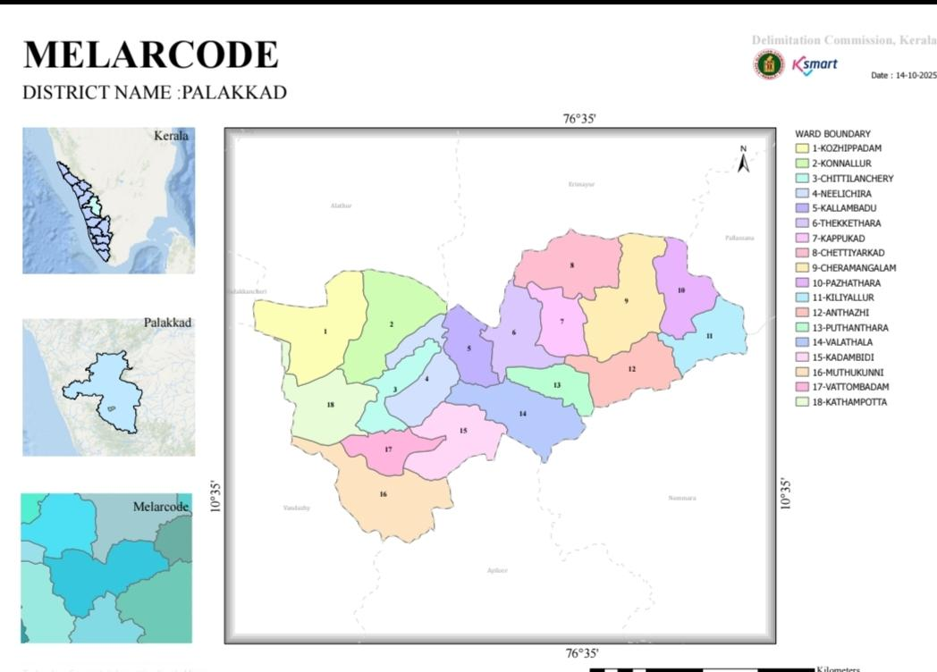
Map 1:Geographical boundaries with political map ( based on latest delimitation)
source:https://wardmap.ksmart.live/

Baseline data
Ward division -
Ward | Houses | Population | Migrants | Wells | Hot  spots | Ed. Institutions | Hosp pvt/govt.
1 | 415 | 2024 | 0 | 237 | 0 | 0 | 0
2 | 434 | 1512 | 0 | 101 | 0 | 0 | 0
3 | 648 | 2210 | 0 | 269 | 0 | 2 | 3
4 | 563 | 2123 | 0 | 135 | 0 | 0 | 0
5 | 486 | 1556 | 0 | 195 | 0 | 1 | 1
6 | 456 | 1585 | 35 | 80 | 0 | 0 | 0
7 | 495 | 1895 | 0 | 147 | 0 | 0 | 0
8 | 524 | 2070 | 10 | 178 | 0 | 1 | 1
9 | 467 | 1830 | 0 | 128 | 0 | 0 | 0
10 | 365 | 1353 | 10 | 92 | 0 | 0 | 0
11 | 365 | 1404 | 10 | 43 | 0 | 0 | 0
12 | 496 | 1911 | 0 | 172 | 0 | 0 | 0
13 | 420 | 1680 | 0 | 156 | 0 | 0 | 0
14 | 426 | 1700 | 0 | 155 | 0 | 0 | 0
15 | 417 | 1444 | 0 | 70 | 0 | 0 | 0
16 | 325 | 1142 | 6 | 267 | 0 | 0 | 0

Risk stratification among wards in the context of Communicable diseases and hazards
The risk stratification for the Grama Panchayat is defined by the intersection of historical disease trends and environmental hazards across its 16 wards. Wards 3, 5, 7, and 13 are identified as primary clinical hotspots due to high recurring cases of Dengue, Leptospirosis, and Hepatitis A. These risks are compounded by local geography, particularly in Ward 14 (Muthukunni), where flood-prone conditions elevate the threat of waterborne transmission, and Ward 2, where landslide risks can disrupt emergency response. To ensure a resilient defense, the plan prioritizes the protection of the 4,337 elderly residents and utilizes the high surge capacity of Ward 3's educational institutions for rapid isolation and treatment during outbreaks.

Major Roads/rivers

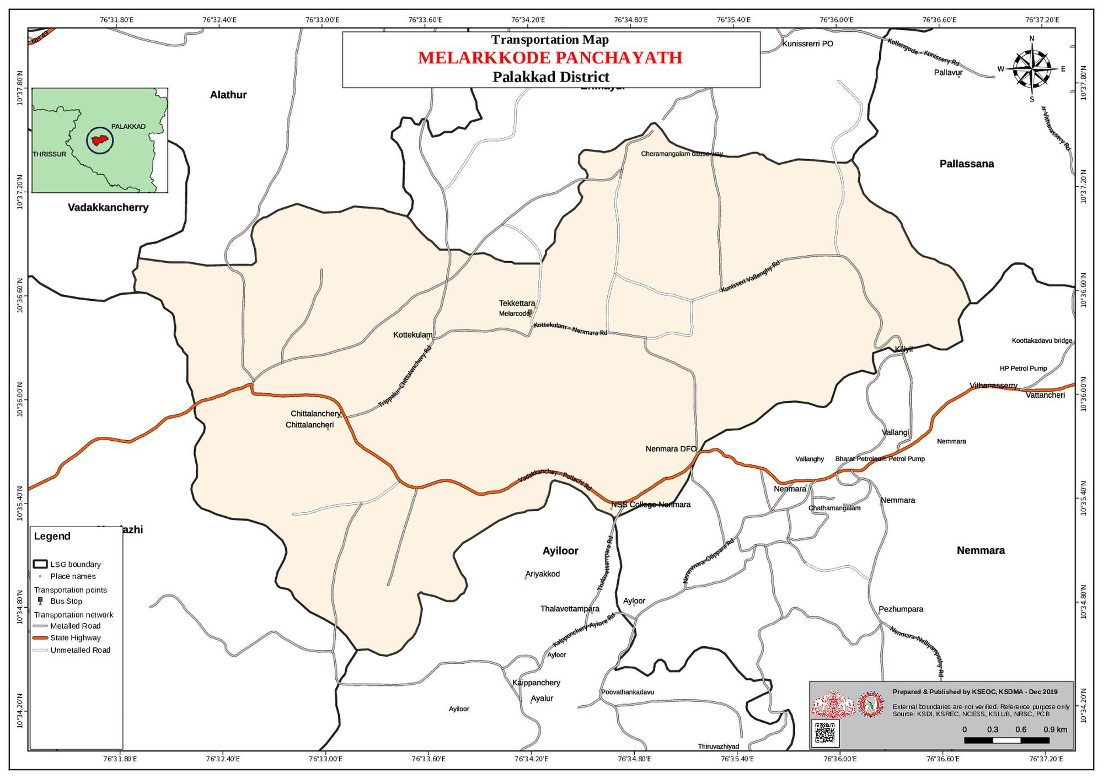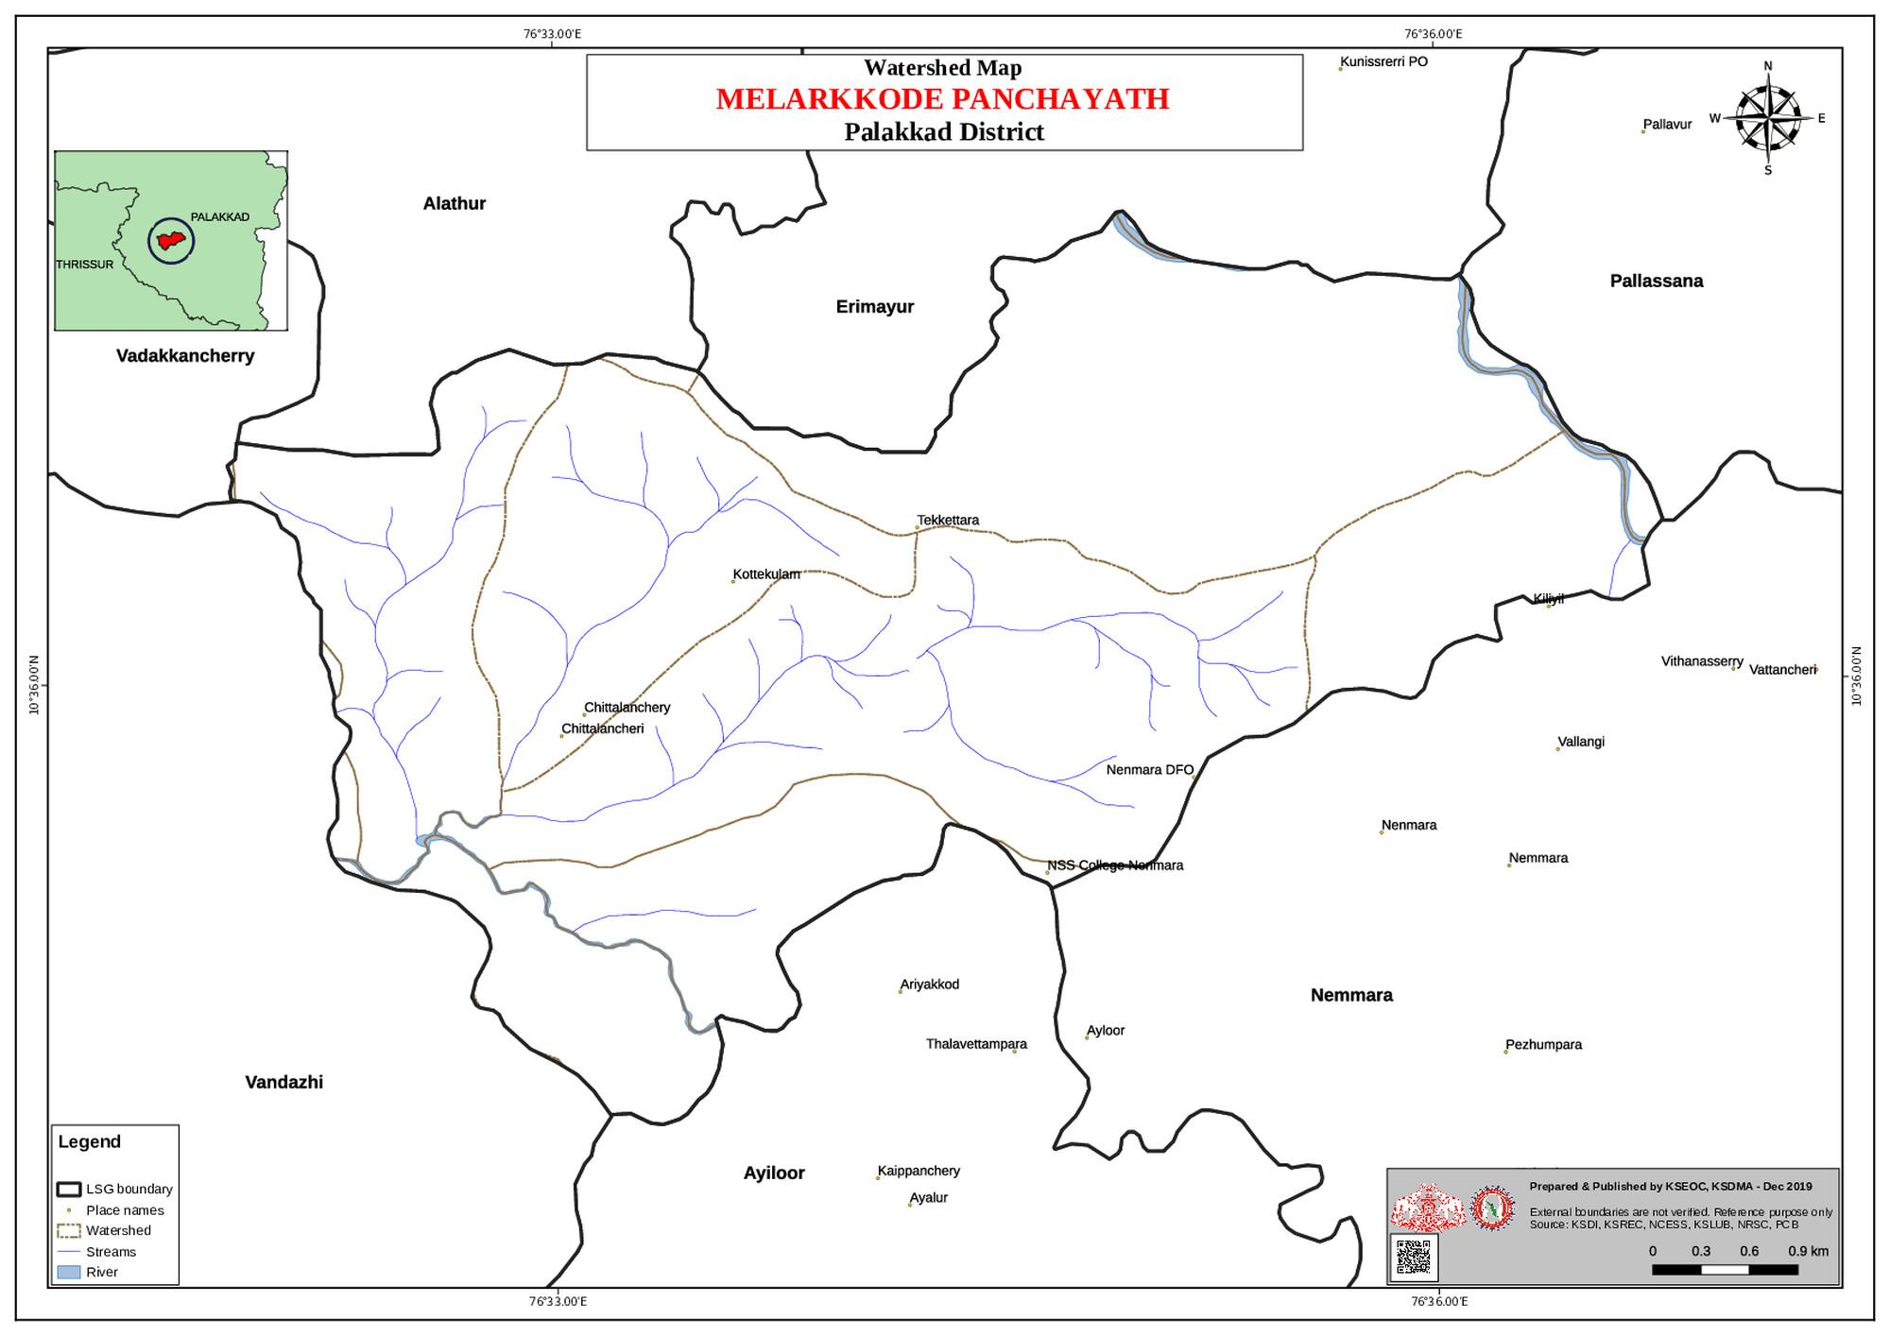
Map 2&3 : Road and River
source:https://dmp.kila.ac.in/

The Melarcode Grama Panchayat is geographically defined by its midland terrain, covering an area of 25.52 sq. km within the Alathur Block. The landscape is predominantly low-lying and dominated by extensive paddy fields, which are integrated into a complex hydrological network featuring two primary rivers and approximately 60 smaller water bodies, including canals and backwaters. This aquatic density makes the region naturally susceptible to seasonal challenges, with specific sectors like Ward 14 (Muthukunni) identified as highly flood-prone and Ward 2 (Konnallur-Kaithonda) marked by its vulnerability to landslides. Complementing this natural landscape is a strategic road network designed to support both daily transit and emergency logistics. The Panchayat’s infrastructure plan emphasizes the mapping of these transport corridors alongside a dedicated inventory of heavy vehicles including JCBs, trucks, and tractors to ensure mobility and the delivery of essential health services even when the terrain becomes difficult during the monsoon season.

Major establishments with geospatial mapping
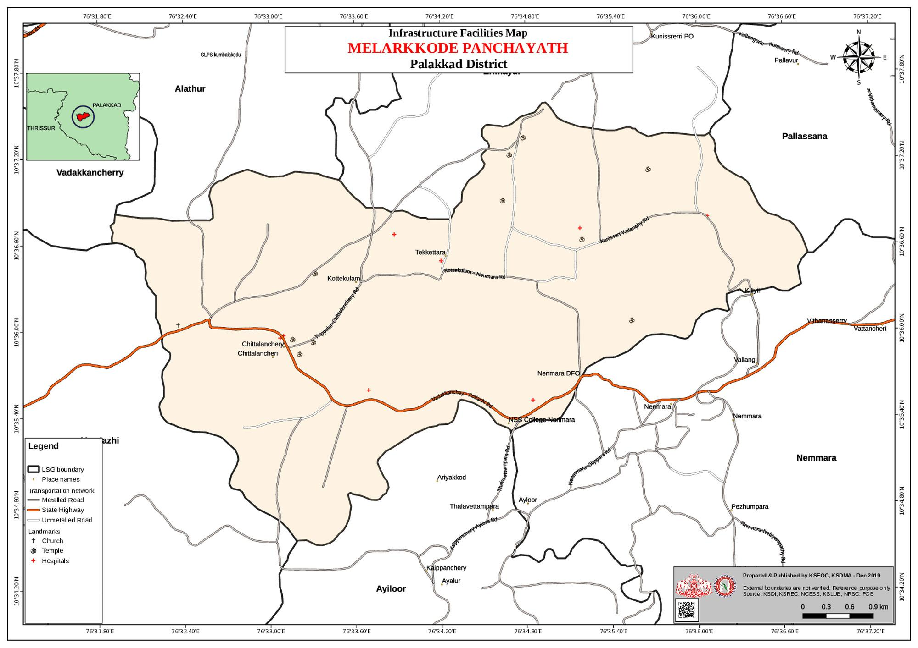
Map 4 : Infrastructure Facilities Map
source:https://dmp.kila.ac.in/

Melarcode Grama Panchayat utilizes systematic geospatial mapping to identify and categorize major establishments, ensuring a coordinated response to public health emergencies. The healthcare infrastructure is anchored by the Primary Health Centre in Kottekulam and five Health and Wellness Centres, supported by a network of private clinics and diagnostic laboratories like Life Care and Neethi in Chittilamchery. Beyond medical facilities, the mapping includes extensive community infrastructure for surge capacity, identifying 26 Anganwadi centres and five major schools, such as MNKMHSS and PKMAUPS, which can provide temporary shelter or isolation beds for up to 1,000 individuals.
The administrative and economic landscape is also integrated into this spatial data, encompassing the Panchayat Office—which serves as the central Pandemic Control Room along with 18 industrial units and 9 Public Distribution System shops to manage essential supply chains. Furthermore, the "One Health" approach is supported through the mapping of the Government Veterinary Hospital and high-risk zoonotic interface points, such as backyard poultry units and wetland areas. By maintaining this detailed digital inventory of 71 religious buildings, 21 water pumping points, and various community halls, the Panchayat ensures that every physical asset can be effectively mobilized for surveillance, logistics, or emergency relief

Occupational groups, socio cultural groups, migration & mobility patterns
The socio-economic landscape of Melarcode Grama Panchayat is rooted in traditional rural livelihoods, with agriculture and allied sectors like paddy cultivation, coconut husk processing, and fishing forming the backbone of the local economy. This is supported by a robust social infrastructure, including 2,916 workers registered under the MGNREGS and a dense network of community-led groups such as the 257 Kudumbashree units and Ayalkootams. The cultural fabric of the region is equally vibrant, centered around 71 religious buildings and major annual events like the Vela festivals in Chittilamchery and Cheramangalam and the Melarcode Nercha, which serve as key community gathering points. These cultural hubs and social networks are vital for grassroots mobilization, particularly when reaching out to the 961 members of the Scheduled Caste community or coordinating with the 23 ASHA workers and 26 Anganwadi workers who provide frontline support.
Mobility patterns in the Panchayat reflect a blend of stable residency and seasonal flux, with approximately 98 in-migrants and 121 emigrants shaping the demographic profile. The migrant workforce is primarily concentrated in specific sectors like construction and agriculture, with notable clusters in Ward 6 and smaller groups in Wards 8, 10, and 11. This movement of people, alongside the high-traffic transit at local markets and transport hubs, creates specific nodes for public health monitoring. By integrating these migration trends with the existing socio-cultural frameworks, the Panchayat’s pandemic strategy ensures that surveillance and essential services are tailored to both the resident population and the mobile labour force, particularly during peak festival seasons when community interaction is at its highest.

Vulnerability mapping
Vulnerability mapping in Melarcode Grama Panchayat is a multi-dimensional analysis that integrates environmental hazards, demographic sensitivities, and clinical data to identify the most at-risk sectors of the community. Geographically, the terrain's midland and low-lying nature, featuring 60 water bodies and two primary rivers, makes Ward 14 (Muthukunni) highly susceptible to flooding and Ward 2 (Konnallur-Kaithonda) vulnerable to landslides. These physical hazards are cross-referenced with demographic layers to prioritize the 4,337 elderly residents, 20 bedbound patients, and 1,508 children who are most at risk during a crisis. Crucially, the plan identifies 190 pregnant women and 83 lactating mothers as a high-priority vulnerable population, ensuring they receive specialized clinical monitoring and dedicated transport support to maintain maternal health services during outbreaks or natural disasters. Social vulnerabilities are also tracked for marginalized groups, including the 961 members of the Scheduled Caste community and migrant labor clusters in Wards 6, 8, 10, and 11.

Disaster prone areas (geographic vulnerability)
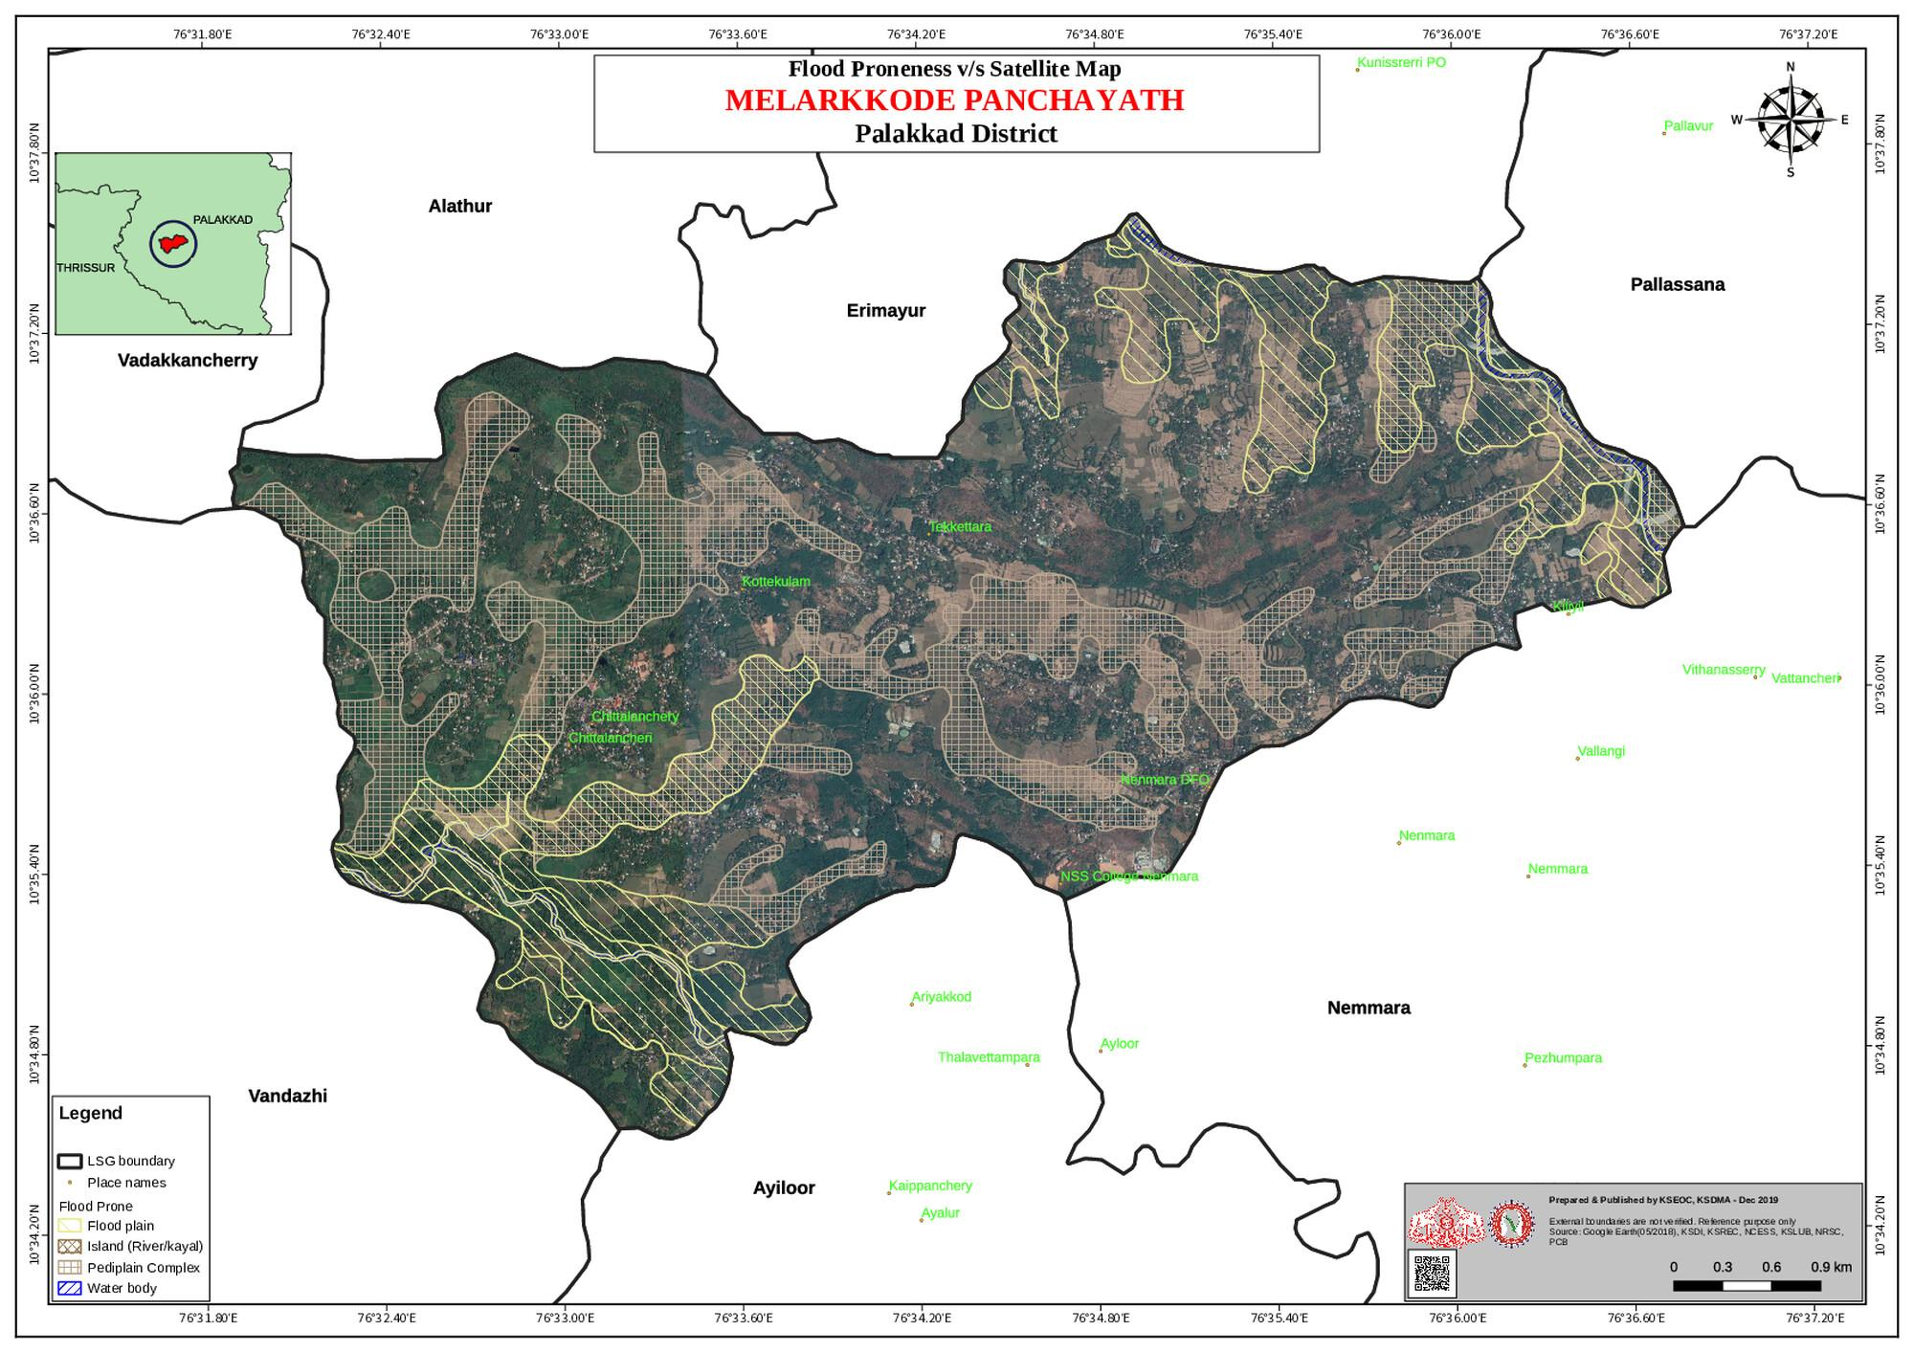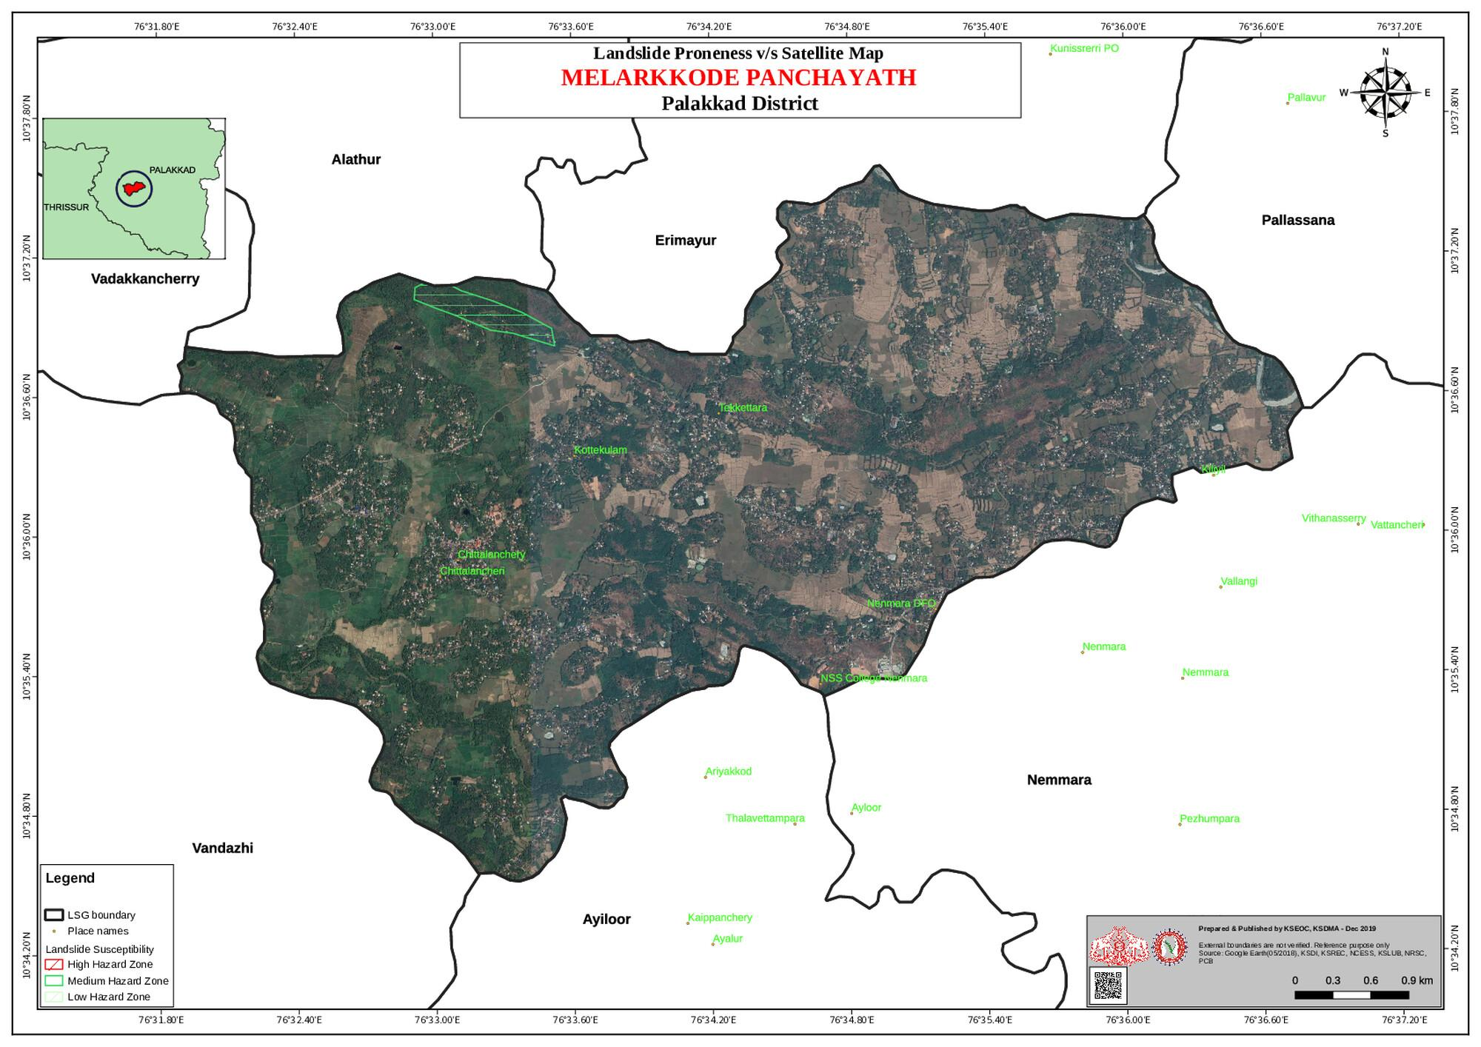
Map 5: Floodproneness & Landslideproneness disaster map
source:https://dmp.kila.ac.in/

The geographic vulnerability of Melarcode Grama Panchayat is fundamentally shaped by its midland terrain, covering a 25.52 sq. km area characterized by a predominantly low-lying landscape of extensive paddy fields, canals, and backwaters. This hydrological density, featuring two primary rivers and approximately 60 smaller water bodies, makes the region highly susceptible to seasonal flooding, with Ward 14 (Muthukunni) identified as the primary high-risk zone for inundation. While the landscape is largely flat, localized geological hazards also exist, notably in Ward 2 (Konnallur-Kaithonda), which is categorized as a high-risk area for landslides that can block essential transit routes. These environmental factors create significant logistical challenges, as the intersection of rural roads and rising water levels often isolates communities from the Primary Health Centre during extreme weather events. Consequently, the Panchayat's disaster strategy emphasizes the strategic mapping of these zones to ensure that specialized resources, such as tractors and JCBs, are pre-positioned to maintain mobility and secure access to healthcare facilities during the monsoon.

GENERAL PROFILE OF THE LSGI’S

Background of the LSGI
Melarcode Grama Panchayat is situated in the Alathur block of Palakkad district, Kerala. Geographically, Melarcode is situated in the midland region of Palakkad, which is characterized by gently undulating terrain, fertile plains, and an agrarian landscape. The area is predominantly rural, with nearly 70% of the land comprising paddy fields, ponds, canals, and water bodies, making agriculture the primary livelihood of the population. The Panchayat falls within the influence of the Palakkad Gap, a significant geographical feature of Kerala that allows climatic interaction between Tamil Nadu and Kerala, resulting in relatively dry conditions compared to other parts of the state while still supporting agriculture.
The terrain of Melarcode is largely plain with scattered low-lying areas, interspersed with irrigation channels and seasonal water bodies. These features contribute to agricultural productivity but also create conditions favorable for water stagnation, especially during monsoon seasons. The presence of canals, ponds, and paddy fields makes the Panchayat environmentally rich but also vulnerable to vector breeding and water-borne diseases.
In terms of disaster vulnerability, Melarcode is moderately prone to monsoon-related risks such as waterlogging, localized flooding, and associated health hazards. The agrarian landscape and low-lying fields increase susceptibility to flooding during heavy rains, while the climatic influence of the Palakkad Gap may contribute to seasonal variations including dry spells and occasional heat stress. These environmental conditions can facilitate outbreaks of vector-borne and water-borne diseases if preventive measures are not strengthened.
Melarcode Grama Panchayat represents a typical midland agrarian ecosystem of Palakkad district, with a mix of fertile land, water resources, and rural settlements. Its geographical and environmental characteristics play a crucial role in shaping public health risks, disaster vulnerability, and the need for localized pandemic preparedness and response strategies.

Table 1: Background of LSGD
Description | Details
Name of LSGI | Melarcode
Type (GP/Municipality / Corporation etc.) | Grama Panchayath
Block | Alathur
Number of wards | 18
Total area (sq. km) | 25.52
Population(Projected) | 28284
Population density | 1108.3 persons/sq km
Terrain (coastal/low-lying/backwaters/foothills, etc.) | midland
Number of rivers passing through LSGI | 2
Number of water bodies in the LSGI | 60
Number of educational institutions | 5
Factories / small-scale industries | 18
Flood-prone wards | 1 ward Muthukunni(new ward 16)
Landslide-prone wards | 1 ward  2 konnallur- kaithonda
Death Management and Disposal Facilities (mortuaries/crematorium, including electric) | 4
Auditoriums/Marriage halls/convention centres/community halls | 4

Demographic and Vulnerable Population
Understanding the demographic composition and vulnerable population groups is essential for pandemic preparedness. Children, elderly, economically deprived families, migrant workers, and socially vulnerable groups are at increased risk during public health emergencies due to higher exposure, limited access to services, and dependency on public systems..

Description |  | Details (in numbers)
DEMOGRAPHIC PROFILE
Total population |  | 28284
Male |  | 13737
Female |  | 14547
Transgender |  | 0
Children under 5 |  | 1508
Adolescent |  | 2621
Elderly (>60) |  | 4337
SOCIAL/LIVELIHOOD VULNERABILITY
Previous EPEP family |  | 64
BPL family |  | 4393
Tribal communities |  | 0
Migration | Immigrant | 98
Migration | Emigrant | 121
Socio-economically deprived |  | 132
Fisherfolk |  | 0
SC Community |  | Total population -961
ST Community |  | Total population - 5

Graphs: Population pyramid (if possible) for seeing if your LSGI has a high "dependency ratio" (lots of children and elderly compared to working adults).

Clinical Vulnerability
Certain population groups needs priority healthcare & are at higher risk of severe illness, complications, and mortality during pandemics. Patients with chronic diseases, those requiring regular medical care, and individuals with mobility or functional limitations face challenges in accessing timely care during emergencies. Mapping these groups helps in prioritizing continuity of treatment, medicine stock planning, oxygen support, referral transport, and targeted home-based care.
Description | Details in numbers
Pregnant women | 190
Lactating mothers | 83
Bedbound patients | 20
Patients under palliative care other than bedbound | 63
Patients on Haemodialysis | 11
Patients on CAPD | 1
Cancer patients (currently on treatment) | 52
Haemophilic patients | 0
Mentally challenged | 85
Differently abled | 92
Diabetic patients | 1257
Hypertensive patients | 1569
TB patients | 8

Major Festivals & Events specific to the LSGI
(with the possibility of a public gathering)

Sl. No. | Name of festival | Month detailing the periodicity
1 | CHITTILAMCHERY VELA | April
2 | KALLAMBAD VELA | APRIL
3 | CHERAMANGALAM VELA | APRIL
4 | THAZHAKKOTTUKAVU VELA | MARCH/APRIL
5 | MELARCODE NERCHA | April
6 | CHITTILAMCHERY ARATT | February

INFRASTRUCTURE & RESOURCE INVENTORY

Health Facility Directory & Basic Capacity in the LSGD
This section provides an overview of the healthcare infrastructure available within the LSGD area. It outlines the distribution and basic capacity of health facilities that form the backbone of service delivery during routine times and public health emergencies.

Family Health Centres (FHCs) and Community Health Centres (CHCs) generally function as the first point of contact for the community, providing essential outpatient and inpatient services. General Hospitals (GH) and Medical College Hospitals (MCH), where accessible, serve as the main referral centres for advanced diagnostics, specialist care, and critical services during public health emergencies. This inventory helps identify existing strengths, gaps, and potential surge capacity that can be mobilised during a pandemic or disaster.

Table 5. Health Facility Resource Summary
Sl.no. | Health Facility | Type of Facility (MCH/GH/CHC/FHC/SC etc.) | Contact Number | Total beds | ICU Beds | Oxygen-Supported Beds | No. of Ventilator Support Beds | No. of ambulances
Government Healthcare Facilities
1 | Phc Melarcode | PHC | 9496915448 | 0 | 0 | 0 | 0 | 0
2 | HWC Melarcode | SC | 9400643739 | 0 | 0 | 0 | 0 | 0
3 | HWC chittilamchery | SC | 9495170824 | 0 | 0 | 0 | 0 | 0
4 | HWC Muthukunni | SC | 9562471956 | 0 | 0 | 0 | 0 | 0
5 | HWC PAZHATHARA | SC | 8943747243 | 0 | 0 | 0 | 0 | 0
6 | HWC CHERAMANGALAM | SC | 9400725124 | 0 | 0 | 0 | 0 | 0
Private Healthcare Facilities
 | 0
AYUSH Healthcare Facilities
 | GOVT AYURVEDA KENDRAM | GAD | 8848699722 | 0 | 0 | 0 | 0 | 0
 | GOVT HOMEO DISPENSERY | GHD | 8848699722 | 0 | 0 | 0 | 0 | 0
 | NARAYANA CHIKILSALAYAM CHITTILAMCHERY | AYURVEDA | 80758271734 | 20 | 0 | 0 | 0 | 0
 | AMRITHAKRIPA AYURVEDA HOSPITAL CHITTILAMCHERY | AYURVEDA | 8921705097 | 30 | 0 | 0 | 0 | 0
 | TRINITY HOMEO CLINIC | HOMEO | 9495707990 | 0 | 0 | 0 | 0 | 0

Private Clinics
Private clinics are an essential part of pandemic preparedness, as they are often the first place people seek care when symptoms begin. In many communities, private clinics manage a significant share of outpatient visits and therefore play a critical role in early case detection, timely referrals, and disease surveillance. Having an up-to-date understanding of where these clinics are located, the services they provide, and how they are linked to the public health system helps ensure that no cases are missed during an outbreak. It also allows health authorities to engage private practitioners more effectively for reporting, risk communication, and coordinated response, strengthening the overall capacity of the health system to manage public health emergencies.

Table 6. Private Clinic Resource Summary
Sl No. | Name of Clinic | Registered (Y/N) | Clinic (General / Speciality) | Speciality (if any) | Address | Contact Number | Diagnostic Facility (Y/N) | Ambulance Linkage (Y/N)
1 | Dr. GEOGEKUTTY CLINIC | Y | GENERAL | No | CHITTILAMCHERY | 9446444645 | N | N

Healthcare Education & Training Institutions
This section tracks the educational infrastructure available, which is vital for human resource planning in the health sector.

Category of Institution | Govt | Private | AYUSH | Total
Medical Colleges | 0 | 0 | 0 | 0
Nursing Colleges | 0 | 0 | 0 | 0
Dental Colleges | 0 | 0 | 0 | 0
Para-medical / Allied Health | 0 | 0 | 0 | 0
Pharmacy Colleges | 0 | 0 | 0 | 0

Specialized Services & Emergency Inventory
This section provides a detailed view of the specialized medical resources available to the community, focusing on emergency response and critical care capabilities. This table tracks the vital assets required for managing severe illnesses and emergencies across Government, Private, and AYUSH sectors.

Item | Govt | Private | AYUSH | Total
Hospital beds | N | N | 50 | 50
Oxygen-generating systems(Y/N) | N | Y | Y | 1
Oxygen-supported beds(Numbers) | N | 0 | 0 | 0
Ventilator-supported beds | N | 0 | 0 | 0
ICU beds | N | 0 | 0 | 0
Burns units | N | 0 | 0 | 0
Blood centres | N | 0 | 0 | 0
BLS ambulances | N | 0 | 0 | 0
ALS ambulances | N | 0 | 0 | 0
Dialysis facilities | N | 0 | 0 | 0
Dispensaries | N | 0 | 2 | 2
Medical store | N | 5 | 0 | 5
Industrial establishments(Medium-scale industries/small-scale industries establishments to whom we can depend in a worst-case scenario)

Oxygen & Diagnostic Capacity
Monitoring oxygen and diagnostic capacity is a critical component of public health preparedness, ensuring that the LSGD can handle both chronic care and sudden surges in respiratory or infectious diseases.
Name of Health Facility | Oxygen-generating System (Y/N) | Backup Oxygen Source (Y/N) | Diagnostic Facilities Available(Y/N)
Name of Health Facility | Oxygen-generating System (Y/N) | Backup Oxygen Source (Y/N) | Lab | USG | X-ray | CT/MRI | RT-PCR
Government Healthcare Facilities
PHC MELARCODE | N | N | N | N | N | N | N

Diagnostics facility mapping at the LSGI level
The diagnostic capacity of Melarcode G.P represents the "intelligence network" of our healthcare system. The speed and accuracy of disease identification depend entirely on the distribution and technical level of these facilities.

Item | Govt | Private | AYUSH | Total
General labs | 0 | 4 | 0 | 4
Microbiology labs | 0 | 0 | 0 | 0
RT-PCR labs | 0 | 0 | 0 | 0
USG units | 0 | 0 | 0 | 0
CT/MRI units | 0 | 0 | 0 | 0
Research labs | 0 | 0 | 0 | 0
Labs of other departments that can be repurposed | 0 | 0 | 0 | 0

Laboratory Identification & Basic Details
Sl. No. | Name of Laboratory | Ownership (Govt / Private / Academic) | Address | Contact No. | 24×7 Services (Yes/No) | NABL / Govt Approved (Yes/No)
1 | Life care lab | Pvt | Chittilamchery | 9747676700 | No | NO
2 | Neethi lab | Pvt | Chittilamchery | 9961437799 | No | NO
3 | Asraya lab | Pvt | Kottekulam | 8921328014 | No | NO
4 | Lakshmi lab | pvt | Melarcode | 9961651471 | No | NO

Social and Community Infrastructure for surge plan
This table serves as our logistics and shelter inventory. By mapping these locations, quickly we can identify where to house displaced citizens, where to set up temporary medical clinics, and how to manage the deceased with dignity during a crisis.

Category | Total Count | Ward | Est. Capacity (Persons) | Contact details
Educational Institutions
Anganwadis | 26 | 18 wards | 95
Schools | 5 | 3,14,5, | 1000
Colleges | 1 | 12 | 300
Healthcare Educational Institutions
Medical colleges (Govt/Private) | 0 | 0 | 0
Nursing colleges (Govt/Private) | 0 | 0 | 0
Dental colleges (Govt/Private) | 0 | 0 | 0
Paramedical institutes (Govt/Private) | 0 | 0 | 0
Community Gathering Spaces
Community halls | 1 | 3 | 50 | 9447369766  Muraleedharan
Auditoriums | 2 | 3, | 100 | 9605443810  Vasudhevan
Religious buildings | 71 | All wards | 360
Vulnerable Group Support Facility
Destitute homes | 0 | 0 | 0
Elderly homes | 1 | 12 | 20 | 9526279073 Sujitha
LSGD owned other buildings | 9 | 5,3,etc | 50
Mass Fatality Management (MFM) Infrastructure
Mortuary | 0 | 0
Crematorium | 5 | 5,7,10,14,18,
*refer annexure 1 for contact details

Human resources
This section focuses on the human capital available within the LSGI. In any emergency—be it a pandemic, flood, or industrial accident—infrastructure is only as effective as the people operating it.

Medical & Clinical Personnel
This table tracks the "Frontline" providers responsible for diagnosis, treatment, and clinical management. Narrative sentence: eg., "Total health workforce: 450 personnel, with 60% in government facilities serving as primary surge capacity." A detailed directory with the contact numbers of all workers is maintained (Annexure in 1).

Cadre | Govt (No.) | Private (No.) | Total
Doctors—Modern Medicine | 1 | 3 | 4
Doctors – AYUSH | 0 | 5 | 5
Doctors – Veterinary | 1 | 0 | 0
Doctors – Dental | 0 | 1 | 1
Nursing officers | 2 | 4 | 6
Lab technicians | 0 | 2 | 2
Optometrist | 0 | 0 | 0
Pharmacists | 0 | 3 | 2
Psychologists | 0 | 0 | 0
Counsellors | 1 | 0 | 1

Public Health & Field-Level Workforce
These individuals are the backbone of surveillance, maternal-child health, and decentralized care.

Cadre | Health services | Municipal common services | Total
HS (Health Supervisors) | 0 | 0 | 0
HI (Health Inspectors) | 1 | 0 | 1
LHS (Lady Health Supervisor) | 0 | 0 | 0
LHI (Lady Health Inspectors) | 1 | 0 | 1
JPHN (Jr Public Health Nurses) | 5 | 0 | 5
JHI (Jr Health Inspectors) | 3 | 0 | 3
MLSP (Mid-Level Service Providers) | 5 | 0 | 5
Palliative Nurses | 1 | 0 | 1
RBSK Nurses | 1 | 1 | 1
PRO | 0 | 0 | 0
Epidemiologist | 0 | 0 | 0
Data Manager | 0 | 0 | 0

Community & Support Cadre
This group represents the surge capacity of the LSGI—people who can be called upon for logistics, rescue, and specialized support.

Cadre | Number
ASHA Workers | 23
AWW (Anganwadi Workers) | 26
Emergency Medical Volunteers (Trained) | 0
Kudumbashree | 280
MNREGS | 2916
Purusha Swayam Sahaya Sangham | 0
Ex-Servicemen | 32
Retired Police Officers | 17
NCC/NSS Volunteers | 56
Red Cross volunteers | 8
One Health Community Volunteers | 0
One Health Community Mentors | 0

Community Organizations
This section details the presence of community-based organisations (CBOs), non-governmental organisations (NGOs), faith-based organisations (FBOs), Kudumbashree Self-Help Groups (SHGs), and Ayalkootams within the Local Self-Government Institution (LSGI). These groups enhance grassroots mobilization, resource distribution, and support networks crucial for pandemic response and community resilience.

Category | Total Count
NGOs | 2
Religious based organizations | 4
Foreign based organizations | 0
Sports Club/youth clubs | 16
Kudumbashree SHGs | 257
Ayalkootams | 257
Political organizations | 6
Residential organizations | 0

Administrative & Emergency Services
This section outlines the availability of key non-health emergency support services and infrastructure within the LSGI, which are essential for effective pandemic preparedness and response. These facilities support law enforcement, disaster response, water supply, logistics, mobility, and community-level interventions during public health emergencies.

Category | Total Count | Contact details
Police Stations | 0
Fire & Rescue Stations | 0
Water Pumping Points | 21
Public Distribution System (PDS) | 9

Information regarding resources
The availability of essential transport and support resources plays a quiet but critical role in saving lives. Equipment such as ambulances, mobile mortuaries, amphibian ambulances, and motorized boats ensures that patients, samples, and healthcare teams can move swiftly—even in flooded, remote, or difficult terrains. Heavy vehicles like JCBs, cranes, tractors, and torus lorries support logistics, waste management, emergency infrastructure, and rapid conversion of spaces into care or isolation facilities. Taxis, four-wheel-drive vehicles, and trucks help maintain continuity of essential services, reach vulnerable populations, and support home-based care and supply delivery.

Means of transportation | Total Count
JCB | 5
Crane | 0
Heavy Trucks | 2
Tractor | 9
Ambulances | 0
Mobile mortuaries | 0
Boats | 0
Taxi service | 0
Note: For specific details regarding vehicle owners and contact information, please refer to Annexure [X].

ONE HEALTH & ENVIRONMENTAL SURVEILLANCE
The One Health method integrates environmental, animal, and human health to enable proactive pandemic preparedness. Panchayat-level surveillance needs to be improved in order to detect and treat zoonotic and environmentally generated diseases early. Surveillance is strengthened through systematic assessment of animal populations, veterinary infrastructure, poultry and slaughter facilities, inter-sectoral coordination, and specialised tools like avian influenza seasonality mapping using GIS in previous outbreaks to enable predictive alerts and ward-specific sampling to support effective pandemic preparedness in high-risk areas like Melarcode Grama Panchayat.

Animal & Bird Population
Mapping animal and bird populations at the Panchayat level is essential for identifying and prioritising zoonotic disease hazards like rabies, avian influenza (H5N1), leptospirosis, anthrax, and Nipah-like spillover occurrences. Risk classification, targeted surveillance, vaccination planning, and early epidemic detection made feasible by comprehensive population mapping all enhance One Health-based pandemic preparedness.

Category | Item | Estimated Population | Wards
Animal Population | Livestock (Cattle/Goats/Buffalo) | 1324 | all wards
Animal Population | Pet Animals (Dogs/Cats) | 1469 | all wards
Animal Population | Stray Dog Population | 399 | all wards
Animal Population | Pig Farms (Number of heads) | 350 | ward-18
 | Small Units (Sheep / Goats – clustered) | 0 | 0
Bird Population | Poultry Units (Birds) | 19(500)
Bird Population | Poultry- (FOWL) | 5236 | ward-18
Bird Population | Wild/Migratory Birds (Observed) | 50 | ward 18
Bird Population | Crow Mortality Events (Reported) | 0 | 0
*ABOVE DATAS COLLECTED FROM VETERINARY DEPT.

The main risk of zoonotic diseases in Melarcode Grama Panchayat is concentrated in Wards 2, 3, 7, and 9, which is explained by the high density of pig farms, cattle congregation areas, and poultry units. The stray dog population in market areas, fish landing sites, and bus stations continues to be a substantial problem for rabies surveillance and bite prevention. There is a considerable risk of avian influenza introduction and amplification during November - December due to the seasonal presence of migratory and resident water birds near ponds, canals, rivers, and paddy fields. Clusters of pig farms and animal shelters vulnerable to flooding particularly in the low-lying areas of Ward 14 further raise the risk of leptospirosis and other zoonoses mediated by the environment, especially during monsoon floods.

Veterinary Infrastructure
Veterinary institutions are a core pillar of One Health surveillance, enabling early zoonotic disease detection through vaccination, investigation of unusual animal illness or deaths, sample collection, and timely outbreak reporting. A well-mapped and responsive veterinary network strengthens coordination with human health and LSGI systems, ensuring rapid response during zoonotic events and pandemics.
Facility Type | Name of Facility | Ownership Govt / Pvt | Location(Ward No) | Contact number
Veterinary Dispensary | GOVT VETERINARY HOSPITAL | GOVT | 3 | 9447269245
Veterinary Hospital / Polyclinic | 0 | 0 | 0 | 0
Veterinary Clinics SUBCENTERS | VETERINARY SUBCENTER | GOVT | 7,9 KILIYALLOOR  CHERAMANGALAM
Mobile / Emergency Vet Service (incl. night services) | 0
Pet Homes / Animal Shelters | 0
Slaughterhouse-linked Veterinary Inspection Unit | -0

Veterinary Doctors & Workforce
Early detection, diagnosis, reporting, and reaction to animal illness epidemics depend on the availability and accessibility of qualified veterinary specialists. By identifying unusual animal morbidity or mortality promptly, collecting samples promptly, and coordinating efficiently with human health and LSGI systems—especially during zoonotic outbreaks and pandemic-prone situations—a clearly defined veterinary workforce enhances One Health surveillance.

Category | Number Available | Type (Govt/Pvt) | Contact number
Government Veterinary Doctors | 1 | GOVT | 9447269245
Private Veterinary Doctors | 0 | 0 | 0
Livestock Inspectors | 0 | 0 | 0
Para-veterinary Staff / Attenders | 1 | 0 | 9847838393
Contract / On-call Veterinary Support (if any) | 0 | 0 | 0

High-Risk Interface Points (Surveillance Sites)
High-risk interface points for zoonotic disease surveillance in Melarcode Grama Panchayath not include wetland–livestock–human contact zones, backyard poultry farms, cattle sheds near water bodies, fish markets, and areas of high human–animal interaction such as community slaughter points and migratory bird congregation sites. These are the primary surveillance sites where zoonotic spillover risks are elevated.n Melarcode, these interfaces are concentrated in specific geographic nodes, such as the poultry units in Ward 2 (Kottekulam) and the extensive midland paddy fields where domestic livestock interact with the region's 60 water bodies. The presence of the Government Veterinary Hospital in Ward 3 and sub-centers in Wards 7 and 9 provides a structured institutional interface for monitoring the 1,324 livestock and 5,236 poultry birds within the Panchayat. Additionally, the environmental vulnerability of flood-prone areas like Ward 14 (Muthukunni) creates a seasonal interface for waterborne zoonoses, while high-traffic zones like the Chittilamchery market serve as critical points for managing the stray dog population to prevent rabies. By systematically mapping these high-risk habitats, Melarcode ensures a proactive One Health response that targets disease at the human-animal-environment boundary.

Type of Habitat | Type of High risk interface | Geographical vulnerability
Wetlands & Backwaters | 0 | 0
Backyard Poultry Farms | 0 | 0
Cattle Sheds near Water Bodies | 0 | 0
Fish & Meat Markets | 0 | 0
Community Slaughter Sites | 0 | 0
Migratory Bird Congregation Areas | 0 | 0
Rodent-Infested Grain Storage | 0 | 0

Category | Total Count | Key Locations (wards)
Poultry Farms | 1 | 2 Kottekulam
Backyard / Clustered Poultry Units | 0 | 0
Duck Rearing Units (open water access) | 0 | 0
Slaughterhouses/ Slaughter Points | 0 | 0
Meat/Fish Markets | 0 | 0
Live Bird Sale Points | 0 | 0
Cattle Markets / Weekly Animal Fairs | 0 | 0
Pet Shops / Breeders | 0 | 0
Animal Shelters / Pet Homes | 0 | 0
Waste Disposal Sites near Animal Units | 0 | 0

Environmental Risk Mapping
Environmental risk mapping identifies monsoon/flood hotspots for vector-borne (dengue, chikungunya), water-borne (leptospirosis, diarrhoea), and zoonotic diseases in Kerala's wetlands. Systematic surveillance supports early warnings, targeted interventions, and Panchayat pandemic preparedness.
Waterborne exposure: Flood-prone areas and stagnant water bodies facilitate leptospira survival, raising leptospirosis risk.

Traditional practices: Informal slaughter and fish markets lack standardized hygiene, creating spillover opportunities.

Risk Factor | High-Risk Wards | Key Locations | Risk Level (High/Med/Low)
Flood-prone areas | ward 14 | Muthukunni | low
Water bodies/wetlands | 0 | 0 | 0
Solid waste accumulation | 0 | 0 | 0
Animal waste disposal issues | 0 | 0 | 0
Rodent infestation zones | 0 | 0 | 0
Industrial effluent discharge | 0 | 0 | 0
Construction sites / abandoned buildings | 0 | 0 | 0
Poor drainage/blocked canals | 0 | 0 | 0
Drinking water source contamination risk | 0 | 0 | 0

Disease Seasonality Mapping
1, Flooding & waterlogging → amplifies leptospirosis, malaria, diarrheal diseases.
·
2, Migratory bird influx (Nov–Feb) → avian influenza risk.

3, Mosquito breeding cycles → vector-borne disease peaks in monsoon.

4, Agricultural practices → close human–animal contact in paddy fields.

Disease | Peak Risk Season | Key Drivers | High-Risk Locations | Surveillance Focus
Avian Influenza | no
Leptospirosis | oct-dec | occupational exposure | Thekkumuri | Doxy prophylaxis, IEC
Dengue/Chikungunya | NO
Acute Diarrheal Diseases | JUNE-JULY | inadequate sanitation, unsafe water | nil | BCC activities
Rabies | no
Anthrax (rare) | no

Vulnerability Mapping
Vulnerability mapping pinpoints high-risk populations, occupations, and areas exposed via environment, livelihoods, socio-economics, and poor service access. Paired with environmental/seasonality mapping, it enables risk-based surveillance, targeted actions, and optimal resource use in One Health and pandemic planning.

Vulnerability Factor | High-Risk Wards | Key Groups / Locations | Risk Level
Flood-prone households | 26 houses | Muthukunni | low
Wetland-adjacent communities | no
Backyard poultry / duck rearing households | no
Livestock-rearing households | 4 |  | low
Slaughterhouse & meat market workers | 0
Fisherfolk & fish market workers | 0
Sanitation workers | 0
Daily wage / migrant workers | 22 |  | low
Elderly & chronically ill populations | 8 |  | low
Pregnant Women | 0
Children (schools, Anganwadi’s) | 8
Limited access to safe water & sanitation | 0

EPIDEMIOLOGICAL TRENDS (2021–2025)

Disease surveillance is the systematic collection, analysis, and interpretation of health data for planning, implementation, and evaluation of public health practice. This section presents the disease surveillance profile of the LSGI based on routine reporting systems and outbreak investigations to identify priority diseases, seasonal patterns, and emerging public health threats.

Disease Burden among human beings(Last 5 Years)
Analysis of disease-wise data for the last five years helps identify persistent public health problems, emerging diseases, and changes in disease burden. This information supports prioritisation of prevention, preparedness, and response activities at the Panchayat level.

Disease | 2021 | 2022 | 2023 | 2024 | 2025 | Trend(Increasing/Stable/Decreasing)
Dengue | 0 | 0 | 19 | 14 | 4 | decreasing
Leptospirosis | 0 | 2 | 0 | 0 | 6 | stable
Hepatitis A | 0 | 3 | 0 | 3 | 2 | stable
Malaria | 0 | 0 | 0 | 0 | 0 | stable
Scrub Typhus | 0 | 0 | 0 | 0 | 0 | stable
Typhoid | 0 | 1 | 1 | 0 | 0 | stable
H1N1 | 0 | 0 | 2 | 1 | 1 | stable
H3N2 | 0 | 0 | 0 | 0 | 0 | stable
ADD | 39 | 57 | 30 | 65 | 141 | stable
Mumps | 0 | 0 | 12 | 14 | 24 | increasing
Measles | 0 | 0 | 0 | 0 | 0 | stable
Hepatitis B | 0 | 0 | 2 | 5 | 0 | stable
Hepatitis C | 0 | 0 | 0 | 0 | 0 | stable
Tuberculosis | 0 | 0 | 12 | 23 | 12 | stable
Leprosy | 0 | 0 | 0 | 0 | 0 | stable
COVID-19 | 1416 | 0 | 0 | 0 | 0 | Decreasing (sharp peak in 2021 followed by no reported cases from 2022–2025)

*(use the above table data to create the graph/diagram)

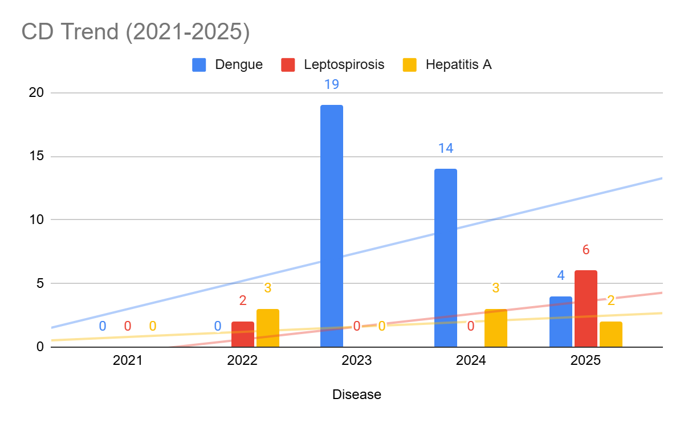

Seasonal Trend Analysis
Seasonal analysis helps anticipate surges (e.g. dengue in monsoon, leptospirosis after floods, influenza in cooler months) and plan pre‑emptive vector control, stockpiling of IV fluids, and awareness campaigns at Panchayat level.

DENGUE
Dengue is a major seasonal vector-borne disease strongly associated with rainfall, water stagnation, and increased mosquito breeding during the monsoon period.

Peak: July–November

Dengue – Ward-wise Yearly Distribution (2021–2025)

Ward | Dengue – Ward-wise Yearly Distribution
Ward | 2021 | 2022 | 2023 | 2024 | 2025 | Total
1 | 0 | 0 | 2 | 1 | 0 | 3
2 | 0 | 0 | 1 | 0 | 0 | 1
3 | 0 | 0 | 3 | 1 | 0 | 4
4 | 0 | 0 | 0 | 0 | 1 | 1
5 | 0 | 0 | 2 | 3 | 1 | 6
6 | 0 | 0 | 1 | 0 | 0 | 1
7 | 0 | 0 | 3 | 4 | 0 | 7
8 | 0 | 0 | 1 | 0 | 1 | 2
9 | 0 | 0 | 1 | 0 | 0 | 1
10 | 0 | 0 | 0 | 3 | 0 | 3
11 | 0 | 0 | 1 | 1 | 2 | 4
12 | 0 | 0 | 0 | 0 | 0 | 0
13 | 0 | 0 | 2 | 0 | 2 | 4
14 | 0 | 0 | 1 | 0 | 1 | 2
15 | 0 | 0 | 0 | 0 | 1 | 1
16 | 0 | 0 | 1 | 1 | 0 | 2

LEPTOSPIROSIS
Leptospirosis cases are closely linked to monsoon rains, flooding, and occupational exposure, particularly in low-lying and waterlogged areas.

Peak: June - August

Leptospirosis – Ward-wise Yearly Distribution (2021–2025)

Ward | Leptospirosis – Ward-wise Yearly Distribution
Ward | 2021 | 2022 | 2023 | 2024 | 2025 | Total
1 | 0 | 0 | 0 | 0 | 0 | 0
2 | 0 | 0 | 0 | 0 | 0 | 0
3 | 0 | 0 | 0 | 0 | 1 | 1
4 | 0 | 0 | 0 | 0 | 1 | 1
5 | 0 | 0 | 0 | 0 | 1 | 1
6 | 0 | 1 | 0 | 0 | 0 | 1
7 | 0 | 0 | 0 | 0 | 0 | 0
8 | 0 | 1 | 0 | 0 | 0 | 1
9 | 0 | 0 | 0 | 0 | 1 | 1
10 | 0 | 0 | 0 | 0 | 1 | 1
11 | 0 | 0 | 0 | 0 | 0 | 0
12 | 0 | 0 | 0 | 0 | 0 | 0
13 | 0 | 0 | 0 | 1 | 0 | 1
14 | 0 | 0 | 0 | 0 | 1 | 1
15 | 0 | 0 | 0 | 0 | 0 | 0
16 | 0 | 0 | 0 | 0 | 0 | 0

VIRAL HEPATITIS - A
Hepatitis A cases are commonly associated with unsafe drinking water, food contamination, and breakdowns in sanitation, often presenting as clusters or outbreaks.

Peak: October - December

Hepatitis A – Ward-wise Yearly Distribution (2021–2025)

Ward | Hep A – Ward-wise Yearly Distribution
Ward | 2021 | 2022 | 2023 | 2024 | 2025 | Total
1 | 0 | 0 | 0 | 0 | 1 | 1
2 | 0 | 0 | 0 | 0 | 0 | 0
3 | 0 | 1 | 0 | 1 | 0 | 2
4 | 0 | 0 | 0 | 0 | 0 | 0
5 | 0 | 0 | 0 | 0 | 0 | 0
6 | 0 | 0 | 0 | 0 | 0 | 0
7 | 0 | 0 | 0 | 0 | 1 | 1
8 | 0 | 0 | 0 | 0 | 0 | 0
9 | 0 | 1 | 0 | 1 | 0 | 2
10 | 0 | 0 | 0 | 0 | 0 | 0
11 | 0 | 0 | 0 | 0 | 0 | 0
12 | 0 | 0 | 0 | 0 | 0 | 0
13 | 0 | 0 | 0 | 0 | 0 | 0
14 | 0 | 0 | 0 | 0 | 0 | 0
15 | 0 | 0 | 0 | 0 | 0 | 0
16 | 0 | 0 | 0 | 1 | 0 | 1

Outcome-Based Trend Analysis- 2025
The overall epidemiological situation in 2025 remains largely stable with low mortality, though a few deaths have been reported due to Tuberculosis and Leptospirosis. Dengue shows a declining trend compared to previous years, while Leptospirosis has shown a slight increase, indicating continued environmental and occupational risk. Hepatitis A remains relatively stable with sporadic cases.
Acute Diarrhoeal Disease (ADD) has shown a significant increase and constitutes the highest disease burden, highlighting major concerns related to water quality and sanitation. Mumps cases are also increasing, indicating the growing importance of air-borne disease control measures. Tuberculosis continues to show a sustained burden with notable mortality, requiring strengthened follow-up and treatment adherence.
Most diseases show low outbreak potential with no major epidemic reported during the year. Water-borne diseases contribute the largest share of cases, followed by air-borne diseases, while vector-borne diseases remain relatively controlled. Blood-borne and zoonotic diseases are minimal but require continued surveillance.
Ward-level analysis indicates high-risk (Red Zone) areas in Wards 3, 5, 6, 10, 13, and 14, where multiple diseases and higher case loads are consistently observed. Moderate-risk wards include Wards 1, 4, 7, 9, 11, and 16.
Overall, there is a need to strengthen interventions focusing on water safety, sanitation, vector control, and targeted public health actions in hotspot wards to enhance community-level disease prevention and resilience.

Transmission Trend- 2025
For effective management of public health issues, it is important to track the trend of disease transmission mode. It helps identify the population or place at high risk that can be used to predict outbreaks and implement targeted interventions as quickly as possible. Understanding these kinds of trends enables authorities to allocate resources efficiently and change the strategies adequately based on the trend that follows.

Mode of Transmission | No. of cases | No. of Deaths
Vector Borne Diseases | 9 | 0
Water Borne Diseases | 151 | 0
Air Borne Diseases | 85 | 0
Blood Borne Diseases | 2 | 0
Food Borne Diseases | 0 | 0

Vector-Borne Disease

Disease | No. of Cases | No. of Deaths
Dengue | 9 | 0
Malaria | 0 | 0
Chikungunya | 0 | 0

Water Borne Disease

Disease | No. of Cases | No. of Deaths
Cholera | 0 | 0
Typhoid | 0 | 0
Hep- A | 2 | 0
Dysentery | 0 | 0
Amoebiasis | 0 | 0
E- Coli infections | 0 | 0
Air Borne Disease

Disease | No. of Cases | No. of Deaths
Influenza | 0 | 0
H1N1 | 0 | 0
TB | 15 | 3
Chickenpox | 45 | 0
Measles | 1 | 0
Covid-19 | 0 | 0
Pertussis | 0 | 00
Mumps | 24 | 0

Blood-Borne Disease

Disease | No. of Cases | No. of Deaths
AIDS | 0 | 0
Hep- B | 1 | 0
Hep- C | 1 | 0

Zoonotic Disease

Disease | No. of Cases | No. of Deaths
Rabies | 0 | 0
Leptospirosis | 6 | 1
Avian influenza | 0 | 0
West nile | 0 | 0
Anthrax | 0 | 0
Nipah | 0 | 0
Scrub Typhus | 0 | 0

Integrated Disease Hotspot Map (2021–2025)

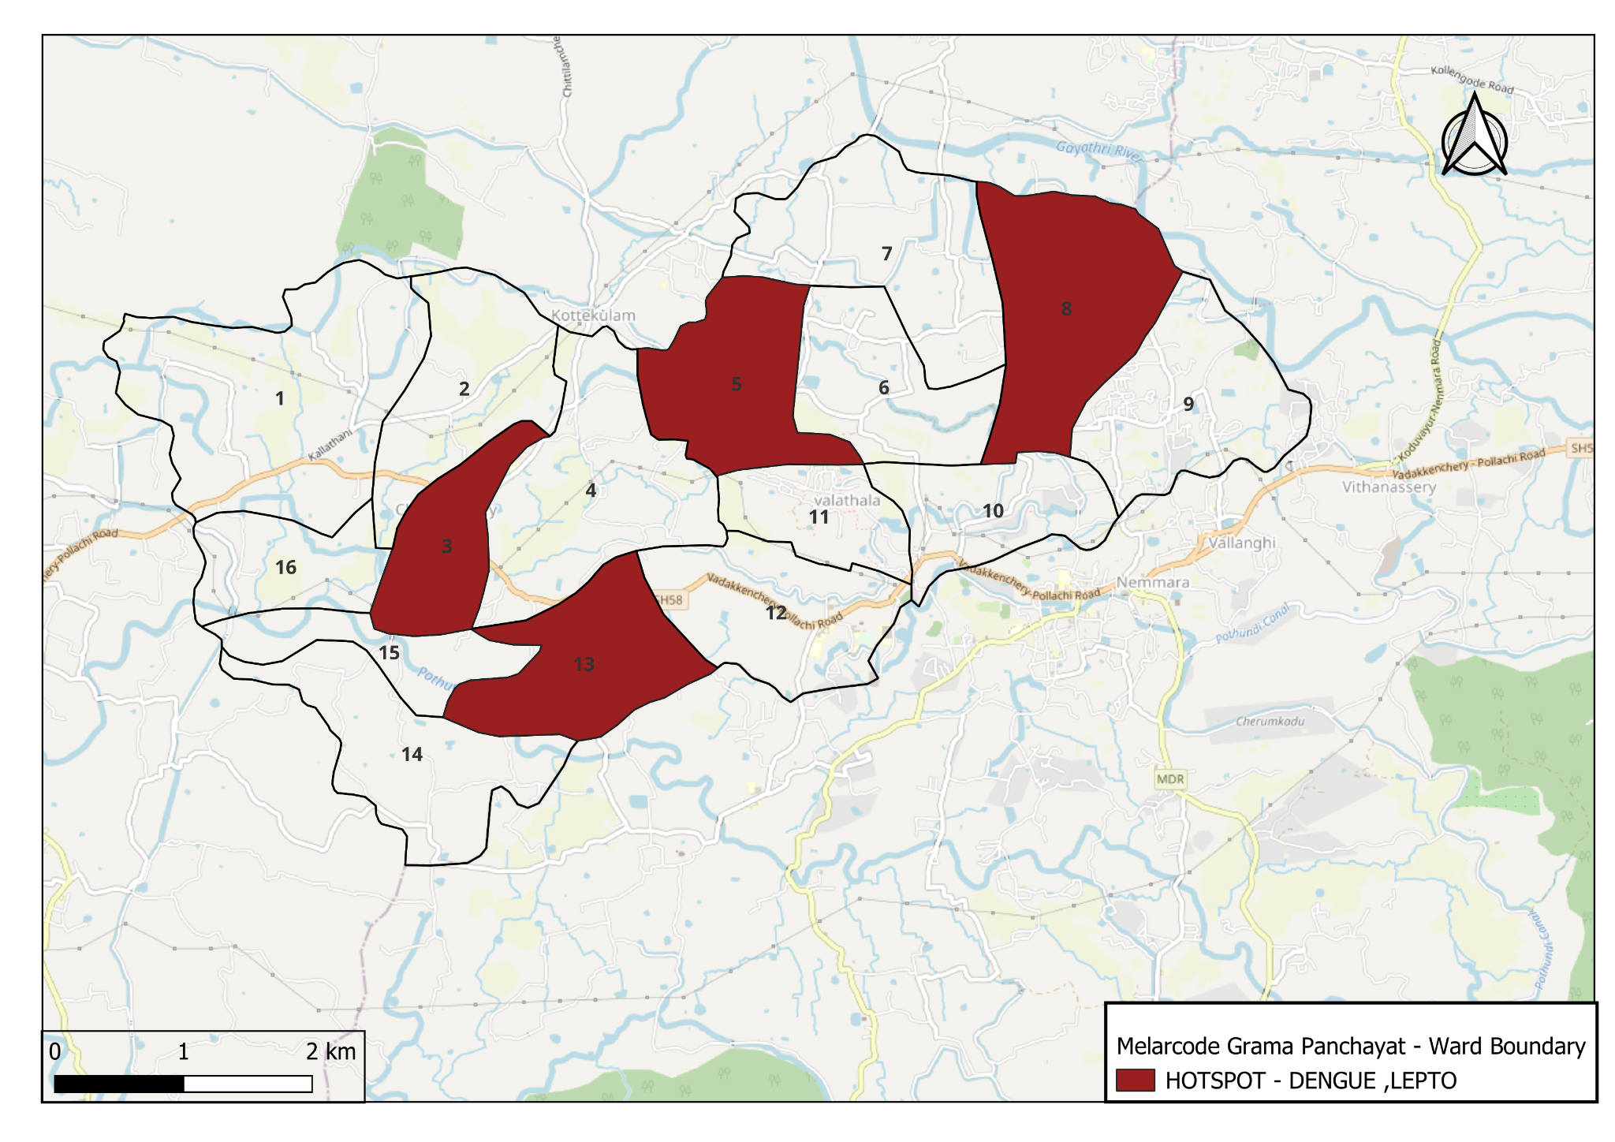
Map 6 : Hotspot Map
source:https://dmp.kila.ac.in/

Ward No | Dengue Total (2021-25) | Leptospirosis Total (2021-25) | Hepatitis A Total (2021-25) | Mumps (2021-25) | ADD (2021-25) | Total Cases
1 | 3 | 0 | 1 | 3 | 17 | 25
2 | 1 | 0 | 0 | 3 | 18 | 22
3 | 4 | 1 | 2 | 3 | 26 | 36
4 | 1 | 1 | 0 | 1 | 23 | 26
5 | 6 | 1 | 0 | 5 | 20 | 32
6 | 1 | 1 | 0 | 6 | 21 | 29
7 | 7 | 0 | 1 | 1 | 16 | 25
8 | 2 | 1 | 0 | 1 | 19 | 23
9 | 1 | 1 | 2 | 0 | 21 | 25
10 | 3 | 1 | 0 | 3 | 19 | 26
11 | 3 | 0 | 0 | 4 | 22 | 29
12 | 1 | 0 | 0 | 0 | 20 | 21
13 | 4 | 2 | 0 | 8 | 21 | 35
14 | 2 | 0 | 0 | 7 | 26 | 35
15 | 1 | 0 | 0 | 3 | 23 | 27
16 | 2 | 0 | 1 | 3 | 20 | 26

By overlaying five years of data, we have identified 6 ‘Red Zone’ Wards (Wards 3, 5, 6, 10, 13, and 14). These are wards where at least two different categories of diseases (e.g., Dengue and Leptospirosis or Hepatitis A) recurred along with consistently high overall case burden, indicating sustained transmission risk and the need for priority interventions.

Preparedness and Response Protocol at LSG Level
This section describes the operational framework for the LSGI once a pandemic is declared. It explains how the LSGI and health system will move from routine data collection to active response, using a One Health approach.

Constitution of One Health Committee
The LSGD shall constitute a One Health Committee comprising the LSGI President, Medical Officers (Modern Medicine, AYUSH, and Veterinary), the Health Inspector, and the Veterinary Surgeon.

Objective: The One Health Committee coordinates human, animal, and environmental health to prevent and control pandemics.

Sl No | Name | Designation | Department/Institution | Role in Committee | Contact Number
1 | BIJUKUMAR | Panchayat President | LSGD | Chairperson | 9497134689
2 | DR.JOWIN JOSE | Medical Officer (PHC/CHC) | HealtH Dept | Member Secretary | 8848970283
3 | BHAGYALAKSHMI | Veterinary Officer | Animal Husbandry | Member | 9447269245
4 | nil | Epidemiologist | Health Dept | Member
5 | SUGATHAN | Health Inspector/PHN | Health Dept | Surveillance | 9744197947
6 | SINDHU | ASHA Supervisor | Health Dept | Community link | PRO-8547758552
7 | KAVITHA | ICDS Supervisor | Social Welfare | Vulnerable groups | 9567640402
8 | GEORGE MATHEW | Police Station Officer  (Sub Inspector) | Police Dept | Law & order | 9497980600
9 | K C VIJAYAN | Ward Councillor Representative | LSGD | Community coordination | 9447377293
10 | NEETHU | Kudumbashree CDO | Kudumbashree | Community mobilisation | 9961188392
11 | PRABHAKARAN | NGO/Volunteer rep | Civil Society | Support services | 9447838876
12 |  | Line Department representations

Key Responsibilities:
- Review disease surveillance data (human + animal)
- Conduct ward-wise risk assessment and vulnerability mapping
- Approve quarantine/isolation centre locations
- Coordinate with district for resources (PPE, oxygen, ambulances)
- Periodically review health system surge capacity, including beds, oxygen, human resources, and ambulances.
- Approve and monitor risk communication and community engagement strategies, including rumour management.
- Ensure protection and service continuity for vulnerable groups (elderly, persons with disabilities, dialysis patients, coastal populations).
- Conduct quarterly mock drills
- Monitor equity measures for vulnerable groups

Meeting Schedule:
Quarterly (normal times) | Weekly (outbreak alert) | Daily (pandemic phase)

Pandemic Response Workforce
To ensure a coordinated and timely response during a pandemic, a dedicated Pandemic Response Workforce shall be constituted at the LSG level. The workforce will function under the overall supervision of the One Health Committee and in close coordination with the health authorities. Team-based deployment will enable efficient surveillance, case management, quarantine and isolation management, logistics support, and risk communication. Each team shall have a clearly designated team leader, defined roles, and an identified pool of personnel to allow rapid activation, rotation of duties, and continuity of services during prolonged emergencies.

Total Response Workforce Available: 300 persons

Team Name | Composition | Key Responsibilities | Team Leader
Surveillance and Contact Tracing Team | HI, JHI, JPHN, ASHAs and Volunteers | Case detection, contact listing, home visits, reporting | HI
Case Management Team | Doctors, Nurses, MLSP, Palliative Nurses | Patient care & referral | DOCTOR
Quarantine & Isolation Team | LSGD staff, Volunteers | Facility management | JHI
Psychosocial support | AH counsellor | Psychosocial support | AH counsellor
Logistics & supply chain Team | LSGD staff, Storekeepers, Drivers 3 | Supplies & transport [PPE, medicines, oxygen, transport, waste management] | Ward Member
Communication Team | Ward members, Kudumbashree, Youth clubs,  AWW workers and other self help groups | IEC, community meetings, countering misinformation | M.O in charge
Transportation | KSRTC, educational institutional buses
Media Surveillance | Development Standing Committee members, IT Volunteers | Monitoring media reports, rumor tracking, misinformation control | Development Standing Committee Chairperson
Intersectoral coordination and convergence | Representatives from Health, LSGD, Police, Education, ICDS | Multi-department coordination, review meetings, resource mobilization | Development Standing Committee Chairperson
Collaborative surveillance | Health Officials, Private Practitioners, Labs | Data sharing, case notification, outbreak alert system | Health Standing Committee Chairperson

All teams shall be activated immediately upon outbreak alert or pandemic declaration and shall report daily to the LSG Incident Commander/Medical Officer, with consolidated reporting to the Block PHC. Duty rosters and alternate personnel shall be maintained to ensure uninterrupted services during staff shortages or prolonged response periods. Team composition and numbers may be revised based on the magnitude of the outbreak and availability of human resources.

Activities and Measures before and during Pandemic

PHASE 1 - Alert / Preparation
Surveillance and Reporting-Enhanced syndromic surveillance:
- Data sources for surveillance:
Surveillance data shall be compiled from multiple sources to ensure comprehensive coverage across the Panchayat. These include outpatient and inpatient registers from public and private health facilities, laboratory test results, reports from ASHA workers and other field health staff including JHIs, JPHNs, and MLSPs, school absenteeism records, pharmacy sales trends of antipyretics and antibiotics, and mortality data from the local registrar. All notifiable diseases and priority syndromes shall be reported in real time through the Integrated Health Information Platform (IHIP) to facilitate early warning signal generation, trend analysis, and rapid public health response.

- Event-based triggers (to be monitored and reported):
Event-based surveillance shall focus on the prompt identification and reporting of unusual or unexpected public health events that may indicate the emergence of a pandemic threat. The following triggers shall be actively monitored and immediately reported through appropriate channels, including the Integrated Health Information Platform (IHIP):
- Sudden clustering of fever, respiratory illness (ILI/SARI), diarrhoeal disease, or other similar syndromes within a locality.
- Two or more epidemiologically linked cases occurring in households, institutions, schools, hostels, migrant labour camps, or elderly care facilities.
- Unexplained severe illness, rapid deterioration, or deaths due to unknown causes.
- Increase in hospital admissions for respiratory or febrile illness beyond the expected baseline.
- Illness among healthcare workers or frontline staff.
- Reports of unusual clinical presentations or failure of standard treatment response.
- Rumours or community reports of sudden illness outbreaks.
All such events shall be verified promptly by field staff, documented, and escalated to higher authorities for timely outbreak investigation and control measures.

- Zoonotic and animal health surveillance
Zoonotic and animal health surveillance shall be strengthened during the alert and preparedness phase through close coordination between the Health Department, Animal Husbandry Department, and local Panchayat authorities under a One Health approach. Continuous monitoring shall be undertaken for unusual illness, sudden deaths, or changes in disease patterns among domestic animals, poultry, and wildlife, particularly in areas of close human–animal interaction such as livestock holdings, backyard poultry units, animal markets, slaughter points, and forest fringe areas.
Reports from livestock owners, poultry farmers, veterinary field staff, and community informants shall be promptly collected, verified, and shared with the public health surveillance system. Any suspected zoonotic event, including clusters of animal illness or mortality with potential human exposure, shall be immediately reported and jointly investigated. Integrated human and animal health surveillance findings shall be used to guide early risk assessment, targeted preventive measures, and timely containment actions to reduce the risk of zoonotic spillover and pandemic emergence.

- Logistics and Stock Preparedness

  - Identify and empanel local vendors and define emergency procurement mechanisms in accordance with existing LSGD and Health Department norms.
  - Prepare and maintain an essential logistics checklist covering medical supplies, consumables, and support equipment.
  - Pre-identify secure storage locations for emergency stocks and ensure maintenance of stock registers with regular updating.
  - Finalise emergency transport arrangements, including availability of vehicles and identified drivers for rapid deployment during alerts.
  - Designate a Nodal Officer for Logistics to enable prompt decision-making, coordination, and communication during emergencies.
  - Conduct rapid stock verification and ensure availability of minimum buffer stock, including:
- PPE kits –0 numbers
- Pulse oximeters – 1 numbers
- Hand sanitizers – 3 litres
- Masks, gloves, disinfectants –yes adequate quantity
Identify critical gaps in logistics and immediately communicate requirements to the Block and District authorities for timely replenishment and support. Monitor expiry dates and stock rotation.

Identification of Quarantine and Isolation Facilities
  - Identify and list suitable buildings for quarantine and isolation (schools, hostels, community halls, etc.).
  - Categorise cases as per the severity and allocate to appropriate facilities (for instance, severe cases to classrooms, mild cases to an assembly hall in case of a school).
  - Facility readiness checklist needed (beds, toilets, ventilation) etc.
  - Find an alternate site if the primary sites are not available or not in use.
  - Identify facility managers and support staff
  - Prepare basic SOPs for:
    - Admission and discharge
    - Food, water, sanitation
    - Infection prevention and waste disposal
  - Ensure availability of basic amenities: water, sanitation, electricity, ventilation, and waste disposal. Prepare a rapid activation plan for these facilities if case numbers increase.

Risk Communication and Community Preparedness
  - Disseminate early warning messages on symptoms, preventive measures, and reporting mechanisms. Display IEC materials both in English and the local language in public places and ensure ward-level awareness.
  - Sensitize elected representatives and community leaders on preparedness measures.
  - Establish a rumour tracking and misinformation response mechanism to identify, verify, and promptly counter false or misleading information.
  - Engage trusted local persons (ward members, ASHA workers, religious leaders, teachers, community volunteers) to communicate official public health messages and reinforce correct practices.
  - Develop and deploy targeted IEC materials for:
    - Schools and educational institutions
    - Markets and commercial areas
    - Work sites and labour settings
  - Conduct community sensitization meetings at the ward level to promote preventive behaviors, address concerns, and strengthen community participation in preparedness and response.

Protection of Vulnerable Groups
Vulnerable populations require priority protection through targeted line-listing, service continuity, and delivery mechanisms.
- Prepare and regularly update line-lists of vulnerable populations, including:
  - Elderly persons living alone
  - Persons with disabilities
  - Pregnant women
  - Migrant workers
  - Dialysis patients
The detailed line-lists shall be maintained as Annexure ___ and updated periodically.

Clinical Dependency Mapping
Develop ward-wise dependency and vulnerability maps to identify households requiring regular support during emergencies. Ensure continuity of essential health services for vulnerable groups, including
- Dialysis services (facility mapping, transport arrangements, and scheduling)
- Continuity of treatment for TB, HIV, and other chronic conditions requiring uninterrupted medication
- Mental health and psychosocial support services
Establish delivery mechanisms for food, essential commodities, and medicines to vulnerable households through coordinated action involving ASHAs, JPHNs, Kudumbashree, volunteers, and local administration.

PHASE 2 - Active Response

Case Identification and Contact Tracing
Case detection and contact tracing activities will be carried out in coordination with the Health authorities, following disease-specific SOPs and IDSP guidelines.
Field Staff Involved
- Health Inspector (HI)
- Junior Health Inspector (JHI)
- Junior Public Health Nurse (JPHN)
- ASHAs and ASHA Supervisors
- Ward-level volunteers and Kudumbashree members (as required)

Screening Checkpoints
Screening checkpoints at high-traffic locations (transport hubs, markets, religious gatherings) for early detection of symptomatic travellers and crowd screening during outbreaks. Potential locations include bus stands, market entry points, etc. based on local context and risk assessment.
Screening activities will be carried out by trained personnel such as ASHAs, ward members, and volunteers, with support from Health Department staff. Necessary equipment, including non-contact thermometers and appropriate PPE, shall be ensured prior to activation.
Location | Type (Bus stand/Jetty/Market/Railway) | Staff Deployed (ASHAs/Volunteers) | Screening Method | Reporting authority
Bus stand | Transport hub | One JHI  One ASHA  One health Mentors | 1.Swab Collection.  2. Blood smears collection (RDT)  3.Thermal Scanners | Surveillance Nodal Officer in control room
Market entry | Market | One JHI  One ASHA  Male health volunteers | 1.Swab Collection.  2. Blood smears collection (RDT)  3.Thermal Scanners | Surveillance Nodal Officer in control room

Standard Screening Protocol

The screening protocol shall include temperature screening, observation for visible symptoms, and inquiry regarding recent travel or exposure history. Individuals identified as suspects during screening shall be immediately referred to the nearest PHC/FHC for further evaluation, testing, and appropriate action as per prevailing guidelines.

Pandemic Control Room
The Pandemic Control Room (PCR) serves as the central nerve center for real-time coordination, data aggregation, decision support, and communication during outbreaks. It consolidates information from all LSGD teams, health facilities and community sources to enable rapid response decisions.

Control Room Infrastructure and Location
Primary Location: Melarcode Panchayath Office.
Backup Location: Community Hall in Melarcode G.P.

Health System Control Room Framework
The PCR is organized into seven functional pillars to ensure no aspect of the response is overlooked:

Rapid Response Team (RRT)
  - Provides immediate intervention during emergencies, clusters, and field alerts.​
  - Coordinates urgent actions such as case investigation, contact tracing, isolation, and inter‑facility referrals.

Data Management & Analytics Team
  - Collects, validates, and manages key health system indicators (cases, tests, beds, HR, supplies).​
  - Analyzes data trends, generates projections, and supports evidence‑based decision‑making for local authorities.

Human Resource Deployment Team
  - Allocates healthcare staff efficiently based on workload and need
  - Ensures adequate and equitable workforce distribution across facilities

Laboratory Surveillance Team
  - Oversees diagnostic testing coordination, sample transport, and timely reporting of results.​
  - Monitors lab indicators (testing volume, positivity rate, turnaround time) for early detection of outbreaks

Vaccination Cell (If Required)
  - Plans and executes vaccination campaigns, including micro‑planning and session scheduling.​
  - Tracks coverage, identifies gaps, and coordinates corrective actions with field teams and outreach services.

Infrastructure & Patient Occupancy Team
  - Monitors facility capacity, earmarked beds, oxygen and critical care resources across all linked facilities.​
  - Ensures optimal patient distribution and referral management using updated bed‑status and resource data.
  - BMWM

Communication team
- Logistics and supply chain
- Transportation (interfacility & emergency transport)
- Media surveillance Call centre
- Management of the deceased
- Intersectoral coordination and convergence

Key Control Room Team
The Control Room Team coordinates all pandemic response activities within the LSGD and serves as the single command and communication hub during activation. It integrates information, field actions, logistics, and policy execution across all participating departments and health facilities.

Role | Name | Designation | Contact Number | Responsibility
In-charge/Nodal Officer | Dr.Jowin Jose | Medical Officer | 8848970283 | Overall coordination, decision-making, and reporting to the District level.
Data Entry Operator |  | Staff as per availability |  | Managing the line list, updating dashboards, and tracking testing results.
Communication Officer | Sugathan K S | Health Inspector | 9744197947 | Handling the public helpline, coordinating ambulance dispatch, and contact tracing calls.
Logistics Coordinator | Jishma | Pharmacist | 9656727221
Technical Support (IT/Data) | Princy A | Senior Clerk | 9947644686

SOP for alert escalation/trigger point with mapping of responsibilities.
Key Points:
- The Control Room shall be staffed with a designated In-charge, data entry personnel, and communication staff with clearly defined roles and shift arrangements.
- It shall maintain updated records on daily monitoring indicators including new cases, persons under active quarantine, and hospital bed occupancy.
- All reports and situation updates shall be shared daily with the Block and District Surveillance Unit.
- The Control Room shall act as a single point of contact for coordination with response teams, health institutions, and other departments.
- Contact details of the Control Room shall be widely communicated to field staff and stakeholders during activation.

Daily Monitoring Indicators
To ensure timely decision-making and effective response, the following key indicators shall be monitored and updated on a daily basis by the Pandemic Control Room:

Epidemiological Indicators:
New cases reported today, Total active cases, Test Positivity Rate (TPR), Case Fatality Rate (CFR)
- Surveillance Indicators:
Persons under home quarantine, High-risk contacts identified, Fever, ILI, SARI or other symptoms (syndromic surges), Travellers (symptomatic or high-risk arrivals),Animal husbandry surveillance (zoonotic alerts, unusual animal deaths, poultry/bird flu signals), Mortality surveillance (excess deaths, unexplained fatalities, verbal autopsy reports)
- Logistics and Infrastructure Indicators:
Hospital / CFLTC beds occupied, Oxygen cylinders/concentrators available, Ambulances on standby
- Alert Findings
The following table outlines category-specific trigger points (red flags) from surveillance indicators and corresponding immediate actions for the Pandemic Control Room. These enable rapid response to alert findings like testing anomalies, positive cases exceeding thresholds, clusters, and WGS reports.

Category | Trigger Point (Red Flag) | Immediate Action
Clusters | Geographical or facility-based: 5+ cases linked to one location (office, school, street). | Declare a micro-containment zone; perimeter control and active case finding.
Testing | Sudden drop in testing volume / delay in reporting / unusual testing trends | Review the sample collection process, address lab bottlenecks, deploy additional testing teams, and notify the District Lab.
Lab | Test Positivity rate increases | Increase testing sites in that ward.
Hospital | >80% Oxygen bed occupancy | Activate backup/CFLTC beds.
Travel | Cluster of cases from a single flight/train or high-risk arrival group. | Trace all passengers in adjacent seats; implement mandatory institutional quarantine.
Animal | Mass poultry/wildlife death or unusual sickness | Notify Animal Husbandry, sample the area, and dispatch RRT for environmental sampling and zoonotic check.
Mortality | Sudden spike in home deaths or brought-in-dead (BID) cases | Audit the deaths and Active Case Search drive
Additional investigations like Whole Genome Sequencing (WGS) | Detection of a Variant of Concern (VOC) or Variant of Interest (VOI) | Implement strict micro-containment; update clinical protocols to match variant severity.

Communication of Public Health Information
A Community Communication Hub shall be established to ensure timely, accurate, and consistent dissemination of information during a pandemic. The Hub will function under the coordination of Nodal officers of the control room and act as the nodal point for public communication, risk messaging, and community engagement. It will support dissemination of official advisories, promote preventive behaviors, address rumors and misinformation, and ensure that messages reach all sections of the population through trusted local channels and leaders.

Key communicators
Channel | Responsible Person | Contact
Ward-level announcements | HI | 9744197947
Social media | Mujeeb | 9037533030
Local Cable TV/Radio | Anoop | 9447715574

- All messages disseminated through the Hub shall align with advisories issued by the Health Department and District authorities.
- Community leaders shall be sensitized to support behavior change, reduce stigma, and counter misinformation.
- Special efforts shall be made to reach vulnerable and hard-to-reach populations using locally appropriate communication methods.

Rumor Tracking: A designated volunteer will monitor local social media/WhatsApp groups daily to identify misinformation and issue official clarifications via the Communication Hub.

Coordination with District/State Authorities & Other Organisations
Effective coordination with Block, District, and State authorities is essential to ensure timely reporting, technical guidance, and uninterrupted supply of essential resources during a pandemic. The LSG shall establish clear communication channels, designate responsible officers, and adhere to prescribed reporting timelines to support coordinated public health action and efficient resource mobilisation.

Key Details:
- Nodal Officer for Reporting: Medical officer
- Contact Number: 9496915448
Reporting Schedule and Protocols:

To Whom | What to Report | Frequency | Nodal Person
Block PHC | Complete Situation Report (Cases, Quarantine, Beds, Screening, Deaths) | Daily / As directed during outbreak | MO
District IDSP Unit | Outbreaks/Clusters/Unusual Events (>5 cases same ward) | Immediately | MO
Veterinary Officer | Animal health events/Zoonotic alerts | Immediately upon detection | Veterinary Inspector / Livestock Inspector
State Cell | Zoonotic cross-sector events | As directed / Immediate during major outbreak | DMO/DSO (through Block PHC)

Supply Chain Coordination
The LSG shall coordinate closely with Block, District, and State authorities (KMSCL) to ensure uninterrupted availability of essential goods, medical supplies, and logistics during a pandemic. Supply requirements shall be assessed regularly based on case load and communicated promptly to the appropriate authorities for timely replenishment.
Key Points:
- Maintain updated contact details of District and Block nodal officers for health logistics, oxygen supply, ambulances, and essential medicines.
- Submit timely indent requests for PPE, testing kits, medicines, oxygen, and other critical supplies through prescribed channels.
- Monitor stock levels at LSGD facilities, quarantine/isolation centres, and field teams through daily stock registers and dispensing logs to prevent shortages.
- Coordinate with District authorities, Karunya/Neethi medical shops, and local purchase committees for funds allocation and emergency procurement.

- Ensure regular monitoring of dispensing registers at all facilities to track usage, expiry, and pilferage—shortages being a perennial issue requiring proactive weekly audits.

- Activate surge procurement protocols during high caseloads, leveraging local purchase powers under LSGD funds alongside state supplies.

Resource Inventory and Contacts
Resource Category | Source  (District/State/Private) | Contact
PPE Kits/Masks/Gloves | KMSCL | 0491- 2533336
PPE Kits/Masks/Gloves | Local Vendors | Janaushadhi  8113077083
Oxygen  Cylinders/Concentrators | KMSCL | 0491- 2533336
Medicines/Antivirals | KMSCL | 0491- 2533336
Medicines/Antivirals | Neethi Shops | nil
Test Kits (RTPCR/Rapid) | KMSCL | 0491- 2533336

Collaboration with NGOs, PPP, and CSR
To augment government efforts during a pandemic, the LSG shall collaborate with NGOs, voluntary organisations, and private sector partners through public–private partnerships and Corporate Social Responsibility (CSR) initiatives, in coordination with District authorities.

Key Points:
- Engage NGOs and community-based organisations for community outreach, awareness, and support to vulnerable populations.
- Leverage CSR support for procurement of medical equipment, PPE, oxygen concentrators, food kits, and sanitation materials, as permitted.
- Ensure all collaborations align with government guidelines and are routed through approved administrative and financial procedures.
- Maintain transparency and documentation for all external support received and utilised.
Organization | Type | Support Offered | Contact Person
Youth Clubs/Student Unions | CBO | Coordination | 9037533030

Interdepartmental Coordination
Coordination among departments during a pandemic shall be ensured through regular review meetings convened by the LSGD President. These meetings will provide a structured platform for sharing situational updates, assessing resource availability, resolving operational gaps, and taking joint decisions to ensure a coordinated and timely response.

Department | Representative | Key Role | Contact
Health (PHC) | Staff Nurse : | Case management | 9847124620
Veterinary | Veterinary Surgeon: | Animal surveillance | 9447269245
ICDS | Supervisor: | Nutrition support | 9567640402
Education | Head Teacher: | School coordination
Police | SI | Containment enforcement | 9497980600_______
Water Authority | AE | Water supply | __________
LSGD Engineering | Assistant Engineer | Quarantine infrastructure | 9605336261______

PHASE 3 - Surge Capacity
Phase 3 is activated when there is a rapid increase in cases, high test positivity rates, or when existing health facilities and quarantine arrangements approach saturation. The focus of this phase is to expand isolation capacity, augment clinical care services, and mobilise additional resources through district and state support mechanisms.

Conversion of Community Facilities
To manage increased case load, the LSGD shall activate additional isolation facilities by repurposing identified community infrastructure such as community halls, auditoriums, schools, hostels, or other suitable buildings.

Name of facility | Facility Type | No. of Buildings | Ward | Surge Capacity (Beds) | Nodal Person
PKMAUP School | School | 30 | 3 | 120 | ASHA HM
MNKMHSS school | School | 60 | 3 | 260 | BINDHU HM
KAUPS Melarcode | School | 3 | 5 | 70 | LAKSHMI HM
GALPS Pazhathara | School | 2 | 8 | 35 | SHOBHANA
ALPS Muthukunni | School | 2 | 14 | 35 | PRASAD
CNS hall | Auditorium | 1 | 3 | 50 | VASUDHEVAN
Community hall Chittilamchery | Auditorium | 1 | 3 | 20 | MURALEEDHARAN

- Recovery and rehabilitation phase
- Recovery
  - Damage & impact assessment
  - Restoration of health services
  - Rehabilitation of affected population
  - Psychosocial & mental health support
  - Disease surveillance during recovery phase
  - Environmental cleanup & sanitation
  - Livelihood restoration
  - Community engagement & confidence building
  - Documentation & after-action review
  - Lessons learned & best practices
  - Health system strengthening
  - Policy revision & preparedness enhancement
  - Research

CONCLUSION
The Overall Pandemic Action Plan of Melarcode Grama Panchayat provides a comprehensive, risk-based, and people-centred framework to prevent, prepare for, and respond to public health emergencies. By incorporating ward-level risk assessment, disease trend analysis, and identification of hotspot areas, the Plan enables timely detection and targeted interventions. Strengthened disease surveillance systems and effective intersectoral coordination ensure prompt response and continuity of essential health and civic services during pandemics.
Special emphasis on community participation, protection of vulnerable groups, and improvement of water, sanitation, and environmental conditions enhances the Panchayat’s resilience against public health threats. The Plan also addresses local risk factors such as water-borne diseases and seasonal outbreaks, ensuring focused preventive and control measures.
Through decentralized planning, data-driven decision-making, and active collaboration with health institutions, frontline workers, and the community, Melarcode Grama Panchayat is well-positioned to reduce disease burden, respond effectively to emergencies, and safeguard the health and well-being of its population in future pandemics.

RECOMMENDATIONS

Strengthening Healthcare Infrastructure
- Establish a primary health response unit within the Panchayat with trained staff.
- Ensure availability of basic medical supplies (masks, sanitizers, PPE kits, oxygen cylinders).
- Create tie-ups with nearby hospitals for emergency referral and transport.

2. Community Awareness & Education
- Conduct regular awareness campaigns on hygiene, vaccination, and preventive measures.
- Use local communication channels (community radio, WhatsApp groups, notice boards) to spread verified information.
- Train volunteers to act as health ambassadors in each ward.

3. Emergency Response & Coordination
- Form a Pandemic Preparedness Committee at Panchayat level including health workers, ward members, and NGOs.
- Develop a clear action plan for lockdowns, quarantine, and distribution of essentials.
- Maintain a database of vulnerable groups (elderly, differently-abled, chronically ill) for targeted support.

4. Supply Chain & Food Security
- Identify and support local suppliers and farmers to ensure uninterrupted food supply.
- Create community kitchens during emergencies to serve vulnerable populations.
- Stockpile essential commodities in Panchayat-run outlets for crisis periods.

5. Digital Preparedness
- Promote digital platforms for telemedicine consultations.
- Use Panchayat’s website/social media for real-time updates on health advisories.
- Encourage online grievance redressal to reduce crowding in offices.

6. Training & Capacity Building
- Organize mock drills for pandemic response in schools, offices, and public spaces.
- Train Panchayat staff and volunteers in first aid, infection control, and crowd management.
- Collaborate with NGOs and health departments for capacity-building workshops.

7. Long-Term Resilience
- Integrate pandemic preparedness into the Panchayat Development Plan.
- Allocate a dedicated budget for health emergencies.
- Encourage community participation in planning and monitoring preparedness measures.

MOCKDRILL SCENARIOS
Mock drill scenarios for public health emergencies, including outbreak response, mass casualty management, and pandemic preparedness, have been identified to strengthen institutional readiness and coordinated response mechanisms; however, implementation is pending across institutions and will be conducted in a phased manner to strengthen emergency response capacity.

ANNEXURE

IMPORTANT PHONE NUMBERS

Phone numbers and particulars of persons responsible for providing guidance, assistance, and support for pandemic preparedness operations may be provided here in a manner that allows easy reference at a glance. The information recorded here could be exhibited elsewhere at the time of emergencies. LSG institutions shall give special attention to collect and record the above data of persons and institutions who/which are supposed to give technical and co-ordination support to reduce the impact of pandemic.

1.1. Details of grama panchayat/municipality/corporation wards
Sl.No | Name of the ward | Ward number | Name of the ward  member | Contact number
1 | Kozhioadam | 1 | Rajendran C | 9846892257
2 | Konnallur | 2 | Sreevidhya | 9645934040
3 | Chittilamchery | 3 | Sajini V | 6282329919
4 | Neelichira | 4 | Praseetha KV | 9496233358
5 | Kallambad | 5 | Ansila S | 9605901127
6 | Thekkethara | 6 | Biju kumar R | 9497134689
7 | Kappukad | 7 | Ajitha A | 9400249755
8 | Chettiyarkad | 8 | Jishamol K K | 8606180445
9 | Cheramangalam | 9 | Jaya R | 8281468155
10 | Pazhathara | 10 | K C Vijayan | 9447377293
11 | Kiliyallor | 11 | Resna U P | 9645324026
12 | Anthazhi | 12 | Shaiju R | 9446344689
13 | Puthanthara | 13 | K C Sajith | 8075222740
14 | Valathala | 14 | Mohanan K | 9446218556
15 | Kadambidi | 15 | Sangeetha das K N | 8593070578
16 | Muthukunni | 16 | Chellakutty K | 9495321986
17 | Vattompadam | 17 | K V Kannan | 9446875724
18 | Kathampotta | 18 | Jyothikrishnan A | 9947339876

1.2. Other important phone numbers of grama panchayat/municipality/corporation area
Sl. No. | Name | Contact number
1. | Hareesh Secretary | 9947798239
2. | Shereena - Assistant Secretary | 9495189769
3. | Neethu -CDS Chairperson | 9961188392
4.
5.
6.
7. | Excise department
8. | Forest department | Saleem 9744856444

1.3. Important offices of grama panchayat/municipality/ corporation
Sl.No | Name of the office | Contact person | Contact number
1. | Village Office | Village Officer | 98478844446
2. | Agriculture Office | Agriculture Officer | 9495657106
3. | Animal Husbandry Office | Animal Husbandry Doctor | 9447269245
4. | Police Station | Police Officer | 9497980600
5. | BSNL Office | Officer | 04922243198
6. | Block Office | Officer | 049233244218 Nenmara
7. | KSEB Office | Officer | 04922255003 Mudappallur
8. | Fisheries Office | Officer | NIL
9. | Fire and Rescue | Officer | alathur- 04922223151

1.4. Health Services

Sl. No | Name of the hospital/institution | Location | Phone number
1. | Government hospitals/PHC | Kottekulam | 04922244077
2. | Private hospitals- | nil
3. | Clinical laboratories
4. | Chemist/pharmacy
5. | Blood donors
6. | Other language experts (Bihari, Hindi, Bengali,  Asamees ………)

1.5. Veterinary Services
Sl.No | Name of the Clinic | Name of the  Surgeon/Doctor | Place/location | Phone  number
1 | Govt.Veterinary Hospital | Dr. Bhagyalakshmi | Chittilamchery | 9447269245

1.6. Helpline numbers
Helpline | Phone number
Police
Fire and Rescue
KSEB

1.7. Public and Private Schools Contact details

S.No | Name of School | Institution type | Phone number
1 | MNKMHSS Chittilamchery | Aided
2 | PKMAUPS Chittilamchery | Aided
3 | KAUPS Melarcode | Aided
4 | GALPS Pazhathara | Aided
5 | ALPS Muthukunni | Aided

1.9. Anganwadi Contact Details

Ward No | Name of Anganwadi Teachers | Phone number
1 | Geetha | 9656760846
2 | Sathyabhama | 8086823053
3 | Saraswathy | 9847547893
3 | Vijayakumary | 6282661867
4 | Prasanna | 818798150
4 | Divya | 7510107972
5 | Prema | 8089817708
5 | Rejani | 9747500469
6 | Sreedevi | 9745527321
6 | Sumathy | 9946022159
7 | Soujath | 9048759409
7 | Sugana | 9497632114
8 | Lathika | 9349134036
8 | Sudha | 9496571735
9 | Resmi | 9645948716
9 | Bindhu
10 | Jayanthi | 9497824569
11 | Omana | 9562975541
12 | Omana | 9847980671
12 | Radha | 9562382657
13 | Vasantha | 8943875046
13 | Sunitha | 9744693255
14 | Jisha | 9847367637
16 | Anitha
14 | Preethy | 8848914286
15 | Latha | 8943856516

Ward No | Anganwadi No and Name of Teacher | Phone number
8
9

1.12. Information regarding resources

Means of transportation | Name of Owner | Phone Number
Heavy Trucks | kUTTAN | 9447370968
Tractor | Kandankutty | 9961210555
Ambulances | Sameer | 9745484040
Boats
Taxi service

Annexure 1: LSG Baseline Data Collection Format
A. Baseline data
Sl. No. | Indicator / Field | Baseline Data | Source / Remarks
1 | Name of LSG | Melarcode
2 | District | Palakkad
3 | Block / Taluk | Alathur
4 | Type of LSG (Gram Panchayat / Municipality / Corporation) | Gramapanchayath
5 | Area (sq. km) | 25.52
6 | No. of wards | 18
7 | GIS boundary file available | Yes
8 | Key contact person & phone

B. Demography
Indicator / Field | Baseline Data | Source / Remarks
Total population | 28284
Males | 13737
Females | 14547
Transgender population | 0
Age distribution  (<5, 5–14, 15–59, ≥60) | <5-1508, >60-4337
No. of households | 7087
Population density (persons/sq.km)
No. of migrant workers | 71
Major occupational groups

C. Vulnerable Populations & Social Risks
Sl. No. | Indicator / Field | Baseline Data (Value / Description) | Source / Remarks
1 | No. of elderly (≥60) | 4337
2 | No. of persons with disability | 92
3 | No. of bedridden persons | 62
4 | No. of chronic disease cases (DM/HTN/COPD/CKD etc.) | 2986
5 | Pregnant women (current estimate)
6 | Children <5 years | 1508
7 | Tribal population (if any) | 5
8 | Fisherfolk / coastal vulnerable groups (if any)
9 | Urban slums / unnotified settlements (if any)
10 | Homeless population
11 | Orphanages / old age homes (number & capacity) | 1 -15
12 | Hostels / prisons / shelters (number & capacity)
13 | Poverty / BPL estimate | 4393
14 | Food insecurity hotspots
15 | Any history of stigma/discrimination issues (Yes/No)

D. Health System & Service Readiness
Sl. No. | Indicator / Field | Baseline Data (Value / Description) | Source / Remarks
1 | No. of health facilities in LSG (PHC/CHC/TH/DH/Private)
2 | PHC/Family Health Centre details (name, location) | Melarcode, Kottekulam
3 | Subcentres / Health & Wellness Centres (number) | 5
4 | Private clinics / hospitals (number) | 3
5 | Labs available (public/private) | 4
6 | Availability of ambulance services (Yes/No, number) | Yes
7 | Availability of isolation/quarantine facilities (Yes/No, details)
8 | Cold chain facilities (Yes/No, details) | Yes
9 | Stockpile space available (Yes/No)
10 | PPE / mask / sanitizer availability plan (Yes/No)
11 | Surveillance staff available (JHI/JPHN/ASHA count) | JHI-3, JPHN-5, ASHA-23
12 | Existing emergency referral pathways (Yes/No)

E. Points of Entry & Mobility
Sl. No. | Indicator / Field | Baseline Data (Value / Description) | Source / Remarks
1 | Bus stands / depots (number)
2 | Railway stations (number)
3 | Boat jetties / fishing harbours (number)
4 | Ports / airports nearby (specify distance)
5 | Major highways/roads passing through
6 | Border crossings (state/district)
7 | Major markets / weekly markets
8 | Tourism hubs / major event venues
9 | Schools/colleges with hostels (number)
10 | Factories / large workplaces (number)
F. Water, Sanitation & Hygiene (WASH)
Sl. No. | Indicator / Field | Baseline Data (Value / Description) | Source / Remarks
1 | Major drinking water sources (piped / wells / borewells / springs) | well-2458  Tube well-957
2 | No. of public wells | 82
3 | No. of households with piped water connection | 5986
4 | Water quality testing routine (Yes/No) | yes
5 | Common contamination risks (flooding, salinity, industrial waste) | no
6 | Open defecation free status (Yes/No) | no
7 | Solid waste management system (Yes/No) | yes
8 | Bio-medical waste disposal mechanism (Yes/No) | yes
9 | No. of public toilets | 4
10 | Handwashing stations in public places (Yes/No) | 0
G. Zoonotic Risks & One Health
Sl. No. | Indicator / Field | Baseline Data (Value / Description) | Source / Remarks
1 | Livestock population (cattle/goats/pigs/poultry) – estimates
2 | No. of dairy farms / poultry farms / pig farms
3 | Slaughterhouses / meat shops (number)
4 | Animal markets (Yes/No, details)
5 | Veterinary dispensaries (number) | 2
6 | History of zoonotic outbreaks (rabies, leptospirosis, avian flu etc.)
7 | Stray dog population management measures (Yes/No)
8 | Rodent infestation hotspots (Yes/No)
9 | Wetlands / waterlogged areas prone to leptospirosis
10 | Bat roosting areas / caves / fruit orchards (if any)
11 | Human-animal interface hotspots (farms near residences)
H. Climate & Disaster Risks (Pandemic Amplifiers)
Sl. No. | Indicator / Field | Baseline Data (Value / Description) | Source / Remarks
1 | Flood-prone wards (list) | 14 muthukunni
2 | Landslide-prone wards (list) | 2 konnallur
3 | Cyclone/sea surge risk (Yes/No) | no
4 | Heatwave risk zones (Yes/No) | no
5 | Waterlogging areas (list) | no
6 | Shelter homes / relief camps (number, capacity) | no
7 | Past disaster displacement history
8 | Disruption to water supply/transport common (Yes/No)
I. Critical Infrastructure & Logistics
Sl. No. | Indicator / Field | Baseline Data (Value / Description) | Source / Remarks
1 | Schools (number) | 5
2 | Anganwadis (number) | 26
3 | Colleges (number) | 1
4 | Community halls (number) | 2
5 | Places of worship with large gatherings (number) | 5000
6 | Large markets / shopping areas (number)
7 | Warehouses / cold storages (number)
8 | Telecom/mobile network coverage gaps (Yes/No)
9 | Power outage frequency (high/medium/low)
10 | Availability of generators in key facilities

J. Risk Communication & Community Networks
Sl. No. | Indicator / Field | Baseline Data (Value / Description) | Source / Remarks
1 | Ward-level rapid response teams (Yes/No) | yes
2 | Jagratha samithis / committees active (Yes/No) | yes
3 | Kudumbashree presence and strength (number of units) | 280
4 | Volunteer network (number, coverage)
5 | Community-based surveillance mechanisms (Yes/No)
6 | IEC dissemination channels (WhatsApp groups, community radio, PA systems)
7 | Rumour tracking mechanisms (Yes/No)
8 | Languages spoken / literacy considerations
9 | Vulnerable groups communication strategy available (Yes/No)

K. Preparedness Planning & Governance
Sl. No. | Indicator / Field | Baseline Data (Value / Description) | Source / Remarks
1 | LSG emergency plan available (Yes/No)
2 | Pandemic preparedness plan available (Yes/No)
3 | Incident Command System identified (Yes/No)
4 | Rapid procurement mechanism available (Yes/No)
5 | Emergency fund available (Yes/No, amount)
6 | Past outbreak response experience (Yes/No, details)
7 | Intersectoral coordination mechanism (Health, Police, LSG, Veterinary, Education)
8 | Mock drills conducted in last 12 months (Yes/No)
9 | Training coverage for staff/volunteers (Yes/No)

L. Surveillance & Data Systems
Sl. No. | Indicator / Field | Baseline Data (Value / Description) | Source / Remarks
1 | Digital reporting tools used (e.g., DHIS2, portals)
2 | Availability of line-listing format (Yes/No)
3 | Contact tracing team identified (Yes/No)
4 | Mapping of high-risk households available (Yes/No)
5 | Testing sample transport mechanism (Yes/No) | yes
6 | Reporting timeline adherence (good/average/poor)
7 | Data sharing between departments (Yes/No) | yes
8 | Availability of dashboard for monitoring (Yes/No)

M. Additional Notes & Observations
Sl. No. | Indicator / Field | Baseline Data (Value / Description) | Source / Remarks
1 | Key challenges perceived by LSG
2 | Top 5 high-risk wards (reason) | Old 14 Flood prone  old 3 Dengue ,  5 Dengue,  10 dengue  old 13 Lepto
3 | Any unique local risks (industrial pollution, refugee camps, etc.)
4 | Recommendations for preparedness strengthening

