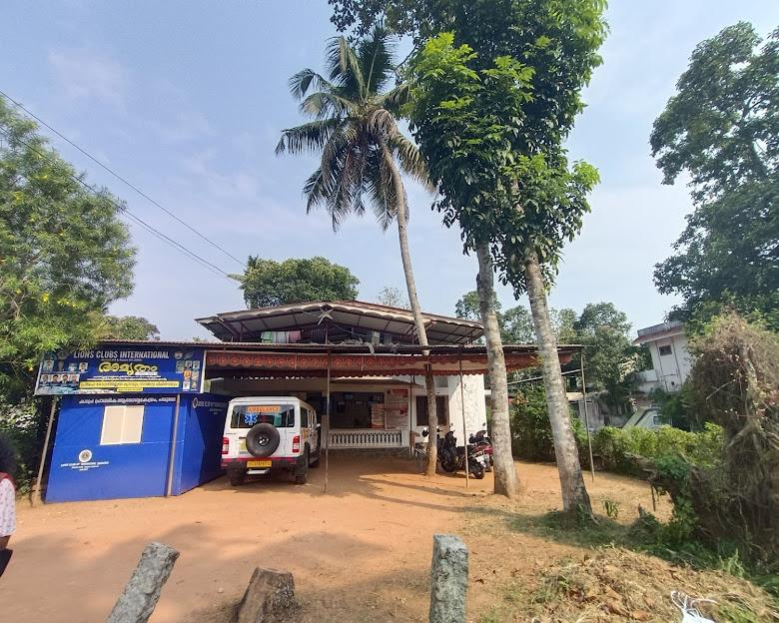
PANDEMIC PREPAREDNESS PLAN
PHC KADAPRA

KadapraGrama panchayat

Dr. Lakshmi R
Medical officer
Phc kadapra

MESSAGE


The safety, health, and resilience of our people remain the highest priority of Kadapra Grama Panchayat. In the face of communicable diseases such as COVID-19, Leptospirosis, Malaria, Dengue fever, and other emerging health threats, as well as natural disasters and pandemics, the Panchayat has adopted a proactive, systematic, and people-centric approach.
To prevent the spread of communicable diseases, the Panchayat is implementing regular sanitation and disinfection drives, vector control activities, and waste management measures across all wards. Special attention is given to eliminating mosquito breeding sites, maintaining drainage systems, ensuring safe drinking water, and promoting environmental hygiene. Awareness programmes are being conducted to educate the public on disease prevention, personal hygiene, and early reporting of symptoms.
In coordination with the Health Department, the Panchayat is strengthening disease surveillance, organizing health camps and vaccination programmes, and ensuring timely medical support for vulnerable sections of society. Field-level health workers, ward committees, and volunteers are actively involved in monitoring and preventive activities.
Kadapra Grama Panchayat is also committed to disaster preparedness and response. Emergency action plans, relief measures, and coordination with various departments are in place to effectively manage natural calamities such as floods and other unforeseen emergencies. Community kitchens, relief camps, and essential services are activated whenever required to ensure that no citizen is left unattended during times of crisis.
Public cooperation is the cornerstone of all these efforts. I earnestly request every resident to remain vigilant, follow health advisories, maintain cleanliness, support preventive measures, and work together with the Panchayat authorities.
With collective responsibility, preparedness, and unity, we can overcome challenges posed by diseases, disasters, and pandemics, and build a healthy, resilient, and secure Kadapra.
With sincere regards,
Liji R Panicker
President
Kadapra Grama Panchayat

MESSAGE

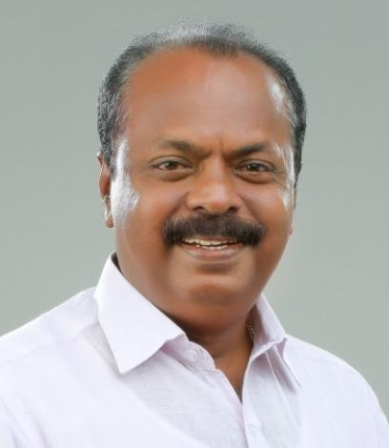
Kadapra Grama Panchayat is a close-knit rural community known for its hardworking families, agricultural way of life, and strong sense of togetherness. The Panchayat, with the support of the Local Self Government Department (LSGD), has always given priority to public health, cleanliness, and the overall welfare of its people.
In recent times, however, several health risks have been noticed in different parts of the Panchayat. Problems such as improper waste disposal, polluted water sources, mosquito breeding, poor sanitation, and other environmental issues are creating serious threats to public health. Many families are already facing illness, financial difficulties, emotional stress, and in some cases, prolonged disease and loss.
These problems affect not only physical health but also the mental well-being and social stability of households in our Panchayat.
As part of this public health initiative supported by the Local Self Government Department (LSGD), and in my capacity as Chairman of the Health Standing Committee, I sincerely request the cooperation and support of:
• All citizens to keep their surroundings clean, avoid dumping waste in public places, remove stagnant water, and cooperate with health inspections and awareness programs.
• Health workers to strengthen monitoring, early detection of diseases, and preventive health activities.
• Community service organizations and volunteers to participate in cleanliness drives, awareness campaigns, counseling programs, and social welfare initiatives.
Protecting the health of Kadapra Grama Panchayat is a shared responsibility. With the collective efforts of citizens, officials, and service organizations, we can safeguard our families, improve living conditions, and build a healthier and safer community for everyone.

Sivadas U Panicker
Chairman – Health Standing Committee
Kadapra Grama Panchayat

MESSAGE
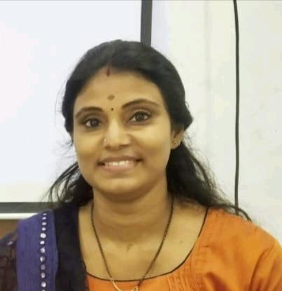
Dear Respected Citizens,
As the Medical Officer of the primary Health Centre (PHC), I want to express my deepest concern for the health and well-being of our community, especially amid the ongoing health challenges we face. The COVID-19 pandemic, along with other diseases like avian flu, leptospirosis, dengue, and malaria, has deeply impacted our people, causing physical, emotional, and financial hardship.
Our panchayat, with its diverse population, is particularly vulnerable due to its location and the presence of many workers in agriculture and industry, as well as through migration. In these trying times, the role of healthcare services becomes more crucial than ever. As part of the FHC, I am committed to providing essential healthcare services to everyone in our community, ensuring timely and effective medical care for all.
However, we cannot overcome these challenges alone. The fight against these health crises requires active involvement from each of you. I urge all community members to stay informed, practice preventive measures, and collaborate with health workers and local authorities. Together, through collective action, we can minimize the impact of these diseases and disasters on our people.
We will continue to work closely with the Gram Panchayat, local authorities, and other departments to ensure that healthcare resources are available, accessible, and effectively distributed. Let us stand united in the face of these challenges to protect the health and safety of our community.
Thank you for your cooperation and commitment to the health of Chennam Pallipuram Panchayat.Yours sincerely,
Dr. Lakshmi R
Medical officer
Phc kadapra

EXECUTIVE SUMMARY

Kadapra Grama Panchayath, situated within the Upper Kuttanad region of Pathanamthitta District, is characterized by a unique deltaic geography defined by its position between the Pamba and Manimala Rivers. This low-lying terrain consists of fertile alluvial plains and a complex network of seasonal wetlands, which serve as the foundation for the local agrarian economy—primarily paddy cultivation and inland fisheries—as well as the historic Travancore Sugars and Chemicals industrial complex. While the branching of the Pamba River around Parumala Island offers significant ecological and cultural value, the region’s high hydrological sensitivity necessitates specialized land-use planning to mitigate the perennial risk of seasonal inundation and waterlogging.
The developmental infrastructure of the Panchayath is anchored by State Highway 6 (SH-6), which facilitates critical regional connectivity via the Pulikeezhu and Parumala bridges. Beyond its role as a transit corridor, Kadapra functions as a vital healthcare and pilgrimage hub, hosting the St. Gregorios Medical Mission Hospital and the historic Parumala Church. Public welfare is administered through the Primary Health Centre (PHC), which provides essential clinical services including maternal and child health, immunization, and non-communicable disease (NCD) management. This institutional framework is bolstered by a decentralized community network of ASHA workers and Anganwadi centers, ensuring the equitable delivery of healthcare services to rural and geographically isolated riverine populations.

Kadapra’s framework for pandemic preparedness and disaster resilience is intrinsically linked to its established flood-response protocols. The Panchayath employs an integrated surveillance model to monitor climate-sensitive diseases, such as Leptospirosis, particularly following monsoon surges. During public health emergencies or natural disasters, localized infrastructure—including the Grama Panchayath Stadium and educational institutions—is transitioned into designated relief and isolation centers. By synthesizing data-driven monitoring with the grassroots mobilization of Kudumbashree units, the Panchayath maintains a robust logistics chain for food and medicine, ensuring community-wide stability and the continued safeguarding of public health standards across the jurisdiction.

LIST OF ABBREVIATIONS
LSGD | Local Self Government Department / Local Self Government Institution
BMO | Block Medical Officer
IDSP | Integrated Disease Surveillance Programme
NDMA | National Disaster Management Authority
PPE | Personal Protective Equipment
ICMR | Indian Council of Medical Research
CD | Communicable Diseases
NCD | Non-Communicable Diseases
KSIDC | Kerala State Industrial Development Corporation
covid | Coronavirus Disease
CAPD | Continuous Ambulatory Peritoneal Dialysis
TB | Tuberculosis
PHC | Primary Health Center
FHC | Family Health Center
AYUSH | Ayurveda, Yoga & Naturopathy, Unani, Siddha, and Homoeopathy
THQH | Taluk Head Quarters Hospital
MCH | Medical College Hospital
USG | Ultrasonography (Ultrasound Scan)
RT-PCR | Reverse Transcription Polymerase Chain Reaction
CT, MRI | Computed Tomography, Magnetic Resonance Imaging
NCC/NSS | National Cadet Corps, National Service Scheme
CBO | Community-Based Organizations
FBO | Faith-Based Organizations
SHG | Self-Help Groups
NGO | Non-Governmental Organizations
SOP | Standard Operating Procedure
ILI, SARI | Influenza-Like Illness, Severe Acute Respiratory Infections
CFLTC | COVID First Line Treatment Centre

TABLE OF CONTENTS

3
INTRODUCTION 9
● Background of the PPP 9
LSGD AT A GLANCE 9
INTEGRATED HEALTH INFRASTRUCTURE MAP OF KADAPRA PANCHAYAT 10
GENERAL PROFILE OF THE LSGI’S 13
Background of the LSGI 13
Demographic and Vulnerable Population 14
Clinical Vulnerability 16
INFRASTRUCTURE & RESOURCE INVENTORY 18
Health Facility Directory & Basic Capacity in the LSGD 18
Private Clinics 19
Healthcare Education & Training Institutions 20
Specialized Services & Emergency Inventory 20
Oxygen & Diagnostic Capacity 21
Diagnostics facility mapping at the LSGI level 22
Laboratory Identification & Basic Details 22
Social and Community Infrastructure for surge plan 22
Human resources 24
Community & Support Cadre 25
Community Organizations 26
Administrative & Emergency Services 27
Information regarding resources 27
ONE HEALTH & ENVIRONMENTAL SURVEILLANCE 28
Animal & Bird Population 28
Veterinary Infrastructure 29
Veterinary Doctors & Workforce 30
High-Risk Interface Points (Surveillance Sites) 30
Environmental Risk Mapping 31
Disease Seasonality Mapping 32
Vulnerability Mapping 33
EPIDEMIOLOGICAL TRENDS (2021–2025) 34
Disease Burden among human beings(Last 5 Years) 34
*(use the above table data to create the graph/diagram) 36
Seasonal Trend Analysis 37
Outcome-Based Trend Analysis- 2025 39
Transmission Trend- 2025 40
Integrated Disease Hotspot Map (2021–2025) 42
Preparedness and Response Protocol at LSG Level 44
Constitution of One Health Committee 44
Pandemic Response Workforce 45
Activities and Measures before and during Pandemic 47
PHASE 1 - Alert / Preparation 47
PHASE 2 - Active Response 50
Standard Screening Protocol 51
PHASE 3 - Surge Capacity 60
Conversion of Community Facilities 60
CONCLUSION 61
RECOMMENDATIONS 62
ANNEXURE 63

INTRODUCTION

Kadapra is a village with an area of about 14.74 sq k m situated in the Pulikkeezhu block panchayat of Pathanamthitta district, Kerala .In this panchayat approximately 24414 people live in more than 6788 houses.
It shares an intradistrict river border with Nedumpuram village separated along the Manimala river towards its north and an interpenetrating intradistrict land border with Niranam village towards its west.

All interdistrict borders are river borders shared with parts of Alappuzha district of which the border with Thalavady towards its northwest is separated by streams of the Manimala river. All other interdistrict river borders are formed by Pampa river which splits into three, near to the east of the village. One of the splits flows northwest and immediately merges with Manimala river forming a border with Thiruvanvandoor towards its northeast. The other two splits forms its island of Parumala of which the outer split shares a border with Pandanad, Ennakkad and Mannar towards its southeast. After merging, the splits flows westard sharing a border with Kurattissery towards the south of the village and Veeyapuram towards its southwest.The average sex ratio is 1174 which is higher than Kerala state average of 1084. The literacy rate stands at 96.94 percentage.

The State Highway 6 forms the skeleton of transportation through the village which enters through Pulikeezhu bridge across the Manimala river from Nedumpuram, passing north–south and exits through Parumala bridge across Pampa river towards Mannar. Buses of the state transport corporation and private ownership connecting Thiruvalla with Kayamkulam via Mavelikkara passes through this segment of road. The Eramallikkara bridge directly connect the village with Thiruvanvandoor and Illimala bridge directly connect its island of Parumala with Pandanad. On Grama Panchayat level, it includes 15 wards and is listed below according to their ward number.

LSGD AT A GLANCE

Ward | Houses | Population | Migrants | Wells | Hot  spots | Ed. Institutions | Hosp pvt/govt.
15 | 6788 | 24414 | 266 | 5666 | 3 | 49 | 2/6

ADMINISTRATIVE BOUNDARIES OF KADAPRA GRAMA PANCHAYAT

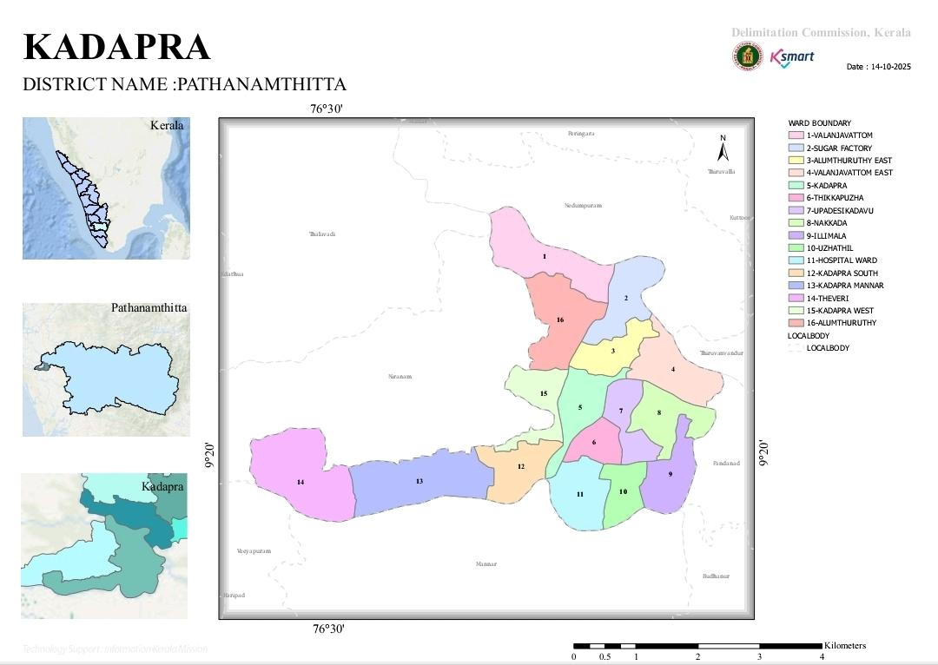

Major Roads/rivers

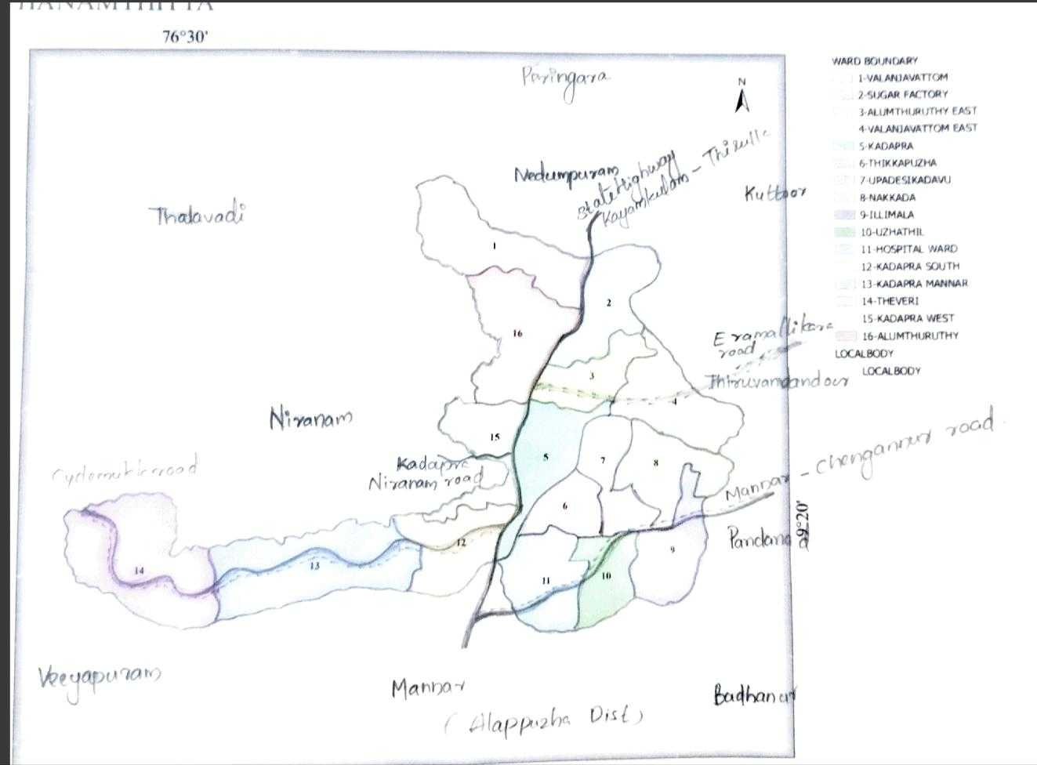

AUXILIARY INFRASTRUCTURE & LOGISTICAL RESOURCE MAP OF THE PANCHAYAT

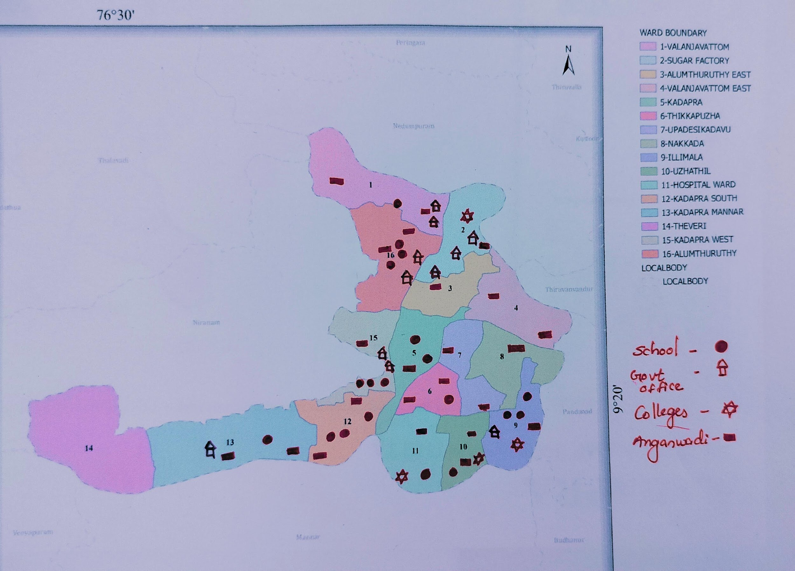

INTEGRATED HEALTH INFRASTRUCTURE MAP OF PANCHAYAT

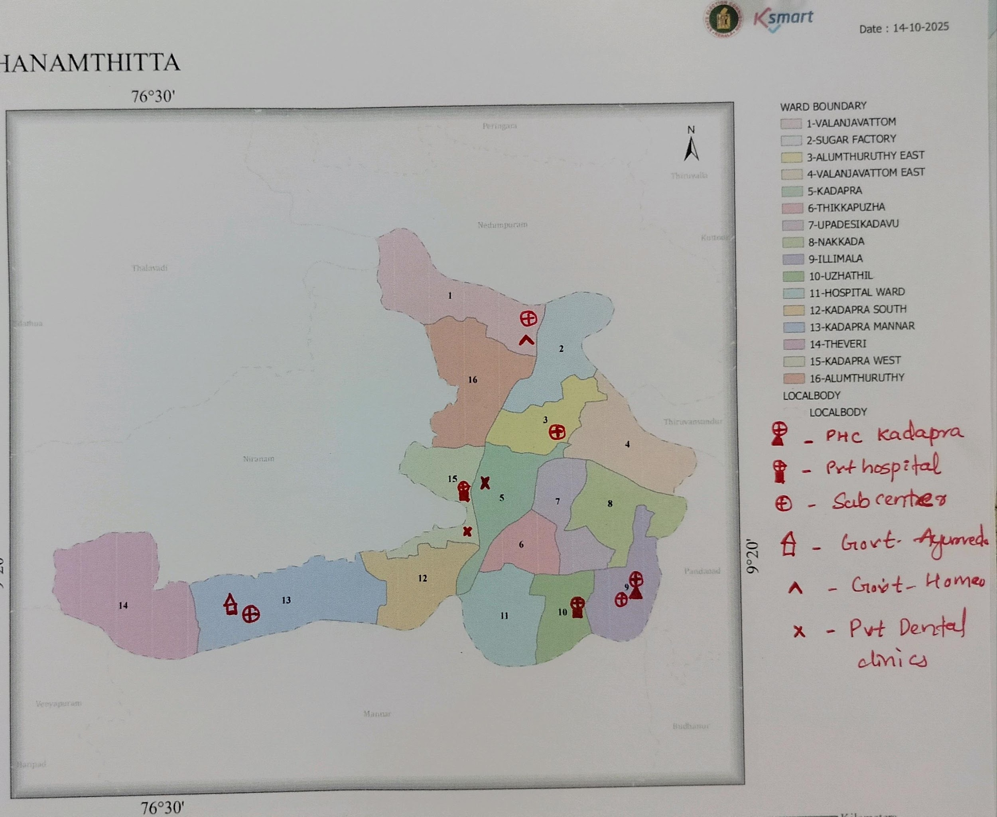

GENERAL PROFILE OF THE LSGI’S

Background of the LSGI
Kadapra Grama Panchayat is situated in the northern part of Pathanamthitta district, Kerala. The geographical landscape of the Panchayat is predominantly low-lying, characterized by extensive paddy fields (Kole lands) and a network of rivers and canals.
The Panchayat is administratively divided into multiple wards, with a population largely dependent on Agriculture—especially paddy cultivation.The area hosts a diverse workforce, including a notable presence of migrant labourers, particularly in construction, agriculture, and allied sectors.
From a public health and disaster management perspective, kadapra LSGI has historically been vulnerable to seasonal flooding, waterborne diseases, and water borne illnesses such as hepatitis and Leptospirosis. The severe floods experienced during recent years, including the 2018 flood disaster, significantly impacted life, livelihoods, and infrastructure within the Panchayat. These recurring emergencies have underscored the importance of strengthening local preparedness, response mechanisms, and inter-departmental coordination.
In this context, the development of a localized, data-driven Auxiliary Infrastructure and Logistical Resource Map is essential to support effective planning, timely emergency response, and sustainable development initiatives. Such mapping enables the Panchayat to identify critical resources, improve accessibility during disasters, and enhance overall resilience of the community.

Table 1: Background of LSGD
Description | Details
Name of LSGI | Kadapra
Type (GP/Municipality / Corporation etc.) | Grama Panchayath
Block | Pulikkeezhu
District | Pathanamthitta
Number of wards | 16
Total area (sq. km) | 14.47 sq m
Population(Projected) | 24414
Population density | 1687
Terrain (coastal/low-lying/backwaters/foothills, etc.) | Low lying
Number of rivers passing through LSGI | 5
Number of water bodies in the LSGI | 15
Number of educational institutions | 24
Factories / small-scale industries | 2
Flood-prone wards | All wards
Landslide-prone wards | Nil
Death Management and Disposal Facilities (mortuaries/crematorium, including electric) | Public crematorium parumala
Auditoriums/Marriage halls/convention centres/community halls | Auditorium -3
Total No of Wells | 5666

Demographic and Vulnerable Population
Understanding the demographic composition and vulnerable population groups is essential for pandemic preparedness. Children, elderly, economically deprived families, migrant workers, and socially vulnerable groups are at increased risk during public health emergencies due to higher exposure, limited access to services, and dependency on public systems..

Description |  | Details (in numbers)
DEMOGRAPHIC PROFILE
Total population |  | 24414
Male |  | 11447
Female |  | 12967
Transgender |  | 0
Children under 5 |  | 799
Adolescent |  | 2179
Elderly (>60) |  | 4886
SOCIAL/LIVELIHOOD VULNERABILITY
Previous EPEP family |  | 36
BPL family |  | 1828
Tribal communities |  | 0
Migration | Immigrant | 250
Migration | Emigrant | 384
Socio-economically deprived |  | 0
Fisherfolk |  | 0
SC Community |  | 535
ST Community |  | 5

The below age pyramid explains the age group distribution

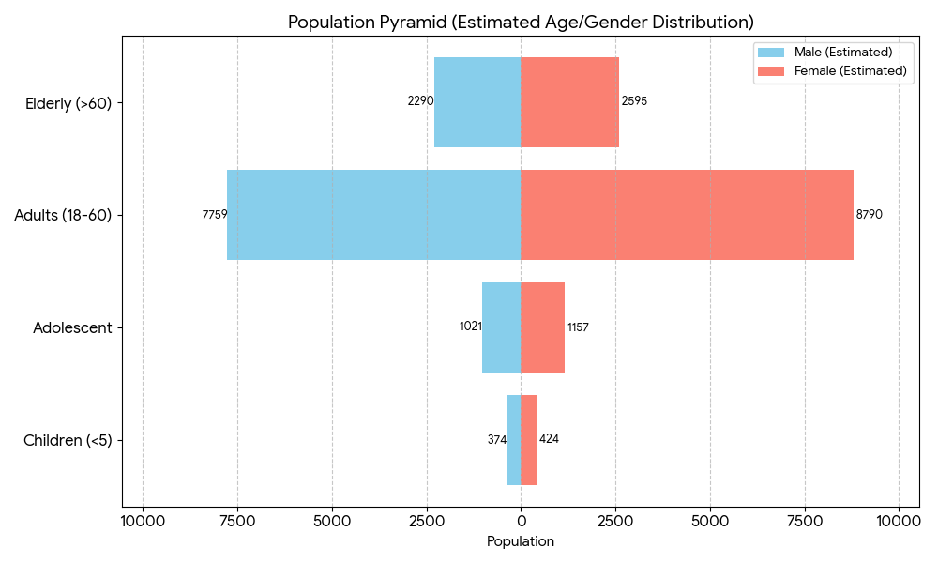

Clinical Vulnerability
Certain population groups needs priority healthcare & are at higher risk of severe illness, complications, and mortality during pandemics. Patients with chronic diseases, those requiring regular medical care, and individuals with mobility or functional limitations face challenges in accessing timely care during emergencies. Mapping these groups helps in prioritizing continuity of treatment, medicine stock planning, oxygen support, referral transport, and targeted home-based care.
Description | Details in numbers
Pregnant women | 61
Lactating mothers | 184
Bedbound patients | 78
Patients under palliative care other than bedbound | 50
Patients on Haemodialysis | 9
Patients on CAPD | 6
Cancer patients (currently on treatment) | 33
Haemophilic patients | 0
Mentally challenged | 11
Differently abled | 46
Diabetic patients | 2696
Hypertensive patients | 1998
TB patients | 15

Major Festivals & Events specific to the LSGI
(with the possibility of a public gathering)

Sl. No. | Name of festival | Month detailing the periodicity
1 | Parumala church feast | October -november  10days

INFRASTRUCTURE & RESOURCE INVENTORY

Health Facility Directory & Basic Capacity in the LSGD
This section provides an overview of the healthcare infrastructure available within the LSGD area. It outlines the distribution and basic capacity of health facilities that form the backbone of service delivery during routine times and public health emergencies.

Family Health Centres (FHCs) and Community Health Centres (CHCs) generally function as the first point of contact for the community, providing essential outpatient and inpatient services. General Hospitals (GH) and Medical College Hospitals (MCH), where accessible, serve as the main referral centres for advanced diagnostics, specialist care, and critical services during public health emergencies. This inventory helps identify existing strengths, gaps, and potential surge capacity that can be mobilised during a pandemic or disaster.

Table 5. Health Facility Resource Summary
Sl.no. | Health Facility | Type of Facility (MCH/GH/CHC/FHC/SC etc.) | Contact Number | Total beds | ICU Beds | Oxygen-Supported Beds | No. of Ventilator Support Beds | No. of ambulances
Government Healthcare Facilities
1 | PHC kadapra | PHC | 0479-2316400 | 0 | 0 | 0 | 0 | 1
2 | HWC Cyclemukku | Subcentre | 9847735632 | 0 | 0 | 0 | 0 | 0
3 | HWC Alumthuruthy | Sub centre | 9847563771 | 0 | 0 | 0 | 0 | 0
4 | HWC Valanjavattom | Sub centre | 8606691346 | 0 | 0 | 0 | 0 | 0
Private Healthcare Facilities
1 | SN hospital | Hospital | 9447454898  04692610234 | 30 | 0 | 11 | 0 | 1
2 | St gregorios medical mission hospital parumala | Hospital | 04792317000 | 296 | 85 | 286 | 21 | 2
AYUSH Healthcare Facilities
1 | Govt Ayurveda Dispensary | Primary centre | Dr Sreelakshmi  7025741864 | 0 | 0 | 0 | 0 | 0
2 | Govt Homeo Dispensary | Primary centre | Dr Ambili  9400501160 | 0 | 0 | 0 | 0 | 0

Private Clinics
Private clinics are an essential part of pandemic preparedness, as they are often the first place people seek care when symptoms begin. In many communities, private clinics manage a significant share of outpatient visits and therefore play a critical role in early case detection, timely referrals, and disease surveillance. Having an up-to-date understanding of where these clinics are located, the services they provide, and how they are linked to the public health system helps ensure that no cases are missed during an outbreak. It also allows health authorities to engage private practitioners more effectively for reporting, risk communication, and coordinated response, strengthening the overall capacity of the health system to manage public health emergencies.

Table 6. Private Clinic Resource Summary
Sl No. | Name of Clinic | Registered (Y/N) | Clinic (General / Speciality) | Speciality (if any) | Address | Contact Number | Diagnostic Facility (Y/N) | Ambulance Linkage (Y/N)
1 | SN HOSPITAL | Yes | Speciality | Paediatric,general medicine , Dermatology,pulmonology, orthopedic&general surgeon | Sn hospital, kadapra niranam p o | 9447454898 | Yes | Yes
2 | St gregorios medical mission hospital parumala | Yes | Speciality | All | St gregorios medical mission hospital parumala, parumala p o ,689626, thiruvalla | 04792317000 | Yes | Yes

Healthcare Education & Training Institutions
This section tracks the educational infrastructure available, which is vital for human resource planning in the health sector.

Category of Institution | Govt | Private | AYUSH | Total
Medical Colleges | 0 | 0 | 0 | 0
Nursing Colleges | 0 | 1 | 0 | 1
Dental Colleges | 0 | 0 | 0 | 0
Para-medical / Allied Health | 0 | 1 | 0 | 1
Pharmacy Colleges | 0 | 0 | 0 | 0

Specialized Services & Emergency Inventory
This section provides a detailed view of the specialized medical resources available to the community, focusing on emergency response and critical care capabilities. This table tracks the vital assets required for managing severe illnesses and emergencies across Government, Private, and AYUSH sectors.

Item | Govt | Private | AYUSH | Total
Hospital beds | 0 | 788 | 0 | 788
Oxygen-generating systems(Y/N) | 0 | 1 | 0 | 1
Oxygen-supported beds(Numbers) | 0 | 297 | 0 | 297
Ventilator-supported beds | 0 | 21 | 0 | 21
ICU beds | 0 | 85 | 0 | 85
Burns units | 0 | 1 | 0 | 1
Blood centres | 0 | 1 | 0 | 1
BLS ambulances | 0 | 2 | 0 | 2
ALS ambulances | 0 | 1 | 0 | 1
Dialysis facilities | 0 | 2 | 0 | 2
Dispensaries | 0 | 2 | 0 | 2
Medical store | 1 | 5 | 1 | 7
Industrial establishments(Medium-scale industries/small-scale industries establishments to whom we can depend in a worst-case scenario) | 0 | 2 | 0 | 2

Oxygen & Diagnostic Capacity
Monitoring oxygen and diagnostic capacity is a critical component of public health preparedness, ensuring that the LSGD can handle both chronic care and sudden surges in respiratory or infectious diseases.
Name of Health Facility | Oxygen-generating System (Y/N) | Backup Oxygen Source (Y/N) | Diagnostic Facilities Available(Y/N)
Name of Health Facility | Oxygen-generating System (Y/N) | Backup Oxygen Source (Y/N) | Lab | USG | X-ray | CT/MRI | RT-PCR
Government Healthcare Facilities
Phc kadapra | No | No | No | No | No | No | No
Private healthcare facilities
SN hospital | No | Yes | Yes | No | Yes | No | No
St gregorios medical mission hospital parumala | Yes | Yes | Yes | Yes | Yes | Yes | Yes

Diagnostics facility mapping at the LSGI level
The diagnostic capacity of kadapra G.P represents the "intelligence network" of our healthcare system. The speed and accuracy of disease identification depend entirely on the distribution and technical level of these facilities.

Item | Govt | Private | AYUSH | Total
General labs | 0 | 6 | 0 | 6
Microbiology labs | 0 | 3 | 0 | 3
RT-PCR labs | 0 | 3 | 0 | 3
USG units | 0 | 2 | 0 | 2
CT/MRI units | 0 | 2 | 0 | 2
Research labs | 0 | 0 | 0 | 0
Labs of other departments that can be repurposed | 0 | 0 | 0 | 0

Laboratory Identification & Basic Details
Sl. No. | Name of Laboratory | Ownership (Govt / Private / Academic) | Address | Contact No. | 24×7 Services (Yes/No) | NABL / Govt Approved (Yes/No)
1 | Medicare parumala | Private | Parumala | 9567216289 | No | No
2 | Medicare kadapra | Private | Kadapra | +91 95448 93819 | No | No
3 | DDRC | Private | Parumala | 9333493334 | No | No
4 | Neethi lab | Private | Kadapra | 7025416665 | No | No
5 | Parumala hospital | Private | Parumala | 04792317000 | Yes | No
6 | SN hospital | Private | Kadapra | 9447454898 | Yes | No

Social and Community Infrastructure for surge plan
This table serves as our logistics and shelter inventory. By mapping these locations, quickly we can identify where to house displaced citizens, where to set up temporary medical clinics, and how to manage the deceased with dignity during a crisis.

Category | Total Count | Ward | Est. Capacity (Persons) | Contact details
Educational Institutions
Anganwadis | 24 | All wards | 120 | AW-2  Anitha- 9562585306
Schools | 20 | 1,4,9,7,10 ,11, 15,16 | 3537 | Annie Mol Abraham  (GLPS PARUMALA)  8281647235
Colleges | 4 | 10,11,2,9 | 2500 | Sreekala (Pamba College)  9946535553
Healthcare Educational Institutions
Medical colleges (Govt/Private) | 0 | 0 | 0 | 0
Nursing colleges (Govt/Private) | 1 | 10 | 297 | 0
Dental colleges (Govt/Private) | 0 | 0 | 0 | 0
Paramedical institutes (Govt/Private) | 1 | 11 | 145 | 0
Community Gathering Spaces
Community halls | 0 | 0 | 0 | 0
Auditoriums | 3 | 5,1 | 5000
Religious buildings | 42 | All wards | 10000 | Parumala Church  9656604669
Vulnerable Group Support Facility
Destitute homes | 0 | 0 | 0 | 0
Elderly homes | 0 | 0 | 0 | 0
LSGD owned other buildings | 0 | 0 | 0 | 0
Mass Fatality Management (MFM) Infrastructure
Mortuary | Yes | 9 | 200 | 9633075506
Crematorium | Yes | 9 | 45 | NA
*refer annexure 1 for contact details

Human resources
This section focuses on the human capital available within the LSGI. In any emergency—be it a pandemic, flood, or industrial accident—infrastructure is only as effective as the people operating it.

Medical & Clinical Personnel
This table tracks the "Frontline" providers responsible for diagnosis, treatment, and clinical management. Narrative sentence: eg., "Total health workforce: 450 personnel, with 60% in government facilities serving as primary surge capacity." A detailed directory with the contact numbers of all workers is maintained (Annexure in 1).

Cadre | Govt (No.) | Private (No.) | Total
Doctors—Modern Medicine | 1 | 55 | 56
Doctors – AYUSH | 2 | 0 | 2
Doctors – Veterinary | 1 | 0 | 1
Doctors – Dental | 0 | 5 | 5
Nursing officers | 3 | 2 | 5
Lab technicians | 0 | 21 | 21
Optometrist | 1 | 4 | 5
Pharmacists | 3 | 5 | 8
Psychologists | 0 | 3 | 3
Counsellors | 0 | 3 | 3

Public Health & Field-Level Workforce
These individuals are the backbone of surveillance, maternal-child health, and decentralized care.

Cadre | Health services | Municipal common services | Total
HS (Health Supervisors) | 1 | 0 | 1
HI (Health Inspectors) | 1 (incharge) | 0 | 1
LHS (Lady Health Supervisor) | 1 (incharge) | 0 | 1
LHI (Lady Health Inspectors) | 1 (incharge) | 0 | 1
JPHN (Jr Public Health Nurses) | 4 | 0 | 4
JHI (Jr Health Inspectors) | 3 | 0 | 3
MLSP (Mid-Level Service Providers) | 4 | 0 | 4
Palliative Nurses | 1 | 0 | 1
RBSK Nurses | 1 | 0 | 1
PRO | 1 | 0 | 1
Epidemiologist | 1 | 0 | 1
Data Manager | 1 | 0 | 1

Community & Support Cadre
This group represents the surge capacity of the LSGI—people who can be called upon for logistics, rescue, and specialized support.

Cadre | Number
ASHA Workers | 20
AWW (Anganwadi Workers) | 24
Emergency Medical Volunteers (Trained) | 34
Kudumbashree | 222 unit
MNREGS | 1108
Purusha Swayam Sahaya Sangham | 0
Ex-Servicemen | 13
Retired Police Officers | 3
NCC/NSS Volunteers | 168
Red Cross volunteers | 34
One Health Community Volunteers | 455
One Health Community Mentors | 105

Community Organizations
This section details the presence of community-based organisations (CBOs), non-governmental organisations (NGOs), faith-based organisations (FBOs), Kudumbashree Self-Help Groups (SHGs), and Ayalkootams within the Local Self-Government Institution (LSGI). These groups enhance grassroots mobilization, resource distribution, and support networks crucial for pandemic response and community resilience.

Category | Total Count
NGOs | 6
Religious based organizations | 4
Foreign based organizations | 0
Sports Club/youth clubs | 12
Kudumbashree SHGs | 222 units
Ayalkootams | 155
Political organizations | 6
Residential organizations | 4

Administrative & Emergency Services
This section outlines the availability of key non-health emergency support services and infrastructure within the LSGI, which are essential for effective pandemic preparedness and response. These facilities support law enforcement, disaster response, water supply, logistics, mobility, and community-level interventions during public health emergencies.

Category | Total Count | Contact details
Police Stations | 1 | 9497980240
Fire & Rescue Stations | 0 | 0469 2600101
Water Pumping Points | 3 | 7510180575
Public Distribution System (PDS) | 6 | Maveli store  8848788330

Information regarding resources
The availability of essential transport and support resources plays a quiet but critical role in saving lives. Equipment such as ambulances, mobile mortuaries, amphibian ambulances, and motorized boats ensures that patients, samples, and healthcare teams can move swiftly—even in flooded, remote, or difficult terrains. Heavy vehicles like JCBs, cranes, tractors, and torus lorries support logistics, waste management, emergency infrastructure, and rapid conversion of spaces into care or isolation facilities. Taxis, four-wheel-drive vehicles, and trucks help maintain continuity of essential services, reach vulnerable populations, and support home-based care and supply delivery.

Means of transportation | Total Count
JCB | 2
Crane | 1
Heavy Trucks | 12
Tractor | 0
Ambulances | 24
Mobile mortuaries | 0
Boats | 0
Taxi service | 14
Note: For specific details regarding vehicle owners and contact information, please refer to Annexure [X].

ONE HEALTH & ENVIRONMENTAL SURVEILLANCE
The One Health method integrates environmental, animal, and human health to enable proactive pandemic preparedness. Panchayat-level surveillance needs to be improved in order to detect and treat zoonotic and environmentally generated diseases early. Surveillance is strengthened through systematic assessment of animal populations, veterinary infrastructure, poultry and slaughter facilities, inter-sectoral coordination, and specialised tools like avian influenza seasonality mapping using GIS in previous outbreaks to enable predictive alerts and ward-specific sampling to support effective pandemic preparedness in high-risk areas like Theveri ,Kandamkalli,valanjavattom .

Animal & Bird Population
Mapping animal and bird populations at the Panchayat level is essential for identifying and prioritising zoonotic disease hazards like rabies, avian influenza (H5N1), leptospirosis, anthrax, and Nipah-like spillover occurrences. Risk classification, targeted surveillance, vaccination planning, and early epidemic detection made feasible by comprehensive population mapping all enhance One Health-based pandemic preparedness.

Category | Item | Estimated Population | Wards
Animal Population | Livestock (Cattle/Goats/Buffalo) | 482 | All wards
Animal Population | Pet Animals (Dogs/Cats) | 614 | All wards
Animal Population | Stray Dog Population | 28 | All wards
Animal Population | Pig Farms (Number of heads) | Nil | Nil
 | Small Units (Sheep / Goats – clustered) | 4 | All wards
Bird Population | Poultry Units (Birds) | 565 | All wards
Bird Population | Poultry- (FOWL) | 2655 | All wards
Bird Population | Wild/Migratory Birds (Observed) | Nil | Nil
Bird Population | Crow Mortality Events (Reported) | Nil | Nil

The main risk of zoonotic diseases in kadapra is concentrated across several Wards, which is explained by the high density of cattle congregation areas, and poultry units. The stray dog population in market areas, fish landing sites, bus stations continues to be a substantial problem for rabies surveillance and bite prevention. Cluster of animal shelters vulnerable to flooding further raise the risk of leptospirosis and other zoonoses mediated by the environment, especially during monsoon floods.

Veterinary Infrastructure
Veterinary institutions are a core pillar of One Health surveillance, enabling early zoonotic disease detection through vaccination, investigation of unusual animal illness or deaths, sample collection, and timely outbreak reporting. A well-mapped and responsive veterinary network strengthens coordination with human health and LSGI systems, ensuring rapid response during zoonotic events and pandemics.
Facility Type | Name of Facility | Ownership Govt / Pvt | Location(Ward No) | Contact number
Veterinary Dispensary | Govt veterinary hospital | Govt | 2 | 9446382721
Veterinary Hospital / Polyclinic | Nil | NA | NA | NA
Private Veterinary Clinics | Nil | NA | NA | NA
Mobile / Emergency Vet Service (incl. night services) | Nil | NA | NA | NA
Pet Homes / Animal Shelters | Nil | NA | NA | NA
Slaughterhouse-linked Veterinary Inspection Unit | Nil | NA | NA | NA

Veterinary Doctors & Workforce
Early detection, diagnosis, reporting, and reaction to animal illness epidemics depend on the availability and accessibility of qualified veterinary specialists. By identifying unusual animal morbidity or mortality promptly, collecting samples promptly, and coordinating efficiently with human health and LSGI systems—especially during zoonotic outbreaks and pandemic-prone situations—a clearly defined veterinary workforce enhances One Health surveillance.

Category | Number Available | Type (Govt/Pvt) | Contact number
Government Veterinary Doctors | 1 | Govt | 9446382721
Private Veterinary Doctors | 0 | 0 | NA
Livestock Inspectors | 3 | Govt | 1. 9747193393  2.9496105753  3.9497614887
Para-veterinary Staff / Attenders | 1 | Govt | 9961052379
Contract / On-call Veterinary Support (if any) | Nil | NA | NA

High-Risk Interface Points (Surveillance Sites)
High-risk interface points are places where people, animals, and the environment interact frequently, closely, or without protection, which raises the risk of zoonotic disease amplification and spillover. To identify animal-to-human transmission risks early, particularly during monsoon, flood , routine mapping, inspection, and surveillance of these sites are essential components of One Health readiness. Clearly define surveillance protocols and responsibilities to enhance early detection and coordinated response.

Type of Habitat | Type of High risk interface | Geographical vulnerability
Wetlands & Backwaters | Nil | Nil
Backyard Poultry Farms | Nil | Nil
Cattle Sheds near Water Bodies | Nil | Nil
Fish & Meat Markets | Nil | Nil
Community Slaughter Sites | Nil | Nil
Migratory Bird Congregation Areas | Nil | Nil
Rodent-Infested Grain Storage | Nil | Nil
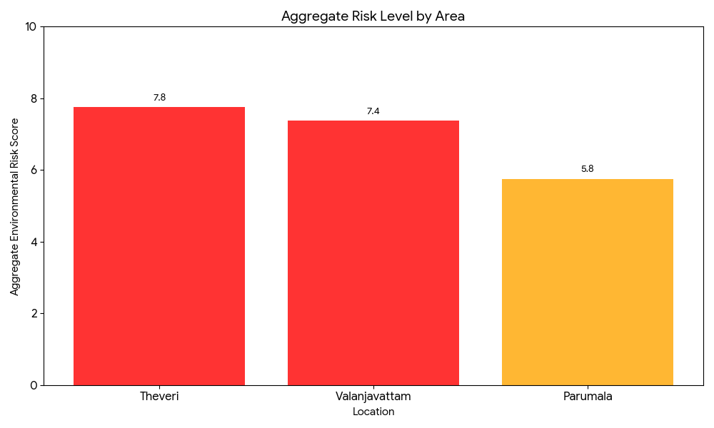
Category | Total Count | Key Locations (wards)
Poultry Farms | Nil | Nil
Backyard / Clustered Poultry Units | Nil | Nil
Duck Rearing Units (open water access) | Nil | Nil
Slaughterhouses/ Slaughter Points | Nil | Nil
Meat/Fish Markets | Nil | Nil
Live Bird Sale Points | Nil | Nil
Cattle Markets / Weekly Animal Fairs | Nil | Nil
Pet Shops / Breeders | Nil | Nil
Animal Shelters / Pet Homes | Nil | Nil
Waste Disposal Sites near Animal Units | Nil | Nil

Environmental Risk Mapping
Environmental risk mapping identifies monsoon/flood hotspots for vector-borne (dengue, chikungunya), water-borne (leptospirosis, diarrhoea), and zoonotic diseases in Kerala's wetlands. Systematic surveillance supports early warnings, targeted interventions, and Panchayat pandemic preparedness.
Waterborne exposure: Flood-prone areas and stagnant water bodies facilitate leptospira survival, raising leptospirosis risk.

Traditional practices: Informal slaughter and fish markets lack standardized hygiene, creating spillover opportunities.

Risk Factor | High-Risk Wards | Key Locations | Risk Level (High/Med/Low)
Flood-prone areas | 10 ward | Theveri, valanjavattam  Parumala | Moderate
Water bodies/wetlands | No | NA | NA
Solid waste accumulation | No | NA | NA
Animal waste disposal issues | No | NA | NA
Rodent infestation zones | No | NA | NA
Industrial effluent discharge | No | NA | NA
Construction sites / abandoned buildings | No | NA | NA
Poor drainage/blocked canals | No | NA | NA
Drinking water source contamination risk | No | NA | NA

Disease Seasonality Mapping
1, Flooding & waterlogging → amplifies leptospirosis, malaria, diarrheal diseases.
·
2, Migratory bird influx (Nov–Feb) → avian influenza risk.

3, Mosquito breeding cycles → vector-borne disease peaks in monsoon.

4, Agricultural practices → close human–animal contact in paddy fields.

Disease | Peak Risk Season | Key Drivers | High-Risk Locations | Surveillance Focus
Avian Influenza | Dec-feb | Crow | Unpredictable | All wards
Leptospirosis | June -sep | Rat | Ward 1,2,14 | All wards
Dengue/Chikungunya | May -sep | Mosquito | Nil | All wards
Acute Diarrheal Diseases | June-sep | Food sources | Nil | All wards
Rabies | - | - | - | -
Anthrax (rare)- | - | - | - | -

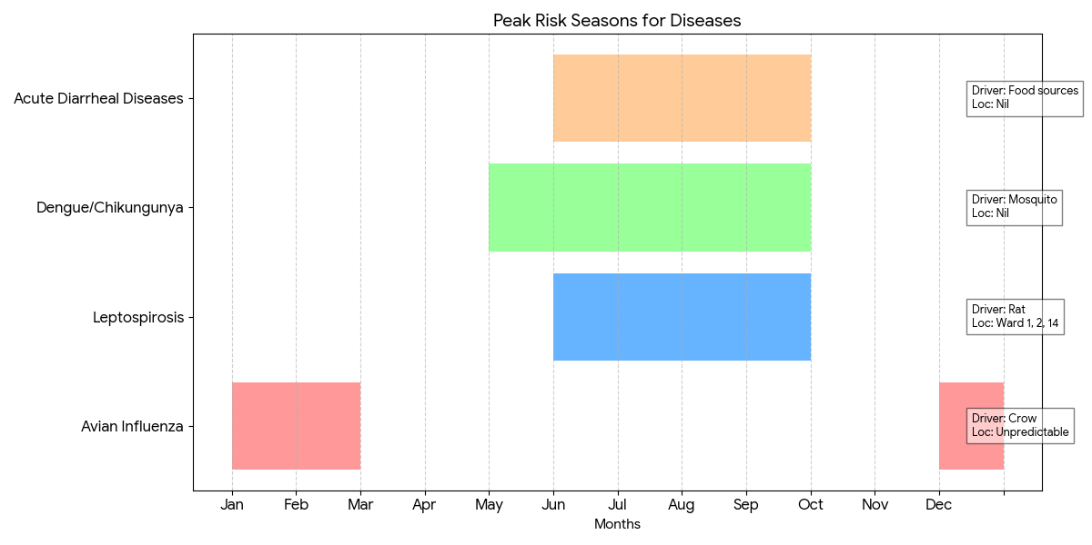

Vulnerability Mapping
Vulnerability mapping pinpoints high-risk populations, occupations, and areas exposed via environment, livelihoods, socio-economics, and poor service access. Paired with environmental/seasonality mapping, it enables risk-based surveillance, targeted actions, and optimal resource use in One Health and pandemic planning.

Vulnerability Factor | High-Risk Wards | Key Groups / Locations | Risk Level
Flood-prone households | 10wards | Theveri, valanjavattam, parumala | Moderate
Wetland-adjacent communities | Ward 13,14 | Theveri | High
Backyard poultry / duck rearing households | No | NA | NA
Livestock-rearing households | All wards | 13-Theveri | Low
Slaughterhouse & meat market workers | No | NA | NA
Fisherfolk & fish market workers | No | NA | NA
Sanitation workers | No | NA | NA
Daily wage / migrant workers | Yes |  | Low
Elderly & chronically ill populations | Yes | All wards | Low
Pregnant Women | No | NA | NA
Children (schools, Anganwadi’s) | No | NA | NA
Limited access to safe water & sanitation | No | NA | NA

EPIDEMIOLOGICAL TRENDS (2021–2025)

Disease surveillance is the systematic collection, analysis, and interpretation of health data for planning, implementation, and evaluation of public health practice. This section presents the disease surveillance profile of the LSGI based on routine reporting systems and outbreak investigations to identify priority diseases, seasonal patterns, and emerging public health threats.

Disease Burden among human beings(Last 5 Years)
Analysis of disease-wise data for the last five years helps identify persistent public health problems, emerging diseases, and changes in disease burden. This information supports prioritisation of prevention, preparedness, and response activities at the Panchayat level.

Disease | 2021 | 2022 | 2023 | 2024 | 2025 | Trend(Increasing/Stable/Decreasing)
Dengue | 0 | 1 | 6 | 6 | 6 | Stable
Leptospirosis | 2 | 2 | 4 | 3 | 4 | Stable
Hepatitis A | 0 | 2 | 0 | 0 | 7 | Increasing
Malaria | 0 | 0 | 0 | 0 | 2 | Increasing
Scrub Typhus | 0 | 0 | 0 | 0 | 0 | Stable
Typhoid | 0 | 0 | 0 | 0 | 1 | Stable
H1N1 | 0 | 0 | 0 | 0 | 2 | Increasing
H3N2 | 0 | 0 | 0 | 0 | 2 | Increasing
ADD | 51 | 49 | 39 | 45 | 38 | Decreasing
Mumps | 0 | 0 | 0 | 0 | 1 | Stable
Measles | 0 | 0 | 0 | 0 | 0 | Stable
Hepatitis B | 0 | 0 | 0 | 0 | 0 | Stable
Hepatitis C | 0 | 0 | 0 | 0 | 0 | Stable
Tuberculosis | 0 | 0 | 2 | 13 | 15 | Increasing
Leprosy | 0 | 0 | 0 | 0 | 0 | Stable
Covid 19 | 4001 | 454 | 0 | 0 | 0 | Stable

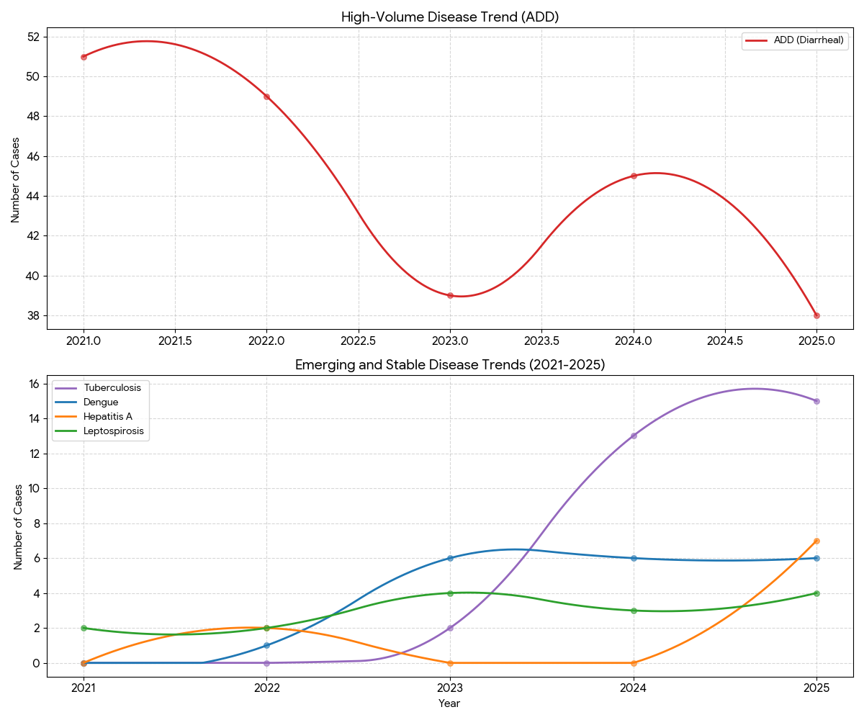

- Dengue: After an initial rise, it has stabilized at 6 cases per year. This suggests the vector (mosquito) is now endemic to the area.
- Leptospirosis: Remains consistent at 3–4 cases. Given the flood-prone nature of Ward 10, this baseline level of "Rat Fever" is a constant seasonal threat.
- Hepatitis A: A sudden spike in 2025 (7 cases) indicates a localized breakdown in water sanitation or food safety during that specific period.

Seasonal Trend Analysis
Seasonal analysis helps anticipate surges (e.g. dengue in monsoon, leptospirosis after floods, influenza in cooler months) and plan pre‑emptive vector control, stockpiling of IV fluids, and awareness campaigns at Panchayat level.

DENGUE
Dengue is a major seasonal vector-borne disease strongly associated with rainfall, water stagnation, and increased mosquito breeding during the monsoon period.

Peak: July–November

Dengue – Ward-wise Yearly Distribution (2021–2025)

Ward | Dengue – Ward-wise Yearly Distribution
Ward | 2021 | 2022 | 2023 | 2024 | 2025 | Total
1 | 0 | 0 | 0 | 1 | 1 | 2
2 | 0 | 0 | 0 | 1 | 1 | 2
3 | 0 | 0 | 1 | 0 | 0 | 1
4 | 0 | 0 | 0 | 0 | 0 | 0
5 | 0 | 0 | 0 | 0 | 0 | 0
6 | 0 | 1 | 2 | 2 | 0 | 5
7 | 0 | 0 | 0 | 0 | 2 | 2
8 | 0 | 0 | 1 | 1 | 1 | 3
9 | 0 | 0 | 0 | 0 | 0 | 0
10 | 0 | 0 | 0 | 1 | 0 | 1
11 | 0 | 0 | 0 | 0 | 0 | 0
12 | 0 | 0 | 0 | 0 | 0 | 0
13 | 0 | 0 | 0 | 0 | 0 | 0
14 | 0 | 0 | 0 | 0 | 1 | 1
15 | 0 | 0 | 1 | 0 | 0 | 1
16 | 0 | 0 | 1 | 0 | 0 | 1

This chart shows the overall surge and stabilization of Dengue in the region.
- 2021–2022: The area was relatively clear of reported Dengue cases.
- 2023 onwards: A sharp jump to 6 cases per year occurred in 2023 and has remained consistent through 2025. This indicates that the virus has become endemic (permanently present) in the local mosquito population.
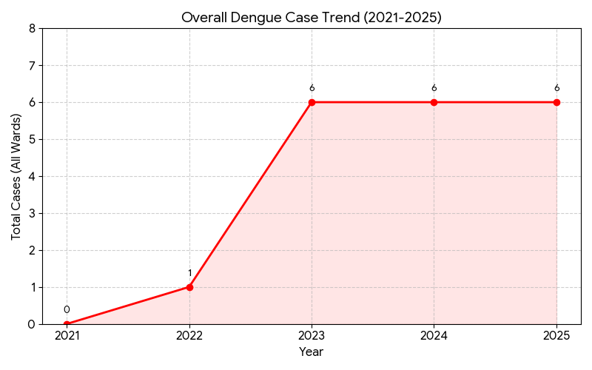

LEPTOSPIROSIS
Leptospirosis cases are closely linked to monsoon rains, flooding, and occupational exposure, particularly in low-lying and waterlogged areas.

Peak: June - August

Leptospirosis – Ward-wise Yearly Distribution (2021–2025)

Ward | Leptospirosis – Ward-wise Yearly Distribution
Ward | 2021 | 2022 | 2023 | 2024 | 2025 | Total
1 | 0 | 0 | 0 | 0 | 2 | 2
2 | 0 | 0 | 0 | 0 | 0 | 0
3 | 0 | 0 | 0 | 1 | 0 | 1
4 | 0 | 0 | 0 | 0 | 0 | 0
5 | 0 | 0 | 0 | 0 | 0 | 0
6 | 0 | 0 | 1 | 0 | 0 | 1
7 | 0 | 0 | 0 | 0 | 0 | 0
8 | 0 | 0 | 0 | 0 | 0 | 0
9 | 0 | 0 | 0 | 0 | 0 | 0
10 | 0 | 1 | 0 | 1 | 0 | 2
11 | 0 | 0 | 2 | 0 | 0 | 2
12 | 0 | 0 | 0 | 0 | 0 | 0
13 | 0 | 0 | 0 | 0 | 0 | 0
14 | 2 | 1 | 1 | 0 | 1 | 5
15 | 0 | 0 | 0 | 0 | 1 | 1
16 | 0 | 0 | 0 | 1 | 0 | 1

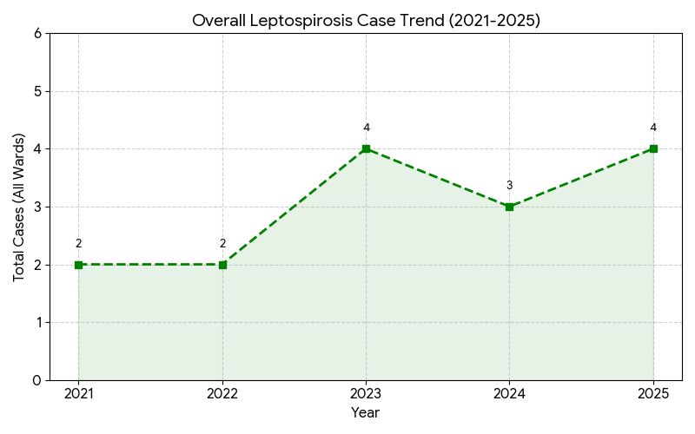
The aggregate trend shows that Leptospirosis remains a stable but persistent threat.
- The total number of cases across all wards fluctuates between 2 and 4 per year.
- The peak occurred in 2023 and 2025 (4 cases each). Given that these cases are seasonally concentrated (June–Sept), this indicates a recurring risk tied to the monsoon and potential flooding events.

VIRAL HEPATITIS - A
Hepatitis A cases are commonly associated with unsafe drinking water, food contamination, and breakdowns in sanitation, often presenting as clusters or outbreaks.

Peak: October - December

Hepatitis A – Ward-wise Yearly Distribution (2021–2025)

Ward | Hep A – Ward-wise Yearly Distribution
Ward | 2021 | 2022 | 2023 | 2024 | 2025 | Total
1 | 0 | 0 | 0 | 0 | 0 | 0
2 | 0 | 0 | 0 | 0 | 0 | 0
3 | 0 | 2 | 0 | 0 | 0 | 2
4 | 0 | 0 | 0 | 0 | 0 | 0
5 | 0 | 0 | 0 | 0 | 1 | 1
6 | 0 | 0 | 0 | 0 | 1 | 1
7 | 0 | 0 | 0 | 0 | 2 | 2
8 | 0 | 0 | 0 | 0 | 0 | 0
9 | 0 | 0 | 0 | 0 | 0 | 0
10 | 0 | 0 | 0 | 0 | 0 | 0
11 | 0 | 0 | 0 | 0 | 0 | 0
12 | 0 | 0 | 0 | 0 | 2 | 2
13 | 0 | 0 | 0 | 0 | 0 | 0
14 | 0 | 0 | 0 | 0 | 1 | 1
15 | 0 | 0 | 0 | 0 | 0 | 0
16 | 0 | 0 | 0 | 0 | 0 | 0

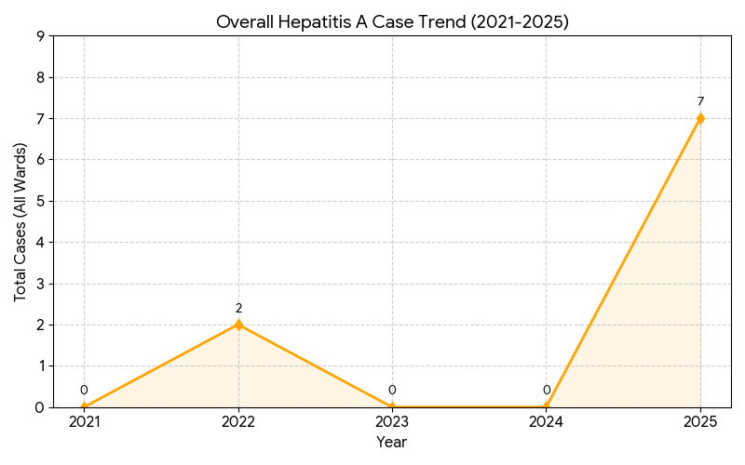
The aggregate trend confirms that Hepatitis A is currently in an "Increasing" phase.
- From 2021 to 2024, the region saw almost zero cases (except for the small 2022 blip).
- In 2025, the total cases jumped to 7, the highest in the five-year period. This represents a significant epidemiological shift.

Outcome-Based Trend Analysis- 2025
This chart shows the "Outcome" of the last five years.
- The Success Story: ADD (Acute Diarrheal Diseases) shows a significant positive outcome with a reduction of 13 cases compared to 2021. This indicates successful long-term management of water and food hygiene.
- The Critical Challenges: Tuberculosis (+15 cases) and Hepatitis A (+7 cases) represent the most significant negative outcomes, requiring immediate strategic reassessment.
- Emerging Threats: New outcomes like Malaria, H1N1, and H3N2 (moving from 0 to 2 cases) indicate a changing environmental risk profile.

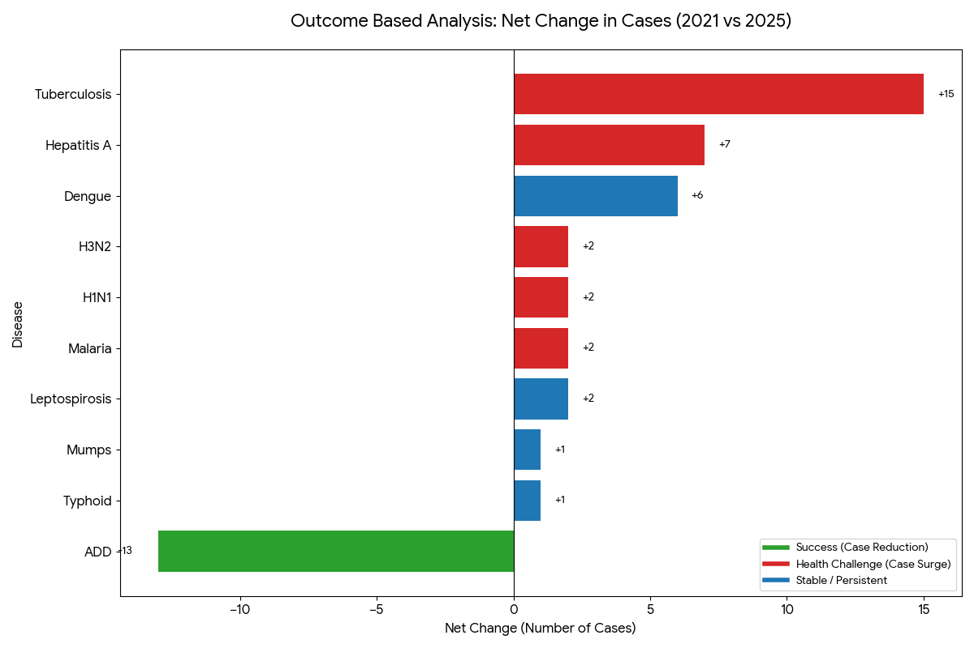
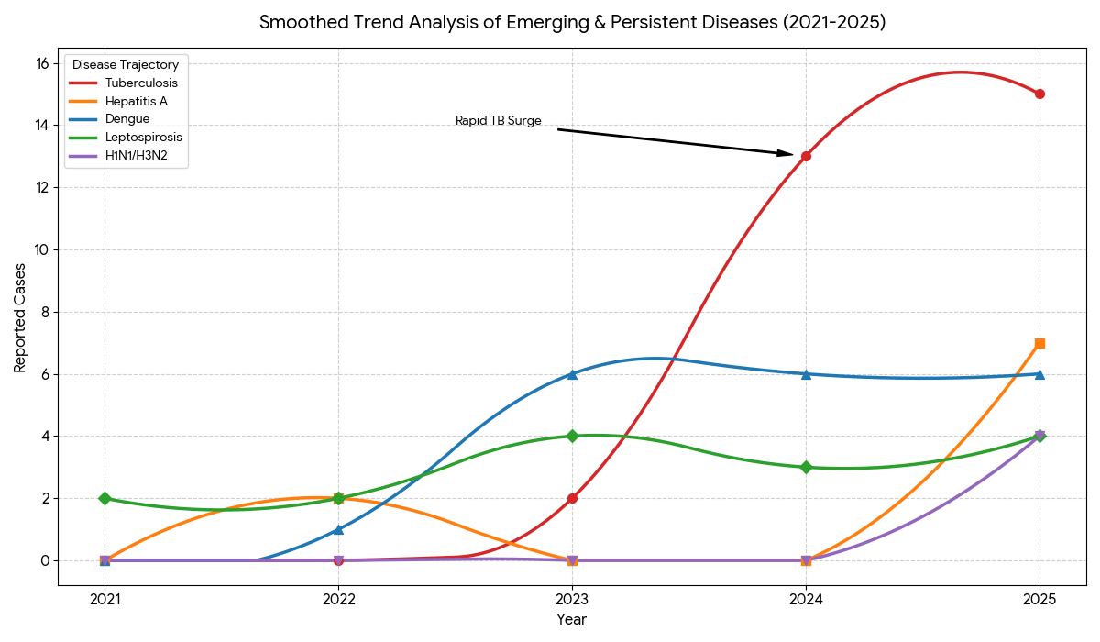

The "J-Curve" (Tuberculosis): The curve for TB shows an exponential-style rise. The sharp upward slope between 2023 and 2025 indicates that the "outcome" for TB is currently a high-velocity outbreak that hasn't yet plateaued.
The "S-Curve" (Dengue): You can see the classic stabilization. After the rapid rise in 2022–2023, the curve flattens out at 6 cases, suggesting the disease has reached a "steady state" in the environment.
The "V-Curve" (Hepatitis A): The dip in 2023–2024 followed by a sharp vertical spike in 2025 highlights the "unpredictable" and "outbreak-prone" nature of waterborne diseases in the region.
The "Baseline Persistent" (Leptospirosis): The curve shows minor wave-like fluctuations but stays within a tight band (2–4 cases), confirming its status as an endemic seasonal risk.

Transmission Trend- 2025
For effective management of public health issues, it is important to track the trend of disease transmission mode. It helps identify the population or place at high risk that can be used to predict outbreaks and implement targeted interventions as quickly as possible. Understanding these kinds of trends enables authorities to allocate resources efficiently and change the strategies adequately based on the trend that follows.

Mode of Transmission | No. of cases | No. of Deaths
Vector Borne Diseases | 8 | 0
Water Borne Diseases | 8 | 0
Air Borne Diseases | 20 | 0
Blood Borne Diseases | 0 | 0
Food Borne Diseases | 0 | 0
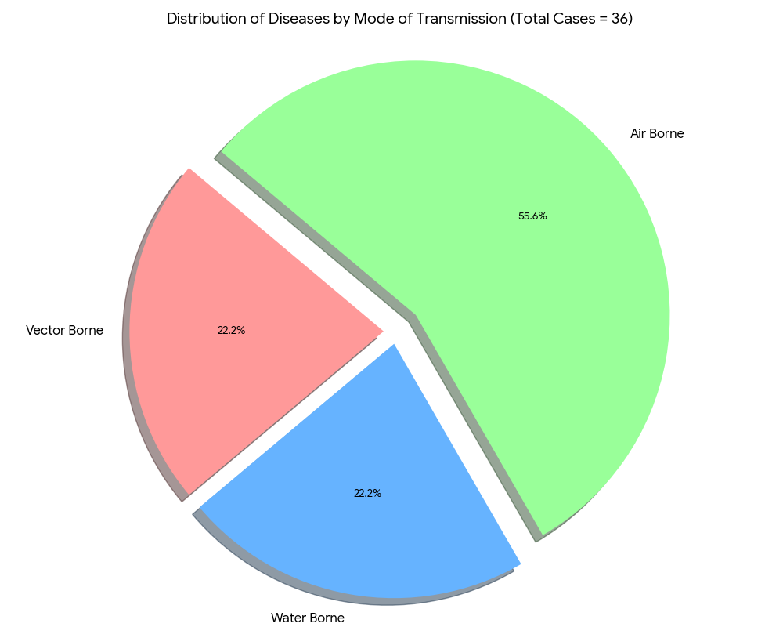

Vector-Borne Disease

Disease | No. of Cases | No. of Deaths
Dengue | 6 | 0
Malaria | 2 | 0
Chikungunya | 0 | 0

Water Borne Disease

Disease | No. of Cases | No. of Deaths
Cholera | 0 | 0
Typhoid | 1 | 0
Hep- A | 7 | 0
Dysentery | 0 | 0
Amoebiasis | 0 | 0
E- Coli infections | 0 | 0

Air Borne Disease

Disease | No. of Cases | No. of Deaths
Influenza | 2 | 0
H1N1 | 0 | 0
TB | 15 | 0
Chickenpox | 5 | 0
Measles | 0 | 0
Covid-19 | 0 | 0
Pertussis | 0 | 0
Mumps | 1 | 0

Blood-Borne Disease

Disease | No. of Cases | No. of Deaths
AIDS | 0 | 0
Hep- B | 0 | 0
Hep- C | 0 | 0

Zoonotic Disease

Disease | No. of Cases | No. of Deaths
Rabies | 0 | 0
Leptospirosis | 4 | 0
Avian influenza | 0 | 0
West nile | 0 | 0
Anthrax | 0 | 0
Nipah | 0 | 0
Scrub Typhus | 0 | 0

Integrated Disease Hotspot Map (2021–2025)
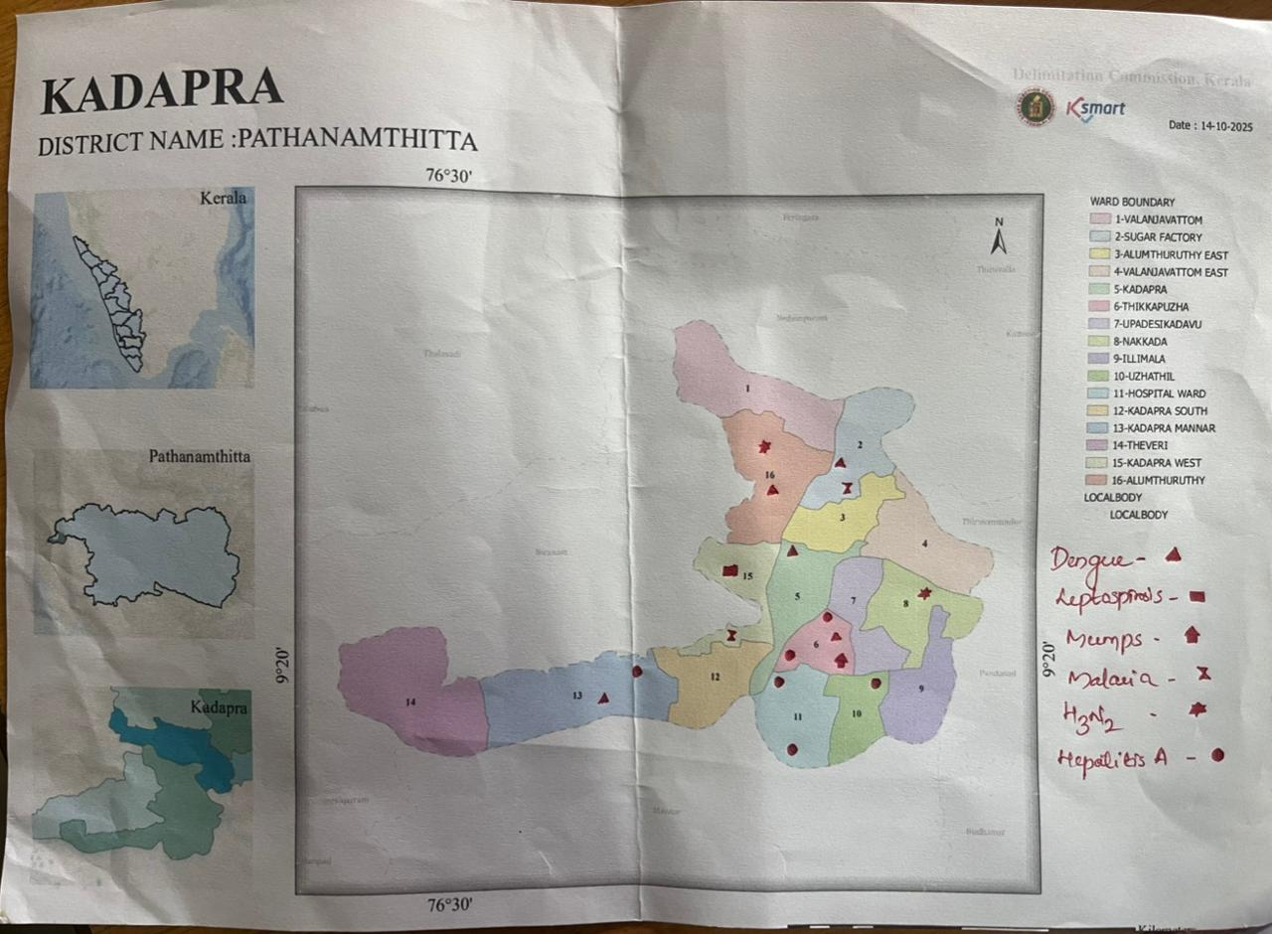
Ward No | Dengue Total (2021-25) | Leptospirosis Total (2021-25) | Hepatitis A Total (2021-25) | Mumps (2021-25) | ADD (2021-25) | Total Cases
1 | 1 | 2 | 0 | 0 | 3 | 6
2 | 1 | 0 | 0 | 0 | 4 | 5
3 | 0 | 0 | 0 | 0 | 2 | 2
4 | 0 | 0 | 0 | 0 | 2 | 2
5 | 0 | 0 | 1 | 0 | 2 | 3
6 | 0 | 0 | 1 | 1 | 2 | 4
7 | 2 | 0 | 2 | 0 | 2 | 6
8 | 0 | 0 | 0 | 0 | 1 | 1
9 | 0 | 0 | 0 | 0 | 3 | 3
10 | 0 | 0 | 0 | 0 | 6 | 6
11 | 0 | 0 | 0 | 0 | 8 | 8
12 | 0 | 0 | 2 | 0 | 3 | 5
13 | 0 | 0 | 0 | 0 | 3 | 3
14 | 0 | 1 | 1 | 0 | 2 | 4
15 | 0 | 1 | 0 | 0 | 5 | 6
16 | 0 | 0 | 0 | 0 | 1 | 1

By overlaying five years of data, we have identified 1, 2, 5, 6, 7, 12, 14, and 15 'Red Zone' Wards. These are wards where at least two different categories of diseases (e.g., Dengue and Lepto) recurred in consecutive years. Ward 11 is categorized as the Highest Priority Hotspot due to its combination of flood vulnerability and high vector density. Future health infrastructure, such as the proposed R.O plants at Panchayat should be prioritized.

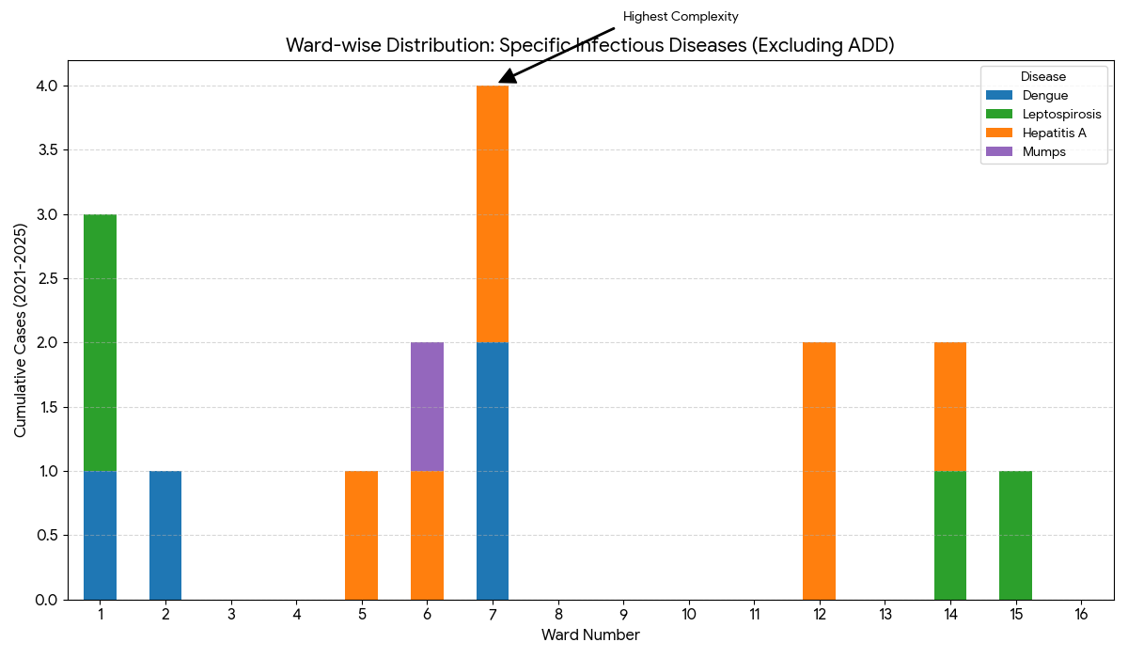

Preparedness and Response Protocol at LSG Level
This section describes the operational framework for the LSGI once a pandemic is declared. It explains how the LSGI and health system will move from routine data collection to active response, using a One Health approach.

Constitution of One Health Committee
The LSGD shall constitute a One Health Committee comprising the LSGI President, Medical Officers (Modern Medicine, AYUSH, and Veterinary), the Health Inspector, and the Veterinary Surgeon.

Objective: The One Health Committee coordinates human, animal, and environmental health to prevent and control pandemics.

Sl No | Name | Designation | Department/Institution | Role in Committee | Contact Number
1 | Liji R . panicker | Panchayat President | LSGD | Chairperson | 9847524120
2 | Dr Lakshmi R | Medical Officer (PHC/CHC) | Health Dept | Member Secretary | 8281532185
3 | Dr Sreekala | Veterinary Officer | Animal Husbandry | Member | 9446382727
4 | Dr Dhanya | Epidemiologist | Health Dept | Member | 9847140643
5 | Sindhu k Pillai | Health Inspector/PHN | Health Dept | Surveillance | 9961824292
6 | Asha Kumari c d | ASHA Supervisor | Health Dept | Community link | 9447932673
7 | Preethi lekshmi | ICDS Supervisor | Social Welfare | Vulnerable groups | 9744252882
8 | Ajith | Police Station Officer | Police Dept | Law & order | 9497980240
9 | Heaven | Ward Councillor Representative | LSGD | Community coordination | 9946928712
10 | Leela | Kudumbashree CDO | Kudumbashree | Community mobilisation | 8111970417
11 |  | NGO/Volunteer rep | Civil Society | Support services
12 |  | Line Department representations

Key Responsibilities:
- Review disease surveillance data (human + animal)
- Conduct ward-wise risk assessment and vulnerability mapping
- Approve quarantine/isolation centre locations
- Coordinate with district for resources (PPE, oxygen, ambulances)
- Periodically review health system surge capacity, including beds, oxygen, human resources, and ambulances.
- Approve and monitor risk communication and community engagement strategies, including rumour management.
- Ensure protection and service continuity for vulnerable groups (elderly, persons with disabilities, dialysis patients, coastal populations).
- Conduct quarterly mock drills
- Monitor equity measures for vulnerable groups

Meeting Schedule:
Quarterly - Normal times
Weekly - outbreak alert

Daily - pandemic phase

Pandemic Response Workforce
To ensure a coordinated and timely response during a pandemic, a dedicated Pandemic Response Workforce shall be constituted at the LSG level. The workforce will function under the overall supervision of the One Health Committee and in close coordination with the health authorities. Team-based deployment will enable efficient surveillance, case management, quarantine and isolation management, logistics support, and risk communication. Each team shall have a clearly designated team leader, defined roles, and an identified pool of personnel to allow rapid activation, rotation of duties, and continuity of services during prolonged emergencies.

Total Response Workforce Available: 300 persons

Team Name | Composition | No | Key Responsibilities | Team Leader
Surveillance and Contact Tracing Team | HI, JHI, JPHN, ASHAs and Volunteers | HI-1 (in charge)  JHI-3  JPHN-4  ASHA-  Volunteers- | Case detection, contact listing, home visits, reporting | HI
Case Management Team | Doctors, Nurses, MLSP, Palliative Nurses | Doctors-1  Nurses-1  MLSP- 4  Palliative  Nurses-1 | Patient care & referral | DOCTOR
Quarantine & Isolation Team | LSGD staff, Volunteers | LSGD staff - 50  Volunteers - 310 | Facility management | JHI
Psychosocial support | AH COUNSELOR | 1 | counselling support | MO
Logistics & supply chain Team | LSGD staffs-  Storekeepers-  Drivers- | LSGD staff - 50  Storekeepers -  Drivers - 1 | Supplies & transport [PPE, medicines, oxygen, transport, waste management] | Ward Member
Communication Team | Ward members, Kudumbashree, Youth clubs,  AWW workers and other self help groups | Ward members- 16  Kudumbashree- 222  Youth clubs- 48  AWW workers- 48  Other self help groups-15 | IEC, community meetings, countering misinformation | M.O in charge
Transportation | KSRTC, educational institutional buses | KSRTC-Thiruvalla  Educational buses -20 | Safety of individuals, patient/staff transport | JHI
Media Surveillance | T Cell, Local Journalists, Volunteers | Journalist -3  Volunters-200 | Monitoring social media, tracking rumors | Public Relations Officer / HI
Intersectoral coordination and convergence | LSG President, Secretary, Health Staff | LSG President -1  LSGD Secretary -1  Health staff -20 | Policy decisions, resource pooling, convergence | LSG Secretary / President
Collaborative surveillance | Vets, Environmental Officers, Health Staff | Health staff-10  Environmental officers -2 | One Health tracking (Animal-Human interface) | Veterinary Surgeon

All teams shall be activated immediately upon outbreak alert or pandemic declaration and shall report daily to the LSG Incident Commander/Medical Officer, with consolidated reporting to the Block PHC. Duty rosters and alternate personnel shall be maintained to ensure uninterrupted services during staff shortages or prolonged response periods. Team composition and numbers may be revised based on the magnitude of the outbreak and availability of human resources.

Activities and Measures before and during Pandemic

PHASE 1 - Alert / Preparation
Surveillance and Reporting-Enhanced syndromic surveillance:

Activate One Health Committee
  - Immediately activate the One Health Committee at the LSG level. Convene an emergency meeting to review risk assessment, roles, and preparedness. Ensure coordination between Health, Veterinary, Agriculture, Local Self Government, and allied departments.
  - Prepare and circulate a contact directory of all committee members and emergency services.
  - Ensure documentation of decisions and action points with timelines.
  - Escalation hierarchy to be finalised (LSG to Institution to Block to District).
Surveillance and Reporting-
- Enhanced syndromic surveillance:
The LSGD shall initiate enhanced surveillance for priority syndromes and events such as:
- Fever
- Influenza-like illness (ILI)
- Severe acute respiratory infection (SARI)
- Unusual illness clusters (any unexpected increase in similar symptoms in a defined area or group)
- Data sources for surveillance:
- Ward-wise household surveillance (through ASHAs/JPHNs/ward volunteers)
- Outpatient surveillance from all government facilities (PHC, FHC, CHC, GH, etc.)
- Private hospitals, clinics, and labs
- Event-based triggers (to be monitored and reported):
- School absenteeism above the usual pattern (to be monitored through the headmaster/PTA nodal person)
- Sudden increase in pharmacy sales of fever/cough/cold medicines
- Workplace illness clusters (multiple staff reporting similar symptoms within a short period)
- Zoonotic and animal health surveillance
- LSGD shall review reports of unusual animal deaths or suspected outbreaks in animals in coordination with the Veterinary Officer.

- Any unusual mortality in poultry, pigs, cattle, companion animals, or wild birds/mammals shall be notified within 24 hours to the Veterinary Officer and One Health Committee for joint investigation.

Reporting Mechanism:
- All government and private health facilities, laboratories, and clinics within the LSGD shall report suspected and confirmed cases of notifiable diseases. Unusual clusters (schools, workplaces, neighbourhoods, events, institutions) shall be reported within 24 hours of detection for verification and field investigation.​
- Logistics and Stock Preparedness
  - Identify and empanel local vendors and define emergency procurement mechanisms in accordance with existing LSGD and Health Department norms.
  - Prepare and maintain an essential logistics checklist covering medical supplies, consumables, and support equipment.
  - Pre-identify secure storage locations for emergency stocks and ensure maintenance of stock registers with regular updating.
  - Finalise emergency transport arrangements, including availability of vehicles and identified drivers for rapid deployment during alerts.
  - Designate a Nodal Officer for Logistics to enable prompt decision-making, coordination, and communication during emergencies.
  - Conduct rapid stock verification and ensure availability of minimum buffer stock, including:
Commodities | Available stock
PPE kit | Nil
Pulse oximeters | 2
Hand sanitizers | Nil
Masks, gloves, disinfectants | Mask-100  Gloves -600  Disinfectants- Black-25 Litre , Dettol-25 Litre

Identify critical gaps in logistics and immediately communicate requirements to the Block and District authorities for timely replenishment and support. Monitor expiry dates and stock rotation.

Identification of Quarantine and Isolation Facilities
  - Identify and list suitable buildings for quarantine and isolation (schools, hostels, community halls, etc.).
  - Categorise cases as per the severity and allocate to appropriate facilities (for instance, severe cases to classrooms, mild cases to an assembly hall in case of a school).
  - Facility readiness checklist needed (beds, toilets, ventilation) etc.
  - Find an alternate site if the primary sites are not available or not in use.
  - Identify facility managers and support staff
  - Prepare basic SOPs for:
    - Admission and discharge
    - Food, water, sanitation
    - Infection prevention and waste disposal
  - Ensure availability of basic amenities: water, sanitation, electricity, ventilation, and waste disposal. Prepare a rapid activation plan for these facilities if case numbers increase.

Risk Communication and Community Preparedness
  - Disseminate early warning messages on symptoms, preventive measures, and reporting mechanisms. Display IEC materials both in English and the local language in public places and ensure ward-level awareness.
  - Sensitize elected representatives and community leaders on preparedness measures.
  - Establish a rumour tracking and misinformation response mechanism to identify, verify, and promptly counter false or misleading information.
  - Engage trusted local persons (ward members, ASHA workers, religious leaders, teachers, community volunteers) to communicate official public health messages and reinforce correct practices.
  - Develop and deploy targeted IEC materials for:
    - Schools and educational institutions
    - Markets and commercial areas
    - Work sites and labour settings
  - Conduct community sensitization meetings at the ward level to promote preventive behaviors, address concerns, and strengthen community participation in preparedness and response.

Protection of Vulnerable Groups
Vulnerable populations require priority protection through targeted line-listing, service continuity, and delivery mechanisms.
- Prepare and regularly update line-lists of vulnerable populations, including:
  - Elderly persons living alone
  - Persons with disabilities
  - Pregnant women
  - Migrant workers
  - Dialysis patients
The detailed line-lists shall be maintained as Annexure 1.C and updated periodically.

Clinical Dependency Mapping
Develop ward-wise dependency and vulnerability maps to identify households requiring regular support during emergencies. Ensure continuity of essential health services for vulnerable groups, including
- Dialysis services (facility mapping, transport arrangements, and scheduling)
- Continuity of treatment for TB, HIV, and other chronic conditions requiring uninterrupted medication
- Mental health and psychosocial support services
Establish delivery mechanisms for food, essential commodities, and medicines to vulnerable households through coordinated action involving ASHAs, JPHNs, Kudumbashree, volunteers, and local administration.

PHASE 2 - Active Response

Case Identification and Contact Tracing
Case detection and contact tracing activities will be carried out in coordination with the Health authorities, following disease-specific SOPs and IDSP guidelines.
Field Staff Involved
- Health Inspector (HI)
- Junior Health Inspector (JHI)
- Junior Public Health Nurse (JPHN)
- ASHAs and ASHA Supervisors
- Ward-level volunteers and Kudumbashree members (as required)

Screening Checkpoints
Screening checkpoints at high-traffic locations (transport hubs, markets, religious gatherings) for early detection of symptomatic travellers and crowd screening during outbreaks. Potential locations include bus stands, market entry points, and boat jetties, based on local context and risk assessment.
Screening activities will be carried out by trained personnel such as ASHAs, ward members, and volunteers, with support from Health Department staff. Necessary equipment, including non-contact thermometers and appropriate PPE, shall be ensured prior to activation.
Location | Type (Bus stand/Jetty/Market/Railway) | Staff Deployed (ASHAs/Volunteers) | Screening Method | Reporting authority
Bus stand | NA | NA | NA | NA
Market entry | Market  Alumthuruthy open market  Parumala Church Friday Market | One JHI  One ASHA  Male health volunteers | 1. Swab Collection.  2.Blood smears collection (RDT)  3.Thermal Scanners | Surveillance Nodal Officer in control room
Boat jetty | NA | NA | NA | NA

Standard Screening Protocol

The screening protocol shall include temperature screening, observation for visible symptoms, and inquiry regarding recent travel or exposure history. Individuals identified as suspects during screening shall be immediately referred to the nearest PHC/FHC for further evaluation, testing, and appropriate action as per prevailing guidelines.

Pandemic Control Room
The Pandemic Control Room (PCR) serves as the central nerve center for real-time coordination, data aggregation, decision support, and communication during outbreaks. It consolidates information from all LSGD teams, health facilities and community sources to enable rapid response decisions.

Control Room Infrastructure and Location
Primary Location: Kadapra Panchayath Office.
Backup Location: Community Hall in Kadapra G.P.

Health System Control Room Framework
The PCR is organized into seven functional pillars to ensure no aspect of the response is overlooked:

Rapid Response Team (RRT)
  - Provides immediate intervention during emergencies, clusters, and field alerts.​
  - Coordinates urgent actions such as case investigation, contact tracing, isolation, and inter‑facility referrals.

Data Management & Analytics Team
  - Collects, validates, and manages key health system indicators (cases, tests, beds, HR, supplies).​
  - Analyzes data trends, generates projections, and supports evidence‑based decision‑making for local authorities.

Human Resource Deployment Team
  - Allocates healthcare staff efficiently based on workload and need
  - Ensures adequate and equitable workforce distribution across facilities

Laboratory Surveillance Team
  - Oversees diagnostic testing coordination, sample transport, and timely reporting of results.​
  - Monitors lab indicators (testing volume, positivity rate, turnaround time) for early detection of outbreaks

Vaccination Cell (If Required)
  - Plans and executes vaccination campaigns, including micro‑planning and session scheduling.​
  - Tracks coverage, identifies gaps, and coordinates corrective actions with field teams and outreach services.

Infrastructure & Patient Occupancy Team
  - Monitors facility capacity, earmarked beds, oxygen and critical care resources across all linked facilities.​
  - Ensures optimal patient distribution and referral management using updated bed‑status and resource data.
  - BMWM

7 . Communication Team
- Ward-Level Alerts: Deploy "Mike Announcements" and WhatsApp-based early warnings specifically for the Red Zone Wards (1, 2, 7, 12, 14) regarding rising water levels in the Pamba River.
- Disease Advisories: Issue immediate public health instructions on boiling water to counteract the rising Hepatitis A trend and the use of protective gear to prevent Leptospirosis.
- Language & Accessibility: Ensure all emergency instructions are available in Malayalam and regional dialects for the farming community in Valanjavattam and Theveri.

8. Logistics & Supply Chain
- Stockpiling Prophylaxis: Pre-position Doxycycline (for Leptospirosis) and ORS packets at the Kadapra Primary Health Centre (PHC) and sub-centers.
- Safe Water Supply: Mobilize mobile water tankers to Wards 11 and 15, which show the highest ADD (Diarrheal) burden, to bypass contaminated local wells.
- Dry Ration Distribution: Establish decentralized storage of dry rations in elevated buildings (like local schools) to ensure food security during road blockages.

9. Transportation (Inter-facility & Emergency)
- Water Ambulances: Deploy small motorized boats for patient evacuation from low-lying areas of Theveri and Valanjavattam to the main road points.
- Emergency Corridor: Designate the Podiyadi-Parumala Road as a priority emergency corridor, ensuring it remains cleared of debris and stalled vehicles.
- Ambulance Mapping: Station 108 ambulances at Parumala Junction for rapid transit to higher-level hospitals in Tiruvalla or Pathanamthitta.

10.Media Surveillance & Call Centre
- Rumor Control: Active monitoring of social media to debunk misinformation regarding "bird flu" (Avian Influenza) vs. seasonal flu.
- Helpdesk Operation: Set up a 24/7 Panchayat-level helpdesk to coordinate rescue requests and record new fever cases for real-time epidemiological tracking.
- Tele-Health: Utilize the call center to provide medical consultations for non-emergency patients, reducing the load on flooded clinics.

11. Management of the Deceased
- Designated Transport: Allocation of specific vehicles for the dignified transport of the deceased, avoiding the use of general emergency ambulances.
- Crematorium Readiness: Ensure that the public crematoriums/cemeteries in Kadapra are protected from waterlogging or identify alternative elevated sites for last rites.
- Legal Documentation: Streamline on-site death certification by health officers to prevent delays during active flood/outbreak periods.

12.. Intersectoral Coordination & Convergence
- Health & KSEB: Coordinate with the Electricity Board to ensure power supply to oxygen concentrators and cold-chain storage (for vaccines/medicines) in the Panchayat.
- Revenue & LSGD: Joint inspection by the Village Office and Panchayat to verify "Red Zone" boundaries and resource allocation.
- Volunteer Integration (Sannadha Sena): Tasking local youth volunteers with "Source Reduction" (mosquito breeding site elimination) in Ward 6 and 8 (Dengue hotspots).

Key Control Room Team
The Control Room Team coordinates all pandemic response activities within the LSGD and serves as the single command and communication hub during activation. It integrates information, field actions, logistics, and policy execution across all participating departments and health facilities.

Role | Name | Designation | Contact Number | Responsibility
In-charge/Nodal Officer | Dr Lakshmi R | Medical officer | 8281532785 | Overall coordination, decision-making, and reporting to the District level.
Data Entry Operator | Saly | Office Assistant | 9847525760 | Managing the line list, updating dashboards, and tracking testing results.
Communication Officer | Anu Thankam | PRO | 9747211456 | Handling the public helpline, coordinating ambulance dispatch, and contact tracing calls.
Logistics Coordinator | Kavya | JHI | 9400547062 | Managing the supply chain (PPE, meds, oxygen), coordinating with Kudumbashree for community kitchens, and overseeing waste management logistics
Technical Support (IT/Data) | Rekha V kaimal | Clerk | 9645042130 | Ensuring hardware/network uptime, physical filing of records, assisting in rapid document dispatch, and maintaining the Control Room's physical infrastructure.

SOP for alert escalation/trigger point with mapping of responsibilities.
Key Points:
- The Control Room shall be staffed with a designated In-charge, data entry personnel, and communication staff with clearly defined roles and shift arrangements.
- It shall maintain updated records on daily monitoring indicators including new cases, persons under active quarantine, and hospital bed occupancy.
- All reports and situation updates shall be shared daily with the Block and District Surveillance Unit.
- The Control Room shall act as a single point of contact for coordination with response teams, health institutions, and other departments.
- Contact details of the Control Room shall be widely communicated to field staff and stakeholders during activation.

Daily Monitoring Indicators
To ensure timely decision-making and effective response, the following key indicators shall be monitored and updated on a daily basis by the Pandemic Control Room:

Epidemiological Indicators:
New cases reported today, Total active cases, Test Positivity Rate (TPR), Case Fatality Rate (CFR)
- Surveillance Indicators:
Persons under home quarantine, High-risk contacts identified, Fever, ILI, SARI or other symptoms (syndromic surges), Travellers (symptomatic or high-risk arrivals),Animal husbandry surveillance (zoonotic alerts, unusual animal deaths, poultry/bird flu signals), Mortality surveillance (excess deaths, unexplained fatalities, verbal autopsy reports)
- Logistics and Infrastructure Indicators:
Hospital / CFLTC beds occupied, Oxygen cylinders/concentrators available, Ambulances on standby
- Alert Findings
The following table outlines category-specific trigger points (red flags) from surveillance indicators and corresponding immediate actions for the Pandemic Control Room. These enable rapid response to alert findings like testing anomalies, positive cases exceeding thresholds, clusters, and WGS reports.

Category | Trigger Point (Red Flag) | Immediate Action
Clusters | Geographical or facility-based: 5+ cases linked to one location (office, school, street). | Declare a micro-containment zone; perimeter control and active case finding.
Testing | Sudden drop in testing volume / delay in reporting / unusual testing trends | Review the sample collection process, address lab bottlenecks, deploy additional testing teams, and notify the District Lab.
Lab | Test Positivity rate increases | Increase testing sites in that ward.
Hospital | >80% Oxygen bed occupancy | Activate backup/CFLTC beds.
Travel | Cluster of cases from a single flight/train or high-risk arrival group. | Trace all passengers in adjacent seats; implement mandatory institutional quarantine.
Animal | Mass poultry/wildlife death or unusual sickness | Notify Animal Husbandry, sample the area, and dispatch RRT for environmental sampling and zoonotic check.
Mortality | Sudden spike in home deaths or brought-in-dead (BID) cases | Audit the deaths and Active Case Search drive
Additional investigations like Whole Genome Sequencing (WGS) | Detection of a Variant of Concern (VOC) or Variant of Interest (VOI) | Implement strict micro-containment; update clinical protocols to match variant severity.

Communication of Public Health Information
A Community Communication Hub shall be established to ensure timely, accurate, and consistent dissemination of information during a pandemic. The Hub will function under the coordination of Nodal officers of the control room and act as the nodal point for public communication, risk messaging, and community engagement. It will support dissemination of official advisories, promote preventive behaviors, address rumors and misinformation, and ensure that messages reach all sections of the population through trusted local channels and leaders.

Key communicators
Channel | Responsible Person | Contact
Ward-level announcements | Rajeevan (JHI) | 9847735632
Social media | Akhila (JHI) | 9895307346
Local Cable TV/Radio | Kavya (JHI) | 9400547062

- All messages disseminated through the Hub shall align with advisories issued by the Health Department and District authorities.
- Community leaders shall be sensitized to support behavior change, reduce stigma, and counter misinformation.
- Special efforts shall be made to reach vulnerable and hard-to-reach populations using locally appropriate communication methods.

Rumor Tracking: A designated volunteer will monitor local social media/WhatsApp groups daily to identify misinformation and issue official clarifications via the Communication Hub.

Coordination with District/State Authorities & Other Organisations
Effective coordination with Block, District, and State authorities is essential to ensure timely reporting, technical guidance, and uninterrupted supply of essential resources during a pandemic. The LSG shall establish clear communication channels, designate responsible officers, and adhere to prescribed reporting timelines to support coordinated public health action and efficient resource mobilisation.

Key Details:
- Nodal Officer for Reporting:
- Contact Number:
Reporting Schedule and Protocols:
To Whom | What to Report | Frequency | Nodal Person
Block PHC | Complete Situation Report (Cases, Quarantine, Beds, Screening, Deaths) | Daily | Dr. Shoukkathali  Puthunkara  9947060745
District IDSP Unit | Outbreaks/Clusters/Unusual Events (>5 cases same ward) | Daily | Dr. Jeevan Nair  9847033362
Veterinary Officer | Animal health events/Zoonotic alerts | Weekly | Dr. Sreekala  9446382721
State Cell | Zoonotic cross-sector events | Weekly | SSO

Supply Chain Coordination
The LSG shall coordinate closely with Block, District, and State authorities (KMSCL) to ensure uninterrupted availability of essential goods, medical supplies, and logistics during a pandemic. Supply requirements shall be assessed regularly based on case load and communicated promptly to the appropriate authorities for timely replenishment.
Key Points:
- Maintain updated contact details of District and Block nodal officers for health logistics, oxygen supply, ambulances, and essential medicines.
- Submit timely indent requests for PPE, testing kits, medicines, oxygen, and other critical supplies through prescribed channels.
- Monitor stock levels at LSGD facilities, quarantine/isolation centres, and field teams through daily stock registers and dispensing logs to prevent shortages.
- Coordinate with District authorities, Karunya/Neethi medical shops, and local purchase committees for funds allocation and emergency procurement.

- Ensure regular monitoring of dispensing registers at all facilities to track usage, expiry, and pilferage—shortages being a perennial issue requiring proactive weekly audits.

- Activate surge procurement protocols during high caseloads, leveraging local purchase powers under LSGD funds alongside state supplies.

Resource Inventory and Contacts
Resource Category | Source  (District/State/Private) | Contact
PPE Kits/Masks/Gloves | KMSCL | Pathanamthitta- 04734223442
PPE Kits/Masks/Gloves | Local Vendors | NA
Oxygen  Cylinders/Concentrators | KMSCL | Pathanamthitta- 04734223442
Medicines/Antivirals | KMSCL | Pathanamthitta- 04734223442
Medicines/Antivirals | Neethi Shops | Omalloor- 04682228030
Test Kits (RTPCR/Rapid) | KMSCL | Pathanamthitta- 04734223442

Collaboration with NGOs, PPP, and CSR
To augment government efforts during a pandemic, the LSG shall collaborate with NGOs, voluntary organisations, and private sector partners through public–private partnerships and Corporate Social Responsibility (CSR) initiatives, in coordination with District authorities.

Key Points:
- Engage NGOs and community-based organisations for community outreach, awareness, and support to vulnerable populations.
- Leverage CSR support for procurement of medical equipment, PPE, oxygen concentrators, food kits, and sanitation materials, as permitted.
- Ensure all collaborations align with government guidelines and are routed through approved administrative and financial procedures.
- Maintain transparency and documentation for all external support received and utilised.
Organization | Type | Support Offered | Contact Person
Youth Clubs/Student Unions | CBO | Yuvadhara ,deepa arts and sports club ,Pamba college student union | 9744353833

Interdepartmental Coordination
Coordination among departments during a pandemic shall be ensured through regular review meetings convened by the LSGD President. These meetings will provide a structured platform for sharing situational updates, assessing resource availability, resolving operational gaps, and taking joint decisions to ensure a coordinated and timely response.

Department | Representative | Key Role | Contact
Health (PHC) | Staff Nurse : Jincy | Case management | 9188351820
Veterinary | Veterinary Surgeon:  Dr. Sreekala | Animal surveillance | 9446382721
ICDS | Supervisor: Preethi Lekshmi | Nutrition support | 9744252882
Education | Head Teacher: | School coordination | GLPS PARUMALA9446020923
Police | Police Officer (SHO) | Containment enforcement | 9497980240
Water Authority | Supplier | Water supply | 7510180575
LSGD Engineering | Assistant Engineer | Quarantine infrastructure | 98472992624

PHASE 3 - Surge Capacity
Phase 3 is activated when there is a rapid increase in cases, high test positivity rates, or when existing health facilities and quarantine arrangements approach saturation. The focus of this phase is to expand isolation capacity, augment clinical care services, and mobilise additional resources through district and state support mechanisms.

Conversion of Community Facilities
To manage increased case load, the LSGD shall activate additional isolation facilities by repurposing identified community infrastructure such as community halls, auditoriums, schools, hostels, or other suitable buildings.

Name of facility | Facility Type | No. of Buildings | Ward | Surge Capacity (Beds) | Nodal Person
Anns Auditorium | Auditorium | 1 | 5 | 1500 | 9961019000
Rio Auditorium | Auditorium | 1 | 1 | 1000 | 9746517490
DBHSS parumala | schools | 1 | 9 | 100 | 9400818766
Pamba college | College | 1 | 11 | 100 | 9946535553
Parumala Church Hall | Community Hall | 2 | 11 | 500 | 04792317000
St.Gregorius Nursing college | College | 1 | 10 | 250 | Tessy -9447568823
Kannasa Smarakam | school | 2 | 2 | 50 | 9946421500
St. Marys HS niranam | school | 2 | 15 | 100 | 9947828430  8606160071

Recovery and rehabilitation phase

1. Damage & Impact Assessment
- Infrastructure Audit: Conduct a rapid assessment of the 16 wards to identify damage to sub-centers, open wells, and the newly proposed R.O. plants.
- Epidemiological Review: Analyze the final case counts of the "Red Zone" wards (1, 2, 7, 12, 14) to determine if the outbreak was successfully contained.

2. Restoration of Health Services
- Facility Decontamination: Disinfect and restore the Kadapra PHC and community clinics, ensuring all cold-chain equipment for vaccines is recalibrated.
- Mobile Medical Units: Deploy transit clinics to Theveri and Valanjavattam to provide routine care while permanent facilities are undergoing repairs.

3. Rehabilitation of Affected Population
- Safe Return Protocols: Issue "Safe to Return" certificates for households in flood-prone wards only after water quality testing for Hepatitis A and ADD.
- Psychosocial & Mental Health Support: Launch the 'Kootu' program—door-to-door counseling for families in Ward 14 (high Lepto risk) and those who lost livelihoods to handle trauma and "disaster fatigue."

4. Post-Crisis Disease Surveillance
- Secondary Surge Monitoring: Continue active surveillance for Tuberculosis and H1N1 for 60 days post-recovery, as crowded relief camps often act as breeding grounds for respiratory diseases.
- Sentinel Sites: Establish Ward 7 and Ward 11 as sentinel sites for ongoing water-quality monitoring to prevent a second wave of Hepatitis A.

5. Environmental Cleanup & Sanitation
- Well Chlorination Drive: Execute a massive well-cleaning campaign across all 16 wards, prioritizing Wards 11 and 15 (the ADD hotspots).
- Carcass Management: Ensure the safe disposal of poultry and livestock carcasses (linked to Avian Influenza risks) using deep burial methods away from water bodies.

6. Livelihood Restoration
- Farmer Support: Coordinate with the Agriculture Department to provide subsidies for paddy and banana farmers in the low-lying areas whose crops were destroyed by inundation or disease.
- MGNREGS Integration: Utilize the national employment scheme for the cleaning of "Theveri Thodu" and other blocked drainage canals as a way to provide immediate income.

7. Documentation & After-Action Review (AAR)
- Trend Analysis: Compare actual 2026 data against the 2021–2025 trends.
  - Question: Did the TB cases continue the "Increasing" trend, or did our intervention create a "Flattening" curve?
- Community Confidence Building: Host a "Grama Sabha" specifically focused on the response effort to gather feedback and restore public trust in the local health system.

8. Lessons Learned & Policy Revision
- Health System Strengthening: If the 2025 Hep A spike was due to pipeline leaks, revise the LSGD (Local Self Government Dept) budget to prioritize pipe replacement over temporary repairs.
- Research: Partner with local medical colleges to study why Ward 6 remains a consistent Dengue hotspot despite interventions.

9. Preparedness Enhancement
- SOP Updates: Update the Kadapra Pandemic Preparedness Plan based on the 2025/2026 experience.
- Resource Mapping: Update the digital map of the Kadapra Grama Panchayat with the new "Red Zone" coordinates for the next monsoon cycle.

CONCLUSION
In conclusion, the path toward a "Resilient Kadapra" depends on the strategic convergence of disaster preparedness and clinical surveillance. By focusing on the eight identified Red Zones—particularly Wards 7 and 14 which bridge the gap between vector-borne and water-borne threats—the Panchayat can move beyond stable endemics like Leptospirosis and Dengue. The implementation of the Phase 2 active response and the robust recovery frameworks outlined in this plan ensures that the community is not merely surviving seasonal floods, but is actively strengthening its health systems against the "unpredictable" outbreaks identified in the data. Future policy must remain data-driven, using these five-year longitudinal trends as a blueprint for localized, ward-level interventions that protect both the livelihoods and the lives of the Upper Kuttanad population

Additional Points

Technical Support & Digital Infrastructure
- GIS-Enabled Tracking: Utilize the existing Hazard Vulnerability Mapping to overlay real-time fever clusters. This allows the health team to see if a "Dengue outbreak" in Ward 6 is physically spreading toward the borders of Ward 8.
- Tele-Health Servers: Establish dedicated tech support to maintain a 24/7 VPN for local PHC doctors, ensuring patient records (especially for the 15 TB patients) are accessible even if the main health center is inundated.
- Data Integrity: Automated daily backups of the disease surveillance portal to prevent data loss during power fluctuations or localized server failures.

Relief-Based Commodities & Supply Chain
- Strategic Stockpiling: Maintain a 30-day "Pandemic Buffer" of N95 masks, PPE kits, and VTM (Viral Transport Medium) kits at the Kadapra Panchayat hall.
- Last-Mile Delivery: Partner with local boat owners in Theveri and Valanjavattam to deliver "Health Kits" (containing paracetamol, chlorine tablets, and ORS) to households isolated by water.
- RO Plant Logistics: Ensure a steady supply of spare filters and UV lamps for the proposed RO plants in Ward 11, as high turbidity during floods can cause frequent equipment failure.

Communication Resilience (HAM Radio Operators)
- Redundant Communication: In the event of mobile tower failure (common during heavy monsoons in Upper Kuttanad), deploy HAM Radio Operators at the Panchayat office and the most isolated ward (Ward 14).
- Emergency Frequency: Establish a dedicated frequency for Kadapra to coordinate with the District Emergency Operations Centre (DEOC) for oxygen supply and critical evacuations.

KSEB & Power Source Management
- Priority Restoration: Establish a pre-agreed "Critical Load List" with KSEB, ensuring the PHC, RO plants, and vaccine storage centers are the first to receive power restoration.
- Solar Backups: Install hybrid solar-battery systems at the Ward 11 health sub-center to maintain the cold chain for vaccines during prolonged grid outages.
- Generator Pre-positioning: Move portable diesel generators to the "Red Zone" wards before the onset of the June-September peak season.

HR Specific Responsibilities
- Occupational Safety: The HR lead must ensure mandatory Leptospirosis prophylaxis (Doxycycline) for all frontline "Sannadha Sena" volunteers and sanitation workers.
- Shift Management: Implement a 3-tier shift system to prevent "Burnout Syndrome" among PHC staff during peak outbreak months (May–September).
- Surge Capacity: Maintain a "Reserve Roster" of retired nurses and medical students residing within Kadapra to be called into action if the primary health workforce is quarantined.
Hazard Vulnerability Mapping
- Micro-Zoning: Refine the mapping of Ward 1, 2, and 14 to identify the exact houses located below mean sea level, as these are the primary sites for "Rat Fever" (Leptospirosis) transmission.
- Evacuation Route Mapping: Digitally map the water levels of the Pamba River against the elevation of the Podiyadi-Parumala road to predict at what point the transport of patients becomes impossible by road.

RECOMMENDATIONS

Strengthening Healthcare Infrastructure
- Establish a primary health response unit within the Panchayat with trained staff.
- Ensure availability of basic medical supplies (masks, sanitizers, PPE kits, oxygen cylinders).
- Create tie-ups with nearby hospitals in Kadapra Grama Panchayath for emergency referral and transport.

2. Community Awareness & Education
- Conduct regular awareness campaigns on hygiene, vaccination, and preventive measures.
- Use local communication channels (community radio, WhatsApp groups, notice boards) to spread verified information.
- Train volunteers to act as health ambassadors in each ward.

3. Emergency Response & Coordination
- Form a Pandemic Preparedness Committee at Panchayat level including health workers, ward members, and NGOs.
- Develop a clear action plan for lockdowns, quarantine, and distribution of essentials.
- Maintain a database of vulnerable groups (elderly, differently-abled, chronically ill) for targeted support.

4. Supply Chain & Food Security
- Identify and support local suppliers and farmers to ensure uninterrupted food supply.
- Create community kitchens during emergencies to serve vulnerable populations.
- Stockpile essential commodities in Panchayat-run outlets for crisis periods.

5. Digital Preparedness
- Promote digital platforms for telemedicine consultations.
- Use Panchayat’s website/social media for real-time updates on health advisories.
- Encourage online grievance redressal to reduce crowding in offices.

6. Training & Capacity Building
- Organize mock drills for pandemic response in schools, offices, and public spaces.
- Train Panchayat staff and volunteers in first aid, infection control, and crowd management.
- Collaborate with NGOs and health departments for capacity-building workshops.

7. Long-Term Resilience
- Integrate pandemic preparedness into the Panchayat Development Plan.
- Allocate a dedicated budget for health emergencies.
- Encourage community participation in planning and monitoring preparedness measures.

MOCKDRILL SCENARIOS

Mock Drill: Operation "Jala Raksha" – Kadapra Panchayat
Focus: Flash Flood & Community Evacuation
Expected Participants: Panchayat Committee, ASHA Workers, Kudumbashree Volunteers, Fire & Rescue, Police, and Local Youth Clubs.

Phase 1: Warning & Activation (08:00 AM – 09:30 AM)
- 08:00 AM: District Disaster Management Authority (DDMA) issues a Red Alert. The Panchayat Secretary receives the notification.
- 08:15 AM: The Panchayat President convenes the Emergency Response Committee (ERC).
- 08:45 AM: Public announcements (miking) begin in Ward 1 and Ward 5 (Low-lying areas).
- 09:15 AM: ASHA workers and Ward Members identify "High-Risk" individuals (elderly, bedridden, and pregnant women) using pre-existing vulnerability maps.

Phase 2: Execution & Evacuation (09:30 AM – 12:30 PM)
Time | Action | Primary Responsibility
09:45 AM | Water level hits "Danger Mark" at the local gauge. Siren sounded. | Irrigation Dept / Ward Member
10:15 AM | Start of simulated evacuation via Fire & Rescue boats and local country boats. | Fire & Rescue / Local Divers
11:00 AM | Medical Scenario: A resident is simulated as "injured" during evacuation. First aid and ambulance dispatch. | Health Inspector / 108 Ambulance
11:45 AM | Closure of local shops and temporary power cut simulation. | KSEB / Police
12:30 PM | Final sweep of wards to ensure 100% evacuation. | Police / Volunteers

Phase 3: Relief Camp Management (12:30 PM – 02:30 PM)
- Setup: The designated Government School is converted into a Relief Center.
- Registration: Digital/Physical register for all "displaced" persons.
- Zoning: Separate areas for men, women, and a "Medical Observation Room" for those showing fever/flu symptoms.
- Logistics: Kudumbashree units simulate the setup of a community kitchen to provide 500+ meals.

Phase 4: De-briefing & Evaluation (03:00 PM)
The drill concludes with a "Table-top Review" to answer four critical questions:
- Communication: Did the warning reach the "last mile" house in time?
- Resources: Were there enough life jackets and stretchers available?
- Coordination: Did the health department know exactly where the ambulance should wait?
- Special Needs: Was the evacuation of bedridden patients handled with dignity and safety?

Critical Success Factors for Kadapra
Note: Because Kadapra has high water table levels, ensure the drill includes a "Snake Bite/Water-borne Disease" component at the medical desk, as these are common secondary risks during Kerala floods.

ANNEXURE

IMPORTANT PHONE NUMBERS

Phone numbers and particulars of persons responsible for providing guidance, assistance, and support for pandemic preparedness operations may be provided here in a manner that allows easy reference at a glance. The information recorded here could be exhibited elsewhere at the time of emergencies. LSG institutions shall give special attention to collect and record the above data of persons and institutions who/which are supposed to give technical and co-ordination support to reduce the impact of pandemic.

1.1. Details of grama panchayat/municipality/corporation wards
Sl.No | Name of the ward | Ward number | Name of the ward  member | Contact number
1 | Valanjavattam | 1 | Shaji | 8156921454
2 | Sugar factory | 2 | Ardra Agnus | 7559092237
3 | Alumthuruthy east | 3 | Soosamma Paulose | 9526787844
4 | Valanjavattam east | 4 | Mukesh m | 9946675848
5 | Kadapra | 5 | Jivin P Varkey | 7736679708
6 | Thikkappuzha | 6 | Lalitha Prehladhan | 7736967245
7 | Upadheshikkadavu | 7 | Saji M N | 9447026964
8 | Nakkada | 8 | Liji R Panicker | 9847524120
9 | Illimala | 9 | Maya Anilkumar | 9995856765
10 | Uzhathil | 10 | Lizzy G | 7510958185
11 | Hospital ward | 11 | Sivadhas U Panicker | 9447103041
12 | Kadapra thekku | 12 | Rajeswari p | 9744997008
13 | Kadapra Mannar | 13 | Komalan Thankappan | 9847492865
14 | Theveri | 14 | Mercy Varghese | 8281604754
15 | Kadapra west | 15 | Jose Cheriyan | 9447276578
16 | Alumthuruthy | 16 | Nirmala | 7025638568

1.2. Other important phone numbers of grama panchayat/municipality/corporation area
Sl. No. | Name | Contact number
1. | Kadapra gramapanchayath | 7907935749
2. | Block panchayath | 9447411088
3. | Village office kadapra | 8089347736
4. | Police station | 9497980240
5. | Agricultural office | 9447957820

1.3. Important offices of grama panchayat/municipality/ corporation
Sl.No | Name of the office | Contact person | Contact number
1. | Village Office | Village Officer | 8089347736
2. | Agriculture Office | Agriculture Officer | 9447957820
3. | Animal Husbandry Office | Animal Husbandry Doctor | 944638272
4. | Police Station | Police Officer | 9497980240
5. | BSNL Office | Officer | NA
6. | Block Office | Officer | 9447411088
7. | KSEB Office | Officer | 9446917182
8. | Fisheries Office | Officer | NA
9. | Fire and Rescue | Officer | 04692600101

1.4. Health Services

Sl. No | Name of the hospital/institution | Location | Phone number
1. | Government hospitals/PHC | kadapra | 04792316400
2. | Private hospitals | parumala | 04792317000
3. | Clinical laboratories | parumala | 9961085841
4. | Chemist/pharmacy | Kadapra PHC | 9496543248
5. | Blood donors | Sandeep | 9496469181
6. | Other language experts (Bihari, Hindi, Bengali,  Asamees ………) | nil | NA

1.5. Veterinary Services
Sl.No | Name of the Clinic | Name of the  Surgeon/Doctor | Place/location | Phone  number
1 | Govt.Veterinary Hospital | Dr. Sreekala | PULIKKEEZHU | 9446382721

1.6. Helpline numbers
Helpline | Phone number
Police | 9497980240
Fire and Rescue | 04692600101
KSEB | 9446917182

1.7. Public and Private Schools Contact details

S.No | Name of School | Ward | Institution type | Phone number
1 | GLPS PARUMALA | 7 | GOVT | 9446020923
2 | KVLPS PARUMALA | 7 | AID | 8921511041
3 | SYNDESMOSES PUBLIC SCHOOL | 5 | PVT | 9496089774
4 | DB GHSS PARUMALA | 7 | AIDED | 8606481240
5 | DB GHS PARUMALA | 7 | AIDED | 8848624625
6 | KVUPSCHOOL VALANJAVATTAM | 1 | AIDED | 8848381305
7 | GOVT LP SCHOOL KADAPRA | 15 | GOVT | 9961942483
8 | KANNASSA HIGH SCHOOL | 15 | GOVT | 9747263625
9 | KANNASSA HSS KADAPRA | 15 | GOVT | 9495329004
10 | GOVT UPSCHOOL KADAPRA | 15 | GOVT | 9495011204
11 | ST MARYS LP SCHOOL | 15 | AIDED | 9995130870
12 | ST MARYS H S | 15 | AIDED | 9947828430
13 | MSM EMS LPS | 11 | AIDED | 9400662450
14 | MSM UPS | 11 | AIDED | 9539981860
15 | STELLA MARYS PUBLIC SCHOOL | 10 | PVT | 7558901329
16 | MARBASELIOUS SCHOOL | 12 | PVT | 7560936438
17 | MOZHESSERI LPS | 12 | AIDED | 7559019831
18 | ST FRANCIS LPS | 9 | AIDED | 9447565215
19 | SEMINARY LPS | 9 | AIDED | 8089362623
20 | NJANODAYA SCHOOL | 10 | AIDED | 9526898384

1.9. Anganwadi Contact Details

Sl.No. | Ward No | Name of Anganwadi Teachers | Anganwadi Number | Phone number
1 | 5 | Krishnakumari | AWC 15 | 9745443421
2 | 1 | Sudharma | AWC 21 | 9745668248
3 | 5 | Ramadevi | AWC 1 | 8078864831
4 | 4 | Anithakumari | AWC 2 | 9562585306
5 | 1 | Prasanna | AWC 8 | 9048509362
6 | 3 | Sheena | AWC 112 | 9778297675
7 | 4 | Renju | AWC 11 | 6238985164
8 | 4 | Smitha | AWC 7 | 8129239993
9 | 13 | Ambika | AWC 4 | 9961774249
10 | 12 | Shyamalakumari | AWC 19 | 9961655811
11 | 12 | Bindhu | AWC 111 | 8157875141
12 | 13 | Geethakumari | AWC 14 | 9961952625
13 | 10 | Latha K | AWC 20 | 8330855562
14 | 10 | Anandheswary | AWC 12 | 9747149030
15 | 13 | Aswathy | AWC 3 | 9400416370
16 | 2 | Susan | AWC 13 | 6235738882
17 | 15 | Sujatha | AWC 10 | 8089310134
18 | 14 | Prasanna | AWC 5 | 7025446184
19 | 5 | Sreekala S Pillai | AWC 152 | 8089054072
20 | 8 | Jishna | AWC 6 | 9061890686
21 | 15 | Susan M V | AWC 17 | 9526230058
22 | 9 | Saudamini | AWC 18 | 8606662335
23 | 8 | Kochumol | AWC 16 | 9605339971
24 | 3 | Jija | AWC 9 | 9747917154

1.12. Information regarding resources

Means of transportation | Name of Owner | Phone Number
Heavy Trucks | SS crane service | 8460536663
Tractor | Jeevitha associates | 90720 21005
Ambulances | Phc kadapra (Sunil kumar) | 9809981831
Boats | Pamba Boating | 99465 37213
Taxi service | Taxi Innova | 96562 39105

Annexure 1: LSG Baseline Data Collection Format
A. Baseline data
Sl. No. | Indicator / Field | Baseline Data | Source / Remarks
1 | Name of LSG | KADAPRA | LSGD DATA
2 | District | PATHANAMTHITTA | LSGD DATA
3 | Block / Taluk | PULIKKEZHU | LSGD DATA
4 | Type of LSG (Gram Panchayat / Municipality / Corporation) | GRAMAPANCHAYAT | LSGD DATA
5 | Area (sq. km) | 14.74 | LSGD DATA
6 | No. of wards | 16 | LSGD DATA
7 | GIS boundary file available | (Yes/No)YES | LSGD DATA
8 | Key contact person & phone | 9847524120 | LSGD DATA

B. Demography
Indicator / Field | Baseline Data | Source / Remarks
Total population | 24414 | LSGD DATA
Males | 11447 | LSGD DATA
Females | 12967 | LSGD DATA
Transgender population | 0 | LSGD DATA
Age distribution  (<5, 5–14, 15–59, ≥60) | <5 - 799  5-14 - 2179  >60 - 4886 | LSGD DATA
No. of households | 6788 | LSGD DATA
Population density (persons/sq.km) | 1687 | LSGD DATA
No. of migrant workers | 250 | LSGD DATA
Major occupational groups | Agriculture , cattle rearing | LSGD DATA

C. Vulnerable Populations & Social Risks
Sl. No. | Indicator / Field | Baseline Data (Value / Description) | Source / Remarks
1 | No. of elderly (≥60) | 4886 | FIELD DATA
2 | No. of persons with disability | 46 | FIELD DATA
3 | No. of bedridden persons | 61 | FIELD DATA
4 | No. of chronic disease cases (DM/HTN/COPD/CKD etc.) | DM -2696  HTN- 1998  COPD- 24  CKD- 11 | FIELD DATA
5 | Pregnant women (current estimate) | 61 | FIELD DATA
6 | Children <5 years | 799 | FIELD DATA
7 | Tribal population (if any) | ST-5 | FIELD DATA
8 | Fisherfolk / coastal vulnerable groups (if any) | Nil | FIELD DATA
9 | Urban slums / unnotified settlements (if any) | NIL | FIELD DATA
10 | Homeless population | Nil | FIELD DATA
11 | Orphanages / old age homes (number & capacity) | NIL | FIELD DATA
12 | Hostels / prisons / shelters (number & capacity) | nil | FIELD DATA
13 | Poverty / BPL estimate | 1828 | FIELD DATA
14 | Food insecurity hotspots | nil | FIELD DATA
15 | Any history of stigma/discrimination issues (Yes/No) | nil | FIELD DATA

D. Health System & Service Readiness
Sl. No. | Indicator / Field | Baseline Data (Value / Description) | Source / Remarks
1 | No. of health facilities in LSG (PHC/CHC/TH/DH/Private) | Govt-1  Pvt-2 | FIELD DATA
2 | PHC/Family Health Centre details (name, location) | Phc kadapra , parumala p o  Parumala | FIELD DATA
3 | Subcentres / Health & Wellness Centres (number) | 4  Valanjavattam  Alumthuruthy  Cyclemukku  Maincentre kadapra | FIELD DATA
4 | Private clinics / hospitals (number) | 2  St.Gregarious parumala- 0479 2317000  S N Hospital Kadapra – 0469-2610234 | FIELD DATA
5 | Labs available (public/private) | 8 | FIELD DATA
6 | Availability of ambulance services (Yes/No, number) | Yes | FIELD DATA
7 | Availability of isolation/quarantine facilities (Yes/No, details) | No | FIELD DATA
8 | Cold chain facilities (Yes/No, details) | Yes,  THQH thiruvalla | FIELD DATA
9 | Stockpile space available (Yes/No) | No | FIELD DATA
10 | PPE / mask / sanitizer availability plan (Yes/No) | Yes | FIELD DATA
11 | Surveillance staff available (JHI/JPHN/ASHA count) | Yes- JHI 3  JPHN 4  ASHA-20 | FIELD DATA
12 | Existing emergency referral pathways (Yes/No) | Yes,  THQH thiruvalla | FIELD DATA

E. Points of Entry & Mobility
Sl. No. | Indicator / Field | Baseline Data (Value / Description) | Source / Remarks
1 | Bus stands / depots (number) | Nil | LSGD DATA
2 | Railway stations (number) | Nil | LSGD DATA
3 | Boat jetties / fishing harbours (number) | Nil | LSGD DATA
4 | Ports / airports nearby (specify distance) | Nil | LSGD DATA
5 | Major highways/roads passing through | NH-66 | LSGD DATA
6 | Border crossings (state/district) | Alappuzha | LSGD DATA
7 | Major markets / weekly markets | Alamthuruthy  Parumala(friday market) | LSGD DATA
8 | Tourism hubs / major event venues | Parumala feast | LSGD DATA
9 | Schools/colleges with hostels (number) | College -3 | LSGD DATA
10 | Factories / large workplaces (number) | 2 ( Straw board factory ,Sugar factory ) | LSGD DATA
F. Water, Sanitation & Hygiene (WASH)
Sl. No. | Indicator / Field | Baseline Data (Value / Description) | Source / Remarks
1 | Major drinking water sources (piped / wells / borewells / springs) | Wells , Piped | LSGD DATA
2 | No. of public wells | 33 | LSGD DATA
3 | No. of households with piped water connection | 2020 | LSGD DATA
4 | Water quality testing routine (Yes/No) | Yes | LSGD DATA
5 | Common contamination risks (flooding, salinity, industrial waste) | Flooding | LSGD DATA
6 | Open defecation free status (Yes/No) | No | LSGD DATA
7 | Solid waste management system (Yes/No) | Yes | LSGD DATA
8 | Bio-medical waste disposal mechanism (Yes/No) | Yes | LSGD DATA
9 | No. of public toilets | Yes -3 | LSGD DATA
10 | Handwashing stations in public places (Yes/No) | No | LSGD DATA

G. Zoonotic Risks & One Health
Sl. No. | Indicator / Field | Baseline Data (Value / Description) | Source / Remarks
1 | Livestock population (cattle/goats/pigs/poultry) estimates | 482 | VETERINARY DEPARTMENT
2 | No. of dairy farms / poultry farms / pig farms |  | VETERINARY DEPARTMENT
3 | Slaughterhouses / meat shops (number) | chicken centre-6  Meat shop-3 | VETERINARY DEPARTMENT
4 | Animal markets (Yes/No, details) | no | VETERINARY DEPARTMENT
5 | Veterinary dispensaries (number) | 1 | VETERINARY DEPARTMENT
6 | History of zoonotic outbreaks (rabies, leptospirosis, avian flu etc.) | No | VETERINARY DEPARTMENT
7 | Stray dog population management measures (Yes/No) | Yes | VETERINARY DEPARTMENT
8 | Rodent infestation hotspots (Yes/No) | No | VETERINARY DEPARTMENT
9 | Wetlands / waterlogged areas prone to leptospirosis | Theveri  Valanjavattom | VETERINARY DEPARTMENT
10 | Bat roosting areas / caves / fruit orchards (if any) | No | VETERINARY DEPARTMENT
11 | Human-animal interface hotspots (farms near residences) | Yes (ward no 2) | VETERINARY DEPARTMENT

H. Climate & Disaster Risks (Pandemic Amplifiers)
Sl. No. | Indicator / Field | Baseline Data (Value / Description) | Source / Remarks
1 | Flood-prone wards (list) | 1-valanjavattom  2-Sugar factory  12,13,14-NoCyclemukku | FIELD DATA
2 | Landslide-prone wards (list) | Nil | FIELD DATA
3 | Cyclone/sea surge risk (Yes/No) | No | FIELD DATA
4 | Heatwave risk zones (Yes/No) | No | FIELD DATA
5 | Waterlogging areas (list) | 1-valanjavattom  2-Sugar factory  11-Kottakkamali  12,13,14-NoCyclemukku | FIELD DATA
6 | Shelter homes / relief camps (number, capacity) | NO | FIELD DATA
7 | Past disaster displacement history | Flood on 2018 | FIELD DATA
8 | Disruption to water supply/transport common (Yes/No) | No | FIELD DATA
I. Critical Infrastructure & Logistics
Sl. No. | Indicator / Field | Baseline Data (Value / Description) | Source / Remarks
1 | Schools (number) | 20 | LSGD DATA
2 | Anganwadis (number) | 24 | LSGD DATA
3 | Colleges (number) | 4 | LSGD DATA
4 | Community halls (number) | Nil | LSGD DATA
5 | Places of worship with large gatherings (number) | 1 | LSGD DATA
6 | Large markets / shopping areas (number) | Alumthuruthy market ,Aashirvad complex | LSGD DATA
7 | Warehouses / cold storages (number) | 2-Beverage ,  Strawboard factory | LSGD DATA
8 | Telecom/mobile network coverage gaps (Yes/No) | No | LSGD DATA
9 | Power outage frequency (high/medium/low) | Medium | LSGD DATA
10 | Availability of generators in key facilities | Yes | LSGD DATA

J. Risk Communication & Community Networks
Sl. No. | Indicator / Field | Baseline Data (Value / Description) | Source / Remarks
1 | Ward-level rapid response teams (Yes/No) | Yes | LSGD DATA
2 | Jagratha samithis / committees active (Yes/No) | Yes | LSGD DATA
3 | Kudumbashree presence and strength (number of units) | Yes-222 | LSGD DATA
4 | Volunteer network (number, coverage) | 180- All wards | LSGD DATA
5 | Community-based surveillance mechanisms (Yes/No) | Yes | LSGD DATA
6 | IEC dissemination channels (WhatsApp groups, community radio, PA systems) | Yes | LSGD DATA
7 | Rumour tracking mechanisms (Yes/No) | Yes | LSGD DATA
8 | Languages spoken / literacy considerations | Yes | LSGD DATA
9 | Vulnerable groups communication strategy available (Yes/No) | Yes | LSGD DATA

K. Preparedness Planning & Governance
Sl. No. | Indicator / Field | Baseline Data (Value / Description) | Source / Remarks
1 | LSG emergency plan available (Yes/No) | Yes | LSGD DATA
2 | Pandemic preparedness plan available (Yes/No) | Yes | LSGD DATA
3 | Incident Command System identified (Yes/No) | Yes | LSGD DATA
4 | Rapid procurement mechanism available (Yes/No) | Yes | LSGD DATA
5 | Emergency fund available (Yes/No, amount) | Yes | LSGD DATA
6 | Past outbreak response experience (Yes/No, details) | Yes- Covid 19 | LSGD DATA
7 | Intersectoral coordination mechanism (Health, Police, LSG, Veterinary, Education) | Yes | LSGD DATA
8 | Mock drills conducted in last 12 months (Yes/No) | Yes | LSGD DATA
9 | Training coverage for staff/volunteers (Yes/No) | Yes | LSGD DATA

L. Surveillance & Data Systems
Sl. No. | Indicator / Field | Baseline Data (Value / Description) | Source / Remarks
1 | Digital reporting tools used (e.g., DHIS2, portals) | Portals | FIELD DATA
2 | Availability of line-listing format (Yes/No) | Yes | FIELD DATA
3 | Contact tracing team identified (Yes/No) | Yes | FIELD DATA
4 | Mapping of high-risk households available (Yes/No) | Yes | FIELD DATA
5 | Testing sample transport mechanism (Yes/No) | Yes | FIELD DATA
6 | Reporting timeline adherence (good/average/poor) | Good | FIELD DATA
7 | Data sharing between departments (Yes/No) | Yes | FIELD DATA
8 | Availability of dashboard for monitoring (Yes/No) | Yes | FIELD DATA

M. Additional Notes & Observations
Sl. No. | Indicator / Field | Baseline Data (Value / Description) | Source / Remarks
1 | Key challenges perceived by LSG | Nil | FIELD DATA
2 | Top 5 high-risk wards (reason) | 1,2,13,14 | FIELD DATA
3 | Any unique local risks (industrial pollution, refugee camps, etc.) | Nil | FIELD DATA
4 | Recommendations for preparedness strengthening | Mock drill should be done | FIELD DATA

