PANDEMIC PREPAREDNESS PLAN
KUTTOOR GRAMAPANCHAYAT
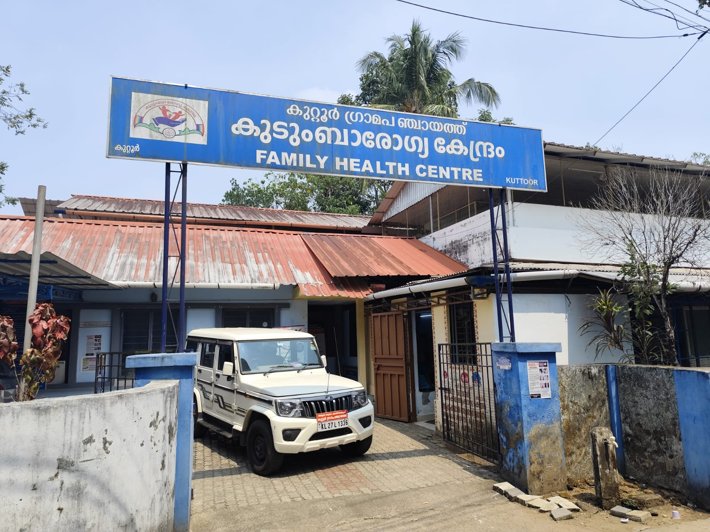

Dr. JAYANTH JOHN MATHAI
MEDICAL OFFICER
FHC KUTTOOR

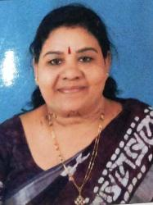
MESSAGE FROM PRESIDENT

Wishing everyone good health, resilience, and unity as we strengthen our preparedness against future pandemics. Together, with awareness and collective responsibility, we can protect our community and ensure the well-being of all.

Prasanna
president kuttoor gramapanchayat

MESSAGE FROM HEALTH STANDING COMMITTE -CHAIRPERSON


Pandemics are not only medical crises but also social and economic challenges, and preparedness is our shared responsibility. By strengthening our healthcare system, surveillance, frontline support, and community coordination, we can protect lives today and build a safer future for tomorrow.
ajithakumari
Chairperson
kuttoor gramapanchayat

MESSAGE BY MEDICAL OFFICER


Kuttoor Panchayat is committed to strengthening pandemic preparedness through early detection, coordinated response, and community participation. Together, we will remain vigilant and protect the health and safety of our community.

Dr. Jayanth John Mathai
Medical officer
FHC Kuttoor

EXECUTIVE SUMMARY

Kuttoor Grama Panchayat, located in the Thiruvalla region of Pathanamthitta, is defined by a unique hydro-geographical split. The Western region consists of low-lying, fertile alluvial plains—historically significant for extensive paddy cultivation—while the Eastern side features elevated terrains like Pottanmala and Pallimala, characterized by laterite and gravel soil. This landscape is shaped by the confluence of the Pamba and Manimala rivers, specifically the Varattar branch, and is served by the Pamba Irrigation Project (PIP) canal. Centered near the ancient Venpala and historically known as a hub for traditional boat-building, the Panchayat maintains a culture of deep communal harmony and a primary economic dependence on agriculture, fishing, and coir processing.
Despite its natural wealth, Kuttoor faces severe environmental and logistical challenges. The area is highly vulnerable to seasonal flooding—most notably during the 2018 disaster—which triggers recurring issues with waterborne and vector-borne diseases like Dengue and Leptospirosis. Unscientific land filling and the encroachment of traditional water bodies, such as Thodus (streams) and Kulams (ponds), have disrupted natural drainage, leading to stagnant water and ecological imbalances. To counter these threats, the Panchayat is leveraging data-driven Logistical Resource Mapping, building on the successful model of the Varattar River rejuvenation to identify high-ground evacuation points and improve emergency accessibility along the MC Road and railway corridors.
In conclusion, the future of Kuttoor hinges on its ability to harmonize its rich agricultural heritage with modern disaster management strategies. The restoration of the Varattar River serves as a flagship example of how ecological recovery can directly enhance community safety by restoring natural drainage. By meticulously mapping its logistical resources—from the elevated "Modis" of the East to the vital water arteries of the West—the Panchayat is transitioning from reactive crisis management to a proactive model of sustainable development. This strategic approach ensures that Kuttoor remains a resilient landscape where tradition and safety coexist against the challenges of a changing climate.

LIST OF ABBREVIATIONS

LSGD/LSGI | Local Self Government Department / Local Self Government Institution
BMO | Block Medical Officer
IDSP | Integrated Disease Surveillance Programme
NDMA | National Disaster Management Authority
PPE | Personal Protective Equipment
ICMR | Indian Council of Medical Research
CD | Communicable Diseases
NCD | NON-COMMUNICABLE Diseases

TABLE OF CONTENTS

3
INTRODUCTION 9
● Background of the PPP 9
LSGD AT A GLANCE 9
INTEGRATED HEALTH INFRASTRUCTURE MAP OF KUTTOR PANCHAYAT 10
GENERAL PROFILE OF THE LSGI’S 13
Background of the LSGI 13
Demographic and Vulnerable Population 14
Clinical Vulnerability 16
INFRASTRUCTURE & RESOURCE INVENTORY 18
Health Facility Directory & Basic Capacity in the LSGD 18
Private Clinics 19
Healthcare Education & Training Institutions 20
Specialized Services & Emergency Inventory 20
Oxygen & Diagnostic Capacity 21
Diagnostics facility mapping at the LSGI level 22
Laboratory Identification & Basic Details 22
Social and Community Infrastructure for surge plan 22
Human resources 24
Community & Support Cadre 25
Community Organizations 26
Administrative & Emergency Services 27
Information regarding resources 27
ONE HEALTH & ENVIRONMENTAL SURVEILLANCE 28
Animal & Bird Population 28
Veterinary Infrastructure 29
Veterinary Doctors & Workforce 30
High-Risk Interface Points (Surveillance Sites) 30
Environmental Risk Mapping 31
Disease Seasonality Mapping 32
Vulnerability Mapping 33
EPIDEMIOLOGICAL TRENDS (2021–2025) 34
Disease Burden among human beings(Last 5 Years) 34
*(use the above table data to create the graph/diagram) 36
Seasonal Trend Analysis 37
Outcome-Based Trend Analysis- 2025 39
Transmission Trend- 2025 40
Integrated Disease Hotspot Map (2021–2025) 42
Preparedness and Response Protocol at LSG Level 44
Constitution of One Health Committee 44
Pandemic Response Workforce 45
Activities and Measures before and during Pandemic 47
PHASE 1 - Alert / Preparation 47
PHASE 2 - Active Response 50
Standard Screening Protocol 51
PHASE 3 - Surge Capacity 60
Conversion of Community Facilities 60
CONCLUSION 61
RECOMMENDATIONS 62
ANNEXURE 63
1. IMPORTANT PHONE NUMBERS 63

INTRODUCTION

Background of the PPP
Kuttor Grama Panchayat, having experienced the significant impact of recurrent floods in Kerala, particularly during the 2018 Kerala floods, recognizes flooding as a major public health risk that can precipitate outbreaks of communicable and zoonotic diseases, disrupt essential health services, and strain local resources. In addition to lessons learned from the COVID-19 pandemic virus ,Lepto cases the Panchayat has developed a comprehensive Pandemic and Disaster Preparedness Plan with special emphasis on flood-related health risks. Adopting a One Health framework, the plan ensures coordinated action between the Health, Veterinary, and allied sectors, with strengthened surveillance during post-flood periods, regular veterinary sessions to monitor livestock health, rapid response mechanisms, safe water and sanitation measures, and strategic Public-Private Partnerships (PPP) to enhance logistics, laboratory support, and continuity of essential services. This integrated and proactive approach aims to ensure early warning, effective outbreak prevention, and sustained community resilience during floods and other public health emergencies
LSGD AT A GLANCE
- Geographical boundaries with political map ( based on latest delimitation)

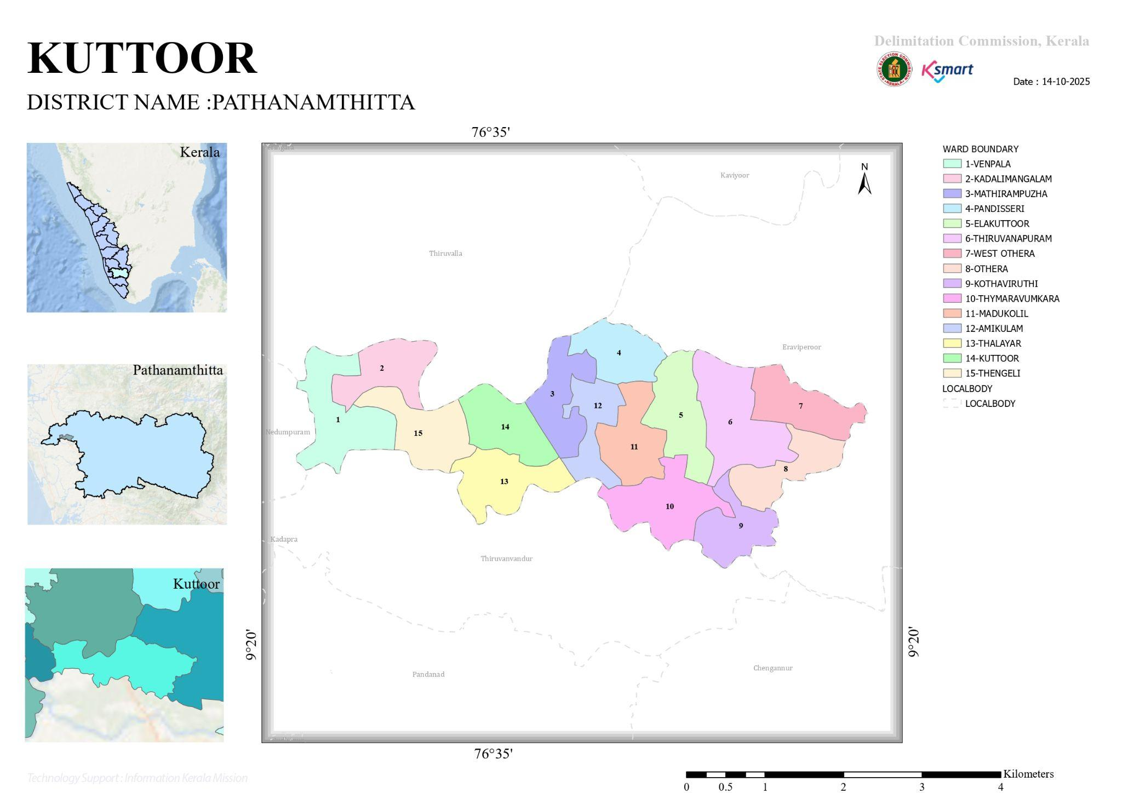

- Baseline data
- Ward division
Ward | Houses | Population | Migrants | Wells | Hot  spots | Ed. Institutions | Hosp pvt/govt.
14 | 6418 | 23578 | 437 | 5604 | 4 | 13 | 3/0

- Risk stratification among wards in the context of Communicable diseases and hazards
- Major Roads/rivers
- Major establishments with geospatial mapping
- occupational groups, socio cultural groups, migration & mobility patterns
- Vulnerability mapping
- Disaster prone areas (geographic vulnerability)

Maps - ward-based (Mention source also)

- Geographical boundaries - ward boundaries map
- Health infrastructure map
- roads and rivers map
- major establishments map
- disaster-prone areas map
- hotspot map - CD & disasters

INTEGRATED HEALTH INFRASTRUCTURE MAP OF KUTTOR PANCHAYAT

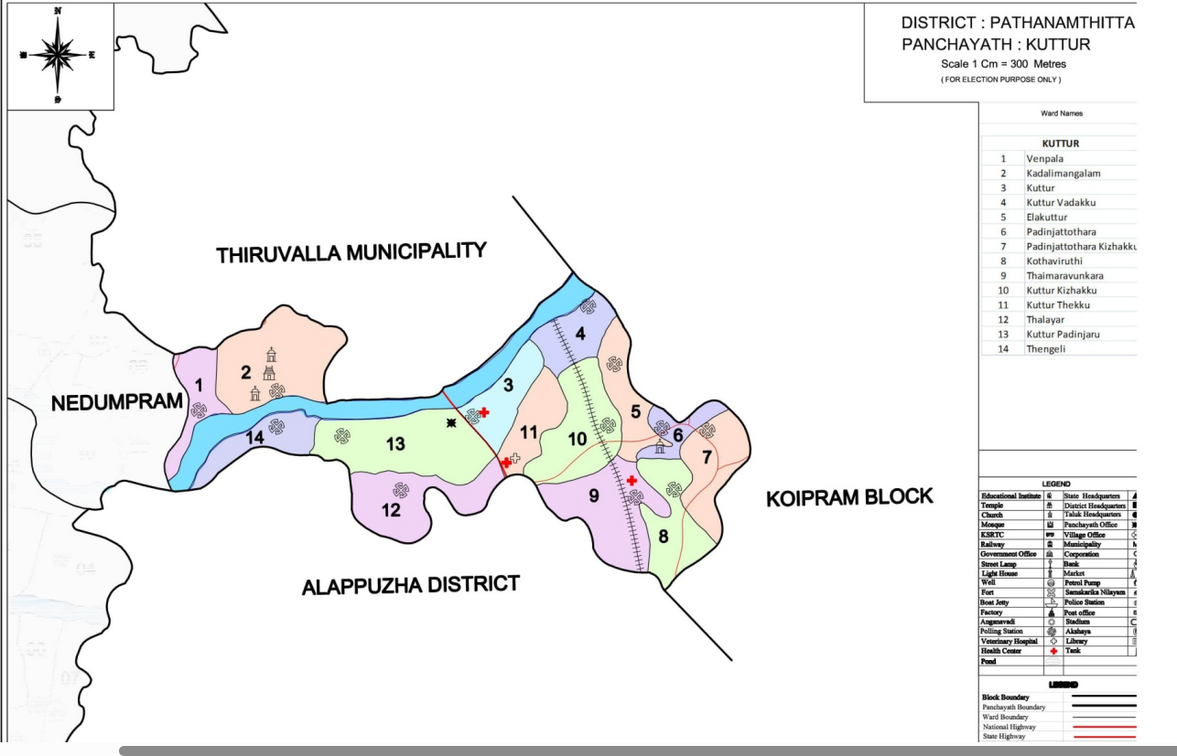

INTEGRATED ROADS AND RIVERS MAP OF KUTTOR PANCHAYAT
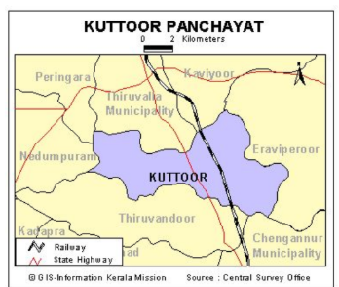

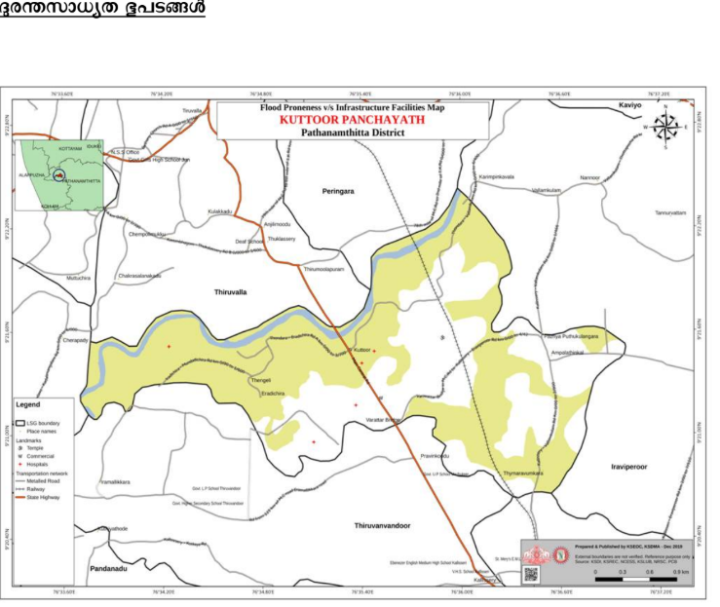

INTEGRATED DISASTER PRONE AREA MAP OF KUTTOR PANCHAYAT

Flood prone area

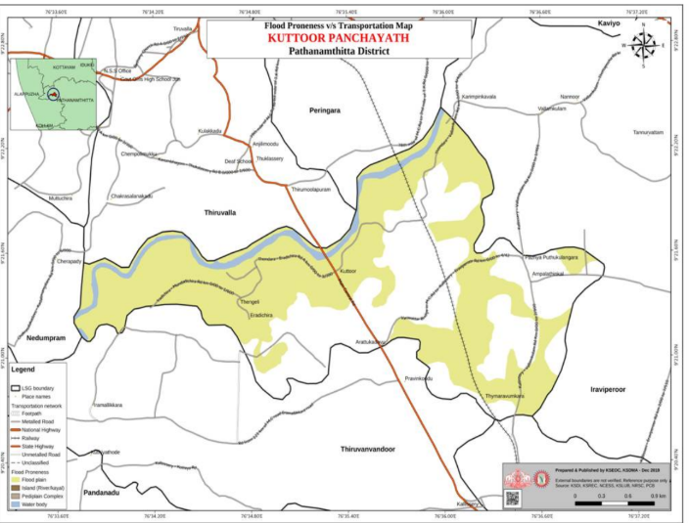

GENERAL PROFILE OF KUTTOR PANCHAYAT

Background of the LSGI

Table 1: Background of LSGD
Description | Details
Name of LSGI | Kuttoor
Type (GP/Municipality / Corporation etc.) | Grama Panchayath
Block | Pulikkeezhu
District | Pathanamthitta
Number of wards | 14
Total area (sq. km) | 12.16
Population(Projected) | 23578
Population density | 1.9
Terrain (coastal/low-lying/backwaters/foothills, etc.) | NA
Number of rivers passing through LSGI | 2
Number of water bodies in the LSGI | 14
Number of educational institutions | 13
Factories / small-scale industries | 2
Flood-prone wards | 2
Landslide-prone wards | Nil
Death Management and Disposal Facilities (mortuaries/crematorium, including electric) | 1
Auditoriums/Marriage halls/convention centres/community halls | 13

Demographic and Vulnerable Population

Description |  | Details (in numbers)
DEMOGRAPHIC PROFILE
Total population |  | 23578
Male |  | 11730
Female |  | 11848
Transgender |  | 0
Children under 5 |  | 619
Adolescent |  | 1582
Elderly (>60) |  | 3076
SOCIAL/LIVELIHOOD VULNERABILITY
Previous EPEP family |  | 17
BPL family |  | 1752
Tribal communities |  | 3
Migration | Immigrant | 206
Migration | Emigrant | 372
Socio-economically deprived |  | 86
Fisherfolk |  | 0
SC Community |  | 2647
ST Community |  | 3

Kuttoor Grama Panchayat exhibits a Dependency Ratio of approximately 28.8%, meaning that for every 100 working-age individuals, there are nearly 29 dependents (children and the elderly) who rely on them for support. This ratio is calculated based on the 3,076 elderly citizens and 2,201 young people (619 children under five and 1,582 adolescents) compared to the working-age population of 18,301. In the context of the Panchayat's high vulnerability to flooding and waterborne diseases, this ratio underscores a significant logistical challenge: during emergencies, a substantial portion of the community lacks the independent mobility to evacuate, placing a heavy responsibility on the able-bodied workforce and the local government's rescue infrastructure.
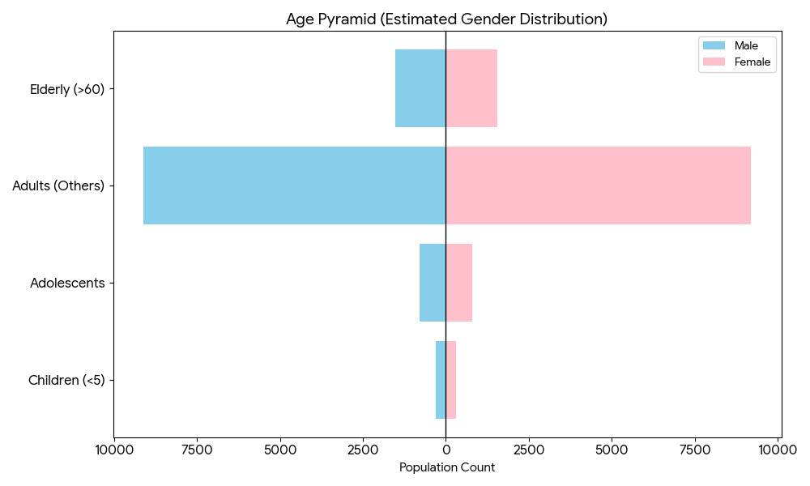

Clinical Vulnerability
Description | Details in numbers
Pregnant women | 46
Lactating mothers | 187
Bedbound patients | 125
Patients under palliative care other than bedbound | 235
Patients on Haemodialysis | 10
Patients on CAPD | 0
Cancer patients (currently on treatment) | 118
Haemophilic patients | 1
Mentally challenged | 52
Differently abled | 167
Diabetic patients | 1592
Hypertensive patients | 2985
TB patients | 4
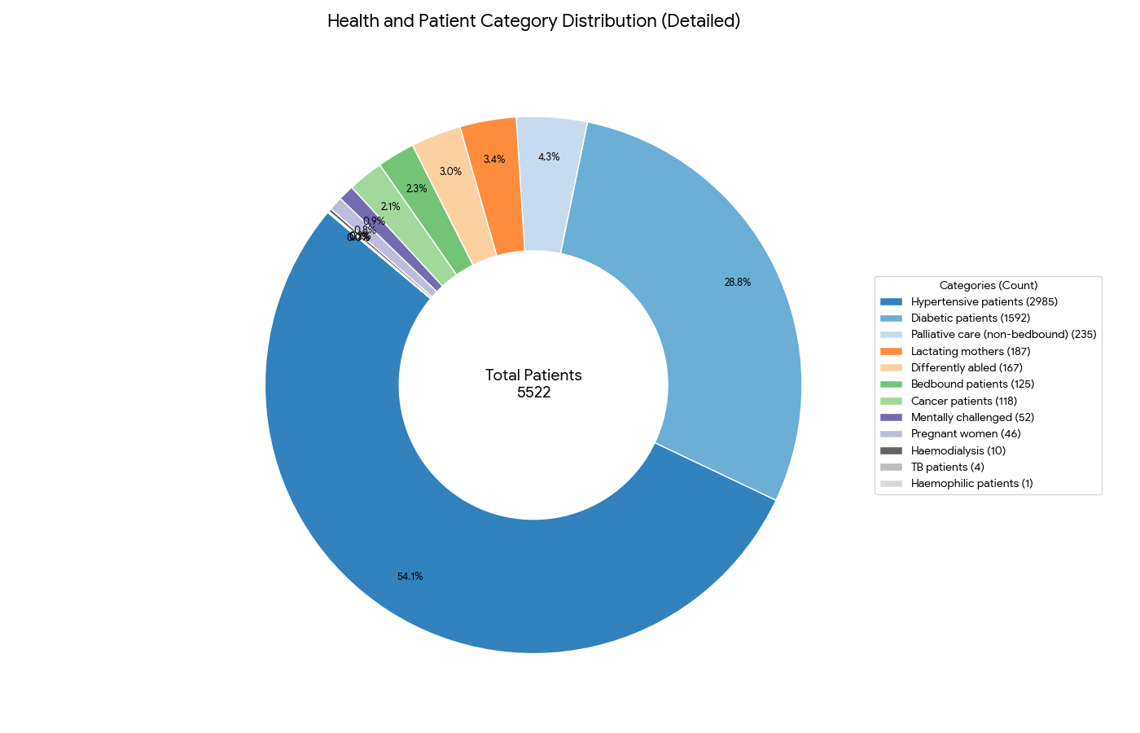

Major Festivals & Events specific to the LSGI
(with the possibility of a public gathering)

Sl. No. | Name of festival | Month detailing the periodicity
1 | SIVA TEMPLE THALAYAR | FEBRUARY
2 | PUTHOORKAV DEVI TEMPLE | DECEMBER
3 | KAYYALAKKAKATHU TEMPLE | FEBRUARY
4 | SHASTHANADA TEMPLE | FEBRUARY
5 | ST. SEBASIAN CHURCH WEST OTHERA | JANUARY
6 | ST. GREGORIOUS CHURCH KUTTOOR | NOVEMBER
7 | ST. MARYS KNANAYA CHURCH OTHERA | JANUARY
8 | ST. THOMAS KNANAYA CHURCH KUTTOOR | FEBRUARY

INFRASTRUCTURE & RESOURCE INVENTORY

Health Facility Directory & Basic Capacity in the LSGD

Table 5. Health Facility Resource Summary
Sl.no. | Health Facility | Type of Facility (MCH/GH/CHC/FHC/SC etc.) | Contact Number | Total beds | ICU Beds | Oxygen-Supported Beds | No. of Ventilator Support Beds | No. of ambulances
Government Healthcare Facilities
1 | FHC KUTTOOR | FHC | 04692614297 | 0 | 0 | 0 | 0 | 0
2 | HWC THALAYAR | SC | 8943053249 | 0 | 0 | 0 | 0 | 0
3 | HWC VENPALA | SC | 8943053249 | 0 | 0 | 0 | 0 | 0
4 | HWC WEST OTHERA | SC | 9946135481 | 0 | 0 | 0 | 0 | 0
Private Healthcare Facilities
1 | MED WELL CLINIC & LABORATORY WEST OTHERA | PVT CLINIC | 9072938008 | 0 | 0 | 0 | 0 | 0
2 | DR. LAKSHMIPRIYA  HOMEO CLINIC | PVT CLINIC | 7510767356 | 0 | 0 | 0 | 0 | 0
3 | DR. SHYNI GOHGI  ST. MARYS  DENTAL CLINIC | PVT CLINIC | 98475221719 | 0 | 0 | 0 | 0 | 0
4 | DR, MARIAMMA SUNNY  HOMEO CLINIC | PVT CLINIC | 9961900527 | 0 | 0 | 0 | 0 | 0
5 | DR.LITY KURIAN THOMAS  PHYSIOTHERAPY CLINIC | PVT CLINIC | 9847084706 | 0 | 0 | 0 | 0 | 0
AYUSH Healthcare Facilities
1 | Govt Ayurveda Dispensary | GOVT | 9446175364 | 0 | 0 | 0 | 0 | 0
2 | GOVT. HOMEO DISPENSARY |  | 97455697516 | 0 | 0 | 0 | 0 | 0

Private Clinics
Private clinics are an essential part of pandemic preparedness, as they are often the first place people seek care when symptoms begin. In many communities, private clinics manage a significant share of outpatient visits and therefore play a critical role in early case detection, timely referrals, and disease surveillance. Having an up-to-date understanding of where these clinics are located, the services they provide, and how they are linked to the public health system helps ensure that no cases are missed during an outbreak. It also allows health authorities to engage private practitioners more effectively for reporting, risk communication, and coordinated response, strengthening the overall capacity of the health system to manage public health emergencies.

Table 6. Private Clinic Resource Summary
Sl No. | Name of Clinic | Registered (Y/N) | Clinic (General / Speciality) | Speciality (if any) | Address | Contact Number | Diagnostic Facility (Y/N) | Ambulance Linkage (Y/N)
1 | MED WELL CLINIC & LABORATORY WEST OTHERA | NO | GENERAL | NO | WEST OTHERA P.O | 9072938008 | YES | N

Healthcare Education & Training Institutions
This section tracks the educational infrastructure available, which is vital for human resource planning in the health sector.

Category of Institution | Govt | Private | AYUSH | Total
Medical Colleges | 0 | 0 | 0 | 0
Nursing Colleges | 0 | 0 | 0 | 0
Dental Colleges | 0 | 0 | 0 | 0
Para-medical / Allied Health | 0 | 0 | 0 | 0
Pharmacy Colleges | 0 | 0 | 0 | 0

Specialized Services & Emergency Inventory
This section provides a detailed view of the specialized medical resources available to the community, focusing on emergency response and critical care capabilities. This table tracks the vital assets required for managing severe illnesses and emergencies across Government, Private, and AYUSH sectors.

Item | Govt | Private | AYUSH | Total
Hospital beds | 0 | 0 | 0 | 0
Oxygen-generating systems(Y/N) | 0 | 0 | 0 | 0
Oxygen-supported beds(Numbers) | 0 | 0 | 0 | 0
Ventilator-supported beds | 0 | 0 | 0 | 0
ICU beds | 0 | 0 | 0 | 0
Burns units | 0 | 0 | 0 | 0
Blood centres | 0 | 0 | 0 | 0
BLS ambulances | 0 | 0 | 0 | 0
ALS ambulances | 0 | 0 | 0 | 0
Dialysis facilities | 0 | 0 | 0 | 0
Dispensaries | 2 | 1 | 1 | 4
Medical store | 0 | 7 | 0 | 7
Industrial establishments(Medium-scale industries/small-scale industries establishments to whom we can depend in a worst-case scenario) | 0 | 0 | 0 | 0

Oxygen & Diagnostic Capacity
Monitoring oxygen and diagnostic capacity is a critical component of public health preparedness, ensuring that the LSGD can handle both chronic care and sudden surges in respiratory or infectious diseases.
Sl no | Name of Health Facility | Oxygen-generating System (Y/N) | Backup Oxygen Source (Y/N) | Diagnostic Facilities Available(Y/N)
 |  |  |  | Lab | USG | X-ray | CT/MRI | RT-PCR
 | Government Healthcare Facilities
1 | Phc kuttoor | No | No | Y | N | N | N | N
2 | Govt Ayurveda Hospital kuttoor | N | N | N | N | N | N | N

Diagnostics facility mapping at the LSGI level
The diagnostic capacity of KUTTOOR GRAMAPANCHAYAT represents the "intelligence network" of our healthcare system. The speed and accuracy of disease identification depend entirely on the distribution and technical level of these facilities.

Item | Govt | Private | AYUSH | Total
General labs | 1 | 3 | 0 | 4
Microbiology labs | 1 | 3 | 0 | 4
RT-PCR labs | 0 | 3 | 0 | 3
USG units | 0 | 0 | 0 | 0
CT/MRI units | 0 | 0 | 0 | 0
Research labs | 0 | 0 | 0 | 0
Labs of other departments that can be repurposed | 0 | 0 | 0 | 0

Laboratory Identification & Basic Details
Sl. No. | Name of Laboratory | Ownership (Govt / Private / Academic) | Address | Contact No. | 24×7 Services (Yes/No) | NABL / Govt Approved (Yes/No)
1 | PHC KUTTOOR | GOVT | PHC KUTTOOR,PATHANAMTHITTA | 9496273113 | NO | YES
2 | KRUPA | PRIVATE | Mariamma scaria,kuttoor | 9961900527 | No | No
3 | Micro lab kuttoor | private | Manu s Rajeev,kuttoor | 9947531831 | No | No
4 | Medwell west othera | private | Reji George,west othara | 9072938008 | No | No

Social and Community Infrastructure for surge plan
This table serves as our logistics and shelter inventory. By mapping these locations, quickly we can identify where to house displaced citizens, where to set up temporary medical clinics, and how to manage the deceased with dignity during a crisis.

Category | Total Count | Ward | Est. Capacity (Persons) | Contact details
Educational Institutions
Anganwadis | 20 | 14 | 40 | 8593962467
Schools | 13 | 7 | 82 | 8547788022 (HM KUTTOOR)
Colleges | 0 | 0 | 0 | 0
Healthcare Educational Institutions
Medical colleges (Govt/Private) | 0 | 0 | 0 | 0
Nursing colleges (Govt/Private) | 0 | 0 | 0 | 0
Dental colleges (Govt/Private) | 0 | 0 | 0 | 0
Paramedical institutes (Govt/Private) | 0 | 0 | 0 | 0
Community Gathering Spaces
Community halls | 2 | 3 | 500 | 9562376942
Auditoriums | 13 | 4,11,14,6,8,10,5 | 17 | 9207543567
Religious buildings | 8 | 10,8,3,4,11 | 12 | 9961454253
Vulnerable Group Support Facility
Destitute homes | 2 | 11, 9 | 2 | 8078715673
Elderly homes | 0 |  | 0
LSGD owned other buildings | 1 | 14 | 0
Mass Fatality Management (MFM) Infrastructure
Mortuary | 0 | 0 | 0 | 0
Crematorium | 1 | 14 | 1
*refer annexure 1 for contact details

Human resources
This section focuses on the human capital available within the LSGI. In any emergency—be it a pandemic, flood, or industrial accident—infrastructure is only as effective as the people operating it.

Medical & Clinical Personnel
This table tracks the "Frontline" providers responsible for diagnosis, treatment, and clinical management. Narrative sentence: eg., "Total health workforce: 450 personnel, with 60% in government facilities serving as primary surge capacity." A detailed directory with the contact numbers of all workers is maintained (Annexure in 1).

Cadre | Govt (No.) | Private (No.) | Total
Doctors—Modern Medicine | 1 | 4 | 5
Doctors – AYUSH | 2 | 3 | 5
Doctors – Veterinary | 1 | 0 | 1
Doctors – Dental | 0 | 2 | 2
Nursing officers | 2 | 0 | 2
Lab technicians | 2 | 3 | 5
Optometrist | 0 | 0 | 0
Pharmacists | 2 | 2 | 4
Psychologists | 0 | 0 | 0
Counsellors | 1 | 0 | 1

Public Health & Field-Level Workforce
These individuals are the backbone of surveillance, maternal-child health, and decentralized care.

Cadre | Health services | Municipal common services | Total
HS (Health Supervisors) | 1 | 0 | 1
HI (Health Inspectors) | 1 | 0 | 1
LHS (Lady Health Supervisor) | 0 | 0 | 0
LHI (Lady Health Inspectors) | 1 | 0 | 1
JPHN (Jr Public Health Nurses) | 3 | 0 | 3
JHI (Jr Health Inspectors) | 2 | 0 | 2
MLSP (Mid-Level Service Providers) | 3 | 0 | 3
Palliative Nurses | 1 | 0 | 1
RBSK Nurses | 1 | 0 | 1
PRO | 1 | 0 | 1
Epidemiologist | 1 | 0 | 1
Data Manager | 1 | 0 | 1

Community & Support Cadre
This group represents the surge capacity of the LSGI—people who can be called upon for logistics, rescue, and specialized support.

Cadre | Number
ASHA Workers | 17
AWW (Anganwadi Workers) | 20
Emergency Medical Volunteers (Trained) | 0
Kudumbashree | 150
MNREGS | 437
Purusha Swayam Sahaya Sangham | 0
Ex-Servicemen | 42
Retired Police Officers | 15
NCC/NSS Volunteers | 38
Red Cross volunteers | 10
One Health Community Volunteers | 686
One Health Community Mentors | 49

Community Organizations
This section details the presence of community-based organisations (CBOs), non-governmental organisations (NGOs), faith-based organisations (FBOs), Kudumbashree Self-Help Groups (SHGs), and Ayalkootams within the Local Self-Government Institution (LSGI). These groups enhance grassroots mobilization, resource distribution, and support networks crucial for pandemic response and community resilience.

Category | Total Count
NGOs | 0
Religious based organizations | 2
Foreign based organizations | 0
Sports Club/youth clubs | 5
Kudumbashree SHGs | 0
Ayalkootams | 152
Political organizations | 14
Residential organizations | 9

Administrative & Emergency Services
This section outlines the availability of key non-health emergency support services and infrastructure within the LSGI, which are essential for effective pandemic preparedness and response. These facilities support law enforcement, disaster response, water supply, logistics, mobility, and community-level interventions during public health emergencies.

Category | Total Count | Contact details
Police Stations | 0 | 0
Fire & Rescue Stations | 0 | 0
Water Pumping Points | 3
Public Distribution System (PDS) | 14 | 14

Information regarding resources
The availability of essential transport and support resources plays a quiet but critical role in saving lives. Equipment such as ambulances, mobile mortuaries, amphibian ambulances, and motorized boats ensures that patients, samples, and healthcare teams can move swiftly—even in flooded, remote, or difficult terrains. Heavy vehicles like JCBs, cranes, tractors, and torus lorries support logistics, waste management, emergency infrastructure, and rapid conversion of spaces into care or isolation facilities. Taxis, four-wheel-drive vehicles, and trucks help maintain continuity of essential services, reach vulnerable populations, and support home-based care and supply delivery.

Means of transportation | Total Count
JCB | 11
Crane | 2
Heavy Trucks | 0
Tractor | 4
Ambulances | 5
Mobile mortuaries | 6
Boats | 0
Taxi service | 55
Note: For specific details regarding vehicle owners and contact information, please refer to Annexure [X].

ONE HEALTH & ENVIRONMENTAL SURVEILLANCE
The One Health method integrates environmental, animal, and human health to enable proactive pandemic preparedness. Panchayat-level surveillance needs to be improved in order to detect and treat zoonotic and environmentally generated diseases early. Surveillance is strengthened through systematic assessment of animal populations, veterinary infrastructure, poultry and slaughter facilities, inter-sectoral coordination, and specialised tools like avian influenza seasonality mapping using GIS in previous outbreaks to enable predictive alerts and ward-specific sampling to support effective pandemic preparedness in high-risk areas like Thengeli.

Animal & Bird Population
Mapping animal and bird populations at the Panchayat level is essential for identifying and prioritising zoonotic disease hazards like rabies, avian influenza (H5N1), leptospirosis, anthrax, and Nipah-like spillover occurrences. Risk classification, targeted surveillance, vaccination planning, and early epidemic detection made feasible by comprehensive population mapping all enhance One Health-based pandemic preparedness.

Category | Item | Estimated Population | Wards
Animal Population | Livestock (Cattle/Goats/Buffalo) | Cattle-536  Buffalo -33 | All wards
Animal Population | Pet Animals (Dogs/Cats) | 788 | All wards
Animal Population | Stray Dog Population | 322 | All wards
Animal Population | Pig Farms (Number of heads) | Nil | nil
 | Small Units (Sheep / Goats – clustered) | Goat -235 | All wards
Bird Population | Poultry Units (Birds) | 6491 | All wards
Bird Population | Poultry- (FOWL) | 6652 | All wards
Bird Population | Wild/Migratory Birds (Observed) | nil | nil
Bird Population | Crow Mortality Events (Reported) | nil | nil

The main risk of zoonotic diseases in lumpy skin is concentrated in all Wards which is explained by the high density of cattle congregation areas. The stray dog population in market areas, fish landing sites, bus stations continues to be a substantial problem for rabies surveillance and bite prevention. There is a considerable risk of avian influenza introduction and amplification during November - December due to the seasonal presence of migratory and resident water birds near ponds/ canal / river / backwater / paddy field. Clusters of pig farms and animal shelters vulnerable to flooding further raise the risk of leptospirosis and other zoonoses mediated by the environment, especially during monsoon floods.

Veterinary Infrastructure
Veterinary institutions are a core pillar of One Health surveillance, enabling early zoonotic disease detection through vaccination, investigation of unusual animal illness or deaths, sample collection, and timely outbreak reporting. A well-mapped and responsive veterinary network strengthens coordination with human health and LSGI systems, ensuring rapid response during zoonotic events and pandemics.
Facility Type | Name of Facility | Ownership Govt / Pvt | Location(Ward No) | Contact number
Veterinary Dispensary | Veterinary Dispensary ,Arattukadavu | Govt | 13 | 9497363748
Veterinary Hospital / Polyclinic | nil | nil | nil | nil
Private Veterinary Clinics | nil | nil | nil | nil
Mobile / Emergency Vet Service (incl. night services) | nil | nil | nil | nil
Pet Homes / Animal Shelters | nil | nil | nil | nil
Slaughterhouse-linked Veterinary Inspection Unit | nil | nil | nil | nil

Veterinary Doctors & Workforce
Early detection, diagnosis, reporting, and reaction to animal illness epidemics depend on the availability and accessibility of qualified veterinary specialists. By identifying unusual animal morbidity or mortality promptly, collecting samples promptly, and coordinating efficiently with human health and LSGI systems—especially during zoonotic outbreaks and pandemic-prone situations—a clearly defined veterinary workforce enhances One Health surveillance.

Category | Number Available | Type (Govt/Pvt) | Contact number
Government Veterinary Doctors | 1 | GOVT | 9497363748
Private Veterinary Doctors | Nil | Nil | Nil
Livestock Inspectors | 3 | Govt | 9961718545
Para-veterinary Staff / Attenders | Nil | Nil | Nil
Contract / On-call Veterinary Support (if any) | 1 | GOVT | 1962

High-Risk Interface Points (Surveillance Sites)
High-risk interface points for zoonotic disease surveillance in Kuttoor Grama Panchayath include livestock–human contact zones,poultry farms ,cattle sheds near water bodies .These are the primary surveillance sites where zoonotic spillover risks are elevated.

Type of Habitat | Type of High risk interface | Geographical vulnerability
Wetlands & Backwaters | NA | nil
Backyard Poultry Farms | Nil | nil
Cattle Sheds near Water Bodies | Flooded areas | mostly in ward 7
Fish & Meat Markets | Nil | Nil
Community Slaughter Sites | Nil | Nil
Migratory Bird Congregation Areas | Nil | Nil
Rodent-Infested Grain Storage | Nil | Nil

Category | Total Count | Key Locations (wards)
Poultry Farms | 1 | 7
Backyard / Clustered Poultry Units | Nil | Nil
Duck Rearing Units (open water access) | Nil | Nil
Slaughterhouses/ Slaughter Points | Nil | Nil
Meat/Fish Markets | Nil | Nil
Live Bird Sale Points | Nil | Nil
Cattle Markets / Weekly Animal Fairs | Nil | Nil
Pet Shops / Breeders | Nil | Nil
Animal Shelters / Pet Homes | Nil | Nil
Waste Disposal Sites near Animal Units | Nil | Nil

Environmental Risk Mapping
Environmental risk mapping identifies monsoon/flood hotspots for vector-borne (dengue, chikungunya), water-borne (leptospirosis, diarrhoea), and zoonotic diseases in Kerala's wetlands. Systematic surveillance supports early warnings, targeted interventions, and Panchayat pandemic preparedness.
Waterborne exposure: Flood-prone areas and stagnant water bodies facilitate leptospira survival, raising leptospirosis risk.

Traditional practices: Informal slaughter and fish markets lack standardized hygiene, creating spillover opportunities.
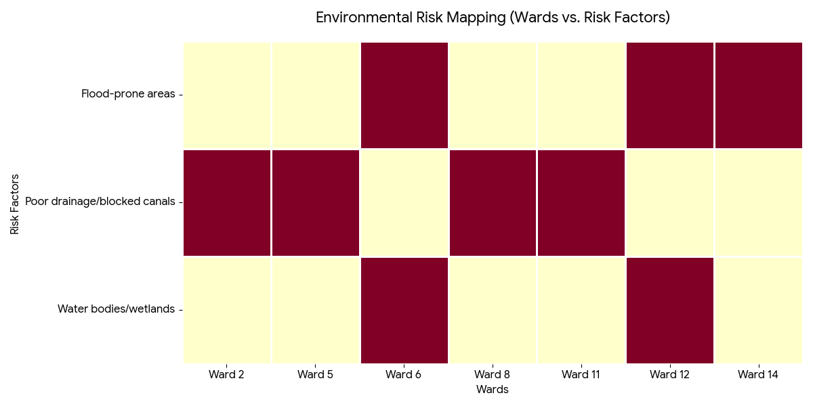
Risk Factor | High-Risk Wards | Key Locations | Risk Level (High/Med/Low)
Flood-prone areas | 6,14,12 | Pattinjaothera  Thengeli  thalayar | Medium
Water bodies/wetlands | 12,6 | Thalayar | Medium
Solid waste accumulation | 0 | 0 | 0
Animal waste disposal issues | 0 | 0 | 0
Rodent infestation zones | 0 | 0 | 0
Industrial effluent discharge | 0 | 0 | 0
Construction sites / abandoned buildings | 0 | 0 | 0
Poor drainage/blocked canals | 8,11,5 ,2 | Kothaviruthy  Kuttoorthekku  Elakuttoor  Kadalimangalam | Med
Drinking water source contamination risk | 0 | 0 | 0

Disease Seasonality Mapping
1, Flooding & waterlogging → amplifies leptospirosis, malaria, diarrheal diseases.
2 Mosquito breeding cycles → vector-borne disease peaks in monsoon.

3, Agricultural practices → close human–animal contact in paddy fields.

Disease | Peak Risk Season | Key Drivers | High-Risk Locations | Surveillance Focus
Avian Influenza | NA | NA | NA | NA
Leptospirosis | JUNE-JULY | CONTAMINATED WATER SOURCES | VENPALA | NREG WORKERS, CATTLE FARMERS, AGRICULTURE WORKERS
Dengue/Chikungunya | JUNE-JULY | INTERMITTEND RAINY SEASON | THENGELI | RIVER SHORE OF MANIMALA
Acute Diarrheal Diseases | MAY-JULY | END OF SUMMER SEASON | ALL WARDS | UNDER 5 CHILDREN
Rabies | APRIL-MAY | STRAY DOGS | KUTTOOR | ALL PEOPLE IN THE PANCHAYAT
Anthrax (rare) | NA | NA | NA | NA

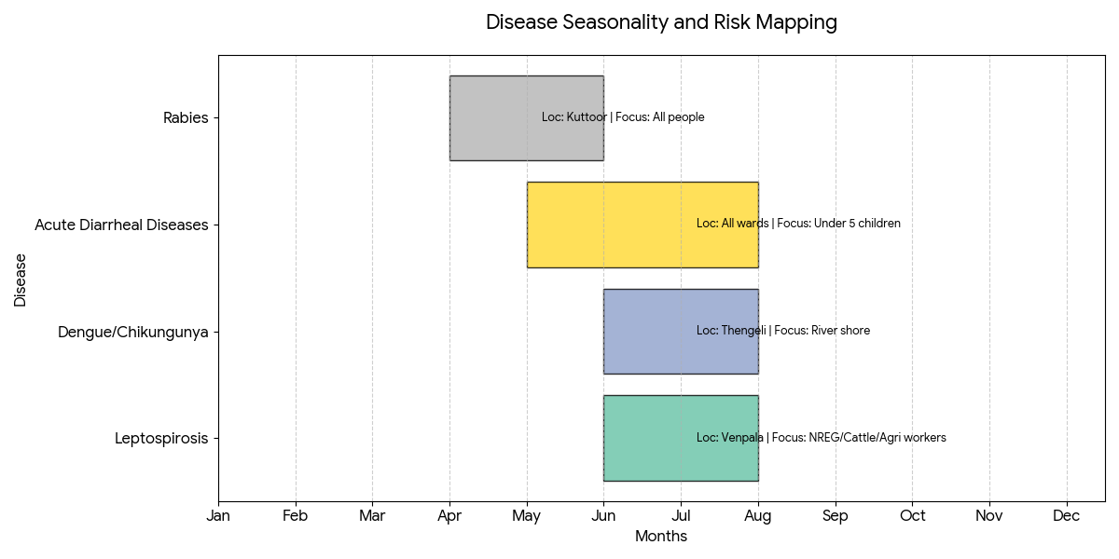

Vulnerability Mapping
Vulnerability mapping pinpoints high-risk populations, occupations, and areas exposed via environment, livelihoods, socio-economics, and poor service access. Paired with environmental/seasonality mapping, it enables risk-based surveillance, targeted actions, and optimal resource use in One Health and pandemic planning.
Vulnerability Factor | High-Risk Wards | Key Groups / Locations | Risk Level
Flood-prone households | 12,13 | VENPALA | MEDIUM
Wetland-adjacent communities | 12,13 | VENPALA | MEDIUM
Backyard poultry / duck rearing households | 12,13 | VENPALA | LOW
Livestock-rearing households | NA | NA | NA
Slaughterhouse & meat market workers | 3,13 | KUTTOOR | LOW
Fisherfolk & fish market workers | 13,3 | KUTTOOR | LOW
Sanitation workers | NA | NA | NA
Daily wage / migrant workers | 3 | KUTTOOR | MEDIUM
Elderly & chronically ill populations | 12,13 | VENPALA  THALAYAR | MEDIUM
Pregnant Women | 8,9,10,12 | THALAYAR | LOW
Children (schools, Anganwadi’s) | 7 | WEST OTHERA | LOW
Limited access to safe water & sanitation | NA | NA | NA

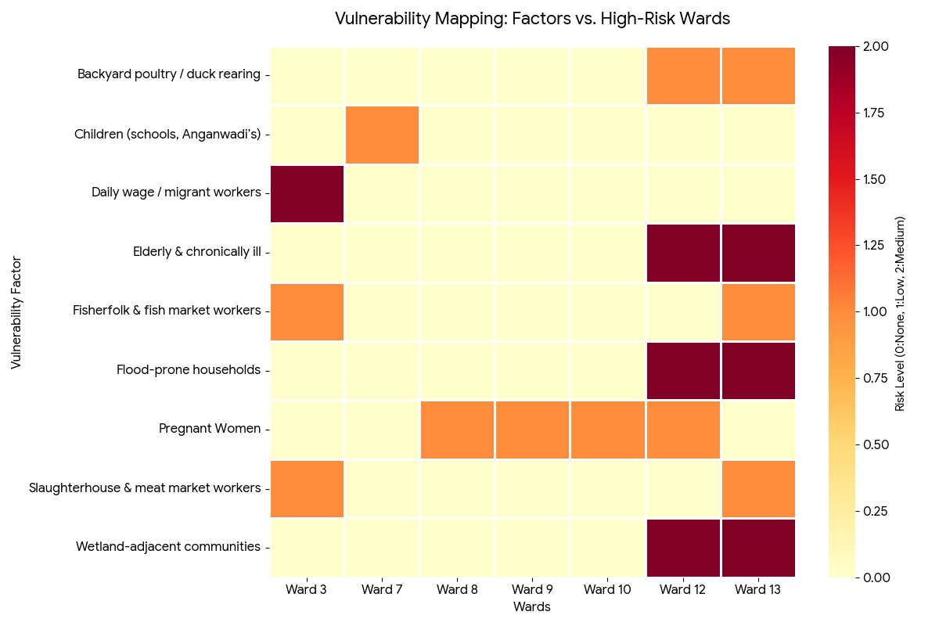

EPIDEMIOLOGICAL TRENDS (2021–2025)

Disease surveillance is the systematic collection, analysis, and interpretation of health data for planning, implementation, and evaluation of public health practice. This section presents the disease surveillance profile of the LSGI based on routine reporting systems and outbreak investigations to identify priority diseases, seasonal patterns, and emerging public health threats.

Disease Burden among human beings(Last 5 Years)
Analysis of disease-wise data for the last five years helps identify persistent public health problems, emerging diseases, and changes in disease burden. This information supports prioritisation of prevention, preparedness, and response activities at the Panchayat level.

Disease | 2021 | 2022 | 2023 | 2024 | 2025 | Trend(Increasing/Stable/Decreasing)
Dengue | 0 | 5 | 9 | 32 | 18 | Decreasing
Leptospirosis | 2 | 1 | 3 | 0 | 1 | Stable
Hepatitis A | 0 | 1 | 2 | 0 | 5 | Increasing
Malaria | 0 | 0 | 0 | 0 | 0 | NA
Scrub Typhus | 0 | 0 | 0 | 0 | 0 | NA
Typhoid | 0 | 0 | 1 | 0 | 0 | Decreasing
H1N1 | 0 | 0 | 2 | 2 | 0 | Decreasing
H3N2 | 0 | 0 | 0 | 0 | 0 | NA
ADD | 31 | 49 | 28 | 16 | 44 | Increasing
Mumps | 0 | 0 | 0 | 0 | 0 | NA
Measles | 0 | 0 | 0 | 0 | 0 | NA
Hepatitis B | 0 | 0 | 0 | 0 | 1 | Increasing
Hepatitis C | 0 | 0 | 0 | 0 | 0 | NA
Tuberculosis | 4 | 3 | 9 | 5 | 5 | Increasing
Leprosy | 0 | 0 | 0 | 0 | 0 | NA
COVID-19 | 0 | 0 | 0 | 0 | 0 | NA

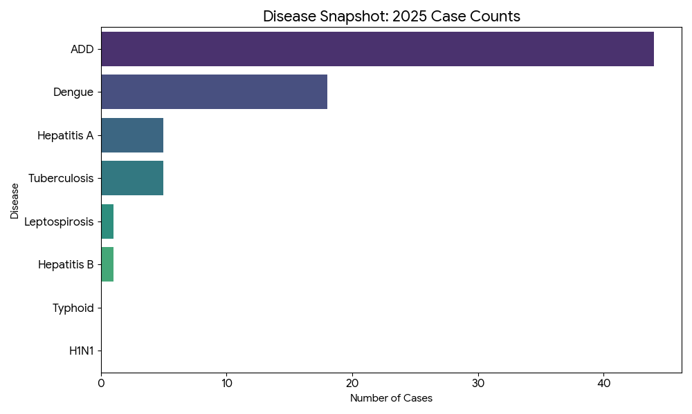

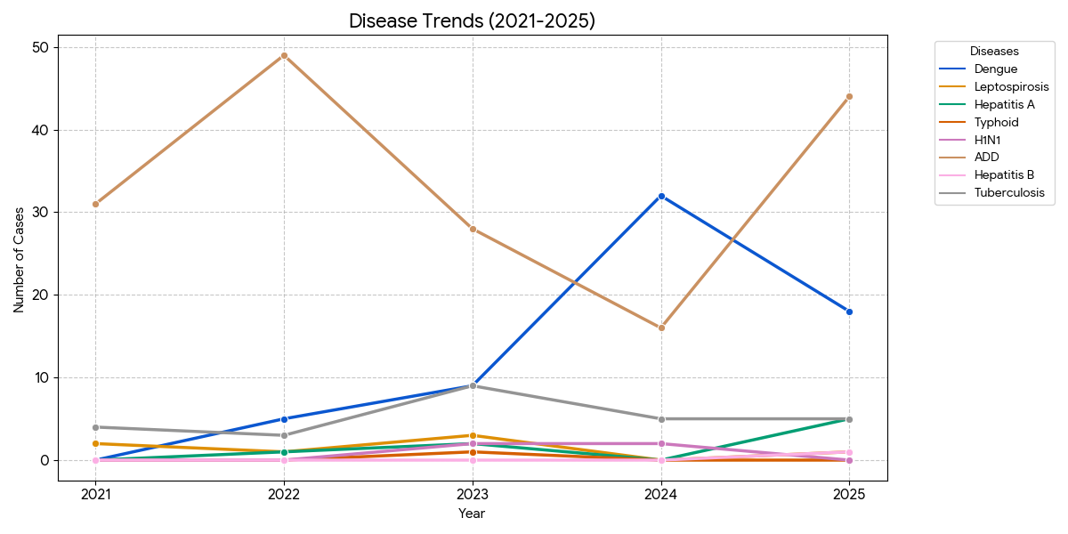
- Acute Diarrheal Diseases (ADD): Remains the highest volume concern, showing a sharp resurgence in 2025 after a dip in 2024.
- Dengue: Experienced a massive spike in 2024 ($32$ cases) but has shown a downward trend in 2025.
- Emerging Risks: Hepatitis A and Hepatitis B are showing increasing trends in the most recent year, requiring closer monitoring.
- Stable/Decreasing: Diseases like H1N1 and Typhoid have returned to zero or near-zero levels in 2025.
The visualizations below provide a clear view of the case distribution and intensity over the five-year period.

Seasonal Trend Analysis
Seasonal analysis helps anticipate surges (e.g. dengue in monsoon, leptospirosis after floods, influenza in cooler months) and plan pre‑emptive vector control, stockpiling of IV fluids, and awareness campaigns at Panchayat level.

DENGUE
Dengue is a major seasonal vector-borne disease strongly associated with rainfall, water stagnation, and increased mosquito breeding during the monsoon period.

Peak: July–November

Dengue – Ward-wise Yearly Distribution (2021–2025)

Ward | Dengue – Ward-wise Yearly Distribution
Ward | 2021 | 2022 | 2023 | 2024 | 2025 | Total
1 | 0 | 0 | 1 | 2 | 2 | 5
2 | 0 | 0 | 0 | 0 | 0 | 0
3 | 0 | 0 | 1 | 3 | 0 | 4
4 | 0 | 0 | 2 | 3 | 0 | 5
5 | 0 | 0 | 2 | 1 | 2 | 5
6 | 0 | 0 | 1 | 1 | 1 | 3
7 | 0 | 0 | 1 | 2 | 0 | 3
8 | 0 | 0 | 0 | 2 | 0 | 2
9 | 0 | 1 | 0 | 2 | 1 | 4
10 | 0 | 0 | 0 | 4 | 0 | 4
11 | 0 | 0 | 0 | 2 | 0 | 2
12 | 0 | 1 | 1 | 2 | 1 | 5
13 | 0 | 1 | 0 | 3 | 0 | 4
14 | 0 | 2 | 0 | 5 | 0 | 7

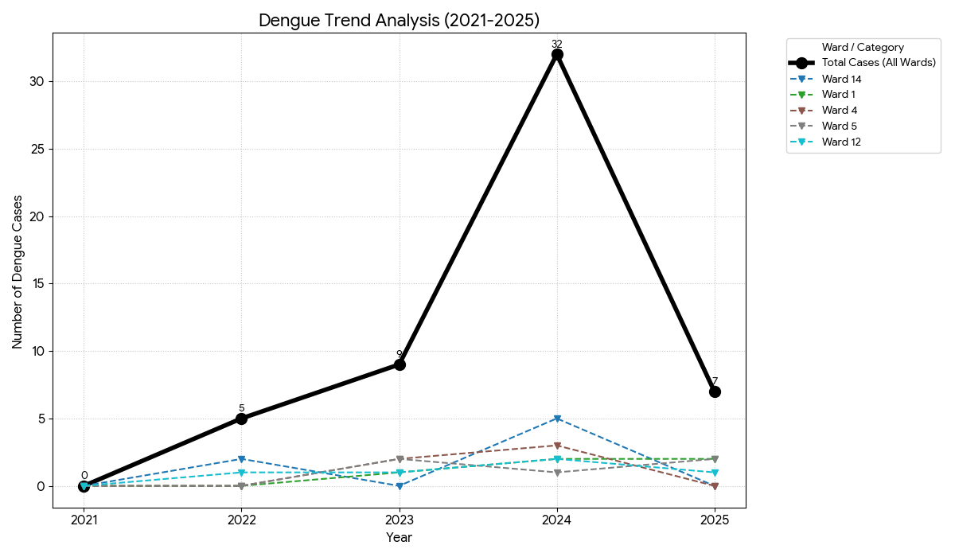

LEPTOSPIROSIS
Leptospirosis cases are closely linked to monsoon rains, flooding, and occupational exposure, particularly in low-lying and waterlogged areas.

Peak: June - August

Leptospirosis – Ward-wise Yearly Distribution (2021–2025)

Ward | Leptospirosis – Ward-wise Yearly Distribution
Ward | 2021 | 2022 | 2023 | 2024 | 2025 | Total
1 | 0 | 0 | 0 | 0 | 0 | 0
2 | 0 | 0 | 0 | 0 | 0 | 0
3 | 0 | 0 | 0 | 0 | 0 | 0
4 | 0 | 0 | 1 | 0 | 0 | 1
5 | 0 | 0 | 0 | 0 | 0 | 0
6 | 0 | 0 | 0 | 0 | 0 | 0
7 | 0 | 0 | 0 | 0 | 1 | 1
8 | 0 | 0 | 0 | 0 | 0 | 0
9 | 0 | 1 | 0 | 0 | 0 | 1
10 | 0 | 0 | 0 | 0 | 0 | 0
11 | 0 | 0 | 0 | 0 | 0 | 0
12 | 0 | 0 | 0 | 0 | 0 | 0
13 | 0 | 0 | 0 | 0 | 0 | 0
14 | 1 | 0 | 1 | 0 | 0 | 2

Ward 14 Persistence: Ward 14 is the only area to report cases in multiple years (2021 and 2023), making it a primary area for surveillance.
Low Incidence: The total count reached a peak of only 2 cases in 2023 and dropped to zero in 2024, indicating a stable but low-level environmental risk.
2025 Status: A single case emerged in Ward 7 in 2025, marking a new location for monitoring compared to previous years.
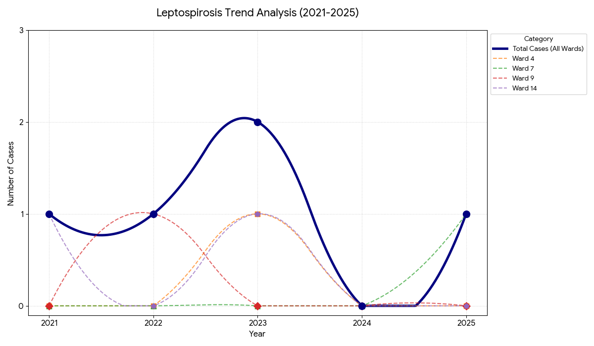

VIRAL HEPATITIS - A
Hepatitis A cases are commonly associated with unsafe drinking water, food contamination, and breakdowns in sanitation, often presenting as clusters or outbreaks.

Peak: October - December

Hepatitis A – Ward-wise Yearly Distribution (2021–2025)

Ward | Hep A – Ward-wise Yearly Distribution
Ward | 2021 | 2022 | 2023 | 2024 | 2025 | Total
1 | 0 | 0 | 0 | 0 | 0 | 0
2 | 0 | 0 | 0 | 0 | 0 | 0
3 | 0 | 0 | 1 | 0 | 0 | 0
4 | 0 | 0 | 0 | 0 | 0 | 0
5 | 0 | 0 | 0 | 0 | 1 | 1
6 | 0 | 1 | 1 | 0 | 1 | 3
7 | 0 | 0 | 0 | 0 | 0 | 0
8 | 0 | 0 | 0 | 0 | 1 | 1
9 | 0 | 0 | 0 | 0 | 0 | 0
10 | 0 | 0 | 0 | 0 | 1 | 1
11 | 0 | 0 | 0 | 0 | 0 | 0
12 | 0 | 0 | 0 | 0 | 0 | 0
13 | 0 | 0 | 0 | 0 | 0 | 0
14 | 0 | 0 | 0 | 0 | 1 | 1

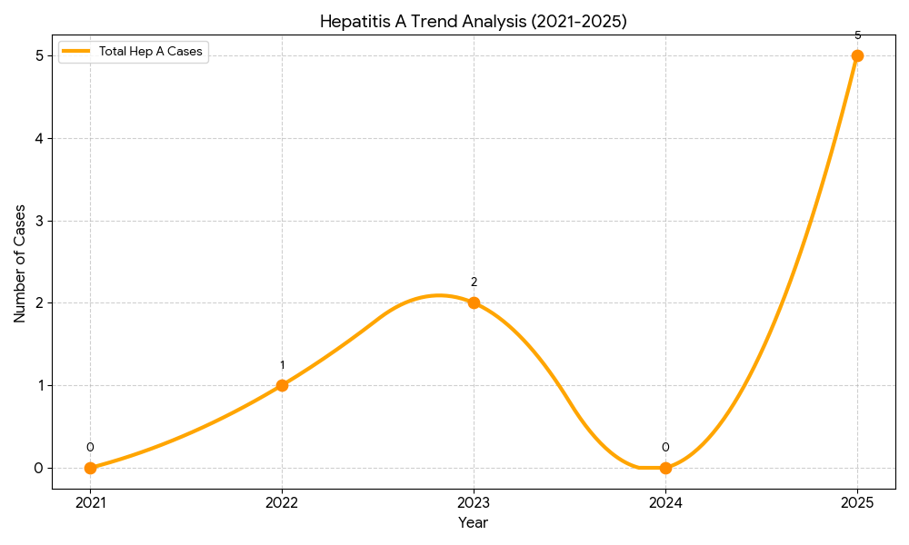
Ward 6 Hotspot: Ward 6 is the most consistently affected area, reporting cases in 2022, 2023, and 2025. It remains a primary focus for water quality surveillance.
2025 Surge: There was a significant spike in 2025 with $5$ cases recorded across five different wards (5, 6, 8, 10, and 14). This suggests a potential common-source issue or widespread water/food safety concerns during that period.
Increasing Trend: The smooth curve reflects an "Increasing" trend, as the number of cases in 2025 is the highest recorded in the five-year window.

Outcome-Based Trend Analysis- 2025
The chart below illustrates the trends for the most relevant diseases—ADD, Dengue, Tuberculosis, and Hepatitis A—using smoothed curves to highlight the progression of cases from 2021 to 2025.

Key Observations from the Smooth Trends:
- Acute Diarrheal Diseases (ADD): Shows a highly volatile pattern, with a significant peak in 2022 followed by a notable resurgence in 2025.
- Dengue: Displays a dramatic upward curve starting from 2022, peaking sharply in 2024 before a relative decline in 2025.
- Tuberculosis: Remains persistent with a notable peak in 2023, requiring sustained public health intervention.
- Hepatitis A: While case numbers are lower, the curve shows an emerging upward trajectory in 2025, marking it as a disease of increasing concern.
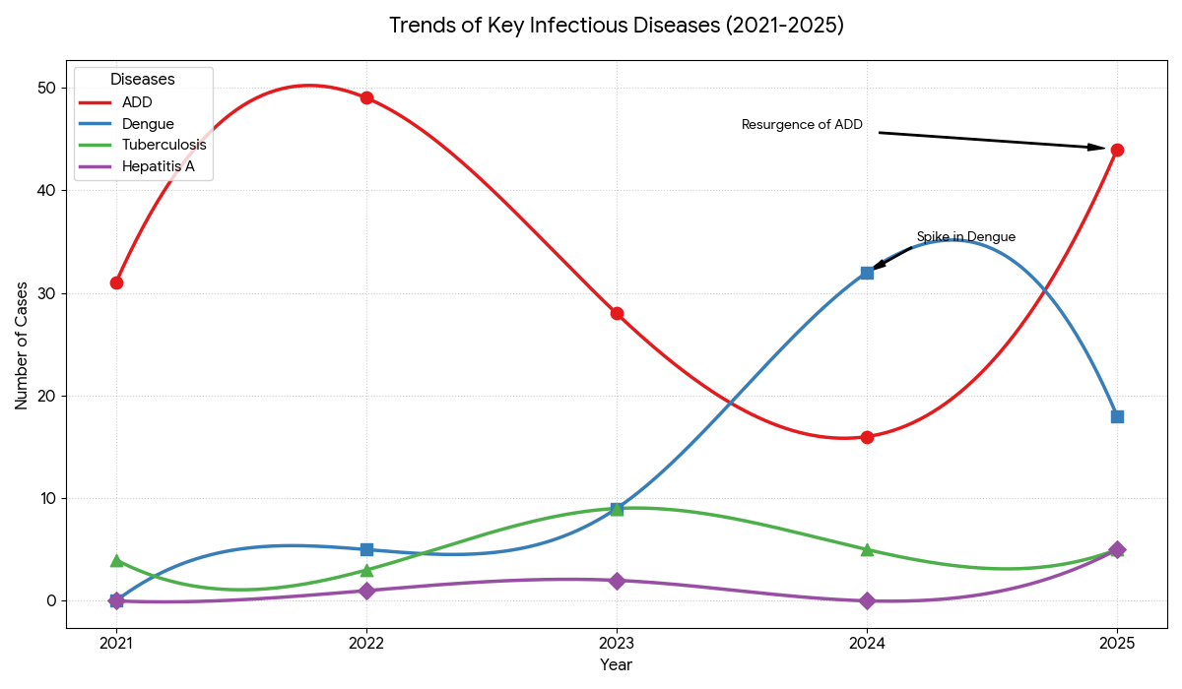

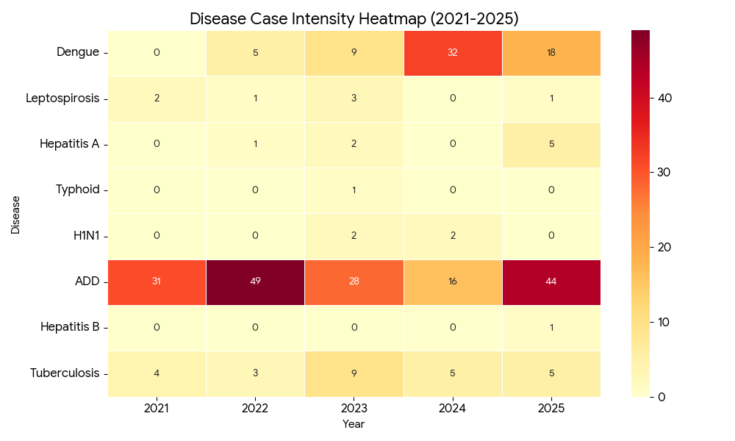

Transmission Trend- 2025
For effective management of public health issues, it is important to track the trend of disease transmission mode. It helps identify the population or place at high risk that can be used to predict outbreaks and implement targeted interventions as quickly as possible. Understanding these kinds of trends enables authorities to allocate resources efficiently and change the strategies adequately based on the trend that follows.

Mode of Transmission | No. of cases | No. of Deaths
Vector Borne Diseases | 16 | 0
Water Borne Diseases | 5 | 0
Air Borne Diseases | 20 | 0
Blood Borne Diseases | 1 | 0
Food Borne Diseases | 44 | 0

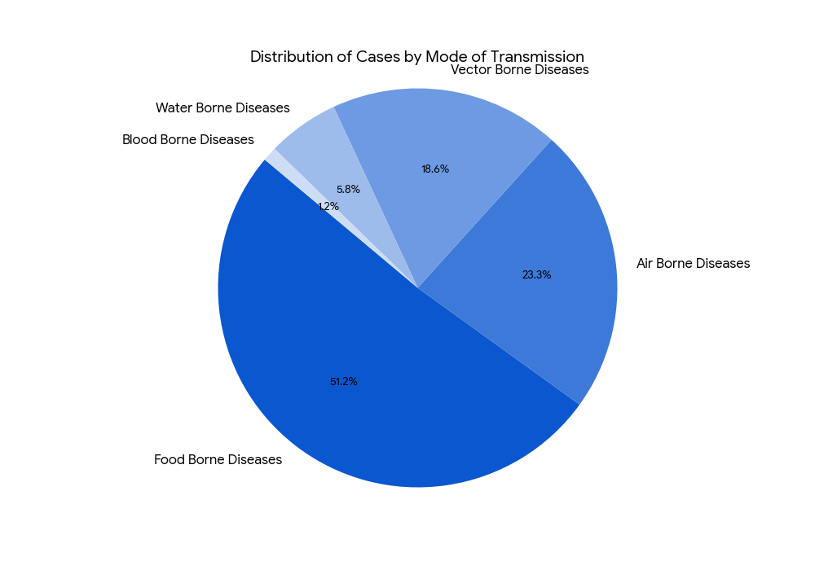

Vector-Borne Disease

Disease | No. of Cases | No. of Deaths
Dengue | 16 | 0
Malaria | 0 | 0
Chikungunya | 0 | 0

Water Borne Disease

Disease | No. of Cases | No. of Deaths
Cholera | 0 | 0
Typhoid | 0 | 0
Hep- A | 5 | 0
Dysentery | 0 | 0
Amoebiasis | 0 | 0
E- Coli infections | 0 | 0
Air Borne Disease

Disease | No. of Cases | No. of Deaths
Influenza | 0 | 0
H1N1 | 0 | 0
TB | 5 | 0
Chickenpox | 15 | 0
Measles | 0 | 0
Covid-19 | 0 | 0
Pertussis | 0 | 0
Mumps | 0 | 0

Blood-Borne Disease

Disease | No. of Cases | No. of Deaths
AIDS | 0 | 0
Hep- B | 1 | 0
Hep- C | 0 | 0

Zoonotic Disease

Disease | No. of Cases | No. of Deaths
Rabies | 0 | 0
Leptospirosis | 2 | 0
Avian influenza | 0 | 0
West nile | 0 | 0
Anthrax | 0 | 0
Nipah | 0 | 0
Scrub Typhus | 0 | 0

Integrated Disease Hotspot Map (2021–2025)
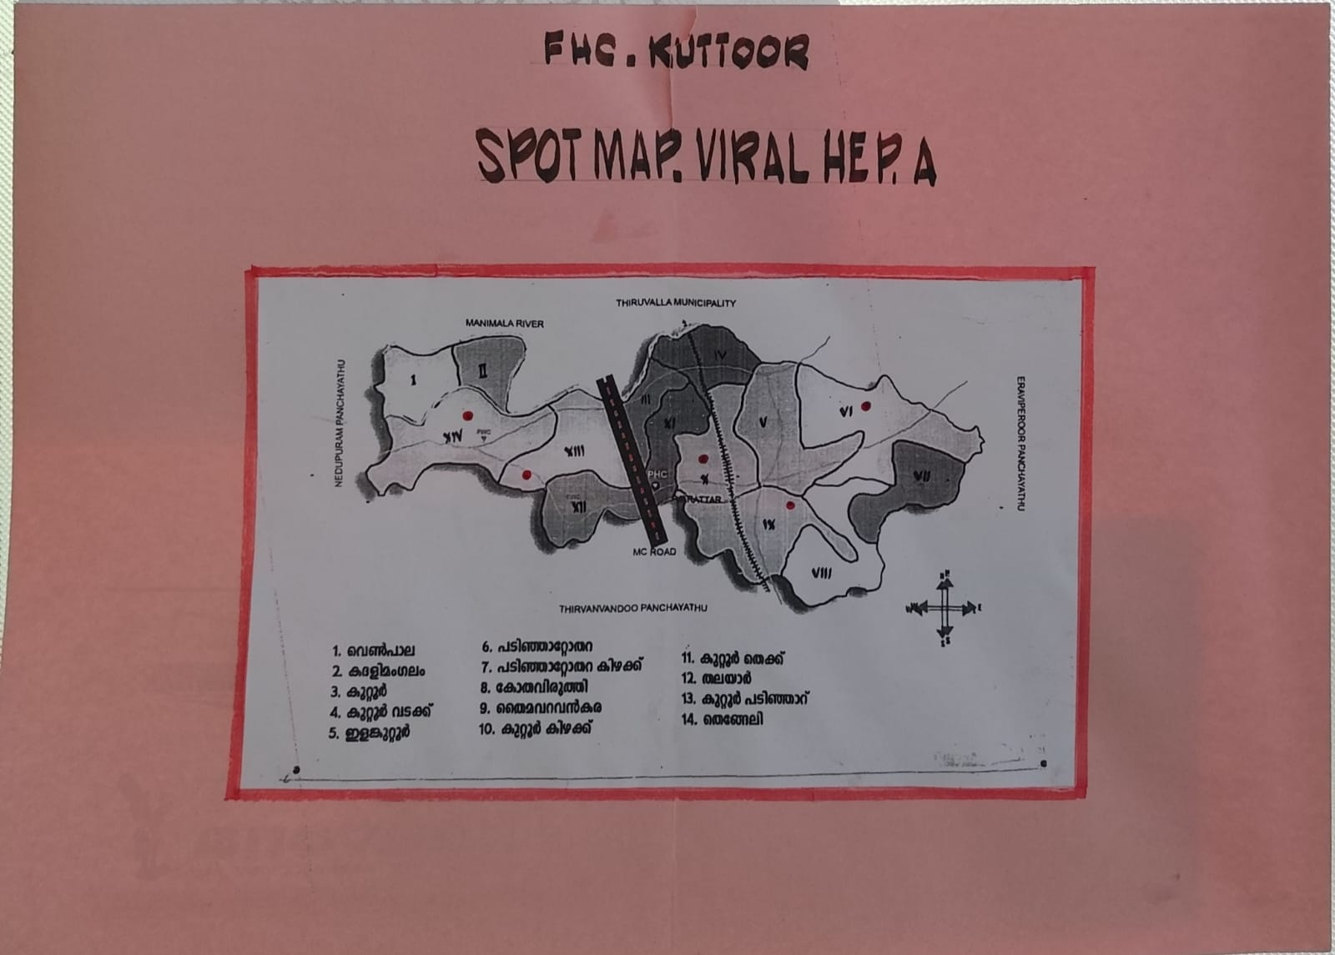
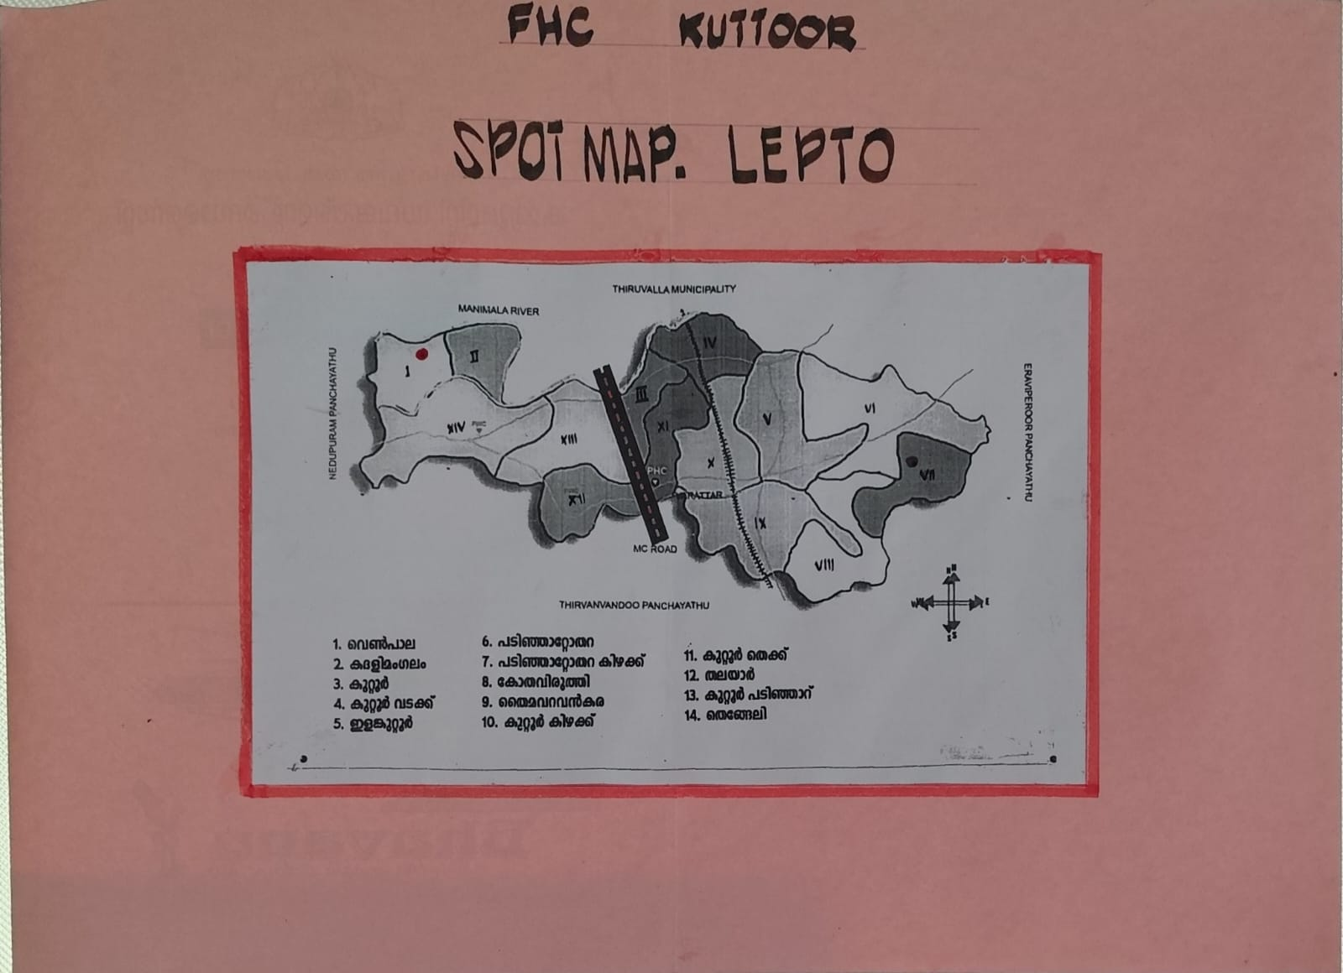

Ward No | Dengue Total (2021-25) | Leptospirosis Total (2021-25) | Hepatitis A Total (2021-25) | Mumps (2021-25) | ADD (2021-25) | Total Cases
1 | 5 | 0 | 0 | NA | 11 | 16
2 | 0 | 0 | 0 | 0 | 13 | 13
3 | 4 | 0 | 1 | 0 | 14 | 19
4 | 5 | 1 | 0 | 0 | 10 | 16
5 | 5 | 0 | 1 | 0 | 10 | 16
6 | 3 | 0 | 3 | 0 | 14 | 20
7 | 3 | 1 | 0 | 0 | 8 | 12
8 | 2 | 0 | 1 | 0 | 16 | 19
9 | 4 | 0 | 0 | 0 | 12 | 16
10 | 4 | 0 | 1 | 0 | 12 | 17
11 | 2 | 0 | 0 | 0 | 9 | 11
12 | 5 | 0 | 0 | 0 | 15 | 20
13 | 4 | 0 | 0 | 0 | 11 | 15
14 | 7 | 2 | 1 | 0 | 13 | 23
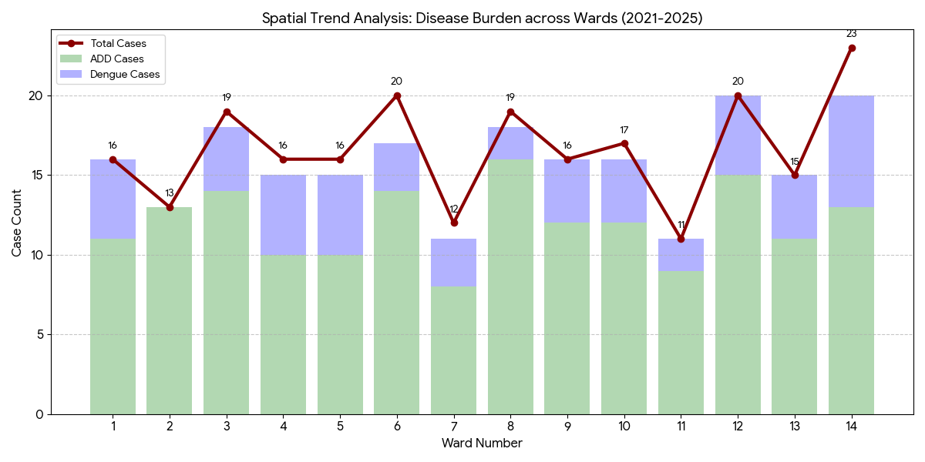
By overlaying five years of data, we have identified 'Red Zone' Wards. These are wards where at least two different categories of diseases (e.g., Dengue and Lepto) recurred in consecutive years. Ward 4 is categorized as the Highest Priority Hotspot due to its combination of flood vulnerability and high vector density.

Preparedness and Response Protocol at LSG Level
This section describes the operational framework for the LSGI once a pandemic is declared. It explains how the LSGI and health system will move from routine data collection to active response, using a One Health approach.

Constitution of One Health Committee
The LSGD shall constitute a One Health Committee comprising the LSGI President, Medical Officers (Modern Medicine, AYUSH, and Veterinary), the Health Inspector, and the Veterinary Surgeon.

Objective: The One Health Committee coordinates human, animal, and environmental health to prevent and control pandemics.

Sl No | Name | Designation | Department/Institution | Role in Committee | Contact Number
1 | Prasanna Satheesh | Panchayat President | LSGD | Chairperson | 9562376943
2 | Dr. Jayanth John Mathai | Medical Officer (PHC/CHC) | Health Dept | Member Secretary | 9496273113
3 | Dr. Sumayya | Veterinary Officer | Animal Husbandry | Member | 9497363748
4 | Dr. Dhanya B Mohan | Epidemiologist | Health Dept | Member | 9847140643
5 | Sakthikumar B | Health Inspector/PHN | Health Dept | Surveillance | 9446044039
6 | Lillykkutty George | ASHA Supervisor | Health Dept | Community link | 9447778930
7 | Preetha | ICDS Supervisor | Social Welfare | Vulnerable groups | 9744252882
8 | SI | Police Station Officer | Police Dept | Law & order | 9497980242.
9 | Deepa R Nair | Ward Councillor Representative | LSGD | Community coordination | 9961718337
10 | Smitha rajagopal | Kudumbashree CDO | Kudumbashree | Community mobilisation | 9947212775
11 | ALEYAS THEKKATTIL | NGO/Volunteer rep | Civil Society | Support services | 9496872705
12 |  | Line Department representations

Key Responsibilities:
- Review disease surveillance data (human + animal)
- Conduct ward-wise risk assessment and vulnerability mapping
- Approve quarantine/isolation centre locations
- Coordinate with district for resources (PPE, oxygen, ambulances)
- Periodically review health system surge capacity, including beds, oxygen, human resources, and ambulances.
- Approve and monitor risk communication and community engagement strategies, including rumour management.
- Ensure protection and service continuity for vulnerable groups (elderly, persons with disabilities, dialysis patients, coastal populations).
- Conduct quarterly mock drills
- Monitor equity measures for vulnerable groups

Meeting Schedule:
Quarterly - Normal times
Weekly - outbreak alert
Daily - pandemic phase

Pandemic Response Workforce
To ensure a coordinated and timely response during a pandemic, a dedicated Pandemic Response Workforce shall be constituted at the LSG level. The workforce will function under the overall supervision of the One Health Committee and in close coordination with the health authorities. Team-based deployment will enable efficient surveillance, case management, quarantine and isolation management, logistics support, and risk communication. Each team shall have a clearly designated team leader, defined roles, and an identified pool of personnel to allow rapid activation, rotation of duties, and continuity of services during prolonged emergencies.

Total Response Workforce Available: 300 persons

Team Name | Composition | No | Key Responsibilities | Team Leader
Surveillance and Contact Tracing Team | HI, JHI, JPHN, ASHAs and Volunteers | HI -1  JHI -2  JPHN-3  ASHA -16  VOLUNTERS -150 | Case detection, contact listing, home visits, reporting | HI
Case Management Team | Doctors, Nurses, MLSP, Palliative Nurses | Doctors-2  Nurses -2  MLSP-4  Palliative nurses -2 | Patient care & referral | DOCTOR
Quarantine & Isolation Team | LSGD staff, Volunteers | LSGD staff - 35  volunteers -100 | Facility management | JHI
Psychosocial support | AH COUNSELOR | 1 | counselling support | MO
Logistics & supply chain Team | LSGD staff, Storekeepers, Drivers 3 | LSGD staff-35  Drivers -3 | Supplies & transport [PPE, medicines, oxygen, transport, waste management] | Ward Member
Communication Team | Ward members, Kudumbashree, Youth clubs,  AWW workers and other self help groups | Ward members -14  Kudumbasree - 350  Youth Clubs- 2  AWW workers- 39 | IEC, community meetings, countering misinformation | M.O in charge
Transportation | KSRTC, educational institutional buses | KSRTC buses -20  Educational Buses-15 | Safety of individuals, patient/staff transport | JHI
Media Surveillance | T Cell, Local Journalists, Volunteers | Volunteers-100  Journalist -4 | Monitoring social media, tracking rumors | Public Relations Officer / HI
Intersectoral coordination and convergence | LSG President, Secretary, Health Staff | LSGD Staff -25  Health staff -25 | Policy decisions, resource pooling, convergence | LSG Secretary / President
Collaborative surveillance | Vets, Environmental Officers, Health Staff | Veterinary staff-10  Environmental Officers- 15  Health Staff -25 | One Health tracking (Animal-Human interface) | Veterinary Surgeon

All teams shall be activated immediately upon outbreak alert or pandemic declaration and shall report daily to the LSG Incident Commander/Medical Officer, with consolidated reporting to the Block PHC. Duty rosters and alternate personnel shall be maintained to ensure uninterrupted services during staff shortages or prolonged response periods. Team composition and numbers may be revised based on the magnitude of the outbreak and availability of human resources.

Activities and Measures before and during the Pandemic
Guidelines for active containment and monitoring.

PHASE 1 - Alert / Preparation

Activate One Health Committee
  - Immediately activate the One Health Committee at the LSG level. Convene an emergency meeting to review risk assessment, roles, and preparedness. Ensure coordination between Health, Veterinary, Agriculture, Local Self Government, and allied departments.
  - Prepare and circulate a contact directory of all committee members and emergency services.
  - Ensure documentation of decisions and action points with timelines.
  - Escalation hierarchy to be finalised (LSG to Institution to Block to District).

Surveillance and Reporting
Objective: To ensure early detection, timely reporting, and response to potential outbreaks through enhanced facility-, community-, and event-based surveillance
- Enhanced syndromic surveillance:
The LSGD shall initiate enhanced surveillance for priority syndromes and events such as:
  - Fever
  - Influenza-like illness (ILI)
  - Severe acute respiratory infection (SARI)
  - Unusual illness clusters (any unexpected increase in similar symptoms in a defined area or group)
- Data sources for surveillance:
- Ward-wise household surveillance (through ASHAs/JPHNs/ward volunteers)
- Outpatient surveillance from all government facilities (PHC, FHC, CHC, GH, etc.)
- Private hospitals, clinics, and labs
- Event-based triggers (to be monitored and reported):
- School absenteeism above the usual pattern (to be monitored through the headmaster/PTA nodal person)
- Sudden increase in pharmacy sales of fever/cough/cold medicines
- Workplace illness clusters (multiple staff reporting similar symptoms within a short period)
- Zoonotic and animal health surveillance
- LSGD shall review reports of unusual animal deaths or suspected outbreaks in animals in coordination with the Veterinary Officer.

- Any unusual mortality in poultry, pigs, cattle, companion animals, or wild birds/mammals shall be notified within 24 hours to the Veterinary Officer and One Health Committee for joint investigation.

Reporting Mechanism:
All government and private health facilities, laboratories, and clinics within the LSGD shall report suspected and confirmed cases of notifiable diseases. Unusual clusters (schools, workplaces, neighbourhoods, events, institutions) shall be reported within 24 hours of detection for verification and field investigation.​

Logistics and Stock Preparedness
  - Identify and empanel local vendors and define emergency procurement mechanisms in accordance with existing LSGD and Health Department norms.
  - Prepare and maintain an essential logistics checklist covering medical supplies, consumables, and support equipment.
  - Pre-identify secure storage locations for emergency stocks and ensure maintenance of stock registers with regular updating.
  - Finalise emergency transport arrangements, including availability of vehicles and identified drivers for rapid deployment during alerts.
  - Designate a Nodal Officer for Logistics to enable prompt decision-making, coordination, and communication during emergencies.
  - Conduct rapid stock verification and ensure availability of minimum buffer stock, including:
Commodities | Available stock
PPE kits | 0 numbers
Pulse oximeters | 5 numbers
Hand sanitizers | 4 litres
Masks, gloves, disinfectants | Mask - 204 Gloves -4000

Identify critical gaps in logistics and immediately communicate requirements to the Block and District authorities for timely replenishment and support. Monitor expiry dates and stock rotation.

Identification of Quarantine and Isolation Facilities -COMMUNITY HALLS
  - Identify and list suitable buildings for quarantine and isolation (schools, hostels, community halls, etc.).
  - Categorise cases as per the severity and allocate to appropriate facilities (for instance, severe cases to classrooms, mild cases to an assembly hall in case of a school).
  - Facility readiness checklist needed (beds, toilets, ventilation) etc.
  - Find an alternate site if the primary sites are not available or not in use.
  - Identify facility managers and support staff
  - Prepare basic SOPs for:
    - Admission and discharge
    - Food, water, sanitation
    - Infection prevention and waste disposal
  - Ensure availability of basic amenities: water, sanitation, electricity, ventilation, and waste disposal. Prepare a rapid activation plan for these facilities if case numbers increase.

Risk Communication and Community Preparedness
  - Disseminate early warning messages on symptoms, preventive measures, and reporting mechanisms. Display IEC materials both in English and the local language in public places and ensure ward-level awareness.
  - Sensitize elected representatives and community leaders on preparedness measures.
  - Establish a rumour tracking and misinformation response mechanism to identify, verify, and promptly counter false or misleading information.
  - Engage trusted local persons (ward members, ASHA workers, religious leaders, teachers, community volunteers) to communicate official public health messages and reinforce correct practices.
  - Develop and deploy targeted IEC materials for:
The following IECs were established by the FHC kuttor during the covid 19 and other diseases like Dengue ,Leptospirosis ,H1N1
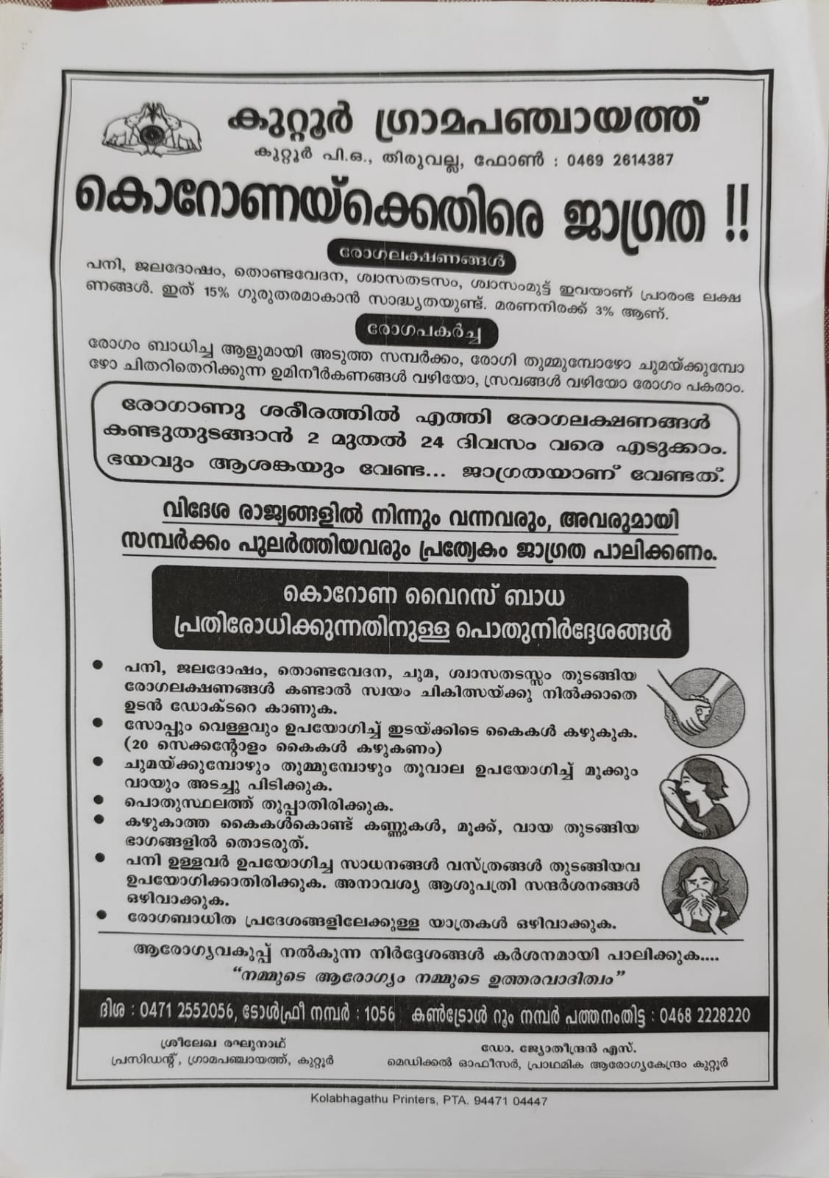

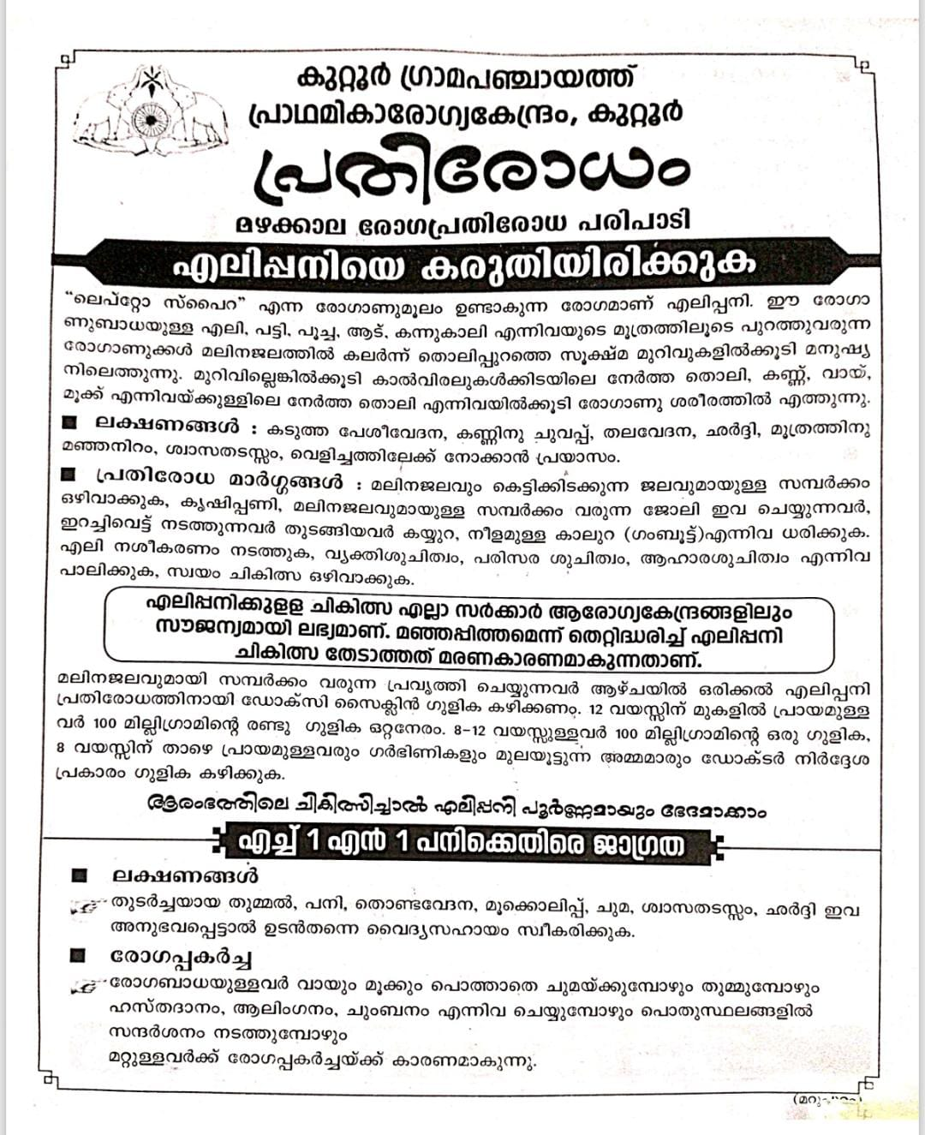
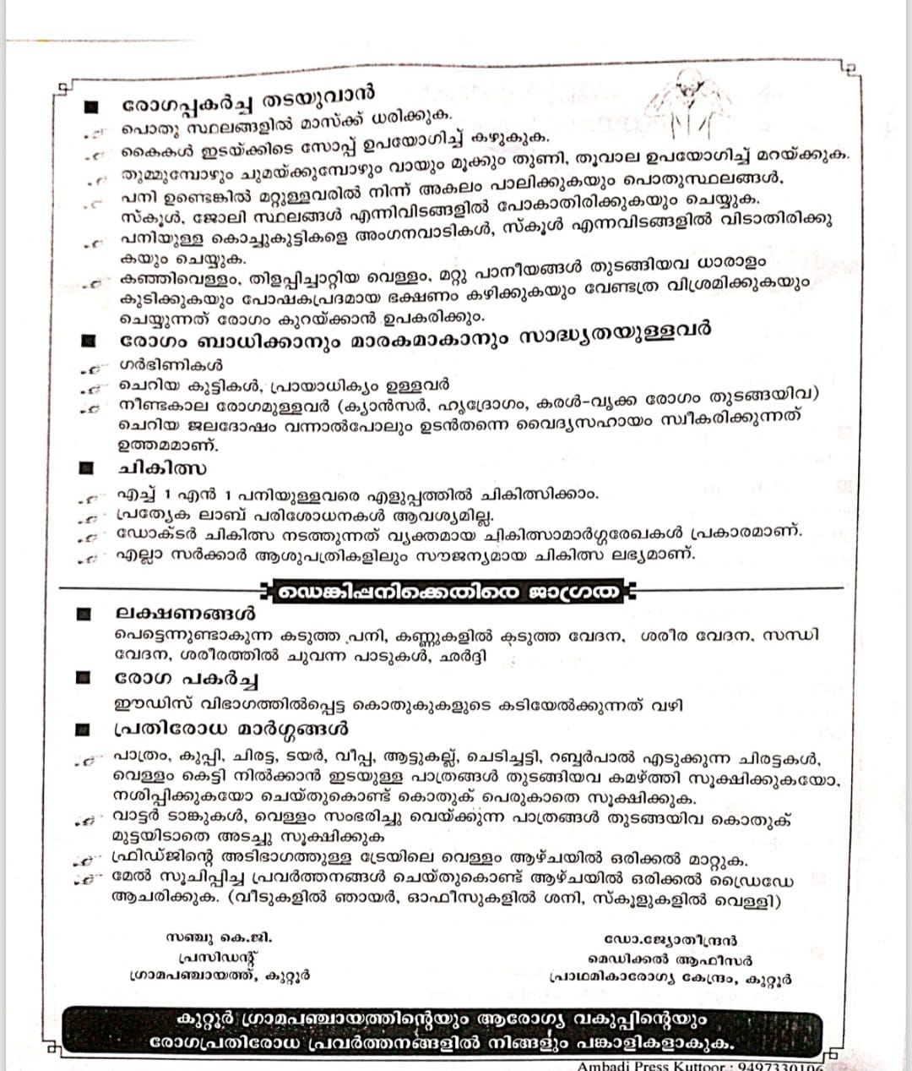
    - Schools and educational institutions
    - Markets and commercial areas
    - Work sites and labour settings
  - Conduct community sensitization meetings at the ward level to promote preventive behaviors, address concerns, and strengthen community participation in preparedness and response.

Protection of Vulnerable Groups
Vulnerable populations require priority protection through targeted line-listing, service continuity, and delivery mechanisms.
- Prepare and regularly update line-lists of vulnerable populations, including: WARD
  - Elderly persons living alone
  - Persons with disabilities
  - Pregnant women
  - Migrant workers
  - Dialysis patients
The detailed line-lists shall be maintained as Annexure 1 c and updated periodically.

Clinical Dependency Mapping -LAB ,AMUBULANCE MAPPING
Develop ward-wise dependency and vulnerability maps to identify households requiring regular support during emergencies. Ensure continuity of essential health services for vulnerable groups, including
- Dialysis services (facility mapping, transport arrangements, and scheduling)
- Continuity of treatment for TB, HIV, and other chronic conditions requiring uninterrupted medication
- Mental health and psychosocial support services
Establish delivery mechanisms for food, essential commodities, and medicines to vulnerable households through coordinated action involving ASHAs, JPHNs, Kudumbashree, volunteers, and local administration.

PHASE 2 - Active Response

Case Identification and Contact Tracing
Case detection and contact tracing activities will be carried out in coordination with the Health authorities, following disease-specific SOPs and IDSP guidelines.
Field Staff Involved
- Health Inspector (HI)
- Junior Health Inspector (JHI)
- Junior Public Health Nurse (JPHN)
- ASHAs and ASHA Supervisors
- Ward-level volunteers and Kudumbashree members (as required)

Screening Checkpoints
Screening checkpoints at high-traffic locations (transport hubs, markets, religious gatherings) for early detection of symptomatic travellers and crowd screening during outbreaks. Potential locations include bus stands, market entry points, and boat jetties, based on local context and risk assessment.
Screening activities will be carried out by trained personnel such as ASHAs, ward members, and volunteers, with support from Health Department staff. Necessary equipment, including non-contact thermometers and appropriate PPE, shall be ensured prior to activation.
Location | Type (Bus stand/Jetty/Market/Railway) | Staff Deployed (ASHAs/Volunteers) | Screening Method | Reporting authority
Bus stand | Transport hub | NA | - | -
Market entry | Market | NA | - | -
Boat jetty | Water transport | NA | - | -

Standard Screening Protocol

The screening protocol shall include temperature screening, observation for visible symptoms, and inquiry regarding recent travel or exposure history. Individuals identified as suspects during screening shall be immediately referred to the nearest PHC/FHC for further evaluation, testing, and appropriate action as per prevailing guidelines.

Pandemic Control Room
The Pandemic Control Room (PCR) serves as the central nerve center for real-time coordination, data aggregation, decision support, and communication during outbreaks. It consolidates information from all LSGD teams, health facilities and community sources to enable rapid response decisions.

Control Room Infrastructure and Location
Primary Location: Kuttoor Panchayath Office.
Backup Location: Community Hall in Kuttoor G.P.

Health System Control Room Framework
The PCR is organized into seven functional pillars to ensure no aspect of the response is overlooked:

Rapid Response Team (RRT)
  - Provides immediate intervention during emergencies, clusters, and field alerts.​
  - Coordinates urgent actions such as case investigation, contact tracing, isolation, and inter‑facility referrals.

Data Management & Analytics Team
  - Collects, validates, and manages key health system indicators (cases, tests, beds, HR, supplies).​
  - Analyzes data trends, generates projections, and supports evidence‑based decision‑making for local authorities.

Human Resource Deployment Team
  - Allocates healthcare staff efficiently based on workload and need
  - Ensures adequate and equitable workforce distribution across facilities

Laboratory Surveillance Team
  - Oversees diagnostic testing coordination, sample transport, and timely reporting of results.​
  - Monitors lab indicators (testing volume, positivity rate, turnaround time) for early detection of outbreaks

Vaccination Cell (If Required)
  - Plans and executes vaccination campaigns, including micro‑planning and session scheduling.​
  - Tracks coverage, identifies gaps, and coordinates corrective actions with field teams and outreach services.

Infrastructure & Patient Occupancy Team
  - Monitors facility capacity, earmarked beds, oxygen and critical care resources across all linked facilities.​
  - Ensures optimal patient distribution and referral management using updated bed‑status and resource data.
  - BMWM

8 .Communication Team
- Public Information & Risk Communication: Develops and disseminates clear, consistent, and culturally appropriate health advisories to the community.
- Combatting Misinformation: Actively monitors social media and local reports to identify and debunk rumors or "infodemics" that could jeopardize public safety.

9 .Logistics and Supply Chain
- Resource Procurement: Manages the inventory of Essential Medicines, Personal Protective Equipment (PPE), and hygiene supplies to ensure zero stock-outs.
- Distribution Management: Oversees the strategic allocation of supplies to field teams and health centers based on real-time consumption data and localized needs.

10 .Transportation (Inter-facility & Emergency Transport)
- Ambulance Coordination: Operates a centralized dispatch system for ambulances and emergency vehicles to ensure rapid transit for critical patients.
- Logistical Movement: Manages the movement of non-clinical assets, including the transport of samples to laboratories and the delivery of supplies to containment zones.

11. Media Surveillance & Call Centre
- Incident Monitoring: Tracks local news reports and community alerts to identify potential clusters or lapses in the response system before they escalate.
- Public Helpline: Operates a dedicated 24/7 call center to provide clinical guidance, mental health support, and information regarding bed availability to the general public.

12. Management of the Deceased
- Dignified Disposal: Ensures that the handling and final rites of the deceased are conducted with dignity and in strict adherence to infection control protocols.
- Family Liaison: Coordinates with bereaved families to provide necessary certifications and psychological support while ensuring safety during the funeral process.

Intersectoral Coordination and Convergence
- Stakeholder Alignment: Facilitates seamless collaboration between the Health Department, LSGD (Local Self-Government Department), Police, and Revenue officials.
- Policy Implementation: Ensures that administrative orders and health protocols are harmonized across all sectors to eliminate departmental silos and optimize the local response.

PCR Operational Workflow
Here is how the coordination flows within the Kuttoor Panchayath framework:
- The Core (PCR Leadership): The Panchayat President and Health Secretary act as the decision-makers, receiving data from the Data Management & Analytics pillar.
- The Field Responders: The RRT, Vaccination Cell, and Laboratory Surveillance teams feed real-time ground intelligence into the hub.
- Support & Logistics: The Logistics, Transportation, and HR Deployment teams ensure the field responders have the "boots on the ground" and supplies they need.
- Community Interface: The Communication, Call Centre, and Media Surveillance teams manage public perception and provide a direct line of help to the citizens.
- External Alignment: Intersectoral Coordination ensures that if a lockdown or a mass screening is needed, the Police and Revenue departments are already synced with the Health teams.

Key Control Room Team
The Control Room Team coordinates all pandemic response activities within the LSGD and serves as the single command and communication hub during activation. It integrates information, field actions, logistics, and policy execution across all participating departments and health facilities.

Role | Name | Designation | Contact Number | Responsibility
In-charge/Nodal Officer | Dr. Jayanth John Mathai | Medical Officer | 9496273113 | Overall coordination, decision-making, and reporting to the District level.
Data Entry Operator | Sajith S | OA | 9497360815 | Managing the line list, updating dashboards, and tracking testing results.
Communication Officer | Anu Thankam | PRO | 9747211456 | Handling the public helpline, coordinating ambulance dispatch, and contact tracing calls.
Logistics Coordinator | Baiju | JHI | 9495556594 | Managing the supply chain (PPE, meds, oxygen), coordinating with Kudumbashree for community kitchens, and overseeing waste management logistics.
Technical Support(IT/Data) | Anu | Clerk | 8921468092 | Ensuring hardware/network uptime, physical filing of records, assisting in rapid document dispatch, and maintaining the Control Room's physical infrastructure.

SOP for alert escalation/trigger point with mapping of responsibilities.
Key Points:
- The Control Room shall be staffed with a designated In-charge, data entry personnel, and communication staff with clearly defined roles and shift arrangements.
- It shall maintain updated records on daily monitoring indicators including new cases, persons under active quarantine, and hospital bed occupancy.
- All reports and situation updates shall be shared daily with the Block and District Surveillance Unit.
- The Control Room shall act as a single point of contact for coordination with response teams, health institutions, and other departments.
- Contact details of the Control Room shall be widely communicated to field staff and stakeholders during activation.

Daily Monitoring Indicators
To ensure timely decision-making and effective response, the following key indicators shall be monitored and updated on a daily basis by the Pandemic Control Room:

Epidemiological Indicators:
New cases reported today, Total active cases, Test Positivity Rate (TPR), Case Fatality Rate (CFR)
- Surveillance Indicators:
Persons under home quarantine, High-risk contacts identified, Fever, ILI, SARI or other symptoms (syndromic surges), Travellers (symptomatic or high-risk arrivals),Animal husbandry surveillance (zoonotic alerts, unusual animal deaths, poultry/bird flu signals), Mortality surveillance (excess deaths, unexplained fatalities, verbal autopsy reports)
- Logistics and Infrastructure Indicators:
Hospital / CFLTC beds occupied, Oxygen cylinders/concentrators available, Ambulances on standby
- Alert Findings
The following table outlines category-specific trigger points (red flags) from surveillance indicators and corresponding immediate actions for the Pandemic Control Room. These enable rapid response to alert findings like testing anomalies, positive cases exceeding thresholds, clusters, and WGS reports.

Category | Trigger Point (Red Flag) | Immediate Action
Clusters | Geographical or facility-based: 5+ cases linked to one location (office, school, street). | Declare a micro-containment zone; perimeter control and active case finding.
Testing | Sudden drop in testing volume / delay in reporting / unusual testing trends | Review the sample collection process, address lab bottlenecks, deploy additional testing teams, and notify the District Lab.
Lab | Test Positivity rate increases | Increase testing sites in that ward.
Hospital | >80% Oxygen bed occupancy | Activate backup/CFLTC beds.
Travel | Cluster of cases from a single flight/train or high-risk arrival group. | Trace all passengers in adjacent seats; implement mandatory institutional quarantine.
Animal | Mass poultry/wildlife death or unusual sickness | Notify Animal Husbandry, sample the area, and dispatch RRT for environmental sampling and zoonotic check.
Mortality | Sudden spike in home deaths or brought-in-dead (BID) cases | Audit the deaths and Active Case Search drive
Additional investigations like Whole Genome Sequencing (WGS) | Detection of a Variant of Concern (VOC) or Variant of Interest (VOI) | Implement strict micro-containment; update clinical protocols to match variant severity.

Communication of Public Health Information
A Community Communication Hub shall be established to ensure timely, accurate, and consistent dissemination of information during a pandemic. The Hub will function under the coordination of Nodal officers of the control room and act as the nodal point for public communication, risk messaging, and community engagement. It will support dissemination of official advisories, promote preventive behaviors, address rumors and misinformation, and ensure that messages reach all sections of the population through trusted local channels and leaders.

Key communicators
Channel | Responsible Person | Contact
Ward-level announcements | HI | 9446044039
Social media | JHI | 9495556594
Local Cable TV/Radio | HI | 9446044039

- All messages disseminated through the Hub shall align with advisories issued by the Health Department and District authorities.
- Community leaders shall be sensitized to support behavior change, reduce stigma, and counter misinformation.
- Special efforts shall be made to reach vulnerable and hard-to-reach populations using locally appropriate communication methods.

Rumor Tracking: A designated volunteer will monitor local social media/WhatsApp groups daily to identify misinformation and issue official clarifications via the Communication Hub.

Coordination with District/State Authorities & Other Organisations
Effective coordination with Block, District, and State authorities is essential to ensure timely reporting, technical guidance, and uninterrupted supply of essential resources during a pandemic. The LSG shall establish clear communication channels, designate responsible officers, and adhere to prescribed reporting timelines to support coordinated public health action and efficient resource mobilisation.

Key Details:
- Nodal Officer for Reporting:
- Contact Number:
Reporting Schedule and Protocols:

To Whom | What to Report | Frequency | Nodal Person
Block PHC | Complete Situation Report (Cases, Quarantine, Beds, Screening, Deaths) | Weekly | Block Medical Officer  Dr. Shoukkathali Puthukkara  9947060745
District IDSP Unit | Outbreaks/Clusters/Unusual Events (>5 cases same ward) | Monthly | Dr. Jeevan Nair  9847033362
Veterinary Officer | Animal health events/Zoonotic alerts | Monthly | Dr. Sumayya  9497363748
State Cell | Zoonotic cross-sector events | Monthly | SSO

Supply Chain Coordination
The LSG shall coordinate closely with Block, District, and State authorities (KMSCL) to ensure uninterrupted availability of essential goods, medical supplies, and logistics during a pandemic. Supply requirements shall be assessed regularly based on case load and communicated promptly to the appropriate authorities for timely replenishment.
Key Points:
- Maintain updated contact details of District and Block nodal officers for health logistics, oxygen supply, ambulances, and essential medicines.
- Submit timely indent requests for PPE, testing kits, medicines, oxygen, and other critical supplies through prescribed channels.
- Monitor stock levels at LSGD facilities, quarantine/isolation centres, and field teams through daily stock registers and dispensing logs to prevent shortages.
- Coordinate with District authorities, Karunya/Neethi medical shops, and local purchase committees for funds allocation and emergency procurement.

- Ensure regular monitoring of dispensing registers at all facilities to track usage, expiry, and pilferage—shortages being a perennial issue requiring proactive weekly audits.

- Activate surge procurement protocols during high caseloads, leveraging local purchase powers under LSGD funds alongside state supplies.

Resource Inventory and Contacts
Resource Category | Source  (District/State/Private) | Contact
PPE Kits/Masks/Gloves | KMSCL | 9995599249
PPE Kits/Masks/Gloves | Local Vendors | 9744800183
Oxygen  Cylinders/Concentrators | KMSCL | 9995599249
Medicines/Antivirals | KMSCL | 9995599249
Medicines/Antivirals | Neethi Shops | 9744800183
Test Kits (RTPCR/Rapid) | KMSCL | 9995599249

Collaboration with NGOs, PPP, and CSR
To augment government efforts during a pandemic, the LSG shall collaborate with NGOs, voluntary organisations, and private sector partners through public–private partnerships and Corporate Social Responsibility (CSR) initiatives, in coordination with District authorities.

Key Points:
- Engage NGOs and community-based organisations for community outreach, awareness, and support to vulnerable populations.
- Leverage CSR support for procurement of medical equipment, PPE, oxygen concentrators, food kits, and sanitation materials, as permitted.
- Ensure all collaborations align with government guidelines and are routed through approved administrative and financial procedures.
- Maintain transparency and documentation for all external support received and utilised.
Organization | Type | Support Offered | Contact Person
Youth Clubs/Student Unions | CBO | NA | NA

Interdepartmental Coordination
Coordination among departments during a pandemic shall be ensured through regular review meetings convened by the LSGD President. These meetings will provide a structured platform for sharing situational updates, assessing resource availability, resolving operational gaps, and taking joint decisions to ensure a coordinated and timely response.

Department | Representative | Key Role | Contact
Health (PHC) | Staff Nurse : Rani | Case management | 9562791622
Veterinary | Veterinary Surgeon:  Dr. Sumayya | Animal surveillance | 9497363748
ICDS | Supervisor:  Preetha Lakshmi  (In-charge) | Nutrition support | 9744252882
Education | Head Teacher:  Sreelatha | School coordination: High School Kuttoor | 8547788022
Police | Sub inspector | Containment enforcement | 9997987053
Water Authority | Supplier | Water supply | 0469 2700748
LSGD Engineering | Assistant Engineer | Quarantine infrastructure | 9497075525

PHASE 3 - Surge Capacity
Phase 3 is activated when there is a rapid increase in cases, high test positivity rates, or when existing health facilities and quarantine arrangements approach saturation. The focus of this phase is to expand isolation capacity, augment clinical care services, and mobilise additional resources through district and state support mechanisms.

Conversion of Community Facilities
To manage increased case load, the LSGD shall activate additional isolation facilities by repurposing identified community infrastructure such as community halls, auditoriums, schools, hostels, or other suitable buildings.

Name of facility | Facility Type | No. of Buildings | Ward | Surge Capacity (Beds) | Nodal Person
Kuttoor School | Govt School | 1 | 3 | 50 | 8547788022
AMM School | Govt School | 1 | 7 | 50 | 9446092763

Within the Kuttoor Grama Panchayath, there are a total of 14 schools, of which two specific institutions—Kuttoor School and AMM School—have been designated as primary centers for disaster management. Additionally, the jurisdiction includes two community halls available for emergency use, while currently, there are no hostel facilities allocated for such purposes.

- Recovery and rehabilitation phase

I. Infrastructure & Environmental Restoration
- Damage & Impact Assessment: The LSGD Engineering Wing conducts a rapid structural audit of all 14 schools and 2 community halls to ensure they are safe for re-occupancy.
- Restoration of Health Services: Prioritizes the "de-flooding" (if applicable) and deep sanitization of the Primary Health Centre (PHC). Ensures the cold chain for vaccines is re-verified before resuming routine immunization.
- Environmental Cleanup & Sanitation: A massive "Shuchitwa Mission" drive is launched to chlorinate all open wells in Kuttoor. The BMWM (Bio-Medical Waste Management) Team ensures that all hazardous waste from the PCR is disposed of via IMAGE (Indian Medical Association Goes Eco-friendly) protocols.

II. Human & Social Rehabilitation
- Rehabilitation of Affected Population: Coordinates the safe return of families from the Kuttoor and AMM School shelters to their homes, providing "Return Kits" (cleaning supplies and dry rations).
- Psychosocial & Mental Health Support: Deploys the "Pariraksha" model, where trained ASHAs and counselors conduct home visits to identify signs of PTSD, anxiety, or "survivor guilt" in the community.
- Livelihood Restoration: Links affected families to the MGNREGS (National Rural Employment Guarantee Scheme) for immediate income and coordinates with Kudumbashree units to provide micro-loans for small business restarts.

III. Health Surveillance & Research
- Disease Surveillance: The Laboratory Surveillance Team continues intensive monitoring for 21 days post-recovery to catch secondary outbreaks of water-borne (Leptospirosis, Cholera) or vector-borne (Dengue) diseases.
- Documentation & After-Action Review: The PCR compiles a "Chronicle of Response," documenting timelines, resource gaps (like the lack of hostels), and successful interventions.
- Research & Policy Revision: Analyzes the case data (like the 51.2% Food Borne Disease rate identified earlier) to propose new bylaws for local food stalls and catering units during festival seasons.

Phase | Duration | Focus Area | Key Actors
Immediate | 0–7 Days | Cleanup, Water Chlorination, PHC Restart | Suchitwa Mission, Health Inspectors
Short-term | 1–4 Weeks | Psychosocial First Aid, Livelihood mapping | Kudumbashree, ICDS (Anganwadis)
Long-term | 1–6 Months | Infrastructure hardening, Policy Revision | Panchayat Board, LSGD Engineering

CONCLUSION

The Pandemic Preparedness Plan for Kuttoor Grama Panchayat serves as a living roadmap to ensure that the community is not merely reactive, but strategically resilient in the face of public health emergencies. By centralizing operations within the Pandemic Control Room (PCR) at the Panchayat Office and designating Kuttoor and AMM Schools as primary relief centers, the administration has established a clear physical and operational command structure.
The strength of this plan lies in its multidisciplinary approach. From the Rapid Response Teams (RRT) managing immediate clinical risks to the LSGD Engineering Wing overseeing structural recovery, every pillar is designed to close the gap between data and action. Furthermore, the focus on Food-Borne Disease prevention (addressing the 51.2% historical case majority) and the integration of Psychosocial Support ensures that both the physical and mental well-being of Kuttoor’s residents remain a priority throughout the recovery phase.
Ultimately, the success of this plan depends on the "Convergence" of local self-government, healthcare professionals, and the community. Through continuous documentation, after-action reviews, and the strengthening of laboratory surveillance, Kuttoor Panchayat is committed to evolving its strategies, ensuring that lessons learned today become the lifesaving protocols of tomorrow.

Additional points

This "First 24-Hour" Action Plan serves as the immediate operational trigger for the Kuttoor Grama Panchayat upon the notification of a potential outbreak or disaster.

Kuttoor Panchayat: The Golden Hour Response (0–24 Hours)

Phase 1: Mobilization (Hours 0–4)
- PCR Activation: The President and Health Secretary officially open the Pandemic Control Room at the Panchayat Office. If the office is compromised, operations shift to the Kuttoor G.P. Community Hall.
- Power & Tech Check: KSEB is alerted to prioritize the PCR grid. Tech Support ensures high-speed internet and dashboard connectivity are live; Ham Radio Operators establish a backup link to District HQ.
- RRT Deployment: The Rapid Response Team is dispatched to the initial "index case" or cluster location for immediate field investigation.

Phase 2: Infrastructure & Logistics (Hours 4–12)
- Shelter Readiness: Kuttoor School and AMM School are unlocked and sanitized. The Infrastructure Team verifies bed capacity and water supply.
- Supply Chain Trigger: The first batch of Relief-Based Commodities (mats, blankets, hygiene kits) is moved from the central store to the designated schools.
- Vulnerability Overlay: The Data Analytics Team pulls the Hazard Vulnerability Map to identify high-risk households (elderly, bedridden, or low-lying areas) near the identified cluster.

Phase 3: Communication & HR (Hours 12–18)
- Public Advisory: The Communication Team issues the first official bulletin via loudspeakers, WhatsApp groups, and local cable TV to prevent panic.
- Duty Roster Activation: HR Specific Responsibilities are assigned via a 24-hour shift roster. ASHAs and Anganwadi workers are briefed on their specific wards.
- Call Centre Launch: The Media Surveillance & Call Centre goes live to handle public inquiries and triage symptomatic callers.

Phase 4: Consolidation (Hours 18–24)
- Intersectoral Briefing: A meeting is held with Police, Revenue, and KSEB officials to synchronize containment zone boundaries and transit routes for Transportation teams.
- First Situation Report (SITREP): The Data Team compiles all findings into a single report for the District Medical Officer (DMO), outlining cases, resource gaps, and the 48-hour projection.

Immediate Action Summary Table
Timeframe | Action Item | Lead Responsibility
0-2 Hours | PCR Command Setup | Panchayat President
2-6 Hours | Shelter/School Activation | LSGD Engineering Wing
6-12 Hours | Resource Mobilization | Logistics & Supply Chain
12-24 Hours | Community Outreach | Communication & ASHA Teams

RECOMMENDATIONS

Strengthening Healthcare Infrastructure
- Establish a primary health response unit within the Panchayat with trained staff.
- Ensure availability of basic medical supplies (masks, sanitizers, PPE kits, oxygen cylinders).
- Create tie-ups with nearby hospitals in thiruvalla or emergency referral and transport.

2. Community Awareness & Education
- Conduct regular awareness campaigns on hygiene, vaccination, and preventive measures.
- Use local communication channels (community radio, WhatsApp groups, notice boards) to spread verified information.
- Train volunteers to act as health ambassadors in each ward.

3. Emergency Response & Coordination
- Form a Pandemic Preparedness Committee at Panchayat level including health workers, ward members, and NGOs.
- Develop a clear action plan for lockdowns, quarantine, and distribution of essentials.
- Maintain a database of vulnerable groups (elderly, differently-abled, chronically ill) for targeted support.

4. Supply Chain & Food Security
- Identify and support local suppliers and farmers to ensure uninterrupted food supply.
- Create community kitchens during emergencies to serve vulnerable populations.
- Stockpile essential commodities in Panchayat-run outlets for crisis periods.

5. Digital Preparedness
- Promote digital platforms for telemedicine consultations.
- Use Panchayat’s website/social media for real-time updates on health advisories.
- Encourage online grievance redressal to reduce crowding in offices.

6. Training & Capacity Building
- Organize mock drills for pandemic response in schools, offices, and public spaces.
- Train Panchayat staff and volunteers in first aid, infection control, and crowd management.
- Collaborate with NGOs and health departments for capacity-building workshops.

7. Long-Term Resilience
- Integrate pandemic preparedness into the Panchayat Development Plan.
- Allocate a dedicated budget for health emergencies.
- Encourage community participation in planning and monitoring preparedness measures.

MOCKDRILL SCENARIOS
On 7 May 2025 at 4 pm, the Kerala State Disaster Management Authority and the Union Ministry of Home Affairs conducted civil defence mock drills in all 14 districts of Kerala, with alert sirens sounded to simulate wartime or emergency situations. The sirens were part of instructions for residents to switch off lights, create a blackout, and follow safety protocols; a short “all-clear” siren sounded around 4:28 pm to signal the end of the exercise. These drills took place in 126 locations statewide, including crowded public places, offices, malls, and community centres, to test preparedness and evacuation procedures (Ref: KSDMA)

Mock Drill Scenario: "Operation Monsoon Shield" (Leptospirosis)

I. The Trigger: The "Silent" Cluster (08:00 AM)
- Incident: Three MGNREGS (National Rural Employment Guarantee Scheme) workers from Ward 8 are admitted to the PHC with high fever, calf muscle pain, and congested eyes (redness).
- Vulnerability Context: Ward 8 was partially waterlogged two weeks ago following heavy rains.
- The Intelligence: Media Surveillance flags a report of "unusual rodent activity" near the Kuttoor School storage area.

II. Immediate Activation: The Prophylaxis Push (09:00 AM – 11:00 AM)
- PCR Command: The President activates the PCR. The Data Management Team identifies all 42 workers who were at the same worksite.
- HR Specific Responsibility: ASHAs are assigned to track every worker for "Doxycycline Compliance."
- Tech Support: Updates the "Prophylaxis Tracker" on the PCR dashboard to ensure 100% coverage of high-risk groups.

III. Environmental Strike & Logistics (11:00 AM – 01:30 PM)
- Sanitation (BMWM & LSGD): The Environmental Cleanup Team initiates a "Rodent Control Drive" and intensive chlorination of all water sources in Ward 8.
- Logistics: Relief-Based Commodities (rubber boots and gloves) are rushed to the remaining field workers to prevent further exposure.
- Ham Radio Check: A simulated "Mobile Tower Down" in Ward 8 forces the RRT to use Ham Radio Operators at the Panchayat Office to request more Larvicides/Rodenticides.

IV. Clinical Triage & Transport (01:30 PM – 03:30 PM)
- The "Hurdle": One worker develops "Weil’s Disease" symptoms (jaundice and decreased urine output).
- Response: The Transportation Team coordinates an emergency transfer. Since the primary road is "simulated blocked" by a protest, the Intersectoral Coordination team (Police) must clear a "Green Corridor" for the ambulance.
- Call Centre: Handles a surge of calls from panicked parents at Kuttoor School asking if the school is safe for children.

V. Community Engagement & Review (03:30 PM – 05:00 PM)
- Communication: The team releases a video testimonial of a "Recovered Patient" to encourage early reporting and discourage self-medication.
- Documentation: The After-Action Review (AAR) focuses on whether the Hazard Vulnerability Mapping correctly predicted the risk in Ward 8.
- Lessons Learned: The Panchayat Board discusses a new policy for mandatory PPE for all LSGD field workers during the monsoon.

ANNEXURE

IMPORTANT PHONE NUMBERS

Phone numbers and particulars of persons responsible for providing guidance, assistance, and support for pandemic preparedness operations may be provided here in a manner that allows easy reference at a glance.The information recorded here could be exhibited elsewhere at the time of emergencies. LSG institutions shall give special attention to collect and record the above data of persons and institutions who/which are supposed to give technical and co-ordination support to reduce the impact of pandemic.

1.1. Details of grama panchayat/municipality/corporation wards
Sl.No | Name of the ward | Ward number | Name of the ward  member | Contact number
1 | VENPALA | 1 | ABHILASH | 9605757058
2 | KADALIMANGALAM | 2 | RAJEEV | 9947187355
3 | KUTTOOR | 3 | DEEPA.S.NAIR | 9961718338
4 | KUTTOOR VADAKKU | 4 | GOPAKUMAR | 9048583570
5 | ELAKUTTOOR | 5 | REJI THOMAS | 7827403375
6 | PADIJATTOTHARA | 6 | ANUPAMA | 9747441548
7 | PADIJATTOTHARAKIZAKKU | 7 | BAIJU | 9447757822
8 | KOTHAVIRUTHI | 8 | PUSHPA VALSAKUMAR | 9400614046
9 | THYMARAVANKARA | 9 | ALEYAS THEKKATTIL | 9496872705
10 | KUTTOOR KIZHAKKU | 10 | MINIUMMAN | 8113060028
11 | KUTTOOR THEKKU | 11 | RADHIKA UTTHAMAN | 9447779053
12 | THALAYAR | 12 | RAJALEKSHMI | 9539041698
13 | KUTTOORPADIJARU | 13 | PRASANNA | 9562376942
14 | THENGELI | 14 | AJITHA | 99615219096

1.2. Other important phone numbers of grama panchayat/municipality/corporation area
Sl. No. | Name | Contact number
1. | PANCHAYATH PRESEDENT | 9562376942
2. | PANCHAYATH SECRETARY | 9207543567
3. | AROGYA STANDING COMMITTEE CHAIR PERSON | 9961521996
4. | Excise department(EXCISE RANGE OFFICE THIRUVALLA) | 04692707632
5. | Forest department | NO

1.3. Important offices of grama panchayat/municipality/ corporation
Sl.No | Name of the office | Contact person | Contact number
1. | Village Office | Village Officer | 04692616100
2. | Agriculture Office | Agriculture Officer | 7994245742
3. | Animal Husbandry Office | Animal Husbandry Doctor | 9497363748
4. | Police Station | Police Officer | 9997987053
5. | BSNL Office | Officer | 04692600300
6. | Block Office | Officer | 8281040530
7. | KSEB Office | Officer | 04762690244
8. | Fisheries Office | Officer | NIL
9. | Fire and Rescue | Officer | 04692600101

1.4. Health Services

Sl. No | Name of the hospital/institution | Location | Phone number
1. | Government hospitals/PHC | PHC Kuttoor | 04692614297
2. | Private hospitals | Nil
3. | Clinical laboratories | Kuttoor, West Othera | 9072938008
4. | Chemist/pharmacy | PHC Kuttoor | 04692614297
5. | Blood donors | TMM blood bank | 7947148163
6. | Other language experts (Bihari, Hindi, Bengali,  Asamees ………) | NA | NA

1.5. Veterinary Services
Sl.No | Name of the Clinic | Name of the  Surgeon/Doctor | Place/location | Phone  number
1 | Govt.Veterinary Hospital | DR.SUMAYYA | KUTTOOR | 9497363748

1.6. Helpline numbers
Helpline | Phone number
Police | 9997987053
Fire and Rescue | 04692600101
KSEB | 04762690244

1.7. Public and Private Schools Contact details

S.No | Name of School | Ward | Institution type | Phone number
1 | UPS WEST OTHARA | 6 | Aided | 9961808721
2 | AMM HS WEST OTHARA | 8 | Aided | 9496148659
3 | SALPS VENPALA | 14 | AIDED | 9495628237
4 | CMSLPS KOTHAVAIRUTHI | 9 | AIDED | 9446458519
5 | PTPM UPS THYMARAVUMKARA | 10 | AIDED | 9446711151
6 | EALPS WEST OTHARA | 8 | AIDED | 9400617072
7 | KADALIMANGALAM DLPS | 2 | AIDED | 9526781202
8 | GOVT LPS WEST OTHARA | 5 | GOVT | 9449817209
9 | GOVT LPS THENGAYLI | 13 | GOVT | 9446585605
10 | GOVT LPS PANDISSERY | 4 | GOVT | 9946727848
11 | GOVT HSS KUTTOOR | 3 | GOVT | 8547788022
12 | MTDM ENGLISH MEDIUM SCHOOL | 14 | PRIVATE | 9447942503
13 | ST MERRY ENGLISH MEDIUM SCHOOL | 7 | PRIVATE | 9446579660
14 | THOMAS CANA NURSERY SCHOOL | 3 | PRIVATE | 9497487185

1.9. Anganwadi Contact Details

Ward No | Name of Anganwadi Teachers | Anganwadi Number | Phone number
1 | VIJIMOL | AW 52 | 9961461885
11 | ACHAMMA | AW 49 | 9961718423
4 | ANJU | AW 53 | 8089967027
4 | SINDHU | AW 45 | 9539914883
6 | SUDHA | AW 52 | 9074147528
10 | SHEELA | AW 57 | 9544199060
10 | RAJALEKSHMI | AW 58 | 9562966474
11 | VIMALA | AW 47 | 9544308634
11 | ALEYAMMA | AW 61 | 8086937629
12 | ASHA KUMARI | AW 55 | 9526115862
12 | SOSAMMA | AW 123 | 9605520430
2 | SYAMALA DEVI | AW 60 | 9447800977
14 | JAYASREE | AW 59 | 7510555722
15 | RAJESHWARI | AW 153 | 9526115862
15 | SUNIJA | AW 48 | 9544884850
5 | ASWINI | AW 50 | 9645563940
5 | JAYANTHI | AW 46 | 9633658064
6 | MALATHI | AW 122 | 9562109567
7 | BINDHU JAIN | AW 51 | 8848788585
7 | SUNI | AW 54 | 6282349197

1.12. Information regarding resources

Means of transportation | Name of Owner | Phone Number
Heavy Trucks | Eicher Trucks and Buses Service Center | 8071 178 940
Tractor | Mahindra Tractor - Jeevitha Associate, Spare Parts and Service | 90720 21005
Ambulances | MEDCO EMERGENCY AMBULANCE SERVICE | 81570 59967
Boats | Nil | nil
Taxi service | Gaadicab | 9665 70 3666

Annexure 1: LSG Baseline Data Collection Format
A. Baseline data
Sl. No. | Indicator / Field | Baseline Data | Source / Remarks
1 | Name of LSG | Kuttoor | LSGD DATA
2 | District | Pathanamthitta | LSGD DATA
3 | Block / Taluk | Pulikkeezhu | LSGD DATA
4 | Type of LSG (Gram Panchayat / Municipality / Corporation) | Gramapanchayath | LSGD DATA
5 | Area (sq. km) | 12.6 | LSGD DATA
6 | No. of wards | 14 | LSGD DATA
7 | GIS boundary file available | Yes | LSGD DATA
8 | Key contact person & phone | Smt.Prasanna 9562376943 | Panchayat president

B. Demography
Indicator / Field | Baseline Data | Source / Remarks
Total population | 23578 | LSGD DATA
Males | 11730 | LSGD DATA
Females | 11848 | LSGD DATA
Transgender population | 0 | LSGD DATA
Age distribution  (<5, 5–14, 15–59, ≥60) | 619,818,19065,3076 | LSGD DATA
No. of households | 6129 | LSGD DATA
Population density (persons/sq.km) | 1.9 | LSGD DATA
No. of migrant workers | 206 | LSGD DATA
Major occupational groups | Agriculture | LSGD DATA

C. Vulnerable Populations & Social Risks
Sl. No. | Indicator / Field | Baseline Data (Value / Description) | Source / Remarks
1 | No. of elderly (≥60) | 3250 | FIELD DATA
2 | No. of persons with disability | 173 | FIELD DATA
3 | No. of bedridden persons | 125 | FIELD DATA
4 | No. of chronic disease cases (DM/HTN/COPD/CKD etc.) | 4031 | FIELD DATA
5 | Pregnant women (current estimate) | 51 | FIELD DATA
6 | Children <5 years | 502 | FIELD DATA
7 | Tribal population (if any) | 1 | FIELD DATA
8 | Fisherfolk / coastal vulnerable groups (if any) | 0 | FIELD DATA
9 | Urban slums / unnotified settlements (if any) | 13 | FIELD DATA
10 | Homeless population | 106 | FIELD DATA
11 | Orphanages / old age homes (number & capacity) | 7 | FIELD DATA
12 | Hostels / prisons / shelters (number & capacity) | 0 | FIELD DATA
13 | Poverty / BPL estimate | 3610 | FIELD DATA
14 | Food insecurity hotspots | 0 | FIELD DATA
15 | Any history of stigma/discrimination issues (Yes/No) | NO | FIELD DATA

D. Health System & Service ReadinessGH
Sl. No. | Indicator / Field | Baseline Data 1(Value / Description) | Source / Remarks
1 | No. of health facilities in LSG (PHC/CHC/TH/DH/Private) | 1 (PHC) | LSGD DATA
2 | PHC/Family Health Centre details (name, location) | PHC KUTTOOR ,KUTTOOR THIRUVALLA | LSGD DATA
3 | Subcentres / Health & Wellness Centres (number) | 4 | LSGD DATA
4 | Private clinics / hospitals (number) | 5(Including Homeo and Dental clinics) | LSGD DATA
5 | Labs available (public/private) | 1 Public Lab (PHC Kuttoor)  3 Private Lab | LSGD DATA
6 | Availability of ambulance services (Yes/No, number) | Yes (Private) | LSGD DATA
7 | Availability of isolation/quarantine facilities (Yes/No, details) | No | LSGD DATA
8 | Cold chain facilities (Yes/No, details) | YES | LSGD DATA
9 | Stockpile space available (Yes/No) | No | LSGD DATA
10 | PPE / mask / sanitizer availability plan (Yes/No) | YES | LSGD DATA
11 | Surveillance staff available (JHI/JPHN/ASHA count) | JHI 2 ,JPHN 4, ASHA 17 | LSGD DATA
12 | Existing emergency referral pathways (Yes/No) | YES | LSGD DATA

E. Points of Entry & Mobility
Sl. No. | Indicator / Field | Baseline Data (Value / Description) | Source / Remarks
1 | Bus stands / depots (number) | NO | LSGD DATA
2 | Railway stations (number) | NO | LSGD DATA
3 | Boat jetties / fishing harbours (number) | NO | LSGD DATA
4 | Ports / airports nearby (specify distance) | NO | LSGD DATA
5 | Major highways/roads passing through | MC ROAD | LSGD DATA
6 | Border crossings (state/district) | NO | LSGD DATA
7 | Major markets / weekly markets | NO | LSGD DATA
8 | Tourism hubs / major event venues | NO | LSGD DATA
9 | Schools/colleges with hostels (number) | 14 | LSGD DATA
10 | Factories / large workplaces (number) | 2 | LSGD DATA
F. Water, Sanitation & Hygiene (WASH)
Sl. No. | Indicator / Field | Baseline Data (Value / Description) | Source / Remarks
1 | Major drinking water sources (piped / wells / borewells / springs) | PIPED,WELL | LSGD DATA
2 | No. of public wells | 25 | LSGD DATA
3 | No. of households with piped water connection | 3252 | LSGD DATA
4 | Water quality testing routine (Yes/No) | Yes | LSGD DATA
5 | Common contamination risks (flooding, salinity, industrial waste) | Yes | LSGD DATA
6 | Open defecation free status (Yes/No) | Yes | LSGD DATA
7 | Solid waste management system (Yes/No) | No | LSGD DATA
8 | Bio-medical waste disposal mechanism (Yes/No) | Yes (PHC Kuttoor) | LSGD DATA
9 | No. of public toilets | Nil | LSGD DATA
10 | Handwashing stations in public places (Yes/No) | No | LSGD DATA
G. Zoonotic Risks & One Health
Sl. No. | Indicator / Field | Baseline Data (Value / Description) | Source / Remarks
1 | Livestock population (cattle/goats/pigs/poultry) – estimates | Cattle-536  Goat-235 Paultry-6491 | VETERINARY DEPARTMENT
2 | No. of dairy farms / poultry farms / pig farms | Poultry farm-1 | VETERINARY DEPARTMENT
3 | Slaughterhouses / meat shops (number) | Nil | VETERINARY DEPARTMENT
4 | Animal markets (Yes/No, details) | Nil | VETERINARY DEPARTMENT
5 | Veterinary dispensaries (number) | 1 | VETERINARY DEPARTMENT
6 | History of zoonotic outbreaks (rabies, leptospirosis, avian flu etc.) | Lumpy skin | VETERINARY DEPARTMENT
7 | Stray dog population management measures (Yes/No) | No | VETERINARY DEPARTMENT
8 | Rodent infestation hotspots (Yes/No) | Yes | VETERINARY DEPARTMENT
9 | Wetlands / waterlogged areas prone to leptospirosis | Yes | VETERINARY DEPARTMENT
10 | Bat roosting areas / caves / fruit orchards (if any) | No | VETERINARY DEPARTMENT
11 | Human-animal interface hotspots (farms near residences) | No | VETERINARY DEPARTMENT

H. Climate & Disaster Risks (Pandemic Amplifiers)
Sl. No. | Indicator / Field | Baseline Data (Value / Description) | Source / Remarks
1 | Flood-prone wards (list) | 12,14 | FIELD DATA
2 | Landslide-prone wards (list) | NO | FIELD DATA
3 | Cyclone/sea surge risk (Yes/No) | NO | FIELD DATA
4 | Heatwave risk zones (Yes/No) | NO | FIELD DATA
5 | Waterlogging areas (list) | Venpala | FIELD DATA
6 | Shelter homes / relief camps (number, capacity) | West othera (25)  Kuttoor (50) | FIELD DATA
7 | Past disaster displacement history | Yes, Flood & Land slide | FIELD DATA
8 | Disruption to water supply/transport common (Yes/No) | Yes | FIELD DATA
I. Critical Infrastructure & Logistics
Sl. No. | Indicator / Field | Baseline Data (Value / Description) | Source / Remarks
1 | Schools (number) | 14 | LSGD DATA
2 | Anganwadis (number) | 20 | LSGD DATA
3 | Colleges (number) | 0 | LSGD DATA
4 | Community halls (number) | 2 | LSGD DATA
5 | Places of worship with large gatherings (number) | 0 | LSGD DATA
6 | Large markets / shopping areas (number) | 1 Kuttoor | LSGD DATA
7 | Warehouses / cold storages (number) | 0 | LSGD DATA
8 | Telecom/mobile network coverage gaps (Yes/No) | Yes | LSGD DATA
9 | Power outage frequency (high/medium/low) | medium | LSGD DATA
10 | Availability of generators in key facilities | 1-PHC Kuttoor | LSGD DATA

J. Risk Communication & Community Networks
Sl. No. | Indicator / Field | Baseline Data (Value / Description) | Source / Remarks
1 | Ward-level rapid response teams (Yes/No) | Yes | LSGD DATA
2 | Jagratha samithis / committees active (Yes/No) | Yes | LSGD DATA
3 | Kudumbashree presence and strength (number of units) | 20 | LSGD DATA
4 | Volunteer network (number, coverage) | Yes- 150 | LSGD DATA
5 | Community-based surveillance mechanisms (Yes/No) | Yes | LSGD DATA
6 | IEC dissemination channels (WhatsApp groups, community radio, PA systems) | Yes | LSGD DATA
7 | Rumour tracking mechanisms (Yes/No) | Yes | LSGD DATA
8 | Languages spoken / literacy considerations | Yes | LSGD DATA
9 | Vulnerable groups communication strategy available (Yes/No) | Yes | LSGD DATA

K. Preparedness Planning & Governance
Sl. No. | Indicator / Field | Baseline Data (Value / Description) | Source / Remarks
1 | LSG emergency plan available (Yes/No) | Yes | LSGD DATA
2 | Pandemic preparedness plan available (Yes/No) | Yes | LSGD DATA
3 | Incident Command System identified (Yes/No) | No | LSGD DATA
4 | Rapid procurement mechanism available (Yes/No) | Yes | LSGD DATA
5 | Emergency fund available (Yes/No, amount) | Yes | LSGD DATA
6 | Past outbreak response experience (Yes/No, details) | Yes | LSGD DATA
7 | Intersectoral coordination mechanism (Health, Police, LSG, Veterinary, Education) | Yes | LSGD DATA
8 | Mock drills conducted in last 12 months (Yes/No) | Yes | LSGD DATA
9 | Training coverage for staff/volunteers (Yes/No) | Yes | LSGD DATA

L. Surveillance & Data Systems
Sl. No. | Indicator / Field | Baseline Data (Value / Description) | Source / Remarks
1 | Digital reporting tools used (e.g., DHIS2, portals) | Yes | FIELD DATA
2 | Availability of line-listing format (Yes/No) | Yes | FIELD DATA
3 | Contact tracing team identified (Yes/No) | Yes | FIELD DATA
4 | Mapping of high-risk households available (Yes/No) | Yes | FIELD DATA
5 | Testing sample transport mechanism (Yes/No) | Yes | FIELD DATA
6 | Reporting timeline adherence (good/average/poor) | Good | FIELD DATA
7 | Data sharing between departments (Yes/No) | Yes | FIELD DATA
8 | Availability of dashboard for monitoring (Yes/No) | Yes | FIELD DATA

M. Additional Notes & Observations
Sl. No. | Indicator / Field | Baseline Data (Value / Description) | Source / Remarks
1 | Key challenges perceived by LSG | Lack of Relief camp facilities | FIELD DATA
2 | Top 5 high-risk wards (reason) | Venpala - Flood , Communicable disease | FIELD DATA
3 | Any unique local risks (industrial pollution, refugee camps, etc.) | Nil | FIELD DATA
4 | Recommendations for preparedness strengthening | Provide adequate facility for PHC | FIELD DATA

