PANDEMIC PREPAREDNESS PLAN
NEDUMPRUM GRAMAPANCHAYAT
FHC NEDUMPRUM
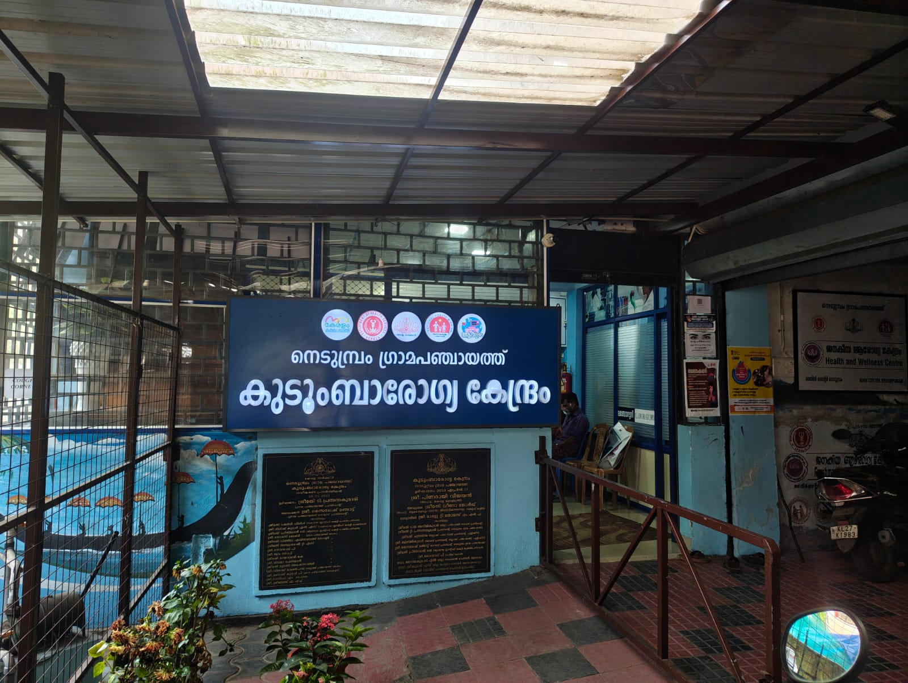
MESSAGE FROM PRESIDENT
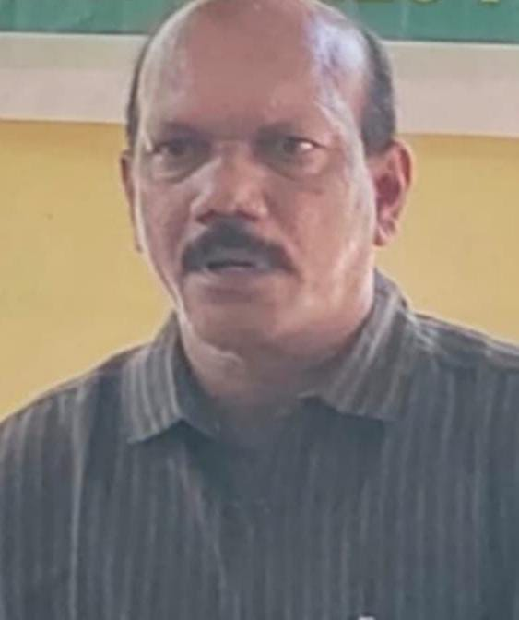
Our panchayat ,with its diverse population of farmers small-industry workers, farmers and migrant workers from other states, is particularly vulnerable to epidemics ,outbreaks and natural disasters. the hardship these events cause,including loss of life and working days,are significant
it is our duty as a local -self government to manage these crises effectively and minimise the suffering of our people.
To address these challenges ,we must implement a comprehensive action plan that prioritises public participation and cross-departmental co ordination .this plan will ensure that any health crisis or disaster is swiftly reported and the relief efforts are organised scientifically and efficiently.
i urge all stake holders -including residents ,community leaders ,and governmental and non governmental bodies - to join forces in supporting this initiative.your co-operation is vital for the success of this plan and for safeguarding the health and well being of our community in the future.let us work together to ensure a healthier ,safer future for all
Sincerely,
Balachandran k
panchayat president
MESSAGE FROM HEALTH STANDING COMMITTE - CHAIRMAN
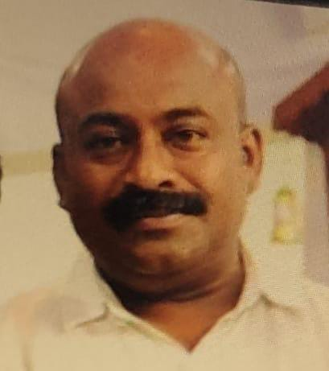

Nedumpuram grama panchayath, with its unique geographic location surrounded by water on
two sides,is home to a diverse population.Our community comprises individuals engaged in
various sectors including agriculture ,dairy farming,industry and migrant workers from with in and outside the country. This diverse economic base ,while a source of strength,also makes us vulnerable to the spread of infectious diseases ,whether local or global.

It is our shared responsibility to prevent loss of life and reduce the physical and mental hardships caused by such diseases .To effectively tackle these challenges ,we must develop and deploy a scientific ,participatory action plan that leverages public-private partnerships and interdepartmental co ordination

The local self government Department (LSGD) is dedicated to promoting public health ,but this cannot be accomplished done. It is only through community involvement and cooperation that we can safe guard the health and well being of our people.

I call on all stake holders -community members ,health workers,and local authorities - to come together ,just as we have before ,to fight potential epidemics and protect our future health,economic stability ,and social welfare .

Let us unite for the greater good of our community.
Best regards

Rinson Thomas
Health Standing Committee Chairman

MESSAGE BY MEDICAL OFFICER


As the Medical Officer of the Family Health Centre (FHC)Nedumprum , I want to express my deepest concern for the health and well-being of our community. While we have successfully navigated the complexities of the recent pandemic, our focus must now shift toward localized threats. This preparedness plan allows us to transition from general care to precision health, ensuring we protect our most vulnerable residents from the persistent risks of seasonal outbreaks and environmental hazards.
Our Pandemic Preparedness Plan is built on the pillars of integrated surveillance and rapid response. By mapping environmental risks—from flood-prone zones to water-borne disease clusters—we are no longer merely reacting to emergencies but anticipating them. This strategy ensures that our medical teams and emergency responders are synchronized, making our intervention during critical situations a life-saving reality for every household.
I wish great success for this preparedness plan and the continued health of our people. This is a shared mission, and I am confident that through our collective vigilance and commitment to hygiene and vector control, we can maintain our safety records and build a resilient health system.
Together, let us ensure our community remains a safe and healthy heaven for all.
Dr Julie George
Medical Officer
FHC NEDUMPRUM
EXECUTIVE SUMMARY

Nedumpuram Grama Panchayat, situated at the confluence of the Manimala and Pamba rivers, is a defining landscape of the Upper Kuttanad belt. Geographically characterized by its low-lying terrain—with much of the land sitting at or below sea level—the Panchayat is interlaced by a dense network of rivers, canals, and expansive paddy fields (Kole lands). While these water bodies are the lifeblood of the local agricultural economy, they also render all 14 wards highly vulnerable to recurrent seasonal flooding. This unique hydrological setting creates a complex public health environment, where the risk of waterborne, vector-borne, and zoonotic diseases is a persistent reality.
With a population of approximately 12,695 residing in 4,551 households, Nedumpuram faces specific demographic and environmental challenges. The community relies on more than 2,800 open wells, which are prone to groundwater contamination during flood surges. Furthermore, the high density of elderly residents (28% of the population) and a significant BPL community necessitate a specialized approach to disaster management. Lessons learned from previous emergencies, including the COVID-19 pandemic and major flood events, have underscored the urgent need for a structured, locally contextualized Pandemic Preparedness Plan that bridges the gap between environmental reality and healthcare delivery.
This plan adopts a One Health framework, integrating the Nedumpuram Family Health Centre (FHC), private sectors like Manak Hospital, and the Government Veterinary Hospital to monitor the human-animal-environment interface. By focusing on ward-level microplanning, advanced Hazard Vulnerability Mapping, and resilient communication tools like HAM Radio, Nedumpuram aims to transform its geographical vulnerabilities into institutional strengths. Through intersectoral coordination and community-led vigilance, the Panchayat is committed to ensuring a healthier, safer, and more resilient future for all its residents.

LIST OF ABBREVIATIONS

LSGD | Local Self Government Department / Local Self Government Institution
BMO | Block Medical Officer
IDSP | Integrated Disease Surveillance Programme
NDMA | National Disaster Management Authority
PPE | Personal Protective Equipment
ICMR | Indian Council of Medical Research
CD | Communicable Diseases
NCD | Non-Communicable Diseases
KSIDC | Kerala State Industrial Development Corporation
covid | Coronavirus Disease
CAPD | Continuous Ambulatory Peritoneal Dialysis
TB | Tuberculosis
PHC | Primary Health Center
FHC | Family Health Center
AYUSH | Ayurveda, Yoga & Naturopathy, Unani, Siddha, and Homoeopathy
THQH | Taluk Head Quarters Hospital
MCH | Medical College Hospital
USG | Ultrasonography (Ultrasound Scan)
RT-PCR | Reverse Transcription Polymerase Chain Reaction
CT, MRI | Computed Tomography, Magnetic Resonance Imaging
NCC/NSS | National Cadet Corps, National Service Scheme
CBO | Community-Based Organizations
SHG | Self-Help Groups
NGO | Non-Governmental Organizations
SOP | Standard Operating Procedure
ILI, SARI | Influenza-Like Illness, Severe Acute Respiratory Infections
CFLTC | COVID First Line Treatment Centre

TABLE OF CONTENTS

3
INTRODUCTION 9
● Background of the PPP 9
LSGD AT A GLANCE 9
INTEGRATED HEALTH INFRASTRUCTURE MAP OF NEDUMPRUM PANCHAYAT 10
GENERAL PROFILE OF THE LSGI’S 13
Background of the LSGI 13
Demographic and Vulnerable Population 14
Clinical Vulnerability 16
INFRASTRUCTURE & RESOURCE INVENTORY 18
Health Facility Directory & Basic Capacity in the LSGD 18
Private Clinics 19
Healthcare Education & Training Institutions 20
Specialized Services & Emergency Inventory 20
Oxygen & Diagnostic Capacity 21
Diagnostics facility mapping at the LSGI level 22
Laboratory Identification & Basic Details 22
Social and Community Infrastructure for surge plan 22
Human resources 24
Community & Support Cadre 25
Community Organizations 26
Administrative & Emergency Services 27
Information regarding resources 27
ONE HEALTH & ENVIRONMENTAL SURVEILLANCE 28
Animal & Bird Population 28
Veterinary Infrastructure 29
Veterinary Doctors & Workforce 30
High-Risk Interface Points (Surveillance Sites) 30
Environmental Risk Mapping 31
Disease Seasonality Mapping 32
Vulnerability Mapping 33
EPIDEMIOLOGICAL TRENDS (2021–2025) 34
Disease Burden among human beings(Last 5 Years) 34
*(use the above table data to create the graph/diagram) 36
Seasonal Trend Analysis 37
Outcome-Based Trend Analysis- 2025 39
Transmission Trend- 2025 40
Integrated Disease Hotspot Map (2021–2025) 42
Preparedness and Response Protocol at LSG Level 44
Constitution of One Health Committee 44
Pandemic Response Workforce 45
Activities and Measures before and during Pandemic 47
PHASE 1 - Alert / Preparation 47
PHASE 2 - Active Response 50
Standard Screening Protocol 51
PHASE 3 - Surge Capacity 60
Conversion of Community Facilities 60
CONCLUSION 61
RECOMMENDATIONS 62
ANNEXURE 63
1. IMPORTANT PHONE NUMBERS 63

INTRODUCTION

Background of the PPP

Nedumpuram Grama Panchayat, with its unique geographic location surrounded by water on two sides, is home to a diverse and vibrant population engaged primarily in agriculture, fishing, and small-scale livelihoods. While this setting enriches the socio-economic fabric of the Panchayat, it also increases vulnerability to recurrent flooding across multiple wards, leading to displacement, waterborne diseases, and public health risks. Drawing lessons from repeated flood events and the COVID-19 pandemic, the Panchayat prioritizes an integrated disaster and pandemic preparedness approach focusing on strengthened surveillance, early warning systems, safe water and sanitation measures, vector control, One Health coordination, rapid response activation, and community participation to ensure resilience and continuity of essential services.

LSGD AT A GLANCE
- Baseline data

Ward | Houses | Population | Migrants | Wells | Hot  spots | Ed. Institutions | Hosp pvt/govt.
14 | 4551 | 12695 | 57 | 2722 | 3 | 7 | 2

Nedumprum represents 14 wards with a significant demographic and infrastructural hub, supporting a substantial population of 12,695 residents across 4,551 households. The ward is well-equipped with essential services, including seven educational institutions and two healthcare facilities (split between private and government sectors). While the ward maintains a stable local community, it also integrates 57 migrants into its social fabric. From a public health and environmental standpoint, the area relies heavily on decentralized water sources with 2,722 wells recorded; however, the identification of three specific hotspots suggests targeted areas that require focused monitoring or intervention to manage localized risks effectively.

Ward wise distribution

Ward | Houses | Population | Migrants | Wells | Hot  spots | Ed. Institutions | Hosp pvt/govt.
1 | 287 | 801 | 0 | 108 | 0 | 1 | 0
2 | 353 | 985 | 5 | 182 | 0 | 0 | Pvt hosp-1
3 | 298 | 831 | 4 | 116 | 0 | 0 | 0
4 | 342 | 954 | 17 | 231 | 0 | 1 | 0
5 | 312 | 870 | 8 | 198 | 0 | 0 | 0
6 | 350 | 976 | 0 | 163 | 0 | 2 | 0
7 | 323 | 901 | 0 | 219 | cherumuttam | 0 | 0
8 | 327 | 912 | 0 | 254 | malayathra | 0 | 0
9 | 327 | 912 | 0 | 249 | 0 | 1 | 0
10 | 297 | 828 | 5 | 119 | 0 | 0 | 0
11 | 319 | 890 | 18 | 221 | palliyarathazham | 0 | 0
12 | 324 | 904 | 0 | 243 | ottathengu | 1 | 0
13 | 358 | 999 | 0 | 218 | 0 | 0 | 0
14 | 334 | 932 | 0 | 201 | 0 | 1 | 0
- Risk stratification among wards in the context of Communicable diseases and hazards

Risk Category | Ward No. | Name of the Ward
High Risk | 8 | murnjachira
 | 9 | malayathira
 | 12 | ottathenga
Low Risk | all other wards except 8,9,12 | all other wards except 8,9,6

Geographical boundaries - ward boundaries map

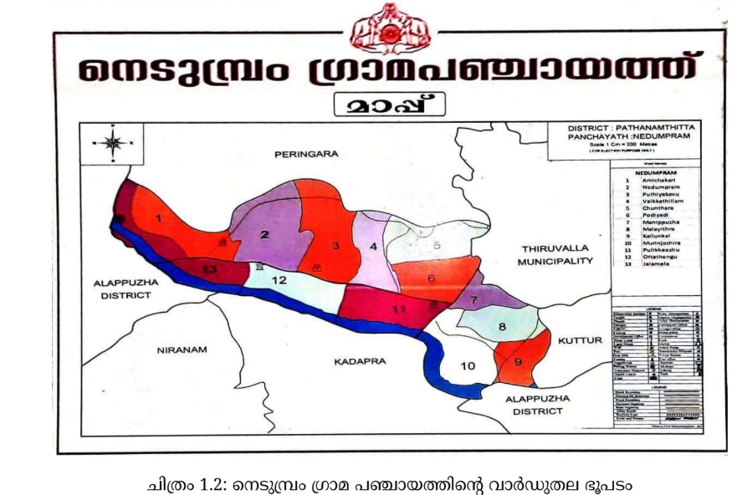

INTEGRATED HEALTH INFRASTRUCTURE MAP OF NEDUMPURAM GRAMA PANCHAYAT
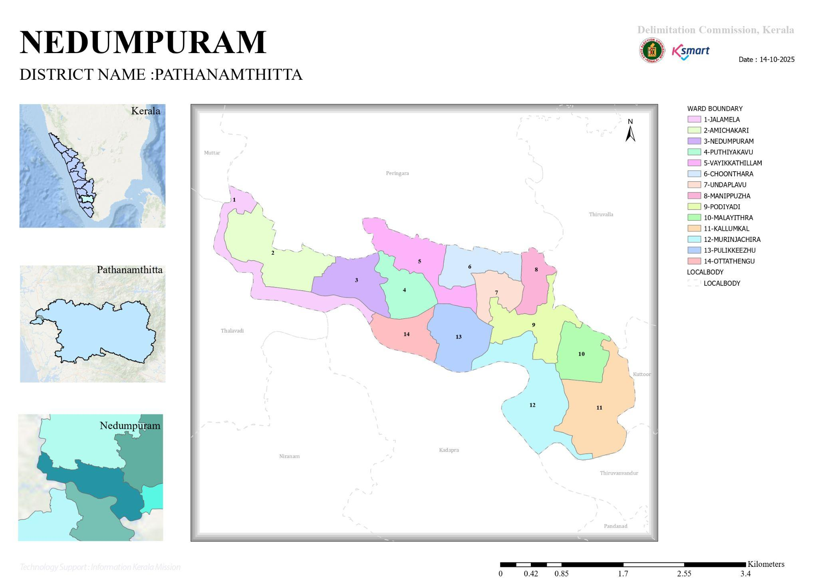

Roads and rivers map

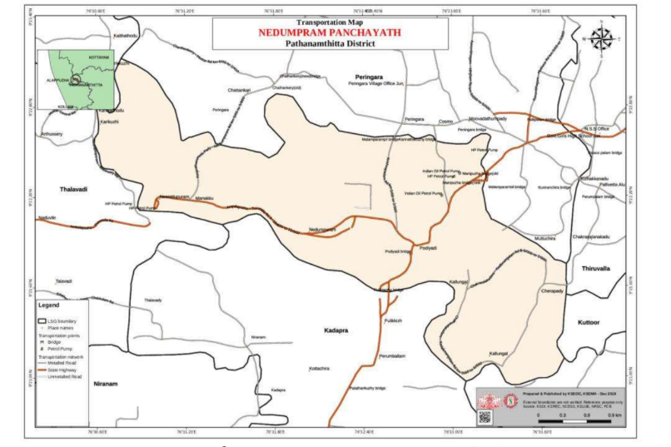

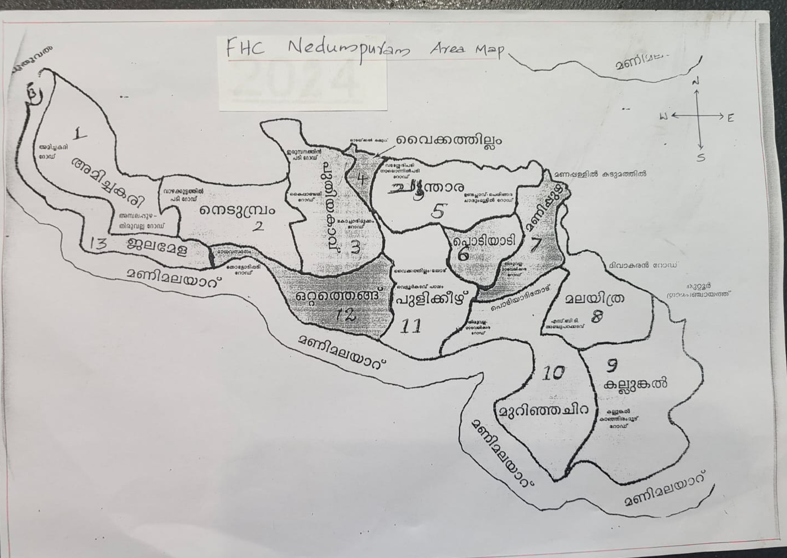

Major establishments map
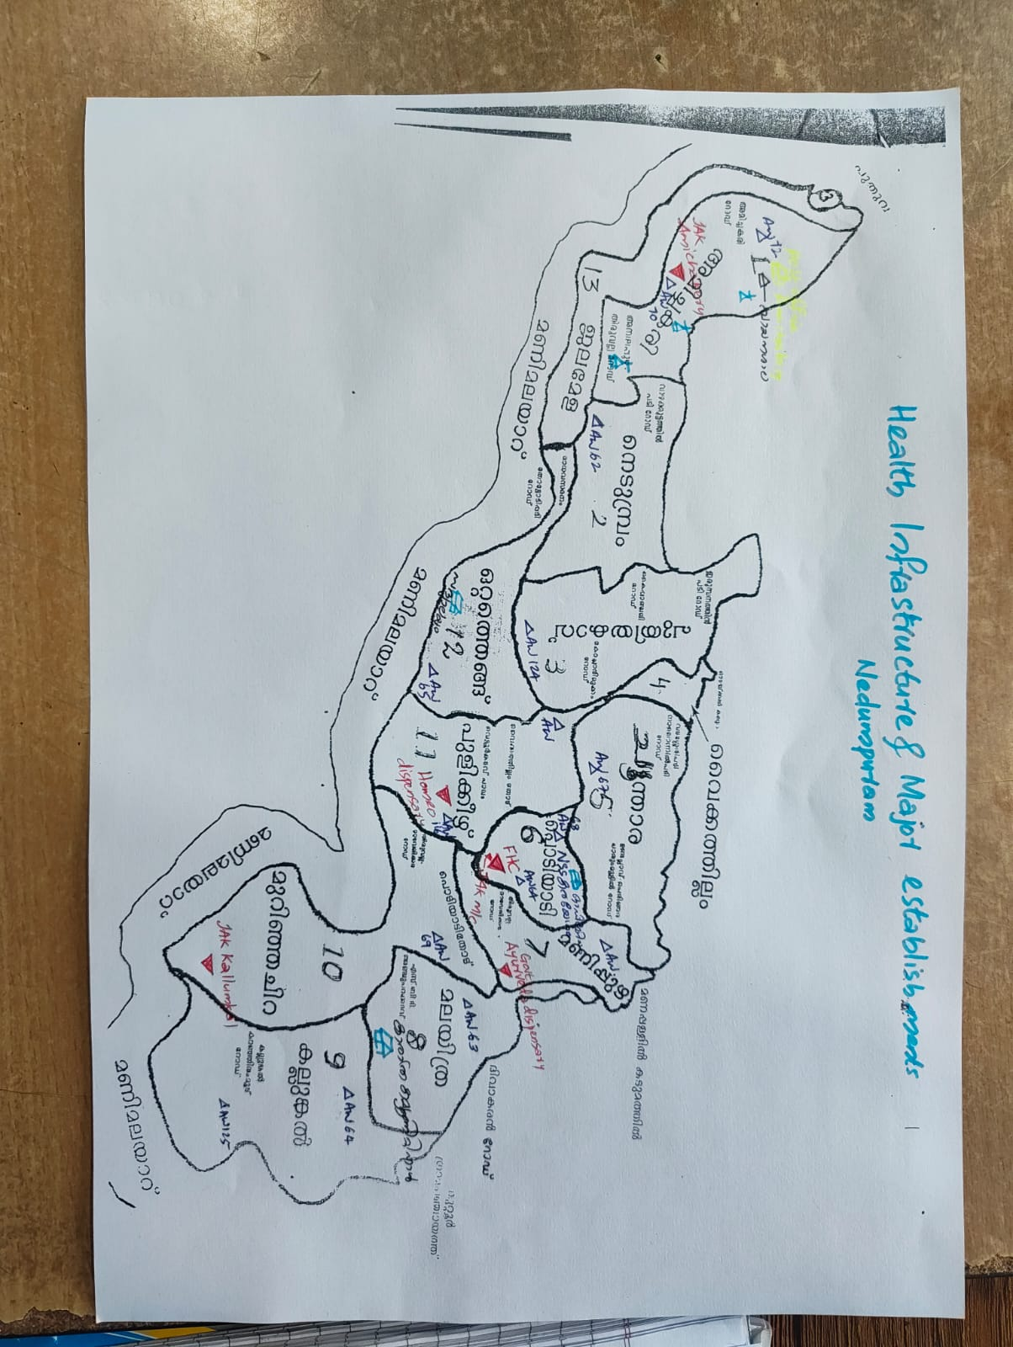

Disaster-prone areas map
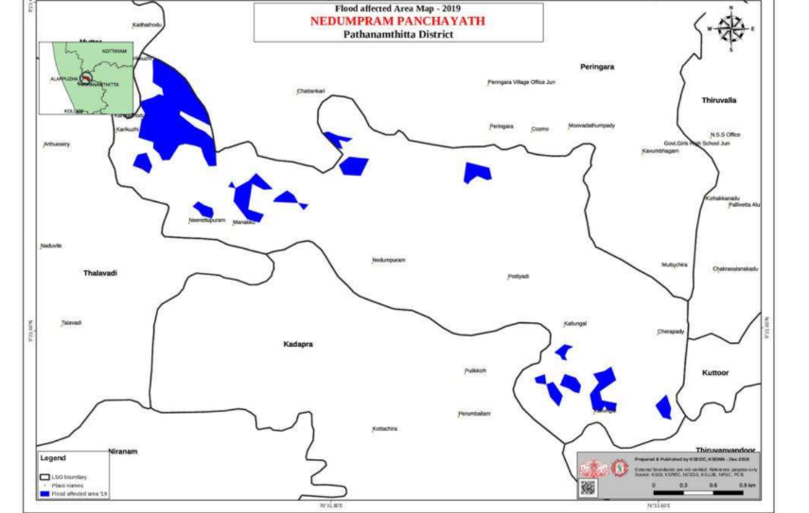

GENERAL PROFILE OF THE LSGI’S

Background of the LSGI

Nedumpuram Grama Panchayat, located on the western edge of Pathanamthitta, is defined by its unique low-lying geography and "Kuttanad-style" landscape. Characterized by extensive Kole lands, paddy fields, and a dense network of rivers and backwaters, the terrain creates a distinct microclimate that is both a source of livelihood and a significant logistical challenge. The local economy is deeply rooted in these wetlands, driven by traditional sectors like paddy cultivation, fishing, and coir processing, alongside a growing service sector and a diverse workforce that includes a significant migrant population.
From a public health and disaster management perspective, this water-centric geography makes Nedumpuram historically vulnerable to recurring seasonal floods and specific health risks. The Panchayat faces ongoing challenges from vector-borne diseases like Dengue and Leptospirosis, as well as waterborne illnesses, all of which are exacerbated during monsoon events. Memories of the 2018 flood disaster continue to shape local policy, highlighting the critical need for robust, localized response mechanisms that can navigate a landscape where traditional transportation often fails during emergencies.
To address these vulnerabilities, the Panchayat is prioritizing the development of a data-driven Auxiliary Infrastructure and Logistical Resource Map. This initiative aims to synchronize inter-departmental efforts—connecting the Family Health Centre, agricultural offices, and emergency services—to identify high-ground shelters and secure water-based transport. By mapping these critical resources, Nedumpuram seeks to transform its geographical challenges into a structured framework for community resilience, ensuring that essential services and disaster relief remain accessible to every resident, regardless of the season.

Table 1: Background of LSGD
Description | Details
Name of LSGI | Nedumpuram
Type (GP/Municipality / Corporation etc.) | Grama Panchayath
Block | Pulikkeezhu
District | Pathanamthitta
Number of wards | 14
Total area (sq. km) | 8.49 sq km
Population(Projected) | 15062
Population density | persons/sq km
Terrain (coastal/low-lying/backwaters/foothills, etc.) | Low lying
Number of rivers passing through LSGI | 1
Number of water bodies in the LSGI | 1
Number of educational institutions | 7
Factories / small-scale industries | 6
Flood-prone wards | 1,2,3,4,5,6,7,8,9,10,11,12,13
Landslide-prone wards | 0
Death Management and Disposal Facilities (mortuaries/crematorium, including electric) | 0
Auditoriums/Marriage halls/convention centres/community halls | 7

Demographic and Vulnerable Population
Understanding the demographic composition and vulnerable population groups is essential for pandemic preparedness. Children, elderly, economically deprived families, migrant workers, and socially vulnerable groups are at increased risk during public health emergencies due to higher exposure, limited access to services, and dependency on public systems..

Description |  | Details (in numbers)
DEMOGRAPHIC PROFILE
Total population |  | 15062
Male |  | 7682
Female |  | 7380
Transgender |  | 0
Children under 5 |  | 708
Adolescent |  | 1328
Elderly (>60) |  | 4212
SOCIAL/LIVELIHOOD VULNERABILITY
Previous EPEP family |  | 27
BPL family |  | 2154
Tribal communities |  | 2
Migration | Immigrant | 57
Migration | Emigrant | 329
Socio-economically deprived |  | 27
Fisherfolk |  | 0
SC Community |  | 1209
ST Community |  | 2

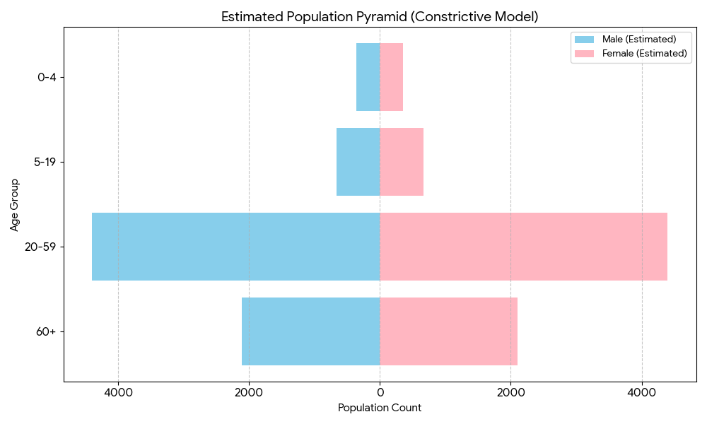

The community’s demographic profile suggests a constrictive population pyramid model, where a narrow base of 708 children under five and 1,328 adolescents is heavily outweighed by an elderly population of 4,212. This "top-heavy" structure indicates a high elderly dependency ratio, meaning the working-age population must support a disproportionately large number of retirees (approximately 28% of the total population). This economic strain is compounded by significant social vulnerabilities, including 2,154 BPL families and 1,211 members of SC/ST communities, which suggests that the local labor force—already thinned by the emigration of 329 individuals—faces a steep challenge in sustaining social security and geriatric care. Consequently, the dependency model highlights a community at risk of socio-economic stagnation unless targeted interventions are made to support both the aging demographic and the economically deprived households.

Clinical Vulnerability
Certain population groups needs priority healthcare & are at higher risk of severe illness, complications, and mortality during pandemics. Patients with chronic diseases, those requiring regular medical care, and individuals with mobility or functional limitations face challenges in accessing timely care during emergencies. Mapping these groups helps in prioritizing continuity of treatment, medicine stock planning, oxygen support, referral transport, and targeted home-based care

Description | Details in numbers
Pregnant women | 53
Lactating mothers | 96
Bedbound patients | 27
Patients under palliative care other than bedbound | 124
Patients on Haemodialysis | 12
Patients on CAPD | 1
Cancer patients (currently on treatment) | 35
Haemophilic patients | 0
Mentally challenged | 12
Differently abled | 117
Diabetic patients | 1893
Hypertensive patients | 3719
TB patients | 2
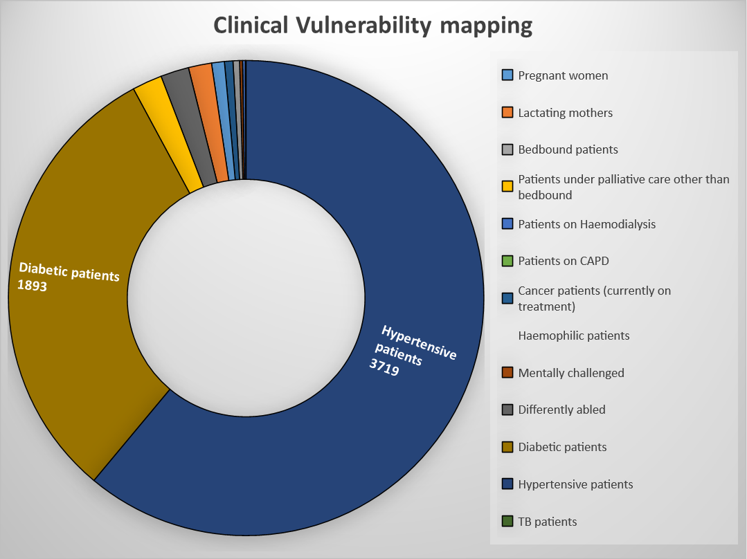

Major Festivals & Events specific to the LSGI
(with the possibility of a public gathering)

Sl. No. | Name of festival | Month detailing the periodicity
1 | Boat race Neerettupuram | September , February
2 | Sree Dharma Sastha Temple | February
3 | Manippuzha Devi Temple | February
4 | Puthenkavu Devi Temple , Nedumprum | March
5 | St.Marys Orthodox church | December

INFRASTRUCTURE & RESOURCE INVENTORY

Health Facility Directory & Basic Capacity in the LSGD
This section provides an overview of the healthcare infrastructure available within the LSGD area. It outlines the distribution and basic capacity of health facilities that form the backbone of service delivery during routine times and public health emergencies.

Family Health Centres (FHCs) and Community Health Centres (CHCs) generally function as the first point of contact for the community, providing essential outpatient and inpatient services. General Hospitals (GH) and Medical College Hospitals (MCH), where accessible, serve as the main referral centres for advanced diagnostics, specialist care, and critical services during public health emergencies. This inventory helps identify existing strengths, gaps, and potential surge capacity that can be mobilised during a pandemic or disaster.

Table 5. Health Facility Resource Summary
Sl.no. | Health Facility | Type of Facility (MCH/GH/CHC/FHC/SC etc.) | Contact Number | Total beds | ICU Beds | Oxygen-Supported Beds | No. of Ventilator Support Beds | No. of ambulances
Government Healthcare Facilities
1 | FHC Nedumpuram | FHC | 8907393040 | 0 | 0 | 1 | 0 | 0
2 | HWC Kallunkal | SC | 8907393040 | 0 | 0 | 0 | 0 | 0
3 | HWC Amichakery | SC | 8907393040 | 0 | 0 | 0 | 0 | 0
Private Healthcare Facilities
1 | Manak hospital | PVT | 9847147626 | 10 | 1 | 10 | 0 | 0
AYUSH Healthcare Facilities
1 | Govt Ayurvedic clinic | Govt | 9446188484 | 0 | 0 | 0 | 0 | 0
2 | Govt Homeo clinic | Govt | 9496012782 | 0 | 0 | 0 | 0 | 0

Private Clinics
Private clinics are an essential part of pandemic preparedness, as they are often the first place people seek care when symptoms begin. In many communities, private clinics manage a significant share of outpatient visits and therefore play a critical role in early case detection, timely referrals, and disease surveillance. Having an up-to-date understanding of where these clinics are located, the services they provide, and how they are linked to the public health system helps ensure that no cases are missed during an outbreak. It also allows health authorities to engage private practitioners more effectively for reporting, risk communication, and coordinated response, strengthening the overall capacity of the health system to manage public health emergencies.

Table 6. Private Clinic Resource Summary
Sl No. | Name of Clinic | Registered (Y/N) | Clinic (General / Speciality) | Speciality (if any) | Address | Contact Number | Diagnostic Facility (Y/N) | Ambulance Linkage (Y/N)
1 | Manak hospital | Y | speciality | Uro,hepato | Manak jn Nedumpuram | 9847147626 | y | n

Healthcare Education & Training Institutions
This section tracks the educational infrastructure available, which is vital for human resource planning in the health sector.

Category of Institution | Govt | Private | AYUSH | Total
Medical Colleges | 0 | 0 | 0 | 0
Nursing Colleges | 0 | 0 | 0 | 0
Dental Colleges | 0 | 0 | 0 | 0
Para-medical / Allied Health | 0 | 0 | 0 | 0
Pharmacy Colleges | 0 | 0 | 0 | 0

Specialized Services & Emergency Inventory
This section provides a detailed view of the specialized medical resources available to the community, focusing on emergency response and critical care capabilities. This table tracks the vital assets required for managing severe illnesses and emergencies across Government, Private, and AYUSH sectors.

Item | Govt | Private | AYUSH | Total
Hospital beds | 0 | 10 | 0 | 10
Oxygen-generating systems(Y/N) | y | y | 0 | 1
Oxygen-supported beds(Numbers) | 1 | 10 | 0 | 11
Ventilator-supported beds | 0 | 0 | 0 | 0
ICU beds | 0 | 0 | 0 | 0
Burns units | 0 | 0 | 0 | 0
Blood centres | 0 | 0 | 0 | 0
BLS ambulances | 0 | 0 | 0 | 0
ALS ambulances | 0 | 0 | 0 | 0
Dialysis facilities | 0 | 0 | 0 | 0
Dispensaries | 0 | 1 | 2 | 3
Medical store | 0 | 3 | 0 | 3
Industrial establishments(Medium-scale industries/small-scale industries establishments to whom we can depend in a worst-case scenario) | 0 | 7 | 0 | 0

Oxygen & Diagnostic Capacity
Monitoring oxygen and diagnostic capacity is a critical component of public health preparedness, ensuring that the LSGD can handle both chronic care and sudden surges in respiratory or infectious diseases.
Name of Health Facility |  | Oxygen-generating System (Y/N) | Backup Oxygen Source (Y/N) | Diagnostic Facilities Available(Y/N)
 |  | Oxygen-generating System (Y/N) | Backup Oxygen Source (Y/N) | Lab | USG | X-ray | CT/MRI | RT-PCR
Government Healthcare Facilities
FHC  Nedumprum |  | y | y | 1 | 0 | 0 | 0 | 0
Manak Hospital | y |  | y | 1 | 0 | 0 | 0 | 1

Diagnostics facility mapping at the LSGI level
The diagnostic capacity of Nedumpuram G.P represents the "intelligence network" of our healthcare system. The speed and accuracy of disease identification depend entirely on the distribution and technical level of these facilities.

Item | Govt | Private | AYUSH | Total
General labs | 1 | 4 | 0 | 5
Microbiology labs | 1 | 4 | 0 | 5
RT-PCR labs | 0 | 1 | 0 | 1
USG units | 0 | 0 | 0 | 0
CT/MRI units | 0 | 0 | 0 | 0
Research labs | 0 | 0 | 0 | 0
Labs of other departments that can be repurposed | Agri-1 | 0 | 0 | 0

Laboratory Identification & Basic Details
Sl. No. | Name of Laboratory | Ownership (Govt / Private / Academic) | Address | Contact No. | 24×7 Services (Yes/No) | NABL / Govt Approved (Yes/No)
1 | Hi Tech | PVT | podiyadi | 9961239351 | No | Yes
2 | Central medical Lab | PVT | Nedumpuram | 9961085841 | No | Yes

Social and Community Infrastructure for surge plan
This table serves as our logistics and shelter inventory. By mapping these locations, quickly we can identify where to house displaced citizens, where to set up temporary medical clinics, and how to manage the deceased with dignity during a crisis.

Category | Total Count | Ward | Est. Capacity (Persons) | Contact details
Educational Institutions
Anganwadis | 15 | 1 to 13 | 0-6 - 582 | 9744549567  (AW 66)
Schools | 7 | 1,4,6,8,12, | 281 | HM -9544125991  (Govt school Podiyadi)
Colleges | 0 | 0 | - | -
Healthcare Educational Institutions
Medical colleges (Govt/Private) | 0 | 0 | 0 | 0
Nursing colleges (Govt/Private) | 0 | 0 | 0 | 0
Dental colleges (Govt/Private) | 0 | 0 | 0 | 0
Paramedical institutes (Govt/Private) | 0 | 0 | 0 | 0
Community Gathering Spaces
Community halls | 1 | 8 | 100 | 9747817519
Auditoriums | 6 | 1,12,7,8,9,10,11 | 75 each | 9188291409
Religious buildings | 6 | 6 | 75 each | 9544993418
Vulnerable Group Support Facility
Destitute homes | 0 | 0 | 0 | 0
Elderly homes | 0 | 0 | 0 | 0
LSGD owned other buildings | 0 | 0 | 0 | 0
Mass Fatality Management (MFM) Infrastructure
Mortuary | 0 | 0 | 0 | 0
Crematorium | 0 | 0 | 0 | 0
*refer annexure 1 for contact details

Human resources
This section focuses on the human capital available within the LSGI. In any emergency—be it a pandemic, flood, or industrial accident—infrastructure is only as effective as the people operating it.

Medical & Clinical Personnel
This table tracks the "Frontline" providers responsible for diagnosis, treatment, and clinical management. Narrative sentence: eg., "Total health workforce: 450 personnel, with 60% in government facilities serving as primary surge capacity." A detailed directory with the contact numbers of all workers is maintained (Annexure in 1).

Cadre | Govt (No.) | Private (No.) | Total
Doctors—Modern Medicine | 2 | 3 | 5
Doctors – AYUSH | 2 | 2 | 4
Doctors – Veterinary | 1 | 0 | 1
Doctors – Dental | 0 | 4 | 4
Nursing officers | 2 | 0 | 2
Lab technicians | 1 | 4 | 5
Optometrist | 1 | 1 | 2
Pharmacists | 1 | 0 | 1
Psychologists | 0 | 1 | 1
Counsellors | 0 | 0 | 0

Public Health & Field-Level Workforce
These individuals are the backbone of surveillance, maternal-child health, and decentralized care.

Cadre | Health services | Municipal common services | Total
HS (Health Supervisors) | 1 | 0 | 1
HI (Health Inspectors) | 1 (incharge) | 0 | 1
LHS (Lady Health Supervisor) | 1 (incharge) | 0 | 1
LHI (Lady Health Inspectors) | 1 (incharge) | 0 | 1
JPHN (Jr Public Health Nurses) | 2 | 0 | 2
JHI (Jr Health Inspectors) | 2 | 0 | 2
MLSP (Mid-Level Service Providers) | 3 | 0 | 3
Palliative Nurses | 1 | 0 | 1
RBSK Nurses | 1 | 0 | 1
PRO | 1 | 0 | 1
Epidemiologist | 1 | 0 | 1
Data Manager | 1 | 0 | 1

Community & Support Cadre
This group represents the surge capacity of the LSGI—people who can be called upon for logistics, rescue, and specialized support.

Cadre | Number
ASHA Workers | 13
AWW (Anganwadi Workers) | 15
Emergency Medical Volunteers (Trained) | 0
Kudumbashree | 158
MNREGS | 47
Purusha Swayam Sahaya Sangham | 0
Ex-Servicemen | 24
Retired Police Officers | 0
NCC/NSS Volunteers | 0
Red Cross volunteers | 0
One Health Community Volunteers | 52
One Health Community Mentors | 0

Community Organizations
This section details the presence of community-based organisations (CBOs), non-governmental organisations (NGOs), faith-based organisations (FBOs), Kudumbashree Self-Help Groups (SHGs), and Ayalkootams within the Local Self-Government Institution (LSGI). These groups enhance grassroots mobilization, resource distribution, and support networks crucial for pandemic response and community resilience.

Category | Total Count
NGOs | 0
Religious based organizations | 0
Foreign based organizations | 0
Sports Club/youth clubs | 2
Kudumbashree SHGs | 14
Ayalkootams | 76
Political organizations | 0
Residential organizations | 0

Administrative & Emergency Services
This section outlines the availability of key non-health emergency support services and infrastructure within the LSGI, which are essential for effective pandemic preparedness and response. These facilities support law enforcement, disaster response, water supply, logistics, mobility, and community-level interventions during public health emergencies.

Category | Total Count | Contact details
Police Stations | 0 | 0
Fire & Rescue Stations | 0 | 0
Water Pumping Points | 1 | 9961221305
Public Distribution System (PDS) | 7 +1 (Maveli) +1(Triveni) | 9947194762(Anand .G)

Information regarding resources
The availability of essential transport and support resources plays a quiet but critical role in saving lives. Equipment such as ambulances, mobile mortuaries, amphibian ambulances, and motorized boats ensures that patients, samples, and healthcare teams can move swiftly—even in flooded, remote, or difficult terrains. Heavy vehicles like JCBs, cranes, tractors, and torus lorries support logistics, waste management, emergency infrastructure, and rapid conversion of spaces into care or isolation facilities. Taxis, four-wheel-drive vehicles, and trucks help maintain continuity of essential services, reach vulnerable populations, and support home-based care and supply delivery.

Means of transportation | Total Count
JCB | 1
Crane | 1
Heavy Trucks | 0
Tractor | 0
Ambulances | 0
Mobile mortuaries | 0
Boats | 0
Taxi service | 12
Note: For specific details regarding vehicle owners and contact information, please refer to Annexure [X].

ONE HEALTH & ENVIRONMENTAL SURVEILLANCE
The One Health method integrates environmental, animal, and human health to enable proactive pandemic preparedness. Panchayat-level surveillance needs to be improved in order to detect and treat zoonotic and environmentally generated diseases early. Surveillance is strengthened through systematic assessment of animal populations, veterinary infrastructure, poultry and slaughter facilities, inter-sectoral coordination, and specialised tools like avian influenza seasonality mapping using GIS in previous outbreaks to enable predictive alerts and ward-specific sampling to support effective pandemic preparedness in high-risk areas like malayathra ,chunthara,murnjachira .

Animal & Bird Population
Mapping animal and bird populations at the Panchayat level is essential for identifying and prioritising zoonotic disease hazards like rabies, avian influenza (H5N1), leptospirosis, anthrax, and Nipah-like spillover occurrences. Risk classification, targeted surveillance, vaccination planning, and early epidemic detection made feasible by comprehensive population mapping all enhance One Health-based pandemic preparedness.

Category | Item | Estimated Population | Wards
Animal Population | Livestock (Cattle/Goats/Buffalo) | 216 | all wards
Animal Population | Pet Animals (Dogs/Cats) | 109 | all wards
Animal Population | Stray Dog Population | 319 | all wards
Animal Population | Pig Farms (Number of heads) | 0 | 0
 | Small Units (Sheep / Goats – clustered) | 3 | 1,12,13
Bird Population | Poultry Units (Birds) | 0 | 0
Bird Population | Poultry- (FOWL) | 962 | All wards
Bird Population | Wild/Migratory Birds (Observed) | 15 | 12,6,10,8
Bird Population | Crow Mortality Events (Reported) | 0 | 0

The no such risk of zoonotic diseases in Nedumprum is concentrated in all Wards .The stray dog population in market areas, fish landing sites, bus stations continues to be a substantial problem for rabies surveillance and bite prevention. The field and the area will be under surveillance zone if any outbreak happens. Clusters of animal shelters vulnerable to flooding further raise the risk of leptospirosis and other zoonoses mediated by the environment, especially during monsoon floods.

Veterinary Infrastructure
Veterinary institutions are a core pillar of One Health surveillance, enabling early zoonotic disease detection through vaccination, investigation of unusual animal illness or deaths, sample collection, and timely outbreak reporting. A well-mapped and responsive veterinary network strengthens coordination with human health and LSGI systems, ensuring rapid response during zoonotic events and pandemics.
Facility Type | Name of Facility | Ownership Govt / Pvt | Location(Ward No) | Contact number
Veterinary Dispensary | Govt Veterinary dispensary | Govt | 12 | 8547049358
Veterinary Hospital / Polyclinic | NA | 0 | 0 | 0
Private Veterinary Clinics | 0 | 0 | 0 | 0
Mobile / Emergency Vet Service (incl. night services) | 0 | 0 | 0 | 0
Pet Homes / Animal Shelters | 0 | 0 | 0 | 0
Slaughterhouse-linked Veterinary Inspection Unit | 0 | 0 | 0 | 0

Veterinary Doctors & Workforce
Early detection, diagnosis, reporting, and reaction to animal illness epidemics depend on the availability and accessibility of qualified veterinary specialists. By identifying unusual animal morbidity or mortality promptly, collecting samples promptly, and coordinating efficiently with human health and LSGI systems—especially during zoonotic outbreaks and pandemic-prone situations—a clearly defined veterinary workforce enhances One Health surveillance.

Category | Number Available | Type (Govt/Pvt) | Contact number
Government Veterinary Doctors | 1 | Govt | 8547049358
Private Veterinary Doctors | 0 | 0 | 0
Livestock Inspectors | 2 | Govt | 9497460927  9446436326
Para-veterinary Staff / Attenders | 2 | Govt | 9961967461
Contract / On-call Veterinary Support (if any) | 0 | 0 | 0

High-Risk Interface Points (Surveillance Sites)
High-risk interface points for zoonotic disease surveillance in Nedumpuram Grama Panchayath include wetland–livestock–human contact zones, backyard poultry farms, cattle sheds near water bodies, fish markets, and areas of high human–animal interaction such as community slaughter points and migratory bird congregation sites. These are the primary surveillance sites where zoonotic spillover risks are elevated.

Type of Habitat | Type of High risk interface | Geographical vulnerability
Wetlands & Backwaters | High | flood prone areas
Backyard Poultry Farms | 0 | NA
Cattle Sheds near Water Bodies | 0 | NA
Fish & Meat Markets | 6 | Nil
Community Slaughter Sites | 0 | NA
Migratory Bird Congregation Areas | 0 | NA
Rodent-Infested Grain Storage | 0 | NA

Category | Total Count | Key Locations (wards)
Poultry Farms | 0 | NA
Backyard / Clustered Poultry Units | 0 | NA
Duck Rearing Units (open water access) | 0 | NA
Slaughterhouses/ Slaughter Points | 0 | NA
Meat/Fish Markets | 1 | 2
Live Bird Sale Points | 0 | NA
Cattle Markets / Weekly Animal Fairs | 0 | NA
Pet Shops / Breeders | 0 | NA
Animal Shelters / Pet Homes | 0 | NA
Waste Disposal Sites near Animal Units | 0 | NA

Environmental Risk Mapping
Environmental risk mapping identifies monsoon/flood hotspots for vector-borne (dengue, chikungunya), water-borne (leptospirosis, diarrhoea), and zoonotic diseases in Kerala's wetlands. Systematic surveillance supports early warnings, targeted interventions, and Panchayat pandemic preparedness.
Waterborne exposure: Flood-prone areas and stagnant water bodies facilitate leptospira survival, raising leptospirosis risk.

Traditional practices: Informal slaughter and fish markets lack standardized hygiene, creating spillover opportunities.
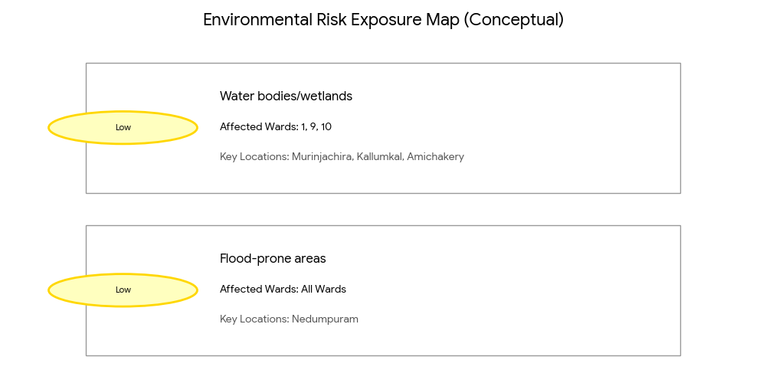
Risk Factor | High-Risk Wards | Key Locations | Risk Level (High/Med/Low)
Flood-prone areas | All wards | nedumpuram | Low
Water bodies/wetlands | 10,9,1 | murinjachira,kallumkal,amichakery | Low
Solid waste accumulation | 0 | Nil | Nil
Animal waste disposal issues | 0 | Nil | Nil
Rodent infestation zones | 0 | Nil | Nil
Industrial effluent discharge | 0 | Nil | Nil
Construction sites / abandoned buildings | 0 | Nil | Nil
Poor drainage/blocked canals | 0 | Nil | Nil
Drinking water source contamination risk | 0 | Nil | Nil

Disease Seasonality Mapping
1, Flooding & waterlogging → amplifies leptospirosis, malaria, diarrheal diseases.
·
2, Migratory bird influx (Nov–Feb) → avian influenza risk.

3, Mosquito breeding cycles → vector-borne disease peaks in monsoon.

4, Agricultural practices → close human–animal contact in paddy fields.

Disease | Peak Risk Season | Key Drivers | High-Risk Locations | Surveillance Focus
Avian Influenza | october-march | 0 | 0 | Bird migration
Leptospirosis | june- october | nil | 1,2,7,8,9,10,12,13 | flood prone,agriculture
Dengue/Chikungunya | april-september | Old cases | 7,12 | Water logged Areas
Acute Diarrheal Diseases | may-august | Occasionally | all wards | Aged population ,children
Rabies | june- october | 0 | all wards | General population
Anthrax (rare) | early rainy season | 0 | 0 | NA

Vulnerability Mapping
Vulnerability mapping pinpoints high-risk populations, occupations, and areas exposed via environment, livelihoods, socio-economics, and poor service access. Paired with environmental/seasonality mapping, it enables risk-based surveillance, targeted actions, and optimal resource use in One Health and pandemic planning.
Vulnerability Factor | High-Risk Wards | Key Groups / Locations | Risk Level  (low/medium/  high)
Flood-prone households | All wards | Jalamela-13,  Amichakery-1, Manippuzha-7  Kallunkal-9  Murinnjachira-10  Pulikkeezhu-11 | Medium
Wetland-adjacent communities | All wards | Amichakery  Vaikathillam  Malayathra  Pulikkeezhu | Medium
Backyard poultry / duck rearing households | 1,4,5,7,11 | Amichakery  Vaikathillam  Pulikkeezhu  Manippuzha | Medium
Livestock-rearing households | All wards | All wards | low
Slaughterhouse & meat market workers | 0 | NA | NA
Fisherfolk & fish market workers | 0 | NA | NA
Sanitation workers | 0 | NA | NA
Daily wage / migrant workers | 57 | Vaikathillam, Podiyadi | Medium
Elderly & chronically ill populations | 34 | All wards | Medium
Pregnant Women | 54 | Kallunkal | Medium
Children (schools, Anganwadi’s) | All wards | All wards | Low
Limited access to safe water & sanitation | 0 | NA | NA

EPIDEMIOLOGICAL TRENDS (2021–2025)

Disease surveillance is the systematic collection, analysis, and interpretation of health data for planning, implementation, and evaluation of public health practice. This section presents the disease surveillance profile of the LSGI based on routine reporting systems and outbreak investigations to identify priority diseases, seasonal patterns, and emerging public health threats.

Disease Burden among human beings(Last 5 Years)
Analysis of disease-wise data for the last five years helps identify persistent public health problems, emerging diseases, and changes in disease burden. This information supports prioritisation of prevention, preparedness, and response activities at the Panchayat level.

Disease | 2021 | 2022 | 2023 | 2024 | 2025 | Trend(Increasing/Stable/Decreasing)
Dengue | 0 | 4 | 3 | 2 | 3 | stable
Leptospirosis | 0 | 1 | 1 | 1 | 0 | stable
Hepatitis A | 0 | 0 | 0 | 0 | 1 | stable
Malaria | 0 | 0 | 0 | 0 | 0 | 0
Scrub Typhus | 0 | 0 | 0 | 0 | 0 | 0
Typhoid | 0 | 0 | 0 | 0 | 0 | 0
H1N1 | 0 | 0 | 0 | 1 | 0 | stable
H3N2 | 0 | 0 | 0 | 0 | 0 | 0
ADD | 19 | 12 | 9 | 14 | 12 | stable
Mumps | 0 | 0 | 0 | 0 | 0 | 0
Measles | 0 | 0 | 0 | 0 | 0 | 0
Hepatitis B | 0 | 0 | 0 | 0 | 0 | 0
Hepatitis C | 0 | 0 | 0 | 0 | 0 | 0
Tuberculosis | 9 | 12 | 4 | 6 | 8 | stable
Leprosy | 1 | 0 | 0 | 0 | 0 | 0
COVID-19 | 9987 | 814 | 21 | 8 | 1 | decreasing

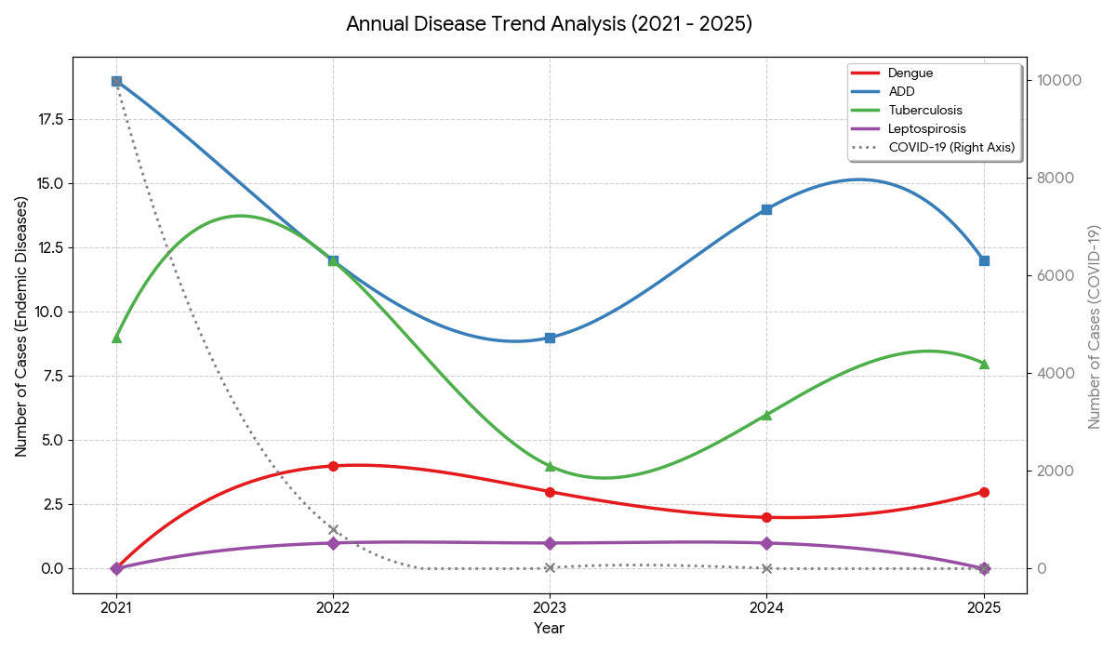

Acute Diarrheal Diseases (ADD): This remains the most consistently reported endemic disease, fluctuating between 9 and 19 cases annually, showing a "stable" but persistent trend.

Tuberculosis: Shows a variable but overall stable trend, peaking at 12 cases in 2022 and settling at 8 cases in 2025.

Dengue & Leptospirosis: Both exhibit low-level transmission. Dengue cases have remained minimal (peaking at 4), while Leptospirosis has hovered around1 case per year, dropping to 0 in 2025.

Negligible/Zero Trends: Several diseases, including Malaria, Typhoid, and Measles, have reported zero cases consistently throughout this period, indicating successful control or absence of these pathogens in the area.

Seasonal Trend Analysis
Seasonal analysis helps anticipate surges (e.g. dengue in monsoon, leptospirosis after floods, influenza in cooler months) and plan pre‑emptive vector control, stockpiling of IV fluids, and awareness campaigns at Panchayat level.

DENGUE
Dengue is a major seasonal vector-borne disease strongly associated with rainfall, water stagnation, and increased mosquito breeding during the monsoon period.

Peak: July–November

Dengue – Ward-wise Yearly Distribution (2021–2025)

Ward | Dengue – Ward-wise Yearly Distribution
Ward | 2021 | 2022 | 2023 | 2024 | 2025 | Total
1 | 0 | 0 | 0 | 0 | 0 | 0
2 | 0 | 1 | 1 | 0 | 0 | 2
3 | 0 | 0 | 0 | 0 | 0 | 0
4 | 0 | 0 | 0 | 0 | 0 | 0
5 | 0 | 0 | 0 | 0 | 0 | 0
6 | 0 | 1 | 0 | 1 | 0 | 2
7 | 0 | 1 | 1 | 0 | 1 | 3
8 | 0 | 1 | 0 | 0 | 0 | 1
9 | 0 | 0 | 0 | 0 | 0 | 0
10 | 0 | 0 | 1 | 1 | 0 | 2
11 | 0 | 0 | 0 | 0 | 1 | 1
12 | 0 | 0 | 0 | 0 | 1 | 1
13 | 0 | 0 | 0 | 0 | 0 | 0
14 | 0 | 0 | 0 | 0 | 0 | 0

- Consistency in Ward 7: Ward 7 is the most consistently affected area, reporting cases in three out of the five years (2022, 2023, and 2025) and holding the highest cumulative total of 3 cases.
- Emerging Areas: While early cases (2022) were concentrated in Wards 2, 6, 7, and 8, new cases have emerged in Wards 11 and 12 as of 2025.
- Stable Hotspots: Wards 2, 6, and 10 have shown sporadic but recurring activity over the years.
- Zero-Case Wards: Wards 1, 3, 4, 5, 9, 13, and 14 have maintained a clean record with zero reported cases throughout the entire 2021–2025 period.
The below charts illustrate the steady nature of the Dengue presence in the region, with the top graph showing the smooth total trend and the bottom heatmap highlighting exactly which wards require continued vigilance.

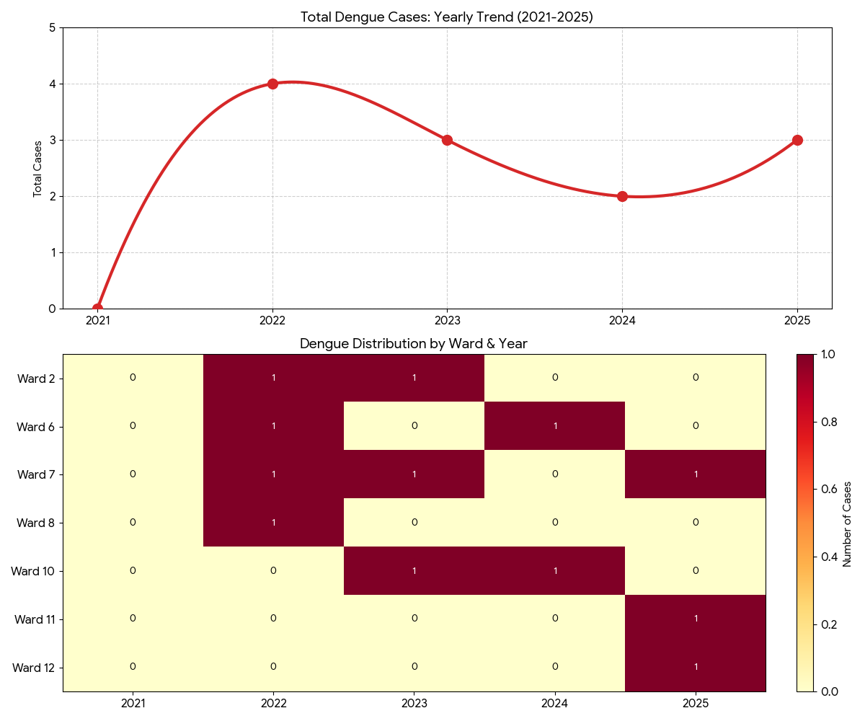

LEPTOSPIROSIS
Leptospirosis cases are closely linked to monsoon rains, flooding, and occupational exposure, particularly in low-lying and waterlogged areas.

Peak: June - August

Leptospirosis – Ward-wise Yearly Distribution (2021–2025)

Ward | Leptospirosis – Ward-wise Yearly Distribution
Ward | 2021 | 2022 | 2023 | 2024 | 2025 | Total
1 | 0 | 0 | 0 | 0 | 0 | 0
2 | 0 | 0 | 0 | 0 | 0 | 0
3 | 0 | 0 | 0 | 0 | 0 | 0
4 | 0 | 0 | 0 | 0 | 0 | 0
5 | 0 | 0 | 0 | 0 | 0 | 0
6 | 0 | 0 | 0 | 0 | 0 | 0
7 | 0 | 0 | 1 | 0 | 0 | 1
8 | 0 | 1 | 0 | 0 | 0 | 1
9 | 0 | 0 | 0 | 0 | 0 | 0
10 | 0 | 0 | 0 | 0 | 0 | 0
11 | 0 | 0 | 0 | 1 | 0 | 1
12 | 0 | 0 | 0 | 0 | 0 | 0
13 | 0 | 0 | 0 | 0 | 0 | 0
14 | 0 | 0 | 0 | 0 | 0 | 0

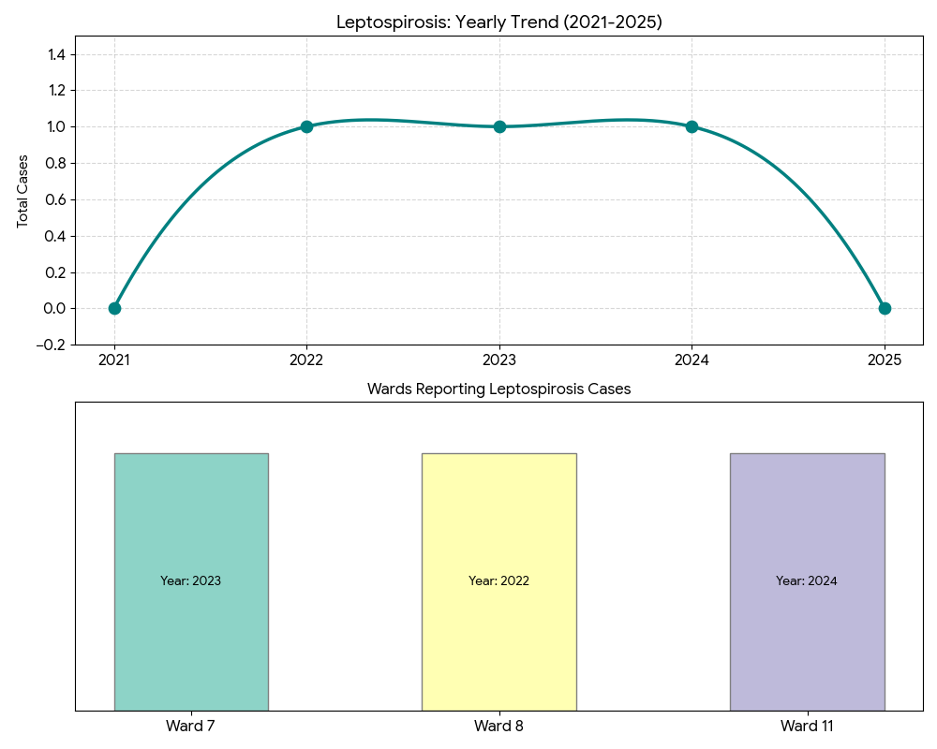

VIRAL HEPATITIS - A
Hepatitis A cases are commonly associated with unsafe drinking water, food contamination, and breakdowns in sanitation, often presenting as clusters or outbreaks.

Peak: October - December

Hepatitis A – Ward-wise Yearly Distribution (2021–2025)

Ward | Hep A – Ward-wise Yearly Distribution
Ward | 2021 | 2022 | 2023 | 2024 | 2025 | Total
1 | 0 | 0 | 0 | 0 | 0 | 0
2 | 0 | 0 | 0 | 0 | 0 | 0
3 | 0 | 0 | 0 | 0 | 0 | 0
4 | 0 | 0 | 0 | 0 | 0 | 0
5 | 0 | 0 | 0 | 0 | 0 | 0
6 | 0 | 0 | 0 | 0 | 0 | 0
7 | 0 | 0 | 0 | 0 | 0 | 0
8 | 0 | 0 | 0 | 0 | 1 | 1
9 | 0 | 0 | 0 | 0 | 0 | 0
10 | 0 | 0 | 0 | 0 | 0 | 0
11 | 0 | 0 | 0 | 0 | 0 | 0
12 | 0 | 0 | 0 | 0 | 0 | 0
13 | 0 | 0 | 0 | 0 | 0 | 0

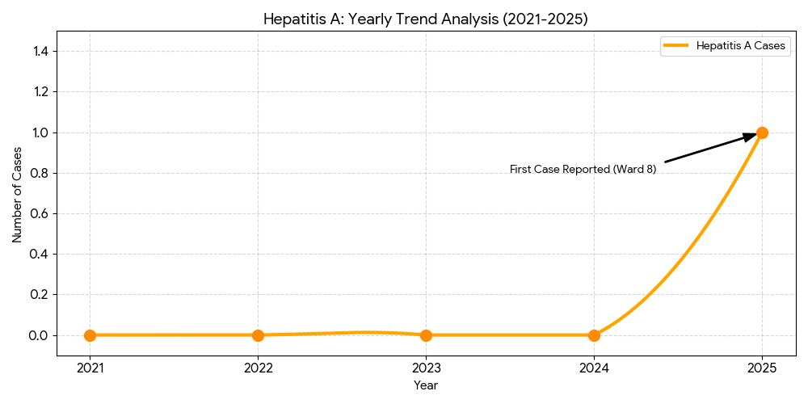

Outcome-Based Trend Analysis- 2025

Indicator | Outcome | Analysis
Pandemic Control | Successful | COVID-19 cases dropped by 99.9% (from 9,987 to 1). This indicates highly effective vaccination, quarantine, and recovery protocols.
Endemic Stability | Maintained | Dengue and ADD show "stable" trends. While they aren't eliminated, there are no explosive outbreaks, suggesting consistent routine surveillance.
Zero-Transmission | Excellent | Malaria, Typhoid, Mumps, and Measles have maintained 0 cases for 5 years. This reflects high immunization coverage and effective vector control.
Chronic Disease | Variable | Tuberculosis (TB) fluctuates (4 to 12 cases). The outcome is stable, but it remains the most significant long-term infectious threat after ADD.

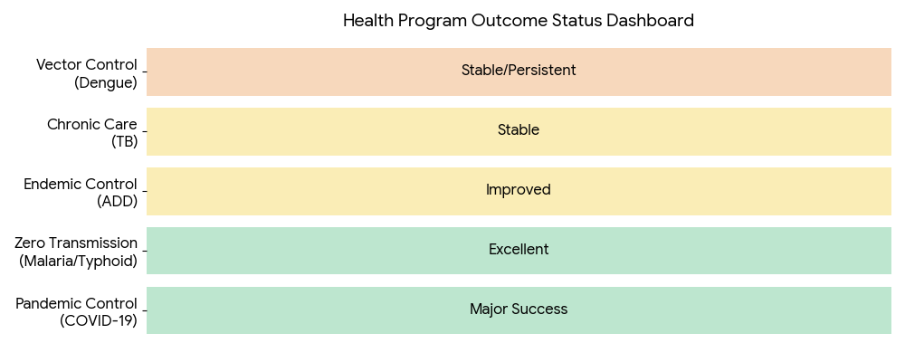
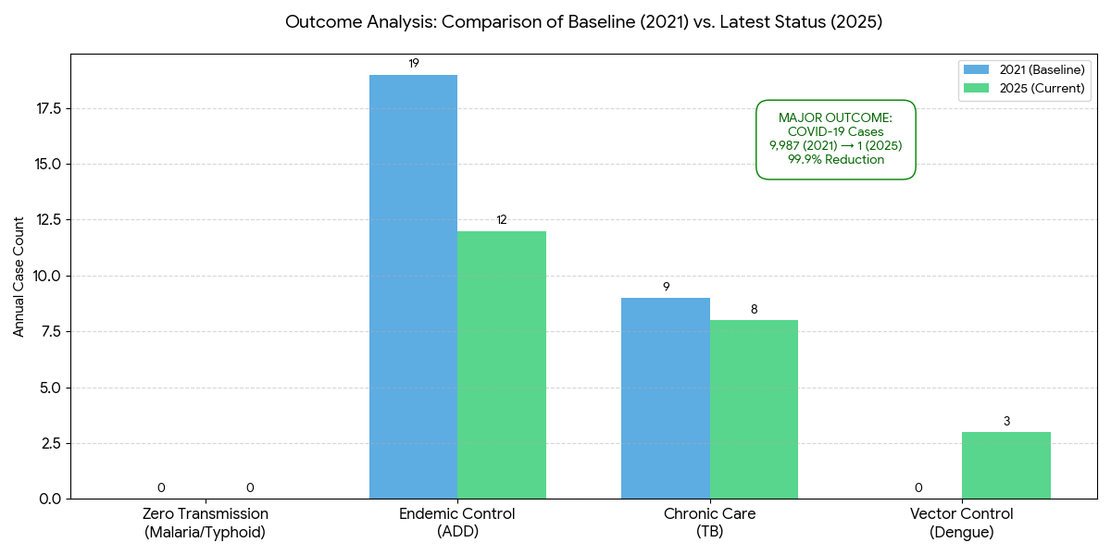

Transmission Trend- 2025
For effective management of public health issues, it is important to track the trend of disease transmission mode. It helps identify the population or place at high risk that can be used to predict outbreaks and implement targeted interventions as quickly as possible. Understanding these kinds of trends enables authorities to allocate resources efficiently and change the strategies adequately based on the trend that follows.

Mode of Transmission | No. of cases | No. of Deaths
Vector Borne Diseases | 3 | 0
Water Borne Diseases | 0 | 0
Air Borne Diseases | 5 | 0
Blood Borne Diseases | 0 | 0
Food Borne Diseases | 0 | 0

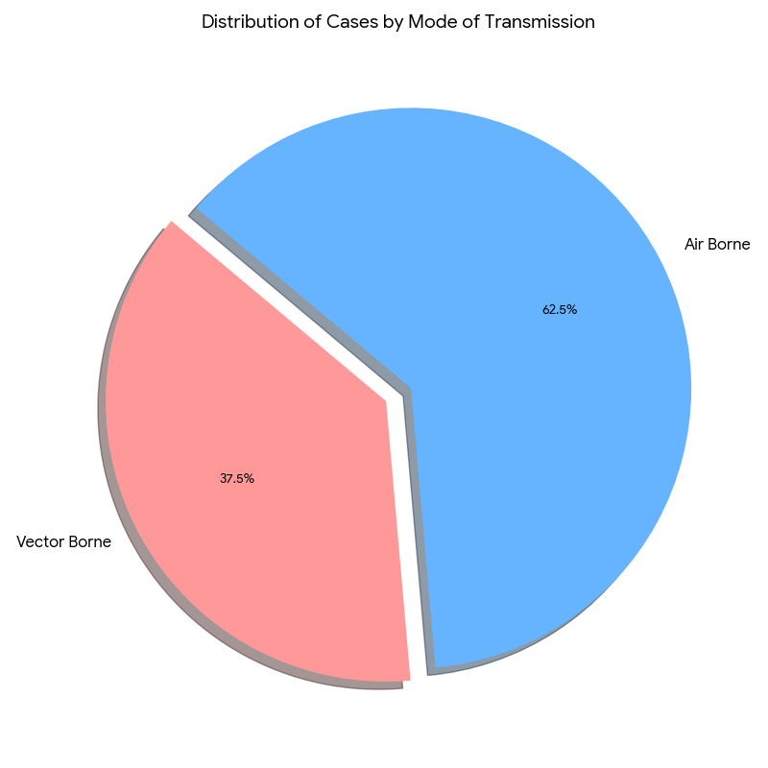

Vector-Borne Disease

Disease | No. of Cases | No. of Deaths
Dengue | 3 | 0
Malaria | 0 | 0
Chikungunya | 0 | 0
Water Borne Disease

Disease | No. of Cases | No. of Deaths
Cholera | 0 | 0
Typhoid | 0 | 0
Hep- A | 1 | 0
Dysentery | 0 | 0
Amoebiasis | 0 | 0
E- Coli infections | 0 | 0
Air Borne Disease

Disease | No. of Cases | No. of Deaths
Influenza | 2 | 0
H1N1 | 0 | 0
TB | 5 | 0
Chickenpox | 3 | 0
Measles | 0 | 0
Covid-19 | 0 | 0
Pertussis | 0 | 0
Mumps | 0 | 0

Blood-Borne Disease

Disease | No. of Cases | No. of Deaths
AIDS | 0 | 0
Hep- B | 0 | 0
Hep- C | 0 | 0

Zoonotic Disease

Disease | No. of Cases | No. of Deaths
Rabies | 0 | 0
Leptospirosis | 0 | 0
Avian influenza | 0 | 0
West nile | 0 | 0
Anthrax | 0 | 0
Nipah | 0 | 0
Scrub Typhus | 0 | 0

Integrated Disease Hotspot Map (2021–2025)

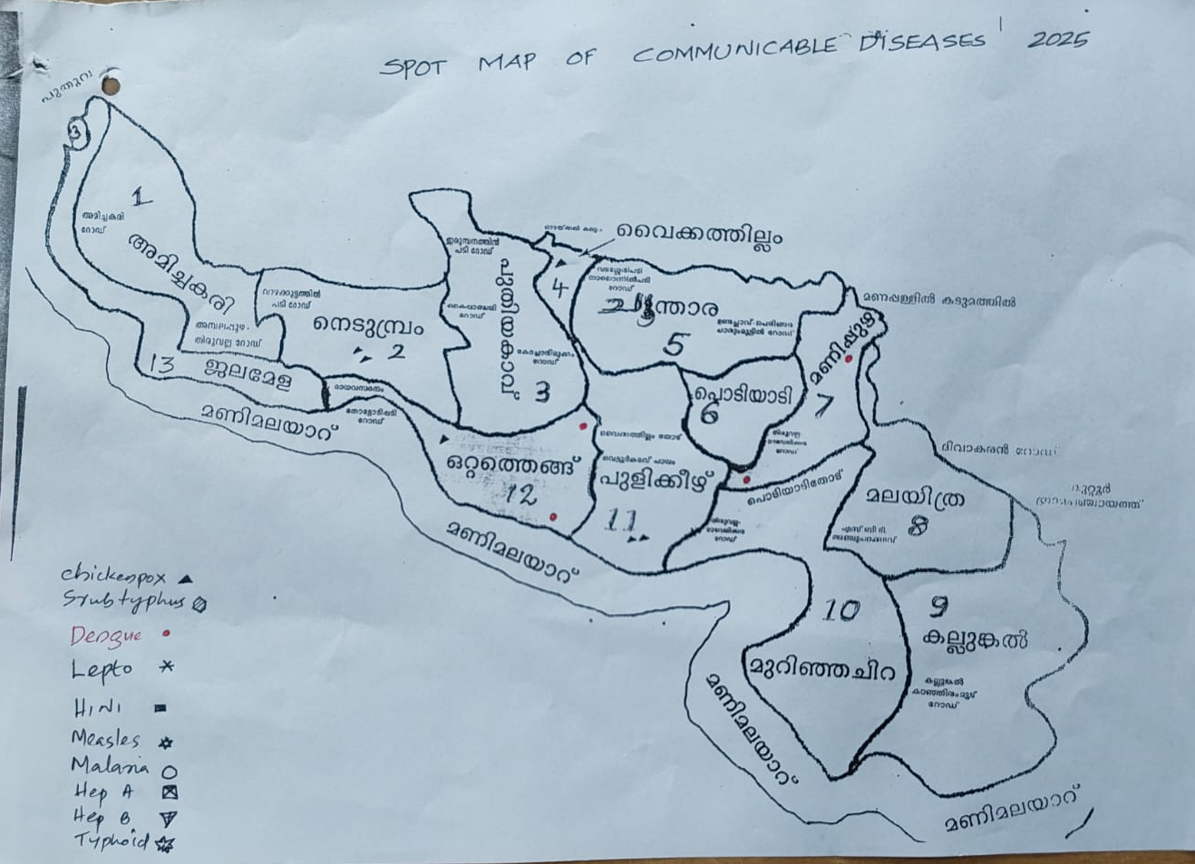

Ward No | Dengue Total (2021-25) | Leptospirosis Total (2021-25) | Hepatitis A Total (2021-25) | Mumps (2021-25) | ADD (2021-25) | Total Cases
1 | 0 | 0 | 0 | 0 | 4 | 4
2 | 2 | 0 | 0 | 0 | 5 | 7
3 | 0 | 0 | 0 | 0 | 4 | 4
4 | 0 | 0 | 0 | 0 | 5 | 5
5 | 0 | 0 | 0 | 0 | 4 | 4
6 | 2 | 0 | 0 | 0 | 5 | 7
7 | 3 | 1 | 0 | 0 | 5 | 9
8 | 1 | 1 | 1 | 0 | 4 | 7
9 | 0 | 0 | 0 | 0 | 6 | 6
10 | 2 | 0 | 0 | 0 | 5 | 7
11 | 1 | 1 | 0 | 0 | 6 | 8
12 | 1 | 0 | 0 | 0 | 5 | 6
13 | 0 | 0 | 0 | 0 | 4 | 4
14 | 0 | 0 | 0 | 0 | 4 | 4

By overlaying five years of data, we have identified zero 'Red Zone' Wards. These are wards where at least two different categories of diseases (e.g., Dengue and Lepto) recurred in consecutive years. Ward is categorized as the Highest Priority Hotspot due to its combination of flood vulnerability and high vector density. Future health infrastructure, such as the proposed R.O plants at Panchayat should be prioritized.

Critical Hotspot Insights
- Ward 7 (Super-Hotspot): Highest cumulative burden (9cases) and most diverse disease profile.
- Ward 8 (Sentinel Zone): Only ward reporting Hepatitis A; sits at a critical intersection of multiple transmission modes.
- Wards 10 & 11: Emerging high-incidence corridor for Dengue and ADD.

Priority Action Plan
- Zone A (Wards 7, 8, 11): Immediate intensive sanitation, rodent control, and mandatory well-chlorination.
- Zone B (Moderate Wards): Pre-monsoon source reduction and vector surveillance.
- General (All Wards): Ongoing hygiene education to combat the universal presence of ADD.

Preparedness and Response Protocol at LSG Level
This section describes the operational framework for the LSGI once a pandemic is declared. It explains how the LSGI and health system will move from routine data collection to active response, using a One Health approach.

Constitution of One Health Committee
The LSGD shall constitute a One Health Committee comprising the LSGI President, Medical Officers (Modern Medicine, AYUSH, and Veterinary), the Health Inspector, and the Veterinary Surgeon.

Objective: The One Health Committee coordinates human, animal, and environmental health to prevent and control pandemics.

Sl No | Name | Designation | Department/Institution | Role in Committee | Contact Number
1 | Mr Balachandran K | Panchayat President | LSGD | Chairperson | 9847899986
2 | Dr.Julie George | Medical Officer (PHC/CHC) | Health Dept | Member Secretary | 8136886657
3 | Dr Vipin | Veterinary Officer | Animal Husbandry | Member | 8547049358
4 | Dr.Dhanya | Epidemiologist | Health Dept | Member | 9847140643
5 | Mr Sakthikumar | Health Inspector/PHN | Health Dept | Surveillance | 9446044039
6 | Smt Anu | ASHA Supervisor | Health Dept | Community link | 9747211456
7 | Smt .Sindhu | ICDS Supervisor | Social Welfare | Vulnerable groups | 9447680851
8 | Mr .Ajith | Police Station Officer | Police Dept | Law & order | 9497947150
9 | Mr.Rinson Thomas | Ward Councillor Representative | LSGD | Community coordination | 9961221305
10 | Smt Shiny | Kudumbashree CDO | Kudumbashree | Community mobilisation | 8137830737

Key Responsibilities:
- Review disease surveillance data (human + animal)
- Conduct ward-wise risk assessment and vulnerability mapping
- Approve quarantine/isolation centre locations
- Coordinate with district for resources (PPE, oxygen, ambulances)
- Periodically review health system surge capacity, including beds, oxygen, human resources, and ambulances.
- Approve and monitor risk communication and community engagement strategies, including rumour management.
- Ensure protection and service continuity for vulnerable groups (elderly, persons with disabilities, dialysis patients, coastal populations).
- Conduct quarterly mock drills
- Monitor equity measures for vulnerable groups

Meeting Schedule:
Quarterly - Normal times
Weekly - outbreak alert
Daily - pandemic phase

Pandemic Response Workforce
To ensure a coordinated and timely response during a pandemic, a dedicated Pandemic Response Workforce shall be constituted at the LSG level. The workforce will function under the overall supervision of the One Health Committee and in close coordination with the health authorities. Team-based deployment will enable efficient surveillance, case management, quarantine and isolation management, logistics support, and risk communication. Each team shall have a clearly designated team leader, defined roles, and an identified pool of personnel to allow rapid activation, rotation of duties, and continuity of services during prolonged emergencies.

Total Response Workforce Available: 300 persons

Team Name | Composition | No | Key Responsibilities | Team Leader
Surveillance and Contact Tracing Team | HI, JHI, JPHN, ASHAs and Volunteers | HI-1  JHI-2  JPHN-2  ASHA-13  Volunteers-13 | Case detection, contact listing, home visits, reporting | HI
Case Management Team | Doctors, Nurses, MLSP, Palliative Nurses | Doctors-2  Nurses-2  MLSP- 2  Palliative  Nurses-1 | Patient care & referral | DOCTOR
Quarantine & Isolation Team | LSGD staff, Volunteers | LSGD staff-13  Volunteers-13 | Facility management | JHI
Psychosocial support | AH COUNSELOR | 1 | counselling support | MO
Logistics & supply chain Team | LSGD staff, Storekeepers, Drivers | LSGD staff- 13  Storekeepers-0  Drivers- 1 | Supplies & transport [PPE, medicines, oxygen, transport, waste management] | Ward Member
Communication Team | Ward members, Kudumbashree, Youth clubs,  AWW workers and other self help groups | Ward members-13  Kudumbashree- 130  Youth clubs-  AWW workers-15  Other self help groups- | IEC, community meetings, countering misinformation | M.O in charge
Transportation | KSRTC, educational institutional buses | KSRTC-Thiruvalla  Educational buses -4 | Safety of individuals, patient/staff transport | JHI
Media Surveillance | T Cell, Local Journalists, Volunteers | Journalist -3  Volunters-200 | Monitoring social media, tracking rumors | Public Relations Officer / HI
Intersectoral coordination and convergence | LSG President, Secretary, Health Staff | LSG President -1  LSGD Secretary -1  Health staff -20 | Policy decisions, resource pooling, convergence | LSG Secretary / President
Collaborative surveillance | Vets, Environmental Officers, Health Staff | Health staff-10  Environmental officers -2 | One Health tracking (Animal-Human interface) | Veterinary Surgeon

All teams shall be activated immediately upon outbreak alert or pandemic declaration and shall report daily to the LSG Incident Commander/Medical Officer, with consolidated reporting to the Block PHC. Duty rosters and alternate personnel shall be maintained to ensure uninterrupted services during staff shortages or prolonged response periods. Team composition and numbers may be revised based on the magnitude of the outbreak and availability of human resources.

Activities and Measures before and during Pandemic

PHASE 1 - Alert / Preparation

Activate One Health Committee
  - Immediately activate the One Health Committee at the LSG level. Convene an emergency meeting to review risk assessment, roles, and preparedness. Ensure coordination between Health, Veterinary, Agriculture, Local Self Government, and allied departments.
  - Prepare and circulate a contact directory of all committee members and emergency services.
  - Ensure documentation of decisions and action points with timelines.
  - Escalation hierarchy to be finalised (LSG to Institution to Block to District).
Surveillance and Reporting-
- Enhanced syndromic surveillance:
The LSGD shall initiate enhanced surveillance for priority syndromes and events such as:
- Fever
- Influenza-like illness (ILI)
- Severe acute respiratory infection (SARI)
- Unusual illness clusters (any unexpected increase in similar symptoms in a defined area or group)

- Data sources for surveillance:
- Ward-wise household surveillance (through ASHAs/JPHNs/ward volunteers)
- Outpatient surveillance from all government facilities (PHC, FHC, CHC, GH, etc.)
- Private hospitals, clinics, and labs

- Event-based triggers (to be monitored and reported):
- School absenteeism above the usual pattern (to be monitored through the headmaster/PTA nodal person)
- Sudden increase in pharmacy sales of fever/cough/cold medicines
- Workplace illness clusters (multiple staff reporting similar symptoms within a short period)

- Zoonotic and animal health surveillance
- LSGD shall review reports of unusual animal deaths or suspected outbreaks in animals in coordination with the Veterinary Officer.

- Any unusual mortality in poultry, pigs, cattle, companion animals, or wild birds/mammals shall be notified within 24 hours to the Veterinary Officer and One Health Committee for joint investigation.

Reporting Mechanism:
- All government and private health facilities, laboratories, and clinics within the LSGD shall report suspected and confirmed cases of notifiable diseases. Unusual clusters (schools, workplaces, neighbourhoods, events, institutions) shall be reported within 24 hours of detection for verification and field investigation.​

- Logistics and Stock Preparedness
- Identify and empanel local vendors and define emergency procurement mechanisms in accordance with existing LSGD and Health Department norms.
- Prepare and maintain an essential logistics checklist covering medical supplies, consumables, and support equipment.
- Pre-identify secure storage locations for emergency stocks and ensure maintenance of stock registers with regular updating.
- Finalise emergency transport arrangements, including availability of vehicles and identified drivers for rapid deployment during alerts.
- Designate a Nodal Officer for Logistics to enable prompt decision-making, coordination, and communication during emergencies.
- Conduct rapid stock verification and ensure availability of minimum buffer stock, including:
Commodities | Available stock
PPE kit | 0
Pulse oximeters | 0
Hand sanitizers | 0
Masks, gloves, disinfectants | Mask-1400 (Three Layer)  Gloves -6.5-1800, 7-300, 7.5-50  Disinfectants- White lotion-5

- Identify critical gaps in logistics and immediately communicate requirements to the Block and District authorities for timely replenishment and support. Monitor expiry dates and stock rotation.

Identification of Quarantine and Isolation Facilities
  - Identify and list suitable buildings for quarantine and isolation (schools, hostels, community halls, etc.).
  - Categorise cases as per the severity and allocate to appropriate facilities (for instance, severe cases to classrooms, mild cases to an assembly hall in case of a school).
  - Facility readiness checklist needed (beds, toilets, ventilation) etc.
  - Find an alternate site if the primary sites are not available or not in use.
  - Identify facility managers and support staff
  - Prepare basic SOPs for:
    - Admission and discharge
    - Food, water, sanitation
    - Infection prevention and waste disposal
  - Ensure availability of basic amenities: water, sanitation, electricity, ventilation, and waste disposal.

Risk Communication and Community Preparedness
  - Disseminate early warning messages on symptoms, preventive measures, and reporting mechanisms. Display IEC materials both in English and the local language in public places and ensure ward-level awareness.
  - Sensitize elected representatives and community leaders on preparedness measures.
  - Establish a rumour tracking and misinformation response mechanism to identify, verify, and promptly counter false or misleading information.
  - Engage trusted local persons (ward members, ASHA workers, religious leaders, teachers, community volunteers) to communicate official public health messages and reinforce correct practices.
  - Develop and deploy targeted IEC materials for:
    - Schools and educational institutions
    - Markets and commercial areas
    - Work sites and labour settings
  - Conduct community sensitization meetings at the ward level to promote preventive behaviors, address concerns, and strengthen community participation in preparedness and response.

Protection of Vulnerable Groups
Vulnerable populations require priority protection through targeted line-listing, service continuity, and delivery mechanisms.
- Prepare and regularly update line-lists of vulnerable populations, including:
  - Elderly persons living alone
  - Persons with disabilities
  - Pregnant women
  - Migrant workers
  - Dialysis patients
The detailed line-lists shall be maintained as Annexure 1.C and updated periodically.

Clinical Dependency Mapping
Develop ward-wise dependency and vulnerability maps to identify households requiring regular support during emergencies. Ensure continuity of essential health services for vulnerable groups, including
- Dialysis services (facility mapping, transport arrangements, and scheduling)
- Continuity of treatment for TB, HIV, and other chronic conditions requiring uninterrupted medication
- Mental health and psychosocial support services
Establish delivery mechanisms for food, essential commodities, and medicines to vulnerable households through coordinated action involving ASHAs, JPHNs, Kudumbashree, volunteers, and local administration.

PHASE 2 - Active Response

Case Identification and Contact Tracing
Case detection and contact tracing activities will be carried out in coordination with the Health authorities, following disease-specific SOPs and IDSP guidelines.
Field Staff Involved
- Health Inspector (HI)
- Junior Health Inspector (JHI)
- Junior Public Health Nurse (JPHN)
- ASHAs and ASHA Supervisors
- Ward-level volunteers and Kudumbashree members (as required)

Screening Checkpoints
Screening checkpoints at high-traffic locations (transport hubs, markets, religious gatherings) for early detection of symptomatic travellers and crowd screening during outbreaks. Potential locations include bus stands, market entry points, and boat jetties, based on local context and risk assessment.
Screening activities will be carried out by trained personnel such as ASHAs, ward members, and volunteers, with support from Health Department staff. Necessary equipment, including non-contact thermometers and appropriate PPE, shall be ensured prior to activation.
In Nedumprum gramapanchayat there is no such transport hub ,boat jetty,market entry ,so possibly there is less chance of getting an outbreak.
Location | Type (Bus stand/Jetty/Market/Railway) | Staff Deployed (ASHAs/Volunteers) | Screening Method | Reporting authority
Bus stand | Transport hub | NA | NA | NA
Market entry | Market | NA | NA | NA
Boat jetty | Water transport | NA | NA | NA

Standard Screening Protocol

The screening protocol shall include temperature screening, observation for visible symptoms, and inquiry regarding recent travel or exposure history. Individuals identified as suspects during screening shall be immediately referred to the nearest PHC/FHC for further evaluation, testing, and appropriate action as per prevailing guidelines.

Pandemic Control Room
The Pandemic Control Room (PCR) serves as the central nerve center for real-time coordination, data aggregation, decision support, and communication during outbreaks. It consolidates information from all LSGD teams, health facilities and community sources to enable rapid response decisions.

Control Room Infrastructure and Location
Primary Location: Nedumpuram Grama Panchayath Office.
Backup Location: Community Hall in Nedumpuram G.P.

Health System Control Room Framework
The PCR is organized into seven functional pillars to ensure no aspect of the response is overlooked:

Rapid Response Team (RRT)
  - Provides immediate intervention during emergencies, clusters, and field alerts.​
  - Coordinates urgent actions such as case investigation, contact tracing, isolation, and inter‑facility referrals.

Data Management & Analytics Team
  - Collects, validates, and manages key health system indicators (cases, tests, beds, HR, supplies).​
  - Analyzes data trends, generates projections, and supports evidence‑based decision‑making for local authorities.

Human Resource Deployment Team
  - Allocates healthcare staff efficiently based on workload and need
  - Ensures adequate and equitable workforce distribution across facilities

Laboratory Surveillance Team
  - Oversees diagnostic testing coordination, sample transport, and timely reporting of results.​
  - Monitors lab indicators (testing volume, positivity rate, turnaround time) for early detection of outbreaks

Vaccination Cell (If Required)
  - Plans and executes vaccination campaigns, including micro‑planning and session scheduling.​
  - Tracks coverage, identifies gaps, and coordinates corrective actions with field teams and outreach services.

Infrastructure & Patient Occupancy Team
  - Monitors facility capacity, earmarked beds, oxygen and critical care resources across all linked facilities.​
  - Ensures optimal patient distribution and referral management using updated bed‑status and resource data.
  - BMWM

7. Communication & Community Engagement
- Information Dissemination: Acts as the official voice of the Nedumpram GP. It issues daily health bulletins through the Ward-level WhatsApp groups and localized advisory notices at the Podiyadi Junction and Chakkulathukavu peripheral areas.
- Feedback Loop: Aggregates community concerns from the 13 Wards and coordinates with the Nedumpram Call Centre to address grievances and public anxiety regarding flood-prone zones or health outbreaks.

8. Logistics & Supply Chain
- Inventory Management: Oversees the procurement and storage of PPE, medicines, and essential supplies at the Nedumpram Gramapanchayat Office (Podiyadi).
- Supply Distribution: Ensures a "Just-in-Time" delivery system to field teams (ASHAs/Anganwadi workers) using the Panchayat’s Community Resource Center as a secondary staging point.

9. Transportation (Inter-facility & Emergency)
- Fleet Command: Manages the deployment of the "Chetana" ambulance network and converted private/school buses (e.g., from local educational institutions like St. Mary's) for mass transit during emergencies.
- Patient Logistics: Coordinates patient movement from home isolation to the Thiruvalla Taluk Hospital or Government Medical College, Kottayam, through a centralized dispatch system at the Panchayat level.

10. Media Surveillance & Call Centre
- Digital Monitoring: Scans local news and social media groups (e.g., "Nedumpram News") for misinformation to prevent panic and provide rapid rebuttals.
- Public Helpline: Operates a 24/7 desk to provide real-time information on Primary Health Centre (PHC) Nedumpram bed availability and testing schedules.

11. Management of the Deceased
- Dignity & Safety: Ensures all terminal protocols follow biosafety standards while respecting the local customs of the community.
- Logistics Coordination: Organizes safe transport to local cemeteries or the public crematoriums, ensuring the disposal squads are provided with adequate safety gear and psychological support.

12. Intersectoral Coordination and Convergence
- Administrative Liaison: Connects the Nedumpram GP President and Secretary with the Pulikeezhu Police Station, Revenue officials (Tahsildar), and the Irrigation Department for a unified response—especially critical during monsoon-related health crises.
- Resource Pooling: Facilitates the transformation of the Nedumpram Community Hall and the Government Schools into backup Domiciliary Care Centres (DCCs) or emergency infrastructure.

Key Control Room Team
The Control Room Team coordinates all pandemic response activities within the LSGD and serves as the single command and communication hub during activation. It integrates information, field actions, logistics, and policy execution across all participating departments and health facilities.

Role | Name | Designation | Contact Number | Responsibility
In-charge/Nodal Officer | Dr.Julie George | M/O I/C | 8136886657 | Overall coordination, decision-making, and reporting to the District level.
Data Entry Operator | Nishad kumar | JHI | 8907393040 | Managing the line list, updating dashboards, and tracking testing results.
Communication Officer | Sajeesh B | JHI | 8921095772 | Handling the public helpline, coordinating ambulance dispatch, and contact tracing calls.
Logistics Coordinator | Sreerekha | clerk | 9645042127 | Managing the supply chain (PPE, meds, oxygen), coordinating with Kudumbashree for community kitchens, and overseeing waste management logistics.
Technical Support(IT/Data) | Suneesh | OA | 8921343294 | Ensuring hardware/network uptime, physical filing of records, assisting in rapid document dispatch, and maintaining the Control Room's physical infrastructure.

SOP for alert escalation/trigger point with mapping of responsibilities.
Key Points:
- The Control Room shall be staffed with a designated In-charge, data entry personnel, and communication staff with clearly defined roles and shift arrangements.
- It shall maintain updated records on daily monitoring indicators including new cases, persons under active quarantine, and hospital bed occupancy.
- All reports and situation updates shall be shared daily with the Block and District Surveillance Unit.
- The Control Room shall act as a single point of contact for coordination with response teams, health institutions, and other departments.
- Contact details of the Control Room shall be widely communicated to field staff and stakeholders during activation.

Daily Monitoring Indicators
To ensure timely decision-making and effective response, the following key indicators shall be monitored and updated on a daily basis by the Pandemic Control Room:

Epidemiological Indicators:
New cases reported today, Total active cases, Test Positivity Rate (TPR), Case Fatality Rate (CFR)
- Surveillance Indicators:
Persons under home quarantine, High-risk contacts identified, Fever, ILI, SARI or other symptoms (syndromic surges), Travellers (symptomatic or high-risk arrivals),Animal husbandry surveillance (zoonotic alerts, unusual animal deaths, poultry/bird flu signals), Mortality surveillance (excess deaths, unexplained fatalities, verbal autopsy reports)
- Logistics and Infrastructure Indicators:
Hospital / CFLTC beds occupied, Oxygen cylinders/concentrators available, Ambulances on standby
- Alert Findings
The following table outlines category-specific trigger points (red flags) from surveillance indicators and corresponding immediate actions for the Pandemic Control Room. These enable rapid response to alert findings like testing anomalies, positive cases exceeding thresholds, clusters, and WGS reports.

Category | Trigger Point (Red Flag) | Immediate Action
Clusters | Geographical or facility-based: 5+ cases linked to one location (office, school, street). | Declare a micro-containment zone; perimeter control and active case finding.
Testing | Sudden drop in testing volume / delay in reporting / unusual testing trends | Review the sample collection process, address lab bottlenecks, deploy additional testing teams, and notify the District Lab.
Lab | Test Positivity rate increases | Increase testing sites in that ward.
Hospital | >80% Oxygen bed occupancy | Activate backup/CFLTC beds.
Travel | Cluster of cases from a single flight/train or high-risk arrival group. | Trace all passengers in adjacent seats; implement mandatory institutional quarantine.
Animal | Mass poultry/wildlife death or unusual sickness | Notify Animal Husbandry, sample the area, and dispatch RRT for environmental sampling and zoonotic check.
Mortality | Sudden spike in home deaths or brought-in-dead (BID) cases | Audit the deaths and Active Case Search drive
Additional investigations like Whole Genome Sequencing (WGS) | Detection of a Variant of Concern (VOC) or Variant of Interest (VOI) | Implement strict micro-containment; update clinical protocols to match variant severity.

Communication of Public Health Information
A Community Communication Hub shall be established to ensure timely, accurate, and consistent dissemination of information during a pandemic. The Hub will function under the coordination of Nodal officers of the control room and act as the nodal point for public communication, risk messaging, and community engagement. It will support dissemination of official advisories, promote preventive behaviors, address rumors and misinformation, and ensure that messages reach all sections of the population through trusted local channels and leaders.

Key communicators
Channel | Responsible Person | Contact
Ward-level announcements | Sajeesh B (JHI) | 8921095772
Social media | Dr.Julie George (MO) | 8136886657
Local Cable TV/Radio | Sajeesh B (JHI) | 8921095772

- All messages disseminated through the Hub shall align with advisories issued by the Health Department and District authorities.
- Community leaders shall be sensitized to support behavior change, reduce stigma, and counter misinformation.
- Special efforts shall be made to reach vulnerable and hard-to-reach populations using locally appropriate communication methods.

Rumor Tracking: A designated volunteer will monitor local social media/WhatsApp groups daily to identify misinformation and issue official clarifications via the Communication Hub.

Coordination with District/State Authorities & Other Organisations
Effective coordination with Block, District, and State authorities is essential to ensure timely reporting, technical guidance, and uninterrupted supply of essential resources during a pandemic. The LSG shall establish clear communication channels, designate responsible officers, and adhere to prescribed reporting timelines to support coordinated public health action and efficient resource mobilisation.

Reporting Schedule and Protocols:

To Whom | What to Report | Frequency | Nodal Person
Block PHC | Complete Situation Report (Cases, Quarantine, Beds, Screening, Deaths) | Daily | Health supervisor
District IDSP Unit | Outbreaks/Clusters/Unusual Events (>5 cases same ward) | Daily | Dr. Jeevan Nair  9847033362
Veterinary Officer | Animal health events/Zoonotic alerts | Weekly | Dr vipin
State Cell | Zoonotic cross-sector events | weekly | SSO

Supply Chain Coordination
The LSG shall coordinate closely with Block, District, and State authorities (KMSCL) to ensure uninterrupted availability of essential goods, medical supplies, and logistics during a pandemic. Supply requirements shall be assessed regularly based on case load and communicated promptly to the appropriate authorities for timely replenishment.
Key Points:
- Maintain updated contact details of District and Block nodal officers for health logistics, oxygen supply, ambulances, and essential medicines.
- Submit timely indent requests for PPE, testing kits, medicines, oxygen, and other critical supplies through prescribed channels.
- Monitor stock levels at LSGD facilities, quarantine/isolation centres, and field teams through daily stock registers and dispensing logs to prevent shortages.
- Coordinate with District authorities, Karunya/Neethi medical shops, and local purchase committees for funds allocation and emergency procurement.

- Ensure regular monitoring of dispensing registers at all facilities to track usage, expiry, and pilferage—shortages being a perennial issue requiring proactive weekly audits.

- Activate surge procurement protocols during high caseloads, leveraging local purchase powers under LSGD funds alongside state supplies.

Resource Inventory and Contacts
Resource Category | Source  (District/State/Private) | Contact
PPE Kits/Masks/Gloves | KMSCL | 9995599249
PPE Kits/Masks/Gloves | Local Vendors | 9744800183
Oxygen  Cylinders/Concentrators | KMSCL | 9995599249
Medicines/Antivirals | KMSCL | 9995599249
Medicines/Antivirals | Neethi Shops | 9744800183
Test Kits (RTPCR/Rapid) | KMSCL | 9995599249

Collaboration with NGOs, PPP, and CSR
To augment government efforts during a pandemic, the LSG shall collaborate with NGOs, voluntary organisations, and private sector partners through public–private partnerships and Corporate Social Responsibility (CSR) initiatives, in coordination with District authorities.

Key Points:
- Engage NGOs and community-based organisations for community outreach, awareness, and support to vulnerable populations.
- Leverage CSR support for procurement of medical equipment, PPE, oxygen concentrators, food kits, and sanitation materials, as permitted.
- Ensure all collaborations align with government guidelines and are routed through approved administrative and financial procedures.
- Maintain transparency and documentation for all external support received and utilised.
Organization | Type | Support Offered | Contact Person
Youth Clubs/Student Unions | CBO | Nil | Nil

Interdepartmental Coordination
Coordination among departments during a pandemic shall be ensured through regular review meetings convened by the LSGD President. These meetings will provide a structured platform for sharing situational updates, assessing resource availability, resolving operational gaps, and taking joint decisions to ensure a coordinated and timely response.

Department | Representative | Key Role | Contact
Health (PHC) | Staff Nurse : Preetha varghese | Case management | 8921867061
Veterinary | Veterinary Surgeon: Vipin | Animal surveillance | 8547049358
ICDS | Supervisor: Sindhu jinka chacko | Nutrition support | 9447680851
Education | Head Teacher:  Bindhu krishna | School coordination | 9447767569
Police |  | Containment enforcement | 9497947150
Water Authority | 0469-2700748 | Water supply | 7947427335
LSGD Engineering | 9744887618 | Quarantine infrastructure | 0471-2309250

PHASE 3 - Surge Capacity
Phase 3 is activated when there is a rapid increase in cases, high test positivity rates, or when existing health facilities and quarantine arrangements approach saturation. The focus of this phase is to expand isolation capacity, augment clinical care services, and mobilise additional resources through district and state support mechanisms.

Conversion of Community Facilities
To manage increased case load, the LSGD shall activate additional isolation facilities by repurposing identified community infrastructure such as community halls, auditoriums, schools, hostels, or other suitable buildings.

Name of facility | Facility Type | No. of Buildings | Ward | Surge Capacity (Beds) | Nodal Person
Karathra community hall | Community Hall | 1 | 8 | 150 | GP Secretary

Nedumpram Pandemic Preparedness & Recovery Plan

1. Recovery Phase: Restoring the Panchayat
- Damage & Impact Assessment: Immediate evaluation of the pandemic’s toll on the 2,154 BPL families and the SC/ST community, mapping "hotspot" wards (likely 7 and 12 due to waterlogging and density).
- Restoration of Health Services: Prioritizing the "re-opening" of non-pandemic services (immunization, dialysis, and NCD clinics) which are critical for the 4,212 elderly residents who often suffer from service disruptions.
- Disease Surveillance during Recovery: Transitioning from pandemic-only monitoring to "Syndromic Surveillance." This includes tracking fever spikes in paddy fields (Leptospirosis) and monitoring the Oct–March migratory bird influx to prevent a secondary Avian Influenza outbreak.

2. Rehabilitation: Rebuilding the Social Fabric
- Psychosocial & Mental Health Support: Launching a door-to-door "Elder-Check" initiative. Since the elderly make up 28% of the population, the plan utilizes the 1,328 adolescents as "Digital Volunteers" to connect isolated seniors with tele-consultation services.
- Environmental Cleanup & Sanitation: Intensive disinfection of public spaces and the 13 wards, focusing on stagnant water areas to prevent a "double burden" of pandemic and vector-borne diseases (Dengue/Chikungunya).
- Livelihood Restoration: Addressing the " Fisherfolk" vulnerability by providing subsidies for Biofloc or poultry units to BPL families, ensuring local protein security if external supply chains are cut again.

3. Health System Strengthening & Policy Revision
- Documentation & After-Action Review: Analyzing the transmission patterns in the SC/ST and BPL clusters to identify gaps in housing and sanitation that accelerated the spread.
- Policy Revision & Preparedness Enhancement: * "One Health" Integration: Formally linking animal husbandry and human health departments to monitor the June–Oct Rabies and Lepto peaks.
  - Vulnerability Mapping: Updating the "Age-Friendly" ward register to ensure the 4,212 elderly are the first to receive vaccines and rations in future waves.
- Research: Partnering with local medical colleges to study the "Long-term Impact of Waterlogging on Pandemic Resilience" in the Kuttanad geography.

CONCLUSION

- The Nedumpuram Grama Panchayat Pandemic Preparedness Plan marks a decisive transition from traditional disaster response to a sophisticated, data-driven governance model. At the heart of this strategy is a comprehensive Hazard Vulnerability Mapping system that identifies specific hotspots like Cherumuttam and Ottathengu. By overlaying environmental risks with the demographic reality of 4,212 elderly residents and 2,154 BPL families, the Panchayat can now deploy resources with surgical precision. This ensures that the most vulnerable clusters receive early warnings and targeted medical interventions long before seasonal floods or zoonotic outbreaks reach their peak.
- To ensure the continuity of this plan during extreme emergencies, the Panchayat has integrated advanced Tech Support and resilient communication layers. Recognizing that traditional networks often fail during the Kuttanad monsoons, the strategy enlists HAM Radio Operators to provide an unbreakable communication link between the Family Health Centre and remote wards. Furthermore, a strategic partnership with KSEB and the development of alternative power sources, such as solar-backed cold chains, guarantees that life-saving vaccines and diagnostic equipment remain functional even during prolonged grid failures.
- The final pillar of this plan focuses on the scientific management of relief-based commodities and livelihood restoration. By addressing the "Zero Fisherfolk" vulnerability through local poultry and aquaculture initiatives, the Panchayat ensures a steady supply of high-quality protein to the 2,154 BPL families and 57 migrant residents during supply chain disruptions. This holistic approach, blending inter-departmental coordination with community-led vigilance, transforms Nedumpuram into a model of rural resilience, where infrastructure, technology, and social welfare work in tandem to safeguard the health of every citizen.

RECOMMENDATIONS

Strengthening Healthcare Infrastructure
- Establish a primary health response unit within the Panchayat with trained staff.
- Ensure availability of basic medical supplies (masks, sanitizers, PPE kits, oxygen cylinders).
- Create tie-ups with nearby hospitals in Nedumprum for emergency referral and transport.

2. Community Awareness & Education
- Conduct regular awareness campaigns on hygiene, vaccination, and preventive measures.
- Use local communication channels (community radio, WhatsApp groups, notice boards) to spread verified information.
- Train volunteers to act as health ambassadors in each ward.

3. Emergency Response & Coordination
- Form a Pandemic Preparedness Committee at Panchayat level including health workers, ward members, and NGOs.
- Develop a clear action plan for lockdowns, quarantine, and distribution of essentials.
- Maintain a database of vulnerable groups (elderly, differently-abled, chronically ill) for targeted support.

4. Supply Chain & Food Security
- Identify and support local suppliers and farmers to ensure uninterrupted food supply.
- Create community kitchens during emergencies to serve vulnerable populations.
- Stockpile essential commodities in Panchayat-run outlets for crisis periods.

5. Digital Preparedness
- Promote digital platforms for telemedicine consultations.
- Use Panchayat’s website/social media for real-time updates on health advisories.
- Encourage online grievance redressal to reduce crowding in offices.

6. Training & Capacity Building
- Organize mock drills for pandemic response in schools, offices, and public spaces.
- Train Panchayat staff and volunteers in first aid, infection control, and crowd management.
- Collaborate with NGOs and health departments for capacity-building workshops.

7. Long-Term Resilience
- Integrate pandemic preparedness into the Panchayat Development Plan.
- Allocate a dedicated budget for health emergencies.
- Encourage community participation in planning and monitoring preparedness measures.

MOCKDRILL SCENARIOS

Mockdrill already done for Drowning Rescue in puthiyakavu at 2023

Mock Drill: Flood Response & Drowning Rescue
Location: Ward 1 jalamela
Scenario: Flash floods causing a riverbank breach, leading to a "person swept away" and a "submerged casualty" scenario.

Phase 1: Alert & Activation (0–5 Minutes)
- Trigger: Warning from the District Disaster Management Authority (DDMA) regarding rising water levels.
- Action: Panchayat Secretary activates the Ward Level Monitoring Committee.
- Communication: Megaphone announcements and WhatsApp alerts to residents in low-lying areas.
- The Incident: A simulated report is received that an individual has fallen into the floodwaters while attempting to move livestock.

Phase 2: Search & Rescue (The "Drowning" Protocol)
- First Response: Local trained volunteers (Asha workers, Kudumbashree members, and local divers) arrive with lifebuoys and country boats.
- Rescue Technique: * Reach & Throw: Attempting rescue using ropes and bamboo poles from the shore.
  - Boat Rescue: Deploying a country boat to retrieve the "drowning" victim from the current.
- Recovery: The victim is brought to a "Safe Landing Point" (identified high ground).

Phase 3: Immediate Medical Intervention
Once the victim is on dry land, the medical team (Primary Health Centre staff) demonstrates the Drowning Resuscitation Protocol:
- Safety Check: Ensure the rescuer and victim are on stable ground.
- Responsiveness: Check for breathing and pulse.
- Rescue Breaths: If the victim is not breathing, give 5 initial rescue breaths (critical for drowning victims to clear water from lungs).
- CPR: Start cycles of 30 chest compressions and 2 breaths (30:2).

Phase 4: Evacuation & Logistics
- Transport: The victim is stabilized and moved to the Ward 1 Healthcare Facility or the designated Relief Camp using a pre-arranged ambulance/vehicle.
- Tracking: The Panchayat Help Desk records the victim's details and informs relatives

Team | Responsibility
Rescue Team | Physical retrieval of victim; use of life-jackets and boats.
Medical Team | Performing CPR and stabilizing the casualty.
Police/Police Mitra | Crowd control and maintaining clear paths for ambulances.
Panchayat Board | Coordinating with the Taluk office for additional NDRF/Fire Force support.

ANNEXURE

IMPORTANT PHONE NUMBERS

Phone numbers and particulars of persons responsible for providing guidance, assistance, and support for pandemic preparedness operations may be provided here in a manner that allows easy reference at a glance.The information recorded here could be exhibited elsewhere at the time of emergencies. LSG institutions shall give special attention to collect and record the above data of persons and institutions who/which are supposed to give technical and co-ordination support to reduce the impact of pandemic.
1.1. Details of grama panchayat/municipality/corporation wards
Sl.No | Name of the ward | Ward number | Name of the ward  member | Contact number
1 | Jalamela | 1 | Joji Thomas | 9847899986
2 | Amichakary | 2 | Mini Saji | 9744364614
3 | Nedumpuram | 3 | Rinson Thomas | 9961221305
4 | Puthiyakavu | 4 | Aneesh kumar K S | 9946615386
5 | Vykkathillam | 5 | Rajappan K K | 9605233090
6 | Choonthara | 6 | Viji V Nair | 9605085621
7 | Undaplavu | 7 | Asha Mohan | 9961913551
8 | Manipuzha | 8 | Sreelekha S | 9496105021
9 | Podiyadi | 9 | Maya Devi K | 9961239351
10 | Malayithra | 10 | Sujitha S | 9656533053
11 | Kallunkal | 11 | Babu Thomas | 7559834009
12 | Murinjachira | 12 | Balachandran K | 9446128000
13 | Pulikkeezhu | 13 | Vysakh P | 7012722437
14 | Ottathengu | 14 | Sandhyamol T S | 9656673476

1.2. Other important phone numbers of grama panchayat/municipality/corporation area
Sl. No. | Name | Contact number
1. | Santha kumar -GP secretary | 9847895474
2. | Surej babu- Assistant Secretary | 9446033273
3. | Health standing committee chairperson | 9961221305
4. | Agriculture officer | 9847121112
5. | Excise department | nil
6. | Forest department | nil

1.3. Important offices of grama panchayat/municipality/ corporation
Sl.No | Name of the office | Contact person | Contact number
1. | Village Office | Village Officer | 9446415463
2. | Agriculture Office | Agriculture Officer | 9847121112
3. | Animal Husbandry Office | Animal Husbandry Doctor | 8547049358
4. | Police Station | Police Officer | 9497947150
5. | BSNL Office | Officer | NA
6. | Block Office | Officer | 8281040530
7. | KSEB Office | Officer | 04692701201
8. | Fisheries Office | Officer | NA
9. | Fire and Rescue | Officer | 04692600682

1.4. Health Services

Sl. No | Name of the hospital/institution | Location | Phone number
1. | Government hospitals/PHC | Podiyadi FHC | 04692642640
2. | Private hospitals | Manak Hospital | 9847147626
3. | Clinical laboratories | Nedumpurum | 8078249415
4. | Chemist/pharmacy | Podiyadi | 9961239351
5. | Blood donors | Nedumpuram | 9961085841
6. | Other language experts (Bihari, Hindi, Bengali,  Asamees ………) | NA | NA

1.5. Veterinary Services
Sl.No | Name of the Clinic | Name of the  Surgeon/Doctor | Place/location | Phone  number
1 | Govt.Veterinary Hospital | Dr Vipin | Vykkathillam | 8547049358

1.6. Helpline numbers
Helpline | Phone number
Police | 9497947150
Fire and Rescue | 04692600682
KSEB | 04692701201

1.7. Public and Private Schools Contact details

S.No | Name of School | Ward | Institution type | Phone number
1 | Govt HS Nedumpuram | 12 ,14 | Govt Aided | 9447767569
2 | Govt LPS Podiyadi | 6, 9 | Govt Aided | 9544125991
3 | MDLPS Kallunkal | 10 , 12 | Govt Aided | 9495734461
4 | MTLPS Amichakery | 13 , 1 | Govt Aided | 8848257740
5 | Mangalodayam UPS | 6 , 9 | Govt Aided | 9446193858
6 | CMS LPS Amichakery | 1 , 2 | Govt Aided | 9544333364
7 | EALPS Kocharimukkam | 4 ,5 | Govt Aided | 9747591065

1.9. Anganwadi Contact Details

No | Ward No | Name of Anganwadi Teachers | AW No | Phone number
1 | 6 | Presannakumari | AW 66 | 9744549567
2 | 4 | Sujamani | AW 71 | 6238468690
3 | 6 | Jyothi K K | AW No 68 | 9778722253
4 | 3 | Medhini | AW No 124 | 9446934441
5 | 2 | Sumi | AW No 62 | 7034943050
6 | 8 | sindhu | AW No 63 | 8606812250
7 | 10 | Shylamma | AW No 69 | 8590832795
8 | 13 | Sujatha | AW No 70 | 9562208289
9 | 12 | Geetha | AW No 65 | 9847672486
10 | 9 | Prasanna | AW No 64 | 9605636987
11 | 7 | Lalitha | AW No 73 | 9961388663
12 | 11 | Sreekala | AW No 116 | 9496874217
13 | 1 | Sudhamani | AW No72 | 8089815513
14 | 5 | Lalitha | AW No 67 | 8547225955
15 | 9 | Sumi moncy | AW No 125 | 9544893663

1.12. Information regarding resources

Means of transportation | Name of Owner | Phone Number
Heavy Trucks | Rinson | 9778722253
Tractor | NA | NA
Ambulances | Sevabharathi | 94469 55300
Boats | NA | NA
Taxi service | Call Taxi Thiruvalla | 83040 23168

Annexure 1: LSG Baseline Data Collection Format
A. Baseline data
Sl. No. | Indicator / Field | Baseline Data | Source / Remarks
1 | Name of LSG | Nedumpuram | Panchayat data
2 | District | Pathanamthitta | Panchayat data
3 | Block / Taluk | Pulikkeezhu/Thiruvalla | Panchayat data
4 | Type of LSG (Gram Panchayat / Municipality / Corporation) | GP | Panchayat data
5 | Area (sq. km) | 8.49 | Panchayat data
6 | No. of wards | 14 | Panchayat data
7 | GIS boundary file available | (Yes/No) | Panchayat data
8 | Key contact person & phone | Santhakumar  GP Secretary 9847895474 | Panchayat data
B. Demography
Indicator / Field | Baseline Data | Source / Remarks
Total population | 15062 | LSGD DATA
Males | 7682 | LSGD DATA
Females | 7380 | LSGD DATA
Transgender population | 0 | LSGD DATA
Age distribution  (<5, 5–14, 15–59, ≥60) | <5 - 708  5–14 -836  15–59 - 9306  ≥60 - 4212 | LSGD DATA
No. of households | 4240 | LSGD DATA
Population density (persons/sq.km) | 179 | LSGD DATA
No. of migrant workers | 57 | LSGD DATA
Major occupational groups | Agriculture | LSGD DATA
C. Vulnerable Populations & Social Risks
Sl. No. | Indicator / Field | Baseline Data (Value / Description) | Source / Remarks
1 | No. of elderly (≥60) | 4212 | FIELD DATA
2 | No. of persons with disability | 117 | FIELD DATA
3 | No. of bedridden persons | 27 | FIELD DATA
4 | No. of chronic disease cases (DM/HTN/COPD/CKD etc.) | DM- 1893  HTN-3719  COPD-1054  CKD-9 | FIELD DATA
5 | Pregnant women (current estimate) | 53 | FIELD DATA
6 | Children <5 years | 708 | FIELD DATA
7 | Tribal population (if any) | 5+1 | FIELD DATA
8 | Fisherfolk / coastal vulnerable groups (if any) | 0 | FIELD DATA
9 | Urban slums / unnotified settlements (if any) | 0 | FIELD DATA
10 | Homeless population | 0 | FIELD DATA
11 | Orphanages / old age homes (number & capacity) | 1(ambadi balasramam)/12 | FIELD DATA
12 | Hostels / prisons / shelters (number & capacity) | 0 | FIELD DATA
13 | Poverty / BPL estimate | 27/3269 | FIELD DATA
14 | Food insecurity hotspots | 0 | FIELD DATA
15 | Any history of stigma/discrimination issues (Yes/No) | No | FIELD DATA

D. Health System & Service Readiness
Sl. No. | Indicator / Field | Baseline Data (Value / Description) | Source / Remarks
1 | No. of health facilities in LSG (PHC/CHC/TH/DH/Private) | FHC-1  HWC-3  PVT-1 | FIELD DATA
2 | PHC/Family Health Centre details (name, location) | FHC Nedumpuram Podiyadi | FIELD DATA
3 | Subcentres / Health & Wellness Centres (number) | Main center  Kallumkal  Amichakery | FIELD DATA
4 | Private clinics / hospitals (number) | 1 | FIELD DATA
5 | Labs available (public/private) | 4 | FIELD DATA
6 | Availability of ambulance services (Yes/No, number) | No | FIELD DATA
7 | Availability of isolation/quarantine facilities (Yes/No, details) | No | FIELD DATA
8 | Cold chain facilities (Yes/No, details) | Yes | FIELD DATA
9 | Stockpile space available (Yes/No) | No | FIELD DATA
10 | PPE / mask / sanitizer availability plan (Yes/No) | Yes | FIELD DATA
11 | Surveillance staff available (JHI/JPHN/ASHA count) | 2,3,13 | FIELD DATA
12 | Existing emergency referral pathways (Yes/No) | Yes | FIELD DATA

E. Points of Entry & Mobility
Sl. No. | Indicator / Field | Baseline Data (Value / Description) | Source / Remarks
1 | Bus stands / depots (number) | 0 | LSGD DATA
2 | Railway stations (number) | 0 | LSGD DATA
3 | Boat jetties / fishing harbours (number) | 0 | LSGD DATA
4 | Ports / airports nearby (specify distance) | 0 | LSGD DATA
5 | Major highways/roads passing through | TA road | LSGD DATA
6 | Border crossings (state/district) | Alappuzha | LSGD DATA
7 | Major markets / weekly markets | 0 | LSGD DATA
8 | Tourism hubs / major event venues | 0 | LSGD DATA
9 | Schools/colleges with hostels (number) | 7/0 | LSGD DATA
10 | Factories / large workplaces (number) | 0 | LSGD DATA
F. Water, Sanitation & Hygiene (WASH)
Sl. No. | Indicator / Field | Baseline Data (Value / Description) | Source / Remarks
1 | Major drinking water sources (piped / wells / borewells / springs) | Piped | LSGD DATA
2 | No. of public wells | 5 | LSGD DATA
3 | No. of households with piped water connection | 3827 | LSGD DATA
4 | Water quality testing routine (Yes/No) | yes | LSGD DATA
5 | Common contamination risks (flooding, salinity, industrial waste) | Flooding | LSGD DATA
6 | Open defecation free status (Yes/No) | Yes | LSGD DATA
7 | Solid waste management system (Yes/No) | Yes | LSGD DATA
8 | Bio-medical waste disposal mechanism (Yes/No) | Yes | LSGD DATA
9 | No. of public toilets | 0 | LSGD DATA
10 | Handwashing stations in public places (Yes/No) | yes | LSGD DATA
G. Zoonotic Risks & One Health
Sl. No. | Indicator / Field | Baseline Data (Value / Description) | Source / Remarks
1 | Livestock population (cattle/goats/pigs/poultry) – estimates | 580 | LSGD DATA
2 | No. of dairy farms / poultry farms / pig farms | 0 | LSGD DATA
3 | Slaughterhouses / meat shops (number) | 0/1 | LSGD DATA
4 | Animal markets (Yes/No, details) | No | LSGD DATA
5 | Veterinary dispensaries (number) | 1 | LSGD DATA
6 | History of zoonotic outbreaks (rabies, leptospirosis, avian flu etc.) | 0 | LSGD DATA
7 | Stray dog population management measures (Yes/No) | No | LSGD DATA
8 | Rodent infestation hotspots (Yes/No) | No | LSGD DATA
9 | Wetlands / waterlogged areas prone to leptospirosis | 0 | LSGD DATA
10 | Bat roosting areas / caves / fruit orchards (if any) | 0 | LSGD DATA
11 | Human-animal interface hotspots (farms near residences) | 0 | LSGD DATA
H. Climate & Disaster Risks (Pandemic Amplifiers)
Sl. No. | Indicator / Field | Baseline Data (Value / Description) | Source / Remarks
1 | Flood-prone wards (list) | 1 to 13 | LSGD DATA
2 | Landslide-prone wards (list) | 0 | LSGD DATA
3 | Cyclone/sea surge risk (Yes/No) | No | LSGD DATA
4 | Heatwave risk zones (Yes/No) | No | LSGD DATA
5 | Waterlogging areas (list) | 0 | LSGD DATA
6 | Shelter homes / relief camps (number, capacity) | 0/1/100 | LSGD DATA
7 | Past disaster displacement history | Flood | LSGD DATA
8 | Disruption to water supply/transport common (Yes/No) | No | LSGD DATA
I. Critical Infrastructure & Logistics
Sl. No. | Indicator / Field | Baseline Data (Value / Description) | Source / Remarks
1 | Schools (number) | 7 | LSGD DATA
2 | Anganwadis (number) | 15 | LSGD DATA
3 | Colleges (number) | 0 | LSGD DATA
4 | Community halls (number) | 1 | LSGD DATA
5 | Places of worship with large gatherings (number) | Podiyadi temple-150  Puthiyakavu temple-200  Church ottathengu-100  St. george church amichakary -100  St. george church kallunkal-160  Mosque nedumpuram-100 | LSGD DATA
6 | Large markets / shopping areas (number) | nil | LSGD DATA
7 | Warehouses / cold storages (number) | nil | LSGD DATA
8 | Telecom/mobile network coverage gaps (Yes/No) | yes | LSGD DATA
9 | Power outage frequency (high/medium/low) | low | LSGD DATA
10 | Availability of generators in key facilities | yes | LSGD DATA

J. Risk Communication & Community Networks
Sl. No. | Indicator / Field | Baseline Data (Value / Description) | Source / Remarks
1 | Ward-level rapid response teams (Yes/No) | Yes | LSGD DATA
2 | Jagratha samithis / committees active (Yes/No) | Yes | LSGD DATA
3 | Kudumbashree presence and strength (number of units) | Yes/ | LSGD DATA
4 | Volunteer network (number, coverage) | Yes | LSGD DATA
5 | Community-based surveillance mechanisms (Yes/No) | Yes | LSGD DATA
6 | IEC dissemination channels (WhatsApp groups, community radio, PA systems) | Yes | LSGD DATA
7 | Rumour tracking mechanisms (Yes/No) | Yes | LSGD DATA
8 | Languages spoken / literacy considerations | Malayalam | LSGD DATA
9 | Vulnerable groups communication strategy available (Yes/No) | yes | LSGD DATA

K. Preparedness Planning & Governance
Sl. No. | Indicator / Field | Baseline Data (Value / Description) | Source / Remarks
1 | LSG emergency plan available (Yes/No) | Yes | LSGD DATA
2 | Pandemic preparedness plan available (Yes/No) | Yes | LSGD DATA
3 | Incident Command System identified (Yes/No) | Yes | LSGD DATA
4 | Rapid procurement mechanism available (Yes/No) | Yes | LSGD DATA
5 | Emergency fund available (Yes/No, amount) | Yes | LSGD DATA
6 | Past outbreak response experience (Yes/No, details) | Yes | LSGD DATA
7 | Intersectoral coordination mechanism (Health, Police, LSG, Veterinary, Education) | Yes | LSGD DATA
8 | Mock drills conducted in last 12 months (Yes/No) | No | LSGD DATA
9 | Training coverage for staff/volunteers (Yes/No) | yes | LSGD DATA

L. Surveillance & Data Systems
Sl. No. | Indicator / Field | Baseline Data (Value / Description) | Source / Remarks
1 | Digital reporting tools used (e.g., DHIS2, portals) | Portals | FIELD DATA
2 | Availability of line-listing format (Yes/No) | Yes | FIELD DATA
3 | Contact tracing team identified (Yes/No) | Yes | FIELD DATA
4 | Mapping of high-risk households available (Yes/No) | Yes | FIELD DATA
5 | Testing sample transport mechanism (Yes/No) | yes | FIELD DATA
6 | Reporting timeline adherence (good/average/poor) | Good | FIELD DATA
7 | Data sharing between departments (Yes/No) | Yes | FIELD DATA
8 | Availability of dashboard for monitoring (Yes/No) | Yes | FIELD DATA

M. Additional Notes & Observations
Sl. No. | Indicator / Field | Baseline Data (Value / Description) | Source / Remarks
1 | Key challenges perceived by LSG | Flood | FIELD DATA
2 | Top 5 high-risk wards (reason) | 7,8,12 dengue,Hep-A | FIELD DATA
3 | Any unique local risks (industrial pollution, refugee camps, etc.) | No | FIELD DATA
4 | Recommendations for preparedness strengthening | Availabilty proper vehicles ,intersector co-ordination | FIELD DATA

