NIRANAM GRAMA PANCHAYATH
PANDEMIC PREPAREDNESS PLAN
FAMILY HEALTH CENTRE NIRANAM

user
[Email address]
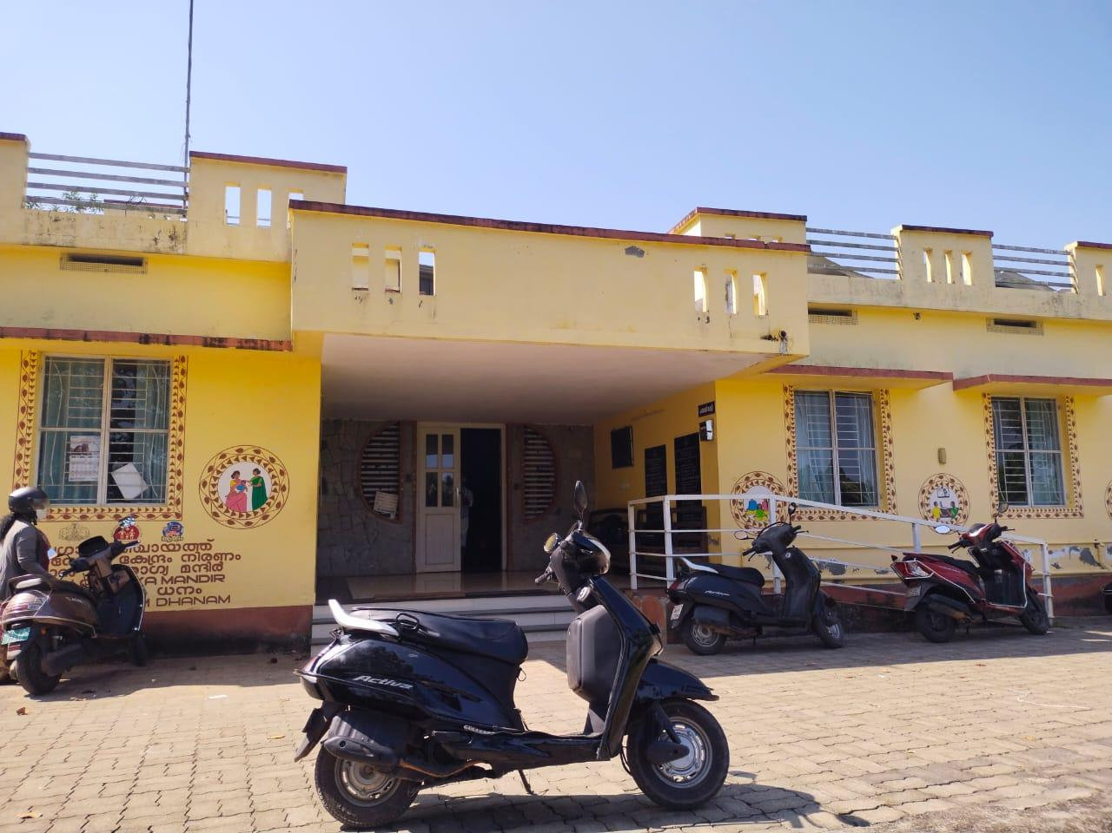

Dr Preethi S R
Medical Officer

MESSAGE FROM PRESIDENT
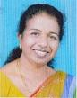

Dear All,
The COVID-19 pandemic has brought unprecedented challenges globally, and our country was not spared from its impact. However, through public participation and inter-departmental coordination, we have managed to control the disease and alleviate much of the suffering. Unfortunately, the pandemic, along with natural disasters and other epidemics like avian flu, leptospirosis, dengue, and malaria, continues to impact our community. These health crises have affected our people physically, mentally, and financially.
Our panchayat, with its diverse population of farmers, small-industry workers, and migrant workers from other states, is particularly vulnerable to epidemics, outbreaks, and natural disasters. The hardships these events cause, including loss of life and working days, are significant. It is our duty as a local self-government to manage these crises effectively and minimise the suffering of our people.

To address these challenges, we must implement a comprehensive action plan that prioritises public participation and cross-departmental coordination. This plan will ensure that any health crisis or disaster is swiftly reported and that relief efforts are organised scientifically and efficiently.
I urge all stakeholders – including residents, community leaders, and governmental and non-governmental bodies – to join forces in supporting this initiative. Your cooperation is vital for the success of this plan and for safeguarding the health and well-being of our community in the future.
Let us work together to ensure a healthier, safer future for all
S
SINCERELY,
JOLLY EAPPEN,Niranam Panachayath President

MESSAGE FROM HEALTH STANDING COMMITTEE CHAIR



Respected Citizens,
Niranam Panchayat, with its unique geographic location surrounded by water on three sides, is home to a diverse population. Our community comprises individuals engaged in various sectors, including poultry and dairy farming, agriculture, industry, and migrant workers from within and outside the country. This diverse economic base, while a source of strength, also makes us vulnerable to the spread of infectious diseases, whether local or global.
It is our shared responsibility to prevent loss of life and reduce the physical and mental hardships caused by such diseases. To effectively tackle these challenges, we must develop and deploy a scientific, participatory action plan that leverages public-private partnerships and interdepartmental coordination.
The Local Self-Government Department (LSGD) is dedicated to promoting public health, but this cannot be accomplished alone. It is only through community involvement and cooperation that we can safeguard the health and well-being of our people.
I call on all stakeholders—community members, health workers, and local authorities—to come together, just as we have before, to fight potential epidemics and protect our future health, economic stability, and social welfare.
Let us unite for the greater good of our community

Best regards
Aiswarya
Health Standing Committee Chairperson

MESSAGE BY MEDICAL OFFICER
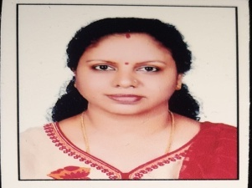
Dear Respected Citizens,
As the Medical Officer of the Family Health Centre (FHC), I want to express my
deepest concern for the health and well-being of our community, especially amid the
ongoing health challenges we face. The COVID-19 pandemic, along with other diseases
like avian flu, leptospirosis, dengue, and malaria, has deeply impacted our people,
causing physical, emotional, and financial hardship.
Our panchayat, with its diverse population, is particularly vulnerable due to its location
and the presence of many workers in agriculture and industry, as well as through
migration. In these trying times, the role of healthcare services becomes more crucial
than ever. As part of the FHC, I am committed to providing essential healthcare
services to everyone in our community, ensuring timely and effective medical care for
all.
However, we cannot overcome these challenges alone. The fight against these health
crises requires active involvement from each of you. I urge all community members to
stay informed, practice preventive measures, and collaborate with health workers and
local authorities. Together, through collective action, we can minimize the impact of
these diseases and disasters on our people
We will continue to work closely with the Gram Panchayat, local authorities, and other
departments to ensure that healthcare resources are available, accessible, and
effectively distributed. Let us stand united in the face of these challenges to protect the
health and safety of our community.
Thank you for your cooperation and commitment to the health of Niranam Panchayat.
Yours sincerely,
Dr PREETHA S R
Family Health Centre, Niranam Panchayath
EXECUTIVE SUMMARY

Niranam Grama Panchayat, located in the Thiruvalla Taluk of Pathanamthitta district, is a geographically unique region within the Upper Kuttanad belt. Covering an area of 13.17 sq. km, it is characterized by low-lying wetlands and plains, with the Pamba and Kolara rivers serving as its primary water bodies. Historically, Niranam is renowned as an ancient maritime port and a significant cultural hub, being the birthplace of the "Niranam Poets" and home to one of the oldest churches in India. With a population of over 13,000 and a high literacy rate of 94.7%, the community is deeply rooted in an agrarian economy, primarily focusing on paddy cultivation where it stands as the second-largest rice producer in the district.
Despite its agricultural productivity, the panchayat’s topography makes it exceptionally vulnerable to climate-related disasters, most notably seasonal flooding. Situated often at or below sea level, nearly 96% of the panchayat was submerged during the devastating 2018 floods, and many areas remain waterlogged for up to six months a year. This geographical reality poses constant threats to livelihoods, causing significant crop destruction and infrastructure damage. Beyond flooding, the region faces secondary challenges such as drought during summer months, health issues related to the heavy use of chemical pesticides in farming, and the displacement of residents during extreme weather events.
To address these recurring threats, the Niranam Disaster Management Plan outlines a robust framework for mitigation, preparedness, and rapid response. The strategy emphasizes local empowerment through the mapping of critical resources, including emergency shelters, transport vehicles, and rescue equipment. Financial provisions have been made for dedicated relief camp infrastructure and innovative communication tools like Farm Radio to maintain contact during power outages. By integrating traditional knowledge with modern disaster resilience projects, the panchayat aims to safeguard its residents and its vital agricultural economy against the increasing unpredictability of climate change.

LIST OF ABBREVIATIONS

LSGD | Local Self Government Department / Local Self Government Institution
BMO | Block Medical Officer
IDSP | Integrated Disease Surveillance Programme
NDMA | National Disaster Management Authority
PPE | Personal Protective Equipment
ICMR | Indian Council of Medical Research
CD | Communicable Diseases
NCD | Non-Communicable Diseases
KSIDC | Kerala State Industrial Development Corporation
covid | Coronavirus Disease
CAPD | Continuous Ambulatory Peritoneal Dialysis
TB | Tuberculosis
PHC | Primary Health Center
FHC | Family Health Center
AYUSH | Ayurveda, Yoga & Naturopathy, Unani, Siddha, and Homoeopathy
THQH | Taluk Head Quarters Hospital
MCH | Medical College Hospital
USG | Ultrasonography (Ultrasound Scan)
RT-PCR | Reverse Transcription Polymerase Chain Reaction
CT, MRI | Computed Tomography, Magnetic Resonance Imaging
NCC/NSS | National Cadet Corps, National Service Scheme
CBO | Community-Based Organizations
SHG | Self-Help Groups
NGO | Non-Governmental Organizations
SOP | Standard Operating Procedure
ILI, SARI | Influenza-Like Illness, Severe Acute Respiratory Infections
CFLTC | COVID First Line Treatment Centre

TABLE OF CONTENTS

3
INTRODUCTION 9
● Background of the PPP 9
LSGD AT A GLANCE 9
INTEGRATED HEALTH INFRASTRUCTURE MAP OF NIRANAM PANCHAYAT 10
GENERAL PROFILE OF THE LSGI’S 13
Background of the LSGI 13
Demographic and Vulnerable Population 14
Clinical Vulnerability 16
INFRASTRUCTURE & RESOURCE INVENTORY 18
Health Facility Directory & Basic Capacity in the LSGD 18
Private Clinics 19
Healthcare Education & Training Institutions 20
Specialized Services & Emergency Inventory 20
Oxygen & Diagnostic Capacity 21
Diagnostics facility mapping at the LSGI level 22
Laboratory Identification & Basic Details 22
Social and Community Infrastructure for surge plan 22
Human resources 24
Community & Support Cadre 25
Community Organizations 26
Administrative & Emergency Services 27
Information regarding resources 27
ONE HEALTH & ENVIRONMENTAL SURVEILLANCE 28
Animal & Bird Population 28
Veterinary Infrastructure 29
Veterinary Doctors & Workforce 30
High-Risk Interface Points (Surveillance Sites) 30
Environmental Risk Mapping 31
Disease Seasonality Mapping 32
Vulnerability Mapping 33
EPIDEMIOLOGICAL TRENDS (2021–2025) 34
Disease Burden among human beings(Last 5 Years) 34
*(use the above table data to create the graph/diagram) 36
Seasonal Trend Analysis 37
Outcome-Based Trend Analysis- 2025 39
Transmission Trend- 2025 40
Integrated Disease Hotspot Map (2021–2025) 42
Preparedness and Response Protocol at LSG Level 44
Constitution of One Health Committee 44
Pandemic Response Workforce 45
Activities and Measures before and during Pandemic 47
PHASE 1 - Alert / Preparation 47
PHASE 2 - Active Response 50
Standard Screening Protocol 51
PHASE 3 - Surge Capacity 60
Conversion of Community Facilities 60
CONCLUSION 61
RECOMMENDATIONS 62
ANNEXURE 63
1. IMPORTANT PHONE NUMBERS 63

INTRODUCTION

Niranam Grama Panchayat operates a structured healthcare network tailored to its unique geography as a low-lying, water-bound region. The Primary Health Centre (PHC) serves as the central hub for clinical services, including outpatient care, immunizations, and disease surveillance. This facility is supported by a grassroots health system consisting of 18 Anganwadis distributed across all 13 wards, which prioritize the nutritional and medical needs of children and mothers. Additionally, the panchayat maintains a Veterinary Hospital to support the livestock that underpins the local agrarian economy. This health network is particularly attentive to long-term community concerns, such as the rising incidence of cancer and the potential health impacts of intensive chemical pesticide use in the surrounding paddy fields.

The panchayat’s Disaster Management Plan incorporates a rigorous preparedness framework designed to maintain medical services during the frequent floods that submerge nearly 96% of the area. Preparedness measures include the pre-identification of high-ground buildings, such as community halls and schools, that can be rapidly converted into temporary medical relief camps. To ensure continuous operation during power failures, the plan includes provisions for emergency communication tools and a centralized directory of medical resources. The management of inorganic waste is also a priority, handled by the Haritha Karma Sena to prevent sanitation-related diseases and environmental degradation, especially during flood recovery phases.

Evacuation and response strategies are a critical component of the panchayat’s healthcare resilience. The plan outlines specific rescue routes and a mobilization strategy to transport the elderly, bedridden patients, and persons with disabilities to the PHC or higher medical centers in nearby towns. Beyond physical health, the preparedness plan integrates psychosocial support through a network of government-approved counselors to address the mental health challenges associated with displacement and property loss. By coordinating between the health department, waste management teams, and local emergency responders, the panchayat ensures a comprehensive safety net that protects both public health and community well-being during environmental crises.

Background of the PPP

The background of the Niranam Panchayath Preparedness Plan (PPP) is deeply rooted in the lessons learned from the devastating 2018 floods, which submerged 96% of the region and highlighted the urgent need for a localized, systematic response framework. Following the state-level "Nammal Nammukkai" initiative, the panchayat developed a comprehensive plan that integrates risk mapping, resource identification, and community-led mitigation strategies. This framework includes the establishment of specialized Emergency Response Teams, the allocation of funds for dedicated relief infrastructure, and the implementation of innovative communication systems like Farm Radio to ensure the flow of information during extreme weather events. By focusing on the unique vulnerabilities of the Upper Kuttanad landscape, the PPP aims to transition the panchayat from a reactive rescue-based approach to a proactive culture of resilience and long-term safety.
Central to this preparedness effort is the Primary Health Centre (PHC), which functions as the Family Health Centre (FHC) and serves as the primary medical lifeline for the community. Strategically located in Ward 10, the health centre coordinates with a network of 18 Anganwadis to provide essential healthcare, maternal support, and nutrition monitoring across all 13 wards. Beyond routine clinical care, the facility is tasked with addressing significant regional health challenges, including an increasing trend in cancer cases and environmental health risks stemming from intensive chemical pesticide use in local paddy fields. During disaster scenarios, the health system is seamlessly integrated into the PPP, with pre-identified evacuation routes and medical protocols designed to protect the most vulnerable populations, such as the elderly and bedridden, while the Haritha Karma Sena manages waste to prevent post-disaster disease outbreaks.

LSGD AT A GLANCE
- Geographical boundaries with political map ( based on latest delimitation)
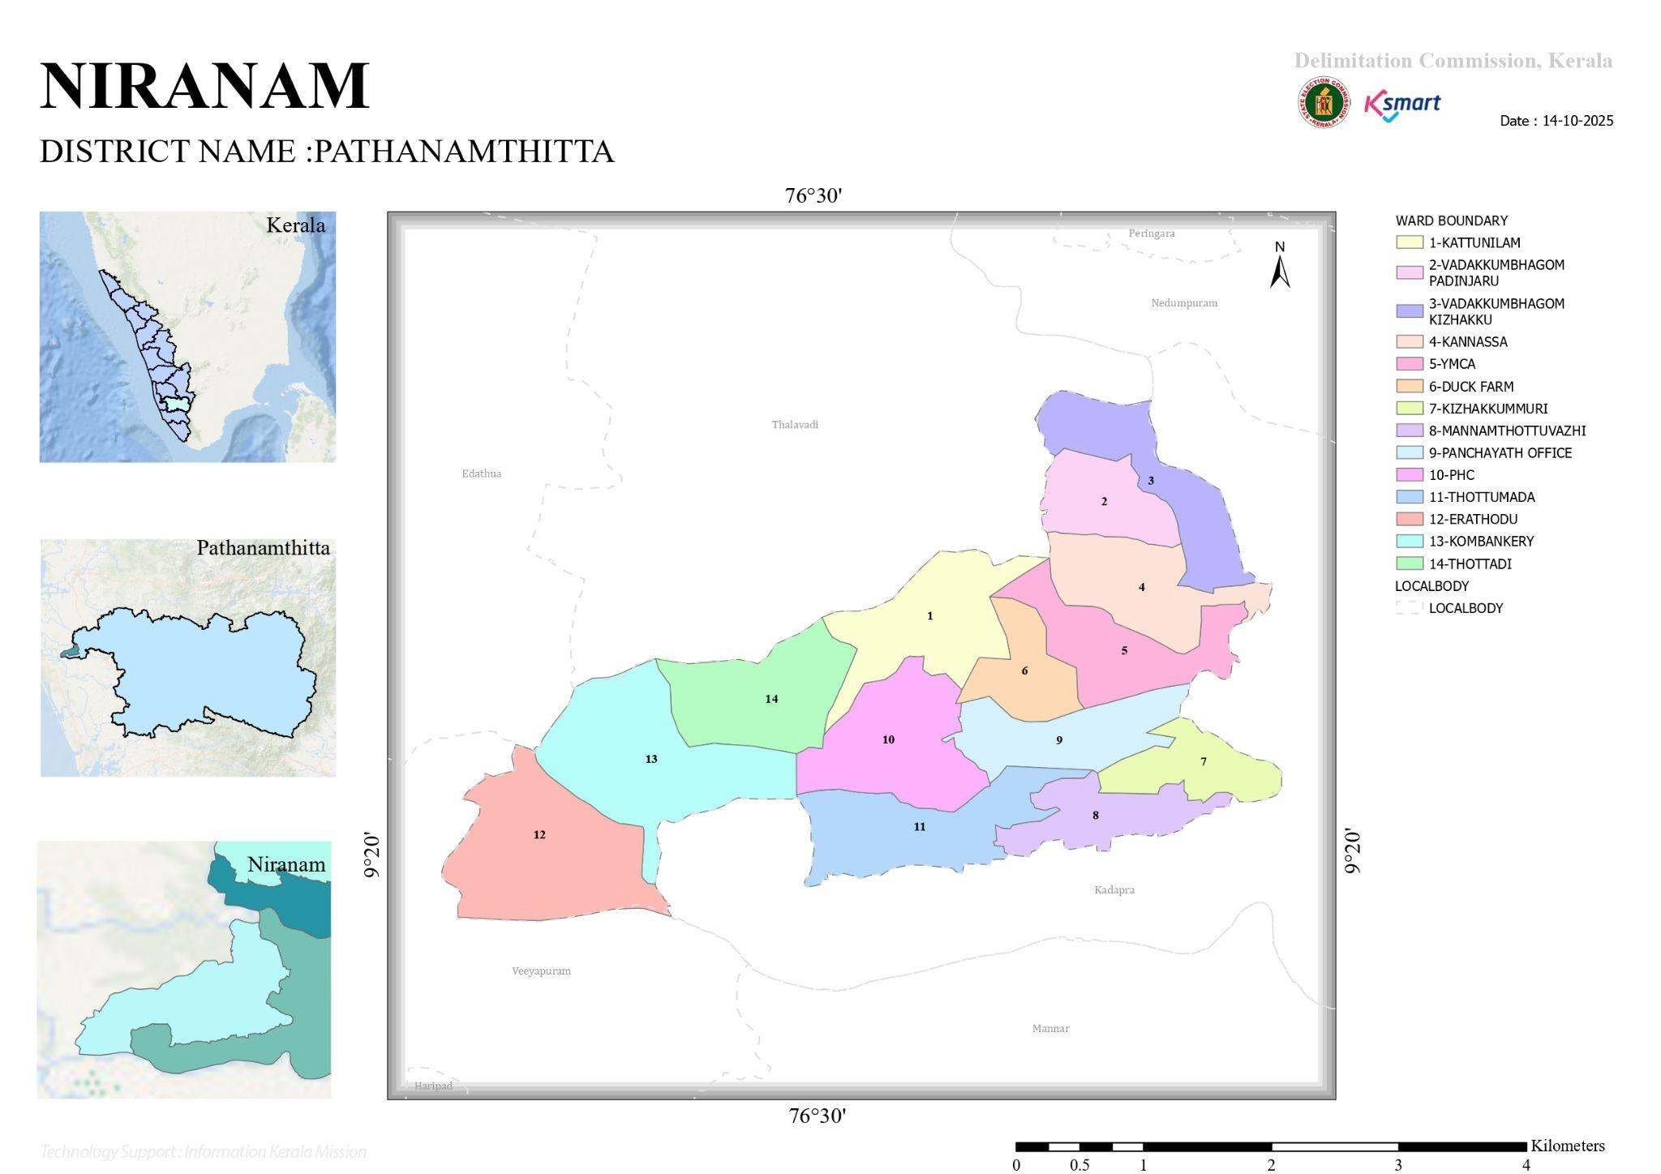
- Baseline data

Ward | Houses | Population | Migrants | Wells | Hot  spots | Ed. Institutions | Hosp pvt/govt.
13 | 4477 | 16262 | 96 | 3774 | All wards | 12 | 0

- Ward division

1-KATTUNILAM
2-VADAKKUMBHAGOM
PADINJARU
3-VADAKKUMBHAGOM
KIZHAKKU
4-KANNASSA
5-YMCA
6-DUCK FARM
7-KIZHAKKUMMURI
8-MANNAMTHOTTUVAZHI
9-PANCHAYATH OFFICE
10-PHC
11-THOTTUMADA
12-ERATHODU
13-KOMBANKERY
14-THOTTADI

- Risk stratification among wards in the context of Communicable diseases and hazards

Risk Category | Ward No. | Name of the Ward
High Risk | 4 | 4-KANNASSA
 | 5 | 5-YMCA
 | 6 | 6-DUCK FARM
 | 7 | 7-KIZHAKKUMMURI
 | 8 | 8-MANNAMTHOTTUVAZHI
 | 9 | 9-PANCHAYATH OFFICE
 | 10 | 10-PHC
 | 11 | 11-THOTTUMADA
 | 12 | 12-ERATHODU
 | 13 | 13-KOMBANKERY
 | 14 | 14-THOTTADI
Moderate Risk | 1 | 1-KATTUNILAM
 | 2 | 2-VADAKKUMBHAGOM PADINJARU
 | 3 | 3-VADAKKUMBHAGOM

- occupational groups, socio cultural groups, migration & mobility patterns

- Vulnerability mapping
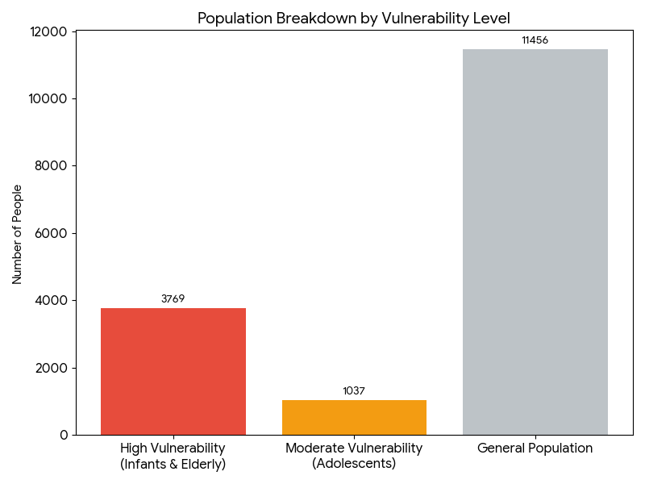
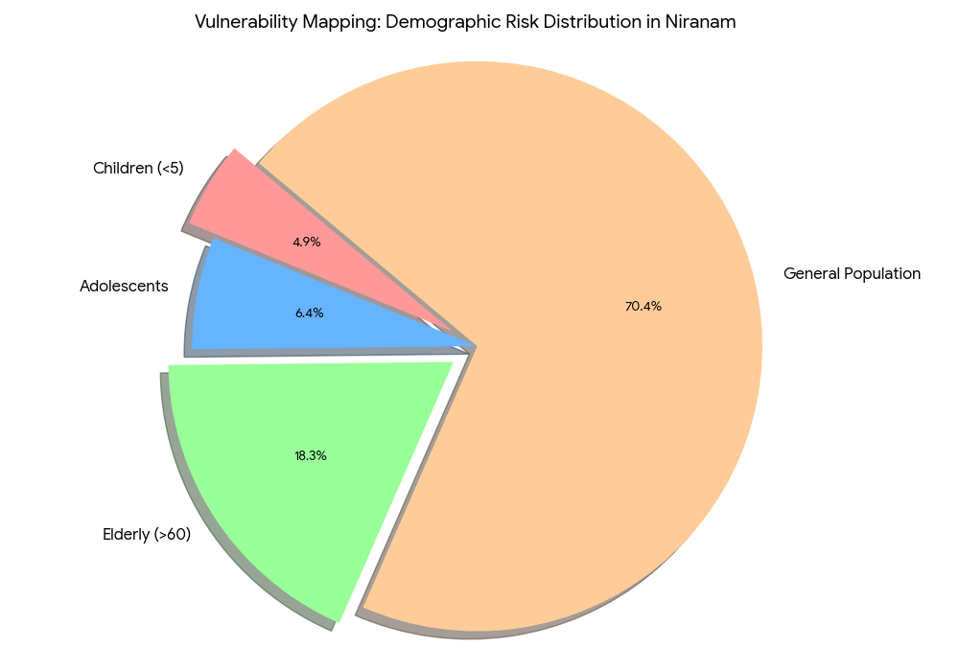

Geographic Vulnerability and Red Zone Mapping
The following charts visualize the extreme geographic risks faced by Niranam Grama Panchayat. Because the region is part of the Upper Kuttanad basin and sits largely at or below sea level, the "Red Zone" (areas of maximum risk) covers almost the entire landscape.

1. Land Risk Distribution
As shown in the data, a staggering 96% of the 13.17 sq. km area is classified as a flood-prone Red Zone. Only a tiny fraction (4%) of the land is considered "Safe Zone" high ground, which typically includes the locations of the Family Health Centre (FHC) and specific designated relief shelters.

2. Primary Geographic Hazards
The "Red Zone" classification is driven by four primary factors:
- Total Flood Risk (96%): The baseline risk where water enters homes and public buildings.
- Pesticide Runoff (High Severity): Due to intensive paddy farming, floodwaters carry chemical contaminants, creating a health crisis alongside the physical one.
- Prolonged Waterlogging: Unlike flash floods, water in Niranam's low-lying basins can remain for up to 6 months, destroying infrastructure and creating breeding grounds for disease.
- Isolation: Significant portions of the Red Zone lose all road connectivity, requiring a pre-planned fleet of boats for the evacuation of the 2,971 elderly residents.
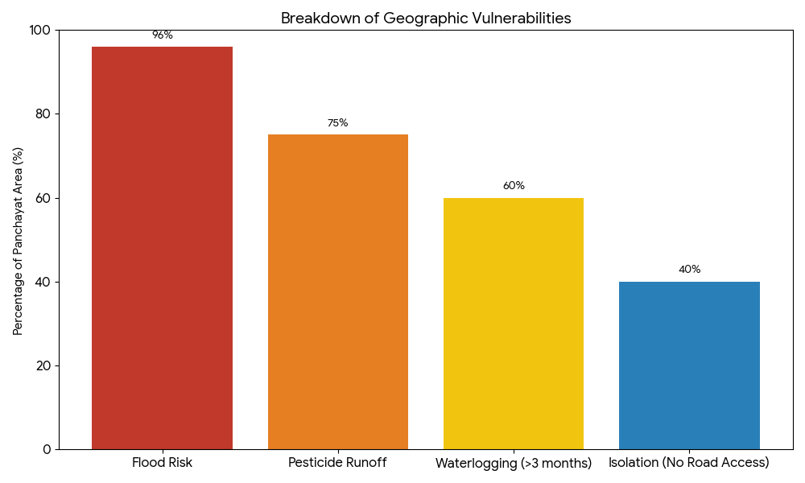

Strategic Use of this Mapping
The Panchayath Preparedness Plan (PPP) uses this "Red Zone" data to:
- Prioritize Evacuation: Residents in the 96% risk area are alerted via Farm Radio to move to the 4% safe zones immediately upon a "Red Alert" warning.
- Resource Placement: Boats and emergency medical supplies are pre-positioned at the edges of the Red Zone to ensure they aren't trapped by rising waters.
- Sanitation Focus: The Haritha Karma Sena uses these maps to target post-flood cleaning in the most waterlogged areas to prevent outbreaks of Leptospirosis.

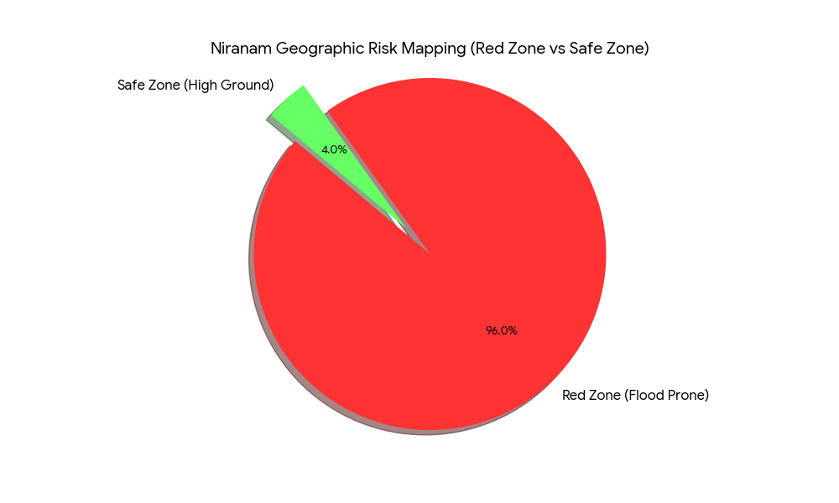

MAPS

Geographical boundaries - ward boundaries map
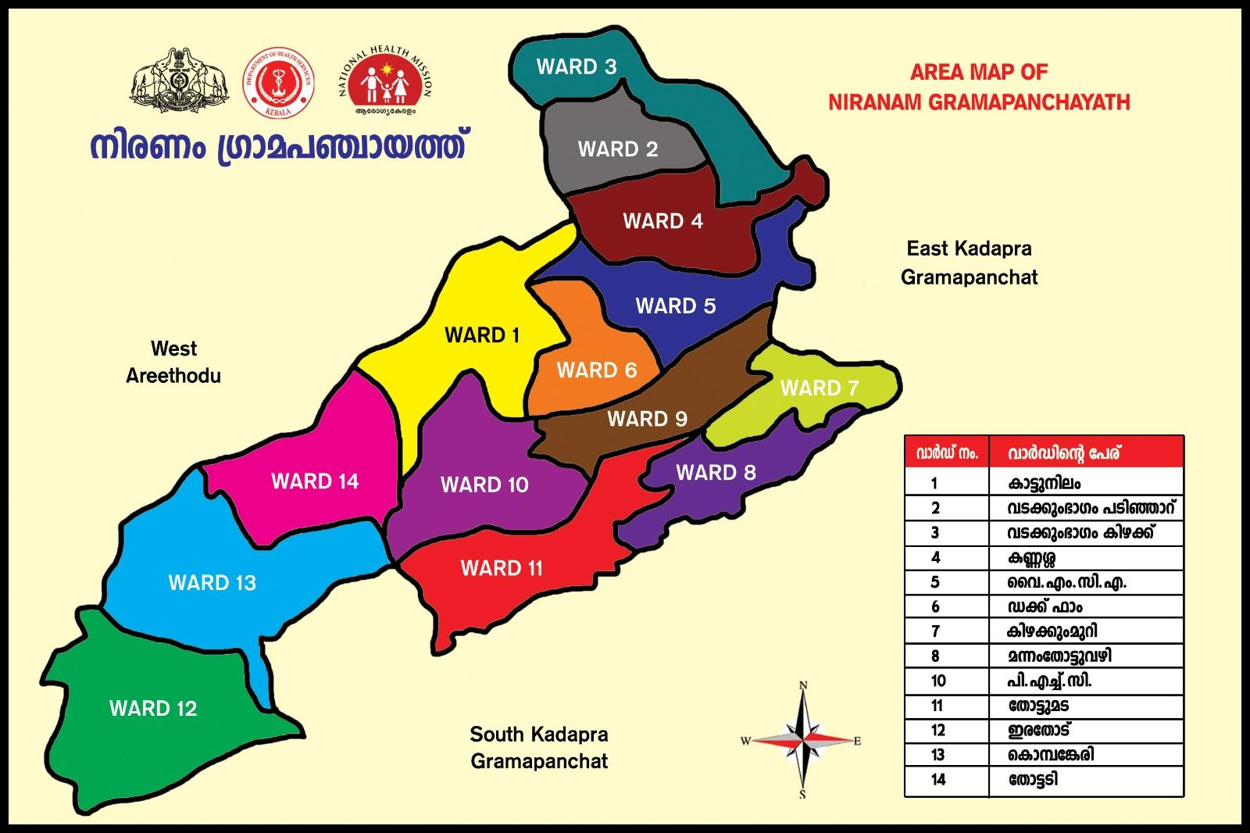

INTEGRATED HEALTH INFRASTRUCTURE MAP OF NIRANAM PANCHAYATH

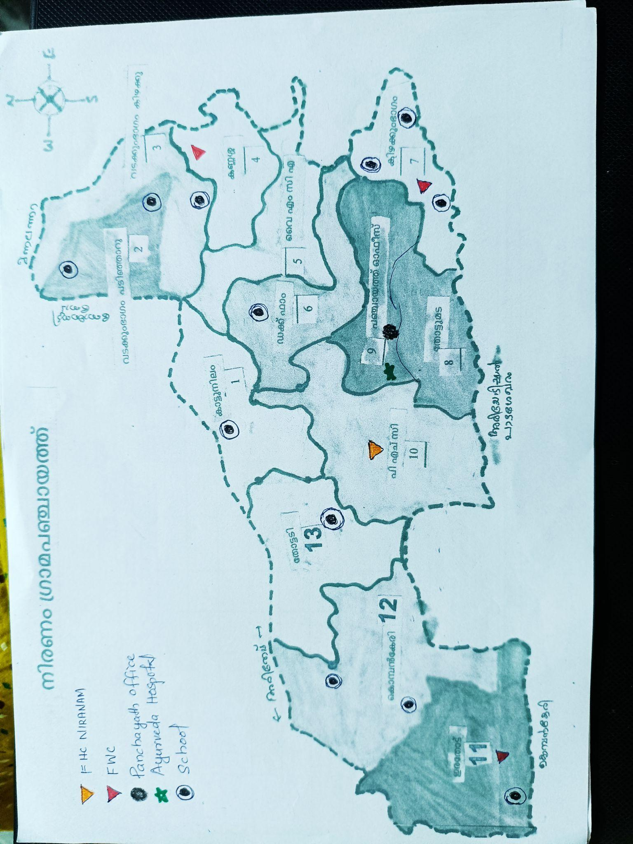



- roads and rivers map

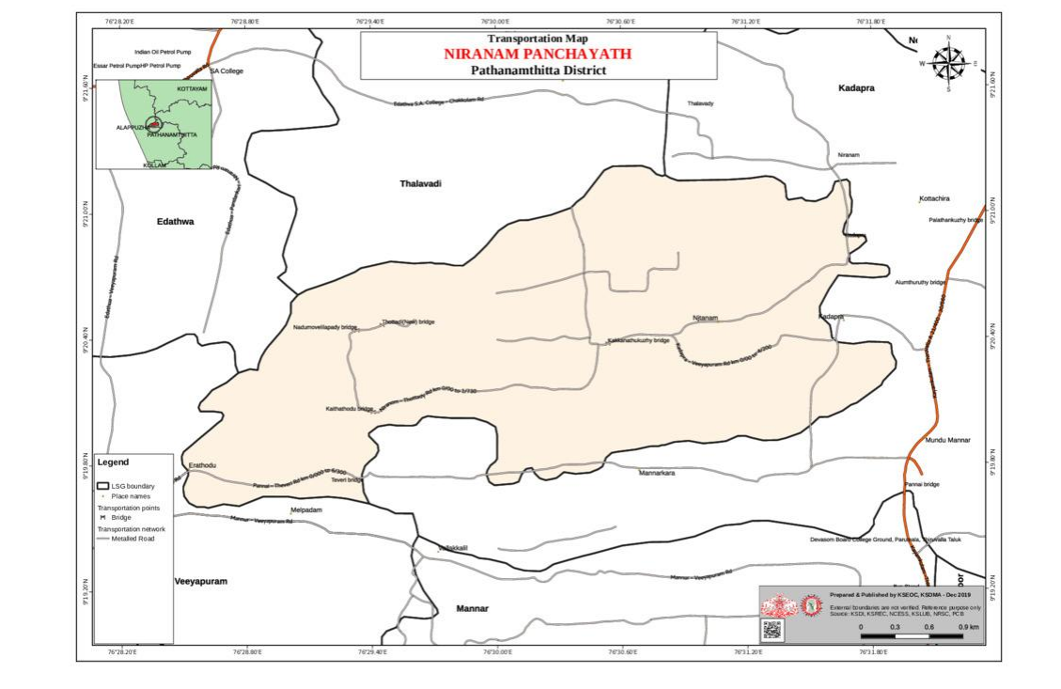

- major establishments map

Auxiliary services map
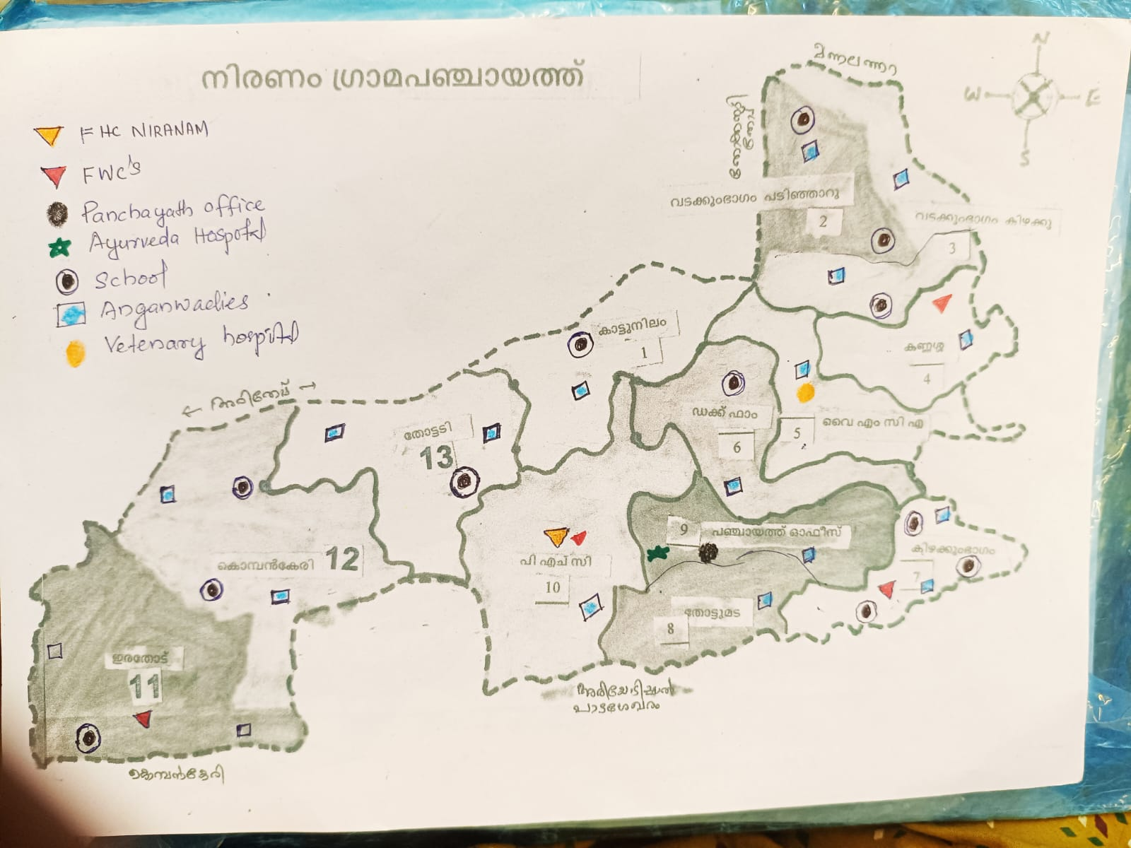

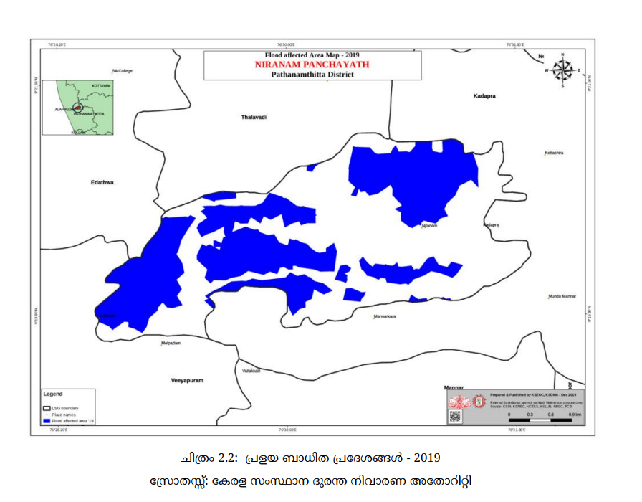
- disaster-prone areas map

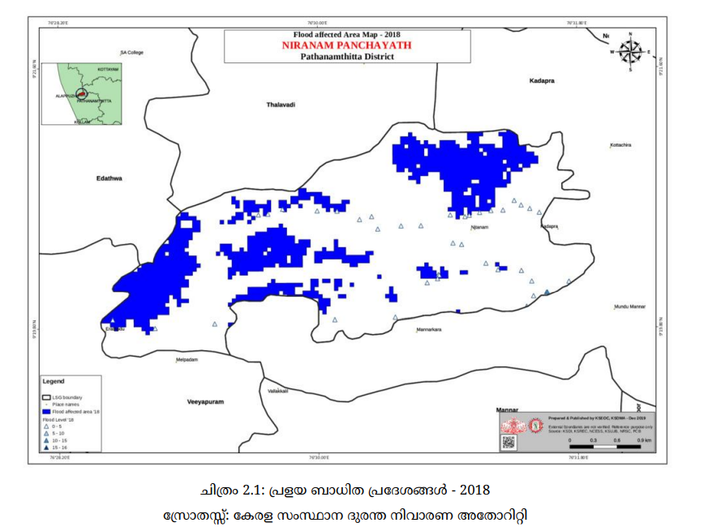

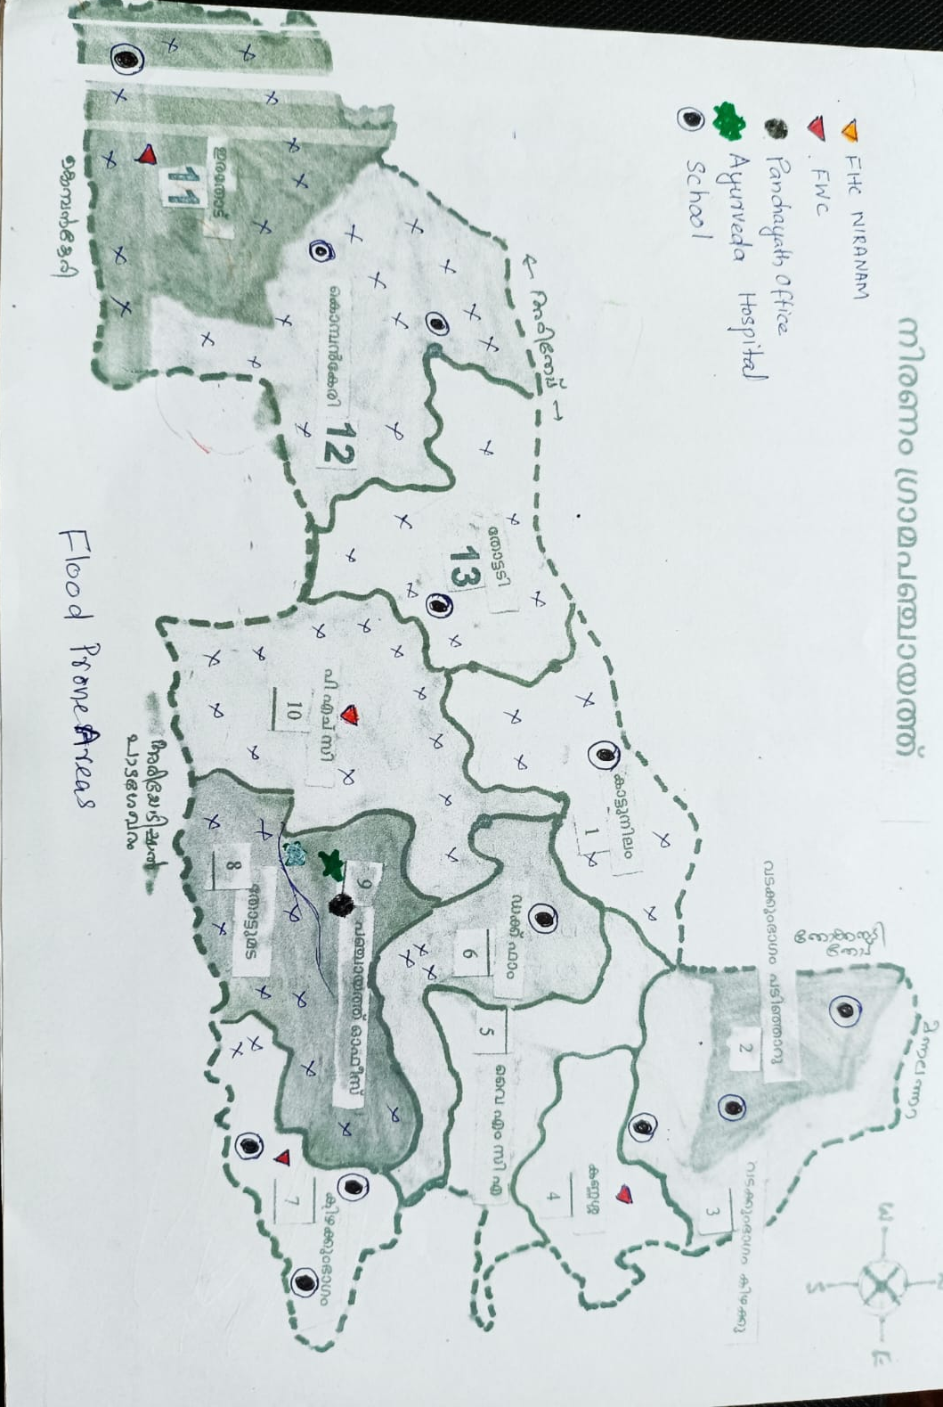

GENERAL PROFILE OF THE NIRANAM PANCHAYAT

Background of the Panchayat

Niranam Grama Panchayat is a significant rural local body situated in the Thiruvalla Taluk of Pathanamthitta District, forming a vital part of the Upper Kuttanad region. Spanning an area of 13.17 sq. km and divided into 13 wards, the panchayat is defined by its unique deltaic geography, bordered by the Pamba River and nourished by the Kolara River. Historically recognized as an ancient maritime port and a cradle of Malayalam literature through the "Niranam Poets," the region sits at a low elevation, with many areas positioned below sea level. This topography has fostered a deeply rooted agrarian economy, where Niranam stands as the second-largest producer of rice in the district, with nearly 62% of its land dedicated to vast paddy fields .
Despite its agricultural wealth, the panchayat faces extreme environmental vulnerabilities, most notably a recurring threat of severe flooding that defines its disaster profile. The catastrophic floods of 2018, which submerged 96% of the panchayat, serves as a benchmark for the region's high risk, where low-lying wetlands remain waterlogged for nearly six months of the year. Beyond natural disasters, the community grapples with modern public health challenges, including a rising trend in cancer cases and the ecological impact of intensive chemical pesticide use in farming. These factors, combined with a population of over 13,000 residents and a significant expatriate community, necessitate a highly specialized approach to governance and local safety.
In response to these challenges, the Niranam LSGI has shifted toward a proactive "Panchayath Preparedness Plan" (PPP) under the state’s "Nammal Nammukkai" initiative. This background of recurring crises has led to the formal mapping of auxiliary infrastructure—ranging from the Primary Health Centre and 18 Anganwadis to a network of emergency relief shelters and specialized rescue equipment. By integrating institutional health monitoring with climate-resilient projects, such as the construction of dedicated relief buildings and the implementation of Farm Radio for emergency communication, the LSGI aims to safeguard its traditional livelihoods while building a data-driven framework for community resilience.

Table 1: Background of LSGD
Description | Details
Name of LSGI | Niranam
Type (GP/Municipality / Corporation etc.) | Grama Panchayath
Block | Pulikeezhu
District | Pathanamthitta
Number of wards | 13
Total area (sq. km) | 13.7sqkm
Population(Projected) | 16262
Population density | 1187.persons/sq km
Terrain (coastal/low-lying/backwaters/foothills, etc.) | Low- lying
Number of rivers passing through LSGI | 1
Number of water bodies in the LSGI | 3
Number of educational institutions | 12
Factories / small-scale industries | 0
Flood-prone wards | 13
Landslide-prone wards | 0
Death Management and Disposal Facilities (mortuaries/crematorium, including electric) | 0
Auditoriums/Marriage halls/convention centres/community halls | 2

Demographic and Vulnerable Population
Understanding the demographic composition and vulnerable population groups is essential for pandemic preparedness. Children, elderly, economically deprived families, migrant workers, and socially vulnerable groups are at increased risk during public health emergencies due to higher exposure, limited access to services, and dependency on public systems.
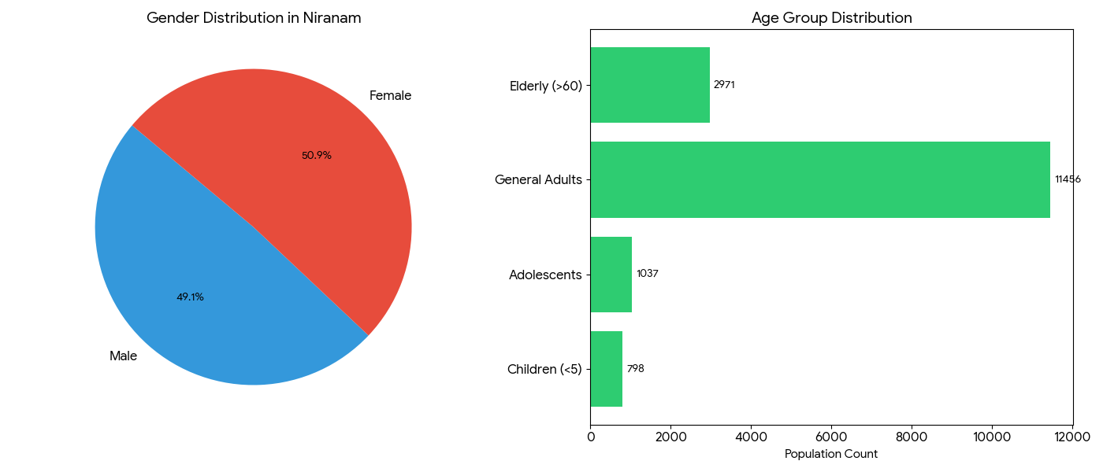

Description |  | Details (in numbers)
DEMOGRAPHIC PROFILE
Total population |  | 16262
Male |  | 7980
Female |  | 8282
Transgender |  | 0
Children under 5 |  | 798
Adolescent |  | 1037
Elderly (>60) |  | 2971
SOCIAL/LIVELIHOOD VULNERABILITY
Previous EPEP family |  | 17
BPL family |  | 2449
Tribal communities |  | 0
Migration | Immigrant | 96
Migration | Emigrant | 2851
Socio-economically deprived
Fisherfolk |  | 0
SC Community |  | 1671
ST Community |  | 0

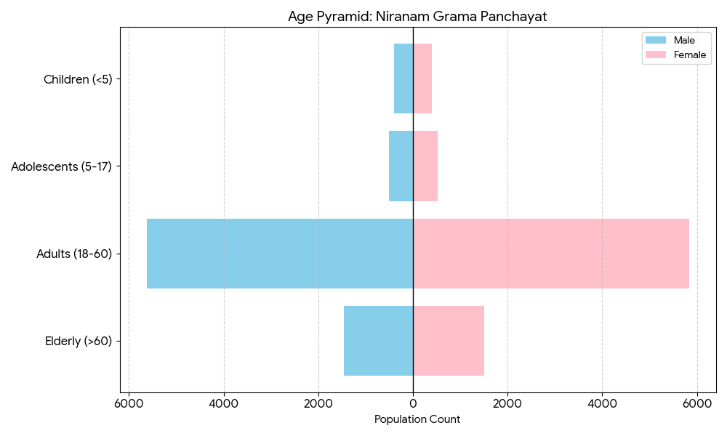

Clinical Vulnerability
Certain population groups needs priority healthcare & are at higher risk of severe illness, complications, and mortality during pandemics. Patients with chronic diseases, those requiring regular medical care, and individuals with mobility or functional limitations face challenges in accessing timely care during emergencies. Mapping these groups helps in prioritizing continuity of treatment, medicine stock planning, oxygen support, referral transport, and targeted home-based care.
Description | Details in numbers
Pregnant women | 70
Lactating mothers | 132
Bedbound patients | 45
Patients under palliative care other than bedbound | 85
Patients on Haemodialysis | 11
Patients on CAPD | 0
Cancer patients (currently on treatment) | 42
Haemophilic patients | 0
Mentally challenged | 31
Differently abled | 78
Diabetic patients | 1744
Hypertensive patients | 2146
TB patients | 8

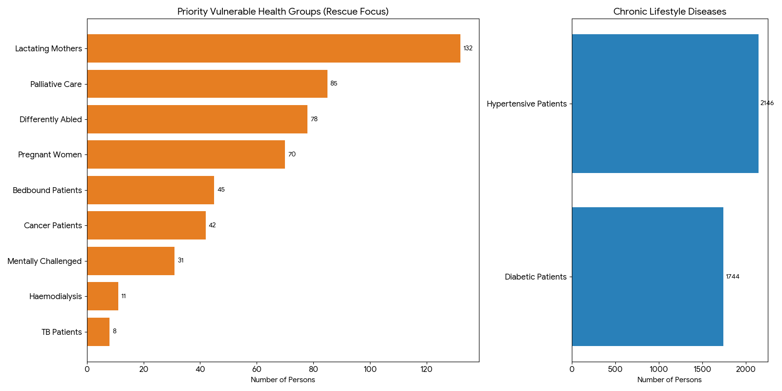

1. Priority Rescue & Medical Support Groups
These groups are the highest priority for the health department during a flood.
- Maternal Health: There are 70 pregnant women and 132 lactating mothers who require access to clean water, specialized nutrition, and proximity to medical facilities.
- Critical Care: A total of 186 patients require high-intensity care, including 45 bedbound individuals, 85 in palliative care, 42 undergoing cancer treatment, and 11 requiring haemodialysis. These patients often cannot be moved to standard relief camps and must be relocated to the FHC or specialized hospitals.
- Inclusion Groups: 78 differently-abled and 31 mentally challenged individuals are mapped to ensure they receive personalized assistance and clear communication during emergencies.

2. Chronic Health Management (Lifestyle Diseases)
The data highlights a massive burden of non-communicable diseases within the community:
- Hypertension & Diabetes: With 2,146 hypertensive patients and 1,744 diabetic patients, nearly 24% of the total population (based on the previous count of 16,262) requires consistent medication.
- Disaster Impact: During floods, the primary risk for these thousands of residents is the interruption of their medication supply. The PPP ensures that the FHC and local pharmacies maintain a buffer stock of insulin and blood pressure medication to prevent secondary health crises during isolation.

Major Festivals & Events specific to the LSGI
(with the possibility of a public gathering)

Sl. No. | Name of festival | Month detailing the periodicity
1 | Thettalikkkal temple | April
2 | Munnuttimanagalam | February
3 | Thirkkapalishwaram temple | February
4 | Thondukulangara temple | December
5 | Niranam church feast | September

INFRASTRUCTURE & RESOURCE INVENTORY

Health Facility Directory & Basic Capacity in Niranam Panchayat
Niranam Grama Panchayat operates an integrated healthcare ecosystem that balances allopathic expertise with traditional AYUSH systems and veterinary support to protect its 16,262 residents. At the heart of this network is the Family Health Centre (FHC) in Ward 10, which manages a high burden of non-communicable diseases, including 2,146 hypertensive and 1,744 diabetic patients, while overseeing a critical care registry of 45 bedbound and 85 palliative patients. This primary care hub is seamlessly augmented by Government Ayurveda and Homeopathy dispensaries that provide holistic wellness, particularly for the large geriatric population of 2,971 elderly individuals. This human health framework is further bolstered by the Government Veterinary Hospital, which secures the livestock-dependent agrarian economy and monitors zoonotic risks, ensuring that the health of the community and its animals is managed under a unified, localized strategy.
This comprehensive health infrastructure is deeply integrated into the Panchayath Preparedness Plan (PPP) to ensure service continuity across a landscape where 96% of the area is flood-prone. By coordinating with 18 Anganwadis and a dedicated field staff network, the health system prioritizes the safety of 70 pregnant women and 132 lactating mothers during seasonal inundations. To overcome geographic isolation, the LSGI has established specialized referral links to Thiruvalla THQH and Medical Colleges at Kottayam and Vandanam for multi-specialty emergencies. Supported by the Haritha Karma Sena for post-flood sanitation and a ₹25 lakh allocation for relief infrastructure, Niranam’s health services are designed to remain resilient, providing a data-driven safety net that maintains medical care and disease surveillance even when the deltaic terrain is severed by rising waters.

Table 5. Health Facility Resource Summary
Sl.no. | Health Facility | Type of Facility (MCH/GH/CHC/FHC/SC etc.) | Contact Number | Total beds | ICU Beds | Oxygen-Supported Beds | No. of Ventilator Support Beds | No. of ambulances
Government Healthcare Facilities
1 | FHC Niranam | FHC | 9447127555 | 3 | 0 | 0 | 0 | 1
2 | HWC Vakkumbhagom | Subcentre | 9074527503 | 0 | 0 | 0 | 0 | 0
3 | HWC  Kizhakkumbhagom | Subcentre | 9074527503 | 0 | 0 | 0 | 0 | 0
4 | HWC Niranam Main centre | Subcentre | 9744104540 | 0 | 0 | 0 | 0 | 0
5 | HWC Niranam West | Subcentre | 9744104540 | 0 | 0 | 0 | 0 | 0
Private Healthcare Facilities
 | NIL
AYUSH Healthcare Facilities
1 | Govt Ayurveda Dispensary | Dispensary | 9747433563 | 0 | 0 | 0 | 0 | 0
2 | Govt Homeo Dispensary | Dispensary | 996110038 | 0 | 0 | 0 | 0 | 0

Private Clinics
Private clinics are an essential part of pandemic preparedness, as they are often the first place people seek care when symptoms begin. In many communities, private clinics manage a significant share of outpatient visits and therefore play a critical role in early case detection, timely referrals, and disease surveillance. Having an up-to-date understanding of where these clinics are located, the services they provide, and how they are linked to the public health system helps ensure that no cases are missed during an outbreak. It also allows health authorities to engage private practitioners more effectively for reporting, risk communication, and coordinated response, strengthening the overall capacity of the health system to manage public health emergencies.

Table 6. Private Clinic Resource Summary
Sl No. | Name of Clinic | Registered (Y/N) | Clinic (General / Speciality) | Speciality (if any) | Address | Contact Number | Diagnostic Facility (Y/N) | Ambulance Linkage (Y/N)
1 | Medical centre,niranam | Y | speciality | ENT,diabetic | Dr Jose Cheriyan,Kandankeril,Niranam | 9747991961 | N | N

Healthcare Education & Training Institutions
This section tracks the educational infrastructure available, which is vital for human resource planning in the health sector.

Category of Institution | Govt | Private | AYUSH | Total
Medical Colleges | 0 | 0 | 0 | 0
Nursing Colleges | 0 | 0 | 0 | 0
Dental Colleges | 0 | 0 | 0 | 0
Para-medical / Allied Health | 0 | 0 | 0 | 0
Pharmacy Colleges | 0 | 0 | 0 | 0

Specialized Services & Emergency Inventory
This section provides a detailed view of the specialized medical resources available to the community, focusing on emergency response and critical care capabilities. This table tracks the vital assets required for managing severe illnesses and emergencies across Government, Private, and AYUSH sectors.

Item | Govt | Private | AYUSH | Total
Hospital beds | 3 | 0 | 0 | 3
Oxygen-generating systems(Y/N) | 0 | 0 | 0 | 0
Oxygen-supported beds(Numbers) | 0 | 0 | 0 | 0
Ventilator-supported beds | 0 | 0 | 0 | 0
ICU beds | 0 | 0 | 0 | 0
Burns units | 0 | 0 | 0 | 0
Blood centres | 0 | 0 | 0 | 0
BLS Ambulance | 1 | 0 | 0 | 1
ALS ambulances | 0 | 0 | 0 | 0
Dialysis facilities | 0 | 0 | 0 | 0
Dispensaries | 0 | 0 | 0 | 0
Medical store | 0 | 2 | 0 | 2
Industrial establishments(Medium-scale industries/small-scale industries establishments to whom we can depend in a worst-case scenario) | 0 | 0 | 0 | 0

Oxygen & Diagnostic Capacity
Monitoring oxygen and diagnostic capacity is a critical component of public health preparedness, ensuring that the LSGD can handle both chronic care and sudden surges in respiratory or infectious diseases.
Name of Health Facility | Oxygen-generating System (Y/N) | Backup Oxygen Source (Y/N) | Diagnostic Facilities Available(Y/N)
Name of Health Facility | Oxygen-generating System (Y/N) | Backup Oxygen Source (Y/N) | Lab | USG | X-ray | CT/MRI | RT-PCR
Government Healthcare Facilities
FHC NIRANAM | N | Y | Y | N | N | N | N
Private Healthcare Facilities
Medical Centre,Niranam | N | N | N | N | N | N | N

Diagnostics facility mapping at the LSGI level
The diagnostic capacity of Niranam Gramapanchayat represents the "intelligence network" of our healthcare system. The speed and accuracy of disease identification depend entirely on the distribution and technical level of these facilities.

Item | Govt | Private | AYUSH | Total
General labs | 1 | 3 | 0 | 4
Microbiology labs | 0 | 0 | 0 | 0
RT-PCR labs | 0 | 0 | 0 | 0
USG units | 0 | 0 | 0 | 0
CT/MRI units | 0 | 0 | 0 | 0
Research labs | 0 | 0 | 0 | 0
Labs of other departments that can be repurposed | 0 | 0 | 0 | 0

Laboratory Identification & Basic Details
Sl. No. | Name of Laboratory | Ownership (Govt / Private / Academic) | Address | Contact No. | 24×7 Services (Yes/No) | NABL / Govt Approved (Yes/No)
1 | Attumalil medical laboratory | private | Sajini,Attumalil,Niranam | 9207413845 | No | No
2 | SG Laboratory | private | Jisha ,chathanaril,niranam | 8281484961 | No | No
3 | Gilgal Medical laboratory | private | Shaji Kurian, | 9847052873 | No | No

Social and Community Infrastructure for surge plan
This table serves as our logistics and shelter inventory. By mapping these locations, quickly we can identify where to house displaced citizens, where to set up temporary medical clinics, and how to manage the deceased with dignity during a crisis.

Category | Total Count | Ward | Est. Capacity (Persons) | Contact details
Educational Institutions
Anganwadis | 18 | All wards | 345 | Niramala devi -9400670284
Schools | 12 | 1,2,3,4,6,7,11,12,13 | 819
Colleges | 0 | 0 | 0 | 0
Healthcare Educational Institutions
Medical colleges (Govt/Private) | 0 | 0 | 0 | 0
Nursing colleges (Govt/Private) | 0 | 0 | 0 | 0
Dental colleges (Govt/Private) | 0 | 0 | 0 | 0
Paramedical institutes (Govt/Private) | 0 | 0 | 0 | 0
Community Gathering Spaces
Community halls | 0 | 0 | 0 | 0
Auditoriums | 1 | 5 | 200
Religious buildings | 5 | 3,4,5,6,7,8,9
Vulnerable Group Support Facility
Destitute homes | 0 | 0 | 0 | 0
Elderly homes | 1 | 12 | 5
LSGD owned other buildings | 3 | 5,7
Mass Fatality Management (MFM) Infrastructure
Mortuary | 0 | 0 | 0 | 0
Crematorium | 0 | 0 | 0 | 0
*refer annexure 1 for contact details

Human resources
This section focuses on the human capital available within the LSGI. In any emergency—be it a pandemic, flood, or industrial accident—infrastructure is only as effective as the people operating it.

Medical & Clinical Personnel
This table tracks the "Frontline" providers responsible for diagnosis, treatment, and clinical management. Narrative sentence: eg., "Total health workforce: 450 personnel, with 60% in government facilities serving as primary surge capacity." A detailed directory with the contact numbers of all workers is maintained (Annexure in 1).

Cadre | Govt (No.) | Private (No.) | Total
Doctors—Modern Medicine | 4 | 1 | 5
Doctors – AYUSH | 1 | 0 | 1
Doctors – Veterinary | 1 | 0 | 1
Doctors – Dental | 1 | 0 | 1
Nursing officers | 2 | 0 | 2
Lab technicians | 1 | 4 | 5
Optometrist | 1 | 0 | 1
Pharmacists | 2 | 2 | 4
Psychologists | 0 | 0 | 0
Counsellors | 0 | 0 | 0

Public Health & Field-Level Workforce
These individuals are the backbone of surveillance, maternal-child health, and decentralized care.

Cadre | Health services | Municipal common services | Total
HS (Health Supervisors) | 0 | 0 | 0
HI (Health Inspectors) | 1 | 0 | 1
LHS (Lady Health Supervisor) | 0 | 0 | 0
LHI (Lady Health Inspectors) | 1 | 0 | 1
JPHN (Jr Public Health Nurses) | 2 | 0 | 2
JHI (Jr Health Inspectors) | 2 | 0 | 2
MLSP (Mid-Level Service Providers) | 4 | 0 | 4
Palliative Nurses | 1 | 0 | 1
RBSK Nurses | 1 | 0 | 1
PRO | 1 | 0 | 1
Epidemiologist | 1 | 0 | 1
Data Manager | 1 | 0 | 1

Community & Support Cadre
This group represents the surge capacity of the LSGI—people who can be called upon for logistics, rescue, and specialized support.

Cadre | Number
ASHA Workers | 17
AWW (Anganwadi Workers) | 18
Emergency Medical Volunteers (Trained) | 26
Kudumbashree | 135
MNREGS | 867
Purusha Swayam Sahaya Sangham | 1
Ex-Servicemen | 1
Retired Police Officers | 5
NCC/NSS Volunteers | 25
Red Cross volunteers | 0
One Health Community Volunteers | 637
One Health Community Mentors | 91

Community Organizations
This section details the presence of community-based organisations (CBOs), non-governmental organisations (NGOs), faith-based organisations (FBOs), Kudumbashree Self-Help Groups (SHGs), and Ayalkootams within the Local Self-Government Institution (LSGI). These groups enhance grassroots mobilization, resource distribution, and support networks crucial for pandemic response and community resilience.

Category | Total Count
NGOs | 1
Religious based organizations | 6
Foreign based organizations | 0
Sports Club/youth clubs | 10
Kudumbashree SHGs | 14
Ayalkootams | 157
Political organizations | 6
Residential organizations | 0

Administrative & Emergency Services
This section outlines the availability of key non-health emergency support services and infrastructure within the LSGI, which are essential for effective pandemic preparedness and response. These facilities support law enforcement, disaster response, water supply, logistics, mobility, and community-level interventions during public health emergencies.

Category | Total Count | Contact details
Police Stations | 0 | 0
Fire & Rescue Stations | 0 | 0
Water Pumping Points | 1 | 7947435686
Public Distribution System (PDS) | 10 | James V -9847094335

Information regarding resources
The availability of essential transport and support resources plays a quiet but critical role in saving lives. Equipment such as ambulances, mobile mortuaries, amphibian ambulances, and motorized boats ensures that patients, samples, and healthcare teams can move swiftly—even in flooded, remote, or difficult terrains. Heavy vehicles like JCBs, cranes, tractors, and torus lorries support logistics, waste management, emergency infrastructure, and rapid conversion of spaces into care or isolation facilities. Taxis, four-wheel-drive vehicles, and trucks help maintain continuity of essential services, reach vulnerable populations, and support home-based care and supply delivery.

Means of transportation | Total Count
JCB | 2
Crane | 0
Heavy Trucks | 0
Tractor | 4
Ambulances | 1
Mobile mortuaries | 0
Boats | 0
Taxi service | 4
Note: For specific details regarding vehicle owners and contact information, please refer to Annexure [X].

ONE HEALTH & ENVIRONMENTAL SURVEILLANCE
The One Health method integrates environmental, animal, and human health to enable proactive pandemic preparedness. Panchayat-level surveillance needs to be improved in order to detect and treat zoonotic and environmentally generated diseases early. Surveillance is strengthened through systematic assessment of animal populations, veterinary infrastructure, poultry and slaughter facilities, inter-sectoral coordination, and specialised tools like avian influenza seasonality mapping using GIS in previous outbreaks to enable predictive alerts and ward-specific sampling to support effective pandemic preparedness in high-risk areas like Pathanamthitta.

Animal & Bird Population
Mapping animal and bird populations at the Panchayat level is essential for identifying and prioritising zoonotic disease hazards like rabies, avian influenza (H5N1), leptospirosis, anthrax, and Nipah-like spillover occurrences. Risk classification, targeted surveillance, vaccination planning, and early epidemic detection made feasible by comprehensive population mapping all enhance One Health-based pandemic preparedness.

Category | Item | Estimated Population | Wards
Animal Population | Livestock (Cattle/Goats/Buffalo) | Approx 80 | All wards
Animal Population | Pet Animals (Dogs/Cats) | Approx 350 | All wards
Animal Population | Stray Dog Population | Approx 300 | All wards
Animal Population | Pig Farms (Number of heads) | 0 | 0
 | Small Units (Sheep / Goats – clustered) | 0 | 0
Bird Population | Poultry Units (Birds) | 45 | 1
Bird Population | Poultry- (FOWL) | 0 | 0
Bird Population | Wild/Migratory Birds (Observed) | present | All wards
Bird Population | Crow Mortality Events (Reported) | NA

The main risk of zoonotic diseases in Niranam is concentrated in several Wards, reflecting the presence of Duck ,Poultry units and migratory birds. The stray dog population in highly concentrated public areas , fish selling areas and along road ways continues to be a substantial problem for rabies surveillance and bite prevention. There is a considerable risk of avian influenza introduction and amplification during November - December due to the seasonal presence of migratory and resident water birds near ponds/ canal / river / backwater / paddy field. Clusters of animal shelters vulnerable to flooding further raise the risk of leptospirosis and other zoonoses mediated by the environment, especially during monsoon floods.

Veterinary Infrastructure
Veterinary institutions are a core pillar of One Health surveillance, enabling early zoonotic disease detection through vaccination, investigation of unusual animal illness or deaths, sample collection, and timely outbreak reporting. A well-mapped and responsive veterinary network strengthens coordination with human health and LSGI systems, ensuring rapid response during zoonotic events and pandemics.
Facility Type | Name of Facility | Ownership Govt / Pvt | Location(Ward No) | Contact number
Veterinary Dispensary | Veterinary dispensary, | Govt | 5 | 8848657758
Veterinary Hospital / Polyclinic | 0 | 0 | 0 | 0
Private Veterinary Clinics | 0 | 0 | 0 | 0
Mobile / Emergency Vet Service (incl. night services) | 0 | 0 | 0 | 0
Pet Homes / Animal Shelters | 0 | 0 | 0 | 0
Slaughterhouse-linked Veterinary Inspection Unit | 0 | 0 | 0 | 0
Only one govt veterinary dispensary serves the LSGD:however there are no mobile services may delay detection of sudden animal death,monsoon floods and avian-influenza high risk season.

Veterinary Doctors & Workforce
Early detection, diagnosis, reporting, and reaction to animal illness epidemics depend on the availability and accessibility of qualified veterinary specialists. By identifying unusual animal morbidity or mortality promptly, collecting samples promptly, and coordinating efficiently with human health and LSGI systems—especially during zoonotic outbreaks and pandemic-prone situations—a clearly defined veterinary workforce enhances One Health surveillance.

Category | Number Available | Type (Govt/Pvt) | Contact number
Government Veterinary Doctors | 1 | Govt | 8848657758
Private Veterinary Doctors | 0 | 0 | 0
Livestock Inspectors | 3 | govt | 0
Para-veterinary Staff / Attenders | 1 | govt | 0
Contract / On-call Veterinary Support (if any) | 0 | 0 | 0

High-Risk Interface Points (Surveillance Sites)
High-risk interface points for zoonotic disease surveillance in Niranam Grama Panchayath include wetland–livestock–human contact zones, backyard poultry farms, cattle sheds near water bodies, fish markets, and areas of high human–animal interaction such as community slaughter points and migratory bird congregation sites. These are the primary surveillance sites where zoonotic spillover risks are elevated.

Type of Habitat | Type of High risk interface | Geographical vulnerability
Wetlands & Backwaters | HIGH | FLOOD
Backyard Poultry Farms | NA | NA
Cattle Sheds near Water Bodies | NA | NA
Fish & Meat Markets | NA | NA
Community Slaughter Sites | NA | NA
Migratory Bird Congregation Areas | NA | NA
Rodent-Infested Grain Storage | NA | NA

Category | Total Count | Key Locations (wards)
Poultry Farms | 1 | 5
Backyard / Clustered Poultry Units | 0 | 0
Duck Rearing Units (open water access) | 4 | 10,12,13
Slaughterhouses/ Slaughter Points | 0 | 0
Meat/Fish Markets | 0 | 0
Live Bird Sale Points | 0 | 0
Cattle Markets / Weekly Animal Fairs | 0 | 0
Pet Shops / Breeders | 0 | 0
Animal Shelters / Pet Homes | 0 | 0
Waste Disposal Sites near Animal Units | 0 | 0

Environmental Risk Mapping
Environmental risk mapping identifies monsoon/flood hotspots for vector-borne (dengue, chikungunya), water-borne (leptospirosis, diarrhoea), and zoonotic diseases in Kerala's wetlands. Systematic surveillance supports early warnings, targeted interventions, and Panchayat pandemic preparedness.
Waterborne exposure: Flood-prone areas and stagnant water bodies facilitate leptospira survival, raising leptospirosis risk.

Traditional practices: Informal slaughter and fish markets lack standardized hygiene, creating spillover opportunities.

The risk mapping is done based on the below table
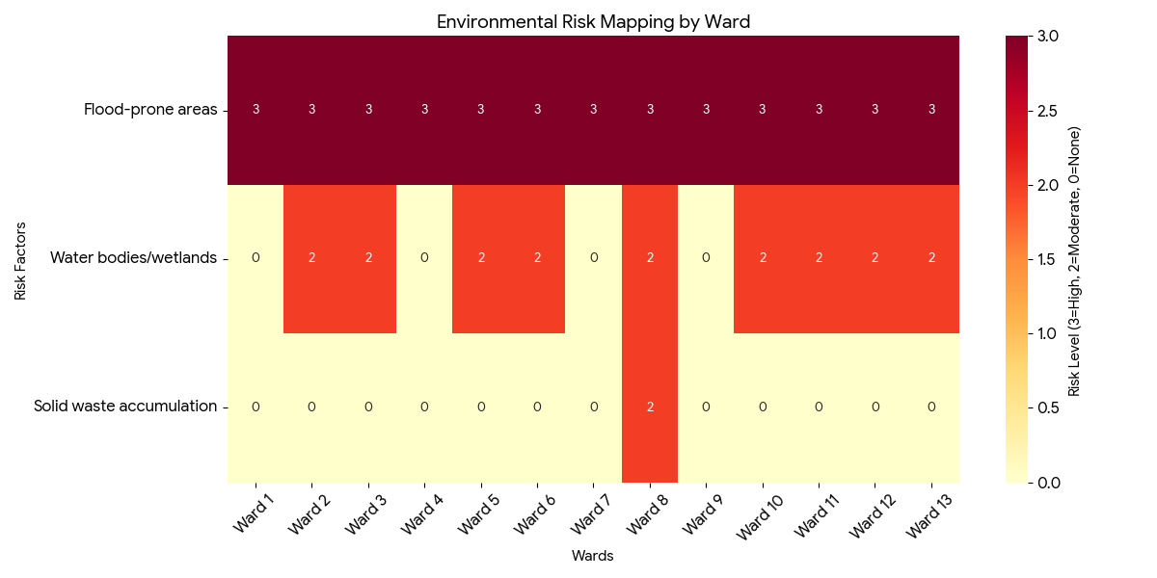
Risk Factor | High-Risk Wards | Key Locations | Risk Level (High/Med/Low)
Flood-prone areas | All wards | All wards | High
Water bodies/wetlands | 2,3,5,6,8,10,11,12,13 | 2,3,5,6,8,10,11,12,13 | Med
Solid waste accumulation | 8 | 8 | Medium
Animal waste disposal issues | 0 | 0 | 0
Rodent infestation zones | 0 | 0 | 0
Industrial effluent discharge | 0 | 0 | 0
Construction sites / abandoned buildings | 0 | 0 | 0
Poor drainage/blocked canals | 0 | 0 | 0
Drinking water source contamination risk | 0 | 0 | 0

Environmental Risk Analysis Summary
The following risk factors were evaluated across wards 1 to 13:
- Flood-prone areas: All wards are classified as High Risk, indicating a uniform vulnerability across the region.
- Water bodies/wetlands: Wards 2, 3, 5, 6, 8, 10, 11, 12, and 13 are identified as Moderate Risk areas.
- Solid waste accumulation: Ward 8 is specifically identified as a Moderate Risk area for waste issues.

Risk Mapping Visualisation
The heatmap below visualizes these risks. In this mapping:
- High Risk is represented by a value of 3 (Dark Red).
- Moderate Risk is represented by a value of 2 (Orange).
- No specific risk reported is represented by 0 (Yellow/White).

Disease Seasonality Mapping
1, Flooding & waterlogging → amplifies leptospirosis, malaria, diarrheal diseases.
·
2, Migratory bird influx (Nov–Feb) → avian influenza risk.

3, Mosquito breeding cycles → vector-borne disease peaks in monsoon.

4, Agricultural practices → close human–animal contact in paddy fields.
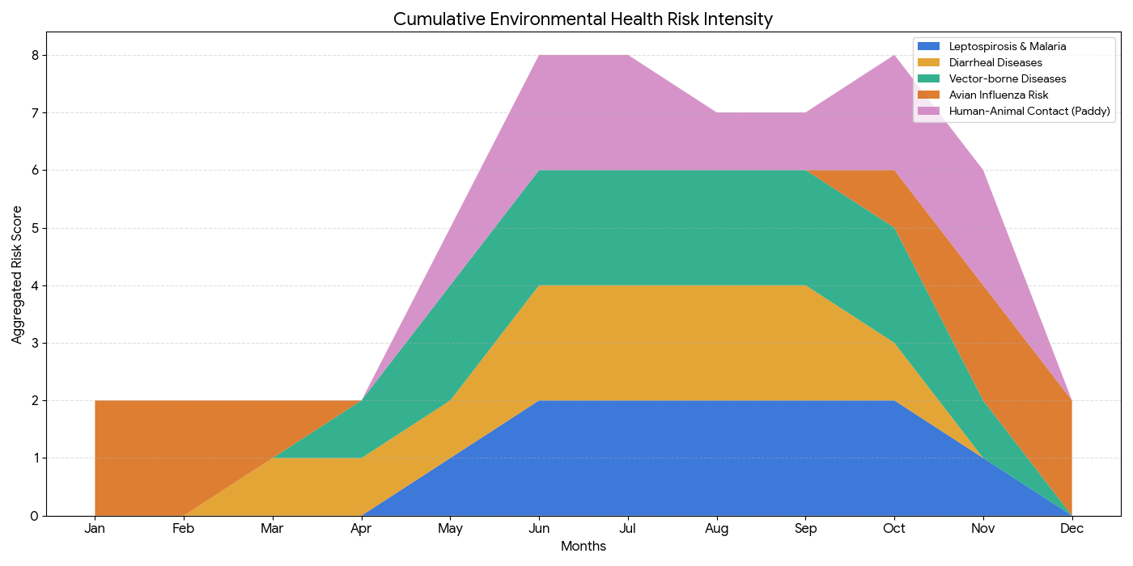
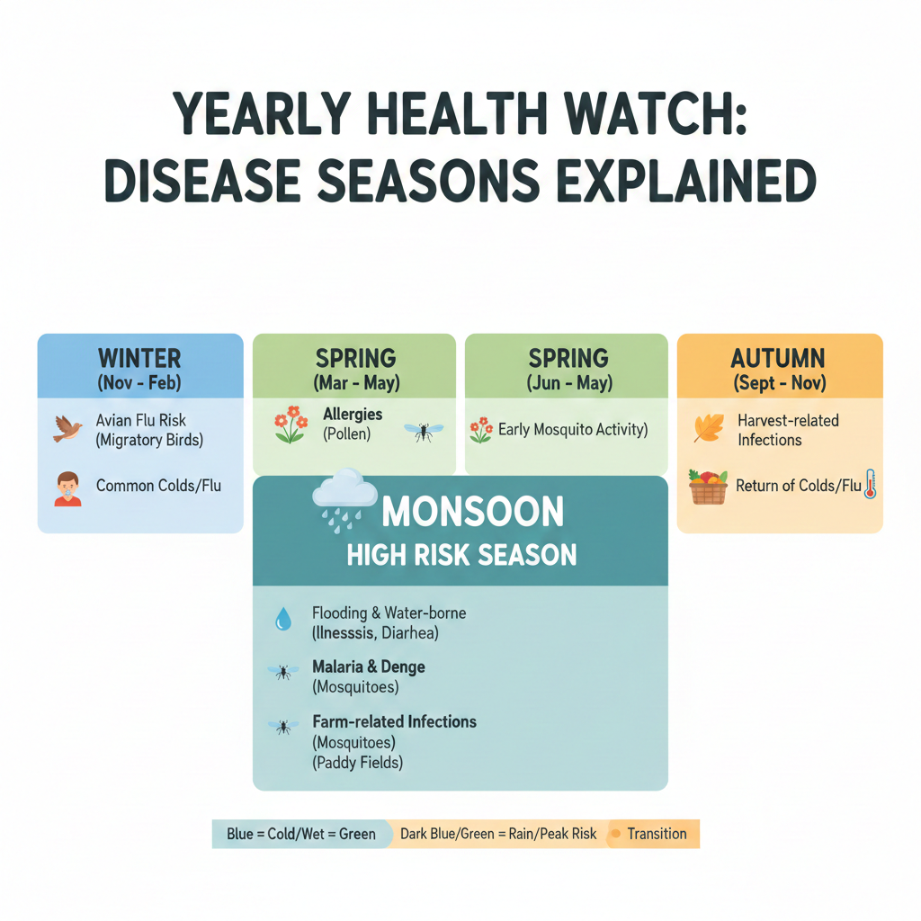
Disease | Peak Risk Season | Key Drivers | High-Risk Locations | Surveillance Focus
Avian Influenza | Nov-Feb | Migratory birds | 10,11,12,13 | All wards
Leptospirosis | June -October | Rat | All wards | All wards
Dengue/Chikungunya | May - October | mosquito | 2,7,8,11 | All wards
Acute Diarrheal Diseases | June-september | Food sources | - | All wards
Rabies | 0 | 0 | 0 | 0
Anthrax (rare) | 0 | 0 | 0 | 0

Vulnerability Mapping
Vulnerability mapping pinpoints high-risk populations, occupations, and areas exposed via environment, livelihoods, socio-economics, and poor service access. Paired with environmental/seasonality mapping, it enables risk-based surveillance, targeted actions, and optimal resource use in One Health and pandemic planning.
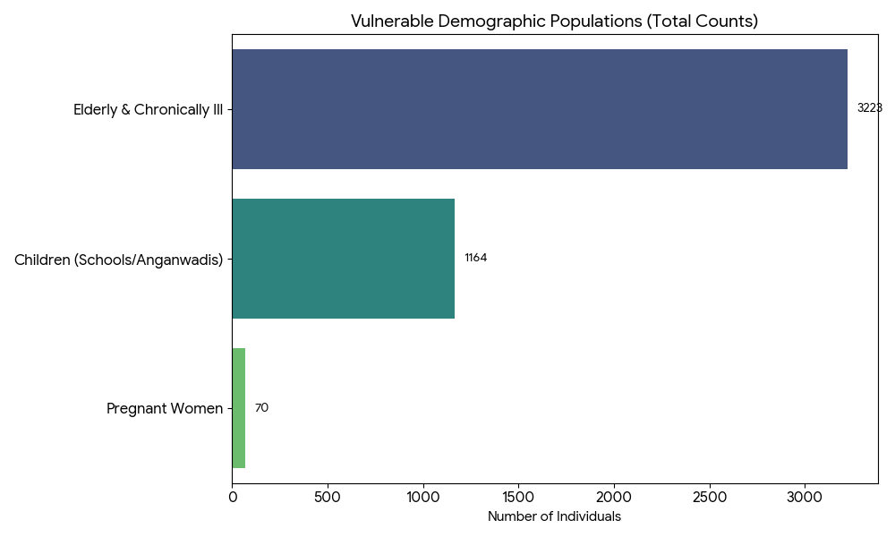

Vulnerability Factor | High-Risk Wards | Key Groups / Locations | Risk Level
Flood-prone households | All wards | Un predictable | High
Wetland-adjacent communities | 0 | 0 | 0
Backyard poultry / duck rearing households | 10,11,12
Livestock-rearing households | All wards | All wards | high
Slaughterhouse & meat market workers | 0 | 0 | 0
Fisherfolk & fish market workers | 0 | 0 | 0
Sanitation workers | 0 | 0 | 0
Daily wage / migrant workers | 3,4,5,7,8,9,12,13 |  | Med
Elderly & chronically ill populations | 3223 |  | Med
Pregnant Women | 70 |  | Med
Children (schools, Anganwadi’s) | 1164 | All wards | Med
Limited access to safe water & sanitation | 0
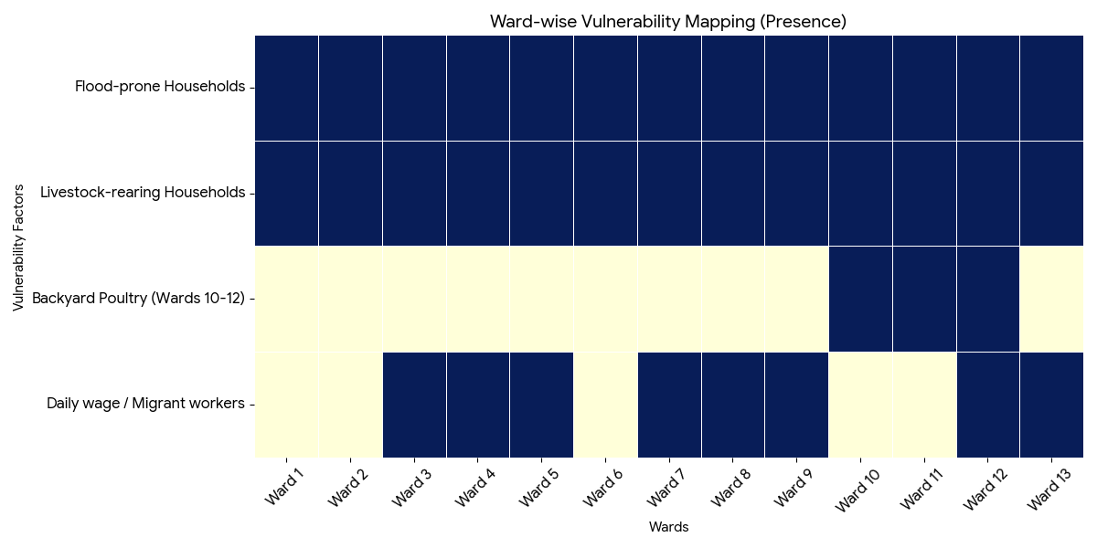
This heatmap shows which specific wards are affected by different environmental and socio-economic vulnerability factors.
- Flood-prone and Livestock-rearing Households: Affect all 13 wards consistently.
- Daily wage / Migrant workers: Concentrated in wards 3, 4, 5, 7, 8, 9, 12, and 13.
- Backyard Poultry: Specifically highlighted in wards 10, 11, and 12.

EPIDEMIOLOGICAL TRENDS (2021–2025)

Disease surveillance is the systematic collection, analysis, and interpretation of health data for planning, implementation, and evaluation of public health practice. This section presents the disease surveillance profile of the LSGI based on routine reporting systems and outbreak investigations to identify priority diseases, seasonal patterns, and emerging public health threats.

Disease Burden among human beings(Last 5 Years)
Analysis of disease-wise data for the last five years helps identify persistent public health problems, emerging diseases, and changes in disease burden. This information supports prioritisation of prevention, preparedness, and response activities at the Panchayat level.

Disease | 2021 | 2022 | 2023 | 2024 | 2025 | Trend(Increasing/Stable/Decreasing)
Dengue | 0 | 4 | 7 | 1 | 3 | Decreasing
Leptospirosis | 1 | 3 | 3 | 1 | 2 | stable
Hepatitis A | 0 | 0 | 1 | 1 | 1 | Stable
Malaria | 0 | 0 | 0 | 1 | 1 | Stable
Scrub Typhus | 0 | 0 | 0 | 0 | 0 | 0
Typhoid | 0 | 0 | 0 | 1 | 0 | 0
H1N1 | 0 | 0 | 0 | 0 | 1 | Stable
H3N2 | 0 | 0 | 0 | 0 | 3 | increasing
ADD | 28 | 20 | 6 | 8 | 24 | increasing
Mumps | 0 | 0 | 0 | 0 | 0 | Stable
Measles | 0 | 0 | 0 | 0 | 0 | Stable
Hepatitis B | 0 | 0 | 0 | 0 | 0 | Stable
Hepatitis C | 0 | 0 | 0 | 0 | 0 | decreasing
Tuberculosis | 8 | 3 | 2 | 7 | 8 | increasing
Leprosy | 0 | 0 | 0 | 0 | 0 | decreasing
COVID-19 | 1165 | 301 | 5 | 0 | 0 | decreasing

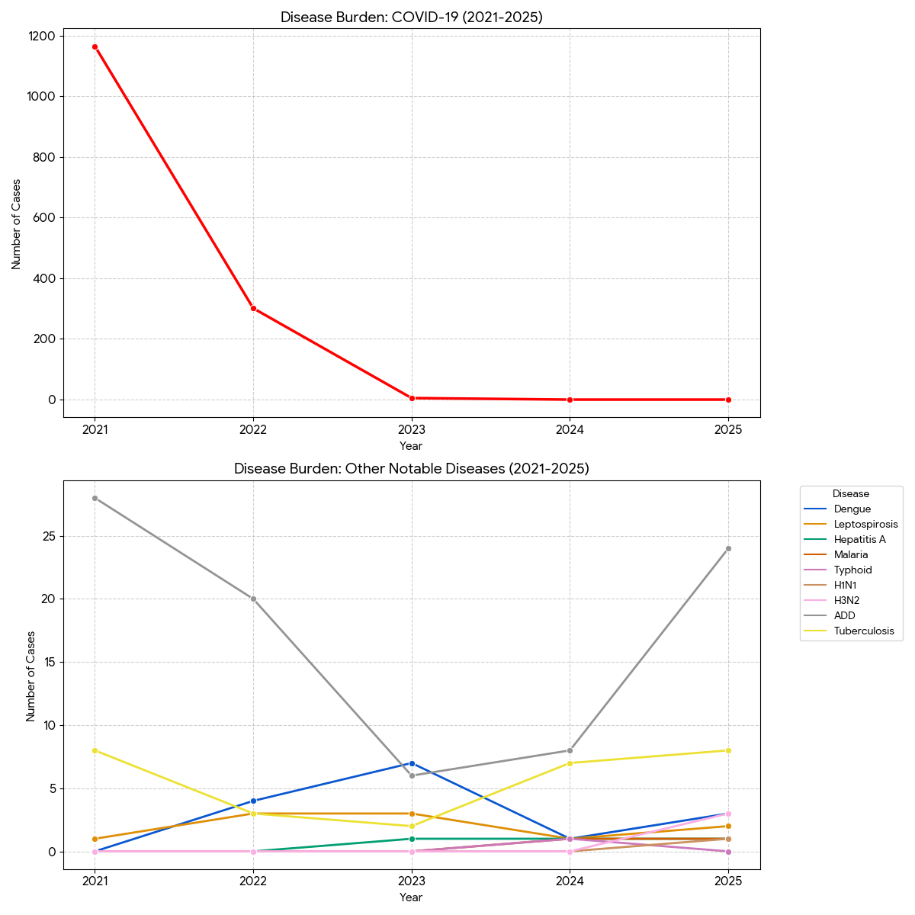

Seasonal Trend Analysis
Seasonal analysis helps anticipate surges (e.g. dengue in monsoon, leptospirosis after floods, influenza in cooler months) and plan pre‑emptive vector control, stockpiling of IV fluids, and awareness campaigns at Panchayat level.

DENGUE
Dengue is a major seasonal vector-borne disease strongly associated with rainfall, water stagnation, and increased mosquito breeding during the monsoon period.

Peak: July–November

Dengue – Ward-wise Yearly Distribution (2021–2025)

Ward | Dengue – Ward-wise Yearly Distribution
 | 2021 | 2022 | 2023 | 2024 | 2025 | Total
1 | 0 | 1 | 0 | 0 | 0 | 1
2 | 0 | 0 | 2 | 0 | 1 | 3
3 | 0 | 0 | 1 | 0 | 0 | 1
4 | 0 | 1 | 1 | 0 | 0 | 2
5 | 0 | 0 | 1 | 1 | 1 | 3
6 | 0 | 0 | 0 | 0 | 0 | 0
7 | 0 | 0 | 1 | 0 | 0 | 1
8 | 0 | 1 | 0 | 0 | 0 | 1
9 | 0 | 0 | 0 | 0 | 0 | 0
10 | 0 | 0 | 1 | 0 | 0 | 1
11 | 0 | 1 | 0 | 0 | 0 | 1
12 | 0 | 0 | 0 | 0 | 1 | 1
13 | 0 | 0 | 0 | 0 | 0 | 0

Ward-Specific Comparisons
- Ward 5 (Persistent): This ward shows the most concerning trend, with cases reported consistently for the last three years (2023–2025).
- Ward 2 (Hotspot): Reported its highest single-year incidence with 2 cases in 2023 and reappeared in the data for 2025.
- Ward 12 (Emerging): Remained Dengue-free until 2025, when its first case was recorded.

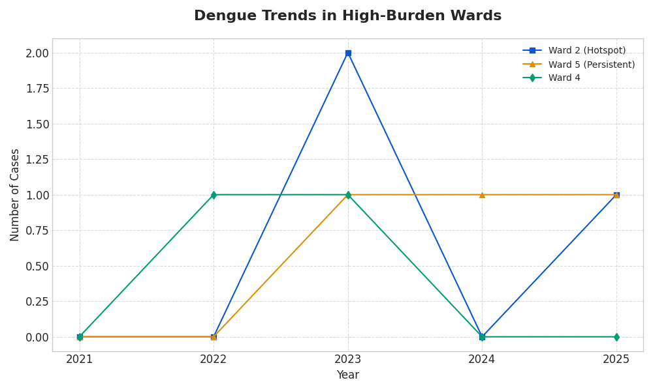

Overall Dengue Trend (Total Cases)
- Initial Baseline: The panchayat reported zero Dengue cases in 2021.
- Growth and Peak: Cases rose to 4 in 2022 and reached a peak of 7 cases in 2023.
- Current Status: After a significant drop to only 1 case in 2024, there was a resurgence to 3 cases in 2025.

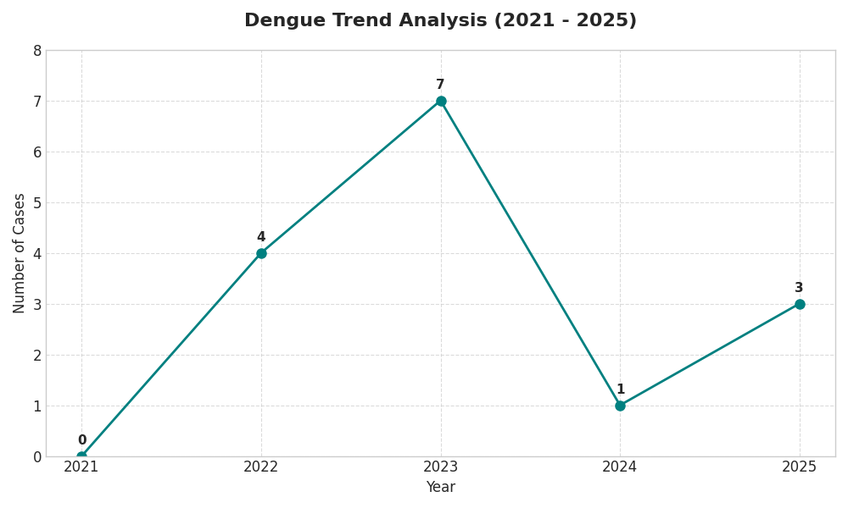

LEPTOSPIROSIS
Leptospirosis cases are closely linked to monsoon rains, flooding, and occupational exposure, particularly in low-lying and waterlogged areas.

Peak: June - August

Leptospirosis – Ward-wise Yearly Distribution (2021–2025)

Ward | Leptospirosis – Ward-wise Yearly Distribution
Ward | 2021 | 2022 | 2023 | 2024 | 2025 | Total
1 | 0 | 0 | 0 | 0 | 0 | 0
2 | 0 | 0 | 0 | 0 | 0 | 0
3 | 0 | 0 | 1 | 1 | 0 | 2
4 | 0 | 0 | 0 | 0 | 0 | 0
5 | 1 | 1 | 1 | 0 | 2 | 5
6 | 0 | 0 | 0 | 0 | 0 | 0
7 | 0 | 1 | 0 | 0 | 0 | 1
8 | 0 | 0 | 0 | 0 | 1 | 1
9 | 0 | 0 | 0 | 0 | 0 | 0
10 | 0 | 0 | 0 | 0 | 0 | 0
11 | 0 | 0 | 0 | 0 | 0 | 0
12 | 0 | 1 | 1 | 0 | 1 | 3
13 | 0 | 0 | 0 | 0 | 0 | 0

Trend Analysis (2021–2025)
1. Overall Fluctuating Trend: The total number of cases across all wards has not followed a linear path but has fluctuated significantly:
- Initial Rise: Cases increased from 1 (2021) to 3 (2022) and remained steady at 3 in 2023.
- The 2024 Dip: There was a significant drop in 2024, with only 1 case reported (Ward 3).
- Recent Surge (2025): 2025 recorded the highest number of cases in the 5-year period with 4 cases, indicating a potential recent spike in environmental risks or improved reporting.
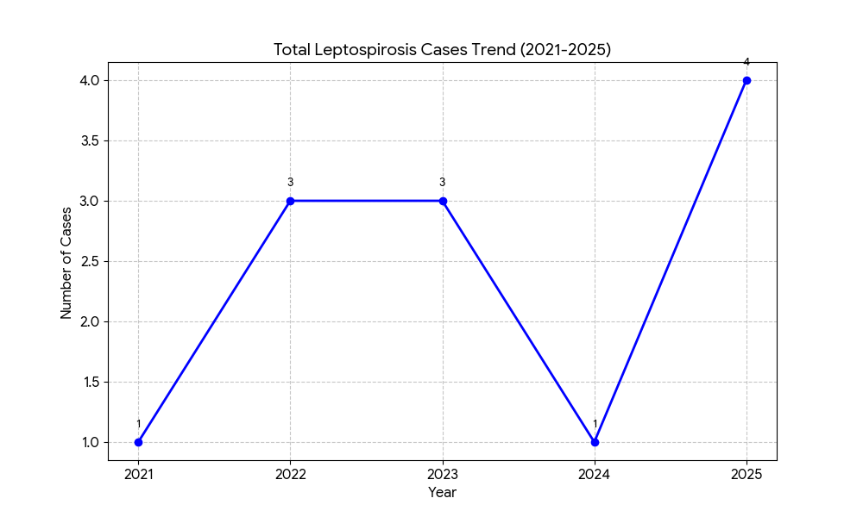
2. Ward-Specific Observations:
- Ward 5 (The Persistent Hotspot): Ward 5 is the only ward with a consistent presence almost every year (except 2024). It reached its peak of 2 cases in 2025, making it the most critical area for intervention.
- Ward 12 (Steady Risk): This ward has shown a steady pattern with 1 case per year in 2022, 2023, and 2025.
- Emergence in Ward 3: Ward 3 was clear until 2023, then reported cases for two consecutive years (2023–2024).
- New Occurrences: Ward 8 reported its first case in the 5-year window in 2025, suggesting the disease may be spreading to previously unaffected areas.
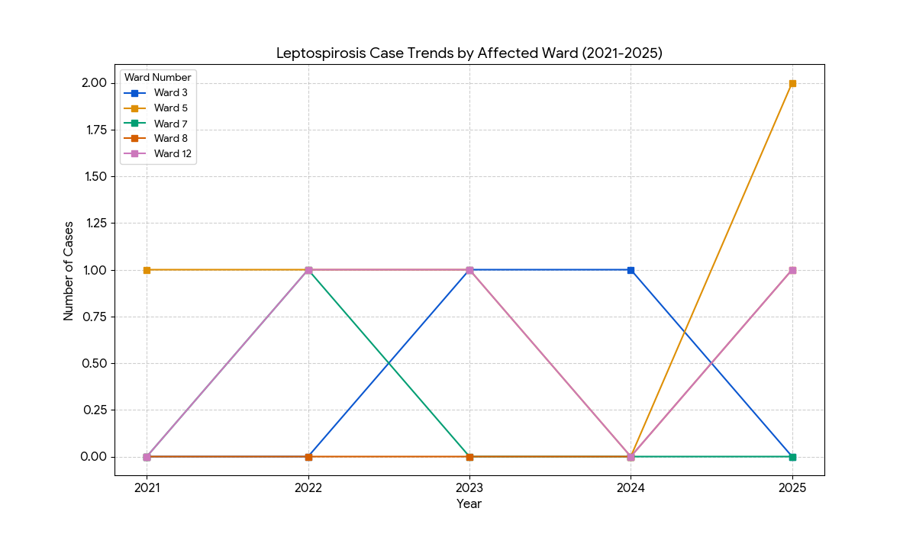
3. Summary of Stability: Over 60% of the Wards (8 out of 13) have maintained a zero-case record for five consecutive years. This suggests that the risk is highly localized to specific environmental conditions (likely drainage or waste management issues) in Wards 5, 12, and 3.
Recommendations based on Trends:
- Urgent Investigation for Ward 5: Since cases doubled in 2025 after a zero-case year, an immediate environmental audit is recommended.
- Pre-Monsoon Planning: Since 2025 saw a spike, the 2026 pre-monsoon period should prioritize rodent control in Wards 5, 12, and 8.

VIRAL HEPATITIS - A
Hepatitis A cases are commonly associated with unsafe drinking water, food contamination, and breakdowns in sanitation, often presenting as clusters or outbreaks.

Peak: October - December

Hepatitis A – Ward-wise Yearly Distribution (2021–2025)

Ward | Hep A – Ward-wise Yearly Distribution
Ward | 2021 | 2022 | 2023 | 2024 | 2025 | Total
1 | 0 | 0 | 0 | 0 | 0 | 0
2 | 0 | 0 | 0 | 1 | 0 | 1
3 | 0 | 0 | 1 | 0 | 0 | 1
4 | 0 | 0 | 0 | 0 | 0 | 0
5 | 0 | 0 | 0 | 0 | 0 | 0
6 | 0 | 0 | 0 | 0 | 0 | 0
7 | 0 | 0 | 0 | 1 | 0 | 1
8 | 0 | 0 | 0 | 0 | 0 | 0
9 | 0 | 0 | 0 | 0 | 0 | 0
10 | 0 | 0 | 0 | 0 | 1 | 1
11 | 0 | 0 | 0 | 0 | 0 | 0
12 | 0 | 0 | 0 | 0 | 0 | 0
13 | 0 | 0 | 0 | 0 | 0 | 0

Trend Analysis (2021–2025)

1. Emerging Low-Level Trend: Unlike Leptospirosis, which had a more consistent presence, Hepatitis A was entirely absent for the first two years of the study (2021 and 2022).

Initial Appearance: The first case appeared in 2023 in Ward 3.

Peak Period: There was a slight increase to 2 cases in 2024, appearing in new locations (Ward 2 and Ward 7).

Recent Status: One case was reported in 2025 in Ward 10.
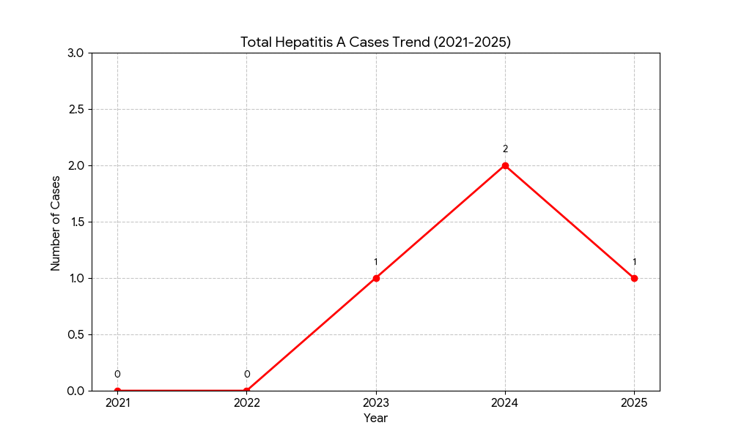

2. Sporadic and Non-Recurring Cases: A significant observation in the Hep A data is that the cases are sporadic.

No single ward has reported a case in more than one year.

Wards 2, 3, 7, and 10 each recorded exactly 1 case across the entire 5-year period.

This suggests that the infections may be related to isolated contaminated water or food sources rather than chronic environmental issues in a specific ward.
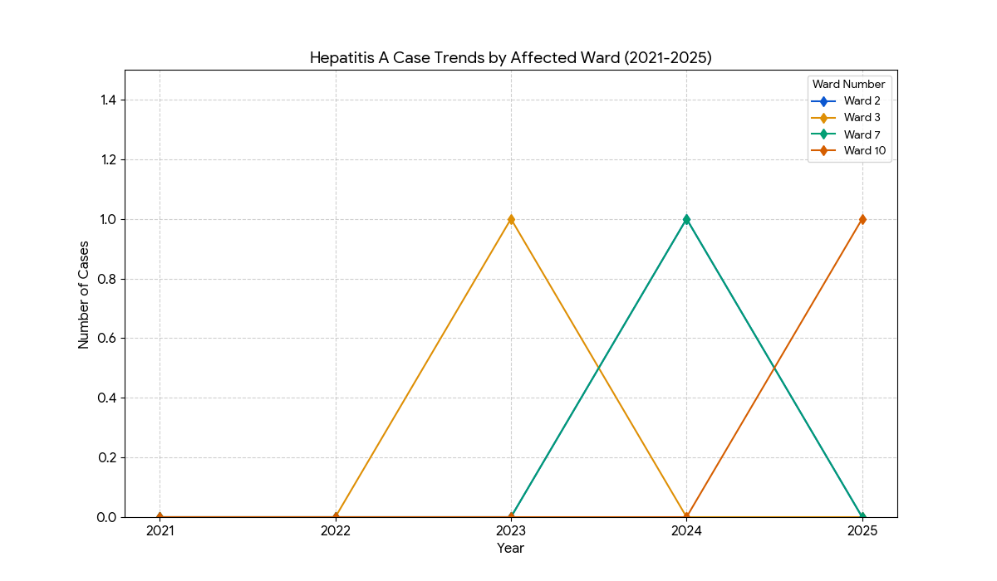

3. Broad Geographic Spread: Although the total number of cases is very low (4 cases in 5 years), they occurred in four different wards (2, 3, 7, and 10). This indicates that while the risk is low, it is not confined to a single cluster.

4. Safety Status: A large majority of the area remains unaffected: 9 out of 13 wards (69%) have reported zero Hepatitis A cases throughout the 5-year period.

Outcome-Based Trend Analysis- 2025
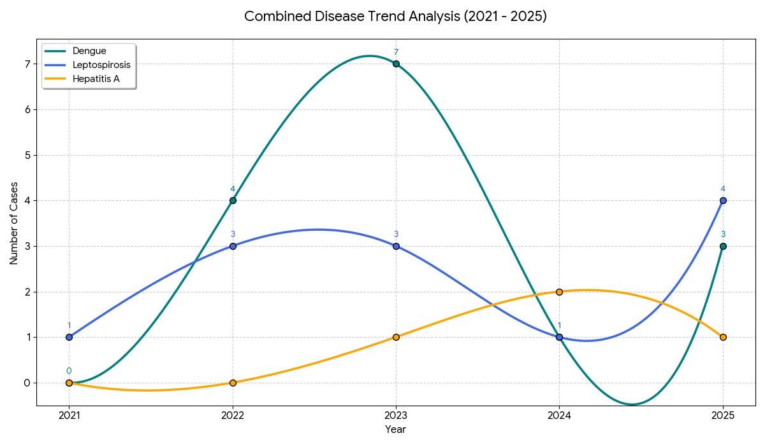

Here we took the main 3 diseases that subjected high risk in the area like Dengue ,Leptospirosis ,Hepatitis A
Inverse Correlation (2023-2024): Interestingly, while Dengue saw a sharp decline after its peak in 2023, Hepatitis A rose to its peak in 2024. This often suggests shifting public health focus—Dengue is vector-borne (mosquitoes), while Hepatitis A is water-borne (sanitation/water supply).
Leptospirosis Resilience: Leptospirosis shows a remarkably resilient trend, returning to a 5-year high of 4 cases in 2025 after a brief dip. This indicates that the environmental factors (likely related to drainage or rodent population in Wards 5 and 12) remain persistent.
Dengue Resurgence: After dropping significantly in 2024, Dengue has started an upward trajectory again in 2025 with 3 cases, signaling the need for renewed pre-monsoon vector control activities.
Overall Burden: 2023 and 2025 stand out as the years with the highest cumulative infectious disease burden for the Panchayat.

Disease | 2021 | 2022 | 2023 | 2024 | 2025 | 5-Year Trend
ADD | 28 | 20 | 6 | 8 | 24 | Increasing (Resurgence in 2025)
Tuberculosis | 8 | 3 | 2 | 7 | 8 | Increasing (Back to 2021 levels)
Dengue | 0 | 4 | 7 | 1 | 3 | Fluctuating (Recent slight rise)
Leptospirosis | 1 | 3 | 3 | 1 | 2 | Stable

Considering the major disease burden :-
Resurgence of ADD: After a significant drop in 2023 ($6$ cases), ADD cases have surged back to 24 in 2025. This indicates a potential breakdown in water sanitation or food safety protocols at the Panchayat level.
Tuberculosis Recovery: TB cases declined until 2023 but have sharply increased over the last two years, reaching $8$ cases in 2025. This suggests a need for intensified screening and treatment adherence programs.

Transmission Trend- 2025
For effective management of public health issues, it is important to track the trend of disease transmission mode. It helps identify the population or place at high risk that can be used to predict outbreaks and implement targeted interventions as quickly as possible. Understanding these kinds of trends enables authorities to allocate resources efficiently and change the strategies adequately based on the trend that follows.

Mode of Transmission | No. of cases | No. of Deaths
Vector Borne Diseases | 4 | 0
Water Borne Diseases | 24 | 0
Air Borne Diseases | 23 | 0
Blood Borne Diseases | 0 | 0
Food Borne Diseases | 0 | 0

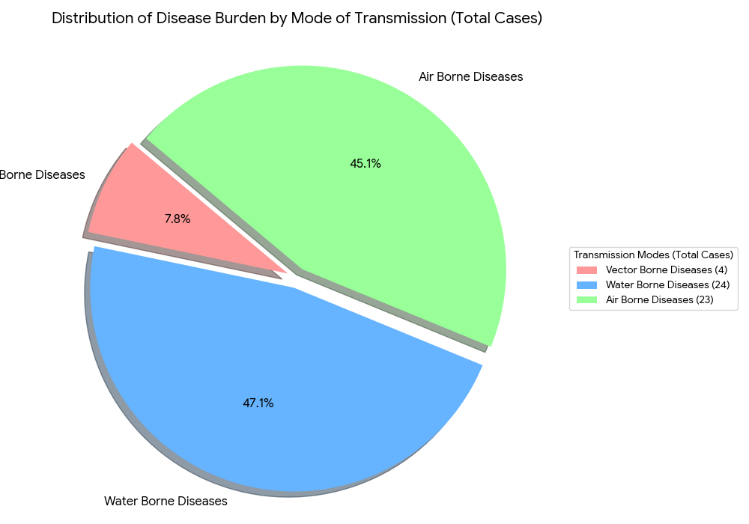
Vector-Borne Disease

Disease | No. of Cases | No. of Deaths
Dengue | 3 | 0
Malaria | 1 | 0
Chikungunya | 0 | 0

Water Borne Disease

Disease | No. of Cases | No. of Deaths
Cholera | 0 | 0
Typhoid | 0 | 0
Hep- A | 1 | 0
Dysentery | 0 | 0
Amoebiasis | 0 | 0
E- Coli infections | 0 | 0
Air Borne Disease

Disease | No. of Cases | No. of Deaths
Influenza | 3 | 0
H1N1 | 1 | 0
TB | 8 | 2
Chickenpox | 23 | 0
Measles | 0 | 0
Covid-19 | 0 | 0
Pertussis | 0 | 0
Mumps | 0 | 0

Blood-Borne Disease

Disease | No. of Cases | No. of Deaths
AIDS | 0 | 0
Hep- B | 0 | 0
Hep- C | 0 | 0

Zoonotic Disease

Disease | No. of Cases | No. of Deaths
Rabies | 0 | 0
Leptospirosis | 4 | 0
Avian influenza | 0 | 0
West nile | 0 | 0
Anthrax | 0 | 0
Nipah | 0 | 0
Scrub Typhus | 0 | 0

Integrated Disease Hotspot Map (2021–2025)

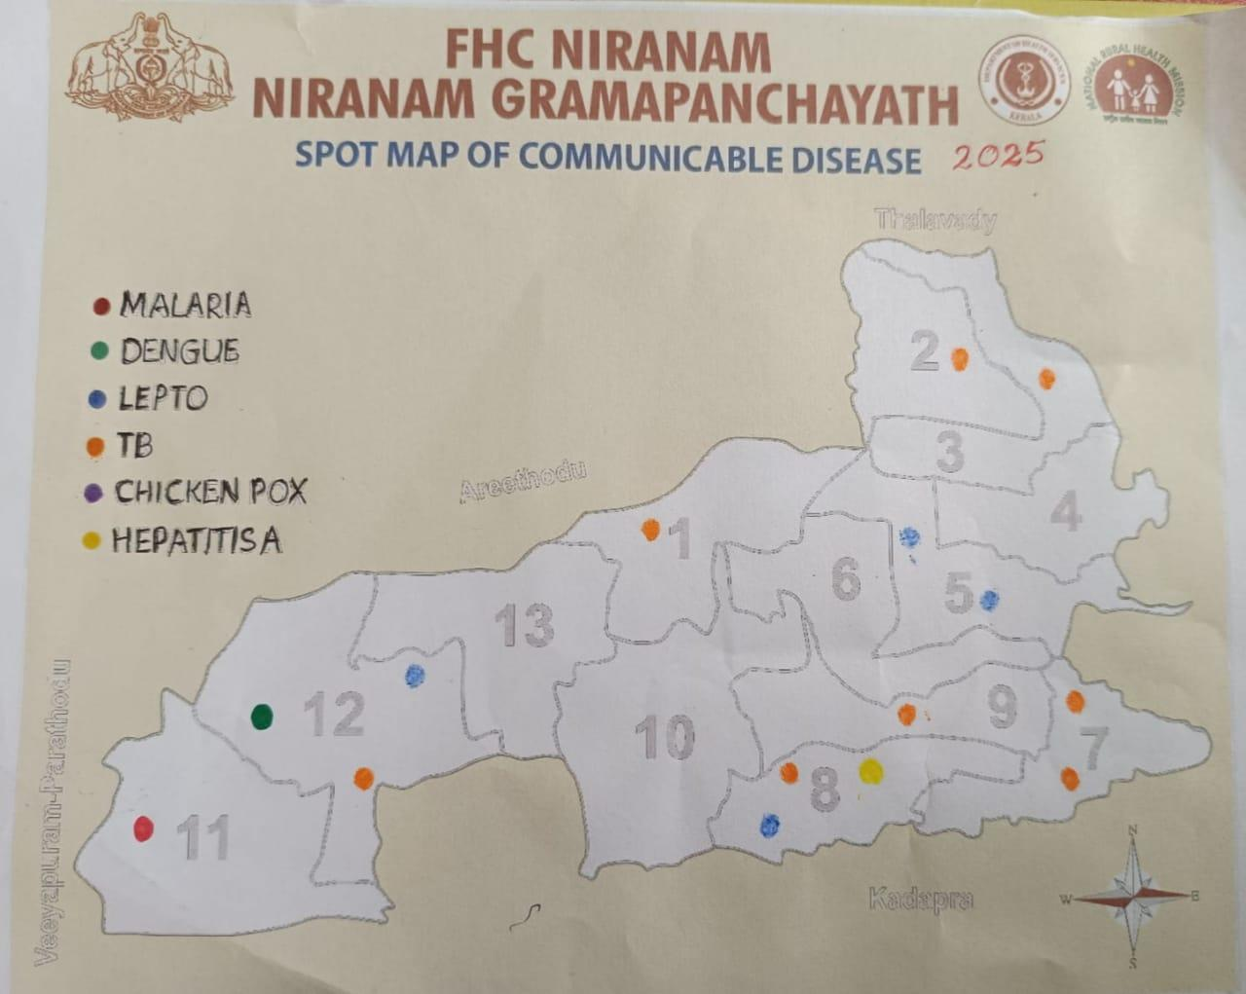

Ward No | Dengue Total (2021-25) | Leptospirosis Total (2021-25) | Hepatitis A Total (2021-25) | Mumps (2021-25) | ADD (2021-25) | Total Cases
1 | 1 | 0 | 0 | 0 | 6 | 7
2 | 3 | 0 | 1 | 0 | 5 | 8
3 | 1 | 2 | 1 | 0 | 8 | 12
4 | 2 | 0 | 0 | 0 | 9 | 11
5 | 3 | 5 | 0 | 0 | 7 | 15
6 | 0 | 0 | 0 | 0 | 9 | 9
7 | 1 | 1 | 1 | 0 | 8 | 11
8 | 1 | 1 | 0 | 0 | 5 | 7
9 | 0 | 0 | 0 | 0 | 5 | 5
10 | 1 | 0 | 0 | 0 | 6 | 7
11 | 1 | 0 | 1 | 0 | 5 | 7
12 | 1 | 3 | 0 | 0 | 4 | 8
13 | 0 | 0 | 0 | 0 | 7 | 7

By overlaying five years of data, we have identified 4-14 considered as ‘Red Zone' Wards. These are wards where at least two different categories of diseases (e.g., Dengue and Lepto) recurred in consecutive years. Ward 4 is categorized as the Highest Priority Hotspot due to its combination of flood vulnerability and high vector density. Future health infrastructure, such as the proposed R.O plants should be prioritized.

1. Top High-Burden Wards
The wards are ranked based on the total number of recorded cases:
- Ward 5 (15 cases): The highest burden ward, primarily driven by Leptospirosis (5 cases) and ADD (7 cases).
- Ward 3 (12 cases): Significant burden with a high prevalence of ADD (8 cases) and Leptospirosis (2 cases).
- Ward 4 & Ward 7 (11 cases each): Both wards show a high incidence of ADD, with Ward 4 having $9$ cases and Ward 7 having $8$.

2. Disease-Specific Distribution
- ADD (Acute Diarrheal Disease): This is the most dominant health issue across all wards, totaling 84 cases (73% of the total burden). It is highest in Wards 4 and 6.
- Dengue: Distributed across most wards, with Ward 2 and Ward 5 showing the highest individual counts ($3$ cases each).
- Leptospirosis: Highly localized, with Ward 5 (5 cases) and Ward 12 (3 cases) being the primary hotspots.
- Hepatitis A: Low but present in five specific wards (Wards 2, 3, 7, and 11).
- Mumps: There were 0 cases reported across all wards during this period.

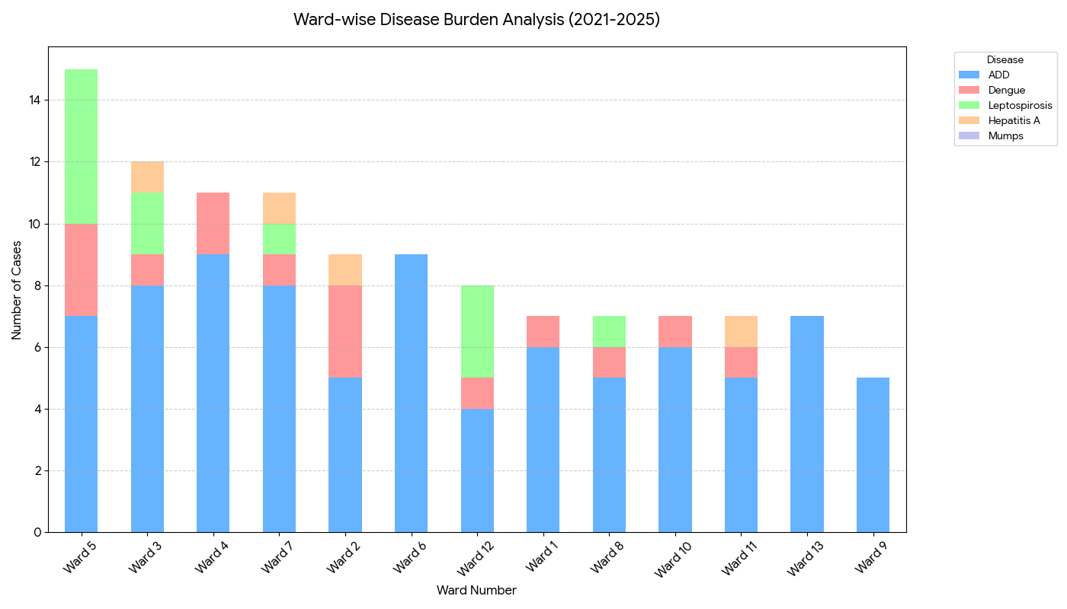

3. Strategic Recommendations for the Panchayat
- Water Sanitation Priority: Since ADD accounts for the majority of cases, immediate focus should be on water source chlorination and sanitation hygiene in Wards 4, 6, 3, and 7.
- Vector & Rodent Control: Targeted intervention for Leptospirosis should be focused on Ward 5, while Dengue prevention (source reduction) should be prioritized in Wards 2 and 5.
- Ward 9 & 13: These wards show the lowest overall disease burden, though they still require monitoring for ADD

Preparedness and Response Protocol at LSG Level
This section describes the operational framework for the LSGI once a pandemic is declared. It explains how the LSGI and health system will move from routine data collection to active response, using a One Health approach.

Constitution of One Health Committee
The LSGD shall constitute a One Health Committee comprising the LSGI President, Medical Officers (Modern Medicine, AYUSH, and Veterinary), the Health Inspector, and the Veterinary Surgeon.

Objective: The One Health Committee coordinates human, animal, and environmental health to prevent and control pandemics.

Sl No | Name | Designation | Department/Institution | Role in Committee | Contact Number
1 | Jolly Eappen | Panchayat President | LSGD | Chairperson | 8301050766
2 | Dr.PreethaS R | Medical Officer (PHC/CHC) | Health Dept | Member Secretary | 9447127555
3 | Dr Hamna | Veterinary Officer | Animal Husbandry | Member | 8848657758
4 | Dr Dhanya | Epidemiologist | Health Dept | Member | 9847140643
5 | Sindhu k pillai | Health Inspector/PHN | Health Dept | Surveillance | 9961824292
6 | Ashakumari | ASHA Supervisor | Health Dept | Community link | 9447932673
7 | Swapna | ICDS Supervisor | Social Welfare | Vulnerable groups | 7736114638
8 | Rishi | Police Station Officer | Police Dept | Law & order | 9496208753
9 | Aneesh | Ward Councillor Representative | LSGD | Community coordination | 9526964771
10 | Bindu | Kudumbashree CDO | Kudumbashree | Community mobilisation | 7012774539
11 | Eby | NGO/Volunteer rep | Civil Society | Support services | 8281443114
12 |  | Line Department representations

Key Responsibilities:
- Review disease surveillance data (human + animal)
- Conduct ward-wise risk assessment and vulnerability mapping
- Approve quarantine/isolation centre locations
- Coordinate with district for resources (PPE, oxygen, ambulances)
- Periodically review health system surge capacity, including beds, oxygen, human resources, and ambulances.
- Approve and monitor risk communication and community engagement strategies, including rumour management.
- Ensure protection and service continuity for vulnerable groups (elderly, persons with disabilities, dialysis patients, coastal populations).
- Conduct quarterly mock drills
- Monitor equity measures for vulnerable groups

Meeting Schedule:
Quarterly (normal times)
Weekly (outbreak alert)
Daily (pandemic phase)

Pandemic Response Workforce
To ensure a coordinated and timely response during a pandemic, a dedicated Pandemic Response Workforce shall be constituted at the LSG level. The workforce will function under the overall supervision of the One Health Committee and in close coordination with the health authorities. Team-based deployment will enable efficient surveillance, case management, quarantine and isolation management, logistics support, and risk communication. Each team shall have a clearly designated team leader, defined roles, and an identified pool of personnel to allow rapid activation, rotation of duties, and continuity of services during prolonged emergencies.

Total Response Workforce Available: 300 persons

Team Name | Composition | Key Responsibilities | Team Leader
Surveillance and Contact Tracing Team | HI, JHI, JPHN, ASHAs and Volunteers | Case detection, contact listing, home visits, reporting | HI
Case Management Team | Doctors, Nurses, MLSP, Palliative Nurses | Patient care & referral | DOCTOR
Quarantine & Isolation Team | LSGD staff, Volunteers | Facility management | JHI
Psychosocial support | School Counselors, ICTC Counselors, Palliative Nurses, Medical Social Workers | Tele-counseling, grief support, managing quarantine stress, supporting frontline workers | Nodal Medical Officer / Psychologist
Logistics & supply chain Team | LSGD staff, Storekeepers, Drivers 3 | Supplies & transport [PPE, medicines, oxygen, transport, waste management] | Ward Member
Communication Team | Ward members, Kudumbashree, Youth clubs,  AWW workers and other self help groups | IEC, community meetings, countering misinformation | M.O in charge
Transportation | KSRTC, educational institutional buses | Safety of individuals, patient/staff transport | JHI
Media Surveillance | T Cell, Local Journalists, Volunteers | Monitoring social media, tracking rumors | Public Relations Officer / HI
Intersectoral coordination and convergence | LSG President, Secretary, Health Staff | Policy decisions, resource pooling, convergence | LSG Secretary / President
Collaborative surveillance | Vets, Environmental Officers, Health Staff | One Health tracking (Animal-Human interface) | Veterinary Surgeon

All teams shall be activated immediately upon outbreak alert or pandemic declaration and shall report daily to the LSG Incident Commander/Medical Officer, with consolidated reporting to the Block PHC. Duty rosters and alternate personnel shall be maintained to ensure uninterrupted services during staff shortages or prolonged response periods. Team composition and numbers may be revised based on the magnitude of the outbreak and availability of human resources.

Activities and Measures before and during Pandemic

PHASE 1 - Alert / Preparation

Activate One Health Committee
  - Immediately activate the One Health Committee at the LSG level. Convene an emergency meeting to review risk assessment, roles, and preparedness. Ensure coordination between Health, Veterinary, Agriculture, Local Self Government, and allied departments.
  - Prepare and circulate a contact directory of all committee members and emergency services.
  - Ensure documentation of decisions and action points with timelines.
  - Escalation hierarchy to be finalised (LSG to Institution to Block to District).

Surveillance and Reporting
Objective: To ensure early detection, timely reporting, and response to potential outbreaks through enhanced facility-, community-, and event-based surveillance
- Enhanced syndromic surveillance:
The LSGD shall initiate enhanced surveillance for priority syndromes and events such as:
  - Fever
  - Influenza-like illness (ILI)
  - Severe acute respiratory infection (SARI)
  - Unusual illness clusters (any unexpected increase in similar symptoms in a defined area or group)
- Data sources for surveillance:
- Ward-wise household surveillance (through ASHAs/JPHNs/ward volunteers)
- Outpatient surveillance from all government facilities (PHC, FHC, CHC, GH, etc.)
- Private hospitals, clinics, and labs
- Event-based triggers (to be monitored and reported):
- School absenteeism above the usual pattern (to be monitored through the headmaster/PTA nodal person)
- Sudden increase in pharmacy sales of fever/cough/cold medicines
- Workplace illness clusters (multiple staff reporting similar symptoms within a short period)
- Zoonotic and animal health surveillance
- LSGD shall review reports of unusual animal deaths or suspected outbreaks in animals in coordination with the Veterinary Officer.

- Any unusual mortality in poultry, pigs, cattle, companion animals, or wild birds/mammals shall be notified within 24 hours to the Veterinary Officer and One Health Committee for joint investigation.

Logistics and Stock Preparedness
  - Identify and empanel local vendors and define emergency procurement mechanisms in accordance with existing LSGD and Health Department norms.
  - Prepare and maintain an essential logistics checklist covering medical supplies, consumables, and support equipment.
  - Pre-identify secure storage locations for emergency stocks and ensure maintenance of stock registers with regular updating.
  - Finalise emergency transport arrangements, including availability of vehicles and identified drivers for rapid deployment during alerts.
  - Designate a Nodal Officer for Logistics to enable prompt decision-making, coordination, and communication during emergencies.
  - Conduct rapid stock verification and ensure availability of minimum buffer stock, including:
- PPE kits –0 numbers
- Pulse oximeters – 2 numbers
- Hand sanitizers –0 litres
- Masks, gloves, disinfectants – adequate quantity
Identify critical gaps in logistics and immediately communicate requirements to the Block and District authorities for timely replenishment and support. Monitor expiry dates and stock rotation.

Identification of Quarantine and Isolation Facilities
  - Identify and list suitable buildings for quarantine and isolation (schools, hostels, community halls, etc.).
  - Categorise cases as per the severity and allocate to appropriate facilities (for instance, severe cases to classrooms, mild cases to an assembly hall in case of a school).
  - Facility readiness checklist needed (beds, toilets, ventilation) etc.
  - Find an alternate site if the primary sites are not available or not in use.
  - Identify facility managers and support staff
  - Prepare basic SOPs for:
    - Admission and discharge
    - Food, water, sanitation
    - Infection prevention and waste disposal
  - Ensure availability of basic amenities: water, sanitation, electricity, ventilation, and waste disposal. Prepare a rapid activation plan for these facilities if case numbers increase.

Risk Communication and Community Preparedness
  - Disseminate early warning messages on symptoms, preventive measures, and reporting mechanisms. Display IEC materials both in English and the local language in public places and ensure ward-level awareness.
  - Sensitize elected representatives and community leaders on preparedness measures.
  - Establish a rumour tracking and misinformation response mechanism to identify, verify, and promptly counter false or misleading information.
  - Engage trusted local persons (ward members, ASHA workers, religious leaders, teachers, community volunteers) to communicate official public health messages and reinforce correct practices.
  - Develop and deploy targeted IEC materials for:
    - Schools and educational institutions
    - Markets and commercial areas
    - Work sites and labour settings
  - Conduct community sensitization meetings at the ward level to promote preventive behaviors, address concerns, and strengthen community participation in preparedness and response.

Protection of Vulnerable Groups
Vulnerable populations require priority protection through targeted line-listing, service continuity, and delivery mechanisms.
- Prepare and regularly update line-lists of vulnerable populations, including:
  - Elderly persons living alone
  - Persons with disabilities
  - Pregnant women
  - Migrant workers
  - Dialysis patients

Vulnerable Group | Preparedness Focus
Elderly Living Alone | Weekly wellness calls and doorstep delivery of essentials.
Persons with Disabilities | Ensuring communication materials are in accessible formats (Braille/Audio/Sign).
Pregnant Women | Pre-arranging emergency transport and identifying non-pandemic maternity wings.
Migrant Workers | Mapping temporary settlements and ensuring inclusion in local food distribution.
Dialysis/Chronic Patients | Creating a dedicated transit permit system for uninterrupted hospital visits.

The detailed line-lists shall be maintained as Annexure ix and updated periodically.

Clinical Dependency Mapping
Develop ward-wise dependency and vulnerability maps to identify households requiring regular support during emergencies. Ensure continuity of essential health services for vulnerable groups, including
- Dialysis services (facility mapping, transport arrangements, and scheduling)
- Continuity of treatment for TB, HIV, and other chronic conditions requiring uninterrupted medication
- Mental health and psychosocial support services
Establish delivery mechanisms for food, essential commodities, and medicines to vulnerable households through coordinated action involving ASHAs, JPHNs, Kudumbashree, volunteers, and local administration.

PHASE 2 - Active Response
In Phase 2 , Active Response, the focus shifts from preparation to immediate containment and mitigation. Deployment of the Case Management Team for emergency triage while ensuring an uninterrupted supply chain of oxygen, PPE, and life-saving medicines to high-risk wards.

Case Identification and Contact Tracing
Case detection and contact tracing activities will be carried out in coordination with the Health authorities, following disease-specific SOPs and IDSP guidelines.
Field Staff Involved
- Health Inspector (HI)
- Junior Health Inspector (JHI)
- Junior Public Health Nurse (JPHN)
- ASHAs and ASHA Supervisors
- Ward-level volunteers and Kudumbashree members (as required)

Screening Checkpoints
Screening checkpoints at high-traffic locations (transport hubs, markets, religious gatherings) for early detection of symptomatic travellers and crowd screening during outbreaks. Potential locations include bus stands, market entry points, and boat jetties, based on local context and risk assessment.
Screening activities will be carried out by trained personnel such as ASHAs, ward members, and volunteers, with support from Health Department staff. Necessary equipment, including non-contact thermometers and appropriate PPE, shall be ensured prior to activation.
Location | Type (Bus stand/Jetty/Market/Railway) | Staff Deployed (ASHAs/Volunteers) | Screening Method | Reporting authority
Bus stand | NA | NA | NA | NA
Market entry | NA | NA | NA | NA
Boat jetty | NA | NA | NA | NA

Standard Screening Protocol
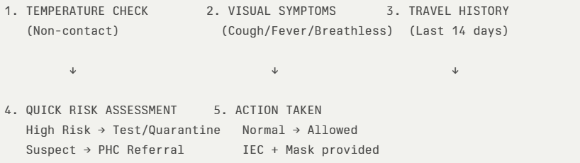
The screening protocol shall include temperature screening, observation for visible symptoms, and inquiry regarding recent travel or exposure history. Individuals identified as suspects during screening shall be immediately referred to the nearest PHC/FHC for further evaluation, testing, and appropriate action as per prevailing guidelines.

Pandemic Control Room
The Pandemic Control Room (PCR) serves as the central nerve center for real-time coordination, data aggregation, decision support, and communication during outbreaks. It consolidates information from all LSGD teams, health facilities and community sources to enable rapid response decisions.

Control Room Infrastructure and Location
Primary Location: Niranam Panchayath Office.
Backup Location: Community Hall in Niranam G.P.

Health System Control Room Framework
The PCR is organized into seven functional pillars to ensure no aspect of the response is overlooked:

Rapid Response Team (RRT)
  - Provides immediate intervention during emergencies, clusters, and field alerts.​
  - Coordinates urgent actions such as case investigation, contact tracing, isolation, and inter‑facility referrals.

Data Management & Analytics Team
  - Collects, validates, and manages key health system indicators (cases, tests, beds, HR, supplies).​
  - Analyzes data trends, generates projections, and supports evidence‑based decision‑making for local authorities.

Human Resource Deployment Team
  - Allocates healthcare staff efficiently based on workload and need
  - Ensures adequate and equitable workforce distribution across facilities

Laboratory Surveillance Team
  - Oversees diagnostic testing coordination, sample transport, and timely reporting of results.​
  - Monitors lab indicators (testing volume, positivity rate, turnaround time) for early detection of outbreaks

Vaccination Cell (If Required)
  - Plans and executes vaccination campaigns, including micro‑planning and session scheduling.​
  - Tracks coverage, identifies gaps, and coordinates corrective actions with field teams and outreach services.

Infrastructure & Patient Occupancy Team
  - Monitors facility capacity, earmarked beds, oxygen and critical care resources across all linked facilities.​
  - Ensures optimal patient distribution and referral management using updated bed‑status and resource data.
  - BMWM

Communication team
- Information Dissemination: Acts as the official voice of the PCR, issuing daily health bulletins and localized advisory notices.
- Feedback Loop: Collects community concerns and coordinates with the Call Centre to address grievances and public anxiety.
8 . Logistics and supply chain
- Inventory Management: Oversees the procurement and storage of PPE, medicines, and oxygen cylinders at the Niranam Panchayath Office.
- Supply Distribution: Ensures a "Just-in-Time" delivery system to field teams based on real-time data from the Analytics Team.

9. Transportation (Inter-facility & Emergency)
- Fleet Command: Manages the deployment of the ambulance network and converted public transport (KSRTC/School buses).
- Patient Logistics: Coordinates the movement of patients from home isolation to designated health facilities through a centralized dispatch system.

10. Media Surveillance & Call Centre
- Digital Monitoring: Scans social media and local news for misinformation to prevent panic and provide rapid rebuttals.
- Public Helpline: Operates 24/7 to provide information on bed availability, testing centers, and emergency support.

11. Management of the Deceased
- Dignity & Safety: Ensures all terminal protocols follow biosafety standards while respecting the emotional needs of the family.
- Logistics Coordination: Organizes safe transport to burial/cremation grounds and monitors the health safety of the disposal squads.

12. Intersectoral Coordination and Convergence
- Administrative Liaison: Connects the Niranam GP leadership with Police, Revenue, and Animal Husbandry departments for a unified response.
- Resource Pooling: Facilitates the use of the Community Hall (Backup Location) and other public assets for emergency infrastructure.

Feature | Primary Location (Panchayath Office) | Backup Location (Community Hall)
Connectivity | High-speed fiber/Broadband | Redundant 4G/Satellite backup
Power | Grid + Inverter/Generator | Portable Generators
Capacity | Core Command & Data Analytics | Large Scale Logistics & HR Deployment

Key Control Room Team
The Control Room Team coordinates all pandemic response activities within the LSGD and serves as the single command and communication hub during activation. It integrates information, field actions, logistics, and policy execution across all participating departments and health facilities.

Role | Name | Designation | Contact Number | Responsibility
In-charge/Nodal Officer | Dr Preetha S R | Medical Officer | 9447127555 | Overall coordination, decision-making, and reporting to the District level.
Data Entry Operator | Vineeth | Clerk | 9656362433 | Managing the line list, updating dashboards, and tracking testing results.
Communication Officer | Sindhu k pillai | HI | 9961824292 | Handling the public helpline, coordinating ambulance dispatch, and contact tracing calls.
Logistics Coordinator | Anu Thankam | PRO | 9747211456 | Managing the supply chain (PPE, meds, oxygen), coordinating with Kudumbashree for community kitchens, and overseeing waste management logistics.Technical Support (IT/Data)
Technical Support(IT/Data) | Ratheesh | OA | 8129616194 | Ensuring hardware/network uptime, physical filing of records, assisting in rapid document dispatch, and maintaining the Control Room's physical infrastructure.

SOP for alert escalation/trigger point with mapping of responsibilities.
Key Points:
- The Control Room shall be staffed with a designated In-charge, data entry personnel, and communication staff with clearly defined roles and shift arrangements.
- It shall maintain updated records on daily monitoring indicators including new cases, persons under active quarantine, and hospital bed occupancy.
- All reports and situation updates shall be shared daily with the Block and District Surveillance Unit.
- The Control Room shall act as a single point of contact for coordination with response teams, health institutions, and other departments.
- Contact details of the Control Room shall be widely communicated to field staff and stakeholders during activation.

Daily Monitoring Indicators
To ensure timely decision-making and effective response, the following key indicators shall be monitored and updated on a daily basis by the Pandemic Control Room:

Epidemiological Indicators:
New cases reported today, Total active cases, Test Positivity Rate (TPR), Case Fatality Rate (CFR)
- Surveillance Indicators:
Persons under home quarantine, High-risk contacts identified, Fever, ILI, SARI or other symptoms (syndromic surges), Travellers (symptomatic or high-risk arrivals),Animal husbandry surveillance (zoonotic alerts, unusual animal deaths, poultry/bird flu signals), Mortality surveillance (excess deaths, unexplained fatalities, verbal autopsy reports)
- Logistics and Infrastructure Indicators:
Hospital / CFLTC beds occupied, Oxygen cylinders/concentrators available, Ambulances on standby
- Alert Findings
The following table outlines category-specific trigger points (red flags) from surveillance indicators and corresponding immediate actions for the Pandemic Control Room. These enable rapid response to alert findings like testing anomalies, positive cases exceeding thresholds, clusters, and WGS reports.

Category | Trigger Point (Red Flag) | Immediate Action
Clusters | Geographical or facility-based: 5+ cases linked to one location (office, school, street). | Declare a micro-containment zone; perimeter control and active case finding.
Testing | Sudden drop in testing volume / delay in reporting / unusual testing trends | Review the sample collection process, address lab bottlenecks, deploy additional testing teams, and notify the District Lab.
Lab | Test Positivity rate increases | Increase testing sites in that ward.
Hospital | >80% Oxygen bed occupancy | Activate backup/CFLTC beds.
Travel | Cluster of cases from a single flight/train or high-risk arrival group. | Trace all passengers in adjacent seats; implement mandatory institutional quarantine.
Animal | Mass poultry/wildlife death or unusual sickness | Notify Animal Husbandry, sample the area, and dispatch RRT for environmental sampling and zoonotic check.
Mortality | Sudden spike in home deaths or brought-in-dead (BID) cases | Audit the deaths and Active Case Search drive
Additional investigations like Whole Genome Sequencing (WGS) | Detection of a Variant of Concern (VOC) or Variant of Interest (VOI) | Implement strict micro-containment; update clinical protocols to match variant severity.

Communication of Public Health Information
A Community Communication Hub shall be established to ensure timely, accurate, and consistent dissemination of information during a pandemic. The Hub will function under the coordination of Nodal officers of the control room and act as the nodal point for public communication, risk messaging, and community engagement. It will support dissemination of official advisories, promote preventive behaviors, address rumors and misinformation, and ensure that messages reach all sections of the population through trusted local channels and leaders.

Key communicators
Channel | Responsible Person | Contact
Ward-level announcements | Ward member | Alex John (Ward -9)  9495537675
Social media | HI- Sindhu | 9961824292
Local Cable TV/Radio | JHI -Sreekala | 9744104540

- All messages disseminated through the Hub shall align with advisories issued by the Health Department and District authorities.
- Community leaders shall be sensitized to support behavior change, reduce stigma, and counter misinformation.
- Special efforts shall be made to reach vulnerable and hard-to-reach populations using locally appropriate communication methods.

Rumor Tracking: A designated volunteer will monitor local social media/WhatsApp groups daily to identify misinformation and issue official clarifications via the Communication Hub.

Coordination with District/State Authorities & Other Organisations
Effective coordination with Block, District, and State authorities is essential to ensure timely reporting, technical guidance, and uninterrupted supply of essential resources during a pandemic. The LSG shall establish clear communication channels, designate responsible officers, and adhere to prescribed reporting timelines to support coordinated public health action and efficient resource mobilisation.

Reporting Schedule and Protocols:

To Whom | What to Report | Frequency | Nodal Person
Block PHC | Complete Situation Report (Cases, Quarantine, Beds, Screening, Deaths) | weekly | MO
District IDSP Unit | Outbreaks/Clusters/Unusual Events (>5 cases same ward) | weekly | DSO
Veterinary Officer | Animal health events/Zoonotic alerts | weekly | Veterinary Medical officer
State Cell | Zoonotic cross-sector events | weekly | SSO

Supply Chain Coordination
The LSG shall coordinate closely with Block, District, and State authorities (KMSCL) to ensure uninterrupted availability of essential goods, medical supplies, and logistics during a pandemic. Supply requirements shall be assessed regularly based on case load and communicated promptly to the appropriate authorities for timely replenishment.
Key Points:
- Maintain updated contact details of District and Block nodal officers for health logistics, oxygen supply, ambulances, and essential medicines.
- Submit timely indent requests for PPE, testing kits, medicines, oxygen, and other critical supplies through prescribed channels.
- Monitor stock levels at LSGD facilities, quarantine/isolation centres, and field teams through daily stock registers and dispensing logs to prevent shortages.
- Coordinate with District authorities, Karunya/Neethi medical shops, and local purchase committees for funds allocation and emergency procurement.

- Ensure regular monitoring of dispensing registers at all facilities to track usage, expiry, and pilferage—shortages being a perennial issue requiring proactive weekly audits.

- Activate surge procurement protocols during high caseloads, leveraging local purchase powers under LSGD funds alongside state supplies.

Resource Inventory and Contacts
Resource Category | Source  (District/State/Private) | Contact
PPE Kits/Masks/Gloves | KMSCL | 9995599249
PPE Kits/Masks/Gloves | Local Vendors | 9744800183
Oxygen  Cylinders/Concentrators | KMSCL | 9995599249
Medicines/Antivirals | KMSCL | 9995599249
Medicines/Antivirals | Neethi Shops | 9744800183
Test Kits (RTPCR/Rapid) | KMSCL | 9995599249

Collaboration with NGOs, PPP, and CSR
To augment government efforts during a pandemic, the LSG shall collaborate with NGOs, voluntary organisations, and private sector partners through public–private partnerships and Corporate Social Responsibility (CSR) initiatives, in coordination with District authorities.

Key Points:
- Engage NGOs and community-based organisations for community outreach, awareness, and support to vulnerable populations.
- Leverage CSR support for procurement of medical equipment, PPE, oxygen concentrators, food kits, and sanitation materials, as permitted.
- Ensure all collaborations align with government guidelines and are routed through approved administrative and financial procedures.
- Maintain transparency and documentation for all external support received and utilised.
Organization | Type | Support Offered | Contact Person
Youth Clubs/Student Unions | CBO | nil | Nil

Interdepartmental Coordination
Coordination among departments during a pandemic shall be ensured through regular review meetings convened by the LSGD President. These meetings will provide a structured platform for sharing situational updates, assessing resource availability, resolving operational gaps, and taking joint decisions to ensure a coordinated and timely response.

Department | Representative | Key Role | Contact
Health (PHC) | Staff Nurse : 7907180234 | Case management | 6238413375
Veterinary | Veterinary surgeon | Animal surveillance | 8848657758
ICDS | Supervisor 9961824292 | Nutrition support | 7736114638
Education | Head Teacher:  9847774842 | School coordination | 9847774842
Police | SHO :9496208753 | Containment enforcement | 0471-2730045
Water Authority | 7947427335 | Water supply | 7947427335
LSGD Engineering | 8606011375 | Quarantine infrastructure | 0471-2309250

PHASE 3 - Surge Capacity
Phase 3 is activated when there is a rapid increase in cases, high test positivity rates, or when existing health facilities and quarantine arrangements approach saturation. The focus of this phase is to expand isolation capacity, augment clinical care services, and mobilise additional resources through district and state support mechanisms.

Conversion of Community Facilities
To manage increased case load, the LSGD shall activate additional isolation facilities by repurposing identified community infrastructure such as community halls, auditoriums, schools, hostels, or other suitable buildings.

Name of facility | Facility Type | No. of Buildings | Ward | Surge Capacity (Beds) | Nodal Person
YMCA | Hall | 1 | 5 | 30 | Ward member

- Recovery and rehabilitation phase
Recovery

1. Immediate Post-Pandemic Restoration
- Damage & Impact Assessment: Conducting a comprehensive audit of the health, economic, and social toll taken on the 13 wards to prioritize resource allocation.
- Restoration of Health Services: Shifting focus back from "pandemic-only" care to routine services like immunizations, maternal health, and non-communicable disease (NCD) clinics.
- Environmental Cleanup & Sanitation: Intensive disinfection of public spaces, schools, and former quarantine centers to ensure physical safety.

2. Human-Centric Rehabilitation
- Rehabilitation of Affected Population: Providing specialized medical follow-up for survivors (e.g., "Post-Viral" or "Long-COVID" clinics) and supporting families who lost breadwinners.
- Psychosocial & Mental Health Support: Expanding the work of the Psychosocial Team to address long-term trauma, grief, and the social stigma associated with the disease.
- Livelihood Restoration: Coordinating with the LSG to facilitate financial aid, interest-free loans, or employment programs for those who lost income (specifically targeting the high-risk migrant and daily-wage groups in Wards 3, 4, 5, etc.).

3. Vigilance & Trust
- Disease Surveillance during Recovery: Maintaining a "Sentinel Surveillance" system to catch any potential second waves or secondary outbreaks early.
- Community Engagement & Confidence Building: Hosting town-hall meetings and Kudumbashree sessions to share recovery milestones and restore public trust in the health system.

4. Systemic Strengthening (The "After-Action" Review)
- Documentation & Best Practices: Compiling the Niranam Pandemic Response report, detailing what worked (e.g., the 300-member workforce efficiency) and what failed.
- Health System Strengthening: Using the "Lessons Learned" to upgrade oxygen plants, lab capacity, and the Control Room infrastructure permanently.
- Policy Revision: Updating the One Health Pandemic Preparedness Plan based on the real-world data collected during the active response phase.

CONCLUSION
The FHC Niranam Pandemic Preparedness Plan establishes a robust, multi-sectoral framework designed to protect the 13 wards through a "One Health" approach that integrates clinical expertise with local governance. By mobilizing a 300-member specialized workforce and a centralized Control Room at the Niranam Panchayath Office, the plan ensures immediate accountability across critical functions such as surveillance, logistics, and the protection of 3,223 high-risk elderly and chronically ill residents. Through strategic resource pooling with Kudumbashree and LSG leadership, and a commitment to long-term recovery—including psychosocial support and systemic health strengthening—FHC Niranam transitions from a routine medical facility into a proactive public health shield capable of mitigating, containing, and recovering from complex biological threats.

Additional points

Operational Resilience & Technical Infrastructure
- Hazard Vulnerability Mapping & Power Continuity: Detailed mapping will be maintained to correlate flood-prone zones with critical infrastructure, specifically ensuring that KSEB power lines and backup generators for FHC cold chains (vaccine storage) are prioritized. In the event of a total grid failure, localized solar-power backup and high-capacity diesel generators will be activated to maintain the Control Room’s digital operations.
- Emergency Communication (Ham Radio Operators): To mitigate the risk of mobile network congestion or tower failure, a network of licensed Ham Radio Operators will be pre-mapped to the FHC and the Backup Control Room. This ensures a "failsafe" communication bridge between Niranam and the District Emergency Operations Centre (DEOC) for reporting casualties and requesting urgent medical supplies.
- Relief-Based Commodities & Logistics: Beyond medical supplies, the Logistics Team will manage the "Essential Commodity Chain," ensuring the distribution of food kits and hygiene packs to quarantined households. This involves coordination with local supply offices to prevent price gouging and ensure the 13 wards have uninterrupted access to dry rations and clean drinking water.
- Tech Support & Digital Vigilance: A dedicated Tech Support Desk will be established within the PCR to manage the telemetry of real-time dashboards and ensure the cybersecurity of patient data. They are responsible for the uptime of the "Health Stack" (reporting software) and providing immediate troubleshooting for field staff using mobile reporting tools.
- HR Specific Responsibilities & Task Shifting: To prevent workforce exhaustion, a "Task-Shifting" protocol will be implemented where non-clinical tasks (data entry, logistics) are strictly handled by Office Assistants (OA) and Clerks, allowing Doctors and Nurses to focus exclusively on clinical triage. Each of the 300 personnel will have a "Duty Card" defining their reporting officer and their specific 8-hour shift window to ensure 24/7 coverage without burnout.

RECOMMENDATIONS

Strengthening Healthcare Infrastructure
- Establish a primary health response unit within the Panchayat with trained staff.
- Ensure availability of basic medical supplies (masks, sanitizers, PPE kits, oxygen cylinders).
- Create tie-ups with nearby hospitals in for emergency referral and transport.

2. Community Awareness & Education
- Conduct regular awareness campaigns on hygiene, vaccination, and preventive measures.
- Use local communication channels (community radio, WhatsApp groups, notice boards) to spread verified information.
- Train volunteers to act as health ambassadors in each ward.

3. Emergency Response & Coordination
- Form a Pandemic Preparedness Committee at Panchayat level including health workers, ward members, and NGOs.
- Develop a clear action plan for lockdowns, quarantine, and distribution of essentials.
- Maintain a database of vulnerable groups (elderly, differently-abled, chronically ill) for targeted support.

4. Supply Chain & Food Security
- Identify and support local suppliers and farmers to ensure uninterrupted food supply.
- Create community kitchens during emergencies to serve vulnerable populations.
- Stockpile essential commodities in Panchayat-run outlets for crisis periods.

5. Digital Preparedness
- Promote digital platforms for telemedicine consultations.
- Use Panchayat’s website/social media for real-time updates on health advisories.
- Encourage online grievance redressal to reduce crowding in offices.

6. Training & Capacity Building
- Organize mock drills for pandemic response in schools, offices, and public spaces.
- Train Panchayat staff and volunteers in first aid, infection control, and crowd management.
- Collaborate with NGOs and health departments for capacity-building workshops.

7. Long-Term Resilience
- Integrate pandemic preparedness into the Panchayat Development Plan.
- Allocate a dedicated budget for health emergencies.
- Encourage community participation in planning and monitoring preparedness measures.
MOCKDRILL SCENARIOS

Mock Drill: "Active Convergence 2026"
Simulated Threat: A localized outbreak of a High-Pathogenicity Respiratory Virus in a flood-affected ward.

08:00 AM – The "Zero Hour" (Alert Trigger)
- The Event: A local clinic reports a cluster of five patients from Ward 12 with severe pneumonia symptoms.
- FHC Action: Dr. Preetha S R (Nodal Officer) activates the Incident Command System.
- The Test: Can the Data Entry Operator (Clerk) pull the "Hazard Vulnerability Map" for Ward 12 within 10 minutes to identify nearby chronically ill residents?

09:30 AM – Command Center Activation
- Logistics & Power: The KSEB Liaison is notified. A simulated power trip occurs; the Tech Support (OA) must switch the PCR to the backup generator and ensure the Ham Radio station is "On-Air."
- Supply Chain: Anu Thankam (Logistics) dispatches "Relief-Based Commodities" (PPE and sanitizers) to the field teams.
- HR Check: The HR Deployment Team ensures 100 of the 300 staff are on active duty, with 200 placed on 4-hour standby.

11:00 AM – Field Interventions & Communication
- Surveillance: Sindhu K Pillai (Communication Officer) directs the Surveillance Team to establish a geographic "Ring Cordon" around the cluster.
- Media Control: A rumor spreads on social media about a "forced lockdown." The Call Centre must handle 20 mock "panic calls" while the Media Team issues an official Fact-Check bulletin.
- Transport: The JHI coordinates an "Inter-facility Transfer" using a KSRTC bus converted into a temporary isolation shuttle.

01:00 PM – Intersectoral Resolution
- The Twist: A simulated road blockage due to waterlogging prevents the ambulance from reaching the FHC.
- Convergence: The LSG Secretary must coordinate with the Intersectoral Team (Police and PWD) to clear an emergency path and ensure the Veterinary Surgeon can access the poultry farms in the area.

03:00 PM – De-escalation & Data Validation
- AAR (After-Action Review): The Data Management Team presents the final mock "Line List" to the Medical Officer.
- Recovery: The Psychosocial Team begins simulated tele-counseling for the families in the affected "Ring Cordon."

Metric | Target
Notification Time | < 15 Minutes
Power Switch-over | < 2 Minutes
PPE Distribution | 100% Accuracy
Communication Failsafe | Ham Radio Operational

ANNEXURE

IMPORTANT PHONE NUMBERS

Phone numbers and particulars of persons responsible for providing guidance, assistance, and support for pandemic preparedness operations may be provided here in a manner that allows easy reference at a glance.The information recorded here could be exhibited elsewhere at the time of emergencies. LSG institutions shall give special attention to collect and record the above data of persons and institutions who/which are supposed to give technical and co-ordination support to reduce the impact of pandemic.

1.1. Details of grama panchayat/municipality/corporation wards
Sl.No | Name of the ward | Ward number | Name of the ward  member | Contact number
1 | Kattunilam | 1 | Jolly Eappen | 8301050766
2 | Vadakkumbhagam padinjaru | 2 | Aiswarya | 9656554208
3 | Vadakkumbhagam kizhakku | 3 | Rijo Varghese | 9744292964
4 | Kannassa | 4 | Ajeesh P U | 9048638189
5 | Ymca | 5 | Renny p Thomas | 9744136900
6 | Duck Farm | 6 | Thomas mathai | 9072375755
7 | Kizhakkummuri | 7 | Bindu | 9747752592
8 | Mannamthoattuvazhy | 8 | Raichal Mathew | 9656859883
9 | Panchayathoffice | 9 | Alex Puthuppally | 9495537675
10 | Phc | 10 | Aneesh | 9526964771
11 | Thoattumada | 11 | Jomol | 7558956859
12 | Erathode | 12 | Sini Koshy | 9757804696
13 | Kombankery | 13 | Ambili Samuel | 9961986981
14 | Thottady | 14 | Ajoy | 9539042261

1.2. Other important phone numbers of grama panchayat/municipality/corporation area
Sl. No. | Name | Contact number
1. | Village Officer | 9961186260
2. | Agriculture officer | 9447877112
3. | Duck Farm | 0469 2711898
4. | Excise office | 0469 2747632
5. | Veterinary officer | 8848657758
6. | KSEB Office | 0469 2610297

1.3. Important offices of grama panchayat/municipality/ corporation
Sl.No | Name of the office | Contact person | Contact number
1. | Village Office | Village Officer | 9961186260
2. | Agriculture Office | Agriculture Officer | 9447877112
3. | Animal Husbandry Office | Animal Husbandry Doctor | 8848657758
4. | Police Station | Police Officer | 8075049821
5. | BSNL Office | Officer | 0
6. | Block Office | Officer | 0
7. | KSEB Office | Officer | 0469 2610297
8. | Fisheries Office | Officer | 0
9. | Fire and Rescue | Officer | 0

1.4. Health Services

Sl. No | Name of the hospital/institution | Location | Phone number
1. | Government hospitals/PHC | Niranam | 9656362433
2. | Private hospitals | 0 | NA
3. | Clinical laboratories | 3 | 94003 19804
4. | Chemist/pharmacy | 3 | 94961 81956
5. | Blood donors | 0 | NA
6. | Other language experts (Bihari, Hindi, Bengali,  Asamees ………) | 0 | NA

1.5. Veterinary Services
Sl.No | Name of the Clinic | Name of the  Surgeon/Doctor | Place/location | Phone  number
1 | Govt.Veterinary Hospital | Dr Hamna | Niranam ward 5 | 8848657758

1.6. Helpline numbers
Helpline | Phone number
Police | 8893098096
Fire and Rescue | 0469 260 0101
KSEB | 04692610297

1.7. Public and Private Schools Contact details

S.No | Name of School | Ward | Institution type | Phone number
1 | St mary”s Higher Secondary School | 7 | Aided | 9847774842
2 | St George UPS ,Erathode | 12 | Aided | 9495555428
3 | Kottayil MD LPS | 13 | Aided | 9495236521
4 | M T L P S Kombankery | 13 | Aided | 9961369697
5 | St Thomas marthoma school | 1 | Private | 9446419024
6 | Marthoman Vidyapeedhom | 7 | Private | 9072013398
7 | Al Ishan School | 3 | Private | 8606638515
8 | Mukalady GUPS | 6 | Govt | 9495343459
9 | MDLPS Mannamthoattuvazhy | 7 | Aided | 9495266264
10 | St Mary”s LPGS | 13 | Aided | 9847798982
11 | Central LPS vadakkumbhagam | 2 | Aided | 7306520719
12 | Sakthimangalam LPS | 2 | Aided | 9447281723

1.9. Anganwadi Contact Details

Sl.No. | Ward No | Name of Anganwadi  Teachers | Anganwadi Number | Phone number
1 | 1 | Ajitha | AWC 85 | 9447620595
2 | 2 | Deepakumari | AWC 114 | 9656853255
3 | 3 | Pushpa | AWC 82 | 8891265965
4 | 3 | Sreedevi C R | AWC 83 | 9526857097
5 | 5 | Sethuamma | AWC 86 | 9961451732
6 | 6 | Shiji | AWC 84 | 9747647961
7 | 7 | Nirmaladevi | AWC 76 | 9400670284
8 | 8 | Liju | AWC 81 | 9961766069
9 | 9 | Bindu C R | AWC 78 | 9605466434
10 | 10 | Hamsa Beevi | AWC 75 | 9633052022
11 | 10 | Meera | AWC 80 | 7025605376
12 | 12 | Chithra lekha | AWC 87 | 9288852356
13 | 13 | Sreekkutty | AWC 154 | 7902260286
14 | 13 | Vasanthakumari | AWC 113 | 9946688976
15 | 13 | Sindhu | AWC 79 | 7025553190
16 | 12 | Rani | AWC 88 | 9539918698
17 | 3 | Rahmath | AWC 77 | 9847975171
18 | 11 | Aeleyamma | AWC 74 | 9745702088

1.12. Information regarding resources

Means of transportation | Name of Owner | Phone Number
Heavy Trucks | Shaji | 9847894997
Tractor | Sachin | 9496341430
Ambulances | Aby | 8281443114
Boats | pamba boating | 99465 37213
Taxi service | Roshan Taxi | 099955 12769

Annexure 1: LSG Baseline Data Collection Format
A. Baseline data
Sl. No. | Indicator / Field | Baseline Data | Source / Remarks
1 | Name of LSG | Niranam | LSGD DATA
2 | District | Pathanamthitta | LSGD DATA
3 | Block / Taluk | Pulikkezhu | LSGD DATA
4 | Type of LSG (Gram Panchayat / Municipality / Corporation) | Grama panchayath | LSGD DATA
5 | Area (sq. km) | 13.7 sq km | LSGD DATA
6 | No. of wards | 14 | LSGD DATA
7 | GIS boundary file available | Yes | LSGD DATA
8 | Key contact person & phone | HI-9961824292 | FIELD DATA

B. Demography
Indicator / Field | Baseline Data | Source / Remarks
Total population | 16262 | LSGD DATA
Males | 7980 | LSGD DATA
Females | 8282 | LSGD DATA
Transgender population | NO | LSGD DATA
Age distribution  (<5, 5–14, 15–59, ≥60) | <5-798  Adolescent-1037  >60-2971 | LSGD DATA
No. of households | 41 | LSGD DATA
Population density (persons/sq.km) | 1187 | LSGD DATA
No. of migrant workers | 96 | LSGD DATA
Major occupational groups | Agriculture | LSGD DATA

C. Vulnerable Populations & Social Risks
Sl. No. | Indicator / Field | Baseline Data (Value / Description) | Source / Remarks
1 | No. of elderly (≥60) | 5268 | FIELD DATA
2 | No. of persons with disability | 122 | FIELD DATA
3 | No. of bedridden persons | 22 | FIELD DATA
4 | No. of chronic disease cases (DM/HTN/COPD/CKD etc.) | DM-1744  HTN-2146  CKD -30  COPD -356 | FIELD DATA
5 | Pregnant women (current estimate) | 39 | FIELD DATA
6 | Children <5 years | 757 | FIELD DATA
7 | Tribal population (if any) | No | FIELD DATA
8 | Fisherfolk / coastal vulnerable groups (if any) | NO | FIELD DATA
9 | Urban slums / unnotified settlements (if any) | NO | FIELD DATA
10 | Homeless population | NO | FIELD DATA
11 | Orphanages / old age homes (number & capacity) | old age home -1 (5)  orphanage-0 | FIELD DATA
12 | Hostels / prisons / shelters (number & capacity) | No | FIELD DATA
13 | Poverty / BPL estimate | 2449 | FIELD DATA
14 | Food insecurity hotspots | NO | FIELD DATA
15 | Any history of stigma/discrimination issues (Yes/No) | NO1 | FIELD DATA

D. Health System & Service Readiness
Sl. No. | Indicator / Field | Baseline Data (Value / Description) | Source / Remarks
1 | No. of health facilities in LSG (PHC/CHC/TH/DH/Private) | 1 | LSGD DATA
2 | PHC/Family Health Centre details (name, location) | FHC Niranam | LSGD DATA
3 | Subcentres / Health & Wellness Centres (number) | 4 | LSGD DATA
4 | Private clinics / hospitals (number) | 2 | LSGD DATA
5 | Labs available (public/private) | 3 (private ) | LSGD DATA
6 | Availability of ambulance services (Yes/No, number) | Yes ,1 | LSGD DATA
7 | Availability of isolation/quarantine facilities (Yes/No, details) | Yes | LSGD DATA
8 | Cold chain facilities (Yes/No, details) | Yes | LSGD DATA
9 | Stockpile space available (Yes/No) | No | LSGD DATA
10 | PPE / mask / sanitizer availability plan (Yes/No) | Yes | LSGD DATA
11 | Surveillance staff available (JHI/JPHN/ASHA count) | JHI-2  JPHN-2  ASHA-17 | LSGD DATA
12 | Existing emergency referral pathways (Yes/No) | Yes | LSGD DATA

E. Points of Entry & Mobility
Sl. No. | Indicator / Field | Baseline Data (Value / Description) | Source / Remarks
1 | Bus stands / depots (number) | NO | LSGD DATA
2 | Railway stations (number) | NO | LSGD DATA
3 | Boat jetties / fishing harbours (number) | NO | LSGD DATA
4 | Ports / airports nearby (specify distance) | NO | LSGD DATA
5 | Major highways/roads passing through | SH -Veeyapuram thiruvalla | LSGD DATA
6 | Border crossings (state/district) | Alppuzha Border | LSGD DATA
7 | Major markets / weekly markets | NO | LSGD DATA
8 | Tourism hubs / major event venues | NO | LSGD DATA
9 | Schools/colleges with hostels (number) | NO | LSGD DATA
10 | Factories / large workplaces (number) | NO | LSGD DATA
F. Water, Sanitation & Hygiene (WASH)
Sl. No. | Indicator / Field | Baseline Data (Value / Description) | Source / Remarks
1 | Major drinking water sources (piped / wells / borewells / springs) | PIPED | LSGD DATA
2 | No. of public wells | 16 | LSGD DATA
3 | No. of households with piped water connection | 3087 | LSGD DATA
4 | Water quality testing routine (Yes/No) | YES | LSGD DATA
5 | Common contamination risks (flooding, salinity, industrial waste) | Flooding | LSGD DATA
6 | Open defecation free status (Yes/No) | YES | LSGD DATA
7 | Solid waste management system (Yes/No) | YES | LSGD DATA
8 | Bio-medical waste disposal mechanism (Yes/No) | YES | LSGD DATA
9 | No. of public toilets | 0 | LSGD DATA
10 | Handwashing stations in public places (Yes/No) | No | LSGD DATA
G. Zoonotic Risks & One Health
Sl. No. | Indicator / Field | Baseline Data (Value / Description) | Source / Remarks
1 | Livestock population (cattle/goats/pigs/poultry) estimates | Approx 80 | LSGD DATA
2 | No. of dairy farms / poultry farms / pig farms | Nil | LSGD DATA
3 | Slaughterhouses / meat shops (number) | Nil | LSGD DATA
4 | Animal markets (Yes/No, details) | Yes | LSGD DATA
5 | Veterinary dispensaries (number) | 1 | LSGD DATA
6 | History of zoonotic outbreaks (rabies, leptospirosis, avian flu etc.) | No outbreaks ,Surveillance zone for Avian Influenza | LSGD DATA ,FIELD DATA
7 | Stray dog population management measures (Yes/No) | No | LSGD DATA
8 | Rodent infestation hotspots (Yes/No) | no | LSGD DATA
9 | Wetlands / waterlogged areas prone to leptospirosis | Yes | LSGD DATA
10 | Bat roosting areas / caves / fruit orchards (if any) | No | LSGD DATA
11 | Human-animal interface hotspots (farms near residences) | all wards near to paddy field | LSGD DATA
H. Climate & Disaster Risks (Pandemic Amplifiers)
Sl. No. | Indicator / Field | Baseline Data (Value / Description) | Source / Remarks
1 | Flood-prone wards (list) | all wards | LSGD DATA
2 | Landslide-prone wards (list) | nil | LSGD DATA
3 | Cyclone/sea surge risk (Yes/No) | nil | LSGD DATA
4 | Heatwave risk zones (Yes/No) | no | LSGD DATA
5 | Waterlogging areas (list) | All wards | LSGD DATA
6 | Shelter homes / relief camps (number, capacity) | 3 | LSGD DATA
7 | Past disaster displacement history | flood | LSGD DATA
8 | Disruption to water supply/transport common (Yes/No) | NO | LSGD DATA
I. Critical Infrastructure & Logistics
Sl. No. | Indicator / Field | Baseline Data (Value / Description) | Source / Remarks
1 | Schools (number) | 12 | LSGD DATA
2 | Anganwadis (number) | 18 | LSGD DATA
3 | Colleges (number) | 0 | LSGD DATA
4 | Community halls (number) | 1 | LSGD DATA
5 | Places of worship with large gatherings (number) | 1 | LSGD DATA
6 | Large markets / shopping areas (number) | Nil | LSGD DATA
7 | Warehouses / cold storages (number) | Nil | LSGD DATA
8 | Telecom/mobile network coverage gaps (Yes/No) | Yes | LSGD DATA
9 | Power outage frequency (high/medium/low) | Medium | LSGD DATA
10 | Availability of generators in key facilities | 1 | LSGD DATA

J. Risk Communication & Community Networks
Sl. No. | Indicator / Field | Baseline Data (Value / Description) | Source / Remarks
1 | Ward-level rapid response teams (Yes/No) | Yes | LSGD DATA
2 | Jagratha samithis / committees active (Yes/No) | No | LSGD DATA
3 | Kudumbashree presence and strength (number of units) | 135 | LSGD DATA
4 | Volunteer network (number, coverage) | 100 | LSGD DATA
5 | Community-based surveillance mechanisms (Yes/No) | Yes | LSGD DATA
6 | IEC dissemination channels (WhatsApp groups, community radio, PA systems) | Yes | LSGD DATA
7 | Rumour tracking mechanisms (Yes/No) | YES | LSGD DATA
8 | Languages spoken / literacy considerations | Yes | LSGD DATA
9 | Vulnerable groups communication strategy available (Yes/No) | No | LSGD DATA

K. Preparedness Planning & Governance
Sl. No. | Indicator / Field | Baseline Data (Value / Description) | Source / Remarks
1 | LSG emergency plan available (Yes/No) | YES | LSGD DATA
2 | Pandemic preparedness plan available (Yes/No) | YES | LSGD DATA
3 | Incident Command System identified (Yes/No) | Yes | LSGD DATA
4 | Rapid procurement mechanism available (Yes/No) | Yes | LSGD DATA
5 | Emergency fund available (Yes/No, amount) | NO | LSGD DATA
6 | Past outbreak response experience (Yes/No, details) | NO | LSGD DATA
7 | Intersectoral coordination mechanism (Health, Police, LSG, Veterinary, Education) | YES | LSGD DATA
8 | Mock drills conducted in last 12 months (Yes/No) | NO | LSGD DATA
9 | Training coverage for staff/volunteers (Yes/No) | NO | LSGD DATA

L. Surveillance & Data Systems
Sl. No. | Indicator / Field | Baseline Data (Value / Description) | Source / Remarks
1 | Digital reporting tools used (e.g., DHIS2, portals) | Portals | Dist -level data
2 | Availability of line-listing format (Yes/No) | Yes | Dist -level data
3 | Contact tracing team identified (Yes/No) | Yes | Dist -level data
4 | Mapping of high-risk households available (Yes/No) | YES | Dist -level data
5 | Testing sample transport mechanism (Yes/No) | Yes | Dist -level data
6 | Reporting timeline adherence (good/average/poor) | good | Dist -level data
7 | Data sharing between departments (Yes/No) | YES | Dist -level data
8 | Availability of dashboard for monitoring (Yes/No) | Yes | Dist -level data

M. Additional Notes & Observations
Sl. No. | Indicator / Field | Baseline Data (Value / Description) | Source / Remarks
1 | Key challenges perceived by LSG | NA | Field data
2 | Top 5 high-risk wards (reason) | 5,3,12,8 | Field data
3 | Any unique local risks (industrial pollution, refugee camps, etc.) | No | Field data
4 | Recommendations for preparedness strengthening | Inter- sectoral convergence strengthening | Field data

