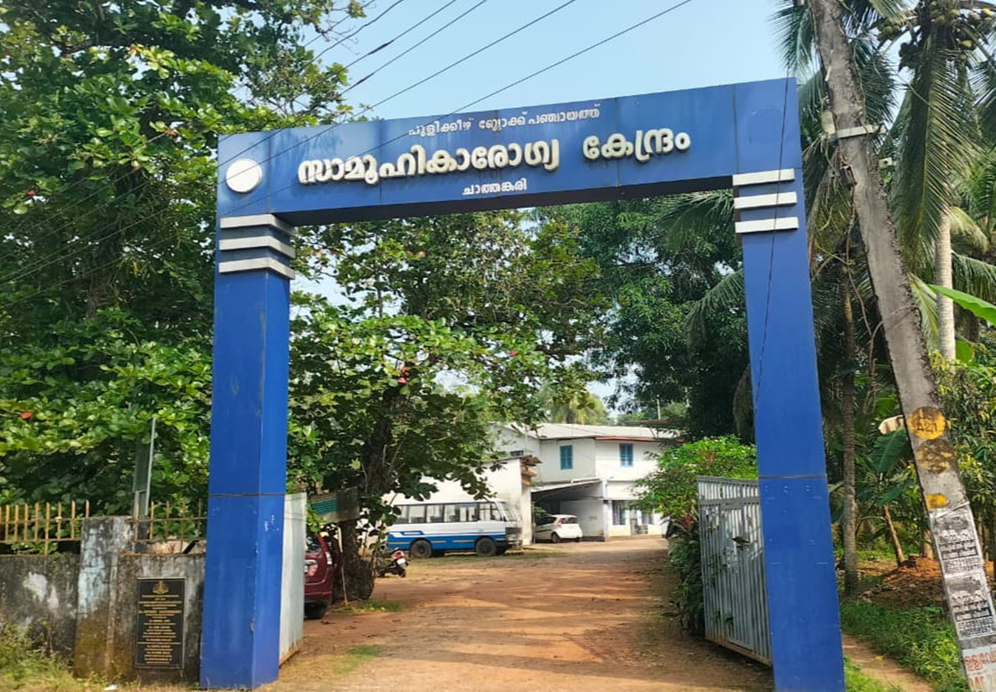
PANDEMIC
PREPAREDNESS PLAN
Peringara grama panchayath
CHC CHATHENKARY

Dr.SHAUKATHALI PUTHUKKARA
MEDICAL OFFICER
chcchathenkary@gmail.com

MESSAGE FROM PRESIDENT
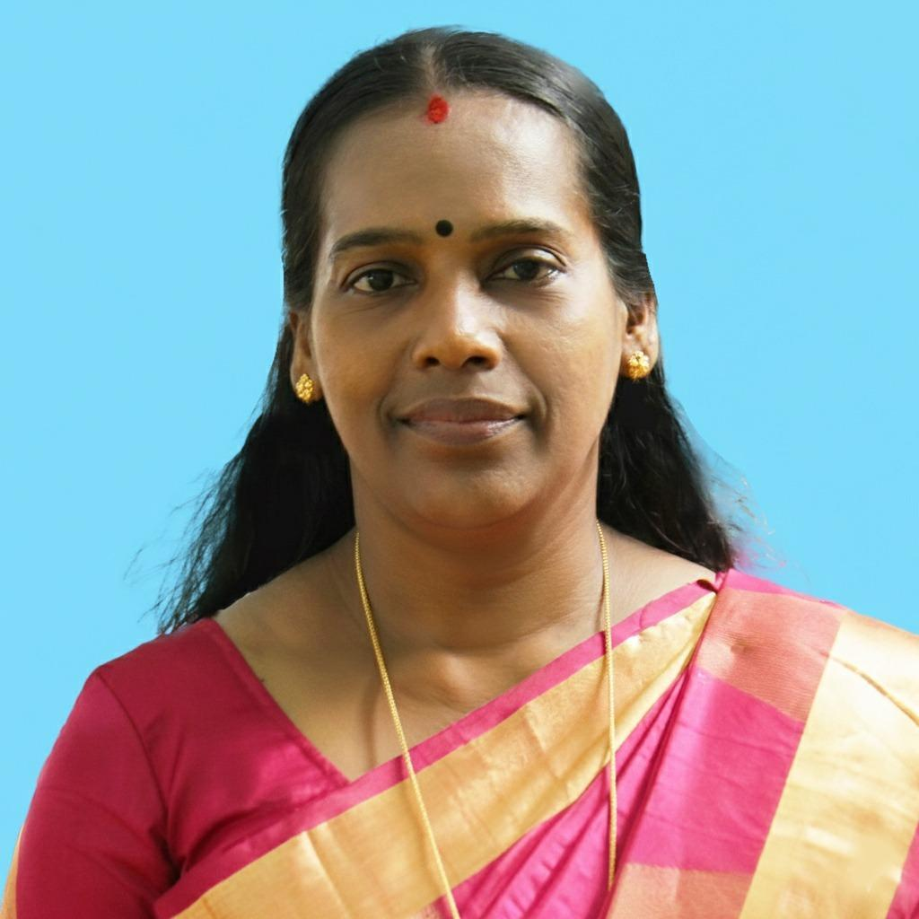
“AS WE HAVE LEARNED FROM PAST COVID EMERGENCIES’ PANDEMICS ARE NOT JUST MEDICAL CRISIS-THEY ARE SOCIAL AND ECONOMIC CHALLENGES AS WELL. SO PANDEMIC PREPARDNESS IS OUR RESPONSIBILITY. SO WE MUST STRENGTHEN OUR HEALTH CARE SYSTEM, SURVEILLANCE, SUPPORT OUR FRONT LINE WORKERS AND COMMUNITY AWARENESS . CO-ORDINATION BETWEEN GOVERNMENT AND CITIZENS ARE THE KEY TO PROTECTING LIFE. PREPAREDNESS TODAY WILL SAVE LIVES TOMORROW AND TOGETHER WE CAN BUILD A SAFER,HEALTHIER FUTURE FOR ALL.”
HARIDASI
PRESIDENT-PERINGARA GRAMAPANCHAYAT

MESSAGE FROM HEALTH STANDING COMMITTEE CHAIRPERSON


“PREPARDNESS TODAY SAVES LIFE TOMORROW . SO LET US STAY ALERT,UNITED AND READY.STRONG PUBLIC HEALTH SYSTEMS AND INFORMED CITIZENS ARE OUR BEST DEFENSE AGAINST PANDEMICS.”

BINDHU G
HEALTH STANDING COMMITTEE CHAIRPERSON

MESSAGE BY MEDICAL OFFICER
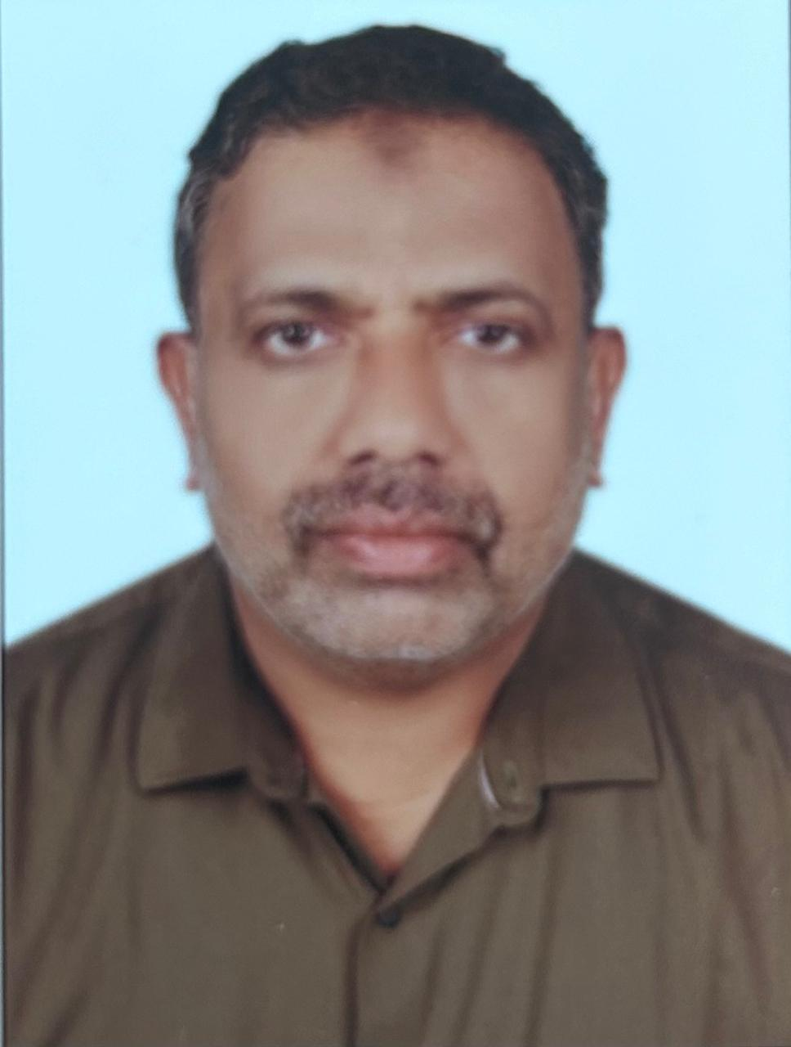

“PREVENTION IS ALWAYS BETTER THAN CURE.SIMPLE ACTIONS TODAY CAN PREVENT SERIOUS ILLNESS TOMORROW. PUBLIC HEALTH WORKERS ARE THE BACK BONE OF PANDEMIC PREPARDNESS. THEY DETECT EARLY WARNING SIGNS IN COMMUNITY, EDUCATE PEOPLE, DO PREVENTIVE ACTIVITIES LIKE SOURCE REDUCTION , VECTOR SURVEY, VACCINATIONS AND ENSURE TIMELY REPORTING. THEIR PRESENCE AT GRASS ROOT LEVEL HELPS PREVENT THE SPREAD OF DISEASE BEFORE IT BECOMES CRISIS. PERINGARA GRAMAPANCHAYAT IS A FLOOD PRONE AREA WHERE CASES OF LEPTOSPIROSIS HAVE BEEN FREQUENTLY REPORTED. HOWEVER DUE TO DEDICATED AND EFFECTIVE ACTIVITIES OF PUBLIC HEALTH DEPARTMENT, THE INCIDENCE OF DISEASE HAS BEEN SIGNIFICANTLY REDUCED. PREPAREDNESS AND AWARENESS HELP US PREVENT FUTURE HEALTH CRISIS.”

Dr. SHOUKKATHALI PUTHUKKARA
Medical Officer , CHC Chathenkary

EXECUTIVE SUMMARY
Peringara Revenue Village, located under Pulikeezhu Block in Thiruvalla Taluk of Pathanamthitta District, lies approximately 5 km from Thiruvalla town. Historically part of the Kuttanad region and formerly under the administrative control of Central Travancore until 1956, Peringara now forms part of Upper Kuttanad and retains the distinctive ecological and agricultural characteristics of Kerala’s “Rice Bowl.” The village is surrounded by water bodies on all sides and is accessible primarily by road, with certain pockets reachable through inland waterways. Geographically, the eastern side of the village is comparatively elevated, whereas the southern region lies below mean sea level, making it particularly vulnerable to riverine flooding from the Manimala River.
As per the 2011 Census, Peringara has a population of 14,440, comprising 6,640 males and 7,800 females. Nearly 75% of the population is engaged in agriculture and related activities, including paddy cultivation across 24 Paddyfields distributed over 10 wards. Other livelihoods include duck rearing, fishing, cultivation of tapioca and vegetables, and small-scale spice farming. The agrarian economy and close human–environment interaction are defining features of the village. Traditionally, inland navigation using small boats (vallam) was a primary mode of transportation, though this has gradually declined due to land conversion and infrastructural changes.

Given its low-lying geography, proximity to water bodies, agrarian livelihood patterns, and vulnerability to seasonal flooding, Peringara faces unique public health risks, particularly during monsoon periods. Flooding may lead to water contamination, vector proliferation, displacement, and disruption of essential health services, thereby increasing susceptibility to communicable diseases. In this context, the development of a comprehensive Pandemic Preparedness Plan is essential to strengthen surveillance systems, ensure coordinated public and private healthcare response, integrate disaster risk reduction strategies, and adopt a One Health approach to safeguard the health and well-being of the population against emerging and re-emerging infectious disease threats.

LIST OF ABBREVIATIONS
LSGD | Local Self Government Department / Local Self Government Institution
BMO | Block Medical Officer
IDSP | Integrated Disease Surveillance Programme
NDMA | National Disaster Management Authority
PPE | Personal Protective Equipment
ICMR | Indian Council of Medical Research
CD | Communicable Diseases
NCD | Non-Communicable Diseases
KSIDC | Kerala State Industrial Development Corporation
covid | Coronavirus Disease
CAPD | Continuous Ambulatory Peritoneal Dialysis
TB | Tuberculosis
PHC | Primary Health Center
FHC | Family Health Center
AYUSH | Ayurveda, Yoga & Naturopathy, Unani, Siddha, and Homoeopathy
THQH | Taluk Head Quarters Hospital
MCH | Medical College Hospital
USG | Ultrasonography (Ultrasound Scan)
RT-PCR | Reverse Transcription Polymerase Chain Reaction
CT, MRI | Computed Tomography, Magnetic Resonance Imaging
NCC/NSS | National Cadet Corps, National Service Scheme
CBO | Community-Based Organizations
SHG | Self-Help Groups
NGO | Non-Governmental Organizations
SOP | Standard Operating Procedure
ILI, SARI | Influenza-Like Illness, Severe Acute Respiratory Infections
CFLTC | COVID First Line Treatment Centre

TABLE OF CONTENTS

3
INTRODUCTION 9
● Background of the PPP 9
LSGD AT A GLANCE 9
INTEGRATED HEALTH INFRASTRUCTURE MAP OF PERINGARA PANCHAYAT 10
GENERAL PROFILE OF THE LSGI’S 13
Background of the LSGI 13
Demographic and Vulnerable Population 14
Clinical Vulnerability 16
INFRASTRUCTURE & RESOURCE INVENTORY 18
Health Facility Directory & Basic Capacity in the LSGD 18
Private Clinics 19
Healthcare Education & Training Institutions 20
Specialized Services & Emergency Inventory 20
Oxygen & Diagnostic Capacity 21
Diagnostics facility mapping at the LSGI level 22
Laboratory Identification & Basic Details 22
Social and Community Infrastructure for surge plan 22
Human resources 24
Community & Support Cadre 25
Community Organizations 26
Administrative & Emergency Services 27
Information regarding resources 27
ONE HEALTH & ENVIRONMENTAL SURVEILLANCE 28
Animal & Bird Population 28
Veterinary Infrastructure 29
Veterinary Doctors & Workforce 30
High-Risk Interface Points (Surveillance Sites) 30
Environmental Risk Mapping 31
Disease Seasonality Mapping 32
Vulnerability Mapping 33
EPIDEMIOLOGICAL TRENDS (2021–2025) 34
Disease Burden among human beings(Last 5 Years) 34
*(use the above table data to create the graph/diagram) 36
Seasonal Trend Analysis 37
Outcome-Based Trend Analysis- 2025 39
Transmission Trend- 2025 40
Integrated Disease Hotspot Map (2021–2025) 42
Preparedness and Response Protocol at LSG Level 44
Constitution of One Health Committee 44
Pandemic Response Workforce 45
Activities and Measures before and during Pandemic 47
PHASE 1 - Alert / Preparation 47
PHASE 2 - Active Response 50
Standard Screening Protocol 51
PHASE 3 - Surge Capacity 60
Conversion of Community Facilities 60
CONCLUSION 61
RECOMMENDATIONS 62
ANNEXURE 63
1. IMPORTANT PHONE NUMBERS 63

INTRODUCTION
Perinagra Panchayat is a rural local self-government institution in Kerala characterized by low-lying terrain, extensive paddy fields, and a network of canals and water bodies. Several wards are identified as flood-prone, particularly during the southwest monsoon, resulting in seasonal waterlogging, disruption of transportation, contamination of water sources, and temporary displacement of residents. These environmental vulnerabilities increase the risk of water-borne, vector-borne, and other communicable diseases, especially when essential services are interrupted. The geographical and climatic profile of the Panchayat therefore necessitates an integrated approach that addresses both disaster risks and public health threats.
The demographic structure of the Panchayat, including elderly individuals, persons with chronic illnesses, children, and other vulnerable groups, further underscores the need for structured pandemic preparedness planning. Closely settled residential areas and community interactions may facilitate rapid transmission of infectious diseases during outbreaks. Strengthening primary healthcare institutions, ensuring coordination between public and private healthcare providers, maintaining effective surveillance systems, and ensuring continuity of essential health services are critical components of preparedness at the local level. Lessons from previous public health emergencies highlight the importance of decentralized planning and community engagement in mitigating the impact of pandemics.
In response to these risks, the Pandemic Preparedness Plan for Perinagra Panchayat has been developed as a comprehensive framework to prevent, detect, and respond effectively to emerging and re-emerging infectious diseases. The plan integrates disaster management principles with public health strategies, emphasizing early warning systems, laboratory linkages, stockpiling of essential supplies, identification of isolation facilities, and coordinated multi-sectoral action. By incorporating a One Health approach that recognizes the interconnection between human, animal, and environmental health, the Panchayat aims to enhance resilience and ensure sustained protection of its population even during concurrent flood-related and infectious disease emergencies.

Background of the PPP
Chathenkary, situated in the western part of Peringara Panchayat, is a geographically sensitive region of Upper Kuttanad defined by its extremely low elevation, which often sits near or below sea level. The area serves as a critical hydraulic junction where the Manimala River flows through its heart and the Pamba River skirts its southern boundaries, creating a "bowl-like" topography that is highly susceptible to the "backwater effect." During the monsoon, these rivers frequently overtop their banks, causing severe inundation across the vast paddy polders and residential clusters of Ward 14 (Chathenkary) and Ward 15 (Chathenkary North). The intensity of flooding in this zone is classified as high to severe, as the interconnected network of internal canals, such as the Komankeri Thodu, often becomes overwhelmed, leading to prolonged waterlogging that isolates neighborhoods and disrupts essential services for weeks at a time.

LSGD AT A GLANCE
- Baseline data

Ward | Houses | Population | Migrants | Wells | Hot  spots | Ed. Institutions | Hosp pvt/govt.
15 | 6057 | 25797 | 248 | 5213 | 5 | 13 | 4

- Risk stratification among wards in the context of Communicable diseases and hazards
Risk Category | Ward No. | Ward Name
High Risk | 1 | Mepral Padinjaru
 | 2 | Mepral Kizhakku
 | 9 | Mepral
 | 12 | Karackal Thekku
 | 13 | Peringara Padinjaru
 | 15 | Chathenkari
Moderate Risk | 3 | Alumthuruthy
 | 4 | Idinijillam
 | 5 | Perumthuruthy
 | 8 | Karackal
Low Risk | 10 | Peringara Kizhakku
 | 11 | Peringara

INTEGRATED GEOGRAPHICAL BOUNDARIES-WARD BOUNDARIES OF PERINGARA PANCHAYAT

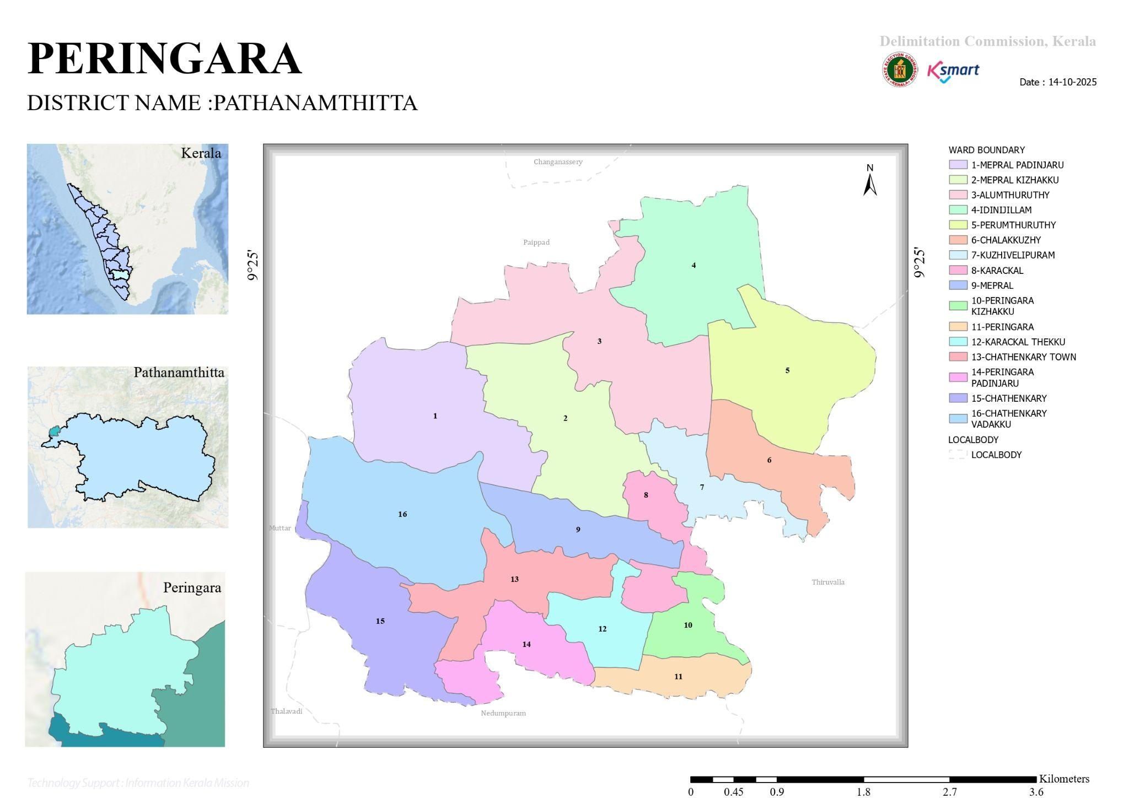

INTEGRATED HEALTH INFRASTRUCTURE AND AUXILIARY ESTABLISHMENT MAP OF PERINGARA PANCHAYAT

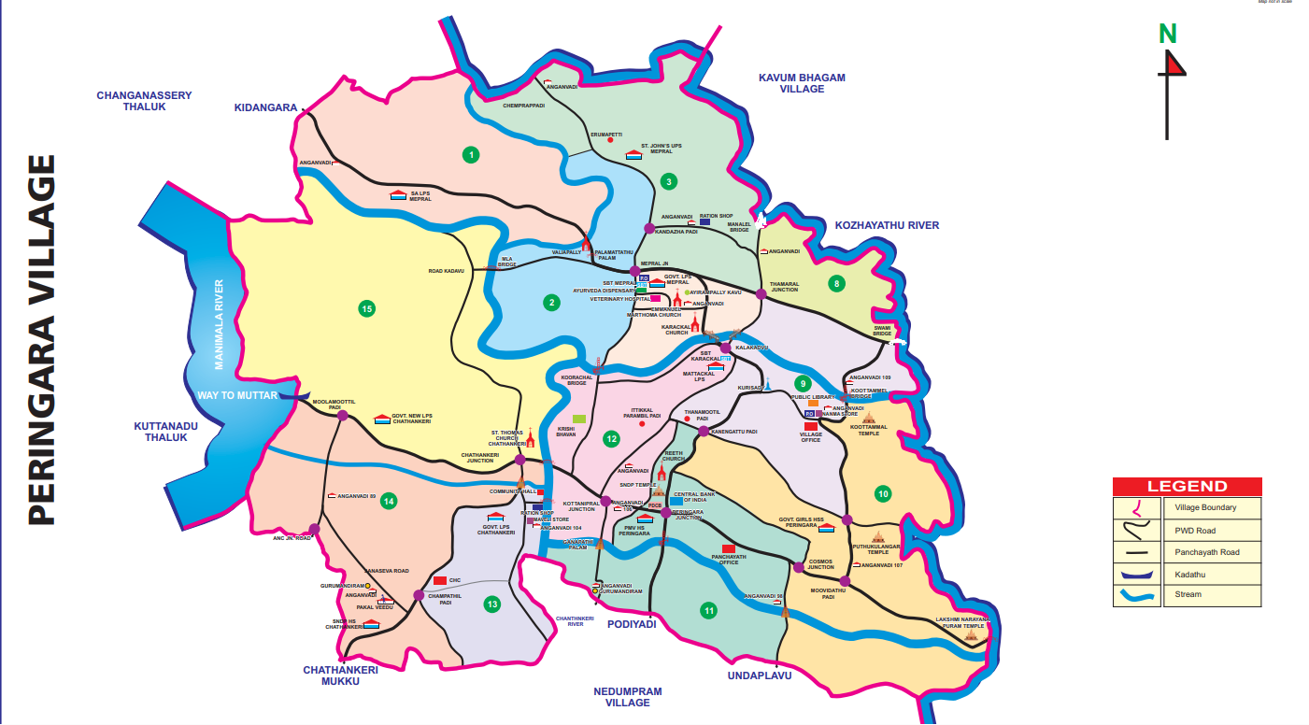

ROAD AND RIVER MAP

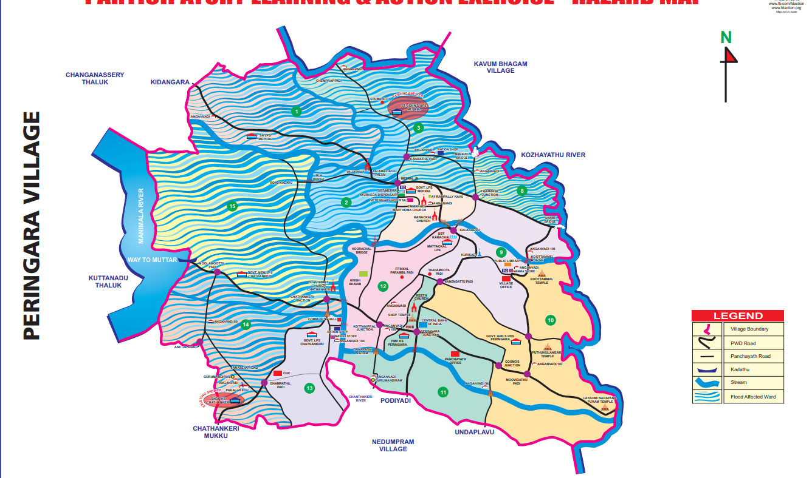

DISASTER PRONE MAP

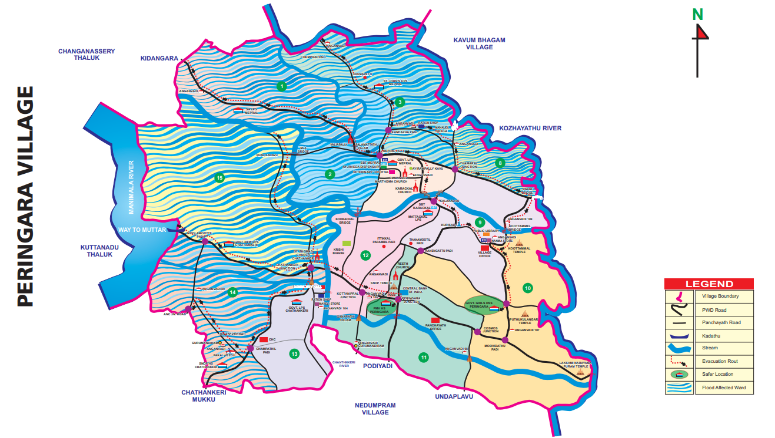

GENERAL PROFILE OF THE LSGI’S

Background of the LSGI
Peringara Grama Panchayat is situated in the Pulikkeezhu block of Pathanamthitta district, Kerala. The geographical landscape of the Panchayat is predominantly low-lying, characterized by extensive paddy fields (Kole lands) and a dense network of rivers, canals, and backwaters. This unique terrain plays a significant role in shaping the local microclimate and poses distinct challenges to transportation, emergency response, and service delivery, particularly during monsoon seasons and flood events.
The Panchayat is administratively divided into multiple wards, with a population largely dependent on traditional livelihoods. Agriculture—especially paddy cultivation—fishing, coir and coconut husk processing, and allied activities form the backbone of the local economy. In recent years, tourism-related activities and service-sector employment have also shown gradual growth. The area hosts a diverse workforce, including a notable presence of migrant labourers, particularly in construction, agriculture, and allied sectors.
From a public health and disaster management perspective, Peringara LSGI has historically been vulnerable to seasonal flooding, waterborne diseases, and vector-borne illnesses such as Dengue and Leptospirosis. The severe floods experienced during recent years, including the 2018 flood disaster, significantly impacted life, livelihoods, and infrastructure within the Panchayat. These recurring emergencies have underscored the importance of strengthening local preparedness, response mechanisms, and inter-departmental coordination.
In this context, the development of a localized, data-driven Auxiliary Infrastructure and Logistical Resource Map is essential to support effective planning, timely emergency response, and sustainable development initiatives. Such mapping enables the Panchayat to identify critical resources, improve accessibility during disasters, and enhance overall resilience of the community.

Table 1: Background of LSGD
Description | Details
Name of LSGI | PERINGARA
Type (GP/Municipality / Corporation etc.) | Grama Panchayath
Block | PULIKKEEZHU
District | PATHANAMTHITTA
Number of wards | 15
Total area (sq. km) | 12.49
Population(Projected) | 25795
Population density | 1400 persons/sq km
Terrain (coastal/low-lying/backwaters/foothills, etc.) | LOW LYING WATER LOGGED
Number of rivers passing through LSGI | 2
Number of water bodies in the LSGI | 20
Number of educational institutions | 13
Factories / small-scale industries | 15
Flood-prone wards | 1,2,3,4,5,8,13,14,15
Landslide-prone wards | NIL
Death Management and Disposal Facilities (mortuaries/crematorium, including electric) | 2
Auditoriums/Marriage halls/convention centres/community halls | 6

Demographic and Vulnerable Population
Understanding the demographic composition and vulnerable population groups is essential for pandemic preparedness. Children, elderly, economically deprived families, migrant workers, and socially vulnerable groups are at increased risk during public health emergencies due to higher exposure, limited access to services, and dependency on public systems..

Description |  | Details (in numbers)
DEMOGRAPHIC PROFILE
Total population |  | 25795
Male |  | 12757
Female |  | 13038
Transgender |  | 0
Children under 5 |  | 424
Adolescent |  | 540
Elderly (>60) |  | 9184
SOCIAL/LIVELIHOOD VULNERABILITY
Previous EPEP family |  | 41
BPL family |  | 1823
Tribal communities |  | 5
Migration | Immigrant | 622
Migration | Emigrant | 957
Socio-economically deprived |  | 1008
Fisherfolk |  | 0
SC Community |  | 3584
ST Community |  | 5

Here is the graphical age pyramid for Peringara Panchayat.
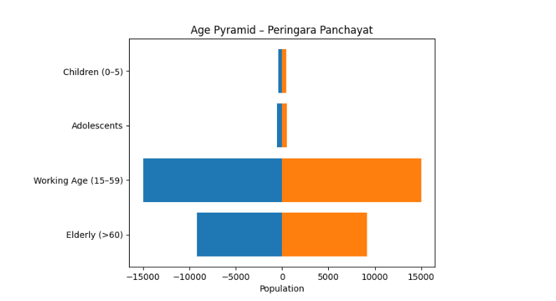

It clearly demonstrates the constrictive (aging) population structure:
- Narrow base → Low proportion of children
- Moderate middle → Working-age majority
- Broad upper section → Large elderly population

Clinical Vulnerability
Certain population groups needs priority healthcare & are at higher risk of severe illness, complications, and mortality during pandemics. Patients with chronic diseases, those requiring regular medical care, and individuals with mobility or functional limitations face challenges in accessing timely care during emergencies. Mapping these groups helps in prioritizing continuity of treatment, medicine stock planning, oxygen support, referral transport, and targeted home-based care.
Description | Details in numbers
Pregnant women | 84
Lactating mothers | 82
Bedbound patients | 156
Patients under palliative care other than bedbound | 54
Patients on Haemodialysis | 19
Patients on CAPD | 1
Cancer patients (currently on treatment) | 111
Haemophilic patients | 0
Mentally challenged | 36
Differently abled | 23
Diabetic patients | 5871
Hypertensive patients | 7354
TB patients | 4

Major Festivals & Events specific to the LSGI
(with the possibility of a public gathering)

Sl. No. | Name of festival | Month detailing the periodicity
1 | ARDHANAREESHWARA TEMPLE | FEBRUARY
2 | MANNAKARA TEMPLE | FEBRUARY
3 | SUBRAHMANYA SWAMI TEMPLE | JANUARY
4 | ALUMTHURUTHY TEMPLE | MARCH
5 | IMMANUEL CHURCH MEPRAL | JANUARY

INFRASTRUCTURE & RESOURCE INVENTORY

Health Facility Directory & Basic Capacity in the LSGD
This section provides an overview of the healthcare infrastructure available within the LSGD area. It outlines the distribution and basic capacity of health facilities that form the backbone of service delivery during routine times and public health emergencies.

Family Health Centres (FHCs) and Community Health Centres (CHCs) generally function as the first point of contact for the community, providing essential outpatient and inpatient services. General Hospitals (GH) and Medical College Hospitals (MCH), where accessible, serve as the main referral centres for advanced diagnostics, specialist care, and critical services during public health emergencies. This inventory helps identify existing strengths, gaps, and potential surge capacity that can be mobilised during a pandemic or disaster.

Table 5. Health Facility Resource Summary
Sl.no. | Health Facility | Type of Facility (MCH/GH/CHC/FHC/SC etc.) | Contact Number | Total beds | ICU Beds | Oxygen-Supported Beds | No. of Ventilator Support Beds | No. of ambulances
Government Healthcare Facilities
1 | CHC CHATHENKARY | CHC | 9947060745 | 24 | 0 | 0 | 0 | 0
2 | SC PERINGARA | SC | 7356809221 | 0 | 0 | 0 | 0 | 0
3 | SC MEPRAL | SC | 7356809221 | 0 | 0 | 0 | 0 | 0
4 | SC KAVUMBHAGAM | SC | 8921858739 | 0 | 0 | 0 | 0 | 0
Private Healthcare Facilities
1 | VLS CLINIC PERINGARA | PVT CLINIC | 7012014801  7012014802 | 0 | 0 | 0 | 0 | 0
2 | MED LOUNGES  WELLNESS CLINIC | PVT CLINIC | 8714745999 | 0 | 0 | 0 | 0 | 0
AYUSH Healthcare Facilities
1 | GOVT AYURVEDA DISPENSARY | GOVT | Dr. Jis Mary  9446273969 | 0 | 0 | 0 | 0 | 0
2 | GOVT AYURVEDA DISPENSARY | GOVT | Dr Nithya  9496211014 | 0 | 0 | 0 | 0 | 0
3 | GOVT HOMEO DISPENSARY | GOVT | Dr.  9495214153 | 0 | 0 | 0 | 0 | 0

Govt Ayurveda Dispensary

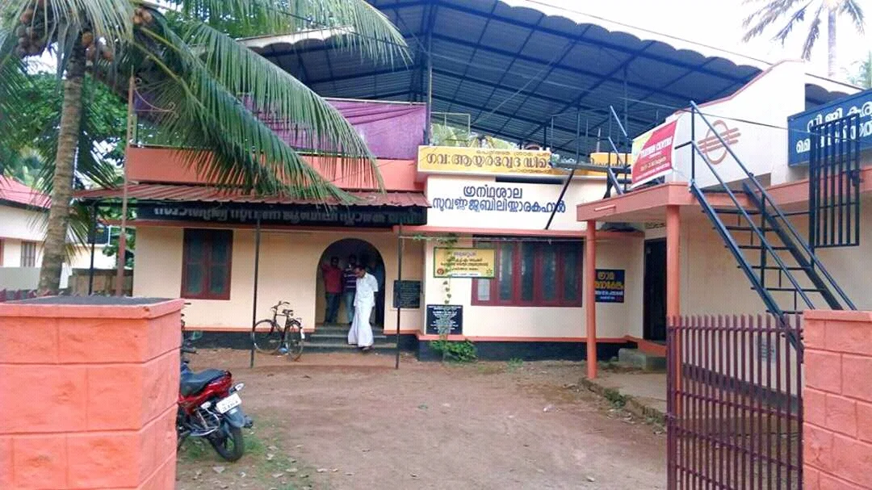

Govt Veterinary Dispensary ,Mepral

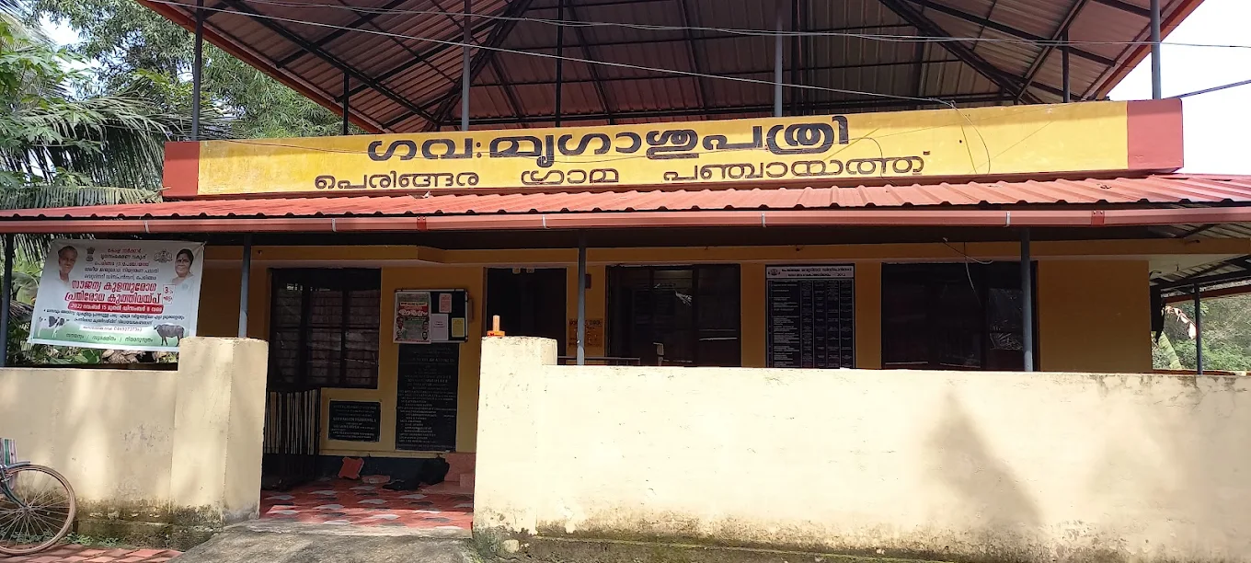

Private Clinics
Private clinics are an essential part of pandemic preparedness, as they are often the first place people seek care when symptoms begin. In many communities, private clinics manage a significant share of outpatient visits and therefore play a critical role in early case detection, timely referrals, and disease surveillance. Having an up-to-date understanding of where these clinics are located, the services they provide, and how they are linked to the public health system helps ensure that no cases are missed during an outbreak. It also allows health authorities to engage private practitioners more effectively for reporting, risk communication, and coordinated response, strengthening the overall capacity of the health system to manage public health emergencies.

Table 6. Private Clinic Resource Summary
Sl No. | Name of Clinic | Registered (Y/N) | Clinic (General / Speciality) | Speciality (if any) | Address | Contact Number | Diagnostic Facility (Y/N) | Ambulance Linkage (Y/N)
1 | VLS CLINIC PERINGARA | N | General | nil | Peringara | 7012014801  7012014802 | N | N
2 | MED LOUNGES  WELLNESS CLINIC | N | Speciality | Obesity clinic | Ezhinjillam | 8714745999 | Y | N

Healthcare Education & Training Institutions
This section tracks the educational infrastructure available, which is vital for human resource planning in the health sector.

Category of Institution | Govt | Private | AYUSH | Total
Medical Colleges | 0 | 0 | 0 | 0
Nursing Colleges | 0 | 0 | 0 | 0
Dental Colleges | 0 | 1 | 0 | 1
Para-medical / Allied Health | 0 | 0 | 0 | 0
Pharmacy Colleges | 0 | 0 | 0 | 0

Specialized Services & Emergency Inventory
This section provides a detailed view of the specialized medical resources available to the community, focusing on emergency response and critical care capabilities. This table tracks the vital assets required for managing severe illnesses and emergencies across Government, Private, and AYUSH sectors.

Item | Govt | Private | AYUSH | Total
Hospital beds | 24 | 0 | 0 | 0
Oxygen-generating systems(Y/N) | 0 | 0 | 0 | 0
Oxygen-supported beds(Numbers) | 0 | 0 | 0 | 0
Ventilator-supported beds | 0 | 0 | 0 | 0
ICU beds | 0 | 0 | 0 | 0
Burns units | 1 | 0 | 0 | 1
Blood centres | 0 | 0 | 0 | 0
BLS ambulances | 0 | 0 | 0 | 0
ALS ambulances | 0 | 0 | 0 | 0
Dialysis facilities | 0 | 0 | 0 | 0
Dispensaries | 0 | 0 | 0 | 0
Medical store | 1 | 0 | 0 | 0
Industrial establishments(Medium-scale industries/small-scale industries establishments to whom we can depend in a worst-case scenario) | 0 | 0 | 0 | 0

Oxygen & Diagnostic Capacity
Monitoring oxygen and diagnostic capacity is a critical component of public health preparedness, ensuring that the LSGD can handle both chronic care and sudden surges in respiratory or infectious diseases.
Name of Health Facility | Oxygen-generating System (Y/N) | Backup Oxygen Source (Y/N) | Diagnostic Facilities Available(Y/N)
Name of Health Facility | Oxygen-generating System (Y/N) | Backup Oxygen Source (Y/N) | Lab | USG | X-ray | CT/MRI | RT-PCR
Government Healthcare Facilities
CHC CHATHENKARY | Y | Y | Y | N | N | N | N

Diagnostics facility mapping at the LSGI level
The diagnostic capacity of Peringara G.P represents the "intelligence network" of our healthcare system. The speed and accuracy of disease identification depend entirely on the distribution and technical level of these facilities.

Item | Govt | Private | AYUSH | Total
General labs | 1 | 1 | 0 | 2
Microbiology labs | 1 | 1 | 0 | 2
RT-PCR labs | 0 | 0 | 0 | 0
USG units | 0 | 0 | 0 | 0
CT/MRI units | 0 | 0 | 0 | 0
Research labs | 0 | 0 | 0 | 0
Labs of other departments that can be repurposed | 0 | 0 | 0 | 0

Laboratory Identification & Basic Details
Sl. No. | Name of Laboratory | Ownership (Govt / Private / Academic) | Address | Contact No. | 24×7 Services (Yes/No) | NABL / Govt Approved (Yes/No)
1 | CHC CHATHENKARY | GOVT | CHATHENKARY | 9947060745 | NO | YES
2 | AMRITHASREE | PVT | IDINJILLOM | 9447504810 | NO | NO

Social and Community Infrastructure for surge plan
This table serves as our logistics and shelter inventory. By mapping these locations, quickly we can identify where to house displaced citizens, where to set up temporary medical clinics, and how to manage the deceased with dignity during a crisis.

Category | Total Count | Ward | Est. Capacity (Persons) | Contact details
Educational Institutions
Anganwadis | 24 | 15 | 300 | 9846473151
Schools | 13 | 15 | 2500 | 8921779731
Colleges | 1 | 6 | 500 | 04692645210
Healthcare Educational Institutions
Medical colleges (Govt/Private) | 0 | 0 | 0 | 0
Nursing colleges (Govt/Private) | 0 | 0 | 0 | 0
Dental colleges (Govt/Private) | 1 | 6 | 500 | 04692645210
Paramedical institutes (Govt/Private) | 0 | 0 | 0 | 0
Community Gathering Spaces
Community halls | 1 | 13 | 100 | 9539263924
Auditoriums | 5 | 6 | 4000 | 8078882200
Religious buildings | 4 | 1 | 300 | 7356809221
Vulnerable Group Support Facility
Destitute homes | 0 | 0 | 0 | 0
Elderly homes | 0 | 0 | 0 | 0
LSGD owned other buildings | 0 | 0 | 0 | 0
Mass Fatality Management (MFM) Infrastructure
Mortuary | 0 | 0 | 0 | 0
Crematorium | 0 | 0 | 0 | 0
*refer annexure 1 for contact details

Human resources
This section focuses on the human capital available within the LSGI. In any emergency—be it a pandemic, flood, or industrial accident—infrastructure is only as effective as the people operating it.

Medical & Clinical Personnel
This table tracks the "Frontline" providers responsible for diagnosis, treatment, and clinical management. Narrative sentence: eg., "Total health workforce: 450 personnel, with 60% in government facilities serving as primary surge capacity." A detailed directory with the contact numbers of all workers is maintained (Annexure in 1).

Cadre | Govt (No.) | Private (No.) | Total
Doctors—Modern Medicine | 4 | 2 | 6
Doctors – AYUSH | 2 | 0 | 2
Doctors – Veterinary | 1 | 0 | 1
Doctors – Dental | 5 | 0 | 5
Nursing officers | 5 | 2 | 7
Lab technicians | 2 | 4 | 6
Optometrist | 1 | 0 | 1
Pharmacists | 2 | 2 | 4
Psychologists | 0 | 0 | 0
Counsellors | 1 | 0 | 1

Public Health & Field-Level Workforce
These individuals are the backbone of surveillance, maternal-child health, and decentralized care.

Cadre | Health services | Municipal common services | Total
HS (Health Supervisors) | 1 | 0 | 1
HI (Health Inspectors) | 1 | 0 | 1
LHS (Lady Health Supervisor) | 1 | 0 | 1
LHI (Lady Health Inspectors) | 1 | 0 | 1
JPHN (Jr Public Health Nurses) | 4 | 0 | 4
JHI (Jr Health Inspectors) | 3 | 0 | 3
MLSP (Mid-Level Service Providers) | 3 | 0 | 3
Palliative Nurses | 2 | 0 | 2
RBSK Nurses | 1 | 0 | 1
PRO | 1 | 0 | 1
Epidemiologist | 1 | 0 | 1
Data Manager | 1 | 0 | 1

Community & Support Cadre
This group represents the surge capacity of the LSGI—people who can be called upon for logistics, rescue, and specialized support.

Cadre | Number
ASHA Workers | 20
AWW (Anganwadi Workers) | 24
Emergency Medical Volunteers (Trained) | 20
Kudumbashree | 450
MNREGS | 645
Purusha Swayam Sahaya Sangham | 4
Ex-Servicemen | 4
Retired Police Officers | 2
NCC/NSS Volunteers | 25
Red Cross volunteers | 20
One Health Community Volunteers | 650
One Health Community Mentors | 105

Community Organizations
This section details the presence of community-based organisations (CBOs), non-governmental organisations (NGOs), faith-based organisations (FBOs), Kudumbashree Self-Help Groups (SHGs), and Ayalkootams within the Local Self-Government Institution (LSGI). These groups enhance grassroots mobilization, resource distribution, and support networks crucial for pandemic response and community resilience.

Category | Total Count
NGOs | 10
Religious based organizations | 3
Foreign based organizations | 0
Sports Club/youth clubs | 4
Kudumbashree SHGs | 4
Ayalkootams | 70
Political organizations | 6
Residential organizations | 15

Administrative & Emergency Services
This section outlines the availability of key non-health emergency support services and infrastructure within the LSGI, which are essential for effective pandemic preparedness and response. These facilities support law enforcement, disaster response, water supply, logistics, mobility, and community-level interventions during public health emergencies.

Category | Total Count | Contact details
Police Stations | 0 | 0
Fire & Rescue Stations | 0 | 0
Water Pumping Points | 0 | 0
Public Distribution System (PDS) | 3 | SASI- 9744754482  Alumthuruthy

Information regarding resources
The availability of essential transport and support resources plays a quiet but critical role in saving lives. Equipment such as ambulances, mobile mortuaries, amphibian ambulances, and motorized boats ensures that patients, samples, and healthcare teams can move swiftly—even in flooded, remote, or difficult terrains. Heavy vehicles like JCBs, cranes, tractors, and torus lorries support logistics, waste management, emergency infrastructure, and rapid conversion of spaces into care or isolation facilities. Taxis, four-wheel-drive vehicles, and trucks help maintain continuity of essential services, reach vulnerable populations, and support home-based care and supply delivery.

Means of transportation | Total Count
JCB | 0
Crane | 0
Heavy Trucks | 0
Tractor | 0
Ambulances | 0
Mobile mortuaries | 0
Boats | 7
Taxi service | 70
Note: For specific details regarding vehicle owners and contact information, please refer to Annexure [X].

ONE HEALTH & ENVIRONMENTAL SURVEILLANCE
The One Health method integrates environmental, animal, and human health to enable proactive pandemic preparedness. Panchayat-level surveillance needs to be improved in order to detect and treat zoonotic and environmentally generated diseases early. Surveillance is strengthened through systematic assessment of animal populations, veterinary infrastructure, poultry and slaughter facilities, inter-sectoral coordination, and specialised tools like avian influenza seasonality mapping using GIS in previous outbreaks to enable predictive alerts and ward-specific sampling to support effective pandemic preparedness in high-risk areas like all wards

Animal & Bird Population
Mapping animal and bird populations at the Panchayat level is essential for identifying and prioritising zoonotic disease hazards like rabies, avian influenza (H5N1), leptospirosis, anthrax, and Nipah-like spillover occurrences. Risk classification, targeted surveillance, vaccination planning, and early epidemic detection made feasible by comprehensive population mapping all enhance One Health-based pandemic preparedness.

Category | Item | Estimated Population | Wards
Animal Population | Livestock (Cattle/Goats/Buffalo) | 1532 | 1-15
Animal Population | Pet Animals (Dogs/Cats) | 245 | 1-15
Animal Population | Stray Dog Population | 102 | 1-15
Animal Population | Pig Farms (Number of heads) | 0 | 0
 | Small Units (Sheep / Goats – clustered) | 0 | 0
Bird Population | Poultry Units (Birds) | 245 | 1-15
Bird Population | Poultry- (FOWL) | 0 | 0
Bird Population | Wild/Migratory Birds (Observed) | 0 | 0
Bird Population | Crow Mortality Events (Reported) | 0 | 0

The main risk of zoonotic diseases in peringara is rabies concentrated in All Wards. The stray dog population in market areas, fish landing sites, bus stations continues to be a substantial problem for rabies surveillance and bite prevention. There is a considerable risk of avian influenza introduction and amplification during November - December due to the seasonal presence of migratory and resident water birds near ponds/ canal / river / backwater / paddy field. Cluster of animal shelters vulnerable to flooding further raise the risk of leptospirosis and other zoonoses mediated by the environment, especially during monsoon floods.

Veterinary Infrastructure
Veterinary institutions are a core pillar of One Health surveillance, enabling early zoonotic disease detection through vaccination, investigation of unusual animal illness or deaths, sample collection, and timely outbreak reporting. A well-mapped and responsive veterinary network strengthens coordination with human health and LSGI systems, ensuring rapid response during zoonotic events and pandemics.
Facility Type | Name of Facility | Ownership Govt / Pvt | Location  (Ward No) | Contact number
Veterinary Dispensary | GOVT VETERINARY CLINIC | GOVT | 2 | 9496421224
Veterinary Hospital / Polyclinic | 0 | 0 | 0 | 0
Private Veterinary Clinics | 0 | 0 | 0 | 0
Mobile / Emergency Vet Service (incl. night services) | 0 | 0 | 0 | 0
Pet Homes / Animal Shelters | 0 | 0 | 0 | 0
Slaughterhouse-linked Veterinary Inspection Unit | 0 | 0 | 0 | 0

Veterinary Doctors & Workforce
Early detection, diagnosis, reporting, and reaction to animal illness epidemics depend on the availability and accessibility of qualified veterinary specialists. By identifying unusual animal morbidity or mortality promptly, collecting samples promptly, and coordinating efficiently with human health and LSGI systems—especially during zoonotic outbreaks and pandemic-prone situations—a clearly defined veterinary workforce enhances One Health surveillance.

Category | Number Available | Type (Govt/Pvt) | Contact number
Government Veterinary Doctors | 1 | Govt | 9496421224
Private Veterinary Doctors | 0 | 0 | 0
Livestock Inspectors | 3 | govt | Archana-9400049425  pramod -9605617661  Sreelatha -9605533131
Para-veterinary Staff / Attenders | 1 | Govt | Radhika -9847919489
Contract / On-call Veterinary Support (if any) | 0 | 0 | 0

High-Risk Interface Points (Surveillance Sites)
High-risk interface points for zoonotic disease surveillance in Peringara Grama Panchayath include wetland–livestock–human contact zones, backyard poultry farms, cattle sheds near water bodies, fish markets, and areas of high human–animal interaction such as community slaughter points and migratory bird congregation sites. These are the primary surveillance sites where zoonotic spillover risks are elevated.

Type of Habitat | Type of High risk interface | Geographical vulnerability
Wetlands & Backwaters | Wetlands | High
Backyard Poultry Farms | 0 | 0
Cattle Sheds near Water Bodies | 0 | 0
Fish & Meat Markets | 0 | 0
Community Slaughter Sites | 0 | 0
Migratory Bird Congregation Areas | 0 | 0
Rodent-Infested Grain Storage | 0 | 0

Category | Total Count | Key Locations (wards)
Poultry Farms | 0 | 0
Backyard / Clustered Poultry Units | 0 | 0
Duck Rearing Units (open water access) | 1 | 15
Slaughterhouses/ Slaughter Points | 0 | 0
Meat/Fish Markets | 0 | 0
Live Bird Sale Points | 0 | 0
Cattle Markets / Weekly Animal Fairs | 0 | 0
Pet Shops / Breeders | 0 | 0
Animal Shelters / Pet Homes | 0 | 0
Waste Disposal Sites near Animal Units | 0 | 0

Environmental Risk Mapping
Environmental risk mapping identifies monsoon/flood hotspots for vector-borne (dengue, chikungunya), water-borne (leptospirosis, diarrhoea), and zoonotic diseases in Kerala's wetlands. Systematic surveillance supports early warnings, targeted interventions, and Panchayat pandemic preparedness.
Waterborne exposure: Flood-prone areas and stagnant water bodies facilitate leptospira survival, raising leptospirosis risk.

Traditional practices: Informal slaughter and fish markets lack standardized hygiene, creating spillover opportunities.

Risk Factor | High-Risk Wards | Key Locations | Risk Level (High/Med/Low)
Flood-prone areas | 1,2,3,4,8,13,14,15 | Peringara | HIGH
Water bodies/wetlands | 5 | Peringara | HIGH
Solid waste accumulation | 0 | NA | NA
Animal waste disposal issues | 0 | NA | NA
Rodent infestation zones | 0 | NA | NA
Industrial effluent discharge | 0 | NA | NA
Construction sites / abandoned buildings | 0 | NA | NA
Poor drainage/blocked canals | 0 | NA | NA
Drinking water source contamination risk | 1 | EDINJILLOM | Medium

Disease Seasonality Mapping
1, Flooding & waterlogging → amplifies leptospirosis, malaria, diarrheal diseases.
·
2, Migratory bird influx (Nov–Feb) → avian influenza risk.

3, Mosquito breeding cycles → vector-borne disease peaks in monsoon.

4, Agricultural practices → close human–animal contact in paddy fields.
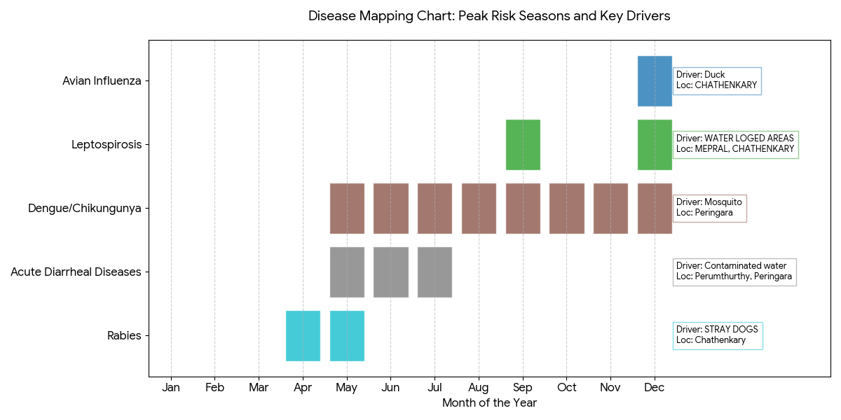
Disease | Peak Risk Season | Key Drivers | High-Risk Locations | Surveillance Focus
Avian Influenza | DECEMBER | Duck | CHATHENKARY | All wards
Leptospirosis | SEPTEMBER, DECEMBER | WATER LOGED AREAS | MEPRAL, CHATHENKARY, | All wards
Dengue/Chikungunya | MAY TO DECEMBER | Mosquito | Peringara | All wards
Acute Diarrheal Diseases | MAY, TO JULY | Contaminated water | Perumthurthy ,peringara | All wards
Rabies | APRIL -MAY | STRAY DOGS | Chathenkary | All wards
Anthrax (rare) | NA | NA | NA | NA

Vulnerability Mapping
Vulnerability mapping pinpoints high-risk populations, occupations, and areas exposed via environment, livelihoods, socio-economics, and poor service access. Paired with environmental/seasonality mapping, it enables risk-based surveillance, targeted actions, and optimal resource use in One Health and pandemic planning.
Vulnerability Factor | High-Risk Wards | Key Groups / Locations | Risk Level
Flood-prone households | 3,9,13,15 | MEPRAL, CHATHENKARY, PERINGARA | HIGH
Wetland-adjacent communities | 3,4,15,13 | MEPRAL, ALUMTHURUTHY,CHATHENKARY, KADAVU | HIGH
Backyard poultry / duck rearing households | 3,4,1 | MEPRAL,ALUMTHURUTHY | HIGH
Livestock-rearing households | ALL15 WARDS | CHATHENKAY | HIGH
Slaughterhouse & meat market workers | NA | NA | NA
Fisherfolk & fish market workers | 2,6 | MEPRAL, PERUMTHURUTHY | HIGH
Sanitation workers | NA | NA | NA
Daily wage / migrant workers | 11,12,7,8 | PERINGARA,  KAVUMBHAGOM | HIGH
Elderly & chronically ill populations | ALL 15 WARDS | CHATHENKARY | HIGH
Pregnant Women | 14 | CHATHENKARY | HIGH
Children (schools, Anganwadi’s) | ALL15 WARDS |  | LOW
Limited access to safe water & sanitation | 1,3 |  | MED

Ward-wise Public Health Risk Profile

This grouped bar chart compares the number of Vulnerability Factors (e.g., flood-prone, elderly population, etc.) against the number of Disease Risks identified for each specific ward.

Wards 3, 13, and 15 emerge as the most critical "Hotspots," as they combine high environmental vulnerability with multiple recurring disease threats.

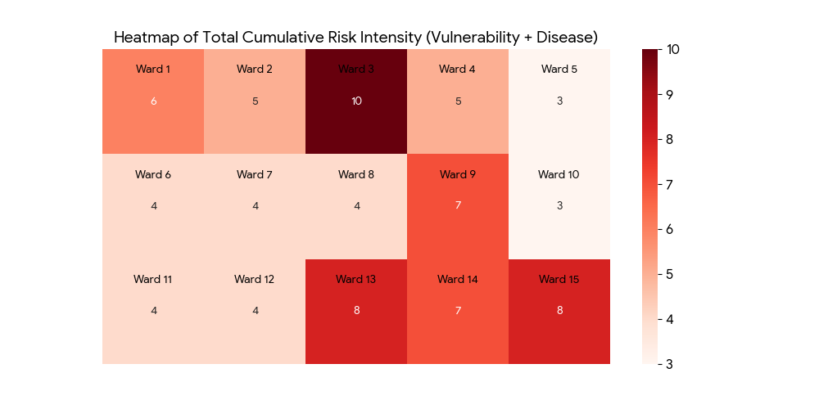
Ward 14 shows a unique spike in maternal-specific risk (Pregnant Women) alongside Chathenkary's general disease risks.

Risk Level | Wards | Primary Action
Extreme Hotspots | 3, 13, 15 | Multi-sectoral intervention (WASH + Vet + Clinical)
High Density | 1, 4, 9, 14 | Targeted surveillance for Avian Flu & Maternal health
Specific Focus | 2, 6, 7, 8, 11, 12 | Occupational safety (Fisherfolk & Migrant workers)
General Monitoring | 5, 10 | Routine surveillance for universal groups (Elderly/Children)

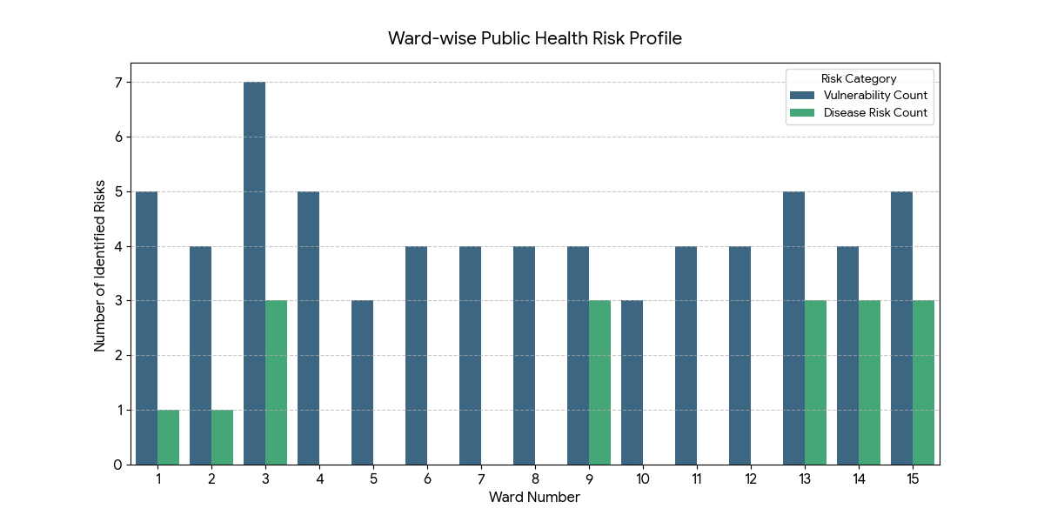

EPIDEMIOLOGICAL TRENDS (2021–2025)

Disease surveillance is the systematic collection, analysis, and interpretation of health data for planning, implementation, and evaluation of public health practice. This section presents the disease surveillance profile of the LSGI based on routine reporting systems and outbreak investigations to identify priority diseases, seasonal patterns, and emerging public health threats.

Disease Burden among human beings(Last 5 Years)
Analysis of disease-wise data for the last five years helps identify persistent public health problems, emerging diseases, and changes in disease burden. This information supports prioritisation of prevention, preparedness, and response activities at the Panchayat level.

Disease | 2021 | 2022 | 2023 | 2024 | 2025 | Trend(Increasing/Stable/Decreasing)
Dengue | 1 | 6 | 6 | 10 | 5 | DECREASING
Leptospirosis | 1 | 4 | 1 | 3 | 5 | INCREASING
Hepatitis A | 0 | 0 | 0 | 4 | 5 | INCREASING
Malaria | 0 | 0 | 1 | 1 | 0 | DECREASING
Scrub Typhus | 0 | 1 | 0 | 1 | 0 | DECREASING
Typhoid | 0 | 1 | 0 | 1 | 0` | DECREASING
H1N1 | 0 | 0 | 0 | 0 | 1 | STABLE
H3N2 | 0 | 0 | 0 | 0 | 0 | STABLE
ADD | 40 | 72 | 62 | 99 | 47 | DECREASING
Mumps | 0 | 0 | 0 | 0 | 0 | STABLE
Measles | 0 | 0 | 0 | 0 | 1 | STABLE
Hepatitis B | 3 | 0 | 0 | 1 | 1 | DECREASING
Hepatitis C | 0 | 1 | 0 | 0 | 0 | DECREASING
Tuberculosis | 7 | 10 | 9 | 8 | 7 | DECREASING
Leprosy | 0 | 0 | 0 | 0 | 0 | STABLE
COVID-19 | 0 | 0 | 0 | 0 | 0 | STABLE

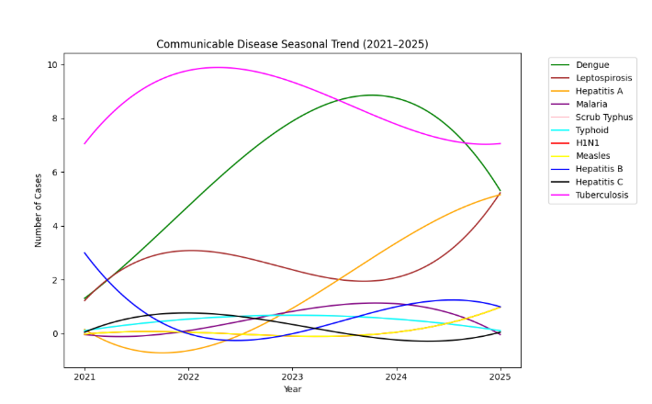

Seasonal Trend Analysis
Seasonal analysis helps anticipate surges (e.g. dengue in monsoon, leptospirosis after floods, influenza in cooler months) and plan pre‑emptive vector control, stockpiling of IV fluids, and awareness campaigns at Panchayat level.

DENGUE
Dengue is a major seasonal vector-borne disease strongly associated with rainfall, water stagnation, and increased mosquito breeding during the monsoon period.

Peak: July–November

Dengue – Ward-wise Yearly Distribution (2021–2025)

Ward | Dengue – Ward-wise Yearly Distribution
Ward | 2021 | 2022 | 2023 | 2024 | 2025 | Total
1 | 0 | 1 | 0 | 0 | 0 | 1
2 | 0 | 0 | 0 | 0 | 0 | 0
3 | 0 | 0 | 1 | 0 | 0 | 1
4 | 0 | 0 | 1 | 2 | 0 | 3
5 | 0 | 0 | 0 | 0 | 0 | 0
6 | 0 | 0 | 0 | 0 | 0 | 0
7 | 0 | 1 | 1 | 1 | 0 | 3
8 | 0 | 0 | 0 | 0 | 0 | 0
9 | 0 | 0 | 0 | 0 | 0 | 0
10 | 0 | 0 | 0 | 0 | 2 | 2
11 | 0 | 0 | 0 | 3 | 0 | 3
12 | 0 | 2 | 1 | 2 | 1 | 6
13 | 0 | 0 | 0 | 0 | 0 | 0
14 | 0 | 1 | 1 | 1 | 2 | 5
15 | 1 | 1 | 0 | 1 | 0 | 0

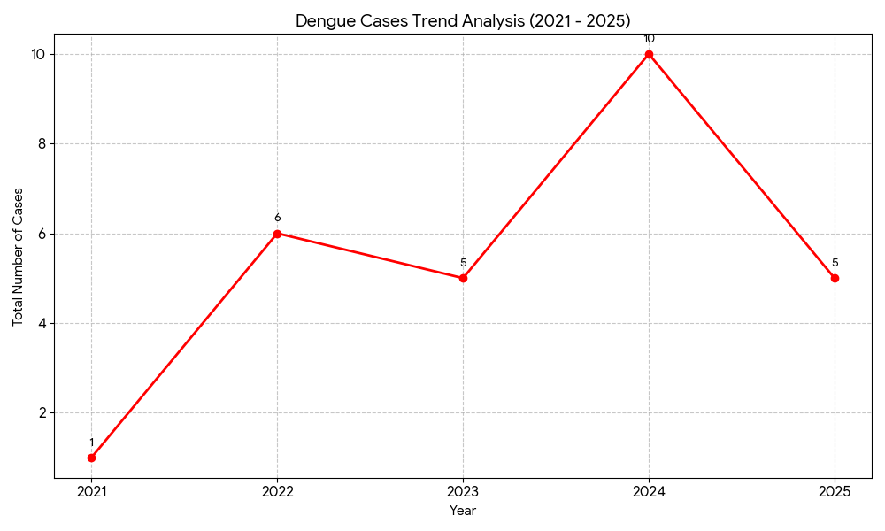

LEPTOSPIROSIS
Leptospirosis cases are closely linked to monsoon rains, flooding, and occupational exposure, particularly in low-lying and waterlogged areas.

Peak: June - August

Leptospirosis – Ward-wise Yearly Distribution (2021–2025)

Ward | Leptospirosis – Ward-wise Yearly Distribution
Ward | 2021 | 2022 | 2023 | 2024 | 2025 | Total
1 | 0 | 1 | 0 | 0 | 1 | 2
2 | 0 | 0 | 0 | 0 | 0 | 0
3 | 1 | 1 | 0 | 1 | 0 | 3
4 | 0 | 1 | 0 | 0 | 1 | 2
5 | 0 | 0 | 0 | 0 | 0 | 0
6 | 0 | 0 | 0 | 0 | 0 | 0
7 | 0 | 0 | 0 | 0 | 0 | 0
8 | 0 | 0 | 0 | 0 | 1 | 1
9 | 0 | 0 | 1 | 1 | 1 | 3.
10 | 0 | 0 | 0 | 0 | 1 | 1
11 | 0 | 0 | 0 | 0 | 0 | 0
12 | 0 | 0 | 0 | 0 | 0 | 0
13 | 0 | 14-1 | 0 | 15-1 | 0 | 2

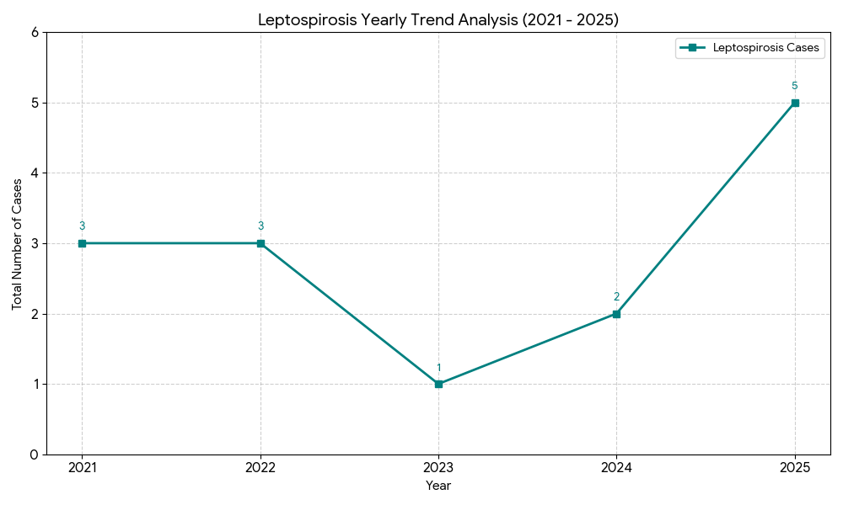

VIRAL HEPATITIS - A
Hepatitis A cases are commonly associated with unsafe drinking water, food contamination, and breakdowns in sanitation, often presenting as clusters or outbreaks.

Peak: October - December

Hepatitis A – Ward-wise Yearly Distribution (2021–2025)

Ward | Hep A – Ward-wise Yearly Distribution
Ward | 2021 | 2022 | 2023 | 2024 | 2025 | Total
1 | 0 | 0 | 0 | 0 | 0 | 0
2 | 0 | 0 | 0 | 0 | 0 | 0
3 | 0 | 0 | 0 | 2 | 0 | 2
4 | 0 | 0 | 0 | 0 | 0 | 0
5 | 0 | 0 | 0 | 0 | 0 | 0
6 | 0 | 0 | 0 | 0 | 0 | 0
7 | 0 | 0 | 0 | 0 | 0 | 0
8 | 0 | 0 | 0 | 0 | 0 | 0
9 | 0 | 0 | 0 | 0 | 1 | 1
10 | 0 | 0 | 0 | 0 | 2 | 2
11 | 0 | 0 | 0 | 0 | 0 | 0
12 | 0 | 0 | 0 | 0 | 1 | 1
13 | 0 | 0 | 0 | 14-2 | 1 | 3

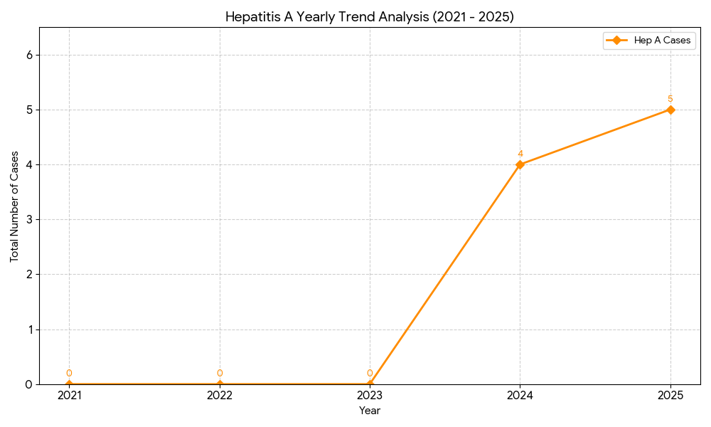

Outcome-Based Trend Analysis- 2025

1. Disease Burden & Trend Trajectory (2021–2025)
The overall health profile shows a transition from general water-borne illness to specific emerging infectious threats.
Category | Status | Primary Observations
Emerging Threats | 🔴 High Alert | Hepatitis A and Leptospirosis show clear upward trajectories, reaching their highest combined levels in 2025.
Volatile Risks | 🟡 Monitor | Dengue and Acute Diarrheal Diseases (ADD) showed significant spikes in 2024 but dropped in 2025. This suggests effective seasonal intervention but persistent vulnerability.
Controlled/Stable | 🟢 Maintenance | Tuberculosis is steadily decreasing (from 10 to 7 cases), and vaccine-preventable diseases like Measles remain sporadic.

2. Geographical Hotspot Mapping (Ward-wise)
The analysis identifies specific wards that carry a disproportionate burden of certain diseases.

📍 The "High-Burden" Wards
- Ward 12: The primary hotspot for Dengue (6 total cases). It consistently reports cases across multiple years, indicating a persistent breeding site or drainage issue.
- Ward 14: Shows the highest overall diversity of risk, appearing prominently in Dengue (5 cases), Hepatitis A, and Leptospirosis data.
- Ward 3 & 9: Key areas for Leptospirosis (3 cases each). These wards likely coincide with the "waterlogged" areas identified in vulnerability data.
- Ward 13 & 14: Emerging clusters for Hepatitis A, particularly in the 2024–2025 period, suggesting a localized breakdown in safe water supply or sanitation.

3. Seasonal Surge Outlook
Based on the "Peak" data provided, the Panchayat faces a year-round rotating threat cycle:
- June – August (Monsoon Peak): Focused on Leptospirosis. High-risk activities include farming and flood-clearing.
- July – November (Vector Peak): Focused on Dengue. This overlaps with the monsoon and extends into the post-monsoon period.
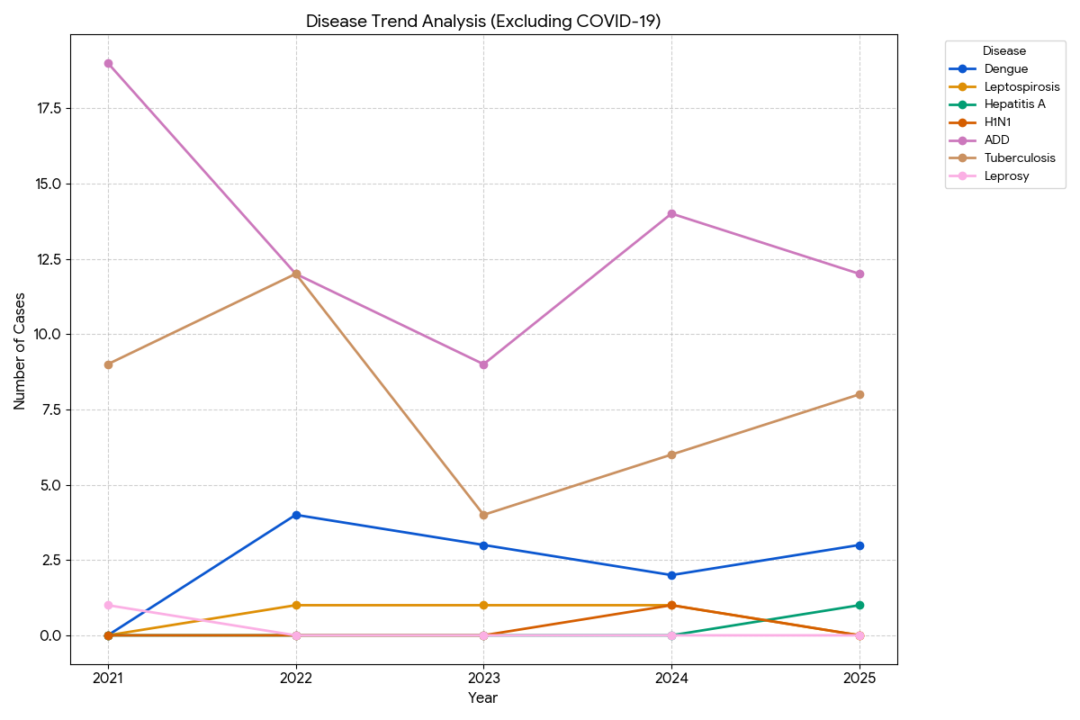
- October – December (Water-borne Peak): Focused on Hepatitis A. This suggests that water contamination might be linked to the receding monsoon or specific seasonal environmental changes.

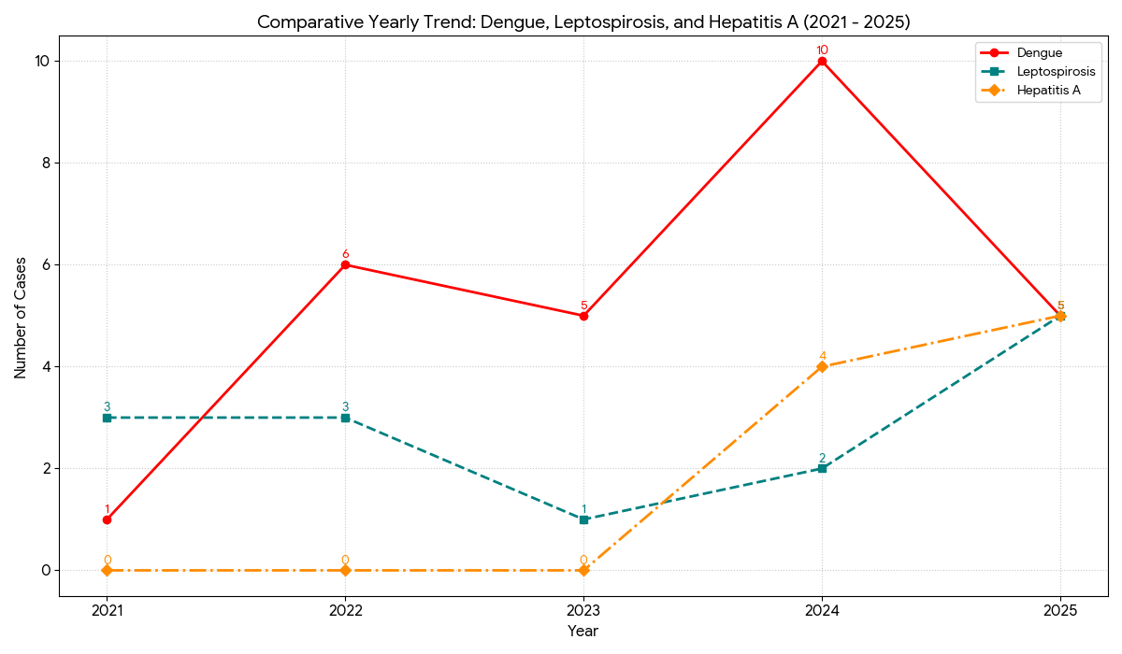

Transmission Trend- 2025
For effective management of public health issues, it is important to track the trend of disease transmission mode. It helps identify the population or place at high risk that can be used to predict outbreaks and implement targeted interventions as quickly as possible. Understanding these kinds of trends enables authorities to allocate resources efficiently and change the strategies adequately based on the trend that follows.

Mode of Transmission | No. of cases | No. of Deaths
Vector Borne Diseases | 30 | 0
Water Borne Diseases | 9 | 1
Air Borne Diseases | 0 | 0
Blood Borne Diseases | 4 | 0
Food Borne Diseases | 2 | 0
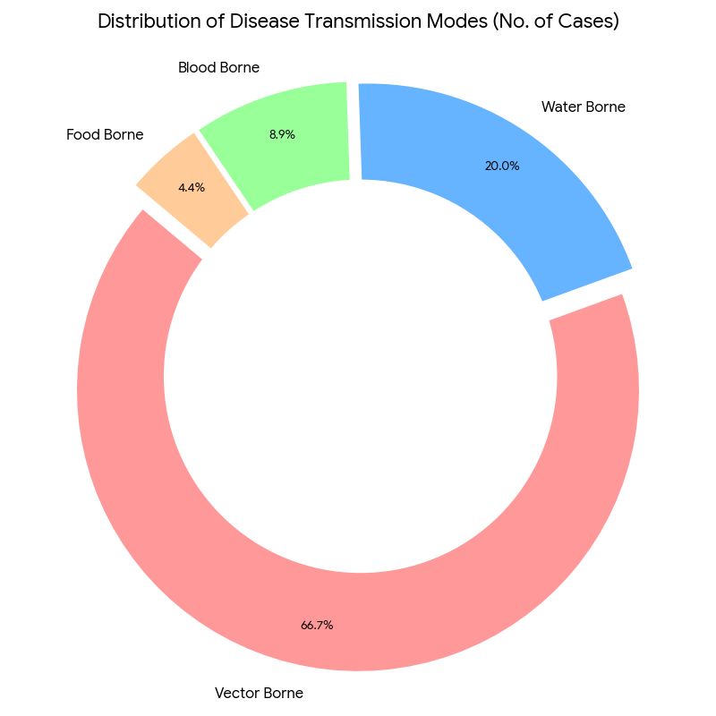

Vector-Borne Disease

Disease | No. of Cases | No. of Deaths
Dengue | 28 | 0
Malaria | 2 | 0
Chikungunya | 0 | 0

Water Borne Disease

Disease | No. of Cases | No. of Deaths
Cholera | 0 | 0
Typhoid | 2 | 0
Hep- A | 9 | 0
Dysentery | 1 | 0
Amoebiasis | 0 | 0
E- Coli infections | 0 | 0
Air Borne Disease

Disease | No. of Cases | No. of Deaths
Influenza | 0 | 0
H1N1 | 1 | 0
TB | 41 | 3
Chickenpox | 6 | 0
Measles | 0 | 0
Covid-19 | 0 | 0
Pertussis | 0 | 0
Mumps | 0 | 0

Blood-Borne Disease

Disease | No. of Cases | No. of Deaths
AIDS | 3 | 0
Hep- B | 3 | 0
Hep- C | 1 | 0

Zoonotic Disease

Disease | No. of Cases | No. of Deaths
Rabies | 0 | 0
Leptospirosis | 15 | 1
Avian influenza | 0 | 0
West nile | 0 | 0
Anthrax | 0 | 0
Nipah | 0 | 0
Scrub Typhus | 2 | 0

Integrated Disease Hotspot Map (2021–2025)

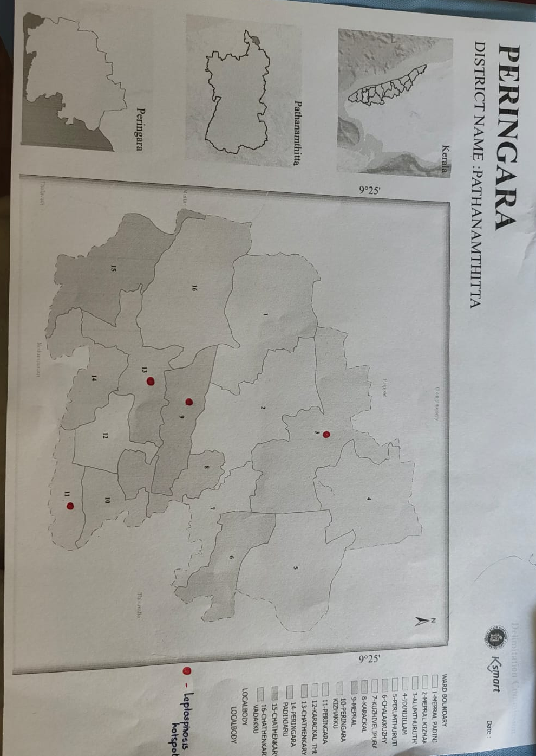

Ward No | Dengue Total (2021-25) | Leptospirosis Total (2021-25) | Hepatitis A Total (2021-25) | Mumps (2021-25) | ADD (2021-25) | Total Cases
1 | 2 | 3 | 0 | 0 | 18 | 23
2 | 0 | 0 | 0 | 0 | 19 | 19
3 | 1 | 2 | 2 | 0 | 21 | 26
4 | 3 | 2 | 0 | 0 | 26 | 31
5 | 0 | 0 | 0 | 0 | 29 | 29
6 | 0 | 0 | 0 | 0 | 17 | 17
7 | 3 | 0 | 0 | 0 | 22 | 25
8 | 0 | 2 | 0 | 0 | 20 | 22
9 | 0 | 2 | 1 | 0 | 20 | 23
10 | 2 | 1 | 2 | 0 | 24 | 29
11 | 3 | 0 | 0 | 0 | 19 | 22
12 | 6 | 0 | 1 | 0 | 23 | 30
13 | 0 | 0 | 1 | 0 | 20 | 1
14 | 5 | 1 | 2 | 0 | 24 | 31
15 | 3 | 0 | 0 | 0 | 18 | 0

By overlaying five years of data, we have identified 12, 14, 15 'Red Zone' Wards. These are wards where at least two different categories of diseases (e.g., Dengue and Lepto) recurred in consecutive years. Ward 4 is categorized as the Highest Priority Hotspot due to its combination of flood vulnerability and high vector density. Future health infrastructure, such as the proposed R.O plants at Thamaral should be prioritized.

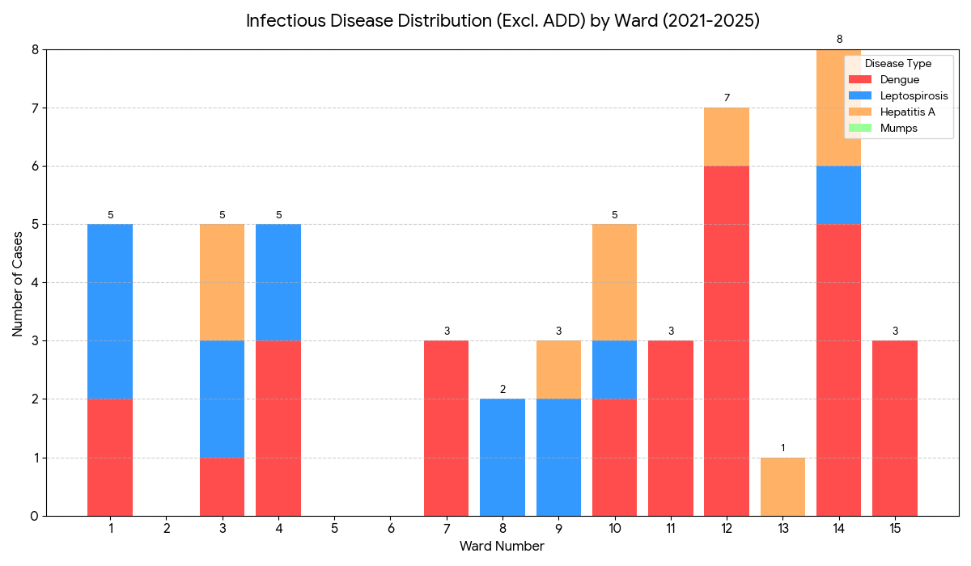

Primary Hotspot: Ward 14 is the most affected area, reporting 8 cases with a high variety of diseases (Dengue, Lepto, and Hepatitis A).
Vector Focus: Ward 12 remains a critical area for Dengue, accounting for 6 cases.
Ward-Specific Risks: Ward 1, 3, and 4 show significant totals (5 cases each) driven largely by combinations of Dengue and Leptospirosis.

Preparedness and Response Protocol at LSG Level
This section describes the operational framework for the LSGI once a pandemic is declared. It explains how the LSGI and health system will move from routine data collection to active response, using a One Health approach.

Constitution of One Health Committee
The LSGD shall constitute a One Health Committee comprising the LSGI President, Medical Officers (Modern Medicine, AYUSH, and Veterinary), the Health Inspector, and the Veterinary Surgeon.

Objective: The One Health Committee coordinates human, animal, and environmental health to prevent and control pandemics.

Sl No | Name | Designation | Department/Institution | Role in Committee | Contact Number
1 | HARIDASI | Panchayat President | LSGD | Chairperson | 9539263924
2 | DR..SHOUKATHALI | Medical Officer (PHC/CHC) | Health Dept | Member Secretary | 9947060745
3 | DR. ANANDHU | Veterinary Officer | Animal Husbandry | Member | 9496421224
4 | Dr Dhanya B Mohan | Epidemiologist | Health Dept | Member | 9847140643
5 | PRIYA GOPAL | Health Inspector/PHN | Health Dept | Surveillance | 8848423421
6 | Manjusha | ASHA Supervisor | Health Dept | Community link | 8086800973
7 | REENA | ICDS Supervisor | Social Welfare | Vulnerable groups | 9846473151
8 | AJITHKUMAR K | Police Station Officer | Police Dept | Law & order | 9497947150
9 | Jith | Ward Councillor Representative | LSGD | Community coordination | 9947361360
10 | Sujitha | Kudumbashree CDO | Kudumbashree | Community mobilisation | 730603626
11 | Chandru | NGO/Volunteer rep | Civil Society | Support services | 9447703721

Key Responsibilities:
- Review disease surveillance data (human + animal)
- Conduct ward-wise risk assessment and vulnerability mapping
- Approve quarantine/isolation centre locations
- Coordinate with district for resources (PPE, oxygen, ambulances)
- Periodically review health system surge capacity, including beds, oxygen, human resources, and ambulances.
- Approve and monitor risk communication and community engagement strategies, including rumour management.
- Ensure protection and service continuity for vulnerable groups (elderly, persons with disabilities, dialysis patients, coastal populations).
- Conduct quarterly mock drills
- Monitor equity measures for vulnerable groups

Meeting Schedule:
Quarterly (normal times) | Weekly (outbreak alert) | Daily (pandemic phase)

Pandemic Response Workforce
To ensure a coordinated and timely response during a pandemic, a dedicated Pandemic Response Workforce shall be constituted at the LSG level. The workforce will function under the overall supervision of the One Health Committee and in close coordination with the health authorities. Team-based deployment will enable efficient surveillance, case management, quarantine and isolation management, logistics support, and risk communication. Each team shall have a clearly designated team leader, defined roles, and an identified pool of personnel to allow rapid activation, rotation of duties, and continuity of services during prolonged emergencies.

Total Response Workforce Available: 300 persons

Team Name | Composition | No | Key Responsibilities | Team Leader
Surveillance and Contact Tracing Team | HI, JHI, JPHN, ASHAs and Volunteers | HI-1  JHI-3  JPHN-4  ASHA-20  Volunteers-50 | Case detection, contact listing, home visits, reporting | HI
Case Management Team | Doctors, Nurses, MLSP, Palliative Nurses | Doctors-3  Nurses-4  MLSP- 4  Palliative  Nurses-2 | Patient care & referral | DOCTOR
Quarantine & Isolation Team | LSGD staff, Volunteers | LSGD staff-13  Volunteers-13 | Facility management | JHI
Psychosocial support | AH Counselor | 1 | Counselling services | HI
Logistics & supply chain Team | LSGD staff, Storekeepers, Drivers 3 | LSGD staff- 13  Storekeepers-0  Drivers- 1 | Supplies & transport [PPE, medicines, oxygen, transport, waste management] | Ward Member
Communication Team | Ward members, Kudumbashree, Youth clubs,  AWW workers and other self help groups | Ward members-13  Kudumbashree- 130  Youth clubs-  AWW workers-15  Other self help groups- | IEC, community meetings, countering misinformation | M.O in charge
Transportation | KSRTC, educational institutional buses | KSRTC-Thiruvalla  Educational buses -4 | Safety of individuals, patient/staff transport | JHI
Media Surveillance | T Cell, Local Journalists, Volunteers | Journalist -3  Volunters-200 | Monitoring social media, tracking rumors | Public Relations Officer / HI
Intersectoral coordination and convergence | LSG President, Secretary, Health Staff | LSG President -1  LSGD Secretary -1  Health staff -20 | Policy decisions, resource pooling, convergence | LSG Secretary / President
Collaborative surveillance | Vets, Environmental Officers, Health Staff | Health staff-10  Environmental officers -2 | One Health tracking (Animal-Human interface) | Veterinary Surgeon

All teams shall be activated immediately upon outbreak alert or pandemic declaration and shall report daily to the LSG Incident Commander/Medical Officer, with consolidated reporting to the Block PHC. Duty rosters and alternate personnel shall be maintained to ensure uninterrupted services during staff shortages or prolonged response periods. Team composition and numbers may be revised based on the magnitude of the outbreak and availability of human resources.

Activities and Measures before and during Pandemic

PHASE 1 - Alert / Preparation

1. Surveillance and Reporting
Definition: The systematic collection and analysis of health data to identify potential outbreaks at the earliest possible stage.
- Action - Enhanced Syndromic Surveillance: Instruct all 15 Ward ASHA workers to conduct weekly "Fever Mapping." Report any unusual clusters of respiratory illness or water-borne symptoms to the PHC Peringara medical officer.
- Action - Data Sources: Aggregate data from local private clinics in Chathenkary, pharmacies at Peringara Junction, and school attendance records to spot spikes in absenteeism.
- Action - Event-Based Triggers: Monitor for "red-flag" events such as a sudden increase in demand for over-the-counter flu medication or multiple cases of severe pneumonia within a single neighborhood.

2. Zoonotic and Animal Health Surveillance
Definition: Monitoring the health of local livestock and wildlife to prevent "spillover" infections from animals to humans.
- Action: Coordinate with the Peringara Veterinary Dispensary to monitor local duck farms and poultry units, especially critical in the Peringara-Mepral belt where Avian Flu is a recurring threat.
- Action: Establish a reporting link between the Krishi Bhavan and the Health Inspector for any reports of mass bird deaths or unusual cattle illness.

3. Logistics and Stock Preparedness
Definition: The administrative and physical readiness of the Panchayat to deploy essential medical and safety gear without delay.

- Identify and empanel local vendors and define emergency procurement mechanisms in accordance with existing LSGD and Health Department norms.
- Prepare and maintain an essential logistics checklist covering medical supplies, consumables, and support equipment.
- Pre-identify secure storage locations for emergency stocks and ensure maintenance of stock registers with regular updating.
- Finalise emergency transport arrangements, including availability of vehicles and identified drivers for rapid deployment during alerts.
- Designate a Nodal Officer for Logistics to enable prompt decision-making, coordination, and communication during emergencies.

  - Conduct rapid stock verification and ensure availability of minimum buffer stock, including:
Commodities | Available stock
PPE kit | 0
Pulse oximeters | 3
Hand sanitizers | 0
Masks, gloves, disinfectants | Mask-1000 ,Gloves-600

Identify critical gaps in logistics and immediately communicate requirements to the Block and District authorities for timely replenishment and support. Monitor expiry dates and stock rotation.

- Action - Vendor Empanelment: Pre-approve a list of local suppliers in Thiruvalla for the emergency procurement of oxygen cylinders, PPE, and bleaching powder, adhering to LSGD fast-track norms.
- Action - Secure Storage: Designate a dedicated, damp-proof room within the Peringara Panchayat Office or the Community Hall for emergency stock, ensuring it is elevated above the typical flood line.
- Action - Nodal Officer: Formally appoint the Peringara Health Inspector as the Nodal Officer for Logistics to bridge communication between the GP Secretary and District authorities.

4. Emergency Transport Arrangements
Definition: Securing a standby fleet for the immediate movement of personnel, samples, or patients.
- Action: Finalize a "Standby Registry" of drivers. For Peringara, this must include motorized country boats for the 14th and 15th Wards (Mepral) and local school buses for mass transit.
- Action: Conduct a "Dry Run" of transport routes from rural wards to the Thiruvalla Taluk Hospital to identify potential road blockages.

5. Stock Verification and Gap Analysis
Definition: A quantitative audit of current supplies against the "Minimum Buffer Stock" required to manage an initial surge.
- Action - Immediate Stock Update: Based on your current data, the Panchayat must address the following critical deficits:
- Action - Reporting Gaps: Formally submit a "Logistics Deficit Report" to the Pulikeezhu Block Panchayat and the District Medical Office (DMO) Pathanamthitta to request immediate replenishment of PPE and sanitizers.

Identification of Quarantine and Isolation Facilities
  - Identify and list suitable buildings for quarantine and isolation (schools, hostels, community halls, etc.).
  - Categorise cases as per the severity and allocate to appropriate facilities (for instance, severe cases to classrooms, mild cases to an assembly hall in case of a school).
  - Facility readiness checklist needed (beds, toilets, ventilation) etc.
  - Find an alternate site if the primary sites are not available or not in use.
  - Identify facility managers and support staff
  - Prepare basic SOPs for:
    - Admission and discharge
    - Food, water, sanitation
    - Infection prevention and waste disposal
  - Ensure availability of basic amenities: water, sanitation, electricity, ventilation, and waste disposal. Prepare a rapid activation plan for these facilities if case numbers increase.

Risk Communication and Community Preparedness
  - Disseminate early warning messages on symptoms, preventive measures, and reporting mechanisms. Display IEC materials both in English and the local language in public places and ensure ward-level awareness.
  - Sensitize elected representatives and community leaders on preparedness measures.
  - Establish a rumour tracking and misinformation response mechanism to identify, verify, and promptly counter false or misleading information.
  - Engage trusted local persons (ward members, ASHA workers, religious leaders, teachers, community volunteers) to communicate official public health messages and reinforce correct practices.
  - Develop and deploy targeted IEC materials for:
    - Schools and educational institutions
    - Markets and commercial areas
    - Work sites and labour settings
  - Conduct community sensitization meetings at the ward level to promote preventive behaviors, address concerns, and strengthen community participation in preparedness and response.

Protection of Vulnerable Groups
Vulnerable populations require priority protection through targeted line-listing, service continuity, and delivery mechanisms.
- Prepare and regularly update line-lists of vulnerable populations, including:
  - Elderly persons living alone
  - Persons with disabilities
  - Pregnant women
  - Migrant workers
  - Dialysis patients
The detailed line-lists shall be maintained as Annexure 1 C and updated periodically.

Clinical Dependency Mapping
Develop ward-wise dependency and vulnerability maps to identify households requiring regular support during emergencies. Ensure continuity of essential health services for vulnerable groups, including
- Dialysis services (facility mapping, transport arrangements, and scheduling)
- Continuity of treatment for TB, HIV, and other chronic conditions requiring uninterrupted medication
- Mental health and psychosocial support services
Establish delivery mechanisms for food, essential commodities, and medicines to vulnerable households through coordinated action involving ASHAs, JPHNs, Kudumbashree, volunteers, and local administration.

PHASE 2 - Active Response

Case Identification and Contact Tracing
Case detection and contact tracing activities will be carried out in coordination with the Health authorities, following disease-specific SOPs and IDSP guidelines.
Field Staff Involved
- Health Inspector (HI)
- Junior Health Inspector (JHI)
- Junior Public Health Nurse (JPHN)
- ASHAs and ASHA Supervisors
- Ward-level volunteers and Kudumbashree members (as required)

Screening Checkpoints
Screening checkpoints at high-traffic locations (transport hubs, markets, religious gatherings) for early detection of symptomatic travellers and crowd screening during outbreaks. Potential locations include bus stands, market entry points, and boat jetties, based on local context and risk assessment.
Screening activities will be carried out by trained personnel such as ASHAs, ward members, and volunteers, with support from Health Department staff. Necessary equipment, including non-contact thermometers and appropriate PPE, shall be ensured prior to activation.
Location | Type (Bus stand/Jetty/Market/Railway) | Staff Deployed (ASHAs/Volunteers) | Screening Method | Reporting authority
Bus stand | NA | NA | NA | NA
Market entry | NA | NA | NA | NA
Boat jetty | NA | NA | NA | NA

Standard Screening Protocol

The screening protocol shall include temperature screening, observation for visible symptoms, and inquiry regarding recent travel or exposure history. Individuals identified as suspects during screening shall be immediately referred to the nearest PHC/FHC for further evaluation, testing, and appropriate action as per prevailing guidelines.

Pandemic Control Room
The Pandemic Control Room (PCR) serves as the central nerve center for real-time coordination, data aggregation, decision support, and communication during outbreaks. It consolidates information from all LSGD teams, health facilities and community sources to enable rapid response decisions.

Control Room Infrastructure and Location
Primary Location: PERINGARA Panchayath Office.
Backup Location: Community Hall in Perinagara G.P.

Health System Control Room Framework
The PCR is organized into seven functional pillars to ensure no aspect of the response is overlooked:

Rapid Response Team (RRT)
  - Provides immediate intervention during emergencies, clusters, and field alerts.​
  - Coordinates urgent actions such as case investigation, contact tracing, isolation, and inter‑facility referrals.

Data Management & Analytics Team
  - Collects, validates, and manages key health system indicators (cases, tests, beds, HR, supplies).​
  - Analyzes data trends, generates projections, and supports evidence‑based decision‑making for local authorities.

Human Resource Deployment Team
  - Allocates healthcare staff efficiently based on workload and need
  - Ensures adequate and equitable workforce distribution across facilities

Laboratory Surveillance Team
  - Oversees diagnostic testing coordination, sample transport, and timely reporting of results.​
  - Monitors lab indicators (testing volume, positivity rate, turnaround time) for early detection of outbreaks

Vaccination Cell (If Required)
  - Plans and executes vaccination campaigns, including micro‑planning and session scheduling.​
  - Tracks coverage, identifies gaps, and coordinates corrective actions with field teams and outreach services.

Infrastructure & Patient Occupancy Team
  - Monitors facility capacity, earmarked beds, oxygen and critical care resources across all linked facilities.​
  - Ensures optimal patient distribution and referral management using updated bed‑status and resource data.
  - BMWM

7. Communication & Community Engagement
- Official Information Flow: Serves as the primary authority for Peringara GP, broadcasting daily health and safety updates through Ward-level digital networks and physical notices at high-traffic hubs like Peringara Junction, Chathenkary, and Mepral.
- Community Response Mechanism: Systems are in place to collect and resolve grievances from the 15 Wards, ensuring the Peringara Help Desk provides rapid clarification on flood risks or disease clusters to maintain public calm.

8. Logistics & Supply Chain
- Centralized Storage: The Peringara Gramapanchayat Office acts as the main hub for the procurement and inventory of PPE, medical kits, and essential relief materials.
- Localized Distribution: Implements an agile delivery model to support ASHA and Anganwadi workers, utilizing the Peringara Community Resource Center as a strategic secondary staging point for field operations.

9. Transportation & Emergency Transit
- Fleet Management: Coordinates a versatile transport network, including the "Chetana" ambulance service and requisitioned private or school buses (e.g., from local Peringara educational institutions) for large-scale evacuations.
- Patient Transfer: Operates a centralized dispatch to move patients from home care to the Thiruvalla Taluk Hospital or Government Medical College, Kottayam, ensuring seamless logistics during transit.

10. Digital Oversight & Call Centre
- Rumor Control: Actively monitors local news outlets and community social media groups (e.g., "Peringara News") to identify and neutralize misinformation before it triggers public anxiety.
- Public Information Desk: Maintains a 24/7 helpline to provide real-time updates on Primary Health Centre (PHC) Peringara bed capacity, testing schedules, and emergency contacts.

11. Management of the Deceased
- Protocol & Respect: Guarantees that all terminal procedures adhere to strict biosafety standards while upholding the cultural and religious traditions of the Peringara community.
- Burial/Cremation Logistics: Manages the safe transport to local cemeteries or public crematoriums, ensuring that disposal teams are equipped with necessary protective gear and emotional support.

12. Intersectoral Coordination
- Integrated Governance: Facilitates direct communication between the Peringara GP President/Secretary, the Pulikeezhu Police, Revenue officials (Tahsildar), and Irrigation departments to manage the unique challenges of the Pamba/Manimala river basin.
- Infrastructure Adaptation: Manages the conversion of the Peringara Community Hall and local government schools into temporary Domiciliary Care Centres (DCCs) or emergency shelters during monsoon-related crises.

Key Control Room Team
The Control Room Team coordinates all pandemic response activities within the LSGD and serves as the single command and communication hub during activation. It integrates information, field actions, logistics, and policy execution across all participating departments and health facilities.

Role | Name | Designation | Contact Number | Responsibility
In-charge/Nodal Officer | DR. SHOUKATH ALI | CIVILSURGEON | 9947060745 | Overall coordination, decision-making, and reporting to the District level.
Data Entry Operator | Krishnachandran | OA | 9946254176 | Managing the line list, updating dashboards, and tracking testing results.
Communication Officer | PRIYAGOPAL | HEALTH INSPECTOR | 8848423421 | Handling the public helpline, coordinating ambulance dispatch, and contact tracing calls.
Logistics Coordinator | JOLLY JOSEPH | PHARMASIST | 9946348646 | Managing the supply chain (PPE, meds, oxygen), coordinating with Kudumbashree for community kitchens, and overseeing waste management logistics.
Technical Support (IT/Data) | Nissar | Clerk | 8547861011 | Ensuring hardware/network uptime, physical filing of records, assisting in rapid document dispatch, and maintaining the Control Room's physical infrastructure.

SOP for alert escalation/trigger point with mapping of responsibilities.
Key Points:
- The Control Room shall be staffed with a designated In-charge, data entry personnel, and communication staff with clearly defined roles and shift arrangements.
- It shall maintain updated records on daily monitoring indicators including new cases, persons under active quarantine, and hospital bed occupancy.
- All reports and situation updates shall be shared daily with the Block and District Surveillance Unit.
- The Control Room shall act as a single point of contact for coordination with response teams, health institutions, and other departments.
- Contact details of the Control Room shall be widely communicated to field staff and stakeholders during activation.

Daily Monitoring Indicators
To ensure timely decision-making and effective response, the following key indicators shall be monitored and updated on a daily basis by the Pandemic Control Room:

Epidemiological Indicators:
New cases reported today, Total active cases, Test Positivity Rate (TPR), Case Fatality Rate (CFR)
- Surveillance Indicators:
Persons under home quarantine, High-risk contacts identified, Fever, ILI, SARI or other symptoms (syndromic surges), Travellers (symptomatic or high-risk arrivals),Animal husbandry surveillance (zoonotic alerts, unusual animal deaths, poultry/bird flu signals), Mortality surveillance (excess deaths, unexplained fatalities, verbal autopsy reports)
- Logistics and Infrastructure Indicators:
Hospital / CFLTC beds occupied, Oxygen cylinders/concentrators available, Ambulances on standby
- Alert Findings
The following table outlines category-specific trigger points (red flags) from surveillance indicators and corresponding immediate actions for the Pandemic Control Room. These enable rapid response to alert findings like testing anomalies, positive cases exceeding thresholds, clusters, and WGS reports.

Category | Trigger Point (Red Flag) | Immediate Action
Clusters | Geographical or facility-based: 5+ cases linked to one location (office, school, street). | Declare a micro-containment zone; perimeter control and active case finding.
Testing | Sudden drop in testing volume / delay in reporting / unusual testing trends | Review the sample collection process, address lab bottlenecks, deploy additional testing teams, and notify the District Lab.
Lab | Test Positivity rate increases | Increase testing sites in that ward.
Hospital | >80% Oxygen bed occupancy | Activate backup/CFLTC beds.
Travel | Cluster of cases from a single flight/train or high-risk arrival group. | Trace all passengers in adjacent seats; implement mandatory institutional quarantine.
Animal | Mass poultry/wildlife death or unusual sickness | Notify Animal Husbandry, sample the area, and dispatch RRT for environmental sampling and zoonotic check.
Mortality | Sudden spike in home deaths or brought-in-dead (BID) cases | Audit the deaths and Active Case Search drive
Additional investigations like Whole Genome Sequencing (WGS) | Detection of a Variant of Concern (VOC) or Variant of Interest (VOI) | Implement strict micro-containment; update clinical protocols to match variant severity.

Communication of Public Health Information
A Community Communication Hub shall be established to ensure timely, accurate, and consistent dissemination of information during a pandemic. The Hub will function under the coordination of Nodal officers of the control room and act as the nodal point for public communication, risk messaging, and community engagement. It will support dissemination of official advisories, promote preventive behaviors, address rumors and misinformation, and ensure that messages reach all sections of the population through trusted local channels and leaders.

Key communicators
Channel | Responsible Person | Contact
Ward-level announcements | JHI | 8590929053
Social media | PRO | 9747211456
Local Cable TV/Radio | KERALAVISION | 0480 2080002

- All messages disseminated through the Hub shall align with advisories issued by the Health Department and District authorities.
- Community leaders shall be sensitized to support behavior change, reduce stigma, and counter misinformation.
- Special efforts shall be made to reach vulnerable and hard-to-reach populations using locally appropriate communication methods.

Rumor Tracking: A designated volunteer will monitor local social media/WhatsApp groups daily to identify misinformation and issue official clarifications via the Communication Hub.

Coordination with District/State Authorities & Other Organisations
Effective coordination with Block, District, and State authorities is essential to ensure timely reporting, technical guidance, and uninterrupted supply of essential resources during a pandemic. The LSG shall establish clear communication channels, designate responsible officers, and adhere to prescribed reporting timelines to support coordinated public health action and efficient resource mobilisation.

Key Details:
- Nodal Officer for Reporting:
- Contact Number:
Reporting Schedule and Protocols:

To Whom | What to Report | Frequency | Nodal Person
Block PHC | Complete Situation Report (Cases, Quarantine, Beds, Screening, Deaths) | Daily | BINU JOY J S (HS)  9447421062
District IDSP Unit | Outbreaks/Clusters/Unusual Events (>5 cases same ward) | Daily | Dr. JEEVAN NAIR  9847033362
Veterinary Officer | Animal health events/Zoonotic alerts | Weekly | Dr. ANANDHU
State Cell | Zoonotic cross-sector events | Weekly | SSO

Supply Chain Coordination
The LSG shall coordinate closely with Block, District, and State authorities (KMSCL) to ensure uninterrupted availability of essential goods, medical supplies, and logistics during a pandemic. Supply requirements shall be assessed regularly based on case load and communicated promptly to the appropriate authorities for timely replenishment.
Key Points:
- Maintain updated contact details of District and Block nodal officers for health logistics, oxygen supply, ambulances, and essential medicines.
- Submit timely indent requests for PPE, testing kits, medicines, oxygen, and other critical supplies through prescribed channels.
- Monitor stock levels at LSGD facilities, quarantine/isolation centres, and field teams through daily stock registers and dispensing logs to prevent shortages.
- Coordinate with District authorities, Karunya/Neethi medical shops, and local purchase committees for funds allocation and emergency procurement.

- Ensure regular monitoring of dispensing registers at all facilities to track usage, expiry, and pilferage—shortages being a perennial issue requiring proactive weekly audits.

- Activate surge procurement protocols during high caseloads, leveraging local purchase powers under LSGD funds alongside state supplies.

Resource Inventory and Contacts
Resource Category | Source  (District/State/Private) | Contact
PPE Kits/Masks/Gloves | KMSCL | 9995599249
PPE Kits/Masks/Gloves | Local Vendors | 9744800183
Oxygen  Cylinders/Concentrators | KMSCL | 9995599249
Medicines/Antivirals | KMSCL | 9995599249
Medicines/Antivirals | Neethi Shops | 9744800183
Test Kits (RTPCR/Rapid) | KMSCL | 9995599249

Collaboration with NGOs, PPP, and CSR
To augment government efforts during a pandemic, the LSG shall collaborate with NGOs, voluntary organisations, and private sector partners through public–private partnerships and Corporate Social Responsibility (CSR) initiatives, in coordination with District authorities.

Key Points:
- Engage NGOs and community-based organisations for community outreach, awareness, and support to vulnerable populations.
- Leverage CSR support for procurement of medical equipment, PPE, oxygen concentrators, food kits, and sanitation materials, as permitted.
- Ensure all collaborations align with government guidelines and are routed through approved administrative and financial procedures.
- Maintain transparency and documentation for all external support received and utilised.
Organization | Type | Support Offered | Contact Person
Youth Clubs/Student Unions | CBO | NA | NA

Interdepartmental Coordination
Coordination among departments during a pandemic shall be ensured through regular review meetings convened by the LSGD President. These meetings will provide a structured platform for sharing situational updates, assessing resource availability, resolving operational gaps, and taking joint decisions to ensure a coordinated and timely response.

Department | Representative | Key Role | Contact
Health (PHC) | Staff Nurse : | Case management | 9946451114
Veterinary | Veterinary Surgeon: | Animal surveillance | 9496421224
ICDS | Supervisor: | Nutrition support | 9846473151
Education | Head Teacher: | School coordination
Police | 04692610149 | Containment enforcement | 04692610149
Water Authority | 0469 270 1267 | Water supply | 04692701267
LSGD Engineering | 9061106026 | Quarantine infrastructure | 0471-2309250

PHASE 3 - Surge Capacity
Phase 3 is activated when there is a rapid increase in cases, high test positivity rates, or when existing health facilities and quarantine arrangements approach saturation. The focus of this phase is to expand isolation capacity, augment clinical care services, and mobilise additional resources through district and state support mechanisms.

Conversion of Community Facilities
To manage increased case load, the LSGD shall activate additional isolation facilities by repurposing identified community infrastructure such as community halls, auditoriums, schools, hostels, or other suitable buildings.

Name of facility | Facility Type | No. of Buildings | Ward | Surge Capacity (Beds) | Nodal Person
VIJAYA CONVENTION CENTER | CONVENTION CENTER | 1 | 5 | 3000 | 8921858739
Community Hall Chathenkary | Community Hall | 1 | 11 | 20 | 9746467625
St Pauls Marthoma Church ,Chathenkary | Church | 1 | 15 | 25 | 9567517050

Recovery and rehabilitation phase

1. Post-Outbreak Recovery & Restoration

Damage & Impact Assessment
- Action: Conduct a multi-sectoral survey (Health, Revenue, and Agriculture) to quantify losses in the Mepral and Chathenkary wards.
- Recommendation: Use a "Digital Loss Register" to track poultry mortality and damaged household sanitation systems to ensure fair compensation distribution.

Restoration of Health Services
- Action: Deep-clean and medically recertify PHC Peringara and the Chathenkary Sub-center if they were used as isolation hubs.
- Recommendation: Prioritize the replenishment of the "Minimum Buffer Stock" (PPE, medicines) that was exhausted during the peak of the pandemic/outbreak.

Environmental Cleanup & Sanitation
- Action: Execute a "Mega-Chlorination Drive" for all open wells and community water sources in flood-prone areas.
- Recommendation: Deploy the Haritha Karma Sena for the scientific disposal of bio-hazardous waste (used PPE/masks) collected from relief camps and DCCs.

2. Rehabilitation & Support Systems

Psychosocial & Mental Health Support
- Action: Activate "Ottappalam" or similar counseling networks for farmers who suffered mass livestock loss and families in long-term isolation.
- Recommendation: Conduct "Aswas" clinics at the Ward level to screen for Post-Traumatic Stress Disorder (PTSD) among frontline ASHA workers and volunteers.

Livelihood Restoration
- Action: Coordinate with Peringara Krishi Bhavan and the Veterinary Department to provide subsidized ducklings/poultry and interest-free loans to affected farmers.
- Recommendation: Implement a "Work-for-Sanitation" program where locals are compensated for participating in drainage cleaning and vector control activities.

3. Surveillance & System Strengthening

Disease Surveillance (Recovery Phase)
- Action: Continue "syndromic surveillance" for 28 days after the last reported case to prevent a second wave.
- Recommendation: Focus specifically on Leptospirosis (Rat Fever) and water-borne diseases which typically spike in Peringara after floodwaters recede.

Documentation & After-Action Review (AAR)
- Action: Convene a formal meeting of the Peringara PDMC to compare the "Mock Drill" performance against the actual response.
- Recommendation: Publish a "Peringara Health White Paper" documenting the timeline, resource gaps, and successful local innovations (like the use of country boats for medicine delivery).

4. Long-Term Policy & Preparedness

Health System Strengthening
- Action: Upgrade the Peringara Community Hall with permanent oxygen piping and backup power to serve as a "Ready-to-Use" DCC for future crises.
- Recommendation: Establish a permanent One-Health Desk at the Panchayat office where the Health Inspector and Veterinary Surgeon meet monthly.

Lessons Learned & Research
- Action: Partner with nearby academic institutions (like Pushpagiri or TMM) to study the "Zoonotic spillover" patterns in the Upper Kuttanad ecosystem.
- Recommendation: Integrate "Pandemic Literacy" into the Peringara school curriculum to ensure the youth are trained in basic biosecurity and hygiene.

Summary Table for Peringara Recovery
Focus Area | Immediate Recommendation (0-30 Days) | Long-term Goal (1 Year+)
Sanitation | Well chlorination in Mepral,Peringara ,chathenkary areas | Raised-platform toilet designs for flood zones.
Economy | Direct cash transfer to duck farmers. | Insurance-linked poultry farming clusters.
Health | Mental health screening camps. | Permanent Infectious Disease Observation Ward at PHC.

CONCLUSION
The Pandemic Preparedness Plan for Peringara Gramapanchayat serves as a strategic roadmap designed to transform the unique geographical vulnerabilities of the Upper Kuttanad region into strengths of organized resilience. By integrating the One Health approach with traditional disaster management, Peringara transitions from a "reactive" stance to a "proactive" shield against the dual threats of zoonotic outbreaks (like Avian Influenza) and recurring monsoon floods.
The success of this plan hinges on the synergy between the grassroots ASHA/Anganwadi network, the Veterinary and Health Departments, and the local community. Through rigorous mock drills like "Operation Kaval," constant surveillance, and the addressing of critical logistics gaps, the Panchayat ensures that no ward—be it the water-locked Mepral or the bustling Peringara Junction—is left behind during a crisis.

Key Recommendations for High-Impact Pandemics
To effectively face high-consequence events like H5N1 (Avian Flu) and catastrophic flooding, the following "Future-Proofing" measures are prioritized:
- Integrated Early Warning System (IEWS): Establish a digital bridge between the Water Resources Department (monitoring Pamba/Manimala river levels) and the Veterinary Department. A spike in river levels should automatically trigger a biosecurity alert for duck farmers to prevent the mixing of wild migratory birds with domestic stock.
- Climate-Resilient Infrastructure: * Designate "High-Ground Hubs" for medicine storage to prevent damage during floods.
  - Equip the Peringara Community Hall with solar power backups and water purification units to ensure it remains functional even if the main grid fails.
- Mobile One Health Teams (MOHT): During monsoon seasons, deploy specialized teams via country boats that carry both human vaccines and veterinary testing kits, ensuring that isolated populations in the southern wards receive care without needing to cross flooded terrains.
- Bio-Security Compensation Fund: Create a local "Emergency Corpus Fund" to provide immediate, interim financial relief to poultry farmers during culling operations. This encourages early reporting of bird deaths, as farmers will not fear immediate total financial ruin.
- Advanced Digital Surveillance: Transition from paper-based reporting to a Real-Time GIS Mapping system where ASHA workers can tag fever clusters or bird death locations on a map, allowing the Rapid Response Team to visualize the "spread path" across Peringara’s landscape.

RECOMMENDATIONS

Strengthening Healthcare Infrastructure
- Establish a primary health response unit within the Panchayat with trained staff.
- Ensure availability of basic medical supplies (masks, sanitizers, PPE kits, oxygen cylinders).
- Create tie-ups with nearby hospitals in peringara panchayat for emergency referral and transport.

2. Community Awareness & Education
- Conduct regular awareness campaigns on hygiene, vaccination, and preventive measures.
- Use local communication channels (community radio, WhatsApp groups, notice boards) to spread verified information.
- Train volunteers to act as health ambassadors in each ward.

3. Emergency Response & Coordination
- Form a Pandemic Preparedness Committee at Panchayat level including health workers, ward members, and NGOs.
- Develop a clear action plan for lockdowns, quarantine, and distribution of essentials.
- Maintain a database of vulnerable groups (elderly, differently-abled, chronically ill) for targeted support.

4. Supply Chain & Food Security
- Identify and support local suppliers and farmers to ensure uninterrupted food supply.
- Create community kitchens during emergencies to serve vulnerable populations.
- Stockpile essential commodities in Panchayat-run outlets for crisis periods.

5. Digital Preparedness
- Promote digital platforms for telemedicine consultations.
- Use Panchayat’s website/social media for real-time updates on health advisories.
- Encourage online grievance redressal to reduce crowding in offices.

6. Training & Capacity Building
- Organize mock drills for pandemic response in schools, offices, and public spaces.
- Train Panchayat staff and volunteers in first aid, infection control, and crowd management.
- Collaborate with NGOs and health departments for capacity-building workshops.

7. Long-Term Resilience
- Integrate pandemic preparedness into the Panchayat Development Plan.
- Allocate a dedicated budget for health emergencies.
- Encourage community participation in planning and monitoring preparedness measures.

MOCKDRILL SCENARIOS

Mock Drill Exercise: "Operation Kaval"
Theme: Integrated One-Health Response to Monsoon-Driven Avian Influenza & Human Cluster Outbreak.
Location: Ward 15 (Mepral) and Ward 14 (Chathenkary).
Duration: 09:00 AM – 01:00 PM.

1. Scenario Set-up (The Trigger)
- Environmental Context: It is the peak of the Southwest Monsoon. The Pamba river has overflowed, and the padashekarams (paddy fields) in Mepral are submerged.
- The Incident: A local duck farmer in Mepral reports the sudden death of 40 ducks. Simultaneously, two members of a family in a nearby temporary relief camp at Govt. UPS Peringara report high fever, severe respiratory distress, and body aches.

2. Drill Phases & Action Steps

Phase I: Notification & Activation (09:00 - 09:45)
- Action 1: The ASHA worker of Ward 15 identifies the symptomatic individuals at the relief camp and alerts the PHC Peringara Medical Officer.
- Action 2: The Veterinary Surgeon (Peringara Dispensary) receives a call from the farmer regarding bird mortality.
- Action 3: One-Health Activation: The PHC MO and Veterinary Surgeon exchange data. The GP President convenes an emergency meeting of the Panchayat Disaster Management Committee (PDMC).

Phase II: Field Investigation & Containment (09:45 - 11:30)
- Action 4 (Animal Health): A Veterinary Rapid Response Team (RRT) arrives at the Mepral padashekharam. They simulate Cordoning (1km radius) and Sample Collection from carcasses using full PPE.
- Action 5 (Human Health): A Health RRT conducts "Line Listing" at the relief camp. Symptomatic individuals are moved to a pre-designated Isolation Corner within the camp using N95 masks.
- Action 6 (Logistics): The Peringara GP Secretary releases emergency stocks (PPE, Sanitizers, Bleaching Powder) from the Panchayat Office storage.

Phase III: Inter-Sectoral Coordination (11:30 - 12:30)
- Action 7: The Pulikeezhu Police simulate movement control, blocking the transport of poultry/ducks out of the Peringara-Chathenkary belt.
- Action 8: The Panchayat "Chetana" Ambulance performs a mock transfer of a "critical" patient from the Mepral water-logged point (using a country boat to land) and then to Thiruvalla Taluk Hospital.
- Action 9: Information Dissemination: The GP Media Cell issues a "Rapid Rebuttal" on the Peringara News WhatsApp group to prevent panic about meat consumption.

3. Roles and Responsibilities Matrix
Authority | Specific Drill Responsibility
GP President | Overall Command; declaring the 1km "Infected Zone."
Medical Officer (PHC) | Clinical triage and supervising sample transport to NIV/Alappuzha.
Veterinary Officer | Carcass disposal simulation and farm biosecurity.
ASHA/Anganwadi | Door-to-door surveillance in the 1-3km "Buffer Zone."
VEO/Secretary | Ensuring food and PPE supply to the isolated relief camp.

4. Evaluation Criteria (The Debrief)
At 12:30 PM, all stakeholders gather at the Peringara Community Hall to evaluate:
- Response Time: How long did it take for the RRT to reach the submerged Ward 15?
- One-Health Linkage: Did the Health and Veterinary departments share data immediately?
- Logistics Readiness: Was there enough PPE in the Panchayat stock (referencing the current gap of 0 PPE kits identified earlier)?
- Communication: Was the public messaging clear enough to prevent a rush at the PHC?

5. Mock Drill Logistics Checklist
- Props: 2 Dummy duck carcasses (weighted bags), 5 PPE Suits, Yellow Bio-hazard bags.
- Transport: 1 Country boat (Mepral sector), 1 Ambulance, 1 Police Jeep.
- Documentation: Mock "Line List" forms and "Referral Slips."

ANNEXURE

IMPORTANT PHONE NUMBERS
Phone numbers and particulars of persons responsible for providing guidance, assistance and support for pandemic preparedness operations may be provided here in a manner that allows easy reference at a glance. The information recorded here could be exhibited elsewhere at the time of emergencies. LSG institutions shall give special attention to collect and record the above data of persons and institutions who/which are supposed to give technical and co-ordination support to reduce the impact of pandemic.

1.1. Details of grama panchayat/municipality/corporation wards
Sl.No | Name of the ward | Ward number | Name of the ward  member | Contact number
1 | MEPRAL WEST | 1 | MINIMOL JOSE | 9562387685
2 | MEPRAL | 2 | SANDHYA S | 9526597237
3 | MEPRAL EAST | 3 | SABU ISAC | 9207243784
4 | ALUMTHURUTHY | 4 | LEENA JOSE | 9656752287
5 | IDINJILLOM | 5 | ROY VARUGHEES | 9747836104
6 | PERUMTHURUTHY | 6 | ALIAMMA THOMAS | 9846986159
7 | CHALAKKUZHY | 7 | BINDHU G | 7306708756
8 | KUZHIVELIPPURAM | 8 | ANU C K | 9961964229
9 | KARAKKAL | 9 | VIPIN GEORGE JOHN | 7034210612
10 | PERINGARA EAST | 10 | DEVARAJAN | 7012310711
11 | PERINGARA | 11 | ARUN M KUMAR | 9746467625
12  13  14  15  16 | KARAKKAL SOUTH  PERINGARA WEST  CHATHENKARY  CHATHENKARY NORTH  KADAVU | 12  13  14  15  16 | ANEESH  CHANDRAN  ANNIE ABRAHAM  RAHUL REGHU  HARIDASI SASI | 9961633234  9946380122  9947381360  9567517050  9539263924

1.2. Other important phone numbers of grama panchayat/municipality/corporation area

Sl. No. | Name | Contact number
1. | SAM EAPPEN(JILLA PANCHAYATH MEMBER) | 9447037009
2. | EAPPAN KURYAN  (BLOCK PANCHAYATH PRESIDENT) | 9447411088
3. | REJANI S  ( BLOCK PANCHAYATH MEMBER) | 9961219355
4. | ADV. RAJESH CHATHENKARY  (BLOCK PANCHAYATH MEMBER) | 9447010685
5. | NISHA ASOKAN( BLOCK HEALTH STANTING COMMITTEE CHAIRE PERSON) | 9895014693
6. | ANTO ANTONY (MP) | 9447010000
7. | Excise department | 04692747632
8. | FIRE AND RESCUE | 04692600101

1.3. Important offices of grama panchayat/municipality/ corporation
Sl.No | Name of the office | Contact person | Contact number
1. | Village Office | Village Officer | 8547611305
2. | Agriculture Office | Agriculture Officer | 047692737797
3. | Animal Husbandry Office | Animal Husbandry Doctor | 9496421224
4. | Police Station | Police Officer | 04692610149
5. | BSNL Office | Officer | 04692600300
6. | Block Office | Officer | 9496804230
7. | KSEB Office | Officer | 04692701201
8. | Fisheries Office | Officer | NA
9. | Fire and Rescue | Officer | 04692600101

1.4. Health Services

Sl. No | Name of the hospital/institution | Location | Phone number
1. | Government hospitals/PHC | CHATHENKARY | 8921092229
2. | Private hospitals | VLS | 7012014802
3. | Clinical laboratories | AMRITHASREE | 9447504810
4. | Chemist/pharmacy | NA | NA
5. | Blood donors | NGO
6. | Other language experts (Bihari, Hindi, Bengali,Asamees …) | NA | NA

1.5. Veterinary Services
Sl.No | Name of the Clinic | Name of the  Surgeon/Doctor | Place/location | Phone  number
1 | Govt.Veterinary Hospital | DR. ANADHU | MEPRAL | 94936421224

1.6. Helpline numbers
Helpline | Phone number
Police | 04692610149
Fire and Rescue | 04692600101
KSEB | 04692701201

1.7. Public and Private Schools Contact details

S.No | Name of School | Ward |  | Institution type | Phone number
S.No | Name of School | Old | New | Institution type | Phone number
1 | SNDP HS | 14 | 15 | Aided | 9074739514
2 | GOVT. LPS CHATHENKARY | 13 | 14 | GOVT | 9961612249
3 | NEW LP CHATHENKARY | 16 | 15 | Private | 8921779731
4 | PMV HS | 11 | 12 | Govt | 9400609807
5 | PMV LPS | 11 | 12 | Private | 9526221805
6 | GHSS PERINGARA | 10 | 10 | Private | 9567566207
7 | KARAKKAL LPS | 9 |  | Private | 9495309514
8 | GOVT. LPS MEPRAL | 2 | 9 | Govt | 9400537113
9 | ST.JOHNS LPS MEPRAL | 2 | 2 | GOVT | 9446293187
10 | ST. JOHNS UPS MEPRAL | 3 | 2 | AIDED | 9847063491
11 | IDINJILLOM LPS | 5 | 4 | GOVT | 8304834273
12 | ALUMTHURUTHY LPS | 4 | 3 | GOVT | 9605380534
13 | MTLPS | 7 | 6 | AIDED | 9995636070

1.9. Anganwadi Contact Details

Sl. No. | Ward No | Centre Number | Name of Anganwadi Teachers | Phone number
1 | 14 | AW 89 | ALEYAMMA KURIAN | 9847970078
2 | 7 | AW 90 | ALICE MATHEW | 9562964807
3 | 15 | AW 91 | SOSAMMA KURIAN | 9947625726
4 | 5 | AW 92 | JAYAKUMARI M T | 8606123653
5 | 15 | AW 93 | PREETHIAMMAL | 9605602219
6 | 2 | AW 94 | JAYALEKSHMI | 9744563909
7 | 9 | AW 95 | USHAKUMARI V G | 9645198644
8 | 13 | AW 96 | ANUJA A M | 6282974092
9 | 12 | AW 97 | TIJI | 7909113844
10 | 12 | AW 98 | SANDHYA | 9539203883
11 | 13 | AW 99 | KUMARI BINDHU | 9947620384
12 | 7 | AW 100 | BINDHU JOHN | 9961651649
13 | 8 | AW 101 | NISHA M | 9747931372
14 | 3 | AW 102 | KRISHNAKUMARI T G | 9526865734
15 | 5 | AW 103 | KAVITHA MOL T V | 9544559754
16 | 13 | AW 104 | SREEJA M | 9562233638
17 | 1 | AW 105 | SUDHA CHERIAN | 8943936788
18 | 11 | AW 106 | JAYASREE L | 9656440695
19 | 10 | AW 107 | REMADEVI P R | 8301822910
20 | 3 | AW 108 | NISHA P | 7025804159
21 | 9 | AW 109 | SHEELAKUMARI | 9746467672
22 | 6 | AW 110 | VALSALAKUMARI | 8156921216
23 | 5 | AW 115 | KOMALAVALLY | 8547045972
24 | 7 | AW 155 | ANITHA K | 9744796992

1.12. Information regarding resources

Means of transportation | Name of Owner | Phone Number
Heavy Trucks | Tata Motors Commercial Vehicle Dealer | 74117 81350
Tractor | Jeevitha Associate, | 90720 21005
Ambulances | Ribu | 9946309689
Boats | Pamba boating | 99465 37213
Taxi service | Daily cars | 7636069887

Annexure 1: LSG Baseline Data Collection Format
A. Baseline data
Sl. No. | Indicator / Field | Baseline Data | Source / Remarks
1 | Name of LSG | PERINGARA | LSGD DATA
2 | District | PATHANAMTHITTA | LSGD DATA
3 | Block / Taluk | PULIKKEEZHU | LSGD DATA
4 | Type of LSG (Gram Panchayat / Municipality / Corporation) | GP | LSGD DATA
5 | Area (sq. km) | 12.49 | LSGD DATA
6 | No. of wards | 16 | LSGD DATA
7 | GIS boundary file available | (Yes/No) Yes | LSGD DATA
8 | Key contact person & phone | HARIDASI  9539263924 | Peringara Panchayath  President

B. Demography
Indicator / Field | Baseline Data | Source / Remarks
Total population | 25797 | LSGD DATA
Males | 12757 | LSGD DATA
Females | 13038 | LSGD DATA
Transgender population | 0 | LSGD DATA
Age distribution  (<5, 5–14, 15–59, ≥60) | 778, 1728,9879,9184 | LSGD DATA
No. of households | 6079 | LSGD DATA
Population density (persons/sq.km) | 2065.4 | LSGD DATA
No. of migrant workers | 250 | LSGD DATA
Major occupational groups | Agriculture | LSGD DATA

C. Vulnerable Populations & Social Risks
Sl. No. | Indicator / Field | Baseline Data (Value / Description) | Source / Remarks
1 | No. of elderly (≥60) | 9184 | FIELD DATA
2 | No. of persons with disability | 65 | FIELD DATA
3 | No. of bedridden persons | 170 | FIELD DATA
4 | No. of chronic disease cases (DM/HTN/COPD/CKD etc.) | DM- 6439  HTN- 8325  COPD- 36  CKD- 19 | FIELD DATA
5 | Pregnant women (current estimate) | 84 | FIELD DATA
6 | Children <5 years | 778 | FIELD DATA
7 | Tribal population (if any) | 7 | FIELD DATA
8 | Fisherfolk / coastal vulnerable groups (if any) | NA | FIELD DATA
9 | Urban slums / unnotified settlements (if any) | NA | FIELD DATA
10 | Homeless population | NA | FIELD DATA
11 | Orphanages / old age homes (number & capacity) | NA | FIELD DATA
12 | Hostels / prisons / shelters (number & capacity) | NA | FIELD DATA
13 | Poverty / BPL estimate | 1821 | FIELD DATA
14 | Food insecurity hotspots | NA | FIELD DATA
15 | Any history of stigma/discrimination issues (Yes/No) | NA | FIELD DATA

D. Health System & Service Readiness
Sl. No. | Indicator / Field | Baseline Data (Value/ Description) | Source / Remarks
1 | No. of health facilities in LSG (PHC/CHC/TH/DH/Private) | CHC-1 | LSGD DATA
2 | PHC/Family Health Centre details (name, location) | CHC CHATHENKARY | LSGD DATA
3 | Subcentres / Health & Wellness Centres (number) | 4 | LSGD DATA
4 | Private clinics / hospitals (number) | VLS | 7012014802
5 | Labs available (public/private) | AMRITHASREE | 9447504810
6 | Availability of ambulance services (Yes/No, number) | YES ,108 | LSGD DATA
7 | Availability of isolation/quarantine facilities (Yes/No, details) | NO | LSGD DATA
8 | Cold chain facilities (Yes/No, details) | YES | LSGD DATA
9 | Stockpile space available (Yes/No) | YES | LSGD DATA
10 | PPE / mask / sanitizer availability plan (Yes/No) | YES | LSGD DATA
11 | Surveillance staff available (JHI/JPHN/ASHA count) | YES | LSGD DATA
12 | Existing emergency referral pathways (Yes/No) | YES | LSGD DATA

E. Points of Entry & Mobility
Sl. No. | Indicator / Field | Baseline Data (Value / Description) | Source / Remarks
1 | Bus stands / depots (number) | NO | LSGD DATA
2 | Railway stations (number) | NO | LSGD DATA
3 | Boat jetties / fishing harbours (number) | NO | LSGD DATA
4 | Ports / airports nearby (specify distance) | NO | LSGD DATA
5 | Major highways/roads passing through | NO | LSGD DATA
6 | Border crossings (state/district) | YES | LSGD DATA
7 | Major markets / weekly markets | NO | LSGD DATA
8 | Tourism hubs / major event venues | NO | LSGD DATA
9 | Schools/colleges with hostels (number) | NO | LSGD DATA
10 | Factories / large workplaces (number) | NO | LSGD DATA
F. Water, Sanitation & Hygiene (WASH)
Sl. No. | Indicator / Field | Baseline Data (Value / Description) | Source / Remarks
1 | Major drinking water sources (piped / wells / borewells / springs) | PIPE | FIELD DATA
2 | No. of public wells | 5 | FIELD DATA
3 | No. of households with piped water connection |  | FIELD DATA
4 | Water quality testing routine (Yes/No) | YES | FIELD DATA
5 | Common contamination risks (flooding, salinity, industrial waste) | FLOODING | FIELD DATA
6 | Open defecation free status (Yes/No) | YES | FIELD DATA
7 | Solid waste management system (Yes/No) | NO | FIELD DATA
8 | Bio-medical waste disposal mechanism (Yes/No) | YES | FIELD DATA
9 | No. of public toilets | NO | FIELD DATA
10 | Handwashing stations in public places (Yes/No) | NO | FIELD DATA
G. Zoonotic Risks & One Health
Sl. No. | Indicator / Field | Baseline Data (Value / Description) | Source / Remarks
1 | Livestock population (cattle/goats/pigs/poultry) – estimates | 1043 | FIELD DATA
2 | No. of dairy farms / poultry farms / pig farms | 2 | FIELD DATA
3 | Slaughterhouses / meat shops (number) | 0 | FIELD DATA
4 | Animal markets (Yes/No, details) | 0 | FIELD DATA
5 | Veterinary dispensaries (number) | 1 | FIELD DATA
6 | History of zoonotic outbreaks (rabies, leptospirosis, avian flu etc.) | 0 | FIELD DATA
7 | Stray dog population management measures (Yes/No) | YES | FIELD DATA
8 | Rodent infestation hotspots (Yes/No) | NO | FIELD DATA
9 | Wetlands / waterlogged areas prone to leptospirosis | WHOLE GP AREAS | FIELD DATA
10 | Bat roosting areas / caves / fruit orchards (if any) | NO | FIELD DATA
11 | Human-animal interface hotspots (farms near residences) | NO | FIELD DATA
H. Climate & Disaster Risks (Pandemic Amplifiers)
Sl. No. | Indicator / Field | Baseline Data (Value / Description) | Source / Remarks
1 | Flood-prone wards (list) | ALL 15 WARDS | LSGD DATA
2 | Landslide-prone wards (list) | NO | LSGD DATA
3 | Cyclone/sea surge risk (Yes/No) | NO | LSGD DATA
4 | Heatwave risk zones (Yes/No) | NO | LSGD DATA
5 | Waterlogging areas (list) | YES | LSGD DATA
6 | Shelter homes / relief camps (number, capacity) | YES | LSGD DATA
7 | Past disaster displacement history | YES | LSGD DATA
8 | Disruption to water supply/transport common (Yes/No) | YES | LSGD DATA
I. Critical Infrastructure & Logistics
Sl. No. | Indicator / Field | Baseline Data (Value / Description) | Source / Remarks
1 | Schools (number) | 13 | LSGD DATA
2 | Anganwadis (number) | 24 | LSGD DATA
3 | Colleges (number) | 0 | LSGD DATA
4 | Community halls (number) | 1 | LSGD DATA
5 | Places of worship with large gatherings (number) | 11 | LSGD DATA
6 | Large markets / shopping areas (number) | 0 | LSGD DATA
7 | Warehouses / cold storages (number) | 0 | LSGD DATA
8 | Telecom/mobile network coverage gaps (Yes/No) | 0 | LSGD DATA
9 | Power outage frequency (high/medium/low) | HIGH | LSGD DATA
10 | Availability of generators in key facilities | NO | LSGD DATA

J. Risk Communication & Community Networks
Sl. No. | Indicator / Field | Baseline Data (Value / Description) | Source / Remarks
1 | Ward-level rapid response teams (Yes/No) | YES | LSGD DATA
2 | Jagratha samithis / committees active (Yes/No) | YES | LSGD DATA
3 | Kudumbashree presence and strength (number of units) | YES - 169 | LSGD DATA
4 | Volunteer network (number, coverage) | YES | LSGD DATA
5 | Community-based surveillance mechanisms (Yes/No) | YES | LSGD DATA
6 | IEC dissemination channels (WhatsApp groups, community radio, PA systems) | YES | LSGD DATA
7 | Rumour tracking mechanisms (Yes/No) | YES | LSGD DATA
8 | Languages spoken / literacy considerations | NO | LSGD DATA
9 | Vulnerable groups communication strategy available (Yes/No) | YES | LSGD DATA

K. Preparedness Planning & Governance
Sl. No. | Indicator / Field | Baseline Data (Value / Description) | Source / Remarks
1 | LSG emergency plan available (Yes/No) | YES | LSGD DATA
2 | Pandemic preparedness plan available (Yes/No) | YES | LSGD DATA
3 | Incident Command System identified (Yes/No) | YES | LSGD DATA
4 | Rapid procurement mechanism available (Yes/No) | YES | LSGD DATA
5 | Emergency fund available (Yes/No, amount) | YES | LSGD DATA
6 | Past outbreak response experience (Yes/No, details) | NO | LSGD DATA
7 | Intersectoral coordination mechanism (Health, Police, LSG, Veterinary, Education) | YES | LSGD DATA
8 | Mock drills conducted in last 12 months (Yes/No) | YES | LSGD DATA
9 | Training coverage for staff/volunteers (Yes/No) | YES | LSGD DATA

L. Surveillance & Data Systems
Sl. No. | Indicator / Field | Baseline Data (Value / Description) | Source / Remarks
1 | Digital reporting tools used (e.g., DHIS2, portals) | PORTALS | FIELD DATA
2 | Availability of line-listing format (Yes/No) | YES | FIELD DATA
3 | Contact tracing team identified (Yes/No) | YES | FIELD DATA
4 | Mapping of high-risk households available (Yes/No) | YES | FIELD DATA
5 | Testing sample transport mechanism (Yes/No) | NO | FIELD DATA
6 | Reporting timeline adherence (good/average/poor) | AVERAGE | FIELD DATA
7 | Data sharing between departments (Yes/No) | YES | FIELD DATA
8 | Availability of dashboard for monitoring (Yes/No) | NO | FIELD DATA

M. Additional Notes & Observations
Sl. No. | Indicator / Field | Baseline Data (Value / Description) | Source / Remarks
1 | Key challenges perceived by LSG | NA | FIELD DATA
2 | Top 5 high-risk wards (reason) | 3,7,12,4 CD | FIELD DATA
3 | Any unique local risks (industrial pollution, refugee camps, etc.) | NA | FIELD DATA
4 | Recommendations for preparedness strengthening | NA | FIELD DATA

