[CHC ENADIMANGALAM]
[phcenadimangalam@gmail.com]

PANDEMIC PREPAREDNESS PLAN
ADOOR MUNCIPALITY
[CHC ENADIMANGALAM]

MESSAGE FROM THE CHAIRPERSON
ADOOR MUNCIPALITY
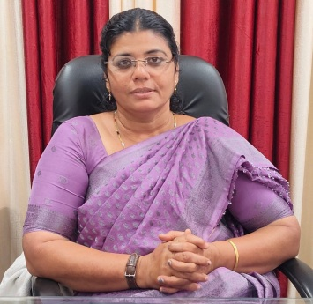
സന്ദേശം
പ്രീ എപ്പിഡെമിക് തയ്യറെടുപ്പ് സന്ദേശം
പ്രിയമിത്രങ്ങളെ
സാധ്യമായ മഹാമാരി/ വ്യാധി വ്യാപനത്തെ മുന്നിൽ കണ്ടുകൊണ്ട് എല്ലാവരും ജാഗ്രത പാലിക്കണം. വ്യക്തിഗത ശുചിത്വം ക്യത്യമായി പാലിക്കുക, കൈകൾ ഇടക്കിടക്ക് സോപ്പ് ഉപയോഗിച്ച് കഴുകുക, ചുമയൊ തുമ്മലൊ വന്നാൽ മാസ്ക് ധരിക്കുക അനാവശ്യ യാത്രകളും തിരക്കുകളും ഒഴിവാക്കുക. ആരോഗ്യ വകുപ്പിൻ്റെ നിർദ്ദേശങ്ങൾ കർശനമായി പാലിക്കുക. ലക്ഷണങ്ങൾ കണ്ടാൽ ഉടൻ സമീപത്തുള്ള ആരോഗ്യകേന്ദ്രവുമായി ബന്ധപ്പെടുക.എല്ലാവരുടെയും സഹകരണം രോഗവ്യാപനം തടയാൻ സഹായകമാണ്. ഇങ്ങനെ ഒരു പ്രീ എപ്പിഡെമിക്ക് തയ്യറെടുപ്പ് നടത്തുന്നതിനു എല്ലാ വിധ ആശംസകളും നേരുന്നു

റീനാ സാമുവൽ

MESSAGE FROM HEALTH STANDING COMMITTEE CHAIR


സന്ദേശം
വരാനിടയുള്ള പകർച്ച് വ്യാധിയെ പ്രതിരോധിക്കുന്നതിനായി എല്ലാവരും മുങ്കരുതലുകൾ സ്വീകരിക്കേണ്ടതാണ്. വീട്ടിലും പരിസരങ്ങളിലും ശുചിത്വം ഉറപ്പാക്കുക. ശുദ്ധജലം മാത്രം ഉപയോഗിക്കുക. കൈകൽ സോപ്പ്/ സാനിറ്റൈസർ ഉപ്യോഗിച്ച് ഇടക്കിടക്ക് വ്യത്തിയാക്കുക. പനി, ചുമ, ശ്വാസ് തടസം തുടങ്ങിയ ലക്ഷണങ്ങൾ കണ്ടാൽ സ്വയം ചികിൽസ ഒഴിവാക്കി ഉടൻ ആരോഗ്യ പ്രവർത്ത്കരെ വിവരം അറിയിക്കുക. സർക്കാർ- ആരോഗ്യ വകുപ്പ് നിർദ്ദേശങ്ങൾ ക്യത്യമായി പാലിക്കുക. സമൂഹത്തിൻ്റെ സുരക്ഷക്ക് എല്ലാവരുടേയുംസഹകരണം അനിവാര്യം ആണ്.

MESSAGE BY MEDICAL OFFICER
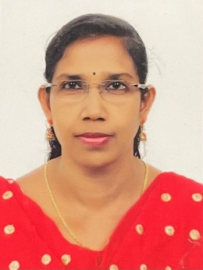

Pandemics can affect any one anywhere, preparedness saves lives. Early detection, honest communication, and community trust are as critical as medicines and ventilators. Stay informed from trusted sources, practice good hygiene, support community efforts protect vulnerable people, and act early when guidance is issued. Preparedness is not panic instead it is a disciplined readiness to protect every life. Preparedness today means resilience tomorrow.

DR.SUNIMOL S
CIVIL SURGEON
CHC ENADIMANGALM

EXECUTIVE SUMMARY

Government General Hospital, Adoor functions as the principal public healthcare institution serving the population of Adoor Municipality, located in Pathanamthitta district. The hospital is a government-run secondary care facility under the Directorate of Health Services, Government of Kerala, providing round-the-clock outpatient, inpatient, emergency, and referral services to the municipal population and adjoining areas. It plays a critical role in delivering accessible and affordable healthcare in alignment with national and state health policies.
The hospital provides general medical and surgical care supported by specialty services including general medicine, paediatrics, obstetrics and gynaecology, orthopaedics, and emergency care. It caters to both routine and emergency health needs of an urban population with mixed socio-economic characteristics. The institution is integrated into the public health delivery system and supports implementation of major national programmes such as the National Health Mission, National Tuberculosis Elimination Programme, and the NPCDCS, contributing to disease prevention, early diagnosis, treatment, and follow-up care.
In the context of pandemic preparedness, Government General Hospital, Adoor functions as a frontline response facility within the district health system. The hospital follows infection prevention and control protocols issued by the Department of Health and Family Welfare, Government of Kerala, including surveillance, triage, isolation, referral, and case management during outbreaks of communicable diseases. Existing emergency services, inpatient capacity, oxygen support systems, and referral linkages with higher centres provide a functional base for surge management during public health emergencies.
The hospital works in coordination with municipal authorities, public health institutions, field health staff, and other government departments to support surveillance, reporting, and response activities during epidemics and pandemics. Disease notification and data reporting are aligned with state and national surveillance mechanisms, enabling timely detection of unusual health events and coordinated response at the municipal and district levels.
Despite increasing service demand and constraints related to infrastructure and manpower, Government General Hospital, Adoor continues to strengthen service delivery through planned infrastructure development, adherence to quality standards, and integration of digital health systems. Ongoing facility expansion and system strengthening initiatives under state and national programmes enhance the hospital’s preparedness to manage future pandemics.
Overall, Government General Hospital, Adoor stands as a vital public health institution for Adoor Municipality, supporting both routine healthcare delivery and organized pandemic preparedness, thereby contributing significantly to the protection of public health and continuity of essential health services during emergencies.

LIST OF ABBREVIATIONS

LSGD/LSGI | Local Self Government Department / Local Self Government Institution
BMO | Block Medical Officer
IDSP | Integrated Disease Surveillance Programme
NDMA | National Disaster Management Authority
PPE | Personal Protective Equipment
ICMR | Indian Council of Medical Research
CD | Communicable Diseases
NCD | NON-COMMUNICABLE Diseases

TABLE OF CONTENTS

3
INTRODUCTION 10
LSGD AT A GLANCE 10
Integrated Health Infrastructure Map Of Adoor Municipality 12
General Profile of Adoor Municipality 15
Demographic and Vulnerable Population 16
Clinical Vulnerability 18
INFRASTRUCTURE & RESOURCE INVENTORY 19
Health Facility Directory & Basic Capacity in Adoor 19
Private Clinics 20
Healthcare Education & Training Institutions 21
Specialized Services & Emergency Inventory 21
Oxygen & Diagnostic Capacity 22
Diagnostics facility mapping at Adoor Muncipality 23
Laboratory Identification & Basic Details-Adoor 23
Social and Community Infrastructure for surge plan 24
Human resources 27
Community & Support Cadre 29
Community Organizations 30
Administrative & Emergency Services 31
Information regarding resources 31
ONE HEALTH & ENVIRONMENTAL SURVEILLANCE 32
Animal & Bird Population 32
Veterinary Infrastructure 34
Veterinary Doctors & Workforce 34
High-Risk Interface Points (Surveillance Sites) 35
Environmental Risk Mapping 37
Disease Seasonality Mapping 38
Vulnerability Mapping 39
EPIDEMIOLOGICAL TRENDS (2021–2025) 40
Disease Burden among human beings(Last 5 Years) 40
Seasonal Trend Analysis 42
Outcome-Based Trend Analysis- 2025 49
Transmission Trend- 2025 50
Integrated Disease Hotspot Map (2021–2025) 53
Disease Burden Percentage Table (2021–2025) 55
Preparedness and Response Protocol at Adoor 56
Constitution of One Health Committee 56
Pandemic Response Workforce 57
Activities and Measures before and during Pandemic 59
PHASE 1 - Alert / Preparation 59
PHASE 2 - Active Response 62
Standard Screening Protocol 63
PHASE 3 - Surge Capacity 73
Conversion of Community Facilities 73
CONCLUSION 74
RECOMMENDATIONS 76
ANNEXURE 78
1. IMPORTANT PHONE NUMBERS 78

INTRODUCTION
Community Health Centre (CHC), Enadimangalam is a key public health institution situated in Enadimangalam Grama Panchayath, functioning under the Enadimangalam health block in Pathanamthitta district of Kerala. The CHC plays a pivotal role in the planning, implementation, and monitoring of all public health activities within Adoor Municipality, ensuring comprehensive coverage of preventive, promotive, and curative health services.
All public health activities under the jurisdiction are carried out under the supervision and administrative leadership of the Civil Surgeon, who serves as the Medical Officer in charge of CHC Enadimangalam. The institution acts as a coordinating centre for field-level health functionaries, facilitating effective execution of national and state health programmes, disease surveillance, outbreak response, and community-based interventions.
A systematic review mechanism is in place through the weekly Integrated Disease Surveillance Programme (IDSP) meetings conducted at CHC Enadimangalam. These meetings enable regular monitoring of disease trends, early identification of outbreaks, and timely public health response. The Health Inspector at CHC Enadimangalam plays a crucial role in coordinating field activities, supervising sanitation and vector control measures, and ensuring effective implementation of surveillance and control strategies at the grassroots level.
Through its structured administrative framework and coordinated approach, CHC Enadimangalam significantly contributes to strengthening public health systems in Adoor Municipality, enhancing preparedness, and ensuring timely response to routine health needs as well as public health emergencies.

LSGD AT A GLANCE
- Geographical boundaries with political map ( based on latest delimitation)
- Baseline data
- Ward division

Ward | Houses | Population | Migrants | Wells | Hot  spots | Ed. Institutions | Hosp pvt/govt.
29 | 9322 | 33217 | 2350 | 8771 | 0 | 54 | 3/1

- Risk stratification among wards in the context of Communicable diseases and hazards
- Major Roads/rivers
- Major establishments with geospatial mapping
- occupational groups, socio cultural groups, migration & mobility patterns
- Vulnerability mapping
- Disaster prone areas (geographic vulnerability)

Maps - ward-based (Mention source also)

- Geographical boundaries - ward boundaries map
- Health infrastructure map
- roads and rivers map
- major establishments map
- disaster-prone areas map
- hotspot map - CD & disasters

Integrated Health Infrastructure Map Of Adoor Municipality

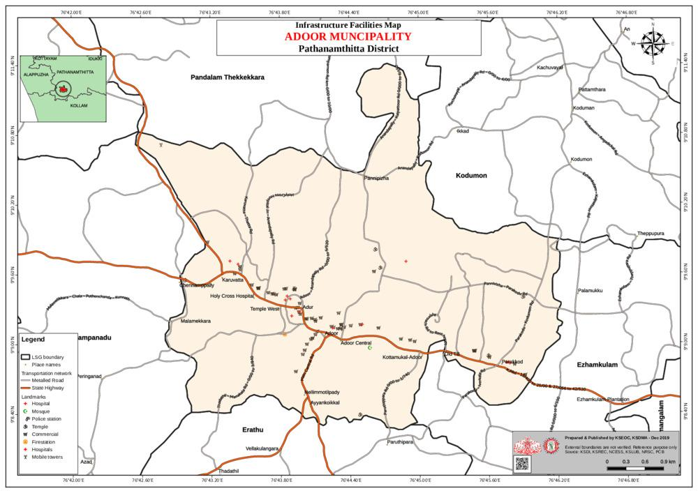
Health Infrastructure Map
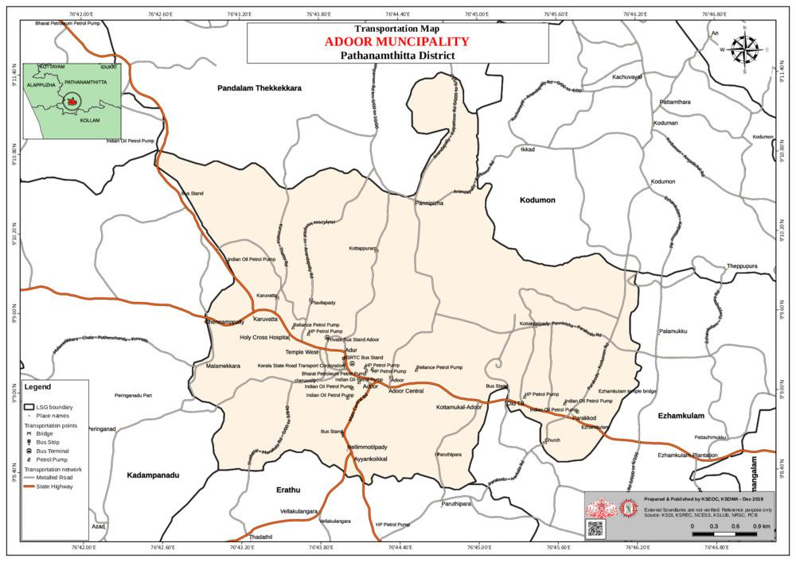
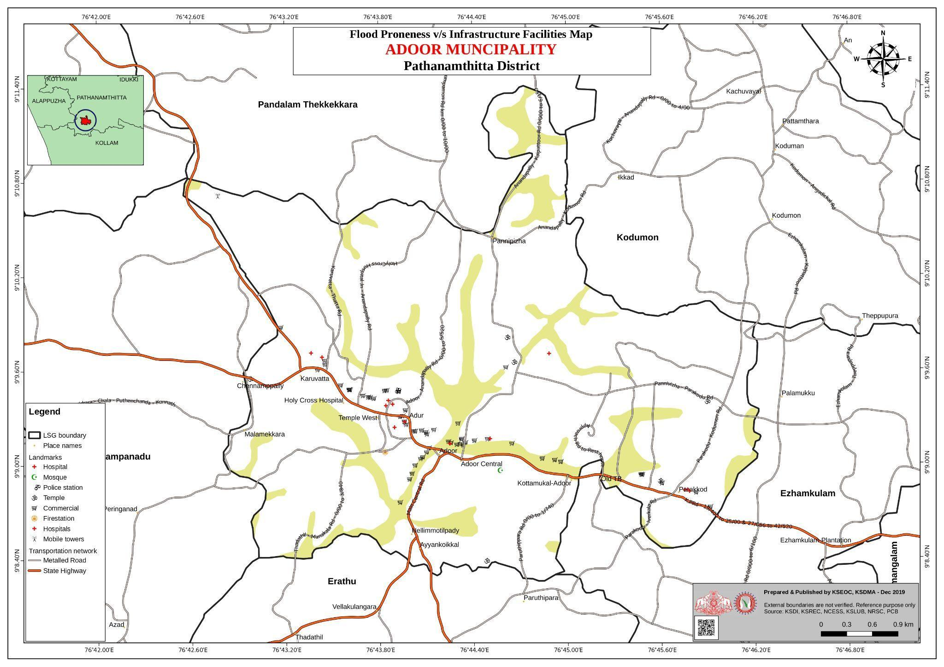
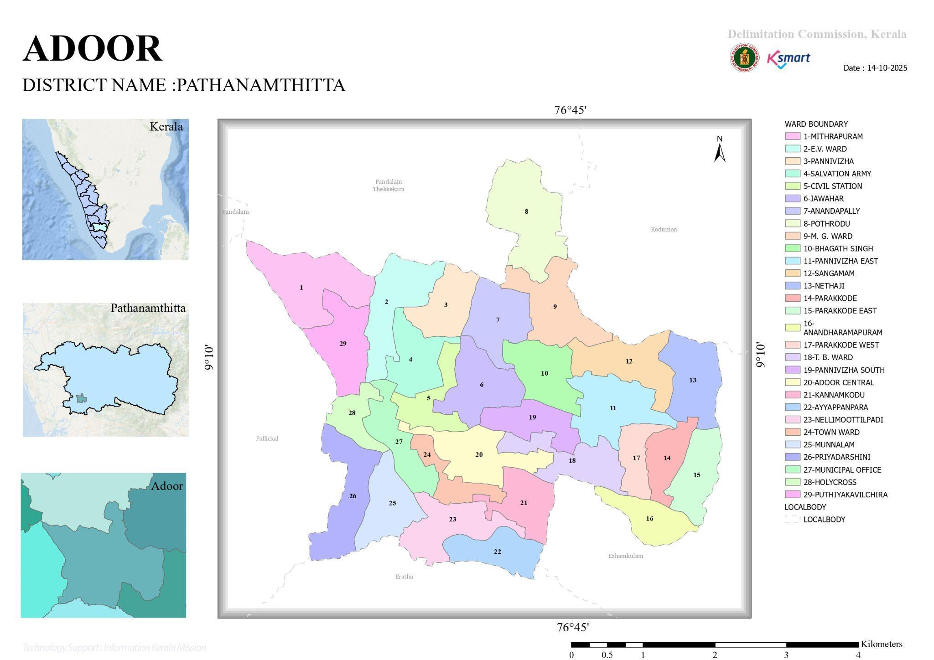

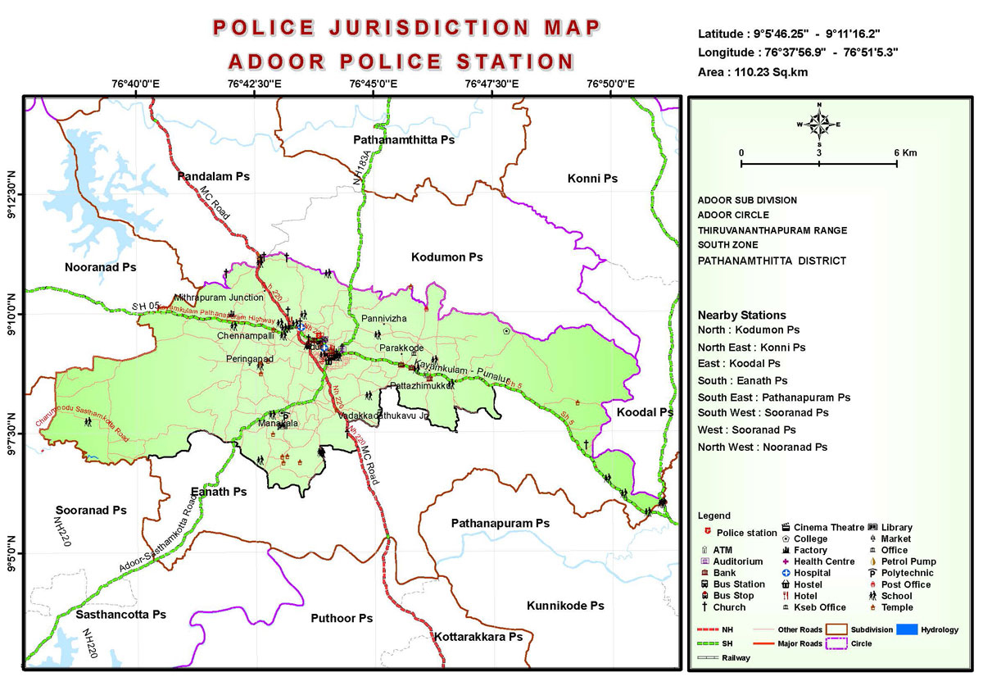

General Profile of Adoor Municipality

Adoor Municipality is situated in the central part of Pathanamthitta district, in the midland region of the state of Kerala. The geographical landscape of the municipality is predominantly undulating midland terrain, characterized by laterite soil, gentle hillocks, mixed residential settlements, and scattered low-lying areas along local streams and drainage channels. Unlike the coastal and deltaic regions of Kerala, Adoor does not have extensive kole lands or backwaters; however, seasonal waterlogging occurs in certain pockets during periods of intense monsoon rainfall. The terrain and road network influence transportation, emergency access, and service delivery, particularly during heavy rains.
Administratively, Adoor Municipality is divided into multiple wards and functions as an important urban centre in the district. The population is largely dependent on non-agricultural livelihoods, with a significant proportion engaged in trade, small businesses, services, transport, government and private sector employment. Agriculture is limited and mainly consists of homestead farming, rubber cultivation, coconut, and other mixed crops in peripheral areas. The municipality also supports a diverse workforce, including migrant labourers, especially in construction, retail trade, hospitality, and allied service sectors.
From a public health and disaster management perspective, Adoor Municipality is vulnerable to monsoon-related hazards, including urban flooding, disruption of essential services, and increased risk of communicable diseases. Seasonal outbreaks of vector-borne diseases such as Dengue and waterborne diseases have been reported, particularly during and after the monsoon season. The impacts of the 2018 Kerala floods were felt in the municipality through disruption of transport, damage to infrastructure, and strain on health and civic services, highlighting systemic vulnerabilities even in urban local bodies located away from major river floodplains.
These recurring climatic and public health challenges underscore the need for strengthened preparedness, coordinated response mechanisms, and resilient urban planning. In this context, the development of a localized, data-driven Auxiliary Infrastructure and Logistical Resource Map is essential for Adoor Municipality. Such a resource supports evidence-based planning, facilitates timely emergency response, improves accessibility to critical services during disasters, and enhances coordination among departments, thereby contributing to long-term resilience and sustainable urban development.

Table 1: Background of Adoor
Description | Details
Name of LSGI | ADOOR MUNCIPALITY
Type (GP/Municipality / Corporation etc.) | MUNCIPALITY
TALUK | ADOOR
District | PATHANAMTHITTA
Number of wards | 29
Total area (sq. km) | 20.42 sq. km
Population(Projected) | 29171
Population density | persons/sq km
Terrain (coastal/low-lying/backwaters/foothills, etc.) | FOOTHILLS
Number of rivers passing through LSGI | 0
Number of water bodies in the LSGI | 0
Number of educational institutions | 54
Factories / small-scale industries | 0
Flood-prone wards | 8,9,24,25,27
Landslide-prone wards | 0
Death Management and Disposal Facilities (mortuaries/crematorium, including electric) | 1
Auditoriums/Marriage halls/convention centres/community halls | 9

Demographic and Vulnerable Population
Understanding the demographic composition and vulnerable population groups is essential for pandemic preparedness. Children, elderly, economically deprived families, migrant workers, and socially vulnerable groups are at increased risk during public health emergencies due to higher exposure, limited access to services, and dependency on public systems..

Description (Adoor) |  | Details (in numbers)
DEMOGRAPHIC PROFILE
Total population |  | 33217
Male |  | 15967
Female |  | 17250
Transgender |  | 0
Children under 5 |  | 1124
Adolescent |  | 1178
Elderly (>60) |  | 8248
SOCIAL/LIVELIHOOD VULNERABILITY
Previous EPEP family |  | 0
BPL family |  | 2421
Tribal communities |  | 38
Migration | Immigrant
Migration | Emigrant
Socio-economically deprived |  | 0
Fisherfolk |  | 0
SC Community |  | 3621
ST Community |  | 38

Graphs: Population pyramid (if possible) for seeing if your LSGI has a high "dependency ratio" (lots of children and elderly compared to working adults).

Clinical Vulnerability
Certain population groups needs priority healthcare & are at higher risk of severe illness, complications, and mortality during pandemics. Patients with chronic diseases, those requiring regular medical care, and individuals with mobility or functional limitations face challenges in accessing timely care during emergencies. Mapping these groups helps in prioritizing continuity of treatment, medicine stock planning, oxygen support, referral transport, and targeted home-based care.
Description (Adoor) | Details in numbers
Pregnant women | 78
Lactating mothers | 120
Bedbound patients | 115
Patients under palliative care other than bedbound | 84
Patients on Haemodialysis | 10
Patients on CAPD | 4
Cancer patients (currently on treatment) | 88
Haemophilic patients | 0
Mentally challenged | 66
Differently abled | 132
Diabetic patients | 5234
Hypertensive patients | 5622
TB patients | 5

Major Festivals & Events specific to Adoor
(with the possibility of a public gathering)

Sl. No. | Name of festival (Adoor) | Month detailing the periodicity
1 | ADOOR POORAM | JANUARY

INFRASTRUCTURE & RESOURCE INVENTORY

Health Facility Directory & Basic Capacity in Adoor
This section provides an overview of the healthcare infrastructure available within the LSGD area. It outlines the distribution and basic capacity of health facilities that form the backbone of service delivery during routine times and public health emergencies.

Family Health Centres (FHCs) and Community Health Centres (CHCs) generally function as the first point of contact for the community, providing essential outpatient and inpatient services. General Hospitals (GH) and Medical College Hospitals (MCH), where accessible, serve as the main referral centres for advanced diagnostics, specialist care, and critical services during public health emergencies. This inventory helps identify existing strengths, gaps, and potential surge capacity that can be mobilised during a pandemic or disaster.

Table: Health Facility Resource Summary (Adoor)
Sl.no. | Health Facility | Type of Facility (MCH/GH/CHC/FHC/SC etc.) | Contact Number | Total beds | ICU Beds | Oxygen-Supported Beds | No. of Ventilator Support Beds | No. of ambulances
Government Healthcare Facilities
1 | GH ADOOR | GH | 9747909534 | 300 | 35 | 164 | 8 | 1
2 | UHWC Pampettukulam | UHWC
3 | UHWC Parakode | UHWC
4 | HWC Kannamkode | SC
5 | HWC Parakode | SC
6 | HWC Pannivizha | SC
7 | HWC Chiranikkal | SC
8 | HWC Ambedkar Colony | SC
9 | HWC Karuvatta | SC
Private Healthcare Facilities
1 | Maria Hospital | PRIVATE | 04734 278 100 | 60 | 6 | 10 | 1 | 0
2 | Holycross Hospital | Private | 04734 234 500 | 200 | 8 | 8 | 1 | 0
AYUSH Healthcare Facilities
1 | NHM Ayurveda Hospital | Govt | 9747664422 | 0 | 0 | 0 | 0 | 0
2 | NHM Homeo Dispensary | Govt | 9495816683 | 0 | 0 | 0 | 0 | 0

Private Clinics
Private clinics are an essential part of pandemic preparedness, as they are often the first place people seek care when symptoms begin. In many communities, private clinics manage a significant share of outpatient visits and therefore play a critical role in early case detection, timely referrals, and disease surveillance. Having an up-to-date understanding of where these clinics are located, the services they provide, and how they are linked to the public health system helps ensure that no cases are missed during an outbreak. It also allows health authorities to engage private practitioners more effectively for reporting, risk communication, and coordinated response, strengthening the overall capacity of the health system to manage public health emergencies.

Table: Private Clinic Resource Summary (Adoor)
Sl No. | Name of Clinic | Registered (Y/N) | Clinic (General / Speciality) | Speciality (if any) | Address | Contact Number | Diagnostic Facility (Y/N) | Ambulance Linkage (Y/N)
1 | Jeevan Homeo Clinic | Yes | General | NO | Jeevan Homeo Clinic,Adoor | 9847350703 | YES | NO
2 | Medical Center | Yes | General | NO | Medical Center,Parakode | 04734216606 | YES | NO

Healthcare Education & Training Institutions
This section tracks the educational infrastructure available, which is vital for human resource planning in the health sector.

Category of Institution (Adoor) | Govt | Private | AYUSH | Total
Medical Colleges | 0 | 0 | 0 | 0
Nursing Colleges | 0 | 1 | 0 | 1
Dental Colleges | 0 | 0 | 0 | 0
Para-medical / Allied Health | 0 | 0 | 0 | 0
Pharmacy Colleges | 0 | 0 | 0 | 0

Specialized Services & Emergency Inventory
This section provides a detailed view of the specialized medical resources available to the community, focusing on emergency response and critical care capabilities. This table tracks the vital assets required for managing severe illnesses and emergencies across Government, Private, and AYUSH sectors.

Item (Adoor) | Govt | Private | AYUSH | Total
Hospital beds | 300 | 260 | 0 | 560
Oxygen-generating systems(Y/N) | Y | N | 0 | 0
Oxygen-supported beds(Numbers) | 164 | 16 | 0 | 270
Ventilator-supported beds | 8 | 2 | 0 | 10
ICU beds | 35 | 14 | 0 | 49
Burns units | 1 | 0 | 0 | 1
Blood centres | 1 | 1 | 0 | 2
BLS ambulances | 1 | 1 | 0 | 2
ALS ambulances | 0 | 0 | 0 | 0
Dialysis facilities | 1 | 2 | 0 | 3
Dispensaries | 2 | 4 | 2 | 8
Medical store | 2 | 18 | 0 | 20
Industrial establishments(Medium-scale industries/small-scale industries establishments to whom we can depend in a worst-case scenario) | NIL | 0 | 0 | 0

Oxygen & Diagnostic Capacity
Monitoring oxygen and diagnostic capacity is a critical component of public health preparedness, ensuring that the LSGD can handle both chronic care and sudden surges in respiratory or infectious diseases.
Name of Health Facility (Adoor) | Oxygen-generating System (Y/N) | Backup Oxygen Source (Y/N) | Diagnostic Facilities Available(Y/N)
Name of Health Facility (Adoor) | Oxygen-generating System (Y/N) | Backup Oxygen Source (Y/N) | Lab | USG | X-ray | CT/MRI | RT-PCR
Government Healthcare Facilities
GH Adoor | Y | Y | 1 | 1 | 1 | 1 | 0
Holycross Hospital | N | Y | 1 | 1 | 1 | 0 | 1
Mariya Hospital | N | Y | 1 | 1 | 1 | 0 | 1

Diagnostics facility mapping at Adoor Muncipality
The diagnostic capacity of Municipality represents the "intelligence network" of our healthcare system. The speed and accuracy of disease identification depend entirely on the distribution and technical level of these facilities.

Item (Adoor) | Govt | Private | AYUSH | Total
General labs | 1 | 2 | 0 | 3
Microbiology labs | 1 | 2 | 0 | 3
RT-PCR labs | 0 | 2 | 0 | 2
USG units | 1 | 2 | 0 | 3
CT/MRI units | 1 | 0 | 0 | 1
Research labs | 0 | 0 | 0 | 0
Labs of other departments that can be repurposed | 0 | 0 | 0 | 0

Laboratory Identification & Basic Details-Adoor
Sl. No. | Name of Laboratory | Ownership (Govt / Private / Academic) | Address | Contact No. | 24×7 Services (Yes/No) | NABL / Govt Approved (Yes/No)
1 | Mar Gregorius Clinical Laboratory | PVT | Mar Gregorius Clinical Laboratory,Naer Adoor | 0468228191 | NO | YES
2 | Kairali Medi Lab | PVT | Kairali Medi Lab,Sndp Building,Adoor | 9447564214 | NO | YES
3 | DDRC | PVT | Ddrc ,Near Private Bus Stand,Adoor | 9446508500 | NO | YES
4 | Janatha Clinical Laborotary | PVT | Janatha Clinical Laborotary,Adoor | 9447256916 | NO | YES
5 | Micro Lab | PVT | Micro Lab,Near Pvt Bus Stand,Adoor | 04734296555 | NO | YES
6 | Dr.Ajis Scanning Center | PVT | Dr.Ajis Scanning Center,Adoor | 04734224060 | NO | YES
7 | St.Marys Scan | PVT | St.Marys Scan,Adoor | 94471144197 | NO | YES
8 | Alpha Diagnostic | PVT | Alpha Diagnostic,Adoor | 8281933604 | NO | YES
9 | Devis Scan Center | PVT | Devis Scan Center | - | NO | YES

Social and Community Infrastructure for surge plan
This table serves as our logistics and shelter inventory. By mapping these locations, quickly we can identify where to house displaced citizens, where to set up temporary medical clinics, and how to manage the deceased with dignity during a crisis.

Category (Adoor) | Total Count | Ward | Est. Capacity (Persons) | Contact details
Educational Institutions
Anganwadis | 23 | ALL WARDS | 350 | 9747284010
Schools | 11 | ALL WARDS | 1000 | 04734 226 872
Colleges | 5 | ALL WARDS | 550 | 04734-224076
Healthcare Educational Institutions
Medical colleges (Govt/Private) | 0 | 0 | 0 | 0
Nursing colleges (Govt/Private) | 1 | 5 | 70 | 0474234500
Dental colleges (Govt/Private) | 0 | 0 | 0 | 0
Paramedical institutes (Govt/Private) | 0 | 0 | 0 | 0
Community Gathering Spaces
Community halls | 3 | 18 | 160 | 04734228845
Auditoriums | 6 | 16 | 250 | 04734217374
Religious buildings | 22 | ALL WARDS | 1050 | 9447055220
Vulnerable Group Support Facility
Destitute homes | 0 | 0 | 0 | 0
Elderly homes | 2 | 3 | 35 | -
LSGD owned other buildings | 1 | 0 | 0 | 0
Mass Fatality Management (MFM) Infrastructure
Mortuary | 1 | 24 | 300 | 04734224843
Crematorium | 0 | 0 | 0 | 0
*refer annexure 1 for contact details

Human resources
This section focuses on the human capital available within the LSGI. In any emergency—be it a pandemic, flood, or industrial accident—infrastructure is only as effective as the people operating it.

Medical & Clinical Personnel
This table tracks the "Frontline" providers responsible for diagnosis, treatment, and clinical management. Narrative sentence: eg., "Total health workforce: 450 personnel, with 60% in government facilities serving as primary surge capacity." A detailed directory with the contact numbers of all workers is maintained (Annexure in 1).

Cadre (Adoor) | Govt (No.) | Private (No.) | Total
Doctors—Modern Medicine | 10 | 72 | 82
Doctors – AYUSH | 1 | 2 | 3
Doctors – Veterinary | 1 | 1 | 2
Doctors – Dental | 0 | 8 | 8
Nursing officers | 12 | 128 | 140
Lab technicians | 3 | 8 | 11
Optometrist | 1 | 2 | 3
Pharmacists | 3 | 8 | 11
Psychologists | 0 | 0 | 0
Counsellors | 1 | 0 | 0

Public Health & Field-Level Workforce
These individuals are the backbone of surveillance, maternal-child health, and decentralized care.

Cadre (Adoor) | Health services | Municipal common services | Total
HS (Health Supervisors) | 0 | 1 | 1
HI (Health Inspectors) | 0 | 2 | 2
LHS (Lady Health Supervisor) | 0 | 0 | 0
LHI (Lady Health Inspectors) | 1 | 0 | 1
JPHN (Jr Public Health Nurses) | 7 | 0 | 1
JHI (Jr Health Inspectors) | 3 | 6 | 9
MLSP (Mid-Level Service Providers) | 0 | 0 | 0
Palliative Nurses | 0 | 0 | 0
RBSK Nurses | 1 | 0 | 0
PRO | 1 | 0 | 1
Epidemiologist | 0 | 0 | 0
Data Manager | 0 | 0 | 0

Community & Support Cadre
This group represents the surge capacity of the LSGI—people who can be called upon for logistics, rescue, and specialized support.

Cadre (Adoor) | Number
ASHA Workers | 36
AWW (Anganwadi Workers) | 23
Emergency Medical Volunteers (Trained) | 0
Kudumbashree | 220
MNREGS | 0
Purusha Swayam Sahaya Sangham | 0
Ex-Servicemen
Retired Police Officers | 4
NCC/NSS Volunteers | 35
Red Cross volunteers | 4
One Health Community Volunteers | 1250
One Health Community Mentors | 196

Community Organizations
This section details the presence of community-based organisations (CBOs), non-governmental organisations (NGOs), faith-based organisations (FBOs), Kudumbashree Self-Help Groups (SHGs), and Ayalkootams within the Local Self-Government Institution (LSGI). These groups enhance grassroots mobilization, resource distribution, and support networks crucial for pandemic response and community resilience.

Category (Adoor) | Total Count
NGOs | 45
Religious based organizations | 35
Foreign based organizations | 0
Sports Club/youth clubs | 5
Kudumbashree SHGs | 220
Ayalkootams | 110
Political organizations | 3
Residential organizations | 18

Administrative & Emergency Services
This section outlines the availability of key non-health emergency support services and infrastructure within the LSGI, which are essential for effective pandemic preparedness and response. These facilities support law enforcement, disaster response, water supply, logistics, mobility, and community-level interventions during public health emergencies.

Category (Adoor) | Total Count | Contact details
Police Stations | 1 | 04734 224829
Fire & Rescue Stations | 1 | 04734229100
Water Pumping Points | 2 | 9446651187
Public Distribution System (PDS) | 1 | 04734 224 826

Information regarding resources
The availability of essential transport and support resources plays a quiet but critical role in saving lives. Equipment such as ambulances, mobile mortuaries, amphibian ambulances, and motorized boats ensures that patients, samples, and healthcare teams can move swiftly—even in flooded, remote, or difficult terrains. Heavy vehicles like JCBs, cranes, tractors, and torus lorries support logistics, waste management, emergency infrastructure, and rapid conversion of spaces into care or isolation facilities. Taxis, four-wheel-drive vehicles, and trucks help maintain continuity of essential services, reach vulnerable populations, and support home-based care and supply delivery.

Means of transportation (Adoor) | Total Count
JCB | 3
Crane | 0
Heavy Trucks | 3
Tractor | 1
Ambulances | 8
Mobile mortuaries | 2
Boats | 0
Taxi service | 9
Note: For specific details regarding vehicle owners and contact information, please refer to Annexure [X].

ONE HEALTH & ENVIRONMENTAL SURVEILLANCE
The One Health method integrates environmental, animal, and human health to enable proactive pandemic preparedness. Panchayat-level surveillance needs to be improved in order to detect and treat zoonotic and environmentally generated diseases early. Surveillance is strengthened through systematic assessment of animal populations, veterinary infrastructure, poultry and slaughter facilities, inter-sectoral coordination, and specialised tools like avian influenza seasonality mapping using GIS in previous outbreaks to enable predictive alerts and ward-specific sampling to support effective pandemic preparedness in high-risk areas like ____________.

Animal & Bird Population
Mapping animal and bird populations at the Panchayat level is essential for identifying and prioritising zoonotic disease hazards like rabies, avian influenza (H5N1), leptospirosis, anthrax, and Nipah-like spillover occurrences. Risk classification, targeted surveillance, vaccination planning, and early epidemic detection made feasible by comprehensive population mapping all enhance One Health-based pandemic preparedness.

Category (Adoor) | Item | Estimated Population | Wards
Animal Population | Livestock (Cattle/Goats/Buffalo) | CATTLE&BUFFALO-957/  GOAT-1822 | ALL WARDS
Animal Population | Pet Animals (Dogs/Cats) | 1475 | ALL WARDS
Animal Population | Stray Dog Population | 534 | ALL WARDS
Animal Population | Pig Farms (Number of heads) | 0 | 0
 | Small Units (Sheep / Goats – clustered) | 1272 | ALL WARDS
Bird Population | Poultry Units (Birds) | 8 | ALL WARDS
Bird Population | Poultry- (FOWL) | 0 | 0
Bird Population | Wild/Migratory Birds (Observed) | 0 | 0
Bird Population | Crow Mortality Events (Reported) | 0 | 0

The main risk of zoonotic diseases in ____________ is concentrated in Wards………………., which is explained by the high density of pig farms, cattle congregation areas, and poultry units. The stray dog population in market areas, fish landing sites, bus stations continues to be a substantial problem for rabies surveillance and bite prevention. There is a considerable risk of avian influenza introduction and amplification during November - December due to the seasonal presence of migratory and resident water birds near ponds/ canal / river / backwater / paddy field. Clusters of pig farms and animal shelters vulnerable to flooding further raise the risk of leptospirosis and other zoonoses mediated by the environment, especially during monsoon floods.

Veterinary Infrastructure
Veterinary institutions are a core pillar of One Health surveillance, enabling early zoonotic disease detection through vaccination, investigation of unusual animal illness or deaths, sample collection, and timely outbreak reporting. A well-mapped and responsive veterinary network strengthens coordination with human health and LSGI systems, ensuring rapid response during zoonotic events and pandemics.
Facility Type(Adoor) | Name of Facility | Ownership Govt / Pvt | Location(Ward No) | Contact number
Veterinary Dispensary | 0 | 0 | 0 | 0
Veterinary Hospital / Polyclinic | Veterinary Polyclinic | GOVT | - | 95447441627
Private Veterinary Clinics | Veterinary polyclinic, Moonalam, Adoor | PVT | - | 04734 223 445
Mobile / Emergency Vet Service (incl. night services) | 0 | 0 | 0 | 0
Pet Homes / Animal Shelters | 0 | 0 | 0 | 0
Slaughterhouse-linked Veterinary Inspection Unit | 0 | 0 | 0 | 0

Veterinary Doctors & Workforce
Early detection, diagnosis, reporting, and reaction to animal illness epidemics depend on the availability and accessibility of qualified veterinary specialists. By identifying unusual animal morbidity or mortality promptly, collecting samples promptly, and coordinating efficiently with human health and LSGI systems—especially during zoonotic outbreaks and pandemic-prone situations—a clearly defined veterinary workforce enhances One Health surveillance.

Category (Adoor) | Number Available | Type (Govt/Pvt) | Contact number
Government Veterinary Doctors | 1 | GOVT | 95447441627
Private Veterinary Doctors | 1 | PVT | 04734 223 445
Livestock Inspectors | 1 | GOVT | 95447441627
Para-veterinary Staff / Attenders | 0 | 0 | 0
Contract / On-call Veterinary Support (if any) | 0 | 0 | 0

High-Risk Interface Points (Surveillance Sites)
High-risk interface points for zoonotic disease surveillance in Adoor Municipality include wetland–livestock–human contact zones, backyard poultry farms, cattle sheds near water bodies, fish markets, and areas of high human–animal interaction such as community slaughter points and migratory bird congregation sites. These are the primary surveillance sites where zoonotic spillover risks are elevated.

Type of Habitat (Adoor) | Type of High risk interface | Geographical vulnerability
Wetlands & Backwaters | 0 | 0
Backyard Poultry Farms | 0 | 0
Cattle Sheds near Water Bodies | 0 | 0
Fish & Meat Markets | 2 | 0
Community Slaughter Sites | 0 | 0
Migratory Bird Congregation Areas | 0 | 0
Rodent-Infested Grain Storage | 0 | 0

Category (Adoor) | Total Count | Key Locations (wards)
Poultry Farms | 8 | ALL WARDS
Backyard / Clustered Poultry Units | 0 | 0
Duck Rearing Units (open water access) | 0 | 0
Slaughterhouses/ Slaughter Points | 0 | 0
Meat/Fish Markets | 2 | 14
Live Bird Sale Points | 0 | 0
Cattle Markets / Weekly Animal Fairs | 0 | 0
Pet Shops / Breeders | 1 | 14
Animal Shelters / Pet Homes | 0 | 0
Waste Disposal Sites near Animal Units | 0 | 0

Environmental Risk Mapping
Environmental risk mapping identifies monsoon/flood hotspots for vector-borne (dengue, chikungunya), water-borne (leptospirosis, diarrhoea), and zoonotic diseases in Kerala's wetlands. Systematic surveillance supports early warnings, targeted interventions, and LSGD pandemic preparedness.
Waterborne exposure: Flood-prone areas and stagnant water bodies facilitate leptospira survival, raising leptospirosis risk.

Traditional practices: Informal slaughter and fish markets lack standardized hygiene, creating spillover opportunities.

Risk Factor (Adoor) | High-Risk Wards | Key Locations | Risk Level (High/Med/Low)
Flood-prone areas | 8,9,24,27 | Prothrad, MG Ward, Town Ward, Muncipal Office | Low
Water bodies/wetlands | 8,9,24,25 | Prothrad, Moonalam, Pannivizha, Karuvatta | LOW
Solid waste accumulation | 14 | Parakode | LOW
Animal waste disposal issues | 3,4,10,12,13,16 | Pannivizha, Salvation Army, Bhgat Singh, Sangamam, Netaji, Anatharampuram | LOW
Rodent infestation zones | 0 | 0 | 0
Industrial effluent discharge | 0 | 0 | 0
Construction sites / abandoned buildings | 0 | 0 | 0
Poor drainage/blocked canals | 0 | 0 | 0
Drinking water source contamination risk | 0 | 0 | 0

Disease Seasonality Mapping
- Flooding & waterlogging → amplifies leptospirosis, malaria, diarrheal diseases.
- Migratory bird influx (Nov–Feb) → avian influenza risk.
- Mosquito breeding cycles → vector-borne disease peaks in monsoon.
- Agricultural practices → close human–animal contact in paddy fields.

Disease (Adoor) | Peak Risk Season | Key Drivers | High-Risk Locations | Surveillance Focus
Avian Influenza | 0 | 0 | 0 | 0
Leptospirosis | 0 | 0 | 0 | 0
Dengue/Chikungunya | 0 | 0 | 0 | 0
Acute Diarrheal Diseases | 0 | 0 | 0 | 0
Rabies | 0 | 0 | 0 | 0
Anthrax (rare) | 0 | 0 | 0 | 0

Vulnerability Mapping
Vulnerability mapping pinpoints high-risk populations, occupations, and areas exposed via environment, livelihoods, socio-economics, and poor service access. Paired with environmental/seasonality mapping, it enables risk-based surveillance, targeted actions, and optimal resource use in One Health and pandemic planning.
Vulnerability Factor (Adoor) | High-Risk Wards | Key Groups / Locations | Risk Level
Flood-prone households | 8,9,24,25,27 | Prothrad, MG Ward, Town Ward, Muncipal Office | LOW
Wetland-adjacent communities | 0 | 0 | 0
Backyard poultry / duck rearing households | 0 | 0 | 0
Livestock-rearing households | 0 | 0 | 0
Slaughterhouse & meat market workers | 14 | PARAKODE | LOW
Fisherfolk & fish market workers | 0 | 0 | 0
Sanitation workers | 0 | 0 | 0
Daily wage / migrant workers | 2350 | ALL WARDS | LOW
Elderly & chronically ill populations | 0 | 0 | 0
Pregnant Women | 78 | ALL WARDS | LOW
Children (schools, Anganwadi’s)
Limited access to safe water & sanitation | 0 | 0 | 0

EPIDEMIOLOGICAL TRENDS (2021–2025)

Disease surveillance is the systematic collection, analysis, and interpretation of health data for planning, implementation, and evaluation of public health practice. This section presents the disease surveillance profile of the LSGI based on routine reporting systems and outbreak investigations to identify priority diseases, seasonal patterns, and emerging public health threats.

Disease Burden among human beings(Last 5 Years)
Analysis of disease-wise data for the last five years helps identify persistent public health problems, emerging diseases, and changes in disease burden. This information supports prioritisation of prevention, preparedness, and response activities at the Panchayat level.

Disease | 2021 | 2022 | 2023 | 2024 | 2025 | Trend(Increasing/Stable/Decreasing)
Dengue | 3 | 3 | 19 | 90 | 9 | Increasing (with outbreak spike in 2024)
Leptospirosis | 1 | 0 | 0 | 5 | 1 | Stable (sporadic)
Hepatitis A | 1 | 1 | 1 | 3 | 7 | Increasing
Malaria | 0 | 2 | 1 | 0 | 1 | Stable (sporadic)
Scrub Typhus | 0 | 0 | 0 | 0 | 0 | Stable (no cases reported)
Typhoid | 0 | 0 | 0 | 0 | 2 | Increasing (recent emergence)
H1N1 | 0 | 0 | 1 | 10 | 0 | Decreasing (post-outbreak)
H3N2 | 0 | 0 | 0 | 4 | 0 | Decreasing
ADD | 0 | 11 | 9 | 14 | 60 | Increasing
Mumps | 0 | 0 | 0 | 16 | 19 | Increasing
Measles | 0 | 0 | 0 | 0 | 0 | Stable (no cases reported)
Hepatitis B |  | 0 | 0 | 5 | 1 | Stable (low-level detection)
Hepatitis C | 0 | 0 | 0 | 0 | 0 | Stable (no cases reported)
Tuberculosis | 4 | 9 | 9 | 6 | 7 | Increasing
Leprosy | 0 | 0 | 0 | 0 | 0 | Stable (no cases reported)
COVID-19 |  | 0 | 0 | 0 | 2 | Stable (low endemic level)

*(use the above table data to create the graph/diagram)

Seasonal Trend Analysis
Seasonal analysis helps anticipate surges (e.g. dengue in monsoon, leptospirosis after floods, influenza in cooler months) and plan pre‑emptive vector control, stockpiling of IV fluids, and awareness campaigns at Panchayat level.

DENGUE
Dengue is a major seasonal vector-borne disease strongly associated with rainfall, water stagnation, and increased mosquito breeding during the monsoon period.

Peak: July–November

Dengue – Ward-wise Yearly Distribution (2021–2025)

Ward | Dengue – Ward-wise Yearly Distribution
Ward | 2021 | 2022 | 2023 | 2024 | 2025 | Total
1 | 0 | 0 | 0 | 3 | 0 | 3
2 | 1 | 0 | 0 | 3 | 0 | 4
3 | 0 | 1 | 0 | 1 | 0 | 2
4 | 1 | 0 | 0 | 0 | 0 | 1
5 | 0 | 0 | 0 | 2 | 0 | 2
6 | 0 | 0 | 0 | 6 | 0 | 6
7 | 0 | 0 | 0 | 3 | 0 | 3
8 | 0 | 0 | 0 | 2 | 0 | 2
9 | 0 | 0 | 0 | 5 | 0 | 5
10 | 0 | 0 | 0 | 7 | 0 | 7
11 | 0 | 0 | 0 | 0 | 0 | 0
12 | 0 | 0 | 0 | 3 | 0 | 3
13 | 1 | 0 | 0 | 3 | 0 | 4
14 | 0 | 0 | 0 | 0 | 1 | 1
15 | 1 | 0 | 0 | 0 | 1 | 2
16 | 0 | 1 | 0 | 0 | 0 | 1
17 | 0 | 0 | 0 | 0 | 1 | 1
18 | 0 | 0 | 0 | 5 | 0 | 5
19 | 1 | 0 | 0 | 0 | 1 | 2
20 | 0 | 0 | 0 | 5 | 0 | 5
21 | 0 | 0 | 0 | 0 | 0 | 0
22 | 1 | 0 | 8 | 3 | 1 | 13
23 | 0 | 0 | 0 | 2 | 0 | 2
24 | 0 | 0 | 0 | 12 | 1 | 13
25 | 1 | 0 | 8 | 8 | 1 | 18
26 | 0 | 0 | 0 | 5 | 1 | 6
27 | 0 | 0 | 0 | 0 | 1 | 1
28 | 0 | 0 | 0 | 0 | 0 | 0

LEPTOSPIROSIS
Leptospirosis cases are closely linked to monsoon rains, flooding, and occupational exposure, particularly in low-lying and waterlogged areas.

Peak: June - August

Leptospirosis – Ward-wise Yearly Distribution (2021–2025)

Ward | Leptospirosis – Ward-wise Yearly Distribution
Ward | 2021 | 2022 | 2023 | 2024 | 2025 | Total
1 | 0 | 0 | 0 | 1 | 0 | 1
2 | 1 | 0 | 0 | 0 | 0 | 1
3 | 0 | 1 | 0 | 0 | 0 | 1
4 | 0 | 0 | 0 | 0 | 0 | 0
5 | 0 | 0 | 0 | 0 | 0 | 0
6 | 0 | 0 | 0 | 0 | 0 | 0
7 | 0 | 0 | 0 | 0 | 0 | 0
8 | 0 | 1 | 0 | 1 | 0 | 2
9 | 0 | 0 | 0 | 0 | 1 | 1
10 | 0 | 0 | 1 | 0 | 0 | 1
11 | 0 | 0 | 0 | 1 | 0 | 1
12 | 0 | 0 | 0 | 0 | 0 | 0
13 | 0 | 0 | 0 | 0 | 0 | 0
14 | 0 | 0 | 0 | 0 | 1 | 1
15 | 0 | 0 | 0 | 0 | 0 | 0
16 | 0 | 0 | 0 | 0 | 0 | 0
17 | 0 | 0 | 0 | 0 | 0 | 0
18 | 0 | 0 | 0 | 0 | 0 | 0
19 | 0 | 0 | 1 | 0 | 0 | 1
20 | 0 | 0 | 0 | 0 | 0 | 0
21 | 0 | 0 | 0 | 0 | 0 | 0
22 | 0 | 0 | 0 | 0 | 0 | 0
23 | 0 | 0 | 0 | 0 | 0 | 0
24 | 0 | 0 | 0 | 0 | 0 | 0
25 | 0 | 0 | 0 | 0 | 0 | 0
26 | 0 | 0 | 0 | 0 | 0 | 0
27 | 0 | 0 | 0 | 0 | 0 | 0
28 | 0 | 0 | 0 | 0 | 0 | 0

VIRAL HEPATITIS - A
Hepatitis A cases are commonly associated with unsafe drinking water, food contamination, and breakdowns in sanitation, often presenting as clusters or outbreaks.

Peak: October - December

Hepatitis A – Ward-wise Yearly Distribution (2021–2025)

Ward | Hep A – Ward-wise Yearly Distribution
Ward | 2021 | 2022 | 2023 | 2024 | 2025 | Total
1 | 0 | 0 | 0 | 0 | 0 | 0
2 | 0 | 0 | 0 | 0 | 0 | 0
3 | 0 | 0 | 0 | 0 | 0 | 0
4 | 0 | 0 | 0 | 0 | 0 | 0
5 | 0 | 0 | 0 | 0 | 0 | 0
6 | 0 | 0 | 0 | 1 | 0 | 1
7 | 0 | 0 | 0 | 0 | 0 | 0
8 | 0 | 0 | 0 | 0 | 0 | 0
9 | 0 | 0 | 0 | 0 | 0 | 0
10 | 0 | 0 | 0 | 1 | 0 | 1
11 | 0 | 0 | 0 | 0 | 0 | 0
12 | 0 | 0 | 0 | 0 | 0 | 0
13 | 0 | 0 | 0 | 0 | 0 | 0
14 | 0 | 0 | 0 | 0 | 4 | 4
15 | 0 | 0 | 0 | 0 | 0 | 0
16 | 0 | 0 | 0 | 0 | 0 | 0
17 | 0 | 0 | 0 | 0 | 0 | 0
18 | 0 | 0 | 0 | 0 | 0 | 0
19 | 0 | 0 | 0 | 0 | 0 | 0
20 | 0 | 0 | 0 | 0 | 0 | 0
21 | 0 | 0 | 0 | 0 | 0 | 0
22 | 0 | 0 | 0 | 1 | 0 | 1
23 | 0 | 0 | 0 | 0 | 0 | 0
24 | 0 | 0 | 0 | 0 | 0 | 0
25 | 0 | 0 | 0 | 0 | 0 | 0
26 | 0 | 0 | 0 | 0 | 0 | 0
27 | 0 | 0 | 0 | 0 | 0 | 0
28 | 0 | 0 | 0 | 0 | 0 | 0

Outcome-Based Trend Analysis- 2025

Transmission Trend- 2025
For effective management of public health issues, it is important to track the trend of disease transmission mode. It helps identify the population or place at high risk that can be used to predict outbreaks and implement targeted interventions as quickly as possible. Understanding these kinds of trends enables authorities to allocate resources efficiently and change the strategies adequately based on the trend that follows.

Mode of Transmission (Adoor) | No. of cases | No. of Deaths
Vector Borne Diseases | 10 | 0
Water Borne Diseases | 9 | 0
Air Borne Diseases | 12 | 0
Blood Borne Diseases | 1 | 0
Food Borne Diseases | 60 | 0

Vector-Borne Disease

Vector-Borne Disease  (Adoor) | No. of Cases | No. of Deaths
Dengue | 9 | 0
Malaria | 1 | 0
Chikungunya | 0 | 0

Water Borne Disease

Water Borne Disease  (Adoor) | No. of Cases | No. of Deaths
Cholera | 0 | 0
Typhoid | 2 | 0
Hep- A | 7 | 0
Dysentery | 0 | 0
Amoebiasis | 0 | 0
E- Coli infections | 0 | 0
Air Borne Disease

Air Borne Disease  (Adoor) | No. of Cases | No. of Deaths
Influenza | 0 | 0
H1N1 | 0 | 0
TB | 7 | 0
Chickenpox | 16 | 0
Measles | 0 | 0
Covid-19 | 2 | 0
Pertussis | 0 | 0
Mumps | 19 | 0

Blood-Borne Disease

Blood-Borne Disease  (Adoor) | No. of Cases | No. of Deaths
AIDS | 0 | 0
Hep- B | 1 | 0
Hep- C | 0 | 0

Zoonotic Disease

Zoonotic Disease  (Adoor) | No. of Cases | No. of Deaths
Rabies | 0 | 0
Leptospirosis | 2 | 0
Avian influenza | 0 | 0
West nile | 0 | 0
Anthrax | 0 | 0
Nipah | 0 | 0
Scrub Typhus | 0 | 0

Integrated Disease Hotspot Map (2021–2025)
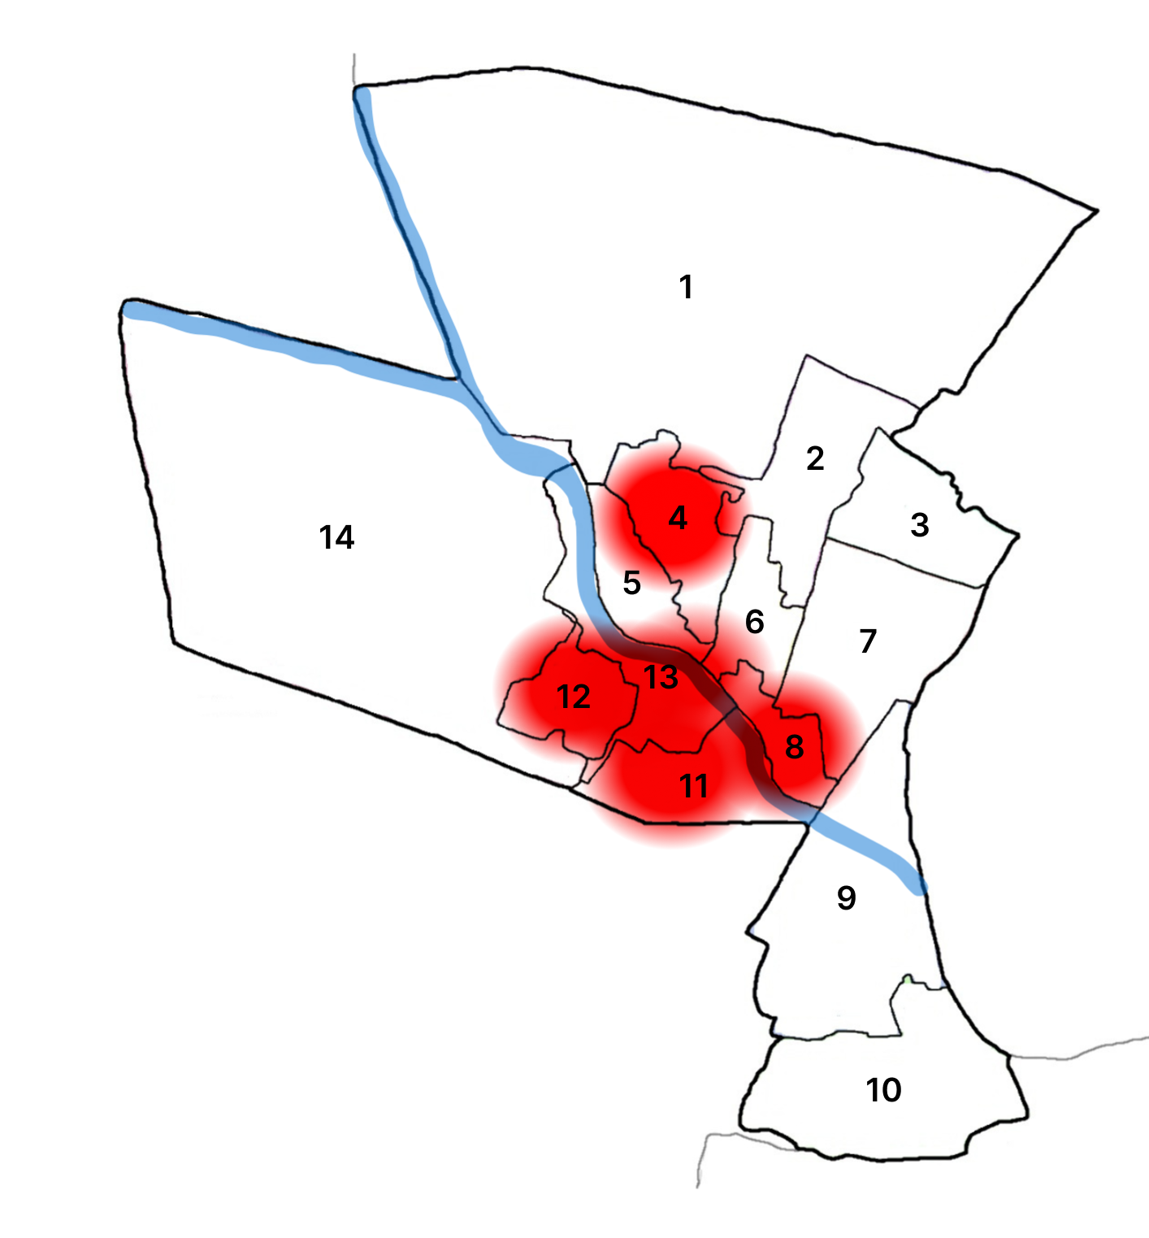

Ward-wise Consolidated Disease Burden (2021–2025)
Ward No | Dengue Total (2021-25) | Leptospirosis Total (2021-25) | Hepatitis A Total (2021-25) | Mumps (2021-25) | ADD (2021-25) | Total Cases
1 | 3 | 1 | 0 | 1 | 2 | 7
2 | 4 | 1 | 0 | 1 | 2 | 8
3 | 2 | 1 | 0 | 1 | 2 | 6
4 | 1 | 0 | 0 | 0 | 1 | 2
5 | 2 | 0 | 0 | 0 | 1 | 3
6 | 6 | 0 | 1 | 1 | 3 | 11
7 | 3 | 0 | 0 | 0 | 2 | 5
8 | 2 | 2 | 0 | 1 | 2 | 7
9 | 5 | 1 | 0 | 1 | 3 | 10
10 | 7 | 1 | 1 | 1 | 3 | 13
11 | 0 | 1 | 0 | 0 | 1 | 2
12 | 3 | 0 | 0 | 0 | 1 | 4
13 | 4 | 0 | 0 | 1 | 2 | 7
14 | 1 | 1 | 4 | 1 | 2 | 9
15 | 2 | 0 | 0 | 0 | 1 | 3
16 | 1 | 0 | 0 | 0 | 1 | 2
17 | 1 | 0 | 0 | 0 | 1 | 2
18 | 5 | 0 | 0 | 1 | 2 | 8
19 | 2 | 1 | 0 | 0 | 1 | 4
20 | 5 | 0 | 0 | 1 | 2 | 8
21 | 0 | 0 | 0 | 0 | 1 | 1
22 | 13 | 0 | 1 | 2 | 4 | 20
23 | 2 | 0 | 0 | 0 | 1 | 3
24 | 13 | 0 | 0 | 2 | 5 | 20
25 | 18 | 0 | 0 | 3 | 6 | 27
26 | 6 | 0 | 0 | 1 | 3 | 10
27 | 1 | 0 | 0 | 0 | 1 | 2
28 | 0 | 0 | 0 | 0 | 1 | 1

By overlaying five years of data, we have identified …………..'Red Zone' Wards. These are wards where at least two different categories of diseases (e.g., Dengue and Lepto) recurred in consecutive years. Ward 4 is categorized as the Highest Priority Hotspot due to its combination of flood vulnerability and high vector density. Future health infrastructure, such as the proposed R.O plants at ………should be prioritized.
Ward No | Dengue Total (2021–25) | Leptospirosis Total (2021–25) | Hepatitis A Total (2021–25) | Mumps (2021–25) | ADD (2021–25) | Total Cases
Total | 122 | 10 | 7 | 19 | 61 | 219

Disease Burden Percentage Table (2021–2025)
Sl. No | Disease | Total Cases | Percentage of Total Cases (%)
1 | Dengue | 122 | 55.7 %
2 | Leptospirosis | 10 | 4.6 %
3 | Hepatitis A | 7 | 3.2 %
4 | Mumps | 19 | 8.7 %
5 | ADD (Acute Diarrhoeal Disease) | 61 | 27.9 %
 | Total | 219 | 100 %

Key Interpretation
- Dengue constitutes the highest disease burden (55.7%), indicating a strong vector-borne disease risk in the municipality.
- ADD contributes 27.9%, suggesting issues related to drinking water quality, sanitation, and seasonal contamination.
- Mumps accounts for 8.7%, indicating occasional localized outbreaks among children and adolescents.
- Leptospirosis and Hepatitis A together contribute about 7.8%, reflecting environmental and water-borne disease risks, especially during monsoon periods.

Preparedness and Response Protocol at Adoor
This section describes the operational framework for the LSGI once a pandemic is declared. It explains how the LSGI and health system will move from routine data collection to active response, using a One Health approach.

Constitution of One Health Committee
The LSGD shall constitute a One Health Committee comprising the LSGI President, Medical Officers (Modern Medicine, AYUSH, and Veterinary), the Health Inspector, and the Veterinary Surgeon.

Objective: The One Health Committee coordinates human, animal, and environmental health to prevent and control pandemics.

Sl No | Name | Designation | Department/Institution | Role in Committee | Contact Number
1 | REENA SAMUEL | MUNCIPALITY | LSGD | Chairperson | 9961627596
2 | DR.Sunimol S | Medical Officer (CHC) | Health Dept | Member Secretary | 9946641173
3 | DR.RACHANA CHIDAMBRAM | Medical Superintendent (GH Adoor) | Health Dept | Member | 9447397198
4 | SAI PRASAD | Veterinary Officer | Animal Husbandry | Member | 0473223445
5 | JAYASREE | Health Inspector/PHN | Health Dept | Surveillance | 9946641173
6 | PUSHPAKUMARI | ASHA Supervisor | Health Dept | Community link | 9847769350
7 | JYOTHI | ICDS Supervisor | Social Welfare | Vulnerable groups | 04734216444
8 | POLICE | Police Station Officer | Police Dept | Law & order | 04734224829
9 | MUMTHAS | Ward Councillor Representative | LSGD | Community coordination | 8086606602
10 | ANU | Kudumbashree CDO | Kudumbashree | Community mobilisation | 7559813699
11 | AFSAL | NGO/Volunteer rep | Civil Society | Support services | 9544890094
12 | - | Line Department representations | - | - | -

Key Responsibilities:
- Review disease surveillance data (human + animal)
- Conduct ward-wise risk assessment and vulnerability mapping
- Approve quarantine/isolation centre locations
- Coordinate with district for resources (PPE, oxygen, ambulances)
- Periodically review health system surge capacity, including beds, oxygen, human resources, and ambulances.
- Approve and monitor risk communication and community engagement strategies, including rumour management.
- Ensure protection and service continuity for vulnerable groups (elderly, persons with disabilities, dialysis patients, coastal populations).
- Conduct quarterly mock drills
- Monitor equity measures for vulnerable groups

Meeting Schedule:
Quarterly (normal times) | Weekly (outbreak alert) | Daily (pandemic phase)

Pandemic Response Workforce
To ensure a coordinated and timely response during a pandemic, a dedicated Pandemic Response Workforce shall be constituted at the LSG level. The workforce will function under the overall supervision of the One Health Committee and in close coordination with the health authorities. Team-based deployment will enable efficient surveillance, case management, quarantine and isolation management, logistics support, and risk communication. Each team shall have a clearly designated team leader, defined roles, and an identified pool of personnel to allow rapid activation, rotation of duties, and continuity of services during prolonged emergencies.

Total Response Workforce Available: 300 persons

Team Name | Composition | Key Responsibilities | Team Leader
Surveillance and Contact Tracing Team | HI, JHI, JPHN, ASHAs and Volunteers | Case detection, contact listing, home visits, reporting | HI
Case Management Team | Doctors, Nurses, MLSP, Palliative Nurses | Patient care & referral | DOCTOR
Quarantine & Isolation Team | LSGD staff, Volunteers | Facility management | JHI
Psychosocial support
Logistics & supply chain Team | LSGD staff, Storekeepers, Drivers 3 | Supplies & transport [PPE, medicines, oxygen, transport, waste management] | Ward Member
Communication Team | Ward members, Kudumbashree, Youth clubs,  AWW workers and other self help groups | IEC, community meetings, countering misinformation | M.O in charge
Transportation | KSRTC, educational institutional buses
Media Surveillance
Intersectoral coordination and convergence
Collaborative surveillance

All teams shall be activated immediately upon outbreak alert or pandemic declaration and shall report daily to the LSG Incident Commander/Medical Officer, with consolidated reporting to the Block PHC. Duty rosters and alternate personnel shall be maintained to ensure uninterrupted services during staff shortages or prolonged response periods. Team composition and numbers may be revised based on the magnitude of the outbreak and availability of human resources.

Activities and Measures before and during Pandemic

PHASE 1 - Alert / Preparation
Surveillance and Reporting-Enhanced syndromic surveillance:
- Data sources for surveillance:
- Event-based triggers (to be monitored and reported):
- Zoonotic and animal health surveillance
- Logistics and Stock Preparedness
  - Identify and empanel local vendors and define emergency procurement mechanisms in accordance with existing LSGD and Health Department norms.
  - Prepare and maintain an essential logistics checklist covering medical supplies, consumables, and support equipment.
  - Pre-identify secure storage locations for emergency stocks and ensure maintenance of stock registers with regular updating.
  - Finalise emergency transport arrangements, including availability of vehicles and identified drivers for rapid deployment during alerts.
  - Designate a Nodal Officer for Logistics to enable prompt decision-making, coordination, and communication during emergencies.
  - Conduct rapid stock verification and ensure availability of minimum buffer stock, including:
- PPE kits – 5 numbers
- Pulse oximeters – 13 numbers
- Hand sanitizers – 2 litres
- Masks, gloves, disinfectants – adequate quantity
Identify critical gaps in logistics and immediately communicate requirements to the Block and District authorities for timely replenishment and support. Monitor expiry dates and stock rotation.

Identification of Quarantine and Isolation Facilities
  - Identify and list suitable buildings for quarantine and isolation (schools, hostels, community halls, etc.).
  - Categorise cases as per the severity and allocate to appropriate facilities (for instance, severe cases to classrooms, mild cases to an assembly hall in case of a school).
  - Facility readiness checklist needed (beds, toilets, ventilation) etc.
  - Find an alternate site if the primary sites are not available or not in use.
  - Identify facility managers and support staff
  - Prepare basic SOPs for:
    - Admission and discharge
    - Food, water, sanitation
    - Infection prevention and waste disposal
  - Ensure availability of basic amenities: water, sanitation, electricity, ventilation, and waste disposal. Prepare a rapid activation plan for these facilities if case numbers increase.

Risk Communication and Community Preparedness
  - Disseminate early warning messages on symptoms, preventive measures, and reporting mechanisms. Display IEC materials both in English and the local language in public places and ensure ward-level awareness.
  - Sensitize elected representatives and community leaders on preparedness measures.
  - Establish a rumour tracking and misinformation response mechanism to identify, verify, and promptly counter false or misleading information.
  - Engage trusted local persons (ward members, ASHA workers, religious leaders, teachers, community volunteers) to communicate official public health messages and reinforce correct practices.
  - Develop and deploy targeted IEC materials for:
    - Schools and educational institutions
    - Markets and commercial areas
    - Work sites and labour settings
  - Conduct community sensitization meetings at the ward level to promote preventive behaviors, address concerns, and strengthen community participation in preparedness and response.

Protection of Vulnerable Groups
Vulnerable populations require priority protection through targeted line-listing, service continuity, and delivery mechanisms.
- Prepare and regularly update line-lists of vulnerable populations, including:
  - Elderly persons living alone
  - Persons with disabilities
  - Pregnant women
  - Migrant workers
  - Dialysis patients
The detailed line-lists shall be maintained as Annexure ___ and updated periodically.

Clinical Dependency Mapping
Develop ward-wise dependency and vulnerability maps to identify households requiring regular support during emergencies. Ensure continuity of essential health services for vulnerable groups, including
- Dialysis services (facility mapping, transport arrangements, and scheduling)
- Continuity of treatment for TB, HIV, and other chronic conditions requiring uninterrupted medication
- Mental health and psychosocial support services
Establish delivery mechanisms for food, essential commodities, and medicines to vulnerable households through coordinated action involving ASHAs, JPHNs, Kudumbashree, volunteers, and local administration.

PHASE 2 - Active Response

Case Identification and Contact Tracing
Case detection and contact tracing activities will be carried out in coordination with the Health authorities, following disease-specific SOPs and IDSP guidelines.
Field Staff Involved
- Health Inspector (HI)
- Junior Health Inspector (JHI)
- Junior Public Health Nurse (JPHN)
- ASHAs and ASHA Supervisors
- Ward-level volunteers and Kudumbashree members (as required)

Screening Checkpoints
Screening checkpoints at high-traffic locations (transport hubs, markets, religious gatherings) for early detection of symptomatic travellers and crowd screening during outbreaks. Potential locations include bus stands, market entry points, and boat jetties, based on local context and risk assessment.
Screening activities will be carried out by trained personnel such as ASHAs, ward members, and volunteers, with support from Health Department staff. Necessary equipment, including non-contact thermometers and appropriate PPE, shall be ensured prior to activation.
Location | Type (Bus stand/Jetty/Market/Railway) | Staff Deployed (ASHAs/Volunteers) | Screening Method | Reporting authority
Bus stand | Transport hub | One JHI  One ASHA  One health Mentors | 1.Swab Collection.  2. Blood smears collection (RDT)  3.Thermal Scanners | Surveillance Nodal Officer in control room
Market entry | Market | One JHI  One ASHA  Male health volunteers | 1.Swab Collection.  2. Blood smears collection (RDT)  3.Thermal Scanners | Surveillance Nodal Officer in control room
Boat jetty | Water transport | One JHI  One ASHA  Male health volunteers | 1.Swab Collection.  2. Blood smears collection (RDT)  3.Thermal Scanners | Surveillance Nodal Officer in control room

Standard Screening Protocol


SCREENING PROTOCOL – PANDEMIC RESPONSE (Adoor Muncipality)

1. TEMPERATURE CHECK (Non-contact)
2. VISUAL SYMPTOMS (Cough / Fever / Breathlessness)
3. TRAVEL HISTORY (Last 14 days)
4. QUICK RISK ASSESSMENT

HIGH RISK | SUSPECT | NORMAL
Test & Quarantine | PHC Referral | Allowed + IEC + Mask

Follow infection prevention measures: Mask, Hand Hygiene, Physical Distancing.

The screening protocol shall include temperature screening, observation for visible symptoms, and inquiry regarding recent travel or exposure history. Individuals identified as suspects during screening shall be immediately referred to the nearest PHC/FHC for further evaluation, testing, and appropriate action as per prevailing guidelines.

Pandemic Control Room
The Pandemic Control Room (PCR) serves as the central nerve center for real-time coordination, data aggregation, decision support, and communication during outbreaks. It consolidates information from all LSGD teams, health facilities and community sources to enable rapid response decisions.

Control Room Infrastructure and Location
Primary Location: Adoor Municipality Office.
Backup Location: Community Hall in Adoor Muncipality.

Health System Control Room Framework
The PCR is organized into seven functional pillars to ensure no aspect of the response is overlooked:

Rapid Response Team (RRT)
  - Provides immediate intervention during emergencies, clusters, and field alerts.​
  - Coordinates urgent actions such as case investigation, contact tracing, isolation, and inter‑facility referrals.

Data Management & Analytics Team
  - Collects, validates, and manages key health system indicators (cases, tests, beds, HR, supplies).​
  - Analyzes data trends, generates projections, and supports evidence‑based decision‑making for local authorities.

Human Resource Deployment Team
  - Allocates healthcare staff efficiently based on workload and need
  - Ensures adequate and equitable workforce distribution across facilities

Laboratory Surveillance Team
  - Oversees diagnostic testing coordination, sample transport, and timely reporting of results.​
  - Monitors lab indicators (testing volume, positivity rate, turnaround time) for early detection of outbreaks

Vaccination Cell (If Required)
  - Plans and executes vaccination campaigns, including micro‑planning and session scheduling.​
  - Tracks coverage, identifies gaps, and coordinates corrective actions with field teams and outreach services.

Infrastructure & Patient Occupancy Team
  - Monitors facility capacity, earmarked beds, oxygen and critical care resources across all linked facilities.​
  - Ensures optimal patient distribution and referral management using updated bed‑status and resource data.
  - BMWM
- Communication team
- Logistics and supply chain
- Transportation (interfacility & emergency transport)
- Media surveillance Call centre
- Management of the deceased
- Intersectoral coordination and convergence

Key Control Room Team
The Control Room Team coordinates all pandemic response activities within the LSGD and serves as the single command and communication hub during activation. It integrates information, field actions, logistics, and policy execution across all participating departments and health facilities.

Role | Name | Designation | Contact Number | Responsibility
In-charge/Nodal Officer | DR.RACHANA CHIDAMBARAN | SUPRIDENTENT | 9447397198 | Overall coordination, decision-making, and reporting to the District level.
Data Entry Operator | SHYMA | DATA ENTRY | 9562371028 | Managing the line list, updating dashboards, and tracking testing results.
Communication Officer | SHYNI | PRO | 9746189334 | Handling the public helpline, coordinating ambulance dispatch, and contact tracing calls.
Logistics Coordinator | SUBASH | CLERK | 9633242922
Technical Support (IT/Data) | BADARUDEEN | JHI | 9747909534

SOP for alert escalation/trigger point with mapping of responsibilities.
Key Points:
- The Control Room shall be staffed with a designated In-charge, data entry personnel, and communication staff with clearly defined roles and shift arrangements.
- It shall maintain updated records on daily monitoring indicators including new cases, persons under active quarantine, and hospital bed occupancy.
- All reports and situation updates shall be shared daily with the Block and District Surveillance Unit.
- The Control Room shall act as a single point of contact for coordination with response teams, health institutions, and other departments.
- Contact details of the Control Room shall be widely communicated to field staff and stakeholders during activation.

Daily Monitoring Indicators
To ensure timely decision-making and effective response, the following key indicators shall be monitored and updated on a daily basis by the Pandemic Control Room:

Epidemiological Indicators:
New cases reported today, Total active cases, Test Positivity Rate (TPR), Case Fatality Rate (CFR)
- Surveillance Indicators:
Persons under home quarantine, High-risk contacts identified, Fever, ILI, SARI or other symptoms (syndromic surges), Travellers (symptomatic or high-risk arrivals),Animal husbandry surveillance (zoonotic alerts, unusual animal deaths, poultry/bird flu signals), Mortality surveillance (excess deaths, unexplained fatalities, verbal autopsy reports)
- Logistics and Infrastructure Indicators:
Hospital / CFLTC beds occupied, Oxygen cylinders/concentrators available, Ambulances on standby
- Alert Findings
The following table outlines category-specific trigger points (red flags) from surveillance indicators and corresponding immediate actions for the Pandemic Control Room. These enable rapid response to alert findings like testing anomalies, positive cases exceeding thresholds, clusters, and WGS reports.

Category | Trigger Point (Red Flag) | Immediate Action
Clusters | Geographical or facility-based: 5+ cases linked to one location (office, school, street). | Declare a micro-containment zone; perimeter control and active case finding.
Testing | Sudden drop in testing volume / delay in reporting / unusual testing trends | Review the sample collection process, address lab bottlenecks, deploy additional testing teams, and notify the District Lab.
Lab | Test Positivity rate increases | Increase testing sites in that ward.
Hospital | >80% Oxygen bed occupancy | Activate backup/CFLTC beds.
Travel | Cluster of cases from a single flight/train or high-risk arrival group. | Trace all passengers in adjacent seats; implement mandatory institutional quarantine.
Animal | Mass poultry/wildlife death or unusual sickness | Notify Animal Husbandry, sample the area, and dispatch RRT for environmental sampling and zoonotic check.
Mortality | Sudden spike in home deaths or brought-in-dead (BID) cases | Audit the deaths and Active Case Search drive
Additional investigations like Whole Genome Sequencing (WGS) | Detection of a Variant of Concern (VOC) or Variant of Interest (VOI) | Implement strict micro-containment; update clinical protocols to match variant severity.

Communication of Public Health Information
A Community Communication Hub shall be established to ensure timely, accurate, and consistent dissemination of information during a pandemic. The Hub will function under the coordination of Nodal officers of the control room and act as the nodal point for public communication, risk messaging, and community engagement. It will support dissemination of official advisories, promote preventive behaviors, address rumors and misinformation, and ensure that messages reach all sections of the population through trusted local channels and leaders.

Key communicators

- All messages disseminated through the Hub shall align with advisories issued by the Health Department and District authorities.
- Community leaders shall be sensitized to support behavior change, reduce stigma, and counter misinformation.
- Special efforts shall be made to reach vulnerable and hard-to-reach populations using locally appropriate communication methods.

Rumor Tracking: A designated volunteer will monitor local social media/WhatsApp groups daily to identify misinformation and issue official clarifications via the Communication Hub.

Channel | Responsible Person | Contact
Ward-level announcements | JAYASREE | HI | 9946641173
Social media | SUBASH | CLERK | 9633242922
Local Cable TV/Radio | BADARUDEEN | JHI | 9747909534

Coordination with District/State Authorities & Other Organisations
Effective coordination with Block, District, and State authorities is essential to ensure timely reporting, technical guidance, and uninterrupted supply of essential resources during a pandemic. The LSG shall establish clear communication channels, designate responsible officers, and adhere to prescribed reporting timelines to support coordinated public health action and efficient resource mobilisation.

Key Details:
- Nodal Officer for Reporting:
- Contact Number:
Reporting Schedule and Protocols:

To Whom | What to Report | Frequency | Nodal Person
Block PHC | Complete Situation Report (Cases, Quarantine, Beds, Screening, Deaths) | DAILY | BMO
District IDSP Unit | Outbreaks/Clusters/Unusual Events (>5 cases same ward) | DAILY | DSO
Veterinary Officer | Animal health events/Zoonotic alerts | DAILY | MUNCIPALITY Veterinary Officer
State Cell | Zoonotic cross-sector events | - | -

Supply Chain Coordination
The LSG shall coordinate closely with Block, District, and State authorities (KMSCL) to ensure uninterrupted availability of essential goods, medical supplies, and logistics during a pandemic. Supply requirements shall be assessed regularly based on case load and communicated promptly to the appropriate authorities for timely replenishment.
Key Points:
- Maintain updated contact details of District and Block nodal officers for health logistics, oxygen supply, ambulances, and essential medicines.
- Submit timely indent requests for PPE, testing kits, medicines, oxygen, and other critical supplies through prescribed channels.
- Monitor stock levels at LSGD facilities, quarantine/isolation centres, and field teams through daily stock registers and dispensing logs to prevent shortages.
- Coordinate with District authorities, Karunya/Neethi medical shops, and local purchase committees for funds allocation and emergency procurement.

- Ensure regular monitoring of dispensing registers at all facilities to track usage, expiry, and pilferage—shortages being a perennial issue requiring proactive weekly audits.

- Activate surge procurement protocols during high caseloads, leveraging local purchase powers under LSGD funds alongside state supplies.

Resource Inventory and Contacts
Resource Category | Source  (District/State/Private) | Contact
PPE Kits/Masks/Gloves | KMSCL | 9995599249
PPE Kits/Masks/Gloves | Local Vendors | 8129435172
Oxygen  Cylinders/Concentrators | KMSCL | 9995599249
Medicines/Antivirals | KMSCL | 9995599249
Medicines/Antivirals | Neethi Shops | 04734244969
Test Kits (RTPCR/Rapid) | KMSCL | 9995599249

Collaboration with NGOs, PPP, and CSR
To augment government efforts during a pandemic, the LSG shall collaborate with NGOs, voluntary organisations, and private sector partners through public–private partnerships and Corporate Social Responsibility (CSR) initiatives, in coordination with District authorities.

Key Points:
- Engage NGOs and community-based organisations for community outreach, awareness, and support to vulnerable populations.
- Leverage CSR support for procurement of medical equipment, PPE, oxygen concentrators, food kits, and sanitation materials, as permitted.
- Ensure all collaborations align with government guidelines and are routed through approved administrative and financial procedures.
- Maintain transparency and documentation for all external support received and utilised.
Organization | Type | Support Offered | Contact Person
Youth Clubs/Student Unions | CBO | 0 | 0

Interdepartmental Coordination
Coordination among departments during a pandemic shall be ensured through regular review meetings convened by the LSGD President. These meetings will provide a structured platform for sharing situational updates, assessing resource availability, resolving operational gaps, and taking joint decisions to ensure a coordinated and timely response.

Department | Representative | Key Role | Contact
Health (PHC) | Staff Nurse : | Case management | 04734224843
Veterinary | Veterinary Surgeon: | Animal surveillance | 04734223445
ICDS | Supervisor: Sindhu | Nutrition support | 04734216444
Education | Head Teacher: | School coordination | 9946362645,9497816078
Police | POLICE DEPARTMENT | Containment enforcement | 04734224829
Water Authority | WATER AUTHORITY | Water supply | 04734 225766
LSGD Engineering | ENGINEER | Quarantine infrastructure | 04734226018

PHASE 3 - Surge Capacity
Phase 3 is activated when there is a rapid increase in cases, high test positivity rates, or when existing health facilities and quarantine arrangements approach saturation. The focus of this phase is to expand isolation capacity, augment clinical care services, and mobilise additional resources through district and state support mechanisms.

Conversion of Community Facilities
To manage increased case load, the LSGD shall activate additional isolation facilities by repurposing identified community infrastructure such as community halls, auditoriums, schools, hostels, or other suitable buildings.

Name of facility (Adoor) | Facility Type | No. of Buildings | Ward | Surge Capacity (Beds) | Nodal Person
TOWN UPS ADOOR | Govt | 2 |  | 50 | HM
TOWN LPS ADOOR | Govt | 1 |  | 50 | HM
GLPS MUNNALAM | Govt | 1 |  | 50 | HM
GLPS KARUVATTA | Govt | 1 |  | 50 | HM
CHIRANICKAL WELFARE SCHOOL | Govt | 1 | 13 | 50 | HM
GLPS PARAKODE | Govt | 1 |  | 50 | HM
GLPS PANNIVIZHA EAST | Govt | 1 | 10 | 35 | HM
GLPS PANNIVIZHA, ANANDHAPALLY | Govt | 1 | 7 | 45 | HM
ST MARYS MMGHSS | Govt | 2 |  | 100 | HM
ALL SAINTS PUBLIC SCHOOL | PRIVATE | 2 |  | 250 | PRINCIPAL

- Recovery and rehabilitation phase
- Recovery
  - Damage & impact assessment
  - Restoration of health services
  - Rehabilitation of affected population
  - Psychosocial & mental health support
  - Disease surveillance during recovery phase
  - Environmental cleanup & sanitation
  - Livelihood restoration
  - Community engagement & confidence building
  - Documentation & after-action review
  - Lessons learned & best practices
  - Health system strengthening
  - Policy revision & preparedness enhancement
  - Research

CONCLUSION

Additional points
- tech support
- relief based commodities
- ham reading operators
- hazard vulnerability mapping
- Kseb & other power source
- HR specific responsibility

RECOMMENDATIONS

Strengthening Healthcare Infrastructure
- Establish a primary health response unit within the Panchayat with trained staff.
- Ensure availability of basic medical supplies (masks, sanitizers, PPE kits, oxygen cylinders).
- Create tie-ups with nearby hospitals in ____________ for emergency referral and transport.

2. Community Awareness & Education
- Conduct regular awareness campaigns on hygiene, vaccination, and preventive measures.
- Use local communication channels (community radio, WhatsApp groups, notice boards) to spread verified information.
- Train volunteers to act as health ambassadors in each ward.

3. Emergency Response & Coordination
- Form a Pandemic Preparedness Committee at Panchayat level including health workers, ward members, and NGOs.
- Develop a clear action plan for lockdowns, quarantine, and distribution of essentials.
- Maintain a database of vulnerable groups (elderly, differently-abled, chronically ill) for targeted support.

4. Supply Chain & Food Security
- Identify and support local suppliers and farmers to ensure uninterrupted food supply.
- Create community kitchens during emergencies to serve vulnerable populations.
- Stockpile essential commodities in Panchayat-run outlets for crisis periods.

5. Digital Preparedness
- Promote digital platforms for telemedicine consultations.
- Use Panchayat’s website/social media for real-time updates on health advisories.
- Encourage online grievance redressal to reduce crowding in offices.

6. Training & Capacity Building
- Organize mock drills for pandemic response in schools, offices, and public spaces.
- Train Panchayat staff and volunteers in first aid, infection control, and crowd management.
- Collaborate with NGOs and health departments for capacity-building workshops.

7. Long-Term Resilience
- Integrate pandemic preparedness into the Panchayat Development Plan.
- Allocate a dedicated budget for health emergencies.
- Encourage community participation in planning and monitoring preparedness measures.

MOCKDRILL SCENARIOS

ANNEXURE

IMPORTANT PHONE NUMBERS

Phone numbers and particulars of persons responsible for providing guidance, assistance, and support for pandemic preparedness operations may be provided here in a manner that allows easy reference at a glance. The information recorded here could be exhibited elsewhere at the time of emergencies. LSG institutions shall give special attention to collect and record the above data of persons and institutions who/which are supposed to give technical and co-ordination support to reduce the impact of pandemic.

1.1. Details of Municipality Wards
Sl.No | Name of the ward | Ward number | Name of the ward  member | Contact number
1 | Mitrapuram | 1 | BIJU SAMUEL | 9447096118
2 | EV WARD | 2 | SARATH | 8089081226
3 | PANNIVIZHA | 3 | R SANAL KUMAR | 9447440159
4 | SALVATION ARMY | 4 | PRASAD | 94470212555
5 | CIVIL SATTION | 5 | NIDHI S | 9496386013
6 | JAWAHAR | 6 | SHYNI BOBY | 9947856829
7 | ANANDHAPALLY | 7 | MANU WILSON | 9497613387
8 | POTHURODU | 8 | PRAMOD | 9645550180
9 | MG ROAD | 9 | JYOTHI SURENDRAN | 9846386277
10 | BHAGAT SINGH | 10 | BABY GIRIJA | 9400929882
11 | PANNIVIZHA EAST | 11 | LINI BABU | 9947512011
12 | SANGAMAM | 12 | SASI KUMAR D | 9848634612
13 | NETAJI | 13 | REENA SAMUEL | 9961627596
14 | PARAKODE | 14 | MINI SIVADASAN | 8714114632
15 | PARAKODE EAST | 15 | ANITHA KUMARI | 9744392415
16 | ANANDHARAMAPURAM | 16 | JOSE | 9447207209
17 | PARAKODE WEST | 17 | ASHID SHAHEEM | 9605833999
18 | TB WARD | 18 | REMYA V | 8606447830
19 | PANNIVIZHA SOUTH | 19 | SHIBU G | 9400721034
20 | ADOOR CENTRAL | 20 | SUNITHA K R | 8301939300
21 | KANNAMKODE | 21 | JENCY | 9074603428
22 | AYYAPPANPARA | 22 | MUHAMMED NASMAL | 9567556059
23 | NELIMOOTILPADI | 23 | BIJU VARGHESE | 9447564201
24 | TOWN WARD | 24 | MUMTHAS A | 8086606602
25 | MOONALAM | 25 | ROOPESH KUMAR | 9747312271
26 | PRIYADARSHINI | 26 | LENET MARIAM | 9207781890
27 | MUNICIPAL OFFICE | 27 | PREETHU JAGATHI | 9605380054
28 | HOLY CROSS | 28 | SHILPA S | 6238495876
28 | PUTHIYAKAVILCHIRA | 29 | CHITRA K | 9744968306

1.2. Other important phone numbers of municipality area
Sl. No. | Name | Contact number
1. | Veterinary Officer | 04734223445
2. | Labour Office | 0474223372
3. | ICDS Supervisor | 04734216444
4. | Clean City Manager | 04734226018
5. | Excise Department | 04734216050

1.3. Important offices of municipality
Sl.No | Name of the office | Contact person | Contact number
1. | Village Office | Village Officer | 8547611203
2. | Agriculture Office | Agriculture Officer | 9383470485
3. | Animal Husbandry Office | Animal Husbandry Doctor | 04734223445
4. | Police Station | Police Officer | 04734224829, 9497980247
5. | BSNL Office | Officer | 04734221627
6. | Block Office | Officer | 04734217150
7. | KSEB Office | Officer | 9446009353
8. | Fisheries Office | Officer | 9744492980
9. | Fire and Rescue | Officer | 04734229100

1.4. Health Services

Sl. No | Name of the hospital/institution (Adoor) | Location | Contact number
1. | Government hospitals/PHC | 24 | 04734224843
2. | Private hospitals | 24,25 | 04734234500
3. | Clinical laboratories | 24,25 | 9446425600
4. | Chemist/pharmacy | 24 | 04734220464
5. | Blood donors | 24,25 | 9947992633
6. | Other language experts (Bihari, Hindi, Bengali,  Asamees ………) | ALL WARDS | 9946399536

1.5. Veterinary Services
Sl.No | Name of the Clinic (Adoor) | Name of the  Surgeon/Doctor | Place/location | Phone  number
1 | Govt.Veterinary Hospital |  | ADOOR | 04734223445

1.6. Helpline numbers
Helpline | Phone number
Police | 04734224829,9497980247
Fire and Rescue | 8848865703
KSEB | 9446009353

1.7. Public and Private Schools Contact details

S.No | Name of School (Adoor) | Institution type | Phone number
1 | TOWN UPS ADOOR | Govt
2 | TOWN LPS ADOOR | Govt
3 | GLPS MUNNALAM | Govt
4 | GLPS KARUVATTA | Govt
5 | CHIRANICKAL WELFARE SCHOOL | Govt | 9745850119
6 | GLPS PARAKODE | Govt
7 | GLPS PANNIVIZHA EAST | Govt | 8547579837
8 | GLPS PANNIVIZHA, ANANDHAPALLY | Govt | 9446116503
9 | ST MARYS MMGHSS | Govt
10 | ALL SAINTS PUBLIC SCHOOL | PRIVATE

1.9. Anganwadi Contact Details

Sl. No. | Ward No. | Name of Teacher | Phone Number
1 | 1 | Preskila | 9778069200
2 | 3 | Sreekala | 8285438253
3 | 4 | Revathy | 8156820126
4 | 6 | Radhmaniyamma | 9497562337
5 | 7 | Sujatha | 9747284010
6 | 7 | Sujatha K | 9447284010
7 | 8 | Saraswathy | 8891365617
8 | 9 | Rejeena | 9544939429
9 | 10 | Daisy | 9605060137 / 8281313735
10 | 11 | Radhamani C R | 9744218470
11 | 12 | Thulasiamma G | 9847888350
12 | 13 | Nisha | 7511160875
13 | 13 | Jisha S Nair | 751160875*
14 | 14 | Bindhu T | 9633572966
15 | 15 | Awathy A | 9544036237
16 | 16 | Sujatha | 9947750639
17 | 18 | Raji R Nair | 8281903734
18 | 19 | Syama | 9074047626
19 | 23 | Dhanya Mol | 8606425162
20 | 24 | Reshma R K | 9072711970
21 | 25 | Santhini | 9048168131

1.12. Information regarding resources
Sl. No. | Means of Transportation | Name of Owner / Service | Phone Number
1 | Heavy Trucks | Sree Krishna Group, Adoor | 9846573911
1 | Heavy Trucks | Aan Crane Recovery Service | 9447454867
2 | Tractor | Pannivizha Co-operative Society | 04734229275
3 | Ambulances | GH Adoor | 9495098472
3 | Ambulances | MD Ambulances | 9946513147
3 | Ambulances | St Thomas Ambulance | 8806705970
4 | Taxi Service | Reji | 9447512859
4 | Taxi Service | Reghu | 9446709454
4 | Taxi Service | Vinod | 9847600947
4 | Taxi Service | Chandranpilla | 9995465061

Annexure 1: LSG Baseline Data Collection Format
A. Baseline data
Sl. No. | Indicator / Field | Baseline Data | Source / Remarks
1 | Name of LSG | Adoor Municipality
2 | District | Pathanamthitta
3 | Block / Taluk | Parakode/Adoor
4 | Type of LSG (Gram Panchayat / Municipality / Corporation) | Municipality
5 | Area (sq. km) | 20.42 SqKm
6 | No. of wards | 29
7 | GIS boundary file available | NO
8 | Key contact person & phone | Chairperson

B. Demography
Indicator / Field (Adoor) |  | Baseline Data | Source / Remarks
Total population |  | 33217
Males |  | 15250
Females |  | 17250
Transgender population |  | 1
Age distribution  (<5, 5–14, 15–59, ≥60) | <5 | 1124
Age distribution  (<5, 5–14, 15–59, ≥60) | 5-14 | 4968
Age distribution  (<5, 5–14, 15–59, ≥60) | 15-59 | 18877
Age distribution  (<5, 5–14, 15–59, ≥60) | >=60 | 8248
No. of households |  | 9322
Population density (persons/sq.km) |  | 20.42 sq.km
No. of migrant workers |  | 2350
Major occupational groups |  | Rubber, Agriculture
C. Vulnerable Populations & Social Risks
Sl. No. | Indicator / Field (Adoor) | Baseline Data (Value / Description) | Source / Remarks
1 | No. of elderly (≥60) | 8248
2 | No. of persons with disability | 198
3 | No. of bedridden persons | 115
4 | No. of chronic disease cases (DM/HTN/COPD/CKD etc.) | 5567
5 | Pregnant women (current estimate) | 78
6 | Children <5 years | 1124
7 | Tribal population (if any) | 38
8 | Fisherfolk / coastal vulnerable groups (if any) | 0
9 | Urban slums / unnotified settlements (if any) | 4
10 | Homeless population
11 | Orphanages / old age homes (number & capacity) | 2
12 | Hostels / prisons / shelters (number & capacity) | 4
13 | Poverty / BPL estimate | 2421
14 | Food insecurity hotspots | 0
15 | Any history of stigma/discrimination issues (Yes/No) | NO
D. Health System & Service Readiness
Sl. No. | Indicator / Field (Adoor) | Baseline Data (Value / Description) | Source / Remarks
1 | No. of health facilities in LSG (PHC/CHC/TH/DH/Private) | GH ADOOR
2 | PHC/Family Health Centre details (name, location) | GH ADOOR
3 | Subcentres / Health & Wellness Centres (number) | 4
4 | Private clinics / hospitals (number) | 2
5 | Labs available (public/private) | 12
6 | Availability of ambulance services (Yes/No, number) | YES
7 | Availability of isolation/quarantine facilities (Yes/No, details) | YES
8 | Cold chain facilities (Yes/No, details) | YES
9 | Stockpile space available (Yes/No) | YES
10 | PPE / mask / sanitizer availability plan (Yes/No) | YES
11 | Surveillance staff available (JHI/JPHN/ASHA count) | YES
12 | Existing emergency referral pathways (Yes/No) | YES
E. Points of Entry & Mobility
Sl. No. | Indicator / Field | Baseline Data (Value / Description) | Source / Remarks
1 | Bus stands / depots (number) | 1
2 | Railway stations (number) | 0
3 | Boat jetties / fishing harbours (number) | 0
4 | Ports / airports nearby (specify distance) | 0
5 | Major highways/roads passing through | MC ROAD(SH-1)  NH 183  KP ROAD
6 | Border crossings (state/district) | NIL
7 | Major markets / weekly markets | PARAKODE
8 | Tourism hubs / major event venues | NIL
9 | Schools/colleges with hostels (number) | NIL
10 | Factories / large workplaces (number) | NIL
F. Water, Sanitation & Hygiene (WASH)
Sl. No. | Indicator / Field (Adoor) | Baseline Data (Value / Description) | Source / Remarks
1 | Major drinking water sources (piped / wells / borewells / springs) | WELLS, PIPED,BORE WELLS
2 | No. of public wells | 34
3 | No. of households with piped water connection | 34
4 | Water quality testing routine (Yes/No) | YES
5 | Common contamination risks (flooding, salinity, industrial waste) | FLOODING
6 | Open defecation free status (Yes/No) | YES
7 | Solid waste management system (Yes/No) | YES
8 | Bio-medical waste disposal mechanism (Yes/No) | YES
9 | No. of public toilets | 2
10 | Handwashing stations in public places (Yes/No) | YES
G. Zoonotic Risks & One Health
Sl. No. | Indicator / Field (Adoor) | Baseline Data (Value / Description) | Source / Remarks
1 | Livestock population (cattle/goats/pigs/poultry) – estimates | CATTLE& BUFFALO-957  GOATS-1822
2 | No. of dairy farms / poultry farms / pig farms | 0
3 | Slaughterhouses / meat shops (number) | 2
4 | Animal markets (Yes/No, details) | NO
5 | Veterinary dispensaries (number) | 3
6 | History of zoonotic outbreaks (rabies, leptospirosis, avian flu etc.) | NIL
7 | Stray dog population management measures (Yes/No) | NO
8 | Rodent infestation hotspots (Yes/No) | NO
9 | Wetlands / waterlogged areas prone to leptospirosis | NIL
10 | Bat roosting areas / caves / fruit orchards (if any) | NA
11 | Human-animal interface hotspots (farms near residences) | YES
H. Climate & Disaster Risks (Pandemic Amplifiers)
Sl. No. | Indicator / Field (Adoor) | Baseline Data (Value / Description) | Source / Remarks
1 | Flood-prone wards (list) | 8,9,24,25,27
2 | Landslide-prone wards (list) | NIL
3 | Cyclone/sea surge risk (Yes/No) | NO
4 | Heatwave risk zones (Yes/No) | NO
5 | Waterlogging areas (list) | NIL
6 | Shelter homes / relief camps (number, capacity) | 18
7 | Past disaster displacement history | NIL
8 | Disruption to water supply/transport common (Yes/No) | NO
I. Critical Infrastructure & Logistics
Sl. No. | Indicator / Field (Adoor ) | Baseline Data (Value / Description) | Source / Remarks
1 | Schools (number) | 49
2 | Anganwadis (number) | 23
3 | Colleges (number) | 5
4 | Community halls (number) | 9
5 | Places of worship with large gatherings (number) | 1
6 | Large markets / shopping areas (number) | 2
7 | Warehouses / cold storages (number) | 1
8 | Telecom/mobile network coverage gaps (Yes/No) | YES
9 | Power outage frequency (high/medium/low) | MEDIUM
10 | Availability of generators in key facilities | YES
J. Risk Communication & Community Networks
Sl. No. | Indicator / Field | Baseline Data (Value / Description) | Source / Remarks
1 | Ward-level rapid response teams (Yes/No) | YES
2 | Jagratha samithis / committees active (Yes/No) | YES
3 | Kudumbashree presence and strength (number of units) | 220
4 | Volunteer network (number, coverage) | 45
5 | Community-based surveillance mechanisms (Yes/No) | YES
6 | IEC dissemination channels (WhatsApp groups, community radio, PA systems) | WHATSAPPGROUP
7 | Rumour tracking mechanisms (Yes/No) | YES
8 | Languages spoken / literacy considerations | YES
9 | Vulnerable groups communication strategy available (Yes/No) | YES
K. Preparedness Planning & Governance
Sl. No. | Indicator / Field | Baseline Data (Value / Description) | Source / Remarks
1 | LSG emergency plan available (Yes/No) | YES
2 | Pandemic preparedness plan available (Yes/No) | YES
3 | Incident Command System identified (Yes/No) | YES
4 | Rapid procurement mechanism available (Yes/No) | YES
5 | Emergency fund available (Yes/No, amount) | NA
6 | Past outbreak response experience (Yes/No, details) | YES(COVID-19)
7 | Intersectoral coordination mechanism (Health, Police, LSG, Veterinary, Education) | YES
8 | Mock drills conducted in last 12 months (Yes/No) | YES
9 | Training coverage for staff/volunteers (Yes/No) | YES
L. Surveillance & Data Systems
Sl. No. | Indicator / Field | Baseline Data (Value / Description) | Source / Remarks
1 | Digital reporting tools used (e.g., DHIS2, portals) | YES
2 | Availability of line-listing format (Yes/No) | YES
3 | Contact tracing team identified (Yes/No) | YES
4 | Mapping of high-risk households available (Yes/No) | YES
5 | Testing sample transport mechanism (Yes/No) | YES
6 | Reporting timeline adherence (good/average/poor) | AVERAGE
7 | Data sharing between departments (Yes/No) | YES
8 | Availability of dashboard for monitoring (Yes/No) | NO
M. Additional Notes & Observations
Sl. No. | Indicator / Field | Baseline Data (Value / Description) | Source / Remarks
1 | Key challenges perceived by LSG | Nil
2 | Top 5 high-risk wards (reason) | NIL
3 | Any unique local risks (industrial pollution, refugee camps, etc.) | NIL
4 | Recommendations for preparedness strengthening | NIL

