PANDEMIC PREPAREDNESS PLAN
ENADIMANGALAM GRAMA PANCHAYATH
CHC ENADIMANGALAM

DR.SUNIMOL S
PHCENADIMANGALAM@GMAIL.COM

MESSAGE FROM PRESIDENT ENADIMANGALAM
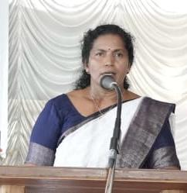
സന്ദേശം
പ്രീ എപ്പിഡെമിക് തയ്യറെടുപ്പ് സന്ദേശം
പ്രിയമിത്രങ്ങളെ
സാധ്യമായ മഹാമാരി/ വ്യാധി വ്യാപനത്തെ മുന്നിൽ കണ്ടുകൊണ്ട് എല്ലാവരും ജാഗ്രത പാലിക്കണം. വ്യക്തിഗത ശുചിത്വം ക്യത്യമായി പാലിക്കുക, കൈകൾ ഇടക്കിടക്ക് സോപ്പ് ഉപയോഗിച്ച് കഴുകുക, ചുമയൊ തുമ്മലൊ വന്നാൽ മാസ്ക് ധരിക്കുക അനാവശ്യ യാത്രകളും തിരക്കുകളും ഒഴിവാക്കുക. ആരോഗ്യ വകുപ്പിൻ്റെ നിർദ്ദേശങ്ങൾ കർശനമായി പാലിക്കുക. ലക്ഷണങ്ങൾ കണ്ടാൽ ഉടൻ സമീപത്തുള്ള ആരോഗ്യകേന്ദ്രവുമായി ബന്ധപ്പെടുക.എല്ലാവരുടെയും സഹകരണം രോഗവ്യാപനം തടയാൻ സഹായകമാണ്. ഇങ്ങനെ ഒരു പ്രീ എപ്പിഡെമിക്ക് തയ്യറെടുപ്പ് നടത്തുന്നതിനു എല്ലാ വിധ ആശംസകളും നേരുന്നു.
സജിത പി പിള്ള

MESSAGE FROM HEALTH STANDING COMMITTEE CHAIR
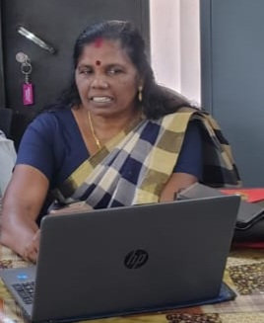

സന്ദേശം
വരാനിടയുള്ള പകർച്ച് വ്യാധിയെ പ്രതിരോധിക്കുന്നതിനായി എല്ലാവരും മുങ്കരുതലുകൾ സ്വീകരിക്കേണ്ടതാണ്. വീട്ടിലും പരിസരങ്ങളിലും ശുചിത്വം ഉറപ്പാക്കുക. ശുദ്ധജലം മാത്രം ഉപയോഗിക്കുക. കൈകൽ സോപ്പ്/ സാനിറ്റൈസർ ഉപ്യോഗിച്ച് ഇടക്കിടക്ക് വ്യത്തിയാക്കുക. പനി, ചുമ, ശ്വാസ് തടസം തുടങ്ങിയ ലക്ഷണങ്ങൾ കണ്ടാൽ സ്വയം ചികിൽസ ഒഴിവാക്കി ഉടൻ ആരോഗ്യ പ്രവർത്ത്കരെ വിവരം അറിയിക്കുക. സർക്കാർ- ആരോഗ്യ വകുപ്പ് നിർദ്ദേശങ്ങൾ ക്യത്യമായി പാലിക്കുക. സമൂഹത്തിൻ്റെ സുരക്ഷക്ക് എല്ലാവരുടേയുംസഹകരണം അനിവാര്യം ആണ്.

വത്സമ്മ

MESSAGE BY MEDICAL OFFICER
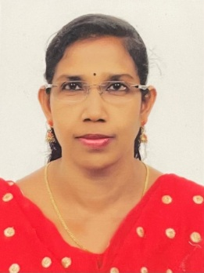
Pandemics can affect any one anywhere, preparedness saves lives. Early detection, honest communication, and community trust are as critical as medicines and ventilators. Stay informed from trusted sources, practice good hygiene, support community efforts protect vulnerable people, and act early when guidance is issued. Preparedness is not panic instead it is a disciplined readiness to protect every life. Preparedness today means resilience tomorrow.

DR.SUNIMOL S
CIVIL SURGEON
CHC ENADIMANGALAM

EXECUTIVE SUMMARY

Enadimangalam is a village and Grama Panchayath in Adoor Taluk, Pathanamthitta district, in the state of Kerala. As per the 2011 Census of India, the total population is 23,356, comprising 11,701 males and 11,655 females, and the geographical area of the village is approximately 33.77 km². Enadimangalam Grama Panchayath administers the village through 15 wards with elected representatives and functions under the Parakode Block Panchayat. The primary public health facility serving the area is the Community Health Centre, Enadimangalam, which provides essential medical services including general outpatient care, maternal and child health services, and other basic healthcare services, as listed in official government health records. In addition, an AYUSH (homoeopathy) Primary Health Centre operates in Enadimangalam under the National Health Mission, offering complementary healthcare services. Older compiled records also indicate the presence of a primary health sub-centre and a maternity and child welfare centre within the village, supporting community-level health outreach activities. For advanced medical care and specialized services, residents are referred to higher-level facilities such as the Government General Hospital, Adoor. Public health institutions in Kerala, including PHCs and CHCs, function under the Ministry of Health and Family Welfare and the state health system, delivering preventive, promotive, curative, and rehabilitative services, including outpatient care, maternal and child health services, immunization support, disease surveillance, and referral services, thereby contributing to the routine primary healthcare needs and public health priorities of Enadimangalam Grama Panchayath.

LIST OF ABBREVIATIONS

LSGD/LSGI | Local Self Government Department / Local Self Government Institution
BMO | Block Medical Officer
IDSP | Integrated Disease Surveillance Programme
NDMA | NationalDisaster Management Authority
PPE | Personal Protective Equipment
ICMR | IndianCouncil of Medical Research
CD | Communicable Diseases
NCD | NON-COMMUNICABLE Diseases

TABLE OF CONTENTS

1
1
INTRODUCTION 9
LSGD AT A GLANCE 10
Integrated Health Infrastructure Map Of Enadimangalam Panchayat 11
General Profile Of Enadimangalam G.P 15
Demographic and Vulnerable Population 16
Clinical Vulnerability 18
INFRASTRUCTURE & RESOURCE INVENTORY 19
Health Facility Directory & Basic Capacity in the LSGD 19
Private Clinics 20
Healthcare Education & Training Institutions 21
Specialized Services & Emergency Inventory 21
Oxygen & Diagnostic Capacity 22
Diagnostics facility mapping at the LSGI level 23
Laboratory Identification & Basic Details-Enadimangalm 23
Social and Community Infrastructure for surge plan 24
Human resources 26
Community & Support Cadre 28
Community Organizations 29
Administrative & Emergency Services 30
Information regarding resources 30
ONE HEALTH & ENVIRONMENTAL SURVEILLANCE 31
Animal & Bird Population 31
Veterinary Infrastructure 33
Veterinary Doctors & Workforce 33
High-Risk Interface Points (Surveillance Sites) 34
Environmental Risk Mapping 36
Disease Seasonality Mapping 37
Vulnerability Mapping 38
EPIDEMIOLOGICAL TRENDS (2021–2025) 39
Disease Burden among human beings(Last 5 Years) 39
Seasonal Trend Analysis 41
Outcome-Based Trend Analysis- 2025 46
Transmission Trend- 2025 47
Integrated Disease Hotspot Map (2021–2025) 50
Disease Burden Percentage Table (2021–2025) 53
Preparedness and Response Protocol at LSG Level 55
Constitution of One Health Committee 55
Pandemic Response Workforce 57
Activities and Measures before and during Pandemic 58
PHASE 1 - Alert / Preparation 58
PHASE 2 - Active Response 61
Standard Screening Protocol 62
PHASE 3 - Surge Capacity 72
Conversion of Community Facilities 72
CONCLUSION 74
RECOMMENDATIONS 75
ANNEXURE 76
1. IMPORTANT PHONE NUMBERS 76

INTRODUCTION
The Pandemic Preparedness Plan for Enadimangalam Grama Panchayath is a comprehensive, evidence-based framework developed to strengthen the Panchayath’s capacity to effectively prevent, detect, respond to, and recover from pandemics and other public health emergencies. Situated in Adoor Taluk of Pathanamthitta district, Enadimangalam is a predominantly rural area with a population of 23,356 (Census 2011), distributed across 15 wards and characterized by dispersed settlements, undulating terrain, and monsoon-influenced environmental conditions.
The Panchayath falls within the midland physiographic zone of Kerala, with laterite soil, small hillocks, and low-lying agricultural areas interspersed with streams forming part of the Achankovil river basin. These geographical features, along with seasonal heavy rainfall, contribute to localized flooding, water stagnation, and occasional disruption of accessibility, thereby posing challenges to timely healthcare delivery and emergency response. Additionally, the presence of migrant labour populations and reliance on agrarian livelihoods further influence public health dynamics and service needs.
The Community Health Centre, Enadimangalam serves as the primary public healthcare institution in the Panchayath, providing essential services including outpatient care, maternal and child health services, immunization, and disease management. The presence of an AYUSH (Homoeopathy) Primary Health Centre and peripheral health institutions enhances the reach of healthcare services at the community level. For advanced care, referral linkages are established with higher-level institutions such as the Government General Hospital, Adoor.
This Pandemic Preparedness Plan builds upon the strengths of Kerala’s decentralized public health system and integrates key national and state health programmes, including the National Health Mission (NHM), Integrated Disease Surveillance Programme (IDSP), Universal Immunization Programme (UIP), and other disease control initiatives. It emphasizes strengthening core public health capacities such as surveillance, early warning systems, outbreak investigation, case management, infection prevention and control, and risk communication.
The plan also incorporates lessons learned from previous public health emergencies, including the COVID-19 pandemic and the 2018 Kerala floods, which underscored the need for robust local preparedness, resilient infrastructure, and coordinated multi-sectoral response mechanisms. A strong focus is placed on micro-level planning, auxiliary infrastructure and logistical resource mapping, and active community engagement through ASHA workers, Anganwadi centres, local self-government institutions, and community-based organizations.
Key priority areas include strengthening health infrastructure, enhancing laboratory and isolation facilities, improving digital health information systems, ensuring adequate trained human resources, and maintaining uninterrupted essential health services during emergencies. Special attention is given to vulnerable populations, including the elderly, children, and migrant workers, to ensure equitable access to healthcare and support services.
Overall, this Pandemic Preparedness Plan serves as a dynamic and operational roadmap to enhance resilience, ensure timely and coordinated response, and safeguard the health and well-being of the population of Enadimangalam Grama Panchayath in the face of future pandemics and public health crises.

LSGD AT A GLANCE
- Geographical boundaries with political map ( based on latest delimitation)
- Baseline data
- Ward division –

Ward | Houses | Population | Migrants | Wells | Hot  spots | Ed. Institutions | Hosp pvt/govt.
16 | 1429 | 23356 | 565 | 13240 | NIL | 14 | 1/4

- Risk stratification among wards in the context of Communicable diseases and hazards
- Major Roads/rivers
- Major establishments with geospatial mapping
- occupational groups, socio cultural groups, migration & mobility patterns
- Vulnerability mapping
- Disaster prone areas (geographic vulnerability)

Maps - ward-based (Mention source also)

- Geographical boundaries - ward boundaries map
- Health infrastructure map
- roads and rivers map
- major establishments map
- disaster-prone areas map
- hotspot map - CD & disasters

Integrated Health Infrastructure Map Of Enadimangalam Panchayat

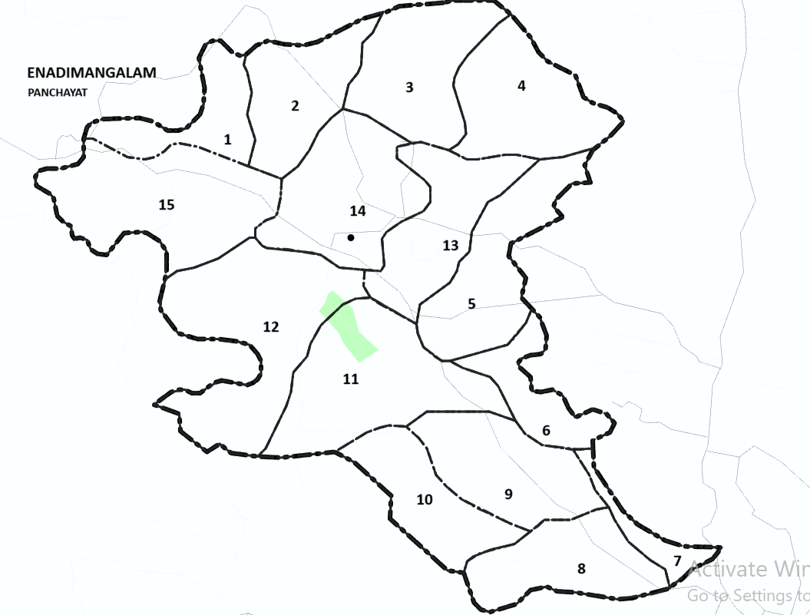

Boundaries

South- Pattazhy Vadakkekara Panchaytah
North- Kodumon Panchayath
East- Kalanjoor & Pathanapuram Grama Panchayaths
West- Ezhamkulam Grama Panchayath

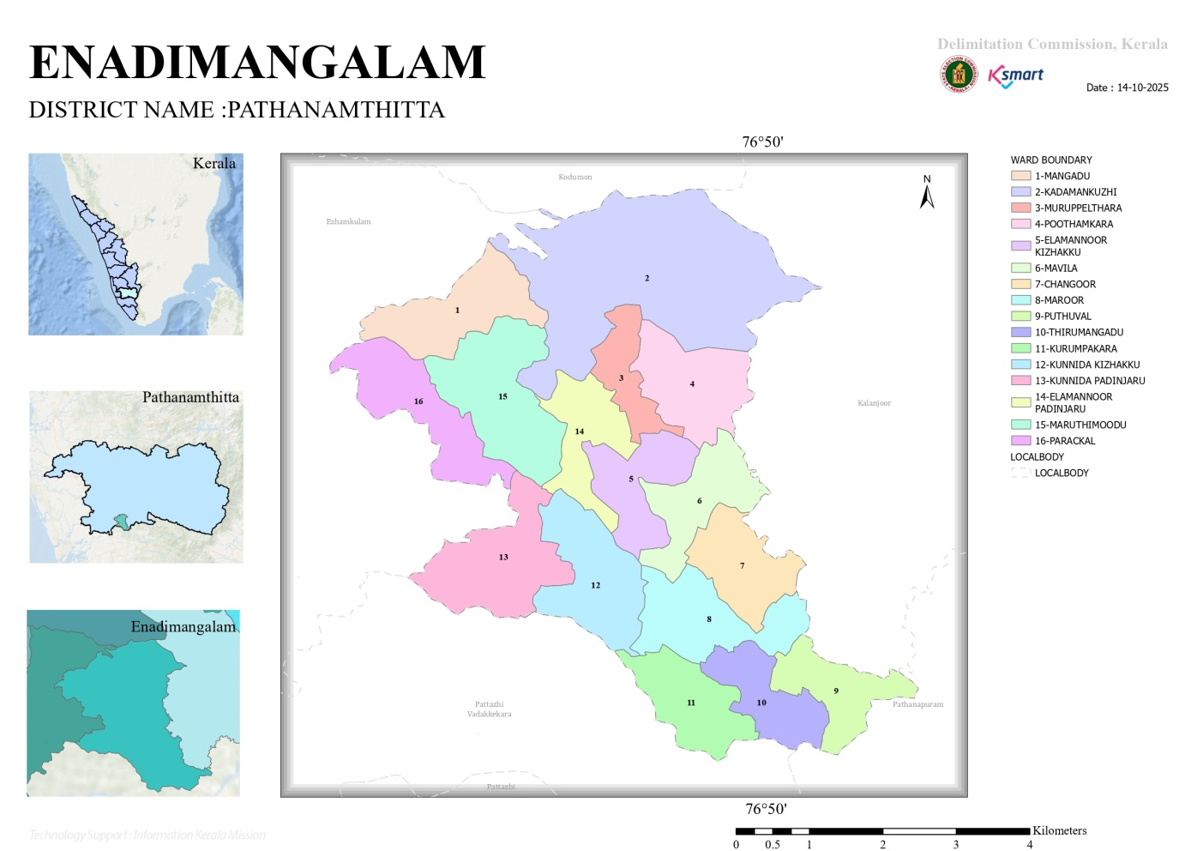

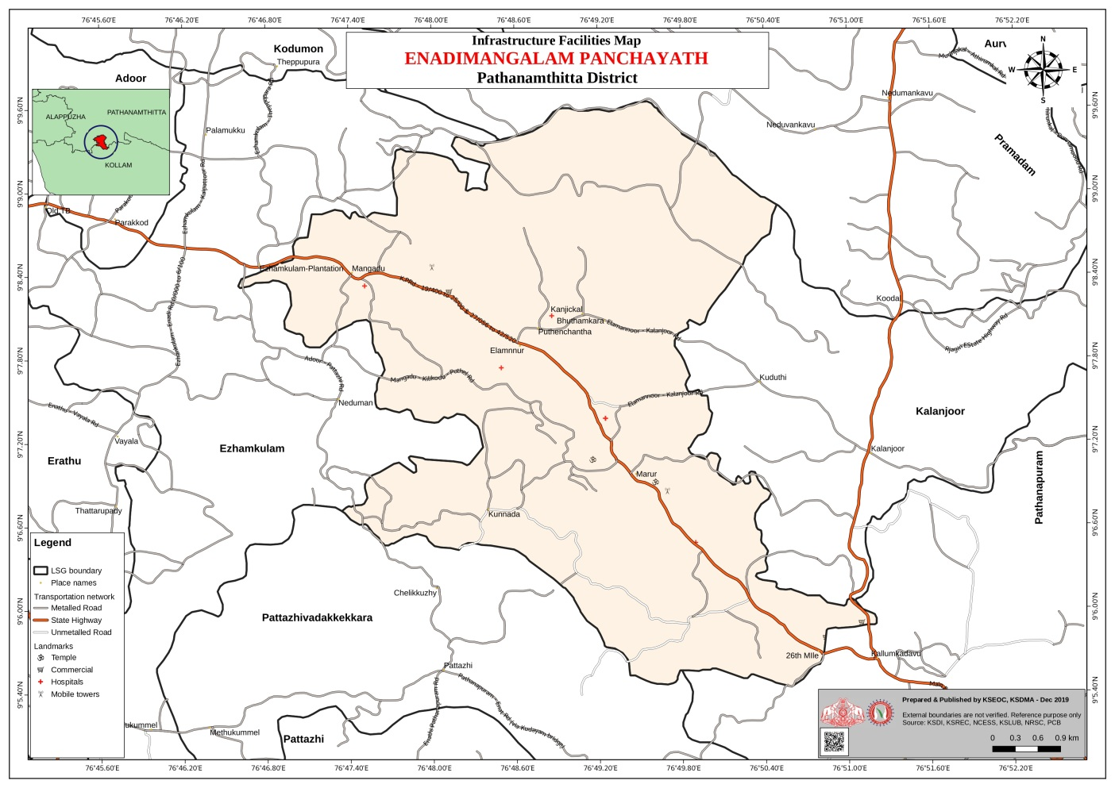

Health Infrastructure Map

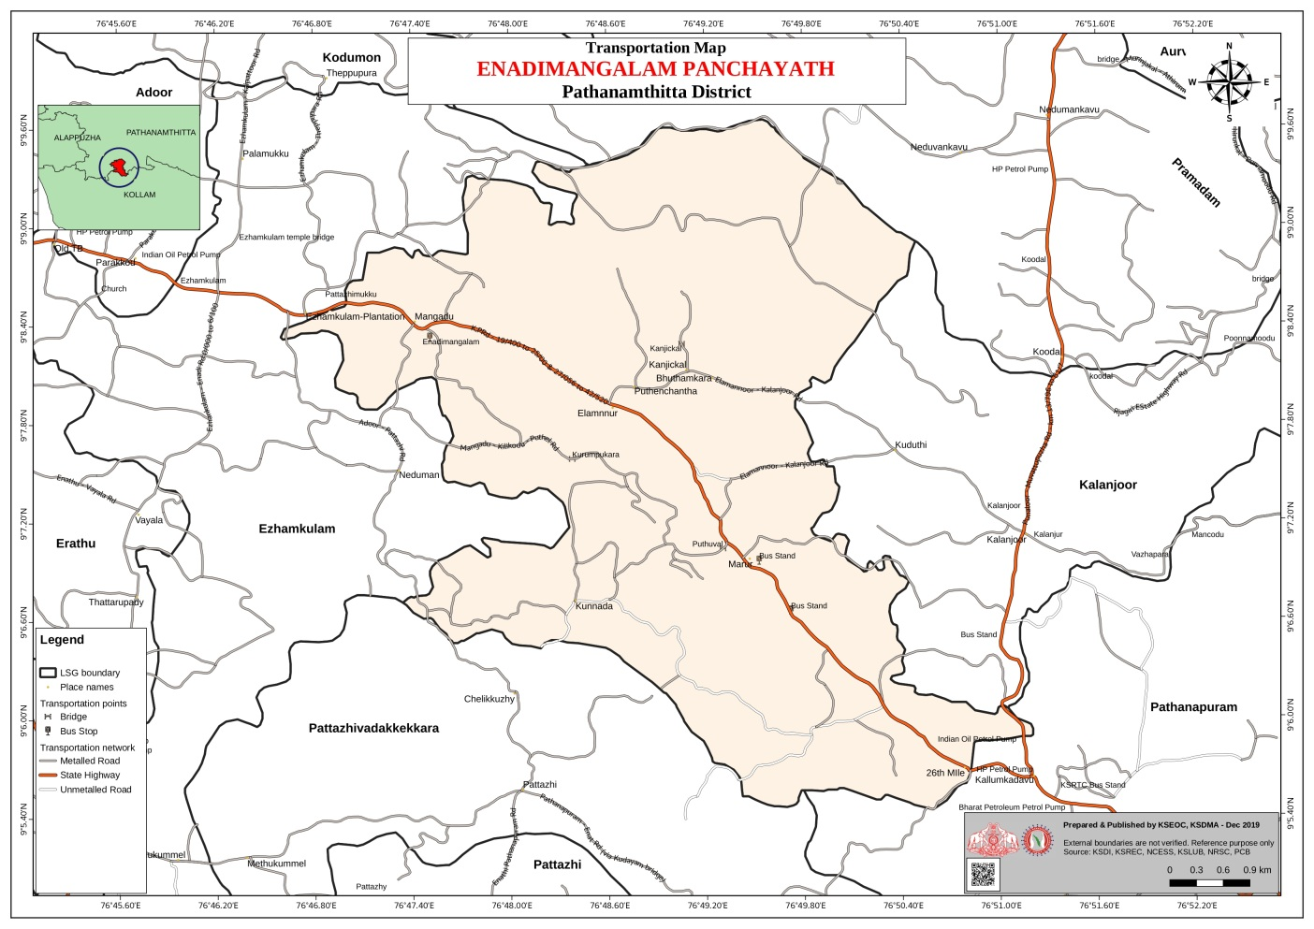

General Profile Of Enadimangalam G.P

Enadimangalam Grama Panchayat is a rural local self-government institution located in Adoor Taluk of Pathanamthitta district, Kerala. The Panchayat falls within the midland physiographic zone of central Kerala and is characterized by an undulating terrain with laterite soil, small hillocks, and low-lying agricultural pockets. The area is drained by minor streams and canals that are part of the Achankovil river basin, influencing local agriculture and water availability, particularly during the southwest and northeast monsoons.
Administratively, the Panchayat is divided into 15 wards and functions under the Parakode Block Panchayat as per the decentralised governance framework of the state. The local economy is primarily agrarian, with paddy cultivation, coconut farming, rubber plantations, and mixed crop agriculture forming major livelihood sources. Allied activities such as animal husbandry, small-scale trade, and service-sector employment contribute to household incomes. Like many rural areas in Pathanamthitta district, the Panchayat also has a section of migrant labourers engaged mainly in construction and agricultural activities.
From a public health and disaster management perspective, Enadimangalam is exposed to seasonal risks associated with heavy monsoon rainfall, including localized flooding, water stagnation, and disruption of road connectivity. These conditions increase the vulnerability to waterborne and vector-borne diseases such as dengue and leptospirosis, which are periodically reported across the district. The Panchayat was also affected by the statewide extreme rainfall and flooding events of 2018, which highlighted gaps in local preparedness, infrastructure resilience, and emergency response systems.
In this context, strengthening local self-government capacity through evidence-based planning is essential. The development of a localized auxiliary infrastructure and logistical resource mapping system supports effective disaster preparedness, public health response, and service delivery. Such an approach enables the Panchayat to systematically identify critical facilities, optimize inter-sectoral coordination, and enhance community resilience in alignment with the objectives of Kerala’s decentralized governance and disaster risk reduction frameworks.

Table 1: Background of Enadimangalam GP
Description | Details
Name of LSGD | ENADIMANGALAM
Type (GP/Municipality / Corporation etc.) | Grama Panchayath
Block | PARAKODE
District | PATHANAMTHITTA
Parliament Constitution | Pathanamthitta
Legislative Assembly Constitution | Konni
Village | Enadimangalam
Number of wards | 16
Total area (sq. km) | 30.77
Population(Projected) | 23356
Population density | 681/sq km
Terrain (coastal/low-lying/backwaters/foothills, etc.) | Hill and undulating terrain
Number of rivers passing through LSGI | 1
Number of water bodies in the LSGI | 18
Number of educational institutions | 14
Factories / small-scale industries | 22
Flood-prone wards | nil
Landslide-prone wards | nil
Death Management and Disposal Facilities (mortuaries/crematorium, including electric) | nil
Auditoriums/Marriage halls/convention centres/community halls | 9
Auditorium-1 | Morning star auditorium

Demographic and Vulnerable Population
Understanding the demographic composition and vulnerable population groups is essential for pandemic preparedness. Children, elderly, economically deprived families, migrant workers, and socially vulnerable groups are at increased risk during public health emergencies due to higher exposure, limited access to services, and dependency on public systems..

Description (Enadimangalam) |  | Details (in numbers)
DEMOGRAPHIC PROFILE
Total population |  | 23356
Male |  | 11701
Female |  | 11655
Transgender |  | 0
Children under 5 |  | 2050
Adolescent |  | 3423
Elderly (>60) |  | 8426
SOCIAL/LIVELIHOOD VULNERABILITY
Previous EPEP family |  | 69
BPL family |  | 1602
Tribal communities |  | 24
Migration | Immigrant | 1630
Migration | Emigrant | 565
Socio-economically deprived |  | Nil
Fisherfolk |  | nil
SC Community |  | 2615
ST Community |  | 24

Graphs: Population pyramid (if possible) for seeing if your LSGI has a high "dependency ratio" (lots of children and elderly compared to working adults).

Clinical Vulnerability
Certain population groups needs priority healthcare & are at higher risk of severe illness, complications, and mortality during pandemics. Patients with chronic diseases, those requiring regular medical care, and individuals with mobility or functional limitations face challenges in accessing timely care during emergencies. Mapping these groups helps in prioritizing continuity of treatment, medicine stock planning, oxygen support, referral transport, and targeted home-based care.
Description (Enadimangalam) | Details in numbers
Pregnant women | 281
Lactating mothers | 1015
Bedbound patients | 170
Patients under palliative care other than bedbound | 175
Patients on Haemodialysis | 0
Patients on CAPD | 16
Cancer patients (currently on treatment) | 21
Haemophilic patients | 0
Mentally challenged | 42
Differently abled | 241
Diabetic patients | 6819
Hypertensive patients | 9814
TB patients | 8

Major Festivals & Events specific to the LSGI
(with the possibility of a public gathering)

Sl. No. | Name of festival (Enadimangalam) | Month detailing the periodicity
1 | Temple festival | Jan - April

INFRASTRUCTURE & RESOURCE INVENTORY

Health Facility Directory & Basic Capacity in the LSGD
This section provides an overview of the healthcare infrastructure available within the LSGD area. It outlines the distribution and basic capacity of health facilities that form the backbone of service delivery during routine times and public health emergencies.

Family Health Centres (FHCs) and Community Health Centres (CHCs) generally function as the first point of contact for the community, providing essential outpatient and inpatient services. General Hospitals (GH) and Medical College Hospitals (MCH), where accessible, serve as the main referral centres for advanced diagnostics, specialist care, and critical services during public health emergencies. This inventory helps identify existing strengths, gaps, and potential surge capacity that can be mobilised during a pandemic or disaster.

Health Facility Resource Summary (Enadimangalam)
Sl.no. | Health Facility | Type of Facility (MCH/GH/CHC/FHC/SC etc.) | Contact Number | Total beds | ICU Beds | Oxygen-Supported Beds | No. of Ventilator Support Beds | No. of ambulances
Government Healthcare Facilities
1 | CHC ENADIMANGALAM | CHC | 9946641173 | 24 | 0 | 0 | 0 | 2
2 | HWC KUNNIDA | SC | 9946641173 | 0 | 0 | 0 | 0 | 0
3 | HWC KURUMPAKARA | SC | 9946641173 | 0 | 0 | 0 | 0 | 0
4 | HWC POOTHANKARA | SC | 9946641173 | 0 | 0 | 0 | 0 | 0
5 | HWC MAINCENTER,ENADIMANGALAM | SC | 9946641173 | 0 | 0 | 0 | 0 | 0
Private Healthcare Facilities
1 | MMC HOSPITAL | Y | 9207101234 | 8 | 0 |  | 0 | 0
2 | Mount Zion Medical College Hospital | MCH | 04734269500 | 700 | 168 | 168 | 11 | 1
AYUSH Healthcare Facilities
1 | Ayurveda Dispensary | GOVT | 9496713550 | 0 | 0 | 0 | 0 | 0
2 | Ayurveda Dispensary | SC | 9496713550 | 0 | 0 | 0 | 0 | 0
3 | NHM Homeo Dispensary | NHM |  | 0 | 0 | 0 | 0 | 0
4 | Mavelil Ayurveda Hospital | Private |  | 30 | 0 | 0 | 0 | 0

Private Clinics
Private clinics are an essential part of pandemic preparedness, as they are often the first place people seek care when symptoms begin. In many communities, private clinics manage a significant share of outpatient visits and therefore play a critical role in early case detection, timely referrals, and disease surveillance. Having an up-to-date understanding of where these clinics are located, the services they provide, and how they are linked to the public health system helps ensure that no cases are missed during an outbreak. It also allows health authorities to engage private practitioners more effectively for reporting, risk communication, and coordinated response, strengthening the overall capacity of the health system to manage public health emergencies.

Private Clinic Resource Summary (Enadimangalam)
Sl No. | Name of Clinic | Registered (Y/N) | Clinic (General / Speciality) | Speciality (if any) | Address | Contact Number | Diagnostic Facility (Y/N) | Ambulance Linkage (Y/N)
1 | MMC HOSPITAL | Y | GENERAL | NA | MMC HOSPITAL,ENADIMANGALAM | 9207101234 | YES | YES

Healthcare Education & Training Institutions
This section tracks the educational infrastructure available, which is vital for human resource planning in the health sector.

Category of Institution (Enadimangalam) | Govt | Private | AYUSH | Total
Medical Colleges | 0 | 1 | 0 | 1
Nursing Colleges | 0 | 1 | 0 | 1
Dental Colleges | 0 | 0 | 0 | 0
Para-medical / Allied Health | 0 | 1 | 0 | 0
Pharmacy Colleges | 0 | 0 | 0 | 0

Specialized Services & Emergency Inventory
This section provides a detailed view of the specialized medical resources available to the community, focusing on emergency response and critical care capabilities. This table tracks the vital assets required for managing severe illnesses and emergencies across Government, Private, and AYUSH sectors.

Item (Enadimangalam) | Govt | Private | AYUSH | Total
Hospital beds | 24 | 700 | 0 | 724
Oxygen-generating systems(Y/N) | 0 | YES | 0 | 0
Oxygen-supported beds(Numbers) | 0 | 168 | 0 | 168
Ventilator-supported beds | 0 | 11 | 0 | 11
ICU beds | 0 | 168 | 0 | 168
Burns units | 0 | 1 | 0 | 1
Blood centres | 0 | 1 | 0 | 1
BLS ambulances | 0 | 1 | 0 | 1
ALS ambulances | 0 | 0 | 0 | 0
Dialysis facilities | 0 | 1 | 0 | 1
Dispensaries | 1 | 1 | 0 | 2
Medical store | 0 | 3 | 0 | 3
Industrial establishments(Medium-scale industries/small-scale industries establishments to whom we can depend in a worst-case scenario) | 0 | 12 | 0 | 12

Oxygen & Diagnostic Capacity
Monitoring oxygen and diagnostic capacity is a critical component of public health preparedness, ensuring that the LSGD can handle both chronic care and sudden surges in respiratory or infectious diseases.

Name of Health Facility (Enadimangalam) | Oxygen-generating System (Y/N) | Backup Oxygen Source (Y/N) | Diagnostic Facilities Available(Y/N)
Name of Health Facility (Enadimangalam) | Oxygen-generating System (Y/N) | Backup Oxygen Source (Y/N) | Lab | USG | X-ray | CT/MRI | RT-PCR
Government Healthcare Facilities
CHC Enadimangalam | N | 0 | 0 | 0 | 0 | 0 | 0
Private
Mount Zion Medical College Elamanoor | Y | Y | 1 | 1 | 1 | 1 | 0

Diagnostics facility mapping at the LSGI level
The diagnostic capacity of ENADIMANGALAM G.P represents the "intelligence network" of our healthcare system. The speed and accuracy of disease identification depend entirely on the distribution and technical level of these facilities.

Item (Enadimangalam) | Govt | Private | AYUSH | Total
General labs | 1 | 8 | 0 | 9
Microbiology labs | 0 | 0 | 0 | 0
RT-PCR labs | 0 | 1 | 0 | 1
USG units | 0 | 1 | 0 | 1
CT/MRI units | 0 | 1 | 0 | 1
Research labs | 0 | 0 | 0 | 0
Labs of other departments that can be repurposed | 0 | 0 | 0 | 0

Laboratory Identification & Basic Details-Enadimangalm
Sl. No. | Name of Laboratory | Ownership (Govt / Private / Academic) | Address | Contact No. | 24×7 Services (Yes/No) | NABL / Govt Approved (Yes/No)
1 | CHC ENADIMANGALAM | GOVT | CHC ENADIMANGALAM | 9645904171 | No | Yes
2 | DDRC LAB | PVT | DDRC,ELAMANOOR | 9846346637 | No | YES
3 | MMC LAB | private | MMC LAB,ELAMANOOR | 9495953439 | No | No
4 | ALPHA LAB | PRIVATE | VACRE,ELAMANOOR | 8157085484 | No | No
5 | OPTUM | PRIVATE | OPTAM,ELAMANOOR | 9544438682 | No | No
6 | TRUECARE | PVT | TRUE CARE,ELAMANOOR | 9207134576 | No | No
7 | KM DIAGNOSTIC | PVT | KM DIAGNOSTIC,MANGADU | 9961146318 | No | No
8 | Mount Zion Medical College | Private | Elamanoor | 04734269500 | Yes

Social and Community Infrastructure for surge plan
This table serves as our logistics and shelter inventory. By mapping these locations, quickly we can identify where to house displaced citizens, where to set up temporary medical clinics, and how to manage the deceased with dignity during a crisis.

Category (Enadimangalam) | Total Count | Ward | Est. Capacity (Persons) | Contact details
Educational Institutions
Anganwadis | 21 | 0 | 400 | 0
Schools | 26 | 0 | 3500 | 0
Colleges | 1 | 15 | 0 | 0
Healthcare Educational Institutions
Medical colleges (Govt/Private) | PRIVATE-1 | 15 | 700 | 04734269500
Nursing colleges (Govt/Private) | PRIVATE-1 | 15 | 0 | 04734269500
Dental colleges (Govt/Private) | 0 | 0 | 0 | 0
Paramedical institutes (Govt/Private) | Private- 1 | 15 | 0 | 04734269500
Community Gathering Spaces
Community halls | 4 | 0 | 200 | 0
Auditoriums | 5 | 0 | 800 | 0
Religious buildings | 5 | 0 | 1000 | 0
Vulnerable Group Support Facility
Destitute homes | 0 | 0 | 0 | 0
Elderly homes | 0 | 0 | 0 | 0
LSGD owned other buildings | 0 | 0 | 0 | 0
Mass Fatality Management (MFM) Infrastructure
Mortuary | 1 | 15 | 0 | 0
Crematorium | 0 | 0 | 0 | 04734269500
*refer annexure 1 for contact details

Human resources
This section focuses on the human capital available within the LSGI. In any emergency—be it a pandemic, flood, or industrial accident—infrastructure is only as effective as the people operating it.

Medical & Clinical Personnel
This table tracks the "Frontline" providers responsible for diagnosis, treatment, and clinical management. Narrative sentence: eg., "Total health workforce: 450 personnel, with 60% in government facilities serving as primary surge capacity." A detailed directory with the contact numbers of all workers is maintained (Annexure in 1).

Cadre (Enadimangalam) | Govt (No.) | Private (No.) | Total
Doctors—Modern Medicine | 7 | 3 | 10
Doctors – AYUSH | 2 | 0 | 2
Doctors – Veterinary | 1 | 0 | 1
Doctors – Dental | 2 | 2 | 4
Nursing officers | 8 | 5 | 13
Lab technicians | 4 | 8 | 12
Optometrist | 1 | 1 | 2
Pharmacists | 3 | 6 | 9
Psychologists | 0 | 1 | 0
Counsellors | 0 | 0 | 0

Public Health & Field-Level Workforce
These individuals are the backbone of surveillance, maternal-child health, and decentralized care.

Cadre (Enadimangalam) | Health services | Municipal common services | Total
HS (Health Supervisors) | 1 | 0 | 1
HI (Health Inspectors) | 1 | 0 | 1
LHS (Lady Health Supervisor) | 1 | 0 | 1
LHI (Lady Health Inspectors) | 1 | 0 | 1
JPHN (Jr Public Health Nurses) | 4 | 0 | 4
JHI (Jr Health Inspectors) | 3 | 1 | 4
MLSP (Mid-Level Service Providers) | 4 | 0 | 5
Palliative Nurses | 1 | 0 | 1
RBSK Nurses | 1 | 0 | 1
PRO | 1 | 0 | 1
Epidemiologist | 1 | 0 | 1
Data Manager | 1 | 0 | 1

Community & Support Cadre
This group represents the surge capacity of the LSGI—people who can be called upon for logistics, rescue, and specialized support.

Cadre (Enadimangalam) | Number
ASHA Workers | 19
AWW (Anganwadi Workers) | 21
Emergency Medical Volunteers (Trained) | 0
Kudumbashree | 215
MNREGS | 0
Purusha Swayam Sahaya Sangham | 4
Ex-Servicemen | 2
Retired Police Officers | 4
NCC/NSS Volunteers | 21
Red Cross volunteers | 0
One Health Community Volunteers | 813
One Health Community Mentors | 7

Community Organizations
This section details the presence of community-based organisations (CBOs), non-governmental organisations (NGOs), faith-based organisations (FBOs), Kudumbashree Self-Help Groups (SHGs), and Ayalkootams within the Local Self-Government Institution (LSGI). These groups enhance grassroots mobilization, resource distribution, and support networks crucial for pandemic response and community resilience.

Category (Enadimangalam) | Total Count
NGOs | 2
Religious based organizations | 7
Foreign based organizations | 0
Sports Club/youth clubs | 5
Kudumbashree SHGs | 67
Ayalkootams | 38
Political organizations | 3
Residential organizations | 0

Administrative & Emergency Services
This section outlines the availability of key non-health emergency support services and infrastructure within the LSGI, which are essential for effective pandemic preparedness and response. These facilities support law enforcement, disaster response, water supply, logistics, mobility, and community-level interventions during public health emergencies.

Category (Enadimangalam) | Total Count | Contact details
Police Stations | 0 | 04734211800
Fire & Rescue Stations | 0 | 04734229100
Water Pumping Points | 2 | 04734225766
Public Distribution System (PDS) | 4

Information regarding resources
The availability of essential transport and support resources plays a quiet but critical role in saving lives. Equipment such as ambulances, mobile mortuaries, amphibian ambulances, and motorized boats ensures that patients, samples, and healthcare teams can move swiftly—even in flooded, remote, or difficult terrains. Heavy vehicles like JCBs, cranes, tractors, and torus lorries support logistics, waste management, emergency infrastructure, and rapid conversion of spaces into care or isolation facilities. Taxis, four-wheel-drive vehicles, and trucks help maintain continuity of essential services, reach vulnerable populations, and support home-based care and supply delivery.

Means of transportation (Enadimangalam) | Total Count
JCB | 6
Crane | 2
Heavy Trucks | 0
Tractor | 1
Ambulances | 4
Mobile mortuaries | 2
Boats | 0
Taxi service | 27
Note: For specific details regarding vehicle owners and contact information, please refer to Annexure [X].

ONE HEALTH & ENVIRONMENTAL SURVEILLANCE
The One Health method integrates environmental, animal, and human health to enable proactive pandemic preparedness. Panchayat-level surveillance needs to be improved in order to detect and treat zoonotic and environmentally generated diseases early. Surveillance is strengthened through systematic assessment of animal populations, veterinary infrastructure, poultry and slaughter facilities, inter-sectoral coordination, and specialised tools like avian influenza seasonality mapping using GIS in previous outbreaks to enable predictive alerts and ward-specific sampling to support effective pandemic preparedness in high-risk areas like ____________.

Animal & Bird Population
Mapping animal and bird populations at the Panchayat level is essential for identifying and prioritising zoonotic disease hazards like rabies, avian influenza (H5N1), leptospirosis, anthrax, and Nipah-like spillover occurrences. Risk classification, targeted surveillance, vaccination planning, and early epidemic detection made feasible by comprehensive population mapping all enhance One Health-based pandemic preparedness.

Category (Enadimangalam) | Item | Estimated Population | Wards
Animal Population | Livestock (Cattle/Goats/Buffalo) | CATTLE-1536  GOAT-47  BUFFALO-86 | All wards
Animal Population | Pet Animals (Dogs/Cats) | DOGS-4687  CATS-6874 | All wards
Animal Population | Stray Dog Population | 4587 | All wards
Animal Population | Pig Farms (Number of heads) | 0 | -
 | Small Units (Sheep / Goats – clustered) | 0 | -
Bird Population | Poultry Units (Birds) | 14 | All wards
Bird Population | Poultry- (FOWL) | 0 | -
Bird Population | Wild/Migratory Birds (Observed) | 0 | -
Bird Population | Crow Mortality Events (Reported) | 0 | -

The main risk of zoonotic diseases in ENADIMANGALAM is concentrated in Ward , which is explained by the high density of pig farms, cattle congregation areas, and poultry units. The stray dog population in market areas, fish landing sites, bus stations continues to be a substantial problem for rabies surveillance and bite prevention. There is a considerable risk of avian influenza introduction and amplification during November - December due to the seasonal presence of migratory and resident water birds near ponds/ canal / river / backwater / paddy field. Clusters of pig farms and animal shelters vulnerable to flooding further raise the risk of leptospirosis and other zoonoses mediated by the environment, especially during monsoon floods.

Veterinary Infrastructure
Veterinary institutions are a core pillar of One Health surveillance, enabling early zoonotic disease detection through vaccination, investigation of unusual animal illness or deaths, sample collection, and timely outbreak reporting. A well-mapped and responsive veterinary network strengthens coordination with human health and LSGI systems, ensuring rapid response during zoonotic events and pandemics.
Facility Type (Enadimangalam) | Name of Facility | Ownership Govt / Pvt | Location(Ward No) | Contact number
Veterinary Dispensary | ENADIMANGALAM | GOVT | 14 | 6238767731, 04734247826
Veterinary Hospital / Polyclinic | 0 | 0 | 0 | 0
Private Veterinary Clinics | 0 | 0 | 0 | 0
Mobile / Emergency Vet Service (incl. night services) | 0 | 0 | 0 | 0
Pet Homes / Animal Shelters | 0 | 0 | 0 | 0
Slaughterhouse-linked Veterinary Inspection Unit | 0 | 0 | 0 | 0

Veterinary Doctors & Workforce
Early detection, diagnosis, reporting, and reaction to animal illness epidemics depend on the availability and accessibility of qualified veterinary specialists. By identifying unusual animal morbidity or mortality promptly, collecting samples promptly, and coordinating efficiently with human health and LSGI systems—especially during zoonotic outbreaks and pandemic-prone situations—a clearly defined veterinary workforce enhances One Health surveillance.

Category (Enadimangalam) | Number Available | Type (Govt/Pvt) | Contact number
Government Veterinary Doctors | 1 | GOVT | 6238767731
Private Veterinary Doctors | 0 | 0 | 0
Livestock Inspectors | 2 | GOVT | -
Para-veterinary Staff / Attenders | 0 | 0 | 0
Contract / On-call Veterinary Support (if any) | 0 | 0 | 0

High-Risk Interface Points (Surveillance Sites)
High-risk interface points for zoonotic disease surveillance in ENADIMANGALAM Grama Panchayath include wetland–livestock–human contact zones, backyard poultry farms, cattle sheds near water bodies, fish markets, and areas of high human–animal interaction such as community slaughter points and migratory bird congregation sites. These are the primary surveillance sites where zoonotic spillover risks are elevated.

Type of Habitat (Enadimangalam) | Type of High risk interface | Geographical vulnerability
Wetlands & Backwaters | 0 | 0
Backyard Poultry Farms | 0 | 0
Cattle Sheds near Water Bodies | 0 | 0
Fish & Meat Markets | 0 | 0
Community Slaughter Sites | 0 | 0
Migratory Bird Congregation Areas | 0 | 0
Rodent-Infested Grain Storage | 0 | 0

Category (Enadimangalam) | Total Count | Key Locations (wards)
Poultry Farms | 1 | 12
Backyard / Clustered Poultry Units | 103 | 0
Duck Rearing Units (open water access) | 0 | 0
Slaughterhouses/ Slaughter Points | 0 | 0
Meat/Fish Markets | 0 | 0
Live Bird Sale Points | 0 | 0
Cattle Markets / Weekly Animal Fairs | 0 | 0
Pet Shops / Breeders | 0 | 0
Animal Shelters / Pet Homes | 0 | 0
Waste Disposal Sites near Animal Units | 0 | 0

Environmental Risk Mapping
Environmental risk mapping identifies monsoon/flood hotspots for vector-borne (dengue, chikungunya), water-borne (leptospirosis, diarrhoea), and zoonotic diseases in Kerala's wetlands. Systematic surveillance supports early warnings, targeted interventions, and Panchayat pandemic preparedness.
Waterborne exposure: Flood-prone areas and stagnant water bodies facilitate leptospira survival, raising leptospirosis risk.

Traditional practices: Informal slaughter and fish markets lack standardized hygiene, creating spillover opportunities.

Risk Factor (Enadimangalam) | High-Risk Wards | Key Locations | Risk Level (High/Med/Low)
Flood-prone areas | 6, 5, 7, 10, 13, 14 | Chankoor, Marror, Thottapalm, Kuthiramon, Maruthimood | Med
Water bodies/wetlands | 0 | 0 | 0
Solid waste accumulation | 0 | 0 | 0
Animal waste disposal issues | 0 | 0 | 0
Rodent infestation zones | 0 | 0 | 0
Industrial effluent discharge | 0 | 0 | 0
Construction sites / abandoned buildings | 0 | 0 | 0
Poor drainage/blocked canals | 0 | 0 | 0
Drinking water source contamination risk | 0 | 0 | 0

Disease Seasonality Mapping
- Flooding & waterlogging → amplifies leptospirosis, malaria, diarrheal diseases.
- Migratory bird influx (Nov–Feb) → avian influenza risk.
- Mosquito breeding cycles → vector-borne disease peaks in monsoon.
- Agricultural practices → close human–animal contact in paddy fields.

Disease (Enadimangalam) | Peak Risk Season | Key Drivers | High-Risk Locations | Surveillance Focus
Avian Influenza | 0 | 0 | 0 | 0
Leptospirosis | June-August | Monsoon | 0 | 0
Dengue/Chikungunya | 0 | 0 | 0 | 0
Acute Diarrheal Diseases | 0 | 0 | 0 | 0
Rabies | 0 | 0 | 0 | 0
Anthrax (rare) | 0 | 0 | 0 | 0

Vulnerability Mapping
Vulnerability mapping pinpoints high-risk populations, occupations, and areas exposed via environment, livelihoods, socio-economics, and poor service access. Paired with environmental/seasonality mapping, it enables risk-based surveillance, targeted actions, and optimal resource use in One Health and pandemic planning.
Vulnerability Factor (Enadimangalam) | High-Risk Wards | Key Groups / Locations | Risk Level
Flood-prone households | 6,5,7,10,13,14 | Chankoor, Marror, Thottapalm, Kuthiramon, maruthimood | Med
Wetland-adjacent communities | 0 | 0 | 0
Backyard poultry / duck rearing households | 0 | 0 | 0
Livestock-rearing households | 0 | 0 | 0
Slaughterhouse & meat market workers | 0 | 0 | 0
Fisherfolk & fish market workers | 0 | 0 | 0
Sanitation workers | 0 | 0 | 0
Daily wage / migrant workers | 0 | 0 | 0
Elderly & chronically ill populations | 0 | 0 | 0
Pregnant Women | 0 | 0 | 0
Children (schools, Anganwadi’s) | 0 | 0 | 0
Limited access to safe water & sanitation | 0 | 0 | 0

EPIDEMIOLOGICAL TRENDS (2021–2025)

Disease surveillance is the systematic collection, analysis, and interpretation of health data for planning, implementation, and evaluation of public health practice. This section presents the disease surveillance profile of the LSGI based on routine reporting systems and outbreak investigations to identify priority diseases, seasonal patterns, and emerging public health threats.

Disease Burden among human beings(Last 5 Years)
Analysis of disease-wise data for the last five years helps identify persistent public health problems, emerging diseases, and changes in disease burden. This information supports prioritisation of prevention, preparedness, and response activities at the Panchayat level.

Disease | 2021 | 2022 | 2023 | 2024 | 2025 | Trend
Dengue | 3 | 2 | 26 | 114 | 14 | Increasing (with peak in 2024, decline in 2025)
Leptospirosis | 3 | 2 | 0 | 3 | 0 | Stable / Sporadic
Hepatitis A | 1 | 0 | 0 | 3 | 2 | Increasing (low-level resurgence)
Malaria | 0 | 0 | 0 | 0 | 0 | Absent / Stable
Scrub Typhus | 0 | 1 | 0 | 0 | 0 | Sporadic
Typhoid | 1 | 1 | 1 | 0 | 0 | Decreasing
H1N1 | 0 | 0 | 0 | 12 | 1 | Decreasing (post-outbreak)
H3N2 | 0 | 0 | 0 | 0 | 0 | Absent / Stable
ADD | 8 | 9 | 14 | 28 | 32 | Increasing
Mumps | 1 | 0 | 2 | 1 | 0 | Sporadic
Measles | 0 | 0 | 0 | 0 | 0 | Absent / Stable
Hepatitis B | 1 | 1 | 1 | 5 | 3 | Increasing (recent years)
Hepatitis C | 0 | 0 | 0 | 0 | 0 | Absent / Stable
Tuberculosis | 9 | 8 | 2 | 5 | 11 | Stable (fluctuating)
Leprosy | 0 | 0 | 0 | 0 | 0 | Absent / Stable
COVID-19 | 0 | 708 | 3 | 0 | 1 | Decreasing (post-pandemic)

*(use the above table data to create the graph/diagram)
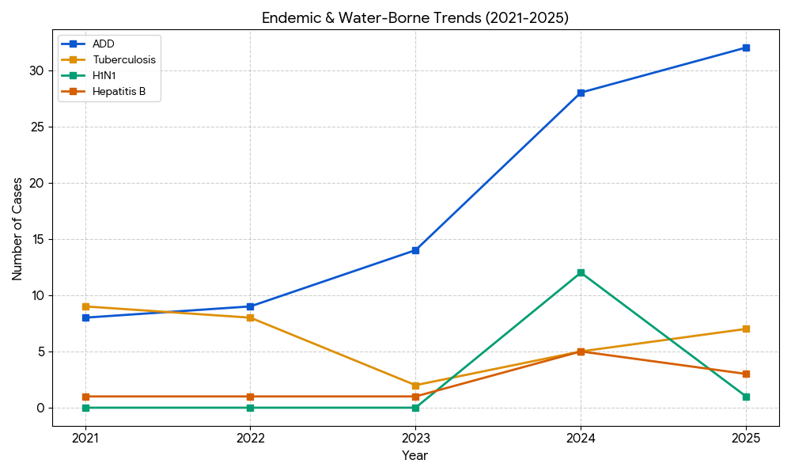
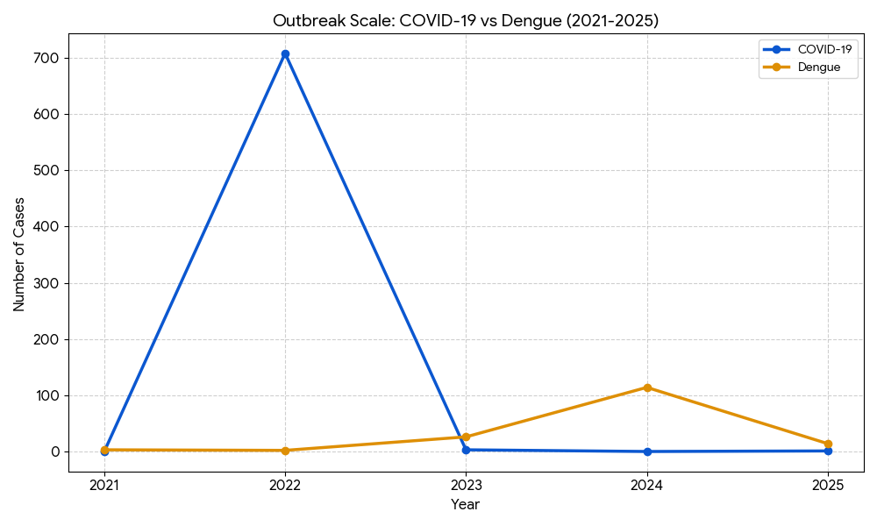

Seasonal Trend Analysis
Seasonal analysis helps anticipate surges (e.g. dengue in monsoon, leptospirosis after floods, influenza in cooler months) and plan pre‑emptive vector control, stockpiling of IV fluids, and awareness campaigns at Panchayat level.

DENGUE
Dengue is a major seasonal vector-borne disease strongly associated with rainfall, water stagnation, and increased mosquito breeding during the monsoon period.

Peak: July–November

Dengue – Ward-wise Yearly Distribution (2021–2025)

Ward | Dengue – Ward-wise Yearly Distribution
Ward | 2021 | 2022 | 2023 | 2024 | 2025 | Total
1 | 1 | 0 | 4 | 10 | 2 | 17
2 | 0 | 0 | 2 | 10 | 1 | 13
3 | 0 | 0 | 1 | 10 | 1 | 12
4 | 0 | 0 | 2 | 10 | 2 | 14
5 | 0 | 0 | 2 | 10 | 1 | 13
6 | 0 | 1 | 3 | 10 | 1 | 15
7 | 0 | 0 | 2 | 10 | 0 | 12
8 | 0 | 0 | 2 | 10 | 1 | 13
9 | 1 | 0 | 2 | 4 | 1 | 8
10 | 0 | 0 | 2 | 5 | 1 | 8
11 | 0 | 0 | 2 | 12 | 1 | 15
12 | 0 | 0 | 2 | 4 | 1 | 7
13 | 0 | 0 | 0 | 6 | 1 | 7
14 | 0 | 0 | 0 | 4 | 1 | 5
15 | 0 | 0 | 0 | 4 | 1 | 5

LEPTOSPIROSIS
Leptospirosis cases are closely linked to monsoon rains, flooding, and occupational exposure, particularly in low-lying and waterlogged areas.

Peak: June - August

Leptospirosis – Ward-wise Yearly Distribution (2021–2025)

Ward | Leptospirosis – Ward-wise Yearly Distribution
Ward | 2021 | 2022 | 2023 | 2024 | 2025 | Total
1 | 2 | 1 | 0 | 0 | 0 | 3
2 | 0 | 0 | 0 | 0 | 0 | 0
3 | 1 | 0 | 0 | 0 | 0 | 1
4 | 0 | 0 | 0 | 0 | 0 | 0
5 | 0 | 1 | 0 | 0 | 0 | 1
6 | 0 | 0 | 0 | 0 | 0 | 0
7 | 0 | 0 | 0 | 0 | 0 | 0
8 | 0 | 0 | 0 | 0 | 0 | 0
9 | 0 | 0 | 0 | 0 | 0 | 0
10 | 0 | 0 | 0 | 0 | 0 | 0
11 | 0 | 2 | 0 | 0 | 0 | 2
12 | 0 | 0 | 0 | 0 | 0 | 0
13 | 1 | 2 | 0 | 0 | 0 | 3
14 | 0 | 0 | 0 | 0 | 0 | 0
15 | 0 | 0 | 0 | 0 | 0 | 0

VIRAL HEPATITIS - A
Hepatitis A cases are commonly associated with unsafe drinking water, food contamination, and breakdowns in sanitation, often presenting as clusters or outbreaks.

Peak: October - December

Hepatitis A – Ward-wise Yearly Distribution (2021–2025)

Ward | Hep A – Ward-wise Yearly Distribution
Ward | 2021 | 2022 | 2023 | 2024 | 2025 | Total
1 | 0 | 0 | 0 | 0 | 0 | 0
2 | 0 | 0 | 0 | 0 | 1 | 1
3 | 0 | 0 | 0 | 0 | 0 | 0
4 | 0 | 0 | 0 | 0 | 0 | 0
5 | 0 | 0 | 0 | 0 | 1 | 1
6 | 0 | 0 | 0 | 0 | 0 | 0
7 | 0 | 0 | 0 | 0 | 0 | 0
8 | 0 | 0 | 0 | 1 | 0 | 1
9 | 0 | 0 | 0 | 0 | 0 | 0
10 | 0 | 0 | 0 | 1 | 0 | 1
11 | 1 | 0 | 0 | 0 | 0 | 1
12 | 0 | 0 | 0 | 0 | 0 | 0
13 | 0 | 0 | 0 | 1 | 0 | 1
14 | 0 | 0 | 0 | 0 | 0 | 0
15 | 0 | 0 | 0 | 0 | 0 | 0

Outcome-Based Trend Analysis- 2025

Transmission Trend- 2025
For effective management of public health issues, it is important to track the trend of disease transmission mode. It helps identify the population or place at high risk that can be used to predict outbreaks and implement targeted interventions as quickly as possible. Understanding these kinds of trends enables authorities to allocate resources efficiently and change the strategies adequately based on the trend that follows.

Mode of Transmission (Enadimangalam) | No. of cases | No. of Deaths
Vector Borne Diseases | 14 | 0
Water Borne Diseases | 32 | 0
Air Borne Diseases | 1 | 0
Blood Borne Diseases | 0 | 0
Food Borne Diseases | 0 | 0

Vector-Borne Disease

Vector-Borne Disease  (Enadimangalam) | No. of Cases | No. of Deaths
Dengue | 14 | 0
Malaria | 0 | 0
Chikungunya | 0 | 0

Water Borne Disease

Water Borne Disease  (Enadimangalam) | No. of Cases | No. of Deaths
Cholera | 0 | 0
Typhoid | 0 | 0
Hep- A | 2 | 0
Dysentery | 0 | 0
Amoebiasis | 0 | 0
E- Coli infections | 0 | 0
Air Borne Disease

Air Borne Disease  (Enadimangalam) | No. of Cases | No. of Deaths
Influenza | 0 | 0
H1N1 | 1 | 0
TB | 11 | 0
Chickenpox | 8 | 0
Measles | 0 | 0
Covid-19 | 1 | 0
Pertussis | 0 | 0
Mumps | 0 | 0

Blood-Borne Disease

Blood-Borne Disease  (Enadimangalam) | No. of Cases | No. of Deaths
AIDS | 0 | 0
Hep- B | 0 | 0
Hep- C | 0 | 0

Zoonotic Disease

Zoonotic Disease  (Enadimangalam) | No. of Cases | No. of Deaths
Rabies | 0 | 0
Leptospirosis | 2 | 0
Avian influenza | 0 | 0
West nile | 0 | 0
Anthrax | 0 | 0
Nipah | 0 | 0
Scrub Typhus | 0 | 0

Integrated Disease Hotspot Map (2021–2025)

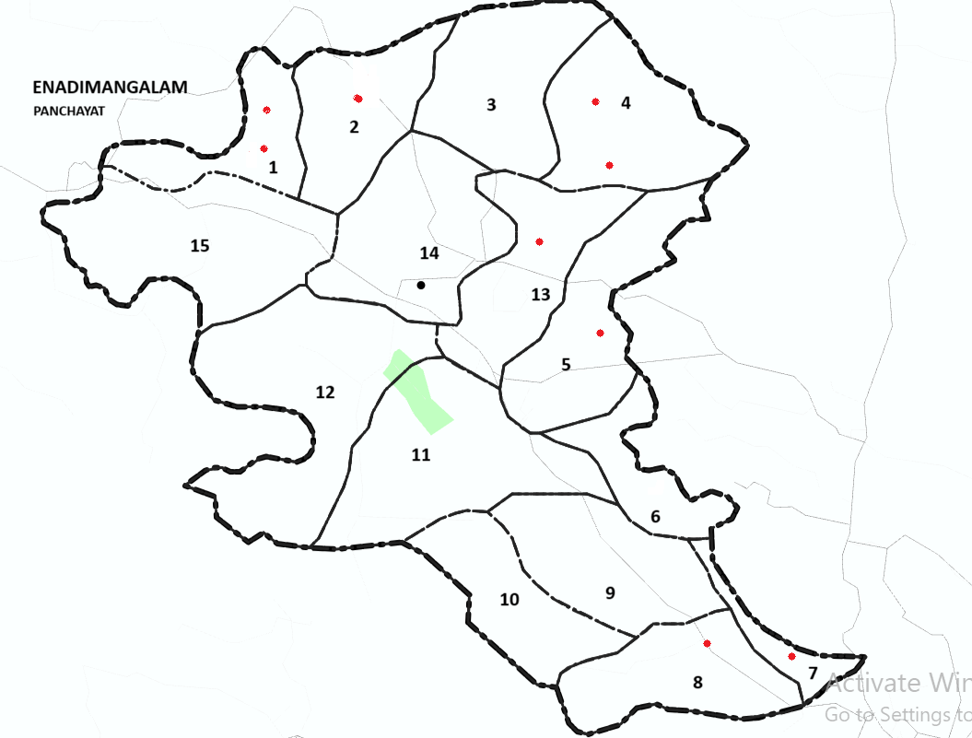

Ward No | Dengue Total (2021-25) | Leptospirosis Total (2021-25) | Hepatitis A Total (2021-25) | Mumps (2021-25) | ADD (2021-25) | Total Cases
1 | 17 | 2 | 0 | 0 | 6 | 25
2 | 8 | 1 | 0 | 2 | 5 | 16
3 | 12 | 1 | 1 | 0 | 7 | 14
4 | 16 | 1 | 0 | 0 | 5 | 22
5 | 11 | 1 | 1 | 2 | 6 | 21
6 | 15 | 0 | 0 | 0 | 5 | 20
7 | 19 | 0 | 1 | 0 | 5 | 25
8 | 14 | 0 | 0 | 0 | 4 | 18
9 | 12 | 0 | 1 | 1 | 8 | 32
10 | 12 | 0 | 0 | 0 | 7 | 19
11 | 10 | 1 | 1 | 0 | 7 | 19
12 | 10 | 1 | 1 | 0 | 9 | 21
13 | 3 | 1 | 0 | 0 | 7 | 11
14 | 0 | 1 | 0 | 0 | 5 | 6
15 | 0 | 1 | 0 | 0 | 7 | 8

By overlaying five years of data, we have identified …………..'Red Zone' Wards. These are wards where at least two different categories of diseases (e.g., Dengue and Lepto) recurred in consecutive years. Ward 4 is categorized as the Highest Priority Hotspot due to its combination of flood vulnerability and high vector density. Future health infrastructure, such as the proposed R.O plants at ………should be prioritized.

Ward No | Dengue Total (2021–25) | Leptospirosis Total (2021–25) | Hepatitis A Total (2021–25) | Mumps (2021–25) | ADD (2021–25) | Total Cases
Total | 159 | 11 | 6 | 5 | 93 | 274

Disease Burden Percentage Table (2021–2025)
Sl. No | Disease | Total Cases | Percentage of Total Cases (%)
1 | Dengue | 159 | 58.0 %
2 | Leptospirosis | 11 | 4.0 %
3 | Hepatitis A | 6 | 2.2 %
4 | Mumps | 5 | 1.8 %
5 | ADD (Acute Diarrhoeal Disease) | 93 | 33.9 %
 | Total | 274 | 100 %

Key Interpretation
- Dengue constitutes the largest share (58%), indicating a significant vector-borne disease burden in the Panchayat.
- ADD contributes 33.9%, highlighting the need for strengthened water safety, sanitation, and hygiene interventions.
- Leptospirosis, Hepatitis A, and Mumps together account for about 8%, reflecting environmental and water-borne disease risks, particularly during monsoon and flooding periods.

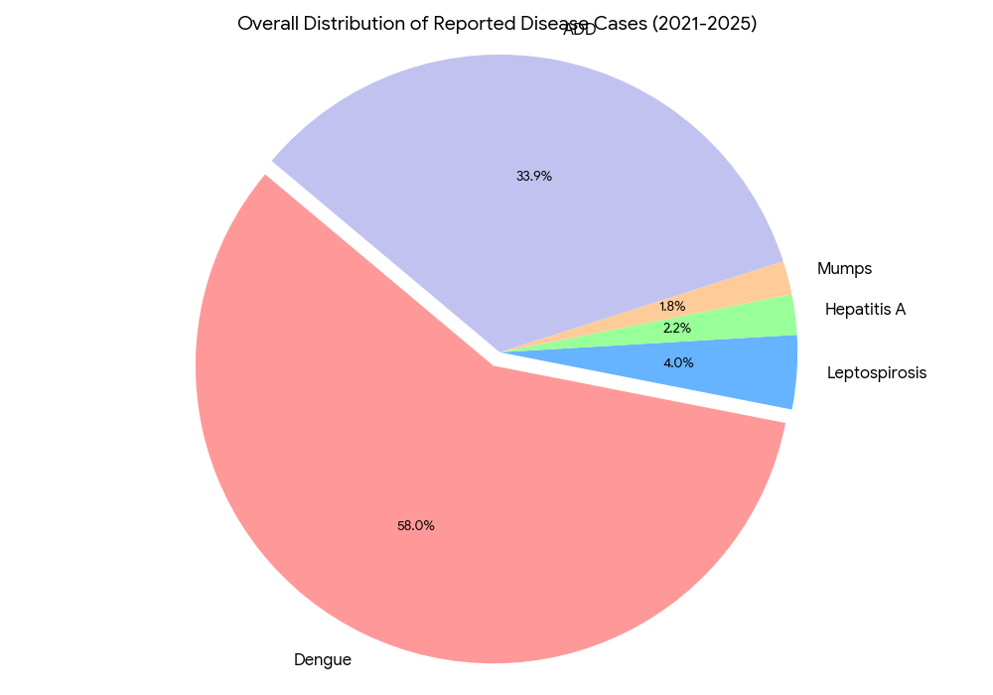

Preparedness and Response Protocol at LSG Level
This section describes the operational framework for the LSGI once a pandemic is declared. It explains how the LSGI and health system will move from routine data collection to active response, using a One Health approach.

Constitution of One Health Committee
The LSGD shall constitute a One Health Committee comprising the LSGI President, Medical Officers (Modern Medicine, AYUSH, and Veterinary), the Health Inspector, and the Veterinary Surgeon.

Objective: The One Health Committee coordinates human, animal, and environmental health to prevent and control pandemics.

Sl No | Name | Designation | Department/Institution | Role in Committee | Contact Number
1 | SAJITHA P Pillai | Panchayat President | LSGD | Chairperson | 9847794921
2 | DR.SUNIMOL S | Medical Officer (PHC/CHC) | Health Dept | Member Secretary | 9895025988
3 | RAJALEKSHMI | Veterinary Officer | Animal Husbandry | Member | 6238767731
4 | AMOL VIKRANTH | Epidemiologist | Health Dept | Member | 9048523036
5 | JAYASREE | Health Inspector | Health Dept | Surveillance | 9946641173
6 | RAMADEVI | ASHA Supervisor/PHN | Health Dept | Community link | 9496551453
7 | DEEPIKA | ICDS Supervisor | Social Welfare | Vulnerable groups | 9947828653
8 | SHO | Police Station Officer | Police Dept | Law & order | 9497947142
9 | GOKUL REJI | Ward Councillor Representative | LSGD | Community coordination | 8848013295
10 | SHEELAKUMARI | Kudumbashree CDO | Kudumbashree | Community mobilisation | 8086945132
11 | ASHA | NGO/Volunteer rep | Civil Society | Support services | 6282806830
12 | SECRETERY | Line Department representations | PANCHAYAT | - | 9747445503

Key Responsibilities:
- Review disease surveillance data (human + animal)
- Conduct ward-wise risk assessment and vulnerability mapping
- Approve quarantine/isolation centre locations
- Coordinate with district for resources (PPE, oxygen, ambulances)
- Periodically review health system surge capacity, including beds, oxygen, human resources, and ambulances.
- Approve and monitor risk communication and community engagement strategies, including rumour management.
- Ensure protection and service continuity for vulnerable groups (elderly, persons with disabilities, dialysis patients, coastal populations).
- Conduct quarterly mock drills
- Monitor equity measures for vulnerable groups

Meeting Schedule:
Quarterly (normal times) | Weekly (outbreak alert) | Daily (pandemic phase)

Pandemic Response Workforce
To ensure a coordinated and timely response during a pandemic, a dedicated Pandemic Response Workforce shall be constituted at the LSG level. The workforce will function under the overall supervision of the One Health Committee and in close coordination with the health authorities. Team-based deployment will enable efficient surveillance, case management, quarantine and isolation management, logistics support, and risk communication. Each team shall have a clearly designated team leader, defined roles, and an identified pool of personnel to allow rapid activation, rotation of duties, and continuity of services during prolonged emergencies.

Total Response Workforce Available: 300 persons

Team Name | Composition | Key Responsibilities | Team Leader
Surveillance and Contact Tracing Team | HI, JHI, JPHN, ASHAs and Volunteers | Case detection, contact listing, home visits, reporting | HI
Case Management Team | Doctors, Nurses, MLSP, Palliative Nurses | Patient care & referral | DOCTOR
Quarantine & Isolation Team | LSGD staff, Volunteers | Facility management | JHI
Psychosocial support
Logistics & supply chain Team | LSGD staff, Storekeepers, Drivers 3 | Supplies & transport [PPE, medicines, oxygen, transport, waste management] | Ward Member
Communication Team | Ward members, Kudumbashree, Youth clubs,  AWW workers and other self help groups | IEC, community meetings, countering misinformation | M.O in charge
Transportation | KSRTC, educational institutional buses
Media Surveillance | HI, BMO |  | MO
Intersectoral coordination and convergence | HI |  | HI
Collaborative surveillance | HI, JHI |  | HI

All teams shall be activated immediately upon outbreak alert or pandemic declaration and shall report daily to the LSG Incident Commander/Medical Officer, with consolidated reporting to the Block PHC. Duty rosters and alternate personnel shall be maintained to ensure uninterrupted services during staff shortages or prolonged response periods. Team composition and numbers may be revised based on the magnitude of the outbreak and availability of human resources.

Activities and Measures before and during Pandemic

PHASE 1 - Alert / Preparation
Surveillance and Reporting-Enhanced syndromic surveillance:
- Data sources for surveillance:
- Event-based triggers (to be monitored and reported):
- Zoonotic and animal health surveillance
- Logistics and Stock Preparedness
  - Identify and empanel local vendors and define emergency procurement mechanisms in accordance with existing LSGD and Health Department norms.
  - Prepare and maintain an essential logistics checklist covering medical supplies, consumables, and support equipment.
  - Pre-identify secure storage locations for emergency stocks and ensure maintenance of stock registers with regular updating.
  - Finalise emergency transport arrangements, including availability of vehicles and identified drivers for rapid deployment during alerts.
  - Designate a Nodal Officer for Logistics to enable prompt decision-making, coordination, and communication during emergencies.
  - Conduct rapid stock verification and ensure availability of minimum buffer stock, including:
- PPE kits – 2 numbers
- Pulse oximeters – 15 numbers
- Hand sanitizers – 2 litres
- Masks, gloves, disinfectants – adequate quantity
Identify critical gaps in logistics and immediately communicate requirements to the Block and District authorities for timely replenishment and support. Monitor expiry dates and stock rotation.

Identification of Quarantine and Isolation Facilities
  - Identify and list suitable buildings for quarantine and isolation (schools, hostels, community halls, etc.).
  - Categorise cases as per the severity and allocate to appropriate facilities (for instance, severe cases to classrooms, mild cases to an assembly hall in case of a school).
  - Facility readiness checklist needed (beds, toilets, ventilation) etc.
  - Find an alternate site if the primary sites are not available or not in use.
  - Identify facility managers and support staff
  - Prepare basic SOPs for:
    - Admission and discharge
    - Food, water, sanitation
    - Infection prevention and waste disposal
  - Ensure availability of basic amenities: water, sanitation, electricity, ventilation, and waste disposal. Prepare a rapid activation plan for these facilities if case numbers increase.

Risk Communication and Community Preparedness
  - Disseminate early warning messages on symptoms, preventive measures, and reporting mechanisms. Display IEC materials both in English and the local language in public places and ensure ward-level awareness.
  - Sensitize elected representatives and community leaders on preparedness measures.
  - Establish a rumour tracking and misinformation response mechanism to identify, verify, and promptly counter false or misleading information.
  - Engage trusted local persons (ward members, ASHA workers, religious leaders, teachers, community volunteers) to communicate official public health messages and reinforce correct practices.
  - Develop and deploy targeted IEC materials for:
    - Schools and educational institutions
    - Markets and commercial areas
    - Work sites and labour settings
  - Conduct community sensitization meetings at the ward level to promote preventive behaviors, address concerns, and strengthen community participation in preparedness and response.

Protection of Vulnerable Groups
Vulnerable populations require priority protection through targeted line-listing, service continuity, and delivery mechanisms.
- Prepare and regularly update line-lists of vulnerable populations, including:
  - Elderly persons living alone
  - Persons with disabilities
  - Pregnant women
  - Migrant workers
  - Dialysis patients
The detailed line-lists shall be maintained as Annexure ___ and updated periodically.

Clinical Dependency Mapping
Develop ward-wise dependency and vulnerability maps to identify households requiring regular support during emergencies. Ensure continuity of essential health services for vulnerable groups, including
- Dialysis services (facility mapping, transport arrangements, and scheduling)
- Continuity of treatment for TB, HIV, and other chronic conditions requiring uninterrupted medication
- Mental health and psychosocial support services
Establish delivery mechanisms for food, essential commodities, and medicines to vulnerable households through coordinated action involving ASHAs, JPHNs, Kudumbashree, volunteers, and local administration.

PHASE 2 - Active Response

Case Identification and Contact Tracing
Case detection and contact tracing activities will be carried out in coordination with the Health authorities, following disease-specific SOPs and IDSP guidelines.
Field Staff Involved
- Health Inspector (HI)
- Junior Health Inspector (JHI)
- Junior Public Health Nurse (JPHN)
- ASHAs and ASHA Supervisors
- Ward-level volunteers and Kudumbashree members (as required)

Screening Checkpoints
Screening checkpoints at high-traffic locations (transport hubs, markets, religious gatherings) for early detection of symptomatic travellers and crowd screening during outbreaks. Potential locations include bus stands, market entry points, and boat jetties, based on local context and risk assessment.
Screening activities will be carried out by trained personnel such as ASHAs, ward members, and volunteers, with support from Health Department staff. Necessary equipment, including non-contact thermometers and appropriate PPE, shall be ensured prior to activation.
Location | Type (Bus stand/Jetty/Market/Railway) | Staff Deployed (ASHAs/Volunteers) | Screening Method | Reporting authority
Bus stand | Transport hub | One JHI  One ASHA  One health Mentors | 1.Swab Collection.  2. Blood smears collection (RDT)  3.Thermal Scanners | Surveillance Nodal Officer in control room
Market entry | Market | One JHI  One ASHA  Male health volunteers | 1.Swab Collection.  2. Blood smears collection (RDT)  3.Thermal Scanners | Surveillance Nodal Officer in control room
Boat jetty | Water transport | One JHI  One ASHA  Male health volunteers | 1.Swab Collection.  2. Blood smears collection (RDT)  3.Thermal Scanners | Surveillance Nodal Officer in control room

Standard Screening Protocol


SCREENING PROTOCOL – PANDEMIC RESPONSE (Enadimangalam LSGD)

1. TEMPERATURE CHECK (Non-contact)
2. VISUAL SYMPTOMS (Cough / Fever / Breathlessness)
3. TRAVEL HISTORY (Last 14 days)
4. QUICK RISK ASSESSMENT

HIGH RISK | SUSPECT | NORMAL
Test & Quarantine | PHC Referral | Allowed + IEC + Mask

Follow infection prevention measures: Mask, Hand Hygiene, Physical Distancing.

The screening protocol shall include temperature screening, observation for visible symptoms, and inquiry regarding recent travel or exposure history. Individuals identified as suspects during screening shall be immediately referred to the nearest PHC/FHC for further evaluation, testing, and appropriate action as per prevailing guidelines.

Pandemic Control Room
The Pandemic Control Room (PCR) serves as the central nerve center for real-time coordination, data aggregation, decision support, and communication during outbreaks. It consolidates information from all LSGD teams, health facilities and community sources to enable rapid response decisions.

Control Room Infrastructure and Location
Primary Location: ENADIMANGALAM Panchayath Office.
Backup Location: Community Hall in ENADIMANGALAM G.P.

Health System Control Room Framework
The PCR is organized into seven functional pillars to ensure no aspect of the response is overlooked:

Rapid Response Team (RRT)
  - Provides immediate intervention during emergencies, clusters, and field alerts.​
  - Coordinates urgent actions such as case investigation, contact tracing, isolation, and inter‑facility referrals.

Data Management & Analytics Team
  - Collects, validates, and manages key health system indicators (cases, tests, beds, HR, supplies).​
  - Analyzes data trends, generates projections, and supports evidence‑based decision‑making for local authorities.

Human Resource Deployment Team
  - Allocates healthcare staff efficiently based on workload and need
  - Ensures adequate and equitable workforce distribution across facilities

Laboratory Surveillance Team
  - Oversees diagnostic testing coordination, sample transport, and timely reporting of results.​
  - Monitors lab indicators (testing volume, positivity rate, turnaround time) for early detection of outbreaks

Vaccination Cell (If Required)
  - Plans and executes vaccination campaigns, including micro‑planning and session scheduling.​
  - Tracks coverage, identifies gaps, and coordinates corrective actions with field teams and outreach services.

Infrastructure & Patient Occupancy Team
  - Monitors facility capacity, earmarked beds, oxygen and critical care resources across all linked facilities.​
  - Ensures optimal patient distribution and referral management using updated bed‑status and resource data.
  - BMWM
- Communication team
- Logistics and supply chain
- Transportation (interfacility & emergency transport)
- Media surveillance Call centre
- Management of the deceased
- Intersectoral coordination and convergence

Key Control Room Team
The Control Room Team coordinates all pandemic response activities within the LSGD and serves as the single command and communication hub during activation. It integrates information, field actions, logistics, and policy execution across all participating departments and health facilities.

Role | Name | Designation | Contact Number | Responsibility
In-charge/Nodal Officer | DR.SUNIMOL .S | MEDICAL OFFICER | 9895025988 | Overall coordination, decision-making, and reporting to the District level.
Data Entry Operator | ANJU THOMAS | DATA MANAGER | 9847394361 | Managing the line list, updating dashboards, and tracking testing results.
Communication Officer | SOUMYA SARA MATHEW | PRO | 9947937082 | Handling the public helpline, coordinating ambulance dispatch, and contact tracing calls.
Logistics Coordinator | PREETHA | PHARMACIST | 9961629040
Technical Support(IT/Data) | JISHA | CLERK | 9946181273

SOP for alert escalation/trigger point with mapping of responsibilities.
Key Points:
- The Control Room shall be staffed with a designated In-charge, data entry personnel, and communication staff with clearly defined roles and shift arrangements.
- It shall maintain updated records on daily monitoring indicators including new cases, persons under active quarantine, and hospital bed occupancy.
- All reports and situation updates shall be shared daily with the Block and District Surveillance Unit.
- The Control Room shall act as a single point of contact for coordination with response teams, health institutions, and other departments.
- Contact details of the Control Room shall be widely communicated to field staff and stakeholders during activation.

Daily Monitoring Indicators
To ensure timely decision-making and effective response, the following key indicators shall be monitored and updated on a daily basis by the Pandemic Control Room:

Epidemiological Indicators:
New cases reported today, Total active cases, Test Positivity Rate (TPR), Case Fatality Rate (CFR)
- Surveillance Indicators:
Persons under home quarantine, High-risk contacts identified, Fever, ILI, SARI or other symptoms (syndromic surges), Travellers (symptomatic or high-risk arrivals),Animal husbandry surveillance (zoonotic alerts, unusual animal deaths, poultry/bird flu signals), Mortality surveillance (excess deaths, unexplained fatalities, verbal autopsy reports)
- Logistics and Infrastructure Indicators:
Hospital / CFLTC beds occupied, Oxygen cylinders/concentrators available, Ambulances on standby
- Alert Findings
The following table outlines category-specific trigger points (red flags) from surveillance indicators and corresponding immediate actions for the Pandemic Control Room. These enable rapid response to alert findings like testing anomalies, positive cases exceeding thresholds, clusters, and WGS reports.

Category | Trigger Point (Red Flag) | Immediate Action
Clusters | Geographical or facility-based: 5+ cases linked to one location (office, school, street). | Declare a micro-containment zone; perimeter control and active case finding.
Testing | Sudden drop in testing volume / delay in reporting / unusual testing trends | Review the sample collection process, address lab bottlenecks, deploy additional testing teams, and notify the District Lab.
Lab | Test Positivity rate increases | Increase testing sites in that ward.
Hospital | >80% Oxygen bed occupancy | Activate backup/CFLTC beds.
Travel | Cluster of cases from a single flight/train or high-risk arrival group. | Trace all passengers in adjacent seats; implement mandatory institutional quarantine.
Animal | Mass poultry/wildlife death or unusual sickness | Notify Animal Husbandry, sample the area, and dispatch RRT for environmental sampling and zoonotic check.
Mortality | Sudden spike in home deaths or brought-in-dead (BID) cases | Audit the deaths and Active Case Search drive
Additional investigations like Whole Genome Sequencing (WGS) | Detection of a Variant of Concern (VOC) or Variant of Interest (VOI) | Implement strict micro-containment; update clinical protocols to match variant severity.

Communication of Public Health Information
A Community Communication Hub shall be established to ensure timely, accurate, and consistent dissemination of information during a pandemic. The Hub will function under the coordination of Nodal officers of the control room and act as the nodal point for public communication, risk messaging, and community engagement. It will support dissemination of official advisories, promote preventive behaviors, address rumors and misinformation, and ensure that messages reach all sections of the population through trusted local channels and leaders.

Key communicators
Channel | Responsible Person | Contact
Ward-level announcements | JAYASREE | 9946641173
Social media | REJANI | 9496150045
Local Cable TV/Radio | MANOJ | 9496411412

- All messages disseminated through the Hub shall align with advisories issued by the Health Department and District authorities.
- Community leaders shall be sensitized to support behavior change, reduce stigma, and counter misinformation.
- Special efforts shall be made to reach vulnerable and hard-to-reach populations using locally appropriate communication methods.

Rumor Tracking: A designated volunteer will monitor local social media/WhatsApp groups daily to identify misinformation and issue official clarifications via the Communication Hub.

Coordination with District/State Authorities & Other Organisations
Effective coordination with Block, District, and State authorities is essential to ensure timely reporting, technical guidance, and uninterrupted supply of essential resources during a pandemic. The LSG shall establish clear communication channels, designate responsible officers, and adhere to prescribed reporting timelines to support coordinated public health action and efficient resource mobilisation.

Key Details:
- Nodal Officer for Reporting:
- Contact Number:
Reporting Schedule and Protocols:

To Whom | What to Report | Frequency | Nodal Person
Block PHC | Complete Situation Report (Cases, Quarantine, Beds, Screening, Deaths) | Daily | Alexander  Health Supervisor
District IDSP Unit | Outbreaks/Clusters/Unusual Events (>5 cases same ward) | Daily | Epidemiologist
Veterinary Officer | Animal health events/Zoonotic alerts | Daily | Dr RAJALEKSHMI
State Cell | Zoonotic cross-sector events | NIL | NIL

Supply Chain Coordination
The LSG shall coordinate closely with Block, District, and State authorities (KMSCL) to ensure uninterrupted availability of essential goods, medical supplies, and logistics during a pandemic. Supply requirements shall be assessed regularly based on case load and communicated promptly to the appropriate authorities for timely replenishment.
Key Points:
- Maintain updated contact details of District and Block nodal officers for health logistics, oxygen supply, ambulances, and essential medicines.
- Submit timely indent requests for PPE, testing kits, medicines, oxygen, and other critical supplies through prescribed channels.
- Monitor stock levels at LSGD facilities, quarantine/isolation centres, and field teams through daily stock registers and dispensing logs to prevent shortages.
- Coordinate with District authorities, Karunya/Neethi medical shops, and local purchase committees for funds allocation and emergency procurement.

- Ensure regular monitoring of dispensing registers at all facilities to track usage, expiry, and pilferage—shortages being a perennial issue requiring proactive weekly audits.

- Activate surge procurement protocols during high caseloads, leveraging local purchase powers under LSGD funds alongside state supplies.

Resource Inventory and Contacts
Resource Category | Source  (District/State/Private) | Contact
PPE Kits/Masks/Gloves | KMSCL | NIL
PPE Kits/Masks/Gloves | Local Vendors | NIL
Oxygen  Cylinders/Concentrators | KMSCL | NIL
Medicines/Antivirals | KMSCL | NIL
Medicines/Antivirals | Neethi Shops | NIL
Test Kits (RTPCR/Rapid) | KMSCL | NIL

Collaboration with NGOs, PPP, and CSR
To augment government efforts during a pandemic, the LSG shall collaborate with NGOs, voluntary organisations, and private sector partners through public–private partnerships and Corporate Social Responsibility (CSR) initiatives, in coordination with District authorities.

Key Points:
- Engage NGOs and community-based organisations for community outreach, awareness, and support to vulnerable populations.
- Leverage CSR support for procurement of medical equipment, PPE, oxygen concentrators, food kits, and sanitation materials, as permitted.
- Ensure all collaborations align with government guidelines and are routed through approved administrative and financial procedures.
- Maintain transparency and documentation for all external support received and utilised.
Organization | Type | Support Offered | Contact Person
Youth Clubs/Student Unions | CBO | NIL | NIL

Interdepartmental Coordination
Coordination among departments during a pandemic shall be ensured through regular review meetings convened by the LSGD President. These meetings will provide a structured platform for sharing situational updates, assessing resource availability, resolving operational gaps, and taking joint decisions to ensure a coordinated and timely response.

Department | Representative | Key Role | Contact
Health (PHC) | Staff Nurse : Ambiliy | Case management | 9446272947
Veterinary | Veterinary Surgeon:  DR. Rajalekshmi | Animal surveillance | 6238767731
ICDS | Supervisor: Sindhu | Nutrition support | 9947828653
Education | Head Teacher: | School coordination | 9946857083
Police | ADOOR | Containment enforcement | 9497987050
Water Authority | ADOOR | Water supply | 9496042690
LSGD Engineering | ENADIMANGALAM | Quarantine infrastructure | 8301023489

PHASE 3 - Surge Capacity
Phase 3 is activated when there is a rapid increase in cases, high test positivity rates, or when existing health facilities and quarantine arrangements approach saturation. The focus of this phase is to expand isolation capacity, augment clinical care services, and mobilise additional resources through district and state support mechanisms.

Conversion of Community Facilities
To manage increased case load, the LSGD shall activate additional isolation facilities by repurposing identified community infrastructure such as community halls, auditoriums, schools, hostels, or other suitable buildings.

Name of facility (Enadimangalam) | Facility Type | No. of Buildings | Ward | Surge Capacity (Beds) | Nodal Person
Govt.UPS Kunnida | Govt | 1 | 10 | 100 | HM
UPS Kurumpakara | Aided | 1 | 11 | 50 | HM
St.George Ashramam UPS | Aided | 1 | 10 | 50 | HM
St.George Ashramam HS | Aided | 1 | 11 | 150 | HM
GHSS Maroor | Govt | 2 | 6 | 150 | HM
ELAMANOOR HIGH SCHOOL | GOVT | 1 | 13 | 35 | HM
GPM LPS POOTHANKARA | GOVT | 1 | 3 | 50 | HM
KPPM UPS ELAMANOOR | PRIVATE | 2 | 14 | 25 | HM
GOVT LPS ELAMANOOR | GOVT | 1 | 14 | 50 | HM
NM LPS KALANJOOR | Aided | 1 | 7 | 50 | HM
NMUPS KALANJOOR | Aided | 1 | 7 | 50 | HM
NEW MANCENTRAL SCHOOL MANGADU | PRIVATE | 4 | 1 | 100 | PRINCIPAL
New Man School | Private | 2 | 1 | 150 | PRINCIPAL
GPM UP School | Govt | 2 | 3 | 100 | PRINCIPAL
BJM School, Puthuval | Private | 2 | 7 | 100
St: Brocads Salempuram | Aided | 2 | 7 | 100
Govt LPS Salempuram | Govt | 2 | 7 | 100

- Recovery and rehabilitation phase
- Recovery
  - Damage & impact assessment
  - Restoration of health services
  - Rehabilitation of affected population
  - Psychosocial & mental health support
  - Disease surveillance during recovery phase
  - Environmental cleanup & sanitation
  - Livelihood restoration
  - Community engagement & confidence building
  - Documentation & after-action review
  - Lessons learned & best practices
  - Health system strengthening
  - Policy revision & preparedness enhancement
  - Research

CONCLUSION

Additional points
- tech support
- relief based commodities
- ham reading operators
- hazard vulnerability mapping
- Kseb & other power source
- HR specific responsibility

RECOMMENDATIONS

Strengthening Healthcare Infrastructure
- Establish a primary health response unit within the Panchayat with trained staff.
- Ensure availability of basic medical supplies (masks, sanitizers, PPE kits, oxygen cylinders).
- Create tie-ups with nearby hospitals in GH ADOOR_for emergency referral and transport.

2. Community Awareness & Education
- Conduct regular awareness campaigns on hygiene, vaccination, and preventive measures.
- Use local communication channels (community radio, WhatsApp groups, notice boards) to spread verified information.
- Train volunteers to act as health ambassadors in each ward.

3. Emergency Response & Coordination
- Form a Pandemic Preparedness Committee at Panchayat level including health workers, ward members, and NGOs.
- Develop a clear action plan for lockdowns, quarantine, and distribution of essentials.
- Maintain a database of vulnerable groups (elderly, differently-abled, chronically ill) for targeted support.

4. Supply Chain & Food Security
- Identify and support local suppliers and farmers to ensure uninterrupted food supply.
- Create community kitchens during emergencies to serve vulnerable populations.
- Stockpile essential commodities in Panchayat-run outlets for crisis periods.

5. Digital Preparedness
- Promote digital platforms for telemedicine consultations.
- Use Panchayat’s website/social media for real-time updates on health advisories.
- Encourage online grievance redressal to reduce crowding in offices.

6. Training & Capacity Building
- Organize mock drills for pandemic response in schools, offices, and public spaces.
- Train Panchayat staff and volunteers in first aid, infection control, and crowd management.
- Collaborate with NGOs and health departments for capacity-building workshops.

7. Long-Term Resilience
- Integrate pandemic preparedness into the Panchayat Development Plan.
- Allocate a dedicated budget for health emergencies.
- Encourage community participation in planning and monitoring preparedness measures.

MOCKDRILL SCENARIOS

ANNEXURE

IMPORTANT PHONE NUMBERS

Phone numbers and particulars of persons responsible for providing guidance, assistance, and support for pandemic preparedness operations may be provided here in a manner that allows easy reference at a glance.The information recorded here could be exhibited elsewhere at the time of emergencies. LSG institutions shall give special attention to collect and record the above data of persons and institutions who/which are supposed to give technical and co-ordination support to reduce the impact of pandemic.

1.1. Details of grama panchayat/municipality/corporation wards
Sl.No | Name of the ward | Ward number | Name of the ward  member | Contact number
1 | Mangadu | 1 | Binoy Raju | 9447594280
2 | Poothamkara West | 2 | Anju S | 9061263398
3 | Poothamkara Vettipuram | 3 | Sajitha P Pillai | 9847794921
4 | Poothankara Kizhaku | 4 | Vipin | 9946695147
5 | Marror Vadakku | 5 | Abinkumar V S | 9539319744
6 | Chankoor | 6 | Gokul Reji | 8848013295
7 | Marror Thekku | 7 | Mini Prasad | 9744792637
8 | Kurumbakara Kizhakku | 8 | Siresh Babu | 9447593989
9 | Maroor Kattukala | 9 | Jordi | 9633780086
10 | Kurumbakara Padinjaru | 10 | Shyam K | 8281653351
11 | Kunnida Kizhakku | 11 | Valsamma | 9946528169
12 | Kunnida Padinjaru | 12 | Abhijith | 8921572730
13 | Elamanoor Kizhaku | 13 | Renjith | 8848566063
14 | Elamanoor Padinjaru | 14 | Seeema R | 9400686133
15 | Mangadu Thekku | 15 | Sindhu | 8086736861
16 | Parakkal | 16 | Sharatha P | 8943094771

1.2. Important offices of Grama Panchayat

Sl. No. | Name of the Office | Contact Person | Contact Number
1 | Village Office | Village Officer | 9747445503
2 | Agriculture Office | Agriculture Officer | 9048110003
3 | Animal Husbandry Office | Animal Husbandry Doctor | 6238767731
4 | Police Station | Police Officer | 9497987050
5 | BSNL Office | Officer | NIL
6 | Block Office | Officer | 04682322014
7 | KSEB Office | Officer | 9446009377
8 | Fisheries Office | Officer | NIL
9 | Fire and Rescue | Officer | 04734229918
10 | Secretary | Enadimangalam LSGD | 9747445503
11 | Excise Department | — | —
12 | Forest Department | — | —

1.4. Health Services

Sl. No | Name of the hospital/institution (Enadimangalam) | Location | Phone number
1. | Government hospitals/PHC | Enadimangalam | 04734247301
2. | Private hospitals | Enadimangalam | 04734269500
3. | Clinical laboratories | Enadimagalam | 9207101234
4. | Chemist/pharmacy | Enadimangalam | 9207101234
5. | Blood donors | Enadimangalam | 04734269500
6. | Other language experts (Bihari, Hindi, Bengali,  Asamees ………) | Nil

1.5. Veterinary Services
Sl.No | Name of the Clinic (Enadimangalam) | Name of the  Surgeon/Doctor | Place/location | Phone  number
1 | Govt.Veterinary Hospital | Rajalekshmi | Elamanoor | 6238767731
2 | Govt.Veterinary, |  | Kunnida | 9447407638

1.6. Helpline numbers
Helpline | Phone number
Police | 9497987050
Fire and Rescue | 04734229918
KSEB | 9446009377
Child line | 0468-2224375
Crime Stopper | 1090
Women Helpline | 0468-2222226

1.7. Public and Private Schools Contact details

S.No | Name of School (Enadimangalam) | Institution type | Phone number
1 | Govt. UPS Kunnida | Govt | 9747769671
2 | UPS Kurumpakara | Aided | 9495509616
3 | St. George Ashramam UPS | Aided | 9446349944
4 | St.George Ashramam HS | Aided | 9747219049
5 | GHSS Maroor | Govt | 9495547339
6 | Elamanoor High School | Govt | 9605450403
7 | THSS Elamanoor | Govt | 7025798681
8 | NM LPS Kalanjoor | Aided | 9656427830
9 | NMUPS Kalanjoor | Aided | 9496109169
10 | New Man Central School Mangadu | Private | 9446708359
11 | GPM LPS Poothankara | Govt | 9495381074
14 | KPPM UPS Elamanoor | Private | 9526059488
15 | GOVT LPS Elamanoor | Govt | 9946857083

1.9. Anganwadi Contact Details

Ward No | Anganwadi No: | Anganwadi Location | Name of Anganwadi Teachers | Phone number
1 | 38 | Parakkal Murukan Kunnu | AMBILI K G | 9539248495
2 | 50 | Mylavel Kadamankuzhy | ASWATHY | 9492248521
3 | 37 | Muruppelthara Lekshamveedu | RAJIKRISHNAN K | 8590646346
3 | 45 | Kadamankuzhy Vancheruvila | SANDYA P CHANDRAN | 9207538698
4 | 35 | Poothamkara Kizhaku | GEETHAKUMARI | 8590335310
4 | 36 | Kanachukuzhy Poothamkara | ASWATHI | 9495248521
5 | 34 | Mavila-Maroor | LEKHA T | 8281174551
6 | 44 | Maroor | RADHAMANIYAMMA | 7306866049
6 | 46 | Chankoor | SUJADEVI T R | 9074939745
7 | 49 | Puthuval-Salempuram | GEETHA S | 6235237690
8 | 43 | Pattara- Kurumbakara | SACHU S NAIR | 90448224926
8 | 51 | Chemenattam-Kurumbakara | ROMAL MEENA | 8848894508
10 | 47 | Udayonmuuttam-Kurumbakara | SUNITHA | 7025323436
11 | 40 | Kunnida | RESMI K NAIR | 9961536687
11 | 42 | Mainamon-Kurumbakara | RESMI | 7902544165
11 | 52 | Chayalode- Kunnida | MANI K | 9539801395
12 |  |  | RADHA R | 9048120038
12 | 41 | Kunnida - Lekshamveedu | SAV ITHA S NAR | 8304859257
13 | 33 | Elamanoor- Lekshamveedu | PRESENNA K G | 9048436654
14 | 48 | Maruthimoodu | PRINU T R | 9526725389
15 | 39 | Mangadu-Chayalode | VALSALA | 7902261440

1.12. Information regarding resources

Means of transportation (Enadimangalam) | Name of Owner | Phone Number
JCB | Lijo Mangalathu,  Raju Thomas | 9846214351,  9447278808
Heavy Trucks | NIL | NIL
Tractor | D BHANUDEVAN | 9495501677
Ambulances | SEVA BHARATHI  Mount Zion | 9544194344  04734269500
Boats | NIL | NIL
Taxi service | UDAYAN,  Binoy Raju | 9048723900,  9447594280

Annexure 1: LSG Baseline Data Collection Format
A. Baseline data
Sl. No. | Indicator / Field | Baseline Data | Source / Remarks
1 | Name of LSG | ENADIMANGALAM | -
2 | District | PATHANAMTHITTA | -
3 | Block / Taluk | PARAKODE | -
4 | Type of LSG (Gram Panchayat / Municipality / Corporation) | GRAMAPANCHAYAT | -
5 | Area (sq. km) | 30.77 | -
6 | No. of wards | 16 | -
7 | GIS boundary file available | Yes | -
8 | Key contact person & phone | 9496042691 | -

B. Demography
Indicator / Field (Enadimangalam) |  | Baseline Data | Source / Remarks
Total population |  | 23356
Males |  | 11701
Females |  | 11655
Transgender population |  | 0
Age distribution  (<5, 5–14, 15–59, ≥60) | <5 | 2050
Age distribution  (<5, 5–14, 15–59, ≥60) | 5-14 | 4326
Age distribution  (<5, 5–14, 15–59, ≥60) | 15-59 | 8554
Age distribution  (<5, 5–14, 15–59, ≥60) | >=60 | 8426
No. of households |  | 23356
Population density (persons/sq.km) |  | 681/ sq.km
No. of migrant workers |  | 565
Major occupational groups |  | Rubber, Agriculture

C. Vulnerable Populations & Social Risks
Sl. No. | Indicator / Field (Enadimangalam) | Baseline Data (Value / Description) | Source / Remarks
1 | No. of elderly (≥60) | 8426
2 | No. of persons with disability | 241
3 | No. of bedridden persons | 170
4 | No. of chronic disease cases (DM/HTN/COPD/CKD etc.) | 6544
5 | Pregnant women (current estimate) | 281
6 | Children <5 years | 2050
7 | Tribal population (if any) | 24
8 | Fisherfolk / coastal vulnerable groups (if any) | 0
9 | Urban slums / unnotified settlements (if any) | 0
10 | Homeless population | 0
11 | Orphanages / old age homes (number & capacity) | 0/1
12 | Hostels / prisons / shelters (number & capacity) | 0
13 | Poverty / BPL estimate | 2675
14 | Food insecurity hotspots | 0
15 | Any history of stigma/discrimination issues (Yes/No) | no

D. Health System & Service Readiness
Sl. No. | Indicator / Field (Enadimangalam) | Baseline Data (Value / Description) | Source / Remarks
1 | No. of health facilities in LSG (PHC/CHC/TH/DH/Private) | CHC-1  Private-2
2 | PHC/Family Health Centre details (name, location) | Enadimangalam
3 | Subcentres / Health & Wellness Centres (number) | 4
4 | Private clinics / hospitals (number) | 2
5 | Labs available (public/private) | 5 -Private
6 | Availability of ambulance services (Yes/No, number) | Yes-3
7 | Availability of isolation/quarantine facilities (Yes/No, details) | Yes-16
8 | Cold chain facilities (Yes/No, details) | Yes
9 | Stockpile space available (Yes/No) | Yes
10 | PPE / mask / sanitizer availability plan (Yes/No) | Yes
11 | Surveillance staff available (JHI/JPHN/ASHA count) | Yes
12 | Existing emergency referral pathways (Yes/No) | Yes

E. Points of Entry & Mobility
Sl. No. | Indicator / Field | Baseline Data (Value / Description) | Source / Remarks
1 | Bus stands / depots (number) | 0
2 | Railway stations (number) | 0
3 | Boat jetties / fishing harbours (number) | 0
4 | Ports / airports nearby (specify distance) | 0
5 | Major highways/roads passing through | YES- KP Road
6 | Border crossings (state/district) | KOLLAM
7 | Major markets / weekly markets | 0
8 | Tourism hubs / major event venues | 0
9 | Schools/colleges with hostels (number) | 0
10 | Factories / large workplaces (number) | 0
F. Water, Sanitation & Hygiene (WASH)
Sl. No. | Indicator / Field (Enadimangalam) | Baseline Data (Value / Description) | Source / Remarks
1 | Major drinking water sources (piped / wells / borewells / springs) | Wells
2 | No. of public wells | 13240 (Private)
3 | No. of households with piped water connection | 13240
4 | Water quality testing routine (Yes/No) | Yes
5 | Common contamination risks (flooding, salinity, industrial waste) | Nil
6 | Open defecation free status (Yes/No) | Yes
7 | Solid waste management system (Yes/No) | Yes
8 | Bio-medical waste disposal mechanism (Yes/No) | Yes
9 | No. of public toilets | 2
10 | Handwashing stations in public places (Yes/No) | Yes
G. Zoonotic Risks & One Health
Sl. No. | Indicator / Field (Enadimangalam) | Baseline Data (Value / Description) | Source / Remarks
1 | Livestock population (cattle/goats/pigs/poultry) – estimates | 1669
2 | No. of dairy farms / poultry farms / pig farms | 0
3 | Slaughterhouses / meat shops (number) | 1
4 | Animal markets (Yes/No, details) | No
5 | Veterinary dispensaries (number) | 2
6 | History of zoonotic outbreaks (rabies, leptospirosis, avian flu etc.) | Nil
7 | Stray dog population management measures (Yes/No) | No
8 | Rodent infestation hotspots (Yes/No) | Yes
9 | Wetlands / waterlogged areas prone to leptospirosis | Yes
10 | Bat roosting areas / caves / fruit orchards (if any) | No
11 | Human-animal interface hotspots (farms near residences) | No
H. Climate & Disaster Risks (Pandemic Amplifiers)
Sl. No. | Indicator / Field (Enadimangalam) | Baseline Data (Value / Description) | Source / Remarks
1 | Flood-prone wards (list) | Nil
2 | Landslide-prone wards (list) | Nil
3 | Cyclone/sea surge risk (Yes/No) | No
4 | Heatwave risk zones (Yes/No) | No
5 | Waterlogging areas (list) | Nil
6 | Shelter homes / relief camps (number, capacity) | 20/2000
7 | Past disaster displacement history | Nil
8 | Disruption to water supply/transport common (Yes/No) | No
I. Critical Infrastructure & Logistics
Sl. No. | Indicator / Field (Enadimangalam) | Baseline Data (Value / Description) | Source / Remarks
1 | Schools (number) | 23
2 | Anganwadis (number) | 21
3 | Colleges (number) | 0
4 | Community halls (number) | 10
5 | Places of worship with large gatherings (number) | 45
6 | Large markets / shopping areas (number) | 0
7 | Warehouses / cold storages (number) | 1
8 | Telecom/mobile network coverage gaps (Yes/No) | NO
9 | Power outage frequency (high/medium/low) | LOW
10 | Availability of generators in key facilities | YES
J. Risk Communication & Community Networks
Sl. No. | Indicator / Field | Baseline Data (Value / Description) | Source / Remarks
1 | Ward-level rapid response teams (Yes/No) | Yes
2 | Jagratha samithis / committees active (Yes/No) | Yes
3 | Kudumbashree presence and strength (number of units) | 860
4 | Volunteer network (number, coverage) | 1078
5 | Community-based surveillance mechanisms (Yes/No) | Yes
6 | IEC dissemination channels (WhatsApp groups, community radio, PA systems) | Yes
7 | Rumour tracking mechanisms (Yes/No) | Yes
8 | Languages spoken / literacy considerations | Yes
9 | Vulnerable groups communication strategy available (Yes/No) | Yes

K. Preparedness Planning & Governance
Sl. No. | Indicator / Field | Baseline Data (Value / Description) | Source / Remarks
1 | LSG emergency plan available (Yes/No) | Yes
2 | Pandemic preparedness plan available (Yes/No) | Yes
3 | Incident Command System identified (Yes/No) | Yes
4 | Rapid procurement mechanism available (Yes/No) | Yes
5 | Emergency fund available (Yes/No, amount) | No
6 | Past outbreak response experience (Yes/No, details) | Yes, Covid 19
7 | Intersectoral coordination mechanism (Health, Police, LSG, Veterinary, Education) | Yes
8 | Mock drills conducted in last 12 months (Yes/No) | Yes
9 | Training coverage for staff/volunteers (Yes/No) | Yes

L. Surveillance & Data Systems
Sl. No. | Indicator / Field | Baseline Data (Value / Description) | Source / Remarks
1 | Digital reporting tools used (e.g., DHIS2, portals) | Yes
2 | Availability of line-listing format (Yes/No) | Yes
3 | Contact tracing team identified (Yes/No) | Yes
4 | Mapping of high-risk households available (Yes/No) | Yes
5 | Testing sample transport mechanism (Yes/No) | Yes
6 | Reporting timeline adherence (good/average/poor) | Good
7 | Data sharing between departments (Yes/No) | Yes
8 | Availability of dashboard for monitoring (Yes/No) | No
M. Additional Notes & Observations
Sl. No. | Indicator / Field | Baseline Data (Value / Description) | Source / Remarks
1 | Key challenges perceived by LSG | Yes
2 | Top 5 high-risk wards (reason) | Nil
3 | Any unique local risks (industrial pollution, refugee camps, etc.) | Nil
4 | Recommendations for preparedness strengthening | Yes

