PANDEMIC PREPARDNESS PLAN

EZHAMKULAM
GRAMA PANCHAYATH
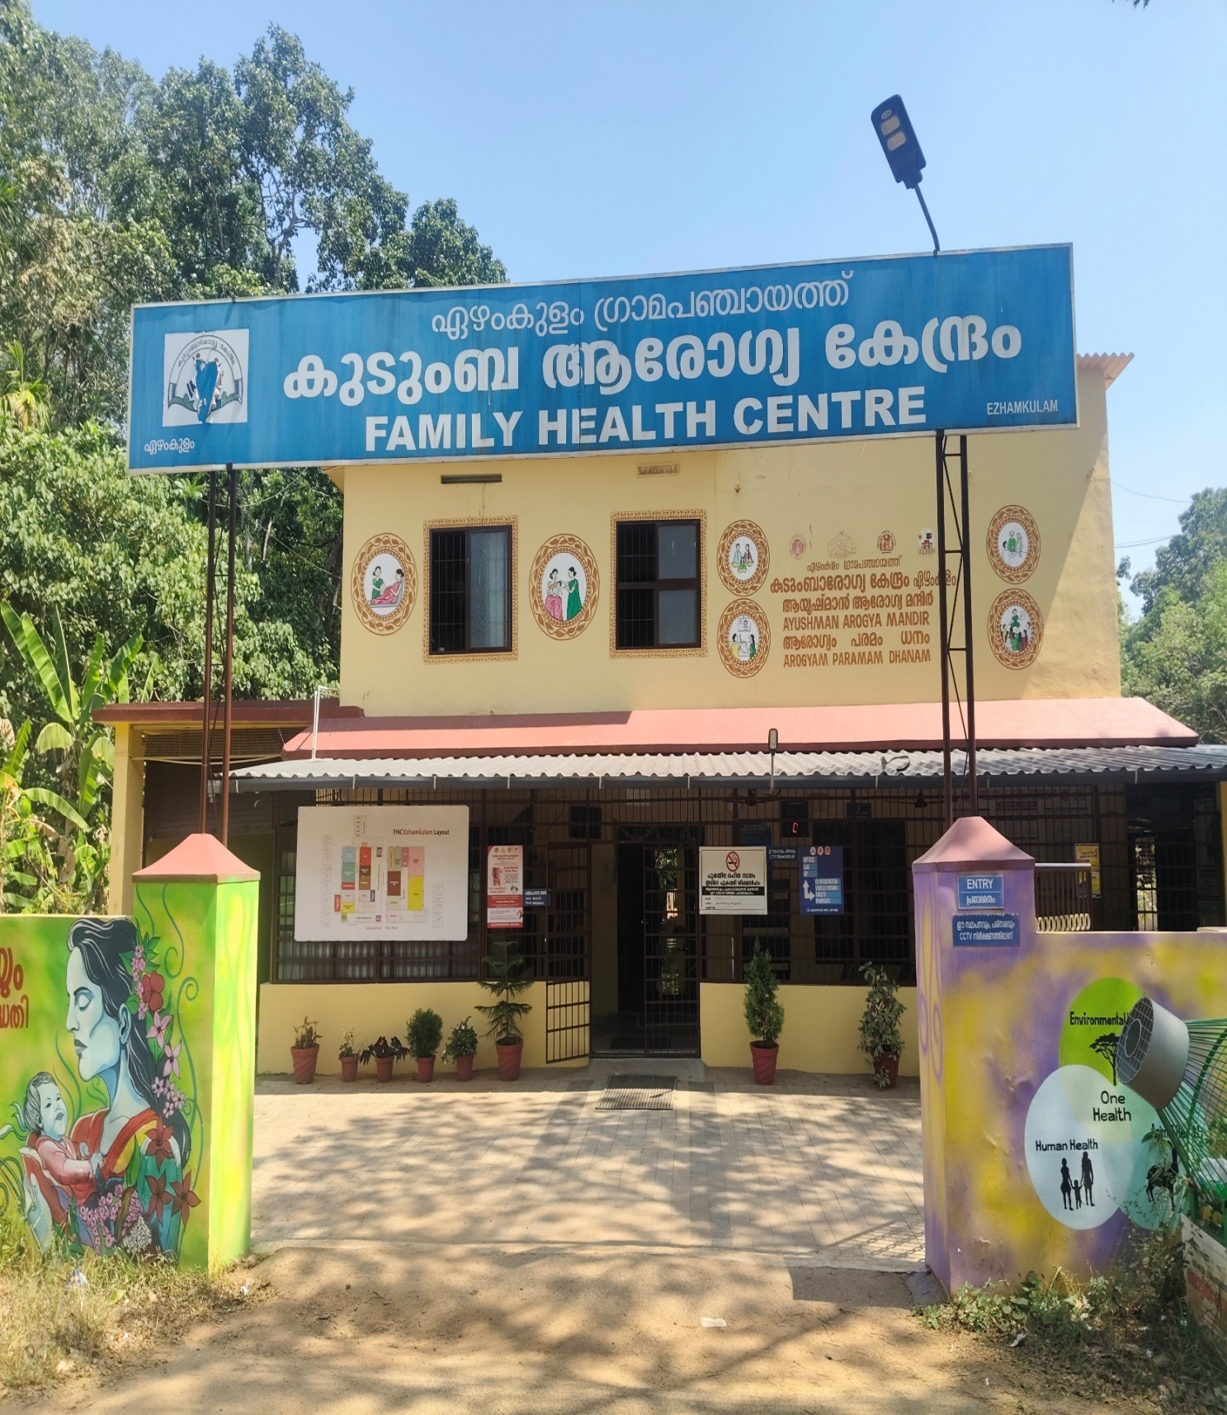

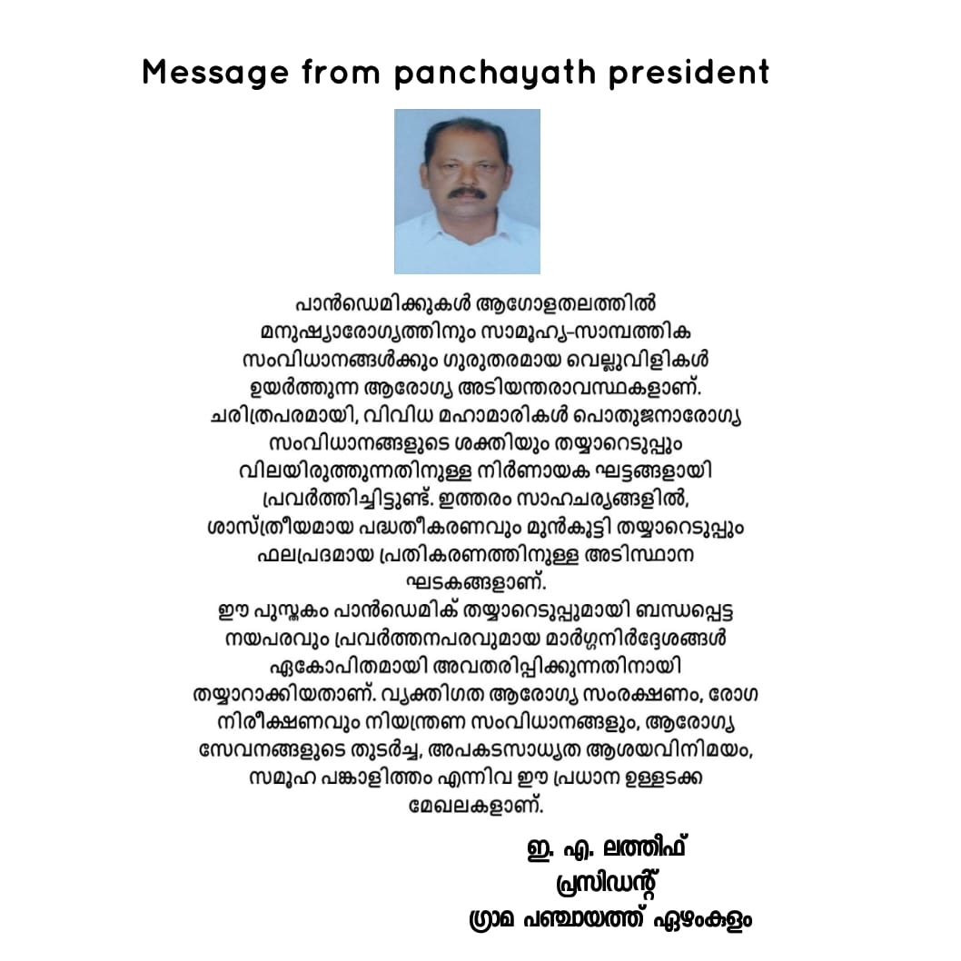



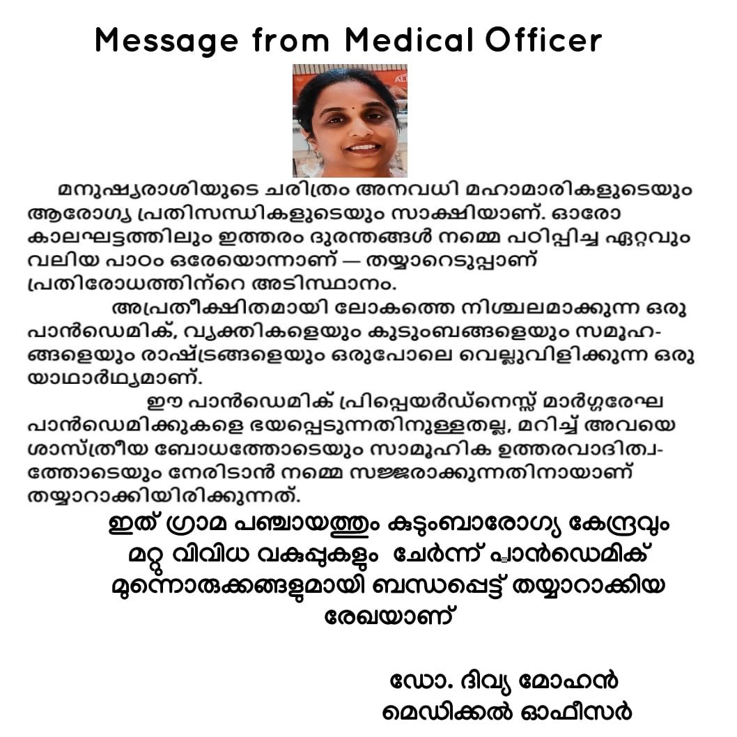

EXECUTIVE SUMMARY
Family Health Centre (FHC) functions as the primary public healthcare institution serving the population of Ezhamkulam Grama Panchayath. The FHC plays a pivotal role in delivering comprehensive, accessible, and affordable healthcare services, with a strong focus on preventive, promotive, curative, and rehabilitative care in accordance with national and state health programmes.
The FHC caters to a predominantly rural population, addressing key public health priorities such as maternal and child health, communicable and non-communicable disease control, immunization, family welfare, adolescent health, and geriatric care. Regular outpatient services, home-based care through field health staff, and outreach activities ensure healthcare coverage even in geographically challenging areas. The institution actively implements national health missions, including the National Health Mission (NHM), National Tuberculosis Elimination Programme, National Programme for Prevention and Control of Cancer, Diabetes, Cardiovascular Diseases and Stroke (NPCDCS), and other disease surveillance initiatives.
Ezhamkulam FHC works in close coordination with the Grama Panchayath, ASHA workers, Anganwadi centres, schools, and community-based organizations to strengthen community participation and improve health awareness. Emphasis is placed on early detection, timely referral, health education, and lifestyle modification to reduce disease burden and improve overall health outcomes.
Despite constraints related to infrastructure, manpower, and increasing service demand, the PHC continues to enhance service delivery through effective planning, data-driven decision-making, and community engagement. Strengthening facilities, upgrading digital health systems, and expanding preventive services remain key focus areas for future development.
Overall, Ezhamkulam Family Health Centre stands as a vital institution in safeguarding public health and improving the quality of life of the residents of Ezhamkulam Grama Panchayath

LIST OF ABBREVIATIONS

LSGD/LSGI | Local Self Government Department / Local Self Government Institution
BMO | Block Medical Officer
IDSP | Integrated Disease Surveillance Programme
NDMA | National Disaster Management Authority
PPE | Personal Protective Equipment
ICMR | Indian Council of Medical Research
CD | Communicable Diseases
NCD | NON-COMMUNICABLE Diseases

TABLE OF CONTENTS

EXECUTIVE SUMMARY 6
LIST OF ABBREVIATIONS 7
TABLE OF CONTENTS 8
INTRODUCTION 10
LSGD at a Glance 10
Maps of Ezhamkulam Panchayat 12
GENERAL PROFILE OF EZHAMKULAM GP 21
Background of Ezhamkulam GP 21
Demographic and Vulnerable Population 27
Clinical Vulnerability 28
Major Festivals & Events specific to Ezhamkulam Grama Panchayath 29
INFRASTRUCTURE & RESOURCE INVENTORY 30
Health Facility Directory & Basic Capacity in Ezhamkulam GP 30
Private Clinics 31
Healthcare Education & Training Institutions 31
Specialized Services & Emergency Inventory 32
Oxygen & Diagnostic Capacity 33
Diagnostics facility mapping at Ezhamkulam Panchayath 33
Laboratory Identification & Basic Details-Ezhamkulam 34
Social and Community Infrastructure for surge plan 34
HUMAN RESOURCES 36
Medical & Clinical Personnel 36
Public Health & Field-Level Workforce 36
Community & Support Cadre 37
Community Organizations 38
Administrative & Emergency Services 39
Information regarding resources 39
ONE HEALTH & ENVIRONMENTAL SURVEILLANCE 40
Animal & Bird Population 40
Veterinary Infrastructure 41
Veterinary Doctors & Workforce 42
High-Risk Interface Points (Surveillance Sites) 43
Environmental Risk Mapping 44
Disease Seasonality Mapping 45
Vulnerability Mapping 46
EPIDEMIOLOGICAL TRENDS (2021–2025) 47
Disease Burden Among Human Beings (Last 5 Years) 47
Seasonal Trend Analysis 50
Outcome-Based Trend Analysis- 2025 53
Transmission Trend- 2025 54
Integrated Disease Hotspot Map (2021–2025) 56
PREPAREDNESS AND RESPONSE PROTOCOL AT LSG LEVEL 61
Constitution of One Health Committee 61
Pandemic Response Workforce 62
ACTIVITIES AND MEASURES BEFORE AND DURING PANDEMIC 64
PHASE 1 - Alert / Preparation 64
PHASE 2 - Active Response 67
PHASE 3 - Surge Capacity 79
Conversion of Community Facilities 79
CONCLUSION 80
RECOMMENDATIONS 81
ANNEXURES 83
1. IMPORTANT PHONE NUMBERS 83

Tables

Table 1: LSGD at Glance 12
Table 2: Baseline Information Ezhamkulam 24
Table 3: Background of Ezhamkulam GP 28
Table 4: Demographic Profile 29
Table 5: Clinical Vulnerability 30
Table 6: Festivals 31
Table 7: Health Facility Resource Summary 32
Table 8: Private Clinic Summary 33
Table 9: Healthcare Educational Institutions 33
Table 10: Specialized Services & Emergency Inventory 34
Table 11: Oxygen & Diagnostic Capacity 35
Table 12: Diagnostic Facility Details 35
Table 13: Laboratory Details Ezhamkulam 36
Table 14: Social & Community Infrastructure 36
Table 15: Medical & Clinical Personnel 38
Table 16: Public Health & Field Level Workforce 39
Table 17: Community & Support Cadre 39
Table 18: Community Organizations 40
Table 19: Administrative & Emargency Services 41
Table 20: Information Regarding Resources 41
Table 21: Animal Populations 42
Table 22: Veterinary Infrastructure 44
Table 23: Veterinary Workforce 44
Table 24: High Risk Interface Points 45
Table 25: High Risk Interface 45
Table 26: Environmental Risk Mapping Details 46
Table 27: Disease Seasonality Mapping 47
Table 28: Vulnerability Mapping 48
Table 29: Communicable Disease Burden Last 5 Years 49
Table 30: Dengue 5 Year Distribution 52
Table 31: Leptospirosis Ward Wise Trend - 5 Years 53
Table 32: Hepatitis A Ward Wise Trend- 5 Years 54
Table 33: Transmission Trend 2025 56
Table 34: Vector-Borne Diseases 56
Table 35: Water Borne Diseases 56
Table 36: Air Borne Diseases 57
Table 37: Blood-Borne Diseases 57
Table 38: Zoonotic Diseases 58
Table 39: Disease Burden 61
Table 40: Disease Burden Percentage 62
Table 41: Constitution of One Health Committee 63
Table 42: Pandemic Response Workforce 65
Table 43: Screening Checkpoints 70
Table 44: Screening Protocol 71
Table 45: Key Control Room Team 73
Table 46: Trigger Points 75
Table 47: Key Communicators 76
Table 48: Reporting Schedule & Protocols 77
Table 49: Resource Inventory & Contacts 78
Table 50: Youth Organizations 79
Table 51: Interdepartmental Coordination 79
Table 52: Conversion of Community Facilities 81

Table Figures

Figure 1: Map Ezhamkulam Panchayath 14
Figure 2: Ward Map Ezhamkulam Panchayath 15
Figure 3: Road Map Ezhamkulam Panchayath 16
Figure 4: Transportation Map Ezhamkulam Panchayath 17
Figure 5: Integrated Health Infrastructure Map 18
Figure 6: Infrastructure Facilities Map Ezhamkulam 19
Figure 7: Health Infrastructure Map Ezhamkulam 20
Figure 8: Flood Proneness Map Ezhamkulam 21
Figure 9: Baseline Iformation 22
Figure 10: Trends in Major Disease Burdens 50
Figure 11: Emerging & Rising Infection Trends 51
Figure 12: Integrated Disease Hotspot Map 59
Figure 13: Disease Hotspot Map 2025 60
Figure 14: Standard Screening Protocol 71

Annexures

Annexure 1: Ward Member's Contacts 86
Annexure 2: Other Important Contacts 87
Annexure 3: Contact's of other Important Offices 87
Annexure 4: Health Services Contact 87
Annexure 5: Heplline Numbers 88
Annexure 6: School's Contacts 88
Annexure 7: Anganwadi Contact Details 89
Annexure 8: Motor Vehicles Contacts 90
Annexure 9: Baseline Data 92
Annexure 10: Demography 92
Annexure 11: Vulnerable Population & Social Risks 92
Annexure 12: Health System & Service Readiness 93
Annexure 13: Points of Mobility 94
Annexure 14: WASH 94
Annexure 15: One Health 95
Annexure 16: Climate & Disaster Risks 95
Annexure 17: Critical Infrastructure & Logistics 96
Annexure 18: Risk Communication & Community Networks 96
Annexure 19: Preparedness Planning & Governance 97
Annexure 20: Surveillance & Data Systems 97
Annexure 21: Additional Notes & Observations 98

INTRODUCTION
The Pandemic Preparedness Plan of Ezhamkulam Grama Panchayath is developed as a proactive and comprehensive framework to address the risks posed by emerging and re-emerging infectious diseases. Drawing lessons from global and national public health emergencies such as the COVID-19 pandemic and the Spanish Flu, the plan emphasizes the need for early preparedness, rapid response, and resilient health systems at the local level.
Kerala’s vulnerability to zoonotic and viral outbreaks, including threats like Nipah virus infection and Avian influenza, further highlights the importance of strengthening grassroots-level preparedness. As a rural Panchayath with seasonal flood risks, population mobility, and monsoon-related disease patterns, Ezhamkulam requires a localized, evidence-based strategy to prevent, detect, and respond to public health emergencies effectively.
This plan aligns with national and state health frameworks, integrating surveillance, risk communication, healthcare capacity strengthening, and inter-sectoral coordination. It focuses on protecting vulnerable populations, ensuring continuity of essential health services, and empowering the community through awareness and participation. By building on the strengths of the Family Health Centre, local self-government institutions, and community networks, the Panchayath aims to enhance its resilience and readiness to manage future pandemics and disease outbreaks in a timely and coordinated manner.

LSGD at a Glance
- Geographical boundaries with political map ( based on latest delimitation)
- Baseline data
- Ward division

Table 1: LSGD at Glance
Sl. No: | Category |  | Number
1 | Ward |  | 21
2 | Houses |  | 10117
3 | Population |  | 35795
4 | Migrants |  | 322
5 | Wells |  | 9913
6 | Hotspots |  | 2
7 | Educational Institutions |  | 19
8 | Hospitals | Government | 3
8 | Hospitals | Private | 3

- Risk stratification among wards in the context of Communicable diseases and hazards
- Major Roads/rivers
- Major establishments with geospatial mapping
- occupational groups, socio cultural groups, migration & mobility patterns
- Vulnerability mapping
- Disaster prone areas (geographic vulnerability)

Maps - ward-based (Mention source also)

- Geographical boundaries - ward boundaries map
- Health infrastructure map
- roads and rivers map
- major establishments map
- disaster-prone areas map
- hotspot map - CD & disasters

Maps of Ezhamkulam Panchayat

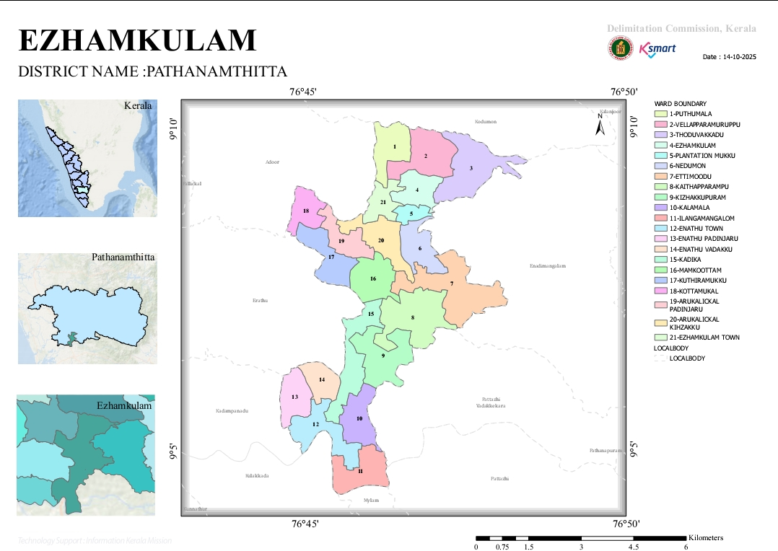
Figure 1: Map Ezhamkulam Panchayath

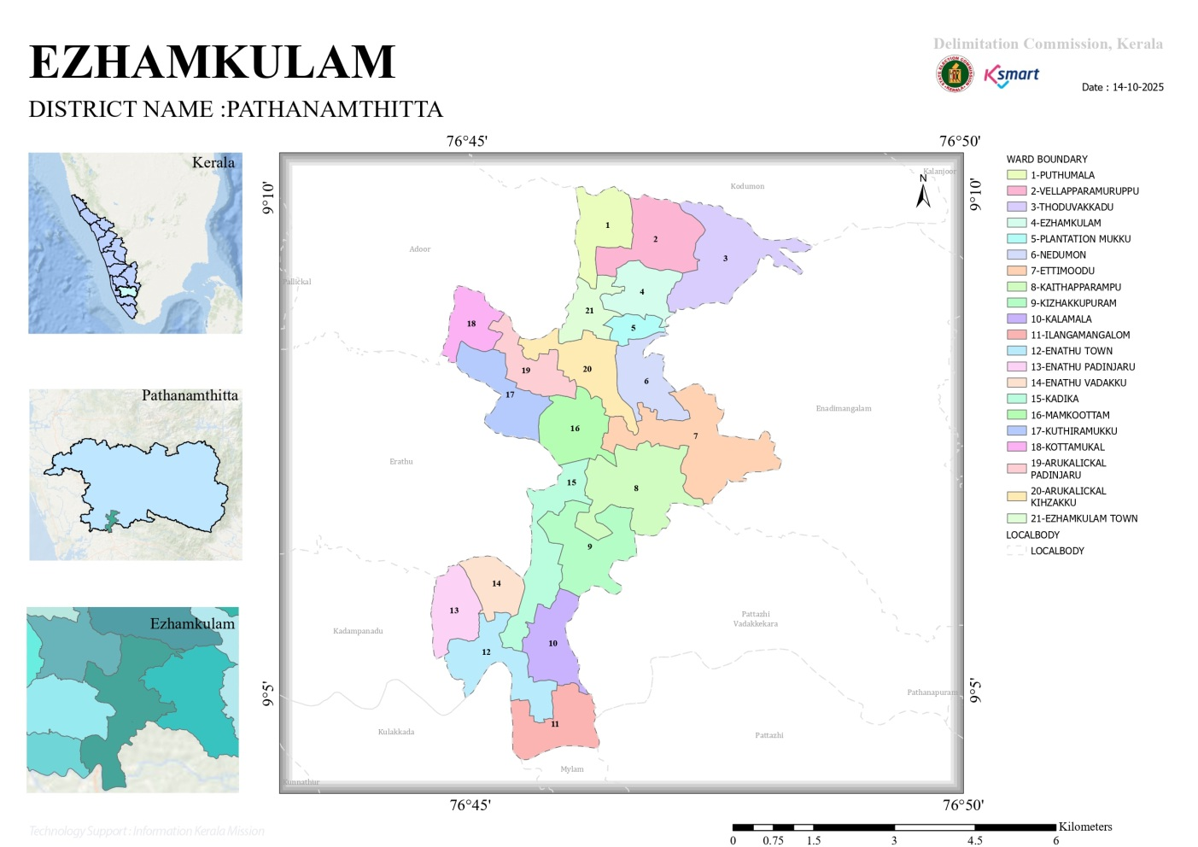
Figure 2: Ward Map Ezhamkulam Panchayath

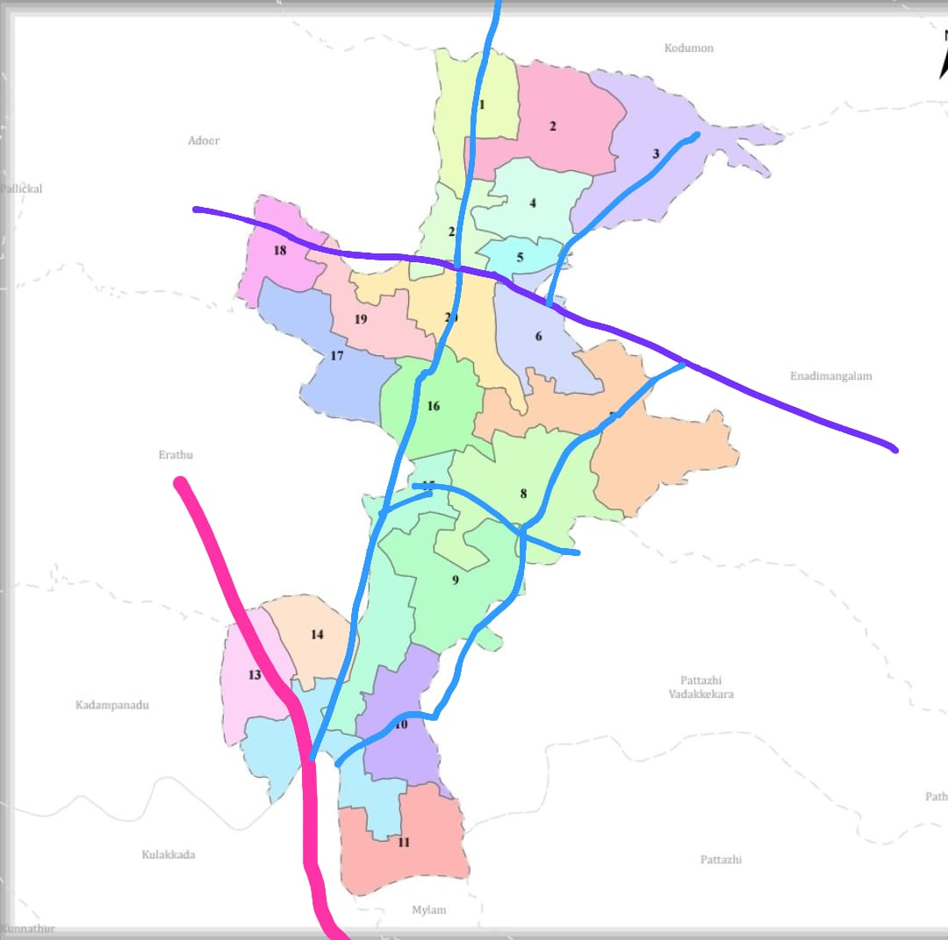
Figure 3: Road Map Ezhamkulam Panchayath

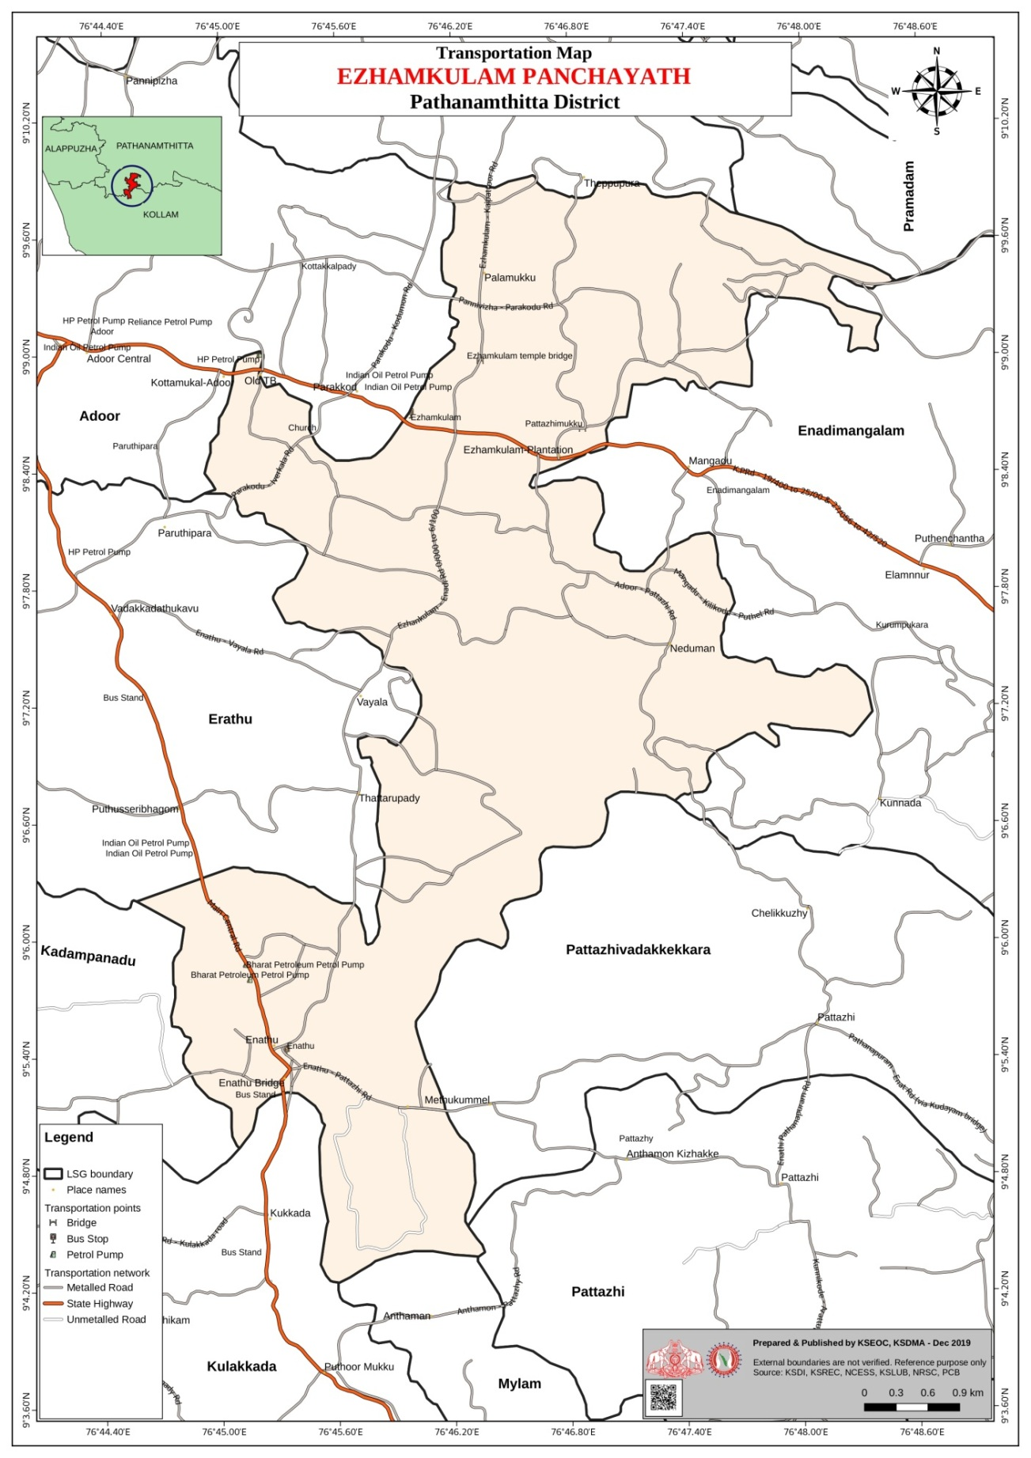
Figure 4: Transportation Map Ezhamkulam Panchayath

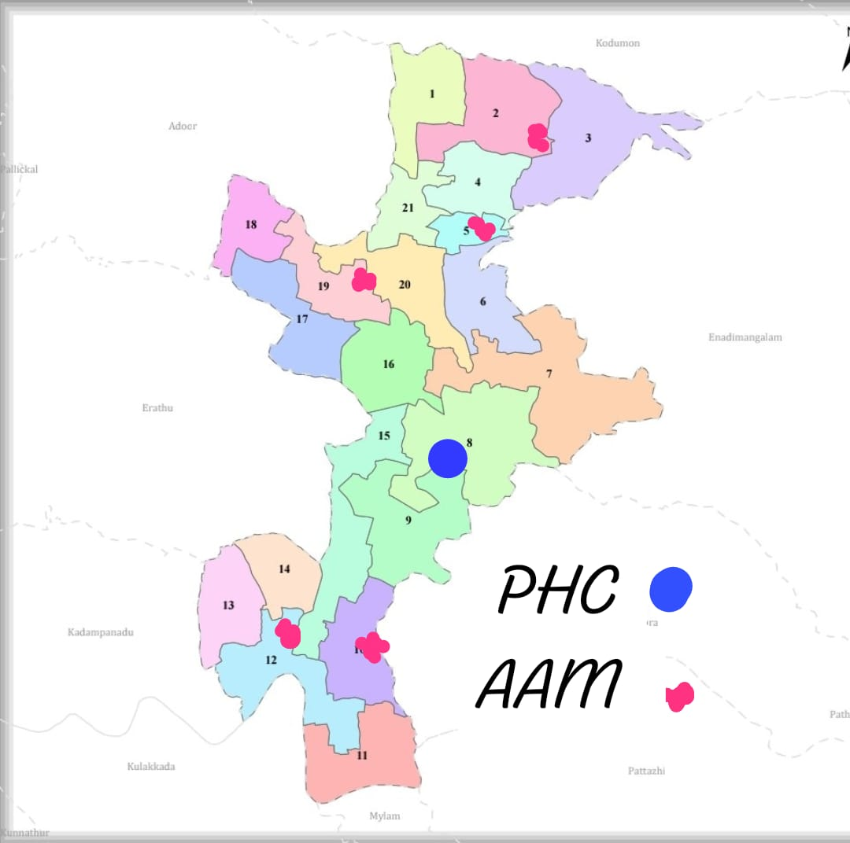
Figure 5: Integrated Health Infrastructure Map

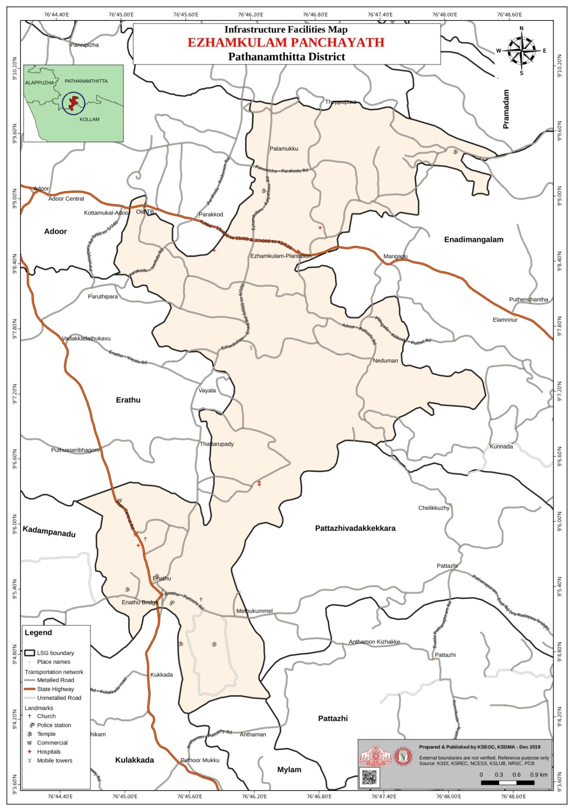
Figure 6: Infrastructure Facilities Map Ezhamkulam

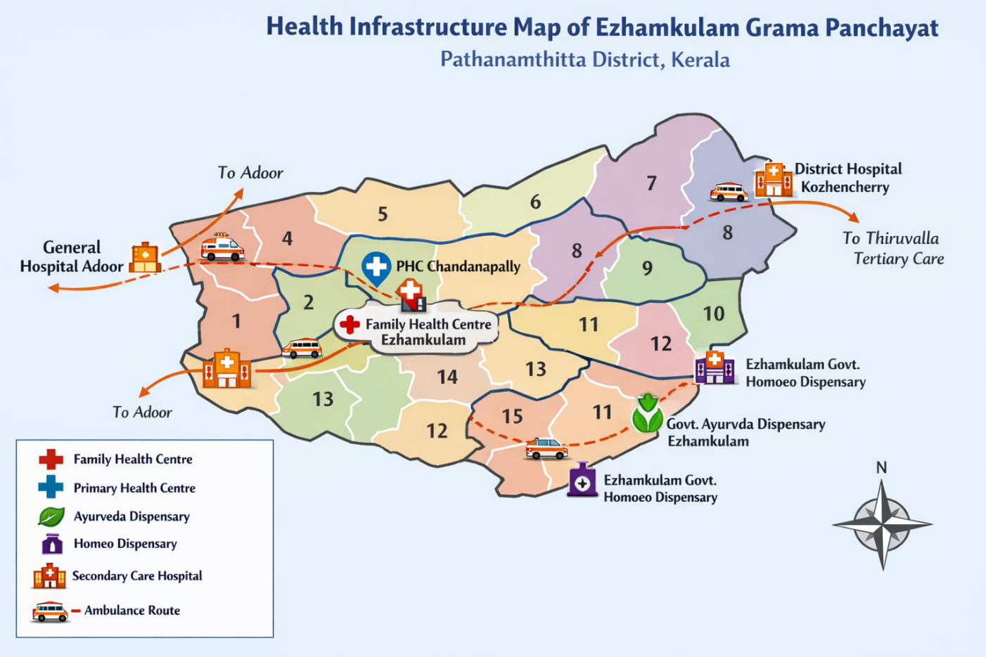
Figure 7: Health Infrastructure Map Ezhamkulam

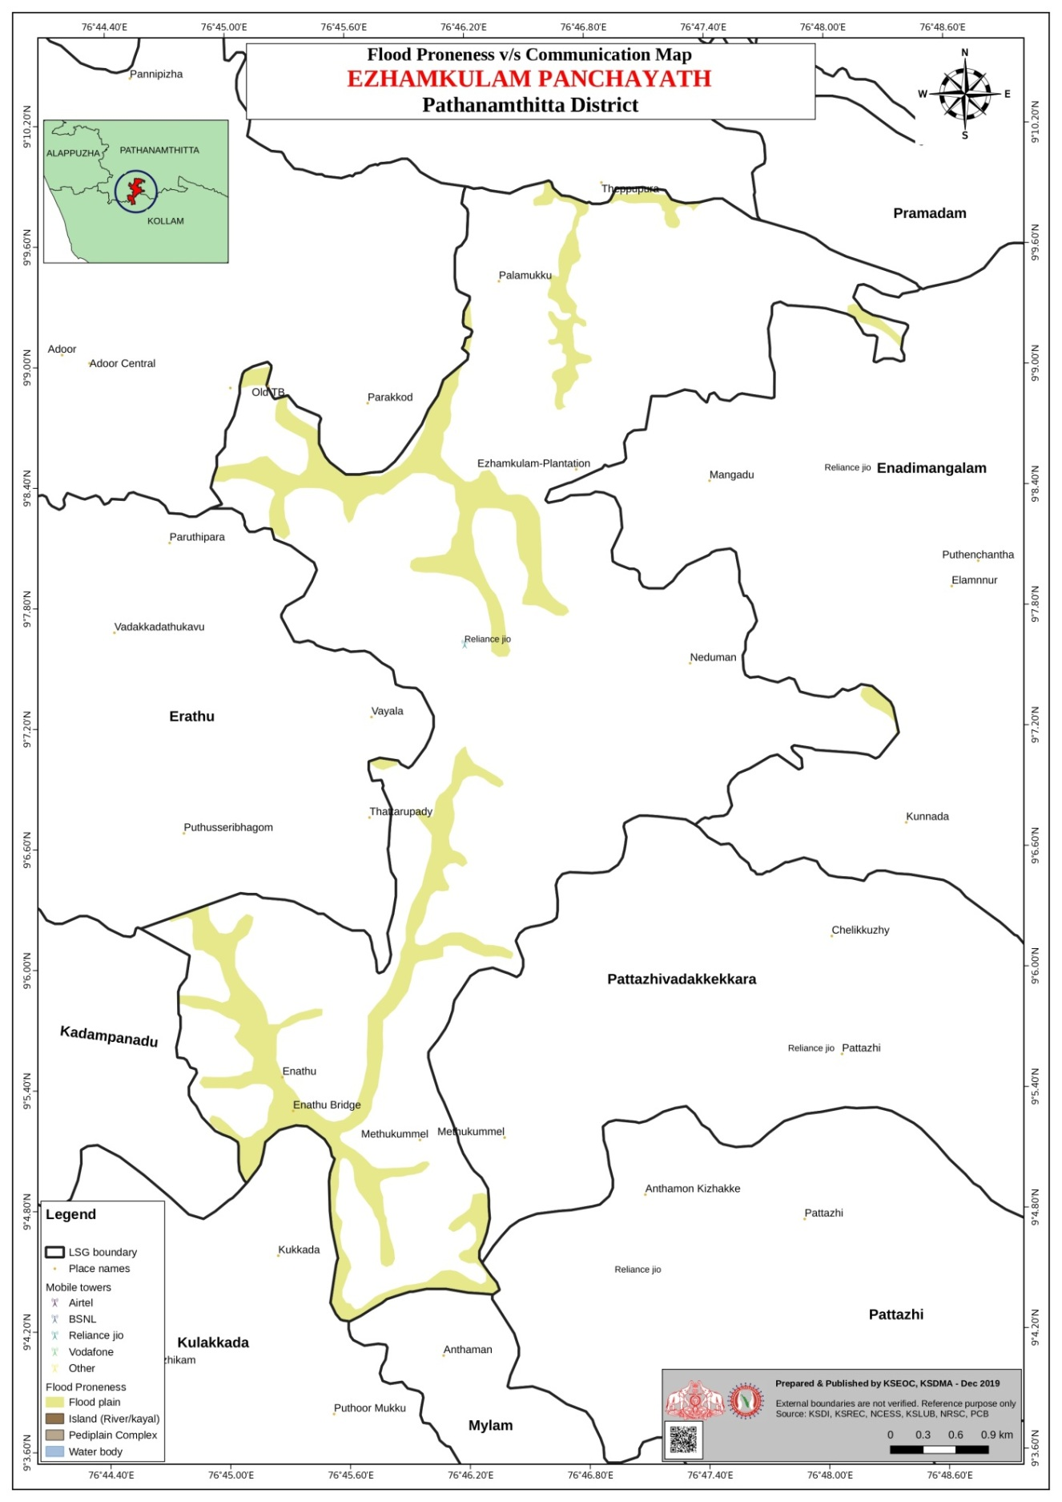
Figure 8: Flood Proneness Map Ezhamkulam
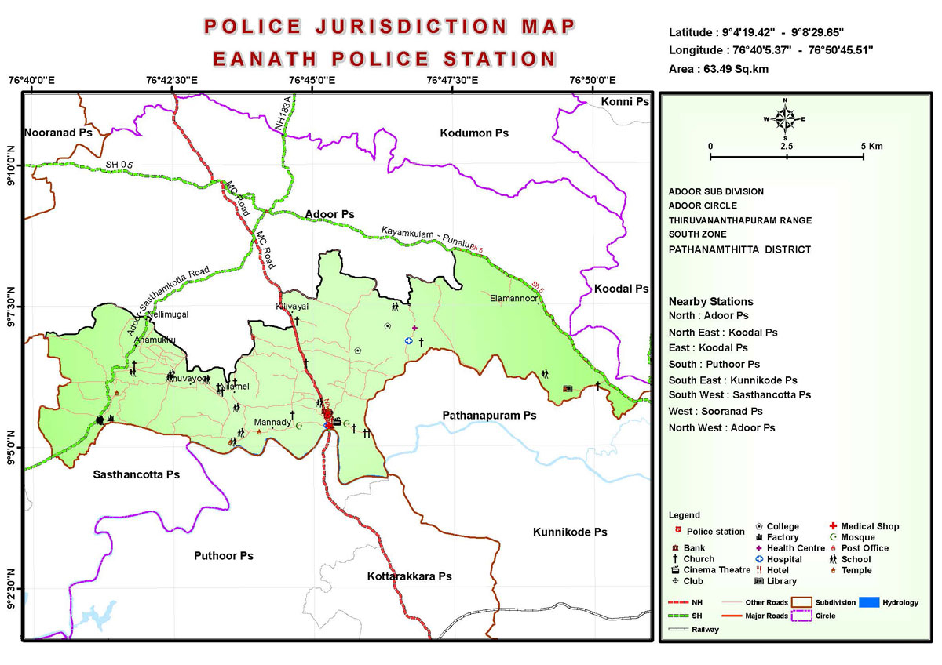

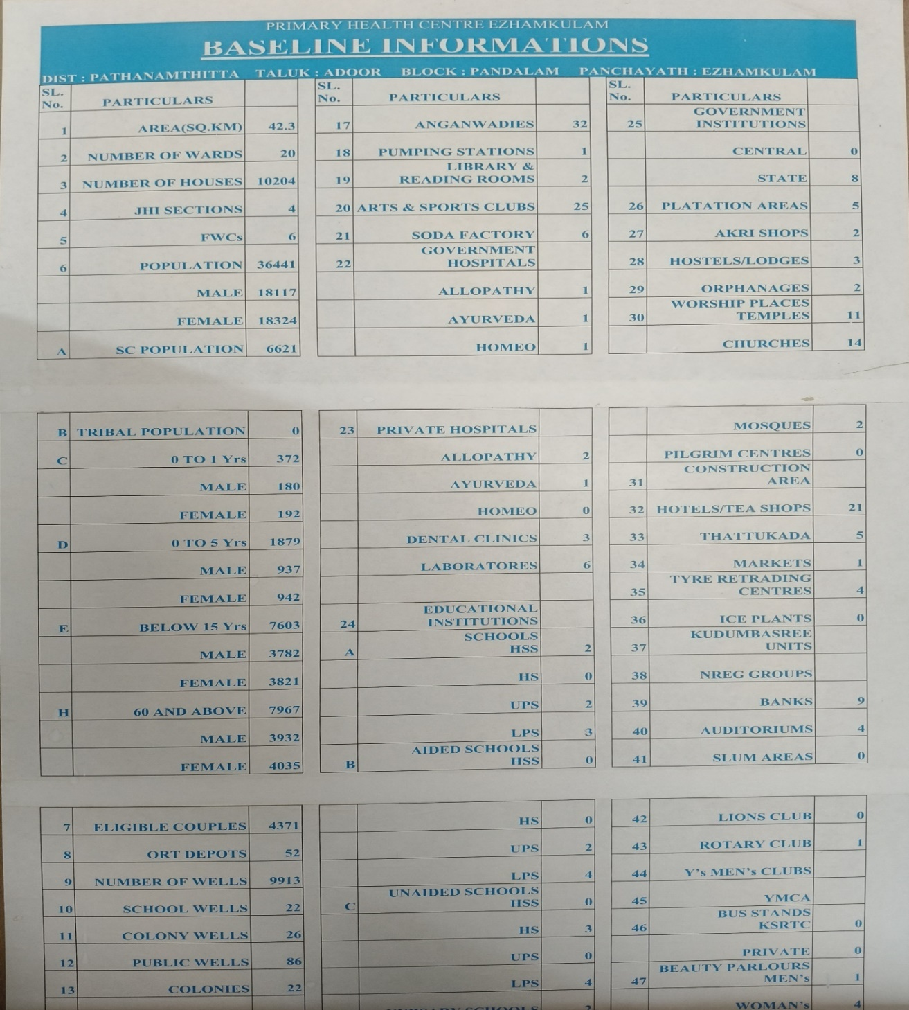
Figure 9: Baseline Iformation

GENERAL PROFILE OF EZHAMKULAM GP

Background of Ezhamkulam GP

Ezhamkulam Grama Panchayat is a rural Local Self Government Institution located in the Adoor–Parakode region of Pathanamthitta district, Kerala. The Panchayat comes under Adoor Taluk and Parakode Block Panchayat, and forms part of the midland zone of the district.
Geographical Profile
Ezhamkulam Panchayat is situated in the midland physiographic region of Pathanamthitta district. The terrain consists predominantly of gently undulating land with agricultural fields, residential clusters, and seasonal water bodies. Unlike high-range Panchayats of the district, Ezhamkulam does not have steep hill systems, but experiences waterlogging and localized flooding in low-lying agricultural areas during periods of intense monsoon rainfall.
The Panchayat lies within the drainage influence of minor streams and canals connected to regional river systems, which play a role in agriculture as well as seasonal flood vulnerability. The monsoon climate significantly influences livelihood activities, disease patterns, and access to services.
Demographic Characteristics
As per Census 2011, Ezhamkulam Panchayat has a population of approximately 16,000–17,000, residing in multiple wards with a predominantly rural settlement pattern. The Panchayat demonstrates a high literacy rate, consistent with district and state averages, and a favourable sex ratio. The population structure includes children, working-age adults, and a growing elderly population, which has implications for healthcare and social support services.
Socio-Economic Profile
The local economy of Ezhamkulam is primarily agrarian, with paddy cultivation playing a key role in low-lying areas. In addition, households depend on plantation crops (rubber and coconut), livestock rearing, small-scale trade, and daily wage labour. A considerable section of the working population is employed in the service sector, including government service, private employment, and overseas migration.
The Panchayat also accommodates migrant labourers, mainly engaged in construction, agriculture, and allied activities, contributing to population mobility and seasonal demographic variation.
Public Health and Disaster Vulnerability
From a public health perspective, Ezhamkulam Panchayat is vulnerable to monsoon-related communicable diseases, particularly vector-borne diseases such as dengue and water-borne illnesses including acute diarrhoeal diseases and leptospirosis. These risks are closely linked to rainfall patterns, water stagnation, sanitation challenges, and population density in certain wards.
According to the Pathanamthitta District Disaster Management Authority plans, the Panchayat is categorized as moderately vulnerable to floods and extreme rainfall events, with indirect impacts on access to health facilities, drinking water safety, and essential service delivery. The 2018 Kerala floods affected parts of Ezhamkulam Panchayat, causing disruption to livelihoods, agriculture, and infrastructure, though large-scale landslides were not a dominant risk in this area.
Relevance to Pandemic Preparedness
The demographic profile, seasonal disease burden, and disaster exposure of Ezhamkulam Panchayat underline the importance of integrated public health preparedness. High literacy and strong local governance structures provide opportunities for effective risk communication, community participation, and surveillance, while challenges related to monsoon flooding, migrant population movement, and water-related diseases necessitate proactive planning.
In this context, localized resource mapping, strengthening of surveillance systems, and inter-sectoral coordination between health, local government, disaster management, and water and sanitation departments are essential to enhance the Panchayat’s preparedness and resilience against future pandemics and public health emergencies.

Table 2: Baseline Information Ezhamkulam
Sl. No | Particulars | Value
1 | Area (Sq. Km) | 42.3
2 | Number of Wards | 20
3 | Number of Houses | 10,204
4 | JHI Sections | 4
5 | FWCs | 6
6 | Population | 36,441
 | Male | 18,117
 | Female | 18,324
A | SC Population | 6,621
B | Tribal Population | 0
Age-wise Population
Category | Particulars | Value
C | 0–1 Years | 372
 | Male | 180
 | Female | 192
D | 0–5 Years | 1,879
 | Male | 937
 | Female | 942
E | Below 15 Years | 7,603
 | Male | 3,782
 | Female | 3,821
H | 60 and Above | 7,967
 | Male | 3,932
 | Female | 4,035
Household & Water Sources
Sl. No | Particulars | Value
7 | Eligible Couples | 4,371
8 | ORT Depots | 52
9 | Number of Wells | 9,913
10 | School Wells | 22
11 | Colony Wells | 26
12 | Public Wells | 86
13 | Colonies | 22
Community Infrastructure
Sl. No | Particulars | Value
17 | Anganwadies | 32
18 | Pumping Stations | 1
19 | Library & Reading Rooms | 2
20 | Arts & Sports Clubs | 25
21 | Soda Factory | 6
Government Health Institutions
Type | Number
Allopathy | 1
Ayurveda | 1
Homeo | 1
Private Health Facilities
Sl. No | Particulars | Value
23 | Private Hospitals (Allopathy) | 2
 | Ayurveda | 1
 | Homeo | 0
 | Dental Clinics | 3
 | Laboratories | 6
Educational Institutions
Government Schools
Category | Number
HSS | 2
HS | 0
UPS | 2
LPS | 3
Aided Schools
Category | Number
HSS | 0
HS | 0
UPS | 2
LPS | 4
Unaided Schools
Category | Number
HSS | 0
HS | 3
UPS | 0
LPS | 4
Government Institutions
Type | Number
Central | 0
State | 8
Other Facilities & Institutions
Sl. No | Particulars | Value
26 | Plantation Areas | 5
27 | Akri Shops | 2
28 | Hostels/Lodges | 3
29 | Orphanages | 2
30 | Worship Places (Temples) | 11
 | Churches | 14
 | Mosques | 2
31 | Pilgrim Centres | 0
32 | Hotels/Tea Shops | 21
33 | Thattukada | 5
34 | Markets | 1
35 | Tyre Retreading Centres | 4
36 | Ice Plants | 0
37 | Kudumbasree Units | —
38 | NREG Groups | —
39 | Banks | 9
40 | Auditoriums | 4
41 | Slum Areas | 0
Clubs & Transport
Sl. No | Particulars | Value
42 | Lions Club | 0
43 | Rotary Club | 1
44 | Y’s Men’s Clubs | —
45 | YMCA | —
46 | Bus Stands (KSRTC) | 0
 | Private | 0
47 | Beauty Parlours (Men’s) | 1
 | Women’s | 4

Table 3: Background of Ezhamkulam GP
Background of LSGD
Description | Details
Name of LSGI | Ezhamkulam
Type (GP/Municipality / Corporation etc.) | Grama Panchayath
Block | Parakkode
District | Pathanamthitta
Number of wards | 21
Total area (sq. km) | 20.55sqkm
Population(Projected) | 35795
Population density | 846 persons/sq km
Terrain (coastal/low-lying/backwaters/foothills, etc.) | Low lying
Number of rivers passing through LSGI | 1
Number of water bodies in the LSGI | 3
Number of educational institutions | 19
Factories / small-scale industries | 2
Flood-prone wards | 2
Landslide-prone wards | 0
Death Management and Disposal Facilities (mortuaries/crematorium, including electric) | 0
Auditoriums/Marriage halls/convention centres/community halls | 5

Demographic and Vulnerable Population
Understanding the demographic composition and vulnerable population groups is essential for pandemic preparedness. Children, elderly, economically deprived families, migrant workers, and socially vulnerable groups are at increased risk during public health emergencies due to higher exposure, limited access to services, and dependency on public systems..

Table 4: Demographic Profile
Description (Ezhamkulam) |  | Details (in numbers)
DEMOGRAPHIC PROFILE
Total population |  | 35795
Male |  | 17063
Female |  | 18718
Transgender |  | 14
Children under 5 |  | 2204
Adolescent |  | 2185
Elderly (>60) |  | 6973
SOCIAL/LIVELIHOOD VULNERABILITY
Previous EPEP family |  | 55
BPL family |  | 2672
Tribal communities |  | 0
Migration | Immigrant | 322
Migration | Emigrant | 1347
Socio-economically deprived |  | 1455
Fisherfolk |  | 0
SC Community |  | 4212
ST Community |  | 0

Graphs: Population pyramid (if possible) for seeing if your LSGI has a high "dependency ratio" (lots of children and elderly compared to working adults).

Clinical Vulnerability
Certain population groups needs priority healthcare & are at higher risk of severe illness, complications, and mortality during pandemics. Patients with chronic diseases, those requiring regular medical care, and individuals with mobility or functional limitations face challenges in accessing timely care during emergencies. Mapping these groups helps in prioritizing continuity of treatment, medicine stock planning, oxygen support, referral transport, and targeted home-based care.
Table 5: Clinical Vulnerability
Description (Ezhamkulam) | Details in numbers
Pregnant women | 193
Lactating mothers | 247
Bedbound patients | 95
Patients under palliative care other than bedbound | 109
Patients on Haemodialysis | 31
Patients on CAPD | 0
Cancer patients (currently on treatment) | 130
Haemophilic patients | 0
Mentally challenged | 14
Differently abled | 472
Diabetic patients | 156
Hypertensive patients | 158
TB patients | 5

Major Festivals & Events specific to Ezhamkulam Grama Panchayath
(with the possibility of a public gathering)

Table 6: Festivals
Sl. No. | Name of festival(Ezhamkulam) | Month detailing the periodicity
1 | Ezhamkulam Devi Temple Festival | Feb
2 | Kalamala Mosque Uruse | Dec

INFRASTRUCTURE & RESOURCE INVENTORY

Health Facility Directory & Basic Capacity in Ezhamkulam GP
This section provides an overview of the healthcare infrastructure available within the LSGD area. It outlines the distribution and basic capacity of health facilities that form the backbone of service delivery during routine times and public health emergencies.

Family Health Centres (FHCs) and Community Health Centres (CHCs) generally function as the first point of contact for the community, providing essential outpatient and inpatient services. General Hospitals (GH) and Medical College Hospitals (MCH), where accessible, serve as the main referral centres for advanced diagnostics, specialist care, and critical services during public health emergencies. This inventory helps identify existing strengths, gaps, and potential surge capacity that can be mobilised during a pandemic or disaster.

Table 7: Health Facility Resource Summary
Health Facility Resource Summary (Ezhamkulam)
Sl.no. | Health Facility | Type of Facility (MCH/GH/CHC/FHC/SC etc.) | Contact Number | Total beds | ICU Beds | Oxygen-Supported Beds | No. of Ventilator Support Beds | No. of ambulances
Government Healthcare Facilities
1 | FHC EZHAMKULAM | FHC | 9446852621 | 3 | 0 | 0 | 0 | 0
2 | HWC Enathu | SC | 0 | 0 | 0 | 0 | 0 | 0
3 | HWC Ezhamkulam | SC | 0 | 0 | 0 | 0 | 0 | 0
4 | HWC Kilikkode | SC | 0 | 0 | 0 | 0 | 0 | 0
5 | HWC Thoduvakadu | SC | 0 | 0 | 0 | 0 | 0 | 0
Private Healthcare Facilities
 | Nil
AYUSH Healthcare Facilities
1 | GAD EZHAMKULAM | Clinic | 0 | 0 | 0 | 0 | 0 | 0
2 | GOVT Homeo | Clinic |  | 0 | 0 | 0 | 0 | 0

Private Clinics
Private clinics are an essential part of pandemic preparedness, as they are often the first place people seek care when symptoms begin. In many communities, private clinics manage a significant share of outpatient visits and therefore play a critical role in early case detection, timely referrals, and disease surveillance. Having an up-to-date understanding of where these clinics are located, the services they provide, and how they are linked to the public health system helps ensure that no cases are missed during an outbreak. It also allows health authorities to engage private practitioners more effectively for reporting, risk communication, and coordinated response, strengthening the overall capacity of the health system to manage public health emergencies.

Table 8: Private Clinic Summary
Private Clinic Resource Summary (Ezhamkulam)
Sl No. | Name of Clinic | Registered (Y/N) | Clinic (General / Speciality) | Speciality (if any) | Address | Contact Number | Diagnostic Facility (Y/N) | Ambulance Linkage (Y/N)
1 | Pranavam Hospital | Y | General | no | Bypass Enathu | 8281621400 | Y | N
2 | Enathu Medical Centre | Y | General | No | Enathu | 9744773446 | Y | N
3 | Nandhanam | Y | General | No | Enathu | 9447715603 | Y | N

Healthcare Education & Training Institutions
This section tracks the educational infrastructure available, which is vital for human resource planning in the health sector.

Table 9: Healthcare Educational Institutions
Category of Institution (Ezhamkulam) | Govt | Private | AYUSH | Total
Medical Colleges | 0 | 0 | 0 | 0
Nursing Colleges | 0 | 0 | 0 | 0
Dental Colleges | 0 | 0 | 0 | 0
Para-medical / Allied Health | 0 | 0 | 0 | 0
Pharmacy Colleges | 0 | 0 | 0 | 0

Specialized Services & Emergency Inventory
This section provides a detailed view of the specialized medical resources available to the community, focusing on emergency response and critical care capabilities. This table tracks the vital assets required for managing severe illnesses and emergencies across Government, Private, and AYUSH sectors.

Table 10: Specialized Services & Emergency Inventory
Item (Ezhamkulam) | Govt | Private | AYUSH | Total
Hospital beds | 0 | 0 | 0 | 0
Oxygen-generating systems(Y/N) | 0 | 0 | 0 | 0
Oxygen-supported beds(Numbers) | 0 | 0 | 0 | 0
Ventilator-supported beds | 0 | 0 | 0 | 0
ICU beds | 0 | 0 | 0 | 0
Burns units | 0 | 0 | 0 | 0
Blood centres | 0 | 0 | 0 | 0
BLS ambulances | 0 | 4 | 0 | 4
ALS ambulances | 0 | 0 | 0 | 0
Dialysis facilities | 0 | 0 | 0 | 0
Dispensaries | 0 | 0 | 0 | 0
Medical store | 1 | 15 | 0 | 16
Industrial establishments(Medium-scale industries/small-scale industries establishments to whom we can depend in a worst-case scenario) | 0 | 0 | 0 | 0

Oxygen & Diagnostic Capacity
Monitoring oxygen and diagnostic capacity is a critical component of public health preparedness, ensuring that the LSGD can handle both chronic care and sudden surges in respiratory or infectious diseases.
Table 11: Oxygen & Diagnostic Capacity
Name of Health Facility(Ezhamkulam) | Oxygen-generating System (Y/N) | Backup Oxygen Source (Y/N) | Diagnostic Facilities Available(Y/N)
Name of Health Facility(Ezhamkulam) | Oxygen-generating System (Y/N) | Backup Oxygen Source (Y/N) | Lab | USG | X-ray | CT/MRI | RT-PCR
Government Healthcare Facilities
FHC Ezhamkulam | N | Y | 1 | 0 | 0 | 0 | 0

Diagnostics facility mapping at Ezhamkulam Panchayath
The diagnostic capacity of Ezhamkulam G.P represents the "intelligence network" of our healthcare system. The speed and accuracy of disease identification depend entirely on the distribution and technical level of these facilities.

Table 12: Diagnostic Facility Details
Item(Ezhamkulam) | Govt | Private | AYUSH | Total
General labs | 1 | 6 | 0 | 7
Microbiology labs | 0 | 1 | 0 | 1
RT-PCR labs | 0 | 1 | 0 | 1
USG units | 0 | 0 | 0 | 0
CT/MRI units | 0 | 0 | 0 | 0
Research labs | 0 | 0 | 0 | 0
Labs of other departments that can be repurposed | 0 | 0 | 0 | 0

Laboratory Identification & Basic Details-Ezhamkulam

Table 13: Laboratory Details Ezhamkulam
Sl. No. | Name of Laboratory | Ownership (Govt / Private / Academic) | Address | Contact No. | 24×7 Services (Yes/No) | NABL / Govt Approved (Yes/No)
1 | FHC Ezhamkulam | Govt | Kaithaparambu,Ezhamkulam | 9446852621 | nil
2 | Micro Lab | Pvt | Ezhamkulam | 9747002700 | nil | Yes
3 | NADAS | Pvt | Mankootam, Ezhamkulam | 9605533842 | nil | No
4 | DDRC | Pvt | Enathu | 9496398072 | Nil | Yes
5 | Quality Care Diagnosis Centre | Pvt | Enathu | 8086190000 | Nil | No
6 | Dhanya Diagnosis | Pvt | Enathu | 8921737989 | Nil | No
7 | Adams’ | Pvt | Enathu | 8288996920 | Nil | No

Social and Community Infrastructure for surge plan
This table serves as our logistics and shelter inventory. By mapping these locations, quickly we can identify where to house displaced citizens, where to set up temporary medical clinics, and how to manage the deceased with dignity during a crisis.

Table 14: Social & Community Infrastructure
Category(Ezhamkulam) | Total Count | Ward | Est. Capacity (Persons) | Contact details
Educational Institutions
Anganwadis | 32 | 20 | 160 | 9745848979
Schools | 19 | 10 | 2200 | 9745848979
Colleges | 3 | 3 | 600 | 9447176552
Healthcare Educational Institutions
Medical colleges (Govt/Private) | 0 | 0 | 0 | 0
Nursing colleges (Govt/Private) | 0 | 0 | 0 | 0
Dental colleges (Govt/Private) | 0 | 0 | 0 | 0
Paramedical institutes (Govt/Private) | 0 | 0 | 0 | 0
Community Gathering Spaces
Community halls | 2 | 2 | 200 | 9745848979
Auditoriums | 4 | 4 | 400 | 9745848979
Religious buildings | 3 | 3 | 200 | 9745848979
Vulnerable Group Support Facility
Destitute homes | 2 | 2 | 75 | 9745848979
Elderly homes | 0 | 0 | 0 | 0
LSGD owned other buildings | 0 | 0 | 0 | 0
Mass Fatality Management (MFM) Infrastructure
Mortuary | 0 | 0 | 0 | 0
Crematorium | 0 | 0 | 0 | 0
*refer annexure for contact details

HUMAN RESOURCES
This section focuses on the human capital available within the LSGI. In any emergency—be it a pandemic, flood, or industrial accident—infrastructure is only as effective as the people operating it.

Medical & Clinical Personnel
This table tracks the "Frontline" providers responsible for diagnosis, treatment, and clinical management. Narrative sentence: eg., "Total health workforce: 450 personnel, with 60% in government facilities serving as primary surge capacity." A detailed directory with the contact numbers of all workers is maintained (Annexure).

Table 15: Medical & Clinical Personnel
Cadre (Ezhamkulam) | Govt (No.) | Private (No.) | Total
Doctors—Modern Medicine | 3 | 3 | 6
Doctors – AYUSH | 1 | 2 | 3
Doctors – Veterinary | 1 | 0 | 1
Doctors – Dental | 5 | 5 | 5
Nursing officers | 1 | 3 | 4
Lab technicians | 1 | 6 | 7
Optometrist | 0 | 0 | 0
Pharmacists | 2 | 8 | 10
Psychologists | 0 | 0 | 0
Counsellors | 0 | 0 | 0

Public Health & Field-Level Workforce
These individuals are the backbone of surveillance, maternal-child health, and decentralized care.
Table 16: Public Health & Field Level Workforce
Cadre (Ezhamkulam) | Health services | Municipal common services | Total
HS (Health Supervisors) | 0 | 0 | 0
HI (Health Inspectors) | 10 | 0 | 1
LHS (Lady Health Supervisor) | 0 | 0 | 0
LHI (Lady Health Inspectors) | 1 | 0 | 1
JPHN (Jr Public Health Nurses) | 6 | 0 | 6
JHI (Jr Health Inspectors) | 4 | 0 | 4
MLSP (Mid-Level Service Providers) | 6 | 0 | 6
Palliative Nurses | 1 | 0 | 1
RBSK Nurses | 1 | 0 | 1
PRO | 0 | 0 | 0
Epidemiologist | 0 | 0 | 0
Data Manager | 0 | 0 | 0

Community & Support Cadre
This group represents the surge capacity of the LSGI—people who can be called upon for logistics, rescue, and specialized support.

Table 17: Community & Support Cadre
Cadre (Ezhamkulam) | Number
ASHA Workers | 20
AWW (Anganwadi Workers) | 32
Emergency Medical Volunteers (Trained) | 0
Kudumbashree | 204
MNREGS | 860
Purusha Swayam Sahaya Sangham | 2
Ex-Servicemen | 42
Retired Police Officers | 26
NCC/NSS Volunteers | 160
Red Cross volunteers | 30
One Health Community Volunteers | 980
One Health Community Mentors | 140

Community Organizations
This section details the presence of community-based organisations (CBOs), non-governmental organisations (NGOs), faith-based organisations (FBOs), Kudumbashree Self-Help Groups (SHGs), and Ayalkootams within the Local Self-Government Institution (LSGI). These groups enhance grassroots mobilization, resource distribution, and support networks crucial for pandemic response and community resilience.

Table 18: Community Organizations
Category (Ezhamkulam) | Total Count
NGOs | 1
Religious based organizations | 8
Foreign based organizations | 0
Sports Club/youth clubs | 9
Kudumbashree SHGs | 260
Ayalkootams | 15
Political organizations | 12
Residential organizations | 3

Administrative & Emergency Services
This section outlines the availability of key non-health emergency support services and infrastructure within the LSGI, which are essential for effective pandemic preparedness and response. These facilities support law enforcement, disaster response, water supply, logistics, mobility, and community-level interventions during public health emergencies.

Table 19: Administrative & Emargency Services
Category (Ezhamkulam) | Total Count | Contact details
Police Stations | 1 | 04734211800
Fire & Rescue Stations | 1 | 04734229100
Water Pumping Points | 1 | 04734225766
Public Distribution System (PDS) | 18

Information regarding resources
The availability of essential transport and support resources plays a quiet but critical role in saving lives. Equipment such as ambulances, mobile mortuaries, amphibian ambulances, and motorized boats ensures that patients, samples, and healthcare teams can move swiftly—even in flooded, remote, or difficult terrains. Heavy vehicles like JCBs, cranes, tractors, and torus lorries support logistics, waste management, emergency infrastructure, and rapid conversion of spaces into care or isolation facilities. Taxis, four-wheel-drive vehicles, and trucks help maintain continuity of essential services, reach vulnerable populations, and support home-based care and supply delivery.

Table 20: Information Regarding Resources
Means of transportation (Ezhamkulam) | Total Count
JCB | 5
Crane | 2
Heavy Trucks | 4
Tractor | 2
Ambulances | 4
Mobile mortuaries | 2
Boats | 0
Taxi service | 9
Note: For specific details regarding vehicle owners and contact information, please refer to Annexure [X].

ONE HEALTH & ENVIRONMENTAL SURVEILLANCE
The One Health method integrates environmental, animal, and human health to enable proactive pandemic preparedness. Panchayat-level surveillance needs to be improved in order to detect and treat zoonotic and environmentally generated diseases early. Surveillance is strengthened through systematic assessment of animal populations, veterinary infrastructure, poultry and slaughter facilities, inter-sectoral coordination, and specialised tools like avian influenza seasonality mapping using GIS in previous outbreaks to enable predictive alerts and ward-specific sampling to support effective pandemic preparedness in high-risk areas.

Animal & Bird Population
Mapping animal and bird populations at the Panchayat level is essential for identifying and prioritising zoonotic disease hazards like rabies, avian influenza (H5N1), leptospirosis, anthrax, and Nipah-like spillover occurrences. Risk classification, targeted surveillance, vaccination planning, and early epidemic detection made feasible by comprehensive population mapping all enhance One Health-based pandemic preparedness.

Table 21: Animal Populations
Category (Ezhamkulam) | Item | Estimated Population | Wards
Animal Population | Livestock (Cattle/Goats/Buffalo) | 1811 | All wards
Animal Population | Pet Animals (Dogs/Cats) | 1162 | All wards
Animal Population | Stray Dog Population | 647 | All wards
Animal Population | Pig Farms (Number of heads) | 0
 | Small Units (Sheep / Goats – clustered) | 14
Bird Population | Poultry Units (Birds) | 3
Bird Population | Poultry- (FOWL) | 1398 | All Wards
Bird Population | Wild/Migratory Birds (Observed) | 0
Bird Population | Crow Mortality Events (Reported) | 0

The main risk of zoonotic diseases in Lepto is concentrated in Ward 3., which is explained by the high density of pig farms, cattle congregation areas, and poultry units. The stray dog population in market areas, fish landing sites, bus stations continues to be a substantial problem for rabies surveillance and bite prevention. There is a considerable risk of avian influenza introduction and amplification during November - December due to the seasonal presence of migratory and resident water birds near ponds/ canal / river / backwater / paddy field. Clusters of pig farms and animal shelters vulnerable to flooding further raise the risk of leptospirosis and other zoonoses mediated by the environment, especially during monsoon floods.

Veterinary Infrastructure
Veterinary institutions are a core pillar of One Health surveillance, enabling early zoonotic disease detection through vaccination, investigation of unusual animal illness or deaths, sample collection, and timely outbreak reporting. A well-mapped and responsive veterinary network strengthens coordination with human health and LSGI systems, ensuring rapid response during zoonotic events and pandemics.
Table 22: Veterinary Infrastructure
Facility Type (Ezhamkulam) | Name of Facility | Ownership Govt / Pvt | Location(Ward No) | Contact number
Veterinary Dispensary | Ezhamkulam | govt | 19 | 9496330054
Veterinary Hospital / Polyclinic | 0 | 0 | 0 | 0
Private Veterinary Clinics | 0 | 0 | 0 | 0
Mobile / Emergency Vet Service (incl. night services) | 0 | 0 | 0 | 0
Pet Homes / Animal Shelters | 0 | 0 | 0 | 0
Slaughterhouse-linked Veterinary Inspection Unit | 0 | 0 | 0 | 0

Veterinary Doctors & Workforce
Early detection, diagnosis, reporting, and reaction to animal illness epidemics depend on the availability and accessibility of qualified veterinary specialists. By identifying unusual animal morbidity or mortality promptly, collecting samples promptly, and coordinating efficiently with human health and LSGI systems—especially during zoonotic outbreaks and pandemic-prone situations—a clearly defined veterinary workforce enhances One Health surveillance.

Table 23: Veterinary Workforce
Category (Ezhamkulam) | Number Available | Type (Govt/Pvt) | Contact number
Government Veterinary Doctors | 1 | govt | 9496330054
Private Veterinary Doctors | 0 | 0 | 0
Livestock Inspectors | 4 | govt | 0
Para-veterinary Staff / Attenders | 1 | govt | 0
Contract / On-call Veterinary Support (if any) | 0 | 0 | 0

High-Risk Interface Points (Surveillance Sites)
High-risk interface points for zoonotic disease surveillance in _Ezhamkulam_Grama Panchayath include wetland–livestock–human contact zones, backyard poultry farms, cattle sheds near water bodies, fish markets, and areas of high human–animal interaction such as community slaughter points and migratory bird congregation sites. These are the primary surveillance sites where zoonotic spillover risks are elevated.

Table 24: High Risk Interface Points
Type of Habitat (Ezhamkulam) | Type of High risk interface | Geographical vulnerability
Wetlands & Backwaters | 0
Backyard Poultry Farms | 0
Cattle Sheds near Water Bodies | 0
Fish & Meat Markets | 1
Community Slaughter Sites | 0
Migratory Bird Congregation Areas | 0
Rodent-Infested Grain Storage | 0

Table 25: High Risk Interface
Category (Ezhamkulam) | Total Count | Key Locations (wards)
Poultry Farms | 3 | 10 Kalamala
Backyard / Clustered Poultry Units | 0
Duck Rearing Units (open water access) | 1
Slaughterhouses/ Slaughter Points | 0
Meat/Fish Markets | 1
Live Bird Sale Points | 0
Cattle Markets / Weekly Animal Fairs | 0
Pet Shops / Breeders | 2
Animal Shelters / Pet Homes | 1
Waste Disposal Sites near Animal Units | 0

Environmental Risk Mapping
Environmental risk mapping identifies monsoon/flood hotspots for vector-borne (dengue, chikungunya), water-borne (leptospirosis, diarrhoea), and zoonotic diseases in Kerala's wetlands. Systematic surveillance supports early warnings, targeted interventions, and Panchayat pandemic preparedness.
Waterborne exposure: Flood-prone areas and stagnant water bodies facilitate leptospira survival, raising leptospirosis risk.

Traditional practices: Informal slaughter and fish markets lack standardized hygiene, creating spillover opportunities.

Table 26: Environmental Risk Mapping Details
Risk Factor (Ezhamkulam) | High-Risk Wards | Key Locations | Risk Level (High/Med/Low)
Flood-prone areas | 11,12 | enathu | Low
Water bodies/wetlands | 2 | ezhamkulam | Low
Solid waste accumulation | 0 | 0 | 0
Animal waste disposal issues | 0 | 0 | 0
Rodent infestation zones | 0 | 0 | 0
Industrial effluent discharge | 0 | 0 | 0
Construction sites / abandoned buildings | 0 | 0 | 0
Poor drainage/blocked canals | 0 | 0 | 0
Drinking water source contamination risk | 1 | 18 | Risk

Disease Seasonality Mapping
- Flooding & waterlogging → amplifies leptospirosis, malaria, diarrheal diseases.
- Migratory bird influx (Nov–Feb) → avian influenza risk.
- Mosquito breeding cycles → vector-borne disease peaks in monsoon.
- Agricultural practices → close human–animal contact in paddy fields.

Table 27: Disease Seasonality Mapping
Disease (Ezhamkulam) | Peak Risk Season | Key Drivers | High-Risk Locations | Surveillance Focus
Avian Influenza | 0 | 0 | 0 | 0
Leptospirosis | 0 | 0 | 0 | 0
Dengue/Chikungunya | 3 | Plantation | Plantation | yes
Acute Diarrheal Diseases | 0 | 0 | 0 | 0
Rabies | 0 | 0 | 0 | 0
Anthrax (rare) | 0 | 0 | 0 | 0

Vulnerability Mapping
Vulnerability mapping pinpoints high-risk populations, occupations, and areas exposed via environment, livelihoods, socio-economics, and poor service access. Paired with environmental/seasonality mapping, it enables risk-based surveillance, targeted actions, and optimal resource use in One Health and pandemic planning.
Table 28: Vulnerability Mapping
Vulnerability Factor (Ezhamkulam) | High-Risk Wards | Key Groups / Locations | Risk Level
Flood-prone households | 11,10 | ENATHU | Low
Wetland-adjacent communities | 0 | 0 | 0
Backyard poultry / duck rearing households | 0 | 0 | 0
Livestock-rearing households | 0 | 0 | 0
Slaughterhouse & meat market workers | 0 | 0 | 0
Fisherfolk & fish market workers | 16 | Enathu, Ezhamkulam | 0
Sanitation workers | 2 | Panchayath | 0
Daily wage / migrant workers | 322 | Enathu, Ezhamkulam | 0
Elderly & chronically ill populations | 328 | 0 | 0
Pregnant Women | 193 | All wards
Children (schools, Anganwadi’s) | 2238 | All Wards
Limited access to safe water & sanitation | 19 | Arukalikal padinjaru | Low

EPIDEMIOLOGICAL TRENDS (2021–2025)

Disease surveillance is the systematic collection, analysis, and interpretation of health data for planning, implementation, and evaluation of public health practice. This section presents the disease surveillance profile of the LSGI based on routine reporting systems and outbreak investigations to identify priority diseases, seasonal patterns, and emerging public health threats.

Disease Burden Among Human Beings (Last 5 Years)
Analysis of disease-wise data for the last five years helps identify persistent public health problems, emerging diseases, and changes in disease burden. This information supports prioritisation of prevention, preparedness, and response activities at the Panchayat level.

Table 29: Communicable Disease Burden Last 5 Years
Disease | 2021 | 2022 | 2023 | 2024 | 2025 | Trend(Increasing/Stable/Decreasing)
Dengue | 4 | 4 | 58 | 48 | 24 | Increasing (peak in 2023, declining thereafter)
Leptospirosis | 0 | 1 | 2 | 4 | 6 | Increasing
Hepatitis A | 0 | 0 | 0 | 2 | 12 | Increasing
Malaria | 0 | 0 | 0 | 0 | 1 | Emerging / Increasing
Scrub Typhus | 0 | 0 | 0 | 0 | 1 | Emerging
Typhoid | 0 | 0 | 0 | 1 | 0 | Stable (sporadic)
H1N1 | 0 | 0 | 0 | 0 | 0 | Absent
H3N2 | 0 | 0 | 0 | 0 | 0 | Absent
ADD | 8 | 59 | 55 | 111 | 106 | Increasing (consistently high)
Mu  mps | 0 | 0 | 1 | 0 | 0 | Stable (sporadic)
Measles | 0 | 0 | 0 | 0 | 0 | Absent
Hepatitis B | 1 | 4 | 0 | 1 | 3 | Fluctuating / Stable
Hepatitis C | 0 | 0 | 0 | 0 | 0 | Absent
Tuberculosis | 2 | 5 | 7 | 9 | 10 | Increasing
Leprosy | 0 | 0 | 0 | 0 | 0 | Absent
COVID-19 | 5267 | 0 | 0 | 0 | 0 | Decreasing / Controlled
*(use the above table data to create the graph/diagram)
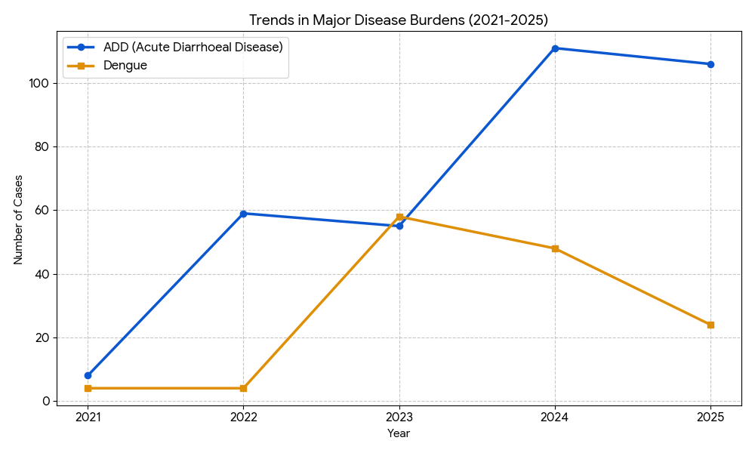
Figure 10: Trends in Major Disease Burdens

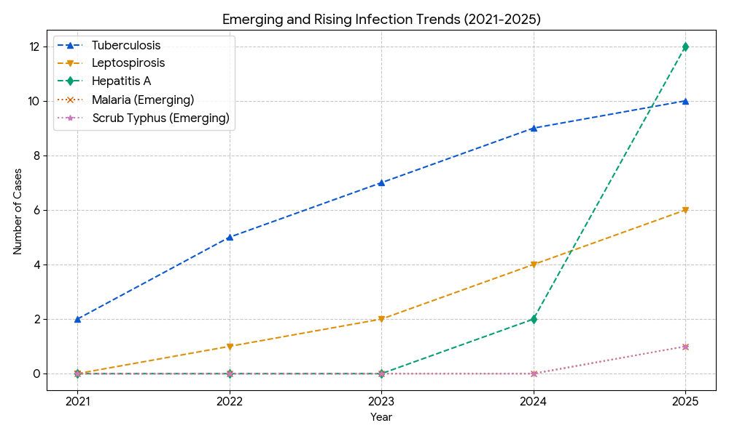
Figure 11: Emerging & Rising Infection Trends

Seasonal Trend Analysis
Seasonal analysis helps anticipate surges (e.g. dengue in monsoon, leptospirosis after floods, influenza in cooler months) and plan pre‑emptive vector control, stockpiling of IV fluids, and awareness campaigns at Panchayat level.

Dengue
Dengue is a major seasonal vector-borne disease strongly associated with rainfall, water stagnation, and increased mosquito breeding during the monsoon period.

Peak: July–November

Dengue – Ward-wise Yearly Distribution (2021–2025)

Table 30: Dengue 5 Year Distribution
Ward | Dengue – Ward-wise Yearly Distribution
Ward | 2021 | 2022 | 2023 | 2024 | 2025 | Total
1 | 0 | 1 | 3 | 4 | 0 | 8
2 | 0 | 0 | 1 | 3 | 3 | 7
3 | 0 | 0 | 4 | 5 | 1 | 10
4 | 0 | 0 | 3 | 6 | 1 | 10
5 | 1 | 0 | 5 | 9 | 1 | 16
6 | 0 | 0 | 4 | 1 | 2 | 7
7 | 0 | 0 | 2 | 1 | 2 | 5
8 | 1 | 0 | 4 | 1 | 2 | 8
9 | 0 | 0 | 5 | 2 | 2 | 9
10 | 1 | 1 | 2 | 1 | 0 | 5
11 | 0 | 1 | 2 | 1 | 1 | 5
12 | 0 | 0 | 4 | 4 | 1 | 9
13 | 0 | 0 | 7 | 1 | 1 | 9
14 | 0 | 0 | 0 | 2 | 0 | 2
15 | 0 | 1 | 1 | 2 | 0 | 4
16 | 0 | 0 | 1 | 0 | 1 | 2
17 | 0 | 0 | 1 | 0 | 1 | 2
18 | 0 | 0 | 1 | 3 | 3 | 7
19 | 1 | 0 | 4 | 0 | 1 | 6
20 | 0 | 0 | 4 | 2 | 1 | 7
Total | 4 | 4 | 58 | 48 | 24 | 138

Leptospirosis
Leptospirosis cases are closely linked to monsoon rains, flooding, and occupational exposure, particularly in low-lying and waterlogged areas.
Peak: June - August

Leptospirosis – Ward-wise Yearly Distribution (2021–2025)

Table 31: Leptospirosis Ward Wise Trend - 5 Years
Ward | Leptospirosis – Ward-wise Yearly Distribution
Ward | 2021 | 2022 | 2023 | 2024 | 2025 | Total
1 | 0 | 0 | 1 | 0 | 0 | 1
2 | 0 | 0 | 0 | 0 | 0 | 0
3 | 0 | 0 | 0 | 2 | 0 | 2
4 | 0 | 0 | 0 | 1 | 0 | 1
5 | 0 | 0 | 0 | 0 | 1 | 1
6 | 0 | 0 | 0 | 0 | 1 | 1
7 | 0 | 0 | 0 | 0 | 0 | 0
8 | 0 | 0 | 0 | 0 | 1 | 1
9 | 0 | 1 | 1 | 0 | 1 | 2
10 | 0 | 0 | 0 | 0 | 0 | 0
11 | 0 | 0 | 0 | 0 | 0 | 0
12 | 0 | 0 | 0 | 0 | 0 | 0
13 | 0 | 0 | 0 | 0 | 0 | 0
14 | 0 | 0 | 0 | 0 | 0 | 1
15 | 1 | 0 | 0 | 0 | 1 | 2
16 | 0 | 0 | 0 | 0 | 0 | 0
17 | 0 | 0 | 0 | 0 | 0 | 0
18 | 0 | 0 | 0 | 1 | 1 | 2
19 | 0 | 0 | 0 | 0 | 0 | 0
20 | 0 | 0 | 0 | 0 | 0 | 0
Total | 1 | 1 | 2 | 4 | 6 | 14

VIRAL HEPATITIS - A
Hepatitis A cases are commonly associated with unsafe drinking water, food contamination, and breakdowns in sanitation, often presenting as clusters or outbreaks.

Peak: October - December

Hepatitis A – Ward-wise Yearly Distribution (2021–2025)

Table 32: Hepatitis A Ward Wise Trend- 5 Years
Ward | Hep A – Ward-wise Yearly Distribution
Ward | 2021 | 2022 | 2023 | 2024 | 2025 | Total
1 | 0 | 0 | 0 | 0 | 0 | 0
2 | 0 | 0 | 0 | 0 | 0 | 0
3 | 00 | 0 | 0 | 0 | 1 | 1
4 | 0 | 0 | 0 | 0 | 5 | 5
5 | 0 | 0 | 0 | 1 | 0 | 1
6 | 0 | 0 | 0 | 0 | 0 | 0
7 | 0 | 0 | 0 | 0 | 2 | 2
8 | 0 | 0 | 0 | 0 | 0 | 0
9 | 0 | 0 | 0 | 0 | 0 | 0
10 | 0 | 0 | 0 | 0 | 1 | 1
11 | 0 | 0 | 0 | 0 | 0 | 0
12 | 0 | 0 | 0 | 0 | 0 | 0
13 | 0 | 0 | 0 | 0 | 1 | 1
14 | 0 | 0 | 0 | 0 | 0 | 00
15 | 0 | 0 | 0 | 0 | 0 | 0
16 | 0 | 0 | 0 | 1 | 1 | 2
17 | 0 | 0 | 0 | 0 | 2 | 2
18 | 0 | 0 | 0 | 0 | 0 | 0
19 | 0 | 0 | 0 | 0 | 0 | 0
20 | 0 | 0 | 0 | 0 | 0 | 0
Total |  |  | 0 | 2 | 13 | 15

Outcome-Based Trend Analysis- 2025

Transmission Trend- 2025
For effective management of public health issues, it is important to track the trend of disease transmission mode. It helps identify the population or place at high risk that can be used to predict outbreaks and implement targeted interventions as quickly as possible. Understanding these kinds of trends enables authorities to allocate resources efficiently and change the strategies adequately based on the trend that follows.

Table 33: Transmission Trend 2025
Mode of Transmission (Ezhamkulam) | No. of cases | No. of Deaths
Vector Borne Diseases | 25 | 0
Water Borne Diseases | 119 | 0
Air Borne Diseases | 26 | 0
Blood Borne Diseases | 0 | 0
Food Borne Diseases | 0 | 0

Vector-Borne Disease

Table 34: Vector-Borne Diseases
Vector-Borne Disease  (Ezhamkulam) | No. of Cases | No. of Deaths
Dengue | 24 | 0
Malaria | 1 | 0
Chikungunya | 0 | 0

Water Borne Disease

Table 35: Water Borne Diseases
Water Borne Disease  (Ezhamkulam) | No. of Cases | No. of Deaths
Cholera | 0 | 0
Typhoid | 0 | 0
Hep- A | 13 | 0
Dysentery | 0 | 0
Amoebiasis | 1 | 0
E- Coli infections | 0 | 0

Air Borne Disease

Table 36: Air Borne Diseases
Air Borne Disease  (Ezhamkulam) | No. of Cases | No. of Deaths
Influenza | 0 | 0
H1N1 | 0 | 0
TB | 10 | 0
Chickenpox | 16 | 0
Measles | 0 | 0
Covid-19 | 0 | 0
Pertussis | 0 | 0
Mumps | 0 | 0

Blood-Borne Disease

Table 37: Blood-Borne Diseases
Blood-Borne Disease  (Ezhamkulam) | No. of Cases | No. of Deaths
AIDS | 0 | 0
Hep- B | 3 | 0
Hep- C | 0 | 0

Zoonotic Disease

Table 38: Zoonotic Diseases
Zoonotic Disease  (Ezhamkulam) | No. of Cases | No. of Deaths
Rabies | 0 | 0
Leptospirosis | 6 | 0
Avian influenza | 0 | 0
West nile | 0 | 0
Anthrax | 0 | 0
Nipah | 0 | 0
Scrub Typhus | 1 | 0

Integrated Disease Hotspot Map (2021–2025)

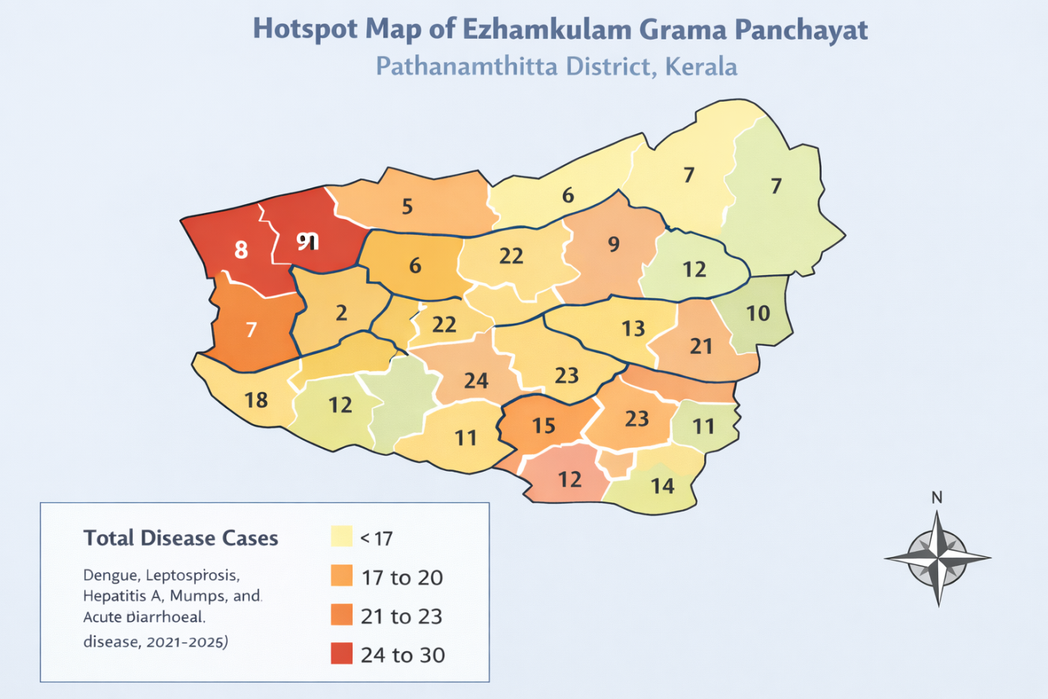
Figure 12: Integrated Disease Hotspot Map

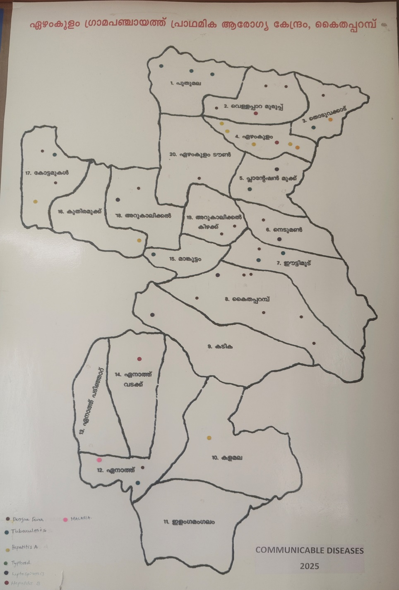
Figure 13: Disease Hotspot Map 2025

Ward No | Dengue Total (2021-25) | Leptospirosis Total (2021-25) | Hepatitis A Total (2021-25) | Mumps (2021-25) | ADD (2021-25) | Total Cases
1 | 8 | 1 | 0 | 0 | 10 | 18
2 | 7 | 0 | 0 | 0 | 12 | 19
3 | 10 | 2 | 1 | 0 | 11 | 24
4 | 10 | 1 | 5 | 0 | 8 | 24
5 | 15 | 1 | 1 | 0 | 13 | 30
6 | 7 | 1 | 0 | 0 | 14 | 22
7 | 4 | 0 | 1 | 0 | 12 | 17
8 | 8 | 1 | 0 | 0 | 11 | 20
9 | 8 | 2 | 0 | 0 | 13 | 23
10 | 5 | 0 | 1 | 0 | 10 | 16
11 | 9 | 0 | 0 | 0 | 12 | 21
12 | 9 | 0 | 0 | 0 | 14 | 23
13 | 2 | 0 | 1 | 0 | 11 | 14
14 | 2 | 1 | 0 | 0 | 14 | 17
15 | 4 | 2 | 0 | 0 | 15 | 21
16 | 1 | 0 | 2 | 0 | 12 | 15
17 | 2 | 0 | 2 | 0 | 13 | 17
18 | 7 | 2 | 0 | 0 | 13 | 22
19 | 6 | 0 | 0 | 0 | 15 | 21
20 | 7 | 0 | 0 | 0 | 16 | 23

By overlaying five years of data, we have identified …………..'Red Zone' Wards. These are wards where at least two different categories of diseases (e.g., Dengue and Lepto) recurred in consecutive years. Ward is categorized as the Highest Priority Hotspot due to its combination of flood vulnerability and high vector density. Future health infrastructure, such as the proposed R.O plants at ………should be prioritized.

Table 39: Disease Burden
Ward No | Dengue Total (2021–25) | Leptospirosis Total (2021–25) | Hepatitis A Total (2021–25) | Mumps (2021–25) | ADD (2021–25) | Total Cases
Total | 131 | 15 | 14 | 0 | 249 | 409

Table 40: Disease Burden Percentage
Sl. No | Disease | Total Cases | Percentage of Total Cases (%)
1 | Dengue | 131 | 32.0 %
2 | Leptospirosis | 15 | 3.7 %
3 | Hepatitis A | 14 | 3.4 %
4 | Mumps | 0 | 0.0 %
5 | ADD (Acute Diarrhoeal Disease) | 249 | 60.9 %
 | Total | 409 | 100 %

Key Insights
- ADD contributes the largest disease burden (60.9%), indicating strong links with drinking water quality, sanitation, and seasonal contamination risks.
- Dengue accounts for 32% of cases, showing continued vector-borne disease risk, particularly during monsoon and post-monsoon periods.
- Leptospirosis and Hepatitis A together account for about 7.1%, reflecting water-borne and environmental exposure risks.
- No mumps cases were reported during the period, suggesting adequate immunization coverage and low transmission in the Panchayat.

PREPAREDNESS AND RESPONSE PROTOCOL AT LSG LEVEL
This section describes the operational framework for the LSGI once a pandemic is declared. It explains how the LSGI and health system will move from routine data collection to active response, using a One Health approach.

Constitution of One Health Committee
The LSGD shall constitute a One Health Committee comprising the LSGI President, Medical Officers (Modern Medicine, AYUSH, and Veterinary), the Health Inspector, and the Veterinary Surgeon.

Objective: The One Health Committee coordinates human, animal, and environmental health to prevent and control pandemics.

Table 41: Constitution of One Health Committee
Sl No | Name | Designation | Department/Institution | Role in Committee | Contact Number
1 | EA Latheef | Panchayat President | LSGD | Chairperson | 9847756358
2 | Dr Divya Mohan | Medical Officer (PHC/CHC) | Health Dept | Member Secretary | 9446852621
3 | Dr Nileema | Veterinary Officer | Animal Husbandry | Member | 9496330054
4 | Dr Amol | Epidemiologist | Health Dept | Member | 9048523036
5 | Sony SR | Health Inspector/PHN | Health Dept | Surveillance | 9496468061
6 |  | ASHA Supervisor | Health Dept | Community link
7 | Deepa | ICDS Supervisor | Social Welfare | Vulnerable groups | 9539789854
8 | SHO | Police Station Officer | Police Dept | Law & order | 9497947142
9 | John Kutty | Ward Councillor Representative | LSGD | Community coordination | 9447394532
10 | Rekha | Kudumbashree CDO | Kudumbashree | Community mobilisation | 9526556311
11 | Shameen | NGO/Volunteer rep | Civil Society | Support services | 9946377277
12 | Secratary | LineDepartment representations | Panchayath |  | 9495175409

Key Responsibilities:
- Review disease surveillance data (human + animal)
- Conduct ward-wise risk assessment and vulnerability mapping
- Approve quarantine/isolation centre locations
- Coordinate with district for resources (PPE, oxygen, ambulances)
- Periodically review health system surge capacity, including beds, oxygen, human resources, and ambulances.
- Approve and monitor risk communication and community engagement strategies, including rumour management.
- Ensure protection and service continuity for vulnerable groups (elderly, persons with disabilities, dialysis patients, coastal populations).
- Conduct quarterly mock drills
- Monitor equity measures for vulnerable groups

Meeting Schedule:
Quarterly (normal times) | Weekly (outbreak alert) | Daily (pandemic phase)

Pandemic Response Workforce
To ensure a coordinated and timely response during a pandemic, a dedicated Pandemic Response Workforce shall be constituted at the LSG level. The workforce will function under the overall supervision of the One Health Committee and in close coordination with the health authorities. Team-based deployment will enable efficient surveillance, case management, quarantine and isolation management, logistics support, and risk communication. Each team shall have a clearly designated team leader, defined roles, and an identified pool of personnel to allow rapid activation, rotation of duties, and continuity of services during prolonged emergencies.

Total Response Workforce Available: 300 persons

Table 42: Pandemic Response Workforce
Team Name | Composition | Key Responsibilities | Team Leader
Surveillance and Contact Tracing Team | HI, JHI, JPHN, ASHAs and Volunteers | Case detection, contact listing, home visits, reporting | HI
Case Management Team | Doctors, Nurses, MLSP, Palliative Nurses | Patient care & referral | DOCTOR
Quarantine & Isolation Team | LSGD staff, Volunteers | Facility management | JHI
Psychosocial support
Logistics & supply chain Team | LSGD staff, Storekeepers, Drivers 3 | Supplies & transport [PPE, medicines, oxygen, transport, waste management] | Ward Member
Communication Team | Ward members, Kudumbashree, Youth clubs,  AWW workers and other self help groups | IEC, community meetings, countering misinformation | M.O in charge
Transportation | KSRTC, educational institutional buses
Media Surveillance
Intersectoral coordination and convergence
Collaborative surveillance

All teams shall be activated immediately upon outbreak alert or pandemic declaration and shall report daily to the LSG Incident Commander/Medical Officer, with consolidated reporting to the Block PHC. Duty rosters and alternate personnel shall be maintained to ensure uninterrupted services during staff shortages or prolonged response periods. Team composition and numbers may be revised based on the magnitude of the outbreak and availability of human resources.

ACTIVITIES AND MEASURES BEFORE AND DURING PANDEMIC

PHASE 1 - Alert / Preparation
Surveillance and Reporting-Enhanced syndromic surveillance:
- Data sources for surveillance:
- Event-based triggers (to be monitored and reported):
- Zoonotic and animal health surveillance
- Logistics and Stock Preparedness
  - Identify and empanel local vendors and define emergency procurement mechanisms in accordance with existing LSGD and Health Department norms.
  - Prepare and maintain an essential logistics checklist covering medical supplies, consumables, and support equipment.
  - Pre-identify secure storage locations for emergency stocks and ensure maintenance of stock registers with regular updating.
  - Finalise emergency transport arrangements, including availability of vehicles and identified drivers for rapid deployment during alerts.
  - Designate a Nodal Officer for Logistics to enable prompt decision-making, coordination, and communication during emergencies.
  - Conduct rapid stock verification and ensure availability of minimum buffer stock, including:
  - PPE kits 20– numbers
  - Pulse oximeters –27 numbers
  - Hand sanitizers –4.5 litres
  - Masks, gloves, disinfectants – adequate quantity
Identify critical gaps in logistics and immediately communicate requirements to the Block and District authorities for timely replenishment and support. Monitor expiry dates and stock rotation.

Identification of Quarantine and Isolation Facilities
  - Identify and list suitable buildings for quarantine and isolation (schools, hostels, community halls, etc.).
  - Categorise cases as per the severity and allocate to appropriate facilities (for instance, severe cases to classrooms, mild cases to an assembly hall in case of a school).
  - Facility readiness checklist needed (beds, toilets, ventilation) etc.
  - Find an alternate site if the primary sites are not available or not in use.
  - Identify facility managers and support staff
  - Prepare basic SOPs for:
    - Admission and discharge
    - Food, water, sanitation
    - Infection prevention and waste disposal
  - Ensure availability of basic amenities: water, sanitation, electricity, ventilation, and waste disposal. Prepare a rapid activation plan for these facilities if case numbers increase.

Risk Communication and Community Preparedness
  - Disseminate early warning messages on symptoms, preventive measures, and reporting mechanisms. Display IEC materials both in English and the local language in public places and ensure ward-level awareness.
  - Sensitize elected representatives and community leaders on preparedness measures.
  - Establish a rumour tracking and misinformation response mechanism to identify, verify, and promptly counter false or misleading information.
  - Engage trusted local persons (ward members, ASHA workers, religious leaders, teachers, community volunteers) to communicate official public health messages and reinforce correct practices.
  - Develop and deploy targeted IEC materials for:
    - Schools and educational institutions
    - Markets and commercial areas
    - Work sites and labour settings
  - Conduct community sensitization meetings at the ward level to promote preventive behaviors, address concerns, and strengthen community participation in preparedness and response.

Protection of Vulnerable Groups
Vulnerable populations require priority protection through targeted line-listing, service continuity, and delivery mechanisms.
- Prepare and regularly update line-lists of vulnerable populations, including:
  - Elderly persons living alone
  - Persons with disabilities
  - Pregnant women
  - Migrant workers
  - Dialysis patients
The detailed line-lists shall be maintained as Annexure and updated periodically.

Clinical Dependency Mapping
Develop ward-wise dependency and vulnerability maps to identify households requiring regular support during emergencies. Ensure continuity of essential health services for vulnerable groups, including
- Dialysis services (facility mapping, transport arrangements, and scheduling)
- Continuity of treatment for TB, HIV, and other chronic conditions requiring uninterrupted medication
- Mental health and psychosocial support services
Establish delivery mechanisms for food, essential commodities, and medicines to vulnerable households through coordinated action involving ASHAs, JPHNs, Kudumbashree, volunteers, and local administration.

PHASE 2 - Active Response

Case Identification and Contact Tracing
Case detection and contact tracing activities will be carried out in coordination with the Health authorities, following disease-specific SOPs and IDSP guidelines.
Field Staff Involved
- Health Inspector (HI)
- Junior Health Inspector (JHI)
- Junior Public Health Nurse (JPHN)
- ASHAs and ASHA Supervisors
- Ward-level volunteers and Kudumbashree members (as required)

Screening Checkpoints
Screening checkpoints at high-traffic locations (transport hubs, markets, religious gatherings) for early detection of symptomatic travellers and crowd screening during outbreaks. Potential locations include bus stands, market entry points, and boat jetties, based on local context and risk assessment.
Screening activities will be carried out by trained personnel such as ASHAs, ward members, and volunteers, with support from Health Department staff. Necessary equipment, including non-contact thermometers and appropriate PPE, shall be ensured prior to activation.
Table 43: Screening Checkpoints
Location | Type (Bus stand/Jetty/Market/Railway) | Staff Deployed (ASHAs/Volunteers) | Screening Method | Reporting authority
Bus stand | Transport hub | One JHI  One ASHA  One health Mentors | 1.Swab Collection.  2. Blood smears collection (RDT)  3.Thermal Scanners | Surveillance Nodal Officer in control room
Market entry | Market | One JHI  One ASHA  Male health volunteers | 1.Swab Collection.  2. Blood smears collection (RDT)  3.Thermal Scanners | Surveillance Nodal Officer in control room
Boat jetty | Water transport | One JHI  One ASHA  Male health volunteers | 1.Swab Collection.  2. Blood smears collection (RDT)  3.Thermal Scanners | Surveillance Nodal Officer in control room

Standard Screening Protocol

Figure 14: Standard Screening Protocol

SCREENING PROTOCOL – PANDEMIC RESPONSE (Ezhamkulam LSGD)

Table 44: Screening Protocol
1. TEMPERATURE CHECK (Non-contact)
2. VISUAL SYMPTOMS (Cough / Fever / Breathlessness)
3. TRAVEL HISTORY (Last 14 days)
4. QUICK RISK ASSESSMENT

HIGH RISK | SUSPECT | NORMAL
Test & Quarantine | PHC Referral | Allowed + IEC + Mask

Follow infection prevention measures: Mask, Hand Hygiene, Physical Distancing.
The screening protocol shall include temperature screening, observation for visible symptoms, and inquiry regarding recent travel or exposure history. Individuals identified as suspects during screening shall be immediately referred to the nearest PHC/FHC for further evaluation, testing, and appropriate action as per prevailing guidelines.

Pandemic Control Room
The Pandemic Control Room (PCR) serves as the central nerve center for real-time coordination, data aggregation, decision support, and communication during outbreaks. It consolidates information from all LSGD teams, health facilities and community sources to enable rapid response decisions.

Control Room Infrastructure and Location
Primary Location: _Ezhamkulam Panchayath Office.
Backup Location: Community Hall in _Ezhamkulam G.P.

Health System Control Room Framework
The PCR is organized into seven functional pillars to ensure no aspect of the response is overlooked:

Rapid Response Team (RRT)
  - Provides immediate intervention during emergencies, clusters, and field alerts.​
  - Coordinates urgent actions such as case investigation, contact tracing, isolation, and inter‑facility referrals.

Data Management & Analytics Team
  - Collects, validates, and manages key health system indicators (cases, tests, beds, HR, supplies).​
  - Analyzes data trends, generates projections, and supports evidence‑based decision‑making for local authorities.

Human Resource Deployment Team
  - Allocates healthcare staff efficiently based on workload and need
  - Ensures adequate and equitable workforce distribution across facilities

Laboratory Surveillance Team
  - Oversees diagnostic testing coordination, sample transport, and timely reporting of results.​
  - Monitors lab indicators (testing volume, positivity rate, turnaround time) for early detection of outbreaks

Vaccination Cell (If Required)
  - Plans and executes vaccination campaigns, including micro‑planning and session scheduling.​
  - Tracks coverage, identifies gaps, and coordinates corrective actions with field teams and outreach services.

Infrastructure & Patient Occupancy Team
  - Monitors facility capacity, earmarked beds, oxygen and critical care resources across all linked facilities.​
  - Ensures optimal patient distribution and referral management using updated bed‑status and resource data.
  - BMWM
- Communication team
- Logistics and supply chain
- Transportation (interfacility & emergency transport)
- Media surveillance Call centre
- Management of the deceased
- Intersectoral coordination and convergence

Key Control Room Team
The Control Room Team coordinates all pandemic response activities within the LSGD and serves as the single command and communication hub during activation. It integrates information, field actions, logistics, and policy execution across all participating departments and health facilities.

Table 45: Key Control Room Team
Role | Name | Designation | Contact Number | Responsibility
In-charge/Nodal Officer | Dr Divya Mohan | MO in Charge | 9446852621 | Overall coordination, decision-making, and reporting to the District level.
Data Entry Operator | Sibi | Clerk | 8281735038 | Managing the line list, updating dashboards, and tracking testing results.
Communication Officer | Amal | PRO | 9074014442 | Handling the public helpline, coordinating ambulance dispatch, and contact tracing calls.
Logistics Coordinator | Anju Pillai | Pharmasist | 9947557622
Technical Support (IT/Data) | Pradeesh BS | JHI | 9447417062

SOP for alert escalation/trigger point with mapping of responsibilities.
Key Points:
- The Control Room shall be staffed with a designated In-charge, data entry personnel, and communication staff with clearly defined roles and shift arrangements.
- It shall maintain updated records on daily monitoring indicators including new cases, persons under active quarantine, and hospital bed occupancy.
- All reports and situation updates shall be shared daily with the Block and District Surveillance Unit.
- The Control Room shall act as a single point of contact for coordination with response teams, health institutions, and other departments.
- Contact details of the Control Room shall be widely communicated to field staff and stakeholders during activation.

Daily Monitoring Indicators
To ensure timely decision-making and effective response, the following key indicators shall be monitored and updated on a daily basis by the Pandemic Control Room:

Epidemiological Indicators:
New cases reported today, Total active cases, Test Positivity Rate (TPR), Case Fatality Rate (CFR)
- Surveillance Indicators:
Persons under home quarantine, High-risk contacts identified, Fever, ILI, SARI or other symptoms (syndromic surges), Travellers (symptomatic or high-risk arrivals),Animal husbandry surveillance (zoonotic alerts, unusual animal deaths, poultry/bird flu signals), Mortality surveillance (excess deaths, unexplained fatalities, verbal autopsy reports)
- Logistics and Infrastructure Indicators:
Hospital / CFLTC beds occupied, Oxygen cylinders/concentrators available, Ambulances on standby
- Alert Findings
The following table outlines category-specific trigger points (red flags) from surveillance indicators and corresponding immediate actions for the Pandemic Control Room. These enable rapid response to alert findings like testing anomalies, positive cases exceeding thresholds, clusters, and WGS reports.

Table 46: Trigger Points
Category | Trigger Point (Red Flag) | Immediate Action
Clusters | Geographical or facility-based: 5+ cases linked to one location (office, school, street). | Declare a micro-containment zone; perimeter control and active case finding.
Testing | Sudden drop in testing volume / delay in reporting / unusual testing trends | Review the sample collection process, address lab bottlenecks, deploy additional testing teams, and notify the District Lab.
Lab | Test Positivity rate increases | Increase testing sites in that ward.
Hospital | >80% Oxygen bed occupancy | Activate backup/CFLTC beds.
Travel | Cluster of cases from a single flight/train or high-risk arrival group. | Trace all passengers in adjacent seats; implement mandatory institutional quarantine.
Animal | Mass poultry/wildlife death or unusual sickness | Notify Animal Husbandry, sample the area, and dispatch RRT for environmental sampling and zoonotic check.
Mortality | Sudden spike in home deaths or brought-in-dead (BID) cases | Audit the deaths and Active Case Search drive
Additional investigations like Whole Genome Sequencing (WGS) | Detection of a Variant of Concern (VOC) or Variant of Interest (VOI) | Implement strict micro-containment; update clinical protocols to match variant severity.

Communication of Public Health Information
A Community Communication Hub shall be established to ensure timely, accurate, and consistent dissemination of information during a pandemic. The Hub will function under the coordination of Nodal officers of the control room and act as the nodal point for public communication, risk messaging, and community engagement. It will support dissemination of official advisories, promote preventive behaviors, address rumors and misinformation, and ensure that messages reach all sections of the population through trusted local channels and leaders.

Key communicators

- All messages disseminated through the Hub shall align with advisories issued by the Health Department and District authorities.
- Community leaders shall be sensitized to support behavior change, reduce stigma, and counter misinformation.
- Special efforts shall be made to reach vulnerable and hard-to-reach populations using locally appropriate communication methods.

Rumor Tracking: A designated volunteer will monitor local social media/WhatsApp groups daily to identify misinformation and issue official clarifications via the Communication Hub.

Table 47: Key Communicators

Channel | Responsible Person | Contact
Ward-level announcements | Sony SR | 9496468061
Social media | Shobi B | 9846446886
Local Cable TV/Radio | Vineesh | 8606489067

Coordination with District/State Authorities & Other Organisations
Effective coordination with Block, District, and State authorities is essential to ensure timely reporting, technical guidance, and uninterrupted supply of essential resources during a pandemic. The LSG shall establish clear communication channels, designate responsible officers, and adhere to prescribed reporting timelines to support coordinated public health action and efficient resource mobilisation.

Key Details:
- Nodal Officer for Reporting:
- Contact Number:
Reporting Schedule and Protocols:

Table 48: Reporting Schedule & Protocols
To Whom | What to Report | Frequency | Nodal Person
Block PHC | Complete Situation Report (Cases, Quarantine, Beds, Screening, Deaths) | Daily | Alexander  Health Supervisor
District IDSP Unit | Outbreaks/Clusters/Unusual Events (>5 cases same ward) | Daily | Epidemiologist
Veterinary Officer | Animal health events/Zoonotic alerts | Daily | Dr. Neelima
State Cell | Zoonotic cross-sector events

Supply Chain Coordination
The LSG shall coordinate closely with Block, District, and State authorities (KMSCL) to ensure uninterrupted availability of essential goods, medical supplies, and logistics during a pandemic. Supply requirements shall be assessed regularly based on case load and communicated promptly to the appropriate authorities for timely replenishment.
Key Points:
- Maintain updated contact details of District and Block nodal officers for health logistics, oxygen supply, ambulances, and essential medicines.
- Submit timely indent requests for PPE, testing kits, medicines, oxygen, and other critical supplies through prescribed channels.
- Monitor stock levels at LSGD facilities, quarantine/isolation centres, and field teams through daily stock registers and dispensing logs to prevent shortages.
- Coordinate with District authorities, Karunya/Neethi medical shops, and local purchase committees for funds allocation and emergency procurement.

- Ensure regular monitoring of dispensing registers at all facilities to track usage, expiry, and pilferage—shortages being a perennial issue requiring proactive weekly audits.

- Activate surge procurement protocols during high caseloads, leveraging local purchase powers under LSGD funds alongside state supplies.

Resource Inventory and Contacts
Table 49: Resource Inventory & Contacts
Resource Category | Source  (District/State/Private) | Contact
PPE Kits/Masks/Gloves | KMSCL | 9995599249
PPE Kits/Masks/Gloves | Local Vendors | 8129435172
Oxygen  Cylinders/Concentrators | KMSCL | 9995599249
Medicines/Antivirals | KMSCL | 9995599249
Medicines/Antivirals | Neethi Shops | 8129435172
Test Kits (RTPCR/Rapid) | KMSCL | 9995599249

Collaboration with NGOs, PPP, and CSR
To augment government efforts during a pandemic, the LSG shall collaborate with NGOs, voluntary organisations, and private sector partners through public–private partnerships and Corporate Social Responsibility (CSR) initiatives, in coordination with District authorities.

Key Points:
- Engage NGOs and community-based organisations for community outreach, awareness, and support to vulnerable populations.
- Leverage CSR support for procurement of medical equipment, PPE, oxygen concentrators, food kits, and sanitation materials, as permitted.
- Ensure all collaborations align with government guidelines and are routed through approved administrative and financial procedures.
- Maintain transparency and documentation for all external support received and utilised.
Table 50: Youth Organizations
Organization | Type | Support Offered | Contact Person
Youth Clubs/Student Unions | CBO

Interdepartmental Coordination
Coordination among departments during a pandemic shall be ensured through regular review meetings convened by the LSGD President. These meetings will provide a structured platform for sharing situational updates, assessing resource availability, resolving operational gaps, and taking joint decisions to ensure a coordinated and timely response.

Table 51: Interdepartmental Coordination
Department | Representative | Key Role | Contact
Health (PHC) | Staff Nurse : | Case management | 9747569156
Veterinary | Veterinary Surgeon: | Animal surveillance | 9496330054
ICDS | Supervisor: Deepa | Nutrition support | 9439789854
Education | Head Teacher: | School coordination | 9496533358
Police | office | Containment enforcement | 04734211800
Water Authority | Adoor | Water supply | 04734225766
LSGD Engineering |  | Quarantine infrastructure | 04734220637

PHASE 3 - Surge Capacity
Phase 3 is activated when there is a rapid increase in cases, high test positivity rates, or when existing health facilities and quarantine arrangements approach saturation. The focus of this phase is to expand isolation capacity, augment clinical care services, and mobilise additional resources through district and state support mechanisms.

Conversion of Community Facilities
To manage increased case load, the LSGD shall activate additional isolation facilities by repurposing identified community infrastructure such as community halls, auditoriums, schools, hostels, or other suitable buildings.

Table 52: Conversion of Community Facilities
Name of facility(Ezhamkulam) | Facility Type | No. of Buildings | Ward | Surge Capacity (Beds) | Nodal Person
MSC LPS Ezhamkulam | Aided | 1 |  |  | HM
GLPS Pattazhy | Govt | 2 | 6 | 50 | HM
St George UPS Nedumon | Aided | 1 | 6 | 50 | HM
GVHS Nedumon | Govt | 3 | 7 | 100 | HM
MGM | Pvt | 3 | 8 | 200 | Pricipal
GHSS Kizhakumpuram | Govt | 3 | 9 | 200 | Principal
Santhom Central | Pvt | 2 | 10 | 100 | Pricipal
Mount Carmel English medium | Pvt | 3 | 11 | 200 | Pricipa
Gups Enathu | Govt | 2 | 14 | 100 | HM
Bapuji English Medium School | Pvt | 2 | 14 | 100 | HM
Padmasree C S | Pvt | 4 | 14 | 250 | Principal
National Central School | Pvt | 3 | 18 | 250 | Principal
VidhyaBharathi | Pvt | 2 |  | 150 | HM
Emson Auditorion EZH | Pvt | 1 | 19 | 100 | Manager
Olive Auditoriom EZH | Pvt | 1 | 20 | 100 | Manager
Muslim Jamath Hall Plantation | Pvt | 1 | 5 | 80 | Manager

- Recovery and rehabilitation phase
- Recovery
  - Damage & impact assessment
  - Restoration of health services
  - Rehabilitation of affected population
  - Psychosocial & mental health support
  - Disease surveillance during recovery phase
  - Environmental cleanup & sanitation
  - Livelihood restoration
  - Community engagement & confidence building
  - Documentation & after-action review
  - Lessons learned & best practices
  - Health system strengthening
  - Policy revision & preparedness enhancement
  - Research

CONCLUSION

Additional points
- tech support
- relief based commodities
- ham reading operators
- hazard vulnerability mapping
- Kseb & other power source
- HR specific responsibility

RECOMMENDATIONS

Strengthening Healthcare Infrastructure
- Establish a primary health response unit within the Panchayat with trained staff.
- Ensure availability of basic medical supplies (masks, sanitizers, PPE kits, oxygen cylinders).
- Create tie-ups with nearby hospitals in GH Adoor for emergency referral and transport.

2. Community Awareness & Education
- Conduct regular awareness campaigns on hygiene, vaccination, and preventive measures.
- Use local communication channels (community radio, WhatsApp groups, notice boards) to spread verified information.
- Train volunteers to act as health ambassadors in each ward.

3. Emergency Response & Coordination
- Form a Pandemic Preparedness Committee at Panchayat level including health workers, ward members, and NGOs.
- Develop a clear action plan for lockdowns, quarantine, and distribution of essentials.
- Maintain a database of vulnerable groups (elderly, differently-abled, chronically ill) for targeted support.

4. Supply Chain & Food Security
- Identify and support local suppliers and farmers to ensure uninterrupted food supply.
- Create community kitchens during emergencies to serve vulnerable populations.
- Stockpile essential commodities in Panchayat-run outlets for crisis periods.

5. Digital Preparedness
- Promote digital platforms for telemedicine consultations.
- Use Panchayat’s website/social media for real-time updates on health advisories.
- Encourage online grievance redressal to reduce crowding in offices.

6. Training & Capacity Building
- Organize mock drills for pandemic response in schools, offices, and public spaces.
- Train Panchayat staff and volunteers in first aid, infection control, and crowd management.
- Collaborate with NGOs and health departments for capacity-building workshops.

7. Long-Term Resilience
- Integrate pandemic preparedness into the Panchayat Development Plan.
- Allocate a dedicated budget for health emergencies.
- Encourage community participation in planning and monitoring preparedness measures.

MOCKDRILL SCENARIOS

ANNEXURES

IMPORTANT PHONE NUMBERS

Phone numbers and particulars of persons responsible for providing guidance, assistance, and support for pandemic preparedness operations may be provided here in a manner that allows easy reference at a glance. The information recorded here could be exhibited elsewhere at the time of emergencies. LSG institutions shall give special attention to collect and record the above data of persons and institutions who/which are supposed to give technical and co-ordination support to reduce the impact of pandemic.

Details of Grama Panchayat Wards
Annexure 1: Ward Member's Contacts
Sl.No | Name of the ward | Ward number | Name of the ward  member | Contact Number
1 | Puthumala | 1 | Radhika Santhosh | 9074720263
2 | Vellaparamuruppu | 2 | K Prassanakumar | 9744177597
3 | Thoduvakadu | 3 | Biju John | 9447472860
4 | Ezhamkulam | 4 | Viju Radhakrishnan | 9847110056
5 | Plantation mukku | 5 | Beena Babu John | 9947124072
6 | Nedomon | 6 | Rajesh Kumar | 8086680750
7 | Ettimuddu | 7 | Shobakumari | 8075695505
8 | Kaithaparambu | 8 | John Kutty | 9447394532
9 | Kizhakupuram | 9 | Kuttanpillai k | 9061104015
10 | KALAMALA | 10 | Sheeba Ani | 9656254915
11 | Elangamangalam | 11 | Santhoshkumar | 9539395931
12 | Enathu Town | 12 | Karmalakusumam | 9745848979
13 | EnathuPadinjaru | 13 | Buhari Nilamattam | 8943968899
14 | Enathuvadakku | 14 | Athira MJ | 8848337508
15 | Kadia | 15 | Anitha kizootu | 9349059505
16 | Mankootam | 16 | Jain Jobby | 9526023349
17 | Kuthiramukku | 17 | E A Latheef | 9847756358
18 | Kottamugal | 18 | Vijayakumari | 94400143145
19 | Arukalikal Padinjaru | 19 | Mohanan | 8078423813
20 | Arukalikal Kizhakku | 20 | Lekha kumari | 9744328317
21 | Ezhamkulam Town | 21 | Rejani | 8086721556

Other Important Phone Numbers of Grama Panchayat Area
Annexure 2: Other Important Contacts
Sl. No. | Name | Contact Number
1. | E A Latheef (Presidant - Grama Panchayath) | 9847756358
2. | Karmalakusumam | 9745848979
3. | Secretary | 9495175409
4. | Health Department | 9446852621
5. | Fire Force | 04734229100
7. | Excise department | 04734216050
8. | Forest department | 047682342005

Important Offices of Grama Panchayat
Annexure 3: Contact's of other Important Offices
Sl.No | Name of the office | Contact person | Contact Number
1. | Village Office | Village Officer | 8547611212
2. | Agriculture Office | Agriculture Officer | 04734220637
3. | Animal Husbandry Office | Animal Husbandry Doctor | 9496330054
4. | Police Station | Police Officer | 04734211800
5. | BSNL Office | Officer | 04734225200
6. | Block Office | Officer | 04734217015
7. | KSEB Office | Officer | 9446009351
8. | Fisheries Office | Officer | nil
9. | Fire and Rescue | Officer | 047682342005

Health Services
Annexure 4: Health Services Contact
Sl. No | Name of the hospital/institution (Ezhamkulam) | Location | Contact Number
1. | Government hospitals/PHC | Kaithaparambu | 9446852621
2. | Private hospitals | Enathu | 8281621400
3. | Clinical laboratories | Ezhamkulam | 9496398072
4. | Chemist/pharmacy | Ezhamkulam | 9048048097
5. | Blood donors | Ward Member | 9847110056
6. | Other language experts (Bihari, Hindi, Bengali,  Asamees ………) | JHI | 8606489067

Helpline numbers
Annexure 5: Heplline Numbers
Helpline | Contact Number
Police | 04734211800
Fire and Rescue | 047682342005
KSEB | 9446009351

Public and Private Schools Contact details

Annexure 6: School's Contacts
S.No | Name of School (Ezhamkulam) | Institution type | Contact Number
1 | MSC LPS Ezhamkulam | Aided | 9447341028
2 | GLPS Pattazhy | Govt | 9946659411
3 | St George Ups Nedumon | Aided | 9947436490
4 | Vidhya Bharathi Centrel School | pvt | 8943274113
5 | GVHS Nedumon | Govt | 9747091221
6 | MGM Kaithaparambu | Aided | 9447581505
7 | GHSS Kaithaarambu | Govt | 9495053779
8 | Santhom Central School | Pivt | 9495989262
9 | Govt Welfare LPS | Govt | 9446018410
10 | GLPS Elangamangalam | Govt | 8848177674
11 | School For Deaf | GovtAided | 9447668069
12 | Mount Carmel English Medium School | Pvt | 9895539926
13 | SVLPS Enathu | AIDED | 8129843745
14 | GUPS Enathu | Govt | 9496533358
15 | Babuji English Medium School | Pvt | 9961039755
16 | Padmasaree Centrel School | Pvt | 9947925699
17 | GLPS Ezhamkulam | Govt | 9645161412
18 | GLPS Arukalikal West | Govt | 9544965784
19 | National Centrel School | Pvt | 8593045467

Anganwadi Contact Details

Annexure 7: Anganwadi Contact Details
Sl No | Ward no | Name of Anganwadi Teachers | Contact Number
1 | 1 | Puthumala, Shoba R, | 7909132481
2 | 2 | Arayanikonam, Sheeja S | 9656657259
3 | 3 | Thoduvakadu, Mini | 9526330854
4 | 4 | Chamakala, Beena Mol | 9656869711
5 | 5 | Kochuroad, Raji | 7558947463
6 | 6 | Mankottuymuruppu,Surasura | 9745491040
7 | 7 | Ettimuddu,Remadevi | 8589827990
8 | 8 | Kaithaparambu, Reeja | 9496577851
9 | 9 | Thattarupaddy, Shobha | 9544048191
10 | 10 | Koyipallimala, Omana | 9645925671
11 | 11 | Elangamangalam, Geethakumari | 7736896438
12 | 12 | Thavalathil, Monisha Mohan | 9847366578
13 | 13 | Keerathil, Sreekala | 8089130557
14 | 14 | Kodiyattu, Shailaja | 9447861735
15 | 15 | Mankootam, Deepa kamal | 9562135394
16 | 16 | Kuthiramukku, Geethakumari | 8547256583
17 | 16 | Kollorpadi, Karthiyayani | 8089312117
18 | 16 | Kudakachiracolony, Kala | 8086942605
19 | 17 | Kottamugal, Susamma | 9544002040
20 | 18 | Arukalikal Padinjaru, Sarala | 9400714587
21 | 19 | Arukalikal Kizhaku, Girija Devi | 9645081533
22 | 20 | Udayanmuttam, Sreelatha | 6238231472
23 | 1 | Asha | 9747888195
24 | 5 | Pattazhimukku, Anitha | 8301849141
25 | 2 | Palamukku,Ambiliy | 9544455368
26 | 3 | Theppupara,Ruby | 9946676154
27 | 7 | Kulaseri, Lathika | 9048553855
28 | 13 | Nettimugal, Seena | 7559077845
29 | 9 | Kottarampadi, Jayakumari | 7591937821
30 | 14 | Enathu, Shoba | 7909132481
31 | 11 | Elangamangalam, Geethakumari | 7736896438
32 | 19 | Arukanikal kizhakku, Ambiliy | 9562720992

Information regarding resources

Annexure 8: Motor Vehicles Contacts
Means of transportation (Ezhamkulam) | Name of Owner | Phone Number
Heavy Trucks
Tractor
Ambulances | FHC Ezhamkulam | 9446852621
Boats | 0
Taxi service | Pramod | 9947374747

Annexure II: LSG Baseline Data Collection Format
A. Baseline data
Annexure 9: Baseline Data
Sl. No. | Indicator / Field | Baseline Data | Source / Remarks
1 | Name of LSG | EZHAMKULAM
2 | District | Pathanamthitta
3 | Block / Taluk | Parakodu
4 | Type of LSG (Gram Panchayat / Municipality / Corporation) | Panchayath
5 | Area (sq. km) | 20.55sq.km
6 | No. of wards | 21
7 | GIS boundary file available | (Yes/No)
8 | Key contact person & phone | 9847756358
B. Demography
Annexure 10: Demography
Indicator / Field (Ezhamkulam) |  | Baseline Data | Source / Remarks
Total population |  | 35795
Males |  | 17063
Females |  | 18718
Transgender population |  | 14
Age distribution  (<5, 5–14, 15–59, ≥60) | <5 | 2204
Age distribution  (<5, 5–14, 15–59, ≥60) | 5–14 | 2202,
Age distribution  (<5, 5–14, 15–59, ≥60) | 15–59 | 22210
Age distribution  (<5, 5–14, 15–59, ≥60) | ≥60 | 6973
No. of households |  | 10117
Population density (persons/sq.km) |  | 846
No. of migrant workers |  | 322
Major occupational groups |  | Rubber, Agriculture

C. Vulnerable Populations & Social Risks
Annexure 11: Vulnerable Population & Social Risks
Sl. No. | Indicator / Field (Ezhamkulam) | Baseline Data (Value / Description) | Source / Remarks
1 | No. of elderly (≥60) | 6973
2 | No. of persons with disability | 472
3 | No. of bedridden persons | 95
4 | No. of chronic disease cases (DM/HTN/COPD/CKD etc.) | 7456
5 | Pregnant women (current estimate) | 193
6 | Children <5 years | 2204
7 | Tribal population (if any) | 0
8 | Fisherfolk / coastal vulnerable groups (if any) | 0
9 | Urban slums / unnotified settlements (if any) | 0
10 | Homeless population | 120
11 | Orphanages / old age homes (number & capacity) | 1
12 | Hostels / prisons / shelters (number & capacity) | 1
13 | Poverty / BPL estimate | 4480
14 | Food insecurity hotspots | 0
15 | Any history of stigma/discrimination issues (Yes/No) | No

D. Health System & Service Readiness
Annexure 12: Health System & Service Readiness
Sl. No. | Indicator / Field (Ezhamkulam) | Baseline Data (Value / Description) | Source / Remarks
1 | No. of health facilities in LSG (PHC/CHC/TH/DH/Private) | FHC
2 | PHC/Family Health Centre details (name, location) | Kaithaparambu
3 | Subcentres / Health & Wellness Centres (number) | 6
4 | Private clinics / hospitals (number) | 3
5 | Labs available (public/private) | 7
6 | Availability of ambulance services (Yes/No, number) | Yes,4
7 | Availability of isolation/quarantine facilities (Yes/No, details) | Yes,16
8 | Cold chain facilities (Yes/No, details) | Yes,1
9 | Stockpile space available (Yes/No) | Yes
10 | PPE / mask / sanitizer availability plan (Yes/No) | Yes
11 | Surveillance staff available (JHI/JPHN/ASHA count) | 4/6/20
12 | Existing emergency referral pathways (Yes/No) | Yes

E. Points of Entry & Mobility
Annexure 13: Points of Mobility
Sl. No. | Indicator / Field | Baseline Data (Value / Description) | Source / Remarks
1 | Bus stands / depots (number) | 0
2 | Railway stations (number) | 0
3 | Boat jetties / fishing harbours (number) | 0
4 | Ports / airports nearby (specify distance) | 0
5 | Major highways/roads passing through | Yes,MC Road
6 | Border crossings (state/district) | Yes, Kollam
7 | Major markets / weekly markets | 0
8 | Tourism hubs / major event venues | 0
9 | Schools/colleges with hostels (number) | 22
10 | Factories / large workplaces (number) | 0
F. Water, Sanitation & Hygiene (WASH)
Annexure 14: WASH
Sl. No. | Indicator / Field(Ezhamkulam) | Baseline Data (Value / Description) | Source / Remarks
1 | Major drinking water sources (piped / wells / borewells / springs) | Well
2 | No. of public wells | 20
3 | No. of households with piped water connection | 1864
4 | Water quality testing routine (Yes/No) | Yes
5 | Common contamination risks (flooding, salinity, industrial waste) | No
6 | Open defecation free status (Yes/No) | Yes
7 | Solid waste management system (Yes/No) | No
8 | Bio-medical waste disposal mechanism (Yes/No) | Yes
9 | No. of public toilets | 2
10 | Handwashing stations in public places (Yes/No) | Yes
G. Zoonotic Risks & One Health
Annexure 15: One Health
Sl. No. | Indicator / Field (Ezhamkulam) | Baseline Data (Value / Description) | Source / Remarks
1 | Livestock population (cattle/goats/pigs/poultry) – estimates | 3209
2 | No. of dairy farms / poultry farms / pig farms | 14
3 | Slaughterhouses / meat shops (number) | 0
4 | Animal markets (Yes/No, details) | No
5 | Veterinary dispensaries (number) | 1
6 | History of zoonotic outbreaks (rabies, leptospirosis, avian flu etc.) | No
7 | Stray dog population management measures (Yes/No) | 0
8 | Rodent infestation hotspots (Yes/No) | No
9 | Wetlands / waterlogged areas prone to leptospirosis | 1 | Ambalavayal
10 | Bat roosting areas / caves / fruit orchards (if any) | 1 | Ward-20
11 | Human-animal interface hotspots (farms near residences) | 0
H. Climate & Disaster Risks (Pandemic Amplifiers)
Annexure 16: Climate & Disaster Risks
Sl. No. | Indicator / Field (Ezhamkulam) | Baseline Data (Value / Description) | Source / Remarks
1 | Flood-prone wards (list) | 0
2 | Landslide-prone wards (list) | 0
3 | Cyclone/sea surge risk (Yes/No) | 0
4 | Heatwave risk zones (Yes/No) | Yes
5 | Waterlogging areas (list) | 1
6 | Shelter homes / relief camps (number, capacity) | 19/3000
7 | Past disaster displacement history | 0
8 | Disruption to water supply/transport common (Yes/No)
I. Critical Infrastructure & Logistics
Annexure 17: Critical Infrastructure & Logistics
Sl. No. | Indicator / Field (Ezhamkulam) | Baseline Data (Value / Description) | Source / Remarks
1 | Schools (number) | 19
2 | Anganwadis (number) | 32
3 | Colleges (number) | 2
4 | Community halls (number) | 4
5 | Places of worship with large gatherings (number) | 2
6 | Large markets / shopping areas (number) | 0
7 | Warehouses / cold storages (number) | 0
8 | Telecom/mobile network coverage gaps (Yes/No) | no
9 | Power outage frequency (high/medium/low) | Medium
10 | Availability of generators in key facilities

J. Risk Communication & Community Networks
Annexure 18: Risk Communication & Community Networks
Sl. No. | Indicator / Field | Baseline Data (Value / Description) | Source / Remarks
1 | Ward-level rapid response teams (Yes/No) | yes
2 | Jagratha samithis / committees active (Yes/No) | yes
3 | Kudumbashree presence and strength (number of units) | 360
4 | Volunteer network (number, coverage) | 978
5 | Community-based surveillance mechanisms (Yes/No) | Yes
6 | IEC dissemination channels (WhatsApp groups, community radio, PA systems) | Yes
7 | Rumour tracking mechanisms (Yes/No) | Yes
8 | Languages spoken / literacy considerations | yes
9 | Vulnerable groups communication strategy available (Yes/No) | Yes

K. Preparedness Planning & Governance
Annexure 19: Preparedness Planning & Governance
Sl. No. | Indicator / Field | Baseline Data (Value / Description) | Source / Remarks
1 | LSG emergency plan available (Yes/No) | Yes
2 | Pandemic preparedness plan available (Yes/No) | Yes
3 | Incident Command System identified (Yes/No) | Yes
4 | Rapid procurement mechanism available (Yes/No) | Yes
5 | Emergency fund available (Yes/No, amount) | No
6 | Past outbreak response experience (Yes/No, details) | Yes
7 | Intersectoral coordination mechanism (Health, Police, LSG, Veterinary, Education) | Yes
8 | Mock drills conducted in last 12 months (Yes/No) | No
9 | Training coverage for staff/volunteers (Yes/No) | Yes

L. Surveillance & Data Systems
Annexure 20: Surveillance & Data Systems
Sl. No. | Indicator / Field | Baseline Data (Value / Description) | Source / Remarks
1 | Digital reporting tools used (e.g., DHIS2, portals) | NA
2 | Availability of line-listing format (Yes/No) | Yes
3 | Contact tracing team identified (Yes/No) | Yes
4 | Mapping of high-risk households available (Yes/No) | Yes
5 | Testing sample transport mechanism (Yes/No) | Yes
6 | Reporting timeline adherence (good/average/poor) | Average
7 | Data sharing between departments (Yes/No) | Yes
8 | Availability of dashboard for monitoring (Yes/No) | Yes

M. Additional Notes & Observations
Annexure 21: Additional Notes & Observations
Sl. No. | Indicator / Field | Baseline Data (Value / Description) | Source / Remarks
1 | Key challenges perceived by LSG
2 | Top 5 high-risk wards (reason)
3 | Any unique local risks (industrial pollution, refugee camps, etc.)
4 | Recommendations for preparedness strengthening

