FHC Chandanapally
[phcchandanapally@gmail.com]

PANDEMIC PREPAREDNESS PLAN KODUMON GRAMA PANCHAYATH

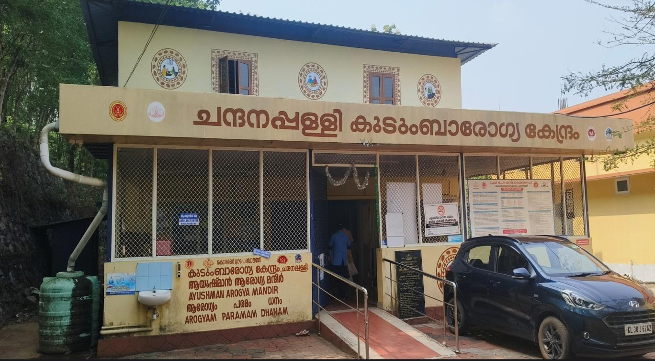

MESSAGE FROM PRESIDENT
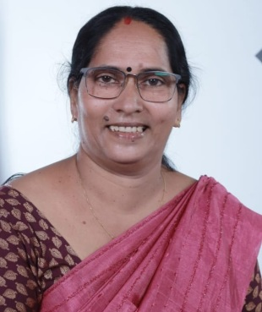

സന്ദേശം
പ്രീ എപ്പിഡെമിക് തയ്യറെടുപ്പ് സന്ദേശം
പ്രിയമിത്രങ്ങളെ,
സാധ്യമായ മഹാമാരി/ വ്യാധി വ്യാപനത്തെ മുന്നിൽ കണ്ടുകൊണ്ട് എല്ലാവരും ജാഗ്രത പാലിക്കണം. വ്യക്തിഗത ശുചിത്വം ക്യത്യമായി പാലിക്കുക, കൈകൾ ഇടക്കിടക്ക് സോപ്പ് ഉപയോഗിച്ച് കഴുകുക, ചുമയൊ തുമ്മലൊ വന്നാൽ മാസ്ക് ധരിക്കുക അനാവശ്യ യാത്രകളും തിരക്കുകളും ഒഴിവാക്കുക. ആരോഗ്യ വകുപ്പിൻ്റെ നിർദ്ദേശങ്ങൾ കർശനമായി പാലിക്കുക. ലക്ഷണങ്ങൾ കണ്ടാൽ ഉടൻ സമീപത്തുള്ള ആരോഗ്യകേന്ദ്രവുമായി ബന്ധപ്പെടുക.എല്ലാവരുടെയും സഹകരണം രോഗവ്യാപനം തടയാൻ സഹായകമാണ്. ഇങ്ങനെ ഒരു പ്രീ എപ്പിഡെമിക്ക് തയ്യറെടുപ്പ് നടത്തുന്നതിനു എല്ലാ വിധ ആശംസകളും നേരുന്നു.

ഗീത ദേവി

MESSAGE FROM HEALTH STANDING COMMITTEE CHAIR

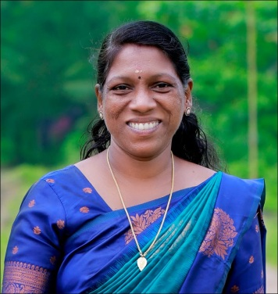

സന്ദേശം
വരാനിടയുള്ള പകർച്ച് വ്യാധിയെ പ്രതിരോധിക്കുന്നതിനായി എല്ലാവരും മുങ്കരുതലുകൾ സ്വീകരിക്കേണ്ടതാണ്. വീട്ടിലും പരിസരങ്ങളിലും ശുചിത്വം ഉറപ്പാക്കുക. ശുദ്ധജലം മാത്രം ഉപയോഗിക്കുക. കൈകൽ സോപ്പ്/ സാനിറ്റൈസർ ഉപ്യോഗിച്ച് ഇടക്കിടക്ക് വ്യത്തിയാക്കുക. പനി, ചുമ, ശ്വാസ് തടസം തുടങ്ങിയ ലക്ഷണങ്ങൾ കണ്ടാൽ സ്വയം ചികിൽസ ഒഴിവാക്കി ഉടൻ ആരോഗ്യ പ്രവർത്ത്കരെ വിവരം അറിയിക്കുക. സർക്കാർ- ആരോഗ്യ വകുപ്പ് നിർദ്ദേശങ്ങൾ ക്യത്യമായി പാലിക്കുക. സമൂഹത്തിൻ്റെ സുരക്ഷക്ക് എല്ലാവരുടേയുംസഹകരണം അനിവാര്യം ആണ്.

അംബിക

MESSAGE BY MEDICAL OFFICER



Pandemics can affect any one anywhere, preparedness saves lives. Early detection, honest communication, and community trust are as critical as medicines and ventilators. Stay informed from trusted sources, practice good hygiene, support community efforts protect vulnerable people, and act early when guidance is issued. Preparedness is not panic instead it is a disciplined readiness to protect every life. Preparedness today means resilience tomorrow.

Dr JIJO T MATHEW
EXECUTIVE SUMMARY
Primary Health Centre / Family Health Centre, Chandanappally functions as the primary public healthcare institution serving the population of Kodumon Grama Panchayat in Pathanamthitta District, Kerala. The institution plays a pivotal role in delivering comprehensive, accessible, and affordable healthcare services, with a strong emphasis on preventive, promotive, curative, and rehabilitative care, in accordance with national and state health programmes and public health guidelines.
The health facility caters to a predominantly rural population with diverse health needs and addresses key public health priorities including maternal and child health, communicable and non-communicable disease prevention and control, universal immunization, family welfare services, adolescent health, and geriatric care. Regular outpatient services, essential laboratory services, home-based care through field health staff, and scheduled outreach activities ensure healthcare access to all sections of the population, including vulnerable and hard-to-reach groups.
The institution actively implements major national and state health programmes such as the National Health Mission (NHM), National Tuberculosis Elimination Programme (NTEP), National Programme for Prevention and Control of Cancer, Diabetes, Cardiovascular Diseases and Stroke (NPCDCS), Universal Immunization Programme (UIP), and disease surveillance activities under the Integrated Disease Surveillance Programme (IDSP). These programmes form the backbone of routine healthcare delivery as well as emergency and outbreak response mechanisms.
Chandanappally Family Health Centre works in close coordination with the Grama Panchayat administration, ASHA workers, Anganwadi centres, schools, Kudumbashree units, and other community-based organizations to strengthen community participation, health awareness, and risk communication. Special emphasis is placed on early detection of cases, timely referral, infection prevention and control practices, health education, and promotion of healthy lifestyles to reduce disease burden and improve overall health outcomes.
Despite challenges related to infrastructure constraints, manpower shortages, and increasing service demand, the health facility continues to strengthen service delivery through effective micro-planning, surveillance-based decision-making, inter-sectoral coordination, and community engagement. Upgradation of health infrastructure, strengthening of isolation and triage facilities, enhancement of digital reporting and tele-health systems, and expansion of preventive and preparedness services are key focus areas under the pandemic preparedness framework.
Overall, Chandanappally Family Health Centre stands as a vital institution in safeguarding public health, ensuring preparedness and response to public health emergencies, and improving the quality of life of the residents of Kodumon Grama Panchayat, particularly during outbreaks and pandemics.

LIST OF ABBREVIATIONS

LSGD/LSGI | Local Self Government Department / Local Self Government Institution
BMO | Block Medical Officer
IDSP | Integrated Disease Surveillance Programme
NDMA | NationalDisaster Management Authority
PPE | Personal Protective Equipment
ICMR | IndianCouncil of Medical Research
CD | Communicable Diseases
NCD | NON-COMMUNICABLE Diseases

TABLE OF CONTENTS

INTRODUCTION 9
LSGD AT A GLANCE 11
AREA MAP OF FHC CHANDANPPALLY 14
Background of the LSGD 16
Demographic and Vulnerable Population 17
Clinical Vulnerability 19
Clinical Vulnerability Mapping 20
INFRASTRUCTURE & RESOURCE INVENTORY 21
Health Facility Directory & Basic Capacity in Kodumon 21
Specialized Services & Emergency Inventory 22
Diagnostics facility mapping 22
Healthcare Education & Training Institutions 23
Private Clinics (without In-patient facility) 25
Oxygen & Diagnostic Capacity 26
Social and Community Infrastructure for surge plan 26
Human resources 29
Community Organizations 31
Community & Support Cadre 32
Administrative & Emergency Services 34
Information regarding resources 34
EPIDEMIOLOGICAL TRENDS (2021–2025) 35
Disease Burden among human beings (Last 5 Years) 35
*(use the above table data to create the graph/diagram) 37
Seasonal Trend Analysis 38
Outcome-Based Trend Analysis- 2025 43
Transmission Trend- 2025 44
Integrated Disease Hotspot Map (2021–2025) 47
ONE HEALTH & ENVIRONMENTAL SURVEILLANCE 51
Animal & Bird Population 51
High-Risk Interface Points (Surveillance Sites) 53
Veterinary Infrastructure 56
Veterinary Doctors & Workforce 56
Environmental Risk Mapping 57
Disease Seasonality Mapping 59
Vulnerability Mapping 60
Preparedness and Response Protocol at Kodumon 62
Constitution of One Health Committee 62
Pandemic Response Workforce 63
Activities and Measures before and during Pandemic 65
PHASE 1 - Alert / Preparation 65
PHASE 2 - Active Response 68
PHASE 3 - Surge Capacity 79
Conversion of Community Facilities 79
CONCLUSION 80
RECOMMENDATIONS 81
ANNEXURE 83
ANNEXURE 2: IMPORTANT CONTACT NUMBERS 91

INTRODUCTION

Pandemics have historically posed significant threats to human health, economic stability, and social systems across the globe. From the devastating Spanish Flu pandemic, which claimed millions of lives worldwide, to the recent COVID-19 pandemic, the world has repeatedly witnessed the far-reaching consequences of infectious disease outbreaks. These events have underscored the urgent need for comprehensive, well-coordinated, and resilient pandemic preparedness and response systems.
The COVID-19 pandemic, in particular, highlighted both strengths and gaps in global and national health systems. It brought renewed attention to essential public health measures such as quarantine, isolation, surveillance, contact tracing, vaccination, and risk communication. Quarantine protocols—implemented to restrict the movement of exposed individuals—along with isolation of confirmed cases, played a crucial role in breaking the chain of transmission. Preventive strategies including hand hygiene, respiratory etiquette, mask usage, physical distancing, and vaccination became foundational pillars in controlling disease spread.
In India, the pandemic response was guided by the Ministry of Health and Family Welfare (MoHFW), in coordination with global standards set by the World Health Organization. The establishment of First Line Treatment Centres (FLTCs), COVID Care Centres, and Dedicated COVID Hospitals ensured tiered healthcare delivery, enabling efficient management of mild, moderate, and severe cases. These systems strengthened the integration between primary, secondary, and tertiary healthcare institutions, forming a robust continuum of care.
Pandemic preparedness is intrinsically linked with disaster management frameworks. It aligns with principles of risk assessment, mitigation, preparedness, response, and recovery, as outlined in national and state disaster management plans. A proactive approach involving surveillance systems, early warning mechanisms, resource mobilization, and intersectoral coordination is essential to minimize morbidity and mortality during health emergencies.
The evolution of public health systems in India has been significantly shaped by landmark recommendations such as those of the Bhore Committee and the Chadha Committee, which emphasized the integration of preventive and curative services and strengthening of primary healthcare. The principles laid down by pioneers like John Snow—often regarded as the father of modern public health—continue to guide disease surveillance and outbreak investigation strategies.
In the context of emerging and re-emerging infectious diseases, including zoonotic and vector-borne illnesses, preparedness planning becomes even more critical. Factors such as globalization, urbanization, climate change, and ecological disruptions contribute to the increasing risk of outbreaks. Therefore, local self-governments, health departments, and communities must work collaboratively to build resilient systems capable of early detection, rapid response, and effective containment.
This Pandemic Preparedness Plan aims to establish a comprehensive framework that integrates national guidelines, global best practices, and local realities. It emphasizes strengthening healthcare infrastructure, enhancing community participation, ensuring resource availability, and fostering interdepartmental coordination. By adopting a holistic public health approach, the plan seeks to safeguard population health, reduce vulnerability, and ensure a timely and effective response to future pandemics.

LSGD AT A GLANCE

Table 1: Background of Kodumon LSGD
Description | Details
Name of LSGD | Kodumon
Type (GP/Municipality / Corporation etc.) | Grama Panchayath
Village | Kodumon, Angadickal
Block | Parakkodu
Taluk | Adoor
District | Pathanamthitta
Health Block | Enadimangalm
Number of wards | 19
Total area (sq. km) | 36.36 sq km
Population (Projected) | 31918
Population density | 815 persons/sq. km
Houses | 8812

Table 2: Background of Kodumon GP
Description | Details
Terrain (coastal/low-lying/backwaters/foothills, etc.) | Foothills & Low-lying
Number of rivers passing through LSGD | Nil
Number of water bodies in the LSGD | 22
Flood-prone wards | Ward 2
Landslide-prone wards | Ottathek
Hotspots | 2 (14&16) [Dengue]
Number of educational institutions | 18
Factories / small-scale industries | 0/16
Industrial establishments (Medium-scale industries/small-scale industries establishments to whom we can depend in a worst-case scenario)
Death Management and Disposal Facilities (mortuaries/crematorium, including electric) | Mortuary- 1
Auditoriums/Marriage halls/convention centres/community halls | 6
Hospitals (Govt/Pvt) | 3/2

- Risk stratification among wards in the context of Communicable diseases and hazards
- Major Roads/rivers
- Major establishments with geospatial mapping
- occupational groups, socio cultural groups, migration & mobility patterns
- Vulnerability mapping
- Disaster prone areas (geographic vulnerability)

Maps - ward-based (Mention source also)

- Geographical boundaries - ward boundaries map
- Health infrastructure map
- roads and rivers map
- major establishments map
- disaster-prone areas map
- hotspot map - CD & disasters

AREA MAP OF FHC CHANDANPPALLY

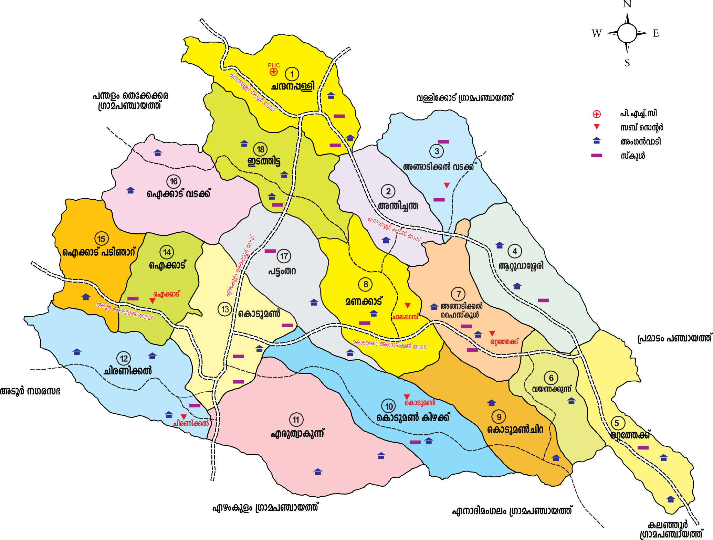

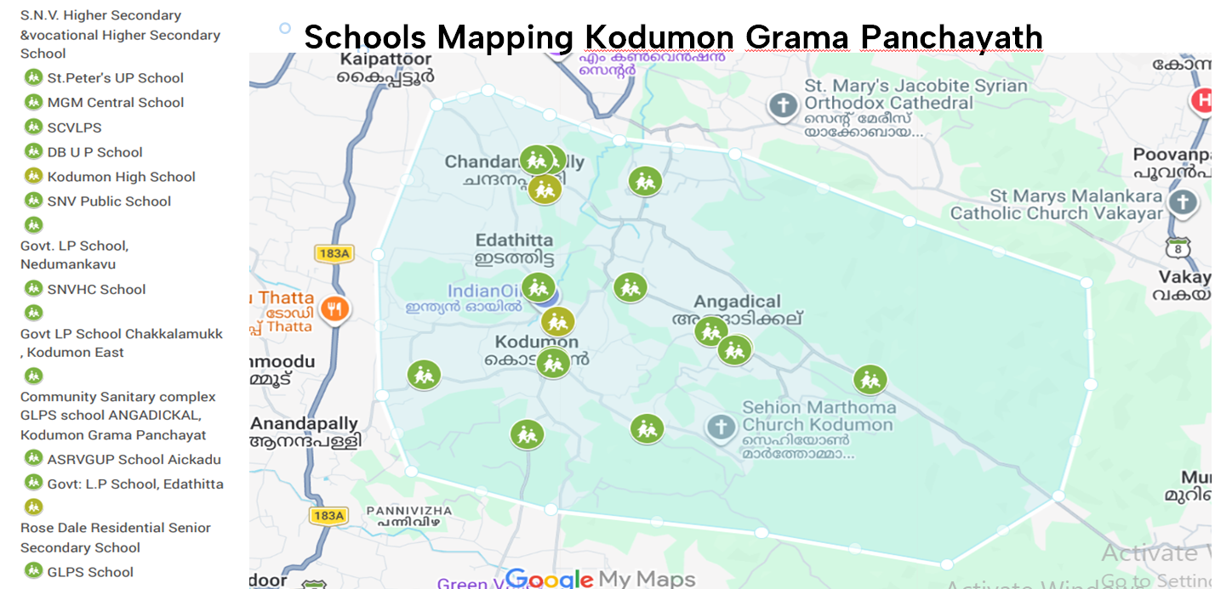

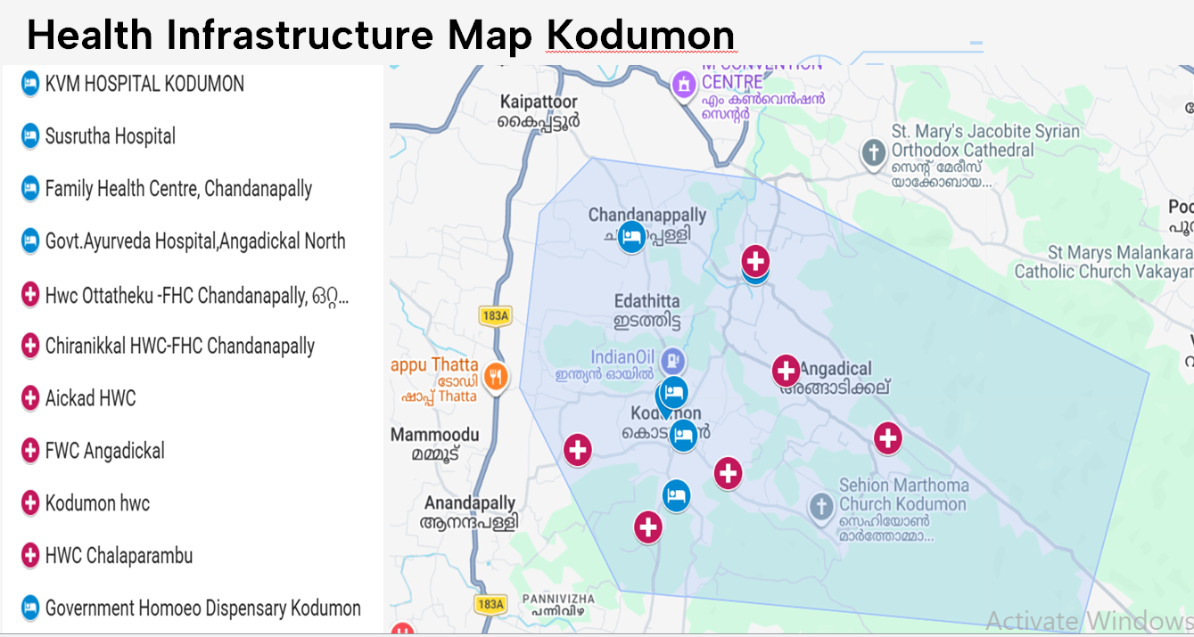
Health Infrastructure Map

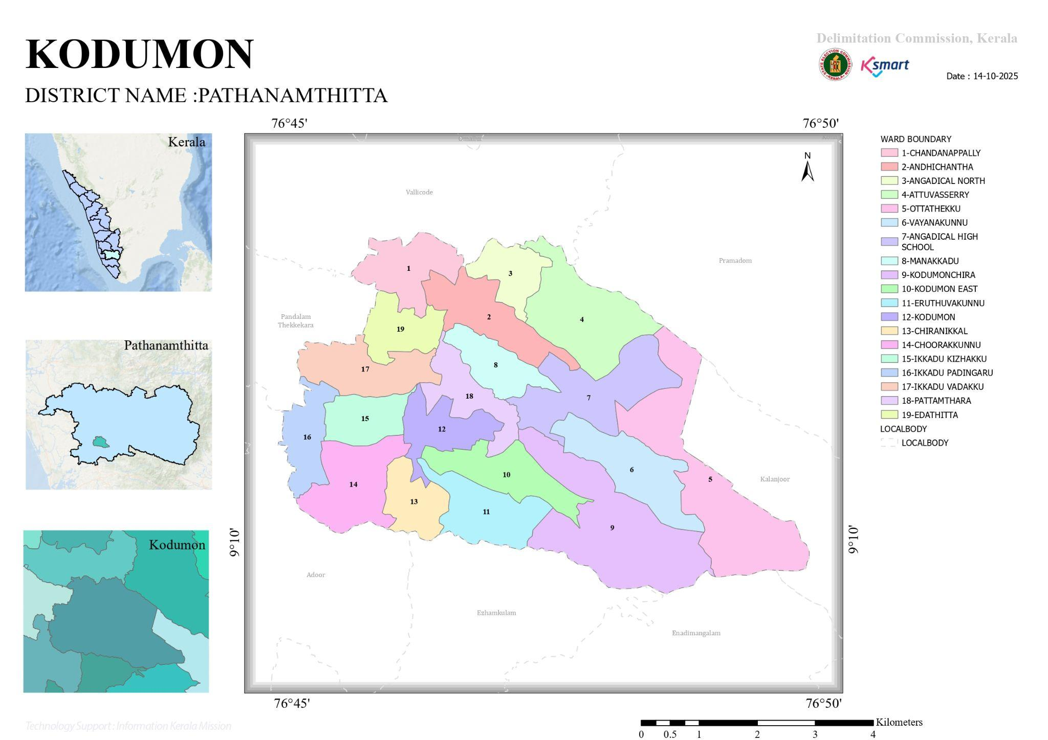

Geographical boundaries with political map (based on latest delimitation)

Boundaries

North – Vallickode, Pramadom
South- Ezhamkulam, Enadimangalam
East- Kalanjoor
West- Pandalam Thekkekara, Adoor Muncipality.

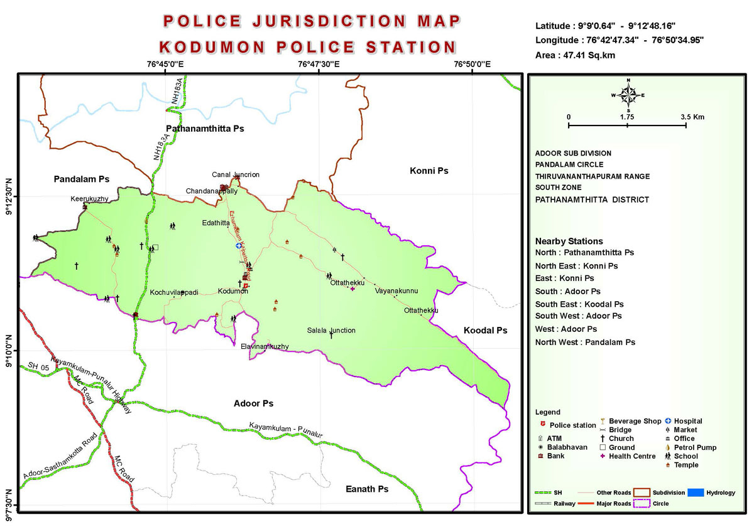

GENERAL PROFILE OF THE LSGD

Background of Kodumon GP
Kodumon Grama Panchayat is situated in the southern part of Pathanamthitta District, Kerala. Established on January 19 in the year 1979. The Panchayat forms part of the midland–highland physiographic region of the district and is characterized by undulating terrain, laterite soil, small hillocks, and narrow valleys, interspersed with streams and seasonal water channels. The area does not have coastal backwaters or Kole lands; however, monsoon rainfall significantly influences surface runoff, local drainage, and accessibility in certain low-lying pockets.
Administratively, the Panchayat is divided into multiple wards, with a predominantly rural population. The local economy is largely agrarian in nature, with rubber cultivation, coconut, banana, tapioca, paddy and mixed crop farming forming the main livelihood activities. In addition, a considerable proportion of the population is engaged in daily wage labour, construction work, small-scale trade, and service-sector employment, both within and outside the Panchayat. The presence of migrant labourers, mainly in construction and agriculture-related activities, is notable and has implications for public health planning and service delivery.
From a public health and disaster management perspective, Kodumon LSGI is vulnerable to monsoon-related hazards such as localized flooding, waterlogging, disruption of road connectivity, and damage to housing and basic infrastructure. Seasonal outbreaks of vector-borne diseases such as Dengue and waterborne diseases including diarrhoeal illnesses and Leptospirosis have been reported, particularly during and after the monsoon season. The 2018 Kerala floods had indirect impacts on the Panchayat due to prolonged heavy rainfall, infrastructure stress, and increased public health risks, highlighting the need for improved preparedness and coordinated response mechanisms.
In this context, the development of a localized, data-driven Auxiliary Infrastructure and Logistical Resource Map is essential to support effective planning, timely emergency response, and sustainable development initiatives. Such mapping enables the Panchayat to identify and optimize critical resources, improve accessibility during emergencies, strengthen inter-departmental coordination, and enhance the overall resilience of the community against disasters and public health emergencies.

Demographic and Vulnerable Population

Understanding the demographic composition and vulnerable population groups is essential for pandemic preparedness. Children, elderly, economically deprived families, migrant workers, and socially vulnerable groups are at increased risk during public health emergencies due to higher exposure, limited access to services, and dependency on public systems.

Sl. No. | Indicator / Field (Kodumon) | Baseline Data (Value / Description) | Source / Remarks
1 | Homeless population | 0
2 | Previous EPEP family | 54
3 | Tribal Communities (Mention if have specific community name & ward/area located) | 1
4 | Fisherfolk / Coastal vulnerable groups (if any) | 0
5 | Urban slums / unnotified settlements (if any) | 0
6 | Orphanages / old age homes (number & capacity) | 3
7 | Hostels / prisons / shelters (number & capacity) | 0
8 | Poverty
9 | Food insecurity hotspots | 0
10 | Any history of stigma/discrimination issues (Yes/No) | No

Table 3: DEMOGRAPHIC PROFILE-(Kodumon)
Description |  | Details (in numbers)
Total population |  | 31918
Male |  | 14877
Female |  | 17041
Transgender |  | 0
Children under 5(<5) |  | 1250
5–14 |  | 5214
15–59 |  | 20348
Elderly (>60) |  | 5106
Adolescent |  | 5212
SOCIAL/LIVELIHOOD VULNERABILITY
BPL family |  | 3319
BPL Population
Migrants |  | 157
Migration | Immigrant | 157
Migration | Emigrant | 4787
Socio-economically deprived |  | 1
SC Population |  | 1
ST Population |  | 6

Graphs: Population pyramid (if possible) for seeing if your LSGD has a high "dependency ratio" (lots of children and elderly compared to working adults).

Clinical Vulnerability
Certain population groups needs priority healthcare & are at higher risk of severe illness, complications, and mortality during pandemics. Patients with chronic diseases, those requiring regular medical care, and individuals with mobility or functional limitations face challenges in accessing timely care during emergencies. Mapping these groups helps in prioritizing continuity of treatment, medicine stock planning, oxygen support, referral transport, and targeted home-based care.
Description (Kodumon) | Details in numbers
Pregnant women (Current estimate) | 120
Lactating mothers | 134
Bedbound patients | 75
Patients under palliative care other than bedbound | 37
Patients on Haemodialysis | 08
Patients on CAPD | 1
Cancer patients (currently on treatment) | 178
Haemophilic patients | 0
Mentally challenged | 112
Differently abled | 389
Total no. of persons with disability | 389
Diabetic patients | 1974
Hypertensive patients | 2213
TB patients | 7
No. of chronic disease cases (DM/HTN/COPD/CKD etc.) | 203

Clinical Vulnerability Mapping

Vulnerability Factor (Kodumon) | High-Risk Wards | Key Groups / Locations | Risk Level
Sanitation workers | 1 | Kodumon | 0
Daily wage / migrant workers | 19 | Kodumon | Low
Elderly & chronically ill populations | 214 | Kodumon | Low
Pregnant Women | 4 | 0 | Low
Children (schools, Anganwadi’s) | 0 | 0 | 0

INFRASTRUCTURE & RESOURCE INVENTORY

Health Facility Directory & Basic Capacity in Kodumon

This section provides an overview of the healthcare infrastructure available within the LSGD area. It outlines the distribution and basic capacity of health facilities that form the backbone of service delivery during routine times and public health emergencies.

Family Health Centres (FHCs) and Community Health Centres (CHCs) generally function as the first point of contact for the community, providing essential outpatient and inpatient services. General Hospitals (GH) and Medical College Hospitals (MCH), where accessible, serve as the main referral centres for advanced diagnostics, specialist care, and critical services during public health emergencies. This inventory helps identify existing strengths, gaps, and potential surge capacity that can be mobilised during a pandemic or disaster.

Sl. No. | Indicator / Field (Kodumon) | Baseline Data (Value / Description) | Remarks
1 | Total no: of health facilities in LSGD (PHC/CHC/TH/DH/Private hospitals/Clinics/Ayush) | 5
2 | PHC/Family Health Centre (Name & location) | 1 FHC | Chandanappally
3 | Sub-centres / Health & Wellness Centres (number) | 7 | Govt
4 | Private hospitals (number) | 2 | Pvt
5 | Private Clinics/ Dispensaries (Ayush + Dental)
6 | Labs available (public/private) | 8 | Pvt
7 | Medical Stores
8 | Availability of ambulance services (Yes/No, number) | Yes | Govt

Specialized Services & Emergency Inventory
This section provides a detailed view of the specialized medical resources available to the community, focusing on emergency response and critical care capabilities. This table tracks the vital assets required for managing severe illnesses and emergencies across Government, Private, and AYUSH sectors.

Item (Kodumon) |  | Govt | Private | AYUSH | Total
Hospital beds |  | 2 | 2 | 10 | 14
Oxygen-generating systems(Y/N) |  | N | 0 | 0 | 0
Oxygen-supported beds(Numbers) |  | N | 0 | 0 | 0
Ventilator-supported beds |  | N | 0 | 0 | 0
ICU beds |  | 0 | 0 | 0 | 0
Burns units |  | 0 | 0 | 0 | 0
Blood centres |  | 0 | 0 | 0 | 0
Ambulances | Regular(Including palliative)
Ambulances | BLS | 0 | 0 | 0 | 0
Ambulances | ALS | 0 | 0 | 0 | 0
Dialysis facilities |  | 0 | 0 | 0 | 0
Dispensaries |  | 0 | 0 | 0 | 0
Industrial establishments(Medium-scale industries/small-scale industries establishments to whom we can depend in a worst-case scenario) |  | 0 | 10 | 0 | 0

Diagnostics facility mapping

The diagnostic capacity of Kodumon G.P represents the "intelligence network" of our healthcare system. The speed and accuracy of disease identification depend entirely on the distribution and technical level of these facilities.

Item (Kodumon) | Govt | Private | AYUSH | Total
General labs | 1 | 7 | 0 | 9
Microbiology labs | 0 | 0 | 0 | 0
RT-PCR labs | 0 | 0 | 0 | 0
USG units | 0 | 0 | 0 | 0
CT/MRI units | 0 | 0 | 0 | 0
Research labs | 0 | 0 | 0 | 0
Labs of other departments that can be repurposed | 0 | 0 | 0 | 0

Healthcare Education & Training Institutions

This section tracks the educational infrastructure available, which is vital for human resource planning in the health sector.

Category of Institution (Kodumon) | Govt | Private | AYUSH | Total
Medical Colleges | 0 | 0 | 0 | 0
Nursing Colleges | 0 | 0 | 0 | 0
Dental Colleges | 0 | 0 | 0 | 0
Para-medical / Allied Health | 0 | 0 | 0 | 0
Pharmacy Colleges | 0 | 0 | 0 | 0

Table 6. Health Facility Resource Summary (Kodumon)
Sl.no. | Health Facility | Type of Facility (MCH/GH/CHC/FHC etc.) | Contact Number | Total beds | ICU Beds | Oxygen-Supported Beds | No. of Ventilator Support Beds | No. of ambulances
Government Healthcare Facilities
1 | FHC Chandanapapply | FHC | 8921464073 | 2 | 0 | 0 | 0 | 1
Private Healthcare Facilities (With IP)
1 | KVM Hospital | PVT | 9744757665 | 1 | 0 | 0 | 0 | 0
2 | Susrutha Hospital | PVT | 94475594290 | 2 | 0 | 0 | 0 | 0

Table 6. AYUSH Healthcare Facilities Resource Summary (Kodumon)
Sl.no. | Health Facility | Type of Facility | Contact Number | Total beds | Ward | No: Buildings | Address | No. of ambulances
1 | Ayurveda Hospital | GOVT | 9400830163 | 10 | 0 | 0 | 0 | 0
2 | Govt Homoeo Dispensary | GOVT | 8301030994 | 0 | 0 | 0 | 0 | 0

- FHC Chandanapally has two oxygen cylinders and two oxygen concentrators.

Private Clinics (without In-patient facility)
Private clinics are an essential part of pandemic preparedness, as they are often the first place people seek care when symptoms begin. In many communities, private clinics manage a significant share of outpatient visits and therefore play a critical role in early case detection, timely referrals, and disease surveillance. Having an up-to-date understanding of where these clinics are located, the services they provide, and how they are linked to the public health system helps ensure that no cases are missed during an outbreak. It also allows health authorities to engage private practitioners more effectively for reporting, risk communication, and coordinated response, strengthening the overall capacity of the health system to manage public health emergencies.

Table 6. Private Clinic Resource Summary (Kodumon)
Sl No. | Name of Clinic | Registered (Y/N) | Clinic (General / Speciality) | Speciality (if any) | Address | Contact Number | Diagnostic Facility (Y/N) | Ambulance Linkage (Y/N)
1 | Susrutha | N | General | No | Kodumon | 9447594290 | Yes | Yes
2 | KVM Hospital | N | Genaral | No | Kodumon | 9744757665 | Yes | Yes
3 | Peringattil Dental Clinic |  | Dental |  |  | 9447504612
4 | Dr. Arya’s Dental |  | Dental |  |  | 9497512216
5 | 32 nd Dental Clinic |  | Dental |  |  | 6238676625

Oxygen & Diagnostic Capacity
Monitoring oxygen and diagnostic capacity is a critical component of public health preparedness, ensuring that the LSGD can handle both chronic care and sudden surges in respiratory or infectious diseases.
Name of Health Facility (Kodumon) | Oxygen-generating System (Y/N) |  | Backup Oxygen Source (Y/N) |  | No: of Oxygen cylinder available | No: of Oxygen concentrators available | Diagnostic Facilities Available(Y/N)
 |  |  |  |  |  |  | Lab | USG | X-ray | CT/MRI | RT-PCR
Government Healthcare Facilities
FHC Chandanapally |  | N |  |  |  | N | 1 | 0 | 0 | 0 | No
KVM Hospital |  | N |  |  |  | N | 1 | 0 | 0 | 0 | 0
Susrutha Hospital |  | N |  |  |  | N | 0 | 0 | 0 | 0 | 0

Social and Community Infrastructure for surge plan
This table serves as our logistics and shelter inventory. By mapping these locations, quickly we can identify where to house displaced citizens, where to set up temporary medical clinics, and how to manage the deceased with dignity during a crisis.

Sl. No. | Indicator / Field (Kodumon) | Baseline Data (Value / Description) | Source / Remarks
1 | Anganwadis (number) | 30 | From ICDS
2 | Schools (number) | 18 | From Schools
3 | Colleges (number) | 1 | ITI College, Iykkad
4 | Community halls (number) | 01 | GP
5 | Auditoriums(Number)
6 | Religious Buildings (Number)
7 | Schools/colleges with hostels (number) | 19
8 | Hostels
9 | Factories / large workplaces (number) | 2 | Kodumon and chandanappally Estate

Category (Kodumon) | Total Counts | Est. Capacity (Persons)
Educational Institutions
Anganwadis | 30 | 120
Schools | 17 | 540
*refer annexure 1 for contact details

Category (Kodumon) | Total Counts | Est. Capacity (Persons)
Community Gathering Spaces
Community halls | 1 | 10
Auditoriums | 5 | 115
Religious buildings | 4 | 100
*refer annexure 1 for contact details

Category (Kodumon) | Total Counts | Ward | Est. Capacity (Persons)
LSGD owned other buildings
Nil | 0 | 0 | 0
*refer annexure 1 for contact details

Category (Kodumon) | Total Count | Ward | Est. Capacity (Persons)
Educational Institutions
Colleges | 1 | 0 | 40
Healthcare Educational Institutions
Medical colleges (Govt/Private) | 0 | 0 | 0
Nursing colleges (Govt/Private) | 0 | 0 | 0
Dental colleges (Govt/Private) | 0 | 0 | 0
Paramedical institutes (Govt/Private) | 0 | 0 | 0
Vulnerable Group Support Facility
Destitute homes | 2 | w-9,12 | 75,35.
Elderly homes | 1 | W -3 | 12
Mass Fatality Management (MFM) Infrastructure
Mortuary | 1 | 18 | 0
Crematorium | 0 | 0 | 0
*refer annexure 1 for contact details

Category (Kodumon) | Total Counts | Ward | Est. Capacity (Persons)
Industrial establishments (Medium-scale industries/small-scale industries establishments to whom we can depend in a worst-case scenario) | 0 | 0 | 0

Human resources

This section focuses on the human capital available within the LSGI. In any emergency—be it a pandemic, flood, or industrial accident—infrastructure is only as effective as the people operating it.

Medical & Clinical Personnel

This table tracks the "Frontline" providers responsible for diagnosis, treatment, and clinical management. Narrative sentence: eg., "Total health workforce: 450 personnel, with 60% in government facilities serving as primary surge capacity." A detailed directory with the contact numbers of all workers is maintained (Annexure in 1).

Cadre (Kodumon) | Govt (No.) | Private (No.) | Total
Doctors—Modern Medicine | 3 | 10 | 13
Doctors – AYUSH | 2 | 1 | 3
Doctors – Veterinary | 1 | 0 | 1
Doctors – Dental | 0 | 5 | 5
Nursing officers | 2 | 70 | 72
Lab technicians | 1 | 10 | 11
Optometrist | 0 | 0 | 0
Pharmacists | 0 | 5 | 5
Psychologists | 0 | 0 | 0
Counsellors | 0 | 1 | 1

Public Health & Field-Level Workforce

These individuals are the backbone of surveillance, maternal-child health, and decentralized care.

Cadre (Kodumon) | Health services | LSGD/ Municipal common services | Total
HS (Health Supervisors) | 0 | 0 | 0
HI (Health Inspectors) | 1 | 0 | 1
LHS (Lady Health Supervisor) | 0 | 0 | 0
LHI (Lady Health Inspectors) | 1 | 0 | 0
JPHN (Jr Public Health Nurses) | 7 | 0 | 7
JHI (Jr Health Inspectors) | 4 | 0 | 4
MLSP (Mid-Level Service Providers) | 7 | 0 | 7
Palliative Nurses | 1 | 0 | 1
RBSK Nurses | 1 | 0 | 1
PRO | 0 | 0 | 0
Epidemiologist | 0 | 0 | 0
Data Manager | 0 | 0 | 0

Community Organizations

This section details the presence of community-based organisations (CBOs), non-governmental organisations (NGOs), faith-based organisations (FBOs), Kudumbashree Self-Help Groups (SHGs), and Ayalkootams within the Local Self-Government Institution (LSGI). These groups enhance grassroots mobilization, resource distribution, and support networks crucial for pandemic response and community resilience.

Category (Kodumon) | Total Count
NGOs | 0
Religious based organizations | 2
Foreign based organizations | 0
Sports Club/youth clubs | 26
Kudumbashree SHGs | 26
Ayalkootams | 26
Political organizations | 4
Residential organizations | 0

Community & Support Cadre

This group represents the surge capacity of the LSGI—people who can be called upon for logistics, rescue, and specialized support.

Cadre (Kodumon) | Number
ASHA Workers | 19
AWW (Anganwadi Workers) | 30
Emergency Medical Volunteers (Trained) | 177
Kudumbashree | 252
MNREGS | 2779
Purusha Swayam SahayaSangham | 0
Ex-Servicemen | 217
Retired Police Officers | 12
NCC/NSS Volunteers | 70
Red Cross volunteers | 0
One Health Community Volunteers | 1026
One Health Community Mentors | 19

Administrative & Emergency Services

This section outlines the availability of key non-health emergency support services and infrastructure within the LSGI, which are essential for effective pandemic preparedness and response. These facilities support law enforcement, disaster response, water supply, logistics, mobility, and community-level interventions during public health emergencies.

Category (Kodumon) | Total Count | Contact details
Police Stations | 1 | 04734285229, 9497947143
Fire & Rescue Stations | 0 | 0
Water Pumping Points | 5 | 0
Public Distribution System (PDS)-Ration shop | 13 | 9048890094  8590796094  9446816903
*refer annexure 1 for contact details

Information regarding resources

The availability of essential transport and support resources plays a quiet but critical role in saving lives. Equipment such as ambulances, mobile mortuaries, amphibian ambulances, and motorized boats ensures that patients, samples, and healthcare teams can move swiftly—even in flooded, remote, or difficult terrains. Heavy vehicles like JCBs, cranes, tractors, and torus lorries support logistics, waste management, emergency infrastructure, and rapid conversion of spaces into care or isolation facilities. Taxis, four-wheel-drive vehicles, and trucks help maintain continuity of essential services, reach vulnerable populations, and support home-based care and supply delivery.

Means of transportation (Kodumon) | Total Count
JCB | 8
Crane | 1
Heavy Trucks | 15
Tractor | 3
Ambulances | 5
Mobile mortuaries | 0
Boats | 0
Taxi service | 55
Note: For specific details regarding vehicle owners and contact information, please refer to Annexure [X].

EPIDEMIOLOGICAL TRENDS (2021–2025)

Disease surveillance is the systematic collection, analysis, and interpretation of health data for planning, implementation, and evaluation of public health practice. This section presents the disease surveillance profile of the LSGI based on routine reporting systems and outbreak investigations to identify priority diseases, seasonal patterns, and emerging public health threats.

Disease Burden among human beings (Last 5 Years)
Analysis of disease-wise data for the last five years helps identify persistent public health problems, emerging diseases, and changes in disease burden. This information supports prioritisation of prevention, preparedness, and response activities at the Panchayat level.

Disease | 2021 | 2022 | 2023 | 2024 | 2025 | Trend (Increasing/Stable/Decreasing)
Dengue | 7 | 9 | 149 | 129 | 24 | Decreasing
Leptospirosis | 3 | 3 | 7 | 4 | 6 | Stable
Hepatitis A | 0 | 0 | 3 | 5 | 6 | Stable
Malaria | 0 | 0 | 0 | 0 | 0 | 0
Scrub Typhus | 0 | 0 | 0 | 0 | 0 | 0
Typhoid | 0 | 0 | 0 | 0 | 0 | 0
H1N1 | 0 | 0 | 3 | 8 | 5 | Decreasing
H3N2 | 0 | 0 | 0 | 0 | 0 | 0
ADD | 13 | 54 | 24 | 86 | 80 | Increasing
Mumps | 0 | 0 | 0 | 0 | 1 | Stable
Measles | 0 | 0 | 0 | 0 | 0 | 0
Hepatitis B | 0 | 5 | 4 | 7 | 3 | Decreasing
Hepatitis C | 0 | 0 | 0 | 0 | 0 | 0
Tuberculosis | 19 | 24 | 30 | 15 | 17 | Stable
Leprosy | 0 | 0 | 0 | 1 | 1 | Stable
COVID-19 | 350 | 85 | 24 | 10 | 0 | Decreasing

*(use the above table data to create the graph/diagram)

Seasonal Trend Analysis

Seasonal analysis helps anticipate surges (e.g. dengue in monsoon, leptospirosis after floods, influenza in cooler months) and plan pre‑emptive vector control, stockpiling of IV fluids, and awareness campaigns at Panchayat level.

DENGUE

Dengue is a major seasonal vector-borne disease strongly associated with rainfall, water stagnation, and increased mosquito breeding during the monsoon period.

Peak: July–November

Dengue – Ward-wise Yearly Distribution (2021–2025)

Ward | Dengue – Ward-wise Yearly Distribution
Ward | 2021 | 2022 | 2023 | 2024 | 2025 | Total
1 | 0 | 1 | 7 | 3 | 0 | 11
2 | 0 | 0 | 2 | 2 | 0 | 4
3 | 1 | 0 | 5 | 5 | 2 | 13
4 | 0 | 0 | 2 | 4 | 1 | 7
5 | 2 | 0 | 0 | 2 | 0 | 4
6 | 1 | 0 | 1 | 5 | 0 | 7
7 | 0 | 0 | 7 | 10 | 0 | 17
8 | 1 | 0 | 7 | 13 | 1 | 22
9 | 0 | 0 | 7 | 5 | 0 | 12
10 | 0 | 0 | 12 | 7 | 1 | 20
11 | 0 | 2 | 12 | 6 | 0 | 20
12 | 0 | 1 | 14 | 7 | 2 | 24
13 | 0 | 0 | 7 | 19 | 0 | 26
14 | 0 | 1 | 22 | 4 | 2 | 29
15 | 1 | 1 | 5 | 8 | 1 | 16
16 | 1 | 3 | 22 | 4 | 9 | 39
17 | 0 | 0 | 12 | 24 | 1 | 37
18 | 0 | 0 | 5 | 1 | 4 | 10

LEPTOSPIROSIS

Leptospirosis cases are closely linked to monsoon rains, flooding, and occupational exposure, particularly in low-lying and waterlogged areas.

Peak: June - August

Leptospirosis – Ward-wise Yearly Distribution (2021–2025)

Ward | Leptospirosis – Ward-wise Yearly Distribution
Ward | 2021 | 2022 | 2023 | 2024 | 2025 | Total
1 | 0 | 0 | 0 | 0 | 0 | 0
2 | 2 | 0 | 0 | 1 | 0 | 3
3 | 0 | 0 | 1 | 0 | 1 | 2
4 | 0 | 1 | 1 | 0 | 0 | 2
5 | 0 | 0 | 2 | 0 | 0 | 2
6 | 0 | 0 | 0 | 0 | 0 | 0
7 | 0 | 0 | 1 | 0 | 0 | 1
8 | 1 | 1 | 0 | 0 | 0 | 2
9 | 0 | 0 | 1 | 0 | 0 | 1
10 | 0 | 0 | 0 | 1 | 0 | 1
11 | 0 | 0 | 0 | 0 | 0 | 0
12 | 0 | 0 | 0 | 0 | 2 | 2
13 | 0 | 0 | 0 | 0 | 0 | 0
14 | 0 | 0 | 0 | 1 | 0 | 1
15 | 0 | 1 | 0 | 1 | 3 | 5
16 | 0 | 0 | 0 | 0 | 0 | 0
17 | 0 | 0 | 1 | 0 | 0 | 1
18 | 0 | 0 | 0 | 0 | 0 | 0

VIRAL HEPATITIS - A

Hepatitis A cases are commonly associated with unsafe drinking water, food contamination, and breakdowns in sanitation, often presenting as clusters or outbreaks.

Peak: October - December

Hepatitis A – Ward-wise Yearly Distribution (2021–2025)

Ward | Hep A – Ward-wise Yearly Distribution
Ward | 2021 | 2022 | 2023 | 2024 | 2025 | Total
1 | 0 | 0 | 0 | 1 | 1 | 2
2 | 0 | 0 | 0 | 0 | 0 | 0
3 | 0 | 0 | 1 | 0 | 0 | 1
4 | 0 | 0 | 0 | 0 | 0 | 0
5 | 0 | 0 | 0 | 0 | 0 | 0
6 | 0 | 0 | 0 | 0 | 0 | 0
7 | 0 | 0 | 0 | 0 | 0 | 0
8 | 0 | 0 | 1 | 0 | 0 | 1
9 | 0 | 0 | 0 | 1 | 0 | 1
10 | 0 | 0 | 0 | 0 | 2 | 2
11 | 0 | 0 | 0 | 0 | 0 | 0
12 | 0 | 0 | 0 | 1 | 2 | 3
13 | 0 | 0 | 0 | 0 | 0 | 0
14 | 0 | 0 | 0 | 0 | 0 | 0
15 | 0 | 0 | 0 | 0 | 0 | 0
16 | 0 | 0 | 1 | 1 | 1 | 3
17 | 0 | 0 | 0 | 0 | 0 | 0
18 | 0 | 0 | 0 | 1 | 0 | 1

Outcome-Based Trend Analysis- 2025

Transmission Trend- 2025
For effective management of public health issues, it is important to track the trend of disease transmission mode. It helps identify the population or place at high risk that can be used to predict outbreaks and implement targeted interventions as quickly as possible. Understanding these kinds of trends enables authorities to allocate resources efficiently and change the strategies adequately based on the trend that follows.

Vector-Borne Disease

Vector-Borne Disease  (Kodumon) | No. of Cases | No. of Deaths
Dengue | 24 | 0
Malaria | 0 | 0
Chikungunya | 0 | 0

Water Borne Disease

Water Borne Disease  (Kodumon) | No. of Cases | No. of Deaths
Cholera | 0 | 0
Typhoid | 0 | 0
Hep- A | 6 | 0
Dysentery | 0 | 0
Amoebiasis | 0 | 0
E- Coli infections | 0 | 0

Air Borne Disease

Air Borne Disease  (Kodumon) | No. of Cases | No. of Deaths
Influenza | 0 | 0
H1N1 | 5 | 0
TB | 17 | 2
Chickenpox | 27 | 0
Measles | 0 | 0
Covid-19 | 0 | 0
Pertussis | 0 | 0
Mumps | 1 | 0

Blood-Borne Disease

Blood-Borne Disease  (Kodumon) | No. of Cases | No. of Deaths
AIDS | 0 | 0
Hep- B | 3 | 0
Hep- C | 0 | 0

Zoonotic Disease

Zoonotic Disease  (Kodumon) | No. of Cases | No. of Deaths
Rabies | 0 | 0
Leptospirosis | 6 | 0
Avian influenza | 0 | 0
West nile | 0 | 0
Anthrax | 0 | 0
Nipah | 0 | 0
Scrub Typhus | 0 | 0

Consolidation of Diseases
Mode of Transmission (Kodumon) | No. of cases | No. of Deaths
Vector Borne Diseases | 24 | 0
Water Borne Diseases | 80 | 0
Air Borne Diseases | 187 | 2 (TB)
Blood Borne Diseases | 0 | 0
Zoonotic Diseases
Food Borne Diseases | 0 | 0

Integrated Disease Hotspot Map (2021–2025)
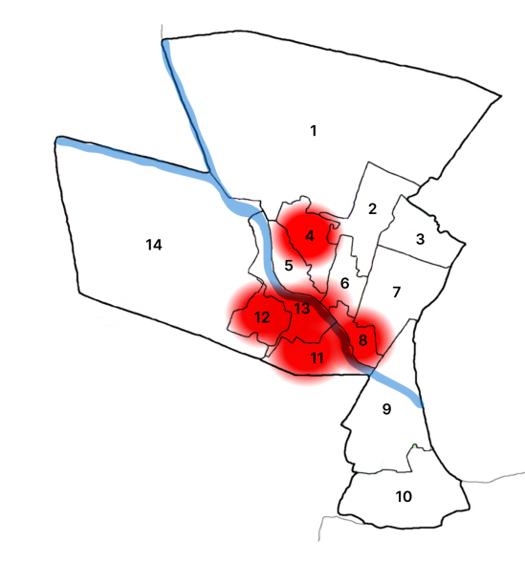

Ward No | Dengue Total (2021-25) | Leptospirosis Total (2021-25) | Hepatitis A Total (2021-25) | Mumps (2021-25) | ADD (2021-25) | Total Cases
1 | 11 | 0 | 2 | 0 | 13 | 26
2 | 4 | 3 | 0 | 0 | 15 | 22
3 | 13 | 2 | 1 | 0 | 12 | 28
4 | 7 | 2 | 0 | 0 | 10 | 19
5 | 4 | 2 | 0 | 0 | 17 | 23
6 | 7 | 0 | 0 | 0 | 19 | 26
7 | 17 | 1 | 0 | 0 | 8 | 24
8 | 22 | 2 | 1 | 0 | 22 | 47
9 | 12 | 1 | 1 | 0 | 19 | 33
10 | 20 | 1 | 2 | 0 | 17 | 40
11 | 20 | 0 | 0 | 0 | 22 | 42
12 | 24 | 2 | 3 | 0 | 21 | 50
13 | 26 | 0 | 0 | 0 | 12 | 38
14 | 29 | 1 | 0 | 1 | 17 | 48
15 | 16 | 5 | 0 | 0 | 16 | 37
16 | 39 | 0 | 3 | 0 | 8 | 50
17 | 37 | 1 | 0 | 0 | 6 | 44
18 | 10 | 0 | 1 | 0 | 3 | 14

By overlaying five years of data, we have identified ………0…..'Red Zone' Wards. These are wards where at least two different categories of diseases (e.g., Dengue and Lepto) recurred in consecutive years. Ward 4 is categorized as the Highest Priority Hotspot due to its combination of flood vulnerability and high vector density. Future health infrastructure, such as the proposed R.O plants at ………should be prioritized.

You can add this summary row at the bottom of your table:
Ward No | Dengue Total (2021-25) | Leptospirosis Total (2021-25) | Hepatitis A Total (2021-25) | Mumps (2021-25) | ADD (2021-25) | Total Cases
Total | 318 | 23 | 14 | 1 | 237 | 593

Disease Burden Percentage Table (2021–2025)
Sl. No | Disease | Total Cases | Percentage of Total Cases (%)
1 | Dengue | 318 | 53.6 %
2 | Leptospirosis | 23 | 3.9 %
3 | Hepatitis A | 14 | 2.4 %
4 | Mumps | 1 | 0.2 %
5 | ADD (Acute Diarrhoeal Disease) | 237 | 39.9 %
 | Total | 593 | 100 %

Key Insight
- Dengue contributes the highest disease burden (53.6%), indicating a strong need for vector control and source reduction activities.
- ADD accounts for 39.9%, highlighting issues related to drinking water safety, sanitation, and seasonal contamination risks.
- Leptospirosis and Hepatitis A contribute smaller but epidemiologically significant proportions, often associated with monsoon-related environmental exposure.

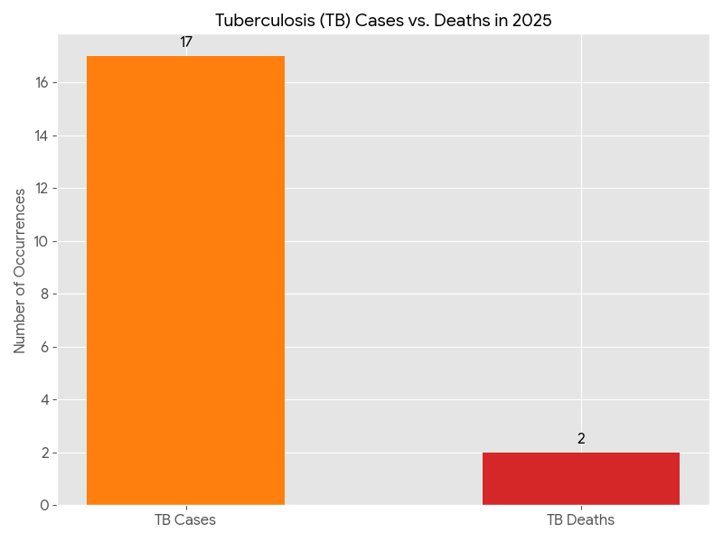

CD Mortality -2025

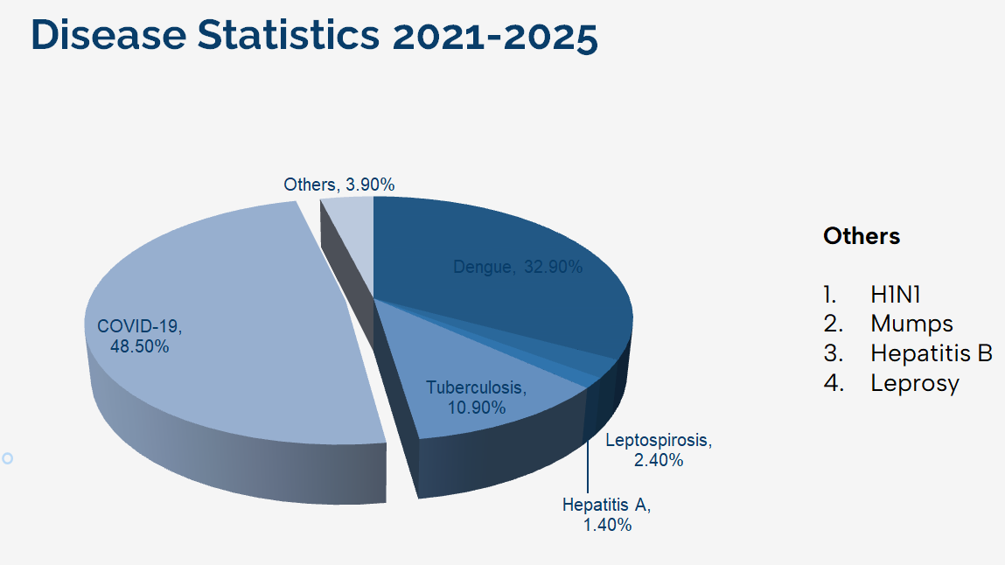

ONE HEALTH & ENVIRONMENTAL SURVEILLANCE

The One Health method integrates environmental, animal, and human health to enable proactive pandemic preparedness. Panchayat-level surveillance needs to be improved in order to detect and treat zoonotic and environmentally generated diseases early. Surveillance is strengthened through systematic assessment of animal populations, veterinary infrastructure, poultry and slaughter facilities, inter-sectoral coordination, and specialised tools like avian influenza seasonality mapping using GIS in previous outbreaks to enable predictive alerts and ward-specific sampling to support effective pandemic preparedness in high-risk areas.

Animal & Bird Population
Mapping animal and bird populations at the Panchayat level is essential for identifying and prioritising zoonotic disease hazards like rabies, avian influenza (H5N1), leptospirosis, anthrax, and Nipah-like spillover occurrences. Risk classification, targeted surveillance, vaccination planning, and early epidemic detection made feasible by comprehensive population mapping all enhance One Health-based pandemic preparedness.
Sl. No. | Indicator / Field (Kodumon) | Baseline Data (Value / Description) | Source / Remarks
1 | Veterinary dispensaries (number) | 1 | Govt
2 | Slaughterhouses (number) | 0 | 0
3 | Meat shops(number)
4 | History of zoonotic outbreaks (rabies, leptospirosis, avian flu etc.) | No | No out breaks
5 | Stray dog population management measures (Yes/No) | No
6 | Rodent infestation hotspots (Yes/No) | No
7 | Wetlands / waterlogged areas prone to leptospirosis | 1 | Paddy Fields
8 | Bat roosting areas / caves / fruit orchards (if any) | Yes
9 | Human-animal interface hotspots (farms near residences) | No | Man to wild boar

Animal Population |  |  | Estimated Population | Total | Wards
Livestock (Cattle/Goats/Buffalo) |  | Dairy Farms (Number)
 |  | Cattle | 989 |  | All Wards
 |  | Goats | 589
 |  | Buffalo | 47
Pet Animals (Dogs/Cats) |  | Dogs | 898 |  | ‘’
 |  | Cats | 654
Stray Dog Population |  |  | 839 |  | All Wards
Pig Farm | No: of Farms |  | 0 |  | 0
Pig Farm | No: of Pigs
Small Units (Sheep / Goats – clustered) |  |  | 0 |  | 0
Crow Mortality Events (Reported)

Bird Population |  | Estimated Population | Total | Wards
Poultry (Birds) | Poultry Frams | 8 |  | 4,5,6,9,16
Poultry (Birds) | No: of Poultry birds | 465
Poultry- (FOWL) | Poultry- (FOWL) Units |  |  | 13/12/15/6/10/9
Poultry- (FOWL) | Poultry- (FOWL) Birds | 6641
Wild/Migratory Birds (Observed) |  | 0

The main risk of zoonotic diseases in Dogs is concentrated in Wards all wards, which is explained by the high density of pig farms, cattle congregation areas, and poultry units. The stray dog population in market areas, fish landing sites, bus stations continues to be a substantial problem for rabies surveillance and bite prevention. There is a considerable risk of avian influenza introduction and amplification during November - December due to the seasonal presence of migratory and resident water birds near ponds/ canal / river / backwater / paddy field. Clusters of pig farms and animal shelters vulnerable to flooding further raise the risk of leptospirosis and other zoonoses mediated by the environment, especially during monsoon floods.

High-Risk Interface Points (Surveillance Sites)

High-Risk Interface Points (Surveillance Sites)

Category(Kodumon) | Total Count | Key Locations (wards)
Poultry Farms | 8 | 6,16,13,
Backyard / Clustered Poultry Units | 18 | All Wards
Duck Rearing Units (open water access) | 0 | 0
Slaughterhouses/ Slaughter Points | 0 | 0
Meat/Fish Markets | 1 | 13
Live Bird Sale Points | 2 | 18,13
Cattle Markets / Weekly Animal Fairs (details) | 0 | 0
Pet Shops / Breeders | 2 | 13
Animal Shelters / Pet Homes | 0 | 0
Waste Disposal Sites near Animal Units | 0 | 0

High-risk interface points for zoonotic disease surveillance in __kodumon__________ Grama Panchayath include wetland–livestock–human contact zones, backyard poultry farms, cattle sheds near water bodies, fish markets, and areas of high human–animal interaction such as community slaughter points and migratory bird congregation sites. These are the primary surveillance sites where zoonotic spillover risks are elevated.

High-Risk Interface Points (Surveillance Sites)
Type of Habitat (Kodumon) | Type of High risk interface | Geographical vulnerability
Wetlands & Backwaters | Man to environment | 1 - Ottathek area
Backyard Poultry Farms | 0 | 0
Cattle Sheds near Water Bodies | 0 | 0
Fish & Meat Markets | 0 | Nil
Community Slaughter Sites | 0 | 0
Migratory Bird Congregation Areas | 0 | Nil
Rodent-Infested Grain Storage | 0 | 0

Veterinary Infrastructure
Veterinary institutions are a core pillar of One Health surveillance, enabling early zoonotic disease detection through vaccination, investigation of unusual animal illness or deaths, sample collection, and timely outbreak reporting. A well-mapped and responsive veterinary network strengthens coordination with human health and LSGI systems, ensuring rapid response during zoonotic events and pandemics.
Facility Type (Kodumon) | Name of Facility | Ownership Govt / Pvt | Location(Ward No) | Contact number
Veterinary Dispensary | 0 | 0 | 0 | 0
Veterinary Hospital / Polyclinic | 1 | Govt | Kodumon Ward 13 | 7012772560
Private Veterinary Clinics | 0 | 0 | 0 | 0
Mobile / Emergency Vet Service (incl. night services) | 0 | 0 | 0 | 0
Pet Homes / Animal Shelters | 0 | 0 | 0 | 0
Slaughterhouse-linked Veterinary Inspection Unit | 0 | 0 | 0 | 0

Veterinary Doctors & Workforce
Early detection, diagnosis, reporting, and reaction to animal illness epidemics depend on the availability and accessibility of qualified veterinary specialists. By identifying unusual animal morbidity or mortality promptly, collecting samples promptly, and coordinating efficiently with human health and LSGI systems—especially during zoonotic outbreaks and pandemic-prone situations—a clearly defined veterinary workforce enhances One Health surveillance.

Category (Kodumon) | Number Available | Type (Govt/Pvt)
Government Veterinary Doctors | 1 | Govt
Private Veterinary Doctors | 0 | 0
Livestock Inspectors | 2 | Govt
Para-veterinary Staff / Attenders | 2 | Govt
Contract / On-call Veterinary Support (if any) | 0 | 0

Environmental Risk Mapping
Environmental risk mapping identifies monsoon/flood hotspots for vector-borne (dengue, chikungunya), water-borne (leptospirosis, diarrhoea), and zoonotic diseases in Kerala's wetlands. Systematic surveillance supports early warnings, targeted interventions, and Panchayat pandemic preparedness.
Waterborne exposure: Flood-prone areas and stagnant water bodies facilitate leptospira survival, raising leptospirosis risk.

Traditional practices: Informal slaughter and fish markets lack standardized hygiene, creating spillover opportunities.

Climate & Disaster Risks (Pandemic Amplifiers)

Sl. No. | Indicator / Field (Kodumon) | Baseline Data (Value / Description) | Source / Remarks
1 | Flood-prone wards (list) | 2 | GP
2 | Waterlogging areas (list)
3 | Landslide-prone wards (list) | 0 | 0
4 | Heatwave risk zones (Yes/No) | No | No
5 | Cyclone/sea surge risk (Yes/No) | N | NA
6 | Drought-prone areas
7 | Shelter homes / relief camps (number, capacity) | 0 | 0
8 | Past disaster displacement history | Yes 2018 Flood | -
9 | Disruption to water supply/transport common (Yes/No) | Yes | From GP

Risk Factor (Kodumon) | High-Risk Wards | Key Locations | Risk Level (High/Med/Low)
Flood-prone areas | Wards – 2, 3, 11, 18, 19 | Near kodumon, Angadickal Thekkekkara, kochuvayal | Low
Water bodies/wetlands | 2 Wards | Near kodumon | Low
Solid waste accumulation | 0 | 0 | 0
Animal waste disposal issues | 0 | 0 | 0
Rodent infestation zones | 0 | 0 | 0
Industrial effluent discharge | 0 | 0 | 0
Construction sites / abandoned buildings | 0 | 0 | 0
Poor drainage/blocked canals | 0 | 0 | 0
Drinking water source contamination risk | 0 | 0 | 0

Disease Seasonality Mapping

- Flooding & water logging → amplifies leptospirosis, malaria, diarrheal diseases.
- Migratory bird influx (Nov–Feb) → avian influenza risk.
- Mosquito breeding cycles → vector-borne disease peaks in monsoon.
- Agricultural practices → close human–animal contact in paddy fields.

Disease (Kodumon) | Peak Risk Season | Key Drivers | High-Risk Locations | Surveillance Focus
Avian Influenza | Nov-Feb | Migratory Birds | 0 | Yes
Leptospirosis | Jauary To December | Cattle,Dogs, Cats, | 2 | Yes
Dengue/Chikungunya | Throughout Year peaks in monsoon | Mosquitos | 14,16 | yes
Acute Diarrheal Diseases | Throughout Year | Food and water | 3 | Yes
Rabies | Throughout Year | Stray Dogs | 18 | Yes
Anthrax (rare) | Nil | NA | 0 | 0

Environment Vulnerability Mapping
Vulnerability mapping pinpoints high-risk populations, occupations, and areas exposed via environment, livelihoods, socio-economics, and poor service access. Paired with environmental/seasonality mapping, it enables risk-based surveillance, targeted actions, and optimal resource use in One Health and pandemic planning.
Vulnerability Factor (Kodumon) | High-Risk Wards | Key Groups / Locations | Risk Level
Flood-prone households | 1 | Antichanda | low
Wetland-adjacent communities | 1 | Ottathekk | low
Backyard poultry / duck rearing households | 0 | 0 | 0
Livestock-rearing households | 0 | 0 | 0
Slaughterhouse & meat market workers | 0 | 0 | 0
Fisherfolk & fish market workers | 0 | 0 | 0
Limited access to safe water & sanitation | 0 | 0 | 0

Preparedness and Response Protocol at Kodumon
Pandemics have historically posed significant threats to public health, causing widespread morbidity, mortality, and socio-economic disruption across communities and nations. The Spanish Flu Pandemic remains one of the deadliest global health crises in history, demonstrating the catastrophic potential of infectious diseases. More recently, the COVID-19 pandemic reinforced the critical importance of preparedness, early detection, rapid response, and coordinated action across all levels of governance.
Guided by global and national frameworks established by the World Health Organization and the Ministry of Health and Family Welfare, this protocol adopts a One Health Approach, recognizing the interconnected nature of human, animal, and environmental health. This integrated approach is essential for addressing emerging and re-emerging infectious diseases, particularly zoonotic threats, and for ensuring comprehensive surveillance and response systems.
Kodumon Grama Panchayath, with its diverse ecological characteristics and socio-demographic composition, requires a decentralized, community-driven preparedness and response framework that is closely aligned with the district and state health systems. Local Self Government Institutions (LSGDs) play a pivotal role as the first line of response, enabling timely interventions through community participation, local resource mobilization, and intersectoral coordination.
This section outlines the operational framework for Kodumon LSGD during a pandemic, detailing the transition from routine surveillance to an active emergency response system. It emphasizes structured coordination through the One Health Committee, activation of response teams, strengthening of surveillance mechanisms, and implementation of evidence-based public health measures to effectively prevent, detect, and respond to pandemic threats while ensuring the protection of vulnerable populations and continuity of essential services.

Governance Framework: One Health Committee

Constitution and Governance Framework
A One Health Committee shall be constituted with representation from:
- LSGD leadership
- Health Department (Modern Medicine, Public Health)
- AYUSH systems
- Animal Husbandry Department
- ICDS, Police, Kudumbashree, NGOs, and Community Representatives

Objective
To ensure integrated surveillance, prevention, and control of pandemics across:
- Human health
- Animal health
- Environmental risk factors.

Sl. No | Name | Designation | Department/Institution | Role in Committee | Contact Number
1 | Geeatha Devi | Panchayat President | LSGD | Chairperson | 9605714040
2 | Dr.Jijo T Mathew | Medical Officer (PHC/CHC) | Health Dept | Member Secretary | 8921464073
3 | Dr.Anitha | Veterinary Officer | Animal Husbandry | Member | 7012772560
4 |  | Epidemiologist | Health Dept | Member
5 | Ajayakumar.K | Health Inspector/PHN | Health Dept | Surveillance | 9447591698
6 | Jaya Pasad | ASHA Supervisor | Health Dept | Community link | 9477699376
7 | Sheeja SI | ICDS Supervisor | Social Welfare | Vulnerable groups | 6282710817
8 | Vinod P | Police Station Officer | Police Dept | Law & order | 9497947143
9 | Prakash | Ward Representative | LSGD | Community coordination | 8086459099
10 | Usha Mohan | Kudumbashree CDO | Kudumbashree | Community mobilisation | 9605112669
11 | Vinayan | NGO/Volunteer rep | Civil Society | Support services | 9497369180
12 | Various department | Line Department representations | various | Service support | 9446009370

Key Responsibilities:

- Review disease surveillance data (human + animal)
- Conduct ward-wise risk assessment and vulnerability mapping
- Approve quarantine/isolation centre locations
- Coordinate with district for resources (PPE, oxygen, ambulances)
- Periodically review health system surge capacity, including beds, oxygen, human resources, and ambulances.
- Approve and monitor risk communication and community engagement strategies, including rumour management.
- Ensure protection and service continuity for vulnerable groups (elderly, persons with disabilities, dialysis patients, coastal populations).
- Conduct quarterly mock drills
- Monitor equity measures for vulnerable groups

Meeting Frequency
- Normal: Quarterly
- Alert: Weekly
- Pandemic Phase: Daily

Pandemic Response Workforce
To ensure a coordinated and timely response during a pandemic, a dedicated Pandemic Response Workforce shall be constituted at the LSG level. The workforce will function under the overall supervision of the One Health Committee and in close coordination with the health authorities. Team-based deployment will enable efficient surveillance, case management, quarantine and isolation management, logistics support, and risk communication. Each team shall have a clearly designated team leader, defined roles, and an identified pool of personnel to allow rapid activation, rotation of duties, and continuity of services during prolonged emergencies.

Total Response Workforce Available: More than 300 persons

Team Name | Composition | Key Responsibilities | Team Leader
Surveillance and Contact Tracing Team | HI, JHI, JPHN, ASHAs and Volunteers | Case detection, contact listing, home visits, reporting | HI
Case Management Team | Doctors, Nurses, MLSP, Palliative Nurses | Patient care, triage & referral | DOCTOR
Quarantine & Isolation Team | LSGD staff, Volunteers | Facility management | JHI
Psychosocial support |  | Mental health services
Logistics & supply chain Team | LSGD staff, Storekeepers, Drivers 3 | Supplies & transport [PPE, medicines, oxygen, transport, waste management] | Ward Member
Communication Team | Ward members, Kudumbashree, Youth clubs,  AWW workers and other self- help groups | IEC, community meetings, countering misinformation | M.O in charge
Transportation | KSRTC, private buses, educational institutional buses | Patient and logistics transport | Concerned authority
Media Surveillance | Radio broadcaster aickadu kodumon | Monitoring public communication | influencer
Intersectoral coordination and convergence | Various department which includes agriculture, educational dept, homeo, police | Multi-department convergence, Prevention and control of communicable disease | Health department
Collaborative surveillance | Public health surveillance include, vector borne disease, disease monitoring, joint efforts, | System strengthening, multi sectorial data sharing, rapid risk assessment, capacity building, actionable intelligence , global health security | WHO

All response teams shall be activated immediately upon receipt of an outbreak alert or formal declaration of a pandemic, ensuring that no delay occurs between detection and response. Activation will be initiated by the LSGD in coordination with the Health Department, and all teams shall come under the operational command of the LSG Incident Commander/Medical Officer, who will function as the central authority for planning, coordination, and decision-making at the Panchayath level.
Each team shall submit daily situation reports to the Incident Commander/Medical Officer, capturing key activities, field observations, challenges, and resource requirements. These reports shall be compiled into a consolidated daily report and forwarded to the Block Primary Health Centre (Block PHC) and higher authorities as per the established reporting protocol. This structured reporting mechanism will ensure real-time data flow, facilitate evidence-based decisions, and enable timely support from Block and District levels.
To maintain continuity of operations during prolonged emergencies or periods of increased workload, duty rosters shall be carefully designed and strictly implemented. Each team shall maintain:
- Shift-based duty schedules to ensure 24×7 service availability where required
- Alternate/backup personnel lists to address absenteeism due to illness, quarantine, or fatigue
- Rotation policies to prevent burnout and ensure sustained efficiency of frontline workers
Special emphasis shall be placed on staff safety and well-being, including adequate rest periods, access to personal protective equipment (PPE), and psychosocial support, as workforce resilience is critical to sustained pandemic response.
The composition, size, and deployment strategy of each team shall remain flexible and dynamic, allowing for rapid scaling up or down based on:
- Magnitude and geographic spread of the outbreak
- Caseload and transmission trends
- Availability of trained human resources
- Emerging priorities such as vaccination drives, containment measures, or surge facility management
Additional personnel may be mobilized from trained volunteers, Kudumbashree networks, NGOs, and interdepartmental resources as needed. Similarly, teams may be restructured, merged, or expanded to address evolving response needs, ensuring optimal utilization of available manpower.
Overall, this adaptive and well-coordinated team activation and management system will ensure uninterrupted service delivery, efficient resource utilization, and a sustained, effective response throughout all phases of the pandemic.

Activities and Measures before and during Pandemic

PHASE 1: ALERT / PREPAREDNESS
- Surveillance System Strengthening
- Enhanced syndromic surveillance (ILI, SARI, fever cases)
- Data sources for surveillance: Integration with IDSP (Integrated Disease Surveillance Programme)
- Monitoring:
  - Event-based triggers (to be monitored and reported):
  - Zoonotic signals (animal health & deaths, surveillance)
  - Environmental risks

- Logistics & Stock Preparedness

  - Identify and empanel local vendors and define emergency procurement mechanisms in accordance with existing LSGD and Health Department norms.
  - Prepare and maintain an essential logistics checklist covering medical supplies, consumables, and support equipment.
  - Pre-identify secure storage locations for emergency stocks and ensure maintenance of stock registers with regular updating.
  - Finalise emergency transport arrangements, including availability of vehicles and identified drivers for rapid deployment during alerts.
  - Designate a Nodal Officer for Logistics to enable prompt decision-making, coordination, and communication during emergencies.
  - Conduct rapid stock verification and ensure availability of minimum buffer stock, including:
PPE Kits | 10 Nos
Pulse oxymeters | 2 Nos
Hand Sanitizers | 2 Litres
Mask | Adequate stock available
Gloves | ‘’
Disinfectants | ‘’

Identify critical gaps in logistics and immediately communicate requirements to the Block and District authorities for timely replenishment and support. Monitor expiry dates and stock rotation.

- Quarantine & Isolation Preparedness

  - Identify and list suitable buildings for quarantine and isolation (schools, hostels, community halls, etc.).
  - Categorise cases as per the severity and allocate to appropriate facilities (for instance, severe cases to classrooms, mild cases to an assembly hall in case of a school).
  - Facility readiness checklist needed (beds, toilets, water, ventilation) etc.
  - Find an alternate site if the primary sites are not available or not in use.
  - Identify facility managers and support staff
  - Prepare basic SOPs for:
    - Admission and discharge
    - Food, water, sanitation
    - Infection prevention and waste disposal
  - Ensure availability of basic amenities: water, sanitation, electricity, ventilation, and waste disposal. Prepare a rapid activation plan for these facilities if case numbers increase.

Risk Communication and Community Preparedness
  - Disseminate early warning messages on symptoms, preventive measures, and reporting mechanisms. Display IEC materials both in English and the local language in public places and ensure ward-level awareness.
  - Sensitize elected representatives and community leaders on preparedness measures.
  - Establish a rumour tracking and misinformation response mechanism to identify, verify, and promptly counter false or misleading information.
  - Engage trusted local persons (ward members, ASHA workers, religious leaders, and teachers, community volunteers) to communicate official public health messages and reinforce correct practices.
  - Develop and deploy targeted IEC materials for:
    - Schools and educational institutions
    - Markets and commercial areas
    - Work sites and labour settings
  - Conduct community sensitization meetings at the ward level to promote preventive behaviours, address concerns, and strengthen community participation in preparedness and response.

Protection of Vulnerable Groups
Vulnerable populations require priority protection through targeted line-listing, service continuity, and delivery mechanisms.
- Prepare and regularly update line-lists of vulnerable populations, including:
  - Elderly persons living alone
  - Persons with disabilities
  - Pregnant women
  - Migrant workers
  - Dialysis patients
Measures:
- Line-listing
- Home delivery of medicines & essentials
- Continuity of TB, HIV, dialysis services

The detailed line-lists shall be maintained as annexures and updated periodically.

Clinical Dependency Mapping
Develop ward-wise dependency and vulnerability maps to identify households requiring regular support during emergencies. Ensure continuity of essential health services for vulnerable groups, including
- Dialysis services (facility mapping, transport arrangements, and scheduling)
- Continuity of treatment for TB, HIV, and other chronic conditions requiring uninterrupted medication
- Mental health and psychosocial support services
Establish delivery mechanisms for food, essential commodities, and medicines to vulnerable households through coordinated action involving ASHAs, JPHNs, Kudumbashree, volunteers, and local administration.

PHASE 2: ACTIVE RESPONSE

Case Identification and Contact Tracing
Case detection and contact tracing activities will be carried out in coordination with the Health authorities, following disease-specific SOPs and IDSP guidelines.

- Field staff: HI, JHI, JPHN, ASHAs
- Rapid contact listing and isolation
- Daily reporting to control room
- Ward-level volunteers and Kudumbashree members (as required)

Screening Checkpoints
Screening checkpoints shall be established at high-traffic and high-risk locations such as transport hubs (bus stands), market entry points, religious gathering sites, and water transport points (boat jetties) to enable early detection of symptomatic individuals and prevent community transmission. These checkpoints shall be strategically selected based on local risk assessment, population movement patterns, and outbreak trends, ensuring maximum coverage of potential entry and congregation points.
Screening activities shall be carried out by trained frontline personnel, including ASHAs, volunteers, and Health Department staff, under the supervision of the ward members or designated nodal officer. Prior to activation, all personnel shall be adequately trained in screening procedures, infection prevention and control (IPC), and use of personal protective equipment (PPE). Essential equipment such as non-contact infrared thermometers, PPE kits, hand sanitizers, masks, and reporting registers shall be ensured at all checkpoints.
The standard screening protocol shall include:
- Thermal screening using non-contact devices
- Assessment of symptoms such as fever, cough, breathlessness, or other disease-specific signs
- Inquiry regarding recent travel history, exposure to confirmed cases, or participation in mass gatherings
- Immediate referral of suspected individuals to the nearest health facility (PHC/FHC) for further evaluation, testing, and isolation

Location | Type (Bus stand/Jetty/Market/Railway) | Staff Deployed (ASHAs/Volunteers) | Screening Method | Reporting authority
Bus stand | Transport hub | One JHI  One ASHA  One health Mentors | 1. Swab Collection.  2. Blood smears collection (RDT)  3.Thermal Scanners | Surveillance Nodal Officer in control room
Market entry | Market | One JHI  One ASHA  Male health volunteers | 1. Swab Collection.  2. Blood smears collection (RDT)  3.Thermal Scanners | Surveillance Nodal Officer in control room
Boat jetty | Water transport | One JHI  One ASHA  Male health volunteers | 1. Swab Collection.  2. Blood smears collection (RDT)  3.Thermal Scanners | Surveillance Nodal Officer in control room

SCREENING PROTOCOL – PANDEMIC RESPONSE (KODUMON LSGD)

1. TEMPERATURE CHECK (Non-contact)
2. VISUAL SYMPTOMS (Cough / Fever / Breathlessness)
3. TRAVEL HISTORY (Last 14 days)
4. QUICK RISK ASSESSMENT

HIGH RISK | SUSPECT | NORMAL
Test & Quarantine | PHC Referral | Allowed + IEC + Mask

Follow infection prevention measures: Mask, Hand Hygiene, Physical Distancing.



- Pandemic Control Room (PCR)

The Pandemic Control Room (PCR) serves as the central nerve center for real-time coordination, data aggregation, decision support, and communication during outbreaks. It consolidates information from all LSGD teams, health facilities and community sources to enable rapid response decisions.

3.1. Control Room Infrastructure and Location
Primary Location: Kodumon Panchayath Office.
Backup Location: Community Hall in Kodumon G.P.

3.2. Health System Control Room Framework

The PCR is organized into seven functional pillars to ensure no aspect of the response is overlooked:

Rapid Response Team (RRT)
  - Provides immediate intervention during emergencies, clusters, and field alerts.​
  - Coordinates urgent actions such as case investigation, contact tracing, isolation, and inter‑facility referrals.

3.1.2. Data Management & Analytics Team
  - Collects, validates, and manages key health system indicators (cases, tests, beds, HR, supplies).​
  - Analyses data trends, generates projections, and supports evidence‑based decision‑making for local authorities.

3.1.3. Human Resource Deployment Team
  - Allocates healthcare staff efficiently based on workload and need
  - Ensures adequate and equitable workforce distribution across facilities

Laboratory Surveillance Team
  - Oversees diagnostic testing coordination, sample transport, and timely reporting of results.​
  - Monitors lab indicators (testing volume, positivity rate, turnaround time) for early detection of outbreaks

3.1.5. Vaccination Cell (If Required)
  - Plans and executes vaccination campaigns, including micro‑planning and session scheduling.​
  - Tracks coverage, identifies gaps, and coordinates corrective actions with field teams and outreach services.

3.1.6. Infrastructure & Patient Occupancy Team
  - Monitors facility capacity, earmarked beds, oxygen and critical care resources across all linked facilities.​
  - Ensures optimal patient distribution and referral management using updated bed‑status and resource data.
  - BMWM

Communication team
    - Logistics and supply chain
    - Transportation (interfacility & emergency transport)
    - Media surveillance Call centre
    - Management of the deceased
    - Intersectoral coordination and convergence

3.3. Key Control Room Team
The Control Room Team coordinates all pandemic response activities within the LSGD and serves as the single command and communication hub during activation. It integrates information, field actions, logistics, and policy execution across all participating departments and health facilities.

Role | Name | Designation | Contact Number | Responsibility
In-charge/Nodal Officer | Dr.Jijo T Mathew | Assistant Surgen | 8921464073 | Overall coordination, decision-making, and reporting to the District level.
Data Entry Operator | Jayalekshmi | Clerk | 9645554584 | Managing the line list, updating dashboards, and tracking testing results.
Communication Officer | Jayalekshmi | Clerk | 9645554584 | Handling the public helpline, coordinating ambulance dispatch, and contact tracing calls.
Logistics Coordinator | Salini | Pharmasist | 8943418975 | Manages the end to end supply chain of pharmaceutical products,ensuring safe storage timely delivery to customers or patient
Technical Support(IT/Data) | Ajayakumar | Heaith Inspector | 9447591698 | Sanitation and hygiene ,inpecting premises,investigating health hazards,educating public

SOP for alert escalation/trigger point with mapping of responsibilities.
Key Points:
- The Control Room shall be staffed with a designated In-charge, data entry personnel, and communication staff with clearly defined roles and shift arrangements.
- It shall maintain updated records on daily monitoring indicators including new cases, persons under active quarantine, and hospital bed occupancy.
- All reports and situation updates shall be shared daily with the Block and District Surveillance Unit.
- The Control Room shall act as a single point of contact for coordination with response teams, health institutions, and other departments.
- Contact details of the Control Room shall be widely communicated to field staff and stakeholders during activation.

3.4. Daily Monitoring Indicators
To ensure timely decision-making and effective response, the following key indicators shall be monitored and updated on a daily basis by the Pandemic Control Room:

Epidemiological Indicators:
- New cases(Daily)
- Active cases(Total)
- Test Positivity Rate (TPR)
- Case Fatality Rate (CFR)
- Surveillance Indicators:
Persons under home quarantine, High-risk contacts identified, Fever, ILI, SARI or other symptoms (syndromic surges), Travellers (symptomatic or high-risk arrivals),
Animal husbandry surveillance (zoonotic alerts, unusual animal deaths, poultry/bird flu signals),
Mortality surveillance (excess deaths, unexplained fatalities, verbal autopsy reports)
- Logistics and Infrastructure Indicators:
Hospital / CFLTC beds occupied,
Oxygen cylinders/concentrators available,
Ambulances on standby
- Alert Findings
The following table outlines category-specific trigger points (red flags) from surveillance indicators and corresponding immediate actions for the Pandemic Control Room. These enable rapid response to alert findings like testing anomalies, positive cases exceeding thresholds, clusters, and WGS reports.

Category | Trigger Point (Red Flag) | Immediate Action
Clusters | Geographical or facility-based: 5+ cases linked to one location (office, school, street). | Declare a micro-containment zone; perimeter control and active case finding.
Testing(TPR) | Sudden drop in testing volume / delay in reporting / unusual testing trends | Review the sample collection process, address lab bottlenecks, deploy additional testing teams, and notify the District Lab.
Lab | Test Positivity rate increases | Increase testing sites in that ward.
Hospital | >80% Oxygen bed occupancy | Activate backup/ FLTC(Surge) beds.
Travel | Cluster of cases from a single flight/train or high-risk arrival group. | Trace all passengers in adjacent seats; implement mandatory institutional quarantine.
Animal | Mass poultry/wildlife death or unusual sickness | Notify Animal Husbandry, sample the area, and dispatch RRT for environmental sampling and zoonotic check.
Mortality | Sudden spike in home deaths or brought-in-dead (BID) cases | Audit the deaths and Active Case Search drive
Additional investigations like Whole Genome Sequencing (WGS) | Detection of a Variant of Concern (VOC) or Variant of Interest (VOI) | Implement strict micro-containment; update clinical protocols to match variant severity.

Communication of Public Health Information
A Community Communication Hub shall be established to ensure timely, accurate, and consistent dissemination of information during a pandemic. The Hub will function under the coordination of Nodal officers of the control room and act as the nodal point for public communication, risk messaging, and community engagement. It will support dissemination of official advisories, promote preventive behaviors, address rumors and misinformation, and ensure that messages reach all sections of the population through trusted local channels and leaders.

Key communicators

- All messages disseminated through the Hub shall align with advisories issued by the Health Department and District authorities.
- Community leaders shall be sensitized to support behavior change, reduce stigma, and counter misinformation.
- Special efforts shall be made to reach vulnerable and hard-to-reach populations using locally appropriate communication methods.

Rumor Tracking: A designated volunteer will monitor local social media/WhatsApp groups daily to identify misinformation and issue official clarifications via the Communication Hub.

Channel | Responsible Person | Contact
Ward-level announcements | Health Inspector | 9447591698
Social media | Medical officer | 9567388989
Local Cable TV/Radio | Local cable tv | 04844200800

Coordination with District/State Authorities & Other Organisations
Effective coordination with Block, District, and State authorities is essential to ensure timely reporting, technical guidance, and uninterrupted supply of essential resources during a pandemic. The LSG shall establish clear communication channels, designate responsible officers, and adhere to prescribed reporting timelines to support coordinated public health action and efficient resource mobilisation.

Key Details:
- Nodal Officer for Reporting:
- Contact Number:
Reporting Schedule and Protocols:

To Whom | What to Report | Frequency | Nodal Person
Block PHC | Complete Situation Report (Cases, Quarantine, Beds, Screening, Deaths) | Daily | Block medical officer
District IDSP Unit | Outbreaks/Clusters/Unusual Events (>5 cases same ward) | Daily | District surveillance officer
Veterinary Officer | Animal health events/Zoonotic alerts | Daily | Veterinary Doctor
State Cell | Zoonotic cross-sector events

Supply Chain Coordination
The LSG shall coordinate closely with Block, District, and State authorities (KMSCL) to ensure uninterrupted availability of essential goods, medical supplies, and logistics during a pandemic. Supply requirements shall be assessed regularly based on case load and communicated promptly to the appropriate authorities for timely replenishment.
Key Points:
- Maintain updated contact details of District and Block nodal officers for health logistics, oxygen supply, ambulances, and essential medicines.
- Submit timely indent requests for PPE, testing kits, medicines, oxygen, and other critical supplies through prescribed channels.
- Monitor stock levels at LSGD facilities, quarantine/isolation centres, and field teams through daily stock registers and dispensing logs to prevent shortages.
- Coordinate with District authorities, Karunya/Neethi medical shops, and local purchase committees for funds allocation and emergency procurement.

- Ensure regular monitoring of dispensing registers at all facilities to track usage, expiry, and pilferage—shortages being a perennial issue requiring proactive weekly audits.

- Activate surge procurement protocols during high caseloads, leveraging local purchase powers under LSGD funds alongside state supplies.

Resource Inventory and Contacts
Resource Category | Source  (District/State/Private) | Contact
PPE Kits/Masks/Gloves | KMSCL | 9995599249
PPE Kits/Masks/Gloves | Local Vendors | 8129435172
Oxygen  Cylinders/Concentrators | KMSCL | 9995599249
Medicines/Antivirals | KMSCL | 9995599249
Medicines/Antivirals | Neethi Shops | 8129435172
Test Kits (RTPCR/Rapid) | KMSCL | 9995599249

Collaboration with NGOs, PPP, and CSR
To augment government efforts during a pandemic, the LSG shall collaborate with NGOs, voluntary organisations, and private sector partners through public–private partnerships and Corporate Social Responsibility (CSR) initiatives, in coordination with District authorities.

Key Points:
- Engage NGOs and community-based organisations for community outreach, awareness, and support to vulnerable populations.
- Leverage CSR support for procurement of medical equipment, PPE, oxygen concentrators, food kits, and sanitation materials, as permitted.
- Ensure all collaborations align with government guidelines and are routed through approved administrative and financial procedures.
- Maintain transparency and documentation for all external support received and utilised.
Organization | Type | Support Offered | Contact Person
Youth Clubs/Student Unions | CBO | RRT | NOT AVAILABLE

Interdepartmental Coordination
Coordination among departments during a pandemic shall be ensured through regular review meetings convened by the LSGD President. These meetings will provide a structured platform for sharing situational updates, assessing resource availability, resolving operational gaps, and taking joint decisions to ensure a coordinated and timely response.

Department | Representative | Key Role | Contact
Health (PHC) | Staff Nurse : | Case management | 9495112312
Veterinary | Veterinary Surgeon: | Animal surveillance | 7012772560
ICDS | Supervisor: | Nutrition support | 6282710817
Education | Head Teacher: | School coordination
Police | SHO | Containment enforcement | 9497947143
Water Authority | Asst: Exe :Engineer | Water supply | Overseer
LSGD Engineering | Asst: Engineer | Quarantine infrastructure | __________

PHASE 3 - Surge Capacity
Phase 3 is activated when there is a rapid increase in cases, high test positivity rates, or when existing health facilities and quarantine arrangements approach saturation. The focus of this phase is to expand isolation capacity, augment clinical care services, and mobilise additional resources through district and state support mechanisms.

Conversion of Community Facilities
To manage increased case load, the LSGD shall activate additional isolation facilities by repurposing identified community infrastructure such as community halls, auditoriums, schools, hostels, or other suitable buildings.

Sl. No. | Name of facility (Kodumon) | Facility Type | No. of Buildings | Ward | Surge Capacity (Beds) | Nodal Person/Contact
1 | Community Hall, Iykkad | Govt | 1 | 14 | 10 | 9495818818
2 | Anugraha Auditorium Chandanappally | Pvt | 1 | 1 | 20 | 9847651550
3 | St: Benedict Church Kodumon | Pvt | 1 | 10 | 20 | 8281221234
4 | St:Behanas Auditorium | Private | 1 | 17 | 25 | 9061521663
5 | Valiyapalli Chandanapaly | Private | 1 | 1 | 20 | 8304887134
6 | Catholic Church Chandanapally | Private | 1 | 1 | 20 | 9447104489
7 | Total |  | 6 |  | 125

Health System Strengthening
- Oxygen support expansion
- Temporary care centers (CFLTCs)
- Additional workforce mobilization

Recovery and Rehabilitation Phase

Recovery

  - Damage & impact assessment
  - Restoration of health services
  - Rehabilitation of affected population
  - Psychosocial & mental health support
  - Disease surveillance during recovery phase
  - Environmental clean-up & sanitation
  - Livelihood restoration
  - Community engagement & confidence building
  - Documentation & after-action review
  - Lessons learned & best practices
  - Health system strengthening
  - Policy revision & preparedness enhancement
  - Research

CONCLUSION
The Pandemic Preparedness and Response Protocol of Kodumon Grama Panchayath establishes a comprehensive, multi-sectoral, and community-driven framework aligned with national and global standards. By integrating the One Health approach, strengthening surveillance systems, ensuring rapid response mechanisms, and prioritizing vulnerable populations, the Panchayath is equipped to effectively prevent, detect, and respond to future pandemics.
Sustained commitment, interdepartmental coordination, and community participation will be essential to building a resilient and responsive local health system capable of managing emerging public health threats.

Additional points
- Technical support
- Relief based commodities
- Ham reading operators
- Hazard vulnerability mapping
- KSEB & other power source
- HR specific responsibility

RECOMMENDATIONS

Strengthening Healthcare Infrastructure

- Establish a primary health response unit within the Panchayat with trained staff.
- Ensure availability of basic medical supplies (masks, sanitizers, PPE kits, oxygen cylinders).
- Create tie-ups with nearby hospitals in Pandemic for emergency referral and transport.

2. Community Awareness & Education
- Conduct regular awareness campaigns on hygiene, vaccination, and preventive measures.
- Use local communication channels (community radio, WhatsApp groups, notice boards) to spread verified information(IEC).
- Train volunteers to act as health ambassadors in each ward.

3. Emergency Response & Coordination
- Form a Pandemic Preparedness Committee at Panchayat level including health workers, ward members, and NGOs.
- Develop a clear action plan for lockdowns, quarantine, and distribution of essentials.
- Maintain a database of vulnerable groups (elderly, differently-abled, chronically ill) for targeted support.

4. Supply Chain & Food Security
- Identify and support local suppliers and farmers to ensure uninterrupted food supply.
- Create community kitchens during emergencies to serve vulnerable populations.
- Stockpile essential commodities in Panchayat-run outlets for crisis periods.

5. Digital Preparedness
- Promote digital platforms for telemedicine consultations.
- Use Panchayat’s website/social media for real-time updates on health advisories.
- Encourage online grievance reddressal to reduce crowding in offices.

6. Training & Capacity Building
- Organize mock drills for pandemic response in schools, offices, and public spaces.
- Train Panchayat staff and volunteers in first aid, infection control, and crowd management.
- Collaborate with NGOs and health departments for capacity-building workshops.

7. Long-Term Resilience
- Integrate pandemic preparedness into the Panchayat Development Plan.
- Allocate a dedicated budget for health emergencies.
- Encourage community participation in planning and monitoring preparedness measures.

MOCKDRILL SCENARIOS

ANNEXURE

- LSG Baseline Data Collection Format
Sl. No. | Indicator / Field | Baseline Data | Source / Remarks
1 | GIS boundary file available (Yes/No) | Yes
2 | Major occupational groups | Agriculture
3 | Key contact person & phone | President | 9605714040
- Water, Sanitation & Hygiene (WASH)
Sl. No. | Indicator / Field (Kodumon) | Baseline Data (Value / Description) | Source / Remarks
1 | Major drinking water sources (piped / wells / borewells / springs) | Well and Piped | Kerala Water Authority
2 | Total no: of Wells | 7459
3 | No. of public wells | 60
4 | No. of households with piped water connection | 7168 | Water Authority
5 | Water quality testing routine (Yes/No) | Yes | Water authority and PH Lab
6 | Common contamination risks (flooding, salinity, industrial waste) | Ecoli | Flooding
7 | Open defecation free status (Yes/No) | Yes
8 | Solid waste management system (Yes/No) | No
9 | Bio-medical waste disposal mechanism (Yes/No) | Yes | Image
10 | No. of public toilets | 5 | Take an Break
11 | Hand washing stations in public places (Yes/No) | No | Only PHC
- Health System & Service Readiness

Sl. No. | Indicator / Field (Kodumon) | Baseline Data (Value / Description) | Remarks
1 | Availability of isolation/quarantine facilities (Yes/No, details) | Yes | Pvt
2 | Cold chain facilities (Yes/No, details) | Yes | Govt
3 | Stockpile space available (Yes/No) | Yes
4 | PPE / mask / sanitizer availability plan (Yes/No) | Yes | Govt
5 | Surveillance staff available (JHI/JPHN/ASHA count) | Yes | Govt
6 | Existing emergency referral pathways (Yes/No) | Yes | Pvt
7 | Blood donors | 112
8 | Other language experts (Bihari, Hindi, Bengali, Asamees ………) | 6

- Sub-Centre Resource Summary (Kodumon)
Table. Sub-Centre Resource Summary (Kodumon)
Sl. No: | Sub-Centre Name | Located ward | Contact Number | Address | Building(Own/rented | Building Age | Catchment wards | Remarks
Sub-Centre Resource Summary (Kodumon)
1 | FHC Main Center
2 | HWC ANGADICKAL |  | 8921464073 | 0 | 0 | 0 | 0 | 0
3 | HWC CHALAPARAMBU |  | 8921464073 | 0 | 0 | 0 | 0 | 0
4 | HWC CHIRANICKAL |  | 8921464073 | 0 | 0 | 0 | 0 | 0
5 | HWC IYKKADU |  | 8921464073 | 0 | 0 | 0 | 0 | 0
6 | HWC OTTATHEKU |  | 8921464073 | 0 | 0 | 0 | 0 | 0
7 | HWC KODUMON |  | 8921464073 | 0 | 0 | 0 | 0 | 0
- Health Facility Resource Summary (Kodumon)
Table. Health Facility Resource Summary (Kodumon)
Sl.no. | Health Facility | Type of Facility (MCH/GH/CHC/FHC etc.) | Stream(Ayush/Dental,etc…..) | Ward | Address | Contact Person | Contact Number
Government Healthcare Facilities
1 | FHC Chandanapally | FHC |  |  |  |  | 8921464073
Private Hospitals
1 | KVM Hospital | PVT |  | 0 | Kodumon | 0 | 9744757665
2 | Susrutha Hospital | PVT |  | 0 | Kodumon | 0 | 94475594290
AYUSH Healthcare Facilities
1 | Ayurveda Hospital | GOVT |  | 0 | 0 | 0 | 9400830163
2 | Govt Homoeo Dispensary | GOVT |  | 0 | 0 | 0 | 8301030994
Medical Stores/ Pharmacy

- Laboratory Identification & Basic Details-Kodumon
Sl. No. | Name of Laboratory | Ownership (Govt / Private / Academic) | Address | Contact No. | 24×7 Services (Yes/No) | NABL / Govt Approved (Yes/No)
1 | Micro Lab | Private | Ennasseril Building Chandanappally | 9744587700 | No | No
2 | Medicare Laboratory | Private | Parakkal Padinjatathahil Chandanappally | 9846729418 | No | No
3 | Kairali Neethi lab | Private | KairalyBhavan, Kodumon | 9447223847 | No | No
4 | Micro lab | Private | Ethan plaza Kodumon | 9745871293 | No | No
5 | DDRC | Private | Kodumon | 9497715870 | No | Yes
6 | Medicare | Private | Ottathek | 9846729418 | No | No

- Points of Entry & Mobility
Sl. No. | Indicator / Field | Baseline Data (Value / Description) | Source / Remarks
1 | Bus stands / depots (number) | 0
2 | Railway stations (number) | 0
3 | Boat jetties / fishing harbours (number) | 0
4 | Ports / airports nearby (specify distance) | 0
5 | Major highways/roads passing through | 0
6 | Border crossings (state/district) | 0
7 | Major markets / weekly markets | 1
8 | Tourism hubs / major event venues | 0

- Critical Infrastructure & Logistics

Sl. No. | Indicator / Field (Kodumon) | Baseline Data (Value / Description) | Source / Remarks
1 | Places of worship with large gatherings (number) | 8 | From Baseline
2 | Large markets / shopping areas (number) | 0 | 0
3 | Warehouses / cold storages (number) | 0 | 0
4 | Telecom/mobile network coverage gaps (Yes/No) | Yes | 0
5 | Power outage frequency (high/medium/low) | Medium | Pvt Parties
6 | Availability of generators in key facilities | Available | Pvt Parties

- Major Festivals & Events specific to the LSGD
(with the possibility of a public gathering)

Sl. No. | Name of festival (Kodumon) | Month detailing the periodicity
1 | Chandanappally Festivel | May
2 | Vaikundapuram Temple Festivel | April

J. Risk Communication & Community Networks
Sl. No. | Indicator / Field | Baseline Data (Value / Description) | Source / Remarks
1 | Ward-level rapid response teams (Yes/No) | Yes | Ward level
2 | Jagrathasamithis / committees active (Yes/No) | Yes | Jak level
3 | Kudumbashree presence and strength (number of units) | 212 | Wald level
4 | Volunteer network (number, coverage) | Yes | Ward level
5 | Community-based surveillance mechanisms (Yes/No) | Yes | Ward level
6 | IEC dissemination channels (WhatsApp groups, community radio, PA systems) | Yes | Different Whatsapp groups
7 | Rumour tracking mechanisms (Yes/No) | Yes | Rumour register available here
8 | Languages spoken / literacy considerations | Yes | Malayalam & Enlish
9 | Vulnerable groups communication strategy available (Yes/No) | Yes | Direct contact

K. Preparedness Planning & Governance
Sl. No. | Indicator / Field | Baseline Data (Value / Description) | Source / Remarks
1 | LSG emergency plan available (Yes/No) | Yes | GP
2 | Pandemic preparedness plan available (Yes/No) | Yes | PHC
3 | Incident Command System identified (Yes/No) | Yes | PHC
4 | Rapid procurement mechanism available (Yes/No) | Yes | PHC
5 | Emergency fund available (Yes/No, amount) | Yes | GP
6 | Past outbreak response experience (Yes/No, details) | Yes | 2018 Flood And Covid
7 | Intersectoral coordination mechanism (Health, Police, LSG, Veterinary, Education) | Yes | Yes Panchayath level
8 | Mock drills conducted in last 12 months (Yes/No) | No | No
9 | Training coverage for staff/volunteers (Yes/No) | Yes | All staff and Health Volunteers

L. Surveillance & Data Systems
Sl. No. | Indicator / Field | Baseline Data (Value / Description) | Source / Remarks
1 | Digital reporting tools used (e.g., DHIS2, portals) | Yes | FHC
2 | Availability of line-listing format (Yes/No) | Yes | FHC
3 | Contact tracing team identified (Yes/No) | Yes | FHC
4 | Mapping of high-risk households available (Yes/No) | Yes | FHC
5 | Testing sample transport mechanism (Yes/No) | Yes | FHC to CHC &THQ
6 | Reporting timeline adherence (good/average/poor) | Good
7 | Data sharing between departments (Yes/No) | Yes | yes
8 | Availability of dashboard for monitoring (Yes/No) | Yes

M. Additional Notes & Observations
Sl. No. | Indicator / Field | Baseline Data (Value / Description) | Source / Remarks
1 | Key challenges perceived by LSG | Nil
2 | Top 5 high-risk wards (reason) | NIL
3 | Any unique local risks (industrial pollution, refugee camps, etc.) | No
4 | Recommendations for preparedness strengthening | Yes

ANNEXURE 2: IMPORTANT CONTACT NUMBERS

Phone numbers and particulars of persons responsible for providing guidance, assistance, and support for pandemic preparedness operations may be provided here in a manner that allows easy reference at a glance. The information recorded here could be exhibited elsewhere at the time of emergencies. LSG institutions shall give special attention to collect and record the above data of persons and institutions who/which are supposed to give technical and co-ordination support to reduce the impact of pandemic.

Other important phone numbers of GP
Sl. No. | Name | Contact number
1. | Grama Panchayath Secratory | 9495818818
2. | Panchayath President | 9605714040
3. | Vise President | 8086459099
4. | Health Standing Committee | 9497369180
5. | Assistant Secretory | 9895111354
6. | Driver | 9895884469

Important offices of GP
Sl. No | Name of the office | Contact person | Contact number | Location
1. | Village Office (2)  Kodumon , Angadickal | Village Officer | 8547611214
2. | Agriculture Office | Agriculture Officer | 04734285198
3. | Animal Husbandry Office | Veterinary Doctor | 7012772560
4. | Police Station- Kodumon | Inspector | 04734285229
5. | BSNL Office | Officer | NIL
6. | Block Office- Parakode | Officer | 04734217150
7. | KSEB Office | Officer | 04682350252
8. | Fisheries Office | Officer | NIL
9. | Fire and Rescue | Officer | 04734229100
10 | Excise department |  | 9400069475
11 | Forest department |  | 9495116868
12 | Water Authority

Helpline numbers
Helpline | Phone number
Police | Kodumon 04734285229
Fire and Rescue | Adoor 04734229100
KSEB | Kaipattoor 04682350252
Civil Supplies corporation

  - Administrative & Emergency Services

Sl. No | Ward No: | Water Pumping Points (Kodumon) | Phone number
1 | 18 |  | 04682251246

  - Public Distribution System (PDS)

Sl. No | Ward No: | Ration Shop Number | Licensee | Phone number
1 | 13 |  |  | 9048890094
2 |  |  |  | 8590796094
3 |  |  |  | 9446816903

Veterinary Services
Sl. No: | Category (Kodumon) | Name | Location | Type (Govt/Pvt) | Contact number
1 | Veterinary Doctors | Dr Anitha | Kodumon | Govt | 7012772560
2 | Livestock Inspectors | 1 |  | Govt | 7012772560
3 | Para-veterinary Staff / Attenders | 1 |  | Govt | 7012772560
4 | Contract / On-call Veterinary Support (if any) | 0 |  | 0 | 0

Contacts of Kodumon Grama Panchayath ward representatives
Sl. No | Name of the ward | Ward number | Name of the ward  member | Contact number
1 | Chandanappally | 1 | Praksh T John | 8086459099
2 | Anthichanda | 2 | Ambika Vinayan | 9497369180
3 | Angadikkal North | 3 | Aniruddhan | 9447117631
4 | Attuvassery | 4 | Kiran Raj | 8086576498
5 | Ottathekk | 5 | Seena Sathyan | 9645326152
6 | Vayanakkunnu | 6 | Asokkumar | 9633169522
7 | Angadikkal HS | 7 | Roopa | 9995399040
8 | Manakkad | 8 | Midhun | 9605060810
9 | Kodumon chira | 9 | Leelamani | 9544119371
10 | Kodumon east | 10 | Geetha Devi | 9605714040
11 | Eruthwakunnu | 11 | Jisha Raj | 9447701085
12 | Chiranikkal | 12 | Lissy Lalji | 8086490504
13 | Kodumon | 13 | Unnikrishnan | 9947102195
14 | Choorakkunnu | 14 | Shyni | 7306185593
15 | Aikkad West | 15 | Krishnakumari | 9562919719
16 | Aikkad North | 16 | Harikumar | 9847965960
17 | Pattamthara | 17 | D Pradeep | 9946257330
18 | Pattamthara | 18 | AG Sreekumar | 9447223261
19 | Idathitta | 19 | Sandhya Raj | 9961594479

Anganwadi Contact Details

Anganwadi Contact Details- Kodumon Panchayath
Sl No. | Ward No: | Anganwadi No. | Name of Anganwadi Teachers | Phone number
1 |  | 82 | Kochukal sugadamma PB | 96059611613
2 |  | 83 | Valluvayal Saraswathy | 9947715183
3 |  | 84 | Chalaparamb Chandraleena | 9539513465
4 |  | 85 | Thundip padi Regha S | 8921653739
5 |  | 86 | Thalayara Sobha P | 9544112782
6 |  | 87 | Karvilacodu Prameela G | 9847070978
7 |  | 88 | Kodumon KIzhakk Lillikutty A | 9544789215
8 |  | 89 | Chettukuzhy Mary MS | 97444112052
9 |  | 90 | Aikkad South Radhamaony N | 9947432260
10 |  | 91 | Cheruva Biji Mohan | 9074539205
11 |  | 92 | Kodumon Chira Valsala MK | 9544981294
12 |  | 93 | Vakundapuram Chandamathi L | 8590815233
13 |  | 94 | Eruthwakunnu Sujatha K | 6238355780
14 |  | 95 | Aikkad Ambika R | 9995008794
15 |  | 96 | Aikkareth Suseela CA | 9605101498
16 |  | 97 | Udankavu Bharathi CK | 9072115677
17 |  | 98 | Chandanappally Mini B | 9495537219
18 |  | 99 | Komattu Rema T | 9496108781
19 |  | 100 | Vayanakunnu Ponnamma | 9745950396
20 |  | 101 | Melethil padi Lekshami S | 9846232644
21 |  | 102 | Manjippuzha Saraswathy B | 9526488574
22 |  | 103 | Kulathinaal Shibi VS | 9947766331
23 |  | 104 | Pannoor Rajimol PR | 9074099447
24 |  | 105 | Poikarottu Geetha Raveendran | 8590063870
25 |  | 106 | Charumuripp Maniyamma N | 6282338046
26 |  | 107 | Moozhikkal Teeja Thankappan | 6238570296
27 |  | 108 | Chakkimukku Jessy Ms | 6282187090
28 |  | 109 | Randamkutty Archana R | 8606767255
29 |  | 110 | Chranikkal Sherin KR | 8089369809
30 |  | 111 | Idathitta Sudhamani G | 9605647928

Public and Private Schools Contact details

Sl. No. | Ward No: | Name of School (Kodumon) | Institution type | Phone number
1 |  | SNV HS | Aided | 9539471877
2 |  | St Peters UPS Kodumon | Aided | 9961309305
3 |  | MGM Central School | Private | 9744519468
4 |  | GSCV LPS Kodumon | Govt | 9447348908
5 |  | DB Ups Angadikkal | Private | 9447340462
6 |  | Kodumon HS | Aided | 9496735485
7 |  | SNV PUBLIC SCHOOL | Private | 9446346055
8 |  | GLPS NEDUMONKAVU | Govt | 8281731292
9 |  | VHSC | Govt | 9447907721
10 |  | Govt GSLPS Kodumon | Govt | 9606421705
11 |  | Govt LPS Angadikkal | Govt | 9605038090
12 |  | ASRV UP School , Aikkad | Govt | 9746057482
13 |  | GLPS Idathitta | Govt | 7907269213
14 |  | GLPS Chandanappally | GOVT | 9207051767
15 |  | Rosedale Residential School Chgandanappally | Private | 8547343258
16 |  | Buds School Kodumon | Govt | 9544511069
17 |  | GLPS Aranthakulangara | Govt | 9495112654

Public and Private Colleges/ Healthcare Educational institution Contact details

Sl. No | Ward No: | Name of College / Institution (Kodumon) | Institution type | Phone number
1 | 15 | ITI College |  | 9847617186

Community Gathering Spaces/ Buildings Contact details (Community/Auditoriums/Religious)

Sl. No | Ward No: | Name of the Facility (Kodumon) | Owner Name | Building type(Comm/Audi/reli) | Phone number
1 | 14 | Iykkad |  | Community Hall | 9562919719
2 | 1 | Anugraha Chandhanapally |  | Auditorium | 9847651550
3 | 10 | St: Benedict Church Kodumon |  | Auditorium | 8281221234
4 | 17 | St:Behanas |  | Auditorium | 9061521663
5 | 1 | Valiyapalli Chandanapaly |  | Auditorium | 8304887134
6 | 1 | Catholic Church Chandanapally |  | Auditorium | 9447104489
7 | 8 |  |  | Religious Building | 8281221234
8 | 10 |  |  | Religious Building
9 | 18 |  |  | Religious Building | 9495209282
10 |  |  |  | Religious Building

Vulnerable group support Facilities (Destitute homes/ Elderly homes) Contact details

Sl. No | Ward No: | Name of the Facility (Kodumon) | Type | Owner Name | Phone number
1 | 9 | Destitute Home | Destitute Home |  | 8086260270
2 | 12 | Destitute Home | Destitute Home
3 | 3 | Elderly Home | Elderly Home |  | 9745168387

LSGD owned buildings Details
Sl. No | Ward No: | Name of the Facility (Kodumon) | Used for | Phone number
1

  - Mass Fatality Management Infrastructure contact details

Sl. No | Ward No: | Name of the Facility (Kodumon) | Operated by | Phone number
1 | 18 | Mortuary |  | 04682251246

Information regarding resources

Means of transportation (Kodumon) | Name of Owner | Phone Number
Crane | Mohan Mathew | 9446185452
Heavy Trucks | Saju Ovil | 9846081247
Heavy Trucks | Asokkumar, Ajaya bhavanam | 9946473196
Heavy Trucks | Praveen Chirakaraottu Vadakke Kara | 8157901237
Tractor
Ambulances | Aneesh | 8289900300
Boats | Nil
Taxi service | Stanly Palanikunnathathil | 9995969768
JCB | Vishnu Melethil | 9745737378
JCB | Santhosh Puthiveed | 9747797105
Tipper/ Hitachi/ JCB | Aneesh Kumar,Parankamvilayil | 9946689644

MAPS

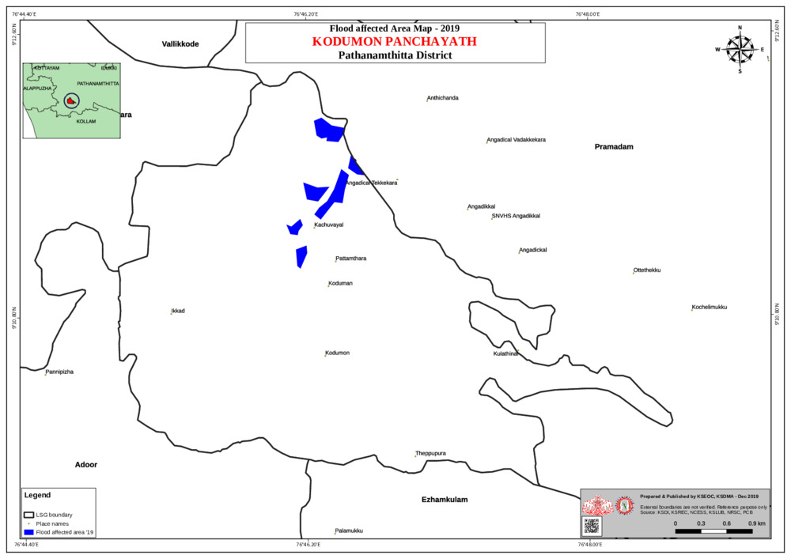
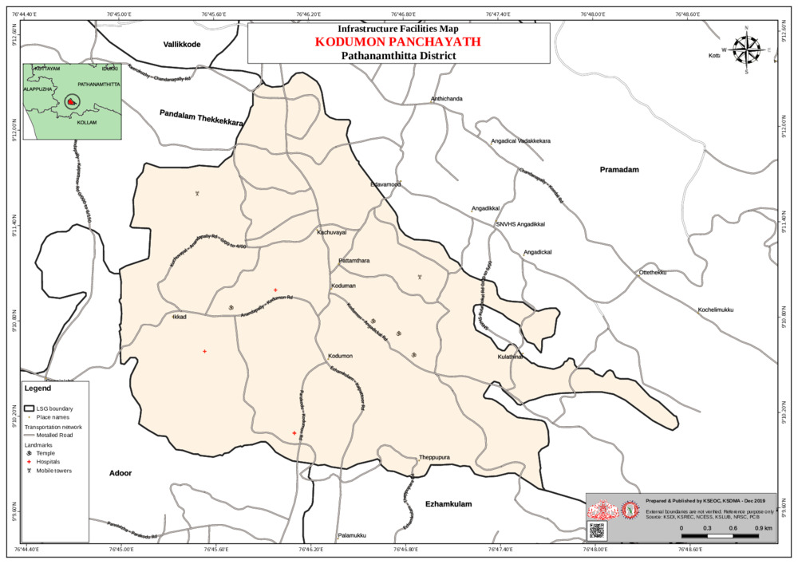
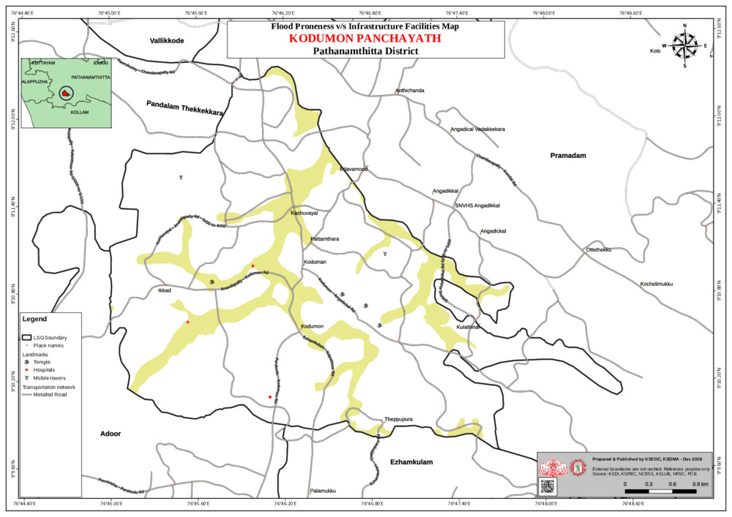

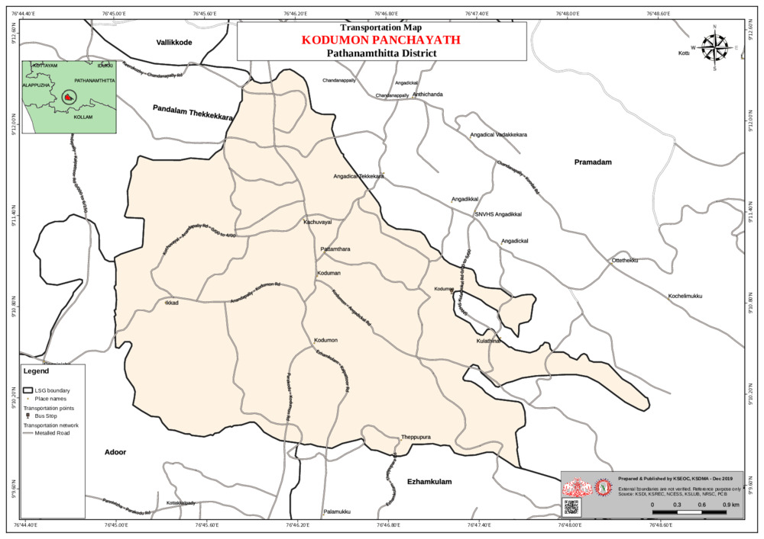

GALLERY

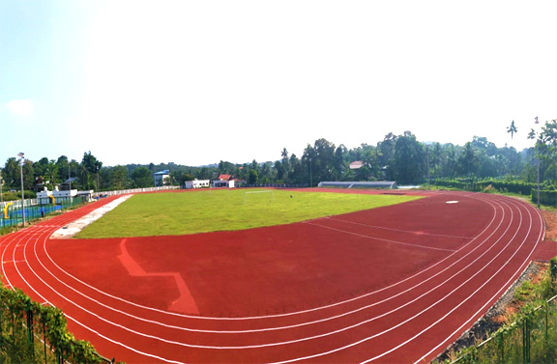
Kodumon Stadium

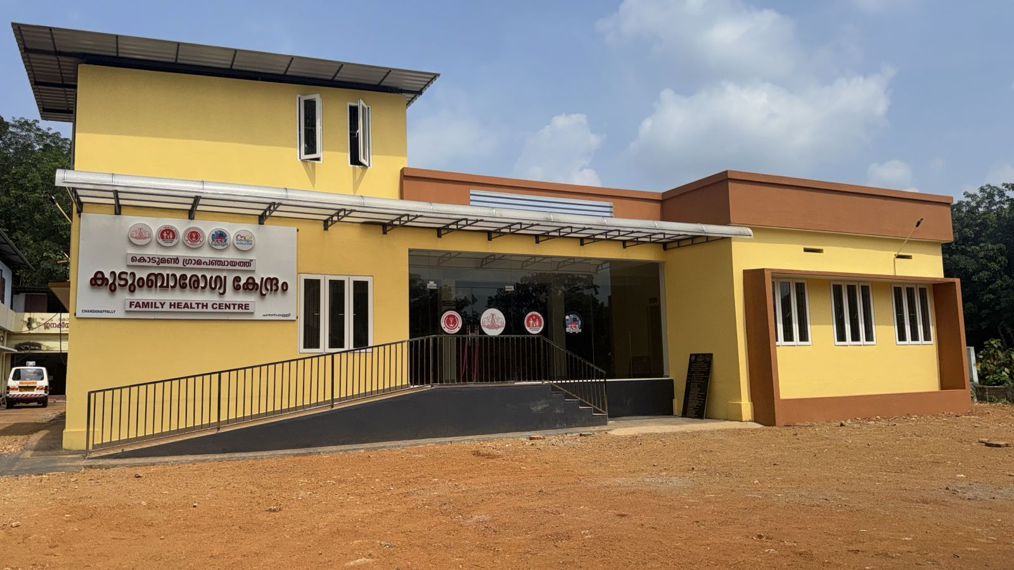
FHC New Building


St: George Orthodox Church Chandhanapally

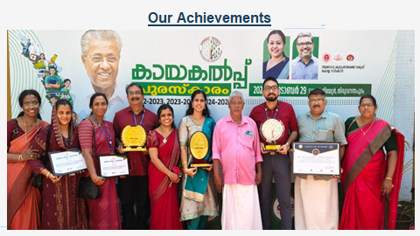

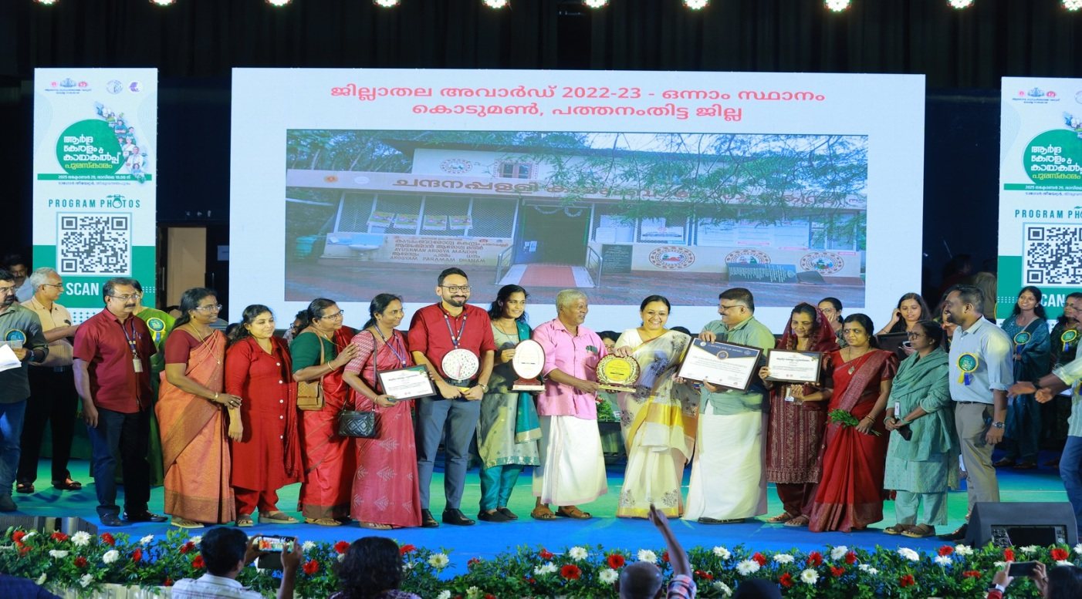

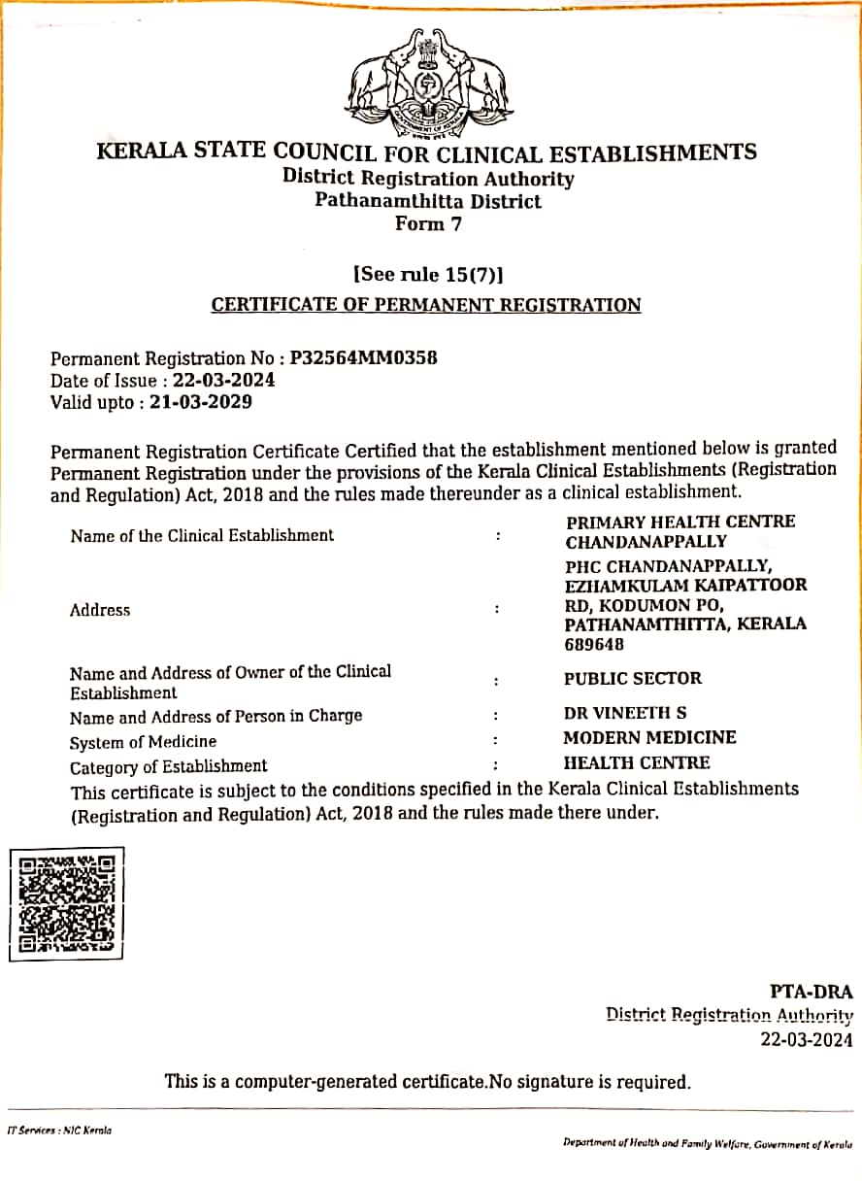
Clinical Establishment Certificate – FHC Chandhanapally

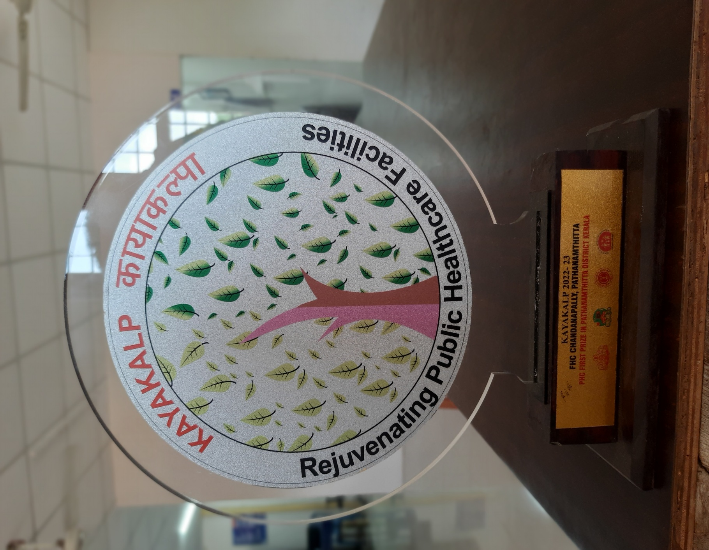
Kayakalp Award FHC Chandhanapally

