FHC Pallickal
phcpallickal@gmail.com
PANDEMIC PREPAREDNESS PLAN
pallickal grama panchayath

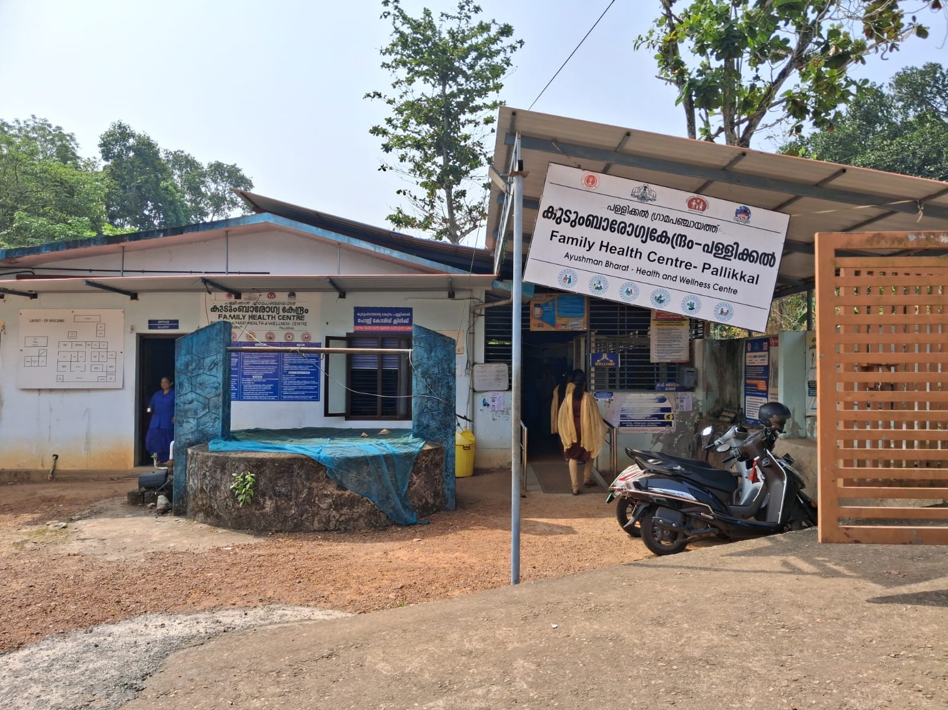

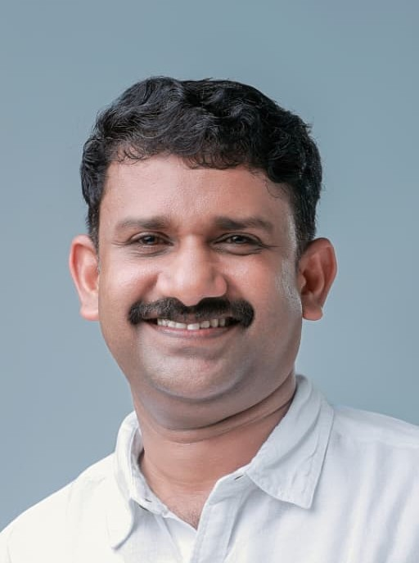
SRI: DINRAJ CR
(PRESIDENT, PALLICKAL GRAMAPANCHAYATH)

പ്രിയപ്പെട്ടവരെ
മഹാമാരികൾക്കെതിരെയുള്ള തയ്യാറെടുപ്പ് നമ്മുടെ രാജ്യത്തിൻറെ സുരക്ഷയ്ക്ക് അത്യന്താപേക്ഷിതമാണ് ശരിയായ ആരോഗ്യ സംവിധാനം, ശാസ്ത്രീയ ഗവേഷണം ,വേഗത്തിലുള്ള പ്രതികരണ സംവിധാനങ്ങൾ എന്നിവയിലൂടെ മാത്രമേ മഹാമാരികളെ ഫലപ്രദമായി നേരിടാൻ കഴിയൂ. സർക്കാർ സംവിധാനങ്ങളും ആരോഗ്യ പ്രവർത്തകരും പൊതുസമൂഹവും കൈകോർത്ത് പ്രവർത്തിക്കുമ്പോൾ മാത്രമേ നമ്മുടെ രാജ്യത്തെ സുരക്ഷിതമാക്കുവാൻ നമുക്കു സാധിക്കൂ.ഐക്യവും ജാഗ്രതയും കൈമുതലാക്കി മഹാമാരികളെ പ്രതിരോധിക്കുവാനും,നിയന്ത്രിക്കുവാനുമുള്ളപ്രവർത്തനങ്ങളിൽ നമുക്ക് ഒന്നിച്ച് ഒന്നായി മുന്നേറാം…………….



SUBHI S (CHAIRPERSON, HEALTH STANDING COMMITTEE, PALLICKAL GRAMA PANCHAYATH)

പ്രിയപ്പെട്ടവരെ,

മഹാമാരി തയ്യാറെടുപ്പ് സമൂഹത്തിൻറെ ആരോഗ്യ സുരക്ഷ ഉറപ്പാക്കുന്നതിന് അനിവാര്യമായ ഒരു ഇടപെടലാണ്. ശക്തമായ പൊതുജനാരോഗ്യ സംവിധാനവും സമയബന്ധിതമായ പരിശോധനയും ചികിത്സയും മാത്രമല്ല ജനങ്ങളിൽ ആരോഗ്യ ബോധവൽക്കരണവും ശീലവൽക്കരണവും അനിവാര്യമാണ് .സർക്കാർ സംവിധാനങ്ങളും ആരോഗ്യപ്രവർത്തകരും ഒരുമിച്ചുകൊണ്ട് മഹാമാരികളെ പ്രതിരോധിക്കുവാൻ ഈ കൈപ്പുസ്തകം പ്രയോജനപ്രദം ആകും എന്ന് ഉറപ്പാണ്.



DR. SURABHY R K
MO (FHC PALLICKAL)

മഹാമാരികളെ പ്രതിരോധിക്കുക എന്ന് പറയുന്നത് നമ്മുടെ കൂട്ടായ പ്രവർത്തനങ്ങളിലൂടെ മാത്രമേ സാധിക്കൂ എന്നുള്ളത് നമുക്കറിയാം. രോഗങ്ങളെ നേരത്തെ കണ്ടെത്തി സമയബന്ധിതമായ ചികിത്സ ശരിയായ പ്രതിരോധ നടപടികൾ മഹാമാരികളെ പ്രതിരോധിക്കുന്നതിനുള്ള അടിസ്ഥാനതത്വം. ആരോഗ്യവകുപ്പിന്റെ നിർദ്ദേശങ്ങൾയഥാസമയം പൊതുജനങ്ങൾ പാലിക്കേണ്ടതും, ശുചിത്വം, പ്രതിരോധ കുത്തിവെപ്പ് ,രോഗപ്രതിരോധ പ്രവർത്തനങ്ങൾ എന്നിവയിൽ ജനകീയ പങ്കാളിത്തം ഉറപ്പുവരുത്തിയാൽ മാത്രമേ നമുക്ക് രോഗങ്ങളെ തടയുവാൻ സാധിക്കുകയുള്ളൂ. അപ്രതീക്ഷിതമായി ഉണ്ടാകുന്ന ആരോഗ്യ പ്രശ്നങ്ങളെ ഫലപ്രദമായി നേരിടുവാൻ ഉതകുന്ന തരത്തിലാണ് ഈ കൈപ്പുസ്തകം തയ്യാറാക്കിയിരിക്കുന്നത്. ഇത് നമ്മുടെ പഞ്ചായത്തിൻറെ ആരോഗ്യപ്രവർത്തനങ്ങൾക്ക് മുതൽക്കൂട്ടാകുമെന്ന് പ്രതീക്ഷിക്കുന്നു.

EXECUTIVE SUMMARY

Primary Health Centre functioning as a Family Health Centre (FHC) serves as the principal public healthcare institution for Pallickal Grama Panchayat. From the perspective of the Local Self Government Institution, the FHC is a cornerstone of the Panchayat’s efforts to ensure accessible, affordable, and quality healthcare for all residents. The FHC plays a vital role in delivering preventive, promotive, curative, and rehabilitative services in alignment with national and state health programmes.
The FHC caters to a predominantly rural population and addresses key public health priorities including maternal and child health, control of communicable and non-communicable diseases, immunisation, family welfare, adolescent health, and geriatric care. Regular outpatient services, home-based care through field health staff, and structured outreach activities enable the Panchayat to ensure equitable healthcare coverage, including in geographically challenging and vulnerable areas.
The institution actively implements major national health initiatives such as the National Health Mission (NHM), National Tuberculosis Elimination Programme (NTEP), National Programme for Prevention and Control of Cancer, Diabetes, Cardiovascular Diseases and Stroke (NPCDCS), and disease surveillance activities under the Integrated Disease Surveillance Programme (IDSP). These programmes significantly contribute to early detection, prevention, and reduction of disease burden within the Panchayat.
Pallickal Grama Panchayat works in close coordination with the FHC, ASHA workers, Anganwadi centres, educational institutions, and community-based organisations to strengthen community participation, health awareness, and behaviour change. Priority is given to early case detection, timely referral, health education, and promotion of healthy lifestyles as part of the Panchayat’s broader public health strategy.
Despite challenges related to infrastructure limitations, manpower constraints, and increasing service demand, the Panchayat, in collaboration with the FHC, continues to enhance healthcare delivery through effective planning, data-driven decision-making, and active community engagement. Strengthening health infrastructure, upgrading digital health systems, and expanding preventive and promotive services remain key focus areas for future development.
Overall, Pallickal Family Health Centre, with the support and stewardship of Pallickal Grama Panchayat, stands as a vital institution in safeguarding public health and improving the quality of life of the Panchayat’s residents.

LIST OF ABBREVIATIONS

LSGD/LSGI | Local Self Government Department / Local Self Government Institution
BMO | Block Medical Officer
IDSP | Integrated Disease Surveillance Programme
NDMA | NationalDisaster Management Authority
PPE | Personal Protective Equipment
ICMR | Indian Council of Medical Research
CD | Communicable Diseases
NCD | NON-COMMUNICABLE Diseases

TABLE OF CONTENTS

INTRODUCTION 13
LSGD at A Glance 14
Maps of Pallickal GP 15
GENERAL PROFILE OF PALLICKAL GP 23
Background of Pallickal GP 23
Demographic and Vulnerable Population 26
Clinical Vulnerability 27
Major Festivals & Events specific to Pallickal GP 28
INFRASTRUCTURE & RESOURCE INVENTORY 29
Health Facility Directory & Basic Capacity in Pallickal GP 29
Private Clinics 30
Healthcare Education & Training Institutions 30
Specialized Services & Emergency Inventory 31
Oxygen & Diagnostic Capacity 32
Diagnostics facility mapping at Pallickal GP 32
Laboratory Identification & Basic Details- Pallickal GP 33
Social and Community Infrastructure for Surge Plan 34
HUMAN RESOURCES 36
Medical & Clinical Personnel 36
Public Health & Field-Level Workforce 36
Community & Support Cadre 37
Community Organizations 38
Administrative & Emergency Services 39
Information regarding resources 39
ONE HEALTH & ENVIRONMENTAL SURVEILLANCE 41
Animal & Bird Population 41
Veterinary Infrastructure 42
Veterinary Doctors & Workforce 43
High-Risk Interface Points (Surveillance Sites) 44
Environmental Risk Mapping 45
Disease Seasonality Mapping 46
Vulnerability Mapping 48
EPIDEMIOLOGICAL TRENDS (2021–2025) 49
Disease Burden Among Human Beings (Last 5 Years) 49
Seasonal Trend Analysis 52
Outcome-Based Trend Analysis- 2025 55
Transmission Trend- 2025 57
Integrated Disease Hotspot Map (2021–2025) 59
PREPAREDNESS AND RESPONSE PROTOCOL 62
Constitution of One Health Committee 62
Pandemic Response Workforce 63
ACTIVITIES AND MEASURES BEFORE AND DURING PANDEMIC 65
PHASE 1 - Alert / Preparation 65
PHASE 2 - Active Response 69
PHASE 3 - Surge Capacity 82
CONCLUSION 84
RECOMMENDATIONS 86
1. Strengthening Healthcare Infrastructure 86
2. Community Awareness & Education 86
3. Emergency Response & Coordination 86
4. Supply Chain & Food Security 86
5. Digital Preparedness 86
6. Training & Capacity Building 86
7. Long-Term Resilience 87
MOCKDRILL SCENARIOS 87
ANNEXURES 88
A. LSG Baseline Data Collection Format 88
B. IMPORTANT PHONE NUMBERS 93

List of Tables

Table 1: LSGD at Glance 14
Table 2: Background of LSGD 25
Table 3: Demographic Vulnerability 26
Table 4: Clinical Vulnerability 27
Table 5: Festivals 28
Table 6: Health Facility Details 29
Table 7: Private Clinic Details 30
Table 8: Healthcare Educational Institutions 31
Table 9: Specialized Services & Emergency Inventory 31
Table 10: Oxygen & Diagnostic Capacity 32
Table 11: Diagnostics Facility Details 32
Table 12: Laboratory Basic Details 33
Table 13: Social & Community Infrastructure 34
Table 14: Medical & Clinical Personnel 36
Table 15: Public Health & Field Work Force 37
Table 16: Community & Support Cadre 37
Table 17: Community Organizations 38
Table 18: Administrative & Emergency Services 39
Table 19: Information of Motor Vehicles 39
Table 20: Animal & Bird Population 41
Table 21: Veterinary Infrastructure 43
Table 22: Veterinary Workforce 43
Table 23: High Risk Interface Points 44
Table 24: High Risk Interface Points - II 44
Table 25: Environmental Risk Points 45
Table 26: Disease Seasonality Details 46
Table 27: Vulnerability Details 48
Table 28: 5 Year Disease Burden 49
Table 29: Dengue Ward Wise Distribution - 5 Years 52
Table 30: Leptospirosis Ward Wise Distribution - 5 Years 53
Table 31: Hepatitis A Ward Wise Distribution - 5 Years 54
Table 32: Disease Transmission Table 57
Table 33: Vector-Borne Diseases 57
Table 34: Water-Borne Diseases 57
Table 35: Air-Borne Diseases 58
Table 36: Blood-Borne Diseases 58
Table 37: Zoonotic Diseases 59
Table 38: Integrated Disease Statistics 59
Table 39: Major Disease Bueden 60
Table 40: Major Disease Burden in Percentage 60
Table 41: Constitution of One Health Committie 62
Table 42: Response Workforce Availability 64
Table 43: Screening Check Points 70
Table 44: Screening Protocol 71
Table 45: Screening & Referral Protocol 71
Table 46: Key Control Room Team 74
Table 47: Trigger Points 76
Table 48: Key Communicators 77
Table 49: Reporting Schedule & Protocol 78
Table 50: Resource Inventory & Contacts 79
Table 51: Collaboration with Organizations 80
Table 52: Interdepartmental Coordination 80
Table 53: Conversion of Community Facilities 82

List of Figures

Figure 1: Pallickal Panchayath Map 15
Figure 2: Integrated Health Infrastructure Map 16
Figure 3: Schools Map 17
Figure 4: Infrastructure Facilities Map 18
Figure 5: Transportation Map 19
Figure 6: Flood Map 20
Figure 7: Land Use Map 21
Figure 8: Boundary Map 22
Figure 9: Overall Disease Burden 50
Figure 10: Top High Burden Disease 51
Figure 11: Disease Distribution by Ward 56
Figure 12: Screening Protocol 70

Annexures

Annexure 1: Baseline Data- LSGD 88
Annexure 2: Demography 88
Annexure 3: Vulnerable Population & Social Risk 88
Annexure 4: Health System & Service Readiness 89
Annexure 5: Points of Entry & Exist (Mobility) 90
Annexure 6: Water, sanitation & Hygiene (WASH) 90
Annexure 7: Zoonotic Risk & One Health 91
Annexure 8: Climate & Disaster Risks ( Pandemic Amplifiers) 91
Annexure 9: Critical Infrastructure & Logistics 91
Annexure 10: Risk Communication & Community Networks 92
Annexure 11: Preparedness Planning & Governance 92
Annexure 12: Surveillance & Data Systems 93
Annexure 13: Additional Notes & Observations 93
Annexure 14: Contact Details of Ward Members Pallickal GP 94
Annexure 15: Contacts of Other Important Offices of LSGD 94
Annexure 16: Health Services Contact Details 95
Annexure 17: Contact of Veterinary Services 95
Annexure 18: Helpline Numbers 95
Annexure 19: Schools Contact Details 96
Annexure 20: Anganwadi Contact Details 96
Annexure 21: Contact Details of Motor Transport 98

INTRODUCTION
The experience of the COVID-19 pandemic has underscored the critical importance of preparedness, resilience, and coordinated response systems in safeguarding public health. Across the globe and within India, the pandemic exposed vulnerabilities in health systems, supply chains, surveillance mechanisms, and community-level preparedness, while also highlighting the strength of decentralized governance, community participation, and primary healthcare networks. In Kerala, the effective integration of Local Self Government Institutions (LSGIs) with the public health system played a pivotal role in mitigating the impact of the pandemic.
Drawing on these lessons, the Pandemic Preparedness Plan of Pallickal Grama Panchayat has been developed as a proactive framework to strengthen the Panchayat’s capacity to prevent, detect, and respond to public health emergencies. The plan aligns with national guidelines of the Ministry of Health and Family Welfare and international standards set by the World Health Organization, while being tailored to the local context, vulnerabilities, and resources of the Panchayat.
Historically, infectious disease outbreaks have posed recurring challenges to public health systems. Events such as the Spanish Flu demonstrated the devastating impact of pandemics in the absence of preparedness. More recently, Kerala has faced outbreaks of emerging and re-emerging infectious diseases, including Nipah virus infection, Avian influenza, and persistent threats such as Rabies. These diseases highlight the increasing interface between humans, animals, and the environment, necessitating a One Health approach to disease prevention and control.
Pallickal Grama Panchayat, with its unique demographic profile, ecological characteristics, and socio-economic conditions, remains vulnerable to both communicable and emerging infectious diseases. Factors such as population mobility, presence of migrant workers, agricultural practices, water bodies, and seasonal flooding contribute to the risk of disease transmission and outbreaks. In this context, strengthening pandemic preparedness is not only essential for emergency response but also for ensuring continuity of essential health services and protecting vulnerable populations.
This Pandemic Preparedness Plan emphasizes early warning systems, integrated disease surveillance, rapid response mechanisms, strengthening of healthcare infrastructure, and effective risk communication. It also recognizes the central role of the Family Health Centre (FHC), ASHA workers, Anganwadi services, and community-based organizations in delivering last-mile healthcare and fostering community engagement.
Furthermore, the plan prioritizes inter-sectoral coordination between health services, local governance, disaster management authorities, and community stakeholders. It aims to build a resilient health system capable of responding efficiently to outbreaks while minimizing social and economic disruption.
In essence, this preparedness plan reflects the commitment of Pallickal Grama Panchayat to translate the hard-earned lessons from past pandemics and emerging disease threats into a structured, sustainable, and community-centered approach to public health emergency management, ensuring the safety, well-being, and resilience of its population.

LSGD at A Glance

- Geographical boundaries with political map ( based on latest delimitation)
- Baseline data
- Ward division

Table 1: LSGD at Glance
Sl. No: | Category |  | Number
1 | Ward |  | 24
2 | Houses |  | 13136
3 | Population |  | 52760
4 | Migrants |  | 324
5 | Wells |  | 12846
6 | Hotspots |  | 1
7 | Educational Institutions |  | 24
8 | Hospitals | Government | 3
8 | Hospitals | Private | 3

- Risk stratification among wards in the context of Communicable diseases and hazards
- Major Roads/rivers
- Major establishments with geospatial mapping
- occupational groups, socio cultural groups, migration & mobility patterns
- Vulnerability mapping
- Disaster prone areas (geographic vulnerability)

Maps - ward-based (Mention source also)

- Geographical boundaries - ward boundaries map
- Health infrastructure map
- roads and rivers map
- major establishments map
- disaster-prone areas map
- hotspot map - CD & disasters

Maps of Pallickal GP
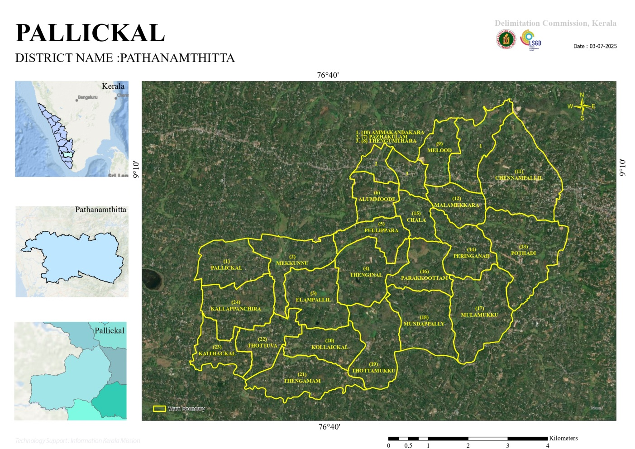
Figure 1: Pallickal Panchayath Map

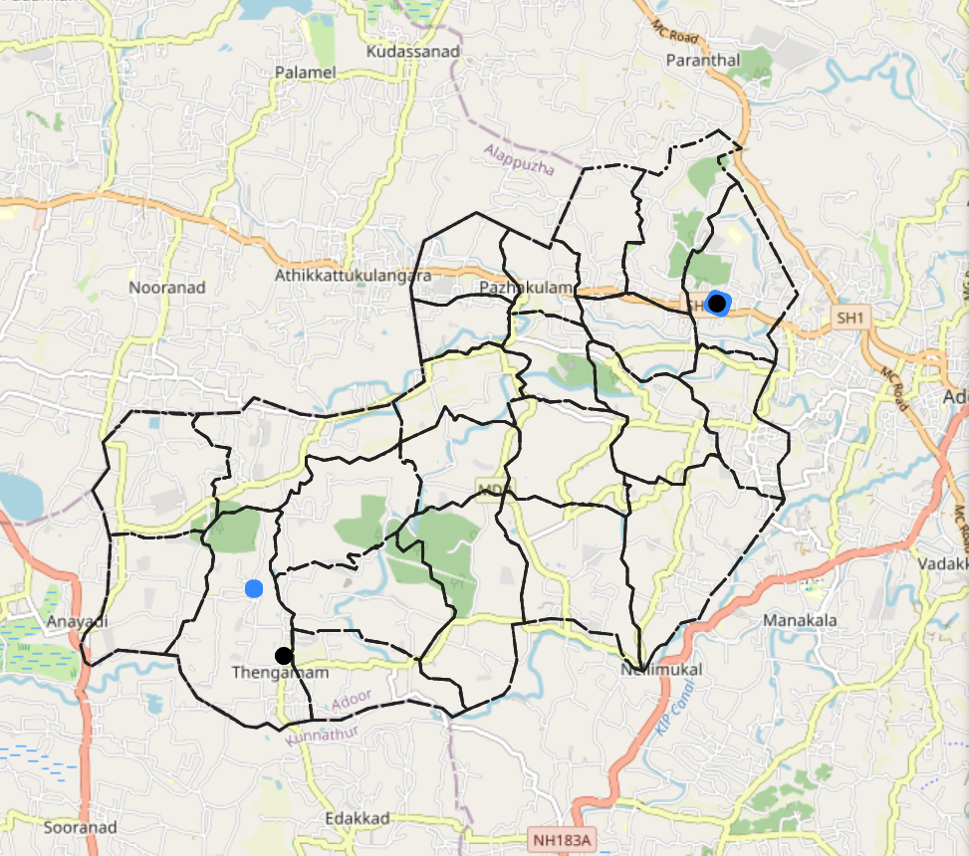
Figure 2: Integrated Health Infrastructure Map

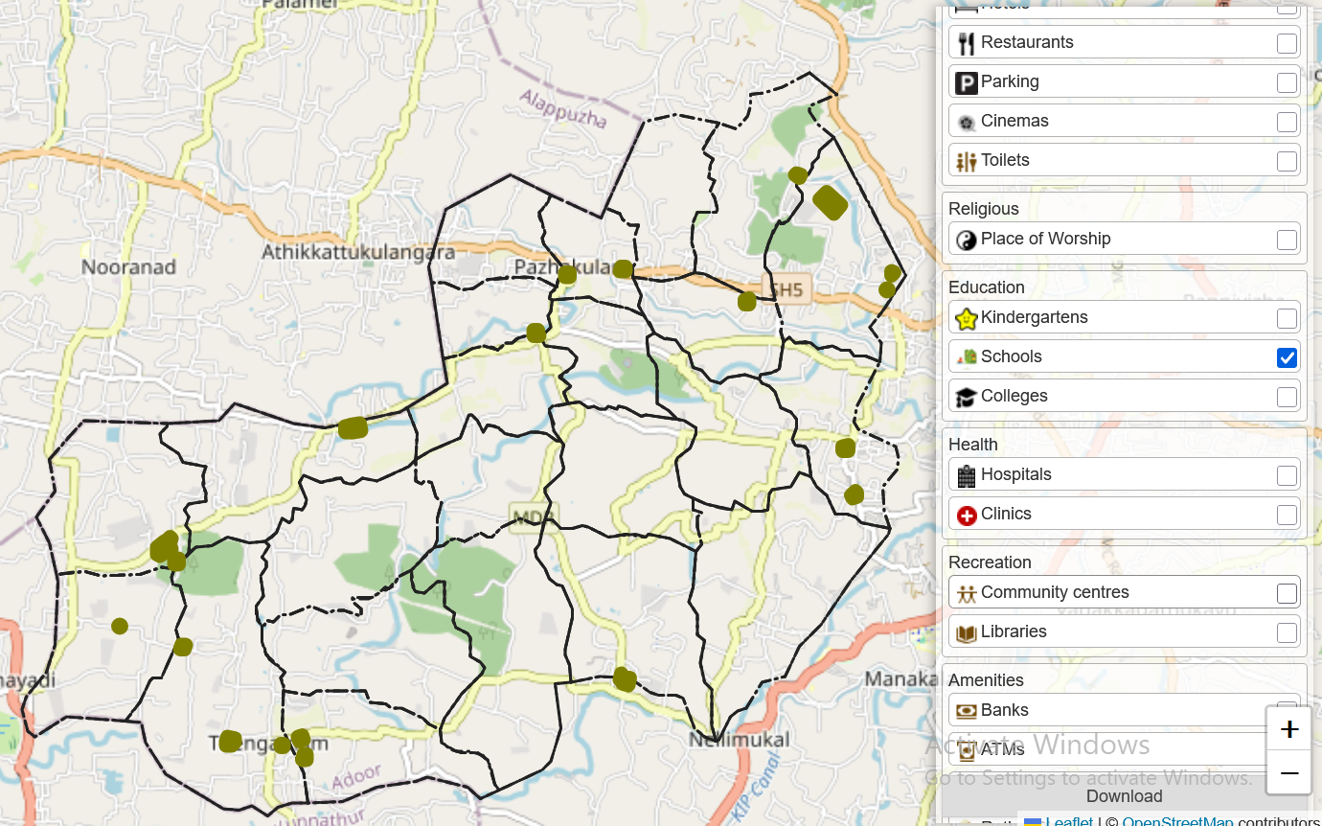
Figure 3: Schools Map

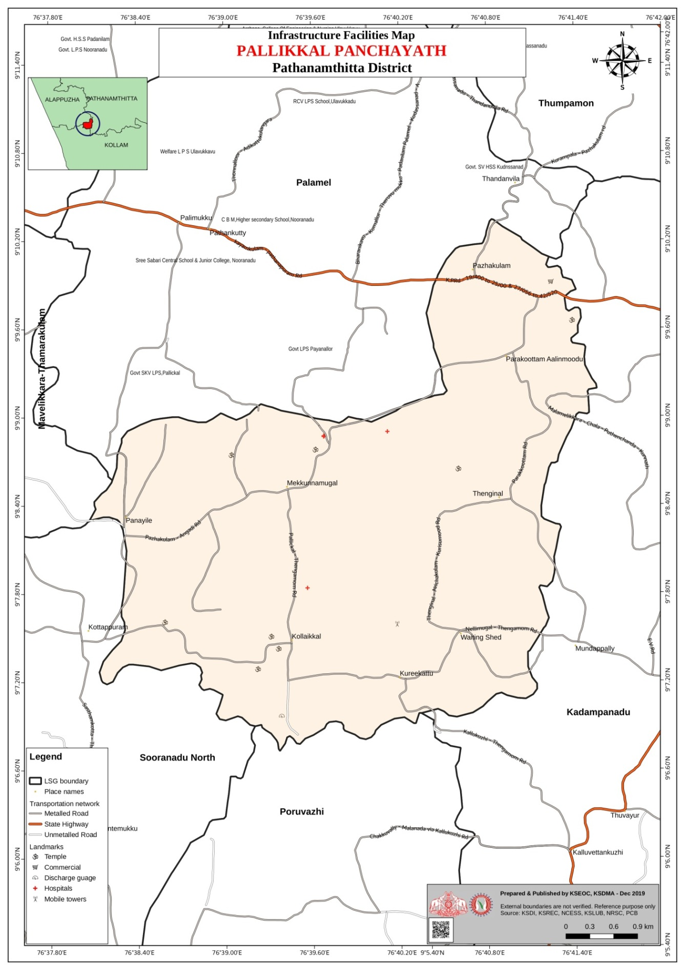
Figure 4: Infrastructure Facilities Map
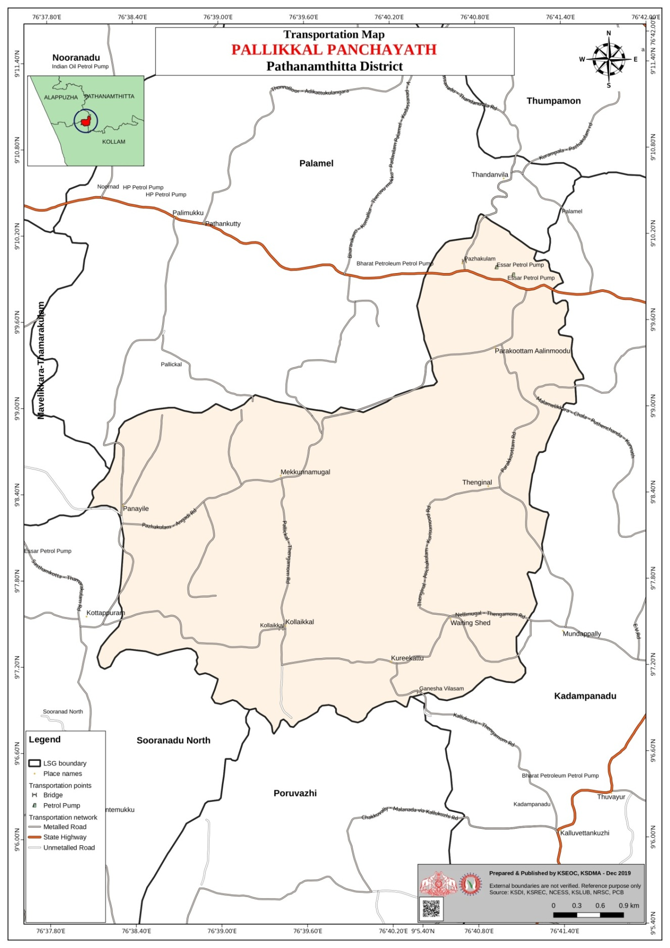
Figure 5: Transportation Map
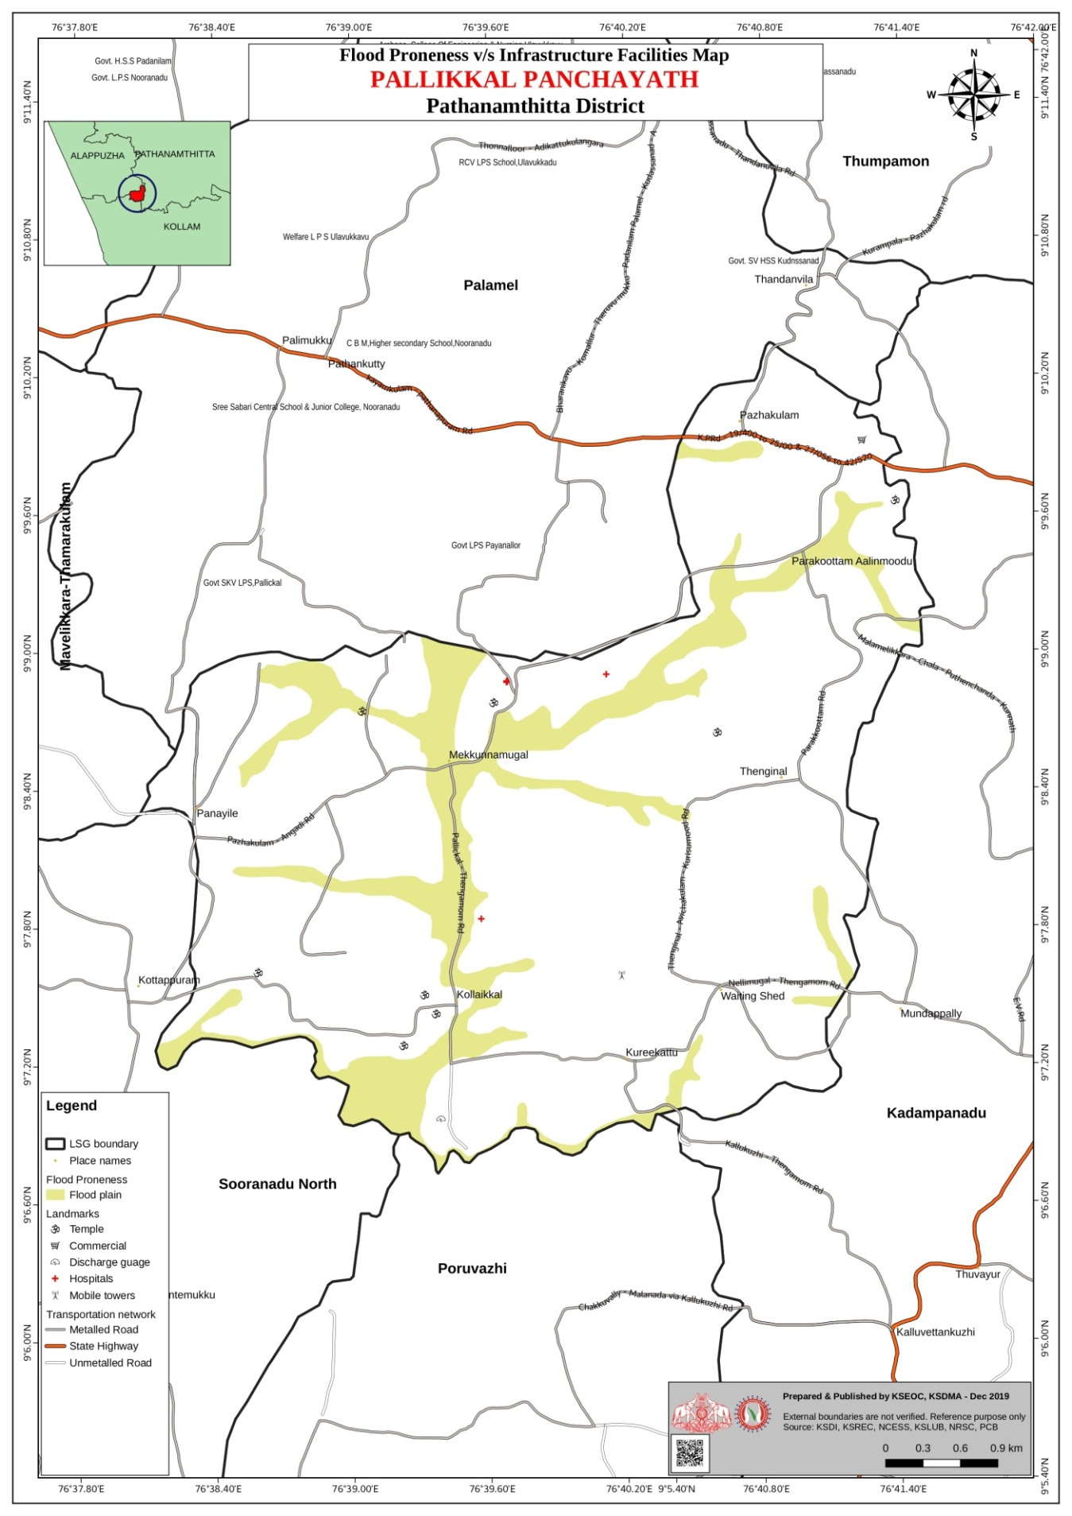
Figure 6: Flood Map
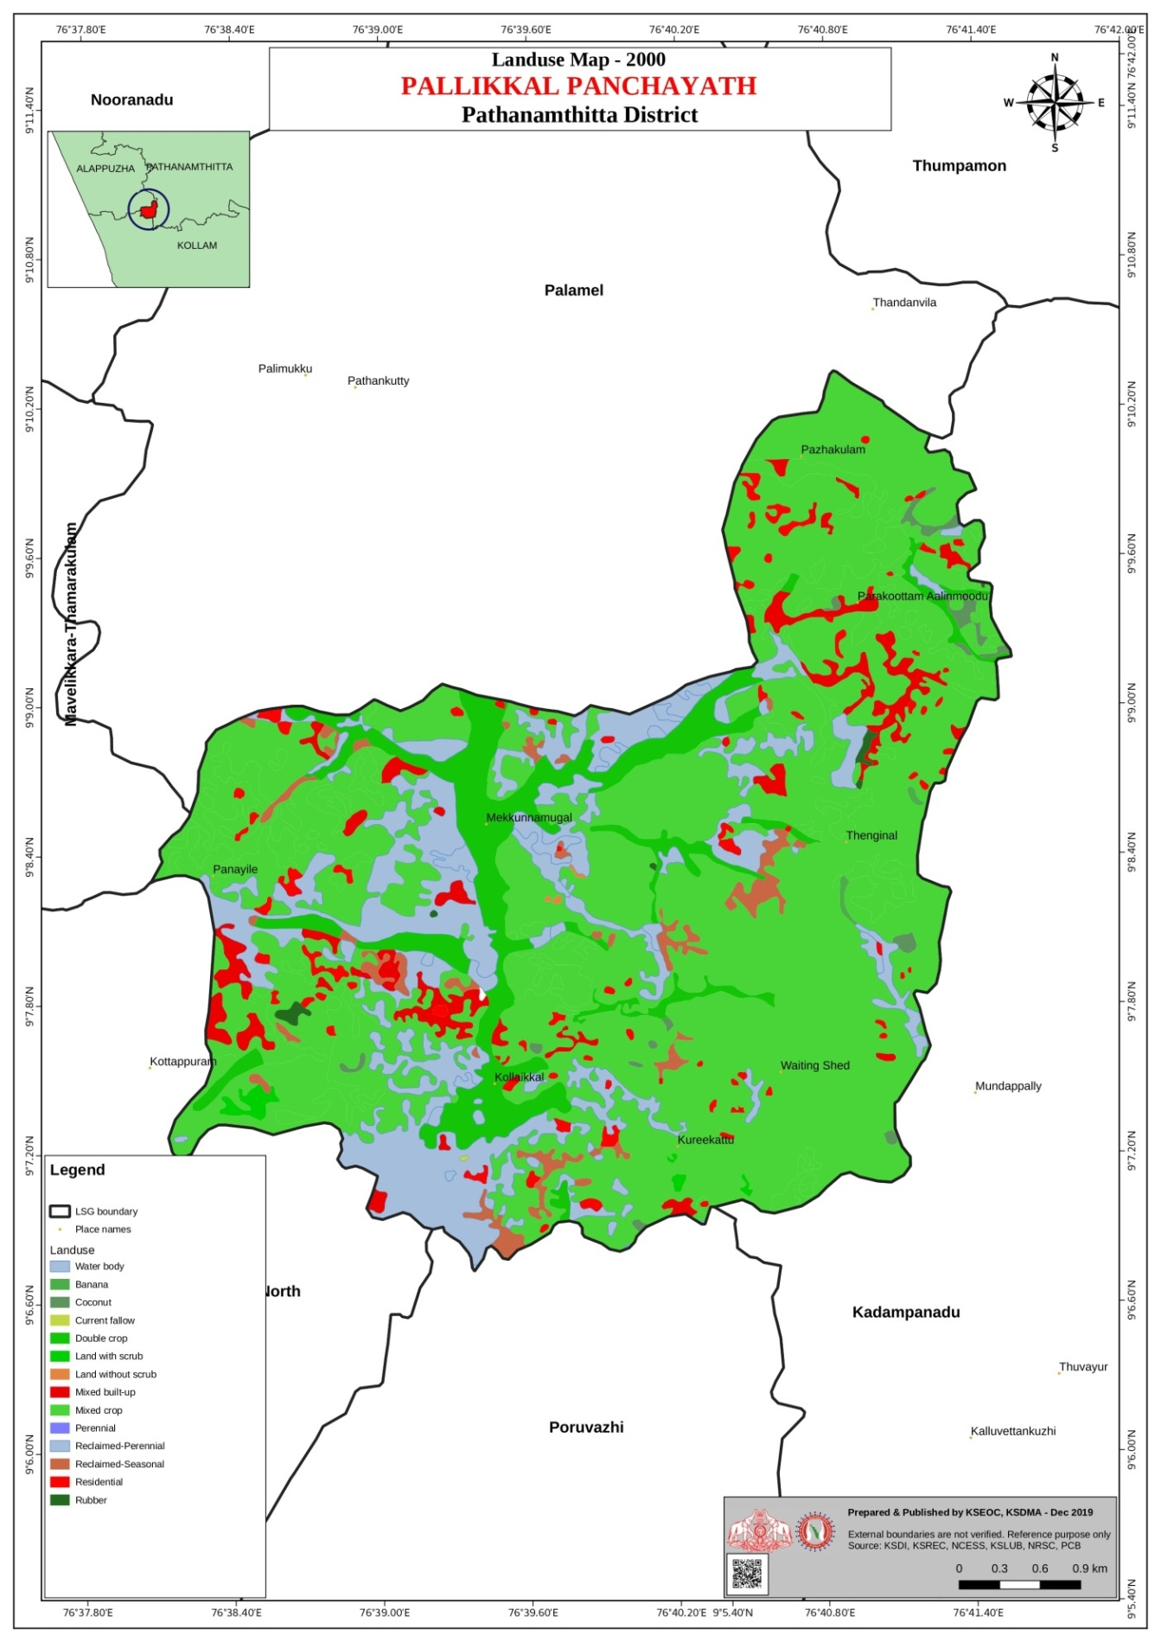
Figure 7: Land Use Map
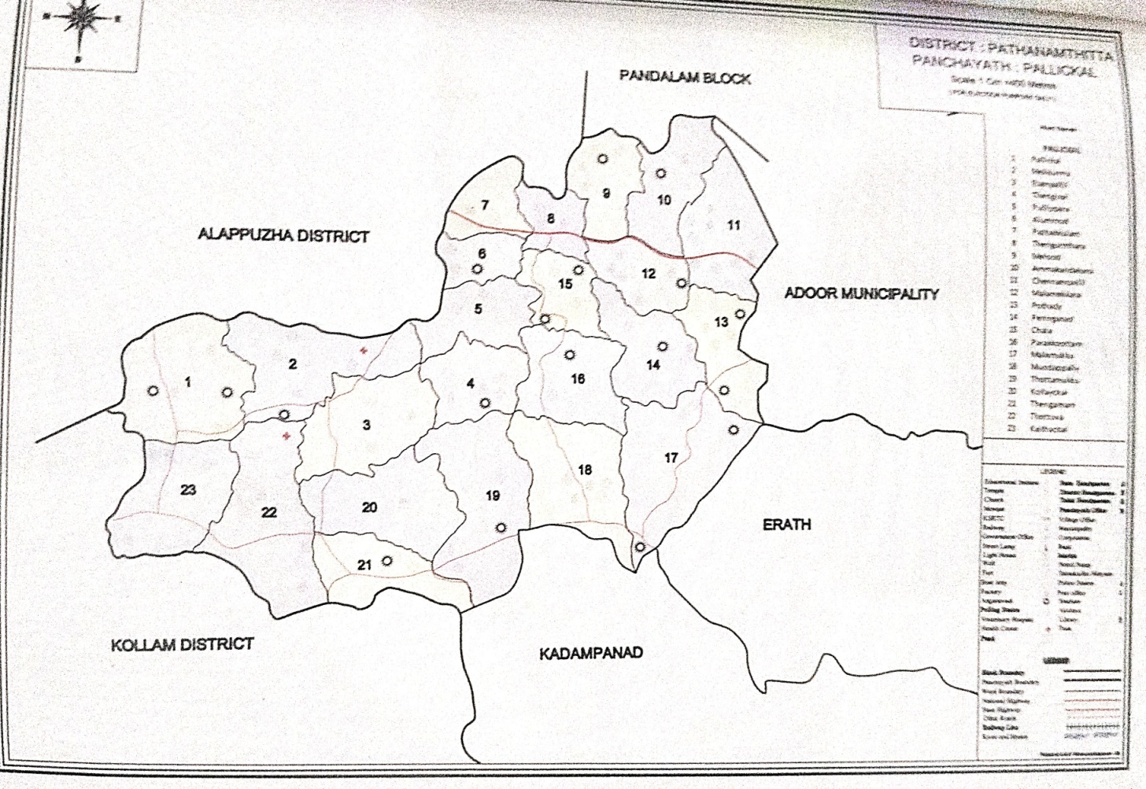
Figure 8: Boundary Map

GENERAL PROFILE OF PALLICKAL GP

Background of Pallickal GP

Pallickal Grama Panchayat is a rural Local Self Government Institution located in Adoor Taluk of Pathanamthitta District. The Panchayat functions under the administrative jurisdiction of Parakode Block Panchayat within the decentralized governance framework of the Government of Kerala. It is one of the major Grama Panchayats in the southern part of the district and plays an important role in rural administration, development planning, and public health service delivery.
Administrative and Geographic Profile
Pallickal Grama Panchayat covers an area of approximately 45.43 square kilometres and is administratively divided into 24 wards governed by elected representatives as per the Kerala Panchayat Raj Act. The Panchayat lies within the midland physiographic zone of Kerala, characterized by gently undulating terrain with laterite soil, small hillocks, agricultural lands, and scattered residential settlements. The region contains a mix of low-lying agricultural fields and elevated residential areas, which influence drainage patterns and local environmental conditions.
The Pallickalar River flows through the Panchayat and forms an important local water resource supporting agriculture and groundwater recharge. In addition to the river, the Panchayat has around 23 ponds and other water bodies, including traditional irrigation tanks and small reservoirs. These water bodies play a significant role in local agriculture, fisheries, and ecological balance but can also contribute to water stagnation during heavy rainfall periods.
Demographic Profile
According to available local self-government projections and administrative records, Pallickal Grama Panchayat has an estimated population of around 52,760 persons, with a population density of approximately 918 persons per square kilometre. The population is distributed across rural settlements with mixed residential and agricultural land use. Like most parts of Pathanamthitta district, the Panchayat has a high literacy rate, reflecting the strong educational attainment characteristic of Kerala.
The demographic structure includes children, working-age adults, and a steadily increasing elderly population, which has important implications for healthcare and social welfare services. In addition, the Panchayat hosts migrant labourers, primarily employed in construction, agriculture, and allied activities. Population mobility associated with migrant workers and commuting populations can influence disease transmission patterns during outbreaks.
Socio-Economic Characteristics
The economy of Pallickal Grama Panchayat is largely agrarian and plantation-based. Major agricultural activities include the cultivation of rubber, coconut, banana, tapioca, and other mixed crops, which form the primary livelihood sources for many households. In addition to agriculture, a considerable proportion of the population is engaged in daily wage labour, small-scale trade, transport services, and employment in nearby towns such as Adoor.
The Panchayat also hosts small-scale industries and commercial establishments, contributing to local employment opportunities. The presence of educational institutions, markets, and community facilities further supports the socio-economic development of the area.
Public Health and Infrastructure
From a public health perspective, Pallickal Grama Panchayat is served by government healthcare institutions operating under the Kerala public health system, including Family Health Centres, Sub-centres, and outreach services provided by ASHA workers and Anganwadi centres. These facilities are responsible for implementing key health programmes such as immunization, maternal and child health services, disease surveillance, and epidemic response.
The Panchayat contains 24 educational institutions, which play a vital role not only in education but also as potential community support centres during emergencies. Additionally, 12 auditoriums, marriage halls, and community halls are available in the Panchayat and can be mobilized as temporary shelters, quarantine centres, or emergency facilities during disaster or pandemic situations.
Disaster and Public Health Vulnerability
Due to its geographical characteristics and monsoon climate, certain parts of Pallickal Grama Panchayat are vulnerable to seasonal flooding and waterlogging. Local administrative records identify wards 1, 13, 16, and 22 as flood-prone areas, where heavy monsoon rainfall can lead to temporary water stagnation and disruption of road connectivity. These environmental conditions can increase the risk of waterborne and vector-borne diseases, particularly during the monsoon season.
Seasonal outbreaks of communicable diseases such as Dengue and Leptospirosis have been periodically reported in parts of the district, often associated with water stagnation, agricultural activities, and rodent exposure. The Panchayat experienced indirect impacts during the 2018 Kerala Floods, including heavy rainfall, infrastructure strain, and increased public health risks.
Relevance to Pandemic Preparedness
The demographic characteristics, environmental conditions, and socio-economic profile of Pallickal Grama Panchayat highlight the need for comprehensive pandemic preparedness planning. Effective preparedness requires strengthening disease surveillance systems, healthcare infrastructure, risk communication mechanisms, and community participation. Local institutions such as schools, community halls, and health centres can serve as important logistical resources during public health emergencies.
Integration of local self-government authorities with the district health administration, disaster management agencies, and community networks is essential for early detection of outbreaks, rapid response, and continuity of essential health services. Strengthening these systems will enhance the resilience of Pallickal Grama Panchayat and improve its capacity to respond effectively to future pandemics and other public health emergencies.

Table 2: Background of LSGD
Table 2: Background of LSGD
Description | Details
Name of LSGI | PALLICKAL
Type (GP/Municipality / Corporation etc.) | GRAMAPANCHAYATH
Block | PARAKODU
District | PATHANAMTHITTA
Number of wards | 24
Total area (sq. km) | 45.43 SQ KM
Population(Projected) | 52760
Population density | 918 persons/sq. KM
Terrain (coastal/low-lying/backwaters/foothills, etc.) | Low-lying
Number of rivers passing through LSGI | 1-PALLICKALAR
Number of water bodies in the LSGI | 23
Number of educational institutions | 24
Factories / small-scale industries | 3
Flood-prone wards | 1,13,16,22 (Wards)
Landslide-prone wards | 0
Death Management and Disposal Facilities (mortuaries/crematorium, including electric) | 0
Auditoriums/Marriage halls/convention centres/community halls | 12

Demographic and Vulnerable Population
Understanding the demographic composition and vulnerable population groups is essential for pandemic preparedness. Children, elderly, economically deprived families, migrant workers, and socially vulnerable groups are at increased risk during public health emergencies due to higher exposure, limited access to services, and dependency on public systems..

Table 3: Demographic Vulnerability
Description(PALLICKAL) |  | Details (in numbers)
DEMOGRAPHIC PROFILE
Total population |  | 52760
Male |  | 24110
Female |  | 28610
Transgender |  | 3
Children under 5 |  | 1403
Adolescent |  | 3081
Elderly (>60) |  | 10810
SOCIAL/LIVELIHOOD VULNERABILITY
Previous EPEP family |  | 77
BPL family |  | 5518
Tribal communities |  | 0
Migration | Immigrant | 624
Migration | Emigrant | 895
Socio-economically deprived |  | 662
Fisher folks |  | 0
SC Community |  | 8677
ST Community |  | 31

Graphs: Population pyramid (if possible) for seeing if your LSGD has a high "dependency ratio" (lots of children and elderly compared to working adults).

Clinical Vulnerability
Certain population groups needs priority healthcare & are at higher risk of severe illness, complications, and mortality during pandemics. Patients with chronic diseases, those requiring regular medical care, and individuals with mobility or functional limitations face challenges in accessing timely care during emergencies. Mapping these groups helps in prioritizing continuity of treatment, medicine stock planning, oxygen support, referral transport, and targeted home-based care.
Table 4: Clinical Vulnerability
Description(Pallickal) | Details in numbers
Pregnant women | 227
Lactating mothers | 226
Bedbound patients | 178
Patients under palliative care other than bedbound | 211
Patients on Haemodialysis | 36
Patients on CAPD | 0
Cancer patients (currently on treatment) | 42
Haemophilic patients | 0
Mentally challenged | 24
Differently abled | 73
Diabetic patients | 2990
Hypertensive patients | 3073
TB patients | 7

Major Festivals & Events specific to Pallickal GP
(With the possibility of a public gathering)

Table 5: Festivals
Sl. No. | Name Of Festival(Pallickal) | Month Detailing The Periodicity
1 | Kandalaswamtemple Ulasavam Pallickal | April
2 | Peringanad Trichennamangalam Ulsavam | Feb

INFRASTRUCTURE & RESOURCE INVENTORY

Health Facility Directory & Basic Capacity in Pallickal GP

This section provides an overview of the healthcare infrastructure available within the LSGD area. It outlines the distribution and basic capacity of health facilities that form the backbone of service delivery during routine times and public health emergencies.

Family Health Centres (FHCs) and Community Health Centres (CHCs) generally function as the first point of contact for the community, providing essential outpatient and inpatient services. General Hospitals (GH) and Medical College Hospitals (MCH), where accessible, serve as the main referral centres for advanced diagnostics, specialist care, and critical services during public health emergencies. This inventory helps identify existing strengths, gaps, and potential surge capacity that can be mobilised during a pandemic or disaster.

Table 6: Health Facility Details
Table 6: Health Facility Resource Summary (Pallickal)
Sl.No. | Health Facility | Type Of Facility (Mch/Gh/Chc/Fhc/Sc Etc.) | Contact Number | Total Beds | Icu Beds | Oxygen-Supported Beds | No. Of Ventilator Support Beds | No. Of Ambulances
Government Healthcare Facilities
1 | Fhc Pallickal | FHC | 8547304432 | 1 | 0 | 0 | 0 | 0
2 | Ammakandakara | HWC |  | 0 | 0 | 0 | 0 | 0
3 | Hwc Pallickal | HWC |  | 0 | 0 | 0 | 0 | 0
4 | Elampally | HWC |  | 0 | 0 | 0 | 0 | 0
5 | Peringanad | HWC |  | 0 | 0 | 0 | 0 | 0
6 | Mundapally | HWC |  | 0 | 0 | 0 | 0 | 0
7 | Maincentre | HWC |  | 0 | 0 | 0 | 0 | 0
8 | Thottuva | HWC |  | 0 | 0 | 0 | 0 | 0
Private Healthcare Facilities
1 | Lifeline Hospital | Hospital | 04734219500 | 275 | 89 | 37 | 5 | 3
Ayush Healthcare Facilities
1 | Gvt Ayurveda Dispensary | Govt
2 | Gvt Homeo Dispensary | Govt

Private Clinics
Private clinics are an essential part of pandemic preparedness, as they are often the first place people seek care when symptoms begin. In many communities, private clinics manage a significant share of outpatient visits and therefore play a critical role in early case detection, timely referrals, and disease surveillance. Having an up-to-date understanding of where these clinics are located, the services they provide, and how they are linked to the public health system helps ensure that no cases are missed during an outbreak. It also allows health authorities to engage private practitioners more effectively for reporting, risk communication, and coordinated response, strengthening the overall capacity of the health system to manage public health emergencies.

Table 7: Private Clinic Details
Table 7: Private Clinic Resource Summary (Pallickal)
Sl No. | Name Of Clinic | Registered (Y/N) | Clinic (General / Speciality) | Speciality (If Any) | Address | Contact Number | Diagnostic Facility (Y/N) | Ambulance Linkage (Y/N)
1 | Vijaya Hospital | Y | General
2 | Lekshmi Nursing Home | Y | General

Healthcare Education & Training Institutions

This section tracks the educational infrastructure available, which is vital for human resource planning in the health sector.

Table 8: Healthcare Educational Institutions
Category of Institution (Pallickal) | Govt | Private | AYUSH | Total
Medical Colleges | 0 | 0 | 0 | 0
Nursing Colleges | 0 | 0 | 0 | 0
Dental Colleges | 0 | 0 | 0 | 0
Para-medical / Allied Health | 0 | 0 | 0 | 0
Pharmacy Colleges | 0 | 0 | 0 | 0

Specialized Services & Emergency Inventory
This section provides a detailed view of the specialized medical resources available to the community, focusing on emergency response and critical care capabilities. This table tracks the vital assets required for managing severe illnesses and emergencies across Government, Private, and AYUSH sectors.

Table 9: Specialized Services & Emergency Inventory
Item (Pallickal) | Govt | Private | AYUSH | Total
Hospital beds | 1 | 275 | 0 | 276
Oxygen-generating systems(Y/N) | 0 | Y | 0
Oxygen-supported beds(Numbers) | 0 | Y | 0 | 89
Ventilator-supported beds | 0 | 5 | 0 | 5
ICU beds | 0 | 89 | 0 | 89
Burns units | 0 | 1 | 0 | 1
Blood centres | 0 | 1 | 0 | 1
BLS ambulances | 0 | 2 | 0 | 2
ALS ambulances | 0 | 1 | 0 | 1
Dialysis facilities | 0 | 1 | 0 | 1
Dispensaries | 0 | 2 | 0 | 2
Medical store | 1 | 5 | 0 | 6
Industrial establishments(Medium-scale industries/small-scale industries establishments to whom we can depend in a worst-case scenario) | 0 | 0 | 0 | 0

Oxygen & Diagnostic Capacity
Monitoring oxygen and diagnostic capacity is a critical component of public health preparedness, ensuring that the LSGD can handle both chronic care and sudden surges in respiratory or infectious diseases.
Table 10: Oxygen & Diagnostic Capacity
Name of Health Facility(Pallickal) | Oxygen-generating System (Y/N) | Backup Oxygen Source (Y/N) | Diagnostic Facilities Available(Y/N)
Name of Health Facility(Pallickal) | Oxygen-generating System (Y/N) | Backup Oxygen Source (Y/N) | Lab | USG | X-ray | CT/MRI | RT-PCR
Government Healthcare Facilities
FHC Pallickal | N | N | Y | N | N | N | N
Private
Life Line Hospital | Y | Y | Y | Y | Y | Y | Y

Diagnostics facility mapping at Pallickal GP
The diagnostic capacity of Pallickal G.P represents the "intelligence network" of our healthcare system. The speed and accuracy of disease identification depend entirely on the distribution and technical level of these facilities.

Table 11: Diagnostics Facility Details
Item(Pallickal) | Govt | Private | AYUSH | Total
General labs | 1 | 3 | 0 | 4
Microbiology labs | 1 | 2 | 0 | 3
RT-PCR labs | 0 | 1 | 0 | 1
USG units | 0 | 1 | 0 | 1
CT/MRI units | 0 | 1 | 0 | 1
Research labs | 0 | 0 | 0 | 0
Labs of other departments that can be repurposed | 0 | 0 | 0 | 0

Laboratory Identification & Basic Details- Pallickal GP
Table 12: Laboratory Basic Details
Sl. No. | Name Of Laboratory | Ownership (Govt / Private / Academic) | Address | Contact No. | 24×7 Services (Yes/No) | Nabl / Govt Approved (Yes/No)
1 | Fhc Pallickal | Govt | Thottuva |  | No | Yes
2 | Life Line | Pvt | Adoor | 04734219500 | Yes | Yes
3 | Pulse Diagnostic | Pvt | Pazhakulam | 8078270459 | No | Yes

Social and Community Infrastructure for Surge Plan
This table serves as our logistics and shelter inventory. By mapping these locations, quickly we can identify where to house displaced citizens, where to set up temporary medical clinics, and how to manage the deceased with dignity during a crisis.

Table 13: Social & Community Infrastructure
Category(Pallickal) | Total Count | Ward | Est. Capacity (Persons) | Contact details
Educational Institutions
Anganwadies | 37 | All wards | 370
Schools | 24 |  | 7500
Colleges | 1 | 7 | 100
Healthcare Educational Institutions
Medical colleges (Govt/Private) | 0 | - | - | -
Nursing colleges (Govt/Private) | 0 | - | - | -
Dental colleges (Govt/Private) | 0 | - | - | -
Paramedical institutes (Govt/Private) | 0 | - | - | -
Community Gathering Spaces
Community halls | 0 | - | - | -
Auditoriums | 12
Religious buildings | 10
Vulnerable Group Support Facility
Destitute homes | 2
Elderly homes | 0 | - | - | -
LSGD owned other buildings | 2
Mass Fatality Management (MFM) Infrastructure
Mortuary | 0 | - | - | -
Crematorium | 0 | - | - | -
*refer annexure 1 for contact details

HUMAN RESOURCES
This section focuses on the human capital available within the LSGI. In any emergency—be it a pandemic, flood, or industrial accident—infrastructure is only as effective as the people operating it.

Medical & Clinical Personnel
This table tracks the "Frontline" providers responsible for diagnosis, treatment, and clinical management. Narrative sentence: eg., "Total health workforce: 450 personnel, with 60% in government facilities serving as primary surge capacity." A detailed directory with the contact numbers of all workers is maintained (Annexure in 1).

Table 14: Medical & Clinical Personnel
Cadre (Pallikal) | Govt (No.) | Private (No.) | Total
Doctors—Modern Medicine | 3 | 172 | 175
Doctors – AYUSH | 1 | 0 | 1
Doctors – Veterinary | 1 | 0 | 0
Doctors – Dental | 0 | 4 | 4
Nursing officers | 3 | 332 | 335
Lab technicians | 2 | 23 | 25
Optometrist | 0 | 0 | 0
Pharmacists | 2 | 26 | 28
Psychologists | 0 | 2 | 2
Counsellors | 0 | 2 | 2

Public Health & Field-Level Workforce
These individuals are the backbone of surveillance, maternal-child health, and decentralized care.

Table 15: Public Health & Field Work Force
Cadre (Pallickal) | Health services | Municipal common services | Total
HS (Health Supervisors) | 0 | 0 | 0
HI (Health Inspectors) | 1 | 0 | 1
LHS (Lady Health Supervisor) | 0 | 0 | 0
PHN( Public health nurse) | 1 | 0 | 1
JPHN (Jr Public Health Nurses) | 7 | 0 | 7
JHI (Jr Health Inspectors) | 4 | 0 | 4
MLSP (Mid-Level Service Providers) | 7 | 0 | 7
Palliative Nurses | 2 | 0 | 2
RBSK Nurses | 2 | 0 | 2
PRO | 0 | 0 | 0
Epidemiologist | 0 | 0 | 0
Data Manager | 0 | 0 | 0

Community & Support Cadre
This group represents the surge capacity of the LSGI—people who can be called upon for logistics, rescue, and specialized support.

Table 16: Community & Support Cadre
Cadre (Pallickal) | Number
ASHA Workers | 31
AWW (Anganwadi Workers) | 37
Emergency Medical Volunteers (Trained) | 0
Kudumbashree | 427
MNREGS | 5232
PurushaSwayamSahayaSangham | 19
Ex-Servicemen | 33
Retired Police Officers | 8
NCC/NSS Volunteers | 213
Red Cross volunteers | 162
One Health Community Volunteers | 253
One Health Community Mentors | 161

Community Organizations
This section details the presence of community-based organisations (CBOs), non-governmental organisations (NGOs), faith-based organisations (FBOs), Kudumbashree Self-Help Groups (SHGs), and Ayalkootams within the Local Self-Government Institution (LSGI). These groups enhance grassroots mobilization, resource distribution, and support networks crucial for pandemic response and community resilience.

Table 17: Community Organizations
Category (Pallickal) | Total Count
NGOs | 3
Religious based organizations | 0
Foreign based organizations | 0
Sports Club/youth clubs | 17
Kudumbashree SHGs | 427
Ayalkootams | 427
Political organizations | 7
Residential organizations | 0

Administrative & Emergency Services
This section outlines the availability of key non-health emergency support services and infrastructure within the LSGI, which are essential for effective pandemic preparedness and response. These facilities support law enforcement, disaster response, water supply, logistics, mobility, and community-level interventions during public health emergencies.

Table 18: Administrative & Emergency Services
Category (Pallickal) | Total Count | Contact details
Police Stations | 0 | -
Fire & Rescue Stations | 0 | -
Water Pumping Points | 0 | -
Public Distribution System (PDS) | 5 | Adoor Taluk Supply Office

Information regarding resources
The availability of essential transport and support resources plays a quiet but critical role in saving lives. Equipment such as ambulances, mobile mortuaries, amphibian ambulances, and motorized boats ensures that patients, samples, and healthcare teams can move swiftly—even in flooded, remote, or difficult terrains. Heavy vehicles like JCBs, cranes, tractors, and torus lorries support logistics, waste management, emergency infrastructure, and rapid conversion of spaces into care or isolation facilities. Taxis, four-wheel-drive vehicles, and trucks help maintain continuity of essential services, reach vulnerable populations, and support home-based care and supply delivery.

Table 19: Information of Motor Vehicles
Means of transportation(Pallickal) | Total Count
JCB | 3
Crane | 0
Heavy Trucks | 5
Tractor | 2
Ambulances | 4
Mobile mortuaries | 1
Boats | 0
Taxi service | 8
Note: For specific details regarding vehicle owners and contact information, please refer to Annexure.

ONE HEALTH & ENVIRONMENTAL SURVEILLANCE
The One Health method integrates environmental, animal, and human health to enable proactive pandemic preparedness. Panchayat-level surveillance needs to be improved in order to detect and treat zoonotic and environmentally generated diseases early. Surveillance is strengthened through systematic assessment of animal populations, veterinary infrastructure, poultry and slaughter facilities, inter-sectoral coordination, and specialised tools like avian influenza seasonality mapping using GIS in previous outbreaks to enable predictive alerts and ward-specific sampling to support effective pandemic preparedness in high-risk areas like Pallickal

Animal & Bird Population
Mapping animal and bird populations at the Panchayat level is essential for identifying and prioritising zoonotic disease hazards like rabies, avian influenza (H5N1), leptospirosis, anthrax, and Nipah-like spillover occurrences. Risk classification, targeted surveillance, vaccination planning, and early epidemic detection made feasible by comprehensive population mapping all enhance One Health-based pandemic preparedness.

Table 20: Animal & Bird Population
Category (Pallickal) | Item | Estimated Population | Wards
Animal Population | Livestock (Cattle/Goats/Buffalo) | 5892 | All wards
Animal Population | Pet Animals (Dogs/Cats) | 1245 | All wards
Animal Population | Stray Dog Population | Can’t count | All wards
Animal Population | Pig Farms (Number of heads) | 1 | 4
 | Small Units (Sheep / Goats – clustered) | 1200 | 0
Bird Population | Poultry Units (Birds) | 2200
Bird Population | Poultry- (FOWL) | 0 | -
Bird Population | Wild/Migratory Birds (Observed) | 0 | -
Bird Population | Crow Mortality Events (Reported) | 0 | -

The main risk of zoonotic diseases in Pallickal Grama Panchayat is associated with areas where domestic animal keeping and poultry rearing are more common, particularly in wards with smallholder poultry units and mixed livestock activity in peri-urban fringes of the Panchayat. Although systematic ward-level data on pig farms and cattle aggregation are not publicly available online, pathogen threats such as avian influenza (H5N1) have been documented in Pathanamthitta district, indicating regional susceptibility to outbreaks among birds during peak migratory seasons. Migratory and resident water birds frequenting ponds, canals, and backwater/riverine areas can introduce or amplify influenza viruses, especially between November and March, the typical season for bird migration and viral activity in Kerala.
The stray dog population in market areas, near bus stands, and common public spaces remains a public health concern for rabies surveillance and bite prevention, as stray dogs are known reservoirs for rabies and other parasitic zoonoses across Kerala. Dog bites and rabies risk persist in local communities, underscoring the need for sustained ABC (Animal Birth Control) and anti-rabies immunisation efforts.
Additionally, seasonal flooding and water stagnation during monsoon can increase environmental risks of water-mediated zoonotic agents such as leptospirosis and other bacterial pathogens, especially where domestic animals and human habitation interface in flood-affected areas. Integrated surveillance by animal husbandry, public health, and Panchayat authorities is critical to detect and respond to these zoonotic risks promptly.

Veterinary Infrastructure
Veterinary institutions are a core pillar of One Health surveillance, enabling early zoonotic disease detection through vaccination, investigation of unusual animal illness or deaths, sample collection, and timely outbreak reporting. A well-mapped and responsive veterinary network strengthens coordination with human health and LSGI systems, ensuring rapid response during zoonotic events and pandemics.
Table 21: Veterinary Infrastructure
Facility Type (Pallickal) | Name of Facility | Ownership Govt / Pvt | Location(Ward No) | Contact number
Veterinary Dispensary | Govt vetinary | govt | 1 | 9447471115
Veterinary Hospital / Polyclinic | Mundapally,thengamam,Elampallil,Thengumthara,chennampally | govt | 17,21,5,8,11 | 9496270287
Private Veterinary Clinics | 0 | 0 | 0 | 0
Mobile / Emergency Vet Service (incl. night services) | 0 | 0 | 0 | 0
Pet Homes / Animal Shelters | 0 | 0 | 0 | 0
Slaughterhouse-linked Veterinary Inspection Unit | 0 | 0 | 0 | 0

Veterinary Doctors & Workforce
Early detection, diagnosis, reporting, and reaction to animal illness epidemics depend on the availability and accessibility of qualified veterinary specialists. By identifying unusual animal morbidity or mortality promptly, collecting samples promptly, and coordinating efficiently with human health and LSGI systems—especially during zoonotic outbreaks and pandemic-prone situations—a clearly defined veterinary workforce enhances One Health surveillance.

Table 22: Veterinary Workforce
Category (Pallickal) | Number Available | Type (Govt/Pvt) | Contact number
Government Veterinary Doctors | 1 | Govt | -
Private Veterinary Doctors | 0 | 0 | 0
Livestock Inspectors | 6 | Govt | 0
Para-veterinary Staff / Attenders | 1 | Govt
Contract / On-call Veterinary Support (if any) | 0 | 0 | 0

High-Risk Interface Points (Surveillance Sites)
High-risk interface points for zoonotic disease surveillance in Pallickal GramaPanchayath include wetland–livestock–human contact zones, backyard poultry farms, cattle sheds near water bodies, fish markets, and areas of high human–animal interaction such as community slaughter points and migratory bird congregation sites. These are the primary surveillance sites where zoonotic spillover risks are elevated.

Table 23: High Risk Interface Points
Type of Habitat (Pallickal) | Type of High risk interface | Geographical vulnerability
Wetlands & Backwaters | 6
Backyard Poultry Farms | 0
Cattle Sheds near Water Bodies | 6
Fish & Meat Markets | 7
Community Slaughter Sites | 0
Migratory Bird Congregation Areas | 0
Rodent-Infested Grain Storage | 0

Table 24: High Risk Interface Points - II
Category (Pallickal) | Total Count | Key Locations (wards)
Poultry Farms | 4 | (8,2,16,11)
Backyard / Clustered Poultry Units | 6
Duck Rearing Units (open water access) | 0
Slaughterhouses/ Slaughter Points | 0
Meat/Fish Markets | 7
Live Bird Sale Points | 0
Cattle Markets / Weekly Animal Fairs | 0
Pet Shops / Breeders | 0
Animal Shelters / Pet Homes | 0
Waste Disposal Sites near Animal Units | 0

Environmental Risk Mapping
Environmental risk mapping identifies monsoon/flood hotspots for vector-borne (dengue, chikungunya), water-borne (leptospirosis, diarrhoea), and zoonotic diseases in Kerala's wetlands. Systematic surveillance supports early warnings, targeted interventions, and Panchayat pandemic preparedness.
Waterborne exposure: Flood-prone areas and stagnant water bodies facilitate leptospira survival, raising leptospirosis risk.

Traditional practices: Informal slaughter and fish markets lack standardized hygiene, creating spillover opportunities.

Table 25: Environmental Risk Points
Risk Factor (Pallickal) | High-Risk Wards | Key Locations | Risk Level (High/Med/Low)
Flood-prone areas | 1,13,16,22 | Kallappanchira,  Peringanad,  Parakootam,  Thottuva | Med
Water bodies/wetlands
Solid waste accumulation | 2 |  | Low
Animal waste disposal issues | 0
Rodent infestation zones | 0
Industrial effluent discharge | 0
Construction sites / abandoned buildings | 0
Poor drainage/blocked canals | 0
Drinking water source contamination risk | 1 |  | Low

Disease Seasonality Mapping
- Flooding& waterlogging → amplifies leptospirosis, malaria, diarrheal diseases.
- Migratory bird influx (Nov–Feb) → avian influenza risk.
- Mosquito breeding cycles → vector-borne disease peaks in monsoon.
- Agricultural practices → close human–animal contact in paddy fields.

Table 26: Disease Seasonality Details
Disease | Peak Risk Season | Key Drivers | High-Risk Locations | Surveillance Focus
Avian Influenza | Nov–Mar (migratory bird season) | Arrival of migratory birds. | Ponds, wetland margins, canals, backwater/riverine edges, poultry rearing clusters | Event-based surveillance for sick/dead birds, reporting of unusual poultry illness, linkage with nearby animal husbandry dept.
Leptospirosis | Jun–Aug (Monsoon) | Flooding, water stagnation, contamination of water by rodent and livestock urine | Low-lying areas, paddy fields, drainage channels, areas near cattle sheds | Syndromic surveillance for febrile illness with myalgia, jaundice; early reporting of suspect cases; rodent control records
Dengue/Chikungunya | Jun–Sep (Monsoon) | Increased mosquito breeding due to stagnant water | Market areas, residential clusters, sites with containers and waste | Vector surveillance (larval indices), prompt febrile illness reporting, hotspot mapping
Acute Diarrheal Diseases | All seasons (peaks in Monsoon/Hot weather) | Contaminated water, poor sanitation, food hygiene lapses | Community water supply points, public gatherings, eateries, schools | Case counts from FHC, upstream outbreak detection.
Rabies | All seasons, slight peaks post-monsoon | Stray/feral dog interactions, free-roaming dog population. | Market areas, bus stops, schools, residential lanes | Animal bite reporting, PEP administration, ABC programme linkage, dog population data
Anthrax (rare) | Nil (very rare/zero reports in area) | Not locally documented | N/A | Routine livestock surveillance

Vulnerability Mapping
Vulnerability mapping pinpoints high-risk populations, occupations, and areas exposed via environment, livelihoods, socio-economics, and poor service access. Paired with environmental/seasonality mapping, it enables risk-based surveillance, targeted actions, and optimal resource use in One Health and pandemic planning.
Table 27: Vulnerability Details
Vulnerability Factor(Pallickal) | High-Risk Wards | Key Groups / Locations | Risk Level
Flood-prone households | 1,13,16,22 |  | Med
Wetland-adjacent communities | 1,13,16,22
Backyard poultry / duck rearing households
Livestock-rearing households
Slaughterhouse & meat market workers
Fisherfolk& fish market workers | 0
Sanitation workers | 0
Daily wage / migrant workers | 17,16,7 | Pazhakulam,  Mithrapuram,  Peringanad
Elderly & chronically ill populations | 389
Pregnant Women | 227
Children (schools, Anganwadi’s)
Limited access to safe water & sanitation | Nil

EPIDEMIOLOGICAL TRENDS (2021–2025)

Disease surveillance is the systematic collection, analysis, and interpretation of health data for planning, implementation, and evaluation of public health practice. This section presents the disease surveillance profile of the LSGI based on routine reporting systems and outbreak investigations to identify priority diseases, seasonal patterns, and emerging public health threats.

Disease Burden among Human Beings (Last 5 Years)
Analysis of disease-wise data for the last five years helps identify persistent public health problems, emerging diseases, and changes in disease burden. This information supports prioritisation of prevention, preparedness, and response activities at the Panchayat level.

Table 28: 5 Year Disease Burden
Disease (Pallickal) | 2021 | 2022 | 2023 | 2024 | 2025 | Trend(Increasing/Stable/Decreasing)
Dengue | 11 | 6 | 35 | 108 | 30 | decreasing
Leptospirosis | 3 | 3 | 8 | 4 | 4 | decreasing
Hepatitis A | 0 | 1 | 0 | 3 | 5 | increasing
Malaria | 0 | 0 | 1 | 0 | 2 | increasing
Scrub Typhus | 0 | 0 | 0 | 1 | 0 | decreasing
Typhoid | 0 | 0 | 0 | 0 | 1 | increasing
H1N1 | 0 | 0 | 8 | 11 | 5 | decreasing
H3N2 | 0 | 0 | 0 | 0 | 0 | stable
ADD | 102 | 162 | 140 | 162 | 183 | increasing
Mumps | 3 | 4 | 8 | 5 | 3 | decreasing
Measles | 0 | 0 | 0 | 0 | 0 | stable
Hepatitis B | 6 | 3 | 2 | 1 | 1 | decreasing
Hepatitis C | 0 | 0 | 0 | 0 | 0 | stable
Tuberculosis | 34 | 28 | 25 | 18 | 19 | decreasing
Leprosy | 1 | 0 | 0 | 0 | 0 | decreasing
COVID-19

*(use the above table data to create the graph/diagram)

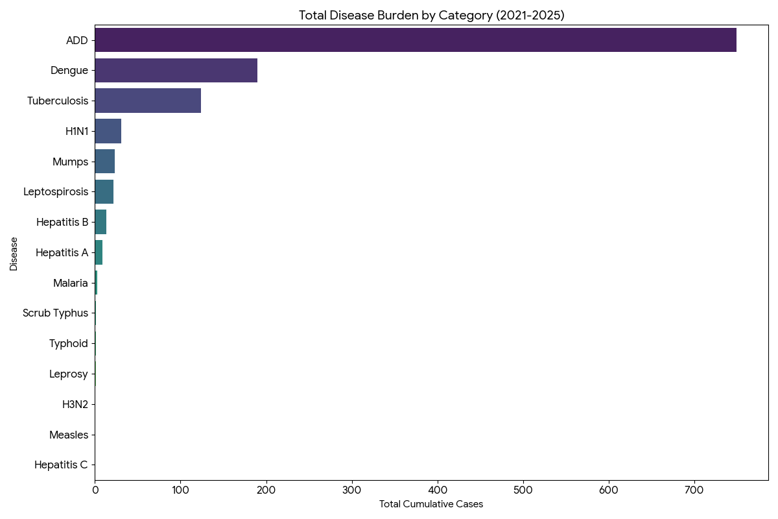
Figure 9: Overall Disease Burden

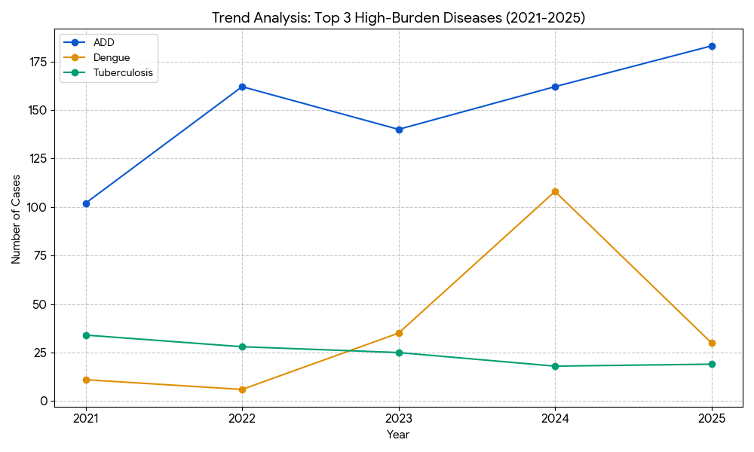
Figure 10: Top High Burden Disease

Seasonal Trend Analysis
Seasonal analysis helps anticipate surges (e.g. dengue in monsoon, leptospirosis after floods, influenza in cooler months) and plan pre‑emptive vector control, stockpiling of IV fluids, and awareness campaigns at Panchayat level.

DENGUE
Dengue is a major seasonal vector-borne disease strongly associated with rainfall, water stagnation, and increased mosquito breeding during the monsoon period.

Peak: July–November
Dengue – Ward-wise Yearly Distribution (2021–2025)

Table 29: Dengue Ward Wise Distribution - 5 Years
Ward | Dengue – Ward-wise Yearly Distribution
Ward | 2021 | 2022 | 2023 | 2024 | 2025 | Total
1 | 0 | 0 | 2 | 3 | 1 | 6
2 | 1 | 0 | 0 | 0 | 0 | 1
3 | 0 | 0 | 0 | 7 | 0 | 7
4 | 0 | 0 | 2 | 1 | 0 | 3
5 | 0 | 0 | 3 | 2 | 2 | 7
6 | 0 | 0 | 5 | 9 | 1 | 15
7 | 0 | 0 | 4 | 6 | 0 | 10
8 | 2 | 0 | 0 | 1 | 7 | 10
9 | 2 | 0 | 0 | 3 | 10 | 15
10 | 0 | 0 | 4 | 5 | 0 | 9
11 | 1 | 1 | 1 | 2 | 0 | 5
12 | 0 | 0 | 2 | 4 | 0 | 6
13 | 0 | 0 | 1 | 1 | 0 | 2
14 | 1 | 0 | 0 | 4 | 0 | 5
15 | 0 | 2 | 4 | 10 | 0 | 16
16 | 1 | 0 | 3 | 20 | 0 | 24
17 | 0 | 0 | 1 | 5 | 0 | 6
18 | 1 | 1 | 0 | 9 | 0 | 11
19 | 0 | 0 | 0 | 1 | 0 | 1
20 | 0 | 0 | 2 | 6 | 0 | 8
21 | 0 | 0 | 0 | 3 | 2 | 5
22 | 1 | 2 | 1 | 3 | 5 | 12
23 | 0 | 0 | 0 | 7 | 2 | 9

LEPTOSPIROSIS
Leptospirosis cases are closely linked to monsoon rains, flooding, and occupational exposure, particularly in low-lying and waterlogged areas.

Peak: June - August
Leptospirosis – Ward-wise Yearly Distribution (2021–2025)

Table 30: Leptospirosis Ward Wise Distribution - 5 Years
Ward | Leptospirosis – Ward-wise Yearly Distribution
Ward | 2021 | 2022 | 2023 | 2024 | 2025 | Total
1 | 0 | 0 | 0 | 0 | 0 | 0
2 | 1 | 0 | 0 | 0 | 0 | 1
3 | 0 | 0 | 0 | 0 | 1 | 1
4 | 0 | 0 | 0 | 0 | 0 | 0
5 | 0 | 0 | 0 | 0 | 0 | 0
6 | 0 | 1 | 0 | 0 | 0 | 1
7 | 0 | 0 | 0 | 0 | 0 | 0
8 | 0 | 0 | 0 | 0 | 0 | 0
9 | 0 | 0 | 0 | 0 | 0 | 0
10 | 0 | 0 | 0 | 1 | 0 | 1
11 | 1 | 1 | 1 | 0 | 0 | 3
12 | 0 | 0 | 2 | 1 | 0 | 3
13 | 0 | 0 | 2 | 2 | 0 | 4
14 | 0 | 0 | 1 | 0 | 0 | 1
15 | 1 | 0 | 0 | 0 | 0 | 1
16 | 0 | 0 | 2 | 0 | 1 | 3
17 | 0 | 0 | 0 | 0 | 2 | 2
18 | 0 | 0 | 0 | 1 | 0 | 1
19 | 0 | 1 | 0 | 0 | 0 | 1
20 | 0 | 0 | 0 | 0 | 0 | 0
21 | 0 | 0 | 0 | 0 | 0 | 0
22 | 0 | 0 | 0 | 0 | 0 | 0
23 | 0 | 0 | 0 | 0 | 0 | 0

VIRAL HEPATITIS - A
Hepatitis A cases are commonly associated with unsafe drinking water, food contamination, and breakdowns in sanitation, often presenting as clusters or outbreaks.

Peak: October – December

Hepatitis A – Ward-wise Yearly Distribution (2021–2025)

Table 31: Hepatitis A Ward Wise Distribution - 5 Years
Ward | Hep A – Ward-wise Yearly Distribution
Ward | 2021 | 2022 | 2023 | 2024 | 2025 | Total
1 | 0 | 0 | 0 | 0 | 0 | 0
2 | 0 | 0 | 0 | 0 | 0 | 0
3 | 0 | 0 | 0 | 0 | 0 | 0
4 | 0 | 0 | 0 | 0 | 0 | 0
5 | 0 | 0 | 0 | 0 | 1 | 1
6 | 0 | 0 | 0 | 0 | 0 | 0
7 | 0 | 0 | 0 | 0 | 0 | 0
8 | 0 | 0 | 0 | 0 | 1 | 1
9 | 0 | 0 | 0 | 0 | 1 | 1
10 | 0 | 0 | 0 | 1 | 0 | 0
11 | 0 | 0 | 0 | 0 | 0 | 0
12 | 0 | 0 | 0 | 0 | 0 | 0
13 | 0 | 0 | 0 | 0 | 0 | 0
14 | 0 | 0 | 0 | 0 | 0 | 0
15 | 0 | 0 | 0 | 0 | 0 | 0
16 | 0 | 0 | 0 | 0 | 1 | 1
17 | 0 | 0 | 0 | 0 | 0 | 0
18 | 0 | 0 | 0 | 1 | 0 | 0
19 | 0 | 0 | 0 | 0 | 0 | 0
20 | 0 | 1 | 0 | 0 | 0 | 0
21 | 0 | 0 | 0 | 0 | 0 | 0
22 | 0 | 0 | 0 | 0 | 0 | 0
23 | 0 | 0 | 0 | 1 | 0 | 1

Outcome-Based Trend Analysis- 2025

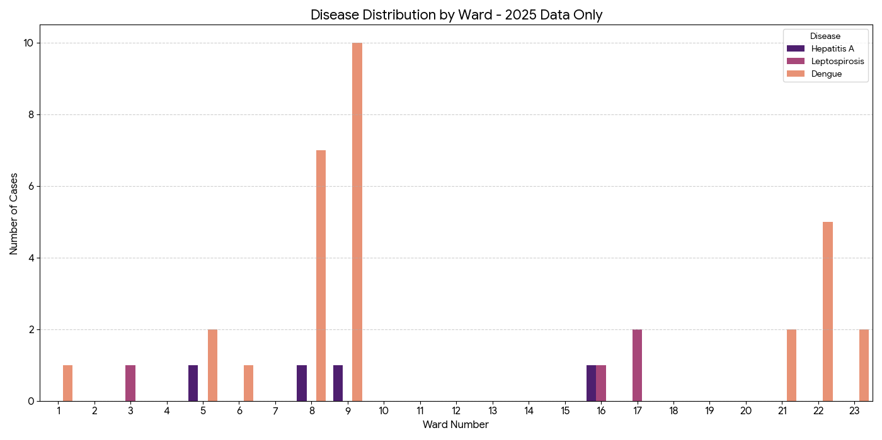
Figure 11: Disease Distribution by Ward

- Critical Hotspot (Ward 9): Ward 9 is the highest-priority area for 2025, accounting for nearly 25% of the total cases across these three diseases. The presence of both Dengue and Hepatitis A suggests both vector and water-related risks in this specific ward.
- Dengue Dominance: Dengue remains the most widespread threat in 2025, with significant clusters in Wards 8, 9, and 22.
- Localized Waterborne Risks: While Leptospirosis and Hepatitis A cases are lower in volume, they are concentrated in Wards 16 and 17 (Lepto) and Wards 5, 8, 9, and 16 (Hep A).
- Clear Zones: Wards 2, 4, 7, 10–15, and 18–20 reported zero cases for these three diseases in 2025, allowing for a strategic shift of resources to the active hotspots.

Transmission Trend- 2025
For effective management of public health issues, it is important to track the trend of disease transmission mode. It helps identify the population or place at high risk that can be used to predict outbreaks and implement targeted interventions as quickly as possible. Understanding these kinds of trends enables authorities to allocate resources efficiently and change the strategies adequately based on the trend that follows.

Table 32: Disease Transmission Table
Mode of Transmission (Pallickal) | No. of cases | No. of Deaths
Vector Borne Diseases | 30 | 0
Water Borne Diseases | 183 | 0
Air Borne Diseases | 39 | 3
Blood Borne Diseases | 1 | 0
Food Borne Diseases | 5 | 0

Vector-Borne Disease

Table 33: Vector-Borne Diseases
Vector-Borne Disease  (Pallickal) | No. of Cases | No. of Deaths
Dengue | 30 | 0
Malaria | 2 | 0
Chikungunya | 0 | 0

Water Borne Disease

Table 34: Water-Borne Diseases
Water Borne Disease  (Pallickal) | No. of Cases | No. of Deaths
Cholera | 0 | 0
Typhoid | 0 | 0
Hep- A | 5 | 0
Dysentery | 0 | 0
Amoebiasis | 0 | 0
E- Coli infections | 0 | 0

Air Borne Disease

Table 35: Air-Borne Diseases
Air Borne Disease  (Pallickal) | No. of Cases | No. of Deaths
Influenza | 0 | 0
H1N1 | 11 | 0
TB | 19 | 2
Chickenpox | 39 | 1
Measles | 0 | 0
Covid-19 | 0 | 0
Pertussis | 0 | 0
Mumps | 12 | 0

Blood-Borne Disease

Table 36: Blood-Borne Diseases
Blood-Borne Disease (Pallickal) | No. of Cases | No. of Deaths
AIDS | 0 | 0
Hep- B | 1 | 0
Hep- C | 0 | 0

Zoonotic Disease

Table 37: Zoonotic Diseases
Zoonotic Disease (Pallickal) | No. of Cases | No. of Deaths
Rabies | 0 | 0
Leptospirosis | 4 | 1
Avian influenza | 0 | 0
West nile | 0 | 0
Anthrax | 0 | 0
Nipah | 0 | 0
Scrub Typhus | 0 | 0

Integrated Disease Hotspot Map (2021–2025)

Table 38: Integrated Disease Statistics
Ward No. | Ward Name | Dengue | Leptospirosis | Hepatitis A | Mumps | ADD | Total Cases
1 | Pallickal | 6 | 0 | 0 | 0 | 28 | 34
2 | Mekkunnu | 1 | 1 | 0 | 1 | 36 | 39
3 | Elampallil | 7 | 1 | 0 | 2 | 29 | 39
4 | Thenginal | 3 | 0 | 0 | 0 | 38 | 41
5 | Pullippara | 7 | 0 | 1 | 0 | 25 | 33
6 | Alummoode | 15 | 1 | 0 | 2 | 28 | 46
7 | Pazhakulam | 10 | 0 | 0 | 1 | 29 | 40
8 | Thengumthara | 10 | 0 | 1 | 0 | 41 | 52
9 | Melood | 15 | 0 | 1 | 1 | 36 | 53
10 | Ammakandakara | 9 | 1 | 1 | 1 | 29 | 41
11 | Chennampallil | 5 | 3 | 0 | 0 | 30 | 38
12 | Malamekkara | 6 | 3 | 0 | 0 | 29 | 38
13 | Pothadi | 2 | 4 | 0 | 2 | 33 | 41
14 | Peringanad | 5 | 1 | 0 | 1 | 36 | 43
15 | Chala | 16 | 1 | 0 | 2 | 22 | 41
16 | Parakkoottam | 24 | 3 | 1 | 0 | 27 | 55
17 | Mulamukku | 6 | 2 | 0 | 3 | 42 | 53
18 | Mundappally | 11 | 1 | 0 | 2 | 33 | 47
19 | Thottamukku | 1 | 1 | 0 | 1 | 28 | 31
20 | Kollaickal | 8 | 0 | 1 | 1 | 30 | 40
21 | Thengamam | 5 | 0 | 0 | 2 | 33 | 40
22 | Thottuva | 12 | 0 | 0 | 1 | 39 | 52
23 | Kaithackal | 9 | 0 | 1 | 0 | 48 | 58

- Dengue Centralization: Wards 16 (Parakkoottam), 15 (Chala), 9 (Melood), and 6 (Alummoode) are the critical hotspots for Dengue, accounting for a significant portion of the Panchayat's vector-borne risk.
- Universal ADD Risk: Unlike other diseases, ADD (Acute Diarrhoeal Disease) is spread across almost every ward, with particularly high concentrations in Wards 23, 17, 8, and 22. This indicates a widespread need for improved water and sanitation infrastructure across the entire Panchayat.
- Leptospirosis Pockets: While lower in volume, Leptospirosis is most prevalent in Ward 13 (Pothadi) and Ward 11 (Chennampallil), identifying these as specific sites for environmental surveillance.

Table 39: Major Disease Bueden
Ward No. | Ward Name | Dengue | Leptospirosis | Hepatitis A | Mumps | ADD | Total Cases
Total | All Wards | 193 | 23 | 7 | 23 | 749 | 995

Disease Burden Percentage
Percentage = (Disease Total ÷ Grand Total) × 100
Table 40: Major Disease Burden in Percentage
Sl. No | Disease | Total Cases | Percentage of Total Cases (%)
1 | Dengue | 193 | 19.4 %
2 | Leptospirosis | 23 | 2.3 %
3 | Hepatitis A | 7 | 0.7 %
4 | Mumps | 23 | 2.3 %
5 | ADD (Acute Diarrhoeal Disease) | 749 | 75.3 %
 | Total | 995 | 100 %

Key Interpretation
- ADD constitutes the largest disease burden (75.3%), indicating a strong association with water quality, sanitation, and seasonal contamination risks.
- Dengue contributes 19.4%, suggesting significant vector breeding potential and need for intensified vector control activities.
- Leptospirosis and Mumps each contribute 2.3%, while Hepatitis A contributes 0.7%, indicating comparatively lower but still important outbreak potential.

PREPAREDNESS AND RESPONSE PROTOCOL
This section describes the operational framework for the LSGD once a pandemic is declared. It explains how the LSGI and health system will move from routine data collection to active response, using a One Health approach.

Constitution of One Health Committee
The LSGD shall constitute a One Health Committee comprising the LSGI President, Medical Officers (Modern Medicine, AYUSH, and Veterinary), the Health Inspector, and the Veterinary Surgeon.

Objective: The One Health Committee coordinates human, animal, and environmental health to prevent and control pandemics.

Table 41: Constitution of One Health Committee
Sl No | Name | Designation | Department/Institution | Role in Committee | Contact Number
1 | DINRAJ.CR | Panchayat President | LSGD | Chairperson | 9447096298
2 | SURABHI SANTHOSH | Medical Officer (PHC/CHC) | Health Dept | Member Secretary | 7034444557
3 | DR LINU | Veterinary Officer | Animal Husbandry | Member | 8547932470
4 | R.RAJESH | Health Inspector/PHN | Health Dept | Surveillance | 8547304432
5 | ANITHAKUMARI | PHN-ASHA Supervisor | Health Dept | Community link | 9946970953
6 | AISWARYA | ICDS Supervisor | Social Welfare | Vulnerable groups | 8301889161
7 |  | Police Station Officer | Police Dept | Law & order
8 | SUBI | Ward Councillor Representative | LSGD | Community coordination | 9656918772
9 | GEETHA | Kudumbashree CDO | Kudumbashree | Community mobilisation | 8129693293
10 |  | NGO/Volunteer rep | Civil Society | Support services
11 |  | Line Department representations

Key Responsibilities:

- Review disease surveillance data (human + animal)
- Conduct ward-wise risk assessment and vulnerability mapping
- Approve quarantine/isolation centre locations
- Coordinate with district for resources (PPE, oxygen, ambulances)
- Periodically review health system surge capacity, including beds, oxygen, human resources, and ambulances.
- Approve and monitor risk communication and community engagement strategies, including rumour management.
- Ensure protection and service continuity for vulnerable groups (elderly, persons with disabilities, dialysis patients, coastal populations).
- Conduct quarterly mock drills
- Monitor equity measures for vulnerable groups

Meeting Schedule:
Quarterly (normal times) | Weekly (outbreak alert) | Daily (pandemic phase)

Pandemic Response Workforce
To ensure a coordinated and timely response during a pandemic, a dedicated Pandemic Response Workforce shall be constituted at the LSG level. The workforce will function under the overall supervision of the One Health Committee and in close coordination with the health authorities. Team-based deployment will enable efficient surveillance, case management, quarantine and isolation management, logistics support, and risk communication. Each team shall have a clearly designated team leader, defined roles, and an identified pool of personnel to allow rapid activation, rotation of duties, and continuity of services during prolonged emergencies.

Total Response Workforce Available: 300 persons

Table 42: Response Workforce Availability
Team Name | Composition | Key Responsibilities | Team Leader
Surveillance and Contact Tracing Team | HI, JHI, JPHN, ASHAs and Volunteers | Case detection, contact listing, home visits, reporting | HI
Case Management Team | Doctors, Nurses, MLSP, Palliative Nurses | Patient care & referral | DOCTOR
Quarantine & Isolation Team | LSGD staff, Volunteers | Facility management | JHI
Psychosocial support
Logistics & supply chain Team | LSGD staff, Storekeepers, Drivers 3 | Supplies & transport [PPE, medicines, oxygen, transport, waste management] | Ward Member
Communication Team | Ward members, Kudumbashree, Youth clubs,  AWW workers and other self- help groups | IEC, community meetings, countering misinformation | M.O in charge
Transportation | KSRTC, educational institutional buses
Media Surveillance
Intersectoral coordination and convergence
Collaborative surveillance

All teams shall be activated immediately upon outbreak alert or pandemic declaration and shall report daily to the LSG Incident Commander/Medical Officer, with consolidated reporting to the Block PHC. Duty rosters and alternate personnel shall be maintained to ensure uninterrupted services during staff shortages or prolonged response periods. Team composition and numbers may be revised based on the magnitude of the outbreak and availability of human resources.

ACTIVITIES AND MEASURES BEFORE AND DURING PANDEMIC

PHASE 1 - Alert / Preparation

Surveillance and Reporting-Enhanced syndromic surveillance:

- Data sources for surveillance:
Enhanced syndromic surveillance relies on multiple data sources to detect early signals of a pandemic. These include healthcare facilities such as outpatient departments (OPDs), emergency rooms, and hospitals, which report unusual clusters of symptoms like fever and respiratory illness. Laboratory data also play a key role by providing diagnostic reports, test results for infectious agents, and trends in positive cases. Community-based reporting contributes through inputs from health workers like ASHA workers, village-level health registers, and informal alerts from local communities. Pharmacy sales data, such as increased purchases of over-the-counter medicines like antipyretics and cough syrups, can indicate a possible outbreak. Additionally, school and workplace absenteeism helps identify early spread through rising absence rates. Mortality data, including unusual increases in deaths and cause-specific trends, are also important indicators. Digital and media surveillance, including social media trends and news reports, along with data from hotlines and telemedicine services where individuals report symptoms or seek advice, further strengthen early detection and monitoring of potential pandemics.

- Event-based triggers (to be monitored and reported):

Event-based surveillance focuses on identifying unusual health events that may signal the onset of a pandemic. These triggers include sudden clusters of cases with similar symptoms, especially severe acute respiratory illnesses or unexplained fevers; unexpected increases in morbidity or mortality in a specific area; and outbreaks of unknown origin. Other important triggers are unusual patterns of disease transmission, such as rapid spread within communities, healthcare settings, or closed groups like schools or workplaces. Reports of illness among healthcare workers, sudden shortages of essential medicines, or increased demand for healthcare services should also be monitored. Additionally, zoonotic events such as unusual illness or deaths in animals, especially those in close contact with humans, and reports from media or community sources indicating public concern or panic, are critical signals that must be promptly reported and investigated.

- Zoonotic and animal health surveillance

Zoonotic and animal health surveillance involves monitoring diseases in animals that have the potential to be transmitted to humans. This includes regular observation of livestock, poultry, and wildlife for unusual illness, sudden deaths, or changes in behavior that may indicate emerging infections. Veterinary reports, farm inspections, and data from animal health workers play a crucial role in early detection. Surveillance also includes monitoring live animal markets, slaughterhouses, and areas where humans and animals interact closely. Laboratory testing of animal samples helps identify pathogens with zoonotic potential. Coordination between human and animal health sectors (One Health approach) ensures timely sharing of information, enabling early warning and prevention of disease spillover from animals to humans.

- Logistics and Stock Preparedness

  - Identify and empanel local vendors and define emergency procurement mechanisms in accordance with existing LSGD and Health Department norms.
  - Prepare and maintain an essential logistics checklist covering medical supplies, consumables, and support equipment.
  - Pre-identify secure storage locations for emergency stocks and ensure maintenance of stock registers with regular updating.
  - Finalise emergency transport arrangements, including availability of vehicles and identified drivers for rapid deployment during alerts.
  - Designate a Nodal Officer for Logistics to enable prompt decision-making, coordination, and communication during emergencies.
  - Conduct rapid stock verification and ensure availability of minimum buffer stock, including:
- PPE kits- 5 numbers
- Pulse oximeters – 6 numbers
- Hand sanitizers – 1 litres
- Masks, gloves, disinfectants – adequate quantity
Identify critical gaps in logistics and immediately communicate requirements to the Block and District authorities for timely replenishment and support. Monitor expiry dates and stock rotation.

Identification of Quarantine and Isolation Facilities
  - Identify and list suitable buildings for quarantine and isolation (schools, hostels, community halls, etc.).
  - Categorise cases as per the severity and allocate to appropriate facilities (for instance, severe cases to classrooms, mild cases to an assembly hall in case of a school).
  - Facility readiness checklist needed (beds, toilets, ventilation) etc.
  - Find an alternate site if the primary sites are not available or not in use.
  - Identify facility managers and support staff
  - Prepare basic SOPs for:
    - Admission and discharge
    - Food, water, sanitation
    - Infection prevention and waste disposal
  - Ensure availability of basic amenities: water, sanitation, electricity, ventilation, and waste disposal. Prepare a rapid activation plan for these facilities if case numbers increase.

Risk Communication and Community Preparedness
  - Disseminate early warning messages on symptoms, preventive measures, and reporting mechanisms. Display IEC materials both in English and the local language in public places and ensure ward-level awareness.
  - Sensitize elected representatives and community leaders on preparedness measures.
  - Establish a rumour tracking and misinformation response mechanism to identify, verify, and promptly counter false or misleading information.
  - Engage trusted local persons (ward members, ASHA workers, religious leaders, teachers, community volunteers) to communicate official public health messages and reinforce correct practices.
  - Develop and deploy targeted IEC materials for:
    - Schools and educational institutions
    - Markets and commercial areas
    - Work sites and labour settings
  - Conduct community sensitization meetings at the ward level to promote preventive behaviours, address concerns, and strengthen community participation in preparedness and response.

Protection of Vulnerable Groups

Vulnerable populations require priority protection through targeted line-listing, service continuity, and delivery mechanisms.
- Prepare and regularly update line-lists of vulnerable populations, including:
  - Elderly persons living alone
  - Persons with disabilities
  - Pregnant women
  - Migrant workers
  - Dialysis patients
The detailed line-lists shall be maintained as Annexure and updated periodically.

Clinical Dependency Mapping
Develop ward-wise dependency and vulnerability maps to identify households requiring regular support during emergencies. Ensure continuity of essential health services for vulnerable groups, including
- Dialysis services (facility mapping, transport arrangements, and scheduling)
- Continuity of treatment for TB, HIV, and other chronic conditions requiring uninterrupted medication
- Mental health and psychosocial support services
Establish delivery mechanisms for food, essential commodities, and medicines to vulnerable households through coordinated action involving ASHAs, JPHNs, Kudumbashree, volunteers, and local administration.

PHASE 2 - Active Response

Case Identification and Contact Tracing
Case detection and contact tracing activities will be carried out in coordination with the Health authorities, following disease-specific SOPs and IDSP guidelines.
Field Staff Involved
- Health Inspector (HI)
- Junior Health Inspector (JHI)
- Junior Public Health Nurse (JPHN)
- ASHAs and ASHA Supervisors
- Ward-level volunteers and Kudumbashree members (as required)

Screening Checkpoints
Screening checkpoints at high-traffic locations (transport hubs, markets, religious gatherings) for early detection of symptomatic travellers and crowd screening during outbreaks. Potential locations include bus stands, market entry points, and boat jetties, based on local context and risk assessment.
Screening activities will be carried out by trained personnel such as ASHAs, ward members, and volunteers, with support from Health Department staff. Necessary equipment, including non-contact thermometers and appropriate PPE, shall be ensured prior to activation.
Table 43: Screening Check Points
Location | Type (Bus stand/Jetty/Market/Railway) | Staff Deployed (ASHAs/Volunteers) | Screening Method | Reporting authority
Bus stand | Transport hub | One JHI  One ASHA  One health Mentors | 1. Swab Collection.  2. Blood smears collection (RDT)  3.Thermal Scanners | Surveillance Nodal Officer in control room
Market entry | Market | One JHI  One ASHA  Male health volunteers | 1. Swab Collection.  2. Blood smears collection (RDT)  3.Thermal Scanners | Surveillance Nodal Officer in control room

SCREENING PROTOCOL – PANDEMIC RESPONSE (Pallickal LSGD)

Figure 12: Screening Protocol
Standard Screening Protocol

Table 44: Screening Protocol
1. TEMPERATURE CHECK (Non-contact)
2. VISUAL SYMPTOMS (Cough / Fever / Breathlessness)
3. TRAVEL HISTORY (Last 14 days)
4. QUICK RISK ASSESSMENT

Table 45: Screening & Referral Protocol
HIGH RISK | SUSPECT | NORMAL
Test & Quarantine | PHC Referral | Allowed + IEC + Mask

Follow infection prevention measures: Mask, Hand Hygiene, Physical Distancing.

The screening protocol shall include temperature screening, observation for visible symptoms, and inquiry regarding recent travel or exposure history. Individuals identified as suspects during screening shall be immediately referred to the nearest PHC/FHC for further evaluation, testing, and appropriate action as per prevailing guidelines.

Pandemic Control Room
The Pandemic Control Room (PCR) serves as the central nerve centre for real-time coordination, data aggregation, decision support, and communication during outbreaks. It consolidates information from all LSGD teams, health facilities and community sources to enable rapid response decisions.

Control Room Infrastructure and Location
Primary Location: Pallickal Panchayath Office.
Backup Location: Community Hall in PALLICKAL G.P.

Health System Control Room Framework
The PCR is organized into seven functional pillars to ensure no aspect of the response is overlooked:

Rapid Response Team (RRT)
  - Provides immediate intervention during emergencies, clusters, and field alerts.​
  - Coordinates urgent actions such as case investigation, contact tracing, isolation, and inter‑facility referrals.

Data Management & Analytics Team
  - Collects, validates, and manages key health system indicators (cases, tests, beds, HR, supplies).​
  - Analyzes data trends, generates projections, and supports evidence‑based decision‑making for local authorities.

Human Resource Deployment Team
  - Allocates healthcare staff efficiently based on workload and need
  - Ensures adequate and equitable workforce distribution across facilities

Laboratory Surveillance Team
  - Oversees diagnostic testing coordination, sample transport, and timely reporting of results.​
  - Monitors lab indicators (testing volume, positivity rate, turnaround time) for early detection of outbreaks

Vaccination Cell (If Required)
  - Plans and executes vaccination campaigns, including micro‑planning and session scheduling.​
  - Tracks coverage, identifies gaps, and coordinates corrective actions with field teams and outreach services.

Infrastructure & Patient Occupancy Team
  - Monitors facility capacity, earmarked beds, oxygen and critical care resources across all linked facilities.​
  - Ensures optimal patient distribution and referral management using updated bed‑status and resource data.
  - BMWM

Communication team
The communication team plays a critical role during the active response phase of a pandemic by ensuring timely, accurate, and transparent dissemination of information to the public and stakeholders. The team is responsible for developing clear risk communication strategies, issuing regular updates on the situation, and addressing rumors and misinformation. It coordinates with health authorities, media, and other government agencies to provide consistent messages regarding preventive measures, case definitions, treatment protocols, and public health advisories. The team also manages press briefings, social media communication, and helplines to keep the public informed and reduce panic. Effective communication helps build public trust, promotes compliance with health measures, and supports overall outbreak control efforts.

- Logistics and supply chain

Logistics and supply chain management ensures the timely procurement, storage, and distribution of essential resources required during a pandemic response. This includes medical supplies such as personal protective equipment (PPE), medicines, vaccines, diagnostic kits, and hospital equipment. It also involves maintaining adequate stock levels, monitoring supply availability, and coordinating transportation to deliver materials to healthcare facilities and response teams. Efficient logistics systems help prevent shortages, support healthcare workers, and ensure that critical items reach affected areas quickly. Proper planning, inventory management, and coordination with suppliers and government agencies are essential to maintain uninterrupted operations during the active response phase.

- Transportation (inter-facility& emergency transport)

Transportation plays a vital role during the active response phase by ensuring safe and timely movement of patients, healthcare workers, and essential supplies. This includes inter-facility transport of patients requiring higher levels of care, using well-equipped ambulances with trained personnel and appropriate infection prevention measures. Emergency transport systems must be strengthened to respond quickly to critical cases, with proper triage and communication between referring and receiving facilities. Dedicated transport arrangements may be required for suspected or confirmed infectious cases to prevent further spread. Additionally, logistics for transporting medical supplies, samples, and essential staff should be well-coordinated to maintain continuity of healthcare services and support outbreak control efforts.

- Media surveillance Call centre

Media surveillance and call centres are important components of the active response phase, helping in early detection, information dissemination, and public support. Media surveillance involves continuous monitoring of news outlets, social media platforms, and other communication channels to identify emerging health concerns, rumors, and public perceptions related to the pandemic. This helps authorities respond quickly to misinformation and detect potential outbreaks. Call centres serve as a direct communication link between the public and health authorities. They provide information on symptoms, preventive measures, testing, and treatment services, while also receiving reports of suspected cases and health concerns from the community. Data collected through call centres can support surveillance and response activities. Together, media surveillance and call centres enhance situational awareness, improve risk communication, and strengthen the overall pandemic response.

- Management of the deceased

Management of the deceased during a pandemic is crucial to ensure dignity, safety, and infection control. Proper protocols must be followed for the handling, storage, and disposal of bodies of suspected or confirmed cases to prevent the risk of disease transmission. This includes the use of appropriate personal protective equipment (PPE) by healthcare and mortuary staff, safe wrapping and labelling of bodies, and disinfection procedures. Transportation of the deceased should be carried out with care, following established guidelines. Clear guidance should also be provided to families regarding safe funeral practices, while respecting cultural and religious beliefs as much as possible. Coordination between healthcare facilities, local authorities, and funeral services is essential to manage increased mortality during pandemics. Proper documentation and reporting of deaths must be maintained. Effective management ensures public health safety while upholding dignity and respect for the deceased and their families.

- Intersectoral coordination and convergence

Inter-sectoral coordination and convergence are essential during the active response phase to ensure a unified and effective pandemic response. This involves collaboration between multiple sectors such as health, transport, education, police, local administration, disaster management authorities, and other government and non-government agencies. Effective coordination helps in resource sharing, efficient decision-making, and implementation of control measures.
Regular communication and joint planning among sectors ensure alignment of strategies, such as containment measures, movement restrictions, public awareness campaigns, and service delivery. Convergence also includes partnerships with private healthcare providers, community organizations, and volunteers to strengthen response capacity. A well-coordinated approach minimizes duplication of efforts, optimizes resource utilization, and enhances the overall effectiveness of pandemic management.

Key Control Room Team
The Control Room Team coordinates all pandemic response activities within the LSGD and serves as the single command and communication hub during activation. It integrates information, field actions, logistics, and policy execution across all participating departments and health facilities.

Table 46: Key Control Room Team
Role | Name | Designation | Contact Number | Responsibility
In-charge/Nodal Officer | DR SURABHI RK | MO |  | Overall coordination, decision-making, and reporting to the District level.
Data Entry Operator | DINESH GEORGE | CLERK |  | Managing the line list, updating dashboards, and tracking testing results.
Communication Officer | R RAJESH | HI |  | Handling the public helpline, coordinating ambulance dispatch, and contact tracing calls.
Logistics Coordinator | DINESH GEORGE | CLERK
Technical Support(IT/Data) | ANJU THOMAS | DATA MANAGER

SOP for alert escalation/trigger point with mapping of responsibilities.
Key Points:
- The Control Room shall be staffed with a designated In-charge, data entry personnel, and communication staff with clearly defined roles and shift arrangements.
- It shall maintain updated records on daily monitoring indicators including new cases, persons under active quarantine, and hospital bed occupancy.
- All reports and situation updates shall be shared daily with the Block and District Surveillance Unit.
- The Control Room shall act as a single point of contact for coordination with response teams, health institutions, and other departments.
- Contact details of the Control Room shall be widely communicated to field staff and stakeholders during activation.

Daily Monitoring Indicators
To ensure timely decision-making and effective response, the following key indicators shall be monitored and updated on a daily basis by the Pandemic Control Room:

Epidemiological Indicators:
New cases reported today, Total active cases, Test Positivity Rate (TPR), Case Fatality Rate (CFR)

Surveillance Indicators:
Persons under home quarantine, High-risk contacts identified, Fever, ILI, SARI or other symptoms (syndromic surges), Travellers (symptomatic or high-risk arrivals),Animal husbandry surveillance (zoonotic alerts, unusual animal deaths, poultry/bird flu signals), Mortality surveillance (excess deaths, unexplained fatalities, verbal autopsy reports)

Logistics and Infrastructure Indicators:
Hospital / CFLTC beds occupied, Oxygen cylinders/concentrators available, Ambulances on standby

Alert Findings
The following table outlines category-specific trigger points (red flags) from surveillance indicators and corresponding immediate actions for the Pandemic Control Room. These enable rapid response to alert findings like testing anomalies, positive cases exceeding thresholds, clusters, and WGS reports.

Table 47: Trigger Points
Category | Trigger Point (Red Flag) | Immediate Action
Clusters | Geographical or facility-based: 5+ cases linked to one location (office, school, street). | Declare a micro-containment zone; perimeter control and active case finding.
Testing | Sudden drop in testing volume / delay in reporting / unusual testing trends | Review the sample collection process, address lab bottlenecks, deploy additional testing teams, and notify the District Lab.
Lab | Test Positivity rate increases | Increase testing sites in that ward.
Hospital | >80% Oxygen bed occupancy | Activate backup/CFLTC beds.
Travel | Cluster of cases from a single flight/train or high-risk arrival group. | Trace all passengers in adjacent seats; implement mandatory institutional quarantine.
Animal | Mass poultry/wildlife death or unusual sickness | Notify Animal Husbandry, sample the area, and dispatch RRT for environmental sampling and zoonotic check.
Mortality | Sudden spike in home deaths or brought-in-dead (BID) cases | Audit the deaths and Active Case Search drive
Additional investigations like Whole Genome Sequencing (WGS) | Detection of a Variant of Concern (VOC) or Variant of Interest (VOI) | Implement strict micro-containment; update clinical protocols to match variant severity.

Communication of Public Health Information
A Community Communication Hub shall be established to ensure timely, accurate, and consistent dissemination of information during a pandemic. The Hub will function under the coordination of Nodal officers of the control room and act as the nodal point for public communication, risk messaging, and community engagement. It will support dissemination of official advisories, promote preventive behaviors, address rumors and misinformation, and ensure that messages reach all sections of the population through trusted local channels and leaders.

Key communicators

- All messages disseminated through the Hub shall align with advisories issued by the Health Department and District authorities.
- Community leaders shall be sensitized to support behavior change, reduce stigma, and counter misinformation.
- Special efforts shall be made to reach vulnerable and hard-to-reach populations using locally appropriate communication methods.

Rumor Tracking: A designated volunteer will monitor local social media/WhatsApp groups daily to identify misinformation and issue official clarifications via the

Table 48: Key Communicators
Channel | Responsible Person | Contact
Ward-level announcements | R RAJESH
Social media | R RAJESH
Local Cable TV/Radio

Coordination with District/State Authorities & Other Organisations
Effective coordination with Block, District, and State authorities is essential to ensure timely reporting, technical guidance, and uninterrupted supply of essential resources during a pandemic. The LSG shall establish clear communication channels, designate responsible officers, and adhere to prescribed reporting timelines to support coordinated public health action and efficient resource mobilisation.

Key Details:
- Nodal Officer for Reporting:
- Contact Number:
Reporting Schedule and Protocols:

Table 49: Reporting Schedule & Protocol
To Whom | What to Report | Frequency | Nodal Person
Block PHC | Complete Situation Report (Cases, Quarantine, Beds, Screening, Deaths) | DAILY | BMO
District IDSP Unit | Outbreaks/Clusters/Unusual Events (>5 cases same ward) | DAILY | DSO
Veterinary Officer | Animal health events/Zoonotic alerts | DAILY
State Cell | Zoonotic cross-sector events | DAILY

Supply Chain Coordination
The LSG shall coordinate closely with Block, District, and State authorities (KMSCL) to ensure uninterrupted availability of essential goods, medical supplies, and logistics during a pandemic. Supply requirements shall be assessed regularly based on case load and communicated promptly to the appropriate authorities for timely replenishment.
Key Points:
- Maintain updated contact details of District and Block nodal officers for health logistics, oxygen supply, ambulances, and essential medicines.
- Submit timely indent requests for PPE, testing kits, medicines, oxygen, and other critical supplies through prescribed channels.
- Monitor stock levels at LSGD facilities, quarantine/isolation centres, and field teams through daily stock registers and dispensing logs to prevent shortages.
- Coordinate with District authorities, Karunya/Neethi medical shops, and local purchase committees for funds allocation and emergency procurement.

- Ensure regular monitoring of dispensing registers at all facilities to track usage, expiry, and pilferage—shortages being a perennial issue requiring proactive weekly audits.

- Activate surge procurement protocols during high caseloads, leveraging local purchase powers under LSGD funds alongside state supplies.

Resource Inventory and Contacts

Table 50: Resource Inventory & Contacts
Resource Category | Source  (District/State/Private) | Contact
PPE Kits/Masks/Gloves | KMSCL | 9995599249
PPE Kits/Masks/Gloves | Local Vendors | 8129435172
Oxygen  Cylinders/Concentrators | KMSCL | 9995599249
Medicines/Antivirals | KMSCL | 9995599249
Medicines/Antivirals | Neethi Shops | 8129435172
Test Kits (RTPCR/Rapid) | KMSCL | 9995599249

Collaboration with NGOs, PPP, and CSR
To augment government efforts during a pandemic, the LSG shall collaborate with NGOs, voluntary organisations, and private sector partners through public–private partnerships and Corporate Social Responsibility (CSR) initiatives, in coordination with District authorities.

Key Points:
- Engage NGOs and community-based organisations for community outreach, awareness, and support to vulnerable populations.
- Leverage CSR support for procurement of medical equipment, PPE, oxygen concentrators, food kits, and sanitation materials, as permitted.
- Ensure all collaborations align with government guidelines and are routed through approved administrative and financial procedures.
- Maintain transparency and documentation for all external support received and utilised.
Table 51: Collaboration with Organizations
Organization | Type | Support Offered | Contact Person
Youth Clubs/Student Unions | CBO

Interdepartmental Coordination
Coordination among departments during a pandemic shall be ensured through regular review meetings convened by the LSGD President. These meetings will provide a structured platform for sharing situational updates, assessing resource availability, resolving operational gaps, and taking joint decisions to ensure a coordinated and timely response.

Table 52: Interdepartmental Coordination
Department | Representative | Key Role | Contact
Health (PHC) | Staff Nurse : Anisha | Case management | 8547386681
Veterinary | Veterinary Surgeon:  Dr LINU | Animal surveillance | 8547932470
ICDS | Supervisor: Aiswarya | Nutrition support | 8301889161
Education | Head Teacher: | School coordination
Police | SHO | Containment enforcement | 9497987050
Water Authority |  | Water supply
LSGD Engineering |  | Quarantine infrastructure

PHASE 3 - Surge Capacity
Phase 3 is activated when there is a rapid increase in cases, high test positivity rates, or when existing health facilities and quarantine arrangements approach saturation. The focus of this phase is to expand isolation capacity, augment clinical care services, and mobilise additional resources through district and state support mechanisms.

Conversion of Community Facilities
To manage increased case load, the LSGD shall activate additional isolation facilities by repurposing identified community infrastructure such as community halls, auditoriums, schools, hostels, or other suitable buildings.

Table 53: Conversion of Community Facilities
Name of facility (Pallickal) | Facility Type | No. of Buildings | Ward | Surge Capacity (Beds) | Nodal Person
Mangalya Auditorium | Auditorium | 1 |  | 100
Kudumbasree Hall |  |  |  | 50
Pass Auditorium | Auditorium |  |  | 200
GLPS Pallickal | School |  |  | 75 | Headmaster
PUSPM HSS Pallickal | School |  |  | 200 | Headmaster

Recovery and rehabilitation phase
The recovery and rehabilitation phase focuses on restoring normalcy and strengthening systems after a pandemic. Recovery begins with a comprehensive assessment of the damage and overall impact on health, economy, and society. Restoration of health services is prioritized to ensure routine and essential healthcare resumes effectively. Rehabilitation of the affected population includes support for those who suffered illness, loss, or economic hardship, along with provision of psychosocial and mental health support to address trauma and stress.
Continued disease surveillance during the recovery phase is essential to detect any resurgence of cases. Environmental cleanup and sanitation measures help eliminate residual risks. Efforts are also directed toward livelihood restoration to support economic recovery and stability. Community engagement and confidence building are crucial to regain public trust and encourage participation in recovery activities.
Special attention must be given to healthcare workers, who often experience burnout due to prolonged duties, continuous work without adequate leave, and high levels of stress during a pandemic. The recovery phase should include a structured approach to support their physical and mental well-being. Assessment of fatigue and burnout levels among healthcare staff should be undertaken, followed by appropriate interventions.
Supportive measures should include provision of special leave and adequate rest periods, ensuring work-life balance after extended duty cycles. Access to counseling services, mental health support, and stress management programs should be made available to help staff recover from psychological strain. Additionally, workforce redistribution, supportive supervision, and recognition of their contributions can significantly improve morale and motivation. Promoting a healthy work environment and ensuring continued occupational safety are also essential components of staff recovery.
Documentation and after-action reviews are conducted to evaluate the response, identify gaps, and record experiences. Lessons learned and best practices are used to strengthen the health system and improve future preparedness. This phase also includes policy revision, enhancement of preparedness plans, and promotion of research to better understand and manage future public health emergencies.
Recovery
  - Damage & impact assessment
  - Restoration of health services
  - Rehabilitation of affected population
  - Psychosocial & mental health support
  - Disease surveillance during recovery phase
  - Environmental cleanup & sanitation
  - Livelihood restoration
  - Community engagement & confidence building
  - Documentation & after-action review
  - Lessons learned & best practices
  - Health system strengthening
  - Policy revision & preparedness enhancement
  - Research

Additional points
- tech support
- relief based commodities
- ham reading operators
- hazard vulnerability mapping
- Kseb& other power source
- HR specific responsibility

CONCLUSION
The Pandemic Preparedness Plan for Pallickal Grama Panchayat presents a comprehensive, actionable, and forward-looking framework aimed at strengthening the Panchayat’s capacity to effectively prevent, detect, and respond to future public health emergencies. Rooted in local demographic characteristics, environmental realities, and epidemiological trends (2021–2025), the plan moves beyond a reactive approach and firmly establishes a proactive, decentralized, and community-driven preparedness model at the Local Self Government Institution (LSGI) level.
The lessons learned from the COVID-19 pandemic, along with the persistent and emerging threats posed by Dengue, Leptospirosis, Nipah virus infection, Avian influenza, and Rabies, clearly highlight the necessity for sustained vigilance, early warning systems, and coordinated multi-sectoral responses. In this regard, the plan adopts a One Health approach, integrating human, animal, and environmental health systems to address the complex dynamics of disease emergence and transmission.
A key strength of the plan lies in the establishment of robust institutional mechanisms, including the formation of a multi-sectoral One Health Committee and a structured Pandemic Response Workforce with a strength of more than 300 personnel. These systems ensure coordinated action across sectors and enable efficient mobilization of resources during emergencies. The plan further delineates three critical phases—Alert/Preparation, Active Response, and Surge Capacity—providing clear operational protocols for surveillance, logistics management, healthcare service delivery, and risk communication. The activation of the Pandemic Control Room as a central command hub, standardized screening systems, and predefined alert escalation triggers further enhance the Panchayat’s readiness for rapid and effective intervention.
At the same time, the plan realistically acknowledges existing challenges, including infrastructure gaps, manpower constraints, and dependence on district and state-level support for certain critical resources. It also identifies the need to strengthen social protection mechanisms for vulnerable populations. Addressing these gaps through continuous capacity building, infrastructure development, digital health integration, and stronger inter-departmental coordination will be essential for building long-term resilience.
In conclusion, this Pandemic Preparedness Plan serves as a vital operational blueprint for Pallickal Grama Panchayat, translating preparedness into a structured, locally driven response system. Its success will depend on sustained commitment, active community participation, and continuous adaptation based on evolving public health challenges. By institutionalizing preparedness and fostering a culture of prevention and resilience, Pallickal Grama Panchayat is well-positioned to safeguard the health, well-being, and socio-economic stability of its population against future pandemics and public health emergencies.

RECOMMENDATIONS

Strengthening Healthcare Infrastructure
- Establish a primary health response unit within the Panchayat with trained staff.
- Ensure availability of basic medical supplies (masks, sanitizers, PPE kits, oxygen cylinders).
- Create tie-ups with nearby hospitals in the GP for emergency referral and transport.

Community Awareness & Education
- Conduct regular awareness campaigns on hygiene, vaccination, and preventive measures.
- Use local communication channels (community radio, WhatsApp groups, notice boards) to spread verified information.
- Train volunteers to act as health ambassadors in each ward.

Emergency Response & Coordination
- Form a Pandemic Preparedness Committee at Panchayat level including health workers, ward members, and NGOs.
- Develop a clear action plan for lockdowns, quarantine, and distribution of essentials.
- Maintain a database of vulnerable groups (elderly, differently-abled, chronically ill) for targeted support.

Supply Chain & Food Security
- Identify and support local suppliers and farmers to ensure uninterrupted food supply.
- Create community kitchens during emergencies to serve vulnerable populations.
- Stockpile essential commodities in Panchayat-run outlets for crisis periods.

Digital Preparedness
- Promote digital platforms for telemedicine consultations.
- Use Panchayat’s website/social media for real-time updates on health advisories.
- Encourage online grievance redressal to reduce crowding in offices.

Training & Capacity Building
- Organize mock drills for pandemic response in schools, offices, and public spaces.
- Train Panchayat staff and volunteers in first aid, infection control, and crowd management.
- Collaborate with NGOs and health departments for capacity-building workshops.

Long-Term Resilience
- Integrate pandemic preparedness into the Panchayat Development Plan.
- Allocate a dedicated budget for health emergencies.
- Encourage community participation in planning and monitoring preparedness measures.

MOCKDRILL SCENARIOS

ANNEXURES

LSG Baseline Data Collection Format
Annexure 1: Baseline Data- LSGD
Sl. No. | Indicator / Field | Baseline Data | Source / Remarks
1 | Name of LSG | Pallickal
2 | District | Pathanamthitta
3 | Block / Taluk | Parakode
4 | Type of LSG (Gram Panchayat / Municipality / Corporation) | Gram Panchayat
5 | Area (sq. km) | 45.43 SqKm
6 | No. of wards | 23
7 | GIS boundary file available | (Yes/No)
8 | Key contact person & phone | LSGD President- Dinraj C R | 94447096298

Annexure 2: Demography
Indicator / Field (Pallickal) |  | Baseline Data | Source / Remarks
Total population |  | 52760 | FHC Baseline
Males |  | 24110
Females |  | 28610
Transgender population |  | 3
Age distribution  (<5, 5–14, 15–59, ≥60) | <5 | 1403
Age distribution  (<5, 5–14, 15–59, ≥60) | 5-14 | 7526
Age distribution  (<5, 5–14, 15–59, ≥60) | 15-59 | 33021
Age distribution  (<5, 5–14, 15–59, ≥60) | ≥60 | 10810
No. of households
Population density (persons/sq.km) |  | 918persons/Sqkm
No. of migrant workers |  | 324
Major occupational groups |  | Daily wage workers

Annexure 3: Vulnerable Population & Social Risk
Sl. No. | Indicator / Field (Pallickal) | Baseline Data (Value / Description) | Source / Remarks
1 | No. of elderly (≥60) | 10810
2 | No. of persons with disability | 486
3 | No. of bedridden persons | 178
4 | No. of chronic disease cases (DM/HTN/COPD/CKD etc.) | 6141
5 | Pregnant women (current estimate) | 227
6 | Children <5 years | 1403
7 | Tribal population (if any) | 31
8 | Fisherfolk / coastal vulnerable groups (if any) | 0
9 | Urban slums / unnotified settlements (if any)
10 | Homeless population | 70
11 | Orphanages / old age homes (number & capacity)
12 | Hostels / prisons / shelters (number & capacity)
13 | Poverty / BPL estimate | 5518
14 | Food insecurity hotspots
15 | Any history of stigma/discrimination issues (Yes/No) | No

Annexure 4: Health System & Service Readiness
Sl. No. | Indicator / Field (Pallickal) | Baseline Data (Value / Description) | Source / Remarks
1 | No. of health facilities in LSG (PHC/CHC/TH/DH/Private) | 4
2 | PHC/Family Health Centre details (name, location) | FHC Pallickal  Thottuva
3 | Subcentres / Health & Wellness Centres (number) | 7
4 | Private clinics / hospitals (number) | 3
5 | Labs available (public/private) | 3
6 | Availability of ambulance services (Yes/No, number) | YES-2
7 | Availability of isolation/quarantine facilities (Yes/No, details) | YES
8 | Cold chain facilities (Yes/No, details) | Yes
9 | Stockpile space available (Yes/No) | Yes
10 | PPE / mask / sanitizer availability plan (Yes/No) | Yes
11 | Surveillance staff available (JHI/JPHN/ASHA count) | 36
12 | Existing emergency referral pathways (Yes/No) | Yes

Annexure 5: Points of Entry & Exist (Mobility)
Sl. No. | Indicator / Field (Pallickal) | Baseline Data (Value / Description) | Source / Remarks
1 | Bus stands / depots (number) | 0
2 | Railway stations (number) | 0
3 | Boat jetties / fishing harbours (number) | 0
4 | Ports / airports nearby (specify distance) | 0
5 | Major highways/roads passing through | KP ROAD
6 | Border crossings (state/district) | NO
7 | Major markets / weekly markets | 5
8 | Tourism hubs / major event venues | 0
9 | Schools/colleges with hostels (number) | 0
10 | Factories / large workplaces (number) | 0

Annexure 6: Water, sanitation & Hygiene (WASH)

Sl. No. | Indicator / Field(Pallickal) | Baseline Data (Value / Description) | Source / Remarks
1 | Major drinking water sources (piped / wells / borewells / springs) | Wells-12846
2 | No. of public wells | 23
3 | No. of households with piped water connection
4 | Water quality testing routine (Yes/No) | Yes
5 | Common contamination risks (flooding, salinity, industrial waste) | flooding
6 | Open defecation free status (Yes/No) | Yes
7 | Solid waste management system (Yes/No) | Yes
8 | Bio-medical waste disposal mechanism (Yes/No) | Yes
9 | No. of public toilets
10 | Hand Washing stations in public places (Yes/No) | Yes

Annexure 7: Zoonotic Risk & One Health
Sl. No. | Indicator / Field(Pallickal) | Baseline Data (Value / Description) | Source / Remarks
1 | Livestock population (cattle/goats/pigs/poultry) – estimates | 5892
2 | No. of dairy farms / poultry farms / pig farms | 0/4/1
3 | Slaughterhouses / meat shops (number) | 0
4 | Animal markets (Yes/No, details) | 0
5 | Veterinary dispensaries (number) | 1
6 | History of zoonotic outbreaks (rabies, leptospirosis, avian flu etc.) | 0
7 | Stray dog population management measures (Yes/No) | No
8 | Rodent infestation hotspots (Yes/No) | No
9 | Wetlands / waterlogged areas prone to leptospirosis | Yes
10 | Bat roosting areas / caves / fruit orchards (if any) | NA
11 | Human-animal interface hotspots (farms near residences) | NA

Annexure 8: Climate & Disaster Risks ( Pandemic Amplifiers)
Sl. No. | Indicator / Field(Pallickal) | Baseline Data (Value / Description) | Source / Remarks
1 | Flood-prone wards (list) | 1,13,16,22(Wards)
2 | Landslide-prone wards (list) | NA
3 | Cyclone/sea surge risk (Yes/No) | No
4 | Heatwave risk zones (Yes/No) | No
5 | Waterlogging areas (list) | 1,13,16,22(Wards)
6 | Shelter homes / relief camps (number, capacity)
7 | Past disaster displacement history | NA
8 | Disruption to water supply/transport common (Yes/No) | Yes

Annexure 9: Critical Infrastructure & Logistics
Sl. No. | Indicator / Field(Pallickal) | Baseline Data (Value / Description) | Source / Remarks
1 | Schools (number) | 24
2 | Anganwadis (number) | 36
3 | Colleges (number) | 1
4 | Community halls (number) | 12
5 | Places of worship with large gatherings (number) | 2
6 | Large markets / shopping areas (number) | Nil
7 | Warehouses / cold storages (number) | Nil
8 | Telecom/mobile network coverage gaps (Yes/No) | Yes
9 | Power outage frequency (high/medium/low) | Medium
10 | Availability of generators in key facilities | NA

Annexure 10: Risk Communication & Community Networks
Sl. No. | Indicator / Field | Baseline Data (Value / Description) | Source / Remarks
1 | Ward-level rapid response teams (Yes/No) | yes
2 | Jagrathasamithis / committees active (Yes/No) | yes
3 | Kudumbashree presence and strength (number of units) | yes
4 | Volunteer network (number, coverage) | Yes
5 | Community-based surveillance mechanisms (Yes/No) | yes
6 | IEC dissemination channels (WhatsApp groups, community radio, PA systems) | yes
7 | Rumour tracking mechanisms (Yes/No) | yes
8 | Languages spoken / literacy considerations | yes
9 | Vulnerable groups communication strategy available (Yes/No) | yes

Annexure 11: Preparedness Planning & Governance
Sl. No. | Indicator / Field | Baseline Data (Value / Description) | Source / Remarks
1 | LSG emergency plan available (Yes/No) | yes
2 | Pandemic preparedness plan available (Yes/No) | yes
3 | Incident Command System identified (Yes/No) | yes
4 | Rapid procurement mechanism available (Yes/No) | no
5 | Emergency fund available (Yes/No, amount) | NO
6 | Past outbreak response experience (Yes/No, details) | YES
7 | Intersectoral coordination mechanism (Health, Police, LSG, Veterinary, Education) | YES
8 | Mock drills conducted in last 12 months (Yes/No) | NO
9 | Training coverage for staff/volunteers (Yes/No) | YES

Annexure 12: Surveillance & Data Systems
Sl. No. | Indicator / Field | Baseline Data (Value / Description) | Source / Remarks
1 | Digital reporting tools used (e.g., DHIS2, portals) | Yes
2 | Availability of line-listing format (Yes/No) | Yes
3 | Contact tracing team identified (Yes/No) | Yes
4 | Mapping of high-risk households available (Yes/No) | Yes
5 | Testing sample transport mechanism (Yes/No) | Yes
6 | Reporting timeline adherence (good/average/poor) | Average
7 | Data sharing between departments (Yes/No) | Yes
8 | Availability of dashboard for monitoring (Yes/No) | No

Annexure 13: Additional Notes & Observations
Sl. No. | Indicator / Field | Baseline Data (Value / Description) | Source / Remarks
1 | Key challenges perceived by LSG
2 | Top 5 high-risk wards (reason)
3 | Any unique local risks (industrial pollution, refugee camps, etc.)
4 | Recommendations for preparedness strengthening

IMPORTANT PHONE NUMBERS

Phone numbers and particulars of persons responsible for providing guidance, assistance, and support for pandemic preparedness operations may be provided here in a manner that allows easy reference at a glance. The information recorded here could be exhibited elsewhere at the time of emergencies. LSG institutions shall give special attention to collect and record the above data of persons and institutions who/which are supposed to give technical and co-ordination support to reduce the impact of pandemic.

Annexure 14: Contact Details of Ward Members Pallickal GP
Sl. No: | Name of the Ward | Ward No: | Name of the  Member | Contact Number
1 | Pallickal | 1 | Sreeleksmi Vinoj | 8281368852
2 | Mekunnu | 2 | Arun Krishnan | 9747447344
3 | Elampallil | 3 | Subi S | 9656918772
4 | Thenginal | 4 | Sobha | 9562197884
5 | Pullippara | 5 | Maya G | 9961809039
6 | Alummood | 6 | S Rajeev | 9446812059
7 | Pazhakulam | 7 | Rahim | 8156917485
8 | Thengumthara | 8 | Abu Abraham | 9946328408
9 | Meloodu | 9 | Ap Santhosh | 9447224932
10 | Ammakandakara | 10 | Sailesh | 8086812021
11 | Chennapallil | 11 | Nirupama Pv | 9497815910
12 | Malamelkara | 12 | Anitha | 9605812527
13 | Pothadi | 13 | G Krishnakumar | 8921346996
14 | Peringanad | 14 | Valsala | 8113955294
15 | Chala | 15 | At Radhakrishnan | 8547230206
16 | Parakootam | 16 | Santhosh Papachan | 9496735364
17 | Mulamukku | 17 | Jolly | 9497744481
18 | Mundapally | 18 | Kavya Venu | 9778167693
19 | Thottamukku | 19 | Asha Sijil | 9656053030
20 | Kollaikkal | 20 | Shany T | 9539392875
21 | Thengamaom | 21 | Geetha Devi | 9645914394
22 | Thottuva | 22 | V Raveendran Pillai | 9447392867
23 | Kaithakkal | 23 | Dinraj Cr | 94447096298
24 | Kallappanchira | 24 | Prasannakumari | 9633171211

Annexure 15: Contacts of Other Important Offices of LSGD
Sl. No: | Name of the office | Contact person | Contact Number
1. | Village Office | Village Officer | 8547611206
2. | Agriculture Office | Agriculture Officer | 9539003848
3. | Animal Husbandry Office | Animal Husbandry Doctor | 8547932470
4. | Police Station | Police Officer | 9497987050
5. | BSNL Office | Officer | 04734288888
6. | Block Office | Officer | 04734217150
7. | KSEB Office | Officer | 9446009882
8. | Fisheries Office | Officer | 9446601279
9. | Fire and Rescue | Officer | 0473422900
10 | Water Authority
11 | Excise Department
12 | Forest Department
13 | Transportation
14 | Ayush

Annexure 16: Health Services Contact Details
Sl. No: | Name Of The Hospital/Institution (Pallickal) | Location | Contact Number
1. | Government Hospitals/PHC | Thottuva
2. | Private Hospitals | Life Line
3. | Clinical Laboratories
4. | Pulse Diagnostic Centre | Pazhakulam | 047334237260
5. | Tech Care Laboratory | Mekunnu | 7559862413
6. | Clinical Lab | Pazhakulam | 9895728294
7. | Chemist/Pharmacy
8. | Blood Donors
9. | Other Language Experts (Bihari, Hindi, Bengali, Asamees ………)

Annexure 17: Contact of Veterinary Services
Sl. No: | Name Of The Clinic (Pallickal) | Name Of The  Surgeon/Doctor | Place/Location | Contact  Number
1 | Govt.Veterinary Hospital | Dr. Linu | Pallickal | 8547932470

Annexure 18: Helpline Numbers
Helpline | Phone number
Police | 100
Fire and Rescue | 101
KSEB | 9446009882

Annexure 19: Schools Contact Details
Sl. No: | Name Of School (Pallickal) | Institution Type | Contact Number
1 | PUSPMHS Pallickal | Aided | 9495032622
2 | Arogyamatha Vellachira | Pvt | 94466200968
3 | THSS Adoor | Govt | 8078764071
4 | UPS Thengamom | Govt | 9496004793
5 | GLPS Thengamom | Govt | 9946535171
6 | TMGHSS Peringanad | Govt | 9400730988
7 | GBHSS Adoor | Govt | 9497204090
8 | SKVUPS Mundapally | Aided | 7034377203
9 | St Stephens School Pazhakulam | Pvt | 8086346009
10 | Govt Girls HSS Adoor | Gvt | 9496110069
11 | GLPS Pazhakulam | Govt | 7356371249
12 | GLPS Thottuva | Govt | 9744647470
13 | PUM VHSS Pallickal | Aided | 8281529177
14 | Travancore International School | Pvt | 956705152
15 | Little Bells Pre School | Pvt | 9833252944
16 | TM GHS Peringanad | Gvt | 9961584515
17 | GLPS Peringanad North | Gvt | 9074164980
18 | Govt Girls HSS Adoor | Govt | 9645511997
19 | GLPS Puthenpurackal | Govt | 9961335244
20 | PM Sree KV Sankethan, Adoor | Govt | 8592908661
21 | GBHS Adoor | Govt | 9645511997
22 | GGHSS Adoor | Govt | 9495088719
23 | GKV UPS Pazhakulam | Aided | 8113030331
 |  |  | 9895356440
24 | SN Public School | Pvt

Annexure 20: Anganwadi Contact Details
Anganwadi Contact Details – Pallickal GP
Sl. No. | Centre Number | Name of Anganwadi Teachers | Contact Number
1 | 73 | Vijayamma | 8593830087
2 | 74 | Ajitha A | 9662360566
3 | 75 | Reshmi S | 6235880139
4 | 76 | Valsala T | 9747878428
5 | 77 | Pushpalatha T | 9562329128
6 | 78 | Asha Kr | 9526844182
7 | 79 | Jayalekshmi R | 9947111752
8 | 80 | Girija S | 7025120319
9 | 81 | Rejani R | 6282526763
10 | 82 | Prabha T | 8590194921
11 | 83 | Ambika R | 954446334
12 | 84 | Suni R | 9207151228
13 | 85 | Rejani | 9744527096
14 | 86 | Rejitha Sasi | 9497201326
15 | 87 | Kumariyamma J | 9207248606
16 | 88 | Remya M | 9747359586
17 | 89 | Pushpalatha Pj | 9495039382
18 | 90 | Sheejadevi P | 8547039039
19 | 91 | Vimala P | 9745725468
20 | 92 | Divya V | 9562138797
21 | 93 | Rejani R | 7907652110
22 | 94 | Ambily Mk | 9995935052
23 | 95 | Smitha S | 9567589917
24 | 96 | Geetha Cs | 9048707936
25 | 97 | Leela C | 9744129501
26 | 98 | Reshma Raj T | 8078196244
27 | 99 | Anitha P | 9645374389
28 | 100 | Ushakumari Pk | 9745342869
29 | 101 | Sheelakumaiyamma N | 9645832124
30 | 102 | Latha S | 9562101639
31 | 103 | Savitha S | 9188040746
32 | 104 | Rejani R | 9406839193
33 | 105 | Soudhamani T | 9526436267
34 | 106 | Biji Pn | 9744895234
35 | 107 | Lekshmi Mohanan | 8590656375
36 | 108 | Mayadevi S | 9496514679
37 | 109 | Manju S | 8281408791

Annexure 21: Contact Details of Motor Transport
Means of transportation (Pallickal) | Name of Owner | Contact Number
Heavy Trucks | NAVAS | 9074390866
Heavy Trucks | WILSON | 9846373112
Tractor | GOPALAKRISHNAN | 9496333495
Ambulances | MOTHERTHERESA PALIATIVE SOCIETY | 9447561466
Boats | NIL | -
Taxi service | RAJESH | 8281216089

