PANDEMIC PREPAREDNESS
PLAN
THOTTAPPUZHASSERY

MESSAGE FROM PRESIDENT
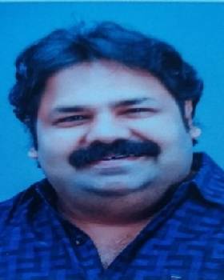
As the president of Thottappuzhassery grama panchayath, i am pleased to present our pandemic preparedness plan, developed to safeguard the health and well-being of our community. The recent years have clearly shown us that health emergencies can arise unexpectedly and affect every aspect of our lives — from livelihoods and education to social stability and economic growth. It is our responsibility as a local self-government to remain prepared, alert, and responsive at all times.
Thottappuzhassery panchayath is home to a diverse population, including farmers, daily wage workers, small business owners, elderly citizens, children, and migrant labourers. This diversity is our strength, but it also requires careful planning to ensure that the most vulnerable groups receive timely protection and support during any health crisis. Our preparedness plan focuses on early detection, rapid response, effective coordination between departments, and active public participation.
The plan emphasizes strengthening surveillance systems, improving communication channels, ensuring availability of essential medicines and supplies, and organizing awareness programmes at the ward level. We have also prioritized support systems for the elderly, children, and economically weaker families to reduce the social and financial burden during emergencies.
I sincerely request the cooperation of all residents, health workers, volunteers, community leaders, and government departments in implementing this plan successfully. Preparedness is not the responsibility of one department alone — it is a collective effort.
Let us work together to build a resilient thottappuzhassery that can face any future pandemic with confidence, unity, and strength.

MESSAGE FROM HEALTH STANDING COMMITTEE CHAIR
As the Health Standing Committee Chairperson of Thottappuzhassery Grama Panchayath, I am proud to present our Pandemic Preparedness Plan, designed to strengthen our capacity to prevent, detect, and respond to public health emergencies effectively. The recent experiences with pandemics and seasonal outbreaks have reminded us that preparedness is the foundation of community safety.
Health security begins at the grassroots level. Our Panchayath is committed to strengthening disease surveillance, improving early reporting systems, and ensuring close coordination between health institutions, ASHA workers, Anganwadi workers, and other frontline staff. Special attention has been given to vulnerable groups such as the elderly, children, and economically disadvantaged families to ensure that no one is left behind during times of crisis.
This plan also emphasizes awareness creation, sanitation and hygiene promotion, vaccination support, and rapid response mechanisms at the ward level. Through teamwork, timely communication, and scientific planning, we can minimize the impact of any future outbreak or disaster.
I request the wholehearted cooperation of residents, community organizations, health workers, and all stakeholders in implementing this preparedness plan. Together, with shared responsibility and collective action, we can protect the health and well-being of our community and build a stronger, safer Thottappuzhassery.

MESSAGE BY MEDICAL OFFICER

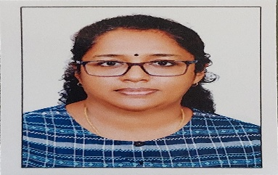

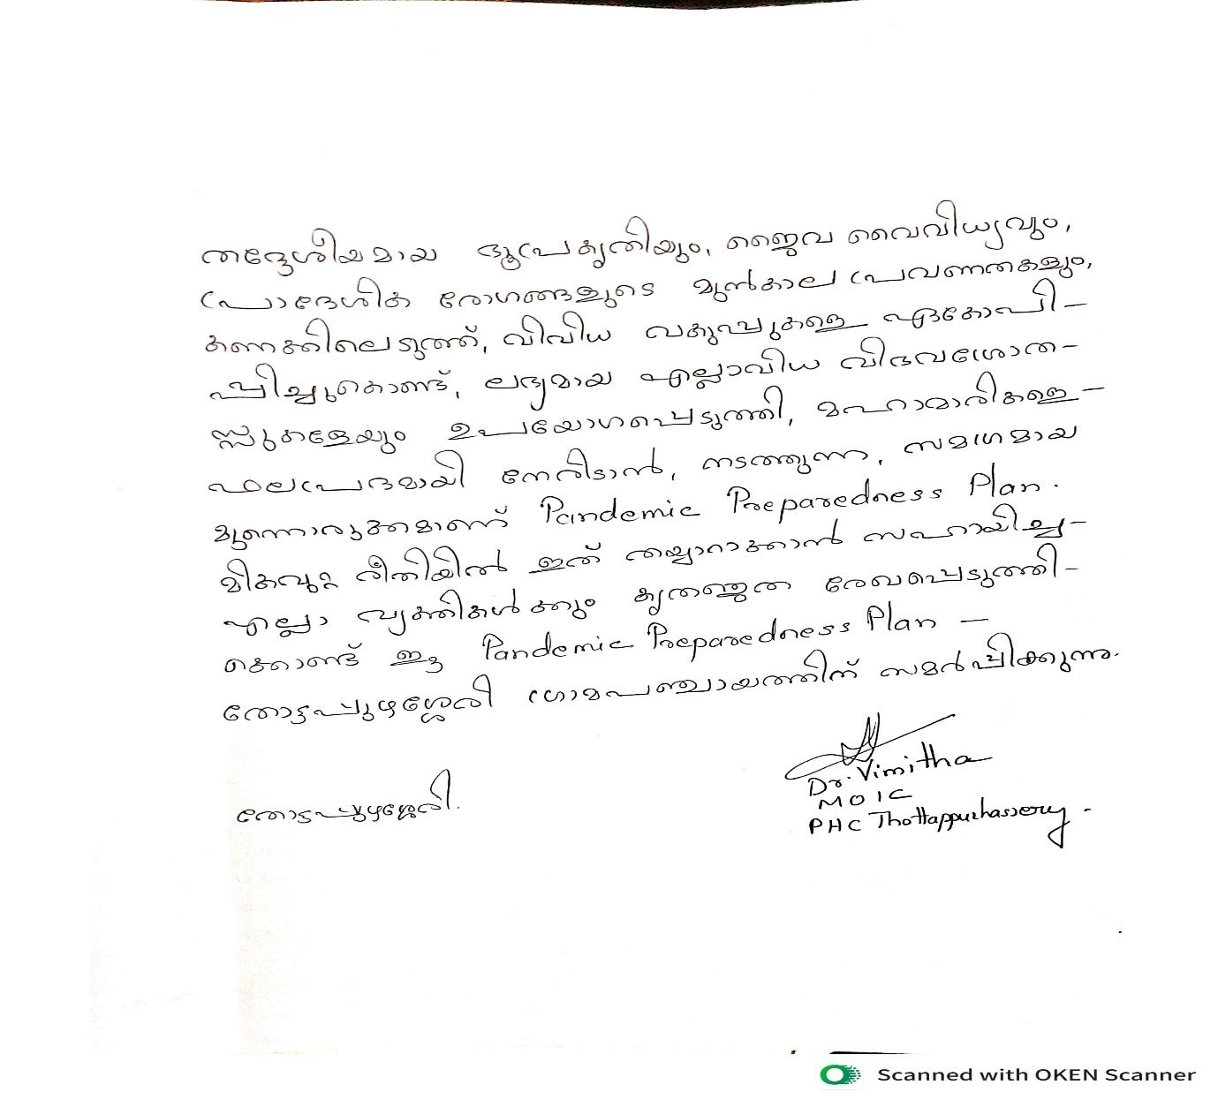

EXECUTIVE SUMMARY

Primary Health Centre (PHC) functions as the primary public healthcare institution serving the population of Thottappuzhassery Grama Panchayath. The PHC plays a pivotal role in delivering comprehensive, accessible, and affordable healthcare services, with a strong focus on preventive, promotive, curative, and rehabilitative care in accordance with national and state health programmes.
The PHC caters to a predominantly rural population, addressing key public health priorities such as maternal and child health, communicable and non-communicable disease control, immunization, family welfare, adolescent health, and geriatric care. Regular outpatient services, home-based care through field health staff, and outreach activities ensure healthcare coverage even in geographically challenging areas. The institution actively implements national health missions, including the National Health Mission (NHM), National Tuberculosis Elimination Programme, National Programme for Prevention and Control of Cancer, Diabetes, Cardiovascular Diseases and Stroke (NPCDCS), and other disease surveillance initiatives.
Thottappuzhassery PHC works in close coordination with the Grama Panchayath, ASHA workers, Anganwadi centres, schools, and community-based organizations to strengthen community participation and improve health awareness. Emphasis is placed on early detection, timely referral, health education, and lifestyle modification to reduce disease burden and improve overall health outcomes.
Despite constraints related to infrastructure, manpower, and increasing service demand, the PHC continues to enhance service delivery through effective planning, data-driven decision-making, and community engagement. Strengthening facilities, upgrading digital health systems, and expanding preventive services remain key focus areas for future development.
Overall, Thottappuzhassery Primary Health Centre stands as a vital institution in safeguarding public health and improving the quality of life of the residents of Thottappuzhassery Grama Panchayath

LIST OF ABBREVIATIONS

LSGD/LSGI | Local Self Government Department / Local Self Government Institution
BMO | Block Medical Officer
IDSP | Integrated Disease Surveillance Programme
NDMA | National Disaster Management Authority
PPE | Personal Protective Equipment
ICMR | Indian Council of Medical Research
CD | Communicable Diseases
NCD | NON-COMMUNICABLE Diseases

TABLE OF CONTENTS

Contents
INTRODUCTION 11
● Background of the PPP 11
LSGD AT A GLANCE 11
🔴 High Risk Wards (23–26 cases) 17
🟡 Moderate Risk Wards (15–22 cases) 18
🟢 Low Risk Ward (<15 cases) 18
Key Observation 18
Background of the LSGI 19
Demographic and Vulnerable Population 20
Clinical Vulnerability 22
INFRASTRUCTURE & RESOURCE INVENTORY 24
Health Facility Directory & Basic Capacity in the LSGD 24
Private Clinics 25
Healthcare Education & Training Institutions 26
Specialized Services & Emergency Inventory 26
Oxygen & Diagnostic Capacity 27
Diagnostics facility mapping at the LSGI level 28
Laboratory Identification & Basic Details 28
Social and Community Infrastructure for surge plan 29
Human resources 31
Medical & Clinical Personnel 31
Public Health & Field-Level Workforce 31
Community & Support Cadre 33
Community Organizations 34
Administrative & Emergency Services 35
Information regarding resources 35
ONE HEALTH & ENVIRONMENTAL SURVEILLANCE 36
Animal & Bird Population 36
Veterinary Infrastructure 37
Veterinary Doctors & Workforce 38
High-Risk Interface Points (Surveillance Sites) 39
Environmental Risk Mapping 42
Disease Seasonality Mapping 44
Vulnerability Mapping 45
EPIDEMIOLOGICAL TRENDS (2021–2025) 46
Disease Burden among human beings(Last 5 Years) 46
*(use the above table data to create the graph/diagram) 47
Seasonal Trend Analysis 48
DENGUE 48
Dengue – Ward-wise Yearly Distribution (2021–2025) 48
LEPTOSPIROSIS 49
Leptospirosis – Ward-wise Yearly Distribution (2021–2025) 49
VIRAL HEPATITIS - A 50
Hepatitis A – Ward-wise Yearly Distribution (2021–2025) 50
Outcome-Based Trend Analysis- 2025 52
Transmission Trend- 2025 53
Integrated Disease Hotspot Map (2021–2025) 56
Preparedness and Response Protocol at LSG Level 59
Constitution of One Health Committee 59
Key Responsibilities: 60
Meeting Schedule: 60
Pandemic Response Workforce 60
Activities and Measures before and during Pandemic 62
PHASE 1 - Alert / Preparation 62
➢ Identification of Quarantine and Isolation Facilities 63
➢ Risk Communication and Community Preparedness 63
➢ Protection of Vulnerable Groups 64
➢ Clinical Dependency Mapping 64
PHASE 2 - Active Response 65
1. Case Identification and Contact Tracing 65
2. Screening Checkpoints 65
Standard Screening Protocol 66
3. Pandemic Control Room 67
Control Room Infrastructure and Location 67
Health System Control Room Framework 67
Key Control Room Team 68
Daily Monitoring Indicators 69
1. Epidemiological Indicators: 69
4. Communication of Public Health Information 71
Key communicators 71
5. Coordination with District/State Authorities & Other Organisations 72
Key Details: 72
Supply Chain Coordination 73
Resource Inventory and Contacts 73
Collaboration with NGOs, PPP, and CSR 74
Interdepartmental Coordination 75
PHASE 3 - Surge Capacity 76
Conversion of Community Facilities 76
CONCLUSION 77
Hazard Vulnerability Mapping 78
KSEB & Other Power Sources 78
RECOMMENDATIONS 80
1. Strengthening Healthcare Infrastructure 80
2. Community Awareness & Education 80
3. Emergency Response & Coordination 80
4. Supply Chain & Food Security 80
5. Digital Preparedness 80
6. Training & Capacity Building 80
7. Long-Term Resilience 80
Scenario: Monsoon Flood with Suspected Water-Borne Disease Outbreak 81
Objectives of the Mock Drill 81
Incident Timeline (Simulation Flow) 81
Phase 1: Alert & Activation (Hour 0–2) 81
Phase 2: Flood Impact (Hour 3–6) 82
Phase 3: Health Emergency (Hour 6–24) 82
Relief Camp Simulation 83
Communication Flow 83
Materials Required for Drill 83
ANNEXURE 84
1. IMPORTANT PHONE NUMBERS 85
1.1. Details of grama panchayat/municipality/corporation wards 85
1.2. Other important phone numbers of grama panchayat/municipality/corporation area 86
1.3. Important offices of grama panchayat/municipality/ corporation 87
1.4. Health Services 87
1.5. Veterinary Services 88
1.6. Helpline numbers 88
1.7. Public and Private Schools Contact details 89
1.9. Anganwadi Contact Details 90
1.12. Information regarding resources 91

INTRODUCTION

Background of the PPP
Pandemics represent significant public health crises that challenge global stability and local resilience. Recent experiences, specifically the COVID-19 pandemic, underscore a critical lesson: preparedness at the grassroots level is the primary determinant of success in controlling disease transmission and maintaining essential services.
Located within the Koipuram Block of Pathanamthitta District, Thottappuzhassery Grama Panchayath is defined by its unique "Low Lying" terrain and proximity to the Pamba river basin. Covering an area of 15.17 sq. km, the region faces dual environmental threats:
- Flooding: Seven wards (6, 7, and 10) are chronically flood-prone.
- Landslides: Wards 3, 4, and 5 are identified as high-risk landslide zones.
These geographical features, combined with a high population density of 1,025 persons/sq. km, create an environment conducive to the rapid spread of water-borne, vector-borne, and zoonotic diseases such as Leptospirosis and Dengue.The Panchayat is a hub for major cultural and religious events, most notably the Maramon Convention (February) and the Aranmula Boat Race (September). These mass gatherings necessitate specialized risk communication and crowd management strategies to prevent "super-spreader” events.This PandemicPreparedness Plan, developed jointly by Thottappuzhassery Grama Panchayath, the Primary Health Centre, and other concerned departments, aims to strengthen local preparedness, enable early containment of outbreaks, ensure continuity of essential health services, and enhance the resilience of the community against future pandemic threats. make this a background of pandemic preparedness plan of Thottappuzhassery.

LSGD AT A GLANCE
- Geographical boundaries with political map ( based on latest delimitation)
- Baseline data
- Ward division -
Ward | Houses | Population | Migrants | Wells | Hot  spots | Ed. Institutions | Hosp pvt/govt.
1 | 348 | 1089 | 15 | 109 | 0 | 2 | 0
2 | 317 | 976 | 13 | 123 | 0 | 1 | 0
3 | 370 | 1277 | 11 | 134 | 0 | 1 | 0
4 | 362 | 1331 | 9 | 111 | 0 | 0 | 1
5 | 357 | 1169 | 7 | 106 | 0 | 1 | 0
6 | 321 | 1150 | 13 | 150 | 0 | 0 | 0
7 | 425 | 1330 | 14 | 159 | 0 | 1 | 0
8 | 398 | 1087 | 12 | 190 | 0 | 2 | 0
9 | 330 | 1034 | 15 | 199 | 0 | 1 | 0
10 | 365 | 1169 | 17 | 203 | 0 | 0 | 0
11 | 393 | 1298 | 14 | 200 | 0 | 0 | 0
12 | 337 | 1212 | 16 | 195 | 0 | 0 | 0
13 | 400 | 1429 | 7 | 198 | 0 | 0 | 0

- Ri11sk stratification among wards in the context of Communicable diseases and hazards

Maps - ward-based (Mention source also)

- Geographical boundaries - ward boundaries map

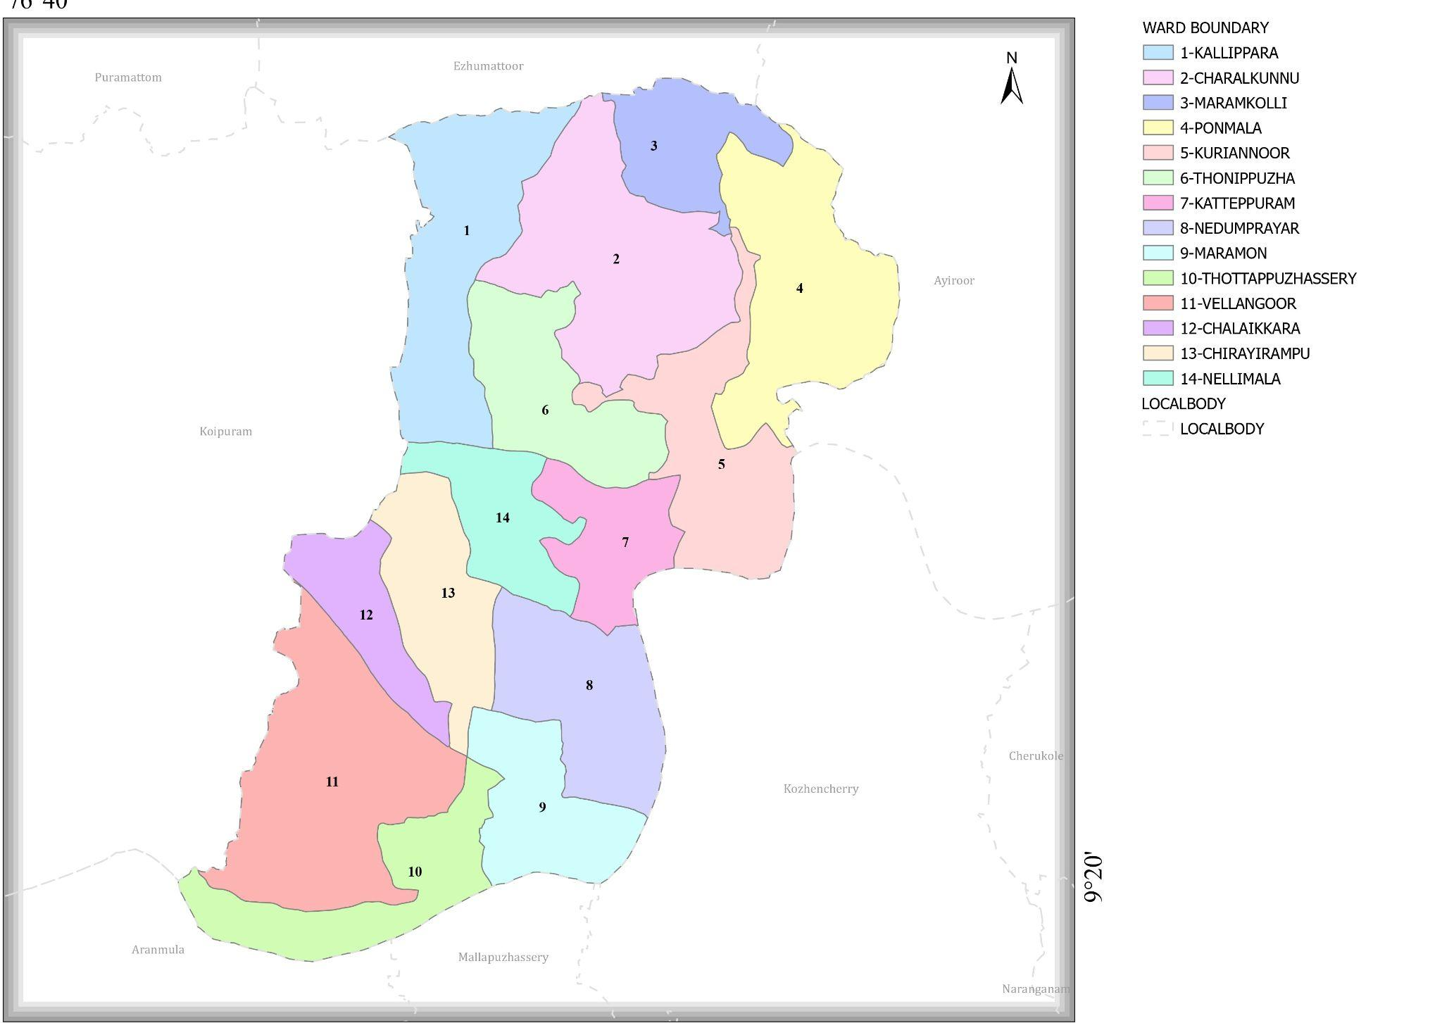

2.Baseline data

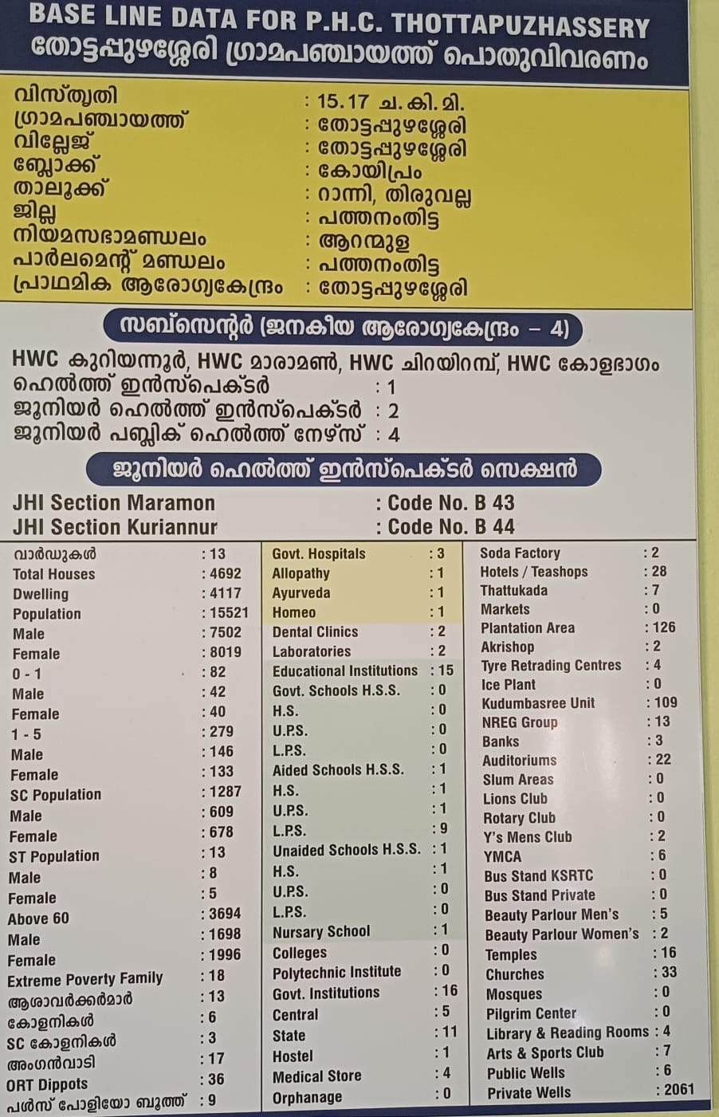

3. Health infrastructure map

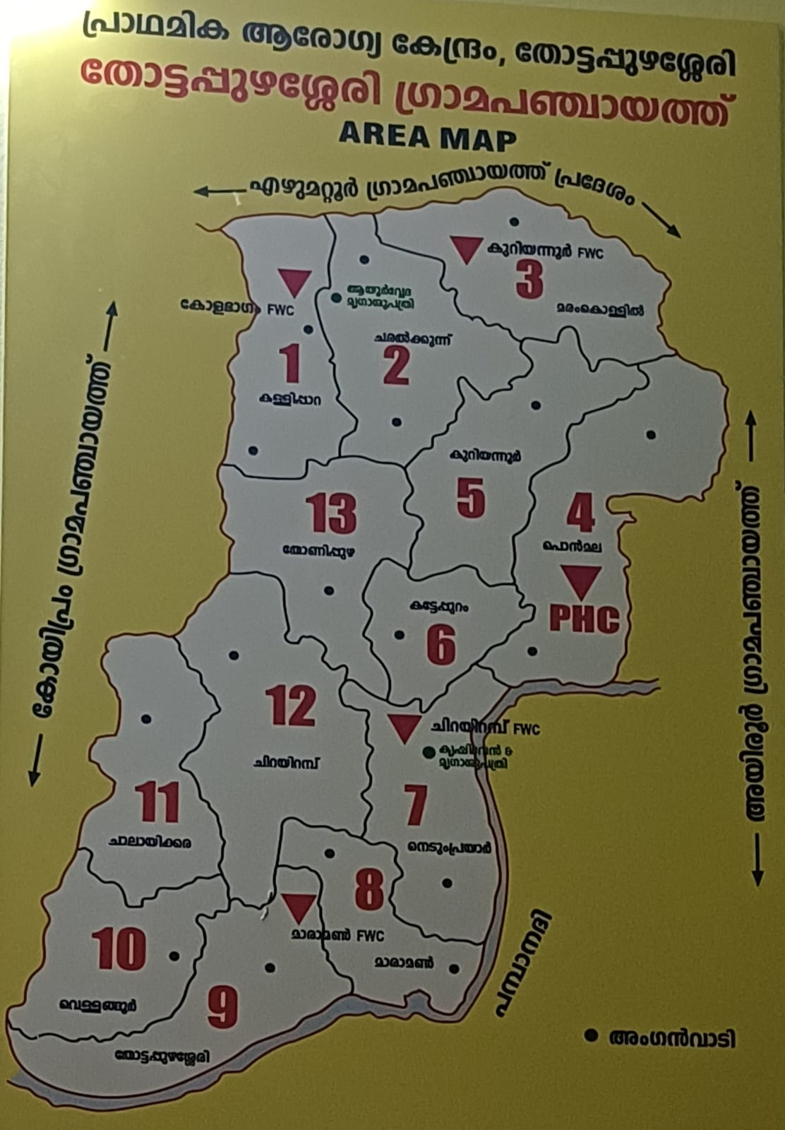

4.DISASTERPRONE-MAP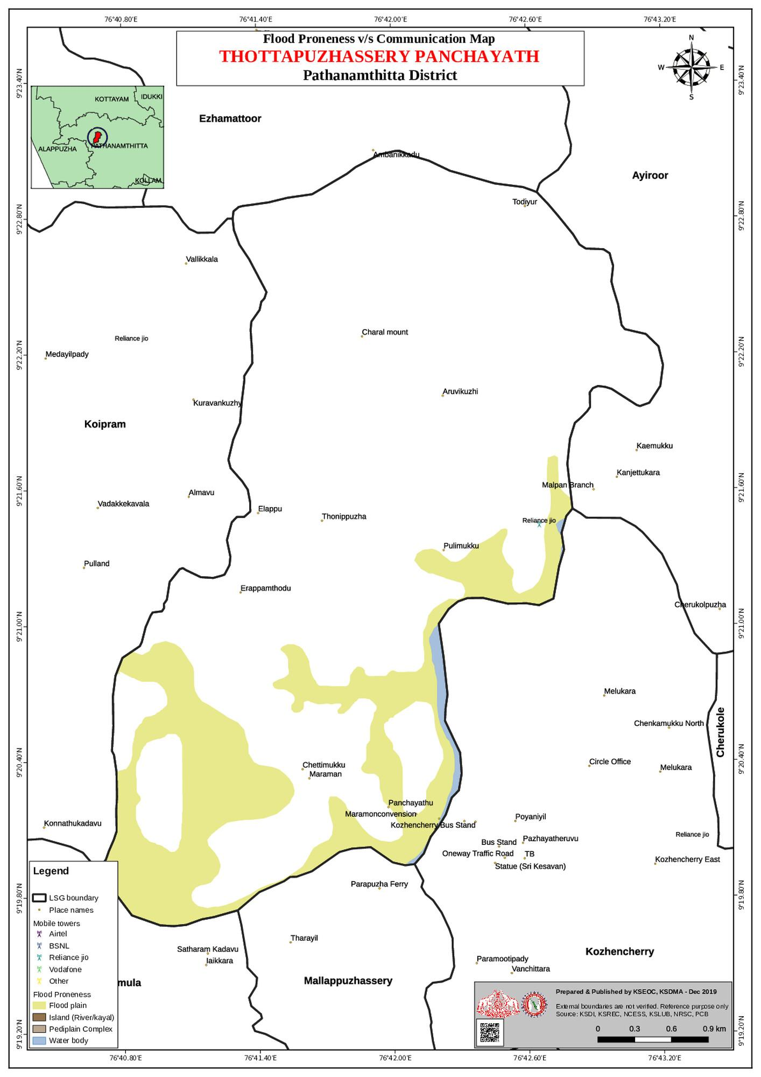

5. Spot map - CD
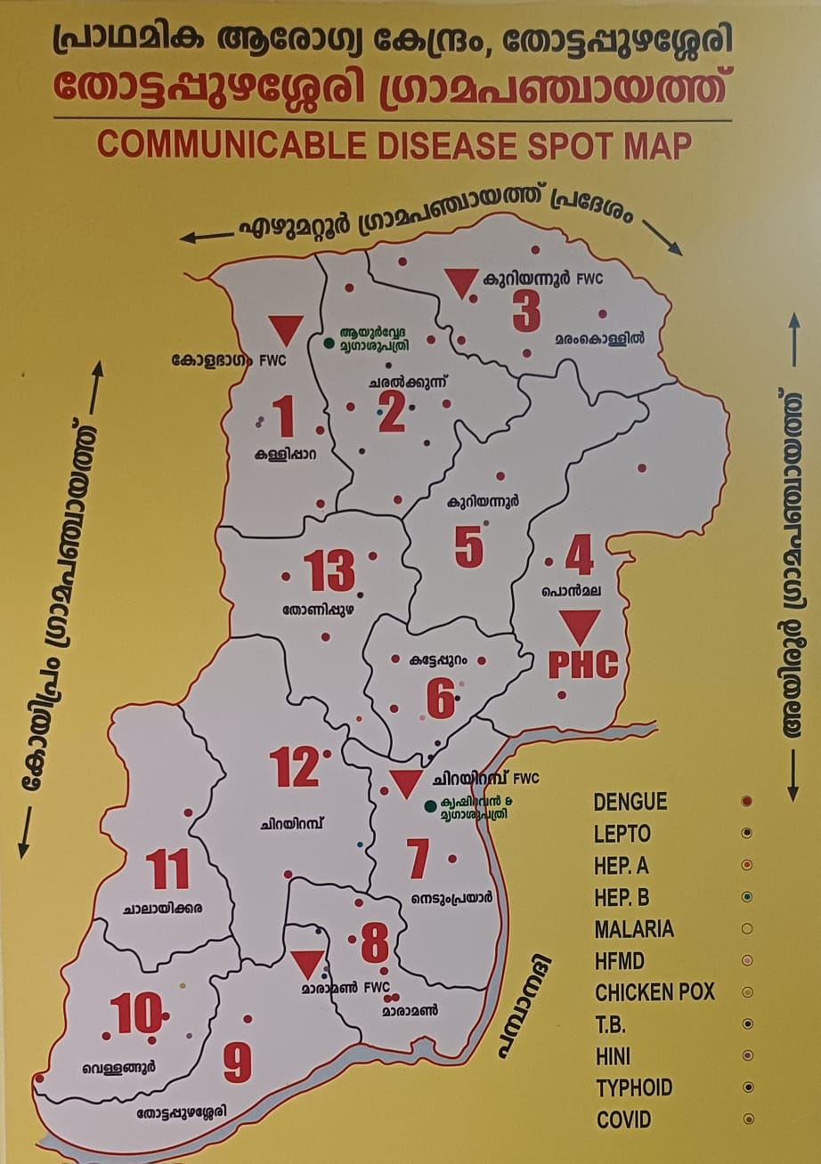

- Risk stratification among wards in the context of Communicable diseases and hazards

Based on total reported cases of Dengue, Leptospirosis, Hepatitis A, Mumps, and Acute Diarrhoeal Disease (ADD), wards are classified as follows:

🔴 High Risk Wards (23–26 cases)
Wards 2, 3, 6, 8
- Higher burden of Dengue and ADD

- Require intensified surveillance and vector control

🟡 Moderate Risk Wards (15–22 cases)
Wards 1, 4, 5, 7, 9, 10, 12, 13
- Moderate levels of Dengue and ADD
- Need strengthened sanitation and regular monitoring

🟢 Low Risk Ward (<15 cases)
Ward 11
- Lowest overall disease burden
- Routine surveillance sufficient

Key Observation
- ADD and Dengue are the major contributors across wards.
- Targeted water safety measures and vector control are essential to reduce future outbreaks.

Background of the LSGI
Thottapuzhassery Grama Panchayat is situated in the north area of Pathanamthitta_district, Kerala. The geographical landscape of the Panchayat is predominantly low-lying, characterized by extensive paddy fields (Kole lands) and a dense network of rivers, canals, and backwaters. This unique terrain plays a significant role in shaping the local microclimate and poses distinct challenges to transportation, emergency response, and service delivery, particularly during monsoon seasons and flood events.
The Panchayat is administratively divided into multiple wards, with a population largely dependent on traditional livelihoods. Agriculture—especially paddy cultivation—fishing, coir and coconut husk processing, and allied activities form the backbone of the local economy. In recent years, tourism-related activities and service-sector employment have also shown gradual growth. The area hosts a diverse workforce, including a notable presence of migrant labourers, particularly in construction, agriculture, and allied sectors.
From a public health and disaster management perspective, Thottapuzhassery LSGI has historically been vulnerable to seasonal flooding, waterborne diseases, and vector-borne illnesses such as Dengue and Leptospirosis. The severe floods experienced during recent years, including the 2018 flood disaster, significantly impacted life, livelihoods, and infrastructure within the Panchayat. These recurring emergencies have underscored the importance of strengthening local preparedness, response mechanisms, and inter-departmental coordination.
In this context, the development of a localized, data-driven Auxiliary Infrastructure and Logistical Resource Map is essential to support effective planning, timely emergency response, and sustainable development initiatives. Such mapping enables the Panchayat to identify critical resources, improve accessibility during disasters, and enhance overall resilience of the community.

Table 1: Background of LSGD
Description | Details
Name of LSGI | THOTTAPUZHASSERY
Type (GP/Municipality / Corporation etc.) | Grama Panchayath
Block | KOIPURAM
District | PATHANAMTHITTA
Number of wards | 14
Total area (sq. km) | 15.17
Population(Projected) | 15551
Population density | 1025persons/sq km
Terrain (coastal/low-lying/backwaters/foothills, etc.) | LOW LYING
Number of rivers passing through LSGI | 1
Number of water bodies in the LSGI | 2
Number of educational institutions | 15
Factories / small-scale industries | 4
Flood-prone wards | 7,6,10
Landslide-prone wards | 3,4,5
Death Management and Disposal Facilities (mortuaries/crematorium, including electric) | CREMATORIUM
Auditoriums/Marriage halls/convention centres/community halls | 22

Demographic and Vulnerable Population
Understanding the demographic composition and vulnerable population groups is essential for pandemic preparedness. Children, elderly, economically deprived families, migrant workers, and socially vulnerable groups are at increased risk during public health emergencies due to higher exposure, limited access to services, and dependency on public systems..

Description |  | Details (in numbers)
DEMOGRAPHIC PROFILE
Total population |  | 15551
Male |  | 7515
Female |  | 8036
Transgender |  | 0
Children under 5 |  | 4961
Adolescent |  | 1066
Elderly (>60) |  | 7133
SOCIAL/LIVELIHOOD VULNERABILITY
Previous EPEP family |  | 18
BPL family |  | 2826
Tribal communities |  | 0
Migration | Immigrant | 156
Migration | Emigrant | 3256
Socio-economically deprived |  | 0
Fisherfolk |  | 7
SC Community |  | 1255
ST Community |  | 12

Population pyramid
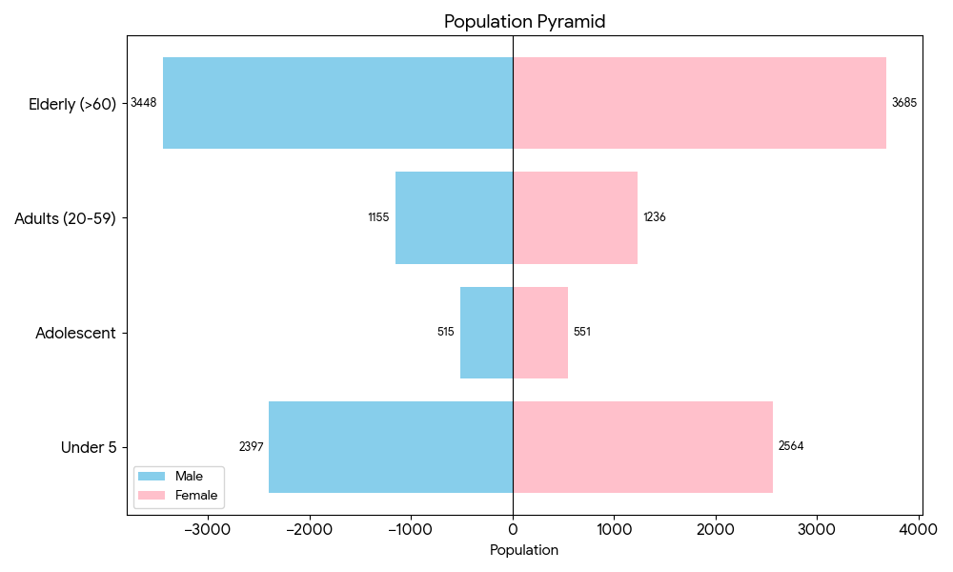

Clinical Vulnerability
Certain population groups needs priority healthcare & are at higher risk of severe illness, complications, and mortality during pandemics. Patients with chronic diseases, those requiring regular medical care, and individuals with mobility or functional limitations face challenges in accessing timely care during emergencies. Mapping these groups helps in prioritizing continuity of treatment, medicine stock planning, oxygen support, referral transport, and targeted home-based care.
Description | Details in numbers
Pregnant women | 57
Lactating mothers | 173
Bedbound patients | 145
Patients under palliative care other than bedbound | 185
Patients on Haemodialysis | 8
Patients on CAPD | 1
Cancer patients (currently on treatment) | 64
Haemophilic patients | 0
Mentally challenged | 18
Differently abled | 121
Diabetic patients | 1622
Hypertensive patients | 1931
TB patients | 4

Major Festivals & Events specific to the LSGI
(with the possibility of a public gathering)

Sl. No. | Name of festival | Month detailing the periodicity
1 | MARAMON CONVENTION | FEBRUARY
2 | ARANMULA BOAT RACE | SEPTEMBER
3 | SIVARATHRI | FEBRUARY

INFRASTRUCTURE & RESOURCE INVENTORY

Health Facility Directory & Basic Capacity in the LSGD
This section provides an overview of the healthcare infrastructure available within the LSGD area. It outlines the distribution and basic capacity of health facilities that form the backbone of service delivery during routine times and public health emergencies.

Family Health Centres (FHCs) and Community Health Centres (CHCs) generally function as the first point of contact for the community, providing essential outpatient and inpatient services. General Hospitals (GH) and Medical College Hospitals (MCH), where accessible, serve as the main referral centres for advanced diagnostics, specialist care, and critical services during public health emergencies. This inventory helps identify existing strengths, gaps, and potential surge capacity that can be mobilised during a pandemic or disaster.

Table 5. Health Facility Resource Summary
Sl.no. | Health Facility | Type of Facility (MCH/GH/CHC/FHC/SC etc.) | Contact Number | Total beds | ICU Beds | Oxygen-Supported Beds | No. of Ventilator Support Beds | No. of ambulances
Government Healthcare Facilities
1 | PHC THOTTAPUZHASSERY | PHC | 04692656505 | 01 | 0 | 0 | 0 | 0
Private Healthcare Facilities
 | NIL
AYUSH Healthcare Facilities
1 | GOVT AYUSH DISPENSARY | gov | nil | 0 | 0 | 0 | 0 | 0

Private Clinics
Private clinics are an essential part of pandemic preparedness, as they are often the first place people seek care when symptoms begin. In many communities, private clinics manage a significant share of outpatient visits and therefore play a critical role in early case detection, timely referrals, and disease surveillance. Having an up-to-date understanding of where these clinics are located, the services they provide, and how they are linked to the public health system helps ensure that no cases are missed during an outbreak. It also allows health authorities to engage private practitioners more effectively for reporting, risk communication, and coordinated response, strengthening the overall capacity of the health system to manage public health emergencies.

Table 6. Private Clinic Resource Summary
Sl No. | Name of Clinic | Registered (Y/N) | Clinic (General / Speciality) | Speciality (if any) | Address | Contact Number | Diagnostic Facility (Y/N) | Ambulance Linkage (Y/N)
 | N/A

Healthcare Education & Training Institutions
This section tracks the educational infrastructure available, which is vital for human resource planning in the health sector.

Category of Institution | Govt | Private | AYUSH | Total
Medical Colleges | 0 | 0 | 0 | 0
Nursing Colleges | 0 | 0 | 0 | 0
Dental Colleges | 0 | 0 | 0 | 0
Para-medical / Allied Health | 0 | 0 | 0 | 0
Pharmacy Colleges | 0 | 0 | 0 | 0

Specialized Services & Emergency Inventory
This section provides a detailed view of the specialized medical resources available to the community, focusing on emergency response and critical care capabilities. This table tracks the vital assets required for managing severe illnesses and emergencies across Government, Private, and AYUSH sectors.

Item | Govt | Private | AYUSH | Total
Hospital beds | 1 | 0 | 0 | 0
Oxygen-generating systems(Y/N) | N | 0 | 0 | 0
Oxygen-supported beds(Numbers) | 0 | 0 | 0 | 0
Ventilator-supported beds | 0 | 0 | 0 | 0
ICU beds | 0 | 0 | 0 | 0
Burns units | 0 | 0 | 0 | 0
Blood centres | 0 | 0 | 0 | 0
BLS ambulances | 0 | 0 | 0 | 0
ALS ambulances | 0 | 0 | 0 | 0
Dialysis facilities | 0 | 0 | 0 | 0
Dispensaries | 1 | 0 | 1 | 2
Medical store | 0 | 8 | 2 | 10
Industrial establishments(Medium-scale industries/small-scale industries establishments to whom we can depend in a worst-case scenario) | 0 | 1 | 0 | 1

Oxygen & Diagnostic Capacity
Monitoring oxygen and diagnostic capacity is a critical component of public health preparedness, ensuring that the LSGD can handle both chronic care and sudden surges in respiratory or infectious diseases.
Name of Health Facility | Oxygen-generating System (Y/N) | Backup Oxygen Source (Y/N) | Diagnostic Facilities Available(Y/N)
Name of Health Facility | Oxygen-generating System (Y/N) | Backup Oxygen Source (Y/N) | Lab | USG | X-ray | CT/MRI | RT-PCR
Government Healthcare Facilities
PHC Thottapuzhassery | N | N | Y | N | N | N | N

Diagnostics facility mapping at the LSGI level
The diagnostic capacity of Thottappuzhassery G.P represents the "intelligence network" of our healthcare system. The speed and accuracy of disease identification depend entirely on the distribution and technical level of these facilities.

Item | Govt | Private | AYUSH | Total
General labs | 1 | 2 | 0 | 3
Microbiology labs | 1 | 2 | 0 | 3
RT-PCR labs | 0 | 0 | 0 | 0
USG units | 0 | 1 | 0 | 1
CT/MRI units | 0 | 0 | 0 | 0
Research labs | 0 | 0 | 0 | 0
Labs of other departments that can be repurposed | 0 | 0 | 0 | 0

Laboratory Identification & Basic Details
Sl. No. | Name of Laboratory | Ownership (Govt / Private / Academic) | Address | Contact No. | 24×7 Services (Yes/No) | NABL / Govt Approved (Yes/No)
1 | GENESIS MEDI TRUST | PRIVATE | THADIYOOR | nil | NO | NO
2
3
4
5

Social and Community Infrastructure for surge plan
This table serves as our logistics and shelter inventory. By mapping these locations, quickly we can identify where to house displaced citizens, where to set up temporary medical clinics, and how to manage the deceased with dignity during a crisis.

Category | Total Count | Ward | Est. Capacity (Persons) | Contact details
Educational Institutions
Anganwadis | 0 | 0 | 0 | 0
Schools | 4 | 8,9,1,4 | 1000 | NIL
Colleges | 0 | 0 | 0 | 0
Healthcare Educational Institutions
Medical colleges (Govt/Private) | 0 | 0 | 0 | 0
Nursing colleges (Govt/Private) | 0 | 0 | 0 | 0
Dental colleges (Govt/Private) | 0 | 0 | 0 | 0
Paramedical institutes (Govt/Private) | 0 | 0 | 0 | 0
Community Gathering Spaces
Community halls | 9 |  | 900 | NIL
Auditoriums | 8 | 7 | 1200 | NIL
Religious buildings | 5 | 4,9,8, | 700 | NIL
Vulnerable Group Support Facility
Destitute homes | 0 | 0 | 0 | 0
Elderly homes | 0 | 0 | 0 | 0
LSGD owned other buildings | 0 | 0 | 0 | 0
Mass Fatality Management (MFM) Infrastructure
Mortuary | 0 | 0 | 0 | 0
Crematorium | 1 | 4 | 10 | N/A
*refer annexure 1 for contact details

Human resources
This section focuses on the human capital available within the LSGI. In any emergency—be it a pandemic, flood, or industrial accident—infrastructure is only as effective as the people operating it.

Medical & Clinical Personnel
This table tracks the "Frontline" providers responsible for diagnosis, treatment, and clinical management. Narrative sentence: eg., "Total health workforce: 450 personnel, with 60% in government facilities serving as primary surge capacity." A detailed directory with the contact numbers of all workers is maintained (Annexure in 1).

Cadre | Govt (No.) | Private (No.) | Total
Doctors—Modern Medicine | 2 | 4 | 6
Doctors – AYUSH | 1 | 2 | 3
Doctors – Veterinary | 1 | 1 | 2
Doctors – Dental | 0 | 4 | 4
Nursing officers | 1 | 0 | 2
Lab technicians | 1 | 2 | 3
Optometrist | 1 | 2 | 3
Pharmacists | 1 | 8 | 9
Psychologists | 0 | 1 | 1
Counsellors | 0 | 4 | 4

Public Health & Field-Level Workforce
These individuals are the backbone of surveillance, maternal-child health, and decentralized care.

Cadre | Health services | Municipal common services | Total
HS (Health Supervisors) | 0 | 0 | 01
HI (Health Inspectors) | 1 | 0 | 1
LHS (Lady Health Supervisor) | 0 | 0 | 0
LHI (Lady Health Inspectors) | 0 | 0 | 0
JPHN (Jr Public Health Nurses) | 4 | 0 | 4
JHI (Jr Health Inspectors) | 2 | 0 | 2
MLSP (Mid-Level Service Providers) | 4 | 0 | 41
Palliative Nurses | 1 | 0 | 11
RBSK Nurses | 1 | 0 | 1
PRO | 1 | 0 | 1
Epidemiologist | 0 | 0 | 0
Data Manager | 0 | 0 | 0

Community & Support Cadre
This group represents the surge capacity of the LSGI—people who can be called upon for logistics, rescue, and specialized support.

Cadre | Number
ASHA Workers | 13
AWW (Anganwadi Workers) | 17
Emergency Medical Volunteers (Trained) | 3
Kudumbashree | 91
MNREGS | 353
Purusha Swayam Sahaya Sangham | 0
Ex-Servicemen | 34
Retired Police Officers | 8
NCC/NSS Volunteers | 89
Red Cross volunteers | 0
One Health Community Volunteers | 410
One Health Community Mentors | 91

Community Organizations
This section details the presence of community-based organisations (CBOs), non-governmental organisations (NGOs), faith-based organisations (FBOs), Kudumbashree Self-Help Groups (SHGs), and Ayalkootams within the Local Self-Government Institution (LSGI). These groups enhance grassroots mobilization, resource distribution, and support networks crucial for pandemic response and community resilience.

Category | Total Count
NGOs | 12
Religious based organizations | 10
Foreign based organizations | 3
Sports Club/youth clubs | 8
Kudumbashree SHGs | 89
Ayalkootams | 0
Political organizations | 4
Residential organizations | 0

Administrative & Emergency Services
This section outlines the availability of key non-health emergency support services and infrastructure within the LSGI, which are essential for effective pandemic preparedness and response. These facilities support law enforcement, disaster response, water supply, logistics, mobility, and community-level interventions during public health emergencies.

Category | Total Count | Contact details
Police Stations | 0 | NIL
Fire & Rescue Stations | 0 | NIL
Water Pumping Points | 4 | NIL
Public Distribution System (PDS) | 3 | NIL

Information regarding resources
The availability of essential transport and support resources plays a quiet but critical role in saving lives. Equipment such as ambulances, mobile mortuaries, amphibian ambulances, and motorized boats ensures that patients, samples, and healthcare teams can move swiftly—even in flooded, remote, or difficult terrains. Heavy vehicles like JCBs, cranes, tractors, and torus lorries support logistics, waste management, emergency infrastructure, and rapid conversion of spaces into care or isolation facilities. Taxis, four-wheel-drive vehicles, and trucks help maintain continuity of essential services, reach vulnerable populations, and support home-based care and supply delivery.

Means of transportation | Total Count
JCB | 1
Crane | 0
Heavy Trucks | 2
Tractor | 2
Ambulances | 1
Mobile mortuaries | 1
Boats | 0
Taxi service | 8
Note: For specific details regarding vehicle owners and contact information, please refer to Annexure [X].

ONE HEALTH & ENVIRONMENTAL SURVEILLANCE
The One Health method integrates environmental, animal, and human health to enable proactive pandemic preparedness. Panchayat-level surveillance needs to be improved in order to detect and treat zoonotic and environmentally generated diseases early. Surveillance is strengthened through systematic assessment of animal populations, veterinary infrastructure, poultry and slaughter facilities, inter-sectoral coordination, and specialised tools like avian influenza seasonality mapping using GIS in previous outbreaks to enable predictive alerts and ward-specific sampling to support effective pandemic preparedness in high-risk areas like Thottapuzhaassery

Animal & Bird Population
Mapping animal and bird populations at the Panchayat level is essential for identifying and prioritising zoonotic disease hazards like rabies, avian influenza (H5N1), leptospirosis, anthrax, and Nipah-like spillover occurrences. Risk classification, targeted surveillance, vaccination planning, and early epidemic detection made feasible by comprehensive population mapping all enhance One Health-based pandemic preparedness.

Category | Item | Estimated Population | Wards
Animal Population | Livestock (Cattle/Goats/Buffalo) | 817 | WHOLE WARD
Animal Population | Pet Animals (Dogs/Cats) | 3000 | all wards
Animal Population | Stray Dog Population | 42 | all wards
Animal Population | Pig Farms (Number of heads) | 0 | 0
 | Small Units (Sheep / Goats – clustered) | 0 | 0
Bird Population | Poultry Units (Birds) | 3726 | all wards
Bird Population | Poultry- (FOWL) | 0 | 0
Bird Population | Wild/Migratory Birds (Observed) | 0 | 0
Bird Population | Crow Mortality Events (Reported) | NIL | 0

The main risk of zoonotic diseases inThottapuzhassery is concentrated in all wards which is explained by the high density of poultry birds , livestock and stray dog population . The stray dog population continues to be a substantial problem for rabies surveillance and bite prevention.

Veterinary Infrastructure
Veterinary institutions are a core pillar of One Health surveillance, enabling early zoonotic disease detection through vaccination, investigation of unusual animal illness or deaths, sample collection, and timely outbreak reporting. A well-mapped and responsive veterinary network strengthens coordination with human health and LSGI systems, ensuring rapid response during zoonotic events and pandemics.
Facility Type | Name of Facility | Ownership Govt / Pvt | Location(Ward No) | Contact number
Veterinary Dispensary | GOVT VETINARY HOSPITAL | GOVT | 7 | 9497315440
Veterinary Hospital / Polyclinic | 0 | 0 | 0 | 0
Private Veterinary Clinics | PETSEE | PVT | 13 | 7012286442
Mobile / Emergency Vet Service (incl. night services) | NIL | 0 | 0 | 0
Pet Homes / Animal Shelters | NIL | 0 | 0 | 0
Slaughterhouse-linked Veterinary Inspection Unit | NIL | 0 | 0 | 0

Veterinary Doctors & Workforce
Early detection, diagnosis, reporting, and reaction to animal illness epidemics depend on the availability and accessibility of qualified veterinary specialists. By identifying unusual animal morbidity or mortality promptly, collecting samples promptly, and coordinating efficiently with human health and LSGI systems—especially during zoonotic outbreaks and pandemic-prone situations—a clearly defined veterinary workforce enhances One Health surveillance.

Category | Number Available | Type (Govt/Pvt) | Contact number
Government Veterinary Doctors | 1 | GOVT | 9497315440
Private Veterinary Doctors | 1 | PVT | 7012286442
Livestock Inspectors | 2 | gov | nil
Para-veterinary Staff / Attenders | 1 | gov | nil
Contract / On-call Veterinary Support (if any) | NIL | 0 | 0

High-Risk Interface Points (Surveillance Sites)
High-risk interface points for zoonotic disease surveillance in ThottapuzhasseryGrama Panchayath include wetland–livestock–human contact zones, backyard poultry farms, cattle sheds near water bodies, fish markets, and areas of high human–animal interaction such as community slaughter points and migratory bird congregation sites. These are the primary surveillance sites where zoonotic spillover risks are elevated.

Type of Habitat | Type of High risk interface | Geographical vulnerability
Wetlands & Backwaters | NIL
Backyard Poultry Farms | NIL | nil
Cattle Sheds near Water Bodies | NIL | nil
Fish & Meat Markets | NIL | nil
Community Slaughter Sites | nil | nil
Migratory Bird Congregation Areas | NIL | nil
Rodent-Infested Grain Storage | NIL | nil

Category | Total Count | Key Locations (wards)
Poultry Farms | NIL | nil
Backyard / Clustered Poultry Units | 10 | 12,4,7
Duck Rearing Units (open water access) | 0 | 0
Slaughterhouses/ Slaughter Points | 0 | 0
Meat/Fish Markets | 0 | 0
Live Bird Sale Points | 2 | 8
Cattle Markets / Weekly Animal Fairs | 0 | 0
Pet Shops / Breeders | 2 | 8
Animal Shelters / Pet Homes | 0 | 0
Waste Disposal Sites near Animal Units | 0 | 0

Environmental Risk Mapping
Environmental risk mapping identifies monsoon/flood hotspots for vector-borne (dengue, chikungunya), water-borne (leptospirosis, diarrhoea), and zoonotic diseases in Kerala's wetlands. Systematic surveillance supports early warnings, targeted interventions, and Panchayat pandemic preparedness.
Waterborne exposure: Flood-prone areas and stagnant water bodies facilitate leptospira survival, raising leptospirosis risk.

Traditional practices: Informal slaughter and fish markets lack standardized hygiene, creating spillover opportunities.

Risk Factor | High-Risk Wards | Key Locations | Risk Level (High/Med/Low)
Flood-prone areas | 7,8,10 | Nedumprayar,kandathil,sbi area,maramon,kandathil | medium
Water bodies/wetlands | NIL | 0 | 0
Solid waste accumulation | NIL | 0 | 0
Animal waste disposal issues | NIL | 0 | 0
Rodent infestation zones | NIL | 0 | 0
Industrial effluent discharge | NIL | 0 | 0
Construction sites / abandoned buildings | NIL | 0 | 0
Poor drainage/blocked canals | NIL | 0 | 0
Drinking water source contamination risk | NIL | 0 | 0
Environmental risk mapping for Wards 7, 8, and 10 identifies a Medium-Risk Flood Profile primarily driven by their proximity to the Pamba River and low-lying geography in areas like Nedumprayar and Maramon. By analyzing spatial data, the mapping highlights that while these wards may not face constant inundation, they are highly susceptible to seasonal monsoon surges and flash floods, particularly in high-density or commercial hubs like the SBI area and Kandathil. This mapping serves as a vital diagnostic tool for disaster management, allowing authorities to pre-identify high-ground evacuation routes, prioritize the desilting of critical drainage channels, and implement flood-resilient building codes to prevent localized risks from escalating into large-scale disasters.

Disease Seasonality Mapping
1, Flooding & waterlogging → amplifies leptospirosis, malaria, diarrheal diseases.
·
2, Migratory bird influx (Nov–Feb) → avian influenza risk.

3, Mosquito breeding cycles → vector-borne disease peaks in monsoon.

4, Agricultural practices → close human–animal contact in paddy fields.

Disease | Peak Risk Season | Key Drivers | High-Risk Locations | Surveillance Focus
Avian Influenza | NIL | NIL | NIL | NIL
Leptospirosis | MONSOOSN | Rat | all wards | all wards
Dengue/Chikungunya | MONSOON | mosquito | all wards | all wardsS
Acute Diarrheal Diseases | NIL | NIL | NIL | NIL
Rabies | NIL | NIL | NIL | NIL
Anthrax (rare) | NIL | NIL | NIL | NIL

Vulnerability Mapping
Vulnerability mapping pinpoints high-risk populations, occupations, and areas exposed via environment, livelihoods, socio-economics, and poor service access. Paired with environmental/seasonality mapping, it enables risk-based surveillance, targeted actions, and optimal resource use in One Health and pandemic planning.
Vulnerability Factor | High-Risk Wards | Key Groups / Locations | Risk Level
Flood-prone households | 4, 7,8,10 | Nedumprayar,maramon,kandathil | MEDIUM
Wetland-adjacent communities | NIL | NIL | NIL
Backyard poultry / duck rearing households | NIL | NIL | NIL
Livestock-rearing households | NIL | NIL | NIL
Slaughterhouse & meat market workers | NIL | NIL | NIL
Fisherfolk & fish market workers | NIL | NIL | NIL
Sanitation workers | NIL | NIL | NIL
Daily wage / migrant workers | NIL | NIL | NIL
Elderly & chronically ill populations | NIL | NIL | NIL
Pregnant Women | NIL | NIL | NIL
Children (schools, Anganwadi’s) | NIL | NIL | NIL
Limited access to safe water & sanitation | NIL | NIL | NIL

EPIDEMIOLOGICAL TRENDS (2021–2025)

Disease surveillance is the systematic collection, analysis, and interpretation of health data for planning, implementation, and evaluation of public health practice. This section presents the disease surveillance profile of the LSGI based on routine reporting systems and outbreak investigations to identify priority diseases, seasonal patterns, and emerging public health threats.

Disease Burden among human beings(Last 5 Years)
Analysis of disease-wise data for the last five years helps identify persistent public health problems, emerging diseases, and changes in disease burden. This information supports prioritisation of prevention, preparedness, and response activities at the Panchayat level.

Disease | 2021 | 2022 | 2023 | 2024 | 2025 | Trend(Increasing/Stable/Decreasing)
Dengue | 4 | 7 | 21 | 38 | 17 | Decreasing
Leptospirosis | 1 | 6 | 3 | 6 | 9 | Increasing
Hepatitis A | 0 | 1 | 0 | 1 | 4 | Increasing
Malaria | 0 | 2 | 2 | 0 | 1 | decreasing
Scrub Typhus | 0 | 0 | 0 | 0 | 0 | stable
Typhoid | 0 | 0 | 1 | 3 | 2 | decreasing
H1N1 | 0 | 1 | 2 | 4 | 3 | decreasing
H3N2 | 0 | 0 | 0 | 0 | 4 | Increasing
ADD | 28 | 49 | 29 | 35 | 47 | Increasing
Mumps | 0 | 0 | 0 | 0 | 1 | stable
Measles | 0 | 0 | 0 | 0 | 0 | stable
Hepatitis B | 0 | 5 | 4 | 2 | 3 | Increasing
Hepatitis C | 0 | 0 | 0 | 0 | 0 | Stable
Tuberculosis | 6 | 8 | 10 | 6 | 6 | stable
Leprosy | 0 | 0 | 0 | 0 | 2 | Increasing
COVID-19 | 10 | 6 | 6 | 1 | 2 | Decreasing

*(use the above table data to create the graph/diagram)

Seasonal Trend Analysis
Seasonal analysis helps anticipate surges (e.g. dengue in monsoon, leptospirosis after floods, influenza in cooler months) and plan pre‑emptive vector control, stockpiling of IV fluids, and awareness campaigns at Panchayat level.

DENGUE
Dengue is a major seasonal vector-borne disease strongly associated with rainfall, water stagnation, and increased mosquito breeding during the monsoon period.

Peak: July–November

Dengue – Ward-wise Yearly Distribution (2021–2025)

Ward | Dengue – Ward-wise Yearly Distribution
Ward | 2021 | 2022 | 2023 | 2024 | 2025 | Total
1 | 0 | 0 | 2 | 2 | 2 | 6
2 | 0 | 2 | 0 | 5 | 1 | 8
3 | 2 | 2 | 1 | 6 | 1 | 12
4 | 1 | 0 | 1 | 3 | 0 | 5
5 | 1 | 0 | 4 | 1 | 5 | 11
6 | 0 | 0 | 2 | 3 | 3 | 8
7 | 0 | 0 | 1 | 2 | 1 | 4
8 | 0 | 0 | 0 | 5 | 0 | 5
9 | 0 | 0 | 1 | 1 | 2 | 4
10 | 0 | 0 | 1 | 4 | 0 | 5
11 | 0 | 0 | 0 | 1 | 1 | 2
12 | 0 | 0 | 4 | 2 | 1 | 7
13 | 0 | 0 | 4 | 3 | 0 | 7

LEPTOSPIROSIS
Leptospirosis cases are closely linked to monsoon rains, flooding, and occupational exposure, particularly in low-lying and waterlogged areas.

Peak: June - August

Leptospirosis – Ward-wise Yearly Distribution (2021–2025)

Ward | Leptospirosis – Ward-wise Yearly Distribution
Ward | 2021 | 2022 | 2023 | 2024 | 2025 | Total
1 | 0 | 0 | 0 | 0 | 2 | 2
2 | 0 | 0 | 0 | 4 | 0 | 4
3 | 0 | 0 | 0 | 0 | 1 | 1
4 | 0 | 1 | 0 | 0 | 1 | 2
5 | 0 | 1 | 0 | 0 | 0 | 1
6 | 0 | 1 | 1 | 1 | 0 | 3
7 | 1 | 1 | 0 | 0 | 0 | 2
8 | 0 | 1 | 0 | 0 | 1 | 2
9 | 0 | 1 | 1 | 0 | 1 | 3
10 | 0 | 0 | 1 | 1 | 1 | 3
11 | 0 | 0 | 0 | 0 | 1 | 1
12 | 0 | 0 | 0 | 0 | 0 | 0
13 | 0 | 0 | 0 | 1 | 1 | 2

VIRAL HEPATITIS - A
Hepatitis A cases are commonly associated with unsafe drinking water, food contamination, and breakdowns in sanitation, often presenting as clusters or outbreaks.

Peak: October - December

Hepatitis A – Ward-wise Yearly Distribution (2021–2025)

Ward | Hep A – Ward-wise Yearly Distribution
Ward | 2021 | 2022 | 2023 | 2024 | 2025 | Total
1 | 0 | 0 | 0 | 0 | 0 | 0
2 | 0 | 0 | 0 | 0 | 1 | 1
3 | 0 | 0 | 0 | 0 | 1 | 1
4 | 0 | 0 | 0 | 0 | 1 | 1
5 | 0 | 0 | 0 | 0 | 0 | 0
6 | 0 | 0 | 0 | 0 | 0 | 0
7 | 0 | 0 | 0 | 0 | 0 | 0
8 | 0 | 0 | 0 | 0 | 0 | 0
9 | 0 | 0 | 0 | 0 | 0 | 0
10 | 0 | 0 | 0 | 0 | 0 | 0
11 | 0 | 0 | 0 | 0 | 0 | 0
12 | 0 | 0 | 0 | 0 | 0 | 0
13 | 1 | 1 | 0 | 1 | 0 | 3

Outcome-Based Trend Analysis- 2025

Transmission Trend- 2025
For effective management of public health issues, it is important to track the trend of disease transmission mode. It helps identify the population or place at high risk that can be used to predict outbreaks and implement targeted interventions as quickly as possible. Understanding these kinds of trends enables authorities to allocate resources efficiently and change the strategies adequately based on the trend that follows.

Mode of Transmission | No. of cases | No. of Deaths
Vector Borne Diseases | 18 | 0
Water Borne Diseases | 6 | 0
Air Borne Diseases | 40 | 0
Blood Borne Diseases | 3 | 0
Food Borne Diseases | 53 | 0

Vector-Borne Disease

Disease | No. of Cases | No. of Deaths
Dengue | 17 | 0
Malaria | 1 | 0
Chikungunya | 0 | 0

Water Borne Disease

Disease | No. of Cases | No. of Deaths
Cholera | 0 | 0
Typhoid | 2 | 0
Hep- A | 4 | 0
Dysentery | 0 | 0
Amoebiasis | 0 | 0
E- Coli infections | 0 | 0
Air Borne Disease0

Disease | No. of Cases | No. of Deaths
Influenza | 0 | 0
H1N1 | 3 | 0
TB | 5 | 0
Chickenpox | 30 | 0
Measles | 0 | 0
Covid-19 | 2 | 0
Pertussis | 0 | 0
Mumps | 0 | 0

Blood-Borne Disease

Disease | No. of Cases | No. of Deaths
AIDS | 0 | 0
Hep- B | 3 | 0
Hep- C | 0 | 0

Zoonotic Disease

Disease | No. of Cases | No. of Deaths
Rabies | 0 | 0
Leptospirosis | 9 | 0
Avian influenza | 0 | 0
West nile | 0 | 0
Anthrax | 0 | 0
Nipah | 0 | 0
Scrub Typhus | 0 | 0

Integrated Disease Hotspot Map (2021–2025)
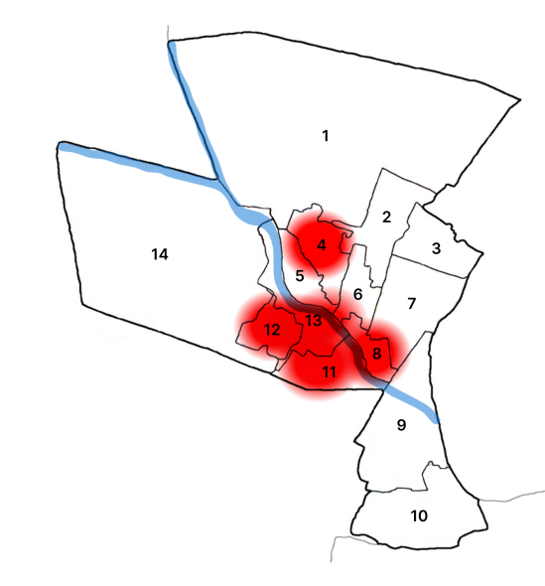

Ward No | Dengue Total (2021-25) | Leptospirosis Total (2021-25) | Hepatitis A Total (2021-25) | Mumps (2021-25) | ADD (2021-25) | Total Cases
1 | 6 | 2 | 0 | 0 | 10 | 18
2 | 8 | 4 | 1 | 0 | 11 | 24
3 | 12 | 1 | 1 | 0 | 12 | 26
4 | 5 | 2 | 1 | 0 | 9 | 17
5 | 11 | 1 | 0 | 0 | 10 | 22
6 | 9 | 3 | 0 | 1 | 11 | 24
7 | 4 | 2 | 0 | 0 | 9 | 15
8 | 5 | 2 | 8 | 0 | 11 | 26
9 | 4 | 3 | 0 | 0 | 13 | 20
10 | 6 | 2 | 0 | 0 | 12 | 20
11 | 2 | 1 | 0 | 0 | 10 | 13
12 | 7 | 0 | 0 | 0 | 9 | 16
13 | 7 | 2 | 1 | 0 | 12 | 22

By overlaying five years of data, we have identified ‘Red Zone' Wards. These are wards where at least two different categories of diseases (e.g., Dengue and Lepta) recurred in consecutive years. Ward 4 is categorized as the Highest Priority Hotspot due to its combination of flood vulnerability and high vector density.

Preparedness and Response Protocol at LSG Level
This section describes the operational framework for the LSGI once a pandemic is declared. It explains how the LSGI and health system will move from routine data collection to active response, using a One Health approach.

Constitution of One Health Committee
The LSGD shall constitute a One Health Committee comprising the LSGI President, Medical Officers (Modern Medicine, AYUSH, and Veterinary), the Health Inspector, and the Veterinary Surgeon.

Objective: The One Health Committee coordinates human, animal, and environmental health to prevent and control pandemics.

Sl No | Name | Designation | Department/Institution | Role in Committee | Contact Number
1 | ELSY CHRISTOPHER | Panchayat President | LSGD | Chairperson | 9744725572
2 | Dr Vimitha Murali | Medical Officer (PHC/CHC) | Health Dept | Member Secretary | 9495775110
3 | Dr Sreekarthika | Veterinary Officer | Animal Husbandry | Member | 9497315440
4 | Dr Nissy | Epidemiologist | Health Dept | Member | 8075378535
5 | Sivakumari S | Health Inspector/PHN | Health Dept | Surveillance | 9961550445
6 | Surabhi | ASHA Supervisor | Health Dept | Community link | 9495185597
7 | Sreelekha | ICDS Supervisor | Social Welfare | Vulnerable groups | 9995405577
8 | Sunumon | Police Station Officer | Police Dept | Law & order | 9497947146
9 | Mini Mathew | Ward Councillor Representative | LSGD | Community coordination | 954478467370
10 | Radha | Kudumbashree CDO | Kudumbashree | Community mobilisation | 9656012412
11 |  | NGO/Volunteer rep | Civil Society | Support services
12 | Dr Sreekarthika | Doctoe | Vetinary | Animal Survillance | 9497315440
13

Key Responsibilities:
- Review disease surveillance data (human + animal)
- Conduct ward-wise risk assessment and vulnerability mapping
- Approve quarantine/isolation centre locations
- Coordinate with district for resources (PPE, oxygen, ambulances)
- Periodically review health system surge capacity, including beds, oxygen, human resources, and ambulances.
- Approve and monitor risk communication and community engagement strategies, including rumour management.
- Ensure protection and service continuity for vulnerable groups (elderly, persons with disabilities, dialysis patients, coastal populations).
- Conduct quarterly mock drills
- Monitor equity measures for vulnerable groups

Meeting Schedule:
Quarterly (normal times) | Weekly (outbreak alert) | Daily (pandemic phase)

Pandemic Response Workforce
To ensure a coordinated and timely response during a pandemic, a dedicated Pandemic Response Workforce shall be constituted at the LSG level. The workforce will function under the overall supervision of the One Health Committee and in close coordination with the health authorities. Team-based deployment will enable efficient surveillance, case management, quarantine and isolation management, logistics support, and risk communication. Each team shall have a clearly designated team leader, defined roles, and an identified pool of personnel to allow rapid activation, rotation of duties, and continuity of services during prolonged emergencies.

Total Response Workforce Available: 300 persons

Team Name | Composition | Key Responsibilities | Team Leader
Surveillance and Contact Tracing Team | HI, JHI, JPHN, ASHAs and Volunteers | Case detection, contact listing, home visits, reporting | HI
Case Management Team | Doctors, Nurses, MLSP, Palliative Nurses | Patient care & referral | DOCTOR
Quarantine & Isolation Team | LSGD staff, Volunteers | Facility management | JHI
Psychosocial support
Logistics & supply chain Team | LSGD staff, Storekeepers, Drivers 3 | Supplies & transport [PPE, medicines, oxygen, transport, waste management] | Ward Member
Communication Team | Ward members, Kudumbashree, Youth clubs,  AWW workers and other self help groups | IEC, community meetings, countering misinformation | M.O in charge
Transportation | KSRTC, educational institutional buses
Media Surveillance
Intersectoral coordination and convergence
Collaborative surveillance

All teams shall be activated immediately upon outbreak alert or pandemic declaration and shall report daily to the LSG Incident Commander/Medical Officer, with consolidated reporting to the Block PHC. Duty rosters and alternate personnel shall be maintained to ensure uninterrupted services during staff shortages or prolonged response periods. Team composition and numbers may be revised based on the magnitude of the outbreak and availability of human resources.

Activities and Measures before and during Pandemic

PHASE 1 - Alert / Preparation
Surveillance and Reporting-Enhanced syndromic surveillance:
- Data sources for surveillance:
- Event-based triggers (to be monitored and reported):
- Zoonotic and animal health surveillance
- Logistics and Stock Preparedness
  - Identify and empanel local vendors and define emergency procurement mechanisms in accordance with existing LSGD and Health Department norms.
  - Prepare and maintain an essential logistics checklist covering medical supplies, consumables, and support equipment.
  - Pre-identify secure storage locations for emergency stocks and ensure maintenance of stock registers with regular updating.
  - Finalise emergency transport arrangements, including availability of vehicles and identified drivers for rapid deployment during alerts.
  - Designate a Nodal Officer for Logistics to enable prompt decision-making, coordination, and communication during emergencies.
  - Conduct rapid stock verification and ensure availability of minimum buffer stock, including:
- PPE kits –25 numbers
- Pulse oximeters – 1___ number
- Hand sanitizers – __30_ litres
- Masks, gloves, disinfectants – adequate quantity
Identify critical gaps in logistics and immediately communicate requirements to the Block and District authorities for timely replenishment and support. Monitor expiry dates and stock rotation.

Identification of Quarantine and Isolation Facilities
  - Identify and list suitable buildings for quarantine and isolation (schools, hostels, community halls, etc.).
  - Categorise cases as per the severity and allocate to appropriate facilities (for instance, severe cases to classrooms, mild cases to an assembly hall in case of a school).
  - Facility readiness checklist needed (beds, toilets, ventilation) etc.
  - Find an alternate site if the primary sites are not available or not in use.
  - Identify facility managers and support staff
  - Prepare basic SOPs for:
    - Admission and discharge
    - Food, water, sanitation
    - Infection prevention and waste disposal
  - Ensure availability of basic amenities: water, sanitation, electricity, ventilation, and waste disposal. Prepare a rapid activation plan for these facilities if case numbers increase.

Risk Communication and Community Preparedness
  - Disseminate early warning messages on symptoms, preventive measures, and reporting mechanisms. Display IEC materials both in English and the local language in public places and ensure ward-level awareness.
  - Sensitize elected representatives and community leaders on preparedness measures.
  - Establish a rumour tracking and misinformation response mechanism to identify, verify, and promptly counter false or misleading information.
  - Engage trusted local persons (ward members, ASHA workers, religious leaders, teachers, community volunteers) to communicate official public health messages and reinforce correct practices.
  - Develop and deploy targeted IEC materials for:
    - Schools and educational institutions
    - Markets and commercial areas
    - Work sites and labour settings
  - Conduct community sensitization meetings at the ward level to promote preventive behaviors, address concerns, and strengthen community participation in preparedness and response.

Protection of Vulnerable Groups
Vulnerable populations require priority protection through targeted line-listing, service continuity, and delivery mechanisms.
- Prepare and regularly update line-lists of vulnerable populations, including:
  - Elderly persons living alone
  - Persons with disabilities
  - Pregnant women
  - Migrant workers
  - Dialysis patients
The detailed line-lists shall be maintained as Annexure ___ and updated periodically.

Clinical Dependency Mapping
Develop ward-wise dependency and vulnerability maps to identify households requiring regular support during emergencies. Ensure continuity of essential health services for vulnerable groups, including
- Dialysis services (facility mapping, transport arrangements, and scheduling)
- Continuity of treatment for TB, HIV, and other chronic conditions requiring uninterrupted medication
- Mental health and psychosocial support services
Establish delivery mechanisms for food, essential commodities, and medicines to vulnerable households through coordinated action involving ASHAs, JPHNs, Kudumbashree, volunteers, and local administration.

PHASE 2 - Active Response

Case Identification and Contact Tracing
Case detection and contact tracing activities will be carried out in coordination with the Health authorities, following disease-specific SOPs and IDSP guidelines.
Field Staff Involved
- Health Inspector (HI)
- Junior Health Inspector (JHI)
- Junior Public Health Nurse (JPHN)
- ASHAs and ASHA Supervisors
- Ward-level volunteers and Kudumbashree members (as required)

Screening Checkpoints
Screening checkpoints at high-traffic locations (transport hubs, markets, religious gatherings) for early detection of symptomatic travellers and crowd screening during outbreaks. Potential locations include bus stands, market entry points, and boat jetties, based on local context and risk assessment.
Screening activities will be carried out by trained personnel such as ASHAs, ward members, and volunteers, with support from Health Department staff. Necessary equipment, including non-contact thermometers and appropriate PPE, shall be ensured prior to activation.
Location | Type (Bus stand/Jetty/Market/Railway) | Staff Deployed (ASHAs/Volunteers) | Screening Method | Reporting authority
Bus stand | Transport hub | One JHI  One ASHA  One health Mentors | 1.Swab Collection.  2. Blood smears collection (RDT)  3.Thermal Scanners | Surveillance Nodal Officer in control room
Market entry | Market | One JHI  One ASHA  Male health volunteers | 1.Swab Collection.  2. Blood smears collection (RDT)  3.Thermal Scanners | Surveillance Nodal Officer in control room

Standard Screening Protocol

The screening protocol shall include temperature screening, observation for visible symptoms, and inquiry regarding recent travel or exposure history. Individuals identified as suspects during screening shall be immediately referred to the nearest PHC/FHC for further evaluation, testing, and appropriate action as per prevailing guidelines.

Pandemic Control Room
The Pandemic Control Room (PCR) serves as the central nerve center for real-time coordination, data aggregation, decision support, and communication during outbreaks. It consolidates information from all LSGD teams, health facilities and community sources to enable rapid response decisions.

Control Room Infrastructure and Location
Primary Location: Thottapuzhassery Panchayath Office.
Backup Location: Community Hall in Thottapuzhassery mG.P.

Health System Control Room Framework
The PCR is organized into seven functional pillars to ensure no aspect of the response is overlooked:

Rapid Response Team (RRT)
  - Provides immediate intervention during emergencies, clusters, and field alerts.​
  - Coordinates urgent actions such as case investigation, contact tracing, isolation, and inter‑facility referrals.

Data Management & Analytics Team
  - Collects, validates, and manages key health system indicators (cases, tests, beds, HR, supplies).​
  - Analyzes data trends, generates projections, and supports evidence‑based decision‑making for local authorities.

Human Resource Deployment Team
  - Allocates healthcare staff efficiently based on workload and need
  - Ensures adequate and equitable workforce distribution across facilities

Laboratory Surveillance Team
  - Oversees diagnostic testing coordination, sample transport, and timely reporting of results.​
  - Monitors lab indicators (testing volume, positivity rate, turnaround time) for early detection of outbreaks

Vaccination Cell (If Required)
  - Plans and executes vaccination campaigns, including micro‑planning and session scheduling.​
  - Tracks coverage, identifies gaps, and coordinates corrective actions with field teams and outreach services.

Infrastructure & Patient Occupancy Team
  - Monitors facility capacity, earmarked beds, oxygen and critical care resources across all linked facilities.​
  - Ensures optimal patient distribution and referral management using updated bed‑status and resource data.
  - BMWM

Communication team
- Logistics and supply chain
- Transportation (interfacility & emergency transport)
- Media surveillance Call centre
- Management of the deceased
- Intersectoral coordination and convergence

Key Control Room Team
The Control Room Team coordinates all pandemic response activities within the LSGD and serves as the single command and communication hub during activation. It integrates information, field actions, logistics, and policy execution across all participating departments and health facilities.

Role | Name | Designation | Contact Number | Responsibility
In-charge/Nodal Officer | Dr. Vimitha | Medical officer | 9495775110 | Overall coordination, decision-making, and reporting to the District level.
Data Entry Operator | Ammu Ashokh | Data Manager | 8086512306 | Managing the line list, updating dashboards, and tracking testing results.
Communication Officer | Sinty John | PRO | 9747211454 | Handling the public helpline, coordinating ambulance dispatch, and contact tracing calls.
Logistics Coordinator
Technical Support (IT/Data)

SOP for alert escalation/trigger point with mapping of responsibilities.
Key Points:
- The Control Room shall be staffed with a designated In-charge, data entry personnel, and communication staff with clearly defined roles and shift arrangements.
- It shall maintain updated records on daily monitoring indicators including new cases, persons under active quarantine, and hospital bed occupancy.
- All reports and situation updates shall be shared daily with the Block and District Surveillance Unit.
- The Control Room shall act as a single point of contact for coordination with response teams, health institutions, and other departments.
- Contact details of the Control Room shall be widely communicated to field staff and stakeholders during activation.

Daily Monitoring Indicators
To ensure timely decision-making and effective response, the following key indicators shall be monitored and updated on a daily basis by the Pandemic Control Room:

Epidemiological Indicators:
New cases reported today, Total active cases, Test Positivity Rate (TPR), Case Fatality Rate (CFR)
- Surveillance Indicators:
Persons under home quarantine, High-risk contacts identified, Fever, ILI, SARI or other symptoms (syndromic surges), Travellers (symptomatic or high-risk arrivals),Animal husbandry surveillance (zoonotic alerts, unusual animal deaths, poultry/bird flu signals), Mortality surveillance (excess deaths, unexplained fatalities, verbal autopsy reports)
- Logistics and Infrastructure Indicators:
Hospital / CFLTC beds occupied, Oxygen cylinders/concentrators available, Ambulances on standby
- Alert Findings
The following table outlines category-specific trigger points (red flags) from surveillance indicators and corresponding immediate actions for the Pandemic Control Room. These enable rapid response to alert findings like testing anomalies, positive cases exceeding thresholds, clusters, and WGS reports.

Category | Trigger Pophint (Red Flag) | Immediate Action
Clusters | Geographical or facility-based: 5+ cases linked to one location (office, school, street). | Declare a micro-containment zone; perimeter control and active case finding.
Testing | Sudden drop in testing volume / delay in reporting / unusual testing trends | Review the sample collection process, address lab bottlenecks, deploy additional testing teams, and notify the District Lab.
Lab | Test Positivity rate increases | Increase testing sites in that ward.
Hospital | >80% Oxygen bed occupancy | Activate backup/CFLTC beds.
Travel | Cluster of cases from a single flight/train or high-risk arrival group. | Trace all passengers in adjacent seats; implement mandatory institutional quarantine.
Animal | Mass poultry/wildlife death or unusual sickness | Notify Animal Husbandry, sample the area, and dispatch RRT for environmental sampling and zoonotic check.
Mortality | Sudden spike in home deaths or brought-in-dead (BID) cases | Audit the deaths and Active Case Search drive
Additional investigations like Whole Genome Sequencing (WGS) | Detection of a Variant of Concern (VOC) or Variant of Interest (VOI) | Implement strict micro-containment; update clinical protocols to match variant severity.

Communication of Public Health Information
A Community Communication Hub shall be established to ensure timely, accurate, and consistent dissemination of information during a pandemic. The Hub will function under the coordination of Nodal officers of the control room and act as the nodal point for public communication, risk messaging, and community engagement. It will support dissemination of official advisories, promote preventive behaviors, address rumors and misinformation, and ensure that messages reach all sections of the population through trusted local channels and leaders.

Key communicators
Channel | Responsible Person | Contact
Ward-level announcements | WARD MEMBER
Social media | nil | nil
Local Cable TV/Radio | VINOD | 9946936907

- All messages disseminated through the Hub shall align with advisories issued by the Health Department and District authorities.
- Community leaders shall be sensitized to support behavior change, reduce stigma, and counter misinformation.
- Special efforts shall be made to reach vulnerable and hard-to-reach populations using locally appropriate communication methods.

Rumor Tracking: A designated volunteer will monitor local social media/WhatsApp groups daily to identify misinformation and issue official clarifications via the Communication Hub.

Coordination with District/State Authorities & Other Organisations
Effective coordination with Block, District, and State authorities is essential to ensure timely reporting, technical guidance, and uninterrupted supply of essential resources during a pandemic. The LSG shall establish clear communication channels, designate responsible officers, and adhere to prescribed reporting timelines to support coordinated public health action and efficient resource mobilisation.

Key Details:
- Nodal Officer for Reporting:
- Contact Number:
Reporting Schedule and Protocols:

To Whom | What to Report | Frequency | Nodal Person
Block PHC | Complete Situation Report (Cases, Quarantine, Beds, Screening, Deaths) | Weekly | MO
District IDSP Unit | Outbreaks/Clusters/Unusual Events (>5 cases same ward) | Weekly | DSO
Veterinary Officer | Animal health events/Zoonotic alerts | Weekly | Veterinary Medical Officer
State Cell | Zoonotic cross-sector events | Weekly | SSO

Supply Chain Coordination
The LSG shall coordinate closely with Block, District, and State authorities (KMSCL) to ensure uninterrupted availability of essential goods, medical supplies, and logistics during a pandemic. Supply requirements shall be assessed regularly based on case load and communicated promptly to the appropriate authorities for timely replenishment.
Key Points:
- Maintain updated contact details of District and Block nodal officers for health logistics, oxygen supply, ambulances, and essential medicines.
- Submit timely indent requests for PPE, testing kits, medicines, oxygen, and other critical supplies through prescribed channels.
- Monitor stock levels at LSGD facilities, quarantine/isolation centres, and field teams through daily stock registers and dispensing logs to prevent shortages.
- Coordinate with District authorities, Karunya/Neethi medical shops, and local purchase committees for funds allocation and emergency procurement.

- Ensure regular monitoring of dispensing registers at all facilities to track usage, expiry, and pilferage—shortages being a perennial issue requiring proactive weekly audits.

- Activate surge procurement protocols during high caseloads, leveraging local purchase powers under LSGD funds alongside state supplies.

Resource Inventory and Contacts
Resource Category | Source  (District/State/Private) | Contact
PPE Kits/Masks/Gloves | KMSCL | 9995599249
PPE Kits/Masks/Gloves | Local Vendors | nil
Oxygen  Cylinders/Concentrators | KMSCL | 9995599249
Medicines/Antivirals | KMSCL | 9995599249
Medicines/Antivirals | Neethi Shops | 9656407879
Test Kits (RTPCR/Rapid) | KMSCL | 9995599249

Collaboration with NGOs, PPP, and CSR
To augment government efforts during a pandemic, the LSG shall collaborate with NGOs, voluntary organisations, and private sector partners through public–private partnerships and Corporate Social Responsibility (CSR) initiatives, in coordination with District authorities.

Key Points:
- Engage NGOs and community-based organisations for community outreach, awareness, and support to vulnerable populations.
- Leverage CSR support for procurement of medical equipment, PPE, oxygen concentrators, food kits, and sanitation materials, as permitted.
- Ensure all collaborations align with government guidelines and are routed through approved administrative and financial procedures.
- Maintain transparency and documentation for all external support received and utilised.
Organization | Type | Support Offered | Contact Person
Youth Clubs/Student Unions | CBO | Community participation

Interdepartmental Coordination
Coordination among departments during a pandemic shall be ensured through regular review meetings convened by the LSGD President. These meetings will provide a structured platform for sharing situational updates, assessing resource availability, resolving operational gaps, and taking joint decisions to ensure a coordinated and timely response.

Department | Representative | Key Role | Contact
Health (PHC) | Staff Nurse : | Case management | 9747231761
Veterinary | Veterinary Surgeon: | Animal surveillance | 9497315440
ICDS | Supervisor: Sindhu | Nutrition support | 9997540557
Education | Head Teacher: | School coordination | 9446381827
Police | SHO | Containment enforcement | 9497947146
Water Authority | AE | Water supply | 8281597952
LSGD Engineering | __________ | Quarantine infrastructure | __________

PHASE 3 - Surge Capacity
Phase 3 is activated when there is a rapid increase in cases, high test positivity rates, or when existing health facilities and quarantine arrangements approach saturation. The focus of this phase is to expand isolation capacity, augment clinical care services, and mobilise additional resources through district and state support mechanisms.

Conversion of Community Facilities
To manage increased case load, the LSGD shall activate additional isolation facilities by repurposing identified community infrastructure such as community halls, auditoriums, schools, hostels, or other suitable buildings.

Name of facility | Facility Type | No. of Buildings | Ward | Surge Capacity (Beds) | Nodal Person
MTHS KURIANNOOR | SCHOOL | 4 | 5 | 50 | SARAMMA
MMAHSS MARAMON | SCHOOL | 3 | 8 | 50 | SARAMMA
AMM TTI MARAMON | SCHOOL | 2 | 9 | 40 | MINI M GEORGE
St Joseph | CHURCH HALL | 1 | 8 | 40 | Fr Stephen
S N AUDITORIUM | AUDITORIUM | 1 | 7 | 40 | SANTHOSH
GOOD SHEPERD SCHOOL | SCHOOL | 1 | 1 | 50

- Recovery and rehabilitation phase
- Recovery
  - Damage & impact assessment
  - Restoration of health services
  - Rehabilitation of affected population
  - Psychosocial & mental health support
  - Disease surveillance during recovery phase
  - Environmental cleanup & sanitation
  - Livelihood restoration
  - Community engagement & confidence building
  - Documentation & after-action review
  - Lessons learned & best practices
  - Health system strengthening
  - Policy revision & preparedness enhancement
  - Research

CONCLUSION
The Pandemic Preparedness Plan of Thottappuzhassery Grama Panchayat reflects a firm commitment to protecting the health, safety, and well-being of its residents through proactive planning and coordinated action. By strengthening surveillance systems, ensuring rapid response mechanisms, enhancing healthcare readiness, and fostering strong interdepartmental coordination, the Panchayat has built a structured framework to effectively manage public health emergencies.
The plan prioritizes early detection, protection of vulnerable populations, uninterrupted essential services, and transparent risk communication. Through active involvement of ward-level committees, health workers, volunteers, and community-based organizations, the Panchayath ensures that preparedness is not only administrative but also community-driven.
Regular mock drills, resource mapping, continuous training, and periodic review will keep the system responsive and adaptable to emerging health threats. With collective responsibility, resilient infrastructure, and strong leadership, Thottappuzhassery Grama Panchayath stands prepared to mitigate risks, reduce impact, and safeguard its community against future pandemics and public health crises.

Additional points

Hazard Vulnerability Mapping
- Ward-wise disease hotspot mapping
- Identification of flood-prone & waterlogged areas
- Mapping of high-density population clusters
- Registry of elderly, bedridden & chronic disease patients
- Critical infrastructure mapping (PHC, schools, water sources)

KSEB & Other Power Sources
- Coordination with Kerala State Electricity Board for uninterrupted supply
- Priority restoration plan for PHC & control room
- Backup generators at health facilities
- Fuel stock for minimum 72-hour operation
- Solar backup options for critical centers
HR specific Responsibilities
- Panchayat President: Overall command & public communication
- Medical Officer: Surveillance & clinical management
- Health Inspector: Environmental control measures
- Ward Members: Local coordination & vulnerable tracking
- ASHA Workers: House-to-house monitoring & follow-up
- Kudumbashree Volunteers: Relief distribution & awareness
- Data Entry Operator: Daily reporting & documentation
- Ambulance Staff: Patient transport & referral coordination

RECOMMENDATIONS

Strengthening Healthcare Infrastructure
- Establish a primary health response unit within the Panchayat with trained staff.
- Ensure availability of basic medical supplies (masks, sanitizers, PPE kits, oxygen cylinders).
- Create tie-ups with nearby hospitals in KOZHENCHERY for emergency referral and transport.

2. Community Awareness & Education
- Conduct regular awareness campaigns on hygiene, vaccination, and preventive measures.
- Use local communication channels (community radio, WhatsApp groups, notice boards) to spread verified information.
- Train volunteers to act as health ambassadors in each ward.

3. Emergency Response & Coordination
- Form a Pandemic Preparedness Committee at Panchayat level including health workers, ward members, and NGOs.
- Develop a clear action plan for lockdowns, quarantine, and distribution of essentials.
- Maintain a database of vulnerable groups (elderly, differently-abled, chronically ill) for targeted support.

4. Supply Chain & Food Security
- Identify and support local suppliers and farmers to ensure uninterrupted food supply.
- Create community kitchens during emergencies to serve vulnerable populations.
- Stockpile essential commodities in Panchayat-run outlets for crisis periods.

5. Digital Preparedness
- Promote digital platforms for telemedicine consultations.
- Use Panchayat’s website/social media for real-time updates on health advisories.
- Encourage online grievance redressal to reduce crowding in offices.

6. Training & Capacity Building
- Organize mock drills for pandemic response in schools, offices, and public spaces.
- Train Panchayat staff and volunteers in first aid, infection control, and crowd management.
- Collaborate with NGOs and health departments for capacity-building workshops.

7. Long-Term Resilience
- Integrate pandemic preparedness into the Panchayat Development Plan.
- Allocate a dedicated budget for health emergencies.
- Encourage community participation in planning and monitoring preparedness measures.

MOCKDRILL SCENARIOS

Scenario: Monsoon Flood with Suspected Water-Borne Disease Outbreak
During the peak monsoon season in July, continuous heavy rainfall for causes the nearby river to overflow, leading to waterlogging in low-lying wards of Thottappuzhassery Panchayath. Several households report:
- Flooded wells and contaminated drinking water
- Displacement of families to relief camps
- Increase in fever
The Panchayath Disaster Management Committee activates the emergency response system.

Objectives of the Mock Drill
- Test early warning and communication systems
- Evaluate evacuation and relief camp management
- Assess coordination between health, police, fire, and local self-government
- Test rapid response to communicable disease outbreak
- Evaluate supply chain for medicines, ORS and bleaching powder

Incident Timeline (Simulation Flow)

Phase 1: Alert & Activation (Hour 0–2)
- IMD issues heavy rainfall alert
- Panchayath President convenes emergency meeting
- Ward Members inform residents in vulnerable areas
- Control Room activated at Panchayath office
Agencies involved:
- Panchayath Administration
- ASHA Workers
- Health Inspector
- Police
- Fire & Rescue

Phase 2: Flood Impact (Hour 3–6)
Simulated flooding in 2 vulnerable wards:
- 45 families “rescued”
- 1 elderly bedridden patient shifted
- 1 pregnant woman identified for referral
- Temporary relief camp opened at Government School

Phase 3: Health Emergency (Hour 6–24)
Health Actions:
- Rapid Response Team visit
- Water chlorination
- Distribution of ORS and doxycycline prophylaxis
- Vector control measures (fogging & source reduction)

Relief Camp Simulation
Camp Setup Checklist:
- Separate space for elderly, children, women
- Drinking water facility
- Sanitation & waste disposal
- Isolation corner for symptomatic patients
- Registration desk

Communication Flow
Ward → Panchayath Control Room → Block Medical Office → District Collectorate
Use:
- WhatsApp emergency group
- Public announcement system
- Ward-level volunteers

Materials Required for Drill
- Stretchers
- First aid kits
- ORS packets
- Chlorine tablets
- Registration forms
- PPE kits
- Mock patient tags

ANNEXURE

IMPORTANT PHONE NUMBERS

Phone numbers and particulars of persons responsible for providing guidance, assistance, and support for pandemic preparedness operations may be provided here in a manner that allows easy reference at a glance. The information recorded here could be exhibited elsewhere at the time of emergencies. LSG institutions shall give special attention to collect and record the above data of persons and institutions who/which are supposed to give technical and co-ordination support to reduce the impact of pandemic.

1.1. Details of grama panchayat/municipality/corporation wards
Sl.No | Name of the ward | Ward number | Name of the ward  member | Contact number
1 | KALLIPPARA | 1 | SHERIN | 9072882310
2 | CHARALKUNNU | 2 | CICILY THOMAS | 8113059558
3 | MARAMKOLLIL | 3 | GEETHAKUMARI | 9605534994
4 | PONMALA | 4 | SANJEEVKUMAR | 9447047311
5 | KURIYANOOR | 5 | ANNESHKUMAR | 7025094872
6 | KATTEPPURAM | 6 | MINI MATHEW | 954787370
7 | NEDUMPRAYAR | 7 | ELSY CHRISTOPHER | 9744725572
8 | MARAMON | 8 | MANJULEKSHMI | 9349444319
9 | THOTTAPUZHASSERY | 9 | THOMAS EBHRAHAM | 9947273406
10 | VELLAGOOR | 10 | PRADEEP KUMAR | 9847037876
11 | CHALAIKARA | 11 | MATHEW | 7907847831
12 | CHIRAYIRAMBU | 12 | GIVSON VARGHESE | 9447877558
13 | THONIPPUZHA | 13 | SAMUEL THOMAS | 9605551196
14 | NELLIMALA | 14

1.2. Other important phone numbers of grama panchayat/municipality/corporation area
Sl. No. | Name | Contact number
1. | PANCHAYATH SECRETARY SURESH | 9605358122
2. | AE PANCHAYATH ANITHA | 9496177757
3. | PRESIDANT ELSY CHRISTOPHER | 9744725572
4. | HEALTH STSNDING MINI MATHEW | 9544787370
5. | VICE P RESIDANT ANEESH KUMAR | 7025094872
6. | MEDICAL OFFICER DR VIMITHA MURALI | 9495775110
7. | Excise department
8. | Forest department

1.3. Important offices of grama panchayat/municipality/ corporation
Sl.No | Name of the office | Contact person | Contact number
1. | Village Office | Village Officer | 8113863883
2. | Agriculture Office | Agriculture Officer | 9497817625
3. | Animal Husbandry Office | Animal Husbandry Doctor | 9497315440
4. | Police Station | Police Officer | 9477947146
5. | BSNL Office | Officer | 04692665200
6. | Block Office | Officer | 9496042632
7. | KSEB Office | Officer | 04735230249
8. | Fisheries Office | Officer
9. | Fire and Rescue | Officer | 04735224101

1.4. Health Services

Sl. No | Name of the hospital/institution | Location | Phone number
1. | Government hospitals/PHC | PULIMUKKU
2. | Private hospitals | GMC Clinic, Kolabhagom | 8113059485
3. | Clinical laboratories | Genesis meditrust, Thadiyoor | 04692947548
4. | Chemist/pharmacy | -
5. | Blood donors | RIBK Pathanamthitta | 7909259161
6. | Other language experts (Bihari, Hindi, Bengali,  Asamees ………) | -

1.5. Veterinary Services
Sl.No | Name of the Clinic | Name of the  Surgeon/Doctor | Place/location | Phone  number
1 | Govt.Veterinary Hospital | DR SREEKARTHIKA | CHIRAYIRAMBU | 9497315440

1.6. Helpline numbers
Helpline | Phone number
Police | 112
Fire and Rescue | 101
KSEB | 04692619279

1.7. Public and Private Schools Contact details

S.No | Name of School | Institution type | Phone number
1 | MTLPS PERUMPARA | AIDED | 9446442361
2 | MTLPS KURIYANOOR EAST | AIDED | 9562722018
3 | MTLPS KURIANOOR WEST | AIDED | 9497617055
4 | MTLPS MULAKALOLIL | AIDED | 7025762955
5 | MTLPS THOTTAPUZHASSERY | AIDED | 85478967167
6 | MTLPS NEDUMPRAYAR | AIDED | 7560894902
7 | MTLPS CHIRAYIRAMBU | AIDED | 9495513734
8 | AMM TTI &UP SCHOOL MARAMON | AIDED | 9847800648
9 | LF LPGS MARAMON | AIDED | 9645206122
10 | MMA HSS MARAMON | AIDED | 9961281587
11 | MTHS KURIANOOR | AIDED | 9446381827
12 | CARMEL SCHOOL | PRIVATE | 9446755480
13 | GOOD SHEPERD SCHOOL | PRIVATE | 9495193549
14  15 | CMSLPS KUNNANTHANAM  LITTILE FLOWER NURSERY &PLAY SCHOOL | AIDED  PRIVATE | 9562646568  6238969201

1.9. Anganwadi Contact Details

Ward No | Name of Anganwadi Teachers | Phone number
1 | SANTHI S H | 9526331963
1 | PONNAMMA K K | 9526398215
3 | BINDHU | 9447397554
4 | VIJAYAMMA | 7025469030
4 | RADHAMANI | 9947032968
5
 | MAYA | 8281039010

Ward No | Anganwadi No and Name of Teacher | Phone number
6  7 | SUNITHA P S | 96050771800
6  7 | AMMINI | 9946793914
8 | GIRIJIA | 9562154176
8  9 | ANNAMMA | 9562672949
8  9 | SOUMYA | 8086508131
M10 | BEENA JOHN | 7907387463
11 | GIGI | 9656017985
12 | ASWATHY SHINU | 7025167720
13 | MINI | 8281637319
2 | PODIYAMMA | 9061952969
2 | AJITHA | 9947173397

1.12. Information regarding resources

Means of transportation | Name of Owner | Phone Number
Heavy Trucks | NA
Tractor | NA
Ambulances | NA
Boats | NA
Taxi service | RAJAMANI | 9495068956

Annexure 1: LSG Baseline Data Collection Format
A. Baseline data
Sl. No. | Indicator / Field | Baseline Data | Source / Remarks
1 | Name of LSG | THOTTAPUZHASSERY | LSGD data
2 | District | PATHANAMTHITA | LSGD data
3 | Block / Taluk | KOIPURAM THIRUVALLA | LSGD data
4 | Type of LSG (Gram Panchayat / Municipality / Corporation) | GRAMAPANCHAYATH | LSGD data
5 | Area (sq. km) |  | LSGD data
6 | No. of wards | 13 | LSGD data
7 | GIS boundary file available | (Yes/No) | LSGD data
8 | Key contact person & phone | ELSY CHRISTOPHER  PANCHAYATH PRESIDANT  9744725572 | LSGD data

B. Demography
Indicator / Field | Baseline Data | Source / Remarks
Total population | 15551 | Field data
Males | 7515 | Field data
Females | 8036 | Field data
Transgender population | 0 | Field data
Age distribution  (<5, 5–14, 15–59, ≥60) |  | Field data
No. of households | 4723 | Field data
Population density (persons/sq.km) | 1025 | Field data
No. of migrant workers | 156 | Field data
Major occupational groups

C. Vulnerable Populations & Social Risks
Sl. No. | Indicator / Field | Baseline Data (Value / Description) | Source / Remarks
1 | No. of elderly (≥60) | 7133 | Field data
2 | No. of persons with disability | 121 | Field data
3 | No. of bedridden persons | 145 | Field data
4 | No. of chronic disease cases (DM/HTN/COPD/CKD etc.) | DM - 1622  HTN - 1931  CKD -8 | Field data
5 | Pregnant women (current estimate) | 57 | Field data
6 | Children <5 years | 4961 | Field data
7 | Tribal population (if any) | 12 | Field data
8 | Fisherfolk / coastal vulnerable groups (if any) | 0 | Field data
9 | Urban slums / unnotified settlements (if any) | 0 | Field data
10 | Homeless population | 0 | Field data
11 | Orphanages / old age homes (number & capacity) | 0 | Field data
12 | Hostels / prisons / shelters (number & capacity) | 0 | Field data
13 | Poverty / BPL estimate | 2826 | Field data
14 | Food insecurity hotspots | 0 | Field data
15 | Any history of stigma/discrimination issues (Yes/No) | N0 | Field data

D. Health System & Service Readiness
Sl. No. | Indicator / Field | Baseline Data (Value / Description) | Source / Remarks
1 | No. of health facilities in LSG (PHC/CHC/TH/DH/Private) | PHC | LSGD Data
2 | PHC/Family Health Centre details (name, location) | THOTTAPUZHASSERYPULIMUKKU | LSGD Data
3 | Subcentres / Health & Wellness Centres (number) | 4 | LSGD Data
4 | Private clinics / hospitals (number) | 0 | LSGD Data
5 | Labs available (public/private) | YES | LSGD Data
6 | Availability of ambulance services (Yes/No, number) | NO | LSGD Data
7 | Availability of isolation/quarantine facilities (Yes/No, details) | NO | LSGD Data
8 | Cold chain facilities (Yes/No, details) | YES | LSGD Data
9 | Stockpile space available (Yes/No) |  | LSGD Data
10 | PPE / mask / sanitizer availability plan (Yes/No) | YES | LSGD Data
11 | Surveillance staff available (JHI/JPHN/ASHA count) | 20 | LSGD Data
12 | Existing emergency referral pathways (Yes/No) | NO | LSGD Data

E. Points of Entry & Mobility
Sl. No. | Indicator / Field | Baseline Data (Value / Description) | Source / Remarks
1 | Bus stands / depots (number) | 0 | LSGD Data
2 | Railway stations (number) | 0 | LSGD Data
3 | Boat jetties / fishing harbours (number) | 0 | LSGD Data
4 | Ports / airports nearby (specify distance) | 0 | LSGD Data
5 | Major highways/roads passing through | 1 | LSGD Data
6 | Border crossings (state/district) | 0 | LSGD Data
7 | Major markets / weekly markets | 0 | LSGD Data
8 | Tourism hubs / major event venues | 2 | LSGD Data
9 | Schools/colleges with hostels (number) | 0 | LSGD Data
10 | Factories / large workplaces (number) | 0 | LSGD Data
F. Water, Sanitation & Hygiene (WASH)
Sl. No. | Indicator / Field | Baseline Data (Value / Description) | Source / Remarks
1 | Major drinking water sources (piped / wells / borewells / springs) | PIPE | LSGD Data
2 | No. of public wells | 6 | LSGD Data
3 | No. of households with piped water connection |  | LSGD Data
4 | Water quality testing routine (Yes/No) | YES | LSGD Data
5 | Common contamination risks (flooding, salinity, industrial waste) | FLOOD | LSGD Data
6 | Open defecation free status (Yes/No) | NO | LSGD Data
7 | Solid waste management system (Yes/No) | YES | LSGD Data
8 | Bio-medical waste disposal mechanism (Yes/No) | YES | LSGD Data
9 | No. of public toilets | 5 | LSGD Data
10 | Handwashing stations in public places (Yes/No) | NO | LSGD Data
G. Zoonotic Risks & One Health
Sl. No. | Indicator / Field | Baseline Data (Value / Description) | Source / Remarks
1 | Livestock population (cattle/goats/pigs/poultry) – estimates | 817 | LSGD Data
2 | No. of dairy farms / poultry farms / pig farms | 3726 | LSGD Data
3 | Slaughterhouses / meat shops (number) | 0 | LSGD Data
4 | Animal markets (Yes/No, details) | NO | LSGD Data
5 | Veterinary dispensaries (number) | 1 | LSGD Data
6 | History of zoonotic outbreaks (rabies, leptospirosis, avian flu etc.) | NO | LSGD Data
7 | Stray dog population management measures (Yes/No) | NO | LSGD Data
8 | Rodent infestation hotspots (Yes/No) | NO | LSGD Data
9 | Wetlands / waterlogged areas prone to leptospirosis | NO | LSGD Data
10 | Bat roosting areas / caves / fruit orchards (if any) | NO | LSGD Data
11 | Human-animal interface hotspots (farms near residences) | NO | LSGD Data
H. Climate & Disaster Risks (Pandemic Amplifiers)
Sl. No. | Indicator / Field | Baseline Data (Value / Description) | Source / Remarks
1 | Flood-prone wards (list) | 7,8,10 | LSGD Data
2 | Landslide-prone wards (list) | 3,4,5 | LSGD Data
3 | Cyclone/sea surge risk (Yes/No) | NO | LSGD Data
4 | Heatwave risk zones (Yes/No) | NO | LSGD Data
5 | Waterlogging areas (list) |  | LSGD Data
6 | Shelter homes / relief camps (number, capacity) | 22 | LSGD Data
7 | Past disaster displacement history | nil | LSGD Data
8 | Disruption to water supply/transport common (Yes/No) | YES | LSGD Data
I. Critical Infrastructure & Logistics
Sl. No. | Indicator / Field | Baseline Data (Value / Description) | Source / Remarks
1 | Schools (number) | 15 | LSGD Data
2 | Anganwadis (number) | 17 | LSGD Data
3 | Colleges (number) | 0 | LSGD Data
4 | Community halls (number) | 22 ( Auditoriums) | LSGD Data
5 | Places of worship with large gatherings (number) | churches -33  temples -16 | LSGD Data
6 | Large markets / shopping areas (number) | 0 | LSGD Data
7 | Warehouses / cold storages (number) | 0 | LSGD Data
8 | Telecom/mobile network coverage gaps (Yes/No) | YES | LSGD Data
9 | Power outage frequency (high/medium/low) | MEDIUM | LSGD Data
10 | Availability of generators in key facilities | NO | LSGD Data

J. Risk Communication & Community Networks
Sl. No. | Indicator / Field | Baseline Data (Value / Description) | Source / Remarks
1 | Ward-level rapid response teams (Yes/No) | YES | LSGD Data
2 | Jagratha samithis / committees active (Yes/No) | YES | LSGD Data
3 | Kudumbashree presence and strength (number of units) | YES 91 | LSGD Data
4 | Volunteer network (number, coverage) | 2005 | LSGD Data
5 | Community-based surveillance mechanisms (Yes/No) | YES | LSGD Data
6 | IEC dissemination channels (WhatsApp groups, community radio, PA systems) | YES | LSGD Data
7 | Rumour tracking mechanisms (Yes/No) | YES | LSGD Data
8 | Languages spoken / literacy considerations | YES | LSGD Data
9 | Vulnerable groups communication strategy available (Yes/No) | YES | LSGD Data

K. Preparedness Planning & Governance
Sl. No. | Indicator / Field | Baseline Data (Value / Description) | Source / Remarks
1 | LSG emergency plan available (Yes/No) | YES | LSGD Data
2 | Pandemic preparedness plan available (Yes/No) | YES | LSGD Data
3 | Incident Command System identified (Yes/No) | NO | LSGD Data
4 | Rapid procurement mechanism available (Yes/No) | YES | LSGD Data
5 | Emergency fund available (Yes/No, amount) | YES | LSGD Data
6 | Past outbreak response experience (Yes/No, details) | NO | LSGD Data
7 | Intersectoral coordination mechanism (Health, Police, LSG, Veterinary, Education) | YES | LSGD Data
8 | Mock drills conducted in last 12 months (Yes/No) | NO | LSGD Data
9 | Training coverage for staff/volunteers (Yes/No) | YES | LSGD Data

L. Surveillance & Data Systems
Sl. No. | Indicator / Field | Baseline Data (Value / Description) | Source / Remarks
1 | Digital reporting tools used (e.g., DHIS2, portals) | YES | District level data
2 | Availability of line-listing format (Yes/No) | YES | District level data
3 | Contact tracing team identified (Yes/No) | YES | District level data
4 | Mapping of high-risk households available (Yes/No) | YES | District level data
5 | Testing sample transport mechanism (Yes/No) | YES | District level data
6 | Reporting timeline adherence (good/average/poor) | GOOD | District level data
7 | Data sharing between departments (Yes/No) | YES | District level data
8 | Availability of dashboard for monitoring (Yes/No) | YES | District level data

M. Additional Notes & Observations
Sl. No. | Indicator / Field | Baseline Data (Value / Description) | Source / Remarks
1 | Key challenges perceived by LSG | vector borne disease  Inadequate public health infrastructure | Field data
2 | Top 5 high-risk wards (reason) | 7, 8,10( Flood prone wards) | Field data
3 | Any unique local risks (industrial pollution, refugee camps, etc.) | NO | Field data
4 | Recommendations for preparedness strengthening | - upgrade public health facilities  - Active surveillance and early detection of cases | Field data

