PANDEMIC PREPAREDNESS PLAN
MODEL OF LSG
Family Health Centre, Kokkathode, Pathanamthitta District
phckokkathode@gmail.com

MESSAGE FROM PRESIDENT
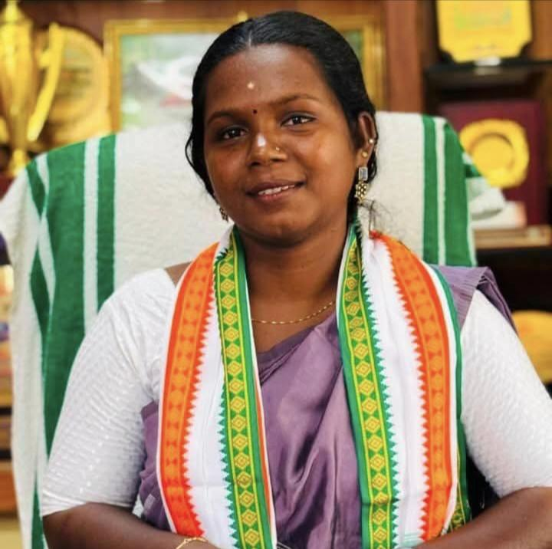
RESHMA B
President
ARUVAPPULAM Grama Panchayat
Dear residents and stakeholders of Aruvappulam Grama Panchayath,
It is with a deep sense of responsibility and foresight that I present The Pandemic Preparedness Plan (PPP) for Aruvappulam Grama Panchayath. The recent global health emergencies have served as a stark reminder that preparedness is not an option, but a mandatory pillar of community resilience. As the president of this grama panchayath, my primary commitment is to safeguard the health, well-being, and livelihoods of every single resident.
This document is more than just a plan; it is a comprehensive blueprint for action, developed in close coordination with our family health centre, veterinary department, police, and local community organizations, embodying the true spirit of the 'one health' approach. This plan critically assesses our specific vulnerabilities—from our hilly terrain and population demographics to our flood-prone areas and common disease seasonality to ensure our response is precisely tailored to Aruvappulam unique needs.
The PPP details our existing healthcare infrastructure, resource inventory, and the operational protocols required to manage any future public health crisis, including the constitution of the 'One Health Committee' for coordinated decision-making. It outlines a phased strategy covering alert/preparation, active response, and surge capacity management, ensuring we can transition smoothly from routine operations to full-scale emergency response.
Effective implementation of this plan requires the active participation of every individual, asha worker, kudumbashree member, and community leader. This is a shared responsibility. I urge all citizens to familiarize themselves with this plan and stand ready to collaborate.
Together, we will transform this preparedness plan into effective action, ensuring Aruvappulam remains a safe, resilient, and healthy community for all.
Reshma B
President

MESSAGE FROM HEALTH STANDING COMMITTEE CHAIRPERSON

K P Thomas
Health Standing Committee Chairperson

Dear Residents,
As Chairperson of the Health and Education Standing Committee, my priority is the safety of every household in Aruvappulam. We are proud to launch our Pandemic Preparedness Plan (PPP)—a roadmap designed to keep our families safe during times of crisis.
This isn’t just a document; it’s a promise. We have worked closely with our doctors, veterinary experts, and local officials to create a "One Health" framework that understands how our environment, our animals, and our people are all connected. Whether you live in our hilly highlands or our riverside communities, this plan is tailored to protect you.
Preparation is our greatest strength. Together, we are building a healthier, safer Aruvappulam.
Our commitment is unyielding: to ensure that when the next challenge arises, Aruvappulam is not just ready, but resilient.

K P Thomas
Health Standing Committee Chairperson

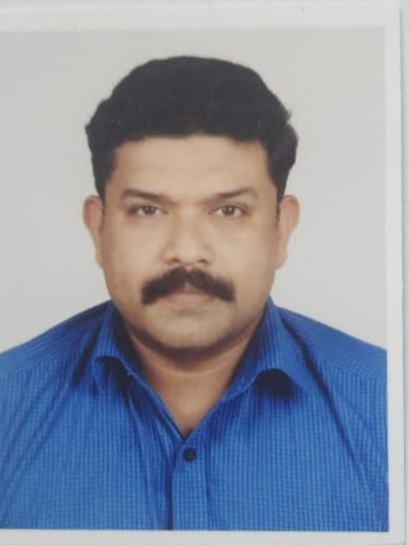
MESSAGE BY MEDICAL OFFICER

DR. .RAJESH S.R
Medical officer in.charge
PHC kokkathodu

As we navigate 2026, the memory of COVID-19 and the more recent global outbreaks of Mpox, H5N1, and Ebola in 2025 serve as a stark reminder that pandemic preparedness is a vital necessity rather than a choice. Despite the lessons learned, global defenses remain fragile; therefore, at PHC Kokkathodu, we are actively advocating for enhanced workforce resources and the establishment of a "warm infrastructure"—a state of constant readiness that allows us to pivot immediately when a novel pathogen emerges. Our strategic focus for protecting Aruvappulam rests on four pillars of localized defense: collaborative surveillance for early detection, clinical care excellence to manage surges, rapid inter-departmental coordination, and robust community protection through equitable health access.
This proactive stance is designed to address the rigorous criteria used by the WHO to designate a pandemic, specifically targeting threats that pose international risks, possess a communicable nature, and threaten wide demographic spread. By preparing for events that could lead to system overloads, significant socio-economic disruption, or the need for unified international action, we aim to ensure the residents of Aruvappulam are never caught off guard. Ultimately, our goal is to build a resilient health system through your continued cooperation in surveillance and vaccination efforts, securing a safer future for our entire community.
Dr. Rajesh S R
Medical Officer, PHC Kokkathodu

EXECUTIVE SUMMARY

Primary Health Centre (PHC) functions as the primary public healthcare institution serving the population of Aruvappulam Grama Panchayath. The PHC plays a pivotal role in delivering comprehensive, accessible, and affordable healthcare services, with a strong focus on preventive, promotive, curative, and rehabilitative care in accordance with national and state health programmes.
The PHC caters to a predominantly rural population, addressing key public health priorities such as maternal and child health, communicable and non-communicable disease control, immunization, family welfare, adolescent health, and geriatric care. Regular outpatient services, home-based care through field health staff, and outreach activities ensure healthcare coverage even in geographically challenging areas. The institution actively implements national health missions, including the National Health Mission (NHM), National Tuberculosis Elimination Programme, National Programme for Prevention and Control of Cancer, Diabetes, Cardiovascular Diseases and Stroke (NPCDCS), and other disease surveillance initiatives.
Kokkathodu PHC works in close coordination with the Grama Panchayath, ASHA workers, Anganwadi centres, schools, and community-based organizations to strengthen community participation and improve health awareness. Emphasis is placed on early detection, timely referral, health education, and lifestyle modification to reduce disease burden and improve overall health outcomes.
Despite constraints related to infrastructure, manpower, and increasing service demand, the PHC continues to enhance service delivery through effective planning, data-driven decision-making, and community engagement. Strengthening facilities, upgrading digital health systems, and expanding preventive services remain key focus areas for future development.
Overall, Kokkathodu Primary Health Centre stands as a vital institution in safeguarding public health and improving the quality of life of the residents of Aruvappulam Grama Panchayath

LIST OF ABBREVIATIONS

LSGD/LSGI | Local Self Government Department / Local Self Government Institution
BMO | Block Medical Officer
IDSP | Integrated Disease Surveillance Programme
NDMA | NationalDisaster Management Authority
PPE | Personal Protective Equipment
ICMR | IndianCouncil of Medical Research
CD | Communicable Diseases
NCD | NON-COMMUNICABLE Diseases

TABLE OF CONTENTS

3
INTRODUCTION 9
LSGD AT A GLANCE 9
INTEGRATED HEALTH INFRASTRUCTURE MAP OF ____________ PANCHAYAT 10
GENERAL PROFILE OF THE LSGI’S 13
Background of the LSGI 13
Demographic and Vulnerable Population 14
Clinical Vulnerability 16
INFRASTRUCTURE & RESOURCE INVENTORY 18
Health Facility Directory & Basic Capacity in the LSGD 18
Private Clinics 19
Healthcare Education & Training Institutions 20
Specialized Services & Emergency Inventory 20
Oxygen & Diagnostic Capacity 21
Diagnostics facility mapping at the LSGI level 22
Laboratory Identification & Basic Details 22
Social and Community Infrastructure for surge plan 22
Human resources 24
Community & Support Cadre 25
Community Organizations 26
Administrative & Emergency Services 27
Information regarding resources 27
ONE HEALTH & ENVIRONMENTAL SURVEILLANCE 28
Animal & Bird Population 28
Veterinary Infrastructure 29
Veterinary Doctors & Workforce 30
High-Risk Interface Points (Surveillance Sites) 30
Environmental Risk Mapping 31
Disease Seasonality Mapping 32
Vulnerability Mapping 33
EPIDEMIOLOGICAL TRENDS (2021–2025) 34
Disease Burden among human beings(Last 5 Years) 34
*(use the above table data to create the graph/diagram) 36
Seasonal Trend Analysis 37
Outcome-Based Trend Analysis- 2025 39
Transmission Trend- 2025 40
Integrated Disease Hotspot Map (2021–2025) 42
Preparedness and Response Protocol at LSG Level 44
Constitution of One Health Committee 44
Pandemic Response Workforce 45
Activities and Measures before and during Pandemic 47
PHASE 1 - Alert / Preparation 47
PHASE 2 - Active Response 50
Standard Screening Protocol 51
PHASE 3 - Surge Capacity 60
Conversion of Community Facilities 60
CONCLUSION 61
RECOMMENDATIONS 62
ANNEXURE 63
1. 86

INTRODUCTION

LSGD AT A GLANCE
- Geographical boundaries with political map (based on latest delimitation)
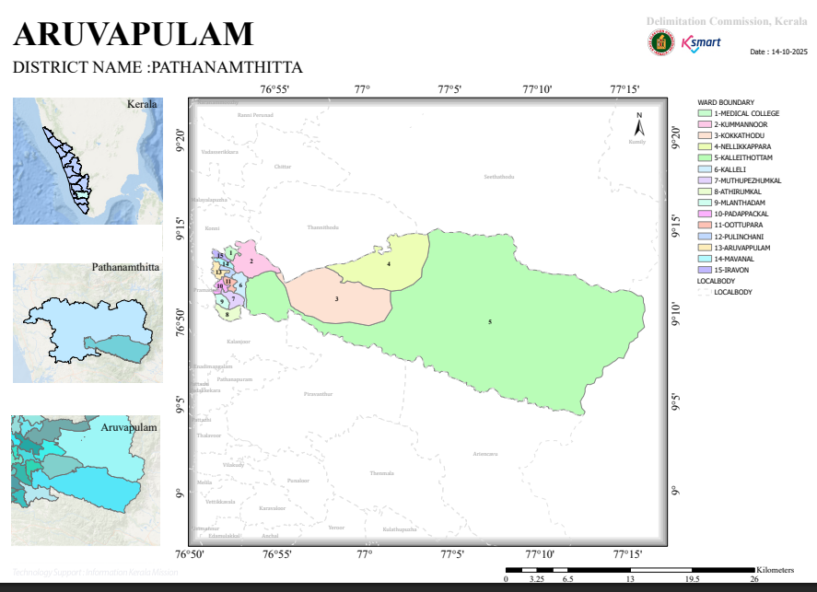
- Baseline data
Area (In Sq.Km) | 277.7 SQ KM
Number Of Wards | 15
Number Of Houses | 6669
Number Of Dwelling House | 5856
Total Population | 21202
Male | 10196
Female | 11006
SC Population | 2265
Male | 1059
Female | 1206
STPopulation | 319
Male | 143
Female | 176
Number Of SC Colonies | 7
Number Of ST Colonies | 3
No Of SC House | 710
Number Of ST House | 85
Basic Health Sections | 5
HWCs | 6
Eligible Couples | 2715
0-1 Year | 95
Male | 43
Female | 52
1-5 Year | 690
Male | 351
Female | 339
10-18 Year | 1095
Male | 533
Female | 562
Above 30 | 7571
Male | 3420
Female | 4151
Above 60 | 3981
Male | 1852
Female | 2129
Number Of Asha Workers | 19
Number Of Anganwadies | 34
ORT Depots | 54
Government Hospitals(Total) | 4
Allopathy | 2
Ayurveda | 1
Homeo | 1
Private Hospitals (Total) | 0
Allopathy | 0
Ayurveda | 0
Homeo | 0
Dental Clinics | 0
Laborotories | 4
Scanning Centre | 0
Educational Institutions(Total) | 8
Government Schools Total | 3
HSS | 0
HS | 1
UPS | 0
LPS | 2
Pre-Primary | 0
Aided Schools Total | 3
HSS | 2
HS | 0
UPS | 1
LPS | 0
Pre-Primary | 0
Unaided Schools Total | 0
HSS | 0
HS | 0
UPS | 0
LPS | 0
Pre-Primary | 0
Colleges | 0
Other Edu. Institution | 0
Government Instituions | 14
Central Govt | 10
State Govt | 4
Number Of Hotels/Tea Shops | 59
Bakery & Coolbar | 19
Thattu Kada | 13
Borma | 1
Catering Unit | 2
Soda Factory | 1
Ice Cream Factory | 0
Chicken Stall | 1
Chicken Farm | 0
Fish Stall | 0
Meat Stall | 0
Beauty Parlours Total | 3
Men | 1
Women | 2
Markets | 0
Scrap/Akri Shop | 0
Tyre Retrading Centres | 0
Auditorium | 4
Crusher Unit | 0
Hostels | 0
Orphanages | 0
Old Age Home | 1
Worship Places Total | 27
Temple | 12
Churches | 11
Mosques | 4
Pilgrim Centres | 0
Total Number Of Wells | 4184
Public Wells | 49
Private Well | 4135
Colony Well | 0
Ponds | 0
Others | 0
Number Of Pumping Stations | 8
Water Scarcity Area | 12
Number Of Plantation | 28
Library & Reading Rooms | 4
Number Of Latrines | 6441
Arts & Sports Clubs | 1
Number Of NGOs | 0
Kudumbasree Units | 223
Number Of CDs Members | 15
Number Of ADs Group | 15
Nreg Groups | 18
Number Of Suchithwa Squad | 117
Banks | 7
Bus Stands | 0
Ksrtc | 0
Private | 0
Number Of Migrant Sites | 12
Migrant Population Total | 178
Male | 171
Female | 7

- Ward division -
Ward | Houses | Population | Migrants | Wells | Hot  spots | Ed. Institutions | Hosp pvt/govt.
15 | 6669 | 21202 | 133 | 4184 | 5 | 8 | 4(gvt)

INTEGRATED HEALTH INFRASTRUCTURE MAP OF ARUVAPPUALM PANCHAYAT

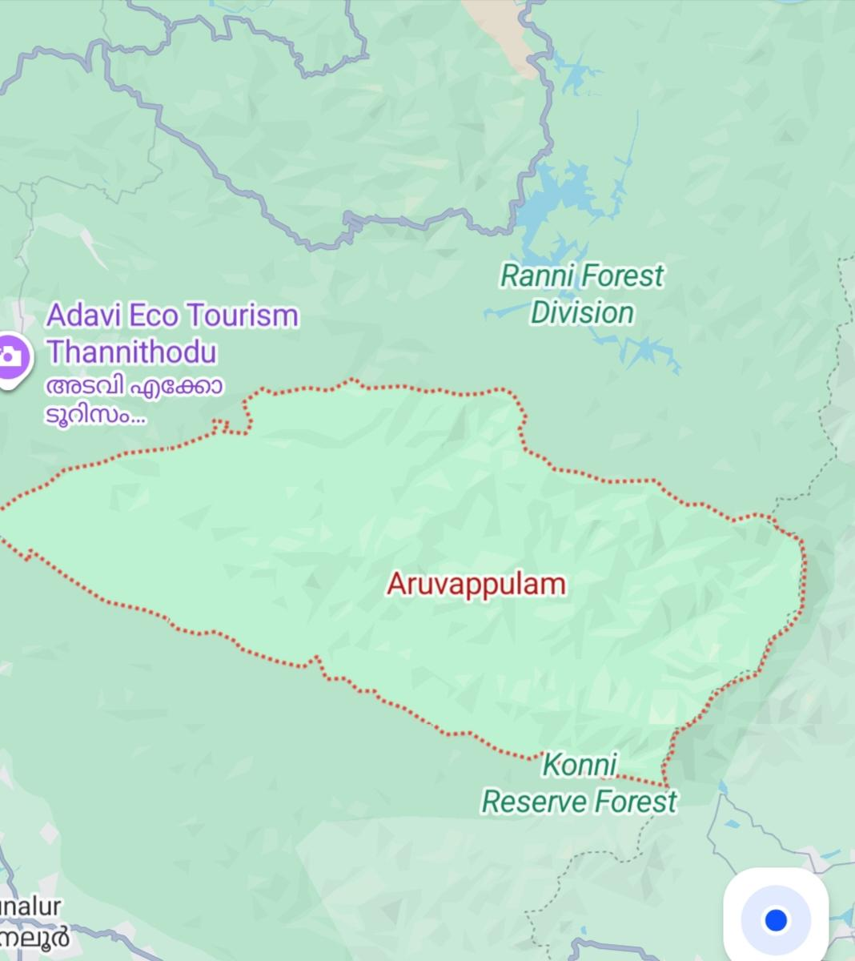

Health Infrastructure Map

GENERAL PROFILE OF THE LSGI’S

Background of the LSGI
Aruvappulam Grama Panchayat, situated in the Konni Taluk of Pathanamthitta District, is a region defined by its diverse and challenging terrain. The geographical landscape of the Panchayat is predominantly hilly. Spanning a significant area that transitions from midland plains to high-altitude hills, it serves as a critical gateway to the eastern Ghats. The panchayat is bisected by the Achankovil River, which, while a vital water resource, also creates geographical barriers during extreme weather events, occasionally isolating wards such as Kokkathodu.
A defining feature of Aruvappulam is its extensive border with the Konni Reserve Forest, a proximity that creates a unique and complex human-animal-environment interface. This geographic reality makes the panchayat a high-priority area for zoonotic disease surveillance, as close contact between residents, livestock, and wildlife increases the risk of spreading pathogens such as KFD, Rabies, or novel viruses. Within these forest fringes, the presence of indigenous tribal settlements necessitates specialized, culturally sensitive health outreach strategies to ensure equitable care.
However, the region’s socio-economic dependence on agriculture, rubber plantations, and forest livelihoods is often challenged by its inherent physical vulnerabilities. The hilly terrain and limited road access to interior wards create significant logistical hurdles for vaccine distribution and medical evacuations, while a history of landslides in the uplands and flash floods along the Achankovil River continues to threaten sanitation systems and community stability, making climate-sensitive planning a cornerstone of Aruvappulam’s resilience.
From a public health and disaster management perspective, Aruvappulam LSGI has historically been vulnerable to seasonal flooding, waterborne diseases, and vector-borne illnesses such as Dengueand Leptospirosis. The severe floods experienced during recent years, including the 2018 flooddisaster, significantly impacted life, livelihoods, and infrastructure within the Panchayat. Theserecurring emergencies have underscored the importance of strengthening local preparedness,response mechanisms, and inter-departmental coordination.
In this context, the development of a localized, data-driven Auxiliary Infrastructure and Logistical Resource Map is essential to support effective planning, timely emergency response, and sustainable development initiatives. Such mapping enables the Panchayat to identify critical resources, improve accessibility during disasters, and enhance overall resilience of the community.

Table 1: Background of LSGD
Description | Details
Name of LSGI | ARUVAPPULAM
Type (GP/Municipality / Corporation etc.) | Grama Panchayath
Block | KONNI
District | PATHANAMTHITTA
Number of wards | 15
Total area (sq. km) | 277.7 Sq.km
Population(Projected) | 21202
Population density | persons/sq km
Terrain (coastal/low-lying/backwaters/foothills, etc.) | foothills
Number of rivers passing through LSGI | 1(ACHAN KOVILAR)
Number of water bodies in the LSGI | 5
Number of educational institutions | 8
Factories / small-scale industries | 2
Flood-prone wards | 5,14,13,10
Landslide-prone wards | 3,4
Death Management and Disposal Facilities (mortuaries/crematorium, including electric) | 5
Auditoriums/Marriage halls/convention centres/community halls | 3

Demographic and Vulnerable Population
Understanding the demographic composition and vulnerable population groups is essential for pandemic preparedness. Children, elderly, economically deprived families, migrant workers, and socially vulnerable groups are at increased risk during public health emergencies due to higher exposure, limited access to services, and dependency on public systems..

Description |  | Details (in numbers)
DEMOGRAPHIC PROFILE
Total population |  | 21202
Male |  | 10196
Female |  | 11006
Transgender |  | 0
Children under 5 |  | 695
Adolescent |  | 785
Elderly (>60) |  | 3981
SOCIAL/LIVELIHOOD VULNERABILITY
Previous EPEP family |  | 63
BPL family |  | 2300
Tribal communities |  | 1
Migration | Immigrant | 1050
Migration | Emigrant | 133
Socio-economically deprived |  | 63
Fisherfolk |  | 0
SC Community |  | 2265
ST Community |  | 319
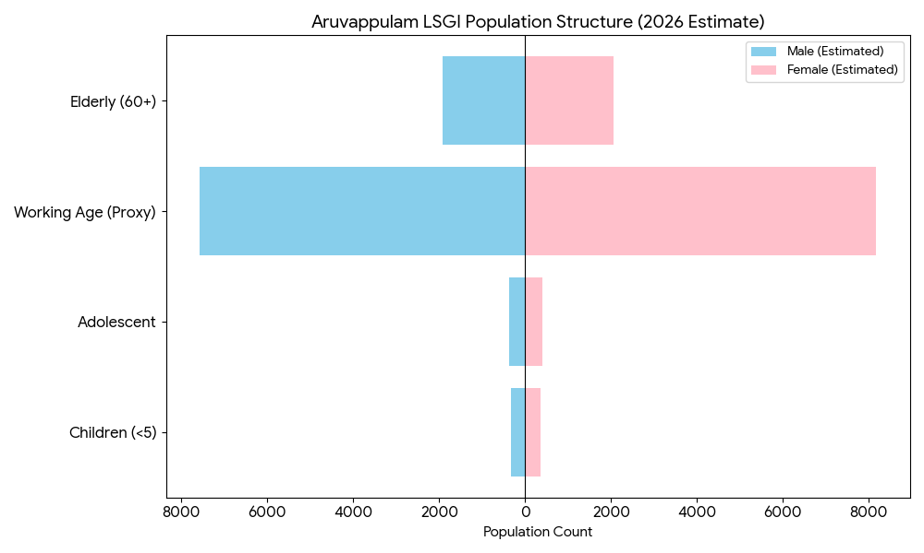

Pandemic planning for the panchayat must prioritize several key vulnerable groups to ensure an effective response. The community faces a significant clinical risk due to its aging population, with nearly 4,000 elderly residents requiring specialized medical infrastructure compared to fewer than 700 young children. Economic barriers are also a major concern, as over 2,300 low-income (BPL) and marginalized (SC) families may struggle to access private care or maintain essential supplies during a crisis. Furthermore, the tribal (ST) community serves as a critical "One Health" interface near forest areas where zoonotic diseases often emerge, necessitating specialized surveillance. Finally, the presence of over 1,000 migrant workers presents a unique challenge, as language barriers and a lack of local support systems can make it difficult to provide them with timely vaccinations and health information.

Clinical Vulnerability
Certain population groups need priority healthcare & are at higher risk of severe illness, complications, and mortality during pandemics. Patients with chronic diseases, those requiring regular medical care, and individuals with mobility or functional limitations face challenges in accessing timely care during emergencies. Mapping these groups helps in prioritizing continuity of treatment, medicine stock planning, oxygen support, referral transport, and targeted home-based care.
Description | Details in numbers
Pregnant women | 54
Lactating mothers | 75
Bedbound patients | 32
Patients under palliative care other than bedbound | 122
Patients on Haemodialysis | 16
Patients on CAPD | 0
Cancer patients (currently on treatment) | 144
Haemophilic patients | 1
Mentally challenged | 59
Differently abled | 53
Diabetic patients | 1328
Hypertensive patients | 1680
TB patients | 5

Major Festivals & Events specific to the LSGI
(with the possibility of a public gathering)

Sl. No. | Name of festival | Month detailing the periodicity
1 | SHIVARATHRI | FEBRUARY
2 | PATHAMUDAYAM | APRIL
3 | BHARANI ULSAVAM | MARCH

INFRASTRUCTURE & RESOURCE INVENTORY

Health Facility Directory & Basic Capacity in the LSGD
This section provides an overview of the healthcare infrastructure available within the LSGD area. It outlines the distribution and basic capacity of health facilities that form the backbone of service delivery during routine times and public health emergencies.

Family Health Centres (FHCs) and Community Health Centres (CHCs) generally function as the first point of contact for the community, providing essential outpatient and inpatient services. General Hospitals (GH) and Medical College Hospitals (MCH), where accessible, serve as the main referral centres for advanced diagnostics, specialist care, and critical services during public health emergencies. This inventory helps identify existing strengths, gaps, and potential surge capacity that can be mobilised during a pandemic or disaster.

Table 5. Health Facility Resource Summary
Sl.no. | Health Facility | Type of Facility (MCH/GH/CHC/FHC/SC etc.) | Contact Number | Total beds | ICU Beds | Oxygen-Supported Beds | No. of Ventilator Support Beds | No. of ambulances
Government Healthcare Facilities
1. | MCH KONNI | MCH | 0468 234823  9447288829 | 300 | 27 | 300 | 5 | 1
2. | PHC KOKKATHODU | FHC | 9074492264 | 0 | 0 | 0 | 0 | 0
Private Healthcare Facilities
 | 0 | 0 | 0 | 0 | 0 | 0 | 0 | 0
AYUSH Healthcare Facilities
1. | GOVT.HOMEO Dispensary kalleli | HWC | 9846414908 | 0 | 0 | 0 | 0 | 0
2. | GOVT.Ayurveda Dispensary ,kalleli | HWC | 8281376564 | 0 | 0 | 0 | 0 | 0

Private Clinics
Private clinics are an essential part of pandemic preparedness, as they are often the first place people seek care when symptoms begin. In many communities, private clinics manage a significant share of outpatient visits and therefore play a critical role in early case detection, timely referrals, and disease surveillance. Having an up-to-date understanding of where these clinics are located, the services they provide, and how they are linked to the public health system helps ensure that no cases are missed during an outbreak. It also allows health authorities to engage private practitioners more effectively for reporting, risk communication, and coordinated response, strengthening the overall capacity of the health system to manage public health emergencies.

Table 6. Private Clinic Resource Summary
Sl No. | Name of Clinic | Registered (Y/N) | Clinic (General / Speciality) | Speciality (if any) | Address | Contact Number | Diagnostic Facility (Y/N) | Ambulance Linkage (Y/N)
1. | 0 | 0 | 0 | 0 | 0 | 0 | 0 | N

Healthcare Education & Training Institutions
This section tracks the educational infrastructure available, which is vital for human resource planning in the health sector.

Category of Institution | Govt | Private | AYUSH | Total
Medical Colleges | 1 | 0 | 0 | 1
Nursing Colleges | 1 | 0 | 0 | 1
Dental Colleges | 0 | 0 | 0 | 0
Para-medical / Allied Health | 0 | 0 | 0 | 0
Pharmacy Colleges | 0 | 0 | 0 | 0

Specialized Services & Emergency Inventory
This section provides a detailed view of the specialized medical resources available to the community, focusing on emergency response and critical care capabilities. This table tracks the vital assets required for managing severe illnesses and emergencies across Government, Private, and AYUSH sectors.

Item | Govt | Private | AYUSH | Total
Hospital beds | 300 | 0 | 0 | 300
Oxygen-generating systems(Y/N) | Yes | 0 | 0 | 1
Oxygen-supported beds (Numbers) | 300 | 0 | 0 | 300
Ventilator-supported beds | 5 | 0 | 0 | 5
ICU beds | 27 | 0 | 0 | 27
Burns units | Nil | 0 | 0 | 0
Blood centres | Yes (1) | 0 | 0 | 1
BLS ambulances | 1 | 0 | 0 | 1
ALS ambulances | Nil | 0 | 0 | 0
Dialysis facilities | Nil | 0 | 0 | 0
Dispensaries | Nil | 0 | 2 | 2
Medical store | 1 | 2 | 0 | 3
Industrial establishments (Medium-scale industries/small-scale industries establishments to whom we can depend in a worst-case scenario) | Nil | 0 | 0 | 0

Oxygen & Diagnostic Capacity
Monitoring oxygen and diagnostic capacity is a critical component of public health preparedness, ensuring that the LSGD can handle both chronic care and sudden surges in respiratory or infectious diseases.
Name of Health Facility | Oxygen-generating System (Y/N) | Backup Oxygen Source (Y/N) | Diagnostic Facilities Available(Y/N)
Name of Health Facility | Oxygen-generating System (Y/N) | Backup Oxygen Source (Y/N) | Lab | USG | X-ray | CT/MRI | RT-PCR
Government Healthcare Facilities
MCH KONNI | Y | Y | Y | Y | Y | Y | Y
PHC KOKKATHODU | N | N | Y | N | N | N | N

Diagnostics facility mapping at the LSGI level
The diagnostic capacity of Aruvappulam G.P represents the "intelligence network" of our healthcare system. The speed and accuracy of disease identification depend entirely on the distribution and technical level of these facilities.

Item | Govt | Private | AYUSH | Total
General labs | 0 | 1 | 0 | 1
Microbiology labs | 0 | 0 | 0 | 0
RT-PCR labs | 0 | 0 | 0 | 0
USG units | 0 | 0 | 0 | 0
CT/MRI units | 0 | 0 | 0 | 0
Research labs | 0 | 0 | 0 | 0
Labs of other departments that can be repurposed | 0 | 0 | 0 | 0

Laboratory Identification & Basic Details
Sl. No. | Name of Laboratory | Ownership (Govt / Private / Academic) | Address | Contact No. | 24×7 Services (Yes/No) | NABL / Govt Approved (Yes/No)
1 | Micro lab, konni | Private | Green valley shopping complex nearcMCH konni | 9747002700 | Yes | Yes
2 | Medon | Private | Medo lab, pulinchani Aruvappulam | 9846396976 | Yes | No
3 | Govt MCH konni | Govt | MCH konni | 9745595794 | Yes | Yes
4 | Microvision kollampadi | Private | Microvision, kollanpadi | 8157951914 | Yes | Yes
5 | Medicare | Private | Medicare, Anakuthy | 9846729418 | Yes | Yes
6 | GOVT.Homeo dispensary,kalleli | govt | kalleli,konni | 9746315360 | yes | yes
7. | GOVT.Ayurvedic Dispensary,kalleli | GOVT | Kalleli,konni | 8281376564 | yes | yes

Social and Community Infrastructure for surge plan
This table serves as our logistics and shelter inventory. By mapping these locations, quickly we can identify where to house displaced citizens, where to set up temporary medical clinics, and how to manage the deceased with dignity during a crisis.

Category | Total Count | Ward | Est. Capacity (Persons) | Contact details
Educational Institutions
Anganwadis | 34 | 15 | 12/person
Schools | 8 | 1,15,13,8,3
Colleges | 0 | 0 | 0 | 0
Healthcare Educational Institutions
Medical colleges (Govt/Private) | 1(govt) | 1
Nursing colleges (Govt/Private) | 1(govt) | 1
Dental colleges (Govt/Private) | 0 | 0 | 0 | 0
Paramedical institutes (Govt/Private) | 0 | 0 | 0 | 0
Community Gathering Spaces
Community halls | 8 | 5,8,13
Auditoriums | 1 | 6
Religious buildings | 14 | All wards
Vulnerable Group Support Facility
Destitute homes | 0
Elderly homes | 1
LSGD owned other buildings | 3
Mass Fatality Management (MFM) Infrastructure
Mortuary | 1 | 5
Crematorium | 4
*refer annexure 1 for contact details

Human resources
This section focuses on the human capital available within the LSGI. In any emergency—be it a pandemic, flood, or industrial accident—infrastructure is only as effective as the people operating it.

Medical & Clinical Personnel
This table tracks the "Frontline" providers responsible for diagnosis, treatment, and clinical management. The healthcare human resource profile of Aruvappulam displays a 100% concentration within government facilities, with no recorded private sector participation across the ten core medical cadres. While this lack of a private-public mix is unusual, it offers a distinct advantage for pandemic management: the entire health workforce of 194 personnel is under a unified command structure, eliminating the coordination hurdles often found in regions with fragmented private care.
However, this data also highlights a significant resource vulnerability. In most LSGIs, private clinics and laboratories act as a "pressure valve" during surges. In Aruvappulam, the Government sector serves as both the primary care provider and the only surge capacity. A detailed directory with the contact numbers of all workers is maintained (Annexure in 1).

Cadre | Govt (No.) | Private (No.) | Total
Doctors—Modern Medicine | 96 | 0 | 96
Doctors – AYUSH | 2 | 0 | 2
Doctors – Veterinary | 1 | 0 | 1
Doctors – Dental | 1 | 0 | 1
Nursing officers | 75 | 0 | 75
Lab technicians | 9 | 0 | 9
Optometrist | 2 | 0 | 0
Pharmacists | 8 | 0 | 8
Psychologists | 1 | 0 | 1
Counsellors | 1 | 0 | 1

Public Health & Field-Level Workforce
These individuals are the backbone of surveillance, maternal-child health, and decentralized care.

Cadre | Health services | Municipal common services | Total
HS (Health Supervisors) | 0 | 0 | 0
HI (Health Inspectors) | 1 | 0 | 1
LHS (Lady Health Supervisor) | 0 | 0 | 0
LHI (Lady Health Inspectors) | 1 | 0 | 1
JPHN (Jr Public Health Nurses) | 4 | 0 | 4
JHI (Jr Health Inspectors) | 4 | 0 | 4
MLSP (Mid-Level Service Providers) | 6 | 0 | 6
Palliative Nurses | 1 | 0 | 1
RBSK Nurses | 1 | 0 | 1
PRO | 0 | 0 | 0
Epidemiologist | 0 | 0 | 0
Data Manager | 0 | 0 | 0

Community & Support Cadre
This group represents the surge capacity of the LSGI—people who can be called upon for logistics, rescue, and specialized support.

Cadre | Number
ASHA Workers | 19
AWW (Anganwadi Workers) | 34
Emergency Medical Volunteers (Trained) | 9
Kudumbashree | 223
MNREGS | 18
Purusha Swayam Sahaya Sangham | 15
Ex-Servicemen | 74
Retired Police Officers | 16
NCC/NSS Volunteers | 28
Red Cross volunteers | 30
One Health Community Volunteers | 105
One Health Community Mentors | 15

Community Organizations
This section details the presence of community-based organisations (CBOs), non-governmental organisations (NGOs), faith-based organisations (FBOs), Kudumbashree Self-Help Groups (SHGs), and Ayalkootams within the Local Self-Government Institution (LSGI). These groups enhance grassroots mobilization, resource distribution, and support networks crucial for pandemic response and community resilience.

Category | Total Count
NGOs | 0
Religious based organizations | 3
Foreign based organizations | 0
Sports Club/youth clubs | 4
Kudumbashree SHGs | 120
Ayalkootams | 120
Political organizations | 3
Residential organizations | 2

Administrative & Emergency Services
This section outlines the availability of key non-health emergency support services and infrastructure within the LSGI, which are essential for effective pandemic preparedness and response. These facilities support law enforcement, disaster response, water supply, logistics, mobility, and community-level interventions during public health emergencies.

Category | Total Count | Contact details
Police Stations | 0 | Na
Fire & Rescue Stations | 0 | Na
Water Pumping Points | 10 | Na
Public Distribution System (PDS) | 1 | -

Information regarding resources
The availability of essential transport and support resources plays a quiet but critical role in saving lives. Equipment such as ambulances, mobile mortuaries, amphibian ambulances, and motorized boats ensures that patients, samples, and healthcare teams can move swiftly—even in flooded, remote, or difficult terrains. Heavy vehicles like JCBs, cranes, tractors, and torus lorries support logistics, waste management, emergency infrastructure, and rapid conversion of spaces into care or isolation facilities. Taxis, four-wheel-drive vehicles, and trucks help maintain continuity of essential services, reach vulnerable populations, and support home-based care and supply delivery.

Means of transportation | Total Count
JCB | 4
Crane | 0
Heavy Trucks | 0
Tractor | 2
Ambulances | 3
Mobile mortuaries | 0
Boats | 0
Taxi service | 26
Note: For specific details regarding vehicle owners and contact information, please refer to Annexure [X].

ONE HEALTH & ENVIRONMENTAL SURVEILLANCE
The One Health method integrates environmental, animal, and human health to enable proactive pandemic preparedness. Panchayat-level surveillance needs to be improved in order to detect and treat zoonotic and environmentally generated diseases early. Surveillance is strengthened through systematic assessment of animal populations, veterinary infrastructure, poultry and slaughter facilities, inter-sectoral coordination, and specialised tools like avian influenza seasonality mapping using GIS in previous outbreaks to enable predictive alerts and ward-specific sampling to support effective pandemic preparedness in high-risk areas like Kokkathodu

Animal & Bird Population
Mapping animal and bird populations at the Panchayat level is essential for identifying and prioritising zoonotic disease hazards like rabies, avian influenza (H5N1), leptospirosis, anthrax, and Nipah-like spillover occurrences. Risk classification, targeted surveillance, vaccination planning, and early epidemic detection made feasible by comprehensive population mapping all enhance One Health-based pandemic preparedness.

Category | Item | Estimated Population | Wards
Animal Population | Livestock (Cattle/Goats/Buffalo) | 1642 | all wards
Animal Population | Pet Animals (Dogs/Cats) | 1447 | all wards
Animal Population | Stray Dog Population | 298 | all wards
Animal Population | Pig Farms (Number of heads) | 1 | 11
 | Small Units (Sheep / Goats – clustered) | 3 | 3,4,5
Bird Population | Poultry Units (Birds) | 10 | 3,4,5,7,11,1
Bird Population | Poultry- (FOWL) | 1087
Bird Population | Wild/Migratory Birds (Observed) | 0 | 0
Bird Population | Crow Mortality Events (Reported) | nil

The livestock and avian profile of Aruvappulam creates a complex epidemiological landscape that requires a synchronized "One Health" approach to prevent zoonotic transmission. With a significant livestock population of 1,642 heads and nearly 1,500 domestic pets distributed across all wards, the panchayat faces a persistent Rabies risk exacerbated by the presence of 298 stray dogs; this necessitates a primary preventive strategy centered on mass anti-rabies vaccination and Animal Birth Control (ABC) programs. Furthermore, the clustering of specialized sheep and goat units in Wards 3, 4, and 5 establishes these sectors as likely epicenters for ruminant-specific pathogens like Foot-and-Mouth Disease (FMD).
The avian sector introduces a more critical threat regarding Influenza surveillance, particularly in Ward 11, which is identified as the panchayat's most sensitive epidemiological site. While current crow mortality remains at zero, the unique Pig-Poultry Interface in Ward 11—where a pig farm exists in close proximity to poultry units—creates a high-priority "hotspot" for viral reassortment, a known risk factor for the emergence of novel influenza strains.
When combined with the concentration of 1,087 fowls across Wards 3, 4, 5, 7, 11, and 1, these factors demand an integrated monitoring system that bridges veterinary and human health services to detect and contain potential H5N1 or other cross-species outbreaks before they reach the human population.
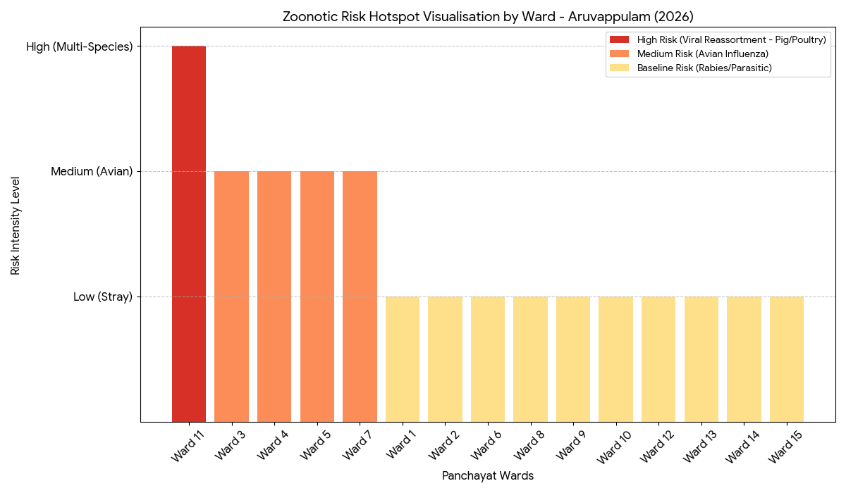
The following chart categorizes the 15 wards based on their specific biological threats. The intensity levels reflect the complexity of the human-animal interface in each sector which allows for immediate identification of where surveillance and resources should be concentrated.

Veterinary Infrastructure
Veterinary institutions are a core pillar of One Health surveillance, enabling early zoonotic disease detection through vaccination, investigation of unusual animal illness or deaths, sample collection, and timely outbreak reporting. A well-mapped and responsive veterinary network strengthens coordination with human health and LSGI systems, ensuring rapid response during zoonotic events and pandemics.
Facility Type | Name of Facility | Ownership Govt / Pvt | Location(Ward No) | Contact number
Veterinary Dispensary | veterinary dispensary ayravon | GOVT | 15
Veterinary Hospital / Polyclinic | NIL
Private Veterinary Clinics | NIL
Mobile / Emergency Vet Service (incl. night services) | MOBILE VETERINARY UNIT | GOVT | UNDER KONNI VETERINARY HOSPITAL | 1962
Pet Homes / Animal Shelters | NIL
Slaughterhouse-linked Veterinary Inspection Unit | NIL

Veterinary Doctors & Workforce
Early detection, diagnosis, reporting, and reaction to animal illness epidemics depend on the availability and accessibility of qualified veterinary specialists. By identifying unusual animal morbidity or mortality promptly, collecting samples promptly, and coordinating efficiently with human health and LSGI systems especially during zoonotic outbreaks and pandemic-prone situations a clearly defined veterinary workforce enhances One Health surveillance.

Category | Number Available | Type (Govt/Pvt) | Contact number
Government Veterinary Doctors | 1 | GOVT | 8714109342
Private Veterinary Doctors | 0 | - | -
Livestock Inspectors | 2 | 2 | 918883838
Para-veterinary Staff / Attenders | 1 | 1 | 9074422194
Contract / On-call Veterinary Support (if any) | 1 | 1 | 1962(MOBILE VETERINARY UNIT)

High-Risk Interface Points (Surveillance Sites)
High-risk interface points for zoonotic disease surveillance in Aruvappulam Grama Panchayath include wetland–livestock–human contact zones, backyard poultry farms, cattle sheds near water bodies, fish markets, and areas of high human–animal interaction such as community slaughter points and migratory bird congregation sites. These are the primary surveillance sites where zoonotic spillover risks are elevated.

Type of Habitat | Type of High-risk interface | Geographical vulnerability
Wetlands & Backwaters | 0
Backyard Poultry Farms | 0
Cattle Sheds near Water Bodies | 0
Fish & Meat Markets | 0
Community Slaughter Sites | 0
Migratory Bird Congregation Areas | 0
Rodent-Infested Grain Storage | 0

Category | Total Count | Key Locations (wards)
Poultry Farms | 0
Backyard / Clustered Poultry Units | 0
Duck Rearing Units (open water access) | 0
Slaughterhouses/ Slaughter Points | 0
Meat/Fish Markets | 0
Live Bird Sale Points | 0
Cattle Markets / Weekly Animal Fairs | 0
Pet Shops / Breeders | 0
Animal Shelters / Pet Homes | 0
Waste Disposal Sites near Animal Units | 0

Environmental Risk Mapping
Environmental risk mapping identifies monsoon/flood hotspots for vector-borne (dengue, chikungunya), water-borne (leptospirosis, diarrhoea), and zoonotic diseases in Kerala's wetlands. Systematic surveillance supports early warnings, targeted interventions, and Panchayat pandemic preparedness.
Waterborne exposure: Flood-prone areas and stagnant water bodies facilitate leptospira survival, raising leptospirosis risk.

Traditional practices: Informal slaughter and fish markets lack standardized hygiene, creating spillover opportunities.

Risk Factor | High-Risk Wards | Key Locations | Risk Level (High/Med/Low)
Flood-prone areas | 2,5,12,13,14,15 | kummannoor,Vayakara, | Medium
Water bodies/wetlands | 0
Solid waste accumulation | 1 | Kalleli | Medium
Animal waste disposal issues | nil
Rodent infestation zones | nil
Industrial effluent discharge | 1 | Aruvappulam | Medium
Construction sites / abandoned buildings | 1 | MCH Konni | High
Poor drainage/blocked canals | nil
Drinking water source contamination risk | nil
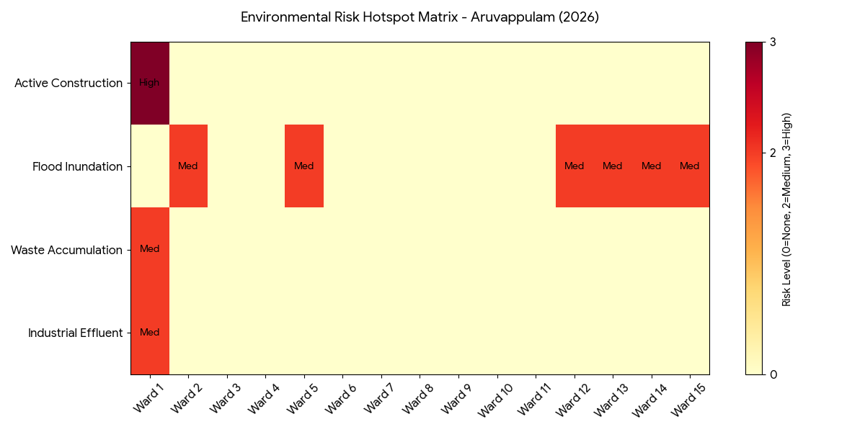
The environmental risk profile of Aruvappulam identifies specific geographic clusters where physical conditions could trigger public health emergencies. This mapping is vital for pre-positioning sanitation resources and vector control teams. By using this Environmental Risk Matrix, the Aruvappulam LSGI can transition from reactive disaster management to a proactive Environmental Health Surveillance model. Wards with a "High" or multiple "Medium" risk scores are designated as Priority 1 Zones for the rapid response teams during the initial 24 hours of any public health alert.

Disease Seasonality Mapping
1, Flooding & waterlogging → amplifies leptospirosis, malaria, diarrheal diseases.
·
2, Migratory bird influx (Nov–Feb) → avian influenza risk.

3, Mosquito breeding cycles → vector-borne disease peaks in monsoon.

4, Agricultural practices → close human–animal contact in paddy fields.

Disease | Peak Risk Season | Key Drivers | High-Risk Locations | Surveillance Focus
Avian Influenza | Jan-Feb | Avian birds | Kokkathodu | Poultry farms
Leptospirosis | Jun-Sep | Cattles | Kalleli | Farmers
Dengue/Chikungunya | Mar -Sep | Mosquito | Muthupezhumkal | Vector indices
Acute Diarrheal Diseases | all over the year | water | All wards
Rabies | No case reported | Na | Na | Na
Anthrax (rare) | No case reported | Na | Na | Na

Vulnerability Mapping
Vulnerability mapping pinpoints high-risk populations, occupations, and areas exposed via environment, livelihoods, socio-economics, and poor service access. Paired with environmental/seasonality mapping, it enables risk-based surveillance, targeted actions, and optimal resource use in One Health and pandemic planning.
Vulnerability Factor | High-Risk Wards | Key Groups / Locations | Risk Level
Flood-prone households | 14,13,12,15,2,5 | Vayakara ,Kummanoor | Medium
Wetland-adjacent communities | 0
Backyard poultry / duck rearing households | 0
Livestock-rearing households | 97
Slaughterhouse & meat market workers | 0
Fisherfolk & fish market workers | 5
Sanitation workers | 24
Daily wage / migrant workers | 168
Elderly & chronically ill populations | 154
Pregnant Women | 53
Children (schools, Anganwadi’s) | 2347
Limited access to safe water & sanitation | 3 | Muthupezhumkal,Aruvappulam,Kokkathodu | High

EPIDEMIOLOGICAL TRENDS (2021–2025)

Disease surveillance is the systematic collection, analysis, and interpretation of health data for planning, implementation, and evaluation of public health practice. This section presents the disease surveillance profile of the LSGI based on routine reporting systems and outbreak investigations to identify priority diseases, seasonal patterns, and emerging public health threats.

Disease Burden among human beings (Last 5 Years)
Analysis of disease-wise data for the last five years helps identify persistent public health problems, emerging diseases, and changes in disease burden. This information supports prioritisation of prevention, preparedness, and response activities at the Panchayat level.

Disease | 2021 | 2022 | 2023 | 2024 | 2025 | Trend(Increasing/Stable/Decreasing)
Dengue | 2 | 6 | 84 | 106 | 14 | Decreasing
Leptospirosis | 1 | 2 | 2 | 3 | 9 | Increasing
Hepatitis A | 0 | 0 | 0 | 5 | 12 | increasing
Malaria | 0 | 0 | 0 | 0 | 1 | stable
Scrub Typhus | 0 | 0 | 0 | 1 | 0 | decreasing
Typhoid | 0 | 0 | 0 | 1 | 0 | decreasing
H1N1 | 0 | 0 | 1 | 9 | 1 | decreasing
H3N2 | 0 | 0 | 0 | 0 | 1 | stable
ADD | 10 | 11 | 5 | 27 | 34 | increasing
Mumps | 0 | 0 | 0 | 0 | 0 | decreasing
Measles | 0 | 0 | 0 | 0 | 0 | decreasing
Hepatitis B | 0 | 0 | 2 | 1 | 1 | stable
Hepatitis C | 0 | 0 | 0 | 0 | 0 | decreasing
Tuberculosis | 0 | 7 | 11 | 9 | 11 | increasing
Leprosy | 0 | 0 | 0 | 1 | 0 | stable
COVID-19 |  |  |  |  | 4 | decreasing

The epidemiological landscape of Aruvappulam has undergone a significant shift between 2021 and 2025, moving from a volatile "peak and correction" of Dengue toward a more sustained rise in waterborne and zoonotic threats. While Dengue cases dramatically spiked to a historic high of 106 in 2024 before dropping to 14 in 2025—largely due to construction-related volatility in Ward 1 (MCH Konni)—a more concerning upward trajectory is now visible in diseases like Acute Diarrheal Disease (ADD) and Hepatitis A, which reached 34 and 12 cases respectively in 2025. This divergence indicates that while vector control has improved, distinct environmental vulnerabilities related to seasonal flooding and water source contamination in Wards 12–15 remain unaddressed. Simultaneously, the emerging threat of Leptospirosis, which has seen a steady nine-fold increase to 9 cases, signals intensified rodent-human interaction. In contrast, chronic and respiratory diseases like Tuberculosis and H1N1 have stabilized, suggesting a constant but managed burden.
Consequently, the 2026 Pandemic Preparedness Plan must transition from a primary focus on vector-borne diseases to a balanced approach prioritizing water safety and hygiene. Strategic actionable insights include establishing early warning thresholds where any month reporting more than 5 Dengue cases triggers immediate ward-level emergency meetings and maintaining a "Hot-Reserve" of Doxycycline at the PHC to address the rising Leptospirosis risk among high-risk workers.

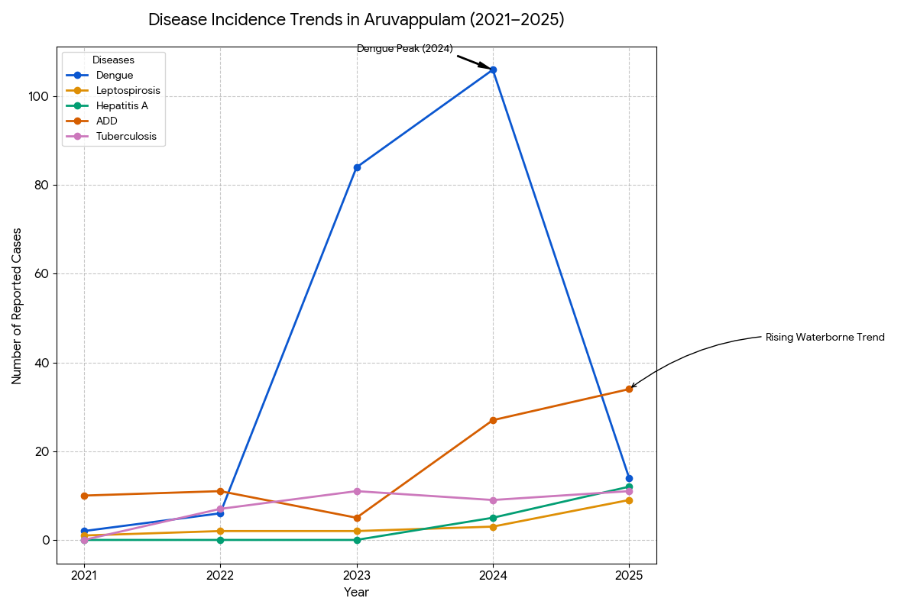
The epidemiological analysis identifies the shifting health risks in Aruvappulam over the last five years. The data reveals a transition from traditional vector-borne outbreaks toward an increasing burden of waterborne and respiratory illnesses.

Seasonal Trend Analysis
Seasonal analysis helps anticipate surges (e.g. dengue in monsoon, leptospirosis after floods, influenza in cooler months) and plan pre‑emptive vector control, stockpiling of IV fluids, and awareness campaigns at Panchayat level.

DENGUE
Dengue is a major seasonal vector-borne disease strongly associated with rainfall, water stagnation, and increased mosquito breeding during the monsoon period.

Peak: July–November

Dengue – Ward-wise Yearly Distribution (2021–2025)

Ward | Dengue – Ward-wise Yearly Distribution
Ward | 2021 | 2022 | 2023 | 2024 | 2025 | Total
1 | 0 | 1 | 2 | 4 | 2 | 9
2 | 0 | 0 | 3 | 0 | 1 | 4
3 | 0 | 0 | 36 | 0 | 0 | 36
4 | 0 | 0 | 2 | 0 | 1 | 3
5 | 0 | 1 | 12 | 0 | 0 | 13
6 | 0 | 0 | 3 | 2 | 0 | 5
7 | 0 | 0 | 4 | 10 | 1 | 15
8 | 0 | 0 | 2 | 9 | 4 | 15
9 | 0 | 0 | 0 | 8 | 1 | 9
10 | 0 | 0 | 6 | 3 | 0 | 9
11 | 0 | 0 | 2 | 4 | 0 | 6
12 | 0 | 0 | 2 | 6 | 2 | 10
13 | 0 | 0 | 4 | 6 | 1 | 11
14 | 0 | 1 | 2 | 1 | 1 | 5
15 | 1 | 0 | 3 | 3 | 1 | 8

The ward-wise distribution of Dengue in Aruvappulam between 2021 and 2025 reveals a highly localized and sporadic outbreak pattern. The analysis identifies specific "outbreak hubs" and temporal shifts that are critical for targeted vector control and resource allocation.

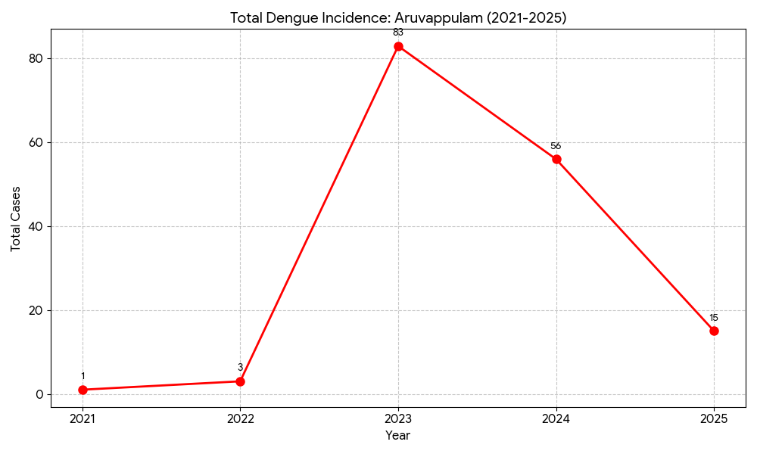

Following near-zero levels in 2021 and 2022, the Panchayat experienced a massive epidemiological surge in 2023 with 83 reported cases, a spike primarily driven by an acute hyper-cluster in Ward 3. By 2024, although the total volume of cases decreased to 56, the virus exhibited a notable geographic shift, becoming more widespread as transmission moved into Wards 7, 8, and 9. This expansion suggests that while the intensity in the original cluster subsided, the vector population became more distributed across the Panchayat's central and eastern sectors. However, by 2025, cases declined further to 15, indicating that targeted public health interventions or shifts in environmental suitability successfully curtailed the breeding cycle, bringing the incidence back toward a manageable baseline.

LEPTOSPIROSIS
Leptospirosis cases are closely linked to monsoon rains, flooding, and occupational exposure, particularly in low-lying and waterlogged areas.

Peak: June - August

Leptospirosis – Ward-wise Yearly Distribution (2021–2025)

Ward | Leptospirosis – Ward-wise Yearly Distribution
Ward | 2021 | 2022 | 2023 | 2024 | 2025 | Total
1 | 0 | 0 | 0 | 1 | 0 | 1
2 | 0 | 0 | 0 | 0 | 0 | 0
3 | 0 | 0 | 0 | 0 | 1 | 1
4 | 0 | 0 | 1 | 0 | 0 | 1
5 | 0 | 1 | 0 | 0 | 2 | 3
6 | 0 | 0 | 0 | 0 | 0 | 0
7 | 1 | 1 | 0 | 1 | 1 | 4
8 | 0 | 0 | 0 | 0 | 0 | 0
9 | 0 | 0 | 0 | 0 | 1 | 1
10 | 0 | 0 | 0 | 0 | 1 | 1
11 | 0 | 0 | 0 | 0 | 3 | 3
12 | 0 | 0 | 0 | 1 | 0 | 1
13 | 0 | 0 | 0 | 0 | 0 | 0
14 | 0 | 0 | 1 | 0 | 0 | 1
15 | 0 | 0 | 0 | 0 | 0 | 0

The ward-wise distribution of Leptospirosis in Aruvappulam indicates a shifting risk profile. While historically low and sporadic, the year 2025 marked a significant turning point in the disease's local transmission dynamics. The incidence of Leptospirosis remained at a near-negligible baseline between 2021 and 2023. However, a sharp escalation occurred in 2025, where cases tripled compared to the previous year.
- 2021–2024: A period of "smoldering" endemicity with 1–3 cases annually, primarily confined to Ward 7.
- 2025 Surge (9 Cases): A 300% increase from 2024, characterized by the emergence of new cases in previously unaffected wards (Wards 3, 9, 10, and 11).
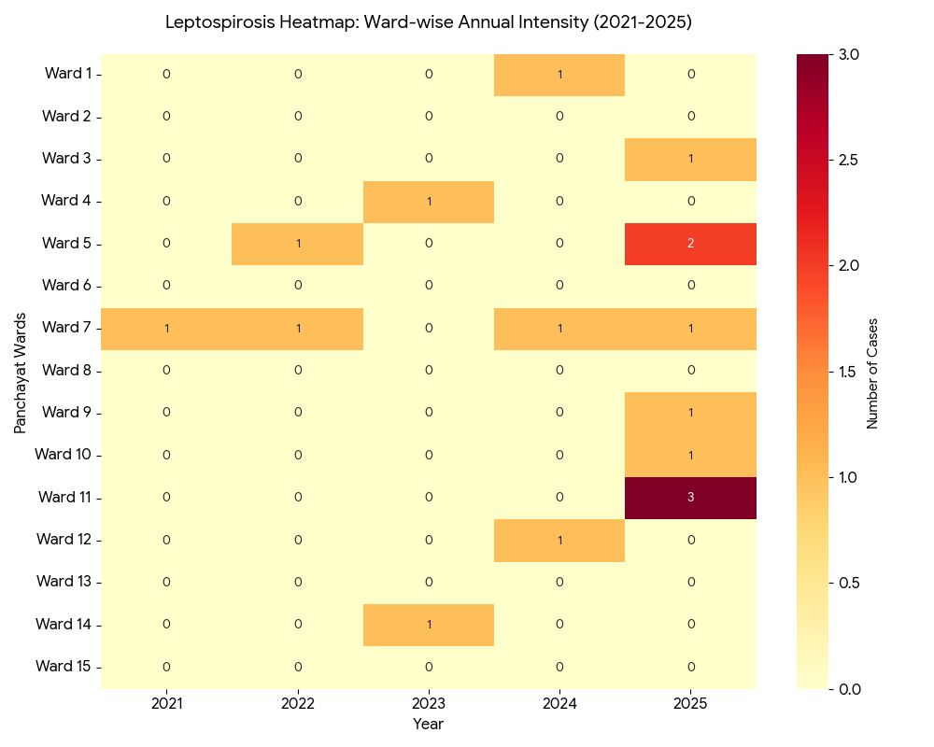
This heatmap visualizes the concentration of Leptospirosis cases over time, highlighting both the spatial spread (which wards are affected) and the temporal intensity (when the clusters became more severe).
The 2021–2025 heatmap for Aruvappulam reveals a shifting epidemiological landscape, transitioning from localized endemicity to a broader geographic expansion of Leptospirosis. Ward 7 stands out as the primary endemic reservoir with a "red line" of consistent transmission across nearly the entire five-year period, whereas Ward 11 represents an acute emerging cluster following a sudden "heat surge" of 3 cases in 2025 after four years of zero incidence. This 2025 surge saw the disease spread simultaneously across six different wards (3, 5, 7, 9, 10, and 11), likely driven by the pig-poultry interface and seasonal flooding, contrasting sharply with the "cold zones" of Wards 2, 6, 8, 13, and 15, which remained entirely case-free and now serve as a vital baseline for future environmental health studies.

VIRAL HEPATITIS - A
Hepatitis A cases are commonly associated with unsafe drinking water, food contamination, and breakdowns in sanitation, often presenting as clusters or outbreaks.

Peak: October - December

Hepatitis A – Ward-wise Yearly Distribution (2021–2025)

Ward | Hep A – Ward-wise Yearly Distribution
Ward | 2021 | 2022 | 2023 | 2024 | 2025 | Total
1 | 0 | 0 | 0 | 1 | 0 | 1
2 | 0 | 0 | 0 | 0 | 0 | 0
3 | 0 | 0 | 0 | 0 | 1 | 1
4 | 0 | 0 | 0 | 0 | 0 | 0
5 | 1 | 0 | 0 | 0 | 0 | 1
6 | 0 | 0 | 0 | 0 | 0 | 0
7 | 0 | 0 | 0 | 0 | 0 | 0
8 | 0 | 0 | 0 | 0 | 6 | 6
9 | 0 | 0 | 0 | 0 | 5 | 5
10 | 0 | 0 | 0 | 0 | 0 | 0
11 | 0 | 0 | 0 | 0 | 0 | 0
12 | 0 | 0 | 0 | 4 | 0 | 4
13 | 0 | 0 | 0 | 0 | 0 | 0
14 | 0 | 0 | 0 | 0 | 0 | 0
15 | 0 | 0 | 0 | 0 | 0 | 0

The ward-wise distribution of Hepatitis A in Aruvappulam reveals a concerning upward trend, transitioning from sporadic, isolated cases to localized cluster outbreaks. A temporal trend analysis from 2021 to 2025 shows that the incidence was virtually non-existent between 2021 and 2023, serving as a baseline with only a single case recorded in Ward 5 during 2021 and zero cases in the following two years. However, a dramatic escalation occurred in 2024 as cases increased to five, marked by an initial surge and a significant cluster of four cases emerging in Ward 12.

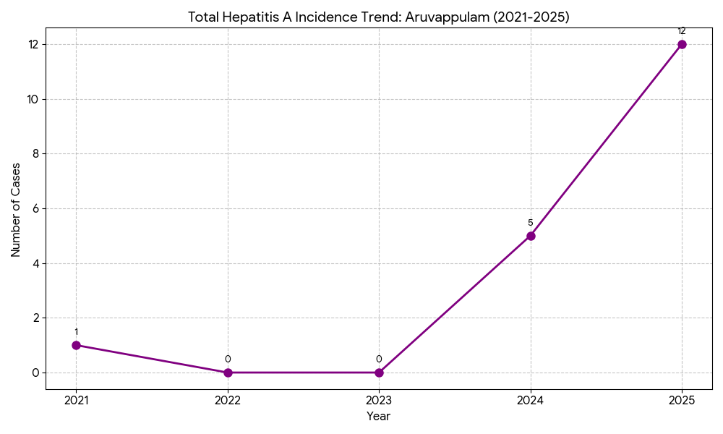
This trajectory culminated in an outbreak peak in 2025, where cases more than doubled to 12, primarily driven by intense clusters in Ward 8 and Ward 9, signaling a critical shift in local sanitation standards or drinking water security that requires immediate intervention.
The epidemiological data for Hepatitis A in Aruvappulam points toward a progressive breakdown in water safety or public sanitation, as evidenced by a rapid shift from zero cases to 12 cases within just two years. This transition suggests the virus has established a firm foothold in the community, with the high concentration of cases in Wards 8 and 9 indicating an active transmission chain within these residential clusters. Because Hepatitis A is primarily transmitted via the fecal-oral route, the spike in Wards 8 and 9 during 2025 and Ward 12 in 2024 strongly points to localized contamination of common drinking water sources, such as public wells, broken pipelines, or poor storage practices. This cyclical risk often coincides with post-flood periods or early monsoon transitions, when sewage or surface runoff can easily infiltrate drinking water supplies, necessitating urgent infrastructure audits and enhanced chlorination protocols for these specific hotspots.
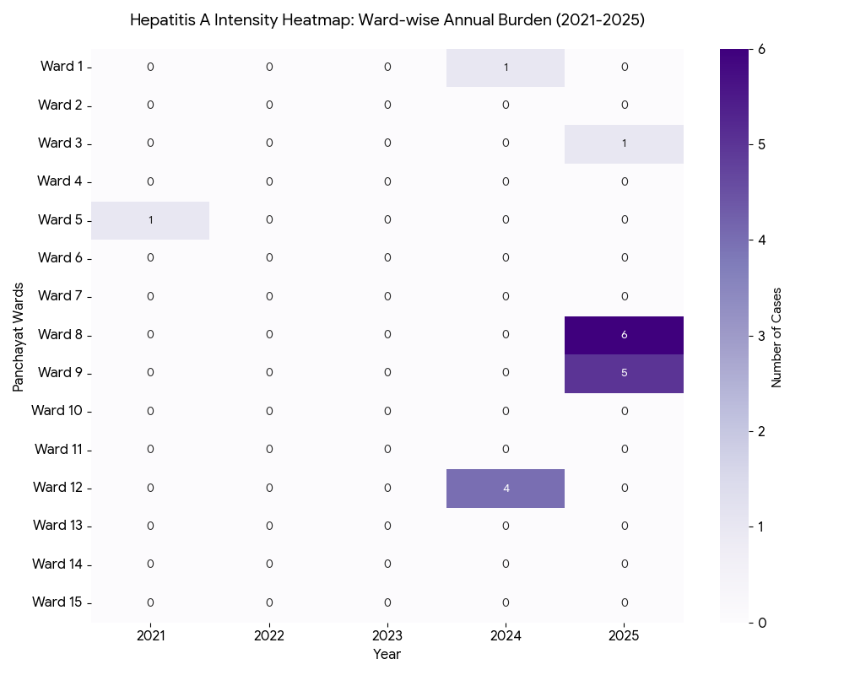
This heatmap identifies the specific pockets of Hepatitis A outbreaks within Aruvappulam, showing the transition from a "cool" (zero case) period to an intense "hot" cluster in the most recent years.

Outcome-Based Trend Analysis- 2025

Transmission Trend- 2025
For effective management of public health issues, it is important to track the trend of disease transmission mode. It helps identify the population or place at high risk that can be used to predict outbreaks and implement targeted interventions as quickly as possible. Understanding these kinds of trends enables authorities to allocate resources efficiently and change the strategies adequately based on the trend that follows.

Mode of Transmission | No. of cases | No. of Deaths
Vector Borne Diseases | 15 | 0
Water Borne Diseases | 11 | 0
Air Borne Diseases | 37 | 2
Blood Borne Diseases | 1 | 0
Food Borne Diseases | 1 | 0

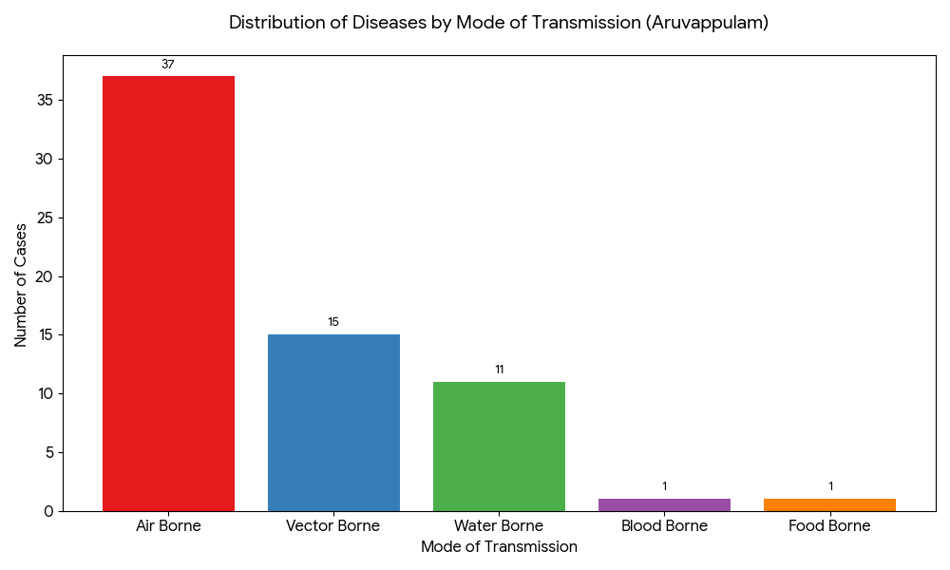
The Aruvappulam transmission profile shows a heavily skewed distribution toward respiratory pathogens, followed by a stable environmental threat from vectors and water sources. The 2026 Pandemic Preparedness Plan must move beyond "mosquito control" to include robust respiratory hygiene and water security protocols to address the actual majority of cases.
The "Air-Vector-Water" triad forms the core of the Panchayat's disease landscape. Resources should be allocated in a ratio that reflects this burden (roughly 3:1:1) for the 2026 preparedness cycle.

Vector-Borne Disease

Disease | No. of Cases | No. of Deaths
Dengue | 14 | 0
Malaria | 1 | 0
Chikungunya | 0 | 0

Water Borne Disease

Disease | No. of Cases | No. of Deaths
Cholera | 0 | 0
Typhoid | 0 | 0
Hep- A | 12 | 0
Dysentery | 0 | 0
Amoebiasis | 0 | 0
E- Coli infections | 0 | 0
Air Borne Disease

Disease | No. of Cases | No. of Deaths
Influenza | 1 | 0
H1N1 | 1 | 0
TB | 11 | 2
Chickenpox | 24 | 0
Measles | 0 | 0
Covid-19 | 4 | 0
Pertussis | 0 | 0
Mumps | 0 | 0

Blood-Borne Disease

Disease | No. of Cases | No. of Deaths
AIDS | 0 | 0
Hep- B | 1 | 0
Hep- C | 0 | 0

Zoonotic Disease

Disease | No. of Cases | No. of Deaths
Rabies | 0 | 0
Leptospirosis | 9 | 0
Avian influenza | 0 | 0
West nile | 0 | 0
Anthrax | 0 | 0
Nipah | 0 | 0
Scrub Typhus | 0 | 0

Integrated Disease Hotspot Map (2021–2025)
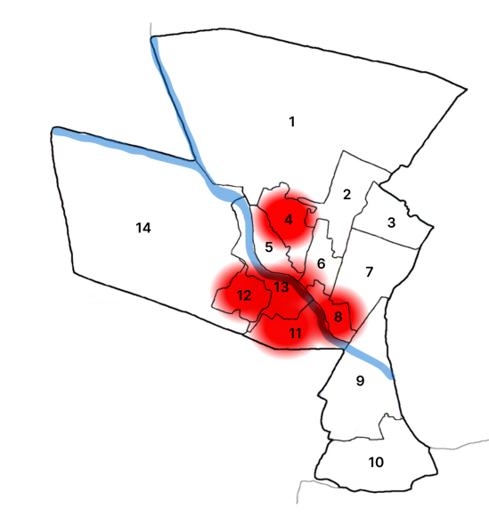

Ward No | Dengue Total (2021-25) | Leptospirosis Total (2021-25) | Hepatitis A Total (2021-25) | Mumps (2021-25) | ADD (2021-25) | Total Cases
1 | 9 | 1 | 1 | 0 | 5 | 16
2 | 4 | 0 | 0 | 0 | 4 | 8
3 | 36 | 1 | 1 | 0 | 5 | 43
4 | 3 | 1 | 0 | 0 | 7 | 11
5 | 13 | 3 | 1 | 0 | 8 | 25
6 | 5 | 0 | 0 | 0 | 5 | 10
7 | 15 | 4 | 0 | 0 | 5 | 24
8 | 9 | 0 | 6 | 0 | 5 | 20
9 | 9 | 1 | 5 | 0 | 7 | 22
10 | 9 | 1 | 0 | 0 | 4 | 14
11 | 6 | 3 | 0 | 0 | 6 | 15
12 | 10 | 1 | 4 | 0 | 5 | 20
13 | 11 | 0 | 0 | 0 | 9 | 20
14 | 5 | 1 | 0 | 0 | 8 | 14
15 | 8 | 0 | 0 | 0 | 4 | 12

Ward-wise Disease Distribution Analysis
The line graph below compares the intensity of the four major disease burdens across all 15 wards.
- Dengue (The Volatile Burden): Dominates the profile in Ward 3 (36 cases) and Ward 7 (15 cases). These peaks are historical "hotspots" likely linked to specific vector breeding events or localized construction.
- Acute Diarrheal Disease (ADD) (The Constant Burden): Unlike Dengue, ADD shows a relatively flat, consistent distribution across almost all wards (ranging from 4 to 9 cases). This indicates a Panchayat-wide vulnerability in household water storage or basic sanitation, rather than a single cluster.
- Hepatitis A & Leptospirosis (The Cluster Risks): These diseases show highly specific geographic "spikes" Hepatitis A in Wards 8 and 9 (11 cases combined) and Leptospirosis in Ward 7 (4 cases).

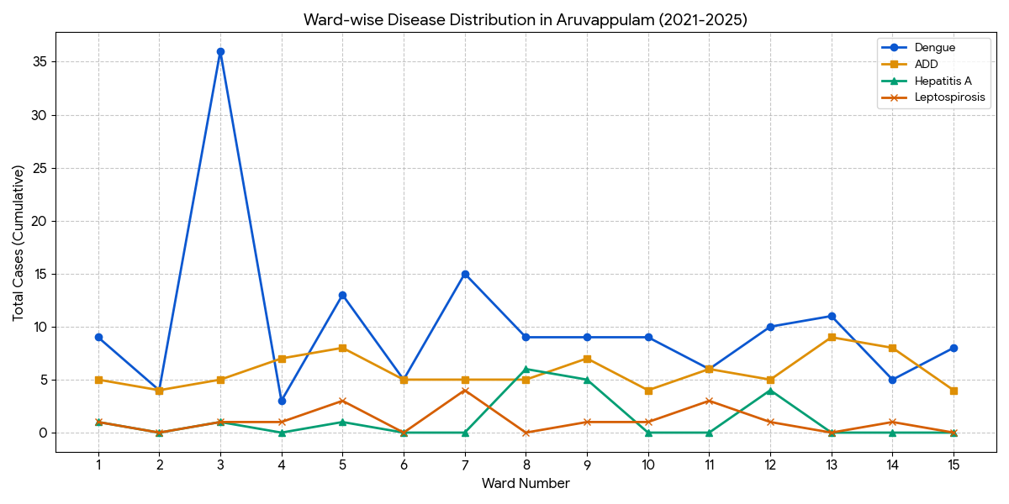

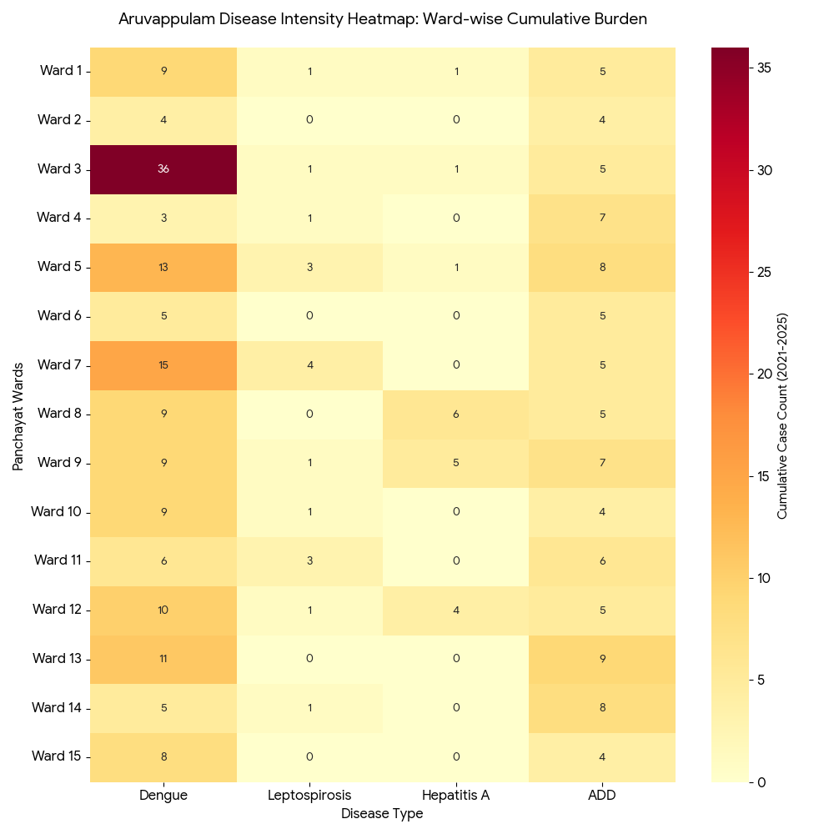
This heatmap provides a visual summary of the disease landscape in Aruvappulam, allowing for an immediate comparison of which wards are "hot" for specific pathogens. By identifying these clusters, the 2026 Pandemic Preparedness Plan can move from generic interventions to ward-specific precision medicine and environmental engineering.

The hotspot mapping confirms that Aruvappulam is facing a transition from isolated sporadic cases to localized geographic clusters. Ward 3 remains the primary focus for vector-borne diseases, while Wards 8, 9, and 11 are the emerging epicenters for waterborne and zoonotic spillover. The 2026 plan must allocate resources—such as fogging machines, Doxycycline reserves, and water testing kits—proportionately to these identified "Red" zones to effectively break the transmission chains.

Preparedness and Response Protocol at LSG Level
This section describes the operational framework for the LSGI once a pandemic is declared. It explains how the LSGI and health system will move from routine data collection to active response, using a One Health approach.

Constitution of One Health Committee
The LSGD shall constitute a One Health Committee comprising the LSGI President, Medical Officers (Modern Medicine, AYUSH, and Veterinary), the Health Inspector, and the Veterinary Surgeon.

Objective: The One Health Committee coordinates human, animal, and environmental health to prevent and control pandemics.

Sl No | Name | Designation | Department/Institution | Role in Committee | Contact Number
1 | RESHMA | Panchayat President | LSGD | Chairperson | 6238895524
2 | Dr RAJESH S.R | Medical Officer (PHC/CHC) | Health Dept | Member Secretary | 8547218570
3 | Dr CHINJU RANI | Veterinary Officer | Animal Husbandry | Member | 8714109342
4 | DR. Afina Azeez | Epidemiologist | Health Dept | Member | 8589068076
5 | DINESH KUMAR R | Health Inspector/PHN | Health Dept | Surveillance | 9447929127
6 | BIJI | ASHA Supervisor | Health Dept | Community link | 9747211457
7 | Raji | ICDS Supervisor | Social Welfare | Vulnerable groups | 9048941489
8 | - | Police Station Officer | Police Dept | Law & order | -
9 | K. P  Thomas | Ward Councillor Representative | LSGD | Community coordination | 9846419193
10 | Soumya | Kudumbashre CDO | Kudumbashree | Community mobilisation | 7909249518
11 | Vijayan | NGO/Volunteer rep | Civil Society | Support services | 9745268837
12 | Jessy Mathews | Line Department representations | Agricultural department | Support services | 04682242357

Key Responsibilities:
- Review disease surveillance data (human + animal)
- Conduct ward-wise risk assessment and vulnerability mapping
- Approve quarantine/isolation centre locations
- Coordinate with district for resources (PPE, oxygen, ambulances)
- Periodically review health system surge capacity, including beds, oxygen, human resources, and ambulances.
- Approve and monitor risk communication and community engagement strategies, including rumour management.
- Ensure protection and service continuity for vulnerable groups (elderly, persons with disabilities, dialysis patients, coastal populations).
- Conduct quarterly mock drills
- Monitor equity measures for vulnerable groups

Meeting Schedule:
Quarterly (normal times) | Weekly (outbreak alert) | Daily (pandemic phase)

Pandemic Response Workforce
To ensure a coordinated and timely response during a pandemic, a dedicated Pandemic Response Workforce shall be constituted at the LSG level. The workforce will function under the overall supervision of the One Health Committee and in close coordination with the health authorities. Team-based deployment will enable efficient surveillance, case management, quarantine and isolation management, logistics support, and risk communication. Each team shall have a clearly designated team leader, defined roles, and an identified pool of personnel to allow rapid activation, rotation of duties, and continuity of services during prolonged emergencies.

Total Response Workforce Available: 100 persons

Team Name | Composition | Key Responsibilities | Team Leader
Surveillance and Contact Tracing Team | HI, JHI, JPHN, ASHAs and Volunteers | Case detection, contact listing, home visits, reporting | HI
Case Management Team | Doctors, Nurses, MLSP, Palliative Nurses | Patient care & referral | DOCTOR
Quarantine & Isolation Team | LSGD staff, Volunteers | Facility management | JHI
Psychosocial support | Doctors, Nurses, MLSP | Emotional suport | Doctor
Logistics & supply chain Team | LSGD staff, Storekeepers, Drivers 3 | Supplies & transport [PPE, medicines, oxygen, transport, waste management] | Ward Member
Communication Team | Ward members, Kudumbashree, Youth clubs,  AWW workers and other self help groups | IEC, community meetings, countering misinformation | M.O in charge
Transportation | KSRTC, educational institutional buses
Media Surveillance
Intersectoral coordination and convergence
Collaborative surveillance

All teams shall be activated immediately upon outbreak alert or pandemic declaration and shall report daily to the LSG Incident Commander/Medical Officer, with consolidated reporting to the Block PHC. Duty rosters and alternate personnel shall be maintained to ensure uninterrupted services during staff shortages or prolonged response periods. Team composition and numbers may be revised based on the magnitude of the outbreak and availability of human resources.

Activities and Measures before and during Pandemic

PHASE 1 - Alert / Preparation
Surveillance and Reporting-Enhanced syndromic surveillance:
- Data sources for surveillance:
Enhanced syndromic surveillance relies on multiple data sources to detect early signals of a pandemic. These include healthcare facilities such as outpatient departments (OPDs), emergency rooms, and hospitals, which report unusual clusters of symptoms like fever and respiratory illness. Laboratory data also play a key role by providing diagnostic reports, test results for infectious agents, and trends in positive cases. Community-based reporting contributes through inputs from health workers like ASHA workers, village-level health registers, and informal alerts from local communities. Pharmacy sales data, such as increased purchases of over-the-counter medicines like antipyretics and cough syrups, can indicate a possible outbreak. Additionally, school and workplace absenteeism helps identify early spread through rising absence rates. Mortality data, including unusual increases in deaths and cause-specific trends, are also important indicators. Digital and media surveillance, including social media trends and news reports, along with data from hotlines and telemedicine services where individuals report symptoms or seek advice, further strengthen early detection and monitoring of potential pandemics.
- Event-based triggers (to be monitored and reported):
Event-based surveillance focuses on identifying unusual health events that may signal the onset of a pandemic. These triggers include sudden clusters of cases with similar symptoms, especially severe acute respiratory illnesses or unexplained fevers; unexpected increases in morbidity or mortality in a specific area; and outbreaks of unknown origin. Other important triggers are unusual patterns of disease transmission, such as rapid spread within communities, healthcare settings, or closed groups like schools or workplaces. Reports of illness among healthcare workers, sudden shortages of essential medicines, or increased demand for healthcare services should also be monitored. Additionally, zoonotic events such as unusual illness or deaths in animals, especially those in close contact with humans, and reports from media or community sources indicating public concern or panic, are critical signals that must be promptly reported and investigated.
- Zoonotic and animal health surveillance
Zoonotic and animal health surveillance involves monitoring diseases in animals that have the potential to be transmitted to humans. This includes regular observation of livestock, poultry, and wildlife for unusual illness, sudden deaths, or changes in behavior that may indicate emerging infections. Veterinary reports, farm inspections, and data from animal health workers play a crucial role in early detection. Surveillance also includes monitoring live animal markets, slaughterhouses, and areas where humans and animals interact closely. Laboratory testing of animal samples helps identify pathogens with zoonotic potential. Coordination between human and animal health sectors (One Health approach) ensures timely sharing of information, enabling early warning and prevention of disease spillover from animals to humans.
- Logistics and Stock Preparedness
  - Identify and empanel local vendors and define emergency procurement mechanisms in accordance with existing LSGD and Health Department norms.
  - Prepare and maintain an essential logistics checklist covering medical supplies, consumables, and support equipment.
  - Pre-identify secure storage locations for emergency stocks and ensure maintenance of stock registers with regular updating.
  - Finalise emergency transport arrangements, including availability of vehicles and identified drivers for rapid deployment during alerts.
  - Designate a Nodal Officer for Logistics to enable prompt decision-making, coordination, and communication during emergencies.
  - Conduct rapid stock verification and ensure availability of minimum buffer stock, including:
- PPE kits – numbers
- Pulse oximeters –60 numbers
- Hand sanitizers – 70litres
- Masks, gloves, disinfectants – adequate quantity
Identify critical gaps in logistics and immediately communicate requirements to the Block and District authorities for timely replenishment and support. Monitor expiry dates and stock rotation.

Identification of Quarantine and Isolation Facilities
  - Identify and list suitable buildings for quarantine and isolation (schools, hostels, community halls, etc.).
  - Categorise cases as per the severity and allocate to appropriate facilities (for instance, severe cases to classrooms, mild cases to an assembly hall in case of a school).
  - Facility readiness checklist needed (beds, toilets, ventilation) etc.
  - Find an alternate site if the primary sites are not available or not in use.
  - Identify facility managers and support staff
  - Prepare basic SOPs for:
    - Admission and discharge
    - Food, water, sanitation
    - Infection prevention and waste disposal
  - Ensure availability of basic amenities: water, sanitation, electricity, ventilation, and waste disposal. Prepare a rapid activation plan for these facilities if case numbers increase.

Risk Communication and Community Preparedness
  - Disseminate early warning messages on symptoms, preventive measures, and reporting mechanisms. Display IEC materials both in English and the local language in public places and ensure ward-level awareness.
  - Sensitize elected representatives and community leaders on preparedness measures.
  - Establish a rumour tracking and misinformation response mechanism to identify, verify, and promptly counter false or misleading information.
  - Engage trusted local persons (ward members, ASHA workers, religious leaders, teachers, community volunteers) to communicate official public health messages and reinforce correct practices.
  - Develop and deploy targeted IEC materials for:
    - Schools and educational institutions
    - Markets and commercial areas
    - Work sites and labour settings
  - Conduct community sensitization meetings at the ward level to promote preventive behaviors, address concerns, and strengthen community participation in preparedness and response.

Protection of Vulnerable Groups
Vulnerable populations require priority protection through targeted line-listing, service continuity, and delivery mechanisms.
- Prepare and regularly update line-lists of vulnerable populations, including:
  - Elderly persons living alone
  - Persons with disabilities
  - Pregnant women
  - Migrant workers
  - Dialysis patients
The detailed line-lists shall be maintained as Annexure and updated periodically.

Clinical Dependency Mapping
Develop ward-wise dependency and vulnerability maps to identify households requiring regular support during emergencies. Ensure continuity of essential health services for vulnerable groups, including
- Dialysis services (facility mapping, transport arrangements, and scheduling)
- Continuity of treatment for TB, HIV, and other chronic conditions requiring uninterrupted medication
- Mental health and psychosocial support services
Establish delivery mechanisms for food, essential commodities, and medicines to vulnerable households through coordinated action involving ASHAs, JPHNs, Kudumbashree, volunteers, and local administration.

PHASE 2 - Active Response

Case Identification and Contact Tracing
Case detection and contact tracing activities will be carried out in coordination with the health authorities, following disease-specific SOPs and IDSP guidelines.
Field Staff Involved
- Health Inspector (HI)
- Junior Health Inspector (JHI)
- Junior Public Health Nurse (JPHN)
- ASHAs and ASHA Supervisors
- Ward-level volunteers and Kudumbashree members (as required)

Screening Checkpoints
Screening checkpoints at high-traffic locations (transport hubs, markets, religious gatherings) for early detection of symptomatic travellers and crowd screening during outbreaks. Potential locations include bus stands, market entry points, and boat jetties, based on local context and risk assessment.
Screening activities will be carried out by trained personnel such as ASHAs, ward members, and volunteers, with support from Health Department staff. Necessary equipment, including non-contact thermometers and appropriate PPE, shall be ensured prior to activation.
Location | Type (Bus stand/Jetty/Market/Railway) | Staff Deployed (ASHAs/Volunteers) | Screening Method | Reporting authority
Bus stand | Transport hub | One JHI  One ASHA  One health Mentors | 1.Swab Collection.  2. Blood smears collection (RDT)  3.Thermal Scanners | Surveillance Nodal Officer in control room
Market entry | Market | One JHI  One ASHA  Male health volunteers | 1.Swab Collection.  2. Blood smears collection (RDT)  3.Thermal Scanners | Surveillance Nodal Officer in control room

Standard Screening Protocol

The screening protocol shall include temperature screening, observation for visible symptoms, and inquiry regarding recent travel or exposure history. Individuals identified as suspects during screening shall be immediately referred to the nearest PHC/FHC for further evaluation, testing, and appropriate action as per prevailing guidelines.

Pandemic Control Room
The Pandemic Control Room (PCR) serves as the central nerve center for real-time coordination, data aggregation, decision support, and communication during outbreaks. It consolidates information from all LSGD teams, health facilities and community sources to enable rapid response decisions.

Control Room Infrastructure and Location
Primary Location: _Aruvappulam Panchayath Office.
Backup Location: Community Hall in Aruvappulam G.P.

Health System Control Room Framework
The PCR is organized into seven functional pillars to ensure no aspect of the response is overlooked:

Rapid Response Team (RRT)
  - Provides immediate intervention during emergencies, clusters, and field alerts.​
  - Coordinates urgent actions such as case investigation, contact tracing, isolation, and inter‑facility referrals.

Data Management & Analytics Team
  - Collects, validates, and manages key health system indicators (cases, tests, beds, HR, supplies).​
  - Analyzes data trends, generates projections, and supports evidence‑based decision‑making for local authorities.

Human Resource Deployment Team
  - Allocates healthcare staff efficiently based on workload and need
  - Ensures adequate and equitable workforce distribution across facilities

Laboratory Surveillance Team
  - Oversees diagnostic testing coordination, sample transport, and timely reporting of results.​
  - Monitors lab indicators (testing volume, positivity rate, turnaround time) for early detection of outbreaks

Vaccination Cell (If Required)
  - Plans and executes vaccination campaigns, including micro‑planning and session scheduling.​
  - Tracks coverage, identifies gaps, and coordinates corrective actions with field teams and outreach services.

Infrastructure & Patient Occupancy Team
  - Monitors facility capacity, earmarked beds, oxygen and critical care resources across all linked facilities.​
  - Ensures optimal patient distribution and referral management using updated bed‑status and resource data.
  - BMWM

Communication team
The communication team plays a critical role during the active response phase of a pandemic by ensuring timely, accurate, and transparent dissemination of information to the public and stakeholders. The team is responsible for developing clear risk communication strategies, issuing regular updates on the situation, and addressing rumors and misinformation. It coordinates with health authorities, media, and other government agencies to provide consistent messages regarding preventive measures, case definitions, treatment protocols, and public health advisories. The team also manages press briefings, social media communication, and helplines to keep the public informed and reduce panic. Effective communication helps build public trust, promotes compliance with health measures, and supports overall outbreak control efforts.

- Logistics and supply chain
Logistics and supply chain management ensures the timely procurement, storage, and distribution of essential resources required during a pandemic response. This includes medical supplies such as personal protective equipment (PPE), medicines, vaccines, diagnostic kits, and hospital equipment. It also involves maintaining adequate stock levels, monitoring supply availability, and coordinating transportation to deliver materials to healthcare facilities and response teams. Efficient logistics systems help prevent shortages, support healthcare workers, and ensure that critical items reach affected areas quickly. Proper planning, inventory management, and coordination with suppliers and government agencies are essential to maintain uninterrupted operations during the active response phase.
- Transportation (interfacility & emergency transport)
Transportation plays a vital role during the active response phase by ensuring safe and timely movement of patients, healthcare workers, and essential supplies. This includes interfacility transport of patients requiring higher levels of care, using well-equipped ambulances with trained personnel and appropriate infection prevention measures. Emergency transport systems must be strengthened to respond quickly to critical cases, with proper triage and communication between referring and receiving facilities. Dedicated transport arrangements may be required for suspected or confirmed infectious cases to prevent further spread. Additionally, logistics for transporting medical supplies, samples, and essential staff should be well-coordinated to maintain continuity of healthcare services and support outbreak control efforts.
- Media surveillance Call centre
Media surveillance and call centres are important components of the active response phase, helping in early detection, information dissemination, and public support. Media surveillance involves continuous monitoring of news outlets, social media platforms, and other communication channels to identify emerging health concerns, rumors, and public perceptions related to the pandemic. This helps authorities respond quickly to misinformation and detect potential outbreaks.Call centres serve as a direct communication link between the public and health authorities. They provide information on symptoms, preventive measures, testing, and treatment services, while also receiving reports of suspected cases and health concerns from the community. Data collected through call centres can support surveillance and response activities. Together, media surveillance and call centres enhance situational awareness, improve risk communication, and strengthen the overall pandemic response.
- Management of the deceased
Management of the deceased during a pandemic is crucial to ensure dignity, safety, and infection control. Proper protocols must be followed for the handling, storage, and disposal of bodies of suspected or confirmed cases to prevent the risk of disease transmission. This includes the use of appropriate personal protective equipment (PPE) by healthcare and mortuary staff, safe wrapping and labeling of bodies, and disinfection procedures. Transportation of the deceased should be carried out with care, following established guidelines.Clear guidance should also be provided to families regarding safe funeral practices, while respecting cultural and religious beliefs as much as possible. Coordination between healthcare facilities, local authorities, and funeral services is essential to manage increased mortality during pandemics. Proper documentation and reporting of deaths must be maintained. Effective management ensures public health safety while upholding dignity and respect for the deceased and their families.

- Intersectoral coordination and convergence
Intersectoral coordination and convergence are essential during the active response phase to ensure a unified and effective pandemic response. This involves collaboration between multiple sectors such as health, transport, education, police, local administration, disaster management authorities, and other government and non-government agencies. Effective coordination helps in resource sharing, efficient decision-making, and implementation of control measures.
Regular communication and joint planning among sectors ensure alignment of strategies, such as containment measures, movement restrictions, public awareness campaigns, and service delivery. Convergence also includes partnerships with private healthcare providers, community organizations, and volunteers to strengthen response capacity. A well-coordinated approach minimizes duplication of efforts, optimizes resource utilization, and enhances the overall effectiveness of pandemic management.

Key Control Room Team
The Control Room Team coordinates all pandemic response activities within the LSGD and serves as the single command and communication hub during activation. It integrates information, field actions, logistics, and policy execution across all participating departments and health facilities.

Role | Name | Designation | Contact Number | Responsibility
In-charge/Nodal Officer | Dr Rajesh S R | Medical officer | 8547218570 | Overall coordination, decision-making, and reporting to the District level.
Data Entry Operator | Nabitha | JHI | 9961895694 | Managing the line list, updating dashboards, and tracking testing results.
Communication Officer | Dinesh kumar | Health inspector | 9447929127 | Handling the public helpline, coordinating ambulance dispatch, and contact tracing calls.
Logistics Coordinator | Dhanya c .s | Pharmacist | 7907277592
Technical Support(IT/Data) | Agnus | JHI | 9746272618

SOP for alert escalation/trigger point with mapping of responsibilities.

Key Points:
- The Control Room shall be staffed with a designated In-charge, data entry personnel, and communication staff with clearly defined roles and shift arrangements.
- It shall maintain updated records on daily monitoring indicators including new cases, persons under active quarantine, and hospital bed occupancy.
- All reports and situation updates shall be shared daily with the Block and District Surveillance Unit.
- The Control Room shall act as a single point of contact for coordination with response teams, health institutions, and other departments.
- Contact details of the Control Room shall be widely communicated to field staff and stakeholders during activation.

Daily Monitoring Indicators
To ensure timely decision-making and effective response, the following key indicators shall be monitored and updated on a daily basis by the Pandemic Control Room:

Epidemiological Indicators:
New cases reported today, Total active cases, Test Positivity Rate (TPR), Case Fatality Rate (CFR)
- Surveillance Indicators:
Persons under home quarantine, High-risk contacts identified, Fever, ILI, SARI or other symptoms (syndromic surges), Travellers (symptomatic or high-risk arrivals),Animal husbandry surveillance (zoonotic alerts, unusual animal deaths, poultry/bird flu signals), Mortality surveillance (excess deaths, unexplained fatalities, verbal autopsy reports)
- Logistics and Infrastructure Indicators:
Hospital / CFLTC beds occupied, Oxygen cylinders/concentrators available, Ambulances on standby
- Alert Findings
The following table outlines category-specific trigger points (red flags) from surveillance indicators and corresponding immediate actions for the Pandemic Control Room. These enable rapid response to alert findings like testing anomalies, positive cases exceeding thresholds, clusters, and WGS reports.

Category | Trigger Pophint (Red Flag) | Immediate Action
Clusters | Geographical or facility-based: 5+ cases linked to one location (office, school, street). | Declare a micro-containment zone; perimeter control and active case finding.
Testing | Sudden drop in testing volume / delay in reporting / unusual testing trends | Review the sample collection process, address lab bottlenecks, deploy additional testing teams, and notify the District Lab.
Lab | Test Positivity rate increases | Increase testing sites in that ward.
Hospital | >80% Oxygen bed occupancy | Activate backup/CFLTC beds.
Travel | Cluster of cases from a single flight/train or high-risk arrival group. | Trace all passengers in adjacent seats; implement mandatory institutional quarantine.
Animal | Mass poultry/wildlife death or unusual sickness | Notify Animal Husbandry, sample the area, and dispatch RRT for environmental sampling and zoonotic check.
Mortality | Sudden spike in home deaths or brought-in-dead (BID) cases | Audit the deaths and Active Case Search drive
Additional investigations like Whole Genome Sequencing (WGS) | Detection of a Variant of Concern (VOC) or Variant of Interest (VOI) | Implement strict micro-containment; update clinical protocols to match variant severity.

Communication of Public Health Information
A Community Communication Hub shall be established to ensure timely, accurate, and consistent dissemination of information during a pandemic. The Hub will function under the coordination of Nodal officers of the control room and act as the nodal point for public communication, risk messaging, and community engagement. It will support dissemination of official advisories, promote preventive behaviors, address rumors and misinformation, and ensure that messages reach all sections of the population through trusted local channels and leaders.

Key communicators
Channel | Responsible Person | Contact
Ward-level announcements | Anilkumar JHI | 8075148942
Social media | MANSOOR A  JR health inspector | 9847682083
Local Cable TV/Radio

- All messages disseminated through the Hub shall align with advisories issued by the Health Department and District authorities.
- Community leaders shall be sensitized to support behavior change, reduce stigma, and counter misinformation.
- Special efforts shall be made to reach vulnerable and hard-to-reach populations using locally appropriate communication methods.

Rumor Tracking: A designated volunteer will monitor local social media/WhatsApp groups daily to identify misinformation and issue official clarifications via the Communication Hub.

Coordination with District/State Authorities & Other Organisations
Effective coordination with Block, District, and State authorities is essential to ensure timely reporting, technical guidance, and uninterrupted supply of essential resources during a pandemic. The LSG shall establish clear communication channels, designate responsible officers, and adhere to prescribed reporting timelines to support coordinated public health action and efficient resource mobilisation.

Key Details:
- Nodal Officer for Reporting: Dinesh Kumar,HI
- Contact Number: 9447929127
Reporting Schedule and Protocols:

To Whom | What to Report | Frequency | Nodal Person
Block PHC | Complete Situation Report (Cases, Quarantine, Beds, Screening, Deaths) | Daily | Medical officer
District IDSP Unit | Outbreaks/Clusters/Unusual Events (>5 cases same ward) | Weekly | HI
Veterinary Officer | Animal health events/Zoonotic alerts | - | -
State Cell | Zoonotic cross-sector events | - | -nil

Supply Chain Coordination
The LSG shall coordinate closely with Block, District, and State authorities (KMSCL) to ensure uninterrupted availability of essential goods, medical supplies, and logistics during a pandemic. Supply requirements shall be assessed regularly based on case load and communicated promptly to the appropriate authorities for timely replenishment.
Key Points:
- Maintain updated contact details of District and Block nodal officers for health logistics, oxygen supply, ambulances, and essential medicines.
- Submit timely indent requests for PPE, testing kits, medicines, oxygen, and other critical supplies through prescribed channels.
- Monitor stock levels at LSGD facilities, quarantine/isolation centres, and field teams through daily stock registers and dispensing logs to prevent shortages.
- Coordinate with District authorities, Karunya/Neethi medical shops, and local purchase committees for funds allocation and emergency procurement.

- Ensure regular monitoring of dispensing registers at all facilities to track usage, expiry, and pilferage—shortages being a perennial issue requiring proactive weekly audits.

- Activate surge procurement protocols during high caseloads, leveraging local purchase powers under LSGD funds alongside state supplies.

Resource Inventory and Contacts
Resource Category | Source  (District/State/Private) | Contact
PPE Kits/Masks/Gloves | KMSCL
PPE Kits/Masks/Gloves | Local Vendors
Oxygen  Cylinders/Concentrators | KMSCL
Medicines/Antivirals | KMSCL
Medicines/Antivirals | Neethi Shops
Test Kits (RTPCR/Rapid) | KMSCL

Collaboration with NGOs, PPP, and CSR
To augment government efforts during a pandemic, the LSG shall collaborate with NGOs, voluntary organisations, and private sector partners through public–private partnerships and Corporate Social Responsibility (CSR) initiatives, in coordination with District authorities.

Key Points:
- Engage NGOs and community-based organisations for community outreach, awareness, and support to vulnerable populations.
- Leverage CSR support for procurement of medical equipment, PPE, oxygen concentrators, food kits, and sanitation materials, as permitted.
- Ensure all collaborations align with government guidelines and are routed through approved administrative and financial procedures.
- Maintain transparency and documentation for all external support received and utilised.
Organization | Type | Support Offered | Contact Person
Youth Clubs/Student Unions | CBO | Nil

Interdepartmental Coordination
Coordination among departments during a pandemic shall be ensured through regular review meetings convened by the LSGD President. These meetings will provide a structured platform for sharing situational updates, assessing resource availability, resolving operational gaps, and taking joint decisions to ensure a coordinated and timely response.

Department | Representative | Key Role | Contact
Health (PHC) | Staff Nurse : | Case management | 9526931593
Veterinary | Veterinary Surgeon: | Animal surveillance | 8714109342
ICDS | Supervisor: Sindhu | Nutrition support
Education | Head Teacher: | School coordination
Police |  | Containment enforcement | __________
Water Authority | __________ | Water supply | __________
LSGD Engineering | __________ | Quarantine infrastructure | __________

PHASE 3 - Surge Capacity
Phase 3 is activated when there is a rapid increase in cases, high test positivity rates, or when existing health facilities and quarantine arrangements approach saturation. The focus of this phase is to expand isolation capacity, augment clinical care services, and mobilise additional resources through district and state support mechanisms.

Conversion of Community Facilities
To manage increased case load, the LSGD shall activate additional isolation facilities by repurposing identified community infrastructure such as community halls, auditoriums, schools, hostels, or other suitable buildings.

Name of facility | Facility Type | No. of Buildings | Ward | Surge Capacity (Beds) | Nodal Person
0 | 0 | 0 | 0 | 0 | 0

- Recovery and rehabilitation phase
The recovery and rehabilitation phase focuses on restoring normalcy and strengthening systems after a pandemic. Recovery begins with a comprehensive assessment of the damage and overall impact on health, economy, and society. Restoration of health services is prioritized to ensure routine and essential healthcare resumes effectively. Rehabilitation of the affected population includes support for those who suffered illness, loss, or economic hardship, along with provision of psychosocial and mental health support to address trauma and stress. Continued disease surveillance during the recovery phase is essential to detect any resurgence of cases. Environmental cleanup and sanitation measures help eliminate residual risks. Efforts are also directed toward livelihood restoration to support economic recovery and stability. Community engagement and confidence building are crucial to regain public trust and encourage participation in recovery activities. Documentation and after-action reviews are conducted to evaluate the response, identify gaps, and record experiences. Lessons learned and best practices are used to strengthen the health system and improve future preparedness. This phase also includes policy revision, enhancement of preparedness plans, and promotion of research to better understand and manage future public health emergencies.

- Recovery
  - Damage & impact assessment
  - Restoration of health services
  - Rehabilitation of affected population
  - Psychosocial & mental health support
  - Disease surveillance during recovery phase
  - Environmental cleanup & sanitation
  - Livelihood restoration
  - Community engagement & confidence building
  - Documentation & after-action review
  - Lessons learned & best practices
  - Health system strengthening
  - Policy revision & preparedness enhancement
  - Research
CONCLUSION
The Pandemic Preparedness Plan for Aruvappulam Panchayat serves as a data-driven operational framework designed to transition the local health strategy from reactive containment to proactive resilience. By synthesizing the specific epidemiological shifts recorded between 2021 and 2025, this plan recognizes that while the community has successfully navigated the post-pandemic landscape, it faces significant recurring challenges from shifting endemic disease clusters.
The plan identifies Ward 3 as the primary high-priority "Red Zone," characterized by a hyper-cluster of 36 Dengue cases that accounts for a massive portion of the Panchayat’s vector burden. This is joined by Wards 8, 9, and 12, which have emerged as critical waterborne hotspots, collectively driving the 2025 peak of 12 Hepatitis A cases. The resurgence of both Dengue and waterborne pathogens underscores the necessity of the plan’s phased response protocols, moving from baseline environmental surveillance to active surge capacity during high-risk seasonal windows.
Central to this preparedness is the coordination of the Pandemic Response Workforce, tasked with disrupting the complex transmission cycles of diseases like Leptospirosis, which exhibited an acute surge in Ward 11 during 2025. By establishing a Pandemic Control Room and standardizing ward-specific screening for the "Air-Vector-Water" triad, the LSGI transitions toward a One Health model. This model treats human health, environmental sanitation, and the animal-human interface as a single interconnected priority to prevent future zoonotic spillovers.
Ultimately, the success of this plan relies on the continuous strengthening of local healthcare infrastructure and the diligent execution of targeted interventions in high-risk zones. Through the implementation of specialized protocols—ranging from infrastructure audits in Wards 8 and 9 to intensive vector management in Ward 3—Aruvappulam Panchayat can maintain the downward trends targeted for 2026. By fostering community-led awareness and data-driven governance, the Panchayat ensures a resilient future where disease outbreaks are detected and contained before they escalate into local crises.

RECOMMENDATIONS

Strengthening Healthcare Infrastructure
- Establish a primary health response unit within the Panchayat with trained staff.
- Ensure availability of basic medical supplies (masks, sanitizers, PPE kits, oxygen cylinders).
- Create tie-ups with nearby hospitals in THQH konni for emergency referral and transport.

2. Community Awareness & Education
- Conduct regular awareness campaigns on hygiene, vaccination, and preventive measures.
- Use local communication channels (community radio, WhatsApp groups, notice boards) to spread verified information.
- Train volunteers to act as health ambassadors in each ward.

3. Emergency Response & Coordination
- Form a Pandemic Preparedness Committee at Panchayat level including health workers, ward members, and NGOs.
- Develop a clear action plan for lockdowns, quarantine, and distribution of essentials.
- Maintain a database of vulnerable groups (elderly, differently-abled, chronically ill) for targeted support.

4. Supply Chain & Food Security
- Identify and support local suppliers and farmers to ensure uninterrupted food supply.
- Create community kitchens during emergencies to serve vulnerable populations.
- Stockpile essential commodities in Panchayat-run outlets for crisis periods.

5. Digital Preparedness
- Promote digital platforms for telemedicine consultations.
- Use Panchayat’s website/social media for real-time updates on health advisories.
- Encourage online grievance redressal to reduce crowding in offices.

6. Training & Capacity Building
- Organize mock drills for pandemic response in schools, offices, and public spaces.
- Train Panchayat staff and volunteers in first aid, infection control, and crowd management.
- Collaborate with NGOs and health departments for capacity-building workshops.

7. Long-Term Resilience
- Integrate pandemic preparedness into the Panchayat Development Plan.
- Allocate a dedicated budget for health emergencies.
- Encourage community participation in planning and monitoring preparedness measures.

MOCKDRILL SCENARIOS
Kokkathode PHC presents a unique challenge. Located deep within the Konni forest area of Pathanamthitta, it is often one of the first places to be "islanded" (cut off) when the Achenkovil River or local streams overflow.
In Kokkathode, a flood drill isn't just about moving files; it’s about survival and self-sufficiency because outside help (from Konni or Pathanamthitta) may not reach you for 24–48 hours.
Scenario: "Operation Aranya-Jalam" (PHC Kokkathode)
- The Trigger: 72 hours of "Extreme Heavy Rainfall." The Main Forest Road to Konni is blocked by a small landslide and rising water at the check-post.
- The Situation: Water is entering the PHC premises. The power grid is down. A pregnant woman in early labor and a patient with a suspected snake bite arrive at the PHC just as the road cuts off.
- Goal: Protect PHC assets and manage critical patients using only on-site resources.
Phase 1: Isolation Protocol (0–20 Minutes)
- Status Check: The Medical Officer (MO) confirms that the road to Konni is impassable.
- Energy Management: Switch to the Solar Power system/Generator. Conserve fuel—only use lights in the Labor Room and Pharmacy.
- Communication: Use the Wireless Police Radio (if available at the nearby Forest Station) or Satellite Phone if mobile towers are down to inform the Control Room: "Kokkathode PHC is isolated but operational."
Phase 2: Asset & Life Protection (20–60 Minutes)
1. The "High-Ground" Shift
- Vaccines: Move all vaccines to the most stable Cold Box with maximum ice packs. Since power might stay out for days, designate a staff member to monitor the "Holdover Time."
- Pharmacy: Move Anti-Snake Venom (ASV), Adrenaline, and Oxygen cylinders to the highest point in the building.
2. Emergency Triage in Isolation
- Labor Room Prep: Since the pregnant patient cannot be shifted to Konni THQH, the Staff Nurse must prepare the Labor Room for an emergency delivery.
- Snake Bite Management: Administer ASV protocol immediately, as the window for transfer has closed.
Phase 3: Community Coordination (1–2 Hours)
- ASHA Network: Contact local ASHA workers via local intercom/short-range radio to identify any high-risk individuals (bedridden/dialysis patients) in the Kokkathode colony who need to be moved to the PHC (which usually acts as the safest local building).
- Water Safety: Add bleaching powder to the PHC overhead tank immediately to ensure the remaining clean water isn't contaminated by flood inflow.

ANNEXURE

IMPORTANT PHONE NUMBERS

Phone numbers and particulars of persons responsible for providing guidance, assistance, and support for pandemic preparedness operations may be provided here in a manner that allows easy reference at a glance.The information recorded here could be exhibited elsewhere at the time of emergencies. LSG institutions shall give special attention to collect and record the above data of persons and institutions who/which are supposed to give technical and co-ordination support to reduce the impact of pandemic.

1.1. Details of grama panchayat/municipality/corporation wards
Sl.No | Name of the ward | Ward number | Name of the ward  member | Contact number
1 | MULAKUKODITHOTTAM | 1 | SUMA VARGHESE | 8111942012
2 | KUMMANNOOR | 2 | SHEEBA SUDHEER | 9745640462
3 | KOKKATHODE | 3 | SHEEBA P K | 8086284330
4 | NELLIKKAPARA | 4 | RESHMA B | 6238955291
5 | KALLELITHOTTAM | 5 | SHANTHA KUMAR | 9447504529
6 | KALLELI | 6 | DANESH GOPAL | 8086184710
7 | MUTHUPEZHUNKAL | 7 | P K THOMAS | 9846419193
8 | ATHIRUNKAL | 8 | BIMAL KUMAR | 9048079652
9 | MLANTHADAM | 9 | SREELATHA | 9846154364
10 | PADAPPACKAL | 10 | DEVASENA | 8157996648
11 | OOTTUPARA | 11 | MADHU CS | 9633778211
12 | PULINCHANI | 12 | SREEKUMAR G | 9447268117
 | ARUVAPPULAM  MAVANAL  IRAVON | 13  14  15 | SMITHA  MINI VINOD  SYAMA KRISHNA | 9446113562  9440014212  8848611019

1.2. Other important phone numbers of grama panchayat/municipality/corporation area
Sl. No. | Name | Contact number
1. | RESHMA B(PRESIDENT) | 6238955291
2. | SREEKUMAR G(VICE PRESIDENT) | 9447268117
3. | GEETHA(A.S) | 7012156720
4 | Excise department
5 | Forest department | 9447897138

1.3. Important offices of grama panchayat/municipality/ corporation
Sl.No | Name of the office | Contact person | Contact number
1. | Village Office | Village Officer | 9188768688
2. | Agriculture Office | Agriculture Officer | 8289868209
3. | Animal Husbandry Office | Animal Husbandry Doctor | 8714109342
4. | Police Station | Police Officer | 9497987052
5. | BSNL Office | Officer | 0468 2345600
6. | Block Office | Officer | 0468 2333661
7. | KSEB Office | Officer | 0468 2442248
8. | Fisheries Office | Officer | 0468 2232085
9. | Fire and Rescue | Officer | 0473 5224101

1.4. Health Services

Sl. No | Name of the hospital/institution | Location | Phone number
1. | Government hospitals/PHC | Vilakkupadi jn kokkathodu | 0468 2242428
2. | Private hospitals | - | -
3. | Clinical laboratories | - | -
4. | Chemist/pharmacy | - | --
5. | Blood donors | - | -
6. | Other language experts (Bihari, Hindi, Bengali,  Asamees ………) | - | -

1.5. Veterinary Services
Sl.No | Name of the Clinic | Name of the  Surgeon/Doctor | Place/location | Phone  number
1 | Govt.Veterinary Hospital | CHINCHU CHITHRAKUMAR | Kalleli | 8714109342

1.6. Helpline numbers
Helpline | Phone number
Police | 100
Fire and Rescue | 101
KSEB | 1912

1.7. Public and Private Schools Contact details

S.No | Name of School | Institution type | Phone number
1 | PSVPM H S IRAVON | Aided | 9495435252
2 | CMS UPS ATHIRUMKAL | Aided | 8129493969
3 | PSVPM HSS IRAVON | AIDED | 8848047717
4 | GLPS ARUVAPPULAM | Govt | 9539630080
5 | GLPS KUMMANOOR | GOVT | 9544051944
6 | MKLM SCHOOL IRAVON | Private | 7909187152
7 | ST GEORGE HS OOTTUPARA | AIDED | 9745268849
8 | GJMUPS KALLELI | AIDED | 7012426947

1.9. Anganwadi Contact Details

Ward No | Name of Anganwadi Teachers | Phone number
1 | Rejani | 9207873848
 | Bindhu | 9539451763
2 | Revathy | 9207888913
3 | Aswathy | 9778076511
4 | Maniyamma | 9745173572
5 | Anitha | 9188356347
6 | Bindhu | 8547490683
7 | Sreedevi | 8848975129
8 | Remani | 9744852991
9 | Ambily | 7306211580
10 | Shyni | 9496590492
11 | Beena | 8301949741
12 | Vimalamma | 7594080617
13 | Saleena | 8086277426
14 | Neethu | 940014783

Ward No | Anganwadi No and Name of Teacher | Phone number
7 | - Divya | 8289905714
8 | sheejamol v | 9400239642
 | shyni | 9400137498
9 | moncy | 8547097186
 | Ambily | 9446295595
10 | Deepa | 9544292871
 | sheeba | 9946032074
 | Anitha | 9745863763
11 | Raji | 9946503042
 | Indhra | 9946034591
 | Gopika | 9605713938
12 | Bindhu mol | 9778030178
13 | Geetha | 8086330764
 | Rohini | 9656254899
14 | Ambily | 9745154079
 | Sheeba | 9495137675
15 | Rekha | 9207652264
 | Akshara | 7025120260

1.12. Information regarding resources

Means of transportation | Name of Owner | Phone Number
Heavy Trucks | Na
Tractor | Na
Ambulances | Na
Boats | Na
Taxi service | Na

Annexure 1: LSG Baseline Data Collection Format
A. Baseline data
Sl. No. | Indicator / Field | Baseline Data | Source / Remarks
1 | Name of LSG | ARUVAPPULAM
2 | District | PATHANAMTHITTA
3 | Block / Taluk | KONNI
4 | Type of LSG (Gram Panchayat / Municipality / Corporation) | GRAMA PANCHAYATH
5 | Area (sq. km) | 277.7SQ.KM
6 | No. of wards | 15
7 | GIS boundary file available | (Yes/No)
8 | Key contact person & phone

B. Demography
Indicator / Field | Baseline Data | Source / Remarks
Total population | 21202
Males | 10196
Females | 11006
Transgender population | 0
Age distribution  (<5, 5–14, 15–59, ≥60) | >60=3981,
No. of households | 6669
Population density (persons/sq.km) | 76.35
No. of migrant workers | 133
Major occupational groups

C. Vulnerable Populations & Social Risks
Sl. No. | Indicator / Field | Baseline Data (Value / Description) | Source / Remarks
1 | No. of elderly (≥60) | 3981
2 | No. of persons with disability | -
3 | No. of bedridden persons | 32
4 | No. of chronic disease cases (DM/HTN/COPD/CKD etc.) | 1680
5 | Pregnant women (current estimate)
6 | Children <5 years | 785
7 | Tribal population (if any) | 21202
8 | Fisherfolk / coastal vulnerable groups (if any) | 0
9 | Urban slums / unnotified settlements (if any) | 0
10 | Homeless population | 0
11 | Orphanages / old age homes (number & capacity) | OLD AGE HOME-1/14
12 | Hostels / prisons / shelters (number & capacity) | 0
13 | Poverty / BPL estimate | 2300
14 | Food insecurity hotspots | Nil
15 | Any history of stigma/discrimination issues (Yes/No) | NO

D. Health System & Service Readiness
Sl. No. | Indicator / Field | Baseline Data (Value / Description) | Source / Remarks
1 | No. of health facilities in LSG (PHC/CHC/TH/DH/Private) | PHC
2 | PHC/Family Health Centre details (name, location) | KOKKATHODU
3 | Subcentres / Health & Wellness Centres (number) | 6
4 | Private clinics / hospitals (number) | 1
5 | Labs available (public/private) | 7
6 | Availability of ambulance services (Yes/No, number) | YES
7 | Availability of isolation/quarantine facilities (Yes/No, details) | NO
8 | Cold chain facilities (Yes/No, details) | YES
9 | Stockpile space available (Yes/No) | NO
10 | PPE / mask / sanitizer availability plan (Yes/No) | YES
11 | Surveillance staff available (JHI/JPHN/ASHA count) | JHI-3,JPHN-5,ASHA-19
12 | Existing emergency referral pathways (Yes/No) | YES

E. Points of Entry & Mobility
Sl. No. | Indicator / Field | Baseline Data (Value / Description) | Source / Remarks
1 | Bus stands / depots (number) | 0
2 | Railway stations (number) | 0
3 | Boat jetties / fishing harbours (number) | 0
4 | Ports / airports nearby (specify distance) | 0
5 | Major highways/roads passing through | NO
6 | Border crossings (state/district) | NO
7 | Major markets / weekly markets | N
8 | Tourism hubs / major event venues | N
9 | Schools/colleges with hostels (number) | N
10 | Factories / large workplaces (number) | 2
F. Water, Sanitation & Hygiene (WASH)
Sl. No. | Indicator / Field | Baseline Data (Value / Description) | Source / Remarks
1 | Major drinking water sources (piped / wells / borewells / springs) | well
2 | No. of public wells | 49
3 | No. of households with piped water connection | -
4 | Water quality testing routine (Yes/No) | YES
5 | Common contamination risks (flooding, salinity, industrial waste) | No
6 | Open defecation free status (Yes/No) | YES
7 | Solid waste management system (Yes/No) | YES
8 | Bio-medical waste disposal mechanism (Yes/No) | YES
9 | No. of public toilets | 0
10 | Handwashing stations in public places (Yes/No) | NO
G. Zoonotic Risks & One Health
Sl. No. | Indicator / Field | Baseline Data (Value / Description) | Source / Remarks
1 | Livestock population (cattle/goats/pigs/poultry) – estimates | 1642
2 | No. of dairy farms / poultry farms / pig farms | 0
3 | Slaughterhouses / meat shops (number) | 0
4 | Animal markets (Yes/No, details) | 0
5 | Veterinary dispensaries (number) | 0
6 | History of zoonotic outbreaks (rabies, leptospirosis, avian flu etc.) | 0
7 | Stray dog population management measures (Yes/No) | yes
8 | Rodent infestation hotspots (Yes/No) | NO
9 | Wetlands / waterlogged areas prone to leptospirosis
10 | Bat roosting areas / caves / fruit orchards (if any) | No
11 | Human-animal interface hotspots (farms near residences) | No
H. Climate & Disaster Risks (Pandemic Amplifiers)
Sl. No. | Indicator / Field | Baseline Data (Value / Description) | Source / Remarks
1 | Flood-prone wards (list) | 10,13,14,5
2 | Landslide-prone wards (list) | 3,4
3 | Cyclone/sea surge risk (Yes/No) | NO
4 | Heatwave risk zones (Yes/No) | NO
5 | Waterlogging areas (list) | NO
6 | Shelter homes / relief camps (number, capacity) | NO
7 | Past disaster displacement history | No
8 | Disruption to water supply/transport common (Yes/No) | YES
I. Critical Infrastructure & Logistics
Sl. No. | Indicator / Field | Baseline Data (Value / Description) | Source / Remarks
1 | Schools (number) | 8
2 | Anganwadis (number) | 34
3 | Colleges (number) | 0
4 | Community halls (number) | 2
5 | Places of worship with large gatherings (number) | 1(KALLELI APPUPPAN KAVU)
6 | Large markets / shopping areas (number) | 0
7 | Warehouses / cold storages (number) | 0
8 | Telecom/mobile network coverage gaps (Yes/No) | YES
9 | Power outage frequency (high/medium/low) | MEDIUM
10 | Availability of generators in key facilities | NO

J. Risk Communication & Community Networks
Sl. No. | Indicator / Field | Baseline Data (Value / Description) | Source / Remarks
1 | Ward-level rapid response teams (Yes/No) | YES
2 | Jagratha samithis / committees active (Yes/No) | YES
3 | Kudumbashree presence and strength (number of units) | 223
4 | Volunteer network (number, coverage)
5 | Community-based surveillance mechanisms (Yes/No) | YES
6 | IEC dissemination channels (WhatsApp groups, community radio, PA systems) | 0
7 | Rumour tracking mechanisms (Yes/No) | YES
8 | Languages spoken / literacy considerations | 0
9 | Vulnerable groups communication strategy available (Yes/No) | YES

K. Preparedness Planning & Governance
Sl. No. | Indicator / Field | Baseline Data (Value / Description) | Source / Remarks
1 | LSG emergency plan available (Yes/No) | YES
2 | Pandemic preparedness plan available (Yes/No) | YES
3 | Incident Command System identified (Yes/No) | No
4 | Rapid procurement mechanism available (Yes/No) | No
5 | Emergency fund available (Yes/No, amount) | no
6 | Past outbreak response experience (Yes/No, details) | no
7 | Intersectoral coordination mechanism (Health, Police, LSG, Veterinary, Education) | YES
8 | Mock drills conducted in last 12 months (Yes/No) | NO
9 | Training coverage for staff/volunteers (Yes/No) | YES

L. Surveillance & Data Systems
Sl. No. | Indicator / Field | Baseline Data (Value / Description) | Source / Remarks
1 | Digital reporting tools used (e.g., DHIS2, portals) | YES
2 | Availability of line-listing format (Yes/No) | YES
3 | Contact tracing team identified (Yes/No) | YES
4 | Mapping of high-risk households available (Yes/No) | YES
5 | Testing sample transport mechanism (Yes/No) | YES
6 | Reporting timeline adherence (good/average/poor) | AVERAGE
7 | Data sharing between departments (Yes/No) | YES
8 | Availability of dashboard for monitoring (Yes/No) | YES

M. Additional Notes & Observations
Sl. No. | Indicator / Field | Baseline Data (Value / Description) | Source / Remarks
1 | Key challenges perceived by LSG | Nil
2 | Top 5 high-risk wards (reason) | 8,9,3,4,5(CD OUTBREAK,TRIBAL COMMUNITY
3 | Any unique local risks (industrial pollution, refugee camps, etc.) | NIL
4 | Recommendations for preparedness strengthening | Nil

