PANDEMIC PREPAREDNESS PLAN
THANNITHODE GRAMA PANCHAYAT-2026

Family Health Centre, Thannithode, Pathanamthitta District
tndphc@gmail.com

MESSAGE FROM PRESIDENT,
THANNITHODE GRAMA PANCHAYAT
LILLY BABU,  President  Thannithode Grama Panchayat | 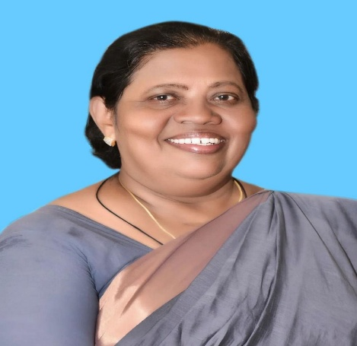
Dear Residents and Stakeholders of Thannithode Grama Panchayath,
It is with a deep sense of responsibility and foresight that I present the Pandemic Preparedness Plan (PPP) for Thannithode Grama Panchayath. The recent global health emergencies have served as a stark reminder that preparedness is not an option, but a mandatory pillar of community resilience. As the President of this Grama Panchayath, my primary commitment is to safeguard the health, well-being, and livelihoods of every single resident.
This document is more than just a plan; it is a comprehensive blueprint for action, developed in close coordination with our Family Health Centre, Veterinary department, ICDS, Police, and local community organizations, embodying the true spirit of the 'One Health' approach. This plan critically assesses our specific vulnerabilities—from our hilly terrain and population demographics to our flood-prone areas and common disease seasonality—to ensure our response is precisely tailored to Thannithode’s unique needs.
The PPP details our existing healthcare infrastructure, resource inventory, and the operational protocols required to manage any future public health crisis, including the constitution of the 'One Health Committee' for coordinated decision-making. It outlines a phased strategy covering Alert/Preparation, Active Response, and Surge Capacity management, ensuring we can transition smoothly from routine operations to full-scale emergency response.
Effective implementation of this plan requires the active participation of every individual, ASHA worker, Kudumbashree member, and community leader. This is a shared responsibility. I urge all citizens to familiarize themselves with this plan and stand ready to collaborate.
Together, we will transform this preparedness plan into effective action, ensuring Thannithode remains a safe, resilient, and healthy community for all.
Lilly Babu
President

MESSAGE FROM
HEALTH STANDING COMMITTEE CHAIR
THANNITHODE GRAMA PANCHAYAT
K R USHA,  Chairperson,  Health & Education Standing Committee,  THANNITHODE Grama Panchayat. | 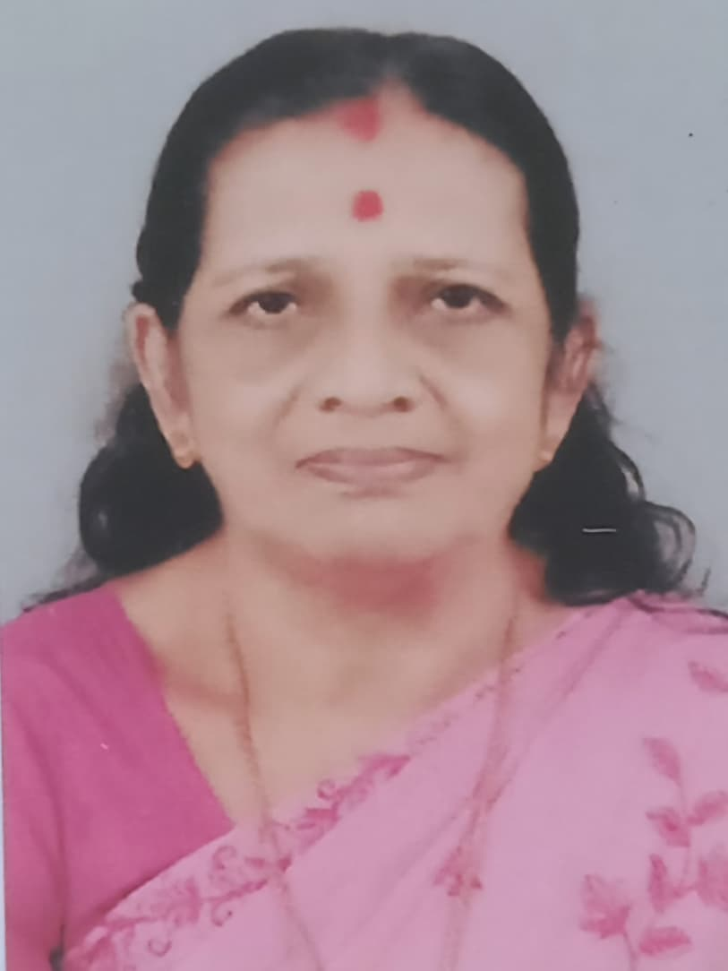
Dear Residents and Partners,
It is a privilege to address you as the Chairperson of the Health and Education Standing Committee of Thannithode Grama Panchayat, presenting this vital Pandemic Preparedness Plan (PPP). The lessons learned from recent public health crises demand that we approach our community's health with systematic planning and unyielding commitment.
This Plan is the result of dedicated inter-departmental collaboration, integrating the expertise of the Family Health Centre, Veterinary, and LSGI systems under a robust 'One Health' framework. It goes beyond simple theory, providing a localized, data-driven strategy specifically tailored to Thannithode’s unique geography and vulnerabilities, including our hilly terrain and historical flood-prone areas.
We have meticulously inventoried our resources, from the capacity of our FHC and HWC network to our human capital—including ASHA workers, JPHNs,JHIs and Kudumbashree members—who form the essential frontline response. Furthermore, the plan details an evidence-based operational strategy, from the Alert/Preparation phase through Active Response and Surge Capacity management, guided by our newly constituted One Health Committee.
The successful execution of this plan depends not just on official directives, but on community ownership. I urge every resident to understand their role, cooperate with our field staff, and uphold the preventive measures outlined. Health is a shared venture. Together, we will ensure that Thannithode is prepared, resilient, and ready to face any future health challenge.
K R USHA, CHAIR PERSON,
HEALTH STANDING COMMITTEE

MESSAGE BY MEDICAL OFFICER IN CHARGE
Dr. Padmanabhan  Medical Officer, in Charge  Family Health Centre, Thannithode | 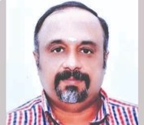

As the Medical Officer in Charge of the Family Health Centre and the technical resource for this initiative, I am pleased to present the Pandemic Preparedness Plan (PPP) for Thannithode Grama Panchayat. This document serves as the essential, evidence-based blueprint designed to safeguard our community against future public health emergencies.
Thannithode, a Grama Panchayat characterized by hilly terrain, historical flood vulnerability, and a significant population of elderly and migrant workers, faces unique risks. Our plan moves beyond generic guidelines by conducting a localized assessment of these specific vulnerabilities, alongside a detailed analysis of our past five years of epidemiological trends (2021–2025), which highlight persistent issues with Dengue, and Leptospirosis, , particularly in wards 9,13,8 and 3.
The PPP is fundamentally rooted in the ‘One Health’ principle, integrating human health, veterinary services, and environmental surveillance. Key features include a comprehensive inventory of our healthcare assets—including the FHC, HWCs, and private clinics—and a meticulous resource mapping of manpower (ASHA, JPHN, JHI, Kudumbashree), logistics, and potential surge capacity infrastructure (schools, community halls).
Crucially, the plan details a phased operational strategy: Phase 1 (Alert/Preparation) focuses on proactive surveillance and stockpiling; Phase 2 (Active Response) outlines protocols for rapid case detection, isolation, and treatment; and Phase 3 (Surge Capacity) addresses the expansion of care facilities to manage overwhelming demand. The plan is driven by the newly constituted One Health Committee, ensuring coordinated, inter-sectoral decision-making.
The successful implementation of this PPP hinges on technical readiness, transparent communication, and community cooperation. It is our collective shield against future threats, transforming our local data into actionable protection for every resident of Thannithode.
Dr Padmanabhan,
Medical Officer in Charge
EXECUTIVE SUMMARY
Primary Health Centre (PHC) functions as the primary public healthcare institution serving the population of Thannithode Grama Panchayath. The PHC plays a pivotal role in delivering comprehensive, accessible, and affordable healthcare services, with a strong focus on preventive, promotive, curative, and rehabilitative care in accordance with national and state health programmes.
The PHC caters to a predominantly rural population, addressing key public health priorities such as maternal and child health, communicable and non-communicable disease control, immunization, family welfare, adolescent health, and geriatric care. Regular outpatient services, home-based care through field health staff, and outreach activities ensure healthcare coverage even in geographically challenging areas. The institution actively implements national health missions, including the National Health Mission (NHM), National Tuberculosis Elimination Programme, National Programme for Prevention and Control of Cancer, Diabetes, Cardiovascular Diseases and Stroke (NPCDCS), and other disease surveillance initiatives.
Thannithode PHC works in close coordination with the Grama Panchayath, ASHA workers, Anganwadi centres, schools, and community-based organizations to strengthen community participation and improve health awareness. Emphasis is placed on early detection, timely referral, health education, and lifestyle modification to reduce disease burden and improve overall health outcomes.
Despite constraints related to infrastructure, manpower, and increasing service demand, the PHC continues to enhance service delivery through effective planning, data-driven decision-making, and community engagement. Strengthening facilities, upgrading digital health systems, and expanding preventive services remain key focus areas for future development.
Overall, Thannithode Primary Health Centre stands as a vital institution in safeguarding public health and improving the quality of life of the residents of Thannithode Grama Panchayath

LIST OF ABBREVIATIONS

LSGD/LSGI | Local Self Government Department / Local Self Government Institution
BMO | Block Medical Officer
IDSP | Integrated Disease Surveillance Programme
NDMA | National Disaster Management Authority
PPE | Personal Protective Equipment
ICMR | Indian Council of Medical Research
CD | Communicable Diseases
NCD | NON-COMMUNICABLE Diseases

TABLE OF CONTENTS

INTRODUCTION 9
LSGD AT A GLANCE 9
INTEGRATED HEALTH INFRASTRUCTURE MAP OF PANCHAYAT 13
GENERAL PROFILE OF THE LSGI’S 15
Background of the LSGI 15
Demographic and Vulnerable Population 16
Clinical Vulnerability 18
INFRASTRUCTURE & RESOURCE INVENTORY 20
Health Facility Directory & Basic Capacity in the LSGD 20
Private Clinics 21
Healthcare Education & Training Institutions 21
Specialized Services & Emergency Inventory 21
Oxygen & Diagnostic Capacity 22
Diagnostics facility mapping at the LSGI level 23
Laboratory Identification & Basic Details 23
Social and Community Infrastructure for surge plan 24
Human resources 26
Community & Support Cadre 27
Community Organizations 28
Administrative & Emergency Services 29
Information regarding resources 29
ONE HEALTH & ENVIRONMENTAL SURVEILLANCE 30
Animal & Bird Population 30
Veterinary Infrastructure 32
Veterinary Doctors & Workforce 33
High-Risk Interface Points (Surveillance Sites) 34
Environmental Risk Mapping 35
Disease Seasonality Mapping 36
Vulnerability Mapping 37
EPIDEMIOLOGICAL TRENDS (2021–2025) 38
Disease Burden among human beings(Last 5 Years) 38
*(use the above table data to create the graph/diagram)
Seasonal Trend Analysis 40
Outcome-Based Trend Analysis- 2025 45
Transmission Trend- 2025 46
Integrated Disease Hotspot Map (2021–2025) 48
Preparedness and Response Protocol at LSG Level 50
Constitution of One Health Committee 51
Pandemic Response Workforce 52
Activities and Measures before and during Pandemic 54
PHASE 1 - Alert / Preparation 54
PHASE 2 - Active Response 57
Standard Screening Protocol 58
PHASE 3 - Surge Capacity 67
Conversion of Community Facilities 67
CONCLUSION 68
RECOMMENDATIONS 69
ANNEXURE 72
1. IMPORTANT PHONE NUMBERS 72

INTRODUCTION

LSGD AT A GLANCE
- Geographical boundaries with political map
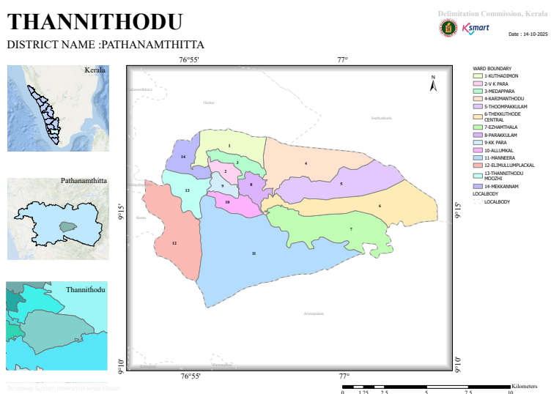
- Baseline data
Area (In Sq.Km) | 43.5 Sq Km
Number Of Wards | 13
Number Of Houses | 4381
Number Of Dwelling House | 4070
Total Population | 14550
Male | 6976
Female | 7574
SC Population | 1454
Male | 715
Female | 739
STPopulation | 127
Male | 59
Female | 68
Number Of SC Colonies | 13
Number Of ST Colonies | 3
No Of SC House | 329
Number Of ST House | 40
Basic Health Sections | 3
HWCs | 7
Eligible Couples | 2032
0-1 Year | 83
Male | 41
Female | 42
1-5 Year | 481
Male | 240
Female | 241
10-18 Year | 1205
Male | 589
Female | 616
Above 30 | 8698
Male | 4128
Female | 4570
Above 60 | 3745
Male | 1831
Female | 1914
Number Of Asha Workers | 13
Number Of Anganwadies | 24
ORT Depots | 36
Government Hospitals(Total) | 3
Allopathy | 1
Ayurveda | 1
Homeo | 1
Private Hospitals (Total) | 1
Allopathy | 1
Ayurveda | 0
Homeo | 0
Dental Clinics | 1
Laborotories | 3
Scanning Centre | 0
Educational Institutions(Total) | 11
Government Schools Total | 6
HSS | 2
HS | 2
UPS | 1
LPS | 1
Pre-Primary | 0
Aided Schools Total | 2
HSS | 0
HS | 1
UPS | 0
LPS | 1
Pre-Primary | 0
Unaided Schools Total | 11
HSS | 0
HS | 0
UPS | 4
LPS | 4
Pre-Primary | 3
Colleges | 1
Other Edu. Institution | 0
Government Instituions | 26
Central Govt | 4
State Govt | 22
Number Of Hotels/Tea Shops | 13
Bakery & Coolbar | 15
Thattu Kada | 2
Borma | 0
Catering Unit | 1
Soda Factory | 0
Ice Cream Factory | 0
Chicken Stall | 8
Chicken Farm | 0
Fish Stall | 2
Meat Stall | 2
Beauty Parlours Total | 7
Men | 4
Women | 3
Markets | 2
Scrap/Akri Shop | 1
Tyre Retrading Centres | 0
Auditorium | 3
Crusher Unit | 0
Hostels | 0
Orphanages | 0
Old Age Home | 0
Worship Places Total | 32
Temple | 13
Churches | 18
Mosques | 1
Pilgrim Centres | 1
Total Number Of Wells | 2783
Public Wells | 6
Private Well | 2772
Colony Well | 2
Ponds | 3
Others | 0
Number Of Pumping Stations | 4
Water Scarcity Area | 13
Number Of Plantation | 325
Library & Reading Rooms | 1
Number Of Latrines | 4120
Arts & Sports Clubs | 3
Number Of NGOs | 2
Kudumbasree Units | 158
Number Of CDs Members | 13
Number Of ADs Group | 9
Nreg Groups | 54
Number Of Suchithwa Squad | 3
Banks | 4
Bus Stands | 0
Ksrtc | 0
Private | 0
Number Of Migrant Sites | 14
Migrant Population Total | 68
Male | 65
Female | 3

- Ward division -
Ward | Houses | Population | Migrants | Wells | Hot  spots | Ed. Institutions | Hosp pvt/govt.
14 | 3968 | 14550 | 72 | 2772 | 1 | 12 | 1

INTEGRATED HEALTH INFRASTRUCTURE MAP OF THANNITHODE PANCHAYAT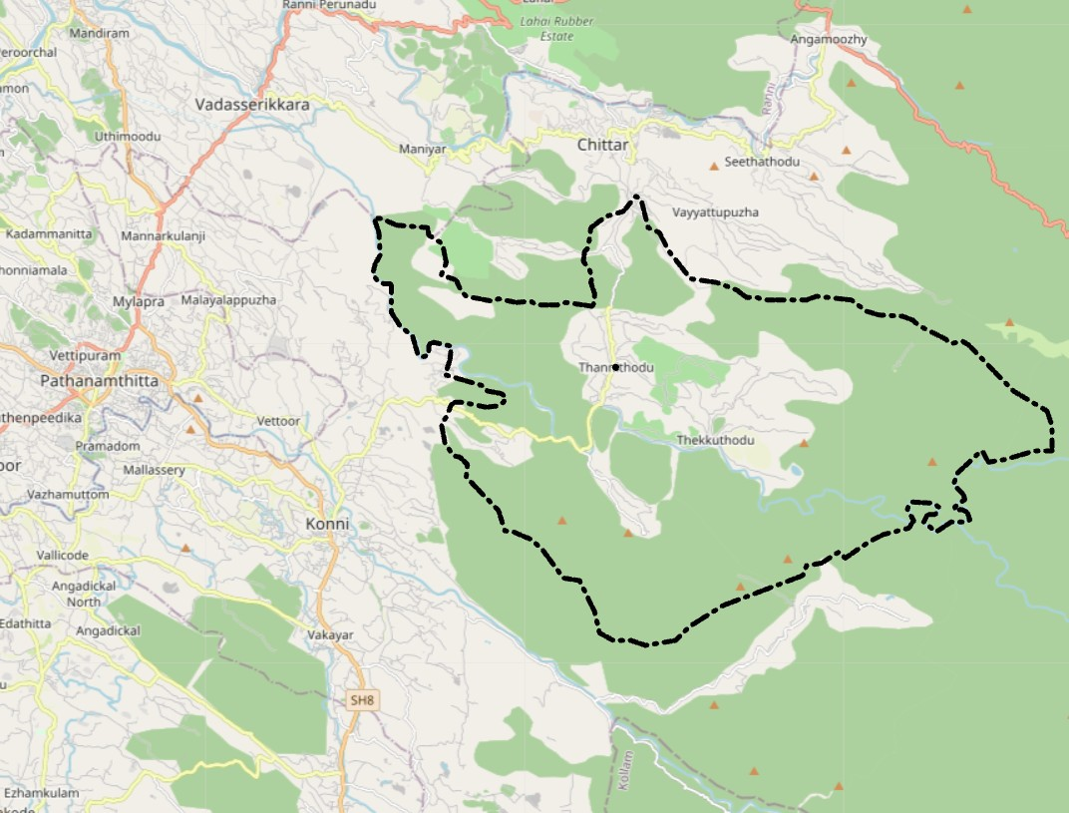

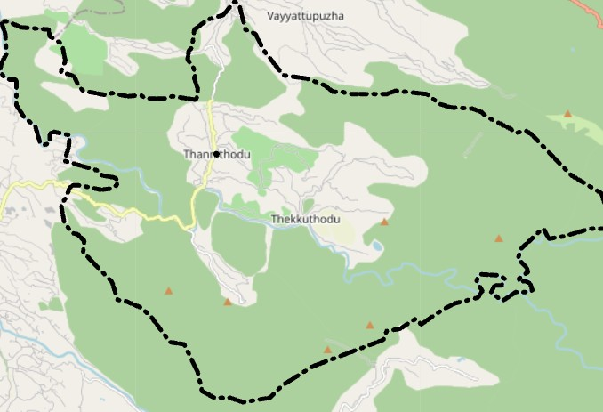

GENERAL PROFILE OF THE LSGI’S

Background of the LSGI
Nestled within the Konni Taluk of Pathanamthitta district, Thannithodu Grama Panchayat serves as a vital gateway to the foothills of the Western Ghats. Characterized by its unique undulating terrain and dense forest fringes, the panchayat is defined by its vast rubber and teak plantations and the life-sustaining Kallar River. With a population of approximately 12,500 and an exceptional literacy rate of 96.63%, the region possesses a socially aware and resilient citizenry—a critical asset for community-based health interventions. While the local economy is anchored in agrarian pursuits and the burgeoning Adavi eco-tourism sector, the village’s geographical seclusion and its proximity to wildlife habitats necessitate a robust, localized Pandemic Preparedness Plan. This plan integrates Thannithodu's high social capital with strategic logistical frameworks to ensure that even the most remote plantation clusters remain protected and informed during public health emergencies.In this context, the development of a localized, data-driven Auxiliary Infrastructure and Logistical Resource Map is essential to support effective planning, timely emergency response, and sustainable development initiatives. Such mapping enables the Panchayat to identify critical resources, improve accessibility during disasters, and enhance overall resilience of the community.

Table 1: Background of LSGD
Description | Details
Name of LSGI | THANNITHODE GP
Type (GP/Municipality / Corporation etc.) | Grama Panchayath
Block | KONNI
District | PATHANAMTHITTA
Number of wards | 14
Total area (sq. km) | 348.02 KM SQUARE
Population(Projected) | 14550
Population density | 41.8/sq km
Terrain (coastal/low-lying/backwaters/foothills, etc.) | Foot hills
Number of rivers passing through LSGI | 1
Number of water bodies in the LSGI | 5
Number of educational institutions | 12
Factories / small-scale industries | 0
Flood-prone wards | 1
Landslide-prone wards | 1
Death Management and Disposal Facilities (mortuaries/crematorium, including electric) | 0
Auditoriums/Marriage halls/convention centres/community halls | 2

Demographic and Vulnerable Population
Understanding the demographic composition and vulnerable population groups is essential for pandemic preparedness. Children, elderly, economically deprived families, migrant workers, and socially vulnerable groups are at increased risk during public health emergencies due to higher exposure, limited access to services, and dependency on public systems..

Description |  | Details (in numbers)
DEMOGRAPHIC PROFILE
Total population |  | 14550
Male |  | 6976
Female |  | 7574
Transgender |  | 0
Children under 5 |  | 564
Adolescent |  | 845
Elderly (>60) |  | 3745
SOCIAL/LIVELIHOOD VULNERABILITY
Previous EPEP family |  | 26
BPL family |  | 1600
Tribal communities |  | 3 (127 MEMBERS)
Migration | Immigrant | 72
Migration | Emigrant | 755
Socio-economically deprived |  | 0
Fisherfolk |  | 0
SC Community |  | 1372
ST Community |  | 127

FEMALE

███ | ███ Under 5

████ | ████ Adolescent

█████████████████████████ | █████████████████████████████ Adults

█████████████ | ██████████████ Elderly

MALE

The adult population (20–59 years) forms the largest segment of the total population, indicating a predominantly working-age community. The elderly population, numbering 3,745, constitutes approximately 26% of the total population, which suggests a significantly ageing population structure. In contrast, the combined proportion of children under five and adolescents forms a comparatively narrower base, reflecting lower representation of younger age groups. Across all age categories, females slightly outnumber males, showing a marginally higher female population overall.

Clinical Vulnerability
Certain population groups needs priority healthcare & are at higher risk of severe illness, complications, and mortality during pandemics. Patients with chronic diseases, those requiring regular medical care, and individuals with mobility or functional limitations face challenges in accessing timely care during emergencies. Mapping these groups helps in prioritizing continuity of treatment, medicine stock planning, oxygen support, referral transport, and targeted home-based care.
Description | Details in numbers
Pregnant women | 64
Lactating mothers | 135
Bedbound patients | 60
Patients under palliative care other than bedbound | 60
Patients on Haemodialysis | 4
Patients on CAPD | 33
Cancer patients (currently on treatment) | 23
Haemophilic patients | 0
Mentally challenged | 43
Differently abled | 185
Diabetic patients | 985
Hypertensive patients | 1345
TB patients | 3

Major Festivals & Events specific to the LSGI

Sl. No. | Name of festival | Month detailing the periodicity
1 | ALUVAMKUDY SIVA RATHRI FESTIVAL | FEBRUARI (1 DAY ONLY)

INFRASTRUCTURE & RESOURCE INVENTORY

Health Facility Directory & Basic Capacity in the LSGD
This section provides an overview of the healthcare infrastructure available within the LSGD area. It outlines the distribution and basic capacity of health facilities that form the backbone of service delivery during routine times and public health emergencies.

Family Health Centres (FHCs) and Community Health Centres (CHCs) generally function as the first point of contact for the community, providing essential outpatient and inpatient services. General Hospitals (GH) and Medical College Hospitals (MCH), where accessible, serve as the main referral centres for advanced diagnostics, specialist care, and critical services during public health emergencies. This inventory helps identify existing strengths, gaps, and potential surge capacity that can be mobilised during a pandemic or disaster.

Table 5. Health Facility Resource Summary
Sl.no. | Health Facility | Type of Facility (MCH/GH/CHC/FHC/SC etc.) | Contact Number | Total beds | ICU Beds | Oxygen-Supported Beds | No. of Ventilator Support Beds | No. of ambulances
Government Healthcare Facilities
1 | FHC THANNITHODE | FHC | 9567114036 | 5 | 0 | 0 | 0 | 1
2 | AAM MAIN CENTR | AAM | 9567114036 | 0 | 0 | 0 | 0 | 0
3 | AAM THANNITHODE | AAM | 9567114036 | 0 | 0 | 0 | 0 | 0
4 | AAM MEDAPPARA | AAM | 9567114036 | 0 | 0 | 0 | 0 | 0
5 | AAM PLANTATION | AAM | 9567114036 | 0 | 0 | 0 | 0 | 0
6 | AAM ELIMULLU | AAM | 9567114036 | 0 | 0 | 0 | 0 | 0
7 | AAM THEKKUTHODE | AAM | 9567114036 | 0 | 0 | 0 | 0 | 0
8 | AAM MANNEERA | AAM | 9567114036 | 0 | 0 | 0 | 0 | 0
Private Healthcare Facilities
 | NIL
AYUSH Healthcare Facilities
1 | GOV AYURVEDA | AYUSH | 9745465812 | 0 | 0 | 0 | 0 | 0
2 | GOV HOMEO | AYUSH | 9809689112 | 0 | 0 | 0 | 0 | 0

Private Clinics
Private clinics are an essential part of pandemic preparedness, as they are often the first-place people seek care when symptoms begin. In many communities, private clinics manage a significant share of outpatient visits and therefore play a critical role in early case detection, timely referrals, and disease surveillance. Having an up-to-date understanding of where these clinics are located, the services they provide, and how they are linked to the public health system helps ensure that no cases are missed during an outbreak. It also allows health authorities to engage private practitioners more effectively for reporting, risk communication, and coordinated response, strengthening the overall capacity of the health system to manage public health emergencies.

Table 6. Private Clinic Resource Summary
Sl No. | Name of Clinic | Registered (Y/N) | Clinic (General / Speciality) | Speciality (if any) | Address | Contact Number | Diagnostic Facility (Y/N) | Ambulance Linkage (Y/N)
1 | NA | NA | NA | NA | NA | NA | NA | NA
2 | NA | NA | NA | NA | NA | NA | NA | NA

Healthcare Education & Training Institutions
This section tracks the educational infrastructure available, which is vital for human resource planning in the health sector.

Category of Institution | Govt | Private | AYUSH | Total
Medical Colleges | 0 | 0 | 0 | 0
Nursing Colleges | 0 | 0 | 0 | 0
Dental Colleges | 0 | 0 | 0 | 0
Para-medical / Allied Health | 0 | 0 | 0 | 0
Pharmacy Colleges | 0 | 0 | 0 | 0

Specialized Services & Emergency Inventory
This section provides a detailed view of the specialized medical resources available to the community, focusing on emergency response and critical care capabilities. This table tracks the vital assets required for managing severe illnesses and emergencies across Government, Private, and AYUSH sectors.

Item | Govt | Private | AYUSH | Total
Hospital beds | 5 | 0 | 0 | 0
Oxygen-generating systems(Y/N) | 0 | 0 | 0 | 0
Oxygen-supported beds (Numbers) | 0 | 0 | 0 | 0
Ventilator-supported beds | 0 | 0 | 0 | 0
ICU beds | 0 | 0 | 0 | 0
Burns units | 0 | 0 | 0 | 0
Blood centres | 0 | 0 | 0 | 0
BLS ambulances | 0 | 0 | 0 | 0
ALS ambulances | 0 | 0 | 0 | 0
Dialysis facilities | 0 | 0 | 0 | 0
Dispensaries | 0 | 0 | 0 | 0
Medical store | 0 | 0 | 0 | 0
Industrial establishments (Medium-scale industries/small-scale industries establishments to whom we can depend in a worst-case scenario) | 0 | 0 | 0 | 0

Oxygen & Diagnostic Capacity
Monitoring oxygen and diagnostic capacity is a critical component of public health preparedness, ensuring that the LSGD can handle both chronic care and sudden surges in respiratory or infectious diseases.
Name of Health Facility | Oxygen-generating System (Y/N) | Backup Oxygen Source (Y/N) | Diagnostic Facilities Available(Y/N)
Name of Health Facility | Oxygen-generating System (Y/N) | Backup Oxygen Source (Y/N) | Lab | USG | X-ray | CT/MRI | RT-PCR
Government Healthcare Facilities
FHC THANNITHODE | N | N | 1 | 0 | 0 | 0 | 0
FHC THANNITHODE | NIL | NIL | Y | N | N | N | N

Diagnostics facility mapping at the LSGI level
The diagnostic capacity of Thannithode G.P represents the "intelligence network" of our healthcare system. The speed and accuracy of disease identification depend entirely on the distribution and technical level of these facilities.

Item | Govt | Private | AYUSH | Total
General labs | 1 | 0 | 0 | 1
Microbiology labs | 0 | 0 | 0 | 0
RT-PCR labs | 0 | 0 | 0 | 0
USG units | 0 | 0 | 0 | 0
CT/MRI units | 0 | 0 | 0 | 0
Research labs | 0 | 0 | 0 | 0
Labs of other departments that can be repurposed | 0 | 0 | 0 | 0

Laboratory Identification & Basic Details
Sl. No. | Name of Laboratory | Ownership (Govt / Private / Academic) | Address | Contact No. | 24×7 Services (Yes/No) | NABL / Govt Approved (Yes/No)
1 | FHC LAB | GOV | FHC | 9645111366 | NO | NO

Social and Community Infrastructure for surge plan
This table serves as our logistics and shelter inventory. By mapping these locations, quickly we can identify where to house displaced citizens, where to set up temporary medical clinics, and how to manage the deceased with dignity during a crisis.

Category | Total Count | Ward | Est. Capacity (Persons) | Contact details
Educational Institutions
Anganwadis | 24 | 13 | NA | NA
Schools | 12 | 5 | NA | NA
Colleges | 1 | 1 | NA | NA
Healthcare Educational Institutions
Medical colleges (Govt/Private) | 0 | NA | NA | NA
Nursing colleges (Govt/Private) | 0 | NA | NA | NA
Dental colleges (Govt/Private) | 0 | NA | NA | NA
Paramedical institutes (Govt/Private) | 0 | NA | NA | NA
Community Gathering Spaces
Community halls | 1 | NA | NA | NA
Auditoriums | 2 | NA | NA | NA
Religious buildings | 15 | NA | NA | NA
Vulnerable Group Support Facility
Destitute homes | 0 | NA | NA | NA
Elderly homes | 0 | NA | NA | NA
LSGD owned other buildings | 15 | NA | NA | NA
Mass Fatality Management (MFM) Infrastructure
Mortuary | 0 | NA | NA | NA
Crematorium | 0 | NA | NA | NA
*refer annexure 1 for contact details

Human resources
This section focuses on the human capital available within the LSGI. In any emergency—be it a pandemic, flood, or industrial accident—infrastructure is only as effective as the people operating it.

Medical & Clinical Personnel
This table tracks the "Frontline" providers responsible for diagnosis, treatment, and clinical management. Narrative sentence: eg., "Total health workforce: 450 personnel, with 60% in government facilities serving as primary surge capacity." A detailed directory with the contact numbers of all workers is maintained (Annexure in 1).

Cadre | Govt (No.) | Private (No.) | Total
Doctors—Modern Medicine | 4 | NA | 4
Doctors – AYUSH | 1 | NA | 1
Doctors – Veterinary | 1 | NA | 1
Doctors – Dental | 0 | NA | 0
Nursing officers | 3 | NA | 3
Lab technicians | 1 | NA | 1
Optometrist | 0 | NA | 0
Pharmacists | 2 | NA | 2
Psychologists | 0 | NA | 0
Counsellors | 0 | NA | 0

Public Health & Field-Level Workforce
These individuals are the backbone of surveillance, maternal-child health, and decentralized care.

Cadre | Health services | Municipal common services | Total
HS (Health Supervisors) | 0 | NA | 0
HI (Health Inspectors) | 1 | NA | 1
LHS (Lady Health Supervisor) | 0 | NA | 0
LHI (Lady Health Inspectors) | 1 | NA | 1
JPHN (Jr Public Health Nurses) | 7 | NA | 7
JHI (Jr Health Inspectors) | 3 | NA | 3
MLSP (Mid-Level Service Providers) | 7 | NA | 7
Palliative Nurses | 1 | NA | 1
RBSK Nurses | 1 | NA | 1
PRO | 1 | NA | 0
Epidemiologist | 0 | NA | 0
Data Manager | 0 | NA | 0

Community & Support Cadre
This group represents the surge capacity of the LSGI—people who can be called upon for logistics, rescue, and specialized support.

Cadre | Number
ASHA Workers | 13
AWW (Anganwadi Workers) | 24
Emergency Medical Volunteers (Trained) | 0
Kudumbashree | 48
MNREGS | 485
Purusha Swayam Sahaya Sangham | 14
Ex-Servicemen | 56
Retired Police Officers | 9
NCC/NSS Volunteers | 35
Red Cross volunteers | 0
One Health Community Volunteers | 75
One Health Community Mentors | 14

Community Organizations
This section details the presence of community-based organisations (CBOs), non-governmental organisations (NGOs), faith-based organisations (FBOs), Kudumbashree Self-Help Groups (SHGs), and Ayalkootams within the Local Self-Government Institution (LSGI). These groups enhance grassroots mobilization, resource distribution, and support networks crucial for pandemic response and community resilience.

Category | Total Count
NGOs | 142
Religious based organizations | 7
Foreign based organizations | 1
Sports Club/youth clubs | 1
Kudumbashree SHGs | 145
Ayalkootams | 135
Political organizations | 3
Residential organizations | 2

Administrative & Emergency Services
This section outlines the availability of key non-health emergency support services and infrastructure within the LSGI, which are essential for effective pandemic preparedness and response. These facilities support law enforcement, disaster response, water supply, logistics, mobility, and community-level interventions during public health emergencies.

Category | Total Count | Contact details
Police Stations | 1 | 0468282253
Fire & Rescue Stations | 0 | 101
Water Pumping Points | 4 | 1916
Public Distribution System (PDS) | 0 | NA

Information regarding resources
The availability of essential transport and support resources plays a quiet but critical role in saving lives. Equipment such as ambulances, mobile mortuaries, amphibian ambulances, and motorized boats ensures that patients, samples, and healthcare teams can move swiftly—even in flooded, remote, or difficult terrains. Heavy vehicles like JCBs, cranes, tractors, and torus lorries support logistics, waste management, emergency infrastructure, and rapid conversion of spaces into care or isolation facilities. Taxis, four-wheel-drive vehicles, and trucks help maintain continuity of essential services, reach vulnerable populations, and support home-based care and supply delivery.

Means of transportation | Total Count
JCB | 2
Crane | 0
Heavy Trucks | 17
Tractor | 0
Ambulances | 3
Mobile mortuaries | 0
Boats | 0
Taxi service | 0
Note: For specific details regarding vehicle owners and contact information, please refer to Annexure [X].

ONE HEALTH & ENVIRONMENTAL SURVEILLANCE
The One Health method integrates environmental, animal, and human health to enable proactive pandemic preparedness. Panchayat-level surveillance needs to be improved in order to detect and treat zoonotic and environmentally generated diseases early. Surveillance is strengthened through systematic assessment of animal populations, veterinary infrastructure, poultry and slaughter facilities, inter-sectoral coordination, and specialised tools like avian influenza seasonality mapping using GIS in previous outbreaks to enable predictive alerts and ward-specific sampling to support effective pandemic preparedness in high-risk areas.

Animal & Bird Population
Mapping animal and bird populations at the Panchayat level is essential for identifying and prioritising zoonotic disease hazards like rabies, avian influenza (H5N1), leptospirosis, anthrax, and Nipah-like spillover occurrences. Risk classification, targeted surveillance, vaccination planning, and early epidemic detection made feasible by comprehensive population mapping all enhance One Health-based pandemic preparedness.

Category | Item | Estimated Population | Wards
Animal Population | Livestock (Cattle/Goats/Buffalo) | 1625 | 2,3,5,7
Animal Population | Pet Animals (Dogs/Cats) | 550 | ALL WARD
Animal Population | Stray Dog Population | 30 | ALL WARD
Animal Population | Pig Farms (Number of heads) | 0 | 1
 | Small Units (Sheep / Goats – clustered) | 0 | NA
Bird Population | Poultry Units (Birds) | 0 | NA
Bird Population | Poultry- (FOWL) | 0 | NA
Bird Population | Wild/Migratory Birds (Observed) | 0 | NA
Bird Population | Crow Mortality Events (Reported) | 0 | NA

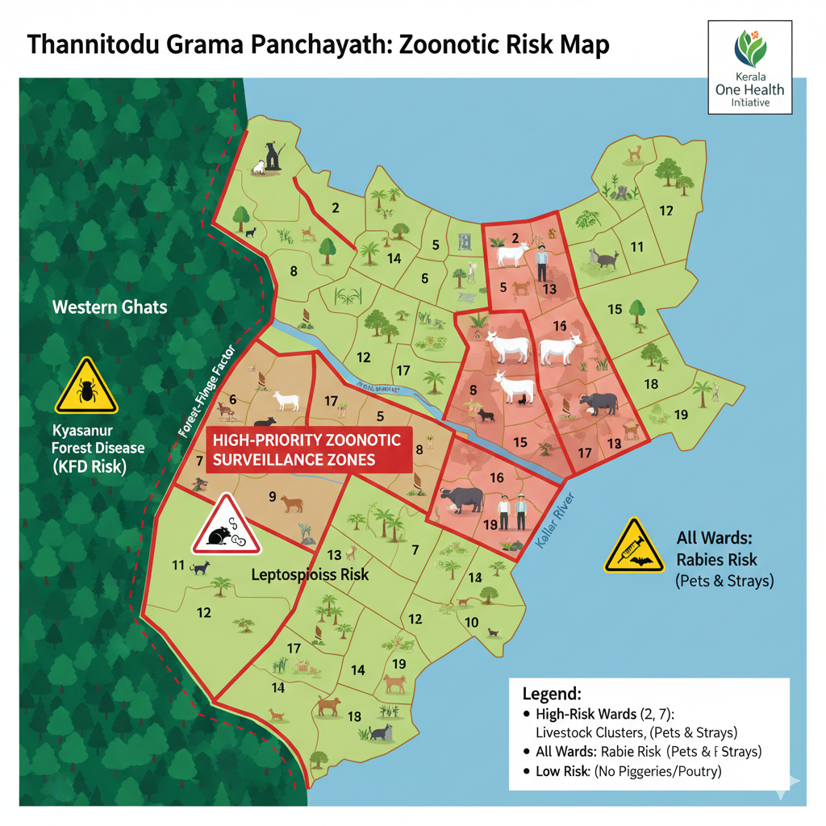

Thannithodu Grama Panchayat presents a distinct epidemiological profile characterized by a significant "One Health" interface, where human, animal, and environmental health are deeply interconnected. The current assessment identifies a concentrated livestock population of 1,625 heads (cattle, goats, and buffalo) primarily within Wards 2, 3, 5, and 7. This creates a localized risk for Leptospirosis, where environmental shedding of bacteria in plantation-rich, high-rainfall areas poses an occupational hazard to the working-age population and a severe clinical threat to the 3,745 elderly residents.

While the total absence of commercial pig farms and poultry units (0 units) effectively minimizes the local risk of Japanese Encephalitis and Avian Influenza, the universal presence of 550 pets and 30 stray dogs across all wards maintains Rabies as a pervasive threat requiring 100% vaccination coverage. Furthermore, Thannithodu’s forest-fringe geography necessitates vigilance against Kyasanur Forest Disease (KFD), as the active labour force serves as a biological bridge between sylvan wildlife cycles and the village.

Preparedness strategies must therefore prioritize syndromic surveillance and "fever mapping" within the livestock-heavy wards, alongside a robust One Health protocol that integrates veterinary insights with primary healthcare to intercept zoonotic spillover at its source.

Veterinary Infrastructure
Veterinary institutions are a core pillar of One Health surveillance, enabling early zoonotic disease detection through vaccination, investigation of unusual animal illness or deaths, sample collection, and timely outbreak reporting. A well-mapped and responsive veterinary network strengthens coordination with human health and LSGI systems, ensuring rapid response during zoonotic events and pandemics.
Facility Type | Name of Facility | Ownership Govt / Pvt | Location(Ward No) | Contact number
Veterinary Dispensary | 1 | NIL | NIL | NIL
Veterinary Hospital / Polyclinic | 1 | GOV | WARD 12 | 8078139486
Private Veterinary Clinics | 0 | NA | NA | NA
Mobile / Emergency Vet Service (incl. night services) | 0 | NA | NA | NA
Pet Homes / Animal Shelters | 0 | NA | NA | NA
Slaughterhouse-linked Veterinary Inspection Unit | 0 | NA | NA | NA

Veterinary Doctors & Workforce
Early detection, diagnosis, reporting, and reaction to animal illness epidemics depend on the availability and accessibility of qualified veterinary specialists. By identifying unusual animal morbidity or mortality promptly, collecting samples promptly, and coordinating efficiently with human health and LSGI systems—especially during zoonotic outbreaks and pandemic-prone situations—a clearly defined veterinary workforce enhances One Health surveillance.

Category | Number Available | Type (Govt/Pvt) | Contact number
Government Veterinary Doctors | 1 | GOV | 8078139486
Private Veterinary Doctors | 0 | NA | NA
Livestock Inspectors | 1 | GOV | 8078139486
Para-veterinary Staff / Attenders | 0 | NA | NA
Contract / On-call Veterinary Support (if any) | 0 | NA | 8078139486

High-Risk Interface Points (Surveillance Sites)
High-risk interface points for zoonotic disease surveillance in Thannithode Grama Panchayath include wetland–livestock–human contact zones, backyard poultry farms, cattle sheds near water bodies, fish markets, and areas of high human–animal interaction such as community slaughter points and migratory bird congregation sites. These are the primary surveillance sites where zoonotic spillover risks are elevated.

Type of Habitat | Type of High risk interface | Geographical vulnerability
Wetlands & Backwaters | 0 | NA
Backyard Poultry Farms | 0 | NA
Cattle Sheds near Water Bodies | 0 | NA
Fish & Meat Markets | 0 | NA
Community Slaughter Sites | 0 | NA
Migratory Bird Congregation Areas | 0 | NA
Rodent-Infested Grain Storage | 0 | NA

Category | Total Count | Key Locations (wards)
Poultry Farms | 0 | NA
Backyard / Clustered Poultry Units | 0 | NA
Duck Rearing Units (open water access) | 0 | NA
Slaughterhouses/ Slaughter Points | 0 | NA
Meat/Fish Markets | 0 | NA
Live Bird Sale Points | 0 | NA
Cattle Markets / Weekly Animal Fairs | 0 | NA
Pet Shops / Breeders | 0 | NA
Animal Shelters / Pet Homes | 0 | NA
Waste Disposal Sites near Animal Units | 0 | NA

Environmental Risk Mapping
Environmental risk mapping identifies monsoon/flood hotspots for vector-borne (dengue, chikungunya), water-borne (leptospirosis, diarrhoea), and zoonotic diseases in Kerala's wetlands. Systematic surveillance supports early warnings, targeted interventions, and Panchayat pandemic preparedness.
Waterborne exposure: Flood-prone areas and stagnant water bodies facilitate leptospira survival, raising leptospirosis risk.

Traditional practices: Informal slaughter and fish markets lack standardized hygiene, creating spillover opportunities.

Risk Factor | High-Risk Wards | Key Locations | Risk Level (High/Med/Low)
Flood-prone areas | 1 | TND JUN | NA
Water bodies/wetlands | 0 | NA | NA
Solid waste accumulation | 0 | NA | NA
Animal waste disposal issues | 0 | NA | NA
Rodent infestation zones | 0 | NA | NA
Industrial effluent discharge | 0 | NA | NA
Construction sites / abandoned buildings | 0 | NA | NA
Poor drainage/blocked canals | 0 | NA | NA
Drinking water source contamination risk | 1 | WARD 12 | LOW

Disease Seasonality Mapping
1, Flooding & waterlogging → amplifies leptospirosis, malaria, diarrheal diseases.
·
2, Migratory bird influx (Nov–Feb) → avian influenza risk.

3, Mosquito breeding cycles → vector-borne disease peaks in monsoon.

4, Agricultural practices → close human–animal contact in paddy fields.

Disease | Peak Risk Season | Key Drivers | High-Risk Locations | Surveillance Focus
Avian Influenza | NA | NA | NA | NA
Leptospirosis | June to November | NA | TKD | Y
Dengue/Chikungunya | March to October | NA | NA | NA
Acute Diarrheal Diseases | March to May | NA | NA | NA
Rabies | NA | NA | NA | NA
Anthrax (rare) | NA | NA | NA | NA

Vulnerability Mapping
Vulnerability mapping pinpoints high-risk populations, occupations, and areas exposed via environment, livelihoods, socio-economics, and poor service access. Paired with environmental/seasonality mapping, it enables risk-based surveillance, targeted actions, and optimal resource use in One Health and pandemic planning.
Vulnerability Factor | High-Risk Wards | Key Groups / Locations | Risk Level
Flood-prone households | 1 | TND JN | LOW
Wetland-adjacent communities | 0 | NA | NA
Backyard poultry / duck rearing households | 0 | NA | NA
Livestock-rearing households | 0 | NA | NA
Slaughterhouse & meat market workers | 0 | NA | NA
Fisherfolk & fish market workers | 0 | NA | NA
Sanitation workers | 0 | NA | NA
Daily wage / migrant workers | 0 | NA | NA
Elderly & chronically ill populations | 0 | NA | NA
Pregnant Women | 0 | NA | NA
Children (schools, Anganwadi’s) | 0 | NA | NA
Limited access to safe water & sanitation | 0 | NA | NA

EPIDEMIOLOGICAL TRENDS (2021–2025)

Disease surveillance is the systematic collection, analysis, and interpretation of health data for planning, implementation, and evaluation of public health practice. This section presents the disease surveillance profile of the LSGI based on routine reporting systems and outbreak investigations to identify priority diseases, seasonal patterns, and emerging public health threats.

Disease Burden among human beings (Last 5 Years)
Analysis of disease-wise data for the last five years helps identify persistent public health problems, emerging diseases, and changes in disease burden. This information supports prioritisation of prevention, preparedness, and response activities at the Panchayat level.

Disease | 2021 | 2022 | 2023 | 2024 | 2025 | Trend(Increasing/Stable/Decreasing)
Dengue | 0 | 16 | 73 | 120 | 9 | DECREASING
Leptospirosis | 0 | 0 | 4 | 2 | 1 | DECREASING
Hepatitis A | 0 | 0 | 0 | 1 | 0 | DECREASING
Malaria | 0 | 0 | 0 | 0 | 1 | DECREASING
Scrub Typhus | 0 | 0 | 0 | 0 | 0 | DECREASING
Typhoid | 0 | 0 | 1 | 3 | 2 | DECREASING
H1N1 | 0 | 0 | 0 | 0 | 2 | DECREASING
H3N2 | 0 | 0 | 0 | 0 | 0 | DECREASING
ADD | 0 | 110 | 66 | 120 | 53 | DECREASING
Mumps | 0 | 0 | 0 | 0 | 0 | DECREASING
Measles | 0 | 0 | 0 | 0 | 0 | DECREASING
Hepatitis B | 1 | 0 | 4 | 0 | 0 | DECREASING
Hepatitis C | 0 | 0 | 0 | 0 | 0 | DECREASING
Tuberculosis | 2 | 4 | 6 | 5 | 5 | DECREASING
Leprosy | 0 | 0 | 0 | 0 | 0 | DECREASING
COVID-19 | 1320 | 5 | 8 | 0 | 0 | DECREASING

Based on the data provided for the years 2021 to 2025, the data suggests that while the pandemic phase of COVID-19 has passed, seasonal diseases like Dengue and ADD require vigilant monitoring as they exhibit cyclical peaks.
The epidemiological landscape from 2021 to 2025 was defined by a transition from a singular pandemic crisis to a complex profile of fluctuating seasonal and endemic diseases. The period began with a massive COVID-19 peak of 1,320 cases in 2021, which effectively eclipsed all other health data before successfully trending toward zero by 2024. In the post-pandemic years, Dengue Fever emerged as a primary concern, exhibiting an aggressive upward trajectory that peaked at 120 cases in 2024 before a sharp intervention-led decline to 9 cases in 2025. Similarly, Acute Diarrheal Disease (ADD) represents a persistent public health challenge, showing a volatile "double peak" pattern in 2022 and 2024 that highlights ongoing vulnerabilities in sanitation or water safety.
While stable endemic diseases like Tuberculosis maintained a consistent, low-level presence of 2 to 6 cases annually, the 2025 data introduced new surveillance priorities with the sporadic emergence of Malaria and H1N1. This shift suggests that while the community has effectively contained the major outbreaks of the early 2020s, it now faces a "new normal" characterized by the re-emergence of traditional infectious threats.

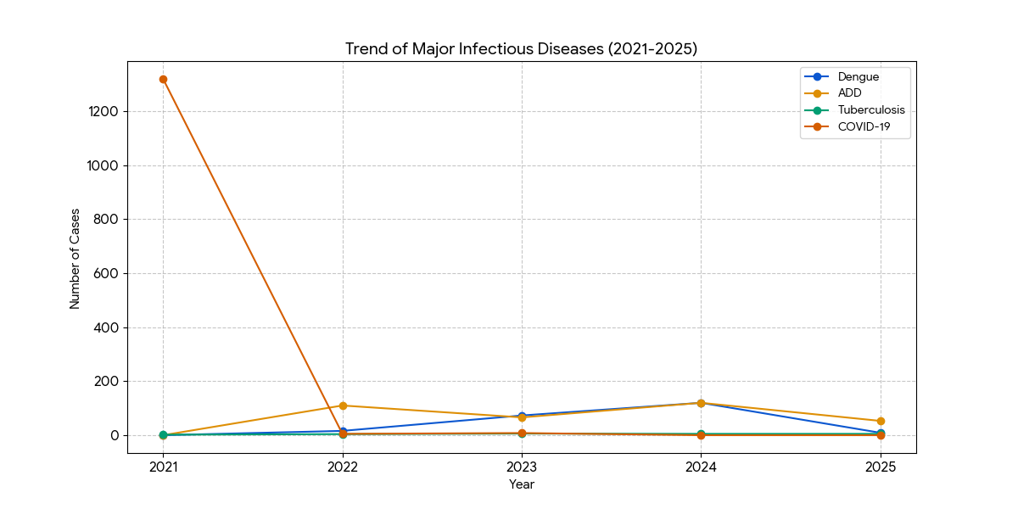
This line graph tracks the progression of the most prevalent diseases. The significant peak of Dengue and ADD in 2024 followed by a universal downturn in 202

Seasonal Trend Analysis
Seasonal analysis helps anticipate surges (e.g. dengue in monsoon, leptospirosis after floods, influenza in cooler months) and plan pre‑emptive vector control, stockpiling of IV fluids, and awareness campaigns at Panchayat level.

DENGUE
Dengue is a major seasonal vector-borne disease strongly associated with rainfall, water stagnation, and increased mosquito breeding during the monsoon period.

Peak: July–November

Dengue – Ward-wise Yearly Distribution (2021–2025)

Ward | Dengue – Ward-wise Yearly Distribution
Ward | 2021 | 2022 | 2023 | 2024 | 2025 | Total
1 | 0 | 2 | 2 | 3 | 2 | 9
2 | 0 | 0 | 1 | 3 | 0 | 4
3 | 0 | 2 | 1 | 4 | 0 | 7
4 | 0 | 1 | 2 | 35 | 0 | 38
5 | 0 | 2 | 3 | 2 | 2 | 9
6 | 0 | 2 | 2 | 10 | 1 | 15
7 | 0 | 2 | 2 | 8 | 1 | 13
8 | 0 | 1 | 1 | 8 | 2 | 12
9 | 0 | 2 | 57 | 40 | 1 | 100
10 | 0 | 2 | 2 | 7 | 0 | 11

The data suggests that the region experienced a propagated outbreak pattern, where the infection likely originated in Ward 9 during 2023 before "spilling over" into surrounding sectors like Ward 4 and Ward 6 by 2024. Furthermore, the dramatic reduction from a total of 120 cases in 2024 to just 9 in 2025 serves as an excellent example of successful public health intervention and vector control efficacy. However, the persistent, low-level recurrence of cases in Wards 1, 5, and 8 during 2025—despite the broader regional decline—highlights critical pockets where larval control and environmental sanitation must be intensified to prevent a secondary resurgence.
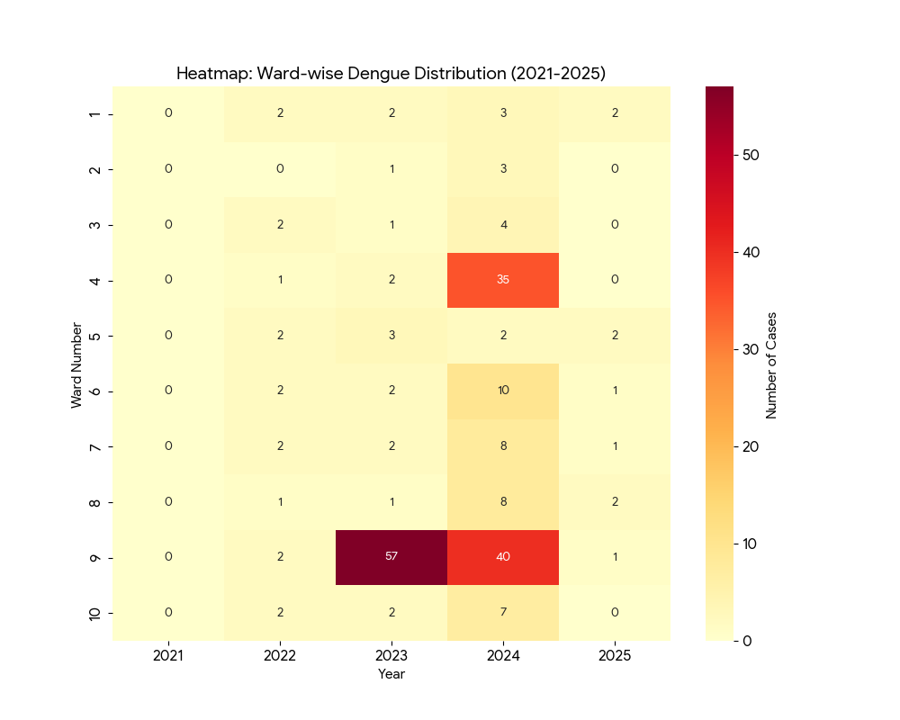
The heatmap reveals a "Core-Periphery" outbreak model. The infection appears to have established a core in Ward 9 during 2023 and then radiated outward to neighboring wards in 2024. The rapid cooling of the map in 2025 suggests that the environmental or social factors driving the 2024 peak were successfully addressed or were naturally seasonal.

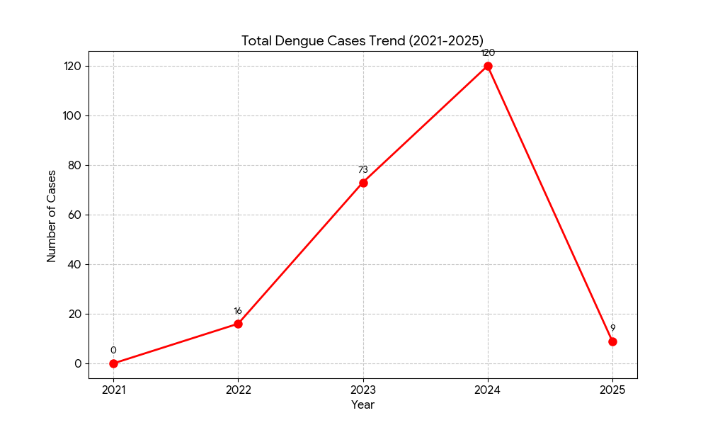
The graph clearly displays a single-peak (unimodal) epidemic curve. The sharp incline from 2022 to 2024 suggests a period of high environmental suitability for mosquito breeding and viral transmission. The subsequent "crash" in 2025 is a positive indicator that public health measures such as community awareness, source reduction, and targeted vector control were highly effective in breaking the chain of transmission.

LEPTOSPIROSIS
Leptospirosis cases are closely linked to monsoon rains, flooding, and occupational exposure, particularly in low-lying and waterlogged areas.

Peak: June - August

Leptospirosis – Ward-wise Yearly Distribution (2021–2025)

Ward | Leptospirosis – Ward-wise Yearly Distribution
Ward | 2021 | 2022 | 2023 | 2024 | 2025 | Total
1 | 0 | 0 | 0 | 0 | 0 | 0
2 | 0 | 0 | 0 | 0 | 0 | 0
3 | 0 | 0 | 2 | 0 | 0 | 2
4 | 0 | 0 | 2 | 0 | 1 | 1
5 | 0 | 0 | 0 | 1 | 0 | 1
6 | 0 | 0 | 0 | 0 | 0 | 0
7 | 0 | 0 | 0 | 0 | 0 | 0
8 | 0 | 0 | 0 | 0 | 0 | 0
9 | 0 | 0 | 0 | 0 | 0 | 0
10 | 0 | 0 | 0 | 0 | 0 | 0
11 | 0 | 0 | 0 | 0 | 0 | 0
12 | 0 | 0 | 0 | 1 | 0 | 1
13 | 0 | 0 | 0 | 0 | 0 | 0

The epidemiological data for Leptospirosis reveals a sporadic and highly localized distribution rather than a widespread outbreak. After a two-year period of zero incidence (2021–2022), the region saw a minor peak in 2023, primarily driven by Ward 3 and Ward 4. The subsequent years (2024–2025) show a thinning of cases, with the disease appearing in new wards (5 and 12) before receding. The fact that Ward 4 is the only area to report a case in 2025 indicates that it remains a minor environmental reservoir for the Leptospira bacteria.

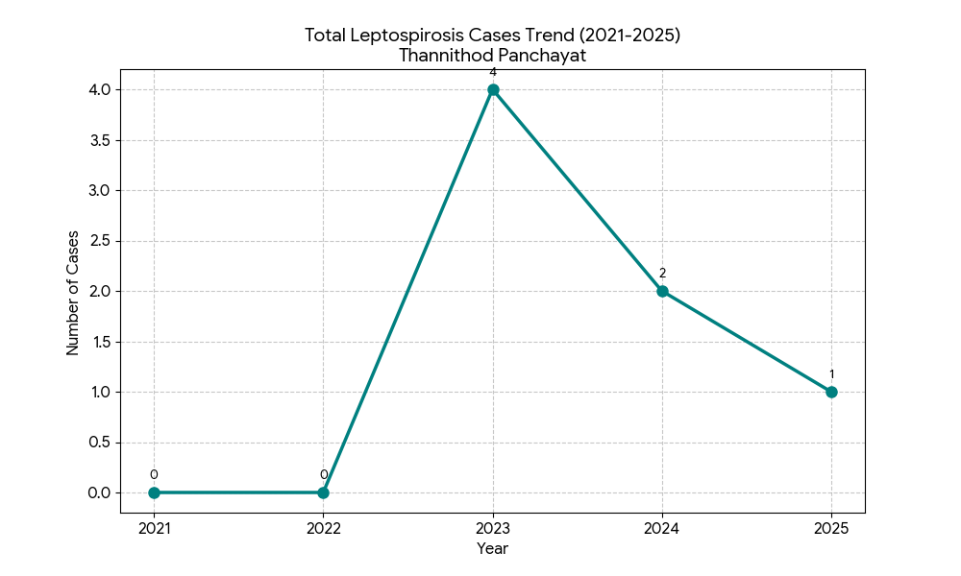

The overall trend is officially classified as Decreasing. The rapid decline following the 2023 peak suggests that public health interventions likely involving improved sanitation, rodent population management, and community awareness regarding water safety have been largely successful.

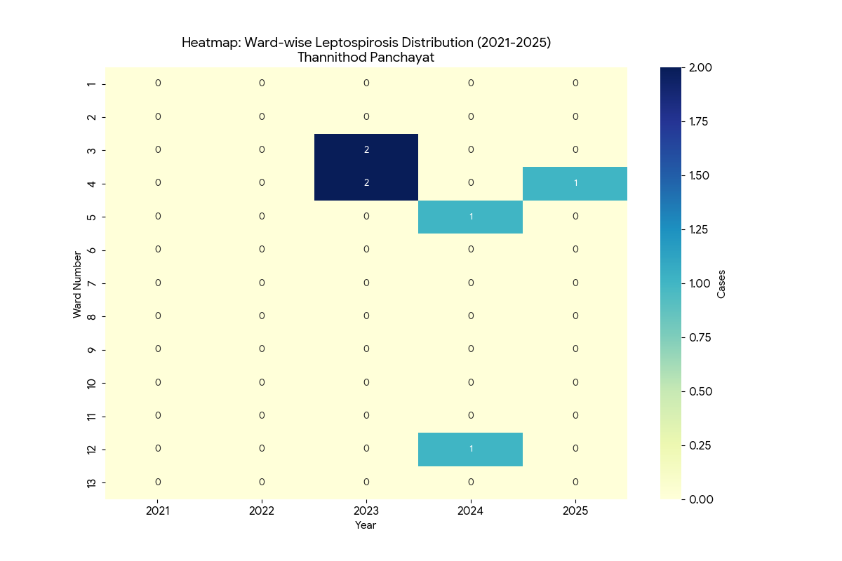
The trend in Thannithod Panchayat is categorized as decreasing and sporadic. Unlike Dengue, which had high volume and wide spread, Leptospirosis is a "low-incidence, high-specificity" disease here. The fact that the incidence has dropped to a single case in 2025 suggests that routine sanitation and rodent control measures are having a positive impact. However, continued surveillance in Ward 4 is recommended, as it appears to be the most consistent site for re-emergence.

VIRAL HEPATITIS - A
Hepatitis A cases are commonly associated with unsafe drinking water, food contamination, and breakdowns in sanitation, often presenting as clusters or outbreaks.

Peak: October - December

Hepatitis A – Ward-wise Yearly Distribution (2021–2025)

Ward | Hep A – Ward-wise Yearly Distribution
Ward | 2021 | 2022 | 2023 | 2024 | 2025 | Total
8 | 0 | 0 | 0 | 1 | 0 | 1
2 | 0 | 0 | 0 | 0 | 0 | 0
3 | 0 | 0 | 0 | 0 | 0 | 0
4 | 0 | 0 | 0 | 0 | 0 | 0
5 | 0 | 0 | 0 | 0 | 0 | 0
6 | 0 | 0 | 0 | 0 | 0 | 0
7 | 0 | 0 | 0 | 0 | 0 | 0
1 | 0 | 0 | 0 | 0 | 0 | 0
9 | 0 | 0 | 0 | 0 | 0 | 0
10 | 0 | 0 | 0 | 0 | 0 | 0
11 | 0 | 0 | 0 | 0 | 0 | 0
12 | 0 | 0 | 0 | 0 | 0 | 0
13 | 0 | 0 | 0 | 0 | 0 | 0

The status of Hepatitis A in Thannithod Panchayat is classified as Stable/Decreasing. Over the five-year surveillance period, only a single case was recorded across the entire Panchayat. The appearance of a single case in Ward 8 during 2024 likely represents an "imported case" (acquired through travel outside the Panchayat) or a highly localized point-source contamination that was immediately contained. Because Hepatitis A is primarily spread through contaminated food and water, the absence of secondary cases in 2025 suggests that the local water supply and sanitation infrastructure are robust.

Outcome-Based Trend Analysis- 2025

Transmission Trend- 2025
For effective management of public health issues, it is important to track the trend of disease transmission mode. It helps identify the population or place at high risk that can be used to predict outbreaks and implement targeted interventions as quickly as possible. Understanding these kinds of trends enables authorities to allocate resources efficiently and change the strategies adequately based on the trend that follows.

Mode of Transmission | No. of cases | No. of Deaths
Vector Borne Diseases | 9 | 0
Water Borne Diseases | 2 | 0
Air Borne Diseases | 17 | 0
Blood Borne Diseases | 0 | 0
Food Borne Diseases | 0 | 0

Vector-Borne Disease

Disease | No. of Cases | No. of Deaths
Dengue | 9 | 0
Malaria | 1 | 0
Chikungunya | 0 | 0

Water Borne Disease

Disease | No. of Cases | No. of Deaths
Cholera | 0 | 0
Typhoid | 2 | 2
Hep- A | 0 | 0
Dysentery | 0 | 0
Amoebiasis | 0 | 0
E- Coli infections | 0 | 0
Air Borne Disease

Disease | No. of Cases | No. of Deaths
Influenza | 0 | 0
H1N1 | 0 | 1
TB | 5 | 2
Chickenpox | 5 | 0
Measles | 0 | 0
Covid-19 | 0 | 0
Pertussis | 0 | 0
Mumps | 0 | 0

Blood-Borne Disease

Disease | No. of Cases | No. of Deaths
AIDS | 0 | 0
Hep- B | 0 | 0
Hep- C | 0 | 0

Zoonotic Disease

Disease | No. of Cases | No. of Deaths
Rabies | 0 | 0
Leptospirosis | 1 | 1
Avian influenza | 0 | 0
West nile | 0 | 0
Anthrax | 0 | 0
Nipah | 0 | 0
Scrub Typhus | 0 | 0

Integrated Disease Hotspot Map (2021–2025)

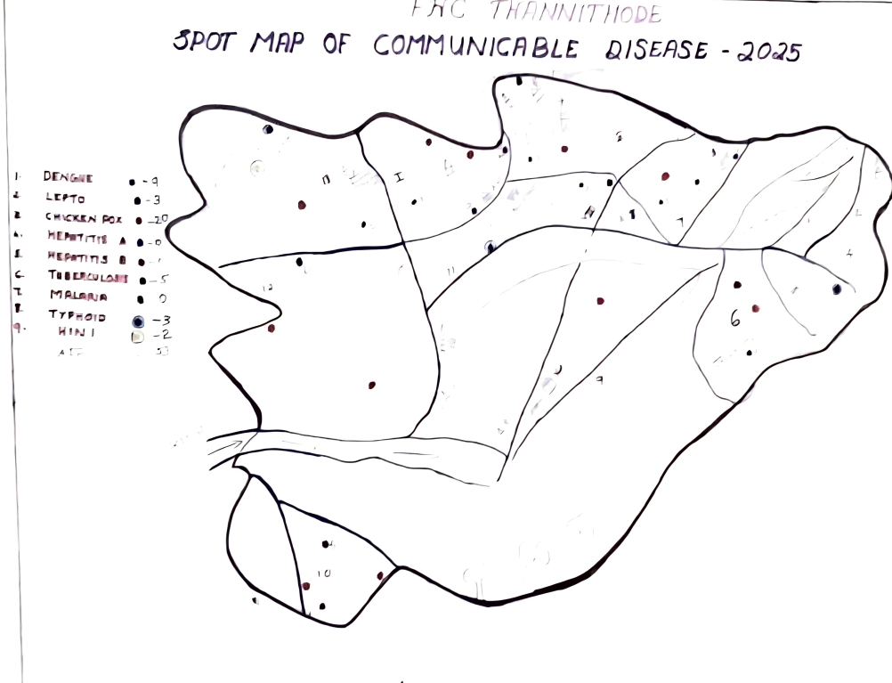

Ward No | Dengue Total (2021-25) | Leptospirosis Total (2021-25) | Hepatitis A Total (2021-25) | Mumps (2021-25) | ADD (2021-25) | Total Cases
1 | 9 | 0 | 1 | 0 | 0 | 10
2 | 4 | 0 | 0 | 0 | 0 | 4
3 | 7 | 2 | 0 | 0 | 0 | 9
4 | 38 | 1 | 0 | 0 | 0 | 39
5 | 9 | 1 | 0 | 0 | 0 | 10
6 | 15 | 0 | 0 | 0 | 0 | 15
7 | 13 | 0 | 0 | 0 | 0 | 13
8 | 12 | 0 | 0 | 0 | 0 | 12
9 | 100 | 0 | 0 | 0 | 0 | 100
10 | 11 | 0 | 0 | 0 | 0 | 11
11 | 0 | 0 | 0 | 0 | 0 | 0
12 | 0 | 1 | 0 | 0 | 0 | 1
13 | 0 | 0 | 0 | 0 | 0 | 0

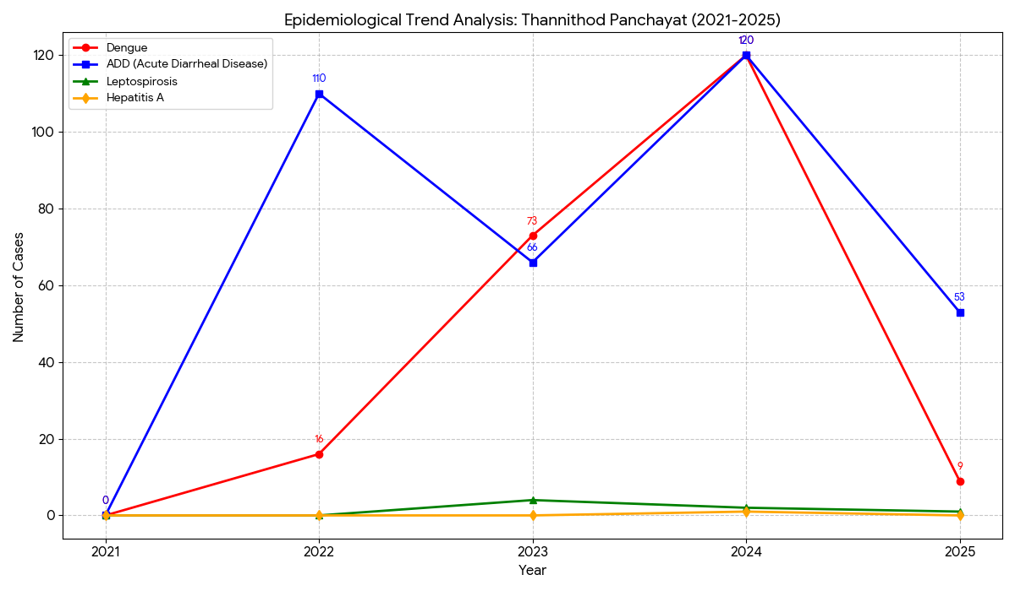
The general epidemiological status of Thannithod Panchayat is Improving/Stabilizing as of 2025. While the major epidemic spikes of 2024 (Dengue and ADD) have been suppressed, the continued presence of ADD cases suggests a need for sustained focus on water-source protection and hygiene education. The re-emergence of minor cases of H1N1 and Malaria in 2025 warrants a shift in surveillance toward early detection of these newer threats.

The cumulative ward-wise analysis for Thannithod Panchayat reveals a highly disproportionate distribution of infectious diseases, where the total burden is primarily driven by a few critical geographic hotspots. Ward 9 stands out as the primary epicenter, accounting for nearly 45% of the region's total cases with 100 recorded instances of Dengue. Ward 4 follows as a significant secondary concern, reporting 39 total cases, including the majority of the area's Dengue and a recorded instance of Leptospirosis. While wards such as 6, 7, and 8 show moderate activity with cases ranging from 12 to 15, a significant portion of the Panchayat remains at low risk; notably, Wards 11 and 13 reported zero cases of any disease throughout the five-year period. Overall, the epidemiological profile of the Panchayat is dominated by Dengue, which constitutes 97.3% of the 224 total cases, while Leptospirosis and Hepatitis A appear only as sporadic, localized incidents in specific sectors like Wards 1, 3, 4, 5, and 12.

Preparedness and Response Protocol at LSG Level
This section describes the operational framework for the LSGI once a pandemic is declared. It explains how the LSGI and health system will move from routine data collection to active response, using a One Health approach.

Constitution of One Health Committee
The LSGD shall constitute a One Health Committee comprising the LSGI President, Medical Officers (Modern Medicine, AYUSH, and Veterinary), the Health Inspector, and the Veterinary Surgeon.

Objective: The One Health Committee coordinates human, animal, and environmental health to prevent and control pandemics.

Sl No | Name | Designation | Department/Institution | Role in Committee | Contact Number
1 | LILLY BABU | Panchayat President | LSGD | Chairperson | 9495805617
2 | DR PADMANABHAN | Medical Officer (PHC/CHC) | Health Dept | Member Secretary | 9447324789
3 | BIJI VIJAYAN | Veterinary Officer | Animal Husbandry | Member | 04682322762
4 | DR AFINA AZIZ | Epidemiologist | Health Dept | Member | 9496238190
5 | SANTHOSH S | Health Inspector/PHN | Health Dept | Surveillance | 8590086078
6 | SUMANGALA V R | ASHA Supervisor | Health Dept | Community link | 8281832271
7 | MINIMOL T | ICDS Supervisor | Social Welfare | Vulnerable groups | 9961403298
8 | JAYARAJ | Police Station Officer | Police Dept | Law & order | 9497947147
9 | USHA K R | Ward Councillor Representative | LSGD | Community coordination | 9446113422
10 | SUJA THOMAS | Kudumbashree CDO | Kudumbashree | Community mobilisation | 821040859
11 | NIL | NGO/Volunteer rep | Civil Society | Support services | NA
12 | NIL | Line Department representations | NA | NA | NA

Key Responsibilities:
- Review disease surveillance data (human + animal)
- Conduct ward-wise risk assessment and vulnerability mapping
- Approve quarantine/isolation centre locations
- Coordinate with district for resources (PPE, oxygen, ambulances)
- Periodically review health system surge capacity, including beds, oxygen, human resources, and ambulances.
- Approve and monitor risk communication and community engagement strategies, including rumour management.
- Ensure protection and service continuity for vulnerable groups (elderly, persons with disabilities, dialysis patients, coastal populations).
- Conduct quarterly mock drills
- Monitor equity measures for vulnerable groups

Meeting Schedule:
Quarterly (normal times) | Weekly (outbreak alert) | Daily (pandemic phase)

Pandemic Response Workforce
To ensure a coordinated and timely response during a pandemic, a dedicated Pandemic Response Workforce shall be constituted at the LSG level. The workforce will function under the overall supervision of the One Health Committee and in close coordination with the health authorities. Team-based deployment will enable efficient surveillance, case management, quarantine and isolation management, logistics support, and risk communication. Each team shall have a clearly designated team leader, defined roles, and an identified pool of personnel to allow rapid activation, rotation of duties, and continuity of services during prolonged emergencies.

Total Response Workforce Available: 150 persons

Team Name | Composition | Key Responsibilities | Team Leader
Surveillance and Contact Tracing Team | HI, JHI, JPHN, ASHAs and Volunteers | Case detection, contact listing, home visits, reporting | HI
Case Management Team | Doctors, Nurses, MLSP, Palliative Nurses | Patient care & referral | DOCTOR
Quarantine & Isolation Team | LSGD staff, Volunteers | Facility management | JHI
Psychosocial support | Doctors, Nurses, MLSP,councellors | Emotional support and Patient care & referral | Doctor
Logistics & supply chain Team | LSGD staff, Storekeepers, Drivers 3 | Supplies & transport [PPE, medicines, oxygen, transport, waste management] | Ward Member
Communication Team | Ward members, Kudumbashree, Youth clubs,  AWW workers and other self help groups | IEC, community meetings, countering misinformation | M.O in charge
Transportation | KSRTC, educational institutional buses | NA | NA
Media Surveillance | NIL | NA | NA
Intersectoral coordination and convergence | YES | NA | NA
Collaborative surveillance | NIL | NA | NA

All teams shall be activated immediately upon outbreak alert or pandemic declaration and shall report daily to the LSG Incident Commander/Medical Officer, with consolidated reporting to the Block PHC. Duty rosters and alternate personnel shall be maintained to ensure uninterrupted services during staff shortages or prolonged response periods. Team composition and numbers may be revised based on the magnitude of the outbreak and availability of human resources.

Activities and Measures before and during Pandemic

PHASE 1 - Alert / Preparation
Surveillance and Reporting-Enhanced syndromic surveillance:
- Data sources for surveillance:
Enhanced syndromic surveillance relies on multiple data sources to detect early signals of a pandemic. These include healthcare facilities such as outpatient departments (OPDs), emergency rooms, and hospitals, which report unusual clusters of symptoms like fever and respiratory illness. Laboratory data also play a key role by providing diagnostic reports, test results for infectious agents, and trends in positive cases. Community-based reporting contributes through inputs from health workers like ASHA workers, village-level health registers, and informal alerts from local communities. Pharmacy sales data, such as increased purchases of over-the-counter medicines like antipyretics and cough syrups, can indicate a possible outbreak. Additionally, school and workplace absenteeism helps identify early spread through rising absence rates. Mortality data, including unusual increases in deaths and cause-specific trends, are also important indicators. Digital and media surveillance, including social media trends and news reports, along with data from hotlines and telemedicine services where individuals report symptoms or seek advice, further strengthen early detection and monitoring of potential pandemics.
- Event-based triggers (to be monitored and reported):
Event-based surveillance focuses on identifying unusual health events that may signal the onset of a pandemic. These triggers include sudden clusters of cases with similar symptoms, especially severe acute respiratory illnesses or unexplained fevers; unexpected increases in morbidity or mortality in a specific area; and outbreaks of unknown origin. Other important triggers are unusual patterns of disease transmission, such as rapid spread within communities, healthcare settings, or closed groups like schools or workplaces. Reports of illness among healthcare workers, sudden shortages of essential medicines, or increased demand for healthcare services should also be monitored. Additionally, zoonotic events such as unusual illness or deaths in animals, especially those in close contact with humans, and reports from media or community sources indicating public concern or panic, are critical signals that must be promptly reported and investigated.
- Zoonotic and animal health surveillance
Zoonotic and animal health surveillance involves monitoring diseases in animals that have the potential to be transmitted to humans. This includes regular observation of livestock, poultry, and wildlife for unusual illness, sudden deaths, or changes in behavior that may indicate emerging infections. Veterinary reports, farm inspections, and data from animal health workers play a crucial role in early detection. Surveillance also includes monitoring live animal markets, slaughterhouses, and areas where humans and animals interact closely. Laboratory testing of animal samples helps identify pathogens with zoonotic potential. Coordination between human and animal health sectors (One Health approach) ensures timely sharing of information, enabling early warning and prevention of disease spillover from animals to humans.

- Logistics and Stock Preparedness
  - Identify and empanel local vendors and define emergency procurement mechanisms in accordance with existing LSGD and Health Department norms.
  - Prepare and maintain an essential logistics checklist covering medical supplies, consumables, and support equipment.
  - Pre-identify secure storage locations for emergency stocks and ensure maintenance of stock registers with regular updating.
  - Finalise emergency transport arrangements, including availability of vehicles and identified drivers for rapid deployment during alerts.
  - Designate a Nodal Officer for Logistics to enable prompt decision-making, coordination, and communication during emergencies.
  - Conduct rapid stock verification and ensure availability of minimum buffer stock, including:
- PPE kits – numbers
- Pulse oximeters – 20numbers
- Hand sanitizers – 80 litres
- Masks, gloves, disinfectants – adequate quantity
Identify critical gaps in logistics and immediately communicate requirements to the Block and District authorities for timely replenishment and support. Monitor expiry dates and stock rotation.

Identification of Quarantine and Isolation Facilities
  - Identify and list suitable buildings for quarantine and isolation (schools, hostels, community halls, etc.).
  - Categorise cases as per the severity and allocate to appropriate facilities (for instance, severe cases to classrooms, mild cases to an assembly hall in case of a school).
  - Facility readiness checklist needed (beds, toilets, ventilation) etc.
  - Find an alternate site if the primary sites are not available or not in use.
  - Identify facility managers and support staff
  - Prepare basic SOPs for:
    - Admission and discharge
    - Food, water, sanitation
    - Infection prevention and waste disposal
  - Ensure availability of basic amenities: water, sanitation, electricity, ventilation, and waste disposal. Prepare a rapid activation plan for these facilities if case numbers increase.

Risk Communication and Community Preparedness
  - Disseminate early warning messages on symptoms, preventive measures, and reporting mechanisms. Display IEC materials both in English and the local language in public places and ensure ward-level awareness.
  - Sensitize elected representatives and community leaders on preparedness measures.
  - Establish a rumour tracking and misinformation response mechanism to identify, verify, and promptly counter false or misleading information.
  - Engage trusted local persons (ward members, ASHA workers, religious leaders, teachers, community volunteers) to communicate official public health messages and reinforce correct practices.
  - Develop and deploy targeted IEC materials for:
    - Schools and educational institutions
    - Markets and commercial areas
    - Work sites and labour settings
  - Conduct community sensitization meetings at the ward level to promote preventive behaviors, address concerns, and strengthen community participation in preparedness and response.

Protection of Vulnerable Groups
Vulnerable populations require priority protection through targeted line-listing, service continuity, and delivery mechanisms.
- Prepare and regularly update line-lists of vulnerable populations, including:
  - Elderly persons living alone
  - Persons with disabilities
  - Pregnant women
  - Migrant workers
  - Dialysis patients
The detailed line-lists shall be maintained as Annexure and updated periodically.

Clinical Dependency Mapping
Develop ward-wise dependency and vulnerability maps to identify households requiring regular support during emergencies. Ensure continuity of essential health services for vulnerable groups, including
- Dialysis services (facility mapping, transport arrangements, and scheduling)
- Continuity of treatment for TB, HIV, and other chronic conditions requiring uninterrupted medication
- Mental health and psychosocial support services
Establish delivery mechanisms for food, essential commodities, and medicines to vulnerable households through coordinated action involving ASHAs, JPHNs, Kudumbashree, volunteers, and local administration.

PHASE 2 - Active Response

Case Identification and Contact Tracing
Case detection and contact tracing activities will be carried out in coordination with the Health authorities, following disease-specific SOPs and IDSP guidelines.
Field Staff Involved
- Health Inspector (HI)
- Junior Health Inspector (JHI)
- Junior Public Health Nurse (JPHN)
- ASHAs and ASHA Supervisors
- Ward-level volunteers and Kudumbashree members (as required)

Screening Checkpoints
Screening checkpoints at high-traffic locations (transport hubs, markets, religious gatherings) for early detection of symptomatic travellers and crowd screening during outbreaks. Potential locations include bus stands, market entry points, and boat jetties, based on local context and risk assessment.
Screening activities will be carried out by trained personnel such as ASHAs, ward members, and volunteers, with support from Health Department staff. Necessary equipment, including non-contact thermometers and appropriate PPE, shall be ensured prior to activation.
Location | Type (Bus stand/Jetty/Market/Railway) | Staff Deployed (ASHAs/Volunteers) | Screening Method | Reporting authority
Bus stand | Transport hubN | One JHI  One ASHA  One health Mentors | 1.Swab Collection.  2. Blood smears collection (RDT)  3.Thermal Scanners | Surveillance Nodal Officer in control room
Market entry | Market | One JHI  One ASHA  Male health volunteers | 1.Swab Collection.  2. Blood smears collection (RDT)  3.Thermal Scanners | Surveillance Nodal Officer in control room

Standard Screening Protocol

The screening protocol shall include temperature screening, observation for visible symptoms, and inquiry regarding recent travel or exposure history. Individuals identified as suspects during screening shall be immediately referred to the nearest PHC/FHC for further evaluation, testing, and appropriate action as per prevailing guidelines.

Pandemic Control Room
The Pandemic Control Room (PCR) serves as the central nerve center for real-time coordination, data aggregation, decision support, and communication during outbreaks. It consolidates information from all LSGD teams, health facilities and community sources to enable rapid response decisions.

Control Room Infrastructure and Location
Primary Location: THANNITHODE Panchayath Office.
Backup Location: Community Hall in THANNITHODE G.P.

Health System Control Room Framework
The PCR is organized into seven functional pillars to ensure no aspect of the response is overlooked:

Rapid Response Team (RRT)
  - Provides immediate intervention during emergencies, clusters, and field alerts.​
  - Coordinates urgent actions such as case investigation, contact tracing, isolation, and inter‑facility referrals.

Data Management & Analytics Team
  - Collects, validates, and manages key health system indicators (cases, tests, beds, HR, supplies).​
  - Analyzes data trends, generates projections, and supports evidence‑based decision‑making for local authorities.

Human Resource Deployment Team
  - Allocates healthcare staff efficiently based on workload and need
  - Ensures adequate and equitable workforce distribution across facilities

Laboratory Surveillance Team
  - Oversees diagnostic testing coordination, sample transport, and timely reporting of results.​
  - Monitors lab indicators (testing volume, positivity rate, turnaround time) for early detection of outbreaks

Vaccination Cell (If Required)
  - Plans and executes vaccination campaigns, including micro‑planning and session scheduling.​
  - Tracks coverage, identifies gaps, and coordinates corrective actions with field teams and outreach services.

Infrastructure & Patient Occupancy Team
  - Monitors facility capacity, earmarked beds, oxygen and critical care resources across all linked facilities.​
  - Ensures optimal patient distribution and referral management using updated bed‑status and resource data.
  - BMWM

Communication team
The communication team plays a critical role during the active response phase of a pandemic by ensuring timely, accurate, and transparent dissemination of information to the public and stakeholders. The team is responsible for developing clear risk communication strategies, issuing regular updates on the situation, and addressing rumors and misinformation. It coordinates with health authorities, media, and other government agencies to provide consistent messages regarding preventive measures, case definitions, treatment protocols, and public health advisories. The team also manages press briefings, social media communication, and helplines to keep the public informed and reduce panic. Effective communication helps build public trust, promotes compliance with health measures, and supports overall outbreak control efforts.

- Logistics and supply chain
Logistics and supply chain management ensures the timely procurement, storage, and distribution of essential resources required during a pandemic response. This includes medical supplies such as personal protective equipment (PPE), medicines, vaccines, diagnostic kits, and hospital equipment. It also involves maintaining adequate stock levels, monitoring supply availability, and coordinating transportation to deliver materials to healthcare facilities and response teams. Efficient logistics systems help prevent shortages, support healthcare workers, and ensure that critical items reach affected areas quickly. Proper planning, inventory management, and coordination with suppliers and government agencies are essential to maintain uninterrupted operations during the active response phase.
- Transportation (interfacility & emergency transport)
Transportation plays a vital role during the active response phase by ensuring safe and timely movement of patients, healthcare workers, and essential supplies. This includes interfacility transport of patients requiring higher levels of care, using well-equipped ambulances with trained personnel and appropriate infection prevention measures. Emergency transport systems must be strengthened to respond quickly to critical cases, with proper triage and communication between referring and receiving facilities. Dedicated transport arrangements may be required for suspected or confirmed infectious cases to prevent further spread. Additionally, logistics for transporting medical supplies, samples, and essential staff should be well-coordinated to maintain continuity of healthcare services and support outbreak control efforts.
- Media surveillance Call centre
Media surveillance and call centres are important components of the active response phase, helping in early detection, information dissemination, and public support. Media surveillance involves continuous monitoring of news outlets, social media platforms, and other communication channels to identify emerging health concerns, rumors, and public perceptions related to the pandemic. This helps authorities respond quickly to misinformation and detect potential outbreaks.Call centres serve as a direct communication link between the public and health authorities. They provide information on symptoms, preventive measures, testing, and treatment services, while also receiving reports of suspected cases and health concerns from the community. Data collected through call centres can support surveillance and response activities. Together, media surveillance and call centres enhance situational awareness, improve risk communication, and strengthen the overall pandemic response.
- Management of the deceased
Management of the deceased during a pandemic is crucial to ensure dignity, safety, and infection control. Proper protocols must be followed for the handling, storage, and disposal of bodies of suspected or confirmed cases to prevent the risk of disease transmission. This includes the use of appropriate personal protective equipment (PPE) by healthcare and mortuary staff, safe wrapping and labeling of bodies, and disinfection procedures. Transportation of the deceased should be carried out with care, following established guidelines.Clear guidance should also be provided to families regarding safe funeral practices, while respecting cultural and religious beliefs as much as possible. Coordination between healthcare facilities, local authorities, and funeral services is essential to manage increased mortality during pandemics. Proper documentation and reporting of deaths must be maintained. Effective management ensures public health safety while upholding dignity and respect for the deceased and their families.

- Intersectoral coordination and convergence
Intersectoral coordination and convergence are essential during the active response phase to ensure a unified and effective pandemic response. This involves collaboration between multiple sectors such as health, transport, education, police, local administration, disaster management authorities, and other government and non-government agencies. Effective coordination helps in resource sharing, efficient decision-making, and implementation of control measures.
Regular communication and joint planning among sectors ensure alignment of strategies, such as containment measures, movement restrictions, public awareness campaigns, and service delivery. Convergence also includes partnerships with private healthcare providers, community organizations, and volunteers to strengthen response capacity. A well-coordinated approach minimizes duplication of efforts, optimizes resource utilization, and enhances the overall effectiveness of pandemic management.

Key Control Room Team
The Control Room Team coordinates all pandemic response activities within the LSGD and serves as the single command and communication hub during activation. It integrates information, field actions, logistics, and policy execution across all participating departments and health facilities.

Role | Name | Designation | Contact Number | Responsibility
In-charge/Nodal Officer | DR PADMANAPHAN | MO I/C | 9447324789 | Overall coordination, decision-making, and reporting to the district level.
Data Entry Operator | NIL | NIL | NIL | Managing the line list, updating dashboards, and tracking testing results.
Communication Officer | SANTHOSH S | HI | 9446644689 | Handling the public helpline, coordinating ambulance dispatch, and contact tracing calls.
Logistics Coordinator | NIL | NIL | NA | NA
Technical Support (IT/Data) | NA | NA | NA | NA

SOP for alert escalation/trigger point with mapping of responsibilities.
Key Points:
- The Control Room shall be staffed with a designated In-charge, data entry personnel, and communication staff with clearly defined roles and shift arrangements.
- It shall maintain updated records on daily monitoring indicators including new cases, persons under active quarantine, and hospital bed occupancy.
- All reports and situation updates shall be shared daily with the Block and District Surveillance Unit.
- The Control Room shall act as a single point of contact for coordination with response teams, health institutions, and other departments.
- Contact details of the Control Room shall be widely communicated to field staff and stakeholders during activation.

Daily Monitoring Indicators
To ensure timely decision-making and effective response, the following key indicators shall be monitored and updated on a daily basis by the Pandemic Control Room:

Epidemiological Indicators:
New cases reported today, Total active cases, Test Positivity Rate (TPR), Case Fatality Rate (CFR)
- Surveillance Indicators:
Persons under home quarantine, High-risk contacts identified, Fever, ILI, SARI or other symptoms (syndromic surges), Travellers (symptomatic or high-risk arrivals),Animal husbandry surveillance (zoonotic alerts, unusual animal deaths, poultry/bird flu signals), Mortality surveillance (excess deaths, unexplained fatalities, verbal autopsy reports)
- Logistics and Infrastructure Indicators:
Hospital / CFLTC beds occupied, Oxygen cylinders/concentrators available, Ambulances on standby
- Alert Findings
The following table outlines category-specific trigger points (red flags) from surveillance indicators and corresponding immediate actions for the Pandemic Control Room. These enable rapid response to alert findings like testing anomalies, positive cases exceeding thresholds, clusters, and WGS reports.

Category | Trigger Pophint (Red Flag) | Immediate Action
Clusters | Geographical or facility-based: 5+ cases linked to one location (office, school, street). | Declare a micro-containment zone; perimeter control and active case finding.
Testing | Sudden drop in testing volume / delay in reporting / unusual testing trends | Review the sample collection process, address lab bottlenecks, deploy additional testing teams, and notify the District Lab.
Lab | Test Positivity rate increases | Increase testing sites in that ward.
Hospital | >80% Oxygen bed occupancy | Activate backup/CFLTC beds.
Travel | Cluster of cases from a single flight/train or high-risk arrival group. | Trace all passengers in adjacent seats; implement mandatory institutional quarantine.
Animal | Mass poultry/wildlife death or unusual sickness | Notify Animal Husbandry, sample the area, and dispatch RRT for environmental sampling and zoonotic check.
Mortality | Sudden spike in home deaths or brought-in-dead (BID) cases | Audit the deaths and Active Case Search drive
Additional investigations like Whole Genome Sequencing (WGS) | Detection of a Variant of Concern (VOC) or Variant of Interest (VOI) | Implement strict micro-containment; update clinical protocols to match variant severity.

Communication of Public Health Information
A Community Communication Hub shall be established to ensure timely, accurate, and consistent dissemination of information during a pandemic. The Hub will function under the coordination of Nodal officers of the control room and act as the nodal point for public communication, risk messaging, and community engagement. It will support dissemination of official advisories, promote preventive behaviors, address rumors and misinformation, and ensure that messages reach all sections of the population through trusted local channels and leaders.

Key communicators
Channel | Responsible Person | Contact
Ward-level announcements | Santhosh ,HI | 9446644689
Social media | Sajeev ,JHI | 9567114036
Local Cable TV/Radio | NIL | NA

- All messages disseminated through the Hub shall align with advisories issued by the Health Department and District authorities.
- Community leaders shall be sensitized to support behavior change, reduce stigma, and counter misinformation.
- Special efforts shall be made to reach vulnerable and hard-to-reach populations using locally appropriate communication methods.

Rumor Tracking: A designated volunteer will monitor local social media/WhatsApp groups daily to identify misinformation and issue official clarifications via the Communication Hub.

Coordination with District/State Authorities & Other Organisations
Effective coordination with Block, District, and State authorities is essential to ensure timely reporting, technical guidance, and uninterrupted supply of essential resources during a pandemic. The LSG shall establish clear communication channels, designate responsible officers, and adhere to prescribed reporting timelines to support coordinated public health action and efficient resource mobilisation.

Key Details:
- Nodal Officer for Reporting: Santhosh, HI
- Contact Number: 9446644689
Reporting Schedule and Protocols:

To Whom | What to Report | Frequency | Nodal Person
Block PHC | Complete Situation Report (Cases, Quarantine, Beds, Screening, Deaths) | Daily | Medical officer
District IDSP Unit | Outbreaks/Clusters/Unusual Events (>5 cases same ward) | Weekly | HI
Veterinary Officer | Animal health events/Zoonotic alerts | NA | NA
State Cell | Zoonotic cross-sector events | NA | NA

Supply Chain Coordination
The LSG shall coordinate closely with Block, District, and State authorities (KMSCL) to ensure uninterrupted availability of essential goods, medical supplies, and logistics during a pandemic. Supply requirements shall be assessed regularly based on case load and communicated promptly to the appropriate authorities for timely replenishment.
Key Points:
- Maintain updated contact details of District and Block nodal officers for health logistics, oxygen supply, ambulances, and essential medicines.
- Submit timely indent requests for PPE, testing kits, medicines, oxygen, and other critical supplies through prescribed channels.
- Monitor stock levels at LSGD facilities, quarantine/isolation centres, and field teams through daily stock registers and dispensing logs to prevent shortages.
- Coordinate with District authorities, Karunya/Neethi medical shops, and local purchase committees for funds allocation and emergency procurement.

- Ensure regular monitoring of dispensing registers at all facilities to track usage, expiry, and pilferage—shortages being a perennial issue requiring proactive weekly audits.

- Activate surge procurement protocols during high caseloads, leveraging local purchase powers under LSGD funds alongside state supplies.

Resource Inventory and Contacts
Resource Category | Source  (District/State/Private) | Contact
PPE Kits/Masks/Gloves | KMSCL | NIL
PPE Kits/Masks/Gloves | Local Vendors | NIL
Oxygen  Cylinders/Concentrators | KMSCL | NIL
Medicines/Antivirals | KMSCL | NIL
Medicines/Antivirals | Neethi Shops | NIL
Test Kits (RTPCR/Rapid) | KMSCL | NIL

Collaboration with NGOs, PPP, and CSR
To augment government efforts during a pandemic, the LSG shall collaborate with NGOs, voluntary organisations, and private sector partners through public–private partnerships and Corporate Social Responsibility (CSR) initiatives, in coordination with District authorities.

Key Points:
- Engage NGOs and community-based organisations for community outreach, awareness, and support to vulnerable populations.
- Leverage CSR support for procurement of medical equipment, PPE, oxygen concentrators, food kits, and sanitation materials, as permitted.
- Ensure all collaborations align with government guidelines and are routed through approved administrative and financial procedures.
- Maintain transparency and documentation for all external support received and utilised.

Organization | Type | Support Offered | Contact Person
Youth Clubs/Student Unions | CBO | NIL | NIL

Interdepartmental Coordination
Coordination among departments during a pandemic shall be ensured through regular review meetings convened by the LSGD President. These meetings will provide a structured platform for sharing situational updates, assessing resource availability, resolving operational gaps, and taking joint decisions to ensure a coordinated and timely response.

Department | Representative | Key Role | Contact
Health (PHC) | Staff Nurse : | Case management | 7559892368
Veterinary | Veterinary Surgeon: VIJI VIJAYAN | Animal surveillance | 8078139486
ICDS | Supervisor: MINIMOL T | Nutrition support | 9961403298
Education | Head Teacher: ANU VARGHESE | School coordination | 9497102967
Police | JAYARAJ | Containment enforcement | __________
Water Authority | __________ | Water supply | __________
LSGD Engineering | __________ | Quarantine infrastructure | __________

PHASE 3 - Surge Capacity
Phase 3 is activated when there is a rapid increase in cases, high test positivity rates, or when existing health facilities and quarantine arrangements approach saturation. The focus of this phase is to expand isolation capacity, augment clinical care services, and mobilise additional resources through district and state support mechanisms.

Conversion of Community Facilities
To manage increased case load, the LSGD shall activate additional isolation facilities by repurposing identified community infrastructure such as community halls, auditoriums, schools, hostels, or other suitable buildings.

Name of facility | Facility Type | No. of Buildings | Ward | Surge Capacity (Beds) | Nodal Person
NOT AVAILABLE | NA | NA | NA | NA | NA
NOT AVAILABLE | NA | NA | NA | NA | NA
NOT AVAILABLE | NA | NA | NA | NA | NA
NOT AVAILABLE | NA | NA | NA | NA | NA
NOT AVAILABLE | NA | NA | NA | NA | NA
NOT AVAILABLE | NA | NA | NA | NA | NA
NOT AVAILABLE | NA | NA | NA | NA | NA
NOT AVAILABLE | NA | NA | NA | NA | NA
NOT AVAILABLE | NA | NA | NA | NA | NA
NOT AVAILABLE | NA | NA | NA | NA | NA
NOT AVAILABLE | NA | NA | NA | NA | NA

- Recovery and rehabilitation phase
The recovery and rehabilitation phase focuses on restoring normalcy and strengthening systems after a pandemic. Recovery begins with a comprehensive assessment of the damage and overall impact on health, economy, and society. Restoration of health services is prioritized to ensure routine and essential healthcare resumes effectively. Rehabilitation of the affected population includes support for those who suffered illness, loss, or economic hardship, along with provision of psychosocial and mental health support to address trauma and stress.Continued disease surveillance during the recovery phase is essential to detect any resurgence of cases. Environmental cleanup and sanitation measures help eliminate residual risks. Efforts are also directed toward livelihood restoration to support economic recovery and stability. Community engagement and confidence building are crucial to regain public trust and encourage participation in recovery activities.Documentation and after-action reviews are conducted to evaluate the response, identify gaps, and record experiences. Lessons learned and best practices are used to strengthen the health system and improve future preparedness. This phase also includes policy revision, enhancement of preparedness plans, and promotion of research to better understand and manage future public health emergencies.

- Recovery
  - Damage & impact assessment
  - Restoration of health services
  - Rehabilitation of affected population
  - Psychosocial & mental health support
  - Disease surveillance during recovery phase
  - Environmental cleanup & sanitation
  - Livelihood restoration
  - Community engagement & confidence building
  - Documentation & after-action review
  - Lessons learned & best practices
  - Health system strengthening
  - Policy revision & preparedness enhancement
  - Research

CONCLUSION
The Pandemic Preparedness Plan for Thannithod Panchayat provides a data-driven operational framework designed to shift the local health strategy from reactive containment to proactive resilience. By integrating the specific epidemiological trends recorded between 2021 and 2025, this plan recognizes that while the acute threat of COVID-19 has subsided from its 2021 peak of 1,320 cases, the Panchayat faces significant recurring challenges from endemic diseases.
The plan identifies Ward 9 as the primary high-priority "Red Zone," accounting for nearly 45% of the region's total disease burden, alongside Ward 4 as a critical secondary hotspot. The resurgence of Dengue and Acute Diarrheal Disease (ADD)—which both peaked in 2024—underscores the necessity of the plan’s phased response protocols, moving from baseline surveillance to active surge capacity during seasonal outbreaks.
Central to this preparedness is the multi-sectoral coordination of the Pandemic Response Workforce, tasked with disrupting the transmission cycles of vector-borne and zoonotic threats like Leptospirosis, which continues to persist in localized clusters. By establishing a Pandemic Control Room and standardizing ward-wise screening, the LSGI transitions toward a One Health model that treats human, environmental, and animal health as a single interconnected priority.
Ultimately, the success of this plan relies on the continuous strengthening of local healthcare infrastructure and a commitment to targeted interventions in high-risk wards. Through diligent implementation of these protocols and a focus on community-led awareness, Thannithod Panchayat can ensure the long-term safety of its residents and maintain the downward disease trends achieved in 2025.

RECOMMENDATIONS

Strengthening Healthcare Infrastructure
- Establish a primary health response unit within the Panchayat with trained staff.
- Ensure availability of basic medical supplies (masks, sanitizers, PPE kits, oxygen cylinders).
- Create tie-ups with nearby hospitals in Konni MCH for emergency referral and transport.

2. Community Awareness & Education
- Conduct regular awareness campaigns on hygiene, vaccination, and preventive measures.
- Use local communication channels (community radio, WhatsApp groups, notice boards) to spread verified information.
- Train volunteers to act as health ambassadors in each ward.

3. Emergency Response & Coordination
- Form a Pandemic Preparedness Committee at Panchayat level including health workers, ward members, and NGOs.
- Develop a clear action plan for lockdowns, quarantine, and distribution of essentials.
- Maintain a database of vulnerable groups (elderly, differently-abled, chronically ill) for targeted support.

4. Supply Chain & Food Security
- Identify and support local suppliers and farmers to ensure uninterrupted food supply.
- Create community kitchens during emergencies to serve vulnerable populations.
- Stockpile essential commodities in Panchayat-run outlets for crisis periods.

5. Digital Preparedness
- Promote digital platforms for telemedicine consultations.
- Use Panchayat’s website/social media for real-time updates on health advisories.
- Encourage online grievance redressal to reduce crowding in offices.

6. Training & Capacity Building
- Organize mock drills for pandemic response in schools, offices, and public spaces.
- Train Panchayat staff and volunteers in first aid, infection control, and crowd management.
- Collaborate with NGOs and health departments for capacity-building workshops.

7. Long-Term Resilience
- Integrate pandemic preparedness into the Panchayat Development Plan.
- Allocate a dedicated budget for health emergencies.
- Encourage community participation in planning and monitoring preparedness measures.

MOCKDRILL SCENARIOS
Thannithode PHC, located in the Konni forest range, is highly vulnerable to landslides (locally known as Urul Pottal) due to its sloping terrain and proximity to the Adavi Eco-tourism belt. Unlike a fire drill, a landslide drill focuses on immediate structural evacuation and managing trauma/crush injuries while the PHC itself might be at risk.
Scenario: "Operation Hill-Guard" (PHC Thannithode)
- Trigger: After 48 hours of heavy rain, a loud "rumbling" sound is heard from the hill behind the PHC. Cracks appear in the rear wall of the Observation Ward.
- The Incident: A minor mudslip hits the back of the building, and reports arrive that three houses in the nearby ward have been buried.
- Challenges: Road access to Konni THQH is threatened by falling trees. 10 patients are currently in the OPD.
Phase 1: Immediate Structural Alert (0–5 Minutes)
- The Signal: The Medical Officer (MO) blows a long, continuous whistle (the designated signal for natural disasters).
- Emergency Evacuation: Staff must immediately move all patients and bystanders to the Front Courtyard (away from the hillside).
  - Rule: Do not use the rear exits.
  - Assistance: Focus on the "Palliative Care" patients or elderly who may be slow to move.
- Power Isolation: The Clerk/Security immediately switches off the Main Electrical DP to prevent fire from short circuits caused by shifting walls.
Phase 2: Surge Capacity & Triage (5–30 Minutes)
Since the PHC is the first point of care for the landslide victims from the village:
- Triage Station: Set up a temporary Triage area in the Portico or a sturdy Open Shed (Safe Zone).
- Equipment Grab: The "Disaster Kit" is brought out. This must include:
  - Cervical collars (for neck injuries).
  - Splints (for fractures).
  - Ambu-bags and Portable Oxygen.
  - Anti-Snake Venom (ASV) – common for landslides in forest areas.
Phase 3: Critical Asset Protection (Concurrent)
While the medical team treats victims, the JHI/JPHN team secures the PHC's future capability:
- The "Life Box": Move the Vaccine Carrier and "Emergency Life-Saving Drugs" to a vehicle (Ambulance/Jeep) parked in a clear exit path.
- Records: If time permits, grab the MCH and Birth/Death Registers. Wrap them in the "Emergency Plastic Sheet" and place them in the vehicle.

ANNEXURE

IMPORTANT PHONE NUMBERS

Phone numbers and particulars of persons responsible for providing guidance, assistance, and support for pandemic preparedness operations may be provided here in a manner that allows easy reference at a glance. The information recorded here could be exhibited elsewhere at the time of emergencies. LSG institutions shall give special attention to collect and record the above data of persons and institutions who/which are supposed to give technical and co-ordination support to reduce the impact of pandemic.

1.1. Details of grama panchayat/municipality/corporation wards
Sl.No | Name of the ward | Ward number | Name of the ward  member | Contact number
1 | KOOTHADIMAN | 1 | RESHMI P V | 9447572057
2 | V K PARA | 2 | K R USHA | 9446113422
3 | MEDAPPARA | 3 | P G SASANKAN | 9446685789
4 | KARIMANTHODE | 4 | JOY CHITTARUVIKKAL | 9496104535
5 | THOOMPAKKULAM | 5 | LEENA DEVAN | 828168304
6 | THEKKUTHODE CENTRAL | 6 | RATHI S | 818292396
7 | EZHAMTHALA | 7 | AJITHA SOMAN (KAVITHA) | 9497670471
8 | PARAKKULAM | 8 | BABY VARGHESE | 9446158376
9 | K K PARA | 9 | ANIYAN THAKIDIYIL | 9446186521
10 | ALLUMKAL | 10 | SICILY VARGHESE | 9497256971
11 | MANNEERA | 11 | RINEESH P DAVID | 9544752082
12 | ELIMULLUMPLAKKAL | 12 | BLESSY DANIEL | 8547635984
13 | THANNITHODE MOOZHI | 13 | LILLY BABU | 9495805617
14 | MEKKANNAM | 14 | N LALAJI | 9447595087

1.2. Other important phone numbers of grama panchayat/municipality/corporation area
Sl. No. | Name | Contact number
1 | Excise department | 04682322235
2 | Forest department | 9495187148

1.3. Important offices of grama panchayat/municipality/ corporation
Sl.No | Name of the office | Contact person | Contact number
1. | Village Office | Village Officer | 9495238314
2. | Agriculture Office | Agriculture Officer | 9383470403
3. | Animal Husbandry Office | Animal Husbandry Doctor | 04682270206
4. | Police Station | Police Officer | 0468282253
5. | BSNL Office | Officer | 04682345600
6. | Block Office | Officer | 04682333161
7. | KSEB Office | Officer | 9446009257
8. | Fisheries Office | Officer | -
9. | Fire and Rescue | Officer | 0468222001

1.4. Health Services

Sl. No | Name of the hospital/institution | Location | Phone number
1. | Government hospitals/PHC | THANNITHODE | 9447324789
2. | Private hospitals | - | -
3. | Clinical laboratories | - | -
4. | Chemist/pharmacy | - | -
5. | Blood donors | - | -
6. | Other language experts (Bihari, Hindi, Bengali,  Asamees ………) | - | -

1.5. Veterinary Services
Sl.No | Name of the Clinic | Name of the  Surgeon/Doctor | Place/location | Phone  number
1 | Govt.Veterinary Hospital | DR VIJI VIJAYAN | WARD 12 | 8078139486

1.6. Helpline numbers
Helpline | Phone number
Police | 100
Fire and Rescue | 101
KSEB | 1012

1.7. Public and Private Schools Contact details

S.No | Name of School | Institution type | Phone number
1 | GOV, H,S..S,  ELIMULLUM PLAKKAL | Aided | 9605066100
2 | GOV, H S  ELIMULLUM PLAKKAL | Aided | 9605066100
3 | GVT. H.S.S,  KARIMANTHODE | Private | 9400824221
4 | GVT. H.S KARIMANTHODE | Govt | 9400824221
5 | GOV WELFARE UPS,  THANNITHODE | Private | 6282208541
6 | ST,BENEDICT ,H.S.S,  THANNITHODE | Private | 9495733342
7 | ST. THOMAS L.P.S,  MANNEERA | AIDED | 9495536884
8 | ST. ANTONY"S SCHOOL,  THANNITHODE | Govt | 9048549379
9 | ST.GEORGE PUBLIC  SCHOOL, THANNITHODE | Govt | 9447829328
10 | EBANAZER UPS,  THEKKUTHODE | Private | 8304901794
11 | EVERSHINE SCHOOL  THANNITHODE | Private | 8606872506
12 | S.N, PUBLIC SCHOLL,KARIMANTHODE | Private | 9497684562

1.9. Anganwadi Contact Details

 | Ward No |  | Name of Anganwadi Teachers | Phone number
 | 1 |  | FOUSIA MOL | 9747896718
 | 2 |  | PUSHPALATHA | 9072724339
 | 3 |  | SAJITHA | 8086054436
 | 4 |  | SREEJAKUMARI | 9961403298
 | 5 |  | DEEPA | 9846396844
6 |  | - FOUSIA MOL |  | 9747896718
 |  | - PUSHPALATHA |  | 9072724339
8 |  | SAJITHA |  | 8086054436
9 |  | - SREEJAKUMARI |  | 9961403298
 |  | - DEEPA |  | 9846396844
 |  | - SURABHI |  | 85928225241
10 |  | SUBAIDABEEVI |  | 9495907058

1.12. Information regarding resources

Means of transportation | Name of Owner | Phone Number
Heavy Trucks | NA | NA
Tractor | NA NA | NA
Ambulances | NA | NA
Boats | NA | NA
Taxi service | NA | NA

Annexure 1: LSG Baseline Data Collection Format
A. Baseline data
Sl. No. | Indicator / Field | Baseline Data | Source / Remarks
1 | Name of LSG | THANNITHODE | RECORDS
2 | District | PATHANAMTHITTA | RECORDS
3 | Block / Taluk | KONNI | RECORDS
4 | Type of LSG (Gram Panchayat / Municipality / Corporation) | GP | RECORDS
5 | Area (sq. km) | 348.2 KM SQURE | RECORDS
6 | No. of wards | 14 | RECORDS
7 | GIS boundary file available | (Yes/No) | RECORDS
8 | Key contact person & phone

B. Demography
Indicator / Field | Baseline Data | Source / Remarks
Total population | 14550 | RECORDS
Males | 6976 | RECORDS
Females | 7574 | RECORDS
Transgender population | 0 | RECORDS
Age distribution  (<5, 5–14, 15–59, ≥60) |  | RECORDS
No. of households | 4381 | RECORDS
Population density (persons/sq.km) | 334 | RECORDS
No. of migrant workers | 72 | RECORDS
Major occupational groups | CONSTRUCTION | RECORDS

C. Vulnerable Populations & Social Risks
Sl. No. | Indicator / Field | Baseline Data (Value / Description) | Source / Remarks
1 | No. of elderly (≥60) | 3458 | SHAILY
2 | No. of persons with disability | 148 | SHAILY
3 | No. of bedridden persons | 60 | SHAILY
4 | No. of chronic disease cases (DM/HTN/COPD/CKD etc.) | 1015 | SHAILY
5 | Pregnant women (current estimate) | 84 | SHAILY
6 | Children <5 years | 564 | SHAILY
7 | Tribal population (if any) | 119 | RECORDS
8 | Fisherfolk / coastal vulnerable groups (if any) | 0 | RECORDS
9 | Urban slums / unnotified settlements (if any) | 0 | RECORDS
10 | Homeless population | 0 | RECORDS
11 | Orphanages / old age homes (number & capacity) | 0 | RECORDS
12 | Hostels / prisons / shelters (number & capacity) | 0 | RECORDS
13 | Poverty / BPL estimate | 1583 | RECORDS
14 | Food insecurity hotspots | 0 | RECORDS
15 | Any history of stigma/discrimination issues (Yes/No) | 0 | RECORDS

D. Health System & Service Readiness
Sl. No. | Indicator / Field | Baseline Data (Value / Description) | Source / Remarks
1 | No. of health facilities in LSG (PHC/CHC/TH/DH/Private) | 1 | RECORDS
2 | PHC/Family Health Centre details (name, location) | 1 | RECORDS
3 | Subcentres / Health & Wellness Centres (number) | 7 | RECORDS
4 | Private clinics / hospitals (number) | 0 | RECORDS
5 | Labs available (public/private) | 1 | RECORDS
6 | Availability of ambulance services (Yes/No, number) | Y | RECORDS
7 | Availability of isolation/quarantine facilities (Yes/No, details) | N | RECORDS
8 | Cold chain facilities (Yes/No, details) | Y | RECORDS
9 | Stockpile space available (Yes/No) | Y | RECORDS
10 | PPE / mask / sanitizer availability plan (Yes/No) | Y | RECORDS
11 | Surveillance staff available (JHI/JPHN/ASHA count) | Y | RECORDS
12 | Existing emergency referral pathways (Yes/No) | Y | RECORDS

E. Points of Entry & Mobility
Sl. No. | Indicator / Field | Baseline Data (Value / Description) | Source / Remarks
1 | Bus stands / depots (number) | 0 | RECORDS
2 | Railway stations (number) | 0 | RECORDS
3 | Boat jetties / fishing harbours (number) | 0 | RECORDS
4 | Ports / airports nearby (specify distance) | 0 | RECORDS
5 | Major highways/roads passing through | 0 | RECORDS
6 | Border crossings (state/district) | 0 | RECORDS
7 | Major markets / weekly markets | 0 | RECORDS
8 | Tourism hubs / major event venues | 1 | RECORDS
9 | Schools/colleges with hostels (number) | 13 | RECORDS
10 | Factories / large workplaces (number) | 0 | RECORDS
F. Water, Sanitation & Hygiene (WASH)
Sl. No. | Indicator / Field | Baseline Data (Value / Description) | Source / Remarks
1 | Major drinking water sources (piped / wells / borewells / springs) | 2604 | RECORDS
2 | No. of public wells | 6 | RECORDS
3 | No. of households with piped water connection | 645 | RECORDS
4 | Water quality testing routine (Yes/No) | Y | RECORDS
5 | Common contamination risks (flooding, salinity, industrial waste) | FLOOD | RECORDS
6 | Open defecation free status (Yes/No) | N | RECORDS
7 | Solid waste management system (Yes/No) | Y | RECORDS
8 | Bio-medical waste disposal mechanism (Yes/No) | Y | RECORDS
9 | No. of public toilets | 0 | RECORDS
10 | Handwashing stations in public places (Yes/No) | 0 | RECORDS
G. Zoonotic Risks & One Health
Sl. No. | Indicator / Field | Baseline Data (Value / Description) | Source / Remarks
1 | Livestock population (cattle/goats/pigs/poultry) – estimates | 1660 | RECORDS
2 | No. of dairy farms / poultry farms / pig farms | 0 | RECORDS
3 | Slaughterhouses / meat shops (number) | 0 | RECORDS
4 | Animal markets (Yes/No, details) | 0 | RECORDS
5 | Veterinary dispensaries (number) | 1 | RECORDS
6 | History of zoonotic outbreaks (rabies, leptospirosis, avian flu etc.) | 0 | RECORDS
7 | Stray dog population management measures (Yes/No) | Y | RECORDS
8 | Rodent infestation hotspots (Yes/No) | Y | RECORDS
9 | Wetlands / waterlogged areas prone to leptospirosis | 2 | RECORDS
10 | Bat roosting areas / caves / fruit orchards (if any) | 0 | RECORDS
11 | Human-animal interface hotspots (farms near residences) | 0 | RECORDS
H. Climate & Disaster Risks (Pandemic Amplifiers)
Sl. No. | Indicator / Field | Baseline Data (Value / Description) | Source / Remarks
1 | Flood-prone wards (list) | 2 | RECORDS
2 | Landslide-prone wards (list) | 1 | RECORDS
3 | Cyclone/sea surge risk (Yes/No) | 0 | RECORDS
4 | Heatwave risk zones (Yes/No) | 0 | RECORDS
5 | Waterlogging areas (list) | 2 | RECORDS
6 | Shelter homes / relief camps (number, capacity) | 0 | RECORDS
7 | Past disaster displacement history | 0 | RECORDS
8 | Disruption to water supply/transport common (Yes/No) | Y | RECORDS
I. Critical Infrastructure & Logistics
Sl. No. | Indicator / Field | Baseline Data (Value / Description) | Source / Remarks
1 | Schools (number) | 12 | RECORDS
2 | Anganwadis (number) | 24 | RECORDS
3 | Colleges (number) | 1 | RECORDS
4 | Community halls (number) | 2 | RECORDS
5 | Places of worship with large gatherings (number) | 8 | RECORDS
6 | Large markets / shopping areas (number) | 0 | RECORDS
7 | Warehouses / cold storages (number) | 0 | RECORDS
8 | Telecom/mobile network coverage gaps (Yes/No) | Y | RECORDS
9 | Power outage frequency (high/medium/low) | Y | RECORDS
10 | Availability of generators in key facilities | N | RECORDS

J. Risk Communication & Community Networks
Sl. No. | Indicator / Field | Baseline Data (Value / Description) | Source / Remarks
1 | Ward-level rapid response teams (Yes/No) | Y | RECORDS
2 | Jagratha samithis / committees active (Yes/No) | Y | RECORDS
3 | Kudumbashree presence and strength (number of units) | Y | RECORDS
4 | Volunteer network (number, coverage) | Y | RECORDS
5 | Community-based surveillance mechanisms (Yes/No) | Y | RECORDS
6 | IEC dissemination channels (WhatsApp groups, community radio, PA systems) | Y | RECORDS
7 | Rumour tracking mechanisms (Yes/No) | Y | RECORDS
8 | Languages spoken / literacy considerations | MALAYALAM | RECORDS
9 | Vulnerable groups communication strategy available (Yes/No) | Y | RECORDS

K. Preparedness Planning & Governance
Sl. No. | Indicator / Field | Baseline Data (Value / Description) | Source / Remarks
1 | LSG emergency plan available (Yes/No) | Y | RECORDS
2 | Pandemic preparedness plan available (Yes/No) | Y | RECORDS
3 | Incident Command System identified (Yes/No) | Y | RECORDS
4 | Rapid procurement mechanism available (Yes/No) | Y | RECORDS
5 | Emergency fund available (Yes/No, amount) | Y | RECORDS
6 | Past outbreak response experience (Yes/No, details) | Y | RECORDS
7 | Intersectoral coordination mechanism (Health, Police, LSG, Veterinary, Education) | Y | RECORDS
8 | Mock drills conducted in last 12 months (Yes/No) | 1 | RECORDS
9 | Training coverage for staff/volunteers (Yes/No) | Y | RECORDS

L. Surveillance & Data Systems
Sl. No. | Indicator / Field | Baseline Data (Value / Description) | Source / Remarks
1 | Digital reporting tools used (e.g., DHIS2, portals) | Y | RECORDS
2 | Availability of line-listing format (Yes/No) | Y | RECORDS
3 | Contact tracing team identified (Yes/No) | Y | RECORDS
4 | Mapping of high-risk households available (Yes/No) | Y | RECORDS
5 | Testing sample transport mechanism (Yes/No) | Y | RECORDS
6 | Reporting timeline adherence (good/average/poor) | GOOD | RECORDS
7 | Data sharing between departments (Yes/No) | Y | RECORDS
8 | Availability of dashboard for monitoring (Yes/No) | Y | RECORDS

M. Additional Notes & Observations
Sl. No. | Indicator / Field | Baseline Data (Value / Description) | Source / Remarks
1 | Key challenges perceived by LSG | NIL | RECORDS
2 | Top 5 high-risk wards (reason) | 9,3,4,5,6, | RECORDS
3 | Any unique local risks (industrial pollution, refugee camps, etc.) | NO | RECORDS
4 | Recommendations for preparedness strengthening | NIL | RECORDS

