Family Health Centre, Pramadom, Pathanamthitta District
phcpramadom@gmail.com
PANDEMIC PREPAREDNESS PLAN
PRAMADOM
GRAMA PANCHAYAT
2026

MESSAGE FROM PRESIDENT,
PRAMADOM GRAMA PANCHAYAT
SUSEELA AJI,  President  Pramadom Grama Panchayat | 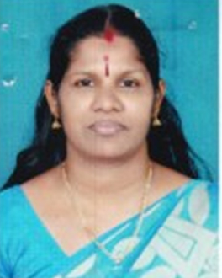
Dear Residents and Stakeholders of Pramadom Grama Panchayath,
It is with a deep sense of responsibility and foresight that I present the Pandemic Preparedness Plan (PPP) for Pramadom Grama Panchayath. The recent global health emergencies have served as a stark reminder that preparedness is not an option, but a mandatory pillar of community resilience. As the President of this Grama Panchayath, my primary commitment is to safeguard the health, well-being, and livelihoods of every single resident.
This document is more than just a plan; it is a comprehensive blueprint for action, developed in close coordination with our Family Health Centre, Veterinary department, ICDS, Police, and local community organizations, embodying the true spirit of the 'One Health' approach. This plan critically assesses our specific vulnerabilities—from our hilly terrain and population demographics to our flood-prone areas and common disease seasonality—to ensure our response is precisely tailored to Pramadom’s unique needs.
The PPP details our existing healthcare infrastructure, resource inventory, and the operational protocols required to manage any future public health crisis, including the constitution of the 'One Health Committee' for coordinated decision-making. It outlines a phased strategy covering Alert/Preparation, Active Response, and Surge Capacity management, ensuring we can transition smoothly from routine operations to full-scale emergency response.
Effective implementation of this plan requires the active participation of every individual, ASHA worker, Kudumbashree member, and community leader. This is a shared responsibility. I urge all citizens to familiarize themselves with this plan and stand ready to collaborate.
Together, we will transform this preparedness plan into effective action, ensuring Pramadom remains a safe, resilient, and healthy community for all.
Susheela Aji
President

MESSAGE FROM
HEALTH STANDING COMMITTEE CHAIR
PRAMADOM GRAMA PANCHAYAT
LOUIS P SAMUEL,
Chairperson, Health & Education Standing Committee
Pramadom Grama Panchayat

Dear Residents and Partners,
It is a privilege to address you as the Chairperson of the Health and Education Standing Committee of Pramadom Grama Panchayat, presenting this vital Pandemic Preparedness Plan (PPP). The lessons learned from recent public health crises demand that we approach our community's health with systematic planning and unyielding commitment.
This Plan is the result of dedicated inter-departmental collaboration, integrating the expertise of the Family Health Centre, Veterinary, and LSGI systems under a robust 'One Health' framework. It goes beyond simple theory, providing a localized, data-driven strategy specifically tailored to Pramadom’s unique geography and vulnerabilities, including our hilly terrain and historical flood-prone areas.
We have meticulously inventoried our resources, from the capacity of our FHC and HWC network to our human capital—including ASHA workers, JPHNs, and Kudumbashree members—who form the essential frontline response. Furthermore, the plan details an evidence-based operational strategy, from the Alert/Preparation phase through Active Response and Surge Capacity management, guided by our newly constituted One Health Committee.
The successful execution of this plan depends not just on official directives, but on community ownership. I urge every resident to understand their role, cooperate with our field staff, and uphold the preventive measures outlined. Health is a shared venture. Together, we will ensure that Pramadom is prepared, resilient, and ready to face any future health challenge.

LOUIS P SAMUEL,
Chairperson, Health & Education Standing Committee

MESSAGE BY MEDICAL OFFICER IN CHARGE
Dr ANJALI KRISHNA, MBBS, MPH  Medical Officer in Charge  Family Health Centre, Pramadom | 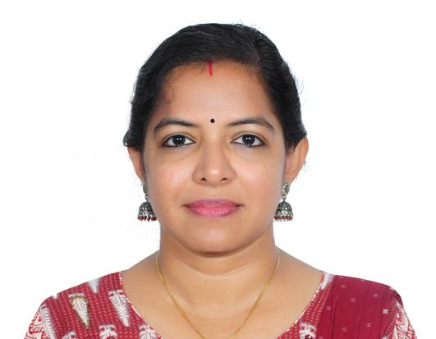

As the Medical Officer in Charge of the Family Health Centre and the technical resource for this initiative, I am pleased to present the Pandemic Preparedness Plan (PPP) for Pramadom Grama Panchayat. This document serves as the essential, evidence-based blueprint designed to safeguard our community against future public health emergencies.
Pramadom, a Grama Panchayat characterized by hilly terrain, historical flood vulnerability, and a significant population of elderly and migrant workers, faces unique risks. Our plan moves beyond generic guidelines by conducting a localized assessment of these specific vulnerabilities, alongside a detailed analysis of our past five years of epidemiological trends (2021–2025), which highlight persistent issues with Dengue, Leptospirosis, and Hepatitis A, particularly in wards 3, 4, 11, 14, and 16.
The PPP is fundamentally rooted in the ‘One Health’ principle, integrating human health, veterinary services, and environmental surveillance. Key features include a comprehensive inventory of our healthcare assets—including the FHC, HWCs, and private clinics—and a meticulous resource mapping of manpower (ASHA, JPHN, Kudumbashree), logistics, and potential surge capacity infrastructure (schools, community halls).
Crucially, the plan details a phased operational strategy: Phase 1 (Alert/Preparation) focuses on proactive surveillance and stockpiling; Phase 2 (Active Response) outlines protocols for rapid case detection, isolation, and treatment; and Phase 3 (Surge Capacity) addresses the expansion of care facilities to manage overwhelming demand. The plan is driven by the newly constituted One Health Committee, ensuring coordinated, inter-sectoral decision-making.
The successful implementation of this PPP hinges on technical readiness, transparent communication, and community cooperation. It is our collective shield against future threats, transforming our local data into actionable protection for every resident of Pramadom.
Dr Anjali Krishna
Medical Officer in Charge
EXECUTIVE SUMMARY

Family Health Centre (FHC) functions as the primary public healthcare institution serving the population of Pramadom Grama Panchayath. The FHC plays a pivotal role in delivering comprehensive, accessible, and affordable healthcare services, with a strong focus on preventive, promotive, curative, and rehabilitative care in accordance with national and state health programmes.
The FHC caters to a predominantly rural population, addressing key public health priorities such as maternal and child health, communicable and non-communicable disease control, immunization, family welfare, adolescent health, and geriatric care. Regular outpatient services, home-based care through field health staff, and outreach activities ensure healthcare coverage even in geographically challenging areas. The institution actively implements national health missions, including the National Health Mission (NHM), National Tuberculosis Elimination Programme, National Programme for Prevention and Control of Cancer, Diabetes, Cardiovascular Diseases and Stroke (NPCDCS), and other disease surveillance initiatives.
Pramadom FHC works in close coordination with the Grama Panchayath, ASHA workers, Anganwadi centres, schools, and community-based organizations to strengthen community participation and improve health awareness. Emphasis is placed on early detection, timely referral, health education, and lifestyle modification to reduce disease burden and improve overall health outcomes.
Despite constraints related to infrastructure, manpower, and increasing service demand, the FHC continues to enhance service delivery through effective planning, data-driven decision-making, and community engagement. Strengthening facilities, upgrading digital health systems, and expanding preventive services remain key focus areas for future development.
Overall, Pramadom Family Health Centre stands as a vital institution in safeguarding public health and improving the quality of life of the residents of Pramadom Grama Panchayath

LIST OF ABBREVIATIONS

LSGD/LSGI | Local Self Government Department / Local Self Government Institution
BMO | Block Medical Officer
IDSP | Integrated Disease Surveillance Programme
NDMA | National Disaster Management Authority
PPE | Personal Protective Equipment
ICMR | Indian Council of Medical Research
CD | Communicable Diseases
NCD | NON-COMMUNICABLE Diseases

TABLE OF CONTENTS

INTRODUCTION 10
INTEGRATED HEALTH INFRASTRUCTURE MAP OF PRAMADOM PANCHAYAT 10
GENERAL PROFILE OF THE LSGI 12
Background of the LSGI 12
Demographic and Vulnerable Population 13
Clinical Vulnerability 14
INFRASTRUCTURE & RESOURCE INVENTORY 16
Health Facility Directory & Basic Capacity in the LSGD 16
Private Clinics 17
Healthcare Education & Training Institutions 18
Specialized Services & Emergency Inventory 19
Oxygen & Diagnostic Capacity 19
Diagnostics facility mapping at the LSGI level 20
Laboratory Identification & Basic Details 21
Social and Community Infrastructure for surge plan 21
Human resources 23
Medical & Clinical Personnel 23
Public Health & Field-Level Workforce 23
Community & Support Cadre 25
Community Organizations 26
Administrative & Emergency Services 27
Information regarding resources 27
ONE HEALTH & ENVIRONMENTAL SURVEILLANCE 28
Veterinary Infrastructure 30
Veterinary Doctors & Workforce 30
High-Risk Interface Points (Surveillance Sites) 31
Environmental Risk Mapping 34
Disease Seasonality Mapping 35
Vulnerability Mapping 36
EPIDEMIOLOGICAL TRENDS (2021–2025) 38
Disease Burden among human beings(Last 5 Years) 38
*(use the above table data to create the graph/diagram) 39
Seasonal Trend Analysis 40
DENGUE 40
Dengue – Ward-wise Yearly Distribution (2021–2025) 40
LEPTOSPIROSIS 42
Leptospirosis – Ward-wise Yearly Distribution (2021–2025) 42
VIRAL HEPATITIS - A 44
Hepatitis A – Ward-wise Yearly Distribution (2021–2025) 44
Transmission Trend- 2025 47
Preparedness and Response Protocol at LSG Level 54
Constitution of One Health Committee 54
Key Responsibilities: 55
Meeting Schedule: 55
Pandemic Response Workforce 55
Activities and Measures before and during Pandemic 57
PHASE 1 - Alert / Preparation 57
➢ Identification of Quarantine and Isolation Facilities 58
➢ Risk Communication and Community Preparedness 58
➢ Protection of Vulnerable Groups 59
➢ Clinical Dependency Mapping 59
PHASE 2 - Active Response 60
1. Case Identification and Contact Tracing 60
2. Screening Checkpoints 60
Standard Screening Protocol 61
3. Pandemic Control Room 62
Control Room Infrastructure and Location 62
1. Rapid Response Team (RRT) 62
2. Data Management & Analytics Team 62
3. Human Resource Deployment Team 62
4. Laboratory Surveillance Team 62
5. Vaccination Cell (If Required) 62
6. Infrastructure & Patient Occupancy Team 63
7. Communication team 63
Key Control Room Team 63
Daily Monitoring Indicators 64
1. Epidemiological Indicators: 64
4. Communication of Public Health Information 66
Key communicators 67
5. Coordination with District/State Authorities & Other Organisations 67
Key Details: 67
Supply Chain Coordination 68
Resource Inventory and Contacts 69
Collaboration with NGOs, PPP, and CSR 70
Interdepartmental Coordination 70
PHASE 3 - Surge Capacity 71
Conversion of Community Facilities 72
CONCLUSION 73
RECOMMENDATIONS 74
1. Strengthening Healthcare Infrastructure 74
2. Community Awareness & Education 74
3. Emergency Response & Coordination 74
4. Supply Chain & Food Security 74
5. Digital Preparedness 74
6. Training & Capacity Building 74
7. Long-Term Resilience 74
1. IMPORTANT PHONE NUMBERS 76
1.1. Details of grama panchayat/municipality/corporation wards 76
1.2. Other important phone numbers of grama panchayat/municipality/corporation area 78
1.3. Important offices of grama panchayat/municipality/ corporation 78
1.4. Health Services 79
1.5. Veterinary Services 80
1.6. Helpline numbers 80
1.7. Public and Private Schools Contact details 81
1.9. Anganwadi Contact Details 81
1.12. Information regarding resources 83

INTRODUCTION

INTEGRATED HEALTH INFRASTRUCTURE MAP OF PRAMADOM PANCHAYAT
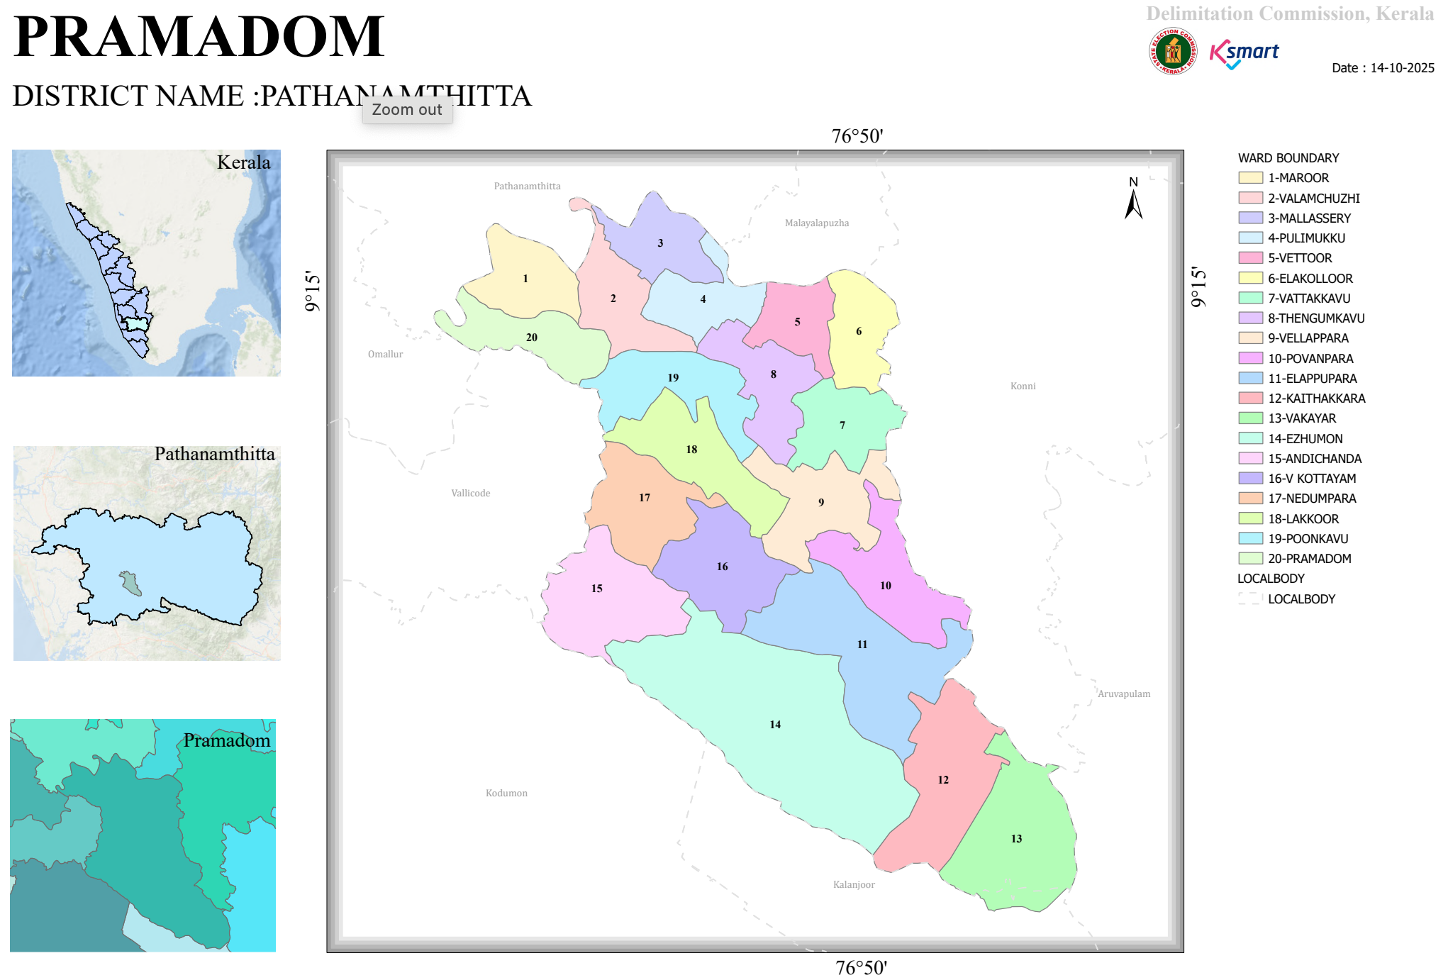

- BASELINE DATA

AREA (IN SQ.KM) | 37.1 SQ KM
NUMBER OF WARDS | 19
NUMBER OF HOUSES | 10454
NUMBER OF DWELLING HOUSE | 9605
TOTAL POPULATION | 34153
MALE | 17089
FEMALE | 17064
SC POPULATION | 3167
MALE | 1569
FEMALE | 1598
ST POPULATION | 139
MALE | 67
FEMALE | 72
NUMBER OF SC COLONIES | 3
NUMBER OF ST COLONIES | 1
NO OF SC HOUSE | 946
NUMBER OF ST HOUSE | 42
BASIC HEALTH SECTIONS | 6
HWCs | 6
ELIGIBLE COUPLES | 3957
0-1 YEAR | 153
MALE | 76
FEMALE | 77
1-5 YEAR | 1314
MALE | 575
FEMALE | 518
10-18 YEAR | 1855
MALE | 900
FEMALE | 955
ABOVE 30 | 20780
MALE | 9923
FEMALE | 10857
ABOVE 60 | 10123
MALE | 4915
FEMALE | 5208
NUMBER OF ASHA WORKERS | 21
NUMBER OF ANGANWADIES | 40
ORT DEPOTS | 74
GOVERNMENT HOSPITALS(TOTAL) | 4
ALLOPATHY | 1
AYURVEDA | 2
HOMEO | 1
PRIVATE HOSPITALS (TOTAL) | 11
ALLOPATHY | 3
AYURVEDA | 7
HOMEO | 1
DENTAL CLINICS | 1
LABOROTORIES | 5
SCANNING CENTRE | 0
EDUCATIONAL INSTITUTIONS(TOTAL) | 16
GOVERNMENT SCHOOLS TOTAL | 5
HSS | 0
HS | 0
UPS | 0
LPS | 5
PRE-PRIMARY | 0
AIDED SCHOOLS TOTAL | 1
HSS | 1
HS | 0
UPS | 0
LPS | 0
PRE-PRIMARY | 0
UNAIDED SCHOOLS TOTAL | 8
HSS | 1
HS | 2
UPS | 2
LPS | 3
PRE-PRIMARY | 0
COLLEGES | 0
OTHER EDU. INSTITUTION | 1
GOVERNMENT INSTITUIONS | 10
CENTRAL GOVT | 3
STATE GOVT | 7
NUMBER OF HOTELS/TEA SHOPS | 16
BAKERY & COOLBAR | 25
THATTU KADA | 14
BORMA | 3
CATERING UNIT | 4
SODA FACTORY | 3
ICE CREAM FACTORY | 1
CHICKEN STALL | 9
CHICKEN FARM | 0
FISH STALL | 3
MEAT STALL | 3
BEAUTY PARLOURS TOTAL | 15
MEN | 9
WOMEN | 6
MARKETS | 3
SCRAP/AKRI SHOP | 3
TYRE RETRADING CENTRES | 3
AUDITORIUM | 3
CRUSHER UNIT | 0
HOSTELS | 0
ORPHANAGES | 1
OLD AGE HOME | 1
WORSHIP PLACES TOTAL | 24
TEMPLE | 13
CHURCHES | 10
MOSQUES | 1
PILGRIM CENTRES | 0
TOTAL NUMBER OF WELLS | 8673
PUBLIC WELLS | 5
PRIVATE WELL | 8658
COLONY WELL | 2
PONDS | 8
OTHERS | 0
NUMBER OF PUMPING STATIONS | 21
WATER SCARCITY AREA | 19
NUMBER OF PLANTATION | 120
LIBRARY & READING ROOMS | 13
NUMBER OF LATRINES | 10212
ARTS & SPORTS CLUBS | 15
NUMBER OF NGOs | 3
KUDUMBASREE UNITS | 198
NUMBER OF CDS MEMBERS | 19
NUMBER OF ADS GROUP | 19
NREG GROUPS | 38
NUMBER OF SUCHITHWA SQUAD | 150
BANKS | 5
BUS STANDS | 0
KSRTC | 0
PRIVATE | 0
NUMBER OF MIGRANT SITES | 18
MIGRANT POPULATION TOTAL | 275
MALE | 260
FEMALE | 15

HEALTH INFRASTRUCTURE MAP

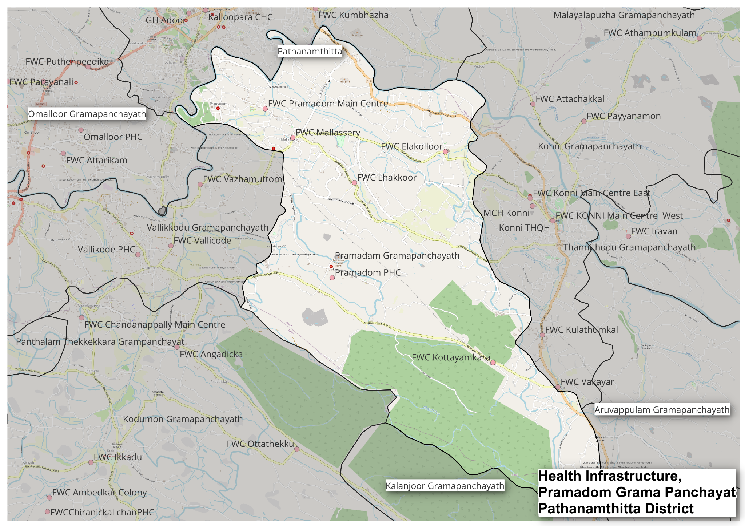
Health infrastructure of Pramadom Grama Panchayat, Pathanamthitta district, 2026

GENERAL PROFILE OF THE LSGI

Background of the LSGI
Pramadom Grama Panchayat is situated in the North of Pathanamthitta district, Kerala. The geographical landscape of the Panchayat is predominantly hilly. This unique terrain plays a significant role in shaping the local microclimate and poses distinct challenges to transportation, emergency response, and service delivery, particularly during monsoon seasons and flood events.
The Panchayat is administratively divided into multiple wards, with a population largely dependent on traditional livelihoods. Agriculture—especially rubber cultivation, and allied activities form the backbone of the local economy. The area hosts a diverse workforce, including a notable presence of migrant labourers, particularly in construction, agriculture, and allied sectors.
From a public health and disaster management perspective,Pramadom LSGI has historically been vulnerable to seasonal flooding, waterborne diseases, and vector-borne illnesses such as Dengue and Leptospirosis. The severe floods experienced during recent years, including the 2018 flood disaster, significantly impacted life, livelihoods, and infrastructure within the Panchayat. These recurring emergencies have underscored the importance of strengthening local preparedness, response mechanisms, and inter-departmental coordination.
In this context, the development of a localized, data-driven Auxiliary Infrastructure and Logistical Resource Map is essential to support effective planning, timely emergency response, and sustainable development initiatives. Such mapping enables the Panchayat to identify critical resources, improve accessibility during disasters, and enhance overall resilience of the community.

Table 1: Background of LSGD
Description | Details
Name of LSGI | Pramadom
Type (GP/Municipality / Corporation etc.) | Grama Panchayath
Block | Konni
District | Pathanamthitta
Number of wards | 20
Total area (sq. km) | 37.1
Population(Projected) | 34153
Population density | 920 persons/sq km
Terrain (coastal/low-lying/backwaters/foothills, etc.) | Hilly
Number of rivers passing through LSGI | 1
Number of water bodies in the LSGI | 6
Number of educational institutions | 16
Factories / small-scale industries | 4(wheat processing unit,timber mill, tin sheet processing unit)
Flood-prone wards | 3
Landslide-prone wards | 0
Death Management and Disposal Facilities (mortuaries/crematorium, including electric) | 0
Auditoriums/Marriage halls/convention centres/community halls | 5

Demographic and Vulnerable Population
Understanding the demographic composition and vulnerable population groups is essential for pandemic preparedness. Children, elderly, economically deprived families, migrant workers, and socially vulnerable groups are at increased risk during public health emergencies due to higher exposure, limited access to services, and dependency on public systems..

Description |  | Details (in numbers)
DEMOGRAPHIC PROFILE
Total population |  | 34153
Male |  | 17089
Female |  | 17064
Transgender |  | 0
Children under 5 |  | 1467
Adolescent |  | 2342
Elderly (>60) |  | 771
SOCIAL/LIVELIHOOD VULNERABILITY
Previous EPEP family |  | 83
BPL family |  | 3218
Tribal communities |  | 2 (141members)
Migration | Immigrant | 275
Migration | Emigrant | 0
Socio-economically deprived |  | 0
Fisherfolk |  | 0
SC Community |  | 3390
ST Community |  | 141

Clinical Vulnerability
Certain population groups needs priority healthcare & are at higher risk of severe illness, complications, and mortality during pandemics. Patients with chronic diseases, those requiring regular medical care, and individuals with mobility or functional limitations face challenges in accessing timely care during emergencies. Mapping these groups helps in prioritizing continuity of treatment, medicine stock planning, oxygen support, referral transport, and targeted home-based care.
Description | Details in numbers
Pregnant women | 77
Lactating mothers | 202
Bedbound patients | 107
Patients under palliative care other than bedbound | 59
Patients on Haemodialysis | 12
Patients on CAPD | 0
Cancer patients (currently on treatment) | 12
Haemophilic patients | 0
Mentally challenged | 52
Differently abled | 17
Diabetic patients | 3303
Hypertensive patients | 4463
TB patients | 6

Major Festivals & Events specific to the LSGI
(with the possibility of a public gathering)

Sl. No. | Name of festival | Month detailing the periodicity
1 | Konni fest | December every year

INFRASTRUCTURE & RESOURCE INVENTORY

Health Facility Directory & Basic Capacity in the LSGD
This section provides an overview of the healthcare infrastructure available within the LSGD area. It outlines the distribution and basic capacity of health facilities that form the backbone of service delivery during routine times and public health emergencies.

Family Health Centres (FHCs) and Community Health Centres (CHCs) generally function as the first point of contact for the community, providing essential outpatient and inpatient services. General Hospitals (GH) and Medical College Hospitals (MCH), where accessible, serve as the main referral centres for advanced diagnostics, specialist care, and critical services during public health emergencies. This inventory helps identify existing strengths, gaps, and potential surge capacity that can be mobilised during a pandemic or disaster.

Table 5. Health Facility Resource Summary
Sl.no. | Health Facility |  |  | Type of Facility (MCH/GH/CHC/FHC/SC etc.) | Contact Number | Total beds |  | ICU Beds | Oxygen-Supported Beds |  | No. of Ventilator Support Beds | No. of ambulances
Government Healthcare Facilities
1 | FHC Pramadom |  |  | FHC | 0468 2306524 | 0 |  | 0 | 0 |  | 0 | 1
2 | HWC Main centre |  |  | HWC | nil | 0 |  | 0 | 0 |  | 0 | 0
3 | HWC Vakayar |  |  | HWC | nil | 0 |  | 0 | 0 |  | 0 | 0
4 | HWC Kottayamkara |  |  | HWC | nil | 0 |  | 0 | 0 |  | 0 | 0
5 | HWC Mallasserry |  |  | HWC | nil | 0 |  | 0 | 0 |  | 0 | 0
6 | HWC Ilakolloor |  |  | HWC | nil | 0 |  | 0 | 0 |  | 0 | 0
7 | HWC Lakkoor |  |  | HWC | nil | 0 |  | 0 | 0 |  | 0 | 0
Private Healthcare Facilities
1 |  | Amma hospital V kottayam | Clinic |  | 7947423193 | 0 | 0 |  | 0 | 0 |  |  | 1
2 |  | Life Care clinic Poonkavu | Clinic |  | 9142847434 | 0 | 0 |  | 0 | 0 |  |  | 0
3 |  | Thoompattu clinic Poonkavu | Clinic |  |  | 0 | 0 |  | 0 | 0 |  |  | 0
AYUSH Healthcare Facilities
1 | Govt Ayurveda Dispensary Pramadom |  |  | HWC | 9633971407 | 0 |  | 0 | 0 |  | 0 | 0
2 | Govt Homeo dispensary,Pramadom |  |  | HWC | 9744491661 | 0 |  | 0 | 0 |  | 0 | 0

Private Clinics
Private clinics are an essential part of pandemic preparedness, as they are often the first place people seek care when symptoms begin. In many communities, private clinics manage a significant share of outpatient visits and therefore play a critical role in early case detection, timely referrals, and disease surveillance. Having an up-to-date understanding of where these clinics are located, the services they provide, and how they are linked to the public health system helps ensure that no cases are missed during an outbreak. It also allows health authorities to engage private practitioners more effectively for reporting, risk communication, and coordinated response, strengthening the overall capacity of the health system to manage public health emergencies.

Table 6. Private Clinic Resource Summary
Sl No. | Name of Clinic | Registered (Y/N) | Clinic (General / Speciality) | Speciality (if any) | Address | Contact Number | Diagnostic Facility (Y/N) | Ambulance Linkage (Y/N)
1 | AMMA hospital,V Kottayam | N | General | Nil | AMMA Hospital,V Kottayam PO | 7947423193 | Y | Y
2 | Lifecare clinic Poonkavu | N | General | Nil | Lifecare clinic Poonkavu | 9142847434 | Y | N

Healthcare Education & Training Institutions
This section tracks the educational infrastructure available, which is vital for human resource planning in the health sector.

Category of Institution | Govt | Private | AYUSH | Total
Medical Colleges | 0 | 0 | 0 | 0
Nursing Colleges | 0 | 0 | 0 | 0
Dental Colleges | 0 | 0 | 0 | 0
Para-medical / Allied Health | 0 | 0 | 0 | 0
Pharmacy Colleges | 0 | 0 | 0 | 0

Specialized Services & Emergency Inventory
This section provides a detailed view of the specialized medical resources available to the community, focusing on emergency response and critical care capabilities. This table tracks the vital assets required for managing severe illnesses and emergencies across Government, Private, and AYUSH sectors.

Item | Govt | Private | AYUSH | Total
Hospital beds | 0 | 0 | 0 | 0
Oxygen-generating systems(Y/N) | N | N | N | N
Oxygen-supported beds (Numbers) | 0 | 0 | 0 | 0
Ventilator-supported beds | 0 | 0 | 0 | 0
ICU beds | 0 | 0 | 0 | 0
Burns units | 0 | 0 | 0 | 0
Blood centres | 0 | 0 | 0 | 0
BLS ambulances | 1 | 1 | 0 | 2
ALS ambulances | 0 | 0 | 0 | 0
Dialysis facilities | 0 | 0 | 0 | 0
Dispensaries | 0 | 0 | 0 | 0
Medical store | 1 | 2 | 0 | 3
Industrial establishments (Medium-scale industries/small-scale industries establishments to whom we can depend in a worst-case scenario) | 0 | 0 | 0 | 0

Oxygen & Diagnostic Capacity
Monitoring oxygen and diagnostic capacity is a critical component of public health preparedness, ensuring that the LSGD can handle both chronic care and sudden surges in respiratory or infectious diseases.
Name of Health Facility | Oxygen-generating System (Y/N) | Backup Oxygen Source (Y/N) | Diagnostic Facilities Available(Y/N)
Name of Health Facility | Oxygen-generating System (Y/N) | Backup Oxygen Source (Y/N) | Lab | USG | X-ray | CT/MRI | RT-PCR
Government Healthcare Facilities
FHC Pramadom | N | Y | Y | N | N | N | N

Diagnostics facility mapping at the LSGI level
The diagnostic capacity of Pramadom G.P represents the "intelligence network" of our healthcare system. The speed and accuracy of disease identification depend entirely on the distribution and technical level of these facilities.

Item | Govt | Private | AYUSH | Total
General labs | 1 | 3 | 0 | 4
Microbiology labs | 0 | 0 | 0 | 0
RT-PCR labs | 0 | 0 | 0 | 0
USG units | 0 | 0 | 0 | 0
CT/MRI units | 0 | 0 | 0 | 0
Research labs | 0 | 0 | 0 | 0
Labs of other departments that can be repurposed | 0 | 0 | 0 | 0

Laboratory Identification & Basic Details
Sl. No. | Name of Laboratory | Ownership (Govt / Private / Academic) | Address | Contact No. | 24×7 Services (Yes/No) |  | NABL / Govt Approved (Yes/No)
1 | FHC Pramadom | Govt | FHC Pramadom,V Kottayam PO | 0468 2306524 | No |  | No
2 | AMMA hospital | Private | AMMA hospital,V Kottayam PO | 7947423193 |  | Yes | No
3 | Micro lab, Poonkavu | Private | Micro lab Poonkavu |  | Yes |  | Yes

Social and Community Infrastructure for surge plan
This table serves as our logistics and shelter inventory. By mapping these locations, quickly we can identify where to house displaced citizens, where to set up temporary medical clinics, and how to manage the deceased with dignity during a crisis.

Category | Total Count | Ward | Est. Capacity (Persons) | Contact details
Educational Institutions
Anganwadis | 40 | 20 | 80
Schools | 16 | 20 | 120
Colleges | 0 | 0 | 0
Healthcare Educational Institutions
Medical colleges (Govt/Private) | 0 | 0 | 0 | 0
Nursing colleges (Govt/Private) | 0 | 0 | 0 | 0
Dental colleges (Govt/Private) | 0 | 0 | 0 | 0
Paramedical institutes (Govt/Private) | 0 | 0 | 0 | 0
Community Gathering Spaces
Community halls | 2 | 6,7
Auditoriums | 2 | 12,10
Religious buildings | 5 | 6,8,9
Vulnerable Group Support Facility
Destitute homes | 0
Elderly homes | 0
LSGD owned other buildings | 1 | 5
Mass Fatality Management (MFM) Infrastructure
Mortuary | 0
Crematorium | 0
*refer annexure 1 for contact details

Human resources
This section focuses on the human capital available within the LSGI. In any emergency—be it a pandemic, flood, or industrial accident—infrastructure is only as effective as the people operating it.

Medical & Clinical Personnel
This table tracks the "Frontline" providers responsible for diagnosis, treatment, and clinical management. The data reveals a total of 18 healthcare professionals across various disciplines. The workforce is relatively balanced between sectors, with 7 individuals in the public sector and 11 individuals in the private sector. A detailed directory with the contact numbers of all workers is maintained (Annexure in 1).

Cadre | Govt (No.) | Private (No.) | Total
Doctors—Modern Medicine | 2 | 2 | 4
Doctors – AYUSH | 1 | 0 | 1
Doctors – Veterinary | 1 | 0 | 1
Doctors – Dental | 0 | 0 | 0
Nursing officers | 2 | 3 | 5
Lab technicians | 1 | 3 | 4
Optometrist | 0 | 0 | 0
Pharmacists | 1 | 2 | 3
Psychologists | 0 | 0 | 0
Counsellors | 0 | 0 | 0

Public Health & Field-Level Workforce
These individuals are the backbone of surveillance, maternal-child health, and decentralized care.

Cadre | Health services | Municipal common services | Total
HS (Health Supervisors) | 0 | 0 | 0
HI (Health Inspectors) | 1 | 0 | 1
LHS (Lady Health Supervisor) | 0 | 0 | 0
LHI (Lady Health Inspectors) | 1 | 0 | 1
JPHN (Jr Public Health Nurses) | 6 | 0 | 6
JHI (Jr Health Inspectors) | 6 | 0 | 6
MLSP (Mid-Level Service Providers) | 6 | 0 | 6
Palliative Nurses | 1 | 0 | 1
RBSK Nurses | 1 | 0 | 1
PRO | 0 | 0 | 0
Epidemiologist | 1 | 0 | 1
Data Manager | 0 | 0 | 0

Community & Support Cadre
This group represents the surge capacity of the LSGI—people who can be called upon for logistics, rescue, and specialized support.

Cadre | Number
ASHA Workers | 20
AWW (Anganwadi Workers) | 40
Emergency Medical Volunteers (Trained) | 0
Kudumbashree | 176
MNREGS | 1254
Purusha Swayam Sahaya Sangham | 4 units
Ex-Servicemen | 1 unit
Retired Police Officers | 0
NCC/NSS Volunteers | 0
Red Cross volunteers | 0
One Health Community Volunteers | 931
One Health Community Mentors | 133

Community Organizations
This section details the presence of community-based organisations (CBOs), non-governmental organisations (NGOs), faith-based organisations (FBOs), Kudumbashree Self-Help Groups (SHGs), and Ayalkootams within the Local Self-Government Institution (LSGI). These groups enhance grassroots mobilization, resource distribution, and support networks crucial for pandemic response and community resilience.

Category | Total Count
NGOs | 5
Religious based organizations | 2
Foreign based organizations | 0
Sports Club/youth clubs | 0
Kudumbashree SHGs | 12
Ayalkootams | 176
Political organizations | 2
Residential organizations | 2

Administrative & Emergency Services
This section outlines the availability of key non-health emergency support services and infrastructure within the LSGI, which are essential for effective pandemic preparedness and response. These facilities support law enforcement, disaster response, water supply, logistics, mobility, and community-level interventions during public health emergencies.

Category | Total Count | Contact details
Police Stations | 1 | 9497987052
Fire & Rescue Stations | 0 | -
Water Pumping Points | 15
Public Distribution System (PDS) | 15

Information regarding resources
The availability of essential transport and support resources plays a quiet but critical role in saving lives. Equipment such as ambulances, mobile mortuaries, amphibian ambulances, and motorized boats ensures that patients, samples, and healthcare teams can move swiftly—even in flooded, remote, or difficult terrains. Heavy vehicles like JCBs, cranes, tractors, and torus lorries support logistics, waste management, emergency infrastructure, and rapid conversion of spaces into care or isolation facilities. Taxis, four-wheel-drive vehicles, and trucks help maintain continuity of essential services, reach vulnerable populations, and support home-based care and supply delivery.

Means of transportation | Total Count
JCB | 6
Crane | 2
Heavy Trucks | 0
Tractor | 5
Ambulances | 2
Mobile mortuaries | 0
Boats | 0
Taxi service | 10

ONE HEALTH & ENVIRONMENTAL SURVEILLANCE
The One Health method integrates environmental, animal, and human health to enable proactive pandemic preparedness. Panchayat-level surveillance needs to be improved in order to detect and treat zoonotic and environmentally generated diseases early. Surveillance is strengthened through systematic assessment of animal populations, veterinary infrastructure, poultry and slaughter facilities, inter-sectoral coordination, and specialised tools like avian influenza seasonality mapping using GIS in previous outbreaks to enable predictive alerts and ward-specific sampling to support effective pandemic preparedness in high-risk areas.
Animal & Bird Population
Mapping animal and bird populations at the Panchayat level is essential for identifying and prioritising zoonotic disease hazards like rabies, avian influenza (H5N1), leptospirosis, anthrax, and Nipah-like spillover occurrences. Risk classification, targeted surveillance, vaccination planning, and early epidemic detection made feasible by comprehensive population mapping all enhance One Health-based pandemic preparedness.

Category | Item | Estimated Population | Wards
Animal Population | Livestock (Cattle/Goats/Buffalo) | 1578 | All wards
Animal Population | Pet Animals (Dogs/Cats) | 722 | All wards
Animal Population | Stray Dog Population | 300 | All wards
Animal Population | Pig Farms (Number of heads) | 0 | -
 | Small Units (Sheep / Goats – clustered) | 0 | -
Bird Population | Poultry Units (Birds) | 0 | -
Bird Population | Poultry- (FOWL) | 560 | All wards
Bird Population | Wild/Migratory Birds (Observed) | 0 | -
Bird Population | Crow Mortality Events (Reported) | 0 | -

The main risk of zoonotic diseases in Pramadom is concentrated in all ward. The stray dog population continues to be a substantial problem for rabies surveillance and bite prevention. Water stagnant areas vulnerable to flooding further raise the risk of leptospirosis and other zoonoses mediated by the environment, especially during monsoon floods.
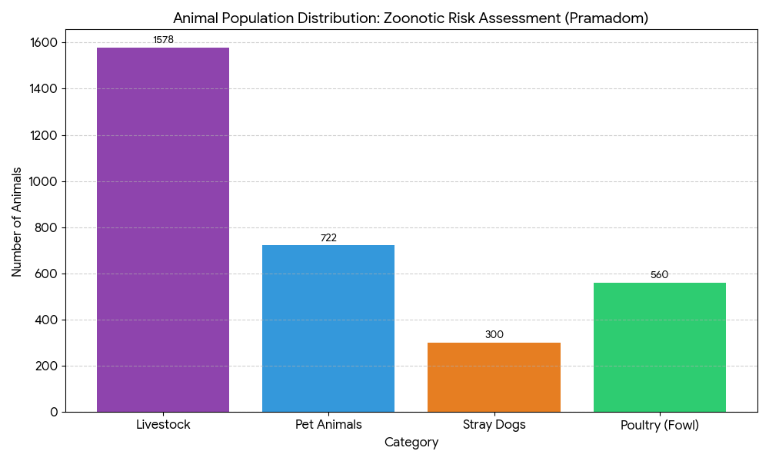
The animal-human interface in Pramadom is highly significant, with over 3,100 domestic and stray animals living in close proximity to residents, necessitating a vigilant "One Health" approach to prevent pathogen spillover. The most immediate threat is Rabies, driven by a population of 300 stray dogs and 722 pets, which requires urgent integrated vaccination and birth control programs.
Additionally, the presence of 1,578 livestock animals across all wards poses a moderate-to-high risk for Leptospirosis, especially during monsoons when water contamination is likely. The 560 backyard poultry birds still require consistent monitoring for seasonal influenza to protect both community health and local livelihoods.

Veterinary Infrastructure
Veterinary institutions are a core pillar of One Health surveillance, enabling early zoonotic disease detection through vaccination, investigation of unusual animal illness or deaths, sample collection, and timely outbreak reporting. A well-mapped and responsive veterinary network strengthens coordination with human health and LSGI systems, ensuring rapid response during zoonotic events and pandemics.
Facility Type | Name of Facility | Ownership Govt / Pvt | Location(Ward No) | Contact number
Veterinary Dispensary | 1 | Govt | 20 | 9947847247
Veterinary Hospital / Polyclinic | 0 | 0 | NA | NA
Private Veterinary Clinics | 1 | Pvt | Mallasserry | -
Mobile / Emergency Vet Service (incl. night services) | 0
Pet Homes / Animal Shelters | 0
Slaughterhouse-linked Veterinary Inspection Unit | 0

Veterinary Doctors & Workforce
Early detection, diagnosis, reporting, and reaction to animal illness epidemics depend on the availability and accessibility of qualified veterinary specialists. By identifying unusual animal morbidity or mortality promptly, collecting samples promptly, and coordinating efficiently with human health and LSGI systems—especially during zoonotic outbreaks and pandemic-prone situations—a clearly defined veterinary workforce enhances One Health surveillance.

Category | Number Available | Type (Govt/Pvt) | Contact number
Government Veterinary Doctors | 1 | Govt | 9947847247
Private Veterinary Doctors | 0 | NA | -
Livestock Inspectors | 3 | Govt | 9544212529,9447331920,9446503454
Para-veterinary Staff / Attenders | 1 | Govt | -
Contract / On-call Veterinary Support (if any) | 1 | Govt | -

High-Risk Interface Points (Surveillance Sites)
High-risk interface points for zoonotic disease surveillance in Pramadom Grama Panchayath include wetland–livestock–human contact zones, backyard poultry farms, cattle sheds near water bodies, fish markets, and areas of high human–animal interaction such as community slaughter points and migratory bird congregation sites. These are the primary surveillance sites where zoonotic spillover risks are elevated.

Type of Habitat | Type of High-risk interface | Geographical vulnerability
Wetlands & Backwaters | 0 | NA
Backyard Poultry Farms | 708 | Nil
Cattle Sheds near Water Bodies | 0 | NA
Fish & Meat Markets | 1 | Nil
Community Slaughter Sites | 0 | NA
Migratory Bird Congregation Areas | 0 | NA
Rodent-Infested Grain Storage | 0 | NA

Category | Total Count | Key Locations (wards)
Poultry Farms | 1 | Pulimukku
Backyard / Clustered Poultry Units | 708(6898 poultry) | All wards
Duck Rearing Units (open water access) | 50(578 ducks) | All wards
Slaughterhouses/ Slaughter Points | 0
Meat/Fish Markets | 1 | Poonkavu
Live Bird Sale Points | 4
Cattle Markets / Weekly Animal Fairs | 0
Pet Shops / Breeders | 0
Animal Shelters / Pet Homes | 0
Waste Disposal Sites near Animal Units | 0

Environmental Risk Mapping
Environmental risk mapping identifies monsoon/flood hotspots for vector-borne (dengue, chikungunya), water-borne (leptospirosis, diarrhoea), and zoonotic diseases in Kerala's wetlands. Systematic surveillance supports early warnings, targeted interventions, and Panchayat pandemic preparedness.
Waterborne exposure: Flood-prone areas and stagnant water bodies facilitate leptospira survival, raising leptospirosis risk.

Traditional practices: Informal slaughter and fish markets lack standardized hygiene, creating spillover opportunities.
Risk Factor | High-Risk Wards | Key Locations | Risk Level (High/Med/Low)
Flood-prone areas | 1,3,16 | valanchuzhy, Maroor,V kottayam | low
Water bodies/wetlands | 1,3 | Valanchuzhy | low
Solid waste accumulation | Nil
Animal waste disposal issues | Nil
Rodent infestation zones | Nil
Industrial effluent discharge | Nil
Construction sites / abandoned buildings | Nil
Poor drainage/blocked canals | Nil
Drinking water source contamination risk | Nil

Disease Seasonality Mapping
1, Flooding & waterlogging → amplifies leptospirosis, malaria, diarrheal diseases.
·
2, Migratory bird influx (Nov–Feb) → avian influenza risk.

3, Mosquito breeding cycles → vector-borne disease peaks in monsoon.

4, Agricultural practices → close human–animal contact in paddy fields.

Disease | Peak Risk Season | Key Drivers | High-Risk Locations | Surveillance Focus
Avian Influenza | NA | NA | NA | NA
Leptospirosis | June to November | Waterlogging during monsoons | All wards | Farmers,NREG workers
Dengue/Chikungunya | March to October | Monsoon ,water scarcity in summer | All wards | Vector indices
Acute Diarrheal Diseases | March to May | Water scarcity in summer | All wards
Rabies | NA | NA | NA | NA
Anthrax (rare) | NA | NA | NA | NA

Vulnerability Mapping
Vulnerability mapping pinpoints high-risk populations, occupations, and areas exposed via environment, livelihoods, socio-economics, and poor service access. Paired with environmental/seasonality mapping, it enables risk-based surveillance, targeted actions, and optimal resource use in One Health and pandemic planning.
Vulnerability Factor | High-Risk Wards | Key Groups / Locations | Risk Level
Flood-prone households | 1,3,16 |  | low
Wetland-adjacent communities | nil |  | nil
Backyard poultry / duck rearing households | all wards |  | low
Livestock-rearing households | all wards |  | low
Slaughterhouse & meat market workers | nil |  | nil
Fisherfolk & fish market workers | nil |  | nil
Sanitation workers | nil |  | nil
Daily wage / migrant workers | all wards |  | low
Elderly & chronically ill populations | all wards |  | low
Pregnant Women | all wards |  | low
Children (schools, Anganwadi’s) | all wards |  | low
Limited access to safe water & sanitation | all wards |  | low

EPIDEMIOLOGICAL TRENDS (2021–2025)

Disease surveillance is the systematic collection, analysis, and interpretation of health data for planning, implementation, and evaluation of public health practice. This section presents the disease surveillance profile of the LSGI based on routine reporting systems and outbreak investigations to identify priority diseases, seasonal patterns, and emerging public health threats.

Disease Burden among human beings (Last 5 Years)
Analysis of disease-wise data for the last five years helps identify persistent public health problems, emerging diseases, and changes in disease burden. This information supports prioritisation of prevention, preparedness, and response activities at the Panchayat level.

Disease | 2021 | 2022 | 2023 | 2024 | 2025 | Trend (Increasing/Stable/Decreasing)
Dengue | 4 | 13 | 89 | 125 | 41 | decreasing
Leptospirosis | 3 | 8 | 8 | 2 | 7 | increasing
Hepatitis A | 1 | 1 | 1 | 15 | 11 | increasing
Malaria | 0 | 0 | 1 | 3 | 1 | decreasing
Scrub Typhus | 0 | 0 | 2 | 0 | 0 | decreasing
Typhoid | 0 | 1 | 0 | 1 | 5 | increasing
H1N1 | 0 | 0 | 0 | 7 | 6 | increasing
H3N2 | 0 | 0 | 0 | 0 | 2 | increasing
ADD | 0 | 0 | 0 | 6 | 57 | decreasing
Mumps | 0 | 0 | 0 | 0 | 3 | increasing
Measles | 0 | 0 | 0 | 0 | 0 | NA
Hepatitis B | 16 | 31 | 11 | 13 | 11 | decreasing
Hepatitis C | 0 | 0 | 0 | 0 | 0 | NA
Tuberculosis | 10 | 13 | 16 | 15 | 15 | steady
Leprosy | 0 | 0 | 0 | 0 | 1 | NA
COVID-19 | - | - | - | - | 2 | decreasing

The region is transitioning from a period of high vector-borne dominance (2024) to a period of waterborne disease risk (2025). The sudden onset of ADD and the continued elevated levels of Dengue suggest that public health efforts must focus heavily on environmental hygiene and vector management to prevent these new baselines from becoming permanent.
The following visualizations provide a clearer look at the health trends in Pramadom Panchayat from 2021 to 2025.

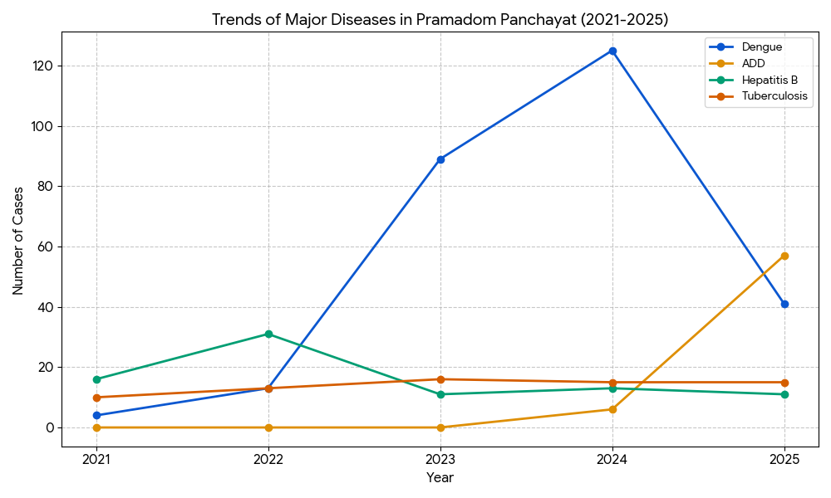

The epidemiological landscape of Pramadom Panchayat has undergone a significant shift, characterized by the dramatic rise and subsequent fall of Dengue, which peaked at 125 cases in 2024 before declining in 2025. While vector-borne threats show signs of stabilization, a critical public health concern has emerged in the form of a synchronized surge in water-borne diseases. This is most evident in the sudden, nearly vertical climb of Acute Diarrheal Disease (ADD), which jumped to 57 cases in 2025 alongside rising instances of Hepatitis A and Typhoid. This localized spike serves as a vital indicator of recent water quality or sanitation failures. In contrast, chronic conditions like Tuberculosis and Hepatitis B remain relatively stable or are showing gradual long-term declines, suggesting that while long-term treatment programs are effective, immediate intervention is required to address the deteriorating hygiene and environmental factors driving the current gastrointestinal outbreak.

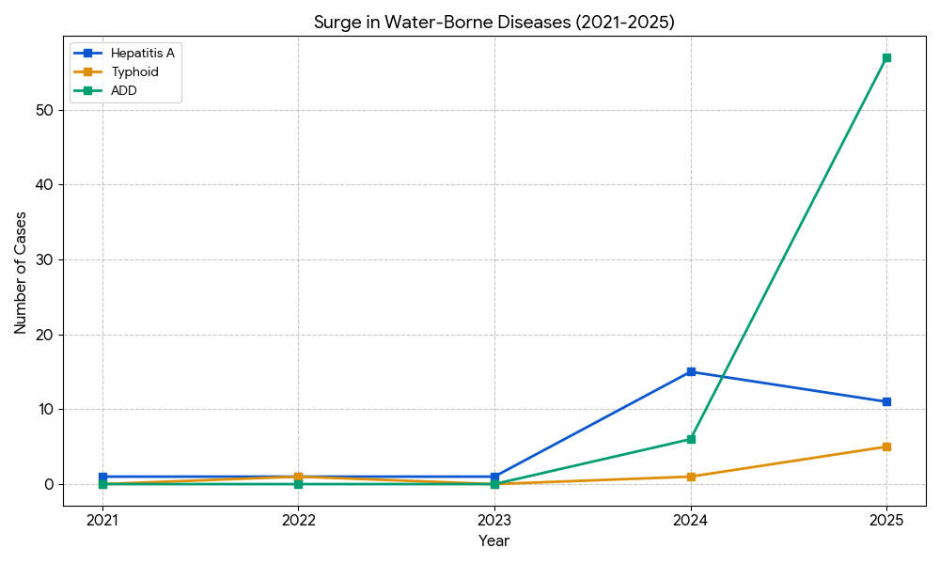

Seasonal Trend Analysis
Seasonal analysis helps anticipate surges (e.g. dengue in monsoon, leptospirosis after floods, influenza in cooler months) and plan pre‑emptive vector control, stockpiling of IV fluids, and awareness campaigns at Panchayat level.

DENGUE
Dengue is a major seasonal vector-borne disease strongly associated with rainfall, water stagnation, and increased mosquito breeding during the monsoon period.

Peak: July–November

Dengue – Ward-wise Yearly Distribution (2021–2025)

Ward | Dengue – Ward-wise Yearly Distribution
Ward | 2021 | 2022 | 2023 | 2024 | 2025 | Total
1 | 0 | 1 | 2 | 19 | 2 | 24
2 | 0 | 0 | 1 | 7 | 0 | 8
3 | 0 | 0 | 10 | 5 | 3 | 18
4 | 0 | 0 | 10 | 10 | 1 | 21
5 | 0 | 0 | 3 | 3 | 1 | 7
6 | 1 | 4 | 7 | 5 | 0 | 17
7 | 0 | 1 | 1 | 1 | 3 | 6
8 | 0 | 0 | 4 | 5 | 4 | 13
9 | 0 | 1 | 3 | 2 | 16 | 23
10 | 0 | 0 | 3 | 7 | 0 | 10
11 | 1 | 1 | 6 | 10 | 1 | 19
12 | 0 | 0 | 2 | 5 | 1 | 8
13 | 0 | 1 | 1 | 4 | 2 | 8
14 | 1 | 1 | 8 | 8 | 2 | 20
15 | 0 | 0 | 9 | 9 | 2 | 20
16 | 0 | 1 | 4 | 18 | 0 | 23
17 | 0 | 1 | 3 | 2 | 0 | 6
18 | 0 | 0 | 2 | 6 | 0 | 8
19 | 1 | 1 | 10 | 4 | 0 | 16
20 | 0 | 0 | 0 | 0 | 0 | 0

The total cases for the Panchayat show a classic epidemic trajectory:
- Initial Stability (2021–2022): Cases were minimal, suggesting a low baseline transmission.
- The Rapid Escalation (2023): Cases jumped significantly to 89, signaling the start of a major outbreak.
- The Peak (2024): The outbreak reached its zenith with 130 total cases, putting extreme pressure on local health resources.
- The Downturn (2025): A sharp decline to 43 cases indicates successful containment strategies, though transmission remains significantly higher than the 2021–2022 baseline.

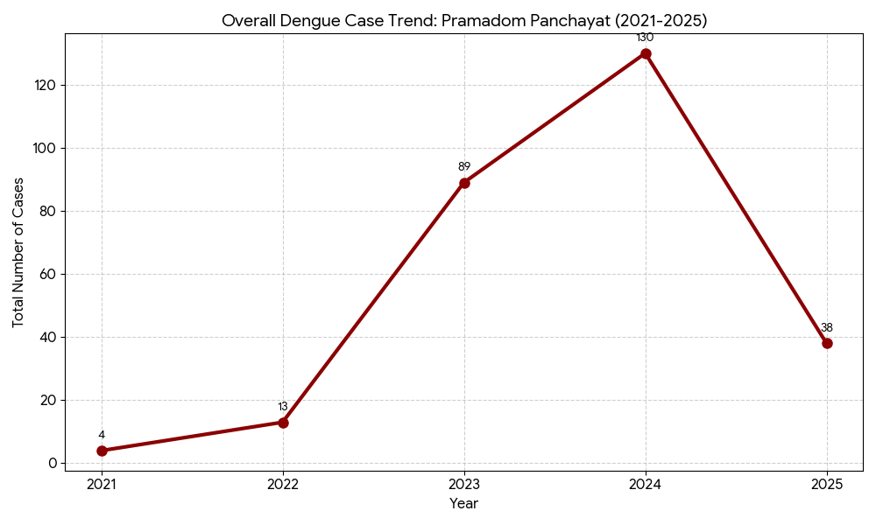The line graphs confirm that while the Panchayat as a whole has moved past the 2024 peak, the fight against Dengue is not over. The Ward 9 spike in 2025 is particularly concerning because it deviates from the general success seen in other high-burden areas like Wards 1 and 16. Public health efforts should now transition from a general "Panchayat-wide" approach to a "micro-targeted" intervention specifically focusing on Ward 9 and maintaining the success in the recovered wards.
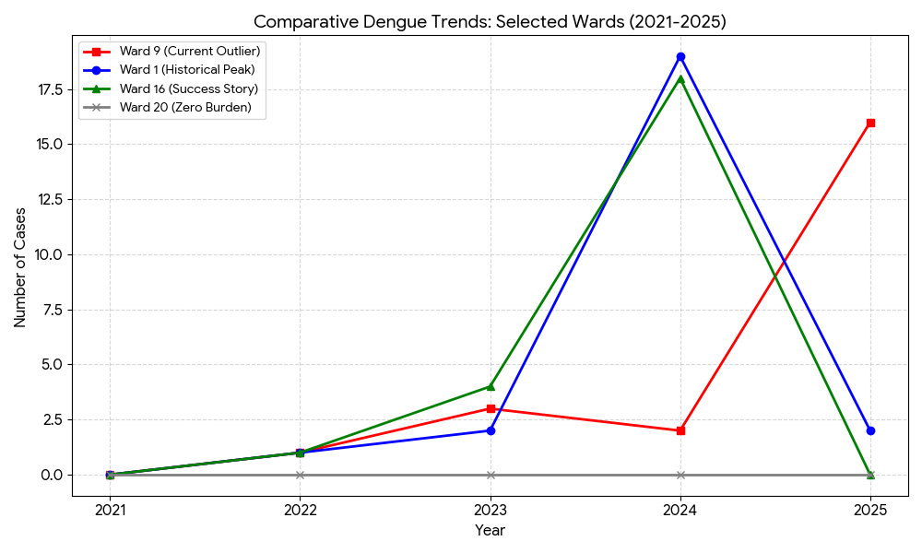

LEPTOSPIROSIS
Leptospirosis cases are closely linked to monsoon rains, flooding, and occupational exposure, particularly in low-lying and waterlogged areas.

Peak: June - August

Leptospirosis – Ward-wise Yearly Distribution (2021–2025)

Ward | Leptospirosis – Ward-wise Yearly Distribution
Ward | 2021 | 2022 | 2023 | 2024 | 2025 | Total
1 | 0 | 0 | 1 | 0 | 0 | 1
2 | 0 | 1 | 1 | 0 | 0 | 2
3 | 1 | 0 | 0 | 0 | 0 | 1
4 | 0 | 0 | 2 | 0 | 0 | 2
5 | 0 | 0 | 1 | 1 | 0 | 2
6 | 0 | 1 | 1 | 0 | 1 | 3
7 | 0 | 1 | 0 | 0 | 1 | 2
8 | 0 | 0 | 2 | 0 | 0 | 2
9 | 0 | 0 | 0 | 0 | 0 | 0
10 | 1 | 0 | 0 | 0 | 1 | 2
11 | 0 | 0 | 0 | 0 | 0 | 0
12 | 0 | 1 | 0 | 0 | 1 | 2
13 | 0 | 0 | 0 | 0 | 0 | 0
14 | 0 | 1 | 0 | 0 | 2 | 3
15 | 0 | 0 | 0 | 0 | 0 | 0
16 | 0 | 1 | 1 | 1 | 1 | 4
17 | 0 | 1 | 0 | 0 | 0 | 1
18 | 1 | 0 | 0 | 0 | 0 | 1
19 | 0 | 0 | 0 | 0 | 0 | 0
20 | 0 | 0 | 0 | 0 | 0 | 0

Based on the ward-wise data for Leptospirosis in Pramadom Panchayat, Leptospirosis cases in the Panchayat show a fluctuating but persistent pattern.
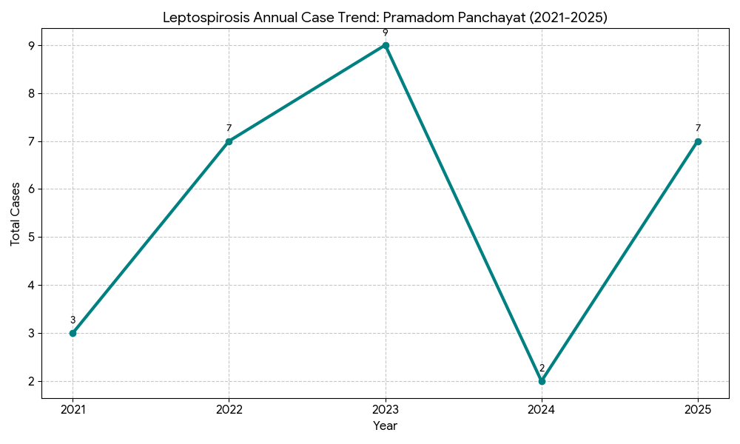
The epidemiological trend of Leptospirosis in Pramadom Panchayat from 2021 to 2025 has been marked by a fluctuating but persistent pattern of transmission. The period began with a low baseline of 3 cases in 2021, which quickly escalated into a primary wave between 2022 and 2023, where cases rose to 7 and then peaked at 9, showing a widely scattered distribution across multiple wards. While there was a significant 77% drop in 2024 with only 2 reported cases in Wards 5 and 16, this proved to be a temporary reprieve rather than a permanent eradication. By 2025, the Panchayat saw a resurgence to 7 cases, a spike that strongly suggests that the underlying environmental risk factors—specifically stagnant waterlogging and rodent populations—remain unaddressed and continue to pose a cyclical threat to the community.

VIRAL HEPATITIS - A
Hepatitis A cases are commonly associated with unsafe drinking water, food contamination, and breakdowns in sanitation, often presenting as clusters or outbreaks.

Peak: October - December

Hepatitis A – Ward-wise Yearly Distribution (2021–2025)

Ward | Hep A – Ward-wise Yearly Distribution
Ward | 2021 | 2022 | 2023 | 2024 | 2025 | Total
1 | 0 | 0 | 0 | 0 | 0 | 0
2 | 0 | 0 | 0 | 0 | 0 | 0
3 | 0 | 0 | 0 | 5 | 1 | 6
4 | 0 | 0 | 0 | 2 | 0 | 2
5 | 0 | 0 | 0 | 2 | 1 | 3
6 | 0 | 0 | 0 | 0 | 1 | 1
7 | 0 | 0 | 0 | 1 | 0 | 1
8 | 0 | 0 | 0 | 0 | 0 | 0
9 | 0 | 0 | 0 | 0 | 0 | 0
10 | 0 | 0 | 0 | 0 | 1 | 1
11 | 0 | 0 | 0 | 0 | 1 | 1
12 | 0 | 0 | 0 | 0 | 0 | 0
13 | 0 | 0 | 0 | 0 | 0 | 0
14 | 1 | 0 | 0 | 2 | 1 | 4
15 | 0 | 0 | 0 | 1 | 0 | 1
16 | 0 | 0 | 0 | 0 | 0 | 0
17 | 0 | 0 | 1 | 2 | 2 | 5
18 | 0 | 1 | 0 | 0 | 1 | 2
19 | 0 | 0 | 0 | 0 | 0 | 0
20 | 0 | 0 | 0 | 0 | 0 | 0

Based on the ward-wise data for Hepatitis A in Pramadom Panchayat, the Hepatitis A profile in the Panchayat underwent a radical transformation starting in 2024.

The Dormant Phase (2021–2023): For three consecutive years, the disease was virtually non-existent, with only one isolated case reported each year.

The 2024 Outbreak: A sudden and massive spike occurred in 2024, with cases jumping to 15. This represents a 1500% increase from the previous year, indicating a significant contamination event, likely in a shared water source or a public food event.

Persistent Transmission (2025): While the numbers dropped to 9 cases in 2025, the disease remains much more prevalent than during the 2021–2023 period. The fact that cases are still occurring in multiple wards suggests that the underlying cause of the 2024 outbreak has not been fully eradicated.

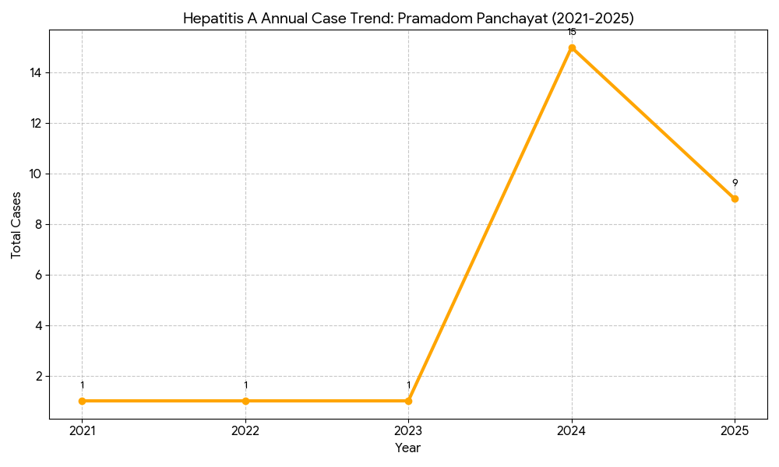

The epidemiological trend of Hepatitis A in Pramadom Panchayat transitioned from a state of near-zero dormancy between 2021 and 2023 to an acute outbreak phase in 2024, where cases surged to 15. This dramatic spike, particularly concentrated in Ward 3, suggests a major breakdown in water sanitation or fecal-oral hygiene protocols. Although 2025 saw a reduction to 9 cases, the continued spread across nearly 50% of the wards—with Ward 17 showing the most consistent year-on-year presence—highlights that the risk of infection remains active. This shift from isolated cases to a broader geographic distribution necessitates a permanent upgrade in local water chlorination and public hygiene awareness to return to the pre-2024 safety levels.

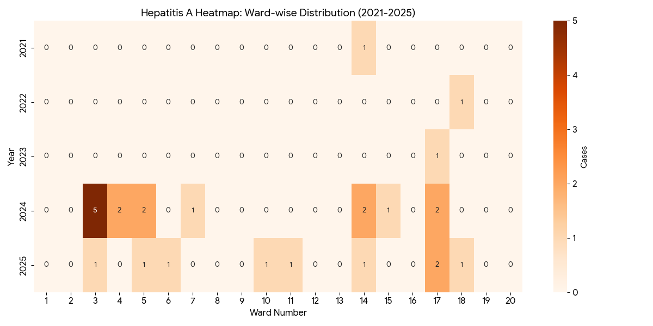

Transmission Trend- 2025
For effective management of public health issues, it is important to track the trend of disease transmission mode. It helps identify the population or place at high risk that can be used to predict outbreaks and implement targeted interventions as quickly as possible. Understanding these kinds of trends enables authorities to allocate resources efficiently and change the strategies adequately based on the trend that follows.

Mode of Transmission | No. of cases | No. of Deaths
Vector Borne Diseases | 42 | 0
Water Borne Diseases | 73 | 0
Air Borne Diseases | 11 | 1
Blood Borne Diseases | 11 | 0
Food Borne Diseases | 0 | 0

Vector-Borne Disease

Disease | No. of Cases | No. of Deaths
Dengue | 41 | 0
Malaria | 1 | 0
Chikungunya | 0 | 0

Water Borne Disease

Disease | No. of Cases | No. of Deaths
Cholera | 0 | 0
Typhoid | 5 | 0
Hep- A | 11 | 0
Dysentery | 0 | 0
Amoebiasis | 0 | 0
E- Coli infections | 0 | 0

Air Borne Disease

Disease | No. of Cases | No. of Deaths
Influenza | 0 | 0
H1N1 | 0 | 0
TB | 15 | 1
Chickenpox | 24 | 0
Measles | 0 | 0
Covid-19 | 2 | 0
Pertussis | 0 | 0
Mumps | 3 | 0

Blood-Borne Disease

Disease | No. of Cases | No. of Deaths
AIDS | 0 | 0
Hep- B | 11 | 0
Hep- C | 0 | 0

Zoonotic Disease

Disease | No. of Cases | No. of Deaths
Rabies | 0 | 0
Leptospirosis | 7 | 0
Avian influenza | 0 | 0
West nile | 0 | 0
Anthrax | 0 | 0
Nipah | 0 | 0
Scrub Typhus | 0 | 0

Ward-wise distribution of various communicable diseases

Ward No | Dengue Total (2021-25) | Leptospirosis Total (2021-25) | Hepatitis A Total (2021-25) | Mumps (2021-25) | ADD (2021-25) | Total Cases
1 | 24 | 1 | 0 | 0 | 1 | 26
2 | 8 | 2 | 0 | 0 | 1 | 11
3 | 18 | 1 | 6 | 1 | 3 | 29
4 | 21 | 2 | 2 | 1 | 2 | 28
5 | 7 | 2 | 3 | 0 | 1 | 13
6 | 17 | 3 | 1 | 0 | 0 | 21
7 | 6 | 2 | 1 | 0 | 1 | 10
8 | 13 | 2 | 0 | 0 | 2 | 17
9 | 23 | 0 | 0 | 0 | 2 | 25
10 | 10 | 2 | 1 | 1 | 2 | 16
11 | 19 | 0 | 1 | 0 | 8 | 28
12 | 8 | 2 | 0 | 0 | 2 | 12
13 | 8 | 0 | 0 | 0 | 0 | 8
14 | 20 | 3 | 4 | 0 | 1 | 28
15 | 20 | 0 | 1 | 0 | 0 | 21
16 | 23 | 4 | 0 | 0 | 3 | 30
17 | 6 | 1 | 5 | 0 | 0 | 12
18 | 8 | 1 | 2 | 0 | 0 | 11
19 | 16 | 0 | 0 | 0 | 0 | 16
20 | 0 | 0 | 0 | 0 | 0 | 0

By overlaying five years of data, we have identified 8 'Red Zone' Wards. These are wards where at least two different categories of diseases (e.g., Dengue and Lepto) recurred in consecutive years. This analysis identifies the geographical disease burden across 20 wards for the period of 2021–2025. By synthesizing the data, we can pinpoint specific hotspots and provide an epidemiological overview of the distribution.

Based on the cumulative surveillance data from 2021 to 2025, the regional epidemiological profile is defined by a heavy vector-borne disease burden and emerging localized enteric clusters. Dengue serves as the primary driver of morbidity, appearing in 19 out of 20 wards, with the most severe hotspots located in Ward 1 (24 cases), Ward 9 (23 cases), and Ward 16 (23 cases). These high-density clusters suggest a prevalence of mosquito breeding sites, such as stagnant water or urban clutter, particularly in Wards 1, 4, 9, 14, 15, and 16, which all reported 20 or more cases.
In contrast to the widespread nature of Dengue, diseases like Acute Diarrheal Disease (ADD) and Hepatitis A exhibit highly localized "point-source" transmission patterns. Ward 11 is the distinct hotspot for ADD with 8 cases—significantly higher than the 0-2 cases seen elsewhere—while Wards 3 and 17 account for 39% of all Hepatitis A infections. These spikes typically point toward specific environmental failures, such as contaminated water sources or localized food safety issues.
Other conditions like Leptospirosis remain relatively stable and scattered, though Ward 16 shows the highest concentration (4 cases), likely correlating with poor drainage or rodent activity. When considering the cumulative multi-disease prevalence, Ward 16 (30 total cases) and Ward 3 (29 total cases) emerge as the areas of greatest public health concern.
Preparedness and Response Protocol at LSG Level
This section describes the operational framework for the LSGI once a pandemic is declared. It explains how the LSGI and health system will move from routine data collection to active response, using a One Health approach.

Constitution of One Health Committee
The LSGD shall constitute a One Health Committee comprising the LSGI President, Medical Officers (Modern Medicine, AYUSH, and Veterinary), the Health Inspector, and the Veterinary Surgeon.

Objective: The One Health Committee coordinates human, animal, and environmental health to prevent and control pandemics.

Sl No | Name | Designation | Department/Institution | Role in Committee | Contact Number
1 | Susheela Aji | Panchayat President | LSGD | Chairperson | 9074583070
2 | Dr Anjali Krishna | Medical Officer in charge (FHC) | Health Dept | Member Secretary | 9496366751
3 | Dr Anupama K | Veterinary Officer | Animal Husbandry | Member | 9947847247
4 | Dr Afina Azeez | Epidemiologist | Health Dept | Member | 9496238190
5 | Shibu Ismail | Health Inspector/PHN | Health Dept | Surveillance | 9446408786
6 | Saiby John | ASHA Supervisor | Health Dept | Community link | 9495733393
7 | Lisa A | ICDS Supervisor | Social Welfare | Vulnerable groups | 9048042043
8 | Raveendran Nair | Police Station Officer | Police Dept | Law & order | 9497987052
9 | Lija A | Ward Councillor Representative | LSGD | Community coordination | 9074037451
10 | Bindhu Anil | Kudumbashree CDO | Kudumbashree | Community mobilisation | 9400815286
11 | Harikrishnan | NGO/Volunteer rep | Civil Society | Support services | 8075676951
12 | Mrs Arathy A | Line Department representations | Agriculture officer | Co ordination | 9767845663

Key Responsibilities:
- Review disease surveillance data (human + animal)
- Conduct ward-wise risk assessment and vulnerability mapping
- Approve quarantine/isolation centre locations
- Coordinate with district for resources (PPE, oxygen, ambulances)
- Periodically review health system surge capacity, including beds, oxygen, human resources, and ambulances.
- Approve and monitor risk communication and community engagement strategies, including rumour management.
- Ensure protection and service continuity for vulnerable groups (elderly, persons with disabilities, dialysis patients, coastal populations).
- Conduct quarterly mock drills
- Monitor equity measures for vulnerable groups

Meeting Schedule:
Quarterly (normal times) | Weekly (outbreak alert) | Daily (pandemic phase)

Pandemic Response Workforce
To ensure a coordinated and timely response during a pandemic, a dedicated Pandemic Response Workforce shall be constituted at the LSG level. The workforce will function under the overall supervision of the One Health Committee and in close coordination with the health authorities. Team-based deployment will enable efficient surveillance, case management, quarantine and isolation management, logistics support, and risk communication. Each team shall have a clearly designated team leader, defined roles, and an identified pool of personnel to allow rapid activation, rotation of duties, and continuity of services during prolonged emergencies.

Total Response Workforce Available: 200 persons

Team Name | Composition | Key Responsibilities | Team Leader
Surveillance and Contact Tracing Team | HI, JHI, JPHN, ASHAs and Volunteers | Case detection, contact listing, home visits, reporting | HI
Case Management Team | Doctors, Nurses, MLSP, Palliative Nurses | Patient care & referral | DOCTOR
Quarantine & Isolation Team | LSGD staff, Volunteers | Facility management | JHI
Psychosocial support | Medical officers, Nurses, MLSP, ASHA, Volunteers | Patient care & referral | Doctor
Logistics & supply chain Team | LSGD staff, Storekeepers, Drivers 3 | Supplies & transport [PPE, medicines, oxygen, transport, waste management] | Ward Member
Communication Team | Ward members, Kudumbashree, Youth clubs,  AWW workers and other self-help groups | IEC, community meetings, countering misinformation | M.O in charge
Transportation | KSRTC, educational institutional buses
Media Surveillance
Intersectoral coordination and convergence
Collaborative surveillance

All teams shall be activated immediately upon outbreak alert or pandemic declaration and shall report daily to the LSG Incident Commander/Medical Officer, with consolidated reporting to the Block PHC. Duty rosters and alternate personnel shall be maintained to ensure uninterrupted services during staff shortages or prolonged response periods. Team composition and numbers may be revised based on the magnitude of the outbreak and availability of human resources.

Activities and Measures before and during Pandemic

PHASE 1 - Alert / Preparation
Surveillance and Reporting-Enhanced syndromic surveillance:
- Data sources for surveillance:
Enhanced syndromic surveillance relies on multiple data sources to detect early signals of a pandemic. These include healthcare facilities such as outpatient departments (OPDs), emergency rooms, and hospitals, which report unusual clusters of symptoms like fever and respiratory illness. Laboratory data also play a key role by providing diagnostic reports, test results for infectious agents, and trends in positive cases. Community-based reporting contributes through inputs from health workers like ASHA workers, village-level health registers, and informal alerts from local communities. Pharmacy sales data, such as increased purchases of over-the-counter medicines like antipyretics and cough syrups, can indicate a possible outbreak. Additionally, school and workplace absenteeism helps identify early spread through rising absence rates. Mortality data, including unusual increases in deaths and cause-specific trends, are also important indicators. Digital and media surveillance, including social media trends and news reports, along with data from hotlines and telemedicine services where individuals report symptoms or seek advice, further strengthen early detection and monitoring of potential pandemics.
- Event-based triggers (to be monitored and reported):
Event-based surveillance focuses on identifying unusual health events that may signal the onset of a pandemic. These triggers include sudden clusters of cases with similar symptoms, especially severe acute respiratory illnesses or unexplained fevers; unexpected increases in morbidity or mortality in a specific area; and outbreaks of unknown origin. Other important triggers are unusual patterns of disease transmission, such as rapid spread within communities, healthcare settings, or closed groups like schools or workplaces. Reports of illness among healthcare workers, sudden shortages of essential medicines, or increased demand for healthcare services should also be monitored. Additionally, zoonotic events such as unusual illness or deaths in animals, especially those in close contact with humans, and reports from media or community sources indicating public concern or panic, are critical signals that must be promptly reported and investigated.
- Zoonotic and animal health surveillance
Zoonotic and animal health surveillance involves monitoring diseases in animals that have the potential to be transmitted to humans. This includes regular observation of livestock, poultry, and wildlife for unusual illness, sudden deaths, or changes in behavior that may indicate emerging infections. Veterinary reports, farm inspections, and data from animal health workers play a crucial role in early detection. Surveillance also includes monitoring live animal markets, slaughterhouses, and areas where humans and animals interact closely. Laboratory testing of animal samples helps identify pathogens with zoonotic potential. Coordination between human and animal health sectors (One Health approach) ensures timely sharing of information, enabling early warning and prevention of disease spillover from animals to humans.
- Logistics and Stock Preparedness
  - Identify and empanel local vendors and define emergency procurement mechanisms in accordance with existing LSGD and Health Department norms.
  - Prepare and maintain an essential logistics checklist covering medical supplies, consumables, and support equipment.
  - Pre-identify secure storage locations for emergency stocks and ensure maintenance of stock registers with regular updating.
  - Finalise emergency transport arrangements, including availability of vehicles and identified drivers for rapid deployment during alerts.
  - Designate a Nodal Officer for Logistics to enable prompt decision-making, coordination, and communication during emergencies.
  - Conduct rapid stock verification and ensure availability of minimum buffer stock, including:
- PPE kits – numbers
- Pulse oximeters – ___ numbers
- Hand sanitizers – ___ litres
- Masks, gloves, disinfectants – adequate quantity
Identify critical gaps in logistics and immediately communicate requirements to the Block and District authorities for timely replenishment and support. Monitor expiry dates and stock rotation.

Identification of Quarantine and Isolation Facilities
  - Identify and list suitable buildings for quarantine and isolation (schools, hostels, community halls, etc.).
  - Categorise cases as per the severity and allocate to appropriate facilities (for instance, severe cases to classrooms, mild cases to an assembly hall in case of a school).
  - Facility readiness checklist needed (beds, toilets, ventilation) etc.
  - Find an alternate site if the primary sites are not available or not in use.
  - Identify facility managers and support staff
  - Prepare basic SOPs for:
    - Admission and discharge
    - Food, water, sanitation
    - Infection prevention and waste disposal
  - Ensure availability of basic amenities: water, sanitation, electricity, ventilation, and waste disposal. Prepare a rapid activation plan for these facilities if case numbers increase.

Risk Communication and Community Preparedness
  - Disseminate early warning messages on symptoms, preventive measures, and reporting mechanisms. Display IEC materials both in English and the local language in public places and ensure ward-level awareness.
  - Sensitize elected representatives and community leaders on preparedness measures.
  - Establish a rumour tracking and misinformation response mechanism to identify, verify, and promptly counter false or misleading information.
  - Engage trusted local persons (ward members, ASHA workers, religious leaders, teachers, community volunteers) to communicate official public health messages and reinforce correct practices.
  - Develop and deploy targeted IEC materials for:
    - Schools and educational institutions
    - Markets and commercial areas
    - Work sites and labour settings
  - Conduct community sensitization meetings at the ward level to promote preventive behaviors, address concerns, and strengthen community participation in preparedness and response.

Protection of Vulnerable Groups
Vulnerable populations require priority protection through targeted line-listing, service continuity, and delivery mechanisms.
- Prepare and regularly update line-lists of vulnerable populations, including:
  - Elderly persons living alone
  - Persons with disabilities
  - Pregnant women
  - Migrant workers
  - Dialysis patients
The detailed line-lists shall be maintained as Annexure and updated periodically.

Clinical Dependency Mapping
Develop ward-wise dependency and vulnerability maps to identify households requiring regular support during emergencies. Ensure continuity of essential health services for vulnerable groups, including
- Dialysis services (facility mapping, transport arrangements, and scheduling)
- Continuity of treatment for TB, HIV, and other chronic conditions requiring uninterrupted medication
- Mental health and psychosocial support services
Establish delivery mechanisms for food, essential commodities, and medicines to vulnerable households through coordinated action involving ASHAs, JPHNs, Kudumbashree, volunteers, and local administration.

PHASE 2 - Active Response

Case Identification and Contact Tracing
Case detection and contact tracing activities will be carried out in coordination with the Health authorities, following disease-specific SOPs and IDSP guidelines.
Field Staff Involved
- Health Inspector (HI)
- Junior Health Inspector (JHI)
- Junior Public Health Nurse (JPHN)
- ASHAs and ASHA Supervisors
- Ward-level volunteers and Kudumbashree members (as required)

Screening Checkpoints
Screening checkpoints at high-traffic locations (transport hubs, markets, religious gatherings) for early detection of symptomatic travellers and crowd screening during outbreaks. Potential locations include bus stands, market entry points, and boat jetties, based on local context and risk assessment.
Screening activities will be carried out by trained personnel such as ASHAs, ward members, and volunteers, with support from Health Department staff. Necessary equipment, including non-contact thermometers and appropriate PPE, shall be ensured prior to activation.
Location | Type (Bus stand/Jetty/Market/Railway) | Staff Deployed (ASHAs/Volunteers) | Screening Method | Reporting authority
LSG Borders at Maroor,Vakayar,Njakkunilam | LSG Border roads | One JHI  One ASHA  One health Mentors | 1.Swab Collection.  2. Blood smears collection (RDT)  3.Thermal Scanners | Surveillance Nodal Officer in control room
Market entry | Poonkavu Market | One JHI  One ASHA  Male health volunteers | 1.Swab Collection.  2. Blood smears collection (RDT)  3.Thermal Scanners | Surveillance Nodal Officer in control room

Standard Screening Protocol

The screening protocol shall include temperature screening, observation for visible symptoms, and inquiry regarding recent travel or exposure history. Individuals identified as suspects during screening shall be immediately referred to the nearest PHC/FHC for further evaluation, testing, and appropriate action as per prevailing guidelines.

Pandemic Control Room
The Pandemic Control Room (PCR) serves as the central nerve center for real-time coordination, data aggregation, decision support, and communication during outbreaks. It consolidates information from all LSGD teams, health facilities and community sources to enable rapid response decisions.

Control Room Infrastructure and Location
Primary Location: Pramadom Panchayath Office.
Backup Location:.Indoor Stadium in Pramadom GP
Health System Control Room Framework
The PCR is organized into seven functional pillars to ensure no aspect of the response is overlooked:

Rapid Response Team (RRT)
  - Provides immediate intervention during emergencies, clusters, and field alerts.​
  - Coordinates urgent actions such as case investigation, contact tracing, isolation, and inter‑facility referrals.

Data Management & Analytics Team
  - Collects, validates, and manages key health system indicators (cases, tests, beds, HR, supplies).​
  - Analyzes data trends, generates projections, and supports evidence‑based decision‑making for local authorities.

Human Resource Deployment Team
  - Allocates healthcare staff efficiently based on workload and need
  - Ensures adequate and equitable workforce distribution across facilities

Laboratory Surveillance Team
  - Oversees diagnostic testing coordination, sample transport, and timely reporting of results.​
  - Monitors lab indicators (testing volume, positivity rate, turnaround time) for early detection of outbreaks

Vaccination Cell (If Required)
  - Plans and executes vaccination campaigns, including micro‑planning and session scheduling.​
  - Tracks coverage, identifies gaps, and coordinates corrective actions with field teams and outreach services.

Infrastructure & Patient Occupancy Team
  - Monitors facility capacity, earmarked beds, oxygen and critical care resources across all linked facilities.​
  - Ensures optimal patient distribution and referral management using updated bed‑status and resource data.
  - BMWM

Communication team
The communication team plays a critical role during the active response phase of a pandemic by ensuring timely, accurate, and transparent dissemination of information to the public and stakeholders. The team is responsible for developing clear risk communication strategies, issuing regular updates on the situation, and addressing rumors and misinformation. It coordinates with health authorities, media, and other government agencies to provide consistent messages regarding preventive measures, case definitions, treatment protocols, and public health advisories. The team also manages press briefings, social media communication, and helplines to keep the public informed and reduce panic. Effective communication helps build public trust, promotes compliance with health measures, and supports overall outbreak control efforts.

- Logistics and supply chain
Logistics and supply chain management ensures the timely procurement, storage, and distribution of essential resources required during a pandemic response. This includes medical supplies such as personal protective equipment (PPE), medicines, vaccines, diagnostic kits, and hospital equipment. It also involves maintaining adequate stock levels, monitoring supply availability, and coordinating transportation to deliver materials to healthcare facilities and response teams. Efficient logistics systems help prevent shortages, support healthcare workers, and ensure that critical items reach affected areas quickly. Proper planning, inventory management, and coordination with suppliers and government agencies are essential to maintain uninterrupted operations during the active response phase.
- Transportation (interfacility & emergency transport)
Transportation plays a vital role during the active response phase by ensuring safe and timely movement of patients, healthcare workers, and essential supplies. This includes interfacility transport of patients requiring higher levels of care, using well-equipped ambulances with trained personnel and appropriate infection prevention measures. Emergency transport systems must be strengthened to respond quickly to critical cases, with proper triage and communication between referring and receiving facilities. Dedicated transport arrangements may be required for suspected or confirmed infectious cases to prevent further spread. Additionally, logistics for transporting medical supplies, samples, and essential staff should be well-coordinated to maintain continuity of healthcare services and support outbreak control efforts.
- Media surveillance Call centre
Media surveillance and call centres are important components of the active response phase, helping in early detection, information dissemination, and public support. Media surveillance involves continuous monitoring of news outlets, social media platforms, and other communication channels to identify emerging health concerns, rumors, and public perceptions related to the pandemic. This helps authorities respond quickly to misinformation and detect potential outbreaks.Call centres serve as a direct communication link between the public and health authorities. They provide information on symptoms, preventive measures, testing, and treatment services, while also receiving reports of suspected cases and health concerns from the community. Data collected through call centres can support surveillance and response activities. Together, media surveillance and call centres enhance situational awareness, improve risk communication, and strengthen the overall pandemic response.
- Management of the deceased
Management of the deceased during a pandemic is crucial to ensure dignity, safety, and infection control. Proper protocols must be followed for the handling, storage, and disposal of bodies of suspected or confirmed cases to prevent the risk of disease transmission. This includes the use of appropriate personal protective equipment (PPE) by healthcare and mortuary staff, safe wrapping and labeling of bodies, and disinfection procedures. Transportation of the deceased should be carried out with care, following established guidelines.Clear guidance should also be provided to families regarding safe funeral practices, while respecting cultural and religious beliefs as much as possible. Coordination between healthcare facilities, local authorities, and funeral services is essential to manage increased mortality during pandemics. Proper documentation and reporting of deaths must be maintained. Effective management ensures public health safety while upholding dignity and respect for the deceased and their families.

- Intersectoral coordination and convergence
Intersectoral coordination and convergence are essential during the active response phase to ensure a unified and effective pandemic response. This involves collaboration between multiple sectors such as health, transport, education, police, local administration, disaster management authorities, and other government and non-government agencies. Effective coordination helps in resource sharing, efficient decision-making, and implementation of control measures.
Regular communication and joint planning among sectors ensure alignment of strategies, such as containment measures, movement restrictions, public awareness campaigns, and service delivery. Convergence also includes partnerships with private healthcare providers, community organizations, and volunteers to strengthen response capacity. A well-coordinated approach minimizes duplication of efforts, optimizes resource utilization, and enhances the overall effectiveness of pandemic management.

Key Control Room Team
The Control Room Team coordinates all pandemic response activities within the LSGD and serves as the single command and communication hub during activation. It integrates information, field actions, logistics, and policy execution across all participating departments and health facilities.

Role | Name | Designation | Contact Number | Responsibility
In-charge/Nodal Officer | Dr Anjali Krishna | Medical Officer | 9496366751 | Overall coordination, decision-making, and reporting to the District level.
Data Entry Operator | Mujeeeb | Clerk | 9446339105 | Managing the line list, updating dashboards, and tracking testing results.
Communication Officer | Shibu Ismail | Health Inspector | 9446408786 | Handling the public helpline, coordinating ambulance dispatch, and contact tracing calls.
Logistics Coordinator | Santhi V S | Pharmacist | 9846980539 | Managing and arranging logistics supply
Technical Support (IT/Data) | Amina Beevi T | Junior health Inspector | 7306028689 | Data management

SOP for alert escalation/trigger point with mapping of responsibilities.
Key Points:
- The Control Room shall be staffed with a designated In-charge, data entry personnel, and communication staff with clearly defined roles and shift arrangements.
- It shall maintain updated records on daily monitoring indicators including new cases, persons under active quarantine, and hospital bed occupancy.
- All reports and situation updates shall be shared daily with the Block and District Surveillance Unit.
- The Control Room shall act as a single point of contact for coordination with response teams, health institutions, and other departments.
- Contact details of the Control Room shall be widely communicated to field staff and stakeholders during activation.

Daily Monitoring Indicators
To ensure timely decision-making and effective response, the following key indicators shall be monitored and updated on a daily basis by the Pandemic Control Room:

Epidemiological Indicators:
New cases reported today, Total active cases, Test Positivity Rate (TPR), Case Fatality Rate (CFR)
- Surveillance Indicators:
Persons under home quarantine, High-risk contacts identified, Fever, ILI, SARI or other symptoms (syndromic surges), Travellers (symptomatic or high-risk arrivals),Animal husbandry surveillance (zoonotic alerts, unusual animal deaths, poultry/bird flu signals), Mortality surveillance (excess deaths, unexplained fatalities, verbal autopsy reports)
- Logistics and Infrastructure Indicators:
Hospital / CFLTC beds occupied, Oxygen cylinders/concentrators available, Ambulances on standby
- Alert Findings
The following table outlines category-specific trigger points (red flags) from surveillance indicators and corresponding immediate actions for the Pandemic Control Room. These enable rapid response to alert findings like testing anomalies, positive cases exceeding thresholds, clusters, and WGS reports.

Category | Trigger Pophint (Red Flag) | Immediate Action
Clusters | Geographical or facility-based: 5+ cases linked to one location (office, school, street). | Declare a micro-containment zone; perimeter control and active case finding.
Testing | Sudden drop in testing volume / delay in reporting / unusual testing trends | Review the sample collection process, address lab bottlenecks, deploy additional testing teams, and notify the District Lab.
Lab | Test Positivity rate increases | Increase testing sites in that ward.
Hospital | >80% Oxygen bed occupancy | Activate backup/CFLTC beds.
Travel | Cluster of cases from a single flight/train or high-risk arrival group. | Trace all passengers in adjacent seats; implement mandatory institutional quarantine.
Animal | Mass poultry/wildlife death or unusual sickness | Notify Animal Husbandry, sample the area, and dispatch RRT for environmental sampling and zoonotic check.
Mortality | Sudden spike in home deaths or brought-in-dead (BID) cases | Audit the deaths and Active Case Search drive
Additional investigations like Whole Genome Sequencing (WGS) | Detection of a Variant of Concern (VOC) or Variant of Interest (VOI) | Implement strict micro-containment; update clinical protocols to match variant severity.

Communication of Public Health Information
A Community Communication Hub shall be established to ensure timely, accurate, and consistent dissemination of information during a pandemic. The Hub will function under the coordination of Nodal officers of the control room and act as the nodal point for public communication, risk messaging, and community engagement. It will support dissemination of official advisories, promote preventive behaviors, address rumors and misinformation, and ensure that messages reach all sections of the population through trusted local channels and leaders.

Key communicators
Channel | Responsible Person | Contact
Ward-level announcements | Sonu A | 9995659652
Social media | Amina, JHI | 7306028689
Local Cable TV/Radio | Sonu A | 9995659652

- All messages disseminated through the Hub shall align with advisories issued by the Health Department and District authorities.
- Community leaders shall be sensitized to support behavior change, reduce stigma, and counter misinformation.
- Special efforts shall be made to reach vulnerable and hard-to-reach populations using locally appropriate communication methods.

Rumor Tracking: A designated volunteer will monitor local social media/WhatsApp groups daily to identify misinformation and issue official clarifications via the Communication Hub.

Coordination with District/State Authorities & Other Organisations
Effective coordination with Block, District, and State authorities is essential to ensure timely reporting, technical guidance, and uninterrupted supply of essential resources during a pandemic. The LSG shall establish clear communication channels, designate responsible officers, and adhere to prescribed reporting timelines to support coordinated public health action and efficient resource mobilisation.

Key Details:
- Nodal Officer for Reporting: Shibu Ismail, HI
- Contact Number: 9446408786
Reporting Schedule and Protocols:

To Whom | What to Report | Frequency | Nodal Person
Block PHC | Complete Situation Report (Cases, Quarantine, Beds, Screening, Deaths) | Daily | Deepthi AL, JHI
District IDSP Unit | Outbreaks/Clusters/Unusual Events (>5 cases same ward) | Daily | Shibu Ismail,HI
Veterinary Officer | Animal health events/Zoonotic alerts | Daily | Akhila PS, JHI
State Cell | Zoonotic cross-sector events | Dr Anjali Krishna | 9496366751

Supply Chain Coordination
The LSG shall coordinate closely with Block, District, and State authorities (KMSCL) to ensure uninterrupted availability of essential goods, medical supplies, and logistics during a pandemic. Supply requirements shall be assessed regularly based on case load and communicated promp mitly to the appropriate authorities for timely replenishment.
Key Points:
- Maintain updated contact details of District and Block nodal officers for health logistics, oxygen supply, ambulances, and essential medicines.
- Submit timely indent requests for PPE, testing kits, medicines, oxygen, and other critical supplies through prescribed channels.
- Monitor stock levels at LSGD facilities, quarantine/isolation centres, and field teams through daily stock registers and dispensing logs to prevent shortages.
- Coordinate with District authorities, Karunya/Neethi medical shops, and local purchase committees for funds allocation and emergency procurement.

- Ensure regular monitoring of dispensing registers at all facilities to track usage, expiry, and pilferage—shortages being a perennial issue requiring proactive weekly audits.

- Activate surge procurement protocols during high caseloads, leveraging local purchase powers under LSGD funds alongside state supplies.

Resource Inventory and Contacts
Resource Category | Source  (District/State/Private) | Contact
PPE Kits/Masks/Gloves | KMSCL | Santhi V S 9846980539
PPE Kits/Masks/Gloves | Local Vendors | Santhi V S 9846980539
Oxygen  Cylinders/Concentrators | KMSCL | Santhi V S 9846980539
Medicines/Antivirals | KMSCL | Santhi V S 9846980539
Medicines/Antivirals | Neethi Shops | Santhi V S 9846980539
Test Kits (RTPCR/Rapid) | KMSCL | Santhi V S 9846980539

Collaboration with NGOs, PPP, and CSR
To augment government efforts during a pandemic, the LSG shall collaborate with NGOs, voluntary organisations, and private sector partners through public–private partnerships and Corporate Social Responsibility (CSR) initiatives, in coordination with District authorities.

Key Points:
- Engage NGOs and community-based organisations for community outreach, awareness, and support to vulnerable populations.
- Leverage CSR support for procurement of medical equipment, PPE, oxygen concentrators, food kits, and sanitation materials, as permitted.
- Ensure all collaborations align with government guidelines and are routed through approved administrative and financial procedures.
- Maintain transparency and documentation for all external support received and utilised.
Organization | Type | Support Offered | Contact Person
Youth Clubs/Student Unions | CBO | community participation and pooling of resources | Harikrishnan PS,8075676951

Interdepartmental Coordination
Coordination among departments during a pandemic shall be ensured through regular review meetings convened by the LSGD President. These meetings will provide a structured platform for sharing situational updates, assessing resource availability, resolving operational gaps, and taking joint decisions to ensure a coordinated and timely response.

Department | Representative | Key Role | Contact
Health (PHC) | Staff Nurse : Deepa R Kurup | Case management | 8078425217
Veterinary | Veterinary Surgeon: Anupama K | Animal surveillance | 9947847247
ICDS | Supervisor: Lisa A | Nutrition support | 9048042043
Education | Head Teacher:  Sasikala P | School coordination | 9447440679
Police | Raveendran Nair | Containment enforcement | 9497987052
Water Authority | Prasad P | Water supply | 0468 2240230
LSGD Engineering | Muhammed Faizal | Quarantine infrastructure | 8075372120

PHASE 3 - Surge Capacity
Phase 3 is activated when there is a rapid increase in cases, high test positivity rates, or when existing health facilities and quarantine arrangements approach saturation. The focus of this phase is to expand isolation capacity, augment clinical care services, and mobilise additional resources through district and state support mechanisms.

Conversion of Community Facilities
To manage increased case load, the LSGD shall activate additional isolation facilities by repurposing identified community infrastructure such as community halls, auditoriums, schools, hostels, or other suitable buildings.

Name of facility | Facility Type | No. of Buildings | Ward | Surge Capacity (Beds) | Nodal Person
Indoor stadium,Pramadom | government | 2 | 18 | 50 | Sindhu,JHI
Vaisakh auditorium, V Kottayam | private | 1 | 16 | 10 | Rajalekshmi,JPHN
Netaji school | private | 2 | 3 | 20 | Akhila A,JHI

Recovery and rehabilitation phase
The recovery and rehabilitation phase focuses on restoring normalcy and strengthening systems after a pandemic. Recovery begins with a comprehensive assessment of the damage and overall impact on health, economy, and society. Restoration of health services is prioritized to ensure routine and essential healthcare resumes effectively. Rehabilitation of the affected population includes support for those who suffered illness, loss, or economic hardship, along with provision of psychosocial and mental health support to address trauma and stress.
Continued disease surveillance during the recovery phase is essential to detect any resurgence of cases. Environmental cleanup and sanitation measures help eliminate residual risks. Efforts are also directed toward livelihood restoration to support economic recovery and stability. Community engagement and confidence building are crucial to regain public trust and encourage participation in recovery activities.
Documentation and after-action reviews are conducted to evaluate the response, identify gaps, and record experiences. Lessons learned and best practices are used to strengthen the health system and improve future preparedness. This phase also includes policy revision, enhancement of preparedness plans, and promotion of research to better understand and manage future public health emergencies.

- Recovery
  - Damage & impact assessment
  - Restoration of health services
  - Rehabilitation of affected population
  - Psychosocial & mental health support
  - Disease surveillance during recovery phase
  - Environmental cleanup & sanitation
  - Livelihood restoration
  - Community engagement & confidence building
  - Documentation & after-action review
  - Lessons learned & best practices
  - Health system strengthening
  - Policy revision & preparedness enhancement
  - Research

CONCLUSION
The Pandemic Preparedness Plan for Pramadom Grama Panchayat establishes a comprehensive and actionable framework to mitigate the impact of future public health emergencies. Drawing upon a detailed analysis of local demographic data, historical epidemiological trends (2021–2025), and existing resource capacities, this plan moves beyond reactive measures to embed a proactive, One Health approach at the local self-governance institution (LSGI) level.

Key findings underscore the recurring threat of vector-borne and water-borne diseases, particularly Dengue and Leptospirosis, with 8 'Red Zone' wards identified as high-priority hotspots. The formation of the multi-sectoral One Health Committee and the structured Pandemic Response Workforce (with a total available strength of 300 personnel) are central to coordinating human, animal, and environmental health responses.

The plan clearly outlines the three phases of action—Alert/Preparation, Active Response, and Surge Capacity—detailing protocols for enhanced surveillance, logistics preparedness, facility management, and risk communication. Critical elements include the activation of the Pandemic Control Room as a central command hub, the standardization of screening checkpoints, and the implementation of specific alert escalation triggers for rapid intervention.

However, the plan also highlights existing vulnerabilities, such as the need to enhance social protection strategies for vulnerable groups and the reliance on district/state support for certain critical resources. The recommendations section emphasizes the continuous need for strengthening local healthcare infrastructure, fostering community awareness, and integrating digital preparedness into the LSGI's routine functioning.

In conclusion, this document serves as a vital operational guide for Pramadom Panchayat, transforming theoretical preparedness into a practical, locally-led response mechanism. Its success hinges on the diligent, multi-sectoral implementation of the outlined protocols and a commitment to continuous learning and capacity building to ensure the long-term resilience and safety of the community.

RECOMMENDATIONS

Strengthening Healthcare Infrastructure
- Establish a primary health response unit within the Panchayat with trained staff.
- Ensure availability of basic medical supplies (masks, sanitizers, PPE kits, oxygen cylinders).
- Create tie-ups with nearby hospitals in Pramadom for emergency referral and transport.

2. Community Awareness & Education
- Conduct regular awareness campaigns on hygiene, vaccination, and preventive measures.
- Use local communication channels (community radio, WhatsApp groups, notice boards) to spread verified information.
- Train volunteers to act as health ambassadors in each ward.

3. Emergency Response & Coordination
- Form a Pandemic Preparedness Committee at Panchayat level including health workers, ward members, and NGOs.
- Develop a clear action plan for lockdowns, quarantine, and distribution of essentials.
- Maintain a database of vulnerable groups (elderly, differently-abled, chronically ill) for targeted support.

4. Supply Chain & Food Security
- Identify and support local suppliers and farmers to ensure uninterrupted food supply.
- Create community kitchens during emergencies to serve vulnerable populations.
- Stockpile essential commodities in Panchayat-run outlets for crisis periods.

5. Digital Preparedness
- Promote digital platforms for telemedicine consultations.
- Use Panchayat’s website/social media for real-time updates on health advisories.
- Encourage online grievance redressal to reduce crowding in offices.

6. Training & Capacity Building
- Organize mock drills for pandemic response in schools, offices, and public spaces.
- Train Panchayat staff and volunteers in first aid, infection control, and crowd management.
- Collaborate with NGOs and health departments for capacity-building workshops.

7. Long-Term Resilience
- Integrate pandemic preparedness into the Panchayat Development Plan.
- Allocate a dedicated budget for health emergencies.
- Encourage community participation in planning and monitoring preparedness measures.
- MOCKDRILL SCENARIOS
Operation Jalamukti" (PHC Pramadom)
- Trigger: The District Emergency Operations Centre (DEOC) issues a Red Alert. The Achenkovil River has breached its banks at Mallassery/Vettoor points. Water is expected to reach the PHC compound within 2 hours.
- Challenge: Power is out. The approach road from Konni is partially waterlogged. 15 elderly patients are in the waiting area for a lifestyle clinic.

Phase 1: Mobilization (0–15 Minutes)
- Announcement: The Medical Officer (MO) uses a megaphone or the PHC PA system: "Attention staff. Level 2 Flood Protocol is active. Initiate asset protection and patient triage immediately."
- Safety Check: Security ensures the Main Gate is clear of vehicles to allow emergency evacuation and checks if the Drainage Grates are clear to prevent localized flooding of the building.
Phase 2: The "Vertical Shift" (15–45 Minutes)
Since PHC Pramadom manages vital local health data and vaccines:
- Pharmacist: Immediately moves the Vaccine Inventory into carriers with conditioned gel packs. If the PHC is single-storied, vaccines must be prepared for transport to the Konni Taluk Hospital or a higher-elevation designated center.
- JHI/JPHN Team: Shift the MCH (Mother & Child) Records and Lifestyle Disease Registers to the top-most shelves or the attic space.
- Lab Technician: Seal the semi-auto analyzer and microscope in double plastic bags and move them to a desk-top or higher platform.
Phase 3: Patient Evacuation (45–75 Minutes)
- Priority Triage: Identify "Red Category" patients (those needing immediate transport).
- Coordination: Call the Pramadom Panchayat Control Room or the 108 Ambulance to request a high-clearance vehicle.
- Snake Bite Kit: One nurse must secure the ASV (Anti-Snake Venom) and a "Snake Rescue Kit" as reptiles often enter the PHC during rising waters in this region.

ANNEXURES

IMPORTANT PHONE NUMBERS

Phone numbers and particulars of persons responsible for providing guidance, assistance, and support for pandemic preparedness operations may be provided here in a manner that allows easy reference at a glance. The information recorded here could be exhibited elsewhere at the time of emergencies. LSG institutions shall give special attention to collect and record the above data of persons and institutions who/which are supposed to give technical and co-ordination support to reduce the impact of pandemic.

1.1. Details of grama panchayat/municipality/corporation wards
Sl.No | Name of the ward | Ward number | Name of the ward  member | Contact number
1 | Maroor | 1 | Susheela Aji | 9074583070
2 | Valanchuzhy | 2 | Prasannakumary | 9495373683
3 | Mallasserry | 3 | Louis P Samuel | 9961631893
4 | Pulimukku | 4 | V Sankar | 9074467099
5 | Vettoor | 5 | Anjali Sankar | 7012853450
6 | Ilakolloor | 6 | Anandavally Amma | 8921038569
7 | Vattakkavu | 7 | Manoj M K | 9745363089
8 | Thengumcavu | 8 | Arunkumar | 9946496793
9 | Vellappara | 9 | K R Prabha | 9447594573
10 | Poovanpara | 10 | Ani Jhonson | 9946845703
11 | Ilappupara | 11 | P K Uthaman | 9072184687
12 | Kaithakkara | 12 | K Harikumar | 8848768027
13 | Vakayar | 13 | Saly Chandy | 9961334061
14 | Ezhumon | 14 | Nisha V L | 9497271482
15 | Anthichantha | 15 | Vijayamma K | 9745438202
16 | V Kottayam | 16 | Lija T | 9074037451
17 | Nedumpara | 17 | Vidya T Ajith | 8590739463
18 | Lakkoor | 18 | K Prakashkumar | 9495862323
19 | Poomkavu | 19 | Jolly Aji Thomas | 9947788300
20 | Pramadom | 20 | K M Mohanan | 9961265272

1.2. Other important phone numbers of grama panchayat/municipality/corporation area
Sl. No. | Name | Contact number
1. | Priyadarshini ,Secratary ,Pramadom gramapanchayath | 9497101693
2. | Deepthi, Plan clerk, Pramadom gramapanchayath | 8301087617
3. | KSEB office Vakayar | 9496008477
4. | Post office, V kottayam | 8289902774
5. | Civil supply office, Konni | 0468 2246060
6. | Assistant executive engineer, LSGD Konni block | 8289877424
7. | Excise Inspector, Konni | 9400069477
8. | Saseendra Kumar S,Range forest officer, Konni forest range | 8547600610

1.3. Important offices of grama panchayat/municipality/ corporation
Sl.No | Name of the office | Contact person | Contact number
1. | Village Office | Village Officer | 8547611113
2. | Agriculture Office | Agriculture Officer | 9767845663
3. | Animal Husbandry Office | Animal Husbandry Doctor | 9947847247
4. | Police Station | Police Officer | 9497987052
5. | BSNL Office | Officer | 0468 2345600
6. | Block Office | Officer | 9946675546
7. | KSEB Office | Officer | 9496008477
8. | Fisheries Office | Officer | 0468 2223134
9. | Fire and Rescue | Officer | 04682222001

1.4. Health Services

Sl. No | Name of the hospital/institution | Location | Phone number
1. | Government hospitals/PHC | FHC Pramadom, V Kottayam | 0468 2306524
2. | Private hospitals | AMMA hospital, V Kottayam | 9747270900
3. | Clinical laboratories | Micro lab, Poonkavu | 9846457722
4. | Chemist/pharmacy | - | -
5. | Blood donors | RIBKPathanamthitta | 7909259161
6. | Other language experts (Bihari, Hindi, Bengali,  Asamees ………)

1.5. Veterinary Services
Sl.No | Name of the Clinic | Name of the  Surgeon/Doctor | Place/location | Phone  number
1 | Govt.Veterinary Hospital | Dr Anupama K | Pramadom | 9947847247

1.6. Helpline numbers
Helpline | Phone number
Police | 9497987052
Fire and Rescue | 04682222001
KSEB | 9496008477

1.7. Public and Private Schools Contact details

S.No | Name of School | Institution type | Phone number
1 | SNDPUPS V Kottayam | Aided | 9496107480
2 | KMUP school,Mallasserrry | Aided | 9496107480
3 | GWLPS Mallassery | Govt | 9747877860
4 | GLPS Pramadom | Govt | 7994140855
5 | Pragathi english medium school Pramadom | Private | 7994140855
6 | SNVLPS Vakayar | Aided | 9496268017
7 | CMSLPS Mallasserry | Private | 9744623532
8 | GLPS Lakkoor | Govt | 9496267979
9 | GLPS V Kottayam | Govt | 9496871656
10 | Amrita LPS, Vellappara | Private | 9446583867

1.9. Anganwadi Contact Details

AW No | Name of Anganwadi Teacher | Phone number
50 | Asha | 7025715135
51 | Renjini | 9645321944
52 | Mariyamma | 9605890098
53 | Annamma | 9544055097
54 | Ambili | 9526020282
57 | Girija | 6282379760
48 | Sujatha | 9048303896
66 | Geetha | 9847351770
67 | Sudha | 9400162032
69 | Valsamma | 9744422151
70 | Sudharmini | 9946760685
42 | Rema | 9961583439
55 | Kamalabhai | 9846712393
50 | Vilasini | 9496302721
56 | Sindhumol | 8304071850
58 | Rakhi | 8547872151
78 | Usha | 9847905482
45 | Vijayamma | 8590306349
43 | Sreekumari | 9048772758
46 | Mohini | 9745444168
49 | Subha | 9744045234
44 | Syama | 90721310855
74 | Anitha | 7559078092
47 | Athira | 9188239869
41 | Sabari | 9747664359
72 | Lekha | 9846347454
71 | Sobhanakumari | 9562126405
73 | Rema | 8606300394
79 | Sobha | 9383425227
77 | Suseela | 8606380394
59 | Ambikakumari | 9747391732
60 | Usha | 9745013593
61 | Ajithakumari | 9446286104
62 | Geethakumari | 9400294254
63 | Archana | 7025318108
65 | Bindu | 8078176453
75 | Raji | 8606345736
76 | Ushakumari | 9778331482
64 | Sobhana | 9744595510

1.12. Information regarding resources

Means of transportation | Name of Owner | Phone Number
Heavy Trucks | Ambadiyil granites | 9447560849
Tractor | Padasekhara samithi,Pramadom | 0468 2336248
Ambulances | AMMA hospital | 9747270900
Boats | nil | -
Taxi service | Sonu A | 9995659652

Annexure 1: LSG Baseline Data Collection Format
A. Baseline data
Sl. No. | Indicator / Field | Baseline Data | Source / Remarks
1 | Name of LSG | Pramadom
2 | District | Pathanamthitta
3 | Block / Taluk | Konni
4 | Type of LSG (Gram Panchayat / Municipality / Corporation) | Grama panchayath
5 | Area (sq. km) | 37.1
6 | No. of wards | 20
7 | GIS boundary file available | (Yes/No) NO
8 | Key contact person & phone | Priyadarsini N

B. Demography
Indicator / Field | Baseline Data | Source / Remarks
Total population | 34153
Males | 17089
Females | 17064
Transgender population | 0
Age distribution  (<5, 5–14, 15–59, ≥60) | 1467,1983,20780,10123
No. of households | 9705
Population density (persons/sq.km) | 920
No. of migrant workers | 275
Major occupational groups | 3

C. Vulnerable Populations & Social Risks
Sl. No. | Indicator / Field | Baseline Data (Value / Description) | Source / Remarks
1 | No. of elderly (≥60) | 10123
2 | No. of persons with disability | 17
3 | No. of bedridden persons | 107
4 | No. of chronic disease cases (DM/HTN/COPD/CKD etc.) | 12234
5 | Pregnant women (current estimate) | 77
6 | Children <5 years | 1467
7 | Tribal population (if any) | 139
8 | Fisherfolk / coastal vulnerable groups (if any) | 0
9 | Urban slums / unnotified settlements (if any) | nil
10 | Homeless population | nil
11 | Orphanages / old age homes (number & capacity) | 1(pakalveedu, 15)
12 | Hostels / prisons / shelters (number & capacity) | nil
13 | Poverty / BPL estimate | 3218
14 | Food insecurity hotspots | 0
15 | Any history of stigma/discrimination issues (Yes/No) | nil

D. Health System & Service Readiness
Sl. No. | Indicator / Field | Baseline Data (Value / Description) | Source / Remarks
1 | No. of health facilities in LSG (PHC/CHC/TH/DH/Private) | 3
2 | PHC/Family Health Centre details (name, location) | FHC Pramadom, V Kottayam
3 | Subcentres / Health & Wellness Centres (number) | 6
4 | Private clinics / hospitals (number) | 2
5 | Labs available (public/private) | 3
6 | Availability of ambulance services (Yes/No, number) | yes,2
7 | Availability of isolation/quarantine facilities (Yes/No, details) | yes,2
8 | Cold chain facilities (Yes/No, details) | yes,at FHC
9 | Stockpile space available (Yes/No) | No
10 | PPE / mask / sanitizer availability plan (Yes/No) | yes
11 | Surveillance staff available (JHI/JPHN/ASHA count) | 38
12 | Existing emergency referral pathways (Yes/No) | yes

E. Points of Entry & Mobility
Sl. No. | Indicator / Field | Baseline Data (Value / Description) | Source / Remarks
1 | Bus stands / depots (number) | 0
2 | Railway stations (number) | 0
3 | Boat jetties / fishing harbours (number) | 0
4 | Ports / airports nearby (specify distance) | 0
5 | Major highways/roads passing through | State high way 8
6 | Border crossings (state/district) | nil
7 | Major markets / weekly markets | nil
8 | Tourism hubs / major event venues | Indoor stadium Pramadom
9 | Schools/colleges with hostels (number) | nil
10 | Factories / large workplaces (number) | 2
F. Water, Sanitation & Hygiene (WASH)
Sl. No. | Indicator / Field | Baseline Data (Value / Description) | Source / Remarks
1 | Major drinking water sources (piped / wells / borewells / springs) | wells,8663
2 | No. of public wells | 5
3 | No. of households with piped water connection
4 | Water quality testing routine (Yes/No) | yes
5 | Common contamination risks (flooding, salinity, industrial waste) | flooding
6 | Open defecation free status (Yes/No) | yes
7 | Solid waste management system (Yes/No) | no
8 | Bio-medical waste disposal mechanism (Yes/No) | yes
9 | No. of public toilets | 3
10 | Handwashing stations in public places (Yes/No) | yes
G. Zoonotic Risks & One Health
Sl. No. | Indicator / Field | Baseline Data (Value / Description) | Source / Remarks
1 | Livestock population (cattle/goats/pigs/poultry) – estimates | 1578
2 | No. of dairy farms / poultry farms / pig farms | 1
3 | Slaughterhouses / meat shops (number) | 0
4 | Animal markets (Yes/No, details) | no
5 | Veterinary dispensaries (number) | 1
6 | History of zoonotic outbreaks (rabies, leptospirosis, avian flu etc.) | no
7 | Stray dog population management measures (Yes/No) | yes
8 | Rodent infestation hotspots (Yes/No) | no
9 | Wetlands / waterlogged areas prone to leptospirosis | no
10 | Bat roosting areas / caves / fruit orchards (if any) | yes
11 | Human-animal interface hotspots (farms near residences) | yes,konni forest range
H. Climate & Disaster Risks (Pandemic Amplifiers)
Sl. No. | Indicator / Field | Baseline Data (Value / Description) | Source / Remarks
1 | Flood-prone wards (list) | 3
2 | Landslide-prone wards (list) | nil
3 | Cyclone/sea surge risk (Yes/No) | no
4 | Heatwave risk zones (Yes/No) | no
5 | Waterlogging areas (list) | no
6 | Shelter homes / relief camps (number, capacity) | 2,70
7 | Past disaster displacement history | yes
8 | Disruption to water supply/transport common (Yes/No) | yes
I. Critical Infrastructure & Logistics
Sl. No. | Indicator / Field | Baseline Data (Value / Description) | Source / Remarks
1 | Schools (number) | 16
2 | Anganwadis (number) | 20
3 | Colleges (number) | 0
4 | Community halls (number) | 2
5 | Places of worship with large gatherings (number) | 2
6 | Large markets / shopping areas (number) | 0
7 | Warehouses / cold storages (number) | 0
8 | Telecom/mobile network coverage gaps (Yes/No) | no
9 | Power outage frequency (high/medium/low) | medium
10 | Availability of generators in key facilities | yes

J. Risk Communication & Community Networks
Sl. No. | Indicator / Field | Baseline Data (Value / Description) | Source / Remarks
1 | Ward-level rapid response teams (Yes/No) | yes
2 | Jagratha samithis / committees active (Yes/No) | yes
3 | Kudumbashree presence and strength (number of units) | yes,176
4 | Volunteer network (number, coverage) | 20,140
5 | Community-based surveillance mechanisms (Yes/No) | yes
6 | IEC dissemination channels (WhatsApp groups, community radio, PA systems) | yes
7 | Rumour tracking mechanisms (Yes/No) | yes
8 | Languages spoken / literacy considerations | malayalam,english
9 | Vulnerable groups communication strategy available (Yes/No) | no

K. Preparedness Planning & Governance
Sl. No. | Indicator / Field | Baseline Data (Value / Description) | Source / Remarks
1 | LSG emergency plan available (Yes/No) | no
2 | Pandemic preparedness plan available (Yes/No) | yes
3 | Incident Command System identified (Yes/No) | no
4 | Rapid procurement mechanism available (Yes/No) | yes
5 | Emergency fund available (Yes/No, amount) | yes
6 | Past outbreak response experience (Yes/No, details) | yes
7 | Intersectoral coordination mechanism (Health, Police, LSG, Veterinary, Education) | yes
8 | Mock drills conducted in last 12 months (Yes/No) | no
9 | Training coverage for staff/volunteers (Yes/No) | yes

L. Surveillance & Data Systems
Sl. No. | Indicator / Field | Baseline Data (Value / Description) | Source / Remarks
1 | Digital reporting tools used (e.g., DHIS2, portals) | yes
2 | Availability of line-listing format (Yes/No) | yes
3 | Contact tracing team identified (Yes/No) | yes
4 | Mapping of high-risk households available (Yes/No) | yes
5 | Testing sample transport mechanism (Yes/No) | yes
6 | Reporting timeline adherence (good/average/poor) | good
7 | Data sharing between departments (Yes/No) | yes
8 | Availability of dashboard for monitoring (Yes/No) | yes

M. Additional Notes & Observations
Sl. No. | Indicator / Field | Baseline Data (Value / Description) | Source / Remarks
1 | Key challenges perceived by LSG | Vector borne diseases
2 | Top 5 high-risk wards (reason) | 1,3,19,20,16
3 | Any unique local risks (industrial pollution, refugee camps, etc.) | nil
4 | Recommendations for preparedness strengthening

