Family Health center Vallicode,Pathanamthitta District
FHCvallikode@gmail.com

PANDEMIC PREPaREDNESS PLAN
MODEL OF vallicode grama panchayat

MESSAGE FROM PRESIDENT
BEENA SOMAN
President
Vallicode Gramapanachayat
The health and safety of our people remain the highest priority of Vallicode Grama Panchayat. This Pandemic Preparedness Plan represents our commitment to proactive planning, coordinated action, and community participation in safeguarding public health. By strengthening healthcare infrastructure, supporting frontline workers, and mobilizing local resources, we aim to ensure timely response to any outbreak or emergency. Together with the Health Department, volunteers, and residents, we strive to build a resilient and prepared Panchayat. With unity and collective responsibility, we are confident that Vallicode can effectively face any public health challenge.

Beena SOMAN
PRESIDENT

MESSAGE FROM HEALTH STANDING COMMITTEE CHAIR
Smt PRASANNA RAJAN
CHAIRPERSON, HEALTH STANDING COMMITTEE
Vallicode Gramapanchayat

The Health Standing Committee of Vallicode Grama Panchayat remains committed to strengthening public health systems and ensuring the well-being of every citizen. This Pandemic Preparedness Plan reflects our collective responsibility to enhance surveillance, improve infrastructure, and ensure timely response during health emergencies. Through close coordination with the Health Department, Panchayat members, and community volunteers, we aim to protect vulnerable populations and maintain uninterrupted essential services. With community participation and proactive planning, we are confident that Vallicode can effectively prevent, prepare for, and respond to any public health crisis.

Prasanna Rajan CHAIRPERSON, HEALTH STANDING COMMITTEE

MESSAGE BY MEDICAL OFFICER
Dr SAjan BABU, MBBS MS
Medical OffiCER In CHARGE
FAMILY HEALTH CENTER VALLICODE

Vallicode Grama Panchayat is committed to protecting the health and safety of our community through strong primary care, early disease surveillance, and coordinated emergency response. This Pandemic Preparedness Plan strengthens our capacity for early detection, rapid containment, and continuity of essential services, especially for vulnerable groups. With the dedicated efforts of our healthcare team, ASHA workers, volunteers, and Panchayat leadership, we aim to build a resilient and responsive health system. Together, through preparedness, teamwork, and community participation, we can effectively face any public health challenge

Dr Sajan Babu
MEDICAL OFFICER IN CHARGE
EXECUTIVE SUMMARY

Family Health Centre (FHC) functions as the primary public healthcare institution serving the population of Vallicode Grama Panchayath. The FHC plays a pivotal role in delivering comprehensive, accessible, and affordable healthcare services, with a strong focus on preventive, promotive, curative, and rehabilitative care in accordance with national and state health programmes.
The FHC caters to a predominantly rural population, addressing key public health priorities such as maternal and child health, communicable and non-communicable disease control, immunization, family welfare, adolescent health, and geriatric care. Regular outpatient services, home-based care through field health staff, and outreach activities ensure healthcare coverage even in geographically challenging areas. The institution actively implements national health missions, including the National Health Mission (NHM), National Tuberculosis Elimination Programme, National Programme for Prevention and Control of Cancer, Diabetes, Cardiovascular Diseases and Stroke (NPCDCS), and other disease surveillance initiatives.
Vallicode FHC works in close coordination with the Grama Panchayath, ASHA workers, Anganwadi centres, schools, and community-based organizations to strengthen community participation and improve health awareness. Emphasis is placed on early detection, timely referral, health education, and lifestyle modification to reduce disease burden and improve overall health outcomes.
Despite constraints related to infrastructure, manpower, and increasing service demand, the FHC continues to enhance service delivery through effective planning, data-driven decision-making, and community engagement. Strengthening facilities, upgrading digital health systems, and expanding preventive services remain key focus areas for future development.
Overall, Vallicode Family Health Centre stands as a vital institution in safeguarding public health and improving the quality of life of the residents of Vallicode Grama Panchayath.

LIST OF ABBREVIATIONS

LSGD/LSGI | Local Self Government Department / Local Self Government Institution
BMO | Block Medical Officer
IDSP | Integrated Disease Surveillance Programme
NDMA | National Disaster Management Authority
PPE | Personal Protective Equipment
ICMR | Indian Council of Medical Research
CD | Communicable Diseases
NCD | NON-COMMUNICABLE Diseases

TABLE OF CONTENTS

INTRODUCTION 9
● Background of the PPP
LSGD AT A GLANCE 9
INTEGRATED HEALTH INFRASTRUCTURE MAP OF VALLICODE PANCHAYAT 12
GENERAL PROFILE OF THE LSGI’S 13
Background of the LSGI 13
Demographic and Vulnerable Population 15
Clinical Vulnerability 17
INFRASTRUCTURE & RESOURCE INVENTORY 19
Health Facility Directory & Basic Capacity in the LSGD 19
Private Clinics 19
Healthcare Education & Training Institutions 20
Specialized Services & Emergency Inventory 20
Oxygen & Diagnostic Capacity 21
Diagnostics facility mapping at the LSGI level 21
Laboratory Identification & Basic Details 22
Social and Community Infrastructure for surge plan 22
Human resources 24
Community & Support Cadre 25
Community Organizations 26
Administrative & Emergency Services 26
Information regarding resources 27
ONE HEALTH & ENVIRONMENTAL SURVEILLANCE 27
Animal & Bird Population 28
Veterinary Infrastructure 28
Veterinary Doctors & Workforce 29
High-Risk Interface Points (Surveillance Sites) 30
Environmental Risk Mapping 31
Disease Seasonality Mapping 31
Vulnerability Mapping 32
EPIDEMIOLOGICAL TRENDS (2021–2025) 33
Disease Burden among human beings(Last 5 Years) 33
Seasonal Trend Analysis 35
Outcome-Based Trend Analysis- 2025 40
Transmission Trend- 2025 40
Integrated Disease Hotspot Map (2021–2025) 42
Preparedness and Response Protocol at LSG Level 47
Constitution of One Health Committee 47
Pandemic Response Workforce 48
Activities and Measures before and during Pandemic 50
PHASE 1 - Alert / Preparation 50
PHASE 2 - Active Response 52
Standard Screening Protocol 53
PHASE 3 - Surge Capacity 62
Conversion of Community Facilities 62
CONCLUSION 63
RECOMMENDATIONS 63
ANNEXURE 66
1. IMPORTANT PHONE NUMBERS 66

INTRODUCTION

LSGD AT A GLANCE
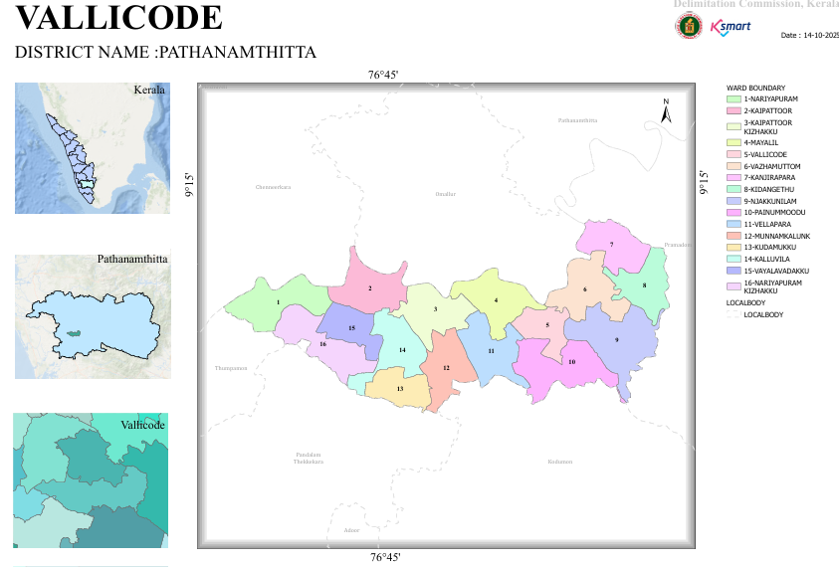
- BASELINE DATA
Area (In Sq.Km) | 19.84 SQ.KM
Number Of Wards | 15
Number Of Houses | 7628
Number Of Dwelling House | 6603
Total Population | 22583
Male | 11132
Female | 11451
ST Population | 3356
Male | 1529
Female | 1827
ST Population | 0
Male | 0
Female | 0
Number Of SC Colonies | 14
Number Of ST Colonies | 0
No Of SC House | 391
Number Of ST House | 0
Basic Health Sections | 3
HWCs | 4
Eligible Couples | 2889
0-1 Year | 87
Male | 44
Female | 43
1-5 Year | 650
Male | 321
Female | 329
10-18 Year | 1432
Male | 742
Female | 690
Above 30 | 5447
Male | 2799
Female | 2648
Above 60 | 4929
Male | 2612
Female | 2317
Number Of Asha Workers | 15
Number Of Anganwadies | 28
ORT Depots | 49
Government Hospitals(Total) | 3
Allopathy | 1
Ayurveda | 1
Homeo | 1
Private Hospitals (Total) | 2
Allopathy | 0
Ayurveda | 1
Homeo | 1
Dental Clinics | 2
Laborotories | 6
Scanning Centre | 0
Educational Institutions(Total) | 15
Government Schools Total | 5
HSS | 1
HS | 0
UPS | 0
LPS | 4
Pre-Primary | 0
Aided Schools Total | 4
HSS | 0
HS | 1
UPS | 1
LPS | 2
Pre-Primary | 0
Unaided Schools Total | 4
HSS | 1
HS | 0
UPS | 1
LPS | 2
Pre-Primary | 0
Colleges | 1
Other Edu. Institution | 0
Government Instituions | 12
Central Govt | 2
State Govt | 10
Number Of Hotels/Tea Shops | 26
Bakery & Coolbar | 28
Thattu Kada | 6
Borma | 1
Catering Unit | 4
Soda Factory | 2
Ice Cream Factory | 0
Chicken Stall | 18
Chicken Farm | 2
Fish Stall | 4
Meat Stall | 2
Beauty Parlours Total | 14
Men | 6
Women | 8
Markets | 0
Scrap/Akri Shop | 4
Tyre Retrading Centres | 2
Auditorium | 4
Crusher Unit | 0
Hostels | 0
Orphanages | 0
Old Age Home | 1
Worship Places Total | 22
Temple | 19
Churches | 3
Mosques | 0
Pilgrim Centres | 0
Total Number Of Wells | 5772
Public Wells | 13
Private Well | 5746
Colony Well | 7
Ponds | 6
Others | 0
Number Of Pumping Stations | 1
Water Scarcity Area | 11
Number Of Plantation | 8
Library & Reading Rooms | 6
Number Of Latrines | 6628
Arts & Sports Clubs | 7
Number OF NGOs | 2
Kudumbasree Units | 153
Number Of CDS Members | 15
Number Of ADS Group | 15
NREG Groups | 22
Number Of Suchithwa Squad | 15
Banks | 5
Bus Stands | 0
Ksrtc | 0
Private | 0
Number Of Migrant Sites | 13
Migrant Population Total | 101
Male | 95
Female | 6

- Ward division -
Ward | Houses | Population | Migrants | Wells | Hot  spots | Ed. Institutions | Hosp pvt/govt.
15 | 6603 | 22583 | 117 | 5772 | 3 | 14 | 2

INTEGRATED HEALTH INFRASTRUCTURE MAP OF VALLICODE GRAMA PANCHAYAT

HEALTH INFRASTRUCTURE MAP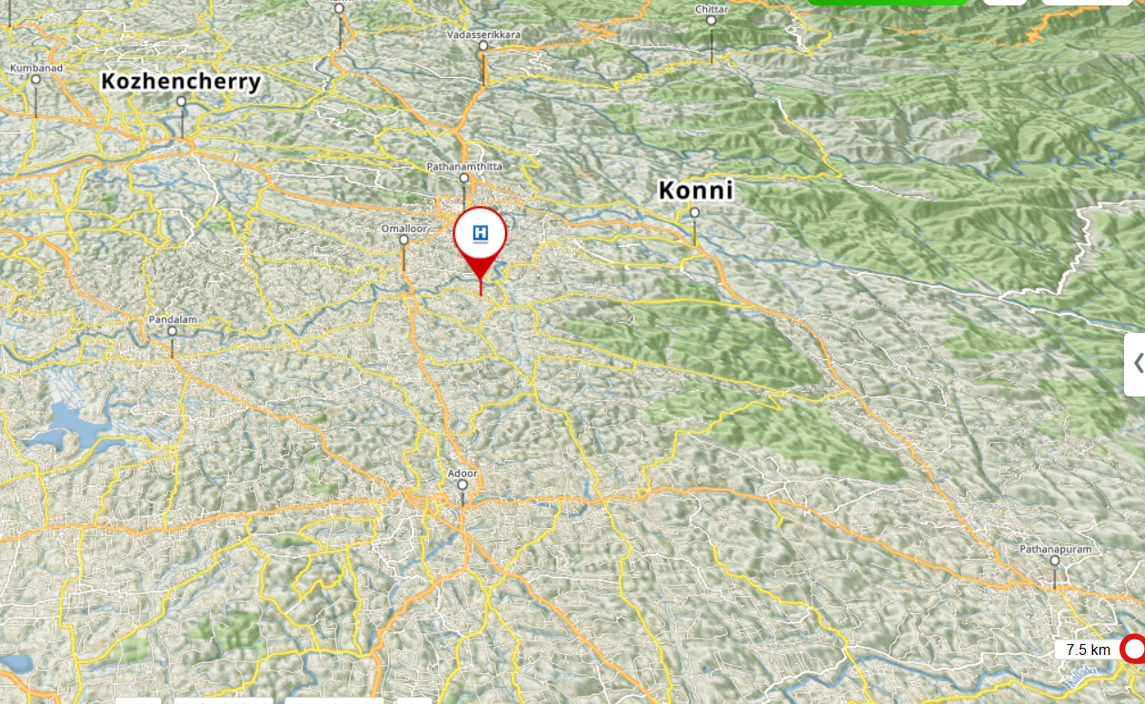

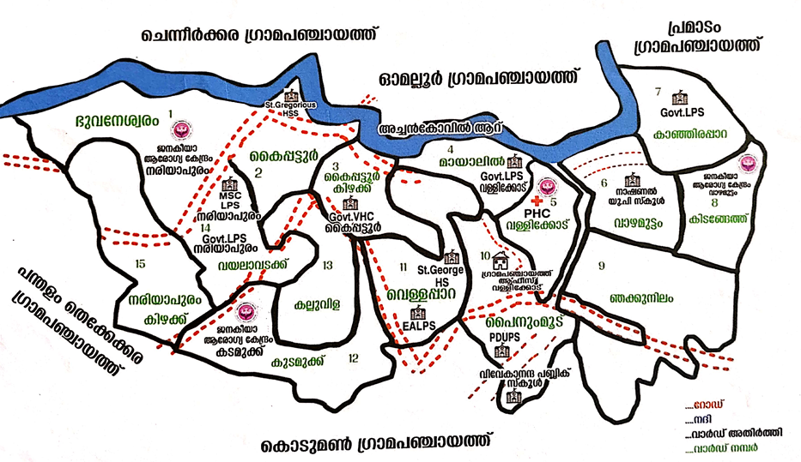

GENERAL PROFILE OF THE LSGI’S

Background of the LSGI
Located in the Konni Taluk of Pathanamthitta, Vallicode Gramapanchayat is a verdant landscape where the rolling foothills of the Western Ghats meet the fertile banks of the Achankovil River. This vital waterway serves as the primary artery for both local ecology and the region's robust agrarian economy. As part of Kerala’s "Rubber Belt," the village maintains a diverse farming portfolio that balances expansive rubber and pepper plantations with preserved paddy fields (elas), plantains, and tubers. This natural beauty is mirrored by a rich cultural tapestry of communal harmony, anchored by historic landmarks such as the Vallicode Thrikkovil Sree Padmanabhaswamy Temple and St. Mary’s Orthodox Syrian Church.
Beyond its scenery, Vallicode is a model of proactive governance, boasting high literacy rates and modern infrastructure. The panchayat has earned widespread recognition for its Haritha Karma Sena waste management initiatives and its strategic development as a gateway to major eco-tourism destinations like Konni and Adavi. By blending traditional heritage with sustainable progress, Vallicode remains a quintessential example of Kerala’s community-driven growth.
Pandemic preparedness is a cornerstone of Vallicode Gramapanchayat’s public health strategy, serving as a vital shield that protects the community during global health crises. By leveraging the strength of its Ward-Level Rapid Response Teams (RRTs) and the dedicated network of ASHA workers and Kudumbashree members, the panchayat ensures that even the most vulnerable residents—such as the elderly and those with chronic illnesses—receive essential medicines and food at their doorstep.
From a public health and disaster management perspective, LSGI has historically been vulnerable to seasonal flooding, waterborne diseases, and vector-borne illnesses such as Dengue and Leptospirosis. The severe floods experienced during recent years, including the 2018 flood disaster, significantly impacted life, livelihoods, and infrastructure within the Panchayat. These recurring emergencies have underscored the importance of strengthening local preparedness, response mechanisms, and inter-departmental coordination.
In this context, the development of a localized, data-driven Auxiliary Infrastructure and Logistical Resource Map is essential to support effective planning, timely emergency response, and sustainable development initiatives. Such mapping enables the Panchayat to identify critical resources, improve accessibility during disasters, and enhance overall resilience of the community.

Table 1: Background of LSGD
Description | Details
Name of LSGI | Vallicode
Type (GP/Municipality / Corporation etc.) | Grama Panchayath
Block | Konni
District | Pathanamthitta
Number of wards | 16
Total area (sq. km) | 25.90sq.km
Population(Projected) | 22583
Population density | 592.894/sq.km
Terrain (coastal/low-lying/backwaters/foothills, etc.) | Low-lying
Number of rivers passing through LSGI | 1
Number of water bodies in the LSGI | 2
Number of educational institutions | 14
Factories / small-scale industries | 1
Flood-prone wards | 3
Landslide-prone wards | 0
Death Management and Disposal Facilities (mortuaries/crematorium, including electric) | 0
Auditoriums/Marriage halls/convention centres/community halls | 5

Demographic and Vulnerable Population
Understanding the demographic composition and vulnerable population groups is essential for pandemic preparedness. Children, elderly, economically deprived families, migrant workers, and socially vulnerable groups are at increased risk during public health emergencies due to higher exposure, limited access to services, and dependency on public systems..

Description |  | Details (in numbers)
DEMOGRAPHIC PROFILE
Total population |  | 22583
Male |  | 11132
Female |  | 11451
Transgender |  | 0
Children under 5 |  | 682
Adolescent |  | 1432
Elderly (>60) |  | 4929
SOCIAL/LIVELIHOOD VULNERABILITY
Previous EPEP family |  | 19
BPL family |  | 404
Tribal communities |  | 0
Migration | Immigrant | 101
Migration | Emigrant | 117
Socio-economically deprived
Fisherfolk |  | nil
SC Community |  | 3034
ST Community |  | 0

The population pyramid below visualizes the distribution across the defined age categories.
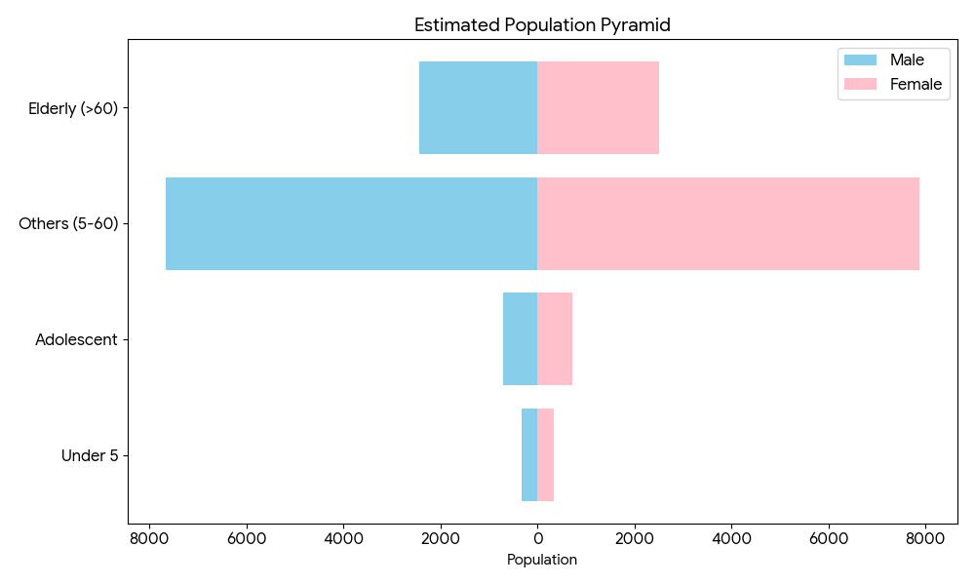
The demographic profile reveals a population in a significant state of transition, characterized by a dominant adult core and a notable trend toward aging. The largest segment, categorized as "Others" (ages 5–60), accounts for approximately 69% of the total population, suggesting a robust potential workforce and a high concentration of school-aged and adult individuals. In contrast, the youth demographic is remarkably small; children under five represent only 3% of the total, and when combined with adolescents, the group under 18 makes up just 9.3% of the population.
This small youth base is starkly outweighed by the elderly population (over 60), which comprises nearly 22% of the total. Because the number of seniors is more than double the number of children and adolescents, the data indicates a clear "aging" demographic profile. Throughout these age groups, a consistent gender balance is maintained, though females slightly outnumber males in every category, making up 50.7% of the overall population.

Clinical Vulnerability
Certain population groups needs priority healthcare & are at higher risk of severe illness, complications, and mortality during pandemics. Patients with chronic diseases, those requiring regular medical care, and individuals with mobility or functional limitations face challenges in accessing timely care during emergencies. Mapping these groups helps in prioritizing continuity of treatment, medicine stock planning, oxygen support, referral transport, and targeted home-based care.
Description | Details in numbers
Pregnant women | 51
Lactating mothers | 98
Bedbound patients | 116
Patients under palliative care other than bedbound | 13
Patients on Haemodialysis | 17
Patients on CAPD | 1
Cancer patients (currently on treatment) | 28
Haemophilic patients | 0
Mentally challenged | 33
Differently abled | 32
Diabetic patients | 2978
Hypertensive patients | 3382
TB patients | 8

Major Festivals & Events specific to the LSGI

Sl. No. | Name of festival | Month detailing the periodicity
1 | Thrippara Temple Festival | February
2 | Thrikkovil Temple.vallicode | March

INFRASTRUCTURE & RESOURCE INVENTORY

Health Facility Directory & Basic Capacity in the LSGD
This section provides an overview of the healthcare infrastructure available within the LSGD area. It outlines the distribution and basic capacity of health facilities that form the backbone of service delivery during routine times and public health emergencies.

Family Health Centres (FHCs) and Community Health Centres (CHCs) generally function as the first point of contact for the community, providing essential outpatient and inpatient services. General Hospitals (GH) and Medical College Hospitals (MCH), where accessible, serve as the main referral centres for advanced diagnostics, specialist care, and critical services during public health emergencies. This inventory helps identify existing strengths, gaps, and potential surge capacity that can be mobilised during a pandemic or disaster.

Table 5. Health Facility Resource Summary
Sl.no. | Health Facility | Type of Facility (MCH/GH/CHC/FHC/SC etc.) | Contact Number | Total beds | ICU Beds | Oxygen-Supported Beds | No. of Ventilator Support Beds | No. of ambulances
Government Healthcare Facilities
1. | BFHC Vallicode | BFHC | 9037700569 | 0 | 0 | 0 | 0 | 1
Private Healthcare Facilities
 | Nil
AYUSH Healthcare Facilities
1. | GOVT Ayurvedic Hospital vazhamuttam | HWC | 9495136256 | NA | NA | NA | NA | NA
2. | AYUSH PHC Homoeo Dispensary | APHC |  | NA | NA | NA | NA | NA

Private Clinics
Private clinics are an essential part of pandemic preparedness, as they are often the first-place people seek care when symptoms begin. In many communities, private clinics manage a significant share of outpatient visits and therefore play a critical role in early case detection, timely referrals, and disease surveillance. Having an up-to-date understanding of where these clinics are located, the services they provide, and how they are linked to the public health system helps ensure that no cases are missed during an outbreak. It also allows health authorities to engage private practitioners more effectively for reporting, risk communication, and coordinated response, strengthening the overall capacity of the health system to manage public health emergencies.

Table 6. Private Clinic Resource Summary
Sl No. | Name of Clinic | Registered (Y/N) | Clinic (General / Speciality) | Speciality (if any) | Address | Contact Number | Diagnostic Facility (Y/N) | Ambulance Linkage (Y/N)
1. | AMR Clinic | Y | Clinic -general | Nil | Dr Chandrasekharan | 9847221481 | N | N

Healthcare Education & Training Institutions
This section tracks the educational infrastructure available, which is vital for human resource planning in the health sector.

Category of Institution | Govt | Private | AYUSH | Total
Medical Colleges | 0 | 0 | 0 | 0
Nursing Colleges | 0 | 0 | 0 | 0
Dental Colleges | 0 | 0 | 0 | 0
Para-medical / Allied Health | 0 | 0 | 0 | 0
Pharmacy Colleges | 0 | 0 | 0 | 0

Specialized Services & Emergency Inventory
This section provides a detailed view of the specialized medical resources available to the community, focusing on emergency response and critical care capabilities. This table tracks the vital assets required for managing severe illnesses and emergencies across Government, Private, and AYUSH sectors.

Item | Govt | Private | AYUSH | Total
Hospital beds | 0 | 0 | 0 | 0
Oxygen-generating systems(Y/N) | 0 | 0 | 0 | 0
Oxygen-supported beds (Numbers) | 0 | 0 | 0 | 0
Ventilator-supported beds | 0 | 0 | 0 | 0
ICU beds | 0 | 0 | 0 | 0
Burns units | 0 | 0 | 0 | 0
Blood centres | 0 | 0 | 0 | 0
BLS ambulances | 0 | 0 | 0 | 0
ALS ambulances | 0 | 0 | 0 | 0
Dialysis facilities | 0 | 0 | 0 | 0
Dispensaries | 0 | 0 | 0 | 0
Medical store | 0 | 1 | 0 | 1
Industrial establishments (Medium-scale industries/small-scale industries establishments to whom we can depend in a worst-case scenario) | 0 | 0 | 0 | 0

Oxygen & Diagnostic Capacity
Monitoring oxygen and diagnostic capacity is a critical component of public health preparedness, ensuring that the LSGD can handle both chronic care and sudden surges in respiratory or infectious diseases.
Name of Health Facility | Oxygen-generating System (Y/N) | Backup Oxygen Source (Y/N) | Diagnostic Facilities Available(Y/N)
Name of Health Facility | Oxygen-generating System (Y/N) | Backup Oxygen Source (Y/N) | Lab | USG | X-ray | CT/MRI | RT-PCR
Government Healthcare Facilities
BFHC VALLICODE | 0 | 0 | 1 | 0 | 0 | 0 | 0

Diagnostics facility mapping at the LSGI level
The diagnostic capacity of Vallicode grama panchayat represents the "intelligence network" of our healthcare system. The speed and accuracy of disease identification depend entirely on the distribution and technical level of these facilities.

Item | Govt | Private | AYUSH | Total
General labs | 1 | 4 | 0 | 5
Microbiology labs | 0 | 0 | 0 | 0
RT-PCR labs | 0 | 0 | 0 | 0
USG units | 0 | 0 | 0 | 0
CT/MRI units | 0 | 0 | 0 | 0
Research labs | 0 | 0 | 0 | 0
Labs of other departments that can be repurposed | 0 | 0 | 0 | 0

Laboratory Identification & Basic Details
Sl. No. | Name of Laboratory | Ownership (Govt / Private / Academic) | Address | Contact No. | 24×7 Services (Yes/No) | NABL / Govt Approved (Yes/No)
1 | BFHC VALLICODE | Govt | FHC Vallicode,Pathanamthitta | 9037700569 | No | Yes

Social and Community Infrastructure for surge plan
This table serves as our logistics and shelter inventory. By mapping these locations, quickly we can identify where to house displaced citizens, where to set up temporary medical clinics, and how to manage the deceased with dignity during a crisis.

Category | Total Count | Ward | Est. Capacity (Persons) | Contact details
Educational Institutions
Anganwadis | 28 | 15 | 210
Schools | 14 | 12 | 1432
Colleges | 0
Healthcare Educational Institutions
Medical colleges (Govt/Private) | 0
Nursing colleges (Govt/Private) | 0
Dental colleges (Govt/Private) | 0
Paramedical institutes (Govt/Private) | 0
Community Gathering Spaces
Community halls | 2
Auditoriums | 3
Religious buildings | 22 | All wards
Vulnerable Group Support Facility
Destitute homes | 0
Elderly homes | 1 | 9
LSGD owned other buildings | 0
Mass Fatality Management (MFM) Infrastructure
Mortuary | 0
Crematorium | 0
*refer annexure 1 for contact details

Human resources
This section focuses on the human capital available within the LSGI. In any emergency—be it a pandemic, flood, or industrial accident—infrastructure is only as effective as the people operating it.

Medical & Clinical Personnel
This table tracks the "Frontline" providers responsible for diagnosis, treatment, and clinical management. It evaluates the current capacity, identifying strengths in public sector leadership and potential gaps in specialized care. Out of the 14 specialized professionals listed, the government employs the majority of core clinical staff (Doctors, Nurses, Pharmacists). Specifically, 80% of the modern medical doctors in Vallicode are government-funded. This reinforces the image of a "Community-Driven Governance" model where the state takes the lead in ensuring basic health rights, supported by private dental and mental health professionals. A detailed directory with the contact numbers of all workers is maintained (Annexure in 1).

Cadre | Govt (No.) | Private (No.) | Total
Doctors—Modern Medicine | 4 | 1 | 5
Doctors – AYUSH | 1 | 0 | 1
Doctors – Veterinary | 1 | 0 | 1
Doctors – Dental | 0 | 2 | 2
Nursing officers | 1 | 0 | 1
Lab technicians | 1 | 0 | 1
Optometrist | 0 | 0 | 0
Pharmacists | 1 | 0 | 1
Psychologists | 0 | 0 | 1
Counsellors | 0 | 0 | 1

Public Health & Field-Level Workforce
These individuals are the backbone of surveillance, maternal-child health, and decentralized care.

Cadre | Health services | Municipal common services | Total
HS (Health Supervisors) | 0
HI (Health Inspectors) | 1 | 0 | 1
LHS (Lady Health Supervisor) | 0 | 0 | 0
LHI (Lady Health Inspectors) | 1 | 0 | 1
JPHN (Jr Public Health Nurses) | 4 | 0 | 4
JHI (Jr Health Inspectors) | 3 | 0 | 3
MLSP (Mid-Level Service Providers) | 4 | 0 | 4
Palliative Nurses | 1 | 0 | 1
RBSK Nurses | 1 | 0 | 1
PRO | 1 | 0 | 1
Epidemiologist | 1 | 0 | 1
Data Manager | 1 | 0 | 1

Community & Support Cadre
This group represents the surge capacity of the LSGI—people who can be called upon for logistics, rescue, and specialized support.

Cadre | Number
ASHA Workers | 15
AWW (Anganwadi Workers) | 28
Emergency Medical Volunteers (Trained) | 0
Kudumbashree | 164
MNREGS | 22
Purusha Swayam Sahaya Sangham | 0
Ex-Servicemen | 126
Retired Police Officers | 42
NCC/NSS Volunteers | 86
Red Cross volunteers | 0
One Health Community Volunteers | 435
One Health Community Mentors | 105

Community Organizations
This section details the presence of community-based organisations (CBOs), non-governmental organisations (NGOs), faith-based organisations (FBOs), Kudumbashree Self-Help Groups (SHGs), and Ayalkootams within the Local Self-Government Institution (LSGI). These groups enhance grassroots mobilization, resource distribution, and support networks crucial for pandemic response and community resilience.

Category | Total Count
NGOs | 8
Religious based organizations | 4
Foreign based organizations | 2
Sports Club/youth clubs | 4
Kudumbashree SHGs | 164
Ayalkootams | 30
Political organizations | 5
Residential organizations | 7

Administrative & Emergency Services
This section outlines the availability of key non-health emergency support services and infrastructure within the LSGI, which are essential for effective pandemic preparedness and response. These facilities support law enforcement, disaster response, water supply, logistics, mobility, and community-level interventions during public health emergencies.

Category | Total Count | Contact details
Police Stations | 0 | --
Fire & Rescue Stations | 0 | -
Water Pumping Points | 1 | -
Public Distribution System (PDS) | 15 | -

Information regarding resources
The availability of essential transport and support resources plays a quiet but critical role in saving lives. Equipment such as ambulances, mobile mortuaries, amphibian ambulances, and motorized boats ensures that patients, samples, and healthcare teams can move swiftly—even in flooded, remote, or difficult terrains. Heavy vehicles like JCBs, cranes, tractors, and torus lorries support logistics, waste management, emergency infrastructure, and rapid conversion of spaces into care or isolation facilities. Taxis, four-wheel-drive vehicles, and trucks help maintain continuity of essential services, reach vulnerable populations, and support home-based care and supply delivery.

Means of transportation | Total Count
JCB | 6
Crane | 0
Heavy Trucks | 0
Tractor | 0
Ambulances | 1
Mobile mortuaries | 0
Boats | NA
Taxi service | 10

ONE HEALTH & ENVIRONMENTAL SURVEILLANCE
The One Health method integrates environmental, animal, and human health to enable proactive pandemic preparedness. Panchayat-level surveillance needs to be improved in order to detect and treat zoonotic and environmentally generated diseases early. Surveillance is strengthened through systematic assessment of animal populations, veterinary infrastructure, poultry and slaughter facilities, inter-sectoral coordination, and specialised tools like avian influenza seasonality mapping using GIS in previous outbreaks to enable predictive alerts and ward-specific sampling to support effective pandemic preparedness in high-risk areas.

Animal & Bird Population
Mapping animal and bird populations at the Panchayat level is essential for identifying and prioritising zoonotic disease hazards like rabies, avian influenza (H5N1), leptospirosis, anthrax, and Nipah-like spillover occurrences. Risk classification, targeted surveillance, vaccination planning, and early epidemic detection made feasible by comprehensive population mapping all enhance One Health-based pandemic preparedness.

Category | Item | Estimated Population | Wards
Animal Population | Livestock (Cattle/Goats/Buffalo) | 1254 | All wards
Animal Population | Pet Animals (Dogs/Cats) | 112 | All wards
Animal Population | Stray Dog Population | 78 | All wards
Animal Population | Pig Farms (Number of heads) | 0
 | Small Units (Sheep / Goats – clustered) | 0
Bird Population | Poultry Units (Birds) | 0
Bird Population | Poultry- (FOWL)
Bird Population | Wild/Migratory Birds (Observed) | 0
Bird Population | Crow Mortality Events (Reported) | 0

The main risk of zoonotic diseases is concentrated in all wards of Vallicode GP. The stray dog population continues to be a substantial problem for rabies surveillance and bite prevention. Water stagnant areas vulnerable to flooding further raise the risk of leptospirosis and other zoonoses mediated by the environment, especially during monsoon floods.
Veterinary Infrastructure
Veterinary institutions are a core pillar of One Health surveillance, enabling early zoonotic disease detection through vaccination, investigation of unusual animal illness or deaths, sample collection, and timely outbreak reporting. A well-mapped and responsive veterinary network strengthens coordination with human health and LSGI systems, ensuring rapid response during zoonotic events and pandemics.
Facility Type | Name of Facility | Ownership Govt / Pvt | Location(Ward No) | Contact number
Veterinary Dispensary | Govt.veterinary Hospital,kaipattoor | Govt | 2 | 9497313822
Veterinary Hospital / Polyclinic | 0 | 0 | 0 | 0
Mobile / Emergency Vet Service (incl. night services) | 0 | 0 | 0 | 0
Pet Homes / Animal Shelters | 0 | 0 | 0 | 0
Slaughterhouse-linked Veterinary Inspection Unit | 0 | 0 | 0 | 0

Veterinary Doctors & Workforce
Early detection, diagnosis, reporting, and reaction to animal illness epidemics depend on the availability and accessibility of qualified veterinary specialists. By identifying unusual animal morbidity or mortality promptly, collecting samples promptly, and coordinating efficiently with human health and LSGI systems—especially during zoonotic outbreaks and pandemic-prone situations—a clearly defined veterinary workforce enhances One Health surveillance.

Category | Number Available | Type (Govt/Pvt) | Contact number
Government Veterinary Doctors | 1 | 1 | 9497313822
Private Veterinary Doctors | 0 | 0 | 0
Livestock Inspectors | 2 | 2
Para-veterinary Staff / Attenders | 0 | 0 | 0
Contract / On-call Veterinary Support (if any) | 0 | 0 | 0

High-Risk Interface Points (Surveillance Sites)
High-risk interface points for zoonotic disease surveillance in Vallicode Grama Panchayath include wetland–livestock–human contact zones, backyard poultry farms, cattle sheds near water bodies, fish markets, and areas of high human–animal interaction such as community slaughter points and migratory bird congregation sites. These are the primary surveillance sites where zoonotic spillover risks are elevated.

Type of Habitat | Type of High risk interface | Geographical vulnerability
Wetlands & Backwaters | 0
Backyard Poultry Farms | 0
Cattle Sheds near Water Bodies | 0
Fish & Meat Markets | 0
Community Slaughter Sites | 0
Migratory Bird Congregation Areas | 0
Rodent-Infested Grain Storage | 0

Category | Total Count | Key Locations (wards)
Poultry Farms | 2
Backyard / Clustered Poultry Units | 0
Duck Rearing Units (open water access) | 0
Slaughterhouses/ Slaughter Points | 0
Meat/Fish Markets | 6
Live Bird Sale Points | 0
Cattle Markets / Weekly Animal Fairs | 0
Pet Shops / Breeders | 0
Animal Shelters / Pet Homes | 0
Waste Disposal Sites near Animal Units | 0

Environmental Risk Mapping
Environmental risk mapping identifies monsoon/flood hotspots for vector-borne (dengue, chikungunya), water-borne (leptospirosis, diarrhoea), and zoonotic diseases in Kerala's wetlands. Systematic surveillance supports early warnings, targeted interventions, and Panchayat pandemic preparedness.
Waterborne exposure: Flood-prone areas and stagnant water bodies facilitate leptospira survival, raising leptospirosis risk.

Traditional practices: Informal slaughter and fish markets lack standardized hygiene, creating spillover opportunities.
Risk Factor | High-Risk Wards | Key Locations | Risk Level (High/Med/Low)
Flood-prone areas | 6 | Ward 1,2,3,4,6,13 | Ward 1,2-high,6-medium,  3,4,13-low
Water bodies/wetlands | 0
Solid waste accumulation | Nil
Animal waste disposal issues | Nil
Rodent infestation zones | Nil
Industrial effluent discharge | Nil
Construction sites / abandoned buildings | Nil
Poor drainage/blocked canals | Nil
Drinking water source contamination risk | Nil

Disease Seasonality Mapping
1, Flooding & waterlogging → amplifies leptospirosis, malaria, diarrheal diseases.
·
2, Migratory bird influx (Nov–Feb) → avian influenza risk.

3, Mosquito breeding cycles → vector-borne disease peaks in monsoon.

4, Agricultural practices → close human–animal contact in paddy fields.

Disease | Peak Risk Season | Key Drivers | High-Risk Locations | Surveillance Focus
Avian Influenza | NA |  | Nil
Leptospirosis | June-September | Mansoon season and |  | Stagnant water bodies and farmers,people dealing with sanitation and cleaning works etc
Dengue/Chikungunya | May-September | Summer season | Nil | Vector indices Dry containers and water storing containers
Acute Diarrheal Diseases | February-April | Contaminated water | Nil
Rabies | NA |  | Nil
Anthrax (rare) | NA |  | Nil

Vulnerability Mapping
Vulnerability mapping pinpoints high-risk populations, occupations, and areas exposed via environment, livelihoods, socio-economics, and poor service access. Paired with environmental/seasonality mapping, it enables risk-based surveillance, targeted actions, and optimal resource use in One Health and pandemic planning.
Vulnerability Factor | High-Risk Wards | Key Groups / Locations | Risk Level
Flood-prone households | 6 | Ward 1,2,3,4,6,13 | Ward 1,2-high,6-medium,  3,4,13-low
Wetland-adjacent communities | Nil
Backyard poultry / duck rearing households | Nil
Livestock-rearing households | Nil
Slaughterhouse & meat market workers | Nil
Fisherfolk & fish market workers | Nil
Sanitation workers | 150 | All wards
Daily wage / migrant workers | 101 | All wards
Elderly & chronically ill populations | 4929 | All wards
Pregnant Women | 96 | All wards
Children (schools, Anganwadi’s) | 1642 | All wards
Limited access to safe water & sanitation | Nil

EPIDEMIOLOGICAL TRENDS (2021–2025)

Disease surveillance is the systematic collection, analysis, and interpretation of health data for planning, implementation, and evaluation of public health practice. This section presents the disease surveillance profile of the LSGI based on routine reporting systems and outbreak investigations to identify priority diseases, seasonal patterns, and emerging public health threats.

Disease Burden among human beings (Last 5 Years)
Analysis of disease-wise data for the last five years helps identify persistent public health problems, emerging diseases, and changes in disease burden. This information supports prioritisation of prevention, preparedness, and response activities at the Panchayat level.

Disease | 2021 | 2022 | 2023 | 2024 | 2025 | Trend(Increasing/Stable/Decreasing)
Dengue | 1 | 5 | 55 | 61 | 25 | Decreasing
Leptospirosis | 1 | 2 | 3 | 4 | 6 | Increasing
Hepatitis A | 0 | 0 | 1 | 2 | 7 | Increasing
Malaria | 0 | 0 | 0 | 0 | 0 | Decreasing
Scrub Typhus | 0 | 0 | 0 | 0 | 0 | Decreasing
Typhoid | 0 | 0 | 0 | 2 | 2 | Decreasing
H1N1 | 0 | 0 | 0 | 13 | 7 | Decreasing
H3N2 | 0 | 0 | 0 | 0 | 0 | Decreasing
ADD | 18 | 57 | 35 | 124 | 88 | Decreasing
Mumps | 0 | 0 | 0 | 0 | 0 | Decreasing
Measles | 0 | 0 | 0 | 0 | 0 | Decreasing
Hepatitis B | 1 | 9 | 4 | 6 | 6 | Stable
Hepatitis C | 0 | 0 | 0 | 0 | 0 | Decreasing
Tuberculosis | 9 | 14 | 14 | 8 | 11 | Increasing
Leprosy | 0 | 0 | 0 | 0 | 0 | Decreasing
COVID-19 | 0 | 0 | 0 | 0 | 3 | Increasing

The data reflects significant fluctuations in disease burden, characterized by major outbreaks of vector-borne and waterborne illnesses, as well as the emergence of respiratory viruses.

The regional public health landscape has undergone a significant shift, transitioning from a low-incidence environment in 2021 to a high-burden period that peaked in 2024, followed by a general but still elevated decline in 2025. Dengue and Acute Diarrheal Disease (ADD) have emerged as the dominant outbreaks and most significant threats in terms of volume. Dengue serves as the primary driver of epidemic activity, exploding from just 1 case in 2021 to a peak of 61 in 2024; although it dropped to 25 cases in 2025, the incidence remains 25 times higher than the baseline, suggesting the disease is now firmly established. Similarly, ADD remains the highest-volume condition, spiking to 124 cases in 2024 before decreasing to 88 cases in 2025, which still represents a substantial community burden.
Beyond these major spikes, there are clear "rising threats" linked to deteriorating environmental and sanitation conditions, specifically Leptospirosis, which climbed steadily from 1 case in 2021 to 6 in 2025, and Hepatitis A, which rose from zero cases to 7 in the same period. Respiratory and chronic infections also show varying patterns: H1N1 appeared suddenly in 2024 with 13 cases before dropping to 7, Tuberculosis is classified as increasing after finishing at 11 cases in 2025, and Hepatitis B has remained stable with 6 cases annually over the last two years.

Seasonal Trend Analysis
Seasonal analysis helps anticipate surges (e.g. dengue in monsoon, leptospirosis after floods, influenza in cooler months) and plan pre‑emptive vector control, stockpiling of IV fluids, and awareness campaigns at Panchayat level.

DENGUE
Dengue is a major seasonal vector-borne disease strongly associated with rainfall, water stagnation, and increased mosquito breeding during the monsoon period.

Peak: July–November

Dengue – Ward-wise Yearly Distribution (2021–2025)

Ward | Dengue – Ward-wise Yearly Distribution
Ward | 2021 | 2022 | 2023 | 2024 | 2025 | Total
1 | 0 | 0 | 0 | 2 | 3 | 5
2 | 0 | 0 | 3 | 1 | 1 | 5
3 | 1 | 0 | 3 | 7 | 3 | 14
4 | 0 | 1 | 4 | 4 | 0 | 9
5 | 0 | 1 | 7 | 5 | 2 | 15
6 | 0 | 1 | 6 | 9 | 1 | 15
7 | 0 | 1 | 7 | 2 | 2 | 12
8 | 0 | 0 | 5 | 4 | 1 | 2
9 | 0 | 0 | 0 | 7 | 3 | 10
10 | 0 | 1 | 2 | 6 | 0 | 9
11 | 0 | 0 | 4 | 6 | 2 | 12
12 | 0 | 0 | 0 | 3 | 0 | 3
13 | 0 | 0 | 7 | 0 | 0 | 7
14 | 0 | 0 | 7 | 1 | 0 | 8
15 | 0 | 0 | 0 | 4 | 2 | 14
The dengue case data for Vallicod Panchayat from 2021 to 2025 reveals a distinct epidemiological shift, moving from a period of relative dormancy to a significant outbreak. During the initial low phase of 2021–2022, the area maintained a minimal footprint with only 6 cases total, but 2023 marked a major turning point as cases surged eleven-fold to a total of 55. This upward trajectory reached its peak in 2024 with 61 recorded cases, driven largely by hotspots in Ward 6, which saw the highest single-year count of 9 cases, alongside notable spikes in Wards 3 and 9. However, the most recent data from 2025 shows a promising downward trend, with cases dropping to 20 and suggesting that the outbreak is finally being contained. Over the full five-year span, Ward 6 emerged as the primary hotspot with 17 total cases, followed closely by Wards 5 and 3, while Ward 12 remained the most resilient area with only 3 cases in total. While most wards improved, Wards 1, 3, 9, and 15 still recorded 2 to 3 cases each in 2025. Although these numbers are lower than their 2024 peaks, these wards remain the active "residual" areas where surveillance should remain high to prevent a 2026 rebound.
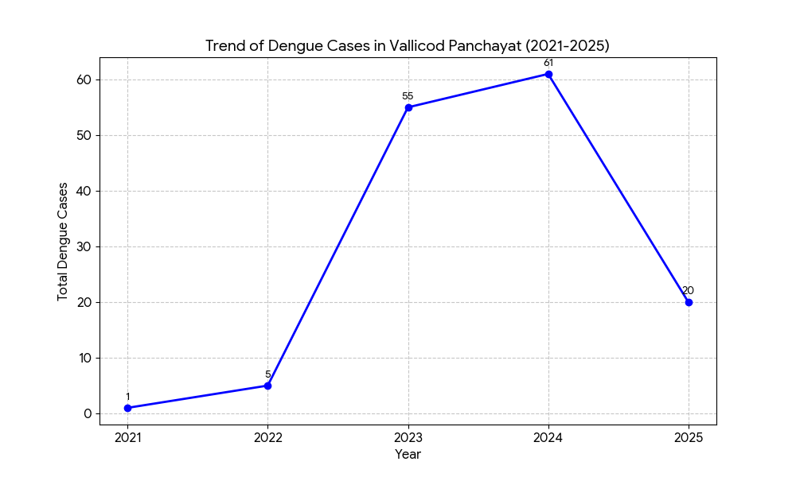

LEPTOSPIROSIS
Leptospirosis cases are closely linked to monsoon rains, flooding, and occupational exposure, particularly in low-lying and waterlogged areas.

Peak: June - August

Leptospirosis – Ward-wise Yearly Distribution (2021–2025)

Ward | Leptospirosis – Ward-wise Yearly Distribution
Ward | 2021 | 2022 | 2023 | 2024 | 2025 | Total
1 | 0 | 0 | 0 | 1 | 0 | 1
2 | 0 | 0 | 0 | 0 | 0 | 0
3 | 0 | 0 | 0 | 1 | 0 | 1
4 | 0 | 0 | 0 | 0 | 0 | 0
5 | 0 | 0 | 0 | 0 | 0 | 0
6 | 1 | 1 | 0 | 1 | 0 | 3
7 | 0 | 0 | 1 | 0 | 1 | 2
8 | 0 | 0 | 0 | 0 | 0 | 0
9 | 0 | 1 | 1 | 1 | 1 | 4
10 | 0 | 0 | 0 | 0 | 1 | 1
11 | 0 | 0 | 0 | 0 | 3 | 3
12 | 0 | 0 | 0 | 0 | 0 | 0
13 | 0 | 0 | 0 | 0 | 0 | 0
14 | 0 | 0 | 1 | 0 | 0 | 1
15 | 0 | 0 | 0 | 0 | 0 | 0

The data reveals a slow but steady upward trend in the incidence of Leptospirosis in Vallicode Panchayat over the last five years. Unlike the rapid spikes seen in dengue data, Leptospirosis has increased incrementally from 1 case in 2021 to 6 cases in 2025. While the overall numbers remain relatively low, the consistent year-over-year growth suggests a persistent environmental or occupational risk factor within the community.
Ward 9 has emerged as the most consistently affected area, reporting cases in every year except 2021, leading to a cumulative total of 4 cases. Ward 11 showed a significant recent surge, recording 3 cases in 2025 alone, making it a new focal point for health interventions. Wards 6 and 7 also show recurring instances, contributing 3 and 2 cases respectively to the total. Conversely, nearly half of the panchayat (Wards 2, 4, 5, 8, 12, 13, and 15) has remained completely free of Leptospirosis during this five-year period. The recent peak in 2025 indicates that despite the low volume, preventive measures like rodent control and awareness for high-risk workers should be intensified.
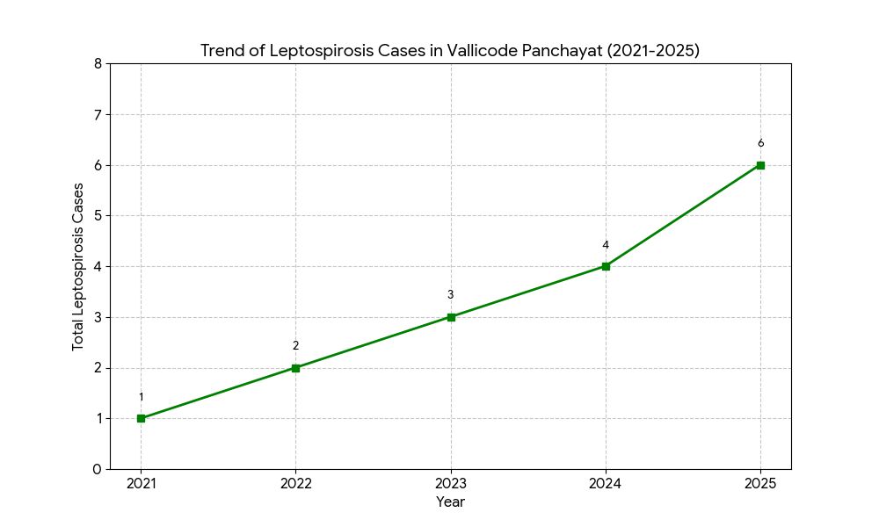

VIRAL HEPATITIS - A
Hepatitis A cases are commonly associated with unsafe drinking water, food contamination, and breakdowns in sanitation, often presenting as clusters or outbreaks.

Peak: October - December

Hepatitis A – Ward-wise Yearly Distribution (2021–2025)

Ward | Hep A – Ward-wise Yearly Distribution
Ward | 2021 | 2022 | 2023 | 2024 | 2025 | Total
1 | 0 | 0 | 0 | 0 | 0 | 0
2 | 0 | 0 | 0 | 0 | 3 | 3
3 | 0 | 0 | 0 | 0 | 0 | 0
4 | 0 | 0 | 0 | 1 | 0 | 1
5 | 0 | 0 | 0 | 0 | 0 | 0
6 | 0 | 0 | 0 | 0 | 0 | 0
7 | 0 | 0 | 0 | 0 | 1 | 1
8 | 0 | 0 | 0 | 0 | 0 | 0
9 | 0 | 0 | 0 | 0 | 0 | 0
10 | 0 | 0 | 0 | 11 | 1 | 12
11 | 0 | 0 | 0 | 0 | 1 | 1
12 | 0 | 0 | 0 | 0 | 0 | 0
13 | 0 | 0 | 0 | 0 | 1 | 1
14 | 0 | 0 | 1 | 0 | 0 | 1
15 | 0 | 0 | 0 | 0 | 0 | 0

The incidence of Hepatitis A in Vallicode Panchayat was virtually non-existent until 2023, followed by a sharp, localized outbreak. During 2021 and 2022, zero cases were recorded across all 15 wards, indicating a period of high water safety or a lack of viral introduction. An "introduction phase" began in 2023 with a single case in Ward 14, which served as a precursor to a major peak in 2024. During that year, cases surged to 12, with a massive concentration of 11 cases in Ward 10 alone, suggesting a specific point-source contamination likely linked to a shared water source or a public gathering. In 2025, while the total cases decreased to 7, the virus showed signs of geographic spread; instead of being confined to a single ward, cases were reported across five different wards (Wards 2, 7, 10, 11, and 13), highlighting a transition from a point-source outbreak to broader environmental presence.

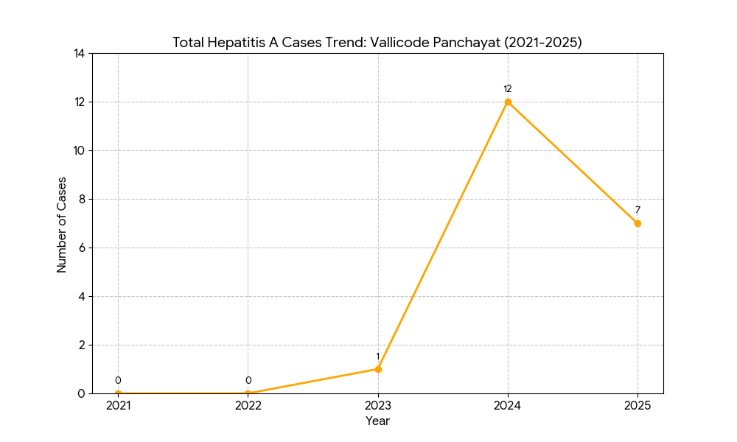

Outcome-Based Trend Analysis- 2025

Transmission Trend- 2025
For effective management of public health issues, it is important to track the trend of disease transmission mode. It helps identify the population or place at high risk that can be used to predict outbreaks and implement targeted interventions as quickly as possible. Understanding these kinds of trends enables authorities to allocate resources efficiently and change the strategies adequately based on the trend that follows.

Mode of Transmission | No. of cases | No. of Deaths
Vector Borne Diseases | 25 | 0
Water Borne Diseases | 97 | 0
Air Borne Diseases | 63 | 1
Blood Borne Diseases | 6 | 0
Food Borne Diseases | 0 | 0

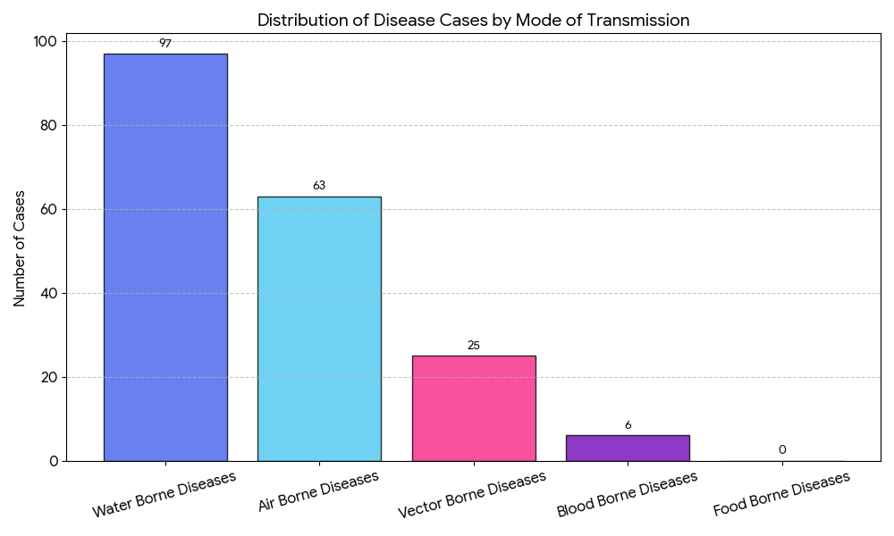
The data indicates that Water-Borne Diseases are the most significant health concern, accounting for over half of all recorded cases (50.8%, or 97 cases). This suggests that contaminated water sources or inadequate sanitation infrastructures are primary drivers of infection. Air-Borne Diseases follow as the second major category with 63 cases (33%), highlighting risks related to airborne pathogens and potentially crowded or poorly ventilated environments. Vector-Borne Diseases, such as Dengue, account for 13.1% (25 cases), while Blood-Borne Diseases remain low at 3.1% (6 cases). Notably, there were zero recorded cases of Food-Borne Diseases, indicating either a robust food safety standard or a lack of reporting in that specific category.
Ultimately, the data suggests that the most effective way to reduce the overall morbidity in the panchayat is to target water sanitation and air quality, as these two factors are the primary drivers of the current public health landscape.
Vector-Borne Disease

Disease | No. of Cases | No. of Deaths
Dengue | 25 | 0
Malaria | 0 | 0
Chikungunya | 0 | 0

Water Borne Disease

Disease | No. of Cases | No. of Deaths
Cholera | 0 | 0
Typhoid | 2 | 0
Hep- A | 7 | 0
Dysentery | 0 | 0
Amoebiasis | 0 | 0
E- Coli infections | 0 | 0

Air Borne Disease

Disease | No. of Cases | No. of Deaths
Influenza | 0 | 0
H1N1 | 7 | 0
TB | 11 | 1
Chickenpox | 42 | 0
Measles | 0 | 0
Covid-19 | 3 | 0
Pertussis | 0 | 0
Mumps | 0 | 0

Blood-Borne Disease

Disease | No. of Cases | No. of Deaths
AIDS | 0 | 0
Hep- B | 6 | 0
Hep- C | 0 | 0

Zoonotic Disease

Disease | No. of Cases | No. of Deaths
Rabies | 0 | 0
Leptospirosis | 6 | 1
Avian influenza | 0 | 0
West nile | 0 | 0
Anthrax | 0 | 0
Nipah | 0 | 0
Scrub Typhus | 0 | 0

Integrated Disease Hotspot Map (2021–2025)

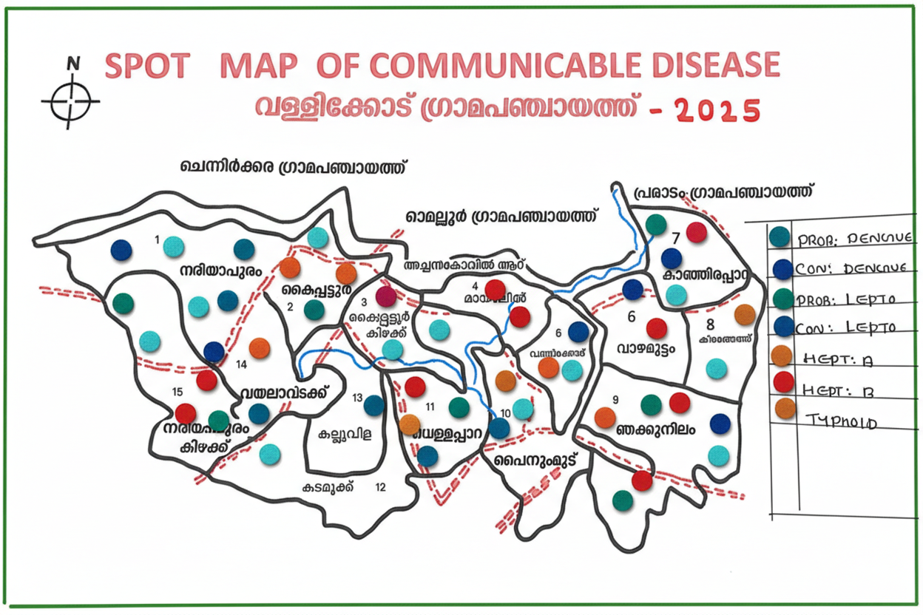

Ward No | Dengue Total (2021-25) | Leptospirosis Total (2021-25) | Hepatitis A Total (2021-25) | Mumps (2021-25) | ADD (2021-25) | Total Cases
1 | 5 | 1 | 0 | 0 | 17 | 23
2 | 5 | 0 | 3 | 0 | 18 | 26
3 | 14 | 1 | 0 | 0 | 21 | 36
4 | 9 | 0 | 1 | 1 | 14 | 25
5 | 15 | 0 | 0 | 0 | 16 | 31
6 | 15 | 3 | 0 | 0 | 24 | 42
7 | 12 | 2 | 1 | 0 | 19 | 34
8 | 2 | 0 | 0 | 0 | 24 | 26
9 | 10 | 4 | 0 | 0 | 18 | 32
10 | 9 | 1 | 2 | 0 | 21 | 33
11 | 12 | 3 | 1 | 0 | 29 | 45
12 | 3 | 0 | 0 | 0 | 26 | 29
13 | 7 | 0 | 1 | 0 | 25 | 33
14 | 8 | 1 | 1 | 0 | 29 | 39
15 | 14 | 0 | 0 | 0 | 21 | 35
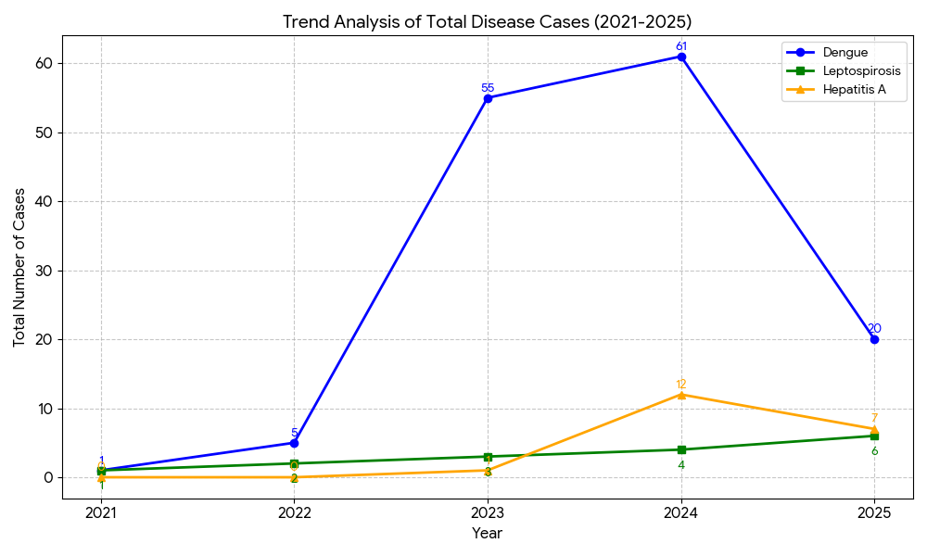
Based on the cumulative data across all 15 wards, Vallicode Panchayat experienced two distinct phases of disease burden between 2021 and 2025. Dengue represented the most dramatic trend, witnessing a rapid escalation starting in 2023 with 55 cases and peaking in 2024 with 61 cases, before a significant 67% decrease in 2025 to 20 cases suggested that the peak had passed and control measures were effective. Hepatitis A followed a similar "surge and decline" pattern on a smaller scale, remaining at zero for two years before spiking to 12 cases in 2024—largely due to a point-source outbreak in Ward 10—and subsequently dropping to 7 cases in 2025. Conversely, Leptospirosis displayed the only consistently rising trend, growing incrementally every year from a single case in 2021 to 6 cases in 2025; while its numbers are lower than Dengue, this steady climb identifies it as an increasing environmental concern. Finally, while a detailed year-by-year breakdown was not provided for Acute Diarrheal Diseases (ADD) and Mumps, the cumulative totals for ADD remain high, and their impact appeared consistent throughout the various ward-wise profiles.

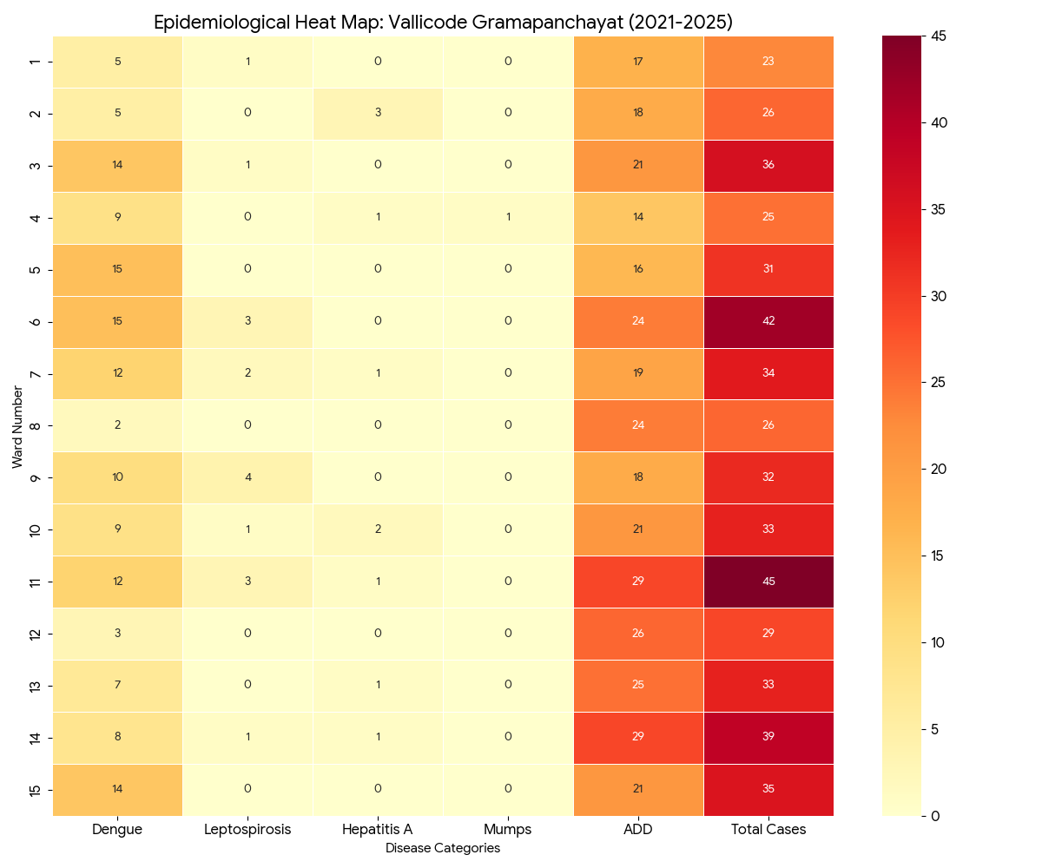
Based on the detailed ward-wise disease data, the Epidemiological Heat Map for Vallicode Grama panchayat (2021–2025) visually identifies the high-risk areas and specific disease clusters across the 15 wards.
The epidemiological data reveals a distinct pattern of health challenges across the panchayat, with a colour gradient from yellow to deep red highlighting specific areas of concern. Wards 6 and 11 emerge as critical "Dark Red Zones," with Ward 11 recording the highest overall burden of 45 cases, largely driven by a peak in Acute Diarrheal Diseases (ADD). A broader analysis of disease clusters shows that ADD remains a persistent threat across nearly all wards, with the most intense concentrations found in Wards 11, 12, 13, and 14. Vector-borne threats are also significant, as evidenced by intense Dengue clusters in Wards 3, 5, 6, and 15, while Ward 9 stands out as a specific hotspot for Leptospirosis. These localized concentrations suggest that targeted interventions—ranging from water source purification in the ADD-heavy wards to aggressive mosquito source reduction in the Dengue clusters—are essential for reducing the panchayat's overall disease burden.

Preparedness and Response Protocol at LSG Level
This section describes the operational framework for the LSGI once a pandemic is declared. It explains how the LSGI and health system will move from routine data collection to active response, using a One Health approach.

Constitution of One Health Committee
The LSGD shall constitute a One Health Committee comprising the LSGI President, Medical Officers (Modern Medicine, AYUSH, and Veterinary), the Health Inspector, and the Veterinary Surgeon.

Objective: The One Health Committee coordinates human, animal, and environmental health to prevent and control pandemics.

Sl No | Name | Designation | Department/Institution | Role in Committee | Contact Number
1 | Beena Soman | Panchayat President | LSGD | Chairperson | 9447400960
2 | Dr Sajan Babu | Medical Officer (FHC/CHC) | Health Dept | Member Secretary | 9037700569
3 | Dr Vishnu | Veterinary Officer | Animal Husbandry | Member | 9497313822
4 | Dr Afina | Epidemiologist | Health Dept | Member | 9496238190
5 | Sreelatha S S Nair | Health Inspector/PHN | Health Dept | Surveillance | 9447906981
6 | Bindhu T R | ASHA Supervisor | Health Dept | Community link | 9496462963
7 | Lakshmi | ICDS Supervisor | Social Welfare | Vulnerable groups | 9495928033
8 | - | Police Station Officer | Police Dept | Law & order
9 | Prasanna Rajan | Ward Councillor Representative | LSGD | Community coordination | 9605083814
10 | Saritha | Kudumbashree CDO | Kudumbashree | Community mobilisation | 7306046068
11 | Venugopal | NGO/Volunteer rep | Civil Society | Support services | 6235129102
12 | ANILA | Line Department representations | Agricultural department |  | 8281488873

Key Responsibilities:
- Review disease surveillance data (human + animal)
- Conduct ward-wise risk assessment and vulnerability mapping
- Approve quarantine/isolation centre locations
- Coordinate with district for resources (PPE, oxygen, ambulances)
- Periodically review health system surge capacity, including beds, oxygen, human resources, and ambulances.
- Approve and monitor risk communication and community engagement strategies, including rumour management.
- Ensure protection and service continuity for vulnerable groups (elderly, persons with disabilities, dialysis patients, coastal populations).
- Conduct quarterly mock drills
- Monitor equity measures for vulnerable groups

Meeting Schedule:
Quarterly (normal times) | Weekly (outbreak alert) | Daily (pandemic phase)

Pandemic Response Workforce
To ensure a coordinated and timely response during a pandemic, a dedicated Pandemic Response Workforce shall be constituted at the LSG level. The workforce will function under the overall supervision of the One Health Committee and in close coordination with the health authorities. Team-based deployment will enable efficient surveillance, case management, quarantine and isolation management, logistics support, and risk communication. Each team shall have a clearly designated team leader, defined roles, and an identified pool of personnel to allow rapid activation, rotation of duties, and continuity of services during prolonged emergencies.

Total Response Workforce Available: 250 persons

Team Name | Composition | Key Responsibilities | Team Leader
Surveillance and Contact Tracing Team | HI, JHI, JPHN, ASHAs and Volunteers | Case detection, contact listing, home visits, reporting | HI
Case Management Team | Doctors, Nurses, MLSP, Palliative Nurses | Patient care & referral | DOCTOR
Quarantine & Isolation Team | LSGD staff, Volunteers | Facility management | JHI
Psychosocial support | Doctors, Nurses, MLSP, ASHA Workers, councellors | Emotional support, Patient care & referral | Doctor
Logistics & supply chain Team | LSGD staff, Storekeepers, Drivers 3 | Supplies & transport [PPE, medicines, oxygen, transport, waste management] | Ward Member
Communication Team | Ward members, Kudumbashree, Youth clubs,  AWW workers and other self help groups | IEC, community meetings, countering misinformation | M.O in charge
Transportation | KSRTC, educational institutional buses | Logistic support and coordination | President
Media Surveillance
Intersectoral coordination and convergence
Collaborative surveillance

All teams shall be activated immediately upon outbreak alert or pandemic declaration and shall report daily to the LSG Incident Commander/Medical Officer, with consolidated reporting to the Block FHC. Duty rosters and alternate personnel shall be maintained to ensure uninterrupted services during staff shortages or prolonged response periods. Team composition and numbers may be revised based on the magnitude of the outbreak and availability of human resources.

Activities and Measures before and during Pandemic

PHASE 1 - Alert / Preparation
Surveillance and Reporting-Enhanced syndromic surveillance:
- Data sources for surveillance:
Enhanced syndromic surveillance relies on multiple data sources to detect early signals of a pandemic. These include healthcare facilities such as outpatient departments (OPDs), emergency rooms, and hospitals, which report unusual clusters of symptoms like fever and respiratory illness. Laboratory data also play a key role by providing diagnostic reports, test results for infectious agents, and trends in positive cases. Community-based reporting contributes through inputs from health workers like ASHA workers, village-level health registers, and informal alerts from local communities. Pharmacy sales data, such as increased purchases of over-the-counter medicines like antipyretics and cough syrups, can indicate a possible outbreak. Additionally, school and workplace absenteeism helps identify early spread through rising absence rates. Mortality data, including unusual increases in deaths and cause-specific trends, are also important indicators. Digital and media surveillance, including social media trends and news reports, along with data from hotlines and telemedicine services where individuals report symptoms or seek advice, further strengthen early detection and monitoring of potential pandemics.
- Event-based triggers (to be monitored and reported):
Event-based surveillance focuses on identifying unusual health events that may signal the onset of a pandemic. These triggers include sudden clusters of cases with similar symptoms, especially severe acute respiratory illnesses or unexplained fevers; unexpected increases in morbidity or mortality in a specific area; and outbreaks of unknown origin. Other important triggers are unusual patterns of disease transmission, such as rapid spread within communities, healthcare settings, or closed groups like schools or workplaces. Reports of illness among healthcare workers, sudden shortages of essential medicines, or increased demand for healthcare services should also be monitored. Additionally, zoonotic events such as unusual illness or deaths in animals, especially those in close contact with humans, and reports from media or community sources indicating public concern or panic, are critical signals that must be promptly reported and investigated.
- Zoonotic and animal health surveillance
Zoonotic and animal health surveillance involves monitoring diseases in animals that have the potential to be transmitted to humans. This includes regular observation of livestock, poultry, and wildlife for unusual illness, sudden deaths, or changes in behavior that may indicate emerging infections. Veterinary reports, farm inspections, and data from animal health workers play a crucial role in early detection. Surveillance also includes monitoring live animal markets, slaughterhouses, and areas where humans and animals interact closely. Laboratory testing of animal samples helps identify pathogens with zoonotic potential. Coordination between human and animal health sectors (One Health approach) ensures timely sharing of information, enabling early warning and prevention of disease spillover from animals to humans.

- Logistics and Stock Preparedness
  - Identify and empanel local vendors and define emergency procurement mechanisms in accordance with existing LSGD and Health Department norms.
  - Prepare and maintain an essential logistics checklist covering medical supplies, consumables, and support equipment.
  - Pre-identify secure storage locations for emergency stocks and ensure maintenance of stock registers with regular updating.
  - Finalise emergency transport arrangements, including availability of vehicles and identified drivers for rapid deployment during alerts.
  - Designate a Nodal Officer for Logistics to enable prompt decision-making, coordination, and communication during emergencies.
  - Conduct rapid stock verification and ensure availability of minimum buffer stock, including:
- PPE kits – 120 numbers
- Pulse oximeters – 50numbers
- Hand sanitizers – 60 litres
- Masks, gloves, disinfectants – adequate quantity
Identify critical gaps in logistics and immediately communicate requirements to the Block and District authorities for timely replenishment and support. Monitor expiry dates and stock rotation.

Identification of Quarantine and Isolation Facilities
  - Identify and list suitable buildings for quarantine and isolation (schools, hostels, community halls, etc.).
  - Categorise cases as per the severity and allocate to appropriate facilities (for instance, severe cases to classrooms, mild cases to an assembly hall in case of a school).
  - Facility readiness checklist needed (beds, toilets, ventilation) etc.
  - Find an alternate site if the primary sites are not available or not in use.
  - Identify facility managers and support staff
  - Prepare basic SOPs for:
    - Admission and discharge
    - Food, water, sanitation
    - Infection prevention and waste disposal
  - Ensure availability of basic amenities: water, sanitation, electricity, ventilation, and waste disposal. Prepare a rapid activation plan for these facilities if case numbers increase.

Risk Communication and Community Preparedness
  - Disseminate early warning messages on symptoms, preventive measures, and reporting mechanisms. Display IEC materials both in English and the local language in public places and ensure ward-level awareness.
  - Sensitize elected representatives and community leaders on preparedness measures.
  - Establish a rumour tracking and misinformation response mechanism to identify, verify, and promptly counter false or misleading information.
  - Engage trusted local persons (ward members, ASHA workers, religious leaders, teachers, community volunteers) to communicate official public health messages and reinforce correct practices.
  - Develop and deploy targeted IEC materials for:
    - Schools and educational institutions
    - Markets and commercial areas
    - Work sites and labour settings
  - Conduct community sensitization meetings at the ward level to promote preventive behaviors, address concerns, and strengthen community participation in preparedness and response.

Protection of Vulnerable Groups
Vulnerable populations require priority protection through targeted line-listing, service continuity, and delivery mechanisms.
- Prepare and regularly update line-lists of vulnerable populations, including:
  - Elderly persons living alone
  - Persons with disabilities
  - Pregnant women
  - Migrant workers
  - Dialysis patients
The detailed line-lists shall be maintained as Annexure and updated periodically.

Clinical Dependency Mapping
Develop ward-wise dependency and vulnerability maps to identify households requiring regular support during emergencies. Ensure continuity of essential health services for vulnerable groups, including
- Dialysis services (facility mapping, transport arrangements, and scheduling)
- Continuity of treatment for TB, HIV, and other chronic conditions requiring uninterrupted medication
- Mental health and psychosocial support services
Establish delivery mechanisms for food, essential commodities, and medicines to vulnerable households through coordinated action involving ASHAs, JPHNs, Kudumbashree, volunteers, and local administration.

PHASE 2 - Active Response

Case Identification and Contact Tracing
Case detection and contact tracing activities will be carried out in coordination with the Health authorities, following disease-specific SOPs and IDSP guidelines.
Field Staff Involved
- Health Inspector (HI)
- Junior Health Inspector (JHI)
- Junior Public Health Nurse (JPHN)
- ASHAs and ASHA Supervisors
- Ward-level volunteers and Kudumbashree members (as required)

Screening Checkpoints
Screening checkpoints at high-traffic locations (transport hubs, markets, religious gatherings) for early detection of symptomatic travellers and crowd screening during outbreaks. Potential locations include bus stands, market entry points, and boat jetties, based on local context and risk assessment.
Screening activities will be carried out by trained personnel such as ASHAs, ward members, and volunteers, with support from Health Department staff. Necessary equipment, including non-contact thermometers and appropriate PPE, shall be ensured prior to activation.
Location | Type (Bus stand/Jetty/Market/Railway) | Staff Deployed (ASHAs/Volunteers) | Screening Method | Reporting authority
Bus stand | Transport hub | One JHI  One ASHA  One health Mentors | 1.Swab Collection.  2. Blood smears collection (RDT)  3.Thermal Scanners | Surveillance Nodal Officer in control room
Market entry | Market | One JHI  One ASHA  Male health volunteers | 1.Swab Collection.  2. Blood smears collection (RDT)  3.Thermal Scanners | Surveillance Nodal Officer in control room
Boat jetty | Water transport | One JHI  One ASHA  Male health volunteers | 1.Swab Collection.  2. Blood smears collection (RDT)  3.Thermal Scanners | Surveillance Nodal Officer in control room

Standard Screening Protocol

The screening protocol shall include temperature screening, observation for visible symptoms, and inquiry regarding recent travel or exposure history. Individuals identified as suspects during screening shall be immediately referred to the nearest FHC/FHC for further evaluation, testing, and appropriate action as per prevailing guidelines.

Pandemic Control Room
The Pandemic Control Room (PCR) serves as the central nerve center for real-time coordination, data aggregation, decision support, and communication during outbreaks. It consolidates information from all LSGD teams, health facilities and community sources to enable rapid response decisions.

Control Room Infrastructure and Location
Primary Location: Vallicode Panchayath Office.
Backup Location: Community Hall in Vallicode G.P.

Health System Control Room Framework
The PCR is organized into seven functional pillars to ensure no aspect of the response is overlooked:

Rapid Response Team (RRT)
  - Provides immediate intervention during emergencies, clusters, and field alerts.​
  - Coordinates urgent actions such as case investigation, contact tracing, isolation, and inter‑facility referrals.

Data Management & Analytics Team
  - Collects, validates, and manages key health system indicators (cases, tests, beds, HR, supplies).​
  - Analyzes data trends, generates projections, and supports evidence‑based decision‑making for local authorities.

Human Resource Deployment Team
  - Allocates healthcare staff efficiently based on workload and need
  - Ensures adequate and equitable workforce distribution across facilities

Laboratory Surveillance Team
  - Oversees diagnostic testing coordination, sample transport, and timely reporting of results.​
  - Monitors lab indicators (testing volume, positivity rate, turnaround time) for early detection of outbreaks

Vaccination Cell (If Required)
  - Plans and executes vaccination campaigns, including micro‑planning and session scheduling.​
  - Tracks coverage, identifies gaps, and coordinates corrective actions with field teams and outreach services.

Infrastructure & Patient Occupancy Team
  - Monitors facility capacity, earmarked beds, oxygen and critical care resources across all linked facilities.​
  - Ensures optimal patient distribution and referral management using updated bed‑status and resource data.
  - BMWM

Communication team
The communication team plays a critical role during the active response phase of a pandemic by ensuring timely, accurate, and transparent dissemination of information to the public and stakeholders. The team is responsible for developing clear risk communication strategies, issuing regular updates on the situation, and addressing rumors and misinformation. It coordinates with health authorities, media, and other government agencies to provide consistent messages regarding preventive measures, case definitions, treatment protocols, and public health advisories. The team also manages press briefings, social media communication, and helplines to keep the public informed and reduce panic. Effective communication helps build public trust, promotes compliance with health measures, and supports overall outbreak control efforts.

- Logistics and supply chain
Logistics and supply chain management ensures the timely procurement, storage, and distribution of essential resources required during a pandemic response. This includes medical supplies such as personal protective equipment (PPE), medicines, vaccines, diagnostic kits, and hospital equipment. It also involves maintaining adequate stock levels, monitoring supply availability, and coordinating transportation to deliver materials to healthcare facilities and response teams. Efficient logistics systems help prevent shortages, support healthcare workers, and ensure that critical items reach affected areas quickly. Proper planning, inventory management, and coordination with suppliers and government agencies are essential to maintain uninterrupted operations during the active response phase.
- Transportation (interfacility & emergency transport)
Transportation plays a vital role during the active response phase by ensuring safe and timely movement of patients, healthcare workers, and essential supplies. This includes interfacility transport of patients requiring higher levels of care, using well-equipped ambulances with trained personnel and appropriate infection prevention measures. Emergency transport systems must be strengthened to respond quickly to critical cases, with proper triage and communication between referring and receiving facilities. Dedicated transport arrangements may be required for suspected or confirmed infectious cases to prevent further spread. Additionally, logistics for transporting medical supplies, samples, and essential staff should be well-coordinated to maintain continuity of healthcare services and support outbreak control efforts.
- Media surveillance Call centre
Media surveillance and call centres are important components of the active response phase, helping in early detection, information dissemination, and public support. Media surveillance involves continuous monitoring of news outlets, social media platforms, and other communication channels to identify emerging health concerns, rumors, and public perceptions related to the pandemic. This helps authorities respond quickly to misinformation and detect potential outbreaks.Call centres serve as a direct communication link between the public and health authorities. They provide information on symptoms, preventive measures, testing, and treatment services, while also receiving reports of suspected cases and health concerns from the community. Data collected through call centres can support surveillance and response activities. Together, media surveillance and call centres enhance situational awareness, improve risk communication, and strengthen the overall pandemic response.
- Management of the deceased
Management of the deceased during a pandemic is crucial to ensure dignity, safety, and infection control. Proper protocols must be followed for the handling, storage, and disposal of bodies of suspected or confirmed cases to prevent the risk of disease transmission. This includes the use of appropriate personal protective equipment (PPE) by healthcare and mortuary staff, safe wrapping and labeling of bodies, and disinfection procedures. Transportation of the deceased should be carried out with care, following established guidelines.Clear guidance should also be provided to families regarding safe funeral practices, while respecting cultural and religious beliefs as much as possible. Coordination between healthcare facilities, local authorities, and funeral services is essential to manage increased mortality during pandemics. Proper documentation and reporting of deaths must be maintained. Effective management ensures public health safety while upholding dignity and respect for the deceased and their families.

- Intersectoral coordination and convergence
Intersectoral coordination and convergence are essential during the active response phase to ensure a unified and effective pandemic response. This involves collaboration between multiple sectors such as health, transport, education, police, local administration, disaster management authorities, and other government and non-government agencies. Effective coordination helps in resource sharing, efficient decision-making, and implementation of control measures.
Regular communication and joint planning among sectors ensure alignment of strategies, such as containment measures, movement restrictions, public awareness campaigns, and service delivery. Convergence also includes partnerships with private healthcare providers, community organizations, and volunteers to strengthen response capacity. A well-coordinated approach minimizes duplication of efforts, optimizes resource utilization, and enhances the overall effectiveness of pandemic management.

Key Control Room Team
The Control Room Team coordinates all pandemic response activities within the LSGD and serves as the single command and communication hub during activation. It integrates information, field actions, logistics, and policy execution across all participating departments and health facilities.

Role | Name | Designation | Contact Number | Responsibility
In-charge/Nodal Officer | Dr Sjan Babu | Medical Officer | 9037700569 | Overall coordination, decision-making, and reporting to the District level.
Data Entry Operator | Neethu | Clerk | 9400145468 | Managing the line list, updating dashboards, and tracking testing results.
Communication Officer | Sreelatha S Nair | Health inspector | 9447906981 | Handling the public helpline, coordinating ambulance dispatch, and contact tracing calls.
Logistics Coordinator | Drisya Viswam | Pharmacist | 9645568053 | Managing and arranging logistics supply
Technical Support (IT/Data) | Rajesh E Gopal | Junior health Inspector | 9447900757 | Data management

SOP for alert escalation/trigger point with mapping of responsibilities.
Key Points:
- The Control Room shall be staffed with a designated In-charge, data entry personnel, and communication staff with clearly defined roles and shift arrangements.
- It shall maintain updated records on daily monitoring indicators including new cases, persons under active quarantine, and hospital bed occupancy.
- All reports and situation updates shall be shared daily with the Block and District Surveillance Unit.
- The Control Room shall act as a single point of contact for coordination with response teams, health institutions, and other departments.
- Contact details of the Control Room shall be widely communicated to field staff and stakeholders during activation.

Daily Monitoring Indicators
To ensure timely decision-making and effective response, the following key indicators shall be monitored and updated on a daily basis by the Pandemic Control Room:

Epidemiological Indicators:
New cases reported today, Total active cases, Test Positivity Rate (TPR), Case Fatality Rate (CFR)
- Surveillance Indicators:
Persons under home quarantine, High-risk contacts identified, Fever, ILI, SARI or other symptoms (syndromic surges), Travellers (symptomatic or high-risk arrivals),Animal husbandry surveillance (zoonotic alerts, unusual animal deaths, poultry/bird flu signals), Mortality surveillance (excess deaths, unexplained fatalities, verbal autopsy reports)
- Logistics and Infrastructure Indicators:
Hospital / CFLTC beds occupied, Oxygen cylinders/concentrators available, Ambulances on standby
- Alert Findings
The following table outlines category-specific trigger points (red flags) from surveillance indicators and corresponding immediate actions for the Pandemic Control Room. These enable rapid response to alert findings like testing anomalies, positive cases exceeding thresholds, clusters, and WGS reports.

Category | Trigger Pophint (Red Flag) | Immediate Action
Clusters | Geographical or facility-based: 5+ cases linked to one location (office, school, street). | Declare a micro-containment zone; perimeter control and active case finding.
Testing | Sudden drop in testing volume / delay in reporting / unusual testing trends | Review the sample collection process, address lab bottlenecks, deploy additional testing teams, and notify the District Lab.
Lab | Test Positivity rate increases | Increase testing sites in that ward.
Hospital | >80% Oxygen bed occupancy | Activate backup/CFLTC beds.
Travel | Cluster of cases from a single flight/train or high-risk arrival group. | Trace all passengers in adjacent seats; implement mandatory institutional quarantine.
Animal | Mass poultry/wildlife death or unusual sickness | Notify Animal Husbandry, sample the area, and dispatch RRT for environmental sampling and zoonotic check.
Mortality | Sudden spike in home deaths or brought-in-dead (BID) cases | Audit the deaths and Active Case Search drive
Additional investigations like Whole Genome Sequencing (WGS) | Detection of a Variant of Concern (VOC) or Variant of Interest (VOI) | Implement strict micro-containment; update clinical protocols to match variant severity.

Communication of Public Health Information
A Community Communication Hub shall be established to ensure timely, accurate, and consistent dissemination of information during a pandemic. The Hub will function under the coordination of Nodal officers of the control room and act as the nodal point for public communication, risk messaging, and community engagement. It will support dissemination of official advisories, promote preventive behaviors, address rumors and misinformation, and ensure that messages reach all sections of the population through trusted local channels and leaders.

Key communicators
Channel | Responsible Person | Contact
Ward-level announcements | Sreelatha S Nair Health inspector | 9447906981
Social media | Rajesh ,Junior health inspector | 9447900757
Local Cable TV/Radio

- All messages disseminated through the Hub shall align with advisories issued by the Health Department and District authorities.
- Community leaders shall be sensitized to support behavior change, reduce stigma, and counter misinformation.
- Special efforts shall be made to reach vulnerable and hard-to-reach populations using locally appropriate communication methods.

Rumor Tracking: A designated volunteer will monitor local social media/WhatsApp groups daily to identify misinformation and issue official clarifications via the Communication Hub.

Coordination with District/State Authorities & Other Organisations
Effective coordination with Block, District, and State authorities is essential to ensure timely reporting, technical guidance, and uninterrupted supply of essential resources during a pandemic. The LSG shall establish clear communication channels, designate responsible officers, and adhere to prescribed reporting timelines to support coordinated public health action and efficient resource mobilisation.

Key Details:
- Nodal Officer for Reporting: Sreelatha S Nair,Health Inspector
- Contact Number: 9447906981
Reporting Schedule and Protocols:

To Whom | What to Report | Frequency | Nodal Person
Block FHC | Complete Situation Report (Cases, Quarantine, Beds, Screening, Deaths) | Daily | Rajesh E Gopal , JHI
District IDSP Unit | Outbreaks/Clusters/Unusual Events (>5 cases same ward) | Daily | Sreelatha S Nair, HI
Veterinary Officer | Animal health events/Zoonotic alerts | Daily | Sanal, JHI
State Cell | Zoonotic cross-sector events | Dr Sajan Babu | 9037700569

Supply Chain Coordination
The LSG shall coordinate closely with Block, District, and State authorities (KMSCL) to ensure uninterrupted availability of essential goods, medical supplies, and logistics during a pandemic. Supply requirements shall be assessed regularly based on case load and communicated promptly to the appropriate authorities for timely replenishment.
Key Points:
- Maintain updated contact details of District and Block nodal officers for health logistics, oxygen supply, ambulances, and essential medicines.
- Submit timely indent requests for PPE, testing kits, medicines, oxygen, and other critical supplies through prescribed channels.
- Monitor stock levels at LSGD facilities, quarantine/isolation centres, and field teams through daily stock registers and dispensing logs to prevent shortages.
- Coordinate with District authorities, Karunya/Neethi medical shops, and local purchase committees for funds allocation and emergency procurement.

- Ensure regular monitoring of dispensing registers at all facilities to track usage, expiry, and pilferage—shortages being a perennial issue requiring proactive weekly audits.

- Activate surge procurement protocols during high caseloads, leveraging local purchase powers under LSGD funds alongside state supplies.

Resource Inventory and Contacts
Resource Category | Source  (District/State/Private) | Contact
PPE Kits/Masks/Gloves | KMSCL
PPE Kits/Masks/Gloves | Local Vendors
Oxygen  Cylinders/Concentrators | KMSCL
Medicines/Antivirals | KMSCL
Medicines/Antivirals | Neethi Shops
Test Kits (RTPCR/Rapid) | KMSCL

Collaboration with NGOs, PPP, and CSR
To augment government efforts during a pandemic, the LSG shall collaborate with NGOs, voluntary organisations, and private sector partners through public–private partnerships and Corporate Social Responsibility (CSR) initiatives, in coordination with District authorities.

Key Points:
- Engage NGOs and community-based organisations for community outreach, awareness, and support to vulnerable populations.
- Leverage CSR support for procurement of medical equipment, PPE, oxygen concentrators, food kits, and sanitation materials, as permitted.
- Ensure all collaborations align with government guidelines and are routed through approved administrative and financial procedures.
- Maintain transparency and documentation for all external support received and utilised.

Organization | Type | Support Offered | Contact Person
Youth Clubs/Student Unions | CBO | community participation and pooling of resources | Venugopal 6235129102

Interdepartmental Coordination
Coordination among departments during a pandemic shall be ensured through regular review meetings convened by the LSGD President. These meetings will provide a structured platform for sharing situational updates, assessing resource availability, resolving operational gaps, and taking joint decisions to ensure a coordinated and timely response.

Department | Representative | Key Role | Contact
Health (FHC) | Staff Nurse : sulekha | Case management | 7510765393
Veterinary | Veterinary Surgeon: | Animal surveillance | 9497313822
ICDS | Supervisor: Sindhu | Nutrition support | 9495928033
Education | Head Teacher: | School coordination | 9747617919
Police | - | Containment enforcement | 04734285229
Water Authority | __________ | Water supply | 8547638197
LSGD Engineering | Vishnu | Quarantine infrastructure | 9847737373

PHASE 3 - Surge Capacity
Phase 3 is activated when there is a rapid increase in cases, high test positivity rates, or when existing health facilities and quarantine arrangements approach saturation. The focus of this phase is to expand isolation capacity, augment clinical care services, and mobilise additional resources through district and state support mechanisms.

Conversion of Community Facilities
To manage increased case load, the LSGD shall activate additional isolation facilities by repurposing identified community infrastructure such as community halls, auditoriums, schools, hostels, or other suitable buildings.

Name of facility | Facility Type | No. of Buildings | Ward | Surge Capacity (Beds) | Nodal Person
M convention center | Auditorium | 2 | 5 | 100
Schools | Govt and private |  | All wards | >100

- Recovery and rehabilitation phase
The recovery and rehabilitation phase focuses on restoring normalcy and strengthening systems after a pandemic. Recovery begins with a comprehensive assessment of the damage and overall impact on health, economy, and society. Restoration of health services is prioritized to ensure routine and essential healthcare resumes effectively. Rehabilitation of the affected population includes support for those who suffered illness, loss, or economic hardship, along with provision of psychosocial and mental health support to address trauma and stress. Continued disease surveillance during the recovery phase is essential to detect any resurgence of cases. Environmental cleanup and sanitation measures help eliminate residual risks. Efforts are also directed toward livelihood restoration to support economic recovery and stability. Community engagement and confidence building are crucial to regain public trust and encourage participation in recovery activities. Documentation and after-action reviews are conducted to evaluate the response, identify gaps, and record experiences. Lessons learned and best practices are used to strengthen the health system and improve future preparedness. This phase also includes policy revision, enhancement of preparedness plans, and promotion of research to better understand and manage future public health emergencies.

- Recovery
  - Damage & impact assessment
  - Restoration of health services
  - Rehabilitation of affected population
  - Psychosocial & mental health support
  - Disease surveillance during recovery phase
  - Environmental cleanup & sanitation
  - Livelihood restoration
  - Community engagement & confidence building
  - Documentation & after-action review
  - Lessons learned & best practices
  - Health system strengthening
  - Policy revision & preparedness enhancement
  - Research

CONCLUSION
The Pandemic Preparedness Plan for Vallicode Grama Panchayat represents a shift from reactive crisis management to a proactive, evidence-based governance model. By integrating five years of epidemiological data (2021–2025) with a granular understanding of local demographics, the Panchayat has moved beyond generic guidelines to create a site-specific operational manual. The identification of Wards 6 and 11 as critical hotspots and the mapping of disease clusters—specifically Acute Diarrheal Diseases (ADD) in the northern wards and Dengue in the central corridors—allows for the precise allocation of resources where they are needed most.
The strength of this plan lies in its structured, three-phase approach—Alert, Active Response, and Surge Capacity. By establishing the Pandemic Control Room as a central command hub and maintaining a detailed directory of the 450-strong health workforce, Vallicode has ensured that its "primary surge capacity" is not just a theoretical concept but a mobilized force ready for rapid intervention. This grassroots readiness is further bolstered by the standardization of screening protocols and the use of specific alert triggers to bypass administrative delays.
While the plan acknowledges current limitations, such as the reliance on district support for specialized medical resources, it provides a clear path forward through its emphasis on digital integration and social protection for vulnerable groups. Ultimately, this document serves as a living guide for Vallicode Panchayat. Its success will be measured by the continued commitment to multi-sectoral collaboration and the transformation of this technical framework into a safer, more resilient environment for every citizen.

RECOMMENDATIONS

Strengthening Healthcare Infrastructure
- Establish a primary health response unit within the Panchayat with trained staff.
- Ensure availability of basic medical supplies (masks, sanitizers, PPE kits, oxygen cylinders).
- Create tie-ups with nearby hospitals for emergency referral and transport.

2. Community Awareness & Education
- Conduct regular awareness campaigns on hygiene, vaccination, and preventive measures.
- Use local communication channels (community radio, WhatsApp groups, notice boards) to spread verified information.
- Train volunteers to act as health ambassadors in each ward.

3. Emergency Response & Coordination
- Form a Pandemic Preparedness Committee at Panchayat level including health workers, ward members, and NGOs.
- Develop a clear action plan for lockdowns, quarantine, and distribution of essentials.
- Maintain a database of vulnerable groups (elderly, differently-abled, chronically ill) for targeted support.

4. Supply Chain & Food Security
- Identify and support local suppliers and farmers to ensure uninterrupted food supply.
- Create community kitchens during emergencies to serve vulnerable populations.
- Stockpile essential commodities in Panchayat-run outlets for crisis periods.

5. Digital Preparedness
- Promote digital platforms for telemedicine consultations.
- Use Panchayat’s website/social media for real-time updates on health advisories.
- Encourage online grievance redressal to reduce crowding in offices.

6. Training & Capacity Building
- Organize mock drills for pandemic response in schools, offices, and public spaces.
- Train Panchayat staff and volunteers in first aid, infection control, and crowd management.
- Collaborate with NGOs and health departments for capacity-building workshops.

7. Long-Term Resilience
- Integrate pandemic preparedness into the Panchayat Development Plan.
- Allocate a dedicated budget for health emergencies.
- Encourage community participation in planning and monitoring preparedness measures.

MOCKDRILL SCENARIOS
- Location: PHC Pharmacy / Medicine Store (near the cold chain point).
- Cause: Short circuit in an old stabilizer connected to a vaccine refrigerator.
- Time: 11:00 AM (Peak OPD hours with 40+ patients in the waiting area).
Phase 1: Detection and Alert (0–2 Minutes)
- Discovery: A staff nurse notices thick black smoke and a burning plastic smell coming from the Pharmacy.
- Initial Action: The nurse shouts "FIRE! FIRE! FIRE!" (The standard vocal alert).
- Activation: The nearest staff member breaks the Manual Call Point (MCP) glass to trigger the fire alarm.
- Notification: The Medical Officer (MO) or Office Clerk calls the Fire Station (101) and the local Police Station, stating: "Fire at [Name] PHC, Pathanamthitta. Short circuit in Pharmacy. Request immediate assistance."
Phase 2: The Response (2–10 Minutes)
Assign roles based on the "RACE" principle (Rescue, Alarm, Confine, Extinguish/Evacuate).
1. Evacuation Team (Nursing Staff & ASHA Workers)
- Priority: Guide pregnant women, elderly patients, and children to the pre-designated Assembly Point (usually the open parking area or courtyard).
- Special Care: Ensure patients in the observation room are assisted or carried if they cannot walk.
2. Fire-Fighting Team (Security & Male Health Workers)
- Containment: Close the doors and windows of the Pharmacy to starve the fire of oxygen.
- Action: Use a CO2 or Dry Chemical Powder (DCP) extinguisher.
  - Note: Do not use water on electrical fires.
- Technique: Use the PASS method (Pull, Aim, Squeeze, Sweep).
3. Cold Chain Management (Vaccine Courier)
- Since Pathanamthitta PHCs manage critical immunization stocks, one staff member should be tasked with ensuring the vaccine bags are ready for emergency transport if the power cut/fire duration is expected to be long.

Phase 3: Roll Call and Assessment (10–20 Minutes)
- Headcount: The MO or Head Nurse conducts a roll call using the daily register to ensure all staff and registered patients are accounted for.
- First Aid: Set up a temporary "Triage Area" at the Assembly Point to treat any smoke inhalation cases or minor injuries sustained during the rush.

ANNEXURE

IMPORTANT PHONE NUMBERS

Phone numbers and particulars of persons responsible for providing guidance, assistance, and support for pandemic preparedness operations may be provided here in a manner that allows easy reference at a glance. The information recorded here could be exhibited elsewhere at the time of emergencies. LSG institutions shall give special attention to collect and record the above data of persons and institutions who/which are supposed to give technical and co-ordination support to reduce the impact of pandemic.

1.1. Details of grama panchayat/municipality/corporation wards
Sl.No | Name of the ward | Ward number | Name of the ward  member | Contact number
1 | Bhuvaneswaram | 1 | Anandhu | 9496934319
2 | Kaipattoor | 2 | Geaorge Varghese | 9447500091
3 | Kaipattoor East | 3 | Pramod s Chandran | 9447593446
4 | Mayalil | 4 | Jayasree A K | 6282444705
5 | Vallikod | 5 | Prasanna Rajan | 9605083814
6 | Vaazhamuttam | 6 | Manilal | 9446415233
7 | Kaanjirappara | 7 | Beena Soman | 9447400960
8 | Kidangeth | 8 | Ajil David John | 9846853012
9 | Njakkunilam | 9 | Shyla Shibu | 8547669761
10 | Painum mood | 10 | R Mohanan Nair | 8547816959
11 | Vellappara | 11 | Mini c Ajayan | 8157978735
12 | Moonam Kalungu | 12 | Biji Peter | 9526783082
13 | Kudamukk | 13 | Bindhu K Syam | 9048703674
14 | Kalluvila | 14 | Soji P John | 8921470734
15 | Vayala North | 15 | Lekha Jayakumar | 9947380510
16 | Nariyapuram East | 16 | Jaisy Koshy | 9446114952

1.2. Other important phone numbers of grama panchayat/municipality/corporation area
Sl. No. | Name | Contact number
1. | Rajeshkumar P G ,Secretary | 8075845051
2. | Neethu ,clerk | 9400145468
3. | KSEB office Kaipettoor | 04682350252
4. | Post office, V kottayam | 8289902774
5. | Civil supply office, Konni | 0468 2246060
6. | Assistant executive engineer, LSGD Konni block | 8289877424
7. | Excise Inspector, Konni | 9400069477
8. | Saseendra Kumar S,Range forest officer, Konni forest range | 8547600610

1.3. Important offices of grama panchayat/municipality/ corporation
Sl.No | Name of the office | Contact person | Contact number
1. | Village Office | Village Officer
2. | Agriculture Office | Agriculture Officer | 828148873
3. | Animal Husbandry Office | Animal Husbandry Doctor | 9497313822
4. | Police Station | Police Officer | 9497987052
5. | BSNL Office | Officer | 0468 2345600
6. | Block Office | Officer | 9946675546
7. | KSEB Office | Officer | 9496008477
8. | Fisheries Office | Officer | 0468 2223134
9. | Fire and Rescue | Officer | 04682222001

1.4. Health Services

Sl. No | Name of the hospital/institution | Location | Phone number
1. | Government hospitals/FHC | FHC Vallicode | 9037700569
2. | Private hospitals
3. | Clinical laboratories
4. | Chemist/pharmacy
5. | Blood donors
6. | Other language experts (Bihari, Hindi, Bengali,  Asamees ………)

1.5. Veterinary Services
Sl.No | Name of the Clinic | Name of the  Surgeon/Doctor | Place/location | Phone  number
1 | Govt.Veterinary Hospital | Dr Vishnu | Vallicode | 9497313822

1.6. Helpline numbers

Helpline | Phone number
Police | 9497987052
Fire and Rescue | 04682222001
KSEB | 04682350252

1.7. Public and Private Schools Contact details

S.No | Name of School | Institution type | Phone number
1 | N.U.P.S VAZHAMUTTAM | Aided | 9847763833
2 | MSCLPS NARIYAPURAM | Aided | 9497257855
3 | EALPS VELLAPPARA | Aided | 8078189156
4 | PDUPS VALLIKKODE | Aided | 9745666914
5 | ST.GEORGES MOUNT HS KAIPPATTOOR | Aided | 9446394514
6 | GLPS VAYALA VADAKKU | Govt | 95444754539
7 | GLPS NARIYAPURAM | Govt | 9446232277
8 | GLPS VAZHAMUTTAM | Govt | 9446115458
9 | GLPS VALLICODE | Govt | 9747617919
10 | GVHSS KAIPPATTOOR | Govt | 7025776910
11 | ST.GREGORIOS HSS KAIPPATTOOR | Private | 8547500141
12 | ST.GEORGE MOUNT EMS KAIPPATTOOR | Private | 7561887943
13 | VIVEKANANDA SCHOOL | Private | 9656404482
14 | LE MONDE GREEN SCHOOL | Private | 9946699548

1.9. Anganwadi Contact Details
Ward No | Name of Anganwadi Teachers | Phone number
1 | Lilly | 9495374469
2 | Thankamani | 9744710642
2 | Prasanna | 9656224287
3 | Vijayakumari | 8943811747
4 | Jayasree | 9633862703
4 | Valsala | 7902449712
5 | Ajitha kumari | 9495436891
6 | Sali V S | 9947074379
6 | Suja | 8075841569
7 | Suseela | 9446188147
8 | Geetha | 8589889461
8 | Omana | 9656794338
9 | Anila | 7034191757
9 | Kavitha | 7025694418
10 | Geethamma | 9497145579
10 | Sunitha | 9846302755
11 | Suma | 9656755069
11 | Sreekala | 9539053169
11 | Subha | 9526784720
12 | Vasumathi | 9446781473
12 | Sasikala | 9495605717
13 | Leeshma | 8594070015
13 | Raji | 9446817598
14 | Subha | 8281426679
15 | Vijayalakshmi | 9562294062
16 | Aliyamma | 8330876474
16 | Rama | 7736172556
16 | Vilasini | 9847838187

1.12. Information regarding resources

Means of transportation | Name of Owner | Phone Number
Heavy Trucks | Nil
Tractor | Nil
Ambulances | Nil
Boats | Nil
Taxi service | Nil

Annexure 1: LSG Baseline Data Collection Format
A. Baseline data
Sl. No. | Indicator / Field | Baseline Data | Source / Remarks
1 | Name of LSG | Vallicode
2 | District | Pathanamthitta
3 | Block / Taluk | Konni
4 | Type of LSG (Gram Panchayat / Municipality / Corporation) | Grama Panchayat
5 | Area (sq. km) | 25.90
6 | No. of wards | 16
7 | GIS boundary file available | (Yes/No)
8 | Key contact person & phone | Panchayat Secretary | 8075845051

B. Demography
Indicator / Field | Baseline Data | Source / Remarks
Total population | 22583
Males | 11132
Females | 11451
Transgender population | 0
Age distribution  (<5, 5–14, 15–59, ≥60) | 682, 1432,15540,4929
No. of households | 6603
Population density (persons/sq.km) | 592.84 | 2011 census
No. of migrant workers | 117
Major occupational groups

C. Vulnerable Populations & Social Risks
Sl. No. | Indicator / Field | Baseline Data (Value / Description) | Source / Remarks
1 | No. of elderly (≥60) | 4929
2 | No. of persons with disability | 35
3 | No. of bedridden persons | 116
4 | No. of chronic disease cases (DM/HTN/COPD/CKD etc.) | 8344
5 | Pregnant women (current estimate) | 51
6 | Children <5 years | 682
7 | Tribal population (if any) | 0
8 | Fisherfolk / coastal vulnerable groups (if any) | 0
9 | Urban slums / unnotified settlements (if any) | 0
10 | Homeless population | 0
11 | Orphanages / old age homes (number & capacity) | 1/ 32
12 | Hostels / prisons / shelters (number & capacity) | 0
13 | Poverty / BPL estimate
14 | Food insecurity hotspots | NIL
15 | Any history of stigma/discrimination issues (Yes/No) | No

D. Health System & Service Readiness
Sl. No. | Indicator / Field | Baseline Data (Value / Description) | Source / Remarks
1 | No. of health facilities in LSG (FHC/CHC/TH/DH/Private) | 1
2 | FHC/Family Health Centre details (name, location) | Vallicode
3 | Subcentres / Health & Wellness Centres (number) | 4
4 | Private clinics / hospitals (number) | 3
5 | Labs available (public/private) | 4
6 | Availability of ambulance services (Yes/No, number) | Yes
7 | Availability of isolation/quarantine facilities (Yes/No, details) | No
8 | Cold chain facilities (Yes/No, details) | Yes
9 | Stockpile space available (Yes/No)
10 | PPE / mask / sanitizer availability plan (Yes/No) | Yes
11 | Surveillance staff available (JHI/JPHN/ASHA count) | 22
12 | Existing emergency referral pathways (Yes/No) | Yes

E. Points of Entry & Mobility
Sl. No. | Indicator / Field | Baseline Data (Value / Description) | Source / Remarks
1 | Bus stands / depots (number) | 0
2 | Railway stations (number) | 0
3 | Boat jetties / fishing harbours (number) | 0
4 | Ports / airports nearby (specify distance) | 0
5 | Major highways/roads passing through | 0
6 | Border crossings (state/district) | 0
7 | Major markets / weekly markets | 0
8 | Tourism hubs / major event venues | 0
9 | Schools/colleges with hostels (number) | 14
10 | Factories / large workplaces (number) | 0
F. Water, Sanitation & Hygiene (WASH)
Sl. No. | Indicator / Field | Baseline Data (Value / Description) | Source / Remarks
1 | Major drinking water sources (piped / wells / borewells / springs) | wells
2 | No. of public wells | 13
3 | No. of households with piped water connection | 987
4 | Water quality testing routine (Yes/No) | yes
5 | Common contamination risks (flooding, salinity, industrial waste) | flooding
6 | Open defecation free status (Yes/No)
7 | Solid waste management system (Yes/No) | yes
8 | Bio-medical waste disposal mechanism (Yes/No) | yes
9 | No. of public toilets | 1
10 | Handwashing stations in public places (Yes/No) | yes
G. Zoonotic Risks & One Health
Sl. No. | Indicator / Field | Baseline Data (Value / Description) | Source / Remarks
1 | Livestock population (cattle/goats/pigs/poultry) – estimates | 1254
2 | No. of dairy farms / poultry farms / pig farms | 1
3 | Slaughterhouses / meat shops (number) | 1
4 | Animal markets (Yes/No, details) | 0
5 | Veterinary dispensaries (number)
6 | History of zoonotic outbreaks (rabies, leptospirosis, avian flu etc.) | 0
7 | Stray dog population management measures (Yes/No) | yes
8 | Rodent infestation hotspots (Yes/No) | no
9 | Wetlands / waterlogged areas prone to leptospirosis | 2
10 | Bat roosting areas / caves / fruit orchards (if any) | 0
11 | Human-animal interface hotspots (farms near residences) | 0
H. Climate & Disaster Risks (Pandemic Amplifiers)
Sl. No. | Indicator / Field | Baseline Data (Value / Description) | Source / Remarks
1 | Flood-prone wards (list) | Ward I.2,3,4,6,13
2 | Landslide-prone wards (list) | NO
3 | Cyclone/sea surge risk (Yes/No) | NO
4 | Heatwave risk zones (Yes/No) | NO
5 | Waterlogging areas (list) | Ward I,5,12,13,15
6 | Shelter homes / relief camps (number, capacity) | 04 (200)
7 | Past disaster displacement history | Flood
8 | Disruption to water supply/transport common (Yes/No) | yes
I. Critical Infrastructure & Logistics
Sl. No. | Indicator / Field | Baseline Data (Value / Description) | Source / Remarks
1 | Schools (number) | 14
2 | Anganwadis (number) | 28
3 | Colleges (number) | 0
4 | Community halls (number) | 2
5 | Places of worship with large gatherings (number) | 2
6 | Large markets / shopping areas (number) | 0
7 | Warehouses / cold storages (number) | 0
8 | Telecom/mobile network coverage gaps (Yes/No) | Yes
9 | Power outage frequency (high/medium/low)
10 | Availability of generators in key facilities

J. Risk Communication & Community Networks
Sl. No. | Indicator / Field | Baseline Data (Value / Description) | Source / Remarks
1 | Ward-level rapid response teams (Yes/No) | Yes
2 | Jagratha samithis / committees active (Yes/No) | Yes
3 | Kudumbashree presence and strength (number of units) | Yes
4 | Volunteer network (number, coverage) | Yes
5 | Community-based surveillance mechanisms (Yes/No) | yes
6 | IEC dissemination channels (WhatsApp groups, community radio, PA systems) | Whats app groups
7 | Rumour tracking mechanisms (Yes/No) | No
8 | Languages spoken / literacy considerations | Malayalam ,English
9 | Vulnerable groups communication strategy available (Yes/No) | yes

K. Preparedness Planning & Governance
Sl. No. | Indicator / Field | Baseline Data (Value / Description) | Source / Remarks
1 | LSG emergency plan available (Yes/No) | Yes
2 | Pandemic preparedness plan available (Yes/No) | Yes
3 | Incident Command System identified (Yes/No) | Yes
4 | Rapid procurement mechanism available (Yes/No) | Yes
5 | Emergency fund available (Yes/No, amount) | No
6 | Past outbreak response experience (Yes/No, details) | Yes
7 | Intersectoral coordination mechanism (Health, Police, LSG, Veterinary, Education) | Yes
8 | Mock drills conducted in last 12 months (Yes/No) | Yes
9 | Training coverage for staff/volunteers (Yes/No) | Yes

L. Surveillance & Data Systems
Sl. No. | Indicator / Field | Baseline Data (Value / Description) | Source / Remarks
1 | Digital reporting tools used (e.g., DHIS2, portals) | porrtals
2 | Availability of line-listing format (Yes/No) | Yes
3 | Contact tracing team identified (Yes/No) | Yes
4 | Mapping of high-risk households available (Yes/No) | Yes
5 | Testing sample transport mechanism (Yes/No) | Yes
6 | Reporting timeline adherence (good/average/poor) | Good
7 | Data sharing between departments (Yes/No) | Yes
8 | Availability of dashboard for monitoring (Yes/No) | Yes

M. Additional Notes & Observations
Sl. No. | Indicator / Field | Baseline Data (Value / Description) | Source / Remarks
1 | Key challenges perceived by LSG
2 | Top 5 high-risk wards (reason) | Ward V,XIII,XV(Dengue Hotspots)
3 | Any unique local risks (industrial pollution, refugee camps, etc.) | NIL
4 | Recommendations for preparedness strengthening

