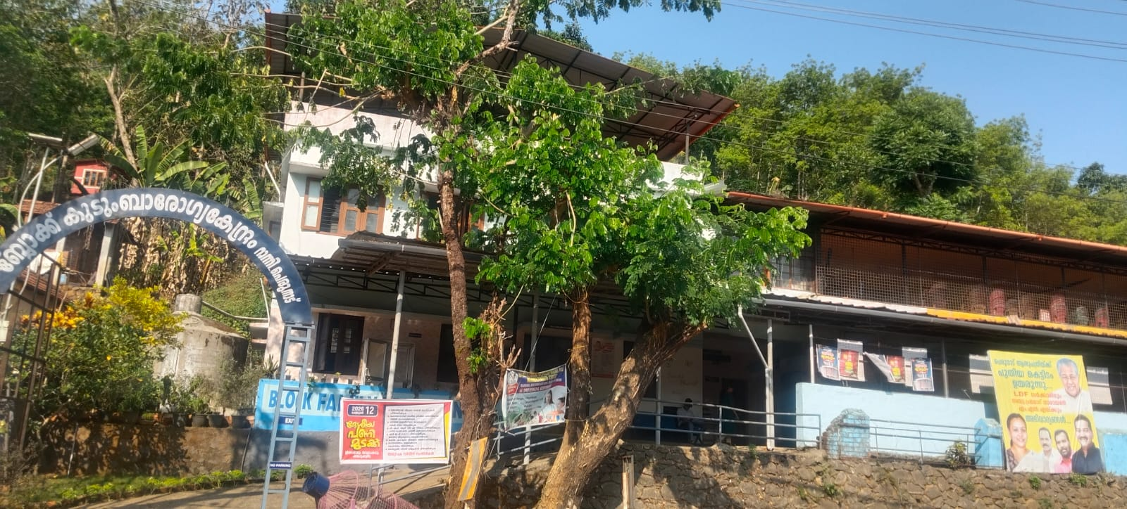
PANDEMIC PREPAREDNESS PLAN Ranni Perunad

MESSAGE FROM PANCHAYATH PRESIDENT

റാന്നി പെരുനാട് ഗ്രാമപഞ്ചായത്തിന്റെ ആരോഗ്യ മേഖലയുമായി ബന്ധപ്പെട്ട സമഗ്ര വിവരങ്ങൾ ഉൾപ്പെടുത്തി തയ്യാറാക്കുന്ന ആക്ഷൻ പ്ലാൻ സംബന്ധിച്ച വിവരം അറിഞ്ഞത് സന്തോഷകരമാണ്. ഈ പ്രവർത്തനത്തിന് എന്റെ ഹൃദയംഗമമായ ആശംസകൾ അറിയിക്കുന്നു.
മഹാമാരി പോലുള്ള അത്യാഹിത സാഹചര്യങ്ങളിൽ ജനങ്ങളുടെ ആരോഗ്യസുരക്ഷ ഉറപ്പാക്കുന്നത് അനിവാര്യമാണ്. ആരോഗ്യവകുപ്പ്, ത്രിതല പഞ്ചായത്ത് സംവിധാനം, സന്നദ്ധ സംഘടനകൾ എന്നിവയുടെ ഏകോപിതവും ഉത്തരവാദിത്വപരവുമായ പ്രവർത്തനത്തിലൂടെ മാത്രമേ ഇത്തരം പദ്ധതികൾ ഫലപ്രദമായി നടപ്പിലാക്കാൻ സാധിക്കൂ.
ഈ ആക്ഷൻ പ്ലാനിന്റെ രൂപീകരണത്തിലും നടപ്പാക്കലിലും പങ്കാളികളായ എല്ലാ ഉദ്യോഗസ്ഥർക്കും, ആരോഗ്യ പ്രവർത്തകർക്കും, സന്നദ്ധ പ്രവർത്തകർക്കും ഹൃദയപൂർവ്വമായ അഭിനന്ദനങ്ങൾ അറിയിക്കുന്നു. എല്ലാവർക്കും ആരോഗ്യവും സുരക്ഷയും ആശംസിക്കുന്നു.

ഹൃദയപൂർവം
ഗിരിജ മധു
പ്രസിഡൻറ്
റാന്നി പെരുനാട് പഞ്ചായത്ത്

MESSAGE FROM HEALTH STANDING COMMITTEE CHAIR

റാന്നി പെരുനാട് ഗ്രാമപഞ്ചായത്തിന്റെ ആരോഗ്യ രംഗത്തെ സമഗ്രമായ വിവരങ്ങൾ ഉൾക്കൊള്ളിച്ചുകൊണ്ടുള്ള ഒരു ആക്ഷൻ പ്ലാൻ തയ്യാറാക്കുന്ന വിവരം അറിഞ്ഞിരിക്കുന്നു. ആയതിലേക്ക് എല്ലാവിധ ആശംസകളും ആദ്യമേ അറിയിക്കട്ടെ.
മഹാമാരിപോലുള്ള പ്രതിസന്ധി സാഹചര്യങ്ങളിൽ ജനങ്ങളുടെ ആരോഗ്യ സുരക്ഷാ ഉറപ്പുവരുത്തേണ്ടതാണ് അത്യാവശ്യമാണ്. ആരോഗ്യവകുപ്പിനോടൊപ്പം ത്രിതല പഞ്ചായത്ത് സംവിധാനം സന്നദ്ധ സംഘടനകൾ എന്നിവരുടെ കൂട്ടായ പ്രവർത്തനം മൂലം നമുക്ക് ഇത് വിജയത്തിലേക്ക് എത്തിക്കാൻ കഴിയും.
ഈ പദ്ധതിയുടെ വിജയത്തിനായി പ്രവർത്തിച്ച എല്ലാ ഉദ്യോഗസ്ഥർക്കും ആരോഗ്യ പ്രവർത്തകർക്കും സന്നദ്ധ പ്രവർത്തകർക്കും ഹൃദയപൂർവ്വം അഭിനന്ദനം അറിയിക്കുന്നു. എല്ലാവർക്കും ആരോഗ്യസുരക്ഷ നേരുന്നു.

ഹൃദയപൂർവം
ലീന സുരേഷ്
ആരോഗ്യ സ്റ്റാൻഡിങ് കമ്മിറ്റി

MESSAGE BY MEDICAL OFFICER

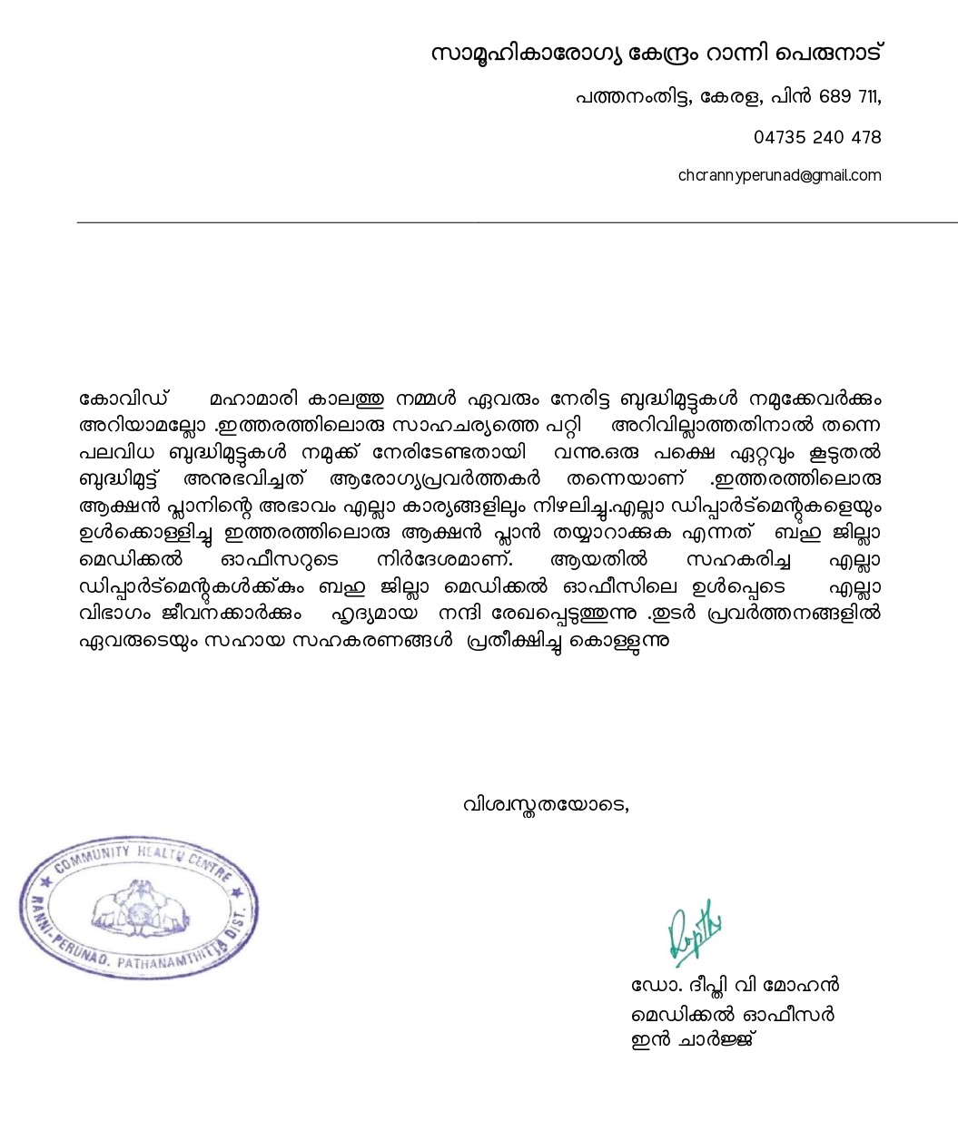

EXECUTIVE SUMMARY

Community Health Centre Ranni Perunad functions as the primary public healthcare institution serving the population of Ranni Perunad Grama Panchayath. The CHC plays a pivotal role in delivering comprehensive, accessible, and affordable healthcare services, with a strong focus on preventive, promotive, curative, and rehabilitative care in accordance with national and state health programmes.
The CHC caters to a predominantly rural population, addressing key public health priorities such as maternal and child health, communicable and non-communicable disease control, immunization, family welfare, adolescent health, and geriatric care. Regular outpatient services, home-based care through field health staff, and outreach activities ensure healthcare coverage even in geographically challenging areas. The institution actively implements national health missions, including the National Health Mission (NHM), National Tuberculosis Elimination Programme, National Programme for Prevention and Control of Cancer, Diabetes, Cardiovascular Diseases and Stroke (NPCDCS), and other disease surveillance initiatives.
Ranni Perunad CHC works in close coordination with the Grama Panchayath, ASHA workers, Anganwadi centres, schools, and community-based organizations to strengthen community participation and improve health awareness. Emphasis is placed on early detection, timely referral, health education, and lifestyle modification to reduce disease burden and improve overall health outcomes.
Despite constraints related to infrastructure, manpower, and increasing service demand, the CHC continues to enhance service delivery through effective planning, data-driven decision-making, and community engagement. Strengthening facilities, upgrading digital health systems, and expanding preventive services remain key focus areas for future development.
Overall, Ranni Perunad Community Health Centre stands as a vital institution in safeguarding public health and improving the quality of life of the residents of Ranni Perunad Grama Panchayath.

LIST OF ABBREVIATIONS

LSGD/LSGI | Local Self Government Department / Local Self Government Institution
BMO | Block Medical Officer
IDSP | Integrated Disease Surveillance Programme
NDMA | National Disaster Management Authority
PPE | Personal Protective Equipment
ICMR | Indian Council of Medical Research
CD | Communicable Diseases
NCD | NON-COMMUNICABLE DISEASES

TABLE OF CONTENTS

INTRODUCTION 9
Background of the PPP 9
LSGD AT A GLANCE 10
INTEGRATED HEALTH INFRASTRUCTURE MAP OF RANNI PERUNAD GRAMA PANCHAYATH 20
Background of the LSGI 20
Demographic and Vulnerable Population 22
Clinical Vulnerability 24
INFRASTRUCTURE & RESOURCE INVENTORY 27
Health Facility Directory & Basic Capacity in the LSGD 27
Private Clinics 28
Healthcare Education & Training Institutions 28
Specialized Services & Emergency Inventory 29
Oxygen & Diagnostic Capacity 30
Diagnostics facility mapping at the LSGI level 30
Laboratory Identification & Basic Details 31
Social and Community Infrastructure for surge plan 31
Human resources 33
Community & Support Cadre 34
Community Organizations 35
Administrative & Emergency Services 36
Information regarding resources 36
ONE HEALTH & ENVIRONMENTAL SURVEILLANCE 37
Animal & Bird Population 37
Veterinary Infrastructure 38
Veterinary Doctors & Workforce 39
High-Risk Interface Points (Surveillance Sites) 39
Environmental Risk Mapping 40
Disease Seasonality Mapping 41
Vulnerability Mapping 42
EPIDEMIOLOGICAL TRENDS (2021–2025) 43
Disease Burden among human beings(Last 5 Years) 43
Seasonal Trend Analysis 46
Outcome-Based Trend Analysis- 2025 52
Transmission Trend- 2025 55
Integrated Disease Hotspot Map (2021–2025) 57
Preparedness and Response Protocol at LSG Level 61
Constitution of One Health Committee 61
Pandemic Response Workforce 62
Activities and Measures before and during Pandemic 64
PHASE 1 - Alert / Preparation 64
PHASE 2 - Active Response 68
Standard Screening Protocol 69
PHASE 3 - Surge Capacity 84
Conversion of Community Facilities 84
CONCLUSION 86
RECOMMENDATIONS 87
ANNEXURE 89
1. IMPORTANT PHONE NUMBERS 89

INTRODUCTION

Background of the PPP
Ranni Perunad Grama Panchayath is a rural local self-government institution situated in the eastern part of Ranni, within Pathanamthitta, Kerala. The Panchayath is characterized by undulating terrain with low hills, forest fringes, valleys, agricultural lands, and scattered rural settlements. The area experiences a tropical monsoon climate with heavy seasonal rainfall, which can affect transportation and access to health services during emergencies. The population is predominantly rural, estimated at around 15,000–20,000 residents, with a mixed age distribution including children, working-age adults, and elderly persons. Livelihoods are largely dependent on agriculture, rubber cultivation, small-scale trade, and wage labor, with some seasonal migration for employment. Health services are primarily delivered through local primary health facilities and are supported by referral institutions in nearby towns. The geographical dispersion of households, seasonal accessibility challenges, and the presence of vulnerable population groups necessitate a structured and context-specific pandemic preparedness plan to ensure timely surveillance, response, and continuity of essential services.

At a glance, the Ranni Perunad Gram Panchayat is a rural local self-government institution located in the Pathanamthitta district of Kerala. The Panchayat covers the villages of Perunad and Kollamula and is administratively divided into 16 wards.Geographically, the area lies in a hilly plantation belt along the banks of the Pamba and Kakkadu rivers and along the Mannarakkulanji–Chalakkayam State Highway and NH-183A corridor, forming an important transit route toward the Sabarimala region. Baseline demographic data indicate around 4,130 households and about 15,018 residents with high literacy levels and notable SC/ST representation, reflecting diverse socio-cultural composition and mixed occupational dependence on agriculture, plantation crops, and migrant income sources. For example, Ward-16 data show 6,187 houses, 21,330 population, migrant presence, numerous wells and educational and health facilities, enabling ward-wise micro-planning for risk stratification of communicable diseases and environmental hazards. The Panchayat economy is plantation-based (rubber, pepper, coconut, banana, etc.), indicating occupational clustering among farmers and agricultural labourers, alongside mobility linked to transport connectivity and pilgrimage routes. Vulnerability mapping highlights exposure to seasonal flooding along riverbanks, landslip-prone hilly terrain, and weather-related disruptions, while the proximity of forest reserve areas adds ecological sensitivity and disaster-preparedness requirements. Overall, integrating political boundaries, infrastructure mapping (roads, rivers, institutions), socio-economic profiling, and hazard-zone identification provides a comprehensive geographic and public-health planning overview for the LSGD area.

LSGD AT A GLANCE
- Geographical boundaries with political map (based on latest delimitation)
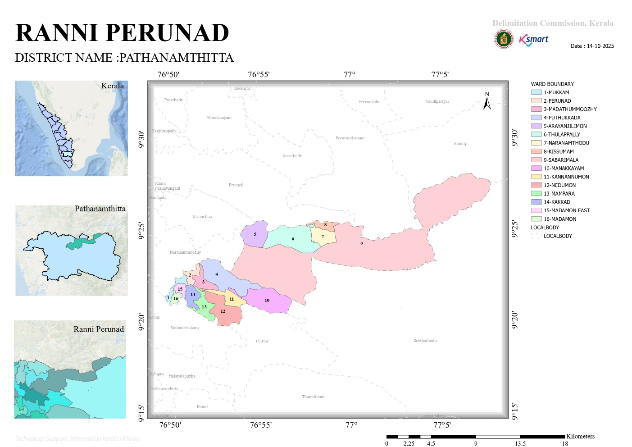

- Baseline data
No.of wards | 16
No.of Houses | 5726
Population | 21330
Male | 10605
Feamale | 10725
Transgender | 0
Below one year | 138
1-5 yr | 769
10-19 yr | 1048
30-60 yr | 13955
Above 60 yr | 2566
Differently abled | 108
Total EC | 2497
Asha workers | 19
AWW | 30
ORT depots | 30
ST nagar | 10
SC Nagar | 5
Extreme poverty families | 20
ICDS Anganwadies | 30
Govt hospitals | 1
Allopathy | 1
Ayurveda | 1
Homeo | 1
Private Hospitals | 1
Allopathy | 1
Ayurveda | 0
Homeo | 0
Dental clinics | 0
Clinical laboratories | 5
Educational institutions | 13
Govt HSS | 1
HS | 0
UPS | 1
LPS | 4
Pre primary | 0
Aided school HSS | 0
HS | 1
UPS | 2
LPS | 1
Pre primary | 1
Un aided schools HSS | 0
HS | 1
UPS | 0
LPS | 0
Pre primary | 1
Colleges | 0
Poly techniques | 0
Govt institutions state | 10
Central | 0
Hostels | 1
Medical colleges | 0
Nursing colleges | 0
Orphanage | 0
Old age homes | 0
Temple | 10
Church | 6
Mosque | 5
No.of private well | 3275
Public well | 25
Pumbing station | 5
Public libraries | 2
Arts and sports clubs | 1
Soda factories | 1
Hotel and tea shop | 55
Thattukada | 12
Market | 1
Slaughter house | 0
Construction area | 2
Rubber plantation | 5
Pineapple plantation | 4

- Ward division -
Ward | Houses | Population | Migrants | Wells | Hot  spots | Ed. Institutions | Hosp pvt/govt.
16 | 6187 | 21330 | 254 | 3300 | 6 | 12(school) | 3 GOVT,2 PRIVATE
- Mukkam
- Perunad
- Madathumoozhy
- Puthukkada
- Arayanjillimon
- Thulappally
- Naranamthodu
- Kisumam
- Sabarimala
- Manakkayam
- Kannanumon
- Nedumon
- Mampara
- Kakkad
- Madamon east
- Madamon

- Risk stratification among wards in the context of Communicable diseases and hazards
Ward 2,9,10,11-Dengue
Ward 7,8,10-Hepatitis
- Major Roads/rivers
Pamba River
Kakkad River
- Occupational groups, socio cultural groups, migration & mobility patterns
- Rubber,cocnut,spices
- Malai Pandaram Tribal community
- Settler Population(migrated for agricultural purposes
- Vulnerability

- Disaster prone areas (geographic vulnerability)
As per the hazard zonation records and vulnerability assessment data of the Kerala State Disaster Management Authority (KSDMA) and guidelines issued under the Disaster Management Act, 2005, the Local Self Government Institution (LSGI) exhibits geographically differentiated disaster risks. Ward-level analysis indicates that Wards 10, 7, and 9 fall under landslide-prone zones, primarily due to terrain slope, soil composition, drainage patterns, and high-intensity monsoon rainfall. These wards are characterized by lateritic soil structures and elevated topography, increasing susceptibility to slope instability during extreme weather events.

Further, Wards 2, 3, 6, 8, 9, 12, and 13 are identified as flood-prone areas based on historical flood incidence, proximity to low-lying wetlands, water channels, and backwater influence. Ward 9 represents a compounded vulnerability zone, being exposed to both landslide and flood risks. CDMA have highlighted recurrent inundation, water stagnation, and infrastructure disruption in these wards. These geographic vulnerabilities significantly influence habitation patterns, public health risks, and emergency response planning within the Panchayat.

The identification of ward-specific geographic risks has been systematically integrated into the Panchayat-level Pandemic Preparedness and Response Plan under the One Health framework. Flood- and landslide-prone wards are recognized as high-risk zones for secondary public health emergencies, including outbreaks of waterborne diseases (e.g., diarrhoeal diseases, Hepatitis A) and vector-borne diseases (e.g., Dengue, Leptospirosis), particularly following extreme rainfall and displacement events.
Accordingly, the preparedness strategy prioritizes these wards for:
- Pre-positioning of essential medical supplies and rapid response teams.
- Strengthened disease surveillance and ward-level early warning systems.
- GIS-based vulnerability mapping and seasonal disease trend analysis.
- Targeted sanitation drives and vector control measures before and after monsoon periods.
- Designation of safe evacuation shelters with infection prevention and control (IPC) protocols.
By aligning geographic hazard mapping with epidemiological risk profiling, the Panchayat ensures a proactive, evidence-based approach to mitigating cascading public health risks during disasters. This integration enhances inter-departmental coordination between Health, Veterinary, Revenue, and Disaster Management authorities, thereby strengthening resilience and ensuring continuity of essential health services during emergencies.
Maps - ward-based

- Geographical boundaries
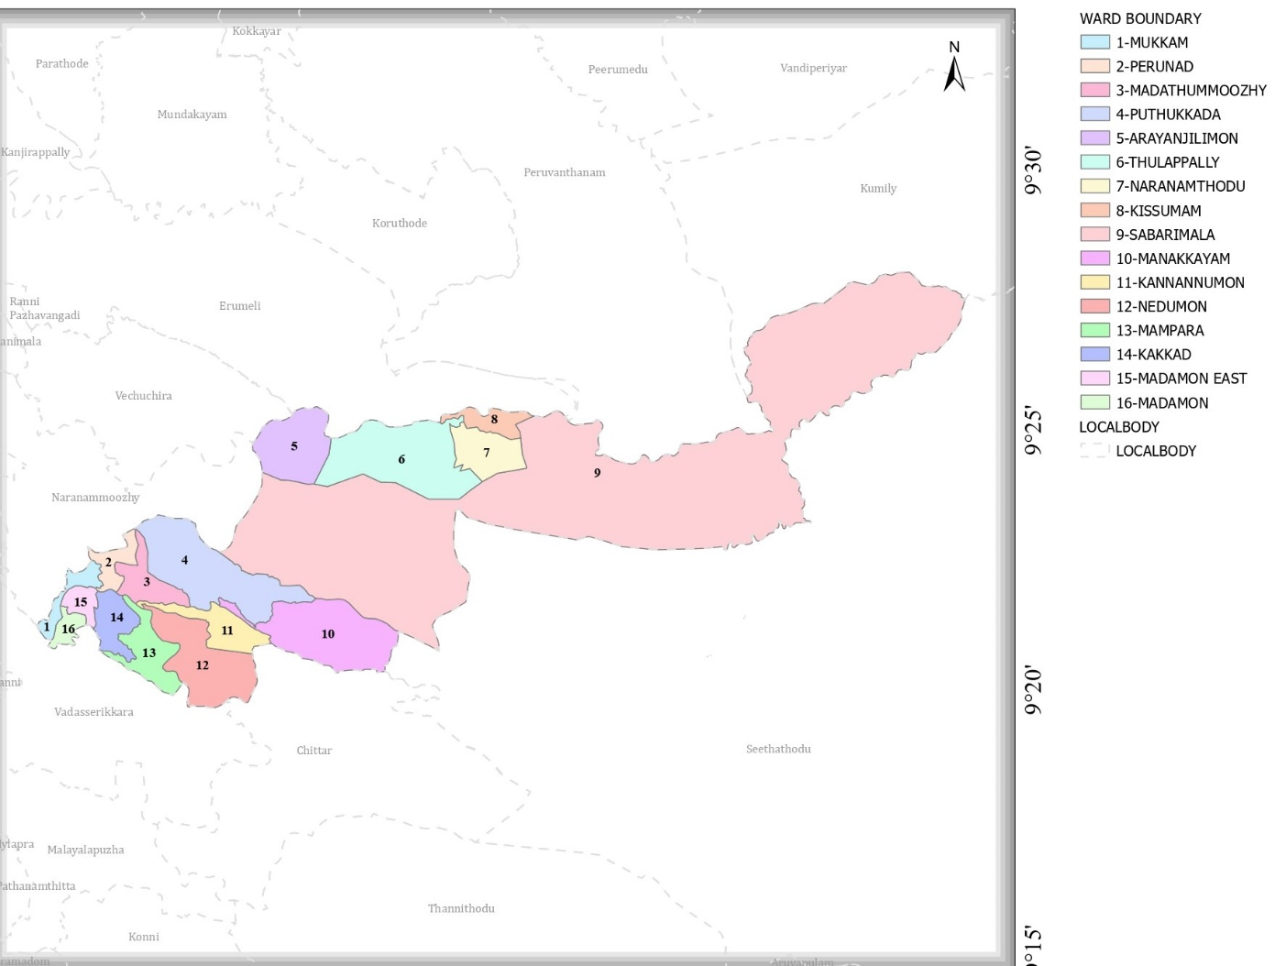
- Health infrastructure map
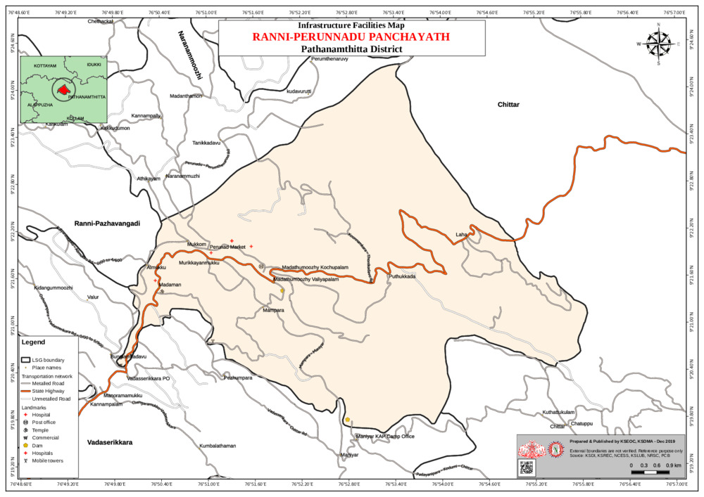
- Roads and Rivers map
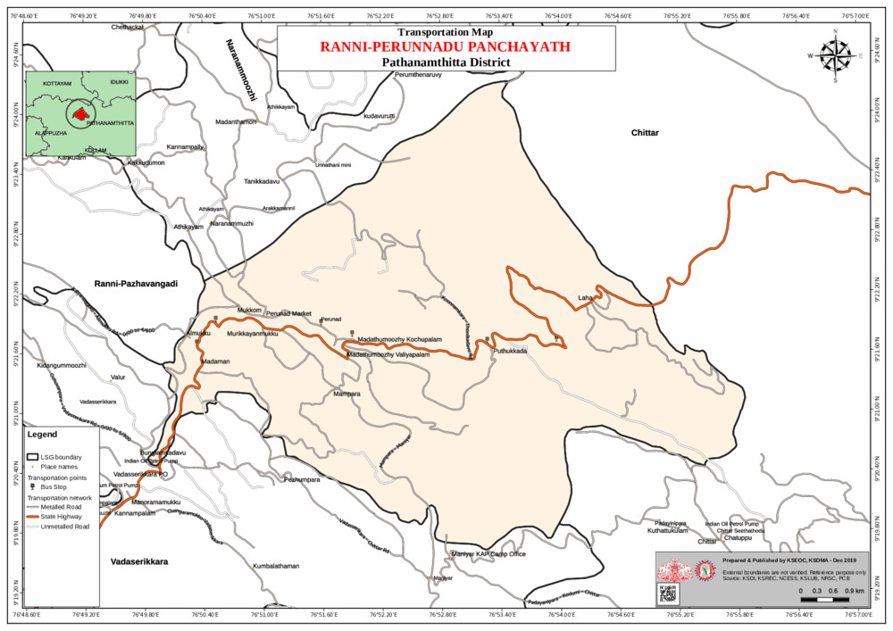
- DISASTER-PRONE AREAS MAP
FLOOD AFFECTED AREA
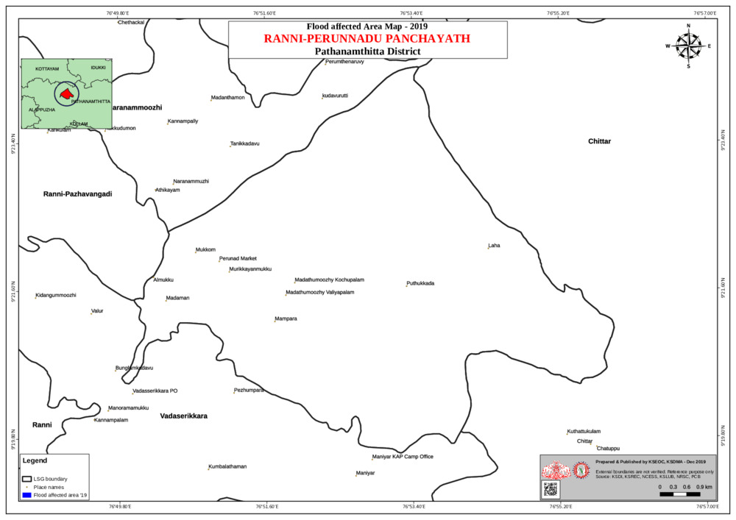
LANDSLIDE AREA
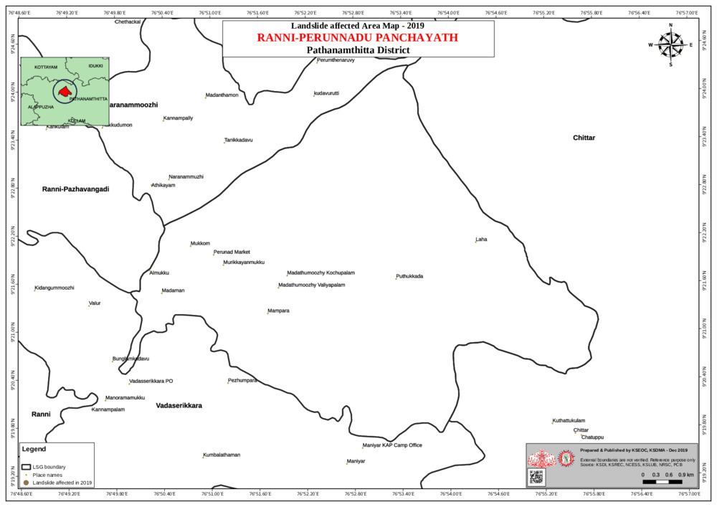
- hotspot map - CD & disasters

INTEGRATED HEALTH INFRASTRUCTURE MAP OF RANNI PERUNAD GRAMA PANCHAYATH

GENERAL PROFILE OF THE LSGI’S

Background of the LSGI
Ranni Perunad Grama Panchayat is situated in the Northern Part of district, Kerala. The geographical landscape of the Panchayat is predominantly low-lying, characterized by extensive paddy fields (Kole lands) and a dense network of rivers, canals, and backwaters. This unique terrain plays a significant role in shaping the local microclimate and poses distinct challenges to transportation, emergency response, and service delivery, particularly during monsoon seasons and flood events.
The Panchayat is administratively divided into multiple wards, with a population largely dependent on traditional livelihoods. Agriculture—especially paddy cultivation—fishing, coir and coconut husk processing, and allied activities form the backbone of the local economy. In recent years, tourism-related activities and service-sector employment have also shown gradual growth. The area hosts a diverse workforce, including a notable presence of migrant labourers, particularly in construction, agriculture, and allied sectors.
From a public health and disaster management perspective, Perunad LSGI has historically been vulnerable to seasonal flooding, waterborne diseases, and vector-borne illnesses such as Dengue and Leptospirosis. The severe floods experienced during recent years, including the 2018 flood disaster, significantly impacted life, livelihoods, and infrastructure within the Panchayat. These recurring emergencies have underscored the importance of strengthening local preparedness, response mechanisms, and inter-departmental coordination.
In this context, the development of a localized, data-driven Auxiliary Infrastructure and Logistical Resource Map is essential to support effective planning, timely emergency response, and sustainable development initiatives. Such mapping enables the Panchayat to identify critical resources, improve accessibility during disasters, and enhance overall resilience of the community.

Table 1: Background of LSGD
Description | Details
Name of LSGI | Ranni Perunad
Type (GP/Municipality / Corporation etc.) | Grama Panchayath
Block | Ranni
District | Pathanamthitta
Number of wards | 16
Total area (sq. km) | 82.06 sq k.m
Population(Projected) | 21330
Population density | 200 persons/sq km
Terrain (coastal/low-lying/backwaters/foothills, etc.) | Foothills
Number of rivers passing through LSGI | Pampa, Kakkat River
Number of water bodies in the LSGI | 6
Number of educational institutions | 42
Factories / small-scale industries | 1
Flood-prone wards | 1,12,13
Landslide-prone wards | 11
Death Management and Disposal Facilities (mortuaries/crematorium, including electric) | No
Auditoriums/Marriage halls/convention centres/community halls | 8

Demographic and Vulnerable Population
Understanding the demographic composition and vulnerable population groups is essential for pandemic preparedness. Children, elderly, economically deprived families, migrant workers, and socially vulnerable groups are at increased risk during public health emergencies due to higher exposure, limited access to services, and dependency on public systems.

Description |  | Details (in numbers)
DEMOGRAPHIC PROFILE
Total population |  | 21330
Male |  | 10605
Female |  | 10725
Transgender |  | 0
Children under 5 |  | 865
Adolescent |  | 1048
Elderly (>60) |  | 13955
SOCIAL/LIVELIHOOD VULNERABILITY
Previous EPEP family |  | 22
BPL family |  | 3418
Tribal communities |  | 2
Migration | Immigrant | 254
Migration | Emigrant
Socio-economically deprived
Fisherfolk |  | NIL
SC Community |  | 1587
ST Community |  | 1264

Clinical Vulnerability
Certain population groups needs priority healthcare & are at higher risk of severe illness, complications, and mortality during pandemics. Patients with chronic diseases, those requiring regular medical care, and individuals with mobility or functional limitations face challenges in accessing timely care during emergencies. Mapping these groups helps in prioritizing continuity of treatment, medicine stock planning, oxygen support, referral transport, and targeted home-based care.
Description | Details in numbers
Pregnant women | 129
Lactating mothers | 124
Bedbound patients | 113
Patients under palliative care other than bedbound | 114
Patients on Haemodialysis | 13
Patients on CAPD | 0
Cancer patients (currently on treatment) | 69
Haemophilic patients | 0
Mentally challenged | 32
Differently abled | 108
Diabetic patients | 2487
Hypertensive patients | 2354
TB patients | 5

The clinical vulnerability assessment of Ranni-Perunad Grama Panchayat, based on ward-level health registry data, indicates a significant burden of high-risk individuals requiring continuous medical support and priority protection during public health emergencies. The data shows a high proportion of bedbound patients and individuals under palliative care, followed by a substantial number of differently abled persons and cancer patients currently undergoing treatment. Additionally, there are identified cases of mentally challenged individuals, patients on haemodialysis, and tuberculosis (TB) patients who require uninterrupted treatment and follow-up. These groups represent clinically vulnerable populations due to compromised immunity, mobility limitations, dependence on regular medical interventions, and increased susceptibility to complications during infectious disease outbreaks.
In the context of pandemic preparedness planning, this clinical vulnerability mapping serves as a critical evidence base for targeted intervention strategies. The Panchayat has incorporated these findings into its Pandemic Preparedness and Response Plan by prioritizing these individuals for early surveillance, doorstep health monitoring, uninterrupted supply of essential medicines, and assured referral transport systems during lockdowns or disaster-induced mobility restrictions. Special emphasis is placed on continuity of dialysis services, oncology treatment coordination, TB drug adherence under the National TB Elimination Programme (NTEP), and home-based palliative care services with Infection Prevention and Control (IPC) protocols.
Further, micro-level health registers maintained by ASHA workers and Primary Health Centre (PHC) teams are integrated with ward disaster management committees to ensure rapid identification and support during emergencies. Isolation preparedness plans, vaccination prioritization, telemedicine consultations, and psychosocial support systems are structured around this clinical vulnerability profile. By systematically incorporating clinical risk stratification into pandemic planning, Ranni-Perunad Grama Panchayat strengthens health system resilience, reduces preventable morbidity and mortality, and ensures equitable protection of its most vulnerable population segments during public health crises.

Major Festivals & Events specific to the LSGI
(with the possibility of a public gathering)

Sl. No. | Name of festival | Month detailing the periodicity
1 | MAKARAVILAKKU | JANUARY 14
2 | SABARIMALA SEASON | NOV-JAN
3 | MADAMON CONVENTION | FEB

INFRASTRUCTURE & RESOURCE INVENTORY

Health Facility Directory & Basic Capacity in the LSGD
This section provides an overview of the healthcare infrastructure available within the LSGD area. It outlines the distribution and basic capacity of health facilities that form the backbone of service delivery during routine times and public health emergencies.

Family Health Centres (FHCs) and Community Health Centres (CHCs) generally function as the first point of contact for the community, providing essential outpatient and inpatient services. General Hospitals (GH) and Medical College Hospitals (MCH), where accessible, serve as the main referral centres for advanced diagnostics, specialist care, and critical services during public health emergencies. This inventory helps identify existing strengths, gaps, and potential surge capacity that can be mobilised during a pandemic or disaster.

Table 5. Health Facility Resource Summary
Sl.no. | Health Facility | Type of Facility (MCH/GH/CHC/FHC/SC etc.) | Contact Number | Total beds | ICU Beds | Oxygen-Supported Beds | No. of Ventilator Support Beds | No. of ambulances
Government Healthcare Facilities
1 | CHC RANNI PERUNAD | CHC | 04735-240478 | 15 | 0 | 0 | 0 | 1
2 | MAIN CENTRE | SC
3 | MADAMON | SUB CENTRE
4 | MANAKKAYAM | SC
5 | KAKKAD | SC
6 | LAHA ATTATHOD | SC
7 | THULAPPALLY | SC
8 | ARAYANJILIMON | SC
Private Healthcare Facilities
1 | CHAITANYA  HOSPITAL
2 | BETHANY HOSPITAL |  | 04735-240536 | 0 | 0 | 0 | 0 | 0
AYUSH Healthcare Facilities
1 | GOVT HOMEO DISPENSARY

Private Clinics
Private clinics are an essential part of pandemic preparedness, as they are often the first place people seek care when symptoms begin. In many communities, private clinics manage a significant share of outpatient visits and therefore play a critical role in early case detection, timely referrals, and disease surveillance. Having an up-to-date understanding of where these clinics are located, the services they provide, and how they are linked to the public health system helps ensure that no cases are missed during an outbreak. It also allows health authorities to engage private practitioners more effectively for reporting, risk communication, and coordinated response, strengthening the overall capacity of the health system to manage public health emergencies.

Table 6. Private Clinic Resource Summary
Sl No. | Name of Clinic | Registered (Y/N) | Clinic (General / Speciality) | Speciality (if any) | Address | Contact Number | Diagnostic Facility (Y/N) | Ambulance Linkage (Y/N)
1 | NIL
2 | NIL

Healthcare Education & Training Institutions
This section tracks the educational infrastructure available, which is vital for human resource planning in the health sector.

Category of Institution | Govt | Private | AYUSH | Total
Medical Colleges | 0 | 0 | 0 | 0
Nursing Colleges | 0 | 0 | 0 | 0
Dental Colleges | 0 | 0 | 0 | 0
Para-medical / Allied Health | 0 | 0 | 0 | 0
Pharmacy Colleges | 0 | 0 | 0 | 0

Specialized Services & Emergency Inventory
This section provides a detailed view of the specialized medical resources available to the community, focusing on emergency response and critical care capabilities. This table tracks the vital assets required for managing severe illnesses and emergencies across Government, Private, and AYUSH sectors.

Item | Govt | Private | AYUSH | Total
Hospital beds | 15 | - | - | 15
Oxygen-generating systems(Y/N) | - | - | - | -
Oxygen-supported beds (Numbers) | 0 | 0 | 0 | 0
Ventilator-supported beds | 0 | 0 | 0 | 0
ICU beds | 0 | 0 | 0 | 0
Burns units | 0 | 0 | 0 | 0
Blood centres | 0 | 0 | 0 | 0
BLS ambulances | 0 | 0 | 0 | 0
ALS ambulances | 0 | 0 | 0 | 0
Dialysis facilities | 0 | 0 | 0 | 0
Dispensaries | 0 | 1 | 0 | 1
Medical store | 0 | 4 | 0 | 4
Industrial establishments (Medium-scale industries/small-scale industries establishments to whom we can depend in a worst-case scenario) | 0 | 1 | 0 | 1

Oxygen & Diagnostic Capacity
Monitoring oxygen and diagnostic capacity is a critical component of public health preparedness, ensuring that the LSGD can handle both chronic care and sudden surges in respiratory or infectious diseases.
Name of Health Facility | Oxygen-generating System (Y/N) | Backup Oxygen Source (Y/N) | Diagnostic Facilities Available(Y/N)
Name of Health Facility | Oxygen-generating System (Y/N) | Backup Oxygen Source (Y/N) | Lab | USG | X-ray | CT/MRI | RT-PCR
Government Healthcare Facilities
CHC Ranni Perunad |  | YES | Y | N | Y | N | N

Diagnostics facility mapping at the LSGI level
The diagnostic capacity of Ranni Perunad Panchayath represents the "intelligence network" of our healthcare system. The speed and accuracy of disease identification depend entirely on the distribution and technical level of these facilities.

Item | Govt | Private | AYUSH | Total
General labs | 1 | 3 | 0 | 4
Microbiology labs | 0 | 1 | 0 | 1
RT-PCR labs | 0 | 0 | 0 | 0
USG units | 0 | 0 | 0 | 0
CT/MRI units | 0 | 0 | 0 | 0
Research labs | 0 | 0 | 0 | 0
Labs of other departments that can be repurposed | 0 | 0 | 0 | 0

Laboratory Identification & Basic Details
Sl. No. | Name of Laboratory | Ownership (Govt / Private / Academic) | Address | Contact No. | 24×7 Services (Yes/No) | NABL / Govt Approved (Yes/No)
1 | PERUNAD | GOVT | CHC PERUNAD | 04735-240478 | NO | YES
2 | J J LAB | PRIVATE | RANNI PERUNAD | 9447695551 | NO | YES
3 | MICROLAB | PRIVATE | MADATHUMMOOZHI | 750684631 | NO | YES

Social and Community Infrastructure for surge plan
This table serves as our logistics and shelter inventory. By mapping these locations, quickly we can identify where to house displaced citizens, where to set up temporary medical clinics, and how to manage the deceased with dignity during a crisis.

Category | Total Count | Ward | Est. Capacity (Persons) |  | Contact details
Educational Institutions
Anganwadis | 30 | 16 WARD | 15 | 6282695368
Schools | 12 | 3,13,6,5 | 250 | 9496806140,9495343459
Colleges | 0 | 0 | 0 | 0
Healthcare Educational Institutions
Medical colleges (Govt/Private) | 0 | 0 | 0 | 0
Nursing colleges (Govt/Private) | 0 | 0 | 0 | 0
Dental colleges (Govt/Private) | 0 | 0 | 0 | 0
Paramedical institutes (Govt/Private) | 0 | 0 | 0 | 0
Community Gathering Spaces
Community halls | 8 | 11,13,8,6 | 300
Auditoriums | 0 | 0 | 0 | 0
Religious buildings | 1 | 13 | 300 | 9846281295
Vulnerable Group Support Facility
Destitute homes | 0 | 0 | 0 | 0
Elderly homes | 0 | 0 | 0 | 0
LSGD owned other buildings | 20 | 2 |  | 04735-240230
Mass Fatality Management (MFM) Infrastructure
Mortuary | 0 | 0 | 0 | 0
Crematorium | 0 | 0 | 0 | 0
*refer annexure 1 for contact details

Human resources
This section focuses on the human capital available within the LSGI. In any emergency—be it a pandemic, flood, or industrial accident—infrastructure is only as effective as the people operating it.

Medical & Clinical Personnel
This table tracks the "Frontline" providers responsible for diagnosis, treatment, and clinical management. Narrative sentence: eg., "Total health workforce: 450 personnel, with 60% in government facilities serving as primary surge capacity." A detailed directory with the contact numbers of all workers is maintained (Annexure in 1).

Cadre | Govt (No.) | Private (No.) | Total
Doctors—Modern Medicine | 8 | 1 | 9
Doctors – AYUSH | 2 | 0 | 2
Doctors – Veterinary | 1 | 0 | 1
Doctors – Dental | 0 | 0 | 0
Nursing officers | 8 | 0 | 8
Lab technicians | 2 | 4 | 6
Optometrist | 0 | 0 | 0
Pharmacists | 3 | 4 | 7
Psychologists | 0 | 0 | 0
Counsellors | 1 | 0 | 1

Public Health & Field-Level Workforce
These individuals are the backbone of surveillance, maternal-child health, and decentralized care.

Cadre | Health services | Municipal common services | Total
HS (Health Supervisors) | 0 | 0 | 0
HI (Health Inspectors) | 1 | 0 | 1
LHS (Lady Health Supervisor) | 0 | 0 | 0
LHI (Lady Health Inspectors) | 1 | 0 | 1
JPHN (Jr Public Health Nurses) | 7 (2 VACANT}) | 0 | 7
JHI (Jr Health Inspectors) | 6 | 0 | 6
MLSP (Mid-Level Service Providers) | 7 | 0 | 7
Palliative Nurses | 1 | 0 | 1
RBSK Nurses | 0 | 0 | 0
PRO | 1 | 0 | 1
Epidemiologist | 1 | 0 | 1
Data Manager | 1 | 0 | 1

Community & Support Cadre
This group represents the surge capacity of the LSGI—people who can be called upon for logistics, rescue, and specialized support.

Cadre | Number
ASHA Workers | 18
AWW (Anganwadi Workers) | 30
Emergency Medical Volunteers (Trained) | 1
Kudumbashree | 220
MNREGS | 1352
Purusha Swayam Sahaya Sangham | 5
Ex-Servicemen | 122
Retired Police Officers | 3
NCC/NSS Volunteers | 24
Red Cross volunteers | 0
One Health Community Volunteers | 735
One Health Community Mentors | 105

Community Organizations
This section details the presence of community-based organisations (CBOs), non-governmental organisations (NGOs), faith-based organisations (FBOs), Kudumbashree Self-Help Groups (SHGs), and Ayalkootams within the Local Self-Government Institution (LSGI). These groups enhance grassroots mobilization, resource distribution, and support networks crucial for pandemic response and community resilience.

Category | Total Count
NGOs | 1
Religious based organizations | 0
Foreign based organizations | 0
Sports Club/youth clubs | 1
Kudumbashree SHGs | 232
Ayalkootams | 270
Political organizations | 3
Residential organizations | 1

Administrative & Emergency Services
This section outlines the availability of key non-health emergency support services and infrastructure within the LSGI, which are essential for effective pandemic preparedness and response. These facilities support law enforcement, disaster response, water supply, logistics, mobility, and community-level interventions during public health emergencies.

Category | Total Count | Contact details
Police Stations | 1 | RANNIPERUNAD POLICESTATION 9497908448
Fire & Rescue Stations | 0 | 0
Water Pumping Points | 5 | 9446115144
Public Distribution System (PDS) | 1 | 8921866720

Information regarding resources
The availability of essential transport and support resources plays a quiet but critical role in saving lives. Equipment such as ambulances, mobile mortuaries, amphibian ambulances, and motorized boats ensures that patients, samples, and healthcare teams can move swiftly—even in flooded, remote, or difficult terrains. Heavy vehicles like JCBs, cranes, tractors, and torus lorries support logistics, waste management, emergency infrastructure, and rapid conversion of spaces into care or isolation facilities. Taxis, four-wheel-drive vehicles, and trucks help maintain continuity of essential services, reach vulnerable populations, and support home-based care and supply delivery.

Means of transportation | Total Count
JCB | 4
Crane | 1
Heavy Trucks | 5
Tractor | 1
Ambulances | 2
Mobile mortuaries | 0
Boats | 0
Taxi service | 15
Note: For specific details regarding vehicle owners and contact information, please refer to Annexure [X].

ONE HEALTH & ENVIRONMENTAL SURVEILLANCE
The One Health method integrates environmental, animal, and human health to enable proactive pandemic preparedness. Panchayat-level surveillance needs to be improved in order to detect and treat zoonotic and environmentally generated diseases early. Surveillance is strengthened through systematic assessment of animal populations, veterinary infrastructure, poultry and slaughter facilities, inter-sectoral coordination, and specialised tools like avian influenza seasonality mapping using GIS in previous outbreaks to enable predictive alerts and ward-specific sampling to support effective pandemic preparedness in high-risk areas like _Attathod Thulappally Arayanjilimon Bethany Mala Bimaram_.

Animal & Bird Population
Mapping animal and bird populations at the Panchayat level is essential for identifying and prioritising zoonotic disease hazards like rabies, leptospirosis, anthrax, and Nipah-like spillover occurrences. Risk classification, targeted surveillance, vaccination planning, and early epidemic detection made feasible by comprehensive population mapping all enhance One Health-based pandemic preparedness.

Category | Item | Estimated Population | Wards
Animal Population | Livestock (Cattle/Goats/Buffalo) | 1858 | 16
Animal Population | Pet Animals (Dogs/Cats) | 4298 | 16
Animal Population | Stray Dog Population | 219 | 16
Animal Population | Pig Farms (Number of heads) | 1 | 3
 | Small Units (Sheep / Goats – clustered) | 5 | 12,10
Bird Population | Poultry Units (Birds) | 25 | 16
Bird Population | Poultry- (FOWL) | 2
Bird Population | Wild/Migratory Birds (Observed) | - | NA
Bird Population | Crow Mortality Events (Reported) | - | NA

Veterinary Infrastructure
Veterinary institutions are a core pillar of One Health surveillance, enabling early zoonotic disease detection through vaccination, investigation of unusual animal illness or deaths, sample collection, and timely outbreak reporting. A well-mapped and responsive veterinary network strengthens coordination with human health and LSGI systems, ensuring rapid response during zoonotic events and pandemics.
Facility Type | Name of Facility | Ownership Govt / Pvt | Location (Ward No) | Contact number
Veterinary Dispensary | 1 | GOVT | 11 | 8086085575
Veterinary Hospital / Polyclinic | 0 | 0 | 0 | 0
Private Veterinary Clinics | 0 | 0 | 0 | 0
Mobile / Emergency Vet Service (incl. night services) | 0 | 0 | 0 | 0
Pet Homes / Animal Shelters | 0 | 0 | 0 | 0
Slaughterhouse-linked Veterinary Inspection Unit | 0 | 0 | 0 | 0

Veterinary Doctors & Workforce
Early detection, diagnosis, reporting, and reaction to animal illness epidemics depend on the availability and accessibility of qualified veterinary specialists. By identifying unusual animal morbidity or mortality promptly, collecting samples promptly, and coordinating efficiently with human health and LSGI systems—especially during zoonotic outbreaks and pandemic-prone situations—a clearly defined veterinary workforce enhances One Health surveillance.

Category | Number Available | Type (Govt/Pvt) | Contact number
Government Veterinary Doctors | 1 | GOVT | 9074546353
Private Veterinary Doctors | 0 | 0 | 0
Livestock Inspectors | 4 | 0 | 98958904510
Para-veterinary Staff / Attenders | 0 | 0 | 0
Contract / On-call Veterinary Support (if any) | 0 | 0 | 0

High-Risk Interface Points (Surveillance Sites)
In the geographical and ecological context of Ranni Perunad Grama Panchayat, high-risk interface points for zoonotic disease surveillance are primarily associated with its forest-fringe terrain, riverine systems, plantation belts, and dispersed rural settlements. The Panchayat’s hilly topography, proximity to wildlife habitats, and monsoon-driven hydrological patterns create multiple human–animal–environment interaction zones with elevated spillover potential.

Type of Habitat | Type of High-risk interface | Geographical vulnerability
Wetlands & Backwaters | FLOODING | LOW
Backyard Poultry Farms | POLLUTION | LOW
Cattle Sheds near Water Bodies | POLLUTION | MODERATE
Fish & Meat Markets | POLLUTION | LOW
Community Slaughter Sites | POLLUTION | LOW
Migratory Bird Congregation Areas | BIRD FLEW | LOW
Rodent-Infested Grain Storage | LEPTO | LOW

Category | Total Count | Key Locations (wards)
Poultry Farms | 0 | 0
Backyard / Clustered Poultry Units | 0 | 0
Duck Rearing Units (open water access) | 0 | 0
Slaughterhouses/ Slaughter Points | 0 | 0
Meat/Fish Markets | 0 | 0
Live Bird Sale Points | 0 | 0
Cattle Markets / Weekly Animal Fairs | 0 | 0
Pet Shops / Breeders | 1 | 3
Animal Shelters / Pet Homes | 0 | 0
Waste Disposal Sites near Animal Units | 0 | 0

Environmental Risk Mapping
Environmental risk mapping identifies monsoon/flood hotspots for vector-borne (dengue, chikungunya), water-borne (leptospirosis, diarrhoea), and zoonotic diseases in Kerala's wetlands. Systematic surveillance supports early warnings, targeted interventions, and Panchayat pandemic preparedness.
Waterborne exposure: Flood-prone areas and stagnant water bodies facilitate leptospira survival, raising leptospirosis risk.

Traditional practices: Informal slaughter and fish markets lack standardized hygiene, creating spillover opportunities.

Risk Factor | High-Risk Wards | Key Locations | Risk Level (High/Med/Low)
Flood-prone areas | 13,1,9,12 | PAMPA RIVER, KAKKAD RIVER | MEDIUM
Water bodies/wetlands | 11,8,9 |  | LOW
Solid waste accumulation | NIL | NIL | NIL
Animal waste disposal issues | NIL | NIL | NIL
Rodent infestation zones | NIL | NIL | NIL
Industrial effluent discharge | 12 | MANIYAR | LOW
Construction sites / abandoned buildings | 4 | PERUNAD | LOW
Poor drainage/blocked canals | 9 | PAMPA | HIGH
Drinking water source contamination risk | 7,8,9 | THULAPPALLY,PAMPA, NARANAMTHOD | HIGH

Disease Seasonality Mapping
- Flooding & waterlogging → amplifies leptospirosis, malaria, diarrheal diseases.
- Mosquito breeding cycles → vector-borne disease peaks in monsoon.
- Agricultural practices → close human–animal contact in paddy fields.

Disease | Peak Risk Season | Key Drivers | High-Risk Locations | Surveillance Focus
Avian Influenza | NIL | NIL | NIL
Leptospirosis | MONSOON | RAT | NEAR RIVER, CATTLE FARMS | YES
Dengue/Chikungunya | MONSOON | MOSQUITO | WATER SCARCITY AREA,PLANTATION | YES
Acute Diarrheal Diseases | WINTER | POOR HYGEINE | SABARIMALA AREA | YES
Rabies | NIL | NIL | NIL
Anthrax (rare) | NIL | NIL | NIL

Vulnerability Mapping
Vulnerability mapping pinpoints high-risk populations, occupations, and areas exposed via environment, livelihoods, socio-economics, and poor service access. Paired with environmental/seasonality mapping, it enables risk-based surveillance, targeted actions, and optimal resource use in One Health and pandemic planning.
Vulnerability Factor | High-Risk Wards | Key Groups / Locations | Risk Level
Flood-prone households | 13,1,6,8,9,12,2 | RIVER SIDE | MODERATE
Wetland-adjacent communities | 0 | 0 | 0
Livestock-rearing households | 0 | 0 | 0
Slaughterhouse & meat market workers | 0 | 0 | 0
Fisherfolk & fish market workers | 0 | 0 | 0
Sanitation workers | 0 | 0 | 0
Daily wage / migrant workers | 9,11 | MIGRANT | MODERATE
Elderly & chronically ill populations | NIL
Pregnant Women | 9 | TRIBAL POPULATION | HIGH
Children (schools, Anganwadi’s) | 9 | TRIBAL POPULATION | MODERATE
Limited access to safe water & sanitation | 9,7,8,14,3 | HILLY AREA | MODERATE

EPIDEMIOLOGICAL TRENDS (2021–2025)

Disease surveillance is the systematic collection, analysis, and interpretation of health data for planning, implementation, and evaluation of public health practice. This section presents the disease surveillance profile of the LSGI based on routine reporting systems and outbreak investigations to identify priority diseases, seasonal patterns, and emerging public health threats.

Disease Burden among human beings(Last 5 Years)
Analysis of disease-wise data for the last five years helps identify persistent public health problems, emerging diseases, and changes in disease burden. This information supports prioritisation of prevention, preparedness, and response activities at the Panchayat level.

Disease | 2021 | 2022 | 2023 | 2024 | 2025 | Trend(Increasing/Stable/Decreasing)
Dengue | 2 | 9 | 16 | 88 | 12 | DECREASING
Leptospirosis | 0 | 0 | 3 | 5 | 4 | DECREASING
Hepatitis A | 0 | 1 | 2 | 3 | 6 | INCREASING
Malaria | 0 | 1 | 0 | 0 | 0 | DECREASING
Scrub Typhus | 0 | 1 | 0 | 0 | 0 | DECREASING
Typhoid | 0 | 0 | 0 | 0 | 0 | STABLE
H1N1 | 0 | 0 | 0 | 4 | 2 | DECREASING
H3N2 | 0 | 0 | 0 | 0 | 0 | STABLE
ADD | 7 | 10 | 8 | 114 | 117 | INCREASING
Mumps | 1 | 2 | 3 | 0 | 1 | DECREASING
Measles | 0 | 0 | 0 | 1 | 0 | DECREASING
Hepatitis B | 0 | 2 | 0 | 3 | 0 | DECREASING
Hepatitis C | 0 | 0 | 0 | 1 | 0 | DECREASING
Tuberculosis | 4 | 8 | 8 | 12 | 7 | INCREASING
Leprosy | 0 | 0 | 0 | 1 | 0 | STABLE
COVID-19 | 26 | 8 | 2 | 0 | 0 | DECREASING

A five-year epidemiological review (2021–2025) indicates a dynamic shift in communicable disease patterns within Ranni-Perunad Grama Panchayat, with notable peaks in vector-borne and waterborne diseases during 2024, followed by partial stabilization in 2025.
Vector-Borne Diseases:
Dengue cases demonstrated a sharp surge in 2024 (88 cases) compared to preceding years (2 in 2021; 9 in 2022; 16 in 2023), followed by a significant decline in 2025 (12 cases), indicating effective post-outbreak control measures. Leptospirosis showed a gradual increase from 2023 onwards (3 in 2023; 5 in 2024; 4 in 2025), though remaining at moderate levels. H1N1 emerged in 2024 (4 cases) with a reduction in 2025 (2 cases). Malaria and Scrub Typhus remained sporadic with no sustained transmission trend.
Waterborne and Foodborne Diseases:
Acute Diarrhoeal Disease (ADD) exhibited a marked escalation in 2024 (114 cases) and remained high in 2025 (117 cases), indicating persistent environmental and sanitation-related vulnerabilities. Hepatitis A showed a steady upward trend, increasing from isolated cases in earlier years to 6 cases in 2025, suggesting the need for strengthened water quality surveillance and preventive interventions. Typhoid remained nil throughout the review period.
Airborne and Vaccine-Preventable Diseases:
Tuberculosis cases increased gradually from 4 cases (2021) to 12 cases (2024), with a slight decline in 2025 (7 cases), reflecting improved detection and treatment follow-up. Mumps and Measles were sporadic without outbreak patterns. Hepatitis B and C showed isolated cases without sustained transmission. Leprosy remained stable with minimal incidence.
COVID-19 Trend:
COVID-19 cases declined consistently from 26 cases in 2021 to zero cases by 2024 and 2025, indicating effective vaccination coverage, community immunity, and containment strategies.

Seasonal Trend Analysis
Seasonal analysis helps anticipate surges (e.g. dengue in monsoon, leptospirosis after floods, influenza in cooler months) and plan pre‑emptive vector control, stockpiling of IV fluids, and awareness campaigns at Panchayat level.

DENGUE
Dengue is a major seasonal vector-borne disease strongly associated with rainfall, water stagnation, and increased mosquito breeding during the monsoon period.

Peak: July–November

Dengue – Ward-wise Yearly Distribution (2021–2025)

Ward | Dengue – Ward-wise Yearly Distribution
Ward | 2021 | 2022 | 2023 | 2024 | 2025 | Total
1 | 0 | 1 | 2 | 6 | 1 | 10
2 | 1 | 0 | 0 | 4 | 3 | 8
3 | 1 | 1 | 0 | 5 | 0 | 7
4 | 0 | 1 | 2 | 4 | 1 | 8
5 | 0 | 0 | 0 | 2 | 1 | 3
6 | 0 | 1 | 1 | 2 | 0 | 4
7 | 0 | 0 | 0 | 1 | 1 | 2
8 | 0 | 1 | 1 | 2 | 1 | 5
9 | 0 | 0 | 3 | 44 | 1 | 48
10 | 0 | 1 | 2 | 0 | 0 | 3
11 | 0 | 1 | 0 | 8 | 2 | 11
12 | 0 | 0 | 2 | 2 | 0 | 4
13 | 0 | 1 | 0 | 0 | 0 | 0
14 | 0 | 0 | 1 | 2 | 0 | 3
15 | 0 | 1 | 0 | 2 | 1 | 4

The ward-wise analysis of Dengue cases over the five-year period (2021–2025) reveals significant spatial clustering and seasonal outbreak patterns, particularly during the monsoon period of 2024.
- Ward 9 reported the highest cumulative burden (48 cases), with an exceptional surge in 2024 (44 cases), indicating a localized outbreak and high vector density. This ward represents a high-risk hotspot requiring intensified pre-monsoon vector control and source reduction activities.
- Wards 1, 4, and 11 demonstrated moderate-to-high cumulative incidence (10, 8, and 11 cases respectively), with marked increases during 2024, suggesting seasonal transmission linked to rainfall and water stagnation.
- Wards 2 and 3 showed intermittent case occurrence with peaks in 2024, indicating episodic clustering rather than sustained transmission.
- Wards 5, 6, 7, 8, 10, 12, 14, and 15 reported low-to-moderate incidences with sporadic seasonal spikes, reflecting scattered vector breeding conditions.
- Across all wards, 2024 represents the peak outbreak year, correlating with monsoon intensity and environmental risk factors. A substantial reduction in 2025 suggests the impact of strengthened vector control, surveillance, and community awareness measures implemented post-outbreak.
The seasonal trend indicates that Dengue transmission is predominantly monsoon-driven, with ward-level clustering influenced by localized environmental factors such as stagnant water bodies, household water storage practices, and construction-related breeding sites. Ward 9 is categorized as a high-priority surveillance and intervention zone, while Wards 1, 4, and 11 fall under moderate-risk zones.
This ward-specific seasonal mapping supports targeted micro-planning under the Panchayat Pandemic Preparedness Plan, enabling focused pre-monsoon larval surveillance, fogging operations, IEC campaigns, and rapid response containment strategies in identified hotspot wards.

LEPTOSPIROSIS
Leptospirosis cases are closely linked to monsoon rains, flooding, and occupational exposure, particularly in low-lying and waterlogged areas.

Peak: June - August

Leptospirosis – Ward-wise Yearly Distribution (2021–2025)

Ward | Leptospirosis – Ward-wise Yearly Distribution
Ward | 2021 | 2022 | 2023 | 2024 | 2025 | Total
1 | 0 | 0 | 0 | 0 | 0 | 0
2 | 0 | 0 | 1 | 1 | 1 | 3
3 | 0 | 0 | 0 | 0 | 1 | 1
4 | 0 | 0 | 0 | 0 | 0 | 0
5 | 0 | 0 | 0 | 0 | 0 | 0
6 | 0 | 0 | 0 | 0 | 0 | 0
7 | 0 | 0 | 0 | 0 | 0 | 0
8 | 0 | 0 | 0 | 1 | 1 | 2
9 | 0 | 0 | 1 | 1 | 1 | 3
10 | 0 | 0 | 1 | 0 | 0 | 1
11 | 0 | 0 | 0 | 0 | 0 | 0
12 | 0 | 0 | 0 | 1 | 0 | 1
13 | 0 | 0 | 0 | 0 | 0 | 0
14 | 0 | 0 | 0 | 1 | 4 | 5

The five-year analysis of Leptospirosis indicates an emerging and gradually increasing trend from 2023 onwards, with no reported cases during 2021 and 2022, followed by progressive case occurrence in 2023 (3 cases), 2024 (5 cases), and 2025 (8 cases). The pattern suggests post-monsoon transmission associated with flooding, water stagnation, and occupational/environmental exposure.
- Ward 14 reported the highest cumulative burden (5 cases), with a notable spike in 2025 (4 cases), indicating a localized high-risk zone and possible environmental exposure linked to waterlogged or agricultural areas.
- Wards 2 and 9 recorded 3 cases each over the review period, showing consistent occurrence from 2023 to 2025, suggesting persistent environmental risk factors.
- Ward 8 showed cases in 2024 and 2025 (2 total), indicating recent emergence.
- Wards 3, 10, and 12 reported isolated sporadic cases without sustained clustering.
- The remaining wards reported no cases during the study period, reflecting either lower exposure risk or effective preventive measures.
The seasonal pattern indicates that Leptospirosis transmission is closely associated with monsoon and post-flood exposure, particularly in low-lying and waterlogged wards. Ward 14 is categorized as a priority surveillance ward, while Wards 2, 9, and 8 are identified as moderate-risk zones requiring intensified preventive strategies.
The ward-specific analysis supports targeted interventions under the Panchayat Disaster and Pandemic Preparedness Plan, including:
- Pre- and post-monsoon chemoprophylaxis campaigns (as per State guidelines).
- Awareness programmes for high-risk occupational groups (farmers, sanitation workers).
- Strengthened rodent control and environmental sanitation measures.
- Rapid fever surveillance and early referral protocols in identified hotspot wards.
This micro-level stratification enhances early detection, reduces case fatality risk, and strengthens integrated disease surveillance during disaster and flood-prone periods.

VIRAL HEPATITIS - A
Hepatitis A cases are commonly associated with unsafe drinking water, food contamination, and breakdowns in sanitation, often presenting as clusters or outbreaks.

Peak: October - December

Hepatitis A – Ward-wise Yearly Distribution (2021–2025)

Ward | Hep A – Ward-wise Yearly Distribution
Ward | 2021 | 2022 | 2023 | 2024 | 2025 | Total
1 | 0 | 0 | 0 | 0 | 0 | 0
2 | 0 | 0 | 0 | 0 | 0 | 0
3 | 0 | 0 | 0 | 0 | 0 | 0
4 | 0 | 0 | 1 | 0 | 0 | 1
5 | 0 | 0 | 0 | 0 | 0 | 0
6 | 0 | 0 | 0 | 0 | 0 | 0
7 | 0 | 0 | 0 | 0 | 0 | 0
8 | 0 | 0 | 0 | 0 | 1 | 1
9 | 0 | 0 | 1 | 0 | 0 | 1
10 | 0 | 0 | 0 | 0 | 4 | 4
11 | 0 | 0 | 0 | 1 | 1 | 2
12 | 0 | 0 | 0 | 0 | 0 | 0
13 | 0 | 1 | 0 | 2 | 0 | 3

The five-year trend analysis of Hepatitis A indicates a gradual and consistent increase in incidence from 2022 onwards, with no reported cases in 2021, followed by 1 case in 2022, 2 cases in 2023, 3 cases in 2024, and a significant rise to 6 cases in 2025. This pattern suggests emerging waterborne transmission associated with sanitation gaps and seasonal contamination of drinking water sources.
- Ward 10 reported the highest cumulative burden (4 cases), all occurring in 2025, indicating a localized cluster and potential common-source contamination.
- Ward 13 recorded 3 cases (2022 and 2024), reflecting intermittent occurrence and possible sanitation-related vulnerability.
- Ward 11 reported 2 cases (2024 and 2025), showing a recent increasing trend.
- Wards 4, 8, and 9 recorded isolated sporadic cases without sustained clustering.
- Remaining wards reported no cases during the review period.
The temporal pattern suggests seasonal association with monsoon and post-monsoon periods, during which contamination of open wells, household storage systems, and distribution pipelines is more likely. The clustering observed in Ward 10 during 2025 indicates a probable localized outbreak requiring focused environmental investigation and water quality assessment.
Based on ward stratification, Ward 10 is categorized as a high-priority surveillance ward, while Wards 13 and 11 are identified as moderate-risk zones.
This ward-specific analysis supports strengthened preventive strategies under the Panchayat Pandemic Preparedness and Water Safety Plan, including:
- Periodic chlorination and water quality monitoring in identified wards.
- Source investigation and sanitary surveys following case detection.
- Health education on boiling of drinking water and hand hygiene practices.
- Rapid response containment measures to prevent secondary transmission.
The integration of seasonal and spatial mapping enhances early outbreak detection and strengthens waterborne disease control within the Panchayat jurisdiction.

Outcome-Based Trend Analysis- 2025

Disease | 2021 | 2022 | 2023 | 2024 | 2025 | 5-Year Trend
ADD | 7 | 10 | 8 | 114 | 117
Tuberculosis | 4 | 8 | 8 | 12 | 7
Dengue | 2 | 9 | 16 | 88 | 12
Leptospirosis | 0 | 0 | 3 | 5 | 4

The comparative analysis of ADD, Tuberculosis, Dengue, and Leptospirosis over the five-year period demonstrates distinct epidemiological patterns with a notable surge in communicable diseases during 2024.
Acute Diarrhoeal Disease (ADD):
ADD shows a dramatic escalation in 2024 (114 cases) and remained high in 2025 (117 cases), compared to relatively low incidence during 2021–2023. This sharp rise indicates increased environmental and sanitation-related vulnerability, likely associated with monsoon-related water contamination and flooding events. The sustained high level in 2025 suggests persistent risk factors requiring intensified water safety and hygiene interventions.
Dengue:
Dengue cases progressively increased from 2 cases (2021) to 16 cases (2023), followed by a major outbreak in 2024 (88 cases). A substantial reduction in 2025 (12 cases) reflects effective post-outbreak vector control and surveillance measures. The pattern indicates monsoon-driven vector proliferation with episodic outbreak potential.
Tuberculosis (TB):
Tuberculosis demonstrates a gradual increase from 4 cases (2021) to 12 cases (2024), followed by a decline to 7 cases in 2025. The trend suggests improved case detection during 2023–2024 and stabilization thereafter. TB remains a persistent endemic public health concern requiring sustained screening and treatment adherence monitoring.
Leptospirosis:
Leptospirosis cases emerged from 2023 onward (3 cases), increasing to 5 cases in 2024 and slightly declining to 4 cases in 2025. The trend reflects seasonal exposure risks, particularly during flood and post-monsoon periods.
- The year 2024 represents a peak outbreak year, particularly for ADD and Dengue.
- Waterborne diseases (ADD) show a sustained high burden, indicating ongoing sanitation and environmental challenges.
- Vector-borne diseases (Dengue, Leptospirosis) exhibit seasonal surge patterns linked to monsoon intensity.
- Tuberculosis remains an endemic condition with moderate fluctuations but no outbreak pattern.
The analysis underscores the need for strengthened integrated disease surveillance, pre-monsoon vector control, water quality monitoring, and sustained TB control measures under the Panchayat-level Pandemic Preparedness and Disaster Risk Reduction framework.

Transmission Trend- 2025
For effective management of public health issues, it is important to track the trend of disease transmission mode. It helps identify the population or place at high risk that can be used to predict outbreaks and implement targeted interventions as quickly as possible. Understanding these kinds of trends enables authorities to allocate resources efficiently and change the strategies adequately based on the trend that follows.

Mode of Transmission | No. of cases | No. of Deaths
Vector Borne Diseases | 128 | 1
Water Borne Diseases | 268 | 0
Air Borne Diseases | 45 | 1
Blood Borne Diseases | 6 | 0
Food Borne Diseases | 12 | 0

Vector-Borne Disease

Disease | No. of Cases | No. of Deaths
Dengue | 127 | 0
Malaria | 1 | 0
Chikungunya | 0 | 0

Water Borne Disease

Disease | No. of Cases | No. of Deaths
Cholera | 0 | 0
Typhoid | 0 | 0
Hep- A | 12 | 0
Dysentery | 256 | 0
Amoebiasis | 1 | 1
E- Coli infections | 0 | 0
Air Borne Disease

Disease | No. of Cases | No. of Deaths
Influenza | 0 | 0
H1N1 | 6 | 0
TB | 39 | 0
Chickenpox | 60 | 0
Measles | 1 | 0
Covid-19 | 36 | 0
Pertussis | 0 | 0
Mumps | 7 | 0

Blood-Borne Disease

Disease | No. of Cases | No. of Deaths
AIDS | 0 | 0
Hep- B | 5 | 0
Hep- C | 1 | 0

Zoonotic Disease

Disease | No. of Cases | No. of Deaths
Rabies | 1 | 1
Leptospirosis | 12 | 0
Avian influenza | 0 | 0
West nile | 0 | 0
Anthrax | 0 | 0
Nipah | 0 | 0
Scrub Typhus | 0 | 0

Integrated Disease Hotspot Map (2021–2025)

Ward No | Dengue Total (2021-25) | Leptospirosis Total (2021-25) | Hepatitis A Total (2021-25) | Mumps (2021-25) | ADD (2021-25) | Total Cases
1 | 10 | 0 | 0 | 0 | 12 | 22
2 | 8 | 3 | 0 | 1 | 16 | 28
3 | 7 | 1 | 1 | 0 | 10 | 19
4 | 8 | 0 | 0 | 1 | 20 | 29
5 | 3 | 0 | 0 | 0 | 22 | 25
6 | 4 | 0 | 0 | 1 | 26 | 30
7 | 2 | 0 | 0 | 0 | 10 | 12
8 | 5 | 2 | 1 | 1 | 10 | 19
9 | 48 | 3 | 1 | 0 | 10 | 62
10 | 3 | 1 | 4 | 1 | 108 | 117
11 | 11 | 0 | 2 | 0 | 108 | 121
12 | 4 | 1 | 0 | 1 | 4 | 10
13 | 1 | 0 | 3 | 1 | 30 | 35
14 | 3 | 5 | 0 | 0 | 32 | 40
15 | 15 | 0 | 0 | 0 | 38 | 53
16 | 0 | 0 | 0 | 0 | 0 | 0

High-Burden Wards
The cumulative five-year communicable disease analysis indicates a significant concentration of cases in Wards 10 and 11, which emerge as the highest burden wards during the reference period. These are followed by Wards 9 and 15, while Wards 14, 13, 6, 5, and 4 demonstrate moderate disease burden. The remaining wards show comparatively lower incidence. The spatial clustering suggests localized environmental and sanitation-related determinants influencing disease distribution.

Disease-Specific Distribution
- Acute Diarrhoeal Disease (ADD) constitutes the predominant share of total cases across most wards, with particularly high contribution in Wards 10 and 11, followed by Wards 15, 14, 13, and 6. This pattern strongly indicates water quality, sanitation practices, and environmental hygiene as primary risk drivers.
- Dengue shows marked clustering in Ward 9, which records the highest vector-borne disease burden, followed by Ward 15 and Ward 11. Moderate dengue transmission is observed in Wards 1, 2, 3, and 4, suggesting localized breeding sites and vector proliferation risks.
- Leptospirosis incidence remains limited but is relatively higher in Ward 14 and Ward 9, consistent with monsoon-linked environmental exposure.
- Hepatitis A cases are sporadically distributed, with relatively higher presence in Ward 10 and Ward 13, suggesting potential localized water contamination events.
- Mumps incidence remains minimal and does not indicate sustained transmission across wards.
Overall, the burden profile reflects dominance of water-borne diseases with secondary contribution from vector-borne infections.

Strategic Recommendations for Panchayat-Level Action
- High-Burden Ward Prioritization:
Immediate intensified surveillance, environmental sanitation drives, and community mobilization should be focused in Wards 10, 11, 9, and 15.
- Water Safety and Sanitation Strengthening:
  - Regular chlorination and water quality testing in high ADD burden wards.
  - Monitoring of drinking water sources and household storage practices.
  - Strengthening solid waste management and drainage maintenance.
- Vector Control Intensification:
  - Pre-monsoon and post-monsoon source reduction campaigns in dengue-prone wards, especially Ward 9 and Ward 15.
  - Routine larval surveillance and fogging in identified hotspots.
- Monsoon Preparedness Integration:
  - Enhanced leptospirosis surveillance and prophylaxis in environmentally vulnerable wards such as Ward 14 and Ward 9.
  - Integration of disease monitoring with flood-risk management plans.
- Targeted IEC and Behaviour Change Communication:
  - Ward-specific awareness campaigns on safe water practices, personal hygiene, and vector control.
  - Engagement of ASHAs, Kudumbashree units, and ward committees for localized outreach.
- Data-Driven Resource Allocation:
  - Rational deployment of health workers, sanitation teams, and logistics based on ward-wise burden ranking.
  - Periodic epidemiological review to adjust intervention strategies.
The five-year ward-wise analysis demonstrates heterogeneous disease distribution with clear high-burden clusters driven primarily by water-borne illnesses and localized vector transmission. A geographically targeted, risk-based intervention strategy is essential to reduce morbidity, optimize resource utilization, and strengthen pandemic and outbreak preparedness within Ranni Grama Panchayat.

Preparedness and Response Protocol at LSG Level
This section describes the operational framework for the LSGI once a pandemic is declared. It explains how the LSGI and health system will move from routine data collection to active response, using a One Health approach.

Constitution of One Health Committee
The LSGD shall constitute a One Health Committee comprising the LSGI President, Medical Officers (Modern Medicine, AYUSH, and Veterinary), the Health Inspector, and the Veterinary Surgeon.

Objective: The One Health Committee coordinates human, animal, and environmental health to prevent and control pandemics.

Sl No | Name | Designation | Department/Institution | Role in Committee | Contact Number
1 | GIRIJA MADHU | Panchayat President | LSGD | Chairperson | 9048586368
2 | DR DEEPTHI V MOHAN | Medical Officer (PHC/CHC) | Health Dept | Member Secretary | 9567210857
3 | DR RAHGUL | Veterinary Officer | Animal Husbandry | Member | 9074546353
4 | DR ARCHANA | Epidemiologist | Health Dept | Member | 9526157363
5 | JESSY JOHN | Health Inspector/PHN | Health Dept | Surveillance | 9447802652
6 | INDHU PRO | ASHA Supervisor | Health Dept | Community link | 9747211453
7 | ARCHANA | ICDS Supervisor | Social Welfare | Vulnerable groups | 6282695368
8 | PERUNAD POLICE STATION | Police Station Officer | Police Dept | Law & order | 9446115144
9 | P K ANIL KUMAR | Ward Councillor Representative | LSGD | Community coordination | 9447366570
10 | SHELAMMA | Kudumbashree CDO | Kudumbashree | Community mobilisation | 8606543542
11 | SHYAM | NGO/Volunteer rep | Civil Society | Support services | 9847744639
12 |  | Line Department representations

Key Responsibilities:
- Review disease surveillance data (human + animal)
- Conduct ward-wise risk assessment and vulnerability mapping
- Approve quarantine/isolation centre locations
- Coordinate with district for resources (PPE, oxygen, ambulances)
- Periodically review health system surge capacity, including beds, oxygen, human resources, and ambulances.
- Approve and monitor risk communication and community engagement strategies, including rumour management.
- Ensure protection and service continuity for vulnerable groups (elderly, persons with disabilities, dialysis patients, coastal populations).
- Conduct quarterly mock drills
- Monitor equity measures for vulnerable groups

Meeting Schedule:
Quarterly (normal times) | Weekly (outbreak alert) | Daily (pandemic phase)

Pandemic Response Workforce
To ensure a coordinated and timely response during a pandemic, a dedicated Pandemic Response Workforce shall be constituted at the LSG level. The workforce will function under the overall supervision of the One Health Committee and in close coordination with the health authorities. Team-based deployment will enable efficient surveillance, case management, quarantine and isolation management, logistics support, and risk communication. Each team shall have a clearly designated team leader, defined roles, and an identified pool of personnel to allow rapid activation, rotation of duties, and continuity of services during prolonged emergencies.

Total Response Workforce Available: 300 persons

Team Name | Composition | Key Responsibilities | Team Leader
Surveillance and Contact Tracing Team | HI, JHI, JPHN, ASHAs and Volunteers | Case detection, contact listing, home visits, reporting | HI
Case Management Team | Doctors, Nurses, MLSP, Palliative Nurses | Patient care & referral | DOCTOR
Quarantine & Isolation Team | LSGD staff, Volunteers | Facility management | JHI
Psychosocial support | School Counselors,ICTC Counselors,Palliative Nurses,Medical Social Workers | Tele counselling,Grief support,managing quarantine,stress,supporting.frontline workers | Nodal Meidical Officers/Psychologist
Logistics & supply chain Team | LSGD staff, Storekeepers, Drivers 3 | Supplies & transport [PPE, medicines, oxygen, transport, waste management] | Ward Member
Communication Team | Ward members, Kudumbashree, Youth clubs,  AWW workers and other self help groups | IEC, community meetings, countering misinformation | M.O in charge
Transportation | KSRTC, educational institutional buses | Safety of Individuals Patient/Staff Transport | JHI
Media Surveillance | Local Journalist,Volunteers | Monitoring social media,tracking Rumours | Public Relatin Officer/HI
Intersectoral coordination and convergence | LSGD President,Scretary, Health Staff | Policy Decision,Resource Pooling,Convergence | LSGD President/Secretary
Collaborative surveillance | Vets,Environmental Staff,Health Staff | One Health Tracking | Veterinary Surgeon

All teams shall be activated immediately upon outbreak alert or pandemic declaration and shall report daily to the LSG Incident Commander/Medical Officer, with consolidated reporting to the Block PHC. Duty rosters and alternate personnel shall be maintained to ensure uninterrupted services during staff shortages or prolonged response periods. Team composition and numbers may be revised based on the magnitude of the outbreak and availability of human resources.

Activities and Measures before and during Pandemic

PHASE 1 - Alert / Preparation
The Alert/Preparation Phase is initiated upon receipt of early warning signals from the State or District Health Authorities, unusual clustering of cases, or global/national alerts regarding emerging infectious diseases. The primary objective of this phase is to strengthen surveillance, ensure logistical readiness, activate coordination mechanisms, and prepare the community for a potential escalation.
Surveillance and Reporting – Enhanced Syndromic Surveillance
An integrated surveillance mechanism shall be activated to ensure early detection of suspected cases and unusual health events.

1. Data Sources for Surveillance:
- Routine reporting from Primary Health Centres (PHCs), Sub Centres, and private healthcare facilities
- Syndromic surveillance reports from ASHA workers and JPHNs
- School absenteeism records
- Pharmacy sales trends (antipyretics, antibiotics, ORS, etc.)
- Laboratory reports (government and private labs)
- Community-based reporting through ward-level committees
- Mortality surveillance data
Daily/weekly consolidation and review of data shall be undertaken at Panchayat level and communicated to Block and District authorities.

2. Event-Based Triggers (to be monitored and reported):
- Sudden increase in fever cases or respiratory illness clusters
- Unusual morbidity or mortality trends
- Clustering of cases within households, schools, or institutions
- Increased absenteeism in schools or workplaces
- Reports of unexplained deaths
- Sudden spike in zoonotic or vector-borne disease cases
Trigger events shall be reported immediately to the Block Medical Officer and District Surveillance Unit.

3. Zoonotic and Animal Health Surveillance
- Coordination with Animal Husbandry Department for monitoring unusual animal morbidity or mortality
- Surveillance of stray dog population health status
- Monitoring of rodent activity in flood-prone areas
- Reporting of unusual livestock illness
A One Health approach shall be adopted to integrate human and animal health monitoring.

Logistics and Stock Preparedness
Logistical preparedness is critical to ensure uninterrupted response during escalation.
- Identify and empanel local vendors and define emergency procurement mechanisms in accordance with existing LSGD and Health Department norms.
- Prepare and maintain an essential logistics checklist covering medical supplies, consumables, and support equipment.
- Pre-identify secure storage locations for emergency stocks and ensure maintenance of stock registers with periodic updating.
- Finalise emergency transport arrangements, including availability of vehicles and identified drivers for rapid deployment.
- Designate a Nodal Officer for Logistics to enable prompt decision-making, coordination, and documentation.

Minimum Buffer Stock Verification:
- PPE kits – adequate numbers as per population risk assessment
- Pulse oximeters – sufficient for ward-level monitoring teams
- Hand sanitizers – adequate litres for institutional and community distribution
- Masks, gloves, disinfectants – sufficient buffer quantity
- Thermometers and rapid diagnostic kits (if applicable)
Critical gaps shall be identified through periodic stock audits and immediately communicated to Block and District authorities. Expiry monitoring and stock rotation shall be strictly enforced.

Identification of Quarantine and Isolation Facilities
A pre-identified list of potential quarantine and isolation facilities shall be maintained.
- Identify suitable buildings (schools, hostels, community halls, auditoriums, vacant buildings).
- Categorise cases based on severity and allocate appropriate facilities.
- Prepare a facility readiness checklist covering:
  - Bed capacity
  - Toilets and bathing facilities
  - Adequate ventilation
  - Safe drinking water
  - Electricity supply
  - Waste disposal mechanisms
- Identify alternate facilities if primary sites are unavailable.
- Designate facility managers and support staff.

Standard Operating Procedures (SOPs) shall include:
- Admission and discharge protocols
- Clinical monitoring and referral
- Food and water supply arrangements
- Infection prevention and control measures
- Biomedical and solid waste management
A rapid activation plan shall be developed to operationalize facilities within 24–48 hours if case load increases.

Risk Communication and Community Preparedness
Effective risk communication is essential to prevent panic and misinformation.
- Disseminate early warning messages on symptoms, preventive measures, and reporting mechanisms.
- Display IEC materials in English and the local language at public places.
- Conduct ward-level awareness programs.
- Sensitize elected representatives and community leaders.
- Establish rumour tracking and misinformation response mechanisms.
- Engage ward members, ASHAs, religious leaders, teachers, Kudumbashree members, and volunteers to amplify official messages.

Targeted IEC Deployment:
- Schools and educational institutions
- Markets and commercial establishments
- Construction sites and labour settings
- Public transport hubs
Community sensitization meetings shall be conducted to promote preventive behaviors and strengthen public cooperation.

Protection of Vulnerable Groups
Priority protection shall be ensured for clinically and socially vulnerable populations.
- Prepare and periodically update line-lists of:
  - Elderly persons living alone
  - Persons with disabilities
  - Pregnant women
  - Migrant workers
  - Dialysis and chronic disease patients
These line-lists shall be maintained reviewed regularly.

Clinical Dependency Mapping
Ward-wise dependency and vulnerability maps shall be developed to identify households requiring continuous support.
Ensure continuity of essential health services including:
- Dialysis services (facility linkage, transport planning, scheduling)
- TB, HIV, and chronic disease medication continuity
- Maternal and child health services
- Mental health and psychosocial support
Mechanisms shall be established for doorstep delivery of:
- Essential medicines
- Food supplies
- Hygiene kits
- Nutritional supplements
This shall be implemented through coordinated efforts of ASHAs, JPHNs, Kudumbashree units, volunteers, and Panchayat administration.

PHASE 2 - Active Response

Case Identification and Contact Tracing
Case detection and contact tracing activities will be carried out in coordination with the Health authorities, following disease-specific SOPs and IDSP guidelines.
Field Staff Involved
- Health Inspector (HI)
- Junior Health Inspector (JHI)
- Junior Public Health Nurse (JPHN)
- ASHAs and ASHA Supervisors
- Ward-level volunteers and Kudumbashree members (as required)

Screening Checkpoints
Screening checkpoints at high-traffic locations (transport hubs, markets, religious gatherings) for early detection of symptomatic travellers and crowd screening during outbreaks. Potential locations include bus stands, market entry points, and boat jetties, based on local context and risk assessment.
Screening activities will be carried out by trained personnel such as ASHAs, ward members, and volunteers, with support from Health Department staff. Necessary equipment, including non-contact thermometers and appropriate PPE, shall be ensured prior to activation.
Location | Type (Bus stand/Jetty/Market/Railway) | Staff Deployed (ASHAs/Volunteers) | Screening Method | Reporting authority
Bus stand | Transport hub | One JHI  One ASHA  One health Mentors | 1.Swab Collection.  2. Blood smears collection (RDT)  3.Thermal Scanners | Surveillance Nodal Officer in control room
Market entry | Market | One JHI  One ASHA  Male health volunteers | 1.Swab Collection.  2. Blood smears collection (RDT)  3.Thermal Scanners | Surveillance Nodal Officer in control room

Standard Screening Protocol

The screening protocol shall include temperature screening, observation for visible symptoms, and inquiry regarding recent travel or exposure history. Individuals identified as suspects during screening shall be immediately referred to the nearest PHC/FHC for further evaluation, testing, and appropriate action as per prevailing guidelines.

Pandemic Control Room
The Pandemic Control Room (PCR) serves as the central nerve center for real-time coordination, data aggregation, decision support, and communication during outbreaks. It consolidates information from all LSGD teams, health facilities and community sources to enable rapid response decisions.

Control Room Infrastructure and Location
Primary Location: Perunadu Panchayath Office.
Backup Location: Community Hall in Perunad G.P.

Health System Control Room Framework
The PCR is organized into seven functional pillars to ensure no aspect of the response is overlooked:
- Rapid Response Team (RRT)
  - Provides immediate intervention during emergencies, clusters, and field alerts.​
  - Coordinates urgent actions such as case investigation, contact tracing, isolation, and inter‑facility referrals.
- Data Management & Analytics Team
  - Collects, validates, and manages key health system indicators (cases, tests, beds, HR, supplies).​
  - Analyzes data trends, generates projections, and supports evidence‑based decision‑making for local authorities.
- Human Resource Deployment Team
  - Allocates healthcare staff efficiently based on workload and need
  - Ensures adequate and equitable workforce distribution across facilities
- Laboratory Surveillance Team
  - Oversees diagnostic testing coordination, sample transport, and timely reporting of results.​
  - Monitors lab indicators (testing volume, positivity rate, turnaround time) for early detection of outbreaks
- Vaccination Cell (If Required)
  - Plans and executes vaccination campaigns, including micro‑planning and session scheduling.​
  - Tracks coverage, identifies gaps, and coordinates corrective actions with field teams and outreach services.
- Infrastructure & Patient Occupancy Team
  - Monitors facility capacity, earmarked beds, oxygen and critical care resources across all linked facilities.​
  - Ensures optimal patient distribution and referral management using updated bed‑status and resource data.
  - BMWM
- Communication team
- Disseminate daily situation updates through official communication channels.
- Counter misinformation through verified announcements.
- Maintain a public helpline or contact point for queries and emergency assistance.
- Conduct focused IEC campaigns in affected wards.

- Logistics and supply chain
- Activate emergency procurement mechanisms for essential medical supplies.
- Monitor real-time stock levels of PPE, masks, sanitizers, oxygen support equipment, and essential medicines.
- Ensure uninterrupted supply of essential commodities including food and drinking water.
- Coordinate with district authorities for additional resource mobilization if required.
- The Logistics Nodal Officer shall maintain daily stock status reports.
- Transportation (interfacility & emergency transport)
- Maintain a dedicated list of ambulances, private vehicles, and emergency drivers available within the Panchayat.
- Establish clear referral linkages with higher treatment centres and designated hospitals.
- Ensure availability of at least one standby vehicle for emergency patient transport from containment zones.
- Implement infection prevention protocols within transport vehicles, including disinfection after each transfer.
- Provide PPE kits and necessary protective measures for drivers and accompanying staff.
- Maintain a transport logbook documenting patient movement, date, time, and receiving facility.
- Priority shall be given to severe cases, pregnant women, dialysis patients, and other high-risk individuals requiring urgent inter-facility transfer
- Media surveillance Call centre
- Monitor print, television, digital media, and social media platforms for disease-related information, rumours, and public concerns.
- Identify and verify misinformation promptly through coordination with District Information Office.
- Issue timely clarifications and official updates through authorized communication channels.
- Establish a Panchayat-level contact point or helpline number for public queries, reporting symptoms, and emergency assistance.
- Maintain a call register documenting nature of queries and action taken.
- Escalate urgent cases to health authorities or emergency services.
- Provide psychological reassurance and guidance on home isolation, testing, and preventive measures.
- Management of the deceased
- Follow infection prevention protocols for handling and transportation of the deceased.
- Provide PPE kits to personnel involved in body handling.
- Restrict handling to trained personnel only.
- Coordinate with designated crematoriums or burial grounds to ensure safe disposal practices.
- Maintain documentation of death details and cause of death as per reporting requirements.
- Provide clear guidance to family members regarding permitted funeral practices and public health safety measures.
- Ensure respectful handling of bodies while balancing infection control requirements.
- Intersectoral coordination and convergence
- Convene regular coordination meetings under the leadership of the Panchayat President/Secretary with representation from Health, Revenue, Police, ICDS, Education, Animal Husbandry, Civil Supplies, Social Justice, and Kudumbashree.
- Establish a Panchayat-level Incident Coordination Group to oversee planning, implementation, monitoring, and reporting of response activities.
- Align all containment, surveillance, and relief activities with directives issued by the District Disaster Management Authority (DDMA) and District Health Authorities.
- Ensure convergence of resources including manpower, vehicles, logistics, relief materials, and communication channels across departments.
- Coordinate with the Education Department for temporary closure, sanitization, or conversion of institutions into quarantine facilities when required.
- Work with the Police Department for enforcement of containment measures and regulation of public gatherings.
- Engage Civil Supplies and Social Welfare Departments to ensure uninterrupted access to food, rations, and social protection schemes.
- Coordinate with the Animal Husbandry Department for zoonotic surveillance where relevant.
- Involve community-based organizations, NGOs, religious institutions, and volunteer networks to support awareness campaigns and relief distribution.

Key Control Room Team
The Control Room Team coordinates all pandemic response activities within the LSGD and serves as the single command and communication hub during activation. It integrates information, field actions, logistics, and policy execution across all participating departments and health facilities.

Role | Name | Designation | Contact Number | Responsibility
In-charge/Nodal Officer | Dr Deepthi V Mohan | Medical Officer I/C | 9567210857 | Overall coordination, decision-making, and reporting to the District level.
Data Entry Operator | Surya | Data Manager | 7356087588 | Managing the line list, updating dashboards, and tracking testing results.
Communication Officer | Jessy John | Health Inspector | 9447802652 | Handling the public helpline, coordinating ambulance dispatch, and contact tracing calls.
Logistics Coordinator | Rajasree S J | Pharmacist | 9633794919 | Scheduling, Tracking
Technical Support (IT/Data) | Gopika Krishnan | Clerk | 9207127846 | Fixing issues, Collecting Data

SOP for alert escalation/trigger point with mapping of responsibilities.

Alert Escalation / Trigger Points with Mapping of Responsibilities

1. Purpose
This SOP defines the trigger thresholds, alert escalation process, and role-based responsibilities for timely activation of response mechanisms under the Pandemic Preparedness Framework.The objective is to ensure early detection, structured escalation, and coordinated multi-sectoral response to emerging public health threats.
2. Alert Levels and Trigger Points
Level 0 – Routine Surveillance (Green Alert)
Trigger | - No unusual increase in cases  - Normal seasonal trends  - No cluster detection
Action | - Continue routine surveillance and reporting  - Weekly data review  - Maintain preparedness and buffer stocks
Responsibility | - JPHN / ASHA Workers – Field surveillance  - Health Standing Committee – Oversight  - Panchayat Secretary – Monitoring compliance

Level 1 – Early Warning (Yellow Alert)
Trigger Points | - Sudden increase (≥2x baseline) in fever/diarrhoeal cases in a ward  - Clustering of cases within households/institutions  - Unusual absenteeism in schools/workplaces  - Detection of zoonotic signals (animal morbidity/mortality)  - District/State advisory issued
Action | - Immediate reporting to Block Medical Officer  - Intensified syndromic surveillance in affected ward  - Field verification by Rapid Response Team (RRT)  - Activation of ward-level monitoring committees  - Review of logistics and stock availability
Responsibility Mapping | - ASHA/JPHN – Case verification & line-listing  - Medical Officer PHC – Clinical validation & reporting  - Panchayat President – Convene emergency review  - Veterinary Officer – Animal surveillance coordination  - Ward Member – Community mobilization

Level 2 – Outbreak Confirmation (Orange Alert)
Trigger Points | - Laboratory-confirmed outbreak  - Sustained local transmission  - Multiple wards reporting clusters  - Healthcare facility strain
Action | - Activate Panchayat Incident Coordination Group  - Implement containment measures in affected wards  - Operationalize quarantine/isolation facilities  - Intensify risk communication and public advisories  - Daily surveillance reporting to District authorities  - Deploy emergency logistics and buffer stocks
Responsibility Mapping | - Panchayat President – Incident Lead  - Medical Officer – Technical Lead  - Panchayat Secretary – Administrative coordination  - Health Inspector – Field containment operations  - Police Department – Enforcement support  - Civil Supplies – Essential commodity continuity

Level 3 – Public Health Emergency (Red Alert)
Trigger Points | - Rapid exponential case increase  - Severe cases requiring referral surge  - District-level emergency declaration  - Health system overload
Action | - Full activation of Emergency Response Plan  - Micro-containment zones  - Emergency procurement activation  - Inter-facility patient transfer coordination  - Activation of helpline and media monitoring  - Coordination with District Disaster Management Authority
Responsibility Mapping | - Panchayat Incident Commander – Strategic oversight  - Block Medical Officer – Clinical coordination  - District Administration – Resource augmentation  - Revenue & Police – Movement regulation  - Kudumbashree/Volunteers – Relief & support services

3. Escalation Flow Mechanism
- Field-level detection by ASHA/JPHN
- Immediate reporting to PHC Medical Officer
- Verification and preliminary assessment
- Communication to Panchayat President & Secretary
- Notification to Block Medical Officer
- Activation of corresponding alert level
- Documentation and situation reporting (SITREP)
All escalation shall occur within defined timelines (within 24 hours for Level 1 and immediate notification for Level 2 and above).
4. Documentation and Reporting
- Maintain Alert Escalation Register
- Daily Situation Reports during Level 2 and 3
- Record decisions taken and action implemented
- Submit consolidated reports to Block and District authorities
5. Review and De-escalation
Alert levels may be downgraded after:
- Two consecutive incubation periods with no new cases
- Declared containment by competent health authority
- Stabilization of surveillance indicators
Key Points:
- The Control Room shall be staffed with a designated In-charge, data entry personnel, and communication staff with clearly defined roles and shift arrangements.
- It shall maintain updated records on daily monitoring indicators including new cases, persons under active quarantine, and hospital bed occupancy.
- All reports and situation updates shall be shared daily with the Block and District Surveillance Unit.
- The Control Room shall act as a single point of contact for coordination with response teams, health institutions, and other departments.
- Contact details of the Control Room shall be widely communicated to field staff and stakeholders during activation.

Daily Monitoring Indicators
To ensure timely decision-making and effective response, the following key indicators shall be monitored and updated on a daily basis by the Pandemic Control Room:

Epidemiological Indicators:
New cases reported today, Total active cases, Test Positivity Rate (TPR), Case Fatality Rate (CFR)
- Surveillance Indicators:
Persons under home quarantine, High-risk contacts identified, Fever, ILI, SARI or other symptoms (syndromic surges), Travellers (symptomatic or high-risk arrivals),Animal husbandry surveillance (zoonotic alerts, unusual animal deaths, poultry/bird flu signals), Mortality surveillance (excess deaths, unexplained fatalities, verbal autopsy reports)
- Logistics and Infrastructure Indicators:
Hospital / CFLTC beds occupied, Oxygen cylinders/concentrators available, Ambulances on standby
- Alert Findings
The following table outlines category-specific trigger points (red flags) from surveillance indicators and corresponding immediate actions for the Pandemic Control Room. These enable rapid response to alert findings like testing anomalies, positive cases exceeding thresholds, clusters, and WGS reports.

Category | Trigger Pophint (Red Flag) | Immediate Action
Clusters | Geographical or facility-based: 5+ cases linked to one location (office, school, street). | Declare a micro-containment zone; perimeter control and active case finding.
Testing | Sudden drop in testing volume / delay in reporting / unusual testing trends | Review the sample collection process, address lab bottlenecks, deploy additional testing teams, and notify the District Lab.
Lab | Test Positivity rate increases | Increase testing sites in that ward.
Hospital | >80% Oxygen bed occupancy | Activate backup/CFLTC beds.
Travel | Cluster of cases from a single flight/train or high-risk arrival group. | Trace all passengers in adjacent seats; implement mandatory institutional quarantine.
Animal | Mass poultry/wildlife death or unusual sickness | Notify Animal Husbandry, sample the area, and dispatch RRT for environmental sampling and zoonotic check.
Mortality | Sudden spike in home deaths or brought-in-dead (BID) cases | Audit the deaths and Active Case Search drive
Additional investigations like Whole Genome Sequencing (WGS) | Detection of a Variant of Concern (VOC) or Variant of Interest (VOI) | Implement strict micro-containment; update clinical protocols to match variant severity.

Communication of Public Health Information
A Community Communication Hub shall be established to ensure timely, accurate, and consistent dissemination of information during a pandemic. The Hub will function under the coordination of Nodal officers of the control room and act as the nodal point for public communication, risk messaging, and community engagement. It will support dissemination of official advisories, promote preventive behaviors, address rumors and misinformation, and ensure that messages reach all sections of the population through trusted local channels and leaders.

Key communicators
Channel | Responsible Person | Contact
Ward-level announcements | Members
Social media
Local Cable TV/Radio | Manoj | 9447455718

- All messages disseminated through the Hub shall align with advisories issued by the Health Department and District authorities.
- Community leaders shall be sensitized to support behavior change, reduce stigma, and counter misinformation.
- Special efforts shall be made to reach vulnerable and hard-to-reach populations using locally appropriate communication methods.

Rumor Tracking: A designated volunteer will monitor local social media/WhatsApp groups daily to identify misinformation and issue official clarifications via the Communication Hub.

Coordination with District/State Authorities & Other Organisations
Effective coordination with Block, District, and State authorities is essential to ensure timely reporting, technical guidance, and uninterrupted supply of essential resources during a pandemic. The LSG shall establish clear communication channels, designate responsible officers, and adhere to prescribed reporting timelines to support coordinated public health action and efficient resource mobilisation.

Key Details:
- Nodal Officer for Reporting:
- Contact Number:
Reporting Schedule and Protocols:

To Whom | What to Report | Frequency | Nodal Person
Block PHC | Complete Situation Report (Cases, Quarantine, Beds, Screening, Deaths) | Weekly | Health Inspector
District IDSP Unit | Outbreaks/Clusters/Unusual Events (>5 cases same ward) | Weekly | DSO
Veterinary Officer | Animal health events/Zoonotic alerts | Weekly | MO
State Cell | Zoonotic cross-sector events | Weekly | SSO

Supply Chain Coordination
The LSG shall coordinate closely with Block, District, and State authorities (KMSCL) to ensure uninterrupted availability of essential goods, medical supplies, and logistics during a pandemic. Supply requirements shall be assessed regularly based on case load and communicated promptly to the appropriate authorities for timely replenishment.
Key Points:
- Maintain updated contact details of District and Block nodal officers for health logistics, oxygen supply, ambulances, and essential medicines.
- Submit timely indent requests for PPE, testing kits, medicines, oxygen, and other critical supplies through prescribed channels.
- Monitor stock levels at LSGD facilities, quarantine/isolation centres, and field teams through daily stock registers and dispensing logs to prevent shortages.
- Coordinate with District authorities, Karunya/Neethi medical shops, and local purchase committees for funds allocation and emergency procurement.

- Ensure regular monitoring of dispensing registers at all facilities to track usage, expiry, and pilferage—shortages being a perennial issue requiring proactive weekly audits.

- Activate surge procurement protocols during high caseloads, leveraging local purchase powers under LSGD funds alongside state supplies.

Resource Inventory and Contacts
Resource Category | Source  (District/State/Private) | Contact
PPE Kits/Masks/Gloves | KMSCL | 999559924
PPE Kits/Masks/Gloves | Local Vendors | 9495907228
Oxygen  Cylinders/Concentrators | KMSCL | 999559924
Medicines/Antivirals | KMSCL | 999559924
Medicines/Antivirals | Neethi Shops | 9946373626
Test Kits (RTPCR/Rapid) | KMSCL | 999559924

Collaboration with NGOs, PPP, and CSR
To augment government efforts during a pandemic, the LSG shall collaborate with NGOs, voluntary organisations, and private sector partners through public–private partnerships and Corporate Social Responsibility (CSR) initiatives, in coordination with District authorities.

Key Points:
- Engage NGOs and community-based organisations for community outreach, awareness, and support to vulnerable populations.
- Leverage CSR support for procurement of medical equipment, PPE, oxygen concentrators, food kits, and sanitation materials, as permitted.
- Ensure all collaborations align with government guidelines and are routed through approved administrative and financial procedures.
- Maintain transparency and documentation for all external support received and utilised.
Organization | Type | Support Offered | Contact Person
Youth Clubs/Student Unions | CBO

Interdepartmental Coordination
Coordination among departments during a pandemic shall be ensured through regular review meetings convened by the LSGD President. These meetings will provide a structured platform for sharing situational updates, assessing resource availability, resolving operational gaps, and taking joint decisions to ensure a coordinated and timely response.

Department | Representative | Key Role | Contact
Health (PHC) | Staff Nurse : | Case management
Veterinary | Veterinary Surgeon: | Animal surveillance | 9074546353
ICDS | Supervisor: Sindhu | Nutrition support | 6282695368
Education | Head Teacher: | School coordination | 9496806140
Police |  | Containment enforcement | __________
Water Authority | __________ | Water supply | __________
LSGD Engineering | __________ | Quarantine infrastructure | 7012364655

PHASE 3 - Surge Capacity
Phase 3 is activated when there is a rapid increase in cases, high test positivity rates, or when existing health facilities and quarantine arrangements approach saturation. The focus of this phase is to expand isolation capacity, augment clinical care services, and mobilise additional resources through district and state support mechanisms.

Conversion of Community Facilities
To manage increased case load, the LSGD shall activate additional isolation facilities by repurposing identified community infrastructure such as community halls, auditoriums, schools, hostels, or other suitable buildings.

Name of facility | Facility Type | No. of Buildings | Ward | Surge Capacity (Beds) | Nodal Person
Carmel Engg College | CFLTC | 1 | 4 | 300
KISUMAM | School | 1 | 8 | 100 | 6282278988
Bethani | School | 1 | 3 | 150 | 8590185380
Edathavalam | Community hall | 1 | 11 | 100

- Recovery and rehabilitation phase
- Recovery
• Damage & Impact Assessment
A comprehensive ward-level assessment is undertaken to evaluate the health, social, and infrastructural impact of the pandemic. This includes identification of affected households, service disruptions, and gaps in healthcare delivery to guide targeted recovery measures.
• Restoration of Health Services
Essential health services such as immunization, maternal and child health, NCD clinics, and TB care are restored in a phased manner. Special focus is given to clearing service backlogs and ensuring uninterrupted access across all wards.
• Rehabilitation of Affected Population
Affected individuals and families are supported through coordinated efforts of the Panchayat, health department, and social welfare schemes. Priority is given to vulnerable groups including elderly, chronically ill, and economically affected households.
• Psychosocial & Mental Health Support
Counselling and mental health support services are strengthened through trained health workers and community volunteers. Interventions focus on stress management, grief counselling, and support for high-risk groups.
• Disease Surveillance during Recovery Phase
Continuous surveillance is maintained to detect any resurgence or secondary outbreaks. Field-level health workers ensure active case reporting, monitoring, and timely response.
• Environmental Cleanup & Sanitation
Intensive sanitation activities, including waste management, water source disinfection, and vector control, are carried out across wards. This is critical in preventing post-pandemic outbreaks of waterborne and vector-borne diseases.
• Livelihood Restoration
Efforts are made to restore livelihoods through convergence with Panchayat schemes, Kudumbashree initiatives, and employment programmes. Special attention is given to families affected economically due to the pandemic.
• Community Engagement & Confidence Building
Awareness campaigns and community participation activities are conducted to rebuild public trust in health systems. Emphasis is placed on promoting hygiene practices, vaccination, and early health-seeking behavior.
• Documentation & After-Action Review
All response activities, outcomes, and challenges are systematically documented. Review meetings are conducted to evaluate the effectiveness of interventions and identify gaps.
• Lessons Learned & Best Practices
Key lessons from the pandemic response are compiled and analyzed. Successful strategies implemented at ward level are documented for future replication.
• Health System Strengthening
Infrastructure, workforce capacity, and logistics systems are strengthened based on identified gaps. This includes improving primary healthcare facilities and emergency preparedness mechanisms.
• Policy Revision & Preparedness Enhancement
Existing policies and standard operating procedures are updated incorporating lessons learned. Preparedness plans are revised to ensure improved response to future public health emergencies.

CONCLUSION
The Pandemic Preparedness Plan of Perunad Grama Panchayat provides a structured, evidence-based framework to effectively address current and future public health emergencies. By integrating disease burden analysis, geographic and clinical vulnerability assessments, and ward-level risk stratification, the plan ensures targeted and need-based interventions. The approach emphasizes decentralized governance, intersectoral coordination, and community participation under the One Health framework. Strengthening surveillance systems, healthcare infrastructure, and response mechanisms enhances the Panchayat’s capacity to manage outbreaks efficiently while ensuring continuity of essential services. Overall, the plan serves as a strategic roadmap to reduce health risks, improve system resilience, and safeguard the well-being of the population in Perunad Grama Panchayat.
Additional points
- tech support
- relief based commodities
- ham reading operators
- hazard vulnerability mapping
- Kseb & other power source
- HR specific responsibility

RECOMMENDATIONS

Strengthening Healthcare Infrastructure
- Establish a primary health response unit within the Panchayat with trained staff.
- Ensure availability of basic medical supplies (masks, sanitizers, PPE kits, oxygen cylinders).
- Create tie-ups with nearby hospitals in Ranni for emergency referral and transport.

2. Community Awareness & Education
- Conduct regular awareness campaigns on hygiene, vaccination, and preventive measures.
- Use local communication channels (community radio, WhatsApp groups, notice boards) to spread verified information.
- Train volunteers to act as health ambassadors in each ward.

3. Emergency Response & Coordination
- Form a Pandemic Preparedness Committee at Panchayat level including health workers, ward members, and NGOs.
- Develop a clear action plan for lockdowns, quarantine, and distribution of essentials.
- Maintain a database of vulnerable groups (elderly, differently-abled, chronically ill) for targeted support.

4. Supply Chain & Food Security
- Identify and support local suppliers and farmers to ensure uninterrupted food supply.
- Create community kitchens during emergencies to serve vulnerable populations.
- Stockpile essential commodities in Panchayat-run outlets for crisis periods.

5. Digital Preparedness
- Promote digital platforms for telemedicine consultations.
- Use Panchayat’s website/social media for real-time updates on health advisories.
- Encourage online grievance redressal to reduce crowding in offices.

6. Training & Capacity Building
- Organize mock drills for pandemic response in schools, offices, and public spaces.
- Train Panchayat staff and volunteers in first aid, infection control, and crowd management.
- Collaborate with NGOs and health departments for capacity-building workshops.

7. Long-Term Resilience
- Integrate pandemic preparedness into the Panchayat Development Plan.
- Allocate a dedicated budget for health emergencies.
- Encourage community participation in planning and monitoring preparedness measures.

MOCKDRILL SCENARIOS

ANNEXURE

IMPORTANT PHONE NUMBERS

Phone numbers and particulars of persons responsible for providing guidance, assistance, and support for pandemic preparedness operations may be provided here in a manner that allows easy reference at a glance. The information recorded here could be exhibited elsewhere at the time of emergencies. LSG institutions shall give special attention to collect and record the above data of persons and institutions who/which are supposed to give technical and co-ordination support to reduce the impact of pandemic.

1.1. Details of grama panchayat/municipality/corporation wards
Sl.No | Name of the ward | Ward number | Name of the ward  member | Contact number
1 | Mukkam |  | P K ANIL KUMAR | 9447366570
2 | Perunad |  | GIRIJA MADHU | 9048586368
3 | Madathumoozhy |  | RAJAM TEACHER | 7025239904
4 | Puthukkada |  | K T SAJI | 9947091914
5 | Arayanjillimon |  | DAISY | 9605344310
6 | Thulappally |  | ANITHA P JOSE | 9446914136
7 | Naranamthodu |  | RATHEESH MON K | 9496262937
8 | Kisumam |  | RAJANIMOL V T | 9072833385
9 | Sabarimala |  | P S UTHAMAN | 9745723326
10 | Manakkayam |  | SURESH BABU | 9495329293
11 | Kannanumon |  | SAJITHA MANOJ | 9496267441
12 | Nedumon |  | SATHEESHMON K | 9446633071
13 | Mampara |  | ISWARYA SANTHOSH | 8606899527
14 | Kakkad |  | RAJANI BIJU | 7306046466
15 | Madamon east |  | NEENA SURESH | 9995594773
16 | Madamon |  | ARUN ANIRUDHAN | 9061383721

1.2. Other important phone numbers of grama panchayat/municipality/corporation area
Sl. No. | Name | Contact number
1. | Agriculture Office | 9383470467
2. | Homeo | 9446189395
3. | Veterinary | 9074546353
4. | Police Station | 9497908448
5. | KSEB | 9496018705
6. | Village Office | 8547611409
7. | Excise department
8. | Forest department | 7025080824

1.3. Important offices of grama panchayat/municipality/ corporation
Sl.No | Name of the office | Contact person | Contact number
1. | Village Office | Village Officer | 8547611409
2. | Agriculture Office | Agriculture Officer | 9383470467
3. | Animal Husbandry Office | Animal Husbandry Doctor | 04735-224550
4. | Police Station | Police Officer | 9497908448
5. | BSNL Office | Officer
6. | Block Office | Officer | 04734227478
7. | KSEB Office | Officer | 9496018705
8. | Fisheries Office | Officer | -
9. | Fire and Rescue | Officer | -

1.4. Health Services

Sl. No | Name of the hospital/institution | Location | Phone number
1. | Government hospitals/PHC | Perunad
2. | Private hospitals | Thulappally | 9946158248
3. | Clinical laboratories | Perunad
4. | Chemist/pharmacy | Perunad
5. | Blood donors | Perunad | 9847744639
6. | Other language experts (Bihari, Hindi, Bengali,  Asamees ………) | Perunadu

1.5. Veterinary Services
Sl.No | Name of the Clinic | Name of the  Surgeon/Doctor | Place/location | Phone  number
1 | Govt.Veterinary Hospital |  |  | 9074546353

1.6. Helpline numbers
Helpline | Phone number
Police | 9497908448
Fire and Rescue
KSEB

1.7. Public and Private Schools Contact details

S.No | Name of School | Institution type | Phone number
1 | Perunad H S | Aided | 9496806140
2 | Thevervelil LPS | Aided | 99611020347
3 | Bethany St Mary H S | Private | 8590105380
4 | Govt L P S Perunad | Govt | 9495343459
5 | Govt U P S, Madamon | Private | 9446112741
6 | St Thomas U P S, Kakkad | Private | 9446976862
7 | Perunadu Estate School | Private | 9497331582
8 | Kisumam H S S, Thulappally | Govt | 6282278988
9 | L P School Arayanjalimon | Govt | 9048831339
10 | Govt L P S, Mampara | Govt | 8848722386
11 | Govt L P S Mampara | Govt | 8590264801
12 | St George L P School | Aided | 9446418434
13 | St.Thomas UPS Kakkad | Aided | 9446976862

1.9. ASHA Contact Details

Ward No | Name of ASHA | Phone number
1 | SUSHAMMA | 9526340409
2 | SOUDHA MOHAN  SASIKALA | 9744234702  9645758133
3 | PRASENNA SHAJI | 9847744789
4 | VANAJA V R | 9961586055
5 | VIJAYAKUMARI | 8606135446
6 | MARYKUTTY | 9400075493
7 | RAJAMONY | 6235179191
8 | ALIKUTTY ABRAHAM | 9562975748
9 | SHEEJA HARISH | 8590831527
10 | PUSHPALATHA | 9495238237
11 | OMANA  ZEENATH BEEVI | 9747297234  8086783384
12 | SAKUNTHALA | 9747783401
13 | NIRMALA | 9526782809
14 | ELCY | 9946814539
15 | KAMALA K SHEELA  SUJATHA | 9961139545  9744107018
16 | - | -

1.10. Anganwadi Contact Details

Ward No | Name of Anganwadi teachers | Phone number
1
2
3 | JAYAMOL  SOBHANA  THULASI MANI  SINDHU | 9847194408  9747091610  9562691274  6238954275
4 | JAYA | 9847941691
5
6
7 | SHAHITHA  JAYA  AMRUTHA | 0405396718  8281197671  7025322721
8 | RAJAMMA  INDIRA | 8086933831  9495396544
9 | SHYLAJA  SULEKHA | 9645636336  9645536550
10 | JAYA | 9747951691
11
12 | SHEEJA  MINI  SHAILAJA  THULASI  JAYA | 9207247603  7025007358  9848894692  9048584603  9847941691
13 | JAYASREE | 9495120190
14
15
16 | - | -

1.12. Information regarding resources

Means of transportation | Name of Owner | Phone Number
Heavy Trucks
Tractor | Subhash | 9946214065
Ambulances | Manoj S | 9846078494
Taxi service

Annexure 1: LSG Baseline Data Collection Format
A. Baseline data
Sl. No. | Indicator / Field | Baseline Data | Source / Remarks
1 | Name of LSG | Ranni Perunad
2 | District | Pathanamthitta
3 | Block / Taluk | Ranni
4 | Type of LSG (Gram Panchayat / Municipality / Corporation) | Grama Panchayat
5 | Area (sq. km)
6 | No. of wards | 16
7 | GIS boundary file available | (Yes/No)
8 | Key contact person & phone | 9633226019

B. Demography
Indicator / Field | Baseline Data | Source / Remarks
Total population | 21330
Males | 10608
Females | 10725
Transgender population | 0
Age distribution  (<5, 5–14, 15–59, ≥60) | 907
No. of households | 6187
Population density (persons/sq.km)
No. of migrant workers | 254
Major occupational groups | Plantation

C. Vulnerable Populations & Social Risks
Sl. No. | Indicator / Field | Baseline Data (Value / Description) | Source / Remarks
1 | No. of elderly (≥60) | 2566
2 | No. of persons with disability | 108
3 | No. of bedridden persons | 113
4 | No. of chronic disease cases (DM/HTN/COPD/CKD etc.) | 69
5 | Pregnant women (current estimate) | 129
6 | Children <5 years | 907
7 | Tribal population (if any) | 1264
8 | Fisherfolk / coastal vulnerable groups (if any) | No
9 | Urban slums / unnotified settlements (if any) | No
10 | Homeless population | 92
11 | Orphanages / old age homes (number & capacity) | 0
12 | Hostels / prisons / shelters (number & capacity) | 01
13 | Poverty / BPL estimate | 3418
14 | Food insecurity hotspots | 0
15 | Any history of stigma/discrimination issues (Yes/No) | No

D. Health System & Service Readiness
Sl. No. | Indicator / Field | Baseline Data (Value / Description) | Source / Remarks
1 | No. of health facilities in LSG (PHC/CHC/TH/DH/Private) | 3
2 | PHC/Family Health Centre details (name, location) | 1 Perunad
3 | Subcentres / Health & Wellness Centres (number) | 7
4 | Private clinics / hospitals (number) | 2
5 | Labs available (public/private) | 5
6 | Availability of ambulance services (Yes/No, number) | Yes
7 | Availability of isolation/quarantine facilities (Yes/No, details) | 4
8 | Cold chain facilities (Yes/No, details) | 2
9 | Stockpile space available (Yes/No) | No
10 | PPE / mask / sanitizer availability plan (Yes/No) | Yes
11 | Surveillance staff available (JHI/JPHN/ASHA count) | Yes
12 | Existing emergency referral pathways (Yes/No) | No

E. Points of Entry & Mobility
Sl. No. | Indicator / Field | Baseline Data (Value / Description) | Source / Remarks
1 | Bus stands / depots (number) | 0
2 | Railway stations (number) | 0
3 | Boat jetties / fishing harbours (number) | 0
4 | Ports / airports nearby (specify distance) | 0
5 | Major highways/roads passing through | 01
6 | Border crossings (state/district) | 0
7 | Major markets / weekly markets | 0
8 | Tourism hubs / major event venues | 1
9 | Schools/colleges with hostels (number) | 0
10 | Factories / large workplaces (number) | 2
F. Water, Sanitation & Hygiene (WASH)
Sl. No. | Indicator / Field | Baseline Data (Value / Description) | Source / Remarks
1 | Major drinking water sources (piped / wells / borewells / springs) | Pipe
2 | No. of public wells | 3000
3 | No. of households with piped water connection | 5332
4 | Water quality testing routine (Yes/No) | Yes
5 | Common contamination risks (flooding, salinity, industrial waste) | Flood
6 | Open defecation free status (Yes/No) | Yes
7 | Solid waste management system (Yes/No) | Yes
8 | Bio-medical waste disposal mechanism (Yes/No) | Yes
9 | No. of public toilets | 112
10 | Handwashing stations in public places (Yes/No) | Yes
G. Zoonotic Risks & One Health
Sl. No. | Indicator / Field | Baseline Data (Value / Description) | Source / Remarks
1 | Livestock population (cattle/goats/pigs/poultry) – estimates | 1839
2 | No. of dairy farms / poultry farms / pig farms | 2
3 | Slaughterhouses / meat shops (number) | 0
4 | Animal markets (Yes/No, details) | 0
5 | Veterinary dispensaries (number) | 1
6 | History of zoonotic outbreaks (rabies, leptospirosis, avian flu etc.) | 0
7 | Stray dog population management measures (Yes/No) | Yes
8 | Rodent infestation hotspots (Yes/No) | No
9 | Wetlands / waterlogged areas prone to leptospirosis | -
10 | Bat roosting areas / caves / fruit orchards (if any) | No
11 | Human-animal interface hotspots (farms near residences) | No
H. Climate & Disaster Risks (Pandemic Amplifiers)
Sl. No. | Indicator / Field | Baseline Data (Value / Description) | Source / Remarks
1 | Flood-prone wards (list) | 4 ward (1,9,11,12)
2 | Landslide-prone wards (list) | 9
3 | Cyclone/sea surge risk (Yes/No) | 0
4 | Heatwave risk zones (Yes/No) | 0
5 | Waterlogging areas (list) | 1,11
6 | Shelter homes / relief camps (number, capacity) | 2
7 | Past disaster displacement history | Yes
8 | Disruption to water supply/transport common (Yes/No) | Yes
I. Critical Infrastructure & Logistics
Sl. No. | Indicator / Field | Baseline Data (Value / Description) | Source / Remarks
1 | Schools (number) | 12
2 | Anganwadis (number) | 30
3 | Colleges (number) | -
4 | Community halls (number) | 1
5 | Places of worship with large gatherings (number) | 21
6 | Large markets / shopping areas (number) | 1
7 | Warehouses / cold storages (number) | -
8 | Telecom/mobile network coverage gaps (Yes/No) | 2
9 | Power outage frequency (high/medium/low) | Medium
10 | Availability of generators in key facilities | Yes

J. Risk Communication & Community Networks
Sl. No. | Indicator / Field | Baseline Data (Value / Description) | Source / Remarks
1 | Ward-level rapid response teams (Yes/No) | Yes
2 | Jagratha samithis / committees active (Yes/No) | Yes
3 | Kudumbashree presence and strength (number of units) | Yes, 220
4 | Volunteer network (number, coverage) | 100
5 | Community-based surveillance mechanisms (Yes/No) | Yes
6 | IEC dissemination channels (WhatsApp groups, community radio, PA systems) | Yes
7 | Rumour tracking mechanisms (Yes/No) | Yes
8 | Languages spoken / literacy considerations
9 | Vulnerable groups communication strategy available (Yes/No) | Yes

K. Preparedness Planning & Governance
Sl. No. | Indicator / Field | Baseline Data (Value / Description) | Source / Remarks
1 | LSG emergency plan available (Yes/No) | Yes
2 | Pandemic preparedness plan available (Yes/No) | Yes
3 | Incident Command System identified (Yes/No) | Yes
4 | Rapid procurement mechanism available (Yes/No) | Yes
5 | Emergency fund available (Yes/No, amount) | Yes
6 | Past outbreak response experience (Yes/No, details) | Yes
7 | Intersectoral coordination mechanism (Health, Police, LSG, Veterinary, Education) | Police, LSG Yes
8 | Mock drills conducted in last 12 months (Yes/No) | No
9 | Training coverage for staff/volunteers (Yes/No) | No

L. Surveillance & Data Systems
Sl. No. | Indicator / Field | Baseline Data (Value / Description) | Source / Remarks
1 | Digital reporting tools used (e.g., DHIS2, portals) | Portal
2 | Availability of line-listing format (Yes/No) | Yes
3 | Contact tracing team identified (Yes/No) | Yes
4 | Mapping of high-risk households available (Yes/No) | Yes
5 | Testing sample transport mechanism (Yes/No) | Yes
6 | Reporting timeline adherence (good/average/poor) | Good
7 | Data sharing between departments (Yes/No) | Yes
8 | Availability of dashboard for monitoring (Yes/No) | Yes

M. Additional Notes & Observations
Sl. No. | Indicator / Field | Baseline Data (Value / Description) | Source / Remarks
1 | Key challenges perceived by LSG
2 | Top 5 high-risk wards (reason) | 2,3,5,9,10
3 | Any unique local risks (industrial pollution, refugee camps, etc.) | No
4 | Recommendations for preparedness strengthening | LSG

