

PANDEMIC PREPAREDNESS PLAN

SEETHATHODE
Seethathode

Dr Prasob E
seethathodephc@gmail.com

MESSAGE FROM PRESIDENT
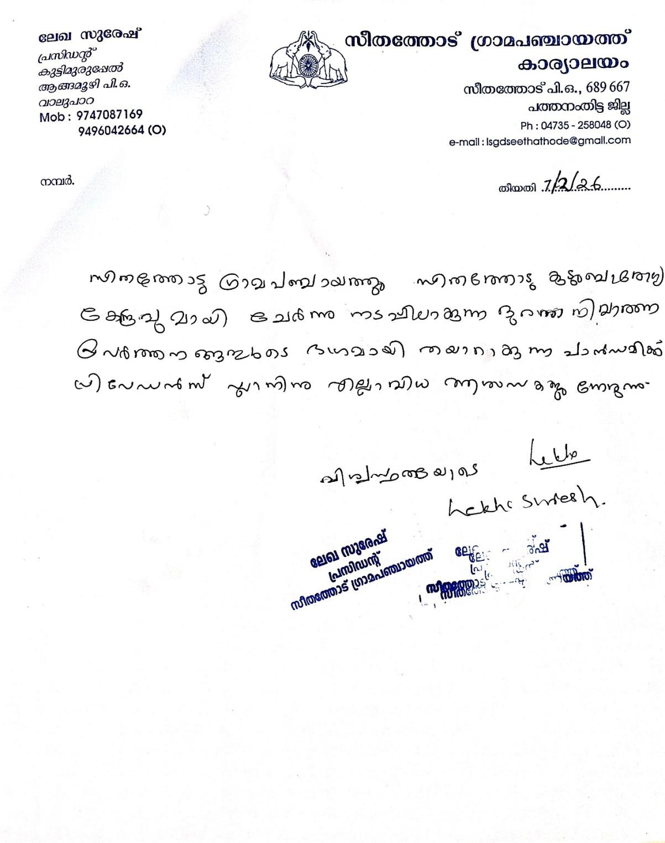

MESSAGE FROM HEALTH STANDING COMMITTEE CHAIR
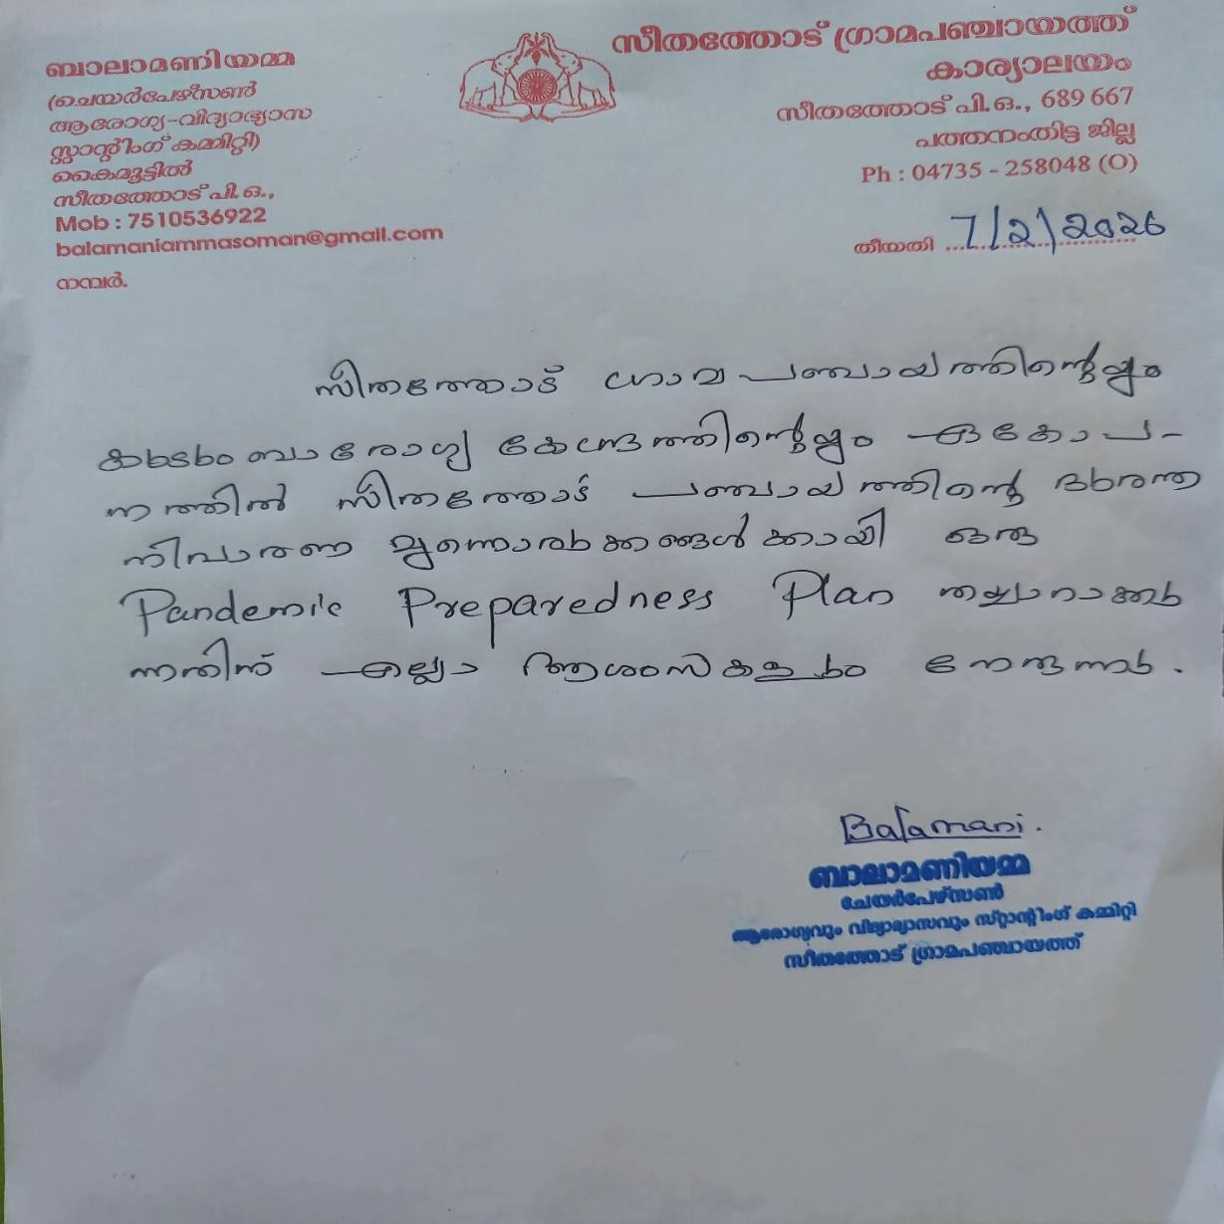

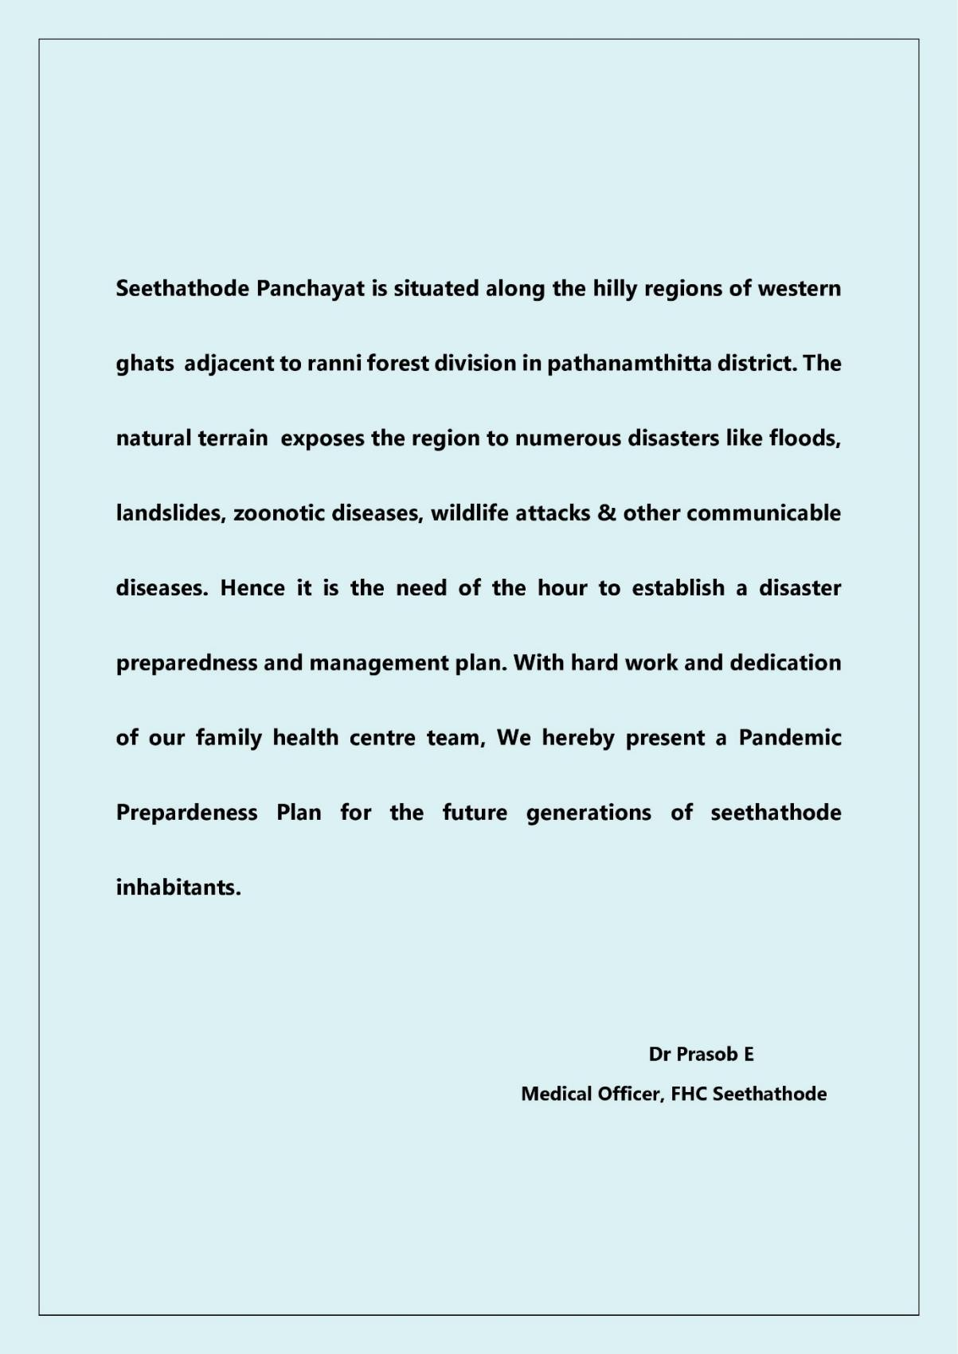
MESSAGE BY MEDICAL OFFICER
EXECUTIVE SUMMARY

Family Health Centre (PHC) functions as the primary public healthcare institution serving the population of Seethathode Grama Panchayath. The PHC plays a pivotal role in delivering comprehensive, accessible, and affordable healthcare services, with a strong focus on preventive, promotive, curative, and rehabilitative care in accordance with national and state health programmes.
The FHC caters to a predominantly rural population, addressing key public health priorities such as maternal and child health, communicable and non-communicable disease control, immunization, family welfare, adolescent health, and geriatric care. Regular outpatient services, home-based care through field health staff, and outreach activities ensure healthcare coverage even in geographically challenging areas. The institution actively implements national health missions, including the National Health Mission (NHM), National Tuberculosis Elimination Programme, National Programme for Prevention and Control of Cancer, Diabetes, Cardiovascular Diseases and Stroke (NPCDCS), and other disease surveillance initiatives.
Seethathode FHC works in close coordination with the Grama Panchayath, ASHA workers, Anganwadi centres, schools, and community-based organizations to strengthen community participation and improve health awareness. Emphasis is placed on early detection, timely referral, health education, and lifestyle modification to reduce disease burden and improve overall health outcomes.
Despite constraints related to infrastructure, manpower, and increasing service demand, the PHC continues to enhance service delivery through effective planning, data-driven decision-making, and community engagement. Strengthening facilities, upgrading digital health systems, and expanding preventive services remain key focus areas for future development.
Overall, Seethathode Family Health Centre stands as a vital institution in safeguarding public health and improving the quality of life of the residents of Seethathode Grama Panchayath

LIST OF ABBREVIATIONS

LSGD/LSGI | Local Self Government Department / Local Self Government  Institution
BMO | Block Medical Officer
IDSP | Integrated Disease Surveillance Programme
NDMA | National Disaster Management Authority
PPE | Personal Protective Equipment
ICMR | Indian Council of Medical Research
CD | Communicable Diseases
NCD | NON-COMMUNICABLE DISEASES

TABLE OF CONTENTS

3

INTRODUCTION 10
- Background of the PPP 10
LSGD AT A GLANCE 10
INTEGRATED HEALTH INFRASTRUCTURE MAP OF SEETHATHODE PANCHAYAT11
GENERAL PROFILE OF THE LSGI’S 14
Background of the LSGI 14
Demographic and Vulnerable Population 16
Clinical Vulnerability 17
INFRASTRUCTURE & RESOURCE INVENTORY 19
Health Facility Directory & Basic Capacity in the LSGD 19
Private Clinics 20
Healthcare Education & Training Institutions 20
Specialized Services & Emergency Inventory 20
Oxygen & Diagnostic Capacity 21
Diagnostics facility mapping at the LSGI level 22
Laboratory Identification & Basic Details 23
Social and Community Infrastructure for surge plan 23
Human resources 25
Community & Support Cadre 26
Community Organizations 27
Administrative & Emergency Services 28
Information regarding resources 28
ONE HEALTH & ENVIRONMENTAL SURVEILLANCE 29
Animal & Bird Population 29
Veterinary Infrastructure 30
Veterinary Doctors & Workforce 31
High-Risk Interface Points (Surveillance Sites) 31
Environmental Risk Mapping 32
Disease Seasonality Mapping 33
Vulnerability Mapping 34
EPIDEMIOLOGICAL TRENDS (2021–2025) 35
Disease Burden among human beings(Last 5 Years) 35
*(use the above table data to create the graph/diagram) 37
Seasonal Trend Analysis 38
Outcome-Based Trend Analysis- 2025 40
Transmission Trend- 2025 41
Integrated Disease Hotspot Map (2021–2025) 43
Preparedness and Response Protocol at LSG Level 45
Constitution of One Health Committee 45
Pandemic Response Workforce 46
Activities and Measures before and during Pandemic 48
PHASE 1 - Alert / Preparation 48
PHASE 2 - Active Response 51
Standard Screening Protocol 52
PHASE 3 - Surge Capacity 61
Conversion of Community Facilities 61
CONCLUSION 62
RECOMMENDATIONS 63
ANNEXURE 64
- IMPORTANT PHONE NUMBERS 64

INTRODUCTION

Background of the PPP

Seethathode Grama Panchayat is situated in the eastern highland region of Pathanamthitta District, Kerala, characterized by predominantly hilly terrain, dense forest areas, plantation belts, river stretches, and widely scattered rural settlements. The Panchayat has a diverse population comprising children, working-age adults, elderly persons, and tribal communities residing in remote and forest-fringe areas. Livelihoods are largely dependent on agriculture, plantation activities, daily wage labour, forest-related occupations, and small-scale trade. The geographical remoteness of certain habitations, limited transportation connectivity, seasonal monsoon impacts, and dependence on natural water sources contribute to increased vulnerability during public health emergencies. Additionally, the presence of socio-economically disadvantaged groups and populations with limited access to healthcare services further heightens risk during pandemics. In this context, the formulation of a comprehensive Pandemic Preparedness Plan is essential to strengthen disease surveillance, ensure early detection and containment, safeguard vulnerable communities, and maintain continuity of essential services. The plan establishes a structured framework for coordinated response, efficient resource mobilization, inter-departmental collaboration, and community participation, thereby enhancing the resilience and preparedness of Seethathode Grama Panchayat against future public health emergencies.

LSGD AT A GLANCE
Seethathode Grama Panchayat is a rural Local Self-Government Institution situated in the eastern highland region of Pathanamthitta District, Kerala. The Panchayat is characterized by predominantly hilly terrain, dense forest areas, river stretches, and widely scattered settlements, including remote forest-fringe habitations. The population comprises children, working-age adults, elderly persons, and a notable proportion of Scheduled Tribe communities residing in interior areas. The socio-economic structure is largely dependent on agriculture, plantation activities (particularly rubber and allied crops), daily wage labour, forest-related occupations, and small-scale trade. A section of the population belongs to economically weaker households reliant on welfare schemes and social security measures. Basic infrastructure facilities such as primary health institutions, anganwadis, schools, road networks, drinking water schemes, and electrification are available, though access in certain remote and hilly regions may be limited. Community-based organizations, self-help groups, and local development initiatives play an active role in grassroots governance and social development. Overall, Seethathode Grama Panchayat reflects a geographically challenging yet socially cohesive rural community with ongoing efforts toward inclusive development and strengthened public service delivery.

- Geographical boundaries with political map ( based on latest delimitation)
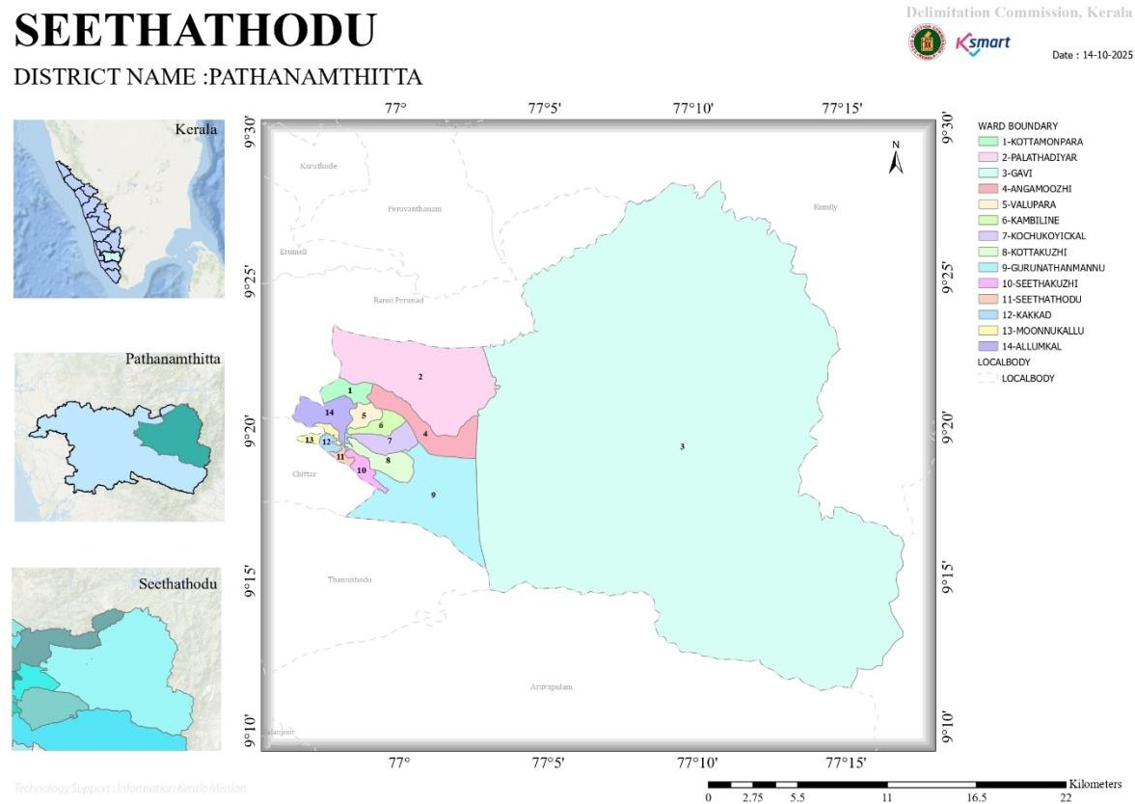
- Baseline data
No.of wards | 14
No.of Houses | 4844
Population | 18222
Male
Feamale
Transgender
Below one year
1-5 yr
10-19 yr
30-60 yr
Above 60 yr
Differently abled
Total EC
Asha workers
AWW
ORT depots
ST nagar
SC Nagar
Extreme poverty families
ICDS Anganwadies
Govt hospitals
Allopathy
Ayurveda
Homeo
Private Hospitals
Allopathy
Ayurveda
Homeo
Dental clinics
Clinical laboratories
Educational institutions
Govt HSS
HS
UPS
LPS
Pre primary
Aided school HSS
HS
UPS
LPS
Pre primary
Un aided schools HSS
HS
UPS
LPS
Pre primary
Colleges
Poly techniques
Govt institutions state
Central
Hostels
Medical colleges
Nursing colleges
Orphanage
Old age homes
Temple
Church
Mosque
No.of private well
Public well
Pumbing station
Public libraries
Arts and sports clubs
Soda factories
Hotel and tea shop
Thattukada
Market
Slaughter house
Construction area
Rubber plantation
Pineapple plantation

- Ward division -
Ward | Houses | Populati on | Migrants | Wells | Hot Spots | Ed. Instituti ons | Hosp pvt/govt.
14 | 4844 | 18222 | 101 | 1636 | 3 | 10 | 5

- KOTTAMANPARA
- PALATHADIYAR
- GAVI
- ANGAMOOZHI
- VALUPARA
- KAMBILINE
- KOCHUKOICKAL
- KOTTAKUZHI
- GURUNATHANMANNU
- SEETHAKUZHI
- SEETHATHODU
- KAKKADU
- MOONUKALLU
- ALUMKALLU
- Risk stratification among wards in the context of Communicable diseases and hazards
Dengue:6,7,8,11
- Major Roads/rivers
- Kakkad River-Significant tributary of Pamba River
- Transit:Pathanamthitta -Angamoozhy-Kumily
- Major establishments with geospatial mapping
- Hydroelectric dam-Kakki Dam and Anathode Dam surrounding Forest Area
- Small scale restaurants and local medias
- Occupational groups, socio cultural groups, migration & mobility patterns
- Rubber,cocnut,spices
- Malai Pandaram Tribal community
- Settler Population (migrated for agricultural purposes)
- Vulnerability mapping

- Disaster prone areas (geographic vulnerability)
As per the hazard zonation and vulnerability profile indicated in the District Disaster Management Plan (DDMP) and guidelines of the Kerala State Disaster Management Authority (KSDMA), Ward 11 of Seethathode Grama Panchayat is categorized under a disaster-prone area owing to its hilly topography, forest-fringe location, and proximity to river stretches and natural drainage channels. The ward is susceptible to intense monsoon rainfall, localized flooding along riverbanks, surface runoff accumulation, and soil erosion in sloped areas. Certain pockets may also face limited road connectivity and temporary isolation during extreme weather events. The environmental conditions, including water stagnation and dense vegetation, create favorable circumstances for vector breeding, thereby increasing the risk of communicable diseases such as Dengue and Leptospirosis during post-monsoon periods. The presence of scattered and remote habitations further heightens vulnerability in terms of timely access to healthcare and emergency services.

The identification of geographic vulnerability in Ward 11 is a critical component of the Pandemic Preparedness Plan of Seethathode Grama Panchayat. Incorporating disaster risk data into health planning enables risk-based surveillance, prioritization of high-risk and hard-to-reach populations, and pre-emptive public health interventions. Geographic vulnerability mapping supports advance logistical arrangements, including pre-positioning of essential medicines, strengthening outreach services, and ensuring uninterrupted supply chains during adverse weather conditions. It also facilitates coordinated inter-departmental response, targeted awareness campaigns, and decentralized containment strategies in vulnerable localities. Integrating disaster risk considerations into pandemic preparedness enhances the resilience, responsiveness, and equity of the Panchayat’s public health system.

Maps - ward-based (Mention source also)

- Geographical boundaries - ward boundaries map

- Health infrastructure map
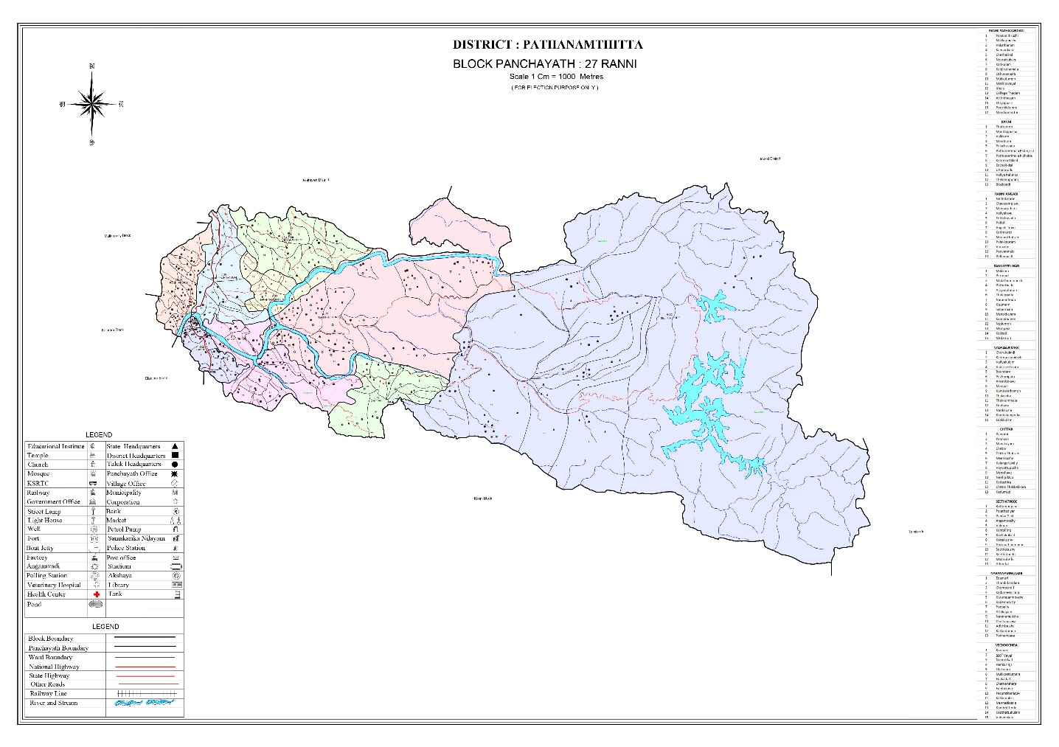
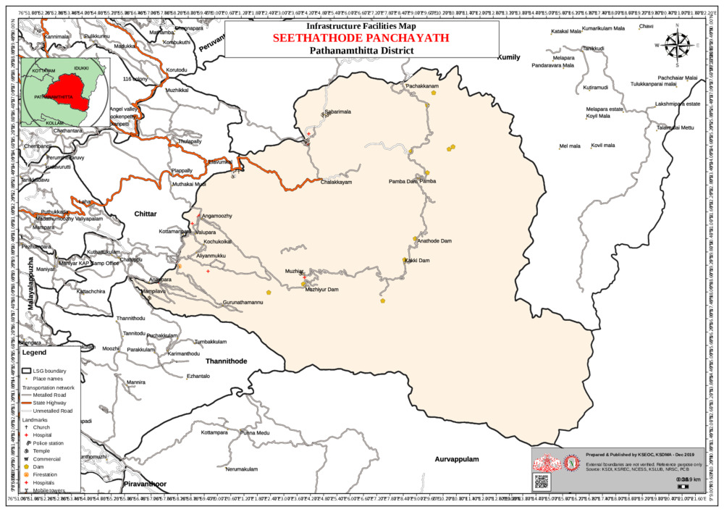
- roads and rivers map
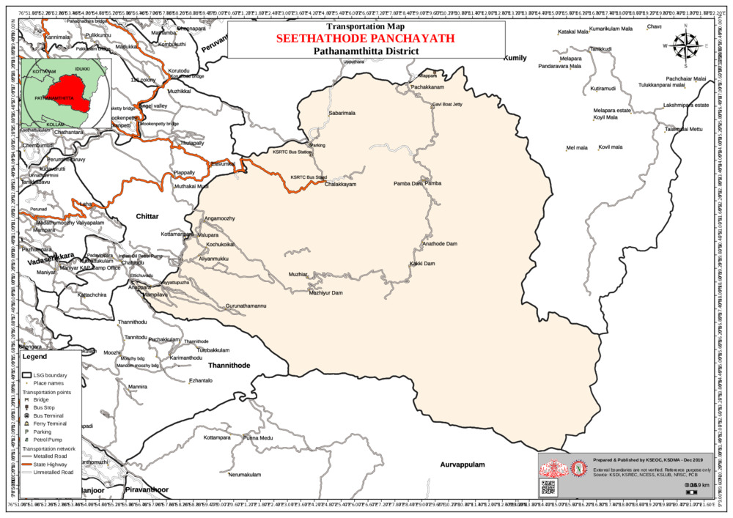

- disaster-prone areas map
Flood affected area
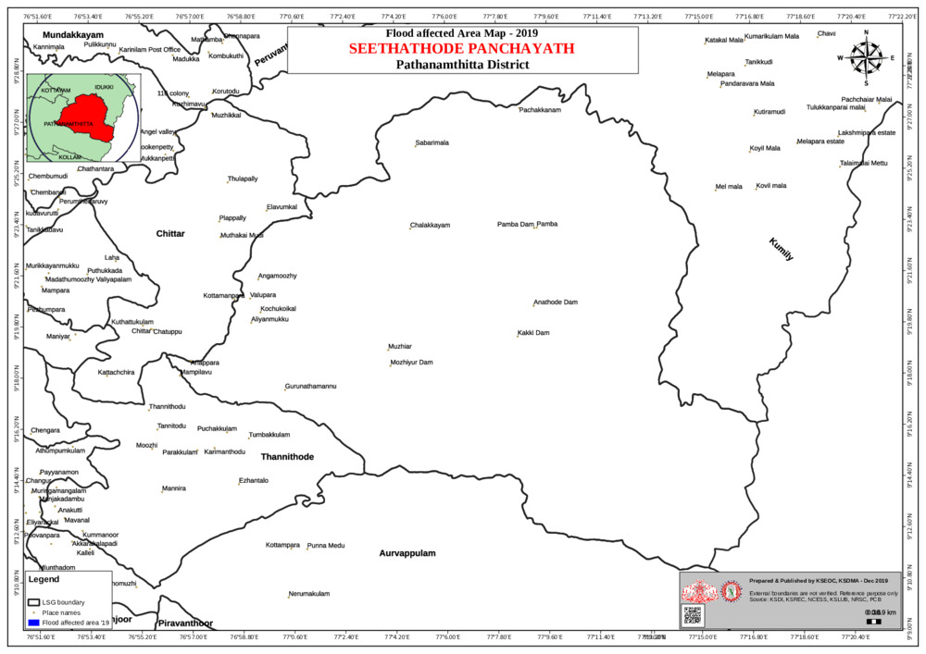

Landslide affected area
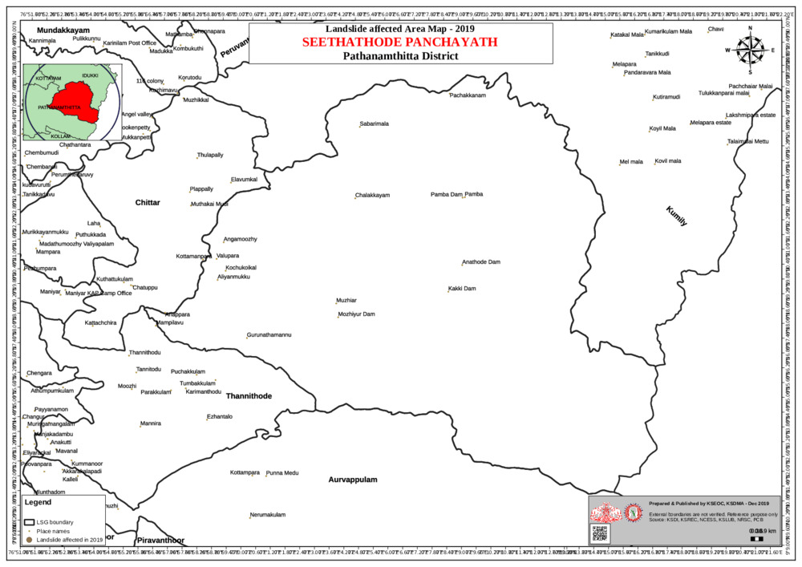
- hotspot map - CD & disasters

INTEGRATED HEALTH INFRASTRUCTURE MAP OF
SEETHATHODE PANCHAYAT

GENERAL PROFILE OF THE LSGI’S

Background of the LSGI
Seethathode Grama Panchayat is situated in the eastern highland region of Pathanamthitta District, Kerala. The geographical landscape of the Panchayat is predominantly hilly and forested, characterized by dense reserve forests, plantation areas, river stretches, and widely dispersed rural and tribal settlements. The presence of river systems and forest ecosystems significantly influences the local microclimate and environmental conditions. This unique and geographically challenging terrain poses distinct constraints to transportation, accessibility, emergency response, and service delivery, particularly during the monsoon season when heavy rainfall may lead to road disruptions, landslides in vulnerable pockets, and localized flooding in low-lying areas..
The Panchayat is administratively divided into multiple wards, with a population predominantly dependent on agriculture and plantation-based livelihoods. Rubber cultivation and other plantation crops form a major component of the local economy, along with subsistence farming and allied agricultural activities. A considerable section of the population is engaged in daily wage labour, forest-related occupations, small-scale trade, and employment in public and private service sectors. The Panchayat also includes Scheduled Tribe communities residing in interior and forest-fringe areas, whose livelihoods are closely linked to agriculture and natural resources. In addition, migrant labourers are present in sectors such as plantation work and construction, contributing to the local workforce.
From a public health and disaster management perspective, Seethathode Grama Panchayat is vulnerable to challenges associated with heavy monsoon rainfall, hilly and forested terrain, localized flooding along river stretches, and the risk of waterborne and vector-borne diseases such as Dengue and Leptospirosis. The extreme weather events and floods experienced in Kerala in recent years, including the 2018 flood disaster, had considerable impact on life, livelihoods, transportation networks, and essential infrastructure within the Panchayat. The presence of remote and forest-fringe habitations further complicates emergency response and timely service delivery during such situations. These recurring emergencies have emphasized the need to strengthen local preparedness, improve response mechanisms, and enhance coordination among departments and community stakeholders.

In this context, the development of a localized, data-driven Auxiliary Infrastructure and Logistical Resource Map is essential to facilitate systematic planning, timely emergency response, and sustainable development initiatives. Such mapping enables the Panchayat to identify vulnerable zones, critical facilities, transportation routes, and available resources, thereby improving accessibility during disasters, ensuring continuity of essential services, and enhancing the overall resilience and preparedness of the community.

Table 1: Background of LSGD
Description | Details
Name of LSGI | Seethathode
Type (GP/Municipality / Corporation etc.) | Grama Panchayath
Block | Ranni
District | Pathanamthitta
Number of wards |  | 14
Total area (sq. km) |  | 651.94
Population(Projected) |  | 18222
Population density |  | 28 persons/sq km
Terrain (coastal/low-lying/backwaters/foothills, etc.) |  | Hilly
Number of rivers passing through LSGI |  | 1
Number of water bodies in the LSGI |  | 2
Number of educational institutions |  | 10
Factories / small-scale industries |  | 0
Flood-prone wards |  | 1
Landslide-prone wards |  | 1
Death Management and Disposal Facilities (mortuaries/crematorium, including electric) |  | Crematorium – electric
Auditoriums/Marriage halls/convention centres/community halls |  | 9

Demographic and Vulnerable Population
Understanding the demographic composition and vulnerable population groups is essential for pandemic preparedness. Children, elderly, economically deprived families, migrant workers, and socially vulnerable groups are at increased risk during public health emergencies due to higher exposure, limited access to services, and dependency on public systems..

Description |  | Details (in numbers)
DEMOGRAPHIC PROFILE
Total population |  | 18222
Male |  | 9268
Female |  | 8954
Transgender |  | NIL
Children under 5 |  | 640
Adolescent |  | 700
Elderly (>60) |  | 3271
SOCIAL/LIVELIHOOD VULNERABILITY
Previous EPEP family |  | 30
BPL family |  | 23
Tribal communities |  | 3
Migration | Immigrant | 0
Migration | Emigrant | 0
Socio-economically deprived |  | 0
Fisherfolk |  | Nil
SC Community |  | 1590
ST Community |  | 387

Clinical Vulnerability
Certain population groups needs priority healthcare & are at higher risk of severe illness, complications, and mortality during pandemics. Patients with chronic diseases, those requiring regular medical care, and individuals with mobility or functional limitations face challenges in accessing timely care during emergencies. Mapping these groups helps in prioritizing continuity of treatment, medicine stock planning, oxygen support, referral transport, and targeted home-based care.

Description | Details in numbers
Pregnant women | 80
Lactating mothers | 151
Bedbound patients | 131
Patients under palliative care other than bedbound | 208
Patients on Haemodialysis | 19
Patients on CAPD | 0
Cancer patients (currently on treatment) | 57
Haemophilic patients | 0
Mentally challenged | 37
Differently abled | 9
Diabetic patients | 1599
Hypertensive patients | 1470
TB patients | 3

As per the consolidated data on Priority Vulnerable Health Groups in Seethathode Grama Panchayat, a substantial number of individuals fall under clinically high-risk categories requiring special attention during public health emergencies. The largest group comprises chronically ill patients categorized as “other than bedbound” (over 200 cases), followed by bedbound patients (approximately 130–140 cases). Cancer patients (around 55–60 cases), mentally challenged individuals (approximately 35–40 cases), and patients undergoing haemodialysis also constitute significant vulnerable segments. Smaller yet high-risk groups include TB patients and differently abled individuals. These categories represent populations with compromised immunity, chronic non-communicable diseases, dependency on continuous medical care, or limited mobility, thereby increasing their susceptibility to severe morbidity and mortality during pandemics and infectious disease outbreaks.
The systematic identification and documentation of clinical vulnerability groups form a core component of the Pandemic Preparedness Plan of Seethathode Grama Panchayat. This data enables evidence-based risk stratification, prioritization for vaccination and prophylactic interventions, targeted health surveillance, and early referral mechanisms during outbreaks. It supports advance logistical planning for uninterrupted supply of essential medicines, dialysis services, palliative and home-based care for bedbound patients, and continuity of treatment for cancer and TB patients. Furthermore, mapping of vulnerable individuals facilitates doorstep service delivery, teleconsultation support, and coordinated action by health workers, ASHAs, and community volunteers, particularly in remote and forest-fringe areas. Integrating clinical vulnerability data into preparedness planning enhances equity in healthcare access, reduces adverse health outcomes, and strengthens the Panchayat’s overall resilience and response capacity during pandemics.

Major Festivals & Events specific to the LSGI
(with the possibility of a public gathering)

Sl.  No. | Name of festival | Month detailing the periodicity
1 | Makaravilakku festival | January 14
2 | Aluvamkudi siva temple festival | February 15

INFRASTRUCTURE & RESOURCE INVENTORY

Health Facility Directory & Basic Capacity in the LSGD
This section provides an overview of the healthcare infrastructure available within the LSGD area. It outlines the distribution and basic capacity of health facilities that form the backbone of service delivery during routine times and public health emergencies.

Family Health Centres (FHCs) and Community Health Centres (CHCs) generally function as the first point of contact for the community, providing essential outpatient and inpatient services. General Hospitals (GH) and Medical College Hospitals (MCH), where accessible, serve as the main referral centres for advanced diagnostics, specialist care, and critical services during public health emergencies. This inventory helps identify existing strengths, gaps, and potential surge capacity that can be mobilised during a pandemic or disaster.

Table 5. Health Facility Resource Summary
Sl.  no. | Health Facility | Type of Facility (MCH/G  H/CHC/ FHC/SC  etc.) | Contact Number | Total beds | ICU  Beds | Oxygen- Support ed Beds | No. of Ventilator Support Beds | No. of ambulance s
Government Healthcare Facilities
1 | FHC Seethathode | FHC | 9495549794 | 0 | 0 | 0 | 0 | 2
2 | FHC Angamoozhy | FHC | 98950434486 | 0 | 0 | 0 | 0 | 0
Private Healthcare Facilities
1 | V Care Hospital | Clinic | 8547964854 | 0 | 0 | 0 | 0 | 1
2 | Amma Clinic | Clinic | 8281885755 | 0 | 0 | 0 | 0 | 0
3 | Alfa Clinic | Clinic | 8281402230 | 0 | 0 | 0 | 0 | 0
AYUSH Healthcare Facilities
1 | Ayurveda hospital | Ayush |  | 0 | 0 | 0 | 0 | 0
2 | Homeo hospital, seethathode | Ayush |  | 0 | 0 | 0 | 0 | 0
3 | Homeo dispensary , Nilakkal | Ayush |  | 0 | 0 | 0 | 0 | 0

Private Clinics
Private clinics are an essential part of pandemic preparedness, as they are often the first place people seek care when symptoms begin. In many communities, private clinics manage a significant share of outpatient visits and therefore play a critical role in early case detection, timely referrals, and disease surveillance. Having an up-to-date understanding of where these clinics are located, the services they provide, and how they are linked to the public health system helps ensure that no cases are missed during an outbreak. It also allows health authorities to engage private practitioners more effectively for reporting, risk communication, and coordinated response, strengthening the overall capacity of the health system to manage public health emergencies.

Table 6. Private Clinic Resource Summary
Sl No. | Name of Clinic | Registered (Y/N) | Clinic  (General / Speciality) | Speciality (if any) | Address | Contact Number | Diagnostic  Facility (Y/N) | Ambulance  Linkage (Y/N)
1 | Amma  clinic | Y | General | Nil | Seethatho  de | 8281885755 | Y | N
2 | V care  clinic | Y | General | Nil | Seethatho  de | 8547964854 | Y | Y
3 | Alpha  care | Y | General | Nil | Moonnuk  allu | 8281402230 | Y | N

Healthcare Education & Training Institutions
This section tracks the educational infrastructure available, which is vital for human resource planning in the health sector.

Category of Institution | Govt | Private | AYUSH | Total
Medical Colleges | 0 | 0 | 0 | 0
Nursing Colleges | 1 | 0 | 0 | 1
Dental Colleges | 0 | 0 | 0 | 0
Para-medical / Allied Health | 0 | 0 | 0 | 0
Pharmacy Colleges | 0 | 0 | 0 | 0

Specialized Services & Emergency Inventory
Item | Govt | Private | AYUSH | Total
Hospital beds | 0 | 0 | 0 | 0
Oxygen-generating systems(Y/N) | N | N | N | 0
Oxygen-supported beds(Numbers) | Y | N | N | 0
Ventilator-supported beds | N | N | N | 0
ICU beds | 0 | 0 | 0 | 0
Burns units | 0 | 0 | 0 | 0
Blood centres | 0 | 0 | 0 | 0
BLS ambulances | 1 | 1 | 0 | 2
ALS ambulances | 1 | 0 | 0 | 1
Dialysis facilities | 0 | 0 | 0 | 0
Dispensaries | 2 | 3 | 3 | 8
Medical store | 0 | 5 | 0 | 5
Industrial establishments(Medium-scale industries/small-scale industries establishments to whom we can depend in a worst-case scenario) | 0 | 0 | 0 | 0
This section provides a detailed view of the specialized medical resources available to the community, focusing on emergency response and critical care capabilities. This table tracks the vital assets required for managing severe illnesses and emergencies across Government, Private, and AYUSH sectors.

Oxygen & Diagnostic Capacity
Name of Health Facility | Oxygen- generating System (Y/N) | Backup Oxygen Source (Y/N) | Diagnostic Facilities Available(Y/N)
Name of Health Facility | Oxygen- generating System (Y/N) | Backup Oxygen Source (Y/N) | Lab | USG | X-ray | CT/MRI | RT-PCR
Government Healthcare Facilities
Fhc Seethathode | N | Y | Y | N | N | N | N
Fhc Angamoozhy | N | Y | Y | N | N | N | N
Monitoring oxygen and diagnostic capacity is a critical component of public health preparedness, ensuring that the LSGD can handle both chronic care and sudden surges in respiratory or infectious diseases.

Diagnostics facility mapping at the LSGI level
The diagnostic capacityof G.P represents the "intelligence network" of our healthcare system. The speed and accuracy of disease identification depend entirely on the distribution and technical level of these facilities.
Item | Govt | Private | AYUSH | Total
General labs | 2 | 4 | 0 | 6
Microbiology labs | 0 | 0 | 0 | 0
RT-PCR labs | 0 | 0 | 0 | 0
USG units | 0 | 0 | 0 | 0
CT/MRI units | 0 | 0 | 0 | 0
Research labs | 0 | 0 | 0 | 0
Labs of other departments that can be repurposed | 0 | 0 | 0 | 0

Laboratory Identification & Basic Details

Sl.  No. | Name of Laboratory | Ownership (Govt /  Private / Academic) | Address | Contact No. | 24×7  Services (Yes/No) | NABL /  Govt Approved (Yes/No)
1 | Fhc Seethathode | Govt | Fhc |  | N | Y
 |  |  | Seethath | 949554979
 |  |  | ode | 4
2 | Fhc | Govt | Fhc |  | N | Y
 | Angamoozhy |  | Angamo | 989504348
 |  |  | ozhy | 6
3 | Neethi Labs | Private | Seethath  ode |  | N | N
4 | Medicare Labs | Private | Seethath | 854796485 | N | N
 |  |  | ode | 4
5 | Alphacare Labs | Private | Moonnu  kallu | 828140223  0 | N | N
6 | Thekkumkal | Private | Seethath | 828188575 | N | N
 | Labs |  | ode | 5

Social and Community Infrastructure for surge plan
This table serves as our logistics and shelter inventory. By mapping these locations, quickly we can identify where to house displaced citizens, where to set up temporary medical clinics, and how to manage the deceased with dignity during a crisis.

Category | Total Count | Ward | Est. Capacity (Persons) | Contact details
Educational Institutions
Anganwadis | 26 |  |  | 9048327778
Schools | 10 | 12,4, | 100 | 9446502150
Colleges | 1 | 11 | 50 | 9539067044
Healthcare Educational Institutions
Medical colleges (Govt/Private) | 0 | 0
Nursing colleges (Govt/Private) | 1 | 12 | 50 | 9539067044
Dental colleges (Govt/Private) | 0
Paramedical institutes (Govt/Private) | 0
Community Gathering Spaces
Community halls | 4 | 10,5,4 | 150
Auditoriums | 4 | 4,12 | 100
Religious buildings | 1 | 2 | 100
Vulnerable Group Support Facility
Destitute homes | 0 | 0
Elderly homes | 1 | 7 | 50
LSGD owned other buildings | 1 | 4 | 50
Mass Fatality Management (MFM) Infrastructure
Mortuary | 0 | 0 | 0
Crematorium | 1 | 4

Human resources
This section focuses on the human capital available within the LSGI. In any emergency—be it a pandemic, flood, or industrial accident—infrastructure is only as effective as the people operating it.

Medical & Clinical Personnel
This table tracks the "Frontline" providers responsible for diagnosis, treatment, and clinical management. Narrative sentence: eg., "Total health workforce: 450 personnel, with 60% in government facilities serving as primary surge capacity." A detailed directory with the contact numbers of all workers is maintained (Annexure in 1).

Cadre | Govt (No.) | Private (No.) | Total
Doctors—Modern Medicine | 4 | 3 | 7
Doctors – AYUSH | 2 | 0 | 2
Doctors – Veterinary | 1 | 0 | 1
Doctors – Dental | 1 | 0 | 1
Nursing officers | 5 | 12 | 17
Lab technicians | 2 | 8 | 10
Optometrist | 1 | 0 | 1
Pharmacists | 3 | 8 | 11
Psychologists | 0 | 0 | 0
Counsellors | 0 | 0 | 0

Public Health & Field-Level Workforce
These individuals are the backbone of surveillance, maternal-child health, and decentralized care.

Cadre | Health services | Municipal common services | Total
HS (Health Supervisors) | 0 | 0 | 0
HI (Health Inspectors) | 1 | 0 | 1
LHS (Lady Health Supervisor) | 0 | 0 | 0
LHI (Lady Health Inspectors) | 1 | 0 | 1
JPHN (Jr Public Health Nurses) | 5 | 0 | 5
JHI (Jr Health Inspectors) | 6 | 0 | 6
MLSP (Mid-Level Service Providers) | 5 | 0 | 5
Palliative Nurses | 1 | 0 | 1
RBSK Nurses | 1 | 0 | 0
PRO | 0 | 0 | 0
Epidemiologist | 0 | 0 | 0
Data Manager | 0 | 0 | 0

Community Organizations
This section details the presence of community-based organisations (CBOs), non-governmental organisations (NGOs), faith-based organisations (FBOs), Kudumbashree Self-Help Groups (SHGs), and Ayalkootams within the Local Self-Government Institution (LSGI). These groups enhance grassroots mobilization, resource distribution, and support networks crucial for pandemic response and community resilience.

Category | Total Count
NGOs | 0
Religious based organizations | 28
Foreign based organizations | 0
Sports Club/youth clubs | 8
Kudumbashree SHGs | 152
Ayalkootams | 152
Political organizations | 16
Residential organizations | 4

Administrative & Emergency Services
This section outlines the availability of key non-health emergency support services and infrastructure within the LSGI, which are essential for effective pandemic preparedness and response. These facilities support law enforcement, disaster response, water supply, logistics, mobility, and community-level interventions during public health emergencies.

Category | Total Count | Contact details
Police Stations | 1 | 04735279190
Fire & Rescue Stations | 1 | 04735258101
Water Pumping Points | 1 | 9747846275
Public Distribution System (PDS) | 14

Information regarding resources
The availability of essential transport and support resources plays a quiet but critical role in saving lives. Equipment such as ambulances, mobile mortuaries, amphibian ambulances, and motorized boats ensures that patients, samples, and healthcare teams can move swiftly—even in flooded, remote, or difficult terrains. Heavy vehicles like JCBs, cranes, tractors, and torus lorries support logistics, waste management, emergency infrastructure, and rapid conversion of spaces into care or isolation facilities. Taxis, four-wheel-drive vehicles, and trucks help maintain continuity of essential services, reach vulnerable populations, and support home-based care and supply delivery.

Means of transportation | Total Count
JCB | 8
Crane | 1
Heavy Trucks | 0
Tractor | 4
Ambulances | 5
Mobile mortuaries | 0
Boats | 0
Taxi service | 9
Note: For specific details regarding vehicle owners and contact information, please refer to
Annexure [X].

ONE HEALTH & ENVIRONMENTAL SURVEILLANCE

The One Health approach integrates environmental, animal, and human health systems to ensure proactive and coordinated pandemic preparedness at the grassroots level. In the context of Seethathode Grama Panchayat, characterized by dense forest areas, river stretches, plantation belts, and close interaction between human populations, livestock, and wildlife, strengthening Panchayat-level surveillance is critical for the early detection and management of zoonotic and environmentally linked diseases. Enhanced surveillance requires systematic assessment of livestock and backyard poultry populations, veterinary service infrastructure, local slaughter practices, and monitoring of wildlife–human interface zones, along with effective inter-sectoral coordination among the Health, Animal Husbandry, Forest, and Local Self-Government Departments. The application of GIS-based tools, seasonal disease trend analysis, and avian influenza risk mapping based on previous outbreak experiences can facilitate predictive alerts and ward-level targeted sampling. Such integrated, data-driven surveillance mechanisms are particularly essential in ecologically sensitive and high-risk areas of Seethathode Grama Panchayat to strengthen early warning systems and ensure comprehensive pandemic preparedness and response.

Animal & Bird Population
Mapping animal and bird populations at the Panchayat level is essential for identifying and prioritising zoonotic disease hazards like rabies, avian influenza (H5N1), leptospirosis, anthrax, and Nipah-like spillover occurrences. Risk classification, targeted surveillance, vaccination planning, and early epidemic detection made feasible by comprehensive population mapping all enhance One Health-based pandemic preparedness.

Category |  | Item |  | Estimated Population |  | Wards
Animal Population |  | Livestock (Cattle/Goats/Buffalo) |  | 3339
 |  | Pet Animals (Dogs/Cats) |  | 2985
 |  | Stray Dog Population |  | 42
 |  | Pig Farms (Number of heads) |  | 3(128)
 |  | Small Units (Sheep / Goats – clustered) |  | 0
Bird Population | Poultry Units (Birds) |  | 4
Bird Population | Poultry- (FOWL) |  | 29245
Bird Population | Wild/Migratory Birds (Observed) |  | 0
Bird Population | Crow Mortality Events (Reported) |  | 0

The main risk of zoonotic diseases in Gurunathanmannu is concentrated in Wards 9, which is explained by the high density of pig farms, cattle congregation areas, and poultry units. The stray dog population in market areas, fish landing sites, bus stations continues to be a substantial problem for rabies surveillance and bite prevention. There is a considerable risk of avian influenza introduction and amplification during November - December due to the seasonal presence of migratory and resident water birds near ponds/ canal / river / backwater / paddy field. Clusters of pig farms and animal shelters vulnerable to flooding further raise the risk of leptospirosis and other zoonoses mediated by the environment, especially during monsoon floods.

Veterinary Infrastructure
Veterinary institutions are a core pillar of One Health surveillance, enabling early zoonotic disease detection through vaccination, investigation of unusual animal illness or deaths, sample collection, and timely outbreak reporting. A well-mapped and responsive veterinary network strengthens coordination with human health and LSGI systems, ensuring rapid response during zoonotic events and pandemics.

Facility Type | Name of Facility | Ownership Govt  / Pvt | Location( Ward No) | Contact number
Veterinary Dispensary | Govt Veterinary dispensary | Govt | 12 | 9447020310
Veterinary Hospital / Polyclinic | 0 | 0 | 0
Private Veterinary Clinics | 0 | 0 | 0
Mobile / Emergency Vet Service (incl. night services) | 0 | 0 | 0
Pet Homes / Animal Shelters | 0 | 0 | 0
Slaughterhouse-linked Veterinary Inspection Unit | 0 | 0 | 0

Veterinary Doctors & Workforce
Early detection, diagnosis, reporting, and reaction to animal illness epidemics depend on the availability and accessibility of qualified veterinary specialists. By identifying unusual animal morbidity or mortality promptly, collecting samples promptly, and coordinating efficiently with human health and LSGI systems—especially during zoonotic outbreaks and pandemic-prone situations—a clearly defined veterinary workforce enhances One Health surveillance.

Category | Number Available | Type (Govt/Pvt) | Contact number
Government Veterinary Doctors | 1 | 1 | 9447020310
Private Veterinary Doctors | 0 | 0
Livestock Inspectors | 2 | 2
Para-veterinary Staff / Attenders | 0 | 0
Contract / On-call Veterinary Support (if any) | 0 | 0

High-Risk Interface Points (Surveillance Sites)
High-risk interface points for zoonotic disease surveillance in Seethathode Grama Panchayat include forest–livestock–human contact zones, backyard poultry units, cattle sheds located near river stretches and natural water sources, local meat stalls and informal slaughter points, and areas along forest fringes where human–wildlife interaction is frequent. Habitations in close proximity to reserve forest areas and regions with increased movement of domestic animals and wildlife also constitute critical surveillance nodes. These locations represent primary surveillance sites where the risk of zoonotic spillover is comparatively elevated, necessitating strengthened monitoring, inter-departmental coordination, and targeted sampling under the One Health framework to support effective pandemic preparedness and early warning systems.

Type of Habitat | Type of High risk interface | Geographical vulnerability
Wetlands & Backwaters | Nil
Backyard Poultry Farms | Medium
Cattle Sheds near Water  Bodies | Medium
Fish & Meat Markets | Medium
Community Slaughter Sites | Nil
Migratory Bird  Congregation Areas | 0
Rodent-Infested Grain  Storage | Medium
Category | Total Count | Key Locations (wards)
Poultry Farms | 4 | Ward 1,9
Backyard / Clustered Poultry Units | 0
Duck Rearing Units (open water access) | 0
Slaughterhouses/ Slaughter Points | 0
Meat/Fish Markets | 1
Live Bird Sale Points | 0
Cattle Markets / Weekly Animal Fairs | 0
Pet Shops / Breeders | 0
Animal Shelters / Pet Homes | 0
Waste Disposal Sites near Animal Units | 0

Environmental Risk Mapping
Environmental risk mapping identifies monsoon/flood hotspots for vector-borne (dengue, chikungunya), water-borne (leptospirosis, diarrhoea), and zoonotic diseases in Kerala's wetlands. Systematic surveillance supports early warnings, targeted interventions, and Panchayat pandemic preparedness.
Waterborne exposure: Flood-prone areas and stagnant water bodies facilitate leptospira survival, raising leptospirosis risk.

Risk Factor | High-Risk Wards | Key Locations | Risk Level (High/Med/Low)
Flood-prone areas | 1 | Ward 11 | Med
Water bodies/wetlands | 0 | 0 | 0
Solid waste accumulation | 0 | 0 | 0
Animal waste disposal issues | 0 | 0 | 0
Rodent infestation zones | 0 | 0 | 0
Industrial effluent discharge | 0 | 0 | 0
Construction sites / abandoned buildings | 0 | 0 | 0
Poor drainage/blocked canals | 0 | 0 | 0
Drinking water source contamination risk | 1 | Ward 4 | Med
Traditional practices: Informal slaughter and fish markets lack standardized hygiene, creating
spillover opportunities.

Disease Seasonality Mapping
1, Flooding & waterlogging → amplifies leptospirosis, malaria, diarrheal diseases.

2, Mosquito breeding cycles → vector-borne disease peaks in monsoon.

Disease | Peak Risk Season | Key Drivers | High-Risk Locations | Surveillance Focus
Avian Influenza | NIL | NIL | NIL | NIL
Leptospirosis | June- August | Presence of rodents | Melekottamonp ara, Kochukoickal | Idsp reports
Dengue/Chikungunya | July- November | Water scarcity | Kochukoickal, | Idsp reports
Acute Diarrheal Diseases | April- June | Water scarcity | Seethathode | Idsp reports
Rabies | February - July | Wild animals | Gurunathanma nnu | Animal conflict reports
Anthrax (rare) | Rare | No cases | Nil | Slaughter houses
3, Agricultural practices → close human–animal contact in paddy fields.

Vulnerability Mapping
Vulnerability mapping pinpoints high-risk populations, occupations, and areas exposed via environment, livelihoods, socio-economics, and poor service access. Paired with environmental/seasonality mapping, it enables risk-based surveillance, targeted actions, and optimal resource use in One Health and pandemic planning.

Vulnerability Factor | High-Risk  Wards | Key Groups /  Locations | Risk Level
Flood-prone households | 11 | Houses along  river banks | Medium
Wetland-adjacent communities | N | N
Backyard poultry / duck rearing  households | N
Livestock-rearing households | 14 | Cattle rearers | Medium
Slaughterhouse & meat market  workers | N
Fisherfolk & fish market workers | N
Sanitation workers | N
Daily wage / migrant workers | 11,12 | Migrant  employees | Medium
Elderly & chronically ill  populations | N
Pregnant Women | N
Children (schools, Anganwadi’s) | N
Limited access to safe water &  sanitation | 1,6,7,11,10,9,8,4 | Water scarcity  during summer | Medium

EPIDEMIOLOGICAL TRENDS (2021–2025)

Disease surveillance is the systematic collection, analysis, and interpretation of health data for planning, implementation, and evaluation of public health practice. This section presents the disease surveillance profile of the LSGI based on routine reporting systems and outbreak investigations to identify priority diseases, seasonal patterns, and emerging public health threats.

Disease Burden among human beings(Last 5 Years)
Analysis of disease-wise data for the last five years helps identify persistent public health problems, emerging diseases, and changes in disease burden. This information supports prioritisation of prevention, preparedness, and response activities at the Panchayat level.

Disease | 2021 | 2022 | 2023 | 2024 | 2025 | Trend(Increasing/Stable/Decreasing)
Dengue | 0 | 1 | 95 | 14 | 1 | Decreasing
Leptospirosis | 4 | 1 | 1 | 0 | 2 | Stable
Hepatitis A | 0 | 1 | 0 | 0 | 0 | Decreasing
Malaria | 0 | 0 | 0 | 0 | 0 | Stable
Scrub Typhus | 0 | 0 | 0 | 0 | 0 | Stable
Typhoid | 0 | 0 | 1 | 1 | 0 | Decreasing
H1N1 | 0 | 0 | 0 | 0 | 0 | Stable
H3N2 | 0 | 0 | 0 | 0 | 0 | Stable
ADD | 15 | 18 | 21 | 14 | 31 | Increasing
Mumps | 0 | 0 | 0 | 0 | 0 | Stable
Measles | 0 | 0 | 2 | 0 | 0 | Decreasing
Hepatitis B | 1 | 0 | 0 | 0 | 0 | Decreasing

Hepatitis C | 0 | 0 | 0 | 0 | 0 | Stable
Tuberculosis | 2 | 4 | 7 | 4 | 7 | Increasing
Leprosy | 0 | 0 | 0 | 0 | 0 | Stable
COVID-19 | 888 | 173 | 0 | 0 | 0 | Stable

The five-year epidemiological analysis (2021–2025) of Seethathode Grama Panchayat indicates a mixed disease trend, with declining vector-borne outbreaks and increasing burden of waterborne and endemic diseases.
Dengue shows a sharp outbreak in 2023 (95 cases) followed by a significant decline in 2024 (14 cases) and 2025 (1 case), indicating effective control measures and a decreasing trend post-outbreak.
Acute Diarrhoeal Disease (ADD) demonstrates a progressively increasing trend, rising from 15 cases (2021) to 31 cases (2025), highlighting ongoing sanitation and water quality challenges.
Tuberculosis (TB) shows an overall increasing trend with fluctuations (2 cases in 2021 to 7 cases in 2025), indicating the need for strengthened detection and treatment adherence.
Leptospirosis remains low and stable, with minor variations (0–4 cases), reflecting sporadic environmental exposure without clustering.
Hepatitis A, Typhoid, Measles, and Hepatitis B show declining trends, with only isolated cases in earlier years and no recent transmission.
COVID-19 shows a sharp decline from 888 cases in 2021 to zero cases from 2023 onwards, indicating successful containment and transition to non-emergency status.
The Panchayat has transitioned from outbreak-prone vector diseases (Dengue) to persistent waterborne (ADD) and endemic diseases (TB).
ADD and TB are the important public health concerns, requiring focused intervention.
Most other diseases remain stable or decreasing, with no current outbreak signals.
Overall, the findings emphasize the need for strengthened WASH interventions, sustained TB control measures, and continuous surveillance, ensuring improved public health resilience and preparedness at the Panchayat level.

Seasonal Trend Analysis
Seasonal analysis helps anticipate surges (e.g. dengue in monsoon, leptospirosis after floods, influenza in cooler months) and plan pre‑emptive vector control, stockpiling of IV fluids, and awareness campaigns at Panchayat level.

DENGUE
Dengue is a major seasonal vector-borne disease strongly associated with rainfall, water stagnation, and increased mosquito breeding during the monsoon period.

Peak: July–November
Dengue – Ward-wise Yearly Distribution (2021–2025)

Ward | Dengue – Ward-wise Yearly Distribution
Ward | 2021 | 2022 | 2023 | 2024 | 2025 | Total
1 | 0 | 0 | 0 | 3 | 0 | 3
2 | 0 | 0 | 2 | 0 | 0 | 2
3 | 0 | 0 | 0 | 0 | 0 | 0
4 | 0 | 0 | 0 | 2 | 0 | 2
5 | 0 | 0 | 9 | 0 | 0 | 9
6 | 0 | 1 | 43 | 5 | 0 | 49
7 | 0 | 0 | 19 | 0 | 1 | 20
8 | 0 | 0 | 9 | 6 | 2 | 17
9 | 0 | 0 | 0 | 0 | 0 | 0
10 | 0 | 0 | 3 | 3 | 0 | 6
11 | 0 | 0 | 4 | 6 | 0 | 10
12 | 0 | 0 | 2 | 5 | 0 | 7
13 | 0 | 0 | 4 | 1 | 0 | 5

The ward-wise analysis of Dengue over the five-year period (2021–2025) reveals a distinct outbreak pattern concentrated in 2023, followed by a marked decline in subsequent years, indicating effective control measures.
Ward 6 (49 cases) reported the highest cumulative burden, with a major spike in 2023 (43 cases) and continued low-level transmission in 2024 (5 cases), identifying it as the primary hotspot ward.
Ward 7 (20 cases) and Ward 8 (17 cases) also showed significant clustering during 2023, with residual cases in later years, indicating secondary hotspot zones.
Wards 11 (10 cases), 5 (9 cases), and 12 (7 cases) demonstrated moderate incidence, mainly linked to the 2023 outbreak.
Wards 10 (6 cases) and 13 (5 cases) reported low-to-moderate occurrence, while Wards 1, 2, and 4 showed minimal cases.
Wards 3 and 9 reported no cases, indicating absence of transmission.
The temporal distribution confirms that Dengue transmission in Seethathode is highly seasonal and outbreak-driven, with a major monsoon-associated outbreak in 2023. The subsequent decline in 2024–2025 reflects the impact of intensified vector control and surveillance measures.

This ward-level stratification supports targeted pre-monsoon interventions, prioritizing hotspot wards (6, 7, 8) for larval source reduction, vector surveillance, and community awareness activities, thereby strengthening outbreak prevention and control under the Panchayat-level public health preparedness framework.

LEPTOSPIROSIS
Leptospirosis cases are closely linked to monsoon rains, flooding, and occupational exposure, particularly in low-lying and waterlogged areas.

Peak: June - August
Leptospirosis – Ward-wise Yearly Distribution (2021–2025)

Ward | Leptospirosis – Ward-wise Yearly Distribution
Ward | 2021 | 2022 | 2023 | 2024 | 2025 | Total
1 | 0 | 0 | 0 | 0 | 2 | 2
2 | 0 | 0 | 0 | 0 | 0 | 0
3 | 0 | 0 | 0 | 0 | 0 | 0
4 | 1 | 0 | 0 | 0 | 0 | 1
5 | 1 | 0 | 0 | 0 | 0 | 1
6 | 1 | 0 | 0 | 0 | 0 | 1
7 | 0 | 0 | 1 | 0 | 0 | 1
8 | 0 | 0 | 0 | 0 | 0 | 0
9 | 1 | 0 | 0 | 0 | 0 | 1
10 | 0 | 0 | 0 | 0 | 0 | 0
11 | 0 | 1 | 0 | 0 | 0 | 1
12 | 0 | 0 | 0 | 0 | 0 | 0
13 | 0 | 0 | 0 | 0 | 0 | 0

The ward-wise analysis of Leptospirosis over the five-year period (2021–2025) indicates a low-incidence, sporadic distribution without any clustering or outbreak pattern.
Ward 1 (2 cases) reported the highest cumulative incidence, with cases occurring in 2025, indicating recent localized exposure.
Wards 4, 5, 6, 7, 9, and 11 each reported single isolated cases across different years, reflecting scattered environmental exposure.
Remaining wards reported no cases, suggesting minimal or no transmission risk.
The overall pattern suggests that Leptospirosis in Seethathode is sporadic and seasonally associated, primarily linked to monsoon and post-monsoon exposure to contaminated water and soil. The absence of clustering indicates low endemicity and effective control.
This ward-level distribution supports a preventive surveillance approach, focusing on pre-monsoon awareness, chemoprophylaxis for high-risk groups, environmental sanitation, and early fever detection to prevent potential escalation during high-risk periods

VIRAL HEPATITIS - A
Hepatitis A cases are commonly associated with unsafe drinking water, food contamination, and breakdowns in sanitation, often presenting as clusters or outbreaks.

Peak: October - December
Ward | Hep A – Ward-wise Yearly Distribution
Ward | 2021 | 2022 | 2023 | 2024 | 2025 | Total
1 | 0 | 0 | 0 | 0 | 0 | 0
2 | 0 | 0 | 0 | 0 | 0 | 0
3 | 0 | 0 | 0 | 0 | 0 | 0
4 | 0 | 0 | 0 | 0 | 0 | 0
5 | 0 | 0 | 0 | 0 | 0 | 0
6 | 0 | 1 | 0 | 0 | 0 | 1
7 | 0 | 0 | 0 | 0 | 0 | 0
8 | 0 | 0 | 0 | 0 | 0 | 0
9 | 0 | 0 | 0 | 0 | 0 | 0
10 | 0 | 0 | 0 | 0 | 0 | 0
11 | 0 | 0 | 0 | 0 | 0 | 0
12 | 0 | 0 | 0 | 0 | 0 | 0
13 | 0 | 0 | 0 | 0 | 0 | 0
Hepatitis A – Ward-wise Yearly Distribution (2021–2025)

The ward-wise analysis of Hepatitis A over the five-year period (2021–2025) indicates an extremely low incidence with no evidence of sustained transmission.
Ward 6 reported a single isolated case in 2022, representing the only occurrence during the study period.
All other wards reported zero cases, indicating absence of disease transmission across the Panchayat.
The overall trend suggests that Hepatitis A in Seethathode is sporadic and non-endemic, with no clustering or outbreak pattern observed. The isolated case may be attributed to localized or external exposure rather than community-level transmission.
This pattern supports continued preventive measures focusing on water safety, sanitation, and hygiene practices, along with routine surveillance to ensure early detection and prevention of any outbreaks

Outcome-Based Trend Analysis- 2025

Disease | 2021 | 2022 | 2023 | 2024 | 2025 | 5-Year Trend
ADD | 15 | 18 | 21 | 14 | 31 | Increase
Tuberculosis | 2 | 4 | 7 | 4 | 7 | Stable
Dengue | 0 | 1 | 95 | 14 | 1 | Decrease
Leptospirosis | 4 | 1 | 1 | 0 | 2 | stable

The five-year trend analysis indicates a mixed epidemiological pattern, with declining outbreak-prone diseases and a rising burden of waterborne conditions.
- Acute Diarrhoeal Disease (ADD) shows a clear increasing trend, rising from 15 cases (2021) to 31 cases (2025), highlighting persistent water and sanitation-related vulnerabilities, especially during monsoon periods.
- Tuberculosis (TB) demonstrates a stable trend with minor fluctuations (2–7 cases), indicating consistent detection and treatment, with no significant outbreak pattern.
- Dengue shows a sharp outbreak in 2023 (95 cases) followed by a significant decline to 1 case in 2025, reflecting effective vector control and a decreasing trend post-outbreak.
- Leptospirosis remains low and stable, with sporadic cases (0–4 annually), indicating environmental exposure without clustering.
The Panchayat has transitioned from a vector-borne outbreak scenario (Dengue) to persistent waterborne disease burden (ADD).
ADD is an important public health concern, requiring strengthened WASH interventions.
Dengue is currently under control, but requires continued seasonal surveillance to prevent resurgence.
TB and Leptospirosis remain stable, necessitating sustained routine public health measures.
Overall, the findings emphasize the need for enhanced sanitation, water quality management, and continued surveillance, ensuring improved public health preparedness and resilie

Transmission Trend- 2025
For effective management of public health issues, it is important to track the trend of disease transmission mode. It helps identify the population or place at high risk that can be used to predict outbreaks and implement targeted interventions as quickly as possible. Understanding these kinds of trends enables authorities to allocate resources efficiently and change the strategies adequately based on the trend that follows.

Mode of Transmission | No. of cases | No. of Deaths
Vector Borne Diseases | 5 | 0
Water Borne Diseases | 31 | 0
Air Borne Diseases | 7 | 0
Blood Borne Diseases | 0 | 0
Food Borne Diseases | 19 | 0

Vector-Borne Disease

Disease | No. of Cases | No. of Deaths
Dengue | 3 | 0
Malaria | 0 | 0
Chikungunya | 0 | 0

Water Borne Disease

Disease | No. of Cases | No. of Deaths
Cholera | 0 | 0
Typhoid | 0 | 0
Hep- A | 0 | 0
Dysentery | 19 | 0
Amoebiasis | 0 | 0
E- Coli infections | 0 | 0

Air Borne Disease

Disease | No. of Cases | No. of Deaths
Influenza | 0 | 0
H1N1 | 0 | 0
TB | 7
Chickenpox | 17 | 0
Measles | 0 | 0
Covid-19 | 0 | 0
Pertussis | 0 | 0
Mumps | 0 | 0

Blood-Borne Disease

Disease | No. of Cases | No. of Deaths
AIDS | 0 | 0
Hep- B | 0 | 0
Hep- C | 0 | 0

Zoonotic Disease

Disease | No. of Cases | No. of Deaths
Rabies | 0 | 0
Leptospirosis | 2 | 0
Avian influenza | 0 | 0
West nile | 0 | 0
Anthrax | 0 | 0

Nipah | 0 | 0
Scrub Typhus | 0 | 0

Integrated Disease Hotspot Map (2021–2025)
Ward | Dengue Total (2021-  25) | Leptospirosis Total (2021-25) | Hepatitis A Total (2021-  25) | Mumps (2021-25) | ADD (2021-25) | Total Cases
1 | 3 | 2 | 0 | 0 | 29 | 34
2 | 2 | 0 | 0 | 0 | 20 | 22
3 | 0 | 0 | 0 | 0 | 18 | 18
4 | 2 | 1 | 0 | 0 | 33 | 36
5 | 9 | 1 | 0 | 0 | 36 | 46
6 | 49 | 1 | 1 | 0 | 28 | 79
7 | 20 | 1 | 0 | 0 | 31 | 52
8 | 17 | 0 | 0 | 0 | 15 | 32
9 | 0 | 1 | 0 | 0 | 20 | 21
10 | 6 | 0 | 0 | 0 | 12 | 18
11 | 10 | 1 | 0 | 0 | 35 | 46
12 | 7 | 0 | 0 | 0 | 24 | 31
13 | 5 | 0 | 0 | 0 | 12 | 17

By overlaying five years of data, we have identified ward 6, ward 7, ward 8 'Red Zone'
Wards. These are wards where at least two different categories of diseases (e.g., Dengue and Lepto) recurred in consecutive years. Ward 6 is categorized as the Highest Priority Hotspot due to its combination of flood vulnerability and high vector density. Future health infrastructure, such as the proposed R.O plants at Panchayat should be prioritized.

Preparedness and Response Protocol at LSG Level
This section describes the operational framework for the LSGI once a pandemic is declared. It explains how the LSGI and health system will move from routine data collection to active response, using a One Health approach.

Constitution of One Health Committee
The LSGD shall constitute a One Health Committee comprising the LSGI President, Medical Officers (Modern Medicine, AYUSH, and Veterinary), the Health Inspector, and the Veterinary Surgeon.

Objective: The One Health Committee coordinates human, animal, and environmental health to prevent and control pandemics.

Sl No | Name | Designation | Department/I nstitution | Role in  Committee | Contact Number
1 | Lekha Suresh | Panchayat President | LSGD | Chairperson | 9747087169
2 | Dr Prasob E | Medical Officer (PHC/CHC) | Health Dept | Member Secretary | 9495549794
3 |  | Veterinary Officer | Animal Husbandry | Member | 9447020310
4 | Dr.Archana M | Epidemiologist | Health Dept | Member | 9526157363
5 | Bindhu P S | Health Inspector/PHN | Health Dept | Surveillance | 9446945988
6 | Ashagopal | ASHA Supervisor | Health Dept | Community link | 9496702979
7 | Sheeba | ICDS Supervisor | Social Welfare | Vulnerable groups | 9048327778
8 | Maheshkumar S | Police Station Officer | Police Dept | Law & order | 04735279190
9 | Lekha Suresh | Ward Councillor Representative | LSGD | Community coordination | 9747087169
10 |  | Kudumbashree CDO | Kudumbashree | Community mobilisation

11 |  | NGO/Volunteer rep | Civil Society | Support services
12 |  | Line Department representations

Key Responsibilities:
- Review disease surveillance data (human + animal)
- Conduct ward-wise risk assessment and vulnerability mapping
- Approve quarantine/isolation centre locations
- Coordinate with district for resources (PPE, oxygen, ambulances)
- Periodically review health system surge capacity, including beds, oxygen, human resources, and ambulances.
- Approve and monitor risk communication and community engagement strategies, including rumour management.
- Ensure protection and service continuity for vulnerable groups (elderly, persons with disabilities, dialysis patients, coastal populations).
- Conduct quarterly mock drills
- Monitor equity measures for vulnerable groups

Meeting Schedule:
Quarterly (normal times) | Weekly (outbreak alert) | Daily (pandemic phase)

Pandemic Response Workforce
To ensure a coordinated and timely response during a pandemic, a dedicated Pandemic Response Workforce shall be constituted at the LSG level. The workforce will function under the overall supervision of the One Health Committee and in close coordination with the health authorities. Team-based deployment will enable efficient surveillance, case management, quarantine and isolation management, logistics support, and risk communication. Each team shall have a clearly designated team leader, defined roles, and an identified pool of personnel to allow rapid activation, rotation of duties, and continuity of services during prolonged emergencies.

Total Response Workforce Available: 300 persons

Team Name | Composition | Key Responsibilities | Team Leader

Surveillance and Contact Tracing Team | HI, JHI, JPHN, ASHAs and  Volunteers | Case detection, contact listing, home visits, reporting | HI
Case Management Team | Doctors, Nurses, MLSP, Palliative Nurses | Patient care & referral | DOCTOR
Quarantine & Isolation Team | LSGD staff, Volunteers | Facility management | JHI
Psychosocial support | Counselor | Provides counselling services | Counselor
Logistics & supply chain Team | LSGD staff, Storekeepers, Drivers 3 | Supplies & transport [PPE, medicines, oxygen, transport, waste management] | Ward Member
Communication Team | Ward members, Kudumbashree, Youth clubs,  AWW workers and other self help groups | IEC, community meetings, countering misinformation | M.O in charge
Transportation | KSRTC, educational institutional buses | Transportational services | Ksrtc
Media Surveillance | Local Journalist,Volunteers | Monitoring social media,tracking Rumours | Public Relatin Officer/HI
Intersectoral coordination and convergence | LSGD President,Scretary, Health Staff | Policy Decision,Resource Pooling,Convergence | LSGD President/Secretary
Collaborative surveillance | Vets,Environmental Staff,Health Staff | One Health Tracking | Veterinary Surgeon

All teams shall be activated immediately upon outbreak alert or pandemic declaration and shall report daily to the LSG Incident Commander/Medical Officer, with consolidated reporting to the Block PHC. Duty rosters and alternate personnel shall be maintained to ensure uninterrupted services during staff shortages or prolonged response periods. Team composition and numbers may be revised based on the magnitude of the outbreak and availability of human resources.

Activities and Measures before and during Pandemic PHASE 1 - Alert / Preparation
The Alert/Preparation Phase is initiated upon receipt of early warning signals from the State or District Health Authorities, unusual clustering of cases, or global/national alerts regarding emerging infectious diseases. The primary objective of this phase is to strengthen surveillance, ensure logistical readiness, activate coordination mechanisms, and prepare the community for a potential escalation.
Surveillance and Reporting – Enhanced Syndromic Surveillance
An integrated surveillance mechanism shall be activated to ensure early detection of suspected cases and unusual health events.

1. Data Sources for Surveillance:
- Routine reporting from Primary Health Centres (PHCs), Sub Centres, and private healthcare facilities
- Syndromic surveillance reports from ASHA workers and JPHNs
- School absenteeism records
- Pharmacy sales trends (antipyretics, antibiotics, ORS, etc.)
- Laboratory reports (government and private labs)
- Community-based reporting through ward-level committees
- Mortality surveillance data
Daily/weekly consolidation and review of data shall be undertaken at Panchayat level and communicated to Block and District authorities.

2. Event-Based Triggers (to be monitored and reported):
- Sudden increase in fever cases or respiratory illness clusters
- Unusual morbidity or mortality trends
- Clustering of cases within households, schools, or institutions
- Increased absenteeism in schools or workplaces
- Reports of unexplained deaths
- Sudden spike in zoonotic or vector-borne disease cases
Trigger events shall be reported immediately to the Block Medical Officer and District Surveillance Unit.

3. Zoonotic and Animal Health Surveillance
- Coordination with Animal Husbandry Department for monitoring unusual animal morbidity or mortality
- Surveillance of stray dog population health status
- Monitoring of rodent activity in flood-prone areas
- Reporting of unusual livestock illness
A One Health approach shall be adopted to integrate human and animal health monitoring.

Logistics and Stock Preparedness
Logistical preparedness is critical to ensure uninterrupted response during escalation.
- Identify and empanel local vendors and define emergency procurement mechanisms in accordance with existing LSGD and Health Department norms.
- Prepare and maintain an essential logistics checklist covering medical supplies, consumables, and support equipment.
- Pre-identify secure storage locations for emergency stocks and ensure maintenance of stock registers with periodic updating.
- Finalise emergency transport arrangements, including availability of vehicles and identified drivers for rapid deployment.
- Designate a Nodal Officer for Logistics to enable prompt decision-making, coordination, and documentation.

Minimum Buffer Stock Verification:
- PPE kits – adequate numbers as per population risk assessment
- Pulse oximeters – sufficient for ward-level monitoring teams
- Hand sanitizers – adequate litres for institutional and community distribution
- Masks, gloves, disinfectants – sufficient buffer quantity
- Thermometers and rapid diagnostic kits (if applicable)
Critical gaps shall be identified through periodic stock audits and immediately communicated to Block and District authorities. Expiry monitoring and stock rotation shall be strictly enforced.

Identification of Quarantine and Isolation Facilities
A pre-identified list of potential quarantine and isolation facilities shall be maintained.
- Identify suitable buildings (schools, hostels, community halls, auditoriums, vacant buildings).
- Categorise cases based on severity and allocate appropriate facilities.
- Prepare a facility readiness checklist covering:
  - Bed capacity
  - Toilets and bathing facilities
  - Adequate ventilation
  - Safe drinking water
  - Electricity supply
  - Waste disposal mechanisms
- Identify alternate facilities if primary sites are unavailable.
- Designate facility managers and support staff.

Standard Operating Procedures (SOPs) shall include:
- Admission and discharge protocols
- Clinical monitoring and referral
- Food and water supply arrangements
- Infection prevention and control measures
- Biomedical and solid waste management
A rapid activation plan shall be developed to operationalize facilities within 24–48 hours if case load increases.

Risk Communication and Community Preparedness
Effective risk communication is essential to prevent panic and misinformation.
- Disseminate early warning messages on symptoms, preventive measures, and reporting mechanisms.
- Display IEC materials in English and the local language at public places.
- Conduct ward-level awareness programs.
- Sensitize elected representatives and community leaders.
- Establish rumour tracking and misinformation response mechanisms.
- Engage ward members, ASHAs, religious leaders, teachers, Kudumbashree members, and volunteers to amplify official messages.

Targeted IEC Deployment:
- Schools and educational institutions
- Markets and commercial establishments
- Construction sites and labour settings
- Public transport hubs
Community sensitization meetings shall be conducted to promote preventive behaviors and strengthen public cooperation.

Protection of Vulnerable Groups
Priority protection shall be ensured for clinically and socially vulnerable populations.
- Prepare and periodically update line-lists of:
  - Elderly persons living alone
  - Persons with disabilities
  - Pregnant women
  - Migrant workers
  - Dialysis and chronic disease patients
These line-lists shall be maintained reviewed regularly.

Clinical Dependency Mapping
Ward-wise dependency and vulnerability maps shall be developed to identify households requiring continuous support.
Ensure continuity of essential health services including:
- Dialysis services (facility linkage, transport planning, scheduling)
- TB, HIV, and chronic disease medication continuity
- Maternal and child health services
- Mental health and psychosocial support
Mechanisms shall be established for doorstep delivery of:
- Essential medicines
- Food supplies
- Hygiene kits
- Nutritional supplements
This shall be implemented through coordinated efforts of ASHAs, JPHNs, Kudumbashree units, volunteers, and Panchayat administration.

PHASE 2 - Active Response

Case Identification and Contact Tracing
Case detection and contact tracing activities will be carried out in coordination with the Health authorities, following disease-specific SOPs and IDSP guidelines.
Field Staff Involved

  - Health Inspector (HI)
  - Junior Health Inspector (JHI)
  - Junior Public Health Nurse (JPHN)
  - ASHAs and ASHA Supervisors
  - Ward-level volunteers and Kudumbashree members (as required)

Screening Checkpoints

Screening checkpoints at high-traffic locations (transport hubs, markets, religious gatherings) for early detection of symptomatic travellers and crowd screening during outbreaks. Potential locations include bus stands, market entry points, and boat jetties, based on local context and risk assessment.
Screening activities will be carried out by trained personnel such as ASHAs, ward members, and volunteers, with support from Health Department staff. Necessary equipment, including non-contact thermometers and appropriate PPE, shall be ensured prior to activation.

Location | Type (Bus stand/Jetty/M arket/Railway) | Staff Deployed (ASHAs/Volun teers) | Screening Method | Reporting authority
Bus stand | Transport hub | One JHI One ASHA  One health Mentors | - Swab Collection.  - Blood smears collection (RDT)  - Thermal Scanners | Surveillance Nodal Officer in control room

Market entry | Market | One JHI One ASHA  Male health volunteers | - Swab Collection.  - Blood smears collection (RDT)  - Thermal Scanners | Surveillance Nodal Officer in control room
Boat jetty | Water transport | One JHI One ASHA  Male health volunteers | - Swab Collection.  - Blood smears collection (RDT)  - Thermal Scanners | Surveillance Nodal Officer in control room

Standard Screening Protocol
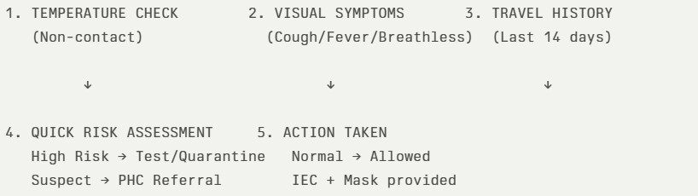
The screening protocol shall include temperature screening, observation for visible symptoms, and inquiry regarding recent travel or exposure history. Individuals identified as suspects during screening shall be immediately referred to the nearest PHC/FHC for further evaluation, testing, and appropriate action as per prevailing guidelines.

Pandemic Control Room
The Pandemic Control Room (PCR) serves as the central nerve center for real-time coordination, data aggregation, decision support, and communication during outbreaks. It consolidates information from all LSGD teams, health facilities and community sources to enable rapid response decisions.

Control Room Infrastructure and Location Primary Location: Seethathode Panchayath Office. Backup Location: Community Hall in Seethathode G.P.

Health System Control Room Framework
The PCR is organized into seven functional pillars to ensure no aspect of the response is overlooked:
- Rapid Response Team (RRT)
  - Provides immediate intervention during emergencies, clusters, and field alerts.​
  - Coordinates urgent actions such as case investigation, contact tracing, isolation, and inter‑facility referrals.
- Data Management & Analytics Team
  - Collects, validates, and manages key health system indicators (cases, tests, beds, HR, supplies).​
  - Analyzes data trends, generates projections, and supports evidence‑based decision‑making for local authorities.
- Human Resource Deployment Team
  - Allocates healthcare staff efficiently based on workload and need
  - Ensures adequate and equitable workforce distribution across facilities
- Laboratory Surveillance Team
  - Oversees diagnostic testing coordination, sample transport, and timely reporting of results.​
  - Monitors lab indicators (testing volume, positivity rate, turnaround time) for early detection of outbreaks
- Vaccination Cell (If Required)
  - Plans and executes vaccination campaigns, including micro‑planning and session scheduling.​
  - Tracks coverage, identifies gaps, and coordinates corrective actions with field teams and outreach services.
- Infrastructure & Patient Occupancy Team
  - Monitors facility capacity, earmarked beds, oxygen and critical care resources across all linked facilities.​
  - Ensures optimal patient distribution and referral management using updated bed‑status and resource data.
  - BMWM
- Communication team
- Disseminate daily situation updates through official communication channels.
- Counter misinformation through verified announcements.
- Maintain a public helpline or contact point for queries and emergency assistance.
- Conduct focused IEC campaigns in affected wards.

- Logistics and supply chain
- Activate emergency procurement mechanisms for essential medical supplies.
- Monitor real-time stock levels of PPE, masks, sanitizers, oxygen support equipment, and essential medicines.
- Ensure uninterrupted supply of essential commodities including food and drinking water.
- Coordinate with district authorities for additional resource mobilization if required.
- The Logistics Nodal Officer shall maintain daily stock status reports.
- Transportation (interfacility & emergency transport)
- Maintain a dedicated list of ambulances, private vehicles, and emergency drivers available within the Panchayat.
- Establish clear referral linkages with higher treatment centres and designated hospitals.
- Ensure availability of at least one standby vehicle for emergency patient transport from containment zones.
- Implement infection prevention protocols within transport vehicles, including disinfection after each transfer.
- Provide PPE kits and necessary protective measures for drivers and accompanying staff.
- Maintain a transport logbook documenting patient movement, date, time, and receiving facility.
- Priority shall be given to severe cases, pregnant women, dialysis patients, and other high-risk individuals requiring urgent inter-facility transfer
- Media surveillance Call centre
- Monitor print, television, digital media, and social media platforms for disease-related information, rumours, and public concerns.
- Identify and verify misinformation promptly through coordination with District Information Office.
- Issue timely clarifications and official updates through authorized communication channels.
- Establish a Panchayat-level contact point or helpline number for public queries, reporting symptoms, and emergency assistance.
- Maintain a call register documenting nature of queries and action taken.
- Escalate urgent cases to health authorities or emergency services.
- Provide psychological reassurance and guidance on home isolation, testing, and preventive measures.
- Management of the deceased
- Follow infection prevention protocols for handling and transportation of the deceased.
- Provide PPE kits to personnel involved in body handling.
- Restrict handling to trained personnel only.
- Coordinate with designated crematoriums or burial grounds to ensure safe disposal practices.
- Maintain documentation of death details and cause of death as per reporting requirements.
- Provide clear guidance to family members regarding permitted funeral practices and public health safety measures.
- Ensure respectful handling of bodies while balancing infection control requirements.
- Intersectoral coordination and convergence
- Convene regular coordination meetings under the leadership of the Panchayat President/Secretary with representation from Health, Revenue, Police, ICDS, Education, Animal Husbandry, Civil Supplies, Social Justice, and Kudumbashree.
- Establish a Panchayat-level Incident Coordination Group to oversee planning, implementation, monitoring, and reporting of response activities.
- Align all containment, surveillance, and relief activities with directives issued by the District Disaster Management Authority (DDMA) and District Health Authorities.
- Ensure convergence of resources including manpower, vehicles, logistics, relief materials, and communication channels across departments.
- Coordinate with the Education Department for temporary closure, sanitization, or conversion of institutions into quarantine facilities when required.
- Work with the Police Department for enforcement of containment measures and regulation of public gatherings.
- Engage Civil Supplies and Social Welfare Departments to ensure uninterrupted access to food, rations, and social protection schemes.
- Coordinate with the Animal Husbandry Department for zoonotic surveillance where relevant.
- Involve community-based organizations, NGOs, religious institutions, and volunteer networks to support awareness campaigns and relief distribution.

Key Control Room Team
The Control Room Team coordinates all pandemic response activities within the LSGD and serves as the single command and communication hub during activation. It integrates information, field actions, logistics, and policy execution across all participating departments and health facilities.

Role | Name | Designation | Contact Number | Responsibility
In-charge/Nodal Officer | Dr Prasob E | Medical Officer | 9495549794 | Overall coordination, decision-making, and reporting to the District level.
Data Entry Operator | Anoop Abraham | Clerk | 7510297119 | Managing the line list, updating dashboards, and tracking testing results.
Communication Officer | Bindhu P S | Health Inspector | 8590701718 | Handling the public helpline, coordinating ambulance dispatch, and contact tracing calls.
Logistics Coordinator | Madhanku mar | Pharmacist | 9495506606
Technical Support
(IT/Data)

SOP for alert escalation/trigger point with mapping of responsibilities.

Alert Escalation / Trigger Points with Mapping of Responsibilities

1. Purpose
This SOP defines the trigger thresholds, alert escalation process, and role-based responsibilities for timely activation of response mechanisms under the Pandemic Preparedness Framework.The objective is to ensure early detection, structured escalation, and coordinated multi-sectoral response to emerging public health threats.
2. Alert Levels and Trigger Points
Level 0 – Routine Surveillance (Green Alert)
Trigger | - No unusual increase in cases  - Normal seasonal trends  - No cluster detection
Action | - Continue routine surveillance and reporting  - Weekly data review  - Maintain preparedness and buffer stocks
Responsibility | - JPHN / ASHA Workers – Field surveillance  - Health Standing Committee – Oversight  - Panchayat Secretary – Monitoring compliance

Level 1 – Early Warning (Yellow Alert)
Trigger Points | - Sudden increase (≥2x baseline) in fever/diarrhoeal cases in a ward  - Clustering of cases within households/institutions  - Unusual absenteeism in schools/workplaces  - Detection of zoonotic signals (animal morbidity/mortality)  - District/State advisory issued
Action | - Immediate reporting to Block Medical Officer  - Intensified syndromic surveillance in affected ward  - Field verification by Rapid Response Team (RRT)  - Activation of ward-level monitoring committees  - Review of logistics and stock availability
Responsibility Mapping | - ASHA/JPHN – Case verification & line-listing  - Medical Officer PHC – Clinical validation & reporting  - Panchayat President – Convene emergency review  - Veterinary Officer – Animal surveillance coordination  - Ward Member – Community mobilization

Level 2 – Outbreak Confirmation (Orange Alert)
Trigger Points | - Laboratory-confirmed outbreak  - Sustained local transmission  - Multiple wards reporting clusters  - Healthcare facility strain
Action | - Activate Panchayat Incident Coordination Group  - Implement containment measures in affected wards  - Operationalize quarantine/isolation facilities  - Intensify risk communication and public advisories  - Daily surveillance reporting to District authorities  - Deploy emergency logistics and buffer stocks
Responsibility Mapping | - Panchayat President – Incident Lead  - Medical Officer – Technical Lead  - Panchayat Secretary – Administrative coordination  - Health Inspector – Field containment operations  - Police Department – Enforcement support  - Civil Supplies – Essential commodity continuity

Level 3 – Public Health Emergency (Red Alert)
Trigger Points | - Rapid exponential case increase  - Severe cases requiring referral surge  - District-level emergency declaration  - Health system overload
Action | - Full activation of Emergency Response Plan  - Micro-containment zones  - Emergency procurement activation  - Inter-facility patient transfer coordination  - Activation of helpline and media monitoring  - Coordination with District Disaster Management Authority
Responsibility Mapping | - Panchayat Incident Commander – Strategic oversight  - Block Medical Officer – Clinical coordination  - District Administration – Resource augmentation  - Revenue & Police – Movement regulation  - Kudumbashree/Volunteers – Relief & support services

3. Escalation Flow Mechanism
- Field-level detection by ASHA/JPHN
- Immediate reporting to PHC Medical Officer
- Verification and preliminary assessment
- Communication to Panchayat President & Secretary
- Notification to Block Medical Officer
- Activation of corresponding alert level
- Documentation and situation reporting (SITREP)
All escalation shall occur within defined timelines (within 24 hours for Level 1 and immediate notification for Level 2 and above).
4. Documentation and Reporting
- Maintain Alert Escalation Register
- Daily Situation Reports during Level 2 and 3
- Record decisions taken and action implemented
- Submit consolidated reports to Block and District authorities
5. Review and De-escalation
Alert levels may be downgraded after:
- Two consecutive incubation periods with no new cases
- Declared containment by competent health authority
- Stabilization of surveillance indicators

Key Points:
- The Control Room shall be staffed with a designated In-charge, data entry personnel, and communication staff with clearly defined roles and shift arrangements.

- It shall maintain updated records on daily monitoring indicators including new cases, persons under active quarantine, and hospital bed occupancy.

- All reports and situation updates shall be shared daily with the Block and District Surveillance Unit.

● The Control Room shall act as a single point of contact for coordination with response teams, health institutions, and other departments.

● Contact details of the Control Room shall be widely communicated to field staff and stakeholders during activation.
Daily Monitoring Indicators
To ensure timely decision-making and effective response, the following key indicators shall be monitored and updated on a daily basis by the Pandemic Control Room:

1. Epidemiological Indicators:
New cases reported today, Total active cases, Test Positivity Rate (TPR), Case Fatality Rate (CFR)
2. Surveillance Indicators:
Persons under home quarantine, High-risk contacts identified, Fever, ILI, SARI or other symptoms (syndromic surges), Travellers (symptomatic or high-risk arrivals),Animal husbandry surveillance (zoonotic alerts, unusual animal deaths, poultry/bird flu signals), Mortality surveillance (excess deaths, unexplained fatalities, verbal autopsy reports)
3. Logistics and Infrastructure Indicators:
Hospital / CFLTC beds occupied, Oxygen cylinders/concentrators available, Ambulances on standby

4. Alert Findings
The following table outlines category-specific trigger points (red flags) from surveillance indicators and corresponding immediate actions for the Pandemic Control Room. These enable rapid response to alert findings like testing anomalies, positive cases exceeding thresholds, clusters, and WGS reports.

Category Trigger Pophint (Red Flag) Immediate Action
Clusters Geographical or facility-based: 5+ cases linked to one location (office, school, street). Declare a micro-containment zone; perimeter control and active case finding.

Testing Sudden drop in testing volume / delay in reporting / unusual testing trends Review the sample collection process, address lab bottlenecks, deploy additional testing teams, and notify the District Lab.
Lab Test Positivity rate increases Increase testing sites in that ward.
Hospital >80% Oxygen bed occupancy Activate backup/CFLTC beds.
Travel Cluster of cases from a single flight/train or high-risk arrival group. Trace all passengers in adjacent seats; implement mandatory institutional quarantine.
Animal Mass poultry/wildlife death or unusual sickness Notify Animal Husbandry, sample the area, and dispatch RRT for environmental sampling and zoonotic check.
Mortality Sudden spike in home deaths or brought-in-dead (BID) cases Audit the deaths and Active Case Search drive
Additional investigations like Whole Genome Sequencing (WGS) Detection of a Variant of Concern (VOC) or Variant of Interest (VOI) Implement strict micro- containment; update clinical protocols to match variant severity.

1. Communication of Public Health Information
A Community Communication Hub shall be established to ensure timely, accurate, and consistent dissemination of information during a pandemic. The Hub will function under the coordination of Nodal officers of the control room and act as the nodal point for public communication, risk messaging, and community engagement. It will support dissemination of official advisories, promote preventive behaviors, address rumors and misinformation, and ensure that messages reach all sections of the population through trusted local channels and leaders.

Key communicators

Channel Responsible Person Contact
Ward-level announcements Health Standing committee chairman 7510536922
Social media Health Inspector 8590701718
Local Cable TV/Radio

● All messages disseminated through the Hub shall align with advisories issued by the Health Department and District authorities.

● Community leaders shall be sensitized to support behavior change, reduce stigma, and counter misinformation.

● Special efforts shall be made to reach vulnerable and hard-to-reach populations using locally appropriate communication methods.

Rumor Tracking: A designated volunteer will monitor local social media/WhatsApp groups daily to identify misinformation and issue official clarifications via the Communication Hub.
2. Coordination with District/State Authorities & Other Organisations
Effective coordination with Block, District, and State authorities is essential to ensure timely reporting, technical guidance, and uninterrupted supply of essential resources during a pandemic. The LSG shall establish clear communication channels, designate responsible officers, and adhere to prescribed reporting timelines to support coordinated public health action and efficient resource mobilisation.

Key Details:
● Nodal Officer for Reporting:
● Contact Number:
Reporting Schedule and Protocols:

To Whom What to Report Frequency Nodal Person
Block PHC Complete Situation
Report (Cases,
Quarantine, Beds, Screening, Deaths) Daily HI
District IDSP Unit Outbreaks/Clusters/Un usual Events (>5 cases same ward) Daily HS
Veterinary Officer Animal health events/Zoonotic alerts Daily Veterinary Doctor
State Cell Zoonotic cross-sector events Daily DSO

Supply Chain Coordination
The LSG shall coordinate closely with Block, District, and State authorities (KMSCL) to ensure uninterrupted availability of essential goods, medical supplies, and logistics during a pandemic. Supply requirements shall be assessed regularly based on case load and communicated promptly to the appropriate authorities for timely replenishment.
Key Points:
● Maintain updated contact details of District and Block nodal officers for health logistics, oxygen supply, ambulances, and essential medicines.

● Submit timely indent requests for PPE, testing kits, medicines, oxygen, and other critical supplies through prescribed channels.

● Monitor stock levels at LSGD facilities, quarantine/isolation centres, and field teams through daily stock registers and dispensing logs to prevent shortages.

● Coordinate with District authorities, Karunya/Neethi medical shops, and local purchase committees for funds allocation and emergency procurement.

● Ensure regular monitoring of dispensing registers at all facilities to track usage, expiry, and pilferage—shortages being a perennial issue requiring proactive weekly audits.

● Activate surge procurement protocols during high caseloads, leveraging local purchase powers under LSGD funds alongside state supplies.

Resource Inventory and Contacts

Resource Category | Source (District/State/Private) | Contact
PPE Kits/Masks/Gloves | KMSCL | 04712945600
PPE Kits/Masks/Gloves | Local Vendors | 04682986400
Oxygen Cylinders/Concentrators | KMSCL | 04712945759
Medicines/Antivirals | KMSCL
Medicines/Antivirals | Neethi Shops
Test Kits (RTPCR/Rapid) | KMSCL

Collaboration with NGOs, PPP, and CSR
To augment government efforts during a pandemic, the LSG shall collaborate with NGOs, voluntary organisations, and private sector partners through public–private partnerships and Corporate Social Responsibility (CSR) initiatives, in coordination with District authorities.

Key Points:
- Engage NGOs and community-based organisations for community outreach, awareness, and support to vulnerable populations.

- Leverage CSR support for procurement of medical equipment, PPE, oxygen concentrators, food kits, and sanitation materials, as permitted.

- Ensure all collaborations align with government guidelines and are routed through approved administrative and financial procedures.

- Maintain transparency and documentation for all external support received and utilised.

Organization | Type | Support Offered | Contact Person
Youth Clubs/Student Unions | CBO

Interdepartmental Coordination
Coordination among departments during a pandemic shall be ensured through regular review meetings convened by the LSGD President. These meetings will provide a structured platform for sharing situational updates, assessing resource availability, resolving operational gaps, and taking joint decisions to ensure a coordinated and timely response.

Department | Representative | Key Role | Contact
Health (PHC) | Staff Nurse | Case management | 9495151625
Veterinary | Veterinary Surgeon: | Animal surveillance | 9447020310
ICDS | Supervisor: Sindhu | Nutrition support | 9048327778
Education | Head Teacher: | School coordination | 8281238727
Police | Station House Officer | Containment enforcement | 04735279190
Water Authority | Plumber | Water supply | 9747846275  04712324903
LSGD Engineering | Assisitant Engineer | Quarantine infrastructure | 9633325384

PHASE 3 - Surge Capacity
Phase 3 is activated when there is a rapid increase in cases, high test positivity rates, or when existing health facilities and quarantine arrangements approach saturation. The focus of this phase is to expand isolation capacity, augment clinical care services, and mobilise additional resources through district and state support mechanisms.

Conversion of Community Facilities
To manage increased case load, the LSGD shall activate additional isolation facilities by repurposing identified community infrastructure such as community halls, auditoriums, schools, hostels, or other suitable buildings.

Name of facility | Facility Type | No. of Buildings | Ward | Surge Capacity (Beds) | Nodal Person
Community hall Angamoozhy | Community hall | 1 | 4 | 25
Community hall Seethakuzhy | Community hall | 1 | 11 | 20
KRPM School | School | 3 | 11 | 50
Knanaya Auditorium, Seethathode | Auditorium | 1 | 11 | 20
SNDP  Auditorium, Seethathode | Auditorium | 1 | 11 | 20
Community hall,Valupara | Community hall | 1 | 1 | 20
Nilakkal church hall | Hall | 1 | 5 | 50

Recovery and rehabilitation phase
Recovery
• Damage & Impact Assessment
A detailed ward-level assessment is carried out to evaluate the health, environmental, and socio-economic impact of the pandemic. This includes identifying affected households, disruption of services, and gaps in healthcare delivery for targeted recovery planning.

• Restoration of Health Services
Essential health services such as immunization, maternal and child health, NCD clinics, and TB services are restored in a phased manner. Priority is given to clearing backlogs and ensuring uninterrupted service delivery across all wards.

• Rehabilitation of Affected Population
Support is extended to affected individuals and families through Panchayat initiatives and convergence with social welfare schemes. Special attention is given to vulnerable groups including elderly, chronically ill, and economically affected populations.

• Psychosocial & Mental Health Support
Mental health support services are strengthened through counselling by health workers and trained volunteers. Focus is given to addressing stress, anxiety, and post-pandemic trauma, particularly among vulnerable groups.

• Disease Surveillance during Recovery Phase
Continuous disease surveillance is maintained to detect any resurgence or secondary outbreaks. Field-level health workers ensure timely reporting, monitoring, and rapid response mechanisms.

• Environmental Cleanup & Sanitation
Intensive sanitation drives, waste management, and disinfection of water sources are undertaken across wards. This is crucial to prevent outbreaks of waterborne and vector-borne diseases.

• Livelihood Restoration
Efforts are made to restore livelihoods through Panchayat schemes, Kudumbashree initiatives, and employment programmes. Priority is given to economically affected households.

• Community Engagement & Confidence Building
Awareness campaigns and community participation activities are conducted to rebuild trust in the health system. Emphasis is placed on hygiene practices, vaccination, and early health-seeking behavior.

• Documentation & After-Action Review
All pandemic response activities, challenges, and outcomes are systematically documented. Review meetings are conducted to assess effectiveness and identify areas for improvement.

• Lessons Learned & Best Practices
Key lessons from the pandemic response are compiled and analyzed. Successful strategies are documented for replication and strengthening future preparedness.

• Health System Strengthening
Healthcare infrastructure, workforce capacity, and logistics systems are strengthened based on identified gaps. This enhances overall emergency response capability.

• Policy Revision & Preparedness Enhancement
Policies and standard operating procedures are updated incorporating lessons learned. Preparedness plans are revised to ensure improved response to future public health emergencies.

• Research
Local epidemiological data and field experiences are utilized for operational research and evidence-based planning. Collaboration with health institutions is encouraged to improve public health outcomes.

CONCLUSION
The Pandemic Preparedness Plan of Seethathode Grama Panchayat provides a comprehensive and evidence-based framework to address public health emergencies through a coordinated and decentralized approach. By integrating disease trend analysis, clinical and geographic vulnerability assessments, and ward-level risk mapping, the plan enables targeted and efficient interventions. The emphasis on strengthened surveillance, improved water and sanitation measures, and continuity of essential health services enhances the Panchayat’s capacity to prevent and control outbreaks. The plan also promotes intersectoral coordination and community participation under the One Health approach, ensuring resilience and adaptability. Overall, this preparedness plan serves as a strategic roadmap to safeguard public health and ensure an effective and timely response to future pandemics.

Additional points
- tech support
- relief based commodities
- ham reading operators
- hazard vulnerability mapping
- Kseb & other power source
- HR specific responsibility

RECOMMENDATIONS
- Strengthening Healthcare Infrastructure
  - Establish a primary health response unit within the Panchayat with trained staff.
  - Ensure availability of basic medical supplies (masks, sanitizers, PPE kits, oxygen cylinders).
  - Create tie-ups with nearby hospitals in Community Health Centre Chittar for emergency referral and transport.

- Community Awareness & Education
  - Conduct regular awareness campaigns on hygiene, vaccination, and preventive measures.
  - Use local communication channels (community radio, WhatsApp groups, notice boards) to spread verified information.
  - Train volunteers to act as health ambassadors in each ward.

- Emergency Response & Coordination
  - Form a Pandemic Preparedness Committee at Panchayat level including health workers, ward members, and NGOs.
  - Develop a clear action plan for lockdowns, quarantine, and distribution of essentials.
  - Maintain a database of vulnerable groups (elderly, differently-abled, chronically ill) for targeted support.

- Supply Chain & Food Security
  - Identify and support local suppliers and farmers to ensure uninterrupted food supply.
  - Create community kitchens during emergencies to serve vulnerable populations.
  - Stockpile essential commodities in Panchayat-run outlets for crisis periods.

- Digital Preparedness
  - Promote digital platforms for telemedicine consultations.
  - Use Panchayat’s website/social media for real-time updates on health advisories.
  - Encourage online grievance redressal to reduce crowding in offices.

- Training & Capacity Building
  - Organize mock drills for pandemic response in schools, offices, and public spaces.
  - Train Panchayat staff and volunteers in first aid, infection control, and crowd management.
  - Collaborate with NGOs and health departments for capacity-building workshops.

- Long-Term Resilience
  - Integrate pandemic preparedness into the Panchayat Development Plan.
● Allocate a dedicated budget for health emergencies.
● Encourage community participation in planning and monitoring preparedness measures.

MOCKDRILL SCENARIOS

ANNEXURE

IMPORTANT PHONE NUMBERS

Phone numbers and particulars of persons responsible for providing guidance, assistance, and support for pandemic preparedness operations may be provided here in a manner that allows easy reference at a glance. The information recorded here could be exhibited elsewhere at the time of emergencies. LSG institutions shall give special attention to collect and record the above data of persons and institutions who/which are supposed to give technical and co-ordination support to reduce the impact of pandemic.
  - Details of grama panchayat/municipality/corporation wards

Sl.No | Name of the ward | Ward  number | Name of the ward  Member | Contact  number
1 | Kottamonpara | 1 | P R Pramod | 9846186960
2 | Palathadiyar | 2 | P K Vasudevan | 9744765405
3 | Gavi | 3 | Manikandan | 9495284900
4 | Angamoozhy | 4 | Raju KK | 9496935353
5 | Valupara | 5 | Surya Ratheesh | 8848936213
6 | Kambiline | 6 | Shalini Balan | 9446662960
7 | Kochukoickal | 7 | Joby T Esho | 9496326884
8 | Kottakuzhy | 8 | Sherly M R | 9645637314
9 | Gurunathanmannu | 9 | Varghese Koshy | 9656601072
10 | Seethakuzhi | 10 | Sheena Prakash | 9747909920
11 | Seethathodu | 11 | Balamaniamma | 7510536922
12 | Kakkad | 12 | Lekha Suresh | 9747087169
13 | Moonnukallu | 13 | Sheeja Sathar | 8590645738
14 | Allumkal | 14 | Thomaskutty T A | 9744343658

  - Other important phone numbers of grama panchayat/municipality/corporation area

Sl.  No. | Name | Contact number
1. | District Panchayat Secretary | 04682223078
2. | Block Panchayat Secretary | 04735227478
3. | Grama Panchayat Office | 04735258048
4. | Women Helpline | 1091
5. | Child Helpline | 1098
6. | Disha ( Health Helpline) | 1056 or 04712552056
7. | Excise department | 04735251922,  9400069479
8. | Forest department | 9447979035
9. | District Emergency Operation Centre | 04682322515
10. | KSEB -Dam Safety Officer | 9446008492

  - Important offices of grama panchayat/municipality/ corporation

Sl.No | Name of the office | Contact person | Contact number
1. | Village Office | Village Officer | 8547618432
2. | Agriculture Office | Agriculture Officer | 9383470466
3. | Animal Husbandry Office | Animal Husbandry  Doctor | 9496042664
4. | Police Station | Police Officer | 04735279190
5. | BSNL Office | Officer | 9188921607
6. | Block Office | Officer | 04735227478
7. | KSEB Office | Officer | 04735258666
8. | Fisheries Office | Officer
9. | Fire and Rescue | Officer | 04735258101
  - Health Services
Sl. No | Name of the hospital/institution | Location | Phone  number
1. | Government hospitals/PHC | 12 | 9495549794
2. | Private hospitals | 12,13 | 8547534856
3. | Clinical laboratories | 12,13 | 8848791396
4. | Chemist/pharmacy | 12,13 | 9946389077
5. | Blood donors | 12 | 9496326884
6. | Other language experts (Bihari, Hindi, Bengali,  Asamees ………) | 12

  - Veterinary Services

Sl. No | Name of the Clinic | Name of the Surgeon/Doctor | Place/lo cation | Phone Number
1 | Govt.Veterinary  Hospital |  | 12 | 9496042664

  - Helpline numbers

Helpline | Phone number
Police | 04735279190
Fire and Rescue | 04735258101
KSEB | 04735258666

  - Public and Private Schools Contact details

S.No | Name of School | Institution type | Phone number
1 | KRPM Seethathodu | Aided | 9446502150
2 | KRPM HSS | Aided | 9495204344
3 | VIDHYADHI RAJA | Private | 9446634714
4 | Govt.SCHOOL GAVI | Govt | 8547226852
5 | St.THOMAS SCHOOL | Private | 9744413676

6 | M M A M ENGLISH SCHOOL | Private | 9656925715
7 | S N UP SCHOOL | Private | 9446354934
8 | Gov SCHOOL .GURUNATHAN MANNU . | Govt | 8330825541
9 | GOV .UPS KOTTAMONPARA | Govt | 9961792019
10 | MOOZHIYAR UP SCHOOL | Govt | 9446911710

1.9. Anganwadi Contact Details

Ward No | Name of Anganwadi Teachers | Phone number
6 | Sathi | 9544199045
1 | Latha mani | 8606381324
5 | Shobana kumari | 9747909929
4 | Sumam | 9778080115
2 | Sreelatha | 9496872693
3 | Raji | 9946156472

Ward No | Anganwadi No and Name of Teacher | Phone number
7 | 1. Ambily | 9048652415
7 | 2.
8 | Sherly | 9645637314
9 | 1. Valsamma | 9745312085
9 | 2. Suni | 9745210262

 | 3. July | 7560924132

1.12. Information regarding resources

Means of transportation | Name of Owner | Phone Number
Heavy Trucks
Tractor
Ambulances | Varghese | 8606712320
Boats
Taxi service

Annexure 1: LSG Baseline Data Collection Format
- Baseline data

Sl.  No. | Indicator / Field | Baseline Data | Source / Remarks
1 | Name of LSG | Seethathode
2 | District | Pathanamthitta
3 | Block / Taluk | Ranni/ Konni
4 | Type of LSG (Gram Panchayat /  Municipality / Corporation) | Grama Panchayat
5 | Area (sq. km) | 651.94
6 | No. of wards | 14
7 | GIS boundary file available | No
8 | Key contact person & phone | LSGD Secretary | 8848201218

- Demography

Indicator / Field | Baseline Data | Source / Remarks
Total population | 18222
Males | 9268
Females | 8954
Transgender population | Nil
Age distribution
(<5, 5–14, 15–59, ≥60)
No. of households | 4844
Population density  (persons/sq.km) | 28
No. of migrant workers
Major occupational groups | Agriculture

- Vulnerable Populations & Social Risks

Sl. No. | Indicator / Field | Baseline Data (Value  / Description) | Source / Remarks
1 | No. of elderly (≥60) | 3271
2 | No. of persons with disability | 9
3 | No. of bedridden persons | 131
4 | No. of chronic disease cases  (DM/HTN/COPD/CKD etc.) | 3115
5 | Pregnant women (current estimate) | 80
6 | Children <5 years | 640
7 | Tribal population (if any) | 387
8 | Fisherfolk / coastal vulnerable  groups (if any) | N
9 | Urban slums / unnotified  settlements (if any) | N
10 | Homeless population
11 | Orphanages / old age homes  (number & capacity) | 1 ( 50)
12 | Hostels / prisons / shelters (number  & capacity) | 1 (50)
13 | Poverty / BPL estimate
14 | Food insecurity hotspots | Y
15 | Any history of  stigma/discrimination issues (Yes/No) | N

- Health System & Service Readiness

Sl. No. | Indicator / Field | Baseline Data  (Value /  Description) | Source / Remarks
1 | No. of health facilities in LSG (PHC/CHC/TH/DH/Privat  e) | 5
2 | PHC/Family Health Centre  details (name, location) | 2- Seethathode &  Angamoozhy
3 | Subcentres / Health &  Wellness Centres (number) | 5
4 | Private clinics / hospitals  (number) | 3
5 | Labs available  (public/private) | 6
6 | Availability of ambulance  services (Yes/No, number) | Y -3
7 | Availability of  isolation/quarantine facilities (Yes/No, details) | Y – CFLTC  Nilakkal Church Hall
8 | Cold chain facilities (Yes/No,  details) | Y
9 | Stockpile space available  (Yes/No) | Y
10 | PPE / mask / sanitizer  availability plan (Yes/No) | Y
11 | Surveillance staff available  (JHI/JPHN/ASHA count) | Y (5/5/16)
12 | Existing emergency referral  pathways (Yes/No) | Y

- Points of Entry & Mobility

Sl. No. | Indicator / Field | Baseline Data (Value  / Description) | Source / Remarks
1 | Bus stands / depots  (number) | 1
2 | Railway stations  (number) | 0
3 | Boat jetties / fishing  harbours (number) | 0
4 | Ports / airports nearby  (specify distance) | 0
5 | Major highways/roads  passing through | 0
6 | Border crossings  (state/district) | 0
7 | Major markets /  weekly markets | 0
8 | Tourism hubs / major event venues | - Panjippara makaravilakk  - Aluvamkudy temple  - Gavi Tourism
9 | Schools/colleges with  hostels (number) | 1
10 | Factories / large  workplaces (number) | N
- Water, Sanitation & Hygiene (WASH)

Sl. No. | Indicator / Field | Baseline Data (Value  / Description) | Source / Remarks
1 | Major drinking water sources (piped  / wells / borewells / springs) | Kakkad
2 | No. of public wells | 9
3 | No. of households with piped water  connection
4 | Water quality testing routine  (Yes/No) | Y
5 | Common contamination risks  (flooding, salinity, industrial waste) | Y- Flooding
6 | Open defecation free status  (Yes/No) | Y
7 | Solid waste management system  (Yes/No) | Y
8 | Bio-medical waste disposal  mechanism (Yes/No) | Y
9 | No. of public toilets | 1
10 | Handwashing stations in public  places (Yes/No) | Y

- Zoonotic Risks & One Health

Sl. No. | Indicator / Field | Baseline Data (Value  / Description) | Source / Remarks
1 | Livestock population (cattle/goats/pigs/poultry) – estimates | 1193/1271/128/292  45
2 | No. of dairy farms / poultry farms /  pig farms | 4/4/3
3 | Slaughterhouses / meat shops  (number) | N
4 | Animal markets (Yes/No, details) | N
5 | Veterinary dispensaries (number)
6 | History of zoonotic outbreaks (rabies,  leptospirosis, avian flu etc.) | N
7 | Stray dog population management  measures (Yes/No) | Y
8 | Rodent infestation hotspots (Yes/No) | N
9 | Wetlands / waterlogged areas prone to  leptospirosis | N
10 | Bat roosting areas / caves / fruit  orchards (if any) | Y
11 | Human-animal interface hotspots  (farms near residences) | Y
- Climate & Disaster Risks (Pandemic Amplifiers)

Sl. No. | Indicator / Field | Baseline Data (Value  / Description) | Source / Remarks
1 | Flood-prone wards (list) | 1 – Maincentre HWC
2 | Landslide-prone wards (list) | - Gurunathanman nu  - Gavi
3 | Cyclone/sea surge risk (Yes/No) | N

4 | Heatwave risk zones (Yes/No) | N
5 | Waterlogging areas (list) | N
6 | Shelter homes / relief camps  (number, capacity) | 7 ( 205)
7 | Past disaster displacement history | Landslides -2018
8 | Disruption to water supply/transport common  (Yes/No) | N
- Critical Infrastructure & Logistics

Sl.  No. | Indicator / Field | Baseline Data (Value  / Description) | Source / Remarks
1 | Schools (number) | 10
2 | Anganwadis (number) | 26
3 | Colleges (number) | 1
4 | Community halls (number) | 7
5 | Places of worship with large  gatherings (number) | 7
6 | Large markets / shopping areas  (number) | 1
7 | Warehouses / cold storages (number) | 0
8 | Telecom/mobile network coverage  gaps (Yes/No) | Y
9 | Power outage frequency  (high/medium/low) | Medium
10 | Availability of generators in key  facilities | N

- Risk Communication & Community Networks

Sl. No. | Indicator / Field | Baseline Data (Value  / Description) | Source / Remarks
1 | Ward-level rapid response teams  (Yes/No) | Y
2 | Jagratha samithis / committees  active (Yes/No) | Y
3 | Kudumbashree presence and  strength (number of units) | Y
4 | Volunteer network (number,  coverage) | Y
5 | Community-based surveillance  mechanisms (Yes/No) | Y
6 | IEC dissemination channels (WhatsApp groups, community  radio, PA systems) | Y
7 | Rumour tracking mechanisms  (Yes/No) | Y
8 | Languages spoken / literacy  considerations | Y
9 | Vulnerable groups communication  strategy available (Yes/No) | Y

- Preparedness Planning & Governance

Sl.  No. | Indicator / Field | Baseline Data (Value  / Description) | Source / Remarks
1 | LSG emergency plan available  (Yes/No) | Y
2 | Pandemic preparedness plan available  (Yes/No) | Y
3 | Incident Command System identified  (Yes/No) | Y
4 | Rapid procurement mechanism  available (Yes/No) | Y
5 | Emergency fund available (Yes/No,  amount) | Y
6 | Past outbreak response experience  (Yes/No, details) | Y- 2018 Landslide
7 | Intersectoral coordination mechanism  (Health, Police, LSG, Veterinary, Education) | Y
8 | Mock drills conducted in last 12  months (Yes/No) | N
9 | Training coverage for staff/volunteers  (Yes/No) | Y

- Surveillance & Data Systems

Sl. No. | Indicator / Field | Baseline Data (Value  / Description) | Source / Remarks
1 | Digital reporting tools used (e.g.,  DHIS2, portals) | Y
2 | Availability of line-listing format  (Yes/No) | Y

3 | Contact tracing team identified  (Yes/No) | Y
4 | Mapping of high-risk households  available (Yes/No) | Y
5 | Testing sample transport mechanism  (Yes/No) | Y
6 | Reporting timeline adherence  (good/average/poor) | Good
7 | Data sharing between departments  (Yes/No) | Y
8 | Availability of dashboard for  monitoring (Yes/No) | N

- Additional Notes & Observations

Sl.  No. | Indicator / Field | Baseline Data (Value  / Description) | Source / Remarks
1 | Key challenges perceived by LSG | Hilly terrain, Water  scarcity
2 | Top 5 high-risk wards (reason) | Ward 3 - Dams Ward 9- Landslide Ward 11- Flood prone Ward 3- Landslide Ward 12- Flood prone  Ward1-Landslide prone
3 | Any unique local risks (industrial  pollution, refugee camps, etc.) | N
4 | Recommendations for preparedness  strengthening

-

