PANDEMIC PREPAREDNESS PLAN
OF RANNI GRama PANCHAYATH
TALUK HOSPITAL RANNI

MESSAGE FROM PRESIDENT
Respected citizens,
As the President of Ranni Grama Panchayat, I emphasize that pandemic preparedness is an essential responsibility of our local self-government. Recent public health emergencies have demonstrated how quickly infectious diseases can affect not only health, but also livelihoods, education, and the overall functioning of society. As a grassroots institution directly connected to the people, the Panchayat plays a crucial role in early identification of outbreaks, community awareness, coordination with health departments, and ensuring uninterrupted delivery of essential services. A comprehensive Pandemic Preparedness Plan helps us strengthen surveillance systems, mobilize local resources, protect vulnerable groups such as children and the elderly, and respond promptly and effectively during health crises. Through proactive planning and community participation, Ranni Grama Panchayat remains committed to safeguarding the well-being, resilience, and sustainable development of our community.
Sincerely
Sasikala
Ranni panchayath President

MESSAGE FROM HEALTH STANDING COMMITTEE CHAIR

Respected citizens,
As the Chairperson of the Health Standing Committee of Ranni Grama Panchayat, I strongly affirm that pandemic preparedness is a vital component of our Panchayat’s public health responsibility. Infectious disease outbreaks can emerge unexpectedly and spread rapidly, affecting the health, economy, and social stability of our community. At the Panchayat level, we are the first line of coordination between the health system and the people. A comprehensive Pandemic Preparedness Plan enables us to strengthen disease surveillance, promote timely reporting, ensure availability of essential medicines and protective equipment, and safeguard vulnerable populations such as children, elderly persons, and those with chronic illnesses. It also enhances inter-sectoral coordination, risk communication, and community participation. Through proactive planning, continuous monitoring, and collective action, Ranni Grama Panchayat is committed to building a resilient health system capable of preventing, preparing for, and effectively responding to future pandemics.

Best Regards,

Health Standing Committee Chairperson

MESSAGE BY MEDICAL OFFICER

As the Taluk Medical Officer of Ranni Taluk, I would like to emphasize that pandemic preparedness at the Panchayat level is a cornerstone of an effective public health response. Infectious diseases can spread rapidly across communities, and early detection, timely intervention, and coordinated action at the grassroots level are critical to minimizing their impact. Panchayats serve as the closest administrative unit to the people and play a vital role in surveillance, contact tracing, risk communication, and ensuring continuity of essential health services. A well-developed Pandemic Preparedness Plan strengthens coordination between the health department and local self-government institutions, ensures resource mobilization, protects vulnerable populations, and enhances community awareness and participation. Proactive planning and preparedness at the Panchayat level not only reduce morbidity and mortality during health emergencies but also build a resilient and responsive health system for the future.

EXECUTIVE SUMMARY

Taluk Hospital functions as the Secondary healthcare institution serving the population of Ranni Grama Panchayath. The PHC plays a pivotal role in delivering comprehensive, accessible, and affordable healthcare services, with a strong focus on preventive, promotive, curative, and rehabilitative care in accordance with national and state health programmes.
The aters to a predominantly rural population, addressing key public health priorities such as immunization, family welfare, adolescent health, and geriatric care. Regular outpatient services, home-based care through field health staff, and outreach activities ensure healthcare coverage even in geographically challenging areas. The institution actively implements national health missions, including the National Health Mission (NHM), National Tuberculosis Elimination Programme, National Programme for Prevention and Control of Cancer, Diabetes, Cardiovascular Diseases and Stroke (NPCDCS), and other disease surveillance initiatives.
THQH works in close coordination with the Grama Panchayath, ASHA workers, Anganwadi centres, schools, and community-based organizations to strengthen community participation and improve health awareness. Emphasis is placed on early detection, timely referral, health education, and lifestyle modification to reduce disease burden and improve overall health outcomes.
Despite constraints related to infrastructure, manpower, and increasing service demand, the PHC continues to enhance service delivery through effective planning, data-driven decision-making, and community engagement. Strengthening facilities, upgrading digital health systems, and expanding preventive services remain key focus areas for future development.
Overall, Taluk Hospital stands as a vital institution in safeguarding public health and improving the quality of life of the residents of Ranni Grama Panchayath

LIST OF ABBREVIATIONS

LSGD/LSGI | Local Self Government Department / Local Self Government Institution
BMO | Block Medical Officer
IDSP | Integrated Disease Surveillance Programme
NDMA | National Disaster Management Authority
PPE | Personal Protective Equipment
ICMR | Indian Council of Medical Research
CD | Communicable Diseases
NCD | NON-COMMUNICABLE Diseases

TABLE OF CONTENTS

3
INTRODUCTION 9
● Background of the PPP 9
LSGD AT A GLANCE 9
INTEGRATED HEALTH INFRASTRUCTURE MAP OF ____________ PANCHAYAT 10
GENERAL PROFILE OF THE LSGI’S 13
Background of the LSGI 13
Demographic and Vulnerable Population 14
Clinical Vulnerability 16
INFRASTRUCTURE & RESOURCE INVENTORY 18
Health Facility Directory & Basic Capacity in the LSGD 18
Private Clinics 19
Healthcare Education & Training Institutions 20
Specialized Services & Emergency Inventory 20
Oxygen & Diagnostic Capacity 21
Diagnostics facility mapping at the LSGI level 22
Laboratory Identification & Basic Details 22
Social and Community Infrastructure for surge plan 22
Human resources 24
Community & Support Cadre 25
Community Organizations 26
Administrative & Emergency Services 27
Information regarding resources 27
ONE HEALTH & ENVIRONMENTAL SURVEILLANCE 28
Animal & Bird Population 28
Veterinary Infrastructure 29
Veterinary Doctors & Workforce 30
High-Risk Interface Points (Surveillance Sites) 30
Environmental Risk Mapping 31
Disease Seasonality Mapping 32
Vulnerability Mapping 33
EPIDEMIOLOGICAL TRENDS (2021–2025) 34
Disease Burden among human beings(Last 5 Years) 34
*(use the above table data to create the graph/diagram) 36
Seasonal Trend Analysis 37
Outcome-Based Trend Analysis- 2025 39
Transmission Trend- 2025 40
Integrated Disease Hotspot Map (2021–2025) 42
Preparedness and Response Protocol at LSG Level 44
Constitution of One Health Committee 44
Pandemic Response Workforce 45
Activities and Measures before and during Pandemic 47
PHASE 1 - Alert / Preparation 47
PHASE 2 - Active Response 50
Standard Screening Protocol 51
PHASE 3 - Surge Capacity 60
Conversion of Community Facilities 60
CONCLUSION 61
RECOMMENDATIONS 62
ANNEXURE 63
1. IMPORTANT PHONE NUMBERS 63

INTRODUCTION

Background of the PPP
Ranni Grama Panchayat is situated in the eastern part of Pathanamthitta district and is characterized by undulating terrain, low hills, forest fringes, river basins, and scattered rural settlements. The Panchayat experiences a tropical monsoon climate with heavy seasonal rainfall, which can lead to flooding, water contamination, transportation barriers, and temporary inaccessibility to health facilities during emergencies. The presence of river systems and forest-adjacent habitations increases the risk of water-borne, vector-borne, and zoonotic diseases, particularly during monsoon and post-monsoon seasons.
The Panchayat has a mixed demographic profile comprising children, adolescents, working-age adults, and a significant proportion of elderly residents. The presence of vulnerable groups such as elderly persons, individuals with chronic illnesses, daily wage workers, migrant laborers, and socially disadvantaged families increases the potential impact of infectious disease outbreaks. Population mobility during festival seasons and local gatherings further elevates the risk of rapid disease transmission.
Given these geographic, climatic, and demographic characteristics, the development of a Pandemic Preparedness Plan is essential. A structured preparedness framework ensures early disease surveillance, rapid response mechanisms, effective coordination between health institutions and local self-government, adequate resource mobilization, risk communication, and protection of vulnerable populations. Pandemic preparedness at the Panchayat level strengthens community resilience, minimizes morbidity and mortality, ensures continuity of essential services, and safeguards socio-economic stability. Proactive planning today enables Ranni Grama Panchayat to respond efficiently to future public health emergencies and protect the overall well-being of its residents.
- Top of Form

- Bottom of Form

- LSGD at a glance

Ranni Grama Panchayat is a rural Local Self Government Institution functioning under the Kerala Panchayati Raj Act in Ranni Taluk of Pathanamthitta district. The Panchayat is characterized by undulating terrain, river basins, agricultural lands, and forest fringes, with a tropical monsoon climate influencing its socio-economic and public health conditions. Governed by an elected President, Vice President, Ward Members, and Standing Committees, the Panchayat is responsible for local administration and grassroots development. Its core functions include public health and sanitation, drinking water supply, waste management, welfare scheme implementation, infrastructure development, and disaster and pandemic preparedness. Through coordination with health institutions, Anganwadis, schools, and community organizations, Ranni Grama Panchayat plays a vital role in ensuring sustainable development, social welfare, and improved quality of life for its residents.

LSGD AT A GLANCE
- Geographical boundaries with political map ( based on latest delimitation)
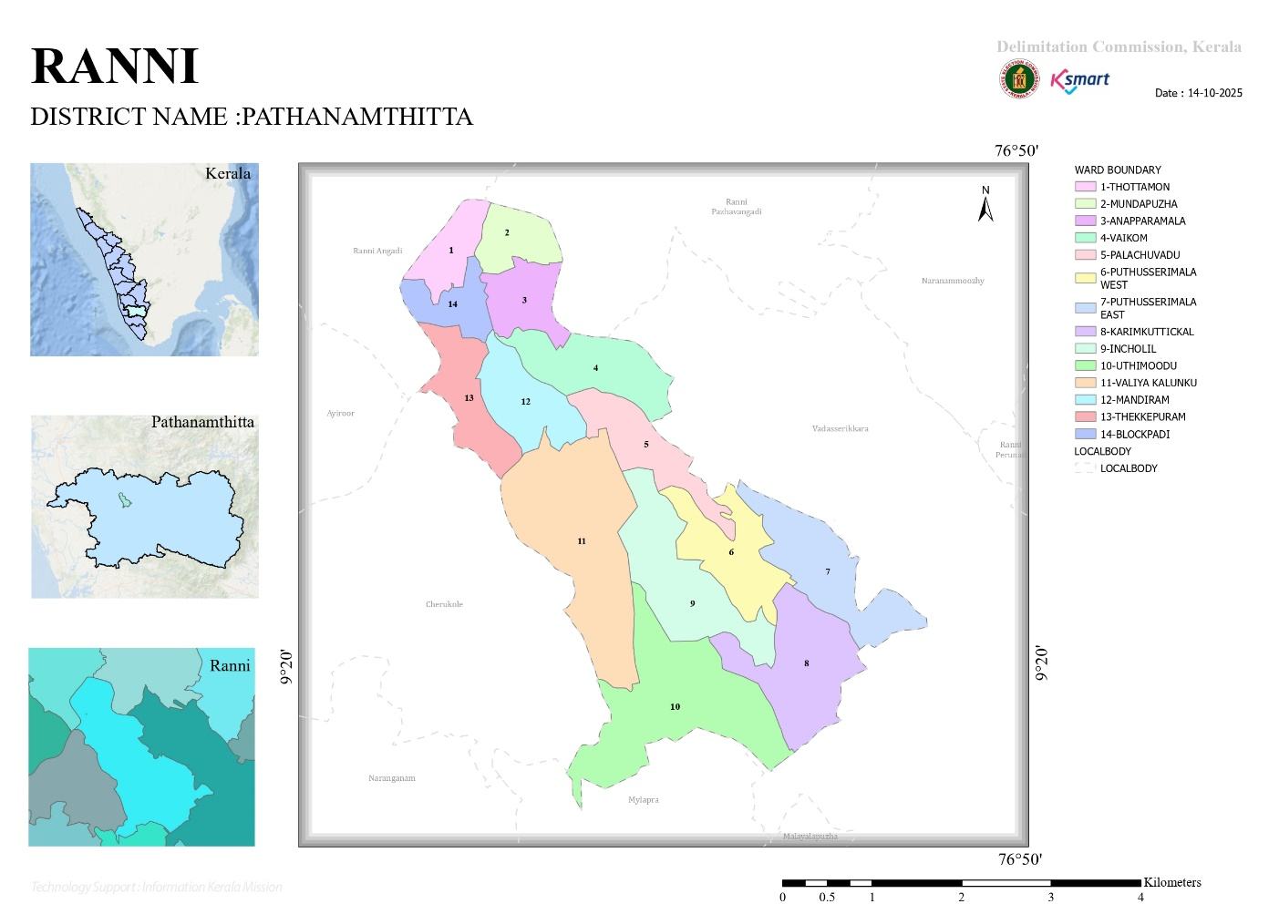
- Baseline data
No.of wards | 14
No.of Houses | 4703
Population | 1401
Male | 6895
Feamale | 7206
Transgender | 0
Below one year | 72
1-5 yr | 448
10-19 yr | 2816
30-60 yr | 3360
Above 60 yr | 3312
Differently abled | 66
Total EC | 1802
Asha workers | 13
AWW | 18
ORT depots | 21
ST nagar | 1
SC Nagar | 9
Extreme poverty families | 17
ICDS Anganwadies | 18
Govt hospitals | 4
Allopathy | 1
Ayurveda | 2
Homeo | 1
Private Hospitals | 1
Allopathy | 0
Ayurveda | 1
Homeo | 0
Dental clinics | 4
Clinical laboratories | 6
Educational institutions | 13
Govt HSS | 0
HS | 0
UPS | 1
LPS | 2
Pre primary | 0
Aided school HSS | 1
HS | 1
UPS | 1
LPS | 3
Pre primary | 0
Un aided schools HSS | 0
HS | 1
UPS | 0
LPS | 0
Pre primary | 3
Colleges | 0
Poly techniques | 0
Govt institutions state | 56
Central | 1
Hostels | 1
Medical colleges | 0
Nursing colleges | 0
Orphanage | 0
Old age homes | 0
Temple | 14
Church | 10
Mosque | 2
No.of private well | 3264
Public well | 10
Pumbing station | 2
Public libraries | 3
Arts and sports clubs | 2
Soda factories | 1
Hotel and tea shop | 19
Thattukada | 6
Market | 0
Slaughter house | 0
Construction area | 6
Rubber plantation | 9
Pineapple plantation | 0

- Ward division -
Ward | Houses | Population | Migrants | Wells | Hot  spots | Ed. Institutions | Hosp pvt/govt.
14 | 4150 | 14101 | 162 | 3274 | 0 | 10 | 0/3
- Thottamon
- Mundapuzha
- Anaparamala
- Vaikom
- Palachuvadu
- Puthusserimala west
- Puthusserimala Easr
- Karimkuttickal
- Incholil
- Uthimoodu
- ValiyaKalinku
- Mandiram
- Thekkepuram
- Blockpadi

- Major Roads/rivers
- State Highway 183 A
- Pamba
- Major establishments with geospatial mapping
- occupational groups, socio cultural groups, migration & mobility patterns
Immigrant
Rubber Plantation
- Vulnerability mapping

- Disaster prone areas (geographic vulnerability)
As per hazard vulnerability references and district disaster management profiles prepared in line with the guidelines of the Kerala State Disaster Management Authority (KSDMA) and the National Disaster Management Authority (NDMA), Ward 13 of Ranni Grama Panchayat falls within a multi-hazard susceptible zone.
The ward is geographically characterized by:
- Undulating and sloping terrain
- Proximity to river stretches and low-lying pockets
- Laterite soil structure prone to erosion
- Scattered rural habitation pattern
- Interior roads vulnerable to waterlogging and disruption
Based on district-level disaster records and monsoon impact assessments, the ward is vulnerable to:
- Seasonal flooding during Southwest and Northeast monsoons
- Localized landslides and soil erosion in sloped areas
- Road inaccessibility during heavy rainfall
- Disruption of electricity, drinking water supply, and essential services
The presence of elderly population clusters and individuals with chronic illnesses further increases the functional vulnerability of the ward during disaster events.

Integration of Geographic Vulnerability into Pandemic Preparedness Plan
The identified geographic vulnerabilities of Ward 13 are systematically incorporated into the Pandemic Preparedness Plan of Ranni Grama Panchayat to ensure a multi-hazard resilient public health response framework.
Key strategic integrations include:
- Pre-Positioning of Resources:
Essential medicines, PPE kits, disinfectants, and emergency medical supplies are strategically stocked in accessible sub-centres prior to monsoon seasons.
- Surveillance Strengthening:
Ward-level health volunteers and ASHA workers are assigned for intensified syndromic surveillance in flood-prone and isolated habitations.
- Alternative Access Planning:
Mapping of alternate transport routes for patient referral and specimen transportation during road blockages.
- Vulnerable Population Registry:
Maintenance of updated line-listing of elderly persons, bedridden patients, persons with comorbidities, and socially vulnerable households.
- Emergency Communication Systems:
Establishment of ward-level communication chains to ensure rapid dissemination of health advisories during simultaneous disaster and disease outbreak situations.
- Multi-Sectoral Coordination:
Alignment of Panchayat disaster response teams with health rapid response teams for coordinated action.
By integrating disaster risk reduction principles recommended by KSDMA and NDMA into pandemic planning, Ranni Grama Panchayat adopts a comprehensive, risk-informed, and decentralized preparedness strategy. This approach enhances early response capacity, reduces morbidity and mortality risks, ensures continuity of essential services, and strengthens overall community resilience against concurrent public health and natural hazard emergencies.

Maps - ward-based (Mention source also)

- Geographical boundaries - ward boundaries map
- Health infrastructure map
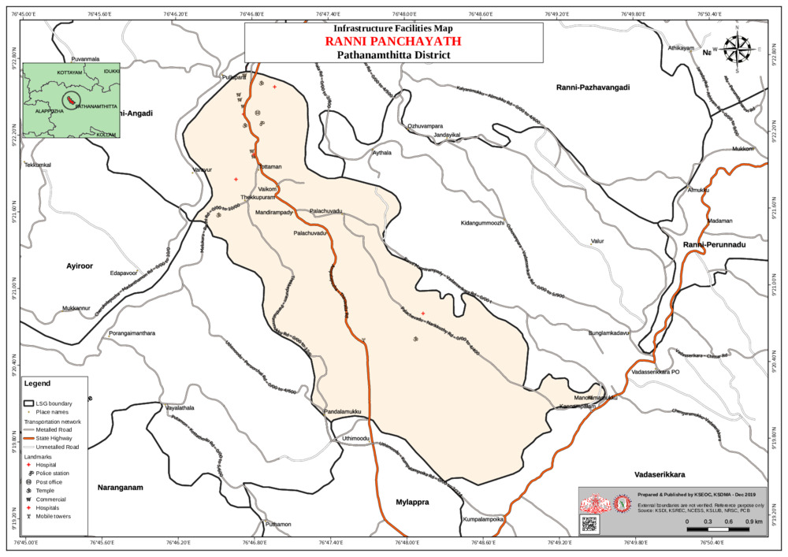
- roads and rivers map
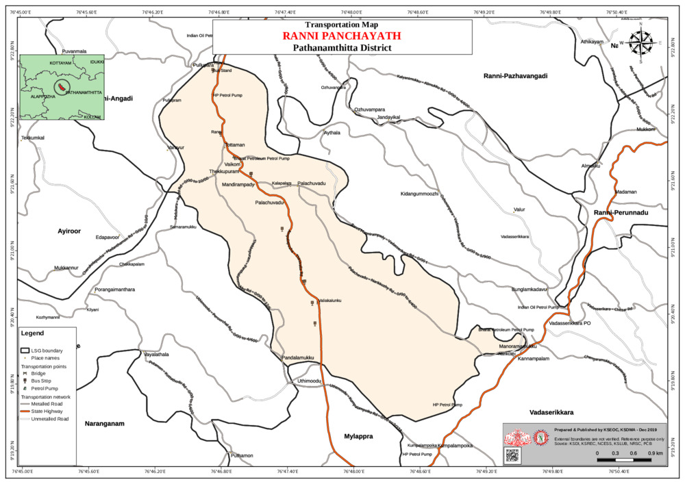
- major establishments map
- disaster-prone areas map
FLOOD PRONE AREA
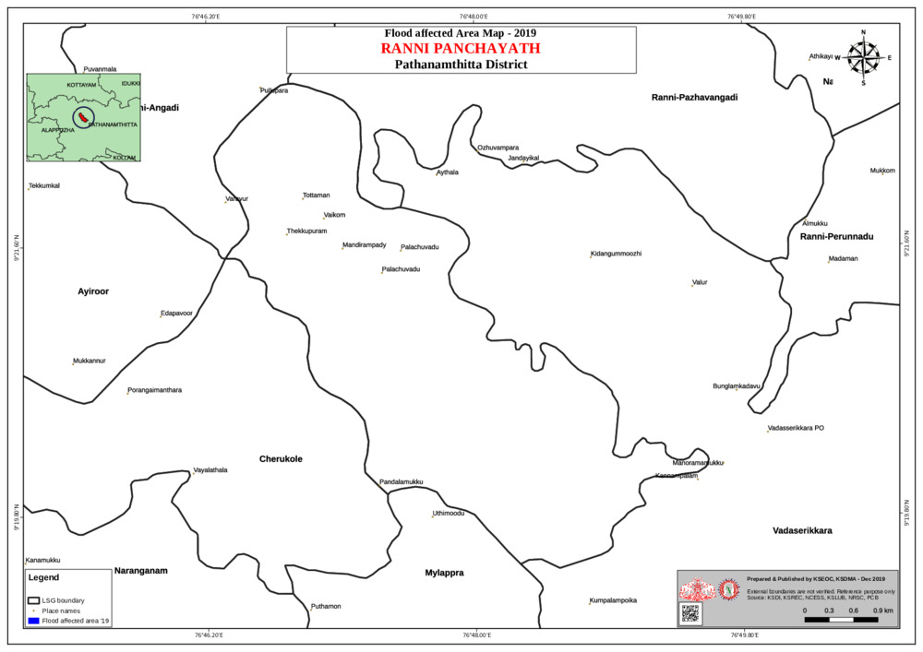
LANDSLIDE AREA
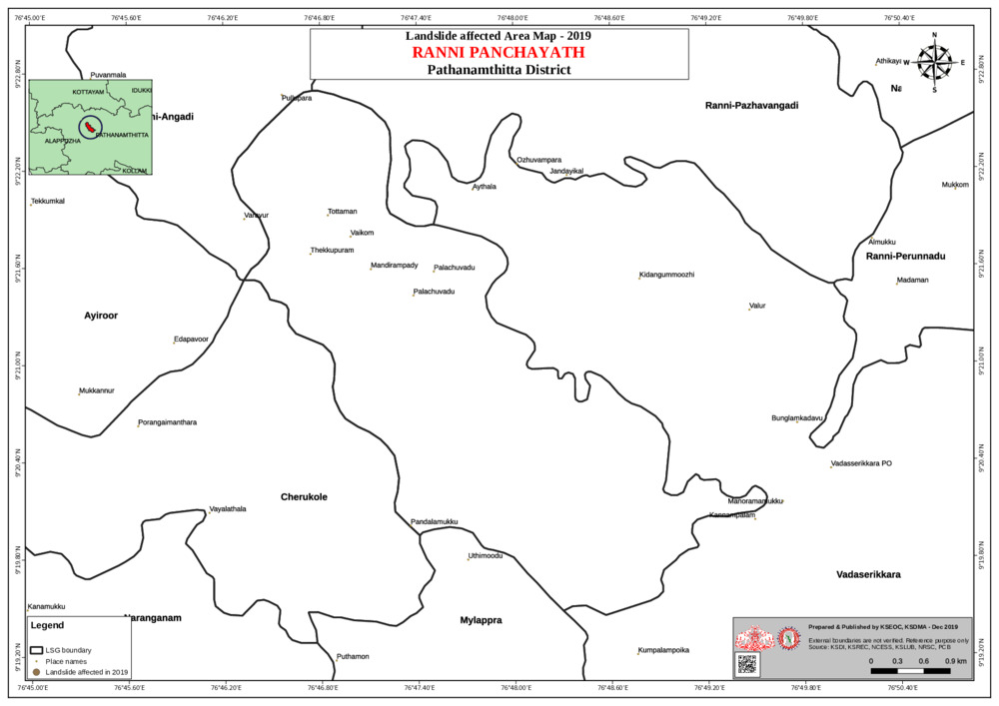
- hotspot map - CD & disasters
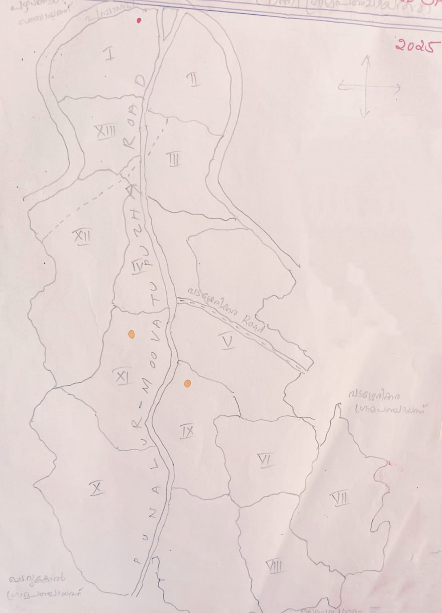

INTEGRATED HEALTH INFRASTRUCTURE MAP OF RANNI PANCHAYAT

GENERAL PROFILE OF THE LSGI’S

Background of the LSGI
Ranni Grama Panchayat is situated in the eastern highland region of Pathanamthitta district, Kerala. The geographical landscape of the Panchayat is predominantly characterized by undulating terrain, midland and highland areas, forest fringes, rubber plantations, and river valleys, particularly along the Pamba river basin. This varied topography significantly influences the local microclimate and creates specific challenges in transportation, emergency accessibility, and public service delivery. During the monsoon season, heavy rainfall often leads to river swelling, localized flooding in low-lying pockets, soil erosion, and occasional landslide risks in sloped areas. These geographic characteristics necessitate strengthened disaster preparedness, resilient infrastructure planning, and coordinated response mechanisms at the Panchayat level
Ranni Grama Panchayat is administratively divided into multiple wards, with a population largely dependent on agriculture and allied rural livelihoods. Rubber cultivation forms the primary economic activity of the Panchayat, along with small-scale farming of crops such as banana, tapioca, pepper, and other plantation produce. A section of the population is engaged in livestock rearing, small trade, daily wage labour, and employment in nearby towns. In recent years, there has been a gradual increase in service-sector employment and business activities, supported by improved connectivity and proximity to pilgrimage routes and commercial centers. The Panchayat also hosts a diverse workforce, including migrant labourers engaged in construction, agriculture, and related sectors, contributing significantly to the local economy.
From a public health and disaster management perspective, Ranni Grama Panchayat has historically been vulnerable to seasonal flooding, heavy monsoon rainfall impacts, and climate-sensitive diseases. Due to its proximity to river basins and undulating terrain within Pathanamthitta district, the Panchayat faces risks of river swelling, localized flooding, soil erosion, and occasional landslide incidents during intense rainfall events. These environmental conditions contribute to increased incidence of waterborne and vector-borne diseases such as Dengue and Leptospirosis, particularly during and after the monsoon season. The severe floods experienced in recent years, including the 2018 Kerala flood disaster, significantly affected life, livelihoods, housing, agriculture, and public infrastructure within the Panchayat. Such recurring emergencies have highlighted the urgent need to strengthen local preparedness systems, improve rapid response mechanisms, and ensure effective inter-departmental coordination.
In this context, the development of a localized, data-driven Auxiliary Infrastructure and Logistical Resource Map is of critical importance. Such a mapping framework will support evidence-based planning, facilitate timely emergency response, and enhance sustainable development initiatives. By systematically identifying critical infrastructure, health facilities, evacuation routes, vulnerable habitations, and essential resource points, the Panchayat can improve accessibility during disasters, optimize resource deployment, and strengthen the overall resilience and public health security of the community.
Table 1: Background of LSGD
Description | Details
Name of LSGI | RANNI
Type (GP/Municipality / Corporation etc.) | Grama Panchayath
Block | RANNI
District | PATHANAMTHITTA
Number of wards | 14
Total area (sq. km)
Population(Projected) | 14101
Population density | persons/sq km
Terrain (coastal/low-lying/backwaters/foothills, etc.) | LOW LYING
Number of rivers passing through LSGI | 1
Number of water bodies in the LSGI | 1
Number of educational institutions | 10
Factories / small-scale industries | 0
Flood-prone wards | 1,2,4,5,13,14
Landslide-prone wards | 3,6,7,8,9,10,11,12
Death Management and Disposal Facilities (mortuaries/crematorium, including electric) | 1
Auditoriums/Marriage halls/convention centres/community halls | 6,1,2,2

Demographic and Vulnerable Population
Understanding the demographic composition and vulnerable population groups is essential for pandemic preparedness. Children, elderly, economically deprived families, migrant workers, and socially vulnerable groups are at increased risk during public health emergencies due to higher exposure, limited access to services, and dependency on public systems.

Description |  | Details (in numbers)
DEMOGRAPHIC PROFILE
Total population |  | 14101
Male |  | 6895
Female |  | 7206
Transgender |  | 0
Children under 5 |  | 575
Adolescent |  | 999
Elderly (>60) |  | 5381
SOCIAL/LIVELIHOOD VULNERABILITY
Previous EPEP family |  | 17
BPL family |  | 2238
Tribal communities |  | 37
Migration | Immigrant | 164
Migration | Emigrant | 265
Socio-economically deprived |  | 204
Fisherfolk |  | 0
SC Community |  | 266
ST Community |  | 37

Clinical Vulnerability
Certain population groups needs priority healthcare & are at higher risk of severe illness, complications, and mortality during pandemics. Patients with chronic diseases, those requiring regular medical care, and individuals with mobility or functional limitations face challenges in accessing timely care during emergencies. Mapping these groups helps in prioritizing continuity of treatment, medicine stock planning, oxygen support, referral transport, and targeted home-based care.
Description | Details in numbers
Pregnant women | 44
Lactating mothers | 360
Bedbound patients | 45
Patients under palliative care other than bedbound | 95
Patients on Haemodialysis | 4
Patients on CAPD | 1
Cancer patients (currently on treatment) | 63
Haemophilic patients | 0
Mentally challenged | 64
Differently abled | 128
Diabetic patients | 6480
Hypertensive patients | 6720
TB patients | 3

The clinical vulnerability database forms a core component of the Panchayat-level Pandemic Preparedness Framework. The following strategic measures are incorporated:
- Priority Vaccination & Prophylaxis Planning:
Categorized beneficiaries are pre-listed for rapid vaccination and preventive interventions during outbreaks.
- Continuity of Essential Health Services:
Mechanisms are established to ensure uninterrupted dialysis, oncology treatment, TB therapy (DOTS), maternal health services, and palliative care during lockdowns or disaster-related disruptions.
- Home-Based Monitoring & Surveillance:
Ward-level health workers (JPHNs, ASHAs) are assigned for regular follow-up and early symptom reporting among high-risk individuals.
- Emergency Referral & Transport Mapping:
Pre-identified transport routes and emergency contact systems are maintained for time-sensitive cases such as dialysis patients and high-risk pregnancies.
- Medicine & Supply Buffer Stocking:
Essential drugs, PPE, and nutritional supplements are planned in advance to prevent service interruptions.
- Data-Driven Resource Allocation:
Clinical vulnerability mapping supports micro-level planning for manpower deployment, ward prioritization, and surge capacity planning.

The integration of clinical vulnerability profiling into the Pandemic Preparedness Plan strengthens risk stratification, reduces preventable mortality, and enhances equitable service delivery. This evidence-based approach aligns with public health emergency preparedness principles and ensures that the most vulnerable sections of the population receive timely, continuous, and coordinated care during health crises.

Major Festivals & Events specific to the LSGI
(with the possibility of a public gathering)

Sl. No. | Name of festival | Month detailing the periodicity
1 | THIRUVABHARAM | JANUARY

INFRASTRUCTURE & RESOURCE INVENTORY

Health Facility Directory & Basic Capacity in the LSGD
This section provides an overview of the healthcare infrastructure available within the LSGD area. It outlines the distribution and basic capacity of health facilities that form the backbone of service delivery during routine times and public health emergencies.

Family Health Centres (FHCs) and Community Health Centres (CHCs) generally function as the first point of contact for the community, providing essential outpatient and inpatient services. General Hospitals (GH) and Medical College Hospitals (MCH), where accessible, serve as the main referral centres for advanced diagnostics, specialist care, and critical services during public health emergencies. This inventory helps identify existing strengths, gaps, and potential surge capacity that can be mobilised during a pandemic or disaster.

Table 5. Health Facility Resource Summary
Sl.no. | Health Facility | Type of Facility (MCH/GH/CHC/FHC/SC etc.) | Contact Number | Total beds | ICU Beds | Oxygen-Supported Beds | No. of Ventilator Support Beds | No. of ambulances
Government Healthcare Facilities
1 | THQHRANNI |  | 9188522985 | 105 | 5 | 5 | 5 | 1
2 | MAINCENTRE RANNI |  | 9747112470 | 0 | 0 | 0 | 0 | 0
3 | HWC MANDIRAM |  | 9995253277 | 0 | 0 | 0 | 0 | 0
4 | HWCPUTHUSSERIMALA |  | 9605359981 | 0 | 0 | 0 | 0 | 0
Private Healthcare Facilities
 |  |  | 0 | 0 | 0 | 0 | 0 | 0
AYUSH Healthcare Facilities
1 | HOMEO |  | 9446330388 | 0 | 0 | 0 | 0 | 0
2 | AYURVEDA |  | 04735225530 | 0 | 0 | 0 | 0 | 0

Private Clinics
Private clinics are an essential part of pandemic preparedness, as they are often the first place people seek care when symptoms begin. In many communities, private clinics manage a significant share of outpatient visits and therefore play a critical role in early case detection, timely referrals, and disease surveillance. Having an up-to-date understanding of where these clinics are located, the services they provide, and how they are linked to the public health system helps ensure that no cases are missed during an outbreak. It also allows health authorities to engage private practitioners more effectively for reporting, risk communication, and coordinated response, strengthening the overall capacity of the health system to manage public health emergencies.

Table 6. Private Clinic Resource Summary
Sl No. | Name of Clinic | Registered (Y/N) | Clinic (General / Speciality) | Speciality (if any) | Address | Contact Number | Diagnostic Facility (Y/N) | Ambulance Linkage (Y/N)
0 | 0 | 0 | 0 | 0 | 0 | 0 | 0 | 0

Healthcare Education & Training Institutions
This section tracks the educational infrastructure available, which is vital for human resource planning in the health sector.

Category of Institution | Govt | Private | AYUSH | Total
Medical Colleges | 0 | 0 | 0 | 0
Nursing Colleges | 0 | 0 | 0 | 0
Dental Colleges | 0 | 0 | 0 | 0
Para-medical / Allied Health | 0 | 0 | 0 | 0
Pharmacy Colleges | 0 | 0 | 0 | 0

Specialized Services & Emergency Inventory
This section provides a detailed view of the specialized medical resources available to the community, focusing on emergency response and critical care capabilities. This table tracks the vital assets required for managing severe illnesses and emergencies across Government, Private, and AYUSH sectors.

Item | Govt | Private | AYUSH | Total
Hospital beds | 105 | 0 | 0 | 105
Oxygen-generating systems(Y/N) | YES | NO | NO | 0
Oxygen-supported beds(Numbers) | 7 | 0 | 0 | 7
Ventilator-supported beds | 5 | 0 | 0 | 5
ICU beds | 5 | 0 | 0 | 5
Burns units | 0 | 0 | 0 | 0
Blood centres | 0 | 0 | 0 | 0
BLS ambulances | 0 | 0 | 0 | 0
ALS ambulances | 1 | 0 | 0 | 1
Dialysis facilities | 14 | 0 | 0 | 14
Dispensaries | 1 | 0 | 0 | 1
Medical store | 1 | 0 | 0 | 1
Industrial establishments(Medium-scale industries/small-scale industries establishments to whom we can depend in a worst-case scenario)

Oxygen & Diagnostic Capacity
Monitoring oxygen and diagnostic capacity is a critical component of public health preparedness, ensuring that the LSGD can handle both chronic care and sudden surges in respiratory or infectious diseases.
Name of Health Facility | Oxygen-generating System (Y/N) | Backup Oxygen Source (Y/N) | Diagnostic Facilities Available(Y/N)
Name of Health Facility | Oxygen-generating System (Y/N) | Backup Oxygen Source (Y/N) | Lab | USG | X-ray | CT/MRI | RT-PCR
Government Healthcare Facilities

Diagnostics facility mapping at the LSGI level
The diagnostic capacity of __Ranni__________ G.P represents the "intelligence network" of our healthcare system. The speed and accuracy of disease identification depend entirely on the distribution and technical level of these facilities.

Item | Govt | Private | AYUSH | Total
General labs | 1 | 5 | 1 | 7
Microbiology labs | 0 | 1 | 0 | 1
RT-PCR labs | 1 | 5 | 0 | 6
USG units | 0 | 1 | 0 | 1
CT/MRI units | 0 | 0 | 0 | 0
Research labs | 0 | 0 | 0 | 0
Labs of other departments that can be repurposed | 0 | 0 | 0 | 0

Laboratory Identification & Basic Details
Sl. No. | Name of Laboratory | Ownership (Govt / Private / Academic) | Address | Contact No. | 24×7 Services (Yes/No) | NABL / Govt Approved (Yes/No)
1 | PERFECT | PVT |  | 7561053049 | NO
2 | JANATHA | PVT |  | 9447211723 | NO
3 | NEW DIAGNOSTIC | PVT |  | 9074469208 | NO
4 | MICRO LAB | PVT |  | 9526207755 | NO
5 | METRO | PVT |  | 9544041639 | NO

Social and Community Infrastructure for surge plan
This table serves as our logistics and shelter inventory. By mapping these locations, quickly we can identify where to house displaced citizens, where to set up temporary medical clinics, and how to manage the deceased with dignity during a crisis.

Category | Total Count | Ward | Est. Capacity (Persons) | Contact details
Educational Institutions
Anganwadis | 18 | All ward expect 9,14 | 0
Schools | 9 | 10,13,6,5,1,4,11, | 0
Colleges | 1 | 13 | 0
Healthcare Educational Institutions
Medical colleges (Govt/Private) | 0 | 0 | 0 | 0
Nursing colleges (Govt/Private) | 0 | 0 | 0 | 0
Dental colleges (Govt/Private) | 0 | 0 | 0 | 0
Paramedical institutes (Govt/Private) | 0 | 0 | 0 | 0
Community Gathering Spaces
Community halls | 2 | 14
Auditoriums | 1
Religious buildings | 12
Vulnerable Group Support Facility
Destitute homes | 0
Elderly homes | 0
LSGD owned other buildings | 1
Mass Fatality Management (MFM) Infrastructure
Mortuary | 0
Crematorium | 1
*refer annexure 1 for contact details

Human resources
This section focuses on the human capital available within the LSGI. In any emergency—be it a pandemic, flood, or industrial accident—infrastructure is only as effective as the people operating it.

Medical & Clinical Personnel
This table tracks the "Frontline" providers responsible for diagnosis, treatment, and clinical management. Narrative sentence: eg., "Total health workforce: 450 personnel, with 60% in government facilities serving as primary surge capacity." A detailed directory with the contact numbers of all workers is maintained (Annexure in 1).

Cadre | Govt (No.) | Private (No.) | Total
Doctors—Modern Medicine | 24
Doctors – AYUSH | 1
Doctors – Veterinary | 1
Doctors – Dental | 1
Nursing officers | 40
Lab technicians | 3
Optometrist | 1
Pharmacists | 5
Psychologists | 1
Counsellors | 1

Public Health & Field-Level Workforce
These individuals are the backbone of surveillance, maternal-child health, and decentralized care.

Cadre | Health services | Municipal common services | Total
HS (Health Supervisors) | 1
HI (Health Inspectors) | 1
LHS (Lady Health Supervisor) | 1
LHI (Lady Health Inspectors) | 1
JPHN (Jr Public Health Nurses) | 3
JHI (Jr Health Inspectors) | 1
MLSP (Mid-Level Service Providers) | 3
Palliative Nurses | 1
RBSK Nurses | 1
PRO | 1
Epidemiologist | 0
Data Manager | 0

Community & Support Cadre
This group represents the surge capacity of the LSGI—people who can be called upon for logistics, rescue, and specialized support.

Cadre | Number
ASHA Workers | 13
AWW (Anganwadi Workers) | 18
Emergency Medical Volunteers (Trained) | 0
Kudumbashree | 133
MNREGS
Purusha Swayam Sahaya Sangham | 13
Ex-Servicemen | 53
Retired Police Officers | 11
NCC/NSS Volunteers
Red Cross volunteers | 25
One Health Community Volunteers | 91
One Health Community Mentors | 0

Community Organizations
This section details the presence of community-based organisations (CBOs), non-governmental organisations (NGOs), faith-based organisations (FBOs), Kudumbashree Self-Help Groups (SHGs), and Ayalkootams within the Local Self-Government Institution (LSGI). These groups enhance grassroots mobilization, resource distribution, and support networks crucial for pandemic response and community resilience.

Category | Total Count
NGOs | 2
Religious based organizations | 2
Foreign based organizations | 1
Sports Club/youth clubs | 3
Kudumbashree SHGs
Ayalkootams
Political organizations
Residential organizations

Administrative & Emergency Services
This section outlines the availability of key non-health emergency support services and infrastructure within the LSGI, which are essential for effective pandemic preparedness and response. These facilities support law enforcement, disaster response, water supply, logistics, mobility, and community-level interventions during public health emergencies.

Category | Total Count | Contact details
Police Stations | 1 | 04735227626
Fire & Rescue Stations | 1 | 04735224101
Water Pumping Points | 1 | 047345227160
Public Distribution System (PDS) | 6

Information regarding resources
The availability of essential transport and support resources plays a quiet but critical role in saving lives. Equipment such as ambulances, mobile mortuaries, amphibian ambulances, and motorized boats ensures that patients, samples, and healthcare teams can move swiftly—even in flooded, remote, or difficult terrains. Heavy vehicles like JCBs, cranes, tractors, and torus lorries support logistics, waste management, emergency infrastructure, and rapid conversion of spaces into care or isolation facilities. Taxis, four-wheel-drive vehicles, and trucks help maintain continuity of essential services, reach vulnerable populations, and support home-based care and supply delivery.

Means of transportation | Total Count
JCB | 18
Crane | 10
Heavy Trucks | 5
Tractor | 7
Ambulances | 4
Mobile mortuaries | 1
Boats | 0
Taxi service | 15
Note: For specific details regarding vehicle owners and contact information, please refer to Annexure [X].

ONE HEALTH & ENVIRONMENTAL SURVEILLANCE
The One Health approach integrates environmental, animal, and human health systems to strengthen proactive pandemic preparedness at the grassroots level. In the context of Ranni Grama Panchayat ,strengthening Panchayat-level surveillance is essential for early detection and management of zoonotic and environmentally linked diseases, particularly during monsoon seasons. Surveillance mechanisms can be enhanced through systematic assessment of domestic animal populations, monitoring of stray dog density, coordination with veterinary services, and periodic review of waste management and environmental sanitation practices. Although large-scale poultry or slaughter facilities are not present, continuous monitoring of animal health status and unusual morbidity or mortality events remains critical. Inter-sectoral coordination between the Health Department, Animal Husbandry Department, and Local Self Government is essential to operationalize a localized One Health framework. Utilization of spatial tools such as ward-level risk mapping and GIS-based seasonal trend analysis can support predictive alerts and targeted sampling in environmentally vulnerable wards, thereby strengthening pandemic preparedness and early response capacity within Ranni Grama Panchayat.

Animal & Bird Population
Mapping animal and bird populations at the Panchayat level is essential for identifying and prioritising zoonotic disease hazards like rabies, avian influenza (H5N1), leptospirosis, anthrax, and Nipah-like spillover occurrences. Risk classification, targeted surveillance, vaccination planning, and early epidemic detection made feasible by comprehensive population mapping all enhance One Health-based pandemic preparedness.

Category | Item | Estimated Population | Wards
Animal Population | Livestock (Cattle/Goats/Buffalo) | 1323 | All Wards
Animal Population | Pet Animals (Dogs/Cats) | 1200 | All Wards
Animal Population | Stray Dog Population | 120 | All Wards
Animal Population | Pig Farms (Number of heads) | 0 | 0
 | Small Units (Sheep / Goats – clustered) | 0 | 0
Bird Population | Poultry Units (Birds) | 0 | 0
Bird Population | Poultry- (FOWL) | 0 | 0
Bird Population | Wild/Migratory Birds (Observed) | 0 | 0
Bird Population | Crow Mortality Events (Reported) | 0 | 0

Although the overall livestock and avian density is low, the presence of a considerable stray dog population and widespread domestic pet ownership across wards represents a potential zoonotic transmission interface. Risk factors include close human-animal interaction, inadequate vaccination coverage among pets and stray dogs, improper disposal of organic waste, environmental contamination during monsoon seasons, and increased rodent activity in flood-prone pockets. Seasonal water stagnation and flooding may facilitate the spread of zoonotic pathogens such as Leptospira spp., while uncontrolled stray dog populations increase the risk of rabies transmission.
Incorporating this zoonotic risk profile into the Pandemic Preparedness Plan strengthens the Panchayat’s One Health framework by promoting coordinated surveillance between the Health Department and Animal Husbandry Department. The data supports targeted anti-rabies vaccination drives, sterilization and stray dog population control measures, public awareness campaigns on safe animal handling, and improved solid waste management systems. Furthermore, systematic monitoring of unusual animal morbidity or mortality events serves as an early warning mechanism for emerging infectious diseases.
This proactive, data-driven approach enhances inter-sectoral coordination, mitigates zoonotic outbreak risks, and contributes to a comprehensive, multi-hazard pandemic preparedness strategy for Ranni Grama Panchayat.

Veterinary Infrastructure
Veterinary institutions are a core pillar of One Health surveillance, enabling early zoonotic disease detection through vaccination, investigation of unusual animal illness or deaths, sample collection, and timely outbreak reporting. A well-mapped and responsive veterinary network strengthens coordination with human health and LSGI systems, ensuring rapid response during zoonotic events and pandemics.
Facility Type | Name of Facility | Ownership Govt / Pvt | Location(Ward No) | Contact number
Veterinary Dispensary | 1 | 0 | 0 | 0
Veterinary Hospital / Polyclinic | 0 | 0 | 0 | 0
Private Veterinary Clinics | 0 | 0 | 0 | 0
Mobile / Emergency Vet Service (incl. night services) | 1
Pet Homes / Animal Shelters | 0 | 0 | 0 | 0
Slaughterhouse-linked Veterinary Inspection Unit | 0 | 0 | 0 | 0

Veterinary Doctors & Workforce
Early detection, diagnosis, reporting, and reaction to animal illness epidemics depend on the availability and accessibility of qualified veterinary specialists. By identifying unusual animal morbidity or mortality promptly, collecting samples promptly, and coordinating efficiently with human health and LSGI systems—especially during zoonotic outbreaks and pandemic-prone situations—a clearly defined veterinary workforce enhances One Health surveillance.

Category | Number Available | Type (Govt/Pvt) | Contact number
Government Veterinary Doctors | 1 | Govt | 04735224550
Private Veterinary Doctors | 0 | 0
Livestock Inspectors | 1 | Govt
Para-veterinary Staff / Attenders | 3 | Govt
Contract / On-call Veterinary Support (if any) | 1 | Govt

High-Risk Interface Points (Surveillance Sites)
High-risk interface points for zoonotic disease surveillance in Ranni Grama Panchayath include wetland–livestock–human contact zones, backyard poultry farms, cattle sheds near water bodies, fish markets, and areas of high human–animal interaction such as community slaughter points and migratory bird congregation sites. These are the primary surveillance sites where zoonotic spillover risks are elevated.

Type of Habitat | Type of High risk interface | Geographical vulnerability
Wetlands & Backwaters | Nil | Nil
Backyard Poultry Farms | Nil | Nil
Cattle Sheds near Water Bodies | Nil | Nil
Fish & Meat Markets | Nil | Nil
Community Slaughter Sites | Nil | Nil
Migratory Bird Congregation Areas | Nil | Nil
Rodent-Infested Grain Storage | Nil | Nil
Flood Prone Area | Moderate Risk Area | Nil
Landslide Area | Moderate Risk | Nil

Category | Total Count | Key Locations (wards)
Poultry Farms | 0 | 0
Backyard / Clustered Poultry Units | 0 | 0
Duck Rearing Units (open water access) | 0 | 0
Slaughterhouses/ Slaughter Points | 0 | 0
Meat/Fish Markets | 3 | 6
Live Bird Sale Points | 1 | 6
Cattle Markets / Weekly Animal Fairs | 0 | 0
Pet Shops / Breeders | 1 | 6
Animal Shelters / Pet Homes | 0 | 0
Waste Disposal Sites near Animal Units | 0 | 0

Environmental Risk Mapping
Environmental risk mapping identifies monsoon/flood hotspots for vector-borne (dengue, chikungunya), water-borne (leptospirosis, diarrhoea), and zoonotic diseases in Kerala's wetlands. Systematic surveillance supports early warnings, targeted interventions, and Panchayat pandemic preparedness.
Waterborne exposure: Flood-prone areas and stagnant water bodies facilitate leptospira survival, raising leptospirosis risk.

Traditional practices: Informal slaughter and fish markets lack standardized hygiene, creating spillover opportunities.

Risk Factor | High-Risk Wards | Key Locations | Risk Level (High/Med/Low)
Flood-prone areas | 1,2,4,5,13,14 | nil | Moderate
Water bodies/wetlands | nil | nil | nil
Solid waste accumulation | nil | nil | nil
Animal waste disposal issues | nil | nil | nil
Rodent infestation zones | nil | nil | nil
Industrial effluent discharge | nil | nil | nil
Construction sites / abandoned buildings | nil | nil | nil
Poor drainage/blocked canals | nil | nil | nil
Drinking water source contamination risk | nil | nil | nil
The analysis indicates that Wards 1, 2, 4, 5, 13, and 14 are categorized as moderately flood-prone areas, primarily due to proximity to river stretches, low-lying pockets, and monsoon-related water accumulation. Seasonal heavy rainfall and river swelling contribute to temporary waterlogging and localized access disruptions in these wards.
The assessment did not identify significant risks related to wetlands, solid waste accumulation hotspots, animal waste disposal clusters, rodent infestation zones, industrial effluent discharge, large-scale construction sites, abandoned structures, blocked drainage canals, or drinking water source contamination at the time of reporting. However, given the Panchayat’s monsoon-dependent hydrological characteristics and rural settlement patterns, periodic monitoring remains essential to prevent secondary environmental health risks.
From a public health preparedness perspective, moderate flood vulnerability in selected wards necessitates proactive measures including pre-monsoon drainage maintenance, safe drinking water surveillance, vector control activities, and emergency access route planning. Environmental monitoring integrated with health surveillance enhances early warning capacity for waterborne and vector-borne disease outbreaks. The findings of this environmental risk analysis support evidence-based planning, targeted resource allocation, and ward-level preparedness interventions, thereby strengthening the overall resilience and emergency response capacity of Ranni Grama Panchayat.

Disease Seasonality Mapping
- Flooding & waterlogging → amplifies leptospirosis, malaria, diarrheal diseases.

- Mosquito breeding cycles → vector-borne disease peaks in monsoon.

- Agricultural practices → Rubber Plantation, Pineapple Plantation .

Disease | Peak Risk Season | Key Drivers | High-Risk Locations | Surveillance Focus
Avian Influenza | nil | nil | nil | nil
Leptospirosis | No Particular Season | Rat | All wards | All wards
Dengue/Chikungunya | No Particular Season | Mosquito | All wards | All wards
Acute Diarrheal Diseases | No Particular Season | Food Source | - | All wards
Rabies | Nil | Nil | Nil | Nil
Anthrax (rare) | Nil | Nil | Nil | Nil

Vulnerability Mapping
Vulnerability mapping pinpoints high-risk populations, occupations, and areas exposed via environment, livelihoods, socio-economics, and poor service access. Paired with environmental/seasonality mapping, it enables risk-based surveillance, targeted actions, and optimal resource use in One Health and pandemic planning.
Vulnerability Factor | High-Risk Wards | Key Groups / Locations | Risk Level
Flood-prone households | 1,2,4,5,13,14 | Unpredictable | Moderate
Wetland-adjacent communities | 0 | 0 | 0
Backyard poultry / duck rearing households | 0 | 0 | 0
Livestock-rearing households | 0 | 0 | 0
Slaughterhouse & meat market workers | 0 | 0 | 0
Fisherfolk & fish market workers | 0 | 0 | 0
Sanitation workers | 0 | 0 | 0
Daily wage / migrant workers | 12 | 0 | 0
Elderly & chronically ill populations | 3312 nos | 0 | 0
Pregnant Women | 44 nos | 0 | 0
Children (schools, Anganwadi’s) | 180 | 0 | 0
Limited access to safe water & sanitation | 0 | 0 | 0
Households located in Wards 1, 2, 4, 5, 13, and 14 are moderately vulnerable to flood-related impacts due to geographical exposure and seasonal rainfall variability. These households may experience temporary displacement, access limitations, and disruption of essential services during monsoon periods.
The Panchayat does not report significant exposure related to wetland-adjacent settlements, backyard poultry or duck rearing units, livestock-rearing clusters, slaughterhouse operations, fish market activities, or sanitation worker concentration zones at present. Additionally, there are no major concerns identified regarding limited access to safe water and sanitation infrastructure, indicating relatively stable baseline environmental health conditions.
However, the presence of daily wage and migrant worker populations in select wards represents a socio-economic vulnerability factor, particularly during lockdowns, mobility restrictions, or livelihood disruptions associated with pandemics. Furthermore, a considerable proportion of elderly individuals, chronically ill persons, pregnant women, and children attending schools and Anganwadis constitute biologically and socially vulnerable groups requiring targeted surveillance and protection.
From a preparedness perspective, this vulnerability mapping supports risk-based prioritization of health services, vaccination strategies, relief distribution planning, and emergency communication mechanisms. By integrating demographic and exposure-based vulnerability indicators into planning frameworks, Ranni Grama Panchayat enhances its capacity for equitable response, minimizes adverse health outcomes, and strengthens resilience against concurrent disaster and public health emergencies.

EPIDEMIOLOGICAL TRENDS (2021–2025)

Disease surveillance is the systematic collection, analysis, and interpretation of health data for planning, implementation, and evaluation of public health practice. This section presents the disease surveillance profile of the LSGI based on routine reporting systems and outbreak investigations to identify priority diseases, seasonal patterns, and emerging public health threats.

Disease Burden among human beings(Last 5 Years)
Analysis of disease-wise data for the last five years helps identify persistent public health problems, emerging diseases, and changes in disease burden. This information supports prioritisation of prevention, preparedness, and response activities at the Panchayat level.

Disease | 2021 | 2022 | 2023 | 2024 | 2025 | Trend(Increasing/Stable/Decreasing)
Dengue | 5 | 6 | 16 | 20 | 10 | stable
Leptospirosis | 2 | 1 | 4 | 2 | 1 | stable
Hepatitis A | 2 | 3 | 5 | 2 | 7 | stable
Malaria | 0 | 0 | 1 | 2 | 0 | Stable
Scrub Typhus | 0 | 0 | 0 | 0 | 1 | Increasing
Typhoid | 0 | 0 | 0 | 0 | 0 | Stable
H1N1 | 0 | 0 | 0 | 0 | 0 | Stable
H3N2 | 0 | 0 | 0 | 0 | 0 | Stable
ADD | 23 | 32 | 49 | 17 | 43 | Stable
Mumps | 0 | 0 | 0 | 0 | 0 | Stable
Measles | 0 | 0 | 0 | 0 | 0 | Stable
Hepatitis B | 2 | 3 | 5 | 4 | 2 | Stable
Hepatitis C | 0 | 0 | 0 | 0 | 0 | Stable
Tuberculosis | 2 | 9 | 5 | 6 | 5 | Stable
Leprosy | 0 | 0 | 0 | 0 | 0 | Stable
COVID-19 | 645 | 824 | 23 | 10 | 0 | Stable

Seasonal Trend Analysis
Seasonal analysis helps anticipate surges (e.g. dengue in monsoon, leptospirosis after floods, influenza in cooler months) and plan pre‑emptive vector control, stockpiling of IV fluids, and awareness campaigns at Panchayat level.

DENGUE
Dengue is a major seasonal vector-borne disease strongly associated with rainfall, water stagnation, and increased mosquito breeding during the monsoon period.

Peak: July–November

Dengue – Ward-wise Yearly Distribution (2021–2025)

Ward | Dengue – Ward-wise Yearly Distribution
Ward | 2021 | 2022 | 2023 | 2024 | 2025 | Total
1 | 0 | 0 | 1 | 2 | 0 | 3
2 | 0 | 0 | 1 | 2 | 0 | 3
3 | 0 | 0 | 1 | 1 | 2 | 4
4 | 0 | 0 | 1 | 1 | 2 | 4
5 | 0 | 2 | 0 | 1 | 0 | 3
6 | 0 | 0 | 3 | 4 | 0 | 7
7 | 0 | 1 | 2 | 1 | 0 | 4
8 | 0 | 0 | 0 | 2 | 1 | 3
9 | 0 | 0 | 0 | 1 | 1 | 2
10 | 0 | 0 | 2 | 0 | 3 | 5
11 | 0 | 1 | 2 | 1 | 2 | 6
12 | 0 | 0 | 2 | 3 | 0 | 5
13 | 0 | 0 | 1 | 1 | 0 | 2
14 | 0 | 0 | 0 | 0 | 0 | 0

- Dengue incidence demonstrates a distinct seasonal concentration during the peak transmission period of July–November, corresponding with monsoon and post-monsoon vector proliferation.
- A progressive increase in cases is observed from 2023 onwards, indicating emerging endemicity in select wards.
- Higher cumulative incidence was recorded in Wards 6, 11, 10, and 12, suggesting localized environmental and vector breeding risk factors.
- Moderate but recurrent transmission was noted in Wards 3, 4, and 7, while sporadic cases were reported in Wards 1, 2, 5, 8, 9, and 13.
- Ward 14 reported no cases during the review period, indicating relatively lower vector transmission risk or effective preventive measures.
- The spatial distribution reflects heterogeneous transmission dynamics, possibly influenced by housing density, water storage practices, drainage conditions, and human mobility patterns.
The seasonal and ward-specific trend analysis supports pre-monsoon vector source reduction campaigns, intensified entomological surveillance, targeted fogging operations, community awareness drives, and ward-prioritized resource allocation. Focused interventions in high-burden wards will strengthen early outbreak containment and enhance dengue prevention capacity within Ranni Grama Panchayat.

LEPTOSPIROSIS
Leptospirosis cases are closely linked to monsoon rains, flooding, and occupational exposure, particularly in low-lying and waterlogged areas.

Peak: June - August

Leptospirosis – Ward-wise Yearly Distribution (2021–2025)

Ward | Leptospirosis – Ward-wise Yearly Distribution
Ward | 2021 | 2022 | 2023 | 2024 | 2025 | Total
1 | 0 | 0 | 0 | 0 | 0 | 0
2 | 0 | 0 | 0 | 0 | 0 | 0
3 | 1 | 0 | 0 | 1 | 0 | 2
4 | 0 | 1 | 0 | 0 | 0 | 1
5 | 0 | 0 | 0 | 0 | 0 | 0
6 | 0 | 0 | 0 | 0 | 0 | 0
7 | 0 | 0 | 1 | 1 | 0 | 2
8 | 0 | 0 | 1 | 1 | 0 | 2
9 | 0 | 0 | 2 | 0 | 0 | 2
10 | 0 | 0 | 1 | 0 | 0 | 1
11 | 0 | 0 | 0 | 0 | 0 | 0
12 | 0 | 0 | 0 | 0 | 0 | 0
13 | 0 | 0 | 0 | 0 | 0 | 0
14 | 0 | 0 | 0 | 0 | 0 | 0

The ward-wise surveillance data indicates a seasonal clustering of Leptospirosis cases during the monsoon peak period (June–August), consistent with rainfall-associated exposure risks.
- Reported cases were sporadic and geographically localized, primarily confined to Wards 3, 4, 7, 8, 9, and 10 during the five-year review period.
- Recurrent reporting in certain wards across different years suggests persistent environmental risk factors, including water stagnation, occupational exposure, and soil/water contamination.
- The majority of wards did not report cases, indicating spatial heterogeneity in risk distribution within the Panchayat.
- No evidence of sustained year-round transmission was observed; incidence appears season-dependent and environmentally triggered.
The identified seasonal and ward-specific pattern supports targeted pre-monsoon prophylaxis initiatives, intensified surveillance, environmental sanitation measures, and community awareness campaigns in historically affected wards. Risk-based micro-planning will enhance early case detection, reduce outbreak amplification, and strengthen monsoon-linked disease preparedness within Ranni Grama Panchayat.
Top of Form
Bottom of Form

VIRAL HEPATITIS - A
Hepatitis A cases are commonly associated with unsafe drinking water, food contamination, and breakdowns in sanitation, often presenting as clusters or outbreaks.

Peak: October - December

Hepatitis A – Ward-wise Yearly Distribution (2021–2025)

Ward | Hep A – Ward-wise Yearly Distribution
Ward | 2021 | 2022 | 2023 | 2024 | 2025 | Total
1 | 0 | 0 | 0 | 0 | 1 | 1
2 | 0 | 0 | 0 | 0 | 1 | 1
3 | 0 | 0 | 0 | 0 | 0 | 0
4 | 0 | 1 | 0 | 0 | 1 | 2
5 | 0 | 0 | 1 | 0 | 0 | 1
6 | 0 | 1 | 0 | 0 | 1 | 2
7 | 0 | 0 | 2 | 0 | 1 | 3
8 | 0 | 0 | 0 | 0 | 0 | 0
9 | 0 | 0 | 0 | 0 | 0 | 0
10 | 0 | 0 | 1 | 0 | 2 | 3
11 | 0 | 1 | 0 | 0 | 0 | 1
12 | 0 | 0 | 1 | 0 | 0 | 1
13 | 0 | 1 | 0 | 0 | 0 | 1

The ward-wise analysis of Hepatitis A over the five-year period (2021–2025) indicates a low-incidence with emerging localized clusters in recent years, particularly from 2023 onwards.
- Wards 7 and 10 (3 cases each) reported the highest cumulative incidence, with recent cases in 2025, indicating localized clustering and increasing trend.
- Wards 4 and 6 (2 cases each) showed intermittent occurrence across years, suggesting sporadic environmental exposure.
- Wards 1, 2, 5, 11, 12, and 13 reported single isolated cases, indicating scattered distribution without sustained transmission.
- Wards 3, 8, and 9 reported no cases, reflecting minimal or no transmission risk.
The temporal distribution suggests that Hepatitis A in Ranni is sporadic with a mild increasing trend in recent years, likely associated with seasonal water contamination during monsoon and gaps in sanitation practices. The clustering observed in Wards 7 and 10 highlights potential localized outbreak risk.
This ward-level analysis supports targeted WASH interventions, including regular chlorination of water sources, sanitary inspections, and community awareness on safe drinking water and hygiene practices, to prevent further transmission and potential outbreaks.

Outcome-Based Trend Analysis- 2025

Disease | 2021 | 2022 | 2023 | 2024 | 2025 | 5-Year Trend
ADD | 23 | 32 | 49 | 17 | 43
Tuberculosis | 2 | 9 | 5 | 6 | 5
Dengue | 0 | 4 | 16 | 20 | 11
Leptospirosis | 1 | 1 | 5 | 3 | 0

- Acute Diarrhoeal Disease (ADD): Demonstrates fluctuating trends over the five-year period, with a marked rise up to 2023, a decline in 2024, and resurgence in 2025. The pattern suggests seasonal and environmental influence, particularly related to water quality and sanitation factors.
- Tuberculosis: Shows variable but relatively stable endemic transmission, with a peak observed in 2022 followed by moderated case levels in subsequent years. The trend indicates ongoing background transmission requiring sustained surveillance and adherence monitoring.
- Dengue: Exhibits a clear upward trend from 2022 to 2024, with the highest incidence recorded in 2024, followed by a reduction in 2025. The pattern reflects increasing vector activity during monsoon/post-monsoon seasons and highlights the need for intensified vector control.
- Leptospirosis: Displays low but episodic occurrence, with a peak in 2023 and a gradual decline thereafter. The trend correlates with monsoon exposure and environmental contamination risks.
The five-year trend analysis indicates climate-sensitive and seasonally driven disease patterns, with vector-borne and water-borne diseases showing periodic surges. The data underscores the necessity for pre-monsoon preparedness measures, strengthened surveillance systems, environmental sanitation initiatives, and ward-focused outbreak response planning to enhance public health resilience.
Top of Form
Bottom of Form

Transmission Trend- 2025
For effective management of public health issues, it is important to track the trend of disease transmission mode. It helps identify the population or place at high risk that can be used to predict outbreaks and implement targeted interventions as quickly as possible. Understanding these kinds of trends enables authorities to allocate resources efficiently and change the strategies adequately based on the trend that follows.

Mode of Transmission | No. of cases | No. of Deaths
Vector Borne Diseases | 10 | 0
Water Borne Diseases | 7 | 0
Air Borne Diseases | 5 | 0
Blood Borne Diseases | 2 | 0
Food Borne Diseases | 0 | 0

Vector-Borne Disease

Disease | No. of Cases | No. of Deaths
Dengue | 57 | 0
Malaria | 3 | 0
Chikungunya | 0 | 0

Water Borne Disease

Disease | No. of Cases | No. of Deaths
Cholera | 0 | 0
Typhoid | 0 | 0
Hep- A | 7 | 0
Dysentery | 0 | 0
Amoebiasis | 0 | 0
E- Coli infections | 0 | 0
Air Borne Disease

Disease | No. of Cases | No. of Deaths
Influenza | 0 | 0
H1N1 | 0 | 0
TB | 5 | 0
Chickenpox | 32 | 0
Measles | 0 | 0
Covid-19 | 0 | 0
Pertussis | 0 | 0
Mumps | 0 | 0

Blood-Borne Disease

Disease | No. of Cases | No. of Deaths
AIDS | 0 | 0
Hep- B | 2 | 0
Hep- C | 0 | 0

Zoonotic Disease

Disease | No. of Cases | No. of Deaths
Rabies | 0 | 0
Leptospirosis | 1 | 0
Avian influenza | 0 | 0
West nile | 0 | 0
Anthrax | 0 | 0
Nipah | 0 | 0
Scrub Typhus | 0 | 0

Integrated Disease Hotspot Map (2021–2025)

Ward No | Dengue Total (2021-25) | Leptospirosis Total (2021-25) | Hepatitis A Total (2021-25)2 | Mumps (2021-25) | ADD (2021-25) | Total Cases
1 | 3 | 0 | 1 | 0 | 8 | 12
2 | 3 | 0 | 1 | 0 | 7 | 11
3 | 4 | 2 | 0 | 0 | 9 | 15
4 | 4 | 1 | 2 | 0 | 11 | 18
5 | 3 | 0 | 1 | 0 | 12 | 16
6 | 7 | 0 | 2 | 0 | 9 | 18
7 | 4 | 1 | 3 | 0 | 8 | 16
8 | 3 | 2 | 0 | 0 | 6 | 11
9 | 2 | 2 | 0 | 0 | 5 | 9
10 | 5 | 1 | 3 | 0 | 8 | 17
11 | 6 | 0 | 1 | 0 | 6 | 13
12 | 5 | 0 | 1 | 0 | 11 | 17
13 | 2 | 0 | 1 | 0 | 10 | 13
14 | 0 | 0 | 0 | 0 | 0 | 0

By overlaying five years of data, we have identified 4-12 Red Zone' Wards. These are wards where ADD recurred in consecutive years. Ward 6 is categorized as the Highest Priority Hotspot due to its combination of flood vulnerability and high vector density. Future health infrastructure, such as the proposed R.O plants should be prioritized.

High-Burden Wards
The consolidated five-year disease burden analysis identifies Wards 4 and 6 as the highest burden wards, followed closely by Wards 10 and 12. Wards 5 and 7 also demonstrate comparatively elevated case loads. Ward 14 reported no cases during the reference period. The spatial distribution indicates clustering of communicable diseases in specific geographic pockets rather than uniform distribution across all wards.

Disease-Specific Distribution
- Acute Diarrhoeal Disease (ADD) constitutes the largest proportion of reported cases across most wards, with particularly higher contribution in Wards 4, 5, 6, 10, and 12, indicating sanitation and water-quality linked vulnerability.
- Dengue shows significant concentration in Wards 6, 11, 10, and 12, suggesting vector breeding risk factors in these localities.
- Hepatitis A cases are sporadically distributed but relatively higher in Wards 7 and 10, reflecting potential localized water contamination risks.
- Leptospirosis incidence remains low but present in Wards 3, 8, and 9, consistent with monsoon-related environmental exposure.
- Mumps was not reported during the review period, indicating absence of outbreak activity.
The cumulative pattern suggests that water-borne and vector-borne diseases remain the dominant public health concerns within the Panchayat.

Strategic Recommendations for Panchayat-Level Action
- Ward-Focused Micro-Planning:
Prioritize Wards 4, 6, 10, and 12 for intensified surveillance, environmental sanitation drives, and targeted health interventions.
- Water Safety and Sanitation Measures:
Strengthen routine chlorination, source water testing, and household-level hygiene promotion to reduce ADD and Hepatitis A incidence.
- Vector Control Intensification:
Conduct pre-monsoon source reduction campaigns, larval surveillance, and community awareness programs in dengue-prone wards.
- Monsoon Preparedness Strategy:
Integrate disease surveillance with flood preparedness plans to mitigate leptospirosis and other monsoon-linked infections.
- Community Engagement and IEC Activities:
Strengthen ward-level health education through ASHA workers, Anganwadi networks, and local committees to promote preventive practices.
- Data-Driven Resource Allocation:
Utilize ward-wise burden data for rational deployment of fogging teams, sanitation workers, and outbreak response resources.
- The five-year ward-wise analysis underscores the importance of risk-based, geographically targeted interventions rather than uniform resource distribution. Strengthening integrated surveillance, environmental management, and ward-specific preparedness planning will significantly enhance the resilience of Ranni Grama Panchayat against communicable disease outbreaks and future public health emergencies

Preparedness and Response Protocol at LSG Level
This section describes the operational framework for the LSGI once a pandemic is declared. It explains how the LSGI and health system will move from routine data collection to active response, using a One Health approach.

Constitution of One Health Committee
The LSGD shall constitute a One Health Committee comprising the LSGI President, Medical Officers (Modern Medicine, AYUSH, and Veterinary), the Health Inspector, and the Veterinary Surgeon.

Objective: The One Health Committee coordinates human, animal, and environmental health to prevent and control pandemics.

Sl No | Name | Designation | Department/Institution | Role in Committee | Contact Number
1 | Sasikala | Panchayat President | LSGD | Chairperson
2 | Dr.Lekha Thobias | Medical Officer | Health Dept | Member Secretary
3 |  | Veterinary Officer | Animal Husbandry | Member
4 | Dr.Archana | Epidemiologist | Health Dept | Member
5 | Abraham Mathew | Health Inspector/PHN | Health Dept | Surveillance
6 |  | ASHA Supervisor | Health Dept | Community link
7 |  | ICDS Supervisor | Social Welfare | Vulnerable groups
8 |  | Police Station Officer | Police Dept | Law & order
9 |  | Ward Councillor Representative | LSGD | Community coordination
10 |  | Kudumbashree CDO | Kudumbashree | Community mobilisation
11 |  | NGO/Volunteer rep | Civil Society | Support services
12 |  | Line Department representations

Key Responsibilities:
- Review disease surveillance data (human + animal)
- Conduct ward-wise risk assessment and vulnerability mapping
- Approve quarantine/isolation centre locations
- Coordinate with district for resources (PPE, oxygen, ambulances)
- Periodically review health system surge capacity, including beds, oxygen, human resources, and ambulances.
- Approve and monitor risk communication and community engagement strategies, including rumour management.
- Ensure protection and service continuity for vulnerable groups (elderly, persons with disabilities, dialysis patients, coastal populations).
- Conduct quarterly mock drills
- Monitor equity measures for vulnerable groups

Meeting Schedule:
Quarterly (normal times) | Weekly (outbreak alert) | Daily (pandemic phase)

Pandemic Response Workforce
To ensure a coordinated and timely response during a pandemic, a dedicated Pandemic Response Workforce shall be constituted at the LSG level. The workforce will function under the overall supervision of the One Health Committee and in close coordination with the health authorities. Team-based deployment will enable efficient surveillance, case management, quarantine and isolation management, logistics support, and risk communication. Each team shall have a clearly designated team leader, defined roles, and an identified pool of personnel to allow rapid activation, rotation of duties, and continuity of services during prolonged emergencies.

Total Response Workforce Available: 300 persons

Team Name | Composition | Key Responsibilities | Team Leader
Surveillance and Contact Tracing Team | HI, JHI, JPHN, ASHAs and Volunteers | Case detection, contact listing, home visits, reporting | HI
Case Management Team | Doctors, Nurses, MLSP, Palliative Nurses | Patient care & referral | DOCTOR
Quarantine & Isolation Team | LSGD staff, Volunteers | Facility management | JHI
Psychosocial support | School Counselors,ICTC Counselors,Palliative Nurses,Medical Social Workers | Tele counselling,Grief support,managing quarantine,stress,supporting.frontline workers | Nodal Meidical Officers/Psychologist
Logistics & supply chain Team | LSGD staff, Storekeepers, Drivers 3 | Supplies & transport [PPE, medicines, oxygen, transport, waste management] | Ward Member
Communication Team | Ward members, Kudumbashree, Youth clubs,  AWW workers and other self help groups | IEC, community meetings, countering misinformation | M.O in charge
Transportation | KSRTC, educational institutional buses | Safety of Individuals Patient/Staff Transport | JHI
Media Surveillance | Local Journalist,Volunteers | Monitoring social media,tracking Rumours | Public Relatin Officer/HI
Intersectoral coordination and convergence | LSGD President,Scretary, Health Staff | Policy Decision,Resource Pooling,Convergence | LSGD President/Secretary
Collaborative surveillance | Vets,Environmental Staff,Health Staff | One Health Tracking | Veterinary Surgeon

All teams shall be activated immediately upon outbreak alert or pandemic declaration and shall report daily to the LSG Incident Commander/Medical Officer, with consolidated reporting to the Block PHC. Duty rosters and alternate personnel shall be maintained to ensure uninterrupted services during staff shortages or prolonged response periods. Team composition and numbers may be revised based on the magnitude of the outbreak and availability of human resources.

Activities and Measures before and during Pandemic

PHASE 1 - Alert / Preparation
The Alert/Preparation Phase is initiated upon receipt of early warning signals from the State or District Health Authorities, unusual clustering of cases, or global/national alerts regarding emerging infectious diseases. The primary objective of this phase is to strengthen surveillance, ensure logistical readiness, activate coordination mechanisms, and prepare the community for a potential escalation.
Surveillance and Reporting – Enhanced Syndromic Surveillance
An integrated surveillance mechanism shall be activated to ensure early detection of suspected cases and unusual health events.

1. Data Sources for Surveillance:
- Routine reporting from Primary Health Centres (PHCs), Sub Centres, and private healthcare facilities
- Syndromic surveillance reports from ASHA workers and JPHNs
- School absenteeism records
- Pharmacy sales trends (antipyretics, antibiotics, ORS, etc.)
- Laboratory reports (government and private labs)
- Community-based reporting through ward-level committees
- Mortality surveillance data
Daily/weekly consolidation and review of data shall be undertaken at Panchayat level and communicated to Block and District authorities.

2. Event-Based Triggers (to be monitored and reported):
- Sudden increase in fever cases or respiratory illness clusters
- Unusual morbidity or mortality trends
- Clustering of cases within households, schools, or institutions
- Increased absenteeism in schools or workplaces
- Reports of unexplained deaths
- Sudden spike in zoonotic or vector-borne disease cases
Trigger events shall be reported immediately to the Block Medical Officer and District Surveillance Unit.

3. Zoonotic and Animal Health Surveillance
- Coordination with Animal Husbandry Department for monitoring unusual animal morbidity or mortality
- Surveillance of stray dog population health status
- Monitoring of rodent activity in flood-prone areas
- Reporting of unusual livestock illness
A One Health approach shall be adopted to integrate human and animal health monitoring.

Logistics and Stock Preparedness
Logistical preparedness is critical to ensure uninterrupted response during escalation.
- Identify and empanel local vendors and define emergency procurement mechanisms in accordance with existing LSGD and Health Department norms.
- Prepare and maintain an essential logistics checklist covering medical supplies, consumables, and support equipment.
- Pre-identify secure storage locations for emergency stocks and ensure maintenance of stock registers with periodic updating.
- Finalise emergency transport arrangements, including availability of vehicles and identified drivers for rapid deployment.
- Designate a Nodal Officer for Logistics to enable prompt decision-making, coordination, and documentation.

Minimum Buffer Stock Verification:
- PPE kits – adequate numbers as per population risk assessment
- Pulse oximeters – sufficient for ward-level monitoring teams
- Hand sanitizers – adequate litres for institutional and community distribution
- Masks, gloves, disinfectants – sufficient buffer quantity
- Thermometers and rapid diagnostic kits (if applicable)
Critical gaps shall be identified through periodic stock audits and immediately communicated to Block and District authorities. Expiry monitoring and stock rotation shall be strictly enforced.

Identification of Quarantine and Isolation Facilities
A pre-identified list of potential quarantine and isolation facilities shall be maintained.
- Identify suitable buildings (schools, hostels, community halls, auditoriums, vacant buildings).
- Categorise cases based on severity and allocate appropriate facilities.
- Prepare a facility readiness checklist covering:
  - Bed capacity
  - Toilets and bathing facilities
  - Adequate ventilation
  - Safe drinking water
  - Electricity supply
  - Waste disposal mechanisms
- Identify alternate facilities if primary sites are unavailable.
- Designate facility managers and support staff.

Standard Operating Procedures (SOPs) shall include:
- Admission and discharge protocols
- Clinical monitoring and referral
- Food and water supply arrangements
- Infection prevention and control measures
- Biomedical and solid waste management
A rapid activation plan shall be developed to operationalize facilities within 24–48 hours if case load increases.

Risk Communication and Community Preparedness
Effective risk communication is essential to prevent panic and misinformation.
- Disseminate early warning messages on symptoms, preventive measures, and reporting mechanisms.
- Display IEC materials in English and the local language at public places.
- Conduct ward-level awareness programs.
- Sensitize elected representatives and community leaders.
- Establish rumour tracking and misinformation response mechanisms.
- Engage ward members, ASHAs, religious leaders, teachers, Kudumbashree members, and volunteers to amplify official messages.

Targeted IEC Deployment:
- Schools and educational institutions
- Markets and commercial establishments
- Construction sites and labour settings
- Public transport hubs
Community sensitization meetings shall be conducted to promote preventive behaviors and strengthen public cooperation.

Protection of Vulnerable Groups
Priority protection shall be ensured for clinically and socially vulnerable populations.
- Prepare and periodically update line-lists of:
  - Elderly persons living alone
  - Persons with disabilities
  - Pregnant women
  - Migrant workers
  - Dialysis and chronic disease patients
These line-lists shall be maintained reviewed regularly.

Clinical Dependency Mapping
Ward-wise dependency and vulnerability maps shall be developed to identify households requiring continuous support.
Ensure continuity of essential health services including:
- Dialysis services (facility linkage, transport planning, scheduling)
- TB, HIV, and chronic disease medication continuity
- Maternal and child health services
- Mental health and psychosocial support
Mechanisms shall be established for doorstep delivery of:
- Essential medicines
- Food supplies
- Hygiene kits
- Nutritional supplements
This shall be implemented through coordinated efforts of ASHAs, JPHNs, Kudumbashree units, volunteers, and Panchayat administration.

PHASE 2 - Active Response
The Active Response Phase is triggered upon confirmation of local transmission, declaration of outbreak/pandemic by competent health authorities, or detection of clustering of cases within the Panchayat. The primary objective of this phase is rapid containment, mitigation of disease spread, protection of vulnerable populations, and maintenance of essential services.

Case Identification and Contact Tracing
Case detection and contact tracing activities will be carried out in coordination with the Health authorities, following disease-specific SOPs and IDSP guidelines.
Field Staff Involved
- Health Inspector (HI)
- Junior Health Inspector (JHI)
- Junior Public Health Nurse (JPHN)
- ASHAs and ASHA Supervisors
- Ward-level volunteers and Kudumbashree members (as required)

Screening Checkpoints
Screening checkpoints at high-traffic locations (transport hubs, markets, religious gatherings) for early detection of symptomatic travellers and crowd screening during outbreaks. Potential locations include bus stands, market entry points, and boat jetties, based on local context and risk assessment.
Screening activities will be carried out by trained personnel such as ASHAs, ward members, and volunteers, with support from Health Department staff. Necessary equipment, including non-contact thermometers and appropriate PPE, shall be ensured prior to activation.
Location | Type (Bus stand/Jetty/Market/Railway) | Staff Deployed (ASHAs/Volunteers) | Screening Method | Reporting authority
Bus stand | Transport hub | One JHI  One ASHA  One health Mentors | 1.Swab Collection.  2. Blood smears collection (RDT)  3.Thermal Scanners | Surveillance Nodal Officer in control room
Market entry | Market | One JHI  One ASHA  Male health volunteers | 1.Swab Collection.  2. Blood smears collection (RDT)  3.Thermal Scanners | Surveillance Nodal Officer in control room

Standard Screening Protocol
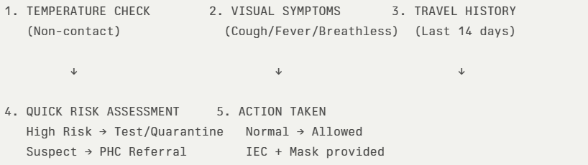
The screening protocol shall include temperature screening, observation for visible symptoms, and inquiry regarding recent travel or exposure history. Individuals identified as suspects during screening shall be immediately referred to the nearest PHC/FHC for further evaluation, testing, and appropriate action as per prevailing guidelines.

Pandemic Control Room
The Pandemic Control Room (PCR) serves as the central nerve center for real-time coordination, data aggregation, decision support, and communication during outbreaks. It consolidates information from all LSGD teams, health facilities and community sources to enable rapid response decisions.

Control Room Infrastructure and Location
Primary Location: Ranni Panchayath Office.
Backup Location: Community Hall in Ranni Panchayth

Health System Control Room Framework
The PCR is organized into seven functional pillars to ensure no aspect of the response is overlooked:

Rapid Response Team (RRT)
  - Provides immediate intervention during emergencies, clusters, and field alerts.​
  - Coordinates urgent actions such as case investigation, contact tracing, isolation, and inter‑facility referrals.

Data Management & Analytics Team
  - Collects, validates, and manages key health system indicators (cases, tests, beds, HR, supplies).​
  - Analyzes data trends, generates projections, and supports evidence‑based decision‑making for local authorities.

Human Resource Deployment Team
  - Allocates healthcare staff efficiently based on workload and need
  - Ensures adequate and equitable workforce distribution across facilities

Laboratory Surveillance Team
  - Oversees diagnostic testing coordination, sample transport, and timely reporting of results.​
  - Monitors lab indicators (testing volume, positivity rate, turnaround time) for early detection of outbreaks

Vaccination Cell (If Required)
  - Plans and executes vaccination campaigns, including micro‑planning and session scheduling.​
  - Tracks coverage, identifies gaps, and coordinates corrective actions with field teams and outreach services.

Infrastructure & Patient Occupancy Team
  - Monitors facility capacity, earmarked beds, oxygen and critical care resources across all linked facilities.​
  - Ensures optimal patient distribution and referral management using updated bed‑status and resource data.
  - BMWM

Communication team
- Disseminate daily situation updates through official communication channels.
- Counter misinformation through verified announcements.
- Maintain a public helpline or contact point for queries and emergency assistance.
- Conduct focused IEC campaigns in affected wards.

- Logistics and supply chain
- Activate emergency procurement mechanisms for essential medical supplies.
- Monitor real-time stock levels of PPE, masks, sanitizers, oxygen support equipment, and essential medicines.
- Ensure uninterrupted supply of essential commodities including food and drinking water.
- Coordinate with district authorities for additional resource mobilization if required.
- The Logistics Nodal Officer shall maintain daily stock status reports.
- Transportation (interfacility & emergency transport)
- Maintain a dedicated list of ambulances, private vehicles, and emergency drivers available within the Panchayat.
- Establish clear referral linkages with higher treatment centres and designated hospitals.
- Ensure availability of at least one standby vehicle for emergency patient transport from containment zones.
- Implement infection prevention protocols within transport vehicles, including disinfection after each transfer.
- Provide PPE kits and necessary protective measures for drivers and accompanying staff.
- Maintain a transport logbook documenting patient movement, date, time, and receiving facility.
- Priority shall be given to severe cases, pregnant women, dialysis patients, and other high-risk individuals requiring urgent inter-facility transfer
- Media surveillance Call centre
- Monitor print, television, digital media, and social media platforms for disease-related information, rumours, and public concerns.
- Identify and verify misinformation promptly through coordination with District Information Office.
- Issue timely clarifications and official updates through authorized communication channels.
- Establish a Panchayat-level contact point or helpline number for public queries, reporting symptoms, and emergency assistance.
- Maintain a call register documenting nature of queries and action taken.
- Escalate urgent cases to health authorities or emergency services.
- Provide psychological reassurance and guidance on home isolation, testing, and preventive measures.
- Management of the deceased
- Follow infection prevention protocols for handling and transportation of the deceased.
- Provide PPE kits to personnel involved in body handling.
- Restrict handling to trained personnel only.
- Coordinate with designated crematoriums or burial grounds to ensure safe disposal practices.
- Maintain documentation of death details and cause of death as per reporting requirements.
- Provide clear guidance to family members regarding permitted funeral practices and public health safety measures.
- Ensure respectful handling of bodies while balancing infection control requirements.
- Intersectoral coordination and convergence
- Convene regular coordination meetings under the leadership of the Panchayat President/Secretary with representation from Health, Revenue, Police, ICDS, Education, Animal Husbandry, Civil Supplies, Social Justice, and Kudumbashree.
- Establish a Panchayat-level Incident Coordination Group to oversee planning, implementation, monitoring, and reporting of response activities.
- Align all containment, surveillance, and relief activities with directives issued by the District Disaster Management Authority (DDMA) and District Health Authorities.
- Ensure convergence of resources including manpower, vehicles, logistics, relief materials, and communication channels across departments.
- Coordinate with the Education Department for temporary closure, sanitization, or conversion of institutions into quarantine facilities when required.
- Work with the Police Department for enforcement of containment measures and regulation of public gatherings.
- Engage Civil Supplies and Social Welfare Departments to ensure uninterrupted access to food, rations, and social protection schemes.
- Coordinate with the Animal Husbandry Department for zoonotic surveillance where relevant.
- Involve community-based organizations, NGOs, religious institutions, and volunteer networks to support awareness campaigns and relief distribution.

Key Control Room Team
The Control Room Team coordinates all pandemic response activities within the LSGD and serves as the single command and communication hub during activation. It integrates information, field actions, logistics, and policy execution across all participating departments and health facilities.

Role | Name | Designation | Contact Number | Responsibility
In-charge/Nodal Officer | Dr.Lekha Thobias | Medical Officer | 9496208265 | Overall coordination, decision-making, and reporting to the District level.
Data Entry Operator | Jiji Sreedhar | Clerk | 9947453246 | Managing the line list, updating dashboards, and tracking testing results.
Communication Officer | Abraham Mathew | HI | 9446078405 | Handling the public helpline, coordinating ambulance dispatch, and contact tracing calls.
Logistics Coordinator |  |  |  | Maintain the Supply Chain,Coordinating with the Kudumbasree for community kitchen and overseeing waste
Technical Support (IT/Data) | Ratheesh | PRO | 9747211462 | Ensuring Hardwork/network uplight,physical filling of records,assisting in rapid document and dispatch and maintaining the control room

SOP for alert escalation/trigger point with mapping of responsibilities.

Alert Escalation / Trigger Points with Mapping of Responsibilities

1. Purpose
This SOP defines the trigger thresholds, alert escalation process, and role-based responsibilities for timely activation of response mechanisms under the Pandemic Preparedness Framework.The objective is to ensure early detection, structured escalation, and coordinated multi-sectoral response to emerging public health threats.
2. Alert Levels and Trigger Points
Level 0 – Routine Surveillance (Green Alert)
Trigger | - No unusual increase in cases  - Normal seasonal trends  - No cluster detection
Action | - Continue routine surveillance and reporting  - Weekly data review  - Maintain preparedness and buffer stocks
Responsibility | - JPHN / ASHA Workers – Field surveillance  - Health Standing Committee – Oversight  - Panchayat Secretary – Monitoring compliance

Level 1 – Early Warning (Yellow Alert)
Trigger Points | - Sudden increase (≥2x baseline) in fever/diarrhoeal cases in a ward  - Clustering of cases within households/institutions  - Unusual absenteeism in schools/workplaces  - Detection of zoonotic signals (animal morbidity/mortality)  - District/State advisory issued
Action | - Immediate reporting to Block Medical Officer  - Intensified syndromic surveillance in affected ward  - Field verification by Rapid Response Team (RRT)  - Activation of ward-level monitoring committees  - Review of logistics and stock availability
Responsibility Mapping | - ASHA/JPHN – Case verification & line-listing  - Medical Officer PHC – Clinical validation & reporting  - Panchayat President – Convene emergency review  - Veterinary Officer – Animal surveillance coordination  - Ward Member – Community mobilization

Level 2 – Outbreak Confirmation (Orange Alert)
Trigger Points | - Laboratory-confirmed outbreak  - Sustained local transmission  - Multiple wards reporting clusters  - Healthcare facility strain
Action | - Activate Panchayat Incident Coordination Group  - Implement containment measures in affected wards  - Operationalize quarantine/isolation facilities  - Intensify risk communication and public advisories  - Daily surveillance reporting to District authorities  - Deploy emergency logistics and buffer stocks
Responsibility Mapping | - Panchayat President – Incident Lead  - Medical Officer – Technical Lead  - Panchayat Secretary – Administrative coordination  - Health Inspector – Field containment operations  - Police Department – Enforcement support  - Civil Supplies – Essential commodity continuity

Level 3 – Public Health Emergency (Red Alert)
Trigger Points | - Rapid exponential case increase  - Severe cases requiring referral surge  - District-level emergency declaration  - Health system overload
Action | - Full activation of Emergency Response Plan  - Micro-containment zones  - Emergency procurement activation  - Inter-facility patient transfer coordination  - Activation of helpline and media monitoring  - Coordination with District Disaster Management Authority
Responsibility Mapping | - Panchayat Incident Commander – Strategic oversight  - Block Medical Officer – Clinical coordination  - District Administration – Resource augmentation  - Revenue & Police – Movement regulation  - Kudumbashree/Volunteers – Relief & support services

3. Escalation Flow Mechanism
- Field-level detection by ASHA/JPHN
- Immediate reporting to PHC Medical Officer
- Verification and preliminary assessment
- Communication to Panchayat President & Secretary
- Notification to Block Medical Officer
- Activation of corresponding alert level
- Documentation and situation reporting (SITREP)
All escalation shall occur within defined timelines (within 24 hours for Level 1 and immediate notification for Level 2 and above).
4. Documentation and Reporting
- Maintain Alert Escalation Register
- Daily Situation Reports during Level 2 and 3
- Record decisions taken and action implemented
- Submit consolidated reports to Block and District authorities
5. Review and De-escalation
Alert levels may be downgraded after:
- Two consecutive incubation periods with no new cases
- Declared containment by competent health authority
- Stabilization of surveillance indicators
Key Points:
- The Control Room shall be staffed with a designated In-charge, data entry personnel, and communication staff with clearly defined roles and shift arrangements.
- It shall maintain updated records on daily monitoring indicators including new cases, persons under active quarantine, and hospital bed occupancy.
- All reports and situation updates shall be shared daily with the Block and District Surveillance Unit.
- The Control Room shall act as a single point of contact for coordination with response teams, health institutions, and other departments.
- Contact details of the Control Room shall be widely communicated to field staff and stakeholders during activation.

Daily Monitoring Indicators
To ensure timely decision-making and effective response, the following key indicators shall be monitored and updated on a daily basis by the Pandemic Control Room:

Epidemiological Indicators:
New cases reported today, Total active cases, Test Positivity Rate (TPR), Case Fatality Rate (CFR)
- Surveillance Indicators:
Persons under home quarantine, High-risk contacts identified, Fever, ILI, SARI or other symptoms (syndromic surges), Travellers (symptomatic or high-risk arrivals),Animal husbandry surveillance (zoonotic alerts, unusual animal deaths, poultry/bird flu signals), Mortality surveillance (excess deaths, unexplained fatalities, verbal autopsy reports)
- Logistics and Infrastructure Indicators:
Hospital / CFLTC beds occupied, Oxygen cylinders/concentrators available, Ambulances on standby
- Alert Findings
The following table outlines category-specific trigger points (red flags) from surveillance indicators and corresponding immediate actions for the Pandemic Control Room. These enable rapid response to alert findings like testing anomalies, positive cases exceeding thresholds, clusters, and WGS reports.

Category | Trigger Pophint (Red Flag) | Immediate Action
Clusters | Geographical or facility-based: 5+ cases linked to one location (office, school, street). | Declare a micro-containment zone; perimeter control and active case finding.
Testing | Sudden drop in testing volume / delay in reporting / unusual testing trends | Review the sample collection process, address lab bottlenecks, deploy additional testing teams, and notify the District Lab.
Lab | Test Positivity rate increases | Increase testing sites in that ward.
Hospital | >80% Oxygen bed occupancy | Activate backup/CFLTC beds.
Travel | Cluster of cases from a single flight/train or high-risk arrival group. | Trace all passengers in adjacent seats; implement mandatory institutional quarantine.
Animal | Mass poultry/wildlife death or unusual sickness | Notify Animal Husbandry, sample the area, and dispatch RRT for environmental sampling and zoonotic check.
Mortality | Sudden spike in home deaths or brought-in-dead (BID) cases | Audit the deaths and Active Case Search drive
Additional investigations like Whole Genome Sequencing (WGS) | Detection of a Variant of Concern (VOC) or Variant of Interest (VOI) | Implement strict micro-containment; update clinical protocols to match variant severity.

Communication of Public Health Information
A Community Communication Hub shall be established to ensure timely, accurate, and consistent dissemination of information during a pandemic. The Hub will function under the coordination of Nodal officers of the control room and act as the nodal point for public communication, risk messaging, and community engagement. It will support dissemination of official advisories, promote preventive behaviors, address rumors and misinformation, and ensure that messages reach all sections of the population through trusted local channels and leaders.

Key communicators
Channel | Responsible Person | Contact
Ward-level announcements | Ward Member
Social media | HI , Abraham Mathew | 9446078405
Local Cable TV/Radio | JHI, Amal

- All messages disseminated through the Hub shall align with advisories issued by the Health Department and District authorities.
- Community leaders shall be sensitized to support behavior change, reduce stigma, and counter misinformation.
- Special efforts shall be made to reach vulnerable and hard-to-reach populations using locally appropriate communication methods.

Rumor Tracking: A designated volunteer will monitor local social media/WhatsApp groups daily to identify misinformation and issue official clarifications via the Communication Hub.

Coordination with District/State Authorities & Other Organisations
Effective coordination with Block, District, and State authorities is essential to ensure timely reporting, technical guidance, and uninterrupted supply of essential resources during a pandemic. The LSG shall establish clear communication channels, designate responsible officers, and adhere to prescribed reporting timelines to support coordinated public health action and efficient resource mobilisation.

Key Details:
- Nodal Officer for Reporting:
- Contact Number:
Reporting Schedule and Protocols:

To Whom | What to Report | Frequency | Nodal Person
Block PHC | Complete Situation Report (Cases, Quarantine, Beds, Screening, Deaths) | Weekly | MO
District IDSP Unit | Outbreaks/Clusters/Unusual Events (>5 cases same ward) | Weekly | DSO
Veterinary Officer | Animal health events/Zoonotic alerts | Weekly | Veterinary Medical officer
State Cell | Zoonotic cross-sector events | Weekly | SSO

Supply Chain Coordination
The LSG shall coordinate closely with Block, District, and State authorities (KMSCL) to ensure uninterrupted availability of essential goods, medical supplies, and logistics during a pandemic. Supply requirements shall be assessed regularly based on case load and communicated promptly to the appropriate authorities for timely replenishment.
Key Points:
- Maintain updated contact details of District and Block nodal officers for health logistics, oxygen supply, ambulances, and essential medicines.
- Submit timely indent requests for PPE, testing kits, medicines, oxygen, and other critical supplies through prescribed channels.
- Monitor stock levels at LSGD facilities, quarantine/isolation centres, and field teams through daily stock registers and dispensing logs to prevent shortages.
- Coordinate with District authorities, Karunya/Neethi medical shops, and local purchase committees for funds allocation and emergency procurement.

- Ensure regular monitoring of dispensing registers at all facilities to track usage, expiry, and pilferage—shortages being a perennial issue requiring proactive weekly audits.

- Activate surge procurement protocols during high caseloads, leveraging local purchase powers under LSGD funds alongside state supplies.

Resource Inventory and Contacts
Resource Category | Source  (District/State/Private) | Contact
PPE Kits/Masks/Gloves | KMSCL | 9995599249
PPE Kits/Masks/Gloves | Local Vendors
Oxygen  Cylinders/Concentrators | KMSCL | 9995599249
Medicines/Antivirals | KMSCL | 9995599249
Medicines/Antivirals | Neethi Shops
Test Kits (RTPCR/Rapid) | KMSCL | 9995599249

Collaboration with NGOs, PPP, and CSR
To augment government efforts during a pandemic, the LSG shall collaborate with NGOs, voluntary organisations, and private sector partners through public–private partnerships and Corporate Social Responsibility (CSR) initiatives, in coordination with District authorities.

Key Points:
- Engage NGOs and community-based organisations for community outreach, awareness, and support to vulnerable populations.
- Leverage CSR support for procurement of medical equipment, PPE, oxygen concentrators, food kits, and sanitation materials, as permitted.
- Ensure all collaborations align with government guidelines and are routed through approved administrative and financial procedures.
- Maintain transparency and documentation for all external support received and utilised.
Organization | Type | Support Offered | Contact Person
Youth Clubs/Student Unions | CBO

Interdepartmental Coordination
Coordination among departments during a pandemic shall be ensured through regular review meetings convened by the LSGD President. These meetings will provide a structured platform for sharing situational updates, assessing resource availability, resolving operational gaps, and taking joint decisions to ensure a coordinated and timely response.

Department | Representative | Key Role | Contact
Health (PHC) | Staff Nurse : | Case management
Veterinary | Veterinary Surgeon: | Animal surveillance
ICDS | Supervisor: Sindhu | Nutrition support
Education | Head Teacher: | School coordination
Police | SHO | Containment enforcement | __________
Water Authority | __________ | Water supply | __________
LSGD Engineering |  | Quarantine infrastructure | __________

PHASE 3 - Surge Capacity
Phase 3 is activated when there is a rapid increase in cases, high test positivity rates, or when existing health facilities and quarantine arrangements approach saturation. The focus of this phase is to expand isolation capacity, augment clinical care services, and mobilise additional resources through district and state support mechanisms.

Conversion of Community Facilities
To manage increased case load, the LSGD shall activate additional isolation facilities by repurposing identified community infrastructure such as community halls, auditoriums, schools, hostels, or other suitable buildings.

Name of facility | Facility Type | No. of Buildings | Ward | Surge Capacity (Beds) | Nodal Person
SCHOOL | GOVT/PRIVATE | 9 |  | 450
COLLEGE | PRIVATE | 1 |  | 50
COMMUNITY HALL | GOVT | 2 |  | 100
AUDITORIUM | PRIVATE | 1 |  | 50

Recovery and rehabilitation phase
Recovery
• Damage & Impact Assessment
A detailed ward-level assessment is conducted to evaluate the health, environmental, and socio-economic impact of the pandemic. This includes identification of affected households, service disruptions, and gaps in healthcare delivery to guide targeted recovery planning.

• Restoration of Health Services
Essential health services such as immunization, maternal and child health, NCD clinics, and TB services are restored in a phased manner. Priority is given to clearing service backlogs and ensuring uninterrupted access across all wards.

• Rehabilitation of Affected Population
Affected individuals and families are supported through Panchayat-led initiatives and convergence with social welfare schemes. Special focus is given to vulnerable groups including elderly, chronically ill, and economically affected populations.

• Psychosocial & Mental Health Support
Counselling services are strengthened through health workers and trained community volunteers to address stress, anxiety, and post-pandemic trauma. Special attention is given to high-risk and vulnerable groups.

• Disease Surveillance during Recovery Phase
Continuous surveillance is maintained to detect any resurgence or secondary outbreaks. Field-level health workers ensure active reporting, monitoring, and timely response.

• Environmental Cleanup & Sanitation
Intensive sanitation drives, waste management, and disinfection of water sources are carried out across wards. This helps prevent outbreaks of waterborne and vector-borne diseases.

• Livelihood Restoration
Efforts are made to restore livelihoods through Panchayat schemes, Kudumbashree initiatives, and employment programmes. Priority is given to economically affected households.

• Community Engagement & Confidence Building
Community awareness programmes and participatory activities are conducted to rebuild trust in the health system. Emphasis is placed on hygiene practices, vaccination, and early health-seeking behavior.

• Documentation & After-Action Review
All response activities, challenges, and outcomes are systematically documented. Review meetings are conducted to evaluate effectiveness and identify operational gaps.

• Lessons Learned & Best Practices
Key lessons from the pandemic response are compiled and analyzed. Successful strategies are documented for replication and strengthening future preparedness.

• Health System Strengthening
Healthcare infrastructure, workforce capacity, and logistics systems are strengthened based on identified gaps. This enhances overall emergency preparedness and response capacity.

• Policy Revision & Preparedness Enhancement
Policies and standard operating procedures are updated incorporating lessons learned. Preparedness plans are revised to ensure improved response to future public health emergencies.

• Research
Local epidemiological data and field experiences are utilized for operational research and evidence-based planning. Collaboration with health institutions is encouraged to strengthen public health strategies.

CONCLUSION
The Pandemic Preparedness Plan of Ranni Grama Panchayat provides a comprehensive and evidence-based framework for managing public health emergencies through a coordinated and decentralized approach. By integrating disease trend analysis, clinical and geographic vulnerability assessments, and ward-level risk stratification, the plan enables targeted and efficient interventions. Emphasis on strengthened surveillance systems, environmental sanitation, and continuity of essential health services enhances the Panchayat’s capacity to prevent and control outbreaks. The plan also promotes intersectoral coordination and community participation under the One Health framework, ensuring resilience and adaptability. Overall, this preparedness plan serves as a strategic roadmap to minimize health risks, strengthen system capacity, and ensure an effective and timely response to future pandemics.

Additional points
- tech support
- relief based commodities
- ham reading operators
- hazard vulnerability mapping
- Kseb & other power source
- HR specific responsibility

RECOMMENDATIONS

Strengthening Healthcare Infrastructure
- Establish a primary health response unit within the Panchayat with trained staff.
- Ensure availability of basic medical supplies (masks, sanitizers, PPE kits, oxygen cylinders).
- Create tie-ups with nearby hospitals in Ranni for emergency referral and transport.

2. Community Awareness & Education
- Conduct regular awareness campaigns on hygiene, vaccination, and preventive measures.
- Use local communication channels (community radio, WhatsApp groups, notice boards) to spread verified information.
- Train volunteers to act as health ambassadors in each ward.

3. Emergency Response & Coordination
- Form a Pandemic Preparedness Committee at Panchayat level including health workers, ward members, and NGOs.
- Develop a clear action plan for lockdowns, quarantine, and distribution of essentials.
- Maintain a database of vulnerable groups (elderly, differently-abled, chronically ill) for targeted support.

4. Supply Chain & Food Security
- Identify and support local suppliers and farmers to ensure uninterrupted food supply.
- Create community kitchens during emergencies to serve vulnerable populations.
- Stockpile essential commodities in Panchayat-run outlets for crisis periods.

5. Digital Preparedness
- Promote digital platforms for telemedicine consultations.
- Use Panchayat’s website/social media for real-time updates on health advisories.
- Encourage online grievance redressal to reduce crowding in offices.

6. Training & Capacity Building
- Organize mock drills for pandemic response in schools, offices, and public spaces.
- Train Panchayat staff and volunteers in first aid, infection control, and crowd management.
- Collaborate with NGOs and health departments for capacity-building workshops.

7. Long-Term Resilience
- Integrate pandemic preparedness into the Panchayat Development Plan.
- Allocate a dedicated budget for health emergencies.
- Encourage community participation in planning and monitoring preparedness measures.

MOCKDRILL SCENARIOS

ANNEXURE

IMPORTANT PHONE NUMBERS

Phone numbers and particulars of persons responsible for providing guidance, assistance, and support for pandemic preparedness operations may be provided here in a manner that allows easy reference at a glance. The information recorded here could be exhibited elsewhere at the time of emergencies. LSG institutions shall give special attention to collect and record the above data of persons and institutions who/which are supposed to give technical and co-ordination support to reduce the impact of pandemic.

1.1. Details of grama panchayat/municipality/corporation wards
Sl.No | Name of the ward | Ward number | Name of the ward  member | Contact number
1 | THOTTAMON | 1 | SASIKALA RAJENDRAN | 9961281702
2 | MUNDAPPUZHA | 2 | SABU P ABRAHAM | 9847143536
3 | ANAPPARAMALA | 3 | BINDUMOL P J | 9605778335
4 | VAIKOM | 4 | SANUJAMOL | 8943686409
5 | PALACHUVADU | 5 | A N SOMAN | 9947736047
6 | PUTHUSSERIMALA WEST | 6 | RAJESH KUMAR | 9496732548
7 | PUTHUSSERIMALA EAST | 7 | OMANA SREEJITH | 7034364142
8 | KARIMKUTICKAL | 8 | RENJITH J | 9947451480
9 | INCHOLIL | 9 | P M PRASANNAKUMARI | 9847936756
10 | UTHIMOODU | 10 | DILEEP P PHILIP | 9072466232
11 | VALIYAKALUNKU | 11 | BABURAJ | 9447093616
12 | MANDIRAM | 12 | VINOD KUMAR M R | 9447802596
13 | THEKKEPURAM | 13 | SYAMALA VASUDEVAN | 7510771175
14 | BLOCKPADI | 14 | SINDU SANJAYAN | 9447935038

1.2. Other important phone numbers of grama panchayat/municipality/corporation area
Sl. No. | Name | Contact number
1.
2.
3.
4.
5.
6.
7. | Excise department
8. | Forest department

1.3. Important offices of grama panchayat/municipality/ corporation
Sl.No | Name of the office | Contact person | Contact number
1. | Village Office | Village Officer | 04735229365
2. | Agriculture Office | Agriculture Officer | 047529620
3. | Animal Husbandry Office | Animal Husbandry Doctor | 9495630834
4. | Police Station | Police Officer | 04735227626
5. | BSNL Office | Officer | 04735226600
6. | Block Office | Officer | 9947022975
7. | KSEB Office | Officer | 04735227582
8. | Fisheries Office | Officer | 04735225425
9. | Fire and Rescue | Officer | 0475224101

1.4. Health Services

Sl. No | Name of the hospital/institution | Location | Phone number
1. | Government hospitals/PHC | THQH RANNI | 9188522985
2. | Private hospitals
3. | Clinical laboratories
4. | Chemist/pharmacy
5. | Blood donors
6. | Other language experts (Bihari, Hindi, Bengali,  Asamees ………)

1.5. Veterinary Services
Sl.No | Name of the Clinic | Name of the  Surgeon/Doctor | Place/location | Phone  number
1 | Govt.Veterinary Hospital | Dr.LEKHA | BLOCKPADI | 9656961300

1.6. Helpline numbers
Helpline | Phone number
Police | 9497987055
Fire and Rescue | 04735224101
KSEB | 04735226355

1.7. Public and Private Schools Contact details
S.No | Name of School | Institution type | Phone number
1 | MS M.S.HIGHSCHOOL+HIGHER SECONDARY SCHOOL | Aided | 9446079420
2 | L.P.G.S RANNY | GOVT | 9400821646
3 | H.H.P.V. MUNDAPUZHA | Aided | 9447142882
4 | M.T.L.PS UTHIMMODU | Aided | 974463434
5 | GOVT.U.P.S VAIKOM | Government | 9747786366
6 | GUPS PUTHUSSERIMALA | Government | 9400821646
7 | CORNERSTONE INTERNATIONAL SCHOOL | Private | 8281832788
8 | GUPS PALACHUVAD | Govt | 9495437385
9 | SNTUPS PALACHUVAD | Aidedt | 8289945368
10 | NMLPS VAALIPLACKAL | AIDED | 9497106182

1.9. Anganwadi Contact Details
Ward No | Name of Anganwadi Teachers | Phone number
6 | Deepa,Ambika | 7012834305,9400200159
1 | Sathikumari | 9446978574
5 | Sindhu | 7034669017
4 | Ajitha,Santha | 9188873025,9947992679
2 | Omana | 8921286273
7 | manju | 9656485238
8 | Sujatha  shobha | 9744043378  9947441048
10 | rejeena | 9605223891
10 | Sulochana | 9605922578
12 | Geetha | 9847197231
13 | Prabha | 9946821341
11 | Thulasibhai | 9074605496

1.12. Information regarding resources

Means of transportation | Name of Owner | Phone Number
Heavy Trucks
Tractor
Ambulances
Taxi service

Annexure 1: LSG Baseline Data Collection Format
A. Baseline data
Sl. No. | Indicator / Field | Baseline Data | Source / Remarks
1 | Name of LSG | Ranni
2 | District | Pathanamthitta
3 | Block / Taluk | Ranni
4 | Type of LSG (Gram Panchayat / Municipality / Corporation) | Gramapanchayath
5 | Area (sq. km) | 15.64
6 | No. of wards | 14
7 | GIS boundary file available | (Yes/No)
8 | Key contact person & phone

B. Demography
Indicator / Field | Baseline Data | Source / Remarks
Total population | 14101
Males | 6895
Females | 7206
Transgender population | 0
Age distribution  (<5, 5–14, 15–59, ≥60) | 575/814/7331/5381
No. of households | 4150
Population density (persons/sq.km)
No. of migrant workers | 167
Major occupational groups

C. Vulnerable Populations & Social Risks
Sl. No. | Indicator / Field | Baseline Data (Value / Description) | Source / Remarks
1 | No. of elderly (≥60) | 1615
2 | No. of persons with disability | 128
3 | No. of bedridden persons | 72
4 | No. of chronic disease cases (DM/HTN/COPD/CKD etc.)
5 | Pregnant women (current estimate) | 44
6 | Children <5 years | 575
7 | Tribal population (if any) | 84
8 | Fisherfolk / coastal vulnerable groups (if any)
9 | Urban slums / unnotified settlements (if any)
10 | Homeless population | 0
11 | Orphanages / old age homes (number & capacity) | 0
12 | Hostels / prisons / shelters (number & capacity) | 1
13 | Poverty / BPL estimate | 1636
14 | Food insecurity hotspots | 0
15 | Any history of stigma/discrimination issues (Yes/No) | 0

D. Health System & Service Readiness
Sl. No. | Indicator / Field | Baseline Data (Value / Description) | Source / Remarks
1 | No. of health facilities in LSG (PHC/CHC/TH/DH/Private) | Thqh ranni -1
2 | PHC/Family Health Centre details (name, location) | 0
3 | Subcentres / Health & Wellness Centres (number) | 3
4 | Private clinics / hospitals (number) | 0
5 | Labs available (public/private) | 5
6 | Availability of ambulance services (Yes/No, number) | 1
7 | Availability of isolation/quarantine facilities (Yes/No, details) | 0
8 | Cold chain facilities (Yes/No, details) | Yes
9 | Stockpile space available (Yes/No) | No
10 | PPE / mask / sanitizer availability plan (Yes/No) | Yes
11 | Surveillance staff available (JHI/JPHN/ASHA count) | Yes
12 | Existing emergency referral pathways (Yes/No) | yes

E. Points of Entry & Mobility
Sl. No. | Indicator / Field | Baseline Data (Value / Description) | Source / Remarks
1 | Bus stands / depots (number) | 1
2 | Railway stations (number) | 0
3 | Boat jetties / fishing harbours (number) | 0
4 | Ports / airports nearby (specify distance) | 0
5 | Major highways/roads passing through | 0
6 | Border crossings (state/district) | 0
7 | Major markets / weekly markets | 0
8 | Tourism hubs / major event venues | 0
9 | Schools/colleges with hostels (number) | 0
10 | Factories / large workplaces (number) | 0
F. Water, Sanitation & Hygiene (WASH)
Sl. No. | Indicator / Field | Baseline Data (Value / Description) | Source / Remarks
1 | Major drinking water sources (piped / wells / borewells / springs) | 1
2 | No. of public wells | 11
3 | No. of households with piped water connection | 3815
4 | Water quality testing routine (Yes/No) | yes
5 | Common contamination risks (flooding, salinity, industrial waste) | No
6 | Open defecation free status (Yes/No) | No
7 | Solid waste management system (Yes/No) | No
8 | Bio-medical waste disposal mechanism (Yes/No) | Yes
9 | No. of public toilets | 2
10 | Handwashing stations in public places (Yes/No) | 2
G. Zoonotic Risks & One Health
Sl. No. | Indicator / Field | Baseline Data (Value / Description) | Source / Remarks
1 | Livestock population (cattle/goats/pigs/poultry) – estimates
2 | No. of dairy farms / poultry farms / pig farms
3 | Slaughterhouses / meat shops (number)
4 | Animal markets (Yes/No, details)
5 | Veterinary dispensaries (number)
6 | History of zoonotic outbreaks (rabies, leptospirosis, avian flu etc.)
7 | Stray dog population management measures (Yes/No)
8 | Rodent infestation hotspots (Yes/No)
9 | Wetlands / waterlogged areas prone to leptospirosis
10 | Bat roosting areas / caves / fruit orchards (if any)
11 | Human-animal interface hotspots (farms near residences)
H. Climate & Disaster Risks (Pandemic Amplifiers)
Sl. No. | Indicator / Field | Baseline Data (Value / Description) | Source / Remarks
1 | Flood-prone wards (list) | 1,2,5,13
2 | Landslide-prone wards (list) | 0
3 | Cyclone/sea surge risk (Yes/No) | 0
4 | Heatwave risk zones (Yes/No) | 0
5 | Waterlogging areas (list) | 0
6 | Shelter homes / relief camps (number, capacity) | 0
7 | Past disaster displacement history | 1
8 | Disruption to water supply/transport common (Yes/No) | 0
I. Critical Infrastructure & Logistics
Sl. No. | Indicator / Field | Baseline Data (Value / Description) | Source / Remarks
1 | Schools (number) | 11
2 | Anganwadis (number) | 18
3 | Colleges (number) | 0
4 | Community halls (number) | 2
5 | Places of worship with large gatherings (number) | 11
6 | Large markets / shopping areas (number) | 0
7 | Warehouses / cold storages (number) | 0
8 | Telecom/mobile network coverage gaps (Yes/No) | 1
9 | Power outage frequency (high/medium/low) | 11
10 | Availability of generators in key facilities | 18

J. Risk Communication & Community Networks
Sl. No. | Indicator / Field | Baseline Data (Value / Description) | Source / Remarks
1 | Ward-level rapid response teams (Yes/No) | Yes
2 | Jagratha samithis / committees active (Yes/No) | Yes
3 | Kudumbashree presence and strength (number of units) | Yes
4 | Volunteer network (number, coverage) | Yes
5 | Community-based surveillance mechanisms (Yes/No) | Yes
6 | IEC dissemination channels (WhatsApp groups, community radio, PA systems) | Yes
7 | Rumour tracking mechanisms (Yes/No) | Yes
8 | Languages spoken / literacy considerations | no
9 | Vulnerable groups communication strategy available (Yes/No)

K. Preparedness Planning & Governance
Sl. No. | Indicator / Field | Baseline Data (Value / Description) | Source / Remarks
1 | LSG emergency plan available (Yes/No) | Yes
2 | Pandemic preparedness plan available (Yes/No)
3 | Incident Command System identified (Yes/No)
4 | Rapid procurement mechanism available (Yes/No)
5 | Emergency fund available (Yes/No, amount)
6 | Past outbreak response experience (Yes/No, details)
7 | Intersectoral coordination mechanism (Health, Police, LSG, Veterinary, Education)
8 | Mock drills conducted in last 12 months (Yes/No)
9 | Training coverage for staff/volunteers (Yes/No)

L. Surveillance & Data Systems
Sl. No. | Indicator / Field | Baseline Data (Value / Description) | Source / Remarks
1 | Digital reporting tools used (e.g., DHIS2, portals)
2 | Availability of line-listing format (Yes/No)
3 | Contact tracing team identified (Yes/No)
4 | Mapping of high-risk households available (Yes/No)
5 | Testing sample transport mechanism (Yes/No)
6 | Reporting timeline adherence (good/average/poor)
7 | Data sharing between departments (Yes/No)
8 | Availability of dashboard for monitoring (Yes/No)

M. Additional Notes & Observations
Sl. No. | Indicator / Field | Baseline Data (Value / Description) | Source / Remarks
1 | Key challenges perceived by LSG
2 | Top 5 high-risk wards (reason)
3 | Any unique local risks (industrial pollution, refugee camps, etc.)
4 | Recommendations for preparedness strengthening

