PANDEMIC PREPAREDNESS PLAN
OF Vechoochira PANCHAYATH
[Document subtitle]

MESSAGE FROM PRESIDENT

I am happy to know that a Pandemic Preparedness Plan has been prepared for Vechuchira Grama Panchayat with the support of the Local Self Government Department and Health Department. In recent years, we have understood how important it is to be prepared for diseases that can spread quickly and affect many people. This plan will help our Panchayat, health workers, and other departments to work together in an organized way during such situations. It will also help in creating awareness among the public and ensuring the safety and well-being of our community. I appreciate the efforts taken by everyone involved in preparing this plan and extend my sincere wishes for its effective implementation for the benefit of the people of Vechuchira Panchayat.
Sincerely

Rema Devi
President
Vechoochira Panchayth

MESSAGE FROM HEALTH STANDING COMMITTEE

Public health preparedness is a fundamental responsibility of the Health Standing Committee of Vechoochira Grama Panchayat. In the context of emerging and re-emerging infectious diseases, the formulation of a comprehensive Pandemic Preparedness Plan is essential to ensure the safety and well-being of our community. Given the geographical features, population distribution, and varying access to healthcare services within the Panchayat, early preparedness, systematic surveillance, and coordinated response mechanisms are crucial to prevent rapid disease transmission and minimize health, social, and economic impacts. This plan provides a structured framework for strengthening disease surveillance, improving inter-sectoral coordination, ensuring availability of essential medical supplies, and enhancing community awareness and participation. It also emphasizes the protection of vulnerable groups, continuity of essential health services, and capacity building of frontline workers. Through this initiative, the Health Standing Committee reaffirms its commitment to building a resilient and responsive public health system in alignment with the policies and guidelines.
Let wishes the best……
Best regards
BINDHU
Vechoochira Panchayath

MESSAGE BY MEDICAL OFFICER

It is a matter of great satisfaction that Vechoochira Grama Panchayat has developed a comprehensive Pandemic Preparedness Plan incorporating local health data, vulnerability assessments, and ward-level risk analysis. Such a systematic and evidence-based approach is essential to effectively prevent, detect, and respond to emerging public health threats.
In the context of increasing risks from communicable diseases and potential pandemics, preparedness at the grassroots level is crucial. The coordinated efforts of the Health Department, Local Self Government, and community stakeholders will play a vital role in ensuring timely response, effective containment, and continuity of essential health services.
I appreciate the dedicated efforts of all health staff, field-level workers, and stakeholders involved in the preparation of this plan. I am confident that this initiative will significantly strengthen the public health system and enhance the resilience of the community.
I extend my best wishes for the successful implementation of this Pandemic Preparedness Plan and for ensuring the health and well-being of the people of Vechoochira.

Dr.lekha thobias
medical officer
chc vechoochira

EXECUTIVE SUMMARY

Community Health Centre (CHC) functions as the primary public healthcare institution serving the population of Vechuchira Grama Panchayath. The PHC plays a pivotal role in delivering comprehensive, accessible, and affordable healthcare services, with a strong focus on preventive, promotive, curative, and rehabilitative care in accordance with national and state health programmes.
The CHC caters to a predominantly rural population, addressing key public health priorities such as maternal and child health, communicable and non-communicable disease control, immunization, family welfare, adolescent health, and geriatric care. Regular outpatient services, home-based care through field health staff, and outreach activities ensure healthcare coverage even in geographically challenging areas. The institution actively implements national health missions, including the National Health Mission (NHM), National Tuberculosis Elimination Programme, National Programme for Prevention and Control of Cancer, Diabetes, Cardiovascular Diseases and Stroke (NPCDCS), and other disease surveillance initiatives.
Vechuchira CHC works in close coordination with the Grama Panchayath, ASHA workers, Anganwadi centres, schools, and community-based organizations to strengthen community participation and improve health awareness. Emphasis is placed on early detection, timely referral, health education, and lifestyle modification to reduce disease burden and improve overall health outcomes.
Despite constraints related to infrastructure, manpower, and increasing service demand, the PHC continues to enhance service delivery through effective planning, data-driven decision-making, and community engagement. Strengthening facilities, upgrading digital health systems, and expanding preventive services remain key focus areas for future development.
Overall, Vechuchira Community Health Center stands as a vital institution in safeguarding public health and improving the quality of life of the residents of Vechuchira Grama Panchayath

LIST OF ABBREVIATIONS

LSGD/LSGI | Local Self Government Department / Local Self Government Institution
BMO | Block Medical Officer
IDSP | Integrated Disease Surveillance Programme
NDMA | National Disaster Management Authority
PPE | Personal Protective Equipment
ICMR | Indian Council of Medical Research
CD | Communicable Diseases
NCD | NON-COMMUNICABLE Diseases

TABLE OF CONTENTS

INTRODUCTION 9
● Background of the PPP 9
LSGD AT A GLANCE 9
INTEGRATED HEALTH INFRASTRUCTURE MAP OF VECHUCHIRA PANCHAYAT 18
GENERAL PROFILE OF THE LSGI’S 20
Background of the LSGI 20
Demographic and Vulnerable Population 22
Clinical Vulnerability 23
INFRASTRUCTURE & RESOURCE INVENTORY 26
Health Facility Directory & Basic Capacity in the LSGD 26
Private Clinics 27
Healthcare Education & Training Institutions 27
Specialized Services & Emergency Inventory 28
Oxygen & Diagnostic Capacity 29
Diagnostics facility mapping at the LSGI level 29
Laboratory Identification & Basic Details 30
Social and Community Infrastructure for surge plan 30
Human resources 32
Community & Support Cadre 33
Community Organizations 34
Administrative & Emergency Services 35
Information regarding resources 35
ONE HEALTH & ENVIRONMENTAL SURVEILLANCE 36
Animal & Bird Population 36
Veterinary Infrastructure 37
Veterinary Doctors & Workforce 38
High-Risk Interface Points (Surveillance Sites) 39
Environmental Risk Mapping 40
Disease Seasonality Mapping 41
Vulnerability Mapping 42
EPIDEMIOLOGICAL TRENDS (2021–2025) 43
Disease Burden among human beings(Last 5 Years) 43
Seasonal Trend Analysis 45
51
Outcome-Based Trend Analysis- 2025 51
Transmission Trend- 2025 54
Integrated Disease Hotspot Map (2021–202 57
Preparedness and Response Protocol at LSG Level 61
Constitution of One Health Committee 61
Pandemic Response Workforce 62
Activities and Measures before and during Pandemic 64
PHASE 1 - Alert / Preparation 64
PHASE 2 - Active Response 67
Standard Screening Protocol 69
PHASE 3 - Surge Capacity 84
Conversion of Community Facilities 84
CONCLUSION 87
RECOMMENDATIONS 89
ANNEXURE 91
1. IMPORTANT PHONE NUMBERS 91

INTRODUCTION

Background of the PPP

Vechoochira Grama Panchayat is situated in a predominantly rural and hilly terrain characterized by undulating topography, scattered settlements, agricultural lands, forest fringes, and areas with limited transportation access. The Panchayat has a diverse population comprising children, working-age adults, and a considerable proportion of elderly residents, many of whom may have underlying health conditions that increase vulnerability during public health emergencies. The geographical dispersion of households, dependence on public transport, seasonal population movements, and varying levels of access to healthcare facilities further heighten the risk of rapid disease transmission and challenges in emergency response. In this context, a structured Pandemic Preparedness Plan is essential to strengthen disease surveillance, ensure early detection and containment, safeguard vulnerable populations, and maintain continuity of essential services. The plan aims to enhance coordination among health institutions, local governance bodies, and community stakeholders while promoting awareness, resilience, and timely intervention. Establishing a comprehensive preparedness framework is therefore critical to minimizing health, social, and economic impacts of future pandemics and ensuring an effective, organized response at the grassroots level.

LSGD AT A GLANCE

Vechoochira Grama Panchayat is a rural Local Self-Government Institution characterized by hilly and undulating terrain, interspersed with agricultural lands, rubber plantations, forest fringes, and scattered residential settlements. The Panchayat has a moderately distributed population comprising various age groups, including children, working-age adults, and elderly residents. The socio-economic profile reflects a predominantly agrarian community, with major occupations including agriculture, plantation work, small-scale trading, daily wage labor, and employment in the service sector. A section of the population depends on seasonal income and government welfare schemes, indicating the presence of economically vulnerable groups. Basic infrastructure facilities such as primary health centers, anganwadis, educational institutions, road networks, drinking water schemes, and electrification are available, though access may vary in remote and interior areas due to the terrain. The Panchayat also benefits from active community-based organizations, self-help groups, and local development initiatives that contribute to social welfare and grassroots governance. Overall, Vechoochira Grama Panchayat reflects a rural socio-economic structure with growing developmental needs and a strong foundation for participatory local governance.

- Geographical boundaries with political map ( based on latest delimitation)
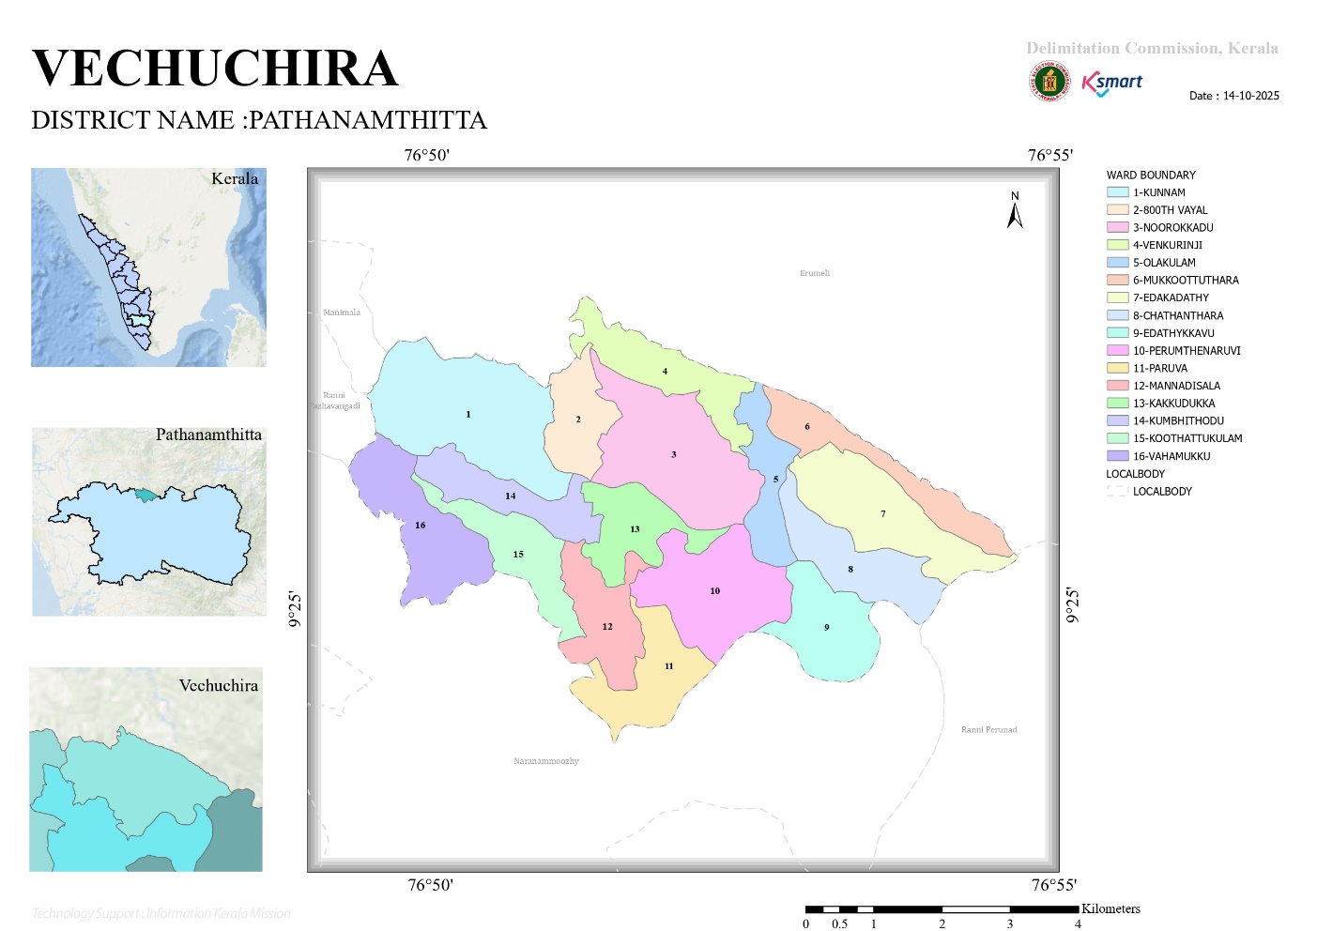
- Baseline data
No.of wards | 16
No.of Houses | 6465
Population | 25698
Male | 12378
Feamale | 13320
Transgender | 0
Below one year | 170
1-5 yr | 677
10-19 yr | 2074
30-60 yr | 9378
Above 60 yr | 4092
Differently abled | 135
Total EC | 3516
Asha workers | 15
AWW | 28
ORT depots | 26
ST nagar | 3
SC Nagar | 3
Extreme poverty families | 25
ICDS Anganwadies | 28
Govt hospitals | 1
Allopathy | 1
Ayurveda | 1
Homeo | 1
Private Hospitals | 2
Allopathy | 1
Ayurveda | 2
Homeo | 2
Dental clinics | 2
Clinical laboratories | 4
Educational institutions | 20
Govt HSS | 2
HS | 1
UPS | 0
LPS | 4
Pre primary | 0
Aided school HSS | 2
HS | 1
UPS | 1
LPS | 4
Pre primary | 0
Un aided schools HSS | 1
HS | 0
UPS | 0
LPS | 2
Pre primary | 0
Colleges | 1
Poly techniques | 1
Govt institutions state | 12
Central | 1
Hostels | 2
Medical colleges | 0
Nursing colleges | 0
Orphanage | 0
Old age homes | 2
Temple | 6
Church | 45
Mosque | 3
No.of private well | 7183
Public well | 57
Pumbing station | 8
Public libraries | 1
Arts and sports clubs | 6
Soda factories | 0
Hotel and tea shop | 34
Thattukada | 11
Market | 1
Slaughter house | 6
Construction area | 9
Rubber plantation | 26
Pineapple plantation | 2

- Ward division -
Ward | Houses | Population | Migrants | Wells | Hot  spots | Ed. Institutions | Hosp pvt/govt.
16 | 6151 | 25698 | 141 | 5840 | 5 | 17 | 3
- Kunnam
- 800th Vayal
- Noorokkadu
- Venkurinji
- Olakkulam
- Mokoottuthara
- Edakkadathy
- Chathenthara
- Edathykkavu
- Perunthenaruvi
- Peruva
- Mannadissala
- Kakkudukka
- Kumbithodu
- Koothattukulam
- Vaahathodu

- Risk stratification among wards in the context of Communicable diseases and hazards
- Major Roads/rivers
Perunthenaruvi River
- Major establishments with geospatial mapping
- occupational groups, socio cultural groups, migration & mobility patterns
- Vulnerability mapping

- Disaster prone areas (geographic vulnerability)
Vechoochira Grama Panchayat exhibits distinct spatial risk patterns influenced by terrain, hydrology, and climatic variability. Ward 2 is categorized under landslide-prone zones, primarily due to its undulating topography, lateritic soil composition, slope instability, and high-intensity rainfall during the monsoon season. Historical micro-level assessments indicate susceptibility to soil erosion, minor slope failures, and localized land subsidence during extreme precipitation events. In contrast, Ward 1 falls within a flood-prone belt, influenced by its proximity to riverine systems, low-lying terrain, and seasonal waterlogging exacerbated by intense rainfall and drainage congestion. CDMA flood vulnerability mapping highlights recurrent inundation patterns, temporary displacement risks, and potential disruption of essential services in this ward. These geographically differentiated vulnerabilities necessitate ward-specific risk mitigation strategies within the Panchayat’s disaster management framework.
Maps - ward-based (Mention source also)

- Geographical boundaries - ward boundaries map

- roads and rivers map
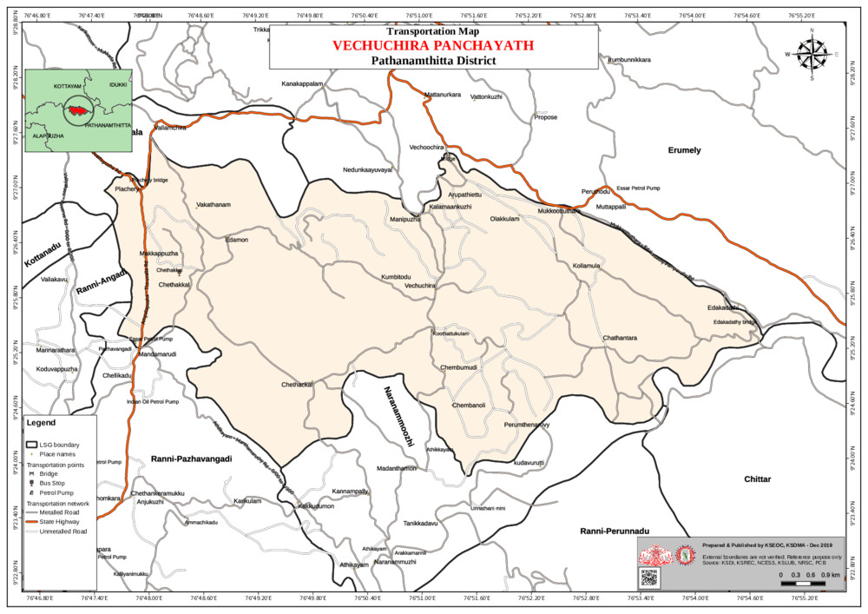
- major establishments map
- disaster-prone areas map
FLOOD AFFECTED AREA
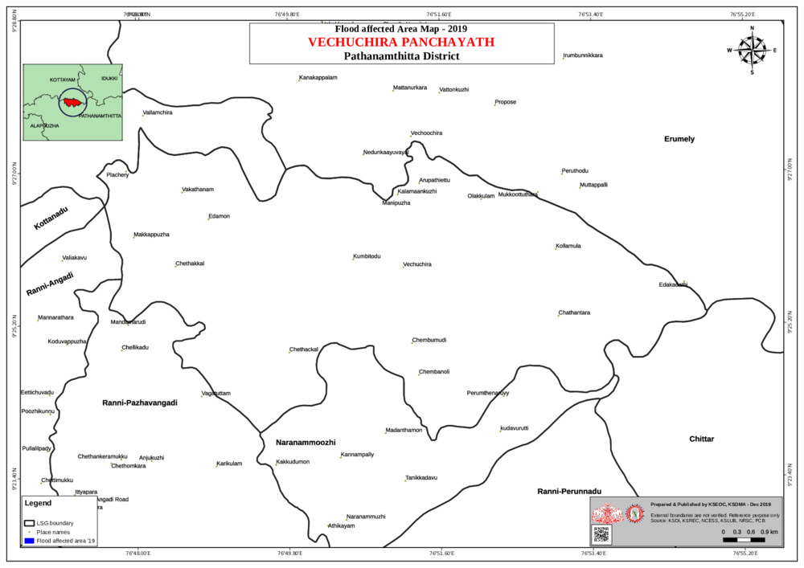
LANDSLIDE AFFECTED AREA
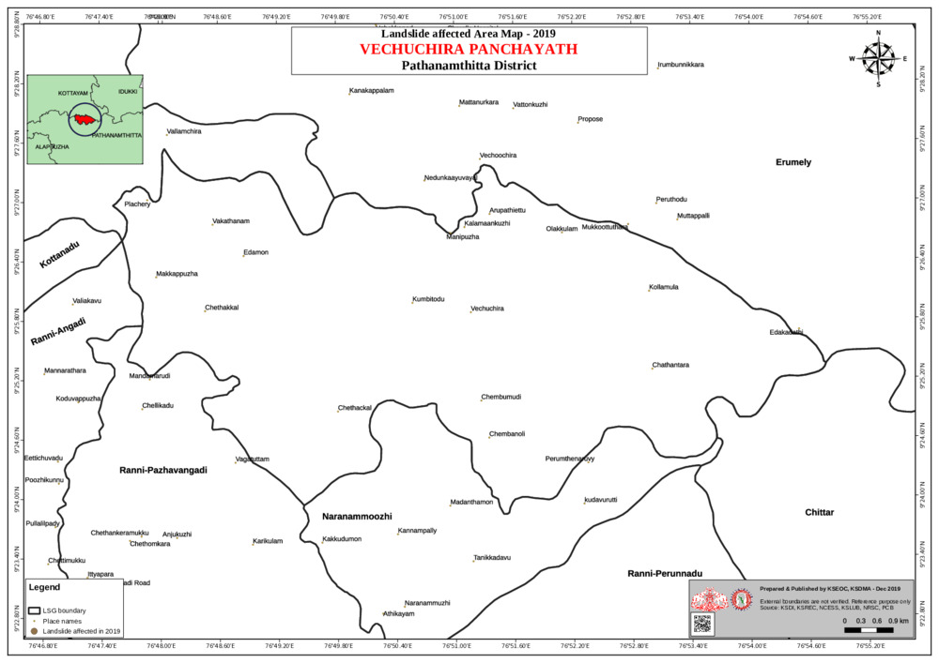
- hotspot map - CD & disasters

INTEGRATED HEALTH INFRASTRUCTURE MAP OF VECHUCHIRA PANCHAYAT
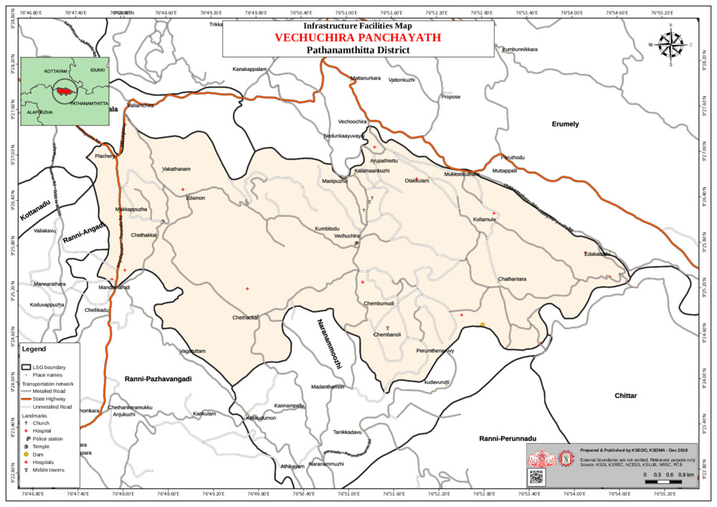

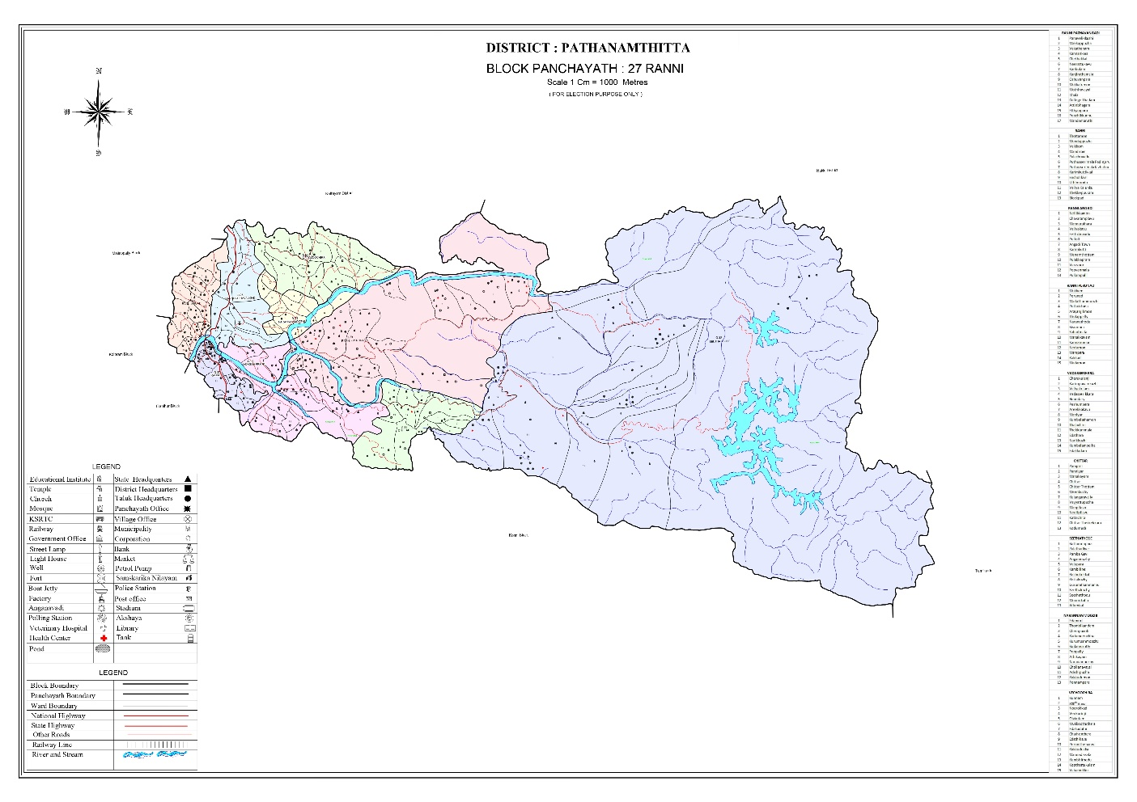

GENERAL PROFILE OF THE LSGI’S

Background of the LSGI
Vechoochira Grama Panchayat is situated in the eastern part of Pathanamthitta District, Kerala. The geographical landscape of the Panchayat is predominantly hilly and undulating, characterized by midland and highland terrain, agricultural lands, rubber plantations, forest fringes, and scattered rural settlements. Several small streams and natural drainage channels traverse the area, influencing the local microclimate and water availability. The terrain and dispersed habitation pattern pose specific challenges to transportation, access to healthcare, emergency response, and service delivery, particularly during heavy monsoon seasons when roads may be affected by waterlogging, soil erosion, or localized flooding.
The Panchayat is administratively divided into multiple wards, with a population predominantly dependent on agriculture and allied activities for livelihood. Rubber cultivation forms a major component of the local economy, along with the cultivation of crops such as tapioca, banana, and other seasonal produce. A significant proportion of residents are engaged in plantation work, small-scale trading, daily wage labour, and employment in the public and private service sectors. In addition, there is a presence of migrant labourers, particularly in the construction, plantation, and agricultural sectors. The socio-economic structure reflects a largely rural community with varying income levels, including economically vulnerable households dependent on welfare schemes and social support systems.
From a public health and disaster management perspective, Vechoochira Grama Panchayat is vulnerable to challenges associated with heavy monsoon rains, localized flooding in low-lying areas, water contamination, and vector-borne diseases such as Dengue and Leptospirosis. The hilly terrain, forest fringes, and scattered settlements can create difficulties in accessibility and timely emergency response, particularly during periods of intense rainfall. The floods and extreme weather events experienced in Kerala in recent years, including the 2018 flood disaster, have highlighted the need for strengthened preparedness, improved coordination, and resilient infrastructure at the local level. These experiences have reinforced the importance of enhancing local response systems, early warning mechanisms, and inter-departmental collaboration.

In this context, the development of a localized, data-driven Auxiliary Infrastructure and Logistical Resource Map is essential to support effective planning, prompt emergency response, and sustainable development initiatives within the Panchayat. Such mapping facilitates the identification of critical facilities, vulnerable zones, transportation routes, and available resources, thereby improving disaster readiness, ensuring continuity of essential services, and enhancing the overall resilience and safety of the community.

Table 1: Background of LSGD
Description | Details
Name of LSGI | VECHOOCHIRA
Type (GP/Municipality / Corporation etc.) | Grama Panchayath
Block | RANNI
District | PATHANAMTHITTA
Number of wards | 16
Total area (sq. km) | 51.80
Population(Projected) | 25698
Population density | 503persons/sq km
Terrain (coastal/low-lying/backwaters/foothills, etc.) | FOOTHILLS
Number of rivers passing through LSGI | 1
Number of water bodies in the LSGI | 1
Number of educational institutions | 17
Factories / small-scale industries | 0
Flood-prone wards | 0
Landslide-prone wards | 3
Death Management and Disposal Facilities (mortuaries/crematorium, including electric) | 0
Auditoriums/Marriage halls/convention centres/community halls | 7

Demographic and Vulnerable Population
Understanding the demographic composition and vulnerable population groups is essential for pandemic preparedness. Children, elderly, economically deprived families, migrant workers, and socially vulnerable groups are at increased risk during public health emergencies due to higher exposure, limited access to services, and dependency on public systems..

Description |  | Details (in numbers)
DEMOGRAPHIC PROFILE
Total population |  | 25698
Male |  | 12440
Female |  | 13258
Transgender |  | 0
Children under 5 |  | 847
Adolescent |  | 2074
Elderly (>60) |  | 4092
SOCIAL/LIVELIHOOD VULNERABILITY
Previous EPEP family |  | 24
BPL family |  | 3690
Tribal communities |  | 626
Migration | Immigrant | 141
Migration | Emigrant | 7548
Socio-economically deprived
Fisherfolk |  | 0
SC Community |  | 1291
ST Community |  | 626

Clinical Vulnerability
Certain population groups needs priority healthcare & are at higher risk of severe illness, complications, and mortality during pandemics. Patients with chronic diseases, those requiring regular medical care, and individuals with mobility or functional limitations face challenges in accessing timely care during emergencies. Mapping these groups helps in prioritizing continuity of treatment, medicine stock planning, oxygen support, referral transport, and targeted home-based care.
Description | Details in numbers
Pregnant women | 138
Lactating mothers | 144
Bedbound patients | 119
Patients under palliative care other than bedbound | 97
Patients on Haemodialysis | 11
Patients on CAPD | 0
Cancer patients (currently on treatment) | 75
Haemophilic patients | 0
Mentally challenged | 47
Differently abled | 12
Diabetic patients | 2279
Hypertensive patients | 2502
TB patients | 6

Major Festivals & Events specific to the LSGI
(with the possibility of a public gathering)

Sl. No. | Name of festival | Month detailing the periodicity
1 | KUNNAM TEMPLE& PARUVA TEMPLE | JANUARY

INFRASTRUCTURE & RESOURCE INVENTORY

Health Facility Directory & Basic Capacity in the LSGD
This section provides an overview of the healthcare infrastructure available within the LSGD area. It outlines the distribution and basic capacity of health facilities that form the backbone of service delivery during routine times and public health emergencies.

Family Health Centres (FHCs) and Community Health Centres (CHCs) generally function as the first point of contact for the community, providing essential outpatient and inpatient services. General Hospitals (GH) and Medical College Hospitals (MCH), where accessible, serve as the main referral centres for advanced diagnostics, specialist care, and critical services during public health emergencies. This inventory helps identify existing strengths, gaps, and potential surge capacity that can be mobilised during a pandemic or disaster.

Table 5. Health Facility Resource Summary
Sl.no. | Health Facility | Type of Facility (MCH/GH/CHC/FHC/SC etc.) | Contact Number | Total beds | ICU Beds | Oxygen-Supported Beds | No. of Ventilator Support Beds | No. of ambulances
Government Healthcare Facilities
1 | CHC VECHOOCHIRA | FHC | 9496208265 | 24 | 0 | 2 | 0 | 0
Private Healthcare Facilities
AYUSH Healthcare Facilities
1 | GOVT .AYRUVEDA HOSPITAL VECHOOCHIRA
2 | GOVT HOMEO HOSPITAL KUNNAM

Private Clinics
Private clinics are an essential part of pandemic preparedness, as they are often the first place people seek care when symptoms begin. In many communities, private clinics manage a significant share of outpatient visits and therefore play a critical role in early case detection, timely referrals, and disease surveillance. Having an up-to-date understanding of where these clinics are located, the services they provide, and how they are linked to the public health system helps ensure that no cases are missed during an outbreak. It also allows health authorities to engage private practitioners more effectively for reporting, risk communication, and coordinated response, strengthening the overall capacity of the health system to manage public health emergencies.

Table 6. Private Clinic Resource Summary
Sl No. | Name of Clinic | Registered (Y/N) | Clinic (General / Speciality) | Speciality (if any) | Address | Contact Number | Diagnostic Facility (Y/N) | Ambulance Linkage (Y/N)
1 | BMC HOSPITAL | YES | CLINIC | NIL | DR.Manu M Varghese |  | YES | YES
2 | CHERUPUSHPAM HOSPITAL | YES | CLINIC | NIL | Dr.Mathew | 9605411811 | YES | NO

Healthcare Education & Training Institutions
This section tracks the educational infrastructure available, which is vital for human resource planning in the health sector.

Category of Institution | Govt | Private | AYUSH | Total
Medical Colleges | 0 | 0 | 0 | 0
Nursing Colleges | 0 | 0 | 0 | 0
Dental Colleges | 0 | 0 | 0 | 0
Para-medical / Allied Health | 0 | 0 | 0 | 0
Pharmacy Colleges | 0 | 0 | 0 | 0

Specialized Services & Emergency Inventory
This section provides a detailed view of the specialized medical resources available to the community, focusing on emergency response and critical care capabilities. This table tracks the vital assets required for managing severe illnesses and emergencies across Government, Private, and AYUSH sectors.

Item | Govt | Private | AYUSH | Total
Hospital beds | 0 | 0 | 0 | 0
Oxygen-generating systems(Y/N) | 0 | 1 | 0 | 1
Oxygen-supported beds(Numbers) | 0 | 1 | 0 | 1
Ventilator-supported beds | 0 | 1 | 0 | 1
ICU beds | 0 | 1 | 0 | 1
Burns units | 0 | 0 | 0 | 0
Blood centres | 0 | 0 | 0 | 0
BLS ambulances | 0 | 0 | 0 | 0
ALS ambulances | 0 | 0 | 0 | 0
Dialysis facilities | 0 | 0 | 0 | 0
Dispensaries | 0 | 0 | 2 | 2
Medical store | 0 | 2 | 0 | 2
Industrial establishments(Medium-scale industries/small-scale industries establishments to whom we can depend in a worst-case scenario) | 0 | 0 | 0 | 0

Oxygen & Diagnostic Capacity
Monitoring oxygen and diagnostic capacity is a critical component of public health preparedness, ensuring that the LSGD can handle both chronic care and sudden surges in respiratory or infectious diseases.
Name of Health Facility | Oxygen-generating System (Y/N) | Backup Oxygen Source (Y/N) | Diagnostic Facilities Available(Y/N)
Name of Health Facility | Oxygen-generating System (Y/N) | Backup Oxygen Source (Y/N) | Lab | USG | X-ray | CT/MRI | RT-PCR
Government Healthcare Facilities
CHC VECHOOCHIRA | YES | Y | Y | N | N | N | N

Diagnostics facility mapping at the LSGI level
The diagnostic capacity of vechuchira grama panchayat represents the "intelligence network" of our healthcare system. The speed and accuracy of disease identification depend entirely on the distribution and technical level of these facilities.

Item | Govt | Private | AYUSH | Total
General labs | 1 | 5 | 0 | 6
Microbiology labs | 0 | 0 | 0 | 0
RT-PCR labs | 0 | 0 | 0 | 0
USG units | 0 | 0 | 0 | 0
CT/MRI units | 0 | 0 | 0 | 0
Research labs | 0 | 0 | 0 | 0
Labs of other departments that can be repurposed | 0 | 0 | 0 | 0

Laboratory Identification & Basic Details
Sl. No. | Name of Laboratory | Ownership (Govt / Private / Academic) | Address | Contact No. | 24×7 Services (Yes/No) | NABL / Govt Approved (Yes/No)
1 | METROPLUS | private
2 | TRUELAB | Private | Manimalethu Building, Koothattukulam | 9747491765 | NO | Y
3 | BINU MEDILAB | Private | Vechoochira P.O, Vechoochira | 9847873247 | NO | Y
4 | ALPHA LAB | PRIVATE |  | 9496784364 | NO | Y
5 | LIFE CARE DIAG: CENTRE | Private | Mannadissala P.O, Chathanthara | 9947817082 | NO | Y

Social and Community Infrastructure for surge plan
This table serves as our logistics and shelter inventory. By mapping these locations, quickly we can identify where to house displaced citizens, where to set up temporary medical clinics, and how to manage the deceased with dignity during a crisis.

Category | Total Count | Ward | Est. Capacity (Persons) | Contact details
Educational Institutions
Anganwadis | 28 | All wards
Schools | 17 | 1,2,4,7,9,10,11
Colleges | 1 | 12
Healthcare Educational Institutions
Medical colleges (Govt/Private) | 0 | 0 | 0 | 0
Nursing colleges (Govt/Private) | 0 | 0 | 0 | 0
Dental colleges (Govt/Private) | 0 | 0 | 0 | 0
Paramedical institutes (Govt/Private) | 0 | 0 | 0 | 0
Community Gathering Spaces
Community halls | 1 | 0 | 0 | 0
Auditoriums | 6 | 0 | 0 | 0
Religious buildings | 54 | 0 | 0 | 0
Vulnerable Group Support Facility
Destitute homes | 0 | 0 | 0 | 0
Elderly homes | 2 | 0 | 0 | 0
LSGD owned other buildings | 8 | 0 | 0 | 0
Mass Fatality Management (MFM) Infrastructure
Mortuary | 0 | 0 | 0 | 0
Crematorium | 0 | 0 | 0 | 0
*refer annexure 1 for contact details

Human resources
This section focuses on the human capital available within the LSGI. In any emergency—be it a pandemic, flood, or industrial accident—infrastructure is only as effective as the people operating it.

Medical & Clinical Personnel
This table tracks the "Frontline" providers responsible for diagnosis, treatment, and clinical management. Narrative sentence: eg., "Total health workforce: 450 personnel, with 60% in government facilities serving as primary surge capacity." A detailed directory with the contact numbers of all workers is maintained (Annexure in 1).

Cadre | Govt (No.) | Private (No.) | Total
Doctors—Modern Medicine | 4 | 4 | 8
Doctors – AYUSH | 2 | 2 | 4
Doctors – Veterinary | 2 | 0 | 2
Doctors – Dental | 1 | 1 | 2
Nursing officers | 2 | 0 | 0
Lab technicians | 2 | 0 | 0
Optometrist | 1 | 0 | 0
Pharmacists | 3 | 0 | 0
Psychologists | 0 | 0 | 0
Counsellors | 0 | 0 | 0

Public Health & Field-Level Workforce
These individuals are the backbone of surveillance, maternal-child health, and decentralized care.

Cadre | Health services | Municipal common services | Total
HS (Health Supervisors) | 1 | 0 | 1
HI (Health Inspectors) | 1 | 0 | 1
LHS (Lady Health Supervisor) | 1 | 0 | 1
LHI (Lady Health Inspectors) | 1 | 0 | 1
JPHN (Jr Public Health Nurses) | 6 | 0 | 6
JHI (Jr Health Inspectors) | 3 | 0 | 3
MLSP (Mid-Level Service Providers) | 4 | 0 | 4
Palliative Nurses | 1 | 0 | 1
RBSK Nurses | 0 | 0 | 0
PRO | 1 | 0 | 1
Epidemiologist | 0 | 0 | 0
Data Manager | 0 | 0 | 0

Community & Support Cadre
This group represents the surge capacity of the LSGI—people who can be called upon for logistics, rescue, and specialized support.

Cadre | Number
ASHA Workers | 15
AWW (Anganwadi Workers) | 28
Emergency Medical Volunteers (Trained) | 15
Kudumbashree | 234
MNREGS | 1000
Purusha Swayam Sahaya Sangham | 4
Ex-Servicemen | 421
Retired Police Officers | 12
NCC/NSS Volunteers | 120
Red Cross volunteers | 0
One Health Community Volunteers | 735
One Health Community Mentors | 105

Community Organizations
This section details the presence of community-based organisations (CBOs), non-governmental organisations (NGOs), faith-based organisations (FBOs), Kudumbashree Self-Help Groups (SHGs), and Ayalkootams within the Local Self-Government Institution (LSGI). These groups enhance grassroots mobilization, resource distribution, and support networks crucial for pandemic response and community resilience.

Category | Total Count
NGOs | 5
Religious based organizations | 12
Foreign based organizations | 2
Sports Club/youth clubs | 8
Kudumbashree SHGs | 7
Ayalkootams | 7
Political organizations | 11
Residential organizations | 6

Administrative & Emergency Services
This section outlines the availability of key non-health emergency support services and infrastructure within the LSGI, which are essential for effective pandemic preparedness and response. These facilities support law enforcement, disaster response, water supply, logistics, mobility, and community-level interventions during public health emergencies.

Category | Total Count | Contact details
Police Stations | 1 | 9656797192
Fire & Rescue Stations | 0
Water Pumping Points | 1
Public Distribution System (PDS) | 0

Information regarding resources
The availability of essential transport and support resources plays a quiet but critical role in saving lives. Equipment such as ambulances, mobile mortuaries, amphibian ambulances, and motorized boats ensures that patients, samples, and healthcare teams can move swiftly—even in flooded, remote, or difficult terrains. Heavy vehicles like JCBs, cranes, tractors, and torus lorries support logistics, waste management, emergency infrastructure, and rapid conversion of spaces into care or isolation facilities. Taxis, four-wheel-drive vehicles, and trucks help maintain continuity of essential services, reach vulnerable populations, and support home-based care and supply delivery.

Means of transportation | Total Count
JCB | 5
Crane | 0
Heavy Trucks | 0
Tractor | 2
Ambulances | 4
Mobile mortuaries | 1
Boats | 0
Taxi service | 28
School bus | 22
Note: For specific details regarding vehicle owners and contact information, please refer to Annexure [X].

ONE HEALTH & ENVIRONMENTAL SURVEILLANCE
The One Health method integrates environmental, animal, and human health to enable proactive pandemic preparedness. Panchayat-level surveillance needs to be improved in order to detect and treat zoonotic and environmentally generated diseases early. Surveillance is strengthened through systematic assessment of animal populations, veterinary infrastructure, poultry and slaughter facilities, inter-sectoral coordination, and specialised tools like avian influenza seasonality mapping using GIS in previous outbreaks to enable predictive alerts and ward-specific sampling to support effective pandemic preparedness in high-risk areas like kunnam,chathanthara.

Animal & Bird Population
Mapping animal and bird populations at the Panchayat level is essential for identifying and prioritising zoonotic disease hazards like rabies, avian influenza (H5N1), leptospirosis, anthrax, and Nipah-like spillover occurrences. Risk classification, targeted surveillance, vaccination planning, and early epidemic detection made feasible by comprehensive population mapping all enhance One Health-based pandemic preparedness.

Category | Item | Estimated Population | Wards
Animal Population | Livestock (Cattle/Goats/Buffalo) | 1222
Animal Population | Pet Animals (Dogs/Cats) | 0
Animal Population | Stray Dog Population
Animal Population | Pig Farms (Number of heads) | 373
 | Small Units (Sheep / Goats – clustered) | 0
Bird Population | Poultry Units | 27 unit 37550 nos
Bird Population | Poultry- (FOWL)
Bird Population | Wild/Migratory Birds (Observed)
Bird Population | Crow Mortality Events (Reported)

The main risk of zoonotic diseases in ____________ is concentrated in Wards………………., which is explained by the high density of pig farms, cattle congregation areas, and poultry units. The stray dog population in market areas, fish landing sites, bus stations continues to be a substantial problem for rabies surveillance and bite prevention. There is a considerable risk of avian influenza introduction and amplification during November - December due to the seasonal presence of migratory and resident water birds near ponds/ canal / river / backwater / paddy field. Clusters of pig farms and animal shelters vulnerable to flooding further raise the risk of leptospirosis and other zoonoses mediated by the environment, especially during monsoon floods.

Veterinary Infrastructure
Veterinary institutions are a core pillar of One Health surveillance, enabling early zoonotic disease detection through vaccination, investigation of unusual animal illness or deaths, sample collection, and timely outbreak reporting. A well-mapped and responsive veterinary network strengthens coordination with human health and LSGI systems, ensuring rapid response during zoonotic events and pandemics.
Facility Type | Name of Facility | Ownership Govt / Pvt | Location(Ward No) | Contact number
Veterinary Dispensary | 0 | GOVT | Koothattukulam(w 14),Chathenthara(w 8)
Veterinary Hospital / Polyclinic | 2 | Govt
Private Veterinary Clinics | 0 | 0 | 0 | 0
Mobile / Emergency Vet Service (incl. night services) | 0 | 0 | 0 | 0
Pet Homes / Animal Shelters | 0 | 0 | 0 | 0
Slaughterhouse-linked Veterinary Inspection Unit | 0 | 0 | 0 | 0

Veterinary Doctors & Workforce
Early detection, diagnosis, reporting, and reaction to animal illness epidemics depend on the availability and accessibility of qualified veterinary specialists. By identifying unusual animal morbidity or mortality promptly, collecting samples promptly, and coordinating efficiently with human health and LSGI systems—especially during zoonotic outbreaks and pandemic-prone situations—a clearly defined veterinary workforce enhances One Health surveillance.

Category | Number Available | Type (Govt/Pvt) | Contact number
Government Veterinary Doctors | 2 | GOVT | Dr.ANAND 8075467644  Dr.Ramsy 7306134752
Priv  ate Veterinary Doctors | 0 | 0 | 0
Livestock Inspectors | 2 | GOVT
Para-veterinary Staff / Attenders | 2 | GOVT
Contract / On-call Veterinary Support (if any) | 0 | 0 | 0

High-Risk Interface Points (Surveillance Sites)
In the geographical and ecological context of Vechuchira Grama Panchayat, high-risk interface points for zoonotic disease surveillance are shaped by its hilly terrain, forest proximity, rubber plantation areas, and monsoon-dependent water systems. The Panchayat’s landscape facilitates frequent interaction between humans, livestock, and wildlife, thereby increasing the risk of zoonotic spillover.
Type of Habitat | Type of High risk interface | Geographical vulnerability
Wetlands & backwaters | Flooding (heavy rainfall) | Low
Backyard poultry farms | Pollution | Low
Cattle sheds near water bodies | Pollution | Moderate
Fish & meat markets | Pollution | Low
Community slaughter sites | Pollution | Low
Migratory bird congregation areas | Bird flu | Low
Rodent-infested grain storage | Lepto | Low
Flood prone area | Flooding | Low
Landslide area | Landslide due to heavy rainall | Medum

Category | Total Count | Key Locations (wards)
Poultry Farms | 9 | kunnam
Backyard / Clustered Poultry Units | 1 | 0
Duck Rearing Units (open water access) | 0 | 0
Slaughterhouses/ Slaughter Points | 0 | 0
Meat/Fish Markets | 1 | chathanthara
Live Bird Sale Points | 0 | 0
Cattle Markets / Weekly Animal Fairs | 0 | 0
Pet Shops / Breeders | 0 | 0
Animal Shelters / Pet Homes | 0 | 0
Waste Disposal Sites near Animal Units | 0 | 0

Environmental Risk Mapping
Environmental risk mapping identifies monsoon/flood hotspots for vector-borne (dengue, chikungunya), water-borne (leptospirosis, diarrhoea), and zoonotic diseases in Kerala's wetlands. Systematic surveillance supports early warnings, targeted interventions, and Panchayat pandemic preparedness.
Waterborne exposure: Flood-prone areas and stagnant water bodies facilitate leptospira survival, raising leptospirosis risk.

Traditional practices: Informal slaughter and fish markets lack standardized hygiene, creating spillover opportunities.

Risk Factor | High-Risk Wards | Key Locations | Risk Level (High/Med/Low)
Flood-prone areas | 1 | kunnam | Medium
Water bodies/wetlands | 0 | 0 | 0
Solid waste accumulation | 0 | 0 | 0
Animal waste disposal issues | 0 | 0 | 0
Rodent infestation zones | All wards |  | High
Industrial effluent discharge | 0 | 0 | 0
Construction sites / abandoned buildings | 0 | 0 | 0
Poor drainage/blocked canals | 0 | 0 | 0
Drinking water source contamination risk | 0 | 0 | 0

Disease Seasonality Mapping
- Flooding & waterlogging → amplifies leptospirosis, malaria, diarrheal diseases.
- Mosquito breeding cycles → vector-borne disease peaks in monsoon.
- Agricultural practices → close human–animal contact in Rubber plantation, Pineapple Plantation

Disease | Peak Risk Season | Key Drivers | High-Risk Locations | Surveillance Focus
Avian Influenza | NIL | NIL | NIL | NIL
Leptospirosis | All Season | MNREGS
Dengue/Chikungunya | All Season | Mosquito
Acute Diarrheal Diseases | All Season | Food
Rabies | NIL | NIL | NIL | NIL
Anthrax (rare) | NIL | NIL | NIL | NIL

Vulnerability Mapping
Vulnerability mapping pinpoints high-risk populations, occupations, and areas exposed via environment, livelihoods, socio-economics, and poor service access. Paired with environmental/seasonality mapping, it enables risk-based surveillance, targeted actions, and optimal resource use in One Health and pandemic planning.
Vulnerability Factor | High-Risk Wards | Key Groups / Locations | Risk Level
Flood-prone households | 1 | RIVER SIDE | MODERATE
Wetland-adjacent communities | 0 | 0 | 0
Backyard poultry / duck rearing households | 0 | 0 | 0
Livestock-rearing households | 0 | 0 | 0
Slaughterhouse & meat market workers | 0 | 0 | 0
Fisherfolk & fish market workers | 0 | 0 | 0
Sanitation workers | 0 | 0 | 0
Daily wage / migrant workers | NIL
Elderly & chronically ill populations | 0 | 0 | 0
Pregnant Women | 0 | 0 | 0
Children (schools, Anganwadi’s) | 0 | 0 | 0
Limited access to safe water & sanitation | 0 | 0 | 0

EPIDEMIOLOGICAL TRENDS (2021–2025)

Disease surveillance is the systematic collection, analysis, and interpretation of health data for planning, implementation, and evaluation of public health practice. This section presents the disease surveillance profile of the LSGI based on routine reporting systems and outbreak investigations to identify priority diseases, seasonal patterns, and emerging public health threats.

Disease Burden among human beings(Last 5 Years)
Analysis of disease-wise data for the last five years helps identify persistent public health problems, emerging diseases, and changes in disease burden. This information supports prioritisation of prevention, preparedness, and response activities at the Panchayat level.

Disease | 2021 | 2022 | 2023 | 2024 | 2025 | Trend(Increasing/Stable/Decreasing)
Dengue | 4 | 4 | 31 | 73 | 125 | Incraesing
Leptospirosis | 1 | 1 | 4 | 0 | 3 | Stable
Hepatitis A | 0 | 1 | 0 | 2 | 3 | Stable
Malaria | 0 | 0 | 0 | 0 | 0 | Stable
Scrub Typhus | 0 | 0 | 0 | 0 | 0 | Stable
Typhoid | 0 | 3 | 0 | 0 | 2 | Stable
H1N1 | 0 | 0 | 0 | 0 | 0 | Stable
H3N2 | 0 | 0 | 0 | 0 | 0 | Stable
ADD | 34 | 21 | 63 | 38 | 85 | Increasing
Mumps | 0 | 0 | 0 | 13 | 0 | Stable
Measles | 0 | 0 | 0 | 0 | 0 | Stable
Hepatitis B | 0 | 0 | 0 | 0 | 1 | Stable
Hepatitis C | 0 | 0 | 0 | 0 | 0 | Stable
Tuberculosis | 8 | 10 | 11 | 11 | 6 | Decreasing
Leprosy | 0 | 0 | 0 | 0 | 1 | Stable
COVID-19 | 1574 | 31 | 0 | 0 | 5 | Stable

The five-year epidemiological analysis (2021–2025) of Vechuchira Grama Panchayat indicates a shifting disease burden with a marked rise in vector-borne and waterborne diseases, alongside stabilization of most other communicable diseases.

Dengue shows a consistent and significant increasing trend, rising from 4 cases (2021–2022) to 31 cases (2023), 73 cases (2024), and peaking at 125 cases in 2025, indicating sustained vector proliferation and high outbreak potential.
Acute Diarrhoeal Disease (ADD) demonstrates a fluctuating but overall increasing trend, with a notable rise to 85 cases in 2025, reflecting persistent environmental and sanitation-related challenges.
Leptospirosis and Hepatitis A show low-to-moderate incidence with relatively stable trends, though sporadic increases suggest seasonal and environmental risk factors, particularly during monsoon periods.
Tuberculosis shows a gradual decline from 11 cases (2023–2024) to 6 cases in 2025, indicating improved case management and treatment adherence under national programmes.
Mumps reported a localized spike in 2024 (13 cases) without continuation, indicating a contained outbreak.
Typhoid, Hepatitis B, and Leprosy reported occasional isolated cases without sustained transmission trends.
COVID-19 shows a sharp decline from a major burden in 2021 (1574 cases) to negligible levels in subsequent years, indicating successful containment and immunization efforts.

Seasonal Trend Analysis
Seasonal analysis helps anticipate surges (e.g. dengue in monsoon, leptospirosis after floods, influenza in cooler months) and plan pre‑emptive vector control, stockpiling of IV fluids, and awareness campaigns at Panchayat level.

DENGUE
Dengue is a major seasonal vector-borne disease strongly associated with rainfall, water stagnation, and increased mosquito breeding during the monsoon period.

Peak: July–November

Dengue – Ward-wise Yearly Distribution (2021–2025)

Ward | Dengue – Ward-wise Yearly Distribution
Ward | 2021 | 2022 | 2023 | 2024 | 2025 | Total
1 | 0 | 0 | 1 | 3 | 0 | 4
2 | 0 | 0 | 0 | 1 | 2 | 3
3 | 0 | 0 | 2 | 2 | 8 | 12
4 | 0 | 1 | 0 | 0 | 15 | 16
5 | 2 | 0 | 2 | 6 | 25 | 35
6 | 0 | 1 | 2 | 2 | 7 | 12
7 | 0 | 0 | 1 | 4 | 1 | 6
8 | 0 | 0 | 4 | 12 | 4 | 20
9 | 0 | 0 | 2 | 9 | 2 | 13
10 | 0 | 0 | 3 | 12 | 29 | 44
11 | 0 | 0 | 2 | 5 | 13 | 20
12 | 1 | 1 | 3 | 11 | 5 | 21
13 | 0 | 0 | 3 | 2 | 5 | 10
14 | 1 | 0 | 3 | 5 | 4 | 13
15 | 0 | 1 | 0 | 0 | 1 | 2
16 | 0 | 0 | 0 | 0 | 0 | 0

The ward-wise analysis of Dengue incidence over the five-year period (2021–2025) demonstrates a clear increasing trend with strong seasonal clustering during the monsoon and post-monsoon periods, particularly from 2023 onwards, culminating in a major surge in 2025.
Ward 10 (44 cases) and Ward 5 (35 cases) reported the highest cumulative burden, with sharp increases in 2024 and 2025, identifying them as high-risk hotspot wards with sustained transmission.
Wards 8 and 11 (20 cases each) and Ward 12 (21 cases) also showed significant clustering, particularly during 2024–2025, indicating moderate-to-high risk zones requiring intensified vector control.
Wards 3 and 6 (12 cases each) and Wards 9 and 14 (13 cases each) exhibited gradual increases with seasonal peaks, suggesting emerging transmission areas.
Wards 1, 2, 4, 7, 13, and 15 reported low-to-moderate incidence with sporadic cases, while Ward 16 reported no cases, indicating minimal or no transmission.
The temporal and spatial distribution indicates that Dengue transmission in Vechuchira is monsoon-driven, with a pronounced escalation during 2024–2025. High-burden wards (5 and 10) reflect localized environmental and entomological factors such as water stagnation, container breeding, and inadequate source reduction.
This ward-level stratification supports risk-based microplanning, with prioritization of hotspot wards for pre-monsoon larval surveillance, intensified fogging, community-based source reduction, and targeted IEC activities, thereby strengthening outbreak prevention and control under the Panchayat-level disease surveillance framework.

LEPTOSPIROSIS
Leptospirosis cases are closely linked to monsoon rains, flooding, and occupational exposure, particularly in low-lying and waterlogged areas.

Peak: June - August

Leptospirosis – Ward-wise Yearly Distribution (2021–2025)

Ward | Leptospirosis – Ward-wise Yearly Distribution
Ward | 2021 | 2022 | 2023 | 2024 | 2025 | Total
1 | 0 | 0 | 0 | 0 | 0 | 0
2 | 0 | 0 | 0 | 0 | 0 | 0
3 | 0 | 0 | 0 | 0 | 0 | 0
4 | 0 | 0 | 1 | 0 | 0 | 1
5 | 0 | 0 | 0 | 0 | 1 | 1
6 | 0 | 0 | 0 | 0 | 0 | 0
7 | 0 | 0 | 0 | 0 | 0 | 0
8 | 0 | 0 | 1 | 0 | 1 | 2
9 | 0 | 0 | 0 | 0 | 0 | 0
10 | 0 | 0 | 0 | 0 | 0 | 0
11 | 0 | 1 | 0 | 0 | 0 | 1
12 | 0 | 0 | 0 | 0 | 1 | 1
14 | 1 | 0 | 1 | 0 | 0 | 2
15 | 0 | 0 | 0 | 0 | 0 | 0
16 | 0 | 0 | 0 | 0 | 0 | 0

The ward-wise analysis of Leptospirosis over the five-year period (2021–2025) indicates a low-incidence but environmentally driven disease pattern, with sporadic cases reported across selected wards without evidence of large-scale outbreaks.
Ward 14 (2 cases) reported the highest cumulative incidence, with cases in 2021 and 2023, indicating intermittent exposure risk likely associated with waterlogged or agricultural environments.
Ward 8 (2 cases) showed occurrence in 2023 and 2025, suggesting recent and recurring seasonal exposure.
Wards 4, 5, 11, and 12 reported single isolated cases during different years, indicating scattered distribution without clustering.
The majority of wards, including Wards 1, 2, 3, 6, 7, 9, 10, 15, and 16, reported no cases, reflecting either low exposure or effective preventive practices.
The overall trend suggests that Leptospirosis in Vechuchira is sporadic and seasonally associated, primarily linked to monsoon and post-monsoon exposure to contaminated water and soil. The absence of clustering indicates no active outbreak zones; however, the presence of cases in specific wards highlights localized environmental risks.
This ward-level analysis supports a preventive surveillance approach, focusing on pre-monsoon chemoprophylaxis, awareness among high-risk occupational groups, environmental sanitation, and early fever surveillance in identified risk wards, thereby strengthening preparedness under the Panchayat-level One Health and disaster management framework.

VIRAL HEPATITIS - A
Hepatitis A cases are commonly associated with unsafe drinking water, food contamination, and breakdowns in sanitation, often presenting as clusters or outbreaks.

Peak: October - December

Hepatitis A – Ward-wise Yearly Distribution (2021–2025)

Ward | Hep A – Ward-wise Yearly Distribution
Ward | 2021 | 2022 | 2023 | 2024 | 2025 | Total
1 | 0 | 0 | 0 | 0 | 0 | 0
2 | 0 | 0 | 0 | 0 | 0 | 0
3 | 0 | 0 | 0 | 0 | 0 | 0
4 | 0 | 0 | 0 | 0 | 0 | 0
5 | 0 | 0 | 0 | 0 | 0 | 0
6 | 0 | 0 | 0 | 0 | 0 | 0
7 | 0 | 0 | 0 | 0 | 0 | 0
8 | 0 | 0 | 0 | 0 | 1 | 1
9 | 0 | 0 | 0 | 0 | 0 | 0
10 | 0 | 0 | 0 | 1 | 2 | 3
11 | 0 | 0 | 0 | 1 | 0 | 1
12 | 0 | 0 | 0 | 0 | 0 | 0
13 | 0 | 0 | 0 | 0 | 0 | 0
14 | 0 | 0 | 0 | 0 | 0 | 0
15 | 0 | 0 | 0 | 0 | 0 | 0
16 | 0 | 0 | 0 | 0 | 0 | 0

The ward-wise analysis of Hepatitis A over the five-year period (2021–2025) indicates a very low incidence with localized and recent emergence, primarily confined to a few wards without widespread transmission.
Ward 10 (3 cases) reported the highest cumulative burden, with cases appearing in 2024 (1 case) and increasing in 2025 (2 cases), suggesting a localized cluster and possible common-source contamination.
Ward 11 (1 case) reported a single case in 2024, indicating isolated occurrence without continuation.
Ward 8 (1 case) reported a case in 2025, reflecting a recent sporadic emergence.
All other wards reported no cases during the study period, indicating minimal or no transmission.
The temporal pattern suggests that Hepatitis A occurrence is sporadic but increasing in recent years (2024–2025), with a likely association to seasonal factors such as monsoon-related water contamination and sanitation gaps. The clustering observed in Ward 10 highlights a potential localized outbreak risk requiring focused environmental investigation.
This ward-level stratification supports targeted water safety interventions, including chlorination, sanitary inspections of drinking water sources, health education on safe water practices, and rapid response measures in identified wards, thereby strengthening waterborne disease prevention under the Panchayat-level public health preparedness framework.

Outcome-Based Trend Analysis- 2025

Disease | 2021 | 2022 | 2023 | 2024 | 2025 | 5-Year Trend
ADD | 34 | 21 | 63 | 38 | 85
Tuberculosis | 8 | 10 | 11 | 11 | 6
Dengue | 4 | 4 | 31 | 73 | 125
Leptospirosis | 1 | 1 | 4 | 0 | 3

The five-year trend analysis of major communicable diseases indicates a shifting disease burden with a predominance of vector-borne and waterborne diseases, along with stabilization of endemic conditions.
Dengue shows a consistently increasing and alarming trend, rising from 4 cases (2021–2022) to 31 (2023), 73 (2024), and peaking at 125 cases in 2025. This reflects high vector density and strong seasonal transmission, indicating a growing public health concern.
Acute Diarrhoeal Disease (ADD) demonstrates a fluctuating but overall increasing trend, with a sharp rise in 2023 (63 cases) and the highest burden in 2025 (85 cases). This suggests persistent environmental and sanitation-related vulnerabilities, especially during monsoon periods.
Tuberculosis (TB) shows a gradual increase from 2021 to 2024 (8 to 11 cases) followed by a decline in 2025 (6 cases), indicating improved case detection and treatment adherence, while still remaining an endemic concern.
Leptospirosis remains low in incidence with a stable trend, showing minor fluctuations across years (1–4 cases), reflecting sporadic, environmentally linked transmission without outbreak patterns.The Panchayat is transitioning towards a vector- and waterborne disease dominant profile, with Dengue and ADD as key contributors.2024–2025 represent high transmission years, particularly for Dengue.
Environmental and seasonal factors (monsoon, water stagnation) play a major role in disease occurrence.
TB remains endemic but controlled, while Leptospirosis remains sporadic.
The findings emphasize the need for intensified vector control, improved water and sanitation measures, and strengthened seasonal surveillance, integrated within the Panchayat-level Pandemic Preparedness and One Health framework.

Transmission Trend- 2025
For effective management of public health issues, it is important to track the trend of disease transmission mode. It helps identify the population or place at high risk that can be used to predict outbreaks and implement targeted interventions as quickly as possible. Understanding these kinds of trends enables authorities to allocate resources efficiently and change the strategies adequately based on the trend that follows.

Mode of Transmission | No. of cases | No. of Deaths
Vector Borne Diseases | 124 | 0
Water Borne Diseases | 91 | 0
Air Borne Diseases | 0 | 0
Blood Borne Diseases | 0 | 0
Food Borne Diseases | 0 | 0

Vector-Borne Disease

Disease | No. of Cases | No. of Deaths
Dengue | 124 | 0
Malaria | 0 | 0
Chikungunya | 0 | 0

Water Borne Disease

Disease | No. of Cases | No. of Deaths
Cholera | 0 | 0
Typhoid | 2 | 0
Hep- A | 3 | 0
Dysentery | 0 | 0
Amoebiasis | 0 | 0
E- Coli infections | 0 | zs
Air Borne Disease

Disease | No. of Cases | No. of Deaths
Influenza | 0 | 0
H1N1 | 0 | 0
TB | 6 | 1
Chickenpox | 30 | 0
Measles | 0 | 0
Covid-19 | 0 | 0
Pertussis | 0 | 0
Mumps | 13 | 0

Blood-Borne Disease

Disease | No. of Cases | No. of Deaths
AIDS | 0 | 0
Hep- B | 2 | 0
Hep- C | 0 | 0

Zoonotic Disease

Disease | No. of Cases | No. of Deaths
Rabies | 0 | 0
Leptospirosis | 3 | 3
Avian influenza | 0 | 0
West Nile | 0 | 0
Anthrax | 0 | 0
Nipah | 0 | 0
Scrub Typhus | 0 | 0

Integrated Disease Hotspot Map (2021–202
Ward No | Dengue Total (2021-25) | Leptospirosis Total (2021-25) | Hepatitis A Total (2021-25) | Mumps (2021-25) | ADD (2021-25) | Total Cases
1 | 4 | 0 | 0 | 0 | 8 | 12
2 | 3 | 0 | 0 | 0 | 12 | 15
3 | 12 | 0 | 0 | 0 | 9 | 21
4 | 16 | 1 | 0 | 0 | 15 | 31
5 | 35 | 1 | 0 | 0 | 21 | 57
6 | 12 | 0 | 0 | 0 | 14 | 26
7 | 6 | 0 | 0 | 0 | 32 | 38
8 | 20 | 2 | 1 | 0 | 21 | 44
9 | 13 | 0 | 0 | 0 | 18 | 31
10 | 44 | 0 | 3 | 13 | 11 | 71
11 | 20 | 1 | 1 | 0 | 15 | 37
12 | 21 | 1 | 0 | 0 | 24 | 46
13 | 10 | 0 | 0 | 0 | 14 | 24
14 | 13 | 2 | 0 | 0 | 15 | 30
15 | 2 | 0 | 0 | 0 | 12 | 14

High-Burden Wards
The cumulative disease burden analysis identifies clear ward-level clustering:
Ward 10 (71 cases) is the highest burden ward, driven by high Dengue (44 cases) and a localized Mumps outbreak (13 cases), along with Hepatitis A incidence.
Ward 5 (57 cases) shows consistently high Dengue (35 cases) and ADD (21 cases), indicating sustained environmental and vector-related risk.
Ward 12 (46 cases) and Ward 8 (44 cases) represent moderate-to-high burden wards, with contributions from Dengue, ADD, and Leptospirosis (Ward 8).
Wards 7 (38 cases), 11 (37 cases), 4 and 9 (31 cases each), and Ward 14 (30 cases) indicate moderate disease burden with mixed contributions from vector- and waterborne diseases.
Remaining wards show comparatively lower burden, while Ward 15 (14 cases) reflects minimal disease occurrence.
Disease-Specific Distribution
Dengue: Major contributor across all wards, with highest concentration in Wards 10, 5, 12, 8, and 11, indicating widespread vector transmission with hotspot clustering.
ADD (Acute Diarrhoeal Disease): Widely distributed, with higher burden in Wards 7, 12, 5, and 8, reflecting sanitation and water quality issues.
Leptospirosis: Low incidence, limited to Wards 4, 5, 8, 11, 12, and 14, indicating localized environmental exposure.
Hepatitis A: Minimal but clustered in Ward 10 and Ward 8, suggesting localized water contamination risks.
Mumps: Notable only in Ward 10, indicating a contained outbreak.

Strategic Recommendations for Panchayat-Level Action
Hotspot-Focused Vector Control:
Intensify pre-monsoon and monsoon vector control measures (larval source reduction, fogging, surveillance) in high-risk wards (10, 5, 12, 8).
Water, Sanitation, and Hygiene (WASH) Strengthening:
Prioritize Wards 7, 12, 5, and 8 for chlorination, water quality monitoring, and sanitation drives to reduce ADD and Hepatitis A risk.
Enhanced Surveillance and Early Warning:
Implement ward-level micro-surveillance systems in high-burden wards, integrating ASHA/health worker reporting and rapid response teams.
Targeted Health Education (IEC/BCC):
Conduct community awareness campaigns focusing on vector control, safe water practices, and personal hygiene in identified hotspot areas.
Zoonotic and Environmental Risk Mitigation:
Strengthen Leptospirosis prevention measures (chemoprophylaxis, protective practices) in environmentally vulnerable wards.
Outbreak Preparedness and Rapid Response:
Maintain readiness for localized outbreaks (e.g., Dengue, Mumps) through stockpiling of essential supplies, isolation protocols, and referral systems.
The ward-level analysis highlights a clustered and environment-driven disease burden, with Dengue and ADD as dominant contributors. The presence of high-burden wards necessitates a risk-stratified, decentralized intervention approach, ensuring efficient resource allocation and strengthened preparedness under the Panchayat-level public health and pandemic response framework.

Preparedness and Response Protocol at LSG Level
This section describes the operational framework for the LSGI once a pandemic is declared. It explains how the LSGI and health system will move from routine data collection to active response, using a One Health approach.

Constitution of One Health Committee
The LSGD shall constitute a One Health Committee comprising the LSGI President, Medical Officers (Modern Medicine, AYUSH, and Veterinary), the Health Inspector, and the Veterinary Surgeon.

Objective: The One Health Committee coordinates human, animal, and environmental health to prevent and control pandemics.

Sl No | Name | Designation | Department/Institution | Role in Committee | Contact Number
1 | REMADEVI S | Panchayat President | LSGD | Chairperson | 9744016290
2 | Dr.Lekha Thobias | Medical Officer (PHC/CHC) | Health Dept | Member Secretary | 9496208265
3 | Dr.Anand | Veterinary Officer | Animal Husbandry | Member | 8075467644
4 | Dr.Archana | Epidemiologist | Health Dept | Member | 9526157363
5 | Juby Thomas | Health Inspector/PHN | Health Dept | Surveillance | 9446078405
6 |  | ASHA Supervisor | Health Dept | Community link
7 | Jalajakumari | ICDS Supervisor | Social Welfare | Vulnerable groups | 9745076239
8 |  | Police Station Officer | Police Dept | Law & order
9 |  | Ward Councillor Representative | LSGD | Community coordination
10 |  | Kudumbashree CDO | Kudumbashree | Community mobilisation
11 |  | NGO/Volunteer rep | Civil Society | Support services
12 |  | Line Department representations

Key Responsibilities:
- Review disease surveillance data (human + animal)
- Conduct ward-wise risk assessment and vulnerability mapping
- Approve quarantine/isolation centre locations
- Coordinate with district for resources (PPE, oxygen, ambulances)
- Periodically review health system surge capacity, including beds, oxygen, human resources, and ambulances.
- Approve and monitor risk communication and community engagement strategies, including rumour management.
- Ensure protection and service continuity for vulnerable groups (elderly, persons with disabilities, dialysis patients, coastal populations).
- Conduct quarterly mock drills
- Monitor equity measures for vulnerable groups

Meeting Schedule:
Quarterly (normal times) | Weekly (outbreak alert) | Daily (pandemic phase)

Pandemic Response Workforce
To ensure a coordinated and timely response during a pandemic, a dedicated Pandemic Response Workforce shall be constituted at the LSG level. The workforce will function under the overall supervision of the One Health Committee and in close coordination with the health authorities. Team-based deployment will enable efficient surveillance, case management, quarantine and isolation management, logistics support, and risk communication. Each team shall have a clearly designated team leader, defined roles, and an identified pool of personnel to allow rapid activation, rotation of duties, and continuity of services during prolonged emergencies.

Total Response Workforce Available: 300 persons

Team Name | Composition | Key Responsibilities | Team Leader
Surveillance and Contact Tracing Team | HI, JHI, JPHN, ASHAs and Volunteers | Case detection, contact listing, home visits, reporting | HI
Case Management Team | Doctors, Nurses, MLSP, Palliative Nurses | Patient care & referral | DOCTOR
Quarantine & Isolation Team | LSGD staff, Volunteers | Facility management | JHI
Psychosocial support | School Counselors,ICTC Counselors,Palliative Nurses,Medical Social Workers | Tele counselling,Grief support,managing quarantine,stress,supporting.frontline workers | Nodal Meidical Officers/Psychologist
Logistics & supply chain Team | LSGD staff, Storekeepers, Drivers 3 | Supplies & transport [PPE, medicines, oxygen, transport, waste management] | Ward Member
Communication Team | Ward members, Kudumbashree, Youth clubs,  AWW workers and other self help groups | IEC, community meetings, countering misinformation | M.O in charge
Transportation | KSRTC, educational institutional buses
Media Surveillance | Local Journalist,Volunteers | Monitoring social media,tracking Rumours | Public Relatin Officer/HI
Intersectoral coordination and convergence | LSGD President,Scretary, Health Staff | Policy Decision,Resource Pooling,Convergence | LSGD President/Secretary
Collaborative surveillance | Vets,Environmental Staff,Health Staff | One Health Tracking | Veterinary Surgeon

All teams shall be activated immediately upon outbreak alert or pandemic declaration and shall report daily to the LSG Incident Commander/Medical Officer, with consolidated reporting to the Block PHC. Duty rosters and alternate personnel shall be maintained to ensure uninterrupted services during staff shortages or prolonged response periods. Team composition and numbers may be revised based on the magnitude of the outbreak and availability of human resources.

Activities and Measures before and during Pandemic

PHASE 1 - Alert / Preparation
The Alert/Preparation Phase is initiated upon receipt of early warning signals from the State or District Health Authorities, unusual clustering of cases, or global/national alerts regarding emerging infectious diseases. The primary objective of this phase is to strengthen surveillance, ensure logistical readiness, activate coordination mechanisms, and prepare the community for a potential escalation.
Surveillance and Reporting – Enhanced Syndromic Surveillance
An integrated surveillance mechanism shall be activated to ensure early detection of suspected cases and unusual health events.

1. Data Sources for Surveillance:
- Routine reporting from Primary Health Centres (PHCs), Sub Centres, and private healthcare facilities
- Syndromic surveillance reports from ASHA workers and JPHNs
- School absenteeism records
- Pharmacy sales trends (antipyretics, antibiotics, ORS, etc.)
- Laboratory reports (government and private labs)
- Community-based reporting through ward-level committees
- Mortality surveillance data
Daily/weekly consolidation and review of data shall be undertaken at Panchayat level and communicated to Block and District authorities.

2. Event-Based Triggers (to be monitored and reported):
- Sudden increase in fever cases or respiratory illness clusters
- Unusual morbidity or mortality trends
- Clustering of cases within households, schools, or institutions
- Increased absenteeism in schools or workplaces
- Reports of unexplained deaths
- Sudden spike in zoonotic or vector-borne disease cases
Trigger events shall be reported immediately to the Block Medical Officer and District Surveillance Unit.

3. Zoonotic and Animal Health Surveillance
- Coordination with Animal Husbandry Department for monitoring unusual animal morbidity or mortality
- Surveillance of stray dog population health status
- Monitoring of rodent activity in flood-prone areas
- Reporting of unusual livestock illness
A One Health approach shall be adopted to integrate human and animal health monitoring.

Logistics and Stock Preparedness
Logistical preparedness is critical to ensure uninterrupted response during escalation.
- Identify and empanel local vendors and define emergency procurement mechanisms in accordance with existing LSGD and Health Department norms.
- Prepare and maintain an essential logistics checklist covering medical supplies, consumables, and support equipment.
- Pre-identify secure storage locations for emergency stocks and ensure maintenance of stock registers with periodic updating.
- Finalise emergency transport arrangements, including availability of vehicles and identified drivers for rapid deployment.
- Designate a Nodal Officer for Logistics to enable prompt decision-making, coordination, and documentation.

Minimum Buffer Stock Verification:
- PPE kits – adequate numbers as per population risk assessment
- Pulse oximeters – sufficient for ward-level monitoring teams
- Hand sanitizers – adequate litres for institutional and community distribution
- Masks, gloves, disinfectants – sufficient buffer quantity
- Thermometers and rapid diagnostic kits (if applicable)
Critical gaps shall be identified through periodic stock audits and immediately communicated to Block and District authorities. Expiry monitoring and stock rotation shall be strictly enforced.

Identification of Quarantine and Isolation Facilities
A pre-identified list of potential quarantine and isolation facilities shall be maintained.
- Identify suitable buildings (schools, hostels, community halls, auditoriums, vacant buildings).
- Categorise cases based on severity and allocate appropriate facilities.
- Prepare a facility readiness checklist covering:
  - Bed capacity
  - Toilets and bathing facilities
  - Adequate ventilation
  - Safe drinking water
  - Electricity supply
  - Waste disposal mechanisms
- Identify alternate facilities if primary sites are unavailable.
- Designate facility managers and support staff.

Standard Operating Procedures (SOPs) shall include:
- Admission and discharge protocols
- Clinical monitoring and referral
- Food and water supply arrangements
- Infection prevention and control measures
- Biomedical and solid waste management
A rapid activation plan shall be developed to operationalize facilities within 24–48 hours if case load increases.

Risk Communication and Community Preparedness
Effective risk communication is essential to prevent panic and misinformation.
- Disseminate early warning messages on symptoms, preventive measures, and reporting mechanisms.
- Display IEC materials in English and the local language at public places.
- Conduct ward-level awareness programs.
- Sensitize elected representatives and community leaders.
- Establish rumour tracking and misinformation response mechanisms.
- Engage ward members, ASHAs, religious leaders, teachers, Kudumbashree members, and volunteers to amplify official messages.

Targeted IEC Deployment:
- Schools and educational institutions
- Markets and commercial establishments
- Construction sites and labour settings
- Public transport hubs
Community sensitization meetings shall be conducted to promote preventive behaviors and strengthen public cooperation.

Protection of Vulnerable Groups
Priority protection shall be ensured for clinically and socially vulnerable populations.
- Prepare and periodically update line-lists of:
  - Elderly persons living alone
  - Persons with disabilities
  - Pregnant women
  - Migrant workers
  - Dialysis and chronic disease patients
These line-lists shall be maintained reviewed regularly.

Clinical Dependency Mapping
Ward-wise dependency and vulnerability maps shall be developed to identify households requiring continuous support.
Ensure continuity of essential health services including:
- Dialysis services (facility linkage, transport planning, scheduling)
- TB, HIV, and chronic disease medication continuity
- Maternal and child health services
- Mental health and psychosocial support
Mechanisms shall be established for doorstep delivery of:
- Essential medicines
- Food supplies
- Hygiene kits
- Nutritional supplements
This shall be implemented through coordinated efforts of ASHAs, JPHNs, Kudumbashree units, volunteers, and Panchayat administration.

PHASE 2 - Active Response

Case Identification and Contact Tracing
Case detection and contact tracing activities will be carried out in coordination with the Health authorities, following disease-specific SOPs and IDSP guidelines.
Field Staff Involved
- Health Inspector (HI)
- Junior Health Inspector (JHI)
- Junior Public Health Nurse (JPHN)
- ASHAs and ASHA Supervisors
- Ward-level volunteers and Kudumbashree members (as required)

Screening Checkpoints
Screening checkpoints at high-traffic locations (transport hubs, markets, religious gatherings) for early detection of symptomatic travellers and crowd screening during outbreaks. Potential locations include bus stands, market entry points, and boat jetties, based on local context and risk assessment.
Screening activities will be carried out by trained personnel such as ASHAs, ward members, and volunteers, with support from Health Department staff. Necessary equipment, including non-contact thermometers and appropriate PPE, shall be ensured prior to activation.
Location | Type (Bus stand/Jetty/Market/Railway) | Staff Deployed (ASHAs/Volunteers) | Screening Method | Reporting authority
Bus stand | Transport hub | One JHI  One ASHA  One health Mentors | 1.Swab Collection.  2. Blood smears collection (RDT)  3.Thermal Scanners | Surveillance Nodal Officer in control room
Market entry | Market | One JHI  One ASHA  Male health volunteers | 1.Swab Collection.  2. Blood smears collection (RDT)  3.Thermal Scanners | Surveillance Nodal Officer in control room
Boat jetty | Water transport | One JHI  One ASHA  Male health volunteers | 1.Swab Collection.  2. Blood smears collection (RDT)  3.Thermal Scanners | Surveillance Nodal Officer in control room

Standard Screening Protocol
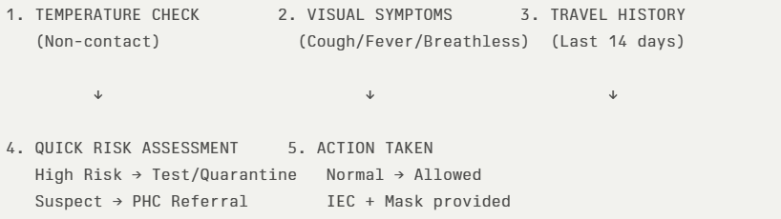
The screening protocol shall include temperature screening, observation for visible symptoms, and inquiry regarding recent travel or exposure history. Individuals identified as suspects during screening shall be immediately referred to the nearest PHC/FHC for further evaluation, testing, and appropriate action as per prevailing guidelines.

Pandemic Control Room
The Pandemic Control Room (PCR) serves as the central nerve center for real-time coordination, data aggregation, decision support, and communication during outbreaks. It consolidates information from all LSGD teams, health facilities and community sources to enable rapid response decisions.

Control Room Infrastructure and Location
Primary Location: Panchayath Office.
Backup Location: Community Hall in Vechuchira Grama Panchayath.

Health System Control Room Framework
The PCR is organized into seven functional pillars to ensure no aspect of the response is overlooked:
- Rapid Response Team (RRT)
  - Provides immediate intervention during emergencies, clusters, and field alerts.​
  - Coordinates urgent actions such as case investigation, contact tracing, isolation, and inter‑facility referrals.
- Data Management & Analytics Team
  - Collects, validates, and manages key health system indicators (cases, tests, beds, HR, supplies).​
  - Analyzes data trends, generates projections, and supports evidence‑based decision‑making for local authorities.
- Human Resource Deployment Team
  - Allocates healthcare staff efficiently based on workload and need
  - Ensures adequate and equitable workforce distribution across facilities
- Laboratory Surveillance Team
  - Oversees diagnostic testing coordination, sample transport, and timely reporting of results.​
  - Monitors lab indicators (testing volume, positivity rate, turnaround time) for early detection of outbreaks
- Vaccination Cell (If Required)
  - Plans and executes vaccination campaigns, including micro‑planning and session scheduling.​
  - Tracks coverage, identifies gaps, and coordinates corrective actions with field teams and outreach services.
- Infrastructure & Patient Occupancy Team
  - Monitors facility capacity, earmarked beds, oxygen and critical care resources across all linked facilities.​
  - Ensures optimal patient distribution and referral management using updated bed‑status and resource data.
  - BMWM
- Communication team
- Disseminate daily situation updates through official communication channels.
- Counter misinformation through verified announcements.
- Maintain a public helpline or contact point for queries and emergency assistance.
- Conduct focused IEC campaigns in affected wards.

- Logistics and supply chain
- Activate emergency procurement mechanisms for essential medical supplies.
- Monitor real-time stock levels of PPE, masks, sanitizers, oxygen support equipment, and essential medicines.
- Ensure uninterrupted supply of essential commodities including food and drinking water.
- Coordinate with district authorities for additional resource mobilization if required.
- The Logistics Nodal Officer shall maintain daily stock status reports.
- Transportation (interfacility & emergency transport)
- Maintain a dedicated list of ambulances, private vehicles, and emergency drivers available within the Panchayat.
- Establish clear referral linkages with higher treatment centres and designated hospitals.
- Ensure availability of at least one standby vehicle for emergency patient transport from containment zones.
- Implement infection prevention protocols within transport vehicles, including disinfection after each transfer.
- Provide PPE kits and necessary protective measures for drivers and accompanying staff.
- Maintain a transport logbook documenting patient movement, date, time, and receiving facility.
- Priority shall be given to severe cases, pregnant women, dialysis patients, and other high-risk individuals requiring urgent inter-facility transfer
- Media surveillance Call centre
- Monitor print, television, digital media, and social media platforms for disease-related information, rumours, and public concerns.
- Identify and verify misinformation promptly through coordination with District Information Office.
- Issue timely clarifications and official updates through authorized communication channels.
- Establish a Panchayat-level contact point or helpline number for public queries, reporting symptoms, and emergency assistance.
- Maintain a call register documenting nature of queries and action taken.
- Escalate urgent cases to health authorities or emergency services.
- Provide psychological reassurance and guidance on home isolation, testing, and preventive measures.
- Management of the deceased
- Follow infection prevention protocols for handling and transportation of the deceased.
- Provide PPE kits to personnel involved in body handling.
- Restrict handling to trained personnel only.
- Coordinate with designated crematoriums or burial grounds to ensure safe disposal practices.
- Maintain documentation of death details and cause of death as per reporting requirements.
- Provide clear guidance to family members regarding permitted funeral practices and public health safety measures.
- Ensure respectful handling of bodies while balancing infection control requirements.
- Intersectoral coordination and convergence
- Convene regular coordination meetings under the leadership of the Panchayat President/Secretary with representation from Health, Revenue, Police, ICDS, Education, Animal Husbandry, Civil Supplies, Social Justice, and Kudumbashree.
- Establish a Panchayat-level Incident Coordination Group to oversee planning, implementation, monitoring, and reporting of response activities.
- Align all containment, surveillance, and relief activities with directives issued by the District Disaster Management Authority (DDMA) and District Health Authorities.
- Ensure convergence of resources including manpower, vehicles, logistics, relief materials, and communication channels across departments.
- Coordinate with the Education Department for temporary closure, sanitization, or conversion of institutions into quarantine facilities when required.
- Work with the Police Department for enforcement of containment measures and regulation of public gatherings.
- Engage Civil Supplies and Social Welfare Departments to ensure uninterrupted access to food, rations, and social protection schemes.
- Coordinate with the Animal Husbandry Department for zoonotic surveillance where relevant.
- Involve community-based organizations, NGOs, religious institutions, and volunteer networks to support awareness campaigns and relief distribution.

Key Control Room Team
The Control Room Team coordinates all pandemic response activities within the LSGD and serves as the single command and communication hub during activation. It integrates information, field actions, logistics, and policy execution across all participating departments and health facilities.

Role | Name | Designation | Contact Number | Responsibility
In-charge/Nodal Officer | Dr.Lekha Thobias | Medical Officer | 8139888265 | Overall coordination, decision-making, and reporting to the District level.
Data Entry Operator | Surya | Data Manager | 7356087588 | Managing the line list, updating dashboards, and tracking testing results.
Communication Officer | Juby thomas | Health Inspector | 9446078405 | Handling the public helpline, coordinating ambulance dispatch, and contact tracing calls.
Logistics Coordinator | Bibin Raju | Pharmacist | 7034925048 | Scheduling, Tracking
Technical Support (IT/Data) | Jiji sreedhar | Clerk | 99947453246 | Fixing issues, Collecting Data

SOP for alert escalation/trigger point with mapping of responsibilities.

Alert Escalation / Trigger Points with Mapping of Responsibilities

1. Purpose
This SOP defines the trigger thresholds, alert escalation process, and role-based responsibilities for timely activation of response mechanisms under the Pandemic Preparedness Framework.The objective is to ensure early detection, structured escalation, and coordinated multi-sectoral response to emerging public health threats.
2. Alert Levels and Trigger Points
Level 0 – Routine Surveillance (Green Alert)
Trigger | - No unusual increase in cases  - Normal seasonal trends  - No cluster detection
Action | - Continue routine surveillance and reporting  - Weekly data review  - Maintain preparedness and buffer stocks
Responsibility | - JPHN / ASHA Workers – Field surveillance  - Health Standing Committee – Oversight  - Panchayat Secretary – Monitoring compliance

Level 1 – Early Warning (Yellow Alert)
Trigger Points | - Sudden increase (≥2x baseline) in fever/diarrhoeal cases in a ward  - Clustering of cases within households/institutions  - Unusual absenteeism in schools/workplaces  - Detection of zoonotic signals (animal morbidity/mortality)  - District/State advisory issued
Action | - Immediate reporting to Block Medical Officer  - Intensified syndromic surveillance in affected ward  - Field verification by Rapid Response Team (RRT)  - Activation of ward-level monitoring committees  - Review of logistics and stock availability
Responsibility Mapping | - ASHA/JPHN – Case verification & line-listing  - Medical Officer PHC – Clinical validation & reporting  - Panchayat President – Convene emergency review  - Veterinary Officer – Animal surveillance coordination  - Ward Member – Community mobilization

Level 2 – Outbreak Confirmation (Orange Alert)
Trigger Points | - Laboratory-confirmed outbreak  - Sustained local transmission  - Multiple wards reporting clusters  - Healthcare facility strain
Action | - Activate Panchayat Incident Coordination Group  - Implement containment measures in affected wards  - Operationalize quarantine/isolation facilities  - Intensify risk communication and public advisories  - Daily surveillance reporting to District authorities  - Deploy emergency logistics and buffer stocks
Responsibility Mapping | - Panchayat President – Incident Lead  - Medical Officer – Technical Lead  - Panchayat Secretary – Administrative coordination  - Health Inspector – Field containment operations  - Police Department – Enforcement support  - Civil Supplies – Essential commodity continuity

Level 3 – Public Health Emergency (Red Alert)
Trigger Points | - Rapid exponential case increase  - Severe cases requiring referral surge  - District-level emergency declaration  - Health system overload
Action | - Full activation of Emergency Response Plan  - Micro-containment zones  - Emergency procurement activation  - Inter-facility patient transfer coordination  - Activation of helpline and media monitoring  - Coordination with District Disaster Management Authority
Responsibility Mapping | - Panchayat Incident Commander – Strategic oversight  - Block Medical Officer – Clinical coordination  - District Administration – Resource augmentation  - Revenue & Police – Movement regulation  - Kudumbashree/Volunteers – Relief & support services

3. Escalation Flow Mechanism
- Field-level detection by ASHA/JPHN
- Immediate reporting to PHC Medical Officer
- Verification and preliminary assessment
- Communication to Panchayat President & Secretary
- Notification to Block Medical Officer
- Activation of corresponding alert level
- Documentation and situation reporting (SITREP)
All escalation shall occur within defined timelines (within 24 hours for Level 1 and immediate notification for Level 2 and above).
4. Documentation and Reporting
- Maintain Alert Escalation Register
- Daily Situation Reports during Level 2 and 3
- Record decisions taken and action implemented
- Submit consolidated reports to Block and District authorities
5. Review and De-escalation
Alert levels may be downgraded after:
- Two consecutive incubation periods with no new cases
- Declared containment by competent health authority
- Stabilization of surveillance indicators
Key Points:
- The Control Room shall be staffed with a designated In-charge, data entry personnel, and communication staff with clearly defined roles and shift arrangements.
- It shall maintain updated records on daily monitoring indicators including new cases, persons under active quarantine, and hospital bed occupancy.
- All reports and situation updates shall be shared daily with the Block and District Surveillance Unit.
- The Control Room shall act as a single point of contact for coordination with response teams, health institutions, and other departments.
- Contact details of the Control Room shall be widely communicated to field staff and stakeholders during activation.

Daily Monitoring Indicators
To ensure timely decision-making and effective response, the following key indicators shall be monitored and updated on a daily basis by the Pandemic Control Room:

Epidemiological Indicators:
New cases reported today, Total active cases, Test Positivity Rate (TPR), Case Fatality Rate (CFR)
- Surveillance Indicators:
Persons under home quarantine, High-risk contacts identified, Fever, ILI, SARI or other symptoms (syndromic surges), Travellers (symptomatic or high-risk arrivals),Animal husbandry surveillance (zoonotic alerts, unusual animal deaths, poultry/bird flu signals), Mortality surveillance (excess deaths, unexplained fatalities, verbal autopsy reports)
- Logistics and Infrastructure Indicators:
Hospital / CFLTC beds occupied, Oxygen cylinders/concentrators available, Ambulances on standby
- Alert Findings
The following table outlines category-specific trigger points (red flags) from surveillance indicators and corresponding immediate actions for the Pandemic Control Room. These enable rapid response to alert findings like testing anomalies, positive cases exceeding thresholds, clusters, and WGS reports.

Category | Trigger Pophint (Red Flag) | Immediate Action
Clusters | Geographical or facility-based: 5+ cases linked to one location (office, school, street). | Declare a micro-containment zone; perimeter control and active case finding.
Testing | Sudden drop in testing volume / delay in reporting / unusual testing trends | Review the sample collection process, address lab bottlenecks, deploy additional testing teams, and notify the District Lab.
Lab | Test Positivity rate increases | Increase testing sites in that ward.
Hospital | >80% Oxygen bed occupancy | Activate backup/CFLTC beds.
Travel | Cluster of cases from a single flight/train or high-risk arrival group. | Trace all passengers in adjacent seats; implement mandatory institutional quarantine.
Animal | Mass poultry/wildlife death or unusual sickness | Notify Animal Husbandry, sample the area, and dispatch RRT for environmental sampling and zoonotic check.
Mortality | Sudden spike in home deaths or brought-in-dead (BID) cases | Audit the deaths and Active Case Search drive
Additional investigations like Whole Genome Sequencing (WGS) | Detection of a Variant of Concern (VOC) or Variant of Interest (VOI) | Implement strict micro-containment; update clinical protocols to match variant severity.

Communication of Public Health Information
A Community Communication Hub shall be established to ensure timely, accurate, and consistent dissemination of information during a pandemic. The Hub will function under the coordination of Nodal officers of the control room and act as the nodal point for public communication, risk messaging, and community engagement. It will support dissemination of official advisories, promote preventive behaviors, address rumors and misinformation, and ensure that messages reach all sections of the population through trusted local channels and leaders.

Key communicators
Channel | Responsible Person | Contact
Ward-level announcements | Ward members
Social media | Ratheesh PRO | 974211462
Local Cable TV/Radio

- All messages disseminated through the Hub shall align with advisories issued by the Health Department and District authorities.
- Community leaders shall be sensitized to support behavior change, reduce stigma, and counter misinformation.
- Special efforts shall be made to reach vulnerable and hard-to-reach populations using locally appropriate communication methods.

Rumor Tracking: A designated volunteer will monitor local social media/WhatsApp groups daily to identify misinformation and issue official clarifications via the Communication Hub.

Coordination with District/State Authorities & Other Organisations
Effective coordination with Block, District, and State authorities is essential to ensure timely reporting, technical guidance, and uninterrupted supply of essential resources during a pandemic. The LSG shall establish clear communication channels, designate responsible officers, and adhere to prescribed reporting timelines to support coordinated public health action and efficient resource mobilisation.

Key Details:
- Nodal Officer for Reporting:
- Contact Number:
Reporting Schedule and Protocols:

To Whom | What to Report | Frequency | Nodal Person
Block PHC | Complete Situation Report (Cases, Quarantine, Beds, Screening, Deaths) | Weekly | Health Inspector
District IDSP Unit | Outbreaks/Clusters/Unusual Events (>5 cases same ward) | Weekly | DSO
Veterinary Officer | Animal health events/Zoonotic alerts | Weekly | MO
State Cell | Zoonotic cross-sector events | Weekly | SSO

Supply Chain Coordination
The LSG shall coordinate closely with Block, District, and State authorities (KMSCL) to ensure uninterrupted availability of essential goods, medical supplies, and logistics during a pandemic. Supply requirements shall be assessed regularly based on case load and communicated promptly to the appropriate authorities for timely replenishment.
Key Points:
- Maintain updated contact details of District and Block nodal officers for health logistics, oxygen supply, ambulances, and essential medicines.
- Submit timely indent requests for PPE, testing kits, medicines, oxygen, and other critical supplies through prescribed channels.
- Monitor stock levels at LSGD facilities, quarantine/isolation centres, and field teams through daily stock registers and dispensing logs to prevent shortages.
- Coordinate with District authorities, Karunya/Neethi medical shops, and local purchase committees for funds allocation and emergency procurement.

- Ensure regular monitoring of dispensing registers at all facilities to track usage, expiry, and pilferage—shortages being a perennial issue requiring proactive weekly audits.

- Activate surge procurement protocols during high caseloads, leveraging local purchase powers under LSGD funds alongside state supplies.

Resource Inventory and Contacts
Resource Category | Source  (District/State/Private) | Contact
PPE Kits/Masks/Gloves | KMSCL
PPE Kits/Masks/Gloves | Local Vendors
Oxygen  Cylinders/Concentrators | KMSCL
Medicines/Antivirals | KMSCL
Medicines/Antivirals | Neethi Shops
Test Kits (RTPCR/Rapid) | KMSCL

Collaboration with NGOs, PPP, and CSR
To augment government efforts during a pandemic, the LSG shall collaborate with NGOs, voluntary organisations, and private sector partners through public–private partnerships and Corporate Social Responsibility (CSR) initiatives, in coordination with District authorities.

Key Points:
- Engage NGOs and community-based organisations for community outreach, awareness, and support to vulnerable populations.
- Leverage CSR support for procurement of medical equipment, PPE, oxygen concentrators, food kits, and sanitation materials, as permitted.
- Ensure all collaborations align with government guidelines and are routed through approved administrative and financial procedures.
- Maintain transparency and documentation for all external support received and utilised.
Organization | Type | Support Offered | Contact Person
Youth Clubs/Student Unions | CBO

Interdepartmental Coordination
Coordination among departments during a pandemic shall be ensured through regular review meetings convened by the LSGD President. These meetings will provide a structured platform for sharing situational updates, assessing resource availability, resolving operational gaps, and taking joint decisions to ensure a coordinated and timely response.

Department | Representative | Key Role | Contact
Health (PHC) | Staff Nurse : | Case management | 8606853827
Veterinary | Veterinary Surgeon: | Animal surveillance | 8075467644
ICDS | Supervisor: Sindhu | Nutrition support
Education | Head Teacher: | School coordination
Police |  | Containment enforcement | __________
Water Authority | __________ | Water supply | __________
LSGD Engineering | __________ | Quarantine infrastructure | __________

PHASE 3 - Surge Capacity
Phase 3 is activated when there is a rapid increase in cases, high test positivity rates, or when existing health facilities and quarantine arrangements approach saturation. The focus of this phase is to expand isolation capacity, augment clinical care services, and mobilise additional resources through district and state support mechanisms.

Conversion of Community Facilities
To manage increased case load, the LSGD shall activate additional isolation facilities by repurposing identified community infrastructure such as community halls, auditoriums, schools, hostels, or other suitable buildings.

Name of facility | Facility Type | No. of Buildings | Ward | Surge Capacity (Beds) | Nodal Person
SCHOOLS | GOVT/PRIVATE | 17 |  | 50 PER SCHOOL

- Recovery and rehabilitation phase
The Recovery and Rehabilitation Phase focuses on restoring normalcy while strengthening the health system and community resilience following a pandemic or public health emergency. In Vechuchira Grama Panchayat, this phase is structured to ensure continuity of essential services, rehabilitation of affected populations, and preparedness for future outbreaks under an integrated, decentralized approach.

Key Components

1. Restoration of Essential Health Services:
Reinstatement of routine healthcare services including immunization, maternal and child health, NCD clinics, and TB services, with special attention to populations whose care was disrupted during the pandemic.

2. Continuity of Care for Vulnerable Groups:
Focused follow-up of clinically vulnerable populations such as elderly, palliative care patients, TB patients, and differently abled individuals through home-based care, outreach services, and telemedicine support.

3. Psychosocial Support and Mental Health Services:
Provision of counselling services for individuals affected by stress, grief, and post-pandemic trauma, involving health workers and trained community volunteers.

4. Livelihood and Social Rehabilitation:
Support to economically affected households through convergence with Local Self Government schemes, Kudumbashree units, and social welfare programmes to restore livelihoods and reduce vulnerability.

5. Strengthening Water, Sanitation, and Hygiene (WASH):
Improvement of sanitation infrastructure, safe drinking water access, and hygiene practices to prevent post-pandemic outbreaks of waterborne diseases such as ADD and Hepatitis A.

6. Infrastructure Strengthening and Resource Replenishment:
Upgradation and replenishment of health infrastructure, including PHCs, sub-centres, isolation facilities, medical equipment, and emergency stockpiles (PPE, medicines, diagnostics).

7. Review, Documentation, and Capacity Building:
Conduct of post-pandemic evaluation, documentation of best practices and gaps, and training of health staff and volunteers to enhance future preparedness.

8. Community Engagement and Risk Communication:
Sustained IEC/BCC activities to reinforce public awareness on hygiene, vaccination, and early health-seeking behaviour, ensuring community participation in recovery efforts.
Recovery
• Damage & Impact Assessment
A systematic assessment is conducted at ward level to evaluate health, social, and infrastructural impacts of the pandemic. This includes identifying affected households, service disruptions, and gaps in healthcare delivery to guide targeted interventions.
• Restoration of Health Services
Routine healthcare services such as immunization, maternal and child health, NCD clinics, and TB programmes are re-established with priority. Health facilities in Vechuchira ensure backlog clearance and uninterrupted service delivery.
• Rehabilitation of Affected Population
Support is provided to individuals and families affected by illness, loss of livelihood, or social disruption. Convergence with Panchayat and welfare schemes ensures inclusive rehabilitation and social protection.
• Psychosocial & Mental Health Support
Counselling services are strengthened through health workers and community volunteers to address stress, anxiety, and post-pandemic trauma. Special focus is given to elderly, children, and bereaved families.
• Disease Surveillance during Recovery Phase
Enhanced surveillance systems continue during recovery to detect any resurgence or secondary outbreaks. ASHA workers and health teams maintain active reporting and rapid response mechanisms.
• Environmental Cleanup & Sanitation
Intensified sanitation drives, waste management, and water source disinfection are carried out across wards. This is crucial in preventing post-pandemic outbreaks of waterborne and vector-borne diseases.
• Livelihood Restoration
Efforts are made to restore income sources through local self-government initiatives, Kudumbashree units, and employment schemes. Priority is given to vulnerable and economically affected households.
• Community Engagement & Confidence Building
Continuous IEC and community participation activities are conducted to rebuild public trust in health systems. Awareness programmes promote vaccination, hygiene practices, and early health-seeking behavior.
• Documentation & After-Action Review
All response activities, challenges, and outcomes are systematically documented. Review meetings are conducted at Panchayat and health system levels to evaluate performance.
• Lessons Learned & Best Practices
Key learnings from the pandemic response are identified and compiled to improve future preparedness. Successful strategies at ward level are documented for replication.
• Health System Strengthening
Infrastructure, workforce capacity, and logistics systems are strengthened based on identified gaps. This includes improving primary healthcare facilities and emergency preparedness capacity.
• Policy Revision & Preparedness Enhancement
Local policies and standard operating procedures are updated incorporating lessons learned. Preparedness plans are revised to ensure faster and more effective response in future emergencies.
• Research
Local-level data and experiences are utilized to support operational research and evidence-based planning. Collaboration with health departments and institutions is encouraged to improve public health strategies.

CONCLUSION
The Pandemic Preparedness Plan of Vechoochira Grama Panchayat presents a comprehensive, evidence-based framework integrating epidemiological trends, geographic and clinical vulnerability assessments, and ward-level risk stratification to ensure effective prevention, preparedness, response, and recovery. The plan emphasizes a decentralized, multi-sectoral approach aligned with the One Health concept, strengthening coordination between Health, Veterinary, Local Self Government, and community systems. By prioritizing high-risk populations, hotspot wards, and seasonal disease patterns, the Panchayat is equipped to implement targeted interventions, enhance surveillance, and ensure continuity of essential services during public health emergencies. The incorporation of capacity building, infrastructure strengthening, and adaptive policy mechanisms further reinforces system resilience. Overall, this plan serves as a strategic roadmap to minimize morbidity and mortality, enhance community resilience, and ensure a timely and efficient response to future pandemics and health crises.
Additional points
- tech support
- relief based commodities
- ham reading operators
- hazard vulnerability mapping
- Kseb & other power source
- HR specific responsibility

RECOMMENDATIONS

Strengthening Healthcare Infrastructure
- Establish a primary health response unit within the Panchayat with trained staff.
- Ensure availability of basic medical supplies (masks, sanitizers, PPE kits, oxygen cylinders).
- Create tie-ups with nearby hospitals in ____________ for emergency referral and transport.

2. Community Awareness & Education
- Conduct regular awareness campaigns on hygiene, vaccination, and preventive measures.
- Use local communication channels (community radio, WhatsApp groups, notice boards) to spread verified information.
- Train volunteers to act as health ambassadors in each ward.

3. Emergency Response & Coordination
- Form a Pandemic Preparedness Committee at Panchayat level including health workers, ward members, and NGOs.
- Develop a clear action plan for lockdowns, quarantine, and distribution of essentials.
- Maintain a database of vulnerable groups (elderly, differently-abled, chronically ill) for targeted support.

4. Supply Chain & Food Security
- Identify and support local suppliers and farmers to ensure uninterrupted food supply.
- Create community kitchens during emergencies to serve vulnerable populations.
- Stockpile essential commodities in Panchayat-run outlets for crisis periods.

5. Digital Preparedness
- Promote digital platforms for telemedicine consultations.
- Use Panchayat’s website/social media for real-time updates on health advisories.
- Encourage online grievance redressal to reduce crowding in offices.

6. Training & Capacity Building
- Organize mock drills for pandemic response in schools, offices, and public spaces.
- Train Panchayat staff and volunteers in first aid, infection control, and crowd management.
- Collaborate with NGOs and health departments for capacity-building workshops.

7. Long-Term Resilience
- Integrate pandemic preparedness into the Panchayat Development Plan.
- Allocate a dedicated budget for health emergencies.
- Encourage community participation in planning and monitoring preparedness measures.

MOCKDRILL SCENARIOS

ANNEXURE

IMPORTANT PHONE NUMBERS

Phone numbers and particulars of persons responsible for providing guidance, assistance, and support for pandemic preparedness operations may be provided here in a manner that allows easy reference at a glance. The information recorded here could be exhibited elsewhere at the time of emergencies. LSG institutions shall give special attention to collect and record the above data of persons and institutions who/which are supposed to give technical and co-ordination support to reduce the impact of pandemic.

1.1. Details of grama panchayat/municipality/corporation wards
Sl.No | Name of the ward | Ward number | Name of the ward  member | Contact number
1 | KUNNAM | 1 | Raji Vijayakumar | 9495666027
2 | ENNOORAMVAYAL | 2 | JOHN MATEHEW | 9447109159
3 | NOOROKKAD | 3 | LINOJ K P | 9446212266
4 | VENKURINJI | 4 | E V VARKEY | 9446915014
5 | OLAKULAM | 5 | SHIJIMOLE JOSE | 9544442259
6 | MUKKOOTTUTHARA | 6 | RESY JOSHY | 96444456341
7 | EDAKADATHY | 7 | K K SOMAN | 9961092290
8 | CHATHENTHARA | 8 | ANUMOL VARGHESE | 9605369981
9 | EDATHIKKAVU | 9 | AMAL ABRAHAM | 9847449845
10 | PERUNTHENARUVI | 10 | T K JAMES | 9447027553
11 | PARUVA | 11 | LINI JAYAKUMAR | 8590716081
12 | MANNADISSALA | 12 | REMADEVI S | 9744016290
13 | KAKKUDUKKA | 13 | PRIYA SURENDRAN | 8943029057
14 | KUMBITHDE | 14 | SIRIYAC THOMAS | 9400200149
15 | KOOTHATTUKULAM | 15 | MAANCHUMOL MK | 8281396774
16 | VAHAMUKKU | 16 | BINDHU THOMAS | 9495254202

1.2. Other important phone numbers of grama panchayat/municipality/corporation area
Sl. No. | Name | Contact number
1. | Excise department
2. | Forest department
3.
4.
5.
6.
7.
8.

1.3. Important offices of grama panchayat/municipality/ corporation
Sl.No | Name of the office | Contact person | Contact number
1. | Village Office | Village Officer, Madhu.V | 8547611405
2. | Agriculture Office | Agriculture Officer | 8138813155
3. | Animal Husbandry Office | Animal Husbandry Doctor | 8075467644
4. | Police Station | Police Officer | 9656797192
5. | BSNL Office | Officer
6. | Block Office | Officer | 9947022975
7. | KSEB Office | Officer | 04735266555
8. | Fisheries Office | Officer
9. | Fire and Rescue | Officer

1.4. Health Services

Sl. No | Name of the hospital/institution | Location | Phone number
1. | Government hospitals/PHC | Koothattukulam
2. | Private hospitals | Vechoochira
3. | Clinical laboratories
4. | Chemist/pharmacy
5. | Blood donors
6. | Other language experts (Bihari, Hindi, Bengali,  Asamees ………)
1.5. Veterinary Services
Sl.No | Name of the Clinic | Name of the  Surgeon/Doctor | Place/location | Phone  number
1 | Govt.Veterinary Hospital | Dr.Anand | Koothattukulam | 8075467644
1.6. Helpline numbers
Helpline | Phone number
Police | 100
Fire and Rescue | 101
KSEB

1.7. Public and Private Schools Contact details

S.No | Name of School | Institution type | Phone number
1 | ST GEORGE LP SCHOOL VENKURINJI | Aided | 8547795938
2 | SNDP HS VENKURINJI | Aided | 9207960027
3 | SNDPHSS | Aided | 7034130402
4 | SN ENGLISH MEDIUM | Private | 9847142625
5 | GOVT LPS PARUVA | GOVT | 9207005868
6 | ST THOMAS VECHOOCHIRA | Private | 7012139445
7 | NAVODAYA SCHOOL | GOVT | 9405085551
8 | LITTLE ANGEL SCHOOL | PRIVATE | 8547091029
9 | GHSS VECHOOCHIRA | Govt | 9847829540
10 | MTVHS KUNNAM | PVT | 9526061678
11 | ELPS ANAMADAM | PVT | 9446693713
12 | CMSLPS VECHOOCHIRA | PVT | 9447256855
13 | UP SCHOOL KOLLAMULA | GVT | 9961513569
14 | LITTLE FLOWER PUBLIC SCHOOL | PVT | 9744838874

1.9. AshaContact Details

Ward No | Name of Asha | Phone number
1 | SANTHAMMA
2 | SHYLA
3 | SUJA
4 | SHIJI
5 | SONIYA
6 | REJANI
7 | ANANDAVALLY
8 | JESSY
9 | SOBHANA
10 | JAYALATHA
11 | SHYAMALA
12 | KUNJUMOL
13 | USHA
14 | MOLLY
15 | BEENA

1.10. Anganwadi Contact Details

Ward No | Name of Anganwadi Teachers | Phone number
1 | GEETHAKUMARI | 9747244212
 | JUBINA | 9744818791
2 | SOLLY GEORGE | 9074066814
3 | SHERLY | 8156978159
 | RAJEENA | 9747556023
4 | REMANI | 9544960775
 | SHEELA | 7736507269
5 | MINI | 9544471557
6 | INDU | 6282423608
7 | SUDARSHINI | 7510472943
 | JOLLY | 9745345078
8 | AMBILIY | 9961135339
9 | SHAJITHA | 9446891790
10 | MALLIKA | 9496861700
11 | SANTHAMMA | 9562167225
 | REMALATHU | 9947803282
12 | INDIRA | 9526777898
 | VIJAYAKUMARI | 7012553491
13
14 | LEELAMMA KJ | 8281425829
 | SUMADEVI | 9605573828
15 | SULABHA | 7594985741
 | SULFI | 9961383963
 | AMBILI VT | 9400200335
 | BIBIN MATHEW | 8547565491
 | SUMADEVI | 9605573828

1.12. Information regarding resources

Means of transportation | Name of Owner | Phone Number
Heavy Trucks
Tractor
Ambulances
School bus
Taxi service

Annexure 1: LSG Baseline Data Collection Format
A. Baseline data
Sl. No. | Indicator / Field | Baseline Data | Source / Remarks
1 | Name of LSG | VECHOOCHIRA
2 | District | PATHANAMTHIT
3 | Block / Taluk | RANNY
4 | Type of LSG (Gram Panchayat / Municipality / Corporation) | G,P
5 | Area (sq. km) | 51.80
6 | No. of wards | 16
7 | GIS boundary file available | (Yes/No)
8 | Key contact person & phone

B. Demography
Indicator / Field | Baseline Data | Source / Remarks
Total population | 25698
Males | 12440
Females | 13258
Transgender population | 0
Age distribution
(<5, 5–14, 15–59, ≥60)
No. of households | 6114
Population density (persons/sq.km)
No. of migrant workers | 565
Major occupational groups | Agriculture

C. Vulnerable Populations & Social Risks
Sl. No. | Indicator / Field | Baseline Data (Value / Description) | Source / Remarks
1 | No. of elderly (≥60) | 4092
2 | No. of persons with disability | 12
3 | No. of bedridden persons | 119
4 | No. of chronic disease cases (DM/HTN/COPD/CKD etc.) | 4781
5 | Pregnant women (current estimate) | 138
6 | Children <5 years | 847
7 | Tribal population (if any) | 626
8 | Fisherfolk / coastal vulnerable groups (if any) | 0
9 | Urban slums / unnotified settlements (if any) | 0
10 | Homeless population | 0
11 | Orphanages / old age homes (number & capacity) | 0
12 | Hostels / prisons / shelters (number & capacity) | 0
13 | Poverty / BPL estimate | 24
14 | Food insecurity hotspots | 0
15 | Any history of stigma/discrimination issues (Yes/No) | 0

D. Health System & Service Readiness
Sl. No. | Indicator / Field | Baseline Data (Value / Description) | Source / Remarks
1 | No. of health facilities in LSG (PHC/CHC/TH/DH/Private) | CHC
2 | PHC/Family Health Centre details (name, location) | 0
3 | Subcentres / Health & Wellness Centres (number) | 8
4 | Private clinics / hospitals (number) | 7
5 | Labs available (public/private) | 5
6 | Availability of ambulance services (Yes/No, number) | 1
7 | Availability of isolation/quarantine facilities (Yes/No, details) | NO
8 | Cold chain facilities (Yes/No, details) | Y
9 | Stockpile space available (Yes/No)
10 | PPE / mask / sanitizer availability plan (Yes/No)
11 | Surveillance staff available (JHI/JPHN/ASHA count) | Y
12 | Existing emergency referral pathways (Yes/No) | Y

E. Points of Entry & Mobility
Sl. No. | Indicator / Field | Baseline Data (Value / Description) | Source / Remarks
1 | Bus stands / depots (number) | 1
2 | Railway stations (number) | 0
3 | Boat jetties / fishing harbours (number) | 0
4 | Ports / airports nearby (specify distance) | 0
5 | Major highways/roads passing through | 0
6 | Border crossings (state/district) | 0
7 | Major markets / weekly markets | 0
8 | Tourism hubs / major event venues | 0
9 | Schools/colleges with hostels (number) | 17
10 | Factories / large workplaces (number) | 0
F. Water, Sanitation & Hygiene (WASH)
Sl. No. | Indicator / Field | Baseline Data (Value / Description) | Source / Remarks
1 | Major drinking water sources (piped / wells / borewells / springs) | Wells
2 | No. of public wells | 59
3 | No. of households with piped water connection | 7181
4 | Water quality testing routine (Yes/No) | YES
5 | Common contamination risks (flooding, salinity, industrial waste) | NO
6 | Open defecation free status (Yes/No) | YES
7 | Solid waste management system (Yes/No) | YES
8 | Bio-medical waste disposal mechanism (Yes/No) | YES
9 | No. of public toilets | 5
10 | Handwashing stations in public places (Yes/No) | 2
G. Zoonotic Risks & One Health
Sl. No. | Indicator / Field | Baseline Data (Value / Description) | Source / Remarks
1 | Livestock population (cattle/goats/pigs/poultry) – estimates | 234
2 | No. of dairy farms / poultry farms / pig farms | 7
3 | Slaughterhouses / meat shops (number) | 2
4 | Animal markets (Yes/No, details) | NO
5 | Veterinary dispensaries (number) | 1
6 | History of zoonotic outbreaks (rabies, leptospirosis, avian flu etc.) | NO
7 | Stray dog population management measures (Yes/No) | NO
8 | Rodent infestation hotspots (Yes/No) | NO
9 | Wetlands / waterlogged areas prone to leptospirosis | NO
10 | Bat roosting areas / caves / fruit orchards (if any) | NO
11 | Human-animal interface hotspots (farms near residences) | NO
H. Climate & Disaster Risks (Pandemic Amplifiers)
Sl. No. | Indicator / Field | Baseline Data (Value / Description) | Source / Remarks
1 | Flood-prone wards (list) | 1 KUNNAM
2 | Landslide-prone wards (list) | 2 ENNOORAMVAYAL
3 | Cyclone/sea surge risk (Yes/No) | NO
4 | Heatwave risk zones (Yes/No) | NO
5 | Waterlogging areas (list) | NO
6 | Shelter homes / relief camps (number, capacity) | NO
7 | Past disaster displacement history | NO
8 | Disruption to water supply/transport common (Yes/No) | NO
I. Critical Infrastructure & Logistics
Sl. No. | Indicator / Field | Baseline Data (Value / Description) | Source / Remarks
1 | Schools (number) | 17
2 | Anganwadis (number) | 28
3 | Colleges (number) | 1
4 | Community halls (number) | 14
5 | Places of worship with large gatherings (number) | 32
6 | Large markets / shopping areas (number) | 1
7 | Warehouses / cold storages (number) | 2
8 | Telecom/mobile network coverage gaps (Yes/No) | NO
9 | Power outage frequency (high/medium/low) | NO
10 | Availability of generators in key facilities | NO

J. Risk Communication & Community Networks
Sl. No. | Indicator / Field | Baseline Data (Value / Description) | Source / Remarks
1 | Ward-level rapid response teams (Yes/No) | YES
2 | Jagratha samithis / committees active (Yes/No) | YES
3 | Kudumbashree presence and strength (number of units) | YES
4 | Volunteer network (number, coverage) | YES
5 | Community-based surveillance mechanisms (Yes/No) | YES
6 | IEC dissemination channels (WhatsApp groups, community radio, PA systems) | YES
7 | Rumour tracking mechanisms (Yes/No) | YES
8 | Languages spoken / literacy considerations | YES
9 | Vulnerable groups communication strategy available (Yes/No) | YES

K. Preparedness Planning & Governance
Sl. No. | Indicator / Field | Baseline Data (Value / Description) | Source / Remarks
1 | LSG emergency plan available (Yes/No) | YES
2 | Pandemic preparedness plan available (Yes/No) | NO
3 | Incident Command System identified (Yes/No) | YES
4 | Rapid procurement mechanism available (Yes/No) | YES
5 | Emergency fund available (Yes/No, amount) | YES
6 | Past outbreak response experience (Yes/No, details) | YES
7 | Intersectoral coordination mechanism (Health, Police, LSG, Veterinary, Education) | YES
8 | Mock drills conducted in last 12 months (Yes/No) | YES
9 | Training coverage for staff/volunteers (Yes/No) | YES

L. Surveillance & Data Systems
Sl. No. | Indicator / Field | Baseline Data (Value / Description) | Source / Remarks
1 | Digital reporting tools used (e.g., DHIS2, portals) | NO
2 | Availability of line-listing format (Yes/No) | NO
3 | Contact tracing team identified (Yes/No) | NO
4 | Mapping of high-risk households available (Yes/No) | YES
5 | Testing sample transport mechanism (Yes/No) | NO
6 | Reporting timeline adherence (good/average/poor) | NO
7 | Data sharing between departments (Yes/No) | YES
8 | Availability of dashboard for monitoring (Yes/No) | YES

M. Additional Notes & Observations
Sl. No. | Indicator / Field | Baseline Data (Value / Description) | Source / Remarks
1 | Key challenges perceived by LSG | YES
2 | Top 5 high-risk wards (reason)
3 | Any unique local risks (industrial pollution, refugee camps, etc.) | N
4 | Recommendations for preparedness strengthening | N

