PANDEMIC PREPAREDNESS PLAN ranni angadi panchayath

MESSAGE FROM PRESIDENT/CHAIR LSGI
റാന്നി അങ്ങാടി ഗ്രാമപഞ്ചായത്തിന്റെ ആരോഗ്യ രംഗത്തെ സമഗ്രമായ വിവരങ്ങൾ ഉൾക്കൊള്ളിച്ചുകൊണ്ടുള്ള ഒരു ആക്ഷൻ പ്ലാൻ തയ്യാറാക്കുന്ന വിവരം അറിഞ്ഞിരിക്കുന്നു. ആയതിലേക്ക് എല്ലാവിധ ആശംസകളും ആദ്യമേ അറിയിക്കട്ടെ.
മഹാമാരിപോലുള്ള പ്രതിസന്ധി സാഹചര്യങ്ങളിൽ ജനങ്ങളുടെ ആരോഗ്യ സുരക്ഷാ ഉറപ്പുവരുത്തേണ്ടതാണ് അത്യാവശ്യമാണ്. ആരോഗ്യവകുപ്പിനോടൊപ്പം ത്രിതല പഞ്ചായത്ത് സംവിധാനം സന്നദ്ധ സംഘടനകൾ എന്നിവരുടെ കൂട്ടായ പ്രവർത്തനം മൂലം നമുക്ക് ഇത് വിജയത്തിലേക്ക് എത്തിക്കാൻ കഴിയും.
ഈ പദ്ധതിയുടെ വിജയത്തിനായി പ്രവർത്തിച്ച എല്ലാ ഉദ്യോഗസ്ഥർക്കും ആരോഗ്യ പ്രവർത്തകർക്കും സന്നദ്ധ പ്രവർത്തകർക്കും ഹൃദയപൂർവ്വം അഭിനന്ദനം അറിയിക്കുന്നു. എല്ലാവർക്കും ആരോഗ്യസുരക്ഷ നേരുന്നു.

ഹൃദയപൂർവം
സുരേഷ് ബി
പ്രസിഡൻറ്
റാന്നി അങ്ങാടി ഗ്രാമ പഞ്ചായത്ത്

MESSAGE FROM HEALTH STANDING COMMITTEE CHAIR
റാന്നി അങ്ങാടി ഗ്രാമപഞ്ചായത്തിന്റെ ആരോഗ്യ രംഗത്തെ സമഗ്രമായ വിവരങ്ങൾ ഉൾക്കൊള്ളിച്ചുകൊണ്ടുള്ള ഒരു ആക്ഷൻ പ്ലാൻ തയ്യാറാക്കുന്ന വിവരം അറിഞ്ഞിരിക്കുന്നു. ആയതിലേക്ക് എല്ലാവിധ ആശംസകളും ആദ്യമേ അറിയിക്കട്ടെ.
മഹാമാരിപോലുള്ള പ്രതിസന്ധി സാഹചര്യങ്ങളിൽ ജനങ്ങളുടെ ആരോഗ്യ സുരക്ഷാ ഉറപ്പുവരുത്തേണ്ടതാണ് അത്യാവശ്യമാണ്. ആരോഗ്യവകുപ്പിനോടൊപ്പം ത്രിതല പഞ്ചായത്ത് സംവിധാനം സന്നദ്ധ സംഘടനകൾ എന്നിവരുടെ കൂട്ടായ പ്രവർത്തനം മൂലം നമുക്ക് ഇത് വിജയത്തിലേക്ക് എത്തിക്കാൻ കഴിയും.
ഈ പദ്ധതിയുടെ വിജയത്തിനായി പ്രവർത്തിച്ച എല്ലാ ഉദ്യോഗസ്ഥർക്കും ആരോഗ്യ പ്രവർത്തകർക്കും സന്നദ്ധ പ്രവർത്തകർക്കും ഹൃദയപൂർവ്വം അഭിനന്ദനം അറിയിക്കുന്നു. എല്ലാവർക്കും ആരോഗ്യസുരക്ഷ നേരുന്നു.

ഹൃദയപൂർവം
ജെവിൻ കെ വിൽസൺ
ആരോഗ്യ സ്റ്റാഡിങ് കമ്മിറ്റി
റാന്നി അങ്ങാടി ഗ്രാമ പഞ്ചായത്ത്

MESSAGE BY MEDICAL OFFICER

It is encouraging to note the preparation of a comprehensive Pandemic Preparedness Plan for the Panchayat, integrating local health data and vulnerability assessments. Strengthening preparedness at the grassroots level is essential to effectively manage emerging public health challenges. I appreciate the efforts of all health staff and stakeholders involved in this initiative and extend my best wishes for its successful implementation, ensuring the health and safety of the community.
Dr. Abhirami
Medical officer
FHC Ranni Angadi

EXECUTIVE SUMMARY

Family Health Centre functions as the primary public healthcare institution serving the population of Ranni Angady Grama Panchayath. The FHC plays a pivotal role in delivering comprehensive, accessible, and affordable healthcare services, with a strong focus on preventive, promotive, curative, and rehabilitative care in accordance with national and state health programmes.
The FHC caters to a predominantly rural population, addressing key public health priorities such as maternal and child health, communicable and non-communicable disease control, immunization, family welfare, adolescent health, and geriatric care. Regular outpatient services, home-based care through field health staff, and outreach activities ensure healthcare coverage even in geographically challenging areas. The institution actively implements national health missions, including the National Health Mission (NHM), National Tuberculosis Elimination Programme, National Programme for Prevention and Control of Cancer, Diabetes, Cardiovascular Diseases and Stroke (NPCDCS), and other disease surveillance initiatives.
Ranny Angady FHC works in close coordination with the Grama Panchayath, ASHA workers, Anganwadi centres, schools, and community-based organizations to strengthen community participation and improve health awareness. Emphasis is placed on early detection, timely referral, health education, and lifestyle modification to reduce disease burden and improve overall health outcomes.
Despite constraints related to infrastructure, manpower, and increasing service demand, the FHC continues to enhance service delivery through effective planning, data-driven decision-making, and community engagement. Strengthening facilities, upgrading digital health systems, and expanding preventive services remain key focus areas for future development.
Overall, Ranny Angady Family Health Centre stands as a vital institution in safeguarding public health and improving the quality of life of the residents of Ranny Angady Grama Panchayath

LIST OF ABBREVIATIONS

LSGD/LSGI | Local Self Government Department / Local Self Government Institution
BMO | Block Medical Officer
IDSP | Integrated Disease Surveillance Programme
NDMA | National Disaster Management Authority
PPE | Personal Protective Equipment
ICMR | Indian Council of Medical Research
CD | Communicable Diseases
NCD | NON-COMMUNICABLE Diseases

TABLE OF CONTENTS

3
INTRODUCTION 9
● Background of the PPP 9
LSGD AT A GLANCE 9
INTEGRATED HEALTH INFRASTRUCTURE MAP OF ___RANNY ANGADY GRAMA_________ PANCHAYAT 10
GENERAL PROFILE OF THE LSGI’S 13
Background of the LSGI 13
Demographic and Vulnerable Population 14
Clinical Vulnerability 16
INFRASTRUCTURE & RESOURCE INVENTORY 18
Health Facility Directory & Basic Capacity in the LSGD 18
Private Clinics 19
Healthcare Education & Training Institutions 20
Specialized Services & Emergency Inventory 20
Oxygen & Diagnostic Capacity 21
Diagnostics facility mapping at the LSGI level 22
Laboratory Identification & Basic Details 22
Social and Community Infrastructure for surge plan 22
Human resources 24
Community & Support Cadre 25
Community Organizations 26
Administrative & Emergency Services 27
Information regarding resources 27
ONE HEALTH & ENVIRONMENTAL SURVEILLANCE 28
Animal & Bird Population 28
Veterinary Infrastructure 29
Veterinary Doctors & Workforce 30
High-Risk Interface Points (Surveillance Sites) 30
Environmental Risk Mapping 31
Disease Seasonality Mapping 32
Vulnerability Mapping 33
EPIDEMIOLOGICAL TRENDS (2021–2025) 34
Disease Burden among human beings(Last 5 Years) 34
*(use the above table data to create the graph/diagram) 36
Seasonal Trend Analysis 37
Outcome-Based Trend Analysis- 2025 39
Transmission Trend- 2025 40
Integrated Disease Hotspot Map (2021–2025) 42
Preparedness and Response Protocol at LSG Level 44
Constitution of One Health Committee 44
Pandemic Response Workforce 45
Activities and Measures before and during Pandemic 47
PHASE 1 - Alert / Preparation 47
PHASE 2 - Active Response 50
Standard Screening Protocol 51
PHASE 3 - Surge Capacity 60
Conversion of Community Facilities 60
CONCLUSION 61
RECOMMENDATIONS 62
ANNEXURE 63
1. IMPORTANT PHONE NUMBERS 63

INTRODUCTION

Background of the PPP
The Pandemic Preparedness Plan of Ranni Angadi Panchayath is developed considering the specific geographical, demographic, and infrastructural characteristics of the region. Situated in the Pathanamthitta district of Kerala, the Panchayath has a mixed topography consisting of semi-urban areas, rural settlements, agricultural land, and regions influenced by the Pamba river basin, with heavy monsoon rainfall that can increase the risk of water-borne and communicable diseases. The Panchayath has a moderately dense population including elderly persons, children, migrant workers, and daily commuters, which increases the potential for rapid disease transmission during outbreaks. The area is supported by essential infrastructure such as Primary Health Centres, nearby hospitals, educational institutions, anganwadis, public transportation, sanitation systems, and active community networks like Kudumbashree units. A pandemic preparedness plan is therefore important in Ranni Angadi Panchayath to ensure early detection of infectious diseases, coordinated response mechanisms, protection of vulnerable groups, maintenance of essential services, effective risk communication, and overall strengthening of community resilience during public health emergencies.
The Local Self Government Department (LSGD) at a glance of Ranni Angadi Panchayath highlights its strategic importance in pandemic preparedness and public health management. Located in Pathanamthitta district of Kerala, the Panchayath features mixed topography including semi-urban settlements, agricultural areas, and river-influenced terrain near the Pamba basin, with heavy monsoon conditions that can contribute to communicable and water-borne disease risks. It has a moderately dense and diverse population comprising children, elderly persons, migrant workers, and daily commuters, which necessitates strong surveillance and preventive health systems during pandemics. Administratively, the Panchayath functions under the three-tier LSG system with elected representatives, standing committees, and coordination with block and district authorities, enabling decentralized decision-making and rapid response. From a public health perspective, the presence of Primary Health Centres, anganwadis, sanitation services, and active community networks such as Kudumbashree units strengthens grassroots-level health interventions. In terms of disaster management, the Panchayath coordinates with district disaster management authorities for flood response, emergency relief, and community awareness. These combined geographical, administrative, and public health capacities form the foundation of an effective pandemic preparedness plan, ensuring early detection, coordinated containment measures, protection of vulnerable groups, and continuity of essential services during public health emergencies.

LSGD AT A GLANCE
- Geographical boundaries with political map ( based on latest delimitation)
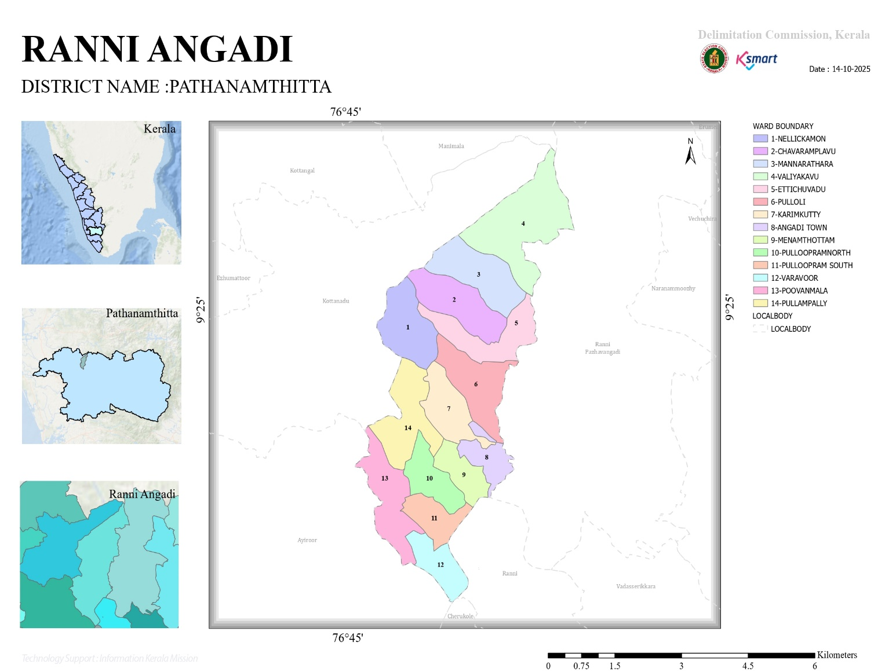

- Baseline data

No.of wards | 14
No.of Houses | 4680
Population | 16780
Male | 8330
Feamale | 8450
Transgender | 0
Below one year | 110
1-5 yr | 502
10-19 yr | 2508
30-60 yr | 9290
Above 60 yr | 4370
Differently abled | 32
Total EC | 1984
Asha workers | 13
AWW | 20
ORT depots | 24
ST nagar | 1
SC Nagar | 2
Extreme poverty families | 16
ICDS Anganwadies | 20
Govt hospitals | 3
Allopathy | 1
Ayurveda | 1
Homeo | 1
Private Hospitals | 3
Allopathy | 3
Ayurveda | 1
Homeo | 0
Dental clinics | 0
Clinical laboratories | 0
Educational institutions | 16
Govt HSS | 0
HS | 0
UPS | 1
LPS | 1
Pre primary | 0
Aided school HSS | 1
HS | 2
UPS | 1
LPS | 7
Pre primary | 0
Un aided schools HSS | 1
HS | 0
UPS | 1
LPS | 0
Pre primary | 1
Colleges | 0
Poly techniques | 0
Govt institutions state | 10
Central | 1
Hostels | 3
Medical colleges | 0
Nursing colleges | 0
Orphanage | 1
Old age homes | 1
Temple | 2
Church | 6
Mosque | 3
No.of private well | 3502
Public well | 18
Pumbing station | 2
Public libraries | 2
Arts and sports clubs | 11
Soda factories | 0
Hotel and tea shop | 18
Thattukada | 6
Market | 0
Slaughter house | 0
Construction area | 6
Rubber plantation | 5
Pineapple plantation | 5

- Ward division -
Ward | Houses | Population | Migrants | Wells | Hot  spots | Ed. Institutions | Hosp pvt/govt.
14 | 4680 | 16780 | 454 | 3520 | NIL | 16 | 5/3

- Risk stratification among wards in the context of Communicable diseases and hazards
Dengue -Ward 3
- Major Roads/rivers
Pamba River
State Highway
- occupational groups, socio cultural groups, migration & mobility patterns
Foreign countries
Rubber Plantation
- Vulnerability Mapping

- Disaster prone areas (geographic vulnerability)
Flood Prone: ward 8,10,11
Landslide :ward 2
Ranni Angady Grama Panchayat demonstrates significant spatial variability in disaster vulnerability. Wards 8, 10, and 11 are identified as flood-prone zones, primarily due to their low-lying topography, proximity to riverine drainage systems, and susceptibility to monsoon-induced inundation. CDMA flood risk mapping indicates recurrent waterlogging, seasonal displacement, contamination of drinking water sources, and disruption of transport and health service accessibility during peak rainfall periods. Conversely, Ward 2 is classified under landslide-prone areas, attributed to slope instability, weathered soil strata, vegetation loss, and high-intensity rainfall events. CDMA assessments highlight risks of localized slope failures, soil erosion, and obstruction of critical access routes, thereby posing challenges to emergency response and service delivery. These hazard-specific vulnerabilities necessitate differentiated, location-sensitive mitigation and preparedness strategies within the Panchayat.
Maps - ward-based (Mention source also)

- Geographical boundaries - ward boundaries map
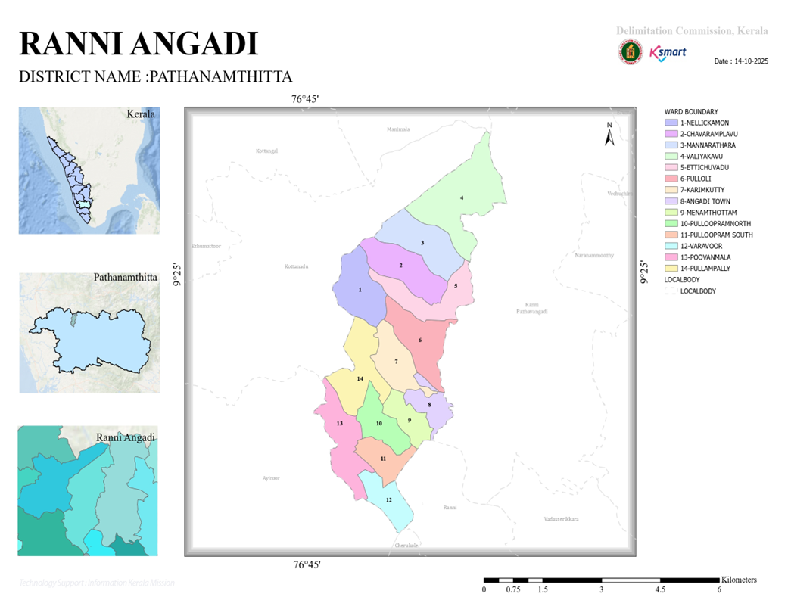
- Health infrastructure map
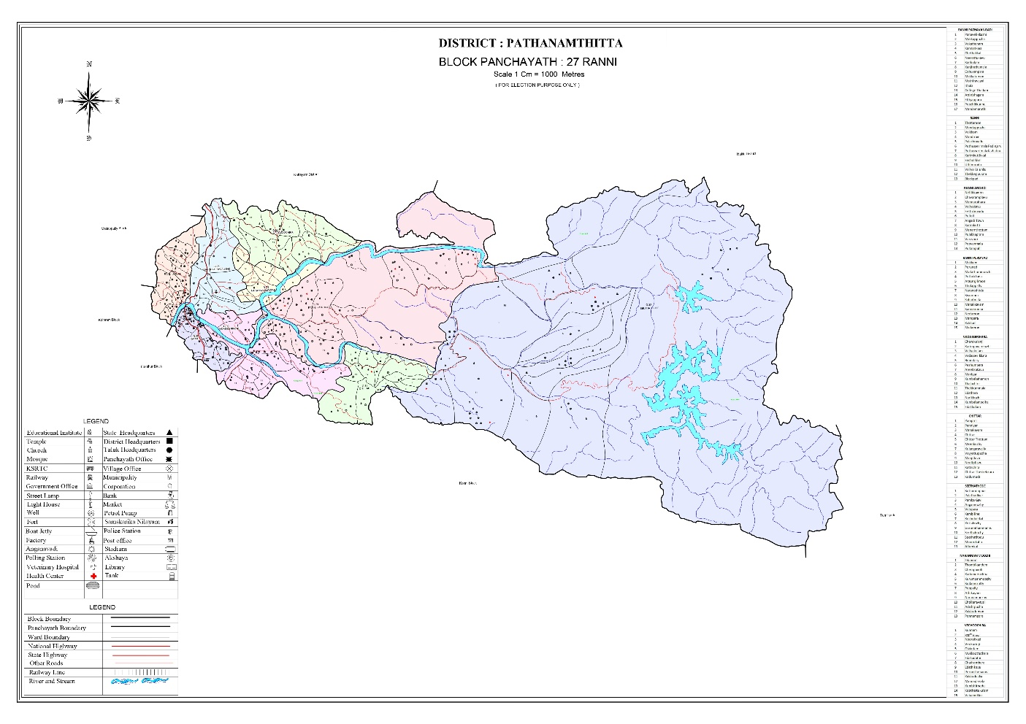
- roads and rivers map
- major establishments map
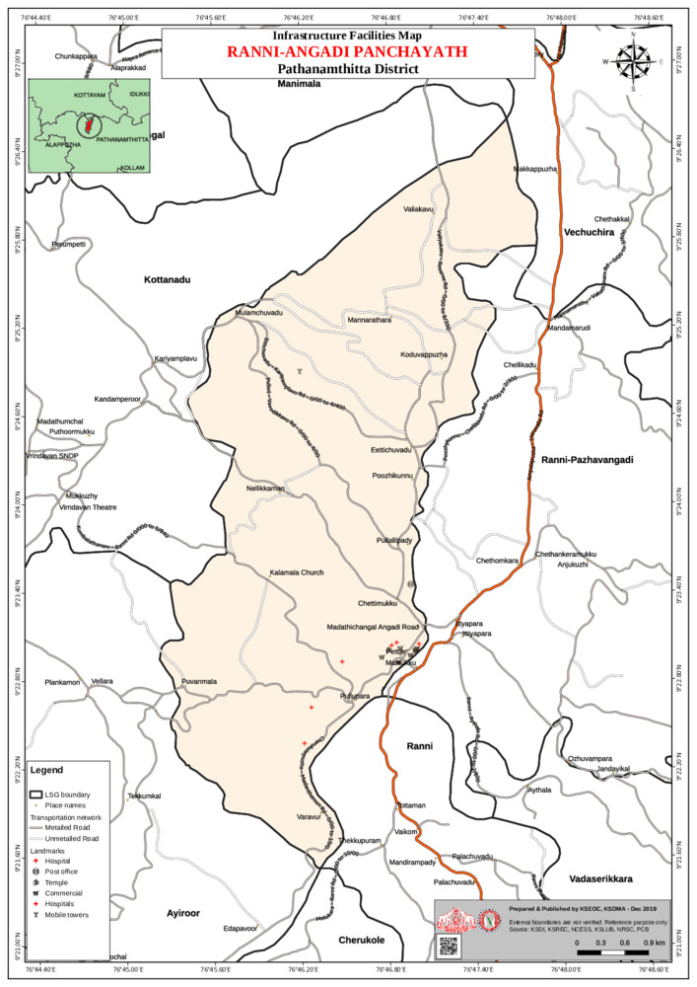
- disaster-prone areas map
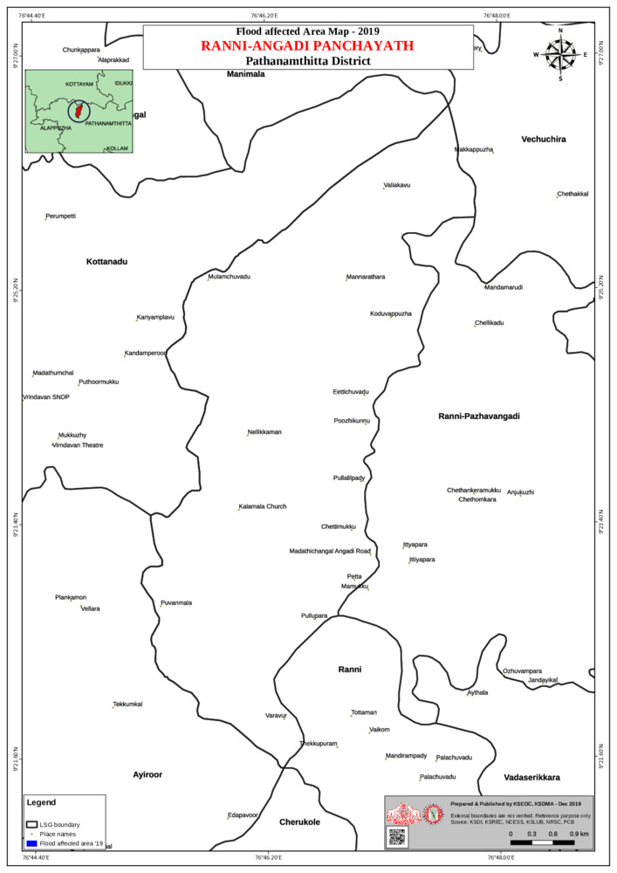

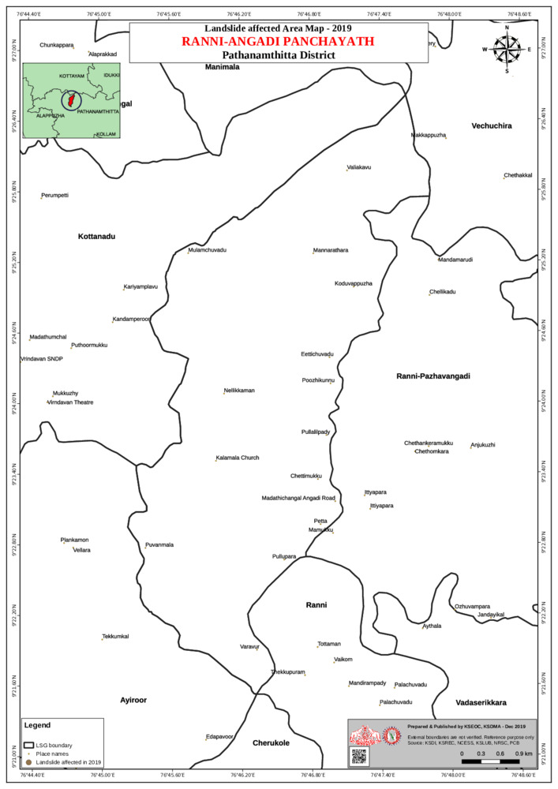
- hotspot map - CD & disasters

INTEGRATED HEALTH INFRASTRUCTURE MAP OF RANNY ANGADY PANCHAYAT

GENERAL PROFILE OF THE LSGI’S

Background of the LSGI
Ranny Angady Grama Panchayat is situated in the Northern part of Pathanamthitta district, Kerala. Ranni Angadi Panchayath, located in Pathanamthitta district of Kerala, has a mixed geographical landscape comprising semi-urban town areas, rural settlements, agricultural lands, and river-influenced terrain. The Panchayath lies along the banks of the Pamba River, a major river that significantly shapes its ecology, agriculture, and flood vulnerability. The region experiences a humid tropical climate with heavy monsoon rainfall. Ranni Angadi serves as an important transit point for pilgrims traveling to Sabarimala Sree Ayyappa Temple, resulting in seasonal population inflow and increased public health considerations. The Panchayath is well connected by major roads, including the Main Eastern Highway (SH-8), facilitating movement of people and goods. Administratively, it functions under Kerala’s decentralized Panchayati Raj system with elected ward members representing various wards, led by a President and supported by standing committees and officials. The Panchayath has a moderately dense population comprising families, elderly persons, workers, and small business communities, and its governance structure ensures implementation of development programs, sanitation services, public health initiatives, and disaster management measures at the grassroots level
From a public health and disaster management perspective, Ranny Angadi LSGI has historically been vulnerable to seasonal flooding, waterborne diseases, and vector-borne illnesses such as Dengue and Leptospirosis. The severe floods experienced during recent years, including the 2018 flood disaster, significantly impacted life, livelihoods, and infrastructure within the Panchayat. These recurring emergencies have underscored the importance of strengthening local preparedness, response mechanisms, and inter-departmental coordination.
In this context, the development of a localized, data-driven Auxiliary Infrastructure and Logistical Resource Map is essential to support effective planning, timely emergency response, and sustainable development initiatives. Such mapping enables the Panchayat to identify critical resources, improve accessibility during disasters, and enhance overall resilience of the community.

Table 1: Background of LSGD
Description | Details
Name of LSGI | RANNY ANGADY
Type (GP/Municipality / Corporation etc.) | Grama Panchayath
Block | RANNY
District | PATHANAMTHITTA
Number of wards | 14
Total area (sq. km) | 30.72
Population(Projected) | 16780
Population density | persons/sq km564.2
Terrain (coastal/low-lying/backwaters/foothills, etc.) | NA
Number of rivers passing through LSGI | 1
Number of water bodies in the LSGI | 5
Number of educational institutions | 16
Factories / small-scale industries | 1
Flood-prone wards | WARD :-8,10,11
Landslide-prone wards | WARD :-2
Death Management and Disposal Facilities (mortuaries/crematorium, including electric) | 1
Auditoriums/Marriage halls/convention centres/community halls | 7

Demographic and Vulnerable Population
Understanding the demographic composition and vulnerable population groups is essential for pandemic preparedness. Children, elderly, economically deprived families, migrant workers, and socially vulnerable groups are at increased risk during public health emergencies due to higher exposure, limited access to services, and dependency on public systems..

Description |  | Details (in numbers)
DEMOGRAPHIC PROFILE
Total population |  | 16780
Male |  | 8330
Female |  | 8450
Transgender |  | 0
Children under 5 |  | 502
Adolescent |  | 2508
Elderly (>60) |  | 4370
SOCIAL/LIVELIHOOD VULNERABILITY
Previous EPEP family |  | 16
BPL family |  | 571
Tribal communities |  | 3 HOUSES
Migration | Immigrant | 621
Migration | Emigrant | 454
Socio-economically deprived |  | 21
Fisherfolk |  | 51
SC Community |  | 310
ST Community |  | 12

Clinical Vulnerability
Certain population groups needs priority healthcare & are at higher risk of severe illness, complications, and mortality during pandemics. Patients with chronic diseases, those requiring regular medical care, and individuals with mobility or functional limitations face challenges in accessing timely care during emergencies. Mapping these groups helps in prioritizing continuity of treatment, medicine stock planning, oxygen support, referral transport, and targeted home-based care.
Description | Details in numbers
Pregnant women | 61
Lactating mothers | 83
Bedbound patients | 94
Patients under palliative care other than bedbound | 127
Patients on Haemodialysis | 11
Patients on CAPD | NIL
Cancer patients (currently on treatment) | 73
Haemophilic patients | 2
Mentally challenged | 27
Differently abled | 32
Diabetic patients | 3722
Hypertensive patients | 3356
TB patients | 5

The clinical vulnerability assessment of Ranni Angady Grama Panchayat highlights a substantial burden of individuals requiring continuous medical care and prioritized attention during public health emergencies. The data indicates a high prevalence of non-communicable diseases, with 3,722 diabetic patients and 3,356 hypertensive patients, representing a significant at-risk population prone to complications during pandemics.
Further, the Panchayat has 94 bedbound patients and 127 individuals under palliative care, indicating a considerable number of highly dependent individuals requiring home-based and continuous medical support. The presence of 73 cancer patients undergoing active treatment and 11 patients on haemodialysis underscores the need for uninterrupted access to specialized healthcare services.
Maternal and child health groups include 61 pregnant women and 83 lactating mothers, who require regular monitoring and essential healthcare services even during emergency situations. Additionally, vulnerable populations such as 27 mentally challenged individuals, 32 differently abled persons, and 2 haemophilic patients require targeted care and support systems.
The presence of 5 TB patients necessitates strict adherence to treatment protocols and uninterrupted drug supply under national programmes. Although no patients are reported on CAPD, the overall clinical profile reflects a high dependency on continuous healthcare services and regular follow-up.
The Panchayat exhibits a high clinical vulnerability profile, driven predominantly by NCD burden and dependent patient groups. This necessitates prioritization in pandemic preparedness planning through:
- Ensuring continuity of care and medicine supply for chronic disease patients.
- Strengthening home-based and palliative care services.
- Prioritizing high-risk groups for vaccination, surveillance, and early intervention.
- Establishing referral linkages for dialysis, oncology, and emergency care services.
Overall, integrating clinical vulnerability mapping into preparedness planning enhances risk stratification, targeted intervention, and reduction of morbidity and mortality during public health emergencies.
Major Festivals & Events specific to the LSGI
(with the possibility of a public gathering)

Sl. No. | Name of festival | Month detailing the periodicity
1 | SHIVARATHRI | FEBRUARY

INFRASTRUCTURE & RESOURCE INVENTORY

Health Facility Directory & Basic Capacity in the LSGD
This section provides an overview of the healthcare infrastructure available within the LSGD area. It outlines the distribution and basic capacity of health facilities that form the backbone of service delivery during routine times and public health emergencies.

Family Health Centres (FHCs) and Community Health Centres (CHCs) generally function as the first point of contact for the community, providing essential outpatient and inpatient services. General Hospitals (GH) and Medical College Hospitals (MCH), where accessible, serve as the main referral centres for advanced diagnostics, specialist care, and critical services during public health emergencies. This inventory helps identify existing strengths, gaps, and potential surge capacity that can be mobilised during a pandemic or disaster.

Table 5. Health Facility Resource Summary
Sl.no. | Health Facility | Type of Facility (MCH/GH/CHC/FHC/SC etc.) | Contact Number | Total beds | ICU Beds | Oxygen-Supported Beds | No. of Ventilator Support Beds | No. of ambulances
Government Healthcare Facilities
1. | FHC RANNY ANGADY | FHC | 9946523634 | 1 |  | NIL | NIL | NIL
Private Healthcare Facilities
1. | MARTHOMA HOSPITAL | PRIVATE HOSPITAL | 04735229900 | 100 | 7 | 7 | 2 | 5
AYUSH Healthcare Facilities
1. | RANNY ANGADY AYURVEDHA HOSPITAL | GOVMT | 04735204020 | NIL | NIL | NIL | NIL | NIL

Private Clinics
Private clinics are an essential part of pandemic preparedness, as they are often the first place people seek care when symptoms begin. In many communities, private clinics manage a significant share of outpatient visits and therefore play a critical role in early case detection, timely referrals, and disease surveillance. Having an up-to-date understanding of where these clinics are located, the services they provide, and how they are linked to the public health system helps ensure that no cases are missed during an outbreak. It also allows health authorities to engage private practitioners more effectively for reporting, risk communication, and coordinated response, strengthening the overall capacity of the health system to manage public health emergencies.

Table 6. Private Clinic Resource Summary
Sl No. | Name of Clinic | Registered (Y/N) | Clinic (General / Speciality) | Speciality (if any) | Address | Contact Number | Diagnostic Facility (Y/N) | Ambulance Linkage (Y/N)
1 | RAFA MED CARE HOSPITAL | YES | CLINIC( GENERAL) |  | RAFA MED CARE HOSPITAL  RANNY ANGADY  ANGADY P.O | 9207777307 | YES | YES
2. | TRINITY HEALTH CARE | YES | CLINIC(GENERAL) |  | TRINITY HEALTH CARE  RANNY ANGADY  ANGADY TOWEN | 9446556336 | YES | YES

Healthcare Education & Training Institutions
This section tracks the educational infrastructure available, which is vital for human resource planning in the health sector.

Category of Institution | Govt | Private | AYUSH | Total
Medical Colleges | NIL | NIL | NIL
Nursing Colleges | NIL | NIL | NIL
Dental Colleges | NIL
Para-medical / Allied Health | NIL
Pharmacy Colleges | NIL

Specialized Services & Emergency Inventory
This section provides a detailed view of the specialized medical resources available to the community, focusing on emergency response and critical care capabilities. This table tracks the vital assets required for managing severe illnesses and emergencies across Government, Private, and AYUSH sectors.

Item | Govt | Private | AYUSH | Total
Hospital beds | 1 | 100 | 0 | 101
Oxygen-generating systems(Y/N) | YES | YES | 0
Oxygen-supported beds(Numbers) | 0 | 7 | 0 | 7
Ventilator-supported beds | 0 | 0 | 2 | 2
ICU beds | 0 | 2 | 0 | 2
Burns units | 0 | 0 | 0 | 0
Blood centres | 0 | 0 | 0 | 0
BLS ambulances | 0 | 0 | 0 | 0
ALS ambulances | 0 | 0 | 0 | 0
Dialysis facilities | 0 | 0 | 0 | 0
Dispensaries | 0 | 0 | 0 | 0
Medical store | 1 | 1 | 1 | 0
Industrial establishments(Medium-scale industries/small-scale industries establishments to whom we can depend in a worst-case scenario)

Oxygen & Diagnostic Capacity
Monitoring oxygen and diagnostic capacity is a critical component of public health preparedness, ensuring that the LSGD can handle both chronic care and sudden surges in respiratory or infectious diseases.
Name of Health Facility | Oxygen-generating System (Y/N) | Backup Oxygen Source (Y/N) | Diagnostic Facilities Available(Y/N)
Name of Health Facility | Oxygen-generating System (Y/N) | Backup Oxygen Source (Y/N) | Lab | USG | X-ray | CT/MRI | RT-PCR
Government Healthcare Facilities
FHC RANNY ANGADY | NIL | NIL | NIL | NIL | NIL | NIL | NIL

Diagnostics facility mapping at the LSGI level
The diagnostic capacity of Ranny Angady G.P represents the "intelligence network" of our healthcare system. The speed and accuracy of disease identification depend entirely on the distribution and technical level of these facilities.

Item | Govt | Private | AYUSH | Total
General labs | NIL | 1 | 0 | 1
Microbiology labs | 0 | 0 | 0 | 0
RT-PCR labs | 0 | 0 | 0 | 0
USG units | 0 | 0 | 0
CT/MRI units | 0 | 0 | 0 | 0
Research labs
Labs of other departments that can be repurposed

Laboratory Identification & Basic Details
Sl. No. | Name of Laboratory | Ownership (Govt / Private / Academic) | Address | Contact No. | 24×7 Services (Yes/No) | NABL / Govt Approved (Yes/No)
1 | 0 | 0 | 0 | 0 | 0 | 0

Social and Community Infrastructure for surge plan
This table serves as our logistics and shelter inventory. By mapping these locations, quickly we can identify where to house displaced citizens, where to set up temporary medical clinics, and how to manage the deceased with dignity during a crisis.

Category | Total Count | Ward | Est. Capacity (Persons) | Contact details
Educational Institutions
Anganwadis | 20 | 14 | 600 | 8547153742
Schools | 16 | 14 | 3090 | 9447092732
Colleges | NIL
Healthcare Educational Institutions
Medical colleges (Govt/Private) | NIL
Nursing colleges (Govt/Private) | NIL
Dental colleges (Govt/Private) | NIL
Paramedical institutes (Govt/Private) | NIL
Community Gathering Spaces
Community halls | NIL
Auditoriums | 7
Religious buildings | NIL
Vulnerable Group Support Facility
Destitute homes | 1
Elderly homes | 1
LSGD owned other buildings | NIL
Mass Fatality Management (MFM) Infrastructure
Mortuary | 1
Crematorium | 0
*refer annexure 1 for contact details

Human resources
This section focuses on the human capital available within the LSGI. In any emergency—be it a pandemic, flood, or industrial accident—infrastructure is only as effective as the people operating it.

Medical & Clinical Personnel
This table tracks the "Frontline" providers responsible for diagnosis, treatment, and clinical management. Narrative sentence: eg., "Total health workforce: 450 personnel, with 60% in government facilities serving as primary surge capacity." A detailed directory with the contact numbers of all workers is maintained (Annexure in 1).

Cadre | Govt (No.) | Private (No.) | Total
Doctors—Modern Medicine | 1 | 20 | 23
Doctors – AYUSH | 1 | 2 | 3
Doctors – Veterinary | 1 | 3 | 4
Doctors – Dental | 0 | 0 | 0
Nursing officers | 2 | 63 | 65
Lab technicians | 0 | 0 | 0
Optometrist | 0 | 1 | 1
Pharmacists | 2 | 7 | 9
Psychologists | 0 | 2 | 2
Counsellors | 0 | 2 | 2

Public Health & Field-Level Workforce
These individuals are the backbone of surveillance, maternal-child health, and decentralized care.

Cadre | Health services | Municipal common services | Total
HS (Health Supervisors) | 0 | 0 | 0
HI (Health Inspectors) | 1 | 0 | 0
LHS (Lady Health Supervisor) | 0 | 0 | 0
LHI (Lady Health Inspectors) | 0 | 0 | 0
JPHN (Jr Public Health Nurses) | 3 | 0 | 0
JHI (Jr Health Inspectors) | 2 | 0 | 0
MLSP (Mid-Level Service Providers) | 3 | 0 | 0
Palliative Nurses | 1 | 0 | 0
RBSK Nurses | 1 | 0 | 0
PRO | 1 | 0 | 0
Epidemiologist | 0 | 0 | 0
Data Manager | 0 | 0 | 0

Community & Support Cadre
This group represents the surge capacity of the LSGI—people who can be called upon for logistics, rescue, and specialized support.

Cadre | Number
ASHA Workers | 13
AWW (Anganwadi Workers) | 20
Emergency Medical Volunteers (Trained) | 5
Kudumbashree | 138
MNREGS | 280
Purusha Swayam Sahaya Sangham | 4
Ex-Servicemen | 833
Retired Police Officers | 184
NCC/NSS Volunteers | 24
Red Cross volunteers | 5
One Health Community Volunteers | 637
One Health Community Mentors | 91

Community Organizations
This section details the presence of community-based organisations (CBOs), non-governmental organisations (NGOs), faith-based organisations (FBOs), Kudumbashree Self-Help Groups (SHGs), and Ayalkootams within the Local Self-Government Institution (LSGI). These groups enhance grassroots mobilization, resource distribution, and support networks crucial for pandemic response and community resilience.

Category | Total Count
NGOs | 7
Religious based organizations | 3
Foreign based organizations | 4
Sports Club/youth clubs | 9
Kudumbashree SHGs | 134
Ayalkootams | 134
Political organizations | 11
Residential organizations | 3

Administrative & Emergency Services
This section outlines the availability of key non-health emergency support services and infrastructure within the LSGI, which are essential for effective pandemic preparedness and response. These facilities support law enforcement, disaster response, water supply, logistics, mobility, and community-level interventions during public health emergencies.

Category | Total Count | Contact details
Police Stations | 0
Fire & Rescue Stations | 0
Water Pumping Points | 1 | 9947943809
Public Distribution System (PDS) | 0

Information regarding resources
The availability of essential transport and support resources plays a quiet but critical role in saving lives. Equipment such as ambulances, mobile mortuaries, amphibian ambulances, and motorized boats ensures that patients, samples, and healthcare teams can move swiftly—even in flooded, remote, or difficult terrains. Heavy vehicles like JCBs, cranes, tractors, and torus lorries support logistics, waste management, emergency infrastructure, and rapid conversion of spaces into care or isolation facilities. Taxis, four-wheel-drive vehicles, and trucks help maintain continuity of essential services, reach vulnerable populations, and support home-based care and supply delivery.

Means of transportation | Total Count
JCB | 7
Crane | 1
Heavy Trucks | 9
Tractor | 5
Ambulances | 10
Mobile mortuaries | 2
Boats | 0
Taxi service | 351
Note: For specific details regarding vehicle owners and contact information, please refer to Annexure [X].

ONE HEALTH & ENVIRONMENTAL SURVEILLANCE
The One Health method integrates environmental, animal, and human health to enable proactive pandemic preparedness. Panchayat-level surveillance needs to be improved in order to detect and treat zoonotic and environmentally generated diseases early. Surveillance is strengthened through systematic assessment of animal populations, veterinary infrastructure, poultry and slaughter facilities, inter-sectoral coordination, and specialised tools like avian influenza seasonality mapping using GIS in previous outbreaks to enable predictive alerts and ward-specific sampling to support effective pandemic preparedness in high-risk areas like Angadi town.

Animal & Bird Population
Mapping animal and bird populations at the Panchayat level is essential for identifying and prioritising zoonotic disease hazards like rabies, avian influenza (H5N1), leptospirosis, anthrax, and Nipah-like spillover occurrences. Risk classification, targeted surveillance, vaccination planning, and early epidemic detection made feasible by comprehensive population mapping all enhance One Health-based pandemic preparedness.

Category | Item | Estimated Population | Wards
Animal Population | Livestock (Cattle/Goats/Buffalo) | 1552 | 14
Animal Population | Pet Animals (Dogs/Cats) | 1324 | 14
Animal Population | Stray Dog Population | 140 | 14
Animal Population | Pig Farms (Number of heads) | 15 | 14
 | Small Units (Sheep / Goats – clustered) | 324 | 5
Bird Population | Poultry Units (Birds) |  | 6
Bird Population | Poultry- (FOWL) | 16014
Bird Population | Wild/Migratory Birds (Observed) | 0
Bird Population | Crow Mortality Events (Reported) | 0

The main risk of zoonotic diseases like leptospirosis is concentrated in all wards which is explained by the topography of the panchayath. Clusters of pig farms and animal shelters vulnerable to flooding further raise the risk of leptospirosis mediated by the environment, especially during monsoon floods.

Veterinary Infrastructure
Veterinary institutions are a core pillar of One Health surveillance, enabling early zoonotic disease detection through vaccination, investigation of unusual animal illness or deaths, sample collection, and timely outbreak reporting. A well-mapped and responsive veterinary network strengthens coordination with human health and LSGI systems, ensuring rapid response during zoonotic events and pandemics.
Facility Type | Name of Facility | Ownership Govt / Pvt | Location(Ward No) | Contact number
Veterinary Dispensary | 3 | GOVT | WAR:-2  WARD:-14  WARD  ;-11
Veterinary Hospital / Polyclinic | 1
Private Veterinary Clinics | NIL
Mobile / Emergency Vet Service (incl. night services) | NIL
Pet Homes / Animal Shelters | 6
Slaughterhouse-linked Veterinary Inspection Unit | 0

Veterinary Doctors & Workforce
Early detection, diagnosis, reporting, and reaction to animal illness epidemics depend on the availability and accessibility of qualified veterinary specialists. By identifying unusual animal morbidity or mortality promptly, collecting samples promptly, and coordinating efficiently with human health and LSGI systems—especially during zoonotic outbreaks and pandemic-prone situations—a clearly defined veterinary workforce enhances One Health surveillance.

Category | Number Available | Type (Govt/Pvt) | Contact number
Government Veterinary Doctors | 1 | GOVT | 9496026756
Private Veterinary Doctors | 0
Livestock Inspectors | 1 |  | 9048096789
Para-veterinary Staff / Attenders | 3
Contract / On-call Veterinary Support (if any)

High-Risk Interface Points (Surveillance Sites)
High-risk interface points for zoonotic disease surveillance in Ranny Angady Grama Panchayath include wetland–livestock–human contact zones, fish markets. These are the primary surveillance sites where zoonotic spillover risks are elevated.

Type of Habitat | Type of High risk interface | Geographical vulnerability
Wetlands & Backwaters | Flood(heavy rainfall) | Moderate
Backyard Poultry Farms | 0
Cattle Sheds near Water Bodies | 0
Fish & Meat Markets | 7 | low
Community Slaughter Sites | 0
Migratory Bird Congregation Areas | 0
Rodent-Infested Grain Storage | 0

Category | Total Count | Key Locations (wards)
Poultry Farms | 13 | VALIYAKAVU
Backyard / Clustered Poultry Units | 2
Duck Rearing Units (open water access) | 3
Slaughterhouses/ Slaughter Points | 0
Meat/Fish Markets | 17
Live Bird Sale Points | 5
Cattle Markets / Weekly Animal Fairs | 0
Pet Shops / Breeders | 3
Animal Shelters / Pet Homes | 9
Waste Disposal Sites near Animal Units | 3

Environmental Risk Mapping
Environmental risk mapping identifies monsoon/flood hotspots for vector-borne (dengue, chikungunya), water-borne (leptospirosis, diarrhoea), and zoonotic diseases in Kerala's wetlands. Systematic surveillance supports early warnings, targeted interventions, and Panchayat pandemic preparedness.
Waterborne exposure: Flood-prone areas and stagnant water bodies facilitate leptospira survival, raising leptospirosis risk.

Traditional practices: Informal slaughter and fish markets lack standardized hygiene, creating spillover opportunities.

Risk Factor | High-Risk Wards | Key Locations | Risk Level (High/Med/Low)
Flood-prone areas | WAR ;-10  WARD  ;=11  WARD:-8 |  | medium
Water bodies/wetlands | NIL
Solid waste accumulation | NIL
Animal waste disposal issues | NIL
Rodent infestation zones | All wards
Industrial effluent discharge | NIL
Construction sites / abandoned buildings | NIL
Poor drainage/blocked canals | NIL
Drinking water source contamination risk | NIL

Disease Seasonality Mapping
1, Flooding & waterlogging → amplifies leptospirosis, malaria, diarrheal diseases.

2, Mosquito breeding cycles → vector-borne disease peaks in monsoon.

Disease | Peak Risk Season | Key Drivers | High-Risk Locations | Surveillance Focus
Avian Influenza | NIL
Leptospirosis | All season | MNREG,Daily wage workers | All wards
Dengue/Chikungunya | All season | Not any particular | All wards
Acute Diarrheal Diseases | All season |  | All wards
Rabies | NIL
Anthrax (rare) | NIL

Vulnerability Mapping
Vulnerability mapping pinpoints high-risk populations, occupations, and areas exposed via environment, livelihoods, socio-economics, and poor service access. Paired with environmental/seasonality mapping, it enables risk-based surveillance, targeted actions, and optimal resource use in One Health and pandemic planning.
Vulnerability Factor | High-Risk Wards | Key Groups / Locations | Risk Level
Flood-prone households | WARD:-8,10,11 |  | moderate
Wetland-adjacent communities | NIL
Backyard poultry / duck rearing households | NIL
Livestock-rearing households | NIL
Slaughterhouse & meat market workers | NIL
Fisherfolk & fish market workers | NIL
Sanitation workers | NIL
Daily wage / migrant workers | NIL
Elderly & chronically ill populations | NIL
Pregnant Women | NIL
Children (schools, Anganwadi’s) | NIL
Limited access to safe water & sanitation | NIL

EPIDEMIOLOGICAL TRENDS (2021–2025)

Disease surveillance is the systematic collection, analysis, and interpretation of health data for planning, implementation, and evaluation of public health practice. This section presents the disease surveillance profile of the LSGI based on routine reporting systems and outbreak investigations to identify priority diseases, seasonal patterns, and emerging public health threats.

Disease Burden among human beings(Last 5 Years)
Analysis of disease-wise data for the last five years helps identify persistent public health problems, emerging diseases, and changes in disease burden. This information supports prioritisation of prevention, preparedness, and response activities at the Panchayat level.

Disease | 2021 | 2022 | 2023 | 2024 | 2025 | Trend(Increasing/Stable/Decreasing)
Dengue | 5 | 6 | 4 | 7 | 4 | stable
Leptospirosis | 0 | 1 | 0 | 1 | 1 | stable
Hepatitis A | 1 | 2 | 0 | 4 | 4 | stable
Malaria | 0 | 1 | 1 | 0 | 0 | stable
Scrub Typhus | 0 | 0 | 0 | 0 | 0 | stable
Typhoid | 1 | 0 | 2 | 2 | 3 | stable
H1N1 | 2 | 3 | 2 | 4 | 3 | stable
H3N2 | 0 | 0 | 0 | 2 | 0 | stable
ADD | 23 | 18 | 14 | 21 | 37 | Increase
Mumps | 0 | 0 | 0 | 0 | 0 | stable
Measles | 0 | 0 | 0 | 1 | 0 | stable
Hepatitis B | 0 | 0 | 2 | 1 | 0 | stable
Hepatitis C | 0 | 0 | 0 | 0 | 0 | stable
Tuberculosis | 3 | 2 | 3 | 5 | 4 | stable
Leprosy | 0 | 0 | 1 | 0 | 0 | stable
COVID-19 | 600 | 15 | 4 | 5 | 4 | stable

*(use the above table data to create the graph/diagram)

The five-year epidemiological analysis (2021–2025) of Ranni Angady Grama Panchayat indicates a predominantly stable disease pattern, with no major outbreaks except for a rising trend in Acute Diarrhoeal Disease (ADD).
- Acute Diarrhoeal Disease (ADD) shows a clear increasing trend, rising from 14 cases (2023) to 37 cases in 2025, indicating persistent water and sanitation-related vulnerabilities, particularly during monsoon periods.
- Dengue remains relatively stable with minor fluctuations (4–7 cases annually), suggesting controlled vector transmission without outbreak-level escalation.
- Leptospirosis and Hepatitis A show low and stable incidence, with occasional cases indicating seasonal environmental exposure risks.
- Typhoid and H1N1 exhibit sporadic but stable occurrence, with no sustained upward trend.
- Tuberculosis (TB) remains endemic but stable (2–5 cases annually), requiring continued surveillance and treatment adherence.
- Other diseases such as Malaria, H3N2, Measles, Hepatitis B, and Leprosy reported isolated or negligible cases without any consistent trend.
- COVID-19 shows a sharp decline from 600 cases in 2021 to minimal levels thereafter, indicating effective control and transition to endemicity.
The Panchayat demonstrates a stable epidemiological profile, with no major outbreak patterns.
- ADD is the primary emerging concern, requiring strengthened WASH (Water, Sanitation, and Hygiene) interventions.
- Vector-borne and other communicable diseases remain controlled with low-level transmission.
Overall, the findings emphasize the need for focused sanitation measures, sustained surveillance, and routine public health interventions, ensuring continued stability and preparedness under the Panchayat-level health system.

Seasonal Trend Analysis
Seasonal analysis helps anticipate surges (e.g. dengue in monsoon, leptospirosis after floods, influenza in cooler months) and plan pre‑emptive vector control, stockpiling of IV fluids, and awareness campaigns at Panchayat level.

DENGUE
Dengue is a major seasonal vector-borne disease strongly associated with rainfall, water stagnation, and increased mosquito breeding during the monsoon period.

Peak: July–November

Dengue – Ward-wise Yearly Distribution (2021–2025)

Ward | Dengue – Ward-wise Yearly Distribution
Ward | 2021 | 2022 | 2023 | 2024 | 2025 | Total
1 | 1 | 0 | 0 | 2 | 0 | 3
2 | 0 | 1 | 0 | 1 | 1 | 3
3 | 1 | 2 | 1 | 0 | 1 | 5
4 | 0 | 0 | 0 | 1 | 1 | 2
5 | 0 | 0 | 1 | 0 | 0 | 1
6 | 2 | 0 | 0 | 1 | 0 | 3
7 | 0 | 1 | 0 | 1 | 0 | 2
8 | 0 | 0 | 1 | 0 | 0 | 0
9 | 0 | 1 | 0 | 0 | 0 | 3
10 | 0 | 0 | 0 | 1 | 0 | 3
11 | 1 | 0 | 0 | 0 | 0 | 0
12 | 0 | 0 | 1 | 0 | 1 | 0
13 | 0 | 1 | 0 | 0 | 0 | 0
14 | 0 | 0 | 0 | 0 | 0 | 0

The ward-wise analysis of Dengue cases over the five-year period (2021–2025) indicates a low-incidence and stable transmission pattern, with sporadic cases distributed across multiple wards and no evidence of major outbreaks.
Ward 3 (5 cases) reported the highest cumulative incidence, followed by Wards 1, 2, and 6 (3 cases each), indicating low-to-moderate risk zones with intermittent transmission.
Wards 4 and 7 (2 cases each) showed occasional seasonal occurrence, while Ward 5 (1 case) reported minimal incidence.
Other wards reported either isolated cases or negligible incidence, with no sustained clustering across consecutive years.
The temporal pattern suggests that Dengue transmission in Ranni Angady is sporadic and seasonally influenced, primarily associated with monsoon-related vector breeding conditions. The absence of significant clustering indicates effective vector control and environmental management.
This ward-level stratification supports a preventive approach, focusing on routine vector surveillance, source reduction activities, and targeted IEC interventions during pre-monsoon periods to maintain the current low transmission levels and prevent potential outbreaks.

LEPTOSPIROSIS
Leptospirosis cases are closely linked to monsoon rains, flooding, and occupational exposure, particularly in low-lying and waterlogged areas.

Peak: June - August

Leptospirosis – Ward-wise Yearly Distribution (2021–2025)

Ward | Leptospirosis – Ward-wise Yearly Distribution
Ward | 2021 | 2022 | 2023 | 2024 | 2025 | Total
1 | 0 | 0 | 0 | 0 | 0 | 0
2 | 0 | 0 | 0 | 0 | 0 | 0
3 | 0 | 0 | 0 | 0 | 0 | 0
4 | 0 | 1 | 0 | 0 | 0 | 1
5 | 0 | 0 | 0 | 0 | 0 | 0
6 | 0 | 0 | 0 | 0 | 0 | 0
7 | 0 | 0 | 0 | 0 | 0 | 0
8 | 0 | 0 | 0 | 0 | 1 | 1
9 | 0 | 0 | 0 | 0 | 0 | 0
10 | 0 | 0 | 0 | 0 | 0 | 0
11 | 0 | 0 | 0 | 1 | 0 | 1
12 | 0 | 0 | 0 | 0 | 0 | 0
13 | 0 | 0 | 0 | 0 | 0 | 0

The ward-wise analysis of Leptospirosis over the five-year period (2021–2025) indicates a very low incidence with isolated and sporadic case occurrence, without any evidence of clustering or outbreak patterns.
Wards 4, 8, and 11 each reported single cases during different years (2022, 2025, and 2024 respectively), indicating localized and time-limited exposure.
All other wards reported no cases throughout the study period, reflecting minimal transmission risk.
The overall trend suggests that Leptospirosis in Ranni Angady is sporadic and environmentally driven, primarily associated with monsoon-related exposure to contaminated water or soil. The absence of clustering indicates effective control and low endemicity.
This ward-level pattern supports a preventive surveillance approach, focusing on pre-monsoon awareness, chemoprophylaxis for high-risk groups, environmental sanitation, and early fever detection to prevent potential case escalation during high-risk seasons.

VIRAL HEPATITIS - A
Hepatitis A cases are commonly associated with unsafe drinking water, food contamination, and breakdowns in sanitation, often presenting as clusters or outbreaks.

Peak: October - December

Hepatitis A – Ward-wise Yearly Distribution (2021–2025)

Ward | Hep A – Ward-wise Yearly Distribution
Ward | 2021 | 2022 | 2023 | 2024 | 2025 | Total
1 | 0 | 0 | 0 | 0 | 1 | 1
2 | 0 | 0 | 0 | 1 | 0 | 1
3 | 1 | 0 | 0 | 0 | 0 | 1
4 | 0 | 0 | 0 | 0 | 0 | 0
5 | 0 | 0 | 0 | 1 | 0 | 1
6 | 0 | 0 | 0 | 0 | 0 | 0
7 | 0 | 0 | 0 | 1 | 2 | 3
8 | 0 | 0 | 0 | 0 | 0 | 0
9 | 0 | 1 | 0 | 0 | 0 | 1
10 | 0 | 0 | 0 | 0 | 0 | 0
11 | 0 | 0 | 0 | 0 | 1 | 1
12 | 0 | 1 | 0 | 0 | 0 | 1
13 | 0 | 0 | 0 | 1 | 0 | 1

The ward-wise analysis of Hepatitis A over the five-year period (2021–2025) indicates a low-incidence but gradually emerging pattern, with sporadic cases distributed across multiple wards.
Ward 7 (3 cases) reported the highest cumulative incidence, with cases in 2024 and 2025, suggesting a localized cluster and recent increase.
Wards 1, 2, 3, 5, 9, 11, 12, and 13 each reported single isolated cases across different years, indicating scattered occurrence without sustained transmission.
Remaining wards reported no cases, reflecting minimal or no risk.
The temporal pattern suggests that Hepatitis A in Ranni Angady is sporadic with mild recent increase, likely associated with seasonal factors such as monsoon-related water contamination and sanitation gaps. The clustering observed in Ward 7 highlights a potential localized risk requiring focused intervention.
This ward-level stratification supports targeted WASH interventions, including water quality monitoring, chlorination, sanitary inspections, and health education on safe drinking water practices, to prevent further transmission and potential outbreaks.

Outcome-Based Trend Analysis- 2025

Disease | 2021 | 2022 | 2023 | 2024 | 2025 | 5-Year Trend
ADD | 23 | 18 | 14 | 21 | 37
Tuberculosis | 3 | 2 | 3 | 5 | 4
Dengue | 5 | 6 | 4 | 7 | 4
Leptospirosis | 0 | 1 | 0 | 1 | 1

The five-year analysis of major communicable diseases indicates a largely stable epidemiological pattern, with a notable increase in waterborne disease burden.
Acute Diarrhoeal Disease (ADD) shows a fluctuating but overall increasing trend, rising from 14 cases (2023) to 37 cases in 2025. This indicates persistent sanitation and water quality challenges, particularly during monsoon periods.
Tuberculosis (TB) demonstrates a stable trend with minor fluctuations (2–5 cases annually), suggesting consistent case detection and treatment adherence, with no outbreak pattern.
Dengue remains stable with slight variations (4–7 cases annually), indicating controlled vector transmission without significant escalation.
Leptospirosis shows a low and stable trend, with isolated cases (0–1 per year), reflecting sporadic environmental exposure rather than widespread transmission.
The Panchayat exhibits a stable disease profile with no major outbreaks.
ADD is the primary emerging concern, requiring strengthened water, sanitation, and hygiene (WASH) interventions.
Vector-borne diseases (Dengue, Leptospirosis) remain low and controlled.
TB continues as a stable endemic condition.

Overall, the findings emphasize the need for focused sanitation improvements, continued surveillance, and seasonal preparedness measures, ensuring sustained public health stability and resilience at the Panchayat level.

Transmission Trend- 2025
For effective management of public health issues, it is important to track the trend of disease transmission mode. It helps identify the population or place at high risk that can be used to predict outbreaks and implement targeted interventions as quickly as possible. Understanding these kinds of trends enables authorities to allocate resources efficiently and change the strategies adequately based on the trend that follows.

Mode of Transmission | No. of cases | No. of Deaths
Vector Borne Diseases | 4 | 0
Water Borne Diseases | 7 | 0
Air Borne Diseases | 13 | 0
Blood Borne Diseases | 0 | 0
Food Borne Diseases | 0 | 0

Vector-Borne Disease

Disease | No. of Cases | No. of Deaths
Dengue | 4 | 0
Malaria | 0 | 0
Chikungunya | 0 | 0

Water Borne Disease

Disease | No. of Cases | No. of Deaths
Cholera | 0
Typhoid | 3 | 0
Hep- A | 4 | 0
Dysentery | 0 | 0
Amoebiasis | 0 | 0
E- Coli infections | 0 | 0zs
Air Borne Disease

Disease | No. of Cases | No. of Deaths
Influenza | 0 | 0
H1N1 | 3 | 0
TB | 4 | 2
Chickenpox | 7 | 0
Measles | 0 | 0
Covid-19 | 0 | 0
Pertussis | 0 | 0
Mumps | 5 | 0

Blood-Borne Disease

Disease | No. of Cases | No. of Deaths
AIDS | 0 | 0
Hep- B | 2 | 1
Hep- C | 0 | 0

Zoonotic Disease

Disease | No. of Cases | No. of Deaths
Rabies | 0 | 0
Leptospirosis | 1 | 0
Avian influenza | 0 | 0
West nile | 0 | 0
Anthrax | 0 | 0
Nipah | 0 | 0
Scrub Typhus | 0 | 0

Integrated Disease Hotspot Map (2021–2025)

Ward No | Dengue Total (2021-25) | Leptospirosis Total (2021-25) | Hepatitis A Total (2021-25) | Mumps (2021-25) | ADD (2021-25) | Total Cases
1 | 3 | 0 | 2 | 0 | 10 | 15
2 | 3 | 0 | 2 | 0 | 13 | 18
3 | 5 | 0 | 1 | 5 | 11 | 22
4 | 2 | 2 | 0 | 0 | 17 | 21
5 | 1 | 0 | 2 | 0 | 7 | 10
6 | 3 | 0 | 0 | 0 | 9 | 12
7 | 2 | 0 | 3 | 0 | 10 | 15
8 | 1 | 2 | 0 | 0 | 7 | 10
9 | 1 | 0 | 2 | 0 | 10 | 13
10 | 1 | 0 | 2 | 0 | 11 | 14
11 | 1 | 2 | 2 | 0 | 9 | 14
12 | 1 | 1 | 2 | 0 | 7 | 11
13 | 1 | 0 | 2 | 0 | 6 | 9

High-Burden Wards
The cumulative disease burden analysis shows a moderate and evenly distributed pattern across wards, with no extreme clustering:
- Ward 3 (22 cases) is the highest burden ward, driven by contributions from Dengue, ADD, and a notable Mumps occurrence (5 cases).
- Ward 4 (21 cases) and Ward 2 (18 cases) represent moderate-to-high burden wards, primarily due to ADD and limited Leptospirosis cases (Ward 4).
- Wards 1 and 7 (15 cases each) and Wards 10 and 11 (14 cases each) show moderate burden, with mixed contributions from waterborne and vector-borne diseases.
Remaining wards demonstrate low-to-moderate burden, indicating absence of major hotspots.
Disease-Specific Distribution
- ADD (Acute Diarrhoeal Disease): The dominant contributor across all wards, with higher burden in Wards 4, 2, 3, and 10, indicating sanitation and water quality issues.
- Dengue: Low and evenly distributed across wards, with no significant clustering, reflecting controlled vector transmission.
- Leptospirosis: Limited to Wards 4, 8, 11, and 12, indicating localized environmental exposure.
- Hepatitis A: Scattered distribution across multiple wards (1, 2, 5, 7, 9, 10, 11, 12, 13), suggesting sporadic water contamination events.
- Mumps: Notable only in Ward 3, indicating a localized and contained outbreak.
Strategic Recommendations
- Strengthening WASH Interventions:
- Prioritize high ADD burden wards (4, 2, 3, 10) for water quality monitoring, chlorination, and sanitation improvement activities.
- Sustained Vector Control Measures:Maintain routine larval surveillance and source reduction activities across all wards to prevent Dengue outbreaks.
- Targeted Surveillance and Rapid Response: Focus on wards with mixed disease burden (3, 4, 2) for early detection and prompt outbreak containment.
- Health Education and Behaviour Change Communication:Conduct ward-level IEC campaigns on safe water practices, hygiene, and vector control.
- Zoonotic and Environmental Risk Reduction:Strengthen Leptospirosis prevention through awareness, protective measures, and environmental sanitation in identified wards.

Preparedness and Response Protocol at LSG Level
This section describes the operational framework for the LSGI once a pandemic is declared. It explains how the LSGI and health system will move from routine data collection to active response, using a One Health approach.

Constitution of One Health Committee
The LSGD shall constitute a One Health Committee comprising the LSGI President, Medical Officers (Modern Medicine, AYUSH, and Veterinary), the Health Inspector, and the Veterinary Surgeon.

Objective: The One Health Committee coordinates human, animal, and environmental health to prevent and control pandemics.

Sl No | Name | Designation | Department/Institution | Role in Committee | Contact Number
1 | SURESH B | Panchayat President | LSGD | Chairperson | 9961561376
2 | DR ABHIRAMI | Medical Officer (PHC/CHC) | Health Dept | Member Secretary | 9946523634
3 | DR ARUN KUMAR A V | Veterinary Officer | Animal Husbandry | Member | 9496026756
4 | DR ARCHANA | Epidemiologist | Health Dept | Member | 9526157363
5 | SANTHOSH KUMAR B | Health Inspector/PHN | Health Dept | Surveillance | 8921113422VI
6 | LEYA | ASHA Supervisor | Health Dept | Community link | 8086800973
7 | VANAJAKUMARI | ICDS Supervisor | Social Welfare | Vulnerable groups | 8547153742
8 | NIL | Police Station Officer | Police Dept | Law & order
9 | JEVIN K WILSON | Ward Councillor Representative | LSGD | Community coordination | 9947961752
10 | OMANA RAJAN | Kudumbashree CDO | Kudumbashree | Community mobilisation | 8281792818
11 | DIPIN DAS | NGO/Volunteer rep | Civil Society | Support services | 9447440075
12 |  | Line Department representations

Key Responsibilities:
- Review disease surveillance data (human + animal)
- Conduct ward-wise risk assessment and vulnerability mapping
- Approve quarantine/isolation centre locations
- Coordinate with district for resources (PPE, oxygen, ambulances)
- Periodically review health system surge capacity, including beds, oxygen, human resources, and ambulances.
- Approve and monitor risk communication and community engagement strategies, including rumour management.
- Ensure protection and service continuity for vulnerable groups (elderly, persons with disabilities, dialysis patients, coastal populations).
- Conduct quarterly mock drills
- Monitor equity measures for vulnerable groups

Meeting Schedule:
Quarterly (normal times) | Weekly (outbreak alert) | Daily (pandemic phase)

Pandemic Response Workforce
To ensure a coordinated and timely response during a pandemic, a dedicated Pandemic Response Workforce shall be constituted at the LSG level. The workforce will function under the overall supervision of the One Health Committee and in close coordination with the health authorities. Team-based deployment will enable efficient surveillance, case management, quarantine and isolation management, logistics support, and risk communication. Each team shall have a clearly designated team leader, defined roles, and an identified pool of personnel to allow rapid activation, rotation of duties, and continuity of services during prolonged emergencies.

Total Response Workforce Available: 300 persons

Team Name | Composition | Key Responsibilities | Team Leader
Surveillance and Contact Tracing Team | HI, JHI, JPHN, ASHAs and Volunteers | Case detection, contact listing, home visits, reporting | HI
Case Management Team | Doctors, Nurses, MLSP, Palliative Nurses | Patient care & referral | DOCTOR
Quarantine & Isolation Team | LSGD staff, Volunteers | Facility management | JHI
Psychosocial support | School Counselors,ICTC Counselors,Palliative Nurses,Medical Social Workers | Tele counselling,Grief support,managing quarantine,stress,supporting.frontline workers | Nodal Meidical Officers/Psychologist
Logistics & supply chain Team | LSGD staff, Storekeepers, Drivers 3 | Supplies & transport [PPE, medicines, oxygen, transport, waste management] | Ward Member
Communication Team | Ward members, Kudumbashree, Youth clubs,  AWW workers and other self help groups | IEC, community meetings, countering misinformation | M.O in charge
Transportation | KSRTC, educational institutional buses
Media Surveillance | Local Journalist,Volunteers | Monitoring social media,tracking Rumours | Public Relatin Officer/HI
Intersectoral coordination and convergence | LSGD President,Scretary, Health Staff | Policy Decision,Resource Pooling,Convergence | LSGD President/Secretary
Collaborative surveillance | Vets,Environmental Staff,Health Staff | One Health Tracking | Veterinary Surgeon

All teams shall be activated immediately upon outbreak alert or pandemic declaration and shall report daily to the LSG Incident Commander/Medical Officer, with consolidated reporting to the Block PHC. Duty rosters and alternate personnel shall be maintained to ensure uninterrupted services during staff shortages or prolonged response periods. Team composition and numbers may be revised based on the magnitude of the outbreak and availability of human resources.

Activities and Measures before and during Pandemic

PHASE 1 - Alert / Preparation
The Alert/Preparation Phase is initiated upon receipt of early warning signals from the State or District Health Authorities, unusual clustering of cases, or global/national alerts regarding emerging infectious diseases. The primary objective of this phase is to strengthen surveillance, ensure logistical readiness, activate coordination mechanisms, and prepare the community for a potential escalation.
Surveillance and Reporting – Enhanced Syndromic Surveillance
An integrated surveillance mechanism shall be activated to ensure early detection of suspected cases and unusual health events.

1. Data Sources for Surveillance:
- Routine reporting from Primary Health Centres (PHCs), Sub Centres, and private healthcare facilities
- Syndromic surveillance reports from ASHA workers and JPHNs
- School absenteeism records
- Pharmacy sales trends (antipyretics, antibiotics, ORS, etc.)
- Laboratory reports (government and private labs)
- Community-based reporting through ward-level committees
- Mortality surveillance data
Daily/weekly consolidation and review of data shall be undertaken at Panchayat level and communicated to Block and District authorities.

2. Event-Based Triggers (to be monitored and reported):
- Sudden increase in fever cases or respiratory illness clusters
- Unusual morbidity or mortality trends
- Clustering of cases within households, schools, or institutions
- Increased absenteeism in schools or workplaces
- Reports of unexplained deaths
- Sudden spike in zoonotic or vector-borne disease cases
Trigger events shall be reported immediately to the Block Medical Officer and District Surveillance Unit.

3. Zoonotic and Animal Health Surveillance
- Coordination with Animal Husbandry Department for monitoring unusual animal morbidity or mortality
- Surveillance of stray dog population health status
- Monitoring of rodent activity in flood-prone areas
- Reporting of unusual livestock illness
A One Health approach shall be adopted to integrate human and animal health monitoring.

Logistics and Stock Preparedness
Logistical preparedness is critical to ensure uninterrupted response during escalation.
- Identify and empanel local vendors and define emergency procurement mechanisms in accordance with existing LSGD and Health Department norms.
- Prepare and maintain an essential logistics checklist covering medical supplies, consumables, and support equipment.
- Pre-identify secure storage locations for emergency stocks and ensure maintenance of stock registers with periodic updating.
- Finalise emergency transport arrangements, including availability of vehicles and identified drivers for rapid deployment.
- Designate a Nodal Officer for Logistics to enable prompt decision-making, coordination, and documentation.

Minimum Buffer Stock Verification:
- PPE kits – adequate numbers as per population risk assessment
- Pulse oximeters – sufficient for ward-level monitoring teams
- Hand sanitizers – adequate litres for institutional and community distribution
- Masks, gloves, disinfectants – sufficient buffer quantity
- Thermometers and rapid diagnostic kits (if applicable)
Critical gaps shall be identified through periodic stock audits and immediately communicated to Block and District authorities. Expiry monitoring and stock rotation shall be strictly enforced.

Identification of Quarantine and Isolation Facilities
A pre-identified list of potential quarantine and isolation facilities shall be maintained.
- Identify suitable buildings (schools, hostels, community halls, auditoriums, vacant buildings).
- Categorise cases based on severity and allocate appropriate facilities.
- Prepare a facility readiness checklist covering:
  - Bed capacity
  - Toilets and bathing facilities
  - Adequate ventilation
  - Safe drinking water
  - Electricity supply
  - Waste disposal mechanisms
- Identify alternate facilities if primary sites are unavailable.
- Designate facility managers and support staff.

Standard Operating Procedures (SOPs) shall include:
- Admission and discharge protocols
- Clinical monitoring and referral
- Food and water supply arrangements
- Infection prevention and control measures
- Biomedical and solid waste management
A rapid activation plan shall be developed to operationalize facilities within 24–48 hours if case load increases.

Risk Communication and Community Preparedness
Effective risk communication is essential to prevent panic and misinformation.
- Disseminate early warning messages on symptoms, preventive measures, and reporting mechanisms.
- Display IEC materials in English and the local language at public places.
- Conduct ward-level awareness programs.
- Sensitize elected representatives and community leaders.
- Establish rumour tracking and misinformation response mechanisms.
- Engage ward members, ASHAs, religious leaders, teachers, Kudumbashree members, and volunteers to amplify official messages.

Targeted IEC Deployment:
- Schools and educational institutions
- Markets and commercial establishments
- Construction sites and labour settings
- Public transport hubs
Community sensitization meetings shall be conducted to promote preventive behaviors and strengthen public cooperation.

Protection of Vulnerable Groups
Priority protection shall be ensured for clinically and socially vulnerable populations.
- Prepare and periodically update line-lists of:
  - Elderly persons living alone
  - Persons with disabilities
  - Pregnant women
  - Migrant workers
  - Dialysis and chronic disease patients
These line-lists shall be maintained reviewed regularly.

Clinical Dependency Mapping
Ward-wise dependency and vulnerability maps shall be developed to identify households requiring continuous support.
Ensure continuity of essential health services including:
- Dialysis services (facility linkage, transport planning, scheduling)
- TB, HIV, and chronic disease medication continuity
- Maternal and child health services
- Mental health and psychosocial support
Mechanisms shall be established for doorstep delivery of:
- Essential medicines
- Food supplies
- Hygiene kits
- Nutritional supplements
This shall be implemented through coordinated efforts of ASHAs, JPHNs, Kudumbashree units, volunteers, and Panchayat administration.

PHASE 2 - Active Response

Case Identification and Contact Tracing
Case detection and contact tracing activities will be carried out in coordination with the Health authorities, following disease-specific SOPs and IDSP guidelines.
Field Staff Involved
- Health Inspector (HI)
- Junior Health Inspector (JHI)
- Junior Public Health Nurse (JPHN)
- ASHAs and ASHA Supervisors
- Ward-level volunteers and Kudumbashree members (as required)

Screening Checkpoints
Screening checkpoints at high-traffic locations (transport hubs, markets, religious gatherings) for early detection of symptomatic travellers and crowd screening during outbreaks. Potential locations include bus stands, market entry points, and boat jetties, based on local context and risk assessment.
Screening activities will be carried out by trained personnel such as ASHAs, ward members, and volunteers, with support from Health Department staff. Necessary equipment, including non-contact thermometers and appropriate PPE, shall be ensured prior to activation.
Location | Type (Bus stand/Jetty/Market/Railway) | Staff Deployed (ASHAs/Volunteers) | Screening Method | Reporting authority
Bus stand | Transport hub | One JHI  One ASHA  One health Mentors | 1.Swab Collection.  2. Blood smears collection (RDT)  3.Thermal Scanners | Surveillance Nodal Officer in control room
Market entry | Market | One JHI  One ASHA  Male health volunteers | 1.Swab Collection.  2. Blood smears collection (RDT)  3.Thermal Scanners | Surveillance Nodal Officer in control room
Boat jetty | Water transport | One JHI  One ASHA  Male health volunteers | 1.Swab Collection.  2. Blood smears collection (RDT)  3.Thermal Scanners | Surveillance Nodal Officer in control room

Standard Screening Protocol

The screening protocol shall include temperature screening, observation for visible symptoms, and inquiry regarding recent travel or exposure history. Individuals identified as suspects during screening shall be immediately referred to the nearest PHC/FHC for further evaluation, testing, and appropriate action as per prevailing guidelines.

Pandemic Control Room
The Pandemic Control Room (PCR) serves as the central nerve center for real-time coordination, data aggregation, decision support, and communication during outbreaks. It consolidates information from all LSGD teams, health facilities and community sources to enable rapid response decisions.

Control Room Infrastructure and Location
Primary Location: ___RANNY ANGADY GRAMA Panchayath Office.
Backup Location: Community Hall in RANNY PANCHAYATH G.P.

Health System Control Room Framework
The PCR is organized into seven functional pillars to ensure no aspect of the response is overlooked:
- Rapid Response Team (RRT)
  - Provides immediate intervention during emergencies, clusters, and field alerts.​
  - Coordinates urgent actions such as case investigation, contact tracing, isolation, and inter‑facility referrals.
- Data Management & Analytics Team
  - Collects, validates, and manages key health system indicators (cases, tests, beds, HR, supplies).​
  - Analyzes data trends, generates projections, and supports evidence‑based decision‑making for local authorities.
- Human Resource Deployment Team
  - Allocates healthcare staff efficiently based on workload and need
  - Ensures adequate and equitable workforce distribution across facilities
- Laboratory Surveillance Team
  - Oversees diagnostic testing coordination, sample transport, and timely reporting of results.​
  - Monitors lab indicators (testing volume, positivity rate, turnaround time) for early detection of outbreaks
- Vaccination Cell (If Required)
  - Plans and executes vaccination campaigns, including micro‑planning and session scheduling.​
  - Tracks coverage, identifies gaps, and coordinates corrective actions with field teams and outreach services.
- Infrastructure & Patient Occupancy Team
  - Monitors facility capacity, earmarked beds, oxygen and critical care resources across all linked facilities.​
  - Ensures optimal patient distribution and referral management using updated bed‑status and resource data.
  - BMWM
- Communication team
- Disseminate daily situation updates through official communication channels.
- Counter misinformation through verified announcements.
- Maintain a public helpline or contact point for queries and emergency assistance.
- Conduct focused IEC campaigns in affected wards.

- Logistics and supply chain
- Activate emergency procurement mechanisms for essential medical supplies.
- Monitor real-time stock levels of PPE, masks, sanitizers, oxygen support equipment, and essential medicines.
- Ensure uninterrupted supply of essential commodities including food and drinking water.
- Coordinate with district authorities for additional resource mobilization if required.
- The Logistics Nodal Officer shall maintain daily stock status reports.
- Transportation (interfacility & emergency transport)
- Maintain a dedicated list of ambulances, private vehicles, and emergency drivers available within the Panchayat.
- Establish clear referral linkages with higher treatment centres and designated hospitals.
- Ensure availability of at least one standby vehicle for emergency patient transport from containment zones.
- Implement infection prevention protocols within transport vehicles, including disinfection after each transfer.
- Provide PPE kits and necessary protective measures for drivers and accompanying staff.
- Maintain a transport logbook documenting patient movement, date, time, and receiving facility.
- Priority shall be given to severe cases, pregnant women, dialysis patients, and other high-risk individuals requiring urgent inter-facility transfer
- Media surveillance Call centre
- Monitor print, television, digital media, and social media platforms for disease-related information, rumours, and public concerns.
- Identify and verify misinformation promptly through coordination with District Information Office.
- Issue timely clarifications and official updates through authorized communication channels.
- Establish a Panchayat-level contact point or helpline number for public queries, reporting symptoms, and emergency assistance.
- Maintain a call register documenting nature of queries and action taken.
- Escalate urgent cases to health authorities or emergency services.
- Provide psychological reassurance and guidance on home isolation, testing, and preventive measures.
- Management of the deceased
- Follow infection prevention protocols for handling and transportation of the deceased.
- Provide PPE kits to personnel involved in body handling.
- Restrict handling to trained personnel only.
- Coordinate with designated crematoriums or burial grounds to ensure safe disposal practices.
- Maintain documentation of death details and cause of death as per reporting requirements.
- Provide clear guidance to family members regarding permitted funeral practices and public health safety measures.
- Ensure respectful handling of bodies while balancing infection control requirements.
- Intersectoral coordination and convergence
- Convene regular coordination meetings under the leadership of the Panchayat President/Secretary with representation from Health, Revenue, Police, ICDS, Education, Animal Husbandry, Civil Supplies, Social Justice, and Kudumbashree.
- Establish a Panchayat-level Incident Coordination Group to oversee planning, implementation, monitoring, and reporting of response activities.
- Align all containment, surveillance, and relief activities with directives issued by the District Disaster Management Authority (DDMA) and District Health Authorities.
- Ensure convergence of resources including manpower, vehicles, logistics, relief materials, and communication channels across departments.
- Coordinate with the Education Department for temporary closure, sanitization, or conversion of institutions into quarantine facilities when required.
- Work with the Police Department for enforcement of containment measures and regulation of public gatherings.
- Engage Civil Supplies and Social Welfare Departments to ensure uninterrupted access to food, rations, and social protection schemes.
- Coordinate with the Animal Husbandry Department for zoonotic surveillance where relevant.
- Involve community-based organizations, NGOs, religious institutions, and volunteer networks to support awareness campaigns and relief distribution.

Key Control Room Team
The Control Room Team coordinates all pandemic response activities within the LSGD and serves as the single command and communication hub during activation. It integrates information, field actions, logistics, and policy execution across all participating departments and health facilities.

Role | Name | Designation | Contact Number | Responsibility
In-charge/Nodal Officer | DR.ABHIRAMI | MEDFICAL OFFICER | 9946523634 | Overall coordination, decision-making, and reporting to the District level.
Data Entry Operator | SOUMYA | CLERK | 9946676473 | Managing the line list, updating dashboards, and tracking testing results.
Communication Officer | MAJINSE MATHEW | JHI | 9447702985 | Handling the public helpline, coordinating ambulance dispatch, and contact tracing calls.
Logistics Coordinator | SURESH B | PANCHAYATH PRESIDENT | 9961561376
Technical Support (IT/Data) | NAJEEB | OFFICE ASSISTENT | 9496266864

SOP for alert escalation/trigger point with mapping of responsibilities.

Alert Escalation / Trigger Points with Mapping of Responsibilities

1. Purpose
This SOP defines the trigger thresholds, alert escalation process, and role-based responsibilities for timely activation of response mechanisms under the Pandemic Preparedness Framework.The objective is to ensure early detection, structured escalation, and coordinated multi-sectoral response to emerging public health threats.
2. Alert Levels and Trigger Points
Level 0 – Routine Surveillance (Green Alert)
Trigger | - No unusual increase in cases  - Normal seasonal trends  - No cluster detection
Action | - Continue routine surveillance and reporting  - Weekly data review  - Maintain preparedness and buffer stocks
Responsibility | - JPHN / ASHA Workers – Field surveillance  - Health Standing Committee – Oversight  - Panchayat Secretary – Monitoring compliance

Level 1 – Early Warning (Yellow Alert)
Trigger Points | - Sudden increase (≥2x baseline) in fever/diarrhoeal cases in a ward  - Clustering of cases within households/institutions  - Unusual absenteeism in schools/workplaces  - Detection of zoonotic signals (animal morbidity/mortality)  - District/State advisory issued
Action | - Immediate reporting to Block Medical Officer  - Intensified syndromic surveillance in affected ward  - Field verification by Rapid Response Team (RRT)  - Activation of ward-level monitoring committees  - Review of logistics and stock availability
Responsibility Mapping | - ASHA/JPHN – Case verification & line-listing  - Medical Officer PHC – Clinical validation & reporting  - Panchayat President – Convene emergency review  - Veterinary Officer – Animal surveillance coordination  - Ward Member – Community mobilization

Level 2 – Outbreak Confirmation (Orange Alert)
Trigger Points | - Laboratory-confirmed outbreak  - Sustained local transmission  - Multiple wards reporting clusters  - Healthcare facility strain
Action | - Activate Panchayat Incident Coordination Group  - Implement containment measures in affected wards  - Operationalize quarantine/isolation facilities  - Intensify risk communication and public advisories  - Daily surveillance reporting to District authorities  - Deploy emergency logistics and buffer stocks
Responsibility Mapping | - Panchayat President – Incident Lead  - Medical Officer – Technical Lead  - Panchayat Secretary – Administrative coordination  - Health Inspector – Field containment operations  - Police Department – Enforcement support  - Civil Supplies – Essential commodity continuity

Level 3 – Public Health Emergency (Red Alert)
Trigger Points | - Rapid exponential case increase  - Severe cases requiring referral surge  - District-level emergency declaration  - Health system overload
Action | - Full activation of Emergency Response Plan  - Micro-containment zones  - Emergency procurement activation  - Inter-facility patient transfer coordination  - Activation of helpline and media monitoring  - Coordination with District Disaster Management Authority
Responsibility Mapping | - Panchayat Incident Commander – Strategic oversight  - Block Medical Officer – Clinical coordination  - District Administration – Resource augmentation  - Revenue & Police – Movement regulation  - Kudumbashree/Volunteers – Relief & support services

3. Escalation Flow Mechanism
- Field-level detection by ASHA/JPHN
- Immediate reporting to PHC Medical Officer
- Verification and preliminary assessment
- Communication to Panchayat President & Secretary
- Notification to Block Medical Officer
- Activation of corresponding alert level
- Documentation and situation reporting (SITREP)
All escalation shall occur within defined timelines (within 24 hours for Level 1 and immediate notification for Level 2 and above).
4. Documentation and Reporting
- Maintain Alert Escalation Register
- Daily Situation Reports during Level 2 and 3
- Record decisions taken and action implemented
- Submit consolidated reports to Block and District authorities
5. Review and De-escalation
Alert levels may be downgraded after:
- Two consecutive incubation periods with no new cases
- Declared containment by competent health authority
- Stabilization of surveillance indicators
Key Points:
- The Control Room shall be staffed with a designated In-charge, data entry personnel, and communication staff with clearly defined roles and shift arrangements.
- It shall maintain updated records on daily monitoring indicators including new cases, persons under active quarantine, and hospital bed occupancy.
- All reports and situation updates shall be shared daily with the Block and District Surveillance Unit.
- The Control Room shall act as a single point of contact for coordination with response teams, health institutions, and other departments.
- Contact details of the Control Room shall be widely communicated to field staff and stakeholders during activation.

Daily Monitoring Indicators
To ensure timely decision-making and effective response, the following key indicators shall be monitored and updated on a daily basis by the Pandemic Control Room:

Epidemiological Indicators:
New cases reported today, Total active cases, Test Positivity Rate (TPR), Case Fatality Rate (CFR)
- Surveillance Indicators:
Persons under home quarantine, High-risk contacts identified, Fever, ILI, SARI or other symptoms (syndromic surges), Travellers (symptomatic or high-risk arrivals),Animal husbandry surveillance (zoonotic alerts, unusual animal deaths, poultry/bird flu signals), Mortality surveillance (excess deaths, unexplained fatalities, verbal autopsy reports)
- Logistics and Infrastructure Indicators:
Hospital / CFLTC beds occupied, Oxygen cylinders/concentrators available, Ambulances on standby
- Alert Findings
The following table outlines category-specific trigger points (red flags) from surveillance indicators and corresponding immediate actions for the Pandemic Control Room. These enable rapid response to alert findings like testing anomalies, positive cases exceeding thresholds, clusters, and WGS reports.

Category | Trigger Pophint (Red Flag) | Immediate Action
Clusters | Geographical or facility-based: 5+ cases linked to one location (office, school, street). | Declare a micro-containment zone; perimeter control and active case finding.
Testing | Sudden drop in testing volume / delay in reporting / unusual testing trends | Review the sample collection process, address lab bottlenecks, deploy additional testing teams, and notify the District Lab.
Lab | Test Positivity rate increases | Increase testing sites in that ward.
Hospital | >80% Oxygen bed occupancy | Activate backup/CFLTC beds.
Travel | Cluster of cases from a single flight/train or high-risk arrival group. | Trace all passengers in adjacent seats; implement mandatory institutional quarantine.
Animal | Mass poultry/wildlife death or unusual sickness | Notify Animal Husbandry, sample the area, and dispatch RRT for environmental sampling and zoonotic check.
Mortality | Sudden spike in home deaths or brought-in-dead (BID) cases | Audit the deaths and Active Case Search drive
Additional investigations like Whole Genome Sequencing (WGS) | Detection of a Variant of Concern (VOC) or Variant of Interest (VOI) | Implement strict micro-containment; update clinical protocols to match variant severity.

Communication of Public Health Information
A Community Communication Hub shall be established to ensure timely, accurate, and consistent dissemination of information during a pandemic. The Hub will function under the coordination of Nodal officers of the control room and act as the nodal point for public communication, risk messaging, and community engagement. It will support dissemination of official advisories, promote preventive behaviors, address rumors and misinformation, and ensure that messages reach all sections of the population through trusted local channels and leaders.

Key communicators
Channel | Responsible Person | Contact
Ward-level announcements | MAJINSE MATHEW | 9447702985
Social media | MAHESH T R | 8301066268
Local Cable TV/Radio | MAHESH T R | 8301066268

- All messages disseminated through the Hub shall align with advisories issued by the Health Department and District authorities.
- Community leaders shall be sensitized to support behavior change, reduce stigma, and counter misinformation.
- Special efforts shall be made to reach vulnerable and hard-to-reach populations using locally appropriate communication methods.

Rumor Tracking: A designated volunteer will monitor local social media/WhatsApp groups daily to identify misinformation and issue official clarifications via the Communication Hub.

Coordination with District/State Authorities & Other Organisations
Effective coordination with Block, District, and State authorities is essential to ensure timely reporting, technical guidance, and uninterrupted supply of essential resources during a pandemic. The LSG shall establish clear communication channels, designate responsible officers, and adhere to prescribed reporting timelines to support coordinated public health action and efficient resource mobilisation.

Key Details:
- Nodal Officer for Reporting:
- Contact Number:
Reporting Schedule and Protocols:

To Whom | What to Report | Frequency | Nodal Person
Block PHC | Complete Situation Report (Cases, Quarantine, Beds, Screening, Deaths) | Weekly | Health Inspector
District IDSP Unit | Outbreaks/Clusters/Unusual Events (>5 cases same ward) | Weekly | DSO
Veterinary Officer | Animal health events/Zoonotic alerts | Weekly | MO
State Cell | Zoonotic cross-sector events | Weekly | SSO

Supply Chain Coordination
The LSG shall coordinate closely with Block, District, and State authorities (KMSCL) to ensure uninterrupted availability of essential goods, medical supplies, and logistics during a pandemic. Supply requirements shall be assessed regularly based on case load and communicated promptly to the appropriate authorities for timely replenishment.
Key Points:
- Maintain updated contact details of District and Block nodal officers for health logistics, oxygen supply, ambulances, and essential medicines.
- Submit timely indent requests for PPE, testing kits, medicines, oxygen, and other critical supplies through prescribed channels.
- Monitor stock levels at LSGD facilities, quarantine/isolation centres, and field teams through daily stock registers and dispensing logs to prevent shortages.
- Coordinate with District authorities, Karunya/Neethi medical shops, and local purchase committees for funds allocation and emergency procurement.

- Ensure regular monitoring of dispensing registers at all facilities to track usage, expiry, and pilferage—shortages being a perennial issue requiring proactive weekly audits.

- Activate surge procurement protocols during high caseloads, leveraging local purchase powers under LSGD funds alongside state supplies.

Resource Inventory and Contacts
Resource Category | Source  (District/State/Private) | Contact
PPE Kits/Masks/Gloves | KMSCL | PHARMACY
PPE Kits/Masks/Gloves | Local Vendors | PHARMACY
Oxygen  Cylinders/Concentrators | KMSCL
Medicines/Antivirals | KMSCL
Medicines/Antivirals | Neethi Shops
Test Kits (RTPCR/Rapid) | KMSCL

Collaboration with NGOs, PPP, and CSR
To augment government efforts during a pandemic, the LSG shall collaborate with NGOs, voluntary organisations, and private sector partners through public–private partnerships and Corporate Social Responsibility (CSR) initiatives, in coordination with District authorities.

Key Points:
- Engage NGOs and community-based organisations for community outreach, awareness, and support to vulnerable populations.
- Leverage CSR support for procurement of medical equipment, PPE, oxygen concentrators, food kits, and sanitation materials, as permitted.
- Ensure all collaborations align with government guidelines and are routed through approved administrative and financial procedures.
- Maintain transparency and documentation for all external support received and utilised.
Organization | Type | Support Offered | Contact Person
Youth Clubs/Student Unions | CBO

Interdepartmental Coordination
Coordination among departments during a pandemic shall be ensured through regular review meetings convened by the LSGD President. These meetings will provide a structured platform for sharing situational updates, assessing resource availability, resolving operational gaps, and taking joint decisions to ensure a coordinated and timely response.

Department | Representative | Key Role | Contact
Health (PHC) | Staff Nurse : SURYA | Case management | 7558946678
Veterinary | Veterinary Surgeon: ARUN KUMAR | Animal surveillance | 9496026756
ICDS | Supervisor: | Nutrition support | 8547153742
Education | Head Teacher: | School coordination
Police |  | Containment enforcement | 04735227626
Water Authority |  | Water supply | 9741237861
LSGD Engineering | PANCHAYATH SECRETARY | Quarantine infrastructure

PHASE 3 - Surge Capacity
Phase 3 is activated when there is a rapid increase in cases, high test positivity rates, or when existing health facilities and quarantine arrangements approach saturation. The focus of this phase is to expand isolation capacity, augment clinical care services, and mobilise additional resources through district and state support mechanisms.

Conversion of Community Facilities
To manage increased case load, the LSGD shall activate additional isolation facilities by repurposing identified community infrastructure such as community halls, auditoriums, schools, hostels, or other suitable buildings.

Name of facility | Facility Type | No. of Buildings | Ward | Surge Capacity (Beds) | Nodal Person
LIONS CLUB | PANCHAYATH HALL | 1 | 8 | 25 | PANCHAYATH PRESIDENT
PC SCHOOL | HIGH SCHOOL | 2 | 10 | 50
 | AUDOTORIU M | 1 | 13 | 25 | WARD MEMBER

Recovery and rehabilitation phase
Recovery
• Damage & Impact Assessment
A detailed ward-level assessment is conducted to evaluate the health, social, and economic impact of the pandemic. This includes identifying affected households, service disruptions, and gaps in healthcare delivery to guide targeted recovery actions.

• Restoration of Health Services
Routine health services such as immunization, maternal and child health care, NCD clinics, and TB services are restored in a phased manner. Priority is given to clearing service backlogs and ensuring uninterrupted access to essential healthcare.

• Rehabilitation of Affected Population
Affected individuals and families are supported through convergence of Panchayat initiatives and social welfare schemes. Special focus is given to vulnerable groups including elderly, chronically ill, and economically affected households.

• Psychosocial & Mental Health Support
Mental health services are strengthened through counselling support provided by health workers and trained volunteers. Interventions focus on stress, anxiety, and post-pandemic trauma, especially among high-risk groups.

• Disease Surveillance during Recovery Phase
Continuous disease surveillance is maintained to detect any resurgence or secondary outbreaks. Field-level health workers ensure active reporting, early detection, and timely response.

• Environmental Cleanup & Sanitation
Intensive sanitation drives, waste management, and disinfection of water sources are carried out across wards. This helps prevent outbreaks of waterborne and vector-borne diseases during the recovery phase.

• Livelihood Restoration
Efforts are made to restore livelihoods through Panchayat-led initiatives, Kudumbashree programmes, and employment schemes. Support is prioritized for economically vulnerable households.

• Community Engagement & Confidence Building
Awareness programmes and community participation activities are conducted to rebuild public trust in health systems. Emphasis is placed on hygiene practices, vaccination, and early health-seeking behavior.

• Documentation & After-Action Review
All response activities, challenges, and outcomes are systematically documented. Review meetings are conducted to evaluate effectiveness and identify areas for improvement.

• Lessons Learned & Best Practices
Key learnings from the pandemic response are compiled and analyzed. Successful strategies are documented for replication in future public health emergencies.

• Health System Strengthening
Infrastructure, workforce capacity, and logistics systems are strengthened based on identified gaps. This includes improving primary healthcare facilities and emergency response capacity.

• Policy Revision & Preparedness Enhancement
Existing policies and standard operating procedures are updated incorporating lessons learned. Preparedness plans are revised to ensure a more effective response to future pandemics.

• Research
Local-level data and experiences are utilized for operational research and evidence-based planning. Collaboration with health departments and institutions is encouraged to strengthen public health strategies.

CONCLUSION
The Pandemic Preparedness Plan of Ranni Angady Grama Panchayat provides a structured and evidence-based framework to effectively manage current and emerging public health threats. The plan integrates disease trend analysis, clinical and geographic vulnerability assessments, and ward-level risk stratification to ensure targeted and efficient interventions. Emphasis is placed on decentralized planning, intersectoral coordination, and community participation to strengthen preparedness and response capacity. With a focus on sustained surveillance, sanitation improvement, and continuity of essential health services, the Panchayat is well-positioned to prevent outbreaks and mitigate health risks. Overall, this plan enhances system resilience and serves as a strategic roadmap for safeguarding the health and well-being of the population in Ranni Angady Grama Panchayat.
Additional points
- tech support
- relief based commodities
- ham reading operators
- hazard vulnerability mapping
- Kseb & other power source
- HR specific responsibility

RECOMMENDATIONS

Strengthening Healthcare Infrastructure
- Establish a primary health response unit within the Panchayat with trained staff.
- Ensure availability of basic medical supplies (masks, sanitizers, PPE kits, oxygen cylinders).
- Create tie-ups with nearby hospitals in ____________ for emergency referral and transport.

2. Community Awareness & Education
- Conduct regular awareness campaigns on hygiene, vaccination, and preventive measures.
- Use local communication channels (community radio, WhatsApp groups, notice boards) to spread verified information.
- Train volunteers to act as health ambassadors in each ward.

3. Emergency Response & Coordination
- Form a Pandemic Preparedness Committee at Panchayat level including health workers, ward members, and NGOs.
- Develop a clear action plan for lockdowns, quarantine, and distribution of essentials.
- Maintain a database of vulnerable groups (elderly, differently-abled, chronically ill) for targeted support.

4. Supply Chain & Food Security
- Identify and support local suppliers and farmers to ensure uninterrupted food supply.
- Create community kitchens during emergencies to serve vulnerable populations.
- Stockpile essential commodities in Panchayat-run outlets for crisis periods.

5. Digital Preparedness
- Promote digital platforms for telemedicine consultations.
- Use Panchayat’s website/social media for real-time updates on health advisories.
- Encourage online grievance redressal to reduce crowding in offices.

6. Training & Capacity Building
- Organize mock drills for pandemic response in schools, offices, and public spaces.
- Train Panchayat staff and volunteers in first aid, infection control, and crowd management.
- Collaborate with NGOs and health departments for capacity-building workshops.

7. Long-Term Resilience
- Integrate pandemic preparedness into the Panchayat Development Plan.
- Allocate a dedicated budget for health emergencies.
- Encourage community participation in planning and monitoring preparedness measures.

MOCKDRILL SCENARIOS

ANNEXURE

IMPORTANT PHONE NUMBERS

Phone numbers and particulars of persons responsible for providing guidance, assistance, and support for pandemic preparedness operations may be provided here in a manner that allows easy reference at a glance. The information recorded here could be exhibited elsewhere at the time of emergencies. LSG institutions shall give special attention to collect and record the above data of persons and institutions who/which are supposed to give technical and co-ordination support to reduce the impact of pandemic.

1.1. Details of grama panchayat/municipality/corporation wards
Sl.No | Name of the ward | Ward number | Name of the ward  member | Contact number
1 | SHYNI MATHEWS | 1 | NELLICKAMON | 9061830701
2 | JOLY MATHEW | 2 | CHAVARANPLAVU | 9747471540
3 | SHIBU SAMUEL | 3 | MANNARATHARA | 9847574207
4 | JOOLY ANIL | 4 | VALIYAKAVU | 8943831397
5 | V A ABRAHAM | 5 | ETTICHUVADU | 9447249099
6 | P M SHAMSUDHEEN | 6 | PULLOLI | 7909228475
7 | DEEPA SAJI | 7 | ANGADY TOWN | 7306442685
8 | BIJU J | 8 | KARIMKUTTY | 9947461094
9 | PREETHA | 9 | MENAMTHOTTAM | 9446220845
10 | ASWATHY MERIN RAJI | 10 | PULLOOPRAM | 8075521217
11 | SURESH B | 11 | VARAVOOR | 9961561376
12 | ANCY JACOB | 12 | POOVANMALA | 9539927515
13 | ADV BLESSON GEORGE | 13 | POOVANMALA | 987633914
14 | JEVIN K WILSON | 14 | UNNAKAVU | 9947961752

1.2. Other important phone numbers of grama panchayat/municipality/corporation area
Sl. No. | Name | Contact number
1. | SECRETARY

1.3. Important offices of grama panchayat/municipality/ corporation
Sl.No | Name of the office | Contact person | Contact number
1. | Village Office | Village Officer | 04735 229364,8547611406
2. | Agriculture Office | Agriculture Officer | 9061000698
3. | Animal Husbandry Office | Animal Husbandry Doctor | 9496026756
4. | Police Station | Police Officer | 04735227626
5. | BSNL Office | Officer
6. | Block Office | Officer
7. | KSEB Office | Officer
8. | Fisheries Office | Officer
9. | Fire and Rescue | Officer

1.4. Health Services

Sl. No | Name of the hospital/institution | Location | Phone number
1. | Government hospitals/PHC | NELLICKAMON | 9946523634
2. | Private hospitals | ANGADY TOWN | 04735229900
3. | Clinical laboratories
4. | Chemist/pharmacy
5. | Blood donors
6. | Other language experts (Bihari, Hindi, Bengali,  Asamees ………)

1.5. Veterinary Services
Sl.No | Name of the Clinic | Name of the  Surgeon/Doctor | Place/location | Phone  number
1 | Govt.Veterinary Hospital | DR ARUN KUMAR AV | ETTICHUVADU | 9496026756

1.6. Helpline numbers
Helpline | Phone number
Police | 04735227626
Fire and Rescue | 04735224101
KSEB | 04735226355

1.7. Public and Private Schools Contact details

S.No | Name of School | Institution type | Phone number
1 | MTLP VALAVODIKAVU | Aided | 94007222130
2  3  4  5  6  7  8  9  10  11 | MTLP EZHOLI  NMLPS POOVANMALA  MTLPS PULLAMPALLY  MTLPS KADAVUPUZHA  NMLPS MANNARATHARA  NMLPS OOTTUPARA  ST THOMAS UPS KARIMKUTTY  PC H S PULLOOPRAM  EBANEZER H S ETTICHUVADU  HSS EBANEZ | Aided | 9744046262  9747727268  8848918010  9544002136
12 | CORNERSTONE PETTA |  | 8289960865
13  14 | GOVT UPS VARAVOOR  GOVT LPS PULLOOPRAM | Govt | 9495537199
1 5 | ST THERESAS UPS PULIMUKKE |  | 9895760357
16 | CITADLE RESIDENCIAL SCHOOL ETTICHUADE |  | 9447255534

1.9. Anganwadi Contact Details
Ward No | Anganwadi No and Name of Teacher | Phone number
1 | MINI | 9961684095
2 | SREEKALA  NOORJAHAN | 9947102919  9656642687
3 | REMLATH | 9539058732
4 | SHYLAJA | 9961319837
5 | LALY  OMANA | 9605535212  9947807235
6 | SHERLY  RADHAMANI | 9562692562  9526793302
7 | RAJI | 9744441994
8
9 | JEENA | 9446708522
10 | PRESANNAKUMARI | 8921471867  8590173872
11
12 | SINDHU | 9745314186  9562839275
13 | ANNAMMA | 9747091494
14 | GEE MOL | 9061676377

1.12. Information regarding resources

Means of transportation | Name of Owner | Phone Number
Heavy Trucks
Tractor
Ambulances | VINOD V C | 9961224341
Boats
Taxi service | AJAYAKUMAR | 9961632359

Annexure 1: LSG Baseline Data Collection Format
A. Baseline data
Sl. No. | Indicator / Field | Baseline Data | Source / Remarks
1 | Name of LSG | RANNY ANGADY GRAMAPANCHAYATH
2 | District | PATHANAMTHIITA
3 | Block / Taluk | RANNY
4 | Type of LSG (Gram Panchayat / Municipality / Corporation) | GRAMA PANCHAYATH
5 | Area (sq. km) | 30.72
6 | No. of wards | 14
7 | GIS boundary file available | (Yes/No)
8 | Key contact person & phone | 9961561376

B. Demography
Indicator / Field | Baseline Data | Source / Remarks
Total population | 16780
Males | 8330
Females | 8450
Transgender population | 0
Age distribution  (<5, 5–14, 15–59, ≥60) | 7380
No. of households | 4680
Population density (persons/sq.km) | 564.2
No. of migrant workers | 454
Major occupational groups | 513

C. Vulnerable Populations & Social Risks
Sl. No. | Indicator / Field | Baseline Data (Value / Description) | Source / Remarks
1 | No. of elderly (≥60) | 4370
2 | No. of persons with disability | 32
3 | No. of bedridden persons | 94
4 | No. of chronic disease cases (DM/HTN/COPD/CKD etc.) | 7078
5 | Pregnant women (current estimate) | 61
6 | Children <5 years | 502
7 | Tribal population (if any) | NIL
8 | Fisherfolk / coastal vulnerable groups (if any) | 51
9 | Urban slums / unnotified settlements (if any) | NI
10 | Homeless population | 14
11 | Orphanages / old age homes (number & capacity) | 1/15
12 | Hostels / prisons / shelters (number & capacity) | 2/120
13 | Poverty / BPL estimate | 571
14 | Food insecurity hotspots | NIL
15 | Any history of stigma/discrimination issues (Yes/No) | NIL

D. Health System & Service Readiness
Sl. No. | Indicator / Field | Baseline Data (Value / Description) | Source / Remarks
1 | No. of health facilities in LSG (PHC/CHC/TH/DH/Private) | PHC:-1
2 | PHC/Family Health Centre details (name, location) | PHC RANNY ANGADY  NKM PO  RANNY ANGADY
3 | Subcentres / Health & Wellness Centres (number) | 3
4 | Private clinics / hospitals (number) | 2/1
5 | Labs available (public/private) | 0
6 | Availability of ambulance services (Yes/No, number) | YES
7 | Availability of isolation/quarantine facilities (Yes/No, details) | NIL
8 | Cold chain facilities (Yes/No, details) | YES  PHC RANNY ANGADY
9 | Stockpile space available (Yes/No) | NO
10 | PPE / mask / sanitizer availability plan (Yes/No) | YES
11 | Surveillance staff available (JHI/JPHN/ASHA count) | 3/2/13
12 | Existing emergency referral pathways (Yes/No) | YES

E. Points of Entry & Mobility
Sl. No. | Indicator / Field | Baseline Data (Value / Description) | Source / Remarks
1 | Bus stands / depots (number) | NIL
2 | Railway stations (number) | O
3 | Boat jetties / fishing harbours (number) | 0
4 | Ports / airports nearby (specify distance) | 0
5 | Major highways/roads passing through | 0
6 | Border crossings (state/district) | 0
7 | Major markets / weekly markets | 0
8 | Tourism hubs / major event venues | 0
9 | Schools/colleges with hostels (number) | 16
10 | Factories / large workplaces (number) | 0
F. Water, Sanitation & Hygiene (WASH)
Sl. No. | Indicator / Field | Baseline Data (Value / Description) | Source / Remarks
1 | Major drinking water sources (piped / wells / borewells / springs) | PIPE/WELL
2 | No. of public wells | 57
3 | No. of households with piped water connection | 2314
4 | Water quality testing routine (Yes/No) | YES
5 | Common contamination risks (flooding, salinity, industrial waste) | NA
6 | Open defecation free status (Yes/No) | NO
7 | Solid waste management system (Yes/No) | YES
8 | Bio-medical waste disposal mechanism (Yes/No) | YES
9 | No. of public toilets | 2
10 | Handwashing stations in public places (Yes/No) | NO
G. Zoonotic Risks & One Health
Sl. No. | Indicator / Field | Baseline Data (Value / Description) | Source / Remarks
1 | Livestock population (cattle/goats/pigs/poultry) – estimates | 1552
2 | No. of dairy farms / poultry farms / pig farms | 81
3 | Slaughterhouses / meat shops (number) | 7
4 | Animal markets (Yes/No, details) | 0
5 | Veterinary dispensaries (number) | 3
6 | History of zoonotic outbreaks (rabies, leptospirosis, avian flu etc.) | 0
7 | Stray dog population management measures (Yes/No) | YES
8 | Rodent infestation hotspots (Yes/No) | NO
9 | Wetlands / waterlogged areas prone to leptospirosis | NO
10 | Bat roosting areas / caves / fruit orchards (if any) | NO
11 | Human-animal interface hotspots (farms near residences) | NO
H. Climate & Disaster Risks (Pandemic Amplifiers)
Sl. No. | Indicator / Field | Baseline Data (Value / Description) | Source / Remarks
1 | Flood-prone wards (list) | 8,10,11
2 | Landslide-prone wards (list) | WARD 2
3 | Cyclone/sea surge risk (Yes/No) | NO
4 | Heatwave risk zones (Yes/No) | NO
5 | Waterlogging areas (list) | NO
6 | Shelter homes / relief camps (number, capacity) | 1/130
7 | Past disaster displacement history | FLOOD YEAR2018
8 | Disruption to water supply/transport common (Yes/No) | NO
I. Critical Infrastructure & Logistics
Sl. No. | Indicator / Field | Baseline Data (Value / Description) | Source / Remarks
1 | Schools (number) | 16
2 | Anganwadis (number) | 20
3 | Colleges (number) | 0
4 | Community halls (number) | 1
5 | Places of worship with large gatherings (number) | 41
6 | Large markets / shopping areas (number) | 0
7 | Warehouses / cold storages (number) | 0
8 | Telecom/mobile network coverage gaps (Yes/No) | YES
9 | Power outage frequency (high/medium/low) | LOW
10 | Availability of generators in key facilities | NIL

J. Risk Communication & Community Networks
Sl. No. | Indicator / Field | Baseline Data (Value / Description) | Source / Remarks
1 | Ward-level rapid response teams (Yes/No) | YES
2 | Jagratha samithis / committees active (Yes/No) | YES
3 | Kudumbashree presence and strength (number of units) | 138
4 | Volunteer network (number, coverage) | 42
5 | Community-based surveillance mechanisms (Yes/No) | NO
6 | IEC dissemination channels (WhatsApp groups, community radio, PA systems) | WHATSAPP GROUP
7 | Rumour tracking mechanisms (Yes/No) | NO
8 | Languages spoken / literacy considerations | NO
9 | Vulnerable groups communication strategy available (Yes/No) | YES

K. Preparedness Planning & Governance
Sl. No. | Indicator / Field | Baseline Data (Value / Description) | Source / Remarks
1 | LSG emergency plan available (Yes/No) | YES
2 | Pandemic preparedness plan available (Yes/No) | YES
3 | Incident Command System identified (Yes/No) | YES
4 | Rapid procurement mechanism available (Yes/No) | YES
5 | Emergency fund available (Yes/No, amount) | YES
6 | Past outbreak response experience (Yes/No, details) | YES
7 | Intersectoral coordination mechanism (Health, Police, LSG, Veterinary, Education) | NIL
8 | Mock drills conducted in last 12 months (Yes/No) | YES
9 | Training coverage for staff/volunteers (Yes/No) | YES

L. Surveillance & Data Systems
Sl. No. | Indicator / Field | Baseline Data (Value / Description) | Source / Remarks
1 | Digital reporting tools used (e.g., DHIS2, portals) | PORTALS
2 | Availability of line-listing format (Yes/No) | YES
3 | Contact tracing team identified (Yes/No) | YES
4 | Mapping of high-risk households available (Yes/No) | YES
5 | Testing sample transport mechanism (Yes/No) | YES
6 | Reporting timeline adherence (good/average/poor) | GOOD
7 | Data sharing between departments (Yes/No) | YES
8 | Availability of dashboard for monitoring (Yes/No) | YES

M. Additional Notes & Observations
Sl. No. | Indicator / Field | Baseline Data (Value / Description) | Source / Remarks
1 | Key challenges perceived by LSG | YES
2 | Top 5 high-risk wards (reason) | NIL
3 | Any unique local risks (industrial pollution, refugee camps, etc.) | REFUGEE CAMP
4 | Recommendations for preparedness strengthening | NIL

