PANDEMIC PREPAREDNESS PLAN

FHC KOTTATHARA

ACER
[Email address]

MESSAGE FROM PRESIDENT/CHAIR LSGI
At Kottathara Grama Panchayat, we work in close collaboration with the Health Department, the Family Health Centre, hospitals, and frontline health workers to ensure early detection of diseases, prompt treatment, and effective response during public health emergencies.
The Panchayat actively promotes preventive health practices across all 14 wards, including environmental sanitation, safe water practices, personal hygiene, appropriate use of masks when necessary, and maintenance of a clean and healthy living environment. Special focus is given to controlling communicable diseases such as dengue, leptospirosis, Hepatitis A, and other seasonal illnesses.
Community participation remains the cornerstone of our public health efforts. Through awareness campaigns, ward-level activities, and support from volunteers, we strive to protect vulnerable groups, including children, the elderly, and tribal communities.
With strong coordination, public awareness, and collective responsibility, Kottathara Grama Panchayat remains committed to building a resilient and health-secure community prepared to face future challenges.

Rajitha C C
Panchayath president
Kottathara Grama panchayath

MESSAGE FROM HEALTH STANDING COMMITTEE CHAIR
Pandemic preparedness is essential to safeguard the health and well-being of the people of Kottathara Grama Panchayat. Recent disease outbreaks have clearly demonstrated how rapidly infections can spread and how crucial advance planning and timely action are in protecting our community.
As the Chairman of the Health Standing Committee, I assure all residents that our Panchayat, in coordination with the Health Department and Family Health Centre, is taking proactive and well-planned measures to strengthen surveillance, preparedness, and emergency response systems to effectively manage any public health crisis.

LEELAMMA
Arogya standing committee chairman
Kottathara grama panchayath

MESSAGE BY MEDICAL OFFICER
Pandemic preparedness has become an integral component of the public health system in Kottathara Grama Panchayat. Recent infectious disease outbreaks have highlighted the urgent need for systematic planning, early detection, and rapid response to emerging health threats. Our local health system has strengthened comprehensive preparedness strategies aimed at minimizing disease transmission, protecting the community, and reducing morbidity and mortality.
The Family Health Centre and associated healthcare facilities have implemented strict infection prevention and control measures, including hand hygiene practices, environmental sanitation, and appropriate use of personal protective equipment (PPE). The system is supported by trained healthcare personnel, frontline workers, and a coordinated response mechanism to ensure timely, organized, and effective management of public health emergencies within the Panchayat.

DR. SUNAND KUMAR N N
Medical Officer
Family health centre, Kottathara

EXECUTIVE SUMMARY

Family Health Centre (FHC) Kottathara functions as the primary public healthcare institution serving the population of Kottathara Grama Panchayath. The FHC plays a pivotal role in delivering comprehensive, accessible, and affordable healthcare services, with a strong focus on preventive, promotive, curative, and rehabilitative care in accordance with national and state health programmes.
The FHC caters to a predominantly rural population, addressing key public health priorities such as maternal and child health, communicable and non-communicable disease control, immunization, family welfare, adolescent health, and geriatric care. Regular outpatient services, home-based care through field health staff, and outreach activities ensure healthcare coverage even in geographically challenging areas. The institution actively implements national health programmes, including the National Health Mission (NHM), National Tuberculosis Elimination Programme, National Programme for Prevention and Control of Cancer, Diabetes, Cardiovascular Diseases and Stroke (NPCDCS), and other disease surveillance initiatives.
FHC Kottathara works in close coordination with Kottathara Grama Panchayath, ASHA workers, Anganwadi centres, schools, and community-based organizations to strengthen community participation and improve health awareness. Emphasis is placed on early detection, timely referral, health education, and lifestyle modification to reduce disease burden and improve overall health outcomes.
Despite constraints related to infrastructure, manpower, and increasing service demand, the FHC continues to enhance service delivery through effective planning, data-driven decision-making, and community engagement. Strengthening facilities, upgrading digital health systems, and expanding preventive services remain key focus areas for future development.
Overall, Family Health Centre (FHC) Kottathara stands as a vital institution in safeguarding public health and improving the quality of life of the residents of Kottathara Grama Panchayath.

LIST OF ABBREVIATIONS

LSGD/LSGI | Local Self Government Department / Local Self Government Institution
BMO | Block Medical Officer
IDSP | Integrated Disease Surveillance Programme
NDMA | NationalDisaster Management Authority
PPE | Personal Protective Equipment
ICMR | IndianCouncil of Medical Research
CD | Communicable Diseases
NCD | NON-COMMUNICABLE Diseases

TABLE OF CONTENTS

INTRODUCTION 10
● Background of the PPP 10
LSGD AT A GLANCE 11
INTEGRATED HEALTH INFRASTRUCTURE MAP OF PANCHAYAT 19
GENERAL PROFILE OF THE LSGI’S 21
Background of the LSGI 21
Demographic and Vulnerable Population 23
Clinical Vulnerability 24
INFRASTRUCTURE & RESOURCE INVENTORY 26
Health Facility Directory & Basic Capacity in the LSGD 26
Private Clinics 27
Healthcare Education & Training Institutions 28
Specialized Services & Emergency Inventory 28
Oxygen & Diagnostic Capacity 29
Diagnostics facility mapping at the LSGI level 30
Laboratory Identification & Basic Details 31
Social and Community Infrastructure for surge plan 31
Human resources 33
Community & Support Cadre 35
Community Organizations 36
Administrative & Emergency Services 37
Information regarding resources 37
ONE HEALTH & ENVIRONMENTAL SURVEILLANCE 38
Animal & Bird Population 39
Veterinary Infrastructure 40
Veterinary Doctors & Workforce 42
High-Risk Interface Points (Surveillance Sites) 42
Environmental Risk Mapping 45
Disease Seasonality Mapping 47
Vulnerability Mapping 47
EPIDEMIOLOGICAL TRENDS (2021–2025) 49
Disease Burden among human beings(Last 5 Years) 49
*(use the above table data to create the graph/diagram) 51
Seasonal Trend Analysis 52
Outcome-Based Trend Analysis- 2025 56
Transmission Trend- 2025 56
Integrated Disease Hotspot Map (2021–2025) 59
Preparedness and Response Protocol at LSG Level 62
Constitution of One Health Committee 62
Pandemic Response Workforce 63
Activities and Measures before and during Pandemic 65
PHASE 1 - Alert / Preparation 65
PHASE 2 - Active Response 77
Standard Screening Protocol 79
PHASE 3 - Surge Capacity 89
Conversion of Community Facilities 89
CONCLUSION 94
RECOMMENDATIONS 95
ANNEXURE 97
1. IMPORTANT PHONE NUMBERS 97

INTRODUCTION

Background of Pandemic Preparedness Plan
Kottathara Grama Panchayat
Kottathara Grama Panchayat, located in the hilly terrain of Wayanad district, functions under the decentralized governance system of the Government of Kerala. Considering the district’s vulnerability to zoonotic diseases, vector-borne illnesses, and climate-sensitive health risks, the Panchayat aligns its pandemic preparedness activities with the guidelines of the Kerala State Health Department and the Wayanad District Disaster Management Authority.
The pandemic preparedness framework of Kottathara Panchayat focuses on early detection, rapid response, community awareness, and inter-sectoral coordination. During public health emergencies such as COVID-19, the Panchayat strengthened surveillance systems through ward-level monitoring, home quarantine supervision, and coordination with Primary Health Centres. Community-based organizations, including Kudumbashree, supported risk communication, distribution of essential supplies, and assistance to vulnerable populations.
Preparedness strategies emphasize strengthening grassroots surveillance, ensuring availability of essential medicines and protective equipment, capacity building of frontline workers, and promoting hygiene and preventive practices among the public. Integration of human, animal, and environmental health perspectives—particularly important in a region prone to zoonotic diseases—forms a critical component of the Panchayat’s public health resilience planning.
Overall, the pandemic preparedness plan of Kottathara Grama Panchayat is embedded within district and state-level emergency response systems, ensuring coordinated action, community participation, and sustainable health security at the local level.

LSGD AT A GLANCE
Geographical Boundaries of Kottathara Grama Panchayath

Kottathara Grama Panchayat is located in Wayanad district under Vythiri Taluk and forms part of Kalpetta Block Panchayat. The Panchayat covers an area of approximately 31.75 sq. km.

Boundaries
- North/North-west: Forest areas of the Western Ghats
- East: Muttil Grama Panchayat
- South-east: Vengappally Grama Panchayat
- West/South-west: Padinjarathara Grama Panchayat

Political/Delimitation Status
As per the latest delimitation under the Kerala Panchayat Raj Act, Kottathara Grama Panchayat is divided into 13 wards for local self-governance. It falls under the Kalpetta Assembly Constituency and the Wayanad Lok Sabha Constituency.
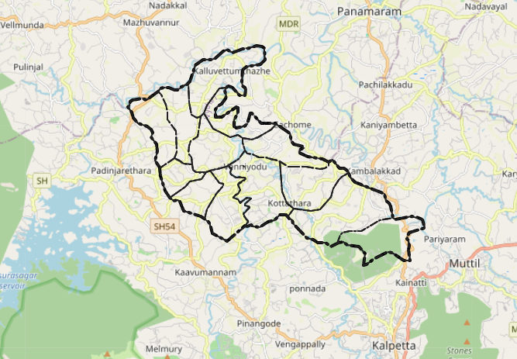

Baseline data

Name of LSGD: Kottathara

Block/Muncipality: Kalpetta

Taluk: Vythiri

District: Wayanad

Total area (sq. km): 31.75sq km
Ward | Houses | Population | Migrants | Wells | Hot  spots | Ed. Institutions | Hosp pvt/govt.
14 | 4680 | 19608 | 59 | 3016 | 1 | 9 | 5

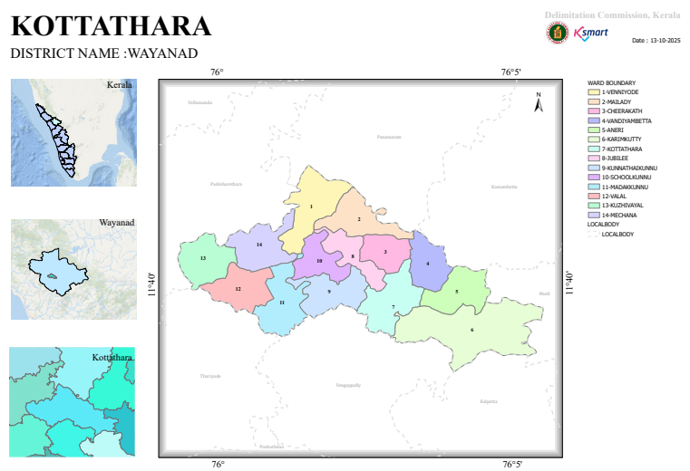

Local Roads Within/Passing Through Kottathara Panchayat
These are key village and district roads serving transportation, connectivity and rural access within the Panchayat:
- Venniyode–Mechana–Arampetta Road – important internal route connecting Venniyode junction with Mechana & Arampetta.
- Vandiyambatta–Kalaripoyil Road – links these local habitations within Kottathara.
- Kottathara–Myladi Road – connects the Panchayat centre to Myladi area.
- Puzhakkalidam–Chembakachal Road – district road supporting local connectivity.
- Mechana–Puzhakkalidam Road – rural access link between two interior settlements.
- Valal–Kuzhivayal Road – connects Valal and Kuzhivayal localities.

Main Access / Connectivity Routes (to/from Kottathara)
These links aren’t highways inside the Panchayat but are the major connecting routes for access:
- Road via Padinjarathara, Kalpetta, Mananthavady and Pinangode – these are the primary town-to-Panchayat routes used by buses and private vehicles.

Major Nearby Roads / Highways (Regional Connectivity)
(Not within the Panchayat but relevant for planning and connecting the Panchayat to districts and beyond):
- National Highway 766 (NH-766) — main regional highway linking Kozhikode to Kalpetta and Wayanad district; serves as the principal long-distance route for traffic to/from the region.
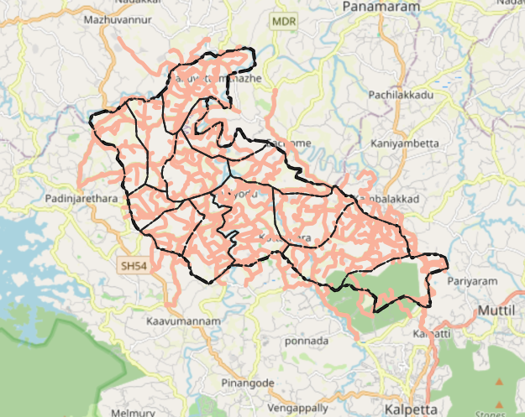

Major River in Kottathara Grama Panchayat
Kabini River – While a major river does not flow directly through the central village of Kottathara, the Kabini River and its tributaries (like Panamaram puzha and Mananthavady puzha) form the primary river basin in the wider Wayanad region that includes Kottathara and surrounding areas. Many of the small streams and rivulets in Kottathara drain into this river system.

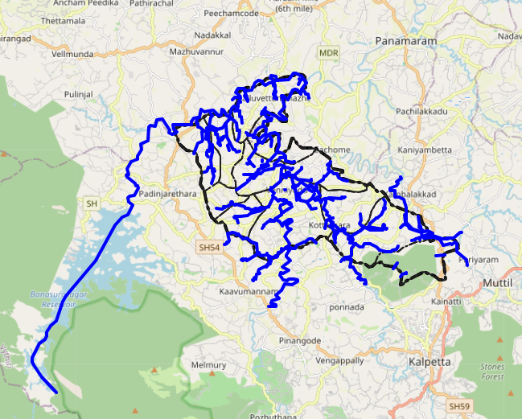

Disaster-Prone Areas – Kottathara Grama Panchayat
Kottathara Grama Panchayat, located in the hilly terrain of Wayanad district, is vulnerable to multiple natural hazards due to its topography, climate, and settlement patterns.

1. Landslide-Prone Areas
- Hilly slopes and areas with steep gradients
- Regions with loose soil and previous history of minor land slips
- Locations near road cuttings and deforested patches
- High-risk zones during intense monsoon rainfall

2. Flood-Prone Areas
- Low-lying agricultural lands
- Areas adjacent to streams and small rivulets
- Regions with poor drainage and water stagnation during heavy rains

3. Soil Erosion Zones
- Sloped agricultural lands
- Areas with reduced vegetation cover
- Riverbank regions vulnerable during monsoon flow

4. Drought-Prone Pockets
- Areas dependent on open wells and seasonal water sources
- Regions experiencing water scarcity during summer months

5. Wind & Storm Vulnerable Areas
- Settlements with lightweight roofing materials
- Isolated tribal hamlets surrounded by forest areas

6. Public Health Risk Zones
- Areas with poor sanitation and waste disposal practices
- Regions with stagnant water leading to vector breeding (dengue, leptospirosis risk)
- Densely populated settlements with limited infrastructure
- 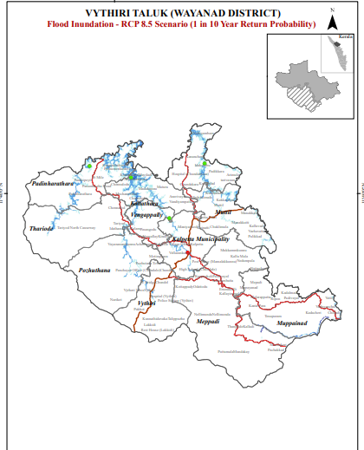
- 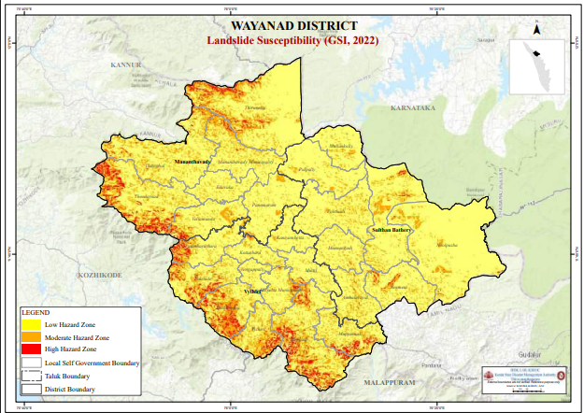

INTEGRATED HEALTH INFRASTRUCTURE MAP OF KOTTATHARA PANCHAYAT

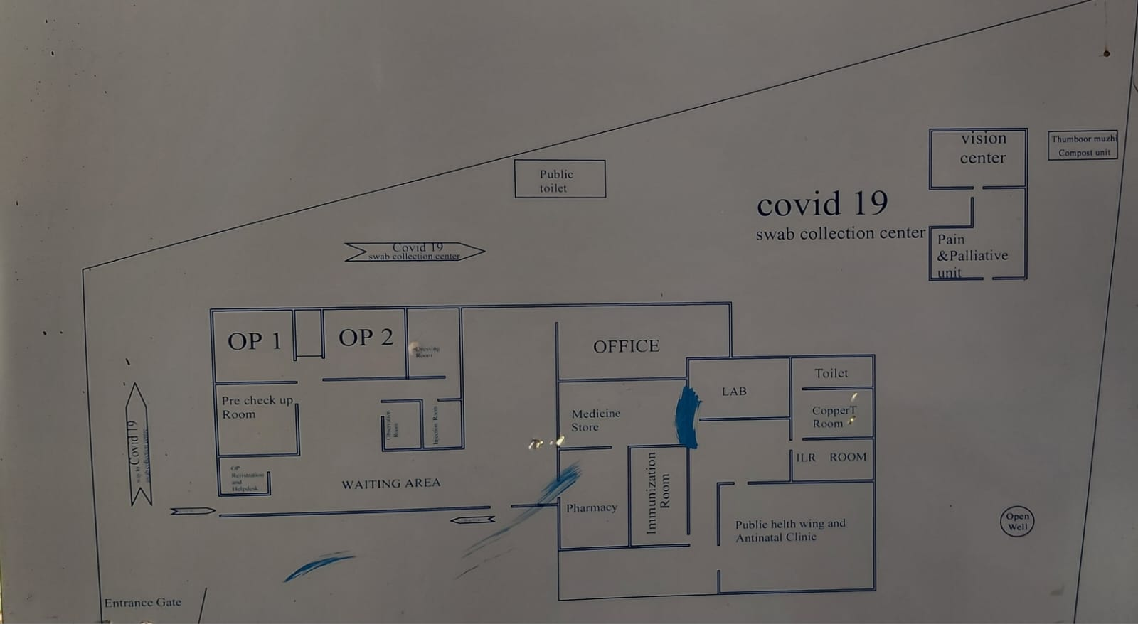
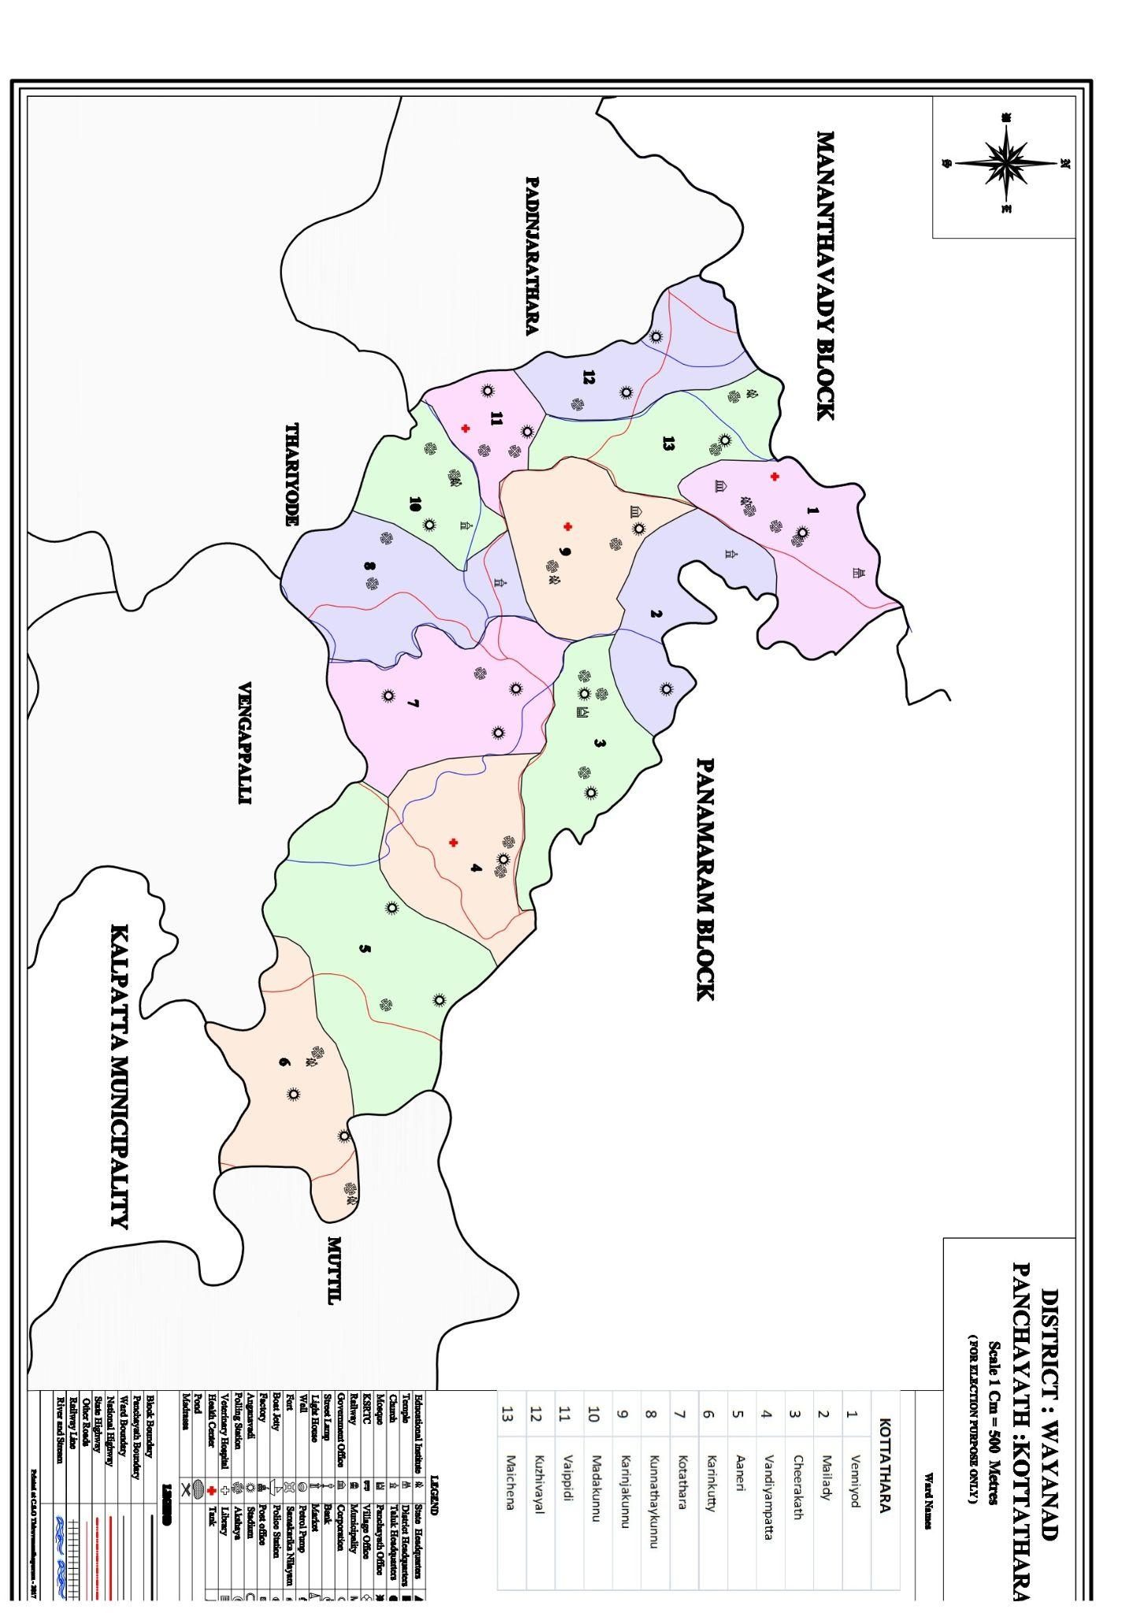

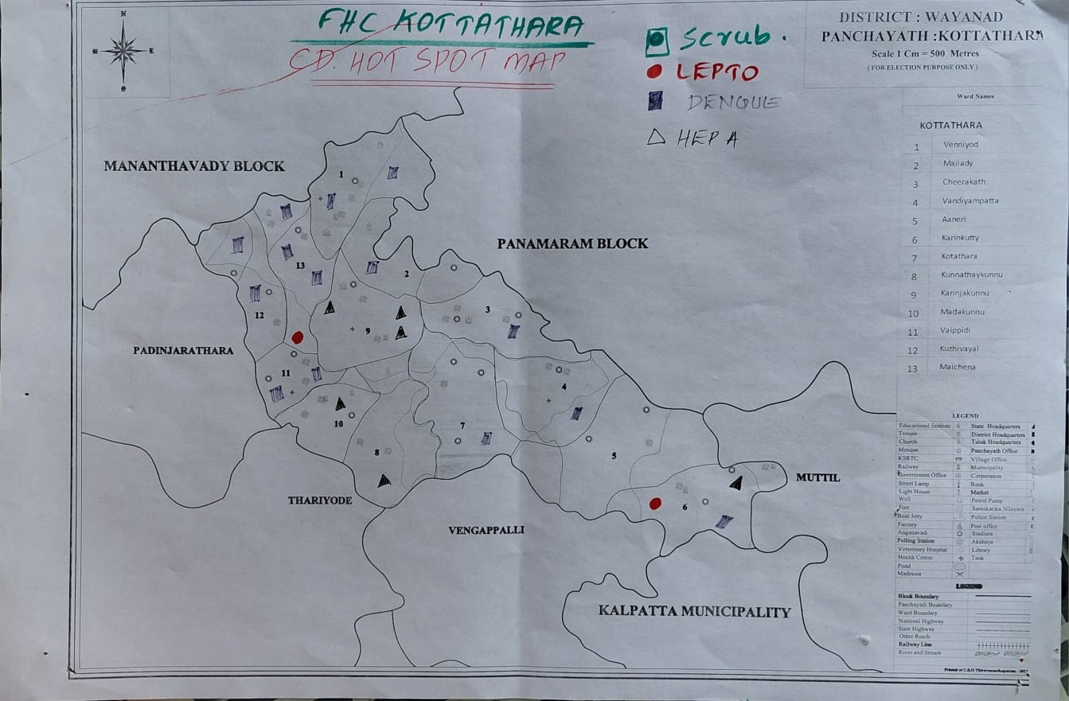
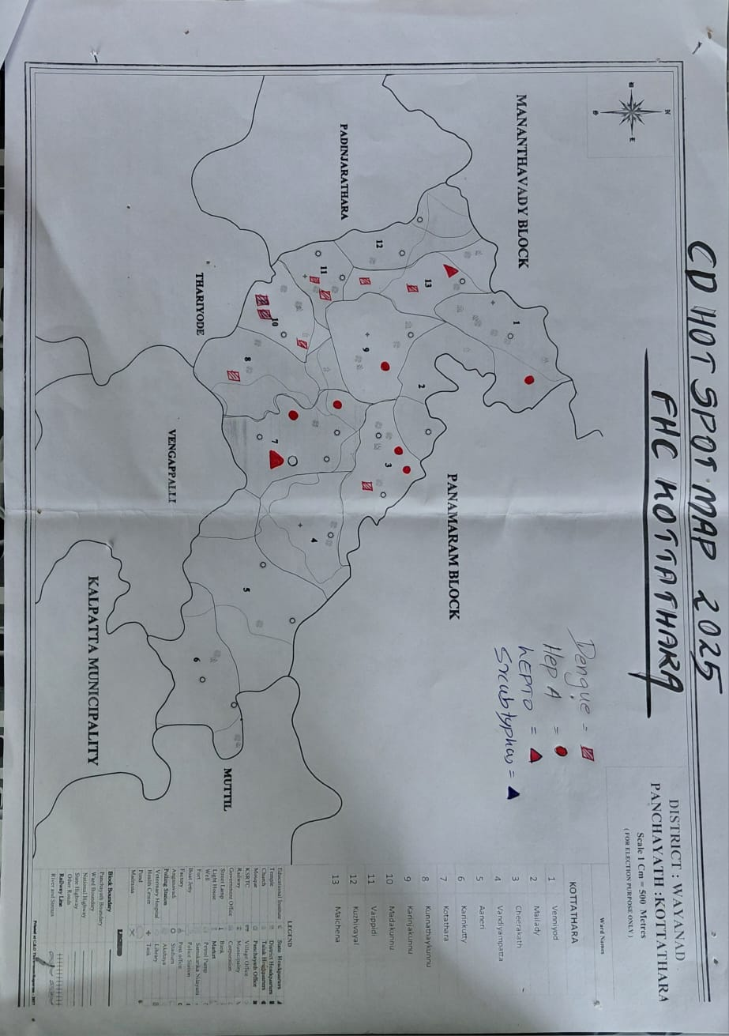

GENERAL PROFILE OF THE LSGI’S

Background of the LSGI
Kottathara Grama Panchayat is a rural Local Self-Government Institution located in Wayanad district under Vythiri Taluk. The Panchayat has a population of over 19,000, including more than 5,000 tribal residents, and is administratively divided into 14 wards. There are 1,435 wells serving as major water sources.
The area reports a regular occurrence of communicable diseases such as dengue, leptospirosis, Hepatitis A, and acute diarrhoeal diseases (ADD). Tuberculosis cases are also reported and effectively managed through the Family Health Centre Kottathara, which conducts surveillance, treatment, and awareness activities in coordination with the Panchayat.

Table 1: Background of LSGD
Description | Details
Name of LSGI | KOTTATHARA
Type (GP/Municipality / Corporation etc.) | GRAMAPANCHAYAT
Block | KALPETTA BLOCK
District | WAYANAD
Number of wards | 14
Total area (sq. km) | 31.75sq km
Population(Projected) | 19680
Population density | 536.45persons/sq km
Terrain (coastal/low-lying/backwaters/foothills, etc.) | Hilly terrain characterized by the kurumbalakotta
Number of rivers passing through LSGI | 2
Number of water bodies in the LSGI | 19
Number of educational institutions | 7
Factories / small-scale industries | 14
Flood-prone wards | 12.14.7
Landslide-prone wards | 2.1
Death Management and Disposal Facilities (mortuaries/crematorium, including electric) | 1
Auditoriums/Marriage halls/convention centres/community halls | 19

Demographic and Vulnerable Population
Understanding the demographic composition and vulnerable population groups in Kottathara Grama Panchayath is essential for effective pandemic preparedness. Children, the elderly, economically deprived families, migrant workers, and other socially vulnerable groups in the Panchayath are at increased risk during public health emergencies due to higher exposure, limited access to healthcare services, and greater dependence on public systems. Identifying and prioritizing these groups helps the Panchayath and health authorities plan targeted interventions, ensure equitable access to essential services, and strengthen community resilience during pandemics.

Description |  | Details (in numbers)
DEMOGRAPHIC PROFILE
Total population |  | 19608
Male |  | 9645
Female |  | 9963
Transgender |  | 0
Children under 5 |  | 1164
Adolescent |  | 4019
Elderly (>60) |  | 2449
SOCIAL/LIVELIHOOD VULNERABILITY
Previous EPEP family |  | 104
BPL family |  | 2484
Tribal communities |  | 5132
Migration | Immigrant | 59
Migration | Emigrant | 0
Socio-economically deprived |  | 2484
Fisherfolk |  | 0
SC Community |  | 853
ST Community |  | 5132

Clinical Vulnerability
Certain population groups in Kottathara Grama Panchayath require priority healthcare as they are at higher risk of severe illness, complications, and mortality during pandemics. Patients with chronic diseases, those requiring regular medical care, and individuals with mobility or functional limitations may face difficulties in accessing timely healthcare during public health emergencies. Mapping these vulnerable groups in Kottathara helps health authorities and the Panchayath prioritize continuity of treatment, plan adequate medicine stocks, ensure availability of oxygen support, arrange referral transport, and provide targeted home-based care for those in need.
Description | Details in numbers
Pregnant women | 87
Lactating mothers | 875
Bedbound patients | 100
Patients under palliative care other than bedbound | 100
Patients on Haemodialysis | 14
Patients on CAPD | 12
Cancer patients (currently on treatment) | 62
Haemophilic patients | 0
Mentally challenged | 21
Differently abled | 47
Diabetic patients | 320
Hypertensive patients | 719
TB patients | 3

Major Festivals & Events specific to the LSGI
(with the possibility of a public gathering)

Sl. No. | Name of festival | Month detailing the periodicity
1 | Alphonsa church | December

INFRASTRUCTURE & RESOURCE INVENTORY

Health Facility Directory & Basic Capacity in the LSGD
This section provides an overview of the healthcare infrastructure available within Kottathara Grama Panchayath. It outlines the distribution and basic capacity of health facilities that form the backbone of healthcare service delivery during routine periods as well as during public health emergencies.
Family Health Centre (FHC) Kottathara functions as the primary point of contact for the community, providing essential outpatient and limited inpatient services. Higher-level facilities such as Community Health Centres (CHCs), General Hospitals (GH), and Medical College Hospitals (MCH), which are accessible to the residents of Kottathara Panchayath, serve as referral centres for advanced diagnostics, specialist treatment, and critical care during public health emergencies.
This inventory of healthcare facilities helps identify existing strengths, gaps, and potential surge capacity that can be mobilised during pandemics or disasters to ensure timely and effective healthcare response for the population of Kottathara Grama Panchayath.

Table 5. Health Facility Resource Summary
Sl.no. | Health Facility | Type of Facility (MCH/GH/CHC/FHC/SC etc.) | Contact Number | Total beds | ICU Beds | Oxygen-Supported Beds | No. of Ventilator Support Beds | No. of ambulance
Government Healthcare Facilities
1 | FHC KOTTATHARA | FHC | 7034238749 | 1 | 0 | 0 | 0 | 1
2 | AAM MANNALAM | SC | 9747142166 | 0 | 0 | 0 | 0 | 0
3 | AAM MECHANA | SC | 9656395761 | 0 | 0 | 0 | 0 | 0
4 | AAM KURUMBALAKOTTA | SC | 8129299457 | 0 | 0 | 0 | 00 | 0
5 | AAM KARIMKUTTY | SC | 8129408882 | 0 | 0 | 0 | 0 | 0
Private Healthcare Facilities
1 | JDC CLINIC VENNIYODE | PVT CLINIC | 07025116236 | 5 | 0 | 0 | 0 | 0
AYUSH Healthcare Facilities
1 | GVT AYURVEDHAM HSPTL | AAM AYUSH | 9480968712 | 0 | 0 | 0 | 0 | 0
2 | GOVT HOMEO | AAM (HOMEO) | 9496313497 | 0 | 0 | 0 | 0 | 0

Private Clinics
Private clinics form an important component of pandemic preparedness in Kottathara Grama Panchayath, as they are often the first point of care when people begin to experience symptoms. In many cases, private clinics handle a considerable share of outpatient consultations and therefore play a key role in early case detection, timely referral of suspected cases, and support to disease surveillance activities.
Maintaining an updated understanding of the location of private clinics in Kottathara Panchayath, the services they provide, and their linkage with the public health system helps ensure that potential cases are not missed during an outbreak. It also enables health authorities to effectively engage private practitioners in disease reporting, risk communication, and coordinated response activities, thereby strengthening the overall capacity of the local health system to manage public health emergencies.

Table 6. Private Clinic Resource Summary
Sl No. | Name of Clinic | Registered (Y/N) | Clinic (General / Speciality) | Speciality (if any) | Address | Contact Number | Diagnostic Facility (Y/N) | Ambulance Linkage (Y/N)
1 | JDC CLINIC | YES | CLINIC | NA | JDC CLINIC VENNIYODE.KOTTATHARA | 7025116236 | YES | N

Healthcare Education & Training Institutions
This section tracks the educational infrastructure available, which is vital for human resource planning in the health sector.

Category of Institution | Govt | Private | AYUSH | Total
Medical Colleges | 0 | 0 | 0 | 0
Nursing Colleges | 0 | 0 | 0 | 0
Dental Colleges | 0 | 0 | 0 | 0
Para-medical / Allied Health | 0 | 0 | 0 | 0
Pharmacy Colleges | 0 | 0 | 0 | 0

Specialized Services & Emergency Inventory
This section provides a detailed view of the specialized medical resources available to the community, focusing on emergency response and critical care capabilities. This table tracks the vital assets required for managing severe illnesses and emergencies across Government, Private, and AYUSH sectors.

Item | Govt | Private | AYUSH | Total
Hospital beds | 1 | 5 | 0 | 6
Oxygen-generating systems(Y/N) | 0 | 0 | 0 | 0
Oxygen-supported beds(Numbers) | 0 | 0 | 0 | 0
Ventilator-supported beds | 0 | 0 | 0 | 0
ICU beds | 0 | 0 | 0 | 0
Burns units | 0 | 0 | 0 | 0
Blood centres | 0 | 0 | 0 | 0
BLS ambulances | 0 | 0 | 0 | 0
ALS ambulances | 0 | 0 | 0 | 0
Dialysis facilities | 0 | 0 | 0 | 0
Dispensaries | 01 | 01 | 0 | 02
Medical store | 0 | 0 | 0 | 0
Industrial establishments(Medium-scale industries/small-scale industries establishments to whom we can depend in a worst-case scenario) | 0 | 0 | 0 | 0

Oxygen & Diagnostic Capacity
Monitoring oxygen and diagnostic capacity is a critical component of public health preparedness, ensuring that the LSGD can handle both chronic care and sudden surges in respiratory or infectious diseases.
Name of Health Facility | Oxygen-generating System (Y/N) | Backup Oxygen Source (Y/N) | Diagnostic Facilities Available(Y/N)
Name of Health Facility | Oxygen-generating System (Y/N) | Backup Oxygen Source (Y/N) | Lab | USG | X-ray | CT/MRI | RT-PCR
Government Healthcare FacilitiesNO NO
 | NO | NO | 2 | 0 | 0 | 0 | 0
NIL | NIL | NIL | NIL | NIL | NIL | NIL | NIL

Diagnostics facility mapping at the LSGI level
The diagnostic capacity of kottathara G.P represents the "intelligence network" of our healthcare system. The speed and accuracy of disease identification depend entirely on the distribution and technical level of these facilities.

Item | Govt | Private | AYUSH | Total
General labs | 1 | 1 | 0 | 2
Microbiology labs | 1 | 1 | 0 | 2
RT-PCR labs | 0 | 0 | 0 | 0
USG units | 0 | 0 | 0 | 0
CT/MRI units | 0 | 0 | 0 | 0
Research labs | 0 | 0 | 0 | 0
Labs of other departments that can be repurposed | 0 | 0 | 0 | 0

Laboratory Identification & Basic Details
Sl. No. | Name of Laboratory | Ownership (Govt / Private / Academic) | Address | Contact No. | 24×7 Services (Yes/No) | NABL / Govt Approved (Yes/No)
1 | FHC KOTTATHARA | GOVT | GOVT FHC KOTTATHARA.VAALAL. | 8075025929 | NO | NO
2 | JDC CLINIC | PRIVATE | JDC CLINIC VENNIYODE | 7025116236 | NO | NO

Social and Community Infrastructure for surge plan
This table serves as our logistics and shelter inventory. By mapping these locations, quickly we can identify where to house displaced citizens, where to set up temporary medical clinics, and how to manage the deceased with dignity during a crisis.

Category | Total Count | Ward | Est. Capacity (Persons) | Contact details
Educational Institutions
Anganwadis | 28 | 14 | 120 PERSON IN 28 AWW | 9605289237(ICDS SUPERVSR)
Schools | 7 | 14 | 550 | -
Colleges | 0 | 0 | 0 | 0
Healthcare Educational Institutions
Medical colleges (Govt/Private) | 0 | 0 | 0 | 0
Nursing colleges (Govt/Private) | 0 | 0 | 0 | 0
Dental colleges (Govt/Private) | 0 | 0 | 0 | 0
Paramedical institutes (Govt/Private) | 0 | 0 | 0 | 0
Community Gathering Spaces
Community halls | 17 |  | 700 | 7907920626
Auditoriums | 2 |  | 180 | 7907920626
Religious buildings | 0 | 0 | 0 | 0
Vulnerable Group Support Facility
Destitute homes | 0 | 0 | 0 | 0
Elderly homes | 0 | 0 | 0 | 0
LSGD owned other buildings | 0 | 0 | 0 | 0
Mass Fatality Management (MFM) Infrastructure
Mortuary | 0 | 0 | 0 | 0
Crematorium | 1 | 0 | 0 | 0
*refer annexure 1 for contact details

Human resources
This section focuses on the human resources available within Kottathara Grama Panchayath. In any emergency—whether a pandemic, flood, or industrial accident—the infrastructure is only as effective as the people managing and operating it.

Medical & Clinical Personnel
This table tracks the "Frontline" providers responsible for diagnosis, treatment, and clinical management. Narrative sentence

Cadre | Govt (No.) | Private (No.) | Total
Doctors—Modern Medicine | 2 | 1 | 3
Doctors – AYUSH | 2 | 1 | 3
Doctors – Veterinary | 1 | 0 | 1
Doctors – Dental | 0 | 1 | 1
Nursing officers | 2 | 2 | 4
Lab technicians | 1 | 2 | 3
Optometrist | 1 | 0 | 01
Pharmacists | 1 | 2 | 3
Psychologists | 0 | 0 | 0
Counsellors | 1 | 0 | 0

Public Health & Field-Level Workforce
These individuals are the backbone of surveillance, maternal-child health, and decentralized care.

Cadre | Health services | Municipal common services | Total
HS (Health Supervisors) | 0 | 0 | 0
HI (Health Inspectors) | 1 | 0 | 1
LHS (Lady Health Supervisor) | 0 | 0 | 0
LHI (Lady Health Inspectors) | 1 | 0 | 1
JPHN (Jr Public Health Nurses) | 4 | 0 | 4
JHI (Jr Health Inspectors) | 2 | 0 | 2
MLSP (Mid-Level Service Providers) | 5 | 0 | 5
Palliative Nurses | 1 | 0 | 01
RBSK Nurses | 1 | 0 | 1
PRO | 0 | 0 | 0
Epidemiologist | 0 | 0 | 0
Data Manager | 0 | 0 | 0

Community & Support Cadre
This group represents the surge capacity of the LSGI—people who can be called upon for logistics, rescue, and specialized support.

Cadre | Number
ASHA Workers | 13
AWW (Anganwadi Workers) | 28
Emergency Medical Volunteers (Trained) | 50
Kudumbashree | 182
MNREGS | 2482
Purusha Swayam Sahaya Sangham | 1
Ex-Servicemen | 0
Retired Police Officers | 6
NCC/NSS Volunteers | 110
Red Cross volunteers | 0
One Health Community Volunteers | 0
One Health Community Mentors | 1

Community Organizations
This section details the presence of community-based organisations (CBOs), non-governmental organisations (NGOs), faith-based organisations (FBOs), Kudumbashree Self-Help Groups (SHGs), and Ayalkootams within the Local Self-Government Institution (LSGI). These groups enhance grassroots mobilization, resource distribution, and support networks crucial for pandemic response and community resilience.

Category | Total Count
NGOs | 2
Religious based organizations | 4
Foreign based organizations | 0
Sports Club/youth clubs | 18
Kudumbashree SHGs | 182
Ayalkootams | 182
Political organizations | 5
Residential organizations | 1

Administrative & Emergency Services
This section outlines the availability of key non-health emergency support services and infrastructure within the LSGI, which are essential for effective pandemic preparedness and response. These facilities support law enforcement, disaster response, water supply, logistics, mobility, and community-level interventions during public health emergencies.

Category | Total Count | Contact details
Police Stations | 1 | 04936286635
Fire & Rescue Stations | 1 | 0493620233
Water Pumping Points | 1 | 04936202594
Public Distribution System (PDS) | 0 | 0

Information regarding resources
The availability of essential transport and support resources plays a crucial role in saving lives in Kottathara Grama Panchayath. Equipment such as ambulances, mobile mortuaries, amphibian ambulances, and motorized boats ensures that patients, samples, and healthcare teams can move quickly, even in flooded, remote, or difficult terrains. Heavy vehicles like JCBs, cranes, tractors, and torus lorries support logistics, waste management, emergency infrastructure, and the rapid conversion of spaces into care or isolation facilities. Taxis, four-wheel-drive vehicles, and trucks help maintain continuity of essential services, reach vulnerable populations, and support home-based care and supply delivery.

Means of transportation | Total Count
JCB | 4
Crane | 0
Heavy Trucks | 3
Tractor | 9
Ambulances | 2
Mobile mortuaries | 0
Boats | 1
Taxi service | 12
Note: For specific details regarding vehicle owners and contact information, please refer to Annexure [

ONE HEALTH & ENVIRONMENTAL SURVEILLANCE
The One Health approach links human, animal, and environmental health to detect and control diseases early, especially those that can spread from animals to people (zoonoses). In Kottathara Panchayat (Kerala, India), strengthening local surveillance means building community capacity to monitor livestock and poultry health, track environmental risks, and collect human health data together. This includes enhancing veterinary support, encouraging reporting of unusual animal or human illness, and using local seasonal mapping and community reporting systems so that ward-level actions and rapid responses can be triggered before outbreaks spread widely. This integrated, grassroots surveillance aligns with Kerala’s state One Health strategy to enable early warning and coordinated response.

Animal & Bird Population
Kottathara Panchayat in Wayanad district, Kerala has a unique mix of rural settlements, agricultural land, forests, and livestock — conditions that create close interactions between humans, domestic animals, wildlife, and birds. These interactions increase the risk of zoonotic diseases — infections that jump from animals or birds to humans — such as rabies, avian influenza, leptospirosis, anthrax, and Nipah-like viruses. Mapping the animal and bird populations locally helps strengthen surveillance, prevention, and response by health and veterinary systems.

Category | Item | Estimated Population | Wards
Animal Population | Livestock (Cattle/Goats/Buffalo) | 1210
Animal Population | Pet Animals (Dogs/Cats) | 910
Animal Population | Stray Dog Population | - | -
Animal Population | Pig Farms (Number of heads) | 8
 | Small Units (Sheep / Goats – clustered) | 0 | -
Bird Population | Poultry Units (Birds) | 20
Bird Population | Poultry- (FOWL) | 0 | -
Bird Population | Wild/Migratory Birds (Observed) | 0 | -
Bird Population | Crow Mortality Events (Reported) | 0 | -

In Kottathara Panchayat, zoonotic disease risk is highest in wards 3–8 where a dense concentration of poultry units increases the chance of spill-over infections, including avian influenza from birds to humans. Recent outbreaks of bird flu in Kerala’s poultry and wild birds highlight this threat.
Stray dogs around market areas, bus stations, and gathering spots raise challenges for rabies surveillance and bite prevention, as unvaccinated dog populations can sustain rabies transmission.
Seasonal migratory and resident water birds near ponds, rivers, and paddy fields during November–December elevate the risk of introducing or amplifying avian influenza at the local level.
Clusters of pig farms and animal shelters in flood-prone zones also heighten risk of leptospirosis and other environment-mediated zoonoses during monsoon floods. This combination of animal, environmental, and human exposure factors makes integrated surveillance and early action essential.

Veterinary Infrastructure
In Kottathara Panchayat (Wayanad district, Kerala), veterinary institutions are a key part of One Health surveillance and animal health support. The District Animal Husbandry Office, Wayanad and the District Veterinary Centre in Kalpetta provide clinical care, disease monitoring, vaccination campaigns, and outbreak reporting for livestock and poultry across the district. These services extend outreach into local panchayats including Kottathara to support early detection of animal diseases and integrated reporting with human health systems. There are also mobile farm aid units (e.g., in Thariyode) that carry out preventive care, sample collection, and animal health assessments in rural areas. Together, these services strengthen coordination between animal health workers, human health services, and local government for comprehensive disease surveillance and response at the grassroots level.
Facility Type | Name of Facility | Ownership Govt / Pvt | Location(Ward No) | Contact number
Veterinary Dispensary | GOVT.VETERINARY DISPENSORY | GOVT |  | 9744934385
Veterinary Hospital / Polyclinic | NIL | NIL | NIL | NIL
Private Veterinary Clinics | NIL | NIL | NIL | NIL
Mobile / Emergency Vet Service (incl. night services) | NIL | NIL | NIL | NIL
Pet Homes / Animal Shelters | NIL | NIL | NIL | NIL
Slaughterhouse-linked Veterinary Inspection Unit | NIL | NIL | NIL | NIL

Veterinary Doctors & Workforce
Early detection, diagnosis, reporting, and reaction to animal illness epidemics depend on the availability and accessibility of qualified veterinary specialists. By identifying unusual animal morbidity or mortality promptly, collecting samples promptly, and coordinating efficiently with human health and LSGI systems—especially during zoonotic outbreaks and pandemic-prone situations—a clearly defined veterinary workforce enhances One Health surveillance.

Category | Number Available | Type (Govt/Pvt) | Contact number
Government Veterinary Doctors | 1 | GOVT | 9744934385
Private Veterinary Doctors | NIL | NIL | NIL
Livestock Inspectors | 2 | GOVT | 9846339115
Para-veterinary Staff / Attenders | 2 | GOVT | -
Contract / On-call Veterinary Support (if any) | 1 | GOVT | -

High-Risk Interface Points (Surveillance Sites)
While Thariode Grama Panchayat does not have large commercial wetland–livestock–human contact zones or major slaughter sites, it does include small-scale poultry farms and backyard poultry rearing, which are common in rural parts of Wayanad district and represent key points of human-animal interaction that could pose zoonotic spillover risk. Small poultry holdings and livestock nearby homes or fields require monitoring as part of integrated animal and human health surveillance at the Panchayat level.
Type of Habitat | Type of High risk interface | Geographical vulnerability
Wetlands & Backwaters | NIL | NIL
Backyard Poultry Farms | NIL | NIL
Cattle Sheds near Water Bodies | NIL | NIL
Fish & Meat Markets | NIL | NIL
Community Slaughter Sites | NIL | NIL
Migratory Bird Congregation Areas | NIL | NIL
Rodent-Infested Grain Storage | NIL | NIL

Category | Total Count | Key Locations (wards)
Poultry Farms | 15 | WARD 3,4,5,6,7,8
Backyard / Clustered Poultry Units | NIL | NIL
Duck Rearing Units (open water access) | NIL | NIL
Slaughterhouses/ Slaughter Points | NIL | NIL
Meat/Fish Markets | NIL | NIL
Live Bird Sale Points | NIL | NIL
Cattle Markets / Weekly Animal Fairs | NIL | NIL
Pet Shops / Breeders | NIL | NIL
Animal Shelters / Pet Homes | NIL | NIL
Waste Disposal Sites near Animal Units | NIL | NIL

Environmental Risk Mapping
Kottathara in Wayanad district, Kerala lies in a flood-prone landscape with heavy monsoon rainfall, river systems, and rural settlements — conditions that shape environmental health risks during and after the rains. Mapping these risks at the Panchayat level — including terrain, water bodies, flood-sensitive areas, and human-animal activity zones — helps with pandemic preparedness, targeted interventions, and early warnings for disease outbreaks.

Risk Factor | High-Risk Wards | Key Locations | Risk Level (High/Med/Low)
Flood-prone areas | 9.7.14.12 | Kottathara,venniyode | Med level
Water bodies/wetlands | 12,7,14,9,10 | Kottathara, Venniyode, Mechana | Med level
Solid waste accumulation | 3 | venniyode | Med level
Animal waste disposal issues | 7 | cherupuzha | Low level
Rodent infestation zones | Na | Na | Na
Industrial effluent discharge | Nil | Nil | Nil
Construction sites / abandoned buildings | 4 | Venniyode,kottathara,mylaadi | Nil
Poor drainage/blocked canals | Ni | Nil | Nil
Drinking water source contamination risk | 9,7,14,12 | Kurumani.karimkutyy.venniyode | High level

Disease Seasonality Mapping
1, Flooding & waterlogging → amplifies leptospirosis, malaria, diarrheal diseases.
·
2, Migratory bird influx (Nov–Feb) → avian influenza risk.

3, Mosquito breeding cycles → vector-borne disease peaks in monsoon.

4, Agricultural practices → close human–animal contact in paddy fields.

Disease | Peak Risk Season | Key Drivers | High-Risk Locations | Surveillance Focus
Avian Influenza | 0 | 0 | 0 | 0
Leptospirosis | Nil | nil | nil | Nil
Dengue/Chikungunya | Dec –march | nil | nil | Nil
Acute Diarrheal Diseases | June sep | 0 | 0 | 0
Rabies | 0 | 0 | 0 | 0
Anthrax (rare) | 0 | 0 | 0 | 00

Vulnerability Mapping
Vulnerability mapping pinpoints high-risk populations, occupations, and areas exposed via environment, livelihoods, socio-economics, and poor service access. Paired with environmental/seasonality mapping, it enables risk-based surveillance, targeted actions, and optimal resource use in One Health and pandemic planning.
Vulnerability Factor | High-Risk Wards | Key Groups / Locations | Risk Level
Flood-prone households | 12.14.7 | ST.GENERAL | MEDIUM
Wetland-adjacent communities | 0 | 0 | 0
Backyard poultry / duck rearing households | 0 | 0 | 0
Livestock-rearing households | 0 | 0 | 0
Slaughterhouse & meat market workers | 0 | 00 | 00
Fisherfolk & fish market workers | 0 | 0 | 0
Sanitation workers | 0 | 0 | 0
Daily wage / migrant workers | 0 | 0 | 0
Elderly & chronically ill populations | 0 | 0 | 0
Pregnant Women | 0 | 0 | 0
Children (schools, Anganwadi’s) | 0 | 0 | 0
Limited access to safe water & sanitation | 0 | 0 | 0

EPIDEMIOLOGICAL TRENDS (2021–2025)

Disease surveillance is the systematic collection, analysis, and interpretation of health data for planning, implementation, and evaluation of public health practice. This section presents the disease surveillance profile of the LSGI based on routine reporting systems and outbreak investigations to identify priority diseases, seasonal patterns, and emerging public health threats.

Disease Burden among human beings(Last 5 Years)
Analysis of disease-wise data for the last five years helps identify persistent public health problems, emerging diseases, and changes in disease burden. This information supports prioritisation of prevention, preparedness, and response activities at the Panchayat level.

Disease | 2021 | 2022 | 2023 | 2024 | 2025 | Trend(Increasing/Stable/Decreasing)
Dengue | 1 | 12 | 14 | 32 | 9 | Decreasing
Leptospirosis | 1 | 7 | 1 | 01 | 2 | Decreasing
Hepatitis A | 7 | 9 | 4 | 15 | 14 | Increasing
Malaria | 0 | 0 | 0 | 0 | 0 | Nil
Scrub Typhus | 1 | 0 | 0 | 0 | 0 | Nil
Typhoid | 0 | 0 |  | 0 | 0 | Nil
H1N1 | 0 | 0 | 0 | 0 | 0 | Nil
H3N2 | 0 | 0 | 0 | 0 | 0 | 0
ADD | 58 | 74 | 43 | 117 | 89 | 0
Mumps | 0 | 1 | 0 | 0 | 0 | 0
Measles | 0 | 2 | 0 | 0 | 01 | Decreasing
Hepatitis B | 0 | 0 | 0 | 0 | 0 | 0
Hepatitis C | 0 | 0 | 0 | 0 | 0 | 0
Tuberculosis | 9 | 9 | 10 | 8 | 8 | Constant level
Leprosy | 0 | 0 | 0 | 0 | 0 | No case detected

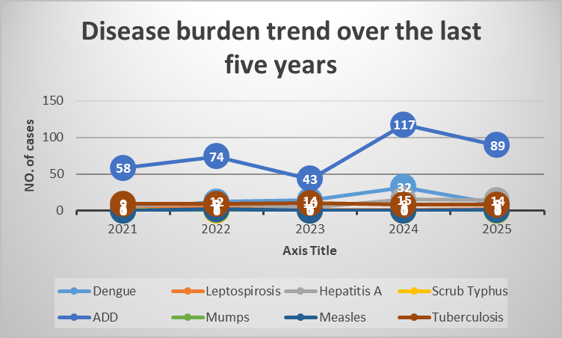

Seasonal Trend Analysis
Seasonal analysis helps anticipate surges (e.g. dengue in monsoon, leptospirosis after floods, influenza in cooler months) and plan pre‑emptive vector control, stockpiling of IV fluids, and awareness campaigns at Panchayat level.

DENGUE
Dengue is a major seasonal vector-borne disease strongly associated with rainfall, water stagnation, and increased mosquito breeding during the monsoon period.

Peak: July–November

Dengue – Ward-wise Yearly Distribution (2021–2025)

Ward | Dengue – Ward-wise Yearly Distribution
Ward | 2021 | 2022 | 2023 | 2024 | 2025 | Total
1 | 0 | 2 | 0 | 1 | 1 | 4
2 | 0 | 0 | 2 | 0 | 0 | 2
3 | 0 | 4 | 0 | 3 | 0 | 7
4 | 0 | 0 | 0 | 0 | 0 | 0
5 | 0 | 0 | 0 | 0 | 1 | 1
6 | 0 | 0 | 0 | 0 | 1 | 1
7 | 1 | 2 | 2 | 1 | 0 | 6
8 | 0 | 1 | 0 | 0 | 0 | 1
9 | 0 | 2 | 4 | 1 | 0 | 7
10 | 0 | 1 | 2 | 1 | 2 | 6
Ward 12=2,ward 13=2,(2023),ward 13=25cases(2024),ward 12=2,ward11=2(2025)

LEPTOSPIROSIS
Leptospirosis cases are closely linked to monsoon rains, flooding, and occupational exposure, particularly in low-lying and waterlogged areas.

Peak: June - August

Leptospirosis – Ward-wise Yearly Distribution (2021–2025)

Ward | Leptospirosis – Ward-wise Yearly Distribution
Ward | 2021 | 2022 | 2023 | 2024 | 2025 | Total
1 | 0 | 0 | 1 | 0 | 0 | 1
2 | 0 | 2 | 0 | 0 | 0 | 2
3 | 0 | 0 | 0 | 0 | 1 | 1
4 | 0 | 0 | 0 | 0 | 0 | 0
5 | 0 | 1 | 0 | 0 | 0 | 1
6 | 1 | 1 | 0 | 0 | 0 | 2
7 | 0 | 0 | 0 | 0 | 0 | 0
8 | 0 | 1 | 0 | 0 | 0 | 1
9 | 0 | 0 | 0 | 0 | 0 | 0
10 | 0 | 0 | 0 | 0 | 0 | 0
11 | 0 | 1 | 0 | 0 | 0 | 1
12 | 0 | 0 | 0 | 1 | 1 | 2
13 | 0 | 1 | 0 | 0 | 0 | 1

VIRAL HEPATITIS - A
Hepatitis A cases are commonly associated with unsafe drinking water, food contamination, and breakdowns in sanitation, often presenting as clusters or outbreaks.

Peak: October - December

Hepatitis A – Ward-wise Yearly Distribution (2021–2025)

Ward | Hep A – Ward-wise Yearly Distribution
Ward | 2021 | 2022 | 2023 | 2024 | 2025 | Total
1 | 0 | 1 | 0 | 2 | 3 | 6
2 | 2 | 0 | 0 | 2 | 0 | 4
3 | 0 | 0 | 0 | 2 | 1 | 3
4 | 1 | 0 | 0 | 2 | 0 | 3
5 | 0 | 0 | 0 | 1 | 3 | 4
6 | 1 | 0 | 0 | 0 | 0 | 1
7 | 0 | 0 | 0 | 0 | 2 | 2
8 | 0 | 1 | 0 | 2 | 0 | 3
9 | 1 | 1 | 0 | 0 | 3 | 5
10 | 0 | 1 | 0 | 0 | 1 | 2
11 | 0 | 3 | 2 | 1 | 0 | 6
12 | 1 | 1 | 2 | 3 | 0 | 7
13 | 1 | 1 | 0 | 0 | 1 | 3

Outcome-Based Trend Analysis- 2025

Transmission Trend- 2025
For effective management of public health issues, it is important to track the trend of disease transmission mode. It helps identify the population or place at high risk that can be used to predict outbreaks and implement targeted interventions as quickly as possible. Understanding these kinds of trends enables authorities to allocate resources efficiently and change the strategies adequately based on the trend that follows.

Mode of Transmission | No. of cases | No. of Deaths
Vector Borne Diseases | 69 | 0
Water Borne Diseases | 49 | 0
Air Borne Diseases | 62 | 4
Blood Borne Diseases | 0 | 00
Food Borne Diseases | 381 | 0

Vector-Borne Disease

Disease | No. of Cases | No. of Deaths
Dengue | 68 | 0
Malaria | 0 | 0
Chikungunya | 0 | 0

Water Borne Disease

Disease | No. of Cases | No. of Deaths
Cholera | 0 | 0
Typhoid | 4 | 0
Hep- A | 49 | 0
Dysentery | 0 | 0
Amoebiasis | 0 | 0
E- Coli infections | 0 | 0
Air Borne Disease

Disease | No. of Cases | No. of Deaths
Influenza | 0 | 0
H1N1 | 0 | 0
TB | 44 | 00
Chickenpox | 14 | 0
Measles | 3 | 0
Covid-19 | 0 | 0
Pertussis | 0 | 0
Mumps | 1 | 0

Blood-Borne Disease

Disease | No. of Cases | No. of Deaths
AIDS | 0 | 0
Hep- B | 0 | 0
Hep- C | 0 | 0

Zoonotic Disease

Disease | No. of Cases | No. of Deaths
Rabies | 0 | 0
Leptospirosis | 12 | 0
Avian influenza | 0 | 0
West nile | 0 | 0
Anthrax | 0 | 0
Nipah | 0 | 0
Scrub Typhus | 0 | 0

Integrated Disease Hotspot Map (2021–2025)

Preparedness and Response Protocol at LSG Level
This section describes the operational framework for the LSGI once a pandemic is declared. It explains how the LSGI and health system will move from routine data collection to active response, using a One Health approach.

Constitution of One Health Committee
The LSGD shall constitute a One Health Committee comprising the LSGI President, Medical Officers (Modern Medicine, AYUSH, and Veterinary), the Health Inspector, and the Veterinary Surgeon.

Objective: The One Health Committee coordinates human, animal, and environmental health to prevent and control pandemics.

Sl No | Name | Designation | Department/Institution | Role in Committee | Contact Number
1 | RAJITHA CC | Panchayat President | LSGD | Chairperson | 9562616524
2 | DR.SUNAND KUMAR NN | Medical Officer (PHC/CHC) | Health Dept | Member Secretary | 7034238749
3 | DR.NEETHU | Veterinary Officer | Animal Husbandry | Member | 9744934385
4 | SIYA | Epidemiologist | Health Dept | Member | 9544142784
5 | HARKISHAN AG | Health Inspector/PHN | Health Dept | Surveillance | 9544589217
6 | JONCY SAJI | ASHA Supervisor | Health Dept | Community link | 9947536396
7 | UMA | ICDS Supervisor | Social Welfare | Vulnerable groups | 9605289237
8 |  | Police Station Officer | Police Dept | Law & order
9 | ANAGHA | Ward Councillor Representative | LSGD | Community coordination | 7510140249
10 | SANTHA BALAKRISHNAN | Kudumbashree CDO | Kudumbashree | Community mobilisation | 8593867461
11 | MANSOOR VP | NGO/Volunteer rep | Civil Society | Support services | 9061848846
12 |  | Line Department representations

Key Responsibilities:
- Review disease surveillance data (human + animal)
- Conduct ward-wise risk assessment and vulnerability mapping
- Approve quarantine/isolation centre locations
- Coordinate with district for resources (PPE, oxygen, ambulances)
- Periodically review health system surge capacity, including beds, oxygen, human resources, and ambulances.
- Approve and monitor risk communication and community engagement strategies, including rumour management.
- Ensure protection and service continuity for vulnerable groups (elderly, persons with disabilities, dialysis patients, coastal populations).
- Conduct quarterly mock drills
- Monitor equity measures for vulnerable groups

Meeting Schedule:
Quarterly (normal times) | Weekly (outbreak alert) | Daily (pandemic phase)

Pandemic Response Workforce
To ensure a coordinated and timely response during a pandemic, a dedicated Pandemic Response Workforce shall be constituted at the LSG level. The workforce will function under the overall supervision of the One Health Committee and in close coordination with the health authorities. Team-based deployment will enable efficient surveillance, case management, quarantine and isolation management, logistics support, and risk communication. Each team shall have a clearly designated team leader, defined roles, and an identified pool of personnel to allow rapid activation, rotation of duties, and continuity of services during prolonged emergencies.

Total Response Workforce Available: 300 persons

Team Name | Composition | Key Responsibilities | Team Leader
Surveillance and Contact Tracing Team | HI, JHI, JPHN, ASHAs and Volunteers | Case detection, contact listing, home visits, reporting | HI
Case Management Team | Doctors, Nurses, MLSP, Palliative Nurses | Patient care & referral | DOCTOR
Quarantine & Isolation Team | LSGD staff, Volunteers | Facility management | JHI
Psychosocial support | LSGD COUNSILOR | PSYCHOLOGICAL MANAGEMENT | COUNSILOR
Logistics & supply chain Team | LSGD staff, Storekeepers, Drivers 3 | Supplies & transport [PPE, medicines, oxygen, transport, waste management] | Ward Member
Communication Team | Ward members, Kudumbashree, Youth clubs,  AWW workers and other self help groups | IEC, community meetings, countering misinformation | M.O in charge
Transportation | KSRTC, educational institutional buses | Transportation | Station master
Media Surveillance | IECTM | Awareness | LSGD
Intersectoral coordination and convergence | FHC and LSGD | Decision making | Secretary and MO
Collaborative surveillance | NGOs, Club, Volunteers | Support | Team leader

All teams shall be activated immediately upon outbreak alert or pandemic declaration and shall report daily to the LSG Incident Commander/Medical Officer, with consolidated reporting to the Block PHC. Duty rosters and alternate personnel shall be maintained to ensure uninterrupted services during staff shortages or prolonged response periods. Team composition and numbers may be revised based on the magnitude of the outbreak and availability of human resources.

Activities and Measures before and during Pandemic

PHASE 1 - Alert / Preparation

1. Data Sources for Surveillance – Kottathara Gram Panchayat
Public health surveillance in Kottathara functions through a network of formal reporting channels and community-based inputs to ensure early detection, monitoring, and response of communicable diseases and conditions of pandemic potential.

1.1 Integrated Health Information Platform (IHIP)
- All public and private health facilities serving the Kottathara area must report notifiable diseases and syndromes with pandemic potential into the Integrated Health Information Platform (IHIP) (part of the national Integrated Disease Surveillance Programme – IDSP).
- Facility in-charges are responsible for daily data entry of syndromic, presumptive, and laboratory forms to capture disease trends and trigger early warning signals.
- Notifications of priority conditions are escalated automatically to district surveillance units for action.

1.2 Health Facility OPD/IPD Records
- Outpatient (OPD) and inpatient (IPD) records from government hospitals, primary health centres, and community health centres that serve Kottathara are analysed routinely for unusual trends or surges in communicable disease presentations.
- Unusual patterns (e.g., spikes in fevers, respiratory complaints) are escalated to the Taluk and District Surveillance Units for investigation.

1.3 Private Hospitals and Diagnostic Labs
- Private healthcare providers and diagnostic laboratories in and around Kottathara are sensitised to report suspected communicable diseases into IHIP and to health authorities.
- Regular coordination and follow-up ensure completeness of reporting from the private sector.

1.4 Community Sources & Media Monitoring
- Local media (print, digital), social media, and community news sources are monitored for early signals of possible disease events affecting the Gram Panchayat.
- Field verification is carried out when media reports indicate unusual health events.

1.5 Grassroots Community Reporting
Regular reporting from community health actors enables rapid detection of unusual health occurrences:
- Accredited Social Health Activists (ASHAs)
- Junior Public Health Nurses (JPHNs)
- Ward Members and community volunteers
These frontline workers notify unusual patterns (clusters of fever, respiratory distress, rash illnesses, etc.) to Panchayat health teams immediately.

2. Event-Based Triggers to be Monitored & Reported
Health workers and facility in-charges in Kottathara should be trained and mandated to report the following triggers promptly to the District Surveillance Unit:

2.1 Priority Event Triggers
- Sudden increase in Influenza-Like Illness (ILI) or Severe Acute Respiratory Infection (SARI) compared to baseline levels.
- Clustering of similar symptoms in a household, workplace, school, hostel, or locality.
- Unusual or unexpected illness clusters with common symptoms (fever, rash, jaundice).
- Unexplained or sudden deaths, especially with respiratory or neurological symptoms.
- Sudden absenteeism spikes in schools, workplaces, or anganwadis.
- Media or social media indications of possible outbreaks.

2.2 Immediate Action Upon Trigger Identification
Upon identification of any trigger event:
- Immediate notification to the Block/District Surveillance Unit and Medical Officer within 24 hours.
- Field verification by Health Inspector (HI) and/or Junior Health Inspector (JHI).
- Case line listing and preliminary risk assessment initiated without delay.
- Enhanced monitoring by institutional, Panchayat, and district teams to determine outbreak status and control measures. (Based on general IDSP framework)

3. Zoonotic & Animal Health Surveillance (One Health Approach)
Close collaboration between human health services and veterinary services is essential for early detection of zoonotic threats in Kottathara.

3.1 Veterinary Surveillance Roles
Veterinary staff serving the Panchayat should monitor and report:
- Unexplained or unusual sickness or mortality in livestock, poultry, or wildlife.
- Sudden deaths in poultry farms/backyard flocks.
- Illness in people with heavy animal contact (farmers, poultry workers, dairy handlers).

3.2 Priority Zoonotic Diseases of Concern
Surveillance should focus on conditions with public health implications, including:
- Leptospirosis
- Avian influenza
- Nipah virus disease
- Anthrax
- Other unusual animal health events
Suspected animal-to-human transmission requires a joint field investigation by health and veterinary teams.
Current State initiatives — such as the Centre for One Health-Kerala — promote community-based surveillance and integrated reporting to strengthen detection and response to zoonotic threats.

4. Logistics & Stock Preparedness
Structured logistics management is crucial for effective response during outbreaks or pandemics in Kottathara Panchayat:

4.1 Emergency Procurement & Vendor Identification
- Identify and empanel local vendors for essential supplies (medicines, PPE, consumables) before emergencies.
- Define emergency procurement procedures aligned with Local Self Government Department (LSGD) norms to minimise delays.

4.2 Essential Supplies Checklist
Develop and maintain an updated checklist of:
- Essential medicines
- PPE and disinfectants
- Laboratory reagents and consumables
- Supportive medical and non-medical equipment
This checklist supports routine stock monitoring and ensures rapid replenishment.

4.3 Stock Maintenance & Storage
- Identify safe and accessible storage facilities within Panchayat limits for emergency stockpiling.
- Maintain well-managed stock registers and conduct periodic physical verifications.

4.4 Emergency Transport Arrangements
- Pre-designate vehicles and drivers for rapid deployment during public health emergencies.
- Maintain a contact list with backups for uninterrupted mobility of health teams, supplies, and patients.

4.5 Logistics Nodal Officer
Designate a Logistics Nodal Officer responsible for:
- Overseeing stock preparedness
- Coordinating procurement and distribution
- Making timely operational decisions during outbreaks/pandemics

Minimum Buffer Stock to be Ensured
- PPE kits – 100 numbers
- Pulse oximeters –20 number
- Hand sanitizers – 10 litres
- Masks, gloves, disinfectants – adequate quantity
- Conduct periodic stock verification, monitor expiry dates, and ensure stock rotation.
- Identify critical gaps and communicate requirements to Block and District authorities for timely replenishment.

Identification of Quarantine and Isolation Facilities
(Kottathara Grama Panchayat)

Identification of Facilities
- Identify and list suitable buildings within Kottathara such as Government schools, hostels, community halls, auditoriums, and unused public buildings for quarantine and isolation purposes.
- Ensure buildings are structurally safe and accessible.

Categorisation of Cases
- Categorise cases based on severity (asymptomatic, mild, moderate, severe).
- Allocate home isolation, institutional quarantine, or referral to higher centres accordingly.

Facility Readiness Checklist
Prepare and maintain a checklist covering:
- Adequate beds and spacing
- Separate toilets for men and women
- Proper ventilation and lighting
- Safe drinking water supply
- Electricity and backup power
- Waste disposal arrangements

Alternate Sites
- Identify alternate buildings in each ward in case primary facilities become unavailable or saturated.

Facility Management
- Designate a Facility Manager for each centre.
- Assign support staff including health workers, housekeeping staff, security personnel, and volunteers.

Basic SOPs to be Prepared
- Standard Admission and Discharge Procedures
- Food, Water, Sanitation, and Housekeeping Protocols
- Infection Prevention and Control (IPC) Guidelines
- Biomedical Waste Segregation and Disposal
- Rapid Activation Plan in case of sudden surge in cases
- Ensure uninterrupted availability of essential amenities

Risk Communication and Community Preparedness
(Kottathara Grama Panchayat)

Early Warning Communication
- Disseminate timely information on symptoms, preventive measures, and reporting mechanisms through ward-level announcements and digital platforms.

IEC Activities
- Display IEC materials in English and Malayalam at public places including Panchayat office, PHC, schools, markets, bus stops, and religious institutions.

Sensitization of Leaders
- Conduct orientation sessions for elected representatives, ward members, and community leaders regarding preparedness and response measures.

Rumour Management
- Establish a rumour tracking and misinformation response mechanism through ward-level monitoring and official clarification channels.

Stakeholder Engagement
Engage:
- Ward Members
- ASHA Workers
- Anganwadi Workers
- Religious Leaders
- Teachers
- Youth Clubs and Volunteers

Targeted IEC for:
- Schools and Educational Institutions
- Markets and Commercial Areas
- Worksites and Labour Settings

Community Sensitization
- Conduct ward-level meetings to promote preventive behaviours, early reporting, and community participation.

Protection of Vulnerable Groups
(Kottathara Grama Panchayat)

Targeted Identification
- Prioritize vulnerable groups through ward-wise line-listing and service continuity planning.

Periodic Updating of Line-Lists
Maintain updated records of:
- Elderly persons living alone
- Persons with disabilities
- Pregnant women
- Migrant workers
- Dialysis patients
- Individuals with chronic illnesses

Clinical Dependency Mapping
(Kottathara Grama Panchayat)

Ward-Wise Vulnerability Mapping
- Develop detailed ward-wise maps identifying high-risk households and clinically dependent individuals.

Continuity of Essential Services
Ensure uninterrupted access to:
- Dialysis services (facility mapping, transport arrangements, scheduling support)
- TB and HIV treatment services
- Chronic disease management (Diabetes, Hypertension, etc.)
- Mental health and psychosocial support

Coordinated Delivery Mechanism
- Establish structured delivery systems for food, essential commodities, and medicines to vulnerable households during emergencies.

PHASE 2 - Active Response

1. Case Identification and Contact Tracing
(Kottathara Grama Panchayat)
Case detection and contact tracing activities in Kottathara Grama Panchayat shall be undertaken in close coordination with the Health Department authorities, strictly adhering to disease-specific Standard Operating Procedures (SOPs) and IDSP guidelines.
All identified cases and contacts shall be promptly reported, line-listed, monitored, and followed up as per the prevailing protocols. Daily reporting and surveillance updates will be ensured through the Panchayat-level health team in coordination with the Block and District authorities.
2. Field Staff Involved
(Kottathara Grama Panchayat)
The following personnel shall be involved in case detection and contact tracing activities:
Health Inspector (HI)
Junior Health Inspector (JHI)
Junior Public Health Nurse (JPHN)
ASHA Workers and ASHA Supervisors
Ward-level Volunteers and Kudumbashree Members (as required)
All field staff shall function under the technical guidance of the Health Department and the supervision of the Panchayat-level Disaster Management Committee.
3. Screening Checkpoints
(Kottathara Grama Panchayat)
Screening checkpoints shall be activated at high-traffic and high-risk locations within Kottathara Grama Panchayat for early identification of symptomatic individuals and travellers during outbreaks.
Locations shall be selected based on local risk assessment, epidemiological trends, and directions from higher authorities.
Screening activities shall be conducted by trained ASHA workers, ward members, and volunteers, with technical supervision from Health Department staff.
Prior to activation, adequate logistics shall be ensured, including:
Non-contact thermometers
Thermal scanners
Personal Protective Equipment (PPE)
Hand hygiene and sanitization supplies
Reporting and referral registers
A clear referral mechanism shall be established for suspected cases requiring further medical evaluation.

4. Screening Point Deployment –

Location | Type (Bus stand/Jetty/Market/Railway) | Staff Deployed (ASHAs/Volunteers) | Screening Method | Reporting authority
Bus stand | Transport hub | One JHI  One ASHA  One health Mentors | 1.Swab Collection.  2. Blood smears collection (RDT)  3.Thermal Scanners | Surveillance Nodal Officer in control room

Standard Screening Protocol

The screening protocol shall include temperature screening, observation for visible symptoms, and inquiry regarding recent travel or exposure history. Individuals identified as suspects during screening shall be immediately referred to the nearest PHC/FHC for further evaluation, testing, and appropriate action as per prevailing guidelines.

Pandemic Control Room
The Pandemic Control Room (PCR) serves as the central nerve center for real-time coordination, data aggregation, decision support, and communication during outbreaks. It consolidates information from all LSGD teams, health facilities and community sources to enable rapid response decisions.

Control Room Infrastructure and Location
Primary Location: Kottathara Panchayath Office.
Backup Location: Community Hall in Kottathara G.P.

Health System Control Room Framework
The PCR is organized into seven functional pillars to ensure no aspect of the response is overlooked:

Rapid Response Team (RRT)
  - Provides immediate intervention during emergencies, clusters, and field alerts.​
  - Coordinates urgent actions such as case investigation, contact tracing, isolation, and inter‑facility referrals.

Data Management & Analytics Team
  - Collects, validates, and manages key health system indicators (cases, tests, beds, HR, supplies).​
  - Analyzes data trends, generates projections, and supports evidence‑based decision‑making for local authorities.

Human Resource Deployment Team
  - Allocates healthcare staff efficiently based on workload and need
  - Ensures adequate and equitable workforce distribution across facilities

Laboratory Surveillance Team
  - Oversees diagnostic testing coordination, sample transport, and timely reporting of results.​
  - Monitors lab indicators (testing volume, positivity rate, turnaround time) for early detection of outbreaks

Vaccination Cell (If Required)
  - Plans and executes vaccination campaigns, including micro‑planning and session scheduling.​
  - Tracks coverage, identifies gaps, and coordinates corrective actions with field teams and outreach services.

Infrastructure & Patient Occupancy Team
  - Monitors facility capacity, earmarked beds, oxygen and critical care resources across all linked facilities.​
  - Ensures optimal patient distribution and referral management using updated bed‑status and resource data.
  - BMWM

Communication team
- Logistics and supply chain
- Transportation (interfacility & emergency transport)
- Media surveillance Call centre
- Management of the deceased
- Intersectoral coordination and convergence

Key Control Room Team
The Control Room Team coordinates all pandemic response activities within the LSGD and serves as the single command and communication hub during activation. It integrates information, field actions, logistics, and policy execution across all participating departments and health facilities.

Role | Name | Designation | Contact Number | Responsibility
In-charge/Nodal Officer | SUNAND KUMAR NN DR.FHC KOTTATHARA | MO | 7034238749 | Overall coordination, decision-making, and reporting to the District level.
Data Entry Operator | NAJEEB | TECHNICAL ASSISTANT.KOTTATHARA .GP | 9605294824 | Managing the line list, updating dashboards, and tracking testing results.
Communication Officer | HARKISHAN AG | HI | 9544589217 | Handling the public helpline, coordinating ambulance dispatch, and contact tracing calls.
Logistics Coordinator | JOSE | DRIVER | 98470613200 | DRIVER
Technical Support(IT/Data) | ASHIM | DATA ENTRY OPRATOR | 8072441810 | DATA ENTRY OPRATOR

SOP for alert escalation/trigger point with mapping of responsibilities.
Key Points:
- The Control Room shall be staffed with a designated In-charge, data entry personnel, and communication staff with clearly defined roles and shift arrangements.
- It shall maintain updated records on daily monitoring indicators including new cases, persons under active quarantine, and hospital bed occupancy.
- All reports and situation updates shall be shared daily with the Block and District Surveillance Unit.
- The Control Room shall act as a single point of contact for coordination with response teams, health institutions, and other departments.
- Contact details of the Control Room shall be widely communicated to field staff and stakeholders during activation.

Daily Monitoring Indicators
To ensure timely decision-making and effective response, the following key indicators shall be monitored and updated on a daily basis by the Pandemic Control Room:

Epidemiological Indicators:
New cases reported today, Total active cases, Test Positivity Rate (TPR), Case Fatality Rate (CFR)
- Surveillance Indicators:
Persons under home quarantine, High-risk contacts identified, Fever, ILI, SARI or other symptoms (syndromic surges), Travellers (symptomatic or high-risk arrivals),Animal husbandry surveillance (zoonotic alerts, unusual animal deaths, poultry/bird flu signals), Mortality surveillance (excess deaths, unexplained fatalities, verbal autopsy reports)
- Logistics and Infrastructure Indicators:
Hospital / CFLTC beds occupied, Oxygen cylinders/concentrators available, Ambulances on standby
- Alert Findings
The following table outlines category-specific trigger points (red flags) from surveillance indicators and corresponding immediate actions for the Pandemic Control Room. These enable rapid response to alert findings like testing anomalies, positive cases exceeding thresholds, clusters, and WGS reports.

Category | Trigger Pophint (Red Flag) | Immediate Action
Clusters | Geographical or facility-based: 5+ cases linked to one location (office, school, street). | Declare a micro-containment zone; perimeter control and active case finding.
Testing | Sudden drop in testing volume / delay in reporting / unusual testing trends | Review the sample collection process, address lab bottlenecks, deploy additional testing teams, and notify the District Lab.
Lab | Test Positivity rate increases | Increase testing sites in that ward.
Hospital | >80% Oxygen bed occupancy | Activate backup/CFLTC beds.
Travel | Cluster of cases from a single flight/train or high-risk arrival group. | Trace all passengers in adjacent seats; implement mandatory institutional quarantine.
Animal | Mass poultry/wildlife death or unusual sickness | Notify Animal Husbandry, sample the area, and dispatch RRT for environmental sampling and zoonotic check.
Mortality | Sudden spike in home deaths or brought-in-dead (BID) cases | Audit the deaths and Active Case Search drive
Additional investigations like Whole Genome Sequencing (WGS) | Detection of a Variant of Concern (VOC) or Variant of Interest (VOI) | Implement strict micro-containment; update clinical protocols to match variant severity.

Communication of Public Health Information
A Community Communication Hub shall be established to ensure timely, accurate, and consistent dissemination of information during a pandemic. The Hub will function under the coordination of Nodal officers of the control room and act as the nodal point for public communication, risk messaging, and community engagement. It will support dissemination of official advisories, promote preventive behaviors, address rumors and misinformation, and ensure that messages reach all sections of the population through trusted local channels and leaders.

Key communicators
Channel | Responsible Person | Contact
Ward-level announcements | JHI | 8129299457
Social media | DATA ENTRY | 8072441810
Local Cable TV/Radio | WAYANAD VISION | 9207713504

- All messages disseminated through the Hub shall align with advisories issued by the Health Department and District authorities.
- Community leaders shall be sensitized to support behavior change, reduce stigma, and counter misinformation.
- Special efforts shall be made to reach vulnerable and hard-to-reach populations using locally appropriate communication methods.

Rumor Tracking: A designated volunteer will monitor local social media/WhatsApp groups daily to identify misinformation and issue official clarifications via the Communication Hub.

Coordination with District/State Authorities & Other Organisations
Effective coordination with Block, District, and State authorities is essential to ensure timely reporting, technical guidance, and uninterrupted supply of essential resources during a pandemic. The LSG shall establish clear communication channels, designate responsible officers, and adhere to prescribed reporting timelines to support coordinated public health action and efficient resource mobilisation.

Key Details:
- Nodal Officer for Reporting: Medical officer
- Contact Number:7034238749
Reporting Schedule and Protocols:

To Whom | What to Report | Frequency | Nodal Person
Block FHC | Complete Situation Report (Cases, Quarantine, Beds, Screening, Deaths) | as per need | Medical Officer
District IDSP Unit | Outbreaks/Clusters/Unusual Events (>5 cases same ward) | as per need | Health Inspector
Veterinary Officer | Animal health events/Zoonotic alerts | as per need | Health Inspector
State Cell | Zoonotic cross-sector events | - | -

Resource Inventory and Contacts
Resource Category | Source  (District/State/Private) | Contact
PPE Kits/Masks/Gloves | KMSCL | 7306660784
PPE Kits/Masks/Gloves | Local Vendors | -
Oxygen  Cylinders/Concentrators | KMSCL | 7306660784
Medicines/Antivirals | KMSCL | 7306660784
Medicines/Antivirals | Neethi Shops | 9446333704
Test Kits (RTPCR/Rapid) | KMSCL | 7306660784

Collaboration with NGOs, PPP, and CSR
To augment government efforts during a pandemic, the LSG shall collaborate with NGOs, voluntary organisations, and private sector partners through public–private partnerships and Corporate Social Responsibility (CSR) initiatives, in coordination with District authorities.

Key Points:
- Engage NGOs and community-based organisations for community outreach, awareness, and support to vulnerable populations.
- Leverage CSR support for procurement of medical equipment, PPE, oxygen concentrators, food kits, and sanitation materials, as permitted.
- Ensure all collaborations align with government guidelines and are routed through approved administrative and financial procedures.
- Maintain transparency and documentation for all external support received and utilised.
Organization | Type | Support Offered | Contact Person
Youth Clubs/Student Unions | NSS | YES | DEEPA NSS CO  MOB:8075259443

Interdepartmental Coordination
Coordination among departments during a pandemic shall be ensured through regular review meetings convened by the LSGD President. These meetings will provide a structured platform for sharing situational updates, assessing resource availability, resolving operational gaps, and taking joint decisions to ensure a coordinated and timely response.

Department | Representative | Key Role | Contact
Health (PHC) | Staff Nurse : BINDHU PK | Case management | 9961414400
Veterinary | Veterinary Surgeon: NEETHU | Animal surveillance | 9744934385
ICDS | Supervisor: UMA | Nutrition support | 9605289237
Education | Head Teacher: | School coordination
Police | SHO.KAMBLAKAD | Containment enforcement | 9497947247
Water Authority | WATER AUTHORITY | Water supply | 04936202594
LSGD Engineering |  | Quarantine infrastructure

PHASE 3 - Surge Capacity
Phase 3 is activated when there is a rapid increase in cases, high test positivity rates, or when existing health facilities and quarantine arrangements approach saturation. The focus of this phase is to expand isolation capacity, augment clinical care services, and mobilise additional resources through district and state support mechanisms.

Conversion of Community Facilities
To manage increased case load, the LSGD shall activate additional isolation facilities by repurposing identified community infrastructure such as community halls, auditoriums, schools, hostels, or other suitable buildings.

Name of facility | Facility Type | No. of Buildings | Ward | Surge Capacity (Beds) | Nodal Person
AUP SCHOOL VALAL | SCHOOL | 4 | 10 | 40 | HM
SALP SCHOOL VENNIYODE | SCHOOL | 3 | 2 | 20 | HM
HSS .KOTTATHARA | SCHOOL | 6 | 9 | 150 | PRINCIPAL
WOHSS KARIMKUTTY | SCHOOL | 6 | 6 | 150 | PRINCIPAL
GLPS MECHANA | SCHOOL | 3 | 13 | 45 | HM
SALP KARIMKUTTY | SCHOOL | 2 | 6 | 25 | HM
MADAKKIMALA | SCHOOL | 3 | 6 | 25 | HM
COMMUNITY HALL GP | CH | 1 | 2 | 50 | SECRETERY
EMS COMMUNITY HALL | CH | 1 | 7 | 25 | SECRETERY
JAIN COMMUNITY HALL | CH | 1 | 2 | 25 | PRESIDENT .TRUST

- Recovery and rehabilitation phase
- 1. Recovery
- Kottathara Grama Panchayat shall initiate coordinated recovery measures immediately after stabilization of the disaster/health emergency situation. The objective is to restore normalcy, essential services, and community confidence in a phased and systematic manner under the leadership of the Panchayat Disaster Management Committee.
2. Damage & Impact Assessment
- Conduct rapid and detailed ward-wise assessment of affected households.
- Assess damage to health institutions, water sources, sanitation systems, roads, and public infrastructure.
- Identify livelihood losses (agriculture, plantation workers, daily wage earners, small businesses).
- Prepare a consolidated impact report for submission to Block and District authorities.
3. Restoration of Health Services
- Resume routine outpatient and outreach services at PHC and sub-centres.
- Ensure availability of essential medicines, vaccines, and medical supplies.
- Continue MCH, immunization, and chronic disease services without interruption.
- Strengthen referral linkages with higher health facilities.
4. Rehabilitation of Affected Population
- Provide temporary shelter assistance where required.
- Ensure food security and nutritional support for vulnerable families.
- Prioritize elderly persons, children, pregnant women, persons with disabilities, and chronically ill patients.
- Facilitate access to government relief and compensation schemes.
5. Psychosocial & Mental Health Support
- Organize counselling services through trained health staff.
- Provide school-based mental health support for children.
- Refer severe psychological distress cases to appropriate facilities.
- Promote community-based psychosocial support initiatives.
6. Disease Surveillance During Recovery Phase
- Intensify IDSP reporting and ward-level monitoring.
- Conduct active surveillance for outbreak-prone diseases (e.g., dengue, leptospirosis, diarrheal diseases).
- Strengthen laboratory testing and rapid response mechanisms.
- Monitor water quality and sanitation-related risks.
7. Environmental Cleanup & Sanitation
- Conduct well chlorination and water source disinfection.
- Ensure solid waste removal and safe disposal.
- Clean drainage systems to prevent vector breeding.
- Implement vector control measures and IEC on hygiene practices.
8. Livelihood Restoration
- Support farmers with agricultural rehabilitation measures.
- Facilitate MGNREGA employment opportunities.
- Assist self-help groups and small-scale workers in restarting activities.
- Coordinate with line departments for financial assistance schemes.
9. Community Engagement & Confidence Building
- Conduct ward-level meetings to update the public on recovery progress.
- Engage Kudumbashree, youth clubs, and community-based organizations.
- Ensure transparent communication to build public trust.
- Encourage community participation in rebuilding efforts.
10. Documentation & After-Action Review
- Document the response timeline, challenges, and corrective actions.
- Conduct review meetings at Panchayat level.
- Identify operational gaps and areas for improvement.
- Prepare a comprehensive recovery report.
11. Lessons Learned & Best Practices
- Identify successful interventions and innovative local practices.
- Share best practices with Block and District authorities.
- Integrate lessons into future disaster preparedness plans.
12. Health System Strengthening
- Conduct capacity building and training for health staff and volunteers.
- Improve emergency stockpiling systems.
- Strengthen surveillance and reporting infrastructure.
- Enhance coordination between health, veterinary, and environmental sectors.
13. Policy Revision & Preparedness Enhancement
- Update the Panchayat Disaster Management Plan.
- Revise SOPs based on experience and feedback.
- Strengthen early warning systems and community-based preparedness strategies.
- Improve inter-sectoral coordination mechanisms.

CONCLUSION
The Pandemic Preparedness Plan of Kottathara Grama Panchayat provides a structured and comprehensive framework to prevent, detect, respond to, and recover from public health emergencies. The plan emphasizes early surveillance, effective case management, protection of vulnerable populations, community participation, and inter-sectoral coordination.
By strengthening health systems, ensuring continuity of essential services, and enhancing risk communication mechanisms, the Panchayat aims to minimize morbidity, mortality, and socio-economic disruption during outbreaks. The integration of preparedness, response, recovery, and rehabilitation components ensures a holistic and resilient approach.
Continuous review, documentation of lessons learned, and updating of strategies will further enhance the Panchayat’s capacity to manage future health emergencies effectively. Through coordinated action and community engagement, Kottathara Grama Panchayat is committed to safeguarding public health and building long-term resilience against pandemics.

Additional points

Technical Support
Establish secure data systems for disease surveillance, reporting, and communication with district health authorities. Ensure basic IT infrastructure and provide training for staff on digital reporting and emergency response systems.

Relief-Based Commodities and Supplies
Maintain essential stockpiles of PPE, sanitizers, medicines, oxygen supplies, and basic relief materials. Coordinate with district supply chains for timely replenishment during emergencies.

HAM Radio and Backup Communication
Identify licensed HAM radio operators and establish backup communication systems to ensure connectivity during disruptions of mobile and internet services.

Hazard Vulnerability Mapping
Map vulnerable areas such as densely populated zones, schools, and elderly homes to support targeted preparedness and response activities.

Critical Infrastructure Support
Coordinate with utility providers to ensure uninterrupted power supply to health facilities and vaccine storage units. Arrange backup power systems where necessary.

Human Resources and Responsibilities
Define clear roles for health workers, volunteers, and administrative staff. Maintain a contingency roster and conduct periodic training and simulation exercises.

Coordination and Communication
Ensure effective communication through public advisories, local media, and community outreach. Maintain two-way communication between authorities and the community.

Evaluation and Continuous Improvement
Establish monitoring and evaluation mechanisms and conduct post-incident reviews to improve preparedness and response strategies.

RECOMMENDATIONS
1. Strengthening Healthcare Infrastructure
- Establish a primary health response unit within the Panchayath staffed with trained personnel.
- Ensure availability of essential medical supplies, including masks, sanitizers, PPE kits, and oxygen cylinders.
- Create formal tie-ups with nearby hospitals, particularly JDC Hospital Venniyode, for emergency referrals and patient transport.
2. Community Awareness and Education
- Conduct regular awareness campaigns on hygiene, vaccination, and preventive health measures.
- Utilize local communication channels such as community radio, WhatsApp groups, and notice boards to share verified information.
- Train volunteers to serve as health ambassadors in each ward to strengthen community outreach.
3. Emergency Response and Coordination
- Form a Pandemic Preparedness Committee at the Panchayath level including health workers, ward members, and NGOs.
- Develop a clear action plan for lockdowns, quarantine management, and distribution of essential supplies.
- Maintain a database of vulnerable groups—elderly, differently-abled, and chronically ill—for targeted support.
4. Supply Chain and Food Security
- Identify and support local suppliers and farmers to ensure uninterrupted food supply during crises.
- Set up community kitchens during emergencies to serve vulnerable populations.
- Stockpile essential commodities in Panchayath-managed outlets for use during emergencies.
5. Digital Preparedness
- Promote digital platforms for telemedicine consultations and online health services.
- Use the Panchayath website and social media channels to provide real-time health advisories and updates.
- Encourage online grievance redressal to reduce crowding in Panchayath offices.
6. Training and Capacity Building
- Organize mock drills for pandemic response in schools, offices, and public spaces.
- Train Panchayath staff and volunteers in first aid, infection control, and crowd management.
- Collaborate with NGOs and health departments to conduct capacity-building workshops.
7. Long-Term Resilience
- Integrate pandemic preparedness into the Panchayath Development Plan.
- Allocate a dedicated budget for health emergencies and response activities.
- Encourage active community participation in planning, monitoring, and evaluating preparedness measures.

MOCKDRILL SCENARIOS

A simulated exercise on pandemic preparedness, incorporating scenarios involving both diseases of established causes and those of uncertain origin, is proposed to evaluate the health system’s response capabilities and readiness. Guidance on technical aspects, required clearances, and support for coordination will be obtained from the District Health Authorities and other key stakeholders to ensure thorough planning and execution in line with established protocols. The mock drill will be organized according to the pandemic preparedness plan and will be conducted twice yearly, in April and August.

ANNEXURE

IMPORTANT PHONE NUMBERS

Phone numbers and particulars of persons responsible for providing guidance, assistance, and support for pandemic preparedness operations may be provided here in a manner that allows easy reference at a glance.The information recorded here could be exhibited elsewhere at the time of emergencies. LSG institutions shall give special attention to collect and record the above data of persons and institutions who/which are supposed to give technical and co-ordination support to reduce the impact of pandemic.

1.1. Details of grama panchayat/municipality/corporation wards
Sl.No | Name of the ward | Ward number | Name of the ward  member | Contact number
1 | VENNIYODE | 1 | BINDHU TEACHER | 9048852582
2 | MAILAADI | 2 | AJEESH EC | 9961149307
3 | CHEERAKATH | 3 | JONCY SAJI | 9947536396
4 | VANDIYAMBETTA | 4 | SAJEESH KUMAR | 9946931311
5 | ANERI | 5 | SANILESH | 9846620667
6 | KARIMKUTTY | 6 | PP RANEESH | 9447756611
7 | KOTTATHARA | 7 | RAJITHA CC | 9562616524
8 | JUBILEE | 8 | PUSHPA ER | 9656347120
9 | KUNNATHAIKUNNU | 9 | ELIZABETH | 9947125707
10 | KARINJAKUNNU | 10 | RAMLA AZEES | 9747103469
11 | MADAKUNNU | 11 | LEELAMMA JOSEPH | 9946948722
12 | KUZHIVAYAL | 12 | JUSTIN CIRAIC | 9605251243

13 MECHANA 13 VAIPADI 13 VR BALAN 9645327625
14 VAIPADIKUNNU 14 PK JHON 8921319827
1.2. Other important phone numbers of grama panchayat/municipality/corporation area
Sl. No. | Name | Contact number
1. | MINI K V SEC KOTTATHARA GP | 9562939676
2. | PRINCE ASSISTANT SEC KOTTATHARA GP | 7907920626
3. | SUNAND KUMAR NN MEDICAL OFFICER | 7034238749
4. | SREEKUMAR VILLAGE OFFICER KOTTATHAR | 9037283915
5. | HARKISHAN AG HI | 9544589217
6. | AE VPIN KOTTATHARA | 6238062520
7. | Excise department | 04936202219
8. | Forest department | 04936207069

1.3. Important offices of grama panchayat/municipality/ corporation
Sl.No | Name of the office | Contact person | Contact number
1. | Village Office | Village Officer | 9037283915
2. | Agriculture Office | Agriculture Officer | 6238062520
3. | Animal Husbandry Office | Animal Husbandry Doctor | 9744934385
4. | Police Station | Police Officer | 04936286635
5. | BSNL Office | Officer | 04936203500
6. | Block Office | Officer | 9446891230
7. | KSEB Office | Officer | 9496001912
8. | Fisheries Office | Officer | 9895979770
9. | Fire and Rescue | Officer | 0493620233

1.4. Health Services

Sl. No | Name of the hospital/institution | Location | Phone number
1. | Government hospitals/PHC | FHC VALAL | 7034238749
2. | Private hospitals | JDC CLINIC | 7025116236
3. | Clinical laboratories | NIL | NIL
4. | Chemist/pharmacy | FHC VALAL | 9497643503
5. | Blood donors | 0 | 0
6. | Other language experts (Bihari, Hindi, Bengali,  Asamees ………) | NSS UNIT | 9447631703

1.5. Veterinary Services
Sl.No | Name of the Clinic | Name of the  Surgeon/Doctor | Place/location | Phone  Number
1 | Govt.Veterinary Hospital | NEETHU | VENNIYODE | 9744934385

1.6. Helpline numbers
Helpline | Phone number
Police | 04936286635
Fire and Rescue | 04936202333
KSEB | 9496010637

1.7. Public and Private Schools Contact details

S.No | Name of School | Institution type | Phone number
1 | AUP SCHOOL VALAL | Aided | 9847922561
2 | SALP SCHOOL VENNIYODE | Aided | 8129612524
3 | WOVHSS KARIMKUTTY | GOVT | 8547289800
4 | HSS KOTTATHARA | Govt | 8075259443
5 | GLPSCHOOL MECHANA | GOVT | 9745679867
6 | SALP SCHOOL KARIMKUTTY | AIDED | 9961101698
7 | HS KOTTATHARA | GOVT | 8075259443

Annexure 1: LSG Baseline Data Collection Format
A. Baseline data
Sl. No. | Indicator / Field | Baseline Data | Source / Remarks
1 | Name of LSG | KOTTATHARA
2 | District | WAYANAD
3 | Block / Taluk | KALPETTA BLOCK
4 | Type of LSG (Gram Panchayat / Municipality / Corporation) | GP
5 | Area (sq. km)
6 | No. of wards | 14
7 | GIS boundary file available | (Yes/No)
8 | Key contact person & phone | SECRETERY | 9562939676

B. Demography
Indicator / Field | Baseline Data | Source / Remarks
Total population | 19608
Males | 9645
Females | 9963
Transgender population | 0
Age distribution  (<5, 5–14, 15–59, ≥60) | 1163,4019,11476,2629
No. of households | 4626
Population density (persons/sq.km) | 829
No. of migrant workers | 59
Major occupational groups | ST POPULATION

C. Vulnerable Populations & Social Risks
Sl. No. | Indicator / Field | Baseline Data (Value / Description) | Source / Remarks
1 | No. of elderly (≥60) | 2629
2 | No. of persons with disability | 47
3 | No. of bedridden persons | 100
4 | No. of chronic disease cases (DM/HTN/COPD/CKD etc.) | 1068
5 | Pregnant women (current estimate) | 87
6 | Children <5 years | 1164
7 | Tribal population (if any) | 5132
8 | Fisherfolk / coastal vulnerable groups (if any) | 0
9 | Urban slums / unnotified settlements (if any) | 0
10 | Homeless population | 0
11 | Orphanages / old age homes (number & capacity) | 0
12 | Hostels / prisons / shelters (number & capacity) | 0
13 | Poverty / BPL estimate | 2424
14 | Food insecurity hotspots | 0
15 | Any history of stigma/discrimination issues (Yes/No) | 0

D. Health System & Service Readiness
Sl. No. | Indicator / Field | Baseline Data (Value / Description) | Source / Remarks
1 | No. of health facilities in LSG (PHC/CHC/TH/DH/Private) | 12
2 | PHC/Family Health Centre details (name, location) | FHC KOTTATHARA,VALAL
3 | Subcentres / Health & Wellness Centres (number) | AAM MAINCENTRE.AAM MANNALAM,AAMKARIMKUTTY.AAM KURUMBALAKOTTA.AAM MECHANA
4 | Private clinics / hospitals (number) | JDC CLINIC VENNIYODE
5 | Labs available (public/private) | 0
6 | Availability of ambulance services (Yes/No, number) | YES,9961604258
7 | Availability of isolation/quarantine facilities (Yes/No, details) | YES
8 | Cold chain facilities (Yes/No, details) | YES
9 | Stockpile space available (Yes/No) | YES
10 | PPE / mask / sanitizer availability plan (Yes/No) | YES
11 | Surveillance staff available (JHI/JPHN/ASHA count) | YES
12 | Existing emergency referral pathways (Yes/No) | YES

E. Points of Entry & Mobility
Sl. No. | Indicator / Field | Baseline Data (Value / Description) | Source / Remarks
1 | Bus stands / depots (number) | NO
2 | Railway stations (number) | NO
3 | Boat jetties / fishing harbours (number) | NO
4 | Ports / airports nearby (specify distance) | NO
5 | Major highways/roads passing through | NO
6 | Border crossings (state/district) | NO
7 | Major markets / weekly markets | NO
8 | Tourism hubs / major event venues | YES
9 | Schools/colleges with hostels (number) | YES
10 | Factories / large workplaces (number) | NO
F. Water, Sanitation & Hygiene (WASH)
Sl. No. | Indicator / Field | Baseline Data (Value / Description) | Source / Remarks
1 | Major drinking water sources (piped / wells / borewells / springs) | 3016
2 | No. of public wells | 103
3 | No. of households with piped water connection | 4626
4 | Water quality testing routine (Yes/No) | YES
5 | Common contamination risks (flooding, salinity, industrial waste) | FLOODING
6 | Open defecation free status (Yes/No) | YES
7 | Solid waste management system (Yes/No) | YES
8 | Bio-medical waste disposal mechanism (Yes/No) | YES
9 | No. of public toilets | 7
10 | Handwashing stations in public places (Yes/No) | YES
G. Zoonotic Risks & One Health
Sl. No. | Indicator / Field | Baseline Data (Value / Description) | Source / Remarks
1 | Livestock population (cattle/goats/pigs/poultry) – estimates | 1287
2 | No. of dairy farms / poultry farms / pig farms | 2
3 | Slaughterhouses / meat shops (number) | 0
4 | Animal markets (Yes/No, details) | 0
5 | Veterinary dispensaries (number) | 1
6 | History of zoonotic outbreaks (rabies, leptospirosis, avian flu etc.) | 0
7 | Stray dog population management measures (Yes/No) | 0 | ON GOING PROCESS
8 | Rodent infestation hotspots (Yes/No) | NO
9 | Wetlands / waterlogged areas prone to leptospirosis | YES
10 | Bat roosting areas / caves / fruit orchards (if any) | 0
11 | Human-animal interface hotspots (farms near residences) | 0
H. Climate & Disaster Risks (Pandemic Amplifiers)
Sl. No. | Indicator / Field | Baseline Data (Value / Description) | Source / Remarks
1 | Flood-prone wards (list) | 12.14.7
2 | Landslide-prone wards (list) | 1,2
3 | Cyclone/sea surge risk (Yes/No) | 0
4 | Heatwave risk zones (Yes/No) | 0
5 | Waterlogging areas (list) | 0
6 | Shelter homes / relief camps (number, capacity) | 19
7 | Past disaster displacement history | NO
8 | Disruption to water supply/transport common (Yes/No) | YES
I. Critical Infrastructure & Logistics
Sl. No. | Indicator / Field | Baseline Data (Value / Description) | Source / Remarks
1 | Schools (number) | 7
2 | Anganwadis (number) | 28
3 | Colleges (number) | 0
4 | Community halls (number) | 17
5 | Places of worship with large gatherings (number) | 2
6 | Large markets / shopping areas (number) | 0
7 | Warehouses / cold storages (number) | 0
8 | Telecom/mobile network coverage gaps (Yes/No) | 0
9 | Power outage frequency (high/medium/low) | 0
10 | Availability of generators in key facilities | YES

J. Risk Communication & Community Networks
Sl. No. | Indicator / Field | Baseline Data (Value / Description) | Source / Remarks
1 | Ward-level rapid response teams (Yes/No) | YES
2 | Jagratha samithis / committees active (Yes/No) | YES
3 | Kudumbashree presence and strength (number of units) | 187
4 | Volunteer network (number, coverage) | 100 ABOVE
5 | Community-based surveillance mechanisms (Yes/No) | YES
6 | IEC dissemination channels (WhatsApp groups, community radio, PA systems) | YES
7 | Rumour tracking mechanisms (Yes/No) | YES
8 | Languages spoken / literacy considerations | YES
9 | Vulnerable groups communication strategy available (Yes/No) | YES

K. Preparedness Planning & Governance
Sl. No. | Indicator / Field | Baseline Data (Value / Description) | Source / Remarks
1 | LSG emergency plan available (Yes/No) | YES
2 | Pandemic preparedness plan available (Yes/No) | YES
3 | Incident Command System identified (Yes/No) | YES
4 | Rapid procurement mechanism available (Yes/No) | YES
5 | Emergency fund available (Yes/No, amount) | YES
6 | Past outbreak response experience (Yes/No, details) | YES
7 | Intersectoral coordination mechanism (Health, Police, LSG, Veterinary, Education) | YES
8 | Mock drills conducted in last 12 months (Yes/No) | YES
9 | Training coverage for staff/volunteers (Yes/No) | YES

L. Surveillance & Data Systems
Sl. No. | Indicator / Field | Baseline Data (Value / Description) | Source / Remarks
1 | Digital reporting tools used (e.g., DHIS2, portals) | 5
2 | Availability of line-listing format (Yes/No) | YES
3 | Contact tracing team identified (Yes/No) | YES
4 | Mapping of high-risk households available (Yes/No) | YES
5 | Testing sample transport mechanism (Yes/No) | YES
6 | Reporting timeline adherence (good/average/poor) | GOOD
7 | Data sharing between departments (Yes/No) | YES
8 | Availability of dashboard for monitoring (Yes/No) | YES

M. Additional Notes & Observations
Sl. No. | Indicator / Field | Baseline Data (Value / Description) | Source / Remarks
1 | Key challenges perceived by LSG | 2
2 | Top 5 high-risk wards (reason) | 12.14.7
3 | Any unique local risks (industrial pollution, refugee camps, etc.) | 0
4 | Recommendations for preparedness strengthening | YES

