7777\

acer
[Email address]
PANDEMIC PREPAREDNESS PLAN
FHC MOOPAINAD
[Document subtitle]

MESSAGE FROM PRESIDENT/CHAIR LSGI

Zoonotic diseases are showing an increasing trend worldwide today. Newly emerging and re-emerging diseases are creating major challenges in the field of public health. A comprehensive pandemic preparedness plan is necessary to prevent and control such widespread diseases.

Panchayat President
Moopainad Grama Panchayat

MESSAGE FROM HEALTH STANDING COMMITTEE CHAIR

Pandemic preparedness is not just a medical issue; it is a comprehensive approach that also requires social, economic, and administrative coordination. A good pandemic preparedness plan should be prepared at the Panchayat level, and all possible support will be provided from my side for the effective implementation of the plan in Moopainad Grama Panchayat.

Health Standing Committee Chair
Moopainad Grama Panchayat

MESSAGE BY MEDICAL OFFICER
Pandemic preparedness is vital for protecting the health and safety of our community. It is not solely a responsibility of the health sector but a shared social commitment. Through collective cooperation, proper planning, and timely preparedness, we can minimize risks and protect the lives of people.

Dr. Anaswara
Medical Officer
Family Health Centre, Moopainad

EXECUTIVE SUMMARY

Primary Health Centre (PHC) Moopainad functions as the primary public healthcare institution serving the population of Moopainad Grama Panchayath. The PHC plays a pivotal role in delivering comprehensive, accessible, and affordable healthcare services, with a strong focus on preventive, promotive, curative, and rehabilitative care in accordance with national and state health programmes.
The PHC caters to a predominantly rural population, addressing key public health priorities such as maternal and child health, communicable and non-communicable disease control, immunization, family welfare, adolescent health, and geriatric care. Regular outpatient services, home-based care through field health staff, and outreach activities ensure healthcare coverage even in geographically challenging areas. The institution actively implements national health missions, including the National Health Mission (NHM), National Tuberculosis Elimination Programme, and the National Programme for Prevention and Control of Cancer, Diabetes, Cardiovascular Diseases and Stroke, along with other disease surveillance initiatives.
Moopainad PHC works in close coordination with Moopainad Grama Panchayath, ASHA workers, Anganwadi centres, schools, and community-based organizations to strengthen community participation and improve health awareness. Emphasis is placed on early detection, timely referral, health education, and lifestyle modification to reduce disease burden and improve overall health outcomes.
Despite constraints related to infrastructure, manpower, and increasing service demand, the PHC continues to enhance service delivery through effective planning, data-driven decision-making, and community engagement. Strengthening facilities, upgrading digital health systems, and expanding preventive services remain key focus areas for future development.
Overall, Moopainad Primary Health Centre stands as a vital institution in safeguarding public health and improving the quality of life of the residents of Moopainad Grama Panchayath.

LIST OF ABBREVIATIONS

LSGD/LSGI | Local Self Government Department / Local Self Government Institution
BMO | Block Medical Officer
IDSP | Integrated Disease Surveillance Programme
NDMA | NationalDisaster Management Authority
PPE | Personal Protective Equipment
ICMR | IndianCouncil of Medical Research
CD | Communicable Diseases
NCD | NON-COMMUNICABLE Diseases

TABLE OF CONTENTS

INTRODUCTION 9
● Background of the PPP 9
LSGD AT A GLANCE 10
INTEGRATED HEALTH INFRASTRUCTURE MAP OF PANCHAYAT 16
GENERAL PROFILE OF THE LSGI’S 17
Background of the LSGI 17
Demographic and Vulnerable Population 19
Clinical Vulnerability 20
INFRASTRUCTURE & RESOURCE INVENTORY 23
Health Facility Directory & Basic Capacity in the LSGD 23
Private Clinics 24
Healthcare Education & Training Institutions 25
Specialized Services & Emergency Inventory 25
Oxygen & Diagnostic Capacity 26
Diagnostics facility mapping at the LSGI level 27
Laboratory Identification & Basic Details 28
Social and Community Infrastructure for surge plan 29
Human resources 30
Community & Support Cadre 32
Community Organizations 33
Administrative & Emergency Services 34
Information regarding resources 34
ONE HEALTH & ENVIRONMENTAL SURVEILLANCE 35
Animal & Bird Population 36
Veterinary Infrastructure 37
Veterinary Doctors & Workforce 38
High-Risk Interface Points (Surveillance Sites) 39
Environmental Risk Mapping 42
Disease Seasonality Mapping 43
Vulnerability Mapping 44
EPIDEMIOLOGICAL TRENDS (2021–2025) 46
Disease Burden among human beings(Last 5 Years) 46
*(use the above table data to create the graph/diagram) 48
Seasonal Trend Analysis 48
Outcome-Based Trend Analysis- 2025 53
Transmission Trend- 2025 53
Integrated Disease Hotspot Map (2021–2025) 57
Preparedness and Response Protocol at LSG Level 62
Constitution of One Health Committee 62
Pandemic Response Workforce 63
Activities and Measures before and during Pandemic 65
PHASE 1 - Alert / Preparation 65
PHASE 2 - Active Response 72
Standard Screening Protocol 73
PHASE 3 - Surge Capacity 83
Conversion of Community Facilities 83
CONCLUSION 88
RECOMMENDATIONS 90
ANNEXURE 91
1. IMPORTANT PHONE NUMBERS 91

INTRODUCTION
Pandemics pose a significant threat to public health, social stability, and economic development. The increasing emergence and re-emergence of infectious diseases, including zoonotic and climate-sensitive illnesses, highlight the need for strong preparedness and response systems at the local level. A Pandemic Preparedness Plan aims to strengthen the ability of the health system and local self-government institutions to prevent, detect, and respond effectively to potential disease outbreaks.
In Moopainad Grama Panchayat, the preparedness plan focuses on coordinated action among the health department, Panchayat authorities, and community stakeholders. The plan emphasizes early detection, disease surveillance, risk communication, and timely response to reduce the impact of public health emergencies. Strengthening local health infrastructure, improving coordination among sectors, and enhancing community awareness are key components of the preparedness strategy.

Background
Experiences from recent global and national health emergencies, particularly the COVID-19 pandemic, have demonstrated the importance of proactive planning and community-level preparedness. Rural areas like Moopainad Grama Panchayat may face additional challenges due to geographic factors, environmental conditions, and the presence of zoonotic disease risks associated with livestock and wildlife in surrounding forest regions. Seasonal rainfall, waterlogging, and vector breeding conditions can also increase the risk of communicable diseases.
To address these challenges, the Panchayat has developed a structured pandemic preparedness plan in collaboration with the local health system, particularly the Primary Health Centre Moopainad and field-level health workers. The plan outlines strategies for surveillance, early warning systems, outbreak response, resource mobilization, quarantine and isolation arrangements, and community engagement. By strengthening coordination between health authorities, local self-government institutions, and the community, the plan aims to minimize the health, social, and economic impacts of future pandemics and ensure the safety and well-being of the population.

LSGD AT A GLANCE

Geographical Background
Moopainad Grama Panchayat is located in Wayanad District in the hilly region of the Western Ghats. The Panchayat has a predominantly rural landscape with hills, agricultural land, small streams, and forest fringes. The area experiences a tropical climate with heavy rainfall during the monsoon seasons. Agriculture, including crops such as paddy, coffee, and pepper, is the main livelihood of the local population. The Panchayat is well connected by road to nearby towns, including Kalpetta.
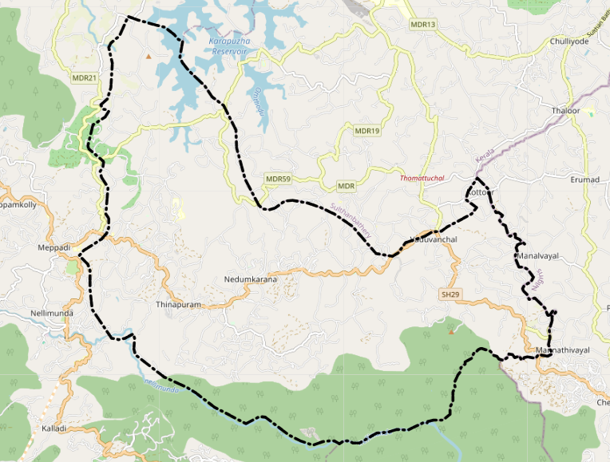

Baseline data

Description | Details
Name of LSGI | Moopainad
Type (GP/Municipality / Corporation etc.) | Grama Panchayath
Block | vythiri
District | wayanad
Number of wards | 16
Total area (sq. km) | 68.92
Population(Projected) | 28169
Population density | persons/sq km 409

Ward | Houses | Population | Migrants | Wells | Hot  spots | Ed. Institutions | Hosp pvt/govt.
17 | 6500 | 28169 | 366 | 3990 | 0 | 8 | 7

Major Roads Passing Through Moopainad Grama Panchayat
- National Highway 766 (NH 766)
  - The main highway connecting Kozhikode, Kalpetta, and Sulthan Bathery. It provides major regional connectivity near Moopainad.
- Meppadi – Kalpetta Road
  - An important road connecting Moopainad with nearby towns and the district headquarters.
- Chundale – Meppadi Road
  - A key local road that links interior wards of the Panchayat with surrounding areas.
- Various Panchayat and Village Roads
  - These roads connect different wards, settlements, and agricultural areas within the Panchayat.
- 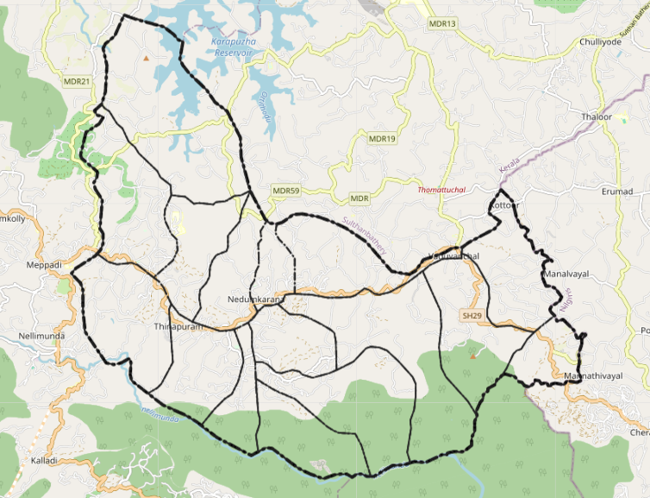
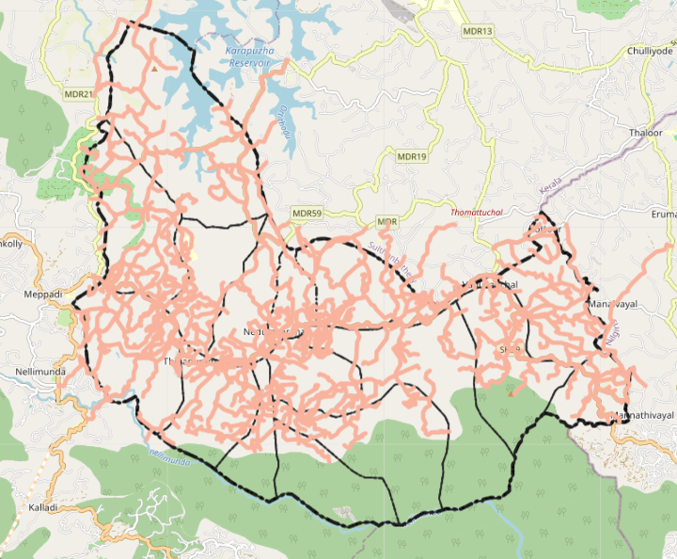

The major river passing through Moopainad Grama Panchayat in Wayanad district is the Chaliyar River.
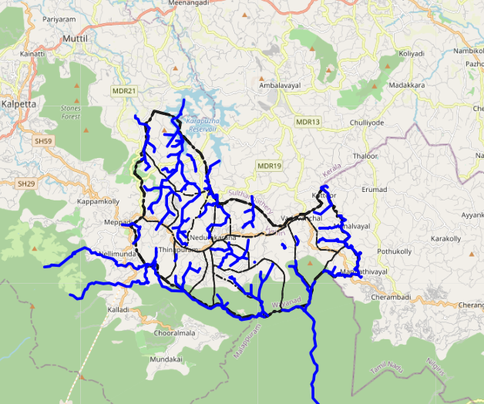

Disaster-Prone Areas – Moopainad Grama Panchayat
Moopainad Grama Panchayat in Wayanad district is prone to landslides in hilly regions during heavy monsoon rains, localized flooding and waterlogging in low-lying areas near streams connected to the Chaliyar River, and road disruptions due to intense rainfall. Some forest-fringe areas may also experience wildlife intrusion.
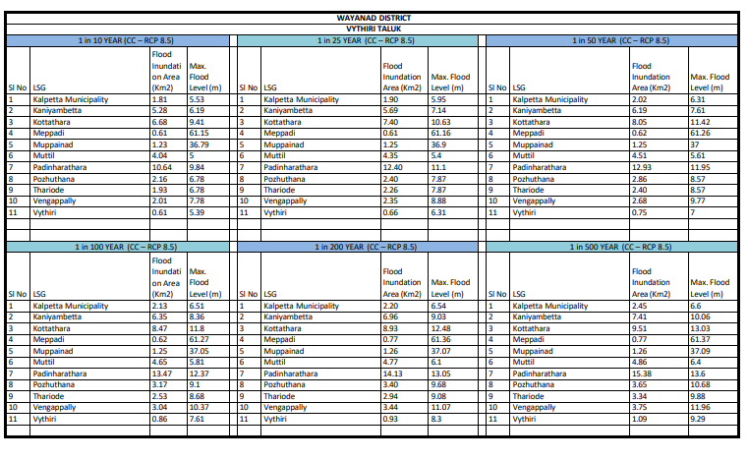
- 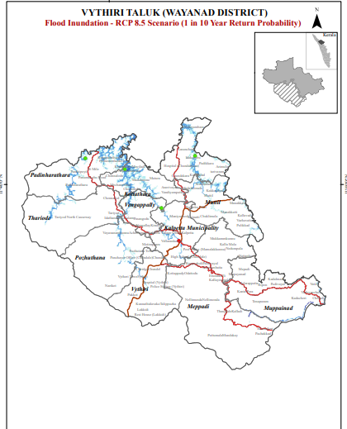
- 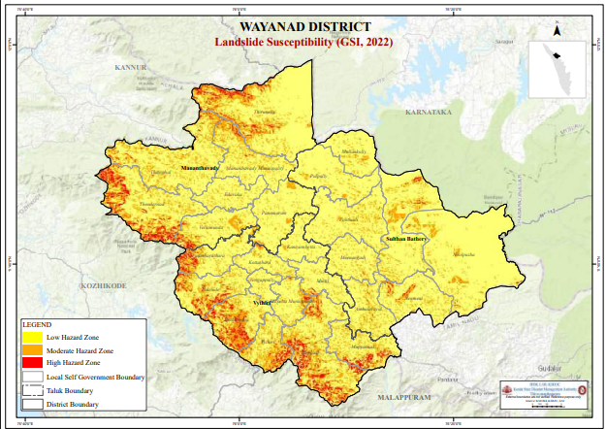

INTEGRATED HEALTH INFRASTRUCTURE MAP OF MOOPAINAD PANCHAYAT

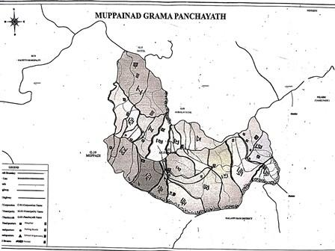

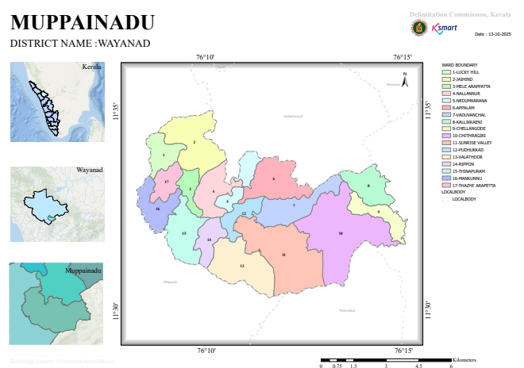

GENERAL PROFILE OF THE LSGI’S

Background of the LSGI
Moopainad Grama Panchayat is situated in the Vythiri Taluk of Wayanad district, Kerala. The geographical landscape of the Panchayat is predominantly hilly and undulating, characterized by forested areas, plantations, valleys, and small streams. This unique terrain significantly influences the local microclimate and poses distinct challenges to transportation, emergency response, and service delivery, particularly during heavy monsoon rains, landslides, and flood-like situations.
The Panchayat is administratively divided into multiple wards, with a population largely dependent on traditional and plantation-based livelihoods. Agriculture—especially cultivation of paddy, coffee, pepper, and other plantation crops—along with livestock rearing and daily wage labour, forms the backbone of the local economy. In recent years, tourism-related activities and service-sector employment have also shown gradual growth due to the scenic and eco-sensitive nature of the region. The area hosts a diverse workforce, including a notable presence of migrant labourers, particularly in construction, plantation, and allied sectors.
From a public health and disaster management perspective, Moopainad LSGI has historically been vulnerable to heavy rainfall, landslides, waterborne diseases, and vector-borne illnesses such as Dengue and Leptospirosis. The severe floods and landslides experienced in recent years, including the 2018 Kerala flood disaster, significantly impacted life, livelihoods, and infrastructure within the Panchayat. These recurring emergencies have underscored the importance of strengthening local preparedness, response mechanisms, and inter-departmental coordination.
In this context, the development of a localized, data-driven Auxiliary Infrastructure and Logistical Resource Map is essential to support effective planning, timely emergency response, and sustainable development initiatives. Such mapping enables the Panchayat to identify critical resources, improve accessibility during disasters, and enhance the overall resilience of the community.

Table 1: Background of LSGD
Description | Details
Name of LSGI | Moopainad
Type (GP/Municipality / Corporation etc.) | Grama Panchayath
Block | vythiri
District | wayanad
Number of wards | 16
Total area (sq. km) | 68.92
Population(Projected) | 28169
Population density | persons/sq km 409
Terrain (coastal/low-lying/backwaters/foothills, etc.) | Foot hill
Number of rivers passing through LSGI | 3
Number of water bodies in the LSGI | 8443
Number of educational institutions | 6
Factories / small-scale industries | 2
Flood-prone wards | 4
Landslide-prone wards | 4
Death Management and Disposal Facilities (mortuaries/crematorium, including electric) | 0
Auditoriums/Marriage halls/convention centres/community halls | 2

Demographic and Vulnerable Population
Understanding the demographic composition and vulnerable population groups is essential for pandemic preparedness. Children, elderly, economically deprived families, migrant workers, and socially vulnerable groups are at increased risk during public health emergencies due to higher exposure, limited access to services, and dependency on public systems..

Description |  | Details (in numbers)
DEMOGRAPHIC PROFILE
Total population |  | 28162
Male |  | 13785
Female |  | 14384
Transgender |  | 0
Children under 5 |  | 2056
Adolescent |  | 5152
Elderly (>60) |  | 4175
SOCIAL/LIVELIHOOD VULNERABILITY
Previous EPEP family |  | 73
BPL family |  | 4612
Tribal communities |  | 6
Migration | Immigrant | 366
Migration | Emigrant | 1786
Socio-economically deprived |  | 45
Fisherfolk |  | 0
SC Community |  | 2242
ST Community |  | 2082

Graphs: Population pyramid (if possible) for seeing if your LSGI has a high "dependency ratio" (lots of children and elderly compared to working adults).

Clinical Vulnerability
Certain population groups needs priority healthcare & are at higher risk of severe illness, complications, and mortality during pandemics. Patients with chronic diseases, those requiring regular medical care, and individuals with mobility or functional limitations face challenges in accessing timely care during emergencies. Mapping these groups helps in prioritizing continuity of treatment, medicine stock planning, oxygen support, referral transport, and targeted home-based care.
Description | Details in numbers
Pregnant women | 228
Lactating mothers | 468
Bedbound patients | 54
Patients under palliative care other than bedbound | 207
Patients on Haemodialysis | 31
Patients on CAPD | 40
Cancer patients (currently on treatment) | 79
Haemophilic patients | 0
Mentally challenged | 6
Differently abled | 3
Diabetic patients | 88
Hypertensive patients | 89
TB patients | 7

Major Festivals & Events specific to the LSGI
(with the possibility of a public gathering)

Sl. No. | Name of festival | Month detailing the periodicity
1  2 | CHITHRIGIRI CHARCH  KETTAKALI TEMPLE | JANUARY  JANUARY
3 | PADIVAYAL OROOS MUSGID | FEBRUARY
4 | MELE ARAPPATTA TEMPLE | FEBRUARY
5 | ST JOSEPH RIPPON 52 CHURCH | FEBRUARY
6 | VADUVANCHAL SIVA TEMPLE | FEBRUARY
7 | SREE PORKKALY TEMPLE | MARCH
8 | ORTHDOX CHARCH | APRIL
9 | MUTHAPPAN TEMPLE | MARCH
10 | THAMPURATTIKAV TEMPLE | MARCH

INFRASTRUCTURE & RESOURCE INVENTORY

Health Facility Directory & Basic Capacity in the LSGD
This section provides an overview of the healthcare infrastructure available within the LSGD area. It outlines the distribution and basic capacity of health facilities that form the backbone of service delivery during routine times and public health emergencies.

Family Health Centres (FHCs) and Community Health Centres (CHCs) generally function as the first point of contact for the community, providing essential outpatient and inpatient services. General Hospitals (GH) and Medical College Hospitals (MCH), where accessible, serve as the main referral centres for advanced diagnostics, specialist care, and critical services during public health emergencies. This inventory helps identify existing strengths, gaps, and potential surge capacity that can be mobilised during a pandemic or disaster.

Table 5. Health Facility Resource Summary
Sl.no. | Health Facility | Type of Facility (MCH/GH/CHC/FHC/SC etc.) | Contact Number | Total beds | ICU Beds | Oxygen-Supported Beds | No. of Ventilator Support Beds | No. of ambulances
Government Healthcare Facilities
1 | MOOPAINAD | FHC | 9697307308 | 3 | 0 | 0 | 0 | 0
Private Healthcare Facilities
1 | DM WIMS | MCH | 8111881101
 | CENTRE HOS.MOOPAINAD | ALLOPATHY | 04936282390 | 60 | 0 | 0 | 0 | 1
  2
3 | SREEDHAR MEMORIL HOSP. VATTTHUVAYAL | ALLOPATHY | 7902217503 | 5 | 0 | 0 | 0 | 0
4 | PODDAR ESTATE HOSPITAL | ALLOPATHY |  | 0 | 0 | 0 | 0 | 0
AYUSH Healthcare Facilities
1 | GOVERNMENT HOSPITAL | AYURVEDAM | 04936288190 | 0 | 0 | 0 | 0 | 0
2 | GOV DISPENSARY | HOMIO |  | 0 | 0 | 0 | 0 | 0

Private Clinics
Private clinics are an essential part of pandemic preparedness, as they are often the first place people seek care when symptoms begin. In many communities, private clinics manage a significant share of outpatient visits and therefore play a critical role in early case detection, timely referrals, and disease surveillance. Having an up-to-date understanding of where these clinics are located, the services they provide, and how they are linked to the public health system helps ensure that no cases are missed during an outbreak. It also allows health authorities to engage private practitioners more effectively for reporting, risk communication, and coordinated response, strengthening the overall capacity of the health system to manage public health emergencies.

Table 6. Private Clinic Resource Summary
Sl No. | Name of Clinic | Registered (Y/N) | Clinic (General / Speciality) | Speciality (if any) | Address | Contact Number | Diagnostic Facility (Y/N) | Ambulance Linkage (Y/N)
 | Nil | Nil | Nil | Nil | Nil | Nil | Nil | Nil
 | Nil | Nil | Nil | Nil | Nil | Nil | Nil | Nil

Healthcare Education & Training Institutions
This section tracks the educational infrastructure available, which is vital for human resource planning in the health sector.

Category of Institution | Govt | Private | AYUSH | Total
Medical Colleges | 0 | 1 | 0 | 1
Nursing Colleges | 0 | 1 | 0 | 1
Dental Colleges | 0 | 0 | 0 | 0
Para-medical / Allied Health | 0 | 1 | 0 | 1
Pharmacy Colleges | 0 | 1 | 0 | 1

Specialized Services & Emergency Inventory
This section provides a detailed view of the specialized medical resources available to the community, focusing on emergency response and critical care capabilities. This table tracks the vital assets required for managing severe illnesses and emergencies across Government, Private, and AYUSH sectors.

Item | Govt | Private | AYUSH | Total
Hospital beds | 3 | 60 | 0 | 63
Oxygen-generating systems(Y/N) | 0 | 1 | 0 | 1
Oxygen-supported beds(Numbers) | 0 | 1 | 0 | 1
Ventilator-supported beds | 0 |  | 0
ICU beds | 0 |  | 0
Burns units | 0 |  | 0
Blood centres | 0 |  | 0
BLS ambulances | 0 |  | 0
ALS ambulances | 0 |  | 0
Dialysis facilities | 0 |  | 0
Dispensaries | 0 |  | 0
Medical store | 0 |  | 0
Industrial establishments(Medium-scale industries/small-scale industries establishments to whom we can depend in a worst-case scenario) | 0 |  | 0

Oxygen & Diagnostic Capacity
Monitoring oxygen and diagnostic capacity is a critical component of public health preparedness, ensuring that the LSGD can handle both chronic care and sudden surges in respiratory or infectious diseases.
Name of Health Facility | Oxygen-generating System (Y/N) | Backup Oxygen Source (Y/N) | Diagnostic Facilities Available(Y/N)
Name of Health Facility | Oxygen-generating System (Y/N) | Backup Oxygen Source (Y/N) | Lab | USG | X-ray | CT/MRI | RT-PCR
Government Healthcare Facilities
FHC MOOPAINAD | NO | NO | YES | NO | NO | NO | NO

Diagnostics facility mapping at the LSGI level
The diagnostic capacity of moopainad G.P represents the "intelligence network" of our healthcare system. The speed and accuracy of disease identification depend entirely on the distribution and technical level of these facilities.

Item | Govt | Private | AYUSH | Total
General labs | 1 | 5 | 0 | 6
Microbiology labs | 0 | 1 | 0 | 1
RT-PCR labs | 0 | 0 | 0 | 0
USG units | 0 | 1 | 0 | 1
CT/MRI units | 0 | 1 | 0 | 1
Research labs | 0 | 0 | 0 | 0
Labs of other departments that can be repurposed | 0 | 0 | 0 | 0

Laboratory Identification & Basic Details
Sl. No. | Name of Laboratory | Ownership (Govt / Private / Academic) | Address | Contact No. | 24×7 Services (Yes/No) | NABL / Govt Approved (Yes/No)
1 | FHC Moopainad | Govt | Padivayal,vaduvchal | 9497307308 | No | YES
2 | DM Wims | Pvt | Naseeranagar  Meppadi (po) | 8111881101 | Yes | YES
3 | Sreedhar memorial hosp. | Pvt | Vattathuvayal,  Vaduvanchal(po) | 9656061797 | No | No
4 | Health care medical lab | Pvt | Thazhe arappatta | 9072133655 | No | No
5 | Lifecare Medical lab | Pvt | Thinapuram | 04936210400 | No | No

Social and Community Infrastructure for surge plan
This table serves as our logistics and shelter inventory. By mapping these locations, quickly we can identify where to house displaced citizens, where to set up temporary medical clinics, and how to manage the deceased with dignity during a crisis.

Category | Total Count | Ward | Est. Capacity (Persons) | Contact details
Educational Institutions
Anganwadis | 23 | 16 | 510 | 9745424930
Schools | 8 | - | 1980 | 9744860277
Colleges | 0 | 0 | 0 | 0
Healthcare Educational Institutions
Medical colleges (Govt/Private) | 1 | 1 | 150 | 04936 287 000
Nursing colleges (Govt/Private) | 1 | 1 | 150 | 04936 287 000
Dental colleges (Govt/Private) | 0 | 0 | 0 | 0
Paramedical institutes (Govt/Private) | 1 | 1 | 150 | 04936 287 000
Community Gathering Spaces
Community halls | 1 |  | 150 | -
Auditoriums | 4 |  | 200 | -
Religious buildings | 4 |  | 50 | 9620474925
Vulnerable Group Support Facility
Destitute homes | 1
Elderly homes | 1 |  |  | 9620474925
LSGD owned other buildings | 0 | 0 | 0 | 0
Mass Fatality Management (MFM) Infrastructure
Mortuary | 0 | 0 | 0 | 0
Crematorium | 0 | 0 | 0 | 0
*refer annexure 1 for contact details

Human resources
This section focuses on the human capital available within the LSGI. In any emergency—be it a pandemic, flood, or industrial accident—infrastructure is only as effective as the people operating it.

Medical & Clinical Personnel
This table tracks the "Frontline" providers responsible for diagnosis, treatment, and clinical management. Narrative sentence: eg., "Total health workforce: 450 personnel, with 60% in government facilities serving as primary surge capacity." A detailed directory with the contact numbers of all workers is maintained (Annexure in 1).

Cadre | Govt (No.) | Private (No.) | Total
Doctors—Modern Medicine | 3 | 3 | 6
Doctors – AYUSH | 2 |  | 2
Doctors – Veterinary | 1 |  | 1
Doctors – Dental | 0 |  | 0
Nursing officers | 1 |  | 1
Lab technicians | 1 |  | 1
Optometrist | 0 |  | 0
Pharmacists | 1 |  | 1
Psychologists | 0 |  | 0
Counsellors | 0 |  | 0

Public Health & Field-Level Workforce
These individuals are the backbone of surveillance, maternal-child health, and decentralized care.

Cadre | Health services | Municipal common services | Total
HS (Health Supervisors) | 0 | 0 | 0
HI (Health Inspectors) | 1 | 0 | 1
LHS (Lady Health Supervisor) | 0 | 0 | 0
LHI (Lady Health Inspectors) | 1 | 0 | 1
JPHN (Jr Public Health Nurses) | 3 | 0 | 3
JHI (Jr Health Inspectors) | 4 | 0 | 4
MLSP (Mid-Level Service Providers) | 7 | 0 | 7
Palliative Nurses | 1 | 0 | 1
RBSK Nurses | 1 | 0 | 1
PRO | 0 | 0 | 0
Epidemiologist | 0 | 0 | 0
Data Manager | 0 | 0 | 0

Community & Support Cadre
This group represents the surge capacity of the LSGI—people who can be called upon for logistics, rescue, and specialized support.

Cadre | Number
ASHA Workers | 22
AWW (Anganwadi Workers) | 23
Emergency Medical Volunteers (Trained) | 12
Kudumbashree | 356
MNREGS | 48
Purusha Swayam Sahaya Sangham | 26
Ex-Servicemen | 7
Retired Police Officers | 4
NCC/NSS Volunteers | 85
Red Cross volunteers | 0
One Health Community Volunteers | 0
One Health Community Mentors | 0

Community Organizations
This section details the presence of community-based organisations (CBOs), non-governmental organisations (NGOs), faith-based organisations (FBOs), Kudumbashree Self-Help Groups (SHGs), and Ayalkootams within the Local Self-Government Institution (LSGI). These groups enhance grassroots mobilization, resource distribution, and support networks crucial for pandemic response and community resilience.

Category | Total Count
NGOs | 15
Religious based organizations | 4
Foreign based organizations | 0
Sports Club/youth clubs | 8
Kudumbashree SHGs | 0
Ayalkootams | 291
Political organizations | 6
Residential organizations | 2

Administrative & Emergency Services
This section outlines the availability of key non-health emergency support services and infrastructure within the LSGI, which are essential for effective pandemic preparedness and response. These facilities support law enforcement, disaster response, water supply, logistics, mobility, and community-level interventions during public health emergencies.

Category | Total Count | Contact details
Police Stations (NEAREST-MEPPADY) | 0 | 049362835821
Fire & Rescue Stations(NEAREST-KALPETTA) | 0 | 914936202333
Water Pumping Points | 15 | -
Public Distribution System (PDS) | 5 | -

Information regarding resources
The availability of essential transport and support resources plays a quiet but critical role in saving lives. Equipment such as ambulances, mobile mortuaries, amphibian ambulances, and motorized boats ensures that patients, samples, and healthcare teams can move swiftly—even in flooded, remote, or difficult terrains. Heavy vehicles like JCBs, cranes, tractors, and torus lorries support logistics, waste management, emergency infrastructure, and rapid conversion of spaces into care or isolation facilities. Taxis, four-wheel-drive vehicles, and trucks help maintain continuity of essential services, reach vulnerable populations, and support home-based care and supply delivery.

Means of transportation | Total Count
JCB | 2
Crane | 0
Heavy Trucks | 3
Tractor | 4
Ambulances | 6
Mobile mortuaries | 1
Boats | 0
Taxi service | 15
Note: For specific details regarding vehicle owners and contact information, please refer to Annexure [X].

One Health & Environmental Surveillance – Moopainad Grama Panchayat
The One Health approach integrates environmental, animal, and human health to support proactive pandemic preparedness. In Moopainad Grama Panchayat in Wayanad district, strengthening Panchayat-level surveillance is essential to detect and respond early to zoonotic and environmentally linked diseases.
Surveillance can be enhanced through systematic assessment of animal populations, veterinary infrastructure, poultry farms, and slaughter facilities, along with strong inter-sectoral coordination between health, veterinary, and local self-government departments. The use of specialised tools such as GIS-based avian influenza seasonality mapping and ward-level environmental monitoring can help identify high-risk locations and support early warning systems. These measures enable timely sampling, targeted interventions, and effective pandemic preparedness in vulnerable areas of the Panchayat.

Animal & Bird Population
Mapping animal and bird populations at the Panchayat level is essential for identifying and prioritising zoonotic disease hazards like rabies, avian influenza (H5N1), leptospirosis, anthrax, and Nipah-like spillover occurrences. Risk classification, targeted surveillance, vaccination planning, and early epidemic detection made feasible by comprehensive population mapping all enhance One Health-based pandemic preparedness.

Category | Item | Estimated Population | Wards
Animal Population | Livestock (Cattle/Goats/Buffalo) | 784/1928/44 | ALL WARDS
Animal Population | Pet Animals (Dogs/Cats) | 789 | ,ALL WARDS
Animal Population | ,Stray Dog Population | 123 | 7,8,16,17
Animal Population | Pig Farms (Number of heads) | 1 | 7,8
 | Small Units (Sheep / Goats – clustered) | 0 | 0
Bird Population | Poultry Units (Birds) | 1 | 13
Bird Population | Poultry- (FOWL) | 25467 | ALL WARDS
Bird Population | Wild/Migratory Birds (Observed) | 0 | 0
Bird Population | Crow Mortality Events (Reported) | 0 | 0

The main risk of zoonotic diseases in Moopainad Grama Panchayat is generally distributed across the Panchayat rather than being concentrated in specific wards. The risk is associated with the presence of pig farms, cattle congregation areas, and poultry units that facilitate animal–human interactions. The stray dog population in market areas, bus stands, and other public places continues to be a concern for rabies surveillance and bite prevention. There is also a potential risk of avian influenza introduction and spread during November–December, when migratory and resident water birds are commonly seen near ponds, canals, rivers, and paddy fields. In addition, pig farms and animal shelters located in flood-prone areas increase the likelihood of leptospirosis and other environmentally mediated zoonotic diseases, particularly during the monsoon season.

Veterinary Infrastructure
Veterinary institutions are a core pillar of One Health surveillance, enabling early zoonotic disease detection through vaccination, investigation of unusual animal illness or deaths, sample collection, and timely outbreak reporting. A well-mapped and responsive veterinary network strengthens coordination with human health and LSGI systems, ensuring rapid response during zoonotic events and pandemics.
Facility Type | Name of Facility | Ownership Govt / Pvt | Location(Ward No) | Contact number
Veterinary Dispensary | Govt vet.dispen | Govt | 4 | 9446640217
Veterinary Hospital / Polyclinic | 0 | 0 | 0 | 0
Private Veterinary Clinics | 0 | 0 | 0 | 0
Mobile / Emergency Vet Service (incl. night services) | Mobile vet, unit | Govt | Kalpetta | 04936202729
Pet Homes / Animal Shelters
Slaughterhouse-linked Veterinary Inspection Unit | 0 | 0 | 0 | 0

Veterinary Doctors & Workforce
Early detection, diagnosis, reporting, and reaction to animal illness epidemics depend on the availability and accessibility of qualified veterinary specialists. By identifying unusual animal morbidity or mortality promptly, collecting samples promptly, and coordinating efficiently with human health and LSGI systems—especially during zoonotic outbreaks and pandemic-prone situations—a clearly defined veterinary workforce enhances One Health surveillance.

Category | Number Available | Type (Govt/Pvt) | Contact number
Government Veterinary Doctors | 1 | Govt | 9446640217
Private Veterinary Doctors | 0 | 0 | 0
Livestock Inspectors | 3 | Govt | 9562641653,
Para-veterinary Staff / Attenders | 1 | Govt | 9605497885
Contract / On-call Veterinary Support (if any) | 1 | Govt Kalpetta | 04936202729

High-Risk Interface Points (Surveillance Sites)
High-risk interface points for zoonotic disease surveillance in __moopainad__________ Grama Panchayath include wetland–livestock–human contact zones, backyard poultry farms, cattle sheds near water bodies, fish markets, and areas of high human–animal interaction such as community slaughter points and migratory bird congregation sites. These are the primary surveillance sites where zoonotic spillover risks are elevated.

Type of Habitat | Type of High risk interface | Geographical vulnerability
Wetlands & Backwaters | 0 | 0
Backyard Poultry Farms | No farms only small scail(10/20)birds | 0
Cattle Sheds near Water Bodies | 0 | 0
Fish & Meat Markets | 0 | 0
Community Slaughter Sites | 0 | 0
Migratory Bird Congregation Areas | 0 | 0
Rodent-Infested Grain Storage | 0 | 0

Category | Total Count | Key Locations (wards)
Poultry Farms | 1 | 7
Backyard / Clustered Poultry Units | 19 | 1 TO 17
Duck Rearing Units (open water access) | 0
Slaughterhouses/ Slaughter Points | 0
Meat/Fish Markets | 10 | 14,15,6
Live Bird Sale Points | 0 | 0
Cattle Markets / Weekly Animal Fairs | 0 | 0
Pet Shops / Breeders | 0 | 0
Animal Shelters / Pet Homes | 0 | 0
Waste Disposal Sites near Animal Units | 0 | 0

Environmental Risk Mapping
Environmental risk mapping identifies monsoon/flood hotspots for vector-borne (dengue, chikungunya), water-borne (leptospirosis, diarrhoea), and zoonotic diseases in Kerala's wetlands. Systematic surveillance supports early warnings, targeted interventions, and Panchayat pandemic preparedness.
Waterborne exposure: Flood-prone areas and stagnant water bodies facilitate leptospira survival, raising leptospirosis risk.

Traditional practices: Informal slaughter and fish markets lack standardized hygiene, creating spillover opportunities.

Risk Factor | High-Risk Wards | Key Locations | Risk Level (High/Med/Low)
Flood-prone areas | 0 | 0 | 0
Water bodies/wetlands | 0 | 0 | 0
Solid waste accumulation | 0 | 0 | 0
Animal waste disposal issues | 0 | 0 | 0
Rodent infestation zones | 0 | 0 | 0
Industrial effluent discharge | 0 | 0 | 0
Construction sites / abandoned buildings | 0 | 0 | 0
Poor drainage/blocked canals | 0 | 0 | 0
Drinking water source contamination risk | 0 | 0 | 0

Disease Seasonality Mapping
1, Flooding & waterlogging → amplifies leptospirosis, malaria, diarrheal diseases.
·
2, Migratory bird influx (Nov–Feb) → avian influenza risk.

3, Mosquito breeding cycles → vector-borne disease peaks in monsoon.

4, Agricultural practices → close human–animal contact in paddy fields.

Disease | Peak Risk Season | Key Drivers | High-Risk Locations | Surveillance Focus
Avian Influenza | 0 | 0 | 0 | 0
Leptospirosis | MAY TO AUGUST | Agriculture | 0 | 0
Dengue/Chikungunya | July to November | Emigrant population | 0 | 0
Acute Diarrheal Diseases | January to July | 0 | 0 | 0
Rabies | 0 | 0 | 0 | 0
Anthrax (rare) | 0 | 0 | 0 | 0

Vulnerability Mapping
Vulnerability mapping pinpoints high-risk populations, occupations, and areas exposed via environment, livelihoods, socio-economics, and poor service access. Paired with environmental/seasonality mapping, it enables risk-based surveillance, targeted actions, and optimal resource use in One Health and pandemic planning.
Vulnerability Factor | High-Risk Wards | Key Groups / Locations | Risk Level
Flood-prone households | 0 | 0 | 0
Wetland-adjacent communities | 0 | 0 | 0
Backyard poultry / duck rearing households
Livestock-rearing households | 0 | 0 | 0
Slaughterhouse & meat market workers | 0 | 0 | 0
Fisherfolk & fish market workers | 6,15,16 | 0 | 0
Sanitation workers | 6,8 | 0 | 0
Daily wage / migrant workers | 2,14,5 | 0 | 0
Elderly & chronically ill populations | 0 | 0 | 0
Pregnant Women | 0 | 0 | 0
Children (schools, Anganwadi’s) | 0 | 0 | 0
Limited access to safe water & sanitation | 0 | 0 | 0

EPIDEMIOLOGICAL TRENDS (2021–2025)

Disease surveillance is the systematic collection, analysis, and interpretation of health data for planning, implementation, and evaluation of public health practice. This section presents the disease surveillance profile of the LSGI based on routine reporting systems and outbreak investigations to identify priority diseases, seasonal patterns, and emerging public health threats.

Disease Burden among human beings(Last 5 Years)
Analysis of disease-wise data for the last five years helps identify persistent public health problems, emerging diseases, and changes in disease burden. This information supports prioritisation of prevention, preparedness, and response activities at the Panchayat level.

Disease | 2021 | 2022 | 2023 | 2024 | 2025 | Trend(Increasing/Stable/Decreasing)
Dengue | 1 | 12 | 12 | 26 | 15 | STABLE
Leptospirosis | 2 | 6 | 9 | 10 | 3 | DECREASING
Hepatitis A | 1 | 4 | 4 | 24 | 34 | INCREASING
Malaria | 0 | 0 | 0 | 0 | 0 | STABLE
Scrub Typhus | 0 | 1 | 5 | 1 | 0 | DECREASING
Typhoid | 1 | 0 | 3 | 3 | 1 | DECREASING
H1N1 | 0 | 1 | 0 | 5 | 0 | DECREASING
H3N2 | 0 | 0 | 0 | 0 | 0 | STABLE
ADD | 61 | 85 | 111 | 91 | 96 | STABLE
Mumps | 3 | 0 | 2 | 7 | 0 | DECREASING
Measles | 0 | 0 | 2 | 3 | 2 | STABLE
Hepatitis B | 1 | 0 | 1 | 1 | 0 | DECREASING
Hepatitis C | 0 | 0 | 0 | 0 | 0 | STABLE
Tuberculosis | 12 | 5 | 7 | 7 | 6 | DECREASING
Leprosy | 0 | 0 | 0 | 0 | 0 | STABLE
COVID-19 | 190 | 88 | 22 | 0 | 1 | DECREASING

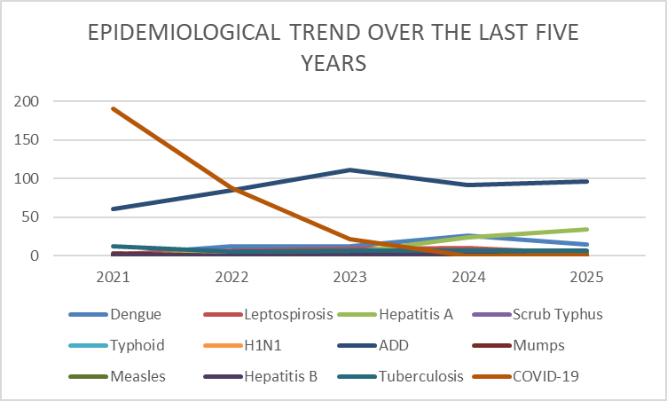

Seasonal Trend Analysis
Seasonal analysis helps anticipate surges (e.g. dengue in monsoon, leptospirosis after floods, influenza in cooler months) and plan pre‑emptive vector control, stockpiling of IV fluids, and awareness campaigns at Panchayat level.

DENGUE
Dengue is a major seasonal vector-borne disease strongly associated with rainfall, water stagnation, and increased mosquito breeding during the monsoon period.

Peak: July–November

Dengue – Ward-wise Yearly Distribution (2021–2025)

Ward | Dengue – Ward-wise Yearly Distribution
Ward | 2021 | 2022 | 2023 | 2024 | 2025 | Total
1 |  | 3 |  | 3 |  | 6
2 |  |  |  | 1 |  | 1
3 |  |  |  |  | 1 | 0
4 |  |  | 1 | 2 | 2 | 5
5 |  |  |  | 4 |  | 4
6 |  | 3 | 1 | 3 | 1 | 8
7 |  | 1 | 1 | 3 | 2 | 7
8 |  | 1 |  | 2 | 1 | 4
9 |  | 1 |  | 1 |  | 2
10 |  |  | 2 |  | 2 | 4
11 |  |  | 1 | 1 | 3 | 5
12 |  |  | 4 | 1 | 2 | 7
13 | 1 |  |  | 2 | 1 | 4
14 |  | 2 | 2 | 1 |  | 5
15 |  | 1 |  | 1 |  | 2
16 |  |  |  | 1

LEPTOSPIROSIS
Leptospirosis cases are closely linked to monsoon rains, flooding, and occupational exposure, particularly in low-lying and waterlogged areas.

Peak: June - August

Leptospirosis – Ward-wise Yearly Distribution (2021–2025)

Ward | Leptospirosis – Ward-wise Yearly Distribution
Ward | 2021 | 2022 | 2023 | 2024 | 2025 | Total
1 | 1 |  | 1 |  | 1
2
3 |  | 1 | 1 | 2
4 |  | 1
5 |  | 1 |  | 2
6 | 1 |  |  | 1 | 1
7 |  |  | 1
8 |  | 1 | 1 | 2
9 |  |  | 1 | 1
10 |  |  | 1 | 1
11 |  | 1
12 |  | 1
13 |  |  | 1 | 1
14
15 |  |  | 2 |  | 1
16

VIRAL HEPATITIS - A
Hepatitis A cases are commonly associated with unsafe drinking water, food contamination, and breakdowns in sanitation, often presenting as clusters or outbreaks.

Peak: October - December

Hepatitis A – Ward-wise Yearly Distribution (2021–2025)

Ward | Hep A – Ward-wise Yearly Distribution
Ward | 2021 | 2022 | 2023 | 2024 | 2025 | Total
1 |  | 1 |  | 2 | 1
2 |  |  |  | 2 | 6
3 |  | 2 | 2 | 2 | 5
4 |  |  |  | 2
5 |  |  |  | 6 | 1
6 | 1 |  |  | 2 | 1
7
8
9 |  |  |  |  | 1
10 |  |  |  | 3 | 3
11
12 |  |  | 1 | 2 | 4
13 |  |  |  | 2 | 2
14 |  |  | 1 |  | 1
15 |  | 1 |  |  | 3
16 |  |  |  | 1 | 6

Outcome-Based Trend Analysis- 2025

Transmission Trend- 2025
For effective management of public health issues, it is important to track the trend of disease transmission mode. It helps identify the population or place at high risk that can be used to predict outbreaks and implement targeted interventions as quickly as possible. Understanding these kinds of trends enables authorities to allocate resources efficiently and change the strategies adequately based on the trend that follows.

Mode of Transmission | No. of cases | No. of Deaths
Vector Borne Diseases | 15 | 0
Water Borne Diseases | 131 | 0
Air Borne Diseases | 9 | 2
Blood Borne Diseases | 0 | 0
Food Borne Diseases | 131 | 0

Vector-Borne Disease

Disease | No. of Cases | No. of Deaths
Dengue | 15 | 0
Malaria | 0 | 0
Chikungunya | 0 | 0

Water Borne Disease

Disease | No. of Cases | No. of Deaths
Cholera | 0 | 0
Typhoid | 1 | 0
Hep- A | 34 | 0
Dysentery | 0 | 0
Amoebiasis | 0 | 0
E- Coli infections | 0 | 0
Air Borne Disease

Disease | No. of Cases | No. of Deaths
Influenza
H1N1 | 1 | 0
TB | 6 | 2
Chickenpox | 6 | 0
Measles | 2 | 0
Covid-19 | 1 | 0
Pertussis | 0 | 0
Mumps | 2 | 0

Blood-Borne Disease

Disease | No. of Cases | No. of Deaths
AIDS | 0 | 0
Hep- B | 0 | 0
Hep- C | 0 | 0

Zoonotic Disease

Disease | No. of Cases | No. of Deaths
Rabies | 0 | 0
Leptospirosis | 3 | 0
Avian influenza | 0 | 0
West nile | 0 | 0
Anthrax | 0 | 0
Nipah | 0 | 0
Scrub Typhus | 0 | 0

Integrated Disease Hotspot Map (2021–2025)

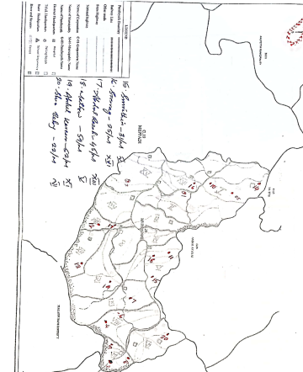

Ward No | Dengue Total (2021-25) | Leptospirosis Total (2021-25) | Hepatitis A Total (2021-25) | Mumps (2021-25) | ADD (2021-25) | Total Cases
1 | 6 | 3 | 4 |  | 36 | 49
2 | 1 | 0 | 8 | 1 | 28 | 38
3 | 0 | 4 | 11 |  | 31 | 47
4 | 5 | 1 | 2 |  | 29 | 37
5 | 4 | 3 | 7 |  | 35 | 49
6 | 8 | 3 | 4 |  | 31 | 56
7 | 7 | 1 | 0 |  | 29 | 37
8 | 4 | 4 | 0 |  | 31 | 39
9 | 2 | 2 | 1 |  | 34 | 39
10 | 4 | 3 | 6 |  | 31 | 44
11 | 5 | 1 | 0 |  | 36 | 42
12 | 7 | 2 | 7 | 1 | 38 | 55
13 | 4 | 0 | 4 |  | 37 | 45
14 | 5 | 3 | 2 |  | 39 | 49
15 | 2 | 0 | 4 |  | 35 | 41
16 | 1 | 0 | 7 |  | 34 | 42

By overlaying five years of data, we have identified …………..'Red Zone' Wards. These are wards where at least two different categories of diseases (e.g., Dengue and Lepto) recurred in consecutive years. Ward 4 is categorized as the Highest Priority Hotspot due to its combination of flood vulnerability and high vector density. Future health infrastructure, such as the proposed R.O plants at ………should be prioritized.

Preparedness and Response Protocol at LSG Level
This section describes the operational framework for the LSGI once a pandemic is declared. It explains how the LSGI and health system will move from routine data collection to active response, using a One Health approach.

Constitution of One Health Committee
The LSGD shall constitute a One Health Committee comprising the LSGI President, Medical Officers (Modern Medicine, AYUSH, and Veterinary), the Health Inspector, and the Veterinary Surgeon.

Objective: The One Health Committee coordinates human, animal, and environmental health to prevent and control pandemics.

Sl No | Name | Designation | Department/Institution | Role in Committee | Contact Number
1 | SUDHA | Panchayat President | LSGD | Chairperson | 8606005860
2 | ANASWARA | Medical Officer (PHC/CHC) | Health Dept | Member Secretary | 9497307308
3 | SHARMADHA | Veterinary Officer | Animal Husbandry | Member | 9446640217
4 | SIYA MOL | Epidemiologist | Health Dept | Member | 9544142784
5 | INDULEKHA | Health Inspector/PHN | Health Dept | Surveillance | 9446781297
6 | TIJI | ASHA Supervisor | Health Dept | Community link | 7306076545
7 | ASATHI | ICDS Supervisor | Social Welfare | Vulnerable groups | 7034791371
8 | SHO MEPPADY | Police Station Officer | Police Dept | Law & order | 04936282433
9 | SHAMEERALI | Ward Councillor Representative | LSGD | Community coordination | 9947883111
10 | SHEELA | Kudumbashree CDO | Kudumbashree | Community mobilisation | 9744806813
11 | RIYAS | NGO/Volunteer rep | Civil Society | Support services | 9605289250
12 | NIL | Line Department representations

Key Responsibilities:
- Review disease surveillance data (human + animal)
- Conduct ward-wise risk assessment and vulnerability mapping
- Approve quarantine/isolation centre locations
- Coordinate with district for resources (PPE, oxygen, ambulances)
- Periodically review health system surge capacity, including beds, oxygen, human resources, and ambulances.
- Approve and monitor risk communication and community engagement strategies, including rumour management.
- Ensure protection and service continuity for vulnerable groups (elderly, persons with disabilities, dialysis patients, coastal populations).
- Conduct quarterly mock drills
- Monitor equity measures for vulnerable groups

Meeting Schedule:
Quarterly (normal times) | Weekly (outbreak alert) | Daily (pandemic phase)

Pandemic Response Workforce
To ensure a coordinated and timely response during a pandemic, a dedicated Pandemic Response Workforce shall be constituted at the LSG level. The workforce will function under the overall supervision of the One Health Committee and in close coordination with the health authorities. Team-based deployment will enable efficient surveillance, case management, quarantine and isolation management, logistics support, and risk communication. Each team shall have a clearly designated team leader, defined roles, and an identified pool of personnel to allow rapid activation, rotation of duties, and continuity of services during prolonged emergencies.

Total Response Workforce Available: 300 persons

Team Name | Composition | Key Responsibilities | Team Leader
Surveillance and Contact Tracing Team | HI, JHI, JPHN, ASHAs and Volunteers | Case detection, contact listing, home visits, reporting | HI
Case Management Team | Doctors, Nurses, MLSP, Palliative Nurses | Patient care & referral | DOCTOR
Quarantine & Isolation Team | LSGD staff, Volunteers | Facility management | JHI
Psychosocial support | LSGD, REVENUE | Psychosocial support | M.O in charge
Logistics & supply chain Team | LSGD staff, Storekeepers, Drivers 3 | Supplies & transport [PPE, medicines, oxygen, transport, waste management] | Ward Member
Communication Team | Ward members, Kudumbashree, Youth clubs,  AWW workers and other self help groups | IEC, community meetings, countering misinformation | M.O in charge
Transportation | KSRTC, educational institutional buses | NIL | NIL
Media Surveillance | Wise president | Media Surveillance | Wise president
Intersectoral coordination and convergence | Various Department heads including LSGD | Ccordination | President/ Secretery
Collaborative surveillance | FHC and LSGD | Decision making | Secretary and MO

All teams shall be activated immediately upon outbreak alert or pandemic declaration and shall report daily to the LSG Incident Commander/Medical Officer, with consolidated reporting to the Block PHC. Duty rosters and alternate personnel shall be maintained to ensure uninterrupted services during staff shortages or prolonged response periods. Team composition and numbers may be revised based on the magnitude of the outbreak and availability of human resources.

Activities and Measures before and during Pandemic

PHASE 1 - Alert / Preparation
Surveillance and Reporting-Enhanced syndromic surveillance:
- Data sources for surveillance
Integrated Health Information Platform (IHIP) for Reporting:
All public and private healthcare facilities in the district are mandated to report notifiable diseases and syndromes with pandemic potential through the Integrated Health Information Platform (IHIP) according to standard case definitions. Facility in-charges ensure daily and accurate data entry in the portal. When a case with pandemic potential is reported, public health officials such as the Health Inspector (HI) and Junior Health Inspector (JHI) conduct field verification and follow-up. These surveillance activities are monitored both at the institutional and district levels.
Health Facility OPD/IPD Records:
OPD and IPD records from health facilities serve as an important data source to monitor trends in communicable diseases. Any unusual increase in cases is immediately reported to higher health authorities.
Private Hospitals and Laboratories:
Private hospitals and laboratories should be sensitized about the importance of timely reporting of communicable diseases through IHIP to ensure early detection and response.
Local Media and News Reports:
Information from local media and newspaper reports may help identify emerging public health concerns or unusual disease events in the community.
Community-Level Reporting:
Community-based surveillance is strengthened through reports from ASHAs, JPHNs, and Ward Members, who help identify unusual health events or clusters of illness at the community level and inform the health system for timely action.

- Event-based triggers (to be monitored and reported)
Event-based surveillance functions as a complementary system to indicator-based reporting for the early detection of unusual public health events. All public and private health institutions, schools, hostels, laboratories, veterinary institutions, and field-level health workers should promptly report unusual health events with pandemic potential to the District Surveillance Unit.
Facility in-charges are responsible for continuous monitoring of the following event-based triggers:
- Sudden increase in Influenza-Like Illness (ILI) or Severe Acute Respiratory Infection (SARI) cases beyond the usual baseline.
- Clustering of fever cases within a household, institution, or locality.
- Unusual or sudden clusters of illness with similar symptoms.
- Unexplained or sudden deaths, especially with respiratory or neurological manifestations.
- Sudden increase in absenteeism in schools, hostels, anganwadis, or workplaces.
- Media or social media reports suggesting disease outbreaks.
Upon identification of any trigger event:
- Immediate notification should be made to the concerned Medical Officer and District Surveillance Unit within 24 hours.
- Field verification will be conducted by the Health Inspector (HI) or Junior Health Inspector (JHI).
- Line listing and preliminary risk assessment should be completed without delay.
- The situation will be continuously monitored at both institutional and district levels.

3. Zoonotic and animal health surveillance
Close coordination shall be maintained between the Health Department and Veterinary Department for the early detection of zoonotic disease threats. Veterinary Officers and field veterinary staff should actively monitor animal health events and report any unusual findings promptly.
The following events should be monitored:
- Unusual or unexplained morbidity or mortality in livestock, poultry, or wildlife, including migratory birds and bats.
- Sudden deaths in poultry farms or backyard poultry units.
- Illness among individuals with close animal contact, such as poultry workers, dairy farmers, slaughterhouse workers, and hunters.
Priority zoonotic diseases under surveillance include:
- Leptospirosis
- Avian Influenza
- Nipah Virus Infection
- Anthrax
Reporting and Response:
- Any unusual animal health event should be immediately reported to the District Veterinary Officer and the District Surveillance Unit.
- Joint field investigations by Health and Veterinary teams should be conducted wherever animal-to-human transmission is suspected.
- Appropriate risk assessment and control measures should be initiated based on the findings.

- Logistics and Stock Preparedness
Logistics Management
Effective logistics management is essential to ensure a timely and coordinated response during public health emergencies. A structured system shall be established to maintain uninterrupted availability of essential supplies and support services during outbreaks or pandemics.
Vendor Identification and Emergency Procurement:
Local vendors shall be identified and empanelled in advance to facilitate rapid procurement of essential materials during emergencies. Clear emergency procurement mechanisms shall be defined in accordance with Local Self Government Department (LSGD) and Health Department norms to avoid procedural delays.
Essential Logistics Checklist:
A comprehensive and regularly updated checklist of essential medicines, consumables, personal protective equipment (PPE), disinfectants, laboratory supplies, and supportive equipment shall be prepared and maintained. This checklist will serve as the reference document for stock monitoring and replenishment.
Stock Maintenance and Storage:
Secure and accessible storage locations shall be pre-identified within the Panchayat limits for emergency stockpiling. Proper inventory management practices, including updated stock registers and periodic physical verification, shall be ensured to prevent shortages or expiry of supplies.
Emergency Transport Arrangements:
Dedicated vehicles and designated drivers shall be pre-identified for rapid deployment of medical teams, supplies, and patients during emergency situations. A contact list with backup arrangements shall be maintained to ensure uninterrupted mobility.
Designation of Logistics Nodal Officer:
A Logistics Nodal Officer shall be designated to oversee stock preparedness, coordinate procurement, manage supply distribution, and ensure timely decision-making during public health emergencies.

  - Identify and empanel local vendors and define emergency procurement mechanisms in accordance with existing LSGD and Health Department norms.
  - Prepare and maintain an essential logistics checklist covering medical supplies, consumables, and support equipment.
  - Pre-identify secure storage locations for emergency stocks and ensure maintenance of stock registers with regular updating.
  - Finalise emergency transport arrangements, including availability of vehicles and identified drivers for rapid deployment during alerts.
  - Designate a Nodal Officer for Logistics to enable prompt decision-making, coordination, and communication during emergencies.
  - Conduct rapid stock verification and ensure availability of minimum buffer stock, including:
- PPE kits –50 numbers
- Pulse oximeters – 2 numbers
- Hand sanitizers –NIL
- Masks, gloves, disinfectants – adequate quantity
Identify critical gaps in logistics and immediately communicate requirements to the Block and District authorities for timely replenishment and support. Monitor expiry dates and stock rotation.

Identification of Quarantine and Isolation Facilities
  - Identify and list suitable buildings for quarantine and isolation (schools, hostels, community halls, etc.).
  - Categorise cases as per the severity and allocate to appropriate facilities (for instance, severe cases to classrooms, mild cases to an assembly hall in case of a school).
  - Facility readiness checklist needed (beds, toilets, ventilation) etc.
  - Find an alternate site if the primary sites are not available or not in use.
  - Identify facility managers and support staff
  - Prepare basic SOPs for:
    - Admission and discharge
    - Food, water, sanitation
    - Infection prevention and waste disposal
  - Ensure availability of basic amenities: water, sanitation, electricity, ventilation, and waste disposal. Prepare a rapid activation plan for these facilities if case numbers increase.

Risk Communication and Community Preparedness
  - Disseminate early warning messages on symptoms, preventive measures, and reporting mechanisms. Display IEC materials both in English and the local language in public places and ensure ward-level awareness.
  - Sensitize elected representatives and community leaders on preparedness measures.
  - Establish a rumour tracking and misinformation response mechanism to identify, verify, and promptly counter false or misleading information.
  - Engage trusted local persons (ward members, ASHA workers, religious leaders, teachers, community volunteers) to communicate official public health messages and reinforce correct practices.
  - Develop and deploy targeted IEC materials for:
    - Schools and educational institutions
    - Markets and commercial areas
    - Work sites and labour settings
  - Conduct community sensitization meetings at the ward level to promote preventive behaviors, address concerns, and strengthen community participation in preparedness and response.

Protection of Vulnerable Groups
Vulnerable populations require priority protection through targeted line-listing, service continuity, and delivery mechanisms.
- Prepare and regularly update line-lists of vulnerable populations, including:
  - Elderly persons living alone
  - Persons with disabilities
  - Pregnant women
  - Migrant workers
  - Dialysis patients
The detailed line-lists shall be maintained and updated periodically.

Clinical Dependency Mapping
Develop ward-wise dependency and vulnerability maps to identify households requiring regular support during emergencies. Ensure continuity of essential health services for vulnerable groups, including
- Dialysis services (facility mapping, transport arrangements, and scheduling)
- Continuity of treatment for TB, HIV, and other chronic conditions requiring uninterrupted medication
- Mental health and psychosocial support services
Establish delivery mechanisms for food, essential commodities, and medicines to vulnerable households through coordinated action involving ASHAs, JPHNs, Kudumbashree, volunteers, and local administration.

PHASE 2 - Active Response

Case Identification and Contact Tracing
Case detection and contact tracing activities in Moopainad Grama Panchayath shall be undertaken in close coordination with Health Department authorities, strictly adhering to disease-specific SOPs and IDSP guidelines. All identified cases and contacts shall be promptly reported, line-listed, monitored, and followed up as per prevailing protocols.
Field Staff Involved
- Health Inspector (HI)
- Junior Health Inspector (JHI)
- Junior Public Health Nurse (JPHN)
- ASHAs and ASHA Supervisors
- Ward-level volunteers and Kudumbashree members (as required)

Screening Checkpoints
Screening checkpoints at high-traffic locations (transport hubs, markets, religious gatherings) for early detection of symptomatic travellers and crowd screening during outbreaks. Potential locations include bus stands, market entry points, and boat jetties, based on local context and risk assessment.
Screening activities will be carried out by trained personnel such as ASHAs, ward members, and volunteers, with support from Health Department staff. Necessary equipment, including non-contact thermometers and appropriate PPE, shall be ensured prior to activation.
Location | Type (Bus stand/Jetty/Market/Railway) | Staff Deployed (ASHAs/Volunteers) | Screening Method | Reporting authority
Bus stand | Transport hub | One JHI  One ASHA  One health Mentors | 1.Swab Collection.  2. Blood smears collection (RDT)  3.Thermal Scanners | Surveillance Nodal Officer in control room
Market entry | Market | One JHI  One ASHA  Male health volunteers | 1.Swab Collection.  2. Blood smears collection (RDT)  3.Thermal Scanners | Surveillance Nodal Officer in control room
Boat jetty | Water transport | One JHI  One ASHA  Male health volunteers | 1.Swab Collection.  2. Blood smears collection (RDT)  3.Thermal Scanners | Surveillance Nodal Officer in control room

Standard Screening Protocol

The screening protocol shall include temperature screening, observation for visible symptoms, and inquiry regarding recent travel or exposure history. Individuals identified as suspects during screening shall be immediately referred to the nearest PHC/FHC for further evaluation, testing, and appropriate action as per prevailing guidelines.

Pandemic Control Room
The Pandemic Control Room (PCR) serves as the central nerve center for real-time coordination, data aggregation, decision support, and communication during outbreaks. It consolidates information from all LSGD teams, health facilities and community sources to enable rapid response decisions.

Control Room Infrastructure and Location
Primary Location: _MOOPAINAD___________ Panchayath Office.
Backup Location: Community Hall in ___MOOPAINAD_________ G.P.

Health System Control Room Framework
The PCR is organized into seven functional pillars to ensure no aspect of the response is overlooked:

Rapid Response Team (RRT)
  - Provides immediate intervention during emergencies, clusters, and field alerts.​
  - Coordinates urgent actions such as case investigation, contact tracing, isolation, and inter‑facility referrals.

Data Management & Analytics Team
  - Collects, validates, and manages key health system indicators (cases, tests, beds, HR, supplies).​
  - Analyzes data trends, generates projections, and supports evidence‑based decision‑making for local authorities.

Human Resource Deployment Team
  - Allocates healthcare staff efficiently based on workload and need
  - Ensures adequate and equitable workforce distribution across facilities

Laboratory Surveillance Team
  - Oversees diagnostic testing coordination, sample transport, and timely reporting of results.​
  - Monitors lab indicators (testing volume, positivity rate, turnaround time) for early detection of outbreaks

Vaccination Cell (If Required)
  - Plans and executes vaccination campaigns, including micro‑planning and session scheduling.​
  - Tracks coverage, identifies gaps, and coordinates corrective actions with field teams and outreach services.

Infrastructure & Patient Occupancy Team
  - Monitors facility capacity, earmarked beds, oxygen and critical care resources across all linked facilities.​
  - Ensures optimal patient distribution and referral management using updated bed‑status and resource data.
  - BMWM

Communication team
- Logistics and supply chain
- Transportation (interfacility & emergency transport)
- Media surveillance Call centre
- Management of the deceased
- Intersectoral coordination and convergence

Key Control Room Team
The Control Room Team coordinates all pandemic response activities within the LSGD and serves as the single command and communication hub during activation. It integrates information, field actions, logistics, and policy execution across all participating departments and health facilities.

Role | Name | Designation | Contact Number | Responsibility
In-charge/Nodal Officer | DR. ANASWARA | Mediacal Officer | 9497307308 | Overall coordination, decision-making, and reporting to the District level.
Data Entry Operator | AJEESH | JHI | 9562906333 | Managing the line list, updating dashboards, and tracking testing results.
Communication Officer | INDULEKHA | HI | 9446781297 | Handling the public helpline, coordinating ambulance dispatch, and contact tracing calls.
Logistics Coordinator | INDULEKHA | HI | 9446781297
Technical Support(IT/Data) |  | OFFICE STAFF

SOP for alert escalation/trigger point with mapping of responsibilities.
Key Points:
- The Control Room shall be staffed with a designated In-charge, data entry personnel, and communication staff with clearly defined roles and shift arrangements.
- It shall maintain updated records on daily monitoring indicators including new cases, persons under active quarantine, and hospital bed occupancy.
- All reports and situation updates shall be shared daily with the Block and District Surveillance Unit.
- The Control Room shall act as a single point of contact for coordination with response teams, health institutions, and other departments.
- Contact details of the Control Room shall be widely communicated to field staff and stakeholders during activation.

Daily Monitoring Indicators
To ensure timely decision-making and effective response, the following key indicators shall be monitored and updated on a daily basis by the Pandemic Control Room:

Epidemiological Indicators:
New cases reported today, Total active cases, Test Positivity Rate (TPR), Case Fatality Rate (CFR)
- Surveillance Indicators:
Persons under home quarantine, High-risk contacts identified, Fever, ILI, SARI or other symptoms (syndromic surges), Travellers (symptomatic or high-risk arrivals),Animal husbandry surveillance (zoonotic alerts, unusual animal deaths, poultry/bird flu signals), Mortality surveillance (excess deaths, unexplained fatalities, verbal autopsy reports)
- Logistics and Infrastructure Indicators:
Hospital / CFLTC beds occupied, Oxygen cylinders/concentrators available, Ambulances on standby
- Alert Findings
The following table outlines category-specific trigger points (red flags) from surveillance indicators and corresponding immediate actions for the Pandemic Control Room. These enable rapid response to alert findings like testing anomalies, positive cases exceeding thresholds, clusters, and WGS reports.

Category | Trigger Pophint (Red Flag) | Immediate Action
Clusters | Geographical or facility-based: 5+ cases linked to one location (office, school, street). | Declare a micro-containment zone; perimeter control and active case finding.
Testing | Sudden drop in testing volume / delay in reporting / unusual testing trends | Review the sample collection process, address lab bottlenecks, deploy additional testing teams, and notify the District Lab.
Lab | Test Positivity rate increases | Increase testing sites in that ward.
Hospital | >80% Oxygen bed occupancy | Activate backup/CFLTC beds.
Travel | Cluster of cases from a single flight/train or high-risk arrival group. | Trace all passengers in adjacent seats; implement mandatory institutional quarantine.
Animal | Mass poultry/wildlife death or unusual sickness | Notify Animal Husbandry, sample the area, and dispatch RRT for environmental sampling and zoonotic check.
Mortality | Sudden spike in home deaths or brought-in-dead (BID) cases | Audit the deaths and Active Case Search drive
Additional investigations like Whole Genome Sequencing (WGS) | Detection of a Variant of Concern (VOC) or Variant of Interest (VOI) | Implement strict micro-containment; update clinical protocols to match variant severity.

Communication of Public Health Information
A Community Communication Hub shall be established to ensure timely, accurate, and consistent dissemination of information during a pandemic. The Hub will function under the coordination of Nodal officers of the control room and act as the nodal point for public communication, risk messaging, and community engagement. It will support dissemination of official advisories, promote preventive behaviors, address rumors and misinformation, and ensure that messages reach all sections of the population through trusted local channels and leaders.

Key communicators
Channel | Responsible Person | Contact
Ward-level announcements | HI MOOPAINAD PANCHAYATH | 9544314794
Social media | HI& PHN | 9446781297
Local Cable TV/Radio | NIL

- All messages disseminated through the Hub shall align with advisories issued by the Health Department and District authorities.
- Community leaders shall be sensitized to support behavior change, reduce stigma, and counter misinformation.
- Special efforts shall be made to reach vulnerable and hard-to-reach populations using locally appropriate communication methods.

Rumor Tracking: A designated volunteer will monitor local social media/WhatsApp groups daily to identify misinformation and issue official clarifications via the Communication Hub.

Coordination with District/State Authorities & Other Organisations
Effective coordination with Block, District, and State authorities is essential to ensure timely reporting, technical guidance, and uninterrupted supply of essential resources during a pandemic. The LSG shall establish clear communication channels, designate responsible officers, and adhere to prescribed reporting timelines to support coordinated public health action and efficient resource mobilisation.

Key Details:
- Nodal Officer for Reporting: Dr. Anaswara (Medical officer)
- Contact Number:9497307308
Reporting Schedule and Protocols:

To Whom | What to Report | Frequency | Nodal Person
Block PHC | Complete Situation Report (Cases, Quarantine, Beds, Screening, Deaths) | DAILY | NURSING OFFICER
District IDSP Unit | Outbreaks/Clusters/Unusual Events (>5 cases same ward) | DAILY | JHI
Veterinary Officer | Animal health events/Zoonotic alerts | DAILY | LI
State Cell | Zoonotic cross-sector events | DAILY

Supply Chain Coordination
The LSG shall coordinate closely with Block, District, and State authorities (KMSCL) to ensure uninterrupted availability of essential goods, medical supplies, and logistics during a pandemic. Supply requirements shall be assessed regularly based on case load and communicated promptly to the appropriate authorities for timely replenishment.
Key Points:
- Maintain updated contact details of District and Block nodal officers for health logistics, oxygen supply, ambulances, and essential medicines.
- Submit timely indent requests for PPE, testing kits, medicines, oxygen, and other critical supplies through prescribed channels.
- Monitor stock levels at LSGD facilities, quarantine/isolation centres, and field teams through daily stock registers and dispensing logs to prevent shortages.
- Coordinate with District authorities, Karunya/Neethi medical shops, and local purchase committees for funds allocation and emergency procurement.

- Ensure regular monitoring of dispensing registers at all facilities to track usage, expiry, and pilferage—shortages being a perennial issue requiring proactive weekly audits.

- Activate surge procurement protocols during high caseloads, leveraging local purchase powers under LSGD funds alongside state supplies.

Resource Inventory and Contacts
Resource Category | Source  (District/State/Private) | Contact
PPE Kits/Masks/Gloves | KMSCL | 7306660784
PPE Kits/Masks/Gloves | Local Vendors | -
Oxygen  Cylinders/Concentrators | KMSCL | 7306660784
Medicines/Antivirals | KMSCL | 7306660784
Medicines/Antivirals | Neethi Shops | 9446333704
Test Kits (RTPCR/Rapid) | KMSCL | 7306660784

Collaboration with NGOs, PPP, and CSR
To augment government efforts during a pandemic, the LSG shall collaborate with NGOs, voluntary organisations, and private sector partners through public–private partnerships and Corporate Social Responsibility (CSR) initiatives, in coordination with District authorities.

Key Points:
- Engage NGOs and community-based organisations for community outreach, awareness, and support to vulnerable populations.
- Leverage CSR support for procurement of medical equipment, PPE, oxygen concentrators, food kits, and sanitation materials, as permitted.
- Ensure all collaborations align with government guidelines and are routed through approved administrative and financial procedures.
- Maintain transparency and documentation for all external support received and utilised.
Organization | Type | Support Offered | Contact Person
Youth Clubs/Student Unions | CBO | nil | nil

Interdepartmental Coordination
Coordination among departments during a pandemic shall be ensured through regular review meetings convened by the LSGD President. These meetings will provide a structured platform for sharing situational updates, assessing resource availability, resolving operational gaps, and taking joint decisions to ensure a coordinated and timely response.

Department | Representative | Key Role | Contact
Health (PHC) | Staff Nurse : | Case management | 9497216238
Veterinary | Veterinary Surgeon: | Animal surveillance | 9446640217
ICDS | Supervisor: ASWATHI | Nutrition support | 7034791371
Education | Head Teacher: | School coordination | 9744083380
Police | SHO | Containment enforcement | 04936282433________
Water Authority | _ENGINEER______ | Water supply | 04936202594
LSGD Engineering | ENGINEER | Quarantine infrastructure | 8921623305

PHASE 3 - Surge Capacity
Phase 3 is activated when there is a rapid increase in cases, rising test positivity rates, or when the existing health facilities and quarantine arrangements in Moopainad Grama Panchayath begin to reach or exceed their capacity. During this phase, immediate measures will be taken to expand isolation and quarantine facilities within the Panchayath and strengthen clinical care services at nearby health institutions.
Additional medical teams, medicines, and essential supplies will be mobilised with the support of district and state health authorities. Referral linkages with higher-level healthcare facilities will be strengthened to ensure timely management of severe cases. Surveillance activities and field-level monitoring will be intensified to identify new cases and clusters at an early stage. Community awareness programmes will also be strengthened to promote preventive measures and reduce the risk of further transmission. Close coordination between the Health Department, Local Self Government institutions, and other supporting departments will be ensured for effective outbreak control and response.

Conversion of Community Facilities
To manage increased case load, the LSGD shall activate additional isolation facilities by repurposing identified community infrastructure such as community halls, auditoriums, schools, hostels, or other suitable buildings.

Name of facility | Facility Type | No. of Buildings | Ward | Surge Capacity (Beds) | Nodal Person
BADER | HWC | 1 | 6 | 0 | MARY JAIN
KADACHIKUNNU | HWC | 1 | 9 | 0 | SOPHIYA
RIPPON | HWC | 1 | 12 | 0 | MARY JAIN
PULOORKUNNU | HWC | 1 | 5 | 0 | TIJI
THINAPURAM | HWC | 1 | 3 | 0 | SOPHIYA
NALLANOOR | HWC | 1 | 16 | 0 | MARY JAIN
NATHANKUNI | HWC | 1 | 14 | 0 | TIJU

- Recovery and rehabilitation phase
1. Recovery
Initiating coordinated recovery activities to restore normalcy after the disaster or public health emergency.
2. Damage & Impact Assessment
Rapid and detailed assessment of:
- Affected households
- Health institutions (PHC/CHC, subcentres)
- Water sources and sanitation facilities
- Roads and essential infrastructure
- Livelihood losses (agriculture, daily wage workers, small businesses)
3. Restoration of Health Services
- Re-establishment of routine OP services at PHC and subcentres
- Ensuring availability of essential medicines and vaccines
- Continuation of Maternal and Child Health (MCH) services
- Re-activation of outreach and field-level activities by ASHA and JPHN
4. Rehabilitation of Affected Population
- Temporary shelter support (if required)
- Nutritional support for vulnerable groups
- Special care for elderly persons, children, pregnant women, and chronic patients
5. Psychosocial & Mental Health Support
- Counseling services through health staff
- School-level mental health support for children
- Referral services for severe psychological distress
6. Disease Surveillance During Recovery Phase
- Strengthening disease surveillance reporting from all wards
- Active surveillance for leptospirosis, dengue, diarrhoeal diseases, etc.
- Monitoring of outbreak-prone conditions
7. Environmental Cleanup & Sanitation
- Chlorination of wells
- Solid waste removal
- Vector control activities
- Cleaning of drainage systems
- IEC activities on personal hygiene and sanitation
8. Livelihood Restoration
- Support for farmers and agricultural rehabilitation
- Engagement through employment schemes such as MGNREGA
- Assistance for small-scale workers and self-help groups
9. Community Engagement & Confidence Building
- Ward-level awareness meetings
- Involvement of community groups, youth clubs, and local leaders
- Transparent communication on recovery measures
10. Documentation & After-Action Review
- Recording the response timeline
- Identification of operational gaps
- Preparation of a local-level disaster response report
11. Lessons Learned & Best Practices
- Identification of successful interventions
- Documentation of community-based innovations
- Improved coordination models for future responses
12. Health System Strengthening
- Capacity building of health staff
- Stockpiling of emergency medicines and supplies
- Strengthening referral linkages
13. Policy Revision & Preparedness Enhancement
- Updating the Disaster Management Plan
- Strengthening early warning systems
- Improving inter-sectoral coordination
14. Research
- Post-disaster health impact studies
- Community-based research on outbreak patterns
- Evaluation of preventive practices.

CONCLUSION
The Pandemic Preparedness Plan for Moopainad Grama Panchayat provides a structured framework to strengthen the Panchayat’s capacity to prevent, detect, and respond to public health emergencies. Through improved surveillance systems, coordinated response mechanisms, adequate logistics management, and active community participation, the Panchayat aims to ensure timely action during outbreaks or pandemics.
Effective coordination between the Health Department, Local Self Government Institutions, and other supporting departments will be essential for the successful implementation of this plan. Continuous monitoring, regular review, and updating of the plan will help address emerging health threats and improve preparedness at the local level. By strengthening healthcare services, enhancing community awareness, and promoting inter-sectoral collaboration, this plan will contribute to safeguarding the health and well-being of the population of Moopainad Panchayat during public health emergencies.

Additional points

Technical Support
- Establish secure data systems for disease surveillance, reporting, and communication with district health authorities. Ensure basic IT infrastructure and provide training for staff on digital reporting and emergency response systems.

Relief-Based Commodities and Supplies
- Maintain essential stockpiles of PPE, sanitizers, medicines, oxygen supplies, and basic relief materials. Coordinate with district supply chains for timely replenishment during emergencies.

HAM Radio and Backup Communication
- Identify licensed HAM radio operators and establish backup communication systems to ensure connectivity during disruptions of mobile and internet services.

Hazard Vulnerability Mapping
- Map vulnerable areas such as densely populated zones, schools, and elderly homes to support targeted preparedness and response activities.

Critical Infrastructure Support
- Coordinate with utility providers to ensure uninterrupted power supply to health facilities and vaccine storage units. Arrange backup power systems where necessary.

Human Resources and Responsibilities
- Define clear roles for health workers, volunteers, and administrative staff. Maintain a contingency roster and conduct periodic training and simulation exercises.

Coordination and Communication
- Ensure effective communication through public advisories, local media, and community outreach. Maintain two-way communication between authorities and the community.

Evaluation and Continuous Improvement
- Establish monitoring and evaluation mechanisms and conduct post-incident reviews to improve preparedness and response strategies.

RECOMMENDATIONS

Strengthening Healthcare Infrastructure
- Establish a primary health response unit within the Panchayat with trained staff.
- Ensure availability of basic medical supplies (masks, sanitizers, PPE kits, oxygen cylinders).
- Create tie-ups with nearby hospitals for emergency referral and transport.

2. Community Awareness & Education
- Conduct regular awareness campaigns on hygiene, vaccination, and preventive measures.
- Use local communication channels (community radio, WhatsApp groups, notice boards) to spread verified information.
- Train volunteers to act as health ambassadors in each ward.

3. Emergency Response & Coordination
- Form a Pandemic Preparedness Committee at Panchayat level including health workers, ward members, and NGOs.
- Develop a clear action plan for lockdowns, quarantine, and distribution of essentials.
- Maintain a database of vulnerable groups (elderly, differently-abled, chronically ill) for targeted support.

4. Supply Chain & Food Security
- Identify and support local suppliers and farmers to ensure uninterrupted food supply.
- Create community kitchens during emergencies to serve vulnerable populations.
- Stockpile essential commodities in Panchayat-run outlets for crisis periods.

5. Digital Preparedness
- Promote digital platforms for telemedicine consultations.
- Use Panchayat’s website/social media for real-time updates on health advisories.
- Encourage online grievance redressal to reduce crowding in offices.

6. Training & Capacity Building
- Organize mock drills for pandemic response in schools, offices, and public spaces.
- Train Panchayat staff and volunteers in first aid, infection control, and crowd management.
- Collaborate with NGOs and health departments for capacity-building workshops.

7. Long-Term Resilience
- Integrate pandemic preparedness into the Panchayat Development Plan.
- Allocate a dedicated budget for health emergencies.
- Encourage community participation in planning and monitoring preparedness measures.

MOCKDRILL SCENARIOS

A simulated pandemic preparedness exercise will be organized in Moopainad Grama Panchayat to evaluate the health system’s readiness to respond to both known infectious diseases and potential outbreaks of unknown origin. The exercise will help assess the effectiveness of planning, coordination, and operational response among different sectors within the Panchayat. Technical guidance, required approvals, and coordination support will be obtained from the District Health Authorities and other relevant stakeholders to ensure proper planning and implementation in line with established protocols. The mock drill will be conducted twice a year, in May and August, following the local pandemic preparedness plan to strengthen preparedness and identify gaps in surveillance and response mechanisms.

ANNEXURE

IMPORTANT PHONE NUMBERS

Phone numbers and particulars of persons responsible for providing guidance, assistance, and support for pandemic preparedness operations may be provided here in a manner that allows easy reference at a glance.The information recorded here could be exhibited elsewhere at the time of emergencies. LSG institutions shall give special attention to collect and record the above data of persons and institutions who/which are supposed to give technical and co-ordination support to reduce the impact of pandemic.

1.1. Details of grama panchayat/municipality/corporation wards
Sl.No | Name of the ward | Ward number | Name of the ward  member | Contact number
1 | LUCKY HILL | 1 | NARAYANISWAMI | 9747103347
2 | JAI HIND | 2 | KESAVAN | 9447082872
3 | MELE ARAPPATTA | 3 | SANGEETH RAMAKRISHANA | 9656312137
4 | NALLANOOR | 4 | SURESH BABU | 7025151481
5 | NEDUMKARANA | 5 | SUDHA | 8606005860
6 | APPALAM | 6 | SHAMEERALI | 9947883111
7 | VADUVANCHAL | 7 | YAMUANA | 9605603738
8 | KALLIKANI | 8 | BALAN | 6238320236
9 | CHELLAMKOD | 9 | GRACY ABRAHAM | 9947396753
10 | CHITHRAGIRI | 10 | JOLY SCARIA | 9747344634
11 | SUNRISE VALI | 11 | MAIMOON | 9656056278
12 | PUTHUKKAD | 12 | SHAIBAN SALAM | 9048957076
13 | VALATHOOR | 13 | SHIHAB | 9605401816
14 | RIPPON | 14 | SAJITHA | 9747906147
15 | THINAPURAM | 15 | SHAFEEQ | 9847889613
16 | MANKUNNU | 16 | REHIYANATH | 9961899417
17 | THAZHE ARAPPATTA | 17 | JASMIN | 9526184409

1.2. Other important phone numbers of grama panchayat/municipality/corporation area
Sl. No. | Name | Contact number
1. | Manojkumar JS | 9847600212
2.
3.
4.
5.
6.
7. | Excise department
8. | Forest department

1.3. Important offices of grama panchayat/municipality/ corporation
Sl.No | Name of the office | Contact person | Contact number
1. | Village Office | Village Officer | 9645289437
2. | Agriculture Office | Agriculture Officer
3. | Animal Husbandry Office | Animal Husbandry Doctor
4. | Police Station | Police Officer | 04936282433
5. | BSNL Office | Officer
6. | Block Office | Officer
7. | KSEB Office | Officer
8. | Fisheries Office | Officer
9. | Fire and Rescue | Officer

1.4. Health Services

Sl. No | Name of the hospital/institution | Location | Phone number
1. | Government hospitals/PHC | PADIVAYAL | 9497307308
2. | Private hospitals | Thazhearapatta, thazhe arapatta,  Rippon,  vattathuvayal | 8111881101, 04936282390  7902217503
3. | Clinical laboratories | 0
4. | Chemist/pharmacy | 0
5. | Blood donors | 0
6. | Other language experts (Bihari, Hindi, Bengali,  Asamees ………) | 0

1.5. Veterinary Services
Sl.No | Name of the Clinic | Name of the  Surgeon/Doctor | Place/location | Phone  number
1 | Govt.Veterinary Hospital | SARMADHA | RIPPON | 9446640217

1.6. Helpline numbers
Helpline | Phone number
Police | 04936282433
Fire and Rescue | 049362023033
KSEB MEPPADI | 04936282200

1.7. Public and Private Schools Contact details

S.No | Name of School | Institution type | Phone number
1 | KALLKKANI U P SCHOOL | Govt | 9744860277
2 | CHITHRAGIRI UP SCHOOL | Govt | 8281540568
3 | SARAWATHI VIDHAMANDIR | Private | 9539226871
4 | GHS RIPPON | Govt | 9526842864
5 | BRAINS SCHOOL | Private | 9526911935
6 | CMS HIGH SCHOOL MELARE APATTA | Aided
7 | IDEAL SCHOOL | Private
8 | CMS UP SCHOOL NEDUMGARANA | Aided
9 |  | Govt
10

1.9. Anganwadi Contact Details

Ward No | Name of Anganwadi Teachers | Phone number
2 | Sheeba | 9745424930
1 | Praseeda | 9562166132
16 | Vijayakumari | 9656207107
16 | Uma | 6238237213
16 | Sajana | 9947068235
17 | Jessy | 8113992009
15 | Leela | 9745630430
7 | Pushpalatha | 9656640813
7 | Mini | 9747516936
9 | Sheeba | 6238263938
9 | Dhaya | 9207292035
8 | Salma | 9656056037
6 | Rosa | 9526040258
3 | Sheraafa | 9847374030
12 | Maimoona | 9048348090
14 | Mrcy Varghese | 9544933623
11 | Bushara | 8606764429
8 | dhaniya | 92072923035
6 | Kadeeja | 9656056269
8 | sumalini | 9656672296
4 | Saline | 6238520461
13 | Devi | 7907131426
1 | Mubeena | 9947727520
1 | Sheeba mc | 9945424930

1.12. Information regarding resources

Means of transportation | Name of Owner | Phone Number
Heavy Trucks | Pramod | 8848678080
Tractor | Mohanan | 9744686882
Ambulances | Brijil | 9495387781
Boats | 0
Taxi service | Shiju | 9745547847

Annexure 1: LSG Baseline Data Collection Format
A. Baseline data
Sl. No. | Indicator / Field | Baseline Data | Source / Remarks
1 | Name of LSG | MOOPAINAD
2 | District | WAYANAD
3 | Block / Taluk | VYTHIRI
4 | Type of LSG (Gram Panchayat / Municipality / Corporation) | GRAMA PANCHAYATH
5 | Area (sq. km) | 68.92
6 | No. of wards | 17
7 | GIS boundary file available | (Yes/No)
8 | Key contact person & phone | 9495345682

B. Demography
Indicator / Field | Baseline Data | Source / Remarks
Total population | 28169
Males | 13785
Females | 14384
Transgender population | 0
Age distribution  (<5, 5–14, 15–59, ≥60) | 2056,4352,17894,4175
No. of households | 6500
Population density (persons/sq.km) | 409
No. of migrant workers | 366
Major occupational groups | Plantation laburs

C. Vulnerable Populations & Social Risks
Sl. No. | Indicator / Field | Baseline Data (Value / Description) | Source / Remarks
1 | No. of elderly (≥60) | 4175
2 | No. of persons with disability | 328
3 | No. of bedridden persons | 54
4 | No. of chronic disease cases (DM/HTN/COPD/CKD etc.)
5 | Pregnant women (current estimate) | 228
6 | Children <5 years | 2056
7 | Tribal population (if any) | 2102
8 | Fisherfolk / coastal vulnerable groups (if any) | 0
9 | Urban slums / unnotified settlements (if any) | 0
10 | Homeless population | 0
11 | Orphanages / old age homes (number & capacity) | 2
12 | Hostels / prisons / shelters (number & capacity) | 1
13 | Poverty / BPL estimate | 4618
14 | Food insecurity hotspots | 0
15 | Any history of stigma/discrimination issues (Yes/No)

D. Health System & Service Readiness
Sl. No. | Indicator / Field | Baseline Data (Value / Description) | Source / Remarks
1 | No. of health facilities in LSG (PHC/CHC/TH/DH/Private) | 1+8
2 | PHC/Family Health Centre details (name, location) | Fhc moopaind, padivayal.vaduvanchal
3 | Subcentres / Health & Wellness Centres (number) | 7
4 | Private clinics / hospitals (number) | 8
5 | Labs available (public/private) | 1+2
6 | Availability of ambulance services (Yes/No, number) | Yes,5
7 | Availability of isolation/quarantine facilities (Yes/No, details) | Yes DM WIMS
8 | Cold chain facilities (Yes/No, details) | YES
9 | Stockpile space available (Yes/No) | NO
10 | PPE / mask / sanitizer availability plan (Yes/No) | YES
11 | Surveillance staff available (JHI/JPHN/ASHA count) | 3,3,22
12 | Existing emergency referral pathways (Yes/No) | YES

E. Points of Entry & Mobility
Sl. No. | Indicator / Field | Baseline Data (Value / Description) | Source / Remarks
1 | Bus stands / depots (number) | 1
2 | Railway stations (number) | 0
3 | Boat jetties / fishing harbours (number) | 0
4 | Ports / airports nearby (specify distance) | 0
5 | Major highways/roads passing through | 0
6 | Border crossings (state/district) | 0
7 | Major markets / weekly markets | 0
8 | Tourism hubs / major event venues | 1
9 | Schools/colleges with hostels (number) | 0
10 | Factories / large workplaces (number) | 2
F. Water, Sanitation & Hygiene (WASH)
Sl. No. | Indicator / Field | Baseline Data (Value / Description) | Source / Remarks
1 | Major drinking water sources (piped / wells / borewells / springs) | WELL
2 | No. of public wells | 144
3 | No. of households with piped water connection | 2651
4 | Water quality testing routine (Yes/No) | YES
5 | Common contamination risks (flooding, salinity, industrial waste)
6 | Open defecation free status (Yes/No) | NO
7 | Solid waste management system (Yes/No) | YES
8 | Bio-medical waste disposal mechanism (Yes/No) | YES
9 | No. of public toilets
10 | Handwashing stations in public places (Yes/No)
G. Zoonotic Risks & One Health
Sl. No. | Indicator / Field | Baseline Data (Value / Description) | Source / Remarks
1 | Livestock population (cattle/goats/pigs/poultry) – estimates | 784/1928/44 | Veterinary dept.
2 | No. of dairy farms / poultry farms / pig farms | 0/1/1 | Veterinary dept.
3 | Slaughterhouses / meat shops (number) | 0 | Veterinary dept.
4 | Animal markets (Yes/No, details) | 0 | Veterinary dept.
5 | Veterinary dispensaries (number) | 1 | Veterinary dept.
6 | History of zoonotic outbreaks (rabies, leptospirosis, avian flu etc.) | 0 | Veterinary dept.
7 | Stray dog population management measures (Yes/No) | yes | Veterinary dept.
8 | Rodent infestation hotspots (Yes/No) | no | Veterinary dept.
9 | Wetlands / waterlogged areas prone to leptospirosis | 0 | Veterinary dept.
10 | Bat roosting areas / caves / fruit orchards (if any) | 0 | Veterinary dept.
11 | Human-animal interface hotspots (farms near residences) |  | Veterinary dept.
H. Climate & Disaster Risks (Pandemic Amplifiers)
Sl. No. | Indicator / Field | Baseline Data (Value / Description) | Source / Remarks
1 | Flood-prone wards (list) | 0
2 | Landslide-prone wards (list) | 0
3 | Cyclone/sea surge risk (Yes/No) | 0
4 | Heatwave risk zones (Yes/No) | 0
5 | Waterlogging areas (list) | 0
6 | Shelter homes / relief camps (number, capacity) | 0
7 | Past disaster displacement history | 0
8 | Disruption to water supply/transport common (Yes/No) | 0
I. Critical Infrastructure & Logistics
Sl. No. | Indicator / Field | Baseline Data (Value / Description) | Source / Remarks
1 | Schools (number) | 8
2 | Anganwadis (number) | 24
3 | Colleges (number) | 0
4 | Community halls (number) | 1
5 | Places of worship with large gatherings (number) | 4
6 | Large markets / shopping areas (number) | 0
7 | Warehouses / cold storages (number)
8 | Telecom/mobile network coverage gaps (Yes/No)
9 | Power outage frequency (high/medium/low)
10 | Availability of generators in key facilities

J. Risk Communication & Community Networks
Sl. No. | Indicator / Field | Baseline Data (Value / Description) | Source / Remarks
1 | Ward-level rapid response teams (Yes/No) | yes
2 | Jagratha samithis / committees active (Yes/No)
3 | Kudumbashree presence and strength (number of units)
4 | Volunteer network (number, coverage)
5 | Community-based surveillance mechanisms (Yes/No)
6 | IEC dissemination channels (WhatsApp groups, community radio, PA systems)
7 | Rumour tracking mechanisms (Yes/No)
8 | Languages spoken / literacy considerations
9 | Vulnerable groups communication strategy available (Yes/No)

K. Preparedness Planning & Governance
Sl. No. | Indicator / Field | Baseline Data (Value / Description) | Source / Remarks
1 | LSG emergency plan available (Yes/No)
2 | Pandemic preparedness plan available (Yes/No) | yes
3 | Incident Command System identified (Yes/No)
4 | Rapid procurement mechanism available (Yes/No) | yes
5 | Emergency fund available (Yes/No, amount)
6 | Past outbreak response experience (Yes/No, details)
7 | Intersectoral coordination mechanism (Health, Police, LSG, Veterinary, Education) | yes
8 | Mock drills conducted in last 12 months (Yes/No)
9 | Training coverage for staff/volunteers (Yes/No) | yes

L. Surveillance & Data Systems
Sl. No. | Indicator / Field | Baseline Data (Value / Description) | Source / Remarks
1 | Digital reporting tools used (e.g., DHIS2, portals) | yes
2 | Availability of line-listing format (Yes/No) | yes
3 | Contact tracing team identified (Yes/No) | yes
4 | Mapping of high-risk households available (Yes/No) | yes
5 | Testing sample transport mechanism (Yes/No) | yes
6 | Reporting timeline adherence (good/average/poor) | good
7 | Data sharing between departments (Yes/No) | yes
8 | Availability of dashboard for monitoring (Yes/No) | yes

M. Additional Notes & Observations
Sl. No. | Indicator / Field | Baseline Data (Value / Description) | Source / Remarks
1 | Key challenges perceived by LSG
2 | Top 5 high-risk wards (reason)
3 | Any unique local risks (industrial pollution, refugee camps, etc.)
4 | Recommendations for preparedness strengthening

