Email id : medicalofficerchcthariode@gmail.com

PANDEMIC PREPAREDNESS PLAN LSGD THARIODE

MESSAGE FROM PRESIDENT/CHAIR LSGI
We are working in close coordination with the health department, hospitals, and frontline personnel to ensure timely identification of cases, proper treatment, and a swift response during any health-related emergency.
Across our Panchayath, we are actively promoting preventive measures such as cleanliness, regular hand hygiene, use of masks whenever required, and maintaining a healthy living environment.
Public participation plays a vital role in preventing the spread of diseases. By following health guidelines and standing together, we can protect our elderly population, children, and other vulnerable groups.
With collective responsibility, awareness, and unity, our Panchayath will remain resilient and ready to face any future health challenges.

Panchayath president
Thariode Grama panchayath

MESSAGE FROM HEALTH STANDING COMMITTEE CHAIRMAN

Pandemic preparedness is very important for the safety and well-being of our people. In recent years, outbreaks have shown us how quickly diseases can spread and how important it is to be prepared in advance.
As the Chairman of the Healthcare Committee, I want to assure everyone that our healthcare system is taking strong steps to handle such situations effectively.

Arogya standing committee chairman
Thariode grama panchayath

MESSAGE BY MEDICAL OFFICER

Pandemic preparedness has become a major component of modern healthcare systems. Recent outbreaks such as covid-19 and Nipah virus have highlighted the critical need for effective planning and rapid response. Our healthcare facility has developed comprehensive strategies to contain pandemics efficiently, with the primary goal of protecting patients and staff, thereby reducing morbidity and mortality.
We have implemented strong infection control practices, including strict hand hygiene protocols and appropriate use of personal protective equipment (PPE). In addition, our facility is supported by well-trained personnel and a coordinated response team to ensure timely, organized, and effective management of public health emergencies.

Medical Officer
Block Family health centre, Thariode

EXECUTIVE SUMMARY
Community Health Centre (CHC) functions as the primary public healthcare institution serving the population of Thariode grama panchayath. The CHC plays a pivotal role in delivering comprehensive, accessible, and affordable healthcare services, with a strong focus on preventive, promotive, curative, and rehabilitative care in accordance with national and state health programmes.
The BFHC caters to a predominantly rural population, addressing key public health priorities such as maternal and child health, communicable and non-communicable disease control, immunization, family welfare, adolescent health, and geriatric care. Regular outpatient services, home-based care through field health staff, and outreach activities ensure healthcare coverage even in geographically challenging areas. The institution actively implements national health missions, including the National Health Mission (NHM), National Tuberculosis Elimination Programme, National Programme for Prevention and Control of Cancer, Diabetes, Cardiovascular Diseases and Stroke (NPCDCS), and other disease surveillance initiatives.
Thariode BFHC works in close coordination with the Grama Panchayath, ASHA workers, Anganwadi centres, schools, and community-based organizations to strengthen community participation and improve health awareness. Emphasis is placed on early detection, timely referral, health education, and lifestyle modification to reduce disease burden and improve overall health outcomes.
Despite constraints related to infrastructure, manpower, and increasing service demand, the CHC continues to enhance service delivery through effective planning, data-driven decision-making, and community engagement. Strengthening facilities, upgrading digital health systems, and expanding preventive services remain key focus areas for future development.
Overall, Thariode community Health Centre stands as a vital institution in safeguarding public health and improving the quality of life of the residents of Thariode Grama Panchayath

LIST OF ABBREVIATIONS

LSGD/LSGI | Local Self Government Department / Local Self Government Institution
BMO | Block Medical Officer
IDSP | Integrated Disease Surveillance Programme
NDMA | NationalDisaster Management Authority
PPE | Personal Protective Equipment
ICMR | IndianCouncil of Medical Research
CD | Communicable Diseases
NCD | NON-COMMUNICABLE Diseases

TABLE OF CONTENTS

INTRODUCTION 12
● Background of the PPP 12
LSGD AT A GLANCE 12
INTEGRATED HEALTH INFRASTRUCTURE MAP OF THARIODE PANCHAYAT 21
GENERAL PROFILE OF THE LSGI’S 25
Background of the LSGI 25
Demographic and Vulnerable Population 28
Clinical Vulnerability 30
INFRASTRUCTURE & RESOURCE INVENTORY 34
Health Facility Directory & Basic Capacity in the LSGD 34
Private Clinics 36
Healthcare Education & Training Institutions 37
Specialized Services & Emergency Inventory 38
Oxygen & Diagnostic Capacity 39
Diagnostics facility mapping at the LSGI level 40
Laboratory Identification & Basic Details 41
Social and Community Infrastructure for surge plan 41
Human resources 43
Community & Support Cadre 46
Community Organizations 47
Administrative & Emergency Services 48
Information regarding resources 49
ONE HEALTH & ENVIRONMENTAL SURVEILLANCE 50
Animal & Bird Population 50
Veterinary Infrastructure 53
Veterinary Doctors & Workforce 54
High-Risk Interface Points (Surveillance Sites) 55
Environmental Risk Mapping 58
Disease Seasonality Mapping 60
Vulnerability Mapping 61
EPIDEMIOLOGICAL TRENDS (2021–2025) 63
Disease Burden among human beings(Last 5 Years) 63
*(use the above table data to create the graph/diagram) 65
Seasonal Trend Analysis 65
Outcome-Based Trend Analysis- 2025 70
Transmission Trend- 2025 70
Integrated Disease Hotspot Map (2021–2025) 74
Preparedness and Response Protocol at LSG Level 78
Constitution of One Health Committee 78
Pandemic Response Workforce 80
Activities and Measures before and during Pandemic 81
PHASE 1 - Alert / Preparation 81
PHASE 2 - Active Response 93
Standard Screening Protocol 95
PHASE 3 - Surge Capacity 108
Conversion of Community Facilities 108
CONCLUSION 113
RECOMMENDATIONS 116
ANNEXURE 118
1. IMPORTANT PHONE NUMBERS 118

INTRODUCTION

Background of the PPP

Thariode Grama Panchayath faces public health challenges due to periodic mass gatherings, population movement, ecological and climatic variations, and the presence of communicable diseases, including zoonotic and climate-sensitive illnesses. The Panchayath’s geographical and socio-environmental characteristics contribute to the potential risk of disease transmission and outbreak occurrence.
Experiences from previous outbreaks and public health emergencies have highlighted the need for a structured, decentralized, and rapid response mechanism at the Local Self Government level. Strengthening early warning systems, disease surveillance, and inter-sectoral coordination remains essential to ensure timely and effective action.
In alignment with IDSP guidelines and state health policies, this Pandemic Preparedness Plan aims to enhance early detection, ensure coordinated response, maintain continuity of essential health services, and protect vulnerable populations during public health emergencies within Thariode Grama Panchayath.

LSGD AT A GLANCE
Geographical Boundaries of Thariode Grama Panchayath
Thariode Grama Panchayath is located in Vythiri Taluk of Wayanad District, Kerala. The Panchayath is bounded by Pozhuthana Grama Panchayath to the north, Vythiri Grama Panchayath to the south, Muttil Grama Panchayath to the east, and Kalpetta Municipality to the west. The Panchayath lies in a hilly terrain with forest fringes and rural settlements, influencing accessibility, population distribution, and public health service delivery.
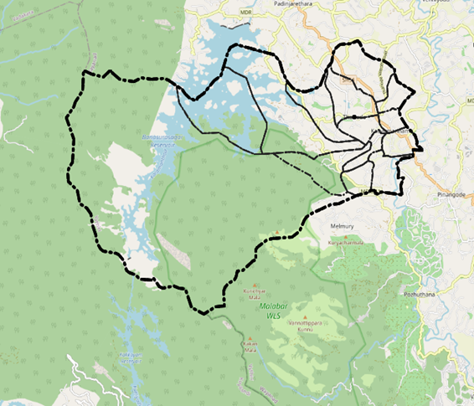

Baseline data

Name of LSGD: Thariode

Block/Muncipality: Kalpetta

Taluk: Vythiri

District: Wayanad

Total area (sq. km): 71.12

Ward | Houses | Population | Migrants | Wells | Hot  spots | Ed. Institutions | Hosp pvt/govt.
14 | 3254 | 13231 | 185 | 2158 | 1 | 7 | 6

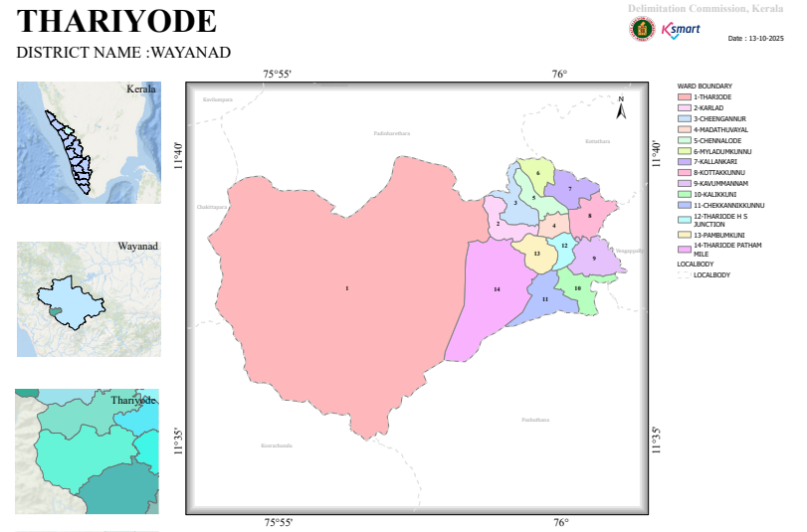

Major Roads Passing Through or Within Thariyode Panchayat

1. Thariyode – Patham Mile Road
- A key local arterial road connecting the centre of Thariyode village (near Kavumannam) to outlying residential areas.
- It serves as a primary feeder route for residents and local traffic.
- This road has been the subject of local mobilization and repair efforts due to deteriorating conditions as reported in local news.

2. 10th Mile Road / Athirathil – Unnathi Road
- Another important feeder route within the Panchayat, linking multiple wards and settlements.
- It functions as a key connector between villages, residential zones, and main highways.
- There are active works documented for re-tarring and maintenance under the Panchayat’s annual plan.

3. Internal Panchayat Roads Network
- A network of smaller local roads maintained by the Thariyode Grama Panchayat.
- These roads link hamlets, schools, markets, health facilities, and community services to the principal feeder roads listed above.
- Typical of rural governance, these are crucial for last-mile connectivity but often consist of village-level pavements and bitumen pavements.

Regional & State Connectivity

NH 766 (Kozhikode – Kalpetta – Mysuru Highway)
- While NH 766 does *not run through the core of Thariyode Panchayat, it lies nearby and acts as the main regional highway that residents use to connect toward Kalpetta, Kozhikode, and Mysuru.
- Local roads (like those above) funnel traffic to and from NH 766 for long-distance and interdistrict travel.

State Highways
- No major State Highway traverses centrally through Thariyode Panchayat itself.
- The closest state highway route is SH 29, which connects Chundale (near Kalpetta) with Vaduvanchal and further east — but it does not directly enter Thariyode village.
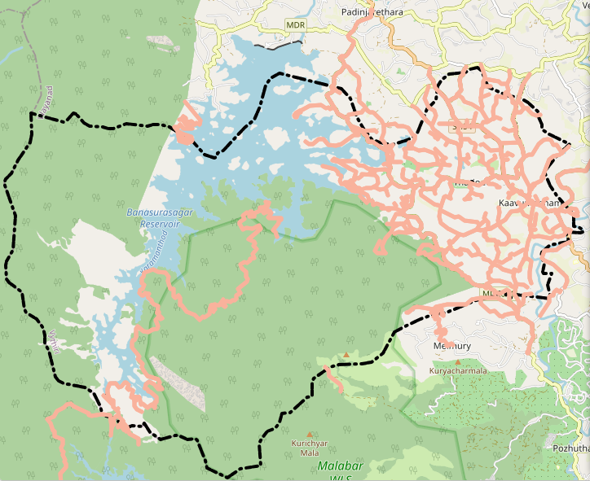

Major River in Thariyode Grama Panchayat
- Karamanthodu – A local river/stream flowing through Thariyode Panchayat area. It is part of the Kabani River basin.
- Tributary of Kabani River – Karamanthodu feeds into the larger Kabani River, one of the major rivers in the region (a tributary of the Cauvery).
- The Banasura Sagar reservoir’s dam structures (like Kottagiri Saddle Dam) are constructed across Karamanthodu within the Panchayat area.
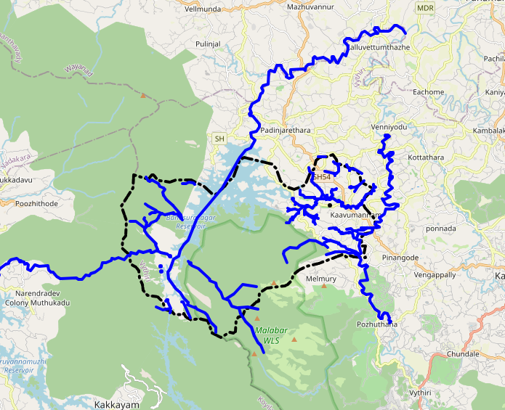
Disaster-Prone Areas – Thariyode Panchayat
Landslide Risk: Thariyode and nearby panchayats in Wayanad are located in hilly terrain that is considered landslide-prone, especially during heavy monsoon rainfall. Parts of Wayanad, including Thariyode, fall under high landslide susceptibility zones identified by hazard assessments.
Monsoon Flooding: Intense monsoon rains in the region can cause flooding and waterlogging in lower areas and along river/stream channels within the Panchayat.

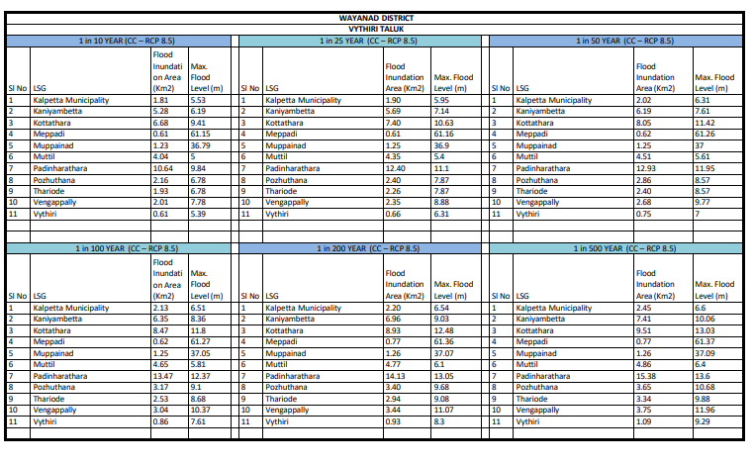

- 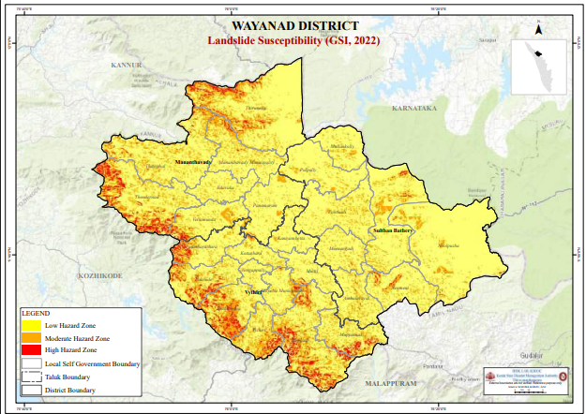

- 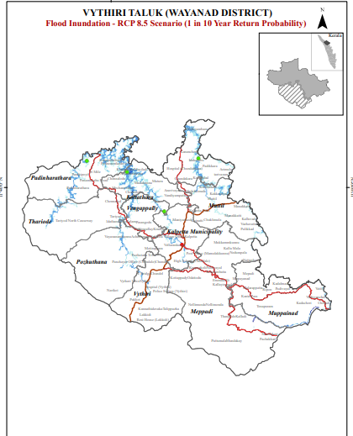

Health Infrastructure Map

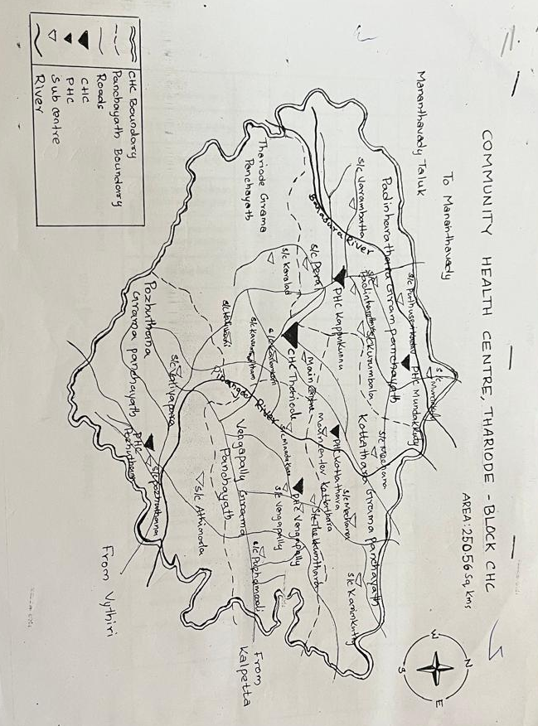
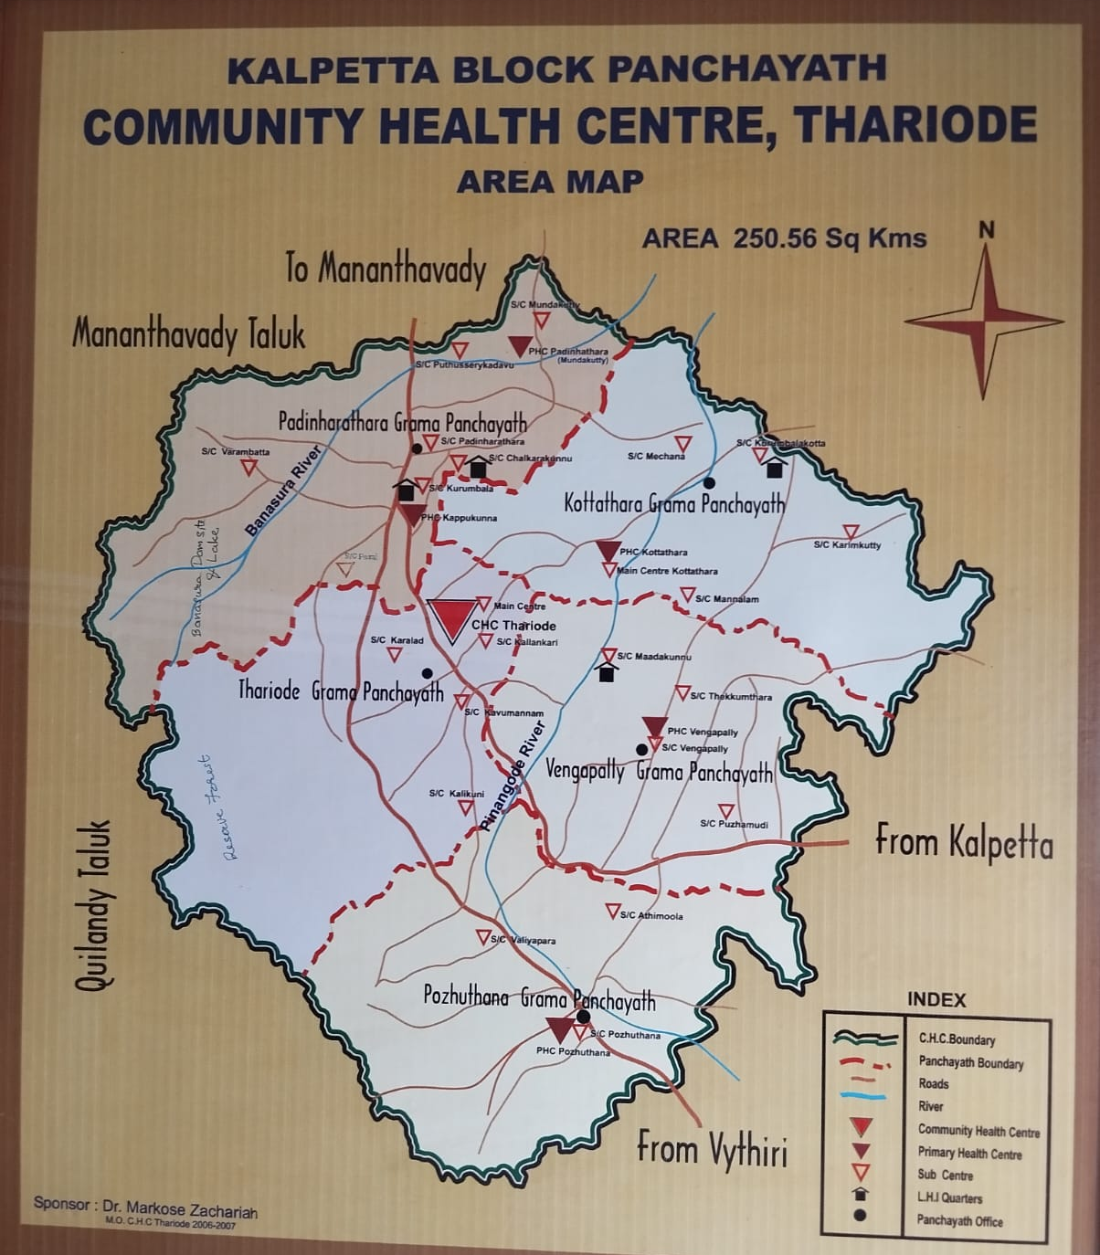

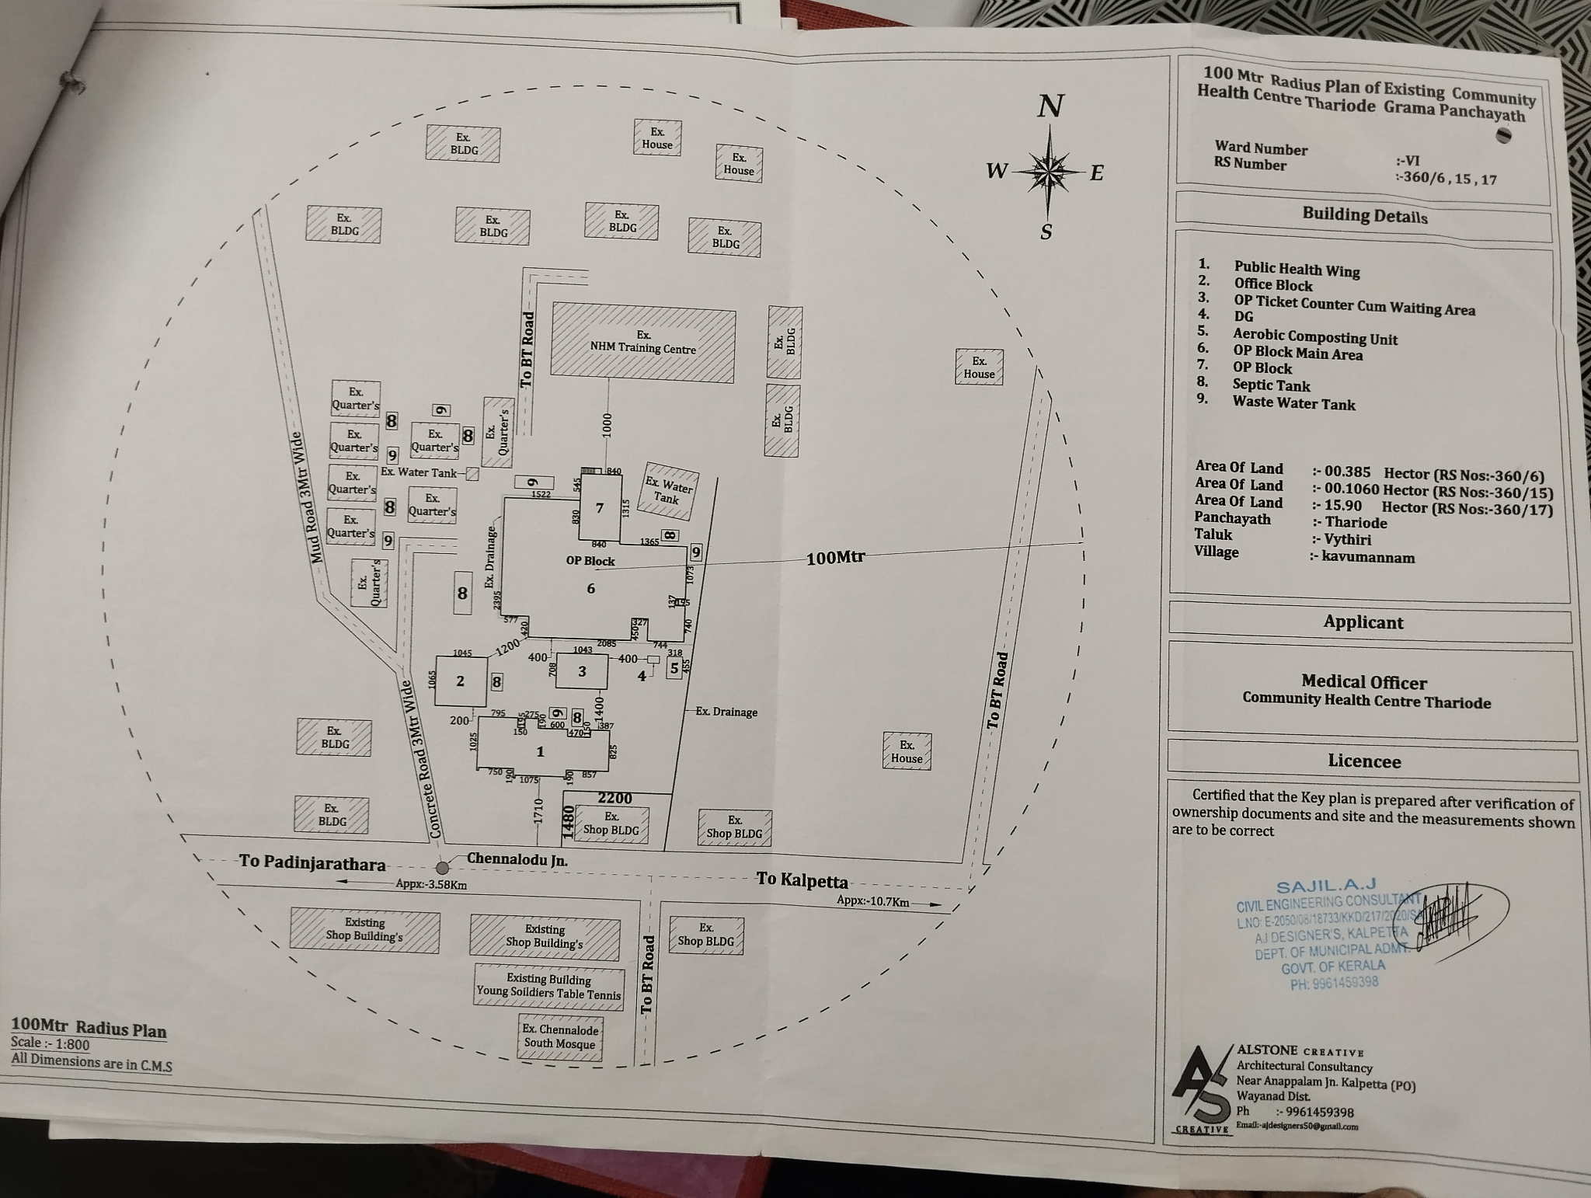

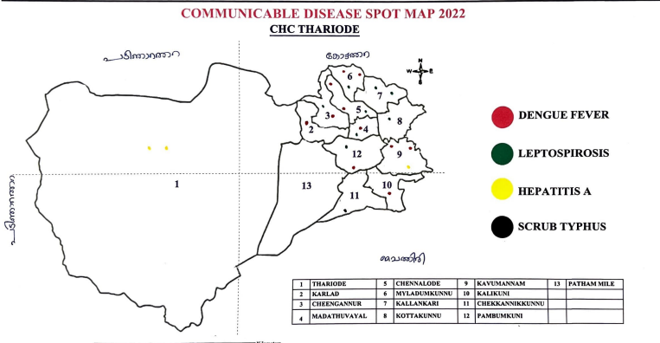
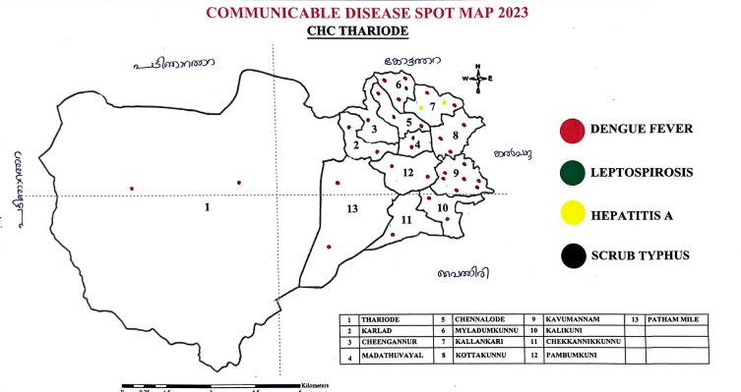

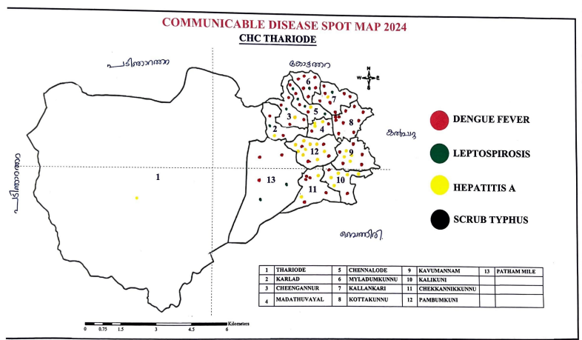

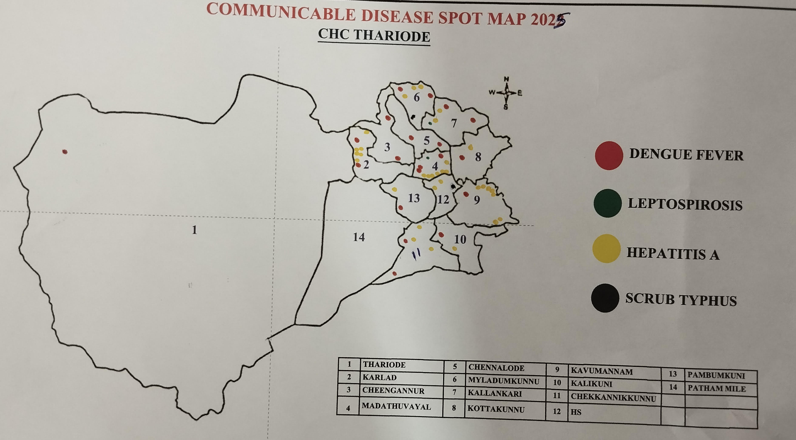

GENERAL PROFILE OF THE LSGI’S

Background of the LSGI
Thariode Grama Panchayat is situated in the middle of wayanad district, Kerala. The geographical landscape of the Panchayat is predominantly low-lying, characterized by rural and hilly landscape ,it has undulating terrain,forests, streams and fertile land.The panjayath has a significant tribal presence (such as paniya,kurichya,kadar) along with settler communities.
The Panchayat is administratively divided into multiple wards, with a population largely dependent on traditional livelihoods. Agriculture based economy— most of the people depended on farming and allied activities. . In recent years, tourism-related activities and service-sector employment have also shown gradual growth. The area hosts a diverse workforce, including a notable presence of migrant labourers, particularly in construction, agriculture, and allied sectors.
From a public health and disaster management perspective, Thariode LSGI has historically been vulnerable to seasonal flooding, waterborne diseases, and vector-borne illnesses such as Dengue and Leptospirosis. The severe floods experienced during recent years, including the 2018 flood disaster, significantly impacted life, livelihoods, and infrastructure within the Panchayat. These recurring emergencies have underscored the importance of strengthening local preparedness, response mechanisms, and inter-departmental coordination.
In this context, the development of a localized, data-driven Auxiliary Infrastructure and Logistical Resource Map is essential to support effective planning, timely emergency response, and sustainable development initiatives. Such mapping enables the Panchayat to identify critical resources, improve accessibility during disasters, and enhance overall resilience of the community.

Table 1: Background of LSGD
Description | Details
Name of LSGI | THARIODE
Type (GP/Municipality / Corporation etc.) | Grama Panchayath
Block | KALPETTA
District | WAYANAD
Number of wards | 14
Total area (sq. km) | 71.12
Population(Projected) | 13231
Population density | 186.03 persons/sq km
Terrain (coastal/low-lying/backwaters/foothills, etc.) | Low lying
Number of rivers passing through LSGI | 1
Number of water bodies in the LSGI | 2
Number of educational institutions | 7
Factories / small-scale industries | 0
Flood-prone wards | 2
Landslide-prone wards | 1
Death Management and Disposal Facilities (mortuaries/crematorium, including electric) | Nil
Auditoriums/Marriage halls/convention centres/community halls | 6

Demographic and Vulnerable Population
Understanding the demographic composition and vulnerable population groups is essential for pandemic preparedness. Thariode Grama Panchayath has a population of 13,231 with a balanced gender distribution, including 773 children under five and 2,157 elderly persons, indicating a high dependency burden. Social vulnerability is evident with 1,679 BPL families, 49 EPEP families, 66 Scheduled Tribe population, and migrant and socio-economically deprived groups, who are at increased risk during public health emergencies due to higher exposure, limited access to services, and dependence on public systems, necessitating prioritized protection, targeted surveillance, and continuity of essential services.

Description |  | Details (in numbers)
DEMOGRAPHIC PROFILE
Total population |  | 13231
Male |  | 6672
Female |  | 6559
Transgender |  | 0
Children under 5 |  | 773
Adolescent |  | 2513
Elderly (>60) |  | 2157
SOCIAL/LIVELIHOOD VULNERABILITY
Previous EPEP family |  | 49
BPL family |  | 1679
Tribal communities |  | 66
Migration | Immigrant | 177
Migration | Emigrant | -
Socio-economically deprived
Fisherfolk |  | 0
SC Community |  | Nil
ST Community |  | 66

POPULATION PYRAMID
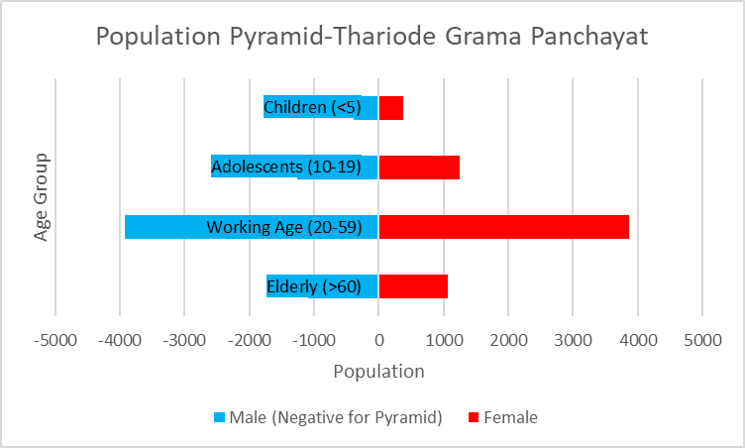

Demographic Interpretation – Thariode Grama Panchayath
- Total population: 13,231
- Working-age population (20–59 years): 7,788
- Dependent population (0–19 years & >60 years): 5,443
- Overall dependency ratio: 69.9% (≈ 70 dependents per 100 working-age persons)
- Working-age group forms the largest population segment.
- Significant elderly population (2,157) indicates increased demand for geriatric and NCD services.
- Substantial child and adolescent population (3,286) reflects continued need for RMNCH+A, immunization, and nutrition services.
- Demographic structure suggests a moderate dependency burden with implications for health system planning and emergency response.

Clinical Vulnerability
In Thariode Grama Panchayath, certain population groups require priority healthcare as they are at higher risk of severe illness, complications, and mortality during pandemics. These include individuals with chronic diseases, patients requiring regular medical care, and persons with mobility or functional limitations, who may face difficulties in accessing timely healthcare during public health emergencies. Identifying and mapping these vulnerable groups is essential to ensure continuity of treatment, proper planning of medicine stocks, availability of oxygen support, referral transport facilities, and the provision of targeted home-based care during emergency situations.
Description | Details in numbers
Pregnant women | 62
Lactating mothers | 247
Bedbound patients | 62
Patients under palliative care other than bedbound | 42
Patients on Haemodialysis | 10
Patients on CAPD | 0
Cancer patients (currently on treatment) | 63
Haemophilic patients | NIL
Mentally challenged | 102
Differently abled | 87
Diabetic patients | 155
Hypertensive patients | 748
TB patients | 5

- A total of 62 pregnant women and 247 lactating mothers require uninterrupted maternal and child health services, including antenatal care, postnatal care, and immunization support during emergencies.
- 62 bedbound patients and 42 patients under palliative care require continuous home-based medical care, essential medicines, and referral support.
- 10 haemodialysis patients and 63 cancer patients on active treatment need assured access to specialized services, transport facilitation, and continuity of life-saving treatment.
- A significant burden of chronic diseases is observed, with 748 hypertensive and 155 diabetic patients, indicating increased risk of complications during infectious disease outbreaks.
- 5 TB patients require uninterrupted drug supply and strict treatment compliance monitoring.
- 102 mentally challenged and 87 differently abled individuals require targeted outreach, caregiver support, and accessible healthcare services.
- The overall vulnerability profile emphasizes the need for ward-level microplanning, medicine buffer stock maintenance, oxygen preparedness, referral transport systems, and strengthened home-based care services during public health emergencies.

Major Festivals & Events specific to the LSGI

Sl. No. | Name of festival | Month detailing the periodicity
1 | PAZHOOR MAHAVISHNU TEMPLE PRATHISHTADINA MAHOLSAVAM | JANUARY
2 | PARADEVATHA TEMPLE PRADISTADINA MAHOLSAVAM | FEBRUARY
3 | MARIYAMMAL TEMPLE MAHOLSAVAM | APRIL
5 | CHERIKKANDY PARADEVATHA TEMPLE THIRA MAHOLSAVAM | MARCH
6 | ST.SEASTIANS CHURCH FESTIVAL | JANUARY
7 | LORD MATHA CHURCH FESTIVAL | JANUARY
8 | ST . SEASTIAN CHURCH MANJOORA FESTIVAL | JANUARY
9 | ST.MARYS FORANE CHURCH FESTIVAL | JANUARY
Thariode Block hosts multiple religious festivals across temples and churches, predominantly during the months of January, February, March, and April. Major events such as Pazhoor Mahavishnu Temple Prathishtadina Maholsavam, Paradevatha Temple Maholsavam, Mariyammal Temple Maholsavam, and various church festivals attract significant local and inter-ward participation.
The clustering of several large gatherings in January and early summer months increases population movement and crowd density, creating potential risks for communicable disease transmission, food safety concerns, waterborne illnesses, and vector-borne diseases.
These events necessitate advance microplanning, temporary medical support arrangements, surveillance strengthening, sanitation monitoring, food safety inspections, and risk communication activities to ensure public health safety during mass gatherings.

INFRASTRUCTURE & RESOURCE INVENTORY

Health Facility Directory & Basic Capacity in the LSGD
The Panchayat has a Community Health Centre (CHC) at Thariode that serves as the primary public health facility for residents, offering outpatient services and basic medical care.
Primary health services are accessible through this CHC and nearby primary/family health centres in the Wayanad district health network.
For more advanced or emergency care, patients are typically referred to Taluk Headquarters Hospital (Vythiri) or General/District Hospitals in Kalpetta or Mananthavady.
These facilities together form the frontline infrastructure for routine health needs and form the backbone of service delivery during public health events or emergencies in the Panchayat and surrounding areas.

Table 5. Health Facility Resource Summary
Sl.no. | Health Facility | Type of Facility (MCH/GH/CHC/FHC/SC etc.) | Contact Number | Total beds |  | ICU Beds | Oxygen-Supported Beds |  | No. of Ventilator Support Beds | No. of ambulances
Government Healthcare Facilities
1 | CHC THARIODE | CHC | 04936293465 | 20 |  | NIL | NIL |  | NIL | NIL
1 | HWC Kavumannam | SC | 8921853188 | NA |  | NA | NA |  | NA | NA
2 | HWC Kurlad | SC | 9447790111 | NA |  | NA | NA |  | NA | NA
3 | HWC Kalikuni | SC | 8592825705 | NA |  | NA | NA |  | NA | NA
4 | HWC MC Thariode | SC | 8157830048 | NA |  | NA | NA |  | NA | NA
5 | HWC Kallengari | SC | 9947101062 | NA |  | NA | NA |  | NA | NA
Private Healthcare Facilities
1 | LOIUS MOUNT HOSPITAL | MENTAL HOSPITAL | 7561891483 | 99 |  | NIL | NIL |  | NIL | NIL
AYUSH Healthcare Facilities
1. | AYURVEDA HOSPITAL 8TH MILE THARIODE(GENERAL) | PHC | 9995817571 | NIL |  | NIL | NIL |  | NIL | NIL
2 | TRIBAL AYURVEDAM KAVUMANNAM | PHC | 9074980306 | NIL |  | NIL | NIL |  | NIL | NIL
3 | GOVT.HOMEO DISPENSORY | - | 9496313497 | NIL | NIL |  |  | NIL | NIL | NIL

Private Clinics
In Thariode Grama Panchayath, private clinics play an important role in pandemic preparedness as they are often the first point of contact for people seeking medical care when symptoms appear. Many community members depend on these clinics for outpatient consultations, making them vital for early case detection, timely referral of suspected cases, and disease surveillance.
Maintaining an updated record of the location, services, and linkage of private clinics with the public health system helps ensure that potential cases are not missed during an outbreak. It also enables health authorities to effectively engage private practitioners in disease reporting, risk communication, and coordinated response, thereby strengthening the overall capacity of the local health system to manage public health emergencies.

Table 6. Private Clinic Resource Summary
Sl No. | Name of Clinic | Registered (Y/N) | Clinic (General / Speciality) | Speciality (if any) | Address | Contact Number | Diagnostic Facility (Y/N) | Ambulance Linkage (Y/N)
1 | KAVUMANNAM CLINIC | YES | GENERAL | NIL | C/O DR.KISHORE KUMAR M P  KAVUMANNAM | 9447963008 | NIL | NIL
2 | LIFE CARE CLINIC | YES | GENERAL | NIL | ℅ DInesh, Kavumannam PO | 9446952377 | NIL | NIL

Healthcare Education & Training Institutions
This section tracks the educational infrastructure available in Thariode Grama Panchayath, which is important for human resource planning in the health sector. Understanding the distribution and availability of educational institutions helps in identifying potential venues for health awareness programs, community engagement, training activities, and mobilization of volunteers during public health emergencies.

Category of Institution | Govt | Private | AYUSH | Total
Medical Colleges | NIL | NIL | NIL | NIL
Nursing Colleges | NIL | NIL | NIL | NIL
Dental Colleges | NIL | NIL | NIL | NIL
Para-medical / Allied Health | NIL | NIL | NIL | NIL
Pharmacy Colleges | NIL | NIL | NIL | NIL

Specialized Services & Emergency Inventory
This section provides an overview of the specialized medical resources available to the community, with a focus on emergency response and critical care capacities. The table tracks essential assets required to manage severe illnesses and pandemic-related emergencies across Government, Private, and AYUSH healthcare facilities in the area.

Item | Govt | Private | AYUSH | Total
Hospital beds | 20 | 99 | NIL | 119
Oxygen-generating systems(Y/N) | NIL | NIL | NIL | NIL
Oxygen-supported beds(Numbers) | NIL | NIL | NIL | NIL
Ventilator-supported beds | NIL | NIL | NIL | NIL
ICU beds | NIL | NIL | NIL | NIL
Burns units | NIL | NIL | NIL | NIL
Blood centres | NIL | NIL | NIL | NIL
BLS ambulances | NIL | NIL | NIL | NIL
ALS ambulances | NIL | NIL | NIL | NIL
Dialysis facilities | NIL | NIL | NIL | NIL
Dispensaries | NIL | 1 | 2 | 3
Medical store | 1 | 5 | 2 | 8
Industrial establishments(Medium-scale industries/small-scale industries establishments to whom we can depend in a worst-case scenario) | NIL | NIL | NIL | NIL

Oxygen & Diagnostic Capacity
Monitoring oxygen and diagnostic capacity is a critical component of public health preparedness, ensuring that the LSGD can handle both chronic care and sudden surges in respiratory or infectious diseases.
Name of Health Facility | Oxygen-generating System (Y/N) | Backup Oxygen Source (Y/N) | Diagnostic Facilities Available(Y/N)
Name of Health Facility | Oxygen-generating System (Y/N) | Backup Oxygen Source (Y/N) | Lab | USG | X-ray | CT/MRI | RT-PCR
Government Healthcare Facilities
CHC THARIODE | NIL | NIL | 1 | NIL | NIL | NIL | NIL
Private health care facilities
 | NIL | NIL |  | NIL | NIL | NIL | NIL

Diagnostics facility mapping at the LSGI level
In Thariyode Grama Panchayat, the diagnostic capacity forms the “intelligence network” of the local healthcare system. The efficiency, speed, and accuracy of disease detection during a pandemic rely heavily on the distribution, accessibility, and technical capabilities of these diagnostic facilities.

Item | Govt | Private | AYUSH | Total
General labs | 1 | 5 | NIL | 6
Microbiology labs | NIL | NIL | NIL | NIL
RT-PCR labs | NIL | NIL | NIL | NIL
USG units | NIL | NIL | NIL | NIL
CT/MRI units | NIL | NIL | NIL | NIL
Research labs | NIL | NIL | NIL | NIL
Labs of other departments that can be repurposed | NIL | NIL | NIL | NIL

Laboratory Identification & Basic Details
Sl. No. | Name of Laboratory | Ownership (Govt / Private / Academic) | Address | Contact No. |  | 24×7 Services (Yes/No) |  | NABL / Govt Approved (Yes/No)
1 | CHC THARIODE | GOVT | CHC THARIODE CHENNALODE | 04936293465 |  | NIL |  | YES
2 | RISANA LAB | PRIVATE | CHENNALODE | 9745827147 |  | NIL |  | NIL
3 | SNEHA LAB | PRIVATE | CHENNALODE | 6282564584 |  | NIL |  | NIL
4 | ASIN LAB | PRIVATE | CHENNALODE | - |  | NIL |  | NIL
5 | ASHREYA LAB | PRIVATE | KAVUMANNAM | 9846009709 |  | NIL |  | NIL
6 | ST.JUDE MEDICAL LAB | PRIVATE | KAVUMANNAM |  | 9656906750 |  | NIL | NIL

Social and Community Infrastructure for surge plan
This table serves as our logistics and shelter inventory. By mapping these locations, quickly we can identify where to house displaced citizens, where to set up temporary medical clinics, and how to manage the deceased with dignity during a crisis.

Category | Total Count | Ward | Est. Capacity (Persons) | Contact details
Educational Institutions
Anganwadis | 22 | 13 | 200 | ICDS SUPERVISOR-6238627097
Schools | 7 | 5 | 2000 | 9074600771  9447491601
Colleges | NIL | NIL | NIL | NIL
Healthcare Educational Institutions
Medical colleges (Govt/Private) | NIL | NIL | NIL | NIL
Nursing colleges (Govt/Private) | NIL | NIL | NIL | NIL
Dental colleges (Govt/Private) | NIL | NIL | NIL | NIL
Paramedical institutes (Govt/Private) | NIL | NIL | NIL | NIL
Community Gathering Spaces
Community halls | 2 | 2,11 | 100 | 9446138346
Auditoriums | 5 | 4 | 1000 | 9048016432
Religious buildings | 6 | 5 | 1000 | 9446162425
Vulnerable Group Support Facility
Destitute homes | NIL | NIL | NIL | NIL
Elderly homes | NIL | NIL | NIL | NIL
LSGD owned other buildings | 5 | 5 | 50 | 9947370344
Mass Fatality Management (MFM) Infrastructure
Mortuary | NIL | NIL | NIL | NIL
Crematorium | NIL | NIL | NIL | NIL
*refer annexure 1 for contact details

Human resources
This section highlights the human resources available within Thariyode Grama Panchayat. During any emergency—whether a pandemic, flood, or industrial accident—the effectiveness of infrastructure depends entirely on the skills, training, and readiness of the personnel operating it.

Medical & Clinical Personnel
This table tracks the "Frontline" providers responsible for diagnosis, treatment, and clinical management. Narrative sentence: eg., "Total health workforce: 450 personnel, with 60% in government facilities serving as primary surge capacity." A detailed directory with the contact numbers of all workers is maintained (Annexure in 1).

Cadre | Govt (No.) | Private (No.) | Total
Doctors—Modern Medicine | 4 | 3 | 7
Doctors – AYUSH | 3 | 1 | 4
Doctors – Veterinary | 1 | 0 | 1
Doctors – Dental | 0 | 2 | 2
Nursing officers | 5 | 0 | 5
Lab technicians | 3 | 10 | 13
Optometrist | 1 | 0 | 0
Pharmacists | 2 | 7 | 9
Psychologists | 0 | 1 | 1
Counsellors | 0 | 2 | 2

Public Health & Field-Level Workforce
These individuals are the backbone of surveillance, maternal-child health, and decentralized care.

Cadre | Health services | Municipal common services | Total
HS (Health Supervisors) | 1 | 0 | 1
HI (Health Inspectors) | 1 | 1(LSGD) | 2
LHS (Lady Health Supervisor) | 1 | 0 | 1
LHI (Lady Health Inspectors) | 1 | 0 | 1
JPHN (Jr Public Health Nurses) | 5 | 0 | 5
JHI (Jr Health Inspectors) | 3 | 0 | 3
MLSP (Mid-Level Service Providers) | 5 | 0 | 5
Palliative Nurses | 2 | 0 | 2
RBSK Nurses | 1 | 0 | 1
PRO | 1 | 0 | 1
Epidemiologist | 1 | 0 | 1
Data Manager | 1 | 0 | 1

Community & Support Cadre
This group represents the surge capacity of the LSGI—people who can be called upon for logistics, rescue, and specialized support.

Cadre | Number
ASHA Workers | 12
AWW (Anganwadi Workers) | 22
Emergency Medical Volunteers (Trained) | 146
Kudumbashree | 164
MNREGS | 4517
Purusha Swayam Sahaya Sangham | 0
Ex-Servicemen | 6
Retired Police Officers | 0
NCC/NSS Volunteers | 50
Red Cross volunteers | 50
One Health Community Volunteers | 13
One Health Community Mentors | 0

Community Organizations
This section highlights the presence of community-based organizations (CBOs), non-governmental organizations (NGOs), faith-based organizations (FBOs), Kudumbashree Self-Help Groups (SHGs), Ayalkootams, and other local groups within Thariyode Grama Panchayat. These organizations play a vital role in grassroots mobilization, resource distribution, and community support networks, all of which are critical for effective pandemic response and building local resilience. Notably, Thariyode hosts 36 Ayalkootams, 5 youth/sports clubs, 4 religious-based organizations, and other active groups, reflecting strong community engagement that can be leveraged during emergencies.

Category | Total Count
NGOs | 1
Religious based organizations | 4
Foreign based organizations | 1
Sports Club/youth clubs | 5
Kudumbashree SHGs | 1
Ayalkootams | 36
Political organizations | 4
Residential organizations | 0

Administrative & Emergency Services
Thariode Panchayat does not have its own police station or fire & rescue station, so emergency support for law enforcement and fire response must be accessed from nearby towns. The area is served by the Padinjarathara Police Station, whose jurisdiction includes Thariode, and the nearest fire & rescue facilities are located in Mananthavady and Kalpetta. This means residents depend on neighbouring service centres for administrative and emergency support during crises.

Category | Total Count | Contact details
Police Stations in Thariode | 0 | 0
Police station (Nearest-Padinjarathara) | 1 | 04936 273401
Fire & Rescue Stations in Thariode | 0 | 0
Fire & Rescue Stations(Nearest-Mananthavady) | 1 | 04936 245052
Water Pumping Points in Thariode | 0 | 0
Public Distribution System (PDS) | 3 | -

Information regarding resources
In Thariode Panchayat, essential transport and support resources play a key role in emergency response, especially given its hilly terrain and rural context. Ambulance services (such as the state-wide KANIV-108 network) serve the area through district-level deployment, ensuring emergency medical transport is available when needed. In major disaster situations, larger rescue operations in the Wayanad region have included deployment of specialized vehicles and heavy machinery (like JCBs), and even resources such as drones and off-road vehicles have been used to reach remote or difficult-to-access zones during landslide relief efforts. These various transport assets ensure that patients, responders, and supplies can be moved swiftly during floods, landslides, or other emergencies affecting the Panchayat.

Means of transportation | Total Count
JCB | 3
Crane | 0
Heavy Trucks | 0
Tractor | 5
Ambulances | 2
Mobile mortuaries | 0
Boats | 0
Taxi service | 50
Note: For specific details regarding vehicle owners and contact information, please refer to Annexure [X].

ONE HEALTH & ENVIRONMENTAL SURVEILLANCE
The One Health approach combines human, animal, and environmental health to improve early detection and control of diseases that emerge at the interface of people, animals, and nature. In the context of Thariode Panchayat, strengthening local surveillance means building capacity to monitor animal populations, environmental risk factors, and human disease patterns together at the grassroots level. This includes enhancing veterinary support, monitoring poultry and livestock health, and using tools like seasonal mapping and community reporting systems to detect potential outbreaks early—especially zoonotic diseases that can jump from animals to humans—so that ward-specific actions and rapid responses can be triggered before widespread transmission occurs.

Animal & Bird Population
Mapping animal and bird populations at the Panchayat level is essential for identifying and prioritising zoonotic disease hazards like rabies, avian influenza (H5N1), leptospirosis, anthrax, and Nipah-like spillover occurrences. Risk classification, targeted surveillance, vaccination planning, and early epidemic detection made feasible by comprehensive population mapping all enhance One Health-based pandemic preparedness.

Category | Item | Estimated Population | Wards
Animal Population | Livestock (Cattle/Goats/Buffalo) | 1210 | All ward
Animal Population | Pet Animals (Dogs/Cats) | 910 | All ward
Animal Population | Stray Dog Population | - | -
Animal Population | Pig Farms (Number of heads) | 8 | 5,3
 | Small Units (Sheep / Goats – clustered) | 0 | -
Bird Population | Poultry Units (Birds) | 20 | 3,4,5,6,7,8,
Bird Population | Poultry- (FOWL) | 0 | -
Bird Population | Wild/Migratory Birds (Observed) | 0 | -
Bird Population | Crow Mortality Events (Reported) | 0 | -

The main risk of zoonotic diseases in Thariode is concentrated in Wards 3,4,5,6,7,8, which is explained by the high density of poultry units. The stray dog population in market areas, fish landing sites, bus stations continues to be a substantial problem for rabies surveillance and bite prevention. There is a considerable risk of avian influenza introduction and amplification during November - December due to the seasonal presence of migratory and resident water birds near ponds/ canal / river / backwater / paddy field. Clusters of pig farms and animal shelters vulnerable to flooding further raise the risk of leptospirosis and other zoonoses mediated by the environment, especially during monsoon floods.

Veterinary Infrastructure
In Thariode Panchayat and the wider Wayanad district, veterinary institutions form an important part of One Health surveillance by enabling early detection of zoonotic diseases and supporting animal health. The District Animal Husbandry Office and District Veterinary Centre in Wayanad provide clinical services, disease monitoring, vaccination, and outbreak reporting for livestock and poultry, with outreach into local panchayats including Thariode. There are also mobile farm aid units serving rural areas, helping with preventive care, sample collection, and animal health assessments that strengthen coordination with human health and local government systems for integrated disease surveillance and response.
Facility Type | Name of Facility | Ownership Govt / Pvt | Location(Ward No) | Contact number
Veterinary Dispensary | GOVT.VETERINARY DISPENSORY | GOVT | 7 | 9495855953
Veterinary Hospital / Polyclinic | NIL | NIL | NIL | NIL
Private Veterinary Clinics | NIL | NIL | NIL | NIL
Mobile / Emergency Vet Service (incl. night services) | NIL | NIL | NIL | NIL
Pet Homes / Animal Shelters | NIL | NIL | NIL | NIL
Slaughterhouse-linked Veterinary Inspection Unit | NIL | NIL | NIL | NIL

Veterinary Doctors & Workforce
Early detection, diagnosis, reporting, and response to animal health outbreaks rely on the availability and accessibility of qualified veterinary professionals in Thariyode Panchayat. By promptly identifying unusual animal morbidity or mortality, collecting and testing samples efficiently, and coordinating closely with human health and LSGI systems—especially during zoonotic outbreaks or pandemic-prone situations—an organized veterinary workforce strengthens the One Health surveillance framework and overall community preparedness.

Category | Number Available | Type (Govt/Pvt) | Contact number
Government Veterinary Doctors | 1 | GOVT | 6238211366
Private Veterinary Doctors | NIL | NIL | NIL
Livestock Inspectors | 2 | GOVT | 9846339115
Para-veterinary Staff / Attenders | 2 | GOVT | -
Contract / On-call Veterinary Support (if any) | 1 | GOVT | -

High-Risk Interface Points (Surveillance Sites)
While Thariode Grama Panchayat does not have large commercial wetland–livestock–human contact zones or major slaughter sites, it does include small-scale poultry farms and backyard poultry rearing, which are common in rural parts of Wayanad district and represent key points of human-animal interaction that could pose zoonotic spillover risk. Small poultry holdings and livestock nearby homes or fields require monitoring as part of integrated animal and human health surveillance at the Panchayat level.
Type of Habitat | Type of High risk interface | Geographical vulnerability
Wetlands & Backwaters | NIL | NIL
Backyard Poultry Farms | NIL | NIL
Cattle Sheds near Water Bodies | NIL | NIL
Fish & Meat Markets | NIL | NIL
Community Slaughter Sites | NIL | NIL
Migratory Bird Congregation Areas | NIL | NIL
Rodent-Infested Grain Storage | NIL | NIL

Category | Total Count | Key Locations (wards)
Poultry Farms | 15 | WARD 3,4,5,6,7,8
Backyard / Clustered Poultry Units | NIL | NIL
Duck Rearing Units (open water access) | NIL | NIL
Slaughterhouses/ Slaughter Points | NIL | NIL
Meat/Fish Markets | NIL | NIL
Live Bird Sale Points | NIL | NIL
Cattle Markets / Weekly Animal Fairs | NIL | NIL
Pet Shops / Breeders | NIL | NIL
Animal Shelters / Pet Homes | NIL | NIL
Waste Disposal Sites near Animal Units | NIL | NIL

Environmental Risk Mapping
In Thariode Grama Panchayat and the surrounding Wayanad district, environmental risk mapping helps identify areas that may be vulnerable to rain-related health hazards such as vector-borne diseases (e.g., dengue), water-borne illnesses (e.g., leptospirosis and diarrhoea), and other climate-influenced infections during heavy monsoon conditions. The region’s high rainfall, hilly terrain, and occasional waterlogging create conditions where stagnant water and poor drainage can promote mosquito breeding and bacterial survival, increasing the risk of such diseases during and after rain events. Systematic surveillance and local risk mapping support early warnings, targeted public health action, and Panchayat-level preparedness for outbreaks in these susceptible settings.
Waterborne exposure: Flood-prone areas and stagnant water bodies facilitate leptospira survival, raising leptospirosis risk.

Traditional practices: Informal slaughter and fish markets lack standardized hygiene, creating spillover opportunities.
Risk Factor | High-Risk Wards | Key Locations | Risk Level (High/Med/Low)
Flood-prone areas | WARD 4,12 | HS KAVUMANNM | MEDIUM
Water bodies/wetlands | NIL | NIL | NIL
Solid waste accumulation | NIL | NIL | NIL
Animal waste disposal issues | NIL | NIL | NIL
Rodent infestation zones | NIL | NIL | NIL
Industrial effluent discharge | NIL | NIL | NIL
Construction sites / abandoned buildings | 1 | MANJOORA | LOW
Poor drainage/blocked canals | NIL | NIL | NIL
Drinking water source contamination risk | NIL | NIL | NIL

Disease Seasonality Mapping
Understanding seasonal patterns of disease occurrence is critical for proactive planning and timely interventions. The following seasonal risk factors have been identified:
- Flooding & Waterlogging (Monsoon Season)
Heavy rains and poor drainage can lead to water accumulation, creating breeding grounds for pathogens and vectors. This significantly amplifies the risk of leptospirosis, malaria, and diarrheal diseases. Preparedness measures include early warning, community awareness, and pre-positioning of medical supplies.
- Migratory Bird Influx (November–February)
The arrival of migratory birds increases the potential for avian influenza outbreaks. Surveillance at wetlands, poultry farms, and human-animal interfaces is recommended during this period.
- Mosquito Breeding Cycles (Monsoon & Post-Monsoon)
Seasonal rainfall and stagnant water promote mosquito proliferation, leading to peaks in vector-borne diseases such as dengue, malaria, and chikungunya. Targeted vector control and community engagement campaigns should coincide with these cycles.
- Agricultural Practices (Planting & Harvest Seasons)
Paddy cultivation and other seasonal agricultural activities involve close human-animal contact, increasing exposure to zoonotic diseases. Health education for farmers and use of protective measures during high-risk periods are essential.

Disease | Peak Risk Season | Key Drivers | High-Risk Locations | Surveillance Focus
Avian Influenza | NIL | NIL | NIL | NIL
Leptospirosis | JUN -OCTOBER | MANSOON RAINFALL | ALL WARDS | ALL WARD
Dengue/Chikungunya | JULY -SEP | MANSOON RAINFALL | ALL WARDS | ALL WARD
Acute Diarrheal Diseases | NIL | NIL | NIL | NIL
Rabies | NIL | NIL | NIL | NIL
Anthrax (rare) | NIL | NIL | NIL | NIL

Vulnerability Mapping
Vulnerability mapping identifies populations, occupations, and areas that are at higher risk due to environmental, occupational, socio-economic, and service access factors. By combining this with disease seasonality and environmental risk data, the Panchayath can prioritize interventions, enhance surveillance, and optimize resource allocation. Key findings include:
Vulnerability Factor | High-Risk Wards | Key Groups / Locations | Risk Level
Flood-prone households | WARD 4,12 | HS KAVUMANNAM | MEDIUM
Wetland-adjacent communities | NIL | NIL | NIL
Backyard poultry / duck rearing households | NIL | NIL | NIL
Livestock-rearing households | 15 | TRIBAL GROUPS | LOW
Slaughterhouse & meat market workers | NIL | NIL | NIL
Fisherfolk & fish market workers | NIL | NIL | NIL
Sanitation workers | 26 | ALL WARDS | MEDIUM
Daily wage / migrant workers | NIL | NIL | NIL
Elderly & chronically ill populations | 852 | ALL WARD | LOW
Pregnant Women | 62 | ALL WARDS | LOW
Children (schools, Anganwadi’s) | 29 | ALL WARD | LOW
Limited access to safe water & sanitation | NIL | NIL | NIL

Interpretation & Planning Use:
- High-risk zones (e.g., flood-prone areas, sanitation work areas) require intensified surveillance and preventive measures during relevant seasons.
- Occupational groups (sanitation workers, livestock handlers) need targeted health education, PPE, and vaccination campaigns.
- Sensitive populations (elderly, pregnant women, children) require prioritized health services, early warning, and rapid response mechanisms.
- Resource optimization: By aligning vulnerability with environmental and seasonality data, interventions can be targeted efficiently, enhancing the One Health approach and pandemic preparedness.

EPIDEMIOLOGICAL TRENDS (2021–2025)

Disease surveillance is the systematic collection, analysis, and interpretation of health data to guide planning, implementation, and evaluation of public health actions. Effective surveillance enables early detection of outbreaks, identification of priority diseases, and understanding of seasonal and emerging public health threats.
This section presents the disease surveillance profile of the LSGI, drawing on routine reporting systems, facility-based data, and outbreak investigations. Insights from this profile inform risk-based interventions, resource allocation, and strategic planning to strengthen pandemic preparedness and the overall health system response.

Disease Burden among human beings(Last 5 Years)
Analyzing disease patterns over time is crucial for understanding the public health landscape of Thariode Panchayat. The data from 2021 to 2025 provides insights into the incidence, persistence, and emergence of various communicable diseases, enabling targeted interventions. By identifying increasing trends, stable conditions, and potential outbreaks, local health authorities in Thariode can prioritize prevention, preparedness, and response strategies. This analysis highlights both emerging concerns such as Dengue, Leptospirosis, and Hepatitis A, as well as diseases with low or stable incidence, ensuring that resources are efficiently allocated to protect the health of the Thariode community.

Disease | 2021 | 2022 | 2023 | 2024 | 2025 | Trend(Increasing/Stable/Decreasing)
Dengue | 8 | 11 | 30 | 54 | 22 | Increasing
Leptospirosis | 3 | 8 | 3 | 10 | 2 | Increasing
Hepatitis A | 3 | 3 | 2 | 27 | 35 | Increasing
Malaria | 0 | 0 | 0 | 0 | 0 | Stable
Scrub Typhus | 1 | 0 | 0 | 0 | 1 | Stable
Typhoid | 0 | 1 | 2 | 0 | 0 | Stable
H1N1 | 0 | 0 | 0 | 0 | 0 | Stable
H3N2 | 0 | 0 | 0 | 0 | 0 | Stable
ADD | 98 | 115 | 128 | 157 | 254 | Increasing
Mumps | 0 | 0 | 0 | 14 | 4 | Stable
Measles | 0 | 0 | 0 | 0 | 0 | Stable
Hepatitis B | 0 | 0 | 0 | 0 | 0 | Stable
Hepatitis C | 0 | 0 | 0 | 0 | 0 | Stable
Tuberculosis | 4 | 11 | 7 | 3 | 5 | Decreasing
Leprosy | 0 | 0 | 0 | 0 | 0 | Stable

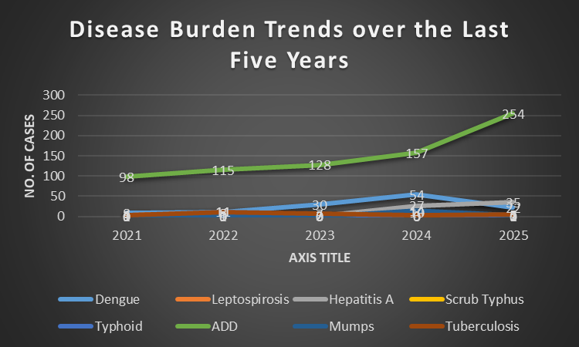

Seasonal Trend Analysis
Seasonal analysis helps anticipate surges (e.g. dengue in monsoon, leptospirosis after floods, influenza in cooler months) and plan pre‑emptive vector control, stockpiling of IV fluids, and awareness campaigns at Panchayat level.

DENGUE
Dengue is a major seasonal vector-borne disease in Thariode, closely linked to rainfall, water stagnation, and increased mosquito breeding during the monsoon. Cases typically peak from July to November, with the highest recorded numbers being 5, 6, 7, and 8 in different years.

Dengue – Ward-wise Yearly Distribution (2021–2025)

Ward | Dengue – Ward-wise Yearly Distribution
Ward | 2021 |  | 2022 | 2023 | 2024 | 2025 |  | Total
1 | 0 |  | 0 | 2 | 0 | 1 |  | 3
2 | 1 |  | 1 | 2 | 2 | 2 |  | 8
3 | 2 |  | 1 | 1 | 4 | 2 |  | 10
4 | 0 |  | 1 | 1 | 2 | 3 |  | 7
5 | 2 |  | 2 | 2 | 4 | 2 |  | 12
6 | 0 |  | 2 | 3 | 6 | 2 |  | 13
7 | 0 |  | 0 | 2 | 7 | 2 |  | 11
8 | 0 |  | 0 | 3 | 10 | 1 |  | 14
9 | 1 |  | 2 | 7 | 5 | 1 |  | 16
10 | 1 |  | 1 | 2 | 2 | 1 |  | 7
11 |  | 0 | 0 | 1 | 5 |  | 2 |  | 8
12 |  | 1 | 1 | 2 | 4 |  | 2 |  | 10
13 |  | 0 | 0 | 2 | 3 |  | 1 |  |  | 6
14 |  | 0 | 0 | 0 | 0 |  | 0 |  |  | 0

LEPTOSPIROSIS
Leptospirosis in Thariode Panchayat is strongly associated with monsoon rains, flooding, and occupational exposure, especially in low-lying and waterlogged areas. Cases typically peak between June and August, with Wards 4 and 5 reporting the highest numbers.

Leptospirosis – Ward-wise Yearly Distribution (2021–2025)

Ward | Leptospirosis – Ward-wise Yearly Distribution
Ward | 2021 | 2022 | 2023 | 2024 | 2025 | Total
1 | 1 | 0 | 0 | 0 | 0 | 1
2 | 1 | 0 | 0 | 1 | 0 | 2
3 | 0 | 1 | 0 | 1 | 0 | 2
4 | 0 | 1 | 1 | 0 | 1 | 3
5 | 0 | 1 | 1 | 4 | 0 | 5
6 | 0 | 1 | 1 | 1 | 0 | 3
7 | 0 | 2 | 0 | 1 | 1 | 4
8 | 00 | 1 | 0 | 0 | 0 | 1
9 | 1 | 0 | 0 | 0 | 0 | 1
10 | 0 | 0 | 0 | 0 | 0 | 0
11 | 0 | 0 | 0 | 0 | 0 | 0
12 | 0 | 1 | 0 | 0 | 0 | 1
13 | 0 | 0 | 0 | 2 | 0 | 2

VIRAL HEPATITIS - A
Hepatitis A in Thariode Panchayat is commonly linked to unsafe drinking water, food contamination, and sanitation lapses, often occurring as clusters or localized outbreaks. Cases usually peak from October to December, with Ward 12 reporting the highest numbers.

Hepatitis A – Ward-wise Yearly Distribution (2021–2025)

Ward | Hep A – Ward-wise Yearly Distribution
Ward | 2021 | 2022 | 2023 | 2024 | 2025 | Total
1 | 0 | 2 | 0 | 1 | 0 | 2
2 | 1 | 0 | 0 | 0 | 1 | 2
3 | 1 | 0 | 0 | 1 | 0 | 2
4 | 0 | 0 | 0 | 3 | 0 | 3
5 | 0 | 0 | 0 | 1 | 0 | 1
6 | 0 | 0 | 0 | 0 | 2 | 2
7 | 0 | 0 | 2 | 1 | 0 | 3
8 | 0 | 0 | 0 | 0 | 1 | 1
9 | 0 | 1 | 0 | 4 | 0 | 5
10 | 0 | 0 | 0 | 5 | 0 | 5
11 | 0 | 0 | 0 | 2 | 3 | 5
12 | 0 | 0 | 0 | 9 | 2 | 11
13 | 1 | 0 | 0 | 0 | 1 | 2

Outcome-Based Trend Analysis- 2025

Transmission Trend- 2025
Tracking trends in disease transmission is important for effective public health management because it helps identify high-risk populations or areas and enables early prediction of outbreaks. Based on the data, water-borne diseases recorded the highest number of cases (35), followed by vector-borne diseases (23) and air-borne diseases (15). Blood-borne and food-borne diseases reported no cases, and no deaths were recorded in any category. These trends help health authorities focus preventive measures on the most common transmission modes, allocate resources efficiently, and implement timely interventions to control the spread of diseases.

Mode of Transmission | No. of cases | No. of Deaths
Vector Borne Diseases | 23 | 0
Water Borne Diseases | 35 | 0
Air Borne Diseases | 15 | 0
Blood Borne Diseases | 0 | 0
Food Borne Diseases | 0 | 0

Vector-Borne Disease

Disease | No. of Cases | No. of Deaths
Dengue | 22 | 0
Malaria | 0 | 0
Chikungunya | 0 | 0

Water Borne Disease

Disease | No. of Cases | No. of Deaths
Cholera | 0 | 0
Typhoid | 0 | 0
Hep- A | 35 | 0
Dysentery | 0 | 0
Amoebiasis | 0 | 0
E- Coli infections | 0 | 0
Air Borne Disease

Disease | No. of Cases | No. of Deaths
Influenza | 0 | 0
H1N1 | 0 | 0
TB | 5 | 0
Chickenpox | 15 | 0
Measles | 0 | 0
Covid-19 | 0 | 0
Pertussis | 0 | 0
Mumps | 0 | 0

Blood-Borne Disease

Disease | No. of Cases | No. of Deaths
AIDS | 0 | 0
Hep- B | 0 | 0
Hep- C | 0 | 0

Zoonotic Disease

Disease | No. of Cases | No. of Deaths
Rabies | 0 | 0
Leptospirosis | 2 | 0
Avian influenza | 0 | 0
West nile | 0 | 0
Anthrax | 0 | 0
Nipah | 0 | 0
Scrub Typhus | 1 | 0

Integrated Disease Hotspot Map (2021–2025)

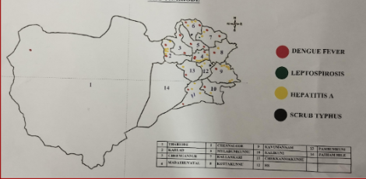

Ward No | Dengue Total (2021-25) | Leptospirosis Total (2021-25) | Hepatitis A Total (2021-25) | Mumps (2021-25) | ADD (2021-25) | Total Cases
1 | 3 | 1 | 2 | 1 | 42 | 7
2 | 8 | 2 | 2 | 3 | 55 | 15
3 | 10 | 2 | 2 | 1 | 61 | 15
4 | 7 | 3 | 3 | 2 | 48 | 15
5 | 12 | 5 | 1 | 2 | 72 | 20
6 | 13 | 3 | 2 | 2 | 64 | 20
7 | 11 | 4 | 3 | 0 | 58 | 18
8 | 14 | 1 | 1 | 2 | 67 | 17
9 | 16 | 1 | 5 | 0 | 49 | 22
10 | 7 | 0 | 5 | 0 | 70 | 13
11 | 8 | 0 | 5 | 0 | 56 | 13
12 | 10 | 1 | 11 | 0 | 54 | 22
13 | 6 | 2 | 2 | 4 | 56 | 14

Preparedness and Response Protocol at LSG Level
This section outlines the operational framework for the LSGI following the declaration of a pandemic. It describes how the LSGI and the health system will transition from routine data collection to an active response, guided by the One Health approach.

Constitution of One Health Committee
The LSGD shall constitute a One Health Committee comprising the LSGI President, Medical Officers (Modern Medicine, AYUSH, and Veterinary), the Health Inspector, and the Veterinary Surgeon.

Objective: The One Health Committee coordinates human, animal, and environmental health to prevent and control pandemics.

Sl No | Name | Designation | Department/Institution | Role in Committee | Contact Number
1 | SUSY BABU | Panchayat President | LSGD | Chairperson | 9446138346
2 | DR SHYNI MATHEW | Medical Officer (PHC/CHC) | Health Dept | Member Secretary | 9447233753
3 | DR SEENA | Veterinary Officer | Animal Husbandry | Member | 9495855953
4 | SIYA MOL | Epidemiologist | Health Dept | Member | 9544142784
5 | SHIBU H | Health Inspector | Health Dept | Surveillance | 8113086505
6 | DR SHYNI MATHEW | ASHA Supervisor | Health Dept | Community link | 9447233753
7 | JISHA | ICDS Supervisor | Social Welfare | Vulnerable groups | 6238627097
8 | NIL | Police Station Officer | Police Dept | Law & order | NIL
9 | AMINA RUKSANA | Ward Councillor Representative | LSGD | Community coordination | 7902780342
10 | RADHA | Kudumbashree CDO | Kudumbashree | Community mobilisation | 9947396517
11 |  | NGO/Volunteer rep | Civil Society | Support services | NIL
12 |  | Line Department representations | - | - | -

Key Responsibilities:
- Review disease surveillance data (human + animal)
- Conduct ward-wise risk assessment and vulnerability mapping
- Approve quarantine/isolation centre locations
- Coordinate with district for resources (PPE, oxygen, ambulances)
- Periodically review health system surge capacity, including beds, oxygen, human resources, and ambulances.
- Approve and monitor risk communication and community engagement strategies, including rumour management.
- Ensure protection and service continuity for vulnerable groups (elderly, persons with disabilities, dialysis patients, coastal populations).
- Conduct quarterly mock drills
- Monitor equity measures for vulnerable groups

Meeting Schedule:
Quarterly (normal times)

Pandemic Response Workforce
To ensure a coordinated and timely response during a pandemic, Thariode Panchayath shall constitute a dedicated Pandemic Response Workforce at the LSG level. The workforce will function under the overall supervision of the One Health Committee and in close coordination with the health authorities. Team-based deployment will support efficient surveillance, case management, quarantine and isolation management, logistics support, and risk communication within the Panchayath. Each team will have a designated team leader, clearly defined roles, and an identified pool of personnel to enable rapid activation, rotation of duties, and continuity of essential services during prolonged public health emergencies.

Total Response Workforce Available: 300 persons

Team Name | Composition | Key Responsibilities | Team Leader
Surveillance and Contact Tracing Team | HI, JHI, JPHN, ASHAs and Volunteers | Case detection, contact listing, home visits, reporting | HI
Case Management Team | Doctors, Nurses, MLSP, Palliative Nurses | Patient care & referral | DOCTOR
Quarantine & Isolation Team | LSGD staff, Volunteers | Facility management | JHI
Psychosocial support | Medical officer, Luise mount mental health hospital | Psychosocial support | Medical officer
Logistics & supply chain Team | LSGD staff, Storekeepers, Drivers 3 | Supplies & transport [PPE, medicines, oxygen, transport, waste management] | Ward Member
Communication Team | Ward members, Kudumbashree, Youth clubs,  AWW workers and other self help groups | IEC, community meetings, countering misinformation | M.O in charge
Transportation | KSRTC, educational institutional buses | NIL | NIL
Media Surveillance | Wise president | Media Surveillance | Wise president
Intersectoral coordination and convergence | Various Department heads including LSGD | Ccordination | President/ Secretery
Collaborative surveillance | Palliative supporting team, VIKAYA, PULSE emergency team | Collaborative surveillance | VIKAYA PRESIDENT

All teams shall be activated immediately upon outbreak alert or pandemic declaration and shall report daily to the LSG Incident Commander/Medical Officer, with consolidated reporting to the Block FHC. Duty rosters and alternate personnel shall be maintained to ensure uninterrupted services during staff shortages or prolonged response periods. Team composition and numbers may be revised based on the magnitude of the outbreak and availability of human resources.

Activities and Measures before and during Pandemic

PHASE 1 - Alert / Preparation

Public Health Preparedness and Response Plan

1. Data Sources for Surveillance – Thariode Grama Panchayat

Surveillance activities in Thariode Grama Panchayat are carried out through multiple structured and community-based reporting systems to ensure early detection and response to communicable diseases and conditions of pandemic potential.

1. Integrated Health Information Platform (IHIP)

All public and private healthcare facilities within Thariode are legally mandated to report notifiable diseases and syndromes with pandemic potential through the Integrated Health Information Platform (IHIP), following standard case definitions.

Facility in-charges are responsible for ensuring daily and accurate data entry into the portal. Any disease with pandemic potential identified in the Panchayat is immediately notified to the district authorities through IHIP.

Following notification, concerned public health officials such as the Health Inspector (HI) and Junior Health Inspector (JHI) conduct field verification, case investigation, and follow-up activities. Surveillance activities are monitored at both the institutional and district levels.

2. Health Facility OPD/IPD Records

Outpatient (OPD) and inpatient (IPD) records maintained at government health facilities in Thariode serve as an important surveillance data source. Trends in communicable diseases are routinely reviewed.

Any sudden increase in cases or unusual disease patterns is promptly reported to higher authorities for further investigation and action.

3. Private Hospitals and Laboratories

Private hospitals and laboratories functioning within or serving the Thariode area are sensitized regarding the importance of timely reporting of communicable diseases through IHIP. Regular coordination ensures completeness of reporting from the private sector.

4. Local Media and News Reports

Local newspapers and media platforms are monitored to identify public concerns or reports related to disease outbreaks or unusual health events in Thariode. Such reports are verified through field investigation when necessary.

5. Community-Level Reporting

Community-based surveillance plays a crucial role in Thariode. Reports of unusual health events are communicated through:

Accredited Social Health Activists (ASHAs)

Junior Public Health Nurses (JPHNs)

Ward Members

This grassroots reporting mechanism enables early detection of outbreaks and rapid public health response at the Panchayat level.

2. Event-Based Triggers to be Monitored and Reported

Thariode Grama Panchayat

Event-based surveillance in Thariode Grama Panchayat functions as a complementary system to indicator-based reporting for the early detection of unusual public health events and diseases of pandemic potential.

All public and private health institutions, schools, hostels, laboratories, veterinary institutions, and field-level health workers within Thariode shall immediately report any unusual health events of public health concern to the District Surveillance Unit.

Facility in-charges are responsible for continuous monitoring of the following event-based triggers:

Sudden increase in Influenza-Like Illness (ILI) or Severe Acute Respiratory Infection (SARI) cases beyond the usual baseline in Thariode.

Clustering of fever cases within a household, institution, or specific ward/locality of the Panchayat.

Unusual or unexpected clusters of illness presenting with similar symptoms.

Unexplained or sudden deaths, particularly those with respiratory or neurological manifestations.

Sudden increase in absenteeism in schools, hostels, anganwadis, or workplaces within the Panchayat.

Media or social media reports indicating possible disease outbreaks in Thariode.

Action Upon Identification of a Trigger Event

Upon identification of any trigger event in Thariode:

Immediate notification shall be made to the concerned Medical Officer and District Surveillance Unit within 24 hours.

Field verification will be conducted by the Health Inspector (HI) and/or Junior Health Inspector (JHI).

Line listing of cases and preliminary risk assessment shall be completed without delay.

The situation will be closely monitored at both institutional and district levels to ensure timely containment and response.

3. Zoonotic and Animal Health Surveillance

Close coordination shall be maintained between the Health Department and Veterinary Department in Thariode Grama Panchayat for the early detection and response to zoonotic threats under the One Health approach.

Veterinary Surveillance Responsibilities

Veterinary Officers and field veterinary staff serving Thariode shall monitor:

Unusual or unexplained morbidity or mortality in livestock, poultry, or wildlife (including migratory birds and bats).

Sudden deaths in poultry farms or backyard poultry units.

Illness among individuals with close animal contact (poultry workers, dairy farmers, slaughterhouse workers, hunters, and animal handlers).

Priority Zoonotic Diseases Under Surveillance

Leptospirosis

Any unusual animal health event identified within Thariode shall be immediately reported to:

District Veterinary Officer

District Surveillance Unit

Wherever animal-to-human transmission is suspected, a joint field investigation shall be conducted by Health and Veterinary teams without delay.

4. Logistics and Stock Preparedness
Effective logistics management is essential to ensure timely response during public health emergencies in Thariode Grama Panchayat. A structured system shall be established to maintain uninterrupted availability of essential supplies and support services during outbreaks or pandemics.
- Vendor Identification and Emergency Procurement:
Local vendors shall be identified and empanelled in advance to facilitate rapid procurement of essential materials during emergencies. Clear emergency procurement mechanisms shall be defined in accordance with Local Self Government Department (LSGD) and Health Department norms to avoid procedural delays.
- Essential Logistics Checklist:
A comprehensive and regularly updated checklist of essential medicines, consumables, personal protective equipment (PPE), disinfectants, laboratory supplies, and supportive equipment shall be prepared and maintained. This checklist shall serve as the reference document for stock monitoring and replenishment.
- Stock Maintenance and Storage:
Secure and accessible storage locations shall be pre-identified within Panchayat limits for emergency stockpiling. Proper inventory management practices, including updated stock registers and periodic physical verification, shall be ensured to prevent shortages or expiries.
- Emergency Transport Arrangements:
Dedicated vehicles and designated drivers shall be pre-identified for rapid deployment of medical teams, supplies, and patients during emergency situations. A contact list with backup arrangements shall be maintained for uninterrupted mobility.
- Designation of Logistics Nodal Officer:
A Nodal Officer for Logistics shall be formally designated to oversee stock preparedness, coordinate procurement, manage supply distribution, and ensure timely decision-making during public health emergencies.

Minimum Buffer Stock to be Ensured
- PPE kits – 50 numbers
- Pulse oximeters – 1 number
- Hand sanitizers – 5 litres
- Masks, gloves, disinfectants – adequate quantity
- Conduct periodic stock verification, monitor expiry dates, and ensure stock rotation.
- Identify critical gaps and communicate requirements to Block and District authorities for timely replenishment.

Identification of Quarantine and Isolation Facilities

Thariode Grama Panchayat shall pre-identify and notify suitable buildings for quarantine and isolation purposes to ensure surge preparedness during outbreaks or pandemics. Public buildings such as schools, hostels, community halls, and other government-owned facilities shall be listed in advance.

Facilities shall be categorised based on severity of cases. Severe or high-risk cases shall be accommodated in well-ventilated individual rooms or classrooms, while mild or asymptomatic cases may be managed in larger halls with adequate spacing and infection prevention measures. Alternate facilities shall also be identified in case the primary sites are unavailable.

A facility readiness checklist shall be maintained covering availability of beds, toilets, water supply, electricity, ventilation, sanitation facilities, and biomedical waste disposal mechanisms. Secure storage for essential supplies shall also be ensured.

Facility managers and required support staff shall be designated in advance for each site. Basic Standard Operating Procedures (SOPs) shall be prepared for:

Admission and discharge procedures

Food, water, and sanitation arrangements

Infection prevention and control measures

Waste management and safe disposal

A rapid activation plan shall be developed to operationalize these facilities immediately if case numbers increase.

Risk Communication and Community Preparedness

Effective risk communication shall be ensured in Thariode Grama Panchayat to promote early reporting, preventive practices, and community cooperation during public health emergencies.

Early warning messages regarding symptoms, preventive measures, and reporting mechanisms shall be disseminated through public announcements, notice boards, social media platforms, and ward-level meetings. IEC materials shall be displayed in both English and the local language at prominent public locations.

Elected representatives, ward members, and community leaders shall be sensitized on preparedness measures to strengthen local response systems. Trusted local persons such as ASHA workers, religious leaders, teachers, and community volunteers shall be engaged to disseminate official health messages.

Targeted IEC materials shall be developed for high-risk and high-footfall settings such as schools, markets, commercial establishments, and labour sites.

A rumour-tracking mechanism shall be established to identify misinformation, verify facts, and promptly issue corrective communication through official channels.

Regular ward-level community sensitization meetings shall be conducted to address concerns, encourage preventive behaviour, and strengthen community participation in preparedness and response activities.

Protection of Vulnerable Groups

Thariode Grama Panchayat shall prioritise the protection of vulnerable populations during public health emergencies through systematic identification, line-listing, and continuity of essential services.

A detailed and regularly updated line-list shall be prepared and maintained for:

Elderly persons living alone

Persons with disabilities

Pregnant women

Migrant workers

Dialysis patients and individuals with chronic illnesses

The detailed line-list shall be maintained as Annexure of this Pandemic Preparedness Plan and updated periodically at the ward level.

During emergencies, special service delivery mechanisms shall be activated to ensure uninterrupted access to medicines, essential healthcare, food supplies, and social support for these vulnerable groups.

Clinical Dependency Mapping
Thariode Grama Panchayat shall undertake ward-wise clinical dependency mapping to identify vulnerable individuals who require uninterrupted medical care and essential support during public health emergencies. This mapping shall help prioritise service delivery and ensure continuity of life-saving treatments.

Ward-wise Vulnerability and Dependency Mapping
Ward-level data shall be compiled and regularly updated to identify individuals dependent on continuous medical services, including those requiring:
- Dialysis
- Tuberculosis (TB) treatment
- HIV treatment and care
- Management of chronic diseases such as diabetes, hypertension, cardiovascular diseases, asthma, and renal disorders
- Mental health and psychosocial support services
This ward-wise vulnerability map shall function as a decision-support tool during outbreaks, lockdowns, or mobility restrictions.

Continuity of Essential Health Services
Thariode Grama Panchayat shall ensure uninterrupted access to essential medical services through coordinated planning:

Dialysis Services
- Mapping of nearest dialysis facilities accessible to residents of Thariode
- Advance scheduling coordination with treatment centres
- Pre-arranged transport support for patients during emergencies

TB, HIV, and Chronic Disease Management
- Ensuring uninterrupted drug supply through coordination with health facilities
- Mechanisms for multi-month drug dispensing when required
- Home delivery arrangements for patients unable to travel

Mental Health and Psychosocial Support
- Identification of individuals requiring regular counselling or psychiatric follow-up
- Coordination with mental health professionals and district services
- Provision of tele-consultation support where feasible

Coordinated Delivery Mechanisms
A structured system shall be established for coordinated delivery of:
- Essential medicines
- Food supplies
- Nutritional support
- Essential household commodities
to vulnerable households, particularly elderly persons living alone, persons with disabilities, migrant workers, and chronically ill patients.
Delivery mechanisms shall involve coordination between Panchayat authorities, Health Department staff, ASHA workers, ICDS functionaries, and community volunteers to ensure timely and equitable distribution.

PHASE 2 - Active Response

1. Case Identification and Contact Tracing
Case detection and contact tracing activities in Thariode Grama Panchayath shall be undertaken in close coordination with Health Department authorities, strictly adhering to disease-specific SOPs and IDSP guidelines. All identified cases and contacts shall be promptly reported, line-listed, monitored, and followed up as per prevailing protocols.

2. Field Staff Involved
- Health Inspector (HI)- Sajeev
- Junior Health Inspector (JHI)- Shibu
- Junior Public Health Nurse (JPHN)
- ASHA workers and ASHA Supervisors
- Ward-level volunteers and Kudumbashree members (as required)

3. Screening Checkpoints
Screening checkpoints shall be activated at high-traffic locations (transport hubs, markets, religious gatherings)and high-risk locations for early identification of symptomatic individuals and travellers during outbreaks.Potential locations include bus stands, market entry points is selected based on local risk assessment and epidemiological situation.
Screening activities shall be conducted by trained ASHAs, ward members, and volunteers, with technical support from Health Department staff. Adequate logistics, including non-contact thermometers, thermal scanners, and PPE, shall be ensured prior to activation.

4. Screening Point Deployment –

Location | Type (Bus stand/Jetty/Market/Railway) | Staff Deployed (ASHAs/Volunteers) | Screening Method | Reporting authority
CHC Thariode, Community hall | Auditorium | One JHI  One ASHA  One health Mentors | 1.Swab Collection.  2. Blood smears collection (RDT)  3.Thermal Scanners | Surveillance Nodal Officer in control room

5. Standard Screening Protocol

The screening protocol shall include:
- Temperature screening
- Observation for visible symptoms
- Enquiry regarding recent travel and exposure history
Individuals identified as suspects shall be immediately referred to the nearest CHC Thariode for further evaluation, testing, isolation, and management as per existing guidelines.

6. Pandemic Control Room (PCR)
The Pandemic Control Room shall function as the central coordination hub for outbreak response in Thariode Grama Panchayath, facilitating real-time data consolidation, decision-making, and communication among all stakeholders.

Control Room Infrastructure and Location
- Primary Location: Thariode Grama Panchayath Office
- Backup Location: Community Hall, Thariode G.P.

7. Health System Control Room Framework
The PCR shall operate through functional pillars to ensure a comprehensive and coordinated response:

Rapid Response Team (RRT)
- Responds immediately to alerts, clusters, and emergencies
- Supports case investigation, contact tracing, isolation, and referrals

Data Management & Analytics
- Collects and validates data on cases, testing, beds, HR, and supplies
- Analyses trends and supports evidence-based decision-making

Human Resource Deployment
- Ensures optimal allocation of health workforce
- Balances staffing needs across facilities

Laboratory Surveillance
- Coordinates diagnostic testing and sample transport
- Monitors positivity rates, testing volumes, and turnaround time

Vaccination Cell (If Required)
- Plans vaccination drives and micro-planning
- Tracks coverage and identifies gaps

Infrastructure & Patient Occupancy
- Monitors bed availability, oxygen, and critical care resources
- Supports referral and patient load management

Additional Support Units
- Biomedical Waste Management (BMWM)
- Communication and IEC
- Logistics and supply chain
- Transportation (inter-facility and emergency)
- Media surveillance and call centre
- Management of the deceased
- Inter-sectoral coordination and convergence

8. Key Control Room Team
The Control Room Team shall function as the single command and communication authority for pandemic response within Thariode Grama Panchayath. It integrates surveillance, field operations, logistics, reporting, and inter-departmental coordination to ensure timely and effective response during activation.

Role | Name | Designation | Contact Number | Responsibility
In-charge/Nodal Officer | Dr. Shiny Mathew | Medical Officer | 9447233753 | Overall coordination, decision-making, and reporting to the District level.
Data Entry Operator | - | - | - | Managing the line list, updating dashboards, and tracking testing results.
Communication Officer | Lijo | PRO | 9633986493 | Handling the public helpline, coordinating ambulance dispatch, and contact tracing calls.
Logistics Coordinator | Sajeev | Health Inspector | 9809612516 | Ensures procurement, stock management, and emergency supply distribution.
Technical Support(IT/Data) | Data manager | Anila C M | 9847062800 | Provides data management, surveillance reporting, and IT system support.

SOP for alert escalation/trigger point with mapping of responsibilities.
Key Points:
- The Control Room shall be staffed with a designated In-charge, data entry personnel, and communication staff with clearly defined roles and shift arrangements.
- It shall maintain updated records on daily monitoring indicators including new cases, persons under active quarantine, and hospital bed occupancy.
- All reports and situation updates shall be shared daily with the Block and District Surveillance Unit.
- The Control Room shall act as a single point of contact for coordination with response teams, health institutions, and other departments.
- Contact details of the Control Room shall be widely communicated to field staff and stakeholders during activation.

Daily Monitoring Indicators
To ensure timely decision-making and effective response, the following key indicators shall be monitored and updated on a daily basis by the Pandemic Control Room:

Epidemiological Indicators:
New cases reported today, Total active cases, Test Positivity Rate (TPR), Case Fatality Rate (CFR)
- Surveillance Indicators:
Persons under home quarantine, High-risk contacts identified, Fever, ILI, SARI or other symptoms (syndromic surges), Travellers (symptomatic or high-risk arrivals),Animal husbandry surveillance (zoonotic alerts, unusual animal deaths, poultry/bird flu signals), Mortality surveillance (excess deaths, unexplained fatalities, verbal autopsy reports)
- Logistics and Infrastructure Indicators:
Hospital / CFLTC beds occupied, Oxygen cylinders/concentrators available, Ambulances on standby
- Alert Findings
The following table outlines category-specific trigger points (red flags) from surveillance indicators and corresponding immediate actions for the Pandemic Control Room. These enable rapid response to alert findings like testing anomalies, positive cases exceeding thresholds, clusters, and WGS reports.

Category | Trigger Pophint (Red Flag) | Immediate Action
Clusters | Geographical or facility-based: 5+ cases linked to one location (office, school, street). | Declare a micro-containment zone; perimeter control and active case finding.
Testing | Sudden drop in testing volume / delay in reporting / unusual testing trends | Review the sample collection process, address lab bottlenecks, deploy additional testing teams, and notify the District Lab.
Lab | Test Positivity rate increases | Increase testing sites in that ward.
Hospital | >80% Oxygen bed occupancy | Activate backup/CFLTC beds.
Travel | Cluster of cases from a single flight/train or high-risk arrival group. | Trace all passengers in adjacent seats; implement mandatory institutional quarantine.
Animal | Mass poultry/wildlife death or unusual sickness | Notify Animal Husbandry, sample the area, and dispatch RRT for environmental sampling and zoonotic check.
Mortality | Sudden spike in home deaths or brought-in-dead (BID) cases | Audit the deaths and Active Case Search drive
Additional investigations like Whole Genome Sequencing (WGS) | Detection of a Variant of Concern (VOC) or Variant of Interest (VOI) | Implement strict micro-containment; update clinical protocols to match variant severity.

Communication of Public Health Information
A Community Communication Hub shall be established to ensure timely, accurate, and consistent dissemination of information during a pandemic. The Hub will function under the coordination of Nodal officers of the control room and act as the nodal point for public communication, risk messaging, and community engagement. It will support dissemination of official advisories, promote preventive behaviors, address rumors and misinformation, and ensure that messages reach all sections of the population through trusted local channels and leaders.

Key communicators
Channel | Responsible Person | Contact
Ward-level announcements | HI | 9809612516
Social media | Health Inspector | 9809612516
Local Cable TV/Radio | JHI | 8113086505

- All messages disseminated through the Hub shall align with advisories issued by the Health Department and District authorities.
- Community leaders shall be sensitized to support behavior change, reduce stigma, and counter misinformation.
- Special efforts shall be made to reach vulnerable and hard-to-reach populations using locally appropriate communication methods.

Rumor Tracking: A designated volunteer will monitor local social media/WhatsApp groups daily to identify misinformation and issue official clarifications via the Communication Hub.

Coordination with District/State Authorities & Other Organisations
Effective coordination with Block, District, and State authorities is essential to ensure timely reporting, technical guidance, and uninterrupted supply of essential resources during a pandemic. The LSG shall establish clear communication channels, designate responsible officers, and adhere to prescribed reporting timelines to support coordinated public health action and efficient resource mobilisation.

Key Details:
- Nodal Officer for Reporting: Medical Officer
- Contact Number:9447233753
Reporting Schedule and Protocols:

To Whom | What to Report | Frequency | Nodal Person
District IDSP Unit | Outbreaks/Clusters/Unusual Events (>5 cases same ward) | as per the cases | Epidemiologist
Veterinary Officer | Animal health events/Zoonotic alerts | as per the situation | Health inspector
State Cell | Zoonotic cross-sector events | - | -

Supply Chain Coordination
The LSG shall coordinate closely with Block, District, and State authorities (KMSCL) to ensure uninterrupted availability of essential goods, medical supplies, and logistics during a pandemic. Supply requirements shall be assessed regularly based on case load and communicated promptly to the appropriate authorities for timely replenishment.
Key Points:
- Maintain updated contact details of District and Block nodal officers for health logistics, oxygen supply, ambulances, and essential medicines.
- Submit timely indent requests for PPE, testing kits, medicines, oxygen, and other critical supplies through prescribed channels.
- Monitor stock levels at LSGD facilities, quarantine/isolation centres, and field teams through daily stock registers and dispensing logs to prevent shortages.
- Coordinate with District authorities, Karunya/Neethi medical shops, and local purchase committees for funds allocation and emergency procurement.

- Ensure regular monitoring of dispensing registers at all facilities to track usage, expiry, and pilferage—shortages being a perennial issue requiring proactive weekly audits.

- Activate surge procurement protocols during high caseloads, leveraging local purchase powers under LSGD funds alongside state supplies.

Resource Inventory and Contacts
Resource Category | Source  (District/State/Private) | Contact
PPE Kits/Masks/Gloves | KMSCL | 9446333703
PPE Kits/Masks/Gloves | Local Vendors | -
Oxygen  Cylinders/Concentrators | KMSCL | 9446333703
Medicines/Antivirals | KMSCL | 9446333703
Medicines/Antivirals | Neethi Shops | 8848570750
Test Kits (RTPCR/Rapid) | KMSCL | 9446333703

Collaboration with NGOs, PPP, and CSR
To strengthen government response during public health emergencies, Thariode Grama Panchayat shall mobilise support from local community institutions, religious organisations, voluntary groups, and private establishments in coordination with district authorities.

Key Strategies
- Engage religious institutions, community leaders, and local volunteer groups for awareness generation, dissemination of official messages, and support to vulnerable households.
- Seek support from local businesses and private establishments for emergency assistance such as food kits, sanitation materials, temporary shelter arrangements, and basic medical supplies, as permitted under government guidelines.
- Explore Corporate Social Responsibility (CSR) assistance through district-level coordination wherever applicable.
- Ensure that all collaborations are aligned with government norms and routed through approved administrative and financial procedures.
- Maintain complete transparency, proper documentation, and utilisation records for all external contributions received and distributed.

Interdepartmental Coordination
Coordination among departments during a pandemic shall be ensured through regular review meetings convened by the LSGD President. These meetings will provide a structured platform for sharing situational updates, assessing resource availability, resolving operational gaps, and taking joint decisions to ensure a coordinated and timely response.

Department | Representative | Key Role | Contact
Health (CHC) | Staff Nurse : Angel | Case management | 9746169062
Veterinary | Veterinary Surgeon: Dr. sreena | Animal surveillance | 9495855953
ICDS | Supervisor: Jisha | Nutrition support | 6238627097
Education | Head Teacher: | School coordination | 9645871703
Police | Padinjarathara | Containment enforcement | 04936 273401
Water Authority | _kseb engineer_________ | Water supply | __________
LSGD Engineering | A E LSGD | Quarantine infrastructure | 7561069431

PHASE 3 - Surge Capacity
Phase 3 in Thariode Grama Panchayat is activated when there is a rapid increase in reported cases, a sustained rise in test positivity rates, or when existing health facilities, isolation centres, and quarantine arrangements within the Panchayat approach saturation.
During this phase, the primary focus is to expand isolation and quarantine capacity within Thariode, strengthen clinical care services at the PHC and referral centres, and mobilise additional human resources, medical supplies, and logistical support through coordination with the Block, District Health Authorities, and State support mechanisms.
The Panchayat Disaster Management Committee will intensify surveillance, streamline referral systems, and ensure uninterrupted essential health services while managing the surge effectively.

Conversion of Community Facilities
To manage increased case load, the LSGD shall activate additional isolation facilities by repurposing identified community infrastructure such as community halls, auditoriums, schools, hostels, or other suitable buildings.

Name of facility | Facility Type | No. of Buildings | Ward | Surge Capacity (Beds) | Nodal Person
COMMUNITY HALL | HALL | 2 | 4,10 | 100 | WARD MEMBERS
SCHOOLS |  | 7 | 2.3,4,8,11,13 | 3000 | SCHOOL HEAD

Recovery and Rehabilitation Phase – Thariode Grama Panchayat

1. Recovery
Initiating coordinated recovery activities in Thariode Grama Panchayat to restore normalcy after the disaster/health emergency.

2. Damage & Impact Assessment
Rapid and detailed assessment of:
- Affected households
- Health institutions (CHC, subcentres)
- Water sources and sanitation facilities
- Roads and essential infrastructure
- Livelihood losses (agriculture, daily wage workers, small businesses)

3. Restoration of Health Services
- Re-establishment of routine OP services at PHC and subcentres
- Ensuring availability of essential medicines and vaccines
- Continuation of MCH services
- Re-activation of outreach and field-level activities by ASHA & JPHN

4. Rehabilitation of Affected Population
- Temporary shelter support (if required)
- Nutritional support for vulnerable groups
- Special care for elderly, children, pregnant women, and chronic patients

5. Psychosocial & Mental Health Support
- Counseling services through health staff
- School-level mental health support for children
- Referral services for severe psychological distress

6. Disease Surveillance During Recovery Phase
- Strengthening IDSP reporting from all wards
- Active surveillance for leptospirosis, dengue, diarrheal diseases, etc.
- Monitoring of outbreak-prone conditions

7. Environmental Cleanup & Sanitation
- Chlorination of wells
- Solid waste removal
- Vector control activities
- Cleaning of drainage systems
- IEC on personal hygiene and sanitation

8. Livelihood Restoration
- Support for farmers and agricultural rehabilitation
- MGNREGA engagement
- Assistance for small-scale workers and self-help groups

9. Community Engagement & Confidence Building
- Ward-level awareness meetings
- Involvement of Kudumbashree, youth clubs, and local leaders
- Transparent communication on recovery measures

10. Documentation & After-Action Review
- Recording response timeline
- Identification of operational gaps
- Preparation of Panchayat-level disaster report

11. Lessons Learned & Best Practices
- Identifying successful interventions
- Community-based innovations
- Improved coordination models

12. Health System Strengthening
- Capacity building of health staff
- Stockpiling of emergency medicines
- Strengthening referral linkages

13. Policy Revision & Preparedness Enhancement
- Updating Panchayat Disaster Management Plan
- Strengthening early warning systems
- Improving inter-sectoral coordination

14. Research
- Post-disaster health impact studies
- Community-based research on outbreak patterns
- Evaluation of preventive practices

CONCLUSION

The pandemic preparedness plan for Thariode (or its health administration) highlights the importance of strengthening local health system capacity, ensuring rapid surveillance and response, and integrating community participation with public health actions. Drawing on broader state-level preparedness efforts, such plans emphasize early detection, coordinated response, risk communication, and resilient healthcare infrastructure to effectively manage infectious disease threats and protect communities. Regular review and updates based on lessons learned from past outbreaks are essential to improve readiness for future pandemics.

Additional points

Technical Support
- Establish secure data systems for disease surveillance, reporting, and communication with district health authorities.
- Equip health facilities with IT infrastructure for telemedicine and digital health records.
- Ensure training and technical support for staff on emergency response systems.

Relief-Based Commodities and Supplies
- Maintain stockpiles of personal protective equipment (PPE), sanitizers, medicines, oxygen supplies, and essential groceries for affected families.
- Coordinate with district supply chains to ensure timely and adequate replenishment during crisis situations.

HAM Radio and Backup Communication
- Identify and register local licensed HAM radio operators who can provide communication support during disruptions of mobile and internet services.
- Establish communication protocols for backup networks to communicate with health teams, emergency services, and Panchayat officials.

Hazard Vulnerability Mapping
- Conduct mapping of vulnerable zones (densely populated areas, schools, elderly homes, etc.) to inform targeted interventions.
- Update maps regularly with inputs from health surveillance teams and community leaders.

Critical Infrastructure Support (Power and Utilities)
- Coordinate with utility providers, including Kerala State Electricity Board (KSEB), to prioritize power supply for health facilities, cold storage (for vaccines/medicines), and communication centers.
- Secure backup power systems (generators/UPS) at key health and emergency response locations.

Human Resources and Responsibilities
- Define clear roles and responsibilities for health workers, volunteers, Panchayat staff, and incident management teams.
- Prepare an HR contingency roster to manage absenteeism and surge service demands.
- Conduct periodic training and simulation exercises for pandemic response.

Coordination and Communication
Good communication between the community, health workers, Panchayat officials, and district health authorities is essential. Mechanisms should include:
- Regular public advisories and awareness campaigns.
- Use of local media, social platforms, and community outreach.
- Transparent two-way feedback loops with residents.
Evaluation & Continuous Improvement
- Establish a monitoring and evaluation team to review plan effectiveness.
- Conduct post-incident reviews after drills and real events to update procedures.
- Integrate lessons learned from state and national response experiences.

RECOMMENDATIONS

Strengthening Healthcare Infrastructure
- Establish a primary health response unit within the Panchayat with trained staff.
- Ensure availability of basic medical supplies (masks, sanitizers, PPE kits, oxygen cylinders).
- Create tie-ups with nearby hospitals for emergency referral and transport.

2. Community Awareness & Education
- Conduct regular awareness campaigns on hygiene, vaccination, and preventive measures.
- Use local communication channels (community radio, WhatsApp groups, notice boards) to spread verified information.
- Train volunteers to act as health ambassadors in each ward.

3. Emergency Response & Coordination
- Form a Pandemic Preparedness Committee at Panchayat level including health workers, ward members, and NGOs.
- Develop a clear action plan for lockdowns, quarantine, and distribution of essentials.
- Maintain a database of vulnerable groups (elderly, differently-abled, chronically ill) for targeted support.

4. Supply Chain & Food Security
- Identify and support local suppliers and farmers to ensure uninterrupted food supply.
- Create community kitchens during emergencies to serve vulnerable populations.
- Stockpile essential commodities in Panchayat-run outlets for crisis periods.

5. Digital Preparedness
- Promote digital platforms for telemedicine consultations.
- Use Panchayat’s website/social media for real-time updates on health advisories.
- Encourage online grievance redressal to reduce crowding in offices.

6. Training & Capacity Building
- Organize mock drills for pandemic response in schools, offices, and public spaces.
- Train Panchayat staff and volunteers in first aid, infection control, and crowd management.
- Collaborate with NGOs and health departments for capacity-building workshops.

7. Long-Term Resilience
- Integrate pandemic preparedness into the Panchayat Development Plan.
- Allocate a dedicated budget for health emergencies.
- Encourage community participation in planning and monitoring preparedness measures.

MOCKDRILL SCENARIOS
A simulated pandemic preparedness exercise will be conducted to assess the health system’s ability to respond to both well-known diseases and those with uncertain causes. The scenarios will help test planning, coordination, and operational readiness across multiple sectors. Technical guidance, necessary approvals, and support for coordination will be sought from the District Health Authorities and other key stakeholders to ensure thorough planning and execution according to established protocols. The mock drill will follow the local pandemic preparedness plan and be held twice yearly, in May and August, to strengthen readiness and identify areas for improvement in surveillance and response.

ANNEXURE

IMPORTANT PHONE NUMBERS

Phone numbers and particulars of persons responsible for providing guidance, assistance, and support for pandemic preparedness operations may be provided here in a manner that allows easy reference at a glance.The information recorded here could be exhibited elsewhere at the time of emergencies. LSG institutions shall give special attention to collect and record the above data of persons and institutions who/which are supposed to give technical and co-ordination support to reduce the impact of pandemic.

1.1. Details of grama panchayat/municipality/corporation wards
Sl.No | Name of the ward |  | Ward number | Name of the ward  member |  | Contact number
1 | THARIODE |  | 1 | GIRIJA SATHYAN |  | 9562500889
2 | KURLAD |  | 2 | DHANUSHA |  | 7510944840
3 | CHEENGANNOR |  | 3 | VIJAYA RAGAVAN |  | 9526744852
4 | MADATHUVAYAL |  | 4 | SHIBU VG |  | 7034262459
5 | CHENNALODE |  | 5 | SAHIRA |  | 6282507138
6 | MAILADAMKUNN |  | 6 | MUBASHIR |  | 9605590156
7 | KALLENGARI |  | 7 | SHAJI VATTATHARA |  | 9061183930
8 | KOTTAKUNN |  | 8 | JESSY THOMAS |  | 9496386142
9 | KAVUMMANDAM |  | 9 | BABY MOOTHEDATH |  | 9495257691
10 | KALIKUNI |  | 10 | SHAMEEM |  | 9048016432
11 | CHEKANNIKUNN |  | 11 | PUSHAPA MANOJ |  | 8113061368
12 | PAMBUIMKUNI |  | 12 | AMINA RUKSANA |  | 7902780342
13 |  | PATHAMILE | 13 | SHUBHA SHINI | 9946260564

1.2. Other important phone numbers of grama panchayat/municipality/corporation area
Sl. No. | Name | Contact number
1. | SECRATORY LSGD | 9495411248
2. | TRIBAL DEPARTMENT | 9207792804
3 | Excise department | NIL
4 | Forest department | 7025943552

1.3. Important offices of grama panchayat/municipality/ corporation
Sl.No | Name of the office | Contact person | Contact number
1. | Village Office | Village Officer | 8547616604
2. | Agriculture Office | Agriculture Officer | 9061816856
3. | Animal Husbandry Office | Animal Husbandry Doctor | 9495293699
4. | Police Station | NIL | NIL
5. | BSNL Office | NIL | NIL
6. | Block Office | Secretary | 9446257304
7. | KSEB Office | NIL | NIL
8. | Fisheries Office | Officer | 9605278547
9. | Fire and Rescue | NIL | NIL

1.4. Health Services

Sl. No | Name of the hospital/institution | Location | Phone number
1. | Government hospitals/CHC | Chennalod | 04936293465
2. | Private hospitals | Louise Mount | 7561891483
3. | Clinical laboratories | Chennalod | 9745827147
4. | Chemist/pharmacy | - | -
5. | Blood donors | - | -
6. | Other language experts (Bihari, Hindi, Bengali,  Asamees ………) | - | –

1.5. Veterinary Services
Sl.No | Name of the Clinic | Name of the  Surgeon/Doctor | Place/location | Phone  number
1 | Govt.Veterinary Hospital | DR.SEENA | Chennalod | 9495855953

1.6. Helpline numbers
Helpline | Phone number
Police Station(Padinjarathara) | 04936 273401
Fire and Rescue(Mananthavady) | 04936 245052
KSEB | 9496011196

1.7. Public and Private Schools Contact details

S.No | Name of School | Institution type | Phone number
1 | GHS THARIODE | GOVT | 9074600771
2 | GLPS THARIODE | GOVT | 9947370144
3 | GUPS CHENNALODE | GOVT | 9400623849
4 | SALP THARIODE | AIDED | 9745247750
5 | NIRMALA HIGH SCHOOL THARIODE | AIDED | 9447491601
6 | SR.MARYS UP SCHOOL | AIDED | 9446647778
7 | GHSS THARIODE | GOVT | 9645873703

1.9. Anganwadi Contact Details

Ward No | Name of Anganwadi Teachers | Phone number
1 | Annamma-ward 1 | 9544450862
2 | Rosamma-ward 2 | 8590273475
3 | Lissi-ward 1 | 9947951145
4 | Leela Mohandas - ward 3 | 8086653523
5 | Neethu-ward 13 | 9633451446
6 | Jincy-ward 13 | 9633205621

Ward No | Anganwadi No and Name of Teacher | Phone number
8 | - Kottakunnu-ward 8 | 9961109233
8 | - Thazhedam | 9747881371
13 | Siji- ward 13 | 9526402402
 | Chennalod-ward 7 | 9207492507
 | Chennalod 2nd -ward 5 | 9656049224
 | Mayiladumkunn-ward 6 | 9744068707
5 | 4.Santhinagar- ward 5 | 7561861630
5 | 5. Chennalod 1st -ward 5 | 9995535601
4 | Kavumannam HS-Ward 4 | 9562595348
9 | Kavumannam -Ward 9 | 8075524919
12 | Kappuvayal- ward 12 | 9847323973
9 | Kundilangadi- ward 9 | 9074179571
10 | Kalikuni 1st-ward 10 | 9961530393
10 | Kalikuni 2nd-ward 10 | 8592074083
10 | Kummayamoola- ward 10 | 9497440498
11 | Nayikanpadi-ward 11 | 9947176705

Annexure 1: LSG Baseline Data Collection Format
A. Baseline data
Sl. No. | Indicator / Field | Baseline Data | Source / Remarks
1 | Name of LSG | THARIODE
2 | District | WAYANAD
3 | Block / Taluk | KALPETTA
4 | Type of LSG (Gram Panchayat / Municipality / Corporation) | GRAMA PAMJAYATH
5 | Area (sq. km) | 70.1SQ
6 | No. of wards | 14
7 | GIS boundary file available | YES | SDMA KERALA
8 | Key contact person & phone | PRESIDANT

B. Demography
Indicator / Field | Baseline Data | Source / Remarks
Total population | 13231
Males | 6672
Females | 6559
Transgender population | 0
Age distribution  (<5, 5–14, 15–59, ≥60) | <5 = 773  5 - 18 = 2249  19-59 =8052  ≥60=2157
No. of households | 3254
Population density (persons/sq.km) | 186.3
No. of migrant workers | 185
Major occupational groups | FARMERS

C. Vulnerable Populations & Social Risks
Sl. No. | Indicator / Field | Baseline Data (Value / Description) | Source / Remarks
1 | No. of elderly (≥60) | 2157
2 | No. of persons with disability | 80
3 | No. of bedridden persons | 20
4 | No. of chronic disease cases (DM/HTN/COPD/CKD etc.)
5 | Pregnant women (current estimate) | 62
6 | Children <5 years | 773
7 | Tribal population (if any) | 3252
8 | Fisherfolk / coastal vulnerable groups (if any) | 0
9 | Urban slums / unnotified settlements (if any) | 0
10 | Homeless population | 0
11 | Orphanages / old age homes (number & capacity) | 0
12 | Hostels / prisons / shelters (number & capacity) | TRIBAL HOSTEL 01
13 | Poverty / BPL estimate | 1679
14 | Food insecurity hotspots | 0
15 | Any history of stigma/discrimination issues (Yes/No) | 0

D. Health System & Service Readiness
Sl. No. | Indicator / Field | Baseline Data (Value / Description) | Source / Remarks
1 | No. of health facilities in LSG (PHC/CHC/TH/DH/Private) | 1
2 | PHC/Family Health Centre details (name, location) | Community health centre Thariode, Chennalod
3 | Subcentres / Health & Wellness Centres (number) | 5
4 | Private clinics / hospitals (number) | 2
5 | Labs available (public/private) | 5
6 | Availability of ambulance services (Yes/No, number) | NO
7 | Availability of isolation/quarantine facilities (Yes/No, details) | YES
8 | Cold chain facilities (Yes/No, details) | YES
9 | Stockpile space available (Yes/No)
10 | PPE / mask / sanitizer availability plan (Yes/No) | YES
11 | Surveillance staff available (JHI/JPHN/ASHA count) | YES
12 | Existing emergency referral pathways (Yes/No) | YES

E. Points of Entry & Mobility
Sl. No. | Indicator / Field | Baseline Data (Value / Description) | Source / Remarks
1 | Bus stands / depots (number) | 0
2 | Railway stations (number) | 0
3 | Boat jetties / fishing harbours (number) | 0
4 | Ports / airports nearby (specify distance) | 0
5 | Major highways/roads passing through | 0
6 | Border crossings (state/district) | 0
7 | Major markets / weekly markets | 0
8 | Tourism hubs / major event venues | 1
9 | Schools/colleges with hostels (number) | 0
10 | Factories / large workplaces (number) | 0
F. Water, Sanitation & Hygiene (WASH)
Sl. No. | Indicator / Field | Baseline Data (Value / Description) | Source / Remarks
1 | Major drinking water sources (piped / wells / borewells / springs) | ALL
2 | No. of public wells | 109
3 | No. of households with piped water connection | 2013
4 | Water quality testing routine (Yes/No) | YES
5 | Common contamination risks (flooding, salinity, industrial waste) | FLOODING
6 | Open defecation free status (Yes/No) | NO
7 | Solid waste management system (Yes/No) | YES
8 | Bio-medical waste disposal mechanism (Yes/No) | YES
9 | No. of public toilets | 1
10 | Handwashing stations in public places (Yes/No) | NO
G. Zoonotic Risks & One Health
Sl. No. | Indicator / Field | Baseline Data (Value / Description) | Source / Remarks
1 | Livestock population (cattle/goats/pigs/poultry) – estimates | 1210
2 | No. of dairy farms / poultry farms / pig farms | 35
3 | Slaughterhouses / meat shops (number) | 0
4 | Animal markets (Yes/No, details) | 0
5 | Veterinary dispensaries (number) | 1
6 | History of zoonotic outbreaks (rabies, leptospirosis, avian flu etc.) | 0
7 | Stray dog population management measures (Yes/No) | 0
8 | Rodent infestation hotspots (Yes/No) | 0
9 | Wetlands / waterlogged areas prone to leptospirosis | 0
10 | Bat roosting areas / caves / fruit orchards (if any) | 0
11 | Human-animal interface hotspots (farms near residences) | 0
H. Climate & Disaster Risks (Pandemic Amplifiers)
Sl. No. | Indicator / Field | Baseline Data (Value / Description) | Source / Remarks
1 | Flood-prone wards (list) | 2 (WARD 4,12)
2 | Landslide-prone wards (list) | 2( WARD 1,12)
3 | Cyclone/sea surge risk (Yes/No) | 0
4 | Heatwave risk zones (Yes/No) | 0
5 | Waterlogging areas (list) | 0
6 | Shelter homes / relief camps (number, capacity) | 0
7 | Past disaster displacement history | YES
8 | Disruption to water supply/transport common (Yes/No) | NO
I. Critical Infrastructure & Logistics
Sl. No. | Indicator / Field | Baseline Data (Value / Description) | Source / Remarks
1 | Schools (number) | 7
2 | Anganwadis (number) | 22
3 | Colleges (number) | 0
4 | Community halls (number) | 2
5 | Places of worship with large gatherings (number) | 0
6 | Large markets / shopping areas (number) | 00
7 | Warehouses / cold storages (number) | 0
8 | Telecom/mobile network coverage gaps (Yes/No) | 0
9 | Power outage frequency (high/medium/low)
10 | Availability of generators in key facilities | yes

J. Risk Communication & Community Networks
Sl. No. | Indicator / Field | Baseline Data (Value / Description) | Source / Remarks
1 | Ward-level rapid response teams (Yes/No) | YES
2 | Jagratha samithis / committees active (Yes/No) | YES
3 | Kudumbashree presence and strength (number of units) | YES
4 | Volunteer network (number, coverage)
5 | Community-based surveillance mechanisms (Yes/No)
6 | IEC dissemination channels (WhatsApp groups, community radio, PA systems) | YES
7 | Rumour tracking mechanisms (Yes/No)
8 | Languages spoken / literacy considerations
9 | Vulnerable groups communication strategy available (Yes/No) | YES

K. Preparedness Planning & Governance
Sl. No. | Indicator / Field | Baseline Data (Value / Description) | Source / Remarks
1 | LSG emergency plan available (Yes/No) | YES
2 | Pandemic preparedness plan available (Yes/No) | YES
3 | Incident Command System identified (Yes/No) | 0
4 | Rapid procurement mechanism available (Yes/No) | 0
5 | Emergency fund available (Yes/No, amount) | YES
6 | Past outbreak response experience (Yes/No, details) | YES
7 | Intersectoral coordination mechanism (Health, Police, LSG, Veterinary, Education) | YES
8 | Mock drills conducted in last 12 months (Yes/No) | NO
9 | Training coverage for staff/volunteers (Yes/No) | NO

L. Surveillance & Data Systems
Sl. No. | Indicator / Field | Baseline Data (Value / Description) | Source / Remarks
1 | Digital reporting tools used (e.g., DHIS2, portals) | NO
2 | Availability of line-listing format (Yes/No) | YES
3 | Contact tracing team identified (Yes/No) | YES
4 | Mapping of high-risk households available (Yes/No) | YES
5 | Testing sample transport mechanism (Yes/No) | YES
6 | Reporting timeline adherence (good/average/poor) | YES
7 | Data sharing between departments (Yes/No) | YES
8 | Availability of dashboard for monitoring (Yes/No) | YES

M. Additional Notes & Observations
Sl. No. | Indicator / Field | Baseline Data (Value / Description) | Source / Remarks
1 | Key challenges perceived by LSG
2 | Top 5 high-risk wards (reason)
3 | Any unique local risks (industrial pollution, refugee camps, etc.)
4 | Recommendations for preparedness strengthening

