PANDEMIC PREPAREDNESS PLAN
FHC VENGAPALLY
2026

HP
Phc vengapally@gmail.com


MESSAGE FROM PRESIDENT/CHAIR LSGI

zoonotic diseases are showing an increasing trend worldwide today.newly emerging diseases and re -emerging diseases are creating major challenges in the field of public health.a comprehensive pandemic preparedness plan is necessary to prevent and control such widespread diseases.

Panchayath president
Vengapally Grama panchayath

MESSAGE FROM HEALTH STANDING COMMITTEE CHAIR

Pandemic preparedness is not just a medical issue ;it is a comprehensive approach that also requires social ,economic and administrative coordination .a good pandemic plan should be prepared at the panchayat level ,and all possible support will be provide from my side.

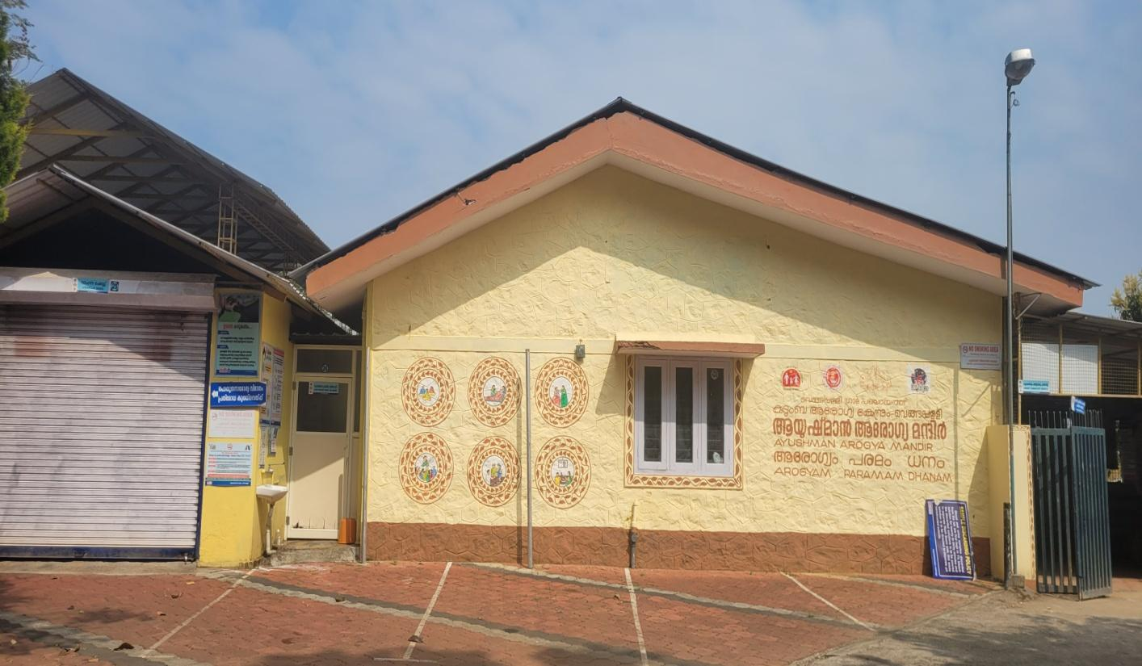
MESSAGE BY MEDICAL OFFICER
pandemic preparedness is esstential to protect the health and safety of our community.it is not only a medical responsibility but also a collective social duty.so together through cooperation and preparedness ,we can reduce risks and safeguard lives.
Medical Officer
Family health centre, Kottathara

exicutive summary
The Family Health Centre (FHC), Vengapally functions as the primary public healthcare institution serving the population of Vengapally Grama Panchayat. The FHC plays a pivotal role in delivering comprehensive, accessible, and affordable healthcare services, with a strong focus on preventive, promotive, curative, and rehabilitative care in alignment with national and state health programmes.
The FHC caters to a predominantly rural population and addresses key public health priorities such as maternal and child health, communicable and non-communicable disease control, immunization, family welfare, adolescent health, and geriatric care. Regular outpatient services, home-based care through field health staff, and outreach activities ensure healthcare coverage even in geographically challenging areas of the Panchayat.
The institution actively implements major national health programmes, including the National Health Mission (NHM), the National Tuberculosis Elimination Programme (NTEP), the National Programme for Prevention and Control of Cancer, Diabetes, Cardiovascular Diseases and Stroke (NPCDCS), and other disease surveillance initiatives under IDSP.
Vengapally FHC works in close coordination with Vengapally Grama Panchayat, ASHA workers, Anganwadi centres, schools, and community-based organizations to strengthen community participation and enhance health awareness. Special emphasis is placed on early detection, timely referral, health education, behavioural change communication, and lifestyle modification to reduce disease burden and improve overall health outcomes.
Despite constraints related to infrastructure, manpower limitations, and increasing service demand, the FHC continues to improve service delivery through systematic planning, data-driven decision-making, and active community engagement. Strengthening infrastructure, upgrading digital health systems, and expanding preventive and screening services remain key focus areas for future development.
Overall, the Family Health Centre, Vengapally, stands as a vital institution in safeguarding public health and improving the quality of life of the residents of Vengapally Grama Panchayat.

LIST OF ABBREVIATIONS

LSGD/LSGI | Local Self Government Department / Local Self Government Institution
MO | Medical Officer
IDSP | Integrated Disease Surveillance Programme
NDMA | NationalDisaster Management Authority
PPE | Personal Protective Equipment
ICMR | IndianCouncil of Medical Research
CD | Communicable Diseases
NCD | NON-COMMUNICABLE Diseases

TABLE OF CONTENTS

INTRODUCTION 9
● Background of the PPP 9
LSGD AT A GLANCE 7
INTEGRATED HEALTH INFRASTRUCTURE MAP OF VENGAPALLY 17
GENERAL PROFILE OF THE LSGI’S 20
Background of the LSGI 20
Demographic and Vulnerable Population 22
Clinical Vulnerability 23
INFRASTRUCTURE & RESOURCE INVENTORY 25
Health Facility Directory & Basic Capacity in the LSGD 25
Private Clinics 26
Healthcare Education & Training Institutions 27
Specialized Services & Emergency Inventory 27
Oxygen & Diagnostic Capacity 29
Diagnostics facility mapping at the LSGI level 29
Laboratory Identification & Basic Details 30
Social and Community Infrastructure for surge plan 30
Human resources 32
Community & Support Cadre 34
Community Organizations 35
Administrative & Emergency Services 36
Information regarding resources 37
ONE HEALTH & ENVIRONMENTAL SURVEILLANCE 38
Animal & Bird Population 38
Veterinary Infrastructure 39
Veterinary Doctors & Workforce 40
High-Risk Interface Points (Surveillance Sites) 41
Environmental Risk Mapping 44
Disease Seasonality Mapping 46
Vulnerability Mapping 46
EPIDEMIOLOGICAL TRENDS (2021–2025) 48
Disease Burden among human beings(Last 5 Years) 48
*(use the above table data to create the graph/diagram) 50
Seasonal Trend Analysis 51
Outcome-Based Trend Analysis- 2025 56
Transmission Trend- 2025 56
Integrated Disease Hotspot Map (2021–2025) 60
Preparedness and Response Protocol at LSG Level 62
Constitution of One Health Committee 62
Pandemic Response Workforce 64
Activities and Measures before and during Pandemic 65
PHASE 1 - Alert / Preparation 65
PHASE 2 - Active Response 78
Standard Screening Protocol 79
PHASE 3 - Surge Capacity 89
Conversion of Community Facilities 89
CONCLUSION 91
RECOMMENDATIONS 92
ANNEXURE 96
1. IMPORTANT PHONE NUMBERS 96

INTRODUCTION

Background of Pandemic Preparedness Plan
Vengapally Grama Panchayat has integrated pandemic preparedness into its local health governance framework to ensure early detection, rapid response, and effective containment of infectious diseases. In coordination with the Health Department and local healthcare facilities, the Panchayat strengthens disease surveillance, promotes infection prevention practices, and conducts community awareness programs. Emphasis is placed on protecting vulnerable populations, maintaining essential health services, and ensuring coordinated action during public health emergencies to minimize transmission, morbidity, and mortality.

LSGD AT A GLANCE

Geographical Boundaries – Vengapally Grama Panchayat
Vengapally Grama Panchayat is located in Wayanad district under Vythiri Taluk and forms part of Kalpetta Block Panchayat. The Panchayat covers an approximate area of 21.16 sq. km.

Boundaries
- North: Kottathara Grama Panchayat
- South: Pozhuthana Grama Panchayat
- West: Thariyode Grama Panchayat
- East: Muttil Grama Panchayat
The Panchayat consists of multiple wards as per the latest delimitation under the Kerala Panchayat Raj Act and functions as a rural local self-government institution responsible for local administration and development activities.

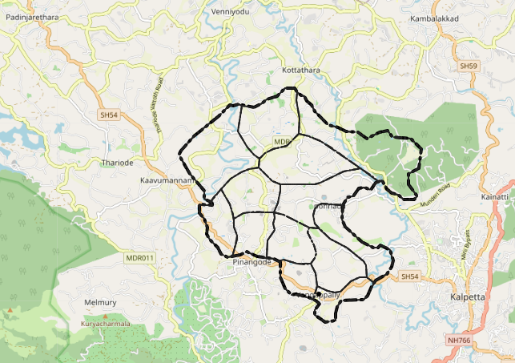

Baseline data

Name of LSGI | Vengapally
Type (GP/Municipality / Corporation etc.) | Grama Panchayath
Block | Kalpetta
District | Wayanad
Number of wards | 14
Total area (sq. km) | 21.16sq.k.m
Population(Projected) | 14094

Ward | Houses | Population | Migrants | Wells | Hot  spots | Ed. Institutions | Hosp pvt/govt.
14 | 3271 | 14399 | 135 | 2343 | nil | 6 | 0/3

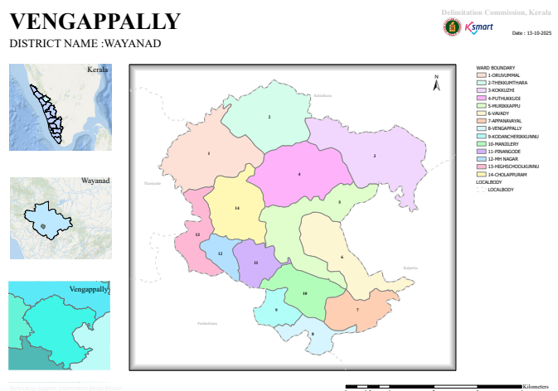

Major Roads
- National Highway 766 (NH 766) – The primary highway connecting Kalpetta (near Vengapally) to Kozhikode in Kerala and Mysore in Karnataka; provides regional access even if it does not run directly through every part of the Panchayat.

Important Nearby State/Regional Roads
- State Highway 29 (SH 29) – Connects Chundale (near Kalpetta) to Vaduvanchal and onward toward the Kerala–Tamil Nadu border via Gudalur; accessible from Vengapally area via connecting roads.
- Local village and Panchayat roads link Vengapally to neighbouring settlements such as Pinangode, Pozhuthana, Puthukudikunnu, Vavadi, and Kalpetta town.

Local Connectivity Roads
- Vengapally – Kalpetta Road – Connects the Panchayat with Kalpetta town and main transport hubs.
- Vengapally – Pinangode Road – Important intra-Panchayat road linking local wards.
- Village roads to Pozhuthana and nearby settlements – Provide access for residents to markets, schools, and health services.
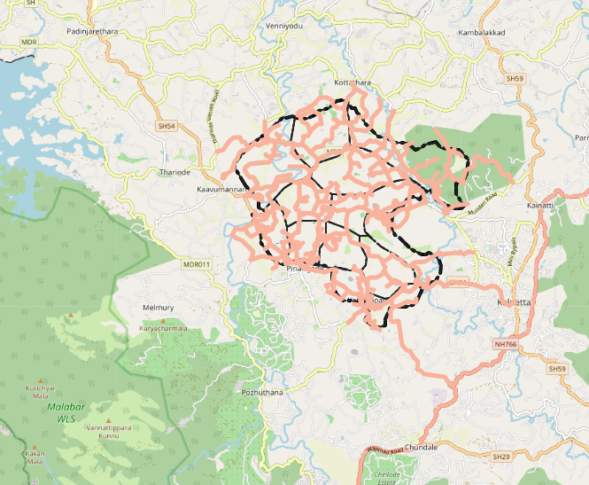

Major Rivers – Vengapally Grama Panchayat
- The Panchayat is influenced by the river system of Kabini River, a major river in Wayanad district.
- Panamaram River and its small seasonal tributaries are the main water streams affecting the local area.
- Several minor seasonal streams flow through the Panchayat, especially during the monsoon season.

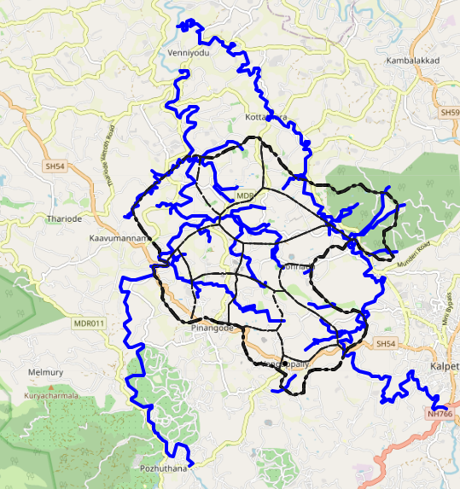

Disaster-Prone Areas – Vengapally Grama Panchayat
1. Landslide-Prone Areas
Hilly regions with steep slopes in the Panchayat
Areas with loose soil structure and deforested patches
Roadside cuttings and plantation zones on slopes
Locations experiencing heavy rainfall impact during monsoon
2. Flood-Prone and Waterlogging Areas
Low-lying areas near small streams and drainage channels
Regions influenced by the tributaries of the Panamaram River system
Agricultural lands with poor drainage
3. Soil Erosion Zones
Sloped agricultural fields
Riverbank and streamside settlements
Areas with reduced vegetation cover
4. Wind and Storm Vulnerable Areas
Houses with weak or temporary roofing structures
Isolated hilltop settlements
5. Public Health Risk Zones
Areas with poor sanitation and stagnant water, increasing risk of vector-borne diseases
Densely populated localities with limited waste management facilities
- 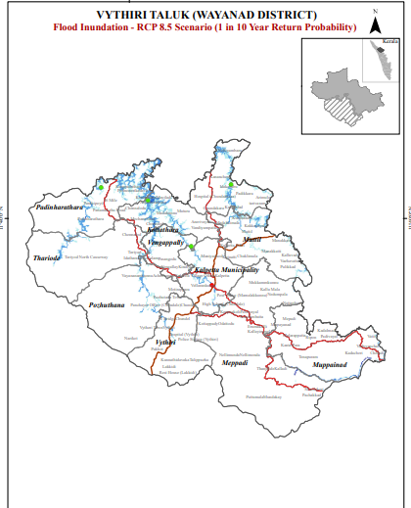
- 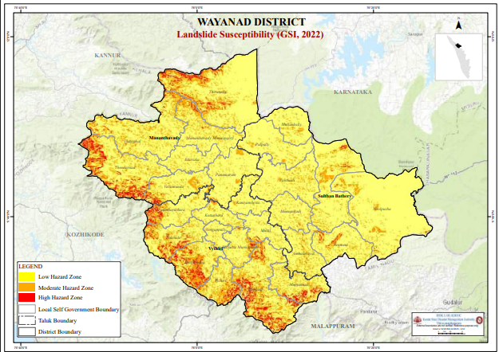

INTEGRATED HEALTH INFRASTRUCTURE MAP OF ____________ PANCHAYAT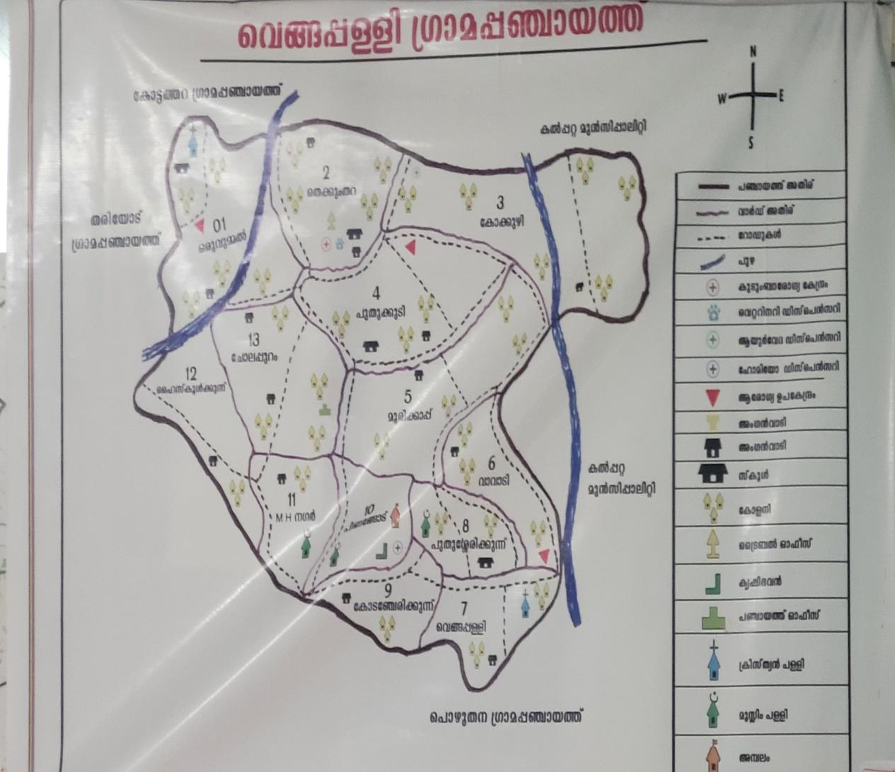

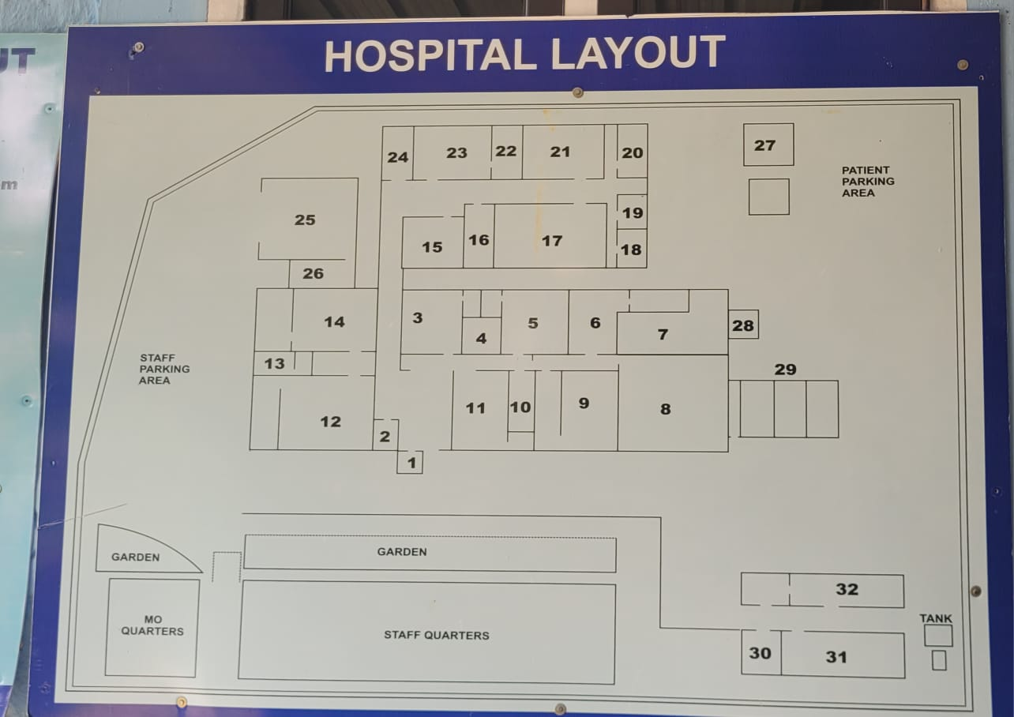

ORGANISATION CHART

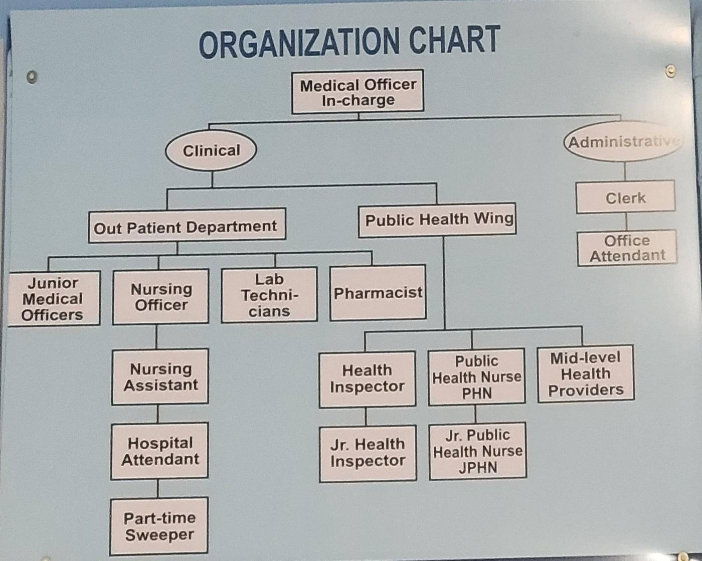

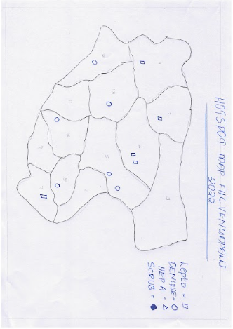
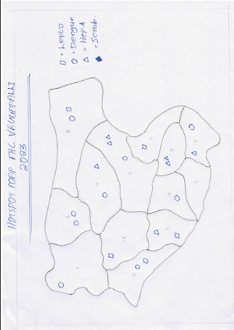

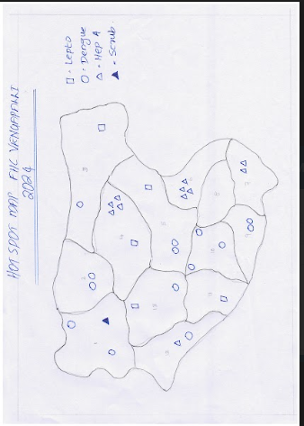

GENERAL PROFILE OF THE LSGI’S

Background of the LSGI
Vengapally Grama Panchayat is located in Wayanad district, Kerala, and is characterised by a high-altitude tropical landscape with lush greenery, paddy fields, and hilly terrain. The area is known for its agricultural traditions, local festivals, and emerging tourism potential, including natural forest landscapes such as the bamboo forest area locally known as Pachathuruthu.
The Panchayat is administratively divided into multiple wards, with a population largely dependent on traditional livelihoods. Agriculture forms the main economic activity, particularly paddy cultivation, coffee plantation farming, and allied agricultural work. In recent years, tourism-related activities and service sector employment have shown gradual growth. The area also has a diverse workforce, including migrant labourers engaged in construction, agriculture, and related sectors.
From a public health and disaster management perspective, Vengapally Grama Panchayat is vulnerable to seasonal flooding, water stagnation, and vector-borne diseases such as dengue and leptospirosis. The severe flood events in recent years, including the impacts of the 2018 Kerala flood, affected livelihoods, infrastructure, and community life, highlighting the need for stronger preparedness and response systems.
In this context, the development of a localized, data-driven auxiliary infrastructure and logistical resource mapping system is essential for effective emergency planning, rapid response, improved accessibility during disasters, and long-term community resilience.

Table 1: Background of LSGD
Description | Details
Name of LSGI | Vengapally
Type (GP/Municipality / Corporation etc.) | Grama Panchayath
Block | Kalpetta
District | Wayanad
Number of wards | 14
Total area (sq. km) | 21.16sq.k.m
Population(Projected) | 14094
Population density | persons/sq km
Terrain (coastal/low-lying/backwaters/foothills, etc.) | High altitude ,lush,green topical landscape
Number of rivers passing through LSGI | 2
Number of water bodies in the LSGI | 0
Number of educational institutions | 6
Factories / small-scale industries | 0
Flood-prone wards | 3(kokkuzhi)1(karattapadi)
Landslide-prone wards | Nil
Death Management and Disposal Facilities (mortuaries/crematorium, including electric) | Nil
Auditoriums/Marriage halls/convention centres/community halls | 1

Demographic and Vulnerable Population
Understanding the demographic composition and vulnerable population groups is essential for pandemic preparedness in Vengapally Panchayath. Children, the elderly, economically deprived families, migrant workers, and other socially vulnerable groups in the Panchayath are at increased risk during public health emergencies due to higher exposure, limited access to services, and dependence on public systems. Identifying and prioritizing these groups helps the Panchayath and health authorities plan targeted interventions, ensure equitable access to essential services, and strengthen community resilience during pandemics.

Description |  | Details (in numbers)
DEMOGRAPHIC PROFILE
Total population |  | 14094
Male |  | 6735
Female |  | 7359
Transgender |  | 0
Children under 5 |  | 509
Adolescent |  | 1320
Elderly (>60) |  | 1191
SOCIAL/LIVELIHOOD VULNERABILITY
Previous EPEP family |  | 22
BPL family |  | 1676
Tribal communities |  | 60
Migration | Immigrant | 135
Socio-economically deprived |  | 0
Fisherfolk |  | 0
SC Community |  | 482
ST Community |  | 3934

Clinical Vulnerability
Certain population groups in Vengapally Panchayath require priority healthcare, as they are at higher risk of severe illness, complications, and mortality during pandemics. Patients with chronic diseases, those needing regular medical care, and individuals with mobility or functional limitations may face difficulties in accessing timely care during emergencies. Mapping these groups in Vengapally Panchayath helps prioritize continuity of treatment, plan medicine stocks, ensure availability of oxygen support, arrange referral transport, and provide targeted home-based care.

Description | Details in numbers
Pregnant women | 76
Lactating mothers | 265
Bedbound patients | 42
Patients under palliative care other than bedbound | 67
Patients on Haemodialysis | 7
Patients on CAPD | 19
Cancer patients (currently on treatment) | 53
Haemophilic patients | 0
Mentally challenged | 10
Differently abled | 17
Diabetic patients | 179
Hypertensive patients | 407
TB patients | 5

INFRASTRUCTURE & RESOURCE INVENTORY

Health Facility Directory & Basic Capacity in the LSGD
This section provides an overview of the healthcare infrastructure available within Vengapally Panchayath. It outlines the distribution and basic capacity of health facilities that form the backbone of service delivery during routine periods as well as during public health emergencies.
Family Health Centres (FHCs) and Community Health Centres (CHCs) serve as the first point of contact for the community, providing essential outpatient and inpatient services. General Hospitals (GH) and Medical College Hospitals (MCH), where accessible to residents of Vengapally Panchayath, act as the main referral centres for advanced diagnostics, specialist care, and critical services during public health emergencies. This inventory helps identify existing strengths, gaps, and potential surge capacity that can be mobilised during pandemics or disasters.

Table 5. Health Facility Resource Summary
Sl.no. | Health Facility | Type of Facility (MCH/GH/CHC/FHC/SC etc.) | Contact Number | Total beds | ICU Beds | Oxygen-Supported Beds | No. of Ventilator Support Beds | No. of ambulance
Government Healthcare Facilities
 | vengapally | FHC | 7902476306 | 3 | 0 | 0 | 0 | 0
 | HWC Thekkumthara | SC |  | NIL | NIL | NIL | NIL | NIL
 | HWC MC | SC |  | NIL | NIL | NIL | NIL | NIL
 | HWC Madakkunnu | SC |  | NIL | NIL | NIL | NIL | NIL
 | HWC Puzhamudi | SC |  | NIL | NIL | NIL | NIL | NIL
Private Healthcare Facilities
 | NIL | NIL | NIL | NIL | NIL | NIL | NIL | NIL

Private Clinics
Private clinics form an important part of pandemic preparedness in Vengapally Panchayath, as they are often the first point of care when people begin experiencing symptoms. In many cases, private clinics handle a significant share of outpatient visits and therefore play a key role in early case detection, timely referrals, and support for disease surveillance.
Maintaining an up-to-date understanding of the location of private clinics in Vengapally Panchayath, the services they provide, and their linkage with the public health system ensures that no cases are missed during an outbreak. It also enables health authorities to engage private practitioners effectively for reporting, risk communication, and coordinated response, strengthening the overall capacity of the local health system to manage public health emergencies.

Table 6. Private Clinic Resource Summary
Sl No. | Name of Clinic | Registered (Y/N) | Clinic (General / Speciality) | Speciality (if any) | Address | Contact Number | Diagnostic Facility (Y/N) | Ambulance Linkage (Y/N)
 | Puthiyottil clinic | yes | general | no | Puthiyottil vegapally | 9745049035 | y | Yes
2 | Nasrath clinic | yes | general | no | vengapally | 9961694376 | yes | yes

Healthcare Education & Training Institutions
This section tracks the educational infrastructure available, which is vital for human resource planning in the health sector.

Category of Institution | Govt | Private | AYUSH | Total
Medical Colleges | nil | nil | nil | NIL
Nursing Colleges | Nil | Nil | nil | NIL
Dental Colleges | Nil | Nil | Nil | NIL
Para-medical / Allied Health | Nil | nil | Nil | NIL
Pharmacy Colleges | nil | nil | nil | NIL

Specialized Services & Emergency Inventory
This section provides a detailed overview of the specialized medical resources available to the community in Vengapally Panchayath, focusing on emergency response and critical care capabilities. The table tracks vital assets required for managing severe illnesses and emergencies across Government, Private, and AYUSH healthcare sectors.

Item | Govt | Private | AYUSH | Total
Hospital beds | nil | NIL | NIL | NIL
Oxygen-generating systems(Y/N) | NIL | NIL | NIL | NIL
Oxygen-supported beds(Numbers) | NIL | NIL | NIL | NIL
Ventilator-supported beds | NIL | NIL | NIL | NIL
ICU beds | NIL | NIL | NIL | NIL
Burns units | NIL | NIL | NIL | NIL
Blood centres | NIL | NIL | NIL | NIL
BLS ambulances | NIL | NIL | NIL | NIL
ALS ambulances | NIL | NIL | NIL | NIL
Dialysis facilities | NIL | NIL | NIL | NIL
Dispensaries | 1 | NIL | NIL | 1
Medical store | 1 | NIL | NIL | 1
Industrial establishments(Medium-scale industries/small-scale industries establishments to whom we can depend in a worst-case scenario) | Nil | NIL | NIL | NIL

Oxygen & Diagnostic Capacity
Monitoring oxygen and diagnostic capacity is a critical component of public health preparedness, ensuring that the LSGD can handle both chronic care and sudden surges in respiratory or infectious diseases.
Name of Health Facility | Oxygen-generating System (Y/N) | Backup Oxygen Source (Y/N) | Diagnostic Facilities Available(Y/N)
Name of Health Facility | Oxygen-generating System (Y/N) | Backup Oxygen Source (Y/N) | Lab | USG | X-ray | CT/MRI | RT-PCR
Government Healthcare Facilities
NIL | NIL | NIL | NIL | NIL | NIL | NIL | NIL
NIL | NIL | NIL | NIL | NIL | NIL | NIL | NIL

Diagnostics facility mapping at the LSGI level
The diagnostic capacity of Vengapally Panchayath represents the "intelligence network" of the local healthcare system. The speed and accuracy of disease identification depend entirely on the distribution and technical capabilities of these facilities.

Item | Govt | Private | AYUSH | Total
General labs | nil | 1 | 0 | 1
Microbiology labs | 0 | 0 | 0 | 0
RT-PCR labs | 0 | 0 | 0 | 0
USG units | 0 | 1 | 0 | 0
CT/MRI units | 0 | 1 | 0 | 0
Research labs | 0 | 0 | 0 | 0
Labs of other departments that can be repurposed | 0 | 0 | 0 | 0

Laboratory Identification & Basic Details
Sl. No. | Name of Laboratory | Ownership (Govt / Private / Academic) | Address | Contact No. | 24×7 Services (Yes/No) | NABL / Govt Approved (Yes/No)
1 | nil | nil | nil | nil | nil | nil
2 | nil | nil | nil | nil | nil | nil
3 | nil | nil | nil | nil | nil | nil
4 | nil | nil | nil | nil | nil | nil
5 | nil | nil | nil | nil | nil | nil

Social and Community Infrastructure for surge plan
This table serves as our logistics and shelter inventory. By mapping these locations, quickly we can identify where to house displaced citizens, where to set up temporary medical clinics, and how to manage the deceased with dignity during a crisis.

Category | Total Count |  | Ward | Est. Capacity (Persons) | Contact details
Educational Institutions
Anganwadis |  | 23 | 14 | 232 | 9048670065
Schools |  | 6 | 14 | 3204 | 9447544657
Colleges |  | 0 | 0 | 0 | 0
Healthcare Educational Institutions
Medical colleges (Govt/Private) | NIL |  | NIL | NIL | NIL
Nursing colleges (Govt/Private) | NIL |  | NIL | NIL | NIL
Dental colleges (Govt/Private) | NIL |  | NIL | NIL | NIL
Paramedical institutes (Govt/Private) | NIL |  | NIL | NIL | NIL
Community Gathering Spaces
Community halls | NIL |  | NIL | NIL | NIL
Auditoriums | 1 |  | 8 | 5000 | 9745176916
Religious buildings | 1 |  | 12 | 3207 | 9446081568
Vulnerable Group Support Facility
Destitute homes | 1 |  | 12 | 123 | 9446343933
Elderly homes | 1 |  | 8 | 92 | 94003707772
LSGD owned other buildings | NIL |  | NIL | NIL | NIL
Mass Fatality Management (MFM) Infrastructure
Mortuary | NIL |  | NIL | NIL | NIL
Crematorium | NIL |  | NIL | NIL | NIL
*refer annexure 1 for contact details

Human resources
This section focuses on the human capital available within the LSGI. In any emergency—be it a pandemic, flood, or industrial accident—infrastructure is only as effective as the people operating it

Cadre | Govt (No.) | Private (No.) | Total
Doctors—Modern Medicine | 3 | 2 | 5
Doctors – AYUSH | 0 | 0 | 0
Doctors – Veterinary | 1 | 0 | 1
Doctors – Dental | 0 | 0 | 0
Nursing officers | 2 | 2 | 4
Lab technicians | 2 | 1 | 3
Optometrist | 1 | 0 | 1
Pharmacists | 2 | 2 | 4
Psychologists | 0 | 0 | 0
Counsellors | 1 | 0 | 0

Public Health & Field-Level Workforce
These individuals are the backbone of surveillance, maternal-child health, and decentralized care.

Cadre | Health services | Municipal common services | Total
HS (Health Supervisors) | 1 | 0 | 1
HI (Health Inspectors) | 1 | 0 | 1
LHS (Lady Health Supervisor) | 1 | 0 | 1
LHI (Lady Health Inspectors) | 1 | 0 | 1
JPHN (Jr Public Health Nurses) | 2 | 0 | 2
JHI (Jr Health Inspectors) | 2 | 0 | 2
MLSP (Mid-Level Service Providers) | 4 | 0 | 4
Palliative Nurses | 1 | 0 | 1
RBSK Nurses | 1 | 0 | 1
PRO | 1 | 0 | 1
Epidemiologist | 1 | 0 | 1
Data Manager | 1 | 0 | 1

Community & Support Cadre
This group represents the surge capacity of the LSGI—people who can be called upon for logistics, rescue, and specialized support.

Cadre | Number
ASHA Workers | 13
AWW (Anganwadi Workers) | 23
Emergency Medical Volunteers (Trained) | 20
Kudumbashree | 1575
MNREGS | 1795
Purusha Swayam Sahaya Sangham | 0
Ex-Servicemen | 0
Retired Police Officers | 0
NCC/NSS Volunteers | 50
Red Cross volunteers | 0
One Health Community Volunteers | 0
One Health Community Mentors | 0

Community Organizations
This section details the presence of community-based organisations (CBOs), non-governmental organisations (NGOs), faith-based organisations (FBOs), Kudumbashree Self-Help Groups (SHGs), and Ayalkootams within the Local Self-Government Institution (LSGI). These groups enhance grassroots mobilization, resource distribution, and support networks crucial for pandemic response and community resilience.

Category | Total Count
NGOs | 253
Religious based organizations | 3
Foreign based organizations | 0
Sports Club/youth clubs | 1
Kudumbashree SHGs | 52
Ayalkootams | 0
Political organizations | 3
Residential organizations | 0

Administrative & Emergency Services
This section outlines the availability of key non-health emergency support services and infrastructure within the LSGI, which are essential for effective pandemic preparedness and response. These facilities support law enforcement, disaster response, water supply, logistics, mobility, and community-level interventions during public health emergencies.

Category | Total Count | Contact details
Police Stations | 1 | Kalpetta-04936202400
Fire & Rescue Stations | 1 | Kalpetta-04936202303
Water Pumping Points | 0 | 0
Public Distribution System (PDS) | 0 | 0

Information regarding resources
The availability of essential transport and support resources plays a critical role in saving lives in Vengapally Panchayath. Equipment such as ambulances, mobile mortuaries, amphibian ambulances, and motorized boats ensures that patients, samples, and healthcare teams can move quickly, even in flooded, remote, or difficult terrains. Heavy vehicles like JCBs, cranes, tractors, and torus lorries support logistics, waste management, emergency infrastructure, and the rapid conversion of spaces into care or isolation facilities. Taxis, four-wheel-drive vehicles, and trucks help maintain continuity of essential services, reach vulnerable populations, and support home-based care and delivery of supplies.

Means of transportation | Total Count
JCB | 3
Crane | 1
Heavy Trucks | 4
Tractor | 9
Ambulances | 1
Mobile mortuaries | 0
Boats | 0
Taxi service | 5

ONE HEALTH & ENVIRONMENTAL SURVEILLANCE
The One Health approach integrates environmental, animal, and human health to enable proactive pandemic preparedness in Vengapally Panchayath. Panchayat-level surveillance needs to be strengthened to detect and manage zoonotic and environmentally generated diseases early. This can be achieved through systematic assessment of animal populations, veterinary infrastructure, poultry and slaughter facilities, inter-sectoral coordination, and specialized tools such as avian influenza seasonality mapping using GIS from previous outbreaks. Ward-specific sampling and predictive alerts help support effective pandemic preparedness in high-risk areas of the Panchayath.

Animal & Bird Population
Mapping animal and bird populations in Vengapally Panchayath is essential for identifying and prioritizing zoonotic disease hazards such as rabies, avian influenza (H5N1), leptospirosis, anthrax, and Nipah-like spillover events. Comprehensive population mapping enables risk classification, targeted surveillance, vaccination planning, and early epidemic detection, all of which strengthen One Health–based pandemic preparedness in the Panchayath.

Category | Item | Estimated Population | Wards
Animal Population | Livestock (Cattle/Goats/Buffalo) | 1595 | 1
Animal Population | Pet Animals (Dogs/Cats) | 500 | 8
Animal Population | Stray Dog Population | 800 | 6
Animal Population | Pig Farms (Number of heads) | 285 | 7
 | Small Units (Sheep / Goats – clustered) | 200 | 12
Bird Population | Poultry Units (Birds) | 0 | 0
Bird Population | Poultry- (FOWL) | 15957 | 12,5,9
Bird Population | Wild/Migratory Birds (Observed) | 0 | 0
Bird Population | Crow Mortality Events (Reported) | 0 | 0

The main risk of zoonotic diseases in Vengapally Panchayath is concentrated in Wards 12, 5, and 9, due to the high density of pig farms, cattle congregation areas, and poultry units. The stray dog population in market areas, fish landing sites, and bus stations remains a significant challenge for rabies surveillance and bite prevention. There is a notable risk of avian influenza introduction and amplification during November–December, driven by the seasonal presence of migratory and resident water birds near ponds, canals, rivers, and paddy fields. Clusters of pig farms and animal shelters that are vulnerable to flooding further increase the risk of leptospirosis and other environmentally mediated zoonoses, particularly during the monsoon season.

Veterinary Infrastructure
Veterinary institutions are a core pillar of One Health surveillance, enabling early zoonotic disease detection through vaccination, investigation of unusual animal illness or deaths, sample collection, and timely outbreak reporting. A well-mapped and responsive veterinary network strengthens coordination with human health and LSGI systems, ensuring rapid response during zoonotic events and pandemics.
Facility Type | Name of Facility | Ownership Govt / Pvt | Location(Ward No) | Contact number
Veterinary Dispensary | 1 | govt | 2 | 04936298022
Veterinary Hospital / Polyclinic | 0 | 0 | 0 | 0
Private Veterinary Clinics | 0 | 0 | 0 | 0
Mobile / Emergency Vet Service (incl. night services) | 0 | 0 | 0 | 0
Pet Homes / Animal Shelters | 0 | 0 | 0 | 0
Slaughterhouse-linked Veterinary Inspection Unit | 0 | 0 | 0 | 0

Veterinary Doctors & Workforce
Early detection, diagnosis, reporting, and response to animal disease outbreaks in Vengapally Panchayath depend on the availability and accessibility of qualified veterinary specialists. Prompt identification of unusual animal morbidity or mortality, timely sample collection, and efficient coordination with human health and Panchayath systems—especially during zoonotic outbreaks and pandemic-prone situations—ensure that a well-defined veterinary workforce strengthens One Health surveillance and supports effective pandemic preparedness.

Category | Number Available | Type (Govt/Pvt) | Contact number
Government Veterinary Doctors | 0 | 1 | 04936298022
Private Veterinary Doctors | 0 | 0 | 0
Livestock Inspectors | 0 | Govt | 04936298022
Para-veterinary Staff / Attenders | 0 | 0 | 0
Contract / On-call Veterinary Support (if any) | 0 | 0 | 0

High-Risk Interface Points (Surveillance Sites)
High-risk interface points for zoonotic disease surveillance in vengapally Grama Panchayath include wetland–livestock–human contact zones, backyard poultry farms, cattle sheds near water bodies,

Type of Habitat | Type of High risk interface | Geographical vulnerability
Wetlands & Backwaters | No | 0
Backyard Poultry Farms | No | 0
Cattle Sheds near Water Bodies | No | 0
Fish & Meat Markets | 5 | 1
Community Slaughter Sites | No | 0
Migratory Bird Congregation Areas | No | 0
Rodent-Infested Grain Storage | No | 0

Category | Total Count | Key Locations (wards)
Poultry Farms | 2 | 5,3 ward
Backyard / Clustered Poultry Units | 0 | 0
Duck Rearing Units (open water access) | 0 | 0
Slaughterhouses/ Slaughter Points | 0 | 0
Meat/Fish Markets | 3 | 0
Live Bird Sale Points | 0 | 0
Cattle Markets / Weekly Animal Fairs | 0 | 0
Pet Shops / Breeders | 0 | 0
Animal Shelters / Pet Homes | 0 | 0
Waste Disposal Sites near Animal Units | 0 | 0

Environmental Risk Mapping

Monsoon-Related Health Risks — Vengapally Panchayat (Kerala)
• Vector-borne diseases (dengue, chikungunya): Heavy rains and standing water create breeding sites for mosquitoes, increasing the chance of dengue and related fevers during/after monsoon. Mosquito population control and eliminating stagnant water reduces risk.
• Water-borne diseases & leptospirosis: Flooding and waterlogging increase exposure to contaminated water. Leptospira bacteria from animal urine can infect people through skin contact, especially when walking through floodwater or stagnant pools.
• Sanitation risks: Poor market hygiene (informal slaughter or fish stalls) and inadequate waste management can raise spillover risks for water-borne and zoonotic infections if not managed properly.
Key precautions for Vengapally
– Remove standing water, keep surroundings clean.
– Use protective gear when in floodwater.
– Drink boiled/treated water and maintain hygiene.

Risk Factor | High-Risk Wards | Key Locations | Risk Level (High/Med/Low)
Flood-prone areas | 3,2,1 | Thekkumthara,kokuzhi | high
Water bodies/wetlands | 3 | kokkuzhi | low
Solid waste accumulation | nil | nil | nil
Animal waste disposal issues | no | no | no
Rodent infestation zones | nil | nil | Ni;
Industrial effluent discharge | nil | nil | nil
Construction sites / abandoned buildings | nil | nil | nil
Poor drainage/blocked canals | nil | nil | nil
Drinking water source contamination risk | Nil | nil | nil

Disease seasonality maping
Flooding and waterlogging in Vengapally Panchayath → amplifies leptospirosis, malaria, and diarrheal diseases.
Influx of migratory birds (November–February) → increases the risk of avian influenza.
Mosquito breeding cycles → lead to peaks of vector-borne diseases during the monsoon.
Agricultural practices → create close human–animal contact in paddy fields, raising the risk of zoonotic infections.

Disease | Peak Risk Season | Key Drivers | High-Risk Locations | Surveillance Focus
Avian Influenza | 0 | 0 | 0 | 0
Leptospirosis | 0 | 0 | 0 | 0
Dengue/Chikungunya | 0 | 0 | 0 | 0
Acute Diarrheal Diseases | 0 | 0 | 0 | 0
Rabies | 0 | 0 | 0 | 0
Anthrax (rare) | 0 | 0 | 0 | 0

Vulnerability Mapping
Vulnerability mapping pinpoints high-risk populations, occupations, and areas exposed via environment, livelihoods, socio-economics, and poor service access. Paired with
environmental/seasonality mapping, it enables risk-based surveillance, targeted actions, and optimal resource use in One Health and pandemic planning.
Vulnerability Factor | High-Risk Wards | Key Groups / Locations | Risk Level
Flood-prone households | 3,2,1 | Kokkuzhi,thekkumthara | high
Wetland-adjacent communities | NIL | NIL | NIL
Backyard poultry / duck rearing households | NIL | NIL | NIL
Livestock-rearing households | NIL | NIL | NIL
Slaughterhouse & meat market workers | NIL | NIL | NIL
Fisherfolk & fish market workers | NIL | NIL | NIL
Sanitation workers | NIL | NIL | NIL
Daily wage / migrant workers | NIL | NIL | NIL
Elderly & chronically ill populations | NIL | NIL | NIL
Pregnant Women | NIL | NIL | NIL
Children (schools, Anganwadi’s) | NIL | NIL | NIL
Limited access to safe water & sanitation | NIL | NIL | NIL

EPIDEMIOLOGICAL TRENDS (2021–2025)
Disease surveillance is the systematic collection, analysis, and interpretation of health data for planning, implementation, and evaluation of public health activities. This section presents the disease surveillance profile of Vengapally Panchayath based on routine reporting systems and outbreak investigations, highlighting priority diseases, seasonal patterns, and emerging public health threats.

Disease Burden among human beings(Last 5 Years)
Analysis of disease-wise data for the last five years helps identify persistent public health problems, emerging diseases, and changes in disease burden. This information supports prioritisation of prevention, preparedness, and response activities at the Panchayat level.

Disease | 2021 | 2022 | 2023 | 2024 | 2025 | Trend(Increasing/Stable/Decreasing)
Dengue | 6 | 6 | 11 | 13 | 10 | increasing
Leptospirosis | 3 | 4 | 4 | 5 | 5 | stable
Hepatitis A | 1 | 0 | 7 | 12 | 1 | increasing
Malaria | 0 | 0 | 0 | 0 | 0 | 0
Scrub Typhus | 0 | 0 | 0 | 1 | 0 | stable
Typhoid | 0 | 0 | 0 | 0 | 0 | 0
H1N1 | 0 | 0 | 0 | 1 | 0 | stable
H3N2 | 0 | 0 | 0 | 0 | 0 | 0
ADD | 54 | 62 | 45 | 42 | 48 | stable
Mumps | 0 | 00 | 0 | 0 | 0 | 0
Measles | 0 | 0 | 1 | 0 | 0 | Stable
Hepatitis B | 0 | 0 | 0 | 0 | 0 | 0
Hepatitis C | 0 | 1 | 0 | 0 | 0 | Stable
Tuberculosis | 5 | 6 | 5 | 8 | 8 | Stable
Leprosy | 0 | 1 | 0 | 0 | 0 | Stable
COVID-19 | 412 | 0 | 0 | 0 | 0 | decreasing

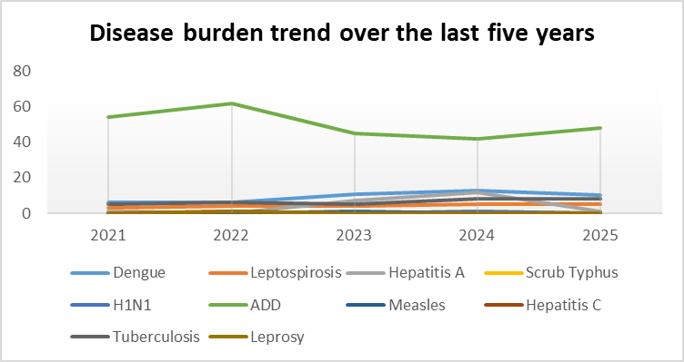

Seasonal Trend Analysis
Seasonal analysis helps anticipate surges (e.g. dengue in monsoon, leptospirosis after floods, influenza in cooler months) and plan pre‑emptive vector control, stockpiling of IV fluids, and awareness campaigns at Panchayat level.

DENGUE
Dengue is a major seasonal vector-borne disease strongly associated with rainfall, water stagnation, and increased mosquito breeding during the monsoon period.

Peak: July–November

Dengue – Ward-wise Yearly Distribution (2021–2025)

Ward | Dengue – Ward-wise Yearly Distribution
Ward | 2021 |  | 2022 | 2023 | 2024 | 2025 |  | Total
1 | 0 |  | 0 | 2 | 0 | 1 |  | 44
2 | 1 |  | 1 | 2 | 2 | 2 |  | 2
3 | 2 |  | 1 | 1 | 4 | 2 |  | 3
4 | 0 |  | 1 | 1 | 2 | 3 |  | 2
5 | 2 |  | 2 | 2 | 4 | 2 |  | 8
6 | 0 |  | 2 | 3 | 6 | 2 |  | 5
7 | 0 |  | 0 | 2 | 7 | 2 |  | 0
8 | 0 |  | 0 | 3 | 10 | 1 |  | 6
9 | 1 |  | 2 | 7 | 5 | 1 |  | 6
10 | 1 |  | 1 | 2 | 2 | 1 |  | 1
11 |  | 0 | 0 | 1 | 5 |  | 2 |  | 0
12 |  | 1 | 1 | 2 | 4 |  | 2 |  | 0
13 |  | 0 | 0 | 2 | 3 |  | 1 |  |  | 0
14 |  | 0 | 0 | 0 | 0 |  | 0 |  |  | 0

LEPTOSPIROSIS
Leptospirosis cases are closely linked to monsoon rains, flooding, and occupational exposure, particularly in low-lying and waterlogged areas.

Peak: June - August

Leptospirosis – Ward-wise Yearly Distribution (2021–2025)

Ward | Leptospirosis – Ward-wise Yearly Distribution
Ward | 2021 | 2022 | 2023 | 2024 | 2025 | Total
1 | 1 | 0 | 0 | 0 | 0 | 27
2 | 1 | 0 | 0 | 1 | 0 | 2
3 | 0 | 1 | 0 | 1 | 0 | 1
4 | 0 | 1 | 1 | 0 | 1 | 5
5 | 0 | 1 | 1 | 4 | 0 | 6
6 | 0 | 1 | 1 | 1 | 0 | 5
7 | 0 | 2 | 0 | 1 | 1 | 3
8 | 00 | 1 | 0 | 0 | 0 | 3
9 | 1 | 0 | 0 | 0 | 0 | 1
10 | 0 | 0 | 0 | 0 | 0 | 1
11 | 0 | 0 | 0 | 0 | 0 | 0
12 | 0 | 1 | 0 | 0 | 0 | 0
13 | 0 | 0 | 0 | 2 | 0 | 0

VIRAL HEPATITIS - A
Hepatitis A cases are commonly associated with unsafe drinking water, food contamination, and breakdowns in sanitation, often presenting as clusters or outbreaks.

Peak: October - December

Hepatitis A – Ward-wise Yearly Distribution (2021–2025)

Ward | Hep A – Ward-wise Yearly Distribution
Ward | 2021 | 2022 | 2023 | 2024 | 2025 | Total
1 | 0 | 2 | 0 | 1 | 0 | 21
2 | 1 | 0 | 0 | 0 | 1 | 4
3 | 1 | 0 | 0 | 1 | 0 | 5
4 | 0 | 0 | 0 | 3 | 0 | 6
5 | 0 | 0 | 0 | 1 | 0 | 3
6 | 0 | 0 | 0 | 0 | 2 | 0
7 | 0 | 0 | 2 | 1 | 0 | 2
8 | 0 | 0 | 0 | 0 | 1 | 5
9 | 0 | 1 | 0 | 4 | 0 | 0
10 | 0 | 0 | 0 | 5 | 0 | 3
11 | 0 | 0 | 0 | 2 | 3 | 0
12 | 0 | 0 | 0 | 9 | 2 | 0
13 | 1 | 0 | 0 | 0 | 1 | 0

Outcome-Based Trend Analysis- 2025

Transmission Trend- 2025
For effective management of public health issues in Vengapally Panchayath, it is important to track trends in disease transmission modes. This helps identify populations or areas at higher risk, allowing authorities to predict potential outbreaks and implement targeted interventions promptly. Understanding these trends also enables efficient allocation of resources and timely adjustment of strategies based on how the situation evolves.

Mode of Transmission | No. of cases | No. of Deaths
Vector Borne Diseases | 10 | 0
Water Borne Diseases | 1 | 0
Air Borne Diseases | 8 | 0
Blood Borne Diseases | 0 | 0
Food Borne Diseases | 0 | 0

Vector-Borne Disease

Disease | No. of Cases | No. of Deaths
Dengue | 10 | 0
Malaria | 0 | 0
Chikungunya | 0 | 0

Water Borne Disease

Disease | No. of Cases | No. of Deaths
Cholera | 0 | 0
Typhoid | 0 | 0
Hep- A | 1 | 0
Dysentery | 0 | 0
Amoebiasis | 0 | 0
E- Coli infections | 0 | 0
Air Borne Disease

Disease | No. of Cases | No. of Deaths
Influenza | 0 | 0
H1N1 | 0 | 0
TB | 8 | 0
Chickenpox | 0 | 0
Measles | 0 | 0
Covid-19 | 0 | 0
Pertussis | 0 | 0
Mumps | 0 | 0

Blood-Borne Disease

Disease | No. of Cases | No. of Deaths
AIDS | 0 | 0
Hep- B | 0 | 0
Hep- C | 0 | 0

Zoonotic Disease

Disease | No. of Cases | No. of Deaths
Rabies | 0 | 0
Leptospirosis | 5 | 0
Avian influenza | 0 | 0
West nile | 0 | 0
Anthrax | 0 | 0
Nipah | 0 | 0
Scrub Typhus | 0 | 0

Integrated Disease Hotspot Map (2021–2025)

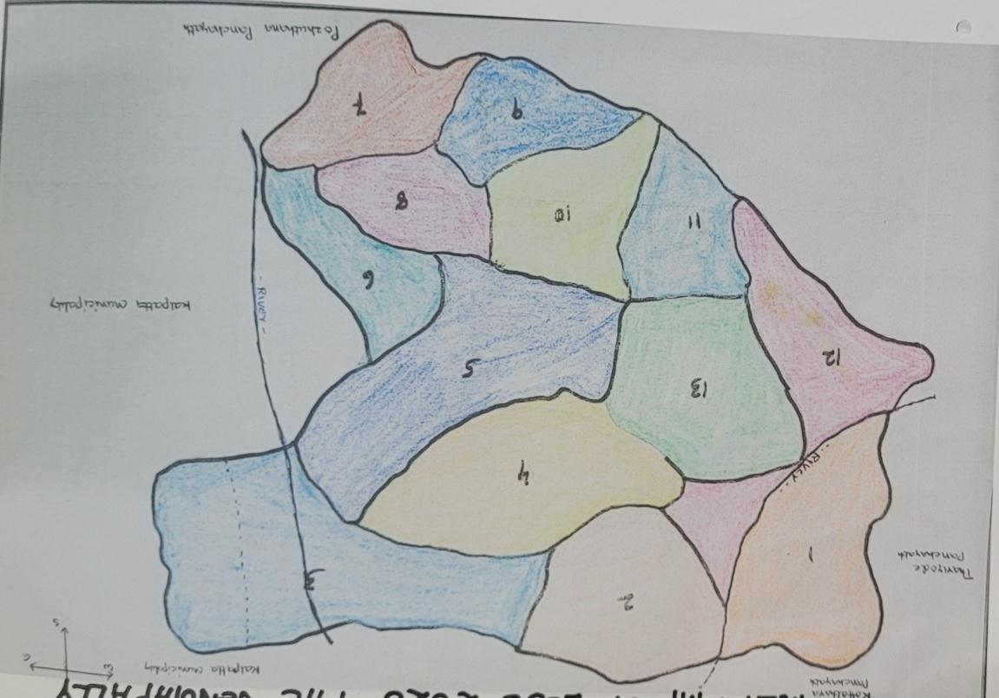

Hotspot ward -12 and 8

Ward No | Dengue Total (2021-25) | Leptospirosis Total (2021-25) | Hepatitis A Total (2021-25) | Mumps (2021-25) | ADD (2021-25) | Total Cases
1 | 44 | 27 | 21 | 0 | 251 | 343
2 | 2 | 2 | 4 | 0 | 23 | 51
3 | 3 | 1 | 5 | 0 | 16 | 25
4 | 2 | 5 | 6 | 00 | 25 | 38
5 | 8 | 6 | 3 | 0 | 24 | 41
6 | 5 | 5 | 0 | 0 | 18 | 28
7 | 0 | 3 | 2 | 0 | 18 | 23
8 | 6 | 03 | 5 | 0 | 19 | 33
9 | 6 | 1 | 0 | 0 | 23 | 30
10 | 1 | 1 | 3 | 0 | 45 | 50
11 | 0 | 0 | 0 | 0 | 10 | 10
12 | 0 | 0 | 0 | 0 | 12 | 12
13 | 0 | 0 | 0 | 0 | 28 | 28

Preparedness and Response Protocol at LSG Level

This section describes the operational framework for Vengapally Panchayath once a pandemic is declared. It explains how the Panchayath and health system will transition from routine data collection to an active response, guided by a One Health approach.

Constitution of One Health Committee
The LSGD shall constitute a One Health Committee comprising the LSGI President, Medical Officers (Modern Medicine, AYUSH, and Veterinary), the Health Inspector, and the Veterinary Surgeon.

Objective: The One Health Committee coordinates human, animal, and environmental health to prevent and control pandemics.

Sl No | Name | Designation | Department/Institution | Role in Committee | Contact Number
1 | Jasar palakkal | Panchayat President | LSGD | Chairperson | 9745176916
2 | Dr,anwar sadath vt | Medical Officer (PHC/CHC) | Health Dept | Member Secretary | 9961036556
3 | Akhila | Veterinary Officer | Animal Husbandry | Member | 04936298022
4 | Evin ziyamol | Epidemiologist | Health Dept | Member | 9544142784
5 | Manju au | Health Inspector/PHN | Health Dept | Surveillance | 8086494549
6 | ambika | ASHA Supervisor | Health Dept | Community link | 9961694376
7 | sheeja | ICDS Supervisor | Social Welfare | Vulnerable groups | 9048670065
8 | nil | Police Station Officer | Police Dept | Law & order
9 | ambili | Ward Councillor Representative | LSGD | Community coordination | 9605116330
10 | babitha | Kudumbashree CDO | Kudumbashree | Community mobilisation | 9846200187
11 | nil | NGO/Volunteer rep | Civil Society | Support services
12 |  | Line Department representations

Key Responsibilities:
- Review disease surveillance data (human + animal)
- Conduct ward-wise risk assessment and vulnerability mapping
- Approve quarantine/isolation centre locations
- Coordinate with district for resources (PPE, oxygen, ambulances)
- Periodically review health system surge capacity, including beds, oxygen, human resources, and ambulances.
- Approve and monitor risk communication and community engagement strategies, including rumour management.
- Ensure protection and service continuity for vulnerable groups (elderly, persons with disabilities, dialysis patients, coastal populations).
- Conduct quarterly mock drills
- Monitor equity measures for vulnerable groups

Meeting Schedule:
Quarterly (normal times) | Weekly (outbreak alert) | Daily (pandemic phase)

Pandemic Response Workforce
To ensure a coordinated and timely response during a pandemic, Vengapally Panchayath shall constitute a dedicated Pandemic Response Workforce at the local government level. The workforce will operate under the overall supervision of the One Health Committee and in close coordination with health authorities. Team-based deployment will support efficient surveillance, case management, quarantine and isolation management, logistics, and risk communication. Each team will have a designated team leader, clearly defined roles, and an identified pool of personnel to allow rapid activation, rotation of duties, and continuity of services during prolonged emergencies.

Total Response Workforce Available: 300 persons

Team Name | Composition | Key Responsibilities | Team Leader
Surveillance and Contact Tracing Team | HI, JHI, JPHN, ASHAs and Volunteers | Case detection, contact listing, home visits, reporting | HI
Case Management Team | Doctors, Nurses, MLSP, Palliative Nurses | Patient care & referral | DOCTOR
Quarantine & Isolation Team | LSGD staff, Volunteers | Facility management | JHI
Psychosocial support
Logistics & supply chain Team | LSGD staff, Storekeepers, Drivers 3 | Supplies & transport [PPE, medicines, oxygen, transport, waste management] | Ward Member
Communication Team | Ward members, Kudumbashree, Youth clubs,  AWW workers and other self help groups | IEC, community meetings, countering misinformation | M.O in charge
Transportation | KSRTC, educational institutional buses
Media Surveillance
Intersectoral coordination and convergence | FHC,LSGD
Collaborative surveillance

All teams shall be activated immediately upon outbreak alert or pandemic declaration and shall report daily to the LSG Incident Commander/Medical Officer, with consolidated reporting to the Block PHC. Duty rosters and alternate personnel shall be maintained to ensure uninterrupted services during staff shortages or prolonged response periods. Team composition and numbers may be revised based on the magnitude of the outbreak and availability of human resources.

Activities and Measures before and during Pandemic

PHASE 1 - Alert / Preparation
Surveillance and Reporting-Enhanced syndromic surveillance:
- Data sources for surveillance
Integrated Health Information Platform (IHIP):
All public and private healthcare facilities in Vengapally Panchayath are legally mandated to report notifiable diseases and syndromes of pandemic potential into the Integrated Health Information Platform (IHIP) as per standard case definitions. IHIP is a real-time disease surveillance platform used across India, integrating data from health facilities and laboratories for early identification of public health events.
Facility in-charges are responsible for daily, accurate data entry. Any disease with pandemic potential must be notified through the portal to the district. Along with online notification, concerned public health officials such as the Health Inspector (HI) and Junior Health Inspector (JHI) will inspect the field and follow up on the case. These activities will be monitored at both institutional and district levels.
Health Facility OPD/IPD Records:
Health Facility outpatient (OPD) and inpatient (IPD) records can be used to monitor communicable disease cases in institutions within Vengapally. Any sudden increase in cases noted from OPD/IPD registers shall be reported promptly to higher officials.
Private Hospitals and Laboratories:
Private hospitals and diagnostic laboratories operating within Vengapally Panchayath must be sensitized about the importance of timely reporting of communicable diseases through IHIP. Mandatory disease reporting improves surveillance and helps detect unusual patterns early.
Local Media and News Reports:
Local media, newspapers, and community news reports may be used to identify public concern about health events or potential outbreaks. These can provide early warning signals that require verification by health authorities.
Community-level Reports:
Community level event reporting will be done through ASHAs, JPHNs, and ward members, who should report unusual health events or symptom clusters in the community to HI/JHI for assessment and action.

Event-Based Triggers (to be monitored and reported)
Event-based surveillance complements routine indicator-based reporting for early detection of unusual public health events.
All public and private health institutions, schools, hostels, laboratories, veterinary institutions, and field health workers within Vengapally Panchayath shall immediately report unusual health events of pandemic potential to the District Surveillance Unit.
Facility in-charges and field staff are responsible for continuous monitoring of the following triggers:
- Sudden increase in Influenza-Like Illness (ILI) or Severe Acute Respiratory Infection (SARI) cases beyond the usual baseline.
- Clustering of fever cases within a household, institution, or locality.
- Unusual sudden or unexpected clusters of illness with similar symptoms.
- Unexplained or sudden deaths, especially with respiratory or neurological manifestations.
- Sudden increase in absenteeism in schools, hostels, anganwadis, or workplaces.
- Media or social media reports suggesting possible disease outbreaks.
Action upon Identification of Triggers:
- Immediate notification shall be made to the concerned Medical Officer and District Surveillance Unit within 24 hours of identifying any trigger event.
- Field verification will be conducted by the HI/JHI.
- Line listing and preliminary risk assessment shall be completed without delay.
- The situation will be monitored at both institution and district levels for further action.

3. Zoonotic and Animal Health Surveillance
Close coordination shall be maintained between the Health Department and the Veterinary Department for early detection of zoonotic threats affecting people in Vengapally Panchayath.
Veterinary Officers and field veterinary staff shall monitor:
- Unusual or unexplained morbidity or mortality in livestock, poultry, or wildlife (including migratory birds and bats).
- Sudden deaths in poultry farms or backyard poultry units.
- Illness among individuals with close animal contact (poultry workers, dairy farmers, slaughterhouse workers, hunters).
Priority Zoonotic Diseases Under Surveillance:
- Leptospirosis
- Avian influenza
- Nipah virus infection
- Anthrax
Any unusual animal health event shall be immediately reported to:
- The District Veterinary Officer
- The District Surveillance Unit
A joint field investigation by the Health and Veterinary teams shall be conducted wherever animal-to-human transmission is suspected.
- Logistics and Stock Preparedness
Effective logistics management is essential to ensure timely response during public health emergencies in Vengapally Grama Panchayat. A structured system shall be established to maintain uninterrupted availability of essential supplies and support services during outbreaks or pandemics.
- Vendor Identification and Emergency Procurement:
Local vendors shall be identified and empanelled in advance to facilitate rapid procurement of essential materials during emergencies. Clear emergency procurement mechanisms shall be defined in accordance with Local Self Government Department (LSGD) and Health Department norms to avoid procedural delays.
- Essential Logistics Checklist:
A comprehensive and regularly updated checklist of essential medicines, consumables, personal protective equipment (PPE), disinfectants, laboratory supplies, and supportive equipment shall be prepared and maintained. This checklist shall serve as the reference document for stock monitoring and replenishment.
- Stock Maintenance and Storage:
Secure and accessible storage locations shall be pre-identified within Panchayat limits for emergency stockpiling. Proper inventory management practices, including updated stock registers and periodic physical verification, shall be ensured to prevent shortages or expiries.
- Emergency Transport Arrangements:
Dedicated vehicles and designated drivers shall be pre-identified for rapid deployment of medical teams, supplies, and patients during emergency situations. A contact list with backup arrangements shall be maintained for uninterrupted mobility.
- Designation of Logistics Nodal Officer:
A Nodal Officer for Logistics shall be formally designated to oversee stock preparedness, coordinate procurement, manage supply distribution, and ensure timely decision-making during public health emergencies.
Minimum Buffer Stock to be Ensured
- PPE kits –10 numbers
- Pulse oximeters – 27 numbers
- Hand sanitizers – 30 litres
- Masks, gloves, disinfectants – adequate quantity
Identify critical gaps in logistics and immediately communicate requirements to the Block and District authorities for timely replenishment and support. Monitor expiry dates and stock rotation.

Identification of Quarantine and Isolation Facilities
1. Advance Identification of Facilities
The Vengapally Panchayath shall pre-identify and notify suitable public buildings and spaces within its jurisdiction to be used as quarantine and isolation facilities in the event of an outbreak or pandemic surge. These may include (but are not limited to):
- Panchayat halls, community halls and public auditoriums
- Schools or unused classrooms during emergencies
- Hostels or government-owned dormitories
- Any government-owned or other suitable buildings that can be safely repurposed
All buildings shall be evaluated for accessibility and suitability, especially in terms of space, ventilation, sanitation, water supply, and electricity.
2. Categorisation of Facilities
Identified facilities shall be categorised based on the expected severity of cases:
- High-risk or severe cases: individual rooms or well-ventilated enclosed spaces with adequate spacing between beds.
- Mild or asymptomatic cases: larger halls or open spaces with demarcated zones, ensuring physical distancing and infection-control spacing.
An alternative facility list shall also be maintained in case primary sites are temporarily unavailable or insufficient.
3. Facility Readiness Checklist
For each site, maintain an updated readiness checklist that includes:
- Number of beds/ sleeping arrangements
- Clean and functioning toilets and wash areas
- Continuous water supply
- Proper electricity and lighting
- Adequate ventilation and natural airflow
- Sanitation facilities (cleaning staff, waste bins, cleaning schedule)
- Biomedical waste management and safe disposal arrangements
- Secure storage space for essential supplies such as PPE, medicines, bedding, and nutrition supplies
4. Management and Staffing
– Facility managers shall be designated in advance for each identified location.
– Local support staff shall be earmarked for logistics, sanitation, entry control, and monitoring.
– Panchayath shall coordinate with the local health system (for example, the Family Health Centre in Vengapally) for medical support and referral protocols.
5. Standard Operating Procedures (SOPs)
Vengapally Panchayath shall prepare clear SOPs covering the following:
a) Admission & Discharge:
– Criteria for admitting individuals to quarantine or isolation facilities
– Documentation of personal details and contact history
– Criteria for safe and timely discharge
b) Food, Water & Housekeeping:
– Regular provision of nutritious food and safe drinking water
– Daily cleaning protocols and hygiene measures
c) Infection Prevention & Control:
– Masking, distancing, and sanitisation guidelines for residents and staff
– Special precautions for staff entering or monitoring quarantine zones
d) Waste Management:
– Segregation and disposal plans for general and biomedical waste
6. Rapid Activation Plan
A rapid response plan shall be in place so facilities can be operationalised with minimal delay whenever a surge of cases is reported. The Panchayath shall engage community volunteers, ASHA workers, and local representatives to assist in mobilising resources and communicating with residents.
7. Local Surveillance and Coordination
While final directives and specific quarantine timelines are guided by state health authorities, the Panchayath has responsibility for ensuring implementation at a local level and may work with surveillance teams and health department personnel to monitor trends and plan facility usage accordingly.

Risk Communication and Community Preparedness
Effective risk communication in Vengapally Panchayath will ensure timely information, promote early reporting, and support community cooperation during public health emergencies. Risk communication helps people understand health risks and take appropriate actions to protect themselves and their families.
Key actions:
- Share early warning messages about symptoms, preventive measures, and reporting methods through public announcements, notice boards, social media, and ward meetings.
- Display IEC materials in both English and Malayalam at key public places like health centres, schools, markets, and Panchayath offices.
- Sensitize elected representatives, ward members, and community leaders on preparedness measures.
- Engage trusted local people such as ASHA workers, teachers, religious leaders, and volunteers to spread official messages.
- Develop targeted materials for places with high footfall (schools, markets, work sites).
- Set up a simple rumour-tracking mechanism to identify misinformation and issue correct updates through official channels.
- Hold regular ward-level community meetings to address concerns and encourage preventive behaviour.

Protection of Vulnerable Groups
Vengapally Panchayath shall prioritise the protection of vulnerable populations during public health emergencies through systematic identification, line-listing, and continuity of essential services.
A detailed and regularly updated line-list shall be prepared and maintained for the following groups in Vengapally Panchayath:
Elderly persons living alone
Persons with disabilities
Pregnant women
Migrant workers
Dialysis patients and individuals with chronic illnesses
This detailed line-list shall be maintained as an Annexure to the Pandemic Preparedness Plan and updated periodically at the ward level to ensure records remain current and complete.
During emergencies, special service delivery mechanisms shall be activated to ensure uninterrupted access to medicines, essential healthcare, food supplies, and social support services for these vulnerable groups. This approach helps reduce barriers to healthcare and ensures continuity of care when routine services are disrupted.
Clinical Dependency Mapping
Vengapally Panchayath shall conduct ward-wise clinical dependency mapping to identify residents who need uninterrupted medical care and essential support during public health emergencies. This will help prioritise service delivery and ensure continuity of life-saving treatments.
Ward-Level Vulnerability and Dependency Mapping
Ward-level data shall be compiled and regularly updated to identify individuals dependent on ongoing medical services, including those requiring:
- Dialysis
- Tuberculosis (TB) treatment
- HIV treatment and care
- Management of chronic diseases such as diabetes, hypertension, cardiovascular diseases, asthma, and renal disorders
- Mental health and psychosocial support services
This ward-wise vulnerability map will be used as a decision-support tool during outbreaks, lockdowns, or mobility restrictions to ensure services continue without interruption.
Continuity of Essential Health Services
Vengapally Panchayath shall ensure uninterrupted access to essential medical services by coordinating planning with health systems and community teams:
Dialysis Services
- Identify nearest accessible dialysis facilities for Panchayath residents.
- Coordinate advance scheduling with treatment centres.
- Arrange transport support for patients during emergencies.
TB, HIV, and Chronic Disease Management
- Work with health facilities to maintain uninterrupted drug supply and treatment services.
- Plan for multi-month medication dispensing when needed.
- Set up home delivery of medicines for patients unable to travel, especially during restrictions.
Mental Health and Psychosocial Support
- Identify individuals needing regular counselling or psychiatric follow-up.
- Coordinate with mental health professionals and district services for support.
- Provide tele-consultation options where feasible.
Coordinated Delivery Mechanisms
A structured system shall be established for the delivery of:
- Essential medicines
- Food supplies and nutritional support
- Essential household commodities
to vulnerable households such as elderly persons living alone, persons with disabilities, migrant workers, and chronically ill patients. Delivery will be coordinated by Panchayat authorities, Health Department staff, ASHA workers, ICDS functionaries, and community volunteers to ensure timely and equitable distribution.

PHASE 2 - Active Response

Case Identification and Contact Tracing
Case detection and contact tracing activities in Vengapally Grama Panchayath shall be undertaken in close coordination with Health Department authorities, strictly adhering to disease-specific SOPs and IDSP guidelines. All identified cases and contacts shall be promptly reported, line-listed, monitored, and followed up as per prevailing protocols.Field Staff Involved
- Health Inspector (HI) : Manju
- Junior Health Inspector (JHI)
- Junior Public Health Nurse (JPHN)
- ASHAs and ASHA Supervisors
- Ward-level volunteers and Kudumbashree members (as required)

Screening Checkpoints
Screening checkpoints at high-traffic locations (transport hubs, markets, religious gatherings) for early detection of symptomatic travellers and crowd screening during outbreaks. Potential locations include bus stands, market entry points, and boat jetties, based on local context and risk assessment.
Screening activities will be carried out by trained personnel such as ASHAs, ward members, and volunteers, with support from Health Department staff. Necessary equipment, including non-contact thermometers and appropriate PPE, shall be ensured prior to activation.
Location | Type (Bus stand/Jetty/Market/Railway) | Staff Deployed (ASHAs/Volunteers) | Screening Method | Reporting authority
Bus stand | Transport hub | One JHI  One ASHA  One health Mentors | 1.Swab Collection.  2. Blood smears collection (RDT)  3.Thermal Scanners | Surveillance Nodal Officer in control room
Market entry | Market | One JHI  One ASHA  health volunteers | 1.Swab Collection.  2. Blood smears collection (RDT)  3.Thermal Scanners | Surveillance Nodal Officer in control room

Standard Screening Protocol

The screening protocol shall include temperature screening, observation for visible symptoms, and inquiry regarding recent travel or exposure history. Individuals identified as suspects during screening shall be immediately referred to the nearest PHC/FHC for further evaluation, testing, and appropriate action as per prevailing guidelines.

Pandemic Control Room

The Pandemic Control Room (PCR) in Vengapally Panchayath serves as the central nerve center for real-time coordination, data aggregation, decision support, and communication during outbreaks. It consolidates information from all Panchayath teams, health facilities, and community sources to enable rapid and informed response decisions.

Control Room Infrastructure and Location
Primary Location: vengapallyPanchayath Office.

Backup Location: Community Hall in vengapally G.P.

Health System Control Room Framework
The PCR is organized into seven functional pillars to ensure no aspect of the response is overlooked:

Rapid Response Team (RRT)
  - Provides immediate intervention during emergencies, clusters, and field alerts.​
  - Coordinates urgent actions such as case investigation, contact tracing, isolation, and inter‑facility referrals.

Data Management & Analytics Team
  - Collects, validates, and manages key health system indicators (cases, tests, beds, HR, supplies).​
  - Analyzes data trends, generates projections, and supports evidence‑based decision‑making for local authorities.

Human Resource Deployment Team
  - Allocates healthcare staff efficiently based on workload and need
  - Ensures adequate and equitable workforce distribution across facilities

Laboratory Surveillance Team
  - Oversees diagnostic testing coordination, sample transport, and timely reporting of results.​
  - Monitors lab indicators (testing volume, positivity rate, turnaround time) for early detection of outbreaks

Vaccination Cell (If Required)
  - Plans and executes vaccination campaigns, including micro‑planning and session scheduling.​
  - Tracks coverage, identifies gaps, and coordinates corrective actions with field teams and outreach services.

Infrastructure & Patient Occupancy Team
  - Monitors facility capacity, earmarked beds, oxygen and critical care resources across all linked facilities.​
  - Ensures optimal patient distribution and referral management using updated bed‑status and resource data.
  - BMWM

Communication team
- Logistics and supply chain
- Transportation (interfacility & emergency transport)
- Media surveillance Call centre
- Management of the deceased
- Intersectoral coordination and convergence

Key Control Room Team
The Control Room Team coordinates all pandemic response activities within the Vengapally panchayat and serves as the single command and communication hub during activation. It integrates information, field actions, logistics, and policy execution across all participating departments and health facilities.

Role | Name | Designation | Contact Number | Responsibility
In-charge/Nodal Officer | Dr.Anwar sadath | Medical officer | 9961036556 | Overall coordination, decision-making, and reporting to the District level.
Data Entry Operator | Sanooja jhi&rajesh | Jhi”s | 9567764557 | Managing the line list, updating dashboards, and tracking testing results.
Communication Officer | manju | hi | 8086494549 | Handling the public helpline, coordinating ambulance dispatch, and contact tracing calls.
Logistics Coordinator | manju | hi | 8086494549
Technical Support(IT/Data) | sanooja | jhi | 9567764557

SOP for alert escalation/trigger point with mapping of responsibilities.
Key Points:
- The Control Room shall be staffed with a designated In-charge, data entry personnel, and communication staff with clearly defined roles and shift arrangements.
- It shall maintain updated records on daily monitoring indicators including new cases, persons under active quarantine, and hospital bed occupancy.
- All reports and situation updates shall be shared daily with the Block and District Surveillance Unit.
- The Control Room shall act as a single point of contact for coordination with response teams, health institutions, and other departments.
- Contact details of the Control Room shall be widely communicated to field staff and stakeholders during activation.

Daily Monitoring Indicators
To ensure timely decision-making and effective response, the following key indicators shall be monitored and updated on a daily basis by the Pandemic Control Room:

Epidemiological Indicators:
New cases reported today, Total active cases, Test Positivity Rate (TPR), Case Fatality Rate (CFR)
- Surveillance Indicators:
Persons under home quarantine, High-risk contacts identified, Fever, ILI, SARI or other symptoms (syndromic surges), Travellers (symptomatic or high-risk arrivals),Animal husbandry surveillance (zoonotic alerts, unusual animal deaths, poultry/bird flu signals), Mortality surveillance (excess deaths, unexplained fatalities, verbal autopsy reports)
- Logistics and Infrastructure Indicators:
Hospital / CFLTC beds occupied, Oxygen cylinders/concentrators available, Ambulances on standby
- Alert Findings
The following table outlines category-specific trigger points (red flags) from surveillance indicators and corresponding immediate actions for the Pandemic Control Room. These enable rapid response to alert findings like testing anomalies, positive cases exceeding thresholds, clusters, and WGS reports.

Category | Trigger Pophint (Red Flag) | Immediate Action
Clusters | Geographical or facility-based: 5+ cases linked to one location (office, school, street). | Declare a micro-containment zone; perimeter control and active case finding.
Testing | Sudden drop in testing volume / delay in reporting / unusual testing trends | Review the sample collection process, address lab bottlenecks, deploy additional testing teams, and notify the District Lab.
Lab | Test Positivity rate increases | Increase testing sites in that ward.
Hospital | >80% Oxygen bed occupancy | Activate backup/CFLTC beds.
Travel | Cluster of cases from a single flight/train or high-risk arrival group. | Trace all passengers in adjacent seats; implement mandatory institutional quarantine.
Animal | Mass poultry/wildlife death or unusual sickness | Notify Animal Husbandry, sample the area, and dispatch RRT for environmental sampling and zoonotic check.
Mortality | Sudden spike in home deaths or brought-in-dead (BID) cases | Audit the deaths and Active Case Search drive
Additional investigations like Whole Genome Sequencing (WGS) | Detection of a Variant of Concern (VOC) or Variant of Interest (VOI) | Implement strict micro-containment; update clinical protocols to match variant severity.

Communication of Public Health Information
A Community Communication Hub shall be established to ensure timely, accurate, and consistent dissemination of information during a pandemic. The Hub will function under the coordination of Nodal officers of the control room and act as the nodal point for public communication, risk messaging, and community engagement. It will support dissemination of official advisories, promote preventive behaviors, address rumors and misinformation, and ensure that messages reach all sections of the population through trusted local channels and leaders.

Key communicators
Channel | Responsible Person | Contact
Ward-level announcements | JHI | 9895910437,9567764557
Social media | HI | 8086494549
Local Cable TV/Radio | HI | 80864945649

- All messages disseminated through the Hub shall align with advisories issued by the Health Department and District authorities.
- Community leaders shall be sensitized to support behavior change, reduce stigma, and counter misinformation.
- Special efforts shall be made to reach vulnerable and hard-to-reach populations using locally appropriate communication methods.

Rumor Tracking: A designated volunteer will monitor local social media/WhatsApp groups daily to identify misinformation and issue official clarifications via the Communication Hub.

Coordination with District/State Authorities & Other Organisations
Effective coordination with Block, District, and State authorities is essential to ensure timely reporting, technical guidance, and uninterrupted supply of essential resources during a pandemic. The LSG shall establish clear communication channels, designate responsible officers, and adhere to prescribed reporting timelines to support coordinated public health action and efficient resource mobilisation.

Key Details:
- Nodal Officer for Reporting:Dr. Anwar Sadath
- Contact Number:9961036556
Reporting Schedule and Protocols:

To Whom | What to Report | Frequency | Nodal Person
Block PHC | Complete Situation Report (Cases, Quarantine, Beds, Screening, Deaths) | as per the cases | Medical officer
District IDSP Unit | Outbreaks/Clusters/Unusual Events (>5 cases same ward) | as per the cases | Epidemiologist
Veterinary Officer | Animal health events/Zoonotic alerts | as per the cases | Health Inspector
State Cell | Zoonotic cross-sector events | - | -

Supply Chain Coordination
The LSG shall coordinate closely with Block, District, and State authorities (KMSCL) to ensure uninterrupted availability of essential goods, medical supplies, and logistics during a pandemic. Supply requirements shall be assessed regularly based on case load and communicated promptly to the appropriate authorities for timely replenishment.
Key Points:
- Maintain updated contact details of District and Block nodal officers for health logistics, oxygen supply, ambulances, and essential medicines.
- Submit timely indent requests for PPE, testing kits, medicines, oxygen, and other critical supplies through prescribed channels.
- Monitor stock levels at LSGD facilities, quarantine/isolation centres, and field teams through daily stock registers and dispensing logs to prevent shortages.
- Coordinate with District authorities, Karunya/Neethi medical shops, and local purchase committees for funds allocation and emergency procurement.

- Ensure regular monitoring of dispensing registers at all facilities to track usage, expiry, and pilferage—shortages being a perennial issue requiring proactive weekly audits.

- Activate surge procurement protocols during high caseloads, leveraging local purchase powers under LSGD funds alongside state supplies.

Resource Inventory and Contacts
Resource Category | Source  (District/State/Private) | Contact
PPE Kits/Masks/Gloves | KMSCL | 7306119007
PPE Kits/Masks/Gloves | KMSCL | 7306119007
Oxygen  Cylinders/Concentrators | KMSCL | 7306119007
Medicines/Antivirals | KMSCL | 7306119007
Medicines/Antivirals | Neethi Shops | 04954251034
Test Kits (RTPCR/Rapid) | KMSCL | 7306119007

Collaboration with NGOs, PPP, and CSR
To augment government efforts during a pandemic, the LSG shall collaborate with NGOs, voluntary organisations, and private sector partners through public–private partnerships and Corporate Social Responsibility (CSR) initiatives, in coordination with District authorities.

Key Points:
- Engage NGOs and community-based organisations for community outreach, awareness, and support to vulnerable populations.
- Leverage CSR support for procurement of medical equipment, PPE, oxygen concentrators, food kits, and sanitation materials, as permitted.
- Ensure all collaborations align with government guidelines and are routed through approved administrative and financial procedures.
- Maintain transparency and documentation for all external support received and utilised.
Organization | Type | Support Offered | Contact Person
Youth Clubs/Student Unions | CBO | NIL | NIL

Interdepartmental Coordination
Coordination among departments during a pandemic shall be ensured through regular review meetings convened by the LSGD President. These meetings will provide a structured platform for sharing situational updates, assessing resource availability, resolving operational gaps, and taking joint decisions to ensure a coordinated and timely response.

Department | Representative | Key Role | Contact
Health (FHC) | Staff Nurse : | Case management | 8590099758
Veterinary | Veterinary Surgeon: | Animal surveillance
ICDS | Supervisor: | Nutrition support | 9048670065
Education | Head Teacher: | School coordination | 9495804703
Police | SI | Containment enforcement | 04936202400
Water Authority | AE | Water supply | 04936202594
LSGD Engineering | AE | Quarantine infrastructure | 04936299481

PHASE 3 - Surge Capacity
Phase 3 in Vengapally Panchayath is triggered when there is a sharp increase in cases, high test positivity rates, or when existing health facilities, quarantine centers, and isolation wards approach saturation. During this phase, the Panchayath focuses on rapidly expanding isolation and treatment capacity, including setting up temporary care centers if needed. Clinical care services are augmented by mobilizing additional doctors, nurses, and support staff, while essential medical supplies, oxygen, and medicines are scaled up. Coordination with district and state health authorities ensures timely deployment of resources, rapid referral of severe cases, and reinforcement of testing, contact tracing, and community surveillance. Public communication is intensified to guide residents on preventive measures, reporting of symptoms, and adherence to quarantine and isolation protocols.

Name of facility | Facility Type | No. of Buildings | Ward | Surge Capacity (Beds) | Nodal Person
Rainbow auditorium | auditorium | 1 | 6 | 100 | MO

Recovery and rehabilitation phase

- Restore Essential Health Services
Resume core health services at Family Health Centre Vengapally and other facilities in coordination with block and district health authorities to ensure OPD, immunisation, maternal and child health, and NCD services are functioning effectively.
- Damage & Impact Assessment
Assess health infrastructure, equipment, and service disruption immediately after an incident and report results to higher health authorities for action.
- Service Restoration
Ensure medicines, logistics, staff deployment, and cold-chain systems are replenished so essential services can be fully restored.
- Rehabilitation Care
Provide follow-up visits, home healthcare support for injured, chronically ill, and vulnerable populations, and coordinate referrals as needed.
- Mental Health Support
Offer basic psychosocial support through authorised mental health services and monitor high-risk individuals.
- Disease Surveillance
Strengthen local disease reporting to detect delayed outbreaks and report daily to surveillance teams.
- Environmental Sanitation
Work with Panchayath sanitation teams and LSGD departments to restore safe water supply, waste management, sanitation, and vector control.
- Livelihood & Welfare Access
Help affected people access welfare schemes and certifications through coordination with relevant departments.
- Community Engagement
Use ASHA workers, Anganwadi workers, and community leaders to promote health education and rebuild confidence.
- Documentation & Review
Keep records of recovery activities and conduct an after-action review to identify gaps and improvements.
- Lessons & Improvements
Document lessons learned and update SOPs to strengthen future disaster preparedness and health system resilience.

CONCLUSION

Vengapally Panchayath shall prioritise strengthening local health system capacity, ensuring rapid surveillance and response, and integrating community participation with public health actions. Such plans emphasise early detection, coordinated response, effective risk communication, and resilient healthcare infrastructure to manage infectious disease threats and protect communities. Lessons learned from past outbreaks are regularly reviewed and used to update preparedness measures, thereby improving readiness for future pandemics and health emergencies

Additional points

Technical Support
Establish secure data systems for disease surveillance, reporting, and communication with district health authorities. Ensure basic IT infrastructure and provide training for staff on digital reporting and emergency response systems.

Relief-Based Commodities and Supplies
Maintain essential stockpiles of PPE, sanitizers, medicines, oxygen supplies, and basic relief materials. Coordinate with district supply chains for timely replenishment during emergencies.

HAM Radio and Backup Communication
Identify licensed HAM radio operators and establish backup communication systems to ensure connectivity during disruptions of mobile and internet services.

Hazard Vulnerability Mapping
Map vulnerable areas such as densely populated zones, schools, and elderly homes to support targeted preparedness and response activities.

Critical Infrastructure Support
Coordinate with utility providers to ensure uninterrupted power supply to health facilities and vaccine storage units. Arrange backup power systems where necessary.

Human Resources and Responsibilities
Define clear roles for health workers, volunteers, and administrative staff. Maintain a contingency roster and conduct periodic training and simulation exercises.

Coordination and Communication
Ensure effective communication through public advisories, local media, and community outreach. Maintain two-way communication between authorities and the community.

Evaluation and Continuous Improvement
Establish monitoring and evaluation mechanisms and conduct post-incident reviews to improve preparedness and response strategies.

RECOMMENDATIONS
1. Strengthening Healthcare Infrastructure
- Establish a primary health response unit within the Panchayath staffed with trained personnel.
- Ensure availability of essential medical supplies, including masks, sanitizers, PPE kits, and oxygen cylinders.
- Create tie-ups with nearby hospitals for emergency referrals and patient transport.
2. Community Awareness and Education
- Conduct regular awareness campaigns on hygiene, vaccination, and preventive health measures.
- Utilize local communication channels such as community radio, WhatsApp groups, and notice boards to spread verified information.
- Train volunteers to serve as health ambassadors in each ward to strengthen community outreach.
3. Emergency Response and Coordination
- Form a Pandemic Preparedness Committee at the Panchayath level, including health workers, ward members, and NGOs.
- Develop a clear action plan for lockdowns, quarantine management, and distribution of essential supplies.
- Maintain a database of vulnerable groups—elderly, differently-abled, and chronically ill—for targeted support during emergencies.
4. Supply Chain and Food Security
- Identify and support local suppliers and farmers to ensure uninterrupted food supply.
- Establish community kitchens during emergencies to serve vulnerable populations.
- Stockpile essential commodities in Panchayath-run outlets for use during crises.
5. Digital Preparedness
- Promote digital platforms for telemedicine consultations and remote health services.
- Use the Panchayath website and social media channels for real-time health advisories and updates.
- Encourage online grievance redressal to reduce crowding in Panchayath offices.
6. Training and Capacity Building
- Organize mock drills for pandemic response in schools, offices, and public spaces.
- Train Panchayath staff and volunteers in first aid, infection control, and crowd management.
- Collaborate with NGOs and health departments for capacity-building workshops.
7. Long-Term Resilience
- Integrate pandemic preparedness into the Panchayath Development Plan.
- Allocate a dedicated budget for health emergencies and response activities.
- Encourage active community participation in planning, monitoring, and evaluating preparedness measures.

MOCKDRILL SCENARIOS
Suspected case identification
Objectives
1.early identification of symtoms
2.immediate isolation procedure
3.proper use of ppe
4.notification protocol activation.
2.mass and screening & triage drill
1objectives
1.triage system efficiency
2.patient flow management
3.separation of suspecte and non suspected cases
4.crowd conrol management
3.isolation and quarenrin e implementation
1.area locdown procedure
2.environmental disinfection
4.ppe shortage simulation
5.contact tracing and data management dril
6.communication and media handing dril
7.surgery capacity drill
8.vaccination campaihn simulation
9.high risk exposure incid

Vengapally Panchayath will conduct a simulated pandemic preparedness exercise to evaluate the local health system’s ability to respond to both known diseases and those with uncertain causes. These simulation scenarios will test planning, coordination, communication, and operational readiness across health services and other sectors. Such exercises are useful in reviewing and strengthening response plans, identifying gaps, and improving collaboration among stakeholders.
Technical guidance, necessary approvals, and coordination support will be sought from the District Health Authorities and other relevant stakeholders to ensure thorough planning and execution according to established protocols. The mock drill will follow the local pandemic preparedness plan and be held twice yearly, in May and August, to strengthen readiness and highlight areas for improvement in surveillance and response.

ANNEXURE
IMPORTANT PHONE NUMBERS

Phone numbers and particulars of persons responsible for providing guidance, assistance, and support for pandemic preparedness operations may be provided here in a manner that allows easy reference at a glance.The information recorded here could be exhibited elsewhere at the time of emergencies. LSG institutions shall give special attention to collect and record the above data of persons and institutions who/which are supposed to give technical and co-ordination support to reduce the impact of pandemic.

1.1. Details of grama panchayat/municipality/corporation wards
Sl.No | Name of the ward | Ward number |  | Name of the ward  member | Contact number
1 | ORUVUMMAL | 1 |  | MIDILA N K | 7902749428
2 | THEKKUMTHARA | 2 |  | VINEESH K M | 9447358333
3 | KOKKUZHI | 3 |  | NIDHIN V K | 9747373374
4 | PUTHUKUDI | 4 |  | SHEEJA N | 9072231311
5 | MOORICARP | 5 |  | SREEJITH V | 9539962577
6 | VAVADI | 6 |  | NIJIKUMARI | 9745609172
7 | APPANAVAYAL | 7 |  | SALEEM E | 9746768388
8 | VENGAPALLY | 8 |  | JASAR PALAKKAL | 9745176916
9 | KODENJERIKUNNE | 9 |  | RAMAN K A | 9526375306
10 | MANGILERI | 10 |  | VASANTHA P K | 9961569628
11 | PINAGHODE | 11 |  | SHARBINA M P | 9562795608
12 | MH NAGAR | 12 |  | HASEENA | 9446081568
13 | HIGHSCHOOLKUNNE | 13 | SHAMEERA |  | 7025811018
14 | CHOLAPURAM | 14 | RAMESH BABU |  | 9961621732

1.2. Other important phone numbers of grama panchayat/municipality/corporation area
Sl. No. | Name | Contact number
1. | Sajeesh raj | 9947192921
2. | Akhila | 8714348514
3. | Anjumol | 9745814486
4. | Sheeja Mathew | 9048670065
5. | Sunitha | 9605278547
6. | poulse | 8075321503
7. | Excise department | 9947103347
8. | Forest department | 04936207069

1.3. Important offices of grama panchayat/municipality/ corporation
Sl.No | Name of the office | Contact person | Contact number
1. | Village Office | Village Officer | 8547616609
2. | Agriculture Office | Agriculture Officer | 9961792370
3. | Animal Husbandry Office | Animal Husbandry Doctor | 8701434851
4. | Police Station | Police Officer | 04936202400
5. | BSNL Office | Officer | 04936207300
6. | Block Office | Officer
7. | KSEB Office | Officer | 04936202398
8. | Fisheries Office | Officer | nil
9. | Fire and Rescue | Officer | 04936202333

1.4. Health Services

Sl. No | Name of the hospital/institution | Location | Phone number
1. | Government hospitals/FHC | Thekkumthara | 7902476306
2. | Private hospitals | 0 | 0
3. | Clinical laboratories | 0 | 0
4. | Chemist/pharmacy | 0 | 0
5. | Blood donors | 0 | 0
6. | Other language experts (Bihari, Hindi, Bengali,  Asamees ………) | 0 | 0

1.5. Veterinary Services
Sl.No | Name of the Clinic | Name of the  Surgeon/Doctor | Place/location | Phone  number
1 | Govt.Veterinary Hospital | akhila | thekkumthara | 8714348514

1.6. Helpline numbers
Helpline | Phone number
Police | 04936202400
Fire and Rescue | 202333
KSEB | 202398

1.7. Public and Private Schools Contact details

S.No | Name of School | Institution type | Phone number
1 | wohss | Aided | 9447544657
2 | ammasahayam | Aided | 9400678977
3 | Shamsul ulma | Private | 9946632440
4 | mooricarp | Govt | 9562385670
5 | Rclp vegapally | aided | 9497519704
6 | St.atonies madakunne | aided | 9946632440

1.9. Anganwadi Contact Details

Ward No | Name of Anganwadi Teachers | Phone number
1 | DEVAKI | 9605333208
2 | SHEENA | 9846049521
3 | INDIRA | 7909299543
4 | SOUMYA | 9048361092
5 | SABITHA | 8301838928
6 | ANU | 8111821526

Ward No | Anganwadi No and Name of Teacher | Phone number
7 | SAVITHA | 8301838928
7 | Sindu | 7510636746
8 | Sayida | 9846049521
9 | santha | 6235390350
9 | NIRMALA | 9746896089

1.12. Information regarding resources

Means of transportation | Name of Owner | Phone Number
Heavy Trucks | 0 | 0
Tractor | 0 | 0
Ambulances | 108 | 04936206768
Boats | 0 | 0
Taxi service | Faisal k | 9847323777

Annexure 1: LSG Baseline Data Collection Format
A. Baseline data
Sl. No. | Indicator / Field | Baseline Data | Source / Remarks
1 | Name of LSG | vengapally | Gp base line data
2 | District | wayand | Gp base line data
3 | Block / Taluk | kalpetta | Gp base line data
4 | Type of LSG (Gram Panchayat / Municipality / Corporation) | gramapanjayath | Gp base line data
5 | Area (sq. km) | 21.16sqkm | Gp base line data
6 | No. of wards | 14 | Gp base line data
7 | GIS boundary file available | (Yes/No) | Gp base line data
8 | Key contact person & phone | Jasar palakkal | 9744176916

B. Demography
Indicator / Field | Baseline Data | Source / Remarks
Total population | 14399 | Fhc base line data
Males | 6735 | Fhc base line data
Females | 7359 | Fhc base line data
Transgender population | 0 | Fhc base line data
Age distribution  (<5, 5–14, 15–59, ≥60) | 509/1329/11370/1191 | Fhc base line data
No. of households | 3750 | Fhc base line data
Population density (persons/sq.km) | 14399 | Fhc base line data
No. of migrant workers | 135 | Fhc base line data
Major occupational groups | 0 | Fhc base line data

C. Vulnerable Populations & Social Risks
Sl. No. | Indicator / Field | Baseline Data (Value / Description) | Source / Remarks
1 | No. of elderly (≥60) | 1191 | Fhc base line data
2 | No. of persons with disability | 10 | Fhc base line data
3 | No. of bedridden persons | 109 | Fhc base line data
4 | No. of chronic disease cases (DM/HTN/COPD/CKD etc.) | 586 | Fhc base line data
5 | Pregnant women (current estimate) | 76 | Fhc base line data
6 | Children <5 years | 768 | Fhc base line data
7 | Tribal population (if any) | 3934 | Fhc base line data
8 | Fisherfolk / coastal vulnerable groups (if any) | 0 | Fhc base line data
9 | Urban slums / unnotified settlements (if any) | 0 | Fhc base line data
10 | Homeless population | 0 | Fhc base line data
11 | Orphanages / old age homes (number & capacity) | 67 | Fhc base line data
12 | Hostels / prisons / shelters (number & capacity) | 0 | Fhc base line data
13 | Poverty / BPL estimate | 1676 | Fhc base line data
14 | Food insecurity hotspots | 0 | Fhc base line data
15 | Any history of stigma/discrimination issues (Yes/No) | 0 | Fhc base line data

D. Health System & Service Readiness
Sl. No. | Indicator / Field | Baseline Data (Value / Description) | Source / Remarks
1 | No. of health facilities in LSG (PHC/CHC/TH/DH/Private) | 1 | Fhc base line data
2 | PHC/Family Health Centre details (name, location) | FHC VENGAPALLY | Fhc base line data
3 | Subcentres / Health & Wellness Centres (number) | 4 | Fhc base line data
4 | Private clinics / hospitals (number) | 4 | Fhc base line data
5 | Labs available (public/private) | 1 | Fhc base line data
6 | Availability of ambulance services (Yes/No, number) | YES | Fhc base line data
7 | Availability of isolation/quarantine facilities (Yes/No, details) | NO | Fhc base line data
8 | Cold chain facilities (Yes/No, details) | YES | Fhc base line data
9 | Stockpile space available (Yes/No) | NO | Fhc base line data
10 | PPE / mask / sanitizer availability plan (Yes/No) | YES | Fhc base line data
11 | Surveillance staff available (JHI/JPHN/ASHA count) | 19 | Fhc base line data
12 | Existing emergency referral pathways (Yes/No) | YES | Fhc base line data

E. Points of Entry & Mobility
Sl. No. | Indicator / Field | Baseline Data (Value / Description) | Source / Remarks
1 | Bus stands / depots (number) | 2 | Fhc base line data
2 | Railway stations (number) | 0 | Fhc base line data
3 | Boat jetties / fishing harbours (number) | 0 | Fhc base line data
4 | Ports / airports nearby (specify distance) | 0 | Fhc base line data
5 | Major highways/roads passing through | 0 | Fhc base line data
6 | Border crossings (state/district) | 0 | Fhc base line data
7 | Major markets / weekly markets | 0 | Fhc base line data
8 | Tourism hubs / major event venues | 0 | Fhc base line data
9 | Schools/colleges with hostels (number) | 0 | Fhc base line data
10 | Factories / large workplaces (number) | 0 | Fhc base line data
F. Water, Sanitation & Hygiene (WASH)
Sl. No. | Indicator / Field | Baseline Data (Value / Description) | Source / Remarks
1 | Major drinking water sources (piped / wells / borewells / springs) | 2186 | Fhc base line data
2 | No. of public wells | 117 | Fhc base line data
3 | No. of households with piped water connection | 1528 | Fhc base line data
4 | Water quality testing routine (Yes/No) | YES | Fhc base line data
5 | Common contamination risks (flooding, salinity, industrial waste) | NO | Fhc base line data
6 | Open defecation free status (Yes/No) | YES | Fhc base line data
7 | Solid waste management system (Yes/No) | YES | Fhc base line data
8 | Bio-medical waste disposal mechanism (Yes/No) | YES | Fhc base line data
9 | No. of public toilets |  | Fhc base line data
10 | Handwashing stations in public places (Yes/No) | NO | Fhc base line data
G. Zoonotic Risks & One Health
Sl. No. | Indicator / Field | Baseline Data (Value / Description) | Source / Remarks
1 | Livestock population (cattle/goats/pigs/poultry) – estimates | 1595/500/285/15957 | Veterinary
2 | No. of dairy farms / poultry farms / pig farms | 0/0/5 | Base line data
3 | Slaughterhouses / meat shops (number) | 0 | 0
4 | Animal markets (Yes/No, details) | 0 | 0
5 | Veterinary dispensaries (number) | 1 | 8714348514
6 | History of zoonotic outbreaks (rabies, leptospirosis, avian flu etc.) | No | 0
7 | Stray dog population management measures (Yes/No) | yes | 8714348514
8 | Rodent infestation hotspots (Yes/No) | yes | 8086494549
9 | Wetlands / waterlogged areas prone to leptospirosis | no | no
10 | Bat roosting areas / caves / fruit orchards (if any) | no | no
11 | Human-animal interface hotspots (farms near residences) | no | no
H. Climate & Disaster Risks (Pandemic Amplifiers)
Sl. No. | Indicator / Field | Baseline Data (Value / Description) | Source / Remarks
1 | Flood-prone wards (list) | 3/2 | Fhc base line data
2 | Landslide-prone wards (list) | 0 | Fhc base line data
3 | Cyclone/sea surge risk (Yes/No) | 0 | Fhc base line data
4 | Heatwave risk zones (Yes/No) | 0 | Fhc base line data
5 | Waterlogging areas (list) | KOKKUZHI,THEKKUMTHARA | Fhc base line data
6 | Shelter homes / relief camps (number, capacity) | 1 | Fhc base line data
7 | Past disaster displacement history | NO | Fhc base line data
8 | Disruption to water supply/transport common (Yes/No) | NO | Fhc base line data
I. Critical Infrastructure & Logistics
Sl. No. | Indicator / Field | Baseline Data (Value / Description) | Source / Remarks
1 | Schools (number) | 6 | Fhc base line data
2 | Anganwadis (number) | 23 | Fhc base line data
3 | Colleges (number) | 0 | Fhc base line data
4 | Community halls (number) | 0 | Fhc base line data
5 | Places of worship with large gatherings (number) | 0 | Fhc base line data
6 | Large markets / shopping areas (number) | 0 | Fhc base line data
7 | Warehouses / cold storages (number) | 0 | Fhc base line data
8 | Telecom/mobile network coverage gaps (Yes/No) | 0 | Fhc base line data
9 | Power outage frequency (high/medium/low) | 0 | Fhc base line data
10 | Availability of generators in key facilities | 0 | Fhc base line data

J. Risk Communication & Community Networks
Sl. No. | Indicator / Field | Baseline Data (Value / Description) | Source / Remarks
1 | Ward-level rapid response teams (Yes/No) | Yes | Fhc base line data
2 | Jagratha samithis / committees active (Yes/No) | Yes | Fhc base line data
3 | Kudumbashree presence and strength (number of units) | Yes | Fhc base line data
4 | Volunteer network (number, coverage) | 0 | Fhc base line data
5 | Community-based surveillance mechanisms (Yes/No) | Yes | Fhc base line data
6 | IEC dissemination channels (WhatsApp groups, community radio, PA systems) | Yes
7 | Rumour tracking mechanisms (Yes/No) | No | Gp base line data
8 | Languages spoken / literacy considerations |  | Gp base line data
9 | Vulnerable groups communication strategy available (Yes/No) | Yes | Gp base line data

K. Preparedness Planning & Governance
Sl. No. | Indicator / Field | Baseline Data (Value / Description) | Source / Remarks
1 | LSG emergency plan available (Yes/No) | Yes | Gp base line data
2 | Pandemic preparedness plan available (Yes/No) | Yes | Gp base line data
3 | Incident Command System identified (Yes/No) |  | Gp base line data
4 | Rapid procurement mechanism available (Yes/No) |  | Gp base line data
5 | Emergency fund available (Yes/No, amount) | Yes | Gp base line data
6 | Past outbreak response experience (Yes/No, details) | Yes | Gp base line data
7 | Intersectoral coordination mechanism (Health, Police, LSG, Veterinary, Education) | Yes | Gp base line data
8 | Mock drills conducted in last 12 months (Yes/No) | No | Gp base line data
9 | Training coverage for staff/volunteers (Yes/No) | Yes | Gp base line data

L. Surveillance & Data Systems
Sl. No. | Indicator / Field | Baseline Data (Value / Description) | Source / Remarks
1 | Digital reporting tools used (e.g., DHIS2, portals) | 102 | Gp base line data
2 | Availability of line-listing format (Yes/No) | 100 | Gp base line data
3 | Contact tracing team identified (Yes/No) | 20 | Gp base line data
4 | Mapping of high-risk households available (Yes/No) | yes | hospital
5 | Testing sample transport mechanism (Yes/No) | Yes | hospital
6 | Reporting timeline adherence (good/average/poor) | average | hospital
7 | Data sharing between departments (Yes/No) | yes | hospital
8 | Availability of dashboard for monitoring (Yes/No) | yes | hospital

M. Additional Notes & Observations
Sl. No. | Indicator / Field | Baseline Data (Value / Description) | Source / Remarks
1 | Key challenges perceived by LSG | no | Gp data
2 | Top 5 high-risk wards (reason) | 3,4,1 | Gp data
3 | Any unique local risks (industrial pollution, refugee camps, etc.) | no | Gp data
4 | Recommendations for preparedness strengthening | 1 | Gp data

