PANDEMIC PREPAREDNESS PHC SUGANTHAGIRI WAYANAD

MESSAGE FROM PRESIDENT/CHAIR LSGI

Dear Residents of Vythiri Gramma Panchayath,

In view of the potential risk of outbreaks of communicable diseases, Vythiri Gramma Panchayath, under the guidance of the Primary Health Centre, Suganthagiri, has strengthened its pandemic preparedness measures to safeguard public health. All residents are requested to strictly follow the health advisories issued by the Health Department, maintain personal and environmental hygiene, and promptly report symptoms such as fever, cough, cold, breathing difficulty, or any other signs of infectious diseases to PHC Suganthagiri or the nearest health worker.
The Panchayath, in coordination with PHC Suganthagiri, medical officers, health staff, and ASHA workers, is fully prepared to carry out surveillance, awareness programmes, and necessary medical interventions. Public cooperation and community responsibility are essential to prevent the spread of diseases.
Let us remain alert, informed, and united to ensure the health and well-being of our community.
With regards,

Sri Rajan
President, Vythiri Gramma Panchayath Vythiri

MESSAGE FROM HEALTH STANDING COMMITTEE CHAIR
In view of the possibility of outbreaks of communicable diseases, Vythiri Gramma Panchayath is strengthening its pandemic preparedness activities to ensure the health and safety of all citizens.
As part of these efforts, the Panchayath, in coordination with the Health Department, Primary Health Centre Suganthagiri, all health staff, ASHA workers, and the Rapid Response Team of Ward 14, Vythiri Gramma Panchayath, is actively engaged in disease surveillance, awareness programmes, and preparedness planning.
All residents are requested to strictly follow health advisories issued by the authorities, maintain personal and environmental hygiene, and seek timely medical care in case of symptoms such as fever, cough, cold, breathing difficulty, or any other signs of infectious diseases.
Public cooperation and community responsibility are essential to prevent the spread of diseases and to protect vulnerable sections of society.
Let us remain vigilant, informed, and united to safeguard the health of our Panchayath.
With regards,

Arogya Standing Committee Chairperson Vythiri Gramma Panchayath

MESSAGE BY MEDICAL OFFICER
Dear Residents of Vythiri Gramma Panchayath,

In view of the possibility of outbreaks of communicable diseases, the Primary Health Centre, Suganthagiri, in coordination with Vythiri Gramma Panchayath, is strengthening pandemic preparedness measures to protect public health.
Surveillance activities are being intensified, and necessary arrangements have been made for early detection, reporting, and management of communicable diseases. The health staff, ASHA workers, and Rapid Response Teams are actively engaged in community awareness, monitoring, and preparedness activities.
All residents are advised to strictly follow health advisories issued by the Health Department, maintain personal and environmental hygiene, and seek immediate medical attention at PHC Suganthagiri or the nearest health facility if symptoms such as fever, cough, cold, breathing difficulty, diarrhoea, or any other signs of infectious diseases are observed.
Public cooperation is essential to prevent the spread of diseases and to ensure the safety of vulnerable groups, including children, the elderly, and those with chronic illnesses.
Let us remain alert, responsible, and united in safeguarding the health of our community.
With regards,

Medical Officer
Primary Health Centre, Suganthagiri Vythiri Gramma Panchayath

EXECUTIVE SUMMARY

Two government healthcare institutions function within the jurisdiction of Vythiri Grama Panchayat: Taluk Head Quarters Hospital (THQH) Vythiri and Family Health Centre Suganthagiri. These institutions serve as the major public healthcare providers in the Panchayat, delivering comprehensive, accessible, and affordable health services with a strong focus on preventive, promotive, curative, and rehabilitative care in line with national and state health programmes.
Both institutions cater predominantly to a rural and semi-urban population and address key public health priorities including maternal and child health, communicable and non-communicable disease control, immunization, family welfare, adolescent health, and geriatric care. Regular outpatient services, inpatient care at THQH Vythiri, home-based care through field health staff, and outreach activities ensure service delivery even in geographically challenging areas.
The institutions actively implement major national health initiatives such as the National Health Mission (NHM), the National Tuberculosis Elimination Programme, and the National Programme for Prevention and Control of Cancer, Diabetes, Cardiovascular Diseases and Stroke (NPCDCS), along with other disease surveillance programmes. Both facilities work in close coordination with the Grama Panchayat, ASHA workers, Anganwadi centres, schools, and community-based organizations to strengthen community participation and health awareness.
Emphasis is placed on early detection of diseases, timely referral, health education, and promotion of healthy lifestyles to reduce disease burden and improve overall health outcomes. Despite challenges related to infrastructure, manpower limitations, and increasing service demand, these institutions continue to strengthen service delivery through effective planning, data-driven decision-making, improvements in digital health systems, and active community engagement.
Together, THQH Vythiri and FHC Suganthagiri play a vital role in protecting public health and improving the quality of life of the residents of Vythiri Grama Panchayat.

LIST OF ABBREVIATIONS

LSGD/LSGI | Local Self Government Department / Local Self Government Institution
BMO | Block Medical Officer
IDSP | Integrated Disease Surveillance Programme
NDMA | NationalDisaster Management Authority
PPE | Personal Protective Equipment
ICMR | IndianCouncil of Medical Research
CD | Communicable Diseases
NCD | NON-COMMUNICABLE DISEASES

TABLE OF CONTENTS

INTRODUCTION 10
  - Background of the PPP
  - LSGD AT A GLANCE 11
INTEGRATED HEALTH INFRASTRUCTURE MAP OF VYTHIRI PANCHAYAT 17
GENERAL PROFILE OF THE LSGI’S 19
Background of the LSGI 19
Demographic and Vulnerable Population 22
Clinical Vulnerability 25
INFRASTRUCTURE & RESOURCE INVENTORY 28
Health Facility Directory & Basic Capacity in the LSGD 29
Private Clinics 31
Healthcare Education & Training Institutions 32
Specialized Services & Emergency Inventory 33
Oxygen & Diagnostic Capacity 34
Diagnostics facility mapping at the LSGI level 35
Laboratory Identification & Basic Details 36
Social and Community Infrastructure for surge plan 37
Human resources 39
Community & Support Cadre 41

Community Organizations 42
Administrative & Emergency Services 43
Information regarding resources 44
ONE HEALTH & ENVIRONMENTAL SURVEILLANCE 45
Animal & Bird Population 45
Veterinary Infrastructure 47
Veterinary Doctors & Workforce 48
High-Risk Interface Points (Surveillance Sites) 49
Environmental Risk Mapping 51
Disease Seasonality Mapping 53
Vulnerability Mapping 54
EPIDEMIOLOGICAL TRENDS (2021–2025) 55
Disease Burden among human beings(Last 5 Years) 55
*(use the above table data to create the graph/diagram) 56
Seasonal Trend Analysis 57
Outcome-Based Trend Analysis- 2025 60
Transmission Trend- 2025 61
Integrated Disease Hotspot Map (2021–2025) 64
Preparedness and Response Protocol at LSG Level 66
Constitution of One Health Committee 66
Pandemic Response Workforce 68
Activities and Measures before and during Pandemic 70

PHASE 1 - Alert / Preparation 70
PHASE 2 - Active Response 74
Standard Screening Protocol 76
PHASE 3 - Surge Capacity 91
Conversion of Community Facilities 91
CONCLUSION 93
RECOMMENDATIONS 94
ANNEXURE 96
- IMPORTANT PHONE NUMBERS 96

INTRODUCTION
Serving as the main gateway to Wayanad through the famous Thamarassery Churam, Vythiri welcomes travelers with breathtaking landscapes and a tranquil atmosphere. Spread across approximately 49 square kilometers, the panchayat forms part of one of the three taluks of Wayanad district, celebrated for its unique blend of biodiversity, culture, and scenic beauty.Among its major attractions is the enchanting Pookode Lake, a serene freshwater lake surrounded by evergreen forests, and Lakkidi View Point, a high-altitude spot offering panoramic views of mist-covered valleys and winding roads below. Adding cultural depth to its natural charm is En Ooru Tribal Heritage Village, which offers visitors an authentic insight into the rich traditions, lifestyle, and heritage of Wayanad’s indigenous communities.Vythiri is also home to the prestigious Kerala Veterinary and Animal Sciences University, located at Pookode, Lakkidi, further enhancing the region’s importance as a center for education and research.With its harmonious blend of nature, culture, and sustainability, Vythiri Panchayat stands out as a jewel of eco-tourism in Kerala, offering unforgettable experiences to nature lovers, researchers, and travelers alike.
Background of the Pandemic Preparedness Plan – Vythiri Grama Panchayat
Pandemics and emerging infectious diseases pose serious threats to public health and community well-being. Experiences from outbreaks such as COVID-19 have highlighted the need for a structured preparedness plan at the local level. The Pandemic Preparedness Plan of Vythiri Grama Panchayat aims to strengthen surveillance, early detection, and coordinated response to potential disease outbreaks. The plan is implemented with the support of local health institutions, health workers, and the Panchayat to ensure timely action, community awareness, and effective management of public health emergencies.

LSGD AT A GLANCE

Geographical Background

Vythiri Grama Panchayat is located in Wayanad district. The Panchayat is bounded by Muttil Grama Panchayat in the north, Pozhuthana Grama Panchayat in the south, Kottathara Grama Panchayat in the east, and Thariode Grama Panchayat in the west. The area is characterized by hilly terrain, forest cover, and plantation agriculture typical of the Wayanad highlands.

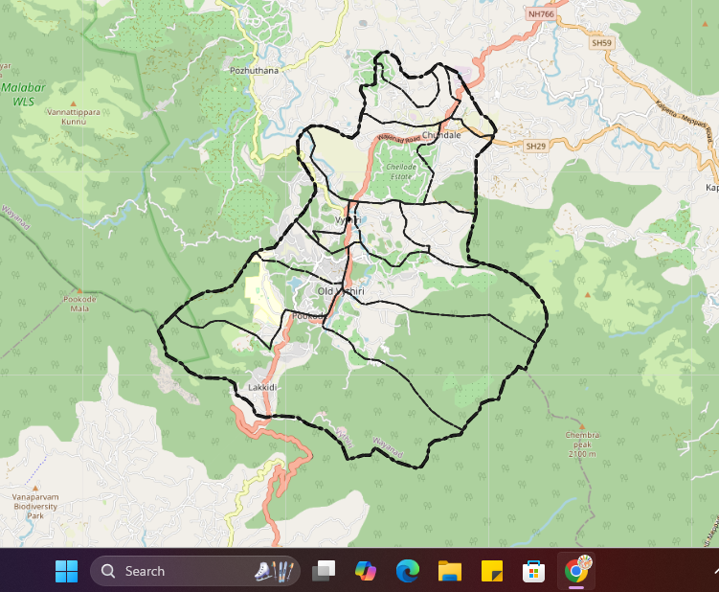

Population Profile
PHC Sugandhagiri, Vythiri Panchayath, Wayanad District

Total Population | 15254
Male Population | 7615
Female Population | 7639
Total SC Population | 2680
Male Population | 1320
Female Population | 1360
Total ST Population | 843
Male Population | 391
Female Population | 452

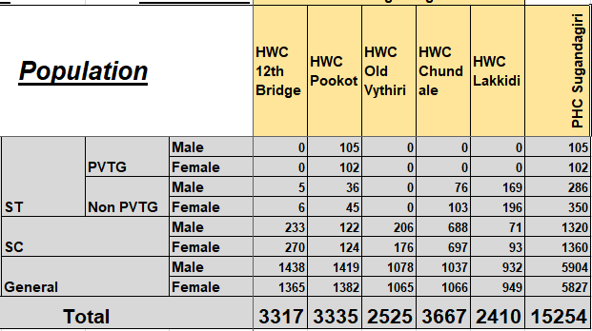

The total population under PHC Sugandhagiri in Vythiri Panchayath, Wayanad District is 15,254. Of this, 7,615 are males and 7,639 are females, showing a slightly higher female population.
The Scheduled Caste (SC) population comprises 2,680 persons, including 1,320 males and 1,360 females, indicating a marginal female predominance within the SC community.
The Scheduled Tribe (ST) population is 843, with 391 males and 452 females. The ST population also reflects a higher proportion of females compared to males.
Overall, the population of the PHC area demonstrates a balanced gender distribution across the general population as well as among SC and ST communities. This demographic information is essential for effective planning and implementation of health services and welfare programmes in the PHC Sugandhagiri area.

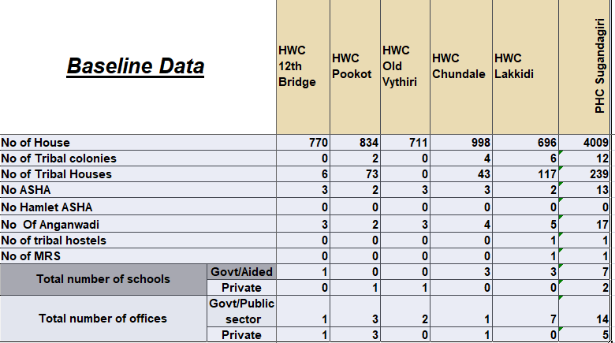

The baseline data presents an overview of households, tribal population, health functionaries, educational institutions, and offices across five Health and Wellness Centre (HWC) areas 12th Bridge, Pookot, Old Vythiri, Chundale, and Lakkidi—under PHC Sugandagiri., Vythiri Panchayath
A total of 4,009 households are covered in the PHC area, with Chundale having the highest number of households (998), followed by Pookot (834). Old Vythiri has the lowest household count (711).
There are 12 tribal colonies in total, mainly concentrated in Lakkidi (6) and Chundale (4), and number of tribal houses totals 239, with Lakkidi (117) and Chundale (43).
The health workforce includes 13 ASHA workers, distributed fairly evenly across the HWCs, while no Hamlet ASHAs are reported in any area. A total of 17 Anganwadi centres function in the PHC area, with Lakkidi having the highest number (5). There is one tribal hostel and one MRS, both located in Lakkidi, indicating focused tribal support infrastructure in this area.

In terms of education, there are 9 schools in total—7 Government/Aided and 2 Private—with Chundale and Lakkidi having higher availability of government/aided institutions. Additionally, the area has 19 offices, comprising 14 government/public sector offices and 5 private offices, with Lakkidi showing the highest concentration of government/public sector offices.
Overall, the data highlights Lakkidi and Chundale as key areas with higher tribal population, institutional presence, and service infrastructure, while Old Vythiri and 12th Bridge show relatively lower figures across most indicators.

Major Roads Passing Through Vythiri Grama Panchayat
- National Highway 766 (NH 766) – The main highway connecting Kozhikode, Kalpetta, and Sulthan Bathery, passing through Vythiri and serving as the primary transport route.
- Vythiri – Lakkidi Road – Connects Vythiri town with Lakkidi and the Thamarassery Ghat road leading to Kozhikode.
- Vythiri – Old Vythiri – Chundale Road – An important local road connecting nearby settlements and wards within the Panchayat.
- Various Panchayat and Village Roads – These roads link residential areas, plantations, tourist spots, and nearby panchayats, supporting local transportation and access to services.

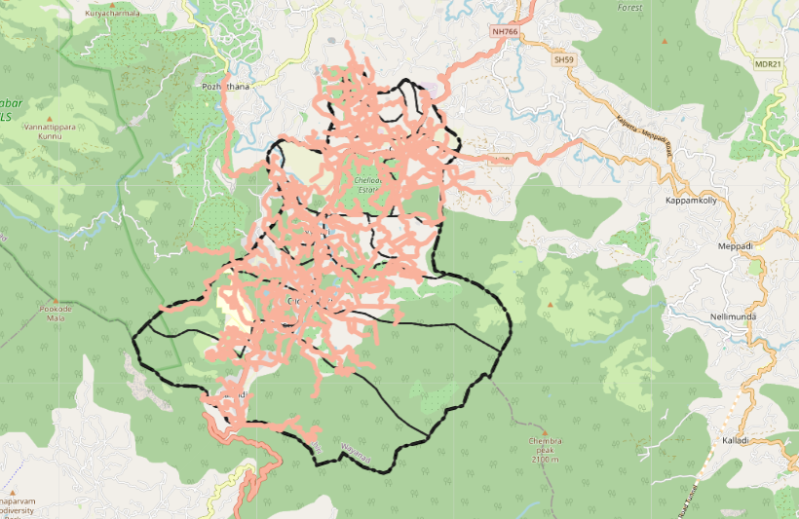

The major river passing through Vythiri Grama Panchayat in Wayanad district is the Chaliyar River.
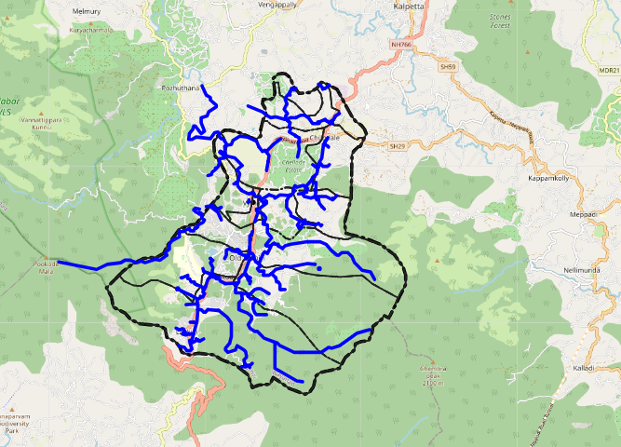

VYTHIRI GRAMMA PANCHAYATH
HOT SPOT MAP VYTHIRI GRAMMA PANCHAYATH
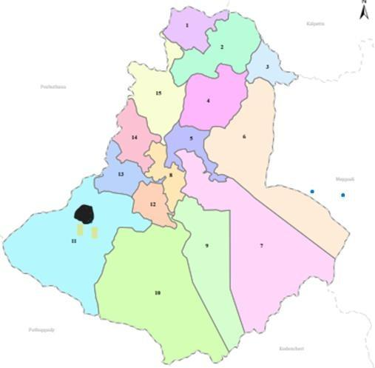

Under PHC Sugandhagiri, the hotspot mapping mechanism identifies areas within Vythiri Grama Panchayath that are vulnerable to outbreaks of major communicable diseases, enabling targeted surveillance and timely public health interventions.
During the past year, no major clusters of communicable diseases were reported across the Panchayath.

However, localized outbreaks of fever and acute diarrheal disease (ADD) were recorded at institutional settings, namely the Veterinary College Hostel, Pookode, and MRS Pookode. These incidents highlight the need for continued vigilance and focused monitoring in institutional and residential facilities.
The hotspot map identifies potential high-risk areas for communicable diseases such as Dengue, Leptospirosis, and Food Poisoning. This supports the Panchayath and PHC teams in implementing targeted preventive measures, community awareness activities, vector control operations, and rapid response actions. Regular updating of the hotspot map facilitates early detection and prompt containment of emerging health threats within the Panchayath.

Disaster-Prone Areas – Vythiri Grama Panchayat
Vythiri Grama Panchayat in Wayanad district is prone to landslides in hilly regions during heavy monsoon rains, localized flooding and waterlogging in low-lying areas near streams, and road disruptions due to intense rainfall. Some forest-fringe areas may also experience wildlife intrusion, especially during extreme weather conditions.
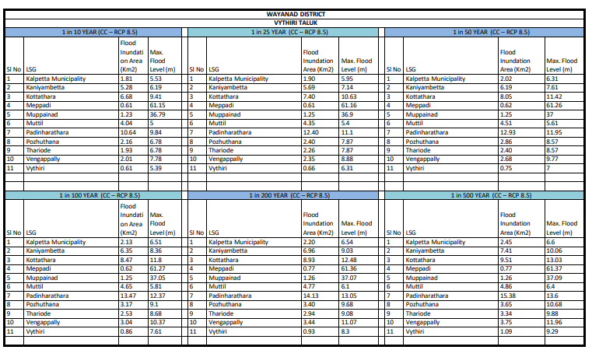
- 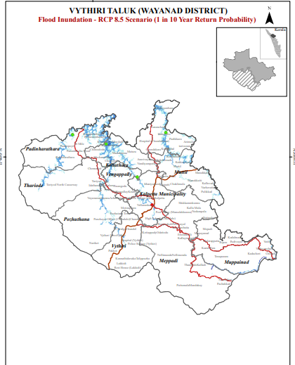
- 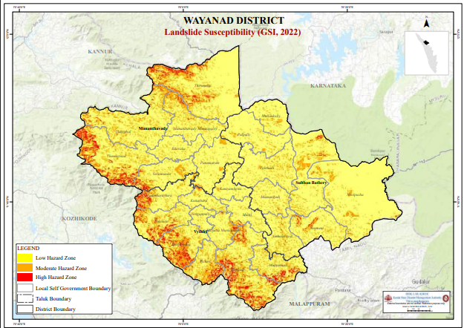
Details of Reported Localized Outbreaks (2025)

SL NO | MONTH | DISEASE | PLACE
1 | January 2025 | Food Poisoning | Veterinary College  Pookode | 32
3 | January 2025 | ADD | MRS Pookod | 14
2 | February 2025 | Food Poisoning | Veterinary College  Pookode | 19

4.1.1 Hotspot Mapping for Major Communicable Diseases

INTEGRATED HEALTH INFRASTRUCTURE MAP OF VYTHIRI PANCHAYATH
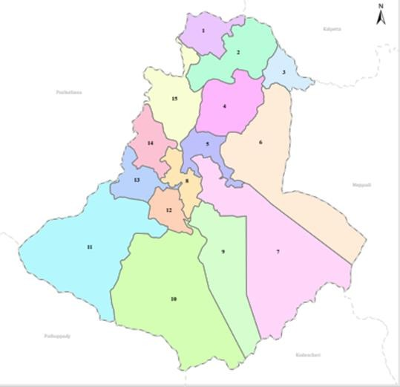

Health Infrastructure Map

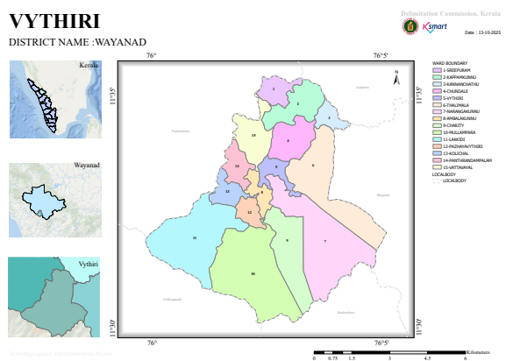

GENERAL PROFILE OF THE LSGI’S
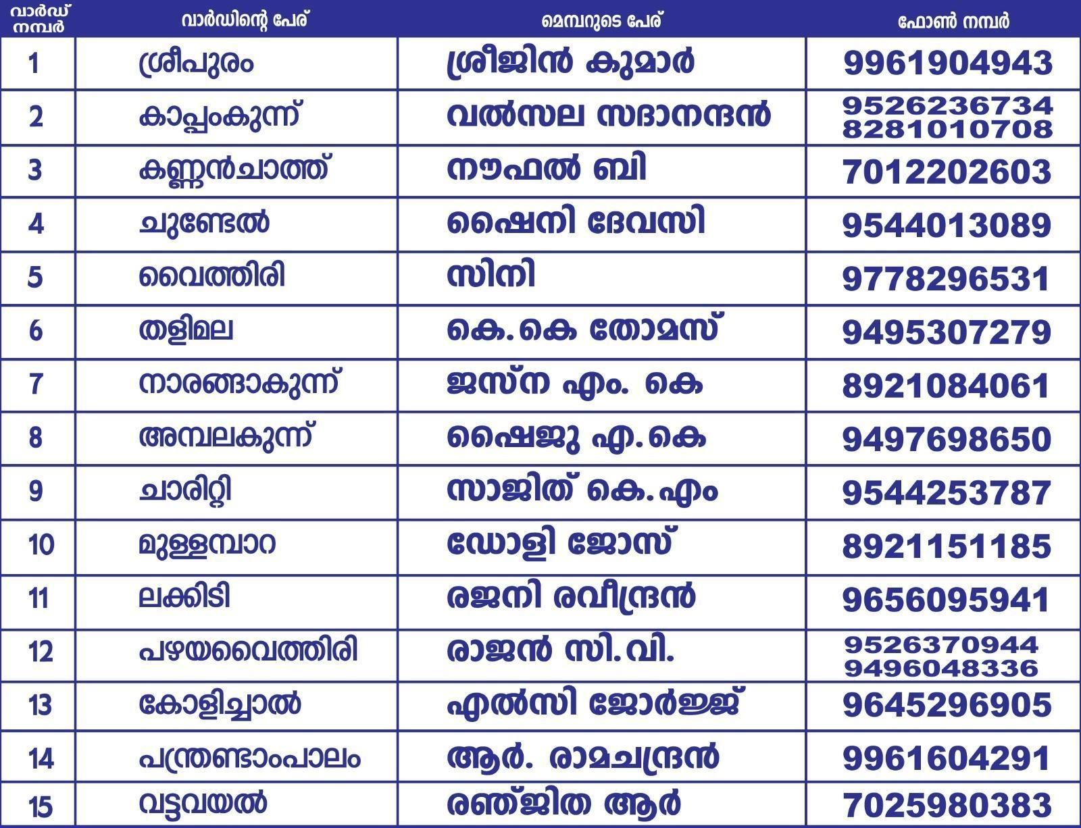

Background of the LSGI

Vythiri Grama Panchayat is situated in the eastern highland region of Wayanad district, Kerala. The geographical landscape of the Panchayat is predominantly hilly and forested, characterized by undulating terrain, valleys, streams, and plantations, including extensive tea estates. The majority of the population earns their livelihood through tourism-related activities, agriculture, tea plantation work, and dairy farming.
This unique terrain significantly influences the local microclimate and presents distinct challenges to transportation, emergency response, and service delivery, particularly during the monsoon season when landslides, road blockages, and heavy rainfall events are common.
The Panchayat is administratively divided into multiple wards, with the population largely dependent on traditional and plantation-based livelihoods. Agriculture— especially spice cultivation, horticulture, and allied activities—forms an important component of the local economy. In recent years, tourism and service-sector employment have expanded considerably, contributing to economic diversification. The area also hosts a diverse workforce, including a significant presence of migrant labourers, particularly in construction, plantation work, and allied sectors.
From a public health and disaster management perspective, Vythiri Grama Panchayat (LSGI) has historically been vulnerable to heavy rainfall, landslides, flash floods in low-lying pockets, and vector-borne diseases such as Dengue and waterborne illnesses including Leptospirosis. The severe floods and climate-related

disasters experienced in recent years, including the 2018 flood disaster, had a substantial impact on lives, livelihoods, and infrastructure within the Panchayat. These recurring events have highlighted the critical need to strengthen local preparedness, response mechanisms, and inter-departmental coordination.
In this context, the development of a localized, data-driven Auxiliary Infrastructure and Logistical Resource Map is essential to support effective planning, timely emergency response, and sustainable development initiatives. Such mapping will enable the Panchayat to identify critical resources, improve accessibility during emergencies, and enhance the overall resilience of the community.

Table 1: Background of LSGD
Description | Details
Name of LSGI | Vythiri
Type (GP/Municipality / Corporation etc.) | Grama Panchayath
Block | Kalpeta
District | Wayanad
Number of wards | 15
Total area (sq. km) | 47.84 sq. km
Population(Projected) | 20285
Population density | 424

Table 1: Background of LSGD
Description | Details
Terrain (coastal/low-lying/backwaters/foothills, etc.) | Low- lying
Number of rivers passing through LSGI | 1
Number of water bodies in the LSGI | 4
Number of educational institutions | 9
Factories / small-scale industries | 2
Flood-prone wards | 2
Landslide-prone wards | 1
Death Management and Disposal Facilities (mortuaries/crematorium, including electric) | 0
Auditoriums/Marriage halls/convention centres/community halls | 8

Demographic and Vulnerable Population

The baseline data presents an overview of households, tribal population, health functionaries, educational institutions, and offices across five Health and Wellness Centre (HWC) areas—12th Bridge, Pookot, Old Vythiri, Chundale, and Lakkidi— under PHC Sugandagiri., Vythiri Panchayath
A total of 4,009 households are covered in the PHC area, with Chundale having the highest number of households (998), followed by Pookot (834). Old Vythiri has the lowest household count (711).
There are 12 tribal colonies in total, mainly concentrated in Lakkidi (6) and Chundale (4), and number of tribal houses totals 239, with Lakkidi (117) and Chundale (43).
The health workforce includes 13 ASHA workers, distributed fairly evenly across the HWCs, while no Hamlet ASHAs are reported in any area. A total of 17 Anganwadi centres function in the PHC area, with Lakkidi having the highest number (5). There is one tribal hostel and one MRS, both located in Lakkidi, indicating focused tribal support infrastructure in this area.

In terms of education, there are 9 schools in total—7 Government/Aided and 2 Private—with Chundale and Lakkidi having higher availability of government/aided institutions. Additionally, the area has 19 offices, comprising 14 government/public sector offices and 5 private offices, with Lakkidi showing the highest concentration of government/public sector offices.
Overall, the data highlights Lakkidi and Chundale as key areas with higher tribal population, institutional presence, and service infrastructure, while Old Vythiri and 12th Bridge show relatively lower figures across most indicators.

Population details of PHC Suganthagiri

Total Population | 15254
Male Population | 7615
Female Population | 7639
Total SC Population | 2680
Male Population | 1320
Female Population | 1360
Total ST Population | 843
Male Population | 391
Female Population | 452

Description |  | Details (in numbers)
DEMOGRAPHIC PROFILE
Total population |  | 20585
Male |  | 10534
Female |  | 10051
Transgender |  | 0
Children under 5 |  | 877
Adolescent |  | 1816
Elderly (>60) |  | 2360
SOCIAL/LIVELIHOOD VULNERABILITY
Previous EPEP family |  | 28
BPL family |  | 3816
Tribal communities |  | 4
Migration | Immigrant | 316
Migration | Emigrant | 461
Socio-economically deprived |  | 1814
Fisherfolk |  | 0

Description | Details (in numbers)
DEMOGRAPHIC PROFILE
SC Community | 2680
ST Community | 843

Clinical Vulnerability

In the PHC Suganthagiri service area of Vythiri Grama Panchayath, the vulnerable population profile is as follows:
- EPEP families: 28
- Children under 5 years: 877
- Population above 5 years: 2,360
- Home-bound patients: 78
- Patients with serious health issues: 46
- Bed-ridden patients: 42

Certain population groups require priority healthcare services and are at a higher risk of severe illness, complications, and mortality during pandemics and public health emergencies. These include patients with chronic diseases, individuals requiring continuous medical care, the elderly, bed-ridden patients, and those with mobility or functional limitations.
During emergencies, these groups often face significant barriers in accessing timely healthcare services, including transportation challenges, disruption of routine treatment, and limited mobility. Systematic mapping and documentation of these

vulnerable populations is therefore essential for effective pandemic preparedness and response. Such mapping enables health authorities and the Panchayath to prioritize continuity of care, ensure adequate medicine and consumable stock, plan for oxygen and emergency medical support, arrange referral and transport services, and deliver targeted home-based healthcare services through health staff and ASHA workers.
This approach strengthens the overall resilience of the healthcare system and helps minimize preventable morbidity and mortality during public health emergencies.

Description | Details in numbers
Pregnant women | 119
Lactating mothers | 161
Bedbound patients | 42
Patients under palliative care other than bedbound | 109
Patients on Haemodialysis | 0
Patients on CAPD | 221
Cancer patients (currently on treatment) | 74
Haemophilic patients | 21
Mentally challenged | 5

Description | Details in numbers
Differently abled | 5
Diabetic patients | 442
Hypertensive patients | 304
TB patients | 2

4.1.3 Vulnerable Population
Within Vythiri Grama Panchayath, certain populations are considered vulnerable due to specific demographic, health, occupational, and social factors. Identifying these groups is essential for targeted interventions, early support, and risk mitigation during a pandemic or public health emergency.

Key vulnerable groups include:
    - Demographic groups: Elderly, children, and pregnant women

    - Tribal communities: Tribal population residing in colonies across the Panchayath
    - Occupational groups: Tea estate laborers, dairy workers, and NREGA workers

    - Migrants: Seasonal and temporary migrant workers

    - Health-related vulnerabilities: Individuals with Non-Communicable Diseases (NCDs) such as diabetes and hypertension
Recognizing these groups allows the Panchayath and PHC Sugandhagiri to implement focused preventive measures, health education, and support services, ensuring that the most at-risk populations are adequately protected during any health emergency.

Major Festivals & Events specific to the LSGI (with the possibility of a public gathering)

Sl.  No. | Name of festival | Month detailing the periodicity
1 | Chundel Church Festival | March
2 | Vythiri Church Festival | January
3 | Vythiri Church Near YMCA | February
4 | Vythiri Temple | March
5 | Chelotte Magham | January
These festivals involve large public gatherings and increased population movement, which may elevate the risk of communicable disease transmission during pandemics. Identifying the timing and location of such events enables the Panchayath and Health Department to:

Plan crowd management and surveillance activities
- Deploy health staff, ASHA workers, and volunteers
- Ensure availability of first aid, emergency referral, and isolation support

Implement risk communication and health advisories
- Coordinate with festival committees for preventive measures

This proactive planning supports effective risk mitigation and community safety
during public health emergencies.

NFRASTRUCTURE & RESOURCE INVENTORY

Health Facility Directory & Basic Capacity in the LSGD
PHC Sugandhagiri currently provides outpatient (OP) services during daytime only. In emergency situations, residents of Vythiri Grama Panchayath primarily rely on the Taluk Headquarters Hospital (THQH), Vythiri, which is located within the Panchayath. THQH Vythiri offers comprehensive medical services, including outpatient (OP) and inpatient (IP) care, laboratory facilities, operation theatre (OT), and mortuary services, making it the key public health facility for critical and emergency care.
In addition, the community also depends on the private sector, particularly Good Shepherds Hospital, Chelotte, which provides OP and IP services, emergency care, and laboratory facilities.
This dual dependency on public and private healthcare facilities highlights the need for coordinated planning and integration of PHC Sugandhagiri with THQH Vythiri and private hospitals, to ensure timely access to essential medical services during pandemics or other public health emergencies.

4.2.2 Private Health Facilities
The community of Vythiri Grama Panchayath relies on several private health facilities for their medical needs:
- Good Shepherds Hospital, Chelotte, Vythiri – provides outpatient (OP) and inpatient (IP) services, emergency care, and laboratory facilities.
- WIMS Hospital, Chundale – offers outpatient (OP) services.

- NS Hospital, Chundale – provides outpatient (OP) services.

These private facilities complement public health services and play a crucial role in ensuring timely access to medical care, especially during emergencies when PHC Sugandhagiri operates only during daytime.

Table 5. Health Facility Resource Summary
Sl  .n  o. | Health Facility | Type of Facility (MCH/ GH/CH  C/FHC/ SC etc.) | Contact Number | Tota l beds | ICU  Bed s | Oxyge n- Suppo rted Beds | No. of Ventilato r Support Beds | No. of ambulan ces
Government Healthcare Facilities
1 | PHC Sugandhagiri | PHC | 94465811  01 | 0 | 0 | 0 | 0 | 0
2 | THQH Vythiri | Taluk Hospital | 04936 255228 | 120 | 6 | 56 | 10 | 3

Table 5. Health Facility Resource Summary
Sl  .n  o. | Health Facility | Type of Facility (MCH/ GH/CH  C/FHC/ SC etc.) | Contact Number | Tota l beds | ICU  Bed s | Oxyge n- Suppo rted Beds | No. of Ventilato r Support Beds | No. of ambulan ces
Private Healthcare Facilities
1 | Good Shepherded Hospital Chelotte, Vythiri | Private | 97444682  25 | 40 | 0 | 0 | 0 | 0
AYUSH Healthcare Facilities
 | Homeo Dispensary Vythiri | Govt | 0 | 0 | 0 | 0 | 0 | 0

Private Clinics

Private clinics are an essential component of pandemic preparedness in Vythiri Grama Panchayath, as they are often the first point of contact for individuals seeking medical care when symptoms appear. A significant proportion of outpatient

consultations in the Panchayath are managed by private clinics, making them critical for early case detection, timely referral, and disease surveillance.
Maintaining an up-to-date mapping of private clinics—including their location, range of services, and referral linkages with public health facilities—helps ensure that potential cases are promptly identified and reported during outbreaks. Such mapping also enables effective engagement of private medical practitioners in disease notification, risk communication, and coordinated response activities.
Strengthening coordination between private clinics and the public health system enhances the overall capacity of Vythiri Grama Panchayath to respond efficiently to pandemics and other public health emergencies, thereby reducing the risk of delayed diagnosis and uncontrolled disease transmission.

Table 6. Private Clinic Resource Summary
Sl N  o. | Name of Clinic | Regi stere d (Y/N  ) | Clinic (Genera l /  Speciali ty) | Special ity (if any) | Addres s | Contact Number | Diagnos tic Facility (Y/N) | Ambula nce Linkage (Y/N)
1 | Dr Rajesh Clinic Vythiri | Y | No | NO | Dr Rajesh Clinic Vythiri | 85478589  70 | Y | Yes

Table 6. Private Clinic Resource Summary
2 | WIMS  Hospital OP | Y | No | No | Wims Hospital Chundel |  | Y | Yes
3 | NS clinic | Y | No | No | NS  clinic, Chundel |  | Y | Y

Healthcare Education & Training Institutions
This section tracks the educational infrastructure available, which is vital for human resource planning in the health sector.

Category of Institution | Govt | Private | AYUSH | Total
Medical Colleges | No | No | No | No
Nursing Colleges | No | No | No | No
Dental Colleges | No | No | No | No
Para-medical / Allied Health | No | No | No | No

Category of Institution | Govt | Private | AYUSH | Total
Pharmacy Colleges | No | No | No | No

Specialized Services & Emergency Inventory

This section provides a detailed view of the specialized medical resources available to the community, focusing on emergency response and critical care capabilities. This table tracks the vital assets required for managing severe illnesses and emergencies across Government, Private, and AYUSH sectors.

Item | Govt | Private | AYUS H | Total
Hospital beds | 120 | 40 |  | 160
Oxygen-generating systems(Y/N) | 0 | 0 |  | 0
Oxygen-supported beds(Numbers) | 56 | 10 |  | 66
Ventilator-supported beds | 10 | 0 |  | 10
ICU beds | 6 | 0 |  | 6
Burns units | 0 | 0 |  | 0
Blood centres | 0 |  |  | 0
BLS ambulances | 1 | 1 | 0 | 2

Item | Govt | Private | AYUS H | Total
ALS ambulances | 1 | 0 |  | 1
Dialysis facilities | 1 | 0 |  | 1
Dispensaries | 1 | 0 |  | 1
Medical store | 4 | 0 |  | 4
Industrial establishments(Medium- scale industries/small-scale industries establishments to whom we can depend in a worst-case scenario) | 0 | 0 |  | 0

Oxygen & Diagnostic Capacity

Monitoring oxygen and diagnostic capacity is a critical component of public health preparedness, ensuring that the LSGD can handle both chronic care and sudden surges in respiratory or infectious diseases.

Name of Health Facility | Oxygen- generating System (Y/N) | Backup Oxygen Source (Y/N) | Diagnostic Facilities Available(Y/N)
Name of Health Facility | Oxygen- generating System (Y/N) | Backup Oxygen Source (Y/N) | Lab | US G | X-  ray | CT/MR I | RT- PCR
Government Healthcare Facilities

Name of Health Facility | Oxygen- generating System (Y/N) | Backup Oxygen Source (Y/N) | Diagnostic Facilities Available(Y/N)
Name of Health Facility | Oxygen- generating System (Y/N) | Backup Oxygen Source (Y/N) | Lab | US G | X-  ray | CT/MR I | RT- PCR
THQH  Vythiri | N | N | Y | N | Y | N | Y

Diagnostics facility mapping at the LSGI level
The diagnostic capacity of Vythiri Gramma panchayath represents the "intelligence network" of our healthcare system. The speed and accuracy of disease identification depend entirely on the distribution and technical level of these facilities.

Item | Govt | Privat e | AYUSH | Total
General labs | 1
Microbiology labs | 0 | 0 | 0 | 0
RT-PCR labs | 1 | 0 | 0 | 0
USG units | 1 | 0 | 0 | 0

CT/MRI units | 0 | 0 | 0 | 0
Research labs | 0 | 0 | 0 | 0
Labs of other departments that can be repurposed | 0 | 0 | 0 | 0

Laboratory Identification & Basic Details

Sl.  No. | Name of Laboratory | Ownership (Govt /  Private /  Academic) | Addres s | Contact No. | 24×7  Services (Yes/No) | NABL /  Govt  Approved (Yes/No)
1 | THQH  Vythiri | Govt | THQH  VYTHI RI | 04936 255228 | Y
2 | Good Shepherded Hospital Lab | Pvt | CHelott e, Vythiri  (PO) | 9744468  225 | Y | N
3
4
5

Social and Community Infrastructure for surge plan

This table serves as our logistics and shelter inventory. By mapping these locations, quickly we can identify where to house displaced citizens, where to set up temporary medical clinics, and how to manage the deceased with dignity during a crisis.

Category | Total Count | Ward | Est. Capacit y (Persons  ) | Contact details
Educational Institutions
Anganwadis | 13 | 13 | 55 | 9745505685
Schools | 11 | NA | 2500 | 6282982130
Colleges | 3 | NA | 1000 | -
Healthcare Educational Institutions
Medical colleges (Govt/Private) | 0 | 0 | 0 | 0

Nursing colleges (Govt/Private) | 0 | 0 | 0 | 0
Dental colleges (Govt/Private) | 0 | 0 | 0 | 0
Paramedical institutes (Govt/Private) | 0 | 0 | 0 | 0
Community Gathering Spaces
Community halls | 1 | Chundel, Vythiri | 250 | 08547616608
Auditoriums | 2 | Chundel, Vythiri | 400 | 7907626159
Religious buildings | 9 |  | 3500 | 8848738881
Vulnerable Group Support Facility
Destitute homes | 0 | 0 | 0 | 0
Elderly homes | 0 | 0 | 0 | 0
LSGD owned other buildings | 1 | 0 | 0 | 08547616608

Mass Fatality Management (MFM) Infrastructure
Mortuary | 1 | THQH,  Vythiri |  | 04936 255228
Crematorium | 1 | Near YMCA |  | 08547616608
*refer annexure 1 for contact details

Human resources
This section focuses on the human capital available within the LSGI. In any emergency—be it a pandemic, flood, or industrial accident—infrastructure is only as effective as the people operating it.

Medical & Clinical Personnel
This table tracks the "Frontline" providers responsible for diagnosis, treatment, and clinical management. Narrative sentence: eg., "Total health workforce: 450 personnel, with 60% in government facilities serving as primary surge capacity." A detailed directory with the contact numbers of all workers is maintained (Annexure in 1).

Cadre | Govt (No.) | Private (No.) | Total
Doctors—Modern Medicine | 14 | 7 | 21
Doctors – AYUSH | 0 | 2 | 2
Doctors – Veterinary | 82 | 0 | 82
Doctors – Dental | 1 | 1 | 2
Nursing officers | 30 | 9 | 39
Lab technicians | 9 | 8 | 17
Optometrist | 1 | 3 | 4
Pharmacists | 1 | 4 | 5
Psychologists | 0 | 0 | 0

Counsellors | 1 | 0 | 1

Public Health & Field-Level Workforce
These individuals are the backbone of surveillance, maternal-child health, and decentralized care.

Cadre | Health services | Municipal common services | Total
HS (Health Supervisors) | 0 | 0 | 0
HI (Health Inspectors) | 1 | 0 | 1
LHS (Lady Health Supervisor) | 0 | 0 | 0
LHI (Lady Health Inspectors) | 1 | 0 | 1
JPHN (Jr Public Health Nurses) | 3 | 0 | 3
JHI (Jr Health Inspectors) | 3 | 0 | 3

Cadre | Health services | Municipal common services | Total
MLSP (Mid-Level Service Providers) | 5 | 0 | 5
Palliative Nurses | 1 | 0 | 1
RBSK Nurses | 1 | 0 | 1
PRO | 0 | 0 | 0
Epidemiologist | 0 | 0 | 0
Data Manager | 0 | 0 | 0

Community & Support Cadre
This group represents the surge capacity of the LSGI—people who can be called upon for logistics, rescue, and specialized support.

Cadre | Number
ASHA Workers | 13
AWW (Anganwadi Workers) | 14
Emergency Medical Volunteers (Trained) | 0
Kudumbashree | 232
MNREGS | 2032
Purusha Swayam Sahaya Sangham | 14
Ex-Servicemen | 7
Retired Police Officers | 8
NCC/NSS Volunteers | 88
Red Cross volunteers | 0

Cadre | Number
One Health Community Volunteers | 0
One Health Community Mentors | 0

Community Organizations
This section details the presence of community-based organisations (CBOs), non- governmental organisations (NGOs), faith-based organisations (FBOs), Kudumbashree Self-Help Groups (SHGs), and Ayalkootams within the Local Self- Government Institution (LSGI). These groups enhance grassroots mobilization, resource distribution, and support networks crucial for pandemic response and community resilience.

Category | Total Count
NGOs | 1
Religious based organizations | 3
Foreign based organizations | 0

Category | Total Count
Sports Club/youth clubs | 3
Kudumbashree SHGs | 232
Ayalkootams | 232
Political organizations | 4
Residential organizations | 2

Administrative & Emergency Services
This section outlines the availability of key non-health emergency support services and infrastructure within the LSGI, which are essential for effective pandemic preparedness and response. These facilities support law enforcement, disaster response, water supply, logistics, mobility, and community-level interventions during public health emergencies.

Category | Total Count | Contact details
Police Stations | 1 | 9497980826
Fire & Rescue Stations | 0 | 0
Water Pumping Points | 2 | 9745211872

Public Distribution System (PDS) | 4

Information regarding resources
The availability of essential transport and support resources plays a quiet but critical role in saving lives. Equipment such as ambulances, mobile mortuaries, amphibian ambulances, and motorized boats ensures that patients, samples, and healthcare teams can move swiftly—even in flooded, remote, or difficult terrains. Heavy vehicles like JCBs, cranes, tractors, and torus lorries support logistics, waste management, emergency infrastructure, and rapid conversion of spaces into care or isolation facilities. Taxis, four-wheel-drive vehicles, and trucks help maintain continuity of essential services, reach vulnerable populations, and support home-based care and supply delivery.

Means of transportation | Total Count
JCB | 4
Crane | 0
Heavy Trucks | 7
Tractor | 5

Ambulances | 5
Mobile mortuaries | 1
Boats | 0
Taxi service | 24
Note: For specific details regarding vehicle owners and contact information, please refer to Annexure [X].

ONE HEALTH & ENVIRONMENTAL SURVEILLANCE

The One Health method integrates environmental, animal, and human health to enable proactive pandemic preparedness. Panchayat-level surveillance needs to be improved in order to detect and treat zoonotic and environmentally generated diseases early. Surveillance is strengthened through systematic assessment of animal populations, veterinary infrastructure, poultry and slaughter facilities, inter-sectoral coordination, and specialised tools like avian influenza seasonality mapping using GIS in previous outbreaks to enable predictive alerts and ward-specific sampling to support effective pandemic preparedness in high-risk areas like veterinary college pookode

Animal & Bird Population

Mapping animal and bird populations at the Panchayat level is essential for identifying and prioritising zoonotic disease hazards like rabies, avian influenza (H5N1), leptospirosis, anthrax, and Nipah-like spillover occurrences. Risk classification, targeted surveillance, vaccination planning, and early epidemic detection made

feasible by comprehensive population mapping all enhance One Health-based pandemic preparedness.

Category | Item | Estimated Population | Wards
Animal Population | Livestock (Cattle/Goats/Buffalo  ) | 314 | All wards
Animal Population | Pet Animals (Dogs/Cats) | 96 | All wards
Animal Population | Stray Dog Population | 40 | All wards
Animal Population | Pig Farms (Number of heads) | 1 | All wards
 | Small Units (Sheep / Goats – clustered) | 1 | All wards
Bird Population | Poultry Units (Birds) | 0 | All wards
Bird Population | Poultry- (FOWL) | 1 | All wards

Category | Item | Estimated Population | Wards
 | Wild/Migratory Birds (Observed) | 0 | 0
 | Crow Mortality Events (Reported) | 0 | All wards

The main risk of zoonotic diseases in Vythiri Panchayath is concentrated in Wards 11 which is explained by the high density of pig farms, cattle congregation areas, and poultry units. The stray dog population in market areas, fish landing sites, bus stations continues to be a substantial problem for rabies surveillance and bite prevention. There is a considerable risk of avian influenza introduction and amplification during November - December due to the seasonal presence of migratory and resident water birds near ponds/ canal / river / backwater / paddy field. Clusters of pig farms and animal shelters vulnerable to flooding further raise the risk of leptospirosis and other zoonoses mediated by the environment, especially during monsoon floods.

Veterinary Infrastructure

Veterinary institutions are a core pillar of One Health surveillance, enabling early zoonotic disease detection through vaccination, investigation of unusual animal illness or deaths, sample collection, and timely outbreak reporting. A well-mapped and responsive veterinary network strengthens coordination with human health and LSGI systems, ensuring rapid response during zoonotic events and pandemics.

Facility Type | Name of Facility | Ownership Govt / Pvt | Location( Ward No) | Contact number
Veterinary Dispensary | KVASU | Govt | 11 | 9447128993  Dean KVASU
Veterinary Hospital  / Polyclinic | KVASU | Govt | 11 | 9447128993  Dean KVASU
Private Veterinary Clinics | 0 | 0 | 0 | 0
Mobile /  Emergency Vet Service (incl. night services) | 0 | 0 | 0 | 0
Pet Homes / Animal Shelters | 0 | 0 | 0 | 0
Slaughterhouse- linked Veterinary Inspection Unit | KVASU | Govt | 11 | 9447128993  Dean KVASU

Veterinary Doctors & Workforce

Early detection, diagnosis, reporting, and reaction to animal illness epidemics depend on the availability and accessibility of qualified veterinary specialists. By identifying unusual animal morbidity or mortality promptly, collecting samples promptly, and coordinating efficiently with human health and LSGI systems—especially during zoonotic outbreaks and pandemic-prone situations—a clearly defined veterinary workforce enhances One Health surveillance.

Category | Number Available | Type (Govt/Pvt  ) | Contact number
Government Veterinary Doctors | 84 | Govt | 9447128993  Dean KVASU
Private Veterinary Doctors | 0 | 0 | 0
Livestock Inspectors | 3 | Govt
Para-veterinary Staff / Attenders | 26 | Govy | 0
Contract / On-call Veterinary Support (if any) | KVASU | Govt | 9447128993  Dean KVASU

High-Risk Interface Points (Surveillance Sites)

High-risk interface points for zoonotic disease surveillance in vythiri Grama Panchayath include wetland–livestock–human contact zones, backyard poultry farms, cattle sheds near water bodies, fish markets, and areas of high human–animal interaction such as community slaughter points and migratory bird congregation sites. These are the primary surveillance sites where zoonotic spillover risks are elevated.

Type of Habitat | Type of High risk  interface | Geographical  vulnerability
Wetlands & Backwaters | 0 | 0
Backyard Poultry Farms | 0 | 0
Cattle Sheds near Water Bodies | 1 | 0
Fish & Meat Markets | 7 | 0
Community Slaughter Sites | 0 | 0

Migratory Bird Congregation Areas | 0 | 0
Rodent-Infested Grain Storage | 0 | 0

Category | Total Count | Key Locations (wards)
Poultry Farms | 1 | 11
Backyard / Clustered Poultry Units | 0 | 0
Duck Rearing Units (open water access) | 0 | 0
Slaughterhouses/ Slaughter Points | 2 | 0
Meat/Fish Markets | 5 | 0
Live Bird Sale Points | 0 | 0
Cattle Markets / Weekly Animal Fairs | 0 | 0
Pet Shops / Breeders | 0 | 0
Animal Shelters / Pet Homes | 0 | 0

Waste Disposal Sites near Animal Units | 0 | 0

Environmental Risk Mapping

Environmental risk mapping identifies monsoon/flood hotspots for vector-borne (dengue, chikungunya), water-borne (leptospirosis, diarrhoea), and zoonotic diseases in Kerala's wetlands. Systematic surveillance supports early warnings, targeted interventions, and Panchayat pandemic preparedness.
Waterborne exposure: Flood-prone areas and stagnant water bodies facilitate
leptospira survival, raising leptospirosis risk.

Traditional practices: Informal slaughter and fish markets lack standardized hygiene, creating spillover opportunities.

Risk Factor | High-Risk Wards | Key Locations | Risk Level  (High/Med/Low)
Flood-prone areas | Ward 13,  Ward 7 | Vattavayal, Mullanppara, Charity | Med
Water bodies/wetlands | 0 | 0 | 0
Solid waste accumulation | 0 | 0 | 0
Animal waste disposal issues | 0 | 0 | 0
Rodent infestation zones | 0 | 0 | 0
Industrial effluent discharge | 0 | 0 | 0
Construction sites / abandoned buildings | 0 | 0 | 0
Poor drainage/blocked canals | 0 | 0 | 0

Drinking water source contamination risk | Ward 13,  Ward 7 | Vattavayal, Mullanppara, Charity | Med

Disease Seasonality Mapping

1, Flooding & waterlogging → amplifies leptospirosis, malaria, diarrheal diseases.

No such area

2, Migratory bird influx (Nov–Feb) → avian influenza risk.

No such area

3, Mosquito breeding cycles → vector-borne disease peaks in monsoon.

No such area

4, Agricultural practices → close human–animal contact in paddy fields.

No such area

Disease | Peak Risk Season | Key Drivers | High-Risk Locations | Surveillance Focus
Avian Influenza | 0 | 0 | 0 | 0
Leptospirosis | June, July, | NREGA  workes | 0 | 0
Dengue/Chikunguny a | June | 0 | 0 | 0
Acute Diarrheal Diseases | June | Hostel inmates | Pookode | Students
Rabies | 0 | 0 | 0 | 0
Anthrax (rare) | 0 | 0 | 0 | 0

Vulnerability Mapping

Vulnerability mapping pinpoints high-risk populations, occupations, and areas exposed via environment, livelihoods, socio-economics, and poor service access. Paired with environmental/seasonality mapping, it enables risk-based surveillance, targeted actions, and optimal resource use in One Health and pandemic planning.

Vulnerability Factor | High-Risk Wards | Key Groups / Locations | Risk Level

Flood-prone households | 2 | Charity, Vattavayal | Medium
Wetland-adjacent communities | 0 | 0 | 0
Backyard poultry / duck rearing households | 0 | 0 | 0
Livestock-rearing households | 0 | 0 | 0
Slaughterhouse & meat market workers | 0 | 0 | 0
Fisherfolk & fish market workers | 0 | 0 | 0
Sanitation workers | 0 | 0 | 0
Daily wage / migrant workers | 0 | 0 | 0
Elderly & chronically ill populations | 0 | 0 | 0
Pregnant Women | 0 | 0 | 0
Children (schools,  Anganwadi’s) | 0 | 0 | 0

Limited access to safe water & sanitation | 0 | 0 | 0

EPIDEMIOLOGICAL TRENDS (2021–2025)

Disease surveillance is the systematic collection, analysis, and interpretation of health data for planning, implementation, and evaluation of public health practice. This section presents the disease surveillance profile of the LSGI based on routine reporting systems and outbreak investigations to identify priority diseases, seasonal patterns, and emerging public health threats.

Disease Burden among human beings(Last 5 Years)
Analysis of disease-wise data for the last five years helps identify persistent public health problems, emerging diseases, and changes in disease burden. This information supports prioritisation of prevention, preparedness, and response activities at the Panchayat level.

Disease | 202  1 | 202  2 | 202  3 | 202  4 | 202  5 | Trend(Increasing/Stable/Decreas ing)
Dengue | 2 | 4 | 7 | 4 | 5 | Stable
Leptospirosi s | 0 | 0 | 1 | 0 | 2 | Stable

Hepatitis A | 3 | 4 | 19 | 10 | 14 | Stable
Malaria | 0 | 0 | 0 | 0 | 1 | Stable
Scrub Typhus | 0 | 0 | 2 | 2 | 0 | Stable
Typhoid | 0 | 0 | 0 | 0 | 0 | Stable
H1N1 | 0 | 0 | 0 | 0 | 0 | Stable
H3N2 | 0 | 0 | 0 | 0 | 0 | Stable
ADD | 22 | 28 | 31 | 44 | 47 | Increasing Pookode, Hostel inmates
Mumps | 2 | 2 | 4 | 9 | 5 | stable
Measles | 0 | 0 | 0 | 0 | 0 | Stable
Hepatitis B | 0 | 0 | 1 | 1 | 1 | Stable

Hepatitis C | 0 | 0 | 0 | 0 | 0 | Stable
Tuberculosis | 3 | 2 | 3 | 3 | 3 | Stable
Leprosy | 1 | 0 | 0 | 0 | 0
COVID-19 | 0 | 84 | 0 | 0 | 0

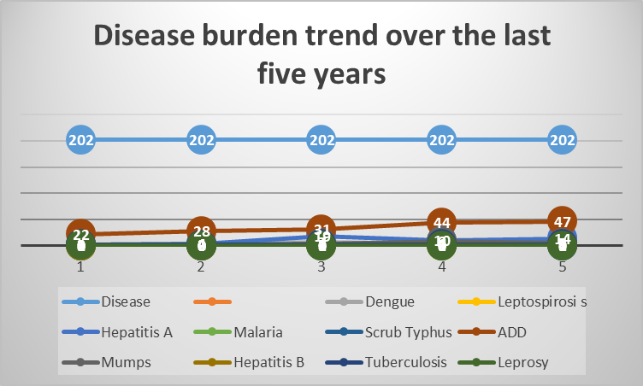

Seasonal Trend Analysis
Seasonal analysis helps anticipate surges (e.g. dengue in monsoon, leptospirosis after floods, influenza in cooler months) and plan pre‑emptive vector control, stockpiling of IV fluids, and awareness campaigns at Panchayat level.

DENGUE
Dengue is a major seasonal vector-borne disease strongly associated with rainfall, water stagnation, and increased mosquito breeding during the monsoon period.

Peak: July–November

Dengue – Ward-wise Yearly Distribution (2021–2025)

Ward | Dengue – Ward-wise Yearly Distribution
Ward | 2021 | 2022 | 2023 | 2024 | 2025 | Total
1 | 0 | 1 | 1 | 0 | 0 | 2
2 | 1 | 0 | 2 | 0 | 0 | 3
3 | 0 | 0 | 0 | 0 | 0 | 0
4 | 1 | 0 | 0 | 0 | 0 | 1

5 |  | 1 | 1 | 1 | 0 | 3
6 |  |  | 2 | 0 | 0 | 2
7 |  | 1 | 1 | 2 | 0 | 4
8 |  | 1 |  |  | 2 | 3
9 |  |  |  | 1 | 0 | 1
10 |  |  |  |  | 0 | 0
11 |  |  |  |  | 0 | 0
12 |  |  |  |  | 2 | 2
13 |  |  |  |  | 1 | 1
14 |  |  |  |  | 0 | 0

LEPTOSPIROSIS
Leptospirosis cases are closely linked to monsoon rains, flooding, and occupational exposure, particularly in low-lying and waterlogged areas.

Peak: June - August
Leptospirosis – Ward-wise Yearly Distribution (2021–2025)

Ward | Leptospirosis – Ward-wise Yearly Distribution
Ward | 2021 | 2022 | 2023 | 2024 | 2025 | Total
1 | 0 | 0 | 1 | 0 | 0 | 1
2 | 0 | 0 | 0 | 0 | 0 | 0
3 | 0 | 0 | 0 | 0 | 1 | 1
4
5
6

7 |  |  |  |  | 1 | 1
8
9
10
11
12
13

VIRAL HEPATITIS - A
Hepatitis A cases are commonly associated with unsafe drinking water, food contamination, and breakdowns in sanitation, often presenting as clusters or outbreaks.

Peak: October - December
Hepatitis A – Ward-wise Yearly Distribution (2021–2025)

Ward | Hep A – Ward-wise Yearly Distribution
Ward | 2021 | 2022 | 2023 | 2024 | 2025 | Total
1 | 0 | 0 | 0 | 0 | 3 | 3
2 | 0 | 0 | 0 | 0 | 2 | 2
3 | 0 | 0 | 0 | 0 | 0 | 0
4 | 0 | 0 | 3 | 1 | 1 | 5
5 | 0 | 0 | 0 | 0 | 0 | 0
6 | 0 | 2 | 2 | 3 | 4 | 11
7 | 1 | 2 | 2 | 0 | 2 | 7
8 | 2 | 0 | 2 | 2 | 0 | 6
9 | 0 | 0 | 1 | 0 | 0 | 1

10 | 0 | 0 | 4 | 0 | 0 | 4
11 | 0 | 0 | 3 | 0 | 0 | 3
12 | 0 | 0 | 0 | 3 | 0 | 3
13 | 0 | 0 | 2 | 1 | 2 | 5

Outcome-Based Trend Analysis- 2025 Transmission Trend- 2025
For effective management of public health issues, it is important to track the trend of disease transmission mode. It helps identify the population or place at high risk that can be used to predict outbreaks and implement targeted interventions as quickly as possible. Understanding these kinds of trends enables authorities to allocate resources efficiently and change the strategies adequately based on the trend that follows.

Mode of Transmission | No. of cases | No. of Deaths
Vector Borne Diseases | 5 | 0
Water Borne Diseases | 14 | 0

Air Borne Diseases | 3 | 0
Blood Borne Diseases | 0 | 0
Food Borne Diseases | 0 | 0

Vector-Borne Disease

Disease | No. of Cases | No. of Deaths
Dengue | 5 | 0
Malaria | 0 | 0
Chikungunya | 0 | 0

Water Borne Disease

Disease | No. of Cases | No. of Deaths
Cholera | 0 | 0

Typhoid | 0 | 0
Hep- A | 14 | 0
Dysentery | 0 | 0
Amoebiasis | 0 | 0
E- Coli infections | 0 | 0Zs
Air Borne Disease

Disease | No. of Cases | No. of Deaths
Influenza | 912 | 0
H1N1 | 0 | 0
TB | 0 | 0
Chickenpox | 7 | 0

Measles | 0 | 0
Covid-19 | 0 | 0
Pertussis | 0 | 0
Mumps | 0 | 0

Blood-Borne Disease

Disease | No. of Cases | No. of Deaths
AIDS | 0 | 0
Hep- B | 0 | 0
Hep- C | 0 | 0

Zoonotic Disease

Disease | No. of Cases | No. of Deaths
Rabies | 0 | 0
Leptospirosis | 2 | 0
Avian influenza | 0 | 0
West nile | 0 | 0
Anthrax | 0 | 0
Nipah | 0 | 0
Scrub Typhus | 0 | 0

Integrated Disease Hotspot Map (2021–2025)

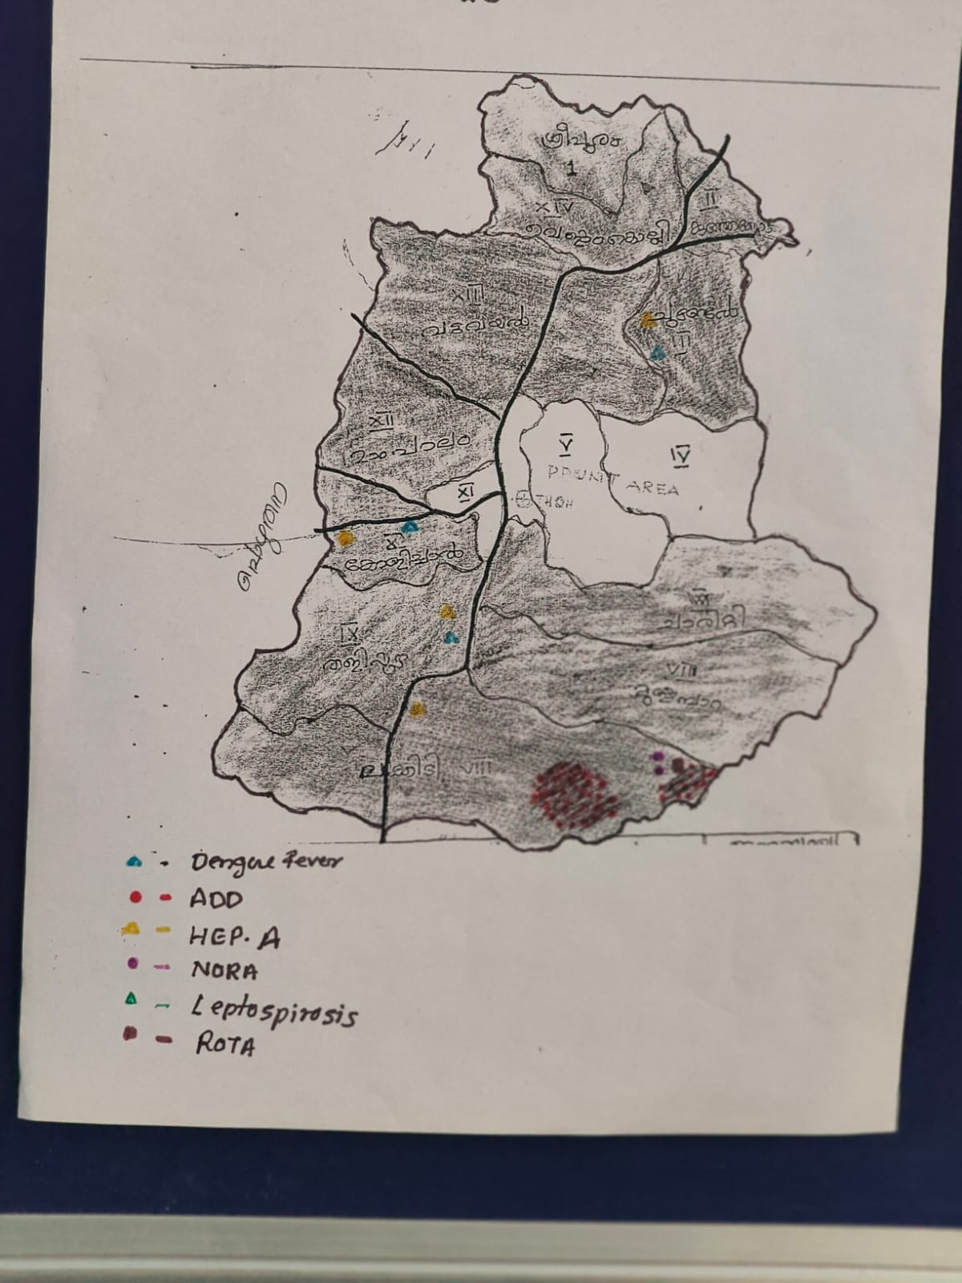

Ward No | Dengue Total (2021-  25) | Leptospirosi s Total  (2021-25) | Hepatitis A Total  (2021-25) | Mumps (2021-25) | ADD (2021-25) | Total Cases
1 | 2 | 1 | 3 | 0 | 3 | 9
2 | 3 | 1 | 2 | 0 | 5 | 11
3 | 0 | 0 | 0 | 6 | 4 | 10
4 | 1 | 0 | 5 | 0 | 7 | 13
5 | 3 | 0 | 0 | 0 | 6 | 9
6 | 2 | 0 | 11 | 0 | 4 | 17
7 | 4 | 1 | 7 | 0 | 5 | 17

8 | 3 |  | 6 | 0 | 120 | 129
9 | 1 |  | 1 | 7 | 9 | 18
10 | 0 |  | 4 | 0 | 8 | 12
11 | 0 |  | 3 | 0 | 4 | 7
12 | 2 |  | 3 | 0 | 5 | 9
13 | 1 |  | 5 | 14 | 5 | 25
14 | 0 |  | 0 |  | 0 | 0

By analysing and overlaying five years of disease surveillance data in Vythiri Grama Panchayat, no Red Zone wards have been identified. Red Zone wards refer to areas where at least two different categories of diseases (such as Dengue and Leptospirosis) have recurred in consecutive years. However, Ward 4 has been categorized as a priority hotspot due to its higher vulnerability to flooding and increased vector density.
To strengthen preventive measures and ensure safe drinking water in vulnerable areas, future health infrastructure—such as the installation of R.O. plants at identified flood-prone wards and high-risk habitations within the Panchayat—should be prioritized.

Pandemic Preparedness Plan

Preparedness and Response Protocol at LSG Level
This section describes the operational framework for the LSGI once a pandemic is declared. It explains how the LSGI and health system will move from routine data collection to active response, using a One Health approach.
Constitution of One Health Committee
The LSGD shall constitute a One Health Committee comprising the LSGI President, Medical Officers (Modern Medicine, AYUSH, and Veterinary), the Health Inspector, and the Veterinary Surgeon.

Objective: The One Health Committee coordinates human, animal, and environmental health to prevent and control pandemics.
 | Sl No | Name | Designation | Department/ Institution | Role in Committee | Contact Number
 | 1 | Mr. Rajan | Panchayat President | LSGD | Chairperson | 9526370944
 | 2 | Dr Babi | Medical Officer (PHC/CHC) | Health Dept | Member Secretary | 9446581101
 | 3 | Veterinary Officer | Veterinary Officer | Animal Husbandry | Member | 9447128933
 | 4 | Smt. Ziya | Epidemiologist | Health Dept | Member | 9544142784
 | 5 | Sajith | Health Inspector/PHN | Health Dept | Surveillanc e | 9074916996
78

Pandemic Preparedness Plan
 | 6 | Sajesh | ASHA Supervisor | Health Dept | Community link | 8086667654
 | 7 | Raeena | ICDS Supervisor | Social Welfare | Vulnerable groups | 9745505685
 | 8 | SI | Police Station Officer | Police Dept | Law & order | 9495998258
 | 9 | Smt Doli | Ward Councillor Representative | LSGD | Community coordinatio n | 8921151185
 | 10 | CDS | Kudumbashree CDO | Kudumbashre e | Community mobilisatio n | 8281388134
Key Responsibilities:
- Review disease surveillance data (human + animal)
- Conduct ward-wise risk assessment and vulnerability mapping
- Approve quarantine/isolation centre locations
- Coordinate with district for resources (PPE, oxygen, ambulances)
- Periodically review health system surge capacity, including beds, oxygen, human resources, and ambulances.
- Approve and monitor risk communication and community engagement strategies, including rumour management.
- Ensure protection and service continuity for vulnerable groups (elderly, persons with disabilities, dialysis patients, coastal populations).

79

- Conduct quarterly mock drills
- Monitor equity measures for vulnerable groups
Meeting Schedule:
Quarterly (normal times) | Weekly (outbreak alert) | Daily (pandemic phase)

Pandemic Response Workforce
To ensure a coordinated and timely response during a pandemic, a dedicated Pandemic Response Workforce shall be constituted at the LSG level. The workforce will function under the overall supervision of the One Health Committee and in close coordination with the health authorities. Team-based deployment will enable efficient surveillance, case management, quarantine and isolation management, logistics support, and risk communication. Each team shall have a clearly designated team leader, defined roles, and an identified pool of personnel to allow rapid activation, rotation of duties, and continuity of services during prolonged emergencies.

Total Response Workforce Available: 300 persons

Team Name | Composition | Key Responsibilities | Team Leader
Surveillance and Contact Tracing Team | HI, JHI, JPHN, ASHAs and  Volunteers | Case detection, contact listing,  home visits, reporting | HI

Case Management Team | Doctors, Nurses, MLSP, Palliative Nurses | Patient care & referral | DOCTOR
Quarantine & Isolation Team | LSGD staff, Volunteers | Facility management | JHI
Psychosocial support | DMHP Wayanad | Psychosocial support | Counsellor
Logistics & supply chain Team | LSGD staff, Storekeepers, Drivers 3 | Supplies &  transport [PPE, medicines, oxygen, transport, waste management] | Ward Member
Communication Team | Ward members, Kudumbashree, Youth clubs,  AWW workers and other self help groups | IEC, community meetings, countering misinformation | M.O in charge
Transportation | KSRTC, educational institutional buses | Transport the victims | HI
Media Surveillance | Local Channel | For proper information | HI

All teams shall be activated immediately upon outbreak alert or pandemic declaration and shall report daily to the LSG Incident Commander/Medical Officer, with consolidated reporting to the Block PHC. Duty rosters and alternate personnel shall be maintained to ensure uninterrupted services during staff shortages or prolonged response periods. Team composition and numbers may be revised based on the magnitude of the outbreak and availability of human resources.

Activities and Measures before and during Pandemic PHASE 1 - Alert / Preparation
Surveillance and Reporting-Enhanced syndromic surveillance:

- Data sources for surveillance
Integrated Health Information Platform (IHIP) for Reporting:
All public and private healthcare facilities in the district are mandated to report notifiable diseases and syndromes with pandemic potential through the Integrated Health Information Platform (IHIP) according to standard case definitions. Facility in-charges ensure daily and accurate data entry in the portal. When a case with pandemic potential is reported, public health officials such as the Health Inspector (HI) and Junior Health Inspector (JHI) conduct field verification and follow-up. These surveillance activities are monitored both at the institutional and district levels.
Health Facility OPD/IPD Records:
OPD and IPD records from health facilities serve as an important data source to monitor trends in communicable diseases. Any unusual increase in cases is immediately reported to higher health authorities.
Private Hospitals and Laboratories:
Private hospitals and laboratories should be sensitized about the importance of timely reporting of communicable diseases through IHIP to ensure early detection and response.
Local Media and News Reports:
Information from local media and newspaper reports may help identify emerging public health concerns or unusual disease events in the community.
Community-Level Reporting:
Community-based surveillance is strengthened through reports from ASHAs, JPHNs, and Ward Members, who help identify unusual health events or clusters of illness at the community level and inform the health system for timely action.

- Event-based triggers (to be monitored and reported)
Event-based surveillance functions as a complementary system to indicator-based reporting for the early detection of unusual public health events. All public and private health institutions, schools, hostels, laboratories, veterinary institutions, and field-level health workers should promptly report unusual health events with pandemic potential to the District Surveillance Unit.
Facility in-charges are responsible for continuous monitoring of the following event-based triggers:
- Sudden increase in Influenza-Like Illness (ILI) or Severe Acute Respiratory Infection (SARI) cases beyond the usual baseline.
- Clustering of fever cases within a household, institution, or locality.
- Unusual or sudden clusters of illness with similar symptoms.
- Unexplained or sudden deaths, especially with respiratory or neurological manifestations.
- Sudden increase in absenteeism in schools, hostels, anganwadis, or workplaces.
- Media or social media reports suggesting disease outbreaks.
Upon identification of any trigger event:
- Immediate notification should be made to the concerned Medical Officer and District Surveillance Unit within 24 hours.
- Field verification will be conducted by the Health Inspector (HI) or Junior Health Inspector (JHI).
- Line listing and preliminary risk assessment should be completed without delay.
- The situation will be continuously monitored at both institutional and district levels.

3. Zoonotic and animal health surveillance
Close coordination shall be maintained between the Health Department and Veterinary Department for the early detection of zoonotic disease threats. Veterinary Officers and field veterinary staff should actively monitor animal health events and report any unusual findings promptly.
The following events should be monitored:
- Unusual or unexplained morbidity or mortality in livestock, poultry, or wildlife, including migratory birds and bats.
- Sudden deaths in poultry farms or backyard poultry units.
- Illness among individuals with close animal contact, such as poultry workers, dairy farmers, slaughterhouse workers, and hunters.
Priority zoonotic diseases under surveillance include:
- Leptospirosis
- Avian Influenza
- Nipah Virus Infection
- Anthrax
Reporting and Response:
- Any unusual animal health event should be immediately reported to the District Veterinary Officer and the District Surveillance Unit.
- Joint field investigations by Health and Veterinary teams should be conducted wherever animal-to-human transmission is suspected.
- Appropriate risk assessment and control measures should be initiated based on the findings.

- Logistics and Stock Preparedness
Logistics Management
Effective logistics management is essential to ensure a timely and coordinated response during public health emergencies. A structured system shall be established to maintain uninterrupted availability of essential supplies and support services during outbreaks or pandemics.
Vendor Identification and Emergency Procurement:
Local vendors shall be identified and empanelled in advance to facilitate rapid procurement of essential materials during emergencies. Clear emergency procurement mechanisms shall be defined in accordance with Local Self Government Department (LSGD) and Health Department norms to avoid procedural delays.
Essential Logistics Checklist:
A comprehensive and regularly updated checklist of essential medicines, consumables, personal protective equipment (PPE), disinfectants, laboratory supplies, and supportive equipment shall be prepared and maintained. This checklist will serve as the reference document for stock monitoring and replenishment.
Stock Maintenance and Storage:
Secure and accessible storage locations shall be pre-identified within the Panchayat limits for emergency stockpiling. Proper inventory management practices, including updated stock registers and periodic physical verification, shall be ensured to prevent shortages or expiry of supplies.
Emergency Transport Arrangements:
Dedicated vehicles and designated drivers shall be pre-identified for rapid deployment of medical teams, supplies, and patients during emergency situations. A contact list with backup arrangements shall be maintained to ensure uninterrupted mobility.
Designation of Logistics Nodal Officer:
A Logistics Nodal Officer shall be designated to oversee stock preparedness, coordinate procurement, manage supply distribution, and ensure timely decision-making during public health emergencies.

  - Identify and empanel local vendors and define emergency procurement mechanisms in accordance with existing LSGD and Health Department norms.
  - Prepare and maintain an essential logistics checklist covering medical supplies, consumables, and support equipment.

  - Pre-identify secure storage locations for emergency stocks and ensure maintenance of stock registers with regular updating.

  - Finalise emergency transport arrangements, including availability of vehicles and identified drivers for rapid deployment during alerts.

  - Designate a Nodal Officer for Logistics to enable prompt decision-making, coordination, and communication during emergencies.
  - Conduct rapid stock verification and ensure availability of minimum buffer stock, including:

- PPE | kits 50 | numbers
- Pulse | oximeters –10 | numbers
- Hand | sanitizers –20 | litres
- Masks, | gloves, disinfectants – adequate | quantity

Identify critical gaps in logistics and immediately communicate requirements to the Block and District authorities for timely replenishment and support. Monitor expiry dates and stock rotation.

Identification of Quarantine and Isolation Facilities
      - Identify and list suitable buildings for quarantine and isolation (schools, hostels, community halls, etc.).
      - Categorise cases as per the severity and allocate to appropriate facilities (for instance, severe cases to classrooms, mild cases to an assembly hall in case of a school).
      - Facility readiness checklist needed (beds, toilets, ventilation) etc.
      - Find an alternate site if the primary sites are not available or not in use.
      - Identify facility managers and support staff
      - Prepare basic SOPs for:

        - Admission and discharge
        - Food, water, sanitation
        - Infection prevention and waste disposal
      - Ensure availability of basic amenities: water, sanitation, electricity, ventilation, and waste disposal. Prepare a rapid activation plan for these facilities if case numbers increase.

Risk Communication and Community Preparedness
      - Disseminate early warning messages on symptoms, preventive measures, and reporting mechanisms. Display IEC materials both in English and the local language in public places and ensure ward-level awareness.
      - Sensitize elected representatives and community leaders on preparedness measures.
      - Establish a rumour tracking and misinformation response mechanism to identify, verify, and promptly counter false or misleading information.
      - Engage trusted local persons (ward members, ASHA workers, religious leaders, teachers, community volunteers) to communicate official public health messages and reinforce correct practices.
      - Develop and deploy targeted IEC materials for:
        - Schools and educational institutions
        - Markets and commercial areas
        - Work sites and labour settings

      - Conduct community sensitization meetings at the ward level to promote preventive behaviors, address concerns, and strengthen community participation in preparedness and response.

Protection of Vulnerable Groups

Vulnerable populations require priority protection through targeted line-listing, service continuity, and delivery mechanisms.
- Prepare and regularly update line-lists of vulnerable populations, including:
  - Elderly persons living alone
  - Persons with disabilities
  - Pregnant women
  - Migrant workers
  - Dialysis patients

The detailed line-lists shall be maintained and updated periodically.
    - Clinical Dependency Mapping

Develop ward-wise dependency and vulnerability maps to identify households requiring regular support during emergencies. Ensure continuity of essential health services for vulnerable groups, including
- Dialysis services (facility mapping, transport arrangements, and scheduling)
- Continuity of treatment for TB, HIV, and other chronic conditions requiring uninterrupted medication
- Mental health and psychosocial support services

Establish delivery mechanisms for food, essential commodities, and medicines to vulnerable households through coordinated action involving ASHAs, JPHNs, Kudumbashree, volunteers, and local administration.

PHASE 2 - Active Response

- Case Identification and Contact Tracing
Case detection and contact tracing activities in Vythiri Grama Panchayath shall be undertaken in close coordination with Health Department authorities, strictly adhering to disease-specific SOPs and IDSP guidelines. All identified cases and contacts shall be promptly reported, line-listed, monitored, and followed up as per prevailing protocols.

Field Staff Involved

  - Health Inspector (HI)
  - Junior Health Inspector (JHI)
  - Junior Public Health Nurse (JPHN)
  - ASHAs and ASHA Supervisors
  - Ward-level volunteers and Kudumbashree members (as required)

Screening Checkpoints

Screening checkpoints at high-traffic locations (transport hubs, markets, religious gatherings) for early detection of symptomatic travellers and crowd screening during outbreaks. Potential locations include bus stands, market entry points, and boat jetties, based on local context and risk assessment.
Screening activities will be carried out by trained personnel such as ASHAs, ward members, and volunteers, with support from Health Department staff. Necessary equipment, including non-contact thermometers and appropriate PPE, shall be ensured prior to activation.

Location | Type (Bus stand/Jetty/ Market/Rail way) | Staff Deployed (ASHAs/Vol unteers) | Screening Method | Reporting authority
Bus stand | Transport hub | One JHI One ASHA  One health Mentors | - Swab Collection.  - Blood smears collection (RDT)  - Thermal Scanners | Surveillanc e Nodal Officer in control room
Market entry | Market | One JHI One ASHA  Male health volunteers | - Swab Collection.  - Blood smears collection (RDT)  - Thermal Scanners | Surveillan ce Nodal Officer in control room
Boat jetty | Water transport | One JHI One ASHA  Male health volunteers | - Swab Collection.  - Blood smears collection (RDT)  - Thermal Scanners | Surveillan ce Nodal Officer in control room

Standard Screening Protocol
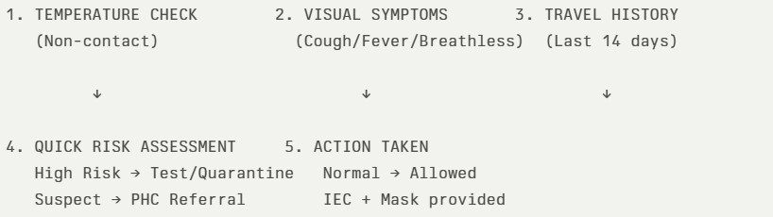

The screening protocol shall include temperature screening, observation for visible symptoms, and inquiry regarding recent travel or exposure history. Individuals identified as suspects during screening shall be immediately referred to the nearest PHC/FHC for further evaluation, testing, and appropriate action as per prevailing guidelines.

Pandemic Control Room
The Pandemic Control Room (PCR) serves as the central nerve center for real- time coordination, data aggregation, decision support, and communication during outbreaks. It consolidates information from all LSGD teams, health facilities and community sources to enable rapid response decisions.

Control Room Infrastructure and Location Primary Location: Vythiri Panchayath Office.
Backup Location: Community Hall inCo Operative Bank Hall Vythiri G.P. Health System Control Room Framework
The PCR is organized into seven functional pillars to ensure no aspect of the response is overlooked:

Rapid Response Team (RRT)
  - Provides immediate intervention during emergencies, clusters, and field alerts.
  - Coordinates urgent actions such as case investigation, contact
tracing, isolation, and inter‑facility referrals.

Data Management & Analytics Team
  - Collects, validates, and manages key health system indicators (cases, tests, beds, HR, supplies).
  - Analyzes data trends, generates projections, and supports
evidence‑based decision‑making for local authorities.

Human Resource Deployment Team
  - Allocates healthcare staff efficiently based on workload and need
  - Ensures adequate and equitable workforce distribution across facilities

Laboratory Surveillance Team
  - Oversees diagnostic testing coordination, sample transport, and timely reporting of results.
  - Monitors lab indicators (testing volume, positivity rate, turnaround time) for early detection of outbreaks

Vaccination Cell (If Required)
  - Plans and executes vaccination campaigns, including
micro‑planning and session scheduling.
  - Tracks coverage, identifies gaps, and coordinates corrective actions with field teams and outreach services.

Infrastructure & Patient Occupancy Team
  - Monitors facility capacity, earmarked beds, oxygen and critical care resources across all linked facilities.
  - Ensures optimal patient distribution and referral management using
updated bed‑status and resource data.
  - BMWM
- Communication team
- Logistics and supply chain
- Transportation (interfacility & emergency transport)
- Media surveillance Call centre
- Management of the deceased
- Intersectoral coordination and convergence
Key Control Room Team
The Control Room Team coordinates all pandemic response activities within the LSGD and serves as the single command and communication hub during activation. It integrates information, field actions, logistics, and policy execution across all participating departments and health facilities.

Role | Name | Designati on | Contact Number | Responsibility
In-charge/Nodal Officer | Dr Babi | Medical Officer | 9446581101 | Overall coordination, decision-making,

 |  |  |  | and reporting to the District level.
Data Entry Operator | Gisha | JHI | 9048135393 | Managing the line list, updating dashboards, and tracking testing results.
Communication Officer | Sajith | HI | 9074916996 | Handling the public helpline, coordinating ambulance dispatch, and contact tracing calls.
Logistics Coordinator | Leka | PHN | 9447515266 | Logistics Coordinator
Technical Support(IT/Data) | Gisha | JHI | 9048135393 | Technical support

SOP for alert escalation/trigger point with mapping of responsibilities.

Key Points:

- The Control Room shall be staffed with a designated In-charge, data entry personnel, and communication staff with clearly defined roles and shift

arrangements.

- It shall maintain updated records on daily monitoring indicators including new cases, persons under active quarantine, and hospital bed occupancy.

- All reports and situation updates shall be shared daily with the Block and District Surveillance Unit.

- The Control Room shall act as a single point of contact for coordination with response teams, health institutions, and other departments.

- Contact details of the Control Room shall be widely communicated to field staff and stakeholders during activation.

Daily Monitoring Indicators

To ensure timely decision-making and effective response, the following key indicators shall be monitored and updated on a daily basis by the Pandemic Control Room:

Epidemiological Indicators:

New cases reported today, Total active cases, Test Positivity Rate (TPR), Case Fatality Rate (CFR)

Surveillance Indicators:

Persons under home quarantine, High-risk contacts identified, Fever, ILI, SARI or other symptoms (syndromic surges), Travellers (symptomatic or high-risk arrivals),Animal husbandry surveillance (zoonotic alerts,

unusual animal deaths, poultry/bird flu signals), Mortality surveillance (excess deaths, unexplained fatalities, verbal autopsy reports)

Logistics and Infrastructure Indicators:

Hospital / CFLTC beds occupied, Oxygen cylinders/concentrators available, Ambulances on standby

Alert Findings
The following table outlines category-specific trigger points (red flags) from surveillance indicators and corresponding immediate actions for the Pandemic Control Room. These enable rapid response to alert findings like testing anomalies, positive cases exceeding thresholds, clusters, and WGS reports.

Category | Trigger Pophint (Red Flag) | Immediate Action
Clusters | Geographical or facility- based: 5+ cases linked to one location (office, school, street). | Declare a micro- containment zone; perimeter control and active case finding.
Testing | Sudden drop in testing volume / delay in reporting / unusual testing trends | Review the sample collection process, address lab bottlenecks, deploy additional testing

 |  | teams, and notify the District Lab.
Lab | Test Positivity rate increases | Increase testing sites in that ward.
Hospital | >80% Oxygen bed occupancy | Activate backup/CFLTC beds.
Travel | Cluster of cases from a single flight/train or high-risk arrival group. | Trace all passengers in adjacent seats; implement mandatory institutional quarantine.
Animal | Mass poultry/wildlife death or unusual sickness | Notify Animal Husbandry, sample the area, and dispatch RRT for environmental sampling and zoonotic check.

Mortality | Sudden spike in home deaths or brought-in-dead (BID) cases | Audit the deaths and Active Case Search drive
Additional investigations like Whole Genome Sequencing (WGS) | Detection of a Variant of Concern (VOC) or Variant of Interest (VOI) | Implement strict micro- containment; update clinical protocols to match variant severity.

Communication of Public Health Information

A Community Communication Hub shall be established to ensure timely, accurate, and consistent dissemination of information during a pandemic. The Hub will function under the coordination of Nodal officers of the control room and act as the nodal point for public communication, risk messaging, and community engagement. It will support dissemination of official advisories, promote preventive behaviors, address rumors and misinformation, and ensure that messages reach all sections of the population through trusted local channels and leaders.

Key communicators

Channel | Responsible Person | Contact
Ward-level announcements | Sajith | 9074916996
Social media | Jibi Pullatt | 9447338602
Local Cable TV/Radio | Gisha | 9048135393

  - All messages disseminated through the Hub shall align with advisories issued by the Health Department and District authorities.

  - Community leaders shall be sensitized to support behavior change, reduce stigma, and counter misinformation.

  - Special efforts shall be made to reach vulnerable and hard-to-reach populations using locally appropriate communication methods.

Rumor Tracking: A designated volunteer will monitor local social media/WhatsApp groups daily to identify misinformation and issue official clarifications via the Communication Hub.

Coordination with District/State Authorities & Other Organisations
Effective coordination with Block, District, and State authorities is essential to ensure timely reporting, technical guidance, and uninterrupted supply of

essential resources during a pandemic. The LSG shall establish clear communication channels, designate responsible officers, and adhere to prescribed reporting timelines to support coordinated public health action and efficient resource mobilisation.

Key Details:

Nodal Officer for Reporting:Medical Officer: Dr. Babi
  - Contact Number:9446581101

Reporting Schedule and Protocols:

To Whom | What to Report | Frequency | Nodal Person
Block PHC | Complete Situation Report (Cases, Quarantine, Beds, Screening, Deaths) | Daily | Medical Officer
District IDSP Unit | Outbreaks/Clusters/ Unusual Events (>5 cases same ward) | Health Inspector | 9074916996
Veterinary Officer | Animal health events/Zoonotic alerts | Veterinary Officer | 9447128933

State Cell | Zoonotic cross- sector events | District epidemiologi st | 8547015069

Supply Chain Coordination
The LSG shall coordinate closely with Block, District, and State authorities (KMSCL) to ensure uninterrupted availability of essential goods, medical supplies, and logistics during a pandemic. Supply requirements shall be assessed regularly based on case load and communicated promptly to the appropriate authorities for timely replenishment.

Key Points:

- Maintain updated contact details of District and Block nodal officers for health logistics, oxygen supply, ambulances, and essential medicines.

- Submit timely indent requests for PPE, testing kits, medicines, oxygen, and other critical supplies through prescribed channels.

- Monitor stock levels at LSGD facilities, quarantine/isolation centres, and field teams through daily stock registers and dispensing logs to prevent shortages.

- Coordinate with District authorities, Karunya/Neethi medical shops, and local purchase committees for funds allocation and emergency procurement.

- Ensure regular monitoring of dispensing registers at all facilities to track usage, expiry, and pilferage—shortages being a perennial issue requiring proactive weekly audits.

- Activate surge procurement protocols during high caseloads, leveraging local purchase powers under LSGD funds alongside state supplies.

Resource Inventory and Contacts

Resource Category | Source (District/State/Private  ) | Contact
PPE Kits/Masks/Gloves | KMSCL | NA
PPE Kits/Masks/Gloves | Local Vendors | NA
Oxygen Cylinders/Concentrators | KMSCL | NA
Medicines/Antivirals | KMSCL | NA
Medicines/Antivirals | Neethi Shops | NA
Test Kits (RTPCR/Rapid) | KMSCL | NA

Collaboration with NGOs, PPP, and CSR
To augment government efforts during a pandemic, the LSG shall collaborate with NGOs, voluntary organisations, and private sector partners through public–private partnerships and Corporate Social Responsibility (CSR) initiatives, in coordination with District authorities.

Key Points:

- Engage NGOs and community-based organisations for community outreach, awareness, and support to vulnerable populations.

- Leverage CSR support for procurement of medical equipment, PPE, oxygen concentrators, food kits, and sanitation materials, as permitted.

- Ensure all collaborations align with government guidelines and are routed through approved administrative and financial procedures.

- Maintain transparency and documentation for all external support received and utilised.

Organization | Type | Support Offered | Contact Person
Youth Clubs/Student Unions | CBO

Interdepartmental Coordination

Coordination among departments during a pandemic shall be ensured through regular review meetings convened by the LSGD President. These meetings will provide a structured platform for sharing situational updates, assessing resource availability, resolving operational gaps, and taking joint decisions to ensure a coordinated and timely response.

Department | Representativ e | Key Role | Contact
Health (PHC) | Staff Nurse : | Case management | 8075465887
Veterinary | Veterinary Surgeon: | Animal surveillance | 9447128933
ICDS | Supervisor: Raseena | Nutrition support | 9745505685
Education | Head Teacher: Sr. Anna | School coordination | 6282982130
Police | Vythiri Police Station | Containment enforcement | 9495998258
Water Authority | Kalpeta | Water supply | 9495211872
LSGD  Engineering | Vythiri | Quarantine infrastructure | 8606356318

PHASE 3 - Surge Capacity
Phase 3 is activated when there is a rapid increase in cases, rising test positivity rates, or when the existing health facilities and quarantine arrangements in Vythiri Grama Panchayath begin to reach or exceed their capacity. During this phase, immediate measures will be taken to expand isolation and quarantine facilities within the Panchayath and strengthen clinical care services at nearby health institutions.
Additional medical teams, medicines, and essential supplies will be mobilised with the support of district and state health authorities. Referral linkages with higher-level healthcare facilities will be strengthened to ensure timely management of severe cases. Surveillance activities and field-level monitoring will be intensified to identify new cases and clusters at an early stage. Community awareness programmes will also be strengthened to promote preventive measures and reduce the risk of further transmission. Close coordination between the Health Department, Local Self Government institutions, and other supporting departments will be ensured for effective outbreak control and response.
.

Conversion of Community Facilities
To manage increased case load, the LSGD shall activate additional isolation facilities by repurposing identified community infrastructure such as community halls, auditoriums, schools, hostels, or other suitable buildings.

Name of facility | Facility Type | No. of Buildin gs | Ward | Surge Capacity (Beds) | Nodal Person
Parish Hall Chundel | Parish Hall | 1 | 14 | 100 | 956228541  0
Vythiri Village Resort | Hall | 1 | 13 | 50 | 944733860  2

Recovery and rehabilitation phase

1. Recovery
Initiating coordinated recovery activities to restore normalcy after the disaster or public health emergency.
2. Damage & Impact Assessment
Rapid and detailed assessment of:
- Affected households
- Health institutions (PHC/CHC, subcentres)
- Water sources and sanitation facilities
- Roads and essential infrastructure
- Livelihood losses (agriculture, daily wage workers, small businesses)
3. Restoration of Health Services
- Re-establishment of routine OP services at PHC and subcentres
- Ensuring availability of essential medicines and vaccines
- Continuation of Maternal and Child Health (MCH) services
- Re-activation of outreach and field-level activities by ASHA and JPHN
4. Rehabilitation of Affected Population
- Temporary shelter support (if required)
- Nutritional support for vulnerable groups
- Special care for elderly persons, children, pregnant women, and chronic patients
5. Psychosocial & Mental Health Support
- Counseling services through health staff
- School-level mental health support for children
- Referral services for severe psychological distress
6. Disease Surveillance During Recovery Phase
- Strengthening disease surveillance reporting from all wards
- Active surveillance for leptospirosis, dengue, diarrhoeal diseases, etc.
- Monitoring of outbreak-prone conditions
7. Environmental Cleanup & Sanitation
- Chlorination of wells
- Solid waste removal
- Vector control activities
- Cleaning of drainage systems
- IEC activities on personal hygiene and sanitation
8. Livelihood Restoration
- Support for farmers and agricultural rehabilitation
- Engagement through employment schemes such as MGNREGA
- Assistance for small-scale workers and self-help groups
9. Community Engagement & Confidence Building
- Ward-level awareness meetings
- Involvement of community groups, youth clubs, and local leaders
- Transparent communication on recovery measures
10. Documentation & After-Action Review
- Recording the response timeline
- Identification of operational gaps
- Preparation of a local-level disaster response report
11. Lessons Learned & Best Practices
- Identification of successful interventions
- Documentation of community-based innovations
- Improved coordination models for future responses
12. Health System Strengthening
- Capacity building of health staff
- Stockpiling of emergency medicines and supplies
- Strengthening referral linkages
13. Policy Revision & Preparedness Enhancement
- Updating the Disaster Management Plan
- Strengthening early warning systems
- Improving inter-sectoral coordination
14. Research
- Post-disaster health impact studies
- Community-based research on outbreak patterns
- Evaluation of preventive practices.

CONCLUSION

The Pandemic Preparedness Plan for Vythiri Grama Panchayat provides a structured framework to strengthen the Panchayat’s capacity to prevent, detect, and respond to public health emergencies. Through strengthened disease surveillance, improved coordination among departments, efficient logistics management, and active community participation, the Panchayat aims to ensure timely and effective response during outbreaks or pandemics.
Successful implementation of this plan requires close coordination between the Health Department, Local Self Government Institutions, and other relevant departments. Regular monitoring, review, and updating of the preparedness strategies will help address emerging health threats and improve local response capacity. By enhancing healthcare services, strengthening community awareness, and promoting inter-sectoral collaboration, this plan will support the protection of public health and resilience of the community in Vythiri Panchayat during future health emergencies.

Additional points

Technical Support
- Establish secure data systems for disease surveillance, reporting, and communication with district health authorities. Ensure basic IT infrastructure and provide training for staff on digital reporting and emergency response systems.

Relief-Based Commodities and Supplies
- Maintain essential stockpiles of PPE, sanitizers, medicines, oxygen supplies, and basic relief materials. Coordinate with district supply chains for timely replenishment during emergencies.

HAM Radio and Backup Communication
- Identify licensed HAM radio operators and establish backup communication systems to ensure connectivity during disruptions of mobile and internet services.

Hazard Vulnerability Mapping
- Map vulnerable areas such as densely populated zones, schools, and elderly homes to support targeted preparedness and response activities.

Critical Infrastructure Support
- Coordinate with utility providers to ensure uninterrupted power supply to health facilities and vaccine storage units. Arrange backup power systems where necessary.

Human Resources and Responsibilities
- Define clear roles for health workers, volunteers, and administrative staff. Maintain a contingency roster and conduct periodic training and simulation exercises.

Coordination and Communication
- Ensure effective communication through public advisories, local media, and community outreach. Maintain two-way communication between authorities and the community.

Evaluation and Continuous Improvement
- Establish monitoring and evaluation mechanisms and conduct post-incident reviews to improve preparedness and response strategies.

RECOMMENDATIONS

- Strengthening Healthcare Infrastructure
  - Establish a primary health response unit within the Panchayat with trained staff.
  - Ensure availability of basic medical supplies (masks, sanitizers, PPE kits, oxygen cylinders).
  - Create tie-ups with nearby hospitals in THQH Vythiri for emergency referral and transport.
- Community Awareness & Education

  - Conduct regular awareness campaigns on hygiene, vaccination, and preventive measures.
  - Use local communication channels (community radio, WhatsApp groups, notice boards) to spread verified information.
  - Train volunteers to act as health ambassadors in each ward.

- Emergency Response & Coordination

  - Form a Pandemic Preparedness Committee at Panchayat level including health workers, ward members, and NGOs.
  - Develop a clear action plan for lockdowns, quarantine, and distribution of essentials.
  - Maintain a database of vulnerable groups (elderly, differently-abled, chronically ill) for targeted support.
- Supply Chain & Food Security

  - Identify and support local suppliers and farmers to ensure uninterrupted food supply.

  - Create community kitchens during emergencies to serve vulnerable populations.
  - Stockpile essential commodities in Panchayat-run outlets for crisis periods.

- Digital Preparedness

  - Promote digital platforms for telemedicine consultations.
  - Use Panchayat’s website/social media for real-time updates on health advisories.
  - Encourage online grievance redressal to reduce crowding in offices.

- Training & Capacity Building

  - Organize mock drills for pandemic response in schools, offices, and public spaces.
  - Train Panchayat staff and volunteers in first aid, infection control, and crowd management.
  - Collaborate with NGOs and health departments for capacity-building workshops.
- Long-Term Resilience

  - Integrate pandemic preparedness into the Panchayat Development Plan.
  - Allocate a dedicated budget for health emergencies.
  - Encourage community participation in planning and monitoring preparedness measures.

MOCKDRILL SCENARIOS

A detailed mock drill was conducted at Vythiri Grama Panchayath as part of comprehensive pandemic preparedness planning, with active coordination and leadership from Primary Health Centre Sugandhagiri. The drill aimed to evaluate the readiness of the local health system, emergency response mechanisms, interdepartmental coordination, and community awareness in the event of a potential infectious disease outbreak.

Objectives of the Mock Drill

- To assess early detection and reporting systems for suspected infectious cases.
- To test coordination between health, local governance, and emergency services.
- To evaluate isolation, triage, and referral protocols.
- To review availability and usage of PPE and medical supplies.
- To strengthen community-level awareness and response mechanisms.

The pandemic preparedness initiatives undertaken under Vythiri Grama Panchayath, in coordination with Primary Health Centre Sugandhagiri, have significantly strengthened the local health system’s capacity to respond effectively to public health emergencies. Through systematic planning, regular mock drills, surveillance activities, and interdepartmental coordination, the Panchayath has established a structured and responsive mechanism to manage potential outbreak
A simulated pandemic preparedness exercise will be organized in Vythiri Grama Panchayat to evaluate the health system’s readiness to respond to both known infectious diseases and potential outbreaks of unknown origin. The exercise will assess the effectiveness of planning, coordination, and operational response among different sectors within the Panchayat. Technical guidance, necessary approvals, and coordination support will be obtained from the District Health Authorities and other relevant stakeholders to ensure proper planning and implementation according to established protocols. The mock drill will be conducted twice a year, in May and August, following the local pandemic preparedness plan to strengthen preparedness and identify gaps in surveillance and response mechanisms.

ANNEXURE

IMPORTANT PHONE NUMBERS

Phone numbers and particulars of persons responsible for providing guidance, assistance, and support for pandemic preparedness operations may be provided here in a manner that allows easy reference at a glance.The information recorded here could be exhibited elsewhere at the time of emergencies. LSG institutions shall give special attention to collect and record the above data of persons and institutions who/which

are supposed to give technical and co-ordination support to reduce the impact of pandemic.
  - Details of grama panchayat/municipality/corporation wards

  - Other important phone numbers of grama panchayat/municipality/corporation area

Sl.  No. | Name | Contact number
5. | Agriculture Office | 9383471938

6. | Village office, Kunnathidavaka | 85476166602
7. | Excise department | 04935240012
8. | Forest department | 04936220454  9447979188

  - Important offices of grama panchayat/municipality/ corporation

Sl.No | Name of the office | Contact person | Contact number
1. | Village Office | Village Officer | 08547616608
2. | Agriculture Office | Agriculture Officer | 04936255165
3. | Animal Husbandry Office | Animal Husbandry Doctor | 04936255261
4. | Police Station | Police Officer | 9497980826
5. | BSNL Office | Officer | 7947111631
6. | Block Office | Officer | 04936202265

7. | KSEB Office | Officer | 04936255261
8. | Fisheries Office | Officer | 8547155621
9. | Fire and Rescue | Officer | 04936202333
  - Health Services

Sl. No | Name of the hospital/institution | Location | Phone number
1. | Government hospitals/PHC | Sugandhagi ri | 9446581101
2. | Private hospitals | Good shepherd hospital, Chellotte | 8281661825
3. | Clinical laboratories | Nil | No
4. | Chemist/pharmacy | Nil | No
5. | Blood donors | Nil | No

6. | Other language experts (Bihari, Hindi, Bengali,  Asamees ………) | No | No

  - Veterinary Services

Sl. No | Name of the Clinic | Name of the Surgeon/Doct or | Place/l ocation | Phone number
1 | Govt.Veterinary Hospital | Dean, KVASU  Pookode | Pookode | 9447128933

  - Helpline numbers

Helpline | Phone number
Police | 9497980826
Fire and Rescue | 04936202333
KSEB | 04936255261

  - Public and Private Schools Contact details

S.N  o | Name of School | Institution type | Phone number
1 | HIM UPS Chelotte | Aided | 6282982130
2 | Govt. LPS Pookode | Govt | 9447405480
3 | St Claret School | Private | 8078788779
4 | EMRS Pookode | Govt | 9947049283
5 | Navodaya Pookode | Govt | 04936256688
6 | RCLPS Chundel | Aided | 9744248261
7 | RCHS Chundel | Aided | 9746843180
8 | RCHSSS Chundel | Aided | 9946151234

1.9. Anganwadi Contact Details

Ward No | Name of Anganwadi Teachers | Phone number
1 | Charity 1 AW | 9544067859
2 | Charity 2 AW | 9526647453
3 | Mullanppara AW | 9497771708

4 | 12 th Bridge AW | 9605382778
5 | Kunnathuthottam AW | 9349661645
6 | Chelotte AW | 9947936824
7 | Lakkidi AW | 7593096905
8 | Aramala AW | 9048988922
9 | Pookode AW | 9544806407
10 | Old Vythiri AW | 7994857945
11 | Thalipuzha AW | 9544036209
12 | Kolichak AW | 9946647981
13 | Vattakundu AW | 8157080861
14 | Chundel AW | 9562260629
15 | Kannanchath AW | 8606316834
16 | Sreepuram AW | 9745898840
17 | Kunjamkode AW | 9496200484

1.12. Information regarding resources

Means of transportation | Name of Owner | Phone Number

Heavy Trucks | NA | NA
Tractor | NA | NA
Ambulances | NA | NA
Boats | NA | NA
Taxi service | NA | NA

Annexure 1: LSG Baseline Data Collection Format

- Baseline data

Sl.  No. | Indicator / Field | Baseline Data | Source /  Remarks
1 | Name of LSG | Vythiri
2 | District | Wayanad
3 | Block / Taluk | Kalpeta
4 | Type of LSG (Gram Panchayat  / Municipality / Corporation) | Gramma  panchayath
5 | Area (sq. km) | 2.084 square  kilometers
6 | No. of wards | 15
7 | GIS boundary file available | (Yes/No) | Yes
8 | Key contact person & phone | President | 9526370944

- Demography

Total Population | 15254
Male Population | 7615
Female Population | 7639
Total SC Population | 2680
Male Population | 1320
Female Population | 1360
Total ST Population | 843

Male Population | 391
Female Population | 452
- Points of Entry & Mobility

Sl. No. | Indicator / Field | Baseline Data (Value /  Description) | Source / Remarks
1 | Bus stands / depots (number) | 0
2 | Railway stations (number) | 0
3 | Boat jetties / fishing harbours (number) | 0
4 | Ports / airports nearby (specify distance) | 0
5 | Major highways/roads passing through | 1

6 | Border crossings (state/district) | 0
7 | Major markets / weekly markets | 0
8 | Tourism hubs / major event venues | Yes | Pookode Lake En ouru
9 | Schools/colleges with hostels (number) | MRS Pookode, Navodaya, KVASU Hostel
10 | Factories / large workplaces (number) | HML Chundel  Tea factory, Chellotte Tea Factory
- Water, Sanitation & Hygiene (WASH)

Sl.  No. | Indicator / Field | Baseline Data (Value /  Description) | Source / Remarks

1 | Major drinking water sources (piped / wells / borewells / springs) | WELLS
2 | No. of public wells | 71
3 | No. of households with piped water connection | -
4 | Water quality testing routine (Yes/No) | Yes
5 | Common contamination risks (flooding, salinity, industrial waste) | No
6 | Open defecation free status (Yes/No) | Yes
7 | Solid waste management system (Yes/No) | Yes
8 | Bio-medical waste disposal mechanism (Yes/No) | yes, Image
9 | No. of public toilets | 6

10 | Handwashing stations in public places (Yes/No) | no
- Zoonotic Risks & One Health

Sl.  No. | Indicator / Field | Baseline Data (Value /  Description) | Source /  Remarks
1 | Livestock population (cattle/goats/pigs/poultry) – estimates | yes
2 | No. of dairy farms / poultry farms / pig farms | yes | Veterinary College
3 | Slaughterhouses / meat shops (number) | No
4 | Animal markets (Yes/No, details) | No
5 | Veterinary dispensaries (number) | Yes, 3

6 | History of zoonotic outbreaks (rabies, leptospirosis, avian flu etc.) | NO
7 | Stray dog population management measures (Yes/No) | Yes
8 | Rodent infestation hotspots (Yes/No) | No
9 | Wetlands / waterlogged areas prone to leptospirosis | No
10 | Bat roosting areas / caves / fruit orchards (if any) | No
11 | Human-animal interface hotspots (farms near residences) | No
- Climate & Disaster Risks (Pandemic Amplifiers)

Sl.  No. | Indicator / Field | Baseline Data (Value /  Description) | Source / Remarks

1 | Flood-prone wards (list) | Yes | Vattavayal, Charity
2 | Landslide-prone wards (list) | Yes | Aramala
3 | Cyclone/sea surge risk (Yes/No) | No
4 | Heatwave risk zones (Yes/No) | No
5 | Waterlogging areas (list) | No
6 | Shelter homes / relief camps (number, capacity) | No
7 | Past disaster displacement history | No
8 | Disruption to water supply/transport common (Yes/No) | No
- Critical Infrastructure & Logistics

Sl.  No. | Indicator / Field | Baseline Data (Value /  Description) | Source / Remarks
1 | Schools (number) | 9
2 | Anganwadis (number) | 16
3 | Colleges (number) | 3
4 | Community halls (number) | 2
5 | Places of worship with large gatherings (number) | 11
6 | Large markets / shopping areas (number) | 0
7 | Warehouses / cold storages (number) | 0
8 | Telecom/mobile network coverage gaps (Yes/No) | 0
9 | Power outage frequency (high/medium/low) | 0

10 | Availability of generators in key facilities | 0

- Risk Communication & Community Networks

Sl.  No. | Indicator / Field | Baseline Data (Value /  Description) | Source / Remarks
1 | Ward-level rapid response teams (Yes/No) | YES
2 | Jagratha samithis / committees active (Yes/No) | Yes
3 | Kudumbashree presence and strength (number of units) | 112
4 | Volunteer network (number, coverage) | Yes
5 | Community-based surveillance mechanisms (Yes/No) | Yes

6 | IEC dissemination channels (WhatsApp groups, community radio, PA systems) | Yes
7 | Rumour tracking mechanisms (Yes/No) | Yes
8 | Languages spoken / literacy considerations | Yes
9 | Vulnerable groups  communication strategy available (Yes/No) | Yes

- Preparedness Planning & Governance

Sl.  No. | Indicator / Field | Baseline Data (Value /  Description) | Source / Remarks
1 | LSG emergency plan available (Yes/No) | Yes

2 | Pandemic preparedness plan available (Yes/No) | Yes
3 | Incident Command System identified (Yes/No) | Yes
4 | Rapid procurement mechanism available (Yes/No) | Yes
5 | Emergency fund available (Yes/No, amount) | Yes
6 | Past outbreak response experience (Yes/No, details) | Yes
7 | Intersectoral coordination mechanism (Health, Police, LSG, Veterinary, Education) | Yes
8 | Mock drills conducted in last 12 months (Yes/No) | Yes
9 | Training coverage for staff/volunteers (Yes/No) | Yes

- Surveillance & Data Systems

Sl.  No. | Indicator / Field | Baseline Data (Value /  Description) | Source / Remarks
1 | Digital reporting tools used (e.g., DHIS2, portals) | Yes
2 | Availability of line-listing format (Yes/No) | Yes
3 | Contact tracing team identified (Yes/No) | yes
4 | Mapping of high-risk households available (Yes/No) | yes
5 | Testing sample transport mechanism (Yes/No) | yes
6 | Reporting timeline adherence (good/average/poor) | yes

7 | Data sharing between departments (Yes/No) | yes
8 | Availability of dashboard for monitoring (Yes/No) | yes

- Additional Notes & Observations

Sl.  No. | Indicator / Field | Baseline Data (Value /  Description) | Source / Remarks
1 | Key challenges perceived by LSG | No
2 | Top 5 high-risk wards (reason) | No
3 | Any unique local risks (industrial pollution, refugee camps, etc.) | No
4 | Recommendations for preparedness strengthening | No

